No. 48 2963

THE SOUTH AUSTRALIAN

GOVERNMENT GAZETTE
www.governmentgazette.sa.gov.au

PUBLISHED BY AUTHORITY

ALL PUBLIC ACTS appearing in this GAZETTE are to be considered official, and obeyed as such

ADELAIDE, THURSDAY, 7 JULY 2011

CONTENTS

Page
Appointments, Resignations, Etc. 2964
Associations Incorporations Act 1985—Notices 2966, 3016
Corporations and District Councils—Notices 3005
Development Act 1993—Notice 2967
Electricity Act 1996—Notices 2968
Equal Opportunity Tribunal—Notice 2966
Essential Services Commission Act 2002—Notice 2966
Fire and Emergency Services Act 2005—Notice 2966
Fisheries Management Act 2007—Notices 2977
Gas Act 1997—Notice 2978
Government Financing Authority Act 1982—Notice 2979
Housing Improvement Act 1940—Notices 2980
Liquor Licensing Act 1997—Notices 2981
Mining Act 1971—Notices 2982
Motor Vehicles Act 1959—Notice 2966
Natural Resources Management Act 2004—Notice 2984

Page
Petroleum and Geothermal Energy Act 2000—
Notices 2984
Premier and Cabinet, Department of the—
Retentions of Title 2965
Proclamations 2997
Public Sector Act 2009—Notice 2988
Public Trustee Office—Administration of Estates 3015
REGULATION
Liquor Licensing Act 1997 (No. 178 of 2011) 2999
Roads (Opening and Closing) Act 1991—Notices 2984
Sale of Property—Notices 3016
Sewerage Act 1929—Erratum 2994
Transport, Department of—Notices to Mariners 2983
Unclaimed Moneys Act 1891—Notice 3017
Water Mains and Sewers—Mains Laid, Replaced, Etc. 2985
Wilderness Protection Regulations 2006—Notice 2987

GOVERNMENT GAZETTE NOTICES
ALL poundkeepers’ and private advertisements forwarded for publication in the South Australian Government Gazette must be PAID FOR PRIOR TO INSERTION; and all notices, from whatever source, should be legibly written on one side of the paper only and sent to Government Publishing SA so as to be received no later
than 4 p.m. on the Tuesday preceding the day of publication. Phone 8207 1045 or Fax 8207 1040. E-mail: governmentgazette@dpc.sa.gov.au. Send as attachments in Word format and please confirm your transmission with a faxed copy of your document, including the date the notice is to be published and to whom the notice will be charged. The Government Gazette is available online at: www.governmentgazette.sa.gov.au

Department of the Premier and Cabinet
Adelaide, 7 July 2011
HIS Excellency the Governor in Executive Council has been pleased to appoint the undermentioned to the Police Superannuation Board, pursuant to the provisions of the Police Superannuation Act 1990:
Deputy Member: (from 7 July 2011 until 29 October 2011)
Julie Marie Foley (Deputy to Zimmermann)
By command,
Russell Paul Wortley, for Premier
T&F11/001CS

Department of the Premier and Cabinet
Adelaide, 7 July 2011
HIS Excellency the Governor in Executive Council has been pleased to appoint the undermentioned to the Aquaculture Tenure Allocation Board, pursuant to the provisions of the Aquaculture Act 2001:
Member: (from 7 July 2011 until 6 July 2014)
Glenn Stuart Davis
Catherine Sheree Cooper
Paula Antoinette Braxton-Smith
Deputy Member: (from 7 July 2011 until 6 May 2012)
Melissa Kate Holzberger (Deputy to Bradsen)
Deputy Member: (from 7 July 2011 until 6 July 2014)
Martin White (Deputy to Cooper)
Presiding Member: (from 7 July 2011 until 6 July 2014)
Glenn Stuart Davis
By command,
Russell Paul Wortley, for Premier
MAFF11/12CS

Department of the Premier and Cabinet
Adelaide, 7 July 2011
HIS Excellency the Governor in Executive Council has been pleased to appoint the undermentioned to the State Crewing Committee, pursuant to the provisions of the Harbors and Navigation Act 1993:
Member: (from 7 July 2011 until 30 June 2013)
Walter Francis Ferrao
Jamie Newlyn
Susan Raelene Mattsson
Allan Arthur Andersen
Paul Francis Carr
Deputy Member: (from 7 July 2011 until 30 June 2013)
Carl Bahadur Kavina (Deputy to Ferrao)
Leslie Allan Parsons (Deputy to Mattsson)
Robert Arthur Williams (Deputy to Carr)
Kevin Paul Menezes (Deputy to Andersen)
Presiding Member: (from 7 July 2011 until 30 June 2013)
Walter Francis Ferrao
Deputy Presiding Member: (from 7 July 2011 until 30 June 2013)
Susan Raelene Mattsson
By command,
Russell Paul Wortley, for Premier
MTR/11/039

Department of the Premier and Cabinet
Adelaide, 7 July 2011
HIS Excellency the Governor in Executive Council has been pleased to appoint the undermentioned to the Health Services Charitable Gifts Board, pursuant to the provisions of the Health Services Charitable Gifts Act 2011:
Commissioner: (from 11 July 2011 until 10 July 2014)
Robyn Pak-Poy
By command,
Russell Paul Wortley, for Premier
HEAC-2011-00027

Department of the Premier and Cabinet
Adelaide, 7 July 2011
His Excellency the Governor in Executive Council has been pleased to appoint Hieu Van Le as Governor’s Deputy of South Australia for the period from 8 a.m. on Tuesday, 12 July 2011 until 6 p.m. on Wednesday, 13 July 2011.
By command,
Russell Paul Wortley, for Premier

Department of the Premier and Cabinet
Adelaide, 7 July 2011
His Excellency the Governor in Executive Council has been pleased to appoint the Honourable Patrick Frederick Conlon, MP, Minister for Transport and Minister for Infrastructure to be also Acting Deputy Premier, Acting Attorney-General, Acting Minister for Justice, Acting Minister for Urban Development, Planning and the City of Adelaide, Acting Minister for Tourism and Acting Minister for Food Marketing for the period from 10 July 2011 to 19 July 2011 inclusive, during the absence of the Honourable John Robert Rau, MP.
By command,
Russell Paul Wortley, for Premier
AGO0182/06CS

Department of the Premier and Cabinet
Adelaide, 7 July 2011
His Excellency the Governor in Executive Council has been pleased to appoint the Honourable Tom Koutsantonis, MP, Minister for Mineral Resources Development, Minister for Industry and Trade, Minister for Small Business and Minister for Correctional Services to be also Acting Treasurer and Acting Minister for Workers Rehabilitation for the period from 9 July 2011 to 22 July 2011 inclusive, during the absence of the Honourable John James Snelling, MP.
By command,
Russell Paul Wortley, for Premier
T&F11/035CS

Department of the Premier and Cabinet
Adelaide, 7 July 2011
HIS Excellency the Governor in Executive Council has been pleased to appoint the Honourable Thomas Richard Kenyon, MP, Minister for Recreation, Sport and Racing, Minister for Road Safety, Minister for Veterans’ Affairs, Minister Assisting the Premier with South Australia’s Strategic Plan and Minister Assisting the Minister for Employment, Training and Further Education to be also Acting Minister for Employment, Training and Further Education for the period from 9 July 2011 to 22 July 2011 inclusive, during the absence of the Honourable John James Snelling, MP.
By command,
Russell Paul Wortley, for Premier
T&F11/035CS

Department of the Premier and Cabinet
Adelaide, 7 July 2011
His Excellency the Governor in Executive Council has been pleased to appoint Joanne Louise Pfeiffer as a part-time Commissioner of the Environment, Resources and Development Court of South Australia and designate her as a Commissioner for the purposes of the Court’s jurisdiction under the Irrigation Act 2009 for a term of three years commencing on 7 July 2011 and expiring on 6 July 2014, pursuant to Section 10 of the Environment, Resources and Development Court Act 1993.
By command,
Russell Paul Wortley, for Premier
AGO0211/10CS

Department of the Premier and Cabinet
Adelaide, 7 July 2011
His Excellency the Governor in Executive Council has been pleased to appoint Megan Mary Lewis as a part-time Commissioner of the Environment, Resources and Development Court of South Australia and designate her as a Commissioner for the purposes of the Court’s jurisdiction under the Environment Protection Act 1993 and the Natural Resources Management Act 2004 for a term of three years commencing on 7 July 2011 and expiring on 6 July 2014, pursuant to Section 10 of the Environment, Resources and Development Court Act 1993.
By command,
Russell Paul Wortley, for Premier
AGO0211/10CS

Department of the Premier and Cabinet
Adelaide, 7 July 2011
His Excellency the Governor in Executive Council has been pleased to appoint John Edward Botting and Carolyn Ireland as part-time Commissioners of the Environment, Resources and Development Court of South Australia and designate them as Commissioners for the purposes of the Court’s jurisdiction under the Natural Resources Management Act 2004 for a term of three years commencing on 7 July 2011 and expiring on 6 July 2014, pursuant to Section 10 of the Environment, Resources and Development Court Act 1993.
By command,
Russell Paul Wortley, for Premier
AGO0211/10CS

Department of the Premier and Cabinet
Adelaide, 7 July 2011
His Excellency the Governor in Executive Council has been pleased to appoint John Andrew Lothian and David William Moyle as part-time Commissioners of the Environment, Resources and Development Court of South Australia and designate them as Commissioners for the purposes of the Court’s jurisdiction under the Native Vegetation Act 1991 for a term of three years commencing on 7 July 2011 and expiring on 6 July 2014, pursuant to Section 10 of the Environment, Resources and Development Court Act 1993.
By command,
Russell Paul Wortley, for Premier
AGO0211/10CS

Department of the Premier and Cabinet
Adelaide, 7 July 2011
His Excellency the Governor in Executive Council has been pleased to appoint Joan Cunningham to the position of Community Visitor for a period of three years commencing on 7 July 2011 and expiring on 6 July 2014, pursuant to the provisions of the Mental Health Act 2009.
By command,
Russell Paul Wortley, for Premier
HEAC-2011-00031

Department of the Premier and Cabinet
Adelaide, 7 July 2011
His Excellency the Governor in Executive Council has been pleased to appoint Christopher Michael Firth to the position of Community Visitor for a period of three years commencing on 7 July 2011 and expiring on 6 July 2014, pursuant to the provisions of the Mental Health Act 2009.
By command,
Russell Paul Wortley, for Premier
HEAC-2011-00031

Department of the Premier and Cabinet
Adelaide, 7 July 2011
His Excellency the Governor in Executive Council has been pleased to appoint Genevieve Hill to the position of Community Visitor for a period of three years commencing on 7 July 2011 and expiring on 6 July 2014, pursuant to the provisions of the Mental Health Act 2009.
By command,
Russell Paul Wortley, for Premier
HEAC-2011-00031

Department of the Premier and Cabinet
Adelaide, 7 July 2011
His Excellency the Governor in Executive Council has been pleased to appoint Carly Jeanne Luzuk to the position of Community Visitor for a period of three years commencing on 7 July 2011 and expiring on 6 July 2014, pursuant to the provisions of the Mental Health Act 2009.
By command,
Russell Paul Wortley, for Premier
HEAC-2011-00031

Department of the Premier and Cabinet
Adelaide, 7 July 2011
His Excellency the Governor in Executive Council has revoked the appointment of Peter James Maynard as a Clerk of Executive Council effective from 7 July 2011, pursuant to the Letters Patent, Section 68 of the Constitution Act 1934 and the Acts Interpretation Act 1915.
By command,
Russell Paul Wortley, for Premier
DPC11/028CS

Department of the Premier and Cabinet
Adelaide, 7 July 2011
His Excellency the Governor in Executive Council has been pleased to appoint Christine Elizabeth Christensen and Brooke Katherine Dyer as Clerks of Executive Council commencing on 7 July 2011, pursuant to the Letters Patent and Section 68 of the Constitution Act 1934.
By command,
Russell Paul Wortley, for Premier
DPC11/028CS

Department of the Premier and Cabinet
Adelaide, 7 July 2011
HIS Excellency the Governor directs it to be notified that he has been pleased to approve retention of the title Honourable by:
The Honourable Justice D. J. Bleby.
Dated 30 June 2011.
By command,
Mike Rann, Premier

Department of the Premier and Cabinet
Adelaide, 7 July 2011
HIS Excellency the Governor directs it to be notified that he has been pleased to approve retention of the title Honourable by:
The Honourable Justice Duggan, AM RFD.
Dated 30 June 2011.
By command,
Mike Rann, Premier

ASSOCIATIONS INCORPORATION ACT 1985
Order Pursuant to Section 42 (2)
Dissolution of Association
WHEREAS the Corporate Affairs Commission (‘the Commis-sion’), pursuant to Section 42 (1) of the Associations Incor-
poration Act 1985 (‘the Act’), is of the opinion that the undertaking or operations of Planning Institute of Australia Incorporated (‘the Association’) being an incorporated association under the Act are being carried on, or would more appropriately be carried on by a company limited by guarantee incorporated under the Corporations Act 2001 (Commonwealth) and whereas the Commission was on 24 May 2011, requested by the Association to transfer its undertaking to Planning Institute of Australia Limited (ACN 151 601 937), the Commission, pursuant to Section 42 (2) of the Act does hereby order that on 1 July 2011, the Association will be dissolved, the property of the Association becomes the property of Planning Institute of Australia Limited and the rights and liabilities of the Association become the rights and liabilities of Planning Institute of Australia Limited.
Given under the seal of the Commission at Adelaide, 29 June 2011.
K. L. Rodger, A Delegate of the Corporate Affairs Commission

EQUAL OPPORTUNITY TRIBUNAL
No. 1164 of 2011
Notice of Exemption
Before Presiding Officer Costello
NOTICE is hereby given that on 8 June 2011, the Equal Opportunity Tribunal of South Australia, on the application of Raytheon Australia Pty Ltd made the following orders for exemption:
1. The exemption granted to the Applicant on 19 May 2008, is extended pursuant to Section 92 of the Equal Opportunity Act to 5 p.m. on Thursday, 25 August 2011, on the same terms and conditions which applied to the grant of the said exemption.
Dated 9 June 2011.
Bjorn De Jager for I. Phillips, Registrar Equal Opportunity Tribunal

ESSENTIAL SERVICES COMMISSION ACT 2002
Price Determination
NOTICE is hereby given that:
1. The Essential Services Commission has made a price determination under the Essential Services Commission Act 2002 (‘the 2011-2014 Electricity Standing Contract (Variation) Price Determination’), varying the 2011-2014 Electricity Standing Contract Price Determination published by the Essential Services Commission on 14 December 2010.
2. The 2011-2014 Electricity Standing Contract (Variation) Price Determination varies the floor and ceiling established under the Commission’s Relative Price Movement methodology, which provides the upper and lower bounds on the movement in electricity standing contract prices during the 2011-2014 regulatory period. The Commission has varied the floor and ceiling to reflect the South Australian network charges to apply from 1 July 2011, as approved by the Australian
Energy Regulator on 3 June 2011. Network charges are treated as a cost pass-through to the electricity standing contract price. For the reasons discussed in the 2011-2014 Electricity Standing Contract (Variation) Price Determination, the approved 2011-2012 network charges are significantly higher than the network charges anticipated by the Commission when making the standing contract price determination in December 2010. The floor and ceiling have been increased to pass through the higher than expected network charges.
3. The 2011-2014 Electricity Standing Contract (Variation) Price Determination takes effect on the date of publication of this notice.
4. Copies of the 2011-2014 Electricity Standing Contract (Variation) Price Determination and the 2011-2014 Electricity Standing Contract Price Determination (as varied) may be inspected or obtained from the Essential Services Commission, 8th Floor, 50 Pirie Street, Adelaide and is also available at www.escosa.sa.gov.au.
5. Queries in relation to the 2011-2014 Electricity Standing Contract (Variation) Price Determination may be directed to the Essential Services Commission, 8th Floor, 50 Pirie Street, Adelaide. Telephone (08) 8463 4444, Freecall 1800 633 592 or email escosa@escosa.sa.gov.au.
Execution
The seal of the Essential Services Commission was affixed with due Authority by the Chairperson of the Essential Services Commission.
Dated 22 June 2011.
P. Walsh, Chairperson, Essential
Services Commission

FIRE AND EMERGENCY SERVICES ACT 2005
Section 4
Establishment of Areas for Fire and Emergency Services
I, DAVID WILLIAM PLACE, the Chief Executive Officer of the South Australian Fire and Emergency Services Commission, hereby abolish the fire district known as the Burra Fire District. The Burra Country Fire Service will be responsible for the area previously defined as the Burra Fire District for the purposes of operations of the Burra Metropolitan Fire Service.
Dated 29 June 2011.
D. Place, Chief Executive, SAFECOM

MOTOR VEHICLES ACT 1959
Recognised Historic Motor Vehicle Club
NOTICE is hereby given that the undermentioned club is recognised as a Historic Motor Vehicle Club in accordance with Regulation 16 (3) of the Motor Vehicles Regulations 2010, for the purposes of Section 25 of the Motor Vehicles Act 1959:
Milang Vintage Machinery Club Inc.
Dated 1 July 2011.
M. Small, Registrar of Motor Vehicles

DEVELOPMENT ACT 1993, SECTION 29 (2) (b) (ii): AMENDMENT TO THE ADELAIDE (CITY) DEVELOPMENT PLAN
Preamble
It is necessary to amend the Adelaide (City) Development Plan dated 24 February 2011.
Notice
PURSUANT to Section 29 (2) (b) (ii) of the Development Act 1993, I, John Rau, being the Minister administering the Act, amend the Adelaide (City) Development Plan dated 24 February 2011 as follows:
1. In the table of LOCAL HERITAGE PLACES for the Margaret Street Policy Area 6, on page 143, delete the following:
40 Margaret Street | House  Edwardian residence | 5842/200 | a, d
2. Replace Map Adel/39 on page 495 with Map Adel/39 in Attachment A.
3. Fix the day on which this notice is published in the Gazette as the day on which the Section 29 (2) (b) (ii) Amendment will come into operation.
Attachment A

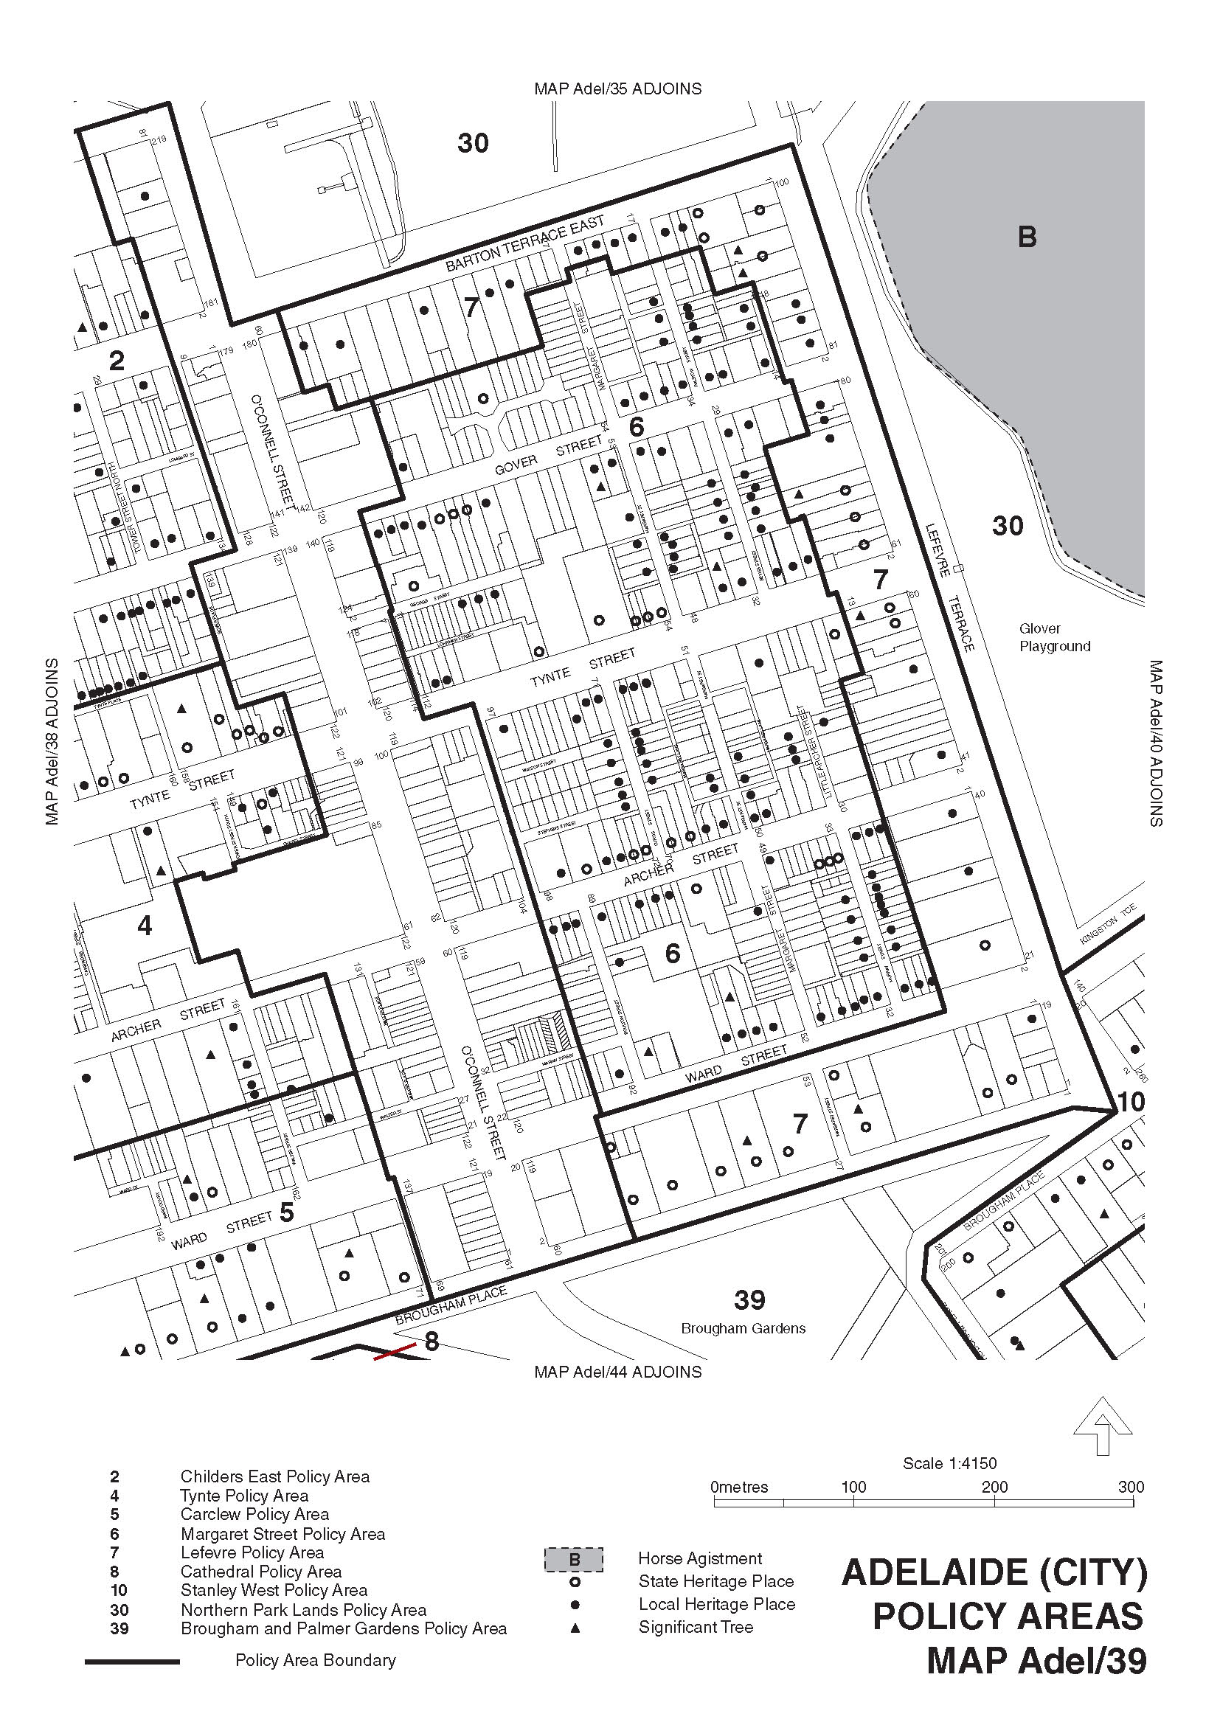
Dated 29 June 2011.
John Rau, Minister for Urban Development, Planning and the City of Adelaide

ELECTRICITY ACT 1996
Notice under the Electricity Standing Contract Price Determination and the Electricity Act 1996 of
AGL South Australia Pty Ltd (AGL SA) ABN 49 091 105 092
Standing and Default Contract Prices for Small Customers
IN accordance with the requirements of the Electricity Standing Contract Price Determination made by the Essential Services Commission of South Australia under the Essential Services Commission Act 2002 on 14 December 2010, notice is hereby given by AGL SA of its standing and default contract prices for customers who are consuming less than 160MWh per annum of electricity (‘small customers’). The standing contract prices are set out below in this notice and will apply from 1 August 2011.
Pursuant to Section 36AB of the Electricity Act 1996, notice is hereby given by AGL SA of its default contract prices for small customers who are purchasing electricity under AGL SA’s default contract terms and conditions. AGL SA has determined that its default contract prices will be the same as the standing contract prices set out in this notice. The default contract prices will apply from 1 August 2011.
Justification Statement—Default Contract Prices
The default contract prices set out in this notice are the same as AGL SA’s standing contract prices as fixed by the above Price Determination.
For further information please call AGL on 131 245.
Paul McWilliams
Director
AGL South Australia Pty Limited

AGL SA Electricity Standing and Default Contract Prices

ELECTRICITY ACT 1996

Default Contract Prices for Small Customers

IN accordance with Section 36AB of the Electricity Act 1996 (SA), TRUenergy Pty Ltd (ABN 99 086 014 968) (‘TRUenergy’) hereby publishes its default electricity contract prices for customers who are consuming less than 160MWh per annum of electricity (‘small customers’). These default contract prices apply on and from 3 August 2011.

The default contract prices detailed in this notice apply to small customers of TRUenergy who are purchasing electricity under TRUenergy’s Default Contract Terms and Conditions published in the Government Gazette on
4 November 2010.

TRUenergy reserves the right to change its default electricity contract price from time to time acting in accordance with all applicable regulations.

Justification Statement
The default contract prices set out in this notice reflect TRUenergy’s total costs associated with providing electricity to TRUenergy’s small customers in South Australia.

ELECTRICITY ACT 1996
Default Contract Prices for Small Customers
NOTICE is given that pursuant to Section 36AB of the Electricity Act 1996, Powerdirect Pty Ltd (ABN 28 067 609 803) hereby publishes its Default Contract Prices for the sale of electricity to default customers in South Australia. The standing contract prices are set out below in this notice and will apply from 1 September 2011.
Powerdirect’s Default Contract Prices are to be read with its Default Contract Terms and Conditions. Powerdirect’s Default Contract may be inspected on the Powerdirect website at www.powerdirect.com.au.
Justification Statement—Default Contract Prices
The default contract prices set out in this notice equates to the standing contract prices as established by the Essential Services Commission of South Australia in accordance with its Electricity Standing Contract Price Determination.
For further information please call Powerdirect on 1300 307 966.

Powerdirect SA Electricity Standing and Default Contract Prices

Tariff Categories |  | Standing and  Default Contract Prices | Standing and Default Contract Prices
 |  | GST Exclusive | GST Inclusive
Domestic Light/Power 110Q
 | First 3.2877 kWh/day (c/kWh) | 25.02 | 27.522
 | Thereafter (c/kWh) | 25.94 | 28.534
 | Supply Charge (c/day) | 55.63 | 61.193
Off-peak Controlled Load 116
 | For all consumption (c/kWh) | 11.94 | 13.134
General Supply 126Q
(Quarterly Meter Read)
 | First 27.3973 kWh/day (c/kWh) | 27.31 | 30.041
 | Thereafter (c/kWh) | 29.19 | 32.109
 | Supply Charge (c/day) | 54.25 | 59.675
General Supply 126M
(Monthly Meter Read)
 | First 27.3973 kWh/day (c/kWh) | 27.31 | 30.041
 | Thereafter (c/kWh) | 29.19 | 32.109
 | Supply Charge (c/day) | 66.03 | 72.633
General Supply Time of Use 128
(Quarterly Meter Read)
 | First 54.7945 kWh/day (c/kWh) | 33.07 | 36.377
 | Thereafter (c/kWh) | 31.00 | 34.100
 | Supply Charge (c/day) | 54.25 | 59.675
 | Off Peak
 | For all consumption (c/kWh) | 16.08 | 17.688
General Supply Time of Use 128M
(Monthly Meter Read)
 | First 54.7945 kWh/day (c/kWh) | 33.07 | 36.377
 | Thereafter (c/kWh) | 31.00 | 34.100
 | Supply Charge (c/day) | 66.03 | 72.633
 | Off Peak
 | For all consumption (c/kWh) | 16.08 | 17.688

Explanatory Notes:
1. Default contract price categories will only apply to small customers (that is, those customers who consume less than 160MWh of electricity per annum) who are purchasing electricity under Powerdirect’s default contract terms and conditions. Default contract prices apply in accordance with the following principles:
(a) ‘Daily Consumption’ is the total electricity consumption for the period to which the customer’s bill relates, divided by the number of days in that period.
(b) Domestic Light/Power 110:
• applicable to all residential consumption (excluding Off-Peak Controlled Load Tariff 116) in premises used wholly or principally as private residences.
(c) Controlled Load 116:
• for electricity used in permanently installed storage water heaters with a rated delivery of not less than 125 litres, storage space heaters and other approved thermal storage applications; the hours of application are fixed from time to time by Powerdirect with control by time switch or other means. This price does not apply to electricity used outside those hours; and
• this price is only available in conjunction with Tariffs 110, 126Q, 126M, 128Q or 128M.
(d) General Supply 126Q (Quarterly Meter Reading):
• available only to non-residential customers.
(e) General Supply 126M (Monthly Meter Reading):
• available only to non-residential customers;
• applies to customers whose meters are scheduled to be read monthly and who are billed monthly; and
• a monthly meter reading fee applies to this tariff.
(f) General Supply Time of Use 128Q (Quarterly Meter Reading):
• available only to non-residential customers with appropriate metering.
(g) General Supply Time of Use 128M (Monthly Meter Reading):
• available only to non-residential customers with appropriate metering;
• applies to customers whose meters are scheduled to be read monthly and who are billed monthly; and
• a monthly meter reading fee applies to this Tariff.
2. Peak period is 0700 hours to 2100 hours from Monday to Friday (Central Standard Time) for all tariffs other than Tariff 110 except where the network meters do not recognise specific tariff days. In these situations peak period is 0700 hours to 2100 hours (Central Standard Time) each day for tariffs other than Tariff 110.
3. Off-peak period is all times other than peak period.
4. Where prices change during a billing cycle the bill for that billing cycle will be calculated on a pro rata basis using:
(a) the old price up to and including the date of change; and
(b) the new price from the date of change to the end of the billing cycle.

FISHERIES MANAGEMENT ACT 2007: SECTION 115
Exemption for SARDI Employees and Specified Affiliates
of SARDI
TAKE notice that pursuant to Section 115 of the Fisheries Management Act 2007, the Chief Scientist and employees of the South Australian Research and Development Institute (SARDI) and in certain cases Specified Affiliates of SARDI (hereinafter referred to as the ‘exemption holder’), are exempt from Sections 70, 71, 72, 73, 74 (1) (b), 76, 77, 79, 127, 128 and 129 of the Fisheries Management Act 2007, (the ‘exempted activity’), subject to the conditions specified in Schedule 1, from 30 June 2011 until 1 July 2012, unless varied or revoked earlier.
Schedule 1
1. All fish shall be taken, released or imported for research purposes only.
2. The exemption holder may take any species of fish using any type of device, except explosives, from any waters of the State.
3. The exemption holder, whilst engaged in activities pursuant to this exemption, must carry an identification card issued by SARDI.
4. At least one hour before conducting the exempted activity, the exemption holder must contact PIRSA Fishwatch on 1800 065 522 and answer a series of questions about the exempted activity. The exemption holder will need to have a copy of this notice in their possession at the time of making the call, and be able to provide information about the area and time of the exempted activity, the vehicles and/or boats involved, and other related issues. Exemption No. 9902458.
5. Before conducting the proposed exempted activity within a specially protected area as defined by the Fisheries Management Act 2007, including the Adelaide Dolphin Sanctuary, a marine park or the River Murray the exemption holder must obtain written approval from delegates of the relevant area namely:
5.1 For Adelaide Dolphin Sanctuary:
Verity Gibbs: verity.gibbs@sa.gov.au or
John Gitsham: john.gitsham@sa.gov.au
5.2 For Marine Parks:
Chris Thomas: chris.thomas@sa.gov.au
6. While engaged in the exempted activity, the exemption holder must be in possession of a copy of this exemption. Such exemption must be produced to a PIRSA Fisheries Officer,
if requested.
7. The exemption holder must not contravene or fail to comply with the Fisheries Management Act 2007, or any regulations made under that Act, except where specifically exempted by this notice.
8. This exemption will only apply to Specified Affiliates of SARDI (including, but not limited to, commercial fishing licence holders, independent contractors, research students, volunteers, and other affiliates) provided the following additional pre-conditions are met:
• the affiliates are at all times in the presence of and under the direct supervision of a SARDI employee while undertaking the exempted activity;
• at least one clear business day (the ‘consideration period’) prior to undertaking the exempted activity, the Chief Scientist of SARDI (or his delegate) notifies the Executive Director, Fisheries and Aquaculture (or his delegate) in writing of the names of the affiliates together with any other identifying information about the affiliates that may be specifically required from time to time;
• no objection is taken to the affiliates nominated by SARDI during the consideration period (with any such objection being communicated to the Chief Scientist of SARDI or his delegate during the consideration period).
9. For the purpose of this instrument the delegate of the Executive Director, Fisheries and Aquaculture is:
Gerard Ferrao
Legislation Programs Co-ordinator
Email: Gerard.Ferrao@sa.gov.au
Dated 30 June 2011.
Professor M. Doroudi, Executive Director,
Fisheries and Aquaculture

FISHERIES MANAGEMENT ACT 2007: SECTION 115
TAKE notice that pursuant to Section 115 of the Fisheries Management Act 2007, Oisin Sweeney of the Department of Environment and Natural Resources, 11 Helen Street, Mount Gambier, S.A. 5290, (the ‘exemption holder’) or persons acting as his agent, is exempt from the provision of Section 70 of the Fisheries Management Act 2007 and the Regulation 10 of the Fisheries Management (General) Regulations 2007, but only insofar as he may engage in the collection of non-native fish (the ‘exempted activity’) from the area described in Schedule 1, using the gear specified in Schedule 1, subject to the conditions set out in Schedule 3, from 30 May 2011 until 30 May 2012, unless varied or revoked earlier.
Schedule 1
Permanent Water Pools at the Mosquito Creek Catchment.
Schedule 2
• Electrofishing (bank mounted).
• Dip nets (0.25 mm mesh).
Schedule 3
1. The exempted activity may only be conducted on the exemption holder’s behalf by the following people—Toby Read, Cath Dickson and Kate Rook.
2. All non-native fish species targeted for collection must be destroyed and disposed off appropriately.
3. Any native fish taken pursuant to the exempted activity must be immediately returned to the water.
4. All Electrofishing gear used must be in accordance with the Australian Code of Electrofishing Practice.
5. Before conducting the exempted activity, the exemption holder must contact PIRSA Fishwatch on 1800 065 522 and answer a series of questions about the exempted activity. You will need to have a copy of your exemption with you at the time of making the call, and be able to provide information about the area and time of the exempted activity, the vehicles and/or boats involved, the number of agents undertaking the exempted activity and other related issues. Exemption No. 9902452.
6. While engaged in the exempted activity, the exemption holder or a person acting as an agent must be in possession of a copy of this notice. Such notice must be produced to a PIRSA Fisheries Officer, if requested.
7. The exemption holder must post a written report to the Executive Director, Fisheries and Aquaculture (G.P.O. Box 1625, Adelaide, S.A. 5001) immediately after undertaking the exempted activity, providing details of the location, time and conditions of the collection.
8. The exemption holder must not contravene or fail to comply with the Fisheries Management Act 2007, or any regulations made under that Act, except where specifically exempted by this notice.
Dated 1 June 2011.
Professor M. Doroudi, Executive Director,
Fisheries and Aquaculture

GAS ACT 1997
Default Contract Price for Small Customers

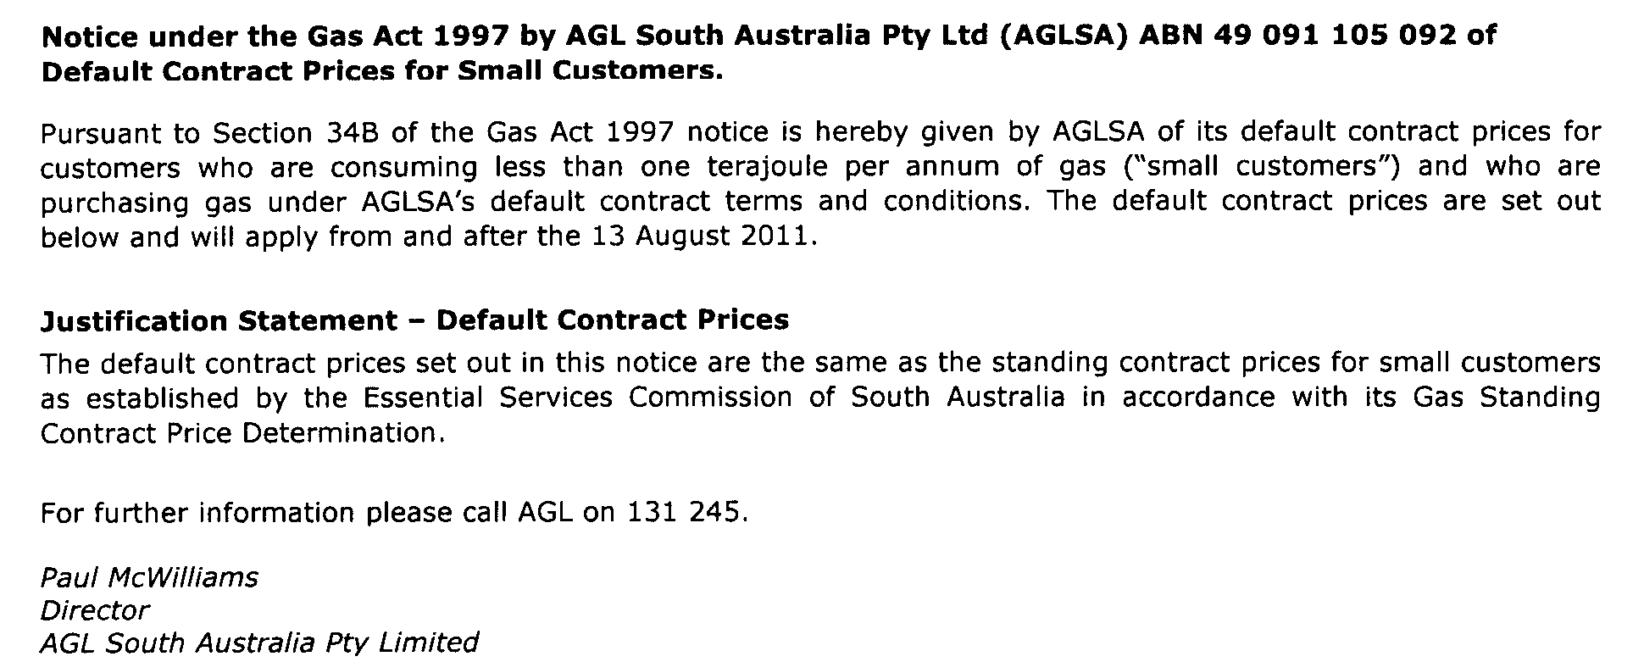

GOVERNMENT FINANCING AUTHORITY ACT 1982
Section 23
Notice of the Treasurer
PURSUANT to Section 23 of the Government Financing Authority Act 1982 (SA), I:
1. Exempt the following instruments from being charged with stamp duty under the Stamp Duties Act 1923 (SA):
(a) any of the Transaction Documents to which the Minister for Health, as a body corporate and declared semi-government authority for the purposes of the Government Financing Authority Act 1982 (SA) (Minister), or South Australian Government Financing Authority (Authority), is a party; and
(b) any instrument that arises from or is connected with the Transactions and to which the Minister is a party.
2. For the purposes of this notice:
‘Transactions’ mean the transactions under or contemplated by a Transaction Document, and relating to the design, construction, commissioning, financing and maintenance of the facility under the Project Agreement between the Minister and SA Health Partnership Nominees Pty Ltd (SAHP), dated 20 May 2011 (Project Agreement).
‘Transaction Document’ means each of the following instruments:
(a) the Project Agreement;
(b) the deed entitled ‘Financier Direct Deed’ between, among others the Minister, SAHP and SA Health Partnership Securitisation Pty Limited (SAHPS), dated 20 May 2011;
(c) the document entitled ‘State Security’ granted by SAHP to the Minister, dated 20 May 2011;
(d) the agreement entitled ‘Independent Certifier Agreement’ between, among others, the Minister and SAHP, dated 20 May 2011;
(e) the deed entitled ‘Payment Directions Deed’ between the Minister, SAHP and SAHPS, dated 20 May 2011;
(f) the deed entitled ‘Receivables Sale Deed’ between the Minister, SAHP and SAHPS, dated 20 May 2011;
(g) the agreement entitled ‘State Loan Agreement’ between the Minister and SAHPS, dated 20 May 2011;
(h) the document entitled ‘Financial Close Adjustment Protocols’ between, among others, the Minister, the Authority, SAHP and others known as ‘Executing Hedge Counterparties’ (Executing Hedge Counter-
party), dated 20 May 2011 (Financial Close Adjustment Protocols);
(i) each document that evidences a swap transaction entered into between the Authority and an Executing Hedge Counterparty pursuant to the Financial Close Adjustment Protocols; and
(j) each deed entitled ‘Novation Deed’ between the Authority, SA Health Partnership Securitisation Pty Limited and an Executing Hedge Counterparty, dated 20 May 2011.
Dated 23 June 2011.
John James Snelling, Treasurer

HOUSING IMPROVEMENT ACT 1940
WHEREAS by notice published in the Government Gazette on the dates mentioned in the following table the South Australian Housing Trust did declare the houses described in the said table to be substandard for the purposes of Part 7 of the Housing Improvement Act 1940, the South Australian Housing Trust in the exercise of the powers conferred by the said Part, does hereby fix as the maximum rental per week which shall be payable subject to Section 55 of the Residential Tenancies Act 1995, in respect of each house described in the following table the amount shown in the said table opposite the description of such house and this notice shall come into force on the date of this publication in the Gazette.
Address of House | Allotment, Section, etc. | Certificate of Title  Volume Folio | Date and page of Government Gazette in which notice declaring house to be substandard published | Maximum rental per week payable in respect of each house  $

11 Church Road, Mitcham |  | Allotment 2 in Deposited Plan 44599, Hundred of Adelaide | 5329 | 708 |  | 12.5.11, page 1373 | 223.00
Unit 3, 16 Grundy Terrace, Christies Beach |  | Allotment 43 in Deposited Plan 3074, Hundred of Noarlunga | 5177 | 436 |  | 12.5.11, page 1373 | 126.00
536 Salisbury Highway, Parafield Gardens |  | Allotment 156 in Deposited Plan 7815, Hundred of Yatala | 5585 | 983 |  | 9.12.10, page 5560 | 230.00
10 Seventh Street, Morgan |  | Allotment 310 in Filed Plan 177192, Hundred of Eba | 5679 | 198 |  | 12.5.11, page 1373 | 98.00
89 Waterloo Corner Road, Salisbury North |  | Allotment 99 in Deposited Plan 31696, Hundred of Munno Para | 5077 | 200 |  | 12.5.11, page 1373 | 171.00

Dated at Adelaide, 7 July 2011. D. Huxley, Director, Corporate and Board Services

HOUSING IMPROVEMENT ACT 1940
NOTICE is hereby given that the South Australian Housing Trust in the exercise of the powers conferred by the Housing Improvement Act 1940, does hereby declare the houses described in the table hereunder to be substandard for the purposes of Part 7 of the Housing Improvement Act 1940.
No. of House and Street | Locality | Allotment, Section, etc. | Certificate of Title  Volume Folio

28-30 Cameron Street |  | Gawler | Allotment 38 in Filed Plan 154439, Hundred of Mudla Wirra | 5359 | 869
30 Grant Avenue |  | Salisbury Downs | Allotment 59 in Deposited Plan 10191, Hundred of Yatala | 5755 | 200
19 Midhurst Avenue |  | Christie Downs | Allotment 314 in Deposited Plan 9667, Hundred of Noarlunga | 5102 | 346
Unit 3, 45 Nelson Road |  | Valley View | Allotment 14 in Deposited Plan 7613, Hundred of Yatala | 5561 | 442
25 Small Crescent |  | Smithfield Plains | Allotment 7 in Deposited Plan 51167, Hundred of Munno Para | 5631 | 580
36 Underdown Road |  | Elizabeth South | Allotment 8 in Deposited Plan 42184, Hundred of Munno Para | 6011 | 135

Dated at Adelaide, 7 July 2011. D. Huxley, Director, Corporate and Board Services

HOUSING IMPROVEMENT ACT 1940
WHEREAS by notice published in the Government Gazette on the dates mentioned in the following table the South Australian Housing Trust did declare the houses described in the said table to be substandard for the purposes of Part 7 of the Housing Improvement Act 1940, and whereas the South Australian Housing Trust is satisfied that each of the houses described hereunder has ceased to be substandard, notice is hereby given that, in exercise of the powers conferred by the said Part, the South Australian Housing Trust does hereby revoke the said declaration in respect of each house.
Address of House | Allotment, Section, etc. | Certificate of Title  Volume Folio | Date and page of Government Gazette in which notice declaring house to be substandard published

21 Dale Street, Port Adelaide |  | Allotments 100-101 in Community Plan 25524, Hundred of Port Adelaide | 6054  6054  6054 | 994  995  996 |  | 4.1.01, page 13
189 Grand Junction Road, Ottoway |  | Allotment 14 in Deposited Plan 2543, Hundred of Port Adelaide | 5742 | 373 |  | 17.3.11, page 781

Dated at Adelaide, 7 July 2011. D. Huxley, Director, Corporate and Board Services

LIQUOR LICENSING ACT 1997 AND GAMING MACHINES ACT 1992
Notice of Application
NOTICE is hereby given, pursuant to Section 52 of the Liquor Licensing Act 1997 and Section 29 of the Gaming Machines Act 1992, that Colin Alfred Phillips and Pauline Phillips have applied to the Licensing Authority for the transfer of a Hotel and Gaming Licence in respect of premises situated at Park Lane, Burra North, S.A. 5417 and known as Bon Accord Hotel.
The applications have been set down for hearing on 8 August 2011 at 9.30 a.m.
Any person may object to the application by lodging a notice of objection in the prescribed form with the Liquor and Gambling Commissioner and serving a copy of the notice on the applicants at the applicants’ address, at least seven days before the hearing date (viz: 1 August 2011).
The applicants’ address for service is c/o Duncan Basheer Hannon, G.P.O. Box 2, Adelaide, S.A. 5001 (Attention: David Tillett).
The application and certain documents and material (including Plans) relevant to the application may be inspected without fee at a place and during a period specified by the Liquor and Gambling Commissioner, 9th Floor, East Wing, 50 Grenfell Street, Adelaide, S.A. 5000. Telephone: 8226 8500. Facsimile: 8226 8512. Email: olgc@agd.sa.gov.au.
Dated 4 July 2011.
Applicants

LIQUOR LICENSING ACT 1997
Notice of Application
NOTICE is hereby given, pursuant to Section 52 (2) (b) of the Liquor Licensing Act 1997, that Concetta Calabro has applied to the Licensing Authority for a Restaurant Licence with Section 34 (1) (c) in respect of premises situated at 248 Unley Road, Unley, S.A. 5061 and to be known as Our Expresso.
The application has been set down for hearing on 8 August 2011 at 11 a.m.
Any person may object to the application by lodging a notice of objection in the prescribed form with the Liquor and Gambling Commissioner and serving a copy of the notice on the applicant at the applicant’s address, at least seven days before the hearing date (viz: 1 August 2011).
The applicant’s address for service is c/o Concetta Calabro, 248 Unley Road, Unley, S.A. 5061.
The application and certain documents and material (including Plans) relevant to the application may be inspected without fee at a place and during a period specified by the Liquor and Gambling Commissioner, 9th Floor, East Wing, 50 Grenfell Street, Adelaide, S.A. 5000. Telephone: 8226 8500. Facsimile: 8226 8512. Email: olgc@agd.sa.gov.au.
Dated 4 July 2011.
Applicant

LIQUOR LICENSING ACT 1997
Notice of Application
NOTICE is hereby given, pursuant to Section 52 (2) (b) of the Liquor Licensing Act 1997, that Purdey Vale Pty Ltd as trustee for the R. D. Jones Bridgeway Trust has applied to the Licensing Authority for alterations, redefinition, variation to Entertainment Consent and variation to Extended Trading Authorisation in respect of premises situated at 18-24 Bridge Road, Pooraka, S.A. 5095 and known as Bridgeway Hotel.
The application has been set down for hearing on 8 August 2011 at 10 a.m.
Conditions
The following licence conditions are sought:
• Variation to the current Extended Trading Authorisation to include outdoor decking area as per plans lodged.
• Entertainment in the redefined area shall be limited to in-house music only.
Any person may object to the application by lodging a notice of objection in the prescribed form with the Liquor and Gambling Commissioner and serving a copy of the notice on the applicant at the applicant’s address, at least seven days before the hearing date (viz: 1 August 2011).
The applicant’s address for service is c/o Duncan Basheer Hannon, G.P.O. Box 2, Adelaide, S.A. 5001 (Attention: Max Basheer or David Tillett).
The application and certain documents and material (including Plans) relevant to the application may be inspected without fee at a place and during a period specified by the Liquor and Gambling Commissioner, 9th Floor, East Wing, 50 Grenfell Street, Adelaide, S.A. 5000. Telephone: 8226 8500. Facsimile: 8226 8512. Email: olgc@agd.sa.gov.au.
Dated 4 July 2011.
Applicant

LIQUOR LICENSING ACT 1997
Notice of Application
NOTICE is hereby given, pursuant to Section 52 (2) (b) of the Liquor Licensing Act 1997, that Teusner & Page Pty Ltd has applied to the Licensing Authority for the removal of a Producer’s Licence in respect of premises currently situated at 29 Jane Place, Tanunda, S.A. 5352, to be situated at the corner of Railway Terrace and Research Road, Nuriootpa, S.A. 5355 and to be known as Teusner Wines.
The application has been set down for hearing on 2 August 2011 at 10.30 a.m.
Any person may object to the application by lodging a notice of objection in the prescribed form with the Liquor and Gambling Commissioner and serving a copy of the notice on the applicant at the applicant’s address, at least seven days before the hearing date (viz: 26 July 2011).
The applicant’s address for service is c/o Talbot Olivier Lawyers, G.P.O. Box 2569, Perth, W.A. 6000 (Attention: Jarrod Ryan).
The application and certain documents and material (including Plans) relevant to the application may be inspected without fee at a place and during a period specified by the Liquor and Gambling Commissioner, 9th Floor, East Wing, 50 Grenfell Street, Adelaide, S.A. 5000. Telephone: 8226 8500. Facsimile: 8226 8512. Email: olgc@agd.sa.gov.au.
Dated 30 June 2011.
Applicant

LIQUOR LICENSING ACT 1997
Notice of Application
NOTICE is hereby given, pursuant to Section 52 (2) (b) of the Liquor Licensing Act 1997, that Para Praia Pty Ltd has applied to the Licensing Authority for alterations, redefinition, Entertainment Consent and the transfer of a Restaurant Licence in respect of premises situated at Port Noarlunga Foreshore, Port Noarlunga, S.A. 5167, known as Reef Café and to be known as Hortas.
The application has been set down for hearing on 2 August 2011 at 9.30 a.m.
Conditions
The following licence conditions are sought:
• Alterations and redefinition to include the major refurbishment and extensions as per plan lodged.
• Entertainment Consent is sought for all internal areas as per plans lodged and for the following days and times:
Thursday and Friday: Noon to 11 p.m.;
Saturday: Noon to 11.30 p.m.;
Sunday: Noon to 11 p.m.;
Maundy Thursday: Noon to 11 p.m.;
Christmas Eve: Noon to 11 p.m.;
Sunday Christmas Eve: Noon to 11 p.m.;
Days preceding other Public Holidays: Noon to 11 p.m.; and
Sundays preceding Public Holidays: Noon to 11 p.m.;
• Entertainment Consent to be limited by the following:
Three piece band and DJ for functions.
No amplification to outside areas of the premises.
Any person may object to the application by lodging a notice of objection in the prescribed form with the Liquor and Gambling Commissioner and serving a copy of the notice on the applicant at the applicant’s address, at least seven days before the hearing date (viz: 26 July 2011).
The applicant’s address for service is c/o Paula Horta, 85 Jetty Road, Brighton, S.A. 5045.
The application and certain documents and material (including Plans) relevant to the application may be inspected without fee at a place and during a period specified by the Liquor and Gambling Commissioner, 9th Floor, East Wing, 50 Grenfell Street, Adelaide, S.A. 5000. Telephone: 8226 8500. Facsimile: 8226 8512. Email: olgc@agd.sa.gov.au.
Dated 30 June 2011.
Applicant

LIQUOR LICENSING ACT 1997
Notice of Application
NOTICE is hereby given, pursuant to Section 52 (2) (b) of the Liquor Licensing Act 1997, that Lunar Wines Pty Ltd has applied to the Licensing Authority for the removal of a Producer’s Licence in respect of premises situated at 108 Seppeltsfield Road, Marananga, S.A. 5355, now to be situated at 7 Mill Street, Tanunda, S.A. 5352 and known as Lunar Wines.
The application has been set down for hearing on 8 August 2011 at 9 a.m.
Any person may object to the application by lodging a notice of objection in the prescribed form with the Liquor and Gambling Commissioner and serving a copy of the notice on the applicant at the applicant’s address, at least seven days before the hearing date (viz: 1 August 2011).
The applicant’s address for service is c/o Corey Chaplin, 7 Mill Street, Tanunda, S.A. 5352.
The application and certain documents and material (including Plans) relevant to the application may be inspected without fee at a place and during a period specified by the Liquor and Gambling Commissioner, 9th Floor, East Wing, 50 Grenfell Street, Adelaide, S.A. 5000. Telephone: 8226 8500. Facsimile: 8226 8512. Email: olgc@agd.sa.gov.au.
Dated 30 June 2011.
Applicant

LIQUOR LICENSING ACT 1997
Notice of Application
NOTICE is hereby given, pursuant to Section 52 (2) (b) of the Liquor Licensing Act 1997, that Wirrulla Hotel Holdings Pty Ltd as trustee for S. & T. Patterson Pub Trust and A. & D. Patterson Pub Trust has applied to the Licensing Authority for the transfer of a Hotel Licence in respect of premises situated at 75 Hay Terrace, Wirrulla, S.A. 5661 and known as Wirrulla Hotel.
The application has been set down for hearing on 2 August 2011 at 10.30 a.m.
Any person may object to the application by lodging a notice of objection in the prescribed form with the Liquor and Gambling Commissioner and serving a copy of the notice on the applicant at the applicant’s address, at least seven days before the hearing date (viz: 26 July 2011).
The applicant’s address for service is c/o Piper Alderman Lawyers, G.P.O. Box 65, Adelaide, S.A. 5001 (Attention: Geoff Forbes or Jonathan Dodd).
The application and certain documents and material (including Plans) relevant to the application may be inspected without fee at a place and during a period specified by the Liquor and Gambling Commissioner, 9th Floor, East Wing, 50 Grenfell Street, Adelaide, S.A. 5000. Telephone: 8226 8500. Facsimile: 8226 8512. Email: olgc@agd.sa.gov.au.
Dated 29 June 2011.
Applicant

MINING ACT 1971
NOTICE is hereby given in accordance with Section 28 (5) of the Mining Act 1971, that the Minister for Mineral Resources Development proposes to grant an Exploration Licence over the undermentioned area:
Applicant: Madam Resources Pty Ltd
Location: Strawbridge Hill area—Approximately 90 km north-west of Port Augusta.
Pastoral Leases: Oakden Hills, Yudnapinna and Lake Blyth.
Term: 1 year
Area in km²: 405
Ref.: 2010/00222
Plan and co-ordinates can be found on the PIRSA website: http://www.pir.sa.gov.au/minerals/public_notices or by phoning Mineral Tenements on (08) 8463 3103.
J. Martin, Mining Registrar

MINING ACT 1971
NOTICE is hereby given in accordance with Section 28 (5) of the Mining Act 1971, that the Minister for Mineral Resources Development proposes to grant an Exploration Licence over the undermentioned area:
Applicant: Madam Resources Pty Ltd
Location: South Oakden Hill area—Approximately 140 km north-west of Port Augusta.
Pastoral Lease: Oakden Hills
Term: 1 year
Area in km²: 363
Ref.: 2010/00227
Plan and co-ordinates can be found on the PIRSA website: http://www.pir.sa.gov.au/minerals/public_notices or by phoning Mineral Tenements on (08) 8463 3103.
J. Martin, Mining Registrar

MINING ACT 1971
NOTICE is hereby given in accordance with Section 28 (5) of the Mining Act 1971, that the Minister for Mineral Resources Development proposes to grant an Exploration Licence over the undermentioned area:
Applicants: Manjunatha Kalal V (50%) and
Usha Pawar (50%).
Location: Hughes area—Approximately 450 km west of Ceduna.
Term: 2 years
Area in km²: 233
Ref.: 2010/00333
Plan and co-ordinates can be found on the PIRSA website: http://www.pir.sa.gov.au/minerals/public_notices or by phoning Mineral Tenements on (08) 8463 3103.
J. Martin, Mining Registrar

MINING ACT 1971
NOTICE is hereby given in accordance with Section 28 (5) of the Mining Act 1971, that the Minister for Mineral Resources Development proposes to grant an Exploration Licence over the undermentioned area:
Applicant: Phoenix Copper Limited
Location: Bald Hill North area—Immediately west of Burra
Term: 2 years
Area in km²: 69
Ref.: 2011/00129
Plan and co-ordinates can be found on the PIRSA website: http://www.pir.sa.gov.au/minerals/public_notices or by phoning Mineral Tenements on (08) 8463 3103.
J. Martin, Mining Registrar

MINING ACT 1971
NOTICE is hereby given in accordance with Section 28 (5) of the Mining Act 1971, that the Minister for Mineral Resources Development proposes to grant an Exploration Licence over the undermentioned area:
Applicant: Centrex Metals Limited
Location: Cockabidnie area—Approximately 120 km south-west of Port Augusta.
Term: 2 years
Area in km²: 154
Ref.: 2011/00149
Plan and co-ordinates can be found on the PIRSA website: http://www.pir.sa.gov.au/minerals/public_notices or by phoning Mineral Tenements on (08) 8463 3103.
J. Martin, Mining Registrar

MINING ACT 1971
NOTICE is hereby given in accordance with Section 28 (5) of the Mining Act 1971, that the Minister for Mineral Resources Development proposes to grant an Exploration Licence over the undermentioned area:
Applicant: Centrex Metals Limited
Location: Minbrie area—Approximately 20 km north-west of Cowell.
Term: 2 years
Area in km²: 117
Ref: 2011/00150
Plan and co-ordinates can be found on the PIRSA website: http://www.pir.sa.gov.au/minerals/public_notices or by phoning Mineral Tenements on (08) 8463 3103.
J. Martin, Mining Registrar

MINING ACT 1971
NOTICE is hereby given in accordance with Section 28 (5) of the Mining Act 1971, that the Minister for Mineral Resources Development proposes to grant an Exploration Licence over the undermentioned area:
Applicant: Centrex Metals Limited
Location: Green Patch area—Immediately north-west of Port Lincoln.
Term: 2 years
Area in km²: 79
Ref.: 2011/00151
Plan and co-ordinates can be found on the PIRSA website: http://www.pir.sa.gov.au/minerals/public_notices or by phoning Mineral Tenements on (08) 8463 3103.
J. Martin, Mining Registrar

MINING ACT 1971
NOTICE is hereby given in accordance with Section 28 (5) of the Mining Act 1971, that the Minister for Mineral Resources Development proposes to grant an Exploration Licence over the undermentioned area:
Applicant: Minotaur Operations Pty Ltd
Location: Mingary area—Approximately 40 km north-east of Olary.
Pastoral Leases: Wompinie, Mulyungarie, Mundi Mundi, Mutooroo, Pine Creek, Tepco and Tikalina.
Term: 2 years
Area in km²: 671
Ref.: 2011/00153
Plan and co-ordinates can be found on the PIRSA website: http://www.pir.sa.gov.au/minerals/public_notices or by phoning Mineral Tenements on (08) 8463 3103.
J. Martin, Mining Registrar

NOTICE TO MARINERS
No. 24 of 2011
South Australia—Gulf St Vincent—Buoys Temporarily Deployed for Wastewater Project
COMMENCING on 11 July to 19 August 2011, a total of 204 chambers filled with macroalgae will be deployed in a grid pattern along the Adelaide metropolitan coast in three separate and sequential stages. Each chamber has a SARDI identification tag attached to an 8 inch white buoy with fluorescent pink stripes, and is anchored by a 12 kg weight.
For the first and second stages chambers will be deployed on a 0.54 nautical mile grid pattern.
The first stage will be deployed for five weekdays in the period between 11 and 29 July (weather dependent) between the latitudes of 34°59′ South and 35°12′ South, with the most offshore sites located approximately 3 nautical miles from land.
The second stage will be deployed for five weekdays in the period between 18 July and 5 August (weather dependent) between the latitudes of 34°48′ South and 34°59.5′ South with the most offshore sites located approximately 3 nautical miles from land. Four additional chambers will be deployed 2 to 3 nautical miles apart along a transect at a latitude around 34°49′ South and between 4.5 and 12.5 nautical miles offshore.
The third stage will be deployed during weekdays over two separate weeks in the period between 25 July and 19 August (weather dependent) between the latitudes of 34°35′ South and 34°50′ South and less than 6 nautical miles from land chambers will be deployed in a 0.54 nautical mile grid pattern. An additional 17 chambers will be deployed 2-3 nautical miles apart between the latitudes of 34°31.5′ South and 34°46′ South and at distances between 4 and 15 nautical miles offshore.
Mariners are advised to exercise caution when navigating in these areas.
For more detailed information about the deployments please contact Grant Westphalen on 0405 755 764.
Charts affected: Aus 130, 137, 138 and 781.
Adelaide, 29 June 2011.
Patrick Conlon, Minister for Transport
DTEI 2011/00735

NOTICE TO MARINERS
No. 25 of 2011
South Australia—Gulf St Vincent—Barker Inlet—
New Navigation Markers Installed
MARINERS are advised that three new Starboard hand unlit markers with conical shape topmarks have been installed in the Barker Inlet. Co-ordinates of the markers in WGS 84 datum are as follows:
(1) Latitude 34°45′05.64″S, longitude 138°30′57.96″E.
(2) Latitude 34°44′16.62″S, longitude 138°28′41.58″E.
(3) Latitude 34°44′05.52″S, longitude 138°28′14.34″E.
Also note that the light characteristics on the existing navigation marker in position latitude 34°47′10.85″S, longitude 138°32′34.19″E, has been changed from Fl. (W) to Fl. (G) 4 seconds, range 2 nautical miles.
Charts affected: Aus 130.
Adelaide, 1 July 2011.
Patrick Conlon, Minister for Transport
DTEI 2011/99735

NATURAL RESOURCES MANAGEMENT ACT 2004
Instrument of Appointment of Authorised Officers
PURSUANT to Section 66 (1) of the Natural Resources Manage-ment Act 2004, (the Act), I, Paul Caica, Minister for Environment and Conservation in the State of South Australia, do hereby appoint the following persons to be State Authorised Officers for the purposes prescribed under the Act in the State of South Australia subject to the conditions that they are prohibited from exercising any of the following powers as detailed in the Act:
• Applying for a magistrate’s warrant, pursuant to Section 69.
• Exercising a general power, pursuant to Section 69 (3) in respect of residential premises.
• Acting as a ‘relevant authority’, pursuant to Sections 121, 182 and 192.
• Issuing a protection order or notice to prepare an action plan in respect of a native animal, pursuant to Section 184.
• Issuing a protection order, pursuant to Section 193 unless that order is an emergency protection order.
• Issuing a reparation order, pursuant to Section 195.
• Commencing proceedings for an offence against the Act, pursuant to Section 217.
• Issuing an expiation notice:
Amanda Beasley (Department for Water)
James Brown (Department for Water)
Aaron McArthur (Department for Water)
Daniel McCullough (Department for Water)
Michael Payne (Department for Water)
Jo Rohrlach (Department for Water)
Hayden Smith (Department for Water)
These appointments will commence on the date of appointment and will remain in effect for the period the named persons are employed by or contracted to the Department of Water unless earlier varied or revoked.
Dated 5 July 2011.
Paul Caica, Minister for Environment and Conservation

PETROLEUM AND GEOTHERMAL ENERGY ACT 2000
Suspension of Geothermal Exploration Licence—GEL 230
PURSUANT to Section 90 of the Petroleum and Geothermal Energy Act 2000, notice is hereby given that the abovementioned Geothermal Exploration Licence has been suspended under the provisions of the Petroleum and Geothermal Energy Act 2000, for the period from and including 4 July 2011 until 22 January 2012, pursuant to delegated powers dated 1 October 2009.
The expiry date of GEL 230 is now determined to be 23 January 2012.
Dated 4 July 2011.
B. A. Goldstein,
Executive Director Petroleum and Geothermal
Minerals and Energy Resources
Primary Industries and Resources SA
Delegate of the Minister for Mineral
Resources Development

PETROLEUM AND GEOTHERMAL ENERGY ACT 2000
Suspension of Geothermal Exploration Licences—
GELs 294 and 295
PURSUANT to Section 90 of the Petroleum and Geothermal Energy Act 2000, notice is hereby given that the abovementioned Exploration Licences have been suspended under the provisions of the Petroleum and Geothermal Energy Act 2000, for the period from and including 1 July 2011 until 30 June 2012, pursuant to delegated powers dated 1 October 2009.
The expiry date of GELs 294 and 295 is now determined to be
8 February 2015.
Dated 30 June 2011.
C. D. Cockshell,
Acting Executive Director Petroleum and Geothermal
Minerals and Energy Resources
Primary Industries and Resources SA
Delegate of the Minister for Mineral
Resources Development

ROADS (OPENING AND CLOSING) ACT 1991:
SECTION 24
NOTICE OF CONFIRMATION OF ROAD
PROCESS ORDER
Road Closure—Doon Terrace, Jamestown
BY Road Process Order made on 10 February 2011, the Northern Areas Council ordered that:
1. The greater portion of the public road (Doon Terrace) generally situate east of Irvine Street adjoining Section 739, Hundred of Belalie and Allotment 6 in Deposited Plan 48978, more particularly being the greater portion of the land lettered ‘A’ on Preliminary Plan No. 10/0005 be closed.
2. Issue a Certificate of Title to the Northern Areas Council for the whole of the land subject to closure which land is being retained by Council to merge with the adjoining Council owned land.
On 18 April 2011 that order was confirmed by the Minister for Infrastructure conditionally upon the deposit by the Registrar-General of Deposited Plan 86689 being the authority for the new boundaries
Pursuant to Section 24 (5) of the Roads (Opening and Closing) Act 1991, NOTICE of the order referred to above and its confirmation is hereby given.
Dated 7 July 2011.
P. M. Kentish, Surveyor-General

ROADS (OPENING AND CLOSING) ACT 1991:
SECTION 37
NOTICE is hereby given pursuant to Section 37 (1) of the Roads (Opening and Closing) Act, 1991 that:
WHEREAS it is considered that CARL FRIEDRICH WILHELM POHLNER of near Angaston, sheep farmer was entitled to a Certificate of Title over the balance of closed road ‘A’ in exchange for portions of Section 537, Hundred of Moorooroo, opened as road and being portions of the land numbered ‘1’ in Road Plan No. 178, deposited in the Office of the Surveyor-General at Adelaide vide notice of confirmation of road order published in the Government Gazette of 5 February 1885 at page 497:
AND whereas no Certificate of Title was issued in respect of the said closed road and the said CARL FRIEDRICH WILHELM POHLNER is believed to be dead or unknown:
AND whereas application is made by DAVID KILPIN of
74 Orontes Avenue, Bridgewater S.A. 5155, for the issue of a Certificate of Title over the said closed road by virtue of possession:
AND whereas I am satisfied that the applicant is in possession of the said closed road and that there is apparently no other known person entitled to possession thereof:
TAKE NOTICE that unless objection by any person claiming any interest in the said land is made in writing to me within one month from the date of this notice, I propose to issue a Certificate of Title for the said land to the said applicant.
Objections should be addressed to the Surveyor-General, Department for Transport, Energy and Infrastructure, G.P.O. Box 1354, Adelaide, S.A. 5001.
Dated 7 July 2011.
P. M. Kentish, Surveyor-General

WATER MAINS AND SEWERS

Office of the South Australian Water Corporation
Adelaide, 7 July 2011

WATER MAINS LAID

Notice is hereby given that the following main pipes or parts of main pipes have been laid down by the South Australian Water Corporation in or near the undermentioned water districts and are now available for a constant supply of water to adjacent land.

ADELAIDE WATER DISTRICT

CITY OF CHARLES STURT
In and across McLean Street, Beverley. p39
Myer Court, Beverley. p39
Easement in reserve (lot 17 in LTRO DP 85379), McLean Street, Beverley. p39
Across George Street, Beverley. p39
Across Pickering Street, Brompton. p42
Boucatt Place, Brompton. p42

CITY OF MARION
Calstock Avenue, Edwardstown. p2
Across Yartoo Street, Hallett Cove. p38
Douglas Court, Hallett Cove. p38
Maitland Street, Dover Gardens. p43

CITY OF ONKAPARINGA
Walnut Street, Old Reynella. p3

CITY OF PLAYFORD
Fradd Road, Angle Vale. p12
Crabb Road, Smithfield Plains. p53
Small Crescent, Smithfield Plains. p54
Small Crescent, Smithfield Plains. p55

CITY OF PORT ADELAIDE ENFIELD
Nelson Street, Semaphore. p1
Dawlish Road, Osborne. p8

CITY OF TEA TREE GULLY
Tuscan Road, Golden Grove. p40 and 41
Quartz Court, Golden Grove. p40

CITY OF UNLEY
Cross Road, Unley Park. p4-7

BRINKLEY COUNTRY LANDS WATER DISTRICT

THE RURAL CITY OF MURRAY BRIDGE
Maurice Road, Rocky Gully. This main is available on application only—not available for constant rateable supply. p26

MURRAY BRIDGE WATER DISTRICT

THE RURAL CITY OF MURRAY BRIDGE
Maurice Road, Murray Bridge. This main is available on application only—not available for constant rateable supply. p26

MALLALA WATER DISTRICT

DISTRICT COUNCIL OF MALLALA
Dublin Road, Mallala. p24 and 25

PORT AUGUSTA WATER DISTRICT

PORT AUGUSTA CITY COUNCIL
Brian Street, Stirling North. p13

PORT VICTOR WATER DISTRICT

CITY OF VICTOR HARBOR
Central Drive, Victor Harbor. p37

TOD RIVER COUNTRY LANDS WATER DISTRICT

DISTRICT COUNCIL OF LOWER EYRE PENINSULA
Easements in section 68, hundred of Cummins. p58
Railway land (section 30, hundred of Cummins). p58
Easements in lot 700 in LTRO DP 85937, Bratten Way, Cummins. p58

WHYALLA WATER DISTRICT

THE CORPORATION OF THE CITY OF WHYALLA
Pattinson Close, Whyalla Norrie. p17

OUTSIDE WATER DISTRICTS

THE RURAL CITY OF MURRAY BRIDGE
Phillips Road, Woods Point. This main is available on application only—not available for constant rateable supply. p27, 28 and 35
Jervois Road, Woods Point. This main is available on application only—not available for constant rateable supply. p28-35

WATER MAINS ABANDONED

Notice is hereby given that the undermentioned water mains have been abandoned by the South Australian Water Corporation.

ADELAIDE WATER DISTRICT

CITY OF PLAYFORD
Crabb Road, Smithfield Plains. p53
Small Crescent, Smithfield Plains. p54
Small Crescent, Smithfield Plains. p55

CITY OF UNLEY
Cross Road, Unley Park. p4-7
Victoria Avenue, Unley Park. p4
Whistler Avenue, Unley Park. p4
Grove Street, Unley Park. p5
George Street, Unley Park. p6
View Street, Unley Park. p6 and 7

MOONTA WATER DISTRICT

DISTRICT COUNCIL OF THE COPPER COAST
Barbary Court, North Moonta. p18
Easement in lot 11 in LTRO DP 85024, Barbary Court, North Moonta. p18

TOD RIVER COUNTRY LANDS WATER DISTRICT

DISTRICT COUNCIL OF LOWER EYRE PENINSULA
Easements in section 68, hundred of Cummins. p58
Railway land (section 30, hundred of Cummins). p58
Easements in lot 700 in LTRO DP 85937, Bratten Way, Cummins. p58

WHYALLA WATER DISTRICT

THE CORPORATION OF THE CITY OF WHYALLA
Pattinson Close, Whyalla Norrie. p17

OUTSIDE WATER DISTRICTS

THE RURAL CITY OF MURRAY BRIDGE
In and across Phillips Road, Woods Point. p36
Easements in section 1341, hundred of Brinkley, The Point Road, Woods Point. p36

WATER MAINS LAID

Notice is hereby given that the undermentioned water main has been laid down by the South Australian Water Corporation and is not available for a constant supply of water to adjacent land.

TOD RIVER COUNTRY LANDS WATER DISTRICT

DISTRICT COUNCIL OF CLEVE
Easements in section 23, hundred of Mann, Rehn Road, Cleve. p44-47

ADDENDUM

Addendum to notice in “Government Gazette” of 25 May 1995

“WATER MAINS LAID”

“Notice is hereby given that the following main pipes or parts of main pipes have been laid down by the Minister for Infrastructure in or near the undermentioned water districts and are now available for a constant supply of water to adjacent land.”

“BRINKLEY COUNTRY LANDS WATER DISTRICT”

“RURAL CITY OF MURRAY BRIDGE”
“Government road south-west of section 535, hundred of Mobilong. p18”

To this notice add “This main is available on application only—not available for constant rateable supply.” p26

CORRECTION

Correction to notice in “Government Gazette” of 14 October 2010.

“WATER MAINS LAID”

“Notice is hereby given that the following main pipes or parts of main pipes have been laid down by the South Australian Water Corporation in or near the undermentioned water districts and are now available for a constant supply of water to adjacent land.”

“ADELAIDE WATER DISTRICT”

“CITY OF PORT ADELAIDE ENFIELD”
“Estella Street, Osborne. p10”
For “Estella Street” read “Furniss Court”

DELETION

Deletion of notice in “Government Gazette” of 8 March 1973

“WATER MAINS REPLACED”

“BRINKLEY WATER DISTRICT” (now Brinkley Country Lands Water District)

“DISTRICT OF MOBILONG” (now the Rural City of Murray Bridge)

“Government road south and south-west of section 536s, and south-west of section 535, hundred of Mobilong—4,625ft. of 3in. A.C. main continuation of 3in. main from boundary of Murray Bridge water district running westerly and north-westerly; replacing 4,638ft. of 2in. main.”

Delete this notice

SEWERS LAID

Notice is hereby given that the following sewers have been laid down by the South Australian Water Corporation in the undermentioned drainage areas and are now available for house connections.

ADELAIDE DRAINAGE AREA

CITY OF BURNSIDE
Gurrs Road, Beulah Park. FB 1208 p38

CAMPBELLTOWN CITY COUNCIL
Easement in lots 52 and 26 in LTRO DP 20192, River Drive, Paradise. FB 1208 p39

CITY OF CHARLES STURT
Easements in lot 189 in LTRO DP 6123, Hobart Road and lot 20 in LTRO DP 74610, Burnley Street, Henley Beach South. FB 1208 p24
Easements in lot 15 in LTRO DP 64907, Manor Court and lots 52 and 50 in LTRO DP 69378, Frederick Road, Grange. FB1208 p31
Monaco Crescent, Grange. FB 1208 p36
Derby Street, Albert Park. FB 1208 p40
Lachlan Avenue, Woodville West. FB 1208 p41
Botting Street, Albert Park. FB 1208 p43
Osborne Street, Albert Park. FB 1208 p43
Across McLean Street, Beverley. FB 1207 p39
Myer Court, Beverley. FB 1207 p39
Across Pickering Street, Brompton. FB 1207 p46
Boucatt Place, Brompton. FB 1207 p46

CITY OF HOLDFAST BAY
Easements in section 1540, hundred of Noarlunga, Burnham Road and section 1539, hundred of Noarlunga, Esplanade, Kingston Park. FB 1208 p29
Moten Avenue, Glenelg North. FB 1208 p47

CITY OF MARION
Calstock Avenue, Edwardstown. FB 1208 p26
Across Angus Avenue, Edwardstown. FB 1208 p33
Emerald Street, Edwardstown. FB 1208 p33
Maitland Street, Dover Gardens. FB 1208 p48
Easement in lot 14 in LTRO DP 73546, Douglas Court, Hallett Cove. FB 1207 p37 and 38
Douglas Court, Hallett Cove. FB 1207 p37 and 38
Kodaro Road, Hallett Cove. FB 1207 p37 and 38

CITY OF MITCHAM
Elphyn Road, Kingswood. FB 1208 p25
Easement in lot 1 in LTRO DP 65638, Eli Street, Torrens Park. FB 1208 p30
Easement in lots 2 and 1 in LTRO DP 19747, Gloucester Avenue, Belair. FB 1208 p32

CITY OF PORT ADELAIDE ENFIELD
Windsor Grove, Klemzig. FB 1208 p37
Llewen Street, Hillcrest. FB 1208 p45
Goward Street, Northfield. FB 1208 p46
Dally Road, Gilles Plains. FB 1208 p49
Sylvia Street, Blair Athol. FB 1208 p50

CITY OF SALISBURY
Wilfred Avenue, Salisbury. FB 1208 p23

CITY OF TEA TREE GULLY
Lindsay Street, Highbury. FB 1208 p44
Tuscan Road, Golden Grove. FB 1207 p40-43

CITY OF UNLEY
Across and in East Avenue, Clarence Park. FB 1208 p35

CITY OF WEST TORRENS
Across Lipsett Terrace, Brooklyn Park. FB 1208 p42
Hazel Street, Brooklyn Park. FB 1208 p42

HAHNDORF COUNTRY DRAINAGE AREA

DISTRICT COUNCIL OF MOUNT BARKER
Easement in lot 282 in LTRO FP 309, Male Crescent, Hahndorf. FB 1208 p28

VICTOR HARBOR COUNTRY DRAINAGE AREA

CITY OF VICTOR HARBOR
Across Almond Avenue, Victor Harbor—40 mm PE80 pressure sewer system main. This main is available on application only. FB 1208 p27
Lot 10 in LTRO DP 86565, Almond Avenue, Victor Harbor—40 mm PE80 pressure sewer system main. This main is available on application only. FB 1208 p27
In and across Central Drive, Victor Harbor. FB 1207 p44 and 45
Easement in allotment piece 3000 in LTRO DP 86793, Malen Avenue, Victor Harbor. FB 1207 p44 and 45

SEWERS ABANDONED

Notice is hereby given that the undermentioned sewers have been abandoned by the South Australian Water Corporation.

ADELAIDE DRAINAGE AREA

CITY OF CHARLES STURT
Across Military Road, Henley Beach. FB 1208 p34
Easement in lot 71 in LTRO DP 81741, Seaview Road, Henley Beach. FB 1208 p34

CITY OF HOLDFAST BAY
Easements in section 1540, hundred of Noarlunga, Burnham Road and section 1539, hundred of Noarlunga, Esplanade, Kingston Park. FB 1208 p29

A. J. Ringham, Chief Executive Officer, South Australian Water Corporation.

WILDERNESS PROTECTION REGULATIONS 2006
Closure of Billiatt Wilderness Protection Area
PURSUANT to Regulation 6 (2) (c) of the Wilderness Protection Regulations 2006, I, Edward Gregory Leaman, Director of National Parks and Wildlife close to the public the whole of Billiatt Wilderness Protection Area from 6 p.m. on Sunday,
7 August 2011 until 6 a.m. on Saturday, 13 August 2011.
The purpose of the closure is to ensure the safety of the public during a pest control and monitoring program within the wilderness protection area during the period indicated.
Use of Firearms Within the Wilderness Protection Area
Pursuant to Regulations 6 (3), 16 (1) (a) and 34 of the Wilderness Protection Regulations 2006, I, Edward Gregory Leaman, Director of National Parks and Wildlife grant permission to members of the Sporting Shooters Association of Australia Hunting & Conservation Branch (SA) Inc. in possession of both a current Hunting Permit and a firearm to enter and remain in the whole of Billiatt Wilderness Protection Area from 6 p.m. on Sunday, 7 August 2011 until 6 a.m. on Saturday, 13 August 2011, for the purpose of taking feral animals.
This permission is conditional upon the observance by each of those persons of the requirements of the Wilderness Protection Act 1992, Wilderness Protection Regulations 2006 and the National Parks and Wildlife (Hunting) Regulations 1996, including those requiring compliance with the Director’s requests, requirements and orders of a Warden.
Dated 30 June 2011.
E. G. Leaman, Director of National Parks and Wildlife

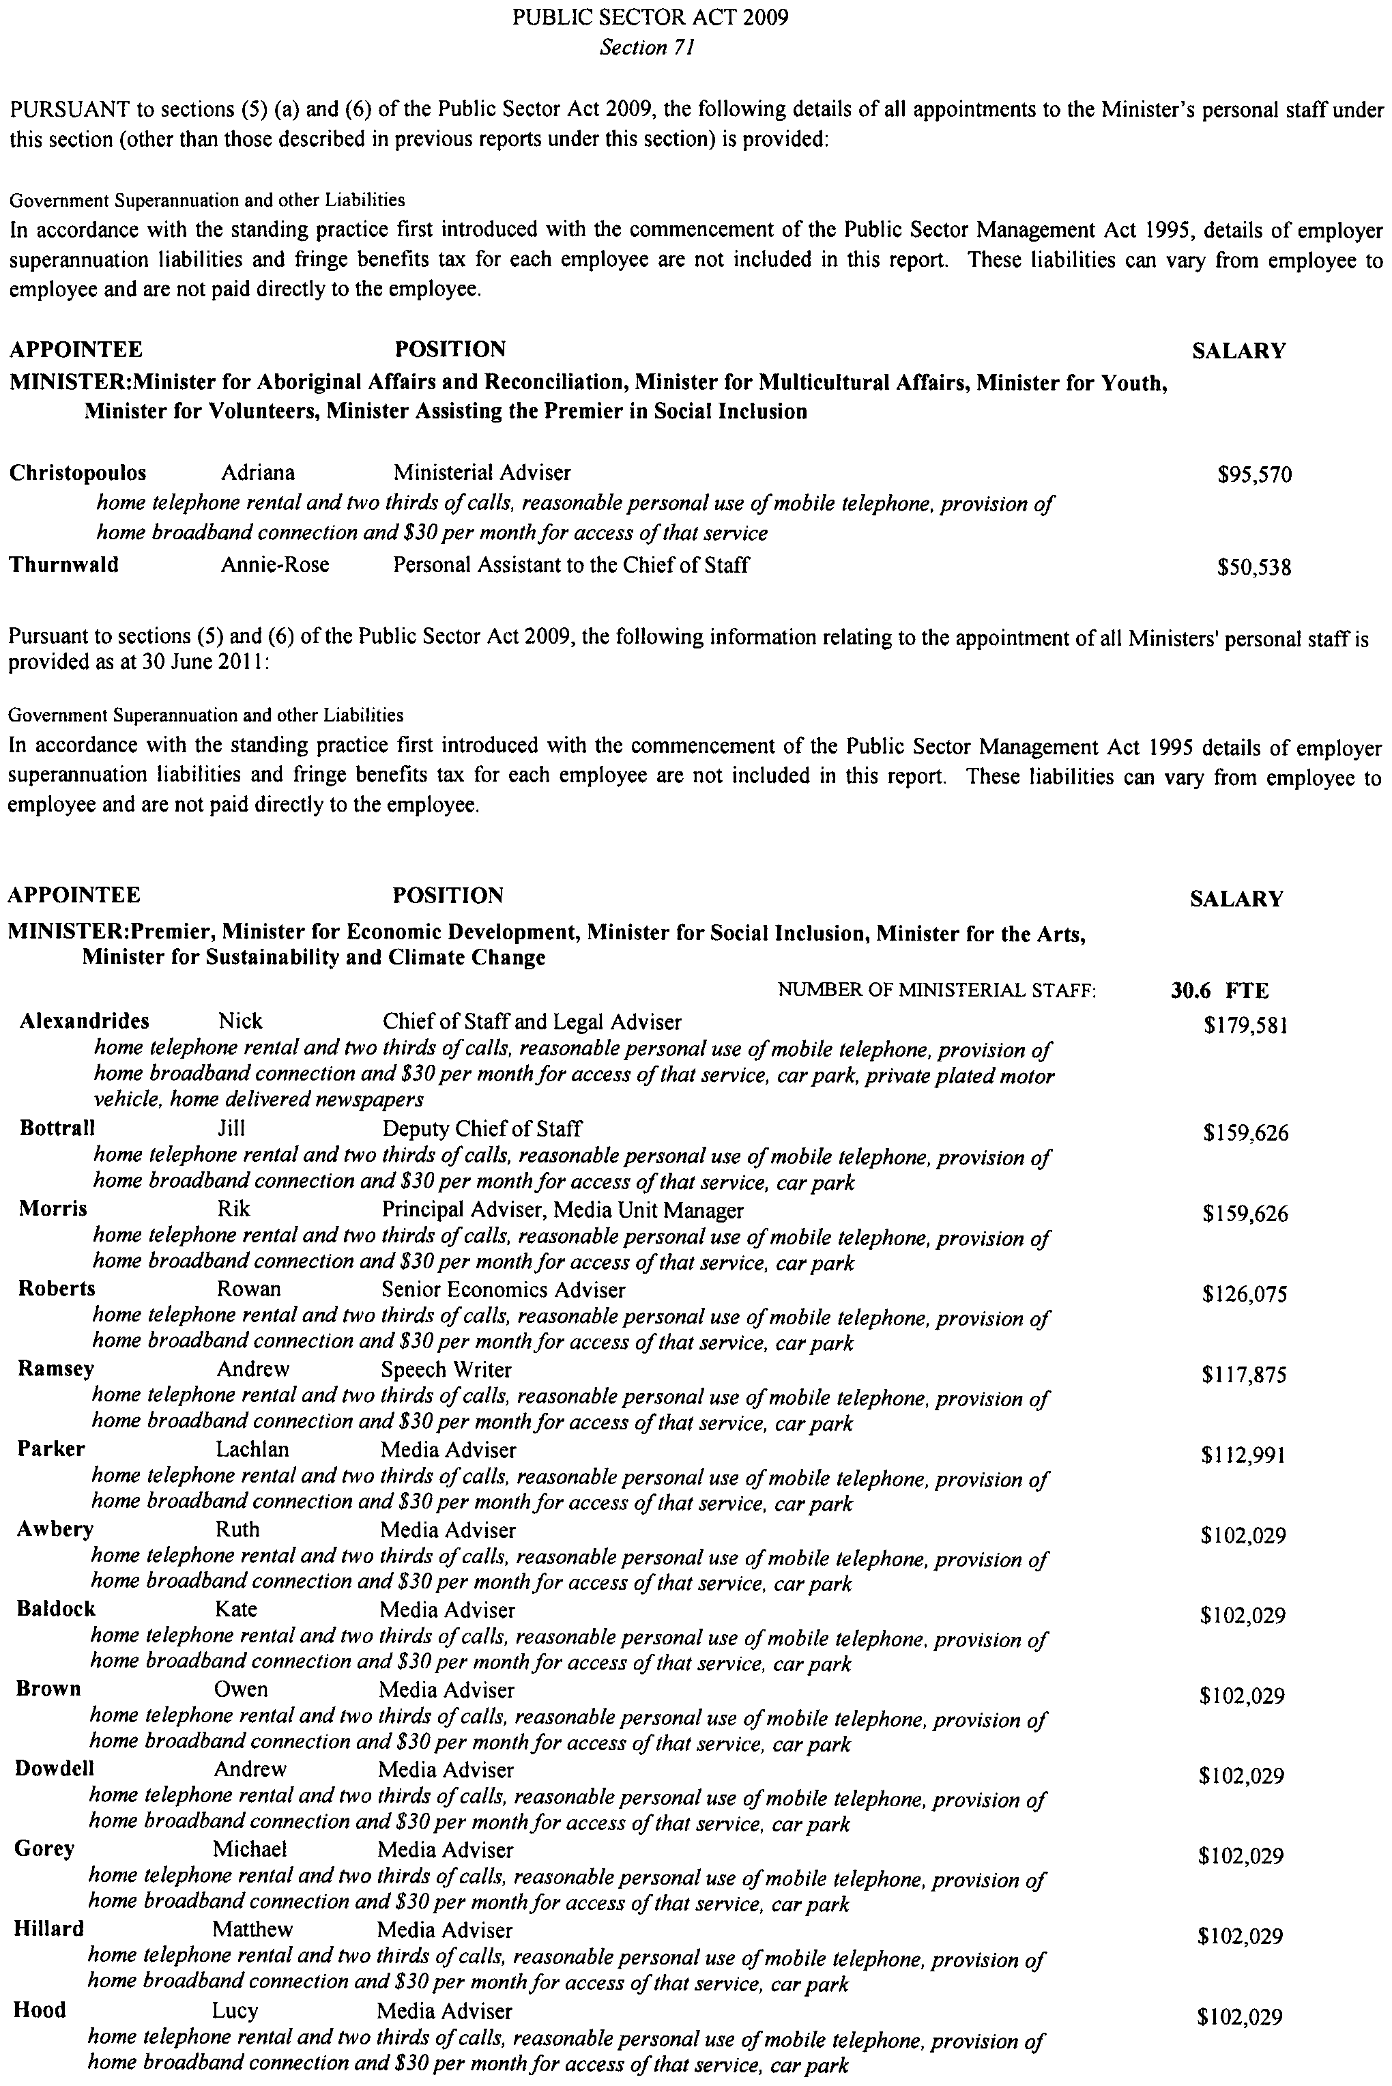
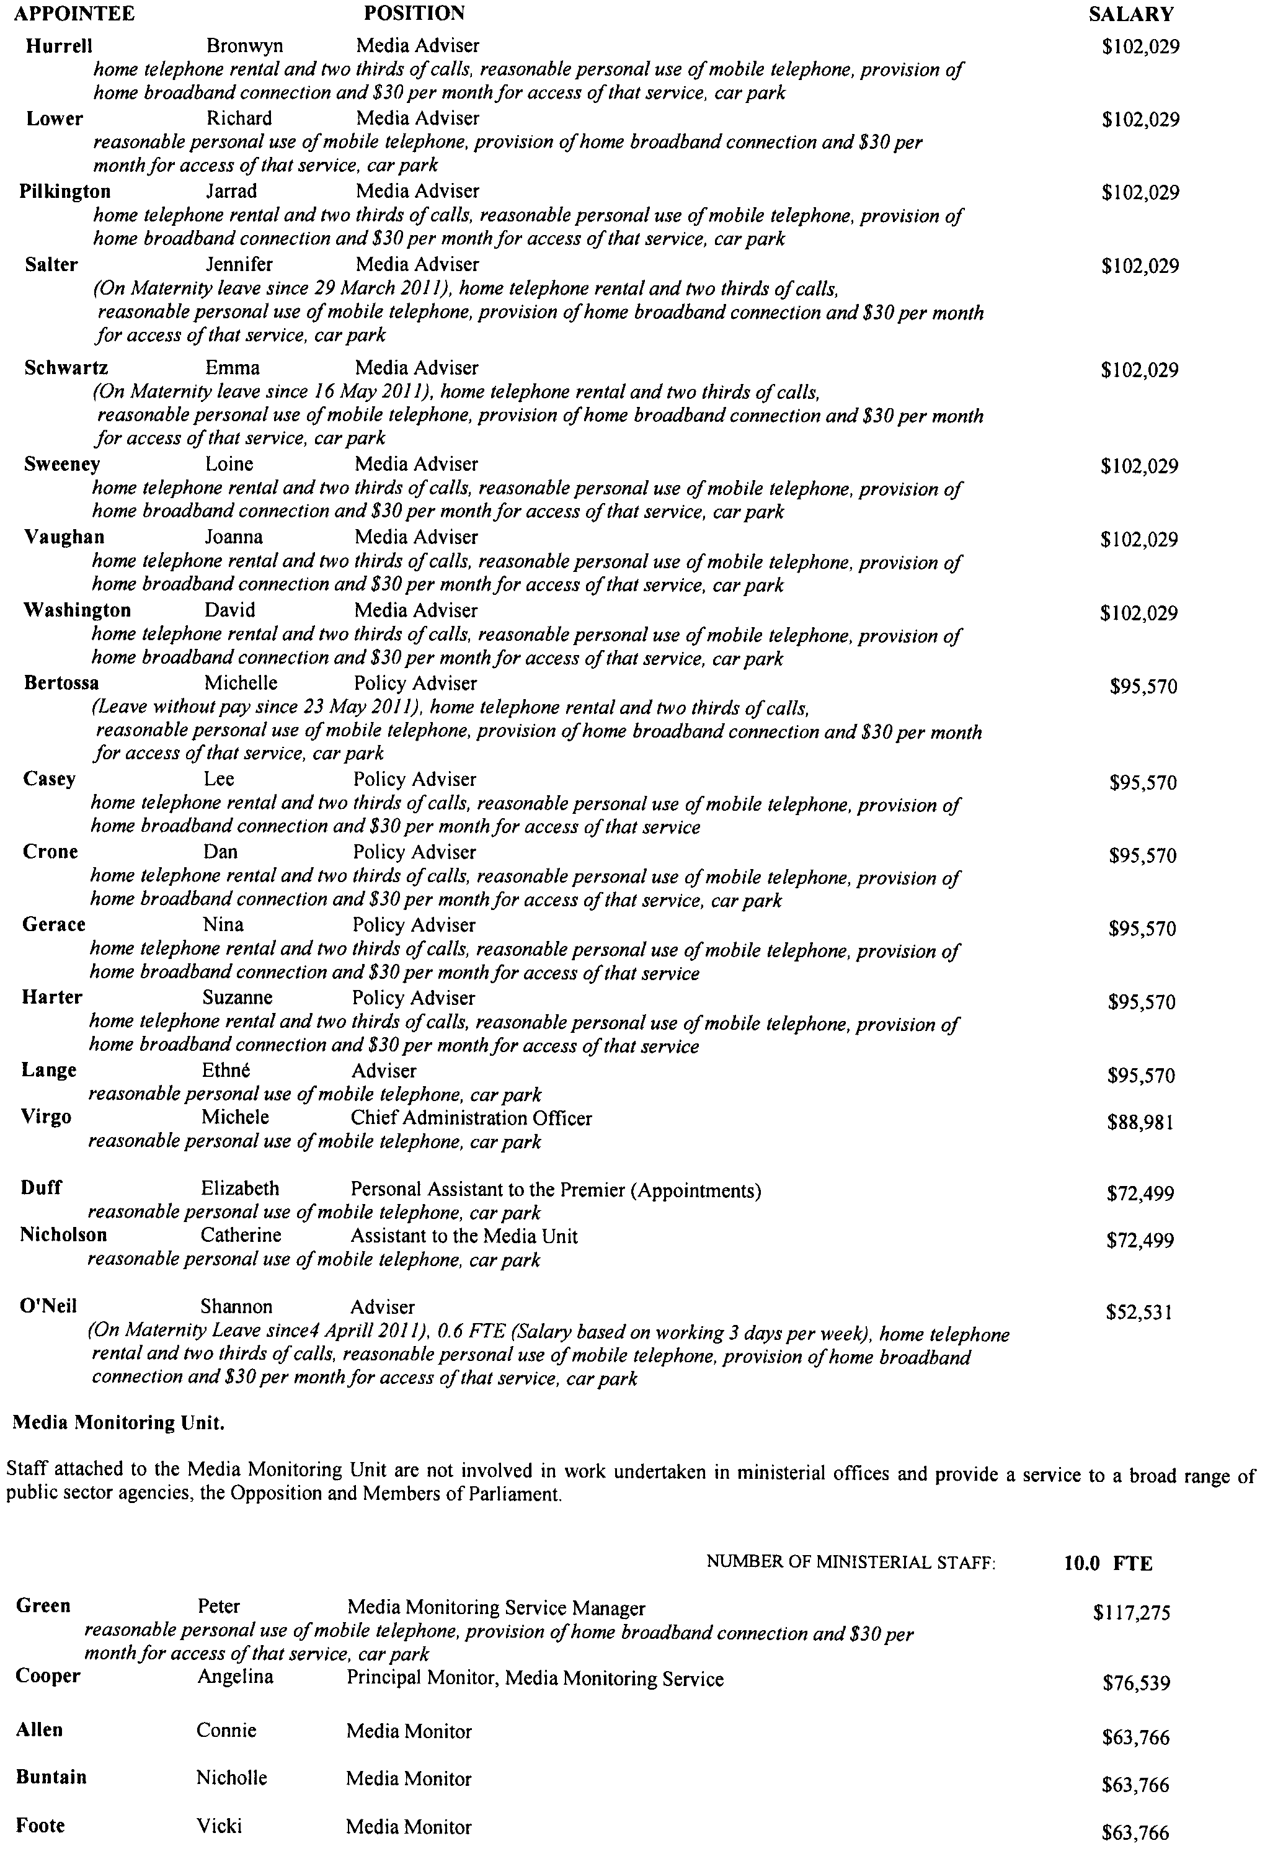
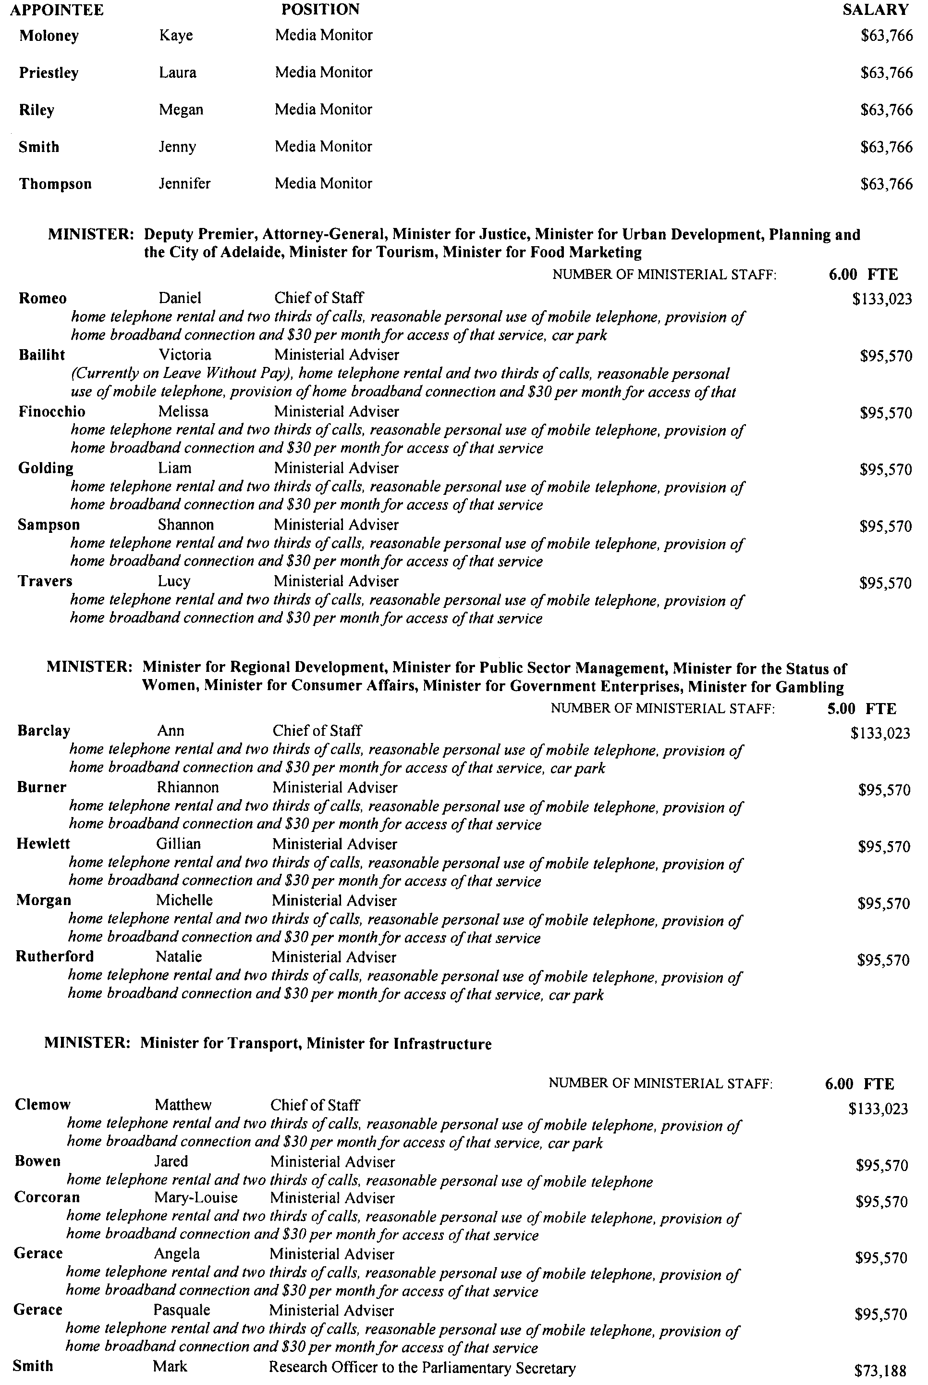
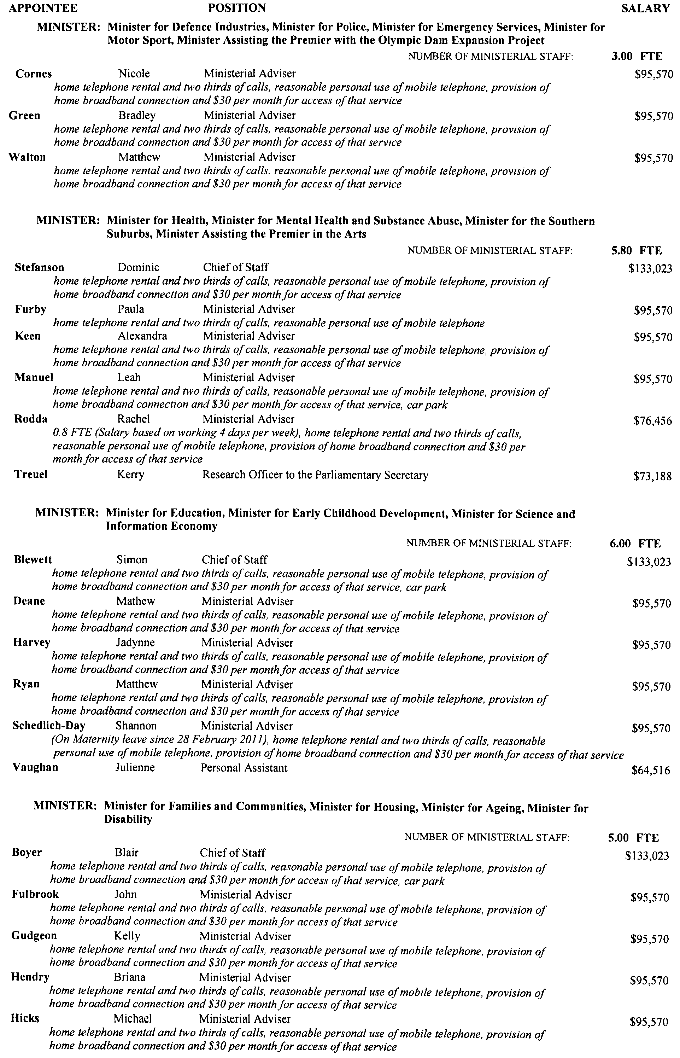
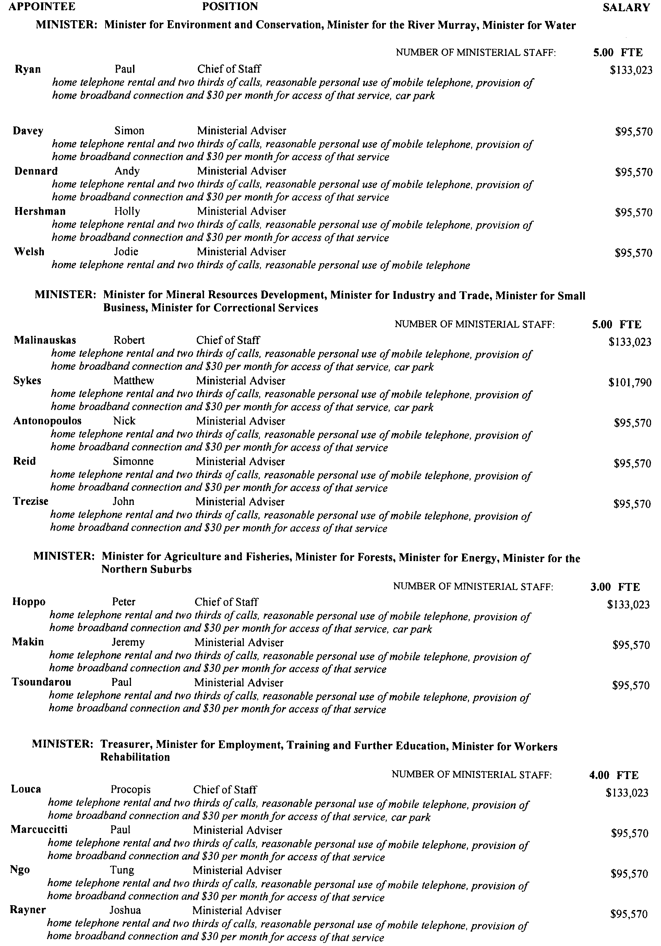
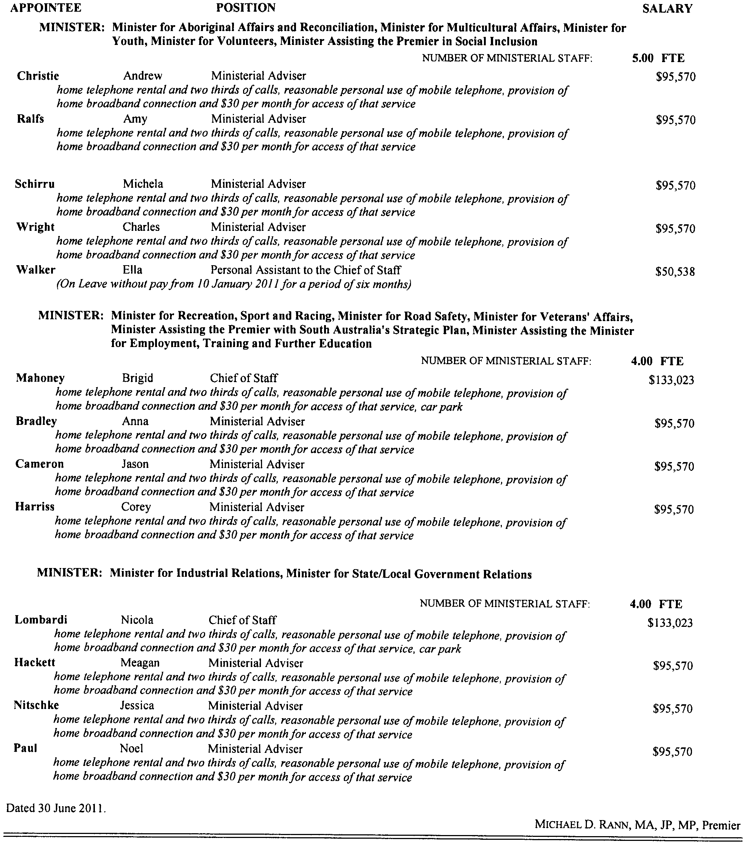

SEWERAGE ACT 1929
Erratum
Addition of Land to Myponga Country Drainage Area
IN Government Gazette No. 44 dated 30 June 2011, on page 2860, an incorrect map was printed in error and should be replaced with the following:
Dated 28 June 2011.
Signed for and on behalf of the South Australian Water Corporation by a person duly authorised so to do:
A. Schirripa, Manager Billing and Collection
In the presence of:
N. Glass, Team Leader Rating
SAWATER 11/02990 D1483

GOVERNMENT GAZETTE ADVERTISEMENT RATES

To apply from 1 July 2011

$  Agents, Ceasing to Act as 45.50  Associations:  Incorporation 23.00  Intention of Incorporation 57.00  Transfer of Properties 57.00  Attorney, Appointment of 45.50  Bailiff’s Sale 57.00  Cemetery Curator Appointed 33.75  Companies:  Alteration to Constitution 45.50  Capital, Increase or Decrease of 57.00  Ceasing to Carry on Business 33.75  Declaration of Dividend 33.75  Incorporation 45.50  Lost Share Certificates:  First Name 33.75  Each Subsequent Name 11.60  Meeting Final 38.00  Meeting Final Regarding Liquidator’s Report on  Conduct of Winding Up (equivalent to ‘Final  Meeting’)  First Name 45.50  Each Subsequent Name 11.60  Notices:  Call 57.00  Change of Name 23.00  Creditors 45.50  Creditors Compromise of Arrangement 45.50  Creditors (extraordinary resolution that ‘the Com-pany be wound up voluntarily and that a liquidator be appointed’) 57.00  Release of Liquidator⎯Application⎯Large Ad. 90.50  ⎯Release Granted 57.00  Receiver and Manager Appointed 52.50  Receiver and Manager Ceasing to Act 45.50  Restored Name 42.50  Petition to Supreme Court for Winding Up 79.00  Summons in Action 67.50  Order of Supreme Court for Winding Up Action 45.50  Register of Interests⎯Section 84 (1) Exempt 102.00  Removal of Office 23.00  Proof of Debts 45.50  Sales of Shares and Forfeiture 45.50  Estates:  Assigned 33.75  Deceased Persons⎯Notice to Creditors, etc. 57.00  Each Subsequent Name 11.60  Deceased Persons⎯Closed Estates 33.75  Each Subsequent Estate 1.50  Probate, Selling of 45.50  Public Trustee, each Estate 11.60 |  | $  Firms:  Ceasing to Carry on Business (each insertion) 30.25  Discontinuance Place of Business 30.25  Land⎯Real Property Act:  Intention to Sell, Notice of 57.00  Lost Certificate of Title Notices 57.00  Cancellation, Notice of (Strata Plan) 57.00  Mortgages:  Caveat Lodgement 23.00  Discharge of 24.10  Foreclosures 23.00  Transfer of 23.00  Sublet 11.60  Leases⎯Application for Transfer (2 insertions) each 11.60  Lost Treasury Receipts (3 insertions) each 33.75  Licensing 67.50  Municipal or District Councils:  Annual Financial Statement⎯Forms 1 and 2 636.00  Electricity Supply⎯Forms 19 and 20 452.00  Default in Payment of Rates:  First Name 90.50  Each Subsequent Name 11.60  Noxious Trade 33.75  Partnership, Dissolution of 33.75  Petitions (small) 23.00  Registered Building Societies (from Registrar-General) 23.00  Register of Unclaimed Moneys⎯First Name 33.75  Each Subsequent Name 11.60  Registers of Members⎯Three pages and over:  Rate per page (in 8pt) 289.00  Rate per page (in 6pt) 382.00  Sale of Land by Public Auction 57.50  Advertisements 3.20  ¼ page advertisement 135.00  ½ page advertisement 270.00  Full page advertisement 529.00  Advertisements, other than those listed are charged at $3.20 per column line, tabular one-third extra.  Notices by Colleges, Universities, Corporations and District Councils to be charged at $3.20 per line.  Where the notice inserted varies significantly in length from that which is usually published a charge of $3.20 per column line will be applied in lieu of advertisement rates listed.  South Australian Government publications are sold on the condition that they will not be reproduced without prior permission from the Government Printer.
All the above prices include GST

GOVERNMENT GAZETTE NOTICES
ALL private advertisements forwarded for publication in the South Australian Government Gazette must be PAID FOR PRIOR TO INSERTION; and all notices, from whatever source, should be legibly written on one side of the paper only and sent to Government Publishing SA so as to be received no later than 4 p.m. Tuesday preceding the day of publication. Phone 8207 1045 or Fax 8207 1040. E-mail: governmentgazette@dpc.sa.gov.au. Send as attachments in Word format. Please include date the notice is to be published and to whom the notice will be charged. The Government Gazette is available online at: www.governmentgazette.sa.gov.au.

MISCELLANEOUS LEGISLATION AND GOVERNMENT PUBLICATIONS PRICES AS FROM 1 JULY 2011

Acts, Bills, Rules, Parliamentary Papers and Regulations
Pages | Main | Amends | Pages | Main | Amends

1-16 | 2.80 | 1.30 | 497-512 | 38.50 | 37.50
17-32 | 3.70 | 2.30 | 513-528 | 39.50 | 38.25
33-48 | 4.85 | 3.45 | 529-544 | 41.00 | 39.50
49-64 | 6.10 | 4.70 | 545-560 | 42.00 | 41.00
65-80 | 7.10 | 5.90 | 561-576 | 43.00 | 42.00
81-96 | 8.30 | 6.85 | 577-592 | 44.50 | 42.50
97-112 | 9.45 | 8.10 | 593-608 | 45.75 | 44.00
113-128 | 10.60 | 9.30 | 609-624 | 46.50 | 45.50
129-144 | 11.80 | 10.50 | 625-640 | 47.75 | 46.00
145-160 | 13.00 | 11.60 | 641-656 | 49.00 | 47.75
161-176 | 14.10 | 12.80 | 657-672 | 49.75 | 48.25
177-192 | 15.40 | 13.90 | 673-688 | 51.50 | 49.75
193-208 | 16.60 | 15.30 | 689-704 | 52.50 | 50.50
209-224 | 17.50 | 16.20 | 705-720 | 53.50 | 52.00
225-240 | 18.70 | 17.30 | 721-736 | 55.00 | 53.00
241-257 | 20.10 | 18.30 | 737-752 | 55.50 | 54.00
258-272 | 21.20 | 19.40 | 753-768 | 57.00 | 55.00
273-288 | 22.30 | 21.00 | 769-784 | 58.00 | 57.00
289-304 | 23.30 | 21.90 | 785-800 | 59.00 | 58.00
305-320 | 24.70 | 23.20 | 801-816 | 60.50 | 58.50
321-336 | 25.75 | 24.30 | 817-832 | 61.50 | 60.50
337-352 | 27.00 | 25.50 | 833-848 | 63.00 | 61.50
353-368 | 27.75 | 26.75 | 849-864 | 64.00 | 62.50
369-384 | 29.25 | 27.75 | 865-880 | 65.50 | 64.00
385-400 | 30.50 | 29.00 | 881-896 | 66.00 | 64.50
401-416 | 31.75 | 30.00 | 897-912 | 67.50 | 66.00
417-432 | 33.00 | 31.50 | 913-928 | 68.00 | 67.50
433-448 | 34.00 | 32.75 | 929-944 | 69.00 | 68.00
449-464 | 34.75 | 33.50 | 945-960 | 70.00 | 68.50
465-480 | 35.25 | 34.50 | 961-976 | 73.00 | 69.50
481-496 | 37.50 | 35.25 | 977-992 | 74.00 | 70.00

Legislation—Acts, Regulations, etc: $
Subscriptions:
Acts 237.00
All Bills as Laid 570.00
Rules and Regulations 570.00
Parliamentary Papers 570.00
Bound Acts 263.00
Index 132.00
Government Gazette
Copy 6.25
Subscription 315.00
Hansard
Copy 17.30
Subscription—per session (issued weekly) 494.00
Cloth bound—per volume 212.00
Subscription—per session (issued daily) 494.00
Legislation on Disk
Whole Database 3 660.00
Annual Subscription for fortnightly updates 1 125.00
Individual Act(s) including updates POA
Notice of Vacancies
Annual Subscription 174.00
Compendium
Subscriptions:
New Subscriptions 2 167.00
Updates 765.00
(All the above prices include GST)

All Legislation, Government Gazette, Hansard and Legislation on disk are available from:
Counter Sales Government Legislation⁺ Outlet
and Mail Orders: Service SA Customer Service Centre,
Ground Floor—EDS Centre, 108 North Terrace, Adelaide, S.A. 5000
Phone: 13 23 24 (local call cost), Fax: (08) 8204 1909
Postal: G.P.O. Box 1707, Adelaide, S.A. 5001

Online Shop: www.shop.service.sa.gov.au

Subscriptions and Government Publishing SA
Standing Orders: Box 9, Plaza Level, Riverside Centre, North Terrace, Adelaide, S.A. 5000
Phone: (08) 8207 1043, (08) 8207 0910, Fax: (08) 8207 1040

South Australia
Motor Vehicles (Third Party Insurance) Amendment Act (Commencement) Proclamation 2011
1—Short title
This proclamation may be cited as the Motor Vehicles (Third Party Insurance) Amendment Act (Commencement) Proclamation 2011.
2—Commencement of Act
The Motor Vehicles (Third Party Insurance) Amendment Act 2011 (No 23 of 2011) will come into operation on 10 July 2011.
Made by the Governor
with the advice and consent of the Executive Council
on 7 July 2011
T&F11/042CS

South Australia
Explosives (Government Magazines) Proclamation 2011
under section 20 of the Explosives Act 1936
1—Short title
This proclamation may be cited as the Explosives (Government Magazines) Proclamation 2011.
2—Commencement
This proclamation comes into operation on the day on which it is made.
3—Declaration of government magazine
(1) Pursuant to section 20 of the Explosives Act 1936, the following area is declared to be a Government magazine:
the area bounded by a length of road that runs approximately easterly between Point A and Point B, southerly between Point B and Point C, westerly between Point C and Point D and northerly between Point D and Point A.
(2) For the purposes of this clause, Point A, Point B, Point C and Point D have the following coordinates (expressed in terms of World Geodetic System 1984):

 | Latitude | Longitude
Point A | 34.59062° south | 139.66232° east
Point B | 34.59053° south | 139.66530° east
Point C | 34.59790° south | 139.66528° east
Point D | 34.59786° south | 139.66231° east
Made by the Governor
with the advice and consent of the Executive Council
on 7 July 2011
MIR11/007CS

South Australia
Liquor Licensing (Dry Areas—Long Term) Variation Regulations 2011
under the Liquor Licensing Act 1997

Contents
Part 1—Preliminary
1 Short title
2 Commencement
3 Variation provisions
Part 2—Variation of Liquor Licensing (Dry Areas—Long Term) Regulations 1997
4 Variation of Schedule 1—Long term dry areas
5 Variation of Schedule 2—Plans of long term dry areas
Schedule 1—Plan to be substituted

Part 1—Preliminary
1—Short title
These regulations may be cited as the Liquor Licensing (Dry Areas—Long Term) Variation Regulations 2011.
2—Commencement
These regulations come into operation on the day on which they are made.
3—Variation provisions
In these regulations, a provision under a heading referring to the variation of specified regulations varies the regulations so specified.
Part 2—Variation of Liquor Licensing (Dry Areas—Long Term) Regulations 1997
4—Variation of Schedule 1—Long term dry areas
(1) Schedule 1, item headed "Port Pirie—Area 1"—delete the item and substitute:

Port Pirie—Area 1
(see Schedule 2: Port Pirie—Plan No 1)
The area in Port Pirie bounded as follows: commencing at the point at which the prolongation in a straight line of the south-eastern boundary of Mary Elie Street intersects the western boundary of Lot 120 DP 53026 (the north-eastern boundary of Main Road), then north-westerly, northerly and north-easterly along the boundary of Lot 120 to the point at which it meets the eastern boundary of Lot 402 DP 75081 (a Railway Reserve), then in a straight line by the shortest route to the eastern edge of the wharf on the western side of the Port Pirie River, then north-westerly along that edge of the wharf to the point at which it meets the southern side of a T-shaped jetty projecting from the wharf into the River (at a point immediately to the east of a fenced playground in Flinders View Park), then around the outer boundary of the jetty back to the wharf on the northern side of the jetty (so as to include the whole of the jetty in the area), then in a straight line by the shortest route to the western boundary of Lot 402 DP 75081 (the Railway Reserve), then generally north-westerly and northerly along that western boundary of Lot 402 to the point at which it is intersected by the prolongation in a straight line of the southern boundary of George Street, then westerly along that prolongation of the southern boundary of George Street to the western boundary of Ellen Street, then southerly along that boundary of Ellen Street to the northern boundary of David Street, then westerly along that boundary of David Street to the point at which it intersects the western boundary of Gertrude Street, then southerly along that boundary of Gertrude Street to the point at which it intersects the southern boundary of Alexander Street, then south-westerly along that boundary of Alexander Street to the eastern boundary of The Terrace, then southerly along that boundary of The Terrace to the northern boundary of Memorial Drive, then north-easterly along that boundary of Memorial Drive to the point at which it meets the western boundary of Gertrude Street, then south-easterly along that boundary of Gertrude Street and the prolongation in a straight line of that boundary to the point at which it intersects the south-eastern boundary of Mary Elie Street, then north-easterly along that boundary of Mary Elie Street and the prolongation in a straight line of that boundary to the point of commencement. The area includes any area beneath a wharf or jetty included in the area, but excludes the Northern Festival Centre (Section 1285 Hundred of Pirie) and any land used for the purpose of carrying on a business. | Continuous until 14 July 2012, provided that where—  (a) an event of historic, cultural, traditional or major community significance is held in the area; and  (b) the consumption and possession of liquor in the area (or a defined portion of the area) are authorised for a specified period for the purposes of the event by the Port Pirie Regional Council,  the prohibition does not apply in the area (or defined portion of the area) during that specified period.  The Port Pirie Regional Council may not grant authorisations under these regulations in relation to more than 8 events per calendar year. | The consumption and possession of liquor are prohibited.
(2) Schedule 1, item headed "Port Pirie—Area 2", column headed "Period"—delete "10 p.m. on each day to 10 a.m. on the following day until 10 a.m. on 6 July 2010," and substitute:
Continuous until 14 July 2012,
(3) Schedule 1, item headed "Port Pirie—Area 2", column headed "Period"—delete "3 events" and substitute:
8 events
(4) Schedule 1, item headed "Port Pirie—Area 3"—delete the item
5—Variation of Schedule 2—Plans of long term dry areas
(1) Schedule 2, plan headed "Port Pirie—Plan No 1"—delete the plan and substitute the plan headed "Port Pirie—Plan No 1" in Schedule 1 of these regulations
(2) Schedule 2, plan headed "Port Pirie—Plan No 3"—delete the plan
Schedule 1—Plan to be substituted
Port Pirie—Plan No 1
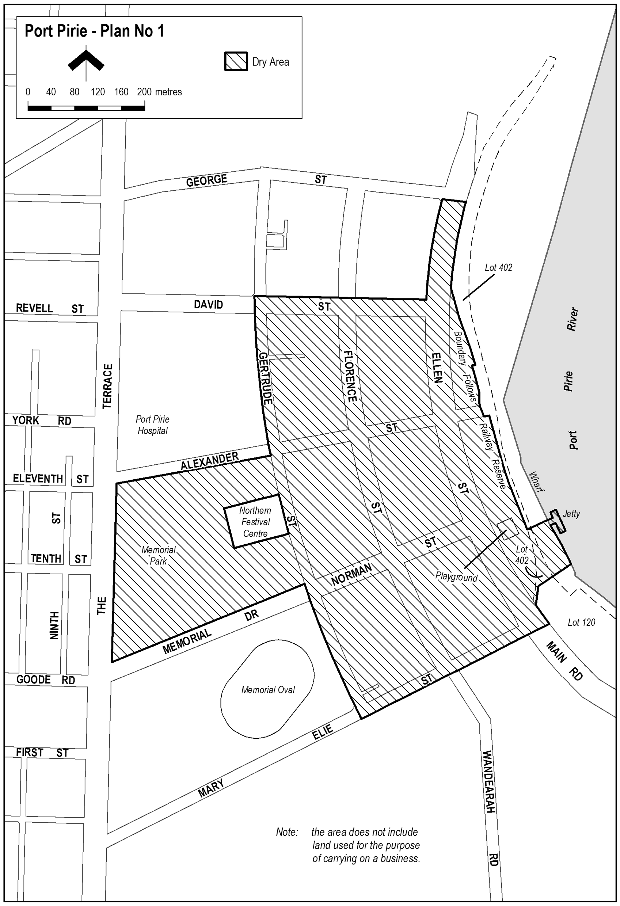
Note—
As required by section 10AA(2) of the Subordinate Legislation Act 1978, the Minister has certified that, in the Minister's opinion, it is necessary or appropriate that these regulations come into operation as set out in these regulations.
Made by the Governor
with the advice and consent of the Executive Council
on 7 July 2011
No 178 of 2011
11MCA0017CS

FAXING COPY?
IF you fax copy to Government Publishing SA for inclusion in the Government Gazette, there is no need to send a Confirmation Copy to us as well.
This creates confusion and may well result in your notice being printed twice.
Please use the following fax number:
Fax transmission: (08) 8207 1040
Phone Enquiries: (08) 8207 1045
Please include a contact person, phone number and order number so that we can phone back with any queries we may have regarding the fax copy.
NOTE: Closing time for lodging new copy (fax, hard copy or email) is 4 p.m. on Tuesday preceding the day of publication.

Government Gazette notices can be Emailed.
The address is:
governmentgazette@dpc.sa.gov.au
Documents should be sent as attachments in Word format.
When sending a document via Email, please confirm your transmission with a faxed copy of your document, including the date the notice is to be published.
Fax transmission: (08) 8207 1040
Phone Enquiries: (08) 8207 1045
NOTE: Closing time for lodging new copy (fax, hard copy or email) is 4 p.m. on Tuesday preceding the day of publication.

CITY OF CAMPBELLTOWN
Adoption of Valuations and Declaration of Rates
NOTICE is hereby given that at its meeting held on 28 June 2011, the Corporation of the City of Campbelltown for the financial year ending 30 June 2012 resolved:
Adoption of Valuation
To adopt for rating purposes the most recent valuations supplied by the Valuer-General of the capital value of land within the Council’s area totalling $9 427 250 000.
Declaration of General Rate for the Year 2011-2012
To declare a general rate of 0.269819 cents for each one dollar of the assessed capital value of rateable property within the Council’s area.
Minimum Rate
To fix a minimum amount payable by way of general rates of $729 in respect of rateable land within the Council’s area.
Natural Resources Management Levy
To declare a separate rate of 0.008366 cents in the dollar on the capital value of all rateable land within the Council’s area to reimburse the Council for amounts contributed to the Adelaide and Mount Lofty Ranges Natural Resources Management Board, totalling $778 408.
P. Di Iulio, Chief Executive Officer

CITY OF HOLDFAST BAY
Adoption of Valuations and Declaration of Rates
NOTICE is hereby given that at its meeting on 28 June 2011, and in relation to the 2011-2012 financial year, the Council, in exercise of the powers contained in Chapter 10 of the Local Government Act 1999:
1. Adopted the most recent valuations of the State Valuation Office of the capital value of land in its area (such valuations of the State Valuation Office being available to the Council as at the date it adopted its budget) and totalling $11 040 959 840.
2. Declared a differential general rate of 0.222955 cents in the dollar of the capital value of land, on rateable land within its area which is used for Residential and Other Land uses.
3. Declared a differential general rate of 0.334433 cents in the dollar for the capital value of land on rateable land within its area which is used for Commercial (Shop), Commercial (Office), Commercial (Other), Industrial (Light), Industrial (Other) and Vacant Land uses.
4. Imposed a minimum amount payable by way of the general rate of $832.
5. Fixed a maximum increase of 10% (subject to conditions) in the general rate charged on rateable land used for residential purposes and is the principal place of residence of a ratepayer.
6. Imposed the application of general rates on the owners of marina berths within the Patawalonga.
7. In order to support and improve business viability, profitability and trade, commerce and industry in that part of the Council’s area comprising the following rateable land:
(a) with a frontage to Jetty Road, Glenelg or Moseley Square;
(b) within the side streets that intersect with Jetty Road, Glenelg between High Street, Glenelg and Augusta Street, Glenelg;
(c) the entire site referred to as the Holdfast Shores 2B Entertainment Centre; and
(d) with a land use of Category 2 (Commercial—Shop), Category 3 (Commercial—Office) and Category 4 (Commercial—Other),
declared a differential separate rate of 0.13555 cents in the dollar of the capital value of land on all rateable land within the above geographical boundary and land use categories set out in Regulation 10 (2) of the Local Government (General) Regulations 1999.
8.—
(a) In exercise of the powers contained in Section 154 of the Local Government Act 1999 and in order to carry out the activity to the maintenance and upkeep of the boat lock in the Patawalonga basin, a separate rate of 0.831 cents in the dollar of the capital value of land, be declared on all rateable land within the Patawalonga basin bounded by the high water mark.
(b) In exercise of the powers contained in Section 158 of the Local Government Act 1999, the amount that would otherwise be payable by way of rates in respect of this separate rate is altered by fixing the amount of rates payable for assessments that are wholly or partly within the part of the area on which this separate rate is imposed and the capital values of which exceed $104 091 at $865.
9. In exercise of the powers contained in Section 95 of the Natural Resources Management Act 2004 and in order to reimburse the Council for the amount contributed to the Adelaide and Mount Lofty Ranges Natural Resources Management Board being $875 698, imposed a levy comprising 0.008229 cents in the dollar of the capital value of land, on rateable land in the Council’s area in the catchment area of the Board, the Capital Value of such land comprising $10 787 072 550, the basis for the levy having been selected as the capital value of rateable land, by the Minister, after consultation with Constituent Councils in the Management Board Area, and submitted to and approved by the Governor.
J. P. Lynch, Chief Executive Officer

CITY OF MARION
Adoption of Valuation
NOTICE is hereby given that on 28 June 2011 the Council of the City of Marion, pursuant to the provisions of the Local Government Act 1999, for the year ending 30 June 2012, adopted the capital valuation to apply in its area for rating for the 2011-2012 financial year as supplied by the Valuer-General totalling $17 146 381 040.
Declaration of Rates
Notice is hereby given that the Council did on 28 June 2011, declare differential general rates in the dollar based on capital value as follows:
(a) 0.304999 cents in the dollar on rateable land of Category 1 (Residential), Category 7 (Primary Production) and Category 9 (Other);
(b) 0.564248 cents in the dollar on rateable land of Category 2 (Commercial—Shop), Category 3 (Commercial—Office), Category 4 (Commercial—Other);
(c) 0.503248 cents in the dollar on rateable land of Category 5 (Industrial—Light), Category 6 (Industrial—Other); and
(d) 0.518498 cents in the dollar on rateable land of Category 8 (Vacant Land).
The Council resolved that the minimum amount payable by way of rates in respect of rateable land within the area for the year ending 30 June 2012 shall be $807.
The Council declared a separate rate of 0.008180 cents in the dollar on all rateable land within the Adelaide and Mount Lofty Ranges Natural Resources Management Board Area within the area for the year ending 30 June 2012.
The Council resolved that rates will be payable in four equal or approximately equal instalments, and that the due dates for those instalments will be 1 September 2011, 1 December 2011, 1 March 2012 and 1 June 2012.
M. Searle, Chief Executive

PORT AUGUSTA CITY COUNCIL
Conversion of Private Road to Public Road
NOTICE is hereby given that the Port Augusta City Council at its meeting held on 27 June 2011, resolved to declare Allotment 11 in Deposited Plan 2364 as described within Certificate of Title Volume 5881, Folio 241, to be a public road, having successfully completed the provisions outlined within Section 210 of the Local Government Act 1999.
G. Perkin, City Manager

PORT AUGUSTA CITY COUNCIL
By-law Made Under the Local Government Act 1999
By-law No. 2—Moveable Signs
TO protect visual amenity and public safety on roads by setting standards for moveable signs on roads and providing conditions for the design, construction and placement of such signs in a manner which recognises the advertising needs of businesses to maximise economic viability and revoke Council’s current By-law No. 2—Moveable Signs.
1. Revocation of By-law
By-law No. 2—Moveable Signs made by the Council on 22 February 2010, is hereby revoked effective from the day on which this by-law comes into operation.
2. Definitions
In this by-law:
2.1 ‘Authorised Person’ has the same meaning as in the Local Government Act 1999.
2.2 ‘Banner’ means a strip of cloth hung up or carried on a pole, fence or other structure and includes a feather banner.
2.3 ‘Boundary’ means that line between private property and the Road or Road Related Area.
2.4 ‘Business premises’ means the premises from which a business, trade or calling is conducted.
2.5 ‘Footpath Area’ means that part of the Road between the boundary of the Road and the edge of the carriageway of the Road on the same side as that boundary.
2.6 ‘Local Government Land’ means land owned by the Council or under the Council’s care, control and management.
2.7 ‘Moveable Sign’ has the same meaning as in the Local Government Act 1999.
2.8 ‘Road’ has the same meaning as in the Local Government Act 1999.
2.9 ‘Road Related Area’ has the same meaning as in the Road Traffic Act 1961 and the Australian Road Rules 1999.
2.10 ‘Vehicle’ has the same meaning as in the Road Traffic Act 1961 and the Australian Road Rules 1999.
3. Design and Construction
A Moveable Sign displayed on a Road must:
3.1 be of a kind known as an ‘A’ frame or Sandwich Board sign, an inverted ‘T’ sign or a flat sign, or, with the permission of the Council, a sign of some other kind;
3.2 be well designed, constructed and maintained in good quality and condition so as not to present a hazard to any member of the public;
3.3 be of strong construction so as to be stable when in position and be able to keep its position in adverse weather conditions;
3.4 not contain sharp or jagged edges or corners;
3.5 not be unsightly or offensive in appearance or content;
3.6 not contain flashing parts or rotate;
3.7 be constructed of timber, cloth, metal, plastic or plastic coated cardboard, or a mixture of such materials;
3.8 not have balloons, flags, streamers or other material attached to it;
3.9 not exceed 900 mm in perpendicular height, or have a base with any side exceeding 600 mm in length;
3.10 not have a display area exceeding one square metre in total or if the sign is two sided, one square metre on each side;
3.11 in the case of an ‘A’ Frame or Sandwich Board sign:
3.11.1 be hinged or joined at the top; and
3.11.2 be of such construction that its sides shall be securely fixed or locked in position when erected;
3.12 in the case of an inverted ‘T’ sign, contain no struts or supports that run between the display area and the base of the sign.
4. Appearance
A Moveable Sign on a Road must, in the opinion of an Authorised Person:
4.1 be painted or otherwise detailed in a competent and professional manner;
4.2 be aesthetically appealing, legible and simply worded to convey a precise message;
4.3 be of such design and contain such colours as are compatible with the architectural design of the premises adjacent to the moveable sign, and which relate well to the townscape and overall amenity of the locality in which it is situated;
4.4 contain combinations of colour and typographical styles which blend in with and reinforce the heritage qualities of the locality and the buildings where it is situated.
5. Placement
A Moveable Sign must:
5.1 only be positioned on the Footpath Area of a Road;
5.2 be adjacent to the Business Premises to which it relates;
5.3 be placed no closer than 400 mm from the edge of the carriageway of a Road;
5.4 in the case of a flat sign, must be in line with and against the property boundary of the Road;
5.5 not be placed on a Footpath Area less than 1.8 m from any structure, fixed object, tree, bush or plant (including another Moveable Sign);
5.6 not be fixed, tied, chained to or leant against any other structure, fixed object, tree, bush or plant (including another Moveable Sign);
5.7 not be placed on the sealed part of any Footpath Area, unless the sealed part is wide enough to contain the sign and still leave a clear thoroughfare for pedestrians of a width of at least 1.8 m;
5.8 not be placed within 1.8 m of the corner of a Road;
5.9 not be placed on a landscaped area;
5.10 be placed on a designated parking area or within 1.8 m of an entrance to or exit from premises;
5.11 not be placed within 1.8 m of an intersection;
5.12 not unreasonably restrict the use of the Footpath Area or endanger the safety of members of the public;
5.13 not be placed on a Footpath Area that is less than 1.8 m wide;
5.14 not be placed on a Footpath Area with a minimum height clearance, of a structure above it of less than 2 m;
5.15 not be placed so as to interfere with the reasonable movement of persons using the Footpath Area in the vicinity of or adjacent to where the moveable sign is positioned;
5.16 in the case of a flat sign, the message of which only contains newspaper headlines and the name of the newspaper, be placed resting against the premises of the business to which the moveable sign relates; and
5.17 not be placed so as to obstruct or impede a vehicle door when opened, provided that the vehicle is parked lawfully on the carriageway.
6. Restrictions
6.1 A Moveable Sign must:
6.1.1 only display material which advertises a business being conducted on premises which is immediately adjacent to the Moveable Sign, or the products available from that business;
6.1.2 be limited to one Moveable Sign per business;
6.1.3 only be displayed when the business to which the Moveable Sign relates is open;
6.1.4 be securely fixed in position such that it cannot be blown over or swept away in adverse weather conditions;
6.1.5 not be in such a position or in such circumstances that the safety of any person or user of the Road is at risk;
6.1.6 not be displayed during the hours of darkness unless it is in a clearly lit area and clearly visible; and
6.1.7 not be displayed on a median strip, traffic island or on the carriageway of a Road.
6.2 If in the opinion of the Council a Footpath Area or other area forming the boundary of any Road is unsafe for any Moveable Sign to be displayed or placed the Council may by resolution prohibit or restrict the display or placement of a Moveable Sign or the times at which a Moveable Sign may be displayed or placed in that area.
7. Banners
A banner must:
7.1 only be displayed on a Road, Footpath Area or Road Related Area; and
7.2 be securely fixed to a pole, fence or other structure so that it does not hang loose or flap; and
7.3 not, without the Council’s permission, be attached to any building, structure, fence, vegetation or other item owned by the Council on a Road, or other improvement to a Road owned by the Council; and
7.4 not be displayed more than one month before and two days after the event it advertises; and
7.5 not be displayed for a continuous period of more than one month and two days in any twelve month period; and
7.6 not exceed 3 m² in size.
8. Signs on Local Government Land
A person must not, without the Council’s permission, display or cause to be displayed a Moveable Sign on any Local Government Land or resting on or attached to a vehicle on any Local Government Land except a moveable sign:
8.1 attached to a licensed taxi;
8.2 on or attached to a vehicle belonging to any Council and which has been placed on or attached to the vehicle with the consent of the Council to which the vehicle belongs;
8.3 on or attached to a bus greater than 6 m in length;
8.4 on or attached to a vehicle which only has a sign or signs painted on or glued to it the main purpose of which is to identify it as belonging to a business;
8.5 comprising a sunscreen on a vehicle, where any message or trade name or mark on the sunscreen does not advertise a business being carried on in the vicinity of the place the vehicle is parked, or the products available from that business.
9. Exemptions
9.1 Subparagraphs 6.1 and 6.2 of this by-law do not apply to a Moveable Sign which is displayed and used:
9.1.1 to advertise a garage sale taking place from residential premises provided that no more than four Moveable Signs per residential premises may be displayed at any one time in relation to a garage sale taking place at that residential premises; or
9.1.2 as a directional sign to a short term (less than three days) event run by a community/charitable body or an unincorporated association.
9.2 Subparagraphs 6.1.1, 6.1.2 and 6.1.3 of this by-law do not apply to a flat sign the message of which only contains a newspaper or magazine headlines and the name of the newspaper or magazine.
9.3 A requirement of this by-law will not apply where the Council has granted permission for the Moveable Sign to be displayed contrary to the requirement.
9.4 This by-law will not apply to a Moveable Sign which is:
9.4.1 placed on a Road pursuant to an authorisation under the Local Government Act 1999 or another Act; or
9.4.2 designed to direct people to the open inspection of any land or building that is available for purchase or lease; or
9.4.3 related to a State or Commonwealth election and is displayed during the period commencing on the issue of writ or writs for the election and ending at the close of polls on polling day; or
9.4.4 related to an election held under the Local Government Act 1999 or the Local Government (Elections) Act 1999 and is displayed during the period commencing four weeks immediately before the date that has been set (either by or under either Act) for polling day and ending at the close of voting on polling day.
10. Removal of Unauthorised Moveable Signs
10.1 If:
10.1.1 the design or construction of a Moveable Sign that has been placed on a Road does not comply with a requirement of this by-law; or
10.1.2 the positioning of a Moveable Sign does not comply with a requirement of this by-law; or
10.1.3 any other relevant requirement of this by-law is not complied with; or
10.1.4 the sign unreasonably:
10.1.4.1 restricts the use of the Road; or
10.1.4.2 endangers the safety of members of the public,
an Authorised Person may order the owner of the sign to remove the sign from the Road.
10.2 A person must comply with an Order of an Authorised Person made pursuant to Paragraph 10.1 of this by-law.
10.3 If the Authorised Person cannot find the owner, or the owner fails to comply immediately with the order, the Authorised Person may remove the Moveable Sign.
10.4 If a Moveable sign that is removed pursuant to Clause 10.3 of this by-law, is not claimed within 30 days of such removal, the Authorised Person may sell, destroy or otherwise dispose of the Moveable Sign as the Authorised Person thinks fit.
10.5 The owner or other person entitled to recover a Moveable Sign removed pursuant to Paragraph 10.3 of this by-law must pay to the Council any reasonable costs incurred by the Council in removing, storing and attempting to dispose of the Moveable Sign before being entitled to recover the Moveable Sign.
11. Removal of Authorised Moveable Signs
11.1 The owner of, or other person responsible for, a Moveable Sign must remove or relocate the Moveable Sign at the request of an Authorised Person if, in the reasonable opinion of that Authorised Person, and notwithstanding compliance with this by-law, there is any hazard or obstruction or there is likely to be a hazard or obstruction arising out of the location of the Moveable Sign.
11.2 The owner of, or other person responsible for, a Moveable Sign must remove or relocate the Moveable Sign at the request of an Authorised Person for the purpose of special events, parades, Road works or in any other circumstances which, in the reasonable opinion of the Authorised Person, requires relocation or removal of the Moveable Sign to protect public safety or to protect or enhance the amenity of a particular locality.
The foregoing by-law was duly made and passed at a meeting of the Port Augusta City Council held on 27 June 2011 by an absolute majority of the members for the time being constituting the Council, there being at least two-thirds of the members present.
G. Perkin, Chief Executive Officer

CITY OF PROSPECT
Adoption of Valuations and Declaration of Rates
NOTICE is hereby given that the Council of the City of Prospect, at a meeting of the Council held on 28 June 2011 at which all of the nine Members of the Council were present, resolved that consideration of the 2011-2012 Annual Business Plan has taken into account:
• The capital valuation of the City as set by the Valuer-General of South Australia.
• The relationship of the amount of rates needed to meet the Objectives of the City of Prospect’s Strategic Plan for 2008-2011 and the Annual Business Plan 2011-2012 (Budget, Long Term Financial Plan, Infrastructure and Asset Management Plan, Rating Strategies).
• The City of Prospect’s Rating Strategy (per annual Business Plan 2011-2012) as adopted by Council on 28 June 2011.
• The relationship and impact of the rates and rate differen-tial between residential and non-residential assessments.
• The equity of the rate structure.
• Rate concessions and rebates that will apply.
A full copy of the Annual Business Plan is available for inspection at the Council’s Principal Office, 128 Prospect Road, Prospect or on Council’s website www.prospect.sa.gov.au.
Adoption of Valuations
That the Council of the City of Prospect, pursuant to Section 167 (2) (a) of the Local Government Act 1999, adopts valuations of capital value made by the Valuer-General in relation to the area of the Council on 28 June 2011 and specifies that the total of the values that are to apply within the area for rating purposes for the year ending 30 June 2012 is $4 939 662 300.
Declaration of Differential General Rates
That the Council of the City of Prospect, pursuant to Sections 153 (1) (b) and 156 (1) (a) of the Local Government Act 1999, hereby declares differential general rates on rateable land within the area, which rates vary by reference to the uses of land designated by Regulation 10 (2) of the Local Government (General) Regulations 1999:
(a) Residential: A rate of 0.274701 cents in the dollar on the capital value of such rateable land.
(b) Commercial—Shop: A rate of 0.528230 cents in the dollar on the capital value of such rateable land.
(c) Commercial—Office: A rate of 0.528230 cents in the dollar on the capital value of such rateable land.
(d) Commercial—Other: A rate of 0.528230 cents in the dollar on the capital value of such rateable land.
(e) Industry—Light: A rate of 0.528230 cents in the dollar on the capital value of such rateable land.
(f) Industry—Other: A rate of 0.528230 cents in the dollar on the capital value of such rateable land.
(g) Primary Production: A rate of 0.528230 cents in the dollar on the capital value of such rateable land.
(h) Vacant Land: A rate of 0.309809 cents in the dollar on the capital value of such rateable land.
(i) Other: A rate of 0.528230 cents in the dollar on the capital value of such rateable land.
Declaration of a Minimum Amount
That the Council of the City of Prospect, pursuant to Section 158 (1) (a) of the Local Government Act 1999, hereby fixes, in respect of the year ending 30 June 2012, a minimum amount of $857 that shall be payable by way of general rates on rateable land within the Council’s area.
Declaration of a Separate Rate (Natural Resources
Management Levy)
That pursuant to Section 95 of the Natural Water Resources Management Act 2004 and Section 154 of the Local Government Act 1999, Council, in order to reimburse to the Council the amount contributed to the Adelaide and Mount Lofty Ranges Natural Resources Management Board Levy of $399 382 declares for the year ending 30 June 2012, a separate rate of 0.00827533 cents in the dollar on the capital valuation of all rateable properties within the area of the City of Prospect.
Payment of Rates
Notice is hereby given that pursuant to Section 181 of the Local Government Act 1999, that the rates shall be payable in four equal or approximately equal instalments due and payable on 1 September 2011, 1 December 2011, 1 March 2012 and 1 June 2012.
M. Goldstone, Chief Executive Officer

CITY OF SALISBURY
Adoption of Valuations and Declaration of Rates
NOTICE is hereby given that the City of Salisbury at a meeting held on Monday, 27 June 2011:
1. Adopted the Valuer-General’s valuation of rateable capital values, being $18 363 451 542, for the year ending 30 June 2012. The valuation shall, from 27 June 2011, become and be the valuation of the Council for rating purposes.
2. Declared differential general rates on property within its area for the financial year ending on 30 June 2012, which rates shall vary by reference to the use of the rateable property in accordance with Regulation 10 of the Local Government Act (General) Regulation 1999, as follows:
(a) in respect of rateable property which is used for Commercial—Shop, Commercial—Office, Commer-cial—Other, Industrial—Light, Industrial—Other land uses, a differential general rate of 0.5202 cents in the dollar for the assessed capital value of such property;
(b) in respect of rateable property which is used for Vacant Land use, a differential general rate of 0.4203 cents in the dollar for the assessed capital value of such property; and
(c) in respect of all other rateable property in the area used for purposes other than as stated in paragraphs (a) and (b) hereof, a differential general rate of 0.3502 cents in the dollar on the assessed capital value of such property.
3. Fixed a minimum amount of $800 which shall be payable by way of rates on any one assessment within the municipality in respect of the year ending 30 June 2012.
4. Declared the following differential separate rates in accordance with Section 154 of the Local Government Act 1999, for the year ending 30 June 2012:
Salisbury Town Centre Separate Rate
A separate rate of 0.068590 cents in the dollar on the capital value of rateable land used for commercial purposes within that part of its area comprising the Salisbury Town Centre District Centre Zone which is delineated on Maps Sal/61 and Sal/62 of the Development Plan under the Development Act 1993, applicable to the Council’s area.
The purpose of this separate rate is to provide a fund to promote and enhance business viability, profitability, trade and commerce in that part of the Council’s area, which is the subject of the separate rate.
Globe Derby Separate Rate
A separate rate of $80 per each allotment numbered 1-32 in Deposited Plan No. 9830 and allotments numbered 33, 34 and 36-64 in Deposited Plan No. 9831 of portion of Section 3070, Hundred of Port Adelaide (laid out as Bolivar).
The purpose of this separate rate is to provide a fund to the Globe Derby Community Club for the purpose of maintaining the common land, being Lot 65 in Deposited Plan No. 9832.
Adelaide and Mount Lofty Ranges Natural Resources
Management Board Separate Rate
A separate rate of 0.008275 cents in the dollar on the capital valuation of all rateable properties within the area of the City of Salisbury.
The purpose of this separate rate is to reimburse to Council the amount contributed to the Adelaide and Mount Lofty Ranges Natural Resources Management Board as required under Section 95 of the Natural Water Resources Management Act 2004.
Mawson Central Carparking Separate Rate
A separate rate of 0.017364 cents in the dollar on the capital value of rateable land in the Council area known as Mawson Central in respect of land use Category 2 (Commercial—Shop), Category 3 (Commercial—Office), Category 4 (Commercial—Other), Category 5 (Industry—Light) and Category 6 (Industry—Other).
The purpose of this separate rate is to maintain, renew and develop carparking facilities within the Mawson Central area of Mawson Lakes.
J. Harry, City Manager

CITY OF TEA TREE GULLY
Roads (Opening and Closing) Act 1991
Tina Drive, Modbury
NOTICE is hereby given pursuant to Section 10 of the Roads (Opening and Closing) Act 1991, that the City of Tea Tree Gully proposes to make a Road Process Order to close, sell and transfer to the adjoining land owner a portion of Tina Drive between Berryman Drive and Eileen Street adjoining Allotment 12 in Deposited Plan 27649, shown marked ‘A’ on Preliminary Plan No. 11/0027.
A copy of the plan and statement of persons affected are available for public inspection at offices of the City of Tea Tree Gully and the Adelaide Office of the Surveyor-General during normal office hours.
Any application for easement or objection must set out the full name, address and details of the submission and must be fully supported by reasons. The application for easement or objection must be made in writing within 28 days from the date of this notice, to the City of Tea Tree Gully, 571 Montague Road, Modbury, S.A. 5092 and the Surveyor-General, G.P.O. Box 1354, Adelaide, S.A. 5001, setting out full details.
Where a submission is made, Council will give notification of a meeting at which the matter will be considered.
Dated 7 July 2011.
D. Rogowski, Chief Executive Officer

CITY OF VICTOR HARBOR
Adoption of Valuations and Declaration of Rates
NOTICE is hereby given that the Council of the City of Victor Harbor, at a meeting held on 4 July 2011, in exercise of the powers contained in Chapter 10 of the Local Government Act 1999 and for the year ending 30 June 2012, resolved as follows:
Adoption of Valuation
Pursuant to Section 167 (2) (a) of the Local Government Act 1999, to adopt for rating purposes, the Valuer-General’s valuation of capital value of land within the area of the Council totalling $3 941 859 000.
Declaration of Rates
Pursuant to Sections 151 (1) (c) (i), 153 (1) (b) and 156 (1) (a) of the Local Government Act 1999, to declare the following differential general rates on rateable land within the area of the Council, based on the capital value of the land and varying by reference to land use as categorized within Regulation 10 of the Local Government (General) Regulations 1999:
• In respect of rateable land with Land Use Category 1 (Residential) and Category 9 (Other), a differential general rate of 0.3011 cents in the dollar.
• In respect of rateable land with Land Use Category 2 (Commercial—Shop), Category 3 (Commercial—Office) and Category 4 (Commercial—Other), a differential rate of 0.3914 cents in the dollar.
• In respect of rateable land with Land Use Category 5 (Industry—Light) and Category 6 (Industry—Other), a differential general rate of 0.3463 cents in the dollar.
• In respect of rateable land with Land Use Category 7 (Primary Production), a differential general rate of 0.2559 cents in the dollar.
• In respect of rateable land with Land Use Category 8 (Vacant Land), a differential general rate of 0.4215 cents in the dollar.
Regional Natural Resources Management Levy
Pursuant to Section 95 of the Natural Resources Management Act 2004 and Section 154 of the Local Government Act 1999, to declare separate rates, based on the capital value of all rateable properties, to recover amounts payable to Natural Resources Management Boards as follows:
• In respect of all rateable properties located within the area of the Council and of the Adelaide and Mount Lofty Natural Resources Management Board, a separate rate of 0.0077 cents in the dollar.
• In respect of all rateable properties located within the area of the Council and of the South Australian Murray-Darling Basin Natural Resources Management Board, a separate rate of 0.0110 cents in the dollar.
Fixed Charge
Pursuant to Section 151 (1) (c) (ii) and in accordance with Section 152 (2) of the Local Government Act 1999, imposed a fixed charge of $300 on each separate piece of rateable land within the area of the Council.
Payment of Rates
Pursuant to Section 181 (1) of the Local Government Act 1999, rates are payable by quarterly instalments on the 8th day of the months of September 2011, December 2011, March 2012 and June 2012.
G. K. Maxwell, City Manager

CITY OF WHYALLA
Adoption of Valuations
THAT in accordance with Section 167 of the Local Government Act 1999, the Council adopts, for the year ending 30 June 2012, the site valuations made by the Valuer-General in respect of land within the Council’s area totalling $907 803 580 in respect to rateable land and $90 004 400 in respect of non rateable land.
Declaration of Rates
Notice is hereby given that having adopted the official valuation of the land (for rating purposes) in Council’s area to the amount of $907 803 580 at its meeting of 27 June 2011 and given that at its meeting held on 27 June 2011, Council considered and adopted the Annual Business Plan and Budget in accordance with the requirements contained in Section 123 of the Local Government Act 1999, notice is hereby given that, pursuant to Section 152 (1) (c), Section 153 (1) (b) and Section 156 (1) (c) of the Local Government Act 1999, the Corporation of the City of Whyalla hereby declares that Differential General Rates according to locality and land use and based on the site value of all rateable property within its area apply for the year ending 30 June 2012; and
1. The differential general rate shall vary according to the locality of the land in various Zones defined in the City’s Development Plan, established pursuant to the Development Act 1993, and the use of the land, pursuant to Section 156 of the Local Government Act 1999 and Regulation 10 (2) of the Local Government (General) Regulations 1999 and the rate applies as follows:
(A) Locality and Use as Differentiating Factors:
(i) In respect of all rateable land situated in Commercial, District Centre, Local Centre, Town Centre, Coastal Open Space, Open Space and Recreation Zones, and so recorded in the assessment records of the Council, a differential general rate of 1.90 cents in the dollar on the assessed site value of the land, excluding any land categorised as Residential and for which the general differential rate is declared in paragraph (B) hereunder.
(ii) In respect of all rateable land situated in Industry, Light Industry and Deferred Industry Zones, and so recorded in the assessment records of the Council, a differential general rate of 1.90 cents in the dollar on the assessed site value of the land, excluding any land categorised as Residential and for which the general differential rate is declared in paragraph (B) hereunder.
(iii) In respect of all rateable property situated in Residential, Residential Character and Community Zones and so recorded in the assessment records of the Council, differential general rate of 0.7532 cents in the dollar on the assessed site value of the land, excluding any land categorised as Commercial (Shop), Commercial (Office), Commercial (Other), Industry (Light) and Industry (Other) and for which the general differential rate is declared in paragraph (B) hereunder.
(iv) In respect of all rateable property situated in Rural Living Zones and so recorded in the assessment records of the Council, a differential general rate of 0.2864 cents in the dollar on the assessed site value of the land, excluding any land categorised as Commercial (Shop), Commercial (Office), Com-mercial (Other), Industry (Light) and Industry (Other) and for which the general differential rate is declared in paragraph (B) hereunder.
(v) In respect of all rateable property situated in Special Industry (Hydrocarbons) and Coastal Conservation Zones and so recorded in the assessment records of the Council, a differential general rate of 12.0260 cents in the dollar on the assessed site value of the land, excluding any land categorised as Residential, Commercial (Other) and Primary Production and for which the general differential rate is declared in paragraph (B) hereunder.
(vi) In respect of all rateable properties situated in Coastal Settlement and Settlement Zones and so recorded in the assessment records of the Council, differential general rate of 0.1640 cents in the dollar on the assessed site value of the land, excluding any land categorised as Commercial (Shop), Com-mercial (Office), Commercial (Other), Industry (Light) and Industry (Other) and for which the general differential rate is declared in paragraph (B) hereunder.
(vii) In respect of all rateable properties situated in Rural (Industry Buffer) Zones and so recorded in the assessment records of the Council, a differential general rate of 0.0120 cents in the dollar on the assessed site value of the land, excluding any land categorised as Commercial (Shop), Commercial (Office), Commercial (Other), Industry (Light) and Industry (Other) and for which the general differential rate is declared in paragraph (B) hereunder.
(viii) In respect of all rateable properties situated in Regional Centre Zones and so recorded in the assessment records of the Council, a differential general rate of 2.3281 cents in the dollar on the assessed site value of the land, excluding any land categorised as Residential and for which the general differential rate is declared in paragraph (B) hereunder.
(B) Land Use as a Differentiating Factor in respect of all land not otherwise falling within paragraph (A) above, as follows:
(i) Residential—a differential general rate of 0.7532 cents in the dollar on the assessed site value of each such property.
(ii) Commercial (Shop)—a differential general rate of 1.90 cents in the dollar on the assessed site value of each such property.
(iii) Commercial (Office)—a differential general rate of 1.90 cents in the dollar on the assessed site value of each such property.
(iv) Commercial (Other)—a differential general rate of 1.90 cents in the dollar on the assessed site value of each such property.
(v) Industry (Light)—differential general rate of 1.90 cents in the dollar on the assessed site value of each such property.
(vi) Industry (Other)—a differential general rate of 1.90 cents in the dollar on the assessed site value of each such property.
(vii) Primary Production—a differential general rate of 0.012 cents in the dollar on the assessed site value of each such property.
(viii) Vacant Land—a differential general rate of 1.90 cents in the dollar on the assessed site value of each such property.
(ix) Other (any other land use not referred to in a previous category)—a differential general rate of 1.90 cents in the dollar on the assessed site value of each such property.
2. The fixed charge shall be in the sum of $334.
Declaration of a Service Rate
3. The Corporation of the City of Whyalla further declares a service rate of $185 on rateable land within its area for the provision of the service of collection, treatment or disposal of waste where such a service is provided pursuant to Section 155 of the Local Government Act 1999.
Amount to be Raised
An amount of $13 725 818 be declared as the amount which the Council intends to raise by general rates, the fixed charge and the service rate, which amount is calculated as follows:
• General rates—$8 083 407.
• Fixed charge—$3 665 316.
• Service rate—$1 977 095.
Declaration of a Separate Rate—City Plaza Rate
4. The Corporation of the City of Whyalla further declares, pursuant to Section 154 of the Local Government Act 1999, a separate rate of 0.7160 cents in the dollar based on the value of the land subject to the rate, situated in the area delineated in the Plan attached as Annexure ‘A’ to the Report under reference.
The purpose of the separate rate is to provide funds to be applied towards development of the City Plaza and surrounding district, promotional activities throughout the year, beautifying the City Plaza area for the benefit of Whyalla and servicing loan repayments.
Declaration of a Separate Rate—Natural Resources
Management Levy
5. The Corporation of the City of Whyalla further declares pursuant to Section 95 of the Natural Resources Management Act 2004 and Section 154 of the Local Government Act 1999, a separate rate based on a fixed charge of $60 on all rateable property within its area and within the area of the Eyre Peninsula Natural Resources Management Board for the purpose of the Natural Resources Management Levy.
The Natural Resource Management (NRM) Levy is collected on behalf of the Eyre Peninsula NRM Board. The levy funds various NRM projects undertaken by the Regional NRM Board.
Rates shall be Payable
6. All rates shall be payable in four instalments in the 2011-2012 financial year within 30 days of the date of the Rate Notice or on 2 September 2011 for the first instalment,
2 December 2011 for the second instalment, 2 March 2012 for the third instalment and 1 June 2012 for the fourth instalment, whichever is the earlier date, pursuant to Section 181 of the Local Government Act 1999.
The Council may agree with the principal ratepayer that rates will be payable in such instalments falling due on such days as the Council sees fit and in that event, the ratepayers rates will be payable accordingly, pursuant to sub-section 181 (5) of that Act.
I. Burfitt, Chief Executive Officer

TOWN OF GAWLER
Amendment of Community Land Management Plan for—Reserve—Lot 101 (13A), Little Paxton Street, Willaston
NOTICE is hereby given that at the Council meeting held on
19 April 2011, the Town of Gawler adopted the proposal to amend the Reserve—Lot 101 (13A) Little Paxton Street, Willaston Community Land Management Plan, pursuant to Chapter 11 of the Local Government Act 1999.
A copy of the plan is available from the Council Office,
89 Murray Street, Gawler, S.A. 5118 or from the Council’s website.
S. Kerrigan, Chief Executive Officer

TOWN OF GAWLER
Amendment of Community Land Management Plan for
Trevor Bellchambers Community Swimming Centre
NOTICE is hereby given that at the Council meeting held on
28 June 2011, the Town of Gawler adopted the proposal to amend the Trevor Bellchambers Community Swimming Centre Community Land Management Plan, pursuant to Chapter 11 of the Local Government Act 1999.
A copy of the plan is available from the Council Office,
89 Murray Street, Gawler, S.A. 5118 or from the Council’s website.
S. Kerrigan, Chief Executive Officer

DISTRICT COUNCIL OF BARUNGA WEST
Revocation—Authorised Officer
NOTICE is hereby given that the appointment made by the District Council of Barunga West to Mark Marziale as an Authorised Officer is hereby revoked.
N. Hand, Chief Executive Officer

THE BERRI BARMERA COUNCIL
Adoption of Valuations and Declaration of Rates 2011-2012
NOTICE is hereby given that at a meeting of the Council held on Tuesday, 28 June 2011 and for the year ending 30 June 2012, it was resolved:
Adoption of Valuations
To adopt the capital values made by the Valuer-General totalling $1 259 736 060 of which $1 188 738 136 is in respect to rateable land.
Declaration of Rates
To declare differential general rates based upon the locality of the land and its use:
(1) Townships of Barmera, Berri, Cobdogla, Glossop, Loveday and Monash as defined:
(a) Residential—0.5539 cents in the dollar;
(b) Commercial (Shop/Office/Other)—0.6099 cents in the dollar;
(c) Industrial (Light/Other)—0.6731 cents in the dollar; and
(d) Other—0.5819 cents in the dollar.
(2) Outside the aforesaid Townships as defined:
(a) Residential—0.5477 cents in the dollar;
(b) Primary Production—0.5127 cents in the dollar;
(c) Vacant—0.4315 cents in the dollar;
(d) Other—0.5819 cents in the dollar;
(e) Commercial (Shop/Office/Other)—0.5834 cents in the dollar; and
(f) Industrial (Light/Other)—0.6575 cents in the dollar.
Declaration of Minimum Rates
To fix a minimum amount payable by way of general rates of $567.
Declaration of Service Charges—Community Wastewater
Management Scheme (Effluent Disposal Scheme)
To impose an annual service charge for all properties serviced by the Berri Barmera Community Wastewater Management System (effluent disposal) as follows:
$617 per unit on each occupied allotment; and
$308.50 per unit on each vacant allotment.
Declaration of Separate Rate—Natural Resources
Management Levy
To declare a separate rate of 0.0098 cents in the dollar, to recover the amount payable to the SA Murray Darling Basin Natural Resources Management Board and to fix a minimum amount payable by way of this separate rate of $12.
D. Beaton, Chief Executive Officer

DISTRICT COUNCIL OF CEDUNA
Annual Business Plan 2011-2012
NOTICE is hereby given that Council pursuant to Section 123 of the Local Government Act 1999, adopts the 2011-2012 Annual Business Plan.
Annual Budget
That Council adopts the Annual Budget for the financial year ending 30 June 2012 as prepared pursuant to Section 123 (10) of the Local Government Act 1999 and Regulation 5B of the Local Government (Financial Management) Regulations Act 1999, including: Estimates of Operating Income totalling $8 815 901 and the Estimates of Cash Expenditure of $9 283 264 (including non-cash items) for the financial year ending 30 June 2012 which includes:
(a) a budgeted income statement, balance sheet, statement of changes in equity and statement of cash flows, presented in a manner consistent with the Model Financial Statements;
(b) state whether projected operating income is sufficient to meet projected operating expenses for the relevant financial year;
(c) a summary of operating and capital investment activities presented in a manner consistent with the note in the model Financial statements entitled ‘Uniform Presentation of Finances’; and
(d) estimates with respect to the Council’s operating surplus ratio, asset sustainability ratio and net financial liabilities ratio presented in a manner consistent with the note in the Model Financial Statements entitled ‘Financial Indicators’.
Adoption of Valuations
That Council, pursuant to Section 167 (2) (a) of the Local Government Act 1999, for the year ending 30 June 2012, adopts for rating purposes the site valuations of the Valuer-General in relation to the area of Council to a total rateable value of $158 525 460.
Differential General Rates
1. Pursuant to Section 153 (3) of the Local Government Act 1999, the Council has determined not to fix a maximum increase in the general rate to be charged on rateable property that constitutes the principal place of residence of a principal ratepayer.
2. Pursuant to Sections 151 (1) (c), 152 (1) (c), 153 (1) (b) and 156 (1) (b) of the Local Government Act 1999, for the financial year ending 30 June 2012, the Council declares differential general rates according to locality on rateable land within the area of the Council as follows:
(a) differential general rate of 31.11378 cents in the dollar on rateable land within Policy Area No. 10 Zoned Industry under the Council’s Development Plan within the township of Ceduna;
(b) differential general rate of 1.56603 cents in the dollar on all other rateable land within the township of Ceduna;
(c) differential general rate of 1.35279 cents in the dollar on rateable land within the township of Thevenard;
(d) differential general rate of 0.91569 cents in the dollar on rateable land within the township of Smoky Bay;
(e) differential general rate of 0.76040 cents in the dollar on rateable land within the township of Denial Bay; and
(f) differential general rate of 1.32858 cents in the dollar on rateable land in the remainder of the area of the District Council of Ceduna.
Fixed Charges
Pursuant to Sections 151 (1) (c) and 152 (1) (c) of the Local Government Act 1999, for the financial year ending 30 June 2012, the Council declares a fixed charge of $525 in respect of each separate piece of rateable land in the area of the Council.
Ceduna/Thevenard Community Wastewater
Management System
That Council pursuant to Section 155 of the Local Government Act 1999, imposes annual service charges on rateable and non-rateable land within the Council area to which the following service is provided:
• Septic Effluent Disposal and Desludging (Common Effluent Drainage) for the Ceduna/Thevenard Community Wastewater Management System:
(a) in respect of each effluent unit applying to occupied allotments a charge of $328; and
(b) in respect of each vacant allotment, a charge of $262.
Smoky Bay Community Wastewater Management System
That Council pursuant to Section 155 of the Local Government Act 1999, imposes annual service charges on rateable and non-rateable land within the Council area to which the following service is provided:
• Septic Effluent Disposal and Desludging (Common Effluent Drainage) for the Smoky Bay Community Waste-water Management System:
(a) in respect of each effluent unit applying to occupied allotments a charge of $415;
(b) in respect of each vacant allotment, a charge of $348; and
(c) in respect of land known as the Smoky Bay Aquaculture Park allotments, a charge of $102 per allotment.
Ceduna/Koonibba Water Scheme
That Council:
(1) Pursuant to Sections 154 (1), 154 (7) and 156 (1) (a) of the Local Government Act 1999, declares a differential separate rate for that part of its designated area delineated and described in the Ceduna/Koonibba Water Scheme rating area policy, using the differentiating factors of residential and primary production land as defined in the Local Government (General) Regulations 1999 and the declared rate of cents in the dollar for the site valuation of the said land as determined by the Valuer-General be:
• Residential Land—0.43970 cents.
• Primary Production Land—0.23087 cents.
(2) Pursuant to Section 155 of the Local Government Act 1999, imposes an annual service charge on rateable and non-rateable land within the Council area to which the following service is provided:
• Payment of costs associated with constructing the infrastructure to provide the prescribed service of a reticulated water supply to the township of Denial Bay:
(a) in respect of each allotment in the township of Denial Bay a charge of $167.25 per annum per allotment.
• Payment of costs associated with the operation
and maintenance of the prescribed service of the Ceduna/Koonibba Water Scheme in the community of Koonibba Aboriginal Community including meter installation, reading of private meters and provision of water use information:
(a) in respect of each assessment in the Koonibba Aboriginal Community a charge of $8 000 per annum per assessment.
Waste Management
That Council pursuant to Section 155 of the Local Government Act 1999, imposes annual service charges on rateable and non-rateable land within the District to which the following prescribed service is provided:
• The collection, treatment or disposal (including by re-cycling) of waste:
(a) in respect of each occupied allotment within the township areas of Ceduna, Thevenard, Smoky Bay and Denial Bay, and within the Waste Collection Designated area(s), a charge of $180 per annum.
• The treatment or disposal (including by re-cycling) of waste:
(a) in respect of each vacant allotment within the township areas of Ceduna, Thevenard, Smoky Bay and Denial Bay, and within the Waste Collection Designated area(s), a charge of $140 per annum;
(b) in respect of each assessment in the remainder of the Council area, a charge of $140 per annum. Where an assessment or assessments are subject to the provisions of contiguous land or single farm enterprise then one charge per annum will apply to those assessment collectively (as already identified through application of the fixed charge component of Council’s General Rates).
Eyre Peninsula Natural Resources Management Levy
That pursuant to Section 95 of the Natural Resources Manage-ment Act 2004 and Section 154 of the Local Government Act 1999, the following separate rate be declared on all rateable land in the Council area in order to reimburse to the Council the amount contributed to the Eyre Peninsula Natural Resource Management Board for the year ending 30 June 2012 being $59.78 per assessment.
Fees and Charges
That Council, pursuant to Section 188 of the Local Government Act 1999, adopt the schedule of fees and charges for the financial year ending 30 June 2012.
Payment of Rates
That pursuant to Section 181 of the Local Government Act 1999, all rates declared or payable in respect of or during the financial year ending 30 June 2011 will fall due in four equal or approximately equal instalments and these instalments will fall due on:
1st Instalment 1 September 2011;
2nd Instalment 1 December 2011;
3rd Instalment 1 March 2012; and
4th Instalment 1 June 2012.
T. Smart, Chief Executive Officer

DISTRICT COUNCIL OF CEDUNA
Aerodrome Fees Act 1998
Arrival and Departure Fees
NOTICE is hereby given that, pursuant to the Aerodrome Fees Act 1998, the District Council of Ceduna hereby advises that Arrival and Departure Fees at the Ceduna Airport are fixed as follows and are effective from 1 August 2011:
Landing Fees
General Aviation Landing Fee—$13.73/tonne for all aircraft (including helicopters) except Regular Passenger Transport.
Passenger Fees
Regular Passenger Transport operations:
Arrival Fees—$13.73 per person
Departure Fees—$13.73 per person
Charter Fees:
Arrival Fees—$13.73 per person
Departure Fees—$13.73 per person
Note: All above fees are GST inclusive.
T. Smart, Chief Executive Officer

DISTRICT COUNCIL OF MALLALA
Adoption of Valuations and Declaration of Rates
NOTICE is hereby given that the Council at its meeting held on
27 June 2011, in respect of the financial year ending 30 June 2012, resolved as follows:
Adoption of Valuation
To adopt, for rating purposes, the most recent valuations of the Valuer-General available to the Council of the Capital Value of land within the Council’s area totalling $1 511 006 640.
Declaration of Rates
Differential general rates on all rateable land as follows:
(1) 0.498 cents in the dollar in the Centre Zones in Mallala and Two Wells, and the Industrial Zone in Two Wells.
(2) 0.419 cents in the dollar in the Residential and Recreational Zones in Mallala and Two Wells and Country Town Zone.
(3) 0.420 cents in the dollar in the Rural Living (1), the Rural Living (2) and the Rural Living (Animal Husbandry) Zones.
(4) 0.432 cents in the dollar in the Coastal Township and Settlements Zones.
(5) 0.369 cents in the dollar in the Horticulture Zone.
(6) 0.356 cents in the dollar in the Future Urban Mallala and Two Wells, Commercial (Bulk Handling), Special Use (Mallala Racecourse), Industry (Mallala Racecourse), Regional Open Space System (Conservation), Regional Open Space System (Watercourse), Coastal, General Farming Zones.
To fix a minimum amount payable by way of the general rates of $660.
Annual Service Charges
To impose service charges in respect to rateable and non-rateable land where a septic tank effluent disposal connection point is provided as follows:
Middle Beach:
$
Large Tank 380
Small Tank 350
Vacant Land 320
and an additional component of $575.08 payable where ratepayers have chosen to fund their STED Scheme installation costs from loan funds raised by Council.
Separate Rate—Dublin Water Supply
To declare a separate rate of $541.46 to recover the amount paid for the installation of the Dublin Water Supply on rateable properties along Harris Road, Dublin.
Natural Resources Management Levy
To declare a separate rate of 0.008615 cents in the dollar on rateable land within its area for the purpose of raising the amount of $128 368 payable to the Adelaide and Mount Lofty Ranges Natural Resources Management Board.
C. Mansueto, Chief Executive Officer

DISTRICT COUNCIL OF PETERBOROUGH
Adoption of Valuations and Declaration of Rates
NOTICE is hereby given that the District Council of Peterborough at its meeting held on 27 June 2011, for the financial year ending
30 June 2012, resolved as follows:
Adoption of Valuations
The District Council of Peterborough, in accordance with Section 167 (2) (a) of the Local Government Act 1999, adopts for the year ending 30 June 2012, for rating purposes, the valuations of the State Valuation Office of capital values in relation to the area of the Council, and hereby specifies 4 June
2011, as the day as and from which such valuations shall become and be the valuations of the Council with the total of the valuations being $176 746 460 comprising $171 158 800 in respect of rateable land and $5 587 660 in respect of non-rateable land before alteration.
Adoption of 2011-2012 Budget and Annual Business Plan
Pursuant to Section 123 of the Local Government Act 1999 and Regulation 5B of the Local Government (Financial Manage-ment) Regulations 1999, the District Council of Peterborough adopts the 2011-2012 Budget and Annual Business Plan which reflects:
(a) total estimated expenditure (including capital) as $6 979 239;
(b) total estimated income from service other than rates of $2 784 258; and
(c) total amount of income by way of rates $1 059 967.
Differential General Rates
Pursuant to Sections 153 (1) (b) and 156 (1) (b) of the Local Government Act 1999, the District Council of Peterborough declares the following differential general rates on the assessed capital values of all rateable properties within the Council area for the year ending 30 June 2012, the said differential general rates to vary by reference to locality in which the rateable land is situated. The said differential general rates declared are as follows:
Peterborough township 0.4550 cents in the dollar
Oodlawirra township 0.3100 cents in the dollar
Yongala township 0.3100 cents in the dollar
Rural property 0.3100 cents in the dollar
Annual Service Charge
Pursuant to Section 155 (1) (b) of the Local Government Act 1999, the District Council of Peterborough declares an Annual Service Charge of $99 per Mobile Garbage Bin (Wheelie Bin) for the year ending 30 June 2012, upon the land to which it provides the service of the collection and disposal of domestic and commercial waste in the Peterborough and Yongala Township only.
Fixed Charge
Pursuant to Section 152 (1) (c) (ii) of the Local Government Act 1999, the District Council of Peterborough declares a fixed charge of $315 on each separate assessed rateable property for the financial year ending 30 June 2012.
Separate Rates
Pursuant to Section 95 of the Natural Resources Management Act 2004 and Section 154 of the Local Government Act 1999 and in order to reimburse the Council for amounts contributed to the Northern Yorke Natural Resources Management Board, being $23 858, declare:
(a) a separate rate of 0.01416 cents in the dollar, based on the assessed capital value of all rateable properties in the area of the Council and of the Northern Yorke Natural Resources Management Board.
Payment of Rates
Pursuant to Section 181 of the Local Government Act 1999, the District Council of Peterborough declares that all rates be payable by four instalments, with the:
first instalment payable on 2 September 2011;
second instalment payable on 2 December 2011;
third instalment payable on 2 March 2012; and
fourth instalment payable on 1 June 2012.
T. D. Barnes, Chief Executive Officer

WATTLE RANGE COUNCIL
Adoption of Valuations and Declaration of Rates
NOTICE is hereby given that at a meeting of Wattle Range Council held on 28 June 2011, the Council in exercise of the powers contained in Part 1 of Chapter 10 of the Local Government Act 1999:
Valuations
1. Adopted the valuations that are to apply in its area for rating purposes for the 2011-2012 financial year, being
the capital valuations of the Valuer-General, totalling $3 391 753 680 comprising $3 298 929 700 in respect of rateable land and $92 823 980 in respect of non-rateable land before alteration.
Differential Rates
2. Declared differential general rates on rateable land within its area for the year ending 30 June 2012 as follows:
Millicent:
In respect of land within the township of Millicent:
(i) for land assigned land use Category 7 (Primary Production), a rate of 0.3766 cents in the dollar;
(ii) for all other land, a rate of 0.5024 cents in the dollar.
Rural Living:
For land outside the township of Millicent and within the Rural Living (Millicent) Zone:
(i) for land assigned land use Category 7 (Primary Production), a rate of 0.3766 cents in the dollar;
(ii) for all other land, a rate of 0.4520 cents in the dollar.
Light Industry:
For land outside the township of Millicent and within the Light Industry Zone, a rate of 0.5024 cents in the dollar.
General Industrial:
For land outside the township of Millicent and within the General Industrial Zone:
(i) for land assigned land use Category 7 (Primary Production), a rate of 0.3766 cents in the dollar;
(ii) for all other land, a rate of 0.5024 cents in the dollar.
Penola:
In respect of land within the township of Penola:
(i) for land assigned land use Category 7 (Primary Production), a rate of 0.3766 cents in the dollar;
(ii) for all other land, a rate of 0.5024 cents in the dollar.
Beachport:
In respect of land within the township of Beachport, a rate of 0.5024 cents in the dollar.
Rural Living Zone and Light Industry Zone:
For land outside the township of Beachport and within the Rural Living Zone and Light Industry Zone, a rate of 0.4520 cents in the dollar.
Coonawarra:
In respect of land within the township of Coonawarra, a rate of 0.5024 cents in the dollar.
Kalangadoo:
In respect of land within the township of Kalangadoo, a rate of 0.5024 cents in the dollar.
General Industry Zone:
For land outside the township of Kalangadoo and within the General Industry (Kalangadoo) Zone:
(i) for land assigned land use Category 6 (Industrial—Other), a rate of 0.5024 cents in the dollar;
(ii) for all other land, a rate of 0.3766 cents in the dollar.
Nangwarry:
In respect of land within the township of Nangwarry, a rate of 0.5024 cents in the dollar.
Southend:
In respect of land within the township of Southend, a rate of 0.5024 cents in the dollar.
Rendelsham:
In respect of land within the township of Rendelsham, a rate of 0.5024 cents in the dollar.
Tantanoola:
In respect of land within the township of Tantanoola, a rate of 0.5024 cents in the dollar.
Mount Burr:
In respect of land within the township of Mount Burr, a rate of 0.5024 cents in the dollar.
All Other Land:
In respect of all other land not hereinbefore referred to in the Council area, a rate of 0.3766 cents in the dollar.
Minimum Rate
3. Declared a minimum amount payable by way of general rates on rateable land in its area of $490.
Service Charges
4. Declared the following service charges:
(a) Garbage Collection Service:
On all occupied land within the Council area to which it provides or makes available a service for the collection, treatment and disposal of waste:
(i) three bin normal waste, recycling and green organics collection and disposal service of $248; and
(ii) two bin normal waste and recycling collection and disposal service of $184.
(b) Community Wastewater Management Systems:
On all properties serviced by community wastewater management systems within its area (Townships of Penola, Southend and Kalangadoo) as follows:
$
(i) Occupied Unit 485
(ii) Vacant Unit 354
Separate Rates
5. Declared the following separate rates:
(a) South East Natural Resources Management Board Levy:
Separate rate of $38.50 on all rateable land in the area of the Council.
Discretionary Rebates of Rates
6. Declared that Discretionary Rebates of Rates be granted for the purposes of providing relief against what would otherwise amount to a substantial change in rates payable by a ratepayer due to rapid changes in valuations where:
(a) the general rates would have increased by more than 15% from the previous year; and
(b) the increase has not resulted from an increased capital value of the assessment by the Valuer-General due to improvements worth more than $30 000 from last year on one individual land parcel contained within that assessment; and
(c) this is not a new assessment created by the division of land or the realignment of land boundaries that result in the creation of additional allotments; and
(d) the general rates raised this and last financial year are not less than or equal to the minimum general rate raised for that financial year; and
(e) ownership of the property has not changed since 1 July 2010 except in circumstances where the landowner makes application to Council and provides evidence that the change of ownership is eligible for exemption from the payment of stamp duty (on the transfer of ownership) pursuant to Section 71CC of the Stamp Duties Act 1923 (Interfamilial Transfer of Farming Property).
Additional Remission of Rates
7. Declared that an additional remission of General Rates of $50 be granted to all eligible pensioners and self-funded retirees for the purpose of providing relief in recognition of increased costs in living.
Payment of Rates
8. Declared that all rates are payable in four equal or approximately equal instalments with the first instalment payable on or before 7 September 2011, second instalment on or before 7 December 2011, third instalment on or before 7 March 2012 and the fourth instalment on or before 6 June 2012.
F. N. Brennan, Chief Executive Officer

DISTRICT COUNCIL OF YANKALILLA
Adoption of Valuations and Declaration of Rates 2011-2012
NOTICE is hereby given that the District Council of Yankalilla at its meeting held on 23 June 2011, for the financial year ending 30 June 2012:
1. Adopted for rating purposes the Valuer-General’s valuations of capital values applicable to land within the Council area totalling $1 845 716 180.
2. Declared differential general rates based upon the use of the land as follows:
(a) Residential—0.4177 cents in the dollar;
(b) Commercial (Shop)—0.4177 cents in the dollar;
(c) Commercial (Office)—0.4177 cents in the dollar;
(d) Commercial (Other)—0.4177 cents in the dollar;
(e) Industry (Light)—0.4177 cents in the dollar;
(f) Industry (Other)—0.4177 cents in the dollar;
(g) Primary Production—0.3764 cents in the dollar;
(h) Vacant Land—0.5724 cents in the dollar; and
(i) Other—0.4177 cents in the dollar.
3. Imposed a minimum rate of $715 in respect of each separate piece of rateable land in the Council area.
4. Declared a separate rate of 0.0081 cents in the dollar on capital value on all rateable land in the Council area to recover the amount of $143 856 payable to the Adelaide and Mount Lofty Ranges Natural Resources Management Board.
5. Imposed annual service charges as follows:
(a) In respect of all occupied properties serviced by the Normanville CWMS Treatment Plant, an annual service charge of $461 per unit.
(b) In respect of all vacant properties within the area serviced by the Normanville CWMS Treatment Plant, an annual service charge of $461 per unit.
(c) In respect of all occupied properties serviced by the Second Valley CWMS, an annual service charge of $313 per unit.
(d) In respect of each vacant allotment within the area serviced by the Second Valley CWMS, an annual service charge of $313 per unit.
(e) In respect of all occupied properties at Myponga Beach serviced by the Myponga Beach Treatment Plant an annual service charge of $461 per unit.
(f) In respect of each vacant allotment at Myponga Beach serviced by the Myponga Beach Treatment Plant an annual service charge of $461 per unit.
(g) In respect of all properties at Cape Jervis serviced by the Cape Jervis Treatment Plant, an annual service charge of $461 per unit.
A property service charge per unit will be charged in accordance with the CWMS property units code as provided at Regulation 9A of the Local Government Act 1999.
R. Sweetman, Chief Executive

IN the matter of the estates of the undermentioned deceased persons:
Corbett, Eva Mildred, late of 6 Booth Avenue, Linden Park, of no occupation, who died on 27 April 2011.
Donovan, Frederick Bruce, late of 200-208 Adams Road, Craigmore, retired spray painter, who died on 27 April 2011.
Eardley, Charles Graham, late of 67 Rose Terrace, Wayville, retired magistrate, who died on 5 January 2011.
Easton, Ella, late of 11-19 Woodville Road, Woodville South, home duties, who died on 24 February 2011.
Fuss, Mary Kathleen, late of 390 Grand Junction Road, Enfield, home duties, who died on 5 May 2011.
Hutchinson, Wesley Keith, late of 7-11 Sirius Avenue, Hope Valley, retired maintenance fitter, who died on 30 March 2011.
O’Brien, Kenneth James, late of 12 Woodmere Avenue, Paradise, retired public servant, who died on 23 December 2010.
Phillips, Michael Shane, late of 122 Esplanade, Semaphore, retired waiter, who died on 16 July 2009.
Read, Lorna Winifred, late of 1099 Grand Junction Road, Hope Valley, retired secretary, who died on 9 March 2011.
Russ, Lois Eleanor, late of 9 Ruby Court, Flagstaff Hill, retired library assistant, who died on 5 May 2011.
Schutze, Juanita Joyce, late of 53-59 Austral Terrace, Morphett-ville, retired legal secretary, who died on 14 March 2011.
Notice is hereby given pursuant to the Trustee Act 1936, as amended, the Inheritance (Family Provision) Act 1972 and the Family Relationships Act 1975, that all creditors, beneficiaries, and other persons having claims against the said estates are required to send, in writing, to the Office of Public Trustee, G.P.O. Box 1338, Adelaide, S.A. 5001, full particulars and proof of such claims, on or before 5 August 2011, otherwise they will be excluded from the distribution of the said estates; and notice is
also hereby given that all persons indebted to the said estates are required to pay the amount of their debts to the Public Trustee or proceedings will be taken for the recovery thereof; and all persons having any property belonging to the said estates are forthwith to deliver same to the Public Trustee.
Dated 7 July 2011.
D. A. Contala, Public Trustee

ASSOCIATIONS INCORPORATION ACT 1985
Notice of Final Meeting
State Retailers Association of South Australia (in liquidation)
(Business No. A1157)
NOTICE is given that a final meeting of members of the Association will be on Thursday, 28 July 2011 at Freer Parker & Associates, 40 Sturt Street, Adelaide at 11 a.m.
Agenda
1. To lay before the Meeting an account showing how the winding up has been conducted and the property of the Association has been disposed of.
2. Any other business.
Dated 1 July 2011.
M. J. O’Flaherty, Liquidator

SALE OF PROPERTY
Auction Date: Thursday, 4 August 2011 at 10 a.m.
Location: Evans & Clarke, 616 Torrens Road, Woodville North.
Notice is hereby given that on the above date at the time and place stated, by virtue of Orders for Sale issued by the Fines Payment Unit of South Australia—Penalty No. EXREG-10/141123-1 and others, are directed to the Sheriff of South Australia in an action wherein Aiden J. Harwood is the Defendant, I, Mark Stokes, Sheriff of the State of South Australia, will by my auctioneers, Evans & Clarke make sale of the following:
1992 Holden VP Commodore
S.A. Registration Number: VMB 707

SALE OF PROPERTY
Auction Date: Thursday, 4 August 2011 at 10 a.m.
Location: Evans & Clarke, 616 Torrens Road, Woodville North.
Notice is hereby given that on the above date at the time and place stated, by virtue of Orders for Sale issued by the Fines Payment Unit of South Australia—Penalty No. EXREG-11/27879-1 and others, are directed to the Sheriff of South Australia in an action wherein Richard Falanga is the Defendant, I, Mark Stokes, Sheriff of the State of South Australia, will by my auctioneers, Evans & Clarke make sale of the following:
1996 Audi Sedan
S.A. Registration Number: VVI 228

UNCLAIMED MONEYS ACT 1891
Register of Unclaimed Moneys Held by Australian Executor Trustees Limited (ACN 007 869 794)
(formerly Tower Trust Ltd and formerly Austrust Ltd)

Name of Owner and Address  on Books | Total Amount  Due to  Owner  $ |  | Description of  Unclaimed Moneys | Date of  Last Claim
Bray, M. D., (address unknown) | 1 671.68 |  | Stopped/cancelled  cheque #629450 | 9.1.03
T. R. & L. P. Stone Pty Ltd (as trustee for the Stone Trust Account), (address unknown) | 288.76 |  | Stopped/cancelled  cheque #629460 | 9.1.03
Unpresented cheques (various), (address unknown) | 3 433.48 |  | Exact breakup unknown—  offset by trans in co drawings  a/c 11160700 (tran #’s 28197165 and 28197142) | 13.1.03
Babadimas, A., (address unknown) | 284.09 |  | Unpresented stale cheque  #113977—issued from  closed a/c #52050900 | 26.2.03
Urlwin, Ann Michele, 39 Glyde Street, Beulah Park, S.A. 5067 | 68.04 |  | Unpresented stale cheque  #22265—issued from  closed a/c #17763400 | 26.2.03
Total | $5 746.05

ATTENTION

CUSTOMERS requiring a proof of their notice for inclusion in the Government Gazette, please note that the onus is on you to inform Government Publishing SA of any subsequent corrections.

For any corrections to your notice please phone 8207 1045 or Fax 8207 1040 before 4 p.m. on Wednesday.

If we do not receive any communication by 10 a.m. on Thursday (day of publication) we will presume the notice is correct and will print it as it is.

Remember—the onus is on you to inform us of any corrections necessary to your notice.

NOTE: Closing time for lodging new copy (electronically, fax or hard copy) is 4 p.m. on Tuesday preceding the day of publication.
Phone: 8207 1045
Fax: 8207 1040
Email: governmentgazette@dpc.sa.gov.au

Printed and published by authority every Thursday by B. MORRIS, Government Printer, South Australia
Price: $6.25, plus postage; to subscribers, $315.00 per annum.
(The above prices are inclusive of GST)

