No. 36 2003

THE SOUTH AUSTRALIAN

GOVERNMENT GAZETTE
www.governmentgazette.sa.gov.au

PUBLISHED BY AUTHORITY

ALL PUBLIC ACTS appearing in this GAZETTE are to be considered official, and obeyed as such

ADELAIDE, THURSDAY, 9 JUNE 2011

CONTENTS

Page
Aquaculture Act 2001—Notices 2004
Compulsory Third Party Insurance:
Premium Schedule 2015
Corporations and District Councils—Notices 2028
Electoral Act 1985—Notice 2004
Fisheries Management Act 2007—Notices 2004
Gaming Machines Act 1992—Notice 2007
Geographical Names Act 1991—Corrigendum 2007
Harbors and Navigation Act 1993—Notices 2007
Housing Improvement Act 1940—Notices 2008
Liquor Licensing Act 1997—Notices 2009
Mining Act 1971—Notices 2010
Page
Native Title (South Australia) Act 1994—Notice 2010
Offshore Petroleum and Greenhouse Gas Storage
Act 2006—Notice 2010
Petroleum and Geothermal Energy Act 2000—
Notices 2011
Public Trustee Office—Administration of Estates 2040
Roads (Opening and Closing) Act 1991—Notices 2014
Transport, Department of—Notices to Mariners 2017
Water Mains and Sewers—Mains Laid, Replaced, Etc 2017
Waterworks Act 1932—Notice 2026
Workers Rehabilitation and Compensation Act 1986—
Determination 2020

GOVERNMENT GAZETTE NOTICES
ALL poundkeepers’ and private advertisements forwarded for publication in the South Australian Government Gazette must be PAID FOR PRIOR TO INSERTION; and all notices, from whatever source, should be legibly written on one side of the paper only and sent to Government Publishing SA so as to be received no later
than 4 p.m. on the Tuesday preceding the day of publication. Phone 8207 1045 or Fax 8207 1040. E-mail: governmentgazette@dpc.sa.gov.au. Send as attachments in Word format and please confirm your transmission with a faxed copy of your document, including the date the notice is to be published and to whom the notice will be charged. The Government Gazette is available online at: www.governmentgazette.sa.gov.au

AQUACULTURE ACT 2001
Grant of Aquaculture Lease
Pursuant to the provisions of Section 22 of the Aquaculture Act 2001, Michael O’Brien, Minister for Agriculture and Fisheries, hereby gives notice of the grant of the following lease for the purposes of aquaculture in the waters of the State:
LA00187
Further details are available for all of the above lease granted on the PIRSA Aquaculture Public Register; which can be found at https://info.pir.sa.gov.au/aquapr/page/gui3/map.html.
Michael O’Brien, Minister for Agriculture and Fisheries

AQUACULTURE ACT 2001
Grant of Aquaculture Leases
PURSUANT to the provisions of Section 22 of the Aquaculture Act 2001, Michael O’Brien, Minister for Agriculture and Fisheries, hereby gives notice of the grant of the following leases for the purposes of aquaculture in the waters of the state:
LA00282
LA00279
Further details are available for all of the above leases granted on the PIRSA Aquaculture Public Register; which can be found at https://info.pir.sa.gov.au/aquapr/page/gui3/map.html.
Michael O’Brien, Minister for Agriculture and Fisheries

ELECTORAL ACT 1985
Part 6—Registration of Political Parties
NOTICE is hereby given, pursuant to Section 42 of the Electoral Act 1985, that I have this day registered the following political party:
Name of Party: Liberal Democratic Party
Abbreviation of Party Name: Liberal Democrats
Dated 31 May 2011.
K. Mousley, Electoral Commissioner
ECSA 49/11

FISHERIES MANAGEMENT ACT 2007: SECTION 79
TAKE note that the notice made under Section 79 of the Fisheries Management Act 2007, dated 29 May 2011, referring to the Spencer Gulf Prawn Fishery, is hereby revoked.
Take note that the notice made under Section 79 of the Fisheries Management Act 2007, dated 21 December 2010, and published in the South Australian Government Gazette dated 6 January 2011, on pages 2-3, being the fifth notice on page 2, referring to the Spencer Gulf Prawn Fishery, is hereby varied such that it will not be unlawful for a person fishing pursuant to a Spencer Gulf Prawn Fishery Licence to use prawn trawl nets in the areas specified in Schedule 1, during the period specified in Schedule 2, and under the conditions specified in Schedule 3.
Schedule 1
1. The waters of the Spencer Gulf Prawn Fishery that are contained within the following co-ordinates:
Commencing at latitude 33°46.00’ S, longitude 137°44.00′ E, then to position latitude 33°37.00′S, longitude 137°33.00′E, then to position latitude 33°37.00′S, longitude 137°29.70′E, then to position latitude 33°42.50′S, longitude 137°27.20′E, then to position latitude 33°42.50′S, longitude 137°07.00′E, then to position latitude 33°49.82′S, longitude 137°21.40′E, then to position latitude 33°52.60′S, longitude 137°13.20′E, then to position latitude 33°57.00′S, longitude 137°15.80′E, then to position latitude 34°08.00′S longitude 137°07.00′E, then to position latitude 34°10.00′S, longitude 137°28.00′E.

2. Except the waters contained within the following co-ordinates:
(a) latitude 33°46.89′S, longitude 137°29.80′E, then to position latitude 33°48.60′S, longitude 137°32.65′E, then to position latitude 33°53.63′S, longitude 137°27.70′E, then to position latitude 33°51.87′S, longitude 137°24.80′E, then to the position of commencement;
(b) latitude 33°42.50’S, longitude 137°07.00′E, then to position latitude 33°49.82′S, longitude 137°21.40′E, then to position latitude 33°52.60′S, longitude 137°13.20′E, then to position latitude 33°57.00′S, longitude 137°15.80′E, then to position latitude 34°08.00′S, longitude 137°07.00′E, then to position latitude 34°10.00′S, longitude 137°28.00′E, then to position latitude 34°21.00′S, longitude 137°12.00′E, then to position latitude 34°38.00′S, longitude 136°58.00′E, then to position latitude 34°38.00′S, longitude 136°31.00′E, then to position latitude 34°19.00′S, longitude 136°10.00′E; and
(c) latitude 34°10.00′S, longitude 137°28.00′E, then to position latitude 34°21.00′S, longitude 137°12.00′E, then to position latitude 34°54.00′S, longitude 137°01.00′E, then to position latitude 34°45.00′S, longitude 137°15.00′E, then to the position of commencement.
Schedule 2
From 1830 hours on 1 June 2011 to 0630 hours on 6 June 2011.
Schedule 3
1. The co-ordinates in Schedule 1 are defined as degrees, decimal, minutes and based on the Australian Geodetic Datum 1966 (AGD 66).
2. No fishing activity may be undertaken during the daylight hours from 0630 hours to 1830 hours on any day during the period specified in Schedule 2.
Dated 1 June 2011.
C. Noell, Prawn Fisheries Manager

FISHERIES MANAGEMENT ACT 2007: SECTION 115
Take notice that pursuant to Section 115 of the Fisheries Management Act 2007, Peter White, G.P.O. Box 829, Port Lincoln, S.A. 5607, holder of Marine Scalefish Fishery Licence No. M505, or a master registered on that licence (the ‘exemption holder’), is exempt from Regulation 7 (b) of the Fisheries Management (General) Regulations 2007, but only insofar as the exemption holder may use a registered sardine net for the purposes of trade or business in the waters described in Schedule 1 (the ‘exempted activity’), subject to the conditions set out in Schedule 2, from 2 June 2011 until 1 June 2012, unless varied or revoked earlier.
Schedule 1
• The waters of or near Coffin Bay contained within and bounded by a line commencing at Mean High Water Springs closest to latitude 34°25′44.84″S, longitude 135°12′22.73″E (Point Sir Isaac), then easterly to the location on Mean High Water Springs closest to latitude 34°25′06.25″S, longitude 135°21′31.65″E (Frenchman Bluff), then beginning southerly following the line of Mean High Water Springs to the point of commencement.
Schedule 2
1. The exemption holder may only undertake the exempted activity pursuant to this exemption when fishing from a boat that is registered on Marine Scalefish Fishery Licence No. M505.
2. The exempted activity may only be undertaken using a sardine net with a maximum depth of 100 m.
3. The exemption holder must comply with all conditions of Marine Scalefish Fishery Licence No. M505 while engaged in the exempted activity.
4. The exemption holder must notify PIRSA Fishwatch on 1800 065 522 at least two hours prior to conducting the exempted activity and answer a series of questions about the exempted activity. The exemption holder will need to have a copy of the exemption at the time of making the call, and be able to provide information about the area and time of the exempted activity, and the boats involved in undertaking the exempted activity and other related questions. Exemption No. 9902453.
5. While engaged in the exempted activity the exemption holder must be in possession of a copy of this notice. Such notice must be produced to a PIRSA Fisheries Officer if requested.
6. The exemption holder must not contravene or fail to comply with the Fisheries Management Act 2007, or any regulations made under that Act, except where specifically permitted by this notice.
Dated 2 June 2011.
Professor M. Doroudi, Executive Director,
Fisheries and Aquaculture

FISHERIES MANAGEMENT ACT 2007: SECTION 79
TAKE note that the notice made under Section 79 of the Fisheries Management Act 2007 dated 1 June 2011, referring to the Spencer Gulf Prawn Fishery, is hereby revoked.
Take note that the notice made under Section 79 of the Fisheries Management Act 2007, dated 21 December 2010, and published in the South Australian Government Gazette dated 6 January 2011, on pages 2-3, being the fifth notice on page 2, referring to the Spencer Gulf Prawn Fishery, is hereby varied such that it will not be unlawful for a person fishing pursuant to a Spencer Gulf Prawn Fishery Licence to use prawn trawl nets in the areas specified in Schedule 1, during the period specified in Schedule 2, and under the conditions specified in Schedule 3.
Schedule 1
1. The waters of the Spencer Gulf Prawn Fishery that are contained within the following co-ordinates:
Commencing at position latitude 33°46.00′S, longitude 137°44.00′E, then to position latitude 33°37.20′S, longitude 137°33.25′E, then to position latitude 33°37.20′S, longitude 137°29.80′E, then to position latitude 33°42.70′S, longitude 137°27.40’E, then to position latitude 33°42.70′S, longitude 137°07.38′E, then to position latitude 33°49.82′S, longitude 137°21.40′E, then to position latitude 33°52.60′S, longitude 137°13.20′E, then to position latitude 33°57.00′S, longitude 137°15.80′E, then to position latitude 34°08.00′S, longitude 137°07.00′E, then to position latitude 34°10.00′S, longitude 137°28.00′E.
2. Except the waters contained within the following co-ordinates, which shall remain closed to fishing:
(a) latitude 33°46.89′S, longitude 137°29.80′E, then to position latitude 33°48.60′S, longitude 137°32.65′E, then to position latitude 33°53.79′S, longitude 137°27.55′E, then to position latitude 33°52.00′S, longitude 137°24.60′E, then to the position of commencement; and
(b) latitude 33°42.70′S, longitude 137°07.38′E, then to position latitude 33°49.82′S, longitude 137°21.40′E, then to position latitude 33°52.60′S, longitude 137°13.20′E, then to position latitude 33°57.00′S, longitude 137°15.80′E, then to position latitude 34°08.00′S, longitude 137°07.00′E, then to position latitude 34°10.00′S, longitude 137°28.00′E, then to position latitude 34°21.00′S, longitude 137°12.00′E, then to position latitude 34°38.00′S, longitude 136°58.00′E, then to position latitude 34°38.00′S, longitude 136°31.00′E, then to position latitude 34°19.00′S, longitude 136°10.00′E; and
(c) latitude 34°10.00′S, 137°28.00′E, then to position latitude 34°21.00′S, 137°12.00′E, then to position latitude 34°54.00′S, 137°01.00′E, then to position latitude 34°45.00′S, 137°15.00′E, then to the position of commencement.
Schedule 2
From 1830 hours on 3 June 2011 to 0630 hours on 6 June 2011.
Schedule 3
1. The co-ordinates in Schedule 1 are defined as degrees, decimal, minutes and based on the Australian Geodetic Datum 1966 (AGD 66).
2. No fishing activity may be undertaken during the daylight hours from 0630 hours to 1830 hours on any day during the period specified in Schedule 2.
Dated 3 June 2011.
C. Noell, Prawn Fisheries Manager

FISHERIES MANAGEMENT ACT 2007: SECTION 79
TAKE note that the notice made under Section 79 of the Fisheries Management Act 2007, dated 21 December 2010, and published in the South Australian Government Gazette dated 6 January 2011, on pages 2-3, being the fifth notice on page 2, referring to the Spencer Gulf Prawn Fishery, is hereby varied such that it will not be unlawful for a person fishing pursuant to a Spencer Gulf Prawn Fishery Licence to use prawn trawl nets in the areas specified in Schedule 1, during the period specified in Schedule 2 and under the condition specified in Schedule 3.
Schedule 1
1. The waters of the Spencer Gulf Prawn Fishery that are contained within the following co-ordinates:
Commencing at latitude 33°46.00′S, longitude 137°44.00′E, then to position latitude 33°37.20′S, longitude 137°33.25′E, then to position latitude 33°37.20′S, longitude 137°32.00′E, then to position latitude 33°42.70′S, longitude 137°30.00′E, then to position latitude 33°42.70′S, longitude 137°07.38′E, then to position latitude 33°49.82′S, longitude 137°21.40′E, then to position latitude 33°52.60′S, longitude 137°13.20′E, then to position latitude 33°57.00′S, longitude 137°15.80′E, then to position latitude 34°08.00′S, longitude 137°07.00′E, then to position latitude 34°10.00′S, longitude 137°28.00′E.
2. Except the waters contained within the following co-ordinates, which shall remain closed to fishing:
(a) latitude 33°46.89′S, longitude 137°29.80′E, then to position latitude 33°48.60′S, longitude 137°32.65′E, then to position latitude 33°53.79′S, longitude 137°27.55′E, then to position latitude 33°52.00′S, longitude 137°24.60′E, then to the position of commencement; and
(b) latitude 33°42.70′S, longitude 137°07.38′E, then to position latitude 33°49.82′S, longitude 137°21.40′E, then to position latitude 33°52.60′S, longitude 137°13.20′E, then to position latitude 33°57.00′S, longitude 137°15.80′E, then to position latitude 34°08.00′S, longitude 137°07.00′E, then to position latitude 34°10.00′S, longitude 137°28.00′E, then to position latitude 34°21.00′S, longitude 137°12.00′E, then to position latitude 34°38.00′S, 136°58.00′E, then to position latitude 34°38.00′S, 136°31.00′E, then to position latitude 34°19.00′S, 136°10.00′E; and
(c) latitude 34°10.00′S, longitude 137°28.00′E, then to position latitude 34°21.00′S, longitude 137°12.00′E, then to position latitude 34°54.00′S, longitude 137°01.00′E, then to position latitude 34°45.00′S, longitude 137°15.00′E, then to the position of commencement.
Schedule 2
From 1830 hours on 6 June 2011 to 0630 hours on 7 June 2011.
Schedule 3
The co-ordinates in Schedule 1 are defined as degrees, decimal, minutes and based on the Australian Geodetic Datum 1966 (AGD 66).
Dated 6 June 2011.
C. Noell, Prawn Fisheries Manager

FISHERIES MANAGEMENT ACT 2007: SECTION 79
TAKE note that the notice made under Section 79 of the Fisheries Management Act 2007 dated 3 June 2011, referring to fishing pursuant to a Gulf St Vincent Prawn Fishery Licence from 1800 hours on 3 June 2011 to 0630 hours on 5 June 2011 is hereby revoked.
Take note that the notice made under Section 79 of the Fisheries Management Act 2007, dated 21 December 2010, and published in the South Australian Government Gazette dated 24 March 2011, on page 823, being the fourth notice on that page, referring to the Gulf St Vincent Prawn Fishery, is hereby varied such that it will not be unlawful for a person fishing pursuant to a Gulf St Vincent Prawn Fishery Licence to use prawn trawl nets in the area specified in Schedule 1, during the periods specified in Schedule 2, and under the conditions specified in Schedule 3.
Schedule 1
The waters of the Gulf St Vincent Prawn Fishery contained within the following co-ordinates:
Commencing at position latitude 34°56.00′S, longitude 137°47.00′E, then to position latitude 35°09.50′S, longitude 138°06.50′E, then to position latitude 35°18.50′S, longitude 137°55.00′E, then to position latitude 35°07.50′S, longitude 137°44.50′E.
Schedule 2
From 1800 hours on 4 June 2011 to 0630 hours on 5 June 2011.
Schedule 3
The co-ordinates in Schedule 1 refer to the World Geodetic System 1984 (WGS 1984) datum and are defined in degrees, decimal, minutes.
Dated 4 June 2011.
C. Noell, Prawn Fisheries Manager

FISHERIES MANAGEMENT ACT 2007: SECTION 79
TAKE note that the notice made under Section 79 of the Fisheries Management Act 2007, dated 21 December 2010, and published in the South Australian Government Gazette dated 24 March 2011, on page 823, being the fourth notice on that page, referring to the Gulf St Vincent Prawn Fishery, is hereby varied such that it will not be unlawful for a person fishing pursuant to a Gulf St Vincent Prawn Fishery Licence to use prawn trawl nets in the area specified in Schedule 1, during the periods specified in Schedule 2 and under the conditions specified in Schedule 3.
Schedule 1
The waters of the Gulf St Vincent Prawn Fishery contained within the following co-ordinates:
Commencing at position latitude 35°16.50′S, longitude 137°58.00′E, then to position latitude 35°24.00′S, longitude 138°08.00′E, then to position latitude 35°26.50′S, longitude 138°01.00′E, then to position latitude 35°20.00′S, longitude 137°54.00′E.
Schedule 2
From 1800 hours on 3 June 2011 to 0630 hours on 5 June 2011.
Schedule 3
1. The co-ordinates in Schedule 1 refer to the World Geodetic System 1984 (WGS 1984) datum and are defined in degrees, decimal, minutes.
2. No fishing activity may be undertaken during the daylight hours from 0630 hours to 1800 hours on any day during the period specified in Schedule 2.
Dated 3 June 2011.
C. Noell, Prawn Fisheries Manager

FISHERIES MANAGEMENT ACT 2007: SECTION 79
TAKE note that the notice made under Section 79 of the Fisheries Management Act 2007, dated 21 December 2010 and published in the South Australian Government Gazette dated 24 March 2011, on page 823, being the fourth notice on that page, referring to the Gulf St Vincent Prawn Fishery, is hereby varied such that it will not be unlawful for a person fishing pursuant to a Gulf St Vincent Prawn Fishery Licence to use prawn trawl nets in the area specified in Schedule 1, during the period specified in Schedule 2 and under the conditions specified in Schedule 3.
Schedule 1
The waters of the Gulf St Vincent Prawn Fishery contained within the following co-ordinates:
Commencing at position latitude 34°′56.00′S, longitude 137°47.00′E, then to position latitude 35°09.50′S, longitude 138°06.50′E, then to position latitude 35°18.50′S, longitude 137°55.00′E, then to position latitude 35°07.50′S, longitude 137°44.50′E.
Schedule 2
From 1800 hours on 5 June 2011 to 0630 hours on 6 June 2011.
Schedule 3
The co-ordinates in Schedule 1 refer to the World Geodetic System 1984 (WGS 1984) datum and are defined in degrees, decimal, minutes.
Dated 5 June 2011.
C. Noell, Prawn Fisheries Manager

FISHERIES MANAGEMENT ACT 2007: SECTION 79
TAKE note that the notice made under Section 79 of the Fisheries Management Act 2007, dated 21 December 2010, and published in the South Australian Government Gazette dated 6 January 2011, on pages 2-3, being the fifth notice on page 2, referring to the Spencer Gulf Prawn Fishery, is hereby varied such that it will not be unlawful for a person fishing pursuant to a Spencer Gulf Prawn Fishery licence to use prawn trawl nets in the areas specified in Schedule 1, during the period specified in Schedule 2, and under the condition specified in Schedule 3.
Schedule 1
The waters of the Spencer Gulf Prawn Fishery that are South of the following co-ordinates:
Commencing at position latitude 34°10.00′S, longitude 137°28.00′E, then to position latitude 34°21.00′S, longitude 137°12.00′E, then to position latitude 34°38.00′S, longitude 136°58.00′E, then to position latitude 34°38.00′S, longitude 136°31.00′E, then to position latitude 34°19.00′S, longitude 136°10.00′E.
Except the waters contained within and bounded by the following co-ordinates, which shall remain closed to fishing:
Commencing at position latitude 34°10.00′S, longitude 137°28.00′E, then to position latitude 34°21.00′S, longitude 137°12.00′E, then to position latitude 34°54.00′S, longitude 137°01.00′E, then to position latitude 34°45.00′S, longitude 137°15.00′E, then to the position of commencement.
Schedule 2
From 1830 hours on 7 June 2011 to 0630 hours on 8 June 2011.
Schedule 3
The co-ordinates in Schedule 1 are defined as degrees, decimal, minutes and based on the Australian Geodetic Datum 1966
(AGD 66).
Dated 7 June 2011.
C. Noell, Prawn Fisheries Manager

GAMING MACHINES ACT 1992
Notice of Application for Grant of Increase in
Number of Gaming Machines
NOTICE is hereby given, pursuant to Section 29 of the Gaming Machines Act 1992 that Caos Pty Ltd has applied to the Liquor and Gambling Commissioner for Increase in Number of Approved Gaming Machines from 9 to 40 in respect of premises situated at 13 North Parade, Port Adelaide, S.A. 5015 and known as British Hotel Port Adelaide.
The application has been set down for hearing on 7 July 2011.
Any person may object to the application by lodging a notice of objection in the prescribed form with the Liquor and Gambling Commissioner, and serving a copy of the notice on the applicant at the applicant’s address given above, at least seven days before the hearing date (viz: 30 June 2011).
The last day to lodge objections is 30 June 2011.
The applicant’s address for service is c/o Talbot Olivier Lawyers, Level 8, 40 The Esplanade, Perth, W.A. 6000 (Attention: Jarrod Ryan).
Dated 31 May 2011.
Applicant

GEOGRAPHICAL NAMES ACT 1991
Corrigendum
Notice of Declaration of Names of Places
IN Government Gazette, 2 June 2011, page 1961, first notice appearing, the suburb of ‘Hiller’ should have been spelt HILLIER.
Dated 7 June 2011.
K. Nisbet, Acting Surveyor-General, Department for Transport, Energy and Infrastructure
DTEI.22-413/09/0021

HARBORS AND NAVIGATION ACT 1993
Schedule of Shipping Charges Pursuant to Section 31
Effective from 1 July 2011
Navigation Services Charge
THE Navigation Services Charge is to recover the costs of providing navigation aids to commercial shipping using the State’s indentured ports of Port Bonython, Port Stanvac and Whyalla. This will be a charge to boats on the basis of the number of times the boat enters State waters from outside those waters and proceeds to an indentured or private port in the State.
Note: Other charging arrangements have been made and apply to the ports of Ardrossan, Klein Point, Port Adelaide, Port Giles, Port Lincoln, Port Pirie, Thevenard and Wallaroo.
The base charge (GST inclusive) to be applied is $1 310 + $0.14431 per gross ton per trading voyage within South Australian waters.
The base charge will be reduced by 25% for each subsequent call of the commercial boat after the first call and within six months of the first call, (i.e. 100% of base charge for first call; 75% for second call within six months of the first call; 50% for the third call; 25% for the fourth call). No Navigation Services Charge will be payable for the fifth call and any subsequent call, provided they occur within six months of the first call.
Alternatively, an option of a one-off, up-front payment of 2.3 times the base charge for unlimited calls by the one commercial boat in a six month period is available. Application must be made prior to the entry of the boat into South Australian waters.
Harbor Services Charge (Applied at Port Bonython Only)
The Harbor Services Charge is to recover the costs of servicing boats in port and at berths.
The base charge (GST inclusive) to be applied is $3 525 + $0.00654 per Gross Registered Ton of the boat per hour at berth.
Dated 2 June 2011.
Patrick Conlon, Minister for Transport

HARBORS AND NAVIGATION ACT 1993
Schedule of Shipping Charges Pursuant to Section 31
Effective from 1 July 2011
Marine Facilities Ferry Services Charge
THE Marine Facilities Ferry Services Charge (GST inclusive) is to apply to any ferry service using the Minister’s Marine (Port) Facilities and assets of Cape Jervis, Penneshaw, Kingscote and American River, unless otherwise stated. The Marine Facilities Services Charge will apply for each of the named harbors/ports used by a ferry operator.
Passengers departing from or arriving at Cape Jervis, Kingscote, Penneshaw and American River: $0.14 per passenger.
Vehicles (irrespective of size and including prime-mover, motorcycle or equivalent but not including a bicycle): $1.12 per vehicle per departure or arrival.
Trailers/caravans: $1.12 per trailer/caravan per departure or arrival.
Freight: $1.57 per lineal metre of the semi-trailer per trip (or tonne equivalent for bulk freight excluding grain).
Bulk grain: $0.61 per tonne per trip.
Boat mooring fee: $61.98 per boat per day (or part thereof).
Dated 2 June 2011.
Patrick Conlon, Minister for Transport

HARBORS AND NAVIGATION ACT 1993
Fishing Industry Facilities Schedule of Fees and
Charges Pursuant to Section 31
Effective from 1 July 2011
FEES for storage, slipping, straddle carrier use and boat movements in Boat Yards at Port MacDonnell, Beachport and Kingscote are charged to recover some of the costs associated with the operation and administration of these facilities.
All of the fees and charges listed below are inclusive of GST.
Port MacDonnell Boat Yard
A Boat Yard fee is to be charged at the Port MacDonnell Boat Yard for all boats or trailers as follows:
• $641 per boat or trailer for 12 months; or
• $160 per boat or trailer per month or part thereof.
The fee entitles recipients to boat or trailer storage and unlimited use of the dirty work area for the period paid.
Beachport Boat Yard
A Boat Yard fee is to be charged at the Beachport Boat Yard for all boats at $3 675 per boat for one year or part thereof. This fee entitles the recipient to boat storage, 4 slippages, 4 yard shifts using the straddle carrier and unlimited use of the dirty work area for one year.
A casual boat storage fee is to be charged at the Beachport Boat Yard for all boats at $553 per month or part thereof.
A casual slipping fee (up to two hours) is to be charged at the Beachport Boat Yard for all boats at $345.
A casual yard shift fee is to be charged for use of the straddle carrier to move a boat in one operation within the Boat Yard for all boats at $229.
Additional to the above and only when applicable, an after hours yard shift fee or an after hours slipping fee of $127 may apply.
Slipway Fees—Kingscote
Use of the Kingscote Slipway will be charged a fee of $134 per day or part thereof.
Dated 2 June 2011.
Patrick Conlon, Minister for Transport

HOUSING IMPROVEMENT ACT 1940
NOTICE is hereby given that the South Australian Housing Trust in the exercise of the powers conferred by the Housing Improvement Act 1940, does hereby declare the houses described in the table hereunder to be substandard for the purposes of Part 7 of the Housing Improvement Act 1940.
No. of House and Street | Locality | Allotment, Section, etc. | Certificate of Title  Volume Folio

14 Creslin Avenue |  | Ingle Farm | Allotment 1542 in Deposited Plan 9327, Hundred of Yatala | 5228 | 94
39 Scott Street |  | Bordertown | Allotment 91 in Filed Plan 199385, Hundred of Tatiara | 5355 | 198
Lot 2, Silver Lake Road |  | Mylor | Allotment 2 in Filed Plan 159279, Hundred of Noarlunga | 5718 | 976
173 South Road |  | Ridleyton | Allotment 98 in Filed Plan 119516, Hundred of Yatala | 5739 | 891

Dated at Adelaide, 9 June 2011. R. Hulm, Acting Director, Corporate and Board Services

HOUSING IMPROVEMENT ACT 1940
WHEREAS by notice published in the Government Gazette on the dates mentioned in the following table the South Australian Housing Trust did declare the houses described in the said table to be substandard for the purposes of Part 7 of the Housing Improvement Act 1940, the South Australian Housing Trust in the exercise of the powers conferred by the said Part, does hereby fix as the maximum rental per week which shall be payable subject to section 55 of the Residential Tenancies Act 1995, in respect of each house described in the following table the amount shown in the said table opposite the description of such house and this notice shall come into force on the date of this publication in the Gazette.
Address of House | Allotment, Section, etc. | Certificate of Title  Volume Folio | Date and page of Government Gazette in which notice declaring house to be substandard published | Maximum rental per week payable in respect of each house  $

36 Gordon Street, Naracoorte |  | Allotment 134, Town of Naracoorte, Hundred of Naracoorte | 5488 | 856 |  | 14.4.11, page 1006 | 136.00
189 Grand Junction Road, Ottoway |  | Allotment 14 in Deposited Plan 2543, Hundred of Adelaide | 5742 | 373 |  | 17.3.11, page 781 | 240.00
48 Hereford Avenue, Trinity Gardens |  | Allotment 36 in Deposited Plan 2666, Hundred of Adelaide | 5789 | 303 |  | 17.3.11, page 781 | 309.00
Lot 204, Ramsey Terrace, Bordertown |  | Allotment 204 in Deposited Plan 17751, Hundred of Tatiara | 5452 | 601 |  | 14.4.11, page 1006 | 91.00
9 Rockbourne Street,  Elizabeth North |  | Allotment 60 in Deposited Plan 50161, Hundred of Munno Para | 5618 | 861 |  | 9.12.10, page 5560 | 180.00

Dated at Adelaide, 9 June 2011. R. Hulm, Acting Director, Corporate and Board Services

HOUSING IMPROVEMENT ACT 1940
WHEREAS by notice published in the Government Gazette on the dates mentioned in the following table the South Australian Housing Trust did declare the houses described in the said table to be substandard for the purposes of Part 7 of the Housing Improvement Act 1940, and whereas the South Australian Housing Trust is satisfied that each of the houses described hereunder has ceased to be substandard, notice is hereby given that, in exercise of the powers conferred by the said Part, the South Australian Housing Trust does hereby revoke the said declaration in respect of each house.
Address of House | Allotment, Section, etc. | Certificate of Title  Volume Folio | Date and page of Government Gazette in which notice declaring house to be substandard published

41 Canning Street, Rosewater |  | Allotment 39 in Filed Plan 120758, Hundred of Yatala | 5808 | 616 |  | 8.11.79, page 1187
355 Grenfell Road, Redwood Park |  | Allotment 137 in Deposited Plan 7661, Hundred of Yatala | 5219 | 209 |  | 13.5.10, page 1820
589 Military Road, Largs Bay |  | Allotment 312 in Deposited Plan 2331, Hundred of Port Adelaide | 5711 | 216 |  | 12.5.11, page 1373
280 Young Street, Wayville |  | Allotment 14 in Filed Plan 10397, Hundred of Adelaide | 5839 | 526 |  | 1.12.77, page 2131

Dated at Adelaide, 9 June 2011. R. Hulm, Acting Director, Corporate and Board Services

LIQUOR LICENSING ACT 1997
Notice of Application
NOTICE is hereby given, pursuant to Section 52 (2) (b) of the Liquor Licensing Act 1997, that Rosslyn Thomas Harvey, Lorna Mary Harvey, Kym Francis Harvey and Ann Lesley French, 37 Kimber Street, Aldinga Beach, S.A. 5173 have applied to the Licensing Authority for a Direct Sales Licence in respect of the business to be known as Hawthorn Estate.
The application has been set down for hearing on 11 July 2011 at 10 a.m.
Any person may object to the application by lodging a notice of objection in the prescribed form with the Liquor and Gambling Commissioner and serving a copy of the notice on the applicants at the applicants’ address, at least seven days before the hearing date (viz: 4 July 2011).
The applicants’ address for service is c/o David Watts and Associates, 1 Cator Street, Glenside, S.A. 5065.
The application and certain documents and material relevant to the application may be inspected without fee at a place and during a period specified by the Liquor and Gambling Commissioner, 9th Floor, East Wing, 50 Grenfell Street, Adelaide, S.A. 5000. Telephone: 8226 8500. Facsimile: 8226 8512. Email: olgc@agd.sa.gov.au.
Dated 2 June 2011.
Applicants

LIQUOR LICENSING ACT 1997
Notice of Application
NOTICE is hereby given, pursuant to Section 52 (2) (b) of the Liquor Licensing Act 1997, that Port Clinton Community & Sports Club Inc. has applied to the Licensing Authority for a variation to an Entertainment Consent and Redefinition and Alterations in respect of premises situated at 12 Yaratoo Drive, Port Clinton, S.A. 5570 and known as Port Clinton Community & Sports Club.
The application has been set down for hearing on 11 July 2011 at 9 a.m.
Conditions
The following licence conditions are sought:
• Alterations and Redefinition including major refurbishment as per plans lodged with this office.
• Variation to the current Extended Trading Authorisation to create an outdoor area at the front of the premises and to include the abovementioned refurbishment as per plans lodged with office.
• Variation to Entertainment Consent is sought as per plans lodged with this office during the following days and time:
Monday to Saturday: 11 a.m. to midnight; and
Sunday: 11 a.m. to 8 p.m.
Any person may object to the application by lodging a notice of objection in the prescribed form with the Liquor and Gambling Commissioner and serving a copy of the notice on the applicant at the applicant’s address, at least seven days before the hearing date (viz: 4 July 2011).
The applicant’s address for service is c/o Michael Tcshaban, Port Clinton General Store, Post Office, Port Clinton, S.A. 5570.
The application and certain documents and material (including Plans) relevant to the application may be inspected without fee at a place and during a period specified by the Liquor and Gambling Commissioner, 9th Floor, East Wing, 50 Grenfell Street, Adelaide, S.A. 5000. Telephone: 8226 8500. Facsimile: 8226 8512. Email: olgc@agd.sa.gov.au.
Dated 2 June 2011.
Applicant

LIQUOR LICENSING ACT 1997
Notice of Application
NOTICE is hereby given, pursuant to Section 52 (2) (b) of the Liquor Licensing Act 1997, that Port Noarlunga Surf Lifesaving Club Inc. has applied to the Licensing Authority for Alterations, Redefinition and for a variation to an Extended Trading Authorisation in respect of premises situated at The Foreshore, Port Noarlunga, S.A. 5167 and known as Port Noarlunga Surf Lifesaving Club.
The application has been set down for hearing on 30 June 2011 at 11 a.m.
Conditions
The following licence conditions are sought:
• Alterations and Redefinition to club rooms to include the major redevelopment as per plans lodged with this office.
• Variation to Extended Trading Authorisation and Entertainment Consent to include the abovementioned areas as per plans lodged with this office.
Any person may object to the application by lodging a notice of objection in the prescribed form with the Liquor and Gambling Commissioner and serving a copy of the notice on the applicant at the applicant’s address, at least one day before the hearing date (viz: 29 June 2011).
The applicant’s address for service is c/o Ben Martin, P.O. Box 51, Port Noarlunga, S.A. 5167.
The application and certain documents and material (including Plans) relevant to the application may be inspected without fee at a place and during a period specified by the Liquor and Gambling Commissioner, 9th Floor, East Wing, 50 Grenfell Street, Adelaide, S.A. 5000. Telephone: 8226 8500. Facsimile: 8226 8512. Email: olgc@agd.sa.gov.au.
Dated 2 June 2011.
Applicant

LIQUOR LICENSING ACT 1997
Notice of Application
NOTICE is hereby given, pursuant to Section 52 (2) (b) of the Liquor Licensing Act 1997, that Perks Hotels Pty Ltd as trustee for Perks Hotel Trust has applied to the Licensing Authority for a variation to Extended Trading Authorisation in respect of premises situated at 10-14 Gowrie Avenue, Whyalla, S.A. 5600 and known as the New Whyalla Hotel.
The application has been set down for hearing on 11 July 2011 at 9.30 a.m.
Conditions
The following licence conditions are sought:
• Variation to Extended Trading Authorisation to include the following:
For consumption on the licence premises:
Sunday: 8 a.m. to 11 a.m.
Consumption off the licence premises:
Sunday 8 a.m. to 11 a.m.
Any person may object to the application by lodging a notice of objection in the prescribed form with the Liquor and Gambling Commissioner and serving a copy of the notice on the applicant at the applicant’s address, at least seven days before the hearing date (viz: 4 July 2011).
The applicant’s address for service is c/o Ashley Perks, P.O. Box 3648, Rundle Mall, S.A. 5000.
The application and certain documents and material (including Plans) relevant to the application may be inspected without fee at a place and during a period specified by the Liquor and Gambling Commissioner, 9th Floor, East Wing, 50 Grenfell Street, Adelaide, S.A. 5000. Telephone: 8226 8500. Facsimile: 8226 8512. Email: olgc@agd.sa.gov.au.
Dated 2 July 2011.
Applicant

LIQUOR LICENSING ACT 1997
Notice of Application
NOTICE is hereby given, pursuant to Section 52 (2) (b) of the Liquor Licensing Act 1997, that North Adelaide Motor Inns Pty Ltd has applied to the Licensing Authority for the transfer of a Residential Licence in respect of premises situated at 44 Barton Terrace East, North Adelaide, S.A. 5006, known as Regal Park Motel and to be known as Regal Park Motor Inn.
The application has been set down for hearing on 7 July 2011 at 10 a.m.
Any person may object to the application by lodging a notice of objection in the prescribed form with the Liquor and Gambling Commissioner and serving a copy of the notice on the applicant at the applicant’s address, at least seven days before the hearing date (viz: 30 June 2011).
The applicant’s address for service is c/o Mark Noblet, 18
St Andrews Street, Walkerville, S.A. 5081.
The application and certain documents and material (including Plans) relevant to the application may be inspected without fee at a place and during a period specified by the Liquor and Gambling Commissioner, 9th Floor, East Wing, 50 Grenfell Street, Adelaide, S.A. 5000. Telephone: 8226 8500. Facsimile: 8226 8512. Email: olgc@agd.sa.gov.au.
Dated 31 May 2011.
Applicant

MINING ACT 1971
NOTICE is hereby given in accordance with Section 35A (1) of the Mining Act 1971, that an application for a mining lease over the undermentioned mineral claim has been received. Details of the proposal may be inspected at the Department of Primary Industries and Resources, Mineral Resources Group, Level 7, 101 Grenfell Street, Adelaide, S.A. 5000:
Applicant: Mulgundawa Investments Pty Ltd
Claim No.: 4279
Location: In Section 283N and Section 283S, Hundred of Barunga, approximately 10 km north of Snowtown.
Area: 83.33 hectares
Purpose: For the recovery of minerals (salt).
Ref.: T02810
A copy of the proposal has been provided to the Wakefield Regional Council.
The Minister for Mineral Resources Development is required to have regard to any representations received from owners of the land (including native title holders) to which the application relates and/or any interested members of the public in determining the application or in fixing the conditions to be attached to the lease if granted.
Written submissions in relation to the granting of the mining lease are invited to be received at the Department of Primary Industries and Resources, Mineral Resources Group, Level 7, 101 Grenfell Street, Adelaide, S.A. 5000 or G.P.O. Box 1671, Adelaide, S.A. 5001 no later than 30 June 2011.
Copies of all submissions will be forwarded to the applicant and may be made available for public inspection unless confidentiality is requested.
J. Martin, Mining Registrar

MINING ACT 1971
NATIVE TITLE (SOUTH AUSTRALIA) ACT 1994
NOTICE is hereby given in accordance with Section 35A (1) of the Mining Act 1971 and Part 5 of the Native Title (South Australia) Act 1994, that an application for an extractive mining lease over the undermentioned mineral claim has been received. Details of the proposal may be inspected at the Department of Primary Industries and Resources, Mineral Resources Group, Level 7, 101 Grenfell Street, Adelaide, S.A. 5000:
Applicant: Bull Bros Pty Ltd
Claim No.: 4261
Location: In Allotment 1, F12077 and Allotment 13, D74040 and Section 487, Hundred of Jessie.
Area: 25.98 hectares
Purpose: For the recovery of extractive minerals (limestone and sand).
Ref.: T02825
A copy of the proposal has been provided to the Naracoorte Lucindale Council.
The Minister for Mineral Resources Development is required to have regard to any representations received from owners of the land (including native title holders) to which the application relates and/or any interested members of the public in determining the application or in fixing the conditions to be attached to the lease if granted.
Written submissions in relation to the granting of the mining lease are invited to be received at the Department of Primary Industries and Resources, Mineral Resources Group, Level 7, 101 Grenfell Street, Adelaide, S.A. 5000 or G.P.O. Box 1671, Adelaide, S.A. 5001 no later than 30 June 2011.
Copies of all submissions will be forwarded to the applicant and may be made available for public inspection unless confidentiality is requested.
J. Martin, Mining Registrar

COMMONWEALTH OF AUSTRALIA
Offshore Petroleum and Greenhouse
Gas Storage Act 2006
Delegation under Section 66 of the Offshore Petroleum and Greenhouse Gas Storage Act 2006 (The Act)
THE Joint Authority in respect of the offshore area of the State of South Australia hereby revokes all existing delegations made pursuant to Section 66 of the Act and delegates all its functions and powers under the Act (other than the power to delegate), or under an Act that incorporates the Act, to the following two persons together:
• the person from time to time performing the duties of General Manager, Offshore Resources Branch, Resources Division, Commonwealth Department of Resources, Energy and Tourism, as the person representing the Commonwealth Minister; and
• the person from time to time holding, occupying or performing the duties of the office of Director, Petroleum and Geothermal Group, Minerals and Energy Resources, Department of Primary Industries and Resources of the State of South Australia, as the person representing the State Minister.
Dated 10 May 2011.
Martin John Ferguson, Minister for Resources and Energy
Dated 30 May 2011.
Tom Koutsantonis, Minister for Mineral Resources Development

PETROLEUM AND GEOTHERMAL ENERGY ACT 2000
Surrender of Geothermal Exploration Licence—GEL 227
Notice is hereby given that I have accepted surrender of the abovementioned Geothermal Exploration Licence under the provisions of the Petroleum and Geothermal Energy Act 2000, pursuant to delegated powers dated 1 October 2009.
No. of Licence | Licensee | Locality | Date of Surrender | Reference
GEL 227 | Torrens Energy Limited | Adelaide Area, South Australia | 20 January 2011 | 27/2/384
Description of Area
All that part of the State of South Australia, bounded as follows:
Area 1
Commencing at a point being the intersection of latitude 34°04′15″S GDA94 and longitude 138°46′50″E GDA94, thence east to longitude 139°02′05″E GDA94, south to latitude 34°26′55″S GDA94, west to longitude 138°46′50″E GDA94 and north to the point of commencement.
Area 2
Commencing at a point being the intersection of latitude 33°36′50″S GDA94 and longitude 138°46′12″E GDA94, thence east to longitude 138°53′05″E GDA94, south to latitude 33°50′43″S GDA94, east to longitude 138°55′30″E GDA94, south to latitude 34°04′13″S GDA94, west to longitude 138°49′50″E GDA94, north to latitude 33°52′33″S GDA94, west to longitude 138°47′45″E GDA94, north to latitude 33°48′06″S GDA94, west to longitude 138°46′12″E GDA94 and north to the point of commencement.
Area 3
Commencing at a point being the intersection of latitude 33°14′00″S GDA94 and longitude 138°34′40″E GDA94, thence east to longitude 138°45′55″E GDA94, south to latitude 33°29′15″S GDA94, west to longitude 138°34′40″E GDA94 and north to the point of commencement.
Area: 1 963 km² approximately.
Dated 3 June 2011.
B. A. Goldstein,
Executive Director Petroleum and Geothermal
Minerals and Energy Resources
Primary Industries and Resources SA
Delegate of the Minister for Mineral Resources Development

PETROLEUM AND GEOTHERMAL ENERGY ACT 2000
Statements of Environmental Objectives for
Existing Regulated Activities
PURSUANT to Section 104 (1) of the Petroleum and Geothermal Energy Act 2000 (the Act), I, Barry Goldstein, Executive Director Petroleum and Geothermal, Minerals and Energy Resources, Department of Primary Industries and Resources SA, Delegate of the Minister for Mineral Resources Development, pursuant to Delegation dated 1 October 2009, Gazetted 1 October 2009, do hereby publish the following document as having been approved as a statement of environmental objectives under the Act:
Documents
Statement of Environmental Objectives, Cooper Creek Water Extraction, Geodynamics, June 2011.
This document is available for public inspection on the Environmental Register section of PIRSA’s website: www.pir.sa.gov.au/petrol/envreg or at the Public Office determined pursuant to Section 107 (1) of the Act to be at:
Office of Minerals and Energy Resources,
Customer Services ,
Level 7, 101 Grenfell Street,
Adelaide SA 5000
Dated 9 June 2011.
B. A. Goldstein,
Executive Director Petroleum and Geothermal
Delegate of the Minister for Mineral Resources Development

Petroleum and Geothermal Energy Act 2000
Temporary Cessation of Suspension of
Petroleum Exploration Licence—PEL 123
Pursuant to Section 90 of the Petroleum and Geothermal Energy Act 2000, notice is hereby given that the suspension dated 20 January 2011 of the abovementioned Exploration Licence has been temporarily ceased under the provisions of the Petroleum and Geothermal Energy Act 2000, for the period from and including 14 June 2011 until 31 October 2011, pursuant to delegated powers dated 1 October 2009.
The suspension dated 20 January 2011 will resume with effect from 1 November 2011 until 11 October 2012 inclusive.
Dated 6 June 2011.
B. A. Goldstein,
Executive Director Petroleum and Geothermal
Minerals and Energy Resources
Primary Industries and Resources SA
Delegate of the Minister for Mineral Resources Development

GOVERNMENT GAZETTE ADVERTISEMENT RATES

To apply from 1 July 2010

$  Agents, Ceasing to Act as 44.25  Associations:  Incorporation 22.40  Intention of Incorporation 55.50  Transfer of Properties 55.50  Attorney, Appointment of 44.25  Bailiff’s Sale 55.50  Cemetery Curator Appointed 32.75  Companies:  Alteration to Constitution 44.25  Capital, Increase or Decrease of 55.50  Ceasing to Carry on Business 32.75  Declaration of Dividend 32.75  Incorporation 44.25  Lost Share Certificates:  First Name 32.75  Each Subsequent Name 11.30  Meeting Final 37.00  Meeting Final Regarding Liquidator’s Report on  Conduct of Winding Up (equivalent to ‘Final  Meeting’)  First Name 44.25  Each Subsequent Name 11.30  Notices:  Call 55.50  Change of Name 22.40  Creditors 44.25  Creditors Compromise of Arrangement 44.25  Creditors (extraordinary resolution that ‘the Com-pany be wound up voluntarily and that a liquidator be appointed’) 55.50  Release of Liquidator⎯Application⎯Large Ad. 88.00  ⎯Release Granted 55.50  Receiver and Manager Appointed 51.00  Receiver and Manager Ceasing to Act 44.25  Restored Name 41.25  Petition to Supreme Court for Winding Up 77.00  Summons in Action 65.50  Order of Supreme Court for Winding Up Action 44.25  Register of Interests⎯Section 84 (1) Exempt 99.00  Removal of Office 22.40  Proof of Debts 44.25  Sales of Shares and Forfeiture 44.25  Estates:  Assigned 32.75  Deceased Persons⎯Notice to Creditors, etc. 55.50  Each Subsequent Name 11.30  Deceased Persons⎯Closed Estates 32.75  Each Subsequent Estate 1.45  Probate, Selling of 44.25  Public Trustee, each Estate 11.30 |  | $  Firms:  Ceasing to Carry on Business (each insertion) 29.50  Discontinuance Place of Business 29.50  Land⎯Real Property Act:  Intention to Sell, Notice of 55.50  Lost Certificate of Title Notices 55.50  Cancellation, Notice of (Strata Plan) 55.50  Mortgages:  Caveat Lodgement 22.40  Discharge of 23.40  Foreclosures 22.40  Transfer of 22.40  Sublet 11.30  Leases⎯Application for Transfer (2 insertions) each 11.30  Lost Treasury Receipts (3 insertions) each 32.75  Licensing 65.50  Municipal or District Councils:  Annual Financial Statement⎯Forms 1 and 2 618.00  Electricity Supply⎯Forms 19 and 20 439.00  Default in Payment of Rates:  First Name 88.00  Each Subsequent Name 11.30  Noxious Trade 32.75  Partnership, Dissolution of 32.75  Petitions (small) 22.40  Registered Building Societies (from Registrar-General) 22.40  Register of Unclaimed Moneys⎯First Name 32.75  Each Subsequent Name 11.30  Registers of Members⎯Three pages and over:  Rate per page (in 8pt) 281.00  Rate per page (in 6pt) 371.00  Sale of Land by Public Auction 56.00  Advertisements 3.10  ¼ page advertisement 131.00  ½ page advertisement 262.00  Full page advertisement 514.00  Advertisements, other than those listed are charged at $3.10 per column line, tabular one-third extra.  Notices by Colleges, Universities, Corporations and District Councils to be charged at $3.10 per line.  Where the notice inserted varies significantly in length from that which is usually published a charge of $3.10 per column line will be applied in lieu of advertisement rates listed.  South Australian Government publications are sold on the condition that they will not be reproduced without prior permission from the Government Printer.
All the above prices include GST

GOVERNMENT GAZETTE NOTICES
ALL private advertisements forwarded for publication in the South Australian Government Gazette must be PAID FOR PRIOR TO INSERTION; and all notices, from whatever source, should be legibly written on one side of the paper only and sent to Government Publishing SA so as to be received no later than 4 p.m. Tuesday preceding the day of publication. Phone 8207 1045 or Fax 8207 1040. E-mail: governmentgazette@dpc.sa.gov.au. Send as attachments in Word format. Please include date the notice is to be published and to whom the notice will be charged. The Government Gazette is available online at: www.governmentgazette.sa.gov.au.

MISCELLANEOUS LEGISLATION AND GOVERNMENT PUBLICATIONS PRICES AS FROM 1 JULY 2010

Acts, Bills, Rules, Parliamentary Papers and Regulations
Pages | Main | Amends | Pages | Main | Amends

1-16 | 2.70 | 1.25 | 497-512 | 37.50 | 36.50
17-32 | 3.60 | 2.25 | 513-528 | 38.50 | 37.25
33-48 | 4.70 | 3.35 | 529-544 | 39.75 | 38.50
49-64 | 5.95 | 4.55 | 545-560 | 40.75 | 39.75
65-80 | 6.90 | 5.75 | 561-576 | 41.75 | 40.75
81-96 | 8.05 | 6.65 | 577-592 | 43.25 | 41.25
97-112 | 9.20 | 7.85 | 593-608 | 44.50 | 42.75
113-128 | 10.30 | 9.05 | 609-624 | 45.25 | 44.25
129-144 | 11.50 | 10.20 | 625-640 | 46.50 | 44.75
145-160 | 12.60 | 11.30 | 641-656 | 47.50 | 46.50
161-176 | 13.70 | 12.40 | 657-672 | 48.25 | 47.00
177-192 | 15.00 | 13.50 | 673-688 | 50.25 | 48.25
193-208 | 16.10 | 14.90 | 689-704 | 51.25 | 49.25
209-224 | 17.00 | 15.70 | 705-720 | 52.00 | 50.50
225-240 | 18.20 | 16.80 | 721-736 | 53.50 | 51.50
241-257 | 19.50 | 17.80 | 737-752 | 54.00 | 52.50
258-272 | 20.60 | 18.90 | 753-768 | 55.50 | 53.50
273-288 | 21.70 | 20.40 | 769-784 | 56.50 | 55.50
289-304 | 22.60 | 21.30 | 785-800 | 57.50 | 56.50
305-320 | 24.00 | 22.50 | 801-816 | 59.00 | 57.00
321-336 | 25.00 | 23.60 | 817-832 | 60.00 | 59.00
337-352 | 26.20 | 24.90 | 833-848 | 61.00 | 60.00
353-368 | 27.00 | 26.00 | 849-864 | 62.00 | 60.50
369-384 | 28.50 | 27.00 | 865-880 | 63.50 | 62.00
385-400 | 29.75 | 28.25 | 881-896 | 64.00 | 62.50
401-416 | 30.75 | 29.25 | 897-912 | 65.50 | 64.00
417-432 | 32.00 | 30.50 | 913-928 | 66.00 | 65.50
433-448 | 33.00 | 31.75 | 929-944 | 67.00 | 66.00
449-464 | 33.75 | 32.50 | 945-960 | 68.00 | 66.50
465-480 | 34.25 | 33.50 | 961-976 | 71.00 | 67.50
481-496 | 36.50 | 34.25 | 977-992 | 72.00 | 68.00

Legislation—Acts, Regulations, etc: $
Subscriptions:
Acts 230.00
All Bills as Laid 554.00
Rules and Regulations 554.00
Parliamentary Papers 554.00
Bound Acts 256.00
Index 128.00
Government Gazette
Copy 6.05
Subscription 306.00
Hansard
Copy 16.80
Subscription—per session (issued weekly) 480.00
Cloth bound—per volume 206.00
Subscription—per session (issued daily) 480.00
Legislation on Disk
Whole Database 3 557.00
Annual Subscription for fortnightly updates 1 093.00
Individual Act(s) including updates POA
Notice of Vacancies
Annual Subscription 169.00
Compendium
Subscriptions:
New Subscriptions 2 106.00
Updates 743.00
(All the above prices include GST)

All Legislation, Government Gazette, Hansard and Legislation on disk are available from:
Counter Sales Government Legislation⁺ Outlet
and Mail Orders: Service SA Customer Service Centre,
Ground Floor—EDS Centre, 108 North Terrace, Adelaide, S.A. 5000
Phone: 13 23 24 (local call cost), Fax: (08) 8204 1909
Postal: G.P.O. Box 1707, Adelaide, S.A. 5001

Online Shop: www.shop.service.sa.gov.au

Subscriptions and Government Publishing SA
Standing Orders: Box 9, Plaza Level, Riverside Centre, North Terrace, Adelaide, S.A. 5000
Phone: (08) 8207 1043, (08) 8207 0910, Fax: (08) 8207 1040

ROADS (OPENING AND CLOSING) ACT 1991:
SECTION 24
NOTICE OF CONFIRMATION OF ROAD
PROCESS ORDER
Road Closure—High Street, Mitcham
BY Road Process Order made on 24 December 2010, the City of Mitcham ordered that:
1. Portion of the public road (High Street) situate between Albert Street and Old Belair Road and adjoining allotment 69 in Filed Plan 15753, more particularly delineated and lettered ‘A’ on Preliminary Plan No. 10/0014 be closed.
1. Issue a Certificate of Title to the City of Mitcham for the whole of the land subject to closure which land is being retained by Council for Public Purposes.
2. The following easements are granted over portions of the land subject to that closure:
Grant to South Australian Water Corporation an easement for water supply purposes.
Grant to Envestra (SA) Ltd an easement for gas supply purposes.
On 29 April 2011 that order was confirmed by the Minister for Infrastructure conditionally upon the deposit by the Registrar-General of Deposited Plan 86531 being the authority for the new boundaries.
Pursuant to Section 24 (5) of the Roads (Opening and Closing) Act 1991, NOTICE of the order referred to above and its confirmation is hereby given.
Dated 9 June 2011.
K. A. Nisbet, Acting Surveyor-General

ROADS (OPENING AND CLOSING) ACT 1991:
SECTION 24
NOTICE OF CONFIRMATION OF ROAD
PROCESS ORDER
Road Opening and Closing—Collins Street, Jamestown
BY Road Process Order made on 5 May 2010, the Northern Areas Council ordered that:
1. Portions of Allotment 19 in Deposited Plan 20604, Allotment 821 in Filed Plan 187333 and Allotments 103, 99 and 98 in Filed Plan 212958, more particularly delineated and numbered ‘1’, ‘2’, ‘3’, ‘4’ and ‘5’ respectively on Preliminary Plan No. 08/0103, be opened as road, forming a re-alignment of the adjoining public roads.
2. Portions of the unnamed public roads and Collins Street (east end) generally adjoining Allotment 821 in Filed Plan 187333 and Allotments 99 to 106 in Filed Plan 212958, more particularly delineated and lettered ‘A’ and ‘B’ on Preliminary Plan No. 08/0103 be closed.
3. The whole of land subject to closure be transferred to T.I.T.E.S. Pty Ltd in accordance with agreement for exchange dated 1 February 2010, entered into between the Northern Areas Council and T.I.T.E.S. Pty Ltd.
4. The following easement be granted over portion of the land subject to that closure:
Grant to South Australian Water Corporation an easement for water supply purposes.
On 8 July 2010 that order was confirmed by the Minister for Infrastructure conditionally upon the deposit by the Registrar-General of Deposited Plan 84526 being the authority for the new boundaries
Pursuant to section 24 (5) of the Roads (Opening and Closing) Act 1991, NOTICE of the order referred to above and its confirmation is hereby given.
Dated 9 June 2011.
K. A. Nisbet, Acting Surveyor-General

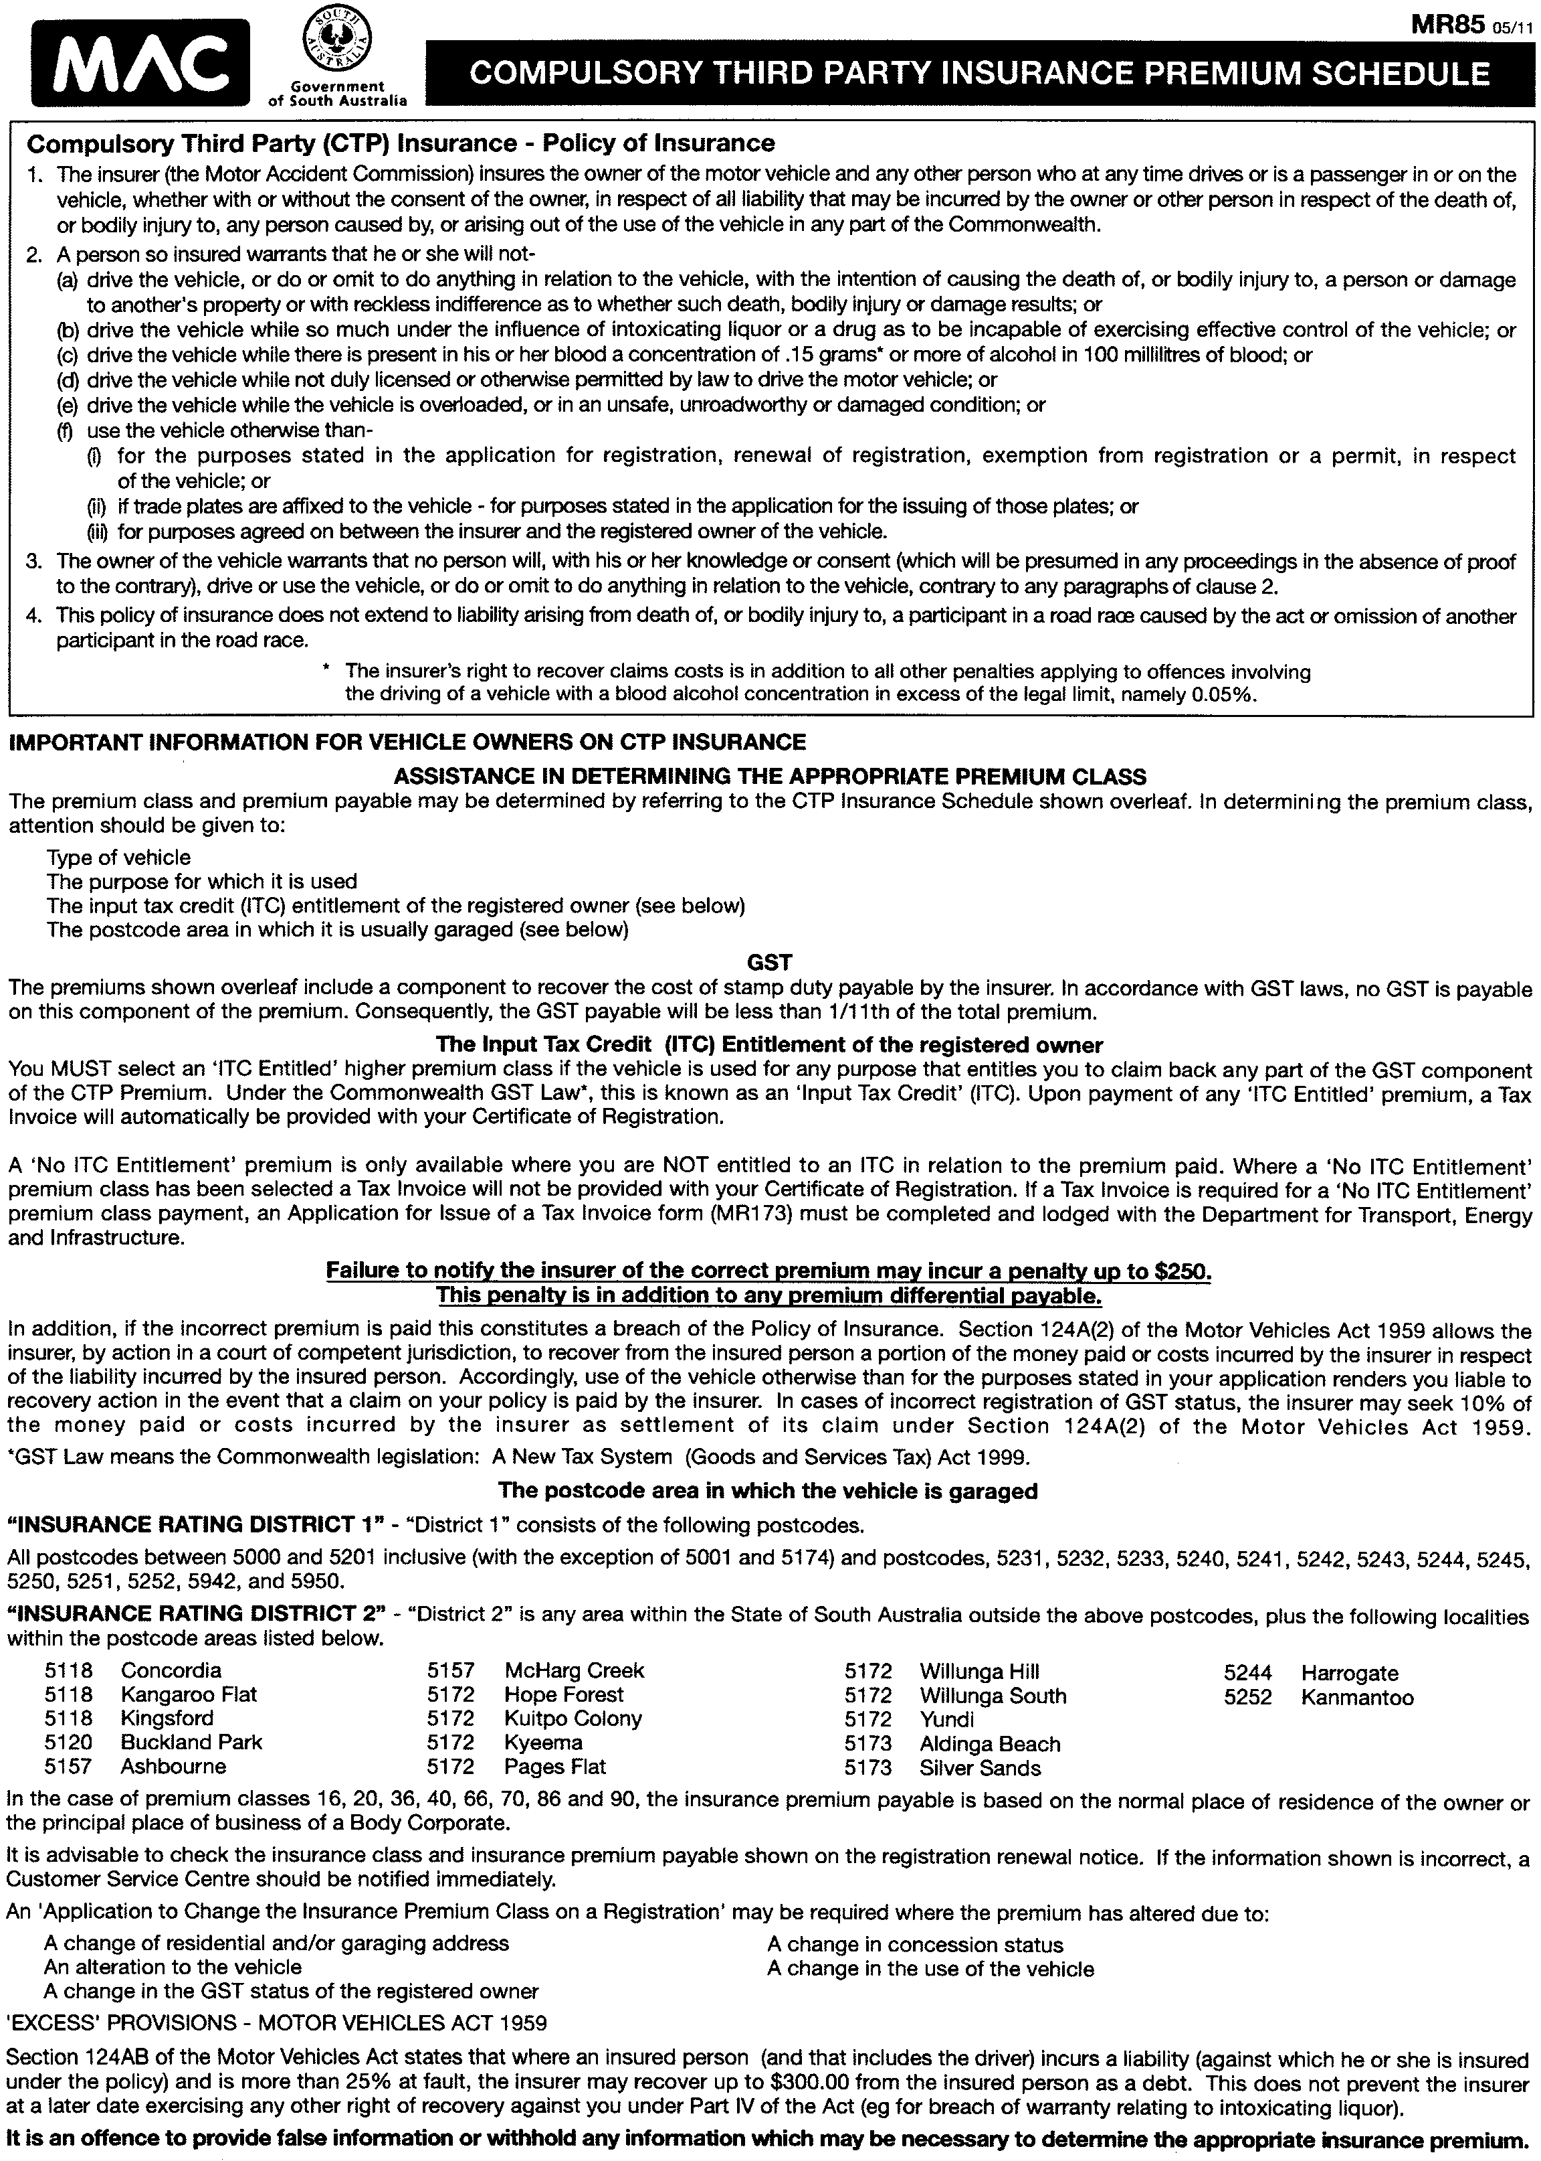

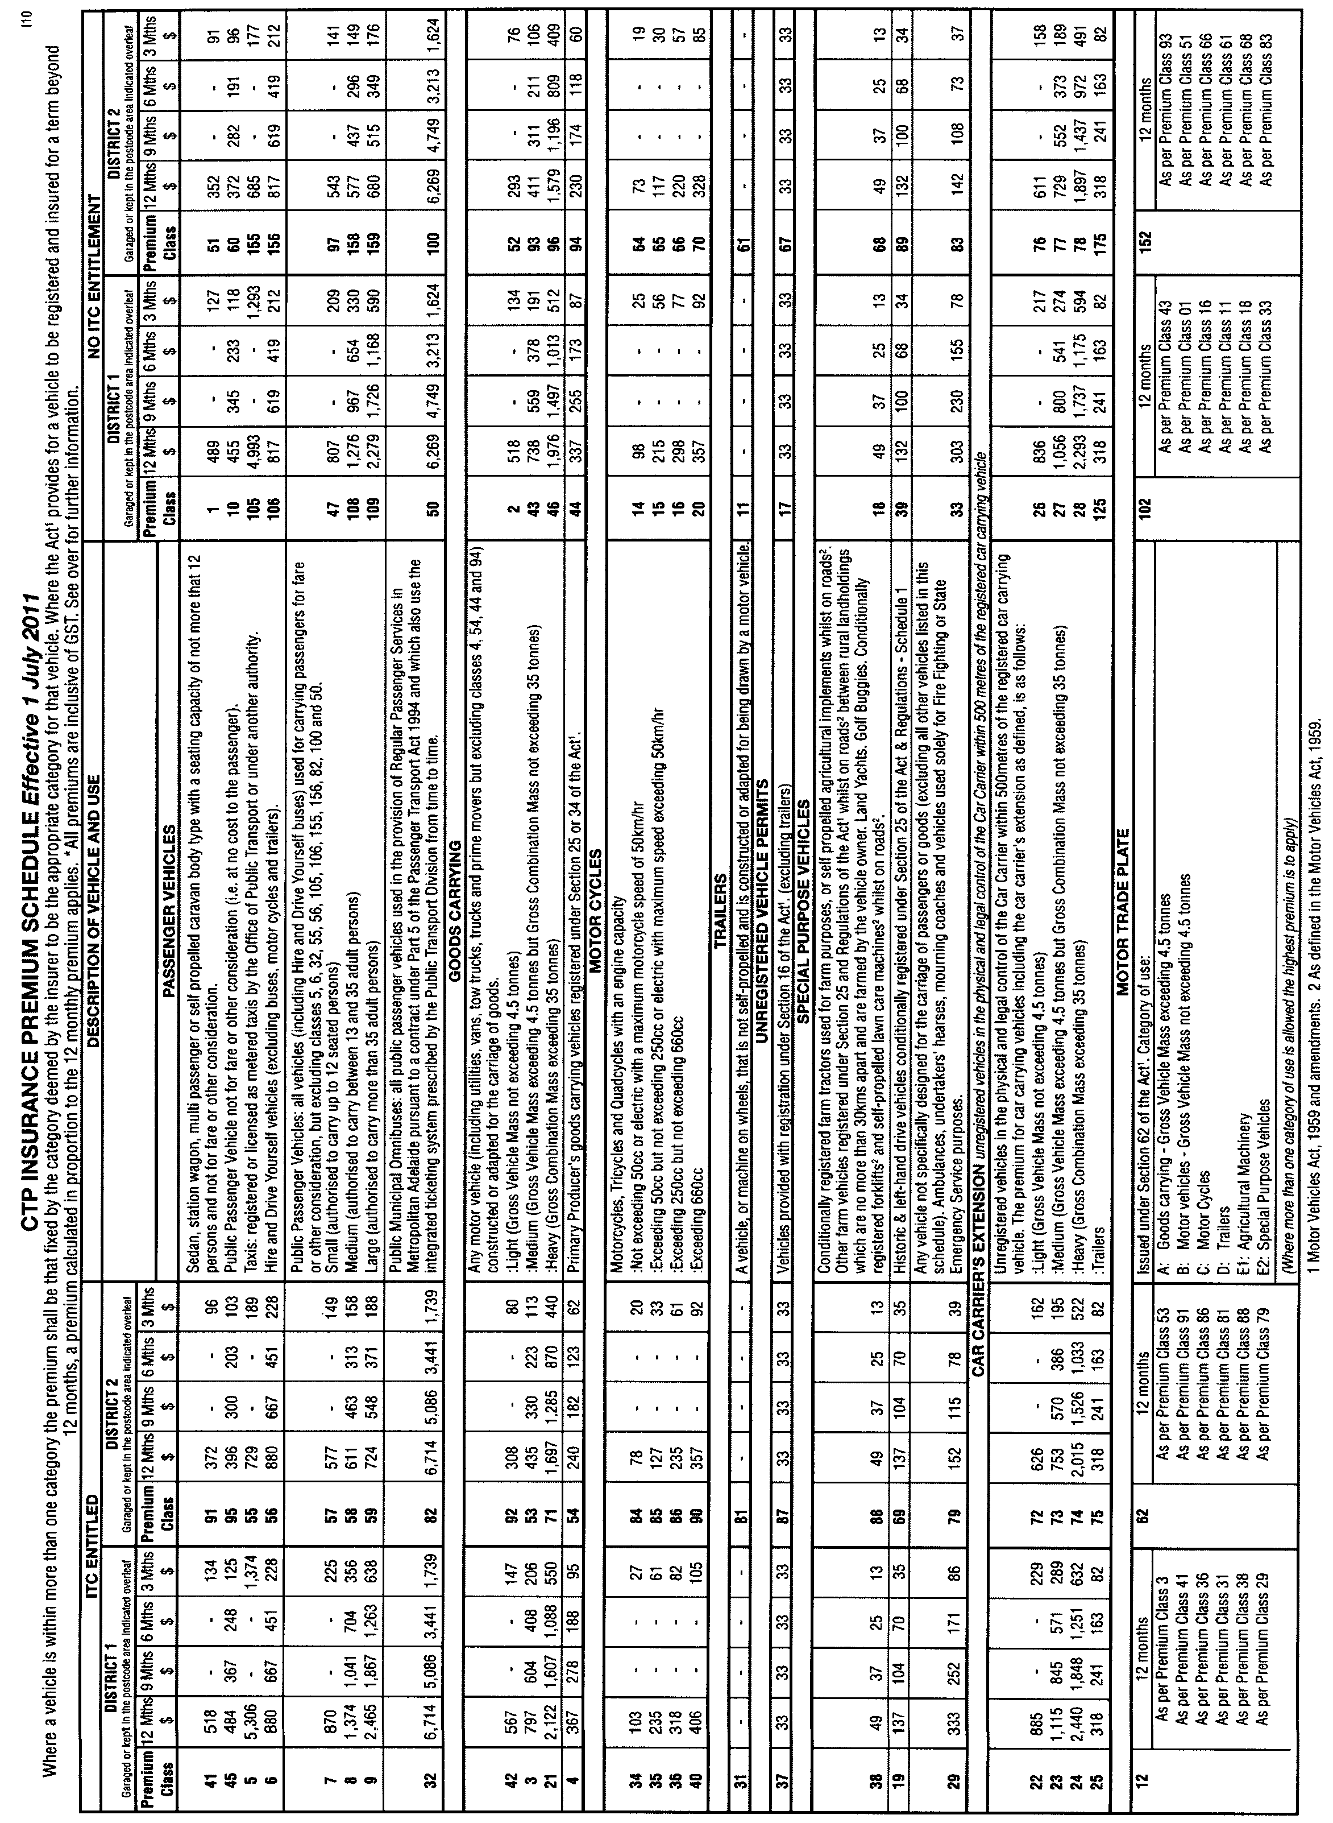

NOTICE TO MARINERS
No. 19 of 2011
South Australia—Kangaroo Island—Floating Rope—
Navigational Hazard
MARINERS are hereby advised that a large cluster of ropes and nets extending for approximately 60 m in length is floating off the coast of Kangaroo Island in approximate location latitude 35°54′.496S, longitude 138°01′.272E.
The hazard is marked with a large 40 litre orange marker buoy at one end supported with two anchors and two other black floating buoys in the middle and at the other end.
Mariners are advised to exercise extreme caution when navigating in the area until such time as the hazard can be removed.
Charts affected: Aus 346.
Adelaide, 31 May 2011.
Patrick Conlon, Minister for Transport
DTEI 2011/00735

NOTICE TO MARINERS
No. 20 of 2011
South Australia—Yankalilla Bay—HMAS Hobart Dive Site
MARINERS are advised that the isolated danger mark buoy at latitude 35°28′9″S, longitude 138°9′5″E marking the location of the HMAS Hobart Dive Site is missing. The frame is hanging off the mooring chain and the mast is lying in 30 m of water.
Mariners are further advised to use extreme caution when navigating in the vicinity of this location.
Navy Charts affected: Aus 444 and 780.
Adelaide, 1 June 2011.
Patrick Conlon, Minister for Transport
DTEI 2011/00735

WATER MAINS AND SEWERS

Office of the South Australian Water Corporation
Adelaide, 9 June 2011

WATER MAINS LAID

Notice is hereby given that the following main pipes or parts of main pipes have been laid down by the South Australian Water Corporation in or near the undermentioned water districts and are now available for a constant supply of water to adjacent land.

ADELAIDE WATER DISTRICT

ADELAIDE CITY COUNCIL
Daly Street, Adelaide. p44

CITY OF MITCHAM
Across Daws Road, Melrose Park and Pasadena. p28
Cashel Street, Pasadena. p28
Hayman Retreat, Craigburn Farm. p40
Across Craigburn Road, Craigburn Farm and Blackwood. p40

DISTRICT COUNCIL OF MOUNT BARKER
In and across Douglas Drive, Mount Barker. p42
Belmont Crescent, Mount Barker. p42
Charbray Court, Mount Barker. p42

CITY OF ONKAPARINGA
In and across Nurlo Road, Noarlunga Downs. p32 and 33
Across and in Cascabel Way, Noarlunga Downs. p32 and 33
Walkway (lot 2010 in LTRO DP 82562), Noarlunga Downs. p32 and 33
Across Goulbourn Terrace, Noarlunga Downs. p32
Dunn Street, Seaford. p38

CITY OF PLAYFORD
In and across Main Terrace, Blakeview. p34
Easements in lot 1258 in LTRO DP 83968, Craigmore Road, Blakeview. p34 and 35
In and across Finnis Street, Blakeview. p34 and 36
Botanic Link, Blakeview. p36
In and across Woodhaven Walk, Blakeview. p36, 37 and 35
Salmon Gum Crescent, Blakeview. p36 and 37
Gumbrae Place, Blakeview. p37
Berry Lane, Blakeview. p35, 34 and 36
Across Days Drive, Munno Para West. p39
Neilson Drive, Munno Para West. p39
Across Curtis Road, Munno Para West. p71
Easements in lot 8012 in LTRO DP 86210, Curtis Road, Munno Para West. p71
Easements in lot 8012 in LTRO DP 86210, Curtis Road, Munno Para West. p72

CITY OF PORT ADELAIDE ENFIELD
Easement in lot 700 in LTRO DP 74460, Mersey Road, Osborne. p14

CITY OF SALISBURY
Sturton Road, Edinburgh. p29 and 30

BAROSSA COUNTRY LANDS WATER DISTRICT

LIGHT REGIONAL COUNCIL
Easements in lot 60 in LTRO DP 83079, Sturt Highway, Kingsford. p1, 3 and 5
Across Sturt Highway, Kingsford. p1-3 and 5
In and across Argent Road, Kingsford. p1, 2, 4 and 5
Easements in lot 60 in LTRO DP 83079 and lot 513 in LTRO DP 77197, Sturt Highway, Kingsford. p6
McDonald Road, Kingsford. p6
Gomersal Road, Kingsford. p7 and 8
Across and in Sturt Highway, Kingsford and Shea-Oak Log. p7 and 8
In and across Lienert Road, Shea-Oak Log. p9 and 10
Across and in Sturt Highway, Shea-Oak Log. p9 and 10
In and across Wandel Road, Shea-Oak Log. p9 and 10
Across Sturt Highway, Shea-Oak Log. p11
Dee Road, Shea-Oak Log. p11
In and across Wehr Road, Daveyston. p12 and 13
Across and in Sturt Highway, Daveyston and Freeling. p12 and 13

BUNDALEER COUNTRY LANDS WATER DISTRICT

WAKEFIELD REGIONAL COUNCIL
Carinya Lane, Kybunga. p64 and 65
Hoyleton North Road, Kybunga. p67

KADINA WATER DISTRICT

DISTRICT COUNCIL OF THE COPPER COAST
In and across Graves Street, Kadina. p15
In and across Lyon Street, Kadina. p15
Fourth Street, Kadina. p15

MYPONGA WATER DISTRICT

DISTRICT COUNCIL OF YANKALILLA
Thomas Street, Yankalilla. p31
Harrison Crescent, Yankalilla. p31
Williss Road, Normanville. p49 and 50
Public road north-east of section 1002, hundred of Yankalilla, Normanville. p50 and 51
Across public road north-east of section 1002, hundred of Yankalilla, Normanville. p52

WARREN COUNTRY LANDS WATER DISTRICT

LIGHT REGIONAL COUNCIL
Sturt Highway, Freeling. p12 and 13

WATER MAINS ABANDONED

Notice is hereby given that the undermentioned water mains have been abandoned by the South Australian Water Corporation.

ADELAIDE WATER DISTRICT

CITY OF ONKAPARINGA
Nurlo Road, Noarlunga Downs. p32
Across Goulbourn Terrace, Noarlunga Downs. p32

CITY OF PORT ADELAIDE ENFIELD
Easements in lot 700 in LTRO DP 74460, Mersey Road, Osborne. p14

BAROSSA COUNTRY LANDS WATER DISTRICT

LIGHT REGIONAL COUNCIL
Easements in lot 60 in LTRO DP 83079, Sturt Highway, Kingsford. p1, 3 and 5
Across Sturt Highway, Kingsford. p1, 3 and 5
Argent Road, Kingsford. p1, 4 and 5
Sturt Highway, Kingsford. p6
McDonald Road, Kingsford. p6
Gomersal Road, Kingsford. p7 and 8
Across and in Sturt Highway, Kingsford and Shea-Oak Log. p7 and 8
Lienert Road, Shea-Oak Log. p9 and 10
Across and in Sturt Highway, Shea-Oak Log. p9 and 10
Wandel Road, Shea-Oak Log. p9 and 10
Across Sturt Highway, Shea-Oak Log. p11
Dee Road, Shea-Oak Log. p11
Wehr Road, Daveyston. p12 and 13
Across and in Sturt Highway, Daveyston and Freeling. p12 and 13

BUNDALEER COUNTRY LANDS WATER DISTRICT

WAKEFIELD REGIONAL COUNCIL
Carinya Lane, Kybunga. p64 and 65
Hoyleton North Road, Kybunga. p67

KADINA WATER DISTRICT

DISTRICT COUNCIL OF COPPER COAST
Graves Street, Kadina. p15
Lyon Street, Kadina. p15
Fourth Street, Kadina. p15

WARREN COUNTRY LANDS WATER DISTRICT

LIGHT REGIONAL COUNCIL
Sturt Highway, Freeling. p12 and 13

OUTSIDE WATER DISTRICTS

WAKEFIELD REGIONAL COUNCIL
Hoyleton North Road, Kybunga. p57 and 67
Carinya Lane, Kybunga. p66, 61 and 64
Easements in allotment piece 93 in LTRO FP 171495, Carinya Lane, Kybunga. p61-64

DISTRICT COUNCIL OF YANKALILLA
Waterworks land (allotment piece 1 in LTRO FP 157720), Reservoir Road, Myponga. p24

WATER MAINS LAID

Notice is hereby given that the undermentioned water mains have been laid down by the South Australian Water Corporation and are not available for a constant supply of water to adjacent land.

ADELAIDE WATER DISTRICT

CAMPBELLTOWN CITY COUNCIL
Waterworks land (lot 142 in LTRO DP 9313), Addison Avenue, Athelstone. p16-20
Easement in lot 227 in LTRO DP 9521, Addison Avenue, Athelstone. p16

JAMESTOWN COUNTRY LANDS WATER DISTRICT

DISTRICT COUNCIL OF PETERBOROUGH
Waterworks land (section 441, hundred of Yongala), Peterborough. p54-56

OUTSIDE WATER DISTRICTS

WAKEFIED REGIONAL COUNCIL
In and across Hoyleton North Road, Kybunga. p57 and 67
Easements in allotment piece 92 in LTRO FP 171495, Hoyleton North Road, and allotment piece 93 in LTRO FP 171495, Carinya Lane, Kybunga. p57-64 and 68
Waterworks land (lot 129 in LTRO FP 176201), Carinya Lane, Kybunga. p63
Carinya Lane, Kybunga. p66

DISTRICT COUNCIL OF YANKALILLA
Waterworks land (allotment piece 1 in LTRO FP 157720), Reservoir Road, Myponga. p24-27

SEWERS LAID

Notice is hereby given that the following sewers have been laid down by the South Australian Water Corporation in the undermentioned drainage areas and are now available for house connections.

ADELAIDE DRAINAGE AREA

TOWN OF GAWLER
Wilton Street, Evanston. FB 1208 p3
Twelfth Street, Gawler South. FB 1208 p4

CITY OF MITCHAM
Hayman Retreat, Craigburn Farm. FB 1207 p4-6
Across and in Craigburn Road, Craigburn Farm and Blackwood. FB 1207 p4-6
Across Woods View, Craigburn Farm. FB 1207 p4-6
Easement in lots 922 and 923 in LTRO DP 85743, Hayman Retreat, Craigburn Farm. FB 1207 p4-6
Easements in lot 83 in LTRO DP 84477, Brookman Crescent and lots 1-4 in LTRO DP 85743, Craigburn Road, Craigburn Farm. FB 1207 p4-6

CITY OF ONKAPARINGA
Across Pritchard Court, Flagstaff Hill. FB 1208 p2
Easements in lot 11 in LTRO DP 32025, Pritchard Court, Flagstaff Hill. FB 1208 p2
Easements in lots 653-655 in LTRO DP 82562, Cascabel Way, Noarlunga Downs. FB 1205 p57-59
Walkway (lot 2010 in LTRO DP 82562), Noarlunga Downs. FB 1205 p57-59
Across and in Cascabel Way, Noarlunga Downs. FB 1205 p57-59
Easement in lots 612 and 611 in LTRO DP 82562, Cascabel Way, Noarlunga Downs. FB 1205 p57, 58 and 60
Easements in lots 645-640 in LTRO DP 82562, Cascabel Way, Noarlunga Downs. FB 1205 p57, 58 and 60
Nurlo Road, Noarlunga Downs. FB 1205 p57, 58 and 60
Dunn Street, Seaford. FB 1207 p1-3

CITY OF PLAYFORD
In and across Main Terrace, Blakeview. FB 1207 p7, 8 and 10
Easements in lot 1258 in LTRO DP 83968, Craigmore Road, Blakeview. FB 1207 p7-11
In and across Finnis Street, Blakeview. FB 1207 p7, 8 and 10
Easement in lot 1260 in LTRO DP 85180, Salmon Gum Crescent, Blakeview. FB 1207 p7, 8 and 10
Botanic Link, Blakeview. FB 1207 p7, 8 and 10
In and across Woodhaven Walk, Blakeview. FB 1207 p7, 9 and 11
Salmon Gum Crescent, Blakeview. FB 1207 p7, 9 and 11
Gumbrae Place, Blakeview. FB 1207 p7, 9 and 10

CITY OF PORT ADELAIDE ENFIELD
Willow Avenue, Manningham. FB 1208 p1

CITY OF SALISBURY
Sturton Road, Edinburgh. FB 1205 p54-56

PORT LINCOLN COUNTRY DRAINAGE AREA

CITY OF PORT LINCOLN
Easements in reserve (lot 801 in LTRO DP 83709), La Fayette Street, lot 103 in LTRO Community Plan 26515 and Common Property in LTRO Community Plan 26515, Carramatta Court, Port Lincoln. FB 1205 p53
Across and in Carramatta Court, Port Lincoln. FB 1205 p53
Easement in lot 2 in LTRO DP 82488, Carramatta Court, Port Lincoln. FB 1205 p53
Easements in lot 5 in LTRO DP 82488, Carramatta Court, Port Lincoln. FB 1205 p53

SEWERS ABANDONED

Notice is hereby given that the undermentioned sewers have been abandoned by the South Australian Water Corporation.

ADELAIDE DRAINAGE AREA

CITY OF ONKAPARINGA
In and across Nurlo Road, Noarlunga Downs. FB 1205 p57 and 58

CITY OF SALISBURY
Easements in reserve (lot 802 in LTRO DP 71564), Edinburgh Road and lot 6 in LTRO DP 68390, Sturton Road, Edinburgh. FB 1205 p54-55

SEWERS LAID

Notice is hereby given that the undermentioned sewer has been laid down by the South Australian Water Corporation and is not available for house connections.

ADELAIDE DRAINAGE AREA

CITY OF ONKAPARINGA
In and across Nurlo Road, Noarlunga Downs. FB 1205 p57, 58 and 60

A. J. Ringham, Chief Executive Officer, South Australian Water Corporation

WORKERS REHABILITATION AND COMPENSATION ACT 1986
Determination
IN exercise of the delegation provided under the Instrument of Delegation of the WorkCover Corporation of South Australia dated 19 May 2011 to the Chief Executive Officer, I, as delegate of the WORKCOVER CORPORATION OF SOUTH AUSTRALIA (‘the Corporation’) in accordance with those provisions of the WORKERS REHABILITATION AND COMPENSATION ACT 1986, as amended (‘the Act’) identified in Item 1 of the Schedule hereto ‘the Schedule’ determine in the terms set out in Item 2 of the Schedule upon the grounds set out in Item 3 of the Schedule, if any, to come into effect on the date set out in Item 4 of the Schedule and determines further that notice of this Determination shall be provided in the manner set out in Item 5 of the Schedule.
Schedule
Item 1 Section Empowering Determination
Section 66.
Item 2 Terms of Determination
2.1 Amendment to Levy Rates
That the Determinations of the Corporation as to the percentage of aggregate remuneration paid to an employer’s workers payable as the levy made prior to the making of this Determination be and are hereby varied so that the percentage of aggregate remuneration paid to an employer’s workers in each class of industry, referred to in Column No. 2 of the Appendix hereto, payable as the levy, shall be the corresponding percentage set out in Column No. 3 of the Appendix hereto plus 10% to allow for GST.
Item 3 Grounds of Determination
3.1 In respect of the levy applicable to the classes of industry that the percentages applicable take into account:
(a) the extent to which work carried on in a relevant class is likely to contribute to the cost of compensable disability; and
(b) the need to establish and maintain sufficient funds:
(i) to satisfy the Corporation’s future liabilities in respect of compensable disabilities attributable to traumas occurring from the date of commencement of this Determination until the 30th day of June 2012 from the levy raised from remuneration in that period; and
(ii) to make proper provision for administrative and other expenditure of the Corporation; and
(iii) to make up any insufficiency in the Compensation Fund resulting from previous liabilities or expenditures or from a reassessment of future liabilities.
3.2 That the percentages so determined in accordance with Section 66 (7) of the Act (not exceeding 7.5 per cent) are as follows:
0.40 per cent 1.90 per cent 3.40 per cent 4.90 per cent 6.40 per cent
0.50 per cent 2.00 per cent 3.50 per cent 5.00 per cent 6.50 per cent
0.60 per cent 2.10 per cent 3.60 per cent 5.10 per cent 6.60 per cent
0.70 per cent 2.20 per cent 3.70 per cent 5.20 per cent 6.70 per cent
0.80 per cent 2.30 per cent 3.80 per cent 5.30 per cent 6.80 per cent
0.90 per cent 2.40 per cent 3.90 per cent 5.40 per cent 6.90 per cent
1.00 per cent 2.50 per cent 4.00 per cent 5.50 per cent 7.00 per cent
1.10 per cent 2.60 per cent 4.10 per cent 5.60 per cent 7.10 per cent
1.20 per cent 2.70 per cent 4.20 per cent 5.70 per cent 7.20 per cent
1.30 per cent 2.80 per cent 4.30 per cent 5.80 per cent 7.30 per cent
1.40 per cent 2.90 per cent 4.40 per cent 5.90 per cent 7.40 per cent
1.50 per cent 3.00 per cent 4.50 per cent 6.00 per cent 7.50 per cent
1.60 per cent 3.10 per cent 4.60 per cent 6.10 per cent
1.70 per cent 3.20 per cent 4.70 per cent 6.20 per cent
1.80 per cent 3.30 per cent 4.80 per cent 6.30 per cent
Item 4 Commencement Date of Determination
1 July 2011.
Item 5 Notice of Determination
That notice of this Determination be published in the South Australian Government Gazette.
Confirmed as a true and correct record of the decision of the Corporation.
Dated June 2011.
Rob Thomson, Board Delegate

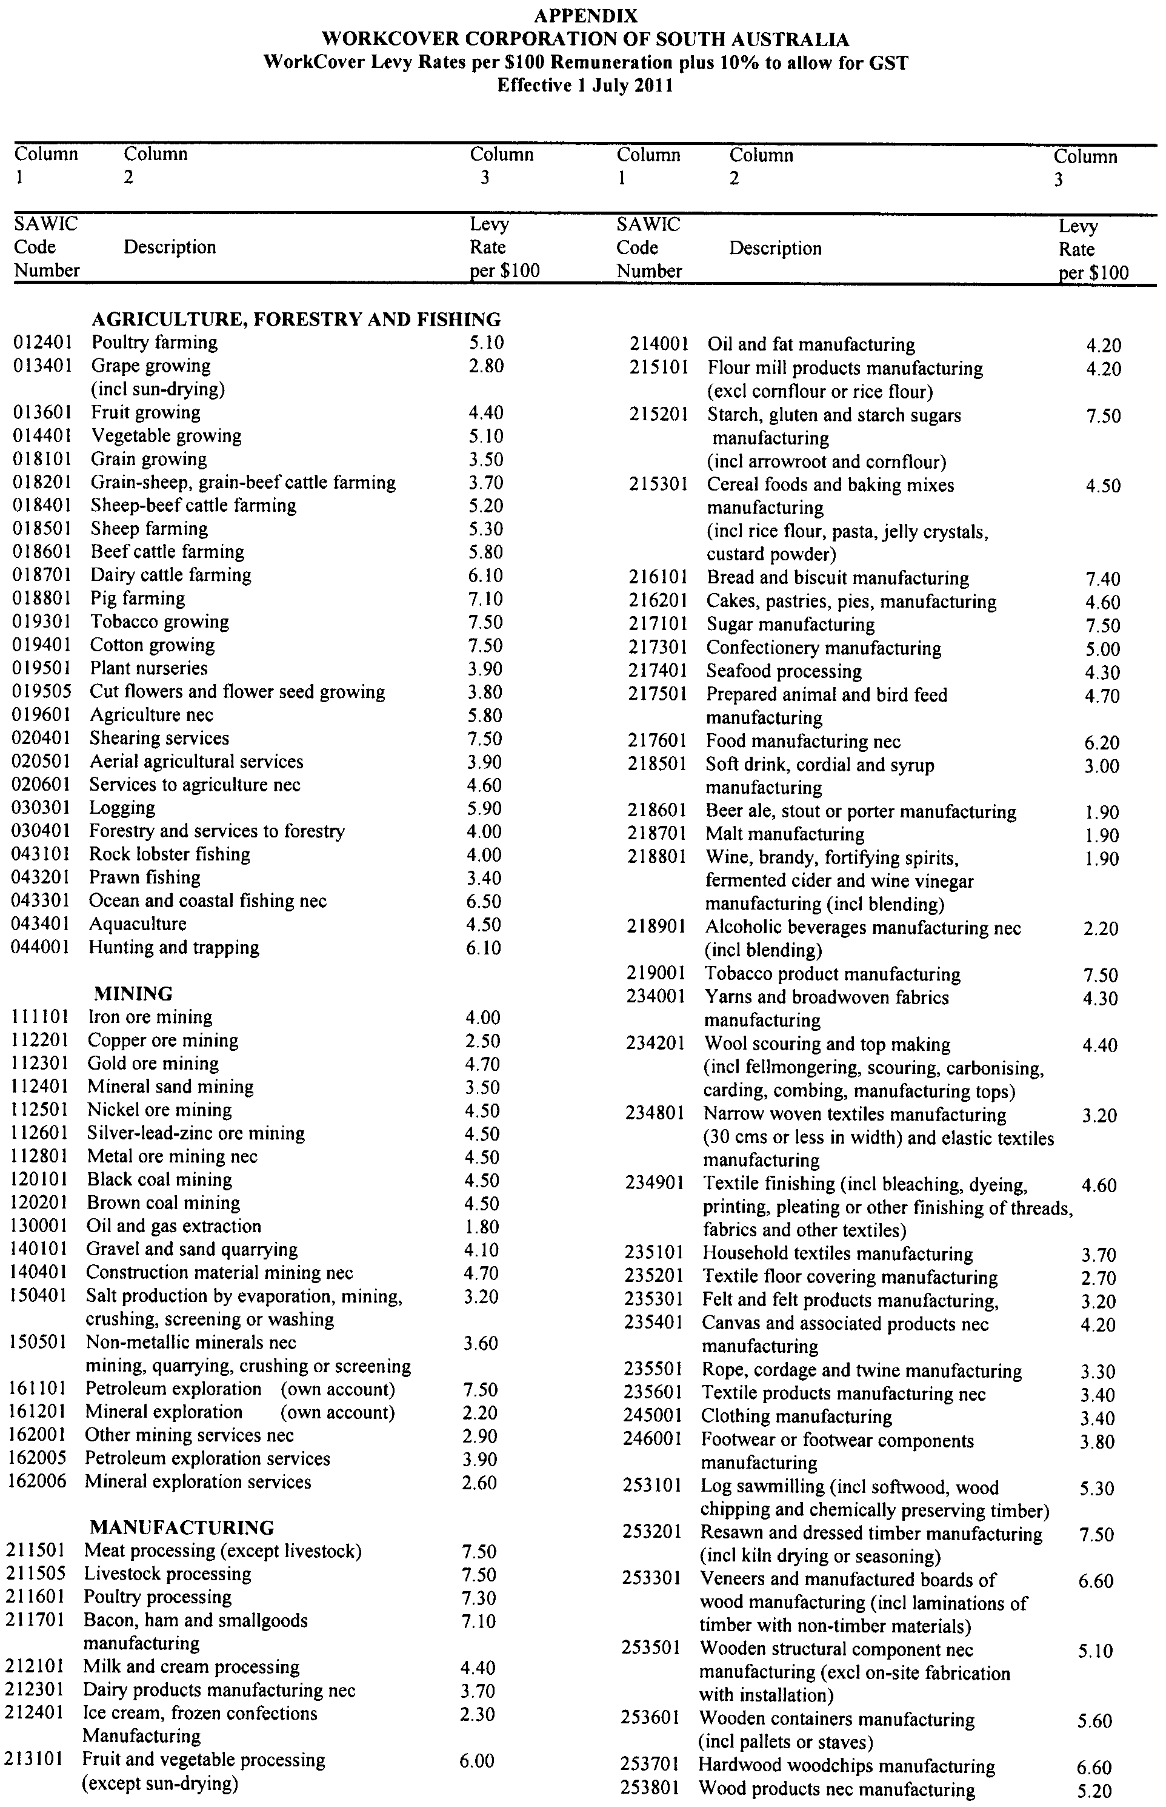
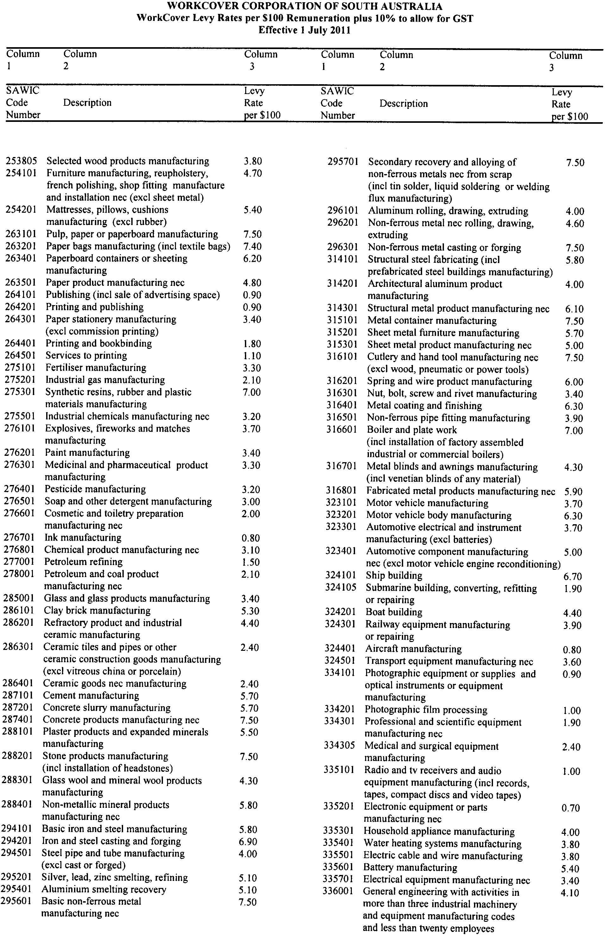
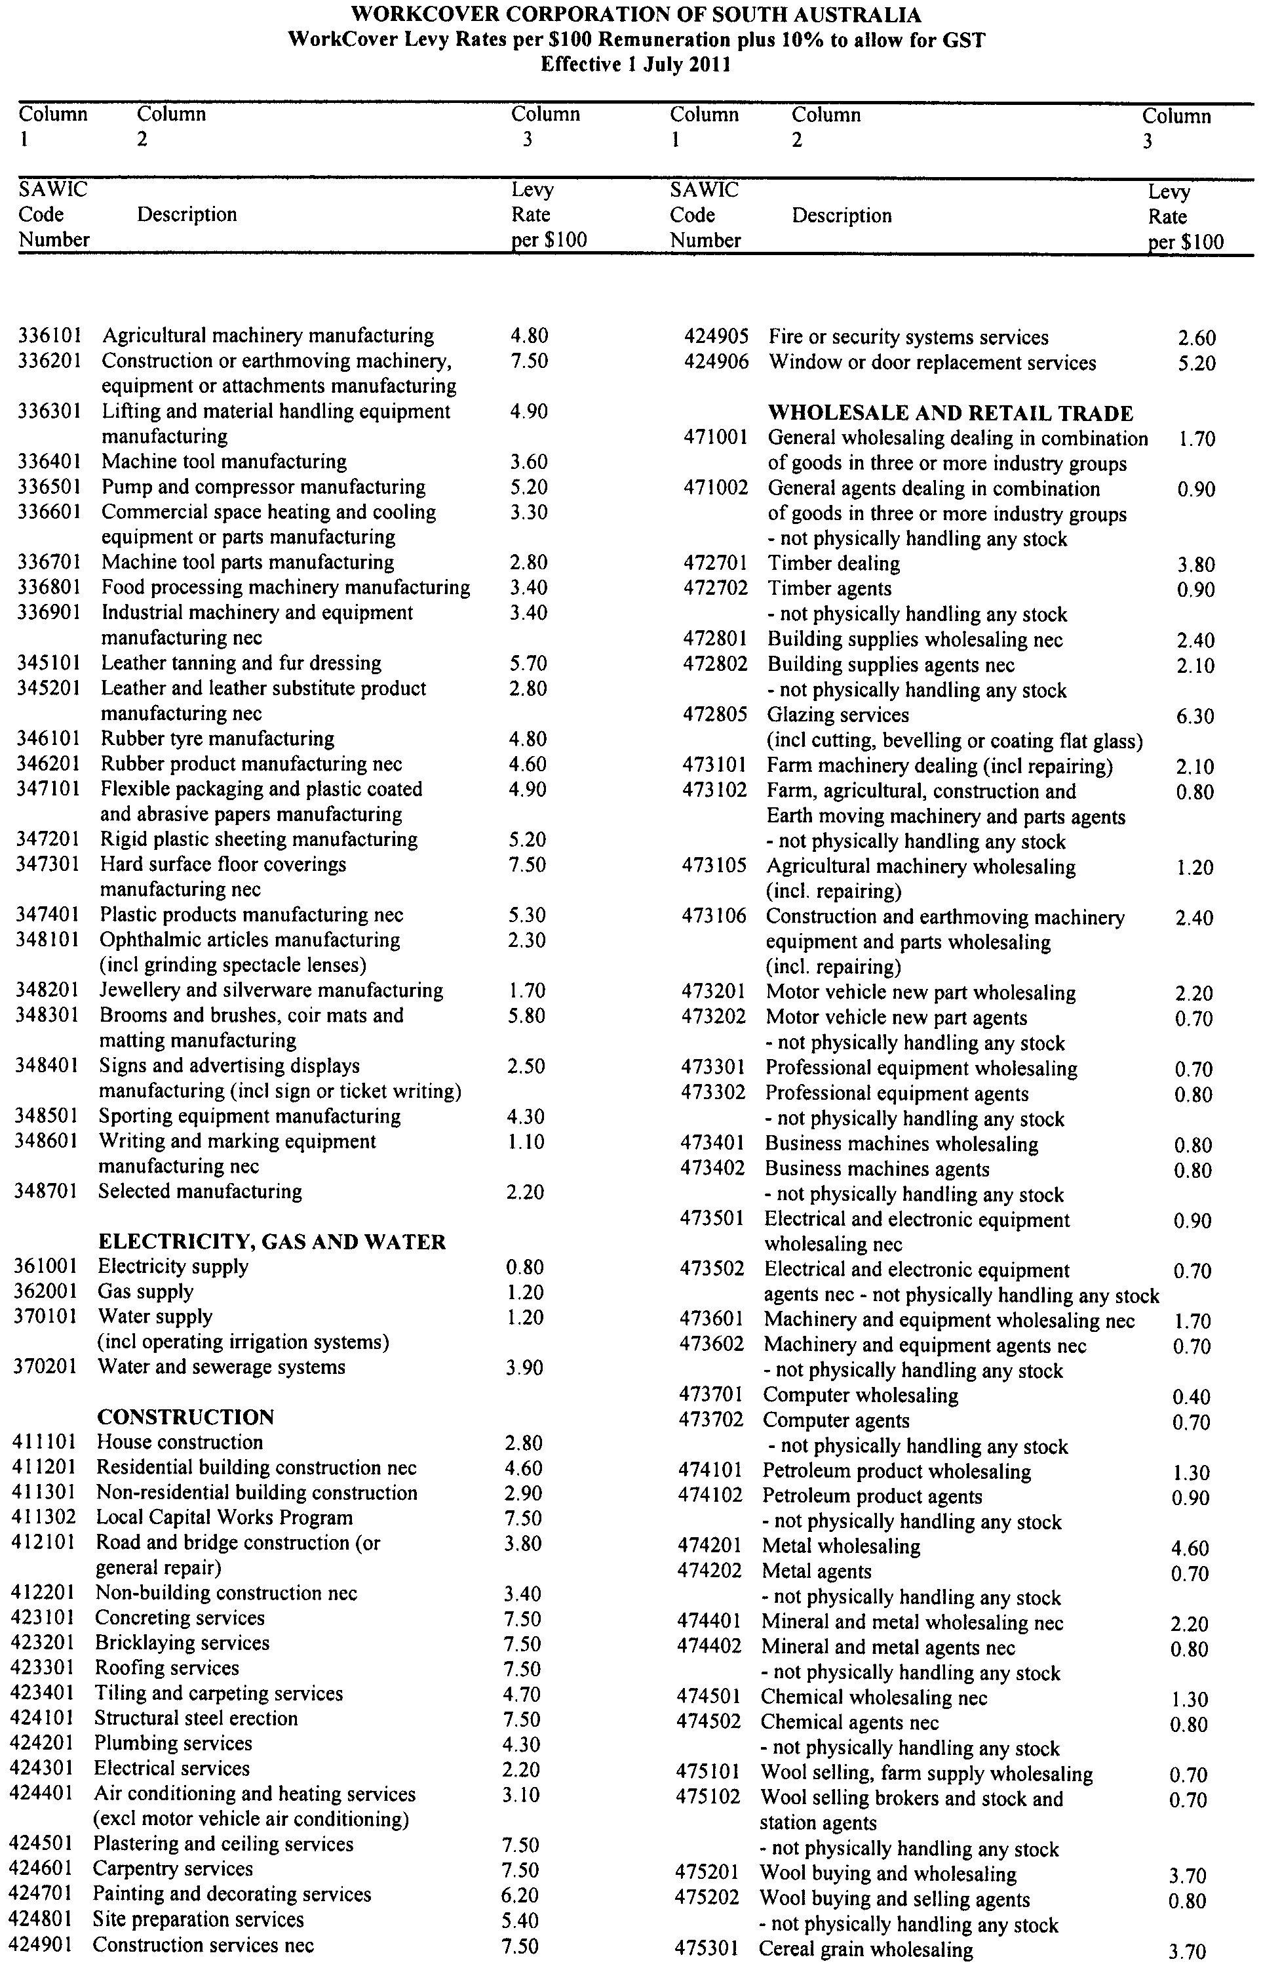
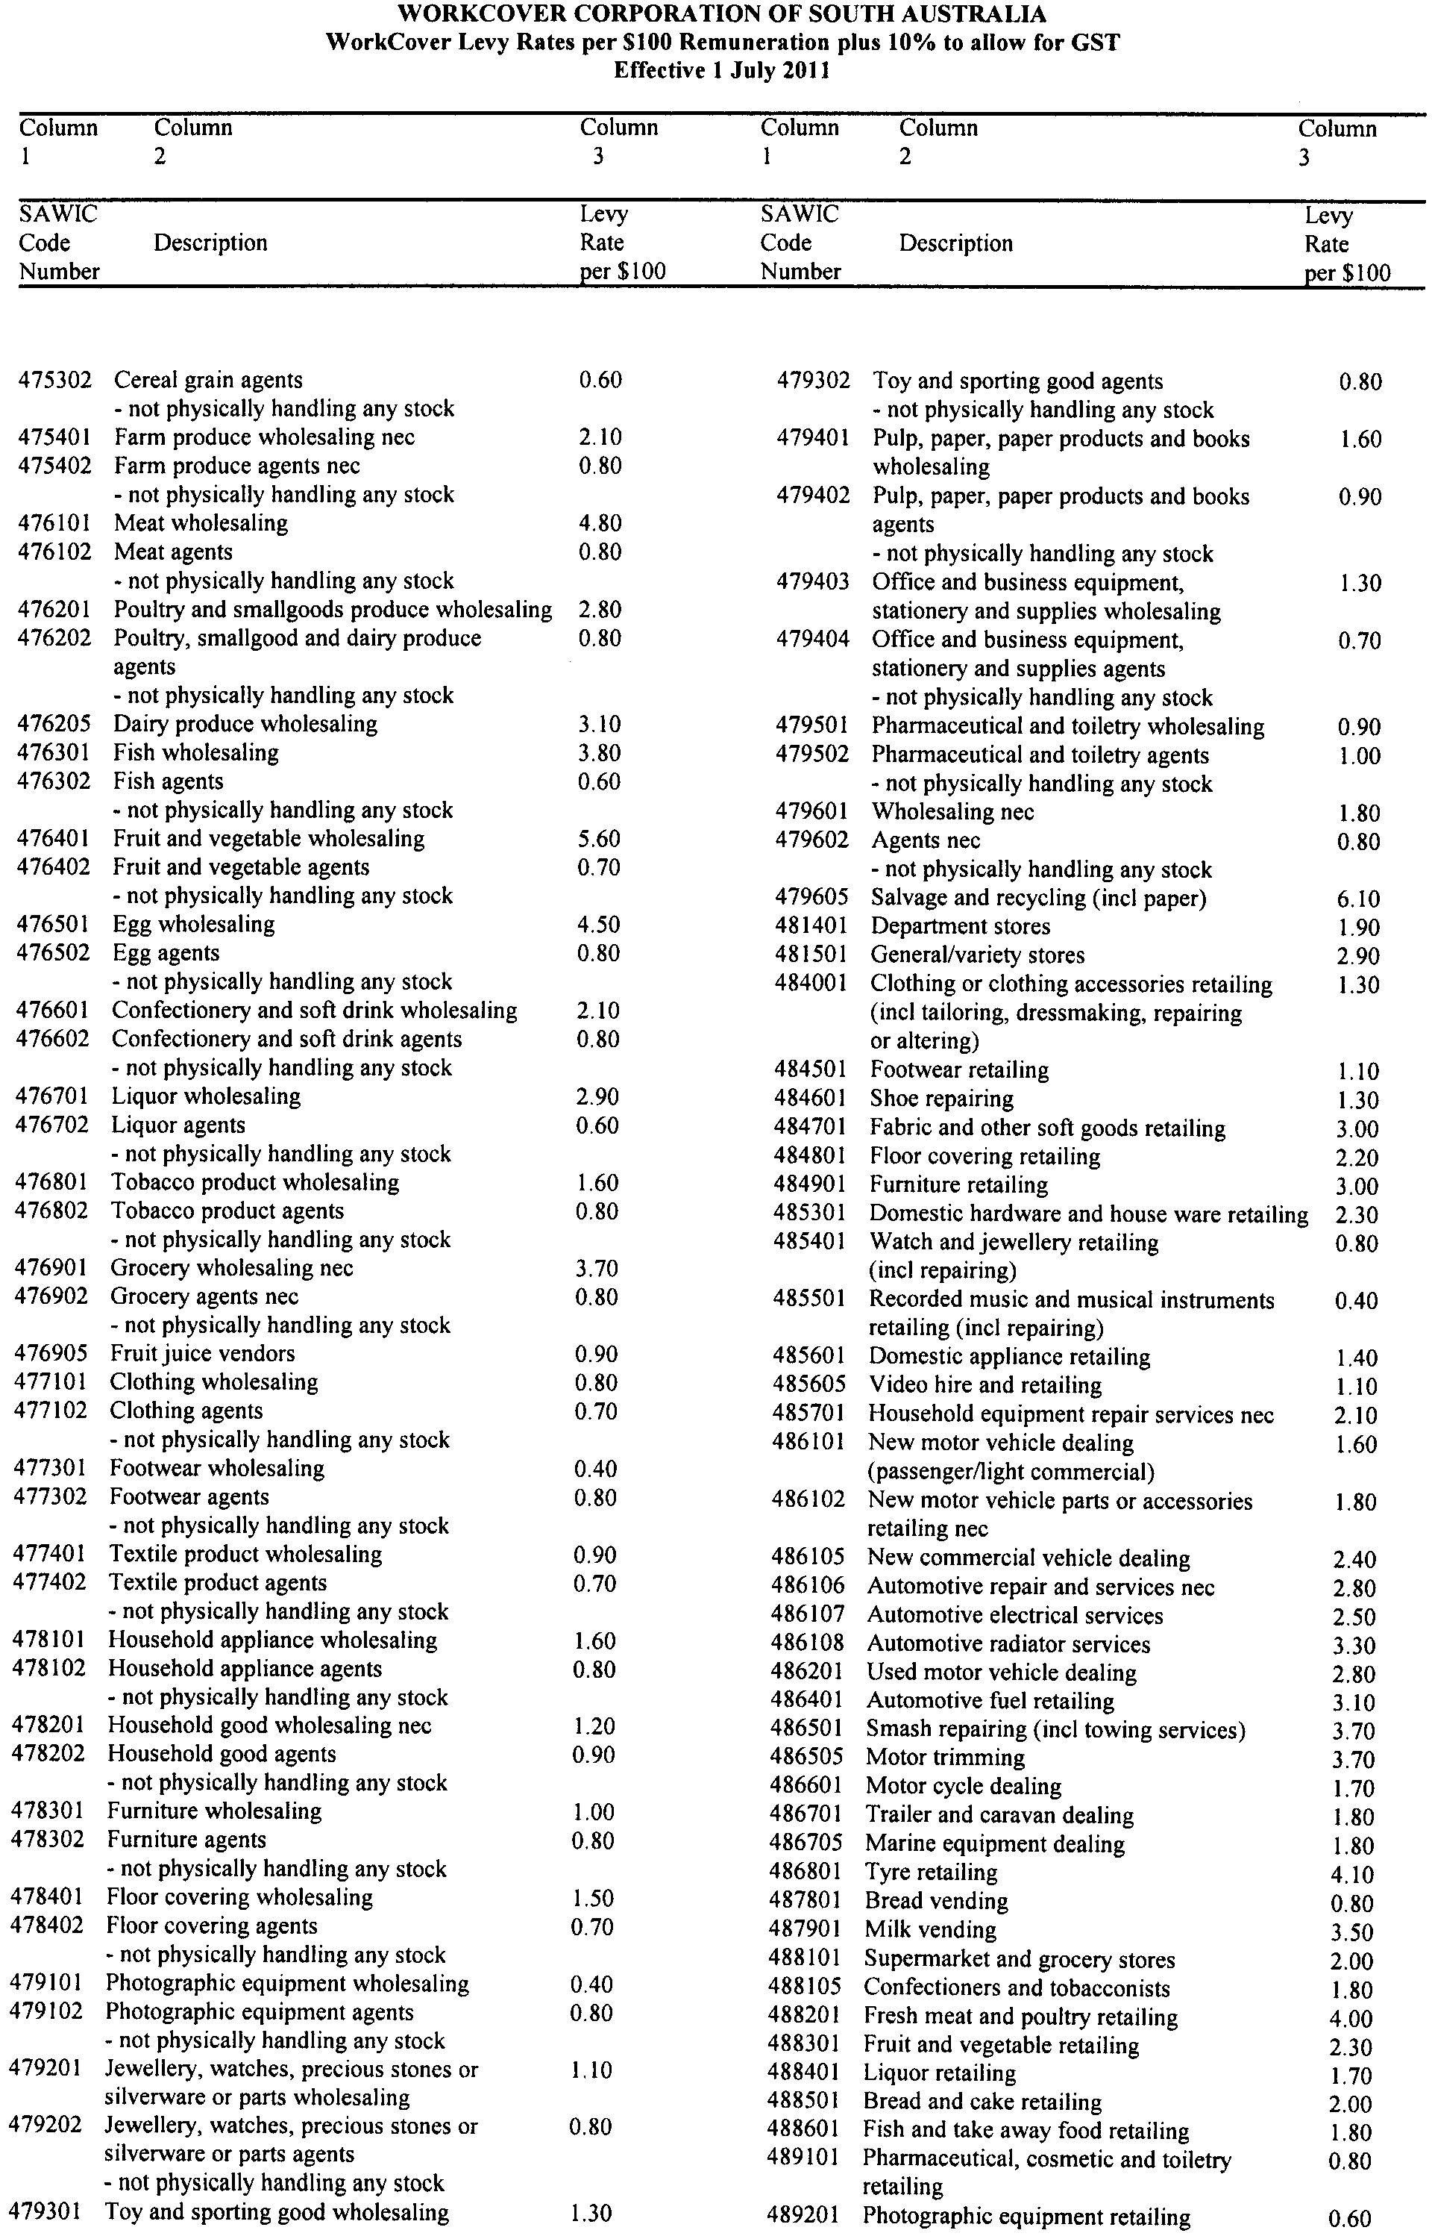
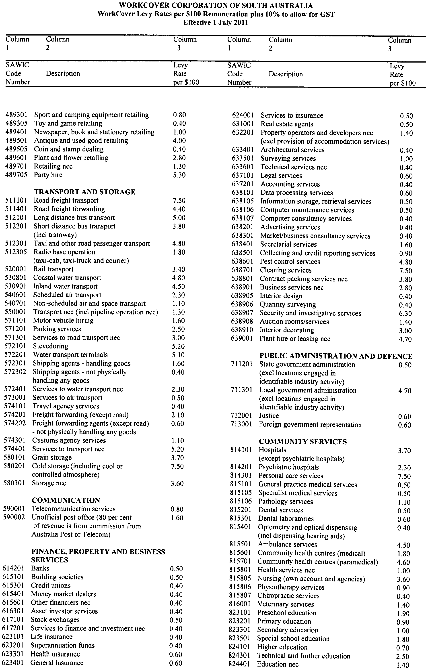
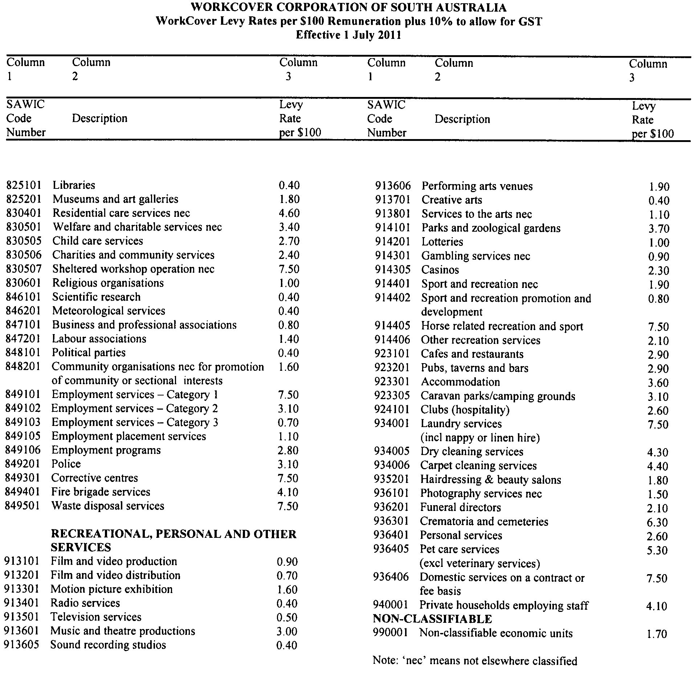

WATERWORKS ACT 1932
Save the River Murray Levy
For General Information
PURSUANT to Sections 65CA of the Waterworks Act 1932 the charges for the Save the River Murray Levy for the financial year commencing 1 July 2011 will be:
(a) For Category 1 land—$9.35 per quarter
(b) For Category 2 land—$42.00 per quarter
Dated 30 May 2011.
Paul Caica, Minister for Water

FAXING COPY?
IF you fax copy to Government Publishing SA for inclusion in the Government Gazette, there is no need to send a Confirmation Copy to us as well.
This creates confusion and may well result in your notice being printed twice.
Please use the following fax number:
Fax transmission: (08) 8207 1040
Phone Enquiries: (08) 8207 1045
Please include a contact person, phone number and order number so that we can phone back with any queries we may have regarding the fax copy.
NOTE: Closing time for lodging new copy (fax, hard copy or email) is 4 p.m. on Tuesday preceding the day of publication.

Government Gazette notices can be Emailed.
The address is:
governmentgazette@dpc.sa.gov.au
Documents should be sent as attachments in Word format.
When sending a document via Email, please confirm your transmission with a faxed copy of your document, including the date the notice is to be published.
Fax transmission: (08) 8207 1040
Phone Enquiries: (08) 8207 1045
NOTE: Closing time for lodging new copy (fax, hard copy or email) is 4 p.m. on Tuesday preceding the day of publication.

THE CORPORATION OF THE CITY OF ADELAIDE
By-law Made Under the Local Government Act 1999
By-law No. 1—Permits and Penalties
TO repeal by-laws, provide for a permit system and continuing penalties in Council by-laws and to clarify the construction of such by-laws.
1. Repeal of By-laws
All previous by-laws made or adopted by the Council prior to the date this by-law is made, with the exception of the Council’s By-law No. 6—Rundle Mall made by the Council on 31 January 2011, are hereby repealed effective from the day on which this by-law comes into operation.
2. Definitions
2.1 In any by-law of the Council ‘person’ includes a natural person, a body corporate, an incorporated association and an unincorporated association.
2.2 In any by-law of the Council, ‘the Council’ means the Corporation of the City of Adelaide.
2.3 In any by-law of the Council, unless the contrary intention is clearly indicated, the word ‘permission’ means the permission of the Council, or such other person as the Council may by resolution authorise for that purpose, given in writing prior to the act, event or activity to which it relates.
3. Permits
3.1 Where a by-law requires that permission be obtained, any person seeking the grant of permission must submit a written application to the Council in the form (if any) and accompanied by the fee (if any) prescribed by the Council.
3.2 The Council, or such other person as the Council may by resolution authorise for that purpose, may attach such conditions (including time limits, renewal and transfer requirements) to a grant of permission as it thinks fit, and may vary or revoke such conditions or impose new conditions by notice in writing to the permit holder.
3.3 Any permit holder shall comply with every such condition.
3.4 The Council, or such other person as the Council may by resolution authorise for that purpose, may suspend or revoke such grant of permission at any time by notice in writing to the permit holder.
4. Offences and Penalties
4.1 Any person who commits a breach of any by-law of the Council shall be guilty of an offence and shall be liable to a maximum penalty being the maximum penalty referred to in the Local Government Act 1999, that may be fixed by by law for any breach of a by-law.
4.2 Any person who commits a breach of any by-law of the Council of a continuing nature shall be guilty of an offence and, in addition to any other penalty that may be imposed, shall be liable to a further penalty for every day on which the offence is continued, such penalty being the maximum amount referred to in the Local Government Act 1999 which may be prescribed by by-law for offences of a continuing nature.
5. Construction
Every by-law of the Council shall be subject to any Act of Parliament and Regulations made thereunder.
The foregoing by-law was duly made and passed at a meeting of the Corporation of the City of Adelaide held on 31 May 2011, by an absolute majority of the members for the time being constituting the Council, there being at least two-thirds of the members present.
P. Smith, Chief Executive Officer

THE CORPORATION OF THE CITY OF ADELAIDE
By-law Made Under the Local Government Act 1999
By-law No. 2—Moveable Signs
TO protect visual amenity and public safety on roads by setting standards for moveable signs and providing conditions for the design, construction and placement of such signs in a manner which recognises the advertising needs of businesses to maximise economic viability.
1. Definitions
In this by-law:
1.1 Authorised Person has the same meaning as in the Local Government Act 1999;
1.2 Boundary means that line between private property and the Road or Road Related Area;
1.3 Business means the business or organisation to which a Moveable Sign relates;
1.4 Business Premises means the premises from which a business, trade or calling is conducted;
1.5 Ceremonial Street means any Road declared as such by the Council;
1.6 Footpath Area means:
1.6.1 that part of the Road between the boundary of the Road and the edge of the carriageway of the Road on the same side as that boundary; or
1.6.2 a footway, laneway or other place made or constructed for the use of pedestrians and not for the use of Vehicles;
1.7 Local Government Land means land owned by the Council or under the Council’s care, control and management;
1.8 Moveable Sign has the same meaning as in the Local Government Act 1999;
1.9 Road has the same meaning as in the Local Government Act 1999 and includes a footpath;
1.10 Road Related Area has the same meaning as in the Road Traffic Act 1961 and the Australian Road Rules 1999;
1.11 Vehicle has the same meaning as in the Road Traffic Act 1961 and the Australian Road Rules 1999.
2. Design and Construction
A Moveable Sign must:
2.1 be of a kind known as an ‘A’ frame sign, a Sandwich Board sign, an inverted ‘T’ sign or, with the permission of the Council, a sign of some other kind;
2.2 be designed, constructed and maintained in good quality and condition so as not to present a hazard to any member of the public;
2.3 be of strong construction so as to be stable when in position and be able to keep its position in adverse weather conditions;
2.4 not contain sharp or jagged edges or corners;
2.5 not be unsightly or offensive in appearance or content;
2.6 not rotate or contain moving parts;
2.7 not contain flashing lights or be illuminated internally;
2.8 be constructed of timber, cloth, metal, plastic or plastic coated cardboard, or a mixture of such materials;
2.9 not have balloons, flags, streamers or other material attached to it;
2.10 not exceed 900 mm in perpendicular height, or have a base with any side exceeding 600 mm in length;
2.11 in the case of an ‘A’ Frame or Sandwich Board sign:
2.11.1 be hinged or joined at the top; and
2.11.2 be of such construction that its sides shall be securely fixed or locked in position when erected; and
2.12 in the case of an inverted ‘T’ sign, contain no struts or supports that run between the display area and the base of the sign.
3. Appearance
A Moveable Sign must, in the opinion of an Authorised Person:
3.1 be painted or otherwise detailed in a competent and professional manner;
3.2 be aesthetically appealing, legible and simply worded to convey a precise message;
3.3 be of such design and contain such colours as are compatible with the architectural design of the premises adjacent to the moveable sign, and which relate well to the townscape and overall amenity of the locality in which it is situated;
3.4 contain combinations of colour and typographical styles which blend in with and reinforce the heritage qualities of the locality and the buildings where it is situated; and
3.5 not detract from or conflict with traffic, safety or direction signs or signals.
4. Placement
A Moveable Sign must:
4.1 only be placed on the Footpath Area of a Road;
4.2 be adjacent to the Business Premises to which it relates;
4.3 be placed no closer than 600 mm from the edge of the carriageway of a Road;
4.4 not be placed on a Footpath Area less than 1.8 m from any structure, object, tree, bush or plant (including another Moveable Sign);
4.5 not be fixed, tied, chained to or leaned against any other structure, object, tree, bush or plant (including another Moveable Sign);
4.6 not be placed on the sealed part of any Footpath Area, unless the sealed part is wide enough to contain the sign and still leave a clear thoroughfare for pedestrians of a width of at least 1.8 m;
4.7 not be placed on a Footpath Area unless the Footpath Area is at least 3 m wide;
4.8 not be placed within 1.8 m of the corner of a Road;
4.9 not be placed on a landscaped area;
4.10 not be placed on a designated parking area or within 1.8 m of an entrance to or exit from premises;
4.11 not be placed within 1.8 m of an intersection;
4.12 not unreasonably restrict the use of the Footpath Area or endanger the safety of members of the public;
4.13 not be placed so as to interfere with the reasonable movement of persons using the Footpath Area in the vicinity of or adjacent to where the moveable sign is positioned or endanger the safety of members of the public;
4.14 not be placed on any Footpath Area adjacent to a Road which contains a designated bus, taxi, disabled or loading zone;
4.15 not be placed within 1.8 m of a construction site;
4.16 not be placed on a Ceremonial Street; and
4.17 not be placed so as to obstruct or impede a Vehicle door when opened, provided that the Vehicle is parked lawfully on the carriageway.
5. Restrictions
5.1 A Moveable Sign must:
5.1.1 only display material which advertises a Business being conducted on premises which is immediately adjacent to the Moveable Sign, or the products available from that Business;
5.1.2 be limited to one Moveable Sign per Business Premises;
5.1.3 only be displayed when the Business to which the Moveable Sign relates is open to the public;
5.1.4 be securely fixed in position such that it cannot be blown over or swept away in adverse weather conditions;
5.1.5 not be in such a position or in such circumstances that the safety of any person or user of the Road is at risk;
5.1.6 not be displayed during the hours of darkness unless it is in a clearly lit area and clearly visible; and
5.1.7 not be displayed on a median strip, traffic island or on the carriageway of a Road.
5.2 If in the opinion of the Council a Footpath Area or other area forming the boundary of any Road is unsafe for any Moveable Sign to be displayed or placed the Council may by resolution prohibit or restrict the display or placement of a Moveable Sign or the times at which a Moveable Sign may be displayed or placed in that area.
6. Signs on Local Government Land
A person must not, without permission, display or cause to be displayed a Moveable Sign on any Local Government Land or rest on or attach to any Vehicle on any Local Government Land any Moveable Sign, except a Moveable Sign:
6.1 attached to a licensed taxi or bus;
6.2 on or attached to a Vehicle belonging to any council and which has been placed on or attached to the Vehicle with the consent of the council to which the Vehicle belongs;
6.3 on or attached to a Vehicle which only has a sign or signs painted on or glued to it, the main purpose of which is to identify it as belonging to a Business; or
6.4 comprising a sunscreen on a Vehicle, where any message or trade name or mark on the sunscreen does not advertise a Business being carried on in the vicinity of the place the Vehicle is parked, or the products available from that Business.
7. Exemptions
7.1 Subparagraphs 5.1 and 5.2 of this by-law do not apply to a Moveable Sign which is displayed and used to advertise a garage sale taking place from residential premises provided that no more than four Moveable Signs per residential premises may be displayed at any one time in relation to a garage sale taking place at that residential premises.
7.2 A requirement of this by-law will not apply where permission has been granted for the Moveable Sign to be displayed contrary to the requirement.
7.3 This by-law will not apply to a Moveable Sign which is:
7.3.1 placed on a Road pursuant to an authorisation under the Local Government Act 1999, or another Act; or
7.3.2 designed to direct people to the open inspection of any land or building that is available for purchase or lease; or
7.3.3 related to a State or Commonwealth election and is displayed during the period commencing on the issue of writ or writs for the election and ending at the close of polls on polling day; or
7.3.4 related to an election held under the Local Government Act 1999, or the Local Government (Elections) Act 1999 and is displayed during the period commencing four weeks immediately before the date that has been set (either by or under either Act) for polling day and ending at the close of voting on polling day.
8. Removal of Non-complying Moveable Signs
8.1 If:
8.1.1 the design or construction of a Moveable Sign that has been placed on a Road does not comply with a requirement of this by-law; or
8.1.2 the positioning of a Moveable Sign does not comply with a requirement of this by-law; or
8.1.3 any other relevant requirement of this by-law is not complied with; or
8.1.4 the sign unreasonably:
8.1.4.1 restricts the use of the Road; or
8.1.4.2 endangers the safety of members of the public,
an Authorised Person may order the owner of the Moveable Sign to remove it from the Road.
8.2 A person must comply with an Order of an Authorised Person made pursuant to subparagraph 8.1 of this by-law.
8.3 If the Authorised Person cannot find the owner, or the owner fails to comply immediately with the order, the Authorised Person may remove the Moveable Sign.
8.4 If a Moveable Sign that is removed pursuant to subparagraph 8.3 of this by-law, is not claimed within thirty days of such removal, the Authorised Person may sell, destroy or otherwise dispose of the Moveable Sign as the Authorised Person thinks fit.
8.5 The owner or other person entitled to recover a Moveable Sign removed pursuant to subparagraph 8.3 of this by-law must pay to the Council any reasonable costs incurred by the Council in removing, storing and attempting to dispose of the Moveable Sign before being entitled to recover the Moveable Sign.
9. Removal of Complying Moveable Signs
9.1 The owner of, or other person responsible for, a Moveable Sign must remove or relocate the Moveable Sign at the request of an Authorised Person if, in the reasonable opinion of that Authorised Person, and notwithstanding compliance with this by-law, there is any hazard or obstruction or there is likely to be a hazard or obstruction arising out of the location of the Moveable Sign.
9.2 The owner of, or other person responsible for, a Moveable Sign must remove or relocate the Moveable Sign at the request of an Authorised Person for the purpose of special events, parades, roadworks or in any other circumstances which, in the reasonable opinion of the Authorised Person, requires relocation or removal of the Moveable Sign to protect public safety or to protect or enhance the amenity of a particular locality.
The foregoing by-law was duly made and passed at a meeting of the Corporation of the City of Adelaide held on 31 May 2011, by an absolute majority of the members for the time being constituting the Council, there being at least two-thirds of the members present.
P. Smith, Chief Executive Officer

THE CORPORATION OF THE CITY OF ADELAIDE
By-law Made Under the Local Government Act 1999
By-law No. 3—Local Government Land
FOR the management of all land vested in or under the care, control and management of the Council.
1. Definitions
In this by-law:
1.1 Authorised Person has the same meaning as in the Local Government Act 1999;
1.2 Boat means any boat, craft, raft or other vessel designed or constructed for the purpose of carrying persons on water;
1.3 Building includes any structure and or fixture of any kind whether for human habitation or not;
1.4 Central Market means the Adelaide Central Market which comprises Town Acres Number 333 and 380 but excludes that area above ground level known as the Central Market Car Park;
1.5 Electoral Matter has the same meaning as in the Electoral Act 1985;
1.6 Emergency Vehicle has the same meaning as in the Australian Road Rules 1999 and the Road Traffic (Road Rules) Ancillary and Miscellaneous Provisions Regulations 1999;
1.7 Horse Riding Track means the area set aside primarily for the purpose of riding horses in Nanto Womma (Park 6) located in the North Park Lands between Robe Terrace, Medindie Road, LeFevre Terrace and Kingston Terrace or any other area that the Council may by resolution designate for that purpose;
1.8 Liquor has the same meaning as in the Liquor Licensing Act 1997;
1.9 Livestock has the same meaning as in the Livestock Act 1997, but does not include dogs and cats;
1.10 Local Government Land means all land vested in or under the care, control and management of the Council (except streets and roads);
1.11 Offensive includes threatening, abusive, insulting or annoying behaviour and ‘offend’ has a complementary meaning;
1.12 Playground means:
1.12.1 any fenced area on or in which there is equipment or other installed devices for the purpose of children’s play; or
1.12.2 any unfenced area within 15 m of equipment or other installed devices for the purposes of children’s play;
1.13 Public Place has the same meaning as in the Local Government Act 1999;
1.14 River Torrens means any part of the River Torrens situated within the area of the Council, including, but not limited to:
1.14.1 the waters known as Torrens Lake;
1.14.2 the waters impounded by the dam referred to in Section 25 of the Adelaide Park Lands Act 2005; and
1.14.3 any watercourse or drain leading to the River Torrens;
1.15 Road has the same meaning as in the Local Government Act 1999 and includes a footpath;
1.16 Vehicle has the same meaning as in the Road Traffic Act 1961 and the Australian Road Rules 1999;
1.17 Waters includes any body of water, including a pond, lake, river, creek or wetland under the care, control and management of the Council;
1.18 Wheeled Recreational Device has the same meaning as in the Road Traffic Act 1961 and the Australian Road Rules 1999.
2. Activities Requiring Permission
No person shall without permission on any Local Government Land:
2.1 Adults in Playgrounds
being over the age of 18, remain in any Playground unless accompanied by a child under the age of 15;
2.2 Amplification
use an amplifier or other device whether mechanical or electrical for the purpose of amplifying sound;
2.3 Athletic and Ball Sports and Games
2.3.1 promote, organise or take part in any organised athletic sport in any area to which this subparagraph applies;
2.3.2 play or practice the game of golf in any area to which this subparagraph applies;
2.3.3 play or practice any game which is likely to cause damage to the land or anything on or in it;
2.3.4 play any organised competition sport, as distinct from organised social play, in any area to which this subparagraph applies;
2.4 Boats
2.4.1 hire or offer for hire a boat, raft, pontoon or other watercraft;
2.4.2 launch, propel, float or otherwise use any boat, raft, pontoon or other watercraft on any Waters;
2.5 Boat Ramps
2.5.1 launch or retrieve a boat other than from a boat ramp constructed for that purpose;
2.5.2 allow any vehicle to remain stationary on any boat ramp longer than is necessary to launch or retrieve a boat;
2.5.3 drive or propel any vehicle on a boat ramp at a speed greater than 25 kph;
2.6 Bridge Jumping
jump or dive into any Waters from any bridge or any other structure;
2.7 Burials and Memorials
2.7.1 bury, inter or spread the ashes of any human or animal remains;
2.7.2 erect any memorial;
2.8 Business Use
conduct, provide or offer to provide services for monetary consideration, including but not limited to personal training services;
2.9 Camping and Tents
2.9.1 camp or remain overnight whether in the open, a building, a vehicle or otherwise;
2.9.2 erect any tent or other structure;
2.10 Canvassing
convey any advertising, religious or other message to any bystander, passer by or other person except for any message or material:
2.10.1 that is related to a Commonwealth or State election and is conveyed during the period commencing on the issue of the writ or writs for the election and ending at the close of polls on polling day; or
2.10.2 that is related to an election under the Local Government Act 1999, or the Local Government (Elections) Act 1999 and is conveyed during the period commencing four weeks immediately before the date that has been set (either by or under either Act) for polling day and ending at the close of voting on polling day; or
2.10.3 that is related to, and conveyed, during the course of and for the purpose of a Referendum;
2.11 Closed Lands
enter or remain on any part of Local Government Land including any Waters:
2.11.1 at any time during which the Council has declared that the part shall be closed to the public, and which is indicated by a sign adjacent to the entrance to that part of the land;
2.11.2 where the land is enclosed with fences and/or walls, and gates have been closed and locked; or
2.11.3 where admission charges are payable, without paying those charges;
2.12 Collections and Donations
collect anything from any passer-by or ask for or receive or indicate that he or she desires a donation of money or any other thing;
2.13 Depositing Rubbish etc.
deposit any structure, goods, materials, earth, soil, clay, gravel, sand, timber, stones, pebbles or any other matter or substance (including any liquid substance);
2.14 Distribution
give out or distribute any hand bill, book, notice, leaflet, or other printed matter to any bystander, passer-by or other person except any hand bill, book, notice, leaflet or other printed matter:
2.14.1 that is related to a Commonwealth or State election and is placed, given out or distributed during the period commencing on the issue of the writ or writs for the election and ending at the close of polls on polling day; or
2.14.2 that is related to an election under the Local Government Act 1999, or the Local Government (Elections) Act 1999 and is placed, given out or distributed during the period commencing four weeks immediately before the date that has been set (either by or under either Act) for polling day and ending at the close of voting on polling day; or
2.14.3 that is related to and placed, given out or distributed during the course of and for the purpose of a Referendum;
2.15 Entertainment and Busking
2.15.1 sing, busk, perform, chant, recite, mime or play any recording or upon any musical instrument so as to appear to be for the purpose of entertaining other persons;
2.15.2 conduct or hold any concert, festival, show, public gathering, circus, meeting, performance or any other similar activity;
2.16 Erection of Structures
2.16.1 erect a fence or hoarding, if:
2.16.1.1 the fence or hoarding is made of or contains barbed or razor wire; or
2.16.1.2 the fence is not easily visible at night and thereby creates a danger to users of the land;
2.16.2 erect, place, use or allow to remain:
2.16.2.1 a ladder or trestle;
2.16.2.2 any other equipment, appliance, object or material likely to cause an obstruction or danger to any person;
2.16.3 park, place, use or allow to remain a mobile crane, scissor lift, elevated platform vehicle or cherry picker;
2.17 Fires
subject to the Fire and Emergency Services Act 2005, light any fire except:
2.17.1 in a place provided by the Council for that purpose; or
2.17.2 in a portable barbeque, as long as the barbeque is used in an area that is clear of flammable material for a distance of at least 4 m;
2.18 Firearms and Fireworks
use, discharge or explode any firearms or fireworks;
2.19 Flora and Fauna
subject to the Native Vegetation Act 1991 and the National Parks and Wildlife Act 1972:
2.19.1 damage, pick, disturb, interfere with or remove any plant or flower thereon;
2.19.2 lead or drive any animal or stand or walk on any flower bed or garden plot;
2.19.3 deposit, dig, damage, disturb, interfere with or remove any soil, stone, wood, clay, gravel, pebbles, timber, bark or any part of the land;
2.19.4 take, interfere with, tease, harm or disturb any animal, bird, marine creature or insect or the eggs or young of any animal, bird, marine creature or insect;
2.19.5 pick, collect, take, interfere with or disturb any fruit, nuts, berries or native seeds;
2.19.6 disturb, interfere with or damage any burrow, nest or habitat of any animal bird;
2.19.7 use, possess or have control of any device for the purpose of killing or capturing any animal, bird or marine creature;
2.19.8 burn any timber or dead wood;
2.20 Glass
be in possession of any glass, china or other brittle material;
2.21 Handbills on Vehicles
place on any Vehicle, or cause to be placed on any Vehicle (without the consent of the owner of the Vehicle), any handbill, book, notice, leaflet, or other printed matter except any handbill, book, notice, leaflet or other printed matter:
2.21.1 that is related to a Commonwealth or State election and is placed, given out or distributed during the period commencing on the issue of the writ or writs for the election and ending at the close of polls on polling day; or
2.21.2 that is related to an election under the Local Government Act 1999, or the Local Government (Elections) Act 1999 and is placed, given out or distributed during the period commencing four weeks immediately before the date that has been set (either by or under either Act) for polling day and ending at the close of voting on polling day; or
2.21.3 that is related to and placed, given out or distributed during the course of and for the purpose of a Referendum;
2.22 Liquor
consume, carry or be in possession or in charge of any Liquor on any Local Government Land comprising Parks or Reserves to which the Council has resolved this subparagraph shall apply;
2.23 Livestock
2.23.1 cause or allow any Livestock to stray onto, move over, graze or be left unattended;
2.23.2 cause or allow any Livestock to enter, swim, bathe or remain in any Waters located on Local Government Land to which the Council has resolved this subparagraph shall apply;
2.23.3 lead or drive any Livestock, except where the Council has set aside a track or other area for use by or in connection with an animal of that kind;
2.23.4 allow any Livestock to damage and flower bed, garden plot, tree, lawn or other item or place;
2.23.5 train any Livestock;
2.24 Model Aircraft, Boats and Cars
fly or operate a model aircraft, boat or model/remote control car which by the use thereof may cause or be likely to cause injury or discomfort to any person being on or in the vicinity of Local Government Land or detract from or be likely to detract from another person’s lawful use and enjoyment of the land;
2.25 Obstructions
2.25.1 obstruct any path, footpath, track, gateway or other area;
2.25.2 erect, place, use or allow to remain over any path, footpath, track, gateway or other area any object including, but not limited to, any planter box, hoarding, crane, cherry picker, elevated platform vehicle, scaffolding, stage, ladder, trestle, appliance, or other equipment.
2.26 Organised Ceremonies and Events etc.
hold, conduct or participate in a funeral, marriage ceremony, game, picnic, other event or entertainment on any Local Government Land except where the number of persons attending the event or entertainment does not exceed 20;
2.27 Overhanging Articles
suspend or hang any article or thing from any building, verandah, pergola, post or other structure where it might present a nuisance or danger to any person using Local Government Land;
2.28 Playing Area
use or occupy any playing area:
2.28.1 in such a manner as to damage or be likely to damage the surface of the playing area and/or infrastructure (above and under ground level);
2.28.2 in any manner contrary to the purpose for which the playing area was intended to be used or occupied;
2.28.3 contrary to directions of the Council made by resolution and indicated on a sign displayed adjacent to the playing area;
2.29 Posting of Bills
post or allow or cause to be posted any bills, advertisements or other papers or items on a building or structure on any Local Government Land or Public Place except for:
2.29.1 any electoral matter posted on a building or structure by or with the authority of a candidate which is related to a Commonwealth or State election and is posted during the period commencing on the issue of the writ or writs for the election and ending at the close of polls on polling day; or
2.29.2 any electoral matter posted on a building or structure by or with the authority of a candidate which is related to an election held under the Local Government Act 1999, or the Local Government (Elections) Act 1999 and is posted during the period commencing four weeks immediately before the date that has been set (either by or under either Act) for polling day and ending at the close of voting on polling day; or
2.29.3 any matter posted during the course of and for the purpose of a Referendum;
2.30 Preaching and Canvassing
preach, canvass, harangue, tout for business or conduct any survey or opinion poll except:
2.30.1 in any area where the Council has, by resolution, determined this restriction shall not apply; or
2.30.2 any opinion poll that is related to a Commonwealth or State election and is conducted during the period commencing on the issue of the writ or writs for the election and ending at the close of polls on polling day; or
2.30.3 any opinion poll that is related to an election under the Local Government Act 1999, or the Local Government (Elections) Act 1999 and is conducted during the period commencing four weeks immediately before the date that has been set (either by or under either Act) for polling day and ending at the close of voting on polling day; or
2.30.4 any opinion poll that is related to and is conducted during the course of and for the purpose of a Referendum;
2.31 Public Exhibitions and Displays
2.31.1 allow or cause any public exhibition or display;
2.31.2 allow or cause to be displayed any bills, advertisements or other papers or items or mark with any substance or apply any stickers or stencils to a building or structure on Local Government Land or other public place except any bills, advertisements or other papers or items:
2.31.2.1 that are related to a Commonwealth or State election and are displayed during the period commencing on the issue of the writ or writs for the election and ending at the close of polls on polling day; or
2.31.2.2 that are related to an election under the Local Government Act 1999, or the Local Government (Elections) Act 1999 and are displayed during the period commencing four weeks immediately before the date that has been set (either by or under either Act) for polling day and ending at the close of voting on polling day; or
2.31.2.3 that are related to and displayed during the course of and for the purpose of a Referendum;
2.32 Riverbank
drive or propel a Vehicle onto or from a riverbank other than by a ramp or thoroughfare constructed on the riverbank or provided by the Council for that purpose;
2.33 Rubbish and Rubbish Dumps
2.33.1 interfere with, remove or take away any rubbish that has been discarded at any rubbish dump on Local Government Land;
2.33.2 remove, disperse or interfere with any rubbish (including bottles, newspapers, cans, containers or packaging etc) that has been discarded in a Council bin on Local Government Land;
2.34 Swimming
swim, bathe or wash in any Waters to which this subparagraph applies;
2.35 Trading
2.35.1 carry on the business of buying or selling, or offering or exposing for sale, or hiring or leasing any goods or services including, but not limited to any Vehicle, watercraft or aircraft; or
2.35.2 set up a Vehicle, stall, stand, table, tray, carpet or other structure for the apparent purpose of buying or selling, or offering or exposing for sale, or hiring or leasing any goods or services including, but not limited to any Vehicle, watercraft or aircraft.
3. Prohibited Activities
No person shall on any Local Government Land:
3.1 Annoyances
offend, annoy or unreasonably interfere with any other person’s use of the land;
3.2 Birds
feed any bird;
3.3 Climbing
climb on or over any fixture, fitting, plant, object or building other than in a Playground or other similar area that the Council has indicated by signage set aside for that purpose;
3.4 Damaging or Defacing Property
3.4.1 deface, damage, paint, write, cut names or make marks on any tree, rock, gate, fence, building, sign or other property of the Council;
3.4.2 attach any object, including an animal on a leash or a bike to any tree, gate, fence or other fixture other than a designated bicycle rack;
3.5 Fishing
3.5.1 fish in any Waters on Local Government Land to which the Council has resolved this subparagraph shall apply;
3.5.2 fish from any bridge or other structure on Local Government Land to which the Council has resolved this subparagraph shall apply;
3.6 Interference with Permitted Use
interrupt, disrupt or interfere with any other person’s use of Local Government Land which is permitted or for which permission has been granted;
3.7 Missiles
throw, roll or discharge any stone, substance or missile to the danger of any person, property or animal;
3.8 Playing Games
play or practice a game:
3.8.1 which is likely to cause damage to the land or anything in or on it;
3.8.2 which endangers the safety or interferes with the comfort of any person;
3.8.3 in any area where a sign indicates that the game is prohibited;
3.9 Repairs to Vehicles
perform the work of repairing, washing, painting, panel-beating or other work of any nature on or to any Vehicle, provided that this subparagraph shall not extend to running repairs in the case of breakdown;
3.10 Smoking
3.10.1 smoke tobacco or any other substance in any building on Local Government Land;
3.10.2 smoke tobacco or any other substance on any Local Government Land or part thereof to which the Council has resolved this subparagraph shall apply;
3.11 Solicitation
tout or solicit customers for the parking of Vehicles or for any other purpose whatsoever;
3.12 Toilets
in any public convenience on Local Government Land:
3.12.1 urinate other than in a urinal or pan or defecate other than in a pan set apart for that purpose;
3.12.2 deposit anything in a pan, urinal or drain which is likely to cause a blockage;
3.12.3 use it for a purpose for which it was not designed or constructed;
3.12.4 enter any toilet that is set aside for use of the opposite sex except:
3.12.4.1 where a child under the age of eight years is accompanied by an adult parent or guardian of that sex; or
3.12.4.2 to provide assistance to a disabled person; or
3.12.4.3 in the case of a genuine emergency;
3.13 Use of Council Rubbish Bins
deposit any commercial waste or other rubbish emanating from commercial premises in any Council rubbish bin;
3.14 Use of Equipment
use any form of equipment or property belonging to the Council other than in the manner and for the purpose for which it was designed;
3.15 Waste
3.15.1 deposit or leave thereon:
3.15.1.1 anything obnoxious or offensive;
3.15.1.2 any offal, dead animal, dung or filth;
3.15.1.3 any mineral, mineral waste, industrial waste or by-products;
3.15.2 foul or pollute any Waters situated thereon;
3.15.3 deposit any rubbish other than in receptacles provided by the Council for that purpose;
3.15.4 deposit in any receptacle any rubbish emanating from domestic or trade purposes, unless designated by a sign or signs;
3.16 Waters
wash clothes in, and/or add any substance to any Waters;
3.17 Wheeled Recreational Devices
use a Wheeled Recreational Device on any part of Local Government Land to which this subparagraph applies.
4. Directions
A person must comply with any reasonable direction or request from an Authorised Person relating to:
4.1 that person’s use of the land;
4.2 that person’s conduct and behaviour on the land;
4.3 that person’s safety on the land;
4.4 the safety and enjoyment of the land by other persons.
5. Removal of Animals and Exclusion of Persons
5.1 If any animal is found on Local Government Land in breach of a by-law:
5.1.1 any person in charge of the animal shall forthwith remove it from that land on the request of an Authorised Person; and
5.1.2 any Authorised Person may remove any animal from the land if the person fails to comply with the request, or if no person is in charge of the animal.
5.2 An Authorised Person may direct any person who is considered to be committing, or has committed, a breach of a by-law to leave Local Government Land.
6. Central Market
In addition to the prohibitions generally applying to Local Government Land, a person must not do any of the following in the Adelaide Central Market without the permission of the Council:
6.1 Animals
bring into or allow any animal to remain (except an Assistant Dog as defined in the Dog and Cat Management Act 1995);
6.2 Forklifts
6.2.1 drive or use a forklift;
6.2.2 fail to carry proof of being qualified to drive a forklift;
6.2.3 fail to equip any forklift with an amber flashing warning device and an audible reversing warning device.
7. Horse Riding Track
In addition to the prohibitions generally applying to Local Government Land, a person must not do any of the following on the Horse Riding Track:
7.1 ride a horse at a gallop;
7.2 train a racehorse, trotting horse or quarter horse; or
7.3 ride or drive a horse with or attached to any cart or Vehicle.
8. National Soldiers’ Memorial
In addition to the prohibitions generally applying to Local Government Land, no person shall do any of the following in or on the National Soldiers’ Memorial or in or on the forecourt and gardens surrounding the National Soldiers’ Memorial:
8.1 affix any object or erect any fixture;
8.2 sit or lie upon any part of the building;
8.3 lie or stand on any seat; or
8.4 drive any vehicle, bicycle, small wheeled recreational vehicle including roller blades.
9. Removal of Obstructions
If an object is obstructing any part of Local Government Land then the Council may remove the object provided that this paragraph shall not apply to any object that has been placed on Local Government Land with the permission of the Council or the object has been placed on the Local Government Land by some other lawful authority.
10. Exemptions
The restrictions in this by-law do not apply to any Police Officer, Council Officer or employee acting in the course and within the scope of that person’s normal duties, or to a contractor while performing work for the Council and while acting under the supervision of a Council Officer, or an emergency worker when driving an Emergency Vehicle in an emergency situation.
11. Application of Paragraphs
Any of subparagraphs 2.3.1, 2.3.2, 2.3.4, 2.11.1, 2.22, 2.23.2, 2.34, 3.5, 3.10.2 and 3.17 of this by-law shall apply only in such portion or portions of the area as the Council may by resolution direct in accordance with Section 246 (3) (e) of the Local Government Act 1999.
The foregoing by-law was duly made and passed at a meeting of the Corporation of the City of Adelaide held on the 31 May 2011, by an absolute majority of the members for the time being constituting the Council, there being at least two-thirds of the members present.
P. Smith, Chief Executive Officer

THE CORPORATION OF THE CITY OF ADELAIDE
By-law Made Under the Local Government Act 1999
By-law No. 4—Roads
FOR the management of roads vested in or under the control of the Council.
1. Definitions
In this by-law:
1.1 Authorised Person has the same meaning as in the Local Government Act 1999;
1.2 Electoral Matter has the same meaning as in the Electoral Act 1985;
1.3 Emergency Vehicle has the same meaning as in the Australian Road Rules 1999 and the Road Traffic
(Road Rules—Ancillary and Miscellaneous Provisions) Regulations 1999;
1.4 Livestock has the same meaning as in the Livestock Act 1997;
1.5 Road has the same meaning as in the Local Government Act 1999;
1.6 Vehicle has the same meaning as in the Road Traffic Act 1961 and the Australian Road Rules 1999.
2. Activities Requiring Permission
No person shall without permission on any Road:
2.1 Advertising
display any sign other than a Moveable Sign which is displayed on a Road in accordance with the Council’s Moveable Signs By-law;
2.2 Amplification
use an amplifier or other device whether mechanical or electrical for the purpose of amplifying sound for broadcasting announcements or advertisements;
2.3 Donations
ask for or receive or indicate that he or she desires a donation of money or any other thing, or otherwise solicit for religious or charitable purposes;
2.4 Hatches
leave any hatch connected with adjacent premises unattended when open;
2.5 Livestock
lead or drive any Livestock on any Road except in those areas that the Council has by resolution designated for that purpose;
2.6 Posting of Bills
post or allow or cause to be posted any bills, advertisements or other papers or items on a building or structure on a Road except for:
2.6.1 any Electoral Matter posted on a building or structure by or with the authority of a candidate which is related to a Commonwealth or State election and is posted during the period commencing on the issue of the writ or writs for the election and ending at the close of polls on polling day; or
2.6.2 any Electoral Matter that is related to an election held under the Local Government Act 1999, or the Local Government (Elections) Act 1999 and is posted during the period commencing four weeks immediately before the date that has been set (either by or under either Act) for polling day and ending at the close of voting on polling day; or
2.6.3 any matter that is posted during the course of and for the purpose of a Referendum;
2.7 Preaching and Canvassing
preach, canvass, harangue or otherwise solicit for religious purposes except on any Road or part thereof where the Council has, by resolution, determined this restriction shall not apply;
2.8 Public Exhibitions and Displays
2.8.1 sing, busk or play any recording or use any musical instrument;
2.8.2 conduct or hold any concert, festival, show, public gathering, circus, meeting, performance or any other similar activity;
2.8.3 cause any public exhibitions or displays,
except on any Road or part thereof where the Council has, by resolution, determined this restriction shall not apply;
2.9 Repairs to Vehicles
perform the work of repairing, washing, painting, panel-beating or other work of any nature on or to any Vehicle, provided that this paragraph shall not extend to running repairs in the case of breakdown;
2.10 Tents and Camping
2.10.1 erect any tent or other structure of calico, canvas, plastic or similar material as a place of habitation;
2.10.2 camp or remain overnight either in the open, in a Vehicle or otherwise;
2.11 Use of Council Rubbish Bins
deposit any commercial waste or other rubbish emanating from commercial premises in any Council rubbish bin;
2.12 Venue Management
allow patrons or potential patrons of a venue under their management or control to queue outside the venue.
3. Directions
A person must comply with any reasonable direction or request from an Authorised Person relating to:
3.1 that person’s use of the Road;
3.2 that person’s conduct and behaviour on the Road;
3.3 that person’s safety on the Road;
3.4 the safety and enjoyment of the Road by other persons.
4. Removal of Animals and Persons
4.1 If any animal is found on any part of a Road in breach of a by-law:
4.1.1 any person in charge of the animal must immediately remove it from that part of the Road on the request of an Authorised Person; and
4.1.2 an Authorised Person of the Council may remove the animal if a person fails to comply with the request, or if no person is in charge of the animal.
4.2 A person who is committing or has committed a breach of this by-law must immediately comply with a direction of an Authorised Person to leave that part of the Road.
4.3 Any Authorised Person may remove any person from a Road who is found committing a breach of a by-law, but must not use force in doing so.
5. Exemptions
The restrictions in this by-law do not apply to any Police Officer, Council Officer or employee acting in the course and within the scope of that person’s normal duties, or to a Contractor while performing work for the Council and while acting under the supervision of a Council Officer, or an Emergency Worker when driving an Emergency Vehicle in an emergency situation.
The foregoing by-law was duly made and passed at a meeting of the Corporation of the City of Adelaide held on 31 May 2011, by an absolute majority of the members for the time being constituting the Council, there being at least two-thirds of the members present.
P. Smith, Chief Executive Officer

THE CORPORATION OF THE CITY OF ADELAIDE
By-law Made Under the Local Government Act 1999
By-law No. 5—Waste Management
FOR the prevention and suppression of nuisances by regulating and controlling the kerbside removal of domestic, recyclable and green organic waste from premises, and by regulating the management of Council property.
1. Definitions
In this by-law:
1.1 Commercial and Industrial Waste (General) has the same meaning as in the Environment Protection Authority Waste Guidelines;
1.2 Commercial Cardboard means non-contaminated cardboard generated by commercial premises but excludes Recyclables, contaminants such as wax boxes, milk cartons, boxes soiled by food, paints or oils, plastic or polystyrene;
1.3 Domestic Waste means any kind of domestic waste including putrescibles generated from residences, but excludes liquids, metals (other than food containers), building materials, stones, bricks, soil, lead acid batteries, any dangerous or toxic waste, Commercial and industrial Waste (General), Listed Waste, Hazardous Waste or Radioactive Waste;
1.4 Domestic Waste Container means a container provided or designated by the Council for the reception of Domestic Waste (maximum weight 60 kg);
1.5 Footpath Area means:
1.5.1 that part of the Road between the boundary of the Road and the edge of the carriageway of the Road on the same side as that boundary; or
1.5.2 a footway, laneway or other place made or constructed for the use of pedestrians and not for the use of Vehicles;
1.6 Green Organics means any clean organic matter consisting of lawn clippings, plants, vegetables, leaves, prunings, horse manure or other materials for which permission has been given by the Council but excludes any item larger than 15 cm in diameter, Domestic Waste, Commercial and Industrial Waste (General), Listed Waste, Hazardous Waste or Radioactive Waste;
1.7 Green Organics Container means a container provided or designated by the Council for the reception of Green Organics (maximum weight 70 kg);
1.8 Hard Waste means solid waste arising from domestic premises which is not suitable for collection using a kerbside bin system and includes any internal and external household items, but excludes any Domestic Waste, Commercial and Industrial Waste (General), Listed Waste, Hazardous Waste, Radioactive Waste or waste that is not deemed suitable for collection by the Council;
1.9 Hazardous Waste has the same meaning as in the Environment Protection Authority Waste Guidelines;
1.10 Listed Waste has the same meaning as in the Environment Protection Authority Waste Guidelines;
1.11 Radioactive Waste has the same meaning as in the Environment Protection Authority Waste Guidelines;
1.12 Recyclables means newspapers, magazines, clean paper and cardboard, clean plastic containers of a type specified by the Council, clean tins and cans, clean glass and clean milk and juice containers and other materials for which permission has been given by the Council;
1.13 Recyclables Container means a container provided or designated by the Council for the reception of Recyclables (maximum weight 60 kg);
1.14 Road has the same meaning as in the Local Government Act 1999.
2. Provide Containers
2.1 Every occupier of domestic premises, and every occupier of any other premises designated by the Council for that purpose, must keep on his or her premises the Domestic Waste Container, the Recyclables Container and the Green Waste Container provided to that premises by the Council.
2.2 No occupier of domestic premises, and every occupier of any other premises designated by the Council for that purpose, shall remove any or all of those containers from his or her premises other than for the purpose of facilitating the relevant kerbside collection service.
3. Management of Kerbside Collection Services
3.1 Domestic Waste
3.1.1 The Council’s Domestic Waste kerbside collection service will be provided only to premises outside of which a Domestic Waste Container is placed in accordance with this by-law.
3.1.2 An occupier of premises must ensure that the Domestic Waste Container only contains Domestic Waste.
3.2 Recyclables
3.2.1 The Council’s Recyclables kerbside collection service will be provided only to premises outside of which a Recyclables Container is placed in accordance with this by-law.
3.2.2 An occupier of premises must ensure that the Recyclables Container only contains Recyclables.
3.3 Green Organics
3.3.1 The Council’s Green Organics kerbside collection service will be provided only to premises outside of which a Green Organics Container is placed in accordance with this by-law.
3.3.2 An occupier of premises must ensure that the Green Organics Container only contains Green Organics.
3.4 Keep Container Clean
3.4.1 An occupier of premises must ensure that each container is kept in a clean and sanitary condition, maintained in good order and repair and kept watertight at all times.
3.4.2 If a container presented for collection is, in the opinion of the Council or the operator of the relevant kerbside collection service, in poor condition so as to make removal of the contents impracticable, the kerbside collection service will not be provided unless and until that condition is rectified.
3.5 Keep Container Closed
3.5.1 An occupier of premises must ensure that the lid of each container is at all times able to be closed and kept closed except when waste is being deposited in or removed from the container.
3.5.2 If a container presented for collection is not closed, the kerbside collection service will not be provided unless and until that container is presented for collection with the lid closed.
3.6 Damage
3.6.1 An occupier of premises must ensure that each container is maintained so that it is not damaged or worn to the extent that:
3.6.1.1 it is not robust or watertight;
3.6.1.2 it is unable to be moved on its wheels (if any) efficiently;
3.6.1.3 the lid does not seal on the container when closed; or
3.6.1.4 its efficiency or use is otherwise impaired.
3.6.2 If a container presented for collection is, in the opinion of the Council or the operator of the relevant kerbside collection service, damaged or worn so as to make removal of the contents impracticable, the kerbside collection service will not be provided unless and until the damage or wear is rectified.
3.7 Collection Services
3.7.1 An occupier of premises must facilitate the collection and removal of Household Waste, Recyclables and Green Organics from his or her premises by placing the relevant container in accordance with subparagraph 3.7.2 of this by-law on the day of or the night before (and not before these times) the scheduled collection day.
3.7.2 An occupier of premises must ensure that the container containing the relevant kind of material is placed out for collection:
3.7.2.1 on the Footpath Area in front of and on the same side as the premises, abutting the edge of (but not on) the carriageway and positioned so that the side of the container on which the hinges of the lid are situated faces the premises; or
3.7.2.2 in another position as approved or directed by the Council; and
3.7.2.3 not under the overhanging branches of street trees; and
3.7.2.4 not so as to impede the passage of pedestrian or other traffic.
3.7.3 An occupier of premises must remove the container from that position on the same day that the collection has taken place.
3.8 Commercial Cardboard
Where the Council makes available a Commercial Cardboard kerbside collection service an occupier of commercial premises:
3.8.1 must ensure that any Commercial Cardboard presented for collection is flattened, bundled and stacked;
3.8.2 who presents Commercial Cardboard for collection must ensure that:
3.8.2.1 any Commercial Cardboard which is bundled is tied with string or nylon and not with wire, cable or similar materials; or
3.8.2.2 any Commercial Cardboard which is not bundled is placed in another cardboard box; and
3.8.2.3 is placed on the Footpath Area or the Road at the collection point designated by the Council no earlier than 3 p.m. and no later than 6 p.m. on the collection day; and
3.8.3 must ensure that any Commercial Cardboard presented for collection is not placed on a Footpath Area or the Road so as to impede the passage of pedestrian or other traffic.
4. Interference with Waste Containers
A person must not remove, disburse or interfere with any Domestic Waste, Recyclables, Green Organics, Commercial Cardboard or Hard Waste contained within a container (including bottles, newspapers, cans, containers or packaging) that has been placed on a Footpath Area, a Road or any other place for collection by the Council, its agents or contractors.
This foregoing by-law was duly made and passed at a meeting of the Corporation of the City of Adelaide held on 31 May 2011, by an absolute majority of the members for the time being constituting the Council, there being at least two-thirds of the members present.
P. Smith, Chief Executive Officer

THE CORPORATION OF THE CITY OF ADELAIDE
By-law Made Under the Local Government Act 1999
By-law No. 7—Dogs
TO limit the number of dogs that can be kept on premises and to provide for the control and management of dogs in the Councils area.
1. Definitions
In this by-law:
1.1 Approved Kennel Establishment means a building, structure, premises or area approved by the relevant authority pursuant to the Development Act 1993 or otherwise lawfully established for the keeping of dogs on a temporary or permanent basis;
1.2 Assistant Dog means an accredited hearing dog, guide dog or disability dog as defined in Section 4 of the Dog and Cat Management Act 1995;
1.3 Dangerous Dog has the same meaning as defined in Section 4 of the Dog and Cat Management Act 1995;
1.4 Dog means an animal of the species canis familiaris that is over three months of age or has lost its juvenile canines, but does not include a dingo or cross of a dingo;
1.5 Local Government Land has the same meaning as in the Local Government Act 1999;
1.6 Premises includes land and a part of any premises or land whether used or occupied for domestic or non-domestic purposes except an Approved Kennel Establishment;
1.7 Prescribed Breed has the same meaning as defined in Section 4 of the Dog and Cat Management Act 1995;
1.8 Small Dwelling means a self-contained dwelling commonly known as a flat, service flat, home unit or the like.
2. Limit on Dog Numbers
A person must not, without the Councils permission, keep:
2.1 more than one dog in a Small Dwelling;
2.2 more than two dogs on any Premises other than a Small Dwelling.
3. Exemptions
The limits set out in paragraph 2 of this by-law do not apply:
3.1 to an Approved Kennel Establishment operating in accordance with all required approvals and consents; or
3.2 to any business involving dogs which is registered in accordance with the Dog and Cat Management Act 1995; or
3.3 if the Council has exempted any Premises from compliance with paragraph 2 of this by law by the granting of an exemption.
4. Dog Free Areas
A person must not on Local Government Land to which this paragraph applies cause, suffer or permit any dog under that persons control, charge or authority (except an Assistant Dog), to be under that persons control, charge or authority or remain in that place.
5. Dogs on Leashes
A person must not on Local Government Land to which this paragraph applies, cause, suffer or permit any dog under that persons control, charge or authority, to be or remain in that place unless such dog is restrained by a strong chain, cord or leash not exceeding two metres in length and either tethered securely to a fixed object or held by a person capable of controlling the dog and preventing it from being a nuisance or danger to other persons.
6. Dog Exercise Areas
6.1 Subject to subparagraph 6.3 and paragraphs 4 and 5 of this by-law, any person may enter any part of Local Government Land to exercise a dog under that persons control.
6.2 Subject to subparagraph 6.3 of this by-law, where a person enters upon any such part of Local Government Land for the purpose of exercising a dog under that persons control, that person must ensure that the dog or dogs remain under effective control either by means of physical restraint or by command, the dog being in close proximity to the person and the person being able to see the dog at all times while on that land.
6.3 A person must not cause, suffer or permit any dog of a Prescribed Breed or a Dangerous Dog under that persons control, charge or authority to be or remain in a dog exercise area.
7. Removal of Dog Faeces
A person who owns or is responsible for the control of a dog is guilty of an offence if the dog defecates on any Local Government Land and the person responsible for the control of the dog does not immediately remove the faeces and dispose of it in a lawful and suitable manner.
8. Application of Paragraphs
Paragraphs 4 and 5 of this by-law shall apply only in such portion or portions of the Councils area as the Council may by resolution direct from time to time in accordance with Section 246 (3) (e) of the Local Government Act 1999.
The foregoing by-law was duly made and passed at a meeting of the Corporation of the City of Adelaide held on 31 May 2011, by an absolute majority of the members for the time being constituting the Council, there being at least two-thirds of the members present.
P. Smith, Chief Executive Officer

THE CORPORATION OF THE CITY OF ADELAIDE
By-law Made Under the Local Government Act 1999
By-law No. 8—Cats
TO limit the number of cats that can be kept on premises and to provide for the control and management of cats in the Council’s area.
1. Definitions
In this by-law:
1.1 Approved Kennel Establishment means a building, structure, premises or area approved by the relevant authority pursuant to the Development Act 1993, or otherwise lawfully established for the keeping of cats on a temporary or permanent basis;
1.2 Cat has the same meaning as in the Dog and Cat Management Act 1995;
1.3 Identification shall be in the form of an implanted microchip and the letter ‘M’ tattooed on the inside of its ears;
1.4 Keep includes the provision of food or shelter;
1.5 Premises includes land and a part of any premises or land whether used or occupied for domestic or non-domestic purposes except an Approved Kennel Establishment;
1.6 Public Place has the same meaning as in the Local Government Act 1999.
2. Limit on Cat Numbers
2.1 A person must not on any Premises, without the Council’s permission, keep more than two Cats over three months in age.
2.2 The limit in subparagraph 2.1 of this by-law does not apply:
2.2.1 to an Approved Kennel Establishment; or
2.2.2 to pet shops approved by the relevant authority pursuant to the Development Act 1993 or otherwise lawfully established; or
2.2.3 to a veterinary practice approved by the relevant authority pursuant to the Development Act 1993, or otherwise lawfully established; or
2.2.4 where:
2.2.4.1 the Council is satisfied that no insanitary condition is being caused by Cats being kept on the Premises; and
2.2.4.2 the Council is satisfied that no nuisance is being caused to any neighbour by reason of odour from cat urine or by reason of any of the Cats wandering from the Premises; and
2.2.4.3 all the Cats over the age of three months (or such later age as is considered appropriate and advised in writing by a veterinary surgeon) kept on the Premises are desexed.
3. Notices
3.1 The Council may serve a notice on the occupier of Premises or the owner of a cat requiring specific action to be taken to ensure compliance with this by-law.
3.2 The person to whom a notice is given pursuant to this by-law must comply with the requirements of the notice.
3.3 If the person to whom a notice is given fails to comply with the requirements of the notice, the Council may then carry out the requirements of the notice and recover its costs from that person.
This foregoing by-law was duly made and passed at a meeting of the Corporation of the City of Adelaide held on 31 May 2011, by an absolute majority of the members for the time being constituting the Council, there being at least two-thirds of the members present.
P. Smith, Chief Executive Officer

THE CORPORATION OF THE CITY OF ADELAIDE
By-law Made Under the Local Government Act 1999
By-law No. 9—Lodging Houses
FOR the controlling, licensing, inspecting and regulating of lodging houses.
1. Definitions
1.1 Authorised Person means a person appointed by Council under the Local Government Act 1999, the Development Act 1993 or the Public and Environmental Health Act 1987;
1.2 Building includes part of a building or cabin;
1.3 Flat includes any self-contained suite of rooms designed, intended or adopted, for separate occupation including bathroom and sanitary conveniences provided for that occupation;
1.4 Licence means a licence issued under this by-law;
1.5 Lodging House includes any building or part thereof of a building providing accommodation where the occupants share facilities (toilets, ablutions and kitchens) for individual use, but shall not include any building which comes within the definition of flat nor any motel, hotel, health care facility or any premises licenced under the Supported Residential Facilities Act 1992;
1.6 Long Term Accommodation means where lodgings are provided for ten or more consecutive days;
1.7 Short Term Accommodation means where lodgings are provided for less than ten consecutive days;
1.8 Proprietor in relation to a Lodging House means the owner of the undertaking carried on at the Lodging House.
2. Licences
2.1 A person must not let any building for lodgings or for the purpose of board or lodging without a Licence.
2.2 A Licence may be issued at the discretion of the Council, or such other person authorised by resolution of the Council for that purpose, and entitles the holder to conduct the business of a Lodging House at the Building specified in the Licence and on the conditions set out in the Licence.
3. Licence Application Requirements
3.1 Any person who wishes to operate a Lodging House, or renew the Licence of an existing Lodging House, must make application to the Council.
3.2 A person who applies for a Licence must, if required by the Council, or such other person authorised by resolution of the Council for that purpose, supply the Council with a sketch plan of the Building that is proposed to be used as a Lodging House.
3.3 The Sketch plan must:
3.3.1 be drawn to a scale of not less than one to one hundred;
3.3.2 show the position, dimensions and intended use of each room or compartment;
3.3.3 show the ratio between the number of guests and the number of ablutions;
3.3.4 show the configuration of sleeping compartments and how many people are intended to sleep in each compartment; and
3.3.5 show any other details required by the Council.
3.4 A fire safety survey shall be undertaken prior to the issuing of a Licence pursuant to this by-law determining the current fire safety standard of the Lodging House. Thereafter, an annual survey shall be undertaken.
3.5 Subject to subparagraph 3.7, every application for renewal of a Licence of a Lodging House must, subject to any determination to the contrary by the Council, or such other person as the Council may authorise by resolution for that purpose, be deposited in the office of the Council on or before 30 September in each year.
3.6 Subject to subparagraph 3.7, a Lodging House Licence expires on 31 October in each year.
3.7 The Council, or such other person as the Council may authorise by resolution for that purpose, may, if in its discretion it sees fit, renew a Licence for a period not exceeding two years.
4. Fees
A person licensed under this by-law must pay to the Council an annual Licence fee fixed by the Council, payable upon the granting of an application for Licence or renewal of existing Licence.
5. Licence Conditions, Revocation and Suspension
5.1 A Lodging House Licence is subject to the conditions set out in the Licence and as the Council, or such other person authorised by resolution of the Council for that purpose, deems appropriate.
5.2 Conditions may be imposed, varied or deleted from such Licence by the Council, or such other person authorised by resolution of the Council for that purpose, at any time by notice in writing to the Licence holder.
5.3 A Licence holder must at all times comply with Licence conditions.
5.4 The Council, or such other person authorised by resolution of the Council for that purpose, may at any time, by notice in writing, revoke or suspend a Licence:
5.4.1 if the Council considers that the building in respect of which the Licence holder is licensed is, by reason of its condition, unsuitable to continue to be used as a Lodging House including, but not limited to the fire safety of the premises;
5.4.2 if the Council has reasonable cause to believe that the Licence holder has committed an offence against this by-law, the Local Government Act 1934, the Local Government Act 1999, the Public and Environmental Health Act 1987, the Food Act 2001, the Development Act 1993 or the Supported Residential Facilities Act 1992;
5.4.3 if the Council considers that the Licence holder is unsuitable to continue as the proprietor of the Lodging House;
5.4.4 if the Licence holder breaches a condition of the Licence; or
5.4.5 for any other reason the Council may deem necessary.
6. Alterations
6.1 A person must not, without the permission of the Council or an Authorised Person:
6.1.1 add to or alter any Lodging House; or
6.1.2 use any part of a Lodging House for other than the purpose indicated on a sketch plan submitted under paragraph 3 or otherwise specified by the Council.
7. Inspections
7.1 An Authorised Person may at any reasonable time enter and inspect a Lodging House for the purposes of undertaking an inspection of the Lodging House.
7.2 The proprietor of a Lodging House or any person in a Lodging House must not hinder or obstruct any Authorised Person either alone or in the company of another person for the purposes of making an inspection of a Lodging House.
7.3 Every lodger must allow access to his or her room to any Authorised Person of the Council for the purposes of inspecting the room.
The foregoing by-law was duly made and passed at a meeting of the Corporation of the City of Adelaide held on 31 May 2011, by an absolute majority of the members for the time being constituting the Council, there being at least two-thirds of the members present.
P. Smith, Chief Executive Officer

PORT AUGUSTA CITY COUNCIL
Declaration of Public Road
NOTICE is hereby given that pursuant to Section 208 of the Local Government Act 1999, Port Augusta City Council resolved at its meeting held on 23 May 2011:
(1) To hereby declare Allotments 35 and 36 in Deposited Plan 1057 as described within Certificate of Title 1033/23 to be public roads.
(2) To hereby declare Allotment 652 in Filed Plan 186354 as described within Certificate of Title 5827/954 to be a public road.
G. Perkin, City Manager

TOWN OF GAWLER
Roads (Opening And Closing) Act 1991
Road Closure—portion of Margaret Street, Evanston
NOTICE is hereby given pursuant to Section 10 of the said Act, that the Town of Gawler proposes to make a Road Process Order to close and retain the strip of Margaret Street (walkway) extending from the cul-de-sac to Hillier Road, shown as ‘A’ on Preliminary Plan No. 11/0024.
A copy of the plan and statement of persons affected are available for public inspection at Council’s Office, 89 Murray Street, Gawler and the Office of the Surveyor-General, 101 Grenfell Street, Adelaide during normal office hours.
Any application for easement or objection must set out the full name, address and give details of the submission with fully supported reasons.
Any submissions must be made in writing within 28 days from 9 June 2011, to the Council, P.O. Box 130, Gawler, S.A. 5118 and the Surveyor-General, G.P.O. Box 1354, Adelaide, S.A. 5001.
Where submission are made, Council will give notification of a meeting to deal with the matter.
S. Kerrigan, Chief Executive Officer

ALEXANDRINA COUNCIL
Appointments
NOTICE is hereby given that, in accordance with Section 56A (5) of the Development Act 1993, the Alexandrina Council resolved on 6 June 2011, the following appointments to its Development Assessment Panel for a period of two years commencing on 7 June 2011:
Don Donaldson, Presiding Member, pursuant to Section 56A (3) (b) of the Development Act 1993;
Councillors Grant Gartrell and Anne Woolford, pursuant to Section 56A (3) (c) (i) (A);
Rosemary Sage, Independent and Stephen Nicholson, Independent, pursuant to Section 56A (c) (ii).
Council also appointed the incumbent of the position of Chief Executive of the Alexandrina Council as Public Officer to the Development Assessment Panel, pursuant to Section 56A (22).
Contact details:
Peter Dinning,
Public Officer,
Alexandrina Council,
Development Assessment Panel
P.O. Box 21,
Goolwa, S.A. 5214
Telephone: (08) 8555 7000
P. Dinning, Chief Executive

DISTRICT COUNCIL OF GRANT
Roads (Opening and Closing) Act 1991
Road Closure—Croyle Road, Suttontown/Wandilo
NOTICE is hereby given pursuant to Section 10 of the Roads (Opening and Closing) Act 1991, that the District Council of Grant proposes to make a Road Process Order to close the whole of the Public Road (Croyle Road) situated between Sunnybrae Road and Riddoch Highway and merge with the adjoining Allotment 2 in Deposited Plan 22162 and Allotments 1 and 4 in Filed Plan 516, shown delineated as ‘E’, ‘B’, ‘D’, ‘A’ and ‘C’ respectively on Preliminary Plan No. 11/0018.
A copy of the plan and a statement of persons affected are available for public inspection at the office of the Council at
324 Commercial Street West, Mount Gambier and the Adelaide Office of the Surveyor-General, 101 Grenfell Street, Adelaide during normal office hours or can be viewed on Council’s website at www.dcgrant.sa.gov.au in the Public Notice section.
Any application for easement or objection must set out the full name, address and details of the submission and must be fully supported by reasons.
The application for easement or objection must be made in writing to the Council, P.O. Box 724, Mount Gambier S.A. 5290 within 28 days of this notice and a copy must be forwarded to the Surveyor-General, G.P.O. Box 1354, Adelaide 5001.
Where a submission is made, the Council will give notification of a meeting at which the matter will be considered.
Dated 9 June 2011.
R. Peate, Executive Officer

IN the matter of the estates of the undermentioned deceased persons:
Beadon, Nellie Dorothy, late of Shackleton Avenue, Ingle Farm, retired school teacher, who died on 3 April 2011.
Boundy, Bruce Palmer, late of 14 Frew Street, Fullarton, retired public servant, who died on 19 March 2011.
Bradley, John Allen, late of Third Street, Cleve, of no occupation, who died on 25 May 2010.
Charles, Yvonne Mary, late of 3 Estuary Close, Port Noarlunga, home duties, who died on 2 March 2011.
Fenwick, Ronald, late of 18 West Terrace, Quorn, retired fitter and turner, who died on 18 March 2011.
Forbes, Irene, late of 52 Dunrobin Road, Hove, retired public servant, who died on 14 April 2011.
Hardy, Miriam May, late of 207-255 Hampstead Road, Northfield, of no occupation, who died on 15 March 2011.
Hewett, William Russell, late of 16-24 Penneys Hill Road, Hackham, retired company representative, who died on
7 April 2011.
Jackson, Kenneth Ivan, late of 32 Princes Road, Greenacres, retired storeman, who died on 20 March 2011.
Martin, Michael Bernard, late of 25 Prelate Court, Wynn Vale, retired motor mechanic, who died on 20 February 2011.
Moore, Kathleen Fiona, late of 6 Seymour Grove, Brighton, retired school teacher, who died on 18 April 2011.
Murfitt, Trevor, late of 160 O.G. Road, Felixstow, of no occupation, who died on 16 April 2011.
Norris, Thelma Joyce, late of 53-59 Austral Terrace, Morphettville, of no occupation, who died on 18 March 2011.
Schuller, Helena Auguste, late of 24-34 Avenue Road, Glynde, of no occupation, who died on 10 February 2011.
Thurlow, Maxine Joy, late of 32 Cross Road, Myrtle Bank, of
no occupation, who died on 6 December 2009.
Turnbull, Jean, late of 58 Chief Street, Brompton, of no occupation, who died on 13 February 2011.
Weaver, Beryl Freda, late of 160 Walkerville Terrace, Walkerville, of no occupation, who died on 19 April 2011.
Notice is hereby given pursuant to the Trustee Act 1936, as amended, the Inheritance (Family Provision) Act 1972 and the Family Relationships Act 1975, that all creditors, beneficiaries, and other persons having claims against the said estates are required to send, in writing, to the Office of Public Trustee, G.P.O. Box 1338, Adelaide, S.A. 5001, full particulars and proof of such claims, on or before 8 July 2011, otherwise they will be excluded from the distribution of the said estates; and notice is also hereby given that all persons indebted to the said estates are required to pay the amount of their debts to the Public Trustee or proceedings will be taken for the recovery thereof; and all persons having any property belonging to the said estates are forthwith to deliver same to the Public Trustee.
Dated 9 June 2011.
D. A. Contala, Public Trustee

ATTENTION

CUSTOMERS requiring a proof of their notice for inclusion in the Government Gazette, please note that the onus is on you to inform Government Publishing SA of any subsequent corrections.

For any corrections to your notice please phone 8207 1045 or Fax 8207 1040 before 4 p.m. on Wednesday.

If we do not receive any communication by 10 a.m. on Thursday (day of publication) we will presume the notice is correct and will print it as it is.

Remember—the onus is on you to inform us of any corrections necessary to your notice.

NOTE: Closing time for lodging new copy (electronically, fax or hard copy) is 4 p.m. on Tuesday preceding the day of publication.
Phone: 8207 1045
Fax: 8207 1040
Email: governmentgazette@dpc.sa.gov.au

