No. 17 565

THE SOUTH AUSTRALIAN

GOVERNMENT GAZETTE
www.governmentgazette.sa.gov.au

PUBLISHED BY AUTHORITY

ALL PUBLIC ACTS appearing in this GAZETTE are to be considered official, and obeyed as such

ADELAIDE, THURSDAY, 3 MARCH 2011

CONTENTS

Page
Acts Assented To 566
Appointments, Resignations, Etc. 566
Corporations and District Councils—Notices 619
Dangerous Substances Act 1979—Notice 567
Environment Protection Act 1993—Notice 568
Explosives Act 1936—Notice 567
Fair Work Act 1994—Notice 573
Gaming Machines Act 1992—Notice 573
Housing Improvement Act 1940—Notices 572
Liquor Licensing Act 1997—Notices 573
Livestock Act 1997—Notices 576
Mining Act 1971—
Erratum 587
Notices 587
Mount Gambier Circuit Court—Notice 587
National Electricity Law—Notice 588
National Parks and Wildlife (National Parks) Regulations
2001—Notices 589
Page
Occupational Health, Safety and Welfare Act 1986—
Notice 589
Petroleum and Geothermal Energy Act 2000—
Notices 589
Petroleum Products Regulation Act 1995—Notice 590
Proclamations 604
Proof of Sunrise and Sunset Act 1923—Almanac 591
Public Trustee Office—Administration of Estates 622

REGULATION
Tobacco Products Regulation Act 1997
(No. 16 of 2011) 606
Roads (Opening and Closing) Act 1991—Notice 595
Road Traffic Act 1961—Notice 592
Transport, Department of—Notices to Mariners 595
Treasury—Quarterly Statement 596
Water Mains and Sewers—Mains Laid, Replaced, Etc. 602
Wilderness Protection Regulations 2006—Notices 603

GOVERNMENT GAZETTE NOTICES
ALL poundkeepers’ and private advertisements forwarded for publication in the South Australian Government Gazette must be PAID FOR PRIOR TO INSERTION; and all notices, from whatever source, should be legibly written on one side of the paper only and sent to Government Publishing SA so as to be received no later
than 4 p.m. on the Tuesday preceding the day of publication. Phone 8207 1045 or Fax 8207 1040. E-mail: governmentgazette@dpc.sa.gov.au. Send as attachments in Word format and please confirm your transmission with a faxed copy of your document, including the date the notice is to be published and to whom the notice will be charged. The Government Gazette is available online at: www.governmentgazette.sa.gov.au

Department of the Premier and Cabinet
Adelaide, 3 March 2011
HIS Excellency the Governor directs it to be notified for general information that he has in the name and on behalf of Her Majesty The Queen, this day assented to the undermentioned Acts passed by the Legislative Council and House of Assembly in Parliament assembled, viz.:
No. 2 of 2011—Classification (Publications, Films and Computer Games) (Exemptions and Approvals) Amendment Act 2011. An Act to amend the Classification (Publications, Films and Computer Games) Act 1995.
No. 3 of 2011—Controlled Substances (Therapeutic Goods and Other Matters) Amendment Act 2011. An act to amend the Controlled Substances Act 1984.
No. 4 of 2011—Occupational Licensing National Law (South Australia) Act 2011. An Act to make provision of a national law to regulate the licensing of certain occupations; and for other purposes.
By command,
Thomas Kenyon, for Acting Premier
DPC06/0875

Department of the Premier and Cabinet
Adelaide, 3 March 2011
HIS Excellency the Governor in Executive Council has been pleased to appoint the undermentioned to the Training Centre Review Board, pursuant to the provisions of the Young Offenders Act 1993:
Member: (from 3 March 2011 until 2 September 2011)
Karen Lorraine Robinson
Peter John Evans
Deputy Member: (from 3 March 2011 until 2 September 2011)
Carole Jean Johnson (Deputy to Robinson)
By command,
Thomas Kenyon, for Acting Premier
AGO0428/02CS

Department of the Premier and Cabinet
Adelaide, 3 March 2011
HIS Excellency the Governor in Executive Council has been pleased to appoint the Honourable Kevin Owen Foley, MP, Minister for Defence Industries, Minister for Police, Minister for Emergency Services, Minister for Motor Sport and Minister Assisting the Premier with the Olympic Dam Expansion Project to be also Acting Minister for Mineral Resources Development, Acting Minister for Industry and Trade, Acting Minister for Small Business and Acting Minister for Correctional Services for the period from 4 March 2011 to 11 March 2011 inclusive, during the absence of the Honourable Tom Koutsantonis, MP.
By command,
Thomas Kenyon, for Acting Premier
MRD11/001SC

Department of the Premier and Cabinet
Adelaide, 3 March 2011
HIS Excellency the Governor in Executive Council has been pleased to appoint the Honourable John Robert Rau, MP, Deputy Premier, Attorney-General, Minister for Justice, Minister for Urban Development, Planning and the City of Adelaide, Minister for Tourism and Minister for Food Marketing to be also Acting Minister for Industrial Relations, Acting Minister for State/Local Government Relations and Acting Minister for Gambling for the period from 3 March 2011 to 6 March 2011 inclusive, during the absence of the Honourable Bernard Vincent Finnigan, MLC.
By command,
Thomas Kenyon, for Acting Premier
MIR11/002CS

Department of the Premier and Cabinet
Adelaide, 3 March 2011
HIS Excellency the Governor in Executive Council has been pleased to appoint Catherine Emily Halliday as Acting Registrar of the Residential Tenancies Tribunal, for a period commencing on 11 March 2011 and expiring on 21 March 2011, pursuant to the provisions of the Residential Tenancies Act 1995.
By command,
Thomas Kenyon, for Acting Premier
11MCA0007CS

Department of the Premier and Cabinet
Adelaide, 3 March 2011
HIS Excellency the Governor in Executive Council has revoked the appointment of Wendy Jean Boonstoppel (nee Lindon) and Craig Matthew Wilton as Deputy Registrars of the Residential Tenancies Tribunal, effective from 3 March 2011, pursuant to the Residential Tenancies Act 1995 and Section 36 of the Acts Interpretation Act 1915.
By command,
Thomas Kenyon, for Acting Premier
11MCA0007CS

Department of the Premier and Cabinet
Adelaide, 3 March 2011
HIS Excellency the Governor in Executive Council has been pleased to appoint Brendan Kyle Robinson as a Deputy Registrar of the Residential Tenancies Tribunal, for a period commencing on 3 March 2011 and expiring on 11 March 2016, pursuant to the provisions of the Residential Tenancies Act 1995.
By command,
Thomas Kenyon, for Acting Premier
11MCA0007CS

Department of the Premier and Cabinet
Adelaide, 3 March 2011
HIS Excellency the Governor in Executive Council has been pleased to appoint Harrison Juliet Anderson, Stuart Webb Andrew, Thomas Mark Rymill and Roger Thomas Vincent as Members of the Residential Tenancies Tribunal, for a period of one year commencing on 2 April 2011 and expiring on 1 April 2012, pursuant to the provisions of the Residential Tenancies Act 1995.
By command,
Thomas Kenyon, for Acting Premier
11MCA0008CS

Department of the Premier and Cabinet
Adelaide, 3 March 2011
HIS Excellency the Governor in Executive Council has been pleased to appoint the people listed as Justices of the Peace for South Australia for a period of ten years commencing from 3 March 2011 and expiring on 2 March 2021, it being a condition of appointment that the Justices of the Peace must take the oaths required of a Justice under the Oaths Act 1936 and return the oaths form to the Justice of the Peace Services within 3 months of the date of appointment, pursuant to Section 4 of the Justices of the Peace Act 2005:
Maria Abraham
Juma Abuyi
Amanda-Jayne Bailey
Dean Lesley Bell
Graham Charles Berry
Paula Marie Blackwell
Emina Cedic
Karoline Jay Clutton
Denise Coleman
Patrick William Cope
David John Cowled
Peter McKinnon Doolette
Trevor James Duell
Dagmar Egen
Bryan Gordon Ellem
Paul Steven Grindley
Qiang Guo
Fabienne Veronique Guyonnet
Fiona Hendry
Tania Louise Higgins
Michelle Ann Holthouse
Sharyn Terese Ingram
Walter Geoffrey Jay
Bradleigh Stephen John Karam
Gina Kasprzyk
Evangelos Katsilis
Mark Peter Kinsley
Andrew Christopher Kyriacou
Kevin William McCarthy
Simone Mary McDonnell
Lisa Gaye McIntosh
Paula Jane McPeake
Anthony Joseph Magiera
Phillip Edward Mills
Gregory Ronald Moulton
Geoffrey Robert Needs
David Bruce Oag
Norman Richard Ogier
Megan Jane Peachey
Christopher Robert Porada
Dianna Pratico
Graham Wayne Puckridge
Cassandra Leigh Ristic
Flora Rumbelow
Cheryl Dawn Scopazzi
Richard William Secomb
James Edwin Speechley
Cosimo Tassone
Kostyantyn Todorashko
Janet Williams
By command,
Thomas Kenyon, for Acting Premier
JP11/003CS

DANGEROUS SUBSTANCES ACT 1979
Appointment
I, BERNARD FINNIGAN, Minister for Industrial Relations in and for the State of South Australia, hereby appoint the following person as an Authorised Officer for the purposes of the Dangerous Substances Act 1979, pursuant to section 7 (1) of that Act:
• Aaron John Thiele
Dated 21 February 2011.
B. Finnigan,
Leader of the Government in the Legislative Council, Minister for Industrial Relations, Minister for State/Local Government Relations, Minister for Gambling

EXPLOSIVES ACT 1936
Appointment
I, BERNARD FINNIGAN, Minister for Industrial Relations in and for the State of South Australia, hereby appoint the following person to be an Authorised Officer for the purposes of the Explosives Act 1936, pursuant to section 9 (1) of that Acts:
• Aaron John Thiele
Dated 21 February 2011.
B. Finnigan,
Leader of the Government in the Legislative Council, Minister for Industrial Relations, Minister for State/Local Government Relations, Minister for Gambling

ENVIRONMENT PROTECTION ACT 1993
Approval of Category B Containers
I, ANDREA KAYE WOODS, Team Leader, Container Deposit Legislation and Delegate of the Environment Protection Authority (‘the Authority’), pursuant to section 68 of the Environment Protection Act 1993 (SA) (‘the Act’) hereby:
Approval of Category B Containers
Approve as Category B Containers, subject to the conditions in subclauses (1), (2), (3) and (4) below, each of the classes of containers identified by reference to the following matters described in the first 4 columns of Schedule 1 of this Notice which are sold in South Australia:
(a) the product which each class of containers shall contain;
(b) the size of the containers;
(c) the type of containers; and
(d) the name of the holders of these approvals.
(1) That containers of the class to which the approval relates must bear the refund marking specified by the Authority for containers of that class.
(2) The holder of the approval must have in place an effective and appropriate waste management arrangement in relation to containers of that class. For the purpose of this approval notice the company named in Column 5 of Schedule 1 of this Notice is the nominated super collector.
(3) In the case of an approval in relation to Category B containers that the waste management arrangement must require the holder of the approval to provide specified super collectors with a declaration in the form determined by the Authority in relation to each sale of such containers by the holder of the approval as soon as practicable after the sale.
(4) The holder of these approvals must ensure that if a sticker bearing the refund marking has been approved and is applied to the container, then the sticker must not be placed on any portion of the opening mechanism or in any other place that would require complete or partial removal of the sticker before the contents may be consumed.
Schedule 1

Column 1 | Column 2 | Column 3 | Column 4 | Column 5
Product Name | Container  Size (mL) | Container Type | Approval Holder | Collection  Arrangements
Samuel Adams Summer Ale | 355 | Glass | Beer Importers & Distributors  Pty Ltd | Statewide Recycling
Whistler Premium Export Lager | 330 | Glass | Beer Importers & Distributors  Pty Ltd | Statewide Recycling
Concord Grape Juice | 946 | Glass | Bettalife Distributors Pty Ltd | Statewide Recycling
Purple Carrot Juice | 946 | Glass | Bettalife Distributors Pty Ltd | Statewide Recycling
Coldstream Cider | 330 | Glass | Coldstream Brewery Pty Ltd | Marine Stores Ltd
Monteiths Original Ale | 330 | Glass | Drinkworks | Marine Stores Ltd
Shepherd Neame Goldings | 500 | Glass | Empire Liquor | Statewide Recycling
Endeavour 2010 Reserve Amber Ale | 330 | Glass | Endeavour Beverages Pty Ltd | Statewide Recycling
Frutti Wild Blueberry Nectar | 200 | Glass | Festival City Wines & Spirits  Pty Ltd | Statewide Recycling
Frutti Wild European Cranberry Nectar | 200 | Glass | Festival City Wines & Spirits  Pty Ltd | Statewide Recycling
Frutti Wild Mix Fruit Nectar | 200 | Glass | Festival City Wines & Spirits  Pty Ltd | Statewide Recycling
Frutti Wild Raspberry Nectar | 200 | Glass | Festival City Wines & Spirits  Pty Ltd | Statewide Recycling
Frutti Wild Strawberry Nectar | 200 | Glass | Festival City Wines & Spirits  Pty Ltd | Statewide Recycling
Jaffa Supa Shake | 500 | LPB—Gable Top | Fonterra Brands Australia Pty Ltd | Statewide Recycling
Strongbow Pear Cider | 355 | Glass | Fosters Australia | Marine Stores Ltd
Free Energy Drink | 250 | Can—Aluminium | Free Energy Drink Australia Pty Ltd | Statewide Recycling
King Brown 4.2% | 650 | Glass | Fresh Cellars Trading as Brewboys | Marine Stores Ltd
Hanks Birch Beer Gourmet Flavoured Soda | 355 | Glass | Gourmet Beverages Pty Ltd | Marine Stores Ltd
Hanks Black Cherry Gourmet Flavoured Soda | 355 | Glass | Gourmet Beverages Pty Ltd | Marine Stores Ltd
Hanks Diet Root Beer Gourmet Flavoured Soda | 355 | Glass | Gourmet Beverages Pty Ltd | Marine Stores Ltd
Hanks Orange Cream Gourmet Flavoured Soda | 355 | Glass | Gourmet Beverages Pty Ltd | Marine Stores Ltd
Hanks Root Beer Gourmet Flavoured Soda | 355 | Glass | Gourmet Beverages Pty Ltd | Marine Stores Ltd
Hanks Vanilla Cream Gourmet Flavoured Soda | 355 | Glass | Gourmet Beverages Pty Ltd | Marine Stores Ltd
Vodka Cruiser Black Vanilla Vodka Lime 6.5% | 330 | Glass | Independent Distillers (Aust.)  Pty Ltd | Statewide Recycling
Vodka Cruiser Lady Luck White Tea Passionflower & Soda 4.8% | 275 | Glass | Independent Distillers (Aust.)  Pty Ltd | Statewide Recycling
Vodka Cruiser Rubi Rolla 4.8% | 275 | Glass | Independent Distillers (Aust.)  Pty Ltd | Statewide Recycling
Sangaria Ramune | 200 | Glass | Japan Food Corp (Aust.) Pty Ltd | Marine Stores Ltd
Lencia Orange Drink 35% | 250 | HDPE | Lencia Fruit Juices Pty Ltd | Statewide Recycling
Lencia Orange Drink 35% | 1 000 | HDPE | Lencia Fruit Juices Pty Ltd | Statewide Recycling
Lencia Orange Drink 35% | 2 000 | HDPE | Lencia Fruit Juices Pty Ltd | Statewide Recycling
Lencia Orange Drink 35% | 500 | HDPE | Lencia Fruit Juices Pty Ltd | Statewide Recycling
Lencia Orange Juice 99% | 500 | HDPE | Lencia Fruit Juices Pty Ltd | Statewide Recycling
Lencia Orange Juice 99% | 250 | HDPE | Lencia Fruit Juices Pty Ltd | Statewide Recycling
Lencia Orange Mango Drink 35% | 500 | HDPE | Lencia Fruit Juices Pty Ltd | Statewide Recycling
Lencia Orange Mango Drink 35% | 375 | HDPE | Lencia Fruit Juices Pty Ltd | Statewide Recycling
Lencia Premium Australian Orange Juice | 500 | HDPE | Lencia Fruit Juices Pty Ltd | Statewide Recycling
Lencia Premium Australian Orange Juice | 250 | HDPE | Lencia Fruit Juices Pty Ltd | Statewide Recycling
eff Mango | 250 | Can—Aluminium | Lencia Fruit Juices Pty Ltd | Statewide Recycling
Little Creatures Single Batch East Kent Goldings Ale | 568 | Glass | Little Creatures Brewing Pty Ltd | Marine Stores Ltd
Play Naturals Apple 25% Fruit Juice | 250 | LPB—Aseptic | P & N Beverages Australia Pty Ltd | Flagcan Distributors
Play Naturals Forest Fruits 25% Fruit Juice | 250 | LPB—Aseptic | P & N Beverages Australia Pty Ltd | Flagcan Distributors
Play Naturals Pine Orange 25% Fruit Juice | 250 | LPB—Aseptic | P & N Beverages Australia Pty Ltd | Flagcan Distributors
Play Naturals Tropical Punch 25% Fruit Juice | 250 | LPB—Aseptic | P & N Beverages Australia Pty Ltd | Flagcan Distributors
Maa Guava Drink | 200 | LPB—Aseptic | Sabi Foods International (Aust.) Pty Ltd | Statewide Recycling
Maa Mango Drink | 1 000 | PET | Sabi Foods International (Aust.) Pty Ltd | Statewide Recycling
Vickie Chapman Says No Tax On Rain | 600 | PET | Springwater Beverages Pty Ltd | Statewide Recycling
Codeo Brewery Shiro Non Filtered Wheat Beer 5.5% | 333 | Glass | The Tetleys Company Pty Ltd | Statewide Recycling
Coedo Brewery Beniaka Reddish Lager Beer 7% | 333 | Glass | The Tetleys Company Pty Ltd | Statewide Recycling
Coedo Brewery Kyara Brown Lager Beer 5% | 333 | Glass | The Tetleys Company Pty Ltd | Statewide Recycling
Coedo Brewery Ruri Pilsner Beer 5% | 333 | Glass | The Tetleys Company Pty Ltd | Statewide Recycling
Coedo Brewery Shikkoku Dark Lager Beer 5% | 333 | Glass | The Tetleys Company Pty Ltd | Statewide Recycling
Super Bock Original 5.2% | 330 | Glass | The Tetleys Company Pty Ltd | Statewide Recycling

GOVERNMENT GAZETTE ADVERTISEMENT RATES

To apply from 1 July 2010

$  Agents, Ceasing to Act as 44.25  Associations:  Incorporation 22.40  Intention of Incorporation 55.50  Transfer of Properties 55.50  Attorney, Appointment of 44.25  Bailiff’s Sale 55.50  Cemetery Curator Appointed 32.75  Companies:  Alteration to Constitution 44.25  Capital, Increase or Decrease of 55.50  Ceasing to Carry on Business 32.75  Declaration of Dividend 32.75  Incorporation 44.25  Lost Share Certificates:  First Name 32.75  Each Subsequent Name 11.30  Meeting Final 37.00  Meeting Final Regarding Liquidator’s Report on  Conduct of Winding Up (equivalent to ‘Final  Meeting’)  First Name 44.25  Each Subsequent Name 11.30  Notices:  Call 55.50  Change of Name 22.40  Creditors 44.25  Creditors Compromise of Arrangement 44.25  Creditors (extraordinary resolution that ‘the Com-pany be wound up voluntarily and that a liquidator be appointed’) 55.50  Release of Liquidator⎯Application⎯Large Ad. 88.00  ⎯Release Granted 55.50  Receiver and Manager Appointed 51.00  Receiver and Manager Ceasing to Act 44.25  Restored Name 41.25  Petition to Supreme Court for Winding Up 77.00  Summons in Action 65.50  Order of Supreme Court for Winding Up Action 44.25  Register of Interests⎯Section 84 (1) Exempt 99.00  Removal of Office 22.40  Proof of Debts 44.25  Sales of Shares and Forfeiture 44.25  Estates:  Assigned 32.75  Deceased Persons⎯Notice to Creditors, etc. 55.50  Each Subsequent Name 11.30  Deceased Persons⎯Closed Estates 32.75  Each Subsequent Estate 1.45  Probate, Selling of 44.25  Public Trustee, each Estate 11.30 |  | $  Firms:  Ceasing to Carry on Business (each insertion) 29.50  Discontinuance Place of Business 29.50  Land⎯Real Property Act:  Intention to Sell, Notice of 55.50  Lost Certificate of Title Notices 55.50  Cancellation, Notice of (Strata Plan) 55.50  Mortgages:  Caveat Lodgement 22.40  Discharge of 23.40  Foreclosures 22.40  Transfer of 22.40  Sublet 11.30  Leases⎯Application for Transfer (2 insertions) each 11.30  Lost Treasury Receipts (3 insertions) each 32.75  Licensing 65.50  Municipal or District Councils:  Annual Financial Statement⎯Forms 1 and 2 618.00  Electricity Supply⎯Forms 19 and 20 439.00  Default in Payment of Rates:  First Name 88.00  Each Subsequent Name 11.30  Noxious Trade 32.75  Partnership, Dissolution of 32.75  Petitions (small) 22.40  Registered Building Societies (from Registrar-General) 22.40  Register of Unclaimed Moneys⎯First Name 32.75  Each Subsequent Name 11.30  Registers of Members⎯Three pages and over:  Rate per page (in 8pt) 281.00  Rate per page (in 6pt) 371.00  Sale of Land by Public Auction 56.00  Advertisements 3.10  ¼ page advertisement 131.00  ½ page advertisement 262.00  Full page advertisement 514.00  Advertisements, other than those listed are charged at $3.10 per column line, tabular one-third extra.  Notices by Colleges, Universities, Corporations and District Councils to be charged at $3.10 per line.  Where the notice inserted varies significantly in length from that which is usually published a charge of $3.10 per column line will be applied in lieu of advertisement rates listed.  South Australian Government publications are sold on the condition that they will not be reproduced without prior permission from the Government Printer.
All the above prices include GST

GOVERNMENT GAZETTE NOTICES
ALL private advertisements forwarded for publication in the South Australian Government Gazette must be PAID FOR PRIOR TO INSERTION; and all notices, from whatever source, should be legibly written on one side of the paper only and sent to Government Publishing SA so as to be received no later than 4 p.m. Tuesday preceding the day of publication. Phone 8207 1045 or Fax 8207 1040. E-mail: governmentgazette@dpc.sa.gov.au. Send as attachments in Word format. Please include date the notice is to be published and to whom the notice will be charged. The Government Gazette is available online at: www.governmentgazette.sa.gov.au.

MISCELLANEOUS LEGISLATION AND GOVERNMENT PUBLICATIONS PRICES AS FROM 1 JULY 2010

Acts, Bills, Rules, Parliamentary Papers and Regulations
Pages | Main | Amends | Pages | Main | Amends

1-16 | 2.70 | 1.25 | 497-512 | 37.50 | 36.50
17-32 | 3.60 | 2.25 | 513-528 | 38.50 | 37.25
33-48 | 4.70 | 3.35 | 529-544 | 39.75 | 38.50
49-64 | 5.95 | 4.55 | 545-560 | 40.75 | 39.75
65-80 | 6.90 | 5.75 | 561-576 | 41.75 | 40.75
81-96 | 8.05 | 6.65 | 577-592 | 43.25 | 41.25
97-112 | 9.20 | 7.85 | 593-608 | 44.50 | 42.75
113-128 | 10.30 | 9.05 | 609-624 | 45.25 | 44.25
129-144 | 11.50 | 10.20 | 625-640 | 46.50 | 44.75
145-160 | 12.60 | 11.30 | 641-656 | 47.50 | 46.50
161-176 | 13.70 | 12.40 | 657-672 | 48.25 | 47.00
177-192 | 15.00 | 13.50 | 673-688 | 50.25 | 48.25
193-208 | 16.10 | 14.90 | 689-704 | 51.25 | 49.25
209-224 | 17.00 | 15.70 | 705-720 | 52.00 | 50.50
225-240 | 18.20 | 16.80 | 721-736 | 53.50 | 51.50
241-257 | 19.50 | 17.80 | 737-752 | 54.00 | 52.50
258-272 | 20.60 | 18.90 | 753-768 | 55.50 | 53.50
273-288 | 21.70 | 20.40 | 769-784 | 56.50 | 55.50
289-304 | 22.60 | 21.30 | 785-800 | 57.50 | 56.50
305-320 | 24.00 | 22.50 | 801-816 | 59.00 | 57.00
321-336 | 25.00 | 23.60 | 817-832 | 60.00 | 59.00
337-352 | 26.20 | 24.90 | 833-848 | 61.00 | 60.00
353-368 | 27.00 | 26.00 | 849-864 | 62.00 | 60.50
369-384 | 28.50 | 27.00 | 865-880 | 63.50 | 62.00
385-400 | 29.75 | 28.25 | 881-896 | 64.00 | 62.50
401-416 | 30.75 | 29.25 | 897-912 | 65.50 | 64.00
417-432 | 32.00 | 30.50 | 913-928 | 66.00 | 65.50
433-448 | 33.00 | 31.75 | 929-944 | 67.00 | 66.00
449-464 | 33.75 | 32.50 | 945-960 | 68.00 | 66.50
465-480 | 34.25 | 33.50 | 961-976 | 71.00 | 67.50
481-496 | 36.50 | 34.25 | 977-992 | 72.00 | 68.00

Legislation—Acts, Regulations, etc: $
Subscriptions:
Acts 230.00
All Bills as Laid 554.00
Rules and Regulations 554.00
Parliamentary Papers 554.00
Bound Acts 256.00
Index 128.00
Government Gazette
Copy 6.05
Subscription 306.00
Hansard
Copy 16.80
Subscription—per session (issued weekly) 480.00
Cloth bound—per volume 206.00
Subscription—per session (issued daily) 480.00
Legislation on Disk
Whole Database 3 557.00
Annual Subscription for fortnightly updates 1 093.00
Individual Act(s) including updates POA
Notice of Vacancies
Annual Subscription 169.00
Compendium
Subscriptions:
New Subscriptions 2 106.00
Updates 743.00
(All the above prices include GST)

All Legislation, Government Gazette, Hansard and Legislation on disk are available from:
Counter Sales Government Legislation⁺ Outlet
and Mail Orders: Service SA Customer Service Centre,
Ground Floor—EDS Centre, 108 North Terrace, Adelaide, S.A. 5000
Phone: 13 23 24 (local call cost), Fax: (08) 8204 1909
Postal: G.P.O. Box 1707, Adelaide, S.A. 5001

Online Shop: www.shop.service.sa.gov.au

Subscriptions and Government Publishing SA
Standing Orders: Box 9, Plaza Level, Riverside Centre, North Terrace, Adelaide, S.A. 5000
Phone: (08) 8207 1043, (08) 8207 0910, Fax: (08) 8207 1040

HOUSING IMPROVEMENT ACT 1940
WHEREAS by notice published in the Government Gazette on the dates mentioned in the following table, the South Australian Housing Trust Board Delegate did declare the houses described in the following table to be substandard for the purposes of Part 7 of the Housing Improvement Act 1940, and whereas the South Australian Housing Trust Board Delegate is satisfied that each of the houses described hereunder has ceased to be substandard, notice is hereby given that, in exercise of the powers conferred by the said Part, the South Australian Housing Trust does hereby revoke the said declaration in respect of each house.
Address of House | Allotment, Section, etc. | Certificate of Title  Volume Folio | Date and page of Government Gazette in which notice declaring house to be substandard published

Flat 2, 10 Ayr Street, Jamestown |  | Allotment 121 in Filed Plan 187443, Hundred of Belalie | 5858 | 192 |  | 29.9.83, page 978
24 Eliza Place, Panorama |  | Allotment 7 in Deposited Plan 5069, Hundred of Adelaide | 5467 | 27 |  | 11.11.10, page 5281
73 Gulfview Road, Christies Beach |  | Allotment 113 in Deposited Plan 7053, Hundred of Noarlunga | 5615 | 503 |  | 22.7.10, page 3538
17 Lynton Avenue, North Brighton |  | Allotment 63 in Deposited Plan 3139, Hundred of Noarlunga | 6012 | 863 |  | 25.11.10, page 5378
95 Main South Road, Yankalilla |  | Allotment 412 in Filed Plan 211198, Hundred of Yankalilla | 5571 | 817 |  | 26.7.07, page 3177
Flat at rear of 60 Ross Road, Hectorville |  | Allotment 2 in Deposited Plan 4703, Hundred of Adelaide | 5352 | 936 |  | 28.3.96, page 1794

Dated at Adelaide, 3 March 2011. D. Huxley, Director, Corporate Services, Housing SA

HOUSING IMPROVEMENT ACT 1940
NOTICE is hereby given that the South Australian Housing Trust Board Delegate in the exercise of the powers conferred by the Housing Improvement Act 1940, does hereby declare the houses described in the table hereunder to be substandard for the purposes of Part 7 of the Housing Improvement Act 1940.
No. of House and Street | Locality | Allotment, Section, etc. | Certificate of Title  Volume Folio

37 Fletcher Road, |  | Elizabeth East | Allotments 504 in Deposited Plan 6433, Hundred of Munno Para | 5128 | 884

Dated at Adelaide, 3 March 2011. D. Huxley, Director, Corporate Services, Housing SA

HOUSING IMPROVEMENT ACT 1940
WHEREAS by notice published in the Government Gazette on the dates mentioned in the following table the South Australian Housing Trust Board Delegate did declare the houses described in the said table to be substandard for the purposes of Part 7 of the Housing Improvement Act 1940, the South Australian Housing Trust Board Delegate in the exercise of the powers conferred by the said Part, does hereby fix as the maximum rental per week which shall be payable subject to section 55 of the Residential Tenancies Act 1995, in respect of each house described in the following table the amount shown in the said table opposite the description of such house and this notice shall come into force on the date of this publication in the Gazette.
Address of House | Allotment, Section, etc. | Certificate of Title  Volume Folio | Date and page of Government Gazette in which notice declaring house to be substandard published | Maximum rental per week payable in respect of each house  $

7 Coglin Street, Brompton |  | Allotments 202 and 203 in Deposited Plan 459, Hundred of Yatala | 5629 | 392 |  | 9.2.67, page 361 | 175.00
64 Coglin Street, Brompton |  | Allotment 31 in Deposited Plan 795, Hundred of Yatala | 5294 | 57 |  | 13.4.67, page 1281 | 211.00
26 Durham Terrace, Ferryden Park |  | Allotment 82 in Filed Plan 115494, Hundred of Yatala | 5686 | 426 |  | 25.11.10, page 5378 | 175.00
28 Humphrey Street, Balaklava |  | Allotment 451 in Filed Plan 175771, Hundred of Balaklava | 5836 | 497 |  | 9.12.10, page 5560 | 100.00
68 Main Road, Yankalilla |  | Allotment 442 in Filed Plan 165161, Hundred of Yankalilla | 5872 | 362 |  | 26.7.07, page 3177 | 112.00
69 Margaret Terrace, Rosewater |  | Allotment 8 in Deposited Plan 464, Hundred of Port Adelaide | 5648 | 487 |  | 26.2.09, page 751 | 235.00
11 Musgrave Street, Goodwood |  | Allotment 19 in Deposited Plan 339, Hundred of Adelaide | 5211 | 764 |  | 25.6.70, page 2267 | 460.00
11 Rowett Street, Kapunda |  | Allotment 399 in Filed Plan 176471, Hundred of Kapunda | 5777 | 656 |  | 17.8.78, page 595 | 155.00

Dated at Adelaide, 3 March 2011. D. Huxley, Director, Corporate Services, Housing SA

FAIR WORK ACT 1994
Appointment
I, BERNARD FINNIGAN, Minister for Industrial Relations in and for the State of South Australia, hereby appoint the following person to be an Inspector for the purposes of the Fair Work Act 1994, pursuant to section 64 (1) (b) of that Act:
• Aaron John Thiele
Dated 21 February 2011.
B. Finnigan,
Leader of the Government in the Legislative Council, Minister for Industrial Relations, Minister for State/Local Government Relations, Minister for Gambling

GAMING MACHINES ACT 1992
Notice of Application for Grant of a Gaming Machine
Service Licence
NOTICE is hereby given, pursuant to section 29 of the Gaming Machines Act 1992, that Augusta Electronic Centre Pty Ltd as trustee for the Lloyd Trading Trust has applied to the Liquor and Gambling Commissioner for a Gaming Machine Service Licence in respect of premises to be situated at 40 Catherine Street, Stirling North, S.A. 5710 and to be known as Augusta Electronic Centre.
The application has been set down for hearing on 30 March 2011 at 10 a.m.
Any person may object to the application by lodging a notice of objection in the prescribed form with the Liquor and Gambling Commissioner (and serving a copy of the notice on the applicant) at least seven days before the hearing date (viz: 23 March 2011).
The applicant’s address for service is c/o Kylie Brazell, 38 Catherine Street, Stirling North, S.A. 5710.
Plans in respect of the premises the subject of the application are open to public inspection without fee at the Office of the Liquor and Gambling Commissioner, 9th Floor, East Wing, 50 Grenfell Street, Adelaide, S.A. 5000.
Dated 23 February 2011.
Applicant

LIQUOR LICENSING ACT 1997
Notice of Application
NOTICE is hereby given, pursuant to section 52 (2) (b) of the Liquor Licensing Act 1997, that Treasure Valley Wines Pty Ltd has applied to the Licensing Authority for the Transfer of a Producer’s Licence in respect of premises situated at Church Road, Rowland Flat, S.A. 5352, known as Curnow Family Vineyards and to be known as 1847—Eighteen Forty-Seven.
The application has been set down for hearing on 4 April 2011 at 9 a.m.
Any person may object to the application by lodging a notice of objection in the prescribed form with the Liquor and Gambling Commissioner and serving a copy of the notice on the applicant at the applicant’s address, at least seven days before the hearing date (viz: 28 March 2011).
The applicant’s address for service is c/o Marc Davies, G.P.O. Box 439, Adelaide, S.A. 5001.
The application and certain documents and material (including Plans) relevant to the application may be inspected without fee at a place and during a period specified by the Liquor and Gambling Commissioner, 9th Floor, East Wing, 50 Grenfell Street, Adelaide, S.A. 5000. Telephone 8226 8410, Facsimile: 8226 8512. Email: olgc@agd.sa.gov.au.
Dated 1 March 2011.
Applicant

LIQUOR LICENSING ACT 1997
Notice of Application
NOTICE is hereby given, pursuant to section 52 (2) (b) of the Liquor Licensing Act 1997, that Spring Club Pty Ltd as trustee for the TCZ Unit Trust has applied to the Licensing Authority for a Restaurant Licence with Section 34 (1) (c) and an Extended Trading Authorisation Licence in respect of premises situated at 238 Gouger Street, Adelaide, S.A. 5000 and to be known as Spring Club Cafe.
The application has been set down for hearing on 31 March 2011 at 9 a.m.
Conditions
The following licence conditions are sought:
• Approval under Section 34 (1) (c) to sell liquor on any day except Good Friday and Christmas Day for consumption on the licensed premises by persons:
(a) seated at a table; or
(b) attending a function where food is provided.
• Extended Trading Authorisation is sought in relation to the abovementioned condition as per plans lodged with this office and for the following days and times:
Monday to Saturday: Midnight to 2 a.m. the following day;
Good Friday: Midnight to 2 a.m.;
Christmas Day: Midnight to 2 a.m.;
Sunday Christmas Eve: 8 p.m. to 2 a.m. the following day;
Days preceding Public Holidays: Midnight to 2 a.m. the following day; and
Sundays preceding Public Holidays: 8 p.m. to 2 a.m. the following day.
Any person may object to the application by lodging a notice of objection in the prescribed form with the Liquor and Gambling Commissioner and serving a copy of the notice on the applicants at the applicant’s address, at least seven days before the hearing date (viz: 24 March 2011).
The applicant’s address for service is c/o Ting Lin, 388 Anzac Highway, Camden Park, S.A. 5038.
The application and certain documents and material (including Plans) relevant to the application may be inspected without fee at a place and during a period specified by the Liquor and Gambling Commissioner, 9th Floor, East Wing, 50 Grenfell Street, Adelaide, S.A. 5000. Telephone 8226 8410, Facsimile: 8226 8512. Email: olgc@agd.sa.gov.au.
Dated 28 February 2011.
Applicant

LIQUOR LICENSING ACT 1997
Notice of Application
NOTICE is hereby given, pursuant to section 52 (2) (b) of the Liquor Licensing Act 1997, that Giuseppe Lopresti has applied to the Licensing Authority for a Wholesale Liquor Merchant’s Licence in respect of premises situated at Lot 2, Aldinga Road, Aldinga, S.A. 5173 and to be known as JC Distribution.
The application has been set down for hearing on 30 March 2011 at 11 a.m.
Any person may object to the application by lodging a notice of objection in the prescribed form with the Liquor and Gambling Commissioner and serving a copy of the notice on the applicant at the applicant’s address, at least seven days before the hearing date (viz: 23 March 2011).
The applicant’s address for service is c/o DBH Commercial Lawyers, G.P.O. Box 2, Adelaide, S.A. 5001 (Attention: David Tillett or John Caruso).
The application and certain documents and material (including Plans) relevant to the application may be inspected without fee at a place and during a period specified by the Liquor and Gambling Commissioner, 9th Floor, East Wing, 50 Grenfell Street, Adelaide, S.A. 5000. Telephone 8226 8410, Facsimile: 8226 8512. Email: olgc@agd.sa.gov.au.
Dated 25 February 2011.
Applicant

LIQUOR LICENSING ACT 1997
Notice of Application
NOTICE is hereby given, pursuant to section 52 (2) (b) of the Liquor Licensing Act 1997, that Pfeiffer Worthington Pty Ltd has applied to the Licensing Authority for a Special Circumstances Licence with Extended Trading Authorisation and Entertainment Consent in respect of premises situated at 148 Main North Road, Sevenhill, S.A. 5453 and to be known as The Little Red Grape.
The application has been set down for hearing on 30 March 2011 at 10.30 a.m.
Conditions
The following licence conditions are sought:
• The licensee is authorised to sell wine which is produced by Clare Valley Producers for consumption off the licensed premises at any time by way of direct sales transactions or otherwise provided that:
○ such producers do not have a retail or cellar door outlet from which they can sell wine produced by them; and
○ the number of such producers whose wine is sold by the licensee must not exceed 20.
• The licensee is authorised to sell or supply for consumption on the licensed premises:
○ wine of the type specified in Condition 1;
○ beer produced in South Australia by the holders of a Producer’s Licence issued under the Act other than beer produced by:
Lion Nathan;
Coopers;
Fosters;
Tooheys; and
Coca Cola Amatil;
At all times:
(a) with or ancillary to a meal; and
(b) to those persons attending a reception.
• The licensee is authorised to sell or supply for tasting by way of free sample or otherwise at any time for consumption on the licensed premises:
○ liquor of the type referred to in Condition 2; and
○ for the purposes of comparison of the type of wine specified in Condition 1 other wise of the same type whether produced in The Clare Valley wine region or not.
• The licensee must at all times when the licensed premises are open to the public, if requested by a patron to do so, provide food no less substantial than finger food comprising bread, cheese, pate, dips, smallgoods and the like or tapas style.
• The licence authorises extended trading of liquor between
8 p.m. and midnight on Sunday.
• The licence authorises the provision of entertainment on the premises at any time the premises are trading.
Any person may object to the application by lodging a notice of objection in the prescribed form with the Liquor and Gambling Commissioner and serving a copy of the notice on the applicant at the applicant’s address, at least seven days before the hearing date (viz: 23 March 2011).
The applicant’s address for service is c/o Hunt and Hunt, G.P.O. Box 439, Adelaide, S.A. 5001 (Attention: Rick Harley).
The application and certain documents and material (including Plans) relevant to the application may be inspected without fee at a place and during a period specified by the Liquor and Gambling Commissioner, 9th Floor, East Wing, 50 Grenfell Street, Adelaide, S.A. 5000. Telephone 8226 8410, Facsimile: 8226 8512. Email: olgc@agd.sa.gov.au.
Dated 24 February 2011.
Applicant

LIQUOR LICENSING ACT 1997
Notice of Application
NOTICE is hereby given, pursuant to section 52 (2) (b) of the Liquor Licensing Act 1997, that Scott Anthony Morgan and Maria Kristina Morgan has applied to the Licensing Authority for the transfer of a Direct Sales Licence in respect of business known as KI2U.
The application has been set down for hearing on 30 March 2011 at 9.30 a.m.
Any person may object to the application by lodging a notice of objection in the prescribed form with the Liquor and Gambling Commissioner and serving a copy of the notice on the applicants at the applicants’ address, at least seven days before the hearing date (viz: 23 March 2011).
The applicants’ address for service is c/o Maria Kristina Morgan, P.O. Box 754, Kingscote, S.A. 5223.
The application and certain documents and material relevant
to the application may be inspected without fee at a place and during a period specified by the Liquor and Gambling Commissioner, 9th Floor, East Wing, 50 Grenfell Street, Adelaide, S.A. 5000. Telephone 8226 8410, Facsimile: 8226 8512. Email: olgc@agd.sa.gov.au.
Dated 23 February 2011.
Applicants

LIQUOR LICENSING ACT 1997
Notice of Application
NOTICE is hereby given, pursuant to section 52 (2) (b) of the Liquor Licensing Act 1997, that Michael Sfera, 191 Reservoir Road, Modbury, S.A. 5092 has applied to the Licensing Authority for a Direct Sales Licence in respect of business to be known as Michael Sfera Trading.
The application has been set down for hearing on 29 March 2011 at 11.30 a.m.
Any person may object to the application by lodging a notice of objection in the prescribed form with the Liquor and Gambling Commissioner and serving a copy of the notice on the applicants at the applicant’s address, at least seven days before the hearing date (viz: 22 March 2011).
The applicant’s address for service is c/o Michael Sfera, 191 Reservoir Road, Modbury, S.A. 5092.
The application and certain documents and material relevant
to the application may be inspected without fee at a place and during a period specified by the Liquor and Gambling Commissioner, 9th Floor, East Wing, 50 Grenfell Street, Adelaide, S.A. 5000. Telephone 8226 8410, Facsimile: 8226 8512. Email: olgc@agd.sa.gov.au.
Dated 23 February 2011.
Applicant

LIQUOR LICENSING ACT 1997
Notice of Application
NOTICE is hereby given, pursuant to section 52 (2) (b) of the Liquor Licensing Act 1997, that Rolocapa Pty Ltd has applied to the Licensing Authority for the transfer of a Entertainment Venue Licence in respect of premises situated at 162-170 Pulteney Street, Adelaide, S.A. 5000 and known as Caffe Amore.
The application has been set down for hearing on 29 March 2011 at 10 a.m.
Any person may object to the application by lodging a notice of objection in the prescribed form with the Liquor and Gambling Commissioner and serving a copy of the notice on the applicants at the applicant’s address, at least seven days before the hearing date (viz: 22 March 2011).
The applicant’s address for service is c/o Wallmans Lawyers, G.P.O. Box 1018, Adelaide, S.A. 5001 (Attention: Peter Hoban or Ben Allen).
The application and certain documents and material (including Plans) relevant to the application may be inspected without fee at a place and during a period specified by the Liquor and Gambling Commissioner, 9th Floor, East Wing, 50 Grenfell Street, Adelaide, S.A. 5000. Telephone 8226 8410, Facsimile: 8226 8512. Email: olgc@agd.sa.gov.au.
Dated 22 February 2011.
Applicant

LIVESTOCK ACT 1997, SECTION 37
Movement of Sheep Within the State
Notice by the Minister
PURSUANT to section 37 of the Livestock Act 1997, and for the purpose of controlling the spread of the disease ovine Johne’s disease, I, Michael O’Brien, Minister for Agriculture and Fisheries, hereby impose the following requirements in relation to the movement and sale of sheep:
Prohibition on the Sale of Sheep at Public Saleyards under Certain Circumstances:
1. With the exception of ‘Terminal ‘T’ Tag lambs’, sheep with a total OJD credit score, as determined from the ‘Ovine Johne’s Disease’ section of the Sheep Health Statement, of three or less must not be sold at a public saleyard unless that saleyard has been approved by the Chief Inspector.
Prohibition of the Movement of Sheep in Certain Circumstances:
1. Sheep with a total OJD credit score, as determined from the ‘Ovine Johne’s Disease’ section of the Sheep Health Statement, of three or less must not be moved onto a property in the OJD Low Prevalence area without the permission of the Chief Inspector.
2. Lambs with an OJD Credit Score of three or less may be moved onto a property and must either:
(a) be removed from the property direct for slaughter at an abattoir, or to an approved feedlot, before the eruption of their first permanent incisor teeth; or
(b) be removed from the property, before the eruption of their first permanent incisor teeth, direct to a saleyard approved by the Chief Inspector and must be tagged with a fluoro pink ‘T’ tag.
3. Sheep from flocks within the OJD Medium Prevalence area of the State with a total OJD credit score of three credits or less are exempted from the requirement for an inspector’s permission to move where the sheep are moved to a flock within the OJD Medium Prevalence area of the State with the same or less credits.
Notification of Assurance Based Credit points (OJD credit score):
1. An Inspector, owner or agent of the owner may, at a public or private sale, for the purpose of advising prospective purchasers of the total OJD Assurance Based Credit Point score, indicate the score by verbal announcement or written placard that is in clear view of prospective purchasers.
2. Where sheep have been consigned to a public sale without an accompanying Animal Health Statement, the sheep must be either returned to the property of origin or may be sold for immediate slaughter unless otherwise authorised by an inspector.
Definitions
In this Notice:
‘approved feedlot’ means a feedlot that transports all its stock directly to slaughter, and is authorised in writing by the Chief Inspector of Stock as a feedlot to which stock with an OJD Credit score of less than three Credit Points may be moved;
‘National Vendor Declaration’ means either of the two documents produced by Meat and Livestock Australia referred to as ‘National Vendor Declaration—Sheep and Lambs Third edition from 1 August 2002’ or ‘National Vendor Declaration (Sheep & Lambs) and Waybill First edition, March 2004’ and approved by the Chief Inspector as a vendor declaration pursuant to the Livestock Regulations 1998.
‘OJD’ means ovine Johne’s disease.
‘OJD credit score’ means the total number of credit points allocated to a flock or group of sheep determined in accordance with the ‘Guidelines for the Implementation of Assurance Based Ovine Johne’s Disease Management in Sheep’ 4th edition, October 2009, endorsed by Animal Health Committee and published on the website www.animalhealthaustralia.com.au.
‘OJD Low Prevalence Area of the State’ means the whole of the State, but does not include the Hundreds of Dudley, Haines, MacGillivray, Menzies, Cassini, Seddon, Newland, Duncan, Ritchie, Gosse, McDonald and Borda on Kangaroo Island and the out of hundreds area of Kangaroo Island.
‘OJD Medium Prevalence Area of the State’ means that area of the State which encompasses the Hundreds of Dudley, Haines, MacGillivray, Menzies, Cassini, Seddon, Newland, Duncan, Ritchie, Gosse, McDonald and Borda on Kangaroo Island and the out of hundreds area of Kangaroo Island.
‘Sheep’ means any sheep that has two or more permanent teeth or is older than 18 months.
‘Sheep Health Statement’ means a document approved by Animal Health Committee, titled ‘National Sheep Health Statement’ and published on the website www.farmbiosecurity.com.au.
The Statements referred to in this Notice can be obtained from the PIRSA website http://www.pir.sa.gov.au or by phoning Animal Health on (08) 8207 7900.
This Notice shall remain in force until 31 March 2012, unless revoked by a subsequent Notice.
Dated 23 February 2011.
Michael O’Brien, Minister for Agriculture and Fisheries

LIVESTOCK ACT 1997, SECTION 37
Documentation Required for the Movement of Dairy Cattle Within the State
Notice by the Minister
PURSUANT to section 37 of the Livestock Act 1997, and for the purpose of controlling the spread of the disease Johne’s disease,
I, Michael O’Brien, Minister for Agriculture and Fisheries, hereby impose the following requirements in relation to the sale or agistment of dairy cattle:
Offering of Dairy Cattle for Sale:
1. A person must not offer dairy cattle for sale or sell dairy cattle unless a completed Vendor Declaration, indicating the ‘Dairy BJD Assurance Herd Score’, in relation to the dairy cattle is made available for the prospective buyer to inspect.
2. A person who has sold dairy cattle must, if requested to do so by the purchaser of the dairy cattle within seven days of the sale, provide to the purchaser a copy of the completed Vendor Declaration, indicating the ‘Dairy BJD Assurance Herd Score’, in relation to the dairy cattle purchased.
Agistment of Dairy Cattle:
1. A person must not agist dairy cattle unless a completed Vendor Declaration, indicating the ‘Dairy BJD Assurance Herd Score’, in relation to the dairy cattle has first been given to the owner or occupier of the land on which the dairy cattle are to be agisted.
Exemptions from the Requirement to Provide a Vendor Declaration:
1. No Vendor Declaration is required where dairy cattle are moved from one property to another property where the properties are owned by the same person.
2. No Vendor Declaration is required to be provided where dairy cattle are moved direct from a property to an abattoir for immediate slaughter.
Retention of Vendor Declaration:
1. A person who sells dairy cattle or moves dairy cattle for agistment purposes must retain a copy of the Vendor Declaration provided to the purchaser or agistee for a period of at least two years after the day on which the dairy cattle were sold or moved and must produce it if requested to do so by an Inspector.
2. A purchaser or agistee of dairy cattle in receipt of a statement that is or purports to be a completed Vendor Declaration must retain it for at least two years after the day on which they receive it and must produce it if requested to do so by an Inspector.
Notification of Dairy BJD Assurance Score:
1. An Inspector, owner or agent of the owner may, at a public or private sale, for the purpose of advising prospective purchasers of the Dairy BJD Assurance Score, indicate the score by verbal announcement or written placard that is in clear view of prospective purchasers.
2. Where dairy cattle are presented at a public sale without an accompanying Vendor Declaration, the dairy cattle may be either returned to the property of origin or sold for immediate slaughter.
Definitions
In this Notice:
‘BJD’ means bovine Johne’s disease.
‘Dairy BJD Assurance Score’ means a point score determined in accordance with Schedule 1 of this Notice.
‘Dairy Cattle’ means cattle, and their progeny, bred for commercial milk production and includes, but is not limited to, the following breeds: Holstein-Friesian, Jersey, Guernsey, Ayrshire, Brown Swiss, Australian Illawarra Shorthorn and Australian Red.
‘National Vendor Declaration (Cattle)’ means the document produced by Meat and Livestock Australia referred to as ‘National Vendor Declaration (Cattle) and Waybill First edition, November 2005’ and subsequent editions and approved by the Chief Inspector as a vendor declaration pursuant to the Livestock Regulations 1998. The Dairy BJD Assurance Score must be written in the ‘Additional information’ section (Section 9).
‘Vendor Declaration’ means either the National Vendor Declaration (Cattle) or a document that includes:
(1) the name and address of either the owner of the dairy cattle herd or the person with the day to day responsibility for managing the dairy cattle herd;
(2) the Property Identification Code of the property from which the cattle have been immediately dispatched;
(3) the description of the cattle which includes the sex and age of the cattle; and
(4) the Dairy BJD Assurance score of the herd from which the cattle have been consigned.
This Notice shall remain in force until 31 December 2012, unless revoked or amended by a subsequent Notice.
Dated 23 February 2011.
Michael O’Brien, Minister for Agriculture and Fisheries

Schedule 1
Dairy BJD Assurance Herd Score Determination
1. Market Assurance Program (CattleMAP) Herd:
MN1 to MN3 are Monitored Negative statuses in the Australian Johne’s Disease Market Assurance Program for Cattle (CattleMAP). The herd’s approved veterinarian issues a herd status certificate that is valid for 12 months. MN1 = 8 points; MN2 = 9 points; MN3 = 10 points.
2. Herds originating from a Free Zone:
Non-assessed herds in a Free Zone are considered equivalent to MN3 = 10 points.
3. Herds originating from a Protected Zone:
Non-assessed herds in a Protected Zone are considered equivalent to MN1 = 8 points.
4. Herd tested negative in the last 12 months:
Check Tested, Tested 4 Year Old and Tested to MAP Standard are statuses allocated to herds that have had a negative test by an approved veterinarian in the previous 24 months. A Check Test is a test of 50 adult cattle (2 years of age and older) in the herd that are the most likely to be infected. Tested 4 Year Old (T4YO) and Tested to MAP Standard (TMS) are tests of all or a large sample of the cattle over 4 years old and 2 years old respectively. Herds satisfying these criteria in a Control or Residual Zone = 7 points;
BJD Zones for South Australia (Protected and Control) are described at www.pir.sa.gov.au.
5. Control Program Herd:
An approved BJD control program is approved by the State or Territory animal health authority for an infected herd. The authority allocates the herd status to reflect the stage of the herd’s progress.
Tested High Prevalence (THP) = 2 points.
Tested Moderate Prevalence (TMP) = 3 points.
Tested Low Prevalence (TLP) = 4 points.
Restricted 1 (RD1)and 2 (RD2) are statuses for infected herds that have had one and two consecutive negative herd tests respectively in an official control program, as per the Standard Definitions and Rules for Johne’s disease in cattle.
RD1 = 5 points; RD2 = 6 points.
6. Infected and suspect Herd:
The herd is classified by the animal health authority as infected (IN) or suspect (SU) and has not been tested to achieve a status under sections 1, 2 or 3 above. IN or SU = 1 point.
7. Non-assessed (not tested) Herd (Control and Residual Zones):
Herds that are not known or suspected to be infected and have not qualified for one of the above statuses by testing are classified as Non-Assessed (NA). The risk that they are infected is affected by the zone classification of the region.
Prior to 30 June 2008 NA = 3 points, after 30 June 2008 NA = 0 points.
8. Calf Credits:
Only calves that have been reared under the following plans are eligible for calf credits. Calves classified in a BJD control program as having a high risk of being infected are not eligible for calf credits.
The JD Calf Accreditation Program (JDCAP) = 3 points.
The Three Step Calf Plan = 1 point (this credit is available after the first annual audit).

LIVESTOCK ACT 1997, SECTION 33
Documentation to Accompany Livestock or Livestock Products En Route into the State or a Specified
Part of the State
Notice by the Minister
PURSUANT to section 33 of the Livestock Act 1997, I, Michael O’Brien, Minister for Agriculture and Fisheries, prohibit entry into the State or a part of the State of livestock or livestock products absolutely or subject to conditions as set out below:
This notice revokes the notice made by the Minister for Agriculture, Food and Fisheries on 10 April 2008.

Species | Absolute or Conditional Prohibition
Cattle, bison, buffalo and deer.  The following are exempt from the requirements for documentation in  column 2:  beef cattle, bison, buffalo, and deer from Western Australia, the Northern Territory, Queensland and those Rural Lands Protection Districts of New South Wales declared to be Protected Areas by Official Notice under the N.S.W. Stock Diseases Act 1923, from time to time. | Non exempt animals entering South Australia require either:  (1) a health certificate known as a Form 1 containing a declaration by the owner the livestock (known as Part 1) completed within the preceding seven days. The section known as Part 2 Bovine Johne’s Disease, and Part 3 (Certificate by Inspector) must be completed if none of the Special Conditions within Part 1 apply; and  (2) if entering into the BJD Protected Zone area of South Australia (as described in Schedule 1), a completed National Animal Health Statement for Johne’s Disease Status of Beef Cattle; or  (3) if entering into the BJD Control Zone area of South Australia (as described in Schedule 1), from a Residual Zone for bovine Johne’s disease, a completed National Animal Health Statement for Johne’s Disease Status of Beef Cattle.  Or  (1) in the case of beef cattle that are consigned from herds that qualify as ‘Beef Only’ herds (as described in Schedule 3) under the Australian National Johne’s Disease Program, the cattle may be accompanied by a National Animal Health Statement for Johne’s Disease Status of Beef Cattle in lieu of a Form 1 health certificate. This condition applies for the entry of beef cattle from a Control Zone into the Protected Zone area of South Australia or from a Residual Zone into the Control Zone Area of South Australia only.  For South Australian animals entering the BJD Protected Zone for bovine Johne’s disease area of South Australia (as described in Schedule 1), a completed National Animal Health Statement for Johne’s Disease Status of Beef Cattle.  The description of stock eligibility for completion of the required documentation to enter either the bovine Johne’s disease Protected Zone area or Control Zone area is described in Schedule 3 of this notice.
Dairy cattle | For entry into South Australia: In addition to the Form 1 requirement, dairy cattle consigned to a public saleyard, must be accompanied by a completed vendor declaration indicating the Dairy BJD Assurance Score of that herd. Stock originating from a bovine Johne’s disease infected or suspect herd may only enter South Australia with the prior written permission of the Chief Inspector of Stock.  For movement of dairy cattle originating from a herd within the State and consigned to a designated public saleyard, the cattle must be accompanied by a completed vendor declaration indicating the Dairy BJD Assurance Score of that herd.
South American camelids, including  Alpaca, guanaco, vicuna and Llama | For entry into South Australia: an SA Alpaca Movement and Health Declaration. Parts A (Animal Details); B (Movements of Alpaca into SA); C (Health Statement) and D (Declaration) must be completed.
Swine (Queensland only) | For entry into South Australia: a Form 1 health certificate must accompany the pigs. The declaration by the owner the livestock (known as Part 1) must be completed within the preceding seven days. The section known as Part 3 (Certificate by Inspector) must be completed if none of the Special Conditions within Part 1 apply.
Sheep | For entry into South Australia a document known as a Sheep Health Statement must be completed and accompany the sheep, excepting sheep consigned direct from a livestock saleyard outside this State to an abattoir in this State for immediate slaughter. In such instances, a delivery docket must accompany the sheep.  The description of stock eligibility for completion of the required documentation to enter the Ovine Johne’s disease (OJD) Medium Prevalence area of the State and OJD Low Prevalence area of the State is described in Schedule 5 of this notice.
Goats  Exemptions:  Goats originating from the Northern  Territory and Queensland are exempted  from the requirement to be accompanied  by a completed Goat Health Statement. | For animals entering:  (1) the Bovine Johne’s disease Control Zone of South Australia (as described in Schedule 1) a Goat Health Statement completed by the owner or manager of the livestock within the preceding seven days and a minimum assurance rating of 5; or  (2) the Bovine Johne’s disease Protected Zone of South Australia (as described in Schedule 1), a Goat Health Statement completed by the owner or manager of the livestock within the preceding seven days and a minimum assurance rating of 6.  For South Australian animals originating from the South Australian OJD Medium Prevalence Area and entering the South Australian BJD Control Zone, a Goat Health Statement completed by the owner or manager of the livestock within the preceding seven days and a minimum assurance rating of 5.  For South Australian animals originating from the South Australian OJD Medium Prevalence Area and entering the South Australian BJD Protected Zone, a Goat Health Statement completed by the owner or manager of the livestock within the preceding seven days and a minimum assurance rating of 6.
Apiary products, bee colonies and  appliances used in an apiary | For entry into South Australia: a health certificate known as a Form 3a3b issued by an inspector within the preceding 1 month and a declaration by the person proposing to introduce the livestock products into the State completed within the preceding one month.  For the purpose of the control of the bee disease Small Hive Beetle, package bees, bee hives, beeswax, pollen, propolis, used appliances, queen cells, queen bees and escorts from New South Wales and Queensland are prohibited from entering the State unless accompanied by written permission of the Chief Inspector.
Queen bees and escorts, queen cells, or package bees  Apiary products, bee colonies and  appliances used in an apiary on Kangaroo  Island | For entry into South Australia: a health certificate known as a Form 3a3b issued by an inspector within the preceding four months and a declaration by the person proposing to introduce the livestock products into the State completed within the preceding four months.  Prohibit entry into Kangaroo Island of honey, pollen, propolis, other bee products, used hives, hive material and appliances subject to the condition that such bee products, hives and appliances may enter Kangaroo Island if an inspector has approved and signed a certificate certifying:  (a) in the case of beeswax, that it has been refined by a heat treatment process approved by the Chief Inspector;  (b) in the case of used hives, hive material and appliances, that they have been subjected to a minimum gamma irradiation dose of 15 K Gray;  (c) in any other case:  (i) that the product has been tested and is free of American foul brood (Paenibacillus larvae) and has been subjected to a temperature of 70°C for two hours or 65°C for eight hours, or a similar approved treatment; or  (ii) that the product has been subjected to a minimum gamma irradiation dose of 15 K Gray.

Definitions
In this Notice:
‘BJD Protected Zone’ means the Protected Zone referred to in Schedule 1 of this Notice.
‘BJD Control Zone’ means the Control Zone referred to in Schedule 1 of this Notice.
‘Dairy BJD Assurance Score’ means a credit point score determined in accordance with Schedule 4 of this Notice.
‘Dairy Cattle’ means cattle, and their progeny, bred for commercial milk production and includes, but is not limited to, the following breeds: Holstein-Friesian, Jersey, Guernsey, Ayrshire, Brown Swiss, Australian Illawarra Shorthorn and Australian Red.
‘Declaration of Johne’s Disease Status for Cattle/Goats’ means an Owner declaration form, indicating herd status for Johne’s disease, as approved from time to time by the Chief Inspector of Stock.
‘Delivery Docket’ means a document that provides the name and address of the owner of the sheep; the name and address of the consignor of the sheep (if different from that of the owner); the name and address of the consignee of the sheep; the delivery address; the place of loading and the number and description of the sheep.
Forms, Certificates and Declarations referred to in this Notice can be obtained from the PIRSA website http://www.pir.sa.gov.au or by phoning Animal Health on (08) 8207 7900.
‘Goat Health Statement’ is a document approved by the Goat Industry Council of Australia Inc. to declare the health status of goats in relation to Johne’s disease, footrot and Caprine Arthritis Encephalitis (CAE) and published on the website www.animalhealthaustralia.com.au.
‘Inspector’ means a person appointed as an inspector under the Livestock Act 1997 or under the law of another State or Territory of the Commonwealth that corresponds to the Livestock Act 1997.
‘National Animal Health Statement for Johne’s Disease Status of Beef Cattle’ means an owner declaration form in relation to the Johne’s disease status of beef cattle, indicating herd status. With reference to ‘Beef Only’ herds, the cattle owner must satisfy all five conditions of the ‘Beef Only’ declaration to be eligible as a ‘Beef Only’ herd.
‘National Vendor Declaration’ means either of the two documents produced by Meat and Livestock Australia referred to as ‘National Vendor Declaration—Sheep and Lambs Third edition from 1 August 2002’ or ‘National Vendor Declaration (Sheep & Lambs) and Waybill First edition, March 2004’ and approved by the Chief Inspector as a vendor declaration pursuant to the Livestock Regulations 1998.
‘National Vendor Declaration (Cattle)’ means the document produced by Meat and Livestock Australia referred to as ‘National Vendor Declaration (Cattle) and Waybill First edition, November 2005’ and subsequent editions and approved by the Chief Inspector as a vendor declaration pursuant to the Livestock Regulations 1998. The Dairy BJD Assurance Score must be written in the ‘Additional information’ section (Section 9).
‘OJD’ means ovine Johne’s disease.
‘OJD Low Prevalence area’ means that area of the State described in Schedule 2, paragraph 1, of this Notice.
‘OJD Medium Prevalence Area’ means that area of the State described in Schedule 2, paragraph 2, of this Notice.
‘Public saleyard’ means those parts of the State where livestock from different holdings are present and is limited to the Mount Gambier and Districts saleyard, Fairbanks Road Glenburnie; the Millicent saleyard, Saleyard Road Millicent; the Naracoorte Regional Livestock Exchange, Hynam Road, Naracoorte; the Strathalbyn saleyard, Dry Plains Road Strathalbyn; the Mount Compass saleyard, Victor Harbor Road, Mount Jagged; the Murray Bridge saleyard, Thomas Street, Murray Bridge and the Dublin Livestock Exchange, Carslake Road, Dublin.
‘Sheep Health Statement’ means a document approved by Animal Health Committee, titled ‘National Sheep Health Statement’ and published on the website www.farmbiosecurity.com.au.
‘Terminal ‘T’ Tag Lambs’ see Schedule 5.
‘Vendor Declaration’ means either the National Vendor Declaration (Cattle) or a document that includes:
(1) the name and address of either the owner of the dairy cattle herd or the person with the day to day responsibility for managing the dairy cattle herd;
(2) the Property Identification Code of the property from which the cattle have been immediately dispatched;
(3) the description of the cattle which includes the sex and age of the cattle; and
(4) the Dairy BJD Assurance score of the herd from which the cattle have been consigned.
Dated 23 February 2011.
Michael O’Brien, Minister for Agriculture and Fisheries

Schedule 1
1. The Protected Zone for bovine Johne’s disease area of South Australia comprises that portion of the State of South Australia, bounded generally by the northern Pastoral Lease area, as follows:
Commencing at the north-eastern corner of the State of South Australia; thence southerly along portion of the eastern boundary of the State of South Australia to the south-eastern corner of Block 993, Out of Hundreds (Chowilla)—Chowilla Regional Reserve; thence generally south-westerly and generally north-westerly along the southern boundaries of Chowilla Regional Reserve, and the eastern, southern, western and south-western boundaries of Calperum, Hawks Nest, Taylorville, Glenlock, Westons Flat, Oakview and Bunyung Pastoral Runs to the south-western corner of Bunyung Pastoral Run; generally northerly along the western boundaries of Bunyung, Balah, Old Koomooloo, Sturt Vale, Faraway Hill, Ti-Tree Well, Manunda, Tiverton, Oulnina Park and Winnininnie Pastoral Runs; generally westerly along the southern, south-eastern and south-western and western boundaries of Winnininnie, Melton, Minburra and North Hills Pastoral Runs to the south-western corner of North Hills Pastoral Run; generally northerly along the western, northern, southern and north-western boundaries of North Hills, Minburra, Wilcowie, Three Creeks, Worumba, Shaggy Ridge, Black Hill and Willippa Pastoral Runs to a south-eastern boundary of the southern portion of Prelina Pastoral Run; generally westerly, generally easterly, northerly, generally westerly, generally easterly, generally north-westerly and generally north-easterly along the southern, northern, western, south-western and north-western boundaries of the southern portion of Prelina, Baldoora, Willow Springs and Wirrealpa Pastoral Runs to a south-eastern corner of Oratunga Pastoral Run; generally westerly along the southern, south-eastern and south-western boundaries of Oratunga, Gum Creek, Werta, Mount Falkland and Motpena Pastoral Runs; southerly, westerly and southerly along the eastern and southern boundaries of Motpena, Wintabatinyana and Lake Torrens Pastoral Runs to a north-western corner of Wallerberdina Pastoral Run; generally easterly, generally north-easterly, generally south-westerly and northerly along the northern, north-western, eastern, southern and western boundaries of Wallerberdina Pastoral Run to a southern boundary of Lake Torrens Pastoral Run; westerly and generally south-westerly along the southern and eastern boundaries of Lake Torrens, Yadlamulka, Wilkatana, Mount Arden, Cariewerloo and the southern portion of Illeroo Pastoral Runs; generally south-easterly along the northern and eastern boundaries of Pandurra and Tregalana Pastoral Runs to a north-western corner of Lincoln Park Pastoral Run; easterly, generally northerly, generally south-easterly and generally south-westerly along the northern, western, north-eastern, eastern and south-eastern boundaries of Lincoln Park and Tregalana Pastoral Runs to an eastern boundary of Roopena Pastoral Run; generally south-westerly and northerly along the eastern, southern and western boundaries of Roopena, Myola, Cooyerdoo, Shirrocoe and Gilles Downs Pastoral Runs to the south-western corner of Corunna Pastoral Run; generally north-easterly and generally south-westerly along the north-western, south-eastern and southern boundaries of Corunna and Uno Pastoral Runs to the south-western corner of Uno Pastoral Run; generally north-westerly along the western, south-western, southern, eastern, northern, south-eastern and north-western boundaries of Uno, Yeltana, Bungeroo, Buckleboo, Paney, Scrubby Peak, Lockes Claypan, Lake Everard, Kondoolka and Pinjarra Pastoral Runs to the Dog Fence intersecting the western boundary of Kondoolka Pastoral Run; generally south-westerly and generally north-westerly along the Dog Fence to the south-eastern corner of Nanbona Pastoral Run; westerly and northerly along the southern and western boundaries of Nanbona Pastoral Run to the Dog Fence; north-westerly along the Dog Fence to the north-eastern corner of Watna Pastoral Run; southerly, westerly and northerly along the eastern, southern and western boundaries of Watna and Mitchidy Moola Pastoral Runs to the Dog Fence; westerly along the Dog Fence to an eastern boundary of section 728, Out of Hundreds (Fowler and Nullarbor)—Yalata Aboriginal Land; northerly, westerly and southerly along the eastern, northern and western boundaries of the Yalata Aboriginal Land to the south-eastern corner of Block 1211, Out of Hundreds (Nullarbor and Coompana)—Nullarbor National Park; generally westerly along the southern boundaries of Nullarbor National Park to the western boundary of the State of South Australia; thence northerly and easterly along the western and northern boundaries of the State of South Australia to the point of commencement and crossing all intervening roads and railways.
2. The Control Zone for bovine Johne’s disease area of South Australia includes all the lands comprising the rest of the State not included within the Protected Zone described above.
A map of the above-described zones can be found at www.pir.sa.gov.au.
Schedule 2
1. ‘OJD Low Prevalence Area of the State’ means the whole of the State, but does not include the Hundreds of Dudley, Haines, MacGillivray, Menzies, Cassini, Seddon, Newland, Duncan, Ritchie, Gosse, McDonald and Borda on Kangaroo Island and the out of hundreds area of Kangaroo Island.
2. ‘OJD Medium Prevalence Area of the State’ means that area of the State which encompasses the Hundreds of Dudley, Haines, MacGillivray, Menzies, Cassini, Seddon, Newland, Duncan, Ritchie, Gosse, McDonald and Borda on Kangaroo Island and the out of hundreds area of Kangaroo Island.
Schedule 3
Part 1
Documentation requirements and description of stock eligibility for entry into the Bovine Johne’s Disease (BJD) Protected Zone of South Australia, as described in Schedule 1 of this Notice.
1. In the case of susceptible stock originating from a BJD Protected or Free Zones:
(a) the susceptible stock must originate from a non-restricted Johne’s disease status herd in a Protected or Free Zone; and
(b) use of a completed Declaration of Johne’s Disease Status for Cattle/Goats form, National Animal Health Statement for Johne’s disease status of beef cattle, Form 1 Health Certificate as applicable, indicating details of the zone status and herd status, which is given to the person to whom the susceptible stock are delivered is encouraged; or
(c) in the case of goats, a completed Form 2 Health Certificate must accompany the goats; or
(d) the susceptible stock are moved in accordance with a written permit issued by an inspector in circumstances that are of a kind approved from time to time by the Chief Inspector of Stock.
2. In the case of susceptible stock originating from a BJD Control Zone:
(a) the susceptible stock are transported:
• In a vehicle directly to an abattoir, where the stock are slaughtered; or
• In a vehicle directly to an ‘approved feedlot’; or
• Are transported in a vehicle, directly or via an ‘approved facility’, into the Protected Zone; and
(b) the susceptible stock must:
• Originate from a herd with a monitored negative (MN) status under the National Johne’s Disease Market Assurance Program with a valid expiry date; or
• Originate from a herd that has tested to the Market Assurance Program standard (TMS) within the previous 12 months; or
• Originate from a herd that has tested to the Check Test standard (CT) within the previous 12 months; or
• Originate from a herd that has tested at least one time under the Beef Cattle Trade Assurance standard (BC-TAS
Level 1) within the previous 24 months; or
• Originate from a herd that qualifies as a ‘Beef Only’ herd under the Australian National Johne’s Disease Program; or
• Originate from a herd with a Non-Assessed status and then only young de-sexed cattle (steers and spayed heifers), that will be removed from the Protected Zone before two years of age or the eruption of their first adult teeth; and
(c) the susceptible stock must be accompanied by a completed Declaration of Johne’s Disease Status for Cattle/Goats form or a Form 1 Health Certificate, indicating details of the zone status and herd status of monitored negative (MN) or Tested to MAP standard (TMS) or Check Test standard (CT) or Beef cattle Trade Assurance standard (BC-TAS Level 1) or from Non-Assessed herds (for young desexed cattle), which is given to the person to whom the susceptible stock are delivered; or
(d) the susceptible stock qualify as ‘Beef Only’ and must be accompanied by an National Animal Health Statement for Johne’s disease status of beef cattle; or
(e) the susceptible stock are moved in accordance with a written permit issued by an inspector in circumstances that are of a kind approved from time to time by the Chief Inspector of Stock.
3. In the case of susceptible stock originating from a BJD Residual Zone:
(a) the susceptible stock are transported:
• In a vehicle directly to an abattoir, where the stock are slaughtered; or
• In a vehicle directly to an ‘approved feedlot’; or
• Are transported in a vehicle, directly or via an ‘approved facility’, into the Protected Zone; and
(b) the susceptible stock must:
• Originate from a herd with a monitored negative (MN) status under the National Johne’s Disease Market Assurance Program with a valid expiry date; or
• Originate from a herd that has tested at least two times under the Beef Cattle Trade Assurance standard (BC-TAS
Level 2) within the previous 22-26 months; and
(c) the susceptible stock must be accompanied by a completed Declaration of Johne’s Disease Status for Cattle/Goats form or a Form 1 Health Certificate, indicating details of the zone status and herd status of monitored negative (MN) or Beef cattle Trade Assurance standard (BC-TAS Level 2), which is given to the person to whom the susceptible stock are delivered; or
(d) the susceptible stock are moved in accordance with a written permit issued by an inspector in circumstances that are of a kind approved from time to time by the Chief Inspector of Stock.
Part 2
Documentation requirements and description of stock eligibility for entry into the Bovine Johne’s Disease (BJD) Control Zone of South Australia, described in Schedule 1 of this Notice.
1. In the case of susceptible stock originating from BJD Protected or Free Zones:
(a) the susceptible stock must originate from a non-restricted Johne’s disease status herd.
2. In the case of susceptible stock originating from a BJD Control Zone:
(a) the susceptible stock must originate from a non-restricted Johne’s disease status herd; and
(b) the susceptible stock must be accompanied by a Form 1 Health Certificate; and
(c) use of a completed Declaration of Johne’s Disease Status for Cattle/Goats form is encouraged; or
(d) the susceptible stock qualify as ‘Beef Only’ and must be accompanied by an Animal Health Statement for Johne’s disease status of beef cattle; or
(e) the susceptible stock are moved in accordance with a written permit issued by an inspector in circumstances that are of a kind approved from time to time by the Chief Inspector of Stock.
2. In the case of susceptible stock originating from a BJD Residual Zone:
(a) the susceptible stock are transported:
• In a vehicle directly to an abattoir, where the stock are slaughtered; or
• In a vehicle directly to an ‘approved feedlot’; or
• Are transported in a vehicle, directly or via an ‘approved facility’, into the Control Zone; and
(b) the susceptible stock must:
• Originate from a herd with a monitored negative (MN) status under the National Johne’s Disease Market Assurance Program with a valid expiry date; or
• Originate from a herd that has tested to the Market Assurance Program standard (TMS) within the previous 12 months; or
• Originate from a herd that has tested to the Check Test standard (CT) within the previous 12 months; or
• Originate from a herd that has tested at least one time under the Beef Cattle Trade Assurance standard (BC-TAS Level 1) within the previous 24 months; or
• The susceptible stock qualify as ‘Beef Only’; or
• Originate from a herd with a Non-Assessed status and then only young de-sexed cattle (steers and spayed heifers), that will be removed from the Control Zone before two years of age or the eruption of their first adult teeth; and
(c) the susceptible stock must be accompanied by a completed Declaration of Johne’s Disease Status for Cattle/Goats form or a Form 1 Health Certificate, indicating details of the zone status and herd status of monitored negative (MN) or Tested to MAP standard (TMS) or Check Test standard (CT) or Beef cattle Trade Assurance standard (BC-TAS Level 1) or from Non-Assessed herds (for young desexed cattle), which is given to the person to whom the susceptible stock are delivered or in the case of ‘Beef Only’ eligible cattle, must be accompanied by an Animal Health Statement for Johne’s disease status of beef cattle; or
(d) the susceptible stock are moved in accordance with a written permit issued by an inspector in circumstances that are of a kind approved from time to time by the Chief Inspector of Stock.
Definitions
‘approved facility’ means a protected sale or other facility that is approved from time to time by the Chief Inspector of Stock.
‘approved feedlot’ means a feedlot that transports all its stock directly to slaughter, and is authorised in writing by the Chief Inspector of Stock as a feedlot in a Protected or Control Zone, to which otherwise restricted stock may be moved.
‘Beef Cattle Trade Assurance Scheme (BC-TAS)’ is a method of herd testing as approved from time to time by the Chief Inspector of Stock.
‘Beef Only’ herds means beef cattle herds that have a bovine Johne’s disease (BJD) status of Non-Assessed (NA), Check tested (CT), Tested to Market Assurance Program (MAP) standard (TMS), Beef Cattle Trade Assurance Scheme (BC-TAS) or CattleMAP herds under the National Johne’s Disease Standard Definitions and Rules. In addition, cattle from ‘Beef Only’ herds must:
• not have grazed with dairy cattle or dairy-cross at any time during the previous five years, unless those dairy cattle were from a herd enrolled in the Australian Johne’s disease Market Assurance Program for Cattle (CattleMAP); and
• not, at any time in the past, grazed on land that had been grazed by adult dairy cattle (2 years old or older) during the 12 months before the arrival of the beef herd, unless those dairy cattle were part of a CattleMAP herd; and
• if introduced into the herd or onto the property, have come from herds which are the same (Beef Only) or higher status for BJD and came with a National Animal Health Statement for Johne’s disease Status of Beef Cattle or BJD vendor declaration; and
• be identified with an NLIS device if the cattle are store cattle.
‘BJD’ means bovine Johne’s disease.
‘Check Test’ has the same meaning as in the Rules and is a method of herd testing as approved from time to time by the Chief Inspector of Stock.
‘Control Zone’ means the Control Zone referred to in Schedule 1 of this Notice or an area declared, from time to time, as a Control Zone by the Chief Inspector of Stock.
‘Declaration of Johne’s Disease Status for Cattle/Goats’ means an Owner declaration form, indicating herd status for Johne’s disease, as approved from time to time by the Chief Inspector of Stock.
‘directly’ means without off-loading susceptible stock from a vehicle on-route.
‘Form 1 Health Certificate’ is required for all cattle, buffalo, deer or swine entering South Australia, with the sole exemption of beef cattle from the declared BJD Free Zone in W.A. and the BJD Protected Zone’s in the N.T., Qld, N.S.W. and Flinders Island.
‘Free Zone’ means an area declared, from time to time, as a Free Zone by the Chief Inspector of Stock.
‘herd’ means a group of animals maintained as a discrete unit.
‘Inspector’ means a person appointed as an inspector under the Livestock Act 1997 or under the law of another State or Territory of the Commonwealth that corresponds to the Livestock Act 1997.
‘non-restricted’ Johne’s disease status herd in a Protected or Free Zone specifically excludes Suspect, Infected and Restricted status herds.
‘monitored negative(MN)’ has the same meaning as in the Rules.
‘non-assessed (NA)’ has the same meaning as in the Rules.
‘Protected Zone’ means the Protected Zone referred to in Schedule 1 of this Notice or an area declared, from time to time, as a Protected Zone by the Chief Inspector of Stock.
‘Residual Zone’ means the Residual Zone referred to in Schedule 1 of this Notice or an area declared, from time to time, as a Residual Zone by the Chief Inspector of Stock.
‘Rules’ means the National Johne’s Disease Program, Standard Definitions and Rules for Cattle, Goats, Alpacas and Deer as published from time to time by the Primary Industry Standing Committee through the Animal Health Committee and approved by the Chief Inspector of Stock.
‘susceptible stock’ means cattle, bison, buffalo, South American camelids, goats and deer.
‘tested negative’ has the same meaning as in the Rules.
‘Tested to Market Assurance Program standards (TMS)’ has the same meaning as in the Rules and is a method of herd testing as approved from time to time by the Chief Inspector of Stock.
Schedule 4
Dairy BJD Assurance Herd Score Determination
1. Market Assurance Program (CattleMAP) herd:
MN1 to MN3 are Monitored Negative statuses in the Australian Johne’s Disease Market Assurance Program for Cattle (CattleMAP). The herd’s approved veterinarian issues a herd status certificate that is valid for 12 months. MN1 = 8 credit points; MN2 = 9 credit points; MN3 = 10 credit points.
2. Herds originating from a Free Zone:
Non-assessed herds in a Free Zone are considered equivalent to MN3 = 10 points.
3. Herds originating from a Protected Zone:
Non-assessed herds in a Protected Zone are considered equivalent to MN1 = 8 points.
4. Herd tested negative in the last 12 months:
Check Tested, Tested 4 Year Old and Tested to MAP Standard are statuses allocated to herds that have had a negative test by an approved veterinarian in the previous 24 months. A Check Test is a test of 50 adult cattle (2 years of age and older) in the herd that are the most likely to be infected. Tested 4 Year Old (T4YO) and Tested to MAP Standard (TMS) are tests of all or a large sample of the cattle over 4 years old and 2 years old respectively. Herds satisfying these criteria in a Control or Residual Zone = 7 credit points;
BJD Zones for South Australia (Protected and Control) are described at www.pir.sa.gov.au.
5. Control Program Herd:
An approved BJD control program is approved by the State or Territory animal health authority for an infected herd. The authority allocates the herd status to reflect the stage of the herd’s progress.
Tested High Prevalence (THP) = 2 points.
Tested Moderate Prevalence (TMP) = 3 points.
Tested Low Prevalence (TLP) = 4 points.
Restricted 1 (RD1)and 2 (RD2) are statuses for infected herds that have had one and two consecutive negative herd tests respectively in an official control program, as per the Standard Definitions and Rules for Johne’s disease in cattle.
RD1 = 5 points; RD2 = 6 points.
6. Infected and Suspect Herd:
The herd is classified by the animal health authority as infected (IN) or suspect (SU) and has not been tested to achieve a status under sections 1, 2 or 3 above. IN or SU = 1 point.
7. Non-assessed (not tested) Herd (Control and Residual Zones):
Herds that are not known or suspected to be infected and have not qualified for one of the above statuses by testing are classified as Non-Assessed (NA). The risk that they are infected is affected by the zone classification of the region.
Prior to 30 June 2008 NA = 3 points, after 30 June 2008 NA = 0 points.
8. Calf Credits:
Only calves that have been reared under the following plans are eligible for calf credits. Calves classified in a BJD control program as having a high risk of being infected are not eligible for calf credits.
The JD Calf Accreditation Program (JDCAP) = 3 credit points.
The Three Step Calf Plan = 1 credit point (this credit is available after the first annual audit).
Schedule 5
Description of sheep eligibility for completion of documentation required to enter South Australia. Stock originating from an ovine Johne’s disease infected, or suspect flock may only enter South Australia with the prior written permission of the Chief Inspector of Stock.
1. In the case of sheep originating from any State or Territory of the Commonwealth and not from an OJD infected, restricted or suspect flock:
(a) sheep and lambs introduced for immediate slaughter, there is no minimum OJD Credit Score. The sheep must be accompanied by a completed Sheep Health Statement unless moving direct from an interstate saleyard; or
(b) sheep and lambs introduced to an approved feedlot, there is no minimum OJD Credit Score and the sheep and lambs must be accompanied by a completed Sheep Health Statement; or
(c) sheep and lambs introduced direct to a property for the purposes of breeding or re-stocking or agistment must have a minimum OJD Credit Score of 4 Credit Points and must be accompanied by a completed Sheep Health Statement; or
(d) sheep and lambs introduced for the purposes of sale at a saleyard must, unless introduced to a saleyard approved by the Chief Inspector, have a minimum OJD Credit Score of 4 Credit Points and must be accompanied by a completed Sheep Health Statement.
(e) sheep with an OJD Credit Score of 2 or 3 may be introduced direct to a saleyard approved by the Chief Inspector and must be accompanied by a completed Sheep Health Statement. Sheep with an OJD Credit Score of 2 or 3 must not be removed from the saleyard and moved to a South Australian property without the prior written permission of an Inspector.
(f) lambs with an OJD Credit Score of less than four may be introduced direct to a saleyard approved by the Chief Inspector and lambs born after 1 January 2011 must be tagged with a fluoro pink ‘T’ tag.
(g) lambs with an OJD Credit Score of less than four may be introduced direct to a South Australian property and must either:
(i) be removed from the property direct for slaughter at an abattoir, or to an approved feedlot, before the eruption of their first permanent incisor teeth; or
(ii) be removed from the property, before the eruption of their first permanent incisor teeth, direct to a saleyard approved by the Chief Inspector and must be tagged with a fluoro pink ‘T’ tag.
2. In the case of sheep originating from any State or Territory of the Commonwealth and from an OJD infected, restricted or suspect flock:
(a) Sheep introduced for immediate slaughter or an approved feedlot:
(i) must be accompanied by a completed Sheep Health Statement and written permission of the Chief Inspector of Stock.
(b) Lambs entering as Terminal ‘T’ tag lambs, either for sale at a saleyard approved by the Chief Inspector or movement onto a SA property, the lambs must:
(i) originate from a tested low level infected1 or low risk flock; and
(ii) be the progeny of a mating between sheep that are not of like breed, and are of no more than 50% merino extraction; and
(iii) be identified with a fluorescent pink ear-tag embossed with the letter T in a circle and the Property Identification Code of the property of origin; and
(iv) be accompanied by a completed Sheep Health Statement and written permission of the Chief Inspector of Stock; and
(v) be slaughtered before the eruption of their first permanent incisor teeth.
¹‘Tested low level infected flock’—an infected flock which has a history supporting low level of infection, an approved Property Disease Management Plan (PDMP) in place, and a flock profile demonstrating a detection rate of not more than 1 of 7 pools by Pooled Faecal Culture (PFC) within the previous two years.
Definitions
‘approved feedlot’ means a feedlot that transports all its stock directly to slaughter, and is authorised in writing by the Chief Inspector of Stock as a feedlot to which stock with an OJD Credit score of less than three Credit Points may be moved.
‘infected’ has the same meaning as in the ‘Guidelines for the Implementation of Assurance Based Ovine Johne’s Disease Management in Sheep’ 4th edition, October 2009, endorsed by Animal Health Committee and published on the website www.animalhealthaustralia.com.au.
‘inspector’ means a person appointed as an inspector under the law of a State or a Territory of the Commonwealth.
‘OJD’ means ovine Johne’s disease.
‘OJD credit score’ means the total number of credit points allocated to a flock or group of sheep determined in accordance with the ‘Guidelines for the Implementation of Assurance Based Ovine Johne’s Disease Management in Sheep’ 4th edition, October 2009, endorsed by Animal Health Committee and published on the website www.animalhealthaustralia.com.au.
‘Sheep’ means any sheep that has two or more permanent teeth or is older than 18 months.
‘Sheep Health Statement’ means a document approved by Animal Health Committee, titled ‘National Sheep Health Statement’ and published on the website www.farmbiosecurity.com.au.
‘suspect’ has the same meaning as in the ‘Guidelines for the Implementation of Assurance Based Ovine Johne’s Disease Management in Sheep’ 4th edition, October 2009, endorsed by Animal Health Committee and published on the website www.animalhealthaustralia.com.au.

LIVESTOCK ACT 1997, SECTION 37
Requirement to Vaccinate Commercial Laying and Meat Poultry with Newcastle Disease Vaccine and Prohibition on the Introduction of Unvaccinated Poultry into South Australia
Notice by the Minister
PURSUANT to section 37 of the Livestock Act 1997 and for the purpose of the control and eradication of Newcastle Disease, a disease of avian species, I, Michael O’Brien, Minister for Agriculture and Fisheries, require that all birds in commercial poultry flocks must:
1. be vaccinated with a Newcastle disease vaccine, and
2. be serologically monitored to demonstrate vaccination efficacy,
in accordance with the ‘Newcastle Disease Vaccination Program’ Standard Operating Procedures, unless otherwise approved by the Chief Inspector of Stock.
In addition, no person may introduce into South Australia any poultry destined for use within the commercial poultry industry unless the birds have been vaccinated for Newcastle disease virus, in accordance with the ‘Newcastle Disease Vaccination Program’ Standard Operating Procedures.
Definitions
In this Notice:
‘commercial poultry flock’ means a managed group of more than 1 000 chickens (Gallus domesticus);
‘Standard Operating Procedures’ means the Newcastle Disease Vaccination Standard Operating Procedures 2008-2012 of the National Newcastle Disease Management Plan 2008-2010, published by Australian Animal Health Council Limited (Animal Health Australia) and available at www.animalhealthaustralia.com.au.
Copies of the ‘Newcastle Disease Vaccination Program Standard Operating Procedures 2008-2012’ amended for South Australia and associated vaccine permit applications may be obtained from the PIRSA Internet website at www.pir.sa.gov.au or from the Chief Inspector of Stock, 33 Flemington Street, Glenside or G.P.O. Box 1671, Adelaide, S.A. 5001.
This Notice shall remain in force until 31 December 2012, unless revoked by a subsequent Notice.
Dated 23 February 2011.
Michael O’Brien, Minister for Agriculture and Fisheries

MINING ACT 1971
NOTICE is hereby given in accordance with section 28 (5) of the Mining Act 1971, that the Minister for Mineral Resources Development proposes to grant an Exploration Licence over the undermentioned area:
Applicant: Sunshine Alliance Resources Pty Ltd
Location: Mount Josephine area⎯Approximately 140 km north-east of Port Augusta.
Pastoral Leases: Willow Springs, Martins Well, Mannawarra, Prelinna, Saltia, Willippa and Glen Warwick.
Term: 1 year
Area in km²: 590
Ref.: 2010/00249
Plan and co-ordinates can be found on the PIRSA website: http://www.pir.sa.gov.au/minerals/public_notices or by phoning Mineral Tenements on (08) 8463 3103.
J. Martin, Mining Registrar

MINING ACT 1971
NOTICE is hereby given in accordance with section 28 (5) of the Mining Act 1971, that the Minister for Mineral Resources Development proposes to grant an Exploration Licence over the undermentioned area:
Applicant: Sunshine Alliance Resources Pty Ltd
Location: Yunta area⎯Approximately 80 km west-south-west of Olary.
Pastoral Leases: Oulnina Park, Winnininnie, Tiverton and Manunda.
Term: 1 year
Area in km²: 618
Ref.: 2010/00250
Plan and co-ordinates can be found on the PIRSA website: http://www.pir.sa.gov.au/minerals/public_notices or by phoning Mineral Tenements on (08) 8463 3103.
J. Martin, Mining Registrar

MINING ACT 1971
Erratum
NOTICE is hereby given in accordance with section 53 (2) of the Mining Act 1971, that an application for a Miscellaneous Purposes Licence has been received. Details of the proposal may be inspected at the Department of Primary Industries and Resources, Mineral Resources Group, Level 7, 101 Grenfell Street, Adelaide, S.A. 5000:
Applicant: Southern Iron Pty Ltd
Location: Block 1269, Out of Hundred (Coober Pedy)—Approximately 30 km south of Coober Pedy.
Area: 52.03 hectares
Purpose: For the purpose of water bores and associated infrastructure.
Reference: T02862
A copy of the proposal has been provided to the District Council of Coober Pedy.
The Minister for Mineral Resources Development is required to have regard to any representations received from owners of the land to which the application relates and/or any interested members of the public in determining the application or in fixing the conditions to be attached to the licence if granted.
Written submissions in relation to the granting of the miscellaneous purposes licence are invited to be received at the Department of Primary Industries and Resources, Mineral Resources Group, Level 7, 101 Grenfell Street, Adelaide, S.A. 5000 or G.P.O. Box 1671, Adelaide, S.A. 5001 no later than 10 March 2011.
Copies of all submissions will be forwarded to the applicant and may be made available for public inspection unless confidentiality is requested.
J. Martin, Mining Registrar

THE DISTRICT COURT OF SOUTH AUSTRALIA
MOUNT GAMBIER CIRCUIT COURT
Sheriff’s Office, Adelaide, 7 March 2011
IN pursuance of a precept from the District Court of South Australia to me directed, I do hereby give notice that the said court will sit as a Court of Oyer and Terminer and General Gaol Delivery at the Courthouse at Mount Gambier on the day and time undermentioned and all parties bound to prosecute and give evidence and all jurors summoned and all others having business at the said Court are required to attend the sittings thereof and the order of such business will be unless a Judge otherwise orders as follows:
Monday, 7 March 2011 at 10 a.m. on the first day of the sittings the only business taken will be the arraignment of prisoners in gaol and the passing of sentences on prisoners in gaol committed for sentence; the surrender of prisoners on bail committed for sentence; the surrender of persons in response to ex officio informations or of persons on bail and committed for trial who have signified their intentions to plead guilty and the passing of sentences.
Juries will be summoned for Tuesday, 8 March 2011 and persons will be tried on this and subsequent days of the sittings.
Prisoners in H.M. Gaol and on bail for sentence and for trial at the sittings of the Mount Gambier Courthouse, commencing Monday, 7 March 2011.
Adams, Sean O’Connor |  | Aggravated possessing child pornography | On bail
Annetts, Wayne Michael |  | Have sexual intercourse with a person under 14 years; indecently assault a person—aggravated offence | On bail
Barnes, Peter William John |  | Indecently assault a person—basic offence; threaten to kill or endanger life—aggravated offence non-aggravated offence—possess firearm without licence | On bail
B, N. V. (suppressed) |  | Persistent sexual exploitation; assault occasioning actual bodily harm | On bail
Black, Paul McCauley |  | Engage in sexual intercourse after consent withdrawn | On bail
Churchill, Jacob William |  | Application for enforcement of a breached bond; attempted serious criminal trespass (non-residential) | On bail
Cuthbertson, Michael Oliver |  | Application for enforcement of a breached bond; damage property not by marking graffiti; damage type unknown; aggravated threatening to cause harm | On bail
Deak, Byron Alexander |  | Aggravated threatening to cause harm | On bail
Dickens, Shaun Leigh |  | Engage in sexual intercourse with a person without consent | In gaol
Easterbrook, Stephen Leslie R. |  | Theft; deception | On bail
Elliott, Nathan William |  | Commit theft using force | On bail
Gartside, Damien John |  | Serious criminal trespass—residence unoccupied aggravated; dishonestly take property without owner’s consent | In gaol
Hopkins, Alan Gregory |  | Indecent assault; unlawful sexual intercourse | On bail
Irving, Geoffrey Jordan |  | Application for enforcement of a breached bond; trafficking in ecstacy | In gaol
Klatt, Michael Leigh |  | Aggravated assault; assault | On bail
Kurray, Michael James |  | Indecently assault a person—aggravated | On bail
Lee, Gordon John |  | Engage in sexual intercourse with a person without consent | On bail
Lovett, Corey Allan |  | Threaten to kill or endanger life—aggravated offence; threaten to kill or endanger life—basic offence | On bail
Male, Rowen |  | Commit assault—aggravated offence other—no weapon | On bail
Mason, Robert John |  | Indecently assault a person—aggravated offence | On bail
McPeake, Carly |  | Fail to comply with bail agreement; breach of bail; threaten a person involved in judicial proceedings | On bail
Miller, Wayne Anthony |  | Indecently assault a person—basic offence | On bail
Modistach, Richard Graeme |  | Possess unregistered firearm; fail to keep Class A or B firearm secured | On bail
M., R. G. (suppressed) |  | Unlawful sexual intercourse with a person under 12 | On bail
Perryman, Luke |  | Traffic (type unknown) in a controlled drug | On bail
Gifford, Paul |  | Traffic (type unknown) in a controlled drug | On bail
Irving, Geoffrey Jordan |  | Traffic (type unknown) in a controlled drug | In gaol
Robinson, Robert William |  | Gross indecency; indecent assault; unlawful sexual intercourse | On bail
Sagiba, Pedro Rocky |  | Engage in sexual intercourse with a person without consent | On bail
Seath, Thomas |  | Aggravated serious criminal trespass in a place of residence; assault | On bail
Sewell, Brooke |  | Serious criminal trespass—residence unoccupied—aggravated; threaten to kill or endanger life—aggravated offence | In gaol
Sharam, Troy Brian |  | Recklessly causing serious harm | On bail
Simmonds, Michael Arthur |  | Aggravated serious criminal trespass in a place of residence; aggravated assault | On bail
McPherson, Clay Justin |  | Aggravated serious criminal trespass in a place of residence; aggravated assault | On bail
Bell, Darren Frederick Amos |  | Aggravated serious criminal trespass in a place of residence | On bail
Smith, Jake Timba |  | Application for enforcement of a breach bond serious criminal trespass—residence unoccupied—aggravated; commit an assault that causes harm; commit an assault that causes harm—aggravated—no weapon | On bail
Smith, Michael John |  | Aggravated causing death by dangerous driving; aggravated causing harm by dangerous driving; leaving the scene of an accident | On bail
Steed, Paul Raymond |  | Recklessly cause serious harm | On bail
Taleporos, Peter Andrew |  | Damaged property; threatening life | On bail
Taleporos, Peter Nikolas |  | Serious criminal trespass—residence unoccupied aggravated; commit theft using force (aggravated) | On bail
Telford, Nigel Leigh |  | Threaten person in judicial proceedings to influence outcome | On bail
Thompson, Lindsay Ros |  | Indecently assault a person—aggravated offence | On bail
Thomson, Adam Paul |  | Threaten to harm person (basic offence) | On bail
Tokona, Allan Junior |  | Arson | On bail
Uphill, Geoffrey John |  | Aggravated serious criminal trespass—non-residential; theft | On bail
Vandepeer, Wayne Paul |  | Application for enforcement of a breached bond; commit theft using force | On bail
Virgo, Kenneth Maxwell |  | Sell a commercial quantity of a controlled drug | On bail
Vorwerk, David John |  | Aggravated assault (no weapon) against child or spouse; serious criminal trespass—residence occupied—aggravated; commit assault—basic | On bail
Weston, Jason |  | Damaging property; aggravated threatening harm | On bail
Widdison, Neville Henry |  | Engage in sexual intercourse with a person without consent; engage in sexual intercourse after consent withdrawn | On bail

Prisoners on bail must surrender at 10 a.m. of the day appointed for the respective trials. If they do not appear when called upon their recognizances and those of their bail will be estreated and a bench warrant issued forthwith.
By Order of the Court,
M. A. Stokes, Sheriff

NATIONAL ELECTRICITY LAW
THE Australian Energy Market Commission (AEMC) gives notice under the National Electrcity Law of the following matter.
Under section 107, the period of time for the making of the final determination on the DNSP Recovery of Transmission-related Charges Rule proposal has been extended to 24 March 2011.
Further details and all documents on the above matter are available on the AEMC’s website www.aemc.gov.au. The relevant documents are also available for inspection at the offices of the AEMC.
John Pierce
Chairman
Australian Energy Market Commission
Level 5, 201 Elizabeth Street
Sydney, N.S.W. 2000
Telephone: (02) 8296 7800
Facsimile: (02) 8296 7899
3 March 2011.

NATIONAL PARKS AND WILDLIFE (NATIONAL PARKS) REGULATIONS 2001
Closure of Kelly Hill Conservation Park
PURSUANT to Regulations 8 (3) (a) and 8 (3) (d) of the National Parks and Wildlife (National Parks) Regulations 2001, I, Edward Gregory Leaman, Director of National Parks and Wildlife close to the public, part of Kelly Hill Conservation Park from 6 a.m. on Tuesday, 3 May 2011 until 6 a.m. on Friday, 6 May 2011.
The closure applies to the whole of the reserve west of Easting 670000, Zone 53S (Universal Transverse Mercator Projection—Datum: Geocentric Datum of Australia 1994), including the area known as ‘Grassdale’.
The purpose of the closure is to ensure the safety of the public during a pest control and monitoring program within the reserve during the period indicated.
Use of Firearms Within the Reserve
Pursuant to Regulations 8 (4), 20 (1) and 41 of the National Parks and Wildlife (National Parks) Regulations 2001, I, Edward Gregory Leaman, Director of National Parks and Wildlife grant permission to staff employed by the Kangaroo Island Natural Resources Management Board, in possession of both a current Hunting Permit and a firearm to enter and remain in Kelly Hill Conservation Park from 6 a.m. on Tuesday, 3 May 2011 until 6 a.m. on Friday, 6 May 2011 for the purpose of taking feral animals.
This permission is conditional upon the observance by each of those persons of the requirements of the National Parks and Wildlife Act 1972, National Parks and Wildlife (National Parks) Regulations 2001, and the National Parks and Wildlife (Hunting) Regulations 1996, including those requiring compliance with the Director’s requests, requirements and orders of a Warden.
Dated 23 February 2011.
E. G. Leaman, Director of National Parks and Wildlife

NATIONAL PARKS AND WILDLIFE (NATIONAL PARKS) REGULATIONS 2001
Closure of Kelly Hill Conservation Park
PURSUANT to Regulations 8 (3) (a) and 8 (3) (d) of the National Parks and Wildlife (National Parks) Regulations 2001, I, Edward Gregory Leaman, Director of National Parks and Wildlife close to the public, part of Kelly Hill Conservation Park from 6 a.m. on Tuesday, 10 May 2011 until 6 a.m. on Friday, 13 May 2011.
The closure applies to the whole of the reserve west of Easting 670000, Zone 53S (Universal Transverse Mercator Projection—Datum: Geocentric Datum of Australia 1994), including the area known as ‘Grassdale’.
The purpose of the closure is to ensure the safety of the public during a pest control and monitoring program within the reserve during the period indicated.
Use of Firearms Within the Reserve
Pursuant to Regulations 8 (4), 20 (1) and 41 of the National Parks and Wildlife (National Parks) Regulations 2001, I, Edward Gregory Leaman, Director of National Parks and Wildlife grant permission to staff employed by the Kangaroo Island Natural Resources Management Board, in possession of both a current Hunting Permit and a firearm to enter and remain in Kelly Hill Conservation Park from 6 a.m. on Tuesday, 10 May 2011 until 6 a.m. on Friday, 13 May 2011 for the purpose of taking feral animals.
This permission is conditional upon the observance by each of those persons of the requirements of the National Parks and Wildlife Act 1972, National Parks and Wildlife (National Parks) Regulations 2001, and the National Parks and Wildlife (Hunting) Regulations 1996, including those requiring compliance with the Director’s requests, requirements and orders of a Warden.
Dated 23 February 2011.
E. G. Leaman, Director of National Parks and Wildlife

NATIONAL PARKS AND WILDLIFE (NATIONAL PARKS) REGULATIONS 2001
Closure of Onkaparinga River National Park
PURSUANT to Regulations 8 (3) (a) and 8 (3) (d) of the National Parks and Wildlife (National Parks) Regulations 2001, I, Edward Gregory Leaman, Director of National Parks and Wildlife, close to the public, the whole of Onkaparinga River National Park from 6 p.m. on Tuesday, 12 April 2011 until 6 a.m. on Thursday, 14 April 2011.
The purpose of the closure is to ensure the safety of the public during a pest control and monitoring program within the reserve during the period indicated.
Use of Firearms Within the Reserve
Pursuant to Regulations 8 (4), 20 (1) and 41 of the National Parks and Wildlife (National Parks) Regulations 2001, I, Edward Gregory Leaman, Director of National Parks and Wildlife, grant permission to members of the Sporting Shooters Association of Australia Hunting & Conservation Branch (SA) Inc. in possession of both a current Hunting Permit and a firearm to enter and remain in Onkaparinga River National Park from 6 p.m. on Tuesday, 12 April 2011 until 6 a.m. on Thursday, 14 April 2011 for the purpose of taking feral animals.
This permission is conditional upon the observance by each of those persons of the requirements of the National Parks and Wildlife Act 1972, National Parks and Wildlife (National Parks) Regulations 2001, and the National Parks and Wildlife (Hunting) Regulations 1996, including those requiring compliance with the Director’s requests, requirements and orders of a Warden.
Dated 1 March 2011.
E. G. Leaman, Director of National Parks and Wildlife

OCCUPATIONAL HEALTH, SAFETY AND WELFARE
ACT 1986
Appointment
I, BERNARD FINNIGAN, Minister for Industrial Relations in and for the State of South Australia, hereby authorise the following person to exercise the powers of an Inspector pursuant to the Occupational Health, Safety and Welfare Act, 1986:
• Aaron John Thiele
Dated 21 February 2011.
B. Finnigan,
Leader of the Government in the Legislative Council, Minister for Industrial Relations, Minister for State/Local Government Relations, Minister for Gambling

PETROLEUM AND GEOTHERMAL ENERGY ACT 2000
Suspension of Licence Condition
Extension of Licence Term
Petroleum Exploration Licence—PEL 107
PURSUANT to section 76A of the Petroleum and Geothermal Energy Act 2000, notice is hereby given that Condition 1 of Petroleum Exploration Licence PEL 107 has been suspended for the period from and including 2 June 2011 to 1 December 2011, under the provisions of the Petroleum and Geothermal Energy Act 2000, pursuant to delegated powers dated 1 October 2009.
The term of PEL 107 has been extended by a period corresponding to the period of suspension, such that the licence will now expire on 1 December 2014.
Dated 24 February 2011.
B. A. Goldstein,
Director Petroleum and Geothermal
Minerals and Energy Resources
Primary Industries and Resources SA
Delegate of the Minister for Mineral
Resources Development

PETROLEUM AND GEOTHERMAL ENERGY ACT 2000
Suspension of Licence Condition
Petroleum Exploration Licences—PELs 494 and 496
PURSUANT to section 76A of the Petroleum and Geothermal Energy Act 2000, notice is hereby given that the year 2 work commitments under licence condition 1 of Petroleum Exploration Licences PELs 494 and 496 have been suspended for the period from and including 24 March 2011 to 23 December 2011, under the provisions of the Petroleum and Geothermal Energy Act 2000, pursuant to delegated powers dated 1 October 2009.
The expiry date for Petroleum Exploration Licences PELs 494 and 496 remains unchanged.
Dated 25 February 2011.
B. A. Goldstein,
Director Petroleum and Geothermal
Minerals and Energy Resources
Primary Industries and Resources SA
Delegate of the Minister for Mineral
Resources Development

PETROLEUM PRODUCTS REGULATION ACT 1995
Appointment
I, BERNARD FINNIGAN, Minister for Industrial Relations in and for the State of South Australia, hereby appoint the following person as an Authorised Officer for the purposes of the Petroleum Products Regulation Act 1995, in accordance with my delegate authority under section 49 of that Act:
• Aaron John Thiele
Dated 21 February 2011.
B. Finnigan,
Leader of the Government in the Legislative Council, Minister for Industrial Relations, Minister for State/Local Government Relations, Minister for Gambling

PROOF OF SUNRISE AND SUNSET ACT 1923—ALMANAC FOR APRIL, MAY AND JUNE 2011
PURSUANT to the requirements of the Proof of Sunrise and Sunset Act 1923, I, Jim Hallion, Commissioner of Highways, at the direction of the Honourable the Minister for Transport and Urban Planning, publish in the Schedule hereto an almanac setting out the times of sunrise and sunset on every day for the three calendar months of April, May and June 2011.
Dated at Adelaide, 1 March 2011.

J. Hallion, Commissioner of Highways
97/03263

The Schedule
Times of sunrise and sunset during the months of April, May and June 2011 for Adelaide: Latitude 34°56′S, longitude 138°36′E, GMT + 9.50 hours (Daylight saving GMT + 10.50).
Month | April |  | May |  | June
Date | Sunrise  hr min | Sunset  hr min | Sunrise  hr min | Sunset  hr min | Sunrise  hr min | Sunset  hr min

1  *2  3  4  5  6  7  8  9  10  11  12  13  14  15  16  17  18  19  20  21  22  23  24  25  26  27  28  29  30  31 | 07 28  06 29  06 29  06 30  06 31  06 32  06 33  06 33  06 34  06 35  06 36  06 36  06 37  06 38  06 39  06 40  06 40  06 41  06 42  06 43  06 44  06 44  06 45  06 46  06 47  06 47  06 48  06 49  06 50  06 51 | 19 12  18 10  18 09  18 07  18 06  18 05  18 03  18 02  18 01  17 59  17 58  17 57  17 55  17 54  17 53  17 52  17 50  17 49  17 48  17 47  17 45  17 44  17 43  17 42  17 41  17 40  17 38  17 37  17 36  17 35 | 06 51  06 52  06 53  06 54  06 55  06 55  06 56  06 57  06 58  06 59  06 59  07 00  07 01  07 02  07 02  07 03  07 04  07 05  07 05  07 06  07 07  07 08  07 08  07 09  07 10  07 10  07 11  07 12  07 12  07 13  07 14 | 17 34  17 33  17 32  17 31  17 30  17 29  17 28  17 27  17 26  17 25  17 25  17 24  17 23  17 22  17 21  17 21  17 20  17 19  17 19  17 18  17 17  17 17  17 16  17 16  17 15  17 15  17 14  17 14  17 13  17 13  17 13 | 07 14  07 15  07 15  07 16  07 17  07 17  07 18  07 18  07 19  07 19  07 20  07 20  07 20  07 21  07 21  07 22  07 22  07 22  07 23  07 23  07 23  07 23  07 23  07 24  07 24  07 24  07 24  07 24  07 24  07 24 | 17 12  17 12  17 12  17 12  17 11  17 11  17 11  17 11  17 11  17 11  17 11  17 10  17 10  17 11  17 11  17 11  17 11  17 11  17 11  17 11  17 11  17 12  17 12  17 12  17 12  17 13  17 13  17 13  17 14  17 14

*Note: Daylight saving time is subject to change.
Sunrise and Sunset times calculated on 23 November 2010.

ROAD TRAFFIC ACT 1961
SUPPLEMENTARY NOTICE OF APPROVAL
Pursuant to Section 161A of the Road Traffic Act 1961
OPERATION OF B-DOUBLE VEHICLES UP TO 25 M IN LENGTH
Information Note
This Notice adds additional routes that can be used by B-Double Vehicles up to 25 m in Length and is a supplement to the Notice titled ‘Operation of B-Double Vehicles up to 25 m in Length’ dated 30 July 2010.

1. APPROVAL
1.1 In accordance with the powers delegated to me by the Minister for Transport under Section 163AA of the Road Traffic Act 1961, I hereby vary the conditions of the Gazette Notice of Approval and Exemption titled, ‘Operation of B-Double Vehicles up to 25 m in length’ dated 30 July 2010 as detailed below.
2. DEFINITIONS
2.1 In this Notice:
2.1.1 ‘Approved Vehicles’ means B-Double vehicles up to an overall length not exceeding 25 m;
2.1.2 ‘Supplementary routes’ means the approved routes specified in the maps ‘Route Network for B-Double Vehicles up to 25 m in Length’ attached to this Supplementary Notice;
2.1.3 ‘Supplementary Notice’ means this Notice;
2.1.4 ‘Primary Notice’ means the Gazette Notice ‘Operation of B-Double Vehicles up to 25 m in Length’ dated 30 July 2010; and
2.1.5 ‘IAP’ means Intelligent Access Program;
2.1.6 All other terms have the same meaning as in the Primary Notice.
3 APPLICATION OF SUPPLEMENTARY NOTICE
3.1 This Supplementary Notice must be read in conjunction with the Primary Notice and applies to all Approved Vehicles operating under the Primary Notice travelling on routes specified in the attached maps.
4. ROUTES AVAILABLE TO APPROVED VEHICLES
4.1 An Approved Vehicle may operate under the conditions of the Primary Notice on a supplementary route specified hereunder:
4.1.1 ‘Route Network for B-Double Vehicles up to 25 m in Length General Mass Limits (GML)’ Hilton Map (Scotland Road, Scotland Road Access Road, Mile End);
4.1.2 ‘Route Network for B-Double Vehicles up to 25 m in Length Higher Mass Limits (HML)’ Hilton Map (Scotland Road, Scotland Road Access Road, Mile End);
5. CONDITIONS AND LIMITATIONS APPLYING TO THIS SUPPLEMENTARY NOTICE
5.1 When operating on a route specified in the attached map, the driver of an Approved Vehicle must:
5.1.1 continue to comply with all conditions and requirements of the Primary Notice; and
5.1.2 carry a legible, current and complete copy of:
(i) this Supplementary Notice and attached maps; and
(ii) the Primary Notice; and
(iii) the ‘Code of Practice for B-Doubles’ dated 30 July 2010; and
(iv) all current approved 25 m B-Double route network map(s) specific to the entire route being travelled/operated on during the particular journey being undertaken, including more specific detailed maps of routes and townships where available; and
(v) if operating at Higher Mass Limits but not operating under the IAP, a completed and signed Route Compliance Certificate.
5.2 Produce these documents when requested by a Department for Transport, Energy and Infrastructure, Transport Safety Compliance Officer appointed under the Road Traffic Act 1961 and/or the Motor Vehicles Act 1959 or a Police Officer.
6. COMMENCEMENT OF THIS NOTICE
5.1 This Notice is effective from 12.01 a.m. on 5 March 2011.
7. EXPIRY OF THIS NOTICE
7.1 This Notice is valid until 11.59 p.m. on 13 March 2011.

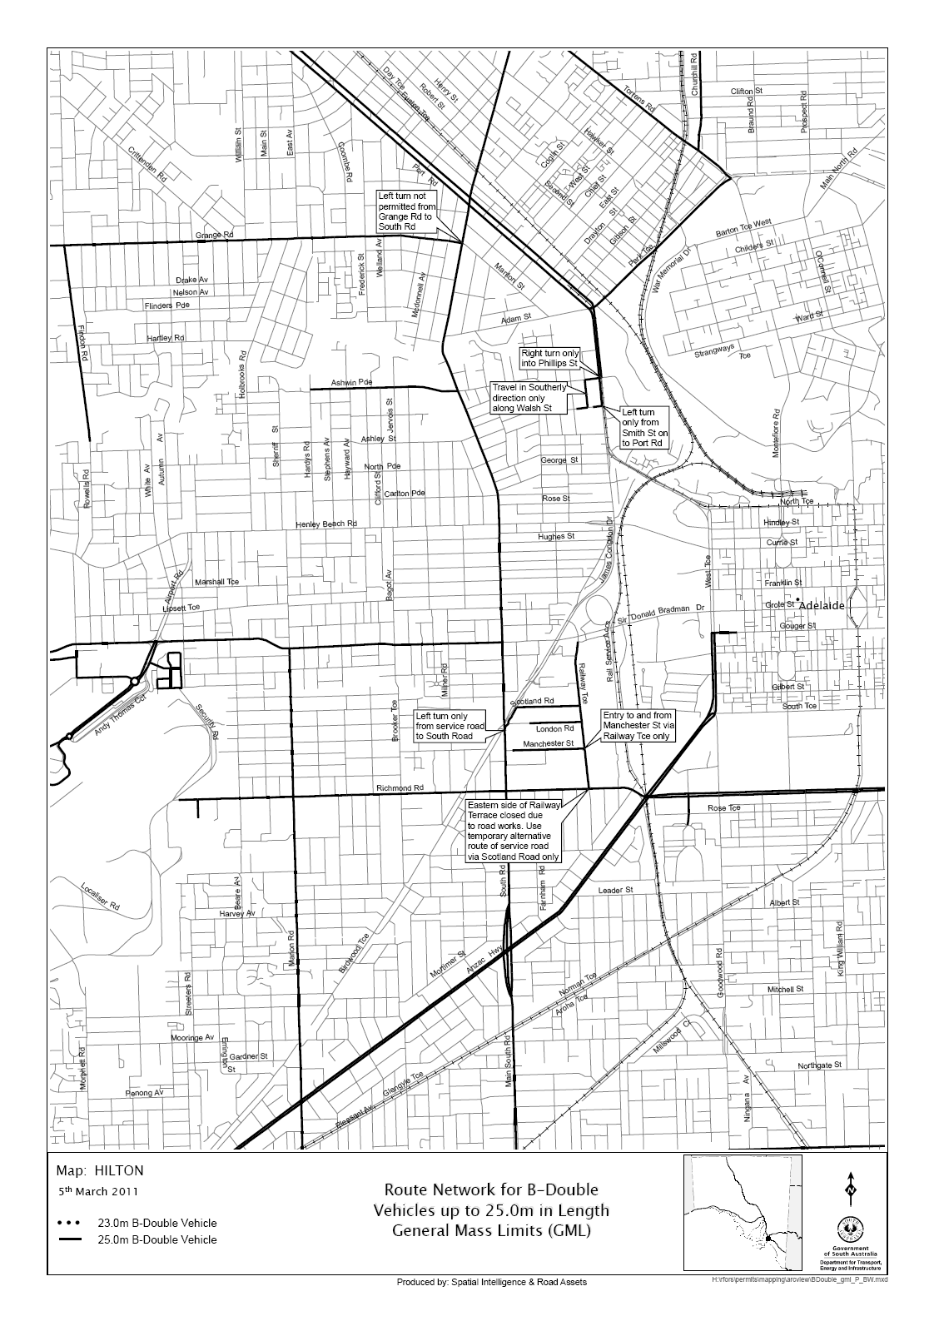
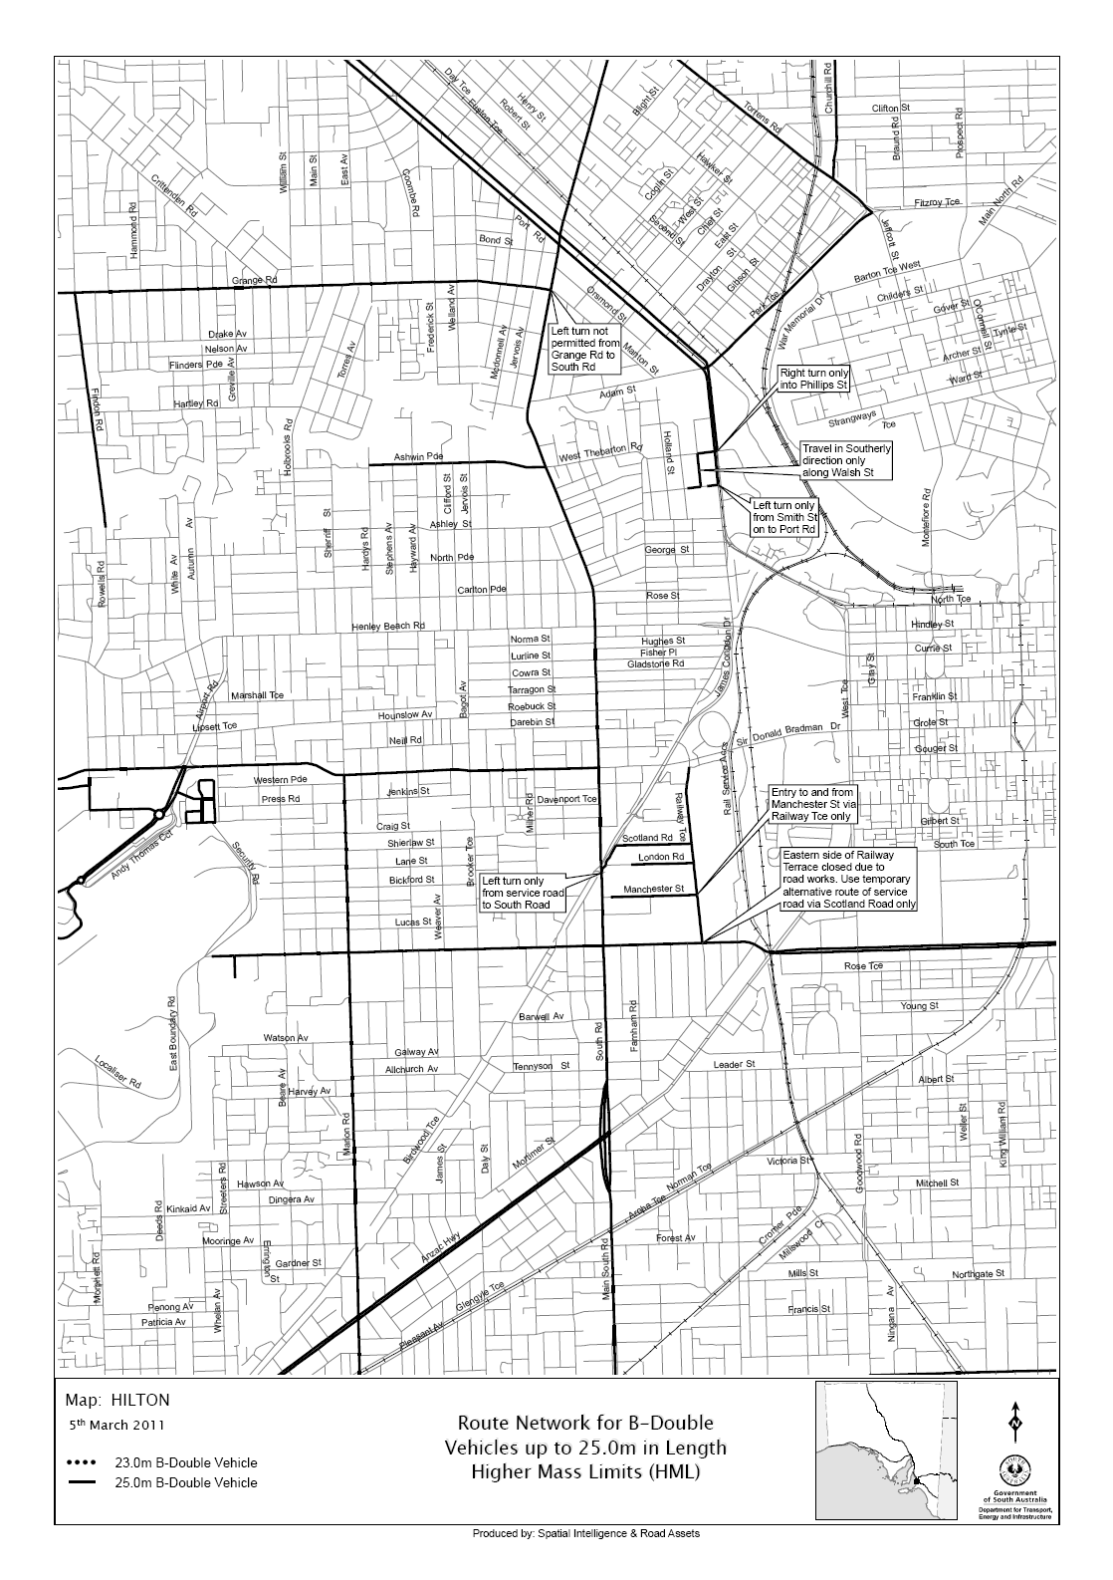
8. AUTHORISATION

Brian Hemming,
Director, Transport Safety Regulation
for and on behalf of
Executive Director, Safety and Regulation Division
Department for Transport, Energy and Infrastructure
Authorised Delegate for the Minister of Transport

ROADS (OPENING AND CLOSING) ACT 1991:
SECTION 24
NOTICE OF CONFIRMATION OF ROAD
PROCESS ORDER
Road Closure—Wolseley
BY Road Process Order made on 9 November 2010, the Tatiara District Council ordered that:
1. Portion of the unnamed public road situate between Railway Terrace South and Tatiara Road and adjoining Piece 52 in Deposited Plan 76827, more particularly delineated and lettered ‘A’ in Preliminary Plan No. 07/0054 be closed.
2. Transfer the whole of the land subject to closure to Australian Rail Track Corporation Ltd in accordance with agreement to transfer dated 9 November 2010 entered into between the Tatiara District Council and Australian Rail Track Corporation Ltd.
On 22 December 2010, that order was confirmed by the Minister for Infrastructure conditionally upon the deposit by the Registrar-General of Deposited Plan 85685 being the authority for the new boundaries.
Pursuant to section 24 (5) of the Roads (Opening and Closing) Act 1991, Notice of the order referred to above and its confirmation is hereby given.
Dated 3 March 2011.
P. M. Kentish, Surveyor-General

NOTICE TO MARINERS
No. 10 of 2011
South Australia—Gulf St Vincent/Spencer Gulf—Restricted Zones
Former Notice No. 4 of 2010
THE general public and mariners in particular are reminded that enforceable restricted zones under the Maritime Transport and Offshore Facilities Security Act of 2003, exist around all commercial shipping (in particular fuel tankers and passenger vessels) in the waters of Gulf St Vincent and Spencer Gulf.
Mariners are advised to exercise caution in the vicinity of these vessels and maintain a clearance distance of 50 m from them at all times.
Adelaide, 24 February 2011.
Patrick Conlon, Minister for Transport
FP2001/1439
DTEI 2011/00735

NOTICE TO MARINERS
No. 11 of 2011
South Australia—Spencer Gulf—Port Lincoln—Submerged Vessel and Exclusion Zone Removed—Clearance Survey Carried Out
Former Notice No. 41 of 2010
MARINERS are advised that the submerged vessel and exclusion zone referred to in the previous notice have been removed. A clearance hydrographic survey has been carried out over Berth 6 and the berth has been returned to its declared depth of 12.2 m LAT.
Navy Chart affected: Aus134
Publication affected: Australian Pilot, Volume 1 (Second Edition, 2008) pages 361-363.
Adelaide, 28 February 2011.
Patrick Conlon, Minister for Transport
FP2001/1439
DTEI 2011/00735

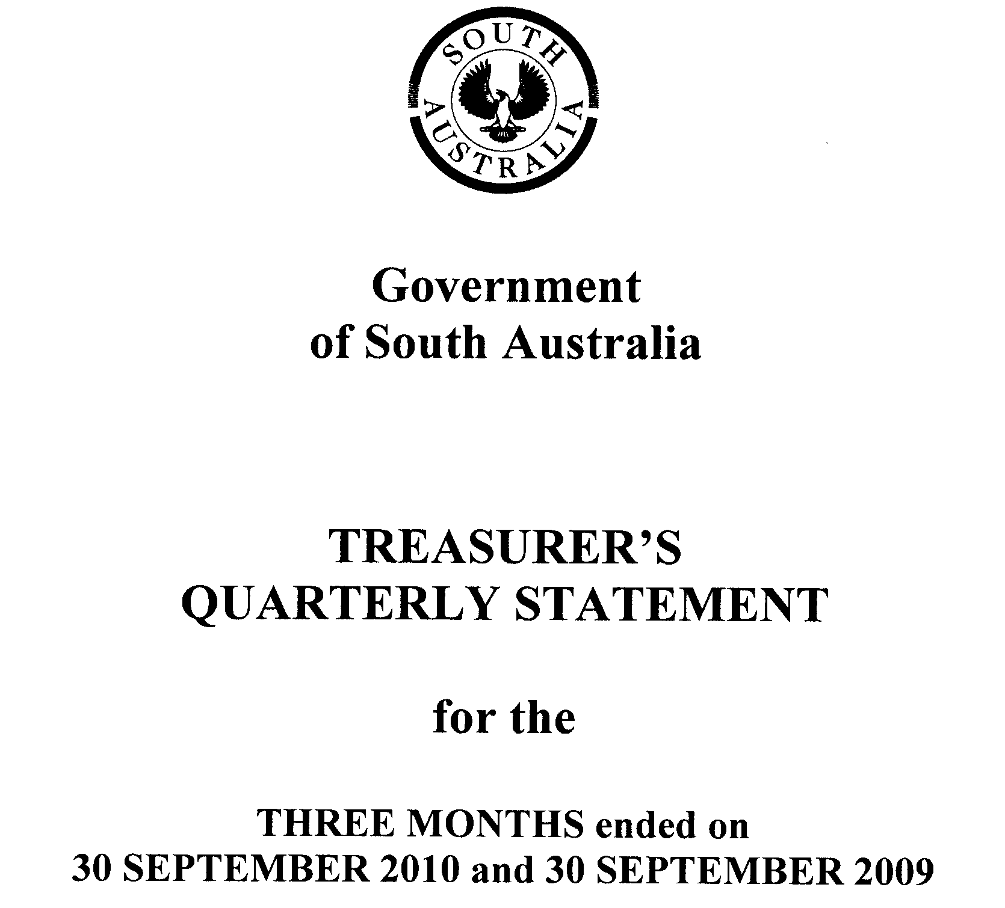

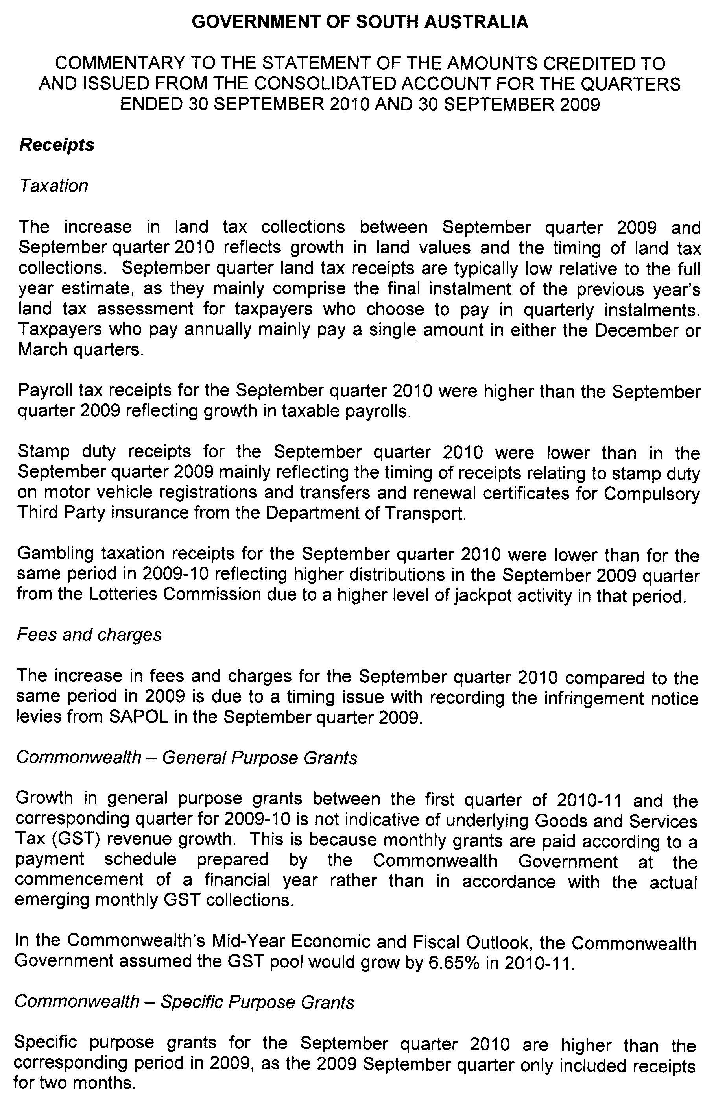
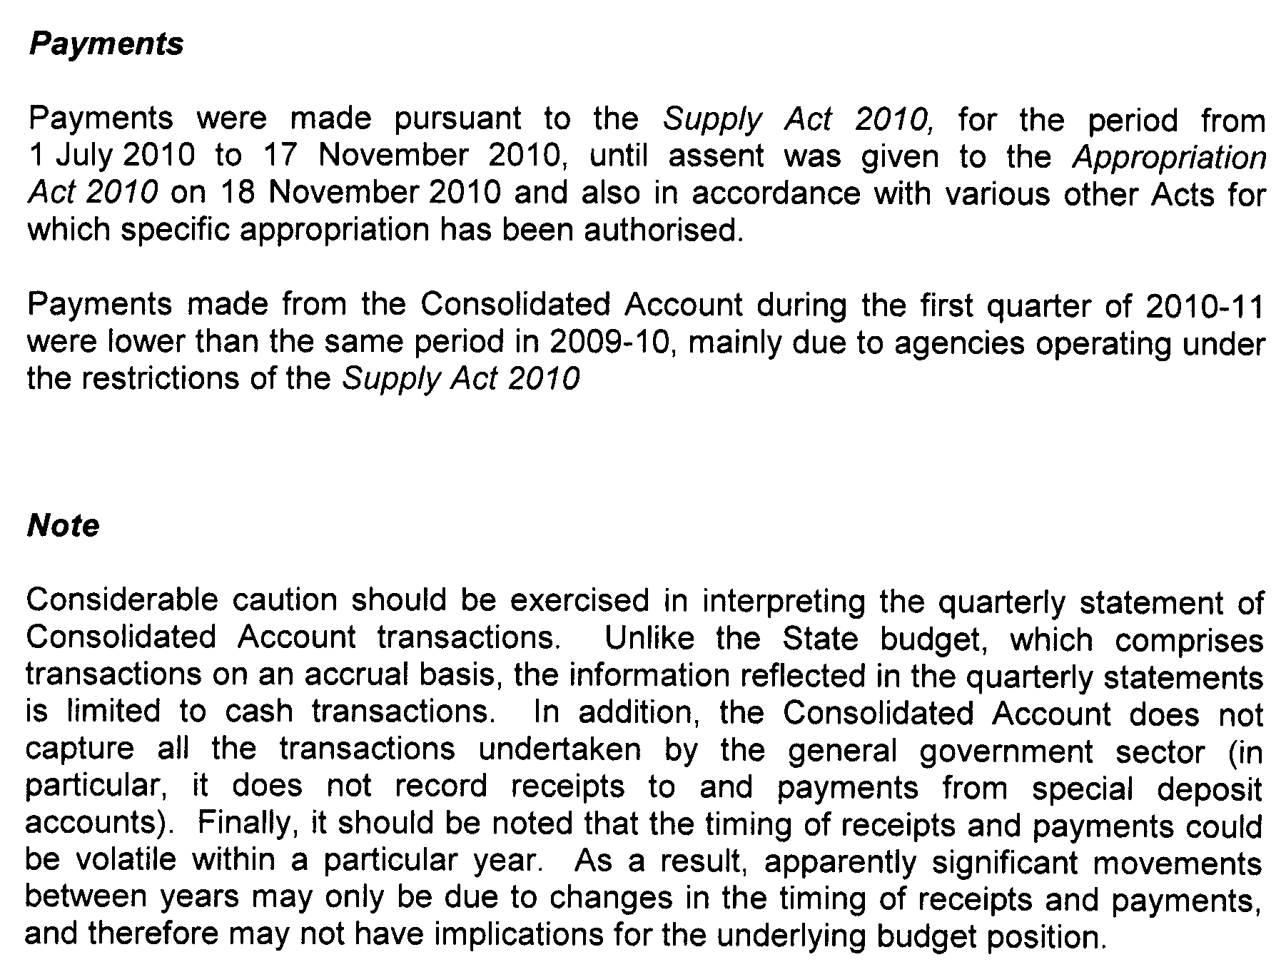
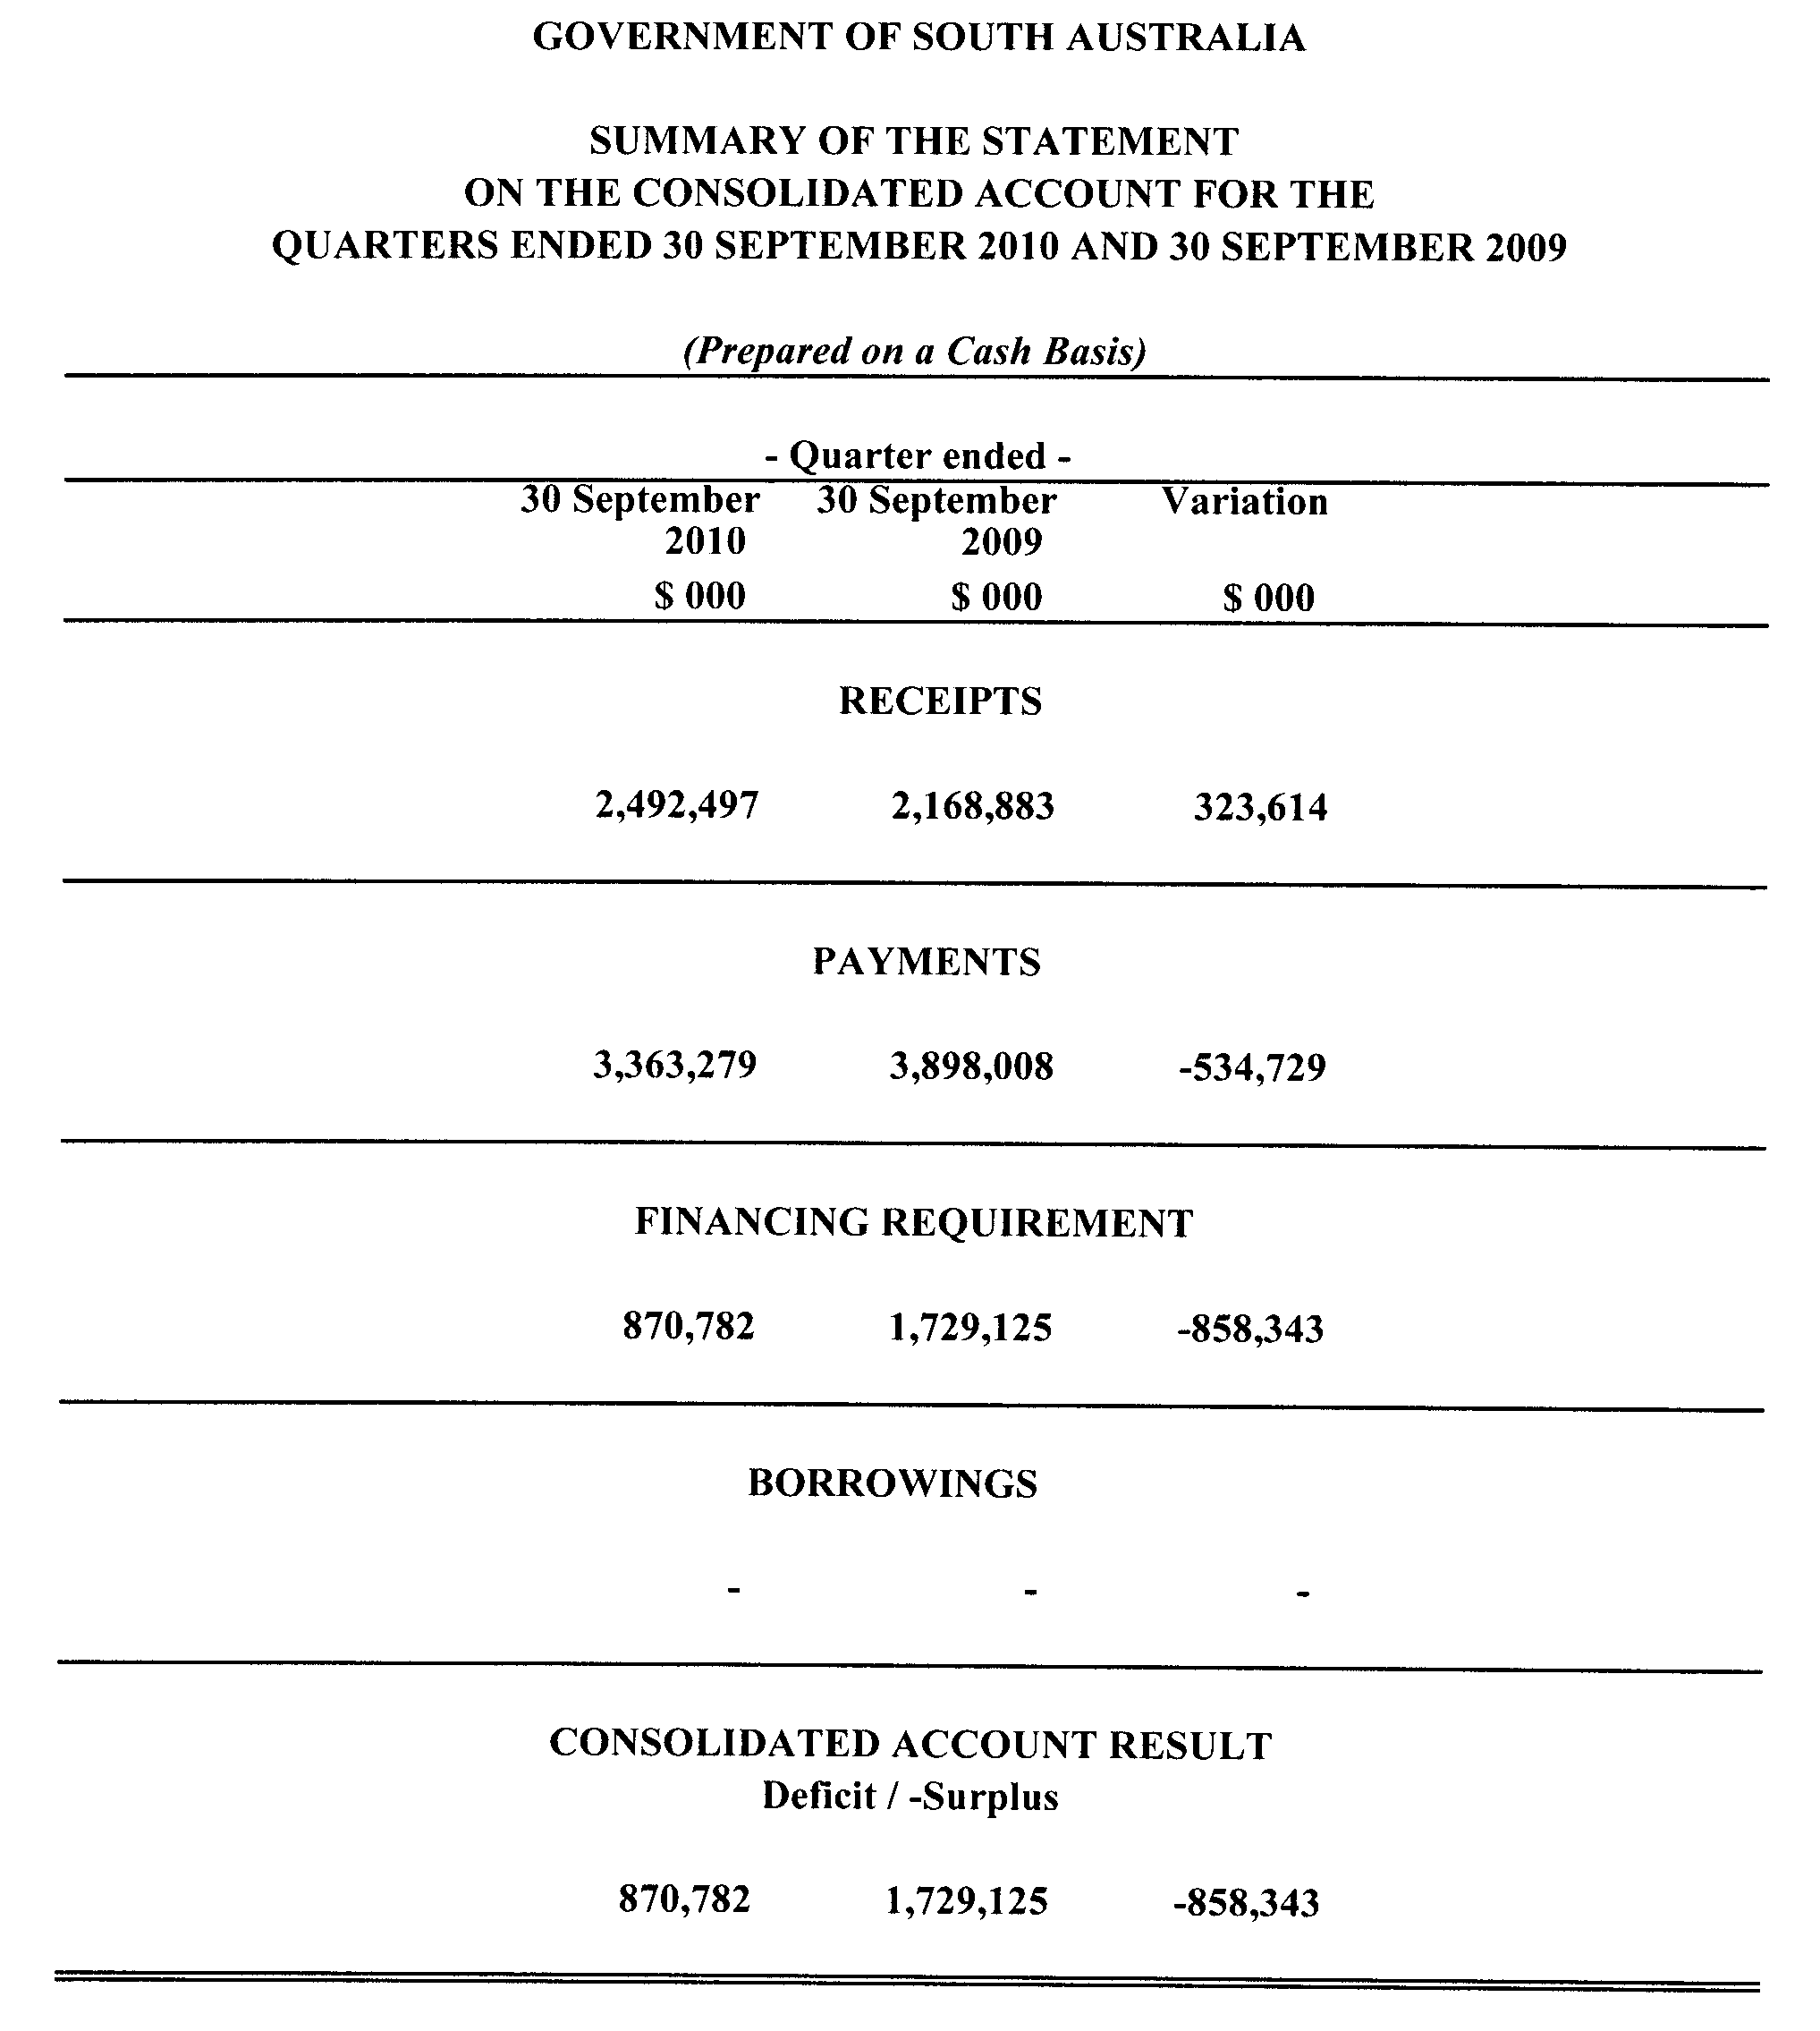
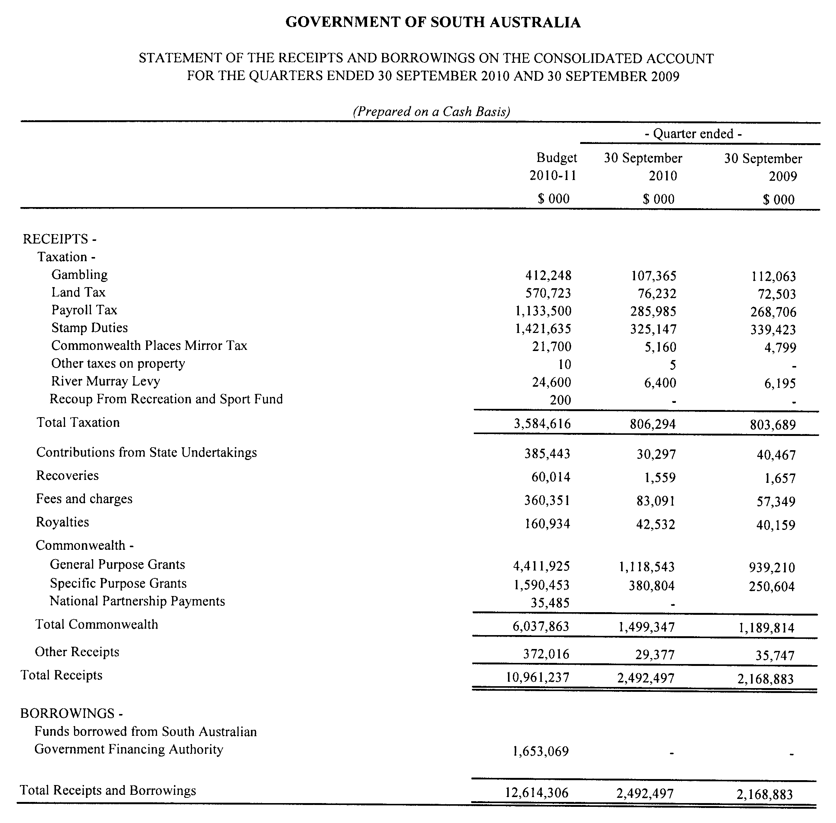

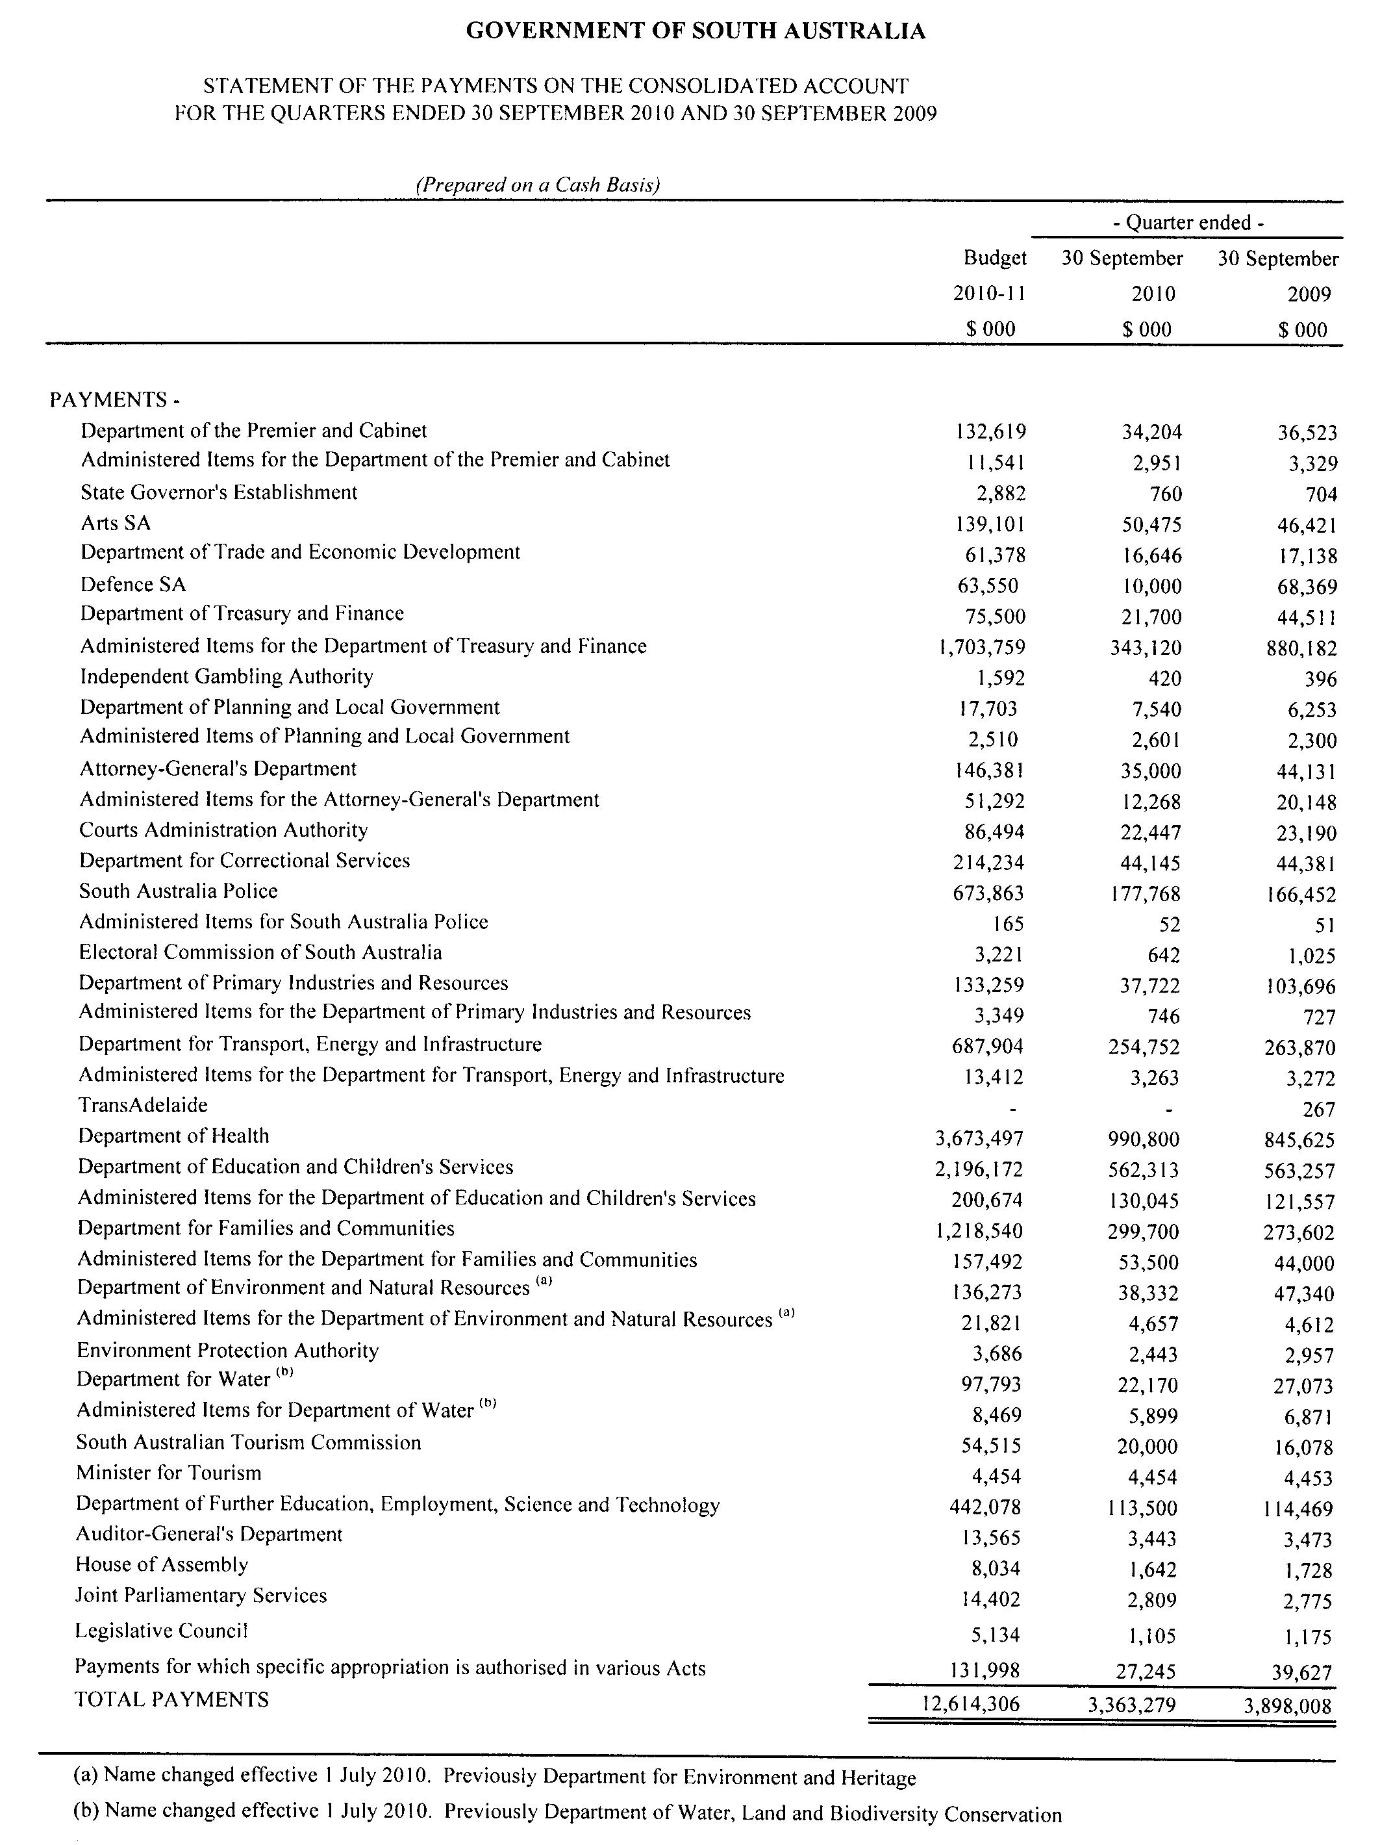

WATER MAINS AND SEWERS

Office of the South Australian Water Corporation
Adelaide, 3 March 2011

WATER MAINS LAID

Notice is hereby given that the following main pipes or parts of main pipes have been laid down by the South Australian Water Corporation in or near the undermentioned water districts and are now available for a constant supply of water to adjacent land.

ADELAIDE WATER DISTRICT

CITY OF BURNSIDE
Glynburn Road, Kensington Gardens. p22

CITY OF MARION
Across and in Lonsdale Road, Sheidow Park. p11

DISTRICT COUNCIL OF MOUNT BARKER
In and across Windsor Avenue, Hahndorf. p13

CITY OF NORWOOD PAYNEHAM AND ST PETERS
Osmond Terrace, Norwood. p23
Almond Street, Glynde. p26

CITY OF ONKAPARINGA
Seaford Road, Seaford Meadows. p12

CITY OF SALISBURY
In and across Coondoo Avenue, Ingle Farm. p28
Across and in Wright Road, Ingle Farm. p28 and 29
Nurrowin Drive, Ingle Farm. p29

CITY OF TEA TREE GULLY
Loral Street, Modbury. p1

COFFIN BAY WATER DISTRICT

DISTRICT COUNCIL OF LOWER EYRE PENINSULA
Across and in Jubilee Drive, Coffin Bay. p14

ELLISTON WATER DISTRICT

THE DISTRICT COUNCIL OF ELLISTON
Wookata Drive, Elliston. p6

TOD RIVER COUNTRY LANDS WATER DISTRICT

DISTRICT COUNCIL OF TUMBY BAY
Lincoln Highway, Tumby Bay. p3

WATER MAINS ABANDONED

Notice is hereby given that the undermentioned water mains have been abandoned by the South Australian Water Corporation.

ADELAIDE WATER DISTRICT

CITY OF BURNSIDE
Glynburn Road, Kensington Gardens. p22

CITY OF MARION
Across and in Lonsdale Road, Sheidow Park. p11

DISTRICT COUNCIL OF MOUNT BARKER
Windsor Avenue, Hahndorf. p13

CITY OF NORWOOD PAYNEHAM AND ST PETERS
Osmond Terrace, Norwood. p23
Almond Street, Glynde. p26

CITY OF ONKAPARINGA
Seaford Road, Seaford Meadows. p12

CITY OF SALISBURY
In and across Coondoo Avenue, Ingle Farm. p28
Across and in Wright Road, Ingle Farm and Walkley Heights. p28 and 29
Nurrowin Drive, Ingle Farm. p29

TOD RIVER COUNTRY LANDS WATER DISTRICT

DISTRICT COUNCIL OF TUMBY BAY
Lincoln Highway, Tumby Bay. p3

WATER MAINS LAID

Notice is hereby given that the undermentioned water mains have been laid down by the South Australian Water Corporation and are not available for a constant supply of water to adjacent land.

TOD RIVER COUNTRY LANDS WATER DISTRICT

DISTRICT COUNCIL OF LOWER EYRE PENINSULA
Waterworks land (lot 6 in LTRO DP 25759), Grimm Road, Coffin Bay. p17-21

DISTRICT COUNCIL OF TUMBY BAY
Waterworks land (lot 1 in LTRO FP 9295), Lincoln Highway, Tumby Bay. p3-5
Across Lincoln Highway, Tumby Bay. p3

SEWERS LAID

Notice is hereby given that the following sewers have been laid down by the South Australian Water Corporation in the undermentioned drainage areas and are now available for house connections.

ADELAIDE DRAINAGE AREA

CITY OF BURNSIDE
Easements in section 659, hundred of Adelaide, Conynham Street and in lot 105 in LTRO Community Plan 25820, Cedar Crescent, Glenside. FB 1204 p9

CAMPBELLTOWN CITY COUNCIL
Mundon Street, Campbelltown. FB 1204 p7
Easements in lot 100 in LTRO FP 133390, Frank Street and in Common Property in LTRO SP 14405, Flotta Street, Newton. FB 1203 p20 and 21

CITY OF CHARLES STURT
Seaton Terrace, Seaton. FB 1204 p6
Flavel Place, Grange. FB 1204 p8

CITY OF HOLDFAST BAY
Moore Street, Somerton Park. FB 1204 p13

CITY OF MARION
Easement in lot 518 in LTRO DP 9599, Shamrock Road, Hallett Cove. FB 1204 p10

THE CITY OF PROSPECT
Guilford Avenue, Prospect. FB 1204 p14

LOBETHAL COUNTRY DRAINAGE AREA

ADELAIDE HILLS COUNCIL
Easement in Common Property in LTRO Community Plan 26028, Rose Street, Lobethal. FB 1204 p11

MOUNT GAMBIER COUNTRY DRAINAGE AREA

CITY OF MOUNT GAMBIER
Across and in Wireless Road West, Mount Gambier. FB 1175 p55 and 56
Easement in lot 61 in LTRO DP 78235, Wireless Road West, Mount Gambier. FB 1175 p55 and 56

STIRLING COUNTRY DRAINAGE AREA

ADELAIDE HILLS COUNCIL
Golding Road, Stirling. FB 1204 p12
Easement in lot A in LTRO RP 7250, Golding Lane, Stirling. FB 1204 p12
Golding Lane, Stirling. FB 1204 p12

SEWERS ABANDONED

Notice is hereby given that the undermentioned sewers have been abandoned by the South Australian Water Corporation.

ADELAIDE DRAINAGE AREA

CITY OF MARION
Easement in lot 518 in LTRO DP 9599, Shamrock Road,
Hallett Cove. FB 1204 p10

MOUNT GAMBIER COUNTRY DRAINAGE AREA

CITY OF MOUNT GAMBIER
In and across Wehl Street North, Mount Gambier—100 mm PVCU pumping main. FB 1175 p52
In and across Allison Street, Mount Gambier—100 mm PVCU pumping main. FB 1175 p52
Across Wireless Road West, Mount Gambier. FB 1175 p55

SEWERS LAID

Notice is hereby given that the undermentioned sewers have been laid down by the South Australian Water Corporation and are not available for house connections.

MOUNT GAMBIER COUNTRY DRAINAGE AREA

CITY OF MOUNT GAMBIER
Across Wehl Street North, Mount Gambier—100 mm PVC pumping main. FB 1175 p52 and 53
Sewerage land (lot 145 in LTRO DP 82721), Wehl Street North, Mount Gambier—100 mm PVC pumping main. FB 1175 p52 and 53
Easement in lot 105 in LTRO DP 82721, Macquarie Court, Mount Gambier—100 mm PVC pumping main. FB 1175 p52 and 53

A. J. Ringham, Chief Executive Officer, South Australian Water Corporation

WILDERNESS PROTECTION REGULATIONS 2006
Closure of Cape Bouguer Wilderness Protection Area
PURSUANT to Regulation 6 (2) (c) of the Wilderness Protection Regulations 2006, I, Edward Gregory Leaman, Director of National Parks and Wildlife close to the public the whole of Cape Bouguer Wilderness Protection Area from 6 a.m. on Tuesday, 3 May 2011 until 6 a.m. on Friday, 6 May 2011.
The purpose of the closure is to ensure the safety of the public during a pest control and monitoring program within the wilderness protection area during the period indicated.
Use of Firearms Within the Wilderness Protection Area
Pursuant to Regulations 6 (3), 16 (1) (a) and 34 of the Wilderness Protection Regulations 2006, I, Edward Gregory Leaman, Director of National Parks and Wildlife grant permission to staff employed by the Kangaroo Island Natural Resources Management Board in possession of both a current Hunting Permit and a firearm to enter and remain in the whole of Cape Bouguer Wilderness Protection Area from 6 a.m. on Tuesday, 3 May 2011 until 6 a.m. on Friday, 6 May 2011, for the purpose of taking feral animals.
This permission is conditional upon the observance by each of those persons of the requirements of the Wilderness Protection Act 1992, Wilderness Protection Regulations 2006, and the National Parks and Wildlife (Hunting) Regulations 1996, including those requiring compliance with the Director’s requests, requirements and orders of a Warden.
Dated 23 February 2011.
E. G. Leaman, Director of National Parks and Wildlife

WILDERNESS PROTECTION REGULATIONS 2006
Closure of Cape Bouguer Wilderness Protection Area
PURSUANT to Regulation 6 (2) (c) of the Wilderness Protection Regulations 2006, I, Edward Gregory Leaman, Director of National Parks and Wildlife close to the public the whole of Cape Bouguer Wilderness Protection Area from 6 a.m. on Tuesday, 10 May 2011 until 6 a.m. on Friday, 13 May 2011.
The purpose of the closure is to ensure the safety of the public during a pest control and monitoring program within the wilderness protection area during the period indicated.
Use of Firearms Within the Wilderness Protection Area
Pursuant to Regulations 6 (3), 16 (1) (a) and 34 of the Wilderness Protection Regulations 2006, I, Edward Gregory Leaman, Director of National Parks and Wildlife grant permission to staff employed by the Kangaroo Island Natural Resources Management Board in possession of both a current Hunting Permit and a firearm to enter and remain in the whole of Cape Bouguer Wilderness Protection Area from 6 a.m. on Tuesday, 10 May 2011 until 6 a.m. on Friday, 13 May 2011, for the purpose of taking feral animals.
This permission is conditional upon the observance by each of those persons of the requirements of the Wilderness Protection Act 1992, Wilderness Protection Regulations 2006, and the National Parks and Wildlife (Hunting) Regulations 1996, including those requiring compliance with the Director’s requests, requirements and orders of a Warden.
Dated 23 February 2011.
E. G. Leaman, Director of National Parks and Wildlife

South Australia
Forestry (Forest Reserve—Mount Gambier Forest District) Variation Proclamation 2011
under section 3(3) of the Forestry Act 1950

Preamble
1 The following land is forest reserve under the Forestry Act 1950 (see proclamation, Gazette 19.3.1992 p877, as varied) and forms part of the Mount Gambier Forest District:
Portion of allotment 21 of Deposited Plan No. 13995, Hundred of Mingbool, now identified as allotment 100 of Deposited Plan No. 85766, Hundred of Mingbool.
2 It is now intended that this land cease to be forest reserve.

Part 1—Preliminary
1—Short title
This proclamation may be cited as the Forestry (Forest Reserve—Mount Gambier Forest District) Variation Proclamation 2011.
2—Commencement
This proclamation comes into operation on the day on which it is made.
3—Variation provisions
In this proclamation, a provision under a heading referring to the variation of a specified proclamation varies the proclamation so specified.
Part 2—Variation of proclamation under Forestry Act 1950 declaring forest reserve (Gazette 19.3.1992 p877) as varied
4—Variation of Schedule
Schedule, clause 5(h)—delete "Lot 21 Deposited Plan 13995" and substitute:
Lot 101 Deposited Plan 85766
Made by the Governor
with the advice and consent of the Executive Council
on 3 March 2011
MFOR11/01CS

South Australia
National Parks and Wildlife (Coorong National Park) Proclamation 2011
under section 27(3) of the National Parks and Wildlife Act 1972
1—Short title
This proclamation may be cited as the National Parks and Wildlife (Coorong National Park) Proclamation 2011.
2—Commencement
This proclamation comes into operation on the day on which it is made.
3—Alteration of boundaries of Coorong National Park
The boundaries of the Coorong National Park are altered by adding to the Park the following Crown land:
Section 33, Hundred of Santo, County of Cardwell.
Made by the Governor
with the advice and consent of the Executive Council
on 3 March 2011
MEC11/0007CS

South Australia
Tobacco Products Variation Regulations 2011
under the Tobacco Products Regulation Act 1997

Contents
Part 1—Preliminary
1 Short title
2 Commencement
3 Variation provisions
Part 2—Variation of Tobacco Products Regulations 2004
4 Variation of regulation 3—Interpretation
5 Revocation of regulation 6
6 Insertion of regulations 9 to 13
9 Display of signs
10 Prescribed actions—general
11 Prescribed actions—retail displays
12 Prescribed actions—vending machines
13 Expiry of certain provisions
7 Insertion of Schedule 2
Schedule 2—Transitional provision
1 References in documents

Part 1—Preliminary
1—Short title
These regulations may be cited as the Tobacco Products Variation Regulations 2011.
2—Commencement
These regulations will come into operation on 1 January 2012.
3—Variation provisions
In these regulations, a provision under a heading referring to the variation of specified regulations varies the regulations so specified.
Part 2—Variation of Tobacco Products Regulations 2004
4—Variation of regulation 3—Interpretation
(1) Regulation 3—after the definition of Act insert:
fruit or confectionary flavoured cigarette means a cigarette—
(a) that possesses, or the smoke of which possesses, a distinctive fruity, sweet or confectionary-like character; and
(b) that is advertised in a way that might encourage young people to smoke,
but does not include a cigarette the flavouring of which is primarily of a menthol character;
packet includes a tin or other container;
periodical means an issue (however described) of a newspaper, magazine, journal, newsletter, or other similar publication, issues of which are published at regular or irregular intervals;
product line, in relation to a tobacco product, means a particular retail line of the tobacco product, distinguishable from similar tobacco products by 1 or more of the following characteristics:
(a) brand name, trade mark or other description of the tobacco product;
(b) nicotine or tar content;
(c) flavour;
(d) in the case of a packet of cigarettes, cigars or cigarillos—the number or size of cigarettes, cigars or cigarillos in the packet;
(e) in the case of cigarette or pipe tobacco—the weight of the packet in which the tobacco is sold.
(2) Regulation 3—after its present contents (now to be designated as subregulation (1)) insert:
(2) For the purposes of these regulations, a reference to a tobacco product includes a reference to a part of a tobacco product.
(3) For the purposes of these regulations, a requirement that the text on a sign, price board or price ticket in particular premises be a standardised font means that the text on each such sign, price board or price ticket in the premises must be written (whether handwritten or otherwise) in a single font.
(4) For the purposes of this regulation, premises will be taken to be the premises of a specialist tobacconist if—
(a) a person sells tobacco products by retail in the premises in the ordinary course of business; and
(b) during—
(i) in the case of a business that has been trading for a period of more than 1 financial year—the immediately preceding financial year; or
(ii) in any other case—the period for which the business has been trading,
the gross turnover of all tobacco products sold at the premises constitutes 80% or more of the gross turnover of all products sold at the premises during the relevant period; and
(c) in the case where the premises are situated within another shop—
(i) the premises are separated from the other shop by means of internal walls or doors; and
(ii) a person is not able to use the premises as a thoroughfare to gain entry to the other shop from outside the premises; and
(iii) the retail display in the premises is not able to be seen by persons in the other shop,
and a reference to a specialist tobacconist has a corresponding meaning.
5—Revocation of regulation 6
Regulation 6—delete the regulation
6—Insertion of regulations 9 to 13
After regulation 8 insert:
9—Display of signs
(1) For the purposes of section 40(3)(a) of the Act, a person is permitted to display the following signs outside premises where tobacco products are sold by retail:
(a) a sign or signs displaying—
(i) the company name or trading name; or
(ii) the company name or trading name and the corporate logo,
of the business, erected or displayed in accordance with any other Act or law relating to such signage;
(b) either—
(i) not more than 1 prescribed tobacco notice on each external wall of the premises that is visible to the public, or on a window in such a wall; or
(ii) a sign displaying not more than 1 prescribed tobacco notice,
erected or displayed in accordance with any other Act or law relating to such signage.
(2) For the purposes of section 40(3)(c) of the Act, a person is permitted to display not more than 1 prescribed tobacco notice inside premises where tobacco products are sold by retail.
(3) In this regulation—
prescribed tobacco notice means a sign containing only, in black text no larger than 40 millimetres high on a white background, the words—
(a) tobacco products sold here; or
(b) cigarette cartons sold here; or
(c) cigarettes sold here;
sign includes every painted sign, mural or other sign, signboard, visual display screen, visual display image, visual display or projection device, other advertising device, lamp, globe, floodlight, banner, bunting, and streamer, including any background as well as any lettering and any advertising structure.
10—Prescribed actions—general
(1) For the purposes of section 40(3)(c) of the Act, the following kinds of action are prescribed:
(a) the advertisement of a tobacco product in or on a periodical—
(i) that is printed outside Australia; and
(ii) that is not principally intended for distribution or use in Australia; and
(iii) in relation to which there is no notice in force under section 17(2) of the Tobacco Advertising Prohibition Act 1992 of the Commonwealth;
(b) the advertisement of a tobacco product that is an accidental or incidental accompaniment to the publication of other matter;
(c) the sale or delivery of a product containing an advertisement—
(i) of a kind referred to in the preceding paragraphs; or
(ii) of a tobacco product in or on a package containing the tobacco product (being a package in which the tobacco product is offered for sale in the ordinary course of business);
(d) the advertisement of a tobacco product consisting of, or reasonably incidental to, the display, at the request of a customer, of the tobacco product to the customer inside premises where tobacco products are sold by retail;
(e) the advertisement of a tobacco product that is reasonably incidental to—
(i) the sale or delivery of a tobacco product;
(ii) the genuine restocking of an area in which the tobacco products are stored in accordance with the Act pending their sale;
(f) the advertisement of tobacco products in premises where tobacco products are only sold by retail in cartons consisting of a single sign attached to or adjacent to a point of sale containing only, in black standardised font no larger than 40 millimetres high on a white background, the words "cartons only sold here";
(g) the advertisement of a tobacco product on the premises of a distributor or manufacturer of tobacco products consisting of a sign or signs displaying—
(i) the company name or trading name; or
(ii) the company name or trading name and the corporate logo,
of the distributor or manufacturer, erected or displayed in accordance with any other Act or law relating to such signage;
(h) the advertisement of a tobacco product to a group of people all of whom are involved in the manufacture, distribution or sale of tobacco products.
(2) For the purposes of section 40(3)(c) of the Act, the advertisement of tobacco products in premises where tobacco products are sold by retail consisting of a single price board is prescribed if—
(a) the total surface area of the board (including, in the case of a sandwich board, the combined surface area of both sides) does not exceed—
(i) if the price board is in the premises of a specialist tobacconist—1 square metre; or
(ii) in any other case—0.5 square metres; and
(b) the board consists of black text on a completely white background; and
(c) the text on the board is a standardised font not exceeding 20 millimetres in height; and
(d) the information on the board does not relate to fruit or confectionary flavoured cigarettes; and
(e) the information on the board is limited to any combination of the following:
(i) the names of particular product lines;
(ii) the prices of particular product lines (displayed in a way that does not indicate that a particular product line has been discounted);
(iii) the packet size of particular product lines (by weight or number of tobacco products contained in the packet or carton);
(iv) nicotine or tar content of particular product lines;
(v) the country of origin of particular product lines;
(vi) a bar code or similar identification code used in the point of sale system of the business;
(f) if the price board is in premises of a prescribed specialist tobacconist—the information on the price board does not relate to any tobacco product advertised in a retail display in the premises.
(3) For the purposes of section 40(3)(c) of the Act, the advertisement of tobacco products in premises where tobacco products are sold by retail consisting of price tickets relating to particular product lines is prescribed if—
(a) all price tickets are of an approximately equal size (but in any case not exceeding 80 millimetres x 40 millimetres);
(b) each price ticket consists of black text on a completely white background;
(c) the text on each price ticket is a standardised font not exceeding 15 millimetres in height;
(d) the price ticket does not relate to fruit or confectionary flavoured cigarettes;
(e) the information on each price ticket is limited to any combination of the following:
(i) the name of the product line;
(ii) the price of the product line (displayed in a way that does not indicate that the product line has been discounted);
(iii) the packet size (by weight or by number of tobacco products contained in the packet);
(iv) the nicotine or tar content of the product line;
(v) the country of origin of the product line;
(vi) a bar code or similar identification code used in the point of sale system of the business;
(vii) any other information reasonably required for the efficient conduct of the business;
(f) if the price ticket is in premises of a prescribed specialist tobacconist containing a retail display that visibly displays the relevant product line—the price ticket is attached to or adjacent to the retail display.
(4) In any proceedings for an offence against section 40 of the Act in which the defendant claims that the advertisement constituting the alleged offence was authorised by subregulation (1)(e), the onus will be on the defendant to prove that the restocking was genuine, and that the advertisement was reasonably incidental to such restocking.
(5) Nothing in this regulation authorises an advertisement comprising a retail display or an advertisement of a tobacco product in or on a vending machine.
(6) In this regulation—
prescribed specialist tobacconist and retail display have the same meanings as in regulation 11.
11—Prescribed actions—retail displays
(1) For the purposes of section 40(3)(c) of the Act, the advertisement in accordance with this regulation of a tobacco product in a retail display in the premises of a prescribed specialist tobacconist is prescribed.
(2) Subject to this regulation, an advertisement will only be taken to be in accordance with this regulation if it complies with the following provisions:
(a) there must be only 1 uninterrupted retail display in the premises;
(b) the area of the retail display does not exceed—
(i) if at least 1 square metre of the retail display consists of the display of cigars (whether in a separate retail display in accordance with subregulation (3) or otherwise)—4 square metres; or
(ii) in any other case—3 square metres;
(c) the retail display must not be located on, nor form part of, a counter containing a point of sale, or from which customers are otherwise served;
(d) the retail display must not be able to be accessed by customers or potential customers without the assistance of a sales assistant;
(e) warnings of a kind approved from time to time by the Minister—
(i) in the case of a retail display not exceeding 1 square metre—of A4 size; or
(ii) in the case of a retail display exceeding 1 square metre—of A3 size,
must be displayed in accordance with the conditions of the relevant licence under Part 2 of the Act;
(f) there must be no more than the following quantities of the specified tobacco products visible on the retail display (not including the top of any tobacco product packets visible due to the slope of a shelf in the retail display in which the packets are displayed):
(i) in the case of cigarettes—2 packets, or 2 pictures of a packet, of each particular product line;
(ii) in the case of cigars—2 packets, or 2 pictures of a packet, or an unrestricted number of individual cigars, of each particular product line;
(iii) in the case of cigarette or pipe tobacco—2 packets, or 2 pictures of a packet, of each particular product line;
(iv) in the case of cigarillos—2 packets, or 2 pictures of a packet, of each particular product line;
(v) in the case of cigarette papers—2 packets, or 2 pictures of a packet, of each particular product line;
(vi) in any other case—2 items of each particular product line;
(g) the retail display must not display—
(i) cartons of tobacco products; or
(ii) empty packets or empty cartons of tobacco products;
(h) the retail display must not display fruit or confectionary flavoured cigarettes;
(i) any picture of a tobacco product displayed on the retail display—
(i) must be no larger than the actual tobacco product; and
(ii) must contain the health warning (if any) appropriate for the tobacco product required by or under the Act or any other Act;
(j) there must be no highlighting in any way (including, to avoid doubt, by the use of a sign or other device not forming part of the retail display) of the retail display or a part of the retail display, or a tobacco product displayed in the retail display;
(k) the retail display must not be visible to a person outside of the premises of the prescribed specialist tobacconist.
(3) Despite subregulation (2)(a), there may be a separate retail display (the area of which must not exceed 1 square metre) for cigars consisting of part of a humidified room, or a humidified container, however the area of that retail display must be counted in determining the area of the retail display referred to in that paragraph.
(4) For the purposes of section 40(3)(c) of the Act, the advertisement of a tobacco product that is reasonably incidental to the genuine restocking of a retail display is prescribed.
(5) For the purposes of this regulation, a product line will be taken to be a separate product line if the packaging of the product line is substantially different (other than a mere visual difference) from another product line containing the same tobacco product.
(6) For the purposes of this regulation, a retail display will be taken not to be located on, nor form part of, a counter containing a point of sale, or from which customers are otherwise served, if the whole of the retail display is more than 1.7 metres above the floor (whether or not the retail display is connected to the counter in any way).
(7) For the purposes of this regulation—
(a) the premises of a prescribed specialist tobacconist means premises at which a person was, immediately before the commencement of this subregulation, carrying on business as a specialist tobacconist pursuant to a licence under Part 2 of the Act, but does not include such premises if, at any time after the commencement of this subregulation—
(i) the person—
(A) ceases (whether temporarily or permanently) for any reason to be a specialist tobacconist in respect of the premises; or
(B) ceases for any reason to hold a current licence under Part 2 of the Act in respect of the premises; or
(C) transfers or assigns the licence under Part 2 of the Act in respect of the premises to another person; or
Note—
Once premises cease to be the premises of a prescribed specialist tobacconist they cannot regain that status.
(ii) a new licence under Part 2 of the Act is issued to another person in respect of the premises (whether or not the same business was being carried on at the premises by another person immediately before the commencement of this subregulation pursuant to another licence),
and a reference to a prescribed specialist tobacconist has a corresponding meaning; and
(b) a reference to the premises of a prescribed specialist tobacconist will be taken not to include a reference to premises at which the prescribed specialist tobacconist first carries on business as a specialist tobacconist after the commencement of this subregulation (whether pursuant to the same licence or otherwise).
(8) In any proceedings for an offence against section 40 of the Act in which the defendant claims that the advertisement constituting the alleged offence was authorised by subregulation (4), the onus will be on the defendant to prove that the restocking was genuine, and that the advertisement was reasonably incidental to such restocking.
(9) In this regulation—
retail display means an area in which tobacco products, or pictures of tobacco products, are displayed or visible to members of the public (whether the tobacco products are contained in a cabinet or on a shelf or otherwise), but does not include—
(a) an area not exceeding 2 square metres in which cigarette cartons are stored (provided such area is located immediately behind a counter containing a point of sale and the cigarette cartons are not visible to a person standing more than 2 metres from the counter); or
(b) an area in which tobacco products are temporarily visible during a genuine restocking of a retail display; or
(c) a vending machine.
12—Prescribed actions—vending machines
(1) For the purposes of section 40(3)(c) of the Act, an advertisement of a tobacco product consisting of the display in accordance with this regulation of any combination of the following in or on a vending machine is prescribed:
(a) the name of the tobacco product;
(b) the price of the tobacco product;
(c) the packet size of the tobacco product (by weight or by number of tobacco products contained in the packet);
(d) the nicotine or tar content of the tobacco product;
(e) the country of origin of the tobacco product.
(2) An advertisement will only be taken to be in accordance with this regulation if it complies with the following provisions:
(a) if the information referred to in subregulation (1) is displayed on tickets—
(i) all tickets must be of an approximately equal size (but in any case not exceeding 80 millimetres x 40 millimetres); and
(ii) each ticket must consist of black text on a completely white background; and
(iii) the text on each ticket must be a standardised font not exceeding 15 millimetres in height;
(b) the advertisement must not be an advertisement for, or in relation to, fruit or confectionary flavoured cigarettes;
(c) an A4 size warning of a kind approved from time to time by the Minister must be displayed on the vending machine in accordance with the conditions of the relevant licence under Part 2 of the Act;
(d) the number of product lines advertised in relation to a particular vending machine must not exceed 40;
(e) there must be no more than 1 ticket in respect of a particular product line displayed in or on the vending machine;
(f) there must be no internal lighting in the vending machine;
(g) there must be no highlighting in any way (including, to avoid doubt, by the use of a sign or other device not forming part of the vending machine) of the vending machine or a ticket displayed in or on the vending machine.
13—Expiry of certain provisions
The following provisions of these regulations will expire on 31 December 2014:
(a) regulation 10(2)(f);
(b) regulation 10(3)(f);
(c) regulation 10(6);
(d) regulation 11.
7—Insertion of Schedule 2
After Schedule 1 insert:
Schedule 2—Transitional provision
1—References in documents
(1) A reference in a document to a provision of these regulations (being a provision that was in force immediately before the commencement of the Tobacco Products Variation Regulations 2011) will, unless the contrary intention appears, be taken to be a reference to the provision of these regulations, as varied by the Tobacco Products Variation Regulations 2011, that has the same effect as that provision.
(2) For the purposes of this clause, a reference to a document includes a reference to a licence under Part 2 of the Act.
Made by the Governor
with the advice and consent of the Executive Council
on 3 March 2011
No 16 of 2011
HEAC-2010-00018

FAXING COPY?
IF you fax copy to Government Publishing SA for inclusion in the Government Gazette, there is no need to send a Confirmation Copy to us as well.
This creates confusion and may well result in your notice being printed twice.
Please use the following fax number:
Fax transmission: (08) 8207 1040
Phone Inquiries: (08) 8207 1045
Please include a contact person, phone number and order number so that we can phone back with any queries we may have regarding the fax copy.
NOTE: Closing time for lodging new copy (fax, hard copy or email) is 4 p.m. on Tuesday preceding the day of publication.

Government Gazette notices can be E-mailed.
The address is:
governmentgazette@dpc.sa.gov.au
Documents should be sent as attachments in Word format.
When sending a document via E-mail, please confirm your transmission with a faxed copy of your document, including the date the notice is to be published.
Fax transmission: (08) 8207 1040
Enquiries: (08) 8207 1045
NOTE: Closing time for lodging new copy (fax, hard copy or email) is 4 p.m. on Tuesday preceding the day of publication.

CITY OF MITCHAM
Revocation of Resolution
NOTICE is hereby given that the City of Mitcham at its meeting held on 28 February 2011, resolved, pursuant to the powers contained in section 359 (2) of the Local Government Act 1934, to revoke the resolution (published in the Gazette on 19 November 1998) excluding vehicles from that part of Craigburn Road, Blackwood which lies 240 m west of the western building alignment of Trevor Terrace, Blackwood by means of the erection of a gate.
M. Pears, Chief Executive Officer

CITY OF MITCHAM
Revocation of Resolution
NOTICE is hereby given that the City of Mitcham at its meeting held on 28 February 2011, resolved, pursuant to the powers contained in section 359 (2) of the Local Government Act 1934, to revoke the resolution (published in the Gazette on 4 November 2010) excluding vehicles travelling to and from the Hayman Retreat Road reserve at the junction of Craigburn Road with the exception of emergency vehicles.
M. Pears, Chief Executive Officer

CITY OF MITCHAM
Revocation of Authorisation
NOTICE is hereby given that the City of Mitcham at its meeting held on 28 February 2011, resolved, pursuant to the powers contained in section 359 (2) of the Local Government Act 1934, to revoke the declaration (published in the Gazette 4 November 2010) relating to the exclusion of vehicles from Craigburn Road with the exception of:
• Government vehicles of their agents
• Members of the dog tracking club of South Australia
• Cyclists
• Horse riders; and
• Emergency vehicles
from a point approximately 10 m west of the intersection between Hayman Retreat and Craigburn Road and westwards of this point by means of installation of a gate.
M. Pears, Chief Executive Officer

CITY OF MITCHAM
Exclusion of Vehicles (with Exceptions)
NOTICE is hereby given that the City of Mitcham at its meeting held on 28 February 2011, resolved, pursuant to the powers contained in section 359 of the Local Government Act 1934, to exclude all vehicles with the exception of:
• Government owned vehicles driven by employees or agents of the government in the course of their employment;
• City of Mitcham owned vehicles driven by employees or agents of the City of Mitcham in the course of their employment;
• SA Water vehicles;
• ETSA Utilities vehicles;
• Country Fire Services vehicles;
• Telstra vehicles; and
• Police vehicles.
from a part of Craigburn Road, Blackwood being an area 1 m in width and 30.5 m in length the southern boundary of which being between Point 2 (281471.62E, 6120546.04N) and Point 3 (281501.64E, 6120549.55N) shown on the attached survey plan.

M. Pears, Chief Executive Officer

CITY OF MITCHAM
Exclusion of Vehicles (with Exceptions)
NOTICE is hereby given that the City of Mitcham at its meeting held on 28 February 2011, resolved, pursuant to section 359 of the Local Government Act 1934, to exclude all vehicles with the exception of:
• Government owned vehicles driven by employees or agents of the government in the course of their employment;
• City of Mitcham owned vehicles driven by employees or agents of the City of Mitcham in the course of their employment;
• SA Water vehicles;
• ETSA Utilities vehicles;
• Country Fire vehicles;
• Telstra vehicles;
• Police vehicles;
• Vehicles driven by Members of the Dog Tracking Club of South Australia;
• Bicycles; and
• Horses
from the portion of Craigburn Road, Blackwood as shown on the attached survey plan, being all of the portion of Craigburn Road including road reserves west of the survey line drawn diagonally from Point 2 (281471.62E, 6120546.04N) to Point 1 (281477.83E, 6120567.70N) of total length of 21.77 m.
M. Pears, Chief Executive Officer

CITY OF BURNSIDE
Council Meeting Date—April 2011
NOTICE is hereby given that at its meeting of 8 February 2011, the Burnside Council resolved, due to the Anzac Day Public Holiday being observed on 26 April 2011, that:
(1) Pursuant to section 81 (1) of the Local Government Act 1999, the second Council meeting of April 2011 shall be held on Wednesday, 27 April 2011, commencing at
7 p.m. in the Council Chambers, 401 Greenhill Road, Tusmore.
(2) Pursuant to section 87 (1) of the Local Government Act 1999, the April 2011 Planning, Heritage and Infrastructure Committee meeting shall be held on Wednesday, 27 April 2011, following the Council meeting.
There is no change to the time or date for the first Council meeting of the month which will be held as usual at 7 p.m. on Tuesday, 12 April 2011.
P. Deb, Acting Chief Executive Officer

CITY OF MARION
Appointment of Public Officer to the Development Panel
NOTICE is hereby given that the City of Marion in accordance with the requirements of section 56A (22) and (23) of the Development Act 1993, advises of the appointment of a Public Officer to the Development Assessment Panel, of the following person:
Adrian Skull,
245 Sturt Road
Sturt, S.A. 5047
Telephone: (08) 8375 6600
M. Searle, Chief Executive

CITY OF UNLEY
Council Meeting Dates
NOTICE is hereby given that at its meeting on Monday, 29 November 2010, the City of Unley resolved that the Council will meet on the fourth Monday of every month at 7 p.m. at the Civic Centre, 181 Unley Road, Unley, with appropriate adjustments to accommodate public holidays, in accordance with the meeting schedule outlined below:
Monday, 31 January 2011
Monday, 28 February 2011
Monday, 28 March 2011
Wednesday, 27 April 2011
Monday, 23 May 2011
Monday, 27 June 2011
Monday, 25 July 2011
Monday, 22 August 2011
Monday, 26 September 2011
Monday, 24 October 2011
Monday, 28 November 2011
Monday, 12 December 2011
R. Pincombe, Chief Executive Officer

DISTRICT COUNCIL OF MOUNT BARKER
Development Act 1993
Public Meeting for Better Development Plan and General DPA and Development Plan Review
NOTICE is hereby given that on 12 January 2011, public consultation closed on the District Council of Mount Barker’s following projects:
• Better Development Plan and General Development Plan Amendment (DPA), and
• Development Plan Review.
In accordance with the Development Act 1993, those submissions which indicated they wish to be heard must be given the opportunity to appear personally at a public meeting and verbally support their written submission.
A public meeting of Council’s Strategic Planning and Development Policy Committee will be held at 7 p.m. on
Monday, 28 March 2011 at the Council Chambers, 6 Dutton Road, Mount Barker. Those submissions which indicated they wished to be heard will be invited to speak at this meeting.
Dated 3 March 2011.
A. Stuart, Chief Executive Officer

DISTRICT COUNCIL OF ROBE
Development Act 1993
Robe Council Development Plan, Better Development Plan (BDP) and General Development Plan Amendment—
Draft for Public Consultation
NOTICE is hereby given that the Robe Council Better Development Plan (BDP) and General Development Plan Amendment (DPA) has been prepared by Council under the provisions of the Development Act 1993 and is now available for comment.
The draft Development Plan Amendment (DPA) amends the existing Development Plan in order to bring the Plan into line with the Better Development Plan (BDP) format released by the Department of Planning and Local Government. The DPA will result in a re-created Development Plan that will be easier to navigate and comprehend and thereby help improve the clarity and understanding of its policy.
The policy content of the current Development Plan has been compared against the equivalent BDP Planning Policy Library modules to ensure that the adopted BDP-based Development Plan is reflective of, and captures, the substance of the existing Development Plan’s policy framework.
The DPA does not introduce any land use/zoning boundary changes as a result of re-creating the existing Development Plan policy into BDP format that would encourage forms of development not currently envisaged in the existing Development Plan, apart from introducing a new Infrastructure Policy Area within the Industry Zone to accommodate the existing and planned expansion of Robe township’s Community Wastewater Manage-ment Scheme. Please note that this is a re-advertising of the draft DPA that was placed on consultation in September 2010, the content being the same with the exception of the zoning change mentioned above.
The draft Development Plan Amendment and Investigations will be available for public inspection from Thursday, 3 March 2011 until Friday, 28 April 2011 during normal office hours at the offices of the District Council of Robe located at Royal Circus, Robe and at the Library and Visitor Information Centre, Mundy Terrace, Robe, as well as being accessible on Council’s website at www.council.robe.sa.gov.au. A copy of the Development Plan Amendment can be downloaded free of cost from Council’s website or a hard copy purchased from the Council office at Robe for $150 (full colour) or for $50 (black-and-white only), or a
CD-ROM copy purchased for $5.
Written submissions regarding the draft amendment will be accepted by the District Council of Robe until 5 p.m. on Friday,
28 April 2011. All submissions should be addressed to Council’s Chief Executive Officer, District Council of Robe, P.O. Box 1, Robe, S.A. 5276. The written submission should clearly indicate whether you will wish to speak at the public meeting on your submission.
Copies of all written submissions received will be available for inspection by interested persons at the Council office at Robe from Monday, 2 May 2011 until the date of the public meeting. A public meeting may be held if required at the Council office, Royal Circus, Robe on Tuesday, 3 May 2011 commencing at 5 p.m.
The public meeting may not be held if no submission indicates an interest in speaking at the public hearing.
Dated 3 March 2011.
B. Hender, Chief Executive Officer

IN the matter of the estate of the undermentioned deceased persons:
Beck, May Vera, late of 2 Anesbury Street, Whyalla Norrie, home duties, who died on 9 June 2010.
Daly, John Arnold, late of 15 Mitchell Street, Seaview Downs, retired cleaner, who died on 27 December 2010.
Davies, Bruce, late of 5 May Street, Wallaroo, retired shipping clerk, who died on 14 September 2010.
Fletcher, Olive, late of 52 Dunrobin Road, Hove, widow, who died on 29 November 2010.
Jackman, Harry Hans, late of 32 Cross Road, Myrtle Bank, retired economist, who died on 8 March 2006.
Lowndes, Bessie Grace Lillian, late of 49A Buxton Street, North Adelaide, of no occupation who died on 31 December 2010.
Milton, Gordon James, late of 342 Marion Road, North Plympton, retired stock clerk, who died on 9 January 2011.
Naylor, Christina, late of 112 Peachey Road, Davoren Park, home duties, who died on 11 May 2010.
Nihill, Edith Joan, late of 160 Walkerville Terrace, Walkerville, retired nurse, who died on 23 November 2010.
Oxer, Phyllis Rachel, late of 7 Lancelot Drive, Daw Park, of no occupation, who died on 26 December 2010.
Polomka, Ada Lorraine, late of 9 Grange Road, Lower Mitcham, home duties, who died on 27 November 2010.
Radivojevich, Julija, late of 172 Trimmer Parade, Seaton, widow, who died on 28 May 2010.
Randall, Keith William, late of 66 Seaview Road, Tennyson, retired interior designer, who died on 13 November 2010.
Wreczycki, Jozefa, late of 110 Strathfield Terrace, Largs North, retired domestic, who died on 2 February 2010.
Notice is hereby given pursuant to the Trustee Act 1936, as amended, the Inheritance (Family Provision) Act 1972 and the Family Relationships Act 1975, that all creditors, beneficiaries, and other persons having claims against the said estates are required to send, in writing, to the Office of Public Trustee, G.P.O. Box 1338, Adelaide, S.A. 5001, full particulars and proof of such claims, on or before 1 April 2011, otherwise they will be excluded from the distribution of the said estate; and notice is also hereby given that all persons indebted to the said estates are required to pay the amount of their debts to the Public Trustee or proceedings will be taken for the recovery thereof; and all persons having any property belonging to the said estates are forthwith to deliver the same to the Public Trustee.
Dated 3 March 2011.
D. A. Contala, Public Trustee

ATTENTION

CUSTOMERS requiring a proof of their notice for inclusion in the Government Gazette, please note that the onus is on you to inform Government Publishing SA of any subsequent corrections.

For any corrections to your notice please phone 8207 1045 or Fax 8207 1040 before 4 p.m. on Wednesday.

If we do not receive any communication by 10 a.m. on Thursday (day of publication) we will presume the notice is correct and will print it as it is.

Remember—the onus is on you to inform us of any corrections necessary to your notice.

NOTE: Closing time for lodging new copy (electronically, fax or hard copy) is 4 p.m. on Tuesday preceding the day of publication.
Phone: 8207 1045
Fax: 8207 1040
Email: governmentgazette@dpc.sa.gov.au

Printed and published by authority every Thursday by B. MORRIS, Government Printer, South Australia
Price: $6.05, plus postage; to subscribers, $306.00 per annum.
(The above prices are inclusive of GST)

