No. 33 1517

THE SOUTH AUSTRALIAN

GOVERNMENT GAZETTE
www.governmentgazette.sa.gov.au

PUBLISHED BY AUTHORITY

ALL PUBLIC ACTS appearing in this GAZETTE are to be considered official, and obeyed as such

ADELAIDE, THURSDAY, 26 MAY 2011

CONTENTS

Page
Acts Assented To 1518
Appointments, Resignations, Etc. 1518
Aquaculture Act 2001—Notice 1519
Associations Incorporation Act 1985—Notice 1520
Corporations and District Councils—Notices 1593
Development Act 1993—Notices 1520
Development Regulations 2008—Notice 1544
Environment Protection Act 1993—Notice 1522
Fisheries Management Act 2007—Notices 1520
Gaming Machines Act 1992—Notices 1575
Health Practitioner Regulation National Law (South
Australia) Act 2010—Notice 1560
Housing Improvement Act 1940—Notices 1523
Land Acquisition Act 1969—Notice 1527
Liquor Licensing Act 1997—Notices 1528
Mining Act 1971—Notices 1531
Motor Vehicles Act 1959—Notice 1562
Petroleum and Geothermal Energy Act 2000—Notices 1525
Plant Health Act 2009—Notice 1531
Page
Port Augusta Circuit Court—Notice 1532
Proclamations 1581
Proof of Sunrise and Sunset Act 1923—Almanac 1534
Public Trustee Office—Administration of Estates 1593
Real Property Act 1886—Notice 1534

REGULATIONS
Classification (Publications, Films and
Computer Games) Act 1995—(No. 46 of 2011) 1583
Legal Practitioners Act 1981—(No. 47 of 2011) 1585
Passenger Transport Act 1994—(No. 48 of 2011) 1587
WorkCover Corporation Act 1994—(No. 49 of 2011) 1590
Roads (Opening and Closing) Act 1991—Notice 1533
Sale of Property 1594
Valuation of Land Act 1971—Notice 1537
Water Conservation Act 1936—Notice 1541
Water Mains and Sewers—Mains Laid, Replaced, Etc. 1537
Waterworks Act 1932—Notices 1541
Wilderness Protection Regulations 2006—Notices 1539

GOVERNMENT GAZETTE NOTICES
ALL poundkeepers’ and private advertisements forwarded for publication in the South Australian Government Gazette must be PAID FOR PRIOR TO INSERTION; and all notices, from whatever source, should be legibly written on one side of the paper only and sent to Government Publishing SA so as to be received no later
than 4 p.m. on the Tuesday preceding the day of publication. Phone 8207 1045 or Fax 8207 1040. E-mail: governmentgazette@dpc.sa.gov.au. Send as attachments in Word format and please confirm your transmission with a faxed copy of your document, including the date the notice is to be published and to whom the notice will be charged. The Government Gazette is available online at: www.governmentgazette.sa.gov.au

Department of the Premier and Cabinet
Adelaide, 26 May 2011
HIS Excellency the Governor directs it to be notified for general information that he has in the name and on behalf of Her Majesty The Queen, this day assented to the undermentioned Acts passed by the Legislative Council and House of Assembly in Parliament assembled, viz.:
No. 15 of 2011—Health Services Charitable Gifts Act 2011. An Act to establish the Health Services Charitable Gifts Board; to provide for the administration of gifts to public health entities; to repeal the Public Charities Funds Act 1935; and for other purposes.
No. 16 of 2011—Safe Drinking Water Act 2011. An Act to make provision for the supply of safe drinking water; to amend the Food Act 2011; and for other purposes.
No. 17 of 2011—Corporations (Commonwealth Powers) (Termination Day) Amendment Act 2011. An Act to amend the Corporations (Commonwealth Powers) Act 2001.
No. 18 of 2011—Coroners (Reportable Death) Amendment Act 2011. An Act to amend the Coroners Act 2003.
By command,
Thomas Kenyon, for Premier
DPC06/0875

Department of the Premier and Cabinet
Adelaide, 26 May 2011
HIS Excellency the Governor in Executive Council has been pleased to appoint the undermentioned to the Health Performance Council, pursuant to the provisions of the Health Care Act 2008:
Deputy Chairperson: (from 26 May 2011 until 25 June 2012)
Barbara Lydia Hartwig
By command,
Thomas Kenyon, for Premier
HEAC-2011-00025

Department of the Premier and Cabinet
Adelaide, 26 May 2011
HIS Excellency the Governor in Executive Council has been pleased to appoint the undermentioned to the Radiation Protection Committee, pursuant to the provisions of the Radiation Protection and Control Act 1982:
Member: (from 26 May 2011 until 25 May 2014)
Sarah Constantine
Con Kapsis
Sharon Maree Paulka
Gerald Steven Laurence
Jill Fitch
Ian David Kirkwood
Gregory George Marshall
Pamela Joy Sykes
Tony Circelli
Deputy Member: (from 26 May 2011 until 25 May 2014)
Michelle Jayne Nottage (Deputy to Constantine)
Liza Marianne Ricote (Deputy to Kapsis)
Kathryn Taylor (Deputy to Paulka)
Peter James Collins (Deputy to Laurence)
Eva Bezak (Deputy to Fitch)
Michael Innes Kitchener (Deputy to Kirkwood)
Alexander Eadie (Deputy to Marshall)
Michael Trent Lardelli (Deputy to Sykes)
Jessica Vilma Burckhardt (Deputy to Circelli)
Deputy Member: (from 26 May 2011 until 31 August 2011)
Keith Baldry (Deputy to Fulcher)
By command,
Thomas Kenyon, for Premier
MEC11/0017CS

Department of the Premier and Cabinet
Adelaide, 26 May 2011
HIS Excellency the Governor in Executive Council has been pleased to appoint the undermentioned to the Anzac Day Commemoration Council, pursuant to the provisions of the Anzac Day Commemoration Act 2005:
Member: (from 26 May 2011 until 23 June 2013)
Candida Jane D’Arcy
By command,
Thomas Kenyon, for Premier
DPC11/022CS

Department of the Premier and Cabinet
Adelaide, 26 May 2011
HIS Excellency the Governor in Executive Council has been pleased to appoint the undermentioned to the South Australian Multicultural and Ethnic Affairs Commission, pursuant to the provisions of the South Australian Multicultural and Ethnic Affairs Commission Act 1980:
Member: (from 26 May 2011 until 25 May 2012)
Stamatiki Kritas
Domenico Totino
Member: (from 4 June 2011 until 3 June 2012)
Swee Ming Dieu
Member: (from 1 September 2011 until 31 August 2012)
Vikram Madan
By command,
Thomas Kenyon, for Premier
MMA11/003SC

Department of the Premier and Cabinet
Adelaide, 26 May 2011
HIS Excellency the Governor in Executive Council has been pleased to appoint the undermentioned to the South Australian Fire and Emergency Services Commission Board, pursuant to the provisions of the Fire and Emergency Services Act 2005:
Member: (from 30 May 2011 until 29 May 2013)
Helen Alyssa Chalmers
Virginia Sue Hickey
Wayne Brian Thorley
Susan Jane Caracoussis
Joseph Karl Szakacs
Deputy Member: (from 30 May 2011 until 29 May 2013)
David Alexander Norton (Deputy To Place)
Haydon William Castle (Deputy To Lupton)
Stuart Andrew Lawson (Deputy To Nettleton)
Matthew Paul Maywald (Deputy To Beattie)
Lois Maree Boswell (Deputy To Chalmers)
Moira Therese Deslandes (Deputy To Hickey)
Kenneth Neil Schutz (Deputy To Thorley)
Lynette Joy Berghofer (Deputy To Caracoussis)
Barry Elliot Luke (Deputy To Szakacs)
By command,
Thomas Kenyon, for Premier
MES11/004CS

Department of the Premier and Cabinet
Adelaide, 26 May 2011
HIS Excellency the Governor in Executive Council has been pleased to appoint the Honourable John Robert Rau, MP, Deputy Premier, Attorney-General, Minister for Justice, Minister for Urban Development, Planning and the City of Adelaide, Minister for Tourism and Minister for Food Marketing to be also Acting Premier, Acting Minister for Economic Development, Acting Minister for Social Inclusion and Acting Minister for Sustainability and Climate Change for the period from 28 May 2011 to 4 June 2011 inclusive, during the absence of the Honourable Michael David Rann, MP.
By command,
Thomas Kenyon, for Premier
DPC11/021CS

Department of the Premier and Cabinet
Adelaide, 26 May 2011
HIS Excellency the Governor in Executive Council has been pleased to appoint the Honourable John David Hill, MP, Minister for Health, Minister for Mental Health and Substance Abuse, Minister for the Southern Suburbs and Minister Assisting the Premier in the Arts to be also Acting Minister for the Arts for the period from 28 May 2011 to 4 June 2011 inclusive, during the absence of the Honourable Michael David Rann, MP.
By command,
Thomas Kenyon, for Premier
DPC11/021CS

Department of the Premier and Cabinet
Adelaide, 26 May 2011
HIS Excellency the Governor in Executive Council has been pleased to appoint the Honourable John Robert Rau, MP, Deputy Premier, Attorney-General, Minister for Justice, Minister for Urban Development, Planning and the City of Adelaide, Minister for Tourism and Minister for Food Marketing to be also Acting Minister for Police, Acting Minister for Emergency Services and Acting Minister for Motor Sport for the period from 26 May 2011 to 5 June 2011 inclusive, during the absence of the Honourable Kevin Owen Foley, MP.
By command,
Thomas Kenyon, for Premier
MDI11/002CS

Department of the Premier and Cabinet
Adelaide, 26 May 2011
THE Council recommends that His Excellency the Governor in Executive Council has been pleased to appoint the Honourable Tom Koutsantonis, MP, Minister for Mineral Resources Development, Minister for Industry and Trade, Minister for Small Business and Minister for Correctional Services to be also Acting Minister for Defence Industries and Acting Minister Assisting the Premier with the Olympic Dam Expansion Project for the period from 26 May 2011 to 5 June 2011 inclusive, during the absence of the Honourable Kevin Owen Foley, MP.
By command,
Thomas Kenyon, for Premier
MDI11/002CS

Department of the Premier and Cabinet
Adelaide, 26 May 2011
HIS Excellency the Governor in Executive Council has revoked the appointment of the Honourable John Robert Rau, MP, Deputy Premier, Attorney-General, Minister for Justice, Minister for Urban Development, Planning and the City of Adelaide, Minister for Tourism and Minister for Food Marketing to be also Acting Minister for Transport, Acting Minister for Infrastructure, Acting Minister for Industrial Relations and Acting Minister for State/Local Government Relations for the period from 26 May 2011 to 5 June 2011 inclusive, during the absence of the Honourable Patrick Frederick Conlon, MP.
By command,
Thomas Kenyon, for Premier
MFI/11/006

Department of the Premier and Cabinet
Adelaide, 26 May 2011
HIS Excellency the Governor in Executive Council has been pleased to appoint Ritchie Stephen Hollands as Official Secretary to the Governor of South Australia commencing on 14 June 2011, pursuant to the provisions of the Constitution Act 1934.
By command,
Thomas Kenyon, for Premier
DPC11/019CS

Department of the Premier and Cabinet
Adelaide, 26 May 2011
HIS Excellency the Governor in Executive Council has accepted the resignation and revoked the appointment of James Vincent Hallion as Commissioner of Highways with effect from 26 May 2011, pursuant to the Highways Act 1926 and the Acts Interpretation Act 1915.
By command,
Thomas Kenyon, for Premier
MTR/11/049

Department of the Premier and Cabinet
Adelaide, 26 May 2011
HIS Excellency the Governor in Executive Council has been pleased to appoint Rodney George Hook as Commissioner of Highways for a period of five years commencing on 26 May 2011, pursuant to Section 10 of the Highways Act 1926.
By command,
Thomas Kenyon, for Premier
MTR/11/049

Department of the Premier and Cabinet
Adelaide, 26 May 2011
HIS Excellency the Governor in Executive Council has been pleased to appoint the people listed below as Special Justices of the Peace for South Australia for a term of five years commencing on 26 May 2011 and expiring on 25 May 2016, pursuant to Section 7 (1) of the Justices of the Peace Act 2005.
John William Ames
John Francis Genovese
Tracyanne Michelle Kirchner
By command,
Thomas Kenyon, for Premier
JP11/009CS

Department of the Premier and Cabinet
Adelaide, 26 May 2011
HIS Excellency the Governor in Executive Council has been pleased to appoint James Vincent Hallion as Clerk of Executive Council commencing on 26 May 2011, pursuant to the Letters Patent and Section 68 of the Constitution Act 1934.
By command,
Thomas Kenyon, for Premier
DPC11/023CS

Department of the Premier and Cabinet
Adelaide, 26 May 2011
HIS Excellency the Governor in Executive Council has been pleased to accept the 2010 University of Adelaide Annual Report, pursuant to Section 25 (1) of the University of Adelaide Act 1971.
By command,
Thomas Kenyon, for Premier
METFE11/004CS

AQUACULTURE ACT 2001
Grant of Aquaculture Lease
PURSUANT to the provisions of Section 22 of the Aquaculture Act 2001, Michael O’Brien, Minister for Agriculture and Fisheries, hereby gives notice of the grant of the following leases for the purposes of aquaculture in the waters of the State:
LA00188
Further details are available for all of the above leases granted on the PIRSA Aquaculture Public Register; which can be found at:
https://info.pir.sa.gov.au/aquapr/page/gui3/map.html.
M. O’Brien, Minister for Agriculture and Fisheries

ASSOCIATIONS INCORPORATION ACT 1985
Dissolution of Association
NOTICE is hereby given that the Corporate Affairs Commission approves the application for transferring of undertaking received from the Association named below pursuant to Section 42 (2) of the Associations Incorporation Act 1985. Dissolution takes effect on the date of publication of this notice.
Take notice that the Corporate Affairs Commission (‘the Commission’), pursuant to subsection 42 (2) of the Associations Incorporation Act 1985 (‘the Act’) orders that the undertakings of the Association shown in Schedule 1 be transferred to a body corporate as shown in Schedule 2 and that on the date of publication in the Government Gazette, the Association will be dissolved. The property of the Association becomes the property of the body corporate and the rights and liabilities of the Association become the rights and liabilities of the body corporate referred to in Schedule 2.
Schedule 1
Australian National Drag Racing Association Incorporated.
Schedule 2
Australian National Drag Racing Association Ltd.
Dated 19 May 2011.
K. L. Rodger, a Delegate of the Corporate Affairs Commission

DEVELOPMENT ACT 1993
Planning Strategy for South Australia—Alterations
PURSUANT to Section 22 (5) (c) of the Development Act 1993, I declare that:
1. an alteration has been made to the ‘Planning Strategy—Regional South Australia, January 2003’ by deleting Chapter 11 titled ‘Mid North Planning and Development Area’ including Figure 11 and pages 87-96 inclusive;
2. an alteration has been made to the Planning Strategy for the purposes of Section 22 by creating a new volume of the strategy titled ‘Mid North Region Plan, May 2011’.
Copies of the Mid North Region Plan are available for inspection and purchase at the Department of Planning and Local Government, Level 5, Roma Mitchell House, 136 North Terrace, Adelaide.
Copies are also available for inspection on the Internet:
www.sa.gov.au/planning/regionplans
Dated 23 May 2011.
John Rau, Minister for Urban Development, Planning and the City of Adelaide

DEVELOPMENT ACT 1993, SECTION 26 (9): ONKAPARINGA (CITY) DEVELOPMENT PLAN SEAFORD HEIGHTS DEVELOPMENT PLAN AMENDMENT
Preamble
1. The Development Plan Amendment entitled Seaford Heights (the Plan Amendment) has been finalised in accordance with the provisions of the Development Act 1993.
2. The Minister for Urban Development, Planning and the City of Adelaide has decided to approve the Plan Amendment.
Notice
PURSUANT to Section 26 of the Development Act 1993, I:
(a) approve the Plan Amendment; and
(b) fix the day on which this notice is published in the Gazette as the day on which the Plan Amendment will come into operation.
Dated 24 May 2011.
John Rau, Deputy Premier, Minister for Urban Development, Planning and the City of Adelaide

FISHERIES MANAGEMENT ACT 2007: SECTION 115
TAKE notice that pursuant to Section 115 of the Fisheries Management Act 2007, Todreel Pty Ltd, holder of Gulf St Vincent Prawn Fishery Licence No. V06 issued pursuant to the Fisheries Management (Prawn Fisheries) Regulations 2006, (the ‘exemption holder’) or a master registered on the licence, are exempt from the notices made under Section 79 of the Fisheries Management Act 2007, prohibiting the taking of King Prawn (Melicertus latisulcatus) and Section 52 of the Fisheries Management Act 2007, but only insofar as the exemption holder shall not be guilty of an offence when using prawn trawl nets in accordance with the conditions of their fishery licence for the purpose of research activities, as directed by SARDI Aquatic Sciences (the ‘exempted activity’), subject to the conditions contained in Schedule 1, from 1200 hours on 24 May 2011 until 1200 hours on 27 May 2011.
Schedule 1
1. The exempted activity may only be conducted whilst using the boat, Anna Pearl, that is registered on Gulf St Vincent Prawn Fishery Licence No. V06
2. The exemption holder must comply with instructions from the SARDI Scientist and work within the allotted research area determined by SARDI.
3. All fish, other than King Prawns, Southern Calamari (Sepioteuthis australis) and Bug (Ibacus spp), taken pursuant to the exempted activity must not be retained by the exemption holder, his agent or crew and must be provided to SARDI Aquatic Sciences.
4. King Prawns, Southern Calamari (Sepioteuthis australis) and Bug (Ibacus spp), taken pursuant to this notice may be retained by the exemption holder and may be sold.
5. While engaged in the exempted activity, the exemption holder must have on board his boat or near his person a copy of this notice. Such notice must be produced to a PIRSA Fisheries Officer, if requested.
6. The exemption holder must not contravene or fail to comply with the Fisheries Management Act 2007, or any other regulations made under that Act except where specifically exempted by this notice.
Dated 23 May 2011.
Professor M. Doroudi, Executive Director,
Fisheries and Aquaculture

FISHERIES MANAGEMENT ACT 2007: SECTION 115
TAKE notice that pursuant to Section 115 of the Fisheries Management Act 2007, the holder of a Prawn Fishery Licence issued pursuant to the Fisheries Management (Prawn Fisheries) Regulations 2006 for the Gulf St Vincent Prawn Fishery listed in Schedule 1 (the ‘exemption holders’), or their registered masters, are exempt from the notices made under Section 79 of the Fisheries Management Act 2007, prohibiting the taking of King Prawn (Merlicertus latisulcatus), but only insofar as the exemption holders shall not be guilty of an offence when using prawn trawl nets in accordance with the conditions of their fishery licence for the purpose of stock assessment survey (the ‘exempted activity’), subject to the conditions contained in Schedule 2.
Schedule 1
Licence  Number | Licence Holder | Boat Name
V02 | St Vincent Gulf Fisheries & Investments Pty Ltd | Angela Kaye
V03 | Josephine K Fisheries Pty Ltd | Josephine-K
V04 | Ledo Pty Ltd | Miss Anita
V05 | Maurice J Corigliano | Frank Cori
V06 | Todreel Pty Ltd | Anna Pearl
V09 | Hamid Huseljic | Candice K

Schedule 2
1. The exemption is valid from 1800 hours on 27 May 2011 until 0630 hours on 30 May 2011.
2. All trawling activity must be completed by 0630 hours on each day with nets out of the water.
3. The exemption holder must comply with instructions from the SARDI Stock Assessment Coordinator and work within the allotted survey trawl stations.
4. All fish, other than King Prawns, Southern Calamari (Sepioteuthis australis) and Bugs (Ibacus spp) taken during the exempted activity for stock assessment purposes, are to be returned to the water immediately after capture, other than species taken as by-catch that are collected, bagged and labelled according to instructions from a SARDI Survey Coordinator.
5. Any by-catch species taken in accordance with Clause 4 must be supplied to a SARDI Survey Coordinator and removed from the boat by SARDI prior to the boat undertaking any other fishing activity. Any by-catch must not be retained by the exemption holder, their agent, crew or any other person.
6. King Prawns, Southern Calamari and Bugs taken pursuant to the exempted activity must be disposed of by the exemption holders in accordance with the ‘GSV Prawn Fishery Survey Participation Agreement’ and must not be retained by the exemption holder, their agent, crew or any other person.
7. While engaged in the exempted activity or while unloading the survey catch, the exemption holder must have on board their boat or near their person a copy of this notice. Such notice must be produced to a PIRSA Fisheries Compliance Officer if requested.
8. The exemption holder must not contravene or fail to comply with the Fisheries Management Act 2007, or any other regulations made under that Act except where specifically exempted by this notice.
Dated 23 May 2011.
Professor M. Doroudi, Executive Director, Fisheries and Aquaculture

ENVIRONMENT PROTECTION ACT 1993
Revocation of Approval of Category B Containers
I, ANDREA WOODS, Delegate of the Environment Protection Authority (‘the Authority’), pursuant to Section 68 of the Environment Protection Act 1993 (SA) (‘the Act’), hereby revoke the approvals of the classes of Category B Containers sold in South Australia as identified by reference to the following matters, which are described in the first 4 columns of Schedule 1 of this Notice:
(a) the product which each class of containers shall contain;
(b) the size of the containers;
(c) the type of containers;
(d) the name of the holders of these approvals.
These approvals are revoked as the Authority is satisfied that the waste management arrangement between the Approval Holder and the party named in column 5 of Schedule 1 of this Notice has been cancelled.
Schedule 1

Column 1 |  | Column 2 |  | Column 3 |  | Column 4 |  | Column 5
Product Name |  | Container  Size (mL) |  | Container Type |  | Approval Holder |  | Collection  Arrangements
Gouldburn Valley Iced Coffee Flavoured  Milk | 600 |  | LPB—Gable Top |  | Coca Cola Amatil (Aust.) Pty Ltd |  | Statewide Recycling
Gouldburn Valley Milk Chocolate Flavoured Milk | 600 |  | LPB—Gable Top |  | Coca Cola Amatil (Aust.) Pty Ltd |  | Statewide Recycling
Gouldburn Valley Mocha Flavoured Milk | 600 |  | LPB—Gable Top |  | Coca Cola Amatil (Aust.) Pty Ltd |  | Statewide Recycling
Gouldburn Valley Smooth Banana Flavoured Milk | 600 |  | LPB—Gable Top |  | Coca Cola Amatil (Aust.) Pty Ltd |  | Statewide Recycling
Gouldburn Valley Wild Strawberry Flavoured Milk | 600 |  | LPB—Gable Top |  | Coca Cola Amatil (Aust.) Pty Ltd |  | Statewide Recycling
Amigo Blue Mexican Shot Beer | 330 |  | Glass |  | Ignite Corp Pty Ltd |  | Statewide Recycling
Cobber Beer | 330 |  | Glass |  | Ignite Corp Pty Ltd |  | Statewide Recycling
Hartleys Water | 600 |  | PET |  | Ignite Corp Pty Ltd |  | Statewide Recycling
Hartleys Water | 350 |  | PET |  | Ignite Corp Pty Ltd |  | Statewide Recycling
Ignite Blueberry Vodka + Guarana | 250 |  | Can—Aluminium |  | Ignite Corp Pty Ltd |  | Statewide Recycling
Ignite Blueberry Vodka + Guarana | 275 |  | Glass |  | Ignite Corp Pty Ltd |  | Statewide Recycling
Ignite Cranberry Vodka + Guarana | 250 |  | Can—Aluminium |  | Ignite Corp Pty Ltd |  | Statewide Recycling
Ignite Lime Vodka + Guarana | 275 |  | Glass |  | Ignite Corp Pty Ltd |  | Statewide Recycling
Ignite Lime Vodka + Guarana | 250 |  | Can—Aluminium |  | Ignite Corp Pty Ltd |  | Statewide Recycling
Ignite Orange Vodka + Guarana | 250 |  | Can—Aluminium |  | Ignite Corp Pty Ltd |  | Statewide Recycling
Ignite Raspberry Vodka + Guarana | 250 |  | Can—Aluminium |  | Ignite Corp Pty Ltd |  | Statewide Recycling
Juiced Up Apple & Blackcurrant Juice | 250 |  | Can—Aluminium |  | Ignite Corp Pty Ltd |  | Statewide Recycling
Juiced Up Apple Juice | 250 |  | PET |  | Ignite Corp Pty Ltd |  | Statewide Recycling
Juiced Up Apple Juice | 250 |  | Glass |  | Ignite Corp Pty Ltd |  | Statewide Recycling
Juiced Up Apple Juice | 500 |  | PET |  | Ignite Corp Pty Ltd |  | Statewide Recycling
Juiced Up Mango Juice | 250 |  | Can—Aluminium |  | Ignite Corp Pty Ltd |  | Statewide Recycling
Juiced Up Orange Juice | 250 |  | PET |  | Ignite Corp Pty Ltd |  | Statewide Recycling
Juiced Up Orange Juice | 500 |  | PET |  | Ignite Corp Pty Ltd |  | Statewide Recycling
Juiced Up Orange Juice | 250 |  | Can—Aluminium |  | Ignite Corp Pty Ltd |  | Statewide Recycling
Juiced Up Orange Juice | 250 |  | Glass |  | Ignite Corp Pty Ltd |  | Statewide Recycling
Juiced Up Pineapple Juice | 500 |  | PET |  | Ignite Corp Pty Ltd |  | Statewide Recycling
Juiced Up Pineapple Juice | 250 |  | PET |  | Ignite Corp Pty Ltd |  | Statewide Recycling
Juiced Up Pineapple Juice | 250 |  | Glass |  | Ignite Corp Pty Ltd |  | Statewide Recycling
Lil Sippa Apple & Banana Juice | 250 |  | PET |  | Ignite Corp Pty Ltd |  | Statewide Recycling
Lil Sippa Apple & Blackcurrant Juice | 250 |  | PET |  | Ignite Corp Pty Ltd |  | Statewide Recycling
Lil Sippa White Grape Juice | 250 |  | PET |  | Ignite Corp Pty Ltd |  | Statewide Recycling
Multi Vitamin Plus Water Echinacea Blueberry Apple Boost | 500 |  | PET |  | Ignite Corp Pty Ltd |  | Statewide Recycling
Multi Vitamin Plus Water Ginseng Raspberry Cranberry Bliss | 500 |  | PET |  | Ignite Corp Pty Ltd |  | Statewide Recycling
Multi Vitamin Plus Water Guarana Passion Mango Fusion | 500 |  | PET |  | Ignite Corp Pty Ltd |  | Statewide Recycling
Multi Vitamin Plus Water Hibiscus Pomegranate Pink | 500 |  | PET |  | Ignite Corp Pty Ltd |  | Statewide Recycling
Multi Vitamin Plus Water Passion Flower OJ Blast | 500 |  | PET |  | Ignite Corp Pty Ltd |  | Statewide Recycling
Multi Vitamin Water Dragonfruit Flavour | 350 |  | PET |  | Ignite Corp Pty Ltd |  | Statewide Recycling
Multi Vitamin Water Dragonfruit Flavour | 500 |  | PET |  | Ignite Corp Pty Ltd |  | Statewide Recycling
Rock Energy Drink | 500 |  | Can—Aluminium |  | Ignite Corp Pty Ltd |  | Statewide Recycling
Rock Energy Drink Sugar Free | 250 |  | Can—Aluminium |  | Ignite Corp Pty Ltd |  | Statewide Recycling
Rock Guarana Energy Drink | 250 |  | Can—Aluminium |  | Ignite Corp Pty Ltd |  | Statewide Recycling
Rogue Lager | 330 |  | Glass |  | Ignite Corp Pty Ltd |  | Statewide Recycling
Island Chill Natural Artesian Water | 1 500 |  | PET |  | Island Chill Aust Pty Ltd |  | Statewide Recycling
Island Chill Natural Artesian Water | 1 000 |  | PET |  | Island Chill Aust Pty Ltd |  | Statewide Recycling
Island Chill Natural Artesian Water | 500 |  | PET |  | Island Chill Aust Pty Ltd |  | Statewide Recycling
1C Berry Lime | 400 |  | PET |  | NZ Beverages Pty Ltd |  | Statewide Recycling
1C Bubgum | 400 |  | PET |  | NZ Beverages Pty Ltd |  | Statewide Recycling
1C Lemon | 400 |  | PET |  | NZ Beverages Pty Ltd |  | Statewide Recycling
1C Mango | 400 |  | PET |  | NZ Beverages Pty Ltd |  | Statewide Recycling
1C Orange | 400 |  | PET |  | NZ Beverages Pty Ltd |  | Statewide Recycling
Mount Warning Spring Water Lightly Sparkling | 500 |  | PET |  | NZ Beverages Pty Ltd |  | Statewide Recycling
Mount Warning Spring Water Lightly Sparkling | 1 000 |  | PET |  | NZ Beverages Pty Ltd |  | Statewide Recycling
Mount Warning Spring Water Perfectly Still | 500 |  | PET |  | NZ Beverages Pty Ltd |  | Statewide Recycling
Mount Warning Spring Water Perfectly Still | 1 000 |  | PET |  | NZ Beverages Pty Ltd |  | Statewide Recycling
NZ Springs Clean Green Refreshing | 1 250 |  | PET |  | NZ Beverages Pty Ltd |  | Statewide Recycling
NZ Springs Clean Green Refreshing | 750 |  | PET |  | NZ Beverages Pty Ltd |  | Statewide Recycling
NZ Springs Clean Green Refreshing | 500 |  | PET |  | NZ Beverages Pty Ltd |  | Statewide Recycling
Rock Mountain Spring Water | 600 |  | PET |  | NZ Beverages Pty Ltd |  | Statewide Recycling
Tiki Bubblegum | 440 |  | Can—Aluminium |  | NZ Beverages Pty Ltd |  | Statewide Recycling
Tiki Classic | 250 |  | Can—Aluminium |  | NZ Beverages Pty Ltd |  | Statewide Recycling
Tiki Classic No Sugar | 250 |  | Can—Aluminium |  | NZ Beverages Pty Ltd |  | Statewide Recycling
Tiki Coffee Bean | 440 |  | Can—Aluminium |  | NZ Beverages Pty Ltd |  | Statewide Recycling
Tiki Double Shot Cola | 440 |  | Can—Aluminium |  | NZ Beverages Pty Ltd |  | Statewide Recycling
Tiki Mango Iced Tea | 440 |  | Can—Aluminium |  | NZ Beverages Pty Ltd |  | Statewide Recycling
Ame Grape & Apricots | 1 000 |  | Glass |  | Thirst For Life |  | Statewide Recycling
Ame Red | 1 000 |  | Glass |  | Thirst For Life |  | Statewide Recycling
Ame Rose | 1 000 |  | Glass |  | Thirst For Life |  | Statewide Recycling
Ame White | 1 000 |  | Glass |  | Thirst For Life |  | Statewide Recycling
Belvoir Cranberry Presse | 750 |  | Glass |  | Thirst For Life |  | Statewide Recycling
Belvoir Cranberry Presse | 250 |  | Glass |  | Thirst For Life |  | Statewide Recycling
Belvoir Lime & Lemongrass Presse | 250 |  | Glass |  | Thirst For Life |  | Statewide Recycling
Belvoir Organic Blood Orange & Mandarin Presse | 750 |  | Glass |  | Thirst For Life |  | Statewide Recycling
Belvoir Organic Blood Orange & Mandarin Presse | 250 |  | Glass |  | Thirst For Life |  | Statewide Recycling
Belvoir Organic Elderflower Presse | 250 |  | Glass |  | Thirst For Life |  | Statewide Recycling
Belvoir Organic Elderflower Presse | 750 |  | Glass |  | Thirst For Life |  | Statewide Recycling
Belvoir Organic Ginger Beer Presse | 750 |  | Glass |  | Thirst For Life |  | Statewide Recycling
Belvoir Organic Ginger Beer Presse | 250 |  | Glass |  | Thirst For Life |  | Statewide Recycling
Belvoir Organic Lemonade Presse | 250 |  | Glass |  | Thirst For Life |  | Statewide Recycling
Belvoir Organic Lemonade Presse | 750 |  | Glass |  | Thirst For Life |  | Statewide Recycling
Belvoir Pomegranate & Raspberry Presse | 750 |  | Glass |  | Thirst For Life |  | Statewide Recycling
Belvoir Pomegranate & Raspberry Presse | 250 |  | Glass |  | Thirst For Life |  | Statewide Recycling
Purdeys Silver | 325 |  | Glass |  | Thirst For Life |  | Statewide Recycling

HOUSING IMPROVEMENT ACT 1940
NOTICE is hereby given that the South Australian Housing Trust in the exercise of the powers conferred by the Housing Improvement Act 1940, does hereby declare the houses described in the table hereunder to be substandard for the purposes of Part 7 of the Housing Improvement Act 1940.
No. of House and Street | Locality | Allotment, Section, etc. | Certificate of Title  Volume Folio

126 Esplanade, |  | Semaphore | Allotment 80 in Filed Plan 4415, Hundred of Port Adelaide | 5192 | 660
Lot 1, Government Road, |  | Kallora | Allotment 1 in Deposited Plan 29052, Hundred of Balaklava | 5460 | 315
27 Kentish Road, |  | Elizabeth Downs | Allotment 52 in Deposited Plan 7078, Hundred of Munno Para | 5264 | 980
508 Regency Road, |  | Enfield | Allotment 91 in Filed Plan 127425, Hundred of Yatala | 5644 | 840
10 Tarana Avenue, |  | Ingle Farm | Allotment 361 in Deposited Plan 7958, Hundred of Yatala | 5541 | 460
14 Woodbrook Avenue, |  | Windsor Gardens | Allotment 188 in Deposited Plan 6702, Hundred of Yatala | 5536 | 855

Dated at Adelaide, 26 May 2011. R. Hulm, Acting Director, Corporate Services, Housing SA

HOUSING IMPROVEMENT ACT 1940
WHEREAS by notice published in the Government Gazette on the dates mentioned in the following table the South Australian Housing Trust did declare the houses described in the said table to be substandard for the purposes of Part 7 of the Housing Improvement Act 1940, the South Australian Housing Trust in the exercise of the powers conferred by the said Part, does hereby fix as the maximum rental per week which shall be payable subject to section 55 of the Residential Tenancies Act 1995, in respect of each house described in the following table the amount shown in the said table opposite the description of such house and this notice shall come into force on the date of this publication in the Gazette.
Address of House | Allotment, Section, etc. | Certificate of Title  Volume Folio | Date and page of Government Gazette in which notice declaring house to be substandard published | Maximum rental per week payable in respect of each house  $

Lot 101, Angle Vale Road, Angle Vale |  | Allotment 101 in Deposited Plan 22220, Hundred of Munno Para | 5238 | 907 |  | 17.3.11, page 781 | 120.00
247 Carrington Street, Adelaide |  | Allotment 2 in Filed Plan 101860, Hundred of Adelaide | 5114 | 537 |  | 11.11.76, page 1612 | 319.00
25 Cedar Avenue, Royal Park |  | Allotment 254 in Deposited Plan 1040, Hundred of Yatala | 5699 | 625 |  | 17.3.11, page 781 | 157.00
6 Euston Terrace, Croydon |  | Allotment 6 in Filed Plan 115818, Hundred of Yatala | 6026 | 851 |  | 17.2.11, page 483 | 126.00
37 Fletcher Road, Elizabeth East |  | Allotment 504 in Deposited Plan 6433, Hundred of Munno Para | 5128 | 884 |  | 3.3.11, page 572 | 122.00
6 Harriett Street, (also known as Lot 117), Clare |  | Allotments 117 and 118 in Filed Plan 212766, Hundred of Clare | 5889 | 164 |  | 27.1.05, page 293 | 150.00
1 Hocking Street, Brompton |  | Allotments 1 and 2 in Deposited Plan 80575, Hundred of Yatala | 6037  6037 | 114  115 |  | 24.6.93, page 2152 | 283.00
60 Hounslow Avenue, Torrensville |  | Allotment 56 in Filed Plan 143784, Hundred of Adelaide | 5769 | 249 |  | 24.8.06, page 2862 | 307.00
13 Ina Close, Craigmore |  | Allotment 474 in Deposited Plan 10907, Hundred of Munno Para | 5493 | 797 |  | 17.3.11, page 781 | 150.00
Unit 32, 6 Loades Street, Salisbury |  | Allotment 99 in Deposited Plan 31696, Hundred of Munno Para | 5049 | 646 |  | 31.3.11, page 932 | 135.00
12 Ninth Street, Gawler South |  | Allotment 121 in Filed Plan 210097, Hundred of Mudla Wirra | 5827 | 151 |  | 17.3.11, page 781 | 248.00
545 Regency Road, Sefton Park |  | Allotment 13 in Deposited Plan 3649, Hundred of Yatala | 5479 | 574 |  | 31.3.11, page 932 | 190.00
House at rear, 145 South Road (previously known as 1 Kintore Lane), Mile End |  | Allotment 401 in Deposited Plan 35179, Hundred of Adelaide | 5098 | 436 |  | 21.8.69, page 473 | 95.00
48 Zadow Drive, Paisley |  | Allotment 22 in Deposited Plan 52173, Hundred of Paisley | 5851 | 653 |  | 31.3.11, page 932 | 34.00

Dated at Adelaide, 26 May 2011. R. Hulm, Acting Director, Corporate Services, Housing SA

HOUSING IMPROVEMENT ACT 1940
WHEREAS by notice published in the Government Gazette on the dates mentioned in the following table the South Australian Housing Trust did declare the houses described in the said table to be substandard for the purposes of Part 7 of the Housing Improvement Act 1940, and whereas the South Australian Housing Trust is satisfied that each of the houses described hereunder has ceased to be substandard, notice is hereby given that, in exercise of the powers conferred by the said Part, the South Australian Housing Trust does hereby revoke the said declaration in respect of each house.
Address of House | Allotment, Section, etc. | Certificate of Title  Volume Folio | Date and page of Government Gazette in which notice declaring house to be substandard published

22 Alfred Street, Adelaide |  | Allotment 2 in Filed Plan 2938, Hundred of Adelaide | 5507 | 347 |  | 9.11.67, page 2049
52 Frederick Street, Welland |  | Allotment 27 in Filed Plan 116239, Hundred of Yatala | 5270 | 189 |  | 5.12.74, page 3604
50 Coglin Street, Brompton |  | Allotment 18 in Deposited Plan 795, Hundred of Yatala | 5135 | 717 |  | 29.8.02, page 3220
51 McIntyre Road (also known as 1 Rick Street), Para Hills West |  | Allotment 80 in Filed Plan 112434, Hundred of Yatala | 5791 | 263 |  | 31.3.11, page 932

Dated at Adelaide, 26 May 2011. R. Hulm, Acting Director, Corporate Services, Housing SA

PETROLEUM AND GEOTHERMAL ENERGY ACT 2000
Grant of Associated Activities Licence—AAL 159
(Adjunct to Petroleum Production Licence PPL 231)
NOTICE is hereby given that the undermentioned Associated Activities Licence has been granted under the provisions of the Petroleum and Geothermal Energy Act 2000, pursuant to delegated powers dated 1 October 2009.

No. of Licence | Licensees | Locality | Reference
AAL 159 | Santos Ltd (Operator)  Vamgas Pty Ltd  Alliance Petroleum Australia Pty Ltd  Reef Oil Pty Ltd  Santos Petroleum Pty Ltd  Bridge Oil Developments Pty Ltd  Santos (BOL) Pty Ltd  Origin Energy Resources Ltd  Delhi Petroleum Pty Ltd  Basin Oil Pty Ltd  Santos (NARNL Cooper) Pty Ltd | Cooper Basin | F2010/000983

Description of Area
All that part of the State of South Australia, bounded as follows:
Area 1
Commencing at a point being the intersection of latitude 28°09′21″S GDA94 and longitude 140°59′05″E GDA94, thence east to the eastern border of the State of South Australia, thence southerly along the border of the said State to latitude 28°15′30″S GDA94, west to longitude 140°59′45″E GDA94, north to latitude 28°14′20″E GDA94, west to longitude 140°59′30″E AGD66, north to latitude 28°13′30″S AGD66, west to longitude 140°59′10″E AGD66, north to latitude 28°13′10″S AGD66, west to longitude 140°59′05″E GDA94 and north to the point of commencement.
Area 2
Commencing at a point being the intersection of latitude 28°17′35″S GDA94 and longitude 140°59′40″E GDA94, thence east to the eastern border of the State of South Australia, thence southerly along the border of the said State to latitude 28°18′43″E GDA94, west to longitude 140°59′05″E GDA94, north to latitude 28°17′40″S GDA94, east to longitude 140°59′40″E GDA94, and north to the point of commencement.
Area: 15 m² approximately.
Dated 23 May 2011.
B. A. Goldstein,
Executive Director
Petroleum and Geothermal
Minerals and Energy Resources
Primary Industries and Resources SA
Delegate of the Minister for Mineral Resources Development

PETROLEUM AND GEOTHERMAL ENERGY ACT 2000
Grant of Geothermal Exploration Licences—GELs 563, 564 and 565
NOTICE is hereby given that the undermentioned Geothermal Exploration Licences have been granted under the provisions of the Petroleum and Geothermal Energy Act 2000, pursuant to delegated powers dated 1 October 2009.

No. of Licence | Licensee | Locality | Expiry
GEL 563
GEL 564 | Roxby Geothermal Pty Ltd | Olympic Dam—Port Augusta | 17 May 2011
GEL 565
Description of Area
GEL 563
All that part of the State of South Australia, bounded as follows:
Commencing at a point being the intersection of latitude 31°39′30″S GDA94 and longitude 137°05′00″E GDA94, thence east to longitude 137°36′00″E GDA94, south to latitude 31°55′00″S GDA94, east to longitude 137°46′00″E GDA94, south to latitude 32°13′05″S GDA94, west to longitude 137°44′08″E GDA94, south to latitude 32°22′00″S GDA94, west to longitude 137°24′00″E GDA94, north to latitude 32°09′00″S GDA94, west to longitude 137°19′00″E GDA94, north to latitude 31°54′00″S GDA94, west to longitude 137°16′00″E GDA94, north to latitude 31°46′00″S GDA94, west to longitude 137°05′00″E GDA94, and north to the point of commencement, but excluding Lake Torrens National Park.
Area: 2 970 km² approximately.
GEL 564
All that part of the State of South Australia, bounded as follows:
Commencing at a point being the intersection of latitude 31°07′00″S GDA94 and longitude 136°50′00″E GDA94, thence east to longitude 137°20′45″E GDA94, south to latitude 31°27′00″S GDA94, east to longitude 137°36′00″E GDA94, south to latitude 31°39′30″S GDA94, west to longitude 137°05′00″E GDA94, north to latitude 31°36′00″S GDA94, west to longitude 137°00′00″E GDA94, north to latitude 31°29′00″S GDA94, west to longitude 136°58′00″E GDA94, north to latitude 31°22′00″S GDA94, west to longitude 136°50′00″E GDA94, and north to the point of commencement.
Area: 2 964 km² approximately.
GEL 565
All that part of the State of South Australia, bounded as follows:
Commencing at a point being the intersection of latitude 30°37′14″S GDA94 and longitude 137°12′24″E GDA94, thence east to longitude 137°19′00″E GDA94, south to latitude 30°41′30″S GDA94, east to longitude 137°26′00″E GDA94, south to latitude 30°52′00″S GDA94, east to longitude 137°31′00″E GDA94, south to latitude 30°58′00″S GDA94, east to longitude 137°36′00″E GDA94, south to latitude 31°04′55″S GDA94, west to longitude 137°20′45″E GDA94, south to latitude 31°07′00″S GDA94, west to longitude 136°51′00″E GDA94, north to latitude 30°41′30″S GDA94, east to longitude 137°12′30″E GDA94, and north to the point of commencement.
Area: 2 971 km² approximately.
Dated 18 May 2011.
B. A. Goldstein, Executive Director, Petroleum and Geothermal
Minerals and Energy Resources
Primary Industries and Resources SA
Delegate of the Minister for Mineral Resources Development

Petroleum and Geothermal Energy Act 2000
Section 25 (5) (b)
Variation of Petroleum Exploration Licences—PEL 187
Notice is hereby given that under the provisions of the Petroleum and Geothermal Energy Act 2000, pursuant to delegated powers dated 1 October 2009, the conditions of the abovementioned Exploration Licence has been varied as follows:
Condition 1 of the licence is omitted and the following substituted:
‘During the term of the licence, the licensee shall carry out or cause to be carried out, exploratory operations on the area comprised in the licence in accordance with such work programs as are approved by the Minister from time to time. Years one and two exploratory operations are guaranteed, and any subsequent licence year work program becomes guaranteed upon entry into any such licence year. These exploratory operations shall include but not necessarily be limited to:
Year of Term  of Licence | Minimum Work Requirements
One | • Gravity survey; and  • Geological and geophysical studies
Two | • Gravity survey; and  • Geological and geophysical studies
Three | • Data review
Four | • Geological and geophysical studies
Five | • Geological and geophysical studies.
’
The revised work requirements as a result of this variation would not have altered the outcome of the original competitive tender process.’
Dated 23 May 2011.
B. A. Goldstein,
Executive Director
Petroleum and Geothermal
Minerals and Energy Resources
Primary Industries and Resources SA
Delegate of the Minister for Mineral
Resources Development

PETROLEUM AND GEOTHERMAL ENERGY ACT 2000
Surrender of Petroleum Exploration Licence—PEL 187
NOTICE is hereby given that I have accepted surrender of the abovementioned Petroleum Exploration Licence under the provisions of the Petroleum and Geothermal Energy Act 2000, pursuant to delegated powers dated 1 October 2009:

No. of  Licence | Licensees | Locality | Date of  Surrender | Reference
PEL  187 | Neo Oil Pty  Ltd | Otway  Basin | 24 May 2011 | 27/2/316

Description of Area
All that part of the State of South Australia, bounded as follows:
Commencing at a point being the intersection of latitude 37°49′00″S GDA94 and longitude 140°51′00″E GDA94, thence east to eastern border of the State of South Australia, thence southerly along the border of the said State to latitude 37°53′30″S AGD66, west to longitude 140°50′00″E AGD66, south to latitude 37°55′00″S AGD66, west to longitude 140°47′30″E AGD66, south to latitude 37°57′20″S GDA94, west to longitude 140°42′40″E GDA94, north to latitude
37°54′50″S GDA94, west to longitude 140°37′40″E GDA94, north to latitude 37°51′00″S GDA94, east to longitude 140°45′00″E GDA94, north to latitude 37°50′00″S GDA94, east to longitude 140°51′00″E GDA94, and north to the point of commencement.
Area: 268 km² approximately.
Dated 23 May 2011.
B. A. Goldstein,
Executive Director
Petroleum and Geothermal
Minerals and Energy Resources
Primary Industries and Resources SA
Delegate of the Minister for Mineral
Resources Development

PETROLEUM AND GEOTHERMAL ENERGY ACT 2000
Suspension of Petroleum Exploration Licence—PEL 124
PURSUANT to Section 90 of the Petroleum and Geothermal Energy Act 2000, notice is hereby given that the abovementioned Petroleum Exploration Licence has been suspended under the provisions of the Petroleum and Geothermal Energy Act 2000, from and including 10 June 2011 until 9 June 2012, pursuant to delegated powers dated 1 October 2009.
The expiry date of PEL 124 is now determined to be 2 October 2014.
Dated 24 May 2011.
M. Malavazos,
Acting Executive Director Petroleum
and Geothermal
Minerals and Energy Resources
Primary Industries and Resources SA
Delegate of the Minister for Mineral
Resources Development

LAND ACQUISITION ACT 1969
(Section 16)
Notice of Acquisition
THE COMMISSIONER OF HIGHWAYS (the ‘Authority’), 136 North Terrace, Adelaide, S.A. 5000, acquires the following interests in the following land:
Definition of Land Acquired
Comprising an estate in fee simple in that piece of land situated at Lot 220, Heaslip Road, Penfield, being portion of Allotment 220 in Deposited Plan 76511, comprised in Certificate of Title Volume 6013, Folio 622 and being the whole of the land numbered 257 in unapproved plan numbered D 80917, that has been lodged in the Lands Titles Office, subject to the existing easement created in TG 9529266.
This notice is given under Section 16 of the Land Acquisition Act 1969.
Compensation
A person who has or had an interest in the land that is divested or diminished by the acquisition or the enjoyment of which is adversely affected by the acquisition who does not receive an offer of compensation from the Authority may apply to the Authority for compensation.
Inquiries
Inquiries should be directed to:
Jim Tuppin,
G.P.O. Box 1533,
Adelaide, S.A. 5001
(08) 8343 2760
Dated 24 May 2011.
The Common Seal of the Commissioner of Highways was hereto affixed by authority of the Commissioner of Highways in the presence of:
D. Thomas, Manager, Transport Property (Authorised Officer), Department for Transport, Energy and Infrastructure
DTEI 2007/11561/01

LIQUOR LICENSING ACT 1997 AND
GAMING MACHINES ACT 1992
Notice of Application
NOTICE is hereby given, pursuant to Section 52 of the Liquor Licensing Act 1997 and Section 29 of the Gaming Machines Act 1992, that Fudgelea Nominees Pty Ltd has applied to the Licensing Authority for the transfer of a Hotel and Gaming Machine Licence in respect of premises situated at 20 Queen Street, Williamstown, S.A. 5351 and known as Williamstown Hotel.
The applications have been set down for hearing on 9 June 2011 at 10 a.m.
Any person may object to the application by lodging a notice of objection in the prescribed form with the Liquor and Gambling Commissioner and serving a copy of the notice on the applicant at the applicant’s address, one day before the hearing date (viz: 8 June 2011).
The applicant’s address for service is c/o Foreman Legal,
69 Mount Barker Road, Stirling, S.A. 5152 (Attention: Philip Foreman).
The application and certain documents and material (including Plans) relevant to the application may be inspected without fee at a place and during a period specified by the Liquor and Gambling Commissioner, 9th Floor, East Wing, 50 Grenfell Street, Adelaide, S.A. 5000. Telephone: 8226 8500. Facsimile: 8226 8512. Email: olgc@agd.sa.gov.au.
Dated 23 May 2011.
Applicant

LIQUOR LICENSING ACT 1997
Notice of Application
NOTICE is hereby given, pursuant to Section 52 (2) (b) of the Liquor Licensing Act 1997, that Erawan Pty Ltd as trustee for
Ho & Tan Unit Trust has applied to the Licensing Authority for the transfer of a Restaurant Licence and Extended Trading Authorisation in respect of premises situated at 308 Port Road, Hindmarsh, S.A. 5007 and known as Enzo’s Ristorante and to be known as Erawan Thai Café.
The application has been set down for hearing on 29 June 2011 at 9.30 a.m.
Conditions
The following licence conditions are sought:
• Extended Trading Authorisation to apply in respect of all Sundays from 9 a.m. to 11 a.m. and 8 p.m. to midnight.
Any person may object to the application by lodging a notice of objection in the prescribed form with the Liquor and Gambling Commissioner and serving a copy of the notice on the applicant at the applicant’s address, at least seven days before the hearing date (viz: 22 June 2011).
The applicant’s address for service is c/o DBH Commercial Lawyers, G.P.O. Box 2, Adelaide, S.A. 5001 (Attention: Max Basheer or David Tillett).
The application and certain documents and material (including Plans) relevant to the application may be inspected without fee at a place and during a period specified by the Liquor and Gambling Commissioner, 9th Floor, East Wing, 50 Grenfell Street, Adelaide, S.A. 5000. Telephone: 8226 8500. Facsimile: 8226 8512. Email: olgc@agd.sa.gov.au.
Dated 24 May 2011.
Applicant

LIQUOR LICENSING ACT 1997
Notice of Application
NOTICE is hereby given, pursuant to Section 52 (2) (b) of the Liquor Licensing Act 1997, that HTT—Plus Pty Ltd has applied to the Licensing Authority for the transfer of a Restaurant Licence in respect of premises situated at 172 Pulteney Street, Adelaide, S.A. 5000 known as Sumo Station Restaurant and to be known as Mekong River Cuisine.
The application has been set down for hearing on 27 June 2011 at 10 a.m.
Any person may object to the application by lodging a notice of objection in the prescribed form with the Liquor and Gambling Commissioner and serving a copy of the notice on the applicant at the applicant’s address, at least seven days before the hearing date (viz: 20 June 2011).
The applicant’s address for service is c/o Hung Dat Vuong,
172-174 Pulteney Street, Adelaide, S.A. 5000.
The application and certain documents and material (including Plans) relevant to the application may be inspected without fee at a place and during a period specified by the Liquor and Gambling Commissioner, 9th Floor, East Wing, 50 Grenfell Street, Adelaide, S.A. 5000. Telephone: 8226 8500. Facsimile: 8226 8512. Email: olgc@agd.sa.gov.au.
Dated 23 May 2011.
Applicant

LIQUOR LICENSING ACT 1997
Notice of Application
NOTICE is hereby given, pursuant to Section 52 (2) (b) of the Liquor Licensing Act 1997, that Triple P Liquor Investments Pty Ltd as trustee for Triple P Investments Unit Trust has applied to the Licensing Authority for the transfer of a Retail Liquor Merchant’s Licence in respect of premises situated at 183 Holbrooks Road, Underdale, S.A. 5032 and known as Sip’n Save Cellars Underdale.
The application has been set down for hearing on 29 June 2011 at 9 a.m.
Any person may object to the application by lodging a notice of objection in the prescribed form with the Liquor and Gambling Commissioner and serving a copy of the notice on the applicant at the applicant’s address, at least seven days before the hearing date (viz: 22 June 2011).
The applicant’s address for service is c/o Wallmans Lawyers, G.P.O. Box 1018, Adelaide, S.A. 5001 (Attention: Peter Hoban or Andrew Fisher).
The application and certain documents and material (including Plans) relevant to the application may be inspected without fee at a place and during a period specified by the Liquor and Gambling Commissioner, 9th Floor, East Wing, 50 Grenfell Street, Adelaide, S.A. 5000. Telephone: 8226 8500. Facsimile: 8226 8512. Email: olgc@agd.sa.gov.au.
Dated 23 May 2011.
Applicant

LIQUOR LICENSING ACT 1997
Notice of Application
NOTICE is hereby given, pursuant to Section 52 (2) (b) of the Liquor Licensing Act 1997, that C. R. Nominees Pty Ltd has applied to the Licensing Authority for the removal of a Producer’s Licence in respect of premises currently situated at 72 Murray Street, Tanunda, S.A. 5352, to be situated at 55 Basedow Road, Tanunda, S.A. 5352 and known as C. R. Lindner Nominees.
The application has been set down for hearing on 27 June 2011 at 9.30 a.m.
Any person may object to the application by lodging a notice of objection in the prescribed form with the Liquor and Gambling Commissioner and serving a copy of the notice on the applicant at the applicant’s address, at least seven days before the hearing date (viz: 20 June 2011).
The applicant’s address for service is c/o Teusner & Co. Lawyers, P.O. Box 70, Tanunda, S.A. 5352 (Attention: Jane Evans).
The application and certain documents and material (including Plans) relevant to the application may be inspected without fee at a place and during a period specified by the Liquor and Gambling Commissioner, 9th Floor, East Wing, 50 Grenfell Street, Adelaide, S.A. 5000. Telephone: 8226 8500. Facsimile: 8226 8512. Email: olgc@agd.sa.gov.au.
Dated 23 May 2011.
Applicant

LIQUOR LICENSING ACT 1997
Notice of Application
NOTICE is hereby given, pursuant to Section 52 (2) (b) of the Liquor Licensing Act 1997, that Tessaj Pty Ltd has applied to the Licensing Authority for a Restaurant Licence and Entertainment Consent in respect of premises situated at 40 Waymouth Street, Adelaide, S.A. 5000 and to be known as Press Food and Wine.
The application has been set down for hearing on 29 June 2011 at 10 a.m.
Conditions
• Entertainment Consent is sought as per plans lodged with this office from Thursday to Sunday from 6 p.m. to 1 a.m. the following day.
Any person may object to the application by lodging a notice of objection in the prescribed form with the Liquor and Gambling Commissioner and serving a copy of the notice on the applicant at the applicant’s address, at least seven days before the hearing date (viz: 22 June 2011).
The applicant’s address for service is c/o David Watts and Associates, 1 Cator Street, Glenside, S.A. 5065.
The application and certain documents and material (including Plans) relevant to the application may be inspected without fee at a place and during a period specified by the Liquor and Gambling Commissioner, 9th Floor, East Wing, 50 Grenfell Street, Adelaide, S.A. 5000. Telephone: 8226 8500. Facsimile: 8226 8512. Email: olgc@agd.sa.gov.au.
Dated 23 May 2011.
Applicant

LIQUOR LICENSING ACT 1997
Notice of Application
NOTICE is hereby given, pursuant to Section 52 (2) (b) of the Liquor Licensing Act 1997, that Hollydene Hill Pty Ltd and TWB and CR James Nominees Pty have applied to the Licensing Authority for a Producer’s Licence in respect of premises situated at 276 California Road, Tatachilla, S.A. 5171 and to be known as Dawson and James.
The application has been set down for hearing on 28 June 2011 at 9 a.m.
Any person may object to the application by lodging a notice of objection in the prescribed form with the Liquor and Gambling Commissioner and serving a copy of the notice on the applicants at the applicants’ address, at least seven days before the hearing date (viz: 21 June 2011).
The applicants’ address for service is c/o Southern Vales Legal, P.O. Box 693, McLaren Vale, S.A. 5171 (Attention: John Doyle).
The application and certain documents and material (including Plans) relevant to the application may be inspected without fee at a place and during a period specified by the Liquor and Gambling Commissioner, 9th Floor, East Wing, 50 Grenfell Street, Adelaide, S.A. 5000. Telephone: 8226 8500. Facsimile: 8226 8512. Email: olgc@agd.sa.gov.au.
Dated 23 May 2011.
Applicants

LIQUOR LICENSING ACT 1997
Notice of Application
NOTICE is hereby given, pursuant to Section 52 (2) (b) of the Liquor Licensing Act 1997, that Kevin John O’Brien, David William Johns and Anthony John Spriggins have applied to the Licensing Authority for a Producer’s Licence in respect of premises situated at Lot 21, Hamilton Road, McLaren Flat, S.A. 5171 and known as Johns O’Brien Spriggins.
The application has been set down for hearing on 27 June 2011 at 9 a.m.
Any person may object to the application by lodging a notice of objection in the prescribed form with the Liquor and Gambling Commissioner and serving a copy of the notice on the applicants at the applicants’ address, at least seven days before the hearing date (viz: 20 June 2011).
The applicants’ address for service is c/o Finlaysons, G.P.O. Box 1244, Adelaide, S.A. 5001.
The application and certain documents and material (including Plans) relevant to the application may be inspected without fee at a place and during a period specified by the Liquor and Gambling Commissioner, 9th Floor, East Wing, 50 Grenfell Street, Adelaide, S.A. 5000. Telephone: 8226 8500. Facsimile: 8226 8512. Email: olgc@agd.sa.gov.au.
Dated 20 May 2011.
Applicants

LIQUOR LICENSING ACT 1997
Notice of Application
NOTICE is hereby given, pursuant to Section 52 (2) (b) of the Liquor Licensing Act 1997, that John Morgan Cunningham and Bronwyn Yvonne Cunningham have applied to the Licensing Authority for a Producer’s Licence in respect of premises situated at Lot 1535, Warren Road, Cromer, S.A. 5235 and known as John Cunningham and Bronwyn Cunningham.
The application has been set down for hearing on 30 June 2011 at 9 a.m.
Any person may object to the application by lodging a notice of objection in the prescribed form with the Liquor and Gambling Commissioner and serving a copy of the notice on the applicants at the applicants’ address, at least seven days before the hearing date (viz: 23 June 2011).
The applicants’ address for service is c/o DBH Commercial Lawyers, G.P.O. Box 2, Adelaide, S.A. 5001 (Attention: David Tillett or John Ferguson).
The application and certain documents and material (including Plans) relevant to the application may be inspected without fee at a place and during a period specified by the Liquor and Gambling Commissioner, 9th Floor, East Wing, 50 Grenfell Street, Adelaide, S.A. 5000. Telephone: 8226 8500. Facsimile: 8226 8512. Email: olgc@agd.sa.gov.au.
Dated 20 May 2011.
Applicants

LIQUOR LICENSING ACT 1997
Notice of Application
NOTICE is hereby given, pursuant to Section 52 (2) (b) of the Liquor Licensing Act 1997, that Lloyd Brothers Wine & Olive Company Pty Ltd, 69 Warners Road, McLaren Vale, S.A. 5171 has applied to the Licensing Authority for a Direct Sales Licence in respect of the business to be known as Lloyd Brothers Wine & Olive Company Pty Ltd.
The application has been set down for hearing on 22 June 2011 at 11 a.m.
Any person may object to the application by lodging a notice of objection in the prescribed form with the Liquor and Gambling Commissioner and serving a copy of the notice on the applicant at the applicant’s address, at least seven days before the hearing date (viz: 15 June 2011).
The applicant’s address for service is c/o David Watts & Associates, 1 Cator Street, Glenside, S.A. 5065 (Attention: David Watts).
The application and certain documents and material (including Plans) relevant to the application may be inspected without fee at a place and during a period specified by the Liquor and Gambling Commissioner, 9th Floor, East Wing, 50 Grenfell Street, Adelaide, S.A. 5000. Telephone: 8226 8500. Facsimile: 8226 8512. Email: olgc@agd.sa.gov.au.
Dated 19 May 2011.
Applicant

LIQUOR LICENSING ACT 1997
Notice of Application
NOTICE is hereby given, pursuant to Section 52 (2) (b) of the Liquor Licensing Act 1997, that Emily Kate Brown has applied to the Licensing Authority for a Restaurant Licence with Section
34 (1) (c), Extended Trading Authorisation and Extension of Trading Area in respect of premises situated at 45 First Street, Quorn, S.A. 5433 and to be known as Emily’s Bistro.
The applications have been set down for hearing on 23 June 2011 at 9 a.m.
Conditions
The following licence conditions are sought:
• Approval under Section 34 (1) (c) to sell liquor on any day except Good Friday and Christmas Day for consumption on the licensed premises by persons:
(a) seated at a table; or
(b) attending a function at which food is provided.
• Extended Trading Authorisation is sought in relation to the abovementioned condition for the following day and time:
Sunday: 8 a.m. to 11 a.m.
• Extension of Trading Area sought to include outdoor dining area as per plans lodged.
Any person may object to the application by lodging a notice of objection in the prescribed form with the Liquor and Gambling Commissioner and serving a copy of the notice on the applicant at the applicant’s address, at least seven days before the hearing date (viz: 16 June 2011).
The applicant’s address for service is c/o Emily Kate Brown, P.O. Box 336, Quorn, S.A. 5433.
The application and certain documents and material (including Plans) relevant to the application may be inspected without fee at a place and during a period specified by the Liquor and Gambling Commissioner, 9th Floor, East Wing, 50 Grenfell Street, Adelaide, S.A. 5000. Telephone: 8226 8500. Facsimile: 8226 8512. Email: olgc@agd.sa.gov.au.
Dated 19 May 2011.
Applicant

LIQUOR LICENSING ACT 1997
Notice of Application
NOTICE is hereby given, pursuant to Section 52 (2) (b) of the Liquor Licensing Act 1997, that Peter Daniel Lynn, 67A Devonport Terrace, Prospect, S.A. 5082 has applied to the Licensing Authority for a Direct Sales Licence to be known as Peter Lynn.
The application has been set down for hearing on 22 June 2011 at 10.30 a.m.
Any person may object to the application by lodging a notice of objection in the prescribed form with the Liquor and Gambling Commissioner and serving a copy of the notice on the applicant at the applicant’s address, at least seven days before the hearing date (viz: 15 June 2011).
The applicant’s address for service is c/o David Watts & Associates, 1 Cator Street, Glenside, S.A. 5065 (Attention: David Watts).
The application and certain documents and material (including Plans) relevant to the application may be inspected without fee at a place and during a period specified by the Liquor and Gambling Commissioner, 9th Floor, East Wing, 50 Grenfell Street, Adelaide, S.A. 5000. Telephone: 8226 8500. Facsimile: 8226 8512. Email: olgc@agd.sa.gov.au.
Dated 19 May 2011.
Applicant

LIQUOR LICENSING ACT 1997
Notice of Application
NOTICE is hereby given, pursuant to Section 52 (2) (b) of the Liquor Licensing Act 1997, that Pollux Wines Pty Ltd, 89 Main Road, Willunga, S.A. 5172 has applied to the Licensing Authority for a Direct Sales Licence in respect of the business to be known as Pollux Wines.
The application has been set down for hearing on 22 June 2011 at 10 a.m.
Any person may object to the application by lodging a notice of objection in the prescribed form with the Liquor and Gambling Commissioner and serving a copy of the notice on the applicant at the applicant’s address, at least seven days before the hearing date (viz: 15 June 2011).
The applicant’s address for service is c/o David Watts & Associates, 1 Cator Street, Glenside, S.A. 5065 (Attention: David Watts).
The application and certain documents and material (including Plans) relevant to the application may be inspected without fee at a place and during a period specified by the Liquor and Gambling Commissioner, 9th Floor, East Wing, 50 Grenfell Street, Adelaide, S.A. 5000. Telephone: 8226 8500. Facsimile: 8226 8512. Email: olgc@agd.sa.gov.au.
Dated 18 May 2011.
Applicant

LIQUOR LICENSING ACT 1997
Notice of Application
NOTICE is hereby given, pursuant to Section 52 (2) (b) of the Liquor Licensing Act 1997, that P.E.P.H Pty Ltd has applied to the Licensing Authority for Alterations, Redefinition, variation to the Extended Trading Authorisation and variation to Entertainment Consent in respect of premises situated at 1931 North East Road, Inglewood, S.A. 5133 and known as Inglewood Inn.
The application has been set down for hearing on 22 June 2011 at 9.30 a.m.
Conditions
The following licence conditions are sought:
• Alterations and Redefinition as per plans lodged with this office.
• Variation to the current Extended Trading Authorisation to apply to the whole of the premises during the following times:
Monday to Saturday: Midnight to 2 a.m. the following day (current hours);
Sunday: 8 a.m. to 11 a.m. and 8 p.m. to midnight (current hours);
Christmas Day: Midnight to 2 a.m. (current hours);
Good Friday: Midnight to 2 a.m.;
Sunday (Christmas Eve): 8 p.m. to 2 a.m. the following day; and
Sundays preceding Public Holidays: 8 p.m. to 2 a.m. the following day.
• Variation to the current Entertainment Consent to include bar, games lounge, lounge, deck and restaurant and to apply during approved trading hours.
Any person may object to the application by lodging a notice of objection in the prescribed form with the Liquor and Gambling Commissioner and serving a copy of the notice on the applicant at the applicant’s address, at least seven days before the hearing date (viz: 15 June 2011).
The applicant’s address for service is c/o Australian Hotels Association—S.A. Branch, 4th Floor, 60 Hindmarsh Square, Adelaide, S.A. 5000 (Attention: Chris Thomson).
The application and certain documents and material (including Plans) relevant to the application may be inspected without fee at a place and during a period specified by the Liquor and Gambling Commissioner, 9th Floor, East Wing, 50 Grenfell Street, Adelaide, S.A. 5000. Telephone: 8226 8500. Facsimile: 8226 8512. Email: olgc@agd.sa.gov.au.
Dated 18 May 2011.
Applicant

LIQUOR LICENSING ACT 1997
Notice of Application
NOTICE is hereby given, pursuant to Section 52 (2) (b) of the Liquor Licensing Act 1997, that Tai Dai Vuong has applied to the Licensing Authority for the transfer of a Restaurant Licence in respect of premises situated at Shop 1, 141 O’Connell Street, North Adelaide, S.A. 5006 and known as Red Rock Noodle Bar and Restaurant, to be known as Beyond the Red.
The application has been set down for hearing on 21 June 2011 at 11.30 a.m.
Any person may object to the application by lodging a notice of objection in the prescribed form with the Liquor and Gambling Commissioner and serving a copy of the notice on the applicant at the applicant’s address, at least seven days before the hearing date (viz: 14 June 2011).
The applicant’s address for service is c/o Tom Manolakis, P.O. Box 521, Salisbury, S.A. 5108.
The application and certain documents and material (including Plans) relevant to the application may be inspected without fee at a place and during a period specified by the Liquor and Gambling Commissioner, 9th Floor, East Wing, 50 Grenfell Street, Adelaide, S.A. 5000. Telephone: 8226 8500. Facsimile: 8226 8512. Email: olgc@agd.sa.gov.au.
Dated 17 May 2011.
Applicant

MINING ACT 1971
NOTICE is hereby given in accordance with Section 28 (5) of the Mining Act 1971, that the Minister for Mineral Resources Development proposes to grant an Exploration Licence over the undermentioned area:
Applicant: UXA Resources Limited
Location: Winjabbie area⎯Approximately 180 km north-west of Port Augusta.
Pastoral Leases: Arcoona
Term: 2 years
Area in km²: 244
Ref.: 2010/00254
Plan and co-ordinates can be found on the PIRSA website: http://www.pir.sa.gov.au/minerals/public_notices or by phoning Mineral Tenements on (08) 8463 3103.
J. Martin, Mining Registrar

MINING ACT 1971
NOTICE is hereby given in accordance with Section 28 (5) of the Mining Act 1971, that the Minister for Mineral Resources Development proposes to grant an Exploration Licence over the undermentioned area:
Applicant: PepinNini Resources Curnamona Pty Ltd (40%), Sinosteel Uranium SA Pty Ltd (60%)
Location: Scott Hill area⎯Approximately 80 km north-west of Manna Hill.
Pastoral Leases: Willipa, Bibliando, Baratta, Curnamona, Koonamore.
Term: 2 years
Area in km²: 521
Ref.: 2011/00138
Plan and co-ordinates can be found on the PIRSA website: http://www.pir.sa.gov.au/minerals/public_notices or by phoning Mineral Tenements on (08) 8463 3103.
J. Martin, Mining Registrar

PLANT HEALTH ACT 2009
Notice Concerning the Establishment of a Quarantine Area with respect to Declared Potato Diseases (Bacterial Wilt and Potato Cyst Nematodes)
PURSUANT to the Plant Health Act 2009, I, Michael O’Brien, Minister for Agriculture and Fisheries, hereby:
1. Declare the whole of Kangaroo Island to be a quarantine area with respect to the declared diseases of potato, namely bacterial wilt (Ralstonia solanacearum) and potato cyst nematodes (Globodera rostochinesis and Globodera pallida). This quarantine area to be known as the ‘Kangaroo Island Protected Production Area’.
2. Prohibit the introduction onto the Kangaroo Island Protected Production Area of potatoes for sowing unless they are:
(i) minitubers or plantlets grown by accredited laboratories using micro-propagation techniques.
3. Prohibit the sowing of potatoes within the Kangaroo Island Protected Production Area unless they are:
(i) minitubers or plantlets grown by accredited laboratories using micro-propagation techniques; or
(ii) generation 1 (G1), generation 2 (G2), generation 3 (G3) or generation 4 (G4) potato seed which have been grown within the Kangaroo Island Protected Production Area.
4. Prohibit the introduction onto the Kangaroo Island Protected Production Area of machinery which is to be used in the production or manipulation of potatoes unless:
(i) in the case of used machinery, it has been thoroughly cleaned and disinfested in a manner approved by the Chief Inspector or his delegate;
(ii) in the case of all machinery, it has been subject to inspection by an authorised inspector or by an accredited officer as recognised by Primary Industries and Resources SA under an approved Compliance Arrangement for the purpose; and
(iii) accompanied by a Plant Health Certificate or approved Plant Health Assurance Certificate indicating that the conditions specified under 4. (i) and 4. (ii) have been met.
5. Prohibit the introduction onto the Kangaroo Island Protected Production Area of plastic potato bins unless:
(i) they are new;
(ii) they have been cleaned and disinfested using a method approved by the Chief Inspector;
(iii) have been inspected by an authorised inspector or by an accredited officer as recognised by Primary Industries and Resources SA under an approved Compliance Arrangement for the purpose; and
(iv) are accompanied by a Plant Health Certificate or approved Plant Health Assurance Certificate indicating that the conditions specified under 5. (ii) and 5. (iii) have been met.
6. Prohibit the introduction onto the Kangaroo Island Protected Production Area of other containers that have been used in the storage and/or manipulation of potatoes including, but not limited to, second-hand timber potato bins, used bulker bags, used jute bags.
7. Prohibit the introduction onto the Kangaroo Island Protected Production Area of potatoes for consumption unless they are washed or brushed and in new packaging.
Dated 12 May 2011.
Michael O’Brien, Minister for Agriculture and Fisheries

THE DISTRICT COURT OF SOUTH AUSTRALIA
PORT AUGUSTA CIRCUIT COURT
Sheriff’s Office, Adelaide, 6 June 2011
IN pursuance of a precept from the District Court of South Australia to me directed, I do hereby give notice that the said Court will sit as a Court of Oyer and Terminer and General Gaol Delivery at the Courthouse at Port Augusta on the day and time undermentioned and all parties bound to prosecute and give evidence and all jurors summoned and all others having business at the said Court are required to attend the sittings thereof and the order of such business will be unless a Judge otherwise orders as follows:
Monday, 6 June 2011 at 10 a.m. on the first day of the sittings the only business taken will be the arraignment of prisoners in gaol and the passing of sentences on prisoners in gaol committed for sentence; the surrender of prisoners on bail committed for sentence; the surrender of persons in response to ex officio informations or of persons on bail and committed for trial who have signified their intentions to plead guilty and the passing of sentences.
Juries will be summoned for Monday, 6 June 2011 at 1.30 p.m. and persons will be tried on this and subsequent days of the sittings.
Prisoners in H.M. Gaol and on bail for sentence and for trial at the sittings of the Port Augusta Courthouse, commencing Monday, 6 June 2011.
Ahkee, Samuel David |  | Serious criminal trespass—residence occupied aggravated; aggravated assault without weapon against a police officer | On bail
Ahkee, Terrance Kedro |  | Serious criminal trespass—residence occupied aggravated; aggravated assault without weapon against a police officer | On bail
Amos, Trevor William |  | Indecent assault; unlawful sexual intercourse | On bail
Austin, Simon Lee |  | Engage in sexual intercourse with a person without consent | In gaol
Bateup, Mark David |  | Causing death by dangerous driving; causing harm by dangerous driving | On bail
Bingapore, Aaron Hassan |  | Application for enforcement of a breached bond; aggravated robbery | In gaol
Brow, Kyle Grant |  | Dishonestly take property without owner’s consent | On bail
Norton, Corey Albert |  | Dishonestly take property without owner’s consent | On bail
Colson, Leon Arthur |  | Cause serious harm to another—aggravated offence—other | On bail
Cook, Ashley James |  | Aggravated assault; aggravated threaten life, false imprisonment | On bail
Coulls, John |  | Aggravated indecent assault; indecently assault a person—aggravated offence; indecent assault | On bail
Dennis, Rachael Louise |  | Trafficking in a controlled drug | On bail
Dermody, Alison Judith |  | Aggravated causing ham with intent to cause harm | On bail
Dermody, Shaun Mathew |  | Aggravated causing harm with intent to cause harm | On bail
Edwards, Munu |  | Serious criminal trespass—non-residential—aggravated offence; dishonestly take property without owner’s consent | On bail
Ellis, Francis Michael |  | Arson | On bail
Faehrmann, Michael Russell |  | Trafficking in a controlled drug; trafficking in commercial quantity of a controlled drug | On bail
Moore, Christopher Simon |  | Trafficking in a controlled drug; trafficking in commercial quantity of a controlled drug | On bail
Freely, Stephen John |  | Endanger life—aggravated offence | On bail
Golotta, Domenico Michael |  | Rape | On bail
Hall, James Akbar |  | Aggravated offence—possess firearm without licence; possess unregistered firearm; fail to keep class C, D or H firearm secured | On bail
Hendrie, Ronald John |  | Persistent sexual exploitation of child | In gaol
James, Leigh |  | Aggravated causing death by dangerous driving | On bail
Jankiewicz, Kurt Manfred |  | Traffic (type unknown) in a controlled drug | On bail
Kobelt, Adam |  | Aggravated causing serious harm with intent to cause serious harm | On bail
Kugena, Lyndon Kevin |  | Cause death by dangerous driving—aggravated offence; leave accident scene after causing harm, subsequent offence; drive under disqualification | In gaol
Launer, Mark Anthony |  | Serious criminal trespass—non-residential—aggravated offence; dishonestly take property without owner’s consent; damage building or motor vehicle (not graffiti or unknown) | On bail
Lovatt, Brian |  | Aggravated possessing child pornography; possessing child pornography | On bail
Lydeamore, Corey Scott |  | Enter licensed premises after being removed; afferay—aggravated offence; commit assault—basic offence; commit assault aggravated other by use of offensive weapon; commit an assault that causes harm | On bail
Marshall, Joshua Darryl |  | Aggravated serious criminal trespass residence occupied unknown | On bail
McCoy, Benjamin |  | Non-aggravated offence—possess firearm without licence | On bail
McGuiness, Sean Adam |  | Unlawful sexual intercourse; aggravated assault with weapon against own child or spouse; aggravated assault (no weapon) against child or spouse; false imprisonment | On bail
McKay, John |  | Fail to comply with bail agreement; mark graffiti, hinder police | On bail
McKenzie, Rex Aaron |  | Aggravated threatening harm; aggravated serious criminal trespass in a place of residence; aggravated threatening life | On bail
McRae, Peter Jade |  | Aggravated serious criminal trespass in a place of residence; theft; damaging property; aggravated causing harm with intent to cause harm dishonestly take property without owner’s consent | On bail
Milward, Alannah Chantele |  | Serious criminal trespass—residence occupied; aggravated; commit assault—aggravated offence other—no weapon | On bail
Milward, Michaela Marie |  | Serious criminal trespass—residence occupied aggravated; commit assault—aggravated offence other—no weapon | On bail

Molling, David James |  | Aggravated serious criminal trespass in a place of residence; aggravated assault | On bail
Molling, Timothy John |  | Serous criminal trespass—residence occupied aggravated; commit assault causing harm—aggravated other—weapon used | On bail
Montgomery, Shane |  | Aggravated indecent assault | On bail
Montgomery, Shane Thomas Edward |  | Persistent sexual exploitation of child; unlawful sexual intercourse with a person under 12 years; indecent assault | On bail
Ngatai, Nicholas Miroa Taranaki |  | Rape; indecent assault | On bail
Nolan, Leon Francis |  | Serious criminal trespass—residence occupied aggravated; commit assault—basic offence | On bail
O’Brien, Kyran |  | Traffic (type unknown) in a controlled drug | On bail
Oliver, Kyle |  | Rape; unlawful sexual intercourse; assault causing harm | On bail
O’Rourke, Kieran Adam |  | Threaten to cause harm to another (aggravated offence); commit assault causing harm—aggravated other—weapon used | On bail
Paddy, Damien |  | Unlawful sexual intercourse | On bail
Pittaway, Adrian John |  | Aggravated offence—possess firearm without licence | In gaol
Reich, Alex Charles |  | Aggravated offence—possess firearm without licence | On bail
Rigney, Brian Leslie |  | Aggravated assault (no weapon) against own child or spouse; engage in sexual intercourse with a person without consent | On bail
Saunders, Edward Vivian |  | Engage in sexual intercourse with a person without consent | On bail
Sexton, Darren |  | Aggravated assault; aggravated threatening life; false imprisonment | On bail
Cook, Ashley James |  | Aggravated assault; aggravated threatening life; false imprisonment | On bail
Sherry, David Darcy |  | Indecent assault; unlawful sexual intercourse | On bail
Shilling, Arnold Johnny |  | Serious criminal trespass—non-residential aggravated offence; dishonestly take property without owner’s consent | On bail
Simpson, Robert |  | Engage in sexual intercourse with a person without consent; unlawful sexual intercourse with person under 17 years | On bail

Truter, Jan Hendrick |  | Rape | On bail
Walker, Owen Henry |  | Assault causing harm; aggravated causing harm with intent to cause harm | On bail
Williams, Bruce Ian Robert |  | Indecent assault | On bail
Willis, Jason Thomas |  | Cause serious harm—aggravated offence against own child | In gaol
Wintjin, Toby |  | Serious criminal trespass—residence occupied aggravated; aggravated assault with weapon against own child or spouse | In gaol
Prisoners on bail must surrender at 10 a.m. of the day appointed for their respective trials. If they do not appear when called upon their recognizances and those of their bail will be estreated and a bench warrant will be issued forthwith.
By order of the Court,
M. A. Stokes, Sheriff

ROADS (OPENING AND CLOSING) ACT 1991
Section 24
NOTICE OF CONFIRMATION OF
ROAD PROCESS ORDER
Road Closure—Alma Terrace and Lawton Crescent,
Woodville West
BY Road Process Order made on 18 February 2011, the City of Charles Sturt ordered that:
1. Irregularly shaped portions of Alma Terrace and Lawton Crescent generally situate between Allotments 35, 36, 44 to 48 in Deposited Plan 4377 and Pieces 8 and 9 in Deposited Plan 57902, more particularly delineated and lettered ‘C’ on Preliminary Plan No. 10/0019 be closed.
2. The whole of the land subject to closure be transferred to South Australian Housing Trust in accordance with agreement for transfer dated 5 November 2010 entered into between the City of Charles Sturt and South Australian Housing Trust.
3. The following easements are granted over the whole of the road closed by this order:
Grant to Distribution Lessor Corporation an easement for overhead electricity supply purposes.
Grant to Envestra (SA) Limited an easement for gas supply purposes.
Grant to South Australian Water Corporation easements for water supply and sewerage purposes.
On 21 March 2011 that order was confirmed by the Minister for Infrastructure conditionally upon the deposit by the Registrar-General of Deposited Plan 86328 being the authority for the new boundaries.
Pursuant to Section 24 (5) of the Roads (Opening and Closing) Act 1991, NOTICE of the order referred to above and its confirmation is hereby given.
Dated 26 May 2011.
K. A. Nisbet, Acting Surveyor-General

PROOF OF SUNRISE AND SUNSET ACT 1923—ALMANAC FOR JULY, AUGUST AND SEPTEMBER 2011
PURSUANT to the requirements of the Proof of Sunrise and Sunset Act 1923, I, Rodney George Hook, Commissioner of Highways, at the direction of the Honourable Minister for Transport , Energy and Infrastructure, published in the Schedule hereto an almanac setting out the times of Sunrise and Sunset on every day for the three calendar months of July, August and September 2011.
Dated at Adelaide, 17 May 2011.

R. G. Hook, Commissioner of Highways
97/03263

The Schedule
Times of sunrise and sunset during the months of July, August and September 2011 for Adelaide: Latitude 34°56′S, Longitude 138°36′E, GMT + 9.50 hours (Daylight saving GMT + 10.50 hours).
Month | July |  | August |  | September
Date | Sunrise  hr min | Sunset  hr min | Sunrise  hr min | Sunset  hr min | Sunrise  hr min | Sunset  hr min

1  2  *3  4  5  6  7  8  9  10  11  12  13  14  15  16  17  18  19  20  21  22  23  24  25  26  27  28  29  30  31 | 07 24  07 24  07 24  07 24  07 24  07 24  07 24  07 23  07 23  07 23  07 23  07 22  07 22  07 22  07 21  07 21  07 20  07 20  07 19  07 19  07 18  07 18  07 17  07 16  07 16  07 15  07 14  07 14  07 13  07 12  07 11 | 17 14  17 15  17 15  17 16  17 16  17 17  17 17  17 18  17 18  17 19  17 19  17 20  17 21  17 21  17 22  17 22  17 23  17 24  17 24  17 25  17 26  17 26  17 27  17 28  17 28  17 29  17 30  17 31  17 31  17 32  17 33 | 07 10  07 10  07 09  07 08  07 07  07 06  07 05  07 04  07 03  07 02  07 01  07 00  06 59  06 58  06 57  06 55  06 54  06 53  06 52  06 51  06 50  06 48  06 47  06 46  06 45  06 43  06 42  06 41  06 39  06 38  06 37 | 17 33  17 34  17 35  17 36  17 36  17 37  17 38  17 39  17 39  17 40  17 41  17 42  17 42  17 43  17 44  17 44  17 45  17 46  17 47  17 47  17 48  17 49  17 50  17 50  17 51  17 52  17 53  17 53  17 54  17 55  17 55 | 06 35  06 34  06 33  06 31  06 30  06 29  06 27  06 26  06 24  06 23  06 22  06 20  06 19  06 17  06 16  06 15  06 13  06 12  06 10  06 09  06 07  06 06  06 04  06 03  06 02  06 00  05 59  05 57  05 56  05 54 | 17 56  17 57  17 58  17 58  17 59  18 00  18 00  18 01  18 02  18 03  18 03  18 04  18 05  18 05  18 06  18 07  18 08  18 08  18 09  18 10  18 11  18 11  18 12  18 13  18 13  18 14  18 15  18 16  18 16  18 17

*Note: Daylight saving time is subject to change.
Sunrise and Sunset times calculated on 23 November 2010.

REAL PROPERTY ACT 1886
WHEREAS the persons named at the foot hereof have each respectively for himself made application to have the land set forth and described before his name at the foot hereof brought under the operation of the Real Property Act: Notice is hereby given that unless caveat be lodged with the Registrar-General by some person having estate or interest in the said lands on or before the expiration of the period herein below for each case specified, the said several pieces of land will be brought under the operation of the said Act as by law directed. Diagrams delineating these parcels of land may be inspected at the Lands Titles Registration Office, Adelaide, and in the offices of the several corporations or district councils in which the lands are situated.

The Schedule
No. of  Applica-  tion | Description of Property |  | Name |  | Residence | Date up to and  inclusive of which  caveat may be  lodged

31158 | Allotment 214 in Filed Plan 55197 being portion of Town Acre No. 414 |  | Forreston Nominees Pty Ltd |  | 87 Angas Street, Adelaide, S.A. 5000 | 27 July 2011

Dated 23 May 2011 at the Lands Titles Registration Office, Adelaide. I. Gant, Deputy Registrar-General

GOVERNMENT GAZETTE ADVERTISEMENT RATES

To apply from 1 July 2010

$  Agents, Ceasing to Act as 44.25  Associations:  Incorporation 22.40  Intention of Incorporation 55.50  Transfer of Properties 55.50  Attorney, Appointment of 44.25  Bailiff’s Sale 55.50  Cemetery Curator Appointed 32.75  Companies:  Alteration to Constitution 44.25  Capital, Increase or Decrease of 55.50  Ceasing to Carry on Business 32.75  Declaration of Dividend 32.75  Incorporation 44.25  Lost Share Certificates:  First Name 32.75  Each Subsequent Name 11.30  Meeting Final 37.00  Meeting Final Regarding Liquidator’s Report on  Conduct of Winding Up (equivalent to ‘Final  Meeting’)  First Name 44.25  Each Subsequent Name 11.30  Notices:  Call 55.50  Change of Name 22.40  Creditors 44.25  Creditors Compromise of Arrangement 44.25  Creditors (extraordinary resolution that ‘the Com-pany be wound up voluntarily and that a liquidator be appointed’) 55.50  Release of Liquidator⎯Application⎯Large Ad. 88.00  ⎯Release Granted 55.50  Receiver and Manager Appointed 51.00  Receiver and Manager Ceasing to Act 44.25  Restored Name 41.25  Petition to Supreme Court for Winding Up 77.00  Summons in Action 65.50  Order of Supreme Court for Winding Up Action 44.25  Register of Interests⎯Section 84 (1) Exempt 99.00  Removal of Office 22.40  Proof of Debts 44.25  Sales of Shares and Forfeiture 44.25  Estates:  Assigned 32.75  Deceased Persons⎯Notice to Creditors, etc. 55.50  Each Subsequent Name 11.30  Deceased Persons⎯Closed Estates 32.75  Each Subsequent Estate 1.45  Probate, Selling of 44.25  Public Trustee, each Estate 11.30 |  | $  Firms:  Ceasing to Carry on Business (each insertion) 29.50  Discontinuance Place of Business 29.50  Land⎯Real Property Act:  Intention to Sell, Notice of 55.50  Lost Certificate of Title Notices 55.50  Cancellation, Notice of (Strata Plan) 55.50  Mortgages:  Caveat Lodgement 22.40  Discharge of 23.40  Foreclosures 22.40  Transfer of 22.40  Sublet 11.30  Leases⎯Application for Transfer (2 insertions) each 11.30  Lost Treasury Receipts (3 insertions) each 32.75  Licensing 65.50  Municipal or District Councils:  Annual Financial Statement⎯Forms 1 and 2 618.00  Electricity Supply⎯Forms 19 and 20 439.00  Default in Payment of Rates:  First Name 88.00  Each Subsequent Name 11.30  Noxious Trade 32.75  Partnership, Dissolution of 32.75  Petitions (small) 22.40  Registered Building Societies (from Registrar-General) 22.40  Register of Unclaimed Moneys⎯First Name 32.75  Each Subsequent Name 11.30  Registers of Members⎯Three pages and over:  Rate per page (in 8pt) 281.00  Rate per page (in 6pt) 371.00  Sale of Land by Public Auction 56.00  Advertisements 3.10  ¼ page advertisement 131.00  ½ page advertisement 262.00  Full page advertisement 514.00  Advertisements, other than those listed are charged at $3.10 per column line, tabular one-third extra.  Notices by Colleges, Universities, Corporations and District Councils to be charged at $3.10 per line.  Where the notice inserted varies significantly in length from that which is usually published a charge of $3.10 per column line will be applied in lieu of advertisement rates listed.  South Australian Government publications are sold on the condition that they will not be reproduced without prior permission from the Government Printer.
All the above prices include GST

GOVERNMENT GAZETTE NOTICES
ALL private advertisements forwarded for publication in the South Australian Government Gazette must be PAID FOR PRIOR TO INSERTION; and all notices, from whatever source, should be legibly written on one side of the paper only and sent to Government Publishing SA so as to be received no later than 4 p.m. Tuesday preceding the day of publication. Phone 8207 1045 or Fax 8207 1040. E-mail: governmentgazette@dpc.sa.gov.au. Send as attachments in Word format. Please include date the notice is to be published and to whom the notice will be charged. The Government Gazette is available online at: www.governmentgazette.sa.gov.au.

MISCELLANEOUS LEGISLATION AND GOVERNMENT PUBLICATIONS PRICES AS FROM 1 JULY 2010

Acts, Bills, Rules, Parliamentary Papers and Regulations
Pages | Main | Amends | Pages | Main | Amends

1-16 | 2.70 | 1.25 | 497-512 | 37.50 | 36.50
17-32 | 3.60 | 2.25 | 513-528 | 38.50 | 37.25
33-48 | 4.70 | 3.35 | 529-544 | 39.75 | 38.50
49-64 | 5.95 | 4.55 | 545-560 | 40.75 | 39.75
65-80 | 6.90 | 5.75 | 561-576 | 41.75 | 40.75
81-96 | 8.05 | 6.65 | 577-592 | 43.25 | 41.25
97-112 | 9.20 | 7.85 | 593-608 | 44.50 | 42.75
113-128 | 10.30 | 9.05 | 609-624 | 45.25 | 44.25
129-144 | 11.50 | 10.20 | 625-640 | 46.50 | 44.75
145-160 | 12.60 | 11.30 | 641-656 | 47.50 | 46.50
161-176 | 13.70 | 12.40 | 657-672 | 48.25 | 47.00
177-192 | 15.00 | 13.50 | 673-688 | 50.25 | 48.25
193-208 | 16.10 | 14.90 | 689-704 | 51.25 | 49.25
209-224 | 17.00 | 15.70 | 705-720 | 52.00 | 50.50
225-240 | 18.20 | 16.80 | 721-736 | 53.50 | 51.50
241-257 | 19.50 | 17.80 | 737-752 | 54.00 | 52.50
258-272 | 20.60 | 18.90 | 753-768 | 55.50 | 53.50
273-288 | 21.70 | 20.40 | 769-784 | 56.50 | 55.50
289-304 | 22.60 | 21.30 | 785-800 | 57.50 | 56.50
305-320 | 24.00 | 22.50 | 801-816 | 59.00 | 57.00
321-336 | 25.00 | 23.60 | 817-832 | 60.00 | 59.00
337-352 | 26.20 | 24.90 | 833-848 | 61.00 | 60.00
353-368 | 27.00 | 26.00 | 849-864 | 62.00 | 60.50
369-384 | 28.50 | 27.00 | 865-880 | 63.50 | 62.00
385-400 | 29.75 | 28.25 | 881-896 | 64.00 | 62.50
401-416 | 30.75 | 29.25 | 897-912 | 65.50 | 64.00
417-432 | 32.00 | 30.50 | 913-928 | 66.00 | 65.50
433-448 | 33.00 | 31.75 | 929-944 | 67.00 | 66.00
449-464 | 33.75 | 32.50 | 945-960 | 68.00 | 66.50
465-480 | 34.25 | 33.50 | 961-976 | 71.00 | 67.50
481-496 | 36.50 | 34.25 | 977-992 | 72.00 | 68.00

Legislation—Acts, Regulations, etc: $
Subscriptions:
Acts 230.00
All Bills as Laid 554.00
Rules and Regulations 554.00
Parliamentary Papers 554.00
Bound Acts 256.00
Index 128.00
Government Gazette
Copy 6.05
Subscription 306.00
Hansard
Copy 16.80
Subscription—per session (issued weekly) 480.00
Cloth bound—per volume 206.00
Subscription—per session (issued daily) 480.00
Legislation on Disk
Whole Database 3 557.00
Annual Subscription for fortnightly updates 1 093.00
Individual Act(s) including updates POA
Notice of Vacancies
Annual Subscription 169.00
Compendium
Subscriptions:
New Subscriptions 2 106.00
Updates 743.00
(All the above prices include GST)

All Legislation, Government Gazette, Hansard and Legislation on disk are available from:
Counter Sales Government Legislation⁺ Outlet
and Mail Orders: Service SA Customer Service Centre,
Ground Floor—EDS Centre, 108 North Terrace, Adelaide, S.A. 5000
Phone: 13 23 24 (local call cost), Fax: (08) 8204 1909
Postal: G.P.O. Box 1707, Adelaide, S.A. 5001

Online Shop: www.shop.service.sa.gov.au

Subscriptions and Government Publishing SA
Standing Orders: Box 9, Plaza Level, Riverside Centre, North Terrace, Adelaide, S.A. 5000
Phone: (08) 8207 1043, (08) 8207 0910, Fax: (08) 8207 1040

VALUATION OF LAND ACT 1971
Notice of General Valuation
PURSUANT to the Valuation of Land Act 1971, notice is hereby given that I have made a general valuation of all land within the following areas:
City of Adelaide
Adelaide Hills Council
Alexandrina Council
The Barossa Council
District Council of Barunga West
The Berri Barmera Council
City of Burnside
City of Campbelltown
District Council of Ceduna
City of Charles Sturt
Clare & Gilbert Valleys Council
District Council of Cleve
District Council of Coober Pedy
The Coorong District Council
District Council of the Copper Coast
District Council of Elliston
The Flinders Ranges Council
District Council of Franklin Harbour
Town of Gawler
Regional Council of Goyder
District Council of Grant
City of Holdfast Bay
Kangaroo Island Council
District Council of Karoonda East Murray
District Council of Kimba
Kingston District Council
Light Regional Council
District Council of Lower Eyre Peninsula
District Council of Loxton Waikerie
District Council of Mallala
City of Marion
Mid Murray Council
City of Mitcham
District Council of Mount Barker
City of Mount Gambier
District Council of Mount Remarkable
The Rural City of Murray Bridge
Naracoorte Lucindale Council
Northern Areas Council
City of Norwood Payneham & St Peters
City of Onkaparinga
District Council of Orroroo Carrieton
District Council of Peterborough
City of Playford
City of Port Adelaide Enfield
City of Port Augusta
City of Port Lincoln
Port Pirie Regional Council
City of Prospect
Renmark Paringa Council
District Council of Robe
Roxby Downs Council
City of Salisbury
Southern Mallee District Council
District Council of Streaky Bay
District Council of Tatiara
City of Tea Tree Gully
District Council of Tumby Bay
City of Unley
City of Victor Harbor
Wakefield Regional Council
Town of Walkerville
Wattle Range Council
City of West Torrens
City of Whyalla
Wudinna District Council
District Council of Yankalilla
District Council of Yorke Peninsula
Un-incorporated areas of the state
The values are assigned as at 1 January 2011 and will come into force at midnight on 30 June 2011.
Dated 26 May 2011.
S. J. O’Loughlin, Deputy Valuer-General

WATER MAINS AND SEWERS

Office of the South Australian Water Corporation
Adelaide, 26 May 2011

WATER MAINS LAID

Notice is hereby given that the following main pipes or parts of main pipes have been laid down by the South Australian Water Corporation in or near the undermentioned water districts and are now available for a constant supply of water to adjacent land.

ADELAIDE WATER DISTRICT

ADELAIDE HILLS COUNCIL
Margaret Street, Woodside. p29

CITY OF CHARLES STURT
Thornes Lane, Brompton. p55

CITY OF NORWOOD PAYNEHAM & ST PETERS
Hill Street, Kensington. p15
Edmund Street, Norwood. p20
King Street, Norwood. p20
Henry Street, Payneham. p21
Thelma Street, Payneham. p21

CITY OF ONKAPARINGA
Green Lane, Willunga South. p53
Kent Street, Moana. p54

CITY OF PORT ADELAIDE ENFIELD
In and across Northfield Road, Northfield. p9
In and across Linden Avenue, Northfield. p9
Folland Avenue, Northfield. p9
Bond Street, Northfield. p9
In and across Estella Street, Osborne. p14
Easement in lot 5 in LTRO DP 74306, Estella Street, Osborne. p14
Easements in allotment piece 8 and lot 6 in LTRO DP 74306, Veitch Road, Osborne. p14
Easements in lot 700 in LTRO DP 74460 and lot 31 in LTRO DP 73709, Mersey Road, Osborne. p14
Dudley Street, Mansfield Park. p19
Gladstone Road, Mansfield Park. p19
Bagot Road, Greenacres. p52

CITY OF WEST TORRENS
Falcon Avenue, Mile End. p44

BEETALOO COUNTRY LANDS WATER DISTRICT

DISTRICT COUNCIL OF BARUNGA WEST
Across Paskeville-Kulpara Road, Melton and Kulpara. p47

BUNDALEER COUNTRY LANDS WATER DISTRICT

WAKEFIELD REGIONAL COUNCIL
Glen Davidson Drive, Snowtown. p16

GOOLWA WATER DISTRICT

ALEXANDRINA COUNCIL
Goode Street, Goolwa. p46

KINGSCOTE WATER DISTRICT

KANGAROO ISLAND COUNCIL
Reeves Street, Kingscote. p56

TOWNSHIP OF LOXTON WATER DISTRICT

DISTRICT COUNCIL OF LOXTON WAIKERIE
Bookpurnong Terrace, Loxton. p38
In and across Martha Street, Loxton. p38

MOONTA WATER DISTRICT

DISTRICT COUNCIL OF THE COPPER COAST
Frances Terrace, Moonta. p1 and 3
In and across George Street, Moonta. p1 and 2
In and across Gardiner Street, Moonta. p1 and 3
Ryan Street, Moonta. p3-6
In and across William Street, Moonta. p4
In and across Henry Street, Moonta. p5

PORT AUGUSTA WATER DISTRICT

PORT AUGUSTA CITY COUNCIL
Easements in lot 85 in LTRO DP 27708, Port Augusta-Quorn Road, Stirling North. p37

PORT BROUGHTON WATER DISTRICT

DISTRICT COUNCIL OF BARUNGA WEST
Hawk Crescent, Port Broughton. p30

PORT LINCOLN WATER DISTRICT

CITY OF PORT LINCOLN
Carramatta Court, Port Lincoln. p45

ROSEWORTHY WATER DISTRICT

LIGHT REGIONAL COUNCIL
Arthur Road, Roseworthy. p10

SNOWTOWN WATER DISTRICT

WAKEFIELD REGIONAL COUNCIL
Glen Davidson Road, Snowtown. p16
James Road, Snowtown. p16

WARREN COUNTRY LANDS WATER DISTRICT

LIGHT REGIONAL COUNCIL
In and across Stockport Road, Freeling and Morn Hill. p57-67
Gill Road, Freeling and Morn Hill. p64, 66 and 67

YORKE PENINSULA COUNTRY LANDS WATER DISTRICT

DISTRICT COUNCIL OF YORKE PENINSULA
Island View Road, Port Victoria. p68

WATER MAINS ABANDONED

Notice is hereby given that the undermentioned water mains have been abandoned by the South Australian Water Corporation.

ADELAIDE WATER DISTRICT

CITY OF NORWOOD PAYNEHAM & ST PETERS
Edmund Street, Norwood. p20
King Street, Norwood. p20
Henry Street, Payneham. p21
Thelma Street, Payneham. p21

CITY OF PORT ADELAIDE ENFIELD
Northfield Road, Northfield. p9
Linden Avenue, Northfield. p9
Folland Avenue, Northfield. p9
Bond Street, Northfield. p9
Dudley Street, Mansfield Park. p19
Gladstone Road, Mansfield Park. p19

BEETALOO COUNTRY LANDS WATER DISTRICT

DISTRICT COUNCIL OF BARUNGA WEST
Across Paskeville-Kulpara Road, Melton and Kulpara. p47

BLANCHETOWN WATER DISTRICT

MID MURRAY COUNCIL
Waterworks land (lot 61 in LTRO DP 74964), North Terrace, Blanchetown. p48 and 49

TOWNSHIP OF LOXTON WATER DISTRICT

DISTRICT COUNCIL OF LOXTON WAIKERIE
Bookpurnong Terrace, Loxton. p38
Martha Street, Loxton. p38

MOONTA WATER DISTRICT

DISTRICT COUNCIL OF THE COPPER COAST
Frances Terrace, Moonta. p1 and 3
George Street, Moonta. p1 and 2
Gardiner Street, Moonta. p1 and 3
In and across Ryan Street, Moonta. p3-6
William Street, Moonta. p4
Henry Street, Moonta. p5

PORT AUGUSTA WATER DISTRICT

PORT AUGUSTA CITY COUNCIL
Easements in lot 85 in LTRO DP 27708, Port Augusta-Quorn Road, Stirling North. p37

SNOWTOWN WATER DISTRICT

WAKEFIELD REGIONAL COUNCIL
Glen Davidson Drive, Snowtown. p16

WARREN COUNTRY LANDS WATER DISTRICT

LIGHT REGIONAL COUNCIL
Stockport Road, Freeling and Morn Hill. p57-67
Gill Road, Freeling and Morn Hill. p64, 66 and 67

YORKE PENINSULA COUNTRY LANDS WATER DISTRICT

DISTRICT COUNCIL OF YORKE PENINSULA
Island View Road, Port Victoria. p68

WATER MAINS LAID

Notice is hereby given that the undermentioned water mains have been laid down by the South Australian Water Corporation and are not available for a constant supply of water to adjacent land.

BLANCHETOWN WATER DISTRICT

MID MURRAY COUNCIL
Waterworks land (lot 61 in LTRO DP 74964), North Terrace, Blanchetown. p48-50

YORKE PENINSULA COUNTRY LANDS WATER DISTRICT

DISTRICT COUNCIL OF YORKE PENINSULA
Waterworks land (lot 559 in LTRO FP 197120), North South Road, Yorke Valley. p17 and 18
Waterworks land (lot 1 in LTRO FP 40331), Pistol Club Road, Maitland. p25-28
Waterworks land (lot 11 in LTRO DP 23248), Boundary Road, Curramulka. p31-34
Easements in lot 10 in LTRO DP 23248, Boundary Road, Curramulka. p31 and 33
Across Boundary Road, Curramulka. p31-34

Waterworks land (lot 359 in LTRO FP 196591), Bittners Road, Curramulka. p39-43
Across Bittners Road, Curramulka. p39-43

SEWERS LAID

Notice is hereby given that the following sewers have been laid down by the South Australian Water Corporation in the undermentioned drainage areas and are now available for house connections.

ADELAIDE DRAINAGE AREA

CAMPBELLTOWN CITY COUNCIL
Rodney Avenue, Tranmere. FB 1206 p30
Chinnery Avenue, Magill. FB 1206 p31
Across Shakespeare Avenue, Magill. FB 1206 p31
McCabe Court, Rostrevor. FB 1206 p32
Stock Avenue, Campbelltown. FB 1206 p42
Second Street, Magill. FB 1206 p46

CITY OF CHARLES STURT
Lock Street, Kidman Park. FB 1206 p38
Lucerne Grove, Findon. FB 1206 p39
Easement in lots 162 and 161 in LTRO DP 6041, Canberra Street, Henley Beach South. FB 1206 p51
Sharpie Crescent, Grange. FB 1206 p52
Thornes Lane, Brompton. FB 1206 p59

TOWN OF GAWLER
McKinlay Avenue, Gawler East. FB 1206 p34

CITY OF MARION
Across and in Woodend Road, Sheidow Park. FB 1206 p27

CITY OF MITCHAM
Easement in lot 109 in LTRO DP 80125, Sheoak Road, Belair. FB 1206 p55

CITY OF ONKAPARINGA
Easements in reserve (lot 268 in LTRO DP 29590), Horseshoe Drive, lot 698 in LTRO DP 82663, Conaghty Court and lots 700 and 701 in LTRO DP 80989, Pimpala Road, Woodcroft. FB 1206 p40
Easement in lots 698 and 704 in LTRO DP 82663, Conaghty Court, Woodcroft. FB 1206 p41
Across Bounty Street, Moana. FB 1206 p44
Kent Street, Moana. FB 1206 p44
David Terrace, Morphett Vale. FB 1206 p57

CITY OF PLAYFORD
Easements in lot 26 in LTRO DP 6183, Hogarth Road and lot 91 in LTRO DP 83687, Twyford Street, Elizabeth Grove. FB 1206 p29
Easement in lot 857 in LTRO DP 6449, Brixton Road, Elizabeth North. FB 1206 p33
Chilmark Street, Elizabeth Vale. FB 1206 p35

CITY OF PORT ADELAIDE ENFIELD
College Avenue, Valley View. FB 1206 p36
Alfred Street, Largs Bay. FB 1206 p58
Severn Avenue, Kilburn. FB 1206 p60

CITY OF SALISBURY
Carousel Street, Para Vista. FB 1206 p28
Roscommon Street, Salisbury Downs. FB 1206 p37
Panto Avenue, Paralowie. FB 1206 p56

CITY OF TEA TREE GULLY
Hovea Court, Modbury North. FB 1206 p45

CITY OF WEST TORRENS
Falcon Avenue, Mile End. FB 1206 p43

ALDINGA DRAINAGE AREA

CITY OF ONKAPARINGA
Butterworth Road, Aldinga Beach. FB 1206 p47
Eden Terrace, Port Willunga. FB 1206 p48
Illman Crescent, Aldinga Beach. FB 1206 p49
Wigham Road, Aldinga Beach. FB 1206 p50

STIRLING COUNTRY DRAINAGE AREA

ADELAIDE HILLS COUNCIL
Easements in lot 8 in LTRO FP 159173, Wilpena Terrace, lot 74 in LTRO FP 157920, lot 75 in LTRO FP 157921 and lot 76 in LTRO FP 157922, Kanmantoo Road, Aldgate. FB 1206 p53

VICTOR HARBOR COUNTRY DRAINAGE AREA

ALEXANDRINA COUNCIL
Seagull Avenue, Hayborough. FB 1206 p54
A. J. Ringham, Chief Executive Officer, South Australian Water Corporation

WILDERNESS PROTECTION REGULATIONS 2006
Closure of Cape Torrens Wilderness Protection Area and
Western River Wilderness Protection Area
PURSUANT to Regulation 6 (2) (c) of the Wilderness Protection Regulations 2006, I, Edward Gregory Leaman, Director of National Parks and Wildlife close to the public the whole of Cape Torrens Wilderness Protection Area and the whole of Western River Wilderness Protection Area from 6 p.m. on Sunday, 24 July 2011 until 6 a.m. on Saturday, 6 August 2011.
The purpose of the closure is to ensure the safety of the public during a pest control and monitoring program within the wilderness protection areas during the period indicated.
Use of Firearms Within the Wilderness Protection Areas
Pursuant to Regulations 6 (3), 16 (1) (a) and 34 of the Wilderness Protection Regulations 2006, I, Edward Gregory Leaman, Director of National Parks and Wildlife grant permission to staff employed by the Kangaroo Island Natural Resources Management Board in possession of both a current Hunting Permit and a firearm to enter and remain in the whole of Cape Torrens Wilderness Protection Area and the whole of Western River Wilderness Protection Area from 6 p.m. on Sunday, 24 July 2011 until 6 a.m. on Saturday, 6 August 2011, for the purpose of taking feral animals.
This permission is conditional upon the observance by each of those persons of the requirements of the Wilderness Protection Act 1992, Wilderness Protection Regulations 2006 and the National Parks and Wildlife (Hunting) Regulations 1996, including those requiring compliance with the Director’s requests, requirements and orders of a Warden.
Dated 17 May 2011.
E. G. Leaman, Director of National Parks and Wildlife

WILDERNESS PROTECTION REGULATIONS 2006
Closure of Cape Torrens Wilderness Protection Area and
Western River Wilderness Protection Area
PURSUANT to Regulation 6 (2) (c) of the Wilderness Protection Regulations 2006, I, Edward Gregory Leaman, Director of National Parks and Wildlife close to the public the whole of Cape Torrens Wilderness Protection Area and the whole of Western River Wilderness Protection Area from 6 p.m. on Sunday,
28 August 2011 until 6 a.m. on Saturday, 10 September 2011.
The purpose of the closure is to ensure the safety of the public during a pest control and monitoring program within the wilderness protection areas during the period indicated.
Use of Firearms Within the Wilderness Protection Areas
Pursuant to Regulations 6 (3), 16 (1) (a) and 34 of the Wilderness Protection Regulations 2006, I, Edward Gregory Leaman, Director of National Parks and Wildlife grant permission to staff employed by the Kangaroo Island Natural Resources Management Board in possession of both a current Hunting Permit and a firearm to enter and remain in the whole of Cape Torrens Wilderness Protection Area and the whole of Western River Wilderness Protection Area from 6 p.m. on Sunday, 28 August 2011 until 6 a.m. on Saturday, 10 September 2011, for the purpose of taking feral animals.
This permission is conditional upon the observance by each of those persons of the requirements of the Wilderness Protection Act 1992, Wilderness Protection Regulations 2006 and the National Parks and Wildlife (Hunting) Regulations 1996, including those requiring compliance with the Director’s requests, requirements and orders of a Warden.
Dated 17 May 2011.
E. G. Leaman, Director of National Parks and Wildlife

WATER CONSERVATION ACT 1936
Rates for Supply by Agreement
IN relation to agreements for the supply of water pursuant to Section 19 of the Water Conservation Act 1936, I fix the rates payable in respect of the 2011-2012 financial year under agreements to which that section applies as set out in the Schedule.
For the purposes of determining, levying or collecting the water rates to be paid in any case, any component of the water rates that relate to the volume of water supplied to land over any particular period may, depending on:
(a) when meters are read; or
(b) the form or nature of the component of any of the rates,
be calculated on a pro rata basis.
Any determination, calculation or adjustment of any amount (whether in the nature of a water rate or in relation to the supply of water) over or in respect of any period or on a pro rata basis may assume that water has been supplied at a uniform daily rate over any relevant period.
Schedule
Quarterly rate payable | $117.30
and
Additional water rates payable for water supplied to or in relation to land and standpipes during a relevant period in the financial year commencing on 1 July 2011 and ending on 30 June 2012, as determined by the timing of quarterly meter readings:

(i) for each kilolitre supplied up to, and including, 0.3288 kilolitres per day  of the relevant meter reading period |  | $1.93 per kilolitre
(ii) for each kilolitre supplied over 0.3288 kilolitres per day of the relevant meter reading period |  | $11.00 per kilolitre

Dated 23 May 2011. Paul Caica, Minister for Water

WATERWORKS ACT 1932
Water Use Charges in Respect of Non-Commercial Land (except Residential and Vacant Land)
AFTER consultation with the South Australian Water Corporation, I fix the following water use charges under Section 65C (1) (d) of the Waterworks Act 1932, in respect of all water supplied to all classes of non-commercial land except residential and vacant land during a relevant period in the financial year commencing on 1 July 2011 and ending on 30 June 2012 as determined by the timing of quarterly meter readings:
(i) for each kilolitre supplied up to, and including, 0.3288 kilolitres per day  of the relevant meter reading period |  | $2.13 per kilolitre
(ii) for each kilolitre supplied over 0.3288 kilolitres per day  of the relevant meter reading period |  | $2.75 per kilolitre
Dated 23 May 2011.
Paul Caica, Minister for Water

WATERWORKS ACT 1932
Supply Charge in Respect of Non-Commercial Land (except Residential and Vacant Land)
AFTER consultation with the South Australian Water Corporation, I fix the supply charge under Section 65C (1) (a) of the Waterworks Act 1932, in respect of all classes of non-commercial land except residential and vacant land for the financial year commencing on 1 July 2011 and ending on 30 June 2012 at $273.00 per annum.
Dated 23 May 2011.
Paul Caica, Minister for Water

WATERWORKS ACT 1932
Supply Charge in Respect of Non-Commercial (Residential and Vacant) Land
AFTER consultation with the South Australian Water Corporation, I fix the supply charge under Section 65C (1) (a) of the Waterworks Act 1932, in respect of residential and vacant land for the financial year commencing on 1 July 2011 and ending on 30 June 2012 at $234.60 per annum.
Dated 23 May 2011.
Paul Caica, Minister for Water

WATERWORKS ACT 1932
Rates for Supply by Agreement (other than recycled water and the Clare Valley Water Supply Scheme)
IN relation to agreements for the supply of water entered into pursuant to Section 37 (1) of the Waterworks Act 1932, the rates payable in respect of the financial year commencing on 1 July 2011 and ending on 30 June 2012 are as set out in the Schedule. The rates in the Schedule:
(a) do not apply to supplies for which rates apply under Part 5 of the Waterworks Act 1932; and
(b) do not apply to the extent that the Corporation determines, pursuant to the Waterworks Act 1932, that those charges do not apply or that other charges apply.
Schedule
Supply charge payable in respect to each supply in any water district other than those in the Marla water  district......................................... |  | $234.60
Water rates payable in respect to each and every supply in any water district other than those in the Marla water district for water supplied during a relevant period in the financial year commencing on 1 July 2011 and ending on 30 June 2012, as determined by the timing of quarterly meter readings, and have the following land use codes:
(a) Houses with the land use codes 1100, 1101, 1118, 1119 and 1912;
(b) Units, maisonettes, townhouses and row houses (various categories) with land use codes in the range 1200 to 1399;
(c) Independent Living Units with the land use code 1765; and
(d) Shacks with the land use codes 1920 and 1921:
(i) for each kilolitre supplied up to, and including, 0.3288 kilolitres per day  of the relevant meter reading period |  | $1.93 per kilolitre
(ii) for each kilolitre supplied over 0.3288 kilolitres per day, and including, 1.4247 kilolitres  per day of the relevant meter reading period |  | $2.75 per kilolitre
(iii) for each kilolitre supplied over 1.4247 kilolitres per day of the relevant  meter reading period |  | $2.98 per kilolitre
Water rates payable in respect to water supplied during a relevant period in the financial year commencing on
1 July 2011 and ending on 30 June 2012, as determined by the timing of quarterly meter readings, with land use codes other than the above or for which the Corporation does not have a land use code:
(i) for each kilolitre supplied up to, and including, 0.3288 kilolitres per day  of the relevant meter reading period |  | $1.93 per kilolitre
(ii) for each kilolitre supplied over 0.3288 kilolitres per day  of the relevant meter reading period |  | $2.75 per kilolitre
Charge payable in respect to each supply in the Marla water district |  | $469.20
Water rates payable in respect to each and every supply in the Marla water district for water supplied during a relevant period in the financial year commencing on 1 July 2011 and ending on 30 June 2012, as determined by the timing of quarterly meter readings, and having the following land use codes:
(a) Houses with the land use codes 1100, 1101, 1118, 1119 and 1912;
(b) Units, maisonettes, townhouses and row houses (various categories) with land use codes in the range 1200 to 1399;
(c) Independent Living Units with the land use code 1765; and
(d) Shacks with the land use codes 1920 and 1921:
(i) for each kilolitre supplied up to, and including, 0.3288 kilolitres per day  of the relevant meter reading period |  | $3.86 per kilolitre
(ii) for each kilolitre supplied over 0.3288 kilolitres per day up to, and including,  1.4247 kilolitres per day of the relevant meter reading period |  | $5.50 per kilolitre
(iii) for each kilolitre supplied over 1.4247 kilolitres per day of the relevant  meter reading period |  | $5.96 per kilolitre
Water rates payable in respect to each and every supply in the Marla water district for water supplied during a relevant period in the financial year commencing on 1 July 2011 and ending on 30 June 2012, as determined by the timing of quarterly meter readings, with land use codes other than above or for which the Corporation does not have land use codes:
(i) for each kilolitre supplied up to, and including, 0.3288 kilolitres per day  of the relevant meter reading period |  | $3.86 per kilolitre
(ii) for each kilolitre supplied over 0.3288 kilolitres per day  of the relevant meter reading period |  | $5.50 per kilolitre
Dated 23 May 2011.
Signed for and on behalf of the South Australian Water Corporation by a person duly authorised so to do:
J. Ringham, Chief Executive
In the presence of:
R. N. Perry, Head of Strategy, Planning and Regulation

WATERWORKS ACT 1932
Water Use Charges in Respect of Commercial Land
AFTER consultation with the South Australian Water Corporation, I fix the water use charges under Section 65C (1) (d) of the Waterworks Act 1932, in respect of water supplied to commercial land during a relevant period in the financial year commencing on
1 July 2011 and ending on 30 June 2012, as determined by the timing of quarterly meter readings:
(i) for each kilolitre supplied up to, and including, 0.3288 kilolitres per day  of the relevant meter reading period |  | $2.13 per kilolitre
(ii) for each kilolitre supplied over 0.3288 kilolitres per day  of the relevant meter reading period |  | $2.75 per kilolitre
Dated 23 May 2011.
Paul Caica, Minister for Water

WATERWORKS ACT 1932
Water Use Charges in Respect of Non-Commercial (Residential and Vacant) Land
AFTER consultation with the South Australian Water Corporation, I fix the following water use charges under Section 65C (1) (d) of the Waterworks Act 1932, in respect of water supplied to residential and vacant land during a relevant period in the financial year commencing on 1 July 2011 and ending on 30 June 2012 as determined by the timing of quarterly meter readings:
Properties having the following land use codes:
(a) Houses with the land use codes 1100, 1101, 1118, 1119 and 1912;
(b) Units, maisonettes, townhouses and row houses (various categories) with land use codes in the range 1200 to 1399;
(c) Independent Living Units with the land use code 1765; and
(d) Shacks with the land use codes 1920 and 1921:
(i) for each kilolitre supplied up to, and including, 0.3288 kilolitres per day  of the relevant meter reading period |  | $1.93 per kilolitre
(ii) for each kilolitre supplied over 0.3288 kilolitres per day up to, and including,  1.4247 kilolitres per day of the relevant meter reading period |  | $2.75 per kilolitre
(iii) for each kilolitre supplied over 1.4247 kilolitres per day of the relevant  meter reading period |  | $2.98 per kilolitre
Properties with land use codes other than the above:
(i) for each kilolitre supplied up to, and including, 0.3288 kilolitres per day  of the relevant meter reading period |  | $1.93 per kilolitre
(ii) for each kilolitre supplied over 0.3288 kilolitres per day of the relevant  meter reading period |  | $2.75 per kilolitre
Dated 23 May 2011.
Paul Caica, Minister for Water

DEVELOPMENT REGULATIONS 2008
COMPLYING DEVELOPMENT—REGULATION 8A AND SCHEDULE 4

Areas Revoked and New Areas Determined by the Minister for the Purposes of Part 1 of Schedule 4—Complying Development, Clause 2B—New dwellings

Preamble
For the purposes of section 35 of the Development Act 1993, the development of new dwellings that are located within areas determined by the Minister and that meet the requirements of Regulation 8A and Part 1 of Schedule 4 Clause 2B—New dwellings of the Development Regulations 2008 will be complying development.

The Minister has decided to amend the determined areas, within the Copper Coast Council, to which the complying development provisions apply and to produce replacement Residential Code Maps for the Council area.

In order to give effect to this new determination, the Minister will revoke previous determined areas within the Copper Coast Council to which Part 2B, Schedule 4 now applies.

NOTICE

PURSUANT to Schedule 4, Clause 2B (1), of the Development Regulations 2008, I, John Rau, being the Minister administering the Development Act 1993, have, within the Copper Coast Council:

- revoked those determined areas for the Purposes of Clause 2B of Schedule 4—New Dwellings as published within the Government Gazette on 27 November 2009, at pages 5322 to 5336, listed as the following maps:

- Index to Residential Code – Map CoCo/2
- Residential Code Map CoCo/6
- Residential Code Map CoCo/10
- Residential Code Map CoCo/11
- Residential Code Map CoCo/12
- Residential Code Map CoCo/13
- Residential Code Map CoCo/14
- Residential Code Map CoCo/15
- Residential Code Map CoCo/16
- Residential Code Map CoCo/18
- Residential Code Map CoCo/19
- Residential Code Map CoCo/20
- Residential Code Map CoCo/21
- Residential Code Map CoCo/22
- Residential Code Map CoCo/23

- determined areas, for the Purposes of Clause 2B of Schedule 4—New dwellings, that will apply as shown on the Residential Code Maps attached to this Notice marked ‘Attachment A’

- Fix the day on which this notice is published in the Gazette as the day on which the determined areas for the Purposes of Clause 2B of Schedule 4—New Dwellings will come into operation.

Attachment A
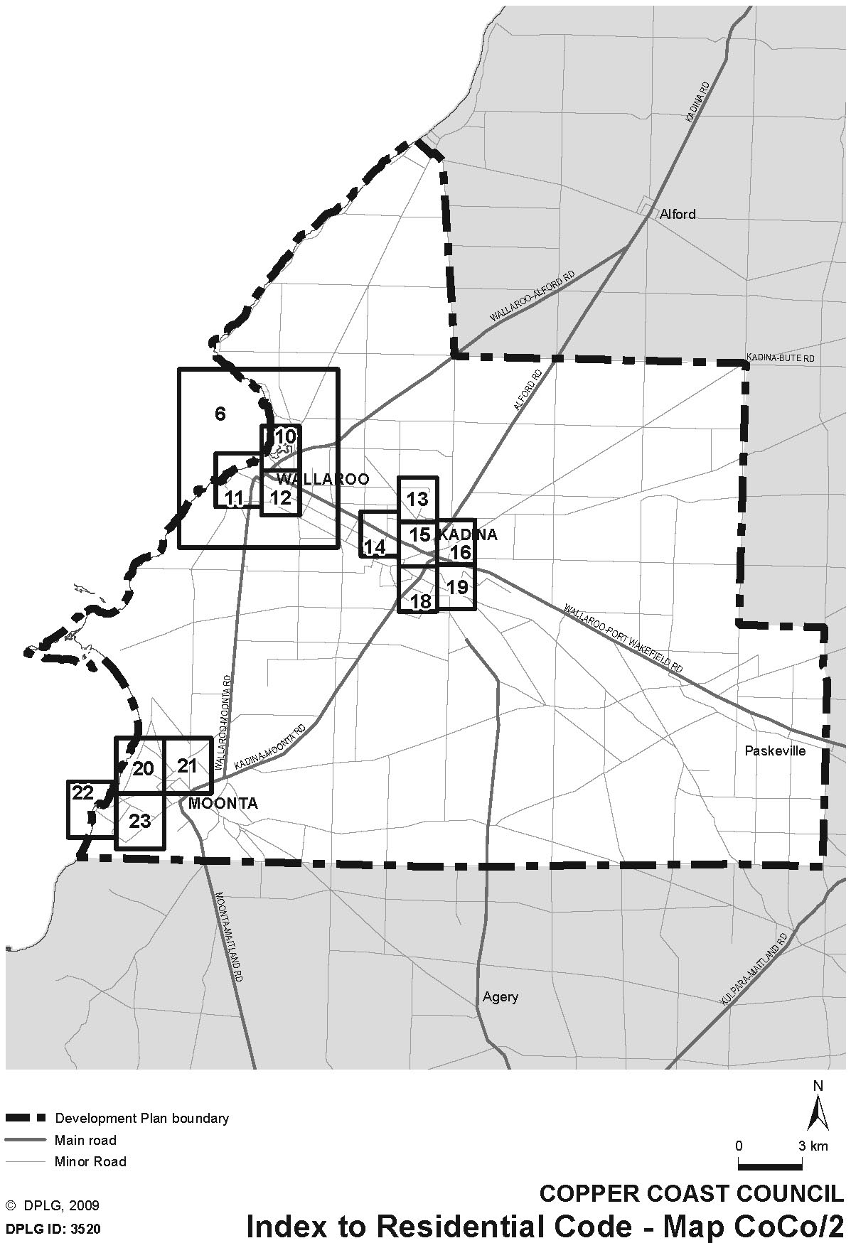
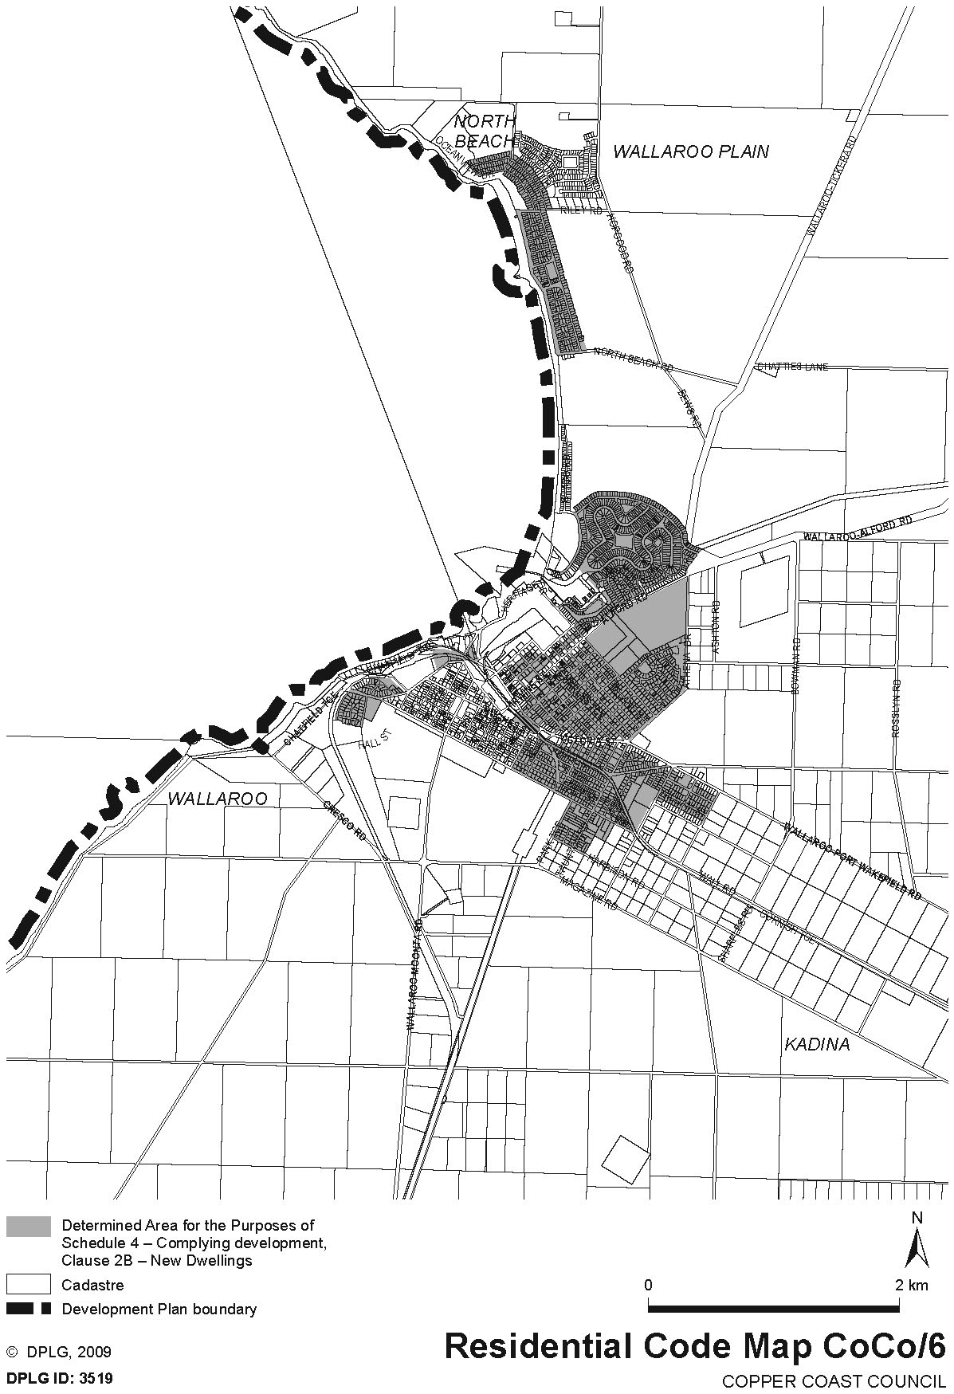
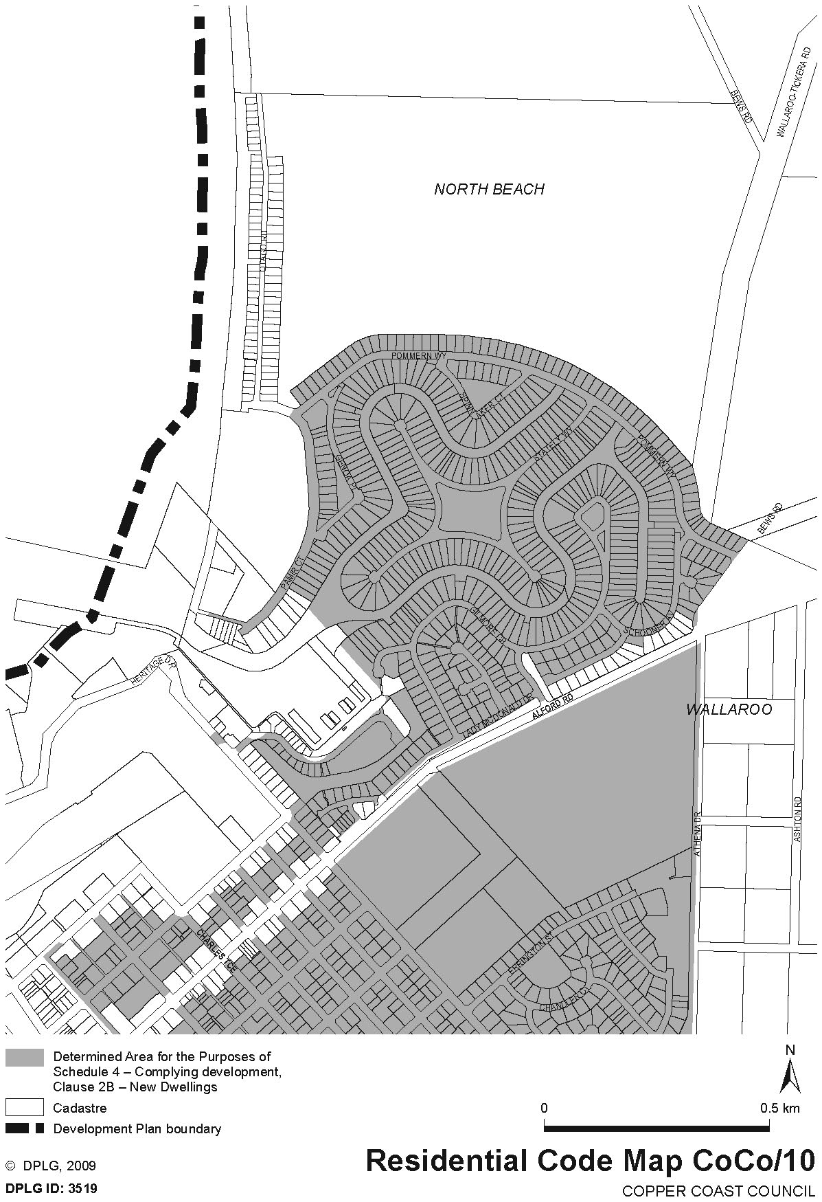
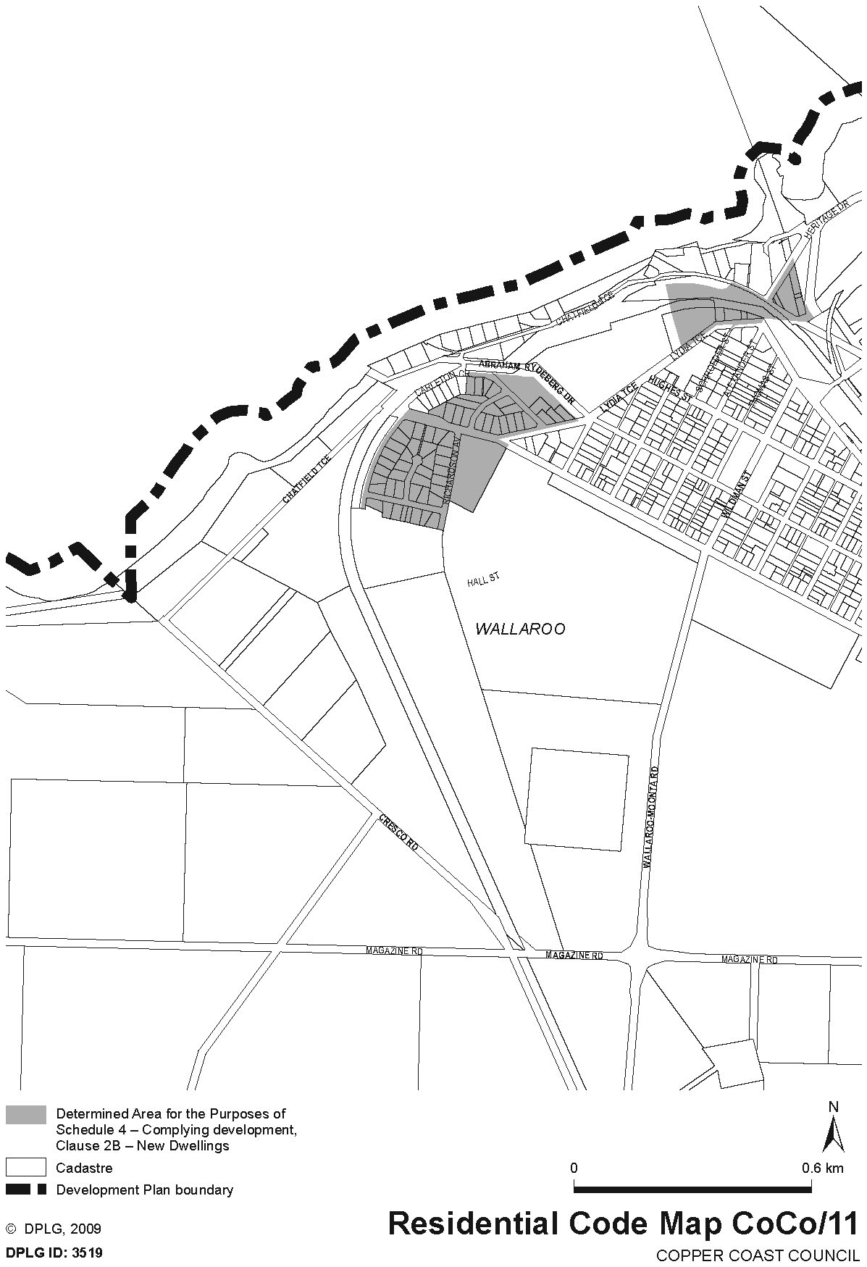
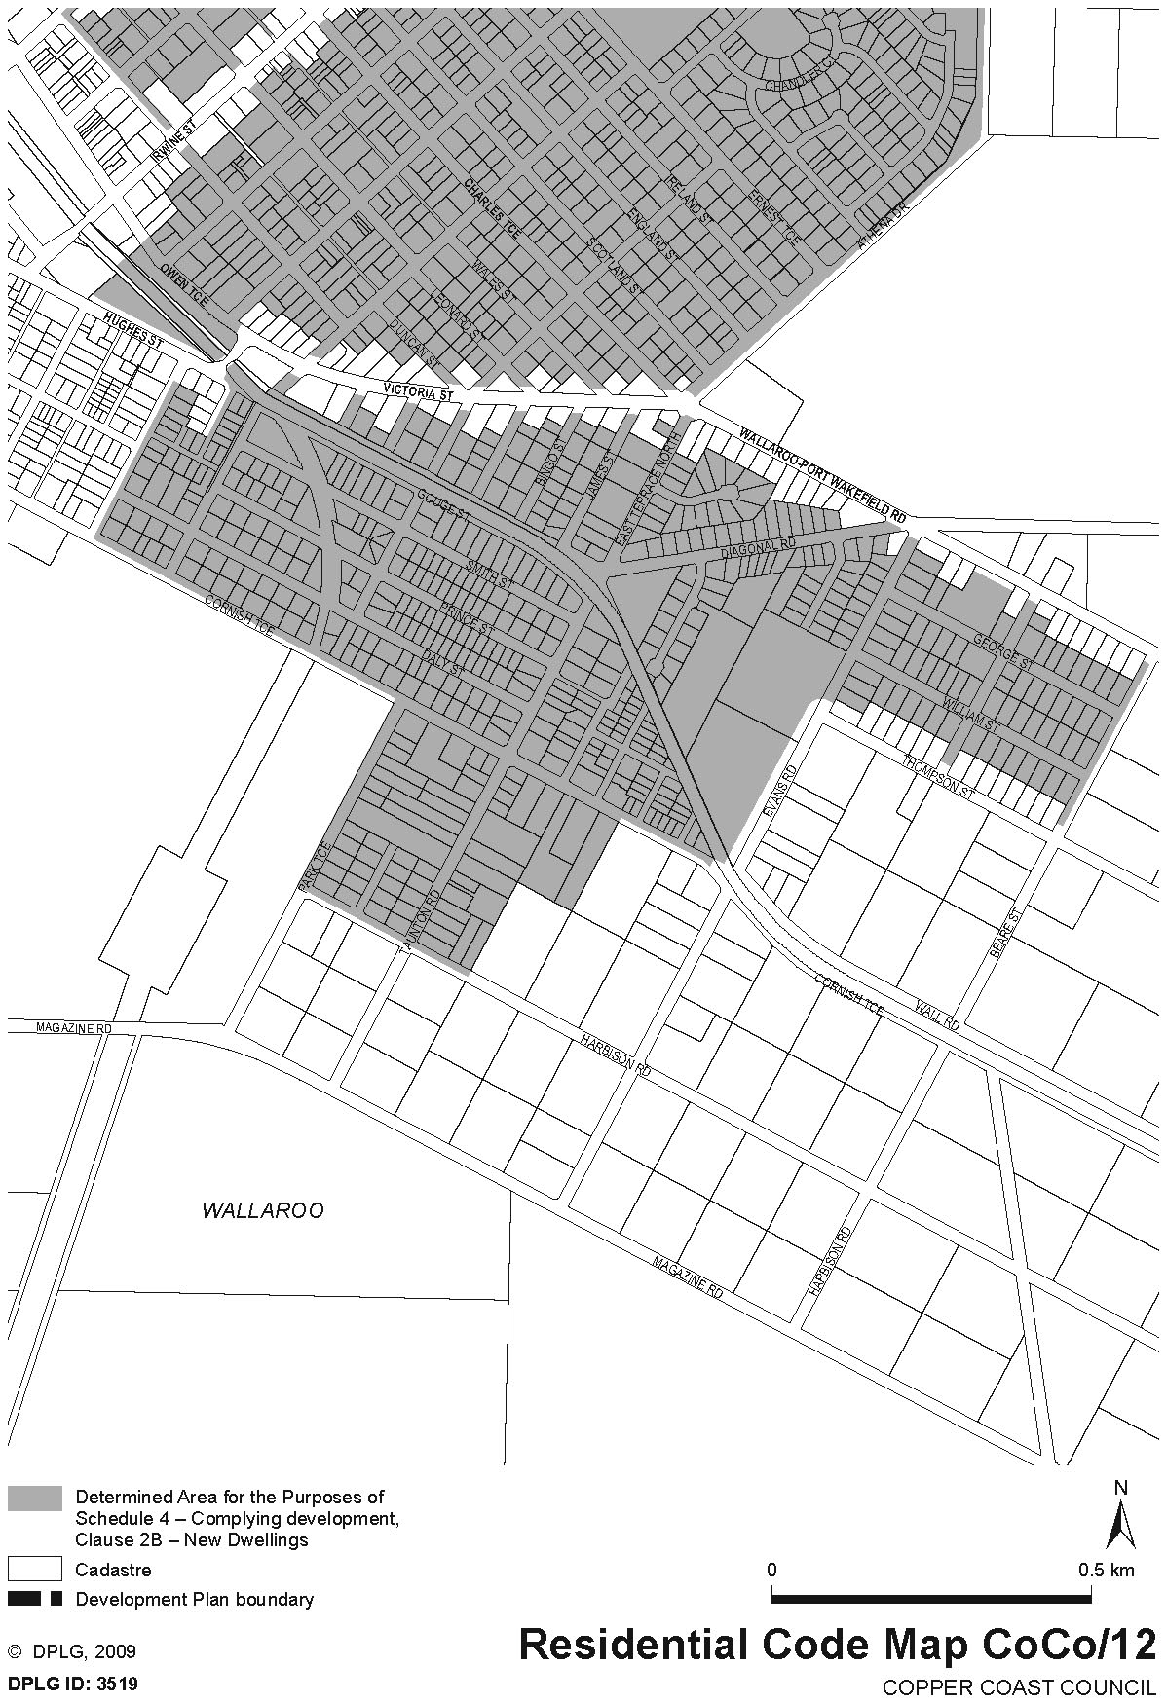
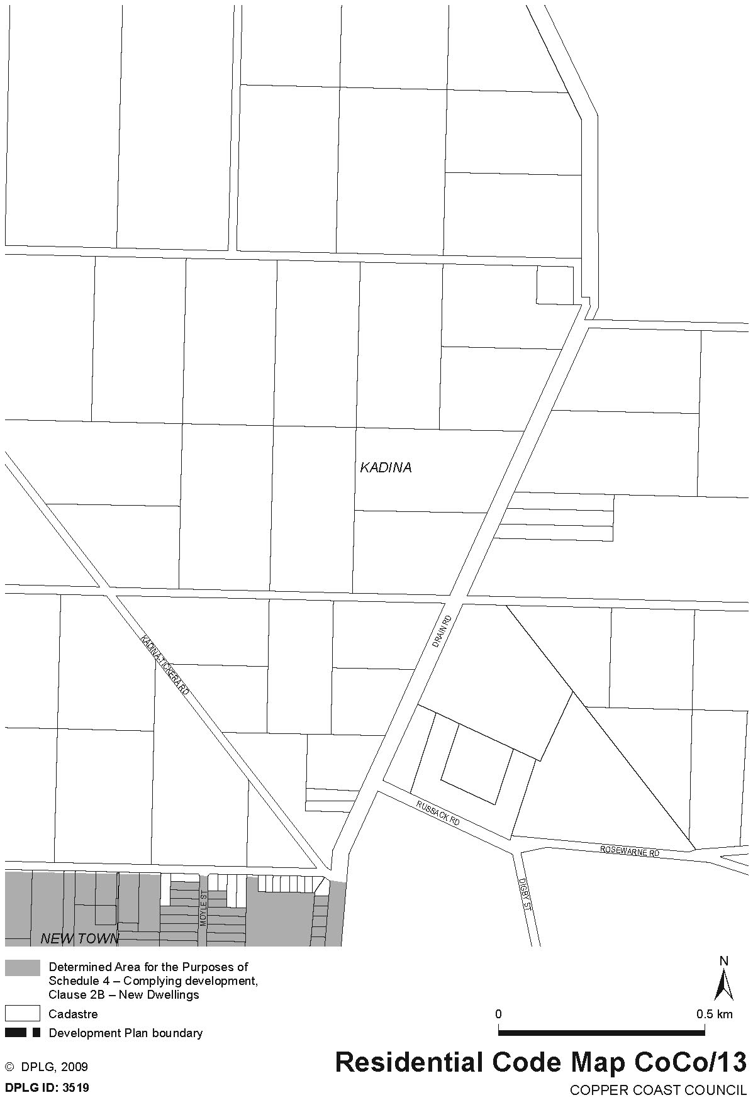
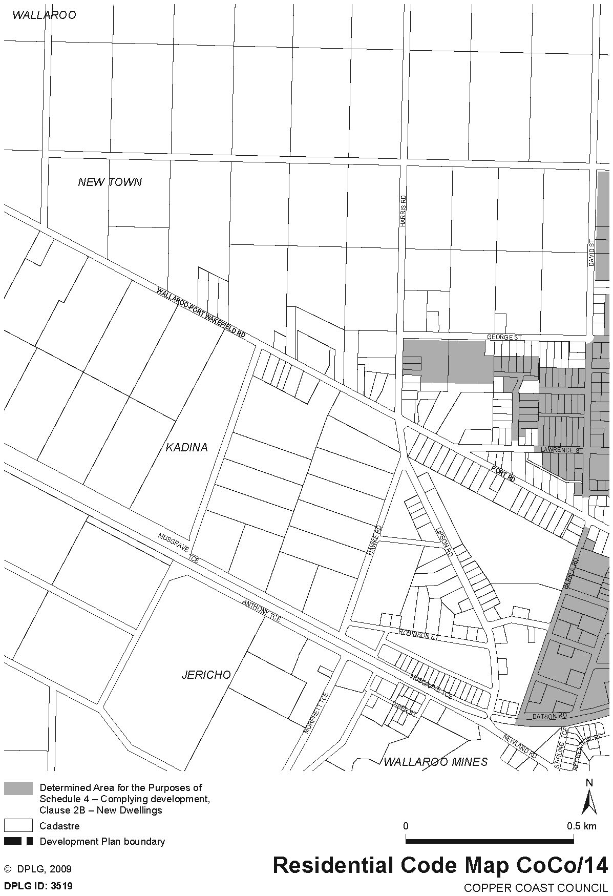
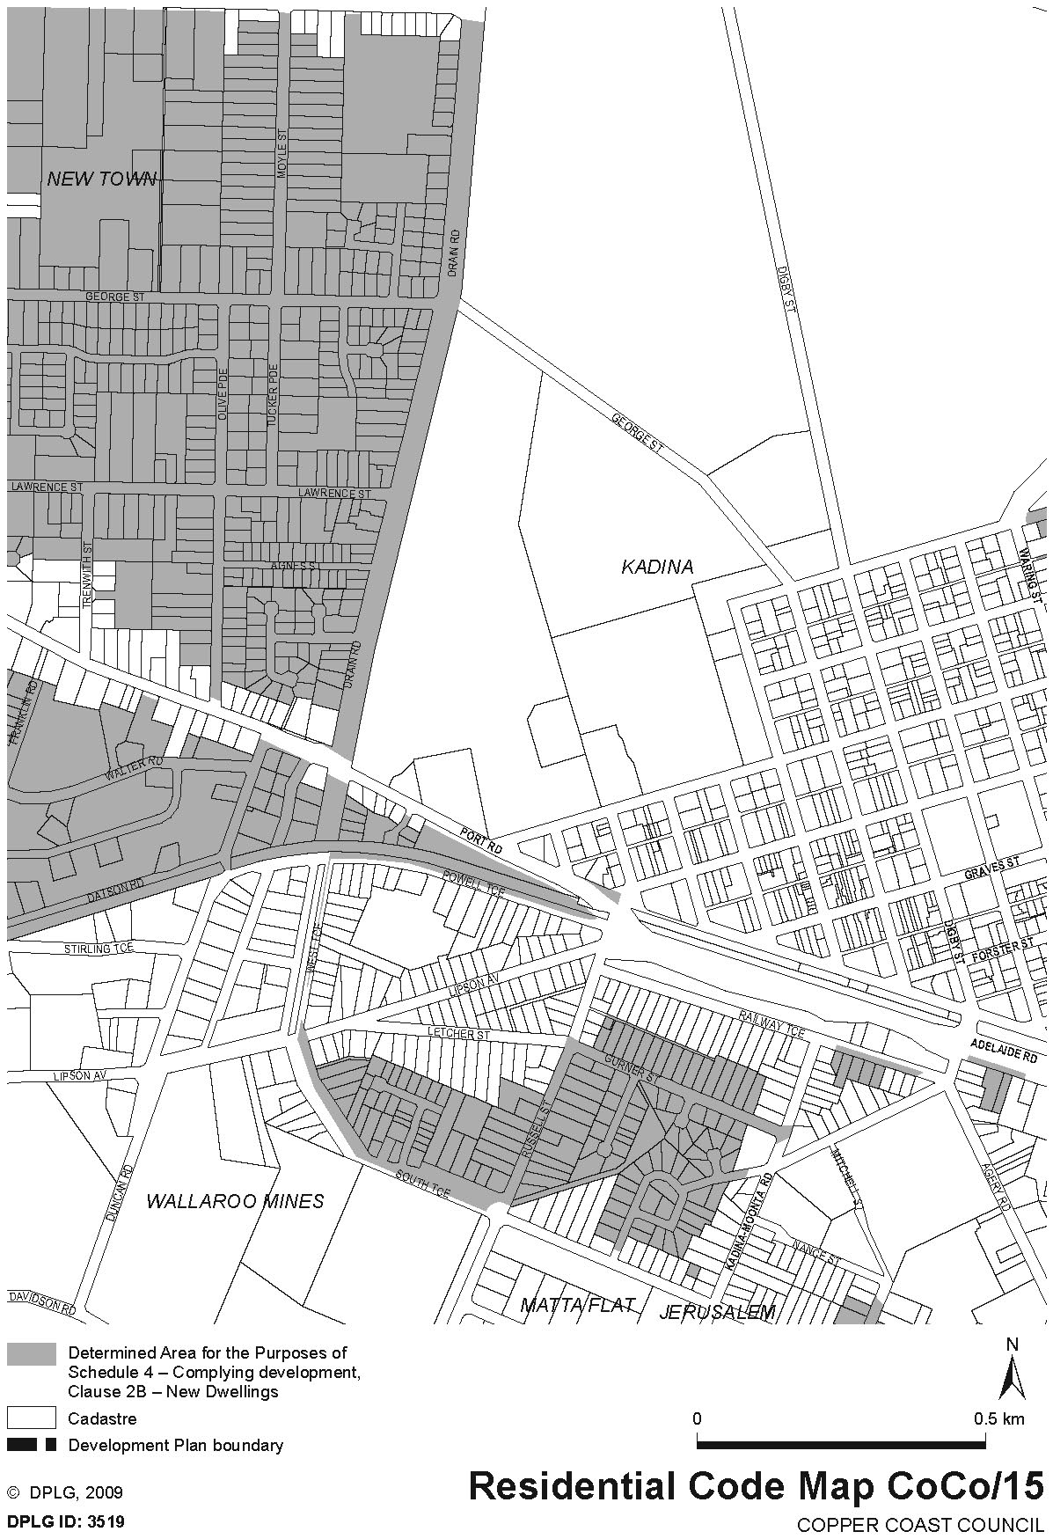
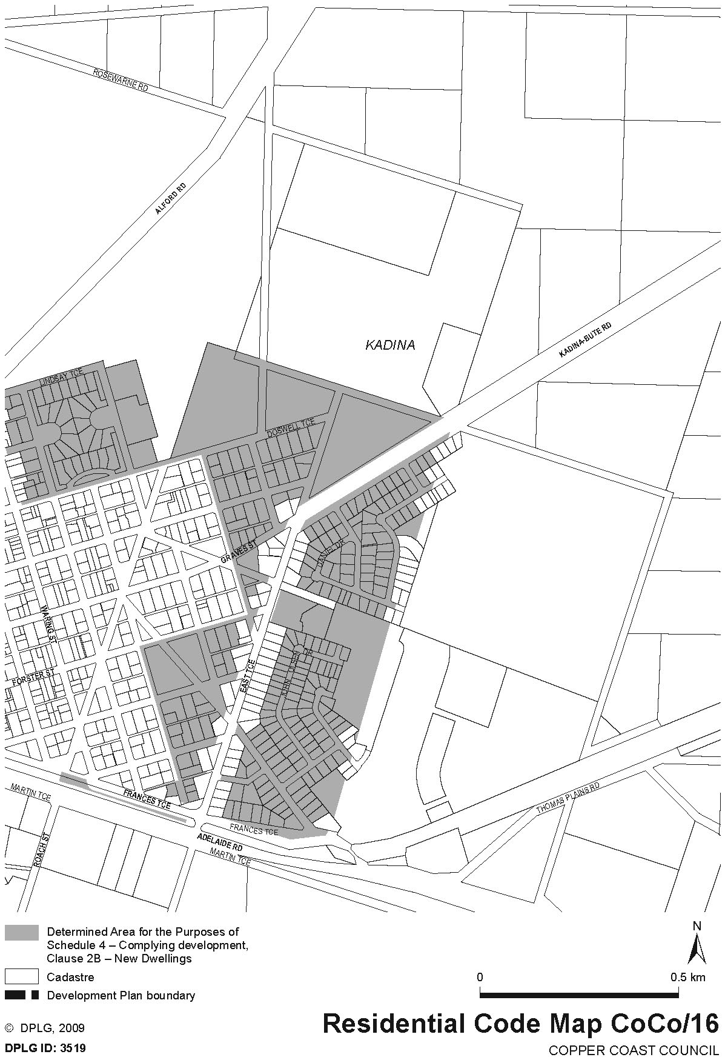
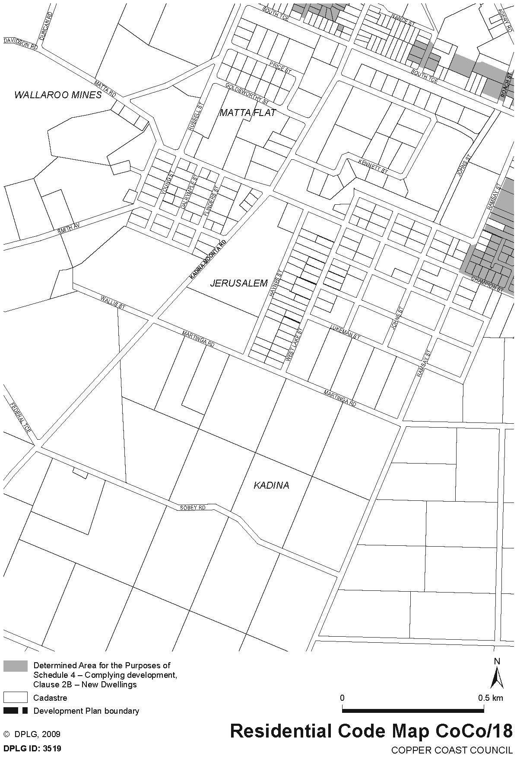
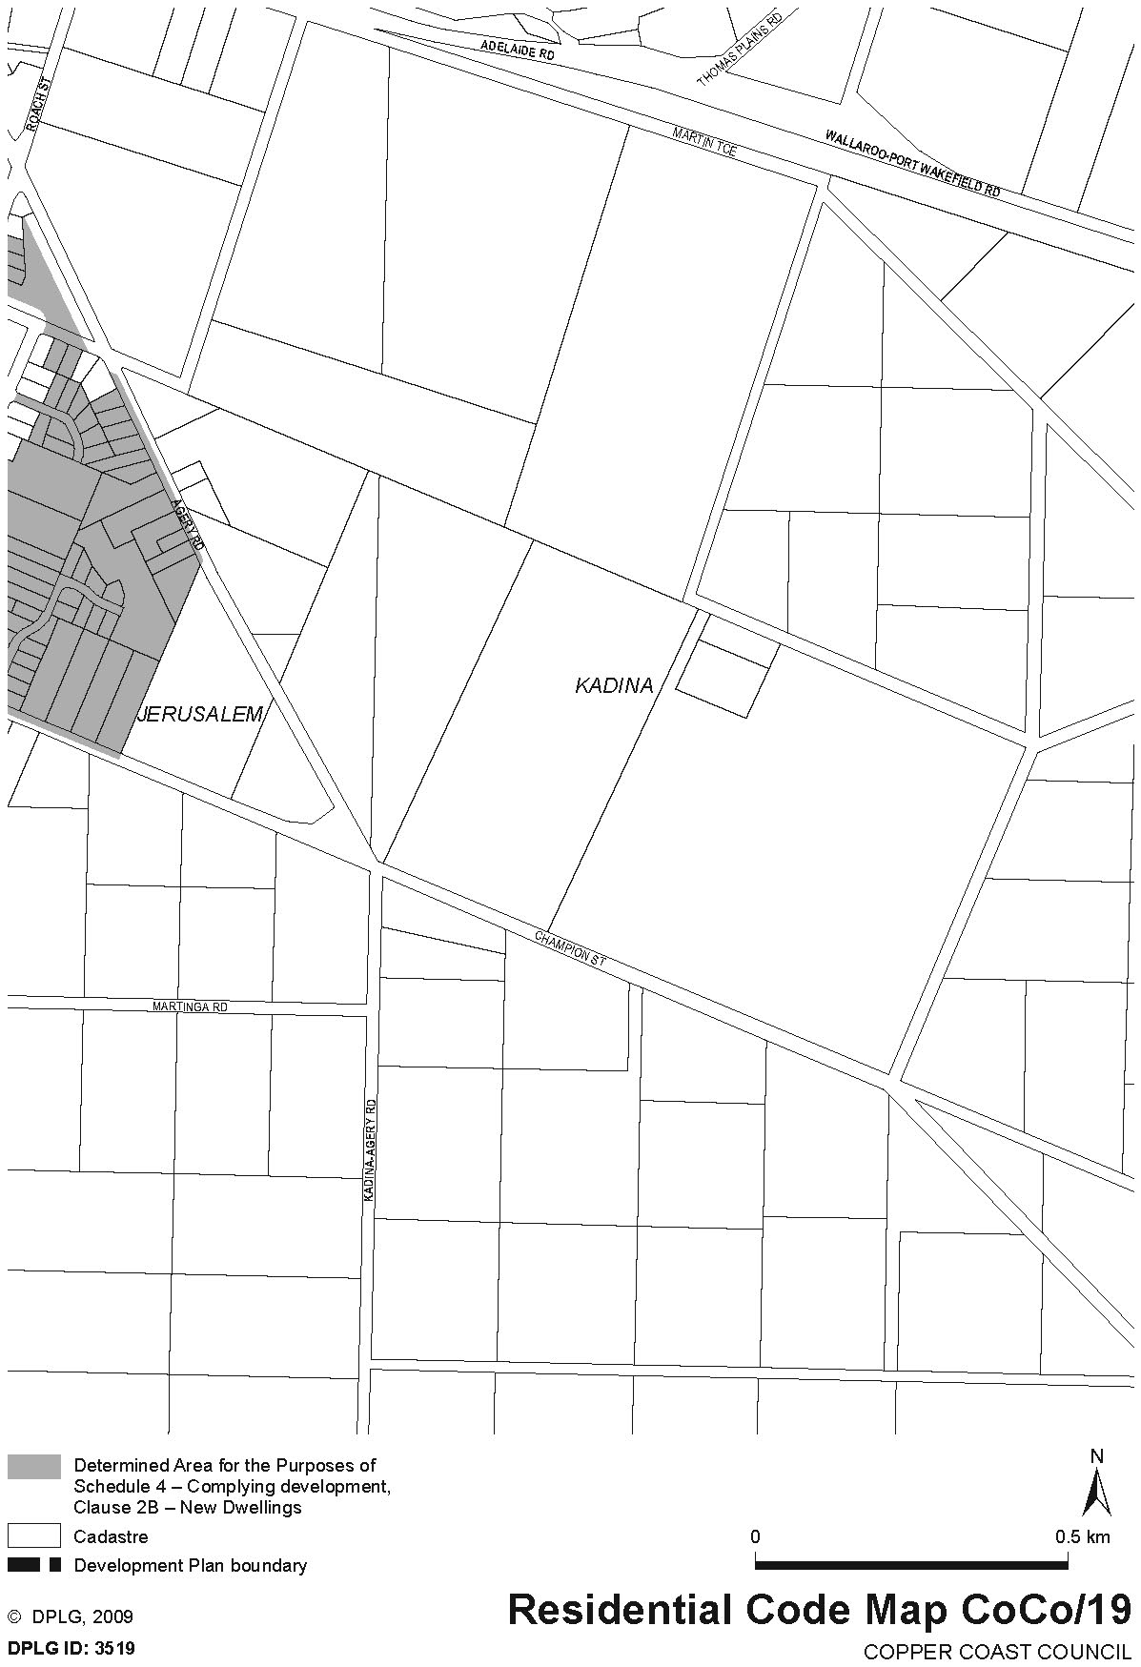
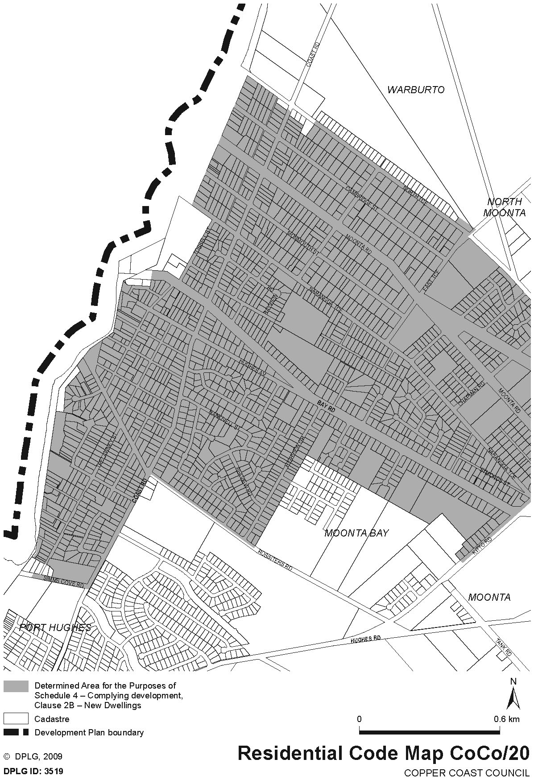
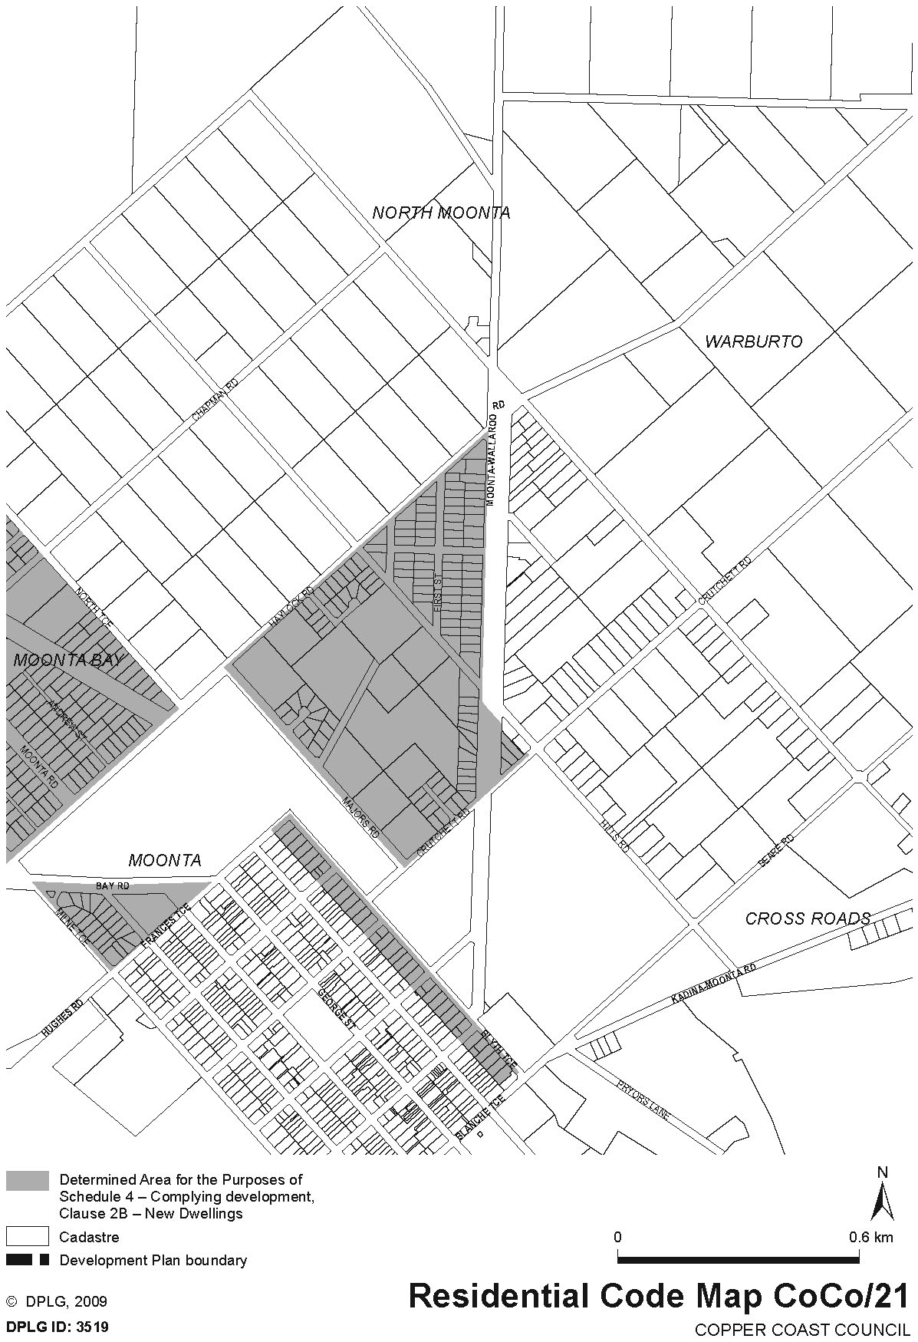
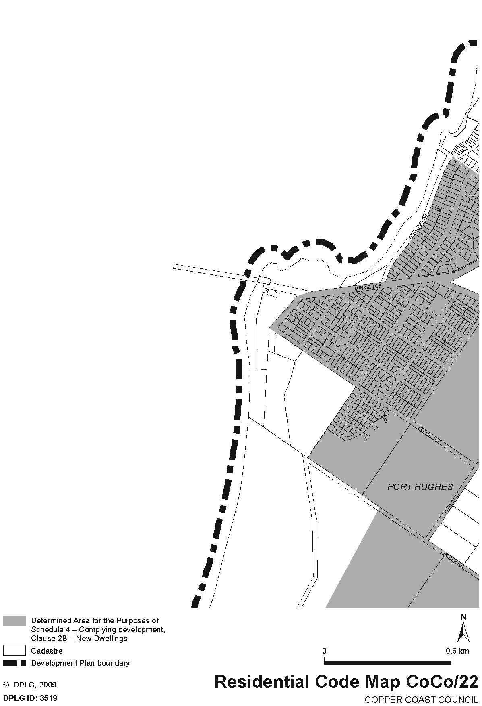
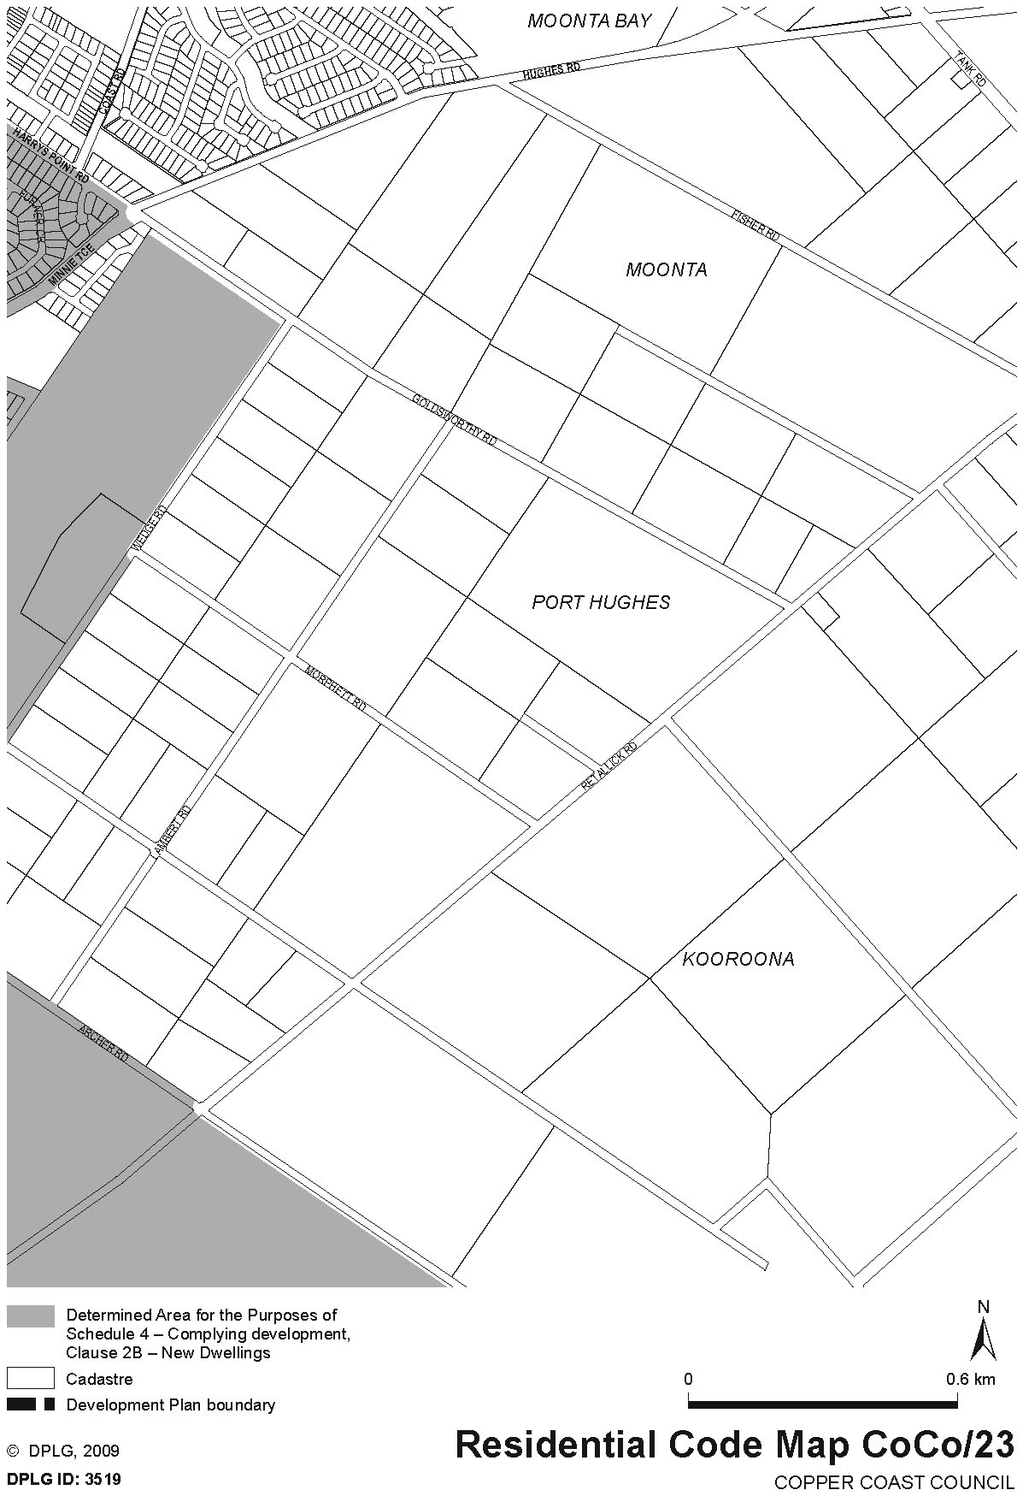

Dated 9 May 2011.
John Rau, Deputy Premier, Minister for Urban Development, Planning and the City of Adelaide

HEALTH PRACTITIONER REGULATION NATIONAL LAW (SOUTH AUSTRALIA) ACT 2010
Allocation Order
I, JOHN HILL, Minister for Health, in accordance with Clause 30 of Schedule 1 of the Health Practitioner Regulation National Law (South Australia) Act 2010, make the following allocation order for the transfer of assets and liabilities from a body referred to in Column 1 of Schedule 1, as set out in Column 2 of Schedule 1, to the entities appearing in the corresponding part of Column 3 of Schedule 1.
Schedule 1—Transfer of Assets and Liabilities

Column 1  Prescribed Body | Column 2  Description of Assets or Liabilities | Column 3  Entities to Which Assets or Liabilities are Transferred
Chiropractic and Osteopathy Board of South Australia | $260,116 representing assets and liabilities to transfer to the National Registration and Accreditation Scheme  $253,183 representing funds surplus to the requirements of the National Registration and Accreditation Scheme | Australian Health Practitioner Regulation Agency  Minister for Health
Dental Board of South Australia | $853,841 representing assets and liabilities to transfer to the National Registration and Accreditation Scheme | Australian Health Practitioner Regulation Agency
Medical Board of South Australia | $2,501,970 representing assets and liabilities to transfer to the National Registration and Accreditation Scheme  $1,500,000 representing funds surplus to the requirements of the National Registration and Accreditation Scheme | Australian Health Practitioner Regulation Agency  Minister for Health
Nursing and Midwifery Board of South Australia | $3,152,810 representing assets and liabilities to transfer to the National Registration and Accreditation Scheme | Australian Health Practitioner Regulation Agency
Optometry Board of South Australia | $71,367 representing assets and liabilities to transfer to the National Registration and Accreditation Scheme | Australian Health Practitioner Regulation Agency
Pharmacy Board of South Australia | $254,508 representing assets and liabilities to transfer to the National Registration and Accreditation Scheme  $83,955 representing assets and liabilities associated with the registration of pharmacy premises and depots in South Australia | Australian Health Practitioner Regulation Agency  Pharmacy Regulation Authority SA
Physiotherapy Board of South Australia | $291,296 representing assets and liabilities to transfer to the National Registration and Accreditation Scheme  $20,989 representing funds surplus to the requirements of the National Registration and Accreditation Scheme | Australian Health Practitioner Regulation Agency  Minister for Health
Podiatry Board of South Australia | $90,952 representing assets and liabilities to transfer to the National Registration and Accreditation Scheme  $87,367 representing funds surplus to the requirements of the National Registration and Accreditation Scheme | Australian Health Practitioner Regulation Agency  Minister for Health
South Australian Psychological Board | $225,635 representing assets and liabilities to transfer to the National Registration and Accreditation Scheme  $353,347 representing funds surplus to the requirements of the National Registration and Accreditation Scheme | Australian Health Practitioner Regulation Agency  Minister for Health

The assets and liabilities assumed as surplus to the requirements of the National Registration and Accreditation Scheme as referred to in Schedule 1 above and referred to in Column 1 of Schedule 2, are transferred to the entities appearing in the corresponding part of Column 2 of Schedule 2.

Schedule 2—Transfer of Assets and Liabilities

Column 1  Description of assets or liabilities | Column 2  Entities to which assets or liabilities are transferred
$253,183 representing funds surplus to the requirements of the National Registration and Accreditation Scheme from the Chiropractic and Osteopathy Board of South Australia  $996,000 representing funds surplus to the requirements of the National Registration and Accreditation Scheme from the Medical Board of South Australia  $504,000 representing funds surplus to the requirements of the National Registration and Accreditation Scheme from the Medical Board of South Australia  $20,989 representing funds surplus to the requirements of the National Registration and Accreditation Scheme from the Physiotherapy Board of South Australia  $87,367 representing funds surplus to the requirements of the National Registration and Accreditation Scheme from the Podiatry Board of South Australia  $353,347 representing funds surplus to the requirements of the National Registration and Accreditation Scheme from the South Australian Psychological Board | Chiropractic and Osteopathy Education Foundation Ltd for educational purposes for the benefit of the chiropractic and osteopathy professions in South Australia  SA Doctors Health Program Pty Ltd for the establishment of a health program for South Australian medical practitioners  Australian Health Practitioner Regulation Agency to cover the shortfall in funding that should have transferred to the National Registration and Accreditation Scheme  Physiotherapy Research Foundation for research to be conducted in South Australia for the health and welfare of all South Australians  Department of Health pending identification of an appropriate auspice to establish a mentoring program for recent graduates working in the rural and remote areas  Department of Health pending identification of an appropriate auspice to establish a training program for psychologists to meet the supervision requirements as set down by the Psychology Board of Australia

These orders will take effect on 1 July 2010.
Dated 12 May 2011.
John Hill, Minister for Health

South Australia
Motor Vehicles (Approval of Motor Bikes and Motor Trikes) Notice 2011
under the Motor Vehicles Act 1959
1—Short title
This notice may be cited as the Motor Vehicles (Approval of Motor Bikes and Motor Trikes) Notice 2011.
2—Commencement
This notice will come into operation on the date of publication in this Gazette.
3—Approved motor bikes and motor trikes
For the purposes of Schedules 2 and 3 of the Motor Vehicles Regulations 2010 and the transitional provisions of the Motor Vehicles Variation Regulations 2005 (No. 233 of 2005), the motor bikes and motor trikes specified in Schedule 1 are approved.

Schedule 1—Approved motor bikes and motor trikes
1—Motor bikes and motor trikes with an engine capacity not exceeding 260 ml
All motor bikes and motor trikes with an engine capacity not exceeding 260 ml and a power to weight ratio not exceeding 150 kilowatts per tonne other than the following:
Suzuki RGV250
Kawasaki KR250 (KR-1 and KR1s models)
Honda NSR250
Yamaha TZR250
Aprilia RS250

2—Motor bikes and motor trikes with an engine capacity not less than 261 ml and not exceeding 660 ml
The motor bikes and motor trikes listed in the table below.

Make | Model | Variant Name | Year | Capacity
AJS | Model 18  Model 20 (formerly known as Model 30) | Model 18  Model 20 | Pre 1963  1955-61 | 497  498
Aprila | Moto 6.5  Pegaso 650  Pegaso 650  Pegaso 650  Pegaso 650 I.E  Pegaso 650 I.E  RXV4.5  RXV5.5  Scarabeo 400  Scarabeo 500  Sportcity 300  Strada 650  Strada 650  SXV4.5  SXV5.5 | Moto 6.5  Dual Sports  Outback  Factory 650  Outback  Dual Sports  RXV4.5  RXV5.5  Scarabeo 400  Scarabeo 500  Sportcity 300  Road  Trail  SXV450  SXV550 | 1998-99  1994-01  2000-01  2007-08  2001-02  2001-06  2006-08  2006-08  2007  2007-08  2008  2006-08  2006-08  2006-08  2006-08 | 649  652  652  660  652  652  449  549  399  460  278  659  659  449  553
Benelli | Velvet Dusk | Velvet 400 | 2003-05 | 383
Beta | RR400  RR450  RR450  RR450  RR520  RR525  RR525 | RR400  RR450  RR450  RR450  RR520  RR525  RR525 | 2010  2010  2008  2000-07  2010  2008  2000-07 | 398  449  448  510  498  510
BMW | F650  F650CS | Funduro  Scarvar | 1995-00  2002-05 | 652  652
 | F650CS  F650GS (does not include models manufactured after Nov. 2007 with 800 ml engine)  F650ST  G 450 X  R50  R60  R65  R65LS  R69  F650GD | SE Road  Dakar  F650GS  F650ST  G 450 X  R50  R60/5, R60/6  R65  R65LS  R69  F650 | 2004-06  2000-08  2000-08  1998  2008  1969  1967  1984-88  1982-86  1961  2000 | 652  652  652  652  450  499  590  650  650  600  652
BSA | A50  A65  A7  B40  B44  B50  B50SS Goldstar  G650 GS  G650 GS Serato  Gold Star  Lightning  Spitfire MkIII  Thunderbolt | A50  A65  A7  B40  B44  B50  B50SS Goldstar  G650 GS  G650 GS  Gold Star  Lightning  Spitfire MkIII  Thunderbolt | 1964-70  1966-69  1961  1969  1967-71  1971  1971  2010  2010  1962  1964  1967  1967 | 500  650  500  350  440  495  498  652  652  500  654  650  499
Buell | Blast | Street Fighter | 2002-07 | 491
Bug | See Kymco
Bultaco | Alpina  Frontera  Sherpa | Alpina  Frontera  Sherpa | 1974  1974  1974 | 350  360  350
Cagiva | 360WR  410TE  610TE-E  650 Alazzura  650 Elfant  Canyon 500  Canyon 600  River 600  W16 600 | 360WR  410TE  610TEE  650 Alazzura  650 Elfant  Dual Sports  Dual Sports  River 600  W16 600 | 1998-02  1996  1998  1984-88  1985-88  1999-06  1996-98  1995-98  1995-97 | 348  399  576  650  650  498  601  601  601
Cossck | 650 | 650 | 1974 | 649
Derbi | Mulhacen | 659/659 Café | 2008 | 659
 | Rambla | RA 300 | 2010 | 278
Dneper | K650  Dneiper  K650  MT9 | K650  Dneiper  K650 Dnepr  MT9 | 1972  1974  1967-74  1974 | 650  650  650  650
Ducati | 400 Monster  400 SS Junior | 400 Monster  400 SS | 2002  1989-96 | 398  398
 | 400SS  500SL  600 Monster  600 Monster  600 S  600M  600SL  600SS  620 Monster Lite  620 Multistrada Lite  DM 350  DM 450  DM450  DM500  F4  M4  M5 | 400SS  Pantah  600 Monster  Dark  600 Supersport  600M  Pantah  600SS  M620 Lite  MTS620 24.5Kw  350  450  DM450  DM500  400 F4  M620ia Lite  Monster 659 | 1992-95  1984  1994-01  1998-01  1994-97  1994-01  1980-84  1994-98  2003-07  2005-07  Pre 1985  Pre 1985  1972  1981-84  1986  2003-04  2011 | 398  499  583  583  583  583  583  583  618  618  350  448  450  498  400  620  659
Enfield | Bullet  Bullet  Bullet  Bullet 350  Bullet350  Bullet 350  Bullet 65  Lightning  Military  Taurus  Bullet 350 STD | Classic  Deluxe  Electra Road  Deluxe  Superstar  Classic  Road  Road  Road  Diesel  Royal Enfield | 1993-08  1993-08  2006-08  1988-01  1988-94  1993-01  2003-04  2000-08  2002-08  2001  1960-90 | 499  499  499  346  346  346  499  499  499  325  346
Gas-Gas | EC300  EC300  EC400  EC450  EC450  EC450  FS400  FS450  FS500  FSE 400  FSE 450  Pampera  Pampera  Pamper  SM400  SM450  TT300 | SM Supermotard  Enduro  FSE Enduro  FSE Enduro  FSE Supermotard  FSR Enduro  FS40A  FS45  FS50  400  450  320 Trail  400 Trail  450  Supermotard  Supermotard  EC300 | 2002  2001-02  2002-03  2003-05  2003-08  2006-08  2006  2006  2006  2002  2003-08  1998-02  2006-08  2007-08  2003-08  2003-08  1998-08 | 299  299  399  449  449  449  398  443  503  398  398  333  399  399  399  443  295
Gilera | Fuoco 500  Nexus 500 | Fuoco 500  Nexus 500 | 2007-08  2003-08 | 493  460
Harley | SS350 | SS350 | 1974 | 350
Honda | 600V Transalp | 600V Transalp | 1988 | 583
 | Bros  C70  CB350  CB350F  CB360  CB400  CB400  CB400F  CB400N  CB400T  CB450  CB500  CB550  CB650  CBX550  CJ360  CL450  CRF450X  CX500  CX650  Deauville  FJS400A  FT500  FTS600D  GB400  GB500  GL400  NF02  NT400  NTV650  NX650  RVF400  SL350  Steed  VT400C  VT500  VT600C  XBR500  XBR500SH  XL350  XL500  XL600  XL600R  XL600RMG  XL600VH  XL650V  XR350  XR350R | Bros  Dream  CB350  CB350F  CB360  CB400  CB400  CB400F  CB400N  CB400T  CB450  CB500  CB550  CB650  CBX550F  CJ360  CL450  CRF450X  CX500  CX650  NT650V  SW-T400  FT500  Silverwing  GB400  GB500  GL400  SH300  NT400  Revere  Dominator  OBI RVF400  SL350  Steed  Shadow, VT400F  VT500F  VT600C  XBR500  XBR500SH  XL350  XL500  XL600  XL600R  XL600RMG  Transalp  Transalp  XR350  XR350R | 1992  Pre 1970  1969  1973  1973-74  1981  2008  1975  1981  1977  1972-75  1977  1978  1979-82  1982-85  1976  1965-77  2005-08  1977  1983-85  2002-06  2009  1984  2006-08  1992  1977  1985  2009  1989-92  1989-92  1988-00  1992-96  1972  2002  2009  1984-86  1993-00  1986-89  1986-89  1984-87  1980-84  1984-89  1984-87  1986-88  1987-89  2002-08  1983  1983-84 | 399  305  348  325  360  395  408  395  408  399  450  498  544  627  572  356  444  449  495  647  647  399  498  582  399  498  396  279  400  647  644  399  348  398  399  498  583  499  499  339  498  589  589  591  583  647  339  339
 | XR350R  XR400  XR400 Motard  XR400R  XR500  XR500R  XR600  XR600R  XR650L  XR650R | XR350R  XR400  XR400 M  XR400R  XR500  XR500R  XR600  XR600R  XR650L  XR650R | 1985-86  1996-08  1996-08  1996-08  1979-85  1983-84  1985  1985-00  2001-06  2000-06 | 353  397  397  397  498  498  591  591  644  649
Hunter | DD350E-6C | Daytona | 2010 | 320
Husaberg | FE400  FE450  FE501E  FE570  FE600E  FE650E  FE650E  FS450E  FS450  FS570  FS650C  FS650E  FS650E  FE (Enduro) 4E8  FE (Enduro) 5E8  FE (Enduro) 7E8  FE550  TE300 | Enduro  Enduro  Enduro  Enduro  Enduro  Enduro  Enduro  Enduro  Supermotard  Supermotard  Supermotard  Supermotard  Supermotard  FE4E8  FE5E8  FE7E8  FE550  TE Series | 2000  2008-10  1997-03  2008-10  1997-00  2004-08  2000-04  2004  2008-10  2009-10  2004-05  2004-08  2002-04  2000  2000  2000  2004  2010 | 399  449  501  565  595  628  644  449  449  565  628  628  644  399  501  644  550  293
Husqvarna | 300WR  310TE  310TE  350TE  400SM  400TE  410TS  410TS  450SM  450SMR  450SMRR  450TC  450TE  450TE-ie  450TXC  A6 SMR 449  A6 TE 449  A6 SMR 511  A6 TE 511  510SM  510TC  510TE  510TE  510TE  510TE-ie  570TE  610SM  610TE  610TE | WR300  TE310 A3  TE310 A2  TE350  Supermotard  Enduro  Enduro  Enduro  Supermotard  Supermotard  Supermotard  Motocross  Enduro  Enduro  Trail  A600AB  A600AATE449  A601AB  A601AATE511  Supermotard  Motocross  Enduro  Enduro  Enduro  TE510ie  570TE(RP)  Dual Sports  TE610(RP), 610TE-e  Dual Sports | 2008-10  2010  2008-10  1995  2002-04  2000-01  1998-00  1994-97  2003-07  2003-08  2008  2001-08  2001-07  2007-08  2007-08  2010  2010  2010  2010  2004-10  2004-07  2004-08  1984-85  1986-90  2008  2000  2000-08  2000  2008 | 298  303  298  349  400  400  400  415  449  449  449  449  449  449  449  450  450  478  478  501  501  501  505  510  510  577  577  577  577
 | AE430  WR260  WR300  WR360  WR400  WR430  SM 450ie  SM 510ie  SMS630  TE310ie  TE630  WR300 | Enduro  Enduro  Enduro  Enduro  Enduro  Enduro  SM 450ie  SM 510ie  A401AB, SM630  TE310ie  630TE  WR300 | 1986-88  1990-91  2010  1991-3  1984-88  1988  2008  2009  2010  2008  2010  2008 | 430  260  293  349  396  430  449  501  600  298  600  298
Hyosung | GT650L  GT650RL  GT650SL  GT650-40  GT650S-40  GT650-40  GV650C  GV650L  GV650-40 | Comet  Comet  Comet  GT650R  GT650S  GT650  Aquila Classic  Aquila  Aquila | 2005-08  2005-08  2005-08  2010  2010  2010  2010  2008-09  2010 | 647  647  647  647  647  647  647  647  647
Indian | Velo | Velo | 1969 | 500
Jawa | 350  638 Road  638 Road | 350  638 Road  638 Road | 1974  1984-85  1985-86 | 350  343  343
Kawasaki | EN400  EN450  EN500  ER-5  ER6-650C  ER6-650C  EX400  EX650C  EX650C  GPZ550  GT550  KL600  KL650  KLE500  KLX300R  KLX400  KLX450R  KLX650  KLX650R  KZ400  KZ440  KZ500  KZ550  LE630D  LTD440  LX400  S2  S3  W1 650  Z400B2 | Vulcan  450Ltd  Vulcan  ER500  Er-6nL  Er-6nL ABS  GPX 400R  Ninja 650RL  Ninja 650RL ABS  GPZ550  Z550  KLR600  KLR650  Dual Sports  KLX300R  KLX400  KLX450R  KLX650  Enduro  KZ400  KZ440  KZ500  KZ550  Versys 650L ABS  LTD440  LX400 Eliminator  S2  S3  W650  KZ400B2 | 1986  1995-87  1990-02  1999-06  2009  2009  1984-94  2009-10  2009-10  1981-90  1984-88  1984-87  1987-10  1992-08  1996-04  2003  2001-10  1989-95  1993-04  1974-84  1985  1979  1986  2010  1982  1989  1972  1974  1965-70  1979 | 400  454  500  498  649  649  399  649  649  553  553  564  651  498  292  400  449  651  651  398  443  497  547  649  443  398  346  400  623  398
 | Z400D  Z500  ZR550  ZZR400 | KZ400  Z500  Zephyr  ZZR400 | 1975  1980  1991-99  1991 | 398  498  553  399
KTM | 300EXC  300EXC  300EXC  300EXC  300EXC-E  30GS  350EXC Special R  360EXC  380EXC  400EXC  400GS  400SC  400TE  450EXC  450EXC-R  500GS  510EXC  520EXC  525EXC  525EXC-R  530EXC  600 Enduro  600 Enduro Incas  625SMC  660SMC  690 Rally Replica | Enduro  Enduro  Enduro  Enduro  Enduro  Enduro  Enduro  Enduro  Enduro  Enduro  Enduro  400SC  400Te  Enduro  Enduro  Enduro  Enduro  Enduro  Enduro  Enduro  Enduro  Enduro  Enduro  625SMC  4T-EGS  4T-EGS | 1984-00  2002-08  2004-07  2000-04  2007-08  1990-95  2005-06  1996-98  2000  2008-09  1993-99  1996-98  2001  2002-07  2005-09  1984-91  1999-02  2000-02  2002-05  2005-07  2008-09  1987-93  1989-90  2004  2004  2010 | 280  293  293  297  293  280  350  360  368  393  400  400  400  448  449  553  510  510  510  510  510  553  553  609  654  654
Kymco | Bug Xciting  Bug Xciting  Bug Xciting  Downtown 300i | 500i  500Ri  500  V20000 (300i) | 2008-08  2005-08  2005-08  2010 | 498  498  498  298
Lambretta  Laro | All model  DD35E-6C  SPT series | Lambretta  Pro Street  SPT350 | Pre 2008  2011  2011 | Under 660  320  320
Laverda | 500 | 500 | 1979 | 497
Lifan | LF400 | LF400 | 2009 | 399
Maico | Enduro | 500E | 1984-88 | 488
Matchless | G12  G80  G80  650  500 | G12, 650  Harris  G80  G11, G12, model 31  G80 Major | Pre 1966  1988-90  Pre 1963  1958-66  1949-66 | 646  494  497  646  500
MBK | Falcone  Yamaha XT660X | Yamaha XT660R  Yamaha XT660X | 2005-08  2005-08 | 660  660
Montessa | Cota 330  Cota 335  Cota 348T  Cota 3505 | Trial  Trial  Trial  Trial | 1985-86  1986-88  1984-87  1984-85 | 328  328  305  349
Moto Guzzi | 350 GT  Falcone | 350 GT  Falcone | 1992  1972 | 350  498
 | V35  V50  V50  V65  V65 | V35  V50  Monza  V65  Lario | 1977-80  1977-79  1980-85  1982-87  1984-89 | 346  490  490  643  643
Moto Morini | 3.5 Road  350 Sport  500 Camel  500 SEI  500 Strada  500W | 3.5 Road  350 Sport  Trail  500 SEI  500 Strada  500 V-twin | 1984-85  1974-85  1984-86  1984-85  1977-85  1977 | 344  344  479  479  479
MuZ | Baghira  Mastiff  Skorpion  Skorpion  Skorpion  Skorpion | Enduro  Supermotard  Replica  Sport  Traveller  Tour | 1999-02  1999-02  1998-02  1998-02  1998-02  1998-02 | 660  660  660  660  660  660
MV Agusta | 350 | 350 | 1972-76 | 349
Norton | 650SS  ES2  Manxman  Model 88  Navigator | 650SS  ES2  Manxman  Dominator  Navigator | 1962-68  Pre 1963  1961  Pre 1966  1964 | 650  490  650  497  350
Oz Trike | Fun 500 | Fun 500 | Pre 2008 | 500
Panther | Model 100  Model 120 | Model 100  Model 120 | Pre 1963  Pre1966 | 598  645
Peugeot | Geopolis (400)  Satelis (400)  Satelis (500) | AEAA  AEAA  AFAA | 2007-08  2007-08  2007-08 | 399  399  493
Piaggio | MP3 300  MP3 400  X7 Evo 300  X8 400  X9 500  XEVO 400ie | MP3 300  MP3 400  Evo 300  X8 400  X9 500  XEVO 400ie | 2010  2008  2009  2007-08  2001-08  2007-08 | 278  399  278  399  460  399
Rickman | 650 | Triumph | 1964 | 649
Royal Enfield | Bullet  Bullet  Bullet  Bullet  Lightning  Taurus  Taurus | Bullet350  Bullet 500  Electra  Classi  Lightning 500  Diesel 324  Diesel 325 | 1988-01  1993-08  2005-08  2005-08  2000-08  1997  2000-01 | 500  500  500  500  350  324  325
RS Honda | XR400M | Motard | 2005-08 | 397
Rudge Whitworth | 650 | Rudge | Pre 1961 | 650
Sherco | S4  S4  S4  S4  S4 | Enduro  Enduro 250  Enduro 450  Enduro 510  Enduro 300 | 2005-06  2010  2010  2010  2010 | 448  248  448  510  290
Suzuki | AN400  AN400A | Burgman  Burgman 400 | 2008  2006 | 400  400
 | AN650  DR350  DR400  DR500  DR600  DR650  DR650SE  DR-Z400E  DR-Z400S  DR-Z400SM  GN400  GR650  GS400  GS450  GS450E  GS500  GS500  GS500F  GS550  GSR400  GSX400  GSX400  GSX650FU  GT380  GT500  GT550  Katana550  LS650  PE400  RE5  SFV650U  SP370  SV650SU  T500  TS400  XF650 | Burgman  All  DR400  All  DR600S, DR600R  All  DR650SE  DR-Z400E  DR-Z400S  DR-Z400SM  GN400  All  GS400  All  GS450E  GS500  GS500  GS500F  All  GSR400  F  E  GSX650FU  GT380  GT500  GT550  Katana550  Savage  PE400  Rotary  SFV650U  Enduro  SV650SU  T500  TS400  Freewind | 2002-08  1991-98  1999  1981-84  1985-90  1990-08  1997-10  2000-08  2005-10  2005-10  1980-81  1983-88  1976-82  1988-89  1977-89  2000-10  1976-82  2004-10  1977-82  2006-08  1981-04  1981-84  2008-10  1973-78  1976-78  1973-78  1981-83  1986-89  1980-81  1974  2009-10  1978  2008-10  1970-74  1976  1997-01 | 638  349  400  498  598  644  644  398  398  398  400  651  400  450  450  487  492  487  549  398  398  398  656  380  500  550  550  652  400  500  645  370  645  500  400  644
SYM | Citycom 300 | LH30W | 2008 | 263
TM | 300E  400E  450E  450MX  530E  530MX  300 Enduro  450  530  TM300  TM400 | Enduro  Enduro  Enduro  450MX  Enduro  530MX  TM300E  TM450  TN530  TM300  TM400 | 2000-08  2002-03  2003-08  2008  2003-08  2008  2000  2003  2003  2002  2002 | 294  400  449  449  528  528  297  450  528  297  400
Triumph | 21  Daytona 500 | 21  Daytona 500 | 1963  1970 | 350  490
 | T100  T120  TR5  TR6  TR7  Tribsa  Thunderbird 650  Note: Only includes models manufactured up to and including 1983 | Tiger  Bonneville  Trophy  Trophy  Tiger  Tribsa  6T, TR65 | 1968  1968  1969  1967  1971  1960-70  1949-66 | 498  649  449  649  649  649  649
Ural | Dneiper  K650  MT9 | Dneiper  K650  MT9 | 1974  1967-74  1974 | 650  650  650
Velocette | Thruxton  Venom | Thruxton  Venom | 1965-67  1955-70 | 499  499
Vespa | GTS 300 Super  GTS 300 Super  GTV 300 VM | GTS 300 S  GTS 300 S  GTV | 2008  2010  2010 | 278  278  278
Vor | 400 Enduro  450 Enduro  500 Enduro  530 Enduro  VOR Enduro  VOR Enduro | 400 Enduro  450 Enduro  500 Enduro  530 Enduro  400SM  500SM | 2000  2002  2001  2001  2000-01  2000-01 | 399  450  503  530  399  503
Xingyue | XY400Y | XY400Y | 2008-09 | 400
Yamaha | DT400  IT426  IT465  IT490  MX400  RD350  RD400  RT2  RT350  SR400  SR400  SR500  SRX400  SRX600  SZR660  TT350  TT500  TT600  TT600E  TT600R  TX650  WR400F  WR426F | DT400  IT426  IT465  IT490  MX400  RD350  RD400  RT2  RT350  SR400  SR400  SR500  SRX400  SRX600  SZR660  TT350  TT500  TT600  TT600E  TT600R  TX650  WR400F  Belgarda import only | 1976-77  1987  1987  1983  1976  To 1975  1976  1970  1972  1978-82 2002  1978  1985-90  1996  1997  1986-01  1975  1995  1997  1999  1976  2000  2001 | 400  426  465  490  400  350  398  360  347  400  400  499  400  608  659  346  500  595  595  595  653  399  426
 | WR450F  WR450F  XJ550  XJ6  XJ6  XJ6  XJ650  XJR400  XJR400  XP500  XS400  XS650  XT350  XT500  XT550  XT600  XT660R  XT660X  XT660Z  XTZ660  XV400  XV535  XVS650  XZ400  XZ550  YP400  RD350LC  WR450  XT600Z  XVS650A | WR450F  WR450F  XJ550  XJ6FL (25kw)  XJ6NL (25kw)  XJ6SL (25kw)  XJ650  XJR400  4HM  XP500  XS400  XS650  XT350  XT500  XT550  XT600  XT660R  XT660X  XT660Z Tenere  XTZ660  XV400 Virago  XV535 Virago  XVS650  XZ400  XZ550  Majesty  LC350  WR450  Tenere  ZVS650A | 2005  2006-08  1981-82  2009-10  2009-10  2010  1991  1999  2003  2000-08  1978-82  1972  1985-99  1977-81  1982-84  1988-96  2004-08  2004-08  2009-2010  2004-08  1983  1993  1997-08  1982  1982-83  2008  1980-86  2002  1988-89  2000 | 450  450  428  600  600  600  653  400  399  499  391  653  346  499  552  590  659  659  660  659  399  535  649  399  550  395  350  450  595  649
Note:
All motorcycles built before December 1960 with an engine capacity not exceeding 660 ml are approved.
All scooters with electric powered engines are approved.
Schedule 2—Revocation
The Motor Vehicles (Approval of Motor Bikes and Motor Trikes) Notice 2010 made on 17 March 2011 (Gazette No. 20, 17 March 2011 page789) is revoked.

Ron Shanks
DEPUTY REGISTRAR OF MOTOR VEHICLES
18 May 2011

South Australia
Gaming machines Act 1992
GM Notice No. 6 of 2011
Gaming Machines—Club Safe and Gaming Care—Recognition Notice 2011
[26 May 2011]
The Independent Gambling Authority publishes this notice under section 10B of the Gaming Machines Act 1992:
1. Citation, commencement, authorising provisions
(1) This notice may be cited as the Gaming Machines—Club Safe and Gaming Care—Recognition Notice 2011.
(2) This notice comes into operation on 1 June 2011.
(3) This notice is authorised by section 10B(1)(a) of the Gaming Machines Act 1992.
2. Recognised industry body—Club Safe
Club Safe Limited, ACN 120 845 365, is recognised as an industry body with which a licensee may enter into a responsible gambling agreement.
3. Recognised industry body—Gaming Care
Hotels Responsible Gambling Early Intervention Agency Limited (also known as Gaming Care), ACN 117 158 282, is recognised as an industry body with which a licensee may enter into a responsible gambling agreement.

South Australia
Gaming machines Act 1992
GM Notice No. 7 of 2011
Gaming Machines—Responsible Gambling Agreements—Prescription Notice 2011
[26 May 2011]
The Independent Gambling Authority publishes this notice under section 10A of the Gaming Machines Act 1992:
1. Citation, commencement, authorising provisions
(1) This notice may be cited as the Gaming Machines—Responsible Gambling Agreements—Prescription Notice 2011.
(2) This notice comes into operation on 1 June 2011.
(3) This notice is authorised by section 10A(1)( f ) of the Gaming Machines Act 1992.
2. Purpose
This notice prescribes the forms of responsible gambling agreement.
3. Responsible gambling agreements
(1) The form of agreement set out in Schedule 1 is prescribed as the form of a responsible gambling agreement.
(2) Without limiting sub-clause (1), an agreement—
(a) made prior to the day on which section 57(3) of the Gaming Machines (Miscellaneous) Amendment Act 2010 comes into operation between a licensee and one of—
(i) Club Safe Limited, ACN 120 845 365; and
(ii) Hotels Responsible Gambling Early Intervention Agency Limited (also known as Gaming Care), ACN 117 158 282; and
(b) which is a responsible gambling agreement for the purposes of clause 2A(2)(b) of the Gaming Machines Responsible Gambling Code of Practice—
is deemed to be an agreement in the form prescribed as the form of a responsible gambling agreement.
(3) For the avoidance of doubt, an agreement will be regarded as following the form set out in Schedule 1 notwithstanding immaterial departures from that form, including—
(a) that the actual name of a party is used in substitution for the short form reference appropriate to that party (and vice versa);
(b) that the document contains a provision revoking an earlier similar agreement between the parties or stating that the agreement supersedes such an agreement.

Schedule 1
Form of responsible gambling agreement
Parties
This agreement is between:
[name, address, etc of body recognised for the purposes of section 10B]
“Recognised Industry Body”
[name, address, etc of holder of gaming machine licence]
“gambling provider”
Recitals
A Various provisions of the Gaming Machines Act 1992, and of the mandatory advertising and responsible gambling codes of practice prescribed to apply to the holders of gaming machine licences under that Act, allow certain exemptions and privileges to a licensee which has entered into a responsible gambling agreement.
B [name of body recognised for the purposes of section 10B] has been recognised as a person with whom the holder of a gaming machine licence may enter into a responsible gambling agreement, for the purposes of section 10B(1)(a) of the Gaming Machines Act 1992. This document is in the form prescribed, for the purposes of section 10A(1)( f ) of the Gaming Machines Act 1992, for a responsible gambling agreement.
C This document has been provided to the gambling provider on the basis that, upon the execution and return to [name of body recognised for the purposes of section 10B], [name of body recognised for the purposes of section 10B] and the gambling provider will be parties to a responsible gambling agreement.
D The gambling provider will enjoy the benefit of the exemptions and privileges available to the holder of a gaming machine licence during any period when the gambling provider is a party to, and is fully compliant with, the terms of this agreement.
Term
This agreement commences on [insert date of execution by last party] and continues until terminated in accordance with this agreement.
1. Conditions
1.1. The gambling provider hereby agrees to—
(a) provide the Recognised Industry Body, its employees and agents with free and unrestricted access to the gambling provider’s premises, staff and patrons at all times the premises are open for business;
(b) undertake to its staff that they will in no way be the subject of prejudice or unfavourable treatment due to making reports of problem gambling behaviour or suspected problem gambling behaviour;
(c) implement such smartcard or pre-commitment programs as are approved by the Independent Gambling Authority and by the Minister for Gambling;
(d) facilitate the comprehensive annual and periodic reporting to the Authority by the Recognised Industry Body of its activities in respect of the gambling provider’s business.
1.2. The Recognised Industry Body will assist the gambling provider with its obligations to conduct its gambling business in a responsible manner, will facilitate those things which the codes of practice allow to be facilitated and will, subject to clause 2 Termination, maintain this agreement with the gambling provider so long as the gambling provider is fully compliant with this agreement.
2. Termination.
2.1. The parties agree that this agreement may be terminated in accordance with the following provisions.
2.2. This agreement may be terminated without notice if:
(a) the Recognised Industry Body ceases to be a recognised industry body;
(b) the gambling provider ceases to hold a gaming machine licence for the premises referred to in this agreement.
2.3. Either party (Terminating Party) may terminate this agreement immediately by notice in writing if the other party is in breach of a material term of this agreement and such breach is not remedied within 30 days of written notification by the Terminating Party, such notification including what the Terminating Party reasonably requires to be done to remedy the breach.
2.4. Without limiting clause 2.3, the Recognised Industry Body may give a 30 day notice to the gambling provider if the Recognised Industry Body determines the gambling provider to be consistently non responsive or uncooperative to requests, suggestions or advice provided by the Recognised Industry Body as to the maintenance, enhancement or improvement of the gambling provider’s product in terms of responsible practices.
2.5. Either party may terminate this agreement by giving 90 days notice in writing to the other party.
[Execution clauses for execution as an agreement]

South Australia
Gaming machines Act 1992
GM Notice No. 8 of 2011
Gaming Machines Codes of Practice (Responsible Gambling Agreements) Variation Notice 2011
[26 May 2011]
The Independent Gambling Authority publishes this notice under section 10A of the Gaming Machines Act 1992:
1. Citation, commencement, authorising provisions
(1) This notice may be cited as the Gaming Machines Codes of Practice (Responsible Gambling Agreements) Variation Notice 2011.
(2) This notice comes into operation on the day on which it is published.
(3) This notice is authorised by section 10A(4) of the Gaming Machines Act 1992.
2. Purpose
This notice makes minor revisions to mandatory advertising and responsible gambling codes of practice in consequence of the prescription of the form of responsible gambling agreement.
3. Variation of Gaming Machines Advertising Code of Practice
The Gaming Machines Advertising Code of Practice is varied as follows:
(a) in clause 2A(1)—for “an approved intervention agency”, substitute
“a responsible gambling”;
(b) in clause 2A(2)(a)(i)—for ‘(“the AIA”)’, substitute ‘(a “recognised industry body”)’.
(c) in clause 2A(2)(a)(iii)(A)—for “AIA”, substitute “recognised industry body”.
(d) in clause 2A(2)(a)(iii)(D)—for “AIA of the AIA’s”, substitute “recognised industry body of the body’s”.
4. Variation of Gaming Machines Responsible Gambling Code of Practice
The Gaming Machines Responsible Gambling Code of Practice is varied as follows:
(a) in clause 2A(2)(a)(i)—for ‘(“the AIA”)’, substitute ‘(a “recognised industry body”)’;
(b) in clause 2A(2)(a)(iii)(A)—for “AIA”, substitute “recognised industry body”;
(c) in clause 2A(2)(a)(iii)(D)—for “AIA of the AIA’s”, substitute “recognised industry body of the body’s”;
(d) in clause 2A(2)(b)—for “advertising”, substitute “responsible gambling”; and
(e) in clause 2A(3)—for “AIA”, substitute “recognised industry body”.

South Australia
Youth Court (Designation and Classification of Special Justices) Proclamation 2011
under section 9 of the Youth Court Act 1993
1—Short title
This proclamation may be cited as the Youth Court (Designation and Classification of Special Justices) Proclamation 2011.
2—Commencement
This proclamation comes into operation on the day on which it is made.
3—Designation and classification of special justices
The special justices named in Schedule 1 are—
(a) designated as special justices of the Youth Court of South Australia; and
(b) classified as members of the Court's ancillary judiciary.
Schedule 1—Special justices of Court
John William Ames
John Francis Genovese
Tracyanne Michelle Kirchner
Made by the Governor
with the advice and consent of the Executive Council
on 26 May 2011
JP11/009CS

South Australia
Gaming Machines (Miscellaneous) Amendment Act (Commencement) Proclamation 2011
1—Short title
This proclamation may be cited as the Gaming Machines (Miscellaneous) Amendment Act (Commencement) Proclamation 2011.
2—Commencement of certain suspended provisions
The following provisions of the Gaming Machines (Miscellaneous) Amendment Act 2010 (No 28 of 2010) will come into operation on 1 June 2011:
(a) section 4(1), (4), (6), (7), (8) and (9)
(b) section 7
(c) sections 10 and 11
(d) sections 13 to 17 (inclusive)
(e) section 19(1)
(f) sections 20 and 21
(g) section 22(4)
(h) sections 23 to 26 (inclusive)
(i) section 29
(j) section 36 but only in so far as it inserts new section 47 into the Gaming Machines Act 1992
(k) section 51
(l) section 55
(m) section 57(3)
(n) Schedule 1 clauses 4 and 5
Made by the Governor
with the advice and consent of the Executive Council
on 26 May 2011
11MGA0001CS
South Australia
Classification (Publications, Films and Computer Games) Regulations 2011
under the Classification (Publications, Films and Computer Games) Act 1995

Contents
1 Short title
2 Commencement
3 Interpretation
4 Applications in relation to exemptions
5 Application for revocation of decision of National Director

1—Short title
These regulations may be cited as the Classification (Publications, Films and Computer Games) Regulations 2011.
2—Commencement
These regulations will come into operation on the day on which the Classification (Publications, Films and Computer Games) (Exemptions and Approvals) Amendment Act 2011 comes into operation.
3—Interpretation
In these regulations—
Act means the Classification (Publications, Films and Computer Games) Act 1995.
4—Applications in relation to exemptions
(1) An application made under section 76, 77, 79 or 79A of the Act must comply with the requirements of the National Director.
(2) The Minister may, in relation to an application made under section 76, 77, 79 or 79A of the Act that is being determined by the Minister, require the applicant to provide to the Minister any additional information of a kind that the Minister considers necessary to determine the application.
5—Application for revocation of decision of National Director
An application made to the Minister under section 79C for revocation of a decision of the National Director must be accompanied by—
(a) a copy of the original application to which the decision of the National Director relates; and
(b) a copy of the decision of the National Director; and
(c) any additional information of a kind that the Minister considers necessary to determine the application.
Note—
As required by section 10AA(2) of the Subordinate Legislation Act 1978, the Minister has certified that, in the Minister's opinion, it is necessary or appropriate that these regulations come into operation as set out in these regulations.
Made by the Governor
with the advice and consent of the Executive Council
on 26 May 2011
No 46 of 2011
AGO0076/10CS

South Australia
Legal Practitioners (Fees) Variation Regulations 2011
under the Legal Practitioners Act 1981

Contents
Part 1—Preliminary
1 Short title
2 Commencement
3 Variation provisions
Part 2—Variation of Legal Practitioners Regulations 2009
4 Substitution of Schedule 2
Schedule 2—Fees

Part 1—Preliminary
1—Short title
These regulations may be cited as the Legal Practitioners (Fees) Variation Regulations 2011.
2—Commencement
These regulations come into operation on the day on which they are made.
3—Variation provisions
In these regulations, a provision under a heading referring to the variation of specified regulations varies the regulations so specified.
Part 2—Variation of Legal Practitioners Regulations 2009
4—Substitution of Schedule 2
Schedule 2—delete the Schedule and substitute:
Schedule 2—Fees

1 | For the issue or renewal of a practising certificate—
 | (a) for more than 6 months | $361.00 fee  $163.00 levy
 | (b) for 6 months or less | $211.00 fee  $82.00 levy
2 | Fee to accompany written notice provided under section 23D of the Act | $30.00
3 | Fee to accompany an annual return lodged under section 24 of the Act | $49.50
Note—
As required by section 10AA(2) of the Subordinate Legislation Act 1978, the Minister has certified that, in the Minister's opinion, it is necessary or appropriate that these regulations come into operation as set out in these regulations.
Made by the Governor
with the advice and consent of the Executive Council
on 26 May 2011
No 47 of 2011
AGO0055/10CS
South Australia
Passenger Transport Variation Regulations 2011
under the Passenger Transport Act 1994

Contents
Part 1—Preliminary
1 Short title
2 Commencement
3 Variation provisions
Part 2—Variation of Passenger Transport Regulations 2009
4 Variation of regulation 99—Causing inconvenience in vehicles
5 Variation of Schedule 3—Maximum fares (metropolitan taxis)

Part 1—Preliminary
1—Short title
These regulations may be cited as the Passenger Transport Variation Regulations 2011.
2—Commencement
These regulations will come into operation on the first Monday following the day on which they are made.
3—Variation provisions
In these regulations, a provision under a heading referring to the variation of specified regulations varies the regulations so specified.
Part 2—Variation of Passenger Transport Regulations 2009
4—Variation of regulation 99—Causing inconvenience in vehicles
Regulation 99(1)—delete "$66" and substitute:
$88
5—Variation of Schedule 3—Maximum fares (metropolitan taxis)
(1) Schedule 3, clause 1(1)—delete subclause (1) and substitute:
(1) For a journey by metropolitan taxi within Metropolitan Adelaide and for a journey by metropolitan taxi that begins and ends in Metropolitan Adelaide, the fare must not exceed the sum of the following:

(a) flagfall—
(i) on tariff 1 | $3.50
(ii) on tariff 2 | $4.90
(iii) on tariff 3 | $4.50
(iv) on tariff 4 | $6.40
(b) for the distance travelled—
(i) on tariff 1—for every 59.23 metres or part | $0.10
(ii) on tariff 2—for every 54.04 metres or part | $0.10
(iii) on tariff 3—for every 45.56 metres or part | $0.10
(iv) on tariff 4—for every 41.56 metres or part | $0.10
(c) for waiting time after the commencement of the hiring—
(i) on tariff 1—for each period of 9.86 seconds | $0.10
(ii) on tariff 2—for each period of 9.86 seconds | $0.10
(iii) on tariff 3—for each period of 7.59 seconds | $0.10
(iv) on tariff 4—for each period of 7.59 seconds | $0.10
(2) Schedule 3, clause 2(1)(a)—delete "$1.34" and substitute:
$1.41
(3) Schedule 3, clause 2(1)(a)—delete "10.16" and substitute:
9.86
(4) Schedule 3, clause 2(1)(b)—delete "$1.03" and substitute:
$1.08
(5) Schedule 3, clause 2(1)(b)—delete "10.16" and substitute:
9.86
(6) Schedule 3, clause 2(3)—delete "10.16" and substitute:
9.86
Note—
As required by section 10AA(2) of the Subordinate Legislation Act 1978, the Minister has certified that, in the Minister's opinion, it is necessary or appropriate that these regulations come into operation as set out in these regulations.
Made by the Governor
with the advice and consent of the Executive Council
on 26 May 2011
No 48 of 2011
MTR/11/019
South Australia
WorkCover Corporation (Claims Management—Contractual Arrangements) Variation Regulations 2011
under the WorkCover Corporation Act 1994

Contents
Part 1—Preliminary
1 Short title
2 Commencement
3 Variation provisions
Part 2—Variation of WorkCover Corporation (Claims Management—Contractual Arrangements) Regulations 2005
4 Substitution of regulation 5
5 Renewal of authorisation

Part 1—Preliminary
1—Short title
These regulations may be cited as the WorkCover Corporation (Claims Management—Contractual Arrangements) Variation Regulations 2011.
2—Commencement
These regulations come into operation on the day on which they are made.
3—Variation provisions
In these regulations, a provision under a heading referring to the variation of specified regulations varies the regulations so specified.
Part 2—Variation of WorkCover Corporation (Claims Management—Contractual Arrangements) Regulations 2005
4—Substitution of regulation 5
Regulation 5—delete the regulation and substitute:
5—Renewal of authorisation
Pursuant to section 14(4a)(b) of the WorkCover Corporation Act 1994, the authorisation of the contract as set out in regulation 4 is renewed.
Note—
As required by section 10AA(2) of the Subordinate Legislation Act 1978, the Minister has certified that, in the Minister's opinion, it is necessary or appropriate that these regulations come into operation as set out in these regulations.
Made by the Governor
with the advice and consent of the Executive Council
on 26 May 2011
No 49 of 2011
11WKC002CS

FAXING COPY?
IF you fax copy to Government Publishing SA for inclusion in the Government Gazette, there is no need to send a Confirmation Copy to us as well.
This creates confusion and may well result in your notice being printed twice.
Please use the following fax number:
Fax transmission: (08) 8207 1040
Phone Enquiries: (08) 8207 1045
Please include a contact person, phone number and order number so that we can phone back with any queries we may have regarding the fax copy.
NOTE: Closing time for lodging new copy (fax, hard copy or email) is 4 p.m. on Tuesday preceding the day of publication.

Government Gazette notices can be Emailed.
The address is:
governmentgazette@dpc.sa.gov.au
Documents should be sent as attachments in Word format.
When sending a document via Email, please confirm your transmission with a faxed copy of your document, including the date the notice is to be published.
Fax transmission: (08) 8207 1040
Phone Enquiries: (08) 8207 1045
NOTE: Closing time for lodging new copy (fax, hard copy or email) is 4 p.m. on Tuesday preceding the day of publication.

CITY OF MITCHAM
Appointment
NOTICE is hereby given that pursuant to Section 56A (22) of the Development Act 1993, that Council at its meeting held on 27 April 2011, appointed Kevin Powell, Director Strategic and Corporate Affairs as the Public Officer for the Development Assessment Panel. The Development Assessment Panel’s Public Officer can be contacted at the City of Mitcham, 131 Belair Road, Torrens Park, telephone: 8372 8888 or email:
mitcham@mitchamcouncil.sa.gov.au.
M. Pears, Chief Executive Officer

CITY OF PROSPECT
Resolution
NOTICE is hereby given that the Council of the City of Prospect at its meeting held on 23 March 2010, passed the following resolution:
That pursuant to Section 359 (1) of the Local Government Act 1934 all classes of vehicles other than those vehicles travelling in a southerly direction shall be excluded from Richards Lane, Prospect between Staples Court and Olive Street, indefinitely until revoked by resolution of Council.
M. Goldstone, Chief Executive Officer

IN Government Gazette No. 32, 19 May 2011 on page 1513, seventh notice appearing on that page to be replaced with this notice.
DISTRICT COUNCIL OF GRANT
Roads (Opening And Closing) Act 1991
Station Lane, Mount Schank/OB Flat
Pursuant to Section 10 of the Roads (Opening and Closing) Act 1991, the District Council of Grant hereby gives notice of its intent to implement a Road Process Order to:
(i) close the whole of Public Road (Station Lane) situated between Louden Hill Road and OB Flat Road and merge with the adjoining Section 488 in Hundred of MacDonnell, shown delineated as ‘A’ on Preliminary Plan No. 11/0019.
(ii) close the whole of Public Road (Station Lane) situated between OB Flat Road and Glenelg River Road and merge with the adjoining Section 486, Hundred of MacDonnell and Allotment 11 in Deposited Plan 85309, shown delineated as ‘B’ and ‘C’ respectively on Preliminary Plan No. 11/0019.
A copy of the plan and a statement of persons affected are available for public inspection at the office of the Council, 324 Commercial Street West, Mount Gambier and the Adelaide office of the Surveyor-General, during normal office hours or can be viewed on Council’s website www.dcgrant.sa.gov.au in the Public Notice section.
Any application for easement or objection must set out the full name, address and details of the submission and must be fully supported by reasons.
The application for easement or objection must be made in writing to the Council, P.O. Box 724, Mount Gambier, S.A. 5290 within 28 days of this notice and a copy must be forwarded to the Surveyor-General, G.P.O. Box 1354, Adelaide, S.A. 5001.
Where a submission is made, the Council will give notification of a meeting at which the matter will be considered.
Dated 26 May 2011.
R. Peate, Chief Executive Officer
[*]

DISTRICT COUNCIL OF GRANT
Roads (Opening and Closing) Act 1991
Road Closure—Croyle Road, Suttontown/Wandilo
Pursuant to Section 10 of the Roads (Opening and Closing) Act 1991, the District Council of Grant hereby gives notice of its intent to implement a Road Process Order to close the whole of the Public Road (Croyle Road) extending from the eastern boundary of Section 646, Hundred of Blanche to the Riddoch Highway and merge with the adjoining Allotment 1 in Filed Plan 516, Allotment 2 in Deposited Plan 22162 and Allotment 4 in Filed Plan 516, shown delineated as ‘A’, ‘B’, ‘D’ and ‘C’ respectively on Preliminary Plan No. 11/0018.
A copy of the plan and a statement of persons affected are available for public inspection at the office of the Council, 324 Commercial Street West, Mount Gambier and the Adelaide office of the Surveyor-General during normal office hours or can be viewed on Council’s website www.dcgrant.sa.gov.au in the Public Notice section.
Any application for easement or objection must set out the full name, address and details of the submission and must be fully supported by reasons.
The application for easement or objection must be made in writing to the Council, P.O. Box 724, Mount Gambier, S.A. 5290, within 28 days of this notice and a copy must be forwarded to the Surveyor-General, G.P.O. Box 1354, Adelaide, S.A. 5001.
Where a submission is made, the Council will give notification of a meeting at which the matter will be considered.
Dated 26 May 2011.
R. Peate, Chief Executive Officer

IN the matter of the estates of the undermentioned deceased persons:
Attwater, Shirley Lorraine, late of 2A Doreen Street, Oaklands Park, retired secretary, who died on 20 March 2011.
Heaton, Margery, late of 20 Eusebio Drive, Salisbury East, home duties, who died on 17 January 2011.
Hobba, Marjorie, late of 31 Rita Avenue, Rostrevor, home duties, who died on 24 February 2011.
Humble, Valda Joan, late of 147 Frost Road, Salisbury South, of no occupation, who died on 7 March 2011.
Kent, Edna Irene, late of 2 Malken Way, Findon, of no occupation, who died on 3 January 2011.
Milbradt, Siegfried Kurt, late of 2 Kalyra Road, Belair, retired supervisor, who died on 22 March 2011.
Rintoule, Clement George, late of 60 States Road, Morphett Vale, retired truck driver, who died on 6 March 2011.
Saunders, James Henry, late of 2-16 Cardigan Street, Angle Park, retired construction engineer, who died on 20 March 2011.
Seaman, Gilbert Frederick, late of 27 William Street, Hawthorn, retired public servant, who died on 22 February 2011.
Tieken, Hendricus, late of 25 Vaucluse Drive, Happy Valley, retired painter and decorator, who died on 25 March 2011.
Walker, Donald Kerry, late of 6 Ellis Street, Enfield, retired office clerk, who died on 16 December 2010.
Ward, Sylvia Norma, late of 78-96 Dumfries Avenue, Northgate, of no occupation, who died on 22 February 2011.
Whelan, Paul David, late of 20A Richards Drive, Morphett Vale, factory clerk, who died on 26 September 2010.
Wilkinson, Reginald Wesley, late of 27 Captain Robertson Avenue, Golden Grove, of no occupation, who died on 26 January 2011.

Notice is hereby given pursuant to the Trustee Act 1936, as amended, the Inheritance (Family Provision) Act 1972 and the Family Relationships Act 1975, that all creditors, beneficiaries, and other persons having claims against the said estates are required to send, in writing, to the Office of Public Trustee, G.P.O. Box 1338, Adelaide, S.A. 5001, full particulars and proof of such claims, on or before 24 June 2011, otherwise they will be excluded from the distribution of the said estates; and notice is also hereby given that all persons indebted to the said estates are required to pay the amount of their debts to the Public Trustee or proceedings will be taken for the recovery thereof; and all persons having any property belonging to the said estates are forthwith to deliver same to the Public Trustee.
Dated 26 May 2011.
D. A. Contala, Public Trustee

SALE OF PROPERTY
Auction Date: Thursday, 9 June 2011 at 10 a.m.
Location: Evans & Clarke, 616 Torrens Road, Woodville North.
Notice is hereby given that on the above date at the time and place stated, by virtue of Orders for Sale issued by the Fines Payment Unit of South Australia—Penalty No. EXREG-09-62156/1 and others, are directed to the Sheriff of South Australia in an action wherein Kylie Hamilton is the Defendant, I, Mark Stokes, Sheriff of the State of South Australia, will by my auctioneers, Evans & Clarke make sale of the following:
1999 Ford Falcon
Registration Number: WLO 459

SALE OF PROPERTY
Auction Date: Thursday 9 June 2011 at 10 a.m.
Location: Evans & Clarke, 616 Torrens Road, Woodville North.
NOTICE is hereby given that on the above date at the time and place stated, by virtue of Orders for Sale issued by the Fines Payment Unit of South Australia—Penalty No. EXREG-09-76630/2 and others, are directed to the Sheriff of South Australia in an action wherein Matthew Scott Bradley is the Defendant, I, Mark Stokes, Sheriff of the State of South Australia, will by my auctioneers, Evans & Clarke make sale of the following:
1994 Commodore Berlina
Registration Number: XER 606

ATTENTION

CUSTOMERS requiring a proof of their notice for inclusion in the Government Gazette, please note that the onus is on you to inform Government Publishing SA of any subsequent corrections.

For any corrections to your notice please phone 8207 1045 or Fax 8207 1040 before 4 p.m. on Wednesday.

If we do not receive any communication by 10 a.m. on Thursday (day of publication) we will presume the notice is correct and will print it as it is.

Remember—the onus is on you to inform us of any corrections necessary to your notice.

NOTE: Closing time for lodging new copy (electronically, fax or hard copy) is 4 p.m. on Tuesday preceding the day of publication.
Phone: 8207 1045
Fax: 8207 1040
Email: governmentgazette@dpc.sa.gov.au

Printed and published by authority every Thursday by B. MORRIS, Government Printer, South Australia
Price: $6.05, plus postage; to subscribers, $306.00 per annum.
(The above prices are inclusive of GST)

? Code prescribed by notice published in the South Australian Government Gazette on 31 March 2011 (No. 22 of 2011) at pages 916–921—Gaming Machines Advertising Code of Practice Prescription Notice 2011, GM Notice No. 1 of 2011; varied by notice published on 12 May 2011 (No. 31 of 2011) at pages 1353–1357—Gaming Machines Codes of Practice (Expiations) Variation Notice 2011, GM Notice No. 3 of 2011.
? Code prescribed by notice published in the South Australian Government Gazette on 31 March 2011 (No. 22 of 2011) at pages 922–931—Gaming Machines Responsible Gambling Code of Practice Prescription Notice 2011, GM Notice No. 1 of 2011; varied by notice published on 12 May 2011 (No. 31 of 2011) at pages 1353–1357—Gaming Machines Codes of Practice (Expiations) Variation Notice 2011, GM Notice No. 3 of 2011.

