No. 76 4363

THE SOUTH AUSTRALIAN

GOVERNMENT GAZETTE
www.governmentgazette.sa.gov.au

PUBLISHED BY AUTHORITY

ALL PUBLIC ACTS appearing in this GAZETTE are to be considered official, and obeyed as such

ADELAIDE, THURSDAY, 3 NOVEMBER 2011

CONTENTS

Page
Act Assented To 4364
Appointments, Resignations, Etc. 4364
Aquaculture Act 2001—Notice 4413
Corporations and District Councils—Notices 4425
Environment Protection Act 1993—Notices 4365
Equal Opportunity Tribunal—Notice 4372
Fire and Emergency Services Act 2005—Notices 4372
Fisheries Management Act 2007—Notices 4372
Health Care Act 2008—Notice 4371
Land Acquisition Act 1969—Notices 4373
Liquor Licensing Act 1997—Notices 4374
National Electricity Law—Notices 4379
National Parks and Wildlife Act 1972—Notices 4381, 4401
Natural Resources Management Act 2004—Notice 4381
Petroleum and Geothermal Energy Act 2000—Notices 4382
Private Advertisement 4426
Professional Standards Act 2004—Notices 4385
Public Trustee Office—Administration of Estates 4425

Page
REGULATIONS
National Parks and Wildlife Act 1972
(No. 232 of 2011) 4414
Occupational Therapy Practice Act 2005
(No. 233 of 2011) 4422
Roads (Opening and Closing) Act 1991—
Notices 4401

RULES
Magistrates Court (Civil) Rules 1992—
(Amendment No. 38) 4402
Magistrates Court Rules 1992—
(Amendment No. 39) 4405
(Amendment No. 40) 4410
Sale of Property 4426
Sewerage Act 1929—Notice 4397
Waterworks Act 1932—Notice 4400
Wilderness Protection Act 1992—Notices 4381, 4401

GOVERNMENT GAZETTE NOTICES
ALL poundkeepers’ and private advertisements forwarded for publication in the South Australian Government Gazette must be PAID FOR PRIOR TO INSERTION; and all notices, from whatever source, should be legibly written on one side of the paper only and sent to Government Publishing SA so as to be received no later
than 4 p.m. on the Tuesday preceding the day of publication. Phone 8207 1045 or Fax 8207 1040. E-mail: governmentgazette@dpc.sa.gov.au. Send as attachments in Word format and please confirm your transmission with a faxed copy of your document, including the date the notice is to be published and to whom the notice will be charged. The Government Gazette is available online at: www.governmentgazette.sa.gov.au

Department of the Premier and Cabinet
Adelaide, 3 November 2011
HIS Excellency the Governor directs it to be notified for general information that he has in the name and on behalf of Her Majesty The Queen, this day assented to the undermentioned Acts passed by the Legislative Council and House of Assembly in Parliament assembled, viz.:
No. 40 of 2011—Liquor Licensing (Miscellaneous) Amend-ment Act 2011. An Act to amend the Liquor Licensing Act 1997.
By command,
I. K. Hunter, for Premier
DPC06/0875

Department of the Premier and Cabinet
Adelaide, 3 November 2011
HIS Excellency the Governor in Executive Council has been pleased to appoint the Honourable Paul Caica, MP, Minister for Sustainability, Environment and Conservation, Minister for Water and the River Murray and Minister for Aboriginal Affairs and Reconciliation to be also Acting Minister for Police, Acting Minister for Correctional Services, Acting Minister for Emergency Services, Acting Minister for Road Safety and Acting Minister for Multicultural Affairs for the period from 9 November 2011 to 12 November 2011 inclusive, during the absence of the Honourable Jennifer Mary Rankine, MP.
By command,
I. K. Hunter, for Premier
MPOL11/013.1CS

Department of the Premier and Cabinet
Adelaide, 3 November 2011
HIS Excellency the Governor in Executive Council has been pleased to appoint the Honourable Thomas Richard Kenyon, MP, Minister for Employment, Higher Education and Skills, Minister for Science and Information Economy and Minister for Recreation and Sport to be also Acting Minister for Manufacturing, Innovation and Trade, Acting Minister for Mineral Resources and Energy and Acting Minister for Small Business for the period from 3 November 2011 to 8 November 2011 inclusive, during the absence of the Honourable Anastasios Koutsantonis, MP.
By command,
I. K. Hunter, for Premier
MRD11/010SC

Department of the Premier and Cabinet
Adelaide, 3 November 2011
HIS Excellency the Governor in Executive Council has been pleased to appoint the people listed as Justices of the Peace for South Australia for a period of ten years commencing from 3 November 2011 and expiring on 2 November 2021, it being a condition of appointment that the Justices of the Peace must take the oaths required of a Justice under the Oaths Act 1936 and return the oaths form to the Justice of the Peace Services within 3 months of the date of appointment, pursuant to Section 4 of the Justices of the Peace Act 2005.
John Richard Bone
Lynette Ruth Breuer
John Mario Richard Leonard Castle
Guido Cavallin
Kenneth Harry Duffield
Angelo Raffaele Fantasia
Susan Mavis Fox
James Alfred Galpin
Mark Justin Gimbrere
Margaret Ipsa Gleeson
Graeme Charles Goodfellow
Raymond John Greig
Steven Paul Griffiths
Nicholas Hedley Hambour
Kevin John Hannagan
Mark Andrew Hector
Keith James Holland
Colin Raymond Johns
Graham Ronald Jones
Betty Dawn King
Assunta Grazia Knight
Michael Anthony Lavender
Suan Le
Robert Heath McFarlane
Arthur Robert McInnes
David Martin
Evelyn Margaret Mitchell
David Frederick Monten
Terry Rex Natt
Kevin Ray Newbold
Michael Redding Pengilly
Desmond Charles Petherick
Ivan Bruce Pilgrim
Robert James Polain
Peter Ray Pope
Geoffrey Malcolm Pritchard
Kevin Charles Rayner
Kevin Rock
John Graham Rumbelow
Marlene Janice Shipard
Gaynor June Slaughter
Stephen Norman Stegmeyer
John Richard Stevens
Deborah Stoll
Peter James Swann
Mary Gabrielle Thompson
Allan Lindsay Tindall
John Bruce Turner
Suzanne Kaye Wendland
Suzanne Helen Wood
By command,
I. K. Hunter, for Premier
JP11/022CS

Department of the Premier and Cabinet
Adelaide, 3 November 2011
HIS Excellency the Governor in Executive Council has been pleased to appoint the SafeWork SA officers listed as Inspectors for the purposes of the Shop Trading Hours Act 1977, pursuant to Section 7 of the Shop Trading Hours Act 1977.
Luke Robert Brammy
Kyla Valerie Gail Ormond
Bridget Mary Partridge
Donna Zeverona
Adrian John Smith
By command,
I. K. Hunter, for Premier
MIR11/027CS

ENVIRONMENT PROTECTION ACT 1993
Vary the Approval of Category B Containers
I, ANDREA KAYE WOODS, Delegate of the Environment Protection Authority (‘the Authority’), pursuant to Section 68 of the Environment Protection Act 1993 (SA) (‘the Act’) hereby:
Vary the Approval of Category B Containers
Approve as Category B Containers, subject to the conditions 1-4 below, each of the classes of containers identified by reference to the following matters described in the first 4 columns of Schedule 1 of this Notice which are sold in South Australia:
(a) the product which each class of containers shall contain;
(b) the size of the containers;
(c) the type of containers; and
(d) the name of the holders of these approvals.
(1) That containers of the class to which the approval relates must bear the refund marking specified by the Authority for containers of that class. The Authority specifies the following refund markings for Category B Containers:
(i) ‘10c refund at collection depots when sold in SA’, or
(ii) ‘10c refund at SA/NT collection depots in State/Territory of purchase’.
(2) The holder of the approval must have in place an effective and appropriate waste management arrangement in relation to containers of that class. For the purpose of this approval notice the company named in Column 5 of Schedule 1 of this Notice is the nominated super collector.
(3) In the case of an approval in relation to Category B Containers that the waste management arrangement must require the holder of the approval to provide specified super collectors with a declaration in the form determined by the Authority in relation to each sale of such containers by the holder of the approval as soon as practicable after the sale.
(4) The holder of these approvals must ensure that if a sticker bearing the refund marking has been approved, and is applied to the container, then the sticker must not be placed on any portion of the opening mechanism or in any other place that would require complete or partial removal of the sticker before the contents may be consumed.
Schedule 1

Column 1 | Column 2 |  |  | Column 3 |  | Column 4 | Column 5
Product Name | Container  Size (mL) |  |  | Container Type |  | Approval Holder | Collection  Arrangements
Absolut Clear Cut |  | 330 | Glass |  | Beam Global Spirits Australia |  |  | Statewide Recycling
Absolut Crisp Cut |  | 330 | Glass |  | Beam Global Spirits Australia |  |  | Statewide Recycling
Absolut Cut |  | 330 | Glass |  | Beam Global Spirits Australia |  |  | Statewide Recycling
Aura Cointreau Apple & Raspberry |  | 300 | Glass |  | Beam Global Spirits Australia |  |  | Statewide Recycling
Aura Cointreau Lime & Soda |  | 300 | Glass |  | Beam Global Spirits Australia |  |  | Statewide Recycling
Aura Cointreau Mandarin & Citrus |  | 300 | Glass |  | Beam Global Spirits Australia |  |  | Statewide Recycling
Aura Cointreau Passionfruit & Lemon |  | 300 | Glass |  | Beam Global Spirits Australia |  |  | Statewide Recycling
Barbaresso Ouzo & Cola |  | 375 | Can—Aluminium |  | Beam Global Spirits Australia |  |  | Statewide Recycling
Canadian Club & Cola |  | 330 | Glass |  | Beam Global Spirits Australia |  |  | Statewide Recycling
Canadian Club & Cola |  | 375 | Can—Aluminium |  | Beam Global Spirits Australia |  |  | Statewide Recycling
Canadian Club & Cola 4.8% |  | 330 | Glass |  | Beam Global Spirits Australia |  |  | Statewide Recycling
Canadian Club & Dry |  | 330 | Glass |  | Beam Global Spirits Australia |  |  | Statewide Recycling
Canadian Club & Dry |  | 375 | Can—Aluminium |  | Beam Global Spirits Australia |  |  | Statewide Recycling
Canadian Club & Dry 4.8% |  | 330 | Glass |  | Beam Global Spirits Australia |  |  | Statewide Recycling
Canadian Club Ginger Beer 4.8% |  | 330 | Glass |  | Beam Global Spirits Australia |  |  | Statewide Recycling
Canadian Club Whisky & Cola 4.8% |  | 375 | Can—Aluminium |  | Beam Global Spirits Australia |  |  | Statewide Recycling
Canadian Club Whisky & Dry 4.8% |  | 375 | Can—Aluminium |  | Beam Global Spirits Australia |  |  | Statewide Recycling
Cointreau Lime & Soda |  | 300 | Glass |  | Beam Global Spirits Australia |  |  | Statewide Recycling
Finlandia Vodka Pulp Lemon |  | 330 | Glass |  | Beam Global Spirits Australia |  |  | Statewide Recycling
Finlandia Vodka Pulp Lime |  | 330 | Glass |  | Beam Global Spirits Australia |  |  | Statewide Recycling
Finlandia Vodka Pulp Wild Berry |  | 330 | Glass |  | Beam Global Spirits Australia |  |  | Statewide Recycling
Jim Beam & Ginger Beer |  | 375 | Can—Aluminium |  | Beam Global Spirits Australia |  |  | Statewide Recycling
Jim Beam & Ginger Beer |  | 330 | Glass |  | Beam Global Spirits Australia |  |  | Statewide Recycling
Jim Beam Black Kentucky Straight Bourbon Whiskey & Cola |  | 375 | Can—Aluminium |  | Beam Global Spirits Australia |  |  | Statewide Recycling
Jim Beam Black Kentucky Straight Bourbon Whiskey & Cola |  | 330 | Glass |  | Beam Global Spirits Australia |  |  | Statewide Recycling
Jim Beam Kentucky Straight Bourbon Whiskey & Cola |  | 640 | Glass |  | Beam Global Spirits Australia |  |  | Statewide Recycling
Jim Beam Kentucky Straight Bourbon Whiskey & Cola White Can |  | 375 | Can—Aluminium |  | Beam Global Spirits Australia |  |  | Statewide Recycling
Jim Beam Kentucky Straight Bourbon Whiskey & Cola White Label |  | 330 | Glass |  | Beam Global Spirits Australia |  |  | Statewide Recycling
Jim Beam Kentucky Straight Bourbon Whiskey & Dry Gingerale |  | 375 | Can—Aluminium |  | Beam Global Spirits Australia |  |  | Statewide Recycling
Jim Beam Kentucky Straight Bourbon Whiskey & Dry Green Label |  | 330 | Glass |  | Beam Global Spirits Australia |  |  | Statewide Recycling
Jim Beam Kentucky Straight Bourbon Whiskey & Dry Green Label |  | 375 | Can—Aluminium |  | Beam Global Spirits Australia |  |  | Statewide Recycling
Jim Beam Kentucky Straight Bourbon Whiskey & Vanilla Cola |  | 375 | Can—Aluminium |  | Beam Global Spirits Australia |  |  | Statewide Recycling
Jim Beam Kentucky Straight Bourbon Whiskey Zero Sugar Cola |  | 330 | Glass |  | Beam Global Spirits Australia |  |  | Statewide Recycling
Jim Beam Kentucky Straight Bourbon Whiskey Zero Sugar Cola |  | 375 | Can—Aluminium |  | Beam Global Spirits Australia |  |  | Statewide Recycling
Jim Beam Kentucky Straight Bourbon Whisky & Cola |  | 355 | Can—Aluminium |  | Beam Global Spirits Australia |  |  | Statewide Recycling
Jim Beam Kentucky Straight Bourbon Whisky & Cola |  | 250 | Can—Aluminium |  | Beam Global Spirits Australia |  |  | Statewide Recycling
Jim Beam Long Black |  | 330 | Glass |  | Beam Global Spirits Australia |  |  | Statewide Recycling
Jim Beam Mid Strength Kentucky Straight Bourbon Whisky & Cola |  | 375 | Can—Aluminium |  | Beam Global Spirits Australia |  |  | Statewide Recycling
Jim Beams Choice Kentucky Straight Bourbon Whiskey & Cola |  | 440 | Can—Aluminium |  | Beam Global Spirits Australia |  |  | Statewide Recycling
Jim Beams Choice Kentucky Straight Bourbon Whiskey & Cola |  | 375 | Can—Aluminium |  | Beam Global Spirits Australia |  |  | Statewide Recycling
Jim Beams Choice Kentucky Straight Bourbon Whiskey & Dry |  | 375 | Can—Aluminium |  | Beam Global Spirits Australia |  |  | Statewide Recycling
Old Crow Kentucky Straight Bourbon Whiskey & Cola |  | 440 | Can—Aluminium |  | Beam Global Spirits Australia |  |  | Statewide Recycling
Old Crow Kentucky Straight Bourbon Whiskey & Cola |  | 375 | Can—Aluminium |  | Beam Global Spirits Australia |  |  | Statewide Recycling
Planet X Jim Beam Blacktoad |  | 330 | Glass |  | Beam Global Spirits Australia |  |  | Statewide Recycling
Planet X Jim Beam Ox Head |  | 330 | Glass |  | Beam Global Spirits Australia |  |  | Statewide Recycling
Planet X Jim Beam Pig Dog |  | 330 | Glass |  | Beam Global Spirits Australia |  |  | Statewide Recycling
Planet X Jim Beam Warthog |  | 330 | Glass |  | Beam Global Spirits Australia |  |  | Statewide Recycling
Ron Rico Hammer Reef Dark Rum & Cola |  | 375 | Can—Aluminium |  | Beam Global Spirits Australia |  |  | Statewide Recycling
William Grants Scotch Whisky & Cola |  | 375 | Can—Aluminium |  | Beam Global Spirits Australia |  |  | Statewide Recycling
Bacchus Chocolate Banana Split |  | 30 | PET |  | Pacific Beverage Company |  |  | Statewide Recycling
Bacchus Original Shot |  | 30 | PET |  | Pacific Beverage Company |  |  | Statewide Recycling
Bacchus Chocolate Shot |  | 30 | PET |  | Pacific Beverage Company |  |  | Statewide Recycling
Bacchus Expresso Shot |  | 30 | PET |  | Pacific Beverage Company |  |  | Statewide Recycling
Bacchus Pancake Shot |  | 30 | PET |  | Pacific Beverage Company |  |  | Statewide Recycling
Bacchus QF |  | 30 | PET |  | Pacific Beverage Company |  |  | Statewide Recycling
Bacchus Cowgirl Shot |  | 30 | PET |  | Pacific Beverage Company |  |  | Statewide Recycling
Bacchus Chocolate Eclair Shot |  | 30 | PET |  | Pacific Beverage Company |  |  | Statewide Recycling

ENVIRONMENT PROTECTION ACT 1993
Revocation of Collection Depot
I, ANDREA KAYE WOODS, Delegate of the Environment Protection Authority (‘the Authority’), pursuant to Section 69 of the Environment Protection Act 1993 (SA) (‘the Act’) hereby:
Revocation of Collection Depot
Revoke the collection depot identified by reference to the following matters, which previously received all containers belonging to a class of containers that were approved as Category B Containers:
(a) the name of the collection depot described in column 1 of Schedule 1 of this Notice;
(b) the name of the proprietor of the depot identified in column 3 of Schedule 1 of this Notice; and
(c) the location of the depot described in columns 4-6 of Schedule 1 of this Notice.
Schedule 1

Column 1 | Column 2 | Column 3 | Column 4 | Column 5 | Column 6 | Column 7
Depot Name | Company/Trading Name | Proprietors | Depot Location  Street | Depot Location  Suburb | Certificate of Title No. Volume/Folio No. | Collection  Area
Cowell Recycling Depot | Cowell Recycling Depot | Yvonne Price | Corner Smith Road and Franklin Terrace | Cowell | n/a | Regional

ENVIRONMENT PROTECTION ACT 1993
Approval of Category B Containers
I, ANDREA KAYE WOODS, Team Leader, Container Deposit Legislation and Delegate of the Environment Protection Authority (‘the Authority’), pursuant to Section 68 of the Environment Protection Act 1993 (SA) (‘the Act’) hereby:
Approval of Category B Containers
Approve as Category B Containers, subject to the conditions in subclauses 1, 2, 3 and 4 below, each of the classes of containers identified by reference to the following matters described in the first 4 columns of Schedule 1 of this Notice which are sold in South Australia:
(a) the product which each class of containers shall contain;
(b) the size of the containers;
(c) the type of containers; and
(d) the name of the holders of these approvals.
(1) That containers of the class to which the approval relates must bear the refund marking specified by the Authority for containers of that class.
The Authority specifies the following refund markings for Category B Containers:
(i) ‘10c refund at collection depots when sold in SA’, or
(ii) ‘10c refund at SA/NT collection depots in State/Territory of purchase’.
(2) The holder of the approval must have in place an effective and appropriate waste management arrangement in relation to containers of that class. For the purpose of this approval notice the company named in Column 5 of Schedule 1 of this Notice is the nominated super collector.
(3) In the case of an approval in relation to Category B Containers that the waste management arrangement must require the holder of the approval to provide specified super collectors with a declaration in the form determined by the Authority in relation to each sale of such containers by the holder of the approval as soon as practicable after the sale’;
(4) The holder of these approvals must ensure that if a sticker bearing the refund marking has been approved, and is applied to the container, then the sticker must not be placed on any portion of the opening mechanism or in any other place that would require complete or partial removal of the sticker before the contents may be consumed.
Schedule 1

Column 1 | Column 2 | Column 3 | Column 4 | Column 5
Product Name | Container Size (mL) | Container Type | Approval Holder | Collection  Arrangements
Southern Comfort & Cola | 330 | Can—Aluminium | Brown Forman Australia Pty Ltd | Statewide Recycling
Wild Turkey Kentucky Straight Bourbon Whiskey & Cola | 340 | Glass | Campari Australia | Statewide Recycling
Wild Turkey Kentucky Straight Bourbon Whiskey & Cola | 375 | Can—Aluminium | Campari Australia | Statewide Recycling
Wild Turkey Kentucky Straight Bourbon Whiskey & Dry | 375 | Can—Aluminium | Campari Australia | Statewide Recycling
Wild Turkey Kentucky Straight Bourbon Whiskey & Dry | 340 | Glass | Campari Australia | Statewide Recycling
Wild Turkey Premium 101 Kentucky Straight Bourbon Whiskey & Cola | 340 | Glass | Campari Australia | Statewide Recycling
Wild Turkey Premium 101 Kentucky Straight Bourbon Whiskey & Cola | 375 | Can—Aluminium | Campari Australia | Statewide Recycling
Coopers Brewery Mild Ale | 750 | Glass | Coopers Brewery Ltd | Marine Stores Ltd
Holsten Alcohol Free | 330 | Glass | Coopers Brewery Ltd | Marine Stores Ltd
Sapporo Premium Beer | 355 | Glass | Coopers Brewery Ltd | Marine Stores Ltd
Estrella INEDIT | 750 | Glass | DBG Australia Pty Ltd (trading as Drinkworks) | Marine Stores Ltd
UDL in a Box Classic Lemonade | 2 000 | Cask—cardboard box and PE/Metal/  Polyester bag | Diageo Australia Pty Ltd | Statewide Recycling
UDL in a Box Tropical Punch | 2 000 | Cask—cardboard box and PE/Metal/  Polyester bag | Diageo Australia Pty Ltd | Statewide Recycling
Fleurieu Chocolate Milk | 500 | HDPE | Fleurieu Milk Company | Statewide Recycling
Fleurieu Strawberry Milk | 500 | HDPE | Fleurieu Milk Company | Statewide Recycling
Blk Water | 500 | PET | Flush Fitness Pty Ltd | Statewide Recycling
Cytomax RTD Citrus | 591 | PET | Flush Fitness Pty Ltd | Statewide Recycling
Cytomax RTD Orange | 591 | PET | Flush Fitness Pty Ltd | Statewide Recycling
Cytomax RTD Tropical | 591 | PET | Flush Fitness Pty Ltd | Statewide Recycling
Bulmers Blackcurrant | 500 | Glass | Fosters Australia | Marine Stores Ltd
Victoria Pale Lager | 355 | Glass | Fosters Australia | Marine Stores Ltd
Coke | 390 | PET | Gideon Services Pty Ltd | Statewide Recycling
Lipton Ice Tea Sparkling Juicy Apple | 1 250 | PET | Gideon Services Pty Ltd | Statewide Recycling
Lipton Ice Tea Sparkling Zesty Lemon | 1 250 | PET | Gideon Services Pty Ltd | Statewide Recycling
Coca Cola | 500 | PET | JD Beverages Pty Ltd | Statewide Recycling
Coca Cola Light | 500 | PET | JD Beverages Pty Ltd | Statewide Recycling
Coca Cola Zero | 500 | PET | JD Beverages Pty Ltd | Statewide Recycling
Juce Citrus Sting | 300 | Can—Aluminium | Juce Beverages | Statewide Recycling
Juce Pomegranate Punch | 300 | Can—Aluminium | Juce Beverages | Statewide Recycling
Beyond Coconut Water | 300 | Glass | Kadac Pty Ltd | Statewide Recycling
Aspall Classic Organic Suffolk Cyder | 500 | Glass | Little Creatures Brewing Pty Ltd | Marine Stores Ltd
Aspall Crisp Draught Suffolk Cyder | 330 | Glass | Little Creatures Brewing Pty Ltd | Marine Stores Ltd
Little Creatures Single Batch The Big Dipper | 568 | Glass | Little Creatures Brewing Pty Ltd | Marine Stores Ltd
Pipsqueak Pear Cider | 330 | Glass | Little Creatures Brewing Pty Ltd | Marine Stores Ltd
UFC Refresh Guava Juice | 240 | Can—Aluminium | Oriental Merchant Pty Ltd | Statewide Recycling
UFC Refresh Lychee Juice | 240 | Can—Aluminium | Oriental Merchant Pty Ltd | Statewide Recycling
UFC Refresh Mango Juice | 240 | Can—Aluminium | Oriental Merchant Pty Ltd | Statewide Recycling
UFC Refresh Pineapple Juice | 240 | Can—Aluminium | Oriental Merchant Pty Ltd | Statewide Recycling
Sanitarium Up & Go Vive Vanilla Bliss | 250 | LPB—Aseptic | Sanitarium Health Food Company | Statewide Recycling
Mini Smoothie Apple With Pinapple Banana and Guava | 115 g | Polypropylene | Seymour Holdings (WA) Pty Ltd (trading as The Organic Fine Food Company) | Statewide Recycling
Mini Smoothie Apple With Raspberries Blueberries & Bramble Berries | 115 g | Polypropylene | Seymour Holdings (WA) Pty Ltd (trading as The Organic Fine Food Company) | Statewide Recycling
Mini Smoothie Apple With Raspberries Blueberries and Banana | 115 g | Polypropylene | Seymour Holdings (WA) Pty Ltd (trading as The Organic Fine Food Company) | Statewide Recycling
Mini Smoothie Apple with Mango and Banana | 115 g | Polypropylene | Seymour Holdings (WA) Pty Ltd (trading as The Organic Fine Food Company) | Statewide Recycling
Mini Smoothie Refresher Apple With Blood Orange | 115 g | Polypropylene | Seymour Holdings (WA) Pty Ltd (trading as The Organic Fine Food Company) | Statewide Recycling
Mini Smoothie Tropical Apple with Mango Banana And Guava | 115 g | Polypropylene | Seymour Holdings (WA) Pty Ltd (trading as The Organic Fine Food Company) | Statewide Recycling
Badger Apple Wood Cider | 500 | Glass | The Beer and Cider Company | Statewide Recycling
Badger Pear Wood Cider | 500 | Glass | The Beer and Cider Company | Statewide Recycling
Marstons Burton Strong Ale | 500 | Glass | The Beer and Cider Company | Statewide Recycling
Marstons Oyster Stout | 500 | Glass | The Beer and Cider Company | Statewide Recycling
Wychwood Ginger Beard Ginger Beer | 500 | Glass | The Beer and Cider Company | Statewide Recycling
Fleurieu Ale Family Reserve | 330 | Glass | The Encounter Bay Brewing Company Pty Ltd | Statewide Recycling

ENVIRONMENT PROTECTION ACT 1993
Variation to Existing Approval of Collection Depot
I, ANDREA KAYE WOODS, Delegate of the Environment Protection Authority (‘the Authority’), pursuant to Section 69 of the Environment Protection Act 1993 (SA) (‘the Act’) hereby:
Variation to Existing Approval of Collection Depot
Vary the approval of the collection depot listed at Schedule 1 of this notice, that was granted under the Act prior to the date of this Notice and impose the conditions of this approval to be as follows:
Approval of Collection Depot
The collection depot identified by reference to the following matters is approved:
(a) the name of the collection depot described in column 1 of Schedule 1 of this Notice;
(b) the name of the proprietor of the depot identified in column 3 of Schedule 1 of this Notice;
(c) the location of the depot described in columns 4-6 of Schedule 1 of this Notice; and
The collection depot listed at Schedule 1 of this Notice is approved in relation to all classes of containers, which were approved under the Act, at or subsequent to the date of this Notice, as Category B Containers.
Conditions of Approval
Impose the following conditions on the approval:
(1) If the Approval Holder’s name or postal address (or both) changes, then the Approval Holder must inform the Authority in writing, within 28 days of the change occurring.
(2) If the collection depot is sold to another party, the Approval Holder must inform the Authority in writing, within 28 days of settlement.
(3) The Approval Holder who wishes to cease operation of the depot shall notify the Authority in writing no less than 14 days from date of closing.
(4) The Approval Holder, or a person acting on his or her behalf, must not pay a refund on, or seek reimbursement for, containers that the Approval Holder, or the person acting on his or her behalf, knows were not purchased in South Australia.
(5) The Approval Holder must ensure that prominent signage is displayed, detailing the offence and the penalties under Section 69 the Act, for presenting interstate containers for refund.
Schedule 1

Column 1 | Column 2 | Column 3 | Column 4 | Column 5 | Column 6 | Column 7
Depot Name | Company/Trading Name | Proprietors | Depot Location  Street | Depot Location  Suburb | Certificate of Title No. Volume/Folio No. | Collection  Area
Fleurieu Recycling | Fleurieu Recycling | Trevor Tucker | 87 Flinders Drive | Cape Jervis | n/a | Regional
Fleurieu Recycling | Fleurieu Recycling | Trevor Tucker | Lot 122, Lacey Drive | Aldinga Beach | Vol. 5109, Folio 988 | Metro

ENVIRONMENT PROTECTION ACT 1993
Approval of Additional Collection Depots
I, ANDREA KAYE WOODS, Delegate of the Environment Protection Authority (‘the Authority’), pursuant to Section 69 of the Environment Protection Act 1993 (SA) (‘the Act’) hereby:
Approval of Additional Collection Depots
Approve the collection depots identified by reference to the following matters, to receive all containers belonging to a class of containers which is, at or subsequent to, the date of this Notice, approved as Category B Containers:
(a) the name of the collection depot described in column 1 of Schedule 1 of this Notice;
(b) the name of the proprietor of the depot identified in column 3 of Schedule 1 of this Notice;
(c) the location of the depot described in columns 4-6 of Schedule 1 of this Notice; and
Conditions of Approval
Impose the following conditions on the approval:
(1) If the Approval Holder’s name or postal address (or both) changes, then the Approval Holder must inform the Authority in writing, within 28 days of the change occurring.
(2) If the collection depot is sold to another party, the Approval Holder must inform the Authority in writing, within 28 days of settlement.
(3) The Approval Holder who wishes to cease operation of the depot shall notify the Authority in writing no less than 14 days from date of closing.
(4) The Approval Holder, or a person acting on his or her behalf, must not pay a refund on, or seek reimbursement for, containers that the Approval Holder, or the person acting on his or her behalf, knows were not purchased in South Australia.
(5) The Approval Holder must ensure that prominent signage is displayed, detailing the offence and the penalties under Section 69 the Act, for presenting interstate containers for refund.
Schedule 1

Column 1 | Column 2 | Column 3 | Column 4 | Column 5 | Column 6 | Column 7
Depot Name | Company/Trading Name | Proprietors | Depot Location  Street | Depot Location  Suburb | Certificate of Title No. Volume/Folio No. | Collection  Area
Cowell Recycling Depot | Cowell Recycling Depot | The Trustee for Roberts Family Trust | Lot 92, Kimba Road | Cowell | Vol. 5727, Folio 772 | Regional

HEALTH CARE ACT 2008
Notice by the Minister for Health and Ageing
Section 44—Fees
TAKE note that I, John Hill, Minister for Health and Ageing, pursuant to Section 44 of the Health Care Act 2008, do hereby set the public car parking fees listed in Columns 3 to 13 to be charged by the incorporated hospitals listed in Column 1, at the health service sites listed in Column 2 of Schedule 1 of this Notice:
Schedule 1
Column 1 | Column 2 | Column 3 | Column 4 | Column 5 | Column 6 | Column 7 | Column 8 | Column 9 | Column 10 | Column 11 | Column 12 | Column 13
Incorporated  Hospital | Health site | Fee payable for parking  0-2 hours | Fee payable for parking  2-3 hours | Fee payable for parking  3-4 hours | Fee payable for parking  4-5 hours | Fee payable for parking  5-6 hours | Fee payable for parking  6-7 hours | Fee payable for parking  7-8 hours | Fee payable for parking  8-9 hours | Fee payable for parking  9-10 hours | Fee  payable for parking 10 or more hours  (all day) | Fee payable for weekly ticket
Central Adelaide Local Health Network  Incorporated | The Queen Elizabeth Hospital | Free | $2.50 | $5.00 | $7.00 | $8.00 | $9.00 | $10.00 | $11.00 | $12.00 | $13.00 | $38.00
Northern Adelaide Local Health Network  Incorporated | Lyell McEwin Hospital ‘open air’ car parks | Free | $2.50 | $5.00 | $7.00 | $8.00 | $9.00 | $10.00 | $11.00 | $12.00 | $13.00 | $38.00
Northern Adelaide Local Health Network  Incorporated | Modbury Hospital | Free | $2.50 | $5.00 | $7.00 | $8.00 | $9.00 | $10.00 | $11.00 | $12.00 | $13.00 | $38.00
Central Adelaide Local Health Network  Incorporated | Hampstead Rehabilitation Centre | Free | $2.50 | $5.00 | $7.00 | $8.00 | $9.00 | $10.00 | $11.00 | $12.00 | $13.00 | $38.00
Southern Adelaide Local Health Network  Incorporated | Noarlunga Hospital | Free | $2.50 | $5.00 | $7.00 | $8.00 | $9.00 | $10.00 | $11.00 | $12.00 | $13.00 | $38.00

TAKE note that I, John Hill, Minister for Health and Ageing, pursuant to Section 44 of the Health Care Act 2008, do hereby set the public car parking fees listed in Columns 3 to 12 to be charged by the incorporated hospitals listed in Column 1, at the health service sites listed in Column 2 of Schedule 2 of this Notice:
Schedule 2
Column 1 | Column 2 | Column 3 | Column 4 | Column 5 | Column 6 | Column 7 | Column 8 | Column 9 | Column 10 | Column 11 | Column 12
Incorporated  Hospital | Health site | Fee  payable for parking  0-1 hours | Fee  payable for parking  1-2 hours | Fee  payable for parking  2-3 hours | Fee  payable for parking  3-4 hours | Fee  payable for parking  4-5 hours | Fee  payable for parking  5-6 hours | Fee  payable for parking  6-7 hours | Fee  payable for parking  7-8 hours | Fee  payable for parking over  8 hours | Fee  payable for weekly ticket
Southern Adelaide Local Health Network  Incorporated | Flinders Medical Centre | $2.50 | $5.00 | $7.00 | $8.00 | $9.00 | $10.00 | $11.00 | $12.00 | $13.00 | $38.00
Northern Adelaide Local Health Network  Incorporated | Lyell McEwin Hospital  multi-deck car park | $2.50 | $5.00 | $7.00 | $8.00 | $9.00 | $10.00 | $11.00 | $12.00 | $13.00 | $38.00

Dated 2 November 2011.
John Hill, Minister for Health

EQUAL OPPORTUNITY TRIBUNAL
No. 1164 of 2011
Notice of Exemption
Before Presiding Officer Costello
Members Jasinski and Altman
NOTICE is hereby given that on 26 August 2011, the Equal Opportunity Tribunal of South Australia, on the application of Raytheon Australia Pty Ltd made the following orders for exemption:
1. Pursuant to Section 92 (6) (b) of the Act, the Applicant is exempt from compliance with the provisions of Sections 52 and 54 of the Equal Opportunity Act 1984 (SA).
2. The exemption will be granted for a period of three years from the date of this Order.
3. The Applicant will undertake to report to the Equal Opportunity Commissioner, commencing from 31 December 2011 and every six months thereafter, for the duration of the exemption period, on its compliance with the exemption requirements and changes in its procedures to reflect amendments to the ITAR.
Dated 6 September 2011.
Bjorn De Jager for I. Phillips, Registrar Equal Opportunity Tribunal

FIRE AND EMERGENCY SERVICES ACT 2005
Section 78
Fire Danger Season
THE South Australian Country Fire Service hereby:
1. Fixes the date of the Fire Danger Season within the part of the State defined as the Adelaide Metropolitan Fire Ban District so as to commence on 1 December 2011 and to end on 30 April 2012.
2. Fixes the date of the Fire Danger Season within the part of the State defined as the Eastern Eyre Peninsula Fire Ban District so as to commence on 1 November 2011 and to end on 15 April 2012.
3. Fixes the date of the Fire Danger Season within the part of the State defined as the Flinders Fire Ban District so as to commence on 1 November 2011 and to end on 15 April 2012.
4. Fixes the date of the Fire Danger Season within the part of the State defined as the Kangaroo Island Fire Ban District so as to commence on 1 December 2011 and to end on 30 April 2012.
5. Fixes the date of the Fire Danger Season within the part of the State defined as the Lower Eyre Peninsula Fire Ban District so as to commence on 1 November 2011 and to end on 15 April 2012.
6. Fixes the date of the Fire Danger Season within the part of the State defined as the Lower South East Fire Ban District so as to commence on 22 November 2011 and to end on 30 April 2012.
7. Fixes the date of the Fire Danger Season within the part of the State defined as the Mid North Fire Ban District so as to commence on 15 November 2011 and to end on 30 April 2012.
8. Fixes the date of the Fire Danger Season within the part of the State defined as the Mount Lofty Ranges Fire Ban District so as to commence on 1 December 2011 and to end on 30 April 2012.
9. Fixes the date of the Fire Danger Season within the part of the State defined as the Murraylands Fire Ban District so as to commence on 15 November 2011 and to end on 15 April 2012.
10. Fixes the date of the Fire Danger Season within the part of the State defined as the North East Pastoral Fire Ban District so as to commence on 15 October 2011 and to end on 31 March 2012.
11. Fixes the date of the Fire Danger Season within the part of the State defined as the North West Pastoral Fire Ban District so as to commence on 15 October 2011 and to end on 31 March 2012.
12. Fixes the date of the Fire Danger Season within the part of the State defined as the Riverland Fire Ban District so as to commence on 15 November 2011 and to end on 15 April 2012.
13. Fixes the date of the Fire Danger Season within the part of the State defined as the Upper South East Fire Ban District so as to commence on 15 November 2011 and to end on 15 April 2012.
14. Fixes the date of the Fire Danger Season within the part of the State defined as the West Coast Fire Ban District so as to commence on 1 November 2011 and to end on 15 April 2012.
15. Fixes the date of the Fire Danger Season within the part of the State defined as the Yorke Peninsula Fire Ban District so as to commence on 15 November 2011 and to end on 30 April 2012.
Greg Nettleton, Chief Officer,
SA Country Fire Service

FIRE AND EMERGENCY SERVICES ACT 2005
Section 79 (2)
Fires During the Fire Danger Season
I, GREG NETTLETON, the Chief Officer of the South Australian Country Fire Service, in accordance with Regulation 32A (3), hereby vary the restriction on lighting and maintaining of fires to allow the lighting of candles on 17 December 2011 within the part of the State bounded by the roads from the corner of Morphett Street and War Memorial Drive, to the corner of War Memorial Drive and King William Street, to corner of King William Street and North Terrace to the corner of North Terrace and Morphett Street to the corner of Morphett Street and War Memorial Drive, Adelaide, S.A.
Greg Nettleton, Chief Officer,
SA Country Fire Service

FISHERIES MANAGEMENT ACT 2007: SECTION 79
TAKE note that the notice made under Section 79 of the Fisheries Management Act 2007, dated 21 December 2010 and published in the South Australian Government Gazette dated 6 January 2011, on pages 2-3, being the fifth notice on page 2, referring to the Spencer Gulf Prawn Fishery, is hereby varied such that it will not be unlawful for a person fishing pursuant to a Spencer Gulf Prawn Fishery Licence to use prawn trawl nets in the areas specified in Schedule 1, during the period specified in Schedule 2 and under the conditions specified in Schedule 3.
Schedule 1
The waters of the Spencer Gulf Prawn Fishery that are:
1. South of the following co-ordinates: Commencing at position latitude 33°34.00′S, longitude 137°14.00′E, then to position latitude 33°34.00′S, longitude 137°34.00′E, then to position latitude 33°38.00′S, longitude 137°34.00′E, then to position latitude 33°46.00′S, longitude 137°44.00′E.
2. Except the waters contained within and bounded by the following co-ordinates:
(a) latitude 33°41.00′S, longitude 137°06.00′E, then to position latitude 33°55.00′S, longitude 137°17.00′E, then to position latitude 34°15.00′S, longitude 136°59.00′E, then to position latitude 34°23.00′S, longitude 136°59.00′E, then to position latitude 34°23.00′S, longitude 136°41.00′E, then to position latitude 34°07.00′S, longitude 136°47.00′E, then to position latitude 33°54.00′S, longitude 136°35.00′E, then to the position of commencement; and
(b) latitude 34°10.00′S, longitude 137°28.00′E, then to position latitude 34°21.00′S, longitude 137°12.00′E, then to position latitude 34°54.00′S, longitude 137°01.00′E, then to position latitude 34°45.00′S, longitude 137°15.00′E, then to the position of commencement.
Schedule 2
From 2030 hours on 28 October 2011 to 0600 hours on
3 November 2011.
Schedule 3
1. The co-ordinates in Schedule 1 are defined as degrees decimal minutes and based on the Australian Geodetic Datum 1966 (AGD 66).
2. No fishing activity may be undertaken during the daylight hours from 0600 hours to 2030 hours on any day during the period specified in Schedule 2.
Dated 28 October 2011.
C. Noell, Prawn Fisheries Manager

FISHERIES MANAGEMENT ACT 2007: SECTION 115
TAKE notice that pursuant to Section 115 of the Fisheries Management Act 2007, all holders of a Blue Crab Fishery Licence (the ‘exemption holders’) or their registered masters, are exempt from Section 53 (2) of the Fisheries Management Act 2007, Clause 21 of Schedule 6 of the Fisheries Management (General) Regulations 2007 and Regulation 14 of the Fisheries Management (Blue Crab Fishery) Regulations 1998, but only insofar as the exemption holder, or a person acting as his agent, may take Blue Swimmer Crab (Portunus armatus) using two unregistered fish traps described as a modified crab pot as set out in Schedule 1 for the purpose of trade or business (the ‘exempted activity’) within the area specified in Schedule 2, subject to the conditions in Schedule 3, from 1 November 2011 until 30 June 2012, unless varied or revoked earlier. Ministerial Exemption No. 9902489.
Schedule 1
A modified crab pot of the following dimensions and specifications:
• Has a maximum height of 650 mm;
• has a maximum diameter of 1.4 m; and
• has a mesh size of 55 mm.
Schedule 2
All waters of the Gulf St Vincent and Spencer Gulf Crab fishing zone (subject to licence holder quota holdings).
Schedule 3
1. The exemption holders may only conduct the exempted activity from a boat registered on their Blue Crab Fishery Licences.
2. All undersize Blue Swimmer Crabs and other species taken in the modified blue crab pots must be returned to the water immediately.
3. The following information must be recorded in relation to each Blue Swimmer Crab retained within a modified pot.
• Length in mm;
• sex (male or female);
• condition (soft, hard or berried);
• location of the pot (longitude and latitude); and
• the date of capture.
4. The information recorded in accordance with Condition 3 must be provided to SARDI in relation to each calendar month and sent to:
Graham Hooper,
Research Officer,
South Australian Research Development Institute (SARDI),
P.O. Box 120,
Henley Beach, S.A. 5022.
5. While engaged in the exempted activity, the exemption holder or their registered master must have in their possession a copy of this notice. Such notice must be produced to a Fisheries Officer if requested.
Dated 1 November 2011.
Professor M. Doroudi, Executive Director, Fisheries and Aquaculture

LAND ACQUISITION ACT 1969
(Section 16)
Notice of Acquisition
THE COMMISSIONER OF HIGHWAYS (the ‘Authority’), 136 North Terrace, Adelaide, S.A. 5000, acquires the following interests in the following land:
Definition of Land Acquired
Comprising an unencumbered estate in fee simple in that piece of land situated at 456 Victor Harbor Road, McLaren Vale, being a portion of Allotment 1 in Filed Plan No. 7967 comprised in Certificate of Title Volume 5092, Folio 687 and being the whole of the land numbered 34 in the plan numbered D87204 that has been lodged in the Lands Titles Office.
This notice is given under Section 16 of the Land Acquisition Act 1969.
Compensation
A person who has or had an interest in the land that is divested or diminished by the acquisition or the enjoyment of which is adversely affected by the acquisition who does not receive an offer of compensation from the Authority may apply to the Authority for compensation.
Inquiries
Inquiries should be directed to:
Carlene Russell,
G.P.O. Box 1533,
Adelaide, S.A. 5001
Phone (08) 8343 2454
Dated 1 November 2011.
The Common Seal of the Commissioner of Highways was hereto affixed by authority of the Commissioner of Highways in the presence of:
D. Thomas, Manager, Transport Property (Authorised Officer), Department for Transport, Energy and Infrastructure
DTEI 2011/04985/01

LAND ACQUISITION ACT 1969
(Section 16)
Notice of Acquisition
THE COMMISSIONER OF HIGHWAYS (the ‘Authority’), 136 North Terrace, Adelaide, S.A. 5000, acquires the following interests in the following land:
Definition of Land Acquired
Comprising an unencumbered estate in fee simple in that piece of land situated at South Road, Regency Park, being a portion of Allotment 70 in Deposited Plan No. D84431 comprised in Certificate of Title Volume 6067, Folio 213 and being the whole of the land numbered 82 in the plan numbered DP 88206 that has been lodged in the Lands Titles Office subject to the easement created by Land Grant Volume 4194, Folio 46.
This notice is given under Section 16 of the Land Acquisition Act 1969.
Compensation
A person who has or had an interest in the land that is divested or diminished by the acquisition or the enjoyment of which is adversely affected by the acquisition who does not receive an offer of compensation from the Authority may apply to the Authority for compensation.
Inquiries
Inquiries should be directed to:
Peter Lloyd,
G.P.O. Box 1533,
Adelaide, S.A. 5001
Phone (08) 8343 2780
Dated 1 November 2011.
The Common Seal of the Commissioner of Highways was hereto affixed by authority of the Commissioner of Highways in the presence of:
D. Thomas, Manager, Transport Property (Authorised Officer), Department for Transport, Energy and Infrastructure
DTEI 2009/02864/03

LIQUOR LICENSING ACT 1997 AND GAMING MACHINES ACT 1992
Notice of Application
NOTICE is hereby given, pursuant to Section 52 of the Liquor Licensing Act 1997 and Section 29 of the Gaming Machines Act 1992, that Robert Wayne Curtis and Janet Elizabeth Lymn have applied to the Licensing Authority for the transfer of a Hotel and Gaming Machine Licence in respect of premises situated at Railway Terrace, Wolseley, S.A. 5269 and known as Wolseley Hotel.
The applications have been set down for hearing on 8 December 2011 at 11 a.m.
Any person may object to the application by lodging a notice of objection in the prescribed form with the Liquor and Gambling Commissioner and serving a copy of the notice on the applicants at the applicants’ address, at least seven days before the hearing date (viz: 1 December 2011).
The applicants’ address for service is c/o Foreman Legal, 69 Mount Barker Road, Stirling, S.A. 5152.
The application and certain documents and material (including Plans) relevant to the application may be inspected without fee at a place and during a period specified by the Liquor and Gambling Commissioner, Chesser House, 3rd Floor, 91-97 Grenfell Street, Adelaide, S.A. 5000. Telephone: 131 882. Facsimile: 8226 8512. Email: olgc@agd.sa.gov.au.
Dated 31 October 2011.
Applicants

LIQUOR LICENSING ACT 1997
Notice of Application
NOTICE is hereby given, pursuant to Section 52 (2) (b) of the Liquor Licensing Act 1997, that Ning Zhang, 4/4 Carrick Hill Drive, Springfield, S.A. 5062 has applied to the Licensing Authority for a Direct Sales Licence in respect of the business to be known as All Palates Wines.
The application has been set down for hearing on 1 December 2011 at 9.30 a.m.
Any person may object to the application by lodging a notice of objection in the prescribed form with the Liquor and Gambling Commissioner and serving a copy of the notice on the applicant at the applicant’s address, at least seven days before the hearing date (viz: 24 November 2011).
The applicant’s address for service is c/o Ning Zhang, 4/4 Carrick Hill Drive, Springfield, S.A. 5062.
The application and certain documents and material (including Plans) relevant to the application may be inspected without fee at a place and during a period specified by the Liquor and Gambling Commissioner, Chesser House, 3rd Floor, 91-97 Grenfell Street, Adelaide, S.A. 5000. Telephone: 131 882. Facsimile: 8226 8512. Email: olgc@agd.sa.gov.au.
Dated 1 November 2011.
Applicant

LIQUOR LICENSING ACT 1997
Notice of Application
NOTICE is hereby given, pursuant to Section 52 (2) (b) of the Liquor Licensing Act 1997, that Sealink Vessels Pty Ltd has applied to the Licensing Authority for the transfer of a Special Circumstances Licence in respect of premises situated 96 Randall Street, Mannum, S.A. 5238 and known as Murray Princess.
The application has been set down for hearing on 21 November 2011 at 9.30 a.m.
Any person may object to the application by lodging a notice of objection in the prescribed form with the Liquor and Gambling Commissioner and serving a copy of the notice on the applicant at the applicant’s address, at least seven days before the hearing date (viz: 14 November 2011).
The applicant’s address for service is c/o Trevor Waller, 440 King William Street, Adelaide, S.A. 5000.
The application and certain documents and material (including Plans) relevant to the application may be inspected without fee at a place and during a period specified by the Liquor and Gambling Commissioner, Chesser House, 3rd Floor, 91-97 Grenfell Street, Adelaide, S.A. 5000. Telephone: 131 882. Facsimile: 8226 8512. Email: olgc@agd.sa.gov.au.
Dated 18 October 2011.
Applicant

LIQUOR LICENSING ACT 1997
Notice of Application
NOTICE is hereby given, pursuant to Section 52 (2) (b) of the Liquor Licensing Act 1997, that Bizinvest Pty Ltd as trustee for the Bizinvest Group Trust has applied to the Licensing Authority for the transfer of a Special Circumstances Licence in respect of premises situated at Hermann Thumm Drive, Lyndoch, S.A. 5351 and known as Chateau Barrossa and to be known as Barossa Chateau.
The application has been set down for hearing on 29 November 2011 at 11.30 a.m.
Any person may object to the application by lodging a notice of objection in the prescribed form with the Liquor and Gambling Commissioner and serving a copy of the notice on the applicant at the applicant’s address, at least seven days before the hearing date (viz: 22 November 2011).
The applicant’s address for service is c/o Bizinvest Pty Ltd, Box 87, Lyndoch, S.A. 5351 (Attention: Mark Stanley Creed).
The application and certain documents and material (including Plans) relevant to the application may be inspected without fee at a place and during a period specified by the Liquor and Gambling Commissioner, Chesser House, 3rd Floor, 91-97 Grenfell Street, Adelaide, S.A. 5000. Telephone: 131 882. Facsimile: 8226 8512. Email: olgc@agd.sa.gov.au.
Dated 25 October 2011.
Applicant

LIQUOR LICENSING ACT 1997
Notice of Application
NOTICE is hereby given, pursuant to Section 52 (2) (b) of the Liquor Licensing Act 1997, that Keith Wilkens, 6 Dandaloo Place, Mount Gambier has applied to the Licensing Authority for a Direct Sales Licence in respect of the business to be known as Keith Wilkens.
The application has been set down for hearing on 10 November 2011 at 9.30 a.m.
Any person may object to the application by lodging a notice of objection in the prescribed form with the Liquor and Gambling Commissioner and serving a copy of the notice on the applicant at the applicant’s address, at least one day before the hearing date (viz: 9 November 2011).
The applicant’s address for service is c/o David Watts & Associates, 1 Cator Street, Glenside, S.A. 5065.
The application and certain documents and material (including Plans) relevant to the application may be inspected without fee at a place and during a period specified by the Liquor and Gambling Commissioner, Chesser House, 3rd Floor, 91-97 Grenfell Street, Adelaide, S.A. 5000. Telephone: 131 882. Facsimile: 8226 8512. Email: olgc@agd.sa.gov.au.
Dated 26 October 2011.
Applicant

LIQUOR LICENSING ACT 1997
Notice of Application
NOTICE is hereby given, pursuant to Section 52 (2) (b) of the Liquor Licensing Act 1997, that Michael Hall Wines Pty Ltd as trustee for Michael Hall Wines Trust has applied to the Licensing Authority for the removal of a Producer’s Licence in respect of premises situated at Lot 147, Sturt Highway, Nuriootpa, S.A. 5355 and to be situated at 10 George Street, Tanunda and known as Michael Hall Wines.
The application has been set down for hearing on 10 November 2011 at 9.30 a.m.
Any person may object to the application by lodging a notice of objection in the prescribed form with the Liquor and Gambling Commissioner and serving a copy of the notice on the applicant at the applicant’s address, on or before 9 November 2011.
The applicant’s address for service is c/o David Watts & Associates, 1 Cator Street, Glenside, S.A. 5065.
The application and certain documents and material relevant to the application may be inspected without fee at a place and during a period specified by the Liquor and Gambling Commissioner, Chesser House, 3rd Floor, 91-97 Grenfell Street, Adelaide, S.A. 5000. Telephone: 131 882. Facsimile: 8226 8512. Email: olgc@agd.sa.gov.au.
Dated 25 October 2011.
Applicant

LIQUOR LICENSING ACT 1997
Notice of Application
NOTICE is hereby given, pursuant to Section 52 (2) (b) of the Liquor Licensing Act 1997, that Michael Hall Wines Pty Ltd as trustee for Michael Hall Wines Trust has applied to the Licensing Authority for the removal of a Producer’s Licence in respect of premises situated at Lot 147, Sturt Highway, Nuriootpa, S.A. 5355 and to be situated at 10 George Street, Tanunda and known as Michael Hall Wines.
The application has been set down for hearing on 10 November 2011 at 9.30 a.m.
Any person may object to the application by lodging a notice of objection in the prescribed form with the Liquor and Gambling Commissioner and serving a copy of the notice on the applicant at the applicant’s address, on or before 9 November 2011.
The applicant’s address for service is c/o David Watts & Associates, 1 Cator Street, Glenside, S.A. 5065.
The application and certain documents and material (including Plans) relevant to the application may be inspected without fee at a place and during a period specified by the Liquor and Gambling Commissioner, Chesser House, 3rd Floor, 91-97 Grenfell Street, Adelaide, S.A. 5000. Telephone: 131 882. Facsimile: 8226 8512. Email: olgc@agd.sa.gov.au.
Dated 13 October 2011.
Applicant

LIQUOR LICENSING ACT 1997
Notice of Application
NOTICE is hereby given, pursuant to Section 52 (2) (b) of the Liquor Licensing Act 1997, that Ashish Talwar and Raman Kumar have applied to the Licensing Authority for a Restaurant Licence in respect of premises situated at Shop 3, 403 Grange Road, Seaton, S.A. 5023 and known as Spice Is Nice.
The application has been set down for hearing on 10 November 2011 at 11 a.m.
Any person may object to the application by lodging a notice of objection in the prescribed form with the Liquor and Gambling Commissioner and serving a copy of the notice on the applicants at the applicants’ address, at least seven days before the hearing date (viz: 9 November 2011).
The applicant’s address for service is c/o Ashish Talwar, Shop 3, 403 Grange Road, Seaton, S.A. 5023.
The application and certain documents and material (including Plans) relevant to the application may be inspected without fee at a place and during a period specified by the Liquor and Gambling Commissioner, Chesser House, 3rd Floor, 91-97 Grenfell Street, Adelaide, S.A. 5000. Telephone: 131 882. Facsimile: 8226 8512. Email: olgc@agd.sa.gov.au.
Dated 19 October 2011.
Applicants

LIQUOR LICENSING ACT 1997
Notice of Application
NOTICE is hereby given, pursuant to Section 52 (2) (b) of the Liquor Licensing Act 1997, that Tim McNeil Wines Pty Ltd as trustee for the McNeil Family Trust has applied to the Licensing Authority for the removal of a Producer’s Licence in respect of premises situated at 37 Union Street, Clare, S.A. 5453 to be situated at Lot 31, Springvale Road, Watervale, S.A. 5352 and known as Tim McNeil Wines.
The application has been set down for hearing on 23 November 2011 at 9.30 a.m.
Conditions
The following licence conditions are sought:
• The licensee is permitted to sell or supply its product by way of sample for consumption on the licensed premises.
• The licensee is permitted to sell its product at any time for consumption on the licensed premises in association with regional events designed to attract members of the public to Clare and the surrounding regions.
Any person may object to the application by lodging a notice of objection in the prescribed form with the Liquor and Gambling Commissioner and serving a copy of the notice on the applicant at the applicant’s address, on or before 22 November 2011.
The applicant’s address for service is c/o Ian Rice, Griffins Lawyers, 49 Flinders Street, Adelaide, S.A. 5000.
The application and certain documents and material (including Plans) relevant to the application may be inspected without fee at a place and during a period specified by the Liquor and Gambling Commissioner, Chesser House, 3rd Floor, 91-97 Grenfell Street, Adelaide, S.A. 5000. Telephone: 131 882. Facsimile: 8226 8512. Email: olgc@agd.sa.gov.au.
Dated 26 October 2011.
Applicant

LIQUOR LICENSING ACT 1997
Notice of Application
NOTICE is hereby given, pursuant to Section 52 (2) (b) of the Liquor Licensing Act 1997, that Samuel Stephen Ward, Ian Alan Ward, Jane Eleanor Laidley Ward and Fiona Alice Ward of Section 293, Hundred of Glenroy, Riddoch Highway, Naracoorte, S.A. 5271 have applied to the Licensing Authority for a Direct Sales Licence in respect of the business to be known as Wirra Partners.
The application has been set down for hearing on 5 December 2011 at 11 a.m.
Any person may object to the application by lodging a notice of objection in the prescribed form with the Liquor and Gambling Commissioner and serving a copy of the notice on the applicants at the applicants’ address, at least seven days before the hearing date (viz: 28 November 2011).
The applicants’ address for service is c/o Westley DiGiorgio Solicitors, P.O. Box 1265, Naracoorte, S.A. 5271.
The application and certain documents and material relevant to the application may be inspected without fee at a place and during a period specified by the Liquor and Gambling Commissioner, Chesser House, 3rd Floor, 91-97 Grenfell Street, Adelaide, S.A. 5000. Telephone: 131 882. Facsimile: 8226 8512. Email: olgc@agd.sa.gov.au.
Dated 27 October 2011.
Applicants

LIQUOR LICENSING ACT 1997
Notice of Application
NOTICE is hereby given, pursuant to Section 52 (2) (b) of the Liquor Licensing Act 1997, that Exceptional Hospitality Pty Ltd as trustee for the Marshall Cafe Trust has applied to the Licensing Authority for a Special Circumstances Licence in respect of premises situated at 22 Old Coach Road, Aldinga, S.A. 5173 and known as The Orchard Cafe.
The application has been set down for hearing on 10 November 2011 at 9.30 a.m.
Any person may object to the application by lodging a notice of objection in the prescribed form with the Liquor and Gambling Commissioner and serving a copy of the notice on the applicant at the applicant’s address, at least one day before the hearing date (viz: 9 November 2011).
The applicant’s address for service is c/o David Watts & Associates, 1 Cator Street, Glenside, S.A. 5065.
The application and certain documents and material (including Plans) relevant to the application may be inspected without fee at a place and during a period specified by the Liquor and Gambling Commissioner, Chesser House, 3rd Floor, 91-97 Grenfell Street, Adelaide, S.A. 5000. Telephone: 131 882. Facsimile: 8226 8512. Email: olgc@agd.sa.gov.au.
Dated 26 October 2011.
Applicant

LIQUOR LICENSING ACT 1997
Notice of Application
NOTICE is hereby given, pursuant to Section 52 (2) (b) of the Liquor Licensing Act 1997, that Spotless Facility Services Pty Ltd has applied to the Licensing Authority for the transfer of a Special Circumstances Licence in respect of premises situated at Adelaide Domestic Airport, Adelaide Airport, S.A. 5950 and known as Virgin Blue Lounge.
The application has been set down for hearing on 22 November 2011 at 10 a.m.
Any person may object to the application by lodging a notice of objection in the prescribed form with the Liquor and Gambling Commissioner and serving a copy of the notice on the applicant at the applicant’s address, on or before 21 November 2011.
The applicant’s address for service is c/o Dean Dannock, Spotless Facility Services Pty Ltd, 549 St Kilda Road, Melbourne, Vic. 3004.
The application and certain documents and material (including Plans) relevant to the application may be inspected without fee at a place and during a period specified by the Liquor and Gambling Commissioner, Chesser House, 3rd Floor, 91-97 Grenfell Street, Adelaide, S.A. 5000. Telephone: 131 882. Facsimile: 8226 8512. Email: olgc@agd.sa.gov.au.
Dated 26 October 2011
Applicant

LIQUOR LICENSING ACT 1997
Notice of Application
NOTICE is hereby given, pursuant to Section 52 (2) (b) of the Liquor Licensing Act 1997, that Tenafeate Creek China Trading Pty Ltd has applied to the Licensing Authority for a Direct Sales Licence in respect of premises to be known as Tenafeate Creek China Trading Pty Ltd.
The application has been set down for hearing on 1 December 2011 at 10 a.m.
Any person may object to the application by lodging a notice of objection in the prescribed form with the Liquor and Gambling Commissioner and serving a copy of the notice on the applicant at the applicant’s address, at least seven days before the hearing date (viz: 24 November 2011).
The applicant’s address for service is c/o Rinaldo D’Aloia, Clelands Lawyers, 208 Carrington Street, Adelaide, S.A. 5000.
The application and certain documents and material (including Plans) relevant to the application may be inspected without fee at a place and during a period specified by the Liquor and Gambling Commissioner, Chesser House, 3rd Floor, 91-97 Grenfell Street, Adelaide, S.A. 5000. Telephone: 131 882. Facsimile: 8226 8512. Email: olgc@agd.sa.gov.au.
Dated 26 October 2011.
Applicant

LIQUOR LICENSING ACT 1997
Notice of Application
NOTICE is hereby given, pursuant to Section 52 (2) (b) of the Liquor Licensing Act 1997, that Wild Geese Wines Pty Ltd has applied to the Licensing Authority for the removal of a Producer’s Licence in respect of premises situated at Lot 3, Deposited Plan 26321, Oakwood Road, Oakbank, S.A. 5243 and to be situated at Lot 1, Monomeith Road, Ashton, S.A. 5137 and known as Wild Geese Wines.
The application has been set down for hearing on 23 November 2011 at 10 a.m.
Any person may object to the application by lodging a notice of objection in the prescribed form with the Liquor and Gambling Commissioner and serving a copy of the notice on the applicant at the applicant’s address, on or before 22 November 2011.
The applicant’s address for service is c/o Lynch Meyer Lawyers, G.P.O. box 467, Adelaide, S.A. 5001.
The application and certain documents and material (including Plans) relevant to the application may be inspected without fee at a place and during a period specified by the Liquor and Gambling Commissioner, Chesser House, 3rd Floor, 91-97 Grenfell Street, Adelaide, S.A. 5000. Telephone: 131 882. Facsimile: 8226 8512. Email: olgc@agd.sa.gov.au.
Dated 26 October 2011.
Applicant

LIQUOR LICENSING ACT 1997
Notice of Application
NOTICE is hereby given, pursuant to Section 52 (2) (b) of the Liquor Licensing Act 1997, that R. L. Jaeschke Pty Ltd as trustee for Hill River Clare Estate, 1 Ystalyfera Avenue, Clare, S.A. 5453 has applied to the Licensing Authority for a Direct Sales Licence in respect of the business to be known as Hill River Clare Estate.
The application has been set down for hearing on 18 November 2011 at 10 a.m.
Any person may object to the application by lodging a notice of objection in the prescribed form with the Liquor and Gambling Commissioner and serving a copy of the notice on the applicant at the applicant’s address, on or before 17 November 2011.
The applicant’s address for service is c/o Robert Leon Jaeschke, P.O. Box 623, Clare, S.A. 5453.
The application and certain documents and material relevant to the application may be inspected without fee at a place and during a period specified by the Liquor and Gambling Commissioner, Chesser House, 3rd Floor, 91-97 Grenfell Street, Adelaide, S.A. 5000. Telephone: 131 882. Facsimile: 8226 8512. Email: olgc@agd.sa.gov.au.
Dated 26 October 2011.
Applicant

LIQUOR LICENSING ACT 1997
Notice of Application
NOTICE is hereby given, pursuant to Section 52 (2) (b) of the Liquor Licensing Act 1997, that Smith & Cru Pty Ltd has applied to the Licensing Authority for a Producer’s Licence in respect of premises situated at 76 Rogers Road, Sellicks Hill, S.A. 5174 and to be known as Smith & Cru Pty Ltd.
The application has been set down for hearing on 1 December 2011 at 11 a.m.
Any person may object to the application by lodging a notice of objection in the prescribed form with the Liquor and Gambling Commissioner and serving a copy of the notice on the applicant at the applicant’s address, at least seven days before the hearing date (viz: 24 November 2011).
The applicant’s address for service is 180 Main Road, McLaren Vale, S.A. 5171.
The application and certain documents and material (including Plans) relevant to the application may be inspected without fee at a place and during a period specified by the Liquor and Gambling Commissioner, Chesser House, 3rd Floor, 91-97 Grenfell Street, Adelaide, S.A. 5000. Telephone: 131 882. Facsimile: 8226 8512. Email: olgc@agd.sa.gov.au.
Dated 26 October 2011.
Applicant

LIQUOR LICENSING ACT 1997
Notice of Application
NOTICE is hereby given, pursuant to Section 52 (2) (b) of the Liquor Licensing Act 1997, that F. D. Pisanelli and M. A. Merola Pty Ltd have applied to the Licensing Authority for a Restaurant Licence in respect of premises situated at 125 Gilles Street, Adelaide, S.A. 5000 and to be known as Etica.
The application has been set down for hearing on 29 November 2011 at 9.30 a.m.
Any person may object to the application by lodging a notice of objection in the prescribed form with the Liquor and Gambling Commissioner and serving a copy of the notice on the applicants at the applicants’ address, at least seven days before the hearing date (viz: 21 November 2011).
The applicants’ address for service is c/o Federico Pisanelli, 125 Gilles Street, Adelaide, S.A. 5000.
The application and certain documents and material (including Plans) relevant to the application may be inspected without fee at a place and during a period specified by the Liquor and Gambling Commissioner, Chesser House, 3rd Floor, 91-97 Grenfell Street, Adelaide, S.A. 5000. Telephone: 131 882. Facsimile: 8226 8512. Email: olgc@agd.sa.gov.au.
Dated 27 October 2011.
Applicants

LIQUOR LICENSING ACT 1997
Notice of Application
NOTICE is hereby given, pursuant to Section 52 (2) (b) of the Liquor Licensing Act 1997, that Forty Eight Two One Five Pty Ltd, 2 Main North Road, Clare, S.A. 5453 has applied to the Licensing Authority for a Direct Sales Licence in respect of the business to be known as Forty Eight Two One Five Pty Ltd.
The application has been set down for hearing on 30 November 2011 at 10.30 a.m.
Any person may object to the application by lodging a notice of objection in the prescribed form with the Liquor and Gambling Commissioner and serving a copy of the notice on the applicant at the applicant’s address, at least seven days before the hearing date (viz: 23 November 2011).
The applicant’s address for service is c/o Wallmans Lawyers, G.P.O. Box 1018, Adelaide, S.A. 5001 (Attention: Peter Hoban or Alex Bastian).
The application and certain documents and material relevant to the application may be inspected without fee at a place and during a period specified by the Liquor and Gambling Commissioner, Chesser House, 3rd Floor, 91-97 Grenfell Street, Adelaide, S.A. 5000. Telephone: 131 882. Facsimile: 8226 8512. Email: olgc@agd.sa.gov.au.
Dated 27 October 2011.
Applicant

LIQUOR LICENSING ACT 1997
Notice of Application
NOTICE is hereby given, pursuant to Section 52 (2) (b) of the Liquor Licensing Act 1997, that Liquorland (Australia) Pty Ltd has applied to the Licensing Authority for the removal of a Retail Liquor Merchant’s Licence in respect of premises situated at 2141 Golden Way, Golden Grove, S.A. 5125 and to be situated at (un-numbered) The Golden Way, Golden Grove Shopping Centre, S.A. 5125 adjacent to the road frontage for the Golden Way approximately 150 m east of the existing licensed premises and known as Liquorland and to be known as first Choice Liquor Superstore.
The application has been set down for hearing on 5 December 2011 at 10 a.m.
Any person may object to the application by lodging a notice of objection in the prescribed form with the Liquor and Gambling Commissioner and serving a copy of the notice on the applicant at the applicant’s address, at least seven days before the hearing date (viz: 28 November 2011).
The applicant’s address for service is c/o Hunt & Hunt Lawyers, Level 12, 26 Flinders Street, Adelaide, S.A. 5000 (Attention: Rick Harley).
The application and certain documents and material (including Plans) relevant to the application may be inspected without fee at a place and during a period specified by the Liquor and Gambling Commissioner, Chesser House, 3rd Floor, 91-97 Grenfell Street, Adelaide, S.A. 5000. Telephone: 131 882. Facsimile: 8226 8512. Email: olgc@agd.sa.gov.au.
Dated 28 October 2011.
Applicant

LIQUOR LICENSING ACT 1997
Notice of Application
NOTICE is hereby given, pursuant to Section 52 (2) (b) of the Liquor Licensing Act 1997, that Adelaide Gentlemen Pty Ltd as trustee for M. Tweedie Family Trust and S. D. Harris Family Trust has applied to the Licensing Authority for the transfer of an Entertainment Licence in respect of premises situated at 182 Hindley Street, Adelaide, S.A. 5000 and known as Elysium Lounge.
The application has been set down for hearing on 1 December 2011 at 11.30 a.m.
Any person may object to the application by lodging a notice of objection in the prescribed form with the Liquor and Gambling Commissioner and serving a copy of the notice on the applicant at the applicant’s address, at least seven days before the hearing date (viz: 24 November 2011).
The applicant’s address for service is c/o Sam Harris, 182 Hindley Street, Adelaide, S.A. 5000.
The application and certain documents and material (including Plans) relevant to the application may be inspected without fee at a place and during a period specified by the Liquor and Gambling Commissioner, Chesser House, 3rd Floor, 91-97 Grenfell Street, Adelaide, S.A. 5000. Telephone: 131 882. Facsimile: 8226 8512. Email: olgc@agd.sa.gov.au.
Dated 27 October 2011.
Applicant

LIQUOR LICENSING ACT 1997
Notice of Application
NOTICE is hereby given, pursuant to Section 52 (2) (b) of the Liquor Licensing Act 1997, that Charminar Henley Pty Ltd has applied to the Licensing Authority for the transfer of a Restaurant Licence in respect of premises situated at 1 Henley Beach Road, Henley Beach South, S.A. 5022 and known as Henleys Corner.
The application has been set down for hearing on 8 December 2011 at 10 a.m.
Any person may object to the application by lodging a notice of objection in the prescribed form with the Liquor and Gambling Commissioner and serving a copy of the notice on the applicant at the applicant’s address, at least seven days before the hearing date (viz: 1 December 2011).
The applicant’s address for service is c/o Naveen K. Irkulla, P.O. Box 615, Brighton, S.A. 5048.
The application and certain documents and material (including Plans) relevant to the application may be inspected without fee at a place and during a period specified by the Liquor and Gambling Commissioner, Chesser House, 3rd Floor, 91-97 Grenfell Street, Adelaide, S.A. 5000. Telephone: 131 882. Facsimile: 8226 8512. Email: olgc@agd.sa.gov.au.
Dated 31 October 2011.
Applicant

LIQUOR LICENSING ACT 1997
Notice of Application
NOTICE is hereby given, pursuant to Section 52 (2) (b) of the Liquor Licensing Act 1997, that Raidillon Holdings Pty Ltd, Innovation House, First Avenue, Mawson Lakes, S.A. 5095 has applied to the Licensing Authority for a Direct Sales Licence in respect of the business to be known as Daily Liquor Deals.
The application has been set down for hearing on 8 December 2011 at 9.30 a.m.
Any person may object to the application by lodging a notice of objection in the prescribed form with the Liquor and Gambling Commissioner and serving a copy of the notice on the applicant at the applicant’s address, at least seven days before the hearing date (viz: 1 December 2011).
The applicant’s address for service is c/o Gerard Wong, 19 Greenside Avenue, Athelstone, S.A. 5076.
The application and certain documents and material (including Plans) relevant to the application may be inspected without fee at a place and during a period specified by the Liquor and Gambling Commissioner, Chesser House, 3rd Floor, 91-97 Grenfell Street, Adelaide, S.A. 5000. Telephone: 131 882. Facsimile: 8226 8512. Email: olgc@agd.sa.gov.au.
Dated 31 October 2011.
Applicant

LIQUOR LICENSING ACT 1997
Notice of Application
NOTICE is hereby given, pursuant to Section 52 (2) (b) of the Liquor Licensing Act 1997, that Pacific Capital Australia Pty Ltd has applied to the Licensing Authority for a Wholesale Liquor Merchant’s Licence in respect of premises situated at 3/1 Lamington Avenue, Seacliff Park, S.A. 5049 and known as Pacific Capital Australia Pty Ltd.
The application has been set down for hearing on 7 December 2011 at 10 a.m.
Any person may object to the application by lodging a notice of objection in the prescribed form with the Liquor and Gambling Commissioner and serving a copy of the notice on the applicant at the applicant’s address, at least seven days before the hearing date (viz: 30 November 2011).
The applicant’s address for service is c/o Glen James, P.O. Box 21, Rundle Mall, Adelaide, S.A. 5000.
The application and certain documents and material (including Plans) relevant to the application may be inspected without fee at a place and during a period specified by the Liquor and Gambling Commissioner, Chesser House, 3rd Floor, 91-97 Grenfell Street, Adelaide, S.A. 5000. Telephone: 131 882. Facsimile: 8226 8512. Email: olgc@agd.sa.gov.au.
Dated 31 October 2011.
Applicant

LIQUOR LICENSING ACT 1997
Notice of Application
NOTICE is hereby given, pursuant to Section 52 (2) (b) of the Liquor Licensing Act 1997, that Ning Zhang, 4/4 Carrick Hill Drive, Springfield, S.A. 5062 has applied to the Licensing authority for a Direct Sales Licence in respect of the business to be known as All Palates Wines.
The application has been set down for hearing on 8 December 2011 at 11.30 a.m.
Any person may object to the application by lodging a notice of objection in the prescribed form with the Liquor and Gambling Commissioner and serving a copy of the notice on the applicant at the applicant’s address, at least seven days before the hearing date (viz: 1 December 2011).
The applicant’s address for service is c/o Ning Zhang, 4/4 Carrick Hill Drive, Springfield, S.A. 5062.
The application and certain documents and material relevant to the application may be inspected without fee at a place and during a period specified by the Liquor and Gambling Commissioner, Chesser House, 3rd Floor, 91-97 Grenfell Street, Adelaide, S.A. 5000. Telephone: 131 882. Facsimile: 8226 8512. Email: olgc@agd.sa.gov.au.
Dated 31 October 2011.
Applicant

LIQUOR LICENSING ACT 1997
Notice of Application
NOTICE is hereby given, pursuant to Section 52 (2) (b) of the Liquor Licensing Act 1997, that The West Beach Trust has applied to the Licensing Authority for an Extended Trading Authorisation, Entertainment Consent and variation of Conditions of Licence in respect of premises situated at Military Road, West Beach, S.A. 5024 and known as Adelaide Shores Holiday Village.
The application has been set down for hearing on 7 December 2011 at 10.30 a.m.
Conditions
The following licence conditions are sought:
1. Authorisation under Section 33 (1) (b) of the Liquor Licensing Act.
2. Extended Trading Authorisation, to apply during the following times:
All Sundays 9 a.m. to 11 a.m. and 8 p.m. to midnight.
Any person may object to the application by lodging a notice of objection in the prescribed form with the Liquor and Gambling Commissioner and serving a copy of the notice on the applicant at the applicant’s address, at least seven days before the hearing date (viz: 30 November 2011).
The applicant’s address for service is c/o Duncan Basheer Hannon Commercial Lawyers, G.P.O. Box 2, Adelaide, S.A. 5001 (Attention: Max Basheer or David Tillett).
The application and certain documents and material (including Plans) relevant to the application may be inspected without fee at a place and during a period specified by the Liquor and Gambling Commissioner, Chesser House, 3rd Floor, 91-97 Grenfell Street, Adelaide, S.A. 5000. Telephone: 131 882. Facsimile: 8226 8512. Email: olgc@agd.sa.gov.au.
Dated 31 October 2011.
Applicant

LIQUOR LICENSING ACT 1997
Notice of Application
NOTICE is hereby given, pursuant to Section 52 (2) (b) of the Liquor Licensing Act 1997, that GHTC Pty Ltd as trustee for TCGH Discretionary Trust has applied to the Licensing Authority for a Restaurant Licence with Entertainment Consent in respect of premises situated at 65 East Street, Brompton, S.A. 5007 and to be known as Taverna Greek Psistaria.
The application has been set down for hearing on 5 December 2011 at 11.30 a.m.
Conditions
The following licence conditions are sought:
Entertainment Consent is sought (3-piece acoustic band) for the whole of the licensed premises for the following days and hours:
Friday and Saturday: 6 p.m. to midnight;
Sunday: 2 p.m. to 8 p.m.
Any person may object to the application by lodging a notice of objection in the prescribed form with the Liquor and Gambling Commissioner and serving a copy of the notice on the applicant at the applicant’s address, at least seven days before the hearing date (viz: 28 November 2011).
The applicant’s address for service is c/o GHTC Pty Ltd as trustee for TCGH Discretionary Trust, 65 East Street, Brompton, S.A. 5007 (Attention: Greg Hagias, Director).
The application and certain documents and material (including Plans) relevant to the application may be inspected without fee at a place and during a period specified by the Liquor and Gambling Commissioner, Chesser House, 3rd Floor, 91-97 Grenfell Street, Adelaide, S.A. 5000. Telephone: 131 882. Facsimile: 8226 8512. Email: olgc@agd.sa.gov.au.
Dated 1 November 2011.
Applicant

NATIONAL ELECTRICITY LAW
THE Australian Energy Market Commission (AEMC) gives notice under the National Electricity Law of the following matters.
Under section 43 (1), the AEMC gives notice that it has commenced the Review of distribution reliability outcomes and standards directed by the Ministerial Council on Energy (Project ref: EPR0027). Submissions on the AEMC’s Issues Paper must be received by 1 December 2011.
Under section 93 (1) (a), the Calculation of return on debt for electricity network businesses Rule request proposed by the Energy Users Rule Change Committee has been consolidated with the Economic regulation of network service providers Rule request proposed by the Australian Energy Regulator.
Under section 95, the consolidated Economic regulation of network service providers Rule request has been initiated (Project Ref ERC0134). The consolidated Rule request seeks to address deficiencies, identified by the proponents, in the framework for economic regulation of electricity network businesses. Submissions must be received by 8 December 2011.
Under section 107, the period of time for the making of the draft determination on the consolidated Economic regulation of network service providers Rule request proposal has been extended to 26 July 2012.
Submissions can be lodged online via the AEMC’s website at www.aemc.gov.au. Before lodging your submission, you must review the AEMC’s privacy statement on its website.
Submissions should be made in accordance with the AEMC’s Guidelines for making written submissions on Rule change proposals. The AEMC publishes all submissions on its website subject to confidentiality.
All documents in relation to the above matters are published on the AEMC’s website and are available for inspection at the offices of the AEMC.
John Pierce
Chairman
Australian Energy Market Commission
Level 5, 201 Elizabeth Street
Sydney, N.S.W. 2000
Telephone: (02) 8296 7800
Facsimile: (02) 8296 7899
3 November 2011.

NATIONAL ELECTRICITY LAW
PURSUANT to section 41 (3), of the National Electricity Law (NEL) the Australian Energy Market Commission (AEMC) gives notice of the following Ministerial Council on Energy (MCE) direction for the Review of distribution reliability outcomes and standards (Project ref: EPR0027).
MCE directed review
Under section 41 of the NEL the MCE may direct the AEMC to review, amongst other things, any matter relating to the National Electricity Market (NEM) or any other market for electricity. Accordingly, under section 41 of the NEL, the MCE directs the AEMC to:
• conduct a review of the frameworks and methodologies adopted by the NEM jurisdictions for the delivery of distribution network reliability outcomes (‘the national review of distribution reliability frameworks’); and
• conduct a review of the reliability standards in New South Wales (NSW) (‘the review of NSW distribution reliability outcomes’).
The terms of reference for these reviews are set out below.
Recognising the links between the two reviews, the AEMC will undertake them in parallel. Given the importance of reaching conclusions on NSW distribution reliability outcomes in time for the next regulatory determination period, this work stream will be completed more quickly.
National review of distribution reliability frameworks
Purpose of the review
The AEMC’s Final Report (23 September 2009) for the Review of National Frameworks For Electricity Distribution Network Planning and Expansion, suggested a separate review be initiated by the MCE into the methodology underpinning security and reliability standards as they relate to the design and planning of distribution networks. The AEMC noted there is currently a lack of consistency and transparency in how standards are determined and described across the NEM and how Distribution Network Service Providers (DNSPs) interpret and comply with these standards. The AEMC argued this lack of consistency may be adversely impacting the efficiency and timeliness of network investments and making it difficult for non-network providers to operate on a NEM wide basis.
The MCE response to the AEMC report (September 2010) ‘… supported in principle, a consistent approach to the setting of reliability standards operating in the NEM.’ However, the MCE noted ‘…that in accordance with the [Australian Energy Market Agreement (AEMA)], service standards will remain State and Territory functions and that it is appropriate for certain standards to differ across jurisdictions due to differing network characteristics.’
At a joint meeting of Energy and Resource Ministers on 10 June 2011, Energy Ministers noted that outcomes from recent distribution network business regulatory determinations have been a significant contributor to price rises for retail customers. Jurisdictional regulators and the Australian Energy Regulator (AER) have commented on the impacts of network expenditure on energy prices.
Energy Ministers seek to ensure that there is an effective balance between ensuring sufficient investment in distribution networks to maintain reliability and pricing outcomes for customers. In recognition that distribution reliability is one aspect of the framework governing network investment, the MCE agreed to direct the AEMC to undertake a national review of frameworks and methodologies for achieving distribution reliability outcomes.
The AEMC’s national review of distribution reliability frameworks will provide an analysis of the different approaches to achieving distribution reliability across the NEM and the underpinning methodology behind those approaches. Based on this analysis the AEMC will consider if there is merit in developing a nationally consistent framework for expressing, delivering and reporting on distribution reliability outcomes.
On receipt of this advice, the MCE will consider whether to request the AEMC to undertake further work to recommend a best practice approach that could potentially be adopted by jurisdictions, noting that it is entirely appropriate for standards to differ across jurisdictions due to the differing characteristics of distribution networks.
Approach to the review
In undertaking the national review of distribution reliability frameworks, the AEMC is requested to:
• identify the different approaches adopted across the NEM jurisdictions for delivering distribution network reliability outcomes. This will build on the work in the early stages of the NSW review to assess best practice approaches to setting distribution reliability standards and outcomes nationally and internationally (see below); and
• assess the costs and benefits of the different approaches in line with the National Electricity Objective. This will particularly focus on assessing the outcomes delivered by different approaches with regard to the balance between consumers’ willingness to pay and the costs of delivering different reliability outcomes; and
• consider and advise whether there is merit in developing a nationally consistent framework for expressing, delivering and reporting on reliability outcomes, noting there will be no harmonisation of existing jurisdictional obligations.
• If requested by MCE following the completion of the above work, develop a best practice framework that delivers nationally consistent reliability outcomes that could be voluntarily adopted by jurisdictions or used as a reference to amend aspects of existing approaches.
In undertaking this assessment, the AEMC needs to acknowledge:
• differences between existing methodologies and approaches within each NEM jurisdiction, and should focus on the outcomes of different approaches. For example, whilst input based deterministic standard based planning is adopted in jurisdictions such as New South Wales, other jurisdictions such as Victoria rely on providing distribution network businesses with output or quality of service based incentives that drive improvements in reliability and the need for network investment; and
• that jurisdictional regulators and relevant government agencies are predominantly involved in setting targets for end customer reliability and customer service standards which aim at balancing reliability and costs to consumers.
In making any recommendations to change the current arrangements, the AEMC shall have regard to the need for changes to be proportionate to the materiality of the issue, as well as the value of stability and predictability in the energy market regime. The AEMC shall provide advice on implementation of any recommendations.
Review of NSW distribution reliability outcomes
Purpose of the review
The NSW Government has concerns about the impact of network expenditure on energy bills in that State with respect to the costs attributable to NSW reliability and quality of service licence conditions imposed on NSW Distribution Network Service Providers. Accordingly, the NSW Government has requested that the MCE direct the AEMC to undertake the review of NSW distribution reliability outcomes.
The AEMC’s review of NSW distribution reliability standards work stream will provide a framework and information for the NSW Government to decide whether it would be appropriate to amend NSW’s existing licence conditions for distribution reliability standards. This will involve a review of NSW’s distribution network reliability and quality of service licence conditions and require the AEMC to make recommendations on how NSW can ensure that distribution networks deliver a level of reliability that most effectively balances the costs of incremental investment and ongoing maintenance with the benefits of reliability. Any changes to NSW’s approach to reliability standards would need to apply from the start of the next NSW regulatory determination period, commencing on 1 July 2014.
Approach to the review
In undertaking the review of NSW distribution reliability outcomes, the AEMC is requested to:
• consider best practice national and international reliability standards and outcomes, in particular how the standards that are set and the outcomes that are delivered, take account of the costs of incremental investment and maintenance, and community expectations and willingness to pay;
• verify that the current expression of distribution reliability standards in the NSW licence conditions remains appropriate. In particular, whether the classification of customer groups, regions and the expression of the reliability standard, e.g. customer minutes lost, provide a reasonable basis for setting future standards;
• estimate the efficient costs of achieving a range of different reliability outcomes that are both higher and lower than the current outcomes based on assessing information to be provided by the NSW distribution businesses, expert analysis and any other relevant information, such as evidence from other jurisdictions;
• estimate, based on expert analysis and public consultation (which may include surveys and/ or focus groups), the willingness of the NSW community to pay for a range of reliability outcomes. It is noted that there may be different levels that are found to be acceptable based on assessment of willingness to pay of different categories of consumers, for example, for households compared with CBD business customers; and
• compare the estimated efficient cost of different possible reliability outcomes established through the above assessment of best practice, expert analysis and consultation, with the evidence about the reliability outcomes that the NSW community would find acceptable and is willing to pay for. The AEMC is requested to set out a cost-benefit assessment of the range of reliability outcomes that the NSW Government should consider to amend the existing licence conditions. This should include the impact of different possible future outcomes on electricity prices, energy security, and any other factors considered to be relevant.
In developing its recommendations, the AEMC is requested to take into consideration:
• the expectations of NSW electricity customers;
• the characteristics and differing risk profiles of different types of customers and regions in NSW;
• investment to date by NSW distribution network businesses to achieve the reliability standards required by NSW licence conditions, and the levels of reliability expected to be achieved by the end of the current regulatory determination period (at 30 June 2014);
• Information to be provided by the NSW distribution businesses as to their assessment of the costs of achieving a range of different reliability outcomes that are both higher and lower than the current outcomes;
• reliability standards and outcomes in place in other jurisdictions; and
• the Australian Energy Market Operator’s (AEMO) work on developing a National Value of Customer Reliability.
Relevant considerations
In addition to the factors outlined above, the AEMC is to have regard to the following in conducting both Reviews:
• the National Electricity Objective;
• the proposed national framework for distribution network planning and expansion, including the Regulatory Investment Test for Distribution;
• the role of the AER in administering the current frameworks and how this impacts on how reliability standards are set and managed. This includes the current incentive framework applied to distribution businesses to maintain quality and reliability of supply—including the AER’s Service Target Performance Incentive Scheme and the Guaranteed Service Level arrangements in relevant jurisdictions;
• any relevant transmission provisions that have applicability to distribution;
• the reporting to the AER on target setting of reliability performance under Chapter 6 of the Rules;
• when released, the MCE’s response to the AEMC’s Transmission Reliability Standards Review;
• other relevant reviews and Rule change determinations; and
• any other relevant information.
Consultation for the review
In conducting the review, the AEMC must:
• consult with jurisdictional Ministers responsible for implementing Clause 19 of Annex 2 of the Australian Energy Market Agreement, which places responsibility for setting service reliability standards, including standards to ensure network security and reliability, with state and territory ministers;
• consult on a regular basis with jurisdictional representatives and the Standing Committee of Officials for Energy Ministers;
• consult with jurisdictional regulatory bodies;
• consult with the AER;
• consult with AEMO; and
• consult and engage with stakeholders, including network companies, market participants and customers and their representatives.
Timeframe and deliverables
National review of distribution reliability frameworks
The AEMC is requested to provide to the MCE and publish:
• advice identifying the different approaches adopted across the NEM jurisdictions, and national and international best practice approaches to delivering distribution reliability outcomes by November 2011;
• an issues paper by May 2012;
• a draft report by September 2012; and
• a final report four months after the MCE has provided advice on the draft report (the final report should be provided to MCE at least two weeks prior to publication).
Review of NSW distribution reliability outcomes
The AEMC is requested to provide to the MCE and publish:
• an issues paper by October 2011;
• a draft report by March 2012;
• a final report by June 2012 (the final report should be provided to MCE two weeks prior to publication).
John Pierce
Chairman
Australian Energy Market Commission
Level 5, 201 Elizabeth Street
Sydney, N.S.W. 2000
Telephone: (02) 8296 7800
Facsimile: (02) 8296 7899
3 November 2011.

NATIONAL PARKS AND WILDLIFE ACT 1972 AND WILDERNESS PROTECTION ACT 1992
Reserves of the Billiatt District Management Plan
I, PAUL CAICA, Minister for Sustainability, Environment and Conservation, hereby give notice under the provisions of Section 38 of the National Parks and Wildlife Act 1972 and Section 31 of the Wilderness Protection Act 1992, that, on 15 September 2011, I adopted a plan of management for the Reserves of the Billiatt District, incorporating the following reserves:
• Billiatt Wilderness Protection Area;
• Billiatt Conservation Park;
• Karte Conservation Park; and
• Peebinga Conservation Park.
Copies of the plan may be inspected at or obtained from the offices of the Department of Environment and Natural Resources at:
• DENR Information Line (e-mail denrinformation@sa.gov.au), telephone 8204 1910;
• http://www.environment.sa.gov.au/parkmanagementplans
• Level 1, 100 Pirie Street, Adelaide, S.A. 5000 (G.P.O. Box 1047, Adelaide, S.A. 5001), telephone 8204 1910;
• South Australian Murray Darling Basin Regional Office,
28 Vaughan Terrace, Berri, S.A. 5343.
P. CAICA, Minister for Sustainability, Environment and Conservation

NATURAL RESOURCES MANAGEMENT ACT 2004
Notice of Authorisation to Take Water
PURSUANT to Section 128 of the Natural Resources Management Act 2004 (the Act), I, Paul Caica, Minister for Sustainability, Environment and Conservation (the Minister) in the State of South Australia and the Minister to whom the administration of the Act is committed, hereby authorise the taking of water from the Lower Limestone Coast Prescribed Wells Area from the wells specified in Schedule A, in the area specified in Schedule B, for the purposes set out in Schedule C and subject to the conditions specified in Schedule D.
Schedule A
Wells
Well unit numbers 6874 02175 and 6824 02176.
Schedule B
Area
The Hundred of Mount Benson.
Schedule C
Purpose
Provision of a public water supply for the Cape Jaffa Anchorage Marina.
Schedule D
Conditions
1. A maximum of 221 megalitres may be taken from the unconfined aquifer per water use year.
2. The water user must:
(a) implement a monitoring program to measure and record water levels (depth to unconfined aquifer) and salinity levels quarterly in March, June, September and December each year from the following wells:
(i) Well unit numbers 682400629, 692400683, 682400684, 682400304, 682400307;
(ii) Well unit numbers 682402176 (Production Well 1) and 682402175 (Production Well 2);
(iii) Well unit number 682402174 (Winery Road 1);
(iv) Wells that do not currently have well unit numbers known as Well 18 (CJ94-10) and Well 19 (CJ94-50); and
(b) provide the following information to the Minister or his agent by June 30 in each year:
(i) records of water and salinity levels in the wells described in Clause 2 (a); and
(ii) cumulative time series hydrographs that include the quarterly water levels in the wells described in 2 (a) above.
3. The water user must not take water except through a meter.
4. The water user must immediately report any fault or suspected fault with the meter or meters to the Mount Gambier office of the Department for Water telephone (08) 8735 1134.
5. The water user must not cause, suffer or permit any interference with a meter used for the purposes of measuring the quantity of water taken under this authorisation or any interference with pipes or fittings that may affect the accuracy of a meter, without the consent of the Minister or his agent.
6. The water user must not adjust or alter the meter without the consent of the Minister or his agent.
7. The water user must not damage or destroy the meter.
8. This authorisation will commence on the date it is published in the Government Gazette and will remain in effect for a period of two years unless earlier varied or revoked.
For the purposes of this authorisation:
‘Water use year’ means a period of 12 months commencing on 1 July and ending 30 June the following calendar year.
Words used in this authorisation that are defined in the Act shall have the meanings set out in the Act.
‘Unconfined aquifer’ means the saturated sequence of rocks occurring above the aquitard on top of the Dilwyn Formation or the Mepunga Formation in the Otway Basin or the Renmark Group in the Murray Basin, whether occurring within the Gambier Limestone of the Otway Basin, the Murray Limestone of the Murray Basin or some other younger geological unit.
Well Unit Numbers means the unique well identifier that is assigned to a well in the South Australian Government data base ‘SA Geodata base’.
Dated 31 October 2011.
Paul Caica, Minister for Sustainability,
Environment and Conservation

PETROLEUM AND GEOTHERMAL ENERGY ACT 2000
Suspension of Licence Condition
Extension of Licence Term
Petroleum Exploration Licence—PEL 90
PURSUANT to Section 76A of the Petroleum and Geothermal Energy Act 2000, notice is hereby given that Condition 1 of
the abovementioned Petroleum Exploration Licence has
been suspended under the provisions of the Petroleum and Geothermal Energy Act 2000, pursuant to delegated powers dated 1 October 2009, for the period from and including 2 May 2012 to 1 November 2012.
The term of PEL 90 has been extended by a period corresponding to the period of suspension, such that PEL 90 will now expire on 1 November 2013.
Dated 27 October 2011.
C. D. Cockshell,
Acting Executive Director,
Petroleum and Geothermal Division
Minerals and Energy Resources
Delegate of the Minister for Mineral
Resources and Energy

PETROLEUM AND GEOTHERMAL ENERGY ACT 2000
Section 25 (5) (b)
Variation of Petroleum Exploration Licence—PEL 218
NOTICE is hereby given that under the provisions of the Petroleum and Geothermal Energy Act 2000, pursuant to delegated powers dated 1 October 2009, the conditions of the abovementioned Exploration Licence have been varied as follows:
Condition 1 of the licence is omitted and the following substituted:
‘1. During the term of the licence, the Licensee shall carry out or cause to be carried out exploratory operations on the area comprised in the licence in accordance with such work programs as are approved by the Minister from time to time. Years one to four exploratory operations are guaranteed and any subsequent licence year becomes guaranteed upon entry into any such licence year. These exploratory operations shall include but not necessarily be limited to:

Year of Term of Licence |  | Minimum Work Requirements
One |  | • Acquire 218 km 2D seismic survey; and  • Geological and Geophysical studies.
Two |  | • Drill one well; and  • Geological and Geophysical studies.
Three |  | • Drill three wells; and  • Geological and Geophysical studies.
Four |  | • Acquire 162 km 2D seismic survey; and  • Drill two wells.
Five |  | • Drill 2 wells.
 | ’
The revised work requirements as a result of this variation would not have altered the outcome of the original competitive tender process.
Dated 26 October 2011.
C. D. Cockshell,
Acting Executive Director,
Petroleum and Geothermal Division
Minerals and Energy Resources
Delegate of the Minister for Mineral
Resources and Energy

PETROLEUM AND GEOTHERMAL ENERGY ACT 2000
Grant of Associated Activities Licence—AAL 167
(Adjunct to Petroleum Retention Licence PRL 15)
NOTICE is hereby given that the abovementioned Associated Activities Licence has been granted under the provisions of the Petroleum and Geothermal Energy Act 2000, pursuant to delegated powers dated 1 October 2009.

No. of  Licence | Licensees | Locality | Reference
AAL 167 | Victoria Oil Exploration Pty Ltd  Permian Oil Pty Ltd  Springfield Oil and Gas Pty Ltd  Impress (Cooper Basin) Pty Ltd | Cooper Basin | F2011/000582

Description of Areas
All that part of the State of South Australia, bounded as follows:
a corridor 100 m wide centred on a line between co-ordinates:
356138.89mE, 6894813.73mN
368376.00mE, 6894405.00mN
371498.35mE, 6894291.41mN
371888.22mE, 6894519.28mN
372698.75mE, 6894252.92mN
395362.44mE, 6893478.06mN
413439.82mE, 6893339.06mN
and a corridor 100 m wide centred on a line between co-ordinates:
373256mE, 6894050mN
373115mE, 6893539mN
373137mE, 6892826mN
373103mE, 6892665mN
373237mE, 6891757mN
373178mE, 6890772mN
373363mE, 6890132mN
373615mE, 6889328mN
373713mE, 6888563mN
373815mE, 6888212mN
and a corridor 100 m wide centred on a line between co-ordinates:
383011mE, 6893772mN
383294mE, 6891473mN
383328mE, 6891368mN
383001mE, 6891239mN
383090mE, 6890174mN
and a corridor 100 m wide centred on a line between co-ordinates:
375237mE, 6897423mN
375858mE, 6894191mN
and areas bounded by co-ordinates:
1
366003mE, 6894491mN
366079mE, 6894238mN
365954mE, 6894221mN
365920mE, 6894483mN
366125mE, 6894502mN
366171mE, 6894254mN
2
373279mE, 6894244mN
373167mE, 6894243mN
373155mE, 6894063mN
373256mE, 6894050mN
3
383004mE, 6893918mN
382894mE, 6893910mN
382906mE, 6893782mN
383011mE, 6893772mN
4
383090mE, 6890174mN
382988mE, 6890172mN
383008mE, 6889960mN
383132mE, 6889964mN
5
394192mE, 6893521mN
394198mE, 6893332mN
394104mE, 6893334mN
394096mE, 6893518mN
6
397493mE, 6893467mN
397585mE, 6893463mN
397576mE, 6893338mN
397415mE, 6893331mN
397412mE, 6893470mN
7
399731mE, 6893449mN
399849mE, 6893451mN
399866mE, 6893606mN
399767mE, 6893617mN
8
401853mE, 6893445mN
401804mE, 6893577mN
401707mE, 6893571mN
401718mE, 6893437mN
9
413321mE, 6893352mN
413307mE, 6893519mN
413441mE, 6893523mN
413441mE, 6893344mN
All co-ordinates are in GDA94, Zone 54.
Area: 72 km² approximately.
Dated 26 October 2011.
C. D. Cockshell,
Acting Executive Director,
Petroleum and Geothermal Division
Minerals and Energy Resources
Delegate of the Minister for Mineral Resources and Energy

PROFESSIONAL STANDARDS ACT 2004
South Australian Bar Association Inc. Scheme
PURSUANT to Section 14 (1) of the Professional Standards Act 2004, I authorise the publication in the Gazette of the South Australian Bar Association Inc. Scheme.
Pursuant to Section 15 (1) (a) of the Professional Standards Act 2004, I specify Sunday, 1 January 2012 as the date of commencement of the South Australian Bar Association Inc. Scheme.
Dated 1 November 2011.
John Rau, Attorney-General

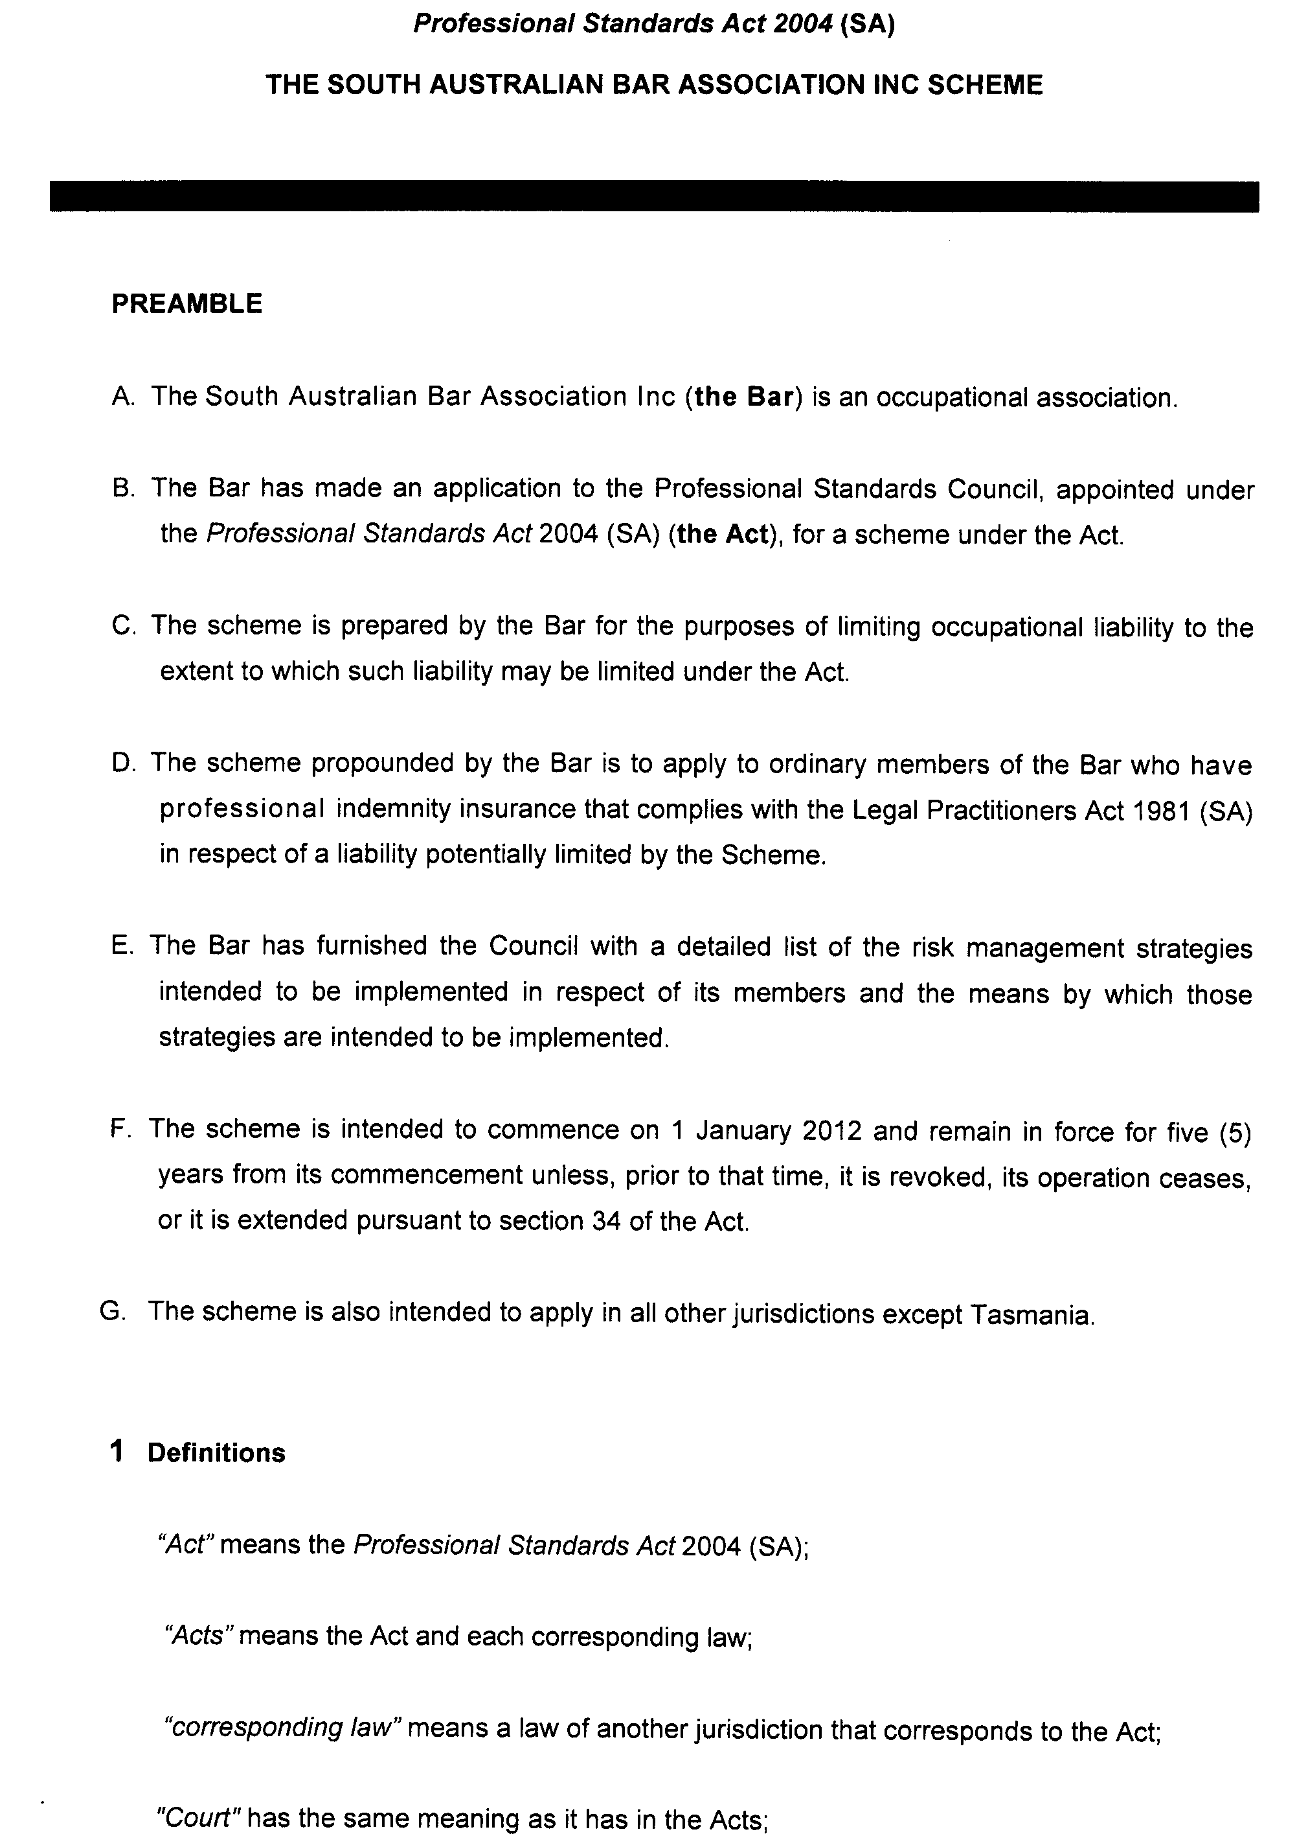
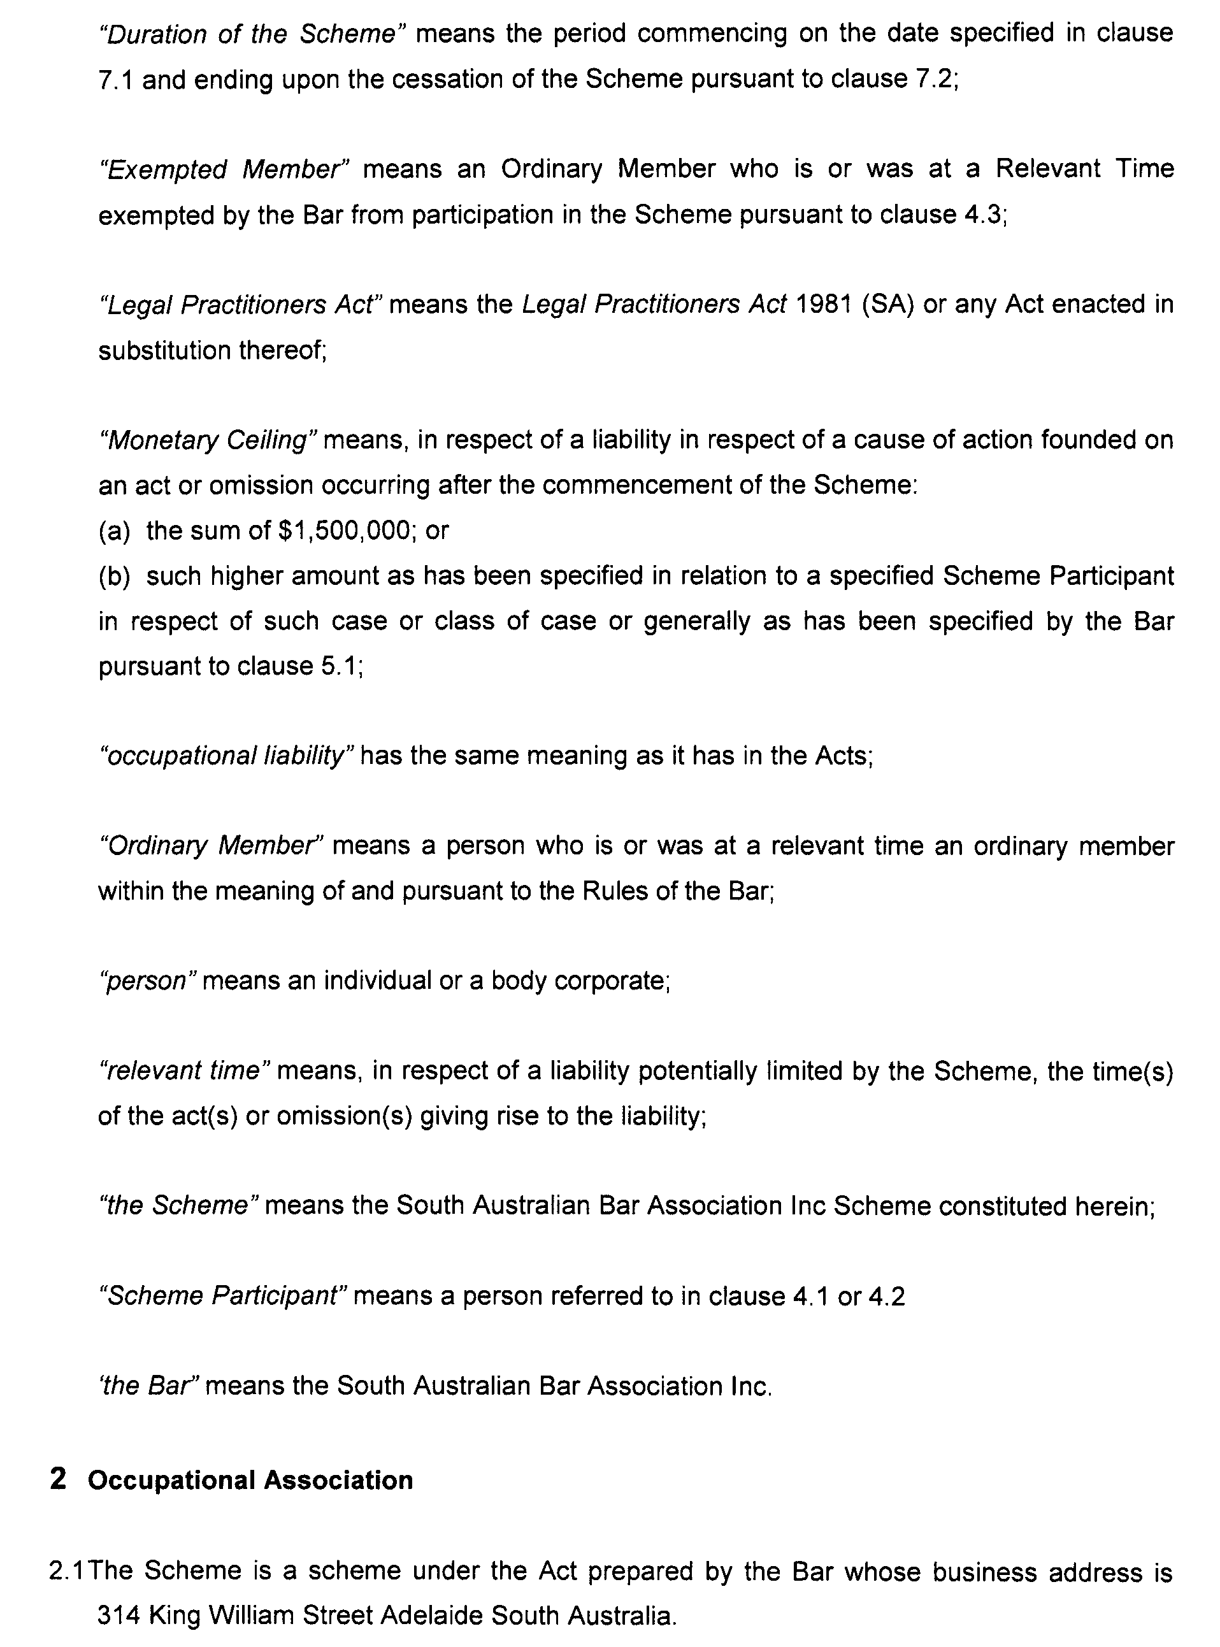
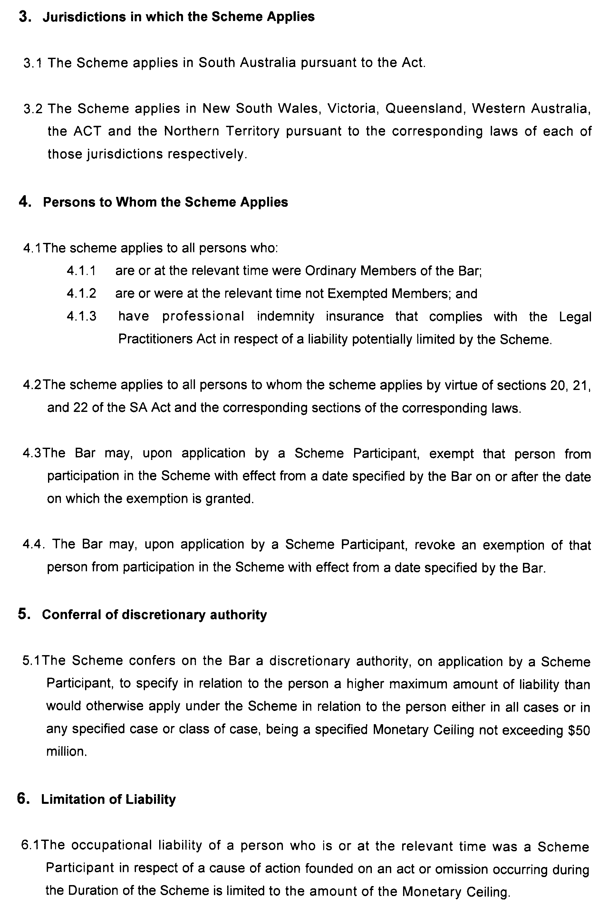
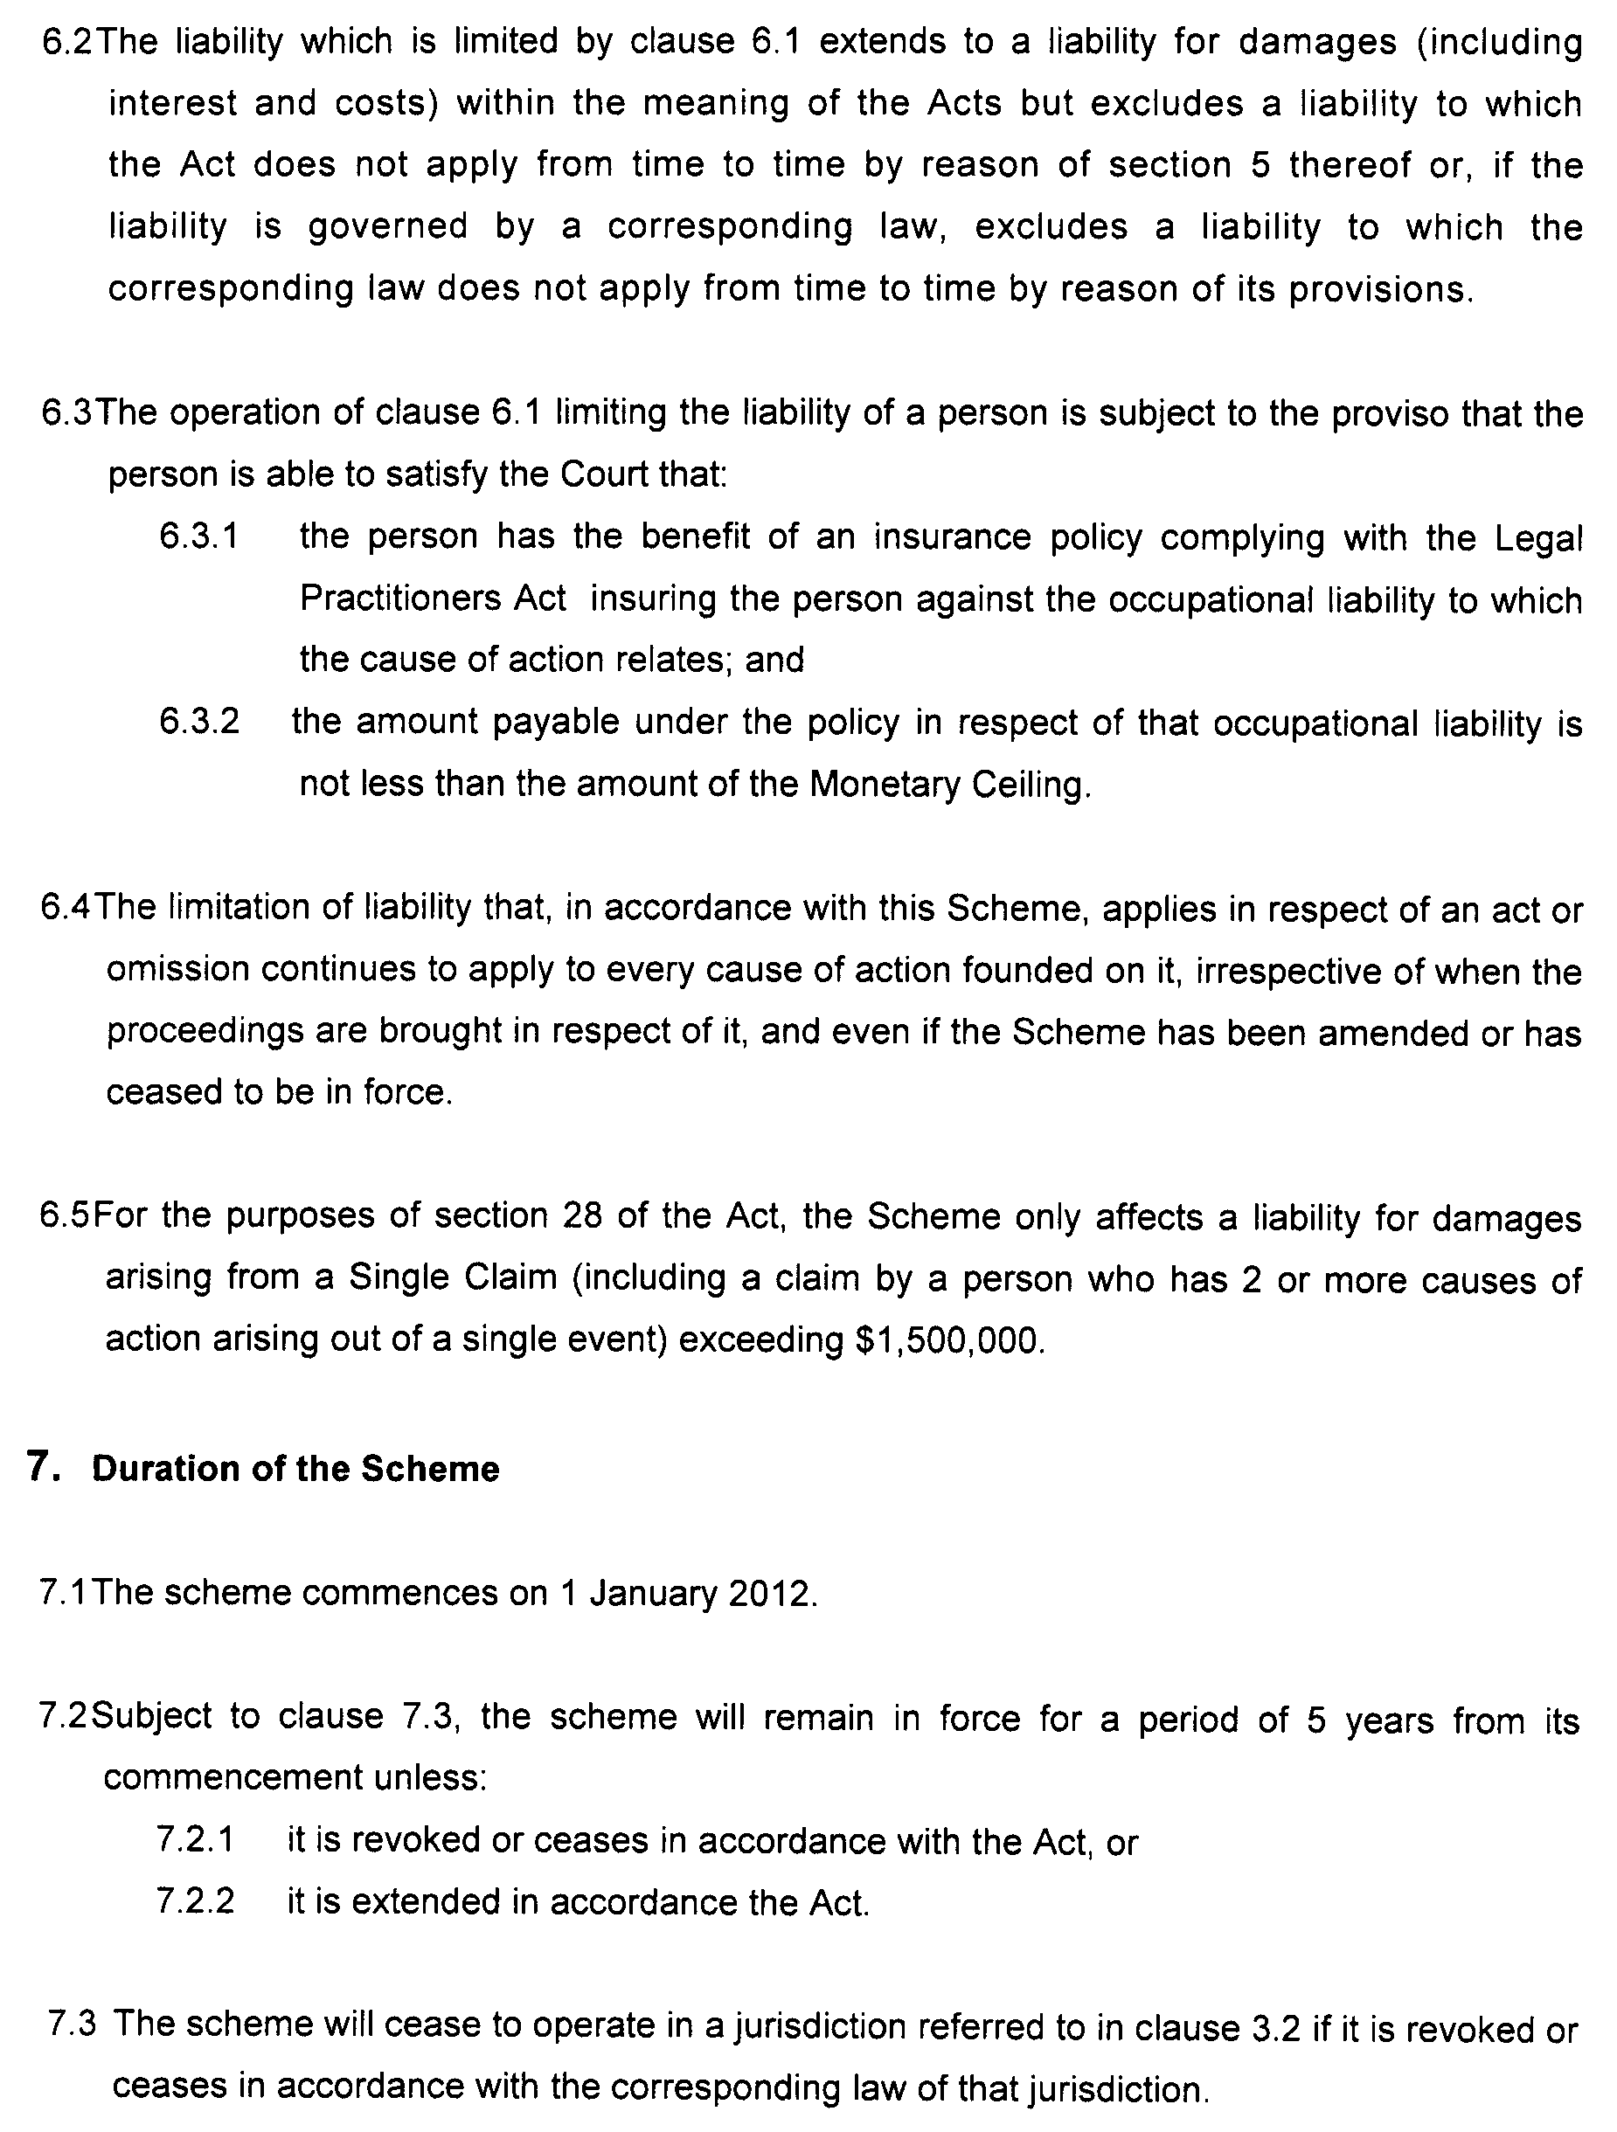

PROFESSIONAL STANDARDS ACT 2004
Law Society of South Australia Professional Standards Scheme
PURSUANT to Section 14 (1) of the Professional Standards Act 2004, I authorise the publication in the Gazette of the Law Society of South Australia Professional Standards Scheme.
Pursuant to Section 15 (1) (a) of the Professional Standards Act 2004, I specify Sunday, 1 January 2012 as the date of commencement of the Law Society of South Australia Professional Standards.
Dated 1 November 2011.
John Rau, Attorney-General

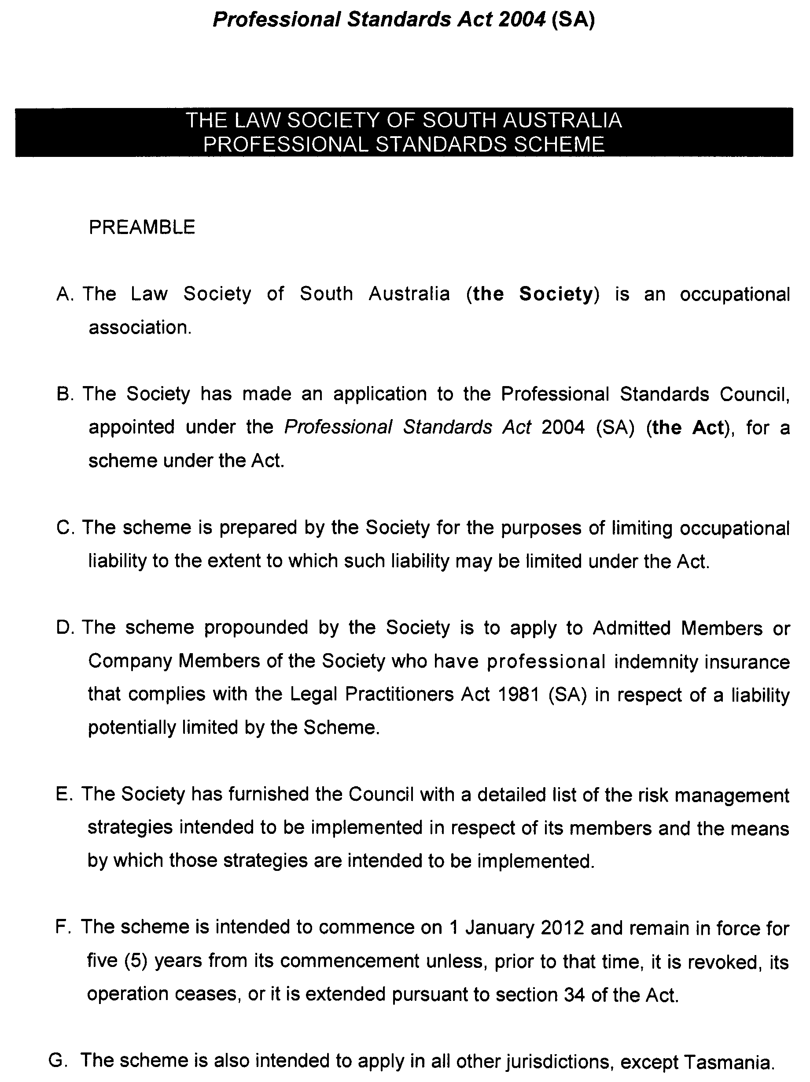
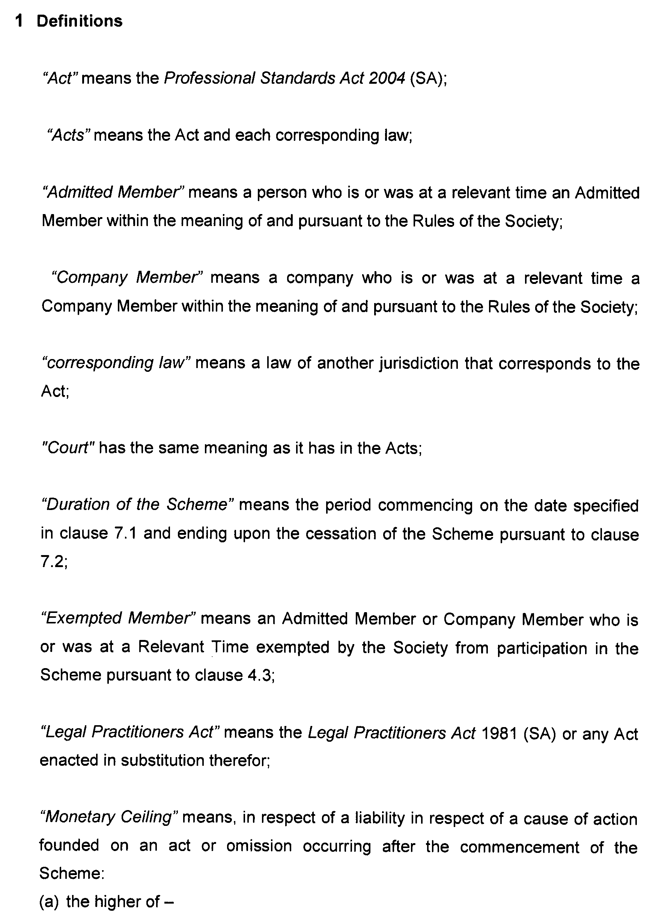
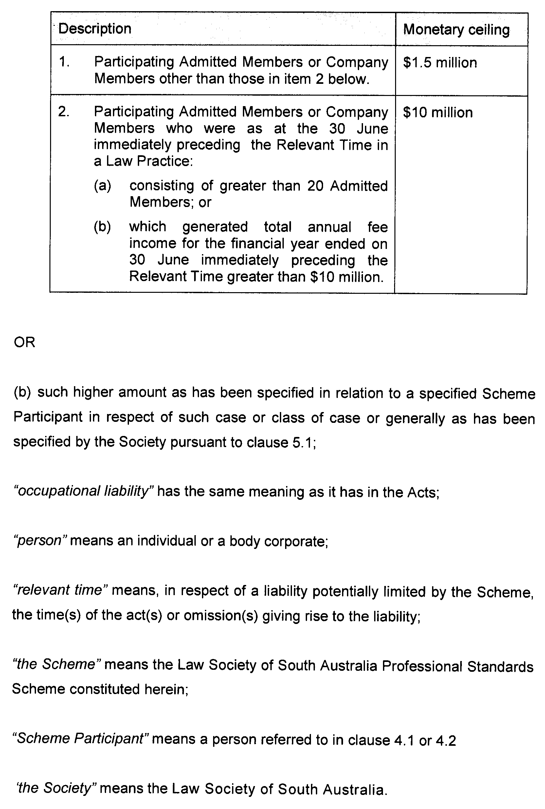
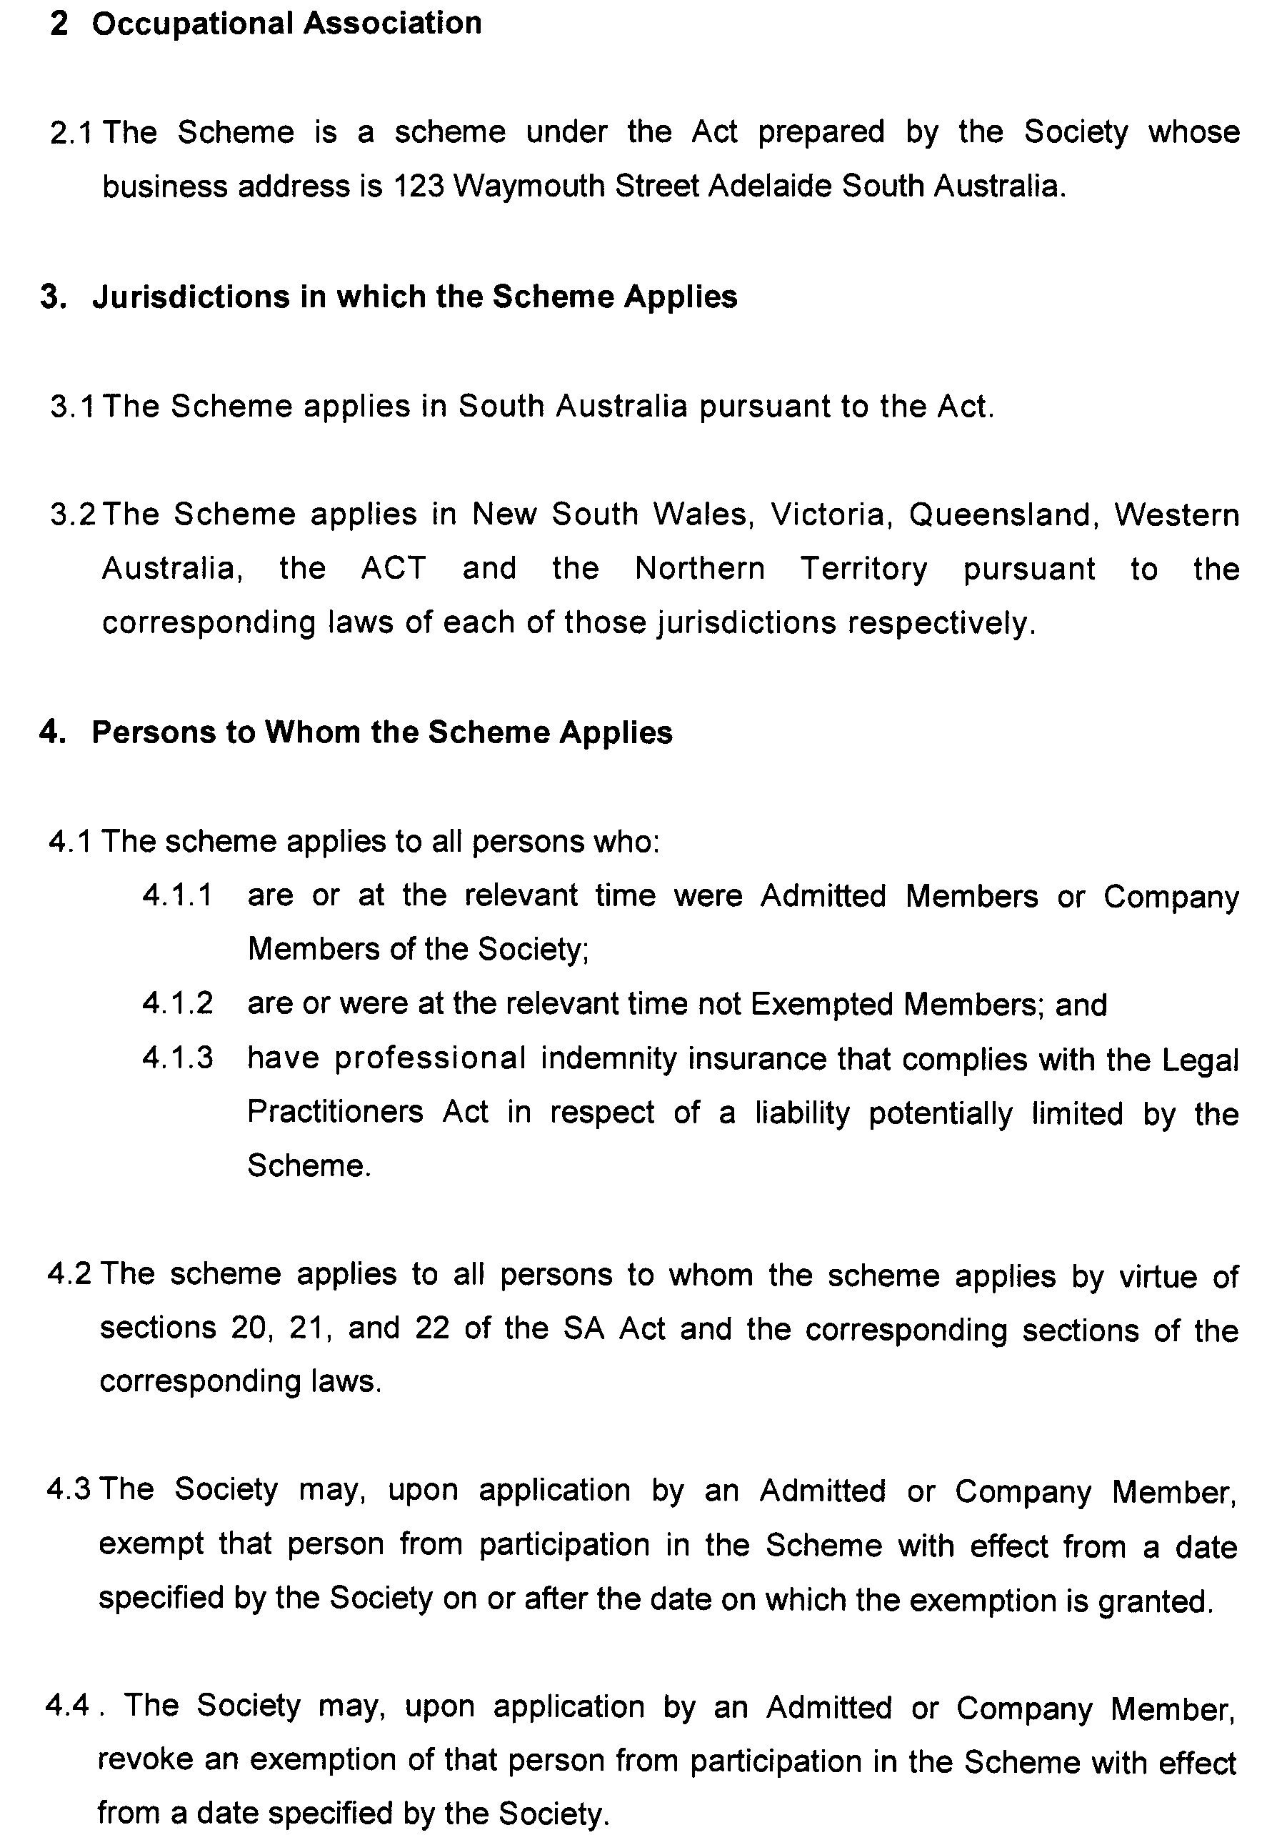
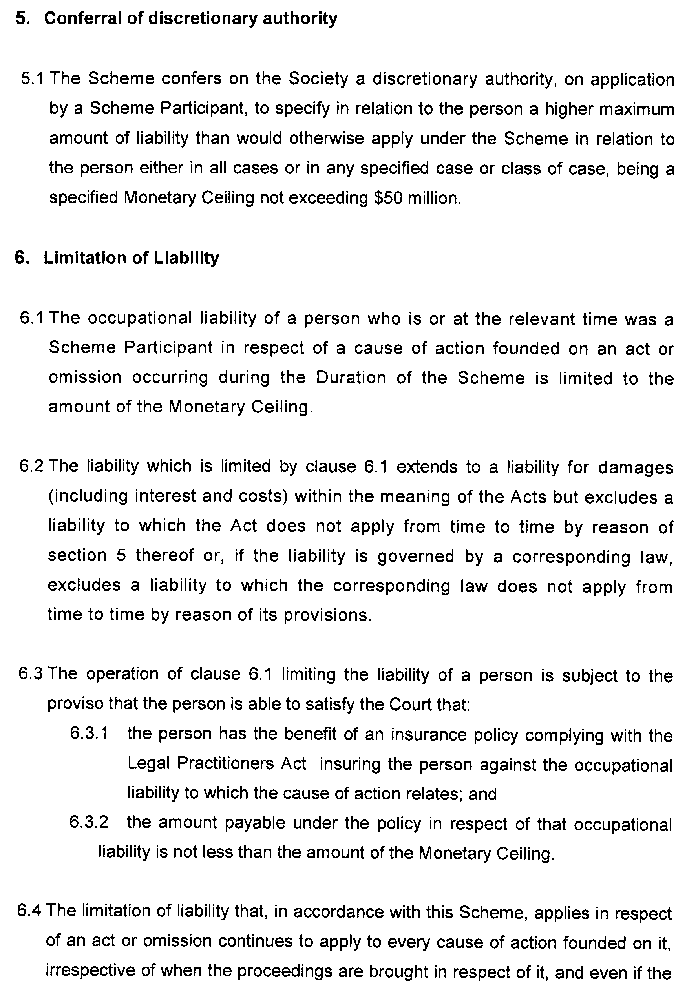
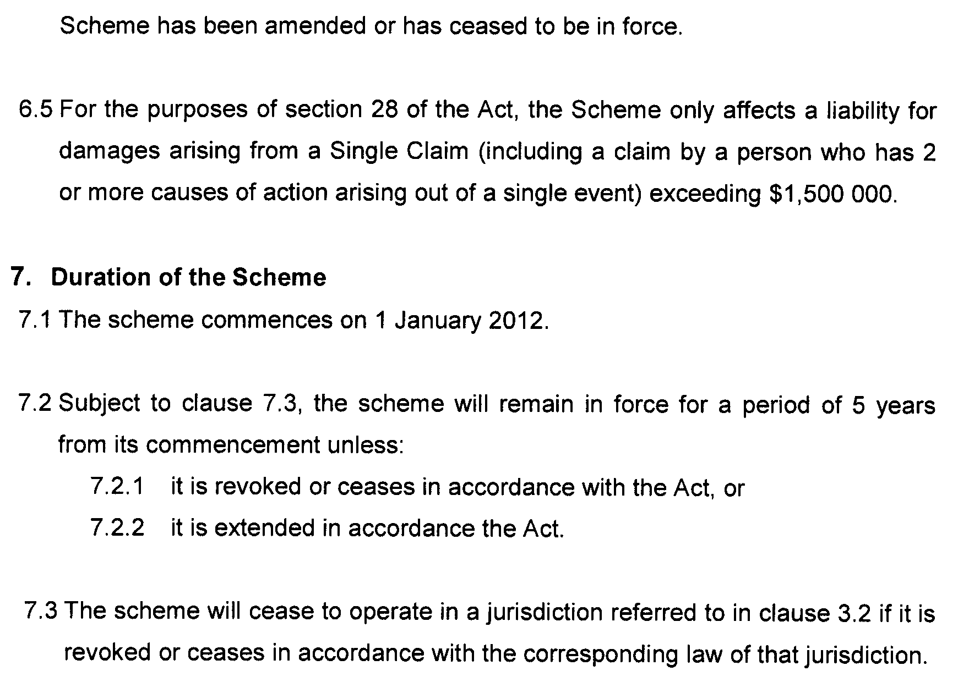

SEWERAGE ACT 1929
Addition of Land to Mannum Country Drainage Area
PURSUANT to Section 18 of the Sewerage Act 1929, the South Australian Water Corporation:
(a) adds to the Mannum Country Drainage Area the land shown on the plan in the Schedule; and
(b) declares that this notice will have effect from 1 July 2012.
Dated 28 October 2011.
Signed for and on behalf of the South Australian Water Corporation by a person duly authorised so to do:
A. Schirripa, Manager Billing and Collection
In the presence of:
N. Hudson, Team Leader Rating
SAWATER 11/06613 D1493

GOVERNMENT GAZETTE ADVERTISEMENT RATES

To apply from 1 July 2011

$  Agents, Ceasing to Act as 45.50  Associations:  Incorporation 23.00  Intention of Incorporation 57.00  Transfer of Properties 57.00  Attorney, Appointment of 45.50  Bailiff’s Sale 57.00  Cemetery Curator Appointed 33.75  Companies:  Alteration to Constitution 45.50  Capital, Increase or Decrease of 57.00  Ceasing to Carry on Business 33.75  Declaration of Dividend 33.75  Incorporation 45.50  Lost Share Certificates:  First Name 33.75  Each Subsequent Name 11.60  Meeting Final 38.00  Meeting Final Regarding Liquidator’s Report on  Conduct of Winding Up (equivalent to ‘Final  Meeting’)  First Name 45.50  Each Subsequent Name 11.60  Notices:  Call 57.00  Change of Name 23.00  Creditors 45.50  Creditors Compromise of Arrangement 45.50  Creditors (extraordinary resolution that ‘the Com-pany be wound up voluntarily and that a liquidator be appointed’) 57.00  Release of Liquidator⎯Application⎯Large Ad. 90.50  ⎯Release Granted 57.00  Receiver and Manager Appointed 52.50  Receiver and Manager Ceasing to Act 45.50  Restored Name 42.50  Petition to Supreme Court for Winding Up 79.00  Summons in Action 67.50  Order of Supreme Court for Winding Up Action 45.50  Register of Interests⎯Section 84 (1) Exempt 102.00  Removal of Office 23.00  Proof of Debts 45.50  Sales of Shares and Forfeiture 45.50  Estates:  Assigned 33.75  Deceased Persons⎯Notice to Creditors, etc. 57.00  Each Subsequent Name 11.60  Deceased Persons⎯Closed Estates 33.75  Each Subsequent Estate 1.50  Probate, Selling of 45.50  Public Trustee, each Estate 11.60 |  | $  Firms:  Ceasing to Carry on Business (each insertion) 30.25  Discontinuance Place of Business 30.25  Land⎯Real Property Act:  Intention to Sell, Notice of 57.00  Lost Certificate of Title Notices 57.00  Cancellation, Notice of (Strata Plan) 57.00  Mortgages:  Caveat Lodgement 23.00  Discharge of 24.10  Foreclosures 23.00  Transfer of 23.00  Sublet 11.60  Leases⎯Application for Transfer (2 insertions) each 11.60  Lost Treasury Receipts (3 insertions) each 33.75  Licensing 67.50  Municipal or District Councils:  Annual Financial Statement⎯Forms 1 and 2 636.00  Electricity Supply⎯Forms 19 and 20 452.00  Default in Payment of Rates:  First Name 90.50  Each Subsequent Name 11.60  Noxious Trade 33.75  Partnership, Dissolution of 33.75  Petitions (small) 23.00  Registered Building Societies (from Registrar-General) 23.00  Register of Unclaimed Moneys⎯First Name 33.75  Each Subsequent Name 11.60  Registers of Members⎯Three pages and over:  Rate per page (in 8pt) 289.00  Rate per page (in 6pt) 382.00  Sale of Land by Public Auction 57.50  Advertisements 3.20  ¼ page advertisement 135.00  ½ page advertisement 270.00  Full page advertisement 529.00  Advertisements, other than those listed are charged at $3.20 per column line, tabular one-third extra.  Notices by Colleges, Universities, Corporations and District Councils to be charged at $3.20 per line.  Where the notice inserted varies significantly in length from that which is usually published a charge of $3.20 per column line will be applied in lieu of advertisement rates listed.  South Australian Government publications are sold on the condition that they will not be reproduced without prior permission from the Government Printer.
All the above prices include GST

GOVERNMENT GAZETTE NOTICES
ALL private advertisements forwarded for publication in the South Australian Government Gazette must be PAID FOR PRIOR TO INSERTION; and all notices, from whatever source, should be legibly written on one side of the paper only and sent to Government Publishing SA so as to be received no later than 4 p.m. Tuesday preceding the day of publication. Phone 8207 1045 or Fax 8207 1040. E-mail: governmentgazette@dpc.sa.gov.au. Send as attachments in Word format. Please include date the notice is to be published and to whom the notice will be charged. The Government Gazette is available online at: www.governmentgazette.sa.gov.au.

MISCELLANEOUS LEGISLATION AND GOVERNMENT PUBLICATIONS PRICES AS FROM 1 JULY 2011

Acts, Bills, Rules, Parliamentary Papers and Regulations
Pages | Main | Amends | Pages | Main | Amends

1-16 | 2.80 | 1.30 | 497-512 | 38.50 | 37.50
17-32 | 3.70 | 2.30 | 513-528 | 39.50 | 38.25
33-48 | 4.85 | 3.45 | 529-544 | 41.00 | 39.50
49-64 | 6.10 | 4.70 | 545-560 | 42.00 | 41.00
65-80 | 7.10 | 5.90 | 561-576 | 43.00 | 42.00
81-96 | 8.30 | 6.85 | 577-592 | 44.50 | 42.50
97-112 | 9.45 | 8.10 | 593-608 | 45.75 | 44.00
113-128 | 10.60 | 9.30 | 609-624 | 46.50 | 45.50
129-144 | 11.80 | 10.50 | 625-640 | 47.75 | 46.00
145-160 | 13.00 | 11.60 | 641-656 | 49.00 | 47.75
161-176 | 14.10 | 12.80 | 657-672 | 49.75 | 48.25
177-192 | 15.40 | 13.90 | 673-688 | 51.50 | 49.75
193-208 | 16.60 | 15.30 | 689-704 | 52.50 | 50.50
209-224 | 17.50 | 16.20 | 705-720 | 53.50 | 52.00
225-240 | 18.70 | 17.30 | 721-736 | 55.00 | 53.00
241-257 | 20.10 | 18.30 | 737-752 | 55.50 | 54.00
258-272 | 21.20 | 19.40 | 753-768 | 57.00 | 55.00
273-288 | 22.30 | 21.00 | 769-784 | 58.00 | 57.00
289-304 | 23.30 | 21.90 | 785-800 | 59.00 | 58.00
305-320 | 24.70 | 23.20 | 801-816 | 60.50 | 58.50
321-336 | 25.75 | 24.30 | 817-832 | 61.50 | 60.50
337-352 | 27.00 | 25.50 | 833-848 | 63.00 | 61.50
353-368 | 27.75 | 26.75 | 849-864 | 64.00 | 62.50
369-384 | 29.25 | 27.75 | 865-880 | 65.50 | 64.00
385-400 | 30.50 | 29.00 | 881-896 | 66.00 | 64.50
401-416 | 31.75 | 30.00 | 897-912 | 67.50 | 66.00
417-432 | 33.00 | 31.50 | 913-928 | 68.00 | 67.50
433-448 | 34.00 | 32.75 | 929-944 | 69.00 | 68.00
449-464 | 34.75 | 33.50 | 945-960 | 70.00 | 68.50
465-480 | 35.25 | 34.50 | 961-976 | 73.00 | 69.50
481-496 | 37.50 | 35.25 | 977-992 | 74.00 | 70.00

Legislation—Acts, Regulations, etc: $
Subscriptions:
Acts 237.00
All Bills as Laid 570.00
Rules and Regulations 570.00
Parliamentary Papers 570.00
Bound Acts 263.00
Index 132.00
Government Gazette
Copy 6.25
Subscription 315.00
Hansard
Copy 17.30
Subscription—per session (issued weekly) 494.00
Cloth bound—per volume 212.00
Subscription—per session (issued daily) 494.00
Legislation on Disk
Whole Database 3 660.00
Annual Subscription for fortnightly updates 1 125.00
Individual Act(s) including updates POA
Notice of Vacancies
Annual Subscription 174.00
Compendium
Subscriptions:
New Subscriptions 2 167.00
Updates 765.00
(All the above prices include GST)

All Legislation, Government Gazette, Hansard and Legislation on disk are available from:
Counter Sales Government Legislation Outlet
and Mail Orders: Service SA Customer Service Centre,
Ground Floor—EDS Centre, 108 North Terrace, Adelaide, S.A. 5000
Phone: 13 23 24 (local call cost), Fax: (08) 8204 1909
Postal: G.P.O. Box 1707, Adelaide, S.A. 5001

Online Shop: www.shop.service.sa.gov.au

Subscriptions and Government Publishing SA
Standing Orders: Box 9, Plaza Level, Riverside Centre, North Terrace, Adelaide, S.A. 5000
Phone: (08) 8207 1043, (08) 8207 0910, Fax: (08) 8207 1040

WATERWORKS ACT 1932
Removal of Land from Mannum-Adelaide Country Lands Water District and Addition to Mannum Water District
PURSUANT to Section 6 of the Waterworks Act 1932, the South Australian Water Corporation:
(a) removes from the Mannum-Adelaide Country Lands Water District and adds to the Mannum Water District the land shown on the plan in the Schedule; and
(b) declares that this notice will have effect from 1 July 2012.

Dated 28 October 2011.
Signed for and on behalf of the South Australian Water Corporation by a person duly authorised so to do:
A. Schirripa, Manager Billing and Collection
In the presence of:
N. Hudson, Team Leader Rating
SAWATER 11/06620 W1492

ROADS (OPENING AND CLOSING) ACT 1991:
SECTION 24
NOTICE OF CONFIRMATION OF ROAD
PROCESS ORDER
Jones Road and Boundary Fire Track, Redhill
BY Road Process Order made on 25 August 2011, the Port Pirie Regional Council ordered that:
1. The whole of Public Roads (Jones Road and Boundary Fire Track) generally situate adjoining the northern and western boundaries of Sections, 132, 131, 130, 140S, 122, Hundred of Redhill and Allotment 267 in Filed Plan 188399, more particularly delineated as ‘A’, ‘B’, ‘C’, ‘D’, ’E’ and ‘F’ in Preliminary Plan No. 11/0010 be closed.
2. The whole of the land subject to closure be transferred to Francis Michael Hayes and Joanne Ruth Hayes in accordance with agreement to transfer dated 25 August 2011, entered into between the Port Pirie Regional Council and F. M. and J. R. Hayes.
3. The following easements are granted over portions of the road closed by this order:
Grant free and unrestricted rights of way appurtenant to Allotment 107 in Filed Plan 214432, Sections 822, 818, 140S, 130, 131, 128N, 128S, 127, 126, 122, Hundred of Redhill, Allotment 267 in Filed Plan 188399 and Allotment 3 in Deposited Plan 55148.
On 7 September 2011 that order was confirmed by the Minister for Infrastructure conditionally upon the deposit by the Registrar-General of Deposited Plan 87779 being the authority for the new boundaries.
Pursuant to Section 24 (5) of the Roads (Opening and Closing) Act 1991, NOTICE of the order referred to above and its confirmation is hereby given.
Dated 3 November 2011.
P. M. Kentish, Surveyor-General

ROADS (OPENING AND CLOSING) ACT 1991:
SECTION 24
NOTICE OF CONFIRMATION OF ROAD
PROCESS ORDER
Road Closure—Waterfall Gully Road, Burnside
BY Road Process Order made on 21 July 2011, the Development Assessment Commission ordered that:
1. Portion of the public road (Waterfall Gully Road) situate adjoining allotment 101 (Reserve) in Deposited Plan 31781, more particularly delineated and lettered ‘A’ on Preliminary Plan No. 10/0044 be closed.
2. Sell/Transfer the whole of the land subject to closure to the South Australian Water Corporation for use for beneficial public purpose.
On 28 July 2011 that order was confirmed by the Minister for Infrastructure conditionally upon the deposit by the Registrar-General of Deposited Plan 87498 being the authority for the new boundaries.
Pursuant to Section 24 (5) of the Roads (Opening and Closing) Act 1991, NOTICE of the order referred to above and its confirmation is hereby given.
Dated 3 November 2011
P. M. Kentish, Surveyor-General

WILDERNESS PROTECTION ACT 1992 AND NATIONAL PARKS AND WILDLIFE ACT 1972
Danggali Wilderness Protection Area and Conservation
Park Management Plan
I, PAUL CAICA, Minister for Sustainability, Environment and Conservation, hereby give notice under the provisions of Section 31 of the Wilderness Protection Act 1992 and Section 38 of the National Parks and Wildlife Act 1972, that, on 15 September 2011, I adopted a plan of management for Danggali Wilderness Protection Area and Danggali Conservation Park.
Copies of the plan may be inspected at or obtained from the offices of the Department of Environment and Natural Resources at:
• DENR Information Line (e-mail denrinformation@sa.gov.au), telephone 8204 1910;
• http://www.environment.sa.gov.au/parkmanagementplans
• Level 1, 100 Pirie Street, Adelaide, S.A. 5000 (G.P.O. Box 1047, Adelaide, S.A. 5001), telephone 8204 1910;
• South Australian Murray Darling Basin Regional Office,
28 Vaughan Terrace, Berri, S.A. 5343.
P. CAICA, Minister for Sustainability, Environment and Conservation

RULES OF COURT
Magistrates Court of South Australia
Amendment 38 to the Magistrates Court
(Civil) Rules 1992
PURSUANT to Section 49 of the Magistrates Court Act 1991 and all other enabling powers, we the undersigned do hereby make the following amendments to the MAGISTRATES COURT (CIVIL) RULES 1992:
1. These Rules may be cited as the ‘Magistrates Court (Civil) Rules 1992 (Amendment 38)’.
2. The Magistrates Court (Civil) Rules 1992 as amended by these amendments apply to and govern all actions commenced in the civil division of the Court on and after the date on which these amendments are gazetted.
3. Form 42 of the Magistrates Court Civil Forms is deleted and replaced with the following Form 42.
Signed on 26 October 2011 by:
ELIZABETH MARY BOLTON, Chief Magistrate
ANDREW JAMES CANNON, Deputy Chief Magistrate
KYM ANDREW MILLARD, Stipendiary Magistrate
SIMON HUGH MILAZZO, Stipendiary Magistrate

RULES OF COURT
Magistrates Court of South Australia
Amendment No. 39
to the Magistrates Court Rules 1992
PURSUANT to Section 49 of the Magistrates Court Act 1991 and all other enabling powers, we the undersigned, do hereby make the following amendments to the MAGISTRATES COURT RULES 1992:
1. These Rules may be cited as the ‘Magistrates Court Rules 1992 (Amendment 39)’.
2. The Magistrates Court Rules 1992 as amended by these amendments apply to and govern all actions commenced in the criminal division of the Court on and after the date on which these amendments are gazetted.
3. Form 66 is deleted and replaced with the following form 66.
4. Form 67 is deleted and replaced with the following form 67.
Signed on 16 September 2011 by:
ELIZABETH MARY BOLTON, Chief Magistrate
ANDREW JAMES CANNON, Deputy Chief Magistrate
MARY-LOUISE HRIBAL, Stipendiary Magistrate
SIMON HUGH MILAZZO, Stipendiary Magistrate

RULES OF COURT
Magistrates Court of South Australia
Amendment No. 40
to the Magistrates Court Rules 1992
PURSUANT to Section 49 of the Magistrates Court Act 1991 and all other enabling powers, we the undersigned do hereby make the following amendments to the MAGISTRATES COURT RULES 1992:
1. Form 84 of the Magistrates Court Forms is deleted and replaced with the following form 84.
Signed on 16 September 2011 by:
ELIZABETH MARY BOLTON, Chief Magistrate
ANDREW JAMES CANNON, Deputy Chief Magistrate
MARY-LOUISE HRIBAL, Stipendiary Magistrate
SIMON HUGH MILAZZO, Stipendiary Magistrate

AQUACULTURE ACT 2001
Call for Submissions
Primary Industries and Resources South Australia—
Draft Aquaculture (Zones—Lower Eyre Peninsula) Policy 2011
PURSUANT to Section 12 of the Aquaculture Act 2001, notice is hereby given that the Minister for Agriculture, Food and Fisheries has released the draft Aquaculture (Zones—Lower Eyre Peninsula) Policy 2011 (the Policy) and supporting Report for a formal two month public consultation period from Saturday,
5 November 2011 until Saturday, 14 January 2012.
The draft Policy has been developed in accordance with the provisions of Part 4 of the Aquaculture Act 2001. It provides an opportunity to develop planning practices that better reflect the needs of the aquaculture industry, Government and the local community.
It aims to ensure the ecologically sustainable development of aquaculture in the Spencer Gulf region, to provide certainty for industry stakeholders, to improve community confidence and facilitate opportunities for moderate aquaculture development.
Section 29 of the Development Act 1993 enables the Minister for Urban Development and Planning to amend a development plan in accordance with an approved aquaculture policy under the Aquaculture Act 2001.
It is proposed to amend the Land Not Within A Council Area (Coastal Waters) Development Plan subject to the approval of the above-mentioned policy. The proposed amendments are to reflect the aquaculture zone contained within this draft Policy into the Aquaculture Zone within the Land Not Within A Council Area (Coastal Waters) Development Plan.
Public Briefing
Officers from PIRSA Fisheries and Aquaculture will hold a public briefing on the draft Policy from 4.30 p.m. to 7 p.m. at the Ravendale Sports Centre, 40 Stamford Terrace, Port Lincoln on Monday, 21 November 2011.
The draft policy and policy report will be available as at Saturday, 5 November 2011, from PIRSA Aquaculture, 14th Floor, 25 Grenfell Street (G.P.O. Box 1625), Adelaide, S.A. 5001, at www.pir.sa.gov.au/aquaculture, by phone on (08) 8226 2214 or by fax on (08) 8226 0330.
Written submissions on the draft Policy and/or the proposed amendment to the Land Not Within A Council Area (Coastal Waters) Development Plan are invited from the public and should be made to PIRSA Fisheries and Aquaculture, G.P.O. Box 1625, Adelaide, S.A. 5001.
Submissions must be received by 5 p.m. on Saturday, 14 January 2012.
Dated 3 November 2011.
Gail Gago, Minister for Agriculture,
Food and Fisheries

South Australia
National Parks and Wildlife (Flinders Ranges National Park) Regulations 2011
under the National Parks and Wildlife Act 1972

Contents
Preamble
Part 1—Preliminary
1 Short title
2 Commencement
3 Interpretation
Part 2—Flinders Ranges National Park Co-management Board
4 Establishment of co-management board
5 Composition of Board
6 Terms and conditions
7 Chairperson and Deputy Chairperson
8 Vacancies or defects in appointment of members
9 Remuneration
10 Functions and powers of Board
11 Delegations
12 Board's procedures
13 Minister may call meetings
14 Suspension of Board (section 43I of the Act)
15 Conflict of interest
16 Annual report (section 43L of the Act)
Schedule 1—Transitional provision
1 Transitional provision

Preamble
1 Flinders Ranges National Park was constituted as a national park by statute on 3 July 1972.
Note—
see Gazette 29.06.1972 p2689.
2 The Adnyamathanha people have a traditional association with the land constituting the national park.
3 It is now intended that the national park be co-managed pursuant to a co-management agreement under the National Parks and Wildlife Act 1972 between the Minister and the Adnyamathanha Traditional Lands Association (Aboriginal Corporation) representing the Adnyamathanha people.

Part 1—Preliminary
1—Short title
These regulations may be cited as the National Parks and Wildlife (Flinders Ranges National Park) Regulations 2011.
2—Commencement
These regulations come into operation on the day on which they are made.
3—Interpretation
In these regulations—
Act means the National Parks and Wildlife Act 1972;
Adnyamathanha people means the Native Title Holders as defined in the determination of native title made by the Federal Court of Australia in the Adnyamathanha No. 2 Native Title Claim SAD 6002/98 on 30 March 2009 (and Adnyamathanha person has a corresponding meaning);
ATLA means the Adnyamathanha Traditional Lands Association (Aboriginal Corporation) RNTBC incorporated under the Corporations (Aboriginal and Torres Strait Islander) Act 2006 of the Commonwealth;
Board means the Flinders Ranges National Park Co-management Board established by regulation 4;
co-management agreement means the co-management agreement for the Flinders Ranges National Park, as in force from time to time;
Department means the administrative unit of the Public Service that is, under the Minister, responsible for the administration of the Act;
Minister means the Minister responsible for the administration of the Act;
Park means the Flinders Ranges National Park.
Part 2—Flinders Ranges National Park Co-management Board
4—Establishment of co-management board
The Flinders Ranges National Park Co-management Board is established as the co-management board for the Park.
5—Composition of Board
(1) Subject to subregulation (2), the Board consists of 8 members appointed by the Minister of whom—
(a) 4 must be Adnyamathanha people appointed on the nomination of ATLA; and
(b) 3 must be officers of the Department, of whom 1 must be either the Director or the person for the time being holding the office of Regional Manager (however described) for the region in which the Park is located (or the person for the time being performing the functions of that office); and
(c) 1 must be a person nominated by the Minister.
(2) If ATLA refuses or fails to nominate an Adnyamathanha person in relation to a particular office under subregulation (1)(a), the Minister may appoint a suitable Adnyamathanha person to fill the office.
(3) At least 1 member of the Board must be a woman and 1 a man.
(4) The Minister may appoint a person to be a deputy of a member appointed under subregulation (1) and a person so appointed may act as a member of the Board in the absence of the member.
(5) The requirements of qualification made by this regulation in relation to an appointment of a member (other than in relation to the member who is the Director or the relevant Regional Manager) extend to an appointment of a deputy of that member.
6—Terms and conditions
(1) A member of the Board will be appointed on conditions determined by the Minister and for a term, not exceeding 4 years, specified in the instrument of appointment and, at the expiration of a term of appointment, is eligible for reappointment.
(2) The Minister may remove a member of the Board from office—
(a) for breach of, or non-compliance with, a condition of appointment; or
(b) for misconduct; or
(c) for failure or incapacity to carry out official duties satisfactorily.
(3) However, the Minister may only remove a member of the Board who is an Adnyamathanha person after consultation with ATLA.
(4) The office of a member of the Board becomes vacant if the member—
(a) dies; or
(b) completes a term of office and is not reappointed; or
(c) resigns by written notice to the Minister; or
(d) ceases to satisfy the qualification by virtue of which the member was eligible for appointment to the Board; or
(e) is removed from office under subregulation (2).
(5) If a casual vacancy occurs in the office of a member, the Minister may appoint a suitable person to fill the vacancy, and that person will hold office for the balance of the term of his or her predecessor.
7—Chairperson and Deputy Chairperson
The Minister must appoint 2 of the members of the Board as Chairperson and Deputy Chairperson of the Board respectively.
8—Vacancies or defects in appointment of members
An act or proceeding of the Board is not invalid by reason only of a vacancy in its membership or a defect in the appointment of a member.
9—Remuneration
A member of the Board (other than a member appointed under regulation 5(1)(b) or a member appointed under regulation 5(1)(c) who is a member of the Public Service) is entitled to remuneration, allowances and expenses determined by the Minister.
10—Functions and powers of Board
(1) The functions of the Board are—
(a) to carry out the functions assigned to the Board by or under the Act; and
(b) to carry out the functions assigned to the Board by the co-management agreement; and
(c) to carry out other functions assigned to the Board by the Minister.
(2) The Board has the power to do anything necessary, expedient or incidental to the performance of its functions.
(3) Without limiting the generality of subregulation (2), the Board may enter into any form of contract, agreement or arrangement.
(4) The Board must perform its functions, or exercise a power, in a manner that is consistent with the co-management agreement.
11—Delegations
(1) The Board must, as soon as is reasonably practicable after the commencement of this regulation and in accordance with the co-management agreement—
(a) delegate to the Minister, or a person or body nominated by the Minister, the powers specified in clause 5 of the co-management agreement; and
(b) delegate the powers specified in Schedule 4 of the co-management agreement (if any).
(2) Without limiting subregulation (1), the Board may delegate any other of its powers (other than this power of delegation)—
(a) to a member of the Board; or
(b) to an officer of the Department.
(3) A delegation under subregulation (1)(a)—
(a) must be in writing; and
(b) is subject to the conditions or limitations specified in clause 5 of the co-management agreement (if any) but must not be made subject to any other conditions or limitations; and
(c) subject to paragraph (d), is not revocable; and
(d) will by force of this regulation be revoked—
(i) on the Lease or the Contract for Services Agreement ceasing to be in force for any reason; or
(ii) on the expiry of the Resort Term.
(4) While a delegation under subregulation (1)(a) is in force, the Board must not exercise or purport to exercise a power the subject of the delegation.
(5) A delegation under subregulation (1)(b)—
(a) must be in writing; and
(b) is subject to the conditions or limitations specified in the co-management agreement (if any) relating to such a delegation; and
(c) may be made subject to any other conditions and limitations specified in the instrument of delegation; and
(d) does not derogate from the power of the Board to act in a matter; and
(e) is not revocable.
(6) A delegation under subregulation (2)—
(a) must be in writing; and
(b) may be made subject to conditions and limitations specified in the instrument of delegation; and
(c) is revocable at will and does not derogate from the power of the Board to act in a matter.
(7) In this regulation—
Contract for Services Agreement, Lease and Resort Term have the same meaning as in the co-management agreement.
12—Board's procedures
(1) Subject to these regulations, 6 members (of whom at least 3 must be Adnyamathanha people and at least 3 must be members appointed under regulation 5(1)(b) or (c)) constitute a quorum of the Board.
(2) The Board must meet at least 4 times in each financial year.
(3) A meeting of the Board will be chaired by the Chairperson or, in the absence of the Chairperson, by the Deputy Chairperson or, in the absence of both, the members present at a meeting of the Board must choose 1 of their number to preside at the meeting.
(4) Subject to this regulation, a decision carried by a majority of the votes cast by members of the Board at a meeting is a decision of the Board.
(5) Each member present at a meeting of the Board has 1 vote on any question arising for decision.
(6) If the Board is unable to decide a question arising for decision, the question must be referred to the Minister for decision (and the decision of the Minister will be taken to be a decision of the Board).
(7) In making a decision under subregulation (6), the Minister—
(a) must have regard to any written submission made by ATLA that is received by the Minister not more than 30 days after the date of the meeting at which the Board was unable to decide the question; and
(b) may have regard to any other matter the Minister thinks fit.
(8) The Minister may direct the Board to implement, or cause to be implemented, a decision of the Minister under subregulation (6).
(9) A conference by telephone or other electronic means between the members of the Board will, for the purposes of this regulation, be taken to be a meeting of the Board at which the participating members are present if—
(a) notice of the conference is given to all members in the manner determined by the Board for the purpose; and
(b) each participating member is capable of communicating with every other participating member during the conference.
(10) A proposed resolution of the Board becomes a valid decision of the Board despite the fact that it is not voted on at a meeting of the Board if—
(a) notice of the proposed resolution is given to all members of the Board in accordance with procedures determined by the Board; and
(b) a majority comprised of not less than 6 members (of whom at least 3 must be Adnyamathanha people and at least 3 must be members appointed under regulation 5(1)(b) or (c)) express concurrence in the proposed resolution by letter, telegram, telex, facsimile transmission, electronic mail or other written communication setting out the terms of the resolution.
(11) The Board must have accurate minutes kept of its meetings.
(12) Subject to these regulations, the Board may determine its own procedures.
13—Minister may call meetings
(1) If—
(a) the Chairperson refuses or fails to call a meeting of the Board within 4 months after the previous meeting; or
(b) 2 or more successive meetings are inquorate,
then the Minister may call a meeting of the Board.
(2) The Minister may direct the members of the Board to attend a meeting called under subregulation (1).
14—Suspension of Board (section 43I of the Act)
(1) Subject to this regulation, during the period of any suspension of the Board under section 43I, the Park—
(a) is under the control of the Minister; and
(b) is under the management of the Director.
(2) The Minister and the Director must, during any period of suspension of the Board, endeavour, where appropriate, to give effect to the objects set out in section 43E of the Act.
15—Conflict of interest
(1) A member of the Board who has a direct or indirect personal or pecuniary interest in a matter decided or under consideration by the Board—
(a) must, as soon as reasonably practicable, disclose in writing to the Board full and accurate details of the interest; and
(b) must not take part in any discussion by the Board relating to that matter; and
(c) must not vote in relation to that matter; and
(d) must be absent from the meeting room when any such discussion or voting is taking place.
Maximum penalty: $2 000.
(2) This regulation does not apply to a member of the Board—
(a) in respect of an interest that is shared in common with Adnyamathanha people generally, or a substantial section of Adnyamathanha people; and
(b) in relation to a matter in which the member has an interest while the member remains unaware that he or she has an interest in the matter (but in any proceedings against the member the burden will lie on the member to prove that he or she was not, at the material time, aware of his or her interest).
(3) The Minister may, by notice published in the Gazette, exempt a member (conditionally or unconditionally) from the application of a provision of this regulation, and may, by further notice published in the Gazette, vary or revoke such an exemption.
(4) Non-compliance by a member with a duty imposed by this regulation constitutes a ground for removal of the member from office.
(5) If a member or former member is convicted of an offence for a contravention of this regulation, the court by which the person is convicted may, in addition to imposing a penalty, order the convicted person to pay to the Minister—
(a) if the court is satisfied that the person or any other person made a profit as a result of the contravention—an amount equal to the profit; and
(b) if the court is satisfied that any loss or damage has been suffered as a result of the contravention—compensation for the loss or damage.
(6) If a member or former member is guilty of a contravention of this regulation, the Minister may (whether or not proceedings have been brought for the offence) recover from the person by action in a court of competent jurisdiction—
(a) if the person or any other person made a profit as a result of the contravention—an amount equal to the profit; and
(b) if any loss or damage has been suffered as a result of the contravention—compensation for the loss or damage.
16—Annual report (section 43L of the Act)
For the purposes of section 43L of the Act, the annual report of the Board must include the following:
(a) information relating to traditional hunting activities in the Park carried out in accordance with section 68D of the National Parks and Wildlife Act 1972;
(b) information relating to the effect of traditional hunting activities in the Park carried out in accordance with section 68D of the National Parks and Wildlife Act 1972 on native plants and protected animals, or the eggs of protected animals (and in particular those species that are scheduled as rare, endangered or vulnerable under the National Parks and Wildlife Act 1972);
(c) information relating to the operations and work programs undertaken by or on behalf of the Board;
(d) information relating to Park infrastructure;
(e) any other information required by the Minister.
Schedule 1—Transitional provision
1—Transitional provision
A licence, permit or written permission issued under the Act or the National Parks and Wildlife (National Parks) Regulations 2001 in relation to the Park, or any other licence, permit, written permission or agreement issued or entered by the Minister in relation to the land constituting the Park, in force immediately before the commencement of these regulations continues in force in accordance with its terms.
Note—
As required by section 10AA(2) of the Subordinate Legislation Act 1978, the Minister has certified that, in the Minister's opinion, it is necessary or appropriate that these regulations come into operation as set out in these regulations.
Made by the Governor
with the advice and consent of the Executive Council
on 3 November 2011
No 232 of 2011
AGO0217/11CS

South Australia
Occupational Therapy Practice (General) Variation Regulations 2011
under the Occupational Therapy Practice Act 2005

Contents
Part 1—Preliminary
1 Short title
2 Commencement
3 Variation provisions
Part 2—Variation of Occupational Therapy Practice (General) Regulations 2006
4 Substitution of regulation 4
4 Exempt providers

Part 1—Preliminary
1—Short title
These regulations may be cited as the Occupational Therapy Practice (General) Variation Regulations 2011.
2—Commencement
These regulations come into operation on the day on which they are made.
3—Variation provisions
In these regulations, a provision under a heading referring to the variation of specified regulations varies the regulations so specified.
Part 2—Variation of Occupational Therapy Practice (General) Regulations 2006
4—Substitution of regulation 4
Regulation 4—delete the regulation and substitute:
4—Exempt providers
For the purposes of the definition of exempt provider in section 3(1) of the Act, the following are exempt providers:
(a) The Flinders University of South Australia;
(b) the University of South Australia.
Note—
As required by section 10AA(2) of the Subordinate Legislation Act 1978, the Minister has certified that, in the Minister's opinion, it is necessary or appropriate that these regulations come into operation as set out in these regulations.
Made by the Governor
with the advice and consent of the Executive Council
on 3 November 2011
No 233 of 2011
HEAC-2011-00044

FAXING COPY?
IF you fax copy to Government Publishing SA for inclusion in the Government Gazette, there is no need to send a Confirmation Copy to us as well.
This creates confusion and may well result in your notice being printed twice.
Please use the following fax number:
Fax transmission: (08) 8207 1040
Phone Enquiries: (08) 8207 1045
Please include a contact person, phone number and order number so that we can phone back with any queries we may have regarding the fax copy.
NOTE: Closing time for lodging new copy (fax, hard copy or email) is 4 p.m. on Tuesday preceding the day of publication.

Government Gazette notices can be Emailed.
The address is:
governmentgazette@dpc.sa.gov.au
Documents should be sent as attachments in Word format.
When sending a document via Email, please confirm your transmission with a faxed copy of your document, including the date the notice is to be published.
Fax transmission: (08) 8207 1040
Phone Enquiries: (08) 8207 1045
NOTE: Closing time for lodging new copy (fax, hard copy or email) is 4 p.m. on Tuesday preceding the day of publication.

CITY OF ONKAPARINGA
Vote Counting Location
THE location for the scrutiny and counting of votes for the City of Onkaparinga Mid South Coast Ward has been changed and will take place at the Electoral Commission of SA, Level 6, 60 Light Square, Adelaide as soon as practicable after noon on Monday,
14 November 2011. A provisional declaration will be made at the conclusion of the election count.
K. Mousley, Returning Officer

CITY OF PLAYFORD
Roads (Opening and Closing) Act 1991
Road Closing, Walkway—Turner Road/Dayman Street,
Elizabeth Park
NOTICE is hereby given pursuant to Section 10 of the said Act, that Council proposes to make a Road Process Order to close and transfer to the adjoining owners the walkway between Turner Road and Dayman Street, shown as ‘A’ and ‘B’ on Preliminary Plan No. 11/0054.
A copy of the plan and statement of persons affected is available for public inspection at Playford Civic Centre, 10 Playford Boulevard, Elizabeth and the Customer Service Area, 12 Bishopstone Road, Davoren Park, also the office of the Surveyor-General, 101 Grenfell Street, Adelaide, during normal office hours.
Any application for easement or objection must be made in writing within 28 days of this notice to the Council, 12 Bishopstone Road, Davoren Park, S.A. 5113 and the Surveyor-General, G.P.O. Box 1354, Adelaide, S.A. 5001, setting out full details.
Where a submission is made, Council will give notification of a meeting at which the matter will be considered.
Dated 3 November 2011.
T. R. S. Jackson, Chief Executive Officer

CORPORATION OF THE TOWN OF WALKERVILLE
Council Development Assessment Panel
Appointment of Public Officer
NOTICE is hereby given that the Corporation of the Town of Walkerville in accordance with the requirements of Section 56A (22) and (23) of the Development Act 1993, advises of the appointment of a Public Officer to the Development Assessment Panel, of the following person:
Kiki Magro
66 Walkerville Terrace
Gilberton S.A. 5081
Telephone: (08) 8342 7100.
K. Magro, Chief Executive Officer

ALEXANDRINA COUNCIL
Development Act 1993
Goolwa Airport Development Plan Amendment—
Public Consultation
NOTICE is hereby given that the Alexandrina Council, pursuant to Sections 24 and 25 of the Development Act 1993, has prepared a Development Plan Amendment Report (DPA) to amend its Development Plan.
The Amendment will change the Development Plan by proposing to include an Airport Zone for the land contained within the existing Goolwa Airport. The Amendment will introduce new objectives for the land surrounding the airport which is currently contained within the General Farming (Port Elliot and Goolwa District) Zone, and will in turn acknowledge the existence and desired continuation of the Goolwa Airport through the creation of an Airport Zone.
The Airport Zone seeks to ensure that the Goolwa Airport serves over the long term as a key transport hub for aviation activity for the lower Fleurieu region. Together with this, the Amendment will also provide guidance for the further development of aviation-related industrial and commercial uses and also for a residential airpark which will afford sought-after resident lifestyle opportunities for enthusiasts and persons affiliated in the aviation industry. These areas will be defined within specific policy areas. This Amendment will assist in underpinning the viability of the airport, and acknowledges the Goolwa Airport flight paths and aviation safety requirements, and will further assist in protecting the airport against encroachment from the expanding township of Goolwa.
The DPA report will be on public consultation from Thursday,
3 November 2011 until 5 p.m. on Friday, 13 January 2012.
Copies of the DPA report are available during normal office hours at the Alexandrina Council Offices located at 11 Cadell Street, Goolwa and Colman Terrace, Strathalbyn. Alternatively the DPA report can be viewed on the Alexandrina Council website at www.alexandrina.sa.gov.au or during normal office hours at both of the Alexandrina Council Libraries located at 11 Cadell Street, Goolwa and Colman Terrace, Strathalbyn.
Written submissions regarding the DPA should be submitted no later than 5 p.m. on Friday, 13 January 2012. All submissions should be addressed to General Manager Planning and Development, Alexandrina Council, P.O. Box 21, Goolwa, S.A. 5214 and should clearly indicate whether you wish to be heard in support of your submission at the public meeting. If you wish to lodge your submission electronically, please email it to alex@alexandrina.sa.gov.au marked Attention: General Manager Planning and Development.
Copies of all submissions will be available for inspection at the Alexandrina Council Offices, 11 Cadell Street, Goolwa from
Thursday, 3 November 2011 until the conclusion of the public meeting.
A public meeting will be held on Tuesday, 24 January 2012 at
7 p.m. at the Alexandrina Council Community Chambers, 11 Cadell Street, Goolwa, at which time interested parties may be heard in relation to the DPA and their submission. The public meeting will only be held if a request to be heard in support of a written submission has been made.
If you would like further information about the DPA, please contact Tom Gregory—Senior Town Planner on 8555 7000 or email alex@alexandrina.sa.gov.au.
Dated 31 October 2011.
P. Dinning, Chief Executive

IN the matter of the estates of the undermentioned deceased persons:
Drenth, Christina Wilhelmina, late of 52 Dunrobin Road, Hove, of no occupation, who died on 13 April 2011.
Granger, Pearl May, late of First Street, Minlaton, retired chef, who died on 5 June 2011.
Guthrie, Conrad Eric, late of 3 Noblet Street, Findon, of no occupation, who died on 20 May 2011.
Howson, Alexandra Rose, late of 150 Adams Road, Craigmore, of no occupation, who died on 26 August 2011.
Kuhri, Alphonse, late of 5 Strathmont Avenue, Gilles Plains, retired glazier, who died on 9 June 2011.
Manuel, Cyril Ernest, late of 20-36 Gardenia Drive, Parafield Gardens, retired painting contractor, who died on 14 August 2011.
O’Connor, Eileen, late of 470 Churchill Road, Kilburn, of no occupation, who died on 4 July 2011.
Pederson, Rosslyn Faye, late of 28 Coe Court, Christie Downs, home duties, who died on 12 June 1998.
Tracy, Noel Richard, late of 3 Mountain Road, Eden Hills, retired professor, who died on 14 June 2011.
Trzicky, Josef Ladislaw, late of 20-36 Gardenia Drive, Parafield Gardens, of no occupation, who died on 24 August 2011.
van der Hoek, Thomas, late of 44 Olivedale Street, Birdwood, retired wine maker, who died on 29 June 2011.

Verwey, Cornelia, late of Hazel Grove, Ridgehaven, of no occupation, who died on 6 September 2011.
West, Gwendoline Clara, late of 437 Salisbury Highway, Parafield Gardens, of no occupation, who died on
4 September 2011.
Notice is hereby given pursuant to the Trustee Act 1936, as amended, the Inheritance (Family Provision) Act 1972 and the Family Relationships Act 1975, that all creditors, beneficiaries, and other persons having claims against the said estates are required to send, in writing, to the Office of Public Trustee, G.P.O. Box 1338, Adelaide, S.A. 5001, full particulars and proof of such claims, on or before 2 December 2011, otherwise they will be excluded from the distribution of the said estates; and notice is also hereby given that all persons indebted to the said estates are required to pay the amount of their debts to the Public Trustee or proceedings will be taken for the recovery thereof; and all persons having any property belonging to the said estates are forthwith to deliver same to the Public Trustee.
Dated 3 November 2011.
D. A. Contala, Public Trustee

IN the matter of the estate of the undermentioned deceased person:
Elhay, Emilia Maria, late of Unit 2, 16 Tod Street, Glenelg North, who died on or between 15 to 18 April 2011.
Notice is hereby given pursuant to the Trustee Act 1936, as amended, the Inheritance (Family Provision) Act 1972 and the Family Relationships Act 1975, that all creditors, beneficiaries, and other persons having claims against the abovenamed estate are directed to send full particulars and evidence of such claims to the undersigned on or before 2 December 2011, otherwise they will be excluded from the distribution of the said estate; and notice is also hereby given that all persons who are indebted to the above estate are required to pay the amount of their debt to the undersigned or proceedings will be taken for the recovery thereof; and all persons having any property belonging to the said estate are forthwith to deliver the same to the undersigned.
National Australia Trustees Limited,
The Manager, Trustee Services, Level 10, 22 King William Street, Adelaide, S.A. 5000.

SALE OF PROPERTY
Auction Date: Thursday, 24 November 2011 at noon.
Location: 4 Customline Drive, Port Willunga.
NOTICE is hereby given that on the above date at the time and place stated, by virtue of the Warrant of Sale issued out of the Magistrates Court, Action No. CHBCI 22 of 2011 directed to the Sheriff of South Australia in an action wherein Graham John Warburton is the Plaintiff and Alfred William Wolferstan is the Defendant, I, Mark Stokes, Sheriff of the State of South Australia, will by my auctioneers, Griffin Real Estate, make sale of the estate, right, title or interest whatsoever it may be of the Defendant The Alternative Webb as the registered proprietor of an estate in fee simple in the following:
That piece of land situated in the area named Port Willunga, being 4 Customline Drive, Port Willunga, in the Area named Port Willunga, Hundred of Willunga, being the property comprised in Certificate of Title Register Book Volume 5343, Folio 434.
Further particulars from the auctioneers:
Griffin Real Estate
8 Greenhill Road
Wayville, S.A. 5034
Telephone: (08) 8372 7872

ATTENTION

CUSTOMERS requiring a proof of their notice for inclusion in the Government Gazette, please note that the onus is on you to inform Government Publishing SA of any subsequent corrections.

For any corrections to your notice please phone 8207 1045 or Fax 8207 1040 before 4 p.m. on Wednesday.

If we do not receive any communication by 10 a.m. on Thursday (day of publication) we will presume the notice is correct and will print it as it is.

Remember—the onus is on you to inform us of any corrections necessary to your notice.

NOTE: Closing time for lodging new copy (electronically, fax or hard copy) is 4 p.m. on Tuesday preceding the day of publication.
Phone: 8207 1045
Fax: 8207 1040
Email: governmentgazette@dpc.sa.gov.au

Printed and published by authority every Thursday by B. MORRIS, Government Printer, South Australia
Price: $6.25, plus postage; to subscribers, $315.00 per annum.
(The above prices are inclusive of GST)

