No. 62 3885

THE SOUTH AUSTRALIAN

GOVERNMENT GAZETTE
www.governmentgazette.sa.gov.au

PUBLISHED BY AUTHORITY

ALL PUBLIC ACTS appearing in this GAZETTE are to be considered official, and obeyed as such

ADELAIDE, THURSDAY, 1 SEPTEMBER 2011

CONTENTS

Page
Administrative Arrangements Act 1994—Notice 3907
Appointments, Resignations, Etc. 3886
Aquaculture Act 2001—Notices 3887
Authorised Betting Operations Act 2000—Notice 3886
Brands Act 1933—
First Quarter 3888
Second Quarter 3897
Corporations and District Councils—Notices 3952
Development Act 1993—Notices 3887
Environment Protection Act 1993—Notice 3904
Fisheries Management Act 2007—Notices 3905
Geographical Names Act 1991—[Republished] 3907
Health Care Act 2008—Notice 3908
Housing Improvement Act 1940—Notices 3909
Liquor Licensing Act 1997—Notices 3911
Local Government (Financial Management) Regulations
2011—Notice 3911
Mining Act 1971—Notice 3913
Page
National Gas Law—Notice 3913
Proclamations 3933
Public Sector Act 2009—Notice 3913
Public Trustee Office—Administration of Estates 3966
Private Advertisement 3966
REGULATIONS
Development Act 1993—
(No. 212 of 2011) 3940
Recreation Grounds (Regulations) Act 1931—
(No. 213 of 2011) 3942
Sewerage Act 1929—Notices 3914
Survey Act 1992—Notice 3914
Treasury—Quarterly Statement 3915
Water Mains and Sewers—Mains Laid, Replaced, Etc 3923
Waterworks Act 1932—Notice 3922
Wilderness Protection Regulations 2006—Notice 3925
Workers Rehabilitation and Compensation Act 1986—
[Republished] 3928

GOVERNMENT GAZETTE NOTICES
ALL poundkeepers’ and private advertisements forwarded for publication in the South Australian Government Gazette must be PAID FOR PRIOR TO INSERTION; and all notices, from whatever source, should be legibly written on one side of the paper only and sent to Government Publishing SA so as to be received no later
than 4 p.m. on the Tuesday preceding the day of publication. Phone 8207 1045 or Fax 8207 1040. E-mail: governmentgazette@dpc.sa.gov.au. Send as attachments in Word format and please confirm your transmission with a faxed copy of your document, including the date the notice is to be published and to whom the notice will be charged. The Government Gazette is available online at: www.governmentgazette.sa.gov.au

Department of the Premier and Cabinet
Adelaide, 1 September 2011
HIS Excellency the Governor in Executive Council has been pleased to appoint the undermentioned to the Occupational Therapy Board of South Australia, pursuant to the provisions of the Occupational Therapy Practice Act 2005:
Member: (from 4 September 2011 until 31 December 2012)
Claire Mary O’Connor
By command,
John James Snelling, for Premier
HEAC-2011-00041

Department of the Premier and Cabinet
Adelaide, 1 September 2011
HIS Excellency the Governor in Executive Council has been pleased to appoint the undermentioned to the Native Vegetation Council, pursuant to the provisions of the Native Vegetation Act 1991:
Member: (from 3 September 2011 until 2 September 2013)
Dennis Ray Mutton
Bruce Conrad Munday
Jayne Alison Bates
Maurice Colm Roche
Jennifer Anne Lillecrapp
Penelope Ann Paton
Deputy Member: (from 3 September 2011 until 2 September 2013)
Ernest Alex Ratcliff (Deputy to Lillecrapp)
Jeanette Ann Gellard (Deputy to Roche)
Dianne Catherine Ashby (Deputy to Paton)
Joseph Lindsay Keynes (Deputy to Munday)
Barry Kym McHugh (Deputy to Bates)
Presiding Member: (from 3 September 2011 until 2 September 2013)
Dennis Ray Mutton
By command,
John James Snelling, for Premier
MEC11/0055CS

Department of the Premier and Cabinet
Adelaide, 1 September 2011
HIS Excellency the Governor in Executive Council has been pleased to appoint the undermentioned to the Veterinary Surgeons Board of South Australia, pursuant to the provisions of the Veterinary Practice Act 2003:
Member: (from 1 October 2011 until 30 September 2014)
Debra Ruth Lane
Wendy Ann Hunt
Christopher Bruce Riley
Member: (from 25 September 2011 until 24 September 2014)
Adele Lea Steel
Deputy Member: (from 1 October 2011 until 30 September 2014)
Paul Douglas Leadbeter (Deputy to Lane)
Charles Benjamin Goode (Deputy to Hunt)
Andrew Wallace Carter (Deputy to Riley)
Deputy Member: (from 25 September 2011 until 24 September 2014)
Mark David Peters (Deputy to Steel)
Presiding Member: (from 1 October 2011 until 30 September 2014)
Debra Ruth Lane
By command,
John James Snelling, for Premier
MAFF11/14CS

Department of the Premier and Cabinet
Adelaide, 1 September 2011
HIS Excellency the Governor in Executive Council has been pleased to appoint the undermentioned to the Adelaide Festival Corporation Board, pursuant to the provisions of the Adelaide Festival Corporation Act 1998:
Member: (from 1 September 2011 until 31 August 2014)
Graham Douglas Walters
Peter John Dunstone Goers
By command,
John James Snelling, for Premier
ASACAB001/02

Department of the Premier and Cabinet
Adelaide, 1 September 2011
HIS Excellency the Governor in Executive Council has been pleased to appoint Jan Foot as the Acting Registrar of the Non-Government Schools Registration Board for a term commencing on 1 September 2011 and expiring on 31 December 2011, while the Registrar is unable to carry out the duties of the office, pursuant to Section 72E of the Education Act 1972 and Section 36 of the Acts Interpretation Act 1915.
By command,
John James Snelling, for Premier
MEDU11/013CS

AUTHORISED BETTING OPERATIONS ACT 2000
Section 4 (1) (b)
Notice of Approval of Contingencies
No. 2 of 2011
INDEPENDENT GAMBLING AUTHORITY, by this notice, approves contingencies relating to sporting or other events within Australia:
1. Citation
This notice may be cited as the Approved Contingencies (Innamincka Picnic Races—Galloping) Notice 2011.
2. Approval
(1) The contingencies listed in the table are approved in respect of fixed odds betting by licensed bookmakers.
(2) This approval is subject to the provisions of the Authorised Betting Operations Act 2000, the Bookmakers Licensing Rules 2000, any other rules made under Section 62 of the Act, and the conditions to which a licence or permit are subject.
(3) This approval of contingencies may be amended or revoked by further notice.
3. Definitions
In this Notice—
‘Event’—
(a) means a race on the flat for horses where each animal is ridden by a person;
(b) includes, in relation to an event mentioned in paragraph (a) for which there were more accepters than places, a division of that event offering the same prize as the event.
‘place’ means the contingency that a specified Entrant will place either first or second (or, if applicable, third or fourth) in a specified Event (including where different odds are offered by a bookmaker for first place vis-a-vis any of second or, if applicable, third or fourth place);
‘race’, with respect to horses, includes—
(a) a race conducted by a licensed racing club; and
(b) a race at a picnic race meeting or a gymkhana.
‘win’ means the contingency that a specified Entrant will place first in, or win, a specified Event.
Table
Picnic race meeting conducted by or on behalf of the Innamincka Sporting Club at the Innamincka racecourse on 27 August 2011 and such later date to which the meeting may be adjourned
No. | Description of Event | Prizes | Approved  Contingencies
1. | Open sprint over 800 metres for horses | First—$800  Second—$200  Third—$100 | Win, place or derivative
2. | Open sprint over 1 000 metres for horses | First—$800  Second—$200  Third—$100 | Win, place or derivative
3. | 800 metres race for horses which have been registered | First—$800  Second—$200  Third—$100 | Win, place or derivative
4. | Open race over 1 400 metres for horses | First—$3 000  and cup  Second—$500  Third—$300 | Win, place or derivative
5. | Open race over 1 000 metres for horses | First—$1 300  and bracelet  Second—$300  Third—$200 | Win, place or derivative
6. | Open race over 1 200 metres for horses | First—$800  Second—$200  Third—$100 | Win, place or derivative
7. | Consolation race over  800 metres for horses which have been registered—open to horses which have started, but not placed first, on the day | First—$700  Second—$200  Third—$100 | Win, place or derivative
Dated 23 August 2011.
R. C. J. Chappell, Secretary to the Independent Gambling Authority

AQUACULTURE ACT 2001
Grant of Aquaculture Lease
PURSUANT to the provisions of Section 22 of the Aquaculture Act 2001, Michael O’Brien, Minister for Agriculture, and Fisheries, hereby gives notice of the grant of the following lease for the purposes of aquaculture in the waters of the State:
LA00158
Further details are available for the above lease granted on the PIRSA Aquaculture Public Register, which can be found at:
https://info.pir.sa.gov.au/aquapr/page/gui3/map.html.
Michael O’Brien, Minister for Agriculture and Fisheries

AQUACULTURE ACT 2001
Grant of Aquaculture Lease
PURSUANT to the provisions of Section 22 of the Aquaculture Act 2001, Michael O’Brien, Minister for Agriculture, and Fisheries, hereby gives notice of the grant of the following lease for the purposes of aquaculture in the waters of the State:
LA00191
Further details are available for the above lease granted on the PIRSA Aquaculture Public Register, which can be found at:
https://info.pir.sa.gov.au/aquapr/page/gui3/map.html.
Michael O’Brien, Minister for Agriculture and Fisheries

DEVELOPMENT ACT 1993, SECTION 25 (17): DISTRICT COUNCIL OF COPPER COAST—INCITEC PIVOT SITE DEVELOPMENT PLAN AMENDMENT
Preamble
1. The Development Plan Amendment entitled District Council of Copper Coast—Incitec Pivot Site has been finalised in accordance with the provisions of the Development Act 1993.
2. The Hon. John Rau has decided to approve the Amendment.
Notice
PURSUANT to Section 25 of the Development Act 1993, I—
(a) approve the Amendment; and
(b) fix the day on which this notice is published in the Gazette as the day on which the Amendment will come into operation.
Dated 26 August 2011.
John Rau, Deputy Premier, Minister for Urban Development, Planning and the City of Adelaide

DEVELOPMENT ACT 1993, SECTION 25 (17): DISTRICT COUNCIL OF COPPER COAST—ATHENA DRIVE WALLAROO—RESIDENTIAL DEVELOPMENT PLAN AMENDMENT
Preamble
1. The Development Plan Amendment entitled District Council of Copper Coast—Athena Drive Wallaroo—Residential has been finalised in accordance with the provisions of the Development Act 1993.
2. The Minister for Urban Development, Planning and the City of Adelaide has decided to approve the Amendment.
Notice
PURSUANT to Section 25 of the Development Act 1993, I—
(a) approve the Amendment; and
(b) fix the day on which this notice is published in the Gazette as the day on which the Amendment will come into operation.
Dated 26 August 2011.
John Rau, Deputy Premier, Minister for Urban Development, Planning and the City of Adelaide

DEVELOPMENT ACT 1993, SECTION 28 (1): DECLAR-ATION OF INTERIM OPERATION OF DISTRICT COUNCIL OF PETERBOROUGH—HERITAGE DEV-ELOPMENT PLAN AMENDMENT
Notice
PURSUANT to Section 28 (1) of the Development Act 1993, I, John Rau, Minister for Urban Development, Planning and the City of Adelaide, am of the opinion that it is necessary in the interest of the orderly and proper development of the area affected by the ‘District Council of Peterborough—Heritage Development Plan Amendment' that the Development Plan Amendment should come into operation without delay. I declare that the Development Plan Amendment will come into operation on an interim basis on
1 September 2011.
John Rau, Minister for Urban Development,
Planning and the City of Adelaide

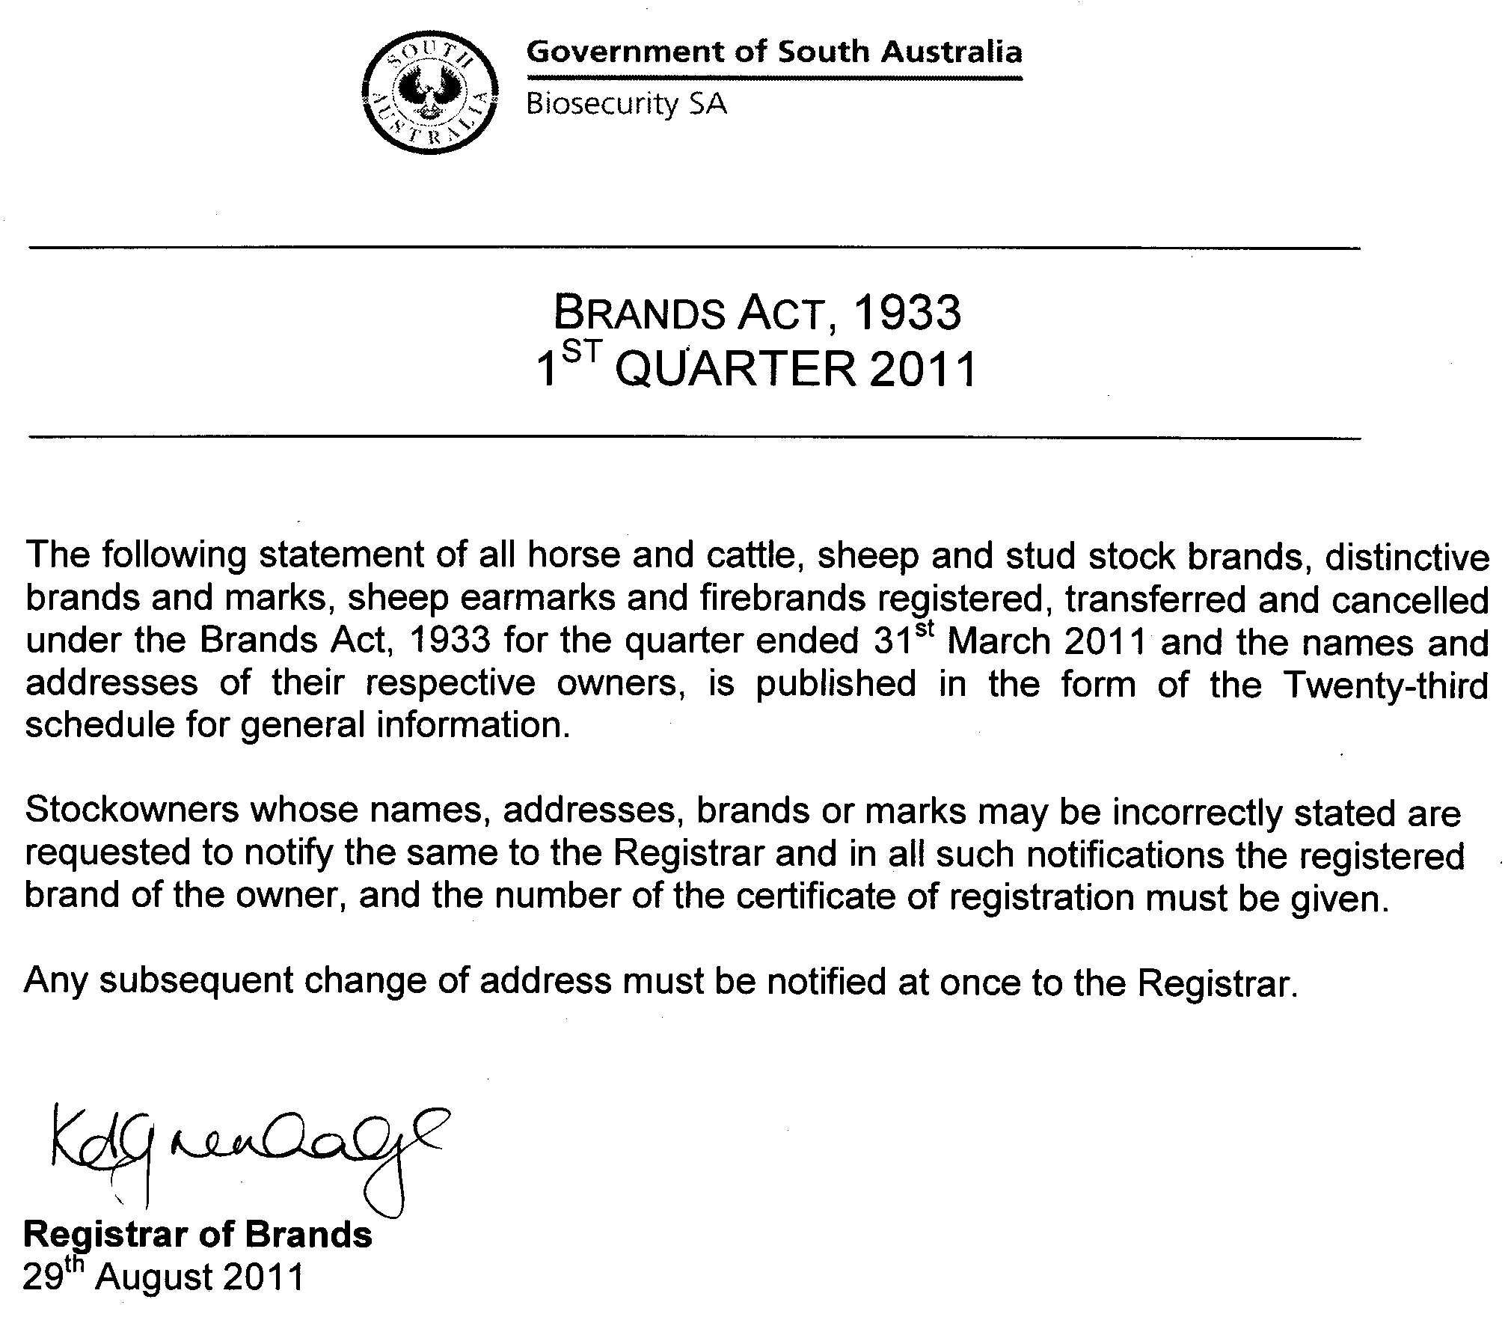
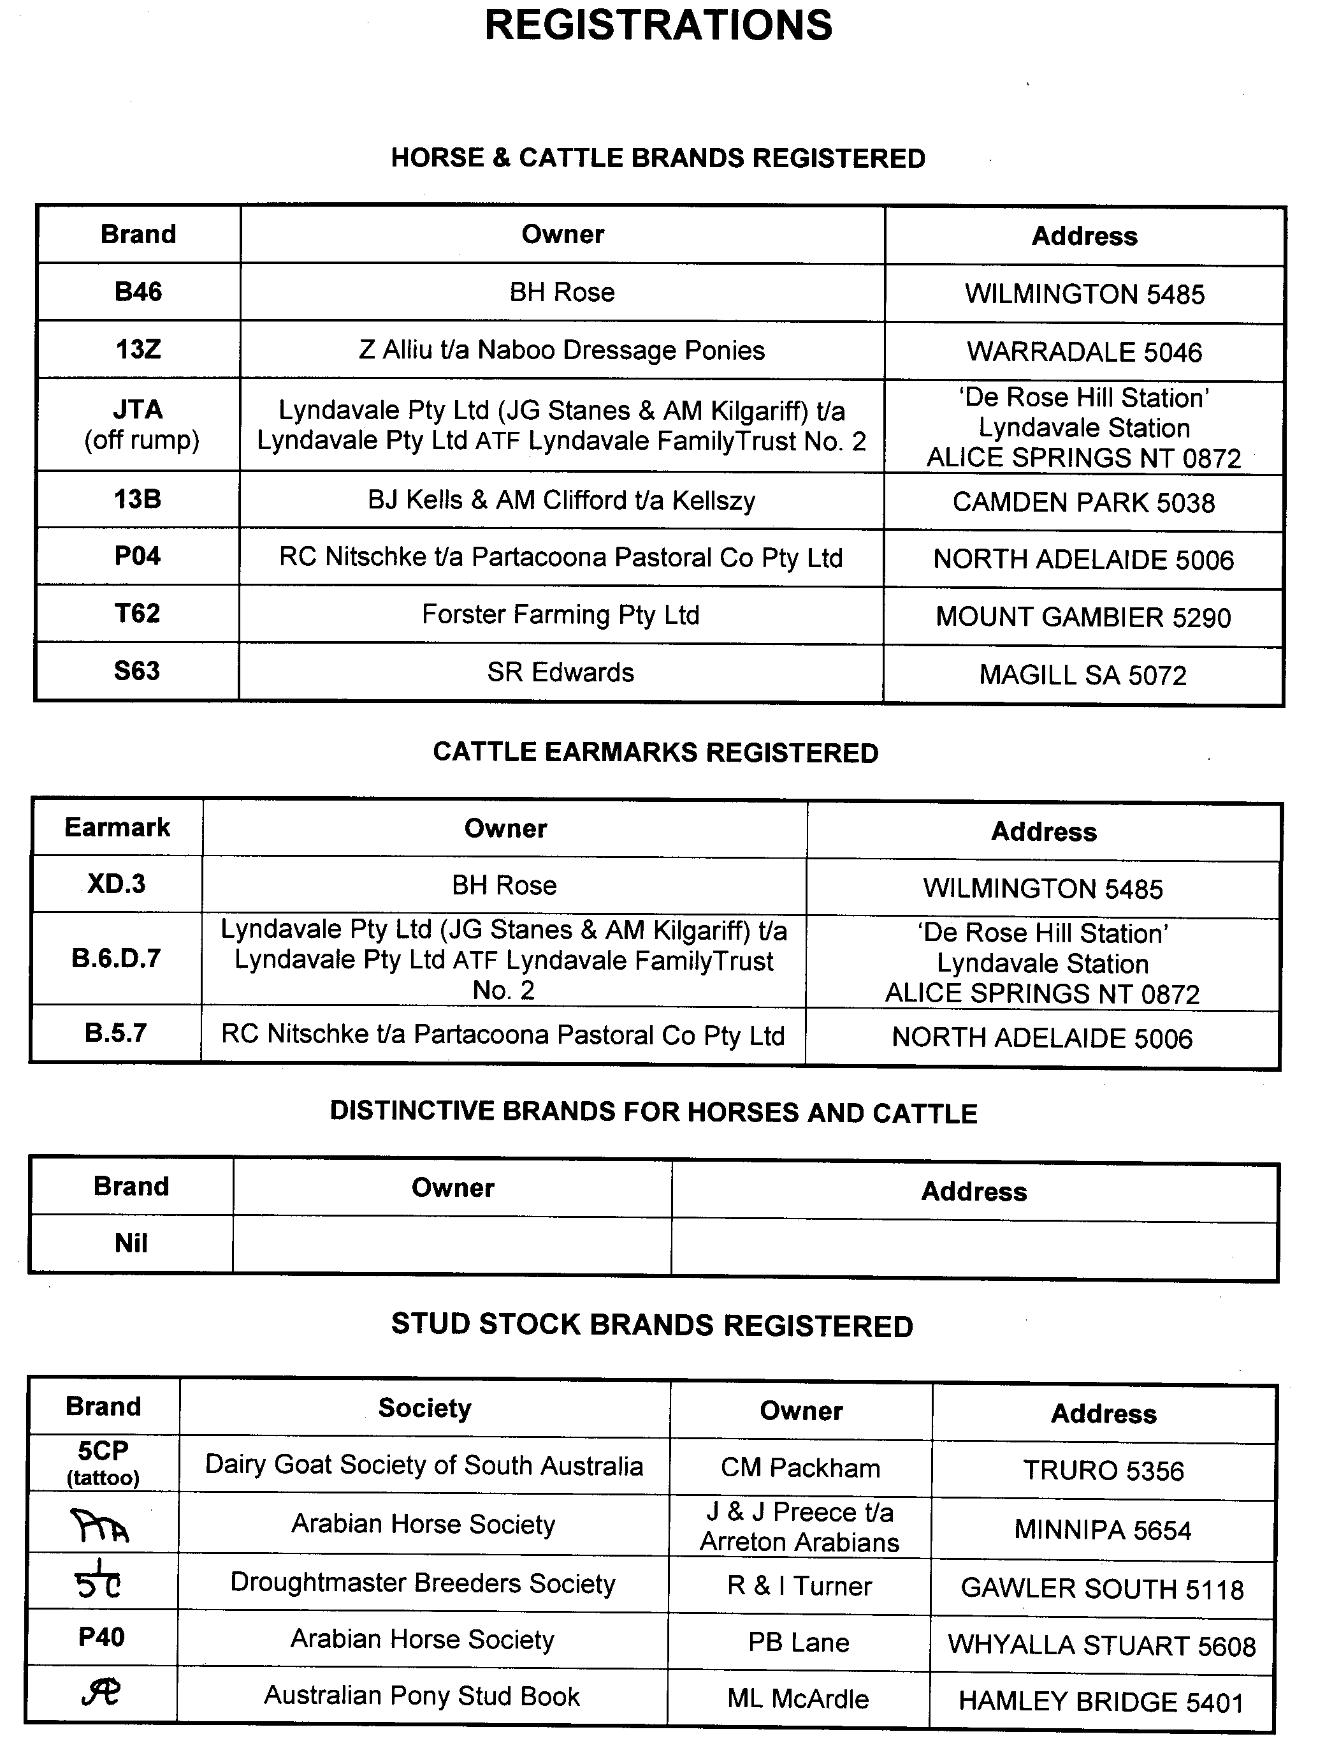
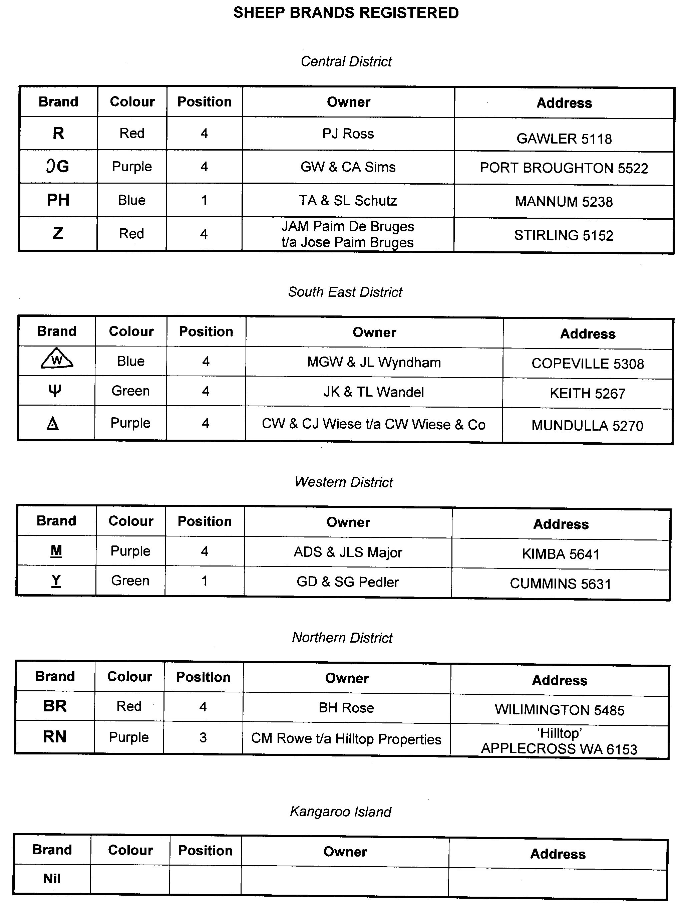
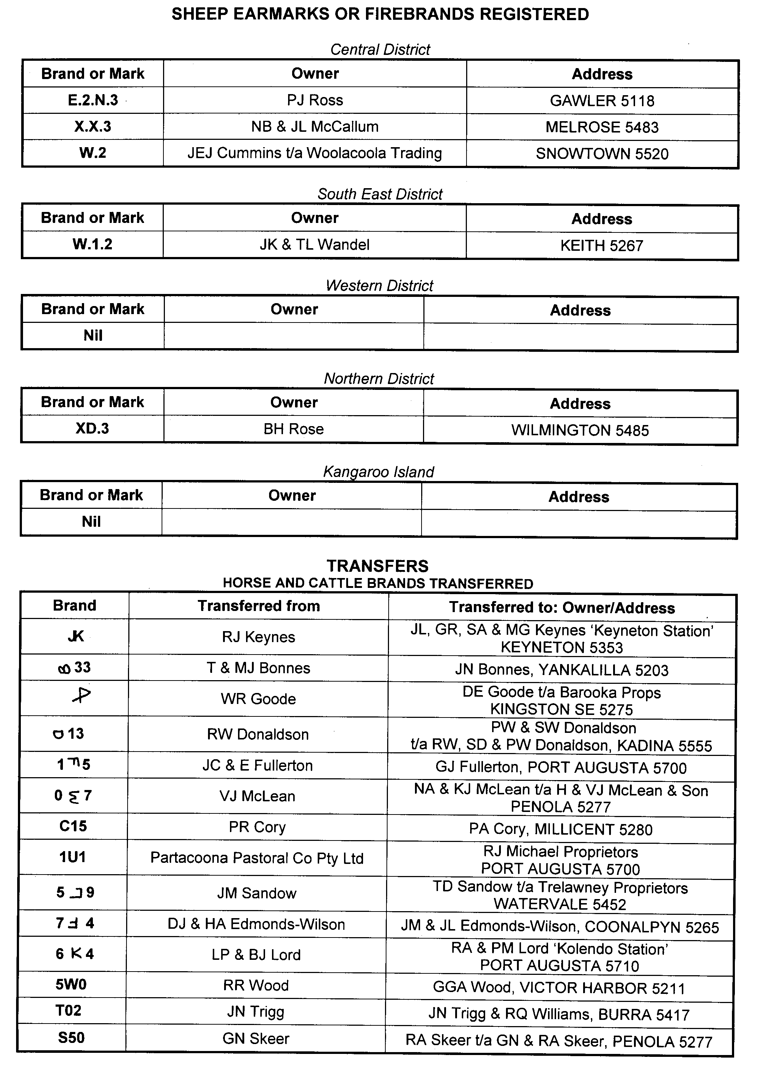
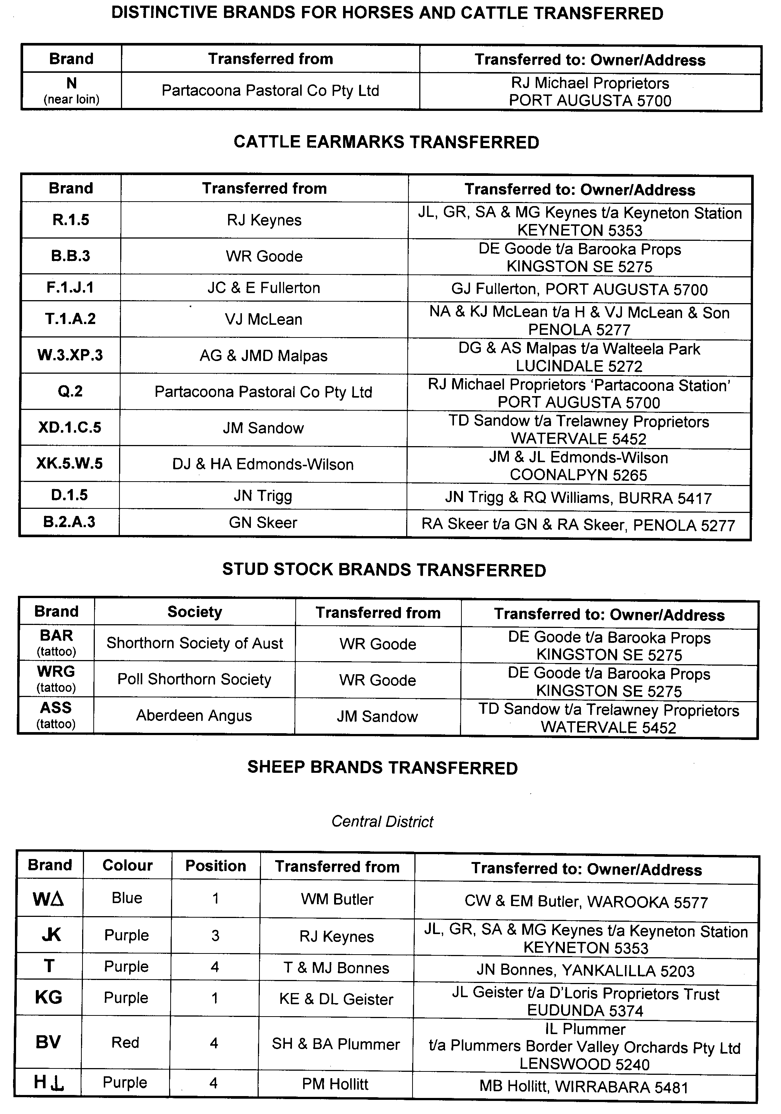
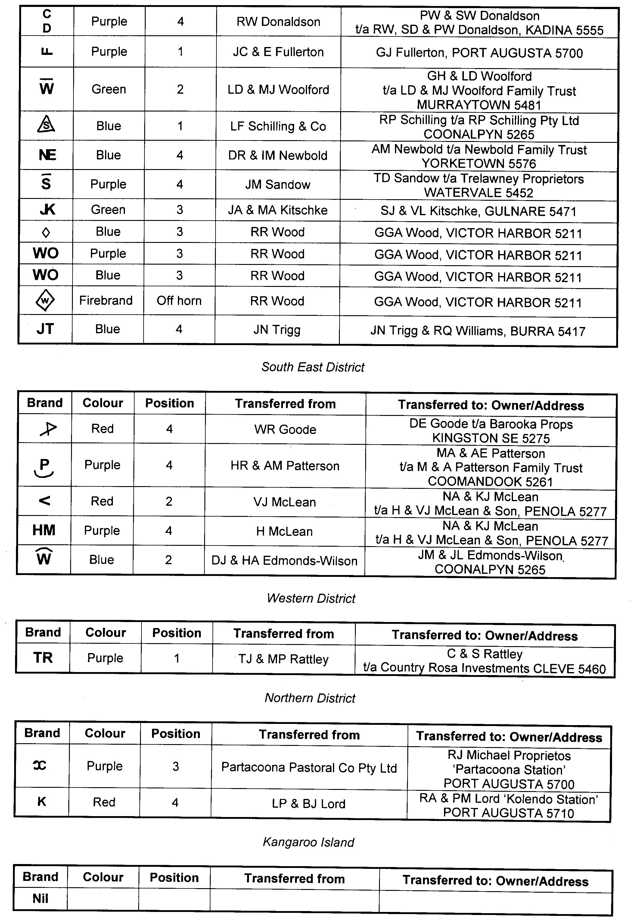
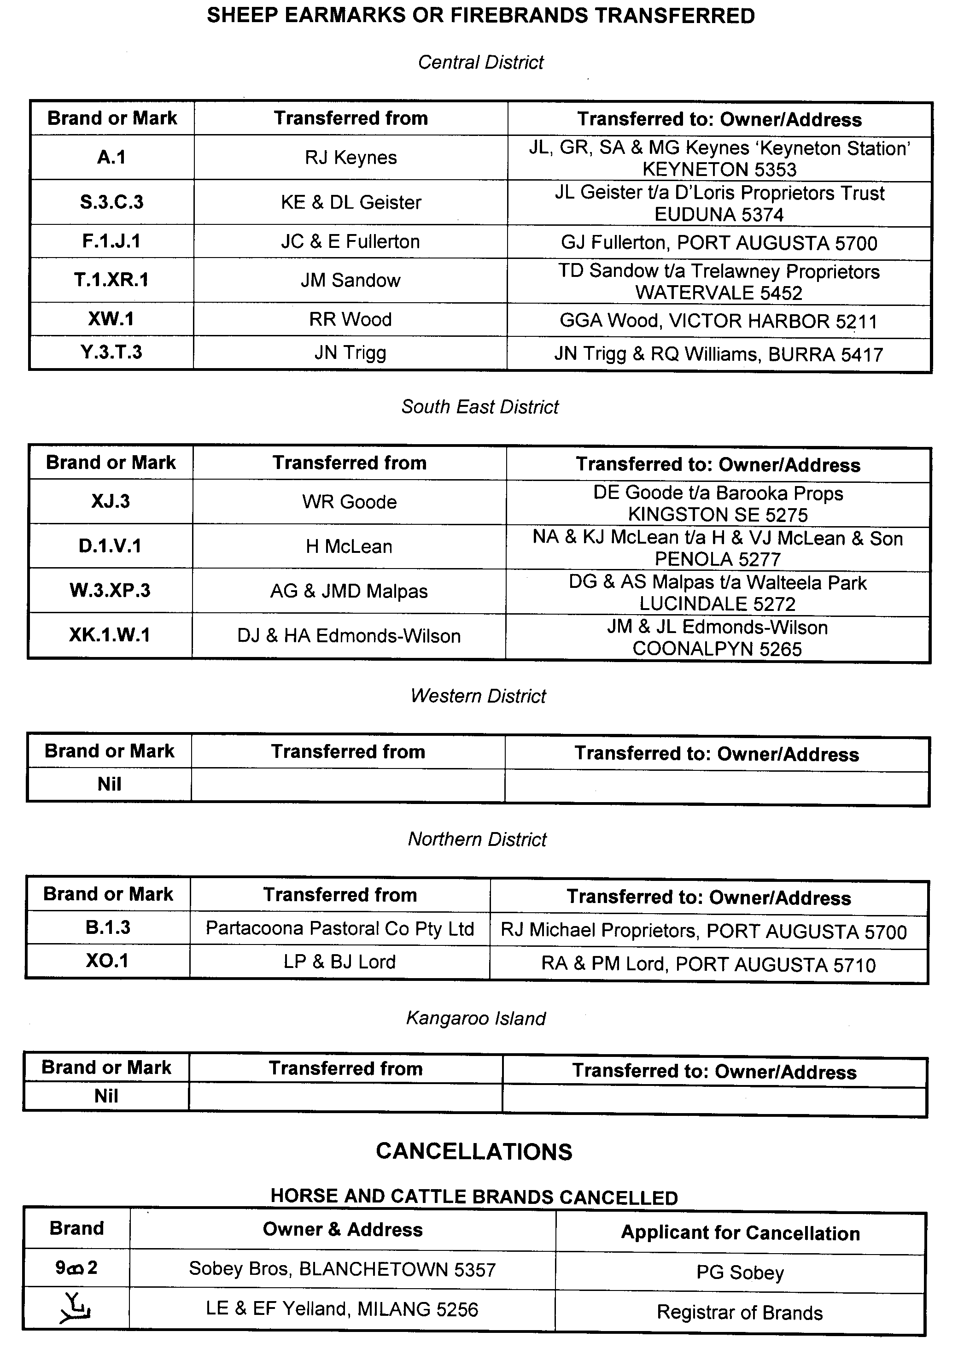
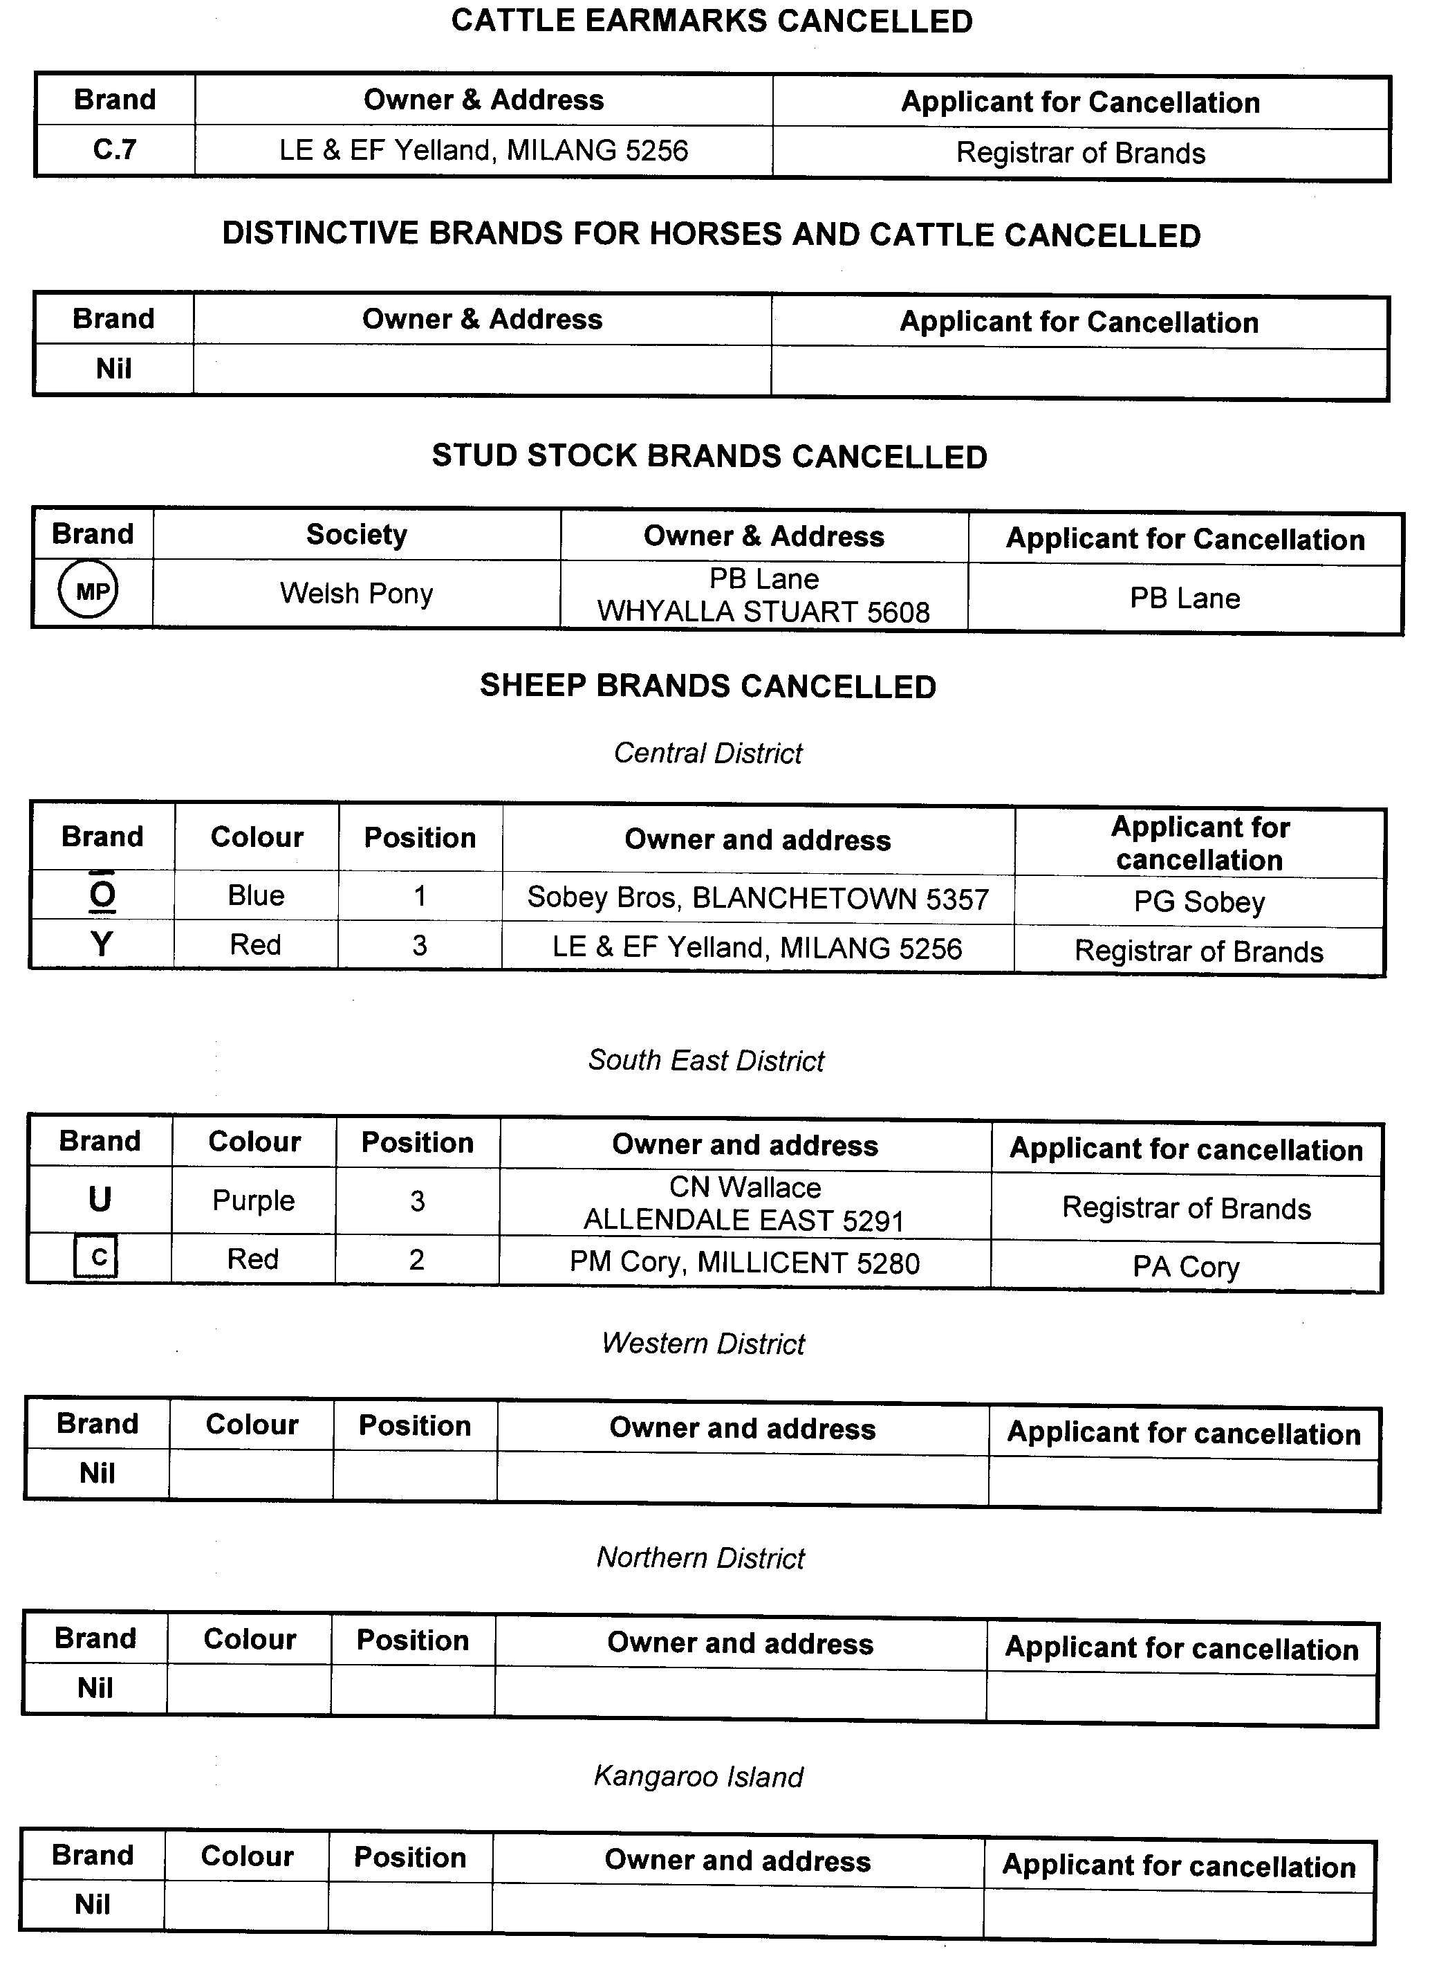
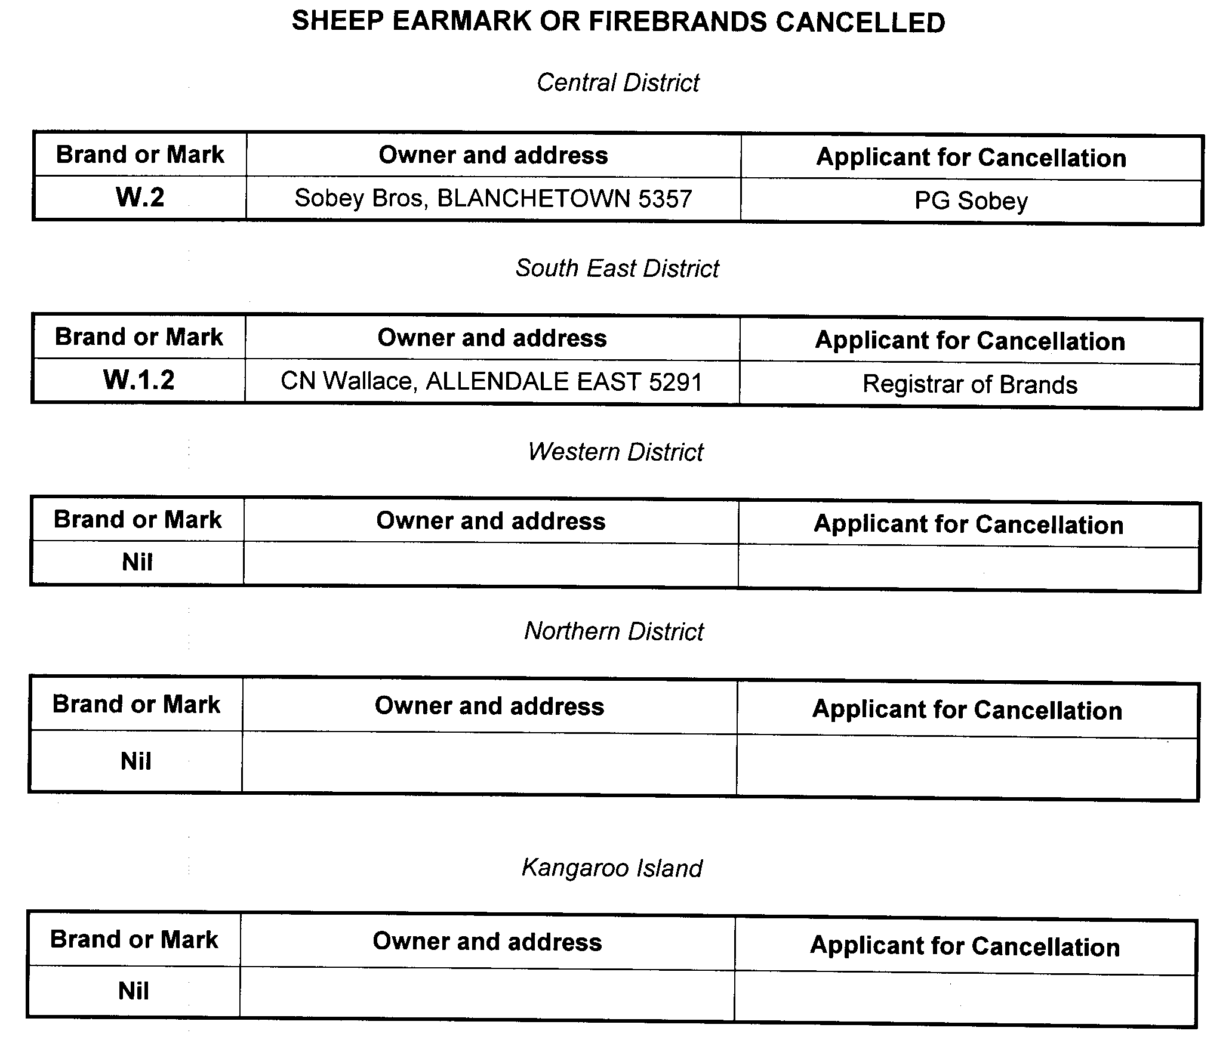


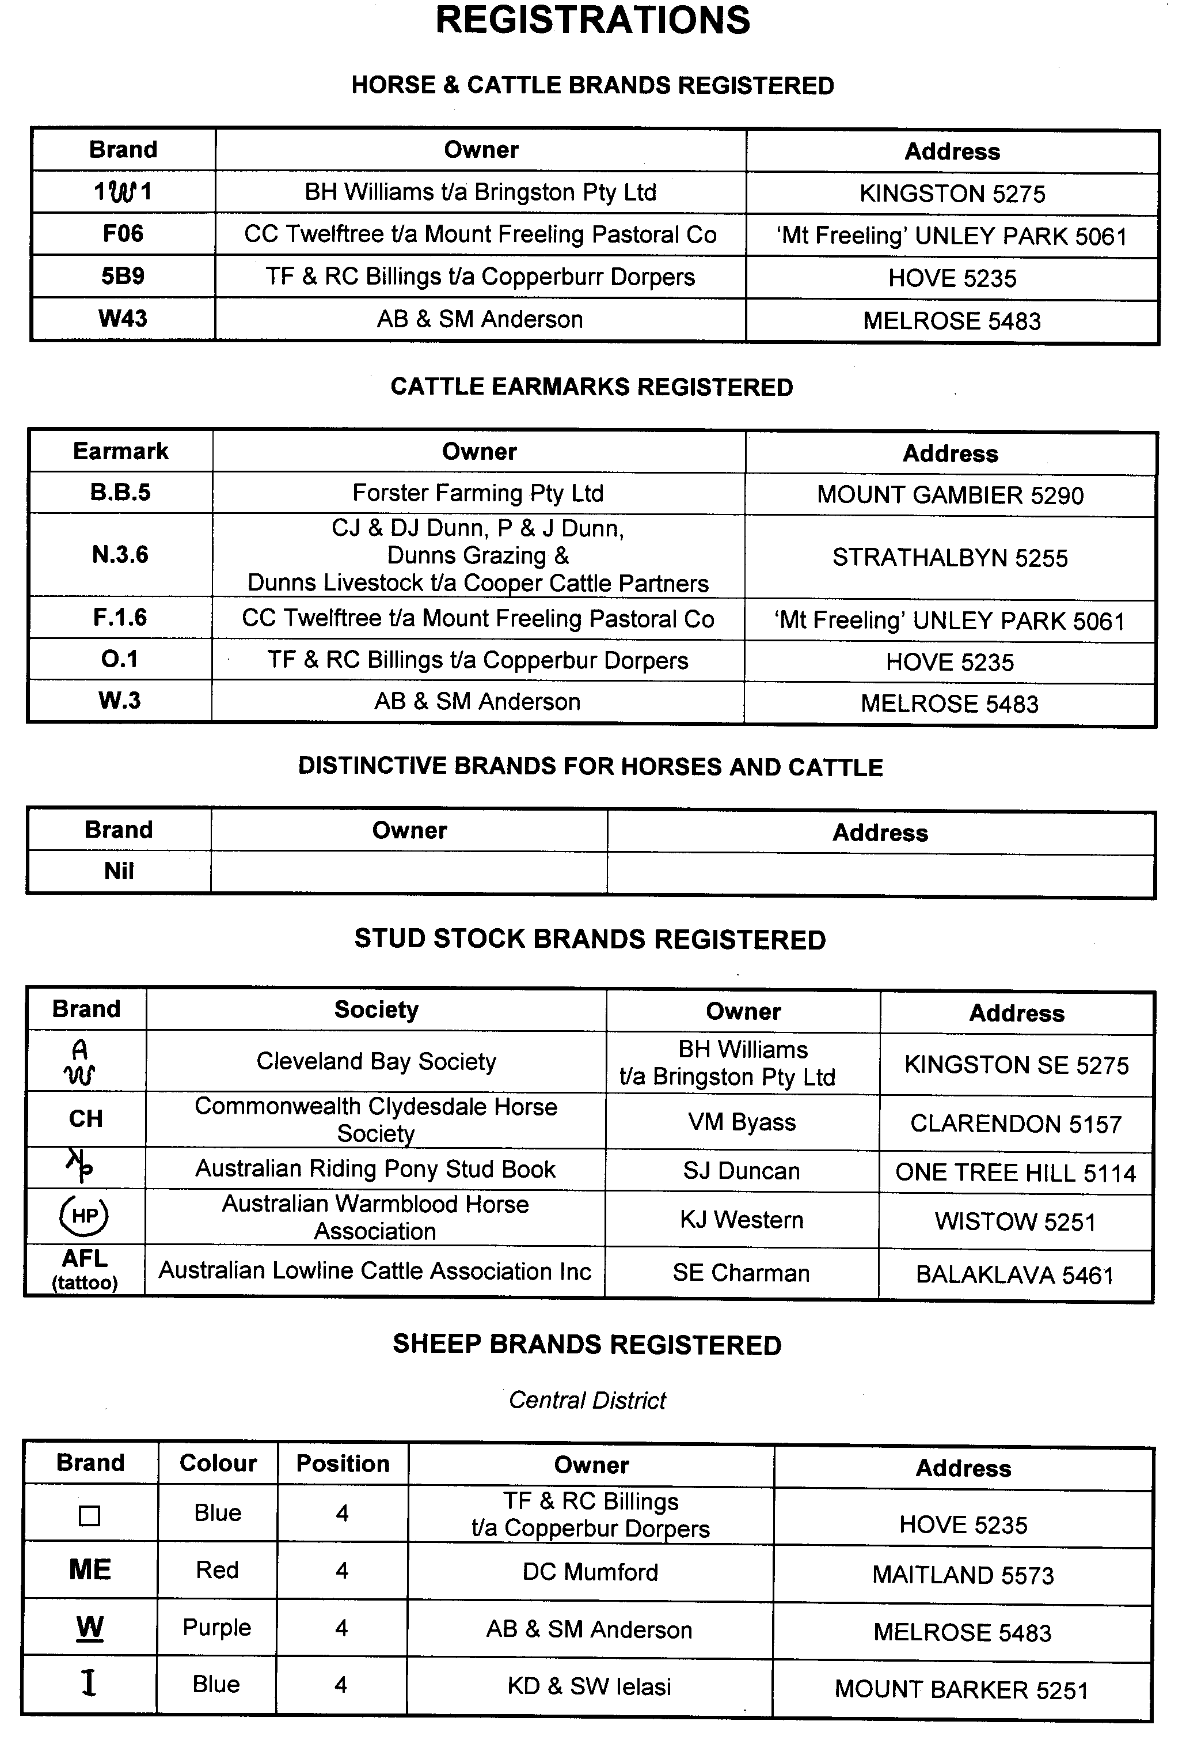
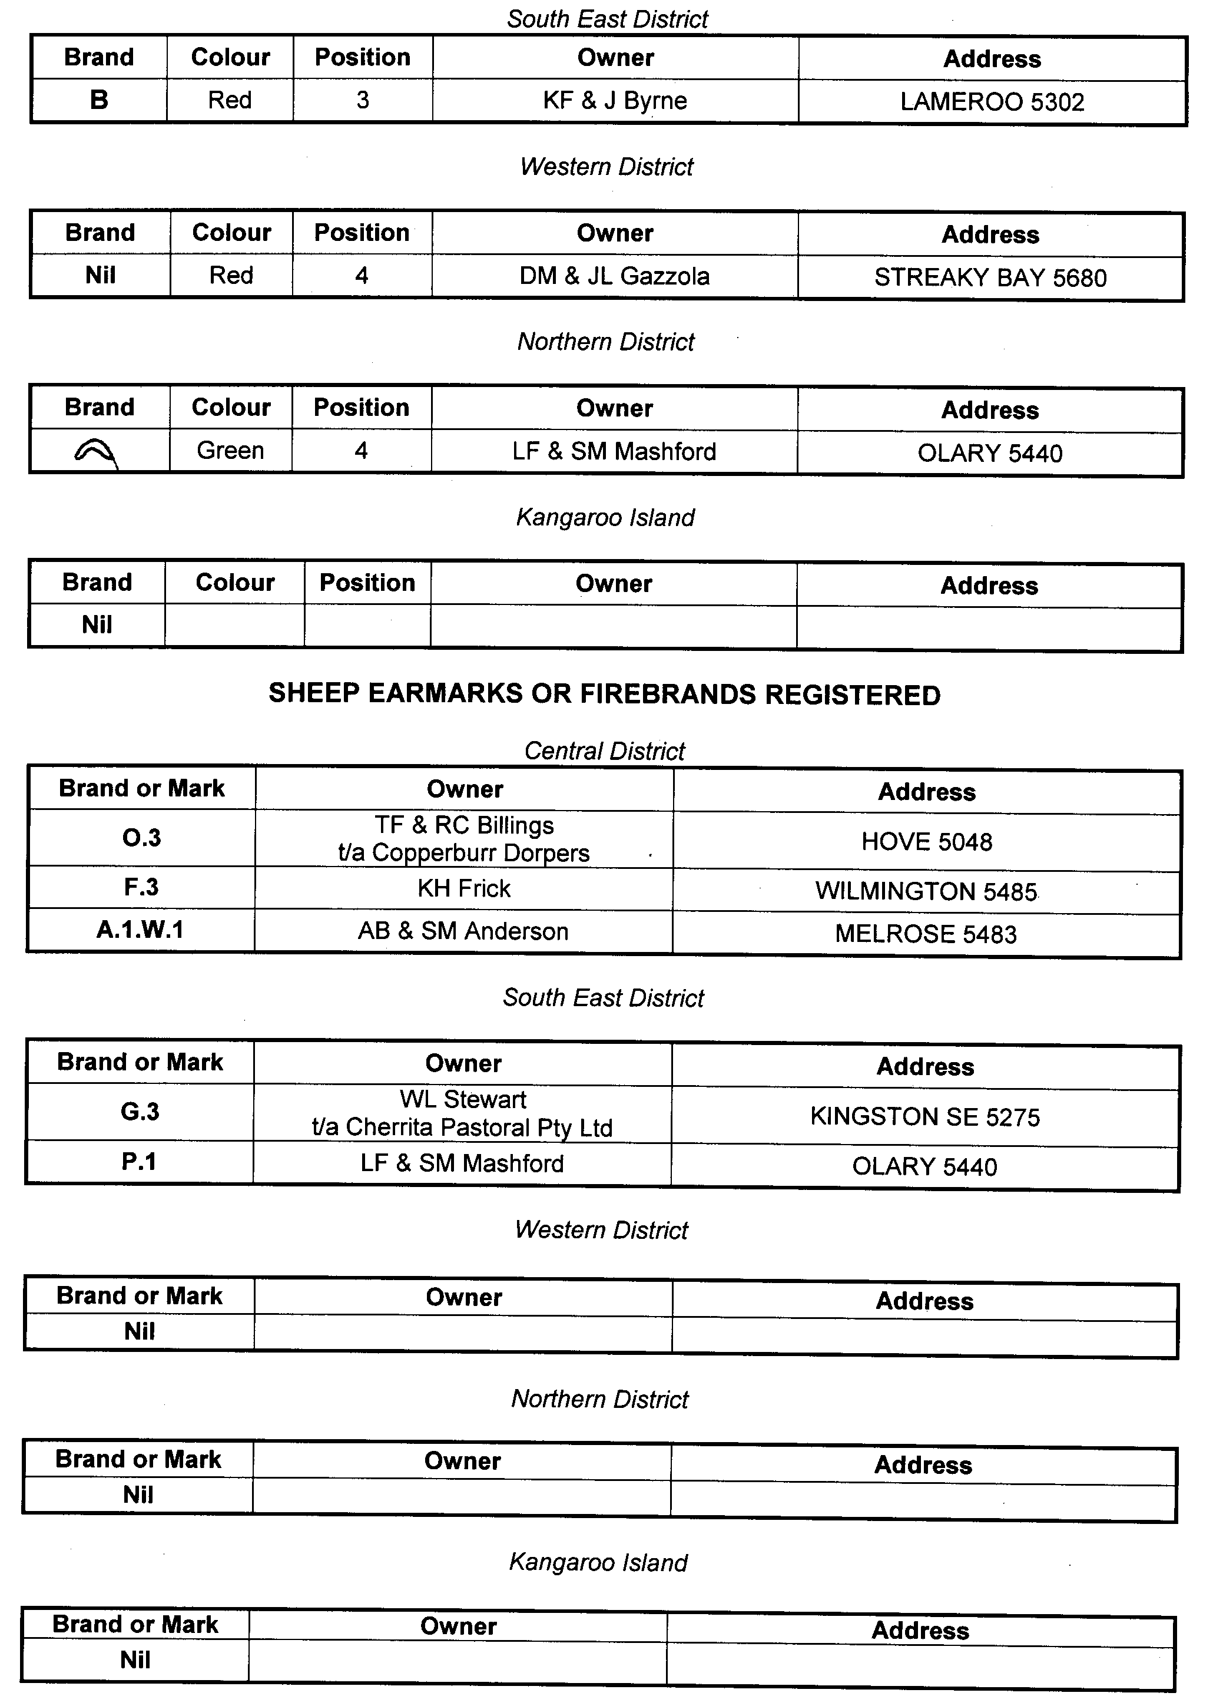
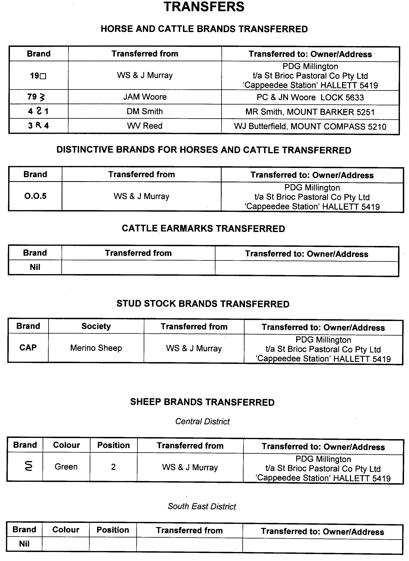
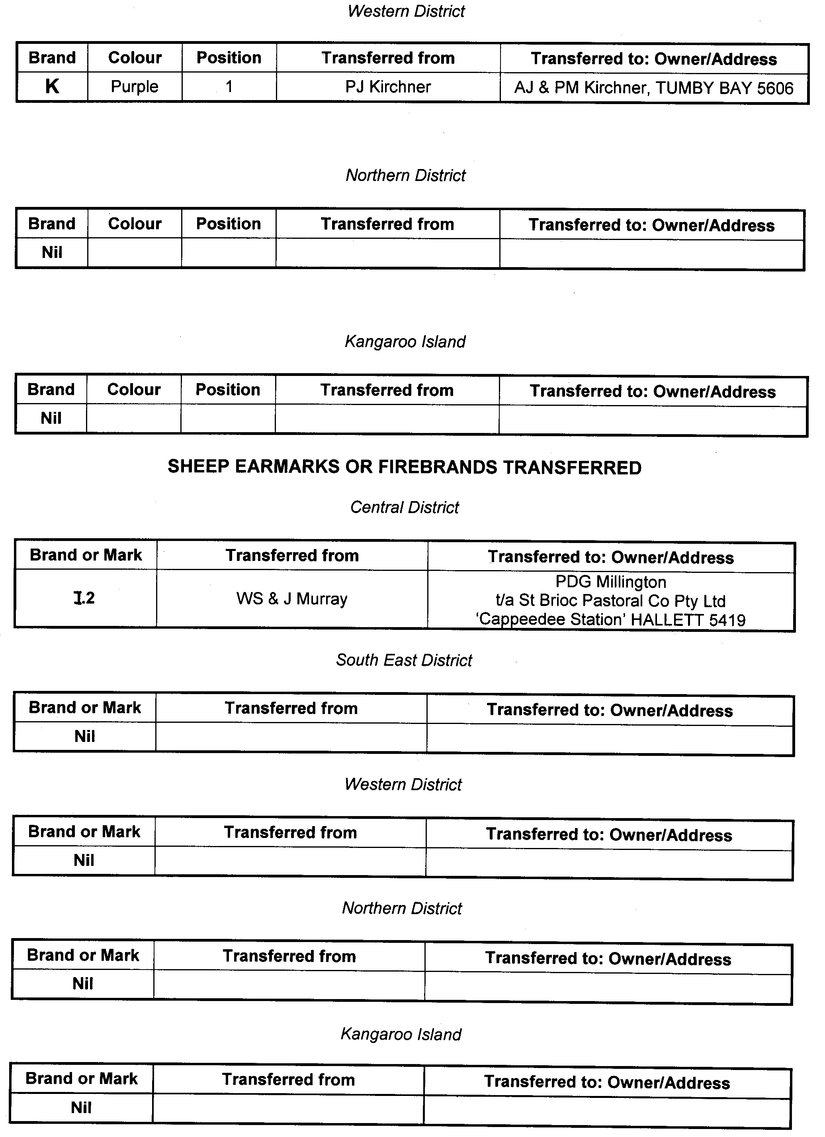
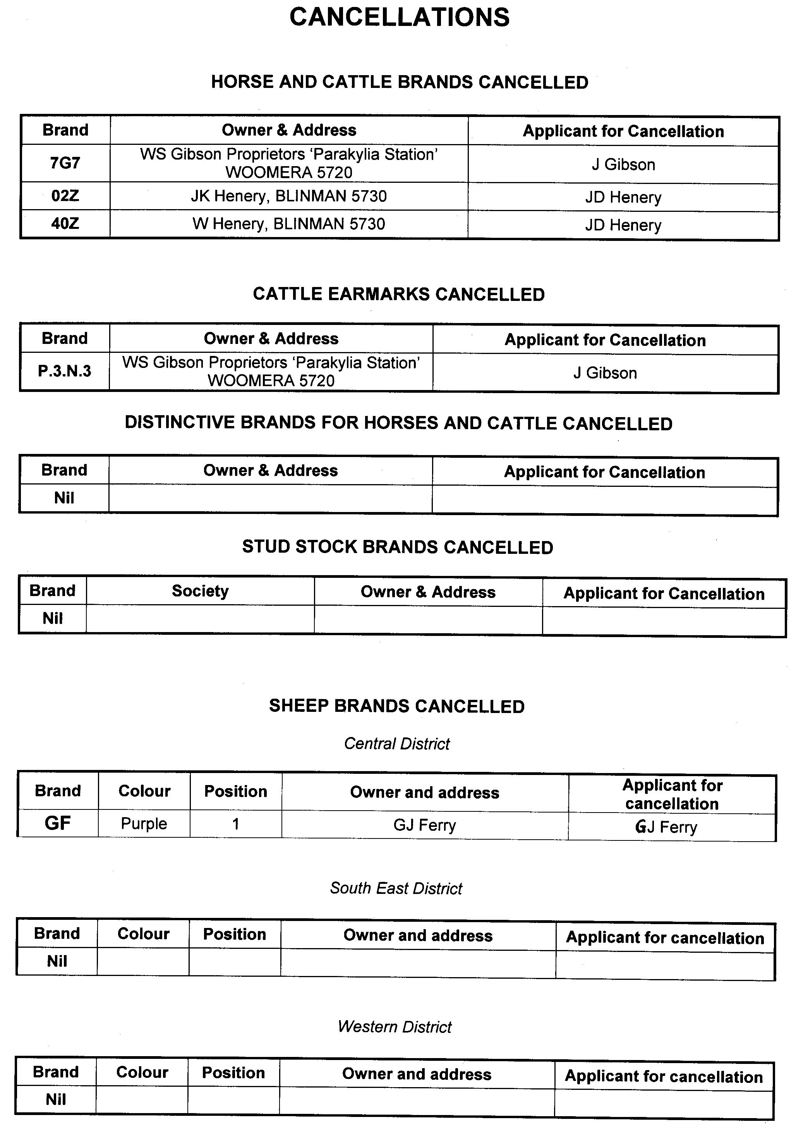
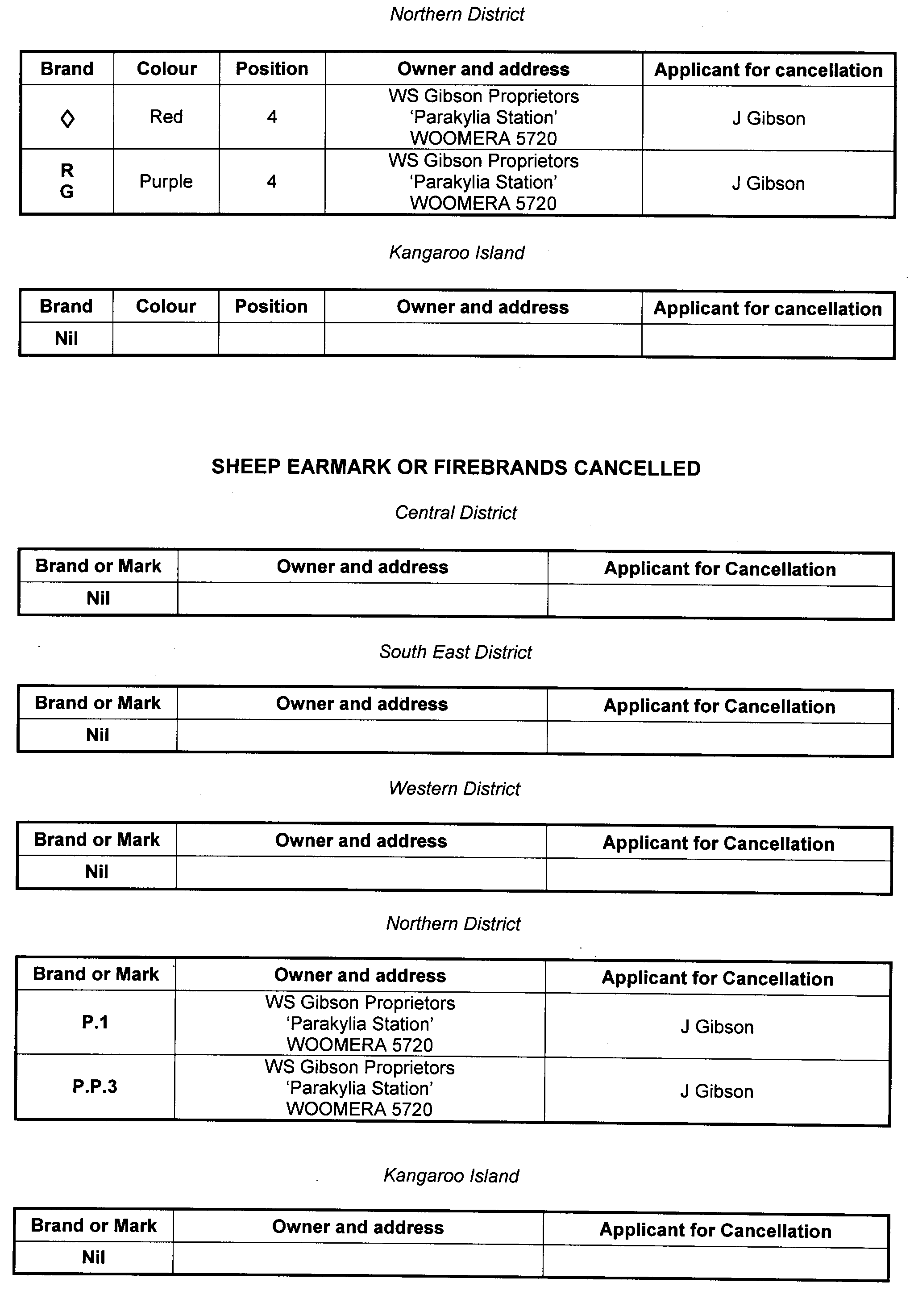

ENVIRONMENT PROTECTION ACT 1993
Revocation of Collection Depot Approval
I, ANDREA KAYE WOODS, Delegate of the Environment Protection Authority (‘the Authority’), pursuant to Section 69 of the Environment Protection Act 1993 (SA) (‘the Act’) hereby:
Revocation of Collection Depot Approval:
Revoke the approval of the collection depot identified by reference to the following matters, which previously received all containers belonging to a class of containers that were approved as Category B Containers:
(a) the name of the collection depot described in Column 1 of Schedule 1 of this Notice;
(b) the name of the proprietor of the depot identified in Column 3 of Schedule 1 of this Notice; and
(c) the location of the depot described in Columns 4-6 of Schedule 1 of this Notice.
Schedule 1

Column 1 | Column 2 | Column 3 | Column 4 | Column 5 | Column 6
Depot Name | Company Name | Proprietors | Depot Location  Street | Depot Location  Suburb | Certificate of Title  Volume/Folio
Scotty’s Diner | Scotty’s Diner | R. Scott and K. Scott | 71 Third Street | Warooka | 3374/67 and 68
Moorook Depot | David and Wendy Thicthener | David Thicthener and Wendy Thicthener | Section 388, Gogel Road | Moorook | n/a
Elizabeth Bottle & Wood Yard | YP Logistics Pty Ltd | Neil and Sue Drogemuller | Cnr. Philip Highway and Goglin Road | Elizabeth South | n/a
Tumby Bay Recycling | R.W. and R. M. J. Denton | R. W. and R. M. J. Denton | 55 LeBrun Street | Tumby Bay | n/a

FISHERIES MANAGEMENT ACT 2007: SECTION 115
TAKE notice that pursuant to Section 115 of the Fisheries Management Act 2007, Damien Wilksch, Block 35, Cadell, S.A. 5321 (the ‘exemption holder’), holder of River Fishery Licence No. R03, is exempt from Section 53 (2) of the Fisheries Management Act 2007 and Regulation 7 (b) (i) and Clause 6 of Schedule 6 of the Fisheries Management (General) Regulations 2007, but only insofar as he may use the device described in Schedule 1 to take carp, bony bream and other non-native species in the areas specified in Schedule 2 for the purpose of trade or business (the ‘exempted activity’), subject to the conditions set out in Schedule 3, from 12 August 2011 until 12 August 2012, unless varied or revoked earlier.
Schedule 1
‘Carp net’—a gill net with a ply greater than 5, having a maximum length of 50 m and a minimum mesh size of 10 cm and a maximum mesh size not exceeding 18 cm.
Schedule 2
(1) Subject to paragraph (2), the licence holder may conduct fishing activities pursuant to this licence in all backwaters of the River Murray excluding the following areas during the corresponding period set out in the following table:
Area Excluded | Period of Closure
Lake Littra and outflow channel | Permanent—all year
Clover Lake | Permanent—all year
Coombool Swamp | Permanent—all year
Lake Limbra and outflow channel | Permanent—all year
Lake Woolpolool | Permanent—all year
Ral Ral Creek below Chaffey Pumping Station and entrance waters to Lake Merreti | Permanent—all year
Katarapko Creek and Eckert Creek, including The Splash | Permanent—all year
Bulyong Creek | Permanent—all year
Pilby Creek | Permanent—all year
Hancock Creek | Permanent—all year
Mundic Creek | Permanent—all year
Pike River | Permanent—all year
Punkah Creek | Permanent—all year
Slaney Creek | Permanent—all year
Loch Luna | Permanent—all year
Cobdogla Swamp | 1 August to 30 April (inclusive)
Loveday Swamp/Mussel lagoons | 1 August to 30 April (inclusive)
Lake Merreti | 1 August to 31 January (inclusive)
(2) The licence holder may conduct fishing operations within the closure areas and periods listed above if given written approval by the Director of Fisheries to undertake specified carp eradication work in a specified area for a specified period.
Schedule 3
1. The exemption holder must not use more than 30 carp nets at any one time in permitted backwaters of the River Murray.
2. The exemption holder must not have more than 30 carp nets in his possession at any time when he is deploying carp nets in the backwaters of the River Murray.
3. The exemption holder may only engage in the exempted activity when also fishing pursuant to River Fishery Licence No. R03, and may only use a boat to engage in the exempted activity if that boat is registered by endorsement on River Fishery Licence No. R03.
4. The exemption holder must not cause or permit a person to act as his agent when engaging in the exempted activity unless that person may lawfully act as an agent for the exemption holder in relation to River Fishery Licence No. R03.
5. All native fish (excluding bony bream and yabbies) taken in the course of the exempted activity must be immediately returned to the water.
6. Immediately prior to commencing the exempted activity, the exemption holder must contact the PIRSA Fishwatch on 1800 065 522 and provide the following details:
• the licence number and person(s) conducting the activity;
• the exact location(s) of the fishing activities;
• the number of carp nets being used;
• Exemption No. 9902466.
7. The exemption holder must ensure that the carp nets are checked and all fish removed at least once during each 24 hour period.
8. When the exemption holder moves the carp nets more than 3 km from the reported location of the nets under Condition 6, or removes the nets from the river completely, the exemption holder must again report to PIRSA Fishwatch on 1800 065 522 and provide either details, as required under Condition 6 of this exemption notice, or report that fishing with carp nets has ceased.
9. While engaged in the exempted activity, the exemption holder must be in possession of a copy of this notice. Such notice must be produced to a PIRSA Fisheries Compliance Officer as requested.
10. The exemption holder must not contravene or fail to comply with the Fisheries Management Act 2007, or any regulations made under that Act, except where specifically exempted by this notice.
Dated 12 August 2011.
Professor M. Doroudi, Executive Director Fisheries and Aquaculture

FISHERIES MANAGEMENT ACT 2007: SECTION 115
TAKE notice that pursuant to Section 115 of the Fisheries Management Act 2007, Antony Smith, 76 Moss Road, Monash S.A. 5342 (the ‘exemption holder’), holder of River Fishery Licence No. R54, is exempt from Section 53 (2) of the Fisheries Management Act 2007 and Regulation 7 (b) (i) and Clause 6 of Schedule 6 of the Fisheries Management (General) Regulations 2007, but only insofar as he may use the device described in Schedule 1, to take carp, bony bream and other non-native species in the areas specified in Schedule 2, for the purpose of trade or business (the ‘exempted activity’), subject to the conditions set out in Schedule 3, from 12 August 2011 until 12 August 2012, unless varied or revoked earlier.
Schedule 1
‘Carp net’—a gill net with a ply greater than 5, having a maximum length of 50 m and a minimum mesh size of 10 cm and a maximum mesh size not exceeding 18 cm.
Schedule 2
(1) Subject to paragraph (2), the licence holder may conduct fishing activities pursuant to this licence in all backwaters of the River Murray excluding the following areas during the corresponding period set out in the following table:
Area Excluded | Period of Closure
Lake Littra and outflow channel | Permanent—all year
Clover Lake | Permanent—all year
Coombool Swamp | Permanent—all year
Lake Limbra and outflow channel | Permanent—all year
Lake Woolpolool | Permanent—all year
Ral Ral Creek below Chaffey Pumping Station and entrance waters to Lake Merreti | Permanent—all year
Katarapko Creek and Eckert Creek, including The Splash | Permanent—all year
Bulyong Creek | Permanent—all year
Pilby Creek | Permanent—all year
Hancock Creek | Permanent—all year
Mundic Creek | Permanent—all year
Pike Creek | Permanent—all year
Punkah Creek | Permanent—all year
Slaney Creek | Permanent—all year
Loch Luna | Permanent—all year
Cobdogla Swamp | 1 August to 30 April (inclusive)
Loveday Swamp/Mussel lagoons | 1 August to 30 April (inclusive)
Lake Merreti | 1 August to 31 January (inclusive)

(2) The licence holder may conduct fishing operations within the closure areas and periods listed above if given written approval by the Director of Fisheries to undertake specified carp eradication work in a specified area for a specified period.
Schedule 3
1. The exemption holder must not use more than 30 carp nets at any one time in permitted backwaters of the River Murray.
2. The exemption holder must not have more than 30 carp nets in his possession at any time when he is deploying carp nets in the backwaters of the River Murray.
3. The exemption holder may only engage in the exempted activity when also fishing pursuant to River Fishery Licence No. R54, and may only use a boat to engage in the exempted activity if that boat is registered by endorsement on River Fishery Licence No. R54.
4. The exemption holder must not cause or permit a person to act as his agent when engaging in the exempted activity unless that person may lawfully act as an agent for the exemption holder in relation to River Fishery Licence No. R54.
5. All native fish (excluding bony bream and yabbies) taken in the course of the exempted activity must be immediately returned to the water.
6. Immediately prior to commencing the exempted activity,
the exemption holder must contact the PIRSA Fishwatch on
1800 065 522 and provide the following details:
• the licence number and person(s) conducting the activity;
• the exact location(s) of the fishing activities;
• the number of carp nets being used;
• Exemption No. 9902467.
7. The exemption holder must ensure that the carp nets are checked and all fish removed at least once during each 24 hour period.
8. When the exemption holder moves the carp nets more than 3 km from the reported location of the nets under Condition 6, or removes the nets from the river completely, the exemption holder must again report to PIRSA Fishwatch on 1800 065 522 and provide either details, as required under Condition 6 of this exemption notice, or report that fishing with carp nets has ceased.
9. While engaged in the exempted activity, the exemption holder must be in possession of a copy of this notice. Such notice must be produced to a PIRSA Fisheries Compliance Officer as requested.
10. The exemption holder must not contravene or fail to comply with the Fisheries Management Act 2007, or any regulations made under that Act, except where specifically exempted by this notice.
Dated 12 August 2011.
Professor M. Doroudi, Executive Director, Fisheries and Aquaculture

FISHERIES MANAGEMENT ACT 2007: SECTION 115
TAKE notice that pursuant to Section 115 of the Fisheries Management Act 2007, Leslie Morrison, current university staff and current post graduate students of the School of Biological Sciences at Flinders University, Sturt Road, Bedford Park (the ‘exemption holders’) are exempt from Sections 70, 71, and 72 of the Fisheries Management Act 2007 and Schedule 5 and 6 of the Fisheries Management (General) Regulations 2007, but only insofar as they may engage in the activities specified in Schedule 1, using the gear specified in Schedule 2, (the ‘exempted activity’), subject to the conditions specified in Schedule 3, from 22 August 2011 until 22 August 2012, unless varied or revoked earlier.
Schedule 1
The collection of aquatic organisms from all waters of South Australia including intertidal ‘rocky’ reefs, excluding aquatic reserves.
Schedule 2
1. Two hauling nets with a mesh size not less than 5 mm, or not exceeding 1 min depth with a rope length not exceeding 50 m.
2. Five drop nets.
3. Two plankton nets where each net is a funnel shaped, fine-meshed net that is towed through the water to collect plankton with a diameter not exceeding 1 m, depth not exceeding 1.6 m and mesh size not exceeding 38 mm.
4. In accordance with the definition and use prescribed under the Fisheries Management (General) Regulations 2007 r.21, the following gear:
• One bait pump;
• One bait spade;
• One dab net;
• One fish trap; and
• One hook and line.
Schedule 3
1. The specimens collected by the exemption holder are for scientific and research purposes only and must not be sold. Any unwanted specimens must be returned to the water immediately.
2. All protected species incidentally taken while undertaking the exempted activity may be measured and recorded prior to being released. Protected Species must not be retained.
3. The exemption holder must not collect specimens for aquaculture research purposes pursuant to this notice.
4. Before conducting the proposed exempted activity within a specially protected area as defined by the Fisheries Management Act 2007, including the Adelaide Dolphin Sanctuary, a Marine Park or the River Murray; the exemption holders must obtain written approval from delegates of the relevant area.
• For Adelaide Dolphin Sanctuary:
Verity Gibbs: verity.gibbs@sa.gov.au;or
John Gitsham: john.gitsham@sa.gov.au.
• For Marine Parks:
Chris Thomas: chris.thomas@sa.gov.au.
• For River Murray:
Kent Truehl: kent.truehl@sa.gov.au.
5. When undertaking the exempted activity within the waters of the Adelaide Dolphin Sanctuary, in addition to Condition 3.4.1, all nets must be attended at all times. All nets must be removed from the water if a dolphin is within the immediate area to minimise any entanglement.
6. At least one hour before conducting the exempted activity, the exemption holder must contact PIRSA Fishwatch on 1800 065 522 and answer a series of questions about the exempted activity. The exemption holder will need to have a copy of this notice in their possession at the time of making the call, and be able to provide information about the area and time of the exempted activity, the vehicles and/or boats involved, the number of permit holders undertaking the exempted activity and other related questions. Exemption No. 9902463.
7. The exemption holder must provide a report in writing detailing the outcomes of the research and collection of organisms pursuant to this notice to the Executive Director, Fisheries and Aquaculture (G.P.O. Box 1625, Adelaide, S.A. 5001) within 15 days of each exempted activity with the following details:
• the date, soak time and location of sampling;
• the number of nets used;
• the number and description of all species collected; and
• any other information regarding size, breeding or anything deemed relevant or of interest that is able to be volunteered.
8. Failure to submit a report as per Condition 3.7 may result in further exemptions not being supported.

9. While engaged in the exempted activity, the exemption holder must be in possession of a signed copy of this notice and carry their identification card issued by Flinders University. Such notice and identification must be produced to a PIRSA Fisheries Officer if requested.
10. The exemption holders must not contravene or fail to comply with the Fisheries Management Act 2007, or any regulations made under that Act, except where specifically exempted by this notice.
Dated 22 August 2011.
Professor M. Doroudi, Executive Director Fisheries and Aquaculture

[Republished]
IN Government Gazette dated 25 August 2011, page 3604, because of a typographical error the notice should have read as follows:
GEOGRAPHICAL NAMES ACT 1991
Notice of Declaration of Names of Places
Corrigendum
IN the Government Gazette of 28 January 1999, page 611, first notice appearing, the plan declaring the suburbs for District Council of Willunga shown as RACK PLAN 792, should have been shown as RACK PLAN 795.
Dated 23 August 2011.
P. M. Kentish, Surveyor-General, Department for Transport Energy and Infrastructure
DTEI.2009/29930/01

ADMINISTRATIVE ARRANGEMENTS ACT 1994
Delegation of Power to the Minister for Mineral
Resources Development
I, John Robert Rau, Minister for Urban Development, Planning and the City of Adelaide, delegate all of my functions and powers under the Development Act 1993, in respect of any decision, process or act to be made or performed under that Act in connection with the Olympic Dam Expansion Project specified in the declaration made by Paul Holloway, Minister for Urban Development and Planning on 18 August 2008 and published in the Government Gazette of 21 August 2008 at page 3709, to Anastasios Koutsantonis, Minister for Mineral Resources Development.
Dated 1 September 2011.
John Rau, Minister for Urban Development, Planning and the City of Adelaide

HEALTH CARE ACT 2008
Section 20
Notice by the Minister
TAKE notice that I, John Hill, Minister for Health, acting at the request of Country Health SA Local Health Network Incorporated (formerly Country Health SA Hospital Incorporated) do hereby transfer to, and vest in, each of the incorporated Health Advisory Councils listed in Column 1 of the Schedule the assets, rights and liabilities appearing in the corresponding part of Column 2 of the Schedule, to the extent that such assets, rights and liabilities were not so transferred and vested by the Health Care (Schedule 4—Dissolution of Hospitals) Proclamation 2008 (Gazette 26 June 2008, page 2566) but were instead transferred to, and vested in, Country Health SA Hospital Incorporated.
Schedule

Column 1 | Column 2
Incorporated Health Advisory Council | Assets, rights and liabilities
Berri Barmera District Health Advisory Council Inc. | The whole of the land comprised in Certificate of Title Register Book Volume 5778, Folio 311 and all assets, rights and liabilities associated with the land.
Berri Barmera District Health Advisory Council Inc. | The whole of the land comprised in Certificate of Title Register Book Volume 5809, Folio 443 and all assets, rights and liabilities associated with the land.
Bordertown and District Health Advisory Council Inc. | The whole of the land comprised in Certificate of Title Register Book Volume 5855, Folio 788 and all assets, rights and liabilities associated with the land.
Lower North Health Advisory Council Inc. | The whole of the land comprised in Certificate of Title Register Book Volume 5878, Folio 325 and all assets, rights and liabilities associated with the land.
Eastern Eyre Health Advisory Council Inc. | The whole of the land comprised in Certificate of Title Register Book Volume 5864, Folio 892 and all assets, rights and liabilities associated with the land.
Eastern Eyre Health Advisory Council Inc. | The whole of the land comprised in Certificate of Title Register Book Volume 5830, Folio 367 and all assets, rights and liabilities associated with the land.
Eastern Eyre Health Advisory Council Inc. | The whole of the land comprised in Certificate of Title Register Book Volume 6081, Folio 209 and all assets, rights and liabilities associated with the land.
Eastern Eyre Health Advisory Council Inc. | The whole of the land comprised in Certificate of Title Register Book Volume 6081, Folio 208 and all assets, rights and liabilities associated with the land.
Loxton and Districts Health Advisory Council Inc. | The whole of the land comprised in Certificate of Title Register Book Volume 5357, Folio 194 and all assets, rights and liabilities associated with the land.
Loxton and Districts Health Advisory Council Inc. | The whole of the land comprised in Certificate of Title Register Book Volume 5357, Folio 195 and all assets, rights and liabilities associated with the land.
Yorke Peninsula Health Advisory Council Inc. | The whole of the land comprised in Certificate of Title Register Book Volume 5848, Folio 633 and all assets, rights and liabilities associated with the land.
Yorke Peninsula Health Advisory Council Inc. | The whole of the land comprised in Certificate of Title Register Book Volume 5327, Folio 130 and all assets, rights and liabilities associated with the land.
Yorke Peninsula Health Advisory Council Inc. | The whole of the land comprised in Certificate of Title Register Book Volume 5925, Folio 889 and all assets, rights and liabilities associated with the land.
Millicent and Districts Health Advisory Council Inc. | The whole of the land comprised in Certificate of Title Register Book Volume 5258, Folio 271 and all assets, rights and liabilities associated with the land.
Mallee Health Service Health Advisory Council Inc. | The whole of the land comprised in Certificate of Title Register Book Volume 5825, Folio 789 and all assets, rights and liabilities associated with the land.
Mallee Health Service Health Advisory Council Inc. | The whole of the land comprised in Certificate of Title Register Book Volume 5603, Folio 817 and all assets, rights and liabilities associated with the land.
Country Health SA Board Health Advisory Council Inc. | The whole of the land comprised in Certificate of Title Register Book Volume 5387, Folio 982 and all assets, rights and liabilities associated with the land.
Country Health SA Board Health Advisory Council Inc. | The whole of the land comprised in Certificate of Title Register Book Volume 5526, Folio 751 and all assets, rights and liabilities associated with the land.
Country Health SA Board Health Advisory Council Inc. | The whole of the land comprised in Certificate of Title Register Book Volume 5907, Folio 333 and all assets, rights and liabilities associated with the land.
Country Health SA Board Health Advisory Council Inc. | The whole of the land comprised in Certificate of Title Register Book Volume 6007, Folio 520 and all assets, rights and liabilities associated with the land.
Mid-West Health Advisory Council Inc. | The whole of the land comprised in Certificate of Title Register Book Volume 1737, Folio 142 and all assets, rights and liabilities associated with the land.
Mid-West Health Advisory Council Inc. | The whole of the land comprised in Certificate of Title Register Book Volume 6077, Folio 465 and all assets, rights and liabilities associated with the land..
Mid-West Health Advisory Council Inc. | The whole of the land comprised in Certificate of Title Register Book Volume 3820, Folio 136 and all assets, rights and liabilities associated with the land.
Coorong Health Service Health Advisory Council Inc. | The whole of the land comprised in Certificate of Title Register Book Volume 5403, Folio 326 and all assets, rights and liabilities associated with the land.
Waikerie and Districts Health Advisory Council Inc. | The whole of the land comprised in Certificate of Title Register Book Volume 2075, Folio 163 and all assets, rights and liabilities associated with the land.
Waikerie and Districts Health Advisory Council Inc. | The whole of the land comprised in Certificate of Title Register Book Volume 6061, Folio 949 and all assets, rights and liabilities associated with the land.
Waikerie and Districts Health Advisory Council Inc. | The whole of the land comprised in Certificate of Title Register Book Volume 5526, Folio 862 and all assets, rights and liabilities associated with the land.
Ceduna District Health Services Health Advisory Council Inc. | The whole of the land comprised in Certificate of Title Register Book Volume 6069, Folio 920 and all assets, rights and liabilities associated with the land.

Dated 29 August 2011.
John Hill, Minister for Health

HOUSING IMPROVEMENT ACT 1940
NOTICE is hereby given that the South Australian Housing Trust in the exercise of the powers conferred by the Housing Improvement Act 1940, does hereby declare the houses described in the table hereunder to be substandard for the purposes of Part 7 of the Housing Improvement Act 1940.
No. of House and Street | Locality | Allotment, Section, etc. | Certificate of Title  Volume Folio

82 Acre Avenue |  | Morphett Vale | Allotment 28 in Deposited Plan 7296, Hundred of Noarlunga | 5997 | 332
5 Bertie Street |  | West Hindmarsh | Allotment 60 in Deposited Plan 955, Hundred of Yatala | 5077 | 317
8 Byre Avenue |  | Somerton Park | Allotment 93 in Deposited Plan 2474, Hundred of Noarlunga | 5772 | 540
7 Queen Street |  | Port Pirie | Allotment 363 in Filed Plan 184445, Hundred of Pirie | 5548 | 617
33 Rupara Street |  | Port Pirie West | Allotment 59 in Deposited Plan 2455, Hundred of Pirie | 5490 | 779

Dated at Adelaide, 1 September 2011. D. Huxley, Director, Corporate Services, Housing SA

HOUSING IMPROVEMENT ACT 1940
WHEREAS by notice published in the Government Gazette on the dates mentioned in the following table the South Australian Housing Trust Board delegate did declare the houses described in the said table to be substandard for the purposes of Part 7 of the Housing Improvement Act 1940, the South Australian Housing Trust in the exercise of the powers conferred by the said Part, does hereby fix as the maximum rental per week which shall be payable subject to Section 55 of the Residential Tenancies Act 1995, in respect of each house described in the following table the amount shown in the said table opposite the description of such house and this notice shall come into force on the date of this publication in the Gazette.
Address of House | Allotment, Section, etc. | Certificate of Title  Volume Folio | Date and page of Government Gazette in which notice declaring house to be substandard published | Maximum rental per week payable in respect of each house  $

53 Fifth Avenue, St Peters |  | Allotment 62 in Filed Plan 135713, Hundred of Adelaide | 5446 | 269 |  | 24.5.07, page 2143 | 387.00
18 Oakley Street, Adelaide |  | Allotment 318 in Filed Plan 48447, Hundred of Adelaide | 5978 | 508 |  | 13.1.77, page 68 | 200.00

Dated at Adelaide, 1 September 2011. D. Huxley, Director, Corporate Services, Housing SA

HOUSING IMPROVEMENT ACT 1940
WHEREAS by notice published in the Government Gazette on the dates mentioned in the following table the South Australian Housing Trust Board delegate did declare the houses described in the said table to be substandard for the purposes of Part 7 of the Housing Improvement Act 1940, and whereas the South Australian Housing Trust is satisfied that each of the houses described hereunder has ceased to be substandard, notice is hereby given that, in exercise of the powers conferred by the said Part, the South Australian Housing Trust does hereby revoke the said declaration in respect of each house.
Address of House | Allotment, Section, etc. | Certificate of Title  Volume Folio | Date and page of Government Gazette in which notice declaring house to be substandard published

105 Hargrave Street, Peterhead |  | Allotment 2 in Deposited Plan 78092, Hundred of Port Adelaide | 6013 | 669 |  | 23.12.93, page 3049
11 Harrow Crescent, Salisbury North |  | Allotment 8 in Deposited Plan 43808, Hundred of Munno Para | 5310 | 300 |  | 4.12.08, page 5311
49 Harvey Street, Ethelton |  | Allotment 47 in Deposited Plan 384, Hundred of Port Adelaide | 5415 | 772 |  | 1.4.04, page 1001
18 Lindsay Terrace, Kadina |  | Allotment 758 in Filed Plan 198129, Hundred of Wallaroo | 5731 | 586 |  | 30.1.92, page 282
60 Ormond Avenue, Clearview |  | Allotment 4 in Filed Plan 142330, Hundred of Yatala | 5264 | 839 |  | 4.8.11, page 3226
212-248 Penola Road, Mount Gambier |  | Allotment 102 of portion of Section 1071, Hundreds of Blanche and Gambier | 5965 | 906 |  | 28.1.93, page 485
Unit 2, 472 Portrush Road, Linden Park |  | Unit 2, Strata Plan 3312, Hundred of Adelaide | 5030 | 793 |  | 21.7.11, page 3106
9 Rockbourne Street, Elizabeth North |  | Allotment 60 in Deposited Plan 50161, Hundred of Munno Para | 5618 | 861 |  | 9.12.10, page 5560
2 Short Street, Gawler East |  | Allotment 6 in Filed Plan 143360, Hundred of Nuriootpa | 5264 | 340 |  | 1.5.03, page 1835
44 Smith Street, Wallaroo |  | Allotment 47 in Deposited Plan 4403, Hundred of Wallaroo | 5824 | 868 |  | 29.6.95, page 3061
14 Twelfth Street, Gawler South |  | Common Property, Strata Plan 1586, Hundred of Mudla Wirra | 5055 | 626 |  | 4.8.11, page 3226

Dated at Adelaide, 1 September 2011. D. Huxley, Director, Corporate Services, Housing SA

LOCAL GOVERNMENT (FINANCIAL MANAGEMENT) REGULATIONS 2011
Exemption from the Requirement for a Regional Subsidiary to Establish an Audit Committee—Eyre Peninsula Local Government Association
Notice of Exemption by the Minister for State/Local
Government Relations
PURSUANT to Regulation 18 of the Local Government (Financial Management) Regulations 2011, I, the Honourable Russell Wortley, MLC, Minister for State/Local Government Relations, grant the Eyre Peninsula Local Government Association an exemption from the requirement to establish an audit committee until 31 December 2012.
Dated 29 August 2011.
Russell Wortley, Minister for State/Local
Government Relations

LIQUOR LICENSING ACT 1997
Notice of Application
NOTICE is hereby given, pursuant to Section 52 (2) (b) of the Liquor Licensing Act 1997, that Lawrie Hotels Pty Ltd as trustee for Lawrie Hotels Trust and Pettigrew Family Hotels Pty Ltd as trustee for Pettigrew Family Hotels Trust have applied to the Licensing Authority for alterations, redefinition and variation to an Extended Trading Authorisation in respect of premises situated at 88 Wright Street, Adelaide, S.A. 5000 and known as Hotel Wright Street.
The application has been set down for hearing on 6 September 2011 at 10.30 a.m.
Conditions
The following licence conditions are sought:
• Alterations to include new internal bar area as per plans lodged.
• Alterations to remove internal walls, creating the proposed outdoor beer garden adjacent to Area 2 as per plans lodged.
• Variation to the current extended trading hours to include the abovementioned alteration as per plans lodged.
Any person may object to the application by lodging a notice of objection in the prescribed form with the Liquor and Gambling Commissioner and serving a copy of the notice on the applicants at the applicants’ address, at least seven days before the hearing date (viz: 30 August 2011).
The applicants’ address for service is c/o Talbot Oliver Lawyers, G.P.O. Box 2569, Perth, W.A. 6000.
The application and certain documents and material (including Plans) relevant to the application may be inspected without fee at a place and during a period specified by the Liquor and Gambling Commissioner, Chesser House, 3rd Floor, 91-97 Grenfell Street, Adelaide, S.A. 5000. Telephone: 131 882. Facsimile: 8226 8512. Email: olgc@agd.sa.gov.au.
Dated 18 August 2011.
Applicants

LIQUOR LICENSING ACT 1997
Notice of Application
NOTICE is hereby given, pursuant to Section 52 (2) (b) of the Liquor Licensing Act 1997, that Sami-Odi Pty Ltd has applied to the Licensing Authority for a Producer’s Licence in respect of premises situated at 5 Yalumba Terrace, Angaston, S.A. 5353 and to be known as Sami-Odi.
The application has been set down for hearing on 26 September 2011 at 11 a.m.
Any person may object to the application by lodging a notice of objection in the prescribed form with the Liquor and Gambling Commissioner and serving a copy of the notice on the applicant at the applicant’s address, at least seven days before the hearing date (viz: 19 September 2011).
The applicant’s address for service is c/o David Watts and Associates, 1 Cator Street, Glenside, S.A. 5065 (Attention: David Watts).
The application and certain documents and material (including Plans) relevant to the application may be inspected without fee at a place and during a period specified by the Liquor and Gambling Commissioner, Chesser House, 3rd Floor, 91-97 Grenfell Street, Adelaide, S.A. 5000. Telephone: 131 882. Facsimile: 8226 8512. Email: olgc@agd.sa.gov.au.
Dated 17 August 2011.
Applicant

LIQUOR LICENSING ACT 1997
Notice of Application
NOTICE is hereby given, pursuant to Section 52 (2) (b) of the Liquor Licensing Act 1997, that Staunton Nominees Pty Ltd as trustee for Staunton Family Trust has applied to the Licensing Authority for the transfer of a Hotel and Gaming Machine Licence in respect of premises situated at 1-3 Loudon Road, Port Augusta West, S.A. 5700 and known as Hotel Augusta.
The application has been set down for hearing on 27 September 2011 at 9 a.m.
Any person may object to the application by lodging a notice of objection in the prescribed form with the Liquor and Gambling Commissioner and serving a copy of the notice on the applicant at the applicant’s address, at least seven days before the hearing date (viz: 20 September 2011).
The applicant’s address for service is c/o Foreman Legal, 69 Mount Barker Road, Stirling, S.A. 5152.
The application and certain documents and material (including Plans) relevant to the application may be inspected without fee at a place and during a period specified by the Liquor and Gambling Commissioner, Chesser House, 3rd Floor, 91-97 Grenfell Street, Adelaide, S.A. 5000. Telephone: 131 882. Facsimile: 8226 8512. Email: olgc@agd.sa.gov.au.
Dated 17 August 2011.
Applicant

LIQUOR LICENSING ACT 1997
Notice of Application
NOTICE is hereby given, pursuant to Section 52 (2) (b) of the Liquor Licensing Act 1997, that Vin Elations Pty Ltd as trustee for the P. J. & M. J. Gajewski Family Trust, Lot 29, Government Road, Renmark, S.A. 5341 has applied to the Licensing Authority for a Direct Sales Licence in respect of the business to be known as Vin Elations Pty Ltd.
The application has been set down for hearing on 26 September 2011 at 10.30 a.m.
Any person may object to the application by lodging a notice of objection in the prescribed form with the Liquor and Gambling Commissioner and serving a copy of the notice on the applicant at the applicant’s address, at least seven days before the hearing date (viz: 19 September 2011).
The applicant’s address for service is c/o David Watts, 1 Cator Street, Glenside, S.A. 5065.
The application and certain documents and material (including Plans) relevant to the application may be inspected without fee at a place and during a period specified by the Liquor and Gambling Commissioner, Chesser House, 3rd Floor, 91-97 Grenfell Street, Adelaide, S.A. 5000. Telephone: 131 882. Facsimile: 8226 8512. Email: olgc@agd.sa.gov.au.
Dated 16 August 2011.
Applicant

LIQUOR LICENSING ACT 1997
Notice of Application
NOTICE is hereby given, pursuant to Section 52 (2) (b) of the Liquor Licensing Act 1997, that Gustus Pty Ltd, Shop 2, 160 King William Street, Hyde Park, S.A. 5061 has applied to the Licensing Authority for a Direct Sales Licence in respect of the business to be known as Gustus Pty Ltd.
The application has been set down for hearing on 26 September 2011 at 10 a.m.
Any person may object to the application by lodging a notice of objection in the prescribed form with the Liquor and Gambling Commissioner and serving a copy of the notice on the applicant at the applicant’s address, at least seven days before the hearing date (viz: 19 September 2011).
The applicant’s address for service is c/o David Watts and Associates, 1 Cator Street, Glenside, S.A. (Attention: David Watts).
The application and certain documents and material (including Plans) relevant to the application may be inspected without fee at a place and during a period specified by the Liquor and Gambling Commissioner, Chesser House, 3rd Floor, 91-97 Grenfell Street, Adelaide, S.A. 5000. Telephone: 131 882. Facsimile: 8226 8512. Email: olgc@agd.sa.gov.au.
Dated 16 August 2011.
Applicant

LIQUOR LICENSING ACT 1997
Notice of Application
NOTICE is hereby given, pursuant to Section 52 (2) (b) of the Liquor Licensing Act 1997, that La Curio Pty Ltd, Allotment 11, Foggo Road, McLaren Flat, S.A. 5171 has applied to the Licensing Authority for a Direct Sales Licence in respect of the business to be known as La Curio.
The application has been set down for hearing on 26 September 2011 at 11.30 a.m.
Any person may object to the application by lodging a notice of objection in the prescribed form with the Liquor and Gambling Commissioner and serving a copy of the notice on the applicant at the applicant’s address, at least seven days before the hearing date (viz: 19 September 2011).
The applicant’s address for service is c/o David Watts, 1 Cator Street, Glenside, S.A. 5065.
The application and certain documents and material relevant to the application may be inspected without fee at a place and during a period specified by the Liquor and Gambling Commissioner, Chesser House, 3rd Floor, 91-97 Grenfell Street, Adelaide, S.A. 5000. Telephone: 131 882. Facsimile: 8226 8512. Email: olgc@agd.sa.gov.au.
Dated 18 August 2011.
Applicant

LIQUOR LICENSING ACT 1997
Notice of Application
NOTICE is hereby given, pursuant to Section 52 (2) (b) of the Liquor Licensing Act 1997, that Busibarz Pty Ltd has applied to the Licensing Authority for the transfer of a Special Circumstances Licence in respect of premises situated at 258A Hindley Street, Adelaide, S.A. 5000 and known as Liqwd.
The application has been set down for hearing on 4 October 2011 at 11.30 a.m.
Any person may object to the application by lodging a notice of objection in the prescribed form with the Liquor and Gambling Commissioner and serving a copy of the notice on the applicant at the applicant’s address, at least seven days before the hearing date (viz: 27 September 2011).
The applicant’s address for service is c/o Marc Catania, 258A Hindley Street, Adelaide, S.A. 5000.
The application and certain documents and material (including Plans) relevant to the application may be inspected without fee at a place and during a period specified by the Liquor and Gambling Commissioner, Chesser House, 3rd Floor, 91-97 Grenfell Street, Adelaide, S.A. 5000. Telephone: 131 882. Facsimile: 8226 8512. Email: olgc@agd.sa.gov.au.
Dated 29 August 2011.
Applicant

LIQUOR LICENSING ACT 1997
Notice of Application
NOTICE is hereby given, pursuant to Section 52 (2) (b) of the Liquor Licensing Act 1997, that Inspire Vintage (Australia) Pty Ltd, 6 Jervois Street, Albert Park, S.A. 5014 has applied to the Licensing Authority for a Direct Sales Licence in respect of the business to be known as Inspire Vintage.
The application has been set down for hearing on 4 October 2011 at 10.30 a.m.
Any person may object to the application by lodging a notice of objection in the prescribed form with the Liquor and Gambling Commissioner and serving a copy of the notice on the applicant at the applicant’s address, at least seven days before the hearing date (viz: 27 September 2011).
The applicant’s address for service is c/o David Watts and Associates, 1 Cator Street, Glenside, S.A. 5065.
The application and certain documents and material relevant to the application may be inspected without fee at a place and during a period specified by the Liquor and Gambling Commissioner, Chesser House, 3rd Floor, 91-97 Grenfell Street, Adelaide, S.A. 5000. Telephone: 131 882. Facsimile: 8226 8512. Email: olgc@agd.sa.gov.au.
Dated 26 August 2011.
Applicant

LIQUOR LICENSING ACT 1997
Notice of Application
NOTICE is hereby given, pursuant to Section 52 (2) (b) of the Liquor Licensing Act 1997, that Salena Estate Cellar Door Pty Ltd has applied to the Licensing Authority for a Producer’s Licence in respect of premises situated 683 Lower North East Road, Paradise, S.A. 5075 and to be known as Salena Estate Cellar Door.
The application has been set down for hearing on 26 September 2011, at 9.30 a.m.
Any person may object to the application by lodging a notice of objection in the prescribed form with the Liquor and Gambling Commissioner and serving a copy of the notice on the applicant at the applicant’s address, at least seven days before the hearing date (viz: 19 September 2011).
The applicant’s address for service is c/o Wallmans Lawyers, G.P.O. Box 1018, Adelaide, S.A. 5001 (Attention Scott Lumsden).
The application and certain documents and material (including plans) relevant to the application may be inspected without fee at a place and during a period specified by the Liquor and Gambling Commissioner, Chesser House, 3rd Floor, 91-97 Grenfell Street, Adelaide, S.A. 5000. Telephone: 131 882. Facsimile: 8226 8512. Email: olgc@agd.sa.gov.au.
Dated 25 August 2011.
Applicant

LIQUOR LICENSING ACT 1997
Notice of Application
NOTICE is hereby given, pursuant to Section 52 (2) (b) of the Liquor Licensing Act 1997, that Justyna Przytula and Monika Przytula have applied to the Licensing Authority for a Restaurant Licence in respect of premises situated at 42 John Street, Salisbury, S.A. 5018 and to be known as Bolek Bistro.
The application has been set down for hearing on 27 September 2011 at 11 a.m.
Any person may object to the application by lodging a notice of objection in the prescribed form with the Liquor and Gambling Commissioner and serving a copy of the notice on the applicants at the applicants’ address, at least seven days before the hearing date (viz: 20 September 2011).
The applicants’ address for service is c/o Justyna Przytula,
42 John Street, Salisbury, S.A. 5108.
The application and certain documents and material (including Plans) relevant to the application may be inspected without fee at a place and during a period specified by the Liquor and Gambling Commissioner, Chesser House, 3rd Floor, 91-97 Grenfell Street, Adelaide, S.A. 5000. Telephone: 131 882. Facsimile: 8226 8512. Email: olgc@agd.sa.gov.au.
Dated 24 August 2011.
Applicants

MINING ACT 1971
NOTICE is hereby given in accordance with Section 41BA (1) of the Mining Act 1971, that an application for a retention lease over the undermentioned mineral claim has been received. Details of the proposal may be inspected at the Department of Primary Industries and Resources, Mineral Resources Group, Level 7, 101 Grenfell Street, Adelaide, S.A. 5000:
Applicant: Samphire Uranium Pty Ltd (formerly known as Gingertom Resources Pty Ltd)
Claim No.: MC 4280
Location: Section 5, Hundred of Poynton, approximately
20 km south-west of Whyalla.
Area: 225 hectares
Purpose: Undertake field trial for the extraction of uranium.
Ref.: T02850
A copy of the proposal has been provided to the District Council of Whyalla.
Written submissions in relation to the granting of the retention lease are invited to be received at the Department of Primary Industries and Resources, Mineral Resources Group, Level 7, 101 Grenfell Street, Adelaide, S.A. 5000 or G.P.O. Box 1671, Adelaide, S.A. 5001 no later than 13 October 2011.
Copies of all submissions will be forwarded to the applicant and may be made available for public inspection unless confidentiality is requested.
J. Martin, Mining Registrar

NATIONAL GAS LAW
THE Australian Energy Market Commission (AEMC) gives notice under the National Gas Law of the following matter.
Under Section 303, AEMO has requested the Short Term Trading Market—Market Schedule Variation Rule change proposal (Project Ref. GRC0010). The proposal seeks to remove a provision from the National Gas Rules relating to an operational aspect of the Short Term Trading Market (STTM), with the intention of inserting an equivalent provision into the STTM Procedures. The AEMC intends to expedite the Rule proposal under Section 304 on the grounds that it considers the proposed Rule is non-controversial, subject to the receipt of written objections.
Written objections to the expedited process must be received by 15 September 2011 and submissions on the proposal must be received by 29 September 2011.
Objections to the use of the expedited process can be forwarded to submissions@aemc.gov.au and must cite the Project Ref. in its title. Before submitting your objection, you must review the AEMC’s privacy collection statement on its website at www.aemc.gov.au.
Submissions on this proposal can be lodged online via the AEMC’s website at www.aemc.gov.au. Before submitting your submission, you must review the AEMC’s privacy collection statement on its website. Submissions should be submitted in accordance with the AEMC’s Guidelines for making written submissions on Rule change proposals. The AEMC publishes all submissions on its website subject to a claim of confidentiality.
All documents in relation to the above matter are published on the AEMC’s website and are available for inspection at the offices of the AEMC.
John Pierce
Chairman
Australian Energy Market Commission
Level 5, 201 Elizabeth Street
Sydney, N.S.W. 2000
Telephone: (02) 8296 7800
Facsimile: (02) 8296 7899
1 September 2011

PUBLIC SECTOR ACT 2009
Employment Opportunity Programs
Section 65
WHEREAS the Premier, being the Minister responsible for the Public Sector Act 2009 may by notice in the Government Gazette declare an employment program designed to:
(i) ensure that persons of a defined class have equal opportunities in relation to employment in the public sector with persons not of that class; or
(ii) to assist persons of a defined class to gain employment, training or experience in the public sector; or
(iii) to assist persons of a defined class employed in the public sector to pursue careers in the public sector as effectively as persons not of that class,
to be an employment opportunity program.
I, the Premier, do hereby declare the employment programs set out in the schedule to be employment opportunity programs pursuant to Section 65 of the Public Sector Act 2009.
The Schedule
Object
To set out and inform the South Australian public sector and public of South Australia of employment opportunity programs under Section 65 of the Public Sector Act 2009, targeted at specific groups.
This notice shall rescind all Equal Employment Opportunity Programs established under Section 67 of the Public Sector Management Act 1995.
Special Provisions
Pursuant to Section 65 of the Public Sector Act 2009, I make special provisions to achieve the object as follows:
Traineeships, Cadetships and Apprenticeships
South Australian public sector agencies may seek applications from persons eligible to participate in State public sector traineeships, cadetships or apprenticeships.
South Australian public sector agencies may, on the basis of merit and following a merit based selection process, engage persons aged from 17-24 years for the specified period of a traineeship up to a maximum period of five years.
South Australian public sector agencies may, on the basis of merit and following a merit based selection process, engage persons aged between 17-30 years for the specified period of the traineeship, up to a maximum period of five years who:
• are of Aboriginal or Torres Strait Islander descent;
• have a declared disability;
• are currently or have been under the Guardianship of the Minister for Families and Communities; or
• are deemed long term unemployed (greater than 12 months).
South Australian public sector agencies may, on the basis of merit and following a merit based selection process, engage persons for the specified period of a cadetship, up to a maximum period of five years who:
• are between the ages of 17-30 years;
• are of Aboriginal or Torres Strait Island descent;
• have a declared disability;
• are currently or have been under the Guardianship of the Minister for Families and Communities; or
• are deemed long term unemployed (greater than 12 months).
South Australian public sector agencies may, on the basis of merit and following a merit based selection process, engage persons for the specified period of an apprenticeship up to a maximum period of 5 years.
Aboriginal Recruitment Program
The Aboriginal Recruitment Program assists job ready Aboriginal and Torres Strait Islander persons on the Aboriginal Employment Register to gain employment in the public sector. Agencies may, on the basis of merit and following a merit based selection process, engage eligible persons referred to roles through the program for a maximum period of five years.
Disability Employment Register
The Disability Employment Register, co-ordinated by Disability Works Australia assists job ready persons on the Register to gain employment in the public sector. Agencies may, on the basis of merit and following a merit based selection process, engage eligible persons referred to roles through the program for a maximum period of five years.
Work Visas (Persons without Australian Residency)
Agencies may on the basis of merit and following a merit based selection process appoint persons as public sector employees persons who have a visa that permits them to work in Australia. The appointment may be on a term basis for any period up to the maximum term of the work visa so long as it does not exceed five years.
General Provisions
Employment in an employment opportunity program will be on a term basis of up to five years and subject to an individual contract that, with the exception of Section 64, may determine that the provisions of Part 7 of the Public Sector Act 2009 are varied to the extent set out in such contract. Section 45 of the Public Sector Act 2009 and Regulation 16 of the Public Sector Regulations 2010 do not apply to employment in employment opportunity programs.
Eligibility to Apply for Roles Advertised in the
Notice of Vacancies
For a period of three years from their separation from the public sector following successful completion of their training/program, the following persons may apply for public sector vacancies which would normally be available only to public sector employees provided they are registered on the Skills Register administered by the Department of Further Education, Employment, Science and Technology:
• Public sector trainees;
• Public sector apprentices;
• Public sector cadets; and
• Persons recruited from the Graduate Register who have completed a period of public sector employment.
Persons who are currently registered with either the Aboriginal Recruitment Program or the Disability Register may apply for public sector vacancies which would normally be available only to public sector employees.
Persons applying for roles in the Notice of Vacancies must provide evidence of their eligibility and be considered along with other applicants on the basis of merit in a merit based selection process.
Dated 31 August 2011.
Michael Rann, Premier

SEWERAGE ACT 1929
Addition of Land to Stirling Country Drainage Area
PURSUANT to Section 18 of the Sewerage Act 1929, the South Australian Water Corporation:
(a) adds to the Stirling Country Drainage Area all the land contained in Allotment 6 in Filed Plan 217940; and
(b) declares that this notice has effect from the commencement of the financial year in which it is published in the Government Gazette.
Dated 29 August 2011.
Signed for and on behalf of the South Australian Water Corporation by a person duly authorised so to do:
A. Schirripa, Manager Billing and Collection
In the presence of:
N. Glass, Team Leader Rating
SAWATER 11/04885 D1487

SEWERAGE ACT 1929
Addition of Land to Stirling Country Drainage Area
PURSUANT to Section 18 of the Sewerage Act 1929, the South Australian Water Corporation:
(a) adds to the Stirling Country Drainage Area all the land contained in Allotments 316, 317 and 318 in Deposited Plan 1379; and
(b) declares that this notice has effect from the commencement of the financial year in which it is published in the Government Gazette.
Dated 24 August 2011.
Signed for and on behalf of the South Australian Water Corporation by a person duly authorised so to do:
A. Schirripa, Manager Billing and Collection
In the presence of:
N. Glass, Team Leader Rating
SAWATER 11/05835 D1486

SURVEY ACT 1992
Revocation of a Confused Boundary Area
PURSUANT to Section 50 (3) of the Survey Act 1992, notice is given that the Confused Boundary Area at Royal Park bounded by Palm Avenue, Gum Street, Maple Avenue and A407/D1375 is revoked.
Dated 1 September 2011.
P. M. Kentish, Surveyor-General
REF: Filed Plan 54844

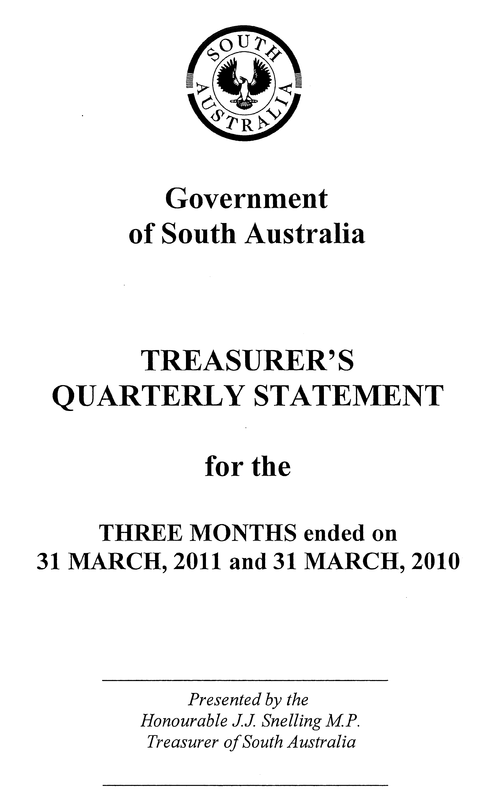
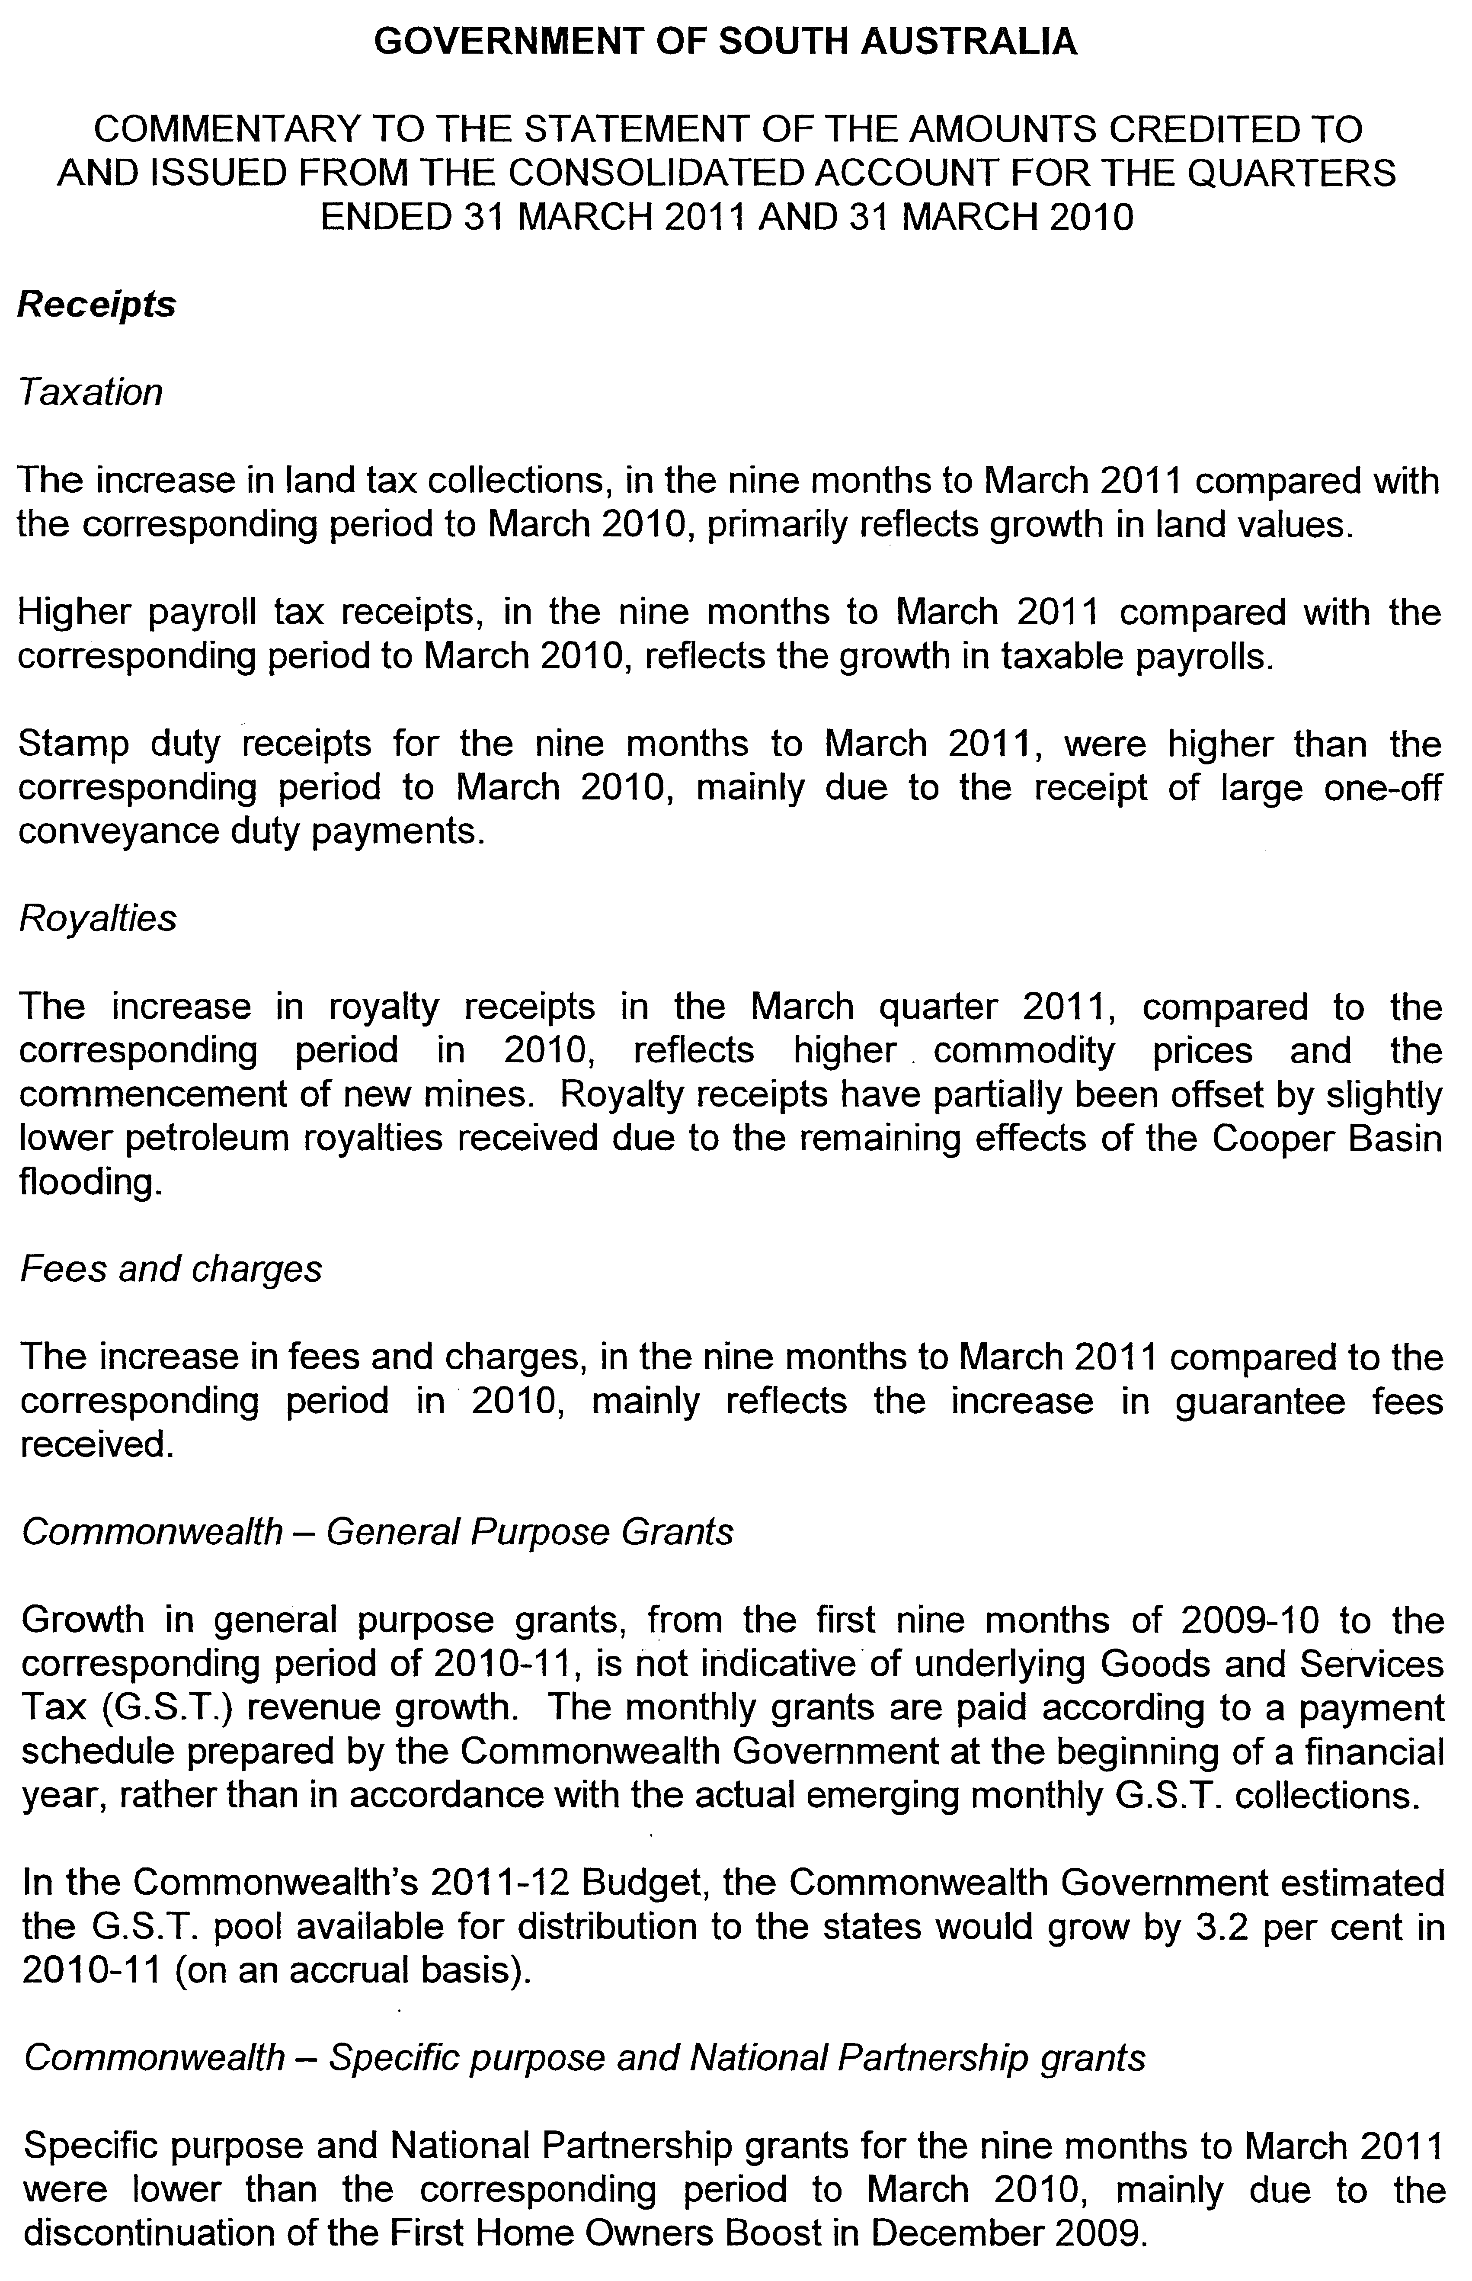
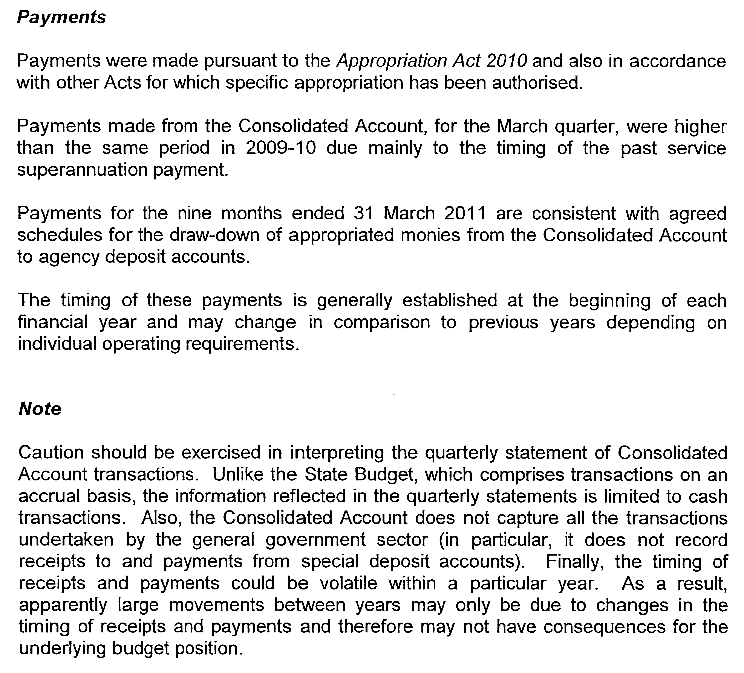

WATERWORKS ACT 1932
Addition of Land to Tod River Country Lands Water District
PURSUANT to Section 6 of the Waterworks Act 1932, the South Australian Water Corporation:
(a) adds to the Tod River Country Lands Water District all the land shown on the plan in the schedule; and
(b) declares that this notice will have effect from 1 July 2011.

Dated 24 August 2011.
Signed for and on behalf of the South Australian Water Corporation by a person duly authorised so to do:
A. Schirripa, Manager Billing and Collection
In the presence of:
N. Glass, Team Leader Billing
SAWATER 11/02992 W1485

WATER MAINS AND SEWERS

Office of the South Australian Water Corporation
Adelaide, 1 September 2011

WATER MAINS LAID

Notice is hereby given that the following main pipes or parts of main pipes have been laid down by the South Australian Water Corporation in or near the undermentioned water districts and are now available for a constant supply of water to adjacent land.

ADELAIDE WATER DISTRICT

CITY OF MARION
Bowaka Street, Park Holme. p3

CITY OF ONKAPARINGA
Across Christopher Road, Christie Downs. p1
Agnes Street, Christie Downs. p1

BAROSSA COUNTRY LANDS WATER DISTRICT

LIGHT REGIONAL COUNCIL
In and across Parkers Road, Ward Belt. p68-91

BEETALOO COUNTRY LANDS WATER DISTRICT

PORT PIRIE REGIONAL COUNCIL
In and across Nurom Road, Nurom. p107

DISTRICT COUNCIL OF YORKE PENINSULA
Easements in allotment piece 7 in LTRO FP 106994, Upper Yorke Road, Kainton. p4 and 7
Across and in Upper Yorke Road, Kainton. p4 and 8

BUNDALEER COUNTRY LANDS WATER DISTRICT

WAKEFIELD REGIONAL COUNCIL
In and across Port Wakefield-Port Augusta Road (known as Highway One), Beaufort and Nantawarra. p10-25

CUMMINS WATER DISTRICT

DISTRICT COUNCIL OF LOWER EYRE PENINSULA
Bratten Way, Cummins. p57 and 65-67
Easement in lot 60 in LTRO DP 31085, Warrow Road, Cummins. p102
Across Bratten Way, Cummins. p102

MIDDLETON WATER DISTRICT

ALEXANDRINA COUNCIL
In and across Seaview Avenue, Middleton. p92-98
Across and in Mindacowie Terrace, Middleton. p92, 96 and 97
Surf Street, Middleton. p92 and 93

PINNAROO WATER DISTRICT

SOUTHERN MALLEE DISTRICT COUNCIL
Across and in government road west of section 280, hundred of Pinnaroo, Pinnaroo. p46
Railway land (allotment piece 110 and lot 106 in LTRO DP 65615, Chandos Road, Pinnaroo. p46
Easement in lot 105 in LTRO DP 65615, Silo Road, Pinnaroo. p46
In and across Foster Road, Pinnaroo. p47
Kruse Road, Pinnaroo. p48
Across South Terrace, Pinnaroo. p49
Gordon Terrace, Pinnaroo. p49-51
Easement in allotment piece 106, lot 101 and allotment piece 105 in LTRO DP 44183, Gordon Terrace, Pinnaroo. p50
PORT AUGUSTA WATER DISTRICT

PORT AUGUSTA CITY COUNCIL
Clarke Street, Port Augusta. p2

TOD RIVER COUNTRY LANDS WATER DISTRICT

DISTRICT COUNCIL OF FRANKLIN HARBOUR
Millers Point Road, Cowell. p101

DISTRICT COUNCIL OF LOWER EYRE PENINSULA
In and across Bratten Way, Cummins. p57-67

WUDINNA DISTRICT COUNCIL
Waterworks land (sections 23 and 34, hundred of Koongawa), Koongawa. p44
Easements is section 3, hundred of Koongawa, Koongawa. p44

TUMBY BAY WATER DISTRICT

DISTRICT COUNCIL OF TUMBY BAY
Young Street, Tumby Bay. p100

WARREN COUNTRY LANDS WATER DISTRICT

LIGHT REGIONAL COUNCIL
In and across Meaney Road, Freeling and Linwood. p26 and 27
In and across Bald Road, Linwood. p26-40
Easements in allotment piece 129 in LTRO FP 216009, lot 1 in LTRO FP 219209 and lot 99 in LTRO FP 215750, Main North Road, Linwood. p26 and 40-42
Across Christian Road, Linwood. p26 and 42
Easement in lot 92 in LTRO FP 216883, Main North Road, Linwood. p26, 42 and 43

WHYALLA WATER DISTRICT

THE CORPORATION OF THE CITY OF WHYALLA
Grundel Street, Whyalla Norrie. p106

WATER MAINS ABANDONED

Notice is hereby given that the undermentioned water mains have been abandoned by the South Australian Water Corporation.

BAROSSA COUNTRY LANDS WATER DISTRICT

LIGHT REGIONAL COUNCIL
Across and in Parkers Road, Ward Belt. p68-89

BEETALOO COUNTRY LANDS WATER DISTRICT

PORT PIRIE REGIONAL COUNCIL
Nurom Road, Nurom. p107
Public road east of allotment piece 9 in LTRO FP 218653, Nurom. p107

DISTRICT COUNCIL OF YORKE PENINSULA
Easement in section 87, hundred of Clinton, Kainton Road, Kainton. p4 and 5
Across and in Kainton Road, Kainton. p4 and 5
Upper Yorke Road, Kainton. p4, 5, 7 and 8
Waterworks land (lot 1 in LTRO DP 12824), Upper Yorke Road, Kainton. p4-6
Easement in lot 2 in LTRO DP 12824 and allotment piece 7 in LTRO FP 106994, Upper Yorke Road, Kainton. p4, 5 and 7

BUNDALEER COUNTRY LANDS WATER DISTRICT

WAKEFIELD REGIONAL COUNCIL
Port Wakefield-Port Augusta Road (known as Highway One), Beaufort. p10, 11 and 24

CUMMINS WATER DISTRICT

DISTRICT COUNCIL OF LOWER EYRE PENINSULA
Bratten Way, Cummins. p57 and 65

MIDDLETON WATER DISTRICT

ALEXANDRINA COUNCIL
In and across Seaview Avenue, Middleton. p92-97
Across and in Mindacowie Terrace, Middleton. p92, 96 and 97
Surf Street, Middleton. p92 and 93

PINNAROO WATER DISTRICT

SOUTHERN MALLEE DISTRICT COUNCIL
Across and in government road west of section 280, hundred of Pinnaroo, Pinnaroo. p46
Railway land (allotment piece 110 and lot 106 in LTRO DP 65615, Chandos Road, Pinnaroo. p46
Easement in lot 105 in LTRO DP 65615, Silo Road, Pinnaroo. p46
In and across Foster Road, Pinnaroo. p47
Kruse Road, Pinnaroo. p48
Across South Terrace, Pinnaroo. p49
Gordon Terrace, Pinnaroo. p49-51
Easement in allotment piece 106, lot 101 and allotment piece 105 in LTRO DP 44183, Gordon Terrace, Pinnaroo. p50

TOD RIVER COUNTRY LANDS WATER DISTRICT

DISTRICT COUNCIL OF FRANKLIN HARBOUR
In and across Millers Point Road, Cowell. p101
Easement in lot 91 in LTRO FP 206959, Millers Point Road, Cowell. p101
Across government road west of lot 91 in LTRO FP 206959, Cowell. p101
Easements in sections 37 and 38, hundred of Playford, Sykes Road, Cowell. p101

DISTRICT COUNCIL OF LOWER EYRE PENINSULA
Waterworks land (lot 6 in LTRO DP 25759), Limestone Lane, Coffin Bay. p55
Bratten Way, Cummins. p57-66

WUDINNA DISTRICT COUNCIL
Easement in section 3, hundred of Koongawa. p44

WARREN COUNTRY LANDS WATER DISTRICT

LIGHT REGIONAL COUNCIL
In and across Meaney Road, Freeling and Linwood. p27
Bald Road, Linwood. p27-40
Main North Road, Linwood. p40-43

WHYALLA WATER DISTRICT

THE CORPORATION OF THE CITY OF WHYALLA
Grundel Street, Whyalla Norrie. p106

SEWERS LAID

Notice is hereby given that the following sewers have been laid down by the South Australian Water Corporation in the undermentioned drainage area and are now available for house connections.

ADELAIDE DRAINAGE AREA

CITY OF CHARLES STURT
MacLagan Avenue, Allenby Gardens. FB 1211 p47

CITY OF HOLDFAST BAY
Sandison Terrace, Glenelg North. FB 1211 p43

CITY OF MARION
Marine Parade, Marino. FB 1211 p42
Finniss Street, Marion. FB 1211 p50

CITY OF PLAYFORD
Easements in lots 13 and 12 in LTRO DP 6145, Norton Street, Elizabeth North. FB 1211 p46

CITY OF PORT ADELAIDE ENFIELD
Macedonia Street, Taperoo. FB 1211 p44
Frome Avenue, Hampstead Gardens. FB 1211 p49

CITY OF TEA TREE GULLY
Milgun Court, Gilles Plains. FB 1211 p45

CITY OF WEST TORRENS
Press Road, Brooklyn Park. FB 1211 p48

SEWERS ABANDONED

Notice is hereby given that the undermentioned sewer has been abandoned by the South Australian Water Corporation.

ADELAIDE DRAINAGE AREA

CITY OF PLAYFORD
Easement in lot 13 in LTRO DP 6145, Norton Street, Elizabeth North. FB 1211 p46

ADDENDUM

Addendum to notices in “Government Gazette” of 18 August 2011

“SEWERS LAID”

“Notice is hereby given that the following sewers have been laid down by the South Australian Water Corporation in the undermentioned drainage areas and are now available for house connections.”

“ADELAIDE DRAINAGE AREA”

“CITY OF MITCHAM”

“Across Holly Hock Court, Craigburn Farm. FB 1210 p17 and 18”

“Easements in lot 613 in LTRO DP 86606, Shelter Row, Craigburn Farm. FB 1210 p17 and 18”

To these notices add “These mains are not available for the first 114.70 m”

A. J. Ringham, Chief Executive Officer, South Australian Water Corporation.

WILDERNESS PROTECTION REGULATIONS 2006
Closure of Cape Torrens Wilderness Protection Area and
Western River Wilderness Protection Area
PURSUANT to Regulation 6 (2) (c) of the Wilderness Protection Regulations 2006, I, Edward Gregory Leaman, Director of National Parks and Wildlife close to the public the whole of Cape Torrens Wilderness Protection Area and the whole of Western River Wilderness Protection Area from 6 p.m. on Sunday, 20 November 2011 until 6 a.m. on Saturday, 26 November 2011.
The purpose of the closure is to ensure the safety of the public during a pest control and monitoring program within the wilderness protection areas during the period indicated.
Use of Firearms Within the Wilderness Protection Areas
Pursuant to Regulations 6 (3), 16 (1) (a) and 34 of the Wilderness Protection Regulations 2006, I, Edward Gregory Leaman, Director of National Parks and Wildlife grant permission to staff employed by the Kangaroo Island Natural Resources Management Board in possession of both a current Hunting Permit and a firearm to enter and remain in the whole of Cape Torrens Wilderness Protection Area and the whole of Western River Wilderness Protection Area from 6 p.m. on Sunday, 20 November 2011 until 6 a.m. on Saturday, 26 November 2011, for the purpose of taking feral animals.
This permission is conditional upon the observance by each of those persons of the requirements of the Wilderness Protection Act 1992, Wilderness Protection Regulations 2006 and the National Parks and Wildlife (Hunting) Regulations 1996, including those requiring compliance with the Director’s requests, requirements and orders of a Warden.
Dated 23 August 2011.
E. G. Leaman, Director of National Parks and Wildlife

WILDERNESS PROTECTION REGULATIONS 2006
Closure of Cape Torrens Wilderness Protection Area and
Western River Wilderness Protection Area
PURSUANT to Regulation 6 (2) (c) of the Wilderness Protection Regulations 2006, I, Edward Gregory Leaman, Director of National Parks and Wildlife close to the public the whole of Cape Torrens Wilderness Protection Area and the whole of Western River Wilderness Protection Area from 6 p.m. on Sunday, 11 December 2011 until 6 a.m. on Saturday, 17 December 2011.
The purpose of the closure is to ensure the safety of the public during a pest control and monitoring program within the wilderness protection areas during the period indicated.
Use of Firearms Within the Wilderness Protection Areas
Pursuant to Regulations 6 (3), 16 (1) (a) and 34 of the Wilderness Protection Regulations 2006, I, Edward Gregory Leaman, Director of National Parks and Wildlife grant permission to staff employed by the Kangaroo Island Natural Resources Management Board in possession of both a current Hunting Permit and a firearm to enter and remain in the whole of Cape Torrens Wilderness Protection Area and the whole of Western River Wilderness Protection Area from 6 p.m. on Sunday, 11 December 2011 until 6 a.m. on Saturday, 17 December 2011, for the purpose of taking feral animals.
This permission is conditional upon the observance by each of those persons of the requirements of the Wilderness Protection Act 1992, Wilderness Protection Regulations 2006 and the National Parks and Wildlife (Hunting) Regulations 1996, including those requiring compliance with the Director’s requests, requirements and orders of a Warden.
Dated 23 August 2011.
E. G. Leaman, Director of National Parks and Wildlife

GOVERNMENT GAZETTE ADVERTISEMENT RATES

To apply from 1 July 2011

$  Agents, Ceasing to Act as 45.50  Associations:  Incorporation 23.00  Intention of Incorporation 57.00  Transfer of Properties 57.00  Attorney, Appointment of 45.50  Bailiff’s Sale 57.00  Cemetery Curator Appointed 33.75  Companies:  Alteration to Constitution 45.50  Capital, Increase or Decrease of 57.00  Ceasing to Carry on Business 33.75  Declaration of Dividend 33.75  Incorporation 45.50  Lost Share Certificates:  First Name 33.75  Each Subsequent Name 11.60  Meeting Final 38.00  Meeting Final Regarding Liquidator’s Report on  Conduct of Winding Up (equivalent to ‘Final  Meeting’)  First Name 45.50  Each Subsequent Name 11.60  Notices:  Call 57.00  Change of Name 23.00  Creditors 45.50  Creditors Compromise of Arrangement 45.50  Creditors (extraordinary resolution that ‘the Com-pany be wound up voluntarily and that a liquidator be appointed’) 57.00  Release of Liquidator⎯Application⎯Large Ad. 90.50  ⎯Release Granted 57.00  Receiver and Manager Appointed 52.50  Receiver and Manager Ceasing to Act 45.50  Restored Name 42.50  Petition to Supreme Court for Winding Up 79.00  Summons in Action 67.50  Order of Supreme Court for Winding Up Action 45.50  Register of Interests⎯Section 84 (1) Exempt 102.00  Removal of Office 23.00  Proof of Debts 45.50  Sales of Shares and Forfeiture 45.50  Estates:  Assigned 33.75  Deceased Persons⎯Notice to Creditors, etc. 57.00  Each Subsequent Name 11.60  Deceased Persons⎯Closed Estates 33.75  Each Subsequent Estate 1.50  Probate, Selling of 45.50  Public Trustee, each Estate 11.60 |  | $  Firms:  Ceasing to Carry on Business (each insertion) 30.25  Discontinuance Place of Business 30.25  Land⎯Real Property Act:  Intention to Sell, Notice of 57.00  Lost Certificate of Title Notices 57.00  Cancellation, Notice of (Strata Plan) 57.00  Mortgages:  Caveat Lodgement 23.00  Discharge of 24.10  Foreclosures 23.00  Transfer of 23.00  Sublet 11.60  Leases⎯Application for Transfer (2 insertions) each 11.60  Lost Treasury Receipts (3 insertions) each 33.75  Licensing 67.50  Municipal or District Councils:  Annual Financial Statement⎯Forms 1 and 2 636.00  Electricity Supply⎯Forms 19 and 20 452.00  Default in Payment of Rates:  First Name 90.50  Each Subsequent Name 11.60  Noxious Trade 33.75  Partnership, Dissolution of 33.75  Petitions (small) 23.00  Registered Building Societies (from Registrar-General) 23.00  Register of Unclaimed Moneys⎯First Name 33.75  Each Subsequent Name 11.60  Registers of Members⎯Three pages and over:  Rate per page (in 8pt) 289.00  Rate per page (in 6pt) 382.00  Sale of Land by Public Auction 57.50  Advertisements 3.20  ¼ page advertisement 135.00  ½ page advertisement 270.00  Full page advertisement 529.00  Advertisements, other than those listed are charged at $3.20 per column line, tabular one-third extra.  Notices by Colleges, Universities, Corporations and District Councils to be charged at $3.20 per line.  Where the notice inserted varies significantly in length from that which is usually published a charge of $3.20 per column line will be applied in lieu of advertisement rates listed.  South Australian Government publications are sold on the condition that they will not be reproduced without prior permission from the Government Printer.
All the above prices include GST

GOVERNMENT GAZETTE NOTICES
ALL private advertisements forwarded for publication in the South Australian Government Gazette must be PAID FOR PRIOR TO INSERTION; and all notices, from whatever source, should be legibly written on one side of the paper only and sent to Government Publishing SA so as to be received no later than 4 p.m. Tuesday preceding the day of publication. Phone 8207 1045 or Fax 8207 1040. E-mail: governmentgazette@dpc.sa.gov.au. Send as attachments in Word format. Please include date the notice is to be published and to whom the notice will be charged. The Government Gazette is available online at: www.governmentgazette.sa.gov.au.

MISCELLANEOUS LEGISLATION AND GOVERNMENT PUBLICATIONS PRICES AS FROM 1 JULY 2011

Acts, Bills, Rules, Parliamentary Papers and Regulations
Pages | Main | Amends | Pages | Main | Amends

1-16 | 2.80 | 1.30 | 497-512 | 38.50 | 37.50
17-32 | 3.70 | 2.30 | 513-528 | 39.50 | 38.25
33-48 | 4.85 | 3.45 | 529-544 | 41.00 | 39.50
49-64 | 6.10 | 4.70 | 545-560 | 42.00 | 41.00
65-80 | 7.10 | 5.90 | 561-576 | 43.00 | 42.00
81-96 | 8.30 | 6.85 | 577-592 | 44.50 | 42.50
97-112 | 9.45 | 8.10 | 593-608 | 45.75 | 44.00
113-128 | 10.60 | 9.30 | 609-624 | 46.50 | 45.50
129-144 | 11.80 | 10.50 | 625-640 | 47.75 | 46.00
145-160 | 13.00 | 11.60 | 641-656 | 49.00 | 47.75
161-176 | 14.10 | 12.80 | 657-672 | 49.75 | 48.25
177-192 | 15.40 | 13.90 | 673-688 | 51.50 | 49.75
193-208 | 16.60 | 15.30 | 689-704 | 52.50 | 50.50
209-224 | 17.50 | 16.20 | 705-720 | 53.50 | 52.00
225-240 | 18.70 | 17.30 | 721-736 | 55.00 | 53.00
241-257 | 20.10 | 18.30 | 737-752 | 55.50 | 54.00
258-272 | 21.20 | 19.40 | 753-768 | 57.00 | 55.00
273-288 | 22.30 | 21.00 | 769-784 | 58.00 | 57.00
289-304 | 23.30 | 21.90 | 785-800 | 59.00 | 58.00
305-320 | 24.70 | 23.20 | 801-816 | 60.50 | 58.50
321-336 | 25.75 | 24.30 | 817-832 | 61.50 | 60.50
337-352 | 27.00 | 25.50 | 833-848 | 63.00 | 61.50
353-368 | 27.75 | 26.75 | 849-864 | 64.00 | 62.50
369-384 | 29.25 | 27.75 | 865-880 | 65.50 | 64.00
385-400 | 30.50 | 29.00 | 881-896 | 66.00 | 64.50
401-416 | 31.75 | 30.00 | 897-912 | 67.50 | 66.00
417-432 | 33.00 | 31.50 | 913-928 | 68.00 | 67.50
433-448 | 34.00 | 32.75 | 929-944 | 69.00 | 68.00
449-464 | 34.75 | 33.50 | 945-960 | 70.00 | 68.50
465-480 | 35.25 | 34.50 | 961-976 | 73.00 | 69.50
481-496 | 37.50 | 35.25 | 977-992 | 74.00 | 70.00

Legislation—Acts, Regulations, etc: $
Subscriptions:
Acts 237.00
All Bills as Laid 570.00
Rules and Regulations 570.00
Parliamentary Papers 570.00
Bound Acts 263.00
Index 132.00
Government Gazette
Copy 6.25
Subscription 315.00
Hansard
Copy 17.30
Subscription—per session (issued weekly) 494.00
Cloth bound—per volume 212.00
Subscription—per session (issued daily) 494.00
Legislation on Disk
Whole Database 3 660.00
Annual Subscription for fortnightly updates 1 125.00
Individual Act(s) including updates POA
Notice of Vacancies
Annual Subscription 174.00
Compendium
Subscriptions:
New Subscriptions 2 167.00
Updates 765.00
(All the above prices include GST)

All Legislation, Government Gazette, Hansard and Legislation on disk are available from:
Counter Sales Government Legislation Outlet
and Mail Orders: Service SA Customer Service Centre,
Ground Floor—EDS Centre, 108 North Terrace, Adelaide, S.A. 5000
Phone: 13 23 24 (local call cost), Fax: (08) 8204 1909
Postal: G.P.O. Box 1707, Adelaide, S.A. 5001

Online Shop: www.shop.service.sa.gov.au

Subscriptions and Government Publishing SA
Standing Orders: Box 9, Plaza Level, Riverside Centre, North Terrace, Adelaide, S.A. 5000
Phone: (08) 8207 1043, (08) 8207 0910, Fax: (08) 8207 1040

[Republished]
IN Government Gazette dated 25 August 2011 on page 3620, because of a typographical error this notice should read as follows:

WORKERS REHABILITATION AND COMPENSATION ACT 1986
Publication of Designated Forms
Preamble
Section 3 (13) of the Workers Rehabilitation and Compensation Act 1986 (the Act), provides that ‘A reference in a provision of this Act to a designated form is a reference to a form designated for the purposes of that provision by the Minister from time to time by notice in the Gazette.’
Notice
PURSUANT to Section 39 (1a) of the Act, the Minister for Workers Rehabilitation gives notice that the template letter at Schedule 1 is a ‘designated form’ for the purposes of that provision, and replaces the template letter published in the South Australian Government Gazette on 18 December 2008.
PURSUANT to Section 39 (3) of the Act, the Minister for Workers Rehabilitation gives notice that the template letter at Schedule 2 is a ‘designated form’ for the purposes of that provision, and replaces the template letter published in the South Australian Government Gazette on 10 July 2008.

Jack Snelling, Minister for Workers Rehabilitation

South Australia
Constitution (Legislative Council Casual Vacancy) Proclamation 2011
under section 13 of the Constitution Act 1934

Preamble
1 A seat of a member of the Legislative Council has become vacant by virtue of the resignation of the Honourable Paul Holloway, MLC.
2 A person must be chosen to occupy the vacant seat by an assembly of the members of both Houses of Parliament.
3 It is necessary to make provision in relation to the constitution and proceedings of that assembly.

1—Short title
This proclamation may be cited as the Constitution (Legislative Council Casual Vacancy) Proclamation 2011.
2—Commencement
This proclamation comes into operation on the day on which it is made.
3—Provisions relating to the assembly of members
The following provisions apply in relation to the constitution and proceedings of an assembly of the members of both Houses of Parliament to choose a person to occupy the vacant seat in the Legislative Council caused by the resignation of the Honourable Paul Holloway, MLC:
(a) the assembly will meet at 10:00 am on Tuesday, 13 September 2011 at the Legislative Council Chamber;
(b) the Honourable Robert Kenneth Sneath, MLC, is appointed to preside over the assembly;
(c) Janice Maxine Davis is appointed to be clerk of the assembly;
(d) the following rules are to be observed at the assembly and applied as the method by which the decision of the assembly will be evidenced:
(i) the presiding officer will take the chair;
(ii) the clerk of the assembly will read this proclamation;
(iii) the presiding officer will invite nominations for the vacant seat from the members of the assembly;
(iv) nominations will first be made without debate;
(v) a nomination will not be accepted by the presiding officer unless—
(A) the nomination is seconded; and
(B) the person nominated is a person who can lawfully be chosen by the assembly to occupy the vacancy;
(vi) when it appears that no further nominations are to be made, the members making the nominations, the members seconding the nominations and any other members of the assembly may speak if they desire;
(vii) when members have concluded their remarks, a ballot will be taken if necessary;
(viii) the presiding officer will announce to the assembly the name of the person chosen to occupy the vacant seat;
(ix) the President of the Legislative Council must be informed in writing of the decision of the assembly and notice of the decision must be published in the Gazette.
Made by the Governor
with the advice and consent of the Executive Council
on 1 September 2011
DPC11/036CS

South Australia
Correctional Services (Appointment of Visiting Tribunals) Variation Proclamation 2011
under section 17 of the Correctional Services Act 1982
Part 1—Preliminary
1—Short title
This proclamation may be cited as the Correctional Services (Appointment of Visiting Tribunals) Variation Proclamation 2011.
2—Commencement
This proclamation comes into operation on the day on which it is made.
3—Variation provisions
In this proclamation, a provision under a heading referring to the variation of a specified proclamation varies the proclamation so specified.
Part 2—Variation of proclamation under Correctional Services Act 1982 appointing Visiting Tribunals (Gazette 30.11.2000 p3356) as varied
4—Variation of clause 2
Clause 2, list—delete "Brian Roger Gitsham"
Made by the Governor
with the advice and consent of the Executive Council
on 1 September 2011
MCS11/013SC

South Australia
Mining (Revocation of Private Mine) Proclamation 2011
under section 73N of the Mining Act 1971

Preamble
1 The following area was declared to be a private mine by proclamation on 6 September 1973 (Gazette 6.9.1973 p1900):
That portion of section 107, hundred of Onkaparinga, county of Adelaide, described in certificate of title, register book, volume 3814, folio 192.
2 The Warden's Court has declared (on 1 March 2011 in Action No 2346 of 2010) that proper grounds exist for revoking the declaration referred to in clause 1.

1—Short title
This proclamation may be cited as the Mining (Revocation of Private Mine) Proclamation 2011.
2—Commencement
This proclamation comes into operation on the day on which it is made.
3—Revocation of private mine
The declaration referred to in clause 1 of the preamble is revoked.
Made by the Governor
on the basis of the declaration of the Warden's Court referred to in clause 2 of the preamble and with the advice and consent of the Executive Council
on 1 September 2011
AGO0252/11CS

South Australia
Mining (Variation of Private Mine) Proclamation 2011
under section 73N of the Mining Act 1971

Preamble
1 The following areas were declared to be a private mine by proclamation on 22 March 1973 (Gazette 22.3.1973 p1004):
(a) Those portions of sections 4483 and 4484, hundred of Macclesfield, county of Hindmarsh described in certificate of title register book volume 3866 folio 63;
(b) That portion of section 5009 hundred of Macclesfield, county of Hindmarsh described in certificate of title, register book, volume 3866, folio 64.
2 The Warden's Court has declared (on 1 March 2011 in Action No 2347 of 2010) that proper grounds exist for varying the declaration referred to in clause 1 by excising from the area of the private mine the whole of the private mine except—
The area described and contained in allotment 98 of Filed Plan 160275, (being the whole of the land comprised in Certificate of Title Register Book Volume 5792 Folio 221).

1—Short title
This proclamation may be cited as the Mining (Variation of Private Mine) Proclamation 2011.
2—Commencement
This proclamation comes into operation on the day on which it is made.
3—Variation of private mine
The declaration referred to in clause 1 of the preamble is varied by excising from the area of the private mine the whole of the private mine except for the following:
Allotment 98 of Filed Plan 160275, (being the whole of the land comprised in Certificate of Title Register Book Volume 5792 Folio 221).
Made by the Governor
on the basis of the declaration of the Warden's Court referred to in clause 2 of the preamble and with the advice and consent of the Executive Council
on 1 September 2011
AGO0253/11CS
South Australia
National Parks and Wildlife (Flinders Ranges National Park) Proclamation 2011
under section 27(3) of the National Parks and Wildlife Act 1972
1—Short title
This proclamation may be cited as the National Parks and Wildlife (Flinders Ranges National Park) Proclamation 2011.
2—Commencement
This proclamation comes into operation on the day on which it is made.
3—Alteration of boundaries of Flinders Ranges National Park
The boundaries of the Flinders Ranges National Park are altered by adding to the Park the following Crown land:
Allotment 208 of Deposited Plan 86294, Hundred of Parachilna, County of Taunton.
Made by the Governor
with the advice and consent of the Executive Council
on 1 September 2011
MEC11/0057CS

South Australia
National Parks and Wildlife (Naracoorte Caves National Park) Proclamation 2011
under section 28(2) of the National Parks and Wildlife Act 1972
1—Short title
This proclamation may be cited as the National Parks and Wildlife (Naracoorte Caves National Park) Proclamation 2011.
2—Commencement
This proclamation comes into operation on the day on which it is made.
3—Alteration of boundaries of Naracoorte Caves National Park
The boundaries of the Naracoorte Caves National Park are altered by adding to the Park the following Crown land:
Allotment 30 of Deposited Plan 44224, Hundred of Joanna, County of Robe;
Allotment 64 of Deposited Plan 55385, Hundred of Jessie, County of Robe;
Allotment 66 of Deposited Plan 55385, Hundred of Joanna, County of Robe;
Allotment 14 of Deposited Plan 68430, Hundred of Joanna, County of Robe;
Allotment 102 of Deposited Plan 63720, Hundred of Joanna, County of Robe;
Pieces 16 and 17 of Deposited Plan 66930, Hundred of Joanna, County of Robe;
Allotment 1 of Deposited Plan 66931, Hundred of Naracoorte, County of Robe.
Made by the Governor
with the advice and consent of the Executive Council
on 1 September 2011
MEC11/0056CS

South Australia
Development (Open Space Contribution Scheme)
Variation Regulations 2011
under the Development Act 1993

Contents
Part 1—Preliminary
1 Short title
2 Commencement
3 Variation provisions
Part 2—Variation of Development Regulations 2008
4 Variation of regulation 56—Open space contribution scheme

Part 1—Preliminary
1—Short title
These regulations may be cited as the Development (Open Space Contribution Scheme) Variation Regulations 2011.
2—Commencement
These regulations come into operation on the day on which they are made.
3—Variation provisions
In these regulations, a provision under a heading referring to the variation of specified regulations varies the regulations so specified.
Part 2—Variation of Development Regulations 2008
4—Variation of regulation 56—Open space contribution scheme
(1) Regulation 56(2)(a) and (b)—delete paragraphs (a) and (b) and substitute:
(a) where the land to be divided is within Metropolitan Adelaide or Outer-Metropolitan Adelaide—$6 150 for each new allotment or strata lot delineated on the relevant plan that does not exceed 1 hectare in area;
(2) Regulation 56(2)(c)—delete "$2 680" and substitute:
$2 758
Note—
As required by section 10AA(2) of the Subordinate Legislation Act 1978, the Minister has certified that, in the Minister's opinion, it is necessary or appropriate that these regulations come into operation as set out in these regulations.
Made by the Governor
with the advice and consent of the Executive Council
on 1 September 2011
No 212 of 2011

South Australia
Recreation Grounds Regulations 2011
under the Recreation Grounds (Regulations) Act 1931

Contents
Part 1—Preliminary
1 Short title
2 Commencement
3 Interpretation
4 Delegation
Part 2—Use of recreation grounds
5 Entry to and exit from grounds
6 Entrance fees
7 Behaviour of persons on grounds
8 Removal of person from grounds
9 Powers of authorised persons
Schedule 1—Recreation grounds
Schedule 2—Revocation
1 Revocation

Part 1—Preliminary
1—Short title
These regulations may be cited as the Recreation Grounds Regulations 2011.
2—Commencement
These regulations will come into operation on 1 September 2011.
3—Interpretation
(1) In these regulations—
authorised person, in relation to a recreation ground, means—
(a) a person authorised by the controlling body of that recreation ground for the purposes of these regulations; or
(b) a member of the police force or a special constable;
controlling body, in relation to a recreation ground, means the body listed in Schedule 1 against the name of the recreation ground.
(2) A reference in these regulations to a recreation ground is a reference to a recreation ground specified in Schedule 1.
4—Delegation
(1) The controlling body of a recreation ground may, by instrument in writing executed by the controlling body, delegate to a person or body any power or function of the controlling body under these regulations other than this power of delegation.
(2) A delegation under this regulation may be given subject to conditions and limitations specified in the instrument of delegation.
(3) A delegation under this regulation is revocable at will and does not prevent the controlling body from acting in any matter.
Part 2—Use of recreation grounds
5—Entry to and exit from grounds
(1) A person must not enter a recreation ground except by an entrance provided by the controlling body.
Maximum penalty: $250.
(2) A person must not leave a recreation ground except by an exit provided by the controlling body.
Maximum penalty: $250.
6—Entrance fees
A person must not enter a recreation ground, or a part of a recreation ground to which access is restricted by the controlling body, unless the person—
(a) pays the entrance fee (if any); or
(b) is otherwise authorised by the controlling body to enter.
Maximum penalty: $500.
7—Behaviour of persons on grounds
(1) A person must not, while on a recreation ground, remain in a walkway or on stairs after having been requested to move from that position by an authorised person.
Maximum penalty: $250.
(2) A person must not—
(a) deposit litter, refuse or waste matter in any place (other than a receptacle provided for that purpose); or
(b) distribute any printed matter; or
(c) erect a sign; or
(d) offer any article for sale; or
(e) take up a collection; or
(f) drive or ride any vehicle; or
(g) bring a dog or, if the owner or person in charge of a dog, allow the dog to remain; or
(h) climb or be on a fence, tree, building, wall or other structure,
on a recreation ground except as authorised by the controlling body or these regulations.
Maximum penalty: $250.
(3) A person who needs the assistance of a guide dog may bring the dog onto a recreation ground if at all times it is restrained on a lead not exceeding 3 metres in length.
(4) A person must not, except as authorised by the controlling body—
(a) bring an intoxicating beverage onto a recreation ground; or
(b) drink an intoxicating beverage on a recreation ground.
Maximum penalty: $250.
(5) A person must not, while on a recreation ground, smoke in an area where smoking is prohibited by the controlling body by signs erected with the authority of the controlling body.
Maximum penalty: $250.
(6) A person must not—
(a) obstruct or interfere with the conduct of a sporting or other event on a recreation ground or the reasonable enjoyment of a spectator of such an event; or
(b) enter onto, or be on, an oval or playing field or other area within a recreation ground used for the staging of sporting or other events on a day on which such an event is scheduled to occur unless—
(i) the person is a player, competitor, umpire, official, medical attendant, performer or technician or is otherwise officially involved in the event or in the preparations for the event; or
(ii) the person has been authorised by the controlling body so to enter.
Maximum penalty: $5 000.
(7) A person must not, while on or in the vicinity of a recreation ground, misuse or damage any property of—
(a) the controlling body of the recreation ground; or
(b) a person or body that has been granted a right to occupy the recreation ground or part of the recreation ground (whether under a lease, licence, contract for hire or any other agreement for the occupancy of land).
Maximum penalty: $5 000.
(8) A person must not, while on or in the vicinity of a recreation ground, carry or be in possession of a flare, firework, explosive device or missile without lawful excuse (proof of which lies on the person).
Maximum penalty: $5 000.
8—Removal of person from grounds
A member of the police force or special constable may remove from a recreation ground any person reasonably suspected of having committed an offence while on the recreation ground and a person who has been so removed on a particular day must not re-enter the recreation ground on that day.
Maximum penalty: $1 250.
9—Powers of authorised persons
(1) If an authorised person reasonably suspects that a vehicle or dog (other than a guide dog)—
(a) has been brought onto a recreation ground or a part of a recreation ground in breach of these regulations; or
(b) is obstructing or interfering with, or is likely to obstruct or interfere with, the conduct of a sporting or other event on the recreation ground or the reasonable enjoyment of a spectator of such an event,
the authorised person may require the owner or person in charge of the vehicle or dog to remove the vehicle or dog from the recreation ground (or from a part of it) or, if the owner or person in charge of the vehicle or dog cannot be located in the vicinity, may remove the vehicle or dog from the recreation ground (or part of it).
(2) An authorised person may require a person who the authorised person reasonably suspects of having breached these regulations to state truthfully the person's full name and usual place of residence.
(3) A person must not, without reasonable excuse, refuse or fail to comply with a requirement of an authorised person under this regulation.
Maximum penalty: $1 250.
Schedule 1—Recreation grounds

Name of recreation ground | Description of land | Controlling body
Adelaide Oval | That part of the North Park Lands at Adelaide leased by the Corporation of the City of Adelaide to Trustees for the South Australian Cricket Association Incorporated under and by virtue of Memorandum of Lease dated 30 November 1994. | The South Australian Cricket Association Incorporated
Adelaide Showground | The whole of the land described in Certificate of Title Register Book Volume 5413 Folio 774. | Royal Agricultural and Horticultural Society of South Australia Incorporated
Adelaide Super-Drome | The whole of the land described in Certificate of Title Register Book Volume 5810 Folio 404. | Minister for Recreation, Sport and Racing
Athletics Stadium | The whole of the land described in Certificate of Title Register Book Volume 5983 Folio 203. | Minister for Recreation, Sport and Racing
Balaklava Racecourse | The whole of the land described in Certificate of Title Register Book Volume 6036 Folio 650. | Balaklava Racing Club Incorporated
Barossa recreation grounds— |  | The Barossa Council
(a) Angas Recreation Park | The whole of the land described in Certificates of Title Register Book Volume 5360 Folio 792, Volume 5675 Folio 727, Volume 5710 Folio 359, Volume 5796 Folio 108 and Volume 5830 Folio 592.
(b) Curdnatta Recreation Ground | The whole of the land described in Certificates of Title Register Book Volume 5725 Folio 628.
(c) Lyndoch Recreation Ground | The whole of the land described in Certificates of Title Register Book Volume 5677 Folios 209, 210 and 211.
(d) Moculta District Recreation Park | The whole of the land described in Certificate of Title Register Book Volume 5411 Folio 858.
(e) Stockwell Recreation Park | The whole of the land described in Certificate of Title Register Book Volume 5914 Folio 918.
(f) Talunga Park | The whole of the land described in Certificates of Title Register Book Volume 5555 Folio 5 and Volume 5768 Folio 33.
(g) Tanunda Recreation Park | The whole of the land described in Certificate of Title Register Book Volume 5905 Folio 680.
(h) Williamstown Queen Victoria Jubilee Recreation Ground | The whole of the land described in Certificate of Title Register Book Volume 5173 Folio 234.
Clare Racecourse | The whole of the land described in Certificates of Title Register Book Volume 5647 Folio 465 and Volume 5836 Folio 302. | Clare Racing Club Incorporated
Copper Coast recreation grounds— |  | District Council of Copper Coast
(a) Kadina Oval | Crown Record Volume 5577 Folio 516.
(b) Recreation Centre | Crown Record Volume 5577 Folio 516.
(c) Moonta Oval | The whole of the land described in Certificate of Title Register Book Volume 5429 Folio 547.
(d) Moonta Gun Club | Crown Record Volume 5755 Folio 956.
(e) Paskerville Recreation Ground | Crown Record Volume 5755 Folio 947.
(f) Wallaroo Recreation Ground | Crown Record Volume 5756 Folio 457.
Eagle Mountain Bike Park | The whole of the land described in Certificate of Title Register Book Volume 5949 Folio 563, Volume 5960 Folio 614. | Minister for Recreation, Sport and Racing
Elizabeth Oval | The whole of the land described in Crown Record Register Book Volume 5752 Folio 704. | City of Playford
Football Park | The whole of the land described in Certificates of Title Register Book Volume 5854 Folio 360, Volume 5178 Folio 136, Volume 6028 Folio 910, Volume 5216 Folio 81, Volume 5503 Folio 274 and Volume 5503 Folio 275. | The South Australian National Football League Incorporated
Gawler Racecourse | The whole of the land described in Certificate of Title Register Book Volume 6079 Folio 738. | Gawler & Barossa Racing Club Incorporated
Glenelg Oval | The whole of the land described in Certificates of Title Register Book Volume 5869 Folio 949. | City of Holdfast Bay
Heini Becker Park | The whole of the land described in Certificate of Title Register Book Volume 5191 Folio 911, Volume 5440 Folio 192. | Minister for Recreation, Sport and Racing
Hindmarsh Stadium | The whole of the land described in Certificates of Title Register Book Volume 6005 Folios 628, 629, 630 and 631. | Minister for Recreation, Sport and Racing
Kulpara Oval | Crown Record Volume 5755 Folio 684 | District Council of Barunga West
Memorial Drive Tennis Club | That part of the North Park Lands at Adelaide leased by the Corporation of the City of Adelaide to Tennis SA Incorporated under and by virtue of Memorandum of Lease dated 1 July 1994 Part of the land in HP 106100 S 1626 Contained in Crown Record Register Book Volume 5452 Folio 85. | Tennis SA Incorporated
Mindarie-Halidon Racecourse | The whole of the land described in Certificates of Title Register Book Volume 5441 Folio 25 and Volume 5567 Folio 895. | Mindarie-Halidon Racing Club Incorporated
Monarto Shooting Complex | The whole of the land described in Certificate of Title Register Book Volume 5475 Folio 272, Volume 5475 Folio 273, Volume 5483 Folio 490. | Monarto Shooting Complex Incorporated
Morphettville Racecourse | The whole of the land described in Certificate of Title Register Book Volume 6058 Folio 99. | South Australian Jockey Club Incorporated
Mortlock Park | The land shown as Mortlock Park in Land Titles Office Plan No. 3171, section 943 being portion of land described in Certificate of Title Register Book Volume 5740 Folio 140. | The City of Mitcham
Mount Gambier Racecourse | The whole of the land described in Certificates of Title Register Book Volume 5969 Folio 43 and Volume 6080 Folio 207. | Mount Gambier Racing Club Incorporated
Murray Bridge Racecourse | The whole of the land described in Certificate of Title Register Book Volume 5160 Folio 281. | Murray Bridge Racing Club Incorporated
Noarlunga Downs Oval | The whole of the land described in Certificates of Title Register Book Volume 5333 Folio 159, Volume 5411 Folio 719 and Volume 5411 Folio 720. | The South Adelaide Football Club Incorporated
Norwood Oval | The whole of the land described in Certificates of Title Register Book Volume 5247 Folio 442, Volume 5416 Folio 398 and Volume 5416 Folio 588. | The Corporation of the City of Norwood Payneham & St Peters
Oakbank Racecourse | The whole of the land described in Certificates of Title Register Book Volume 5604 Folio 537 and Volume 5905 Folio 715. | Oakbank Racing Club Incorporated
Office for Recreation and Sport (Kidman Park Playing Fields) | The whole of the land described in Certificate of Title Register Book Volume 5523 Folio 470. | Minister for Recreation, Sport and Racing
Pines Hockey Stadium | The whole of the land described in Certificate of Title Register Book Volume 5810 Folio 405. | South Australian Hockey Association Incorporated
Port Adelaide/Enfield recreation grounds— |  | City of Port Adelaide Enfield and Port Adelaide Football Club Ltd
(a) Alberton Oval | The whole of the land described in Certificates of Title Register Book Volume 5831 Folio 45, Volume 5831 Folio 46, Volume 5831 Folio 47, Volume 5553 Folio 489 and Volume 5553 Folio 490.
(b) Eastern Parade Reserve | The whole of the land described in Certificate of Title Register Book Volume 5885 Folio 158.
(c) John Hart Reserve | The whole of the land described in Certificate of Title Register Book Volume 5976 Folio 939.
(d) Largs Reserve | The whole of the land described in Certificate of Title Register Book Volume 5932 Folio 851.
Port Lincoln Racecourse | The whole of the land described in Certificates of Title Register Book Volume 5931 Folio 262 and Volume 5931 Folio 263. | Port Lincoln Racing Club Incorporated
Prospect Oval | The whole of the land described in Certificate of Title Register Book Volume 5204 Folio 868. | The Corporation of the City of Prospect
Ramsay Park | The whole of the land described in Certificates of Title Register Book Volume 5570 Folio 631 and Volume 6051 Folio 358. | City of Playford
Richmond Oval | The whole of the land described in Certificate of Title Register Book Volume 5271 Folio 959. | The City of West Torrens
SA Aquatic & Leisure Centre | The whole of the land described in Certificates of Title Register Book Volume 5497 Folio 741, Volume 5610 Folio 705, Volume 5681 Folios 914, 915, 916 and 917, Volume 5707 Folio 672 and Volume 5880 Folios 720 and 721. | YMCA Aquatic and Event Services Limited
State Netball Centre | The whole of the land described in Certificate of Title Register Book Volume 5744 Folio 144. | South Australian Netball Association Incorporated
State Shooting Park | The whole of the land described in Certificate of Title Register Book Volume 5797 Folio 126, Volume 5845 Folio 68. | Minister for Recreation, Sport and Racing
Strathalbyn Racecourse | The whole of the land described in Certificate of Title Register Book Volume 5825 Folio 206. | Strathalbyn Racing Club Incorporated
Thebarton Oval | The whole of the land described in Certificate of Title Register Book Volume 5092 Folio 344 and portion of Volume 5436 Folio 231. | City of West Torrens
Unley Oval | The whole of the land described in Certificate of Title Register Book Volume 5831 Folio 139. | The Corporation of the City of Unley
Virginia Oval | The whole of the land described in Certificate of Title Register Book Volume 5916 Folio 58. | City of Playford
Whyalla recreation grounds— |  | The Corporation of the City of Whyalla
(a) Bennett Oval | Crown Record Volume 6018 Folio 798.
(b) Centrals Oval | Crown Record Volume 6018 Folio 798.
(c) Bradford Street Reserve | Crown Record Volume 5759 Folio 686.
(d) Club Italico Soccer Grounds | Crown Record Volume 5754 Folio 342.
(e) Dakalanta Park | Crown Record Volume 5917 Folio 33.
(f) Jenkins Park | Crown Record Volume 5752 Folio 659.
(g) Jubilee Park | Crown Record Volume 5754 Folio 342.
(h) Magill Park | Crown Record Volume 5754 Folio 346.
(i) Memorial Oval | Crown Record Volume 5752 Folio 626.
(j) Ryan Reserve | Crown Record Volume 5752 Folio 734.
(k) Schultz Reserve | Crown Record Volume 5646 Folio 894.
(l) Stuart Park | Crown Record Volume 5754 Folio 342.
(m) Swandel Park | Crown Record Volume 5753 Folio 979.
(n) Tennis Courts | Crown Record Volume 5752 Folio 669.
(o) Velodrome | Crown Record Volume 5975 Folio 392.
(p) Civic Park | Crown Record Volume 5646 Folio 894.
Women's Memorial Playing Fields | The whole of the land described in Certificate of Title Register Book Volume 5247 Folio 595. | South Australian Cricket Association Incorporated
Womma Park Rugby Oval | The whole of the land described in Certificate of Title Register Book Volume 5752 Folio 702. | City of Playford
Woodville recreation grounds— |  | City of Charles Sturt
(a) Frank Mitchell Park | The whole of the land described in Certificate of Title Register Book Volume 5552 Folio 577 and Volume 5690 Folio 340.
(b) Woodville Oval | The whole of the land described in Certificate of Title Register Book Volume 5218 Folio 142.
Schedule 2—Revocation
1—Revocation
The Recreation Grounds Regulations 1996 are revoked.
Note—
As required by section 10AA(2) of the Subordinate Legislation Act 1978, the Minister has certified that, in the Minister's opinion, it is necessary or appropriate that these regulations come into operation as set out in these regulations.
Made by the Governor
with the advice and consent of the Executive Council
on 1 September 2011
No 213 of 2011
MRSR11/003CS

FAXING COPY?
IF you fax copy to Government Publishing SA for inclusion in the Government Gazette, there is no need to send a Confirmation Copy to us as well.
This creates confusion and may well result in your notice being printed twice.
Please use the following fax number:
Fax transmission: (08) 8207 1040
Phone Enquiries: (08) 8207 1045
Please include a contact person, phone number and order number so that we can phone back with any queries we may have regarding the fax copy.
NOTE: Closing time for lodging new copy (fax, hard copy or email) is 4 p.m. on Tuesday preceding the day of publication.

Government Gazette notices can be Emailed.
The address is:
governmentgazette@dpc.sa.gov.au
Documents should be sent as attachments in Word format.
When sending a document via Email, please confirm your transmission with a faxed copy of your document, including the date the notice is to be published.
Fax transmission: (08) 8207 1040
Phone Enquiries: (08) 8207 1045
NOTE: Closing time for lodging new copy (fax, hard copy or email) is 4 p.m. on Tuesday preceding the day of publication.

CITY OF PLAYFORD
Changes to Street Names—Andrews Farm, Blakeview and
Munno Para
NOTICE is hereby given that pursuant to Section 219 of the Local Government Act 1999, Council has resolved to amend the names of the following streets:
• Griffin Drive, Andrews Farm
Rename Griffin Drive to Burley Griffin Drive in Deposited Plan 8051.
• Leibrook Boulevard, Blakeview
Rename Leibrook Boulevard to Leibrooke Boulevard in Deposited Plan 83005.
• Purdie Road, Blakeview
Rename portion of Purdie Road, Blakeview to Hayfield Avenue, Blakeview in Deposited Plan 87039.
• Coventry Road, Munno Para West
Rename Coventry Road to Sansbury Street, between Freeman Avenue and Coulthard Way in Deposited Plan 84146.
• Coventry Road, Munno Para West
Rename Coventry to Douglas Drive, between Curtis Drive and Douglas Drive in Deposited Plan 84146.
• Days Drive, Munno Para West
Rename Days Drive to Timothy Street, adjacent Allotments 18 and 19 in Deposited Plan 81164.
T. Jackson, Chief Executive Officer

CITY OF UNLEY
Change of Road Name
NOTICE is hereby given that at the meeting of Council held on
27 June 2011, Council resolved pursuant to Section 219 (1) of the Local Government Act 1999, to rename the following:
Johnstone Terrace, Wayville to Hamilton Boulevard, Wayville.
R. Pincombe, Chief Executive Officer,

TOWN OF GAWLER
Town Centre Carparking Fund
PURSUANT to section 50 (A) of the Development Act 1993, notice is hereby given to determine the contribution amounts which apply to the Town Centre Carparking Fund.
Details of the Fund are as follows:
Name of Fund—Town Centre Carparking Fund.
Designated Area—Town Centre Historic (Conservation) Zone.
Contribution Rate (per carpark not provided) for 2011-2012:
Town Centre Historic (Conservation) (TCH(C)) Zone:
Light TCH (C) Policy Area: $5 948.
Gawler South TCH (C) Policy Area: $4 468.
Dated 1 September 2011.
S. Kerrigan, Chief Executive Officer

ADELAIDE HILLS COUNCIL
By-laws
NOTICE is hereby given that at the Council meeting held on 23 August 2011, the following seven by-laws were made by Council.
These new by-laws are: By-law No. 1—Permits and Penalties; By-law No. 2—Moveable Signs; By-law No. 3—Local Government Land; By-law No. 4—Roads; By-law No. 5—Dogs; By-law No. 6—Cats and By-Law No. 7—Bird Scarers.
These by-laws will come into effect from 1 January 2012, copies of the new by-laws are available for viewing at the Council’s offices and on Council’s website: www.ahc.sa.gov.au.
P. Peppin, Chief Executive Officer

ADELAIDE HILLS COUNCIL
By-law Made Under the Local Government Act 1999
By-law No. 1—Permits and Penalties 2011
THIS by-law is to create a permit system for Council by-laws to fix maximum and continuing penalties for offences and for the construction of Council by-laws.
Part 1—Preliminary
1. Title
This by-law may be cited as the Permits and Penalties By-law 2011 and is By-law No. 1 of the Adelaide Hills Council.
2. Authorising Law
This by-law is made under Section 246 of the Act and Sections 667 (1) 3.liv and 9.xvi of the Local Government Act 1934, as amended.
3. Purpose
The objects of this by-law are to provide for the good rule and government of the Council area, and for the convenience, comfort and safety of its inhabitants by:
3.1 creating a permit system for Council by-laws;
3.2 providing for the enforcement of breaches of Council By-laws and fixing penalties; and
3.3 clarifying the construction of Council by-laws.
4. Commencement, Revocation and Expiry
4.1 The following by-laws previously made by the Council are revoked from the day on which this by-law comes into operation:
4.1.1 By-Law No. 1—Permits and Penalties.
4.2 This by-law will expire on 1 January 2019.
5. Application
5.1 This by-law applies throughout the Council area.
6. Interpretation
In this by-law, unless the contrary intention appears:
6.1 Act means the Local Government Act 1999;
6.2 Council means Adelaide Hills Council; and
6.3 Person includes a body corporate.
7. Construction of By-laws Generally
7.1 Every by-law of the Council is subject to any Act of Parliament and Regulations made there under.
7.2 In any by-law of the Council, unless the contrary intention appears permission means permission of the Council, granted in writing prior to the act, event or activity to which it relates.
Part 2—Permits and Penalties
8. Permits
8.1 Where a by-law requires that permission be obtained any person seeking the grant of permission must submit a written application to the Council in the form (if any) and accompanied by the fee (if any) prescribed by the Council.
8.2 The Council may attach such conditions as it thinks fit to a grant of permission, and may vary or revoke such conditions or impose new conditions by notice in writing to the person granted permission.
8.3 A person granted permission must comply with every such condition.
8.4 The Council may suspend or revoke a grant of permission at any time by notice in writing to the person granted permission.
9. Offences and Penalties
9.1 A person who commits a breach of any by-law of the Council is guilty of an offence and is liable to a maximum penalty being the maximum penalty referred to in the Act that may be fixed by a by-law for any breach of a by-law.
9.2 A person who commits a breach of a by-law of the Council of a continuing nature is guilty of an offence and, in addition to any other penalty that may be imposed, is liable to a further penalty for every day on which the offence continues, such penalty being the maximum amount referred to in the Act that may be fixed by a by-law for a breach of a by-law of a continuing nature.
This by-law was duly made and passed at a meeting of the Adelaide Hills Council held on 23 August 2011, by an absolute majority of the members for the time being, constituting the Council, there being at least two-thirds of the members present.
P. Peppin, Chief Executive Officer

ADELAIDE HILLS COUNCIL
By-law Made Under the Local Government Act 1999
By-law No. 2—Moveable Signs By-law 2011
THIS by-law is to set standards to moveable signs on roads and to provide conditions for the placement of such signs.
Part 1—Preliminary
1. Title
This by-law may be cited as the Moveable Signs By-law 2011 and is By-law No. 2 of the Adelaide Hills Council.
2. Authorising Law
This by-law is made under Sections 239 and 246 of the Act and Sections 667 (1), 4.i and 9.xvi of the Local Government Act 1934, as amended.
3. Purpose
The object of this by-law is to set standards for moveable signs on roads:
3.1 to protect the comfort and safety of road users and members of the public;
3.2 to enhance the amenity of roads and surrounding parts of the Council area;
3.3 to prevent nuisances occurring on roads;
3.4 to prevent unreasonable interference with the use of a road; and
3.5 for the good rule and government of the Council area.
4. Commencement, Revocation and Expiry
4.1 The following by-laws previously made by the Council are revoked from the day on which this by-law comes into operation:
4.1.1 By-Law No. 2—Moveable Signs.
4.2 This by-law will expire on 1 January 2019.
5. Application
5.1 This by-law operates subject to the Council’s Permits and Penalties By-law 2011.
5.2 This by-law applies throughout the Council area.
6. Interpretation
In this by-law, unless the contrary intention appears:
6.1 Act means the Local Government Act 1999;
6.2 business premises means premises from which a business is being conducted;
Note:
A business premise does not include a place where a home activity (as defined in the Development Regulations 2008) is being conducted.
6.3 Council means Adelaide Hills Council;
6.4 footpath area means:
6.4.1 that part of a road between the property boundary of the road and the edge of the carriageway on the same side as that boundary;
6.4.2 a footway, lane or other place made or constructed for the use of pedestrians and not for the use of vehicles;
6.5 vehicle has the same meaning as in the Road Traffic Act 1961.
Part 2–—Moveable Signs
7. Construction and Design
A moveable sign placed on a footpath area must:
7.1 be of kind known as an ‘A’ frame or sandwich board sign, an inverted ‘T’ sign, or a flat sign or, with the permission of the Council, a sign of some other kind;
7.2 be designed, constructed and maintained in good quality and condition;
7.3 be of strong construction and sufficiently stable or securely fixed so as to keep its position in adverse weather conditions;
7.4 have no sharp or jagged edges or corners;
7.5 not be unsightly or offensive in appearance or content;
7.6 be constructed of timber, metal, plastic or plastic coated cardboard, or a mixture of such materials;
7.7 not exceed 900 mm in height, 600 mm in width and 600 mm in depth;
7.8 in the case of an ‘A’ frame or sandwich board sign:
7.8.1 be hinged or joined at the top;
7.8.2 be of such construction that its sides are securely fixed or locked in position when erected; and
7.8.3 not have a base area in excess of 0.6 m²;
7.9 in the case of an inverted ‘T’ sign, not contain struts or members that run between the display area and the base of the sign.
8. Placement
A moveable sign must not be:
8.1 placed on any part of a road apart from the footpath area;
8.2 placed on a footpath that is less than 2.5 m wide;
8.3 placed closer than 2 m from another structure, fixed object, tree, bush or plant;
8.4 placed within 1 m of an entrance to any business premises;
8.5 placed on the sealed part of a footpath, if there is an unsealed part on which the sign can be placed in accordance with this by-law;
8.6 placed so as to interfere with the reasonable movement of persons or vehicles using the footpath or road in the vicinity of where the moveable sign is placed;
8.7 placed closer than 1.5 m to the kerb (or, if there is no kerb, to the edge of the carriageway of a road or the shoulder of the road, whichever is the greater);
8.8 placed on a landscaped area, other than landscaping that comprises only lawn;
8.9 placed within 10 m of an intersection of two or more roads;
8.10 placed on a footpath area with a minimum height clearance from a structure above it of less than 2 m;
8.11 placed on a designated parking area or within 1 m of an entrance to premises;
8.12 tied, fixed or attached to, or placed closer than 2 m to any other structure, object or thing (including another moveable sign);
8.13 displayed during the hours of darkness unless it is clearly lit;
8.14 placed in such a position or in such circumstances that the safety of a user of the footpath area or road is at risk.
9. Appearance
A moveable sign placed on the footpath area of a road must, in the opinion of an authorised person:
9.1 be painted or otherwise detailed at a competent and professional manner;
9.2 be attractive, legible and simply worded to convey a precise message;
9.3 be of such design and contain such colours which are compatible with the architectural design of the premises adjacent to the sign, and which relate well to the town scope and overall amenity of the locality in which it is situated;
9.4 contain combinations of colour and typographical styles which blend in with and reinforce the heritage qualities of the locality and the buildings where it is situated;
9.5 not have balloons, flags, streamers or other things attached to it; and
9.6 not rotate or contain flashing parts.
10. Banners
A person must not erect or display a banner on a building or structure on a road without the Council’s permission.
11. Restrictions
11.1 The owner or operator of a business must not, without the permission of the Council, cause or allow more than one moveable sign for each business premises to be displayed on the footpath area of a road at any time.
11.2 A person must not, without the Council's permission, display a moveable sign on or attached to or adjacent to a vehicle that is parked on Local Government land (including roads) primarily for the purpose of advertising or offering for sale a product (including the vehicle) or business to which the sign relates.
11.3 For the purposes of Clause 11.2, the definition of a ‘moveable sign on or attached to or adjacent to a vehicle’ does not apply to:
11.3.1 a sign that is required by law to be on or attached to or adjacent to a vehicle; or
11.3.2 any sign which is permanently attached to the chassis or roof of the vehicle; or
11.3.3 any moveable sign in respect of which an authorisation or permit has been issued by the Council.
11.4 A person must not, without the permission of the Council, cause or allow a moveable sign to be placed on a footpath area unless:
11.4.1 it only displays material which advertises a business being conducted on premises adjacent to the moveable sign or the goods and services available from that business; and
11.4.2 the business premises to which it relates is open to the public.
11.5 If in the opinion of the Council a footpath area is unsafe for a moveable sign to be displayed, the Council may prohibit or restrict the display of a moveable sign on such conditions as the Council thinks fit.
12. Exemptions
12.1 Subclauses 7, 8 and 11 of this by-law do not apply to a moveable sign which:
12.1.1 advertises a garage sale taking place from residential premises;
12.1.2 is a directional sign to an event run by a community organisation or charitable body.
12.2 Subclauses 7, 8 and 11 of this by-law do not apply to a flat sign which only contains a newspaper headline and the name of a newspaper or magazine.
12.3 A requirement of this by-law will not apply where the Council has granted permission for the moveable sign to be displayed contrary to that requirement.
Note:
This by-law does not apply to moveable signs placed and maintained on a road in accordance with Section 226 (3) of the Act, which includes any sign:
• placed there pursuant to an authorisation under another Act;
• designed to direct people to the open inspection of any land or building that is available for purchase or lease;
• related to a State or Commonwealth election and is displayed during the period commencing on the issue of the writ of writs for the election and ending at the close of polls on polling day;
• related to an election held under this Act or the Local Government (Elections) Act 1999 and is displayed during the period commencing four weeks immediately before the date that has been set (either by or under either Act) for polling day and ending at the close of voting on polling day; or
• the sign is of a prescribed class.
Part 3—Enforcement
13. Removal of Moveable Signs
13.1 A person must immediately comply with the order of an authorised person to remove a moveable sign made pursuant to Section 227 (1) of the Act.
13.2 The owner of or other person entitled to recover a moveable sign removed by an authorised person pursuant to Section 227 (2) of the Act, may be required to pay to the Council any reasonable costs incurred by the Council in removing, storing, and/or disposing of the moveable sign before being entitled—to recover the moveable sign.
13.3 The owner, or other person responsible for a moveable sign must remove or relocate the moveable sign at the request of an authorised person:
13.3.1 if, in the opinion of an authorised person, and not withstanding compliance with this by-law, there is any hazard or obstruction or there is likely to be a hazard or obstruction arising out of the location of the moveable sign; or
13.3.2 for the purpose of special events, parades, road works or in any other circumstances which, in the opinion of the authorised person, require relocation or removal of the moveable sign to protect public safety or to protect or enhance the amenity of a particular locality.
This by-law was duly made and passed at a meeting of the Adelaide Hills Council held on 23 August 2011, by an absolute majority of the members for the time being, constituting the Council, there being at least two-thirds of the members present.
P. Peppin, Chief Executive Officer

ADELAIDE HILLS COUNCIL
By-law Made Under the Local Government Act 1999
By-law No. 3—Local Government Land By-law 2011
A by-law to regulate the access to and use of Local Government land (other than roads) and certain public places.
Part 1—Preliminary
1. Title
This by-law may be cited as the Local Government Land By-law 2011 and is by-law No. 3 of the Adelaide Hills Council.
2. Authorising Law
This by-law is made under Sections 238 and 246 of the Act and Sections 667 (1), 4.i and 9.xvi of the Local Government Act 1934, as amended.
3. Purpose
The objects of this by-law are to regulate the access to and use of Local Government land (other than roads), and certain public places:
3.1 to prevent and mitigate nuisances;
3.2 to prevent damage to Local Government land;
3.3 to protect the convenience, comfort and safety of members of the public;
3.4 to enhance the amenity of the Council area; and
3.5 for the good rule and government of the area.
4. Commencement, Revocation and Expiry
4.1 The following by-laws previously made by the Council are revoked from the day on which this by-law comes into operation:
4.1.1 By-Law No. 3—Local Government Land.
4.2 This by-law will expire on 1 January 2019.
5. Application
5.1 This by-law operates subject to the Council’s Permits and Penalties By-law 2011.
5.2 Subject to Clauses 5.3 and 5.4, this by-law applies throughout the Council area.
5.3 Clauses 9.3, 9.9.1, 10.3 and 10.9.3 of this by-law only apply in such part or parts of the Council area as the Council may, by resolution direct in accordance with Section 246 (3) (e) of the Act.
6. Interpretation
In this by-law, unless the contrary intention appears:
6.1 Act means the Local Government Act 1999;
6.2 animal or animals includes birds and insects but does not include a dog;
6.3 boat includes a raft, pontoon or personal watercraft or other similar device;
6.4 camp includes setting up a camp, or causing a tent, caravan or motor home to remain on the land for the purpose of staying overnight, whether or not any person is in attendance or sleeps on the land;
6.5 children’s playground means an enclosed area in which there is equipment or other devices installed for the purpose of children's play (or within 3 m of such devices if there is no enclosed area);
6.6 Council means Adelaide Hills Council;
6.7 electoral matter has the same meaning as in the Electoral Act 1985, provided that such electoral matter is not capable of causing physical damage or injury to any person within its immediate vicinity;
6.8 effective control means a person exercising effective control of an animal either:
6.8.1 by means of a physical restraint; or
6.8.2 by command, the animal being in close proximity to the person and the person being able to see the animal at all times;
6.9 emergency worker has the same meaning as in the Road Traffic (Road Rules—Ancillary and Miscellaneous Provisions) Regulations 1999;
6.10 funeral ceremony means a ceremony only (i.e. a memorial service) and does not include a burial;
6.11 liquor has the same meaning as in the Liquor Licensing Act 1997;
6.12 Local Government land means all land owned by the Council or under the Council’s care, control and management (except roads);
6.13 offensive includes threatening, abusive, insulting or annoying behaviour and offend has a complementary meaning;
6.14 open container means a container which:
(a) after the contents of the container have been sealed at the time of manufacture:
(i) being a bottle, it has had its cap, cork or top removed (whether or not it has since been replaced);
(ii) being a can, it has been opened or punctured;
(iii) being a cask, it has had its tap placed in a position to allow it to be used;
(iv) being any other form of container, it has been opened, broken, punctured or manipulated in such a way as to allow access to its contents; or
(v) is a flask, glass, mug or other container able to contain liquid.
6.15 tobacco product has the same meaning as in the Tobacco Products Regulation Act 1997;
6.16 vehicle has the same meaning as in the Road Traffic Act 1961;
6.17 waters includes a body of water, including a pond, lake, river, creek or wetlands under the care, control and management of the Council.
Part 2—Access to Local Government Land
7. Access
The Council may:
7.1 close, or regulate or restrict access to, any part of Local Government land to the public for specified times and days; and
7.2 fix charges or fees payable for entry onto any part of Local Government land.
8. Closed Lands
A person must not without permission, enter or remain on any Local Government land:
8.1 which has been closed, or in respect of which access by the public is regulated or restricted in accordance with Clause 7.1;
8.2 where entry fees or charges are payable, without paying those fees or charges; or
8.3 where the land has been enclosed by fences and/or walls and gates that have been closed and locked.
Part 3—Use of Local Government Land
9. Activities Requiring Permission
A person must not without the permission of the Council, do any of the following on Local Government land.
9.1 Advertising
Subject to Clause 14, display, paint or erect any sign or hoarding for the purpose of commercial advertising or any other purpose.
9.2 Aircraft
Subject to the Civil Aviation Act 1988, land any aircraft on, or take off any aircraft from the land.
9.3 Alcohol
Consume, carry or be in possession or in charge of any liquor on Local Government land comprising parks or reserves to which the Council has determined this paragraph applies.
9.4 Amplification
Use an amplifier or other mechanical or electrical device for the purpose of broadcasting sound, or magnifying sound, to an audience.
9.5 Animals
9.5.1 On Local Government land:
(a) cause or allow an animal to stray onto, move over, graze or be left unattended on Local Government land; or
(b) cause or allow an animal to enter, swim, bathe or remain in any waters located on Local Government land; or
(c) lead, herd or exercise an animal, except where the Council has set aside a track or other area for use by or in connection with an animal of that kind, and provided that the animal or animals are under effective control.
9.6 Annoyance
Do anything likely to offend or unreasonably interfere with any other person:
(a) using that land; or
(b) occupying nearby premises,
by making a noise or creating a disturbance.
9.7 Attachments
Subject to Clause 14, attach anything to a tree, plant, equipment, fence, post, structure or fixture on Local Government land.
9.8 Bees
Place a hive of bees on such land, or allow it to remain thereon.
9.9 Boats
Subject to the provisions of the Harbors and Navigation Act 1993:
9.9.1 launch or retrieve a boat to or from any waters where the Council has determined that this sub clause applies;
9.9.2 launch or retrieve a boat other than from a boat ramp constructed for that purpose;
9.9.3 propel, float or otherwise use a boat on or in any waters;
9.9.4 hire out a boat or otherwise use a boat for commercial purposes; or
9.9.5 moor a boat on any waters or to a pontoon attached to Local Government land.
9.10 Bridge Jumping
Jump or dive from a bridge on Local Government land.
9.11 Buildings
Use a building, or structure on Local Government land for a purpose other than its intended purpose.
9.12 Burials and Memorials
9.12.1 Bury, inter or spread the ashes of any human or animal remains.
9.12.2 Erect any memorial.
9.13 Camping and Tents
9.13.1 Erect a tent or other structure of calico, canvas, plastic or similar material as a place of habitation.
9.13.2 Camp or sleep overnight except where a person is in a caravan park on Local Government land, the proprietor of which has been given permission to operate the caravan park on that land.
9.14 Canvassing
Subject to Clause 14, convey any advertising, religious or other message to any bystander, passer-by or other.
9.15 Defacing Property
Deface, paint, spray, write, cut names, letters or make marks on any tree, rock, gate, fence, building, sign, bridge or property of the Council.
9.16 Distribution
Subject to Clause 14, place on a vehicle (without the consent of the owner of the vehicle), or give out or distribute any hand bill, book, notice, leaflet, or other printed matter to any bystander, passer-by or other person.
9.17 Donations
Ask for or receive or indicate that he or she desires a donation of money or any other thing.
9.18 Entertainment and Busking
9.18.1 Sing, busk or play a recording or use a musical instrument for the apparent purpose of either entertaining others or receiving money.
9.18.2 Conduct or hold a concert, festival, show, public gathering, circus, meeting, performance or any other similar activity.
9.19 Equipment
Use an item of equipment, facilities or property belonging to the Council if that person is of or over the age indicated by a sign or notice as the age limit for using such equipment, facility or property.
9.20 Fires
Subject to the Fire and Emergency Services Act 2005, light a fire except:
9.20.1 in a place provided by the Council for that purpose; or
9.20.2 in a portable barbeque, as long as the barbeque is used in an area that is clear of flammable material for a distance of at least 4 m.
9.21 Fireworks
Ignite or discharge any fireworks.
9.22 Flora and Fauna
Subject to the Native Vegetation Act 1991 and the National Parks and Wildlife Act 1972:
9.22.1 damage, pick, disturb, interfere with or remove any plant or flower thereon;
9.22.2 cause or allow an animal to stand or walk on any flower bed or garden plot;
9.22.3 deposit, dig, damage, disturb, interfere with or remove any soil, stone, wood, clay, gravel, pebbles, timber, bark or any part of the land;
9.22.4 take, interfere with, tease, harm or disturb any animal, bird or marine creature or the eggs or young of any animal, bird or marine creature;
9.22.5 pick, collect, take, interfere with or disturb any fruit, nuts, berries or native seeds;
9.22.6 disturb, interfere with or damage any burrow, nest or habitat of any animal or bird;
9.22.7 use, possess or have control of any device for the purpose of killing or capturing any animal, bird or marine creature; or
9.22.8 burn any timber or dead wood.
9.23 Games
9.23.1 Participate in, promote or organise any organised competition or sport, as distinct from organised social play.
9.23.2 Play or practise any game which involves kicking, hitting or throwing a ball or other object on Local Government land which may cause or be likely to cause injury or discomfort to a person being on or in the vicinity of that land or detract from or be likely to detract from another person’s lawful use and enjoyment of that land.
9.23.3 Play or practise the game of golf on Local Government land to which the Council has resolved this sub clause applies.
9.24 Marine Life
Introduce any marine life to any waters located on Local Government land.
9.25 Model Aircraft, Boats and Cars
Fly or operate a model aircraft, boat or model or remote control vehicle in a manner which may cause or be likely to cause injury or discomfort to a person being on or in the vicinity of the land or detract from or be likely to detract from another person’s lawful use of and enjoyment of the land.
9.26 Overhanging Articles or Displaying Personal Items
Suspend or hang an article or object from a building, verandah, pergola, post or other structure on Local Government land where it might present a nuisance or danger to a person using the land or be of an unsightly nature.
9.27 Playing Area
Use or occupy a playing area:
9.27.1 in such a manner as to damage or be likely to damage the surface of the playing area or infrastructure (above and under ground level);
9.27.2 in a manner contrary to the purpose for which the playing area was intended to be used or occupied;
9.27.3 contrary to directions of the Council made by resolution and indicated on any sign displayed adjacent to the playing area.
9.28 Pontoons
Install or maintain a pontoon or jetty in any waters on Local Government land.
9.29 Posting of Bills
Subject to Clause 14, post or allow or cause to be posted any bills, advertisements or other papers or items on a building or structure on Local Government land or in a public place.
9.30 Preaching
Subject to Clause 14, preach, harangue or solicit for religious purposes.
9.31 Ropes
Place a buoy, cable, chain, hawser, rope or net in or across any waters.
9.32 Swimming
Subject to the provisions of the Harbors and Navigation Act 1993, swim in, bathe or enter any waters except:
9.32.1 in an area which the Council has determined may be used for such purposes; and
9.32.2 in accordance with any conditions that the Council may have determined by resolution apply to such use.
9.33 Trading
Sell, buy, offer or display anything for sale.
9.34 Vehicles
9.34.1 Drive or propel a vehicle except on an area or road constructed and set aside by the Council for that purpose.
9.34.2 Promote, organise or take part in a race, test or trial of any kind in which vehicles take part, except on an area properly constructed for that purpose.
9.34.3 Repair, wash, paint, panel beat or carry out other work to a vehicle, except for running repairs in the case of a breakdown.
9.35 Weddings, Functions and Special Events
9.35.1 Hold, conduct or participate in a marriage ceremony, funeral or special event.
9.35.2 Erect a marquee, stage or structure for the purpose of holding or conducting a wedding, funeral or special event.
9.35.3 Hold or conduct any filming where the filming is for a commercial purpose.
10. Prohibited Activities
A person must not do any of the following on Local Government land.
10.1 Animals
10.1.1 Cause or allow any animal to enter, swim, bathe or remain in any waters to the inconvenience, annoyance or danger of any other person bathing or swimming.
10.1.2 Cause or allow an animal to damage a flowerbed, garden plot, tree, lawn or like thing or place.
10.1.3 Lead, herd or exercise a horse in such manner as to cause a nuisance or endanger the safety of a person.
10.2 Equipment
Use any item of equipment, facilities or property belonging to the Council other than in the manner and for the purpose for which it was designed, constructed or intended to be used or in such manner as is likely to damage or destroy it.
10.3 Fishing
Fish in any waters to which the Council has determined this Sub-clause applies.
10.4 Glass
Wilfully break any glass, china or other brittle material.
10.5 Interference with Land
Interfere with, alter or damage the land (including a building, structure or fixture located on the land) including:
10.5.1 altering the construction or arrangement of the land to permit or facilitate access from an adjacent property;
10.5.2 erecting or installing a structure in, on, across, under or over the land;
10.5.3 changing or interfering with the construction, arrangement or materials of the land;
10.5.4 planting a tree or other vegetation on the land, interfering with the vegetation on the land or removing vegetation from the land;
10.5.5 otherwise use the land in a manner contrary to the purpose for which the land was designed to be used.
10.6 Interference with Permitted Use
Interrupt, disrupt or interfere with any other person’s use of Local Government land which is permitted or for which permission has been granted.
10.7 Litter
10.7.1 Throw, cast, place, deposit or leave any rubbish, dirt or refuse of any kind whatsoever except in a garbage container provided for that purpose.
10.7.2 Deposit any soil, clay, stone, gravel, green waste or other putrescible waste or any other matter.
10.8 Nuisance
Behave in such a manner as to cause discomfort, inconvenience, annoyance or offence to any other person.
10.9 Playing games
Play or practise a game:
10.9.1 which is likely to cause damage to the land or anything on it;
10.9.2 in any area where a sign indicates that the game is prohibited.
10.10 Smoking
Smoke, hold or otherwise have control over an ignited tobacco product:
10.10.1 in any building;
10.10.2 in any children’s playground; or
10.10.3 on any land to which the Council has determined this sub clause applies.
10.11 Solicitation
Tout or solicit customers for the parking of vehicles or for any other purpose whatsoever.
10.12 Throwing objects
Throw, roll, project or discharge a stone, substance or other missile, excluding sport and recreational equipment designed to be used in that way.
10.13 Toilets
In any public convenience on Local Government land:
10.13.1 urinate other than in a urinal or pan or defecate other than in a pan set apart for that purpose;
10.13.2 deposit anything in a pan, urinal or drain which is likely to cause a blockage;
10.13.3 use it for a purpose for which it was not designed or constructed;
10.13.4 enter a toilet that is set aside for use of the opposite sex except:
10.13.4.1 where a child under the age of eight years is accompanied by an adult parent or guardian of that sex; or
10.13.4.2 to provide assistance to a disabled person; or
10.13.4.3 in the case of a genuine emergency.
10.14 Waste
10.14.1 Deposit or leave thereon:
10.14.1.1 anything obnoxious or offensive;
10.14.1.2 any offal, dead animal, dung or filth; or
10.14.1.3 any mineral, mineral waste, industrial waste or bi-products.
10.14.2 Foul or pollute any waters situated thereon.
10.14.3 Deposit any rubbish other than in receptacles provided by the Council for that purpose.
10.14.4 Deposit in a receptacle any rubbish emanating from domestic or trade purposes, unless designated by a sign or signs.
Part 4—Enforcement
11. Directions
11.1 A person on Local Government land must comply with a reasonable direction from an authorised person relating to:
11.1.1 that person’s use of the land;
11.1.2 that person’s conduct and behaviour on the land;
11.1.3 that person’s safety on the land; or
11.1.4 the safety and enjoyment of other persons on the land.
11.2 A person who, in the opinion of an authorised person, is likely to commit or has committed, a breach of this by-law must immediately comply with a direction of an authorised person to leave that part of Local Government land.
12. Orders
If a person fails to comply with an order of an authorised person made pursuant to Section 262 of the Act in respect of a breach of this by-law, the Council may recover its costs of any action taken under Section 262 (3) of the Act from the person to whom the order was directed.
13. Removal of Animals and Objects
An authorised person may remove an animal or object that is on Local Government land in breach of a by-law if no person is in charge of, or apparently in charge of, the animal or object.
Part 5—Miscellaneous
14. Exemptions
14.1 The restrictions in this by-law do not apply to a Police Officer, Emergency Worker, Council Officer or employee acting in the course and within the scope of that person’s normal duties, or to a contractor while performing work for the Council and while acting under the supervision of a Council Officer.
14.2 The restrictions in Clauses 9.1, 9.7, 9.16 and 9.29 of this by-law do not apply to electoral matter authorised by a candidate and which is:
14.2.1 related to a Commonwealth or State election and occurs during the period commencing on the issue of the writ or writs for the election and ending at the close of polls on polling day; or
14.2.2 related to an election under the Act or the Local Government (Elections) Act 1999 and occurs during the period commencing four weeks immediately before the date that has been set (either by or under either Act) for polling day and ending at the close of voting on polling day; or
14.2.3 related to, and occurs during the course of and for the purpose of a referendum.
14.3 The restrictions in Clauses 9.1, 9.7, 9.14, 9.16, 9.29 and 9.30 of this by-law do not apply to any form of lawful communication on government and political matters, and are not intended to restrict communication in relation to such matters.
This by-law was duly made and passed at a meeting of the Adelaide Hills Council held on 23 August 2011, by an absolute majority of the members for the time being, constituting the Council, there being at least two-thirds of the members present.
P. Peppin, Chief Executive Officer

ADELAIDE HILLS COUNCIL
By-law Made Under the Local Government Act 1999
By-law No. 4—Roads By-law 2011
THIS by-law is to regulate certain activities on roads in the Council area.
Part 1—Preliminary
1. Title
This by-law may be cited as the Local Government Land By-law 2011 and is By-law No. 4 of the Adelaide Hills Council.
2. Authorising Law
This by-law is made under Sections 239 and 246 of the Act, Regulation 13 (1) (c) of the Local Government (Implementation) Regulations 1999, Section 18A of the Local Government (General) Regulations 1999 and Sections 667 (1), 4.i and 9.xvi of the Local Government Act 1934, as amended.
3. Purpose
The objectives of this by-law are to manage and regulate the prescribed uses of roads in the Council area:
3.1 to protect the convenience, comfort and safety of road users and members of the public;
3.2 to prevent damage to buildings and structures on roads;
3.3 to prevent certain nuisances occurring on roads; and
3.4 for the good rule and government of the Council area.
4. Commencement, Revocation and Expiry
4.1 The following by-laws previously made by the Council are revoked from the day on which this by-law comes into operation:
4.1.1 By-law No. 4—Roads.
4.2 This by-law will expire on 1 January 2019.
5. Application
5.1 This by-law operates subject to the Council’s Permits and Penalties By-law 2011.
5.2 This by-law applies throughout the Council area.
6. Interpretation
In this by-law, unless the contrary intention appears:
6.1 Act means the Local Government Act 1999;
6.2 animal includes birds, insects and poultry but does not include a dog or a cat;
6.3 camp includes setting up a camp, or causing a tent, caravan or motor home to remain on the land for the purpose of staying overnight, whether or not any person is in attendance or sleeps on the land;
6.4 Council means Adelaide Hills Council;
6.5 effective control means a person exercising effective control of an animal either:
6.5.1 by means of a physical restraint; or
6.5.2 by command, the animal being in close proximity to the person, and the person being able to see the animal at all times;
6.6 electoral matter has the same meaning as in the Electoral Act 1995, provided that such electoral matter is not capable of causing physical damage or injury to a person within its immediate vicinity;
6.7 emergency worker has the same meaning as in the Road Traffic (Road Rules—Ancillary and Miscellaneous Provisions) Regulations 1999;
6.8 vehicle has the same meaning as in the Road Traffic Act 1961.
Part 2—Use of Roads
7. Activities Requiring Permission
A person must not do any of the following activities on a road without the permission of the Council:
7.1 Amplification
Subject to Clause 11, use an amplifier or other device whether mechanical or electrical for the purpose of broadcasting announcements or advertisements.
7.2 Animals
7.2.1 Cause or allow an animal to stray onto, move over, or graze on a road except where the Council has set aside a track or other area for use by or in connection with an animal of that kind, and provided the animal or animals are under effective control.
7.2.2 Lead, herd or exercise an animal in such a manner as to cause a nuisance or endanger the safety of a person.
7.3 Camping and Tents
7.3.1 Erect a tent or other structure of calico, canvas, plastic or other similar material as a place of habitation.
7.3.2 Camp or sleep overnight.
7.4 Obstructions
Erect, install or place or cause to be erected, installed or placed any structure, object or material of any kind so as to obstruct a road or footway, water-channel, or watercourse in a road.
7.5 Posting of Bills
Subject to Clause 11, post or allow or cause to be posted any bills, advertisements, or other papers or items on a building or structure on a road.
7.6 Public Exhibitions and Displays
7.7.1 Sing, busk, play a recording or use a music instrument, or perform similar activities.
7.7.2 Conduct or hold a concert, festival, show, circus, performance or a similar activity.
7.7.3 Erect a stage or structure for the purpose of conducting or holding a concert, festival, show, circus, performance or a similar activity.
7.7.4 Cause any public exhibitions or displays.
7.7 Soliciting for Religious or Charitable Purposes
Ask for or receive or indicate a desire for a donation of money or any other thing, or otherwise solicit for religious or charitable purposes.
7.8 Vehicles
Repair, wash, paint, panel beat or perform other work of a similar nature to a vehicle, except for running repairs in the case of a vehicle breakdown.
Part 3—Enforcement
8. Directions
A person who, in the opinion of an authorised person is committing or has committed a breach of this by-law, must immediately comply with a direction of an authorised person to leave that part of the road.
9. Orders
If a person does not comply with an order of an authorised person made pursuant to Section 262 of the Act in respect of a breach of this by-law, the Council may recover its costs of any action taken under Section 262 (3) of the Act from the person to whom the order was directed.
10. Removal of Animals and Objects
An authorised person may remove an animal or object that is on a road in breach of a by-law if no person is in charge, or apparently in charge, of the animal or object.
Part 4—Miscellaneous
11. Exemptions
11.1 The restrictions in this by-law do not apply to a Police Officer, Emergency Worker, Council Officer or employee acting in the course and within the scope of that person's normal duties, or to a contractor while performing work for the Council and while acting under the supervision of a Council Officer.
11.2 The restrictions in Clause 7.5 of this by-law does not apply to electoral matter authorised by a candidate and which is:
11.2.1 related to a Commonwealth or State election and occurs during the period commencing on the issue of the writ or writs for the election and ending at the close of polls on polling day; or
11.2.2 related to an election under the Act or the Local Government (Elections) Act 1999 and occurs during the period commencing four weeks immediately before the date that has been set (either by or under either Act) for polling day and ending at the close of voting on polling day; or
11.2.3 related to, and occurs during the course of and for the purpose of a referendum.
11.3 The restrictions in Clauses 7.1 and 7.5 of this by-law do not apply to any form of lawful communication on government and political matters, and are not intended to restrict communication in relation to such matters.
This by-law was duly made and passed at a meeting of the Adelaide Hills Council held on 23 August 2011, by an absolute majority of the members for the time being, constituting the Council, there being at least two-thirds of the members present.
P. Peppin, Chief Executive Officer

ADELAIDE HILLS COUNCIL
By-law Made Under the Local Government Act 1999
By-law No. 5—Dog By-law 2011
A by-law to limit the number of dogs kept on premises and for the management and control of dogs in the Council area.
Part 1—Preliminary
1. Title
This by-law may be cited as the Dog By-law 2011 and is
By-law No. 5 of the Adelaide Hills Council.
2. Authorising Law
This by-law is made under Section 90 (5) of the Dog and Cat Management Act 1995, Sections 238 and 246 of the Act and Sections 667 (1), 9.xvi of the Local Government Act 1934, as amended.
3. Purpose
The objects of this by-law are to control and manage dogs in the Council area:
3.1 to reduce the incidence of environmental nuisance caused by dogs;
3.2 to promote responsible dog ownership;
3.3 to protect the convenience, comfort and safety of members of the public; and
3.4 for the good rule and government of the Council area.
4. Commencement, Revocation and Expiry
4.1 The following by-laws previously made by the Council are revoked from the day on which this by-law comes into operation:
4.1.1 By-Law No. 5—Dogs.
4.2 This by-law will expire on 1 January 2019.
5. Application
5.1 This by-law operates subject to the Council’s Permits and Penalties By-law 2011.
5.2 Subject to Clause 5.3, this by-law applies throughout the Council area.
5.3 Clauses 8.1, 9.1.1 and 10.1.2 of this by-law only apply in such part or parts of the Council area as the Council may, by resolution direct in accordance with Section 246 (3) (e) of the Act.
6. Interpretation
In this by-law, unless the contrary intention appears:
6.1 Act means the Local Government Act 1999;
6.2 approved kennel establishment means a building, structure or area approved by a relevant authority, pursuant to the Development Act 1993, for the keeping of dogs on a temporary or permanent basis;
6.3 children’s playground means an enclosed area in which there is equipment or other installed devices for the purpose of children’s play (or within 3 m of such devices if there is no enclosed area);
6.4 Council means Adelaide Hills Council;
6.5 dog (except for in Clause 7.1) has the same meaning as in the Dog and Cat Management Act 1995;
6.6 effective control means a person exercising effective control of a dog either:
6.6.1 by means of a physical restraint; or
6.6.2 by command, the dog being in close proximity to the person and the person being able to see the dog at all times;
6.7 keep includes the provision of food or shelter;
6.8 premises includes land, whether used or occupied for domestic or non-domestic purposes, except an approved kennel establishment; and
6.9 working dog means a dog used principally for droving or tending livestock.
Part 2—Limits on Dog Numbers
7. Limits on Dog Numbers in Private Premises
7.1 Subject to Clauses 7.3 and 7.5, a person must not, without the Council’s permission keep:
7.1.1 in a township, more than two dogs in premises;
7.1.2 outside of a township, more than three dogs (other than working dogs).
7.2. For the purposes of Clause 7.1, ‘dog’ means a dog that is three months of age or older or, a dog that has lost its juvenile teeth.
7.3 Clause 7.1 does not apply to:
7.3.1 approved kennel establishments operating in accordance with all required approvals and consents; or
7.3.2 any business involving dogs provided that the business is registered in accordance with the Dog and Cat Management Act 1995.
7.4 The Council may require that premises which are the subject of an application for permission to keep additional dogs must be inspected by an authorised person for the purpose of assessing the suitability of the premises for housing dogs.
7.5 No dog is to be kept on any premises where, in the opinion of an authorised person, there is no secure or appropriate area where a dog may be effectively confined.
Part 3—Dog Controls
8. Dog Exercise Areas
8.1 Subject to Clauses 9 and 10 of this by-law, a person may enter a public place or part of Local Government Land to which the Council has determined this clause applies for the purpose of exercising a dog under his or her effective control.
8.2 A person entering a dog exercise area designated by the Council must ensure that any dog under that person’s control, charge or authority is under effective control at all times.
9. Dog on Leash Areas
9.1 A person must not, without the Council's permission, allow a dog under that person’s control, charge or authority (except an accredited guide dog, hearing dog or disability dog that is required to remain off-lead in order to fulfil its functions) to be or remain:
9.1.1 on Local Government land or in a public place to which the Council has resolved that this subclause applies; and
9.1.2 on any park or reserve during times when organised sport is being played;
unless the dog is secured by a strong leash not exceeding 2 m in length which is either tethered securely to a fixed object capable of securing the dog or held by a person capable of controlling the dog and preventing it from being a nuisance or a danger to other persons.
10. Dog Prohibited Areas
10.1 A person must not allow a dog under that person’s control, charge or authority (except an accredited guide dog, hearing dog or disability dog) to enter or remain:
10.1.1 on any children’s playground on Local Government land;
10.1.2 on any other Local Government land or in a public place to which the Council has determined that this subclause applies.
11. Dog Faeces
No person is to allow a dog under that person’s control, charge or authority to be in a public place or on Local Government land unless that person has in their possession a bag or other suitable container for the collection and lawful disposal of any faeces that the dog may deposit (for the purpose of complying with their obligation under Section 45A (6) of the Dog and Cat Management Act 1995).
Part 4—Enforcement
12. Orders
12.1. If a person engages in conduct that is in contravention of this by-law, an authorised person may order that person:
12.1.1 if the conduct is still continuing—to stop the conduct; and
12.1.2 whether or not the conduct is still continuing—to take specified action to remedy the contravention.
12.2 A person must comply with an order under this clause.
12.3 If a person does not comply with an order, the authorised person may take action reasonably required to have the order carried out, and the Council may recover its costs of any action so taken from the person to whom the order was directed.
12.4 However, an authorised person may not use force against a person under this section.
This by-law was duly made and passed at a meeting of the Adelaide Hills Council held on 23 August 2011, by an absolute majority of the members for the time being, constituting the Council, there being at least two-thirds of the members present.
P. Peppin, Chief Executive Officer

ADELAIDE HILLS COUNCIL
By-law Made Under the Local Government Act 1999
By-law No. 6—Cat By-law 2011
A by-law to limit the number of cats kept on premises and for the management and control of cats in the Council area.
Part 1—Preliminary
1. Title
This by-law may be cited as the Cats By-law 2011 and is
By-law No. 6 of the Adelaide Hills Council.
2. Authorising law
This by-law is made under Section 90 (5) of the Dog and Cat Management Act 1995, Section 246 of the Act and Sections 667 (1), 4.i and 9.xvi of the Local Government Act 1934, as amended.
3. Purpose
The objects of this by-law are to control and manage cats in the Council area:
3.1 to promote responsible cat ownership;
3.2 to reduce the incidence of the public and environmental nuisance caused by cats;
3.3 to protect the comfort and safety of members of the public; and
3.4 for the good rule and government of the Council area.
4. Commencement, Revocation and Expiry
4.1 The following by-laws previously made by the Council are revoked from the day on which this by-law comes into operation:
4.1.1 By-Law No. 6—Cats.
4.2 This by-law will expire on 1 January 2019.
5. Application
5.1 This by-law operates subject to the Council’s Permits and Penalties By-law 2011.
5.2 This by-law applies throughout the Council area.
6. Interpretation
In this by-law, unless the contrary intention appears;
6.1 Act means the Local Government Act 1999;
6.2 approved cattery means a building, structure or area approved by a relevant authority, pursuant to the Development Act 1993, for the keeping of cats on a temporary or permanent basis;
6.3 cat means an animal of the species felis cactus which is three months of age or has lost its juvenile canine teeth;
6.4 Council means Adelaide Hills Council;
6.5 identified cat means a cat identified in the manner set out in Regulation 8 of the Dog and Cat Management Regulations 2010.
6.6 keep includes the provision of food or shelter;
6.7 nuisance in relation to the keeping of cats means:
6.7.1 unreasonably interfering with the peace, comfort or convenience of a person (including, but not limited to, the noise or odour created by a cat);
6.7.2 injurious to a person’s real or personal property; or
6.7.3 obnoxious, offensive or hazardous to health; or
6.7.4 failing to keep a cat under effective control such that the cat wanders onto public or private land without the consent to the owner or occupier of the land;
6.8 premises includes land whether used or occupied for domestic or non-domestic purposes except an approved cattery.
Part 2—Limits On Cat Numbers
7. Limits on Cat Numbers
7.1 Subject to Clauses 7.2 and 7.3 a person must not, without the Council’s permission keep more than two cats in any premises.
7.2 Clause 7.1 does not apply if the person has the permission of the Council in writing. Such permission may be given if the Council is satisfied that:
7.2.1 no insanitary condition exists on the premises as a result of the keeping of cats on the premises;
7.2.2 a nuisance is not caused to any neighbour as a result of the keeping of cats on the premises, and
7.2.3 all cats kept on the premises over the age of six months are desexed unless the person obtains a letter signed by a veterinary surgeon indicating that the health of the cat will be jeopardised if it is desexed before a stated age. If such a letter is produced the owner of the cat will undertake to have an appropriately qualified person to desex the cat when it reaches the stated age.
7.3 Clause 7.1 does not apply to an approved cattery in respect of which a development authorisation is in force pursuant to the Development Act 1993.
Part 3—Enforcement
8. Orders
8.1 If a person engages in conduct that is a contravention of this by-law, an authorised person may order that person:
8.1.1 if the conduct is still continuing—to stop the conduct; and
8.1.2 whether or not the conduct is still continuing—to take specified action to remedy the contravention.
8.2 A person must comply with an order under this clause.
8.3 If a person does not comply with an order, the authorised person may take action reasonably required to have the order carried out, and the Council may recover its costs of any action so taken from the person to whom the order was directed.
8.4 However, an authorised person may not use force against a person under this section.
This by-law was duly made and passed at a meeting of the Adelaide Hills Council held on 23 August 2011, by an absolute majority of the members for the time being, constituting the Council, there being at least two-thirds of the members present.
P. Peppin, Chief Executive Officer

ADELAIDE HILLS COUNCIL
By-law Made Under the Local Government Act 1999
By-law No. 7—Bird Scarers By-law 2011
A by-law to regulate the use of bird scaring devices for the prevention of nuisances and to encourage land owners to use a wide range of bird control techniques.
Part 1—Preliminary
1. Title
This by may be cited as the Bird Scarers By-law 2011 and is By-law No. 7 of the Adelaide Hills Council.
2. Authorising Law
This by-law is made under Section 246 of the Act, and Sections 667 (1), 4.i and 9.xvi of the Local Government Act 1934, as amended.
3. Purpose
The objectives of this by-law are to manage and regulate the prescribed uses of Bird Scarers in the Council area:
3.1 to protect the convenience, comfort and safety of residents and members of the public;
3.2 to prevent certain nuisances occurring in the Council area; and
3.3 for the good rule and government of the Council area.
4. Commencement, Revocation and Expiry
4.1 The following by-laws previously made by the Council are revoked from the day on which this by-law comes into operation:
4.1.1 By-Law No. 16—Bird Scarers.
4.2 This by-law will expire on 1 January 2019.
5. Application
5.1 This by-law operates subject to the Council’s Permits and Penalties By-law 2011.
5.2 This by-law applies throughout the Council area.
6. Interpretation
In this by-law, unless the contrary intention appears:
6.1 Act means the Local Government Act 1999;
6.2 device means any noise generating device designed and used for the purpose of scaring birds from land.
6.3 Council means Adelaide Hills Council;
6.4 flammable undergrowth means grass, weeds and other flammable or potentially flammable growth
6.5 land means any piece or section of land or any aggregation of contiguous land subject to the same ownership or occupation.
Part 2—Use of Bird Scarers
7. Activities Requiring Permission
7.1 No person being the owner or occupier of land shall, without permission, activate a device:
7.1.1 other than between the hours of 7 a.m. and 8 p.m.;
7.1.2 at frequencies greater than six per hour;
7.1.3 within 200 m of a dwelling that does not form part of the land on which the device is located;
7.1.4 within 200 m of a hospital or school building that does not form part of the land on which the device is located; or
7.1.5 in a building or structure.
7.2 Direct a device towards a dwelling other than that person’s dwelling.
7.3 Activate more than one device per 4.2 hectares of land.
7.4 For the purposes of Clauses 7.1 and 7.3, ‘activate’ in relation to a device means;
7.4.1 for a gas powered device, one detonation producing a single emission; and
7.4.2 for an electric powered device, a single noise emission or one which produces a continuous sequence of noise emissions but which does not exceed 30 seconds in duration.
8. Prohibited Activities
8.1 No person being the owner or occupier of land, shall use or employ any device;
8.1.1 in such a manner as to be a nuisance or danger to any other person;
8.1.2 on Christmas Day or Good Friday; or
8.1.3 where the device is gas powered:
(a) unless all flammable undergrowth within a 4 m radius of the device is destroyed by cutting, slashing or utilising other means;
(b) unless all other flammable material within a 4 m radius of the device is removed.
Part 3—Enforcement
9. Directions
9.1 Where there is a breach of any provision of this by-Law, an authorised person may serve notice in writing on the owner or occupier of any land requiring that person to reduce the number of activations or disarm or remove a device.
9.2 Any person on whom a notice is served shall comply with the notice.
9.3 If the notice is not complied with an authorised person may carry out or cause to be carried out the measures required by the notice.
10. Exemption
If an Environment Protection Order issued under Part 7 of the Environment Protection (Noise) Policy 2007, regulates any activities that are the subject of a permit granted by the Council pursuant to Clause 7 of this by-law, the Order prevails to the extent of any inconsistency.
This by-law was duly made and passed at a meeting of the Adelaide Hills Council held on 23 August 2011, by an absolute majority of the members for the time being, constituting the Council, there being at least two-thirds of the members present.
P. Peppin, Chief Executive Officer

THE FLINDERS RANGES COUNCIL
Temporary Road Closure
Notice is hereby given that in accordance with Section 33 of the Road Traffic Act 1961, The Flinders Ranges Council at its meeting held on Tuesday, 12 July 2011, passed a resolution that Short Street, Quorn between Port Augusta Road and Elliott Street, be closed to all vehicles excluding Council and emergency vehicles on Monday, 12 September 2011 until Friday, 14 October 2011 for the purpose of constructing a concrete ford at the Pinkerton Creek crossing.
C. J. Davies, Chief Executive Officer

DISTRICT COUNCIL OF KIMBA
Change of Road Name
NOTICE is hereby given that in accordance with Section 219 of the Local Government Act 1999, Council at its meeting held on Wednesday, 10 August 2011, agreed to change the name of a section of South Terrace from the intersection of Eyre Highway south to the intersection of the Kimba-Cleve Road. This section will now be known as the Cowell-Kimba Road. Comments will be received at Council’s Administration Office up until 5 p.m. on Friday, 23 September 2011. This change has been initiated due to the roll-out of Rural Property Addressing.
D. A. Cearns, Chief Executive Officer

DISTRICT COUNCIL OF ORROROO/CARRIETON
Adoption of Valuation and Declaration of Rates
NOTICE is hereby given that at its meeting held on 22 July 2011, the District Council of Orroroo/Carrieton, for the financial year ending 30 June 2012:
1. Adopted, for rating purposes, the Valuer-General’s valuation of capital value of land within the Council’s area totalling $163 622 600.
2. Declared a general rate of 0.2898 cents in the dollar.
3. Imposed a fixed charge of $200 as part of the general rate upon each separate piece of rateable land.
4. Imposed an annual service charge of $250 on all land within the Council area to which the waste and recycling collection service is provided inclusive of the additional kerbside recycling collection service.
5. Declared a separate rate of 0.0166 cents in the dollar on all rateable land in the Council area in order to raise the amount of $21 971 payable to the Northern Yorke Natural Resources Management Board.
6. Declared that all rates and charges be payable in four equal or approximately equal instalments on 30 September 2011,
23 December 2011, 30 March 2012 and 29 June 2012.
I. Wilson, Chief Executive Officer

DISTRICT COUNCIL OF PETERBOROUGH
Development Act 1993
District Council of Peterborough Development Plan
Heritage Development Plan Amendment—
Draft for Public Consultation
THE District Council of Peterborough Heritage Development Plan Amendment (DPA) has been prepared by Council under the provisions of the Development Act 1993 and is now available for comment.
The draft DPA proposes to formally list 41 proposed Local Heritage Places in the Development Plan in an effort to protect them from inappropriate development. The Council Wide policies relating to heritage places will also be amended and refined to provide appropriate design parameters for development affecting heritage places.
In addition, it is proposed that the existing Historic Conservation Area at Peterborough be expanded and a new Historic Conservation Policy Area be introduced at Yongala.
The draft Development Plan Amendment and Investigations will be available for public inspection from Thursday, 1 September 2011 until Friday, 28 October 2011 during normal office hours at Council’s Office, 108 Main Street, Peterborough,
as well as being accessible on Council’s website at: www.peterborough.sa.gov.au. A copy of the Development Plan Amendment can be downloaded free of cost from Council’s website or a hard copy purchased from the Council office at Peterborough for $150 (full colour) or for $50 (black-and-white only) or a CD-ROM copy purchased for $5.
Written submissions regarding the draft amendment will be accepted by the District Council of Peterborough until 5 p.m. on Friday, 28 October 2011. All submissions should be addressed to Council’s Chief Executive Officer, District Council of Peterborough, P.O. Box 121, Peterborough, S.A. 5422. The written submission should clearly indicate whether you will wish to speak at the public meeting on your submission.
Copies of all written submissions received will be available for inspection by interested persons at Council’s offices from Monday, 31 October 2011 until the date of the public meeting. A public meeting may be held if required within the Council Meeting Room, 108 Main Street, Peterborough, on Tuesday, 8 November 2011 at 5.30 p.m.
The public meeting may not be held if no submission indicates an interest in speaking at the public hearing.
Dated 1 September 2011.
T. Barnes, Chief Executive Officer

WATTLE RANGE COUNCIL
Roads (Opening and Closing) Act 1991
Road Opening and Closing—Penola Bypass Road Project
NOTICE is hereby given pursuant to Section 10 of the said Act, that Council proposes to make Road Process Orders to open a new line of road for the Penola Bypass Road extending south-westerly from the Riddoch Highway, then generally west of Penola to re-link with the Riddoch Highway after South Terrace and close portions of Abbey Road, as delineated on Preliminary Plan Nos 11/0036 to 11/0039 (inclusive).
PP 11/0036
Road openings numbered 1 to 4 with additional land required identified as ‘R’ and ‘S’.
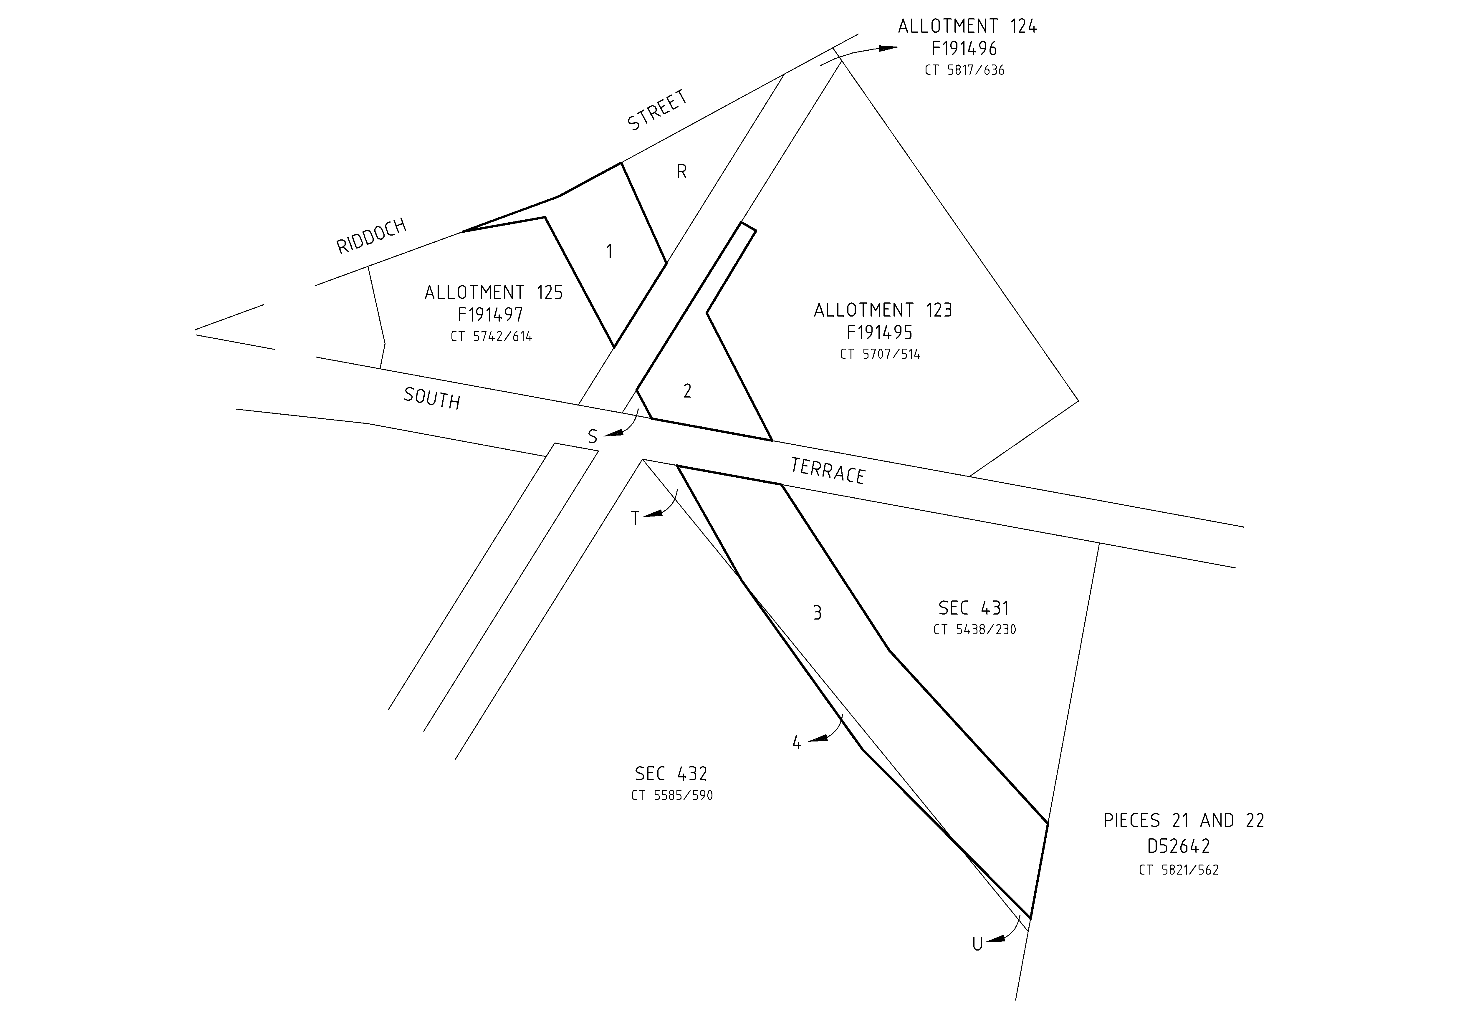
PP 11/0037
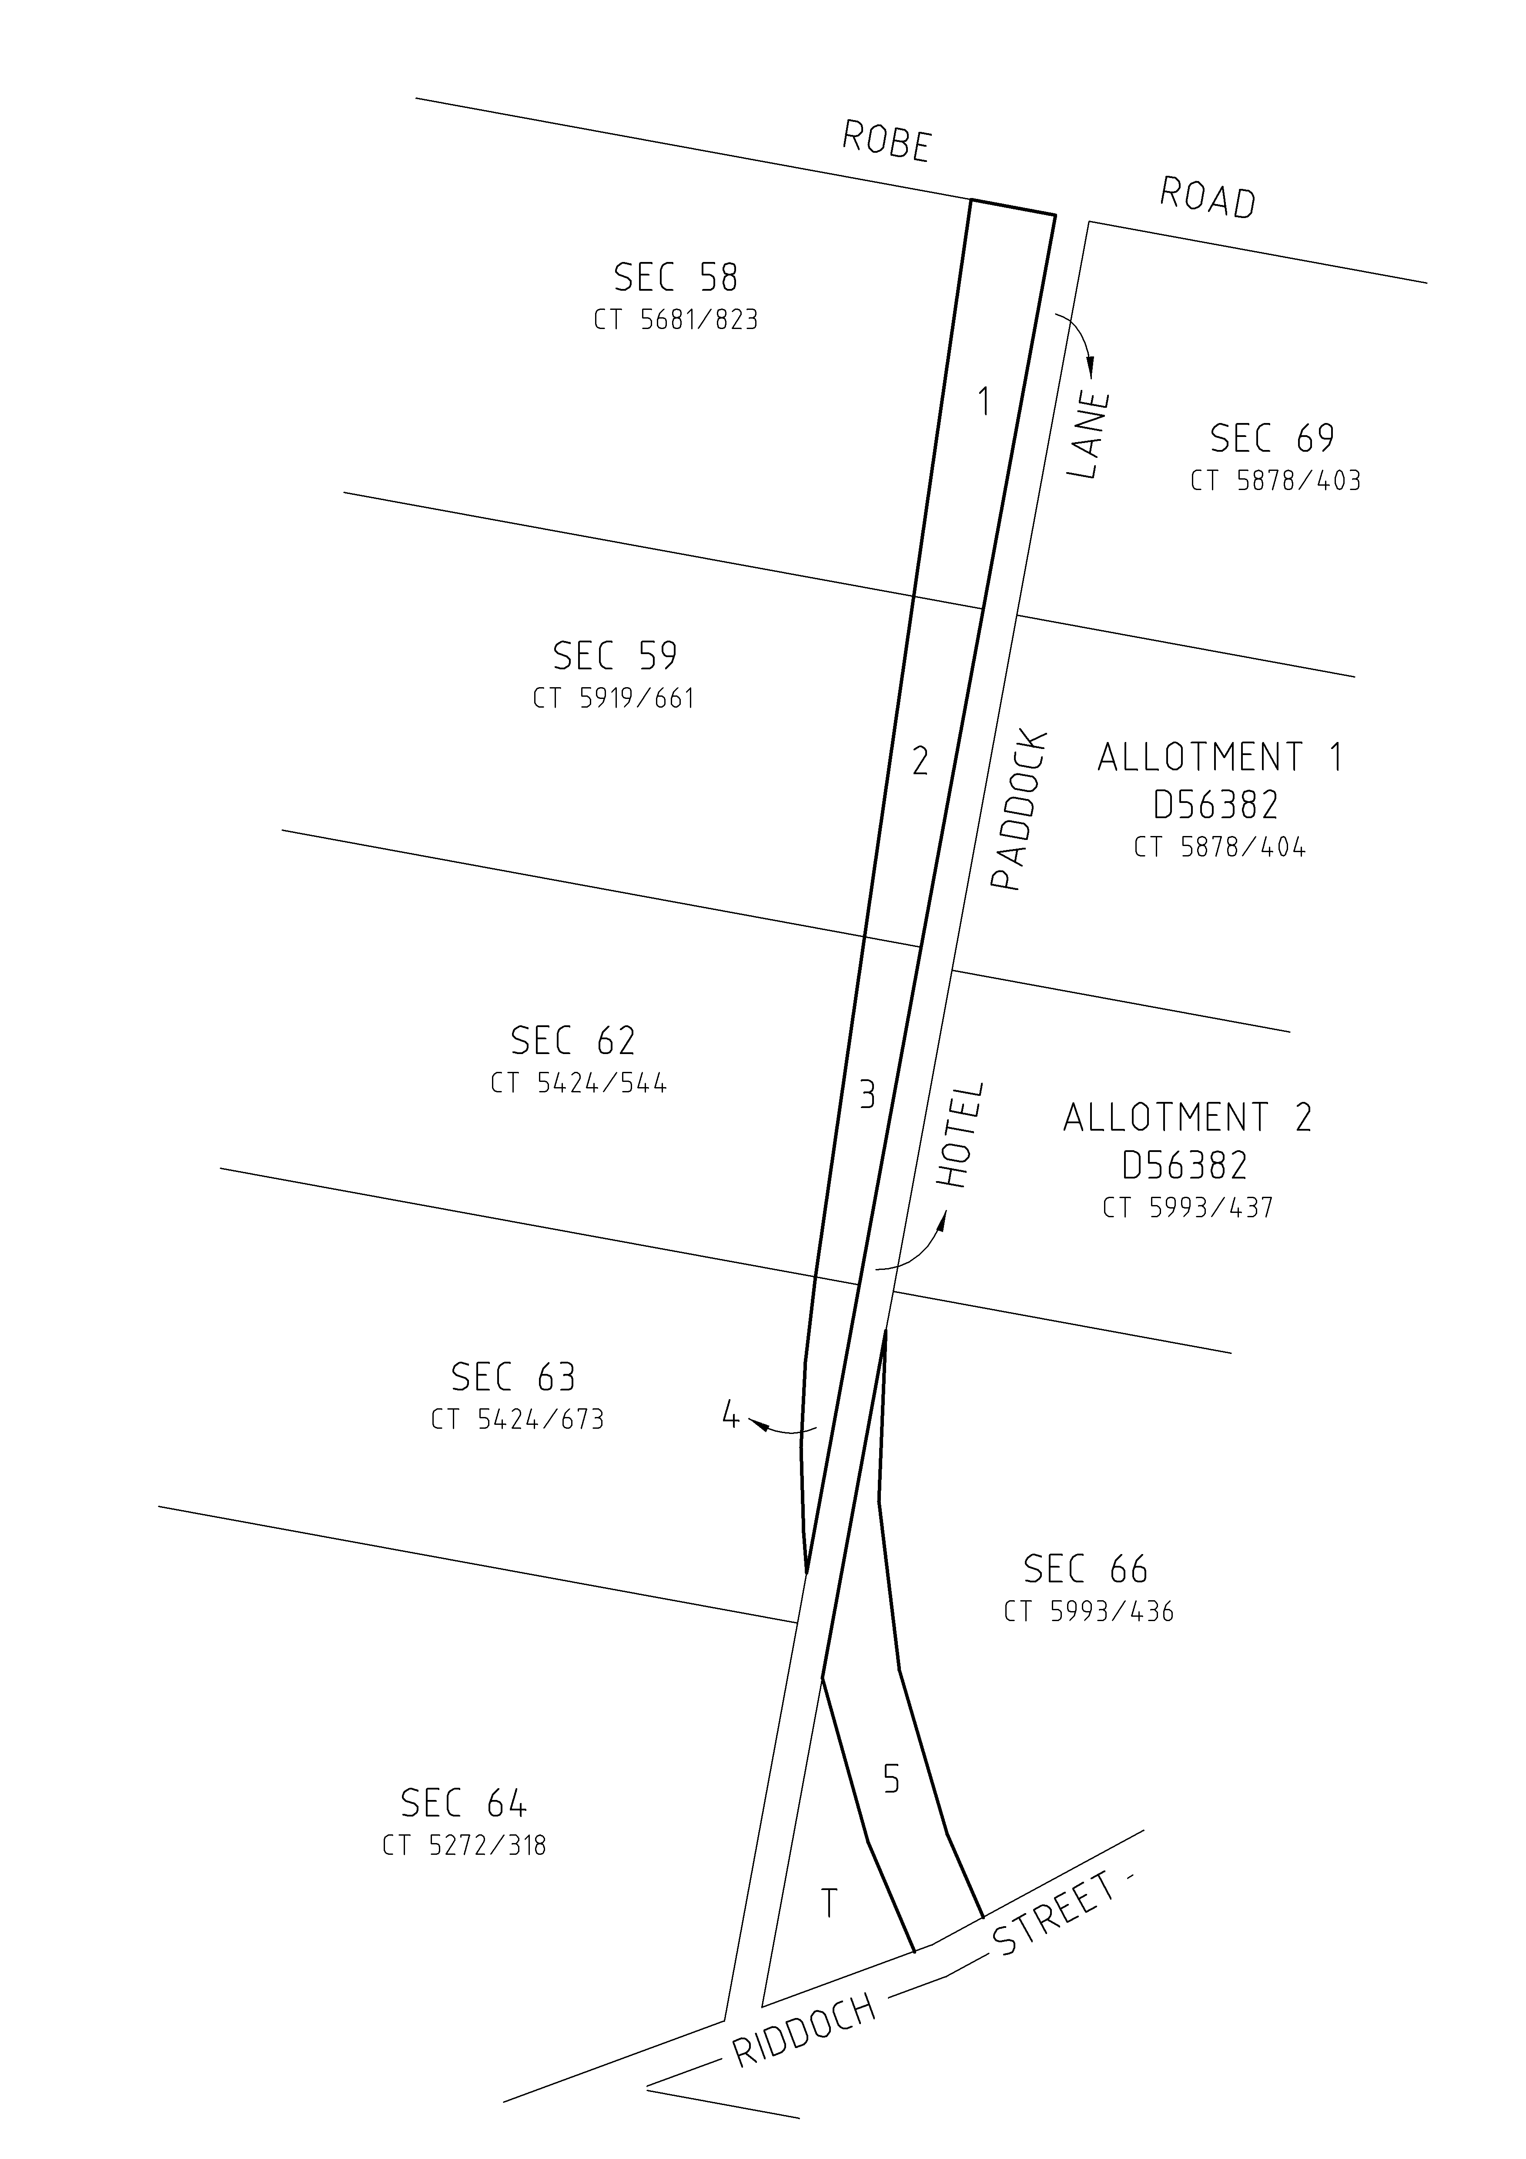
Road openings numbered 1 to 5 with additional land required identified as ‘T’.

PP 11/0038
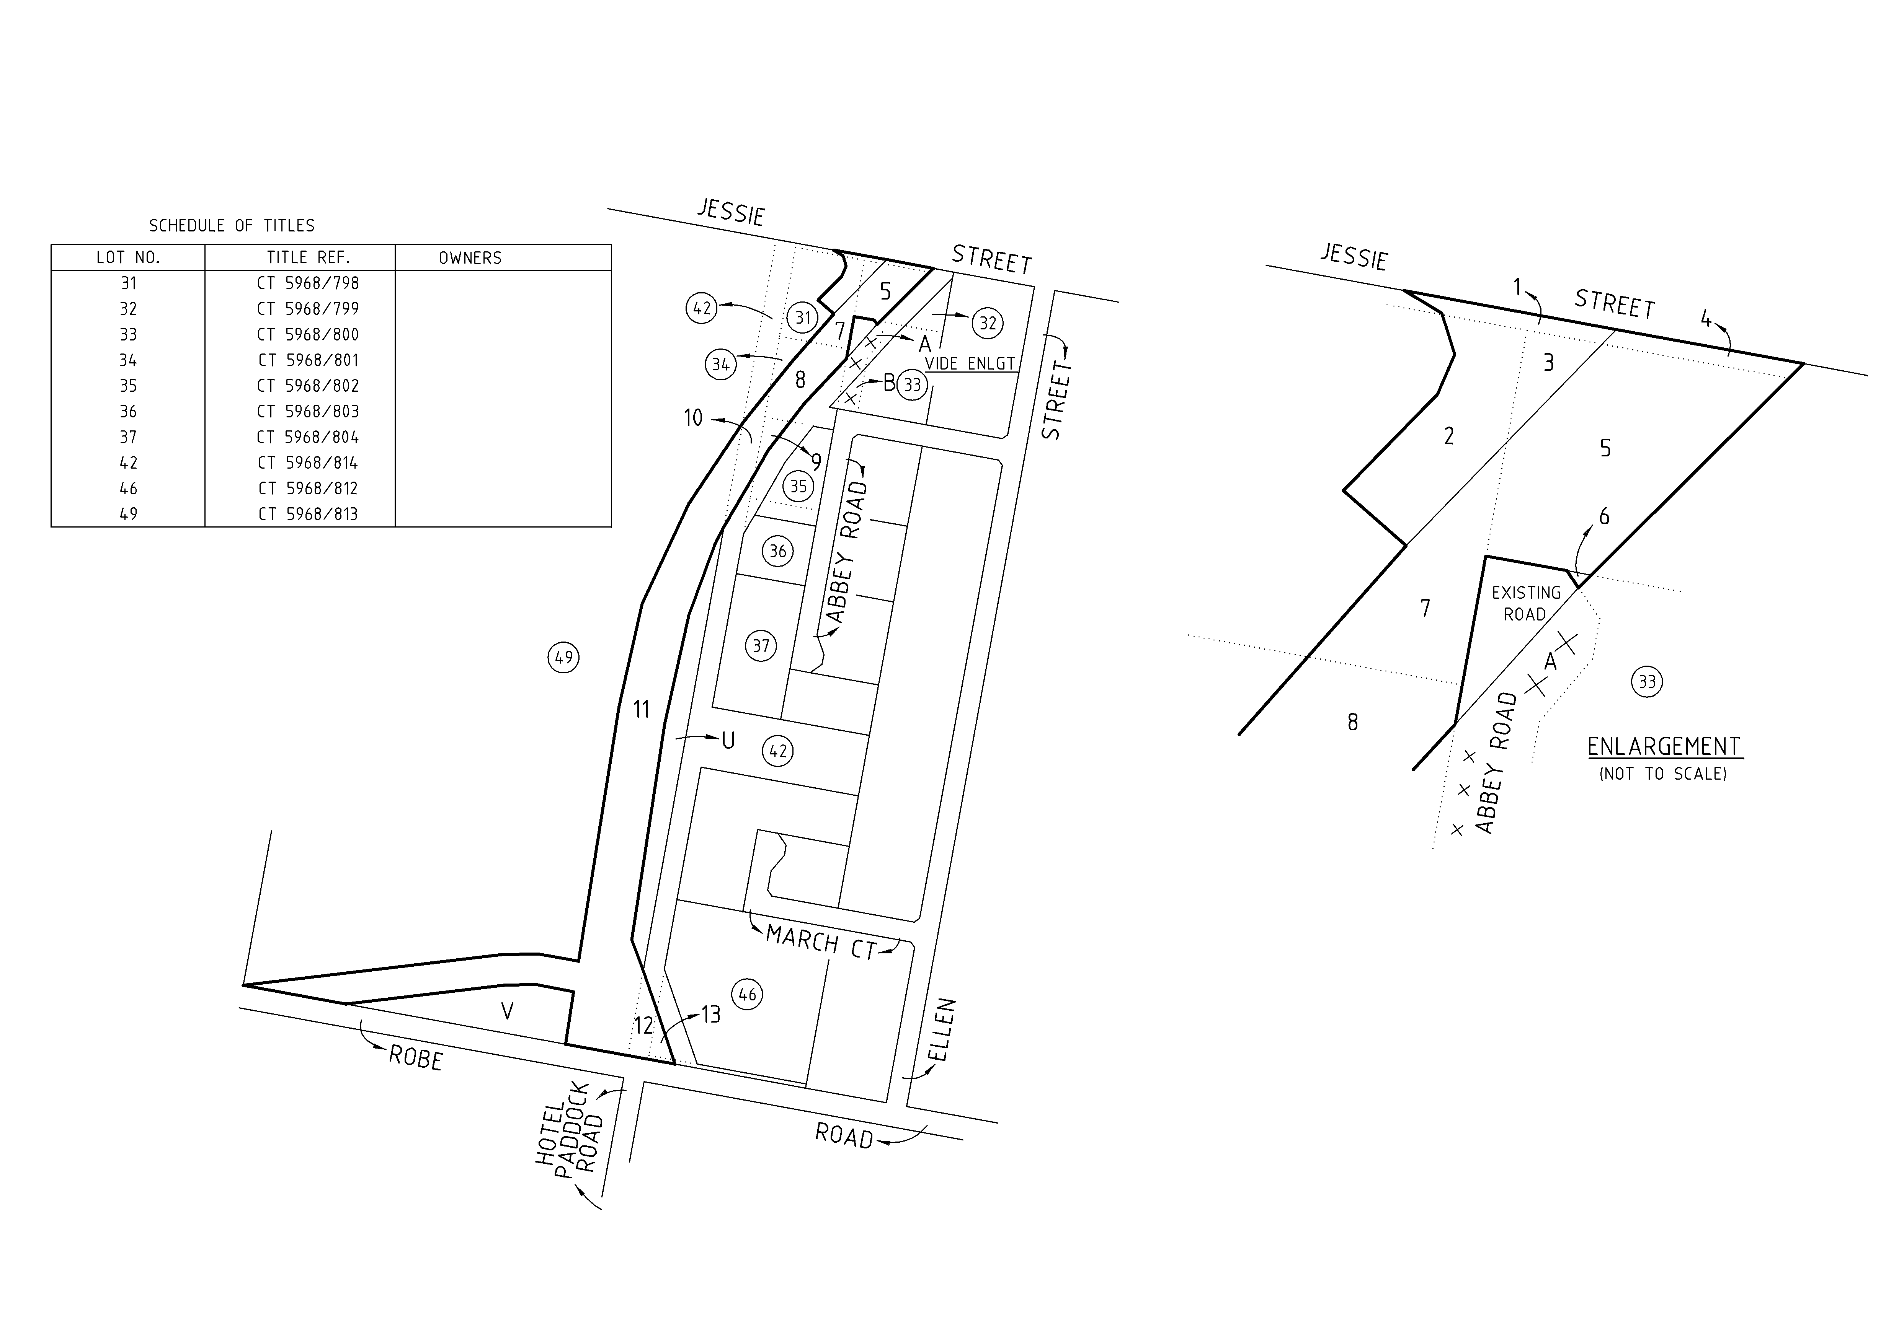
Road openings numbered 1 to 13 and road closing lettered ‘A’ and B with additional land required identified as ‘U’ and ‘V’.
PP 11/0039
Road openings numbered 1 to 6 with additional land required identified as ‘V’ to ‘Z’.
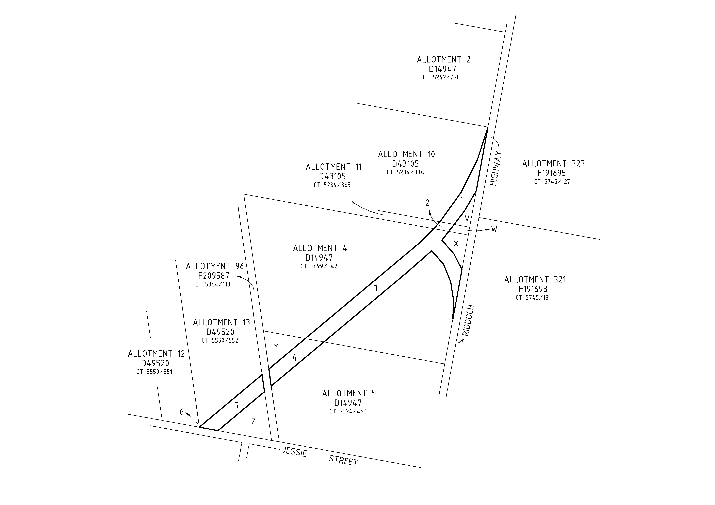

Copies of the plans and statements of persons affected are available for public inspection at Council’s office at the ‘Civic Centre’, George Street, Millicent and the office of the Surveyor-General, 101 Grenfell Street, Adelaide during normal office hours.
Any application for easement or objection must set out the full name, address and details of the submission and must be fully supported by reasons. The application for easement or objection must be made in writing to the Council, P.O. Box 27, Millicent, S.A. 5280, within 28 days of this notice and a copy must be forwarded to the Surveyor General, G.P.O. Box 1354, Adelaide, S.A. 5001. Where a submission is made, Council will give notification of the date and time of a Council meeting to deal with the matter.
F. N. Brennan, Chief Executive Officer

IN the matter of the estates of the undermentioned deceased persons:
Bruce, Mary, late of 580 Brighton Road, South Brighton, of no occupation, who died on 30 May 2011.
Bubner, John Howard, late of 19 Hawker Avenue, Gilles Plains, of no occupation, who died on 9 April 2011.
Dicker, Ruth Ann, late of 16-24 Penneys Hill Road, Hackham, of no occupation, who died on 10 July 2011.
Doolan, Robert Leonard, late of 50 Zante Road, Berri, retired winemaker, who died on 5 June 2011.
Herbert, Beatrice Jean, late of 200-208 Adams Road, Craigmore, of no occupation, who died on 7 July 2011.
Jurgiewicz, Jozef, late of 58 Morgan Avenue, Daw Park, retired production line worker, who died on 24 February 2011.
Poole, Ronald, late of 150 Adams Road, Craigmore, retired truck driver, who died on 16 June 2011.
Sanders, Dora, late of Blamey Road, Elizabeth East, of no occupation, who died on 15 June 2011.
Warner, Barbara Elizabeth, late of 14 Beaufort Street, Woodville, retired clerk, who died on 17 July 2011.
Wilmshurst, Louise, late of 3 Palomino Parade, Wynn Vale, retired hairdresser, who died on 10 May 2011.
Notice is hereby given pursuant to the Trustee Act 1936, as amended, the Inheritance (Family Provision) Act 1972 and the Family Relationships Act 1975, that all creditors, beneficiaries, and other persons having claims against the said estates are required to send, in writing, to the Office of Public Trustee, G.P.O. Box 1338, Adelaide, S.A. 5001, full particulars and proof of such claims, on or before 30 September 2011, otherwise they will be excluded from the distribution of the said estates; and notice is also hereby given that all persons indebted to the said estates are required to pay the amount of their debts to the Public Trustee or proceedings will be taken for the recovery thereof; and all persons having any property belonging to the said estates are forthwith to deliver same to the Public Trustee.
Dated 1 September 2011.
D. A. Contala, Public Trustee

IN the matter of the estate of the undermentioned deceased person:
Hams, Edith Lucy, late of 1-7 Cumnock Street, Jamestown, South Australia, who died on 30 April 2010.
Notice is hereby given pursuant to the Trustee Act 1936, as amended, the Inheritance (Family Provisions) Act 1972-1975 and the Family Relationships Act 1975, that all creditors, beneficiaries and other persons having claims against the abovenamed estate are directed to send full particulars and evidence of such claims to the undersigned on or before 6 October 2011, otherwise they will be excluded from the distribution of the said estate; and notice is also hereby given that all persons who are indebted to the above estate are required to pay the amount of their debt to the undersigned or proceedings will be taken for the recovery thereof; and all persons having any property belonging to the said estate are forthwith to deliver the same to the undersigned.
National Australia Trustees Limited, The Manager, Trustee Services, Level 10, 22 King William Street, Adelaide, S.A. 5000.

ATTENTION

CUSTOMERS requiring a proof of their notice for inclusion in the Government Gazette, please note that the onus is on you to inform Government Publishing SA of any subsequent corrections.

For any corrections to your notice please phone 8207 1045 or Fax 8207 1040 before 4 p.m. on Wednesday.

If we do not receive any communication by 10 a.m. on Thursday (day of publication) we will presume the notice is correct and will print it as it is.

Remember—the onus is on you to inform us of any corrections necessary to your notice.

NOTE: Closing time for lodging new copy (electronically, fax or hard copy) is 4 p.m. on Tuesday preceding the day of publication.
Phone: 8207 1045
Fax: 8207 1040
Email: governmentgazette@dpc.sa.gov.au

Printed and published by authority every Thursday by B. MORRIS, Government Printer, South Australia
Price: $6.25, plus postage; to subscribers, $315.00 per annum.
(The above prices are inclusive of GST)

