No. 67 4095

THE SOUTH AUSTRALIAN

GOVERNMENT GAZETTE
www.governmentgazette.sa.gov.au

PUBLISHED BY AUTHORITY

ALL PUBLIC ACTS appearing in this GAZETTE are to be considered official, and obeyed as such

ADELAIDE, THURSDAY, 29 SEPTEMBER 2011

CONTENTS

Page
Appointments, Resignations, Etc. 4096
Aquaculture (Approval of Arno Bay Zones Policy)
Notice 2011 4114
Aquaculture (Approval of Revocation Policy) Notice 2011 4119
Aquaculture (Approval of Streaky Bay Zones Policy)
Notice 2011 4121
Aquaculture Cost Recovery Revocation Policy 2011 4120
Aquaculture (Zones—Arno Bay) Policy 2011 4115
Aquaculture (Zones—Streaky Bay) Policy 2011 4122
Corporations and District Councils—Notices 4150
Fire and Emergency Services Act 2005—
Notice 4097
Republished 4097
Geographical Names Act 1991—Notices 4097
Harbours and Navigation Act 1993—Notices 4098
Health Care Act 2008—Notice 4101
Housing Improvement Act 1940—Notices 4100
Land Acquisition Act 1969—Notices 4102
Liquor Licensing Act 1997—Notices 4102

Page
Mining Act 1971—Notices 4104
National Electricity Law—Notice 4105
National Parks and Wildlife Act 1972—Notice 4105
National Parks and Wildlife (National Parks) Regulations
2001—Notice 4105
Petroleum and Geothermal Energy Act 2000—Notices 4105
Private Advertisement 4150
Proclamations 4136
Public Trustee Office—Administration of Estates 4150
REGULATIONS
Electrical Products Act 2000 (No. 217 of 2011) 4138
Development Act 1993 (No. 218 of 2011) 4139
Road Traffic Act 1961 (No. 219 of 2011) 4143
Electoral Act 1985 (No. 220 of 2011) 4145
South Australian Electoral Districts Boundaries
Commission—Notice 4107
Training and Skills Development Act 2008—Notices 4108
Transport Department of—Notice to Mariners 4104
Water Mains and Sewers—Mains Laid, Replaced, Etc 4112

GOVERNMENT GAZETTE NOTICES
ALL poundkeepers’ and private advertisements forwarded for publication in the South Australian Government Gazette must be PAID FOR PRIOR TO INSERTION; and all notices, from whatever source, should be legibly written on one side of the paper only and sent to Government Publishing SA so as to be received no later
than 4 p.m. on the Tuesday preceding the day of publication. Phone 8207 1045 or Fax 8207 1040. E-mail: governmentgazette@dpc.sa.gov.au. Send as attachments in Word format and please confirm your transmission with a faxed copy of your document, including the date the notice is to be published and to whom the notice will be charged. The Government Gazette is available online at: www.governmentgazette.sa.gov.au

Department of the Premier and Cabinet
Adelaide, 29 September 2011
HIS Excellency the Governor in Executive Council has revoked the appointment of Melinda Jane Jeffreys as a Director and Deputy Chair of the South Australian Tourism Commission Board, effective from 1 October 2011, pursuant to the provisions of the South Australian Tourism Commission Act 1993 and Section 36 of the Acts Interpretation Act 1915.
By command,
Russell Paul Wortley, for Premier
MFT0024/11CS

Department of the Premier and Cabinet
Adelaide, 29 September 2011
HIS Excellency the Governor in Executive Council has been pleased to appoint the undermentioned to the South Australian Tourism Commission Board, pursuant to the provisions of the South Australian Tourism Commission Act 1993:
Director: (from 1 October 2011 until 30 September 2012)
Melinda Jane Jeffreys
Chair: (from 1 October 2011 until 30 September 2012)
Melinda Jane Jeffreys
Director: (from 1 October 2011 until 30 September 2013)
John Irving
Jan Lynne Turbill
Michael Douglas Tilley
Brian Robert Michael Hayes
By command,
Russell Paul Wortley, for Premier
MFT0024/11CS

Department of the Premier and Cabinet
Adelaide, 29 September 2011
HIS Excellency the Governor in Executive Council has been pleased to appoint the Honourable John David Hill, MP, Minister for Health, Minister for Mental Health and Substance Abuse, Minister for the Southern Suburbs and Minister Assisting the Premier in the Arts to be also Acting Deputy Premier, Acting Attorney-General, Acting Minister for Justice, Acting Minister for Urban Development, Planning and the City of Adelaide, Acting Minister for Tourism and Acting Minister for Food Marketing for the period from 3 October 2011 to 10 October 2011 inclusive, during the absence of the Honourable John Robert Rau, MP.
By command,
Russell Paul Wortley, for Premier
AGO0182/06CS

Department of the Premier and Cabinet
Adelaide, 29 September 2011
HIS Excellency the Governor in Executive Council has been pleased to appoint the Honourable Jennifer Mary Rankine, MP, Minister for Families and Communities, Minister for Housing, Minister for Ageing and Minister for Disability to be also Acting Minister for Transport and Acting Minister for Infrastructure for the period from 4 October 2011 to 14 October 2011 inclusive, during the absence of the Honourable Patrick Frederick Conlon, MP.
By command,
Russell Paul Wortley, for Premier
MFI/11/038

Department of the Premier and Cabinet
Adelaide, 29 September 2011
HIS Excellency the Governor in Executive Council has been pleased to appoint the Honourable Gail Elizabeth Gago, MLC, Minister for Regional Development, Minister for Public Sector Management, Minister for the Status of Women, Minister for Consumer Affairs, Minister for Government Enterprises and Minister for Gambling to be also Acting Minister for Education and Acting Minister for Early Childhood Development for the period from 3 October 2011 to 9 October 2011 inclusive, during the absence of the Honourable Jay Wilson Weatherill, MP.
By command,
Russell Paul Wortley, for Premier
MEDU11/016CS

Department of the Premier and Cabinet
Adelaide, 29 September 2011
HIS Excellency the Governor in Executive Council has been pleased to appoint the Honourable Thomas Richard Kenyon, MP, Minister for Recreation, Sport and Racing, Minister for Road Safety, Minister for Veterans’ Affairs, Minister Assisting the Premier with South Australia’s Strategic Plan and Minister Assisting the Minister for Employment, Training and Further Education to be also Acting Minister for Science and Information Economy for the period from 3 October 2011 to 9 October 2011 inclusive, during the absence of the Honourable Jay Wilson Weatherill, MP.
By command,
Russell Paul Wortley, for Premier
MEDU11/016CS

Department of the Premier and Cabinet
Adelaide, 29 September 2011
HIS Excellency the Governor in Executive Council has been pleased to appoint the Honourable John David Hill, MP, Minister for Health, Minister for Mental Health and Substance Abuse, Minister for the Southern Suburbs and Minister Assisting the Premier in the Arts to be also Acting Minister for Environment and Conservation, Acting Minister for the River Murray and Acting Minister for Water for the period from 10 October 2011 to 14 October 2011 inclusive, during the absence of the Honourable Paul Caica, MP.
By command,
Russell Paul Wortley, for Premier
MEC11/0047CS

Department of the Premier and Cabinet
Adelaide, 29 September 2011
HIS Excellency the Governor in Executive Council has been pleased to appoint Klynton Wanganeen to the office of Commissioner for Aboriginal Engagement on a part time basis (0.6 FTE) for a period of one month commencing on 1 October 2011 and expiring on 31 October 2011, pursuant to Section 68 of the Constitution Act 1934.
By command,
Russell Paul Wortley, for Premier
MAA11/012SC

Department of the Premier and Cabinet
Adelaide, 29 September 2011
HIS Excellency the Governor in Executive Council has been pleased to appoint Khatija Thomas to the office of Commissioner for Aboriginal Engagement on a full time basis for a period of six months commencing on 1 October 2011 and expiring on 31 March 2012, pursuant to Section 68 of the Constitution Act 1934.
By command,
Russell Paul Wortley, for Premier
MAA11/012SC

Department of the Premier and Cabinet
Adelaide, 29 September 2011
HIS Excellency the Governor in Executive Council has been pleased to appoint the Members listed to the Residential Tenancies Tribunal, for the terms specified, pursuant to the provisions of the Residential Tenancies Act 1995:
Member: (from 2 April 2011 and expiring on 30 June 2012)
Harrison Juliet Anderson
Roger Thomas Vincent
Member: (from 29 September 2011 and expiring on 27 June 2014)
Barbara Ellen Johns
Deputy Presiding Member: (from 29 September 2011 and expiring on 27 June 2014)
Barbara Ellen Johns
By command,
Russell Paul Wortley, for Premier
11MCA0002PN

[Republished]
IN Government Gazette dated 15 September 2011 on page 4001, the third notice appearing, because of additional information should read as follows:
FIRE AND EMERGENCY SERVICES ACT 2005
Section 78 and Section 80
Fire Ban Districts
I, GREGORY HUGH NETTLETON, the Chief Officer of the South Australian Country Fire Service, hereby declare that the following Fire Ban Districts as set out in rack plans detailed below, including any wharf, jetty, breakwater or structure which projects into the water from any land within the fire ban districts are approved under Section 78 and Section 80 for determining the whole or any part of the State:
Rack Plan Number | Fire Ban  District # | Fire Ban District Name | Fire Area Type
1001 | 1 | Adelaide Metropolitan | Fire Ban District
1002 | 2 | Mount Lofty Ranges | Fire Ban District
1003 | 3 | Yorke Peninsula | Fire Ban District
1004 | 4 | Kangaroo Island | Fire Ban District
1005 | 5 | Lower South East | Fire Ban District
1006 | 6 | Upper South East | Fire Ban District
1007 | 7 | Murraylands | Fire Ban District
1008 | 8 | Riverland | Fire Ban District
1009 | 9 | Mid North | Fire Ban District
1010 | 10 | Flinders | Fire Ban District
1011 | 11 | Lower Eyre Peninsula | Fire Ban District
1012 | 12 | Eastern Eyre Peninsula | Fire Ban District
1013 | 13 | West Coast | Fire Ban District
1014 | 14 | North West Pastoral | Fire Ban District
1015 | 15 | North East Pastoral | Fire Ban District

Dated 22 September 2011.
G. Nettleton, Chief Officer, SA Country
Fire Service

FIRE AND EMERGENCY SERVICES ACT 2005
Section 4
Establishment of Areas for Fire and Emergency Services
I, DAVID WILLIAM PLACE, the Chief Executive Officer of the South Australian Fire and Emergency Services Commission, hereby establish the following Fire District (Adelaide Metropolitan) as set out in Rack Plan No. 1016 lodged in the Surveyor-General’s Office at Adelaide. This notice will come into operation on 25 October 2011.
Dated 29 September 2011
D. Place, Chief Executive, SAFECOM

GEOGRAPHICAL NAMES ACT 1991
Notice of Declaration of Names of Places
NOTICE is hereby given pursuant to Section 11A of the Geographical Names Act 1991, that the names of those places set out in The Schedule hereunder shall be the geographical names
of those said places. Precise location of the said features can
be obtained from the South Australian Government Gazette at www.placenames.sa.gov.au or by contacting the Geographical Names Unit, DTEI on (08) 8204 8539.
The Schedule
Mapsheet | Feature
1:50 000 Mapsheet 6227-1 (Pondalowie) | Barawarli (dual name with Cape West)  Waluri (dual name with Daly Head)  Wannanawi (dual name with Jime Brown Waterhole)
1:50 000 Mapsheet 6329-2 (Wardang) | Bugara (cliff)  Bungya (dual name with Point Pearce, the point)  Waraldi (dual name with Wardang Island)
1:50 000 Mapsheet 66427-4 (Edithburgh) | Dhalliwanggu (dual name with Lake Sunday)
1:50 000 Mapsheet 6427-4 (Hillock) | Gadjarawi (dual name with Point Yorke)
1:50 000 Mapsheet 6532-4 (Wilmington) | Amyton Creek
1:50 000 Mapsheet 6428-1 (Port Julia) | Black Point/Gudliwardi (dual name for the point)  Pine Point/Malyuwardi (dual name for the point)
1:50 000 Mapsheet 6429-3 (Maitland) | Guuranda (dual name with Yorke Peninsula)
1:50 000 Mapsheet 6327-1 (Coonarie) | Manbiwi (dual name with Point Davenport)
1:50 000 Mapsheet 6529-4 (Corny Point) | Nhildidji (dual name with Corny Point, the point)  Windanya (swamp)
1:50 000 Mapsheet 6529-4 (Wakefield) | Nhandhu-warra (dual name with South Hummocks)

Note: words shown in parentheses are not part of the name.
Certified that the above names have been examined in line with the policies of the Geographical Names Unit and that they comply with Section 11A of the Geographical Names Act 1991.
Dated 22 September 2011.
P. M. Kentish, Surveyor-General, Department for Transport, Energy and Infrastructure
DTEI.2009/29925/01

GEOGRAPHICAL NAMES ACT 1991
Notice to Rescind a Name of a Feature
NOTICE is hereby given pursuant to the provisions of the above Act that I, PETER MACLAREN KENTISH, Surveyor-General and Delegate appointed by Patrick Conlon, Minister for Infrastructure, Minister of the Crown to whom the administration of the Geographical Names Act 1991, is committed DO HEREBY rescind the name NGADJALI for that feature located on the
1:50 000 Mapsheet Pondalowie (6227-1) at Latitude –35°01′48″ and Longitude 136°55′43″ and declare the feature as DALY HEAD/ WALURI.
Dated 22 September 2011.
P. M. Kentish, Surveyor-General, Department for Transport, Energy and Infrastructure

GEOGRAPHICAL NAMES ACT 1991
For Public Consultation
Notice of Intent to Alter the Names and Boundaries of Places
NOTICE is hereby given pursuant to the provisions of the above Act, that the Minister for Infrastructure seeks public comment on a proposal to exclude from EDITHBURGH that area marked (A) on the plan below and to create the new locality of SULTANA POINT.
The Plan
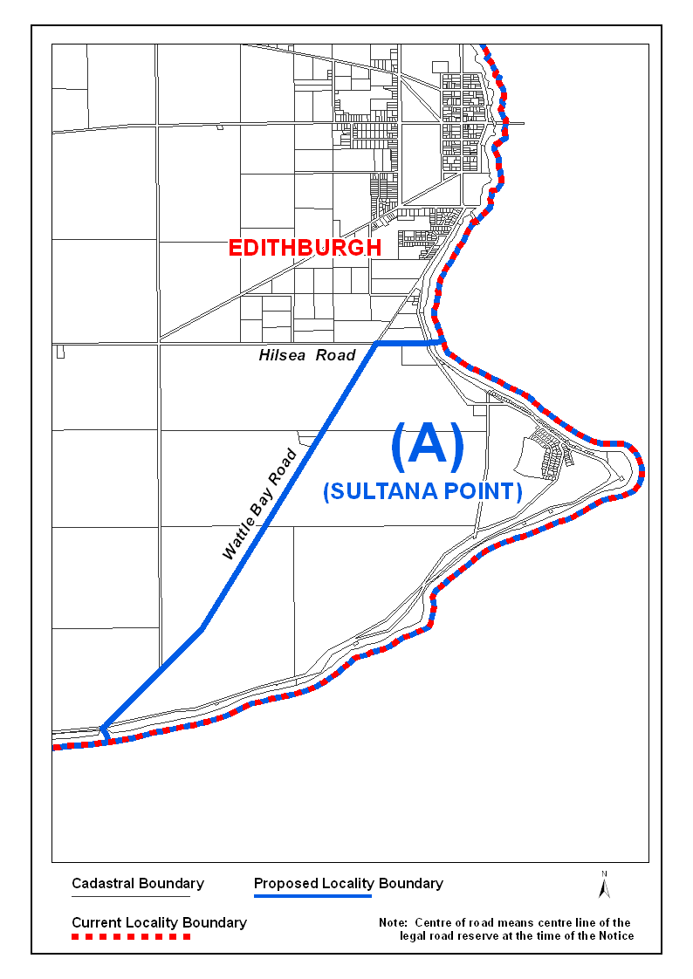
Copies of the plan showing the extent of the subject area can be viewed at:
• the Office of the Surveyor-General, 101 Grenfell Street, Adelaide.
• the office of the District Council of Yorke Peninsula.
• the Land Services web-site at:
www.landservices.sa.gov.au/1Online_Services/
55Place_Names/
Submissions in writing regarding this proposal may be lodged with the Surveyor-General, G.P.O. Box 1354, Adelaide, S.A. 5001, within one month of the publication of this notice.
Dated 7 September 2011.
P. M. Kentish, Surveyor-General, Department for Transport, Energy and Infrastructure
DTEI.2011/10220/01

HARBORS AND NAVIGATION ACT 1993
Determination of the State Crewing Committee
THE State Crewing Committee convened on 9 September 2011 and made the following determination, pursuant to Part 6, Section 45 of the Harbors and Navigation Act 1993.
Patrick Conlon, Minister for Transport
V30016

HARBORS AND NAVIGATION ACT 1993
Determination of the State Crewing Committee in respect
of the ‘Pot Luck’
THE following determination is made by the State Crewing Committee pursuant to Part 6, Section 45 of the Harbors and Navigation Act 1993, in respect of the Pot Luck.
Operational Limits
Limit 1—Voyages up to 12 hours up to 30 nm seaward of the coast of South Australia.
Limit 2—Voyages more than 12 hours up to 100 nm seaward of the coast of South Australia.
Limit 3—Voyages more than 12 hours up to 200 nm seaward of the coast of South Australia.
Minimum Crew
Limit 1—2 Persons, Master and Marine Engine Driver.
Limit 2—2 Persons, Master and Marine Engine Driver.
Limit 3—3 Persons, Master, Mate and Marine Engine Driver.
Minimum Qualifications
Limit 1—Master to hold a Master Class 5 Certificate of Competency, Marine Engine Driver Grade 2 Certificate of Competency.
Can be dual ticket; if dual ticket used, must also have a General Purpose Hand on board who is to be 16 years, medically fit, holds a Certificate for Elements of Shipboard Safety and has had at least three months experience.
Limit 2—Master to hold a Master Class 5 Certificate of Competency, Marine Engine Driver Grade 2 Certificate of Competency.
Can be dual ticket; if dual ticket used, must also have a Coxswain Certificate of Competency on board.
Limit 3—Master to hold a Master Class 5 Certificate of Competency, Mate to hold a Master Class 5 Certificate of Competency, Marine Engine Driver Grade 2 Certificate of Competency.
Can be dual ticket; if dual ticket used, must also have a General Purpose Hand on board who is to be 16 years, medically fit, holds a Certificate for Elements of Shipboard Safety and has had at least three months experience.
Capt. W. Ferrao, Presiding Member, State Crewing Committee

HARBORS AND NAVIGATION ACT 1993
Determination of the State Crewing Committee
THE State Crewing Committee convened on 6 September 2011 and made the following determination, pursuant to Part 6, Section 45 of the Harbors and Navigation Act 1993.
Patrick Conlon, Minister for transport
TSA 30010

HARBORS AND NAVIGATION ACT 1993
Determination of the State Crewing Committee in respect of the ‘Tuna Express’
THE following determination is made by the State Crewing Committee pursuant to Part 6, Section 45 of the Harbors and Navigation Act 1993, in respect of the Tuna Express.
Operational Limits
Up to 50 Passengers for day trips less than 12 hours in Partially Smooth Waters of the coast of South Australia.
Minimum Crew and Qualifications
Minimum 3 Crew.
The Master is to hold a Master Class 5 Certificate of Competency and a Marine Engine Driver Grade 3 Certificate of Competency a General Person Hand who is to be 16 years, medically fit, holds a Certificate for Elements of Shipboard Safety and has at least three months experience.
Can hold a dual ticket, if so, need another General Person Hand.
Capt. W. Ferrao, Presiding Member, State Crewing Committee

HARBORS AND NAVIGATION ACT 1993
Determination of the State Crewing Committee
THE State Crewing Committee convened on 24 August 2011 and made the following determination, pursuant to Part 6, Section 45 of the Harbors and Navigation Act 1993.
Patrick Conlon, Minister for Transport
TSA 30047

HARBORS AND NAVIGATION ACT 1993
Determination of the State Crewing Committee in respect of the M.T. ‘30047’
THE following determination is made by the State Crewing Committee pursuant to Part 6, Section 45 of the Harbors and Navigation Act 1993, in respect of the 30047.
Operational Limits
Smooth Waters—Area of operation.
Minimum Crew and Qualifications
Minimum one crew, to hold a Restricted Coxswain Certificate of Competency.
Capt. W. Ferrao, Presiding Member, State Crewing Committee

HARBORS AND NAVIGATION ACT 1993
Determination of the State Crewing Committee
THE State Crewing Committee convened on 24 August 2011 and made the following determination, pursuant to Part 6, Section 45 of the Harbors and Navigation Act 1993.
Patrick Conlon, Minister for Transport
TSA 29984

HARBORS AND NAVIGATION ACT 1993
Determination of the State Crewing Committee in respect of the ‘Mongoose’
THE following determination is made by the State Crewing Committee pursuant to Part 6, Section 45 of the Harbors and Navigation Act 1993 in respect of the Mongoose.
Operational Limits
Smooth Waters.
Minimum Crew and Qualifications
Minimum one crew—Master is to hold a Coxswain Certificate of Competency.
Capt. W. Ferrao, Presiding Member, State Crewing Committee

HARBORS AND NAVIGATION ACT 1993
Determination of the State Crewing Committee
THE State Crewing Committee convened on 24 August 2011 and made the following determination, pursuant to Part 6, Section 45 of the Harbors and Navigation Act 1993.
Patrick Conlon, Minister for Transport
TSA 30044

HARBORS AND NAVIGATION ACT 1993
Determination of the State Crewing Committee in respect of the MW ‘Swaffer’
THE following determination is made by the State Crewing Committee pursuant to Part 6, Section 45 of the Harbors and Navigation Act 1993, in respect of the MW Swaffer.
Operational Limits
Limit 1—Up to 15 nm seaward of the coast of South Australia (voyages less than 12 hours).
Limit 2—Up to 15 nm seaward of the coast of South Australia (voyages more than 12 hours).
Limit 3—Up to the offshore loading facility at Whyalla.
Minimum Crew and Qualifications
Limit 1—Minimum 2 crew, Master and Engineer.
Limit 2—Minimum 3 crew; Master, Mate and Engineer.
Limit 3—Minimum 2 crew; Master and Engineer.
Master is to hold a Master Class 5 Certificate of Competency.
Mate is to hold a Coxswain Certificate of Competency.
Engineer is to hold a Marine Engine Driver Class 3 Certificate of Competency.
For both limits the Master may hold dual certification but must carry a General Purpose Hand who is to be a person, who is at least 16 years of age, is medically fit for the duties employed, holds a certificate for Elements of Shipboard Safety and has at least three months experience.
Capt. W. Ferrao, Presiding Member, State Crewing Committee

HOUSING IMPROVEMENT ACT 1940
NOTICE is hereby given that the South Australian Housing Trust Board Delegate in the exercise of the powers conferred by the Housing Improvement Act 1940, does hereby declare the houses described in the table hereunder to be substandard for the purposes of Part 7 of the Housing Improvement Act 1940.
No. of House and Street | Locality | Allotment, Section, etc. | Certificate of Title  Volume Folio

12 Greenoch Street |  | Sellicks Beach | Allotment 173 in Deposited Plan 6906, Hundred of Willunga | 5206 | 584
Unit 3, 41 Hassell Street |  | Ferryden Park | Allotment 50 in Deposited Plan 3144, Hundred of Yatala | 5429 | 446
135 Mead Street |  | Peterhead | Allotment 4 in Deposited Plan 22262, Hundred of Port Adelaide | 5440 | 819
Unit 8, 6 Percy Street |  | Prospect | Unit 8, Strata Plan 2037, Hundred of Yatala | 5043 | 86
17 Princess Street |  | Peterborough | Allotment 420 in Deposited Plan 3873, Hundred of Yongala | 5951 | 991
65 Witton Road |  | Christies Beach | Allotment 52 in Deposited Plan 2394, Hundred of Noarlunga | 5323 | 240

Dated at Adelaide, 29 September 2011. R. Hulm, Director, Corporate Services, Housing SA

HOUSING IMPROVEMENT ACT 1940
WHEREAS by notice published in the Government Gazette on the dates mentioned in the following table the South Australian Housing Trust Board Delegate did declare the houses described in the said table to be substandard for the purposes of Part 7 of the Housing Improvement Act 1940, the South Australian Housing Trust in the exercise of the powers conferred by the said Part, does hereby fix as the maximum rental per week which shall be payable subject to Section 55 of the Residential Tenancies Act 1995, in respect of each house described in the following table the amount shown in the said table opposite the description of such house and this notice shall come into force on the date of this publication in the Gazette.
Address of House | Allotment, Section, etc. | Certificate of Title  Volume Folio | Date and page of Government Gazette in which notice declaring house to be substandard published | Maximum rental per week payable in respect of each house  $

27 Beauchamp Street, Kurralta Park |  | Allotment 334 in Filed Plan 19503, Hundred of Adelaide | 5168 | 987 |  | 4.12.08, page 5311 | 350
30A Dew Street, Thebarton |  | Allotment 51 in Filed Plan 6527, Hundred of Adelaide | 5694 | 368 |  | 18.8.11, page 3476 | 180
24 Fulton Street, Glenelg North |  | Allotment 47 in Filed Plan 1883, Hundred of Noarlunga | 5505 | 607 |  | 12.2.09, page 584 | 240
30 Grant Avenue, Salisbury Downs |  | Allotment 59 in Deposited Plan 10191, Hundred of Yatala | 5755 | 200 |  | 7.7.11, page 2980 | 155
27 Knighton Road, Elizabeth North |  | Allotment 223 in Deposited Plan 39090, Hundred of Munno Para | 5175 | 332 |  | 4.8.11, page 3226 | 105
19 Midhurst Avenue, Christies Downs |  | Allotment 314 in Deposited Plan 9667, Hundred of Noarlunga | 5102 | 346 |  | 7.7.11, page 2980 | 170 for whole house  90 per room  per week
Unit 3, 45 Nelson Road, Valley View |  | Allotment 14 in Deposited Plan, Hundred of Yatala | 5561 | 442 |  | 7.7.11, page 2980 | 78
70 Orsmond Street, Hindmarsh |  | Allotment 93 in Filed Plan 12012, Hundred of Yatala | 5711 | 628 |  | 5.9.74, page 1702 | 287
31 Queen Elizabeth Drive, Barmera |  | Section 643, Cobdogla Irrigation Area (Nookamka Division) | 5901 | 118 |  | 4.8.11, page 3226 | 70
508 Regency Road, Enfield |  | Allotment 91 in Filed Plan 127425, Hundred of Yatala | 5644 | 840 |  | 26.5.11, page 1523 | 199
150 Waterfall Gully Road, Waterfall Gully |  | Allotments 8 and 9 in Deposited Plan 4777, Hundred of Adelaide | 5449  5236 | 268  514 |  | 30.3.95, page 1142 | 120

Dated at Adelaide, 29 September 2011. R. Hulm, Director, Corporate Services, Housing SA

HOUSING IMPROVEMENT ACT 1940
WHEREAS by notice published in the Government Gazette on the dates mentioned in the following table the South Australian Housing Trust Board Delegate did declare the houses described in the said table to be substandard for the purposes of Part 7 of the Housing Improvement Act 1940, and whereas the South Australian Housing Trust is satisfied that each of the houses described hereunder has ceased to be substandard, notice is hereby given that, in exercise of the powers conferred by the said Part, the South Australian Housing Trust does hereby revoke the said declaration in respect of each house.
Address of House | Allotment, Section, etc. | Certificate of Title  Volume Folio | Date and page of Government Gazette in which notice declaring house to be substandard published

Unit 1, 71 Jervois Street, Plympton |  | Allotment 67 in Deposited Plan 821, Hundred of Adelaide | 5124 | 118 |  | 28.10.76, page 1496
Unit 1, 18 Murray Street, Tanunda |  | Allotment 553 in Filed Plan 172004, Hundred of Moorooroo | 5955 | 876 |  | 15.4.10, page 1257
78 Wellington Street, Port Adelaide |  | Allotments 531 and 532 in Deposited Plan 3, Hundred of Port Adelaide and Yatala | 5075  5075 | 964  965 |  | 4.8.11, page 3226

Dated at Adelaide, 29 September 2011. R. Hulm, Director, Corporate Services, Housing SA

HEALTH CARE ACT 2008
Notice by the Minister
Section 44—Fees
TAKE note that I, John Hill, Minister for Health, pursuant to Section 44 of the Health Care Act 2008, do hereby set the fees listed in Columns 3 to 12 to be charged by the incorporated hospitals listed in Column 1, for car parking by the public health service sites listed in Column 2 of Schedule 1 of this Notice:
Schedule 1
Column 1 | Column 2 | Column 3 | Column 4 | Column 5 | Column 6 | Column 7 | Column 8 | Column 9 | Column 10 | Column 11 | Column 12
Incorporated  Hospital | Health site | Fee payable for parking  0-1 hour | Fee payable for parking  1-2 hours | Fee payable for parking  2-3 hours | Fee payable for parking  3-4 hours | Fee payable for parking  4-5 hours | Fee payable for parking  5-6 hours | Fee payable for parking  6-7 hours | Fee payable for parking  7-8 hours | Fee payable for parking over  8 hours | Fee payable  for weekly ticket
Northern Adelaide Local Health Network Incorporated | Lyell McEwin Hospital | $2.50 | $5.00 | $7.00 | $8.00 | $9.00 | $10.00 | $11.00 | $12.00 | $13.00 | $38.00
Central  Adelaide Local Health Network Incorporated | The Queen Elizabeth Hospital | $2.50 | $5.00 | $7.00 | $8.00 | $9.00 | $10.00 | $11.00 | $12.00 | $13.00 | $38.00
Southern Adelaide Network Incorporated | Noarlunga General Hospital | $2.50 | $5.00 | $7.00 | $8.00 | $9.00 | $10.00 | $11.00 | $12.00 | $13.00 | $38.00
Southern Adelaide Local Health Network Incorporated | Flinders Medical Centre | $2.50 | $5.00 | $7.00 | $8.00 | $9.00 | $10.00 | $11.00 | $12.00 | $13.00 | $38.00

Dated 28 September 2011.
John Hill, Minister for Health

LAND ACQUISITION ACT 1969
(Section 16)
Notice of Acquisition
THE COMMISSIONER OF HIGHWAYS (the ‘Authority’), 136 North Terrace, Adelaide, S.A. 5000, acquires the following interests in the following land:
Definition of Land Acquired
Comprising an unencumbered estate in fee simple in that piece of land situated at 827 Main Road, McLaren Vale, being a portion of Allotment 90 in Filed Plan No. 153476 comprised in Certificate of Title Volume 5468, Folio 956 and being the whole of the land numbered 40 in the approved plan numbered D87207 that has been lodged in the Lands Titles Office.
This notice is given under Section 16 of the Land Acquisition Act 1969.
Compensation
A person who has or had an interest in the land that is divested or diminished by the acquisition or the enjoyment of which is adversely affected by the acquisition who does not receive an offer of compensation from the Authority may apply to the Authority for compensation.
Inquiries
Inquiries should be directed to:
Carlene Russell,
G.P.O. Box 1533,
Adelaide, S.A. 5001
Phone (08) 8343 2454
Dated 26 September 2011.
The Common Seal of the Commissioner of Highways was hereto affixed by authority of the Commissioner of Highways in the presence of:
D. Thomas, Manager, Transport Property (Authorised Officer), Department for Transport, Energy and Infrastructure
DTEI 2011/04990/01

LAND ACQUISITION ACT 1969
(Section 16)
Notice of Acquisition
THE COMMISSIONER OF HIGHWAYS (the ‘Authority’), 136 North Terrace, Adelaide, S.A. 5000, acquires the following interests in the following land:
Definition of Land Acquired
Comprising an unencumbered estate in fee simple in that piece of land situated at Lot 2 Carissa Road, McLaren Vale, being a portion of Allotment 2 in Filed Plan No. 7967 comprised in Certificate of Title Volume 5458, Folio 732 and being the whole of the land numbered 32 in the plan numbered D87202 that has been lodged in the Lands Titles Office.
This notice is given under Section 16 of the Land Acquisition Act 1969.
Compensation
A person who has or had an interest in the land that is divested or diminished by the acquisition or the enjoyment of which is adversely affected by the acquisition who does not receive an offer of compensation from the Authority may apply to the Authority for compensation.
Inquiries
Inquiries should be directed to:
Carlene Russell,
G.P.O. Box 1533,
Adelaide, S.A. 5001
Phone (08) 8343 2454
Dated 13 September 2011.
The Common Seal of the Commissioner of Highways was hereto affixed by authority of the Commissioner of Highways in the presence of:
D. Thomas, Manager, Transport Property (Authorised Officer), Department for Transport, Energy and Infrastructure
DTEI 2011/04987/01

LAND ACQUISITION ACT 1969
(Section 16)
Notice of Acquisition
THE COMMISSIONER OF HIGHWAYS (the ‘Authority’), 136 North Terrace, Adelaide, S.A. 5000, acquires the following interests in the following land:
Definition of Land Acquired
Comprising an unencumbered estate in fee simple in that piece of land situated at Lot 89 Main Road, McLaren Vale, being a portion of Allotment 89 in Filed Plan No. 153475 comprised in Certificate of Title Volume 5549, Folio 771 and being the whole of the land numbered 42 on approved plan numbered D87208 that has been lodged in the Land Titles Office.
This notice is given under Section 16 of the Land Acquisition Act 1969.
Compensation
A person who has or had an interest in the land that is divested or diminished by the acquisition or the enjoyment of which is adversely affected by the acquisition who does not receive an offer of compensation from the Authority may apply to the Authority for compensation.
Inquiries
Inquiries should be directed to:
Carlene Russell,
G.P.O. Box 1533,
Adelaide, S.A. 5001
Phone (08) 8343 2454
Dated 26 September 2011.
The Common Seal of the Commissioner of Highways was hereto affixed by authority of the Commissioner of Highways in the presence of:
D. Thomas, Manager, Transport Property (Authorised Officer), Department for Transport, Energy and Infrastructure
DTEI 2011/04993/01

LIQUOR LICENSING ACT 1997 AND GAMING MACHINES ACT 1992
Notice of Application
NOTICE is hereby given, pursuant to Section 52 of the Liquor Licensing Act 1997 and Section 29 of the Gaming Machines Act 1992, that Australia In-Sight Pty Ltd has applied to the Licensing Authority for the transfer of a Hotel and Gaming Machine Licence in respect of premises situated at Railway Terrace, Marree, S.A. 5733 and known as Marree Hotel.
The applications have been set down for hearing on 25 October 2011 at 10 a.m.
Any person may object to the application by lodging a notice of objection in the prescribed form with the Liquor and Gambling Commissioner and serving a copy of the notice on the applicant at the applicant’s address, at least seven days before the hearing date (viz: 18 October 2011).
The applicant’s address for service is c/o Kelly & Co., G.P.O. Box 286, Adelaide, S.A. 5001 (Attention: Dimitris Parhas).
The application and certain documents and material (including Plans) relevant to the application may be inspected without fee at a place and during a period specified by the Liquor and Gambling Commissioner, Chesser House, 3rd Floor, 91-97 Grenfell Street, Adelaide, S.A. 5000. Telephone: 131 882. Facsimile: 8226 8512. Email: olgc@agd.sa.gov.au.
Dated 23 September 2011.
Applicant

LIQUOR LICENSING ACT 1997 AND GAMING MACHINES ACT 1992
Notice of Application
NOTICE is hereby given, pursuant to Section 52 of the Liquor Licensing Act 1997 and Section 29 of the Gaming Machines Act 1992, that Trevor Nigel Morgan has applied to the Licensing Authority for the transfer of a Hotel and Gaming Machine Licence in respect of premises situated at Fourth Street, Alford, S.A. 5554 and known as Alford Hotel.
The applications have been set down for hearing on 24 October 2011 at 11 a.m.
Any person may object to the application by lodging a notice of objection in the prescribed form with the Liquor and Gambling Commissioner and serving a copy of the notice on the applicant at the applicant’s address, at least seven days before the hearing date (viz: 18 October 2011).
The applicant’s address for service is c/o Foreman Legal, 69 Mount Barker Road, Stirling, S.A. 5152.
The application and certain documents and material (including Plans) relevant to the application may be inspected without fee at a place and during a period specified by the Liquor and Gambling Commissioner, Chesser House, 3rd Floor, 91-97 Grenfell Street, Adelaide, S.A. 5000. Telephone: 131 882. Facsimile: 8226 8512. Email: olgc@agd.sa.gov.au.
Dated 21 September 2011.
Applicant

LIQUOR LICENSING ACT 1997
Notice of Application
NOTICE is hereby given, pursuant to Section 52 (2) (b) of the Liquor Licensing Act 1997, that Tiffins on the Park Pty Ltd has applied to the Licensing Authority for a transfer of a Residential Licence in respect of premises situated at 176 Greenhill Road, Parkside, S.A. 5063 and known as Tiffins on the Park.
The application has been set down for hearing on 31 October 2011 at 11.30 a.m.
Any person may object to the application by lodging a notice of objection in the prescribed form with the Liquor and Gambling Commissioner and serving a copy of the notice on the applicant at the applicant’s address, at least seven days before the hearing date (viz: 24 October 2011).
The applicant’s address for service is c/o Wallmans Lawyers, G.P.O Box 1018, Adelaide, S.A. 5001 (Attention: Ben Allen or Andrew Fisher).
The application and certain documents and material relevant to the application may be inspected without fee at a place and during a period specified by the Liquor and Gambling Commissioner, Chesser House, 3rd Floor, 91-97 Grenfell Street, Adelaide, S.A. 5000. Telephone: 131 882. Facsimile: 8226 8512. Email: olgc@agd.sa.gov.au.
Dated 26 September 2011.
Applicant

LIQUOR LICENSING ACT 1997
Notice of Application
NOTICE is hereby given, pursuant to Section 52 (2) (b) of the Liquor Licensing Act 1997, that Richmond Road Projects Pty Ltd has applied to the Licensing Authority for a Special Circumstances Licence in respect of premises situated at 2 Egmont Terrace, Hawthorn, S.A. 5062 and to be known as The Pantry on Egmont.
The applications have been set down for hearing on 31 October 2011 at 10.30 a.m.
Conditions
The following licence conditions are sought:
The licence shall authorise the consumption of liquor:
• on the licensed premises (café) with or ancillary to food; and
• at a place other than the licensed premises for catering purposes provided that such consumption is only by persons attending a pre-booked function.
Any person may object to the application by lodging a notice of objection in the prescribed form with the Liquor and Gambling Commissioner and serving a copy of the notice on the applicant at the applicant’s address, at least seven days before the hearing date (viz: 24 October 2011).
The applicant’s address for service is c/o Camatta Lempens, Level 1, 345 King William Street, Adelaide, S.A. 5000 (Attention: Bob Lempens).
The application and certain documents and material (including Plans) relevant to the application may be inspected without fee at a place and during a period specified by the Liquor and Gambling Commissioner, Chesser House, 3rd Floor, 91-97 Grenfell Street, Adelaide, S.A. 5000. Telephone: 131 882. Facsimile: 8226 8512. Email: olgc@agd.sa.gov.au.
Dated 23 September 2011.
Applicant

LIQUOR LICENSING ACT 1997
Notice of Application
NOTICE is hereby given, pursuant to Section 52 (2) (b) of the Liquor Licensing Act 1997, that FP Murray Bridge Pty Ltd as trustee for FP Murray Bridge Unit Trust has applied to the Licensing Authority for a Restaurant Licence in respect of premises situated at Unit F6, Murray Bridge Market Place, South Terrace, Murray Bridge, S.A. 5254 and to be known as Fasta Pasta Murray Bridge.
The application has been set down for hearing on 31 October 2011 at 10 a.m.
Any person may object to the application by lodging a notice of objection in the prescribed form with the Liquor and Gambling Commissioner and serving a copy of the notice on the applicant at the applicant’s address, at least seven days before the hearing date (viz: 24 October 2011).
The applicant’s address for service is c/o David Watts and Associates, 1 Cator Street, Glenside, S.A. 5065.
The application and certain documents and material (including Plans) relevant to the application may be inspected without fee at a place and during a period specified by the Liquor and Gambling Commissioner, Chesser House, 3rd Floor, 91-97 Grenfell Street, Adelaide, S.A. 5000. Telephone: 131 882. Facsimile: 8226 8512. Email: olgc@agd.sa.gov.au.
Dated 22 September 2011.
Applicant

LIQUOR LICENSING ACT 1997
Notice of Application
NOTICE is hereby given, pursuant to Section 52 (2) (b) of the Liquor Licensing Act 1997, that Michael Robertson and Biserka Racic have applied to the Licensing Authority for the transfer of a Hotel Licence in respect of premises situated at Main North Road, Watervale, S.A. 5452 and known as Watervale Hotel.
The application has been set down for hearing on 24 October 2011 at 10.30 a.m.
Any person may object to the application by lodging a notice of objection in the prescribed form with the Liquor and Gambling Commissioner and serving a copy of the notice on the applicants at the applicants’ address, at least seven days before the hearing date (viz: 17 October 2011).
The applicants’ address for service is c/o Foreman Legal, 69 Mount Barker Road, Stirling, S.A. 5152.
The application and certain documents and material (including Plans) relevant to the application may be inspected without fee at a place and during a period specified by the Liquor and Gambling Commissioner, Chesser House, 3rd Floor, 91-97 Grenfell Street, Adelaide, S.A. 5000. Telephone: 131 882. Facsimile: 8226 8512. Email: olgc@agd.sa.gov.au.
Dated 21 September 2011.
Applicants

LIQUOR LICENSING ACT 1997
Notice of Application
NOTICE is hereby given, pursuant to Section 52 (2) (b) of the Liquor Licensing Act 1997, that Woolworths Limited has applied to the Licensing Authority for a Retail Liquor Merchant’s Licence in respect of premises situated at Tenancy 8, Blakes Crossing Market Place Shopping Centre, Lot 4002, Main Terrace, Blakeview, S.A. 5114 and to be known as Woolworths Liquor Blakes Crossing.
The application has been set down for hearing on 25 October 2011 at 10.30 a.m.
Any person may object to the application by lodging a notice of objection in the prescribed form with the Liquor and Gambling Commissioner and serving a copy of the notice on the applicant at the applicant’s address, at least seven days before the hearing date (viz: 18 October 2011).
The applicant’s address for service is c/o Clelands Lawyers, 208 Carrington Street, Adelaide, S.A. 5000 (Attention: Rinaldo D’Aloia).
The application and certain documents and material (including Plans) relevant to the application may be inspected without fee at a place and during a period specified by the Liquor and Gambling Commissioner, Chesser House, 3rd Floor, 91-97 Grenfell Street, Adelaide, S.A. 5000. Telephone: 131 882. Facsimile: 8226 8512. Email: olgc@agd.sa.gov.au.
Dated 21 September 2011.
Applicant

NOTICE TO MARINERS
No. 38 of 2011
South Australia—Gulf St Vincent—Klein Point—Maintenance Dredging Complete—Berth Returned to Declared Depth
Former Notice No. 18 of 2011
MARINERS are advised that the maintenance dredging at Klein Point referred to in the previous notice has now been completed and the berthing area returned to its declared depth of 6.5 m LAT.
Navy Chart affected: Aus139
Publication affected: Australian Pilot, Volume 1 (Second Edition, 2008), pages 410-411.
Adelaide, 21 September 2011.
Patrick Conlon, Minister for Transport
FP2001/1439
DTEI 2011/00735

MINING ACT 1971
NOTICE is hereby given in accordance with Section 28 (5) of the Mining Act 1971, that the Minister for Mineral Resources Development proposes to grant an Exploration Licence over the undermentioned area:
Applicant: BHP Billiton Nickel West Pty Ltd
Location: Island Dam area⎯Approximately 80 km north-east of Woomera.
Pastoral Lease: Bosworth
Term: 2 years
Area in km²: 130
Ref.: 2011/00091
Plan and co-ordinates can be found on the PIRSA website: http://www.pir.sa.gov.au/minerals/public_notices or by phoning Mineral Tenements on (08) 8463 3103.
J. Martin, Mining Registrar

MINING ACT 1971
NOTICE is hereby given in accordance with Section 28 (5) of the Mining Act 1971, that the Minister for Mineral Resources Development proposes to grant an Exploration Licence over the undermentioned area:
Applicant: Minotaur Operations Pty Ltd
Location: Yudnapinna area⎯Approximately 90 km west-north-west of Port Augusta.
Pastoral Lease: Yudnapinna
Term: 2 years
Area in km²: 137
Ref.: 2011/00095
Plan and co-ordinates can be found on the PIRSA website: http://www.pir.sa.gov.au/minerals/public_notices or by phoning Mineral Tenements on (08) 8463 3103.
J. Martin, Mining Registrar

MINING ACT 1971
NOTICE is hereby given in accordance with Section 28 (5) of the Mining Act 1971, that the Minister for Mineral Resources Development proposes to grant an Exploration Licence over the undermentioned area:
Applicant: Lost Sands Pty Ltd
Location: Eucla Basin area⎯Approximately 390 km north-west of Ceduna.
Term: 2 years
Area in km²: 670
Ref.: 2011/00172
Plan and co-ordinates can be found on the PIRSA website: http://www.pir.sa.gov.au/minerals/public_notices or by phoning Mineral Tenements on (08) 8463 3103.
J. Martin, Mining Registrar

MINING ACT 1971
NOTICE is hereby given in accordance with Section 28 (5) of the Mining Act 1971, that the Minister for Mineral Resources Development proposes to grant an Exploration Licence over the undermentioned area:
Applicant: Lost Sands Pty Ltd
Location: Eucla Basin area⎯Approximately 320 km north-west of Ceduna.
Term: 2 years
Area in km²: 1443
Ref.: 2011/00173
Plan and co-ordinates can be found on the PIRSA website: http://www.pir.sa.gov.au/minerals/public_notices or by phoning Mineral Tenements on (08) 8463 3103.
J. Martin, Mining Registrar

MINING ACT 1971
NOTICE is hereby given in accordance with Section 28 (5) of the Mining Act 1971, that the Minister for Mineral Resources Development proposes to grant an Exploration Licence over the undermentioned area:
Applicant: Gold Fields Australasia Pty Ltd
Location: Oakbank area⎯Approximately 300 km north-east of Adelaide.
Pastoral Leases: Mutooroo, Lilydale, Oakvale, Quondong and Pine Valley.
Term: 2 years
Area in km²: 777
Ref.: 2011/00175
Plan and co-ordinates can be found on the PIRSA website: http://www.pir.sa.gov.au/minerals/public_notices or by phoning Mineral Tenements on (08) 8463 3103.
J. Martin, Mining Registrar

NATIONAL ELECTRICITY LAW
THE Australian Energy Market Commission (AEMC) gives notice under the National Electricity Law of the following matters.
Under Section 99, the making of the following:
• draft determination and draft National Electricity Amendment (Efficiency Benefit Sharing Scheme and Demand Management Expenditure by Transmission Businesses) Rule 2011 (Project Ref. ERC0127);
• draft determination and draft National Electricity Amendment (Inclusion of Embedded Generation Research into Demand Management Incentive Scheme) Rule 2011 (Project Ref. ERC0128);
• draft determination and draft National Electricity Amendment (Network Support Payments and Avoided TuoS for Embedded Generators’) Rule 2011 (Project Ref. ERC0129); and
• draft determination on the Total factor productivity for distribution network regulation Rule proposal (Project Ref. ERC0068).
In relation to these draft determinations:
• requests for a pre-determination hearing must be received by 6 October 2011;
• submissions must be received by 10 November 2011; and
• requests for a hearing should be forwarded to submissions@aemc.gov.au and must cite the Project Ref. in the title.
Submissions can be lodged online via the AEMC’s website at www.aemc.gov.au. Before lodging your submission, you must review the AEMC’s privacy collection statement on its website. Submissions should be made in accordance with the AEMC’s Guidelines for making written submissions on Rule change proposals. The AEMC publishes all submissions on its website subject to a claim of confidentiality.
All documents in relation to the above matters are published on the AEMC’s website and are available for inspection at the offices of the AEMC.
John Pierce
Chairman
Australian Energy Market Commission
Level 5, 201 Elizabeth Street
Sydney, N.S.W. 2000
Telephone: (02) 8296 7800
Facsimile: (02) 8296 7899
29 September 2011.

NATIONAL PARKS AND WILDLIFE ACT 1972
Mamungari Conservation Park Management Plan
I, PAUL CAICA, Minister for Environment and Conservation, hereby give notice under the provisions of Section 38 of the National Parks and Wildlife Act 1972 that, on 8 September 2011, I adopted a plan of management for Mamungari Conservation Park.
Copies of the plan may be inspected at or obtained from the offices of the Department of Environment and Natural Resources at:
• DENR Information Line (e-mail DENRinformation@ sa.gov.au), telephone 8204 1910;
• http://www.environment.sa.gov.au/Conservation/Land/Parks_ management/Management_plans_
• Level 1, 100 Pirie Street, Adelaide, S.A. 5000 (G.P.O. Box 1047, Adelaide, S.A. 5001), telephone 8204 1910;
• Eyre Regional Office, 75 Liverpool Street, Port Lincoln, S.A. 5606, Phone: (08) 8688 3111.
Paul Caica, Minister for Environment and Conservation

NATIONAL PARKS AND WILDLIFE (NATIONAL PARKS)
REGULATIONS 2001
Closure of Simpson Desert Regional Reserve and
Simpson Desert Conservation Park
PURSUANT to Regulations 8 (3) (a) and 8 (3) (d) of the National Parks and Wildlife (National Parks) Regulations 2001, I, Michael Joseph Williams, Director, Public Land Management and Operational Support, authorised delegate of the Director of National Parks and Wildlife, close to the public the whole of
the Simpson Desert Regional Reserve and the whole of Simpson Desert Conservation Park from 6 p.m. on Wednesday,
30 November 2011 to 6 p.m. on Thursday, 15 March 2012.
The purpose of the closure is in the interest of public safety as a result of anticipated high daytime temperatures likely to be experienced in the reserves during the closure period.
Dated 22 September 2011.
M. Williams, Director, Public Land Management and Operational Support, Department of Environment and Natural Resources

PETROLEUM AND GEOTHERMAL ENERGY ACT 2000
Application for Grant of an Associated Activities Licence—
AAL 167
PURSUANT to Section 65 (6) of the Petroleum and Geothermal Energy Act 2000 (the Act) and Delegation dated 1 October 2009, notice is hereby given that an application for the grant of an Associated Activities Licence within the area described below has been received from:
Springfield Oil and Gas Pty Ltd;
Impress (Cooper Basin) Pty Ltd;
Victoria Oil Exploration (1977) Pty Ltd; and
Permian Oil Pty Ltd.
The application will be determined on or after 13 October 2011.
Description of Application Area
All that part of the State of South Australia, bounded as follows:
A corridor 100 m wide centred on a line between co-ordinates:
356138.89mE 6894813.73mN
368376.00mE 6894405.00mN
371498.35mE 6894291.41mN
371888.22mE 6894519.28mN
372698.75mE 6894252.92mN
395362.44mE 6893478.06mN
413439.82mE 6893339.06mN

A corridor 100 m wide centred on a line between co-ordinates:
373256mE 6894050mN
373115mE 6893539mN
373137mE 6892826mN
373103mE 6892665mN
373237mE 6891757mN
373178mE 6890772mN
373363mE 6890132mN
373615mE 6889328mN
373713mE 6888563mN
373815mE 6888212mN
A corridor 100 m wide centred on a line between co-ordinates:
383011mE 6893772mN
383294mE 6891473mN
383328mE 6891368mN
383001mE 6891239mN
383090mE 6890174mN
A corridor 100 m wide centred on a line between co-ordinates:
375237mE 6897423mN
375858mE 6894191mN
and areas bounded by co-ordinates:
(1) 366003mE 6894491mN
366079mE 6894238mN
365954mE 6894221mN
365920mE 6894483mN
366125mE 6894502mN
366171mE 6894254mN
(2) 373279mE 6894244mN
373167mE 6894243mN
373155mE 6894063mN
373256mE 6894050mN
(3) 383004mE 6893918mN
382894mE 6893910mN
382906mE 6893782mN
383011mE 6893772mN
(4) 383090mE 6890174mN
382988mE 6890172mN
383008mE 6889960mN
383132mE 6889964mN
(5) 394192mE 6893521mN
394198mE 6893332mN
394104mE 6893334mN
394096mE 6893518mN
(6) 397493mE 6893467mN
397585mE 6893463mN
397576mE 6893338mN
397415mE 6893331mN
397412mE 6893470mN
(7) 399731mE 6893449mN
399849mE 6893451mN
399866mE 6893606mN
399767mE 6893617mN
(8) 401853mE 6893445mN
401804mE 6893577mN
401707mE 6893571mN
401718mE 6893437mN
(9) 413321mE 6893352mN
413307mE 6893519mN
413441mE 6893523mN
413441mE 6893344mN
All co-ordinates are in GDA94, Zone 54.
Area: 7.7 km² approximately.
Dated 27 September 2011.
M. Malavazos,
Acting Executive Director,
Petroleum and Geothermal Division
Minerals and Energy Resources
Primary Industries and Resources SA
Delegate of the Minister for Mineral
Resources Development

PETROLEUM AND GEOTHERMAL ENERGY ACT 2000
Surrender of Associated Activities Licence—AAL 154
(Adjunct to Petroleum Exploration Licence PEL 92)
NOTICE is hereby given that I have accepted surrender of the abovementioned Associated Activities Licence under the provisions of the Petroleum and Geothermal Energy Act 2000, pursuant to delegated powers dated 1 October 2009:

No. of  Licence | Licensee | Locality | Date of Expiry | Reference
AAL 154 | Beach Energy Limited  Cooper Energy Limited | Cooper Basin | 8 November 2013 | F2009/739
Description of Area
A 50 m buffer around line segments defined by the following pairs of co-ordinates and adjacent to Petroleum Exploration Licence No. 92:
MGA Zone 54
352393mE 6898679mN
355958mE 6898658mN
351409mE 6901258mN
352231mE 6901247mN
Area: 0.454 km² approximately.
Dated 22 September 2011.
B. A. Goldstein,
Executive Director,
Petroleum and Geothermal Division
Minerals and Energy Resources
Primary Industries and Resources SA
Delegate of the Minister for Mineral Resources Development

SOUTH AUSTRALIAN ELECTORAL DISTRICTS BOUNDARIES COMMISSION
Notice Issued Pursuant to Section 85(1) of the
Constitution Act 1934
PURSUANT to Section 82 (1) of the Constitution Act 1934 (‘the Constitution’) the South Australian Electoral Districts Boundaries Commission is about to commence proceedings for the purpose of an electoral redistribution of South Australia into House of Assembly (State) electoral districts.
A redistribution of the Federal electoral boundaries is also taking place this year. The Federal redistribution is a separate exercise from the State redistribution, governed by different legislation and timeframes, and they are not related.
What is the basis of the redistribution?
Whenever an electoral redistribution is made, the number of electors in each electoral district must not vary from the electoral quota by more than 10 per cent. The electoral quota is obtained by dividing the total number of electors for the House of Assembly as at a specified date, being a date not earlier than six months before the date of the Commission’s order, by the number of electoral districts.
What is the task of the Commission?
In making an electoral redistribution, the Commission is required to:
• ensure, as far as practicable, that the electoral redistribution is fair to prospective candidates and groups of candidates so that, if candidates of a particular group attract more than 50 per cent of the popular vote (determined by aggregating votes cast throughout the State and allocating preferences to the necessary extent), they will be elected in sufficient numbers to enable a government to be formed;
• have regard, as far as practicable, to:
(a) the desirability of making the electoral redistribution so as to reflect communities of interest of an economic, social, regional or other kind;
(b) the population of each proposed electoral district;
(c) the topography of areas within which new electoral boundaries will be drawn;
(d) the feasibility of communication between electors affected by the redistribution and their parliamentary representative in the House of Assembly; and
(e) the nature of substantial demographic changes that the Commission considers likely to take place in proposed electoral districts between the conclusion of its present proceedings and the date of expiry of the present term of the House of Assembly.
The Commission is also authorised to have regard to any other matter it thinks relevant.
Can you make a submission?
The Commission invites representations from any person in relation to the proposed electoral redistribution.
Any persons wanting to make representations to the Commission regarding the proposed electoral redistribution may do so in writing, either personally or by post to the Secretary of the Commission, by 5 p.m. on Tuesday, 31 January 2012.
When and where will the hearings take place?
The Commission will conduct a preliminary hearing as to demographic data which will commence at 10 a.m. on Monday, 14 November 2011 in the Commonwealth Law Courts Building,
3 Angas Street, Adelaide.
Please refer to our website ecsa.sa.gov.au for more information on the demographic data and details of the Commission.
The Secretary,
Electoral Districts Boundaries Commission,
c/o The Electoral Commission SA,
Level 6, 60 Light Square,
Adelaide, S.A. 5000.
Postal address:
G.P.O. Box 646,
Adelaide, S.A. 5001.

TRAINING AND SKILLS DEVELOPMENT ACT 2008

Part 4—Apprenticeships/Traineeships

Pursuant to the provision of the Training and Skills Development Act 2008, the Training and Skills Commission (TaSC) gives notice that determines the following
Trades or Declared Vocations in addition to the gazette notices of:

- 25 September 2008 | - 23 October 2008 | - 13 November 2008 | - 4 December 2008
- 18 December 2008 | - 29 January 2009 | - 12 February 2009 | - 5 March 2009
- 12 March 2009 | - 26 March 2009 | - 30 April 2009 | - 18 June 2009
- 25 June 2009 | - 27 August 2009 | - 17 September 2009 | - 24 September 2009
- 9 October 2009 | - 22 October 2009 | - 3 December 2009 | - 17 December 2009
- 4 February 2010 | - 11 February 2010 | - 18 February 2010 | - 18 March 2010
- 8 April 2010 | - 6 May 2010 | - 20 May 2010 | - 3 June 2010
- 17 June 2010 | - 24 June 2010 | - 8 July 2010 | - 9 September 2010
- 23 September 2010 | - 4 November 2010 | - 25 November 2010 | - 16 December 2010
- 23 December 2011 | - 17 March 2011 | - 7 April 2011 | - 21 April 2011
- 19 May 2011 | 42. 30 June 2011 | 43. 21 July 2011 | 44. 8 September 2011

Trades or Declared Vocations and Required Qualifications and
Training Contract Conditions for the
Chemical, Hydrocarbons and Refining Training Package PMA08 Version 2.1

*Trade/#Declared Vocation/  Other Occupation | Code | Title | Nominal  Term of  Training  Contract | Probationary  Period
# Process Plant Operator | PMA30108 | Certificate III in Process Plant Operations | 36 months | 2 months

TRAINING AND SKILLS DEVELOPMENT ACT 2008

Part 4—Apprenticeships/Traineeships

Pursuant to the provision of the Training and Skills Development Act 2008, the Training and Skills Commission (TaSC) gives notice that determines the following
Trades or Declared Vocations in addition to the gazette notices of:

- 25 September 2008 | - 23 October 2008 | - 13 November 2008 | - 4 December 2008
- 18 December 2008 | - 29 January 2009 | - 12 February 2009 | - 5 March 2009
- 12 March 2009 | - 26 March 2009 | - 30 April 2009 | - 18 June 2009
- 25 June 2009 | - 27 August 2009 | - 17 September 2009 | - 24 September 2009
- 9 October 2009 | - 22 October 2009 | - 3 December 2009 | - 17 December 2009
- 4 February 2010 | - 11 February 2010 | - 18 February 2010 | - 18 March 2010
- 8 April 2010 | - 6 May 2010 | - 20 May 2010 | - 3 June 2010
- 17 June 2010 | - 24 June 2010 | - 8 July 2010 | - 9 September 2010
- 23 September 2010 | - 4 November 2010 | - 25 November 2010 | - 16 December 2010
- 23 December 2011 | - 17 March 2011 | - 7 April 2011 | - 21 April 2011
- 19 May 2011 | 42. 30 June 2011 | 43. 21 July 2011 | 44. 8 September 2011

Trades or Declared Vocations and Required Qualifications and
Training Contract Conditions for the
Integrated Telecommunications Training Package ICT10

*Trade/#Declared Vocation/  Other Occupation | Code | Title | Nominal  Term of  Training  Contract | Probationary  Period
# Telecommunications  Installing | ICT20210 | Certificate II in  Telecommunications | 12 months | 1 month

GOVERNMENT GAZETTE ADVERTISEMENT RATES

To apply from 1 July 2011

$  Agents, Ceasing to Act as 45.50  Associations:  Incorporation 23.00  Intention of Incorporation 57.00  Transfer of Properties 57.00  Attorney, Appointment of 45.50  Bailiff’s Sale 57.00  Cemetery Curator Appointed 33.75  Companies:  Alteration to Constitution 45.50  Capital, Increase or Decrease of 57.00  Ceasing to Carry on Business 33.75  Declaration of Dividend 33.75  Incorporation 45.50  Lost Share Certificates:  First Name 33.75  Each Subsequent Name 11.60  Meeting Final 38.00  Meeting Final Regarding Liquidator’s Report on  Conduct of Winding Up (equivalent to ‘Final  Meeting’)  First Name 45.50  Each Subsequent Name 11.60  Notices:  Call 57.00  Change of Name 23.00  Creditors 45.50  Creditors Compromise of Arrangement 45.50  Creditors (extraordinary resolution that ‘the Com-pany be wound up voluntarily and that a liquidator be appointed’) 57.00  Release of Liquidator⎯Application⎯Large Ad. 90.50  ⎯Release Granted 57.00  Receiver and Manager Appointed 52.50  Receiver and Manager Ceasing to Act 45.50  Restored Name 42.50  Petition to Supreme Court for Winding Up 79.00  Summons in Action 67.50  Order of Supreme Court for Winding Up Action 45.50  Register of Interests⎯Section 84 (1) Exempt 102.00  Removal of Office 23.00  Proof of Debts 45.50  Sales of Shares and Forfeiture 45.50  Estates:  Assigned 33.75  Deceased Persons⎯Notice to Creditors, etc. 57.00  Each Subsequent Name 11.60  Deceased Persons⎯Closed Estates 33.75  Each Subsequent Estate 1.50  Probate, Selling of 45.50  Public Trustee, each Estate 11.60 |  | $  Firms:  Ceasing to Carry on Business (each insertion) 30.25  Discontinuance Place of Business 30.25  Land⎯Real Property Act:  Intention to Sell, Notice of 57.00  Lost Certificate of Title Notices 57.00  Cancellation, Notice of (Strata Plan) 57.00  Mortgages:  Caveat Lodgement 23.00  Discharge of 24.10  Foreclosures 23.00  Transfer of 23.00  Sublet 11.60  Leases⎯Application for Transfer (2 insertions) each 11.60  Lost Treasury Receipts (3 insertions) each 33.75  Licensing 67.50  Municipal or District Councils:  Annual Financial Statement⎯Forms 1 and 2 636.00  Electricity Supply⎯Forms 19 and 20 452.00  Default in Payment of Rates:  First Name 90.50  Each Subsequent Name 11.60  Noxious Trade 33.75  Partnership, Dissolution of 33.75  Petitions (small) 23.00  Registered Building Societies (from Registrar-General) 23.00  Register of Unclaimed Moneys⎯First Name 33.75  Each Subsequent Name 11.60  Registers of Members⎯Three pages and over:  Rate per page (in 8pt) 289.00  Rate per page (in 6pt) 382.00  Sale of Land by Public Auction 57.50  Advertisements 3.20  ¼ page advertisement 135.00  ½ page advertisement 270.00  Full page advertisement 529.00  Advertisements, other than those listed are charged at $3.20 per column line, tabular one-third extra.  Notices by Colleges, Universities, Corporations and District Councils to be charged at $3.20 per line.  Where the notice inserted varies significantly in length from that which is usually published a charge of $3.20 per column line will be applied in lieu of advertisement rates listed.  South Australian Government publications are sold on the condition that they will not be reproduced without prior permission from the Government Printer.
All the above prices include GST

GOVERNMENT GAZETTE NOTICES
ALL private advertisements forwarded for publication in the South Australian Government Gazette must be PAID FOR PRIOR TO INSERTION; and all notices, from whatever source, should be legibly written on one side of the paper only and sent to Government Publishing SA so as to be received no later than 4 p.m. Tuesday preceding the day of publication. Phone 8207 1045 or Fax 8207 1040. E-mail: governmentgazette@dpc.sa.gov.au. Send as attachments in Word format. Please include date the notice is to be published and to whom the notice will be charged. The Government Gazette is available online at: www.governmentgazette.sa.gov.au.

MISCELLANEOUS LEGISLATION AND GOVERNMENT PUBLICATIONS PRICES AS FROM 1 JULY 2011

Acts, Bills, Rules, Parliamentary Papers and Regulations
Pages | Main | Amends | Pages | Main | Amends

1-16 | 2.80 | 1.30 | 497-512 | 38.50 | 37.50
17-32 | 3.70 | 2.30 | 513-528 | 39.50 | 38.25
33-48 | 4.85 | 3.45 | 529-544 | 41.00 | 39.50
49-64 | 6.10 | 4.70 | 545-560 | 42.00 | 41.00
65-80 | 7.10 | 5.90 | 561-576 | 43.00 | 42.00
81-96 | 8.30 | 6.85 | 577-592 | 44.50 | 42.50
97-112 | 9.45 | 8.10 | 593-608 | 45.75 | 44.00
113-128 | 10.60 | 9.30 | 609-624 | 46.50 | 45.50
129-144 | 11.80 | 10.50 | 625-640 | 47.75 | 46.00
145-160 | 13.00 | 11.60 | 641-656 | 49.00 | 47.75
161-176 | 14.10 | 12.80 | 657-672 | 49.75 | 48.25
177-192 | 15.40 | 13.90 | 673-688 | 51.50 | 49.75
193-208 | 16.60 | 15.30 | 689-704 | 52.50 | 50.50
209-224 | 17.50 | 16.20 | 705-720 | 53.50 | 52.00
225-240 | 18.70 | 17.30 | 721-736 | 55.00 | 53.00
241-257 | 20.10 | 18.30 | 737-752 | 55.50 | 54.00
258-272 | 21.20 | 19.40 | 753-768 | 57.00 | 55.00
273-288 | 22.30 | 21.00 | 769-784 | 58.00 | 57.00
289-304 | 23.30 | 21.90 | 785-800 | 59.00 | 58.00
305-320 | 24.70 | 23.20 | 801-816 | 60.50 | 58.50
321-336 | 25.75 | 24.30 | 817-832 | 61.50 | 60.50
337-352 | 27.00 | 25.50 | 833-848 | 63.00 | 61.50
353-368 | 27.75 | 26.75 | 849-864 | 64.00 | 62.50
369-384 | 29.25 | 27.75 | 865-880 | 65.50 | 64.00
385-400 | 30.50 | 29.00 | 881-896 | 66.00 | 64.50
401-416 | 31.75 | 30.00 | 897-912 | 67.50 | 66.00
417-432 | 33.00 | 31.50 | 913-928 | 68.00 | 67.50
433-448 | 34.00 | 32.75 | 929-944 | 69.00 | 68.00
449-464 | 34.75 | 33.50 | 945-960 | 70.00 | 68.50
465-480 | 35.25 | 34.50 | 961-976 | 73.00 | 69.50
481-496 | 37.50 | 35.25 | 977-992 | 74.00 | 70.00

Legislation—Acts, Regulations, etc: $
Subscriptions:
Acts 237.00
All Bills as Laid 570.00
Rules and Regulations 570.00
Parliamentary Papers 570.00
Bound Acts 263.00
Index 132.00
Government Gazette
Copy 6.25
Subscription 315.00
Hansard
Copy 17.30
Subscription—per session (issued weekly) 494.00
Cloth bound—per volume 212.00
Subscription—per session (issued daily) 494.00
Legislation on Disk
Whole Database 3 660.00
Annual Subscription for fortnightly updates 1 125.00
Individual Act(s) including updates POA
Notice of Vacancies
Annual Subscription 174.00
Compendium
Subscriptions:
New Subscriptions 2 167.00
Updates 765.00
(All the above prices include GST)

All Legislation, Government Gazette, Hansard and Legislation on disk are available from:
Counter Sales Government Legislation Outlet
and Mail Orders: Service SA Customer Service Centre,
Ground Floor—EDS Centre, 108 North Terrace, Adelaide, S.A. 5000
Phone: 13 23 24 (local call cost), Fax: (08) 8204 1909
Postal: G.P.O. Box 1707, Adelaide, S.A. 5001

Online Shop: www.shop.service.sa.gov.au

Subscriptions and Government Publishing SA
Standing Orders: Box 9, Plaza Level, Riverside Centre, North Terrace, Adelaide, S.A. 5000
Phone: (08) 8207 1043, (08) 8207 0910, Fax: (08) 8207 1040

WATER MAINS AND SEWERS

Office of the South Australian Water Corporation
Adelaide, 29 September 2011

WATER MAINS LAID

Notice is hereby given that the following main pipes or parts of main pipes have been laid down by the South Australian Water Corporation in or near the undermentioned water districts and are now available for a constant supply of water to adjacent land.

ADELAIDE WATER DISTRICT

CITY OF CHARLES STURT
Fisher Street, Royal Park. p2

DISTRICT COUNCIL OF MOUNT BARKER
In and across Old Princes Highway, Blakiston. p26
In and across Blakiston Road, Blakiston and Littlehampton. p26

CITY OF PLAYFORD
In and across Liebrooke Boulevard, Blakeview. p21
Rose Circuit, Blakeview. p21
In and across Michael Street, Blakeview. p21
Olivia Court, Blakeview. p21
Liebrooke Boulevard, Blakeview. p22
Darryl Street, Blakeview. p22
Olivia Court, Blakeview. p22

BAROSSA COUNTRY LANDS WATER DISTRICT

DISTRICT COUNCIL OF MALLALA
In and across Germantown Road, Korunye. p23
Richter Road, Korunye. p23

CRYSTAL BROOK WATER DISTRICT

PORT PIRIE REGIONAL COUNCIL
Easement in lot 3 in LTRO DP 73886, Wongabirrie Road, Crystal Brook. p9

MURRAY BRIDGE WATER DISTRICT

THE RURAL CITY OF MURRAY BRIDGE
Avoca Road, Murray Bridge. p25

TAILEM BEND WATER DISTRICT

COORONG DISTRICT COUNCIL
Blue Gum Place, Tailem Bend. p24

TOD RIVER COUNTRY LANDS WATER DISTRICT

DISTRICT COUNCIL OF CLEVE
Waterworks land (lot 2 in LTRO DP 17921), Arno Bay Road, Cleve. p5-7
Across Arno Bay Road, Cleve. p5-7
Easement in lot 14 in LTRO FP 204298, Arno Bay Road, Cleve. p5-7
In and across Birdseye Highway, Rudall. p12, 13, 19 and 20
Rocky Corner Road, Rudall. p12-20

YORKE PENINSULA COUNTRY LANDS WATER DISTRICT

DISTRICT COUNCIL OF YORKE PENINSULA
Yarrum Road, Yorke Valley. p11

WATER MAINS ABANDONED

Notice is hereby given that the undermentioned water mains have been abandoned by the South Australian Water Corporation.

BAROSSA COUNTRY LANDS WATER DISTRICT

DISTRICT COUNCIL OF MALLALA
In and across Germantown Road, Korunye. p23

CRYSTAL BROOK WATER DISTRICT

PORT PIRIE REGIONAL COUNCIL
Easement in lots 3 and 4 in LTRO DP 73886, Wongabirrie Road, Crystal Brook. p9

MURRAY BRIDGE WATER DISTRICT

THE RURAL CITY OF MURRAY BRIDGE
Mardon Street, Murray Bridge. p4

TOD RIVER COUNTRY LANDS WATER DISTRICT

DISTRICT COUNCIL OF CLEVE
In and across Birdseye Highway, Rudall. p13 and 19
Rocky Corner Road, Rudall. p13-19

YORKE PENINSULA COUNTRY LANDS WATER DISTRICT

DISTRICT COUNCIL OF YORKE PENINSULA
Yarrum Road, Yorke Valley. p11

WATER MAINS LAID

Notice is hereby given that the undermentioned water mains have been laid down by the South Australian Water Corporation and are not available for a constant supply of water to adjacent land.

OUTSIDE PENNESHAW WATER DISTRICT

KANGAROO ISLAND COUNCIL
Across Desal Drive, Kangaroo Head. p1
In and across William Walker Way, Kangaroo Head. p1

SEWERS LAID

Notice is hereby given that the following sewers have been laid down by the South Australian Water Corporation in the undermentioned drainage area and are now available for house connections.

ADELAIDE DRAINAGE AREA

ADELAIDE CITY COUNCIL
Easements in lot 13 in LTRO DP 83873, Finniss Street, North Adelaide. FB 1212 p17

CAMPBELLTOWN CITY COUNCIL
Hawker Street, Magill. FB 1212 p20

CITY OF CHARLES STURT
Church Street, Woodville South. FB 1212 p7
Thain Avenue, Findon. FB 1212 p19

TOWN OF GAWLER
Across Hillier Road, Evanston. FB 1210 p59 and 60
Mattei Court, Evanston. FB 1210 p59 and 60

CITY OF HOLDFAST BAY
Ferris Avenue, Somerton Park. FB 1212 p9
Panton Crescent, Somerton Park. FB 1212 p16

CITY OF MARION
Russell Avenue, Seacombe Gardens. FB 1212 p12
McKellar Terrace, Morphettville. FB 1212 p13

CITY OF MITCHAM
Easements in lot 1090 in LTRO DP 85882, Watts Terrace, Craigburn Farm. FB 1213 p11-13
Across Creswell Avenue, Craigburn Farm. FB 1213 p11-13
Fergusson Avenue, Craigburn Farm. FB 1213 p14, 15 and 17
In and across Dawbiney Avenue, Craigburn Farm. FB 1213 p14, 15 and 17
Easements in lots 487-493 in LTRO DP 86606, Dawbiney Avenue, Craigburn Farm. FB 1213 p14, 15 and 17
Easements in lots 470-476 and 478 in LTRO DP 86606, Shelter Row, Craigburn Farm. FB 1213 p14, 16 and 18
Easements in lot 613 in LTRO DP 86606, Shelter Row, Craigburn Farm. FB 1213 p14, 16 and 18
In and across Fisher Crescent, Craigburn Farm. FB 1213 p14, 16 and 18
Shelter Row, Craigburn Farm. FB 1213 p14, 16 and 18

CITY OF NORWOOD PAYNEHAM AND ST PETERS
Across Fullarton Road, Kent Town. FB 1212 p21
Wakefield Street, Kent Town. FB 1212 p21

CITY OF ONKAPARINGA
Easements in lot 103 in LTRO DP 61332, Taminga Way and lot 6 in LTRO DP 87714, Maplewood Court, Flagstaff Hill. FB 1213 p19 and 20
Maplewood Court, Flagstaff Hill. FB 1213 p19 and 20

CITY OF PLAYFORD
Petherton Road, Penfield and Andrews Farm. FB 1213 p8-10
In and across Esperance Drive, Andrews Farm. FB 1213 p8-10
Sauvignon Street, Andrews Farm. FB 1213 p8-10
Semillon Crescent, Andrews Farm FB 1213 p8-10
In and across The Avenue, Blakeview. FB 1213 p21-23
Lodge Way, Blakeview. FB 1213 p21-23
Borders Place, Blakeview. FB 1213 p21-23

CITY OF PORT ADELAIDE ENFIELD
Victoria Street, Klemzig. FB 1212 p6
Napier Street, Hillcrest. FB 1212 p8
Seventh Avenue, Woodville Gardens. FB 1212 p18

CITY OF SALISBURY
Easement in lots 1362 and 1345 in LTRO DP 9285, Sunburt Street, Ingle Farm. FB 1212 p10
Waterloo Corner Road, Salisbury North. FB 1213 p24-30

CITY OF UNLEY
Easement in lot 28 in LTRO DP 3269, Ferguson Avenue, Myrtle Bank. FB 1212 p11

SEWERS ABANDONED

Notice is hereby given that the undermentioned sewers have been abandoned by the South Australian Water Corporation.

ADELAIDE DRAINAGE AREA

CITY OF ONKAPARINGA
Easement in lot 3 in LTRO DP 87714, Maplewood Court, Flagstaff Hill. FB 1213 p19 and 20
Across Maplewood Court, Flagstaff Hill. FB 1213 p19 and 20
Easement in lot 14 in LTRO DP 87714, Maplewood Court, Flagstaff Hill. FB 1213 p19 and 20

CITY OF SALISBURY
In and across Waterloo Corner Road, Salisbury North. FB 1213 p24 and 26

CITY OF TEA TREE GULLY
In and across Gallery Road, Highbury—150 mm AC pumping main. FB 1212 p14

SEWERS LAID

Notice is hereby given that the undermentioned sewers have been laid down by the South Australian Water Corporation and are not available for house connections.

ADELAIDE DRAINAGE AREA

CITY OF TEA TREE GULLY
Across Gallery Road, Highbury—160 mm PE pumping main. FB 1212 p14
Across Awoonga Road, Highbury and Hope Valley. FB 1212 p15
Sewerage land (lot 1 in LTRO FP 16704), Awoonga Road, Hope Valley. FB 1212 p15

A. J. Ringham, Chief Executive Officer, South Australian Water Corporation.

South Australia
Aquaculture (Approval of Arno Bay Zones Policy) Notice 2011
under section 12 of the Aquaculture Act 2001
1—Short title
This notice may be cited as the Aquaculture (Approval of Arno Bay Zones Policy) Notice 2011.
2—Approval of aquaculture policy
(1) The Aquaculture (Zones-Arno Bay) Policy 2011 is approved.
(2) The policy comes into operation on the day on which this notice is published in the Gazette.
Made by the Minister for Agriculture and Fisheries
on 29 September 2011
South Australia
Aquaculture (Zones—Arno Bay) Policy 2011
under the Aquaculture Act 2001

Contents
Part 1—Preliminary
1 Short title
2 Interpretation
3 Object of policy
4 Prescription of criteria does not limit matters that may be taken into account
Part 2—Arno Bay aquaculture zone
5 Identification of aquaculture zone
6 Class of permitted aquaculture
7 Prescribed criteria
8 Variation or revocation of Gazette notice
Schedule 1—Description of zones
1 Description of Arno Bay aquaculture zone
Schedule 2—Map of zone
Schedule 3—Revocation of Arno Bay Aquaculture Management Policy

Part 1—Preliminary
1—Short title
This policy may be cited as the Aquaculture (Zones—Arno Bay) Policy 2011.
2—Interpretation
(1) In this policy—
Act means the Aquaculture Act 2001;
Arno Bay (inner) sector means the area within the Arno Bay aquaculture zone described in Schedule 1 clause 1(a);
Arno Bay (outer) sector means the area within the Arno Bay aquaculture zone described in Schedule 1 clause 1(b);
finfish means all members of the classes Actinopterygii, Elasmobranchii and Myxini;
lease means an aquaculture lease;
leased area, in an aquaculture zone or sector in an aquaculture zone, means the total area in the zone or sector subject to lease;
licence means an aquaculture licence;
prescribed wild caught tuna means members of the genera Allothunnus, Auxis, Euthunnus, Katsuwonus, and Thunnus that have been taken from the wild;
prescribed wild caught tuna broodstock means prescribed wild caught tuna farmed for breeding purposes only.
(2) For the purposes of identification of zones in this policy, unless the contrary intention appears, all lines are geodesics based on the Geocentric Datum of Australia 1994 (GDA94) as defined in the Commonwealth of Australia Gazette GN35 of 6 September 1995 and all co-ordinates are expressed in terms of GDA94.
(3) The point references given in a description identifying the aquaculture zone in Schedule 1 are references to the corresponding points in the map of that zone in Schedule 2.
Note—
Unless the contrary intention appears, terms used in this policy that are defined in the Act have the respective meanings assigned to those terms by the Act.
3—Object of policy
Pursuant to section 11 of the Act, this policy—
(a) identifies an aquaculture zone; and
(b) specifies for the aquaculture zone—
(i) the classes of aquaculture permitted in the zone; and
(ii) prescribed criteria to be taken into account in the determination of applications for licences or in the making of other decisions under the Act in relation to the zone.
4—Prescription of criteria does not limit matters that may be taken into account
This policy does not limit the matters that may be taken into account in the determination of applications for licences or in the making of other decisions under the Act.
Part 2—Arno Bay aquaculture zone
5—Identification of aquaculture zone
The Arno Bay aquaculture zone (consisting of the Arno Bay (inner) sector and Arno Bay (outer) sector) comprises the State waters described in Schedule 1.
6—Class of permitted aquaculture
The classes of aquaculture permitted in the Arno Bay aquaculture zone are—
(a) the farming of aquatic animals (other than prescribed wild caught tuna) in a manner that involves regular feeding; and
(b) the farming of prescribed wild caught tuna broodstock.
7—Prescribed criteria
In the determination of applications for licences and in the making of other decisions under the Act in relation to the Arno Bay aquaculture zone, the following prescribed criteria must be taken into account:
(a) the leased area in the zone must not exceed 280 hectares;
(b) in the Arno Bay (inner) sector—
(i) the leased area must not exceed 200 hectares;
(ii) the biomass of aquatic animals (other than prescribed wild caught tuna) being farmed in a manner that involves regular feeding must not exceed—
(A) an amount that would, in the opinion of the Minister, have an environmental impact on the sector equivalent to the environmental impact that 2 900 tonnes of finfish would have on the sector; or
(B) if some other amount is specified by the Minister by notice in the Gazette, that other amount;
(iii) the biomass of prescribed wild caught tuna broodstock being farmed must not exceed 100 tonnes or, if some other amount is specified by the Minister by notice in the Gazette, that other amount;
(c) in the Arno Bay (outer) sector—
(i) the leased area must not exceed 80 hectares;
(ii) the biomass of aquatic animals (other than prescribed wild caught tuna) being farmed in a manner that involves regular feeding must not exceed—
(A) an amount that would, in the opinion of the Minister, have an environmental impact on the sector equivalent to the environmental impact that 1 200 tonnes of finfish would have on the sector; or
(B) if some other amount is specified by the Minister by notice in the Gazette, that other amount.
8—Variation or revocation of Gazette notice
(1) The Minister may vary or revoke a notice in the Gazette made under clause 7 by subsequent notice in the Gazette.
(2) The power to vary or revoke a notice under subclause (1) is exercisable in the same way, and subject to the same conditions, as the power to make the notice.
Schedule 1—Description of zones
1—Description of Arno Bay aquaculture zone
The Arno Bay aquaculture zone comprises sectors as follows:
(a) the Arno Bay (inner) sector, comprising the State waters contained within and bounded by a line commencing at 33°53'38" South, 136°43'14" East (Point 1), then south-westerly to 33°58'32" South, 136°35'29" East (Point 2), then north-westerly to 33°56'55" South, 136°34'60" East (Point 3), then north-easterly to 33°55'51" South, 136°35'36" East (Point 4), then north-easterly to 33°55'27" South, 136°36'24" East (Point 5), then north-easterly to 33°54'41" South, 136°39'40" East (Point 6), then north-easterly to 33°53'10" South, 136°42'41" East (Point 7), then south-easterly to the point of commencement; and
(b) the Arno Bay (outer) sector, comprising the State waters contained within and bounded by a line commencing at 34°01'05" South, 136°36'20" East (Point 8), then south-easterly to 34°01'57" South, 136°37'07" East (Point 9), then south-westerly to 34°05'37" South, 136°31'25" East (Point 10), then north-westerly to 34°04'46" South, 136°30'37" East (Point 11), then north-easterly to the point of commencement.
Schedule 2—Map of zone
The map in this Schedule is provided for convenience of reference only.
Arno Bay aquaculture zone
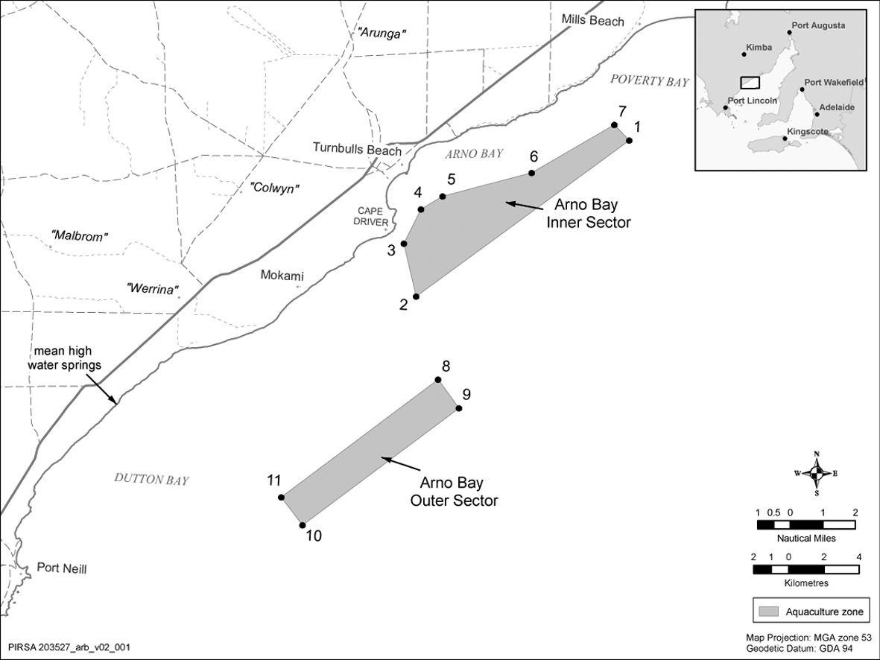
Schedule 3—Revocation of Arno Bay Aquaculture Management Policy
The Arno Bay Aquaculture Management Policy (see Gazette 19.5.2005 p1272) is revoked.
South Australia
Aquaculture (Approval of Revocation Policy) Notice 2011
under section 12 of the Aquaculture Act 2001
1—Short title
This notice may be cited as the Aquaculture (Approval of Revocation Policy) Notice 2011.
2—Approval of Aquaculture Cost Recovery Revocation Policy
(1) The Aquaculture Cost Recovery Revocation Policy 2011 is approved.
(2) The policy comes into operation on the day on which this notice is published in the Gazette.
Made by the Minister for Agriculture and Fisheries
on 29 September 2011
South Australia
Aquaculture Cost Recovery Revocation Policy 2011
under the Aquaculture Act 2001

Contents
1 Short title
2 Revocation of Aquaculture Cost Recovery Policy

1—Short title
This policy may be cited as the Aquaculture Cost Recovery Revocation Policy 2011.
2—Revocation of Aquaculture Cost Recovery Policy
The Aquaculture Cost Recovery Policy (see Gazette 13.2.2003 p577) is revoked.
South Australia
Aquaculture (Approval of Streaky Bay Zones Policy) Notice 2011
under section 12 of the Aquaculture Act 2001
1—Short title
This notice may be cited as the Aquaculture (Approval of Streaky Bay Zones Policy) Notice 2011.
2—Approval of aquaculture policy
(1) The Aquaculture (Zones-Streaky Bay) Policy 2011 is approved.
(2) The policy comes into operation on the day on which this notice is published in the Gazette.
Made by the Minister for Agriculture and Fisheries
on 29 September 2011
South Australia
Aquaculture (Zones—Streaky Bay) Policy 2011
under the Aquaculture Act 2001

Contents
Part 1—Preliminary
1 Short title
2 Interpretation
3 Object of policy
4 Prescription of criteria does not limit matters that may be taken into account
Part 2—Blanche Port aquaculture zone
5 Identification of aquaculture zone
6 Classes of permitted aquaculture
7 Prescribed criteria
Part 3—Haslam (north bank) aquaculture zone
8 Identification of aquaculture zone
9 Classes of permitted aquaculture
10 Prescribed criteria
Part 4—Perlubie (south bank) aquaculture zone
11 Identification of aquaculture zone
12 Classes of permitted aquaculture
13 Prescribed criteria
Part 5—Point Gibson aquaculture zone
14 Identification of aquaculture zone
15 Classes of permitted aquaculture
16 Prescribed criteria
Part 6—Streaky Bay aquaculture exclusion zone
17 Identification of aquaculture exclusion zone
Part 7—Streaky Bay aquaculture zone
18 Identification of aquaculture zone
19 Classes of permitted aquaculture
20 Prescribed criteria
Part 8—Miscellaneous
21 Prescribed criteria for all aquaculture zones
22 Variation or revocation of Gazette notice
Schedule 1—Descriptions of zones
1 Description of Blanche Port aquaculture zone
2 Description of Haslam (north bank) aquaculture zone
3 Description of Perlubie (south bank) aquaculture zone
4 Description of Point Gibson aquaculture zone
5 Description of Streaky Bay aquaculture exclusion zone
6 Description of Streaky Bay aquaculture zone
Schedule 2—Maps of zones
Schedule 3—Revocation of Streaky Bay Aquaculture Management Policy

Part 1—Preliminary
1—Short title
This policy may be cited as the Aquaculture (Zones—Streaky Bay) Policy 2011.
2—Interpretation
(1) In this policy, unless the contrary intention appears—
abalone means abalone (Haliotis spp.) of all species;
Act means the Aquaculture Act 2001;
conservation park has the same meaning as in the National Parks and Wildlife Act 1972;
lease means an aquaculture lease;
leased area, in an aquaculture zone, means the total area in the zone subject to lease;
licence means an aquaculture licence.
(2) For the purposes of identification of zones in this policy, unless the contrary intention appears, all lines are geodesics based on the Geocentric Datum of Australia 1994 (GDA94) as defined in the Commonwealth of Australia Gazette GN35 of 6 September 1995 and all co-ordinates are expressed in terms of GDA94.
(3) The point references given in a description identifying an aquaculture zone or aquaculture exclusion zone in Schedule 1 are references to the corresponding points in the map of that zone in Schedule 2.
Note—
Unless the contrary intention appears, terms used in this policy that are defined in the Act have the respective meanings assigned to those terms by the Act.
3—Object of policy
Pursuant to section 11 of the Act, this policy—
(a) identifies aquaculture zones and an aquaculture exclusion zone; and
(b) specifies for an aquaculture zone—
(i) the classes of aquaculture permitted in the zone; and
(ii) prescribed criteria to be taken into account in the determination of applications for licences or in the making of other decisions under the Act in relation to the zone.
4—Prescription of criteria does not limit matters that may be taken into account
This policy does not limit the matters that may be taken into account in the determination of applications for licences or in the making of other decisions under the Act.
Part 2—Blanche Port aquaculture zone
5—Identification of aquaculture zone
The Blanche Port aquaculture zone comprises the State waters described in Schedule 1 clause 1.
6—Classes of permitted aquaculture
The class of aquaculture permitted in the Blanche Port aquaculture zone is the farming of bivalve molluscs other than mussels.
7—Prescribed criteria
In the determination of applications for licences and in the making of other decisions under the Act in relation to the Blanche Port aquaculture zone, it must be taken into account that the leased area in the zone must not exceed 77.5 hectares.
Part 3—Haslam (north bank) aquaculture zone
8—Identification of aquaculture zone
The Haslam (north bank) aquaculture zone comprises the State waters described in Schedule 1 clause 2.
9—Classes of permitted aquaculture
The class of aquaculture permitted in the Haslam (north bank) aquaculture zone is the farming of bivalve molluscs other than mussels.
10—Prescribed criteria
In the determination of applications for licences and in the making of other decisions under the Act in relation to the Haslam (north bank) aquaculture zone, it must be taken into account that the leased area in the zone must not exceed 50 hectares.
Part 4—Perlubie (south bank) aquaculture zone
11—Identification of aquaculture zone
The Perlubie (south bank) aquaculture zone comprises the State waters described in Schedule 1 clause 3.
12—Classes of permitted aquaculture
The class of aquaculture permitted in the Perlubie (south bank) aquaculture zone is the farming of bivalve molluscs other than mussels.
13—Prescribed criteria
In the determination of applications for licences and in the making of other decisions under the Act in relation to the Perlubie (south bank) aquaculture zone, it must be taken into account that the leased area in the zone must not exceed 40 hectares.
Part 5—Point Gibson aquaculture zone
14—Identification of aquaculture zone
The Point Gibson aquaculture zone comprises the State waters described in Schedule 1 clause 4.
15—Classes of permitted aquaculture
The class of aquaculture permitted in the Point Gibson aquaculture zone is the farming of bivalve molluscs other than mussels.
16—Prescribed criteria
In the determination of applications for licences and in the making of other decisions under the Act in relation to the Point Gibson aquaculture zone, it must be taken into account that the leased area in the zone must not exceed 70 hectares.
Part 6—Streaky Bay aquaculture exclusion zone
17—Identification of aquaculture exclusion zone
The Streaky Bay aquaculture exclusion zone comprises the State waters described in Schedule 1 clause 5.
Part 7—Streaky Bay aquaculture zone
18—Identification of aquaculture zone
The Streaky Bay aquaculture zone comprises the State waters described in Schedule 1 clause 6.
19—Classes of permitted aquaculture
The classes of aquaculture permitted in the Streaky Bay aquaculture zone are—
(a) the farming of bivalve molluscs other than mussels; and
(b) the farming of abalone.
20—Prescribed criteria
In the determination of applications for licences and in the making of other decisions under the Act in relation to the Streaky Bay aquaculture zone the following prescribed criteria must be taken into account:
(a) the leased area in the zone must not exceed 40 hectares;
(b) the biomass of abalone being farmed in the zone must not exceed—
(i) an amount that would, in the opinion of the Minister, have an environmental impact on the sector equivalent to the environmental impact that 200 tonnes of finfish would have on the zone; or
(ii) if some other amount is specified by the Minister by notice in the Gazette, that other amount.
Part 8—Miscellaneous
21—Prescribed criteria for all aquaculture zones
In the determination of applications for licences and in the making of other decisions under the Act in relation to the aquaculture zones in this policy, it must be taken into account that of the aggregated area leased or available for lease in those zones, at least 5 hectares must be used or available for use for the farming of aquatic organisms for the purposes of research or for the purposes of trade, or a business, established for educational purposes.
22—Variation or revocation of Gazette notice
(1) The Minister may vary or revoke a notice in the Gazette made under this policy by subsequent notice in the Gazette.
(2) The power to vary or revoke a notice under subclause (1) is exercisable in the same way, and subject to the same conditions, as the power to make the earlier notice.
Schedule 1—Descriptions of zones
1—Description of Blanche Port aquaculture zone
The Blanche Port aquaculture zone comprises the State waters contained within and bounded by a line commencing at the location on mean high water springs closest to 32°44'54.73" South, 134°14'26.12" East (Point 31), then beginning southerly following the line of mean high water springs to the location closest to 32°47'04.24" South, 134°13'20.12" East (Point 33), then westerly to the location on mean high water springs closest to 32°47'03.64" South, 134°11'35.61" East (Point 34), then beginning northerly following the line of mean high water springs to the location on mean high water springs closest to 32°43'51.67" South, 134°12'55.99" East (Point 32), then south-easterly to the point of commencement.
2—Description of Haslam (north bank) aquaculture zone
The Haslam (north bank) aquaculture zone comprises the State waters contained within and bounded by a line commencing at 32°31'26.32" South, 134°12'32.94" East (Point 1), then south-easterly to 32°31'47.22" South, 134°13'07.72" East (Point 2), then south-westerly to 32°33'04.77" South, 134°11'59.59" East (Point 3), then north-westerly to 32°32'41.95" South, 134°11'22.64" East (Point 4), then north-easterly to the point of commencement.
3—Description of Perlubie (south bank) aquaculture zone
The Perlubie (south bank) aquaculture zone comprises the State waters contained within and bounded by a line commencing at 32°37'57.87" South, 134°14'56.80" East (Point 5), then southerly to 32°38'20.87" South, 134°14'57.97" East (Point 6), then westerly to 32°38'20.61" South, 134°12'55.65" East (Point 7), then northerly to 32°37'57.64" South, 134°12'55.77" East (Point 8), then easterly to the point of commencement.
4—Description of Point Gibson aquaculture zone
The Point Gibson aquaculture zone comprises the State waters contained within and bounded by a line commencing at 32°43'28.22" South, 134°13'06.16" East (Point 9), then southerly to 32°43'46.08" South, 134°13'02.81" East (Point 10), then north-westerly to 32°43'01.03" South, 134°10'56.63" East (Point 11), then westerly to 32°43'04.29" South, 134°10'11.42" East (Point 12), then northerly to 32°42'41.62" South, 134°10'11.16" East (Point 13), then easterly to 32°42'42.16" South, 134°10'54.20" East (Point 14), then south-easterly to the point of commencement.
5—Description of Streaky Bay aquaculture exclusion zone
The Streaky Bay aquaculture exclusion zone comprises the State waters contained within and bounded by—
(a) a line commencing at mean high water springs closest to 32°27'46.89" South, 134°08'45.97" East (Point 15), then southerly to a point 1000 metres seaward of Acraman Creek Conservation Park boundary closest to 32°28'21.95" South, 134°08'48.17" East (Point 16), then beginning easterly following a line 1000 metres seaward of the conservation park boundary to the location closest to 32°28'52.25" South, 134°05'07.21" East (Point 17), then northerly to the location on mean high water springs closest to 32°28'15.63" South, 134°05'10.92" East (Point 18), then beginning northerly following the line of mean high water springs to the point of commencement; and
(b) a line commencing at mean high water springs closest to 32°30'59.38" South, 134°13'05.75" East (Point 19), then south-westerly to 32°31'06.15" South, 134°12'55.16" East (Point 20), then westerly to 32°31'06.34" South, 134°12'33.52" East (Point 21), then north-westerly to 32°30'57.01" South, 134°12'13.04" East (Point 22), then north-westerly to 32°30'41.60" South, 134°12'04.26" East (Point 23), then northerly to 32°30'20.94" South, 134°12'02.78" East (Point 24), then north-easterly to the location on mean high water springs closest to 32°30'12.38" South, 134°12'13.65" East (Point 25), then generally south-easterly following the line of mean high water springs to the point of commencement; and
(c) a line commencing at mean high water springs closest to 32°42'24.96" South, 134°16'31.73" East (Point 26), then north-westerly to 32°42'04.61" South, 134°15'30.52" East (Point 27), then north-westerly to 32°40'36.18" South, 134°14'42.30" East (Point 28), then north-easterly to 32°39'17.88" South, 134°15'38.38" East (Point 29), then north-easterly to the location on mean high water springs closest to 32°38'39.03" South, 134°16'44.28" East (Point 30), then beginning southerly following the line of mean high water springs to the point of commencement; and
(d) a line commencing at mean high water springs closest to 32°47'03.64" South, 134°11'35.61" East (Point 34), then easterly to the location on mean high water springs closest to 32°47'04.24" South, 134°13'20.12" East (Point 33), then beginning southerly following the line of mean high water springs to the point of commencement; and
(e) a line commencing at mean high water springs closest to 32°43'10.94" South, 134°08'39.38" East (Point 35), then north-easterly to 32°42'58" South, 134°08'41.63" East (Point 36), then north-easterly to 32°42'44.86" South, 134°09'06.80" East (Point 37), then easterly to 32°42'46.20" South, 134°09'33.74" East (Point 38), then south-easterly to 32°43'03.05" South, 134°09'53.98" East (Point 39), then southerly to the location on mean high water springs closest to 32°43'15.82" South, 134°9'55.14" East (Point 40), then generally westerly following the line of mean high water springs to the point of commencement.
6—Description of Streaky Bay aquaculture zone
The Streaky Bay aquaculture zone comprises the State waters contained within and bounded by a line commencing at the location 1 000 metres seaward of Acraman Creek Conservation Park boundary closest to 32°28'52.25" South, 134°05'07.21" East (Point 17), then generally north-easterly following a line 1 000 metres seaward of the conservation park boundary to the location closest to 32°28'21.95" South, 134°08'48.17" East (Point 16), then northerly to the location on mean high water springs closest to 32°27'46.89" South, 134°08'45.97" East (Point 15), then beginning south-easterly following the line of mean high water springs to the location closest to 32°44'54.73" South, 134°14'26.12" East (Point 31), then north-westerly to the location on mean high water springs closest to 32°43'51.67" South, 134°12'55.99" East (Point 32), then beginning north-westerly following the line of mean high water springs to the location closest to 32°43'20.47" South, 134°03'38.96" East (Point 41), then north-easterly to the point of commencement, but does not include the aquaculture exclusion zone, or any aquaculture zones, identified in this policy.
Schedule 2—Maps of zones
The maps in this Schedule are provided for convenience of reference only.
Overview
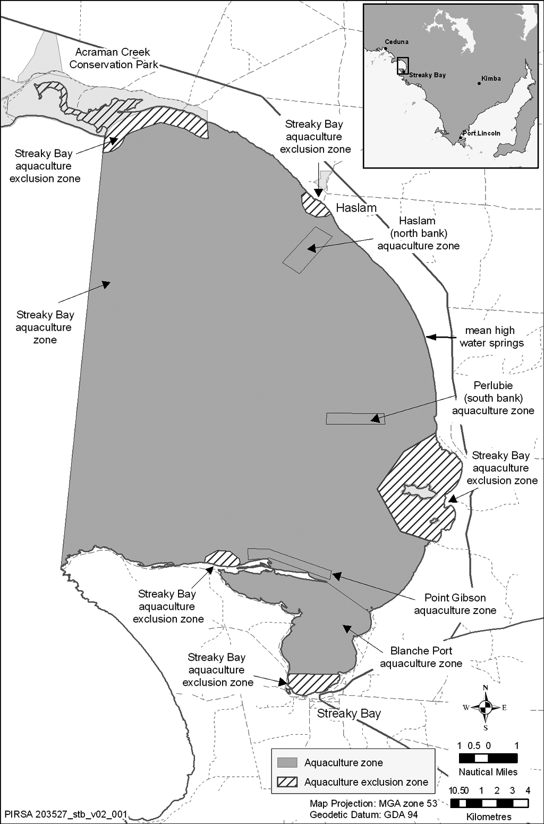
Blanche Port aquaculture zone
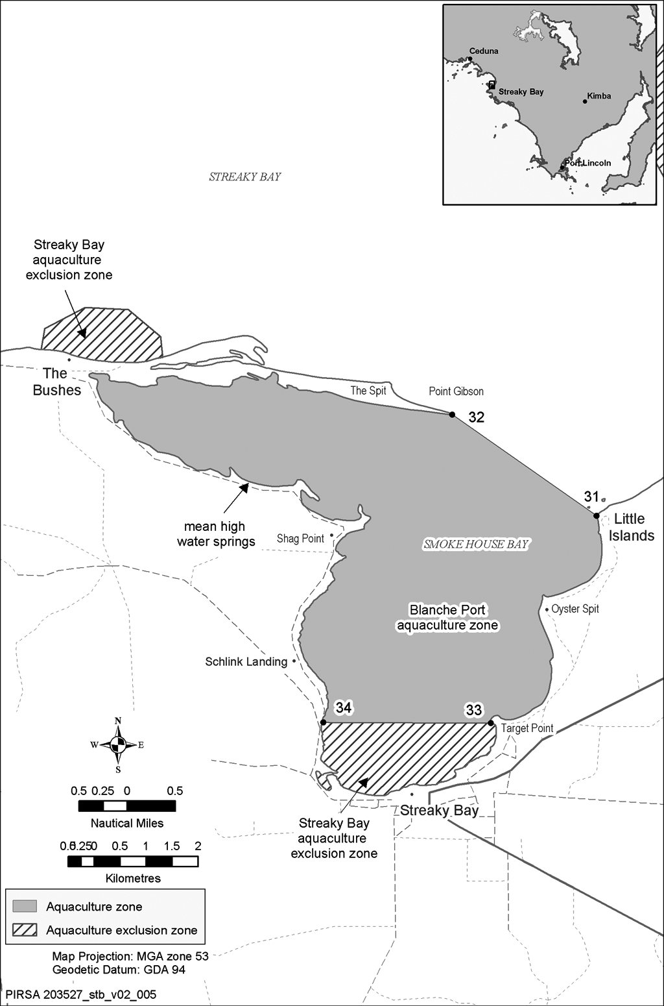
Haslam (north bank) aquaculture zone
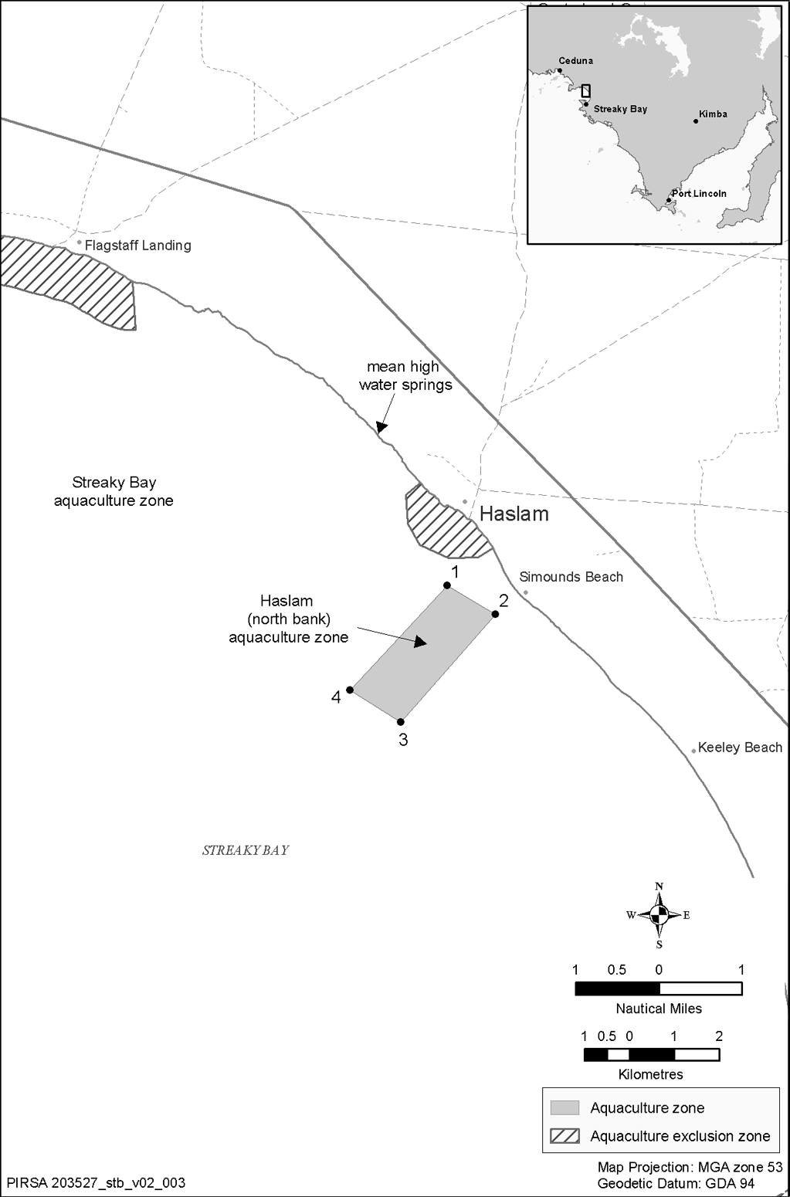
Perlubie (south bank) aquaculture zone
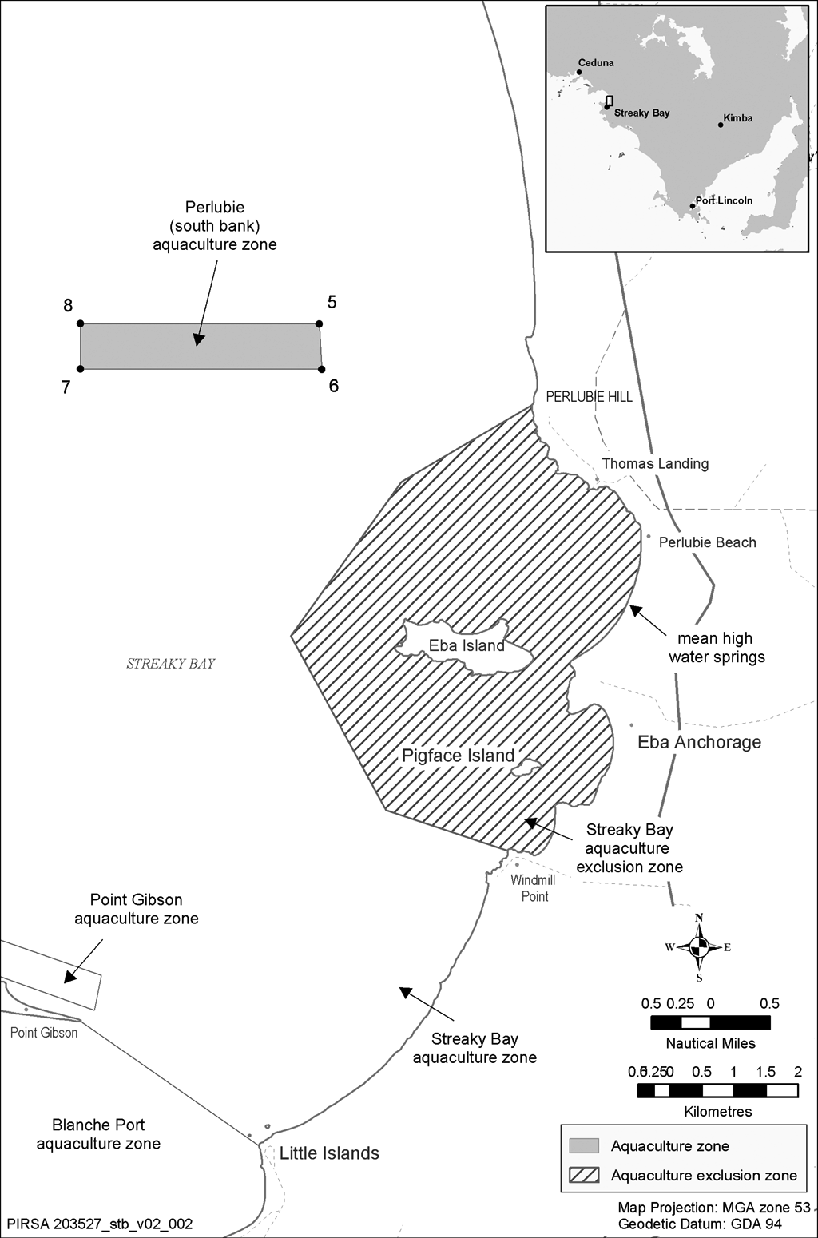
Point Gibson aquaculture zone
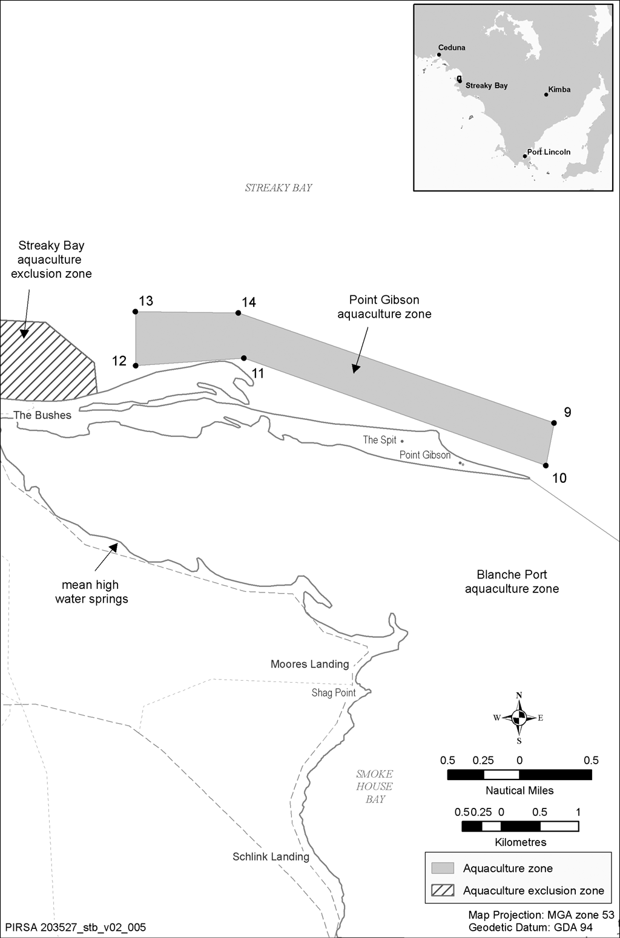
Streaky Bay aquaculture exclusion zone
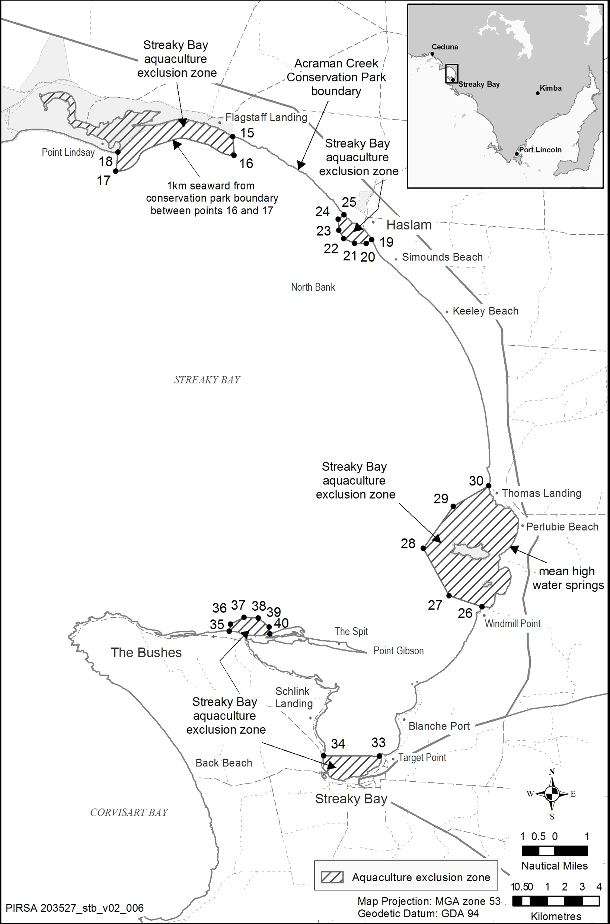
Streaky Bay aquaculture zone
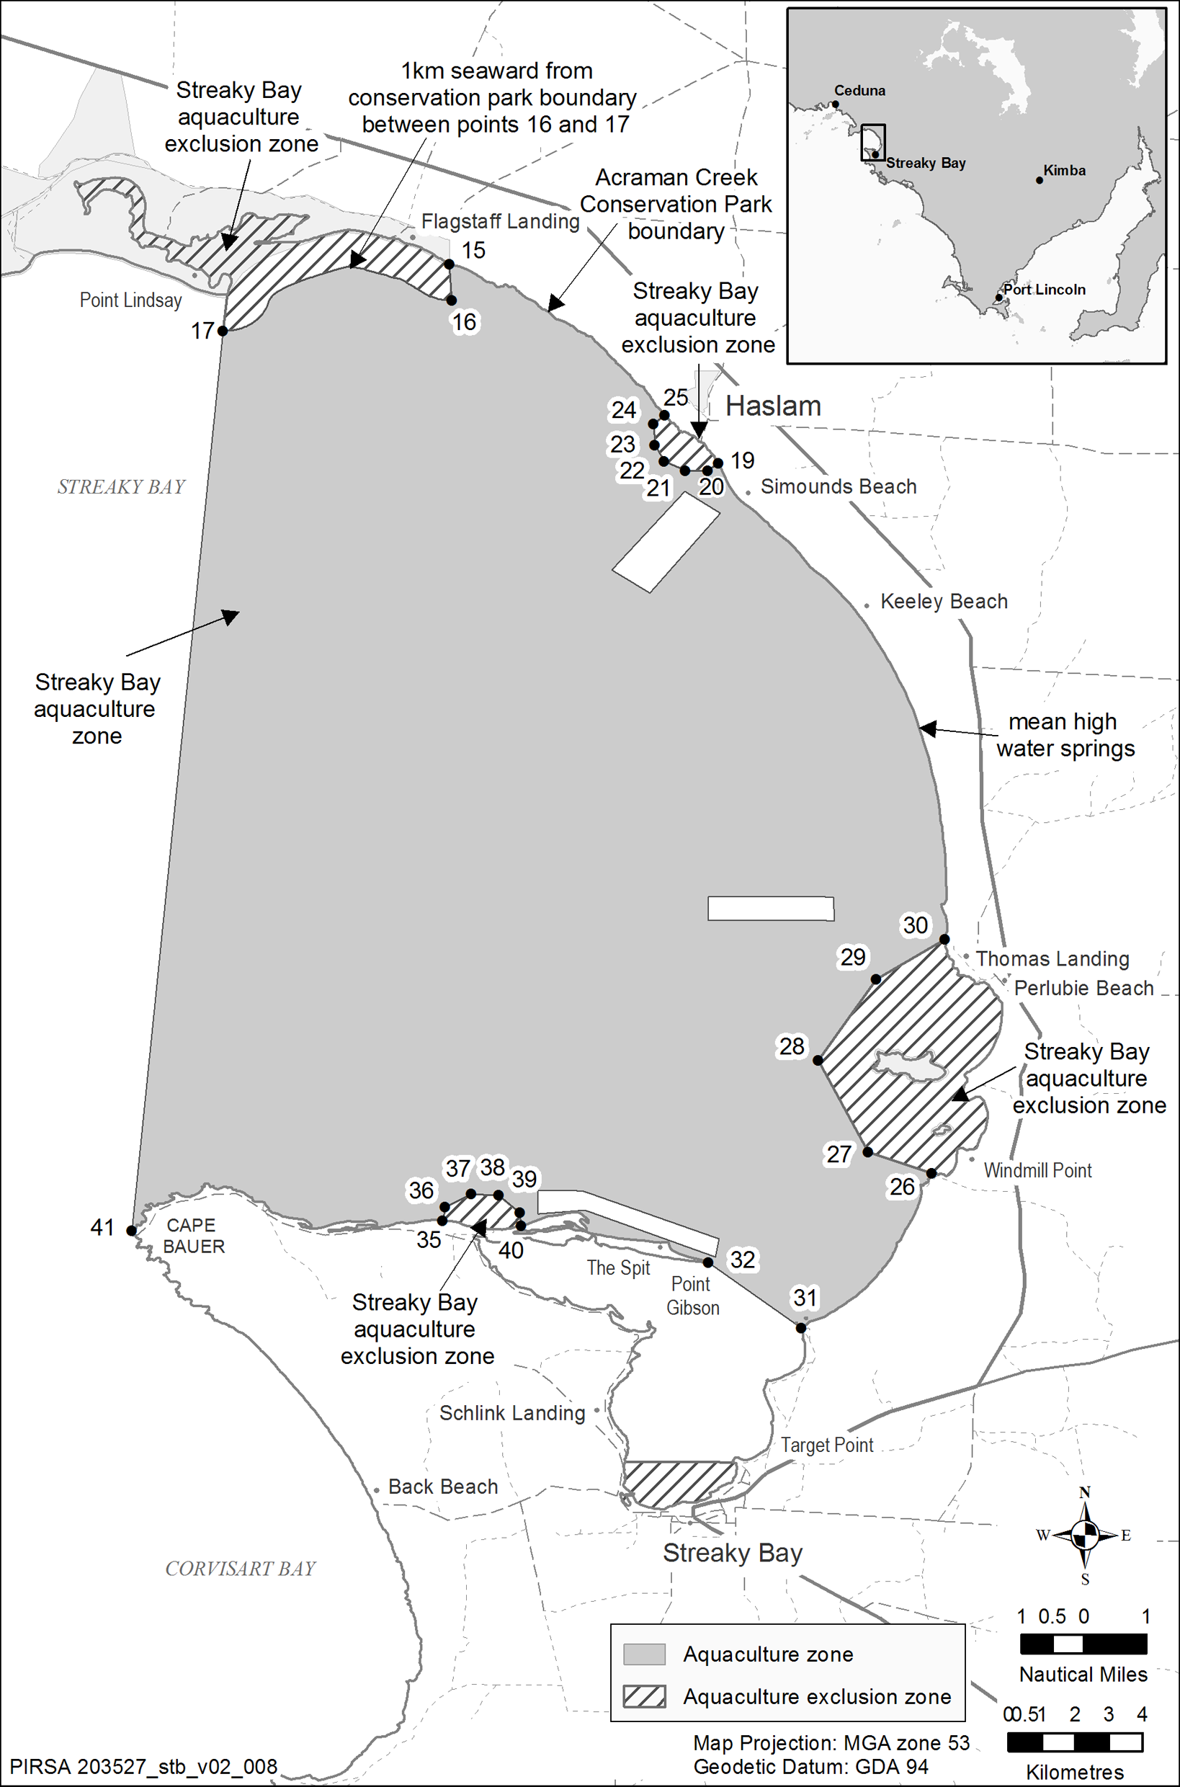
Schedule 3—Revocation of Streaky Bay Aquaculture Management Policy
The Streaky Bay Aquaculture Management Policy (see Gazette 9.12.2004 p4477) is revoked.
South Australia
Adelaide Oval Redevelopment and Management Act (Commencement) Proclamation 2011
1—Short title
This proclamation may be cited as the Adelaide Oval Redevelopment and Management Act (Commencement) Proclamation 2011.
2—Commencement
The Adelaide Oval Redevelopment and Management Act 2011 (No 29 of 2011) will come into operation on 29 September 2011.
Made by the Governor
with the advice and consent of the Executive Council
on 29 September 2011
MFI/11/042

South Australia
Administrative Arrangements (Administration of Adelaide Oval Redevelopment and Management Act) Proclamation 2011
under section 5 of the Administrative Arrangements Act 1994
1—Short title
This proclamation may be cited as the Administrative Arrangements (Administration of Adelaide Oval Redevelopment and Management Act) Proclamation 2011.
2—Commencement
This proclamation comes into operation on the day on which it is made.
3—Administration of Act committed to Minister for Infrastructure
The administration of the Adelaide Oval Redevelopment and Management Act 2011 is committed to the Minister for Infrastructure.
Made by the Governor
with the advice and consent of the Executive Council
on 29 September 2011
MFI/11/042
South Australia
Electrical Products (Part 2 Declarations) Variation Proclamation 2011
under section 5 of the Electrical Products Act 2000
Part 1—Preliminary
1—Short title
This proclamation may be cited as the Electrical Products (Part 2 Declarations) Variation Proclamation 2011.
2—Commencement
This proclamation will come into operation on 1 October 2011.
3—Variation provisions
In this proclamation, a provision under a heading referring to the variation of a specified proclamation varies the proclamation so specified.
Part 2—Variation of Electrical Products (Part 2 Declarations) Proclamation 2004
4—Variation of clause 5—Energy performance registration
Clause 5(3)—delete subclause (3)
5—Variation of Schedule 2—Energy performance registration
(1) Item 1—delete "AS/NZS 3823.2:2009 as in force as at 1 January 2010 with the modifications specified in clause 5(3)2" and substitute:
AS/NZS 3823.22
(2) Item 2—delete "AS/NZS 3823.2:2009 as in force as at 1 January 2010 with the modifications specified in clause 5(3)1" and substitute:
AS/NZS 3823.21
(3) Item 6A—delete "AS/NZS 4934.2(Int): 2008 as in force as at 6 April 20102" and substitute:
AS/NZS 4934.22
Made by the Governor
with the advice and consent of the Executive Council
on 29 September 2011
MEN11/01CS
South Australia
Electrical Products Variation Regulations 2011
under the Electrical Products Act 2000

Contents
Part 1—Preliminary
1 Short title
2 Commencement
3 Variation provisions
Part 2—Variation of Electrical Products Regulations 2001
4 Revocation of regulation 14A

Part 1—Preliminary
1—Short title
These regulations may be cited as the Electrical Products Variation Regulations 2011.
2—Commencement
These regulations will come into operation on 1 October 2011.
3—Variation provisions
In these regulations, a provision under a heading referring to the variation of specified regulations varies the regulations so specified.
Part 2—Variation of Electrical Products Regulations 2001
4—Revocation of regulation 14A
Regulation 14A—delete the regulation
Note—
As required by section 10AA(2) of the Subordinate Legislation Act 1978, the Minister has certified that, in the Minister's opinion, it is necessary or appropriate that these regulations come into operation as set out in these regulations.
Made by the Governor
with the advice and consent of the Executive Council
on 29 September 2011
No 217 of 2011
MEN11/01CS
South Australia
Development (Trusses) Variation Regulations 2011
under the Development Act 1993

Contents
Part 1—Preliminary
1 Short title
2 Commencement
3 Variation provisions
Part 2—Variation of Development Regulations 2008
4 Variation of regulation 74—Notifications during building work
5 Insertion of regulation 74A
74A Provision of truss information
6 Variation of regulation 80AB—Building inspection policies
7 Variation of Schedule 5—Requirements as to plans and specifications

Part 1—Preliminary
1—Short title
These regulations may be cited as the Development (Trusses) Variation Regulations 2011.
2—Commencement
These regulations will come into operation on 1 July 2012.
3—Variation provisions
In these regulations, a provision under a heading referring to the variation of specified regulations varies the regulations so specified.
Part 2—Variation of Development Regulations 2008
4—Variation of regulation 74—Notifications during building work
(1) Regulation 74(1)—after paragraph (c) insert:
(ca) without limiting a preceding paragraph—1 business day's notice of the completion of all roof framing forming part of the building work (including top and bottom chord restraints, bracing and tie-downs);
(2) Regulation 74—after subregulation (4) insert:
(5) If a notice is given under subregulation (1)(ca), the person who gives the notice must, within 1 business day after the notice is given, provide to the council a duly completed supervisor's checklist relating to the roof framing, signed by a registered building work supervisor, being a registered building work supervisor who has undertaken any training required and recognised under a scheme (if any) approved by the Minister for the purposes of this subregulation.
(6) A person must not conceal any completed roof framing until after the expiration of 2 clear business days after the notice required under subregulation (1)(ca) has been received by the council (with the person being able to assume receipt of the notice in the ordinary course of business or transmission).
(7) Subregulations (1)(ca), (5) and (6) do not apply if—
(a) the building is a Class 10 building under the Building Code, other than where the Class 10 building is attached to any part of the roof framing of a building of another class; or
(b) the building is a transportable building.
(8) A person who breaches a requirement under subregulation (1), (5) or (6) is guilty of an offence.
Maximum penalty: $10 000.
Expiation fee: $500.
(9) In this regulation—
roof framing means timber roof framing or light steel framing, including coupled and non-coupled roof framing and roof trusses, but not including portal framing;
supervisor's checklist means a checklist published by the Minister in the Gazette for the purposes of subregulation (5);
transportable building means a building that is fabricated at 1 site and then transported to and located at another site.
5—Insertion of regulation 74A
After regulation 74 insert:
74A—Provision of truss information
(1) A person who is engaged to manufacture a roof truss must, before commencing the work, furnish to—
(a) the council for the area where the roof truss is to be installed; and
(b) —
(i) the licensed building work contractor responsible for the relevant building work; or
(ii) if there is no such licensed building work contractor—the person who is otherwise responsible for the relevant work,
the information required by the checklist that is also required for the purposes of clause 1(1)(g) of Schedule 5.
Maximum penalty: $5 000.
Expiation fee: $315.
(2) The information must be furnished in a manner determined by the Minister for the purposes of this regulation.
6—Variation of regulation 80AB—Building inspection policies
Regulation 80AB—after its present contents (now to be designated as subregulation (1)) insert:
(2) For the purposes of section 71A(4a) of the Act, with respect to any building work involving the construction of any roof framing within the area of the council, the following minimum levels of inspection are prescribed:
(a) a number of inspections equal to 66% of building rules consents issued over the course of the year for building work involving the construction of any roof framing where a licensed building work contractor is responsible for the relevant building work;
(b) a number of inspections equal to 90% of building rules consents issued over the course of the year for building work involving the construction of roof framing where a licensed building work contractor is not responsible for the relevant building work.
(3) All classes of buildings, other than Class 10 buildings, under the Building Code are prescribed under section 71A(2) of the Act for the purposes of subregulation (2).
(4) A reference in subregulation (3) to Class 10 buildings does not include a Class 10 building that is attached to any part of the roof framing of a building of another class.
(5) In this regulation—
roof framing has the same meaning as in regulation 74.
7—Variation of Schedule 5—Requirements as to plans and specifications
(1) Schedule 5, clause 1(1)—after paragraph (f) insert:
and
(g) if the building work involves the installation, alteration, relocation or removal and reinstatement of a roof truss within the ambit of the Minister's Schedule 5 roof framing checklist—the details relating to the truss required by the Minister's Schedule 5 roof framing checklist (provided in the form of the checklist).
(2) Schedule 5, clause 1—after subclause (6) insert:
(6a) In subclause (1)—
Minister's Schedule 5 roof framing checklist means a checklist published by the Minister in the Gazette for the purposes of subclause (1)(g).
Made by the Governor
with the advice and consent of the Executive Council
on 29 September 2011
No 218 of 2011
MUDP09/027CS

South Australia
Road Traffic (Miscellaneous) Variation Regulations 2011
under the Road Traffic Act 1961

Contents
Part 1—Preliminary
1 Short title
2 Commencement
3 Variation provisions
Part 2—Variation of Road Traffic (Miscellaneous) Regulations 1999
4 Variation of regulation 43—Fees for inspections
5 Variation of Schedule 9—Expiation fees

Part 1—Preliminary
1—Short title
These regulations may be cited as the Road Traffic (Miscellaneous) Variation Regulations 2011.
2—Commencement
These regulations will come into operation on 10 October 2011.
3—Variation provisions
In these regulations, a provision under a heading referring to the variation of specified regulations varies the regulations so specified.
Part 2—Variation of Road Traffic (Miscellaneous) Regulations 1999
4—Variation of regulation 43—Fees for inspections
Regulation 43(4)—delete "$27.00" and substitute:
$52.00
5—Variation of Schedule 9—Expiation fees
(1) Schedule 9, Part 2, items relating to sections 117(1) and 118(1)—delete the items and substitute:

117(1) | Vehicle in breach of vehicle standards or maintenance requirement driven on road—being driver of vehicle—
 | non-compliance with rule 155 of the vehicle standards | $550
 | any other contravention of section 117(1) | $350
118(1) | Vehicle in breach of vehicle standards or maintenance requirement driven on road—being operator of vehicle—
 | non-compliance with rule 155 of the vehicle standards | $550
 | any other contravention of section 118(1) | $350
(2) Schedule 9, Part 2, item relating to section 164A(1), sub-item relating to section 145(5f)—delete "$165" and substitute:
$350
(3) Schedule 9, Part 2, item relating to section 164A(1)—after sub-item relating to section 145(5f) insert:

145(6) | Driving, selling, etc vehicle contrary to terms of defect notice | $500
Note—
As required by section 10AA(2) of the Subordinate Legislation Act 1978, the Minister has certified that, in the Minister's opinion, it is necessary or appropriate that these regulations come into operation as set out in these regulations.
Made by the Governor
with the advice and consent of the Executive Council
on 29 September 2011
No 219 of 2011
MTR/11/060

South Australia
Electoral Variation Regulations 2011
under the Electoral Act 1985

Contents
Part 1—Preliminary
1 Short title
2 Commencement
3 Variation provisions
Part 2—Variation of Electoral Regulations 2009
4 Insertion of regulations 5A to 5C
5A Registration of political parties—nomination of party entitled to rely on person (section 36)
5B Registration of political parties—annual returns and other inquiries (section 43A)
5C Prescribed persons (section 46B)
5 Variation of Schedule 1—Forms

Part 1—Preliminary
1—Short title
These regulations may be cited as the Electoral Variation Regulations 2011.
2—Commencement
These regulations will come into operation on the day on which section 9 of the Electoral (Miscellaneous) Amendment Act 2009 comes into operation.
3—Variation provisions
In these regulations, a provision under a heading referring to the variation of specified regulations varies the regulations so specified.
Part 2—Variation of Electoral Regulations 2009
4—Insertion of regulations 5A to 5C
After regulation 5 insert:
5A—Registration of political parties—nomination of party entitled to rely on person (section 36)
(1) For the purposes of section 36(4)(a) of the Act, the Electoral Commissioner must give a person relied on by 2 or more political parties an opportunity to nominate the party entitled to rely on the person by giving the person a notice advising the person that—
(a) the person is being relied on by 2 or more parties for the purposes of Part 6 of the Act; and
(b) the Act prevents the person from being so relied on; and
(c) the person may nominate the party entitled to rely on the person for the purposes of Part 6 of the Act; and
(d) the nomination must be in writing and sent to the Electoral Commissioner; and
(e) if no such nomination is received by the Electoral Commissioner within 28 days of the date of the notice, the person is not entitled to be relied on by any of the parties.
(2) For the purposes of section 36(4)(b) of the Act, the Electoral Commissioner must give a party an opportunity to change a person or persons on whom it relies by giving the registered officer of the party a notice advising the registered officer that—
(a) the registration of the party is liable to be cancelled because of the provisions of section 36; and
(b) the party may change the person or persons on whom it relies—
(i) in the case of a party that is not a parliamentary party—by providing to the Electoral Commissioner—
(A) the name and address of the person, or names and addresses of the persons, on whom the party proposes to rely in place of the person or persons on whom the party may no longer rely as a result of the operation of section 36; and
(B) a declaration or declarations of membership of the party (in the form determined by the Electoral Commissioner) completed and signed by the person or persons referred to in subsubparagraph (A) (on whom the party proposes to rely); or
(ii) in the case of a parliamentary party—by providing to the Electoral Commissioner—
(A) the name and address of the member on whom the party proposes to rely in place of the person on whom the party may no longer rely as a result of the operation of section 36; and
(B) a declaration of membership of the party (in the form determined by the Electoral Commissioner) completed and signed by the member referred to in subsubparagraph (A); and
(c) details to be provided under paragraph (b) must be in writing and sent to the Electoral Commissioner; and
(d) details to be provided under paragraph (b) must be received by the Electoral Commissioner within 28 days of the date of the notice.
5B—Registration of political parties—annual returns and other inquiries (section 43A)
(1) For the purposes of section 43A(1) of the Act, the prescribed form for an annual return is set out in Form A1 in Schedule 1.
(2) For the purposes of section 43A(2) of the Act, the following documents are required:
(a) in the case of a party that is not a parliamentary party—
(i) a document that sets out the names and addresses (as enrolled) of 200 electors who are members of the party and on whom the party relies for the purpose of qualifying as an eligible political party; and
(ii) declarations of membership of the party (in the form determined by the Electoral Commissioner) completed and signed within the period to which the annual return relates by the members on whom the party relies for the purpose of qualifying as an eligible political party;
(b) in the case of a parliamentary party—
(i) a document that sets out the name and address of the member on whom the party relies for the purpose of qualifying as an eligible political party; and
(ii) a declaration of membership of the party (in the form determined by the Electoral Commissioner) completed and signed within the period to which the annual return relates by the member on whom the party relies for the purpose of qualifying as an eligible political party.
5C—Prescribed persons (section 46B)
For the purposes of section 46B of the Act, the following are prescribed persons:
(a) the Crown Solicitor for the State of South Australia;
(b) a police officer;
(c) an employee of the administrative unit that is, under the Minister, responsible for the administration of the Criminal Law Consolidation Act 1935 engaged in the investigation of an offence against the Electoral Act 1985.
5—Variation of Schedule 1—Forms
Schedule 1—before Form 1 insert:
Form A1—Form of annual return
Name of party:
Registered officer—
(a) Name:
(b) Address:
(c) Contact Details:
For the purposes of demonstrating the party's continued eligibility for registration under Part 6 of the Electoral Act 1985, I attach the documents required under regulation 5B(2) of the Electoral Regulations 2009.
Signature:
Date:
Note—
As required by section 10AA(2) of the Subordinate Legislation Act 1978, the Minister has certified that, in the Minister's opinion, it is necessary or appropriate that these regulations come into operation as set out in these regulations.
Made by the Governor
with the advice and consent of the Executive Council
on 29 September 2011
No 220 of 2011
AGO0170/04CS

FAXING COPY?
IF you fax copy to Government Publishing SA for inclusion in the Government Gazette, there is no need to send a Confirmation Copy to us as well.
This creates confusion and may well result in your notice being printed twice.
Please use the following fax number:
Fax transmission: (08) 8207 1040
Phone Enquiries: (08) 8207 1045
Please include a contact person, phone number and order number so that we can phone back with any queries we may have regarding the fax copy.
NOTE: Closing time for lodging new copy (fax, hard copy or email) is 4 p.m. on Tuesday preceding the day of publication.

Government Gazette notices can be Emailed.
The address is:
governmentgazette@dpc.sa.gov.au
Documents should be sent as attachments in Word format.
When sending a document via Email, please confirm your transmission with a faxed copy of your document, including the date the notice is to be published.
Fax transmission: (08) 8207 1040
Phone Enquiries: (08) 8207 1045
NOTE: Closing time for lodging new copy (fax, hard copy or email) is 4 p.m. on Tuesday preceding the day of publication.

PORT AUGUSTA CITY COUNCIL
Declaration of Public Road
NOTICE is hereby given that pursuant to Section 208 of the Local Government Act 1999, Port Augusta Council resolved at its meeting held on 26 September 2011:
(1) To declare Allotment 37 in Deposited Plan 1057 as described within Certificate of Title 1033/23 to be a public road.
(2) Allocates the name ‘Puddy Lane’ to this road reserve.
G. Perkin, City Manager

TOWN OF WALKERVILLE
Road Closure—St Andrew’s Lane and George Street, Walkerville
NOTICE is hereby given that by Council resolution on Monday, 19 September 2011, the Town of Walkerville Council body resolved to allow the following installation or alteration of a traffic control device, such installation or alteration will exclude vehicles from a particular street, road or public place or part of a particular street, road or public place:
(1) St Andrew’s Lane between the hours of 7.30 a.m. and
5 p.m. from Monday to Friday.
(2) Portion of George Street between the hours of 7.30 a.m. and 5 p.m. from Monday to Friday.
K. Magro, Chief Executive Officer

THE BAROSSA COUNCIL
Naming of Keynes Gap Road—Eden Valley
NOTICE is hereby given that pursuant to Section 219 of the Local Government Act 1999, Council on 20 September 2011, resolved to rename Dawkins Road—Eden Valley Road. The road is to be known as Keynes Gap Road.
D. Morcom, Chief Executive Officer

DISTRICT COUNCIL OF CEDUNA
Change of Meeting Time and Dates
NOTICE is hereby given that Council advises that the following changes have occurred:
• All Ordinary Council Meetings will commence at 3 p.m.;
• the November ordinary Council meeting has been rescheduled to Tuesday, 15 November 2011, commencing at 3 p.m.; and
• the December ordinary Council meeting has been rescheduled to Wednesday, 14 December 2011, commencing at 3 p.m.
T. Smart, Chief Executive Officer

DISTRICT COUNCIL OF MOUNT BARKER
Exclusion of Vehicles
NOTICE is hereby given that on 19 September 2011, the District Council of Mount Barker resolved to:
Close an 85 m section of road to motor vehicles running west from the western edge of the driveway access to 36 Little Dublin Road via the use of a set of two locked gates at each end of the closure in accordance with the relevant Traffic Control Device Code and with adjacent bollards for pedestrian and bicycle access.
A. Stuart, Chief Executive Officer

IN the matter of the estates of the undermentioned deceased persons:
Barton-Ancliffe, Dorothy, late of 181 Hansworth Street, Mulgrave, Victoria, retired machinist, who died on 15 February 2010.
Blunden, Gillian Mary, late of 7A Wheaton Street, South Plympton, retired secretary, who died on 29 June 2011.
Briggs, Laurel Emma, late of 324 Military Road, Semaphore Park, retired school teacher, who died on 21 August 2011.
Burke, Ian Shane, late of Mundoora Road, Port Broughton, retired boilermaker, who died on 5 April 2011.
Crane, Helen Grace, late of 18 Foster Street, Norwood, of no occupation, who died on 1 February 2011.
Davis, Glenys Elaine, late of 13 Greenasche Grove, Seacombe Gardens, home duties, who died on 23 June 2011.
Germon, Stanley Maxwell, late of 8 Mine Street, Kadina, retired boilermaker, who died on 8 February 2011.
Gill, Leslie, late of 86 Oaklands Road, Glengowrie, retired clerk, who died on 2 June 2011.
Green Karen Dawn, late of 286 Portrush Road, Kensington, of no occupation, who died on 9 July 2011.
Johnson, Agnes Ruby, late of 43A Flinders Avenue, Whyalla Stuart, of no occupation, who died on 9 July 2011.
McMillan, Catherine McMaster, late of 26 River Road, Port Noarlunga, of no occupation who died on 7 July 2011.
Meyer, Irene Irma Anne, late of 580 Brighton Road, South Brighton, widow, who died on 11 May 2011.
Painter, Maria Frances, late of 11 Anna Court, West Lakes, home duties, who died on 19 July 2011.
Peacock, Ronald, late of 33 Nelson Avenue, Flinders Park retired civil engineer, who died on 13 November 2009.
Reid, Alfred Clement, late of Grainger Road, Somerton Park, retired accountant, who died on 17 July 2011.
Reinschmidt, Victor Frederick, late of 22 Norman Street, Port Pirie, retired worker, who died on 27 July 2011.
Romans, John Frederick, late of 2-10 First Street, Brompton, retired postman, who died on 10 November 2009.
Sweeney, Roger Paul, late of East Street, Port Wakefield, retired instrument technician, who died on 21 October 2010.
Notice is hereby given pursuant to the Trustee Act 1936, as amended, the Inheritance (Family Provision) Act 1972 and the Family Relationships Act 1975, that all creditors, beneficiaries, and other persons having claims against the said estates are required to send, in writing, to the Office of Public Trustee, G.P.O. Box 1338, Adelaide, S.A. 5001, full particulars and proof of such claims, on or before 28 October 2011, otherwise they will be excluded from the distribution of the said estates; and notice is also hereby given that all persons indebted to the said estates are required to pay the amount of their debts to the Public Trustee or proceedings will be taken for the recovery thereof; and all persons having any property belonging to the said estates are forthwith to deliver same to the Public Trustee.
Dated 29 September 2011.
D. A. Contala, Public Trustee

IN the matter of the estate of the undermentioned deceased person:
McRostie, Colin George, late of 2B Chatsworth Grove, Toorak Gardens, who died on 8 January 2011.
Notice is hereby given pursuant to the Trustee Act 1936,as amended, the Inheritance (Family Provisions) Act 1972-1975 and the Family Relationships Act 1975, that all creditors, beneficiaries and other persons having claims against the abovementioned estate are directed to send full particulars and evidence of such claims to the undersigned on or before 27 October 2011, otherwise they will be excluded from the distribution of the said estate; and notice is also hereby given that all persons who are indebted to the above estate are required to pay the amount of their debt to the undersigned or proceedings will be taken for the recovery thereof; and all persons having any property belonging to the said estate are forthwith to deliver the same to the undersigned.
National Australia Trustees Limited, The Manager, Trustee Services, Level 10, 22 King William Street, Adelaide, S.A. 5000

ATTENTION

CUSTOMERS requiring a proof of their notice for inclusion in the Government Gazette, please note that the onus is on you to inform Government Publishing SA of any subsequent corrections.

For any corrections to your notice please phone 8207 1045 or Fax 8207 1040 before 4 p.m. on Wednesday.

If we do not receive any communication by 10 a.m. on Thursday (day of publication) we will presume the notice is correct and will print it as it is.

Remember—the onus is on you to inform us of any corrections necessary to your notice.

NOTE: Closing time for lodging new copy (electronically, fax or hard copy) is 4 p.m. on Tuesday preceding the day of publication.
Phone: 8207 1045
Fax: 8207 1040
Email: governmentgazette@dpc.sa.gov.au

Printed and published by authority every Thursday by B. MORRIS, Government Printer, South Australia
Price: $6.25, plus postage; to subscribers, $315.00 per annum.
(The above prices are inclusive of GST)

