SUPPLEMENTARY GAZETTE



THE SOUTH AUSTRALIAN

GOVERNMENT GAZETTE
www.governmentgazette.sa.gov.au

PUBLISHED BY AUTHORITY

ALL PUBLIC ACTS appearing in this GAZETTE are to be considered official, and obeyed as such

ADELAIDE, TUESDAY, 17 APRIL 2012

Housing and Urban Development (Administrative Arrangements) Act 1995
Transfer of Assets of the Urban Renewal Authority
Pursuant to the provisions of Section 23 of the Housing and Urban Development (Administrative Arrangements) Act 1995, I, Patrick Conlon, Minister for Housing and Urban Development, with the concurrence of Jack Snelling, Treasurer, gives notice of the transfer of the properties, with Certificate of Title and Allotment References listed in Schedule 1, from the Urban Renewal Authority to the South Australian Housing Trust on 29 March 2012.
Schedule 1
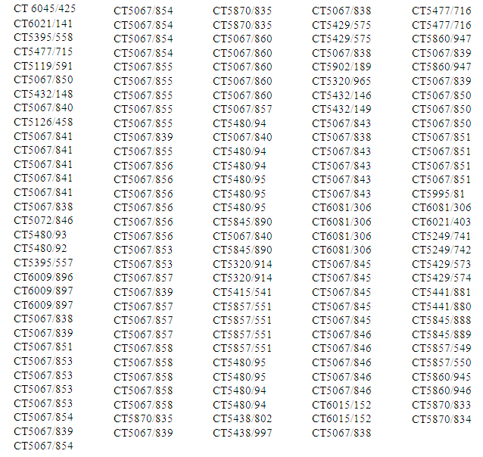

Dated 30 March 2012.
Patrick Conlon, Minister for Housing and Urban Development
Dated 11 April 2012.
Jack Snelling, Treasurer

B. MORRIS, Government Printer, South Australia

