No. 15 937



THE SOUTH AUSTRALIAN

GOVERNMENT GAZETTE
www.governmentgazette.sa.gov.au

PUBLISHED BY AUTHORITY

ALL PUBLIC ACTS appearing in this GAZETTE are to be considered official, and obeyed as such

ADELAIDE, THURSDAY, 8 MARCH 2012

CONTENTS

Page
Acts Assented To 938
Anangu Pitjantjatjara Yankunytjatjara Land
Rights Act 1981—Notice 939
Appointments, Resignations, Etc. 938
Erratum 938
Corporations and District Councils—Notices 962
Firearms Act 1977—Notices 940
Fisheries Management Act 2007—Notice 940
Geographical Names Act 1991—Notice 940
Land Acquisition Act 1969—Notice 941
Liquor Licensing Act 1997—Notices 941
Mining Act 1971—Notices 942
Motor Vehicles Act 1959—Notice 948
National Parks and Wildlife Act 1972—Notice 943

Page
National Parks and Wildlife (National Parks)
Regulations 2001—Notices 943
Partnership Act 1891—Notice 965
Proclamation 958
Public Trustee Office—Administration of Estates 965
REGULATION
Liquor Licensing Act 1997
(No. 13 of 2012) 959
RULES
Magistrates Court (Civil) Rules 1992—
(Amendment No. 41) 949
Survey Actt 1992—Notice 944
Water Mains and Sewers—Mains Laid, Replaced, Etc. 944

GOVERNMENT GAZETTE NOTICES
ALL poundkeepers’ and private advertisements forwarded for publication in the South Australian Government Gazette must be PAID FOR PRIOR TO INSERTION; and all notices, from whatever source, should be legibly written on one side of the paper only and sent to Government Publishing SA so as to be received no later
than 4 p.m. on the Tuesday preceding the day of publication. Phone 8207 1045 or Fax 8207 1040. E-mail: governmentgazette@dpc.sa.gov.au. Send as attachments in Word format and please confirm your transmission with a faxed copy of your document, including the date the notice is to be published and to whom the notice will be charged. The Government Gazette is available online at: www.governmentgazette.sa.gov.au

Department of the Premier and Cabinet
Adelaide, 8 March 2012
HIS Excellency the Governor directs it to be notified for general information that he has in the name and on behalf of Her Majesty The Queen, this day assented to the undermentioned Acts passed by the Legislative Council and House of Assembly in Parliament assembled, viz.:
No. 1 of 2012—Arkaroola Protection Act 2012. An Act to provide for the establishment of the Arkaroola Protection Area; to provide for the proper management of the Arkaroola Protection Area and prohibit mining activities in the Arkaroola Protection Area; to make related amendments to the Development Act 1993, the Natural Resources Management Act 2004 and the Pastoral Land Management and Conservation Act 1989; and for other purposes.
No. 2 of 2012—Vocational Education and Training (Commonwealth Powers) Act 2012. An Act to adopt the National Vocational Education and Training Regulator Act 2011 of the Commonwealth and the National Vocational Education and Training Regulator (Transitional Provisions) Act 2011 of the Commonwealth, and to refer certain matters relating to the regulation of vocational education and training to the Parliament of the Commonwealth, for the purposes of Section 51 (xxxvii) of the Constitution of the Commonwealth.
By command,
Jay Wilson Weatherill, Premier
DPC06/0875

Department of the Premier and Cabinet
Adelaide, 1 March 2012
Erratum
IN Government Gazette No. 13 dated 1 March 2012, the name at the top of page 865, Jennifer Leanne Duchatenier should have read Jennifer Leanne DuChatenier.
By command,
Jay Wilson Weatherill, Premier
JP11/038CS

Department of the Premier and Cabinet
Adelaide, 8 March 2012
HIS Excellency the Governor in Executive Council has been pleased to appoint the undermentioned to the Training Centre Review Board, pursuant to the provisions of the Young Offenders Act 1993:
Member: (from 8 March 2012 until 7 March 2015)
Robert David Gray
Christopher Paul Zanker
Deputy Member: (from 8 March 2012 until 7 March 2015)
Gregory Lee Forrest (Deputy to Gray)
Stewart Andrew Dodd (Deputy to Zanker)
By command,
Jay Wilson Weatherill, Premier
AGO0428/02CS

Department of the Premier and Cabinet
Adelaide, 8 March 2012
His Excellency the Governor in Executive Council has been pleased to appoint the people listed as Justices of the Peace for South Australia for a period of ten years commencing from
8 March 2012 and expiring on 7 March 2022, it being a condition of appointment that the Justices of the Peace must take the oaths required of a Justice under the Oaths Act 1936 and return the oaths form to the Justice of the Peace Services within 3 months of the date of appointment, pursuant to Section 4 of the Justices of the Peace Act 2005:
Brian Stephen Blunt
Graham David Brinkworth
Edward John Brittle
Noel John Brook
John Clifford Browne
Vanessa Catterall
Barrington Gordon Conroy
Ian Malcolm Cooper
Neil James Crabb
John Charles Danese
Necia Heather Ebert
Jeanette Mary Elliott
Gerard Francis Ferrao
Philip John Gates
Evan Terrence Georgiou
Geoffrey Charles Glynn-Roe
Hamish Alexander Elder Gosse
Leonie Madge Habbershaw
Raymond Harry Hendrie
Nigel Phillip Holden
Quentin Jerome Hornhardt
Robert James Howard
Faye Jessie Hugo
Bruce William Johansen
Graham Stephen Jones
Stephen John Kelton
William David Leonard
Raymond Allan McGlashan
Darrol Keith Magor
Marc Marshall
John Francis Millington
Janet Moira Milton
Cassandra Munro
Kanaga Nathan
Marshall Andrew Peters
Brian Angus Richards
Kathleen Mary Richardson
Lesley Jean Roberts
Brenton Craig Rolton
Peter Walter Strazds
Robert George McBurnie Thomas
Desmond John Thompson
David Stanley Tucker
Garry Roland Tunn
Mark Andrew Vucic
Angela Vukajlovic
Lynette Ann Warnock
Diane Carol Winterling
Thomas Gratton Young
Judith Dianne Zippel
By command,
Jay Wilson Weatherill, Premier
JP12/007CS

Department of the Premier and Cabinet
Adelaide, 8 March 2012
His Excellency the Governor in Executive Council has been pleased to appoint the persons listed to the list of legally qualified medical practitioners for the purpose of constituting Medical Panels for a period commencing on 12 March 2012 and expiring on 11 March 2015, pursuant to Section 98 (2) of the Workers Rehabilitation and Compensation Act 1986:
Given  Name | Middle  Name | Surname | Specialty
Peter | Lazarus | Anastassiadis | Rehabilitation Physician
Kevin | Reginald | Angel | Orthopaedic Surgeon
Justin | Peter | Ardill | Cardiologist
David | John | Ash | Psychiatrist
Robert | Neville | Atkinson | Orthopaedic Surgeon
John | Putnam | Bastian | Rehabilitation Physician
David | Bates | Bowman | Gastroenterologist
Christopher | John | Branson | Psychiatrist
Brian | Patrick | Brophy | Neurosurgeon
Richard | Bruce | Burnet | Endocrinologist
Gary |  | Champion | Rheumatologist
Robin | Craig | Chase | Occupational Physician
Michael | Peter | Clarke | Psychiatrist
Given  Name | Middle  Name | Surname | Specialty
Gary | Kenneth | Clothier | Rehabilitation and Pain Physician
Antonio |  | Cocchiaro | General Practitioner
Pasqualino |  | Cocchiaro | General Practitioner
Helen | Louise | Crocker | General & Respiratory Medicine Physician
John | Lionel | Crompton | Ophthalmologist
John | Alexander | Cross | Occupational Physician
Maria |  | Crotty | Rehabilitation Physician
Gustaw | Jozef | Czechowicz | General Practitioner
David | John | David | Plastic and Reconstructive Surgeon
David | John | Fitzgerald | General Practitioner
Nicholas | Lawrence | Ford | Psychiatrist
Thomas | Alexander | Frayne | ENT Surgeon
Cherrie | Ann | Galletly | Psychiatrist
Janina |  | Gipslis | Psychiatrist
Paul | Nathan | Goldwater | Infectious Diseases Physician
Geoffrey | James | Graham | Occupational Physician
Noel | Leslie | Grieve | Dermatologist
David | Wyndham | Hamilton | General Surgeon
Richard |  | Heah | General Practitioner
Ian | Winston | Hocking | Obstetrician & Gynaecologist
Catherine | Mary | Houen | Psychiatrist
Clive | Anthony | Hume | General Practitioner
James | David | Hundertmark | Psychiatrist
Glyn | Garfield | Jamieson | General Surgeon
Michael | John Magnus | Jay | ENT Surgeon
Reece | Ian | Jennings | General Practitioner
Peter | Tomas | Jezukaitis | Occupational Physician
Christopher | Brian | Kelly | Occupational Physician
Chris |  | Koulos | General Practitioner
Stephen | (Meng How) | Leow | General Practitioner
Edward | Tuckseng | Mah | Orthopaedic Surgeon
David | John | Marshall | Orthopaedic Surgeon
Edward |  | Marzec | ENT Surgeon
Alexander | Cowell | McFarlane | Psychiatrist
Brian | Stuart | McKenny | Psychiatrist
John | Christopher | Meegan | Occupational Physician
Jonathan | Rodwell | Middleton | Orthopaedic Surgeon
Cynthia | Joyce | Molloy | Neurosurgeon
Gordon | William | Morrison | Orthopaedic Surgeon
Sharon | Leanne | Morton | General & Respiratory Medicine Physician
Susan | Josephine | Neuhaus | General Surgeon
Graham | Russell | Norton | Neurologist
Orso | Lorenzo | Osti | Orthopaedic Surgeon
Thomas | Craig | Paterson | Psychiatrist
Paul | Laszlo | Pers | General Practitioner
Oswald | Marino | Petrucco | Obstetrician & Gynaecologist
Catherine | Margaret | Reid | Dermatologist
Martin | Kevin | Robinson | Neurologist
Bruce | Frederick | Rounsefell | Pain Physician
Leanne |  | Rowe | General Practitioner
Randall | Paul | Sach | Plastic and Reconstructive Surgeon
John | Fraser | Sangster | Cardiologist
Given  Name | Middle  Name | Surname | Specialty
Richard | Glen | Sarre | General Surgeon
Anastasios | Tom | Savvoulidis | Orthopaedic Surgeon
Ernst | Michael | Shanahan | Rheumatologist
Ivan | Josef | Simmons | Dermatologist
James | Leslie | Sweeney | General Surgeon
Peter |  | Sylaidis | Plastic and Reconstructive Surgeon
David | Michael | Tamblyn | Ophthalmologist
Chee Keong |  | Thoo | Occupational Physician
John |  | Tomich | ENT Surgeon
Nicholas | Gerasimos | Vlachoulis | General Practitioner
Christopher | Arther | Wagner | General Practitioner
Ingrid | Birgitta | Wangel | General Practitioner
Warren |  | Weightman | Dermatologist
John | Leslie | Wilson | Occupational Physician
Lindon | Michael Harper | Wing | General Medicine Specialist
David | Alan | Cherry | Pain Physician
Erik | Theodore | Eriksen | General Surgeon
Donald | Peter | Reid | Gastroenterologist
Peter | Lawrence | Reilly | Neurosurgeon
Graham | Robert | Sinclair | Urologist
Thomas | McIntyre | Stevenson | Orthopaedic Surgeon
Andrew | D’Arcy | Sutherland | Orthopaedic Surgeon

By command,
Jay Wilson Weatherill, Premier
12MWRH002CS

ANANGU PITJANTJATJARA YANKUNYTJATJARA LAND RIGHTS ACT 1981
Anangu Pitjantjatjara Yankunytjatjara Executive Board Elections
IN accordance with the Anangu Pitjantjatjara Yankunytjatjara Land Rights Act 1981, Schedule 3, Part 3, Section 17, I, Kay Mousley, Returning Officer for Anangu Pitjantjatjara Yankunytjatjara Executive Board Elections, hereby declare the following persons elected to the Executive Board:
Candidates
Milyika Paddy | Executive Member
Owen Burton | Executive Member
Anton Baker | Executive Member
Leon Arthur Colson (Palpatja) | Executive Member
Trevor Adamson | Executive Member
Willy Pompey | Executive Member
Alex Pannikan Baker | Executive Member
Bernard Singer | Executive Member
The results for each election are as follows:
Pipalyatjara/Kalka Executive Board Member
Candidates
Milyika Paddy | Elected Unopposed
Amata/Tjurma Executive Board Member
Candidates | No. of Votes
Owen Burton | 23
Stanley Douglas | 7
Lee Brady | 10
Deborah Burton | 5
Total | 45
Kanypi/Nyapari/Angatja Executive Board Member
Candidates
Anton Baker | Elected Unopposed
Watarru Executive Board Member
No nominations received
Kaltjiti/Irintata/Watinuma Executive Board Member
No nominations received
Anilalya/Turkey Bore Executive Board Member
Candidates | No. of Votes
Leon Arthur Colson (Palpatja) | 18
Dennis R. Colson | 4
Total | 22
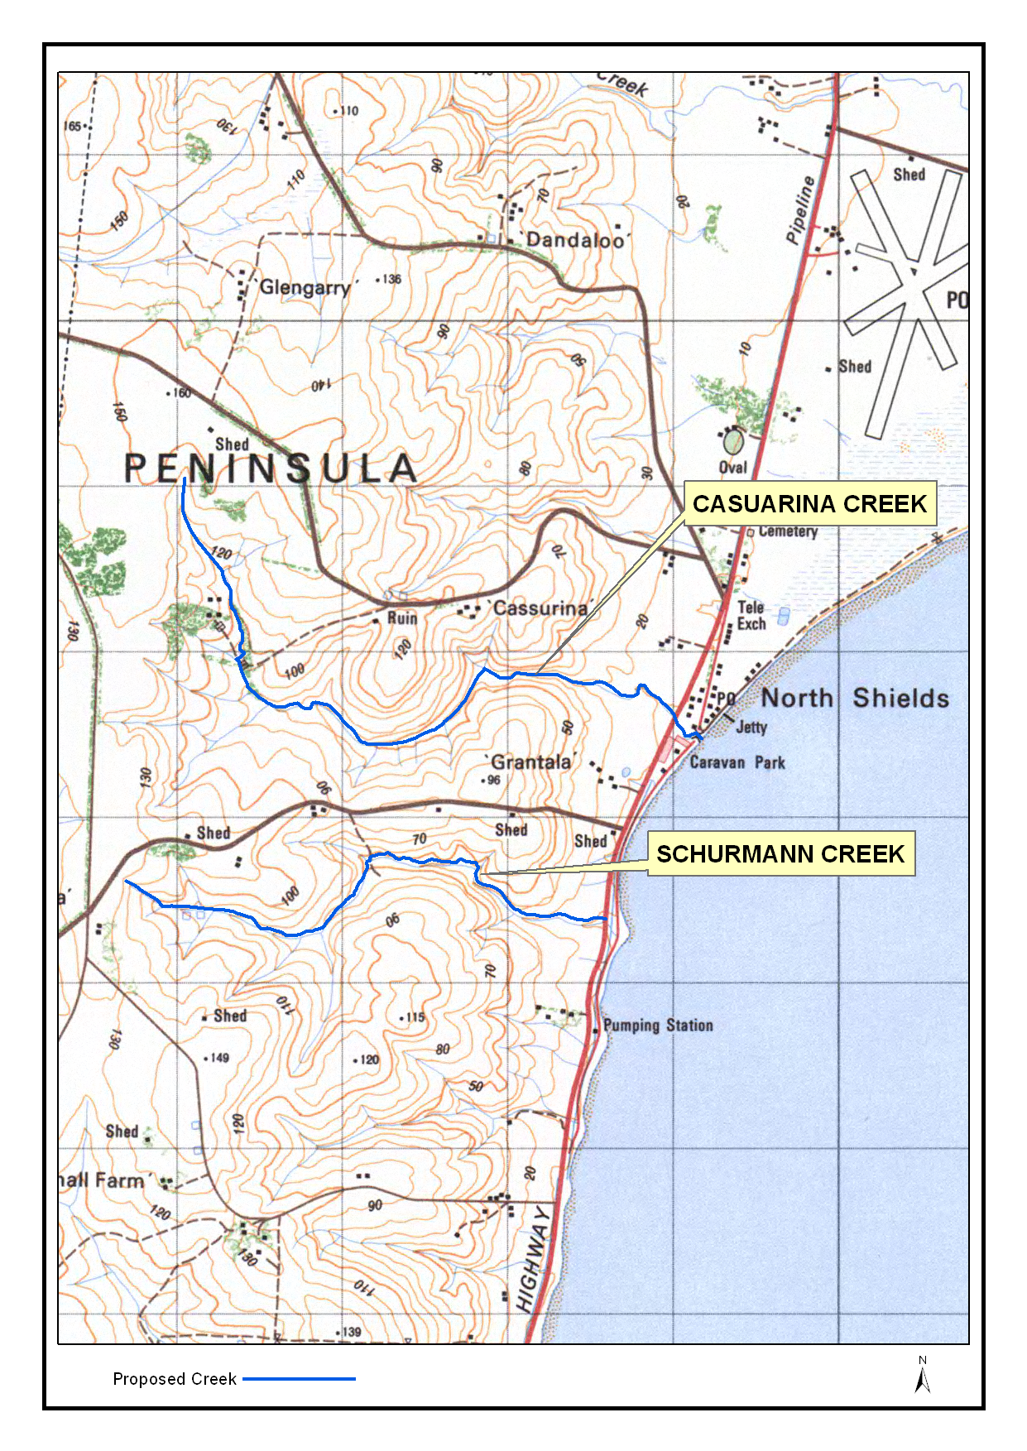
Pukatja/Yunyarinyi Executive Board Member
Candidates | No. of Votes
Tana Goodwin | 49
Trevor Adamson | 67
Makinti Minutjukur | 12
Total | 128
Mimili Executive Board Member
Willy Pompey Elected Unopposed.
Iwantja Executive Board Member
Candidates | No. of Votes
Alex Pannikan Baker | 36
Ronnie Brumby | 34
Peter Mungkuri | 10
Total | 80
Amuruna/Railway Bore/Witjintitja/Wallatinna Executive Board Member
Candidates | No. of Votes
Rosemary Helen Lester | 8
Bernard Singer | 21
Total | 29
K. Mousley, Returning Officer

FIREARMS ACT 1977
Recognised Paintball Operators
PURSUANT to the Firearms Act 1977, I, the Honourable Jennifer Rankine, the Minister of the Crown to whom the administration of the Firearms Act 1977, is for the time being committed by the Governor, do hereby declare Delta Force Paintball, to be a recognised paintball operator pursuant to Section 21D of the Firearms Act 1977.
Dated 27 February 2011.
Jennifer Rankine, Minister for Police

FIREARMS ACT 1977: SECTION 21C
Recognised Firearms Clubs
PURSUANT to the Firearms Act 1977, I, the Honourable Jennifer Rankine, the Minister of the Crown to whom the administration of the Firearms Act 1977, herein after referred to as the ‘said Act’ is for the time being committed by the Governor, as a result of change to their name and constitution, the club mentioned in the Second Schedule, previously recognised in Government Gazette notices referred to in the First Schedule is a recognised firearms club for the purposes of the said Act.
First Schedule
Gazette References
Date |  | Page
22 May 1980 |  | 1375

Second Schedule
Morialta Target Shooters Incorporated.
Dated 27 February 2011.
Jennifer Rankine, Minister for Police

GEOGRAPHICAL NAMES ACT 1991
For Public Consultation
Notice to Assign Names to Places
NOTICE is hereby given pursuant to the provisions of the above Act, that I, PETER MACLAREN KENTISH, Surveyor-General and Delegate appointed by Patrick Conlon, Minister for Infrastructure, Minister of the Crown to whom the administration of the Geographical Names Act 1991 is committed DO HEREBY assign the names CASUARINA CREEK and SCHURMANN CREEK to those features located on the 1:50 000 Lincoln Mapsheet (6028-1) as shown on the plan below.
The Plan

The plan for this naming proposal can be viewed on the Land Services website located at:
www.landservices.sa.gov.au/1Online_Services/55Place_Names/
Dated 1 March 2012.
P. M. Kentish, Surveyor-General, Department of Planning, Transport and Infrastructure
DTEI.2010/14638/01

Fisheries Management Act 2007: Section 79
Coorong Beach Closure
Closure of Pipi Fishery—Recreational
TAKE notice that pursuant to Section 79 of the Fisheries Management Act 2007, it is hereby declared that it shall be unlawful for any person to engage in the class of fishing activity specified in Schedule 1, in the area specified in Schedule 2, during the period specified in Schedule 3.
Schedule 1
The act of taking or an act preparatory to the taking of Pipi (Donax deltoides).
Schedule 2
The Sir Richard Peninsula between the Murray Mouth and Middleton Point, near Mill Terrace, Middleton.
Schedule 3
From midnight on 1 March 2012 until midnight on 31 March 2012.
Dated 1 March 2012.
Professor M. Doroudi, Director of Fisheries

LAND ACQUISITION ACT 1969
(Section 16)
Notice of Acquisition
THE COMMISSIONER OF HIGHWAYS (the ‘Authority’), 136 North Terrace, Adelaide, S.A. 5000, acquires the following interests in the following land:
Definition of Land Acquired
Comprising an estate in fee simple in that piece of land situated at 1-3 Salisbury Highway, Salisbury, S.A. 5108, being portion of Allotment 78 in Deposited Plan No. 24825 comprised in Certificate of Title Volume 5155, Folio 364 and being the whole of the land delineated as Allotments 82 and 83 in the plan D87162, lodged in the Lands Titles Office.
This notice is given under Section 16 of the Land Acquisition Act 1969.
Compensation
A person who has or had an interest in the land that is divested or diminished by the acquisition or the enjoyment of which is adversely affected by the acquisition who does not receive an offer of compensation from the Authority may apply to the Authority for compensation.
Inquiries
Inquiries should be directed to:
Lloyd Ioannou,
G.P.O. Box 1533,
Adelaide, S.A. 5001
Phone (08) 8343 2760
Dated 22 February 2012.
The Common Seal of the Commissioner of Highways was hereto affixed by authority of the Commissioner of Highways in the presence of:
D. Thomas, Manager, Transport Property, Department of Planning, Transport and Infrastructure
DTEI: 2001/05347/01

LIQUOR LICENSING ACT 1997
Notice of Application
NOTICE is hereby given, pursuant to Section 52 (2) (b) of the Liquor Licensing Act 1997, that Redress Pty Ltd as trustee for Redress Trust has applied to the Licensing Authority for Redefinition and variation to Entertainment Consent in respect of premises situated at Yankalilla to Cape Jervis Road, Second Valley, S.A. 5204 and known as Leonards Mill.
The application has been set down for hearing on 10 April 2012 at 10.30 a.m.
Conditions
The following licence conditions are sought:
• Redefinition to the licensed premises to include two outdoor areas adjacent to Cape Jervis Road as per plans lodged with this office.
• Variation to the current Entertainment Consent is to include the above mentioned are.
Any person may object to the application by lodging a notice of objection in the prescribed form with the Liquor and Gambling Commissioner and serving a copy of the notice on the applicant at the applicant’s address, at least seven days before the hearing date (viz: 3 April 2012).
The applicant’s address for service is c/o Rinaldo D’Aloia Clelands Lawyers, 208 Carrington Street, Adelaide, S.A. 5000.
The application and certain documents and material (including Plans) relevant to the application may be inspected without fee at a place and during a period specified by the Liquor and Gambling Commissioner, Chesser House, 3rd Floor, 91-97 Grenfell Street, Adelaide, S.A. 5000. Telephone: 8226 8655. Facsimile: 8226 8512. Email: olgc@agd.sa.gov.au.
Dated 1 March 2012.
Applicant

LIQUOR LICENSING ACT 1997
Notice of Application
NOTICE is hereby given, pursuant to Section 52 (2) (b) of the Liquor Licensing Act 1997, that Sorrentos at the Main Pty Ltd has applied to the Licensing Authority for a Special Circumstances Licence with Extended Trading Authorisation in respect of premises situated at 119 Ruwoldt Road, Yahl, S.A. 5291 and known as Sorrentos at the Main.
The application has been set down for hearing on 11 April 2012 at 10.30 a.m.
Conditions
The following licence conditions are sought:
• Approval to sell liquor in accordance with Section 40 of the Liquor Licensing Act 1997.
• To sell liquor on the licensed premises for consumption at places other than the licensed premises, only at pre-booked functions with or ancillary to food:
During the following hours (including Extended Trading Authorisation):
Monday to Saturday: 5 a.m. to midnight; and
Sunday: 11 a.m. to midnight.
• No patrons or customers to be served at the licensed premises.
• To be able to sell liquor with or ancillary to food at a pre-booked function at places other than the licensed premises in addition to and only when a drinks package has been provided by the licensee.
Any person may object to the application by lodging a notice of objection in the prescribed form with the Liquor and Gambling Commissioner and serving a copy of the notice on the applicant at the applicant’s address, at least seven days before the hearing date (viz: 4 April 2012).
The applicant’s address for service is c/o Lachlan Barclay Mutton, P.O. Box 1880, Mount Gambier, S.A. 5290.
The application and certain documents and material (including Plans) relevant to the application may be inspected without fee at a place and during a period specified by the Liquor and Gambling Commissioner, Chesser House, 3rd Floor, 91-97 Grenfell Street, Adelaide, S.A. 5000. Telephone: 8226 8655. Facsimile: 8226 8512. Email: olgc@agd.sa.gov.au.
Dated 29 February 2012.
Applicant

LIQUOR LICENSING ACT 1997
Notice of Application
NOTICE is hereby given, pursuant to Section 52 (2) (b) of the Liquor Licensing Act 1997, that Peter William Clutterbuck has applied to the Licensing Authority for a Producer’s Licence in respect of premises situated at 44 McFarlane Road, Coomunga, S.A. 5607 and known as Peter William Clutterbuck.
The application has been set down for hearing on 5 April 2012 at 11 a.m.
Any person may object to the application by lodging a notice of objection in the prescribed form with the Liquor and Gambling Commissioner and serving a copy of the notice on the applicant at the applicant’s address, at least seven days before the hearing date (viz: 29 March 2012).
The applicant’s address for service is c/o Peter Clutterbuck,
44 McFarlane Road, Coomunga, S.A. 5606.
The application and certain documents and material (including Plans) relevant to the application may be inspected without fee at a place and during a period specified by the Liquor and Gambling Commissioner, Chesser House, 3rd Floor, 91-97 Grenfell Street, Adelaide, S.A. 5000. Telephone: 8226 8655. Facsimile: 8226 8512. Email: olgc@agd.sa.gov.au.
Dated 29 February 2012.
Applicant

LIQUOR LICENSING ACT 1997
Notice of Application
NOTICE is hereby given, pursuant to Section 52 (2) (b) of the Liquor Licensing Act 1997, that The Wine Boys Pty Ltd has applied to the Licensing Authority for a Direct Sales Licence to be known as The Wine Boys Pty Ltd.
The application has been set down for hearing on 5 April 2012 at 10 a.m.
Any person may object to the application by lodging a notice of objection in the prescribed form with the Liquor and Gambling Commissioner and serving a copy of the notice on the applicant at the applicant’s address, at least seven days before the hearing date (viz: 29 March 2012).
The applicant’s address for service is c/o Wallmans Lawyers, G.P.O. Box 1018, Adelaide, S.A. 5001 (Attention: Ben Allen or Alex Bastian).
The application and certain documents and material relevant to the application may be inspected without fee at a place and during a period specified by the Liquor and Gambling Commissioner, Chesser House, 3rd Floor, 91-97 Grenfell Street, Adelaide, S.A. 5000. Telephone: 8226 8655. Facsimile: 8226 8512. Email: olgc@agd.sa.gov.au.
Dated 28 February 2012.
Applicant

LIQUOR LICENSING ACT 1997
Notice of Application
NOTICE is hereby given, pursuant to Section 52 (2) (b) of the Liquor Licensing Act 1997, that Caroline Elizabeth Mandelli-Burns, 13 Palmer Street, Aldinga Street, S.A. 5173 has applied to the Licensing Authority for a Direct Sales Licence in respect of the business to be known as Caroline Elizabeth Mandelli-Burns.
The application has been set down for hearing on 11 April 2012 at 11 a.m.
Any person may object to the application by lodging a notice of objection in the prescribed form with the Liquor and Gambling Commissioner and serving a copy of the notice on the applicant at the applicant’s address, at least seven days before the hearing date (viz: 4 April 2012).
The applicant’s address for service is c/o David Watts and Associates, 1 Cator Street, Glenside, S.A. 5065 (Attention: David Watts).
The application and certain documents and material relevant to the application may be inspected without fee at a place and during a period specified by the Liquor and Gambling Commissioner, Chesser House, 3rd Floor, 91-97 Grenfell Street, Adelaide, S.A. 5000. Telephone: 8226 8655. Facsimile: 8226 8512. Email: olgc@agd.sa.gov.au.
Dated 5 March 2012.
Applicant

LIQUOR LICENSING ACT 1997
Notice of Application
NOTICE is hereby given, pursuant to Section 52 (2) (b) of the Liquor Licensing Act 1997, that Vin Clubs Pty Ltd, Level 4, 191 Pulteney Street, Adelaide, S.A. 5000 has applied to the Licensing Authority for Direct Sales Licence in respect of the business to be known as Vin Clubs.
The application has been set down for hearing on 10 April 2012 at 11 a.m.
Any person may object to the application by lodging a notice of objection in the prescribed form with the Liquor and Gambling Commissioner and serving a copy of the notice on the applicant at the applicant’s address, at least seven days before the hearing date (viz: 3 April 2012).
The applicant’s address for service is c/o Talbot Olivier Lawyers, Level 8, Wesfarmers House, 40 The Esplanade, Perth, W.A. 6000 (Attention: Jarrod Ryan).
The application and certain documents and material relevant to the application may be inspected without fee at a place and during a period specified by the Liquor and Gambling Commissioner, Chesser House, 3rd Floor, 91-97 Grenfell Street, Adelaide, S.A. 5000. Telephone: 8226 8655. Facsimile: 8226 8512. Email: olgc@agd.sa.gov.au.
Dated 5 March 2012.
Applicant

LIQUOR LICENSING ACT 1997
Notice of Application
NOTICE is hereby given, pursuant to Section 52 (2) (b) of the Liquor Licensing Act 1997, that Clare Valley Brewing Company Pty Ltd has applied to the Licensing Authority for a Direct Sales Licence to be known as Clare Valley Brewing Company Pty Ltd.
The application has been set down for hearing on 5 April 2012 at 10.30 a.m.
Any person may object to the application by lodging a notice of objection in the prescribed form with the Liquor and Gambling Commissioner and serving a copy of the notice on the applicant at the applicant’s address, at least seven days before the hearing date (viz: 29 March 2012).
The applicant’s address for service is c/o Wallmans Lawyers, G.P.O. Box 1018, Adelaide, S.A. 5001 (Attention: Ben Allen).
The application and certain documents and material relevant to the application may be inspected without fee at a place and during a period specified by the Liquor and Gambling Commissioner, Chesser House, 3rd Floor, 91-97 Grenfell Street, Adelaide, S.A. 5000. Telephone: 8226 8655. Facsimile: 8226 8512. Email: olgc@agd.sa.gov.au.
Dated 2 March 2012.
Applicant

MINING ACT 1971
NOTICE is hereby given in accordance with Section 28 (5) of the Mining Act 1971, that the Minister for Mineral Resources and Energy proposes to grant an Exploration Licence over the undermentioned area:
Applicant: Doray Minerals Limited
Location: Pureba area⎯Approximately 90 km east of Ceduna.
Pastoral Leases Pinjarra
Term: 2 years
Area in km²: 409
Ref.: 2011/00074
Plan and co-ordinates can be found on the PIRSA website: http://www.pir.sa.gov.au/minerals/public_notices or by phoning Mineral Tenements on (08) 8463 3103.
J. Martin, Mining Registrar

MINING ACT 1971
NOTICE is hereby given in accordance with Section 28 (5) of the Mining Act 1971, that the Minister for Mineral Resources and Energy proposes to grant an Exploration Licence over the undermentioned area:
Applicant: Doray Minerals Limited
Location: Yantanabie area⎯Approximately 60 km north-east of Streaky Bay.
Term: 2 years
Area in km²: 93
Ref.: 2011/00114
Plan and co-ordinates can be found on the PIRSA website: http://www.pir.sa.gov.au/minerals/public_notices or by phoning Mineral Tenements on (08) 8463 3103.
J. Martin, Mining Registrar

NATIONAL PARKS AND WILDLIFE ACT 1972
Appointment of Wardens
PURSUANT to Section 20 of the National Parks and Wildlife Act 1972, I, John Erwin Schutz, Executive Director Regional Services, authorised delegate, hereby appoint each of the listed members of the Mannum Aboriginal Community Association Incorporated (MACAI), as Wardens for the State of South Australia, subject to the limitations as specified in Schedule 1 below, pursuant to the said Act, for the period commencing on 1 March 2012 and ending on 31 December 2012.
Schedule 1
Card No. | Name of Warden | Organisation | Limitations
410 | Campbell, Isobelle | MACAI | Section 22 (1) (d) of the National Parks and Wildlife Act 1972 only. Restricted to Ngaut Ngaut Conservation Park only.
417 | Hutchinson, Cynthia | MACAI | Section 22 (1) (d) of the National Parks and Wildlife Act 1972 only. Restricted to Ngaut Ngaut Conservation Park only.
497 | Campbell, Ivy | MACAI | Section 22 (1) (d) of the National Parks and Wildlife Act 1972 only. Restricted to Ngaut Ngaut Conservation Park only.

Dated 29 February 2012.
J. E. Schutz, Executive Director Regional Services, Department for Environment and Natural Resources

NATIONAL PARKS AND WILDLIFE (NATIONAL PARKS) REGULATIONS 2001
Closure of Martin Washpool Conservation Park
PURSUANT to Regulations 8 (3) (a) and 8 (3) (d) of the National Parks and Wildlife (National Parks) Regulations 2001, I, Grant Anthony Pelton, Director, Public Land Management and Operational Support, Regional Services, authorised delegate of the Director of National Parks and Wildlife, close to the public, the whole of Martin Washpool Conservation Park from 6 p.m. on Sunday, 3 June 2012 until 6 a.m. on Saturday, 30 June 2012.
The purpose of the closure is to ensure the safety of the public during a pest control and monitoring program within the reserve during the period indicated.
Use of Firearms Within the Reserve
Pursuant to Regulations 8 (4), 20 (1) and 41 of the National Parks and Wildlife (National Parks) Regulations 2001, I, Grant Anthony Pelton, Director, Public Land Management and Operational Support, Regional Services, authorised delegate of the Director of National Parks and Wildlife, grant permission to members of the Australian Deer Association Incorporated (ADA), in possession of both a current Hunting Permit and a firearm to enter and remain in the whole of Martin Washpool Conservation Park from 6 p.m. on Sunday, 3 June 2012 until 6 a.m. on Friday, 30 June 2012, for the purpose of taking feral animals.
This permission is conditional upon the observance by each of the persons of the requirements of the National Parks and Wildlife Act 1972, National Parks and Wildlife (National Parks) Regulations 2001 and the National Parks and Wildlife (Hunting) Regulations 2011, including those requiring compliance with the Director’s requests, requirements and orders of a Warden.
Dated 27 February 2012.
G. A. Pelton, Director, Public Land
Management and Operational Support,
Regional Services, Department of
Environment and Natural Resources

NATIONAL PARKS AND WILDLIFE (NATIONAL PARKS) REGULATIONS 2001
Closure of Flinders Ranges National Park including
Wilpena Pound
PURSUANT to Regulations 8 (3) (a) and 8 (3) (d) of the National Parks and Wildlife (National Parks) Regulations 2001, I, Grant Anthony Pelton, Director, Public Land Management and Operational Support, Regional Services, authorised delegate of the Flinders Ranges National Park Co-management Board, close to the public, the whole of Flinders Ranges National Park from 6 a.m. on Sunday, 18 March 2012 until 6 a.m. on Tuesday, 20 March 2012 with the following exceptions:
Hawker to Blinman Road;
Hawker to Arkaroola (Wirrealpa) Road;
Sacred Canyon Road;
Brachina Gorge Road (open for through traffic only—no stopping);
Dingley Dell Campground;
Wilpena Pound Resort and Campground;
Wilpena Pound will be closed from 6 a.m. on Sunday, 18 March 2012 until 6 a.m. on Monday, 19 March 2012 only.
The purpose of the closure is to ensure the safety of the public during a pest control and monitoring program within the reserve during the period indicated.
Dated 6 March 2012.
G. A. Pelton, Director, Public Land Management and Operational Support, Regional Services, Department of Environment and Natural Resources

NATIONAL PARKS AND WILDLIFE (NATIONAL PARKS) REGULATIONS 2001
Closure of Fairview Conservation Park and
Jip Jip Conservation Park
PURSUANT to Regulations 8 (3) (a) and 8 (3) (d) of the National Parks and Wildlife (National Parks) Regulations 2001, I, Grant Anthony Pelton, Director, Public Land Management and Operational Support, Regional Services, authorised delegate of the Director of National Parks and Wildlife, close to the public, the whole of Fairview Conservation Park and the whole of Jip Jip Conservation Park from 6 p.m. on Sunday, 22 April 2012 until 6 a.m. on Friday, 1 June 2012.
The purpose of the closure is to ensure the safety of the public during a pest control and monitoring program within the reserves during the period indicated.
Use of Firearms Within the Reserves
Pursuant to Regulations 8 (4), 20 (1) and 41 of the National Parks and Wildlife (National Parks) Regulations 2001, I, Grant Anthony Pelton, Director, Public Land Management and Operational Support, Regional Services, authorised delegate of the Director of National Parks and Wildlife, grant permission to members of the Australian Deer Association Incorporated (ADA), in possession of both a current Hunting Permit and a firearm to enter and remain in the whole of Fairview Conservation Park and the whole of Jip Jip Conservation Park from 6 p.m. on Sunday,
22 April 2012 until 6 a.m. on Friday, 1 June 2012 for the purpose of taking feral animals.
This permission is conditional upon the observance by each of the persons of the requirements of the National Parks and Wildlife Act 1972, National Parks and Wildlife (National Parks) Regulations 2001 and the National Parks and Wildlife (Hunting) Regulations 2011, including those requiring compliance with the Director’s requests, requirements and orders of a Warden.
Dated 27 February 2012.
G. A. Pelton, Director, Public Land Management and Operational Support, Regional Services, Department of Environment and Natural Resources

SURVEY ACT 1992
PURSUANT to Section 50 of the Survey Act, 1992, notice is given that a Confused Boundary Area is declared for the area bounded by Mount Barker Road, Anderson Road and Pindari Place comprising Filed Plan 11671 and Deposited Plan 24136 in the area of Aldgate.
Dated 8 March 2012.
P. M. Kentish, Surveyor General
REF: LTO 3/2012

WATER MAINS AND SEWERS

Office of the South Australian Water Corporation
Adelaide, 8 March 2012

WATER MAINS LAID

Notice is hereby given that the following main pipes or parts of main pipes have been laid down by the South Australian Water Corporation in or near the undermentioned water districts and are now available for a constant supply of water to adjacent land.

ADELAIDE WATER DISTRICT

CAMPBELLTOWN CITY COUNCIL
Berry Street, Magill. p3

CITY OF CHARLES STURT
Jury Street, Royal Park. p15
The Avenue, Athol Park. p19
The Avenue, Athol Park. p20

CITY OF HOLDFAST BAY
Augusta Street, Glenelg. p1
Across Colley Terrace, Glenelg. p1
Easements in allotment piece 900 in LTRO FP 48304, Colley Terrace, and reserves (lot 301 in LTRO CP 23557 and lot 903 in LTRO FP 48304), Holdfast Promenade, Glenelg. p1
Across and in Holdfast Promenade, Glenelg. p1
Easements in lot 107 in LTRO DP 71400, Holdfast Promenade, and reserve (lot 100 in LTRO DP 76687), Moseley Square, Glenelg. p2

DISTRICT COUNCIL OF MOUNT BARKER
Easement in lot 255 in LTRO FP 9509, Mann Street, Mount Barker. p16
In and across Hack Street, Mount Barker. p16

CITY OF PLAYFORD
Manilla Street, Munno Para West. p14
In and across Tomnicstas Street, Munno Para West. p14
Rody Court, Munno Para West. p14
Across walkway (lot 50 in LTRO DP 86296), Munno Para West. p14
Across Stebonheath Road, Munno Para West. p14

CITY OF PORT ADELAIDE ENFIELD
In and across Regency Road, Enfield and Broadview. p6-8
Markham Avenue, Enfield. p6
In and across Galway Avenue, Broadview. p7
Robert Avenue, Broadview. p8
In and across Hampstead Road, Broadview and Manningham. p8
Across Hobart Crescent, Manningham. p8
In and across Muller Road, Manningham, Hampstead Gardens and Greenacres. p8-10
Manoora Street, Greenacres. p9
Tabard Street, Hampstead Gardens. p9
Elm Street, Hampstead Gardens. p10

CITY OF PROSPECT
In and across Regency Road, Prospect and Enfield. p4-6
William Street, Prospect. p4
Prospect Road, Prospect. p5
Arthur Street, Prospect. p5
Clifford Street, Prospect. p6

RENMARK WATER DISTRICT

RENMARK PARINGA COUNCIL
Flinders Street, Renmark. p12
Cook Street, Renmark. p12

WHYALLA WATER DISTRICT

THE CORPORATION OF THE CITY OF WHYALLA
In and across Industry Drive, Whyalla Barson. p13
Bowers Court, Whyalla Barson. p13

WATER MAINS ABANDONED

Notice is hereby given that the undermentioned water mains have been abandoned by the South Australian Water Corporation.

ADELAIDE WATER DISTRICT

CITY OF CHARLES STURT
The Avenue, Athol Park. p19
The Avenue, Athol Park. p20

CITY OF HOLDFAST BAY
Augusta Street, Glenelg. p1
Across Colley Terrace, Glenelg. p1
Easements in allotment piece 900 in LTRO FP 48304, Colley Terrace, and reserve (lot 301 in LTRO CP 23557), Holdfast Promenade, Glenelg. p1

DISTRICT COUNCIL OF MOUNT BARKER
Easement in lot 255 in LTRO FP 9509, Mann Street, Mount Barker. p16
Hack Street, Mount Barker. p16

CITY OF PORT ADELAIDE ENFIELD
In and across Regency Road, Enfield and Broadview. p6-8
Markham Avenue, Enfield. p6
In and across Galway Avenue, Broadview. p7
Robert Avenue, Broadview. p8
In and across Hampstead Road, Broadview and Manningham. p8
Across Hobart Crescent, Manningham. p8
In and across Muller Road, Manningham and Hampstead Gardens. p8-10
Manoora Street, Greenacres. p9
Tabard Street, Hampstead Gardens. p9
Elm Street, Hampstead Gardens. p10

CITY OF PROSPECT
In and across Regency Road, Prospect and Enfield. p4-6
William Street, Prospect. p4
Prospect Road, Prospect. p5
Arthur Street, Prospect. p5
Clifford Street, Prospect. p6

WATER MAINS LAID

Notice is hereby given that the undermentioned water mains have been laid down by the South Australian Water Corporation and are not available for a constant supply of water to adjacent land.

YORKE PENINSULA COUNTRY LANDS WATER DISTRICT

DISTRICT COUNCIL OF YORKE PENINSULA
Waterworks land (lot 5 in LTRO DP 39980), Gumbowie Road, Coobowie. p21-23
Across Gumbowie Road, Coobowie. p21-23

SEWERS LAID

Notice is hereby given that the following sewers have been laid down by the South Australian Water Corporation in the undermentioned drainage area and are now available for house connections.

ADELAIDE DRAINAGE AREA

CAMPBELLTOWN CITY COUNCIL
Berry Street, Magill. FB 1216 p2

CITY OF CHARLES STURT
Across Risely Avenue, Royal Park. FB 1216 p5
Jury Street, Royal Park. FB 1216 p5

CITY OF HOLDFAST BAY
St Johns Row, Glenelg. FB 1217 p27
Easements in reserve (lot 100 in LTRO DP 76687), Moseley Square, Glenelg. FB 1217 p27

CITY OF MARION
Kelsey Avenue, Mitchell Park. FB 1214 p60

CITY OF ONKAPARINGA
Fuller Terrace, Christies Beach. FB 1216 p1
Easement in lots 327 in LTRO DP 9820, Perth Place and 332 in LTRO DP 9820, Scottsglade Road, Christie Downs. FB 1216 p4

CITY OF PLAYFORD
Across Stebonheath Road, Munno Para and Munno Para West. FB 1217 p28-30
Through walkway (lot 50 in LTRO DP 86296), Stebonheath Road, Munno Para West. FB 1217 p28-30
Rody Court, Munno Para West. FB 1217 p28-30
Across and in Tomnicstas Street, Munno Para West. FB 121
p28-30
Manilla Street, Munno Para West. FB 1217 p28-30

CITY OF PORT ADELAIDE ENFIELD
Madge Street, Blair Athol. FB 1214 p59

CITY OF TEA TREE GULLY
Judith Avenue, Holden Hill. FB 1216 p3

CITY OF WEST TORRENS
Meyer Street, Torrensville. FB 1214 p58

SEWERS ABANDONED

Notice is hereby given that the undermentioned sewers have been abandoned by the South Australian Water Corporation.

ADELAIDE DRAINAGE AREA

CITY OF HOLDFAST BAY
Hope Street, Glenelg. FB 1217 p27
Easements in Common Property and lot 112 in LTRO Community Plan 23680, Common Property in LTRO Community Plan 23557 and lot 111 in Community Plan 23680, Moseley Square, Glenelg. FB 1217 p27

CITY OF MARION
Across Marion Road, Park Holme. FB 1214 p57
Easement in lot 13 in LTRO DP 54642, Oaklands Road, Park Holme. FB 1214 p57

CITY OF PLAYFORD
Easement in lot 10 in LTRO DP 70038, Gravity Grove, Munno Para West. FB 1217 p28 and 29
Across Manilla Street, Munno Para West. FB 1217 p28 and 29

MOUNT GAMBIER COUNTRY DRAINAGE AREA

CITY OF MOUNT GAMBIER
Sewerage land (lot 61 in LTRO DP 50256), Commercial Street West, Mount Gambier. FB 1196 p1
Easement in lot 60 in LTRO DP 50256, Nicholas Street, Mount Gambier. FB 1196 p1

A. J. Ringham, Chief Executive Officer, South Australian Water Corporation

GOVERNMENT GAZETTE ADVERTISEMENT RATES

To apply from 1 July 2011

$  Agents, Ceasing to Act as 45.50  Associations:  Incorporation 23.00  Intention of Incorporation 57.00  Transfer of Properties 57.00  Attorney, Appointment of 45.50  Bailiff’s Sale 57.00  Cemetery Curator Appointed 33.75  Companies:  Alteration to Constitution 45.50  Capital, Increase or Decrease of 57.00  Ceasing to Carry on Business 33.75  Declaration of Dividend 33.75  Incorporation 45.50  Lost Share Certificates:  First Name 33.75  Each Subsequent Name 11.60  Meeting Final 38.00  Meeting Final Regarding Liquidator’s Report on  Conduct of Winding Up (equivalent to ‘Final  Meeting’)  First Name 45.50  Each Subsequent Name 11.60  Notices:  Call 57.00  Change of Name 23.00  Creditors 45.50  Creditors Compromise of Arrangement 45.50  Creditors (extraordinary resolution that ‘the Com-pany be wound up voluntarily and that a liquidator be appointed’) 57.00  Release of Liquidator⎯Application⎯Large Ad. 90.50  ⎯Release Granted 57.00  Receiver and Manager Appointed 52.50  Receiver and Manager Ceasing to Act 45.50  Restored Name 42.50  Petition to Supreme Court for Winding Up 79.00  Summons in Action 67.50  Order of Supreme Court for Winding Up Action 45.50  Register of Interests⎯Section 84 (1) Exempt 102.00  Removal of Office 23.00  Proof of Debts 45.50  Sales of Shares and Forfeiture 45.50  Estates:  Assigned 33.75  Deceased Persons⎯Notice to Creditors, etc. 57.00  Each Subsequent Name 11.60  Deceased Persons⎯Closed Estates 33.75  Each Subsequent Estate 1.50  Probate, Selling of 45.50  Public Trustee, each Estate 11.60 |  | $  Firms:  Ceasing to Carry on Business (each insertion) 30.25  Discontinuance Place of Business 30.25  Land⎯Real Property Act:  Intention to Sell, Notice of 57.00  Lost Certificate of Title Notices 57.00  Cancellation, Notice of (Strata Plan) 57.00  Mortgages:  Caveat Lodgement 23.00  Discharge of 24.10  Foreclosures 23.00  Transfer of 23.00  Sublet 11.60  Leases⎯Application for Transfer (2 insertions) each 11.60  Lost Treasury Receipts (3 insertions) each 33.75  Licensing 67.50  Municipal or District Councils:  Annual Financial Statement⎯Forms 1 and 2 636.00  Electricity Supply⎯Forms 19 and 20 452.00  Default in Payment of Rates:  First Name 90.50  Each Subsequent Name 11.60  Noxious Trade 33.75  Partnership, Dissolution of 33.75  Petitions (small) 23.00  Registered Building Societies (from Registrar-General) 23.00  Register of Unclaimed Moneys⎯First Name 33.75  Each Subsequent Name 11.60  Registers of Members⎯Three pages and over:  Rate per page (in 8pt) 289.00  Rate per page (in 6pt) 382.00  Sale of Land by Public Auction 57.50  Advertisements 3.20  ¼ page advertisement 135.00  ½ page advertisement 270.00  Full page advertisement 529.00  Advertisements, other than those listed are charged at $3.20 per column line, tabular one-third extra.  Notices by Colleges, Universities, Corporations and District Councils to be charged at $3.20 per line.  Where the notice inserted varies significantly in length from that which is usually published a charge of $3.20 per column line will be applied in lieu of advertisement rates listed.  South Australian Government publications are sold on the condition that they will not be reproduced without prior permission from the Government Printer.
All the above prices include GST

GOVERNMENT GAZETTE NOTICES
ALL private advertisements forwarded for publication in the South Australian Government Gazette must be PAID FOR PRIOR TO INSERTION; and all notices, from whatever source, should be legibly written on one side of the paper only and sent to Government Publishing SA so as to be received no later than 4 p.m. Tuesday preceding the day of publication. Phone 8207 1045 or Fax 8207 1040. E-mail: governmentgazette@dpc.sa.gov.au. Send as attachments in Word format. Please include date the notice is to be published and to whom the notice will be charged. The Government Gazette is available online at: www.governmentgazette.sa.gov.au.

MISCELLANEOUS LEGISLATION AND GOVERNMENT PUBLICATIONS PRICES AS FROM 1 JULY 2011

Acts, Bills, Rules, Parliamentary Papers and Regulations
Pages | Main | Amends | Pages | Main | Amends

1-16 | 2.80 | 1.30 | 497-512 | 38.50 | 37.50
17-32 | 3.70 | 2.30 | 513-528 | 39.50 | 38.25
33-48 | 4.85 | 3.45 | 529-544 | 41.00 | 39.50
49-64 | 6.10 | 4.70 | 545-560 | 42.00 | 41.00
65-80 | 7.10 | 5.90 | 561-576 | 43.00 | 42.00
81-96 | 8.30 | 6.85 | 577-592 | 44.50 | 42.50
97-112 | 9.45 | 8.10 | 593-608 | 45.75 | 44.00
113-128 | 10.60 | 9.30 | 609-624 | 46.50 | 45.50
129-144 | 11.80 | 10.50 | 625-640 | 47.75 | 46.00
145-160 | 13.00 | 11.60 | 641-656 | 49.00 | 47.75
161-176 | 14.10 | 12.80 | 657-672 | 49.75 | 48.25
177-192 | 15.40 | 13.90 | 673-688 | 51.50 | 49.75
193-208 | 16.60 | 15.30 | 689-704 | 52.50 | 50.50
209-224 | 17.50 | 16.20 | 705-720 | 53.50 | 52.00
225-240 | 18.70 | 17.30 | 721-736 | 55.00 | 53.00
241-257 | 20.10 | 18.30 | 737-752 | 55.50 | 54.00
258-272 | 21.20 | 19.40 | 753-768 | 57.00 | 55.00
273-288 | 22.30 | 21.00 | 769-784 | 58.00 | 57.00
289-304 | 23.30 | 21.90 | 785-800 | 59.00 | 58.00
305-320 | 24.70 | 23.20 | 801-816 | 60.50 | 58.50
321-336 | 25.75 | 24.30 | 817-832 | 61.50 | 60.50
337-352 | 27.00 | 25.50 | 833-848 | 63.00 | 61.50
353-368 | 27.75 | 26.75 | 849-864 | 64.00 | 62.50
369-384 | 29.25 | 27.75 | 865-880 | 65.50 | 64.00
385-400 | 30.50 | 29.00 | 881-896 | 66.00 | 64.50
401-416 | 31.75 | 30.00 | 897-912 | 67.50 | 66.00
417-432 | 33.00 | 31.50 | 913-928 | 68.00 | 67.50
433-448 | 34.00 | 32.75 | 929-944 | 69.00 | 68.00
449-464 | 34.75 | 33.50 | 945-960 | 70.00 | 68.50
465-480 | 35.25 | 34.50 | 961-976 | 73.00 | 69.50
481-496 | 37.50 | 35.25 | 977-992 | 74.00 | 70.00

Legislation—Acts, Regulations, etc: $
Subscriptions:
Acts 237.00
All Bills as Laid 570.00
Rules and Regulations 570.00
Parliamentary Papers 570.00
Bound Acts 263.00
Index 132.00
Government Gazette
Copy 6.25
Subscription 315.00
Hansard
Copy 17.30
Subscription—per session (issued weekly) 494.00
Cloth bound—per volume 212.00
Subscription—per session (issued daily) 494.00
Legislation on Disk
Whole Database 3 660.00
Annual Subscription for fortnightly updates 1 125.00
Individual Act(s) including updates POA
Notice of Vacancies
Annual Subscription 174.00
Compendium
Subscriptions:
New Subscriptions 2 167.00
Updates 765.00
(All the above prices include GST)

All Legislation, Government Gazette, Hansard and Legislation on disk are available from:
Counter Sales Government Legislation Outlet
and Mail Orders: Service SA Customer Service Centre,
Ground Floor—EDS Centre, 108 North Terrace, Adelaide, S.A. 5000
Phone: 13 23 24 (local call cost), Fax: (08) 8204 1909
Postal: G.P.O. Box 1707, Adelaide, S.A. 5001

Online Shop: www.shop.service.sa.gov.au

Subscriptions and Government Publishing SA
Standing Orders: Plaza Level, Riverside Centre, North Terrace, Adelaide, S.A. 5000
Phone: (08) 8207 1043, (08) 8207 0910, Fax: (08) 8207 1040

South Australia

Motor Vehicles (Approved Foreign Licences—Experienced Driver Recognition) Notice 2012

under Sections 72A(1)(b)(ii), 79(1)(b)(iii) and 79A(1)(b)(i)(B) of the Motor Vehicles Act 1959

- Short Title

This notice may be cited as the Motor Vehicles (Approved Foreign Licences—Experienced Driver Recognition) Notice 2012.

- Commencement

This notice will come into operation on 2 April 2012.

- Approved foreign licences—Sections 72A(1)(b)(ii) and 79(1)(b)(iii)

For the purposes of Sections 72A(1)(b)(ii) and 79(1)(b)(iii) of the Motor Vehicles Act 1959 foreign licences issued by the countries listed in Schedule 1 where the licence holder is 25 years of age or older are approved.

- Approved foreign licences—Section 79A(1)(b)(i)(B)

For the purposes of Section 79A(1)(b)(i)(B) of the Motor Vehicles Act 1959 foreign licences issued by the countries listed in Schedule 1 where the licence holder is 25 years of age or older are approved.

Schedule 1—Countries with approved foreign licences—Experienced Driver Recognition

Czech Republic Hong Kong Republic of Korea Taiwan

The Motor Vehicles (Approved Foreign Licences) Notice 2007 made on 19 March 2007 remains in effect.

Made by J. HOLMES, Registrar of Motor Vehicles

on 8 March 2012.

RULES OF COURT
Magistrates Court of South Australia
Amendment No. 41 to the Magistrates Court
(Civil) Rules 1992
PURSUANT to section 49 of the Magistrates Court Act 1991 and all other enabling powers, we, the undersigned, do hereby make the following amendments to the Magistrates Court (Civil) Rules 1992 as amended.
1. These Rules may be cited as the ‘Magistrates Court (Civil) Rules 1992 (Amendment 41)’.
2. The Magistrates Court (Civil) Rules 1992 as amended by these amendments apply to and govern all actions commenced in the civil division of the Court on and after the date on which these amendments are gazetted.
3. Rule 60 (1) is deleted and replaced with the following:
(1) Subject to sub-rule (4), where a party has been served with an action (other than an action under Rules 26A, 37 and 38) and does not file a defence within 21 days of service, or any other period fixed by the Court, the other party, on proof to the Registrar of such service, may sign judgment against the party in default, by filing a Form 18—
4. Rule 60 (4) is inserted as follows:
(4) Where a party has been served with an action under either Section 15 or Section 16 of the Building and Construction Industry Security of Payment Act 2009, and does not file a defence within 21 days of service, or any other period fixed by the Court, the other party, on proof to the Registrar of such service, may only sign judgment against the party in default by filing with the Form 18 an affidavit certifying as to the circumstances required by either Section 15 (1) or Section 16 (1).
5. Rule 62 (1) is deleted and replaced with the following:
(1) Subject to sub-rule (5), in any other case not provided for in Rule 61, where a party signs judgment the Registrar must fix a date, time and place for the hearing, by the Court, in respect of the assessment of damages or such other order, remedy or relief as the action may require, and give at least 21 days notice in writing of the hearing to the parties.
6. Rule 62 (5) is inserted as follows:
(5) In an action for damages for personal injury, where a party signs judgment the Registrar must fix a date, time and place for a directions hearing, and give at least 21 days notice in writing of the directions hearing to the parties. The parties who have signed judgment must serve on all other parties at least 21 days before the date of the directions hearing a notice in Form 19A.
7. Note D in Scale 3 of Schedule 3 is deleted.
8. Form 2 of the Magistrates Court Civil Forms is deleted and replaced with the following Form 2.
9. Form 3 of the Magistrates Court Civil Forms is deleted and replaced with the following Form 3.
10. Form 7B of the Magistrates Court Civil Forms is deleted and replaced with the following Form 7B.
11. Form 19A of the Magistrates Court Civil Forms is inserted.
Signed on 20 February 2012.
Elizabeth Mary Bolton, Chief Magistrate
Andrew James Cannon, Deputy Chief Magistrate
Kym Andrew Millard, Stipendiary Magistrate
Mary-Louise Hribal, Stipendiary Magistrate

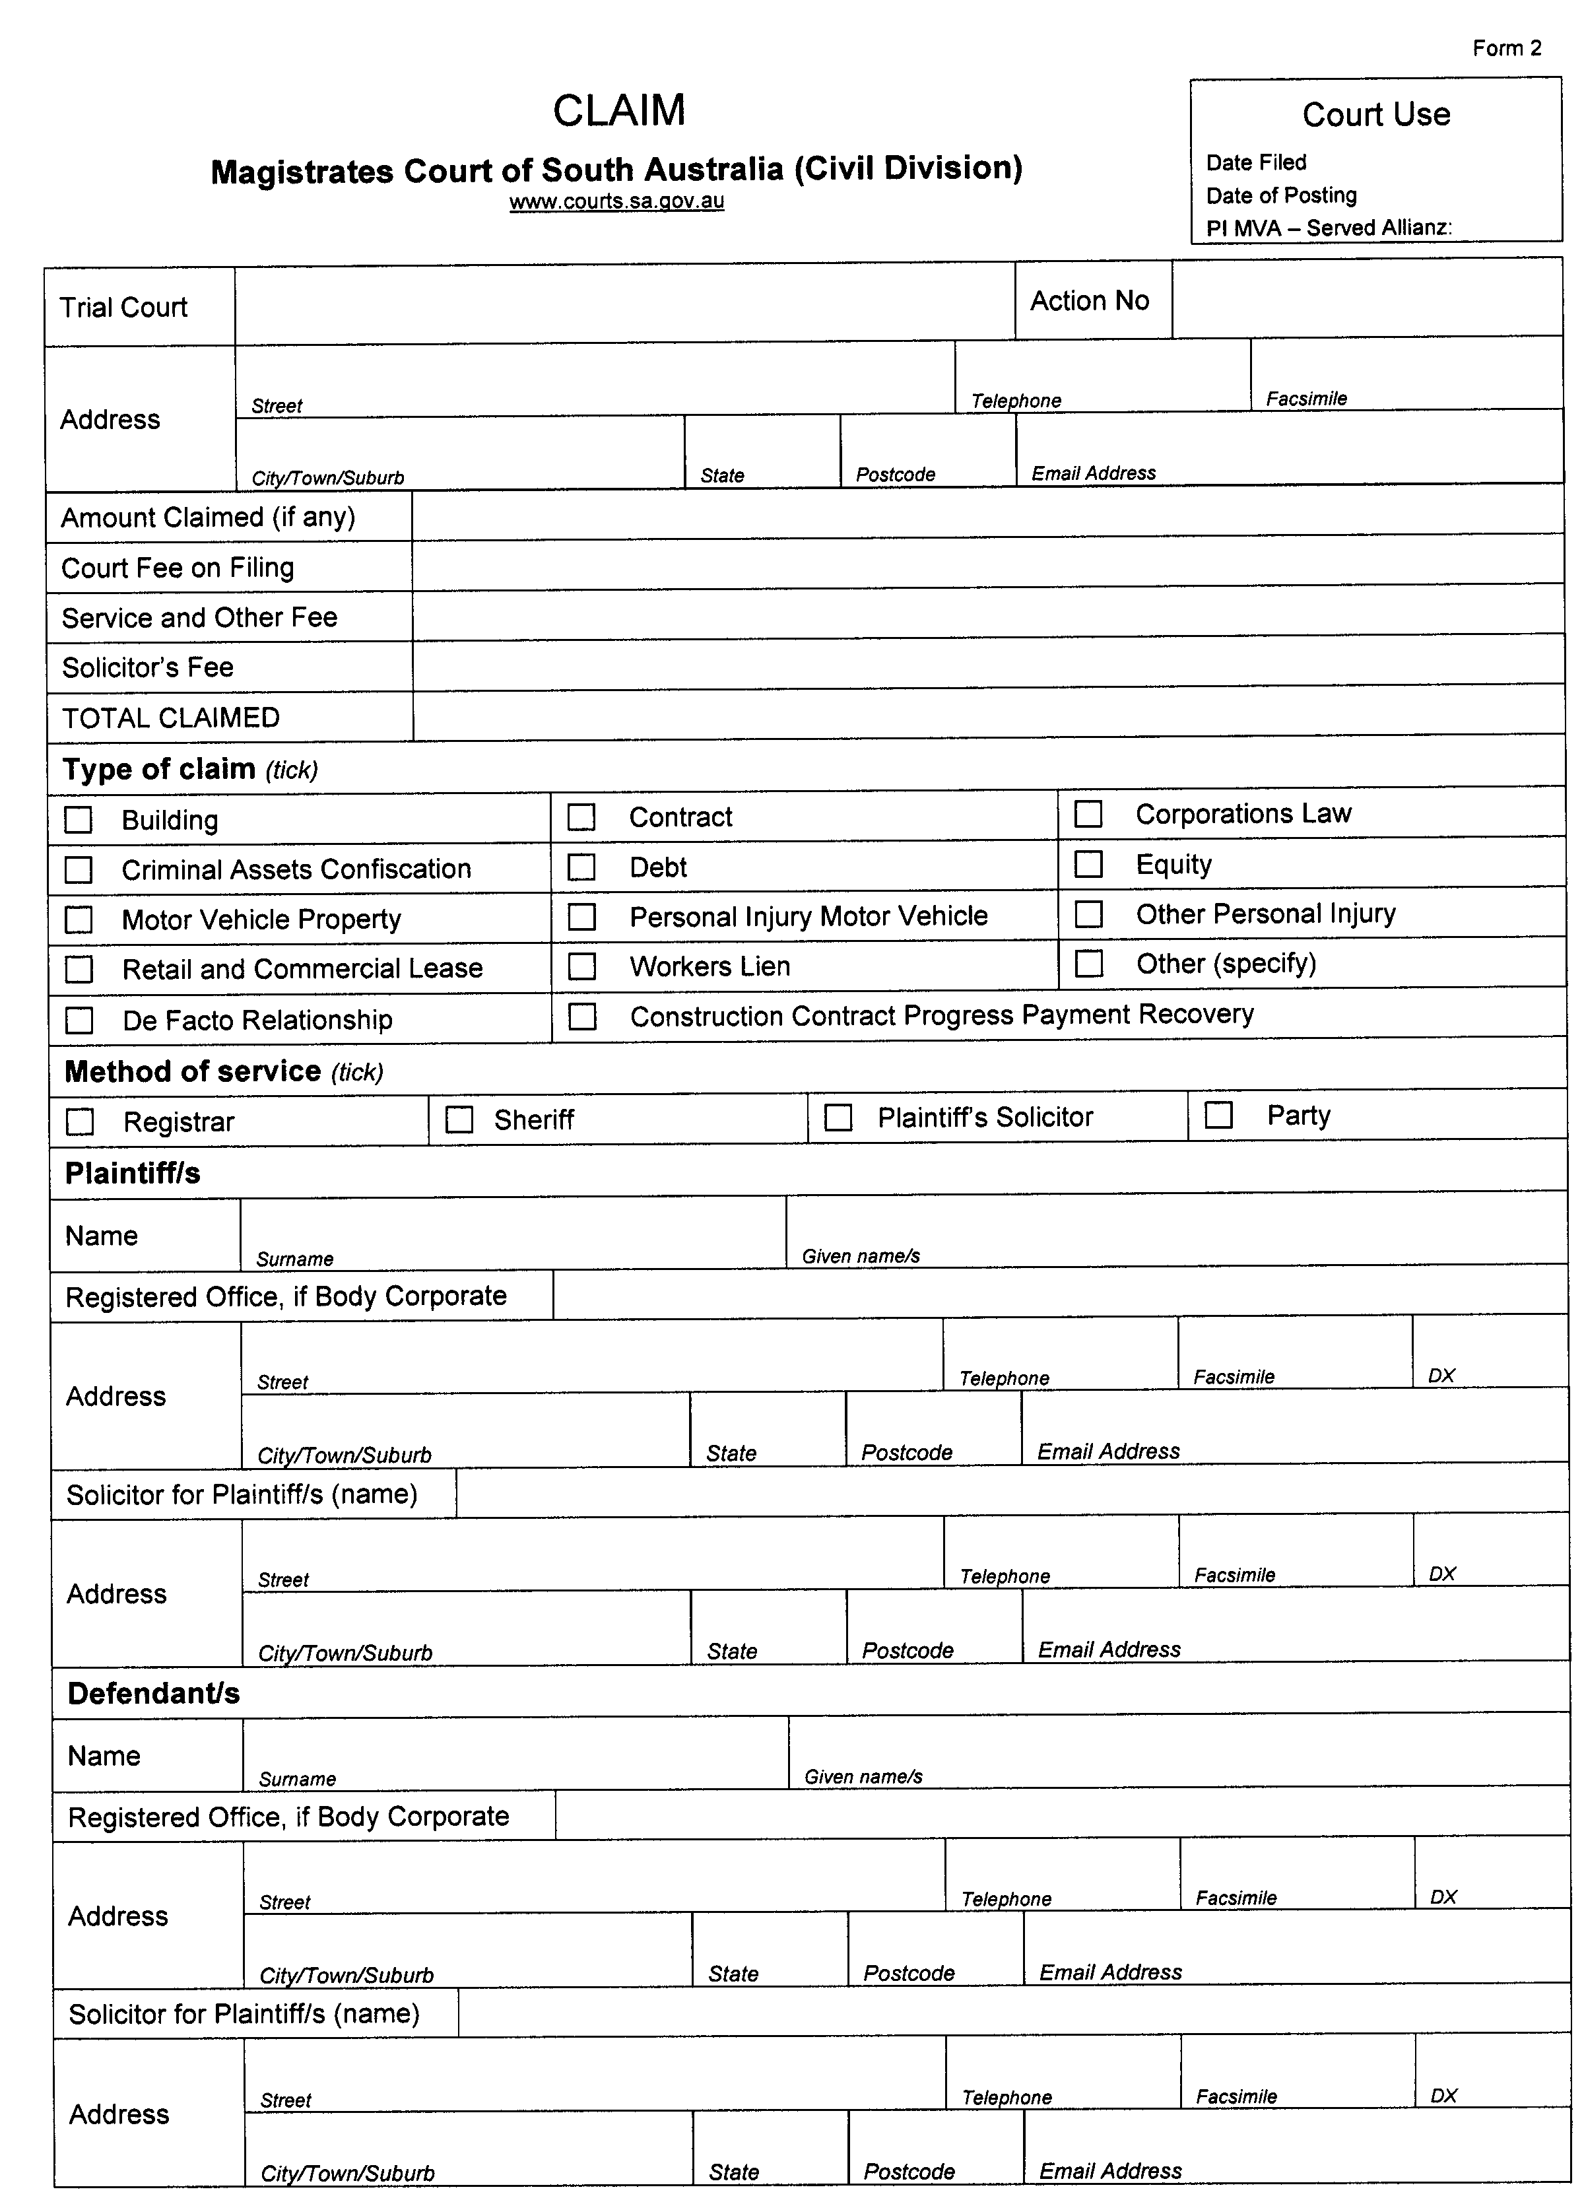
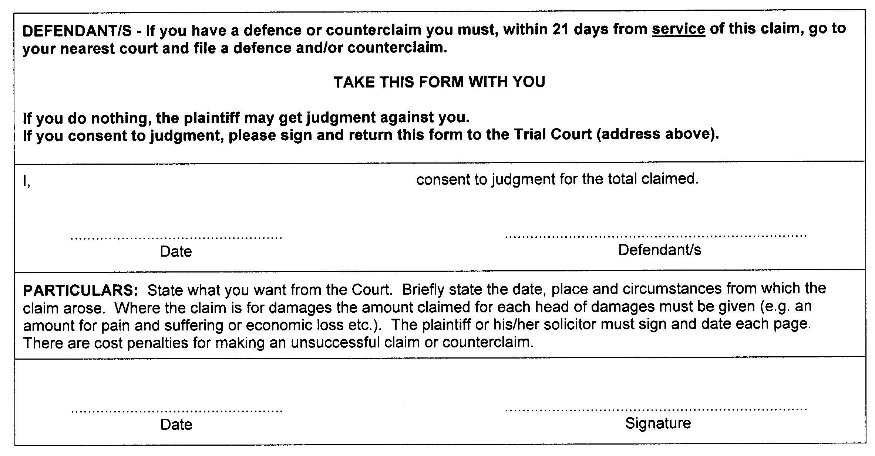
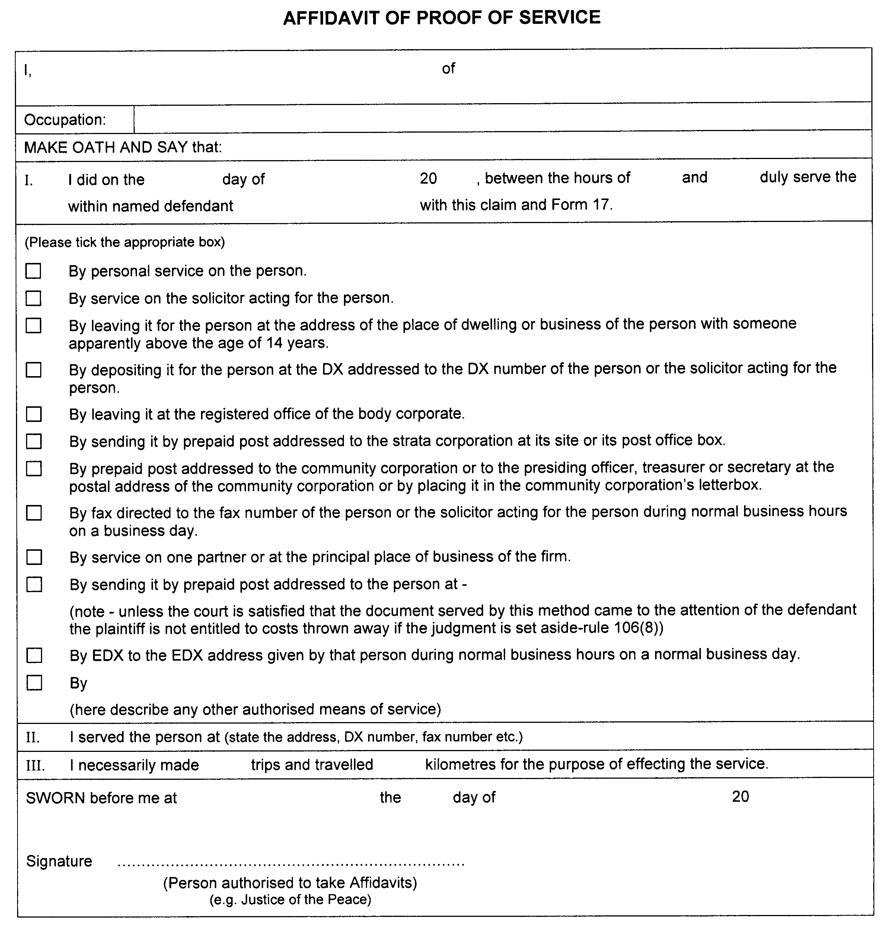
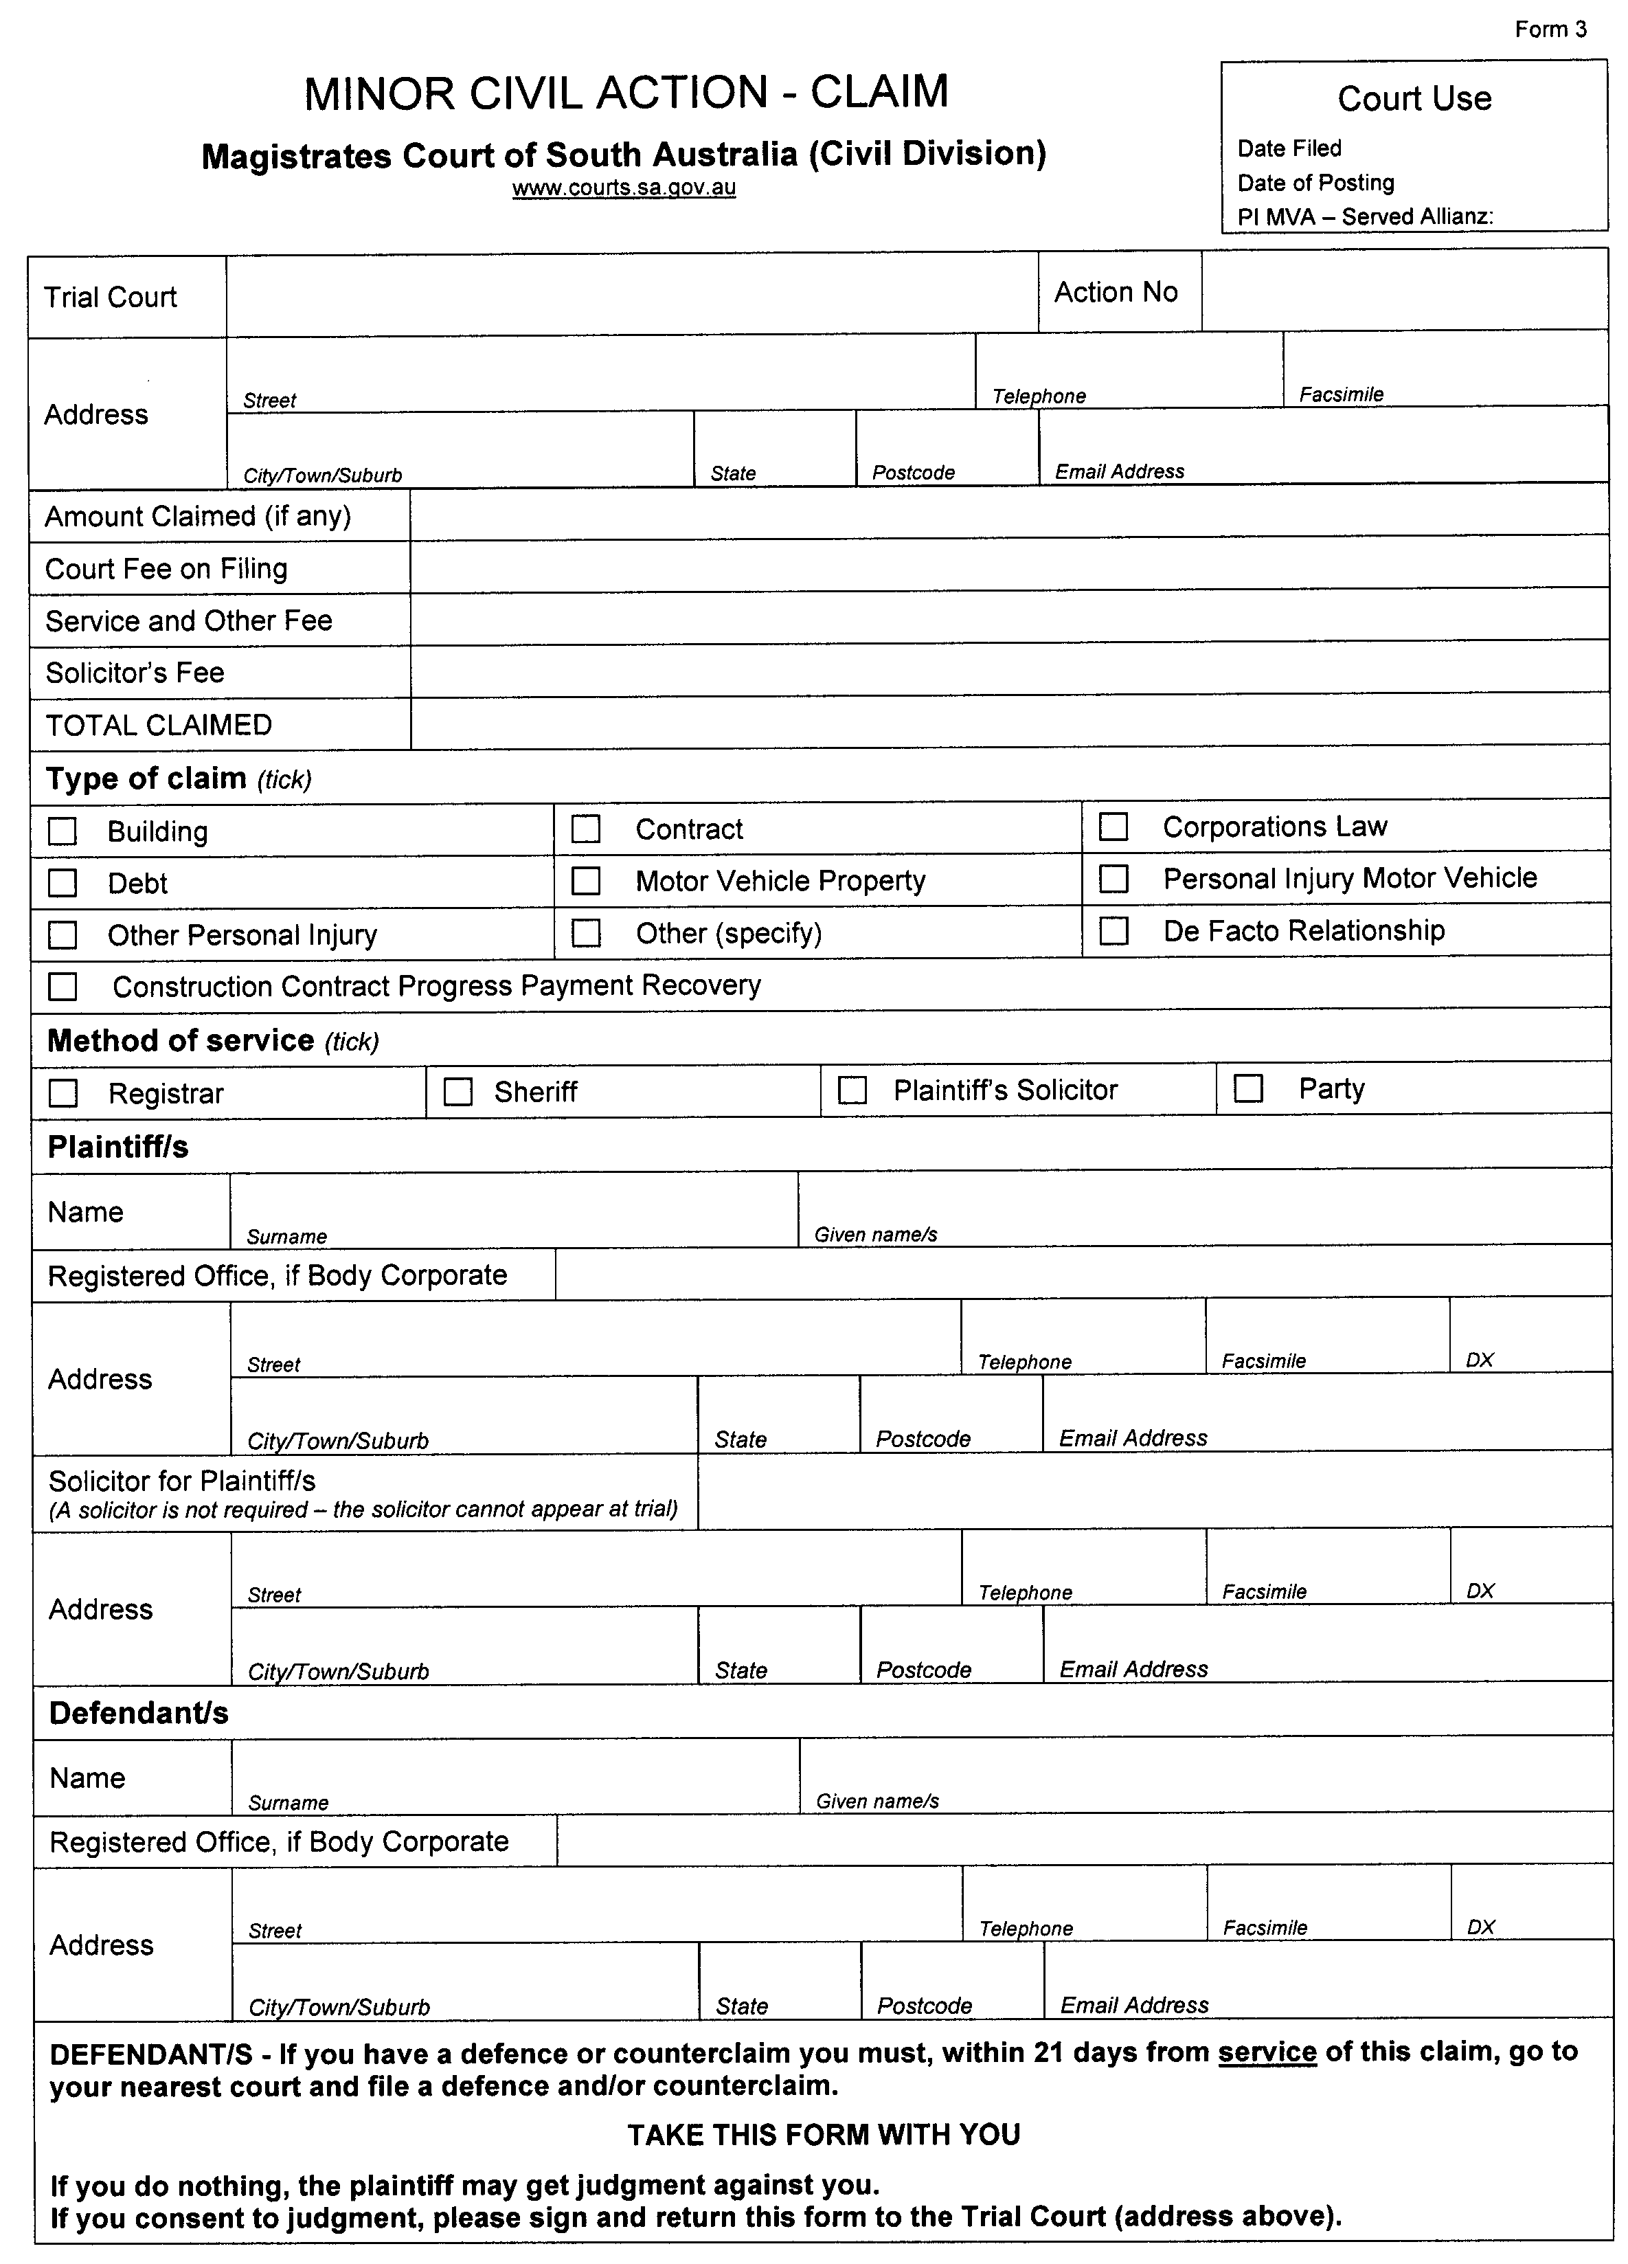
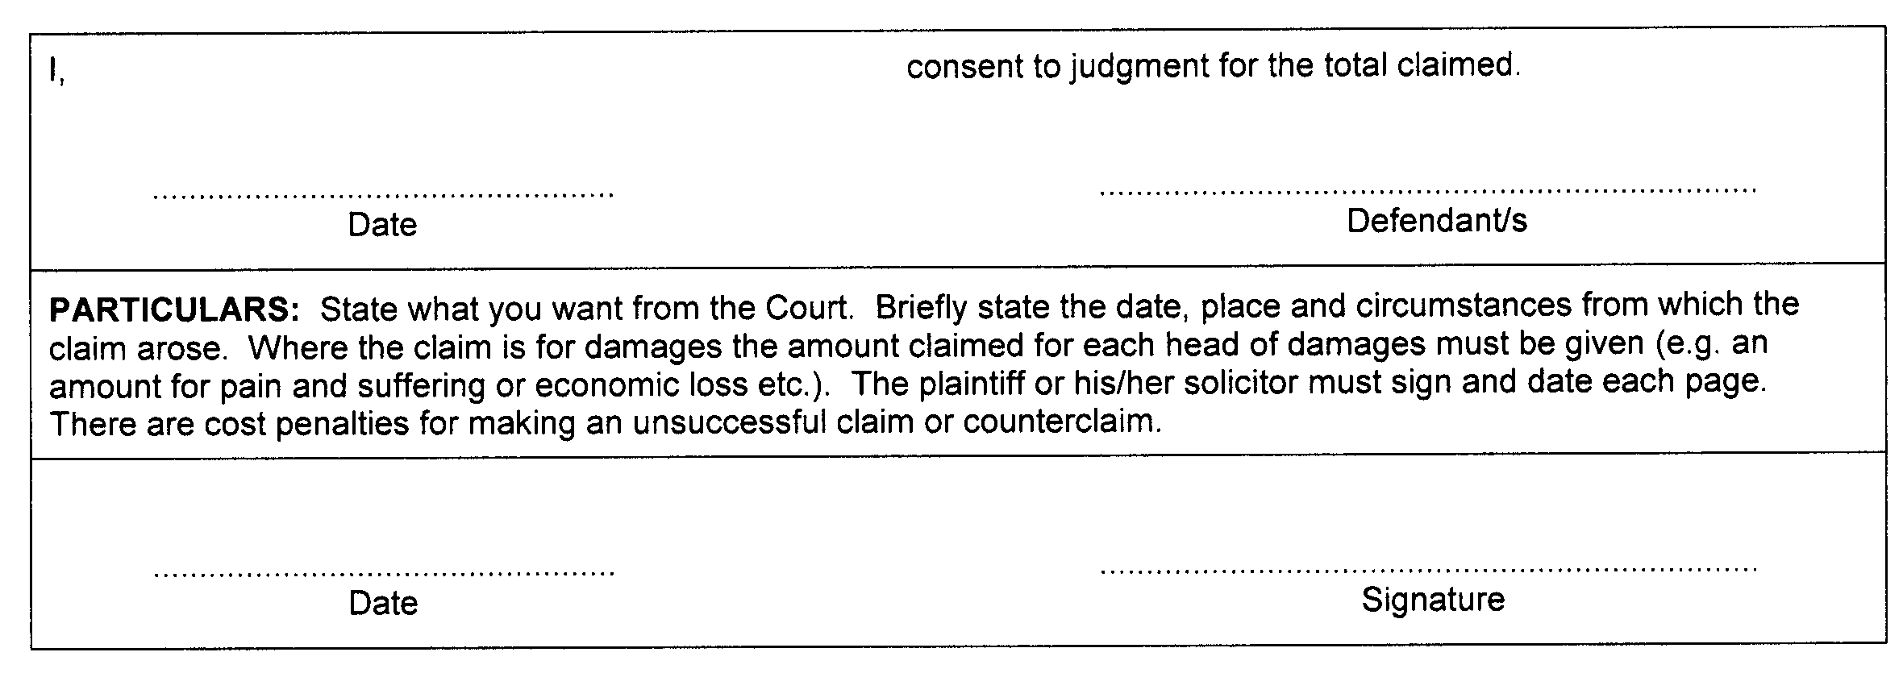
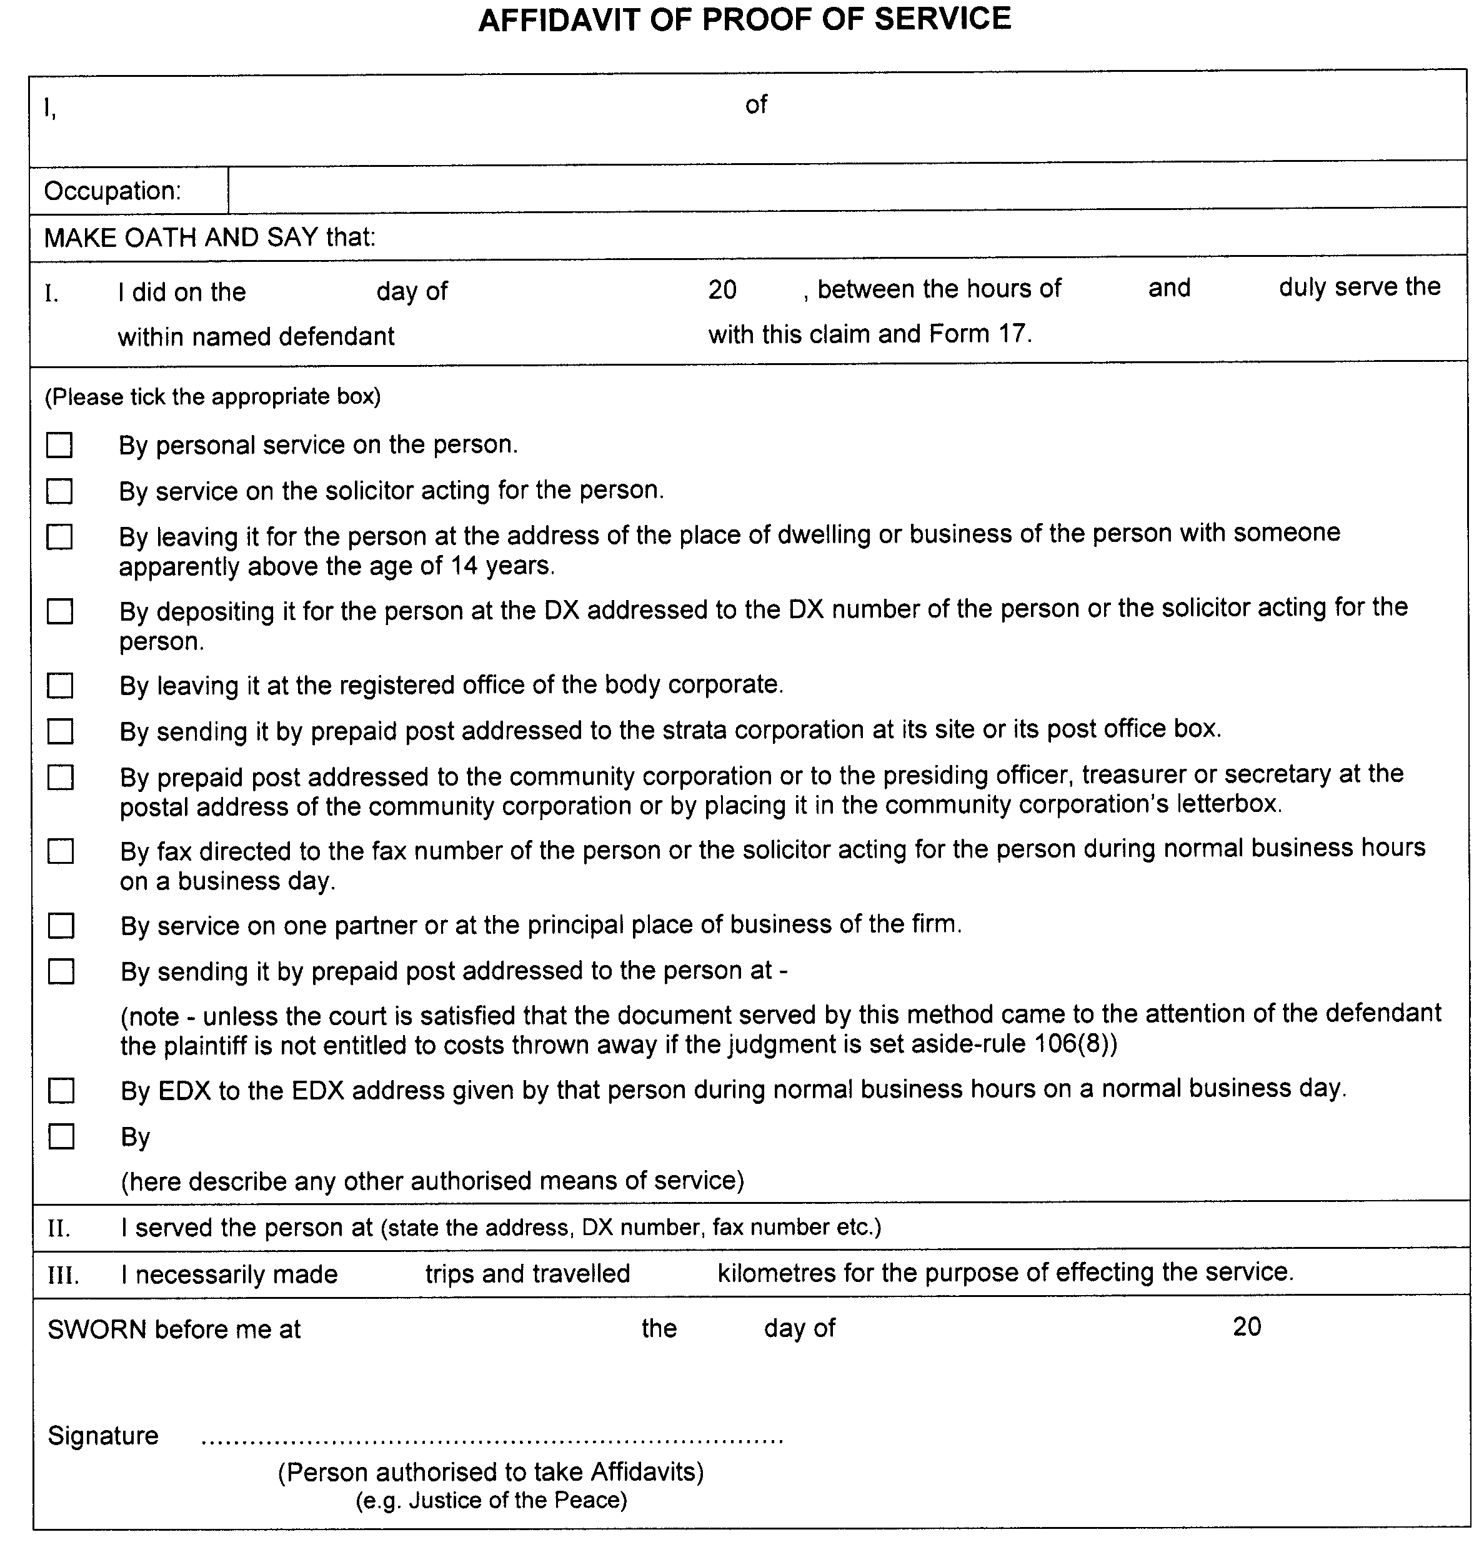
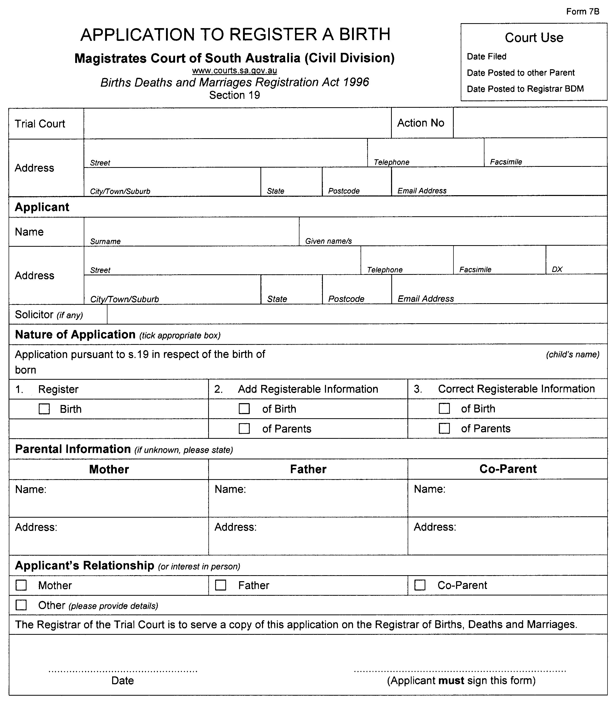
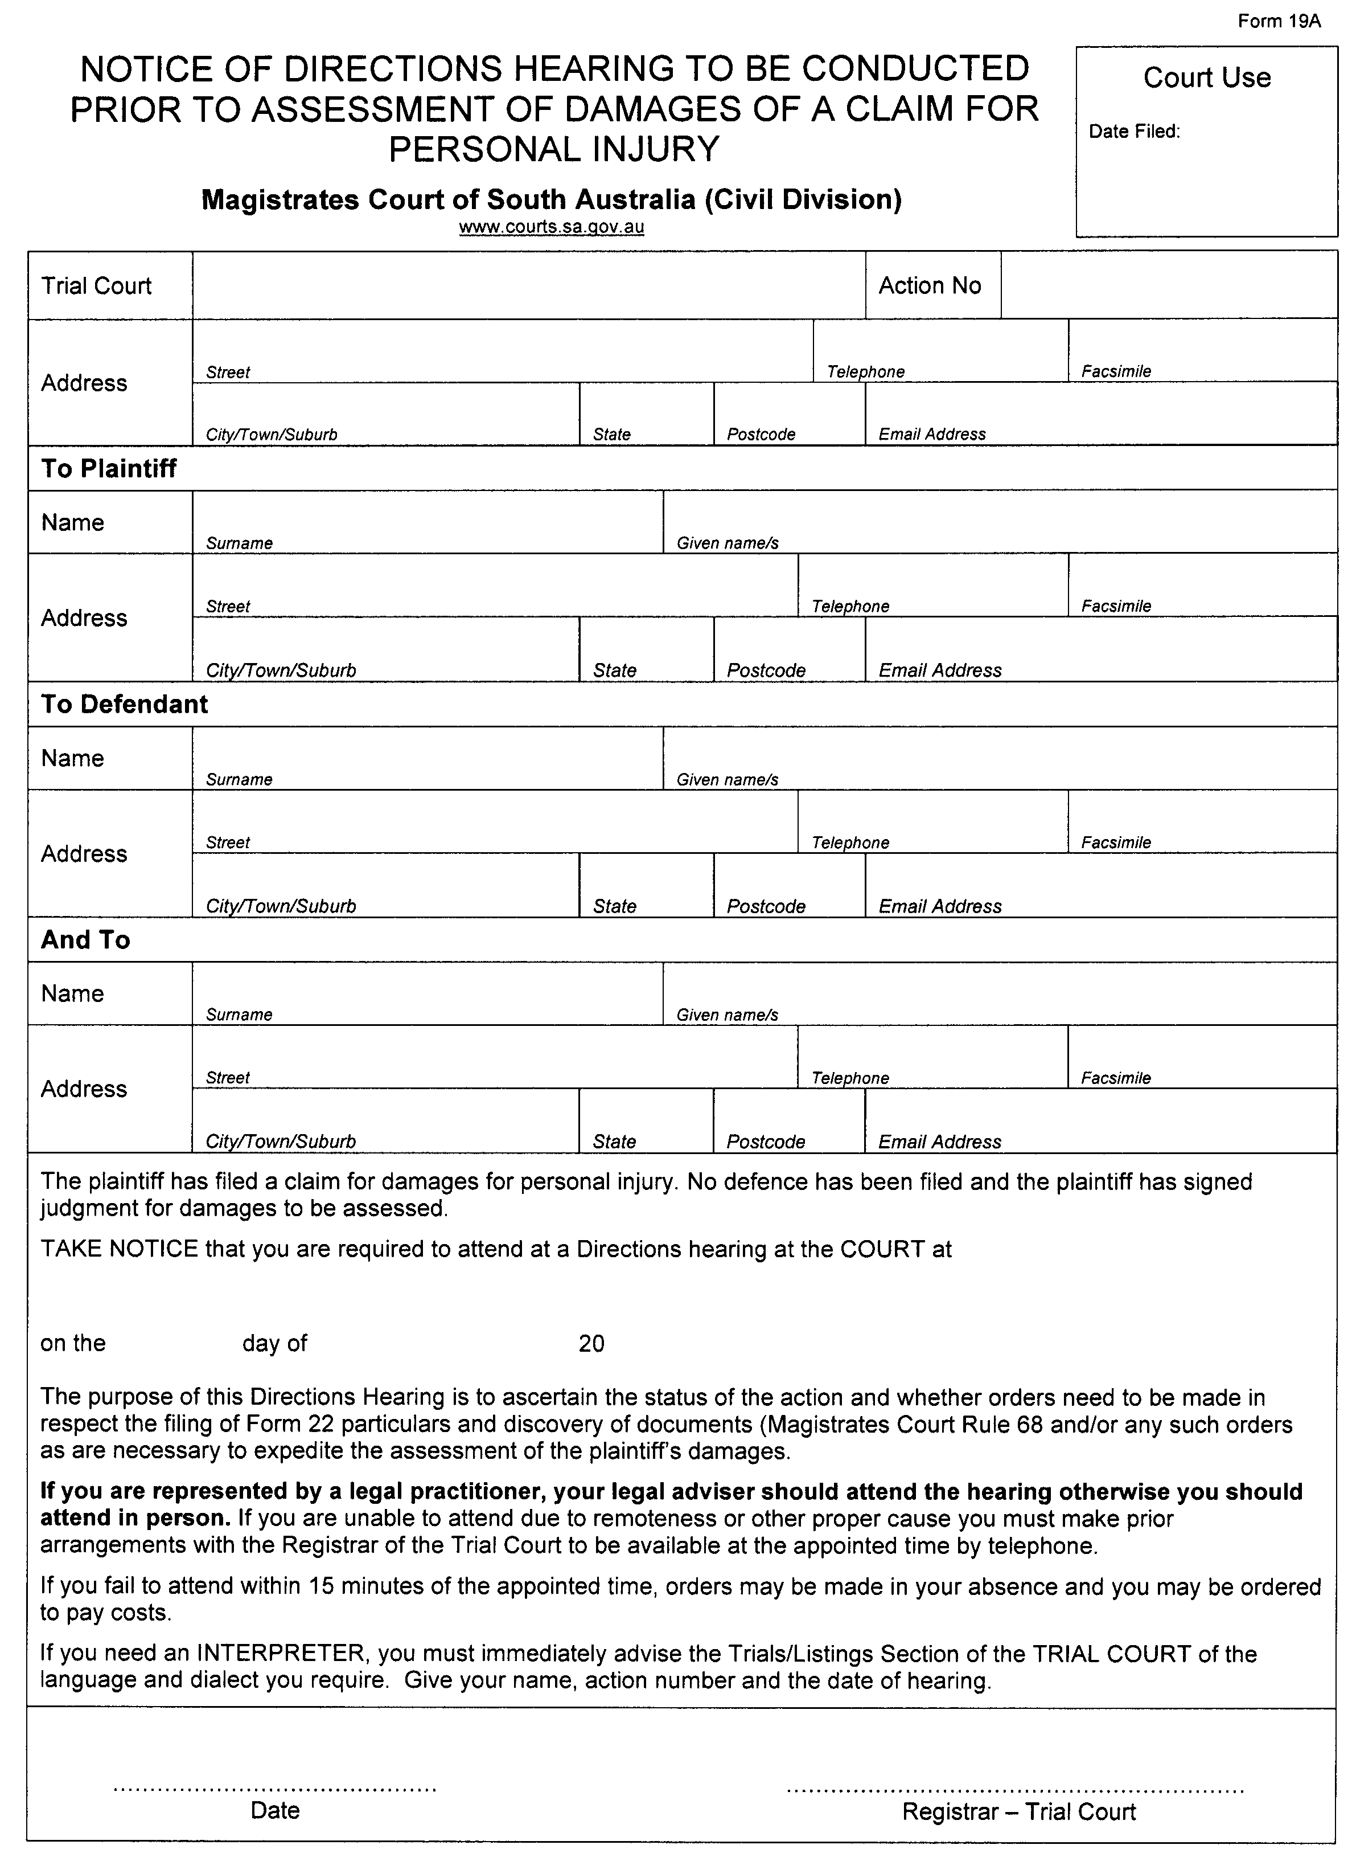

South Australia
Highways (Road Closure—Old Port Wakefield Road, Virginia) Proclamation 2012
under section 27AA of the Highways Act 1926
1—Short title
This proclamation may be cited as the Highways (Road Closure—Old Port Wakefield Road, Virginia) Proclamation 2012.
2—Commencement
This proclamation comes into operation on the day on which it is made.
3—Road closure
The portion of public road delineated as allotment 100 in approved Plan No FP 56142 lodged in the Lands Titles Registration Office is closed.
Made by the Governor
on the recommendation of the Commissioner of Highways and with the advice and consent of the Executive Council
on 8 March 2012
MTR/12/011

South Australia
Liquor Licensing (Dry Areas—Long Term) Variation Regulations 2012
under the Liquor Licensing Act 1997

Contents
Part 1—Preliminary
1 Short title
2 Commencement
3 Variation provisions
Part 2—Variation of Liquor Licensing (Dry Areas—Long Term) Regulations 1997
4 Variation of Schedule 1—Long term dry areas

Part 1—Preliminary
1—Short title
These regulations may be cited as the Liquor Licensing (Dry Areas—Long Term) Variation Regulations 2012.
2—Commencement
These regulations come into operation on the day on which they are made.
3—Variation provisions
In these regulations, a provision under a heading referring to the variation of specified regulations varies the regulations so specified.
Part 2—Variation of Liquor Licensing (Dry Areas—Long Term) Regulations 1997
4—Variation of Schedule 1—Long term dry areas
(1) Schedule 1, item headed "Clare—Area 1", column headed "Period"—delete "2012" and substitute:
2017
(2) Schedule 1, item headed "Clare—Area 2", column headed "Period"—delete "2012" and substitute:
2017
(3) Schedule 1, item headed "Clare—Area 3", column headed "Period"—delete "2012" and substitute:
2017
(4) Schedule 1, item headed "Clare—Area 4", column headed "Period"—delete "2012" and substitute:
2017
Note—
As required by section 10AA(2) of the Subordinate Legislation Act 1978, the Minister has certified that, in the Minister's opinion, it is necessary or appropriate that these regulations come into operation as set out in these regulations.
Made by the Governor
with the advice and consent of the Executive Council
on 8 March 2012.
No 13 of 2012
MLI0003/12CS

FAXING COPY?
IF you fax copy to Government Publishing SA for inclusion in the Government Gazette, there is no need to send a Confirmation Copy to us as well.
This creates confusion and may well result in your notice being printed twice.
Please use the following fax number:
Fax transmission: (08) 8207 1040
Phone Enquiries: (08) 8207 1045
Please include a contact person, phone number and order number so that we can phone back with any queries we may have regarding the fax copy.
NOTE: Closing time for lodging new copy (fax, hard copy or email) is 4 p.m. on Tuesday preceding the day of publication.

Government Gazette notices can be Emailed.
The address is:
governmentgazette@dpc.sa.gov.au
Documents should be sent as attachments in Word format.
When sending a document via Email, please confirm your transmission with a faxed copy of your document, including the date the notice is to be published.
Fax transmission: (08) 8207 1040
Phone Enquiries: (08) 8207 1045
NOTE: Closing time for lodging new copy (fax, hard copy or email) is 4 p.m. on Tuesday preceding the day of publication.

CITY OF MITCHAM
Amendment of Exclusion of Vehicles (with Exceptions)
NOTICE is hereby given that the City of Mitcham at its meeting held on 20 December 2011, resolved to amend its previous declaration made at its meeting held on 28 February 2011 and published in the Gazette on 3 March 2011 under Section 359 of the Local Government Act 1934, as amended, relating to the closure of a portion of Craigburn Road, Blackwood. This resolution prohibits access to and from Hayman Retreat for all vehicles with an exemption for cyclists in addition to the currently listed authorised vehicles.
Council has resolved to exclude all vehicles with the exception of:
• Government owned vehicles driven by employees or agents of the government in the course of their employment;
• City of Mitcham owned vehicles driven by employees or agents of the City of Mitcham in the course of their employment;
• SA Water vehicles;
• ETSA Utilities vehicles;
• Country Fire Services vehicles;
• Telstra vehicles;
• Police vehicles; and
• Bicycles,
from a part of Craigburn Road, Blackwood, being an area one metre in width and 30.5 metres in length, the southern boundary of which being between Point 2 (281471.62E and 6120546.04N) and Point 3 (281501.64E and 6120549.55N) shown on the attached survey plan.
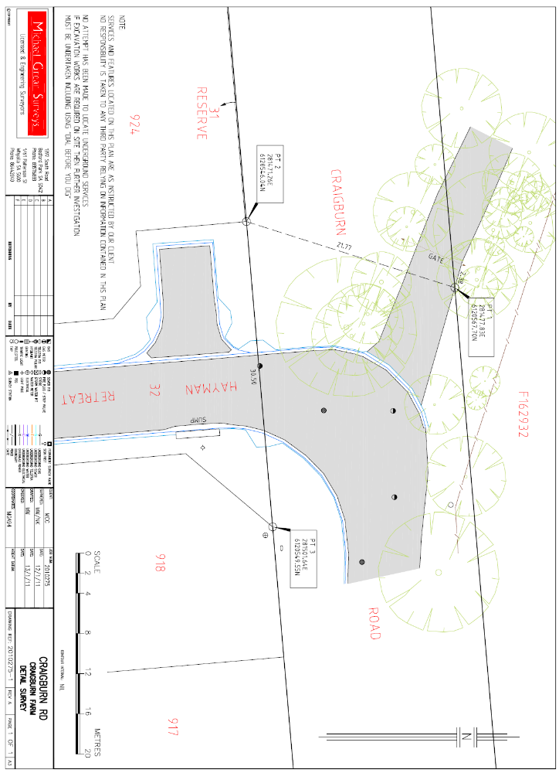
M. Pears, Chief Executive Officer

CITY OF CHARLES STURT
Adoption of Management Plans for Community Land
PURSUANT to the provisions of Section 197 (3) of the Local Government Act 1999, Council hereby gives notice that it has adopted Management Plans for the following parcels of Community Land:
Ray Street Reserve, Ray Street, Findon CT: V6062 F766;
Kiln Reserve, Kiln Drive, Brompton CT: V5994 F541;
Horticultural Centre and Historic James Brickworks, Toogood Avenue, Beverley CT: V5816 F854;
Horsley Drive Reserve, Horsley Drive, Kidman Park CT: V6045 F275;
Hamilton Road Reserve, Hamilton Road, Woodville North CT: V6028 F494;
Findon Reserve, Reserve Parade, Findon CT: V1877 F53;
Emma Street Reserve, Emma Street, Athol Park;
St Clair Oval No. 3, Brocas/Actil Avenue, Woodville CT: V6065 F935;
Don Klaebe Reserve, Drummond Avenue, Brompton CT: V5756 F762, CT: F110;
Thomas Harkness Reserve, Spurs Avenue, Brompton CT: V6028 F762, CT: V6025 F240;
The Avenue Reserve, The Avenue, Athol Park CT: V6044, F253; and
Cooke Reserve, Cooke Crescent, Royal Park CT: V5718 F681, CT: V5704 F573.
M. Withers, Chief Executive Officer

THE BAROSSA COUNCIL
4.5 Tonne Load Limit—Saleyards Road
NOTICE is hereby given pursuant to the provisions of Section 359 of the Local Government Act 1934 and pursuant to Rule 104 of the Australian Road Rules 1999, Council resolves to implement a 4.5 Tonne Local Load Limit on Saleyards Road from Stockwell Road to Light Pass Road and Stockwell Road to Penrice Road to limit truck access.
I. Baldwin, Acting Chief Executive Officer

REGIONAL COUNCIL OF GOYDER
Road Name Changes
NOTICE is hereby given that pursuant to Section 219 of the Local Government Act 1999, as amended, Council at its meetings of
20 September 2011 and 17 January 2012, resolved that:
• Road 137 from the intersection of the Burra to Clare Road to the intersection with the Goyder Highway be renamed Booborowie Road in the Hundreds of Hanson and Ayers.
• Bowling Club Road in the township of Booborowie be renamed Recreation Ground Road terminating at Quinn Road.
• Tohl Road in the township of Booborowie to continue and terminate at Recreation Ground Road replacing that road named Willis Road.
• Ernedale Road in the Hundred of Bright between Worlds End Highway and Rosalea Road be renamed Erndale Road.
• Bridge Terrace, Burra between Kingston Street and Bridge Street East be renamed Bridge Street.
The new names will take effect from 1 May 2012.
J. P. Brak, Chief Executive Officer

KANGAROO ISLAND COUNCIL
Development Act 1993
Primary Production, Forestry and Bushfire Protection Development Plan Amendment (DPA)
Draft for Public Consultation
NOTICE is hereby given that the Kangaroo Island Council has prepared a draft Development Plan Amendment. The Develop-ment Plan Amendment will amend Council’s Development Plan by:
• Changing policies affecting the Primary Production Zone primarily relating to protection of agricultural land;
• Incorporation of amended policies relating to Commercial Forestry;
• Additional policy relating to development adjoining the Kingscote Airport.
The draft Development Plan Amendment will be available for public inspection during normal office hours at the Council Office, 43 Dauncey Street, Kingscote and on the Council website www.kangarooisland.sa.gov.au from 8 March 2012 to 8 June 2012. A copy of the Development Plan Amendment can be downloaded from the website.
Written submissions regarding the draft amendment will be accepted by the Kangaroo Island Council until 5 p.m. on 8 June 2012. The written submission should also clearly indicate whether you will wish to speak at the public hearing regarding your submission. All submissions should be addressed to the Chief Executive Officer of the Kangaroo Island Council, P.O .Box 121, Kingscote, S.A. 5223 and may be submitted via email to kicouncil@kicouncil.sa.gov.au.
Drop in information sessions will be held at the following locations and times:
• Kingscote Council Chambers on 21 March 2012, 5 p.m. to 7 p.m.
• Penneshaw Town Hall on 22 March 2012, 5 p.m. to 7 p.m.
• Parndana Town Hall on 10 April 2012, 5 p.m. to 7 p.m.
• American River Town Hall on 11 April 2012, 5 p.m. to 7 p.m.
Copies of all written submissions received will be available for inspection by interested persons at the Council Offices from
10 June 2012 until the date of the public hearing.
A public hearing will be held at the Council Chambers on
25 June 2012 at 10 a.m. The public hearing will not be held if no submission indicates an interest in speaking at a public hearing.
For further information about the draft Development Plan Amendment, please contact the Development Services Depart-ment, Kangaroo Island Council on (08) 8553 4500 or via email at kicouncil@kicouncil.sa.gov.au.
Dated 8 March 2012.
A. Boardman, Chief Executive Officer

LIGHT REGIONAL COUNCIL
Conversion of Private Road to Public Road
NOTICE is hereby given pursuant to Section 210 of the Local Government Act 1999, that Light Regional Council at its meeting held on 28 February 2012, declared portion of Sections 1401 and 1489 Hundred of Kapunda, being the land marked ‘A’ in Lands Titles Office Deposited Plan 85459, and known commonly as Gawler Street, to be public road named Gawler Street.
B. Carr, Chief Executive Officer

LIGHT REGIONAL COUNCIL
Assignment of Road Name
NOTICE is hereby given pursuant to the provisions of Section 219 of the Local Government Act 1999, the Light Regional Council, at its meeting held on 28 February 2012, passed a resolution to assign the name Old Mallala Road to that section of public road in the Hundred of Mudla Wirra, being the service road located to the east of the main Redbanks Road and generally situate adjacent to allotments in Lands Titles Office Deposited Plans 34300 and 60073 and Lands Titles Office Filed Plans 174583 and 174586.
B. Carr, Chief Executive Officer

IN the matter of the estates of the undermentioned deceased persons:
Dalby, Elsie May, late of 47 Eve Road, Bellevue Heights, widow, who died on 17 December 2011.
Dillon, Adelisa Alpiz, late of 8 Mawson Avenue, Tailem Bend, home duties, who died on 7 October 2011.
Hall, Ian Robert, late of 15 Blyth Terrace, Moonta, teacher, who died on 1 October 2011.
Hore, Iris Millicent, late of 18 Cross Road, Myrtle Bank, of no occupation, who died on 30 December 2011.
Johnson, Brian Wesley, late of 6 Booth Avenue, Linden Park, retired cheese maker, who died on 28 April 2011.
Jolly, Marjorie Janet, late of 262 Cross Road, Kings Park, retired technical librarian, who died on 27 December 2011.
Keane, Lawrence Thomas, late of 13 Nile Street, Exeter, retired labourer, who died on 20 December 2011.
Keighran, Freda, late of 86 Oaklands Road, Glengowrie, of no occupation, who died on 11 November 2011.
Lundin, Rita Blance, late of 22 Norman Street, Port Pirie, of no occupation, who died on 7 November 2011.
McAuliffe, Jean Mary, late of 345 Fullarton Road, Fullarton, retired nurse, who died on 11 December 2011.
Reeves, Phyllis Ronda, late of 55 David Street, Port Pirie, retired food supervisor, who died on 5 January 2012.
Richards, Alan James, late of 12A Seaton Terrace, Seaton, home duties, who died on 7 December 2011.
Russell, Ivy, late of 18 Clipper Court, Seaford, retired nursery garden proprietor, who died on 25 November 2011.
Standfield, Mavis Christina, late of 60 States Road, Morphett Vale, widow, who died on 8 January 2012.
Surfield, William Thomas, late of 27 Hilliers Road, Morphett Vale, retired clerk, who died on 13 January 2012.
Taylor, Molly Price, late of 14-22 King William Road, Wayville, of no occupation, who died on 29 November 2011.
Walker, Ethel Marion, late of 147 St Bernards Road, Rostrevor, retired secretary, who died on 9 January 2012.
Notice is hereby given pursuant to the Trustee Act 1936, as amended, the Inheritance (Family Provision) Act 1972 and the Family Relationships Act 1975, that all creditors, beneficiaries, and other persons having claims against the said estates are required to send, in writing, to the Office of Public Trustee, G.P.O. Box 1338, Adelaide, S.A. 5001, full particulars and proof of such claims, on or before 6 April 2012, otherwise they will be excluded from the distribution of the said estates; and notice is also hereby given that all persons indebted to the said estates are required to pay the amount of their debts to the Public Trustee or proceedings will be taken for the recovery thereof; and all persons having any property belonging to the said estates are forthwith to deliver same to the Public Trustee.
Dated 8 March 2012.
D. A. Contala, Public Trustee

PARTNERSHIP ACT 1891
Notice of Resignation
TAKE notice that as from 26 October 2010, the partnership of Lei Zhang, 5/19 Kent Road, Keswick, S.A. 5035, Yuan Gao, 9 Wilson Street, Plympton Park, S.A. 5038 and Haidong Liu, 20 Patrick Street, Athelstone, S.A. 5076 in the State of South Australia who traded as L Zhang Y Gao H Liu was dissolved.
Haidong Liu has retired from the partnership.
Lei Zhang and Yuan Gao will continue to operate the business under the name of L Zhang & Y Gao and shall be responsible for all the debts and liabilities thereof.
Dated 20 February 2012.
Lei Zhang
Yuan Gao
Haidong Liu

ATTENTION

CUSTOMERS requiring a proof of their notice for inclusion in the Government Gazette, please note that the onus is on you to inform Government Publishing SA of any subsequent corrections.

For any corrections to your notice please phone 8207 1045 or Fax 8207 1040 before 4 p.m. on Wednesday.

If we do not receive any communication by 10 a.m. on Thursday (day of publication) we will presume the notice is correct and will print it as it is.

Remember—the onus is on you to inform us of any corrections necessary to your notice.

NOTE: Closing time for lodging new copy (electronically, fax or hard copy) is 4 p.m. on Tuesday preceding the day of publication.
Phone: 8207 1045
Fax: 8207 1040
Email: governmentgazette@dpc.sa.gov.au

Printed and published by authority every Thursday by B. MORRIS, Government Printer, South Australia
Price: $6.25, plus postage; to subscribers, $315.00 per annum.
(The above prices are inclusive of GST)

