No. 22 1219

THE SOUTH AUSTRALIAN

GOVERNMENT GAZETTE
www.governmentgazette.sa.gov.au

PUBLISHED BY AUTHORITY

ALL PUBLIC ACTS appearing in this GAZETTE are to be considered official, and obeyed as such

ADELAIDE, THURSDAY, 29 MARCH 2012

CONTENTS

Page
Appointments, Resignations, Etc. 1220
Corporations and District Councils—Notices 1313
Development Act 1993—Notice 1221
Environment Protection Act 1993—Notice 1222
Fisheries Management Act 2007—Notices 1225
Gaming Machines Regulations 2005—Notice 1227
Housing Improvement Act 1940—Notices 1228
Liquor Licensing Act 1997—Notices 1229
Livestock Act 1997—Notice 1230
Mining Act 1971—Notices 1230
Motor Vehicles Act 1959—Notice 1234
National Electricity Law—Notice 1262
National Parks and Wildlife Act 1972—Notice 1262
National Parks and Wildlife (National Parks)
Regulations 2001—Notice 1262
Petroleum and Geothermal Energy Act 2000—
Notices 1262
Proclamations 1294
Public Trustee Office—Administration of Estates 1314
REGULATIONS
Workers Rehabilitation and Compensation Act 1986
(No. 20 of 2012) 1297
(No. 21 of 2012) 1306
Page
REGULATIONS—continued.
Liquor Licensing Act 1997
(No. 22 of 2012) 1308
(No. 23 of 2012) 1310
Real Property Act 1886—Notice 1264
Retention of Title—Notice 1221
Retirement Villages Act 1987—Notice 1264
Road Traffic Act 1961—Notice 1265
RULES
District Court (Criminal and Miscellaneous) Rules 1992—
(Amendment No. 11) 1290
Supreme Court Criminal Rules 1992—
(Amendment No. 29) 1285
South Australian Housing Trust Act 1995—Notice 1284
Survey Act 1992—Notice 1264
Training Skills and Development Act 2008—
Notice 1270
[Republished] 1269
Treasury—Quarterly Statement 1272
Wilderness Protection Regulations 2006—
Notices 1280
Workers Rehabilitation and Compensation Act 1986—
Notice 1281

GOVERNMENT GAZETTE NOTICES
ALL poundkeepers’ and private advertisements forwarded for publication in the South Australian Government Gazette must be PAID FOR PRIOR TO INSERTION; and all notices, from whatever source, should be legibly written on one side of the paper only and sent to Government Publishing SA so as to be received no later
than 4 p.m. on the Tuesday preceding the day of publication. Phone 8207 1045 or Fax 8207 1040. E-mail: governmentgazette@dpc.sa.gov.au. Send as attachments in Word format and please confirm your transmission with a faxed copy of your document, including the date the notice is to be published and to whom the notice will be charged. The Government Gazette is available online at: www.governmentgazette.sa.gov.au

Department of the Premier and Cabinet
Adelaide, 29 March 2012
HIS Excellency the Governor in Executive Council has been pleased to appoint the undermentioned to the Lotteries Commission of South Australia, pursuant to the provisions of the State Lotteries Act 1966:
Member: (from 23 April 2012 until 22 April 2013)
Suzanne Joy Mackenzie
Member: (from 25 May 2012 until 24 May 2013)
Wayne Robert Jackson
By command,
Jay Wilson Weatherill, Premier
MFIN12/01CS

Department of the Premier and Cabinet
Adelaide, 29 March 2012
HIS Excellency the Governor in Executive Council has been pleased to appoint the undermentioned to the Health Performance Council, pursuant to the provisions of the Health Care Act 2008:
Member: (from 29 May 2012 until 28 May 2016)
Anne Murren Dunn
Chairperson: (from 29 May 2012 until 28 May 2016)
Anne Murren Dunn
By command,
Jay Wilson Weatherill, Premier
HEAC-2012-00014

Department of the Premier and Cabinet
Adelaide, 29 March 2012
HIS Excellency the Governor in Executive Council has been pleased to appoint the undermentioned to the South Australian Motor Sport Board, pursuant to the provisions of the South Australian Motor Sport Act 1984:
Member: (from 29 March 2012 until 28 March 2014)
Sam Mario Ciccarello
By command,
Jay Wilson Weatherill, Premier
DPC12/010CS

Department of the Premier and Cabinet
Adelaide, 29 March 2012
HIS Excellency the Governor in Executive Council has been pleased to appoint the undermentioned to the Homestart Finance Board of Management, pursuant to the provisions of the Housing and Urban Development (Administrative Arrangements) Act 1995:
Member: (from 29 March 2012 until 14 December 2013)
Claude Arthur Long
Presiding Member: (from 29 March 2012 until 14 December 2013)
Claude Arthur Long
By command,
Jay Wilson Weatherill, Premier
MHUD/12/006

Department of the Premier and Cabinet
Adelaide, 29 March 2012
HIS Excellency the Governor in Executive Council has been pleased to appoint Hieu Van Le as Governor’s Deputy of South Australia for the periods from 8 a.m. on Wednesday, 4 April 2012 until 12 p.m. on Thursday, 5 April 2012 and from 10 a.m. on Thursday, 3 May 2012 until 10 p.m. on Sunday, 13 May 2012.
By command,
Jay Wilson Weatherill, Premier

Department of the Premier and Cabinet
Adelaide, 29 March 2012
HIS Excellency the Governor in Executive Council has been pleased to appoint the Honourable John David Hill, MP, Minister for Health and Ageing, Minister for Mental Health and Substance Abuse and Minister for the Arts to be also Acting Deputy Premier, Acting Attorney-General, Acting Minister for Planning and Acting Minister for Business Services and Consumers for the period from 16 April 2012 to 22 April 2012 inclusive, during the absence of the Honourable John Robert Rau, MP.
By command,
Jay Wilson Weatherill, Premier
AGO0182/06CS

Department of the Premier and Cabinet
Adelaide, 29 March 2012
HIS Excellency the Governor in Executive Council has been pleased to appoint Frederick Robert Field to the office of Magistrate of the Magistrates Court of South Australia and to the office of Magistrate of the Youth Court of South Australia both on an auxiliary basis from 1 April 2012 to 31 March 2013, it being a condition of appointment that the powers and jurisdictions of office should only be exercised during the time or times the actual duties are being undertaken, but at no other time throughout the period of appointment, pursuant to Section 3 of the Judicial Administration (Auxiliary Appointments and Powers) Act 1988.
By command,
Jay Wilson Weatherill, Premier
AGO0241/02CS

Department of the Premier and Cabinet
Adelaide, 29 March 2012
HIS Excellency the Governor in Executive Council has been pleased to appoint Gary Thomas Burns to the position of Deputy Commissioner of Police for a period of three years commencing on 1 April 2012 and expiring on 31 March 2015, pursuant to the provisions of the Police Act 1998.
By command,
Jay Wilson Weatherill, Premier
12MPO/004CS

Department of the Premier and Cabinet
Adelaide, 29 March 2012
HIS Excellency the Governor in Executive Council has been pleased to appoint Michael John Sinkunas to the position of Small Business Commissioner, for a period of five years commencing on 29 March 2012 and expiring on 28 March 2017, pursuant to Section 4 of the Small Business Commissioner Act 2011.
By command,
Jay Wilson Weatherill, Premier
MSB12/002CS

Department of the Premier and Cabinet
Adelaide, 29 March 2012
HIS Excellency the Governor in Executive Council has been pleased to appoint Khatija Thomas to the office of Commissioner for Aboriginal Engagement on a part-time basis (0.8 FTE) for a period of three years commencing on 1 April 2012 and expiring on 31 March 2015, pursuant to Section 68 of the Constitution Act 1934.
By command,
Jay Wilson Weatherill, Premier
12MAARCS002

Department of the Premier and Cabinet
Adelaide, 29 March 2012
HIS Excellency the Governor in Executive Council has been pleased to appoint Delfina Lanzilli as Deputy Valuer-General for a period commencing on 31 March 2012 and expiring on 30 March 2013, pursuant to Section 6 of the Valuation of Land Act 1971.
By command,
Jay Wilson Weatherill, Premier
MFI/12/004

Department of the Premier and Cabinet
Adelaide, 15 March 2012
HIS Excellency the Governor directs it to be notified that he has been pleased to approve retention of the title Honourable by:
The Honourable Kevin Foley.
Jay Weatherill, Premier

DEVELOPMENT ACT 1993
Provision of Truss Information
Preamble
1. The Development (Trusses) Variation Regulations 2011, were made by the Governor with the advice and consent of the Executive Council on 29 September 2011 and were published in the Gazette on the same day.
2. The Development (Trusses) Variation Regulations 2011, will come into operation on 1 July 2012.
3. Regulation 74 A requires a person who is engaged to manufacture a roof truss to furnish information to specified parties, in a manner determined by the Minister, for the purposes of the Regulation.
Notice
FOR the purpose of Regulation 74 A, the information must be furnished in the following manner:
(a) The information must be sent in a manner that it is received by the parties specified in Regulation 74 A (1) within one business day of it being sent.
(b) If the information is sent electronically, there must be a record that the message was received, such as a ‘read receipt’.
Dated 22 March 2012.
John Rau, Minister for Planning

ENVIRONMENT PROTECTION ACT 1993
Revocation of Approval of Category B Containers
I, ANDREA KAYE WOODS, Delegate of the Environment Protection Authority (‘the Authority’), pursuant to Section 68 of the Environment Protection Act 1993 (SA) (‘the Act’) hereby revoke the approvals of the classes of Category B Containers sold in South Australia as identified by reference to the following matters, which are described in the first 4 columns of Schedule 1 of this Notice:
(a) the product which each class of containers shall contain;
(b) the size of the containers;
(c) the type of containers; and
(d) the name of the holders of these approvals.
These approvals are revoked as the Authority is satisfied that the waste management arrangement between the approval holder and the party named in Column 5 of Schedule 1 of this Notice has been cancelled.
Schedule 1

Column 1 | Column 2 |  |  | Column 3 |  | Column 4 | Column 5
Product Name | Container  Size (mL) |  |  | Container Type |  | Approval Holder | Collection  Arrangements
AO Bourbon & Cola |  | 375 | Can |  | Festival City Wines & Spirits Pty Ltd |  |  | Statewide Recycling
AO Gin & Tonic |  | 375 | Can |  | Festival City Wines & Spirits Pty Ltd |  |  | Statewide Recycling
AO Melonade |  | 375 | Can |  | Festival City Wines & Spirits Pty Ltd |  |  | Statewide Recycling
AO Ouzo & Cola |  | 375 | Can |  | Festival City Wines & Spirits Pty Ltd |  |  | Statewide Recycling
AO Rum & Cola |  | 375 | Can |  | Festival City Wines & Spirits Pty Ltd |  |  | Statewide Recycling
AO Scotch & Cola |  | 375 | Can |  | Festival City Wines & Spirits Pty Ltd |  |  | Statewide Recycling
AO Vodka & Orange |  | 375 | Can |  | Festival City Wines & Spirits Pty Ltd |  |  | Statewide Recycling
AO Vodka & Passionfruit |  | 375 | Can |  | Festival City Wines & Spirits Pty Ltd |  |  | Statewide Recycling
AO Vodka & Raspberry |  | 375 | Can |  | Festival City Wines & Spirits Pty Ltd |  |  | Statewide Recycling
Andes Beer |  | 350 | Glass |  | Festival City Wines & Spirits Pty Ltd |  |  | Statewide Recycling
Baitz Blue Vodka & Blue Curacao |  | 330 | Glass |  | Festival City Wines & Spirits Pty Ltd |  |  | Statewide Recycling
Bass Pale Ale |  | 330 | Glass |  | Festival City Wines & Spirits Pty Ltd |  |  | Statewide Recycling
Biere Des Druids |  | 500 | Can |  | Festival City Wines & Spirits Pty Ltd |  |  | Statewide Recycling
Biere Grande Armee |  | 500 | Can |  | Festival City Wines & Spirits Pty Ltd |  |  | Statewide Recycling
Brahma Beer |  | 345 | Glass |  | Festival City Wines & Spirits Pty Ltd |  |  | Statewide Recycling
Budweiser |  | 345 | Can |  | Festival City Wines & Spirits Pty Ltd |  |  | Statewide Recycling
Budweiser Beer |  | 345 | Glass |  | Festival City Wines & Spirits Pty Ltd |  |  | Statewide Recycling
Budweiser Original |  | 345 | Glass |  | Festival City Wines & Spirits Pty Ltd |  |  | Statewide Recycling
Caffreys Irish Ale |  | 440 | Can |  | Festival City Wines & Spirits Pty Ltd |  |  | Statewide Recycling
Chinotto Fonteviva |  | 200 | Glass |  | Festival City Wines & Spirits Pty Ltd |  |  | Statewide Recycling
Dreher Beer |  | 330 | Glass |  | Festival City Wines & Spirits Pty Ltd |  |  | Statewide Recycling
Equilibrio Apple Nectar |  | 125 | Glass |  | Festival City Wines & Spirits Pty Ltd |  |  | Statewide Recycling
Equilibrio Apple Nectar |  | 200 | Glass |  | Festival City Wines & Spirits Pty Ltd |  |  | Statewide Recycling
Equilibrio Apricot Nectar |  | 700 | Glass |  | Festival City Wines & Spirits Pty Ltd |  |  | Statewide Recycling
Equilibrio Apricot Nectar |  | 200 | Glass |  | Festival City Wines & Spirits Pty Ltd |  |  | Statewide Recycling
Equilibrio Apricot Nectar |  | 125 | Glass |  | Festival City Wines & Spirits Pty Ltd |  |  | Statewide Recycling
Equilibrio Peach Nectar |  | 125 | Glass |  | Festival City Wines & Spirits Pty Ltd |  |  | Statewide Recycling
Equilibrio Peach Nectar |  | 200 | Glass |  | Festival City Wines & Spirits Pty Ltd |  |  | Statewide Recycling
Equilibrio Peach Nectar |  | 700 | Glass |  | Festival City Wines & Spirits Pty Ltd |  |  | Statewide Recycling
Equilibrio Pear Nectar |  | 200 | Glass |  | Festival City Wines & Spirits Pty Ltd |  |  | Statewide Recycling
Equilibrio Pear Nectar |  | 700 | Glass |  | Festival City Wines & Spirits Pty Ltd |  |  | Statewide Recycling
Equilibrio Pear Nectar |  | 125 | Glass |  | Festival City Wines & Spirits Pty Ltd |  |  | Statewide Recycling
Fancy Biker Beer |  | 500 | Can |  | Festival City Wines & Spirits Pty Ltd |  |  | Statewide Recycling
Ferrarelle Carbonated Water |  | 330 | Glass |  | Festival City Wines & Spirits Pty Ltd |  |  | Statewide Recycling
Ferrarelle Carbonated Water |  | 750 | Glass |  | Festival City Wines & Spirits Pty Ltd |  |  | Statewide Recycling
Ferrarelle Mineral Water |  | 330 | Glass |  | Festival City Wines & Spirits Pty Ltd |  |  | Statewide Recycling
Ferrarelle Mineral Water |  | 750 | Glass |  | Festival City Wines & Spirits Pty Ltd |  |  | Statewide Recycling
Fonteviva Bitter Orange |  | 180 | Glass |  | Festival City Wines & Spirits Pty Ltd |  |  | Statewide Recycling
Fonteviva Chinotto |  | 180 | Glass |  | Festival City Wines & Spirits Pty Ltd |  |  | Statewide Recycling
Fonteviva Lemon Drink |  | 180 | Glass |  | Festival City Wines & Spirits Pty Ltd |  |  | Statewide Recycling
Fonteviva Red Bitter |  | 100 | Glass |  | Festival City Wines & Spirits Pty Ltd |  |  | Statewide Recycling
Forst Kronen Speciale Beer |  | 330 | Glass |  | Festival City Wines & Spirits Pty Ltd |  |  | Statewide Recycling
Frutti Wild Blueberry Nectar |  | 200 | Glass |  | Festival City Wines & Spirits Pty Ltd |  |  | Statewide Recycling
Frutti Wild European Cranberry Nectar |  | 200 | Glass |  | Festival City Wines & Spirits Pty Ltd |  |  | Statewide Recycling
Frutti Wild Mix Fruit Nectar |  | 200 | Glass |  | Festival City Wines & Spirits Pty Ltd |  |  | Statewide Recycling
Frutti Wild Raspberry Nectar |  | 200 | Glass |  | Festival City Wines & Spirits Pty Ltd |  |  | Statewide Recycling
Frutti Wild Strawberry Nectar |  | 200 | Glass |  | Festival City Wines & Spirits Pty Ltd |  |  | Statewide Recycling
Heineken Dark |  | 330 | Glass |  | Festival City Wines & Spirits Pty Ltd |  |  | Statewide Recycling
La Rossa Birra |  | 330 | Glass |  | Festival City Wines & Spirits Pty Ltd |  |  | Statewide Recycling
Michelob |  | 345 | Glass |  | Festival City Wines & Spirits Pty Ltd |  |  | Statewide Recycling
Minerello Mineral Water |  | 250 | Glass |  | Festival City Wines & Spirits Pty Ltd |  |  | Statewide Recycling
Minerello Mineral Water |  | 750 | Glass |  | Festival City Wines & Spirits Pty Ltd |  |  | Statewide Recycling
Minerello Sparkling Mineral Water |  | 250 | Glass |  | Festival City Wines & Spirits Pty Ltd |  |  | Statewide Recycling
Minerello Sparkling Mineral Water |  | 750 | Glass |  | Festival City Wines & Spirits Pty Ltd |  |  | Statewide Recycling
Moretti Beer |  | 330 | Glass |  | Festival City Wines & Spirits Pty Ltd |  |  | Statewide Recycling
Moretti Birra |  | 660 | Glass |  | Festival City Wines & Spirits Pty Ltd |  |  | Statewide Recycling
Nastro Azzuro |  | 330 | Glass |  | Festival City Wines & Spirits Pty Ltd |  |  | Statewide Recycling
Peroni Gran Riserva |  | 330 | Glass |  | Festival City Wines & Spirits Pty Ltd |  |  | Statewide Recycling
Peroni Nastro Azzurro |  | 330 | Glass |  | Festival City Wines & Spirits Pty Ltd |  |  | Statewide Recycling
Pilots Beer 1 |  | 500 | Can |  | Festival City Wines & Spirits Pty Ltd |  |  | Statewide Recycling
Pilots Beer 2 |  | 500 | Can |  | Festival City Wines & Spirits Pty Ltd |  |  | Statewide Recycling
Pilsner Urquell |  | 330 | Glass |  | Festival City Wines & Spirits Pty Ltd |  |  | Statewide Recycling
Qvarzia Natural Still Water |  | 330 | Glass |  | Festival City Wines & Spirits Pty Ltd |  |  | Statewide Recycling
Qvarzia Sparkling Water |  | 750 | Glass |  | Festival City Wines & Spirits Pty Ltd |  |  | Statewide Recycling
Qvarzia Sparkling Water Blue Bottle |  | 750 | Glass |  | Festival City Wines & Spirits Pty Ltd |  |  | Statewide Recycling
Qvarzia Sparkling Water Blue Bottle |  | 330 | Glass |  | Festival City Wines & Spirits Pty Ltd |  |  | Statewide Recycling
Qvarzia Sparkling Water Green Bottle |  | 750 | Glass |  | Festival City Wines & Spirits Pty Ltd |  |  | Statewide Recycling
Radnor Valley Apple & Blackcurrant Flavoured Spring Water |  | 1 000 | Plastic |  | Festival City Wines & Spirits Pty Ltd |  |  | Statewide Recycling
Radnor Valley Apple & Blackcurrant Flavoured Spring Water |  | 330 | Plastic |  | Festival City Wines & Spirits Pty Ltd |  |  | Statewide Recycling
Radnor Valley Forest Fruit Flavoured Spring Water |  | 1 000 | Plastic |  | Festival City Wines & Spirits Pty Ltd |  |  | Statewide Recycling
Radnor Valley Forest Fruit Flavoured Spring Water |  | 330 | Plastic |  | Festival City Wines & Spirits Pty Ltd |  |  | Statewide Recycling
Radnor Valley Peach Flavoured Spring Water |  | 1 000 | Plastic |  | Festival City Wines & Spirits Pty Ltd |  |  | Statewide Recycling
Radnor Valley Peach Flavoured Spring Water |  | 330 | Plastic |  | Festival City Wines & Spirits Pty Ltd |  |  | Statewide Recycling
Radnor Valley Pear Flavoured Spring Water |  | 330 | Plastic |  | Festival City Wines & Spirits Pty Ltd |  |  | Statewide Recycling
Radnor Valley Strawberry Flavoured Spring Water |  | 1 000 | Plastic |  | Festival City Wines & Spirits Pty Ltd |  |  | Statewide Recycling
Radnor Valley Strawberry Flavoured Spring Water |  | 330 | Plastic |  | Festival City Wines & Spirits Pty Ltd |  |  | Statewide Recycling
Sans Souci Birra |  | 330 | Glass |  | Festival City Wines & Spirits Pty Ltd |  |  | Statewide Recycling
Stones Bitter Draught |  | 480 | Can |  | Festival City Wines & Spirits Pty Ltd |  |  | Statewide Recycling
Tennents Extra |  | 330 | Glass |  | Festival City Wines & Spirits Pty Ltd |  |  | Statewide Recycling
Tennents Lager |  | 330 | Glass |  | Festival City Wines & Spirits Pty Ltd |  |  | Statewide Recycling
Tennents Milk Stout |  | 330 | Glass |  | Festival City Wines & Spirits Pty Ltd |  |  | Statewide Recycling
Tennents Stout |  | 330 | Glass |  | Festival City Wines & Spirits Pty Ltd |  |  | Statewide Recycling
Tennents Super |  | 330 | Glass |  | Festival City Wines & Spirits Pty Ltd |  |  | Statewide Recycling
Tequila Slammer Lemon |  | 330 | Glass |  | Festival City Wines & Spirits Pty Ltd |  |  | Statewide Recycling
Wattle Lager |  | 345 | Glass |  | Festival City Wines & Spirits Pty Ltd |  |  | Statewide Recycling
Duff Beer |  | 375 | Can |  | South Australian Brewing Company Pty Ltd |  |  | Statewide Recycling
Soycult Natural Soy Drink |  | 600 | PET |  | Soyganic Foods Australia |  |  | Statewide Recycling
Soycult Wildberry Soy Drink |  | 600 | PET |  | Soyganic Foods Australia |  |  | Statewide Recycling
Twist and Drink Orange |  | 200 | LDPE |  | Twist and Drink |  |  | Statewide Recycling
Twist and Drink Wild Berry |  | 200 | LDPE |  | Twist and Drink |  |  | Statewide Recycling
Twist and Drink Apple |  | 200 | LDPE |  | Twist and Drink |  |  | Statewide Recycling
Twist and Drink Cherry |  | 200 | LDPE |  | Twist and Drink |  |  | Statewide Recycling
Twist and Drink Cola |  | 200 | LDPE |  | Twist and Drink |  |  | Statewide Recycling
Twist and Drink Raspberry |  | 200 | LDPE |  | Twist and Drink |  |  | Statewide Recycling

FISHERIES MANAGEMENT ACT 2007: SECTION 79
TAKE note that the notice made under Section 79 of the Fisheries Management Act 2007, dated 22 March 2012, referring to the Spencer Gulf Prawn Fishery, is hereby revoked.
Take note that the notice made under Section 79 of the Fisheries Management Act 2007, dated 12 January 2012 and published in the South Australian Government Gazette dated 19 January 2012, on page 222, being the third notice on that page, referring to the Spencer Gulf Prawn Fishery, is hereby varied such that it will not be unlawful for a person fishing pursuant to a Spencer Gulf Prawn Fishery Licence to use prawn trawl nets in the areas specified in Schedule 1, during the period specified in Schedule 2 and under the conditions specified in Schedule 3.
Schedule 1
The waters of the Spencer Gulf Prawn Fishery that are:
1. South of the following co-ordinates: Commencing at latitude 33°35.00′S, longitude 137°14.00′E, then to position latitude 33°52.14′S, longitude 137°23.85′E, then to position latitude 33°54.33′S, longitude 137°27.06′E, then to position latitude 33°50.00′S, longitude 137°30.30′E, then to position latitude 33°47.74′S, longitude 137°28.11′E, then to position latitude 33°37.00′S, longitude 137°33.00′E, then to position latitude 33°46.00′S, 137°44.00′E.
2. Except the waters contained within and bounded by the following co-ordinates:
(a) latitude 33°41.00′S, longitude 137°06.00′E, then to position latitude 33°52.00′S, longitude 137°15.00′E, then to position latitude 33°54.89′S, longitude 137°09.21′E, then to position latitude 33°58.85′S, longitude 137°12.16′E, then to position latitude 34°17.00′S, longitude 136°50.00′E, then to position latitude 34°17.00′S, longitude 136°43.00′E, then to position latitude 34°04.00′S, longitude 136°49.00′E, then to position latitude 33°53.00′S, longitude 136°38.00′E; and
(b) latitude 34°10.00′S, longitude 137°28.00′E, then to position latitude 34°21.00′S, longitude 137°12.00′E, then to position latitude 34°45.00′S, longitude 137°15.00′E, then to position latitude 34°54.00′S, longitude 137°01.00′E.
Schedule 2
From 2030 hours on 24 March 2012 to 0630 hours on 30 March 2012.
Schedule 3
1. The co-ordinates in Schedule 1 are defined as degrees decimal minutes and based on the Australian Geodetic Datum 1966 (AGD 66).
2. No fishing activity may be undertaken during the daylight hours from 0630 hours to 2030 hours on any day during the period specified in Schedule 2.
Dated 24 March 2012.
C. Noell, Prawn Fisheries Manager

FISHERIES MANAGEMENT ACT 2007: SECTION 79
TAKE note that the notice made under Section 79 of the Fisheries Management Act 2007, dated 25 March 2012, referring to the Spencer Gulf Prawn Fishery, is hereby revoked.
Take note that the notice made under Section 79 of the Fisheries Management Act 2007, dated 12 January 2012 and published in the South Australian Government Gazette dated 19 January 2012, on page 222, being the third notice on that page, referring to the Spencer Gulf Prawn Fishery, is hereby varied such that it will not be unlawful for a person fishing pursuant to a Spencer Gulf Prawn Fishery Licence to use prawn trawl nets in the areas specified in Schedule 1, during the period specified in Schedule 2 and under the conditions specified in Schedule 3.
Schedule 1
The waters of the Spencer Gulf Prawn Fishery that are:
1. South of the following co-ordinates: Commencing at latitude 33°35.00′S, longitude 137°14.00′E, then to position latitude 33°52.52′S, longitude 137°23.45′E, then to position latitude 33°54.88′S, longitude 137°26.90′E, then to position latitude 33°45.70′S, longitude 137°33.88′E, then to position latitude 33°37.70′S, longitude 137°33.88′E, then to position latitude 33°46.00′S, longitude 137°44.00′E.
2. Except the waters contained within and bounded by the following co-ordinates:
(a) latitude 33°41.00′S, longitude 137°06.00′E, then to position latitude 33°52.00′S, longitude 137°15.00′E, then to position latitude 33°54.80′S, longitude 137°09.50′E, then to position latitude 33°58.70′S, longitude 137°12.35′E, then to position latitude 34°17.00′S, longitude 136°50.00′E, then to position latitude 34°17.00′S, longitude 136°43.00′E, then to position latitude 34°04.00′S, longitude 136°49.00′E, then to position latitude 33°53.00′S, longitude 136°38.00′E; and

(b) latitude 34°10.00′S, longitude 137°28.00′E, then to position latitude 34°21.00′S, longitude 137°12.00′E, then to position latitude 34°45.00′S, longitude 137°15.00′E, then to position latitude 34°54.00′S, longitude 137°01.00′E.
Schedule 2
From 2000 hours on 27 March 2012 to 0630 hours on 28 March 2012.
Schedule 3
1. The co-ordinates in Schedule 1 are defined as degrees decimal minutes and based on the Australian Geodetic Datum 1966 (AGD 66).
2. No fishing activity may be undertaken during the daylight hours from 0630 hours to 2000 hours on any day during the period specified in Schedule 2.
Dated 27 March 2012.
C. Noell, Prawn Fisheries Manager

FISHERIES MANAGEMENT ACT 2007: SECTION 79
TAKE note that the notice made under Section 79 of the Fisheries Management Act 2007, dated 12 January 2012 and published in the South Australian Government Gazette dated 19 January 2012, on page 222, being the third notice on that page, referring to the Spencer Gulf Prawn Fishery, is hereby varied such that it will not be unlawful for a person fishing pursuant to a Spencer Gulf Prawn Fishery Licence to use prawn trawl nets in the areas specified in Schedule 1, during the period specified in Schedule 2 and under the conditions specified in Schedule 3.
Schedule 1
The waters of the Spencer Gulf Prawn Fishery that are:
1. South of the following co-ordinates: Commencing at latitude 33°35.00′S, longitude 137°14.00′E, then to position latitude 33°52.00′S, longitude 137°24.00′E, then to position latitude 33°54.00′S, longitude 137°27.00′E, then to position latitude 33°50.00′S, longitude 137°30.00′E, then to position latitude 33°48.00′S, longitude 137°28.00′E, then to position latitude 33°37.00′S, longitude 137°33.00′E, then to position latitude 33°46.00′S, longitude 137°44.00′ E;
2. Except the waters contained within and bounded by the following co-ordinates:
(a) Latitude 33°41.00′S, longitude 137°06.00′E, then to position latitude 33°52.00′S, longitude 137°15.00′E, then to position latitude 33°55.00′S, longitude 137°09.00′E, then to position latitude 33°59.00′S, longitude 137°12.00′E, then to position latitude 34°17.00′S, longitude 136°50.00′E, then to position latitude 34°17.00′S, longitude 136°43.00′E, then to position latitude 34°04.00′S, longitude 136°49.00′E, then to position latitude 33°53.00′S, longitude 136°38.00′ E; and
(b) Latitude 34°10.00′S, longitude 137°28.00′E, then to position latitude 34°21.00′S, longitude 137°12.00′E, then to position latitude 34°45.00′S, longitude 137°15.00′E, then to position latitude 34°54.00′S, longitude 137°01.00′ E.
Schedule 2
From 2030 hours on 22 March 2012 to 0630 hours on 30 March 2012.
Schedule 3
1. The co-ordinates in Schedule 1 are defined as degrees decimal minutes and based on the Australian Geodetic Datum 1966 (AGD 66).
2. No fishing activity may be undertaken during the daylight hours from 0630 hours to 2030 hours on any day during the period specified in Schedule 2.
Dated 22 March 2012.
C. Noell, Prawn Fisheries Manager

FISHERIES MANAGEMENT ACT 2007: SECTION 115
TAKE notice that pursuant to Section 115 of the Fisheries Management Act 2007, Adam Watt, Department of Environment and Natural Resources (the ‘exemption holder’), or a person acting as his agent, is exempt from Section 72 (2) of the Fisheries Management Act 2007, but only insofar as the exemption holder may take and be in possession of protected fish species specified in Schedule 1 (the ‘exempted activity’), subject to the conditions specified in Schedule 2, from 19 March 2012 until 19 March 2013, unless varied or revoked earlier.
Schedule 1
• Fish of the Genus Nannoperca spp.—up to 3 000 individuals.
• Fish of the Genus Mogurnda adspersa—up to 600 individuals.
• River Blackfish (Gadopsis marmoratus)—up to 100 individuals.
• Murray Hardyhead (Craterocephalus fluviatilis)—up to 1 800 individuals.
Schedule 2
1. The fish species may only be held at the following locations Flinders University, Adelaide Zoo, Chesser House, Adelaide; Jarvis Street, Berri; Urrbrae Agricultural High School, Urrbrae; Goolwa Primary School, Strathalbyn; and Cleland Wildlife Park, Cleland.
2. The exemption holder must not sell or trade species collected pursuant to this exemption notice.
3. Specimens collected under this exemption may be given to the SA Museum for scientific purposes.
4. Native fish collected and retained must be kept at a site approved by the Executive Director Fisheries and Aquaculture and must not be relocated without the written approval of the Executive Director Fisheries and Aquaculture.
5. Before conducting the exempted activity, the exemption holder must contact the PIRSA Fishwatch on 1800 065 522 and answer a series of questions about the exempted activity. You will need to have a copy of your exemption with you at the time of making the call, and be able to provide information about the area and time of the exempted activity, the vehicles and/or boats involved, the number of agents undertaking the exempted activity and other related issues. Exemption No. 9902518.
6. The exemption holder must provide a report in writing detailing the outcomes of the collection of fish pursuant to this notice to the Executive Director Fisheries and Aquaculture, (G.P.O. Box 1625, Adelaide, S.A. 5001) within 14 days of any collection, giving the following details:
• the date and time of collection;
• location of collection site;
• the full location address of the facility where the fish will be held;
• the description of all species collected;
• the number of each species collected; and
• the number of each species retained for in-situ maintenance.
7. While engaged in the exempted activity, the exemption holder must be in possession of a copy of this notice. Such notice must be produced to a Fisheries Officer if requested.
8. The exemption holder must not contravene or fail to comply with the Fisheries Management Act 2007 or any regulations made under that Act, except where specifically exempted by this notice.
Dated 19 March 2012.
Professor M. Doroudi, Director of Fisheries

FISHERIES MANAGEMENT ACT 2007: SECTION 115
TAKE notice that pursuant to Section 115 of the Fisheries Management Act 2007, Kate Mason of the South Australian Murray-Darling Basin Natural Resource Management Board, P.O. Box 2343, Murray Bridge, S.A. 5253, (the ‘exemption holder’) or a person acting as her agent, is exempt from the provisions of Sections 70 and 71 of the Fisheries Management Act 2007 and Regulation 7 (a) of the Fisheries Management (General) Regulations 2007, but only insofar as she may engage in the collection of fish (the ‘exempted activity’) from the waters described in Schedule 1, using the gear specified in Schedule 2, subject to the conditions set out in Schedule 3, from 19 March 2012 until 19 March 2013, unless varied or revoked earlier.
Schedule 1
The tributaries, anabranches, floodplains, estuaries and wetlands of the River Murray System between Blanchetown and the Coorong.
Schedule 2
• 8 fine mesh fyke nets, (3 m single wing with 6 hoops and drawstring cod end, 20 ply mesh);
• 20 shrimp traps, (standard collapsible with 3 mm and 6 mm mesh);
• 2 seine nets (6 m and 3mm mesh); and
• 2 dip nets (hand-held 500 mm width opening, 600 mm handle and 6 mm mesh).
Schedule 3
1. The specimens collected by the exemption holders are for scientific and research purposes only and must not be sold.
2. Where further identification of fish species is required a maximum of five fish species per location may be taken for the purpose of species identification. All other native fish taken pursuant to the exempted activity must be immediately returned to the water.
3. Before conducting the exempted activity, the exemption holder or a person acting as her agent must contact the PIRSA Fishwatch on 1800 065 522 and answer a series of questions about the exempted activity. Your agent or you will need to have a copy of this exemption at the time of making the call and be able to provide information about the area and time of the exempted activity, the vehicles and/or boats involved, the number of agents undertaking the exempted activity and other related issues. Exemption No. 9902520.
4. The exemption holder must provide a report in writing detailing the outcomes of the research and the collection of organisms pursuant to this notice to the Executive Director Fisheries and Aquaculture, (G.P.O. Box 1625, Adelaide, S.A. 5001) within 14 days of the expiry of this notice, giving the following details:
• the date, time and location of collection;
• the description of all species collected; and
• the number of each species collected.
5. While engaged in the exempted activity the exemption holder must have in their possession the copy of this notice and produce that notice to a Fisheries Officer upon request.
6. The exemption holder must not contravene or fail to comply with the Fisheries Management Act 2007 or any regulations made under that Act, except where specifically exempted by this notice.
Dated 19 March 2012.
Professor M. Doroudi, Director of Fisheries

GAMING MACHINES REGULATIONS 2005
Notice Under Regulation 5B
Trading Round for Gaming Machine Entitlements
I, PAUL WHITE, Liquor and Gambling Commissioner, hereby establish a trading round for gaming machine entitlements. This trading round will be known as Trading Round 1/2012.
Offers to purchase or sell gaming machine entitlements in Trading Round 1/2012 are invited from persons entitled to do so in accordance with the Gaming Machines Act 1992 and the Gaming Machines Regulations 2005.
The closing date and time for the submission of offers is Friday, 4 May 2012 at 5 p.m.
Determination of offers that are to be regarded as accepted (the trading day) will occur on 14 June 2012.
An administration fee of $100 (per entitlement) applies for Trading Round 1/2012 for the submission of offers to purchase and for the withdrawal of offers to sell.
Offers to purchase or sell gaming machine entitlements in Trading Round 1/2012 may only be made on the application forms available from the Consumer and Business Services website at www.cbs.sa.gov.au by following the links to Liquor and Gambling information.
Applications must be submitted in a sealed envelope clearly marked ‘Trading Round 1/2012’ and must be received by Consumer and Business Services no later than 5 p.m. on Friday,
4 May 2012.
Applications may only be lodged in person (9 a.m. to 5 p.m. Monday to Friday) at:
Consumer and Business Services
Level 3, East Wing,
50 Grenfell Street, Adelaide, S.A. 5000.
or by mail:
Consumer and Business Services
Trading Round 1/2012,
P.O. Box 3241,
Rundle Mall, Adelaide, S.A. 5000.
Applications received after the closing date and time (including those submitted by mail), will not be considered for inclusion in this trading round. Applications forwarded by email or facsimile will not be accepted under any circumstances.
Trading Round enquiries: Telephone (08) 8204 9442 or Email: gmetrade@agd.sa.gov.au.
Dated 29 March 2012.
Paul White, Liquor and Gambling Commissioner

HOUSING IMPROVEMENT ACT 1940
NOTICE is hereby given that the South Australian Housing Trust Board Delegate in the exercise of the powers conferred by the Housing Improvement Act 1940, does hereby declare the houses described in the table hereunder to be substandard for the purposes of Part 7 of the Housing Improvement Act 1940.

No. of House and Street | Locality | Allotment, Section, etc. | Certificate of Title  Volume Folio
2 Bammann Street | Christies Beach | Allotment 329 in Deposited Plan 7459, Hundred of Noarlunga | 5596 | 715
22 Hampden Road | Mount Barker | Allotment 171 in Filed Plan 9188, Hundred of Macclesfield | 5488 | 914
Section 137, 653 Narrung Road | Meningie | Section 137 in Hundred 750300, Hundred of Bonney | 5984 | 777
Dated at Adelaide, 29 March 2012. R. Hulm, Director, Corporate Services, Housing SA

HOUSING IMPROVEMENT ACT 1940
WHEREAS by notice published in the Government Gazette on the dates mentioned in the following table the South Australian Housing Trust Board Delegate did declare the houses described in the said table to be substandard for the purposes of Part 7 of the Housing Improvement Act 1940, the South Australian Housing Trust in the exercise of the powers conferred by the said Part, does hereby fix as the maximum rental per week which shall be payable subject to Section 55 of the Residential Tenancies Act 1995, in respect of each house described in the following table the amount shown in the said table opposite the description of such house and this notice shall come into force on the date of this publication in the Gazette.

Address of House | Allotment, Section, etc. | Certificate of Title  Volume Folio |  | Date and page of Government Gazette in which notice declaring house to be substandard published | Maximum rental per week  payable in respect of each house  $
67 Cedar Avenue, Royal Park | Allotment 99 in Deposited Plan 1375, Hundred of Yatala | 5148 | 805 | 2.2.12, page 433 | 157.00
80 Main Street, Peterborough | Allotment 771 in Filed Plan 185663, Hundred of Yongala | 5442 | 240 | 29.1.09, page 430 | 128.00
18 Palmer Street, Port Pirie West | Allotment 35 in Deposited Plan 1582, Hundred of Pirie | 5404 | 694 | 16.9.10, page 4841 | 165.00
554 (also known as Lot 11) Piccadilly Road, Summertown | Allotment comprising pieces 11 and 12 in Filed Plan 1306451, Hundred of Onkaparinga | 5257 | 401 | 30.10.03, page 3902 | 125.00
41 Railway Terrace West, Snowtown | Allotments 215 and 216 in Township Plan 210101, Hundred of Barunga | 5674  5731 | 65  954 | 30.9.93, page 1370 | 145.00
Unit 4, 30 Semaphore Road, Semaphore | Unit 4 in Strata Plan 1037, Hundred of Port Adelaide | 5051 | 65 | 22.12.11, page 5114 | 152.00
6 Third Avenue, Forestville | Allotment 66 in Filed Plan 9186, Hundred of Adelaide | 5840 | 181 | 2.2.12, page 433 | 136.00
Dated at Adelaide, 29 March 2012. R. Hulm, Director, Corporate Services, Housing SA

HOUSING IMPROVEMENT ACT 1940
WHEREAS by notice published in the Government Gazette on the dates mentioned in the following table the South Australian Housing Trust Board Delegate did declare the houses described in the said table to be substandard for the purposes of Part 7 of the Housing Improvement Act 1940, and whereas the South Australian Housing Trust is satisfied that each of the houses described hereunder has ceased to be substandard, notice is hereby given that, in exercise of the powers conferred by the said Part, the South Australian Housing Trust does hereby revoke the said declaration in respect of each house.

Address of House | Allotment, Section, etc. | Certificate of Title  Volume Folio |  | Date and page of Government Gazette in which notice declaring house to be substandard published
4 Harvey Avenue, Gilles Plains | Allotment 34 of sub-division of Portion of Section 504 | 5635 | 966 | 7.7.94, page 21
23 Park Street, Sefton Park | Allotment 77 in Filed Plan 18679, Hundred of Yatala | 5295 | 210 | 29.9.04, page 867
79 Railway Terrace West, Snowtown | Allotment 21 in Deposited Plan 26890, Hundred of Barunga | 5088 | 203 | 26.9.91, page 901
Flat 3, 60 Brighton Road, Glenelg East | Allotment 103 in Filed Plan 7388, Hundred of Noarlunga | 5502 | 641 | 18.8.11, page 3476
Dated at Adelaide, 29 March 2012. R. Hulm, Director, Corporate Services, Housing SA

LIQUOR LICENSING ACT 1997
Notice of Application
NOTICE is hereby given, pursuant to Section 52 (2) (b) of the Liquor Licensing Act 1997, that Princes North Terrace Development Pty Ltd has applied to the Licensing Authority for a Special Circumstances Licence in respect of premises situated at Level 3/142, North Terrace, Adelaide, S.A. 5000 and to be known as Princes North Terrace Development Pty Ltd.
The application has been set down for hearing on 1 May 2012 at 11 a.m.
Conditions
The following licence conditions are sought:
• Trading hours (including Extended Trading Authorisation and Entertainment Consent):
Wednesday to Sunday: 12 p.m. to 5 a.m. the following day;
Days preceding public holidays: 12 p.m. to 5 a.m. the following day.
• Liquor shall be sold for consumption on the licensed premises only
Any person may object to the application by lodging a notice of objection in the prescribed form with the Liquor and Gambling Commissioner and serving a copy of the notice on the applicant at the applicant’s address, at least seven days before the hearing date (viz: 24 April 2012).
The applicant’s address for service is c/o Ian Rice, Griffins Lawyers, G.P.O. Box 2077, Adelaide, S.A. 5001.
The application and certain documents and material (including Plans) relevant to the application may be inspected without fee at a place and during a period specified by the Liquor and Gambling Commissioner, Chesser House, 3rd Floor, 91-97 Grenfell Street, Adelaide, S.A. 5000. Telephone: 8226 8655. Facsimile: 8226 8512. Email: olgc@agd.sa.gov.au.
Dated 26 March 2012.
Applicant

LIQUOR LICENSING ACT 1997
Notice of Application
NOTICE is hereby given, pursuant to Section 52 (2) (b) of the Liquor Licensing Act 1997, that Ian William Adam and Elizabeth Clare Langford have applied to the Licensing Authority for a Producer’s Licence in respect of premises situated at 69 Dabblebrook Close, Sellicks Hill, S.A. 5174 and to be known as Dabblebrook Wines.
The application has been set down for hearing on 1 May 2012 at 10 a.m.
Any person may object to the application by lodging a notice of objection in the prescribed form with the Liquor and Gambling Commissioner and serving a copy of the notice on the applicants at the applicants’ address, at least seven days before the hearing date (viz: 24 April 2012).
The applicants’ address for service is c/o Libby Langford, P.O. Box 65, Willunga, S.A. 5172.
The application and certain documents and material (including Plans) relevant to the application may be inspected without fee at a place and during a period specified by the Liquor and Gambling Commissioner, Chesser House, 3rd Floor, 91-97 Grenfell Street, Adelaide, S.A. 5000. Telephone: 8226 8655. Facsimile: 8226 8512. Email: olgc@agd.sa.gov.au.
Dated 26 March 2012.
Applicants

LIQUOR LICENSING ACT 1997
Notice of Application
NOTICE is hereby given, pursuant to Section 52 (2) (b) of the Liquor Licensing Act 1997, that Trading Liquid Pty Ltd has applied to the Licensing Authority for a Direct Sales Licence to be known as Trading Liquid.
The application has been set down for hearing on 30 April 2012 at 11.30 a.m.
Any person may object to the application by lodging a notice of objection in the prescribed form with the Liquor and Gambling Commissioner and serving a copy of the notice on the applicant at the applicant’s address, at least seven days before the hearing date (viz: 23 April 2012).
The applicant’s address for service is c/o Hunt & Hunt Lawyers, Level 10, 400 King William Street, Adelaide, S.A. 5000 (Attention: Rick Harley).
The application and certain documents and material relevant to the application may be inspected without fee at a place and during a period specified by the Liquor and Gambling Commissioner, Chesser House, 3rd Floor, 91-97 Grenfell Street, Adelaide, S.A. 5000. Telephone: 8226 8655. Facsimile: 8226 8512. Email: olgc@agd.sa.gov.au.
Dated 23 March 2012.
Applicant

LIQUOR LICENSING ACT 1997
Notice of Application
NOTICE is hereby given, pursuant to Section 52 (2) (b) of the Liquor Licensing Act 1997, that Trading Liquid Pty Ltd has applied to the Licensing Authority for a Producer’s Licence in respect of premises situated at 91 Glen Osmond Road, Eastwood, S.A. 5063 and known as Trading Liquid.
The application has been set down for hearing on 30 April 2012 at 11 a.m.
Any person may object to the application by lodging a notice of objection in the prescribed form with the Liquor and Gambling Commissioner and serving a copy of the notice on the applicant at the applicant’s address, at least seven days before the hearing date (viz: 23 April 2012).
The applicant’s address for service is c/o Hunt & Hunt Lawyers, Level 10, 400 King William Street, Adelaide, S.A. 5000 (Attention: Rick Harley).
The application and certain documents and material (including Plans) relevant to the application may be inspected without fee at a place and during a period specified by the Liquor and Gambling Commissioner, Chesser House, 3rd Floor, 91-97 Grenfell Street, Adelaide, S.A. 5000. Telephone: 8226 8655. Facsimile: 8226 8512. Email: olgc@agd.sa.gov.au.
Dated 23 March 2012.
Applicant

LIQUOR LICENSING ACT 1997
Notice of Application
NOTICE is hereby given, pursuant to Section 52 (2) (b) of the Liquor Licensing Act 1997, that Zella Fitzpatrick has applied to the Licensing Authority for a Restaurant Licence with extension of trading area (outdoor dining) in respect of premises situated at 31 East Terrace, Adelaide, S.A. 5000 and to be known as Tree House Cafe.
The application has been set down for hearing on 30 April 2012 at 10.30 a.m.
Any person may object to the application by lodging a notice of objection in the prescribed form with the Liquor and Gambling Commissioner and serving a copy of the notice on the applicant at the applicant’s address, at least seven days before the hearing date (viz: 23 April 2012).
The applicant’s address for service is c/o Zella Fitzpatrick, 31 East Terrace, Adelaide, S.A. 5000.
The application and certain documents and material (including Plans) relevant to the application may be inspected without fee at a place and during a period specified by the Liquor and Gambling Commissioner, Chesser House, 3rd Floor, 91-97 Grenfell Street, Adelaide, S.A. 5000. Telephone: 8226 8655. Facsimile: 8226 8512. Email: olgc@agd.sa.gov.au.
Dated 22 March 2012.
Applicant

LIQUOR LICENSING ACT 1997
Notice of Application
NOTICE is hereby given, pursuant to Section 52 (2) (b) of the Liquor Licensing Act 1997, that Tigani Wines Pty Ltd has applied to the Licensing Authority for a Direct Sales Licence in respect of premises situated to be known as Tigani Wines Pty Ltd.
The application has been set down for hearing on 26 April 2012 at 9.30 a.m.
Any person may object to the application by lodging a notice of objection in the prescribed form with the Liquor and Gambling Commissioner and serving a copy of the notice on the applicant at the applicant’s address, at least seven days before the hearing date (viz: 19 April 2012).
The applicant’s address for service is c/o David Watts and Associates, 1 Cator Street, Glenside, S.A. 5065.
The application and certain documents and material (including Plans) relevant to the application may be inspected without fee at a place and during a period specified by the Liquor and Gambling Commissioner, Chesser House, 3rd Floor, 91-97 Grenfell Street, Adelaide, S.A. 5000. Telephone: 8226 8655. Facsimile: 8226 8512. Email: olgc@agd.sa.gov.au.
Dated 21 March 2012.
Applicant

LIQUOR LICENSING ACT 1997
Notice of Application
NOTICE is hereby given, pursuant to Section 52 (2) (b) of the Liquor Licensing Act 1997, that William Talbot has applied to the Licensing Authority for a Producer’s Licence in respect of premises situated at Lot 101, Possingham Pit Road, Clare, S.A. 5453 and to be known as Talbots Block Wines.
The application has been set down for hearing on 24 April 2012 at 11.30 a.m.
Any person may object to the application by lodging a notice of objection in the prescribed form with the Liquor and Gambling Commissioner and serving a copy of the notice on the applicant at the applicant’s address, at least seven days before the hearing date (viz: 19 April 2012).
The applicant’s address for service is c/o William Talbot, P.O. Box 1211, Clare, S.A. 5453.
The application and certain documents and material (including Plans) relevant to the application may be inspected without fee at a place and during a period specified by the Liquor and Gambling Commissioner, Chesser House, 3rd Floor, 91-97 Grenfell Street, Adelaide, S.A. 5000. Telephone: 8226 8655. Facsimile: 8226 8512. Email: olgc@agd.sa.gov.au.
Dated 20 March 2012.
Applicant

LIVESTOCK ACT 1997
Notice by the Minister
Variation to the Notifiable Diseases
Preamble
1. On 8 August 2010, the Minister, by notice in the Gazette (dated 12 August 2010, pages 4015, 4016 and 4017), declared certain endemic and exotic diseases as notifiable diseases under the Livestock Act 1997.
2. It is necessary to vary the list in the following Manner.
Notice
PURSUANT to Sections 4 and 87 of the Livestock Act 1997, I, Gail Elizabeth Gago, Minister for Agriculture, Food and Fisheries, vary the notice referred to in Clause 1 of the Preamble by:
• In the list of Diseases of other species:
○ Remove: avian mycoplasmosis (M. synoviae)
• In the list of Exotic diseases:
○ Diseases of aquatic species:
■ Include: infectious spleen and kidney necrosis virus—like (ISKNV-like) viruses;
■ Include: ostreid herpesvirus-1 μ variant (OsHV-1 μvar).
○ Diseases of other species:
■ Include: enzootic abortion of ewes (ovine chlamydiosis);
■ Remove: trypanosomosis and replace with trypanosomosis (tsetse fly associated);
■ Remove: theileriasis and replace with Mediterranean theileriosis.
Dated 22 March 2012.
Gail Gago, Minister for Agriculture, Food and Fisheries

MINING ACT 1971
NOTICE is hereby given in accordance with Section 28 (5) of the Mining Act 1971, that the Minister for Mineral Resources and Energy proposes to grant an Exploration Licence over the undermentioned area:
Applicant: Endeavour Uranium Pty Ltd
Location: Warpunna Hill area⎯Approximately 80 km north-north-east of Marree.
Pastoral Leases: Peachawarinna, Dulkaninna, Clayton, Muloorina.
Term: 2 years
Area in km²: 816
Ref.: 2010/00235
Plan and co-ordinates can be found on the DMITRE website: http://www.pir.sa.gov.au/minerals/public_notices or by phoning Mineral Tenements on (08) 8463 3103.
J. Martin, Mining Registrar

MINING ACT 1971
NOTICE is hereby given in accordance with Section 28 (5) of the Mining Act 1971, that the Minister for Mineral Resources and Energy proposes to grant an Exploration Licence over the undermentioned area:
Applicant: Endeavour Uranium Pty Ltd
Location: Clayton area⎯Approximately 50 km north-north-east of Marree.
Pastoral Leases: Dulkaninna, Clayton, Muloorina
Term: 2 years
Area in km²: 997
Ref.: 2010/00236
Plan and co-ordinates can be found on the DMITRE website: http://www.pir.sa.gov.au/minerals/public_notices or by phoning Mineral Tenements on (08) 8463 3103.
J. Martin, Mining Registrar

MINING ACT 1971
NOTICE is hereby given in accordance with Section 28 (5) of the Mining Act 1971, that the Minister for Mineral Resources and Energy proposes to grant an Exploration Licence over the undermentioned area:
Applicant: Endeavour Copper Gold Pty Ltd
Location: Agnes Creek area⎯Approximately 90 km north-west of Marla.
Pastoral Leases: Agnes Creek, Ayers Range South
Term: 2 years
Area in km²: 991
Ref.: 2010/00358
Plan and co-ordinates can be found on the DMITRE website: http://www.pir.sa.gov.au/minerals/public_notices or by phoning Mineral Tenements on (08) 8463 3103.
J. Martin, Mining Registrar

MINING ACT 1971
NOTICE is hereby given in accordance with Section 28 (5) of the Mining Act 1971, that the Minister for Mineral Resources and Energy proposes to grant an Exploration Licence over the undermentioned area:
Applicant: Endeavour Copper Gold Pty Ltd
Location: Kite Hill area⎯Approximately 90 km north-north-west of Marla.
Pastoral Leases: Agnes Creek, Ayers Range South, Tieyon, Paxton’s Bluff North and South.
Term: 2 years
Area in km²: 972
Ref.: 2010/00359
Plan and co-ordinates can be found on the DMITRE website: http://www.pir.sa.gov.au/minerals/public_notices or by phoning Mineral Tenements on (08) 8463 3103.
J. Martin, Mining Registrar

MINING ACT 1971
NOTICE is hereby given in accordance with Section 28 (5) of the Mining Act 1971, that the Minister for Mineral Resources and Energy proposes to grant an Exploration Licence over the undermentioned area:
Applicant: Endeavour Copper Gold Pty Ltd
Location: Hopeful Hill area⎯Approximately 40 km south-east of Tarcoola.
Pastoral Leases: Wilgena
Term: 2 years
Area in km²: 245
Ref.: 2010/00360
Plan and co-ordinates can be found on the DMITRE website: http://www.pir.sa.gov.au/minerals/public_notices or by phoning Mineral Tenements on (08) 8463 3103.
J. Martin, Mining Registrar

MINING ACT 1971
NOTICE is hereby given in accordance with Section 28 (5) of the Mining Act 1971, that the Minister for Mineral Resources and Energy proposes to grant an Exploration Licence over the undermentioned area:
Applicant: Endeavour Uranium Pty Ltd
Location: Dulkaninna area⎯Approximately 90 km north-east of Marree.
Pastoral Leases: Dulkaninna, Etadunna, Peachawarinna
Term: 2 years
Area in km²: 744
Ref.: 2011/00041
Plan and co-ordinates can be found on the DMITRE website: http://www.pir.sa.gov.au/minerals/public_notices or by phoning Mineral Tenements on (08) 8463 3103.
J. Martin, Mining Registrar

MINING ACT 1971
NOTICE is hereby given in accordance with Section 28 (5) of the Mining Act 1971, that the Minister for Mineral Resources and Energy proposes to grant an Exploration Licence over the undermentioned area:
Applicant: Endeavour Uranium Pty Ltd
Location: Etadunna area⎯Approximately 120 km north-east of Marree.
Pastoral Leases: Etadunna, Peachawarinna
Term: 2 years
Area in km²: 979
Ref.: 2011/00042
Plan and co-ordinates can be found on the DMITRE website: http://www.pir.sa.gov.au/minerals/public_notices or by phoning Mineral Tenements on (08) 8463 3103.
J. Martin, Mining Registrar

MINING ACT 1971
NOTICE is hereby given in accordance with Section 28 (5) of the Mining Act 1971, that the Minister for Mineral Resources and Energy proposes to grant an Exploration Licence over the undermentioned area:
Applicant: Strategic Energy Resources Ltd (75%) and
U Energy Pty Ltd (25%)
Location: Cultana area⎯Approximately 30 km south of Port Augusta.
Pastoral Leases: Lincoln Park
Term: 2 years
Area in km²: 324
Ref.: 2011/00044
Plan and co-ordinates can be found on the DMITRE website: http://www.pir.sa.gov.au/minerals/public_notices or by phoning Mineral Tenements on (08) 8463 3103.
J. Martin, Mining Registrar

MINING ACT 1971
NOTICE is hereby given in accordance with Section 28 (5) of the Mining Act 1971, that the Minister for Mineral Resources and Energy proposes to grant an Exploration Licence over the undermentioned area:
Applicant: Strategic Energy Resources Ltd (75%) and
U Energy Pty Ltd (25%)
Location: Tregalana area⎯Approximately 20 km west of Port Augusta.
Pastoral Leases: Lincoln Park, Roopena, Tregalana, Pandurra
Term: 2 years
Area in km²: 381
Ref.: 2011/00045
Plan and co-ordinates can be found on the DMITRE website: http://www.pir.sa.gov.au/minerals/public_notices or by phoning Mineral Tenements on (08) 8463 3103.
J. Martin, Mining Registrar

MINING ACT 1971
NOTICE is hereby given in accordance with Section 28 (5) of the Mining Act 1971, that the Minister for Mineral Resources and Energy proposes to grant an Exploration Licence over the undermentioned area:
Applicant: Iluka Resources Ltd
Location: Kybunga area—Approximately 110 km north of Adelaide.
Term: 2 years
Area in km²: 564
Ref.: 2011/00073
Plan and co-ordinates can be found on the DMITRE website: http://www.pir.sa.gov.au/minerals/public_notices or by phoning Mineral Tenements on (08) 8463 3103.
J. Martin, Mining Registrar

MINING ACT 1971
NOTICE is hereby given in accordance with Section 28 (5) of the Mining Act 1971, that the Minister for Mineral Resources and Energy proposes to grant an Exploration Licence over the undermentioned area:
Applicant: Endeavour Copper Gold Pty Ltd
Location: Malboorna area—Approximately 30 km west of Tarcoola.
Pastoral Leases: Wilgena, Mulgathing
Term: 2 years
Area in km²: 153
Ref.: 2011/00075
Plan and co-ordinates can be found on the DMITRE website: http://www.pir.sa.gov.au/minerals/public_notices or by phoning Mineral Tenements on (08) 8463 3103.
J. Martin, Mining Registrar

MINING ACT 1971
NOTICE is hereby given in accordance with Section 28 (5) of the Mining Act 1971, that the Minister for Mineral Resources and Energy proposes to grant an Exploration Licence over the undermentioned area:
Applicant: Endeavour Copper Gold Pty Ltd
Location: Yerda area—Approximately 80 km south-east of Tarcoola.
Pastoral Leases: North Well, Wilgena
Term: 2 years
Area in km²: 144
Ref.: 2011/00115
Plan and co-ordinates can be found on the DMITRE website: http://www.pir.sa.gov.au/minerals/public_notices or by phoning Mineral Tenements on (08) 8463 3103.
J. Martin, Mining Registrar

MINING ACT 1971
NOTICE is hereby given in accordance with Section 28 (5) of the Mining Act 1971, that the Minister for Mineral Resources and Energy proposes to grant an Exploration Licence over the undermentioned area:
Applicant: Iluka Resources Ltd
Location: Newikie Creek area—Approximately 30 km north-east of Burra.
Term: 2 years
Area in km²: 103
Ref.: 2011/00164
Plan and co-ordinates can be found on the DMITRE website: http://www.pir.sa.gov.au/minerals/public_notices or by phoning Mineral Tenements on (08) 8463 3103.
J. Martin, Mining Registrar

MINING ACT 1971
NOTICE is hereby given in accordance with Section 28 (5) of the Mining Act 1971, that the Minister for Mineral Resources and Energy proposes to grant an Exploration Licence over the undermentioned area:
Applicant: Menninnie Metals Pty Ltd
Location: Wipipippee Hill area—Approximately 65 km west-north-west of Port Augusta.
Pastoral Leases: Nonning, Siam, Yudnapinna, Kolendo
Term: 2 years
Area in km²: 862
Ref.: 2011/00202
Plan and co-ordinates can be found on the DMITRE website: http://www.pir.sa.gov.au/minerals/public_notices or by phoning Mineral Tenements on (08) 8463 3103.
J. Martin, Mining Registrar

MINING ACT 1971
NOTICE is hereby given in accordance with Section 28 (5) of the Mining Act 1971, that the Minister for Mineral Resources and Energy proposes to grant an Exploration Licence over the undermentioned area:
Applicant: Lincoln Minerals Limited
Location: Lake Giles area—Approximately 40 km north-east of Kimba.
Pastoral Leases: Uno
Term: 3 years
Area in km²: 98
Ref.: 2011/00267
Plan and co-ordinates can be found on the DMITRE website: http://www.pir.sa.gov.au/minerals/public_notices or by phoning Mineral Tenements on (08) 8463 3103.
J. Martin, Mining Registrar

MINING ACT 1971
NOTICE is hereby given in accordance with Section 28 (5) of the Mining Act 1971, that the Minister for Mineral Resources and Energy proposes to grant an Exploration Licence over the undermentioned area:
Applicant: Lincoln Minerals Limited
Location: Wanilla area—Approximately 40 km north-west of Port Lincoln.
Term: 2 years
Area in km²: 1 000
Ref.: 2011/00272
Plan and co-ordinates can be found on the DMITRE website: http://www.pir.sa.gov.au/minerals/public_notices or by phoning Mineral Tenements on (08) 8463 3103.
J. Martin, Mining Registrar

MINING ACT 1971
NOTICE is hereby given in accordance with Section 28 (5) of the Mining Act 1971, that the Minister for Mineral Resources and Energy proposes to grant an Exploration Licence over the undermentioned area:
Applicant: Lincoln Minerals Limited
Location: Cummins area—Approximately 70 km north-north-east of Port Lincoln.
Term: 2 years
Area in km²: 162
Ref.: 2011/00273
Plan and co-ordinates can be found on the DMITRE website: http://www.pir.sa.gov.au/minerals/public_notices or by phoning Mineral Tenements on (08) 8463 3103.
J. Martin, Mining Registrar

MINING ACT 1971
NOTICE is hereby given in accordance with Section 28 (5) of the Mining Act 1971, that the Minister for Mineral Resources and Energy proposes to grant an Exploration Licence over the undermentioned area:
Applicant: Lincoln Minerals Limited
Location: Lake Gilles area—Approximately 110 km south-west of Port Augusta.

Pastoral Leases: Gilles Downs, Uno, Corunna
Term: 2 years
Area in km²: 248
Ref.: 2011/00274
Plan and co-ordinates can be found on the DMITRE website: http://www.pir.sa.gov.au/minerals/public_notices or by phoning Mineral Tenements on (08) 8463 3103.
J. Martin, Mining Registrar

MINING ACT 1971
NOTICE is hereby given in accordance with Section 28 (5) of the Mining Act 1971, that the Minister for Mineral Resources and Energy proposes to grant an Exploration Licence over the undermentioned area:
Applicant: Kensington Exploration Pty Ltd
Location: Lake Gairdner North area—Approximately 55 km west-south-west of Woomera.
Pastoral Leases: Wirraminna
Term: 2 years
Area in km²: 708
Ref.: 2011/00274
Plan and co-ordinates can be found on the DMITRE website: http://www.pir.sa.gov.au/minerals/public_notices or by phoning Mineral Tenements on (08) 8463 3103.
J. Martin, Mining Registrar

MINING ACT 1971
NOTICE is hereby given in accordance with Section 28 (5) of the Mining Act 1971, that the Minister for Mineral Resources and Energy proposes to grant an Exploration Licence over the undermentioned area:
Applicant: Kensington Exploration Pty Ltd
Location: Lake Gardiner South area—Approximately 60 km south-west of Woomera.
Pastoral Leases: Wirraminna, Mahanewo
Term: 2 years
Area in km²: 678
Ref.: 2011/00075
Plan and co-ordinates can be found on the DMITRE website: http://www.pir.sa.gov.au/minerals/public_notices or by phoning Mineral Tenements on (08) 8463 3103.
J. Martin, Mining Registrar

MOTOR VEHICLES ACT 1959, SECTION 47A: CLASSES,
SPECIFICATIONS AND DESIGN OF NUMBER PLATES
Notice by the Registrar of Motor Vehicles

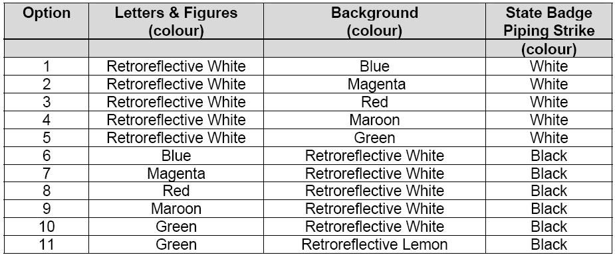

Dated 26 March 2012.
J. Holmes, Registrar of Motor Vehicles

NATIONAL ELECTRICITY LAW
THE Australian Energy Market Commission (AEMC) gives notice under the National Electricity Law of the following matter.
Under Section 95, International Power-GDF Suez Australia and Loy Yang Marketing Management Company have requested the Negative offers from scheduled network service providers Rule proposal (Project Ref. ERC0140). The proposal seeks to establish a price floor of zero for network dispatch offers from scheduled network service providers. Submissions must be received by
3 May 2012.
Submissions can be lodged online via the AEMC’s website at www.aemc.gov.au. Before lodging your submission, you must review the AEMC’s privacy statement on its website.
Submissions should be made in accordance with the AEMC’s Guidelines for making written submissions on Rule change proposals. The AEMC publishes all submissions on its website subject to confidentiality.
All documents in relation to the above matter are published on the AEMC’s website and are available for inspection at the offices of the AEMC.
Australian Energy Market Commission
Level 5, 201 Elizabeth Street,
Sydney, N.S.W. 2000
Telephone: (02) 8296 7800
Facsimile: (02) 8296 7899
29 March 2012.

National Parks and Wildlife Act 1972
Co-management Agreement—Flinders Ranges National Park
I, PAUL CAICA, Minister for Sustainability, Environment and Conservation, hereby give notice under Section 43F (6) of the National Parks and Wildlife Act 1972 that, on 6 October 2011, I entered into a co-management agreement for the Flinders Ranges National Park with the Adnyamathanha Traditional Lands Association on behalf of the Adnyamathanha People.
Dated 5 March 2012.
Paul Caica, Minister for Sustainability, Environment and Conservation

NATIONAL PARKS AND WILDLIFE (NATIONAL PARKS)
REGULATIONS 2001
Part Closure of the Katarapko Section of
Murray River National Park
PURSUANT to Regulations 8 (3) (a) and 8 (3) (d) of the National Parks and Wildlife (National Parks) Regulations 2001, I, Grant Anthony Pelton, Director Public Land Management and Operational Support, Regional Services, authorised delegate of the Director of National Parks and Wildlife, close to the public, part of the Katarapko Section of Murray River National Park, from 6 p.m. on Thursday, 22 March 2012 until 6 p.m. on Sunday, 4 November 2012.
The closure applies to the ‘Lock 4 Section’ encompassing the area between the Northern Arm of Eckert Creek and Sawmill Creek. The ‘Rodeo Ground Road’ entrance to the park will be closed. The Eckert Creek and main Katarapko entrances will remain open.
The purpose of the closure is to ensure the safety of the public within the reserve during the period indicated.
Dated 22 March 2012.
G. A. Pelton, Director, Public Land
Management and Operational Support,
Regional Services, Department of
Environment and Natural Resources

PETROLEUM AND GEOTHERMAL ENERGY ACT 2000
Delegation under Section 7 (1) (a)
I, TOM KOUTSANTONIS, Minister for Mineral Resources and Energy in the State of South Australia, under Section 7 (1) (a) of the Act, do hereby delegate to the persons who, from time to time hold, occupy or perform the following positions, Ministerial
powers or functions pursuant to the following Sections and Regulations and the power of sub-delegation pursuant to Section 7 (2) of the Act:
(1) To the Chief Executive, Department for Manufacturing, Innovation, Trade, Resources and Energy.
(2) To the Deputy Chief Executive Resources and Energy, Department for Manufacturing, Innovation, Trade, Resources and Energy.
(3) To the Executive Director, Energy Resources Division, Department for Manufacturing, Innovation, Trade, Resources and Energy.
Petroleum and Geothermal Energy Act 2000—all Sections except: 35 (2), 49 (1), 49 (2), 52, 55 (1), 55 (3), 55 (6), 55 (7), 55 (9), 111 (2), 125 (4), 126 (1), 126 (4), 127 (1), 127 (2) and 127 (3).
Regulations under the Petroleum and Geothermal Energy Act 2000—all regulations.
The previous instrument of delegation, published in the South Australian Government Gazette on 1 October 2009 (pages 4751 and 4752) is hereby revoked pursuant to Section 7 (1) (b) of the Act.
Dated 21 March 2012.
Tom Koutsantonis, Minister for Mineral Resources and Energy

Petroleum and Geothermal Energy Act 2000
Application for Grant of Preliminary Survey Licence—PSL 25
Pursuant to Section 65 (6) of the Petroleum and Geothermal Energy Act 2000 (the Act) and Delegation dated 21 March 2012, notice is hereby given that an application for the grant of Preliminary Survey Licence within the area described below has been received from:
Great Artesian Oil and Gas Limited.
The application will be determined on or after 12 April 2012.
Description of Application Area
All that part of the State of South Australia, bounded as follows:
A line joining points of co-ordinates set out in the following table:
333859.31mE, 6932849.15mN
351691.26mE, 6939258.20mN
356610.66mE, 6939305.97mN
378434.29mE, 6931759.00mN
399218.96mE, 6911464.46mN
403981.11mE, 6899871.23mN
399700.90mE, 6895749.23mN
340178.20mE, 6892422.82mN
329765.19mE, 6903582.94mN
All co-ordinates in GDA94, Zone 54.
Area: 2543 km² approximately.
Dated 27 March 2012.
B. A. Goldstein,
Executive Director,
Energy Resources Division
Department for Manufacturing, Innovation, Trade, Resources and Energy
Delegate of the Minister for Mineral
Resources and Energy

PETROLEUM AND GEOTHERMAL ENERGY ACT 2000
Surrender of Geothermal Exploration Licences—
GELs 169, 329, 330, 411, 412, 413, 414, 415, 416, 417, 418, 419, 420, 421 and 422
NOTICE is hereby given that I have accepted surrender of the abovementioned Geothermal Exploration Licences under the provisions of the Petroleum and Geothermal Energy Act 2000, pursuant to delegated powers dated 1 October 2009.
No. of  Licence | Licensee | Locality | Date of Surrender | Reference
GEL 169 | Eden Energy Limited | Cooper Basin | 4.November 2011 | 27/2/292
GEL 329 | Teratherma Limited | Arrowie Basin | 4.November 2011 | 27/2/495
GEL 330 | Teratherma Limited | Arrowie Basin | 4.November 2011 | 27/2/496
GELs 411-422 | Teratherma Limited | Adjacent Spencer Gulf | 4.November 2011 | 27/2/528
Dated 22 March 2012.
B. A. Goldstein,
Executive Director
Energy Resources Division
Department for Manufacturing, Innovation, Trade, Resources and Energy
Delegate of the Minister for Mineral Resources and Energy

PETROLEUM AND GEOTHERMAL ENERGY ACT 2000
Suspension of Geothermal Exploration Licences
GELs 226, 230 and 425
PURSUANT to Section 90 of the Petroleum and Geothermal Energy Act 2000, notice is hereby given that the abovementioned Geothermal Exploration Licences have been suspended for the period from and including 23 March 2012 until 22 May 2012, under the provisions of the Petroleum and Geothermal Energy Act 2000, pursuant to delegated powers dated 1 October 2009.
The expiry date of GELs 226 and 230 is now determined to be 23 May 2012.
The expiry date of GEL 425 is now determined to be 24 May 2014.
Dated 21 January 2012.
B. A. Goldstein,
Executive Director
Energy Resources Division
Department for Manufacturing, Innovation,
Trade, Resources and Energy
Delegate of the Minister for Mineral
Resources and Energy

REAL PROPERTY ACT NOTICE
WHEREAS the several persons named in the schedule at the foot hereof have severally made application to the Registrar-General, under Section 140 of the Real Property Act of 1886-1974, for orders for foreclosures as mortgagees of the land set forth and described before their several names in the said schedule: Notice is hereby given that the said lands are severally offered for sale by the Registrar-General until the several periods mentioned in the schedule, upon and after the expiration of which said several periods orders for foreclosures will be issued to the said persons respectively, unless in the interval, sufficient amounts have been realised by the sale of such lands to satisfy the principal and interest moneys due and all expenses occasioned by such sale and proceedings.

The Schedule
No. of  Application | Description of Property |  | Name |  | Residence | Date up to and Inclusive of Which Caveat may be  Lodged

31160 | Portion of Town Acre 863, City of Adelaide, being Allotment 50 in Filed Plan No. 54622 |  | The North Adelaide Baptist Church Inc |  | 144-150 Tynte Street, North Adelaide, S.A. 5006 | 29 May 2012

Dated 29 March 2012, at the Lands Titles Registration Office, Adelaide. I. Gant, Deputy Registrar-General

RETIREMENT VILLAGES ACT 1987
Section 4 (2)
Notice of Exemption
TAKE notice that I, John Hill, Minister for Health and Ageing, pursuant to subsection (2) of Section 4 of the Retirement Villages Act 1987 (the Act), hereby exempt the organisation specified in Schedule 1 from subsection (6) (a) (i) of Section 22 of the Act, subject to the conditions set out in Schedule 2.
Schedule 1
Southern Adelaide Health Institute Inc.
Schedule 2
1. This exemption only applies in respect of the retirement villages named Belair Close and Cherington Lodge.
2. This exemption only applies in respect of the 2010-2011 financial year.
Dated 26 March 2012.
John Hill, Minister for Health and Ageing

SURVEY ACT 1992
Revocation of a Confused Boundary Area
PURSUANT to Section 50 (3) of the Survey Act 1992, notice is given that the Confused Boundary Area at Grange bounded by Surrey Street, Grange Road, Kirkcaldy Avenue and Allotments 20 and 109 in Filed Plan 20 is revoked.
Dated 29 March 2012.
P. M. Kentish, Surveyor-General
Ref.: Filed Plan 55653

ROAD TRAFFIC ACT 1961
Pursuant to Sections 161A and 163AA of the Road Traffic Act 1961

OPERATION OF MOTOR GRADER TOWING TWO TRAILERS UP TO 26 METRES IN LENGTH FOR USE IN ROAD CONSTRUCTION AND/OR ROAD MAINTENANCE

1. APPROVAL
1.1 I hereby approve motor graders towing two trailers up to an overall length of 26 m, to travel on regional Council roads, for the purpose of road construction and/or road maintenance of regional Council roads.

2. EXEMPTION
2.1 I hereby exempt a motor grader, operating under the terms and conditions of this notice, from the following provisions of the Road Traffic (Vehicle Standards) Rules 1999:
2.1.1 Part 5, Division 1, Regulation 27(4)—Steering;
2.1.2 Part 8, Division 8, Regulation 94—Vehicles needing Side Marker Lights.
2.2 I hereby exempt a motor grader, operating under the terms and conditions of this notice, from the following provisions of the Road Traffic (Oversize or Overmass Vehicle Exemptions) Regulations 1999:
2.2.1 Part 3, Regulation 25—Prohibition on towing other vehicles.
2.3 I hereby exempt trailers towed in combination with a motor grader, operating under terms and conditions of this notice, from the following provisions of the Road Traffic (Vehicle Standards) Rules 1999:
2.3.1 Part 8, Division 7—Clearance Lights;
2.3.2 Part 8, Division 8—Side Marker Lights;
2.3.3 Part 8, Division 19—Other Lights, Reflectors, Rear Marking Plates or Signals;
2.3.4 Rule 132—Trailer braking requirements.

3. CONDITIONS
3.1 The motor grader and two trailer combination is only permitted to travel on a regional council road or road related area for the purpose of:
3.1.1 Undertaking activities involved directly with road construction and/or road maintenance; or
3.1.2 Transport from a place of road construction and/or road maintenance operation to another place of road construction and/or road maintenance.
3.2 The motor grader and two trailer combination shall not be driven or used on a road or road related area between the hours of sunset and sunrise as specified in the Proof of Sunrise and Sunset Act 1923, as amended, and published in the South Australian Government Gazette.
3.3 The motor grader and two trailer combination shall not be driven or used on a road or road related area during periods of low visibility.
Note: For the purpose of this notice ‘a period of low visibility’ means any time when, owing to insufficient daylight or unfavourable conditions, persons or vehicles on a road are not clearly visible at a distance of 250 m to a person of normal vision.
3.4 The vehicle combination shall not travel within the ‘Adelaide Area (Metropolitan)’ or the ‘Adelaide Hills Area’.
Note: For the purposes of this notice, the ‘Adelaide Area (Metropolitan)’ is defined as the area described in ‘Map 1 Adelaide Area (Metropolitan)—Overwidth Agricultural Vehicles’ of this notice.
Note: For the purposes of this notice the ‘Adelaide Hills Area’ is defined as the shaded areas shown in ‘Map 2, Adelaide Hills Area—Overwidth Agricultural Vehicles’ of this notice.
3.5 The motor grader and two trailer combination shall not be operated at a speed exceeding 40 km/h.
3.6 The motor grader and two trailer combination may cross DPTI roads only if the combination does not exceed 19 m in length.
3.7 That all vehicles in combination shall be appropriately registered (e.g. not registered for use on worksites only).
3.8 The sum of the load carrying capacity of tyres fitted to each unit of the combination must match the manufacturer’s gross vehicle mass (GVM), or gross trailer mass (GCM) of that vehicle, where applicable. If no GVM or GTM is specified then statutory axle mass limits will apply.
3.9 The motor grader and two trailer combination shall not exceed statutory axle mass limits.
3.10 The motor grader and two trailer combination shall not exceed manufacturer’s GVM and/or GTM for each vehicle in the combination, where applicable.
3.11 The tow coupling attached to each vehicle in the combination must be of a sufficient rating for its use in the combination.

3.12 When in transit, any road construction equipment (e.g. towed roller) in the combination, must travel without any additional weight added (ie. No ballast).
3.13 The motor grader shall display a warning light or lights (revolving yellow flashing lights) so that the light emanating from at least one of them is clearly visible at a distance of 500 m in any direction and which meet the following specifications:
3.13.1 Emit a rotating, flashing, yellow coloured light; and
3.13.2 Flash at a rate between 120 and 200 times per minute; and
3.13.3 Have a power of at least 55 watts; and
3.13.4 Not be a strobe light.
3.14 Warning light(s) shall be either permanently connected into the electrical system of the vehicle or use standard automotive connectors to allow easy electrical disconnection and removal of the light(s) when not required.
3.15 Warning light(s) shall have incorporated into their electrical system, an ‘on/off’switch control which is located within easy reach of the driver, when seated in the driving position.

The motor grader and two trailer combination shall be fitted with:
3.16 A ‘Long Vehicle’ warning sign complying with Part 6, Section 60, Section 61 and Section 62 of the Road Traffic (Vehicle Standards) Rules 1999.
3.17 A audible warning device complying with Rule 34 of the Road Traffic (Vehicle Standards) Rules 1999, if the vehicle was manufactured on or after 1 July 1996.
3.18 A rear vision mirror or mirrors complying with the requirements of Rules 35 and 36 of the Road Traffic (Vehicle Standards) Rules 1999.
3.19 Parking lights that operate effectively and clearly visible, if the motor grader and two trailer combination is left standing on a road or road related area between the hours of sunset and sunrise or during periods of low visibility.
3.20 Clearance lights and side marker lights that operate effectively and clearly visible, if the motor grader and two trailer combination is left standing on a road or road related area between the hours of sunset and sunrise or during periods of low visibility.
3.21 Service brakes:
3.21.1 Operating on four or more wheels complying with the performance requirements of Rule 128 of the Road Traffic (Vehicles Standards) Rules 1999; or
3.21.2 Utilising a vehicular transmission retardation system commonly referred to as a ‘hydrostatic braking system’, complying with the performance requirements of Rule 128 of the Road Traffic (Vehicles Standards) Rules 1999.
3.22 A parking brake that operates on at least two wheels and that is capable of holding the vehicle stationary on a 12 per cent gradient.
3.23 An actuating mechanism for the parking brake that incorporates a device that prevents accidental release of that mechanism and holds the brake in the applied position unless intentionally released by the driver.
NOTES
For the purpose of this notice a vehicle which incorporates a positive transmission locking system that operates by locking two transmission gears together or engaging a transmission parking pawl is deemed to satisfy the requirements of Clauses 3.22 and 3.23 above provided that the mechanism is capable of holding the vehicle stationary on a 12 per cent gradient.
In accordance with Rule 226 of the Australian Road Rules a person shall not drive a vehicle with a GVM over 12 tonnes unless the vehicle is equipped with at least 3 portable warning triangles that must be used in accordance with Rule 227 of the Australian Road Rules. If the GVM of the vehicle is not specified, the unladen mass of the vehicle shall apply.
The owner of a motor grader and two trailer combination must ensure that all other relevant requirements under the South Australian Road Traffic Act 1961 and the Motor Vehicles Act 1959 are met (e.g. registration requirements).

4. DEFINITIONS
4.1 ‘Motor grader’ means a machine with its own motive power, fitted with pneumatic tyres, built to perform road construction and/or maintenance tasks.
4.2 ‘Trailer’ means a vehicle fitted with pneumatic tyres, towed by a motor grader and is built to perform road construction and/or maintenance task.
4.3 ‘Motor grader and two trailer combination’ means a motor grader towing two trailers interconnected (e.g. motor grader towing a road roller, a fuel trailer or utility).
4.4 DPTI means the Department of Planning, Transport and Infrastructure.
5. COMMENCEMENT OF THIS NOTICE
5.1 This notice is valid from 12.01 a.m. on 30 March 2012.
6. AUTHORISATION

Mark Elford, Director, Road Transport Policy and Planning,
Department for Planning, Transport and Infrastructure,
Delegate for the Minister for Transport and Infrastructure

[Republished]
IN Government Gazette No. 4 dated 19 January 2012 at page 264, first column of the table read ‘(Financial Intuitions)’ should read ‘(Financial Institutions)’.
TRAINING AND SKILLS DEVELOPMENT ACT 2008
Part 4—Apprenticeships/Traineeships
Erratum

Pursuant to the provision of the Training and Skills Development Act 2008, the Training
and Skills Commission (TaSC) gives notice that determines the following
Trades or Declared Vocations in addition to the Gazette notices of:

- 25 September 2008 | - 23 October 2008 | - 13 November 2008 | - 4 December 2008
- 18 December 2008 | - 29 January 2009 | - 12 February 2009 | - 5 March 2009
- 12 March 2009 | - 26 March 2009 | - 30 April 2009 | - 18 June 2009
- 25 June 2009 | - 27 August 2009 | - 17 September 2009 | - 24 September 2009
- 9 October 2009 | - 22 October 2009 | - 3 December 2009 | - 17 December 2009
- 4 February 2010 | - 11 February 2010 | - 18 February 2010 | - 18 March 2010
- 8 April 2010 | - 6 May 2010 | - 20 May 2010 | - 3 June 2010
- 17 June 2010 | - 24 June 2010 | - 8 July 2010 | - 9 September 2010
- 23 September 2010 | - 4 November 2010 | - 25 November 2010 | - 16 December 2010
- 23 December 2011 | - 17 March 2011 | - 7 April 2011 | - 21 April 2011
- 19 May 2011 | - 30 June 2011 | - 21 July 2011 | - 8 September 2011
- 10 November 2011 | - 24 November 2011 | - 1 December 2011 | - 8 December 2011
- 15 December 2011 | - 22 December 2011 | - 5 January 2012

Trades or Declared Vocations and Required Qualifications and
Training Contract Conditions for the
Financial Services Training Package FNS10

*Trade/ #Declared Vocation/  Other Occupation | Code | Title | Nominal Term of  Training Contract | Probationary Period
# Customer Servicing (Financial Institutions) | FNS41110 | Certificate IV in Financial Markets Operations | 24 months | 1 month
# Customer Servicing (Financial Institutions) | FNS41210 | Certificate IV in Mobile Banking | 18 months | 1 month
# Customer Servicing (Financial Institutions) | FNS50310 | Diploma of Finance and Mortgage Broking Management | 24 months | 1 month
# Customer Servicing (Financial Institutions) | FNS50510 | Diploma of Personal Trustees | 18 months | 1 month
# Customer Servicing (Financial Institutions) | FNS50610 | Diploma of Financial Planning | 36 months | 3 months
# Customer Servicing (Financial Institutions) | FNS50710 | Diploma of Superannuation | 36 months | 3 months
# Customer Servicing (Financial Institutions) | FNS51010 | Diploma of Financial Markets | 24 months | 1 month
# Customer Servicing (Financial Institutions) | FNS51210 | Diploma of Insurance Broking | 24 months | 1 month
# Customer Servicing (Financial Institutions) | FNS51510 | Diploma of Credit Management | 24 months | 1 month
# Customer Servicing (Financial Institutions) | FNS60110 | Advanced Diploma of Insurance Broking | 36 months | 3 months
# Customer Servicing (Financial Institutions) | FNS60410 | Advance Diploma of Financial Planning | 24 months | 1 month
# Customer Servicing (Financial Institutions) | FNS60510 | Advanced Diploma of Superannuation | 36 months | 1 month

TRAINING AND SKILLS DEVELOPMENT ACT 2008
Part 4—Apprenticeships/Traineeships

Pursuant to the provision of the Training and Skills Development Act 2008, the Training and Skills Commission (TaSC) gives notice that determines the following
Trades or Declared Vocations in addition to the Gazette notices of:

- 25 September 2008 | - 23 October 2008 | - 13 November 2008 | - 4 December 2008
- 18 December 2008 | - 29 January 2009 | - 12 February 2009 | - 5 March 2009
- 12 March 2009 | - 26 March 2009 | - 30 April 2009 | - 18 June 2009
- 25 June 2009 | - 27 August 2009 | - 17 September 2009 | - 24 September 2009
- 9 October 2009 | - 22 October 2009 | - 3 December 2009 | - 17 December 2009
- 4 February 2010 | - 11 February 2010 | - 18 February 2010 | - 18 March 2010
- 8 April 2010 | - 6 May 2010 | - 20 May 2010 | - 3 June 2010
- 17 June 2010 | - 24 June 2010 | - 8 July 2010 | - 9 September 2010
- 23 September 2010 | - 4 November 2010 | - 25 November 2010 | - 16 December 2010
- 23 December 2010 | - 17 March 2011 | - 7 April 2011 | - 21 April 2011
- 19 May 2011 | - 30 June 2011 | - 21 July 2011 | - 8 September 2011
- 10 November 2011 | - 24 November 2011 | - 1 December 2011 | - 8 December 2011
- 15 December 2011 | - 22 December 2011 | - 5 January 2012 | - 19 January 2012
- 1 March 2012

Trades or Declared Vocations and Required Qualifications and
Training Contract Conditions for the
Property Services Training Package CPP07

*Trade/ #Declared Vocation/ Other Occupation | Code | Title | Nominal Term of Training Contract | Probationary Period
# Asset Maintenance | CPP20411 | Certificate II in Waste Management | 12 months | 1 month
# Asset Maintenance | CPP20511 | Certificate II in Fire Protection Inspection and Testing | 12 months | 1 month
# Asset Maintenance | CPP20611 | Certificate II in Cleaning Operations | 6 months | 2 weeks
# Asset Maintenance | CPP20711 | Certificate II in Carpet Cleaning Operations | 12 months | 1 month
# Asset Maintenance | CPP30507 | Certificate III in Technical Services | 18 months | 1.5 months
# Asset Maintenance | CPP30711 | Certificate III in Waste Management | 24 months | 2 months
# Asset Maintenance | CPP30811 | Certificate III in Fire Protection Inspection and Testing | 24 months | 2 months

*Trade/ #Declared Vocation/ Other Occupation | Code | Title | Nominal Term of Training Contract | Probationary Period
# Asset Maintenance | CPP30911 | Certificate III in Pest Management | 24 months | 2 months
# Asset Maintenance | CPP31011 | Certificate III in Cleaning Operations | 12 months | 1 month
# Asset Maintenance | CPP31111 | Certificate III in Carpet Cleaning Operations | 12 months | 1 month
# Asset Maintenance | CPP40911 | Certificate IV in Waste Management | 36 months | 3 months
# Asset Maintenance | CPP41011 | Certificate IV in Cleaning Management | 24 months | 2 months


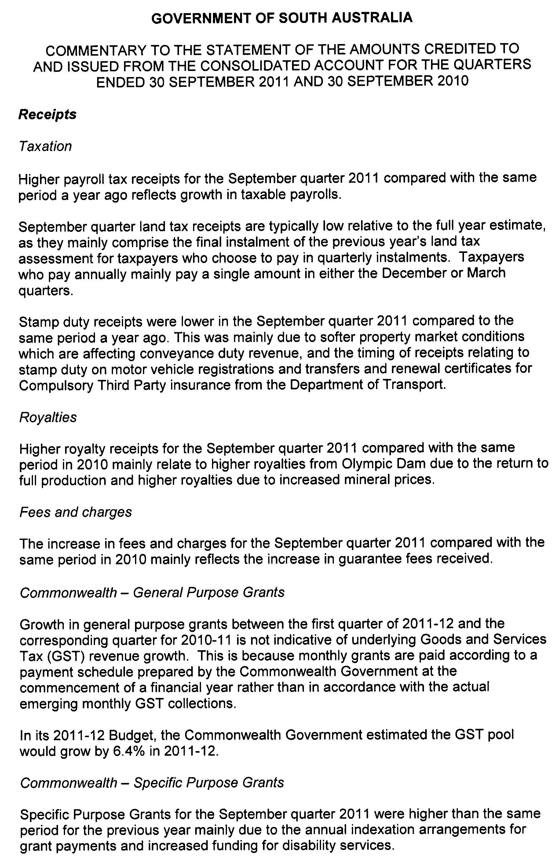
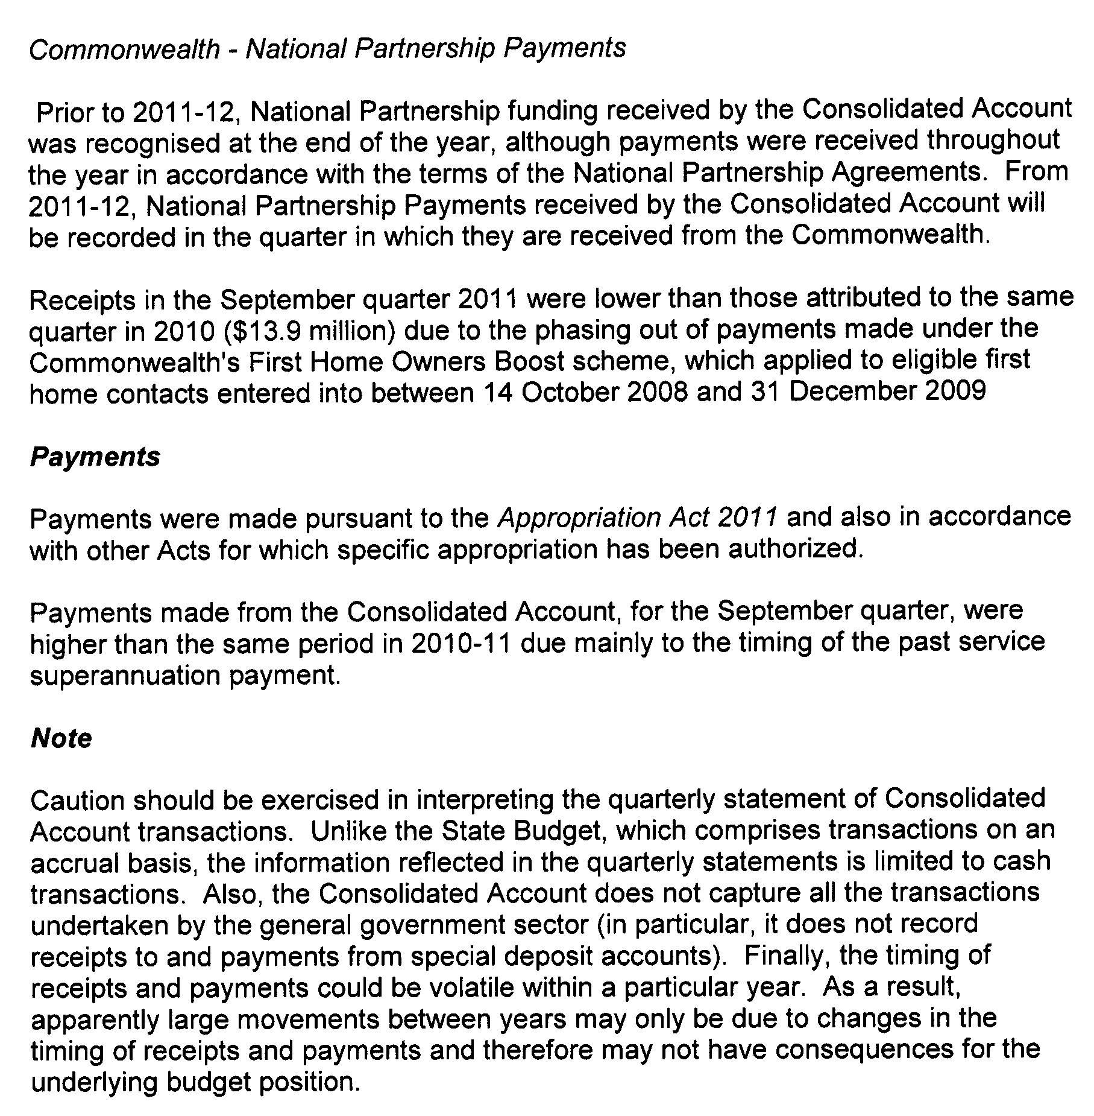
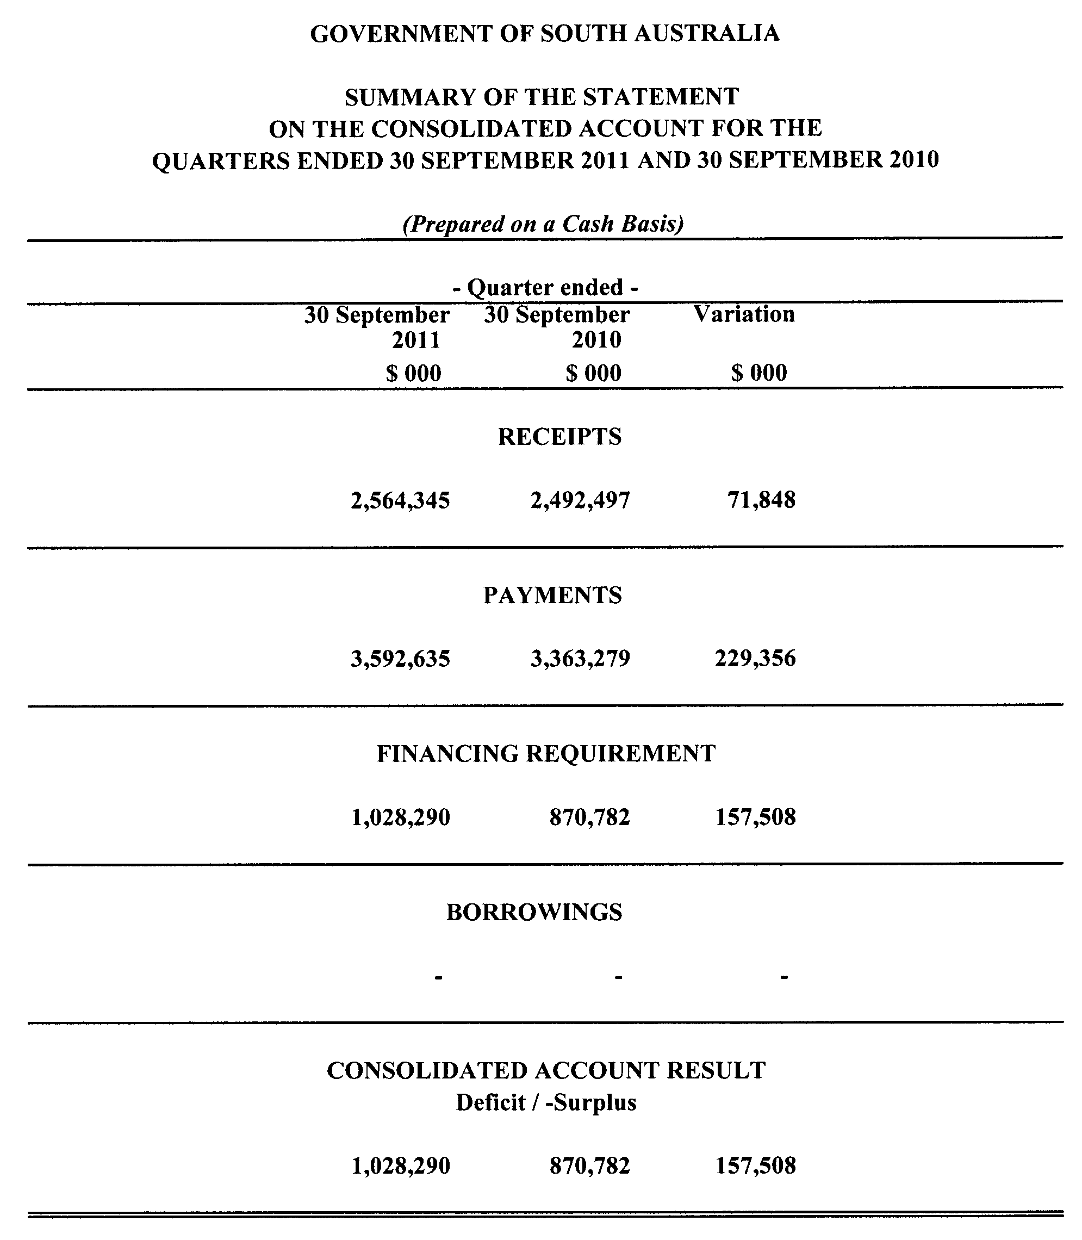
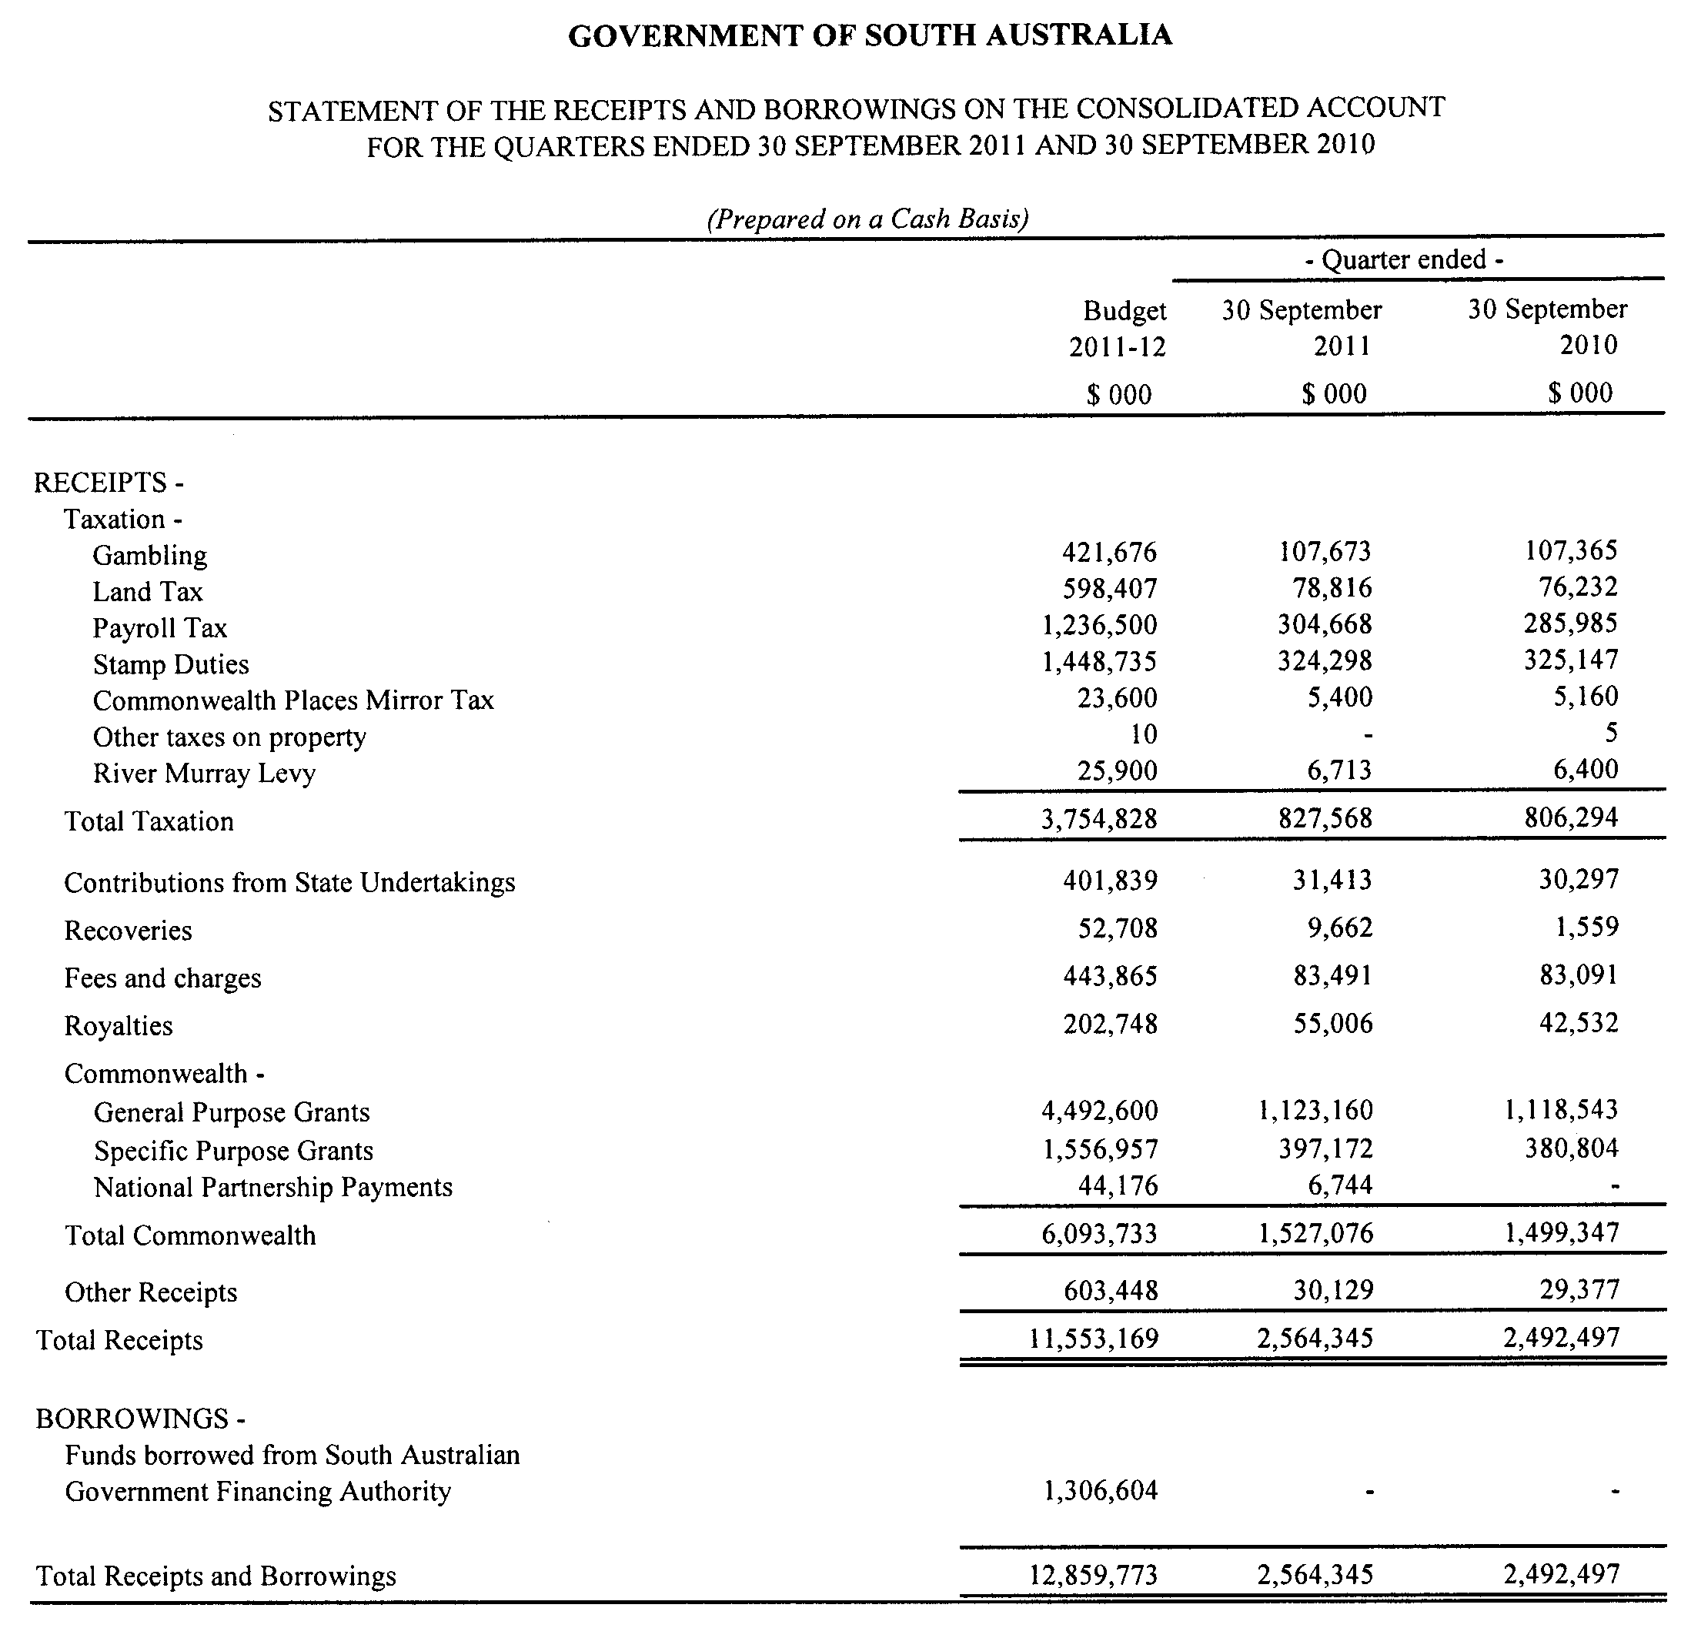

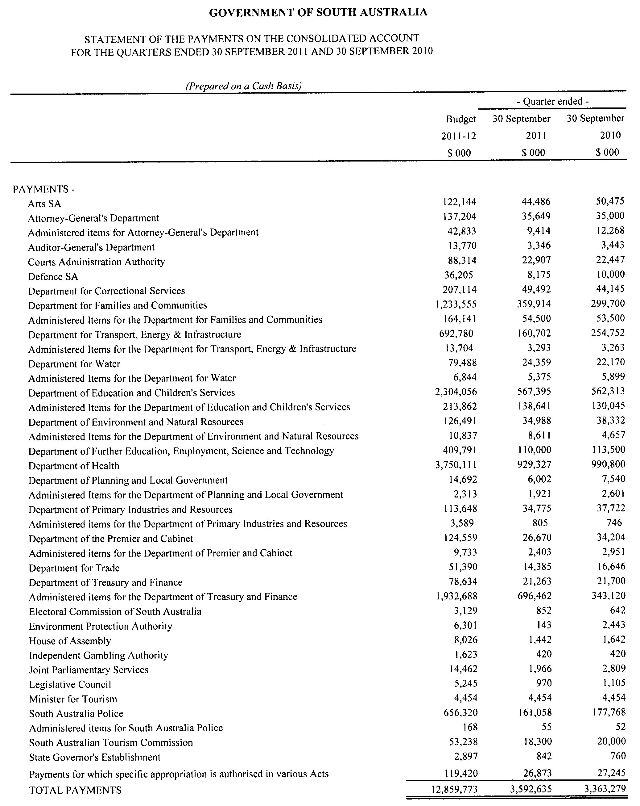

GOVERNMENT GAZETTE ADVERTISEMENT RATES

To apply from 1 July 2011

$  Agents, Ceasing to Act as 45.50  Associations:  Incorporation 23.00  Intention of Incorporation 57.00  Transfer of Properties 57.00  Attorney, Appointment of 45.50  Bailiff’s Sale 57.00  Cemetery Curator Appointed 33.75  Companies:  Alteration to Constitution 45.50  Capital, Increase or Decrease of 57.00  Ceasing to Carry on Business 33.75  Declaration of Dividend 33.75  Incorporation 45.50  Lost Share Certificates:  First Name 33.75  Each Subsequent Name 11.60  Meeting Final 38.00  Meeting Final Regarding Liquidator’s Report on  Conduct of Winding Up (equivalent to ‘Final  Meeting’)  First Name 45.50  Each Subsequent Name 11.60  Notices:  Call 57.00  Change of Name 23.00  Creditors 45.50  Creditors Compromise of Arrangement 45.50  Creditors (extraordinary resolution that ‘the Com-pany be wound up voluntarily and that a liquidator be appointed’) 57.00  Release of Liquidator⎯Application⎯Large Ad. 90.50  ⎯Release Granted 57.00  Receiver and Manager Appointed 52.50  Receiver and Manager Ceasing to Act 45.50  Restored Name 42.50  Petition to Supreme Court for Winding Up 79.00  Summons in Action 67.50  Order of Supreme Court for Winding Up Action 45.50  Register of Interests⎯Section 84 (1) Exempt 102.00  Removal of Office 23.00  Proof of Debts 45.50  Sales of Shares and Forfeiture 45.50  Estates:  Assigned 33.75  Deceased Persons⎯Notice to Creditors, etc. 57.00  Each Subsequent Name 11.60  Deceased Persons⎯Closed Estates 33.75  Each Subsequent Estate 1.50  Probate, Selling of 45.50  Public Trustee, each Estate 11.60 |  | $  Firms:  Ceasing to Carry on Business (each insertion) 30.25  Discontinuance Place of Business 30.25  Land⎯Real Property Act:  Intention to Sell, Notice of 57.00  Lost Certificate of Title Notices 57.00  Cancellation, Notice of (Strata Plan) 57.00  Mortgages:  Caveat Lodgement 23.00  Discharge of 24.10  Foreclosures 23.00  Transfer of 23.00  Sublet 11.60  Leases⎯Application for Transfer (2 insertions) each 11.60  Lost Treasury Receipts (3 insertions) each 33.75  Licensing 67.50  Municipal or District Councils:  Annual Financial Statement⎯Forms 1 and 2 636.00  Electricity Supply⎯Forms 19 and 20 452.00  Default in Payment of Rates:  First Name 90.50  Each Subsequent Name 11.60  Noxious Trade 33.75  Partnership, Dissolution of 33.75  Petitions (small) 23.00  Registered Building Societies (from Registrar-General) 23.00  Register of Unclaimed Moneys⎯First Name 33.75  Each Subsequent Name 11.60  Registers of Members⎯Three pages and over:  Rate per page (in 8pt) 289.00  Rate per page (in 6pt) 382.00  Sale of Land by Public Auction 57.50  Advertisements 3.20  ¼ page advertisement 135.00  ½ page advertisement 270.00  Full page advertisement 529.00  Advertisements, other than those listed are charged at $3.20 per column line, tabular one-third extra.  Notices by Colleges, Universities, Corporations and District Councils to be charged at $3.20 per line.  Where the notice inserted varies significantly in length from that which is usually published a charge of $3.20 per column line will be applied in lieu of advertisement rates listed.  South Australian Government publications are sold on the condition that they will not be reproduced without prior permission from the Government Printer.
All the above prices include GST

GOVERNMENT GAZETTE NOTICES
ALL private advertisements forwarded for publication in the South Australian Government Gazette must be PAID FOR PRIOR TO INSERTION; and all notices, from whatever source, should be legibly written on one side of the paper only and sent to Government Publishing SA so as to be received no later than 4 p.m. Tuesday preceding the day of publication. Phone 8207 1045 or Fax 8207 1040. E-mail: governmentgazette@dpc.sa.gov.au. Send as attachments in Word format. Please include date the notice is to be published and to whom the notice will be charged. The Government Gazette is available online at: www.governmentgazette.sa.gov.au.

MISCELLANEOUS LEGISLATION AND GOVERNMENT PUBLICATIONS PRICES AS FROM 1 JULY 2011

Acts, Bills, Rules, Parliamentary Papers and Regulations
Pages | Main | Amends | Pages | Main | Amends

1-16 | 2.80 | 1.30 | 497-512 | 38.50 | 37.50
17-32 | 3.70 | 2.30 | 513-528 | 39.50 | 38.25
33-48 | 4.85 | 3.45 | 529-544 | 41.00 | 39.50
49-64 | 6.10 | 4.70 | 545-560 | 42.00 | 41.00
65-80 | 7.10 | 5.90 | 561-576 | 43.00 | 42.00
81-96 | 8.30 | 6.85 | 577-592 | 44.50 | 42.50
97-112 | 9.45 | 8.10 | 593-608 | 45.75 | 44.00
113-128 | 10.60 | 9.30 | 609-624 | 46.50 | 45.50
129-144 | 11.80 | 10.50 | 625-640 | 47.75 | 46.00
145-160 | 13.00 | 11.60 | 641-656 | 49.00 | 47.75
161-176 | 14.10 | 12.80 | 657-672 | 49.75 | 48.25
177-192 | 15.40 | 13.90 | 673-688 | 51.50 | 49.75
193-208 | 16.60 | 15.30 | 689-704 | 52.50 | 50.50
209-224 | 17.50 | 16.20 | 705-720 | 53.50 | 52.00
225-240 | 18.70 | 17.30 | 721-736 | 55.00 | 53.00
241-257 | 20.10 | 18.30 | 737-752 | 55.50 | 54.00
258-272 | 21.20 | 19.40 | 753-768 | 57.00 | 55.00
273-288 | 22.30 | 21.00 | 769-784 | 58.00 | 57.00
289-304 | 23.30 | 21.90 | 785-800 | 59.00 | 58.00
305-320 | 24.70 | 23.20 | 801-816 | 60.50 | 58.50
321-336 | 25.75 | 24.30 | 817-832 | 61.50 | 60.50
337-352 | 27.00 | 25.50 | 833-848 | 63.00 | 61.50
353-368 | 27.75 | 26.75 | 849-864 | 64.00 | 62.50
369-384 | 29.25 | 27.75 | 865-880 | 65.50 | 64.00
385-400 | 30.50 | 29.00 | 881-896 | 66.00 | 64.50
401-416 | 31.75 | 30.00 | 897-912 | 67.50 | 66.00
417-432 | 33.00 | 31.50 | 913-928 | 68.00 | 67.50
433-448 | 34.00 | 32.75 | 929-944 | 69.00 | 68.00
449-464 | 34.75 | 33.50 | 945-960 | 70.00 | 68.50
465-480 | 35.25 | 34.50 | 961-976 | 73.00 | 69.50
481-496 | 37.50 | 35.25 | 977-992 | 74.00 | 70.00

Legislation—Acts, Regulations, etc: $
Subscriptions:
Acts 237.00
All Bills as Laid 570.00
Rules and Regulations 570.00
Parliamentary Papers 570.00
Bound Acts 263.00
Index 132.00
Government Gazette
Copy 6.25
Subscription 315.00
Hansard
Copy 17.30
Subscription—per session (issued weekly) 494.00
Cloth bound—per volume 212.00
Subscription—per session (issued daily) 494.00
Legislation on Disk
Whole Database 3 660.00
Annual Subscription for fortnightly updates 1 125.00
Individual Act(s) including updates POA
Notice of Vacancies
Annual Subscription 174.00
Compendium
Subscriptions:
New Subscriptions 2 167.00
Updates 765.00
(All the above prices include GST)

All Legislation, Government Gazette, Hansard and Legislation on disk are available from:
Counter Sales Government Legislation Outlet
and Mail Orders: Service SA Customer Service Centre,
Ground Floor—EDS Centre, 108 North Terrace, Adelaide, S.A. 5000
Phone: 13 23 24 (local call cost), Fax: (08) 8204 1909
Postal: G.P.O. Box 1707, Adelaide, S.A. 5001

Online Shop: www.shop.service.sa.gov.au

Subscriptions and Government Publishing SA
Standing Orders: Plaza Level, Riverside Centre, North Terrace, Adelaide, S.A. 5000
Phone: (08) 8207 1043, (08) 8207 0910, Fax: (08) 8207 1040

WILDERNESS PROTECTION REGULATIONS 2006
Closure of Danggali Wilderness Protection Area
PURSUANT to Regulations 6 (2) (c) of the Wilderness Protection Regulations 2006, I, Edward Gregory Leaman, Director of National Parks and Wildlife close to the public the whole
of Danggali Wilderness Protection Area from 6 p.m. on Sunday,
29 April 2012 until 6 p.m. on Sunday, 13 May 2012.
The purpose of the closure is to ensure the safety of the public during a pest control and monitoring program within the wilderness protection area during the period indicated.
Dated 27 March 2012.
E. G. Leaman, Director of National Parks and Wildlife

WILDERNESS PROTECTION REGULATIONS 2006
Closure of Western River Wilderness Protection Area
PURSUANT to Regulations 6 (2) (c) of the Wilderness Protection Regulations 2006, I, Edward Gregory Leaman, Director of National Parks and Wildlife close to the public the whole of Western River Wilderness Protection Area from 6 a.m. on Sunday, 20 May 2012 until 6 a.m. on Saturday, 2 June 2012.
From 6 a.m. on Saturday, 2 June 2012, the northern section of the wilderness protection area will re-open however, the southern section of the wilderness protection area will remain closed until 6 a.m. on Saturday, 30 June 2012, as previously detailed in a notice published in the South Australian Government Gazette dated 22 December 2011, on page 5129.
The purpose of the closure is to ensure the safety of the public during a pest control and monitoring program within the wilderness protection area during the period indicated.
Use of Firearms Within the Wilderness Protection Area
Pursuant to Regulations 6 (4), 16 (1) (a) and 34 of the Wilderness Protection Regulations 2006, I, Edward Gregory Leaman, Director of National Parks and Wildlife grant permission to staff employed by the Kangaroo Island Natural Resources Management Board in possession of both a current Hunting Permit and a firearm to enter and remain in the whole Western River Wilderness Protection Area from 6 a.m. on Sunday, 20 May 2012, until 6 a.m. on Saturday, 2 June 2012 for the purpose of taking feral animals.

This permission is conditional upon the observance by each of those persons of the requirements of the Wilderness Protection Act 1992, Wilderness Protection Regulations 2006 and the National Parks and Wildlife (Hunting) Regulations 2011, including those requiring compliance with the Director’s requests, requirements and orders of a Warden.
Dated 21 March 2012.
E. G. Leaman, Director of National Parks and Wildlife

WILDERNESS PROTECTION REGULATIONS 2006
Closure of Cape Torrens Wilderness Protection Area
PURSUANT to Regulations 6 (2) (c) of the Wilderness Protection Regulations 2006, I, Edward Gregory Leaman, Director of National Parks and Wildlife close to the public the whole of Cape Torrens Wilderness Protection Area from 6 a.m. on Sunday, 20 May 2012 until 6 a.m. on Saturday, 2 June 2012.
The purpose of the closure is to ensure the safety of the public during a pest control and monitoring program within the wilderness protection area during the period indicated.
Use of Firearms Within the Wilderness Protection Area
Pursuant to Regulations 6 (4), 16 (1) (a) and 34 of the Wilderness Protection Regulations 2006, I, Edward Gregory Leaman, Director of National Parks and Wildlife grant permission to staff employed by the Kangaroo Island Natural Resources Management Board in possession of both a current Hunting Permit and a firearm to enter and remain in the whole Cape Torrens Wilderness Protection Area from 6 a.m. on Sunday, 20 May 2012, until 6 a.m. on Saturday, 2 June 2012 for the purpose of taking feral animals.
This permission is conditional upon the observance by each of those persons of the requirements of the Wilderness Protection Act 1992, Wilderness Protection Regulations 2006 and the National Parks and Wildlife (Hunting) Regulations 2011, including those requiring compliance with the Director’s requests, requirements and orders of a Warden.
Dated 21 March 2012.
E. G. Leaman, Director of National Parks and Wildlife

WORKERS REHABILITATION AND COMPENSATION ACT 1986
Publication Amendment to Designated Forms

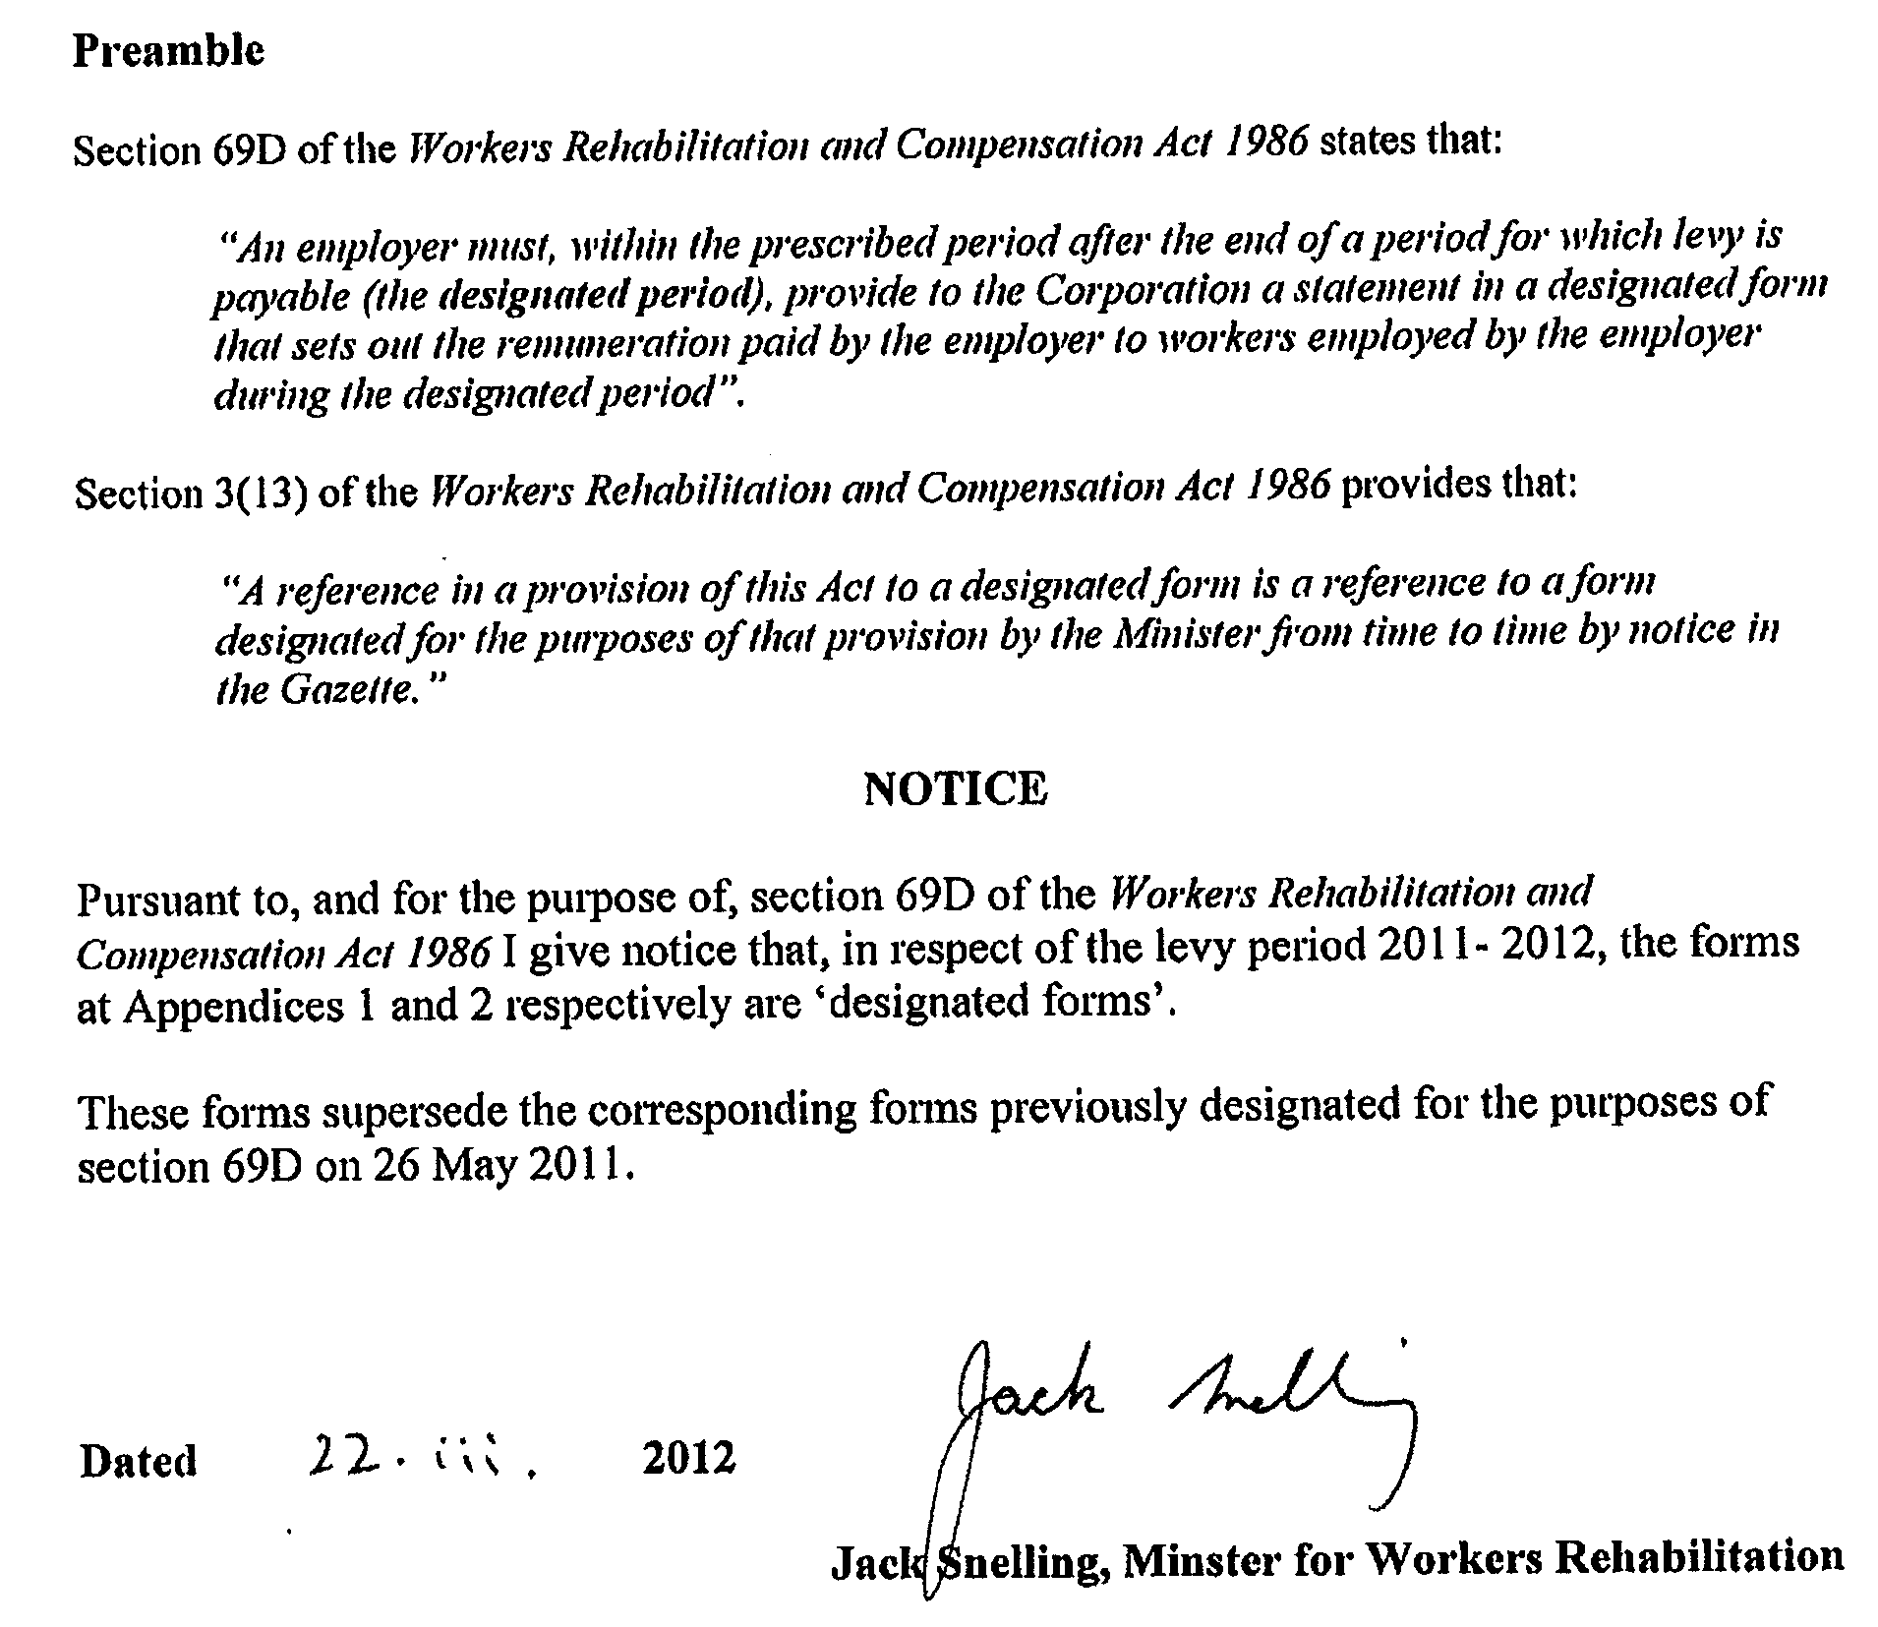

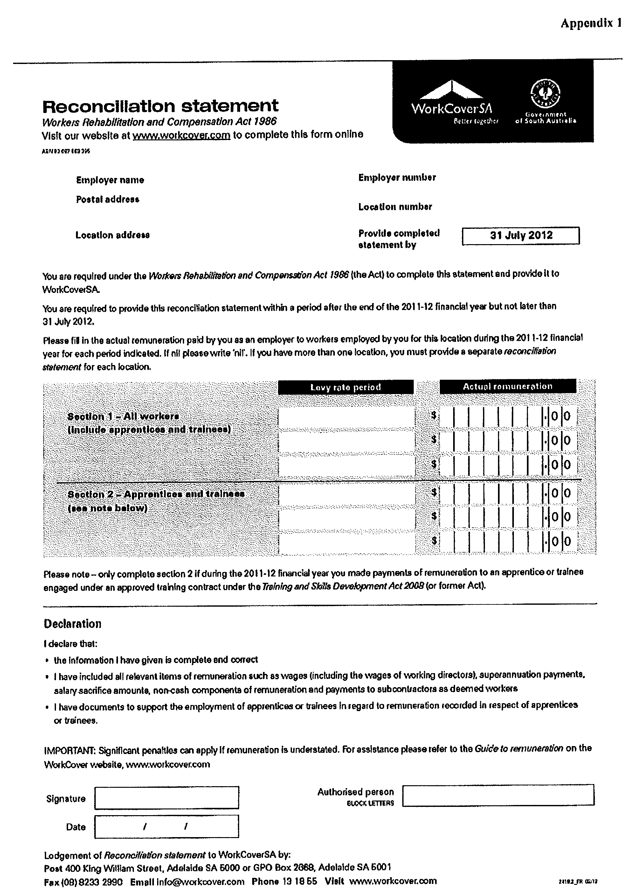

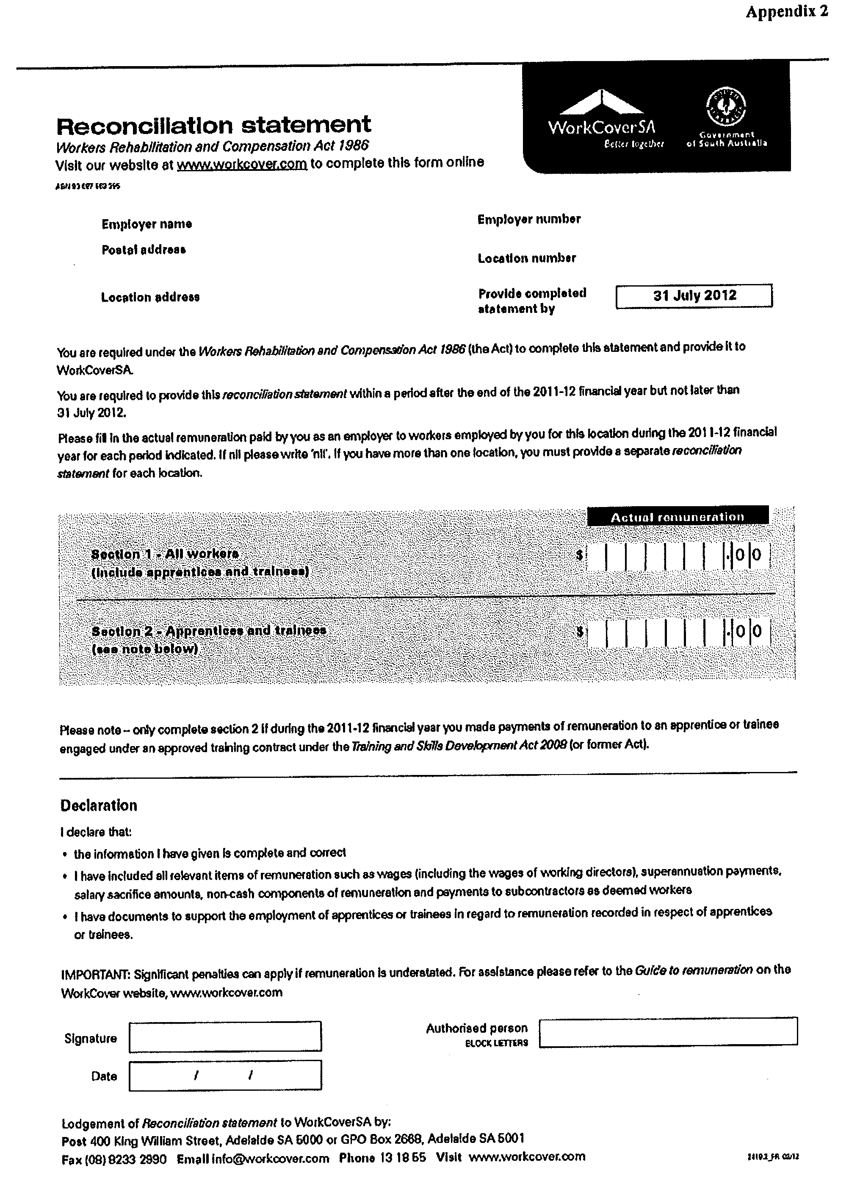

South Australia
Administrative Arrangements (Transfer of Assets,
Rights and Liabilities to South Australian Housing Trust) Notice 2012
under section 23 of the South Australian Housing Trust Act 1995.
1—Short title
This notice may be cited as the Administrative Arrangements (Transfer of Assets, Rights and Liabilities to the South Australian Trust) Notice 2012.
2—Commencement
This notice comes into operation on the day on which it is made.
3—Transfer of assets, rights and liabilities

In order to be able to secure Government’s interests and administer the Local Government Community Housing Program, the assets, rights and liabilities of The Minister are transferred to the South Australian Housing Trust.

Made by the Minister for Social Housing

Ian Hunter MLC

21 March 2012

SOUTH AUSTRALIA
SUPREME COURT CRIMINAL RULES 1992
(Amendment No. 29)

BY virtue and in pursuance of Section 72 of the Supreme Court Act 1935, and all other enabling powers, We, Judges of the Supreme Court of South Australia, make the following Supreme Court Criminal Rules 1992, (Amendment No. 29).
- These Rules may be cited as the “Supreme Court Criminal Rules 1992 (Amendment No 29)”.
- The Supreme Court Criminal Rules 1992 are amended as set out below.
- This amendment will commence on 1 April 2012, or upon its gazettal, whichever is the later.
- A new Rule 32 is inserted immediately after Rule 31 as follows:
“Notices of Intention to Adduce Evidence of Discreditable Conduct under s 34P of the Evidence Act 1929
32.01 The Notice required by s 34P(4) of the Evidence Act 1929 of an intention to adduce evidence of a discreditable conduct is:
(a) in the case of a Notice being given by the Director of Public Prosecutions (State or Commonwealth), to be in Form 25;
(b) in all other cases, and whether the evidence is to be led in evidence-in-chief or adduced in cross-examination, to be in Form 26.
32.02 The Notice must be filed in the Court and served on all other parties to the proceedings:
(a) in the case of a Notice by the Director of Public Prosecutions (State or Commonwealth), no later than 21 days after the date on which the proceedings are listed for trial;
(b) in all other cases, not less than 21 days before the listed trial date.
32.03 Any party who intends to object to the admission of proposed evidence of discreditable conduct must file in the Court and serve on all other parties to the proceedings a written Notice of Objection using Form 27.
32.04 The Notice of Objection under Rule 32.03 must be filed in the Court and served on all other parties to the proceedings:
(a) in the case of an objection to evidence proposed to be led by the Director of Public Prosecutions (State or Commonwealth), no later than 28 days after the filing of the Director’s Notice;
(b) in all other cases, not less than seven days before the listed trial date.
32.05 The Court may enlarge or shorten the time within which any Notice under this Rule may be filed and served.”
5. The following Forms numbered 25, 26 and 27 are inserted immediately after Form 24.

“Form 25
In the SUPREME COURT
SCCRM of 20
R v _________________
Notice of Intention by the Director of Public Prosecutions to Adduce Evidence of Discreditable Conduct
Evidence Act 1929 s 34P(4)
To: [insert name(s) of defendant(s)] ……………………………………………..

The Director of Public Prosecutions gives notice of the intention of the Director at trial to seek to adduce evidence of discreditable conduct of [insert name] and provides the following particulars:
1. the nature of the discreditable conduct: ….……………………………..
2. the witness or witnesses from whom the evidence is to be led:
…………………………………………………………………………..
3. the use or uses of the evidence which are said to be permissible uses under s 34P(2): …………………………………………….…………...
………………………………………………………………..…………
4. if the evidence is to be adduced as circumstantial evidence of a fact in issue, the fact or facts in issue to which the evidence relates:
……………………………………………………………………….......

Dated the day of 20
[signed]………………………………………….
Director of Public Prosecutions
Note: If you wish to object to the admission of the evidence of discreditable conduct proposed to be adduced by the Director of Public Prosecutions you must, within 28 days of the filing of this Notice, file in the Court and serve on all other parties to the proceedings a Notice using Form 27 which sets out the grounds of your objection.

Form 26
In the SUPREME COURT
SCCRM of 20
R v _________________
Notice of Intention by a Defendant to Adduce Evidence of
Discreditable Conduct
Evidence Act 1929 s 34P(4)
To: the Director of Public Prosecutions:
And to:[ insert name of any other defendant(s)] …………………………………
The defendant [insert name] gives notice of the intention of the defendant at the trial to seek to adduce evidence of discreditable conduct of [insert name of co-defendant] and gives the following particulars:
1. the nature of the discreditable conduct is ………………………….…
………………………………………………………………………………

2. the witness or witnesses from whom the evidence is to be led, whether in examination-in-chief or in cross-examination, is/are ………………
………………………………………………………………………………
3. the use or uses of the evidence which are said to be permissible under s 34P(2) is/are ……………………………………………………..…...

Dated the day of 20
Signed…………………………………………
Defendant
Note: This Notice must be filed in the Court and served on all other parties to the proceedings at least 21 days before the listed trial date.

Form 27
In the SUPREME COURT
SCCRM of 20
R v ___________________
Notice of Objection to Proposed Evidence of Discreditable Conduct
Evidence Act 1929 s 34P(4)

Take notice that [insert name or title of party objecting] ………………………
will object to the evidence of discreditable conduct proposed to be adduced by
[insert name of relevant party] .
The grounds of objection are: [set out the grounds of objection]
…………………………………………………………………………………….
…………………………………………………………………………………….
…………………………………………………………………………………….

Dated the day of 20
………………………………… ……………………………….
Director of Public Prosecutions* Defendant*
[*delete whichever is inapplicable]
Note: This Notice must be filed in the Court and served on all other parties to the proceedings at least 7 days before the listed trial date.”

GIVEN under our hands and the Seal of the Supreme Court of South Australia
this 27th day of February 2012.

J. J. DOYLE, CJ
M. J. NYLAND, J
T. A. GRAY, J
J. R. SULAN, J
A. M. VANSTONE, J
T. R. ANDERSON, J
R. C. WHITE, J
M. DAVID, J
P. KELLY, J
C. KOURAKIS, J
M. F. BLUE, J
T. L. STANLEY, J

RULES OF COURT
District Court (Criminal And Miscellaneous)
Rules 1992
(Amendment No. 11)

BY virtue and in pursuance of Section 51 of the District Court Act 1991 and all other enabling powers, we, Terence Anthony Worthington, Chief Judge, and Dean Ernest Clayton, and Kevin Gordon Nicholson, Judges of the District Court of South Australia, do hereby make the following Rules of Court:
- These Rules may be cited as the “District Court (Criminal and Miscellaneous) Rules 1992 (Amendment No 11)”.
- The District Court (Criminal and Miscellaneous) Rules 1992 are amended as set out below.
- This amendment will commence on 1 April 2012, or upon its gazettal, whichever is the later.
- After Rule IV-30 there is to be inserted the following note:
“Note- There is no Rule IV-31 in the District Court”
- A new Rule IV-32 is inserted immediately after the Note as follows:
“Notices of Intention to Adduce Evidence of Discreditable Conduct under s 34P of the Evidence Act 1929
IV-32.01 The Notice required by s 34P(4) of the Evidence Act 1929 of an intention to adduce evidence of a discreditable conduct is:
(a) in the case of a Notice being given by the Director of Public Prosecutions (State or Commonwealth), to be in Form 25;
(b) in all other cases, and whether the evidence is to be led in evidence-in-chief or adduced in cross-examination, to be in Form 26.
IV-32.02 The Notice must be filed in the Court and served on all other parties to the proceedings:
(a) in the case of a Notice by the Director of Public Prosecutions (State or Commonwealth), no later than 21 days after the date on which the proceedings are listed for trial;
(b) in all other cases, not less than 21 days before the listed trial date.
IV-32.03 Any party who intends to object to the admission of proposed evidence of discreditable conduct must file in the Court and serve on all other parties to the proceedings a written Notice of Objection using Form 27.
IV-32.04 The Notice of Objection under Rule 32.03 must be filed in the Court and served on all other parties to the proceedings:
(a) in the case of an objection to evidence proposed to be led by the Director of Public Prosecutions (State or Commonwealth), no later than 28 days after the filing of the Director’s Notice;
(b) in all other cases, not less than seven days before the listed trial date.
IV- 32.05 The Court may enlarge or shorten the time within which any Notice under this Rule may be filed and served.”

6. After Form No 22 there is to be inserted the following note:
“Form 23—There is no Form No 23 in the District Court.
Form 24—There is no Form No 24 in the District Court.
The following Forms numbered 25, 26 and 27 are inserted immediately after the note:
“Form 25
In the DISTRICT COURT
File No
R v _________________
Notice of Intention by the Director of Public Prosecutions to Adduce Evidence of Discreditable Conduct
Evidence Act 1929 s 34P(4)
To: [insert name(s) of defendant(s)] ……………………………………………..

The Director of Public Prosecutions gives notice of the intention of the Director at trial to seek to adduce evidence of discreditable conduct of [insert name] and provides the following particulars:
1. the nature of the discreditable conduct: ……………………….……...
2. the witness or witnesses from whom the evidence is to be led:
…………………………………………………………………………..
3. the use or uses of the evidence which are said to be permissible uses under s 34P(2): ………………………………………………………...
…………………………………………………………………………..
4. if the evidence is to be adduced as circumstantial evidence of a fact in issue, the fact or facts in issue to which the evidence relates:
…………………………………………………………………….......

Dated the day of 20
[signed]………………………………………….

Director of Public Prosecutions
Note: If you wish to object to the admission of the evidence of discreditable conduct proposed to be adduced by the Director of Public Prosecutions you must, within 28 days of the filing of this Notice, file in the Court and serve on all other parties to the proceedings a Notice using Form 27 which sets out the grounds of your objection.

Form 26
In the DISTRICT COURT
File No
R v _________________
Notice of Intention by a Defendant to Adduce Evidence of
Discreditable Conduct
Evidence Act 1929 s 34P(4)
To: the Director of Public Prosecutions:
And to:[ insert name of any other defendant(s)] …………………………………
The defendant [insert name] gives notice of the intention of the defendant at the trial to seek to adduce evidence of discreditable conduct of [insert name of co-defendant] and gives the following particulars:
1. the nature of the discreditable conduct is ……………………………
…………………………………………………………………………
2. the witness or witnesses from whom the evidence is to be led, whether in examination-in-chief or in cross-examination, is/are ………..……
…………………………………………………………………………
3. the use or uses of the evidence which are said to be permissible under s 34P(2) is/are ………………………………………………………...

Dated the day of 20
Signed…………………………………………
Defendant
Note: This Notice must be filed in the Court and served on all other parties to the proceedings at least 21 days before the listed trial date.

Form 27
In the DISTRICT COURT
File No
R v ___________________
Notice of Objection to Proposed Evidence of Discreditable Conduct
Evidence Act 1929 s 34P(4)

Take notice that [insert name or title of party objecting] ………………………
will object to the evidence of discreditable conduct proposed to be adduced by
[insert name of relevant party] .
The grounds of objection are: [set out the grounds of objection]
…………………………………………………………………………………….
…………………………………………………………………………………….
…………………………………………………………………………………….

Dated the day of 20
………………………………… ……………………………….
Director of Public Prosecutions* Defendant*
[*delete whichever is inapplicable]
Note: This Notice must be filed in the Court and served on all other parties to the proceedings at least 7 days before the listed trial date.”

Dated 16 March 2012.

T. A. WORTHINGTON, Chief Judge
D. E. CLAYTON, Judge
K. G. NICHOLSON, Judge

South Australia
Workers Rehabilitation and Compensation (Employer Payments) Amendment Act (Commencement) Proclamation 2012
1—Short title
This proclamation may be cited as the Workers Rehabilitation and Compensation (Employer Payments) Amendment Act (Commencement) Proclamation 2012.
2—Commencement of suspended provisions
The remaining provisions of the Workers Rehabilitation and Compensation (Employer Payments) Amendment Act 2011 (No 48 of 2011) will come into operation on 1 July 2012.
Made by the Governor
with the advice and consent of the Executive Council
on 29 March 2012
12MWRH004CS

South Australia
Planning (Revocation of Open Space Preservation) Proclamation 2012
under section 62 of the Planning Act 1982
1—Short title
This proclamation may be cited as the Planning (Revocation of Open Space Preservation) Proclamation 2012.
2—Commencement
This proclamation comes into operation on the day on which it is made.
3—Revocation of prohibition
(1) The prohibition imposed in relation to the prescribed land by a proclamation that has force and effect under section 62 of the Planning Act 1982 (as continued under section 21 of the Statutes Repeal and Amendment (Development) Act 1993) is revoked.
(2) In subclause (1)—
prescribed land means Allotment 206 in Filed Plan 167021, being land in Certificate of Title Register Book Volume 5766 Folio 404.
Made by the Governor
with the advice and consent of the Executive Council
on 29 March 2012
PLN0039/12CS

South Australia
Planning (Revocation of Open Space Preservation—2) Proclamation 2012
under section 62 of the Planning Act 1982
1—Short title
This proclamation may be cited as the Planning (Revocation of Open Space Preservation—2) Proclamation 2012.
2—Commencement
This proclamation comes into operation on the day on which it is made.
3—Revocation of prohibition
(1) The prohibition imposed in relation to the prescribed land by a proclamation that has force and effect under section 62 of the Planning Act 1982 (as continued under section 21 of the Statutes Repeal and Amendment (Development) Act 1993) is revoked.
(2) In subclause (1)—
prescribed land means Allotment 500 in Filed Plan 32836, being land in Certificate of Title Register Book Volume 5160 Folio 281.
Made by the Governor
with the advice and consent of the Executive Council
on 29 March 2012
PLN0039/12CS

South Australia
Workers Rehabilitation and Compensation (Employer Payments) Variation Regulations 2012
under the Workers Rehabilitation and Compensation Act 1986

Contents
Part 1—Preliminary
1 Short title
2 Commencement
3 Variation provisions
Part 2—Variation of Workers Rehabilitation and Compensation Regulations 2010
4 Variation of regulation 8—Evidentiary provision (section 31 of Act)
5 Variation of regulation 9—Registration of employers (section 59 of Act)
6 Variation of regulation 11—Registration (section 62 of Act)
7 Substitution of regulations 13, 14 and 15
13 Employer categories (section 68 of Act)
14 Industry rates (section 70 of Act)
15 Remission of premium (section 72 of Act)
16 Limit on fine (section 72A(6) of Act)
16A Remissions and supplementary payments (section 72C of Act)
16B Penalty for late payment (section 72K of Act)
8 Variation of regulation 21—Interpretation
9 Variation of regulation 22—Standards and requirements—Rehabilitation programs (section 28C of Act)
10 Variation of regulation 23—Standards and requirements—Rehabilitation and return to work plans (section 28C of Act)
11 Variation of regulation 41—Exemption from 2 weeks of payments (section 46 of Act)
12 Variation of regulation 44—Period of notice if provisional weekly payments not commenced (section 50D of Act)
13 Variation of regulation 45—Substantive law (section 58AE of Act)
14 Variation of regulation 49—Disclosure of information (section 112 of Act)
15 Variation of regulation 50—Noise induced hearing loss (section 113 of Act)
16 Insertion of new Part
Part 7—Transitional provisions (Workers Rehabilitation and Compensation (Employer Payments) Amendment Act 2011)
56 Interpretation
57 Retro-paid loss arrangement
17 Variation of Schedule 1—Self-insured employers terms and conditions of registration
18 Variation of Schedule 2 heading
19 Variation of Schedule 2
20 Variation of Schedule 4

Part 1—Preliminary
1—Short title
These regulations may be cited as the Workers Rehabilitation and Compensation (Employer Payments) Variation Regulations 2012.
2—Commencement
(1) Subject to subregulation (2), these regulations will come into operation on 1 July 2012.
(2) Regulation 16 will come into operation on the day on which these regulations are made.
3—Variation provisions
In these regulations, a provision under a heading referring to the variation of specified regulations varies the regulations so specified.
Part 2—Variation of Workers Rehabilitation and Compensation Regulations 2010
4—Variation of regulation 8—Evidentiary provision (section 31 of Act)
Regulation 8—delete "disability" wherever occurring (including in a heading) and substitute in each case:
injury
5—Variation of regulation 9—Registration of employers (section 59 of Act)
(1) Regulation 9(1)(c)—delete "calendar" and substitute:
financial
(2) Regulation 9(1)—delete "Division 6" and substitute:
Division 7
(3) Regulation 9(3)—delete "calendar" and substitute:
financial
(4) Regulation 9(4)—delete "a disability" and substitute:
an injury
(5) Regulation 9(4)—delete "compensable disability" and substitute:
compensable injury
(6) Regulation 9(4)—delete "the disability until" and substitute:
the injury until
(7) Regulation 9(4)—delete "the disability occurred" and substitute:
the injury occurred
(8) Regulation 9(5)(a)—delete "Division 6" and substitute:
Division 7
(9) Regulation 9—after subregulation (5) insert:
(6) For the purposes of subregulation (1) and (3), the amount applying in relation to an employer at any time during a financial year will be the amount applying as at the beginning of that financial year.
6—Variation of regulation 11—Registration (section 62 of Act)
(1) Regulation 11(1)(c)(i)(C)—delete "disabled" and substitute:
injured
(2) Regulation 11—after subregulation (3) insert:
(4) For the purposes of section 62(3) of the Act—
(a) any material change in any details or information previously provided under section 62(1) of the Act will constitute prescribed circumstances; and
(b) the period of 30 days from the occurrence of any such change is prescribed.
7—Substitution of regulations 13, 14 and 15
Regulations 13, 14 and 15—delete the regulations and substitute:
13—Employer categories (section 68 of Act)
(1) For the purposes of section 68(1) of the Act, employers (other than self-insured employers) are divided into the following categories:
(a) small employers;
(b) medium employers;
(c) large employers.
(2) For the purposes of subregulation (1)—
(a) a small employer is an employer—
(i) whose aggregate base premiums applying to the employer in respect of all classes of industry in which the employer employs workers is less than an amount determined by the Corporation for the purposes of this subparagraph in relation to a particular premium period; or
(ii) whose total remuneration payable by the employer to all workers in any industry is less than an amount determined by the Corporation for the purposes of this subparagraph in relation to a particular premium period; or
(iii) who satisfies both subparagraph (i) and (ii); and

(b) a medium employer is an employer who is not a small employer and whose aggregate base premiums applying to the employer in respect of all classes of industry in which the employer employs workers is less than an amount determined by the Corporation for the purposes of this paragraph in relation to a particular premium period; and
(c) a large employer is an employer whose aggregate base premiums applying to the employer in respect of all classes of industry in which the employer employs workers is equal to or greater than the amount determined by the Corporation for the purposes of paragraph (b) in relation to a particular premium period.
(3) The Corporation may, in acting under this regulation—
(a) provide for the adjustment of aggregate base premiums and total remuneration so that they apply on an annualised basis in cases where the period to which the premium payable by a particular employer is less than 12 months; and
(b) rely on estimates at the beginning of a particular premium period and then adjust an assignment of an employer to a particular category at the time that an adjusted premium or a hindsight premium payable by the employer falls to be determined.
(4) Nothing in this regulation limits or affects the ability of the Corporation to aggregate base premiums or total remuneration of all employers within a group so as to determine the category into which all employers within the group will be assigned.
(5) In this regulation—
premium period means the period that applies in relation to a WorkCover premium order under section 71(1) of the Act.
14—Industry rates (section 70 of Act)
For the purposes of section 70(4) of the Act, the following criteria are prescribed:
(a) the extent to which work carried on in the particular class of industry is, in the opinion of the Corporation, likely to contribute to the cost of compensable injuries;
(b) the need for the Corporation to establish and maintain sufficient funds—
(i) to satisfy the Corporation's current and future liabilities in respect of compensable injuries attributable to traumas occurring in a particular period from premiums raised in relation to that period; and
(ii) to make proper provision for administrative and other expenditure of the Corporation; and
(iii) to make up any insufficiency in the Compensation Fund resulting from previous liabilities or expenditures or from a reassessment of future liabilities.

15—Remission of premium (section 72 of Act)
For the purposes of section 72(8) of the Act, the following are prescribed as circumstances where the Corporation may remit the premium payable by an employer under that section:
(a) if the remuneration otherwise subject to the premium belongs to a category of remuneration determined by the Corporation for the purposes of this paragraph to be a category in relation to which the premium will be remitted (with the extent of the remission under this paragraph reflecting the extent to which remuneration falls into any such category);
(b) if the Corporation considers that administrative savings are being made (or will be made) on account of the employer managing claims made by workers who suffer compensable injuries in the employment of the employer;
(c) if, in the opinion of the Corporation, the amount standing to the credit of the Compensation Fund is sufficient to justify a remission of premium.
16—Limit on fine (section 72A(6) of Act)
For the purposes of section 72A(6) of the Act, the amount of $5 000 is prescribed.
16A—Remissions and supplementary payments (section 72C of Act)
For the purposes of section 72C(5) of the Act, a scheme for the provision or payment of remissions and supplementary payments will include matters determined by the Corporation for the purposes of this regulation and published in the Gazette.
16B—Penalty for late payment (section 72K of Act)
(1) For the purposes of section 72K of the Act, the rate of penalty interest on an amount in arrears is a simple interest rate equal to 5% of the amount in arrears (expressed as an annual rate and applied with respect to the relevant period) plus the TAA market rate for the financial year in which, under Part 5 of the Act, notice of an assessment is given, with the interest to be calculated at a daily rate over the relevant period.
(2) In this regulation—
relevant period means the period during which the amount in arrears is unpaid;
TAA market rate means the market rate as defined in section 26 of the Taxation Administration Act 1996.
8—Variation of regulation 21—Interpretation
(1) Regulation 21, definition of injured worker—delete "a disability" and substitute:
an injury
(2) Regulation 21, definition of injured worker—delete "worker's disability" and substitute:
worker's injury
(3) Regulation 21, definition of pre-injury employer—delete "a disability" and substitute:
an injury
(4) Regulation 21, definition of pre-injury employment—delete "a disability" and substitute:
an injury
9—Variation of regulation 22—Standards and requirements—Rehabilitation programs (section 28C of Act)
(1) Regulation 22(b)(v)—delete "disability" and substitute:
injury
(2) Regulation 22(b)(vi)—delete "disability" and substitute:
injury
(3) Regulation 22(h)—delete "disability" wherever occurring and substitute in each case:
injury
(4) Regulation 22(i)(A)—delete "a supplementary levy in accordance with section 67" and substitute:
a supplementary payment in accordance with section 72C
10—Variation of regulation 23—Standards and requirements—Rehabilitation and return to work plans (section 28C of Act)
(1) Regulation 23(b)(v)—delete "disability" and substitute:
injury
(2) Regulation 23(b)(vi)—delete "disability" and substitute:
injury
(3) Regulation 23(i)(A)—delete "a supplementary levy in accordance with section 67" and substitute:
a supplementary payment in accordance with section 72C
11—Variation of regulation 41—Exemption from 2 weeks of payments (section 46 of Act)
(1) Regulation 41(2)(a)—delete "disability" and substitute:
injury
(2) Regulation 41(2)(b)—delete "disability" wherever occurring and substitute in each case:
injury
(3) Regulation 41(3), definition of RISE scheme—delete "compensable disabilities" and substitute:
compensable injuries
12—Variation of regulation 44—Period of notice if provisional weekly payments not commenced (section 50D of Act)
Regulation 44—delete "disability" and substitute:
injury
13—Variation of regulation 45—Substantive law (section 58AE of Act)
Regulation 45—delete "disability" wherever occurring (including in the defined term) and substitute in each case:
injury
14—Variation of regulation 49—Disclosure of information (section 112 of Act)
Regulation 49(2), definition of Commonwealth workers compensation authority—delete "disabilities" and substitute:
injuries
15—Variation of regulation 50—Noise induced hearing loss (section 113 of Act)
Regulation 50(1)—delete "disability" and substitute:
injury
16—Insertion of new Part
After regulation 55 insert:
Part 7—Transitional provisions (Workers Rehabilitation and Compensation (Employer Payments) Amendment Act 2011)
56—Interpretation
In this Part—
principal Act means the Workers Rehabilitation and Compensation Act 1986;
2011 Amendment Act means the Workers Rehabilitation and Compensation (Employer Payments) Amendment Act 2011.

57—Retro-paid loss arrangement
The Corporation may, for the purposes of any arrangement or agreement entered into under section 71(6)(d) of the principal Act, as enacted by the 2011 Amendment Act, require that certain steps be taken by the relevant employer (for example, the provision of a financial guarantee) before 1 July 2012 (so that the matter to which a step relates is then in place on 1 July 2012).
17—Variation of Schedule 1—Self-insured employers terms and conditions of registration
(1) Schedule 1, clause 4—delete "disabilities" and substitute:
injuries
(2) Schedule 1, clause 5(1)(b)(xiii)—delete "disability" and substitute:
injury
(3) Schedule 1, clause 5(1)(b)(xvii)—delete "disability" and substitute:
injury
(4) Schedule 1, clause 5(1)(b)(xviii)—delete "disability" and substitute:
injury
(5) Schedule 1, clause 5(1)(b)(xix)—delete "disability" and substitute:
injury
(6) Schedule 1, clause 5(1)(b)(xx)—delete "disability" and substitute:
injury
(7) Schedule 1, clause 5(1)(b)(xxi)—delete "disability" and substitute:
injury
(8) Schedule 1, clause 5(1)(b)(xxii)—delete "disability" and substitute:
injury
(9) Schedule 1, clause 5(1)(b)(xxiii)—delete "disability" and substitute:
injury
(10) Schedule 1, clause 5(1)(b)(xxvi)—delete "disability" wherever occurring and substitute in each case:
injury
(11) Schedule 1, clause 8(2)(a)(i)—delete "disabilities" and substitute:
injuries
(12) Schedule 1, clause 8(2)(a)(ii)—delete "disabilities" and substitute:
injuries
(13) Schedule 1, clause 11(b)—delete "disability" and substitute:
injury

18—Variation of Schedule 2 heading
Schedule 2, heading—after "employers" insert:
(section 105 of Act)
19—Variation of Schedule 2
(1) Schedule 2, clause 2—delete "disability" wherever occurring and substitute in each case:
injury
(2) Schedule 2, clause 7(d)—delete "disability" and substitute:
injury
(3) Schedule 2, clause 9—delete "disability" wherever occurring and substitute in each case:
injury
20—Variation of Schedule 4
Schedule 4—delete "disabilities" wherever occurring and substitute in each case:
injuries
Note—
As required by section 10AA(2) of the Subordinate Legislation Act 1978, the Minister has certified that, in the Minister's opinion, it is necessary or appropriate that these regulations come into operation as set out in these regulations.
Made by the Governor
with the advice and consent of the Executive Council
on 29 March 2012
No 20 of 2012
12MWRH004CS

South Australia
Workers Rehabilitation and Compensation (Disclosure
of Information) Variation Regulations 2012
under the Workers Rehabilitation and Compensation Act 1986

Contents
Part 1—Preliminary
1 Short title
2 Commencement
3 Variation provisions
Part 2—Variation of Workers Rehabilitation and Compensation Regulations 2010
4 Insertion of regulation 49A
49A Disclosure of information (section 112AA of Act)

Part 1—Preliminary
1—Short title
These regulations may be cited as the Workers Rehabilitation and Compensation (Disclosure of Information) Variation Regulations 2012.
2—Commencement
These regulations will come into operation on—
(a) 1 July 2012; or
(b) the day immediately following the day on which the time for disallowance of these regulations has passed (see section 112AA(2) of the Workers Rehabilitation and Compensation Act 1986),
whichever occurs later.
3—Variation provisions
In these regulations, a provision under a heading referring to the variation of specified regulations varies the regulations so specified.

Part 2—Variation of Workers Rehabilitation and Compensation Regulations 2010
4—Insertion of regulation 49A
After regulation 49 insert:
49A—Disclosure of information (section 112AA of Act)
Pursuant to section 112AA(1)(h) of the Act, a disclosure of information is authorised if—
(a) the information—
(i) constitutes, or is contained in, a claim summary report provided to the employer by or on behalf of the Corporation; or
(ii) in the case of a self-insured employer—constitutes, or is contained in, a summary report prepared by the employer that provides information that is similar to the information contained in reports provided under subparagraph (i); and
(b) the disclosure is reasonably required for, or in connection with, the possible or proposed transfer of the business of the employer.
Note—
As required by section 10AA(2) of the Subordinate Legislation Act 1978, the Minister has certified that, in the Minister's opinion, it is necessary or appropriate that these regulations come into operation as set out in these regulations.
Made by the Governor
with the advice and consent of the Executive Council
on 29 March 2012
No 21 of 2012
12MWRH004CS
South Australia
Liquor Licensing (General) Variation Regulations 2012
under the Liquor Licensing Act 1997

Contents
Part 1—Preliminary
1 Short title
2 Commencement
3 Variation provisions
Part 2—Variation of Liquor Licensing (General) Regulations 1997
4 Variation of regulation 8—Cases where licence is not required

Part 1—Preliminary
1—Short title
These regulations may be cited as the Liquor Licensing (General) Variation Regulations 2012.
2—Commencement
These regulations come into operation on the day on which they are made.
3—Variation provisions
In these regulations, a provision under a heading referring to the variation of specified regulations varies the regulations so specified.
Part 2—Variation of Liquor Licensing (General) Regulations 1997
4—Variation of regulation 8—Cases where licence is not required
Regulation 8(2)(k)—delete paragraph (k) and substitute:
(k) the sale of wine by or on behalf of Roma Mitchell Secondary College, Valley View Secondary School or Windsor Gardens Vocational College (the exempt schools) if—
(i) the wine is produced as part of a course in winemaking offered by Roma Mitchell Secondary College and sold by or on behalf of an exempt school that contributes as part of its curriculum to the production, promotion or sale of the wine; and
(ii) the sale is made by and to a person of or above the age of 18 years.

Note—
As required by section 10AA(2) of the Subordinate Legislation Act 1978, the Minister has certified that, in the Minister's opinion, it is necessary or appropriate that these regulations come into operation as set out in these regulations.
Made by the Governor
with the advice and consent of the Executive Council
on 29 March 2012
No 22 of 2012
MLI0005/12CS
South Australia
Liquor Licensing (Dry Areas—Long Term) Variation Regulations 2012
under the Liquor Licensing Act 1997

Contents
Part 1—Preliminary
1 Short title
2 Commencement
3 Variation provisions
Part 2—Variation of Liquor Licensing (Dry Areas—Long Term) Regulations 1997
4 Variation of Schedule 1—Long term dry areas

Part 1—Preliminary
1—Short title
These regulations may be cited as the Liquor Licensing (Dry Areas—Long Term) Variation Regulations 2012.
2—Commencement
These regulations come into operation on the day on which they are made.
3—Variation provisions
In these regulations, a provision under a heading referring to the variation of specified regulations varies the regulations so specified.
Part 2—Variation of Liquor Licensing (Dry Areas—Long Term) Regulations 1997
4—Variation of Schedule 1—Long term dry areas
Schedule 1, item headed "Murray Bridge—Area 1", column headed "Period"—delete "2012" and substitute:
2017
Note—
As required by section 10AA(2) of the Subordinate Legislation Act 1978, the Minister has certified that, in the Minister's opinion, it is necessary or appropriate that these regulations come into operation as set out in these regulations.
Made by the Governor
with the advice and consent of the Executive Council
on 29 March 2012
No 23 of 2012
MLI0004/12CS

FAXING COPY?
IF you fax copy to Government Publishing SA for inclusion in the Government Gazette, there is no need to send a Confirmation Copy to us as well.
This creates confusion and may well result in your notice being printed twice.
Please use the following fax number:
Fax transmission: (08) 8207 1040
Phone Enquiries: (08) 8207 1045
Please include a contact person, phone number and order number so that we can phone back with any queries we may have regarding the fax copy.
NOTE: Closing time for lodging new copy (fax, hard copy or email) is 4 p.m. on Tuesday preceding the day of publication.

Government Gazette notices can be Emailed.
The address is:
governmentgazette@dpc.sa.gov.au
Documents should be sent as attachments in Word format.
When sending a document via Email, please confirm your transmission with a faxed copy of your document, including the date the notice is to be published.
Fax transmission: (08) 8207 1040
Phone Enquiries: (08) 8207 1045
NOTE: Closing time for lodging new copy (fax, hard copy or email) is 4 p.m. on Tuesday preceding the day of publication.

CITY OF VICTOR HARBOR
Restrictive Road Closure—Jenke Road
NOTICE is hereby given in accordance with Section 359 of the Local Government Act 1934, as amended, that the City of Victor Harbor, at its meeting held on 27 February 2012, resolved to exclude vehicles, with the exception of service and utility vehicles, from the section of Jenke Road from Strawberry Hill Road to the northern end of the Encounter Lutheran School car park.
G. K. Maxwell, City Manager

REGIONAL COUNCIL OF GOYDER
Road Name Changes
NOTICE is hereby given that pursuant to Section 219 of the Local Government Act 1999, Council at its meeting held on 20 March 2012, resolved that the following public road name changes be initiated:
• May Road north of Bower Dam Road to be renamed May Road North.
• Geyer Road north from the intersection with Thiele Highway to Border Road, the smaller section be renamed Geyer Road South.
• The westerly section of Schulz Road be renamed Schulz Road West.
• The road commencing at the intersection with Goyder Highway south of Booborowie to the northern Goyder Council Boundary be named North Booborowie Road.
• The road commencing at the intersection of the Barrier Highway west of Burra to the intersection with Turner Road be renamed Koonoona Road.
• Clay Road south of Hallett be renamed Woodman Road from the Barrier Highway to join the existing road named Woodman Road.
• Railway Road at Sutherlands be renamed Railway Terrace.
The new names will take effect from 1 May 2012.
J. P. Brak, Chief Executive Officer

DISTICT COUNCIL OF MALLALA
Development Act 1993
Two Wells Residential Development Plan Amendment—
Public Consultation
Notice is hereby given that the District Council of Mallala, pursuant to Sections 24 and 25 of the Development Act 1993, has prepared a Development Plan Amendment Report (DPA) to amend its Development Plan.
The DPA seeks to rezone approximately 417 hectares of land immediately north of Two Wells for urban development. It is proposed that a new Suburban Neighbourhood Zone be introduced over the majority of this land, with a Residential Zone and Rural Living Zone also proposed for portions of the land. These zones will replace the current Future Urban (Two Wells) Zone, Industry (Two Wells) Zone and General Farming Zone within the Area Affected.
The DPA report will be on public consultation from Thursday, 29 March 2012 until Thursday, 31 May 2012.
Copies of the DPA report are available during normal office hours at:
• Two Wells Service Centre, 69 Old Port Wakefield Road, Two Wells.
• Two Wells Library, 61 Old Port Wakefield Road, Two Wells.
• Mallala Council Offices, 2A Wasleys Road, Mallala.
Alternatively the DPA report can be viewed on the Internet at Council’s Website at www.mallala.sa.gov.au.
Further information on the DPA can be obtained at a Community Drop-In Day to be held on Sunday, 29 April 2012 at the Catholic Church Hall, Two Wells from noon to 4 p.m.
Written submissions regarding the DPA should be submitted no later than 5 p.m. on Thursday, 31 May 2012. All submissions should be addressed to the Chief Executive Officer, District Council of Mallala, P.O. Box 18, Mallala, S.A. 5502 and should clearly indicate whether you wish to be heard in support of your submission at the public meeting. If you wish to lodge your submission electronically, please email it to info@mallala.sa.gov.au and title the email: Response to Two Wells Residential DPA.
Copies of all submissions will be available for inspection at:
• Two Wells Service Centre, 69 Old Port Wakefield Road, Two Wells.
• Two Wells Library, 61 Old Port Wakefield Road, Two Wells.
• Mallala Council Offices, 2A Wasleys Road, Mallala,
from Friday, 1 June 2012 until the conclusion of the public meeting.
A public meeting will be held on Wednesday, 13 June 2012 at 7 p.m. at the Two Wells Community Centre, Two Wells Sports Complex, Old Port Wakefield Road, Two Wells where interested persons may be heard in relation to the DPA and the submissions. The public meeting will not be held if no submissions are received or if no submission makes a request to be heard.
If you would like further information about the DPA, contact the General Manager, Infrastructure and Planning Services, on 8527 0252 or email info@mallala.sa.gov.au.
Dated 29 March 2012.
C. Mansueto, Chief Executive Officer

DISTRICT COUNCIL OF ROBE
Car Parking Fund
NOTICE is hereby given that Council, at a meeting held on Tuesday, 14 February 2012, declared that pursuant to Section 50 A of the Development Act 1993, has determined that the contribution rate for the Car Parking Fund applying to the Town Centre Zone shown on Maps Ro/7 and Ro/8 of the Council’s Development Plan be set at $6 000.00 per car parking space.
D. Gollan, Acting Chief Executive Officer

DISTRICT COUNCIL OF YORKE PENINSULA
Road Closures—Un-named road, Kainton, Un-named road, Price, Portion Diagonal Road, Point Souttar/Point Turton
Notice is hereby given pursuant to Section 10 of the Roads (Opening and Closing) Act 1991, that the District Council of Yorke Peninsula proposes to make Road Process Orders as follows:
Kainton: Close and sell to L. J. and K. P. Holman, the un-named road (situated dividing Section 443 from Sections 258 and 442) Hundred of Clinton, more particularly delineated as ‘A’ on Preliminary Plan No. 12/0008.
Price: Close and sell to K. A. Correll, the un-named road (situated dividing Allotments 4 and 5 in Deposited Plan 44470) more particularly delineated as ‘B’ on Preliminary Plan No. 12/0009.
Point Souttar/Point Turton: Close and sell to AA Murdock, the portion of Diagonal Road (situated dividing Section 249 Hundred of Para Wurlie from Filed Plan 107222) more particularly delineated as ‘C’ on Preliminary Plan No. 12/0010.
Copies of the plans and statements of persons affected are available for public inspection at the Council offices located at Maitland, Minlaton, Yorketown and Warooka, on Council’s website at www.yorke.sa.gov.au and the office of the Surveyor-General, 101 Grenfell Street, Adelaide, S.A. 5000, during office hours.
Any applications for easements or objections must be made in writing to both: Andrew Cameron, Chief Executive Officer, District Council of Yorke Peninsula, P.O. Box 88, Minlaton, S.A. 5575 and the Surveyor-General, G.P.O. Box 1354, Adelaide, S.A. 5001, setting out full details.
Following receipt of submissions, Council will give notification of a meeting to address this matter.
Applications close at 5 p.m. on Thursday, 26 April 2012.
This is the first and only publication of this notice.
A. Cameron, Chief Executive Officer

IN the matter of the estates of the undermentioned deceased persons:
Flemmig Wieland Teja, late of 8 Proctor Street, Flagstaff Hill, of no occupation, who died on 7 December 2011.
Holder Edith Grace, late of 78-96 Dumfries Avenue, Northgate, of no occupation, who died on 26 July 2011.
Johnson Alice Jane, late of 2 Jelley Street, Woodville, of no occupation, who died on 19 February 2012.
Jones Aileen, late of 5 Luther Road, Loxton, of no occupation, who died on 8 January 2012.
Luff John Edward, late of 76 Sandison Road, Hallett Cove, retired marine engineer, who died on 20 January 2012.
Malik Anna, late of 60 States Road, Morphett Vale, of no occupation, who died on 12 February 2009.
Nadels Doreen Gladys, late of 160 Walkerville Terrace, Walkerville, of no occupation, who died on 15 February 2012.
Price Barbara Jeanette, late of 88-94 Robert Street, West Croydon, of no occupation, who died on 11 February 2012.
Putland Clara Ruth, late of Hay Flat Road, Normanville, home duties, who died on 19 October 2011.
Reed Andrew John, late of 7 Tully Heads Road, Tully Heads, Queensland, retired public servant, who died on 26 September 2011.
Smith Colin Frederick, late of 32 McAllan Avenue, Beaumont, retired sales manager, who died on 9 January 2012.
Thompson Dorothy Florence, late of 47 Glen Osmond Road, Eastwood, of no occupation, who died on 1 February 2012.
Wonga Angelina, late of Hospital Road, Coober Pedy, of no occupation, who died on 3 January 2012.
Notice is hereby given pursuant to the Trustee Act 1936, as amended, the Inheritance (Family Provision) Act 1972 and the Family Relationships Act 1975, that all creditors, beneficiaries, and other persons having claims against the said estates are required to send, in writing, to the Office of Public Trustee, G.P.O. Box 1338, Adelaide, S.A. 5001, full particulars and proof of such claims, on or before 27 April 2012, otherwise they will be excluded from the distribution of the said estates; and notice is also hereby given that all persons indebted to the said estates are required to pay the amount of their debts to the Public Trustee or proceedings will be taken for the recovery thereof; and all persons having any property belonging to the said estates are forthwith to deliver same to the Public Trustee.
Dated 29 March 2012.
D. A. Contala, Public Trustee

ATTENTION

CUSTOMERS requiring a proof of their notice for inclusion in the Government Gazette, please note that the onus is on you to inform Government Publishing SA of any subsequent corrections.

For any corrections to your notice please phone 8207 1045 or Fax 8207 1040 before 4 p.m. on Wednesday.

If we do not receive any communication by 10 a.m. on Thursday (day of publication) we will presume the notice is correct and will print it as it is.

Remember—the onus is on you to inform us of any corrections necessary to your notice.

NOTE: Closing time for lodging new copy (electronically, fax or hard copy) is 4 p.m. on Tuesday preceding the day of publication.
Phone: 8207 1045
Fax: 8207 1040
Email: governmentgazette@dpc.sa.gov.au

Printed and published by authority every Thursday by B. MORRIS, Government Printer, South Australia
Price: $6.25, plus postage; to subscribers, $315.00 per annum.
(The above prices are inclusive of GST)

