SUPPLEMENTARY GAZETTE



THE SOUTH AUSTRALIAN

GOVERNMENT GAZETTE
www.governmentgazette.sa.gov.au

PUBLISHED BY AUTHORITY

ALL PUBLIC ACTS appearing in this GAZETTE are to be considered official, and obeyed as such

ADELAIDE, THURSDAY, 10 MAY 2012

Workers Rehabilitation and Compensation Act 1986

WorkCover Premium Provisions 2012-13

The Board of the WorkCover Corporation of South Australia (‘the Corporation’) after consultation with the Minister publishes the following terms and conditions that will apply in relation to the calculation, imposition and payment of premiums for the purposes of section 66(1) of the Workers Rehabilitation and Compensation Act 1986 (‘the Act’) and these terms and conditions will be referred to as the ‘WorkCover Premium Provisions 2012-13’.

The WorkCover Premium Provisions 2012-13 apply for the premium period 2012-13 (and each premium period thereafter until modified in accordance with section 66(1) of the Act).

Part 1 – Preliminary Matters

- These terms and conditions apply to the calculation, imposition and payment of premiums on or after 1 July 2012.

Part 2 - Definitions

- For the purposes of the WorkCover Premium Provisions 2012-13, WorkCover Premium Order (Experience Rating System) 2012-13 (as amended from time to time) and the WorkCover Premium Order (Retro-Paid Loss Arrangements) 2012-13 (as amended from time to time) the following definitions will apply except where otherwise modified:

apprentice: Has the same meaning as in the Act.

employer: Has the same meaning as in the Act.

financial year: The period from 1 July in a calendar year to 30 June in the next calendar year with full financial year being the whole of that 12 month period and part financial year being any period less than the whole 12 month period.

group: Where 2 or more employers have been grouped in accordance with section 72A(1) of the Act.

GST: The Goods and Services Tax, with the same meaning as in the A New Tax System (Goods and Services Tax) Act 1999 of the Commonwealth.

industry premium rate: A rate that corresponds to a SAWIC as published by the Corporation from time to time in the Government Gazette.

new employer: An employer who has acquired a business under a transfer of business pursuant to section 72P of the Act.

OHS: The occupational health and safety registration fee calculated for each financial year and collected by the Corporation on behalf of SafeWork SA.

old employer: An employer who has sold a business under a transfer of business pursuant to section 72P of the Act.

period: Includes any financial year, or as provided in Part 9.

premium period: Refers to any financial year for which premium is calculated.

Regulations: The Workers Rehabilitation and Compensation Regulations 2010.

remuneration: Has the same meaning as in the Act.

SAWIC: South Australian WorkCover Industrial Classification.

secondary injury: Has the same meaning as in the Act.

the Act : Workers Rehabilitation and Compensation Act 1986.

unrepresentative injury: Has the same meaning as in the Act.

Part 3 - Liability to pay premiums

- For the purposes of section 67(1) of the Act, the employer will be liable to pay a premium for each premium period.

Part 4 – Calculation of Base Premium

Explanatory Note

For the purposes of section 70(9) of the Act, the intent of the formula set out below is to calculate an employer’s base premium by multiplying an employer’s remuneration by their relevant industry premium rate. Given that an employer could have more than one location, each with its own industry premium rate, the formula is written to show that an employer’s base premium could be the aggregate of many calculations.

- The base premium (BP) is to be calculated in accordance with the following formula:

BP = (Ra x Ia) + (Rb x Ib) + …(Rn x In)

Where:

Ra, Rb, …Rn are each a part of the total remuneration in respect of the period for which the premium is to be calculated, being a part of the total remuneration attributable to each relevant SAWIC applicable to the employer.

Ia, Ib, …In are each an industry premium rate expressed as a percentage that corresponds to each relevant SAWIC applicable to the employer.

Part 5 – Categories of Employers

Explanatory Note

For the purposes of section 68 of the Act and regulation 13 of the Workers Rehabilitation and Compensation Regulations 2010 (the Regulations), the intent of the values set out below is to set the thresholds for the categories established in the Regulations.

- For the purposes of regulation 13(2)(a)(i) of the Regulations, the amount determined by the Corporation is $20,000.

- For the purposes of regulation 13(2)(a)(ii) of the Regulations, the amount determined by the Corporation is $300,000.

- For the purposes of regulation 13(2)(b) of the Regulations, the amount determined by the Corporation is $500,000.

Part 6 – Premium Payable by a Small Employer

- Where an employer is a small employer, the premium payable (“P”) is calculated in accordance with the following formula:

P = (BP – A) + SuR + GST + OHS

Where:

P is the premium payable for a premium period or part thereof.

BP is the base premium calculated in accordance with Part 4 of these WorkCover Premium Provisions.

A is the Apprentice and Trainee incentive amount, if any, for the employer determined with respect to the premium period or part thereof in accordance with Part 7 of these WorkCover Premium Provisions.

SuR is the net value of any supplementary payment (a positive value) or remission (a negative value) if applied under section 72C of the Act.

GST is as defined in Part 2 of these WorkCover Premium Provisions.

OHS is as defined in Part 2 of these WorkCover Premium Provisions.

Part 7 – Apprentice and Trainee Incentive Amount

- The Apprentice and Trainee incentive amount (A) for an employer is to be calculated in accordance with the following formula:

A = (Aa x Ia) + (Ab x Ib) + …(An x In)

Where:

Aa, Ab, …An are each a part of the total remuneration payable by the employer to apprentices and trainees under approved training contracts in respect of the period for which the premium is to be calculated, being a part of the total remuneration attributable to a SAWIC applicable to the employer.

Ia, Ib, …In are each an industry premium rate being a percentage rate that corresponds to each relevant SAWIC applicable to the employer.

- In this Part approved training contract has the same meaning as a contract approved as a training contract under the Training and Skills Development Act 2008.

- If the employer has not supplied a return with respect to remuneration (as required under the Act) in respect of any relevant period, the apprentice and trainee incentive amount (A) is taken to be zero for the purposes of the calculation of the employer’s premium but the premium may be recalculated when the required return as to remuneration has been supplied.

Part 8 – Transfer of Business

- For the purposes of section 72P(1) of the Act the Corporation will determine that a transfer of business has occurred:

  - Where the new employer has employed workers who constituted all or a majority of the workers employed by the old employer at any time at the business location or locations transferred to the new employer, and

  - At any time carried out activities and/or performed services for the new employer that are the same or similar to activities carried out and/or services performed by those workers for the old employer, and

  - These provisions apply whether or not the business of the new employer or the activities and/or services performed are at the same business location.

- For the purposes of the premium calculation, where a transfer of business has been taken to occur under clause 1 of this Part, the claims and remuneration history will transfer from the old employer to the new employer.

Part 9 – Designated period and designated minimum premium

- For the purposes of section 71(8)(a) of the Act, the designated period is a financial year.

- For the purposes of section 71(8)(b) of the Act, the designated minimum premium is $200.

I confirm that this is a true and correct record of the decision of the Board of the Corporation made on the 26 day of April 2012.

Dated 26 April 2012.
P. BENTLEY, Board Chair

Workers Rehabilitation and Compensation Act 1986

WorkCover Premium Order (Experience Rating System) 2012-13

The Board of the WorkCover Corporation of South Australia (‘the Corporation’) after consultation with the Minister publishes the principles fixing the manner in which a premium payable by an employer (or person who proposes to become an employer) will be calculated for the purposes of section 71 of the Workers Rehabilitation and Compensation Act 1986 (‘the Act’), referred to as ‘WorkCover Premium Order (Experience Rating System) 2012-13’ (‘the Order’). This Order fixes the manner in which such a premium is to be calculated so as to take effect on or after 1 July 2012 and up to and including 30 June 2013.

Part 1 – Preliminary Matters

- This Order is the WorkCover Premium Order (Experience Rating System) 2012-13 published pursuant to section 71(3) of the Act.

- This Order commences on 1 July 2012.

Part 2 – Application

- This Order applies to medium and large employers (as defined in regulation 13 of the Workers Rehabilitation and Compensation Regulations 2010 and the WorkCover Premium Provisions 2012-13), unless another Order applies.

- If before 1 July 2013, a WorkCover Premium Order (Experience Rating System) has not been made for the 2013-14 period, this Order applies pending the making of such an Order.

- The terms and conditions in the WorkCover Premium Provisions 2012-13 apply unless this Order provides otherwise.

- In this Order, words and expressions have the same meaning as they have in the WorkCover Premium Provisions 2012-13, unless this Order provides otherwise.

Part 3 – Calculation of premium payable by an employer

Basic Calculation

- The premium payable by an employer for a premium period, or part thereof, is to be calculated by the following formula:

P = (EAP – A) + SuR + GST + OHS

Where:

P is the premium payable for a premium period, or part thereof, either being:

  - for the initial premium, payable in accordance with this Order, or

  - where adjustments are required to be made (including for the purposes of the hindsight premium) to that premium by reason of the operation of this Order, for the premium payable by reason of those adjustments.

EAP is the experience adjusted premium to be calculated by the following formula:

EAP = (BP x (1 – S)) + (EP x S)

A is the Apprentice and Trainee incentive amount, if any, for the employer determined with respect to the premium period or part thereof in accordance with Part 7 of the WorkCover Premium Provisions.

SuR is the net value of any supplementary payment (a positive value) or remission (a negative value) applied under section 72C of the Act.

GST is the Goods and Services Tax as defined in Part 2 of the WorkCover Premium Provisions.

OHS is the occupational health and safety registration fee as defined in accordance with Part 2 of the WorkCover Premium Provisions.

BP is the base premium calculated in accordance with Part 4 of the WorkCover Premium Provisions.

S is the sizing factor for the employer determined with respect to the premium period or part thereof in accordance with Part 4 of this Order.

EP is the experience premium, if any, for the employer determined with respect to the premium period or part thereof in accordance with Part 5 of this Order.

Maximum premium cap for an employer

- Where the employer’s base premium less the Apprentice and Trainee incentive amount (BP – A) for a premium period:

  - Is less than $100,000 (or, for a part premium period where the base premium less the Apprentice and Trainee incentive amount (BP – A) would be less than $100,000 were that to be annualised), the experience adjusted premium (EAP) is not to exceed one and a half times the amount of the base premium (1.5 x BP), or

  - Is or exceeds $100,000 but is less than $200,000 (or for a part premium period, where the base premium less the Apprentice and Trainee incentive amount (BP – A) would be or would exceed $100,000 but would be less than $200,000 were that to be annualised), the experience adjusted premium (EAP) is not to exceed twice the amount of the base premium (2 x BP), or

  - Is or exceeds $200,000 (or for a part premium period, where the base premium less the Apprentice and Trainee incentive amount (BP – A) would be or would exceed $200,000 were that to be annualised), the experience adjusted premium (EAP) is not to exceed two and a half times the amount of the base premium (2.5 x BP).

- However, if the employer is a member of a group Clause 2 of this Part does not apply and:

  - Where the sum of the base premiums less the sum of Apprentice and Trainee incentive amounts (BP_{G} – A_{G}) for all the members of that group:

    - Is less than $100,000 (or for a part premium period, where the sum of base premiums less the sum of Apprentice and Trainee incentive amounts (BP_{G} – A_{G}) would be less than $100,000 were that to be annualised), the experience adjusted premium (EAP) for the employer is not to exceed one and a half times the amount of the employer’s base premium (1.5 x BP), or

    - Is or exceeds $100,000 but is less than $200,000 (or for a part premium period, where the sum of base premiums less the sum of Apprentice and Trainee incentive amounts (BP_{G} – A_{G}) would be or would exceed $100,000 but would be less than $200,000 were that to be annualised), the experience adjusted premium (EAP) for the employer is not to exceed twice the amount of the employer’s base premium (2 x BP), or

    - Is or exceeds $200,000 (or for a part premium period, where the sum of base premiums less the sum of Apprentice and Training incentive amounts (BP_{G} – A_{G}) would be or would exceed $200,000 were that to be annualised), the experience adjusted premium (EAP) for the employer is not to exceed two and a half times the amount of the employer’s base premium (2.5 x BP).

Where:

A_{G} is the sum of Apprentice and Trainee incentive amounts (if any) for all the members of the group calculated in accordance with Part 7 of the WorkCover Premium Provisions with respect to that period.

BP_{G} is the sum of the base premiums for all the members of the group calculated in accordance with Part 4 of the WorkCover Premium Provisions with respect to that period.
Part 4 – Sizing Factor

- The sizing factor (S) for an employer is as follows:

  - Where the employer has been a registered employer (or was required to be registered) for two or more full periods immediately preceding the commencement of the premium period for which the premium is to be calculated, the factor is calculated in accordance with the following formula:

S = 0.07 + | 0.8 x BP
 | BP + 500,000

Where:

BP is the base premium as calculated:

    - Where the period to which the premium relates is a full premium period – in accordance with Part 4 of the WorkCover Premium Provisions with respect to that period, or

    - Where the period to which the premium relates is a part premium period – in accordance with Part 4 of the WorkCover Premium Provisions as if that period to which the premiums relate had been annualised.

  - Where the employer has commenced business requiring registration as an employer at commencement of the premium period for which the premium is to be calculated, the sizing factor is the factor calculated in accordance with the formula in clause 1.1 of this Part multiplied by 0.33.

  - Where the employer has commenced business requiring registration as an employer for less than one full period immediately preceding the commencement of the premium period for which the premium is to be calculated, the sizing factor is the factor calculated in accordance with the formula in clause 1.1 of this Part multiplied by 0.33.

  - Where the employer has commenced business requiring registration as an employer for one or more full periods but less than two full periods immediately preceding the commencement of the premium period for which the premium is to be calculated, the sizing factor is the factor calculated in accordance with the formula in clause 1.1 of this Part multiplied by 0.66.

- However, if the employer is a member of a group of employers, a reference in this Part to the base premium of the employer (however expressed) is taken to be a reference to the sum of the base premium of all employers in the group.

- For the purpose of clause 1 of this Part, a reference to an employer’s registration commencement date shall have regard to the registration commencement date of an old employer where a transfer of business has occurred.

- For the purpose of clauses 1 and 2 of this Part, an employer who has previously been registered for any period of time as a self-insured employer, will be taken to have been registered as an employer to determine the employer’s registration commencement date.

- For the purposes of clause 1 of this Part, an employer’s registration, including an old employer’s registration history, may be taken to be a registration for the full periods even if there has been a break or breaks in the requirement to register within that period.

Part 5 - Experience Premium

- The Experience Premium (EP) for an employer is to be calculated:

  - For the purpose of calculating the initial premium payable for a premium period, in accordance with the following formula:

EP = BP x | Initial ECCR
 | ICCR₁
  - For the purpose of calculating the hindsight premium payable (after the period for which the premium is to be calculated has ended), in accordance with the following formula:

EP = BP x | Hindsight ECCR
 | ICCR₂

Where:

BP is the base premium calculated in accordance with Part 4 of the WorkCover Premium Provisions.

Initial ECCR is the initial Employer’s Claims Cost Rate calculated using the following formula:

Initial ECCR = | C₁ + C₂ | x | 100
 | R₁ + R₂ |  | 1

ICCR₁ is the initial Industry Claims Cost Rate for a South Australian WorkCover Industrial Classification (SAWIC) applicable to the employer or location for the period to which the premium relates, as published in the Government Gazette.

Hindsight ECCR is the hindsight Employer’s Claims Cost Rate calculated using the following formula:

Hindsight ECCR = | C₀ + C₁ + C₂ | x | 100
 | R₀ + R₁ + R₂ |  | 1

ICCR₂ is the hindsight Industry Claims Cost Rate for a SAWIC applicable to the employer or location for the period to which the premium relates, as published in the Government Gazette.

C₀ is the total of the cost of claims for the employer as defined in Part 6 of this Order in respect of claims with a date of injury in the premium period to which the premium relates.

C₁ and C₂ are respectively the totals of the cost of claims for the employer as defined in Part 6 of this Order in respect of claims with a date of injury in the last and second last periods before the commencement of the premium period to which the premium relates.

Date of injury is the date the person sustained the injury, or the deemed date of injury.

R₀ is the total of the remuneration in respect of the premium period to which the premium relates.

R₁ and R₂ are respectively the totals of the remuneration in respect of the last and second last periods before the commencement of the premium period to which the premium relates.

If the employer does not supply the Corporation with a return with respect to remuneration paid during the period preceding the premium period for which an initial premium is to be calculated (as required by the Act) the Corporation may, for the purpose of calculating the initial ECCR, determine the amount of remuneration (R1 or R2) as the amount of the last submitted return (or if no available return, as specified by the Corporation at that time).

- If during any period referred to in C₀, C₁, C₂, R₀, R₁ or R₂ in clause 1 of this Part, a transfer of business has occurred as provided by Part 8 of the WorkCover Premium Provisions:

  - The cost of claims for the employer during that period includes, for the purposes of C₀, C₁ and C₂, the cost of claims of the relevant business of the old employer, and

  - The remuneration during that period includes, for the purposes of R₀, R₁ and R₂, the remuneration in respect of the relevant business of the old employer.

- If the experience premium (EP) in clause 1 of this Part relates to more than one industry class then:

  - ICCR₁ shall be calculated using the following formula:

ICCR₁ = | (Ra1 x ICCR1a) + (Rb1 x ICCR1b) + …(Rn1 x ICCR1n)
 | (Ra1 + Rb1 + …Rn1)

  - ICCR₂ shall be calculated using the following formula:

ICCR₂ = | (Ra2 x ICCR2a) + (Rb2 x ICCR2b) + …(Rn2 x ICCR2n)
 | (Ra2 + Rb2 + …Rn2)

Where:

Ra1, Rb1, …Rn1 are each a part of the remuneration in respect of the initial premium calculation for which the premium is to be calculated being a part of the total remuneration attributable to each industry class applicable to the employer.

ICCR1a, ICCR1b, …ICCR1n are each a initial Industry Claims Cost Rate for each industry class applicable to the employer.

Ra2, Rb2, …Rn2 are each a part of the actual remuneration in respect of the hindsight premium calculation for which the premium is to be calculated being a part of the total remuneration attributable to each industry class applicable to the employer.

ICCR2a, ICCR2b, …ICCR2n are each a hindsight Industry Claims Cost Rate for each industry class applicable to the employer.

Part 6 – Cost of Claims

- Cost of claims means the total of:

  - costs paid on, and in respect of, each claim for compensation allocated to a particular employer (irrespective of whether the claim for compensation was withdrawn by the worker, accepted or rejected), and

  - the current and most accurate estimate assessed by the Corporation of the outstanding liability for each claim.

- Cost of claims includes payments:

  - made under Division 7A of the Act – Special provisions for commencement of weekly payments after initial notification of injury (which includes the Provisional Payments Guidelines); and

  - made under section 32A of the Act - Special provisions for payment of medical expenses after initial notification of injury.

- The costs of each claim are the total costs for the claim based on the evidence available at the time relevant to the premium period:

  - Being the beginning of the premium period for an initial premium; or

  - Being the end of the premium period for a hindsight premium.

- Excluded from the costs of each claim are:

  - Costs associated with claims for unrepresentative and secondary injuries

  - Costs associated with successfully prosecuted fraudulent claims

  - Estimated and/or actual recoveries for compulsory third party and common law actions under section 54 of the Act

  - The first two weeks of income maintenance

  - The costs for interpreter services

  - Claims costs in excess of $200,000 (large claims cap).

Part 7 - Transitional Provisions

- An employer’s premium rate is capped at 75% and 125% of the employer’s previous year’s WorkCover levy rate, determined as the WorkCover levy for 2011-12 divided by the employer’s remuneration for the same period.

- The employer’s premium rate is the employer’s experience adjusted premium (EAP) divided by the employer’s remuneration for the same period.

Part 8 – Group Training Organisation Arrangement

- Prior to 1 July 2016, the Corporation will undertake an assessment of the performance of Group Training Organisations, considering the impact of the Experience Rating System.

- In consultation with stakeholders, consideration will be given to whether the proposed arrangement outlined below remains appropriate. Any decision regarding changes to the proposed arrangement arising from this assessment must be made in time to be implemented from 1 July 2016.

Proposed arrangement

- The arrangement is to apply after the transitional provisions in Part 7 of this Order expire, subject to clauses 1 and 2 of this Part.

- Where an employer is registered with the South Australian Government as meeting the National Standards for Group Training Organisations in the relevant premium period, the calculation of [EAP – A] for the premium period will be determined as follows:

  - [EAP – A] for the previous premium period, calculated in accordance with the relevant WorkCover Premium Order (Experience Rating System), plus

  - 25% of the difference between the amount determined by clause 2.1 of this Part and [EAP – A] for the current period, calculated in accordance with Part 3 of this Order; and

  - Adjusted for changes in remuneration between the two premium periods.

- This arrangement shall only apply if the employer has registered and obtained a separate employer number with WorkCoverSA for the purpose of reporting apprentice and trainee remuneration.

Part 9 - Alternative set of Principles (Retro Paid Loss Arrangement)

- For the purposes of section 71(6)(d) of the Act, the WorkCover Premium Order (Retro-Paid Loss Arrangement) 2012-2013 is an alternative set of principles for the payment of premium for an employer or employers.

I confirm that this is a true and correct record of the decision of the Board of the Corporation made on the 26 day of April 2012.

Dated 26 April 2012.
P. BENTLEY, Board Chair

Workers Rehabilitation and Compensation Act 1986

WorkCover Premium Order (Retro-Paid Loss Arrangement) 2012–13

The Board of the WorkCover Corporation of South Australia (‘the Corporation’) after consultation with the Minister publishes the principles fixing the manner in which a premium payable by an employer (or person who proposes to become an employer) will be calculated for the purposes of section 71 of the Workers Rehabilitation and Compensation Act 1986 (‘the Act’), referred to as ‘WorkCover Premium Order (Retro-Paid Loss Arrangement) 2012-13’ (‘the Order’).

This Order fixes the manner in which such a premium is to be calculated for the Retro-Paid Loss Arrangement authorised under section 71(6)(d) of the Act for the period beginning 1 July 2012 and up to and including 30 June 2013.

Part 1 – Preliminary Matters

- This Order is the WorkCover Premium Order (Retro-Paid Loss Arrangement) 2012-13 published pursuant to section 71(3) of the Act.

- This Order commences on 1 July 2012.

Part 2 – Application

- This Order applies to employers who, in accordance with section 71(6)(d) of the Act, on application and at the discretion of the Corporation, satisfy specified criteria so as to pay a premium determined according to an alternative set of principles.

- In accordance with section 71(6)(d) of the Act and as determined in Part 9 of the WorkCover Premium Order (Experience Rating System) 2012-13 this Order fixes such an alternative set of principles for calculating premiums (to be known as the Retro-Paid Loss Arrangement premium calculation).

- In accordance with section 71(6)(e) of the Act, this Order also determines the required deposit (financial guarantee) in respect of such a premium period that an employer participates in the Retro-Paid Loss Arrangement.

- If, before 1 July 2013, a WorkCover Premium Order (Retro-Paid Loss Arrangement) has not been made for the 2013-14 period (or such further period thereafter), this Order applies pending the making of such an order.

- The terms and conditions in the WorkCover Premium Provisions 2012-13 apply to, and in respect of, a Retro-Paid Loss Arrangement unless this Order provides otherwise.

- In this Order, words and expressions have the same meaning as they have in the WorkCover Premium Provisions, unless this Order provides otherwise.

Part 3 - Retro-Paid Loss Arrangement premium calculation

- The Retro-Paid Loss premium calculated at the commencement of the premium period is the deposit premium, determined in accordance with Part 7 of this Order.

- The Retro-Paid Loss premium is then recalculated at each adjustment date as the adjusted premium, determined in accordance with Part 7 of this Order.

Part 4 - Returns and payment terms

- Any deposit premium may be paid in accordance with the provisions in the Payment of Statutory Payments Notice 2012, except as provided below:

  - Instalment payments for a Retro-Paid Loss Arrangement must be paid by direct debit, unless otherwise determined by the Corporation.

- Any adjusted premium is to be paid in full on the date specified on the adjustment note.

- The required deposit (financial guarantee) is to be in place on the date specified by the Corporation.

- Despite the Payment of Statutory Payments Notice 2012, for the purposes of section 72E(1) of the Act the date for the provision of a return is 31 May.

- Despite the Publication of Designated Manner and Forms Notice 2012, the designated manner for the provision of a return excludes providing the information online.

Part 5 - Adjustment dates

- In this Order:

  - adjustment date, in relation to the Retro-Paid Loss Arrangement, means each of the following dates:

    - the date that is 15 months after the date of the commencement of the premium period (the first adjustment date),

    - the date that is 24 months after the date of the commencement of the premium period (the second adjustment date),

    - the date that is 36 months after the date of the commencement of the premium period (the third adjustment date),

    - the date that is 48 months after the date of the commencement of the premium period (the fourth adjustment date),

    - the date that is 60 months after the date of the commencement of the premium period (the fifth adjustment date).

Part 6 - Calculation of required deposit (financial guarantee)

- For the purposes of section 71(6)(e) of the Act, the required deposit (financial guarantee) for an employer is to be calculated according to the following formula:

  - at the commencement of the premium period:

F_{G} = P_{max} - P_{D}

  - on and from the first adjustment date:

F_{G} = P_{max} - P

Where:

F_{G} is the required deposit (financial guarantee) in respect of the premium period.

P_{max} is the maximum premium that is payable by the employer calculated in accordance with Part 8 of this Order.

P_{D} is the deposit premium payable by the employer calculated in accordance with Part 7 of this Order.

P is the premium payable by an employer calculated in accordance with Part 7 of this Order.

- However, if the employer is a member of a group, clause 1 of this Part does not apply and the required deposit (financial guarantee) for an employer is to be calculated in accordance with the following formula:

  - at the commencement of the premium period:
F_{G} = (P_{Gmax} – P_{Gd}) x | P_{Ed}
F_{G} = (P_{Gmax} – P_{Gd}) x | P_{Gd}
  - on and from the first adjustment date:
F_{G} = (P_{Gmax} – P_{G}) x | P_{E}
F_{G} = (P_{Gmax} – P_{G}) x | P_{G}
Where:

F_{G} is the required deposit (financial guarantee) in respect of the premium period.

P_{Gmax} is the maximum premium that is payable by the members of the group in respect of the premium period calculated in accordance with Part 8 of this Order.

P_{Gd} is the deposit premium payable by the members of the group in respect of the premium period calculated in accordance with Part 7 of this Order.

P_{Ed} is the deposit premium that is payable by the employer who is a member of a group calculated in accordance with Part 7 of this Order.

P_{E} is the premium for the time being payable by an employer who is a member of a group in respect of the premium period calculated in accordance with Part 7 of this Order (including, where adjustments are required to be made to that premium by reason of the operation of this Order, the premium so payable by reason of those adjustments).

P_{G} is the group premium payable by the members of the group in respect of the premium period calculated in accordance with Part 7 of this Order.

Part 7 - Calculation of deposit premium and adjusted premium

- The method for calculating the premium:

  - at the commencement of the premium period (the deposit premium) is as follows:

P_{D} = [((BP x (1 – S)) x 1.25) – A] + SuR + GST + OHS

  - at each adjustment date (the adjusted premium) is as follows:

P = [(C x V_{n}) – A] + SuR + GST + OHS

but is not less than P_{min} and not more than P_{max}.

Where:

P_{D} is the deposit premium payable by the employer in respect of the premium period.

BP is the base premium calculated in accordance with Part 4 of the WorkCover Premium Provisions.

S is the sizing factor for the employer determined with respect to the premium period or part thereof in accordance with Part 9 of this Order.

A is the Apprentice and Trainee incentive amount, if any, for the employer determined with respect to the premium period or part thereof in accordance with Part 7 of the WorkCover Premium Provisions.

SuR is the net value of any supplementary payment (a positive value) or remission (a negative value) if applied under section 72C of the Act.

GST is the Goods and Services Tax as defined in the WorkCover Premium Provisions Part 2.

OHS is the occupational health and safety registration fee as defined in accordance with Part 2 of the WorkCover Premium Provisions.

P is the adjusted premium for the time being payable by the employer in respect of the premium period (including, where adjustments are required to be made to that premium by reason of the operation of this Order, the premium so payable by reason of those adjustments).

C is the total of the cost of claims for the employer as defined in Part 10 of this Order in respect of claims with a date of injury in the premium period.

Date of injury is the date the person received the injury, or the deemed date of injury.

V_{n} is the claims adjustment factor for the employer determined with respect to the adjustment date (n) in accordance with Part 11 of this Order.

P_{min} is the minimum premium that is payable by the employer calculated in accordance with Part 8 of this Order.

P_{max} is the maximum premium that is payable by the employer calculated in accordance with Part 8 of this Order.

Deposit premium and adjusted premium for a grouped employer

- However, if an employer is a member of a group clause 1 of this Part does not apply and the following deposit premium and adjusted premium calculations will apply:

  - The premium at the commencement of the premium period (the deposit premium) is as follows:

P_{Ed} = P_{Gd} x BP_{E} – A + SuR + GST + OHS
BP_{G}

  - OPTION 1

For members of a group to which Option 1 applies, the premium at each adjustment date (the adjusted premium) is as follows:

P_{E} = P_{G} x BP_{E} – A + SuR + GST + OHS
BP_{G}

  - OPTION 2

For members of a group to which Option 2 applies, the premium at each adjustment date (the adjusted premium) is as follows:

P_{E} = (40% x P_{G} x BP_{E} ) + (60% x P_{G} x C_{E} ) – A + SuR + GST + OHS
BP_{G} C_{G}

  - OPTION 3

For members of a group to which Option 3 applies, the premium at each adjustment date (the adjusted premium) is as follows:

P_{E} = P_{G} x | [(BP_{E} x (1 – S)) + C_{E}] | – A + SuR + GST + OHS
 | [(BP_{G} x (1 – S)) + C_{G}]

Where:

P_{Ed} is the deposit premium payable by the employer who is a member of a group in respect of the premium period to which the employer registration relates.

P_{Gd} is the group deposit premium payable by the members of the group calculated as follows:

P_{Gd} = ((BP_{G} x (1 – S)) x 1.25)

BP_{E} is the base premium (BP) for the employer who is a member of a group calculated:

  - Where the period to which the premium relates is a full premium period – in accordance with Part 4 of the WorkCover Premium Provisions with respect to that period, or

  - Where the period to which the premium relates is a part premium period – in accordance with Part 4 of the WorkCover Premium Provisions as if the periods to which the premiums relate had been annualised.

BP_{G} is the sum of the base premiums for all the members of the group calculated:

  - Where the period to which the premium relates is a full premium period – in accordance with Part 4 of the WorkCover Premium Provisions with respect to that period, or

  - Where the period to which the premium relates is a part premium period – in accordance with Part 4 of the WorkCover Premium Provisions as if the periods to which the premiums relate had been annualised.

S is the sizing factor for a group of which the employer is a member determined with respect to the premium period in accordance with Part 9 of this Order.

P_{E} is the adjusted premium payable by an employer who is a member of a group in respect of the premium period (including, where adjustments are required to be made to that premium by reason of the operation of this Order, the premium so payable by reason of those adjustments).

P_{G} is the group adjusted premium payable calculated as follows:

P_{G} = C_{G} x V_{nG}

but is not less than P_{Gmin} and not more than P_{Gmax}.

C_{E} is the total of the cost of claims for the employer as defined in Part 10 of this Order in respect of claims with a date of injury in the premium period.

C_{G} is the total of the cost of claims as defined in Part 10 of this Order in respect of claims with a date of injury in the premium period, for all members of the group.

V_{nG} is the claims adjustment factor for the group determined with respect to the adjustment date in accordance with Part 11 of this Order.

P_{Gmin} is the minimum premium that is payable by the members of the group in accordance with Part 8 of this Order

P_{Gmax} is the maximum premium that is payable by the members of the group in accordance with Part 8 of this Order

Part 8 - Maximum and minimum premium payable

- For the purposes of this Order, the maximum premium (P_{max}) that is payable by the employer in respect of the premium period is calculated as follows:

P_{max} = [(BP x 2.5) – A] + SuR + GST + OHS

- However, if an employer is a member of a group the maximum premium (P_{Gmax}) that is payable by the members of the group in respect of the premium period is calculated as follows:

P_{Gmax} = (BP_{G} x 2.5)

- For the purposes of this Order, the minimum premium (P_{min}) that is payable by the employer in respect of the premium period is calculated as follows:

  - in relation to a premium calculated at the first or second adjustment date:

P_{min} = [(BP x (1 – S) x 1.25) – A] + SuR + GST + OHS

  - in relation to a premium calculated at the third, fourth or fifth adjustment date:

P_{min} = [(BP x (1 – S)) – A ]+ SuR + GST + OHS

- However, if an employer is a member of a group the minimum premium (P_{Gmin}) that is payable by the members of the group in respect of the premium period is calculated as follows:

  - in relation to a premium calculated at the first or second adjustment date:

P_{Gmin} = (BP_{G} x (1 – S)) x 1.25

  - in relation to a premium calculated at the third, fourth or fifth adjustment date:

P_{Gmin} = BP_{G} x (1 – S)

- Despite any other provision of this Order, a deposit premium or an adjusted premium is to be no less than the minimum premium specified in Part 9 of the WorkCover Premium Provisions.

Part 9 – Sizing Factor

- The sizing factor (S) for an employer is as follows:

S = 0.07 + | 0.8 x BP
 | BP + 500,000

Where:

BP is the base premium as calculated:

  - Where the period to which the premium relates is a full premium period – in accordance with Part 4 of the WorkCover Premium Provisions with respect to that period; or

  - Where the period to which the premium relates is a part premium period – in accordance with Part 4 of the WorkCover Premium Provisions as if the periods to which the premiums relate had been annualised.

- However, if the employer is a member of a group of employers, a reference in this Part to the base premium of the employer is taken to be a reference to the sum of the base premium of all employers in the group.

Part 10 – Cost of claims

- Cost of claims means the total of:

  - costs paid on, and in respect of, each claim for compensation allocated to a particular employer (irrespective of whether the claim for compensation was withdrawn by the worker, accepted or rejected); and

  - the current and most accurate estimate assessed by the Corporation of the outstanding liability for each claim.

- Cost of claims includes payments:

  - made under Division 7A of the Act – Special provisions for commencement of weekly payments after initial notification of injury (which includes the Provisional Payments Guidelines); and

  - made under section 32A of the Act - Special provisions for payment of medical expenses after initial notification of injury; and

  - made on claims for secondary injuries.

- The costs of each claim are the total costs for the claim, as described in clause 1 of this Part, based on the evidence available at the time of the relevant adjustment date.

- Excluded from the costs of each claim are:

  - Costs associated with claims for unrepresentative injuries

  - Costs associated with successfully prosecuted fraudulent claims

  - Actual recoveries for compulsory third party and common law actions under section 54 of the Act

  - The first two weeks of income maintenance

  - The costs for interpreter services

  - Claims costs in excess of the relevant large claim cap as determined in accordance with clause 6 of this Part.

- But, in any case where a single event leads to 3 or more individual claims, the total costs of all those claims in relation to that event are not to exceed an amount that is twice the relevant large claim cap for the employer as determined in accordance with clause 6 of this Part (this is known as the large claim limit).

- For the purposes of subclause 4.6 and clause 5 in relation to a Retro-Paid Loss premium period an employer is, before the commencement of the premium period, to elect a large claim cap of one of the following amounts:

  - $350,000, or

  - $500,000.

- Employers within a group will need to each select the same large claim cap under either sub-clause 6.1 or 6.2 of this Part.

Part 11 - Claims adjustment factor

- The claims adjustment factor for an employer (V_{n}) (or for a group (V_{nG})) at the adjustment date set out in Column 1 of Table 1 is, if the employer has elected a large claim cap of:

  - $350,000—the factor set out in Column 2 of the Table corresponding to that date, or

  - $500,000—the factor set out in Column 3 of the Table corresponding to that date.

Table 1

Column 1 | Column 2 | Column 3
Adjustment date | Adjustment factor V_{n} (or V_{nG}) for $350,000 large claim cap | Adjustment factor V_{n} (or V_{nG}) for $500,000 large claim cap
First adjustment date (being commencement of premium period plus 15 months) – V₁ | 3.03 | 3.01
Second adjustment date (being commencement of premium period plus 24 months) – V₂ | 2.00 | 1.96
Third adjustment date (being commencement of premium period plus 36 months) – V₃ | 1.87 | 1.80
Fourth adjustment date (being commencement of premium period plus 48 months) – V₄ | 1.79 | 1.67
Fifth adjustment date (being commencement of premium period plus 60 months) – V₅ | 1.79 | 1.67

I confirm that this is a true and correct record of the decision of the Board of the Corporation made on the 26 day of April 2012.

Dated 26 April 2012.
P. BENTLEY, Board Chair

Workers Rehabilitation and Compensation Act 1986

Publication of Designated Manners and Forms Notice 2012

Subsections 3(13) and 3(14) of the Workers Rehabilitation and Compensation Act 1986 (‘the Act’) provide that the WorkCover Corporation of South Australia (‘the Corporation’) may, by notice in the Gazette, designate manners and forms for the purposes of the Act.

In accordance with the delegation provided under the Instrument of Delegation of the Corporation I, Rob Thomson, Chief Executive Officer, designate pursuant the sections of the Act specified herein the manners and forms by which information is to be provided by an employer.

Part 1 – Preliminary Matters

- This notice may be cited as the Publication of Designated Manners and Forms Notice 2012.

- This notice commences on 1 July 2012, subject to clauses 3 and 4 of this Part.

- The designated forms published in this notice do not apply in relation to the 2011-12 financial year (or any preceding financial year) in accordance with Schedule 2 clause 10 of the Workers Rehabilitation and Compensation (Employer Payments) Amendment Act 2011 (‘Employer Payments Amendment Act’).

- These manners and forms are designated in accordance with Schedule 2 subclause 11(1)(a) of the Employer Payments Amendment Act, which provides that the Corporation may –

“require employers to furnish (in a designated manner and form) information to the Corporation about any matter that the Corporation considers necessary in the circumstances”,

- In accordance with Schedule 2 subclause 11(4) of the Employer Payments Amendment Act these requirements are published.

Part 2 – Designated Forms

Application for registration as an employer

- Pursuant to subsection 62(1)(a) of the Act, notice is given that the form in Schedule 1 is the designated form for the purpose of this section. This form supersedes the corresponding form previously designated for the purposes of subsection 62(1)(a) of the Act published in a notice in the South Australian Government Gazette on 3 June 2010 at pages 2132 to 2141.

Application to amend employer registration details

- Pursuant to subsection 62(3) of the Act, notice is given that the form in Schedule 2 is the designated form for the purpose of this section.

Certificate of registration

- Pursuant to subsection 76(2) of the Act, notice is given that the form in Schedule 3 is the designated form for the purpose of this section.

Remuneration return

- Pursuant to subsection 72E(1) of the Act, notice is given that the form in Schedule 4 is the designated form for the purpose of this section in respect of a return required at the beginning of the premium period or upon registration.. This form supersedes the corresponding form previously designated for the purposes of subsection 69(1) of the Act published in a notice in the South Australian Government Gazette on 2 June 2011 at pages 1990 to 1991.
Reconciliation statement

- Pursuant to subsection 72F(1) of the Act, notice is given that the form in Schedule 5 is a designated form for the purpose of this section applicable for the premium period 2012-13.

Revised estimate of remuneration

- Pursuant to subsection 72F(1) of the Act, notice is given that the form in Schedule 6 is a designated form for the purpose of this section when required at any time in the premium period by the Corporation or if an employer considers it appropriate. This form supersedes the corresponding forms previously designated for the purposes of previous subsection 69A(1), subsection 69A(2), and subsection 69(B) of the Act published in a notice in the South Australian Government Gazette on 3 June 2010 at pages 2132 to 2141.

Part 3 – Date for the Provision of a Return or Statement

- For the purposes of section 72E(1) and 72F(1) of the Act the date for the provision of a return or statement is 31 July, or as determined by the Corporation by notice to an individual employer or class of employers.

Part 4 – Designated Manner and Specified Form

- In accordance with subsection 3(13) of the Act, employers may supply the information contained in the designated forms in Part 2 in the following designated manners and specified forms:

  - in person

  - by post

  - by facsimile

  - by phone

  - by email

  - by lodging at WorkCover’s website

- For the purposes of the form designated in Part 2 clause 1 titled ‘Application for registration as an employer’, all designated manners shall apply except for subclause 1.4 of this Part.

- The information shall be deemed to have been provided if one of the designated manners or specified forms in clause 1 of this Part is used.

- No signature is required for the purposes of clauses 1.4, 1.5 and 1.6 of this Part.

Part 5 – Statutory Declaration

- If information provided under section 72E or 72F of the Act requires verification by a statutory declaration, the Corporation will specify the date for the provision of the statutory declaration by notice to an individual employer.

Confirmed as a true and correct record of the decision of the Corporation made in the exercise of my delegated authority.

Dated 30 April 2012.
R. THOMSON, Board Delegate

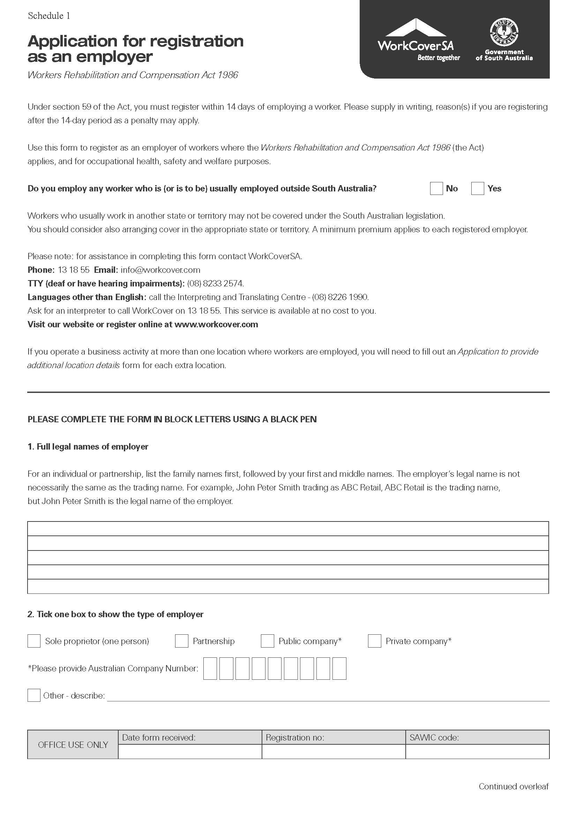
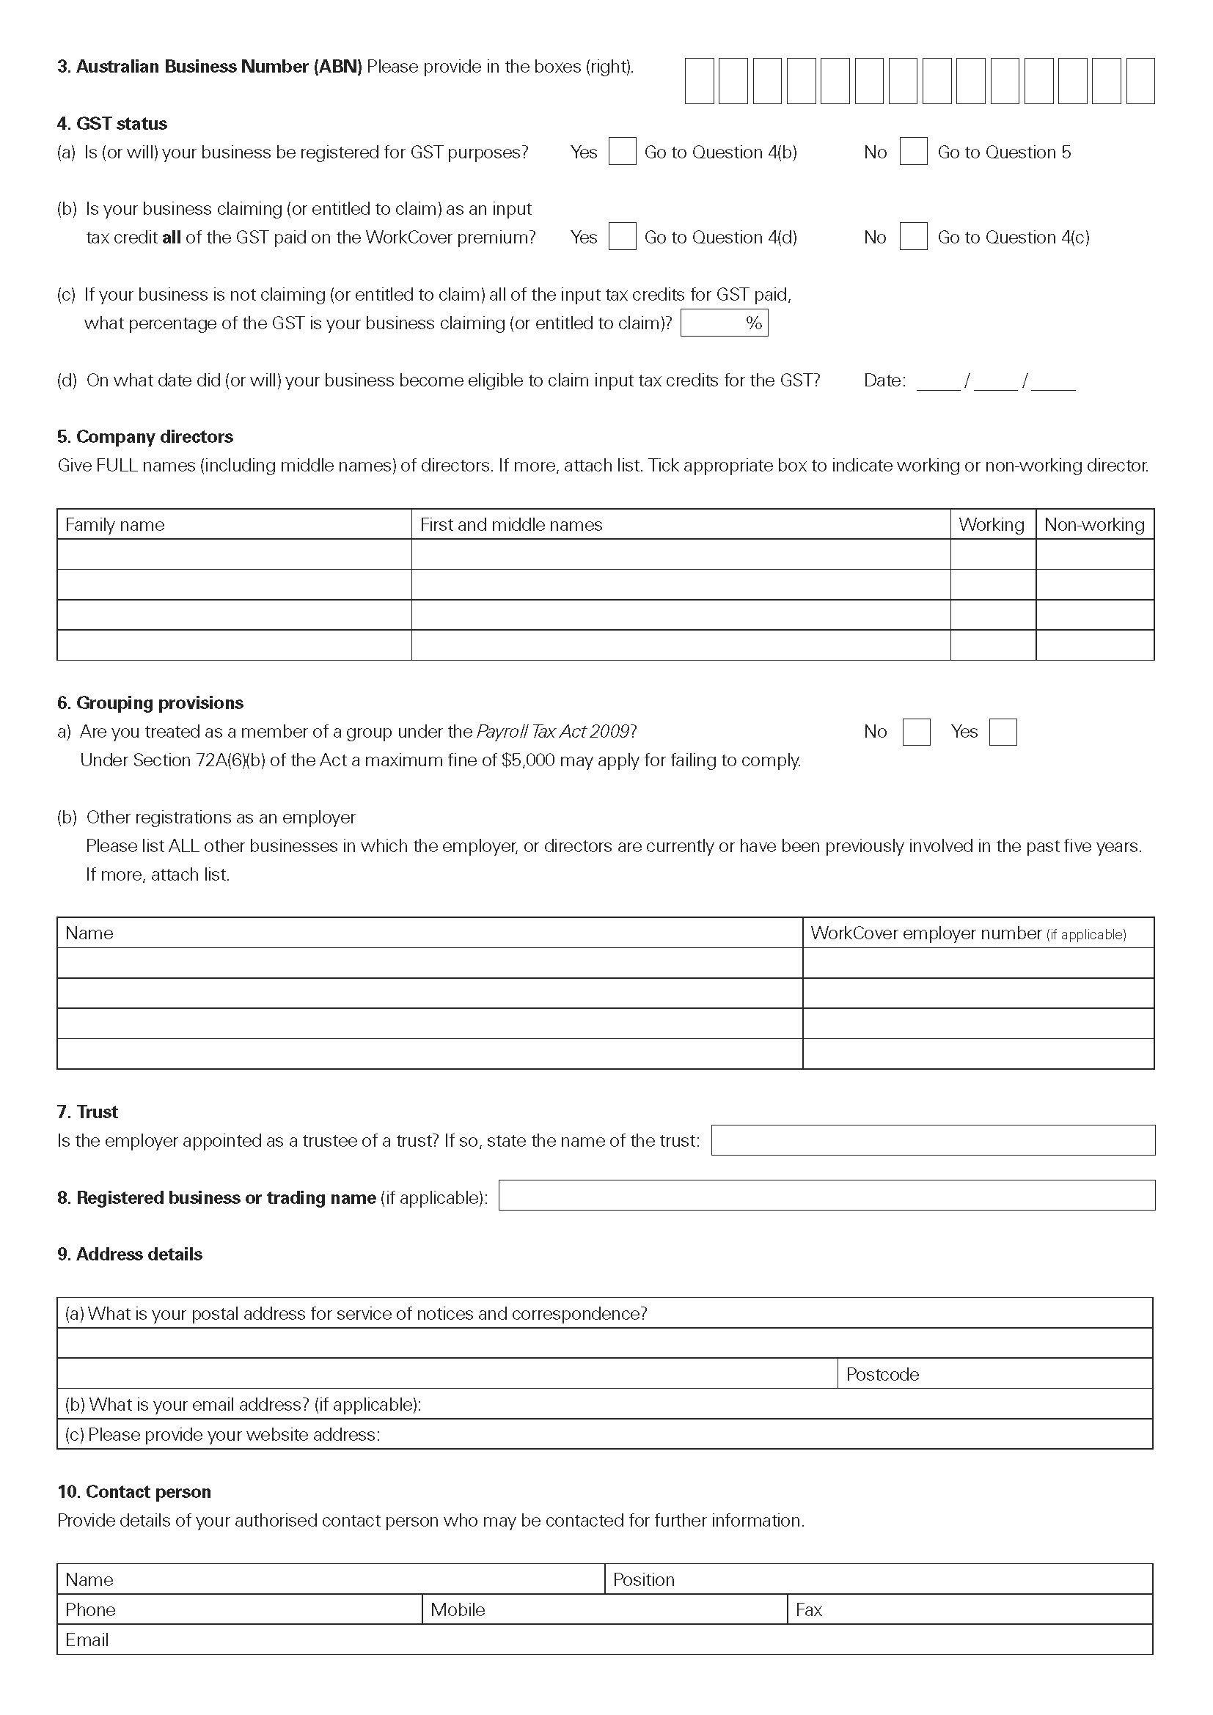
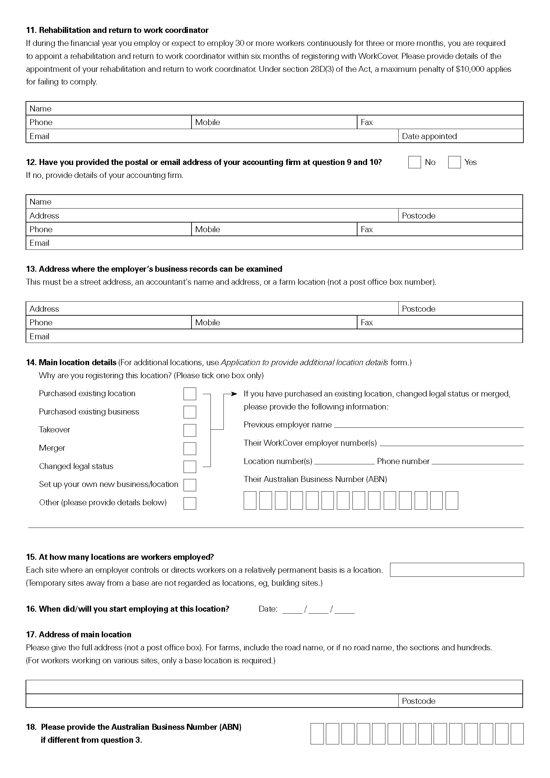
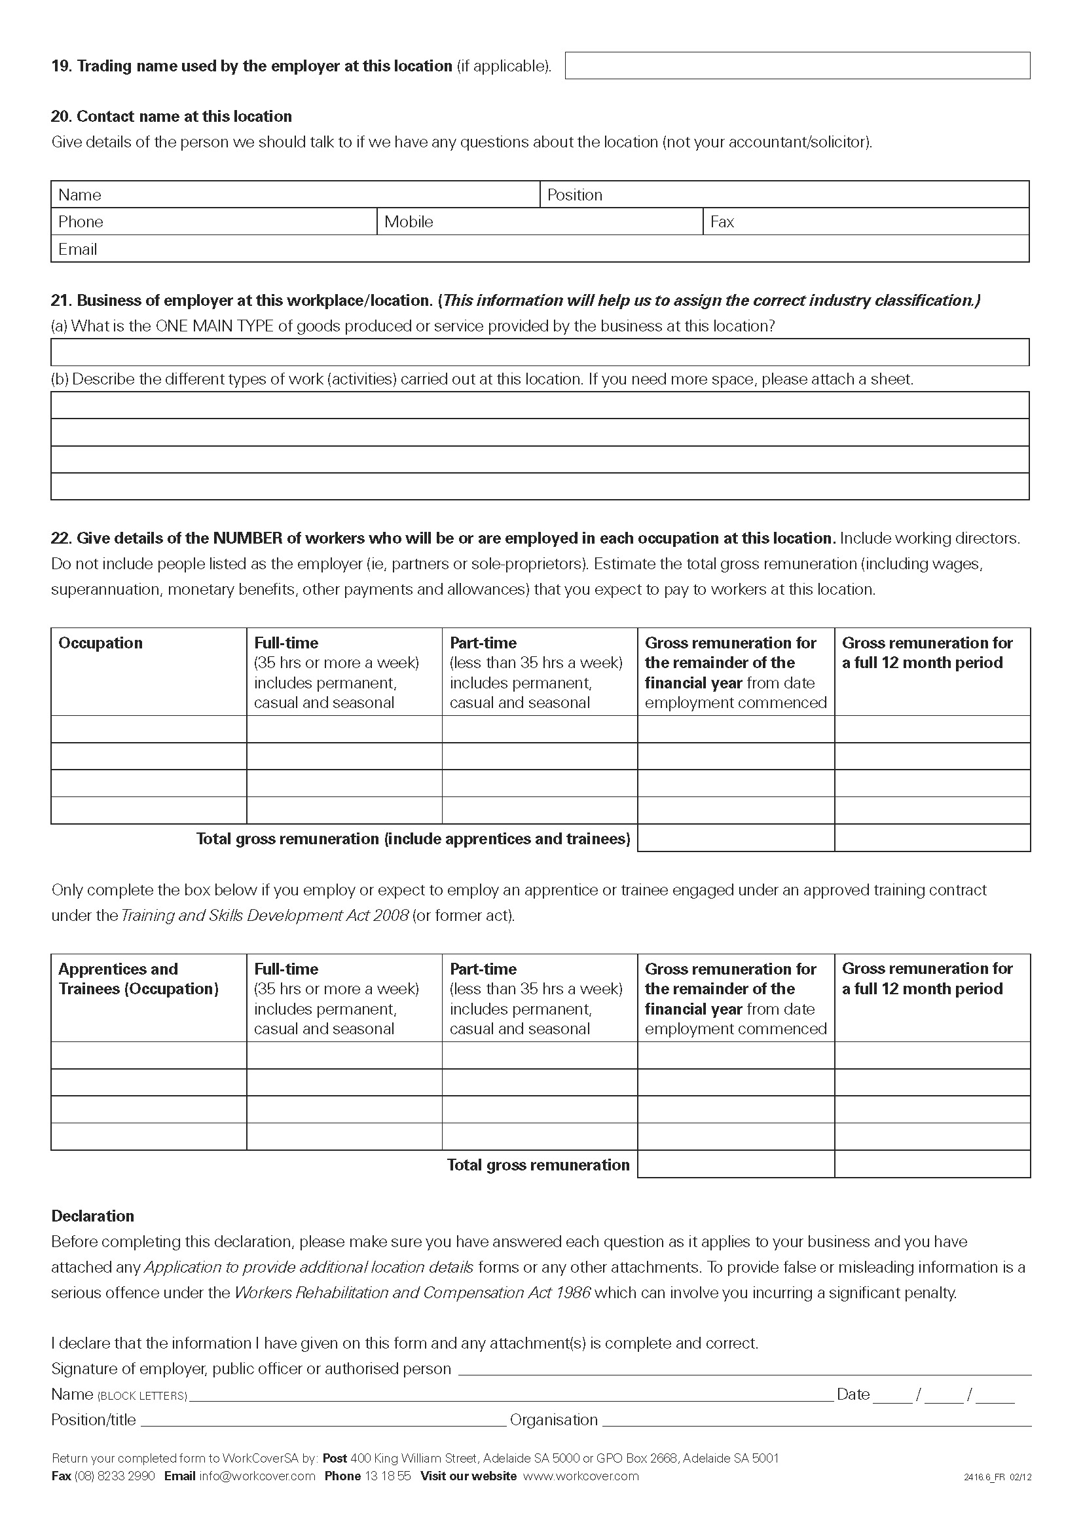
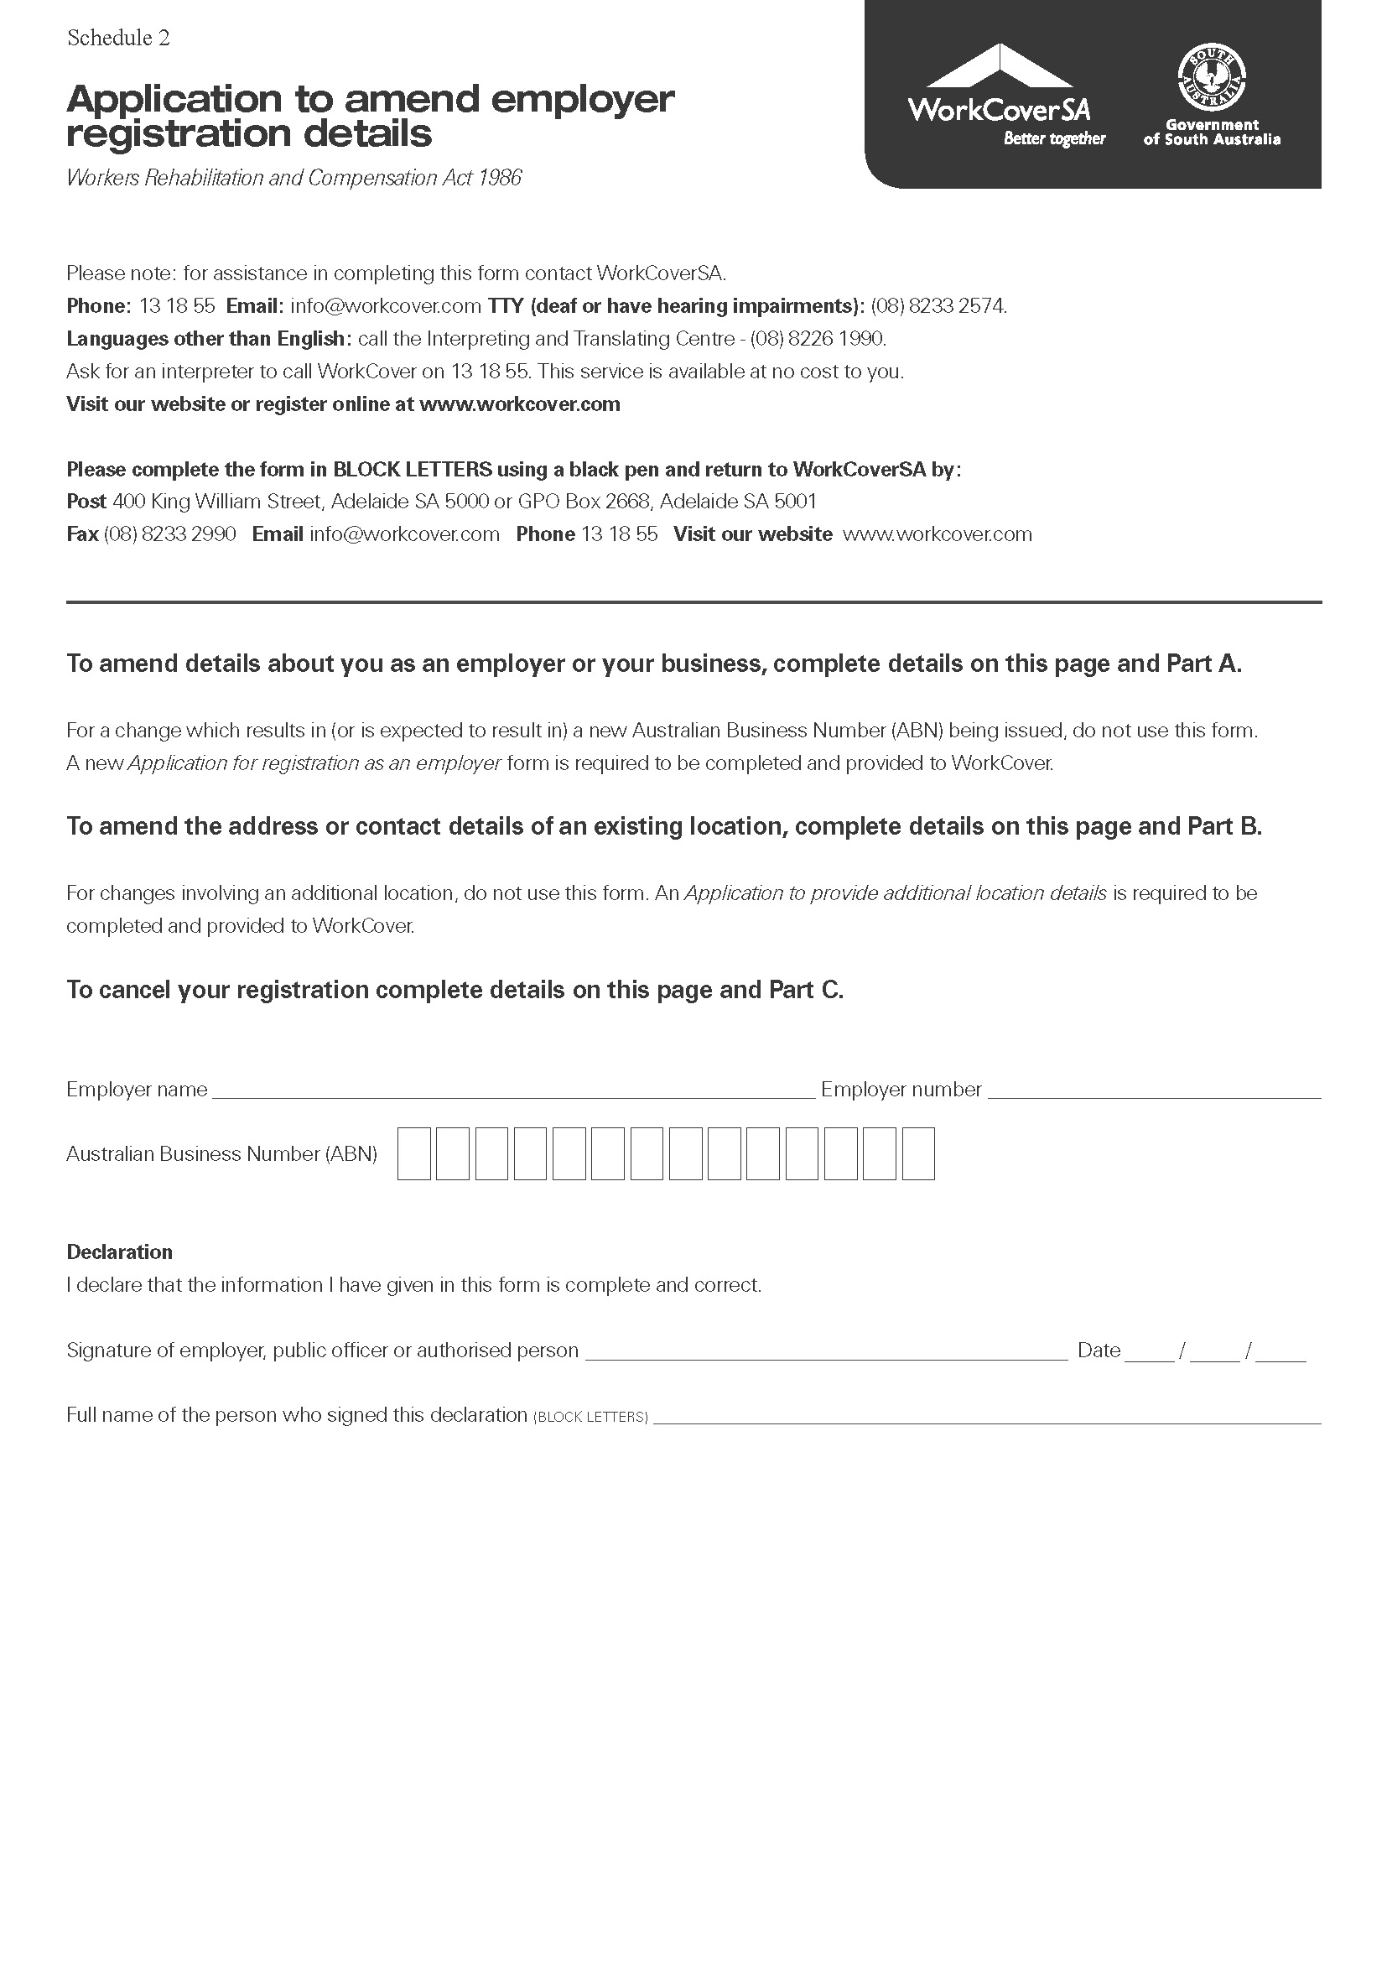
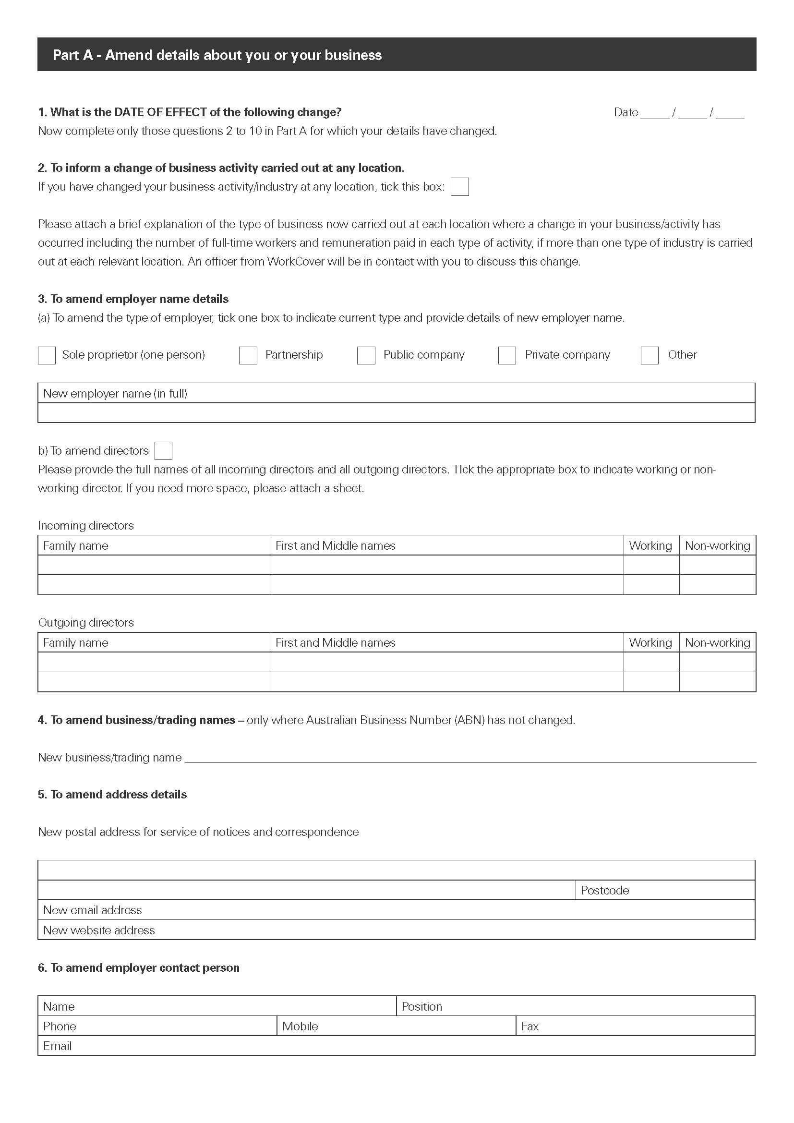
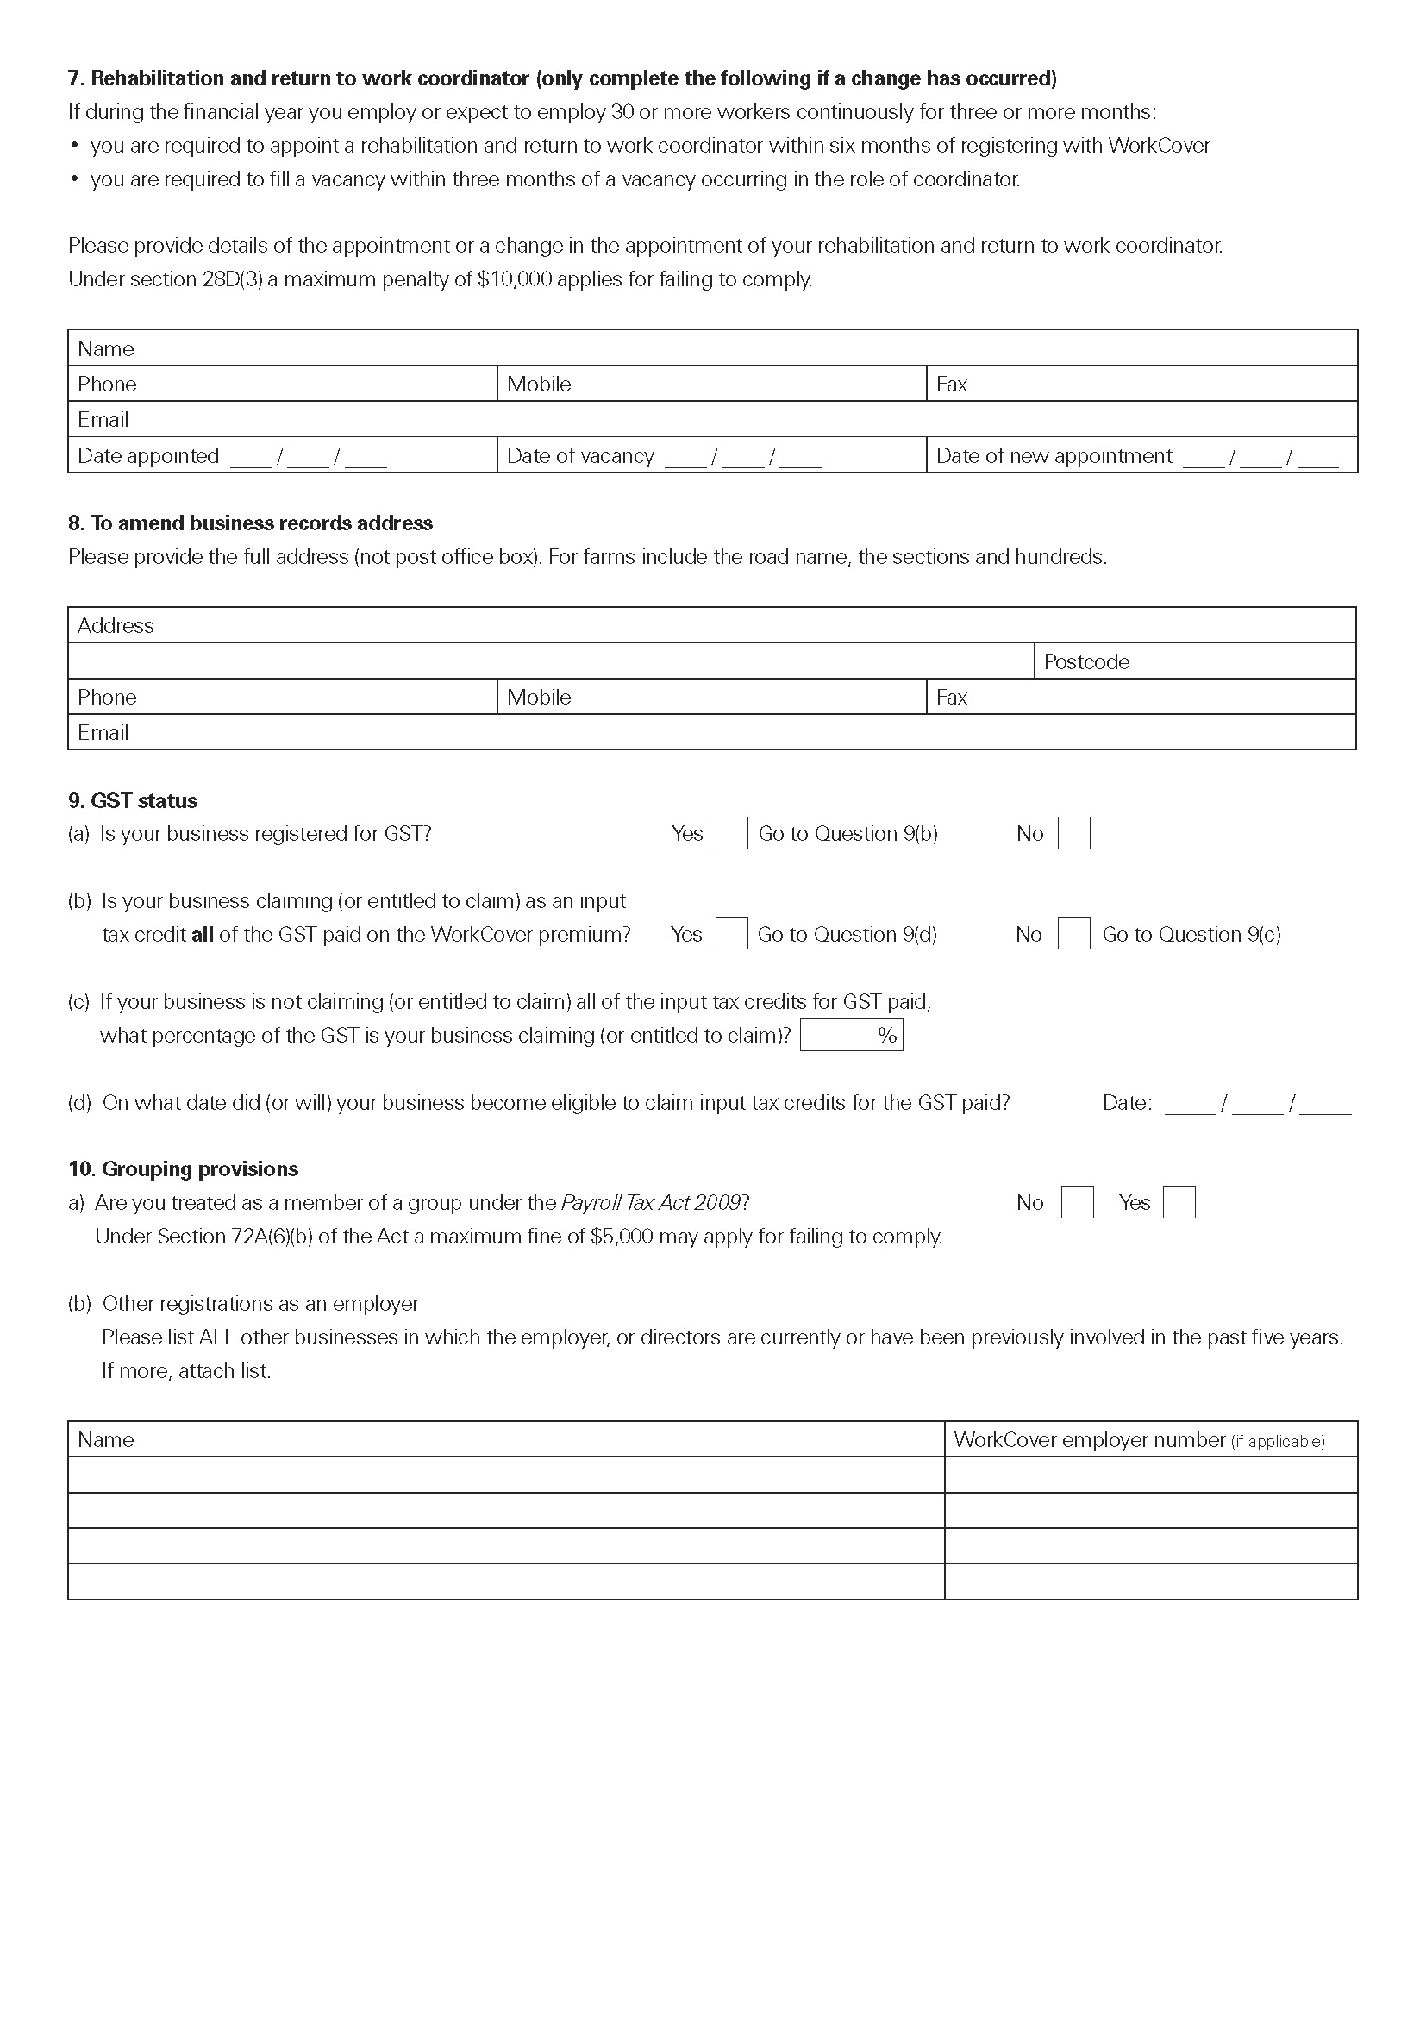
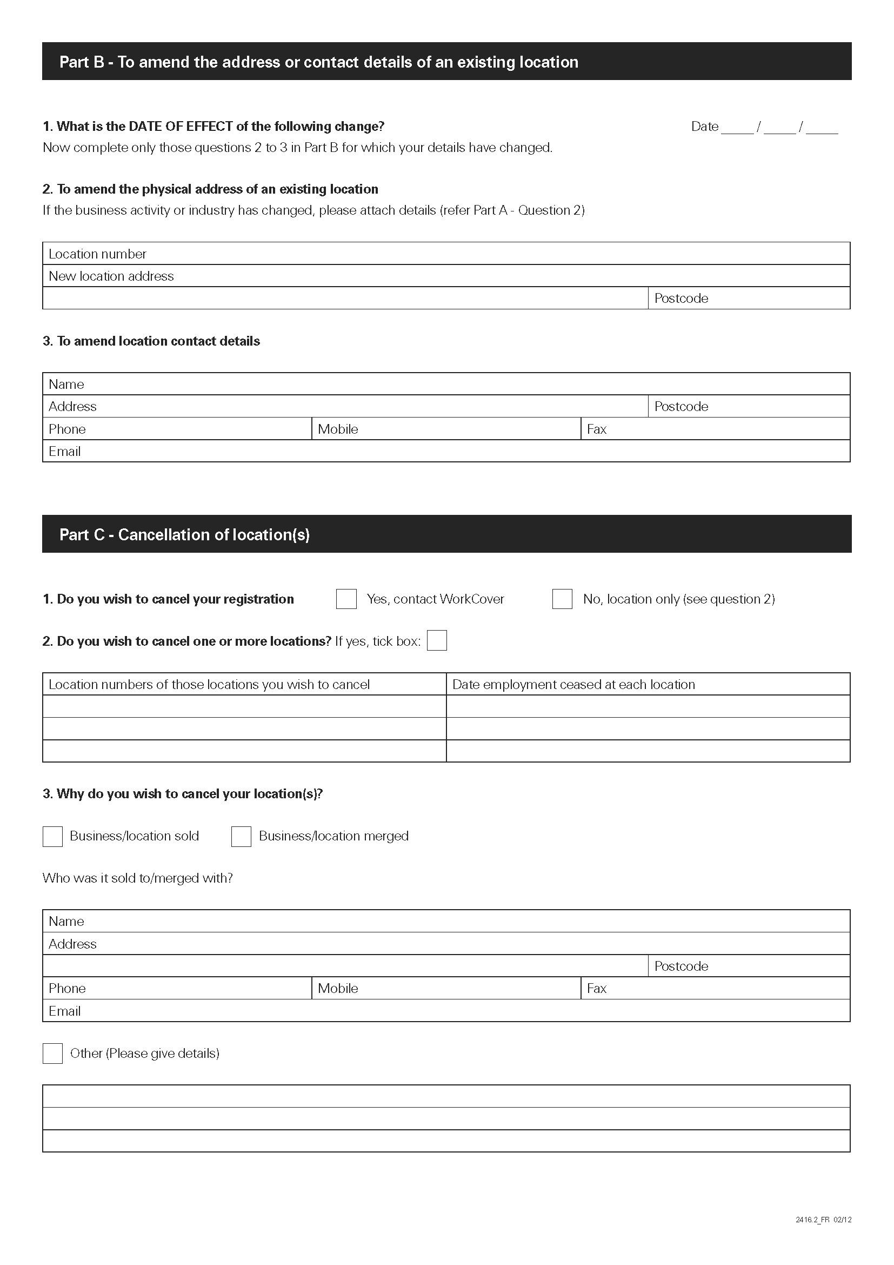
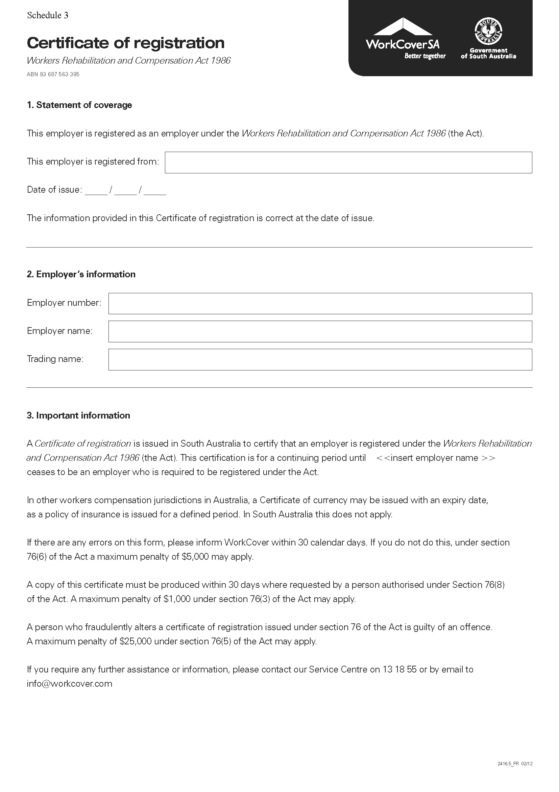
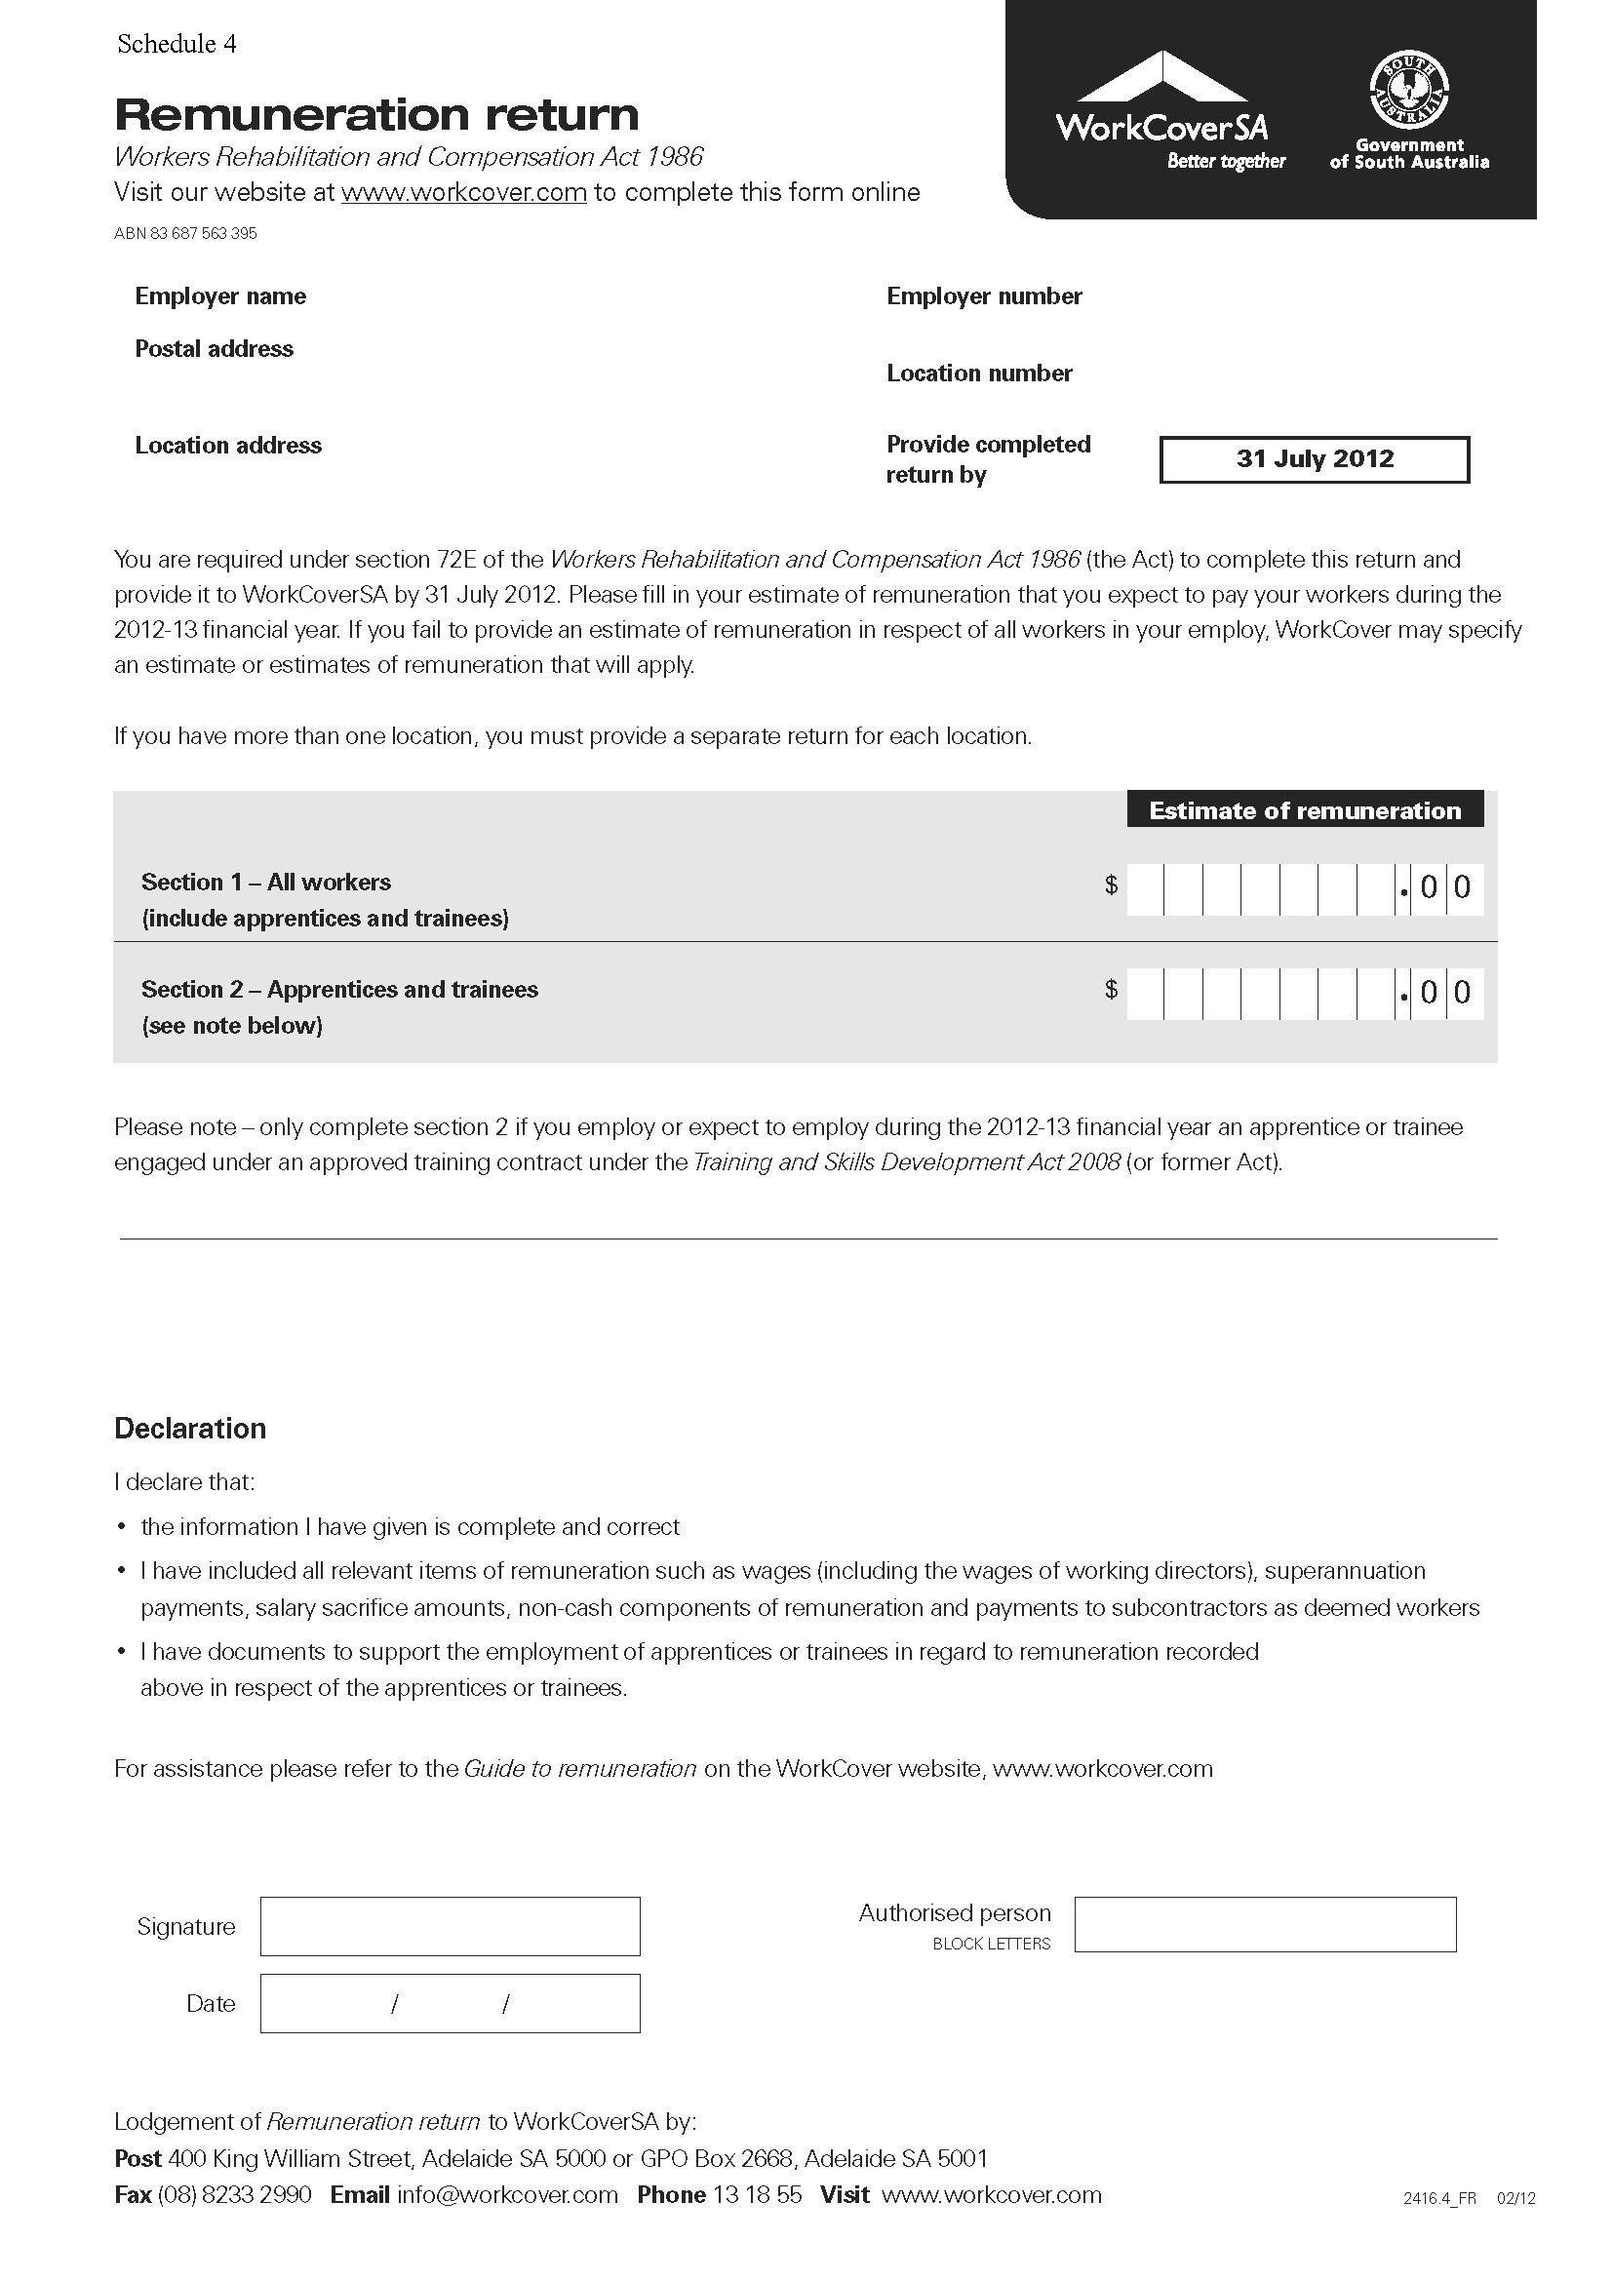
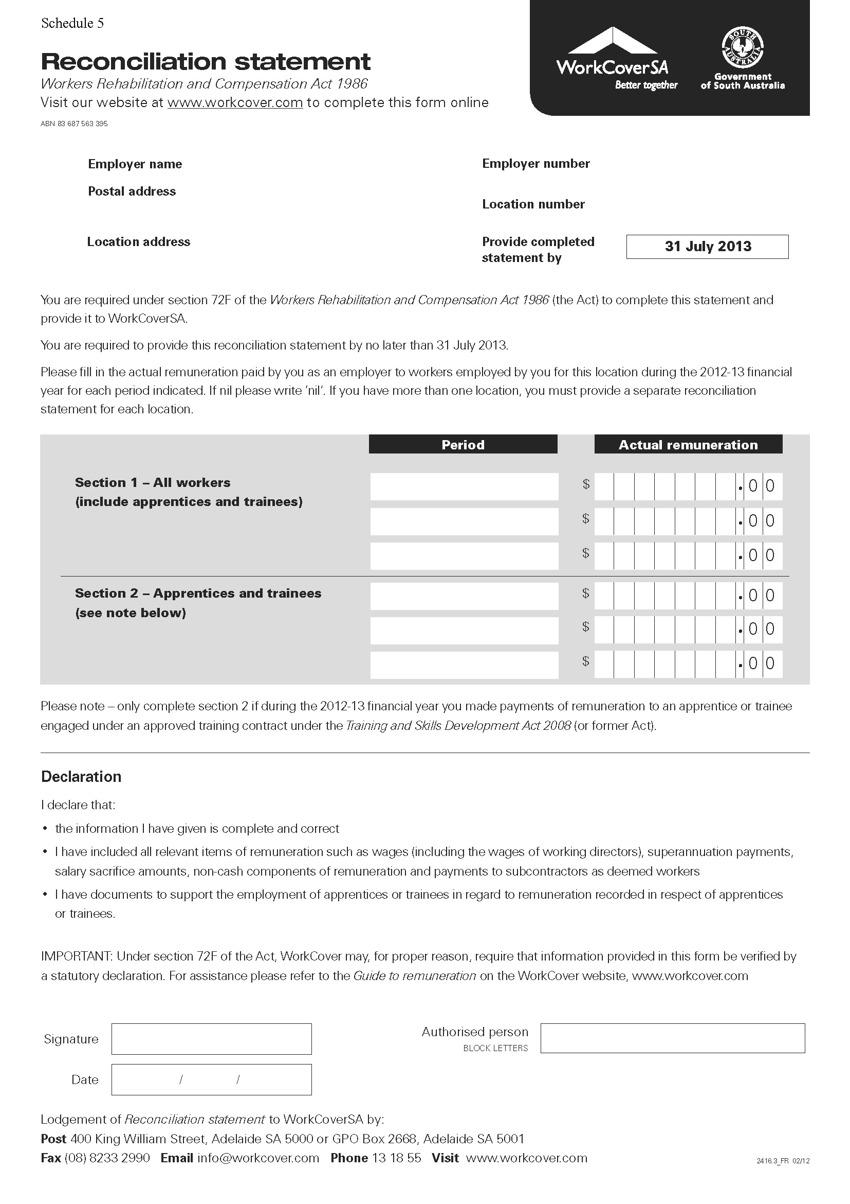
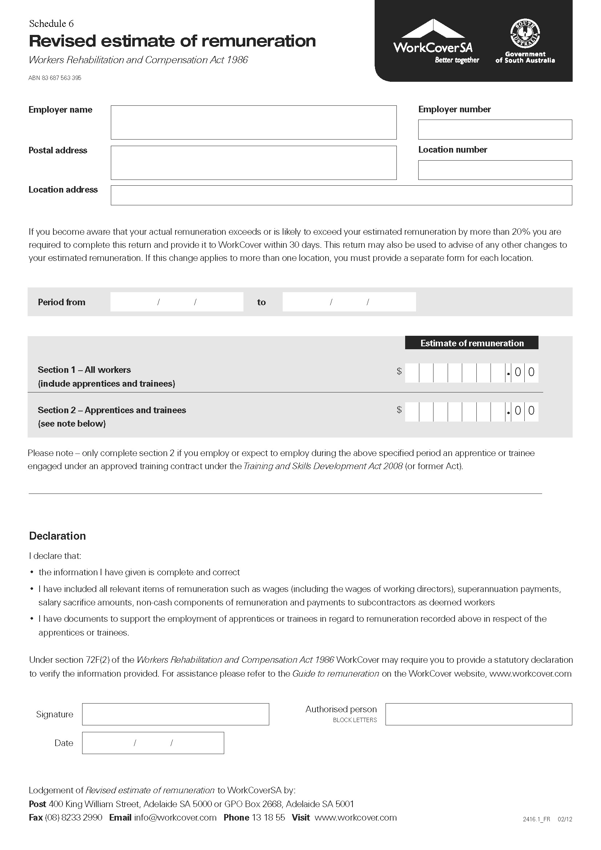
WorkCover Corporation Act 1994

Workers Rehabilitation and Compensation Act 1986

Premium Review Panel Determination 2012

The Board of the WorkCover Corporation of South Australia (‘the Corporation’) determines as follows pursuant to section 17 of the WorkCover Corporation Act 1994 (‘the WCA’), section 72M of the Workers Rehabilitation and Compensation Act 1986 (‘the Act’) and all other enabling powers:

Part 1 – Preliminary Matters

- This determination may be cited as the WorkCover Premium Review Panel Determination 2012.

- This determination commences on 1 July 2012 and applies to any application for review lodged under section 72M of the Act in relation to a statutory payment in respect of a period commencing on or after that date, subject to Part 9.

Continuation of WorkCover Levy Review Panel as WorkCover Premium Review Panel

- The WorkCover Levy Review Panel established by the Board’s determination of 29 June 2000 (see South Australian Government Gazette, 29 June 2000, page 3472) and continued by the Board’s determination of 14 June 2002 (see South Australian Government Gazette, 27 June 2002, page 2731), as amended, is hereby continued as the WorkCover Premium Review Panel (‘the Panel’).

Functions and powers under section 72M of the Act

- The function of the Panel shall be to perform the functions of the Board under section 72M of the Act as delegate of the Board under that section in reviewing decisions of the Corporation pursuant to subsection 68(2), subsections 69(2), 69(3), 69(4), 69(5), subsections 70(1), 70(2), subsection 72A(1), subsections 72C(1), 72C(2), 72C(3)(a), (b) and (c), subsection, 72C(4), subsection 72E(3)(a), subsection 72F(3), subsection 72G(1), section 72H, subsection 72J(1), (2), (3), (4), subsection 72K(1), 72K(3) of the Act and subject to the proceeding clauses of this determination, the powers of the Board under section 72M of the Act (other than the power to review a decision of the Corporation on a matter of law going to the validity of that decision) are delegated to the Panel for that purpose.

Part 2 - Constitution of Panel

- The Panel shall comprise four members appointed by the Board consisting of:

  - a President, who shall be a legal practitioner (wherever in Australia admitted), and who shall decide any questions of law falling within the delegated functions of the Panel; and

  - a member with expertise in the interests of registered employers; and

  - a member with expertise in the interests of workers; and

  - a member with expertise in the interests of the Corporation.

- Where the anticipated unavailability of appointed members or the anticipated volume of work necessitates, deputy members may be appointed by the Board.

- A Deputy President or other Deputy Member has the powers and duties of the position held by the President or Member respectively.

- The President may sit alone:

  - to give directions;

  - to determine procedural matters;

  - for the promotion of conciliation;

  - to seek evidence; or

  - to dispose of an application on a matter of law falling within the delegated functions of the Panel involving no disputes of fact and no exercise of discretion.

- Except as provided for in clause 4 of this Part, the Panel shall otherwise sit as a panel of four.

- A decision of a majority of members of the Panel, other than a decision as to a matter of law falling within the delegated functions of the Panel, shall be the decision of the Panel, but a member not agreeing with a decision of the majority may give reasons for not agreeing.

- In the event of the Panel being equally divided in opinion as to the decision to be made, the Panel’s decision shall be in accordance with the opinion of the President or Deputy President.

- A quorum of the Panel shall be three members, provided that members representing each interest referred to in clause 1 of this Part or (where applicable) deputies thereof have been offered, in the opinion of the President, a reasonable opportunity to sit.

- If a member of the Panel becomes unavailable after the commencement of a hearing, the application must be heard again by the Panel properly constituted or (with the concurrence of the parties) adjourned until the absent member becomes available again, unless the decision of the remaining members is unanimous.

- However, no hearing may commence or continue without the President or a Deputy President.

Part 3 - Indemnity of Members

- Any liability attaching to a member of the Panel (including a deputy member appointed under clause 2 of Part 2 of this determination) for an act or omission by the member, or by the Panel, in good faith and in the exercise or purported exercise of a power or function, or in a discharge or purported exercise of a duty, of the member or the Panel is assumed by the Corporation.

Part 4 - Tenure of Members

- Members (other than the President) shall be appointed for a term of two years, except in the event of a casual vacancy, where a member may be appointed for two years or for the balance of the term of the former member at the option of the Board.

- The President of the Panel shall be appointed for a term of five years.

- A deputy of a member shall be appointed for a term specified by the Board in the instrument of appointment, not exceeding the balance of the term of the member for whom the deputy is to deputise, or for such term not exceeding five years as the Board considers appropriate.

- A member of the Panel whose term has expired may, if a new appointment has not been made, continue to sit as a member of the Panel until a new appointment is made.

- A former member of the Panel may sit as a member of the Panel for the purpose of completing the hearing and determination of part-heard proceedings in which they were involved.

Part 5 - Reconsideration and Conciliation

- Upon receipt of any application lodged under section 72M(1) of the Act, the registry of the Panel will forward a copy to the Corporation, which will reconsider the decision (disregarding any question of whether the application is out of time) and must inform the Panel and the applicant within 14 days of the result of the reconsideration (and its attitude to any question of an extension of time).

- Where:

  - the applicant has sought an extension of time for the making of the application or, in the opinion of the Corporation, the application for review is out of time; and

  - the Corporation intends to oppose an extension of time, and

  - the Corporation considers proper reason exists for considering the extension of time before undertaking reconsideration,

  - the Corporation may request the application to be referred to the President of the Panel to consider the extension of time.

- If an application is referred to the President under clause 2 of this Part, the President may grant a provisional extension of time and make such other procedural directions as the President thinks appropriate, but only if the President agrees that proper reason exists for departing from the usual practice under clause 1 of this Part. A provisional extension of time does not prevent the Panel from refusing an extension of time, if appropriate, when dealing with the application for review on the merits.

- If the President refuses to make a provisional extension of time, the applicant may request that the extension of time be referred to the Panel for final determination. A finding by the President that proper reason does not exist for departing from the usual practice under clause 1 of this Part is not a refusal.

- In this Part, consideration of an extension of time includes consideration of the question whether an application is in fact out of time.

- Where the Corporation considers it impracticable to complete reconsideration within 14 days (and gives the registry of the Panel appropriate reasons for so considering), the registry may grant an extension of time for the reconsideration.

- Before granting an extension of time for reconsideration that exceeds seven days, the registry must invite the applicant to indicate whether it has any objections to the proposed extension of time for reconsideration and the reasons for any objections. If there is any such objection, the registry must refer the question to the president of the Panel to determine.

- If:

  - the Corporation, on reconsideration of a disputed decision, confirms the decision; or

  - the Corporation, on reconsideration of a disputed decision, varies the decision and the applicant expresses dissatisfaction with the variation,

the registry of the Panel must refer the dispute for conciliation by a conciliator who will use his or her best endeavours to bring the applicant and the Corporation to an agreed resolution of the matters referred to in the application, and the Panel may not hear and determine any application unless it is satisfied that conciliation has been attempted and failed or it is satisfied that such attempts have no realistic prospects of success.

- If, during the hearing of any matter, it appears to the Panel that there is a realistic prospect of a negotiated outcome being achieved, it may refer the matter back for further conciliation or the Panel may make such other attempts to promote conciliation as it thinks appropriate.

- In this Part “conciliation” includes:

  - counselling;

  - mediation;

  - neutral evaluation;

  - case appraisal;

  - conciliation;

  - any combination of the above,

and the format of conciliation in any particular case shall be at the discretion of the conciliator in consultation with the parties, with the proviso that any confidential information provided during conciliation may be withheld from the Panel if the provider of that information so requests;

and “the Corporation” includes:

  - the operating unit of the Corporation that made the reviewable decision to which an application for review relates; and

  - the Director Scheme Legal, Senior Lawyer or other legal practitioner employed by the Corporation.

Part 6 - Principles of Operation of Panel

- The Panel shall be bound by and is hereby directed to follow the principles of natural justice.

- Subject to clause 1 of this Part, the Panel:

  - shall act according to equity, good conscience and the substantial merits of the case, without regard to technicalities and legal forms; and

  - is not bound by the rules of evidence, but may inform itself by such means and such material as it thinks fit; and

  - shall act as expeditiously as the circumstances of a particular case permit.

- The Panel must ascertain whether the parties to any proceedings desire to be heard by way of oral evidence or submissions and must in that event give at least 14 days notice of the date, time and place of hearing, but if both parties to particular proceedings wish to have the application determined on the documents, the Panel need not hold a hearing but must give the parties at least 14 days notice to make final written submissions before proceeding to make it a determination.

- If only one party to proceedings desires to submit oral evidence or submissions, the Panel must give the other party at least 14 days notice of the hearing and inform that party that there is a danger that at the hearing the Panel may hear things from the first party that the other party will be unable to respond to if it does not attend.

- A party may appear in person or (if a body corporate) by any proper officer or may be represented by counsel or by any duly appointed and authorised agent.

- A party engaging representation must do so at its own cost.

Part 7 - Powers of President of Panel

- The President of the Panel, or a Deputy President acting in that office may, while so acting, exercise the powers of, and is hereby appointed as, an authorised officer under the Act. For the purposes of this Part, operating units of the Corporation and its agents are directed to comply with any requirements of the President or Deputy President as though they were subject to section 110 of the Act.

Part 8 - Reservation of Board’s Discretion to Decide

- The Panel is required to determine all applications that fail to resolve through reconsideration or at conciliation, unless the Corporation, within 14 days of receipt of any application, advises the Board that the particular dispute is of unusual significance and the Board or its relevant Board Committee, prior to the hearing of the application by the Panel, serves notice on the Panel and the applicant that the Panel is to make a recommendation only and refer the matter to the Board or relevant Board Committee.
Part 9 - Revocation and Transitional Provision

- The WorkCover Levy Review Determination 2002 (the Revoked Determination) as published in the South Australian Government Gazette on 29 October 2009 at pages 4977 to 4979 is revoked, save and except that an Application for Review lodged before 1 July 2012 or relating to a period commencing earlier than 1 July 2012 shall be dealt with under the Revoked Determination.

I confirm that this is a true and correct record of the decision of the Board of the Corporation made on the 26 day of April 2012.

Dated 26 April 2012.
P. BENTLEY, Board Chair

Workers Rehabilitation and Compensation Act 1986

Definition of Remuneration Determination 2012

The Board of the WorkCover Corporation of South Australia (‘the Corporation’) determines that remuneration for the purposes of section 65 of the Workers Rehabilitation and Compensation Act 1986 (‘the Act’), is as follows:

Part 1 – Preliminary Matters

- This determination may be cited as the Definition of Remuneration Determination 2012.

- This determination commences on 1 July 2012.

- The determination of the Corporation made on 16 December 2010 and published in the South Australian Government Gazette on 23 December 2010 at pages 5793 to 5794 is hereby revoked from the commencement of this determination.

Part 2 – Grounds for Determination

- In respect of the inclusions referred to in Part 3 of this determination:

  - That the same should be regarded as included within the scope of remuneration.

- In respect of the exclusions referred to in Part 3 of this determination:

  - That the same should not be regarded as within the scope of remuneration.

Part 3 - Terms of Determination

- For the purposes of Part 5 and section 65 of the Act, remuneration includes payments, whether made in cash or by cheque or negotiable instrument or by investment or capitalisation or credit to any account, reserve or fund or in kind or in any manner, and whether by piece work rates or otherwise, including specifically, without limiting the foregoing, payments made to or for the benefit of a worker for or by way of the following table:

Accommodation allowance | Life assurance
Annual leave | Living away from home allowance
All payments qualifying as credit units (including trade dollars) arising from or associated with a barter or countertrade transaction to which the value of any such credit units (including trade dollars) is hereby deemed to be valued as the equal of one Australian dollar (or such different value where it is established, to the satisfaction of the corporation, a particular organisation’s credit units (including trade dollars) are being traded consistently at a different value) | Loadings
 | Locality allowance
 | Long service leave
 | Meal allowance
 | Motor vehicle allowance
 | Over award payment
 | Overtime allowance
 | Paid parental leave (other than payments under the Paid Parental Leave Act 2010 of the Commonwealth)
 | Penalty rates
 | Personal accident and sickness insurance
Back pay | Piece work payments
Bonuses | Qualification allowance
Callout or call back allowance | Remote area allowance
Clothing allowance | Rental allowance
Club subscriptions | Representation allowance
Commission | Salary
Directors’ fees and emolument | Salary continuance insurance
Dirt money | School or education expenses for children, spouse or dependents of workers
Disability allowance
Dry cleaning
Employee (worker) Incentive Plan contributions | Service increments
Employee (worker) Incentive Plan contributions | Sick Pay
Entertainment allowance | Site allowance
Fares for travel | Skill allowance
First aid allowance | Standby or on call allowance
Follow-the-job allowance | Studying allowance
Footwear allowance | Superannuation contributions
Health insurance | Supplementary payments
Higher duty allowance | Telephone allowance
Holiday pay | Tool allowance
Home entertainment allowance | Travelling allowance
Incentives | Uniform allowance
Industry allowance | Wages
Instructor’s allowance | All other allowances
Leave loadings

  - In relation to salary sacrifice benefits or fringe benefits “remuneration” is the GST inclusive value of the benefits (i.e. cost of the acquisition of the benefit by the employer (after deducting input tax credits to which the employer is entitled on account of the acquisition of the benefit) plus GST paid by the employer to the Australian Taxation Office);

  - In the case of payments to contractors as a worker defined under the Act “remuneration” is the GST exclusive amount of the payments made by the employer to the contractor (i.e. amount paid to the contractor less any amount paid to the contractor on account of GST less any input tax credits to which the employer is entitled in relation to the acquisition of the contractor’s services).

- For the purposes of Part 5 of the Act the following payments do not constitute remuneration being payments for or by way of:

  - Payments for reimbursement or compensation to a worker for payments or expenses actually made or incurred by the worker for goods or services for or on behalf of an employer or acquired by or provided to the worker, in the course of and for the purposes of work performed by the worker for that employer.

  - Allowances paid to a worker in respect of the use of the worker’s own motor vehicle in the course of the worker’s employment by the employer, for the financial year concerned, at a rate that does not exceed:

    - The rate prescribed by regulations under section 28-25 of the Income Tax Assessment Act 1997 of the Commonwealth for calculating a deduction for car expenses for a large car using the “cents per kilometre method”; or

    - If no rate is prescribed as referred to in (a) above, the rate prescribed by the regulations under the South Australian Payroll Tax Act 1971,

    - for each kilometre actually travelled in the course of and for the purposes of that employment.

  - Accommodation allowances paid to a worker in respect of the cost of accommodation at a hotel, motel, guest house or other temporary lodging, while the worker is absent from their usual residence in the course of and for the purpose of the employment of the worker by the employer, for the financial year concerned, at a rate that does not exceed:

    - the total reasonable amount for daily travel allowance expenses using the lowest capital city for the lowest salary band for the financial year determined by the Commissioner of Taxation of the Commonwealth; or

    - if no determination referred to in (a) above is in force, the rate prescribed by the regulations under the South Australian Payroll Tax Act 1971.

  - All payments of compensation made by employers (including self-insured employers) to workers under Part 4 of the Act.

  - An amount paid to or for the benefit of a worker as a consequence of cessation of employment either as termination payment or redundancy/severance pay or ‘eligible termination payment’ as defined in the Income Tax Assessment Act 1936 of the Commonwealth.

  - An amount in the form of contributions to a fund, by an employer bound by an award, enterprise agreement, industrial agreement pursuant to an award or such other registered industrial agreements to meet all or some of the liabilities of the employer in relation to redundancy/severance payments to a worker pursuant to an award, enterprise agreement, industrial agreement to an award or such other registered industrial agreements.

  - An amount paid to or for the benefit of a worker, as a consequence of cessation of employment, in the form of payments made by a trustee or an employer in the capacity of trustee of a superannuation fund.

  - All payments paid to or for the benefit of a worker as a consequence of a worker’s eligibility to a payment by way of a determination in terms of the Paid Parental Leave Scheme under the Paid Parental Leave Act 2010 of the Commonwealth.

Item 4 – Notice of Determination

That notice of this determination be published in the South Australian Government Gazette.

I confirm that this is a true and correct record of the decision of the Board of the Corporation made on the 26 day of April 2012.

Dated 26 April 2012.
P. BENTLEY, Board Chair

Workers Rehabilitation and Compensation Act 1986

Provision of Remuneration Information Notice 2012

In accordance with the delegation provided under the Instrument of Delegation of the Corporation I, Rob Thomson, Chief Executive Officer, hereby give notice of the requirements of the Corporation under the sections of the Workers Rehabilitation and Compensation Act 1986 (the Act) specified herein.

Part 1 – Preliminary Matters

- This notice may be cited as the Provision of Remuneration Information Notice 2012.

- This notice commences on 1 July 2012.

Part 2 – Terms of Notice

Estimate

- When calculating remuneration in relation to a premium period or other period, a reference to information for the purposes of sections 62, 72E and s72F of the Act is the estimate of the monetary value of all remuneration payable to all workers by the employer calculated by reference to the forms or returns (if any) furnished in accordance with the Act by the employer to the Corporation or, where the monetary value of the remuneration has been ascertained by the Corporation, the actual value of the remuneration.

Failure to furnish a return

- For the purposes of section 72J of the Act, if at any time an employer fails to furnish a return as required by the Act in respect of any relevant period and the monetary value of the remuneration concerned has not been ascertained by the Corporation, the estimate of the monetary value of the remuneration is taken to be such amount as is calculated by multiplying the monetary value (or reasonable estimate) of remuneration for the immediately preceding premium period, or equivalent period as determined by the Corporation, by 1.06.

Specified event

- For the purposes of section 72F(1)(c) of the Act, a specified event is where an employer becomes aware that the actual remuneration paid or payable by the employer:

  - exceeds or is likely to exceed by more than 20% the estimate, or latest estimate, (as the case may be) of aggregate remuneration applying in relation to the employer under this Division, or

  - exceeds or is likely to exceed by less than 20%, or falls by any percentage below, the estimate or latest estimate (as the case may be) of aggregate remuneration applying in relation to the employer under this Division.

- In the event of clause 3.1 of this Part applying, the employer must submit a revised estimate or estimates, in the designated manner and form, within 30 days of becoming aware of such changed circumstances.

- In the event of clause 3.2 of this Part applying, the employer may submit if the employer wishes/elects to do so a revised estimate or estimates, in the designated manner and form, before the end of the relevant premium period.

Information

- For the purposes of section 72E and 72F, the information required by the Corporation is satisfied if the information required by the relevant designated form(s) is provided in one of the designated manners or forms.
Confirmed as a true and correct record of the decision of the Corporation made in the exercise of my delegated authority.

Dated 30 April 2012.

R. THOMSON, Board Delegate

Workers Rehabilitation and Compensation Act 1986

Payment of Statutory Payments Notice 2012

The Board of the WorkCover Corporation of South Australia (‘the Corporation’) determines pursuant to section 72 of the Workers Rehabilitation and Compensation Act 1986 (‘the Act’) that an employer is liable to the Corporation for payment of statutory payments in accordance with the following terms:

Part 1 – Preliminary Matters

- This notice may be cited as the Payment of Statutory Payments Notice 2012.

- This notice commences on 1 July 2012.

- The determination of the Corporation published in the South Australian Government Gazette on 27 May 2010 at pages 2075 to 2076 is hereby revoked from the commencement of this notice.

Part 2 – Terms of Notice

- For the purposes of subsection 72(2) of the Act where the initial premium payable for a premium period is $2,000 or less, the employer is required to make payment of the premium payable in full by 7 September of that premium period (or such later date as may be specified to an individual employer in the tax invoice). Payment will be made as outlined in the tax invoice.

- For the purposes of subsection 72(2) and 72(5) of the Act, where the initial premium is greater than $2,000, the initial premium payment can be made as follows:

  - In full by 7 September of that premium period, or

  - By way of 10 monthly instalments commencing on 7 September and thereafter on the seventh day of each month up to and including 7 June, or as determined by notice to an individual employer, or

  - As outlined in the tax invoice.

- Where an employer has elected to make payments by instalments and fails to make a payment as required, the employer may be required to pay the outstanding balance as a lump sum on the date specified by the Corporation in a tax invoice.

- Where an employer fails to submit a return by the required date, the Corporation will issue an estimate pursuant to section 72E or 72F of the Act and a tax invoice. The premium is payable on the date or dates specified in the tax invoice.

- For the purpose of subsection 72(3) of the Act, when an adjustment is made to an initial premium, the payment date or dates will be specified on the tax invoice.

Hindsight premium

- For the purposes of section 72(4) of the Act, the hindsight premium for a premium period must be paid in full by the due date specified on the tax invoice.

- For the purpose of subsection 72(3) of the Act where an adjustment is made to a hindsight premium for a premium period, the payment terms will be specified on the tax invoice.

Remissions and supplementary payments

- Pursuant to Regulation 16A of the Workers Rehabilitation and Compensation Regulations 2010, the payment terms for a remission or supplementary payment will be specified on the tax invoice.
Part 3 – Notice of Determination

That notice of this determination be published in the South Australian Government Gazette.

I confirm that this is a true and correct record of the decision of the Board of the Corporation made on the 26 day of April 2012.

Dated 26 April 2012.
P. BENTLEY, Board Chair

B. MORRIS, Government Printer, South Australia

