No. 72 4793

THE SOUTH AUSTRALIAN

GOVERNMENT GAZETTE
www.governmentgazette.sa.gov.au

PUBLISHED BY AUTHORITY

ALL PUBLIC ACTS appearing in this GAZETTE are to be considered official, and obeyed as such

ADELAIDE, THURSDAY, 1 NOVEMBER 2012

CONTENTS

Page
Appointments, Resignations, Etc. 4794
Agricultural and Veterinary Products (Control of
Use) Regulations 2004—Notice 4794
Associations Incorporation Act 1985—Notice 4794
Authorised Betting Operations Act 2000—Notice 4794
Brands Act 1933—Third Quarter 2012 4797
Corporations and District Councils—Notices 4832
Development Act 1993—Notices 4795
Fisheries Management Act 2007—Notice 4795
Health Care Act 2008—[Republished] 4806
Liquor Licensing Act 1997—Notices 4795
Mining Act 1971—Notices 4808
National Gas Law—Notice 4813
National Parks and Wildlife (National Parks)
Regulations 2001—Notices 4813
Natural Resources Management Act 2004—Notice 4814
Partnership Act 1891-1975—Notice 4832
Passenger Transport Act 1994—Notice 4814

Page
Passenger Transport Regulations 2009—Notice 4814
Petroleum and Geothermal Energy Act 2000—Notice 4812
Proclamation 4819
Public Intoxication Act 1984—Notice 4815
Public Trustee Office—Administration of Estates 4832
REGULATIONS
Liquor Licensing Act 1997—
(No. 220 of 2012) 4820
(No. 221 of 2012) 4824
(No. 222 of 2012) 4826
(No. 223 of 2012) 4828
Lottery and Gaming Act 1936 (No. 224 of 2012) 4830
Roads (Opening and Closing) Act 1991—Notices 4815
Sale of Property 4833
Shop Trading Hours Act 1977—Notice 4816
Water Mains and Sewers—Mains Laid,
Replaced, Etc. 4816
Wilderness Protection Regulations 2006—Notice 4818

GOVERNMENT GAZETTE NOTICES
ALL poundkeepers’ and private advertisements forwarded for publication in the South Australian Government Gazette must be PAID FOR PRIOR TO INSERTION; and all notices, from whatever source, should be legibly written on one side of the paper only and sent to Government Publishing SA so as to be received no later
than 4 p.m. on the Tuesday preceding the day of publication. Phone 8207 1045 or Fax 8207 1040. E-mail: governmentgazette@dpc.sa.gov.au. Send as attachments in Word format and please confirm your transmission with a faxed copy of your document, including the date the notice is to be published and to whom the notice will be charged. The Government Gazette is available online at: www.governmentgazette.sa.gov.au

Department of the Premier and Cabinet
Adelaide, 1 November 2012
HIS Excellency the Governor in Executive Council has been pleased to appoint the undermentioned to the South East Natural Resources Management Board, pursuant to the provisions of the Natural Resources Management Act 2004:
Member: (from 1 November 2012 until 13 April 2014)
Francis Newman Brennan
Presiding Member: (from 1 November 2012 until 13 April 2014)
Francis Newman Brennan
By command,
Ian Keith Hunter, for Premier
12MSECCS057

Department of the Premier and Cabinet
Adelaide, 1 November 2012
HIS Excellency the Governor in Executive Council has been pleased to appoint the undermentioned to the Art Gallery Board, pursuant to the provisions of the Art Gallery Act 1939:
Member: (from 12 November 2012 until 11 November 2015)
Robert John Whitington
By command,
Ian Keith Hunter, for Premier
ASACAB007/02

Department of the Premier and Cabinet
Adelaide, 1 November 2012
HIS Excellency the Governor in Executive Council has been pleased to appoint Stephen Joseph Brennan as the Employee Ombudsman for a term of six years commencing on 7 November 2012 and expiring on 6 November 2018, pursuant to the provisions of the Fair Work Act 1994.
By command,
Ian Keith Hunter, for Premier
MIR12/026CS

AGRICULTURAL AND VETERINARY PRODUCTS (CONTROL OF USE) REGULATIONS 2004
Notice by the Minister
Approval of Prescribed Qualification
I, GAIL GAGO, Minister for Agriculture, Food and Fisheries, pursuant to Regulation 3 (1) of the Agricultural and Veterinary Products (Control of Use) Regulations 2004, approve the qualification listed below as a prescribed qualification:
A valid Auschem Training Registration Statement issued by Auschem Training (Vic.) Incorporated certifying successful completion of the Auschem Victoria AgVet Chemical Users Course, provided the Statement also verifies the accreditation holder has completed the South Australian legislation assessment.
Dated 11 October 2012.
Gail Gago, Minister for Agriculture, Food and Fisheries

ASSOCIATIONS INCORPORATION ACT 1985
Order Pursuant to Section 42 (2)
Dissolution of Association
WHEREAS the Corporate Affairs Commission (‘the Commission’) pursuant to section 42 (1) of the Associations Incorporation Act 1985 (‘the Act’) is of the opinion that the undertaking or operations of Habitat For Humanity Australia SA Incorporated (‘the Association’) being an incorporated association under the Act are being carried on, or would more appropriately be carried on by a company limited by guarantee incorporated under the Corporations Act 2001 (Commonwealth) and whereas the Commission was on 9 August 2012 requested by the Association to transfer its undertaking to Habitat For Humanity Australia SA (ACN 159 846 232), the Commission pursuant to Section 42 (2) of the Act does hereby order that at 3 October 2012, the Association will be dissolved, the property of the Association becomes the property of Habitat For Humanity Australia SA and the rights and liabilities of the Association become the rights and liabilities of Habitat For Humanity Australia SA.
Given under the seal of the Commission at Adelaide, 30 October 2012.
S. Aitchison, A Delegate of the Corporate Affairs Commission

AUTHORISED BETTING OPERATIONS ACT 2000
Section 42
Revocation of Direction to the Independent Gambling Authority
PURSUANT to Section 42 (2) of the Authorised Betting Operations Act 2000 (the Act) and all other relevant enabling powers, I, Hon. John Rau, MP, being the Minister responsible for the administration of the Act, hereby revoke the direction to the Independent Gambling Authority dated 4 June 2011.
Dated 29 October 2012.
John Rau, Minister for Business Services and Consumers

AUTHORISED BETTING OPERATIONS ACT 2000
Sections 55 (4) and 57 (3)
Direction to the Liquor and Gambling Commissioner
PURSUANT to Sections 55 (4) and 57 (3) of the Authorised Betting Operations Act 2000 (the Act) and all other relevant enabling powers, I, John Rau, MP, being the Minister responsible for the administration of the Act, hereby direct the Liquor and Gambling Commissioner (the Commissioner) (until such time as this Direction may be revoked or varied by (a) further Direction(s)):
1. Pursuant to Section 55 (4) of the Act:
(a) not to issue any permit to a bookmaker that would authorise betting on a day and at a place other than a racecourse or licensed betting shop that would constitute Direct Walk In Trade, other than a permit issued in accordance with this Direction;
(b) that the Commissioner may issue a permit to a bookmaker that would authorise betting on a day and at a place other than a racecourse for any day, other than Good Friday and Christmas Day, where:
(i) the bookmaker is not a body corporate;
(ii) the permit applies only to the acceptance of bets by the bookmaker at a premises or location approved by the Commissioner;
(iii) the permit applies for a maximum of six months from the date of issue;
(iv) the Commissioner is satisfied that the bookmaker (or his or her agent) has, in the preceding six months from the date of the application, attended and operated as a bookmaker on at least three Saturday or public holiday Class A galloping race meetings per month.
2. Pursuant to Section 57 (3) of the Act, to include conditions in each permit issued to a bookmaker under Section 55 (1) of the Act prohibiting:
(a) in the case of a permit issued in accordance with this Direction authorising betting on a day and at a place other than a racecourse:
(i) the acceptance of any bet at that place other than bets made by telephone to that place; and
(ii) the acceptance of any bet that would constitute Indirect Walk In Trade; and
(b) in any other case, the acceptance of any bet that would constitute Direct or Indirect Walk In Trade.
I hereby revoke the Ministerial Direction issued pursuant to Sections 55 (4) and 57 (3) dated 6 June 2011.
In this Ministerial Direction, unless the contrary intention appears, words have the same meaning as in the Act.
Direct Walk In Trade and Indirect Walk In Trade have the same meaning as in the Approved Licensing Agreement between the SA TAB and the Treasurer.
Class A galloping race meeting means a race meeting classified as such in accordance with a determination made by the Commissioner pursuant to Rule 2B of the Bookmakers Licensing Rules 2000 (South Australia).
Dated 29 October 2012.
John Rau, Minister for Business Services and Consumers

DEVELOPMENT ACT 1993, SECTION 29 (2) (b) (ii) AMEND-MENT TO THE ADELAIDE (CITY) DEVELOPMENT PLAN
Preamble
It is necessary to amend the Adelaide (City) Development Plan consolidated on 25 October 2012.
Notice
PURSUANT to Section 29 (2) (b) (ii) of the Development Act 1993, I amend the Adelaide (City) Development Plan dated
25 October 2012 as follows:
1. Within the Council Wide section of the Development Plan:
(a) Replace Principle of Development Control 139 with the following:
‘A local heritage place (as identified in Table Adel/2, 3 or 4) or the Elements of Heritage Value (as identified in Table Adel/2) should not be demolished unless it can be demonstrated that the place, or those Elements of Heritage Value that are proposed to be demolished, have become so distressed in condition or diminished in integrity that the remaining fabric is no longer capable of adequately representing its heritage value as a local heritage place.’
2. Fix the day on which this notice is published in the Gazette as the day on which the Amendment will come into operation.
John Rau, Deputy Premier, Minister for Planning

DEVELOPMENT ACT 1993, SECTION 25 (17): ALEXANDRINA COUNCIL—CURRENCY CREEK DEVELOPMENT PLAN AMENDMENT
Preamble
1. The Development Plan Amendment entitled Alexandrina Council—Currency Creek Development Plan Amendment has been finalised in accordance with the provisions of the Development Act 1993.
2. The Minister for Planning, the Hon. John Rau has decided to approve the Amendment.
Notice
PURSUANT to Section 25 of the Development Act 1993, I—
(a) approve the Amendment; and
(b) fix the day on which this notice is published in the Gazette as the day on which the Amendment will come into operation.
Dated 19 October 2012.
John Rau, Deputy Premier, Minister for Planning

FISHERIES MANAGEMENT ACT 2007: SECTION 115
TAKE notice that pursuant to Section 115 of the Fisheries Management Act 2007, the holder of a Northern Zone Rock Lobster Fishery Licence issued pursuant to the Fisheries Management (Rock Lobster Fisheries) Regulations 2006, (the ‘exemption holders’) are exempted from the provisions of Regulation 4 the Fisheries Management (Vessel Monitoring Scheme) Regulations 2007, but only insofar as an exemption holder shall not be guilty of an offence when using a registered boat that is endorsed on the licence to undertake fishing activity for the sole purpose of fishing for species other than southern rock lobster (Jasus edwardsii) and giant crabs (Pseudocarinus gigas) without having a fitted and operational vessel monitoring system (the ‘exempted activity’), subject to the conditions specified in Schedule 1, from 1 November 2012 until 31 May 2013, unless this notice is varied or revoked earlier.
Schedule 1
1. The exemption holder may only conduct the exempted activity from a boat that is registered and endorsed on their Northern Zone Rock Lobster Fishery Licence and that is less than 6 m in length.
2. The exemption holder must ensure that only a master registered on their Northern Zone Rock Lobster Fishery Licence undertakes the exempted activity (Exemption No. 9902579).
3. The exemption holder must notify PIRSA Fisheries by calling 1800 065 522 prior to engaging in the exempted activity and providing the following information:
• the name of the licence holder making the call;
• the fishery licence number of the licence on which the registered boat is endorsed;
• the name of the boat and the commercial boat registration number;
• the time and date the exempted activity will commence; and
• the time and date the exempted activity will cease.
4. An exemption holder must ensure that no rock lobster pots are on board the registered boat at any time during the exempted activity.
5. An exemption holder must not take or have on board the registered boat any rock lobster during the exempted activity.
6. An exemption holder must not contravene or fail to comply with the Fisheries Management Act 2007, or any other regulations made under that Act, except where specifically exempted by this notice.
Dated 18 October 2012.
Professor M. Doroudi, Director of Fisheries

LIQUOR LICENSING ACT 1997
Notice of Application
NOTICE is hereby given, pursuant to Section 52 (2) (b) of the Liquor Licensing Act 1997, that FP Rundle Place Pty Ltd as trustee for FP Rundle Place Unit Trust has applied to the Licensing Authority for a Special Circumstances Licence in respect of premises situated at 77-91 Rundle Mall, Adelaide, S.A. 5000 and to be known as Fasta Pasta Rundle Place.
The application has been set down for hearing on 29 November 2012 at 10.30 a.m.
Conditions
The following licence conditions are sought:
• For consumption on the licensed premises by a person seated at a table with or ancillary to a meal.
• Saturdays to Thursdays: 7 a.m. to 9 p.m.; and
• Fridays: 7 a.m. to 11 p.m.
Any person may object to the application by lodging a notice of objection in the prescribed form with the Liquor and Gambling Commissioner and serving a copy of the notice on the applicant at the applicant’s address, at least seven days before the hearing date (viz: 22 November 2012).
The applicant’s address for service is c/o David Watts and Associates, 1 Cator Street, Glenside, S.A. 5065 (Attention: David Watts).
The application and certain documents and material (including Plans) relevant to the application may be inspected without fee at a place and during a period specified by the Liquor and Gambling Commissioner, Chesser House, 3rd Floor, 91-97 Grenfell Street, Adelaide, S.A. 5000. Telephone: 8226 8655. Facsimile: 8226 8512. Email: olgc@agd.sa.gov.au.
Dated 29 October 2012.
Applicant

LIQUOR LICENSING ACT 1997
Notice of Application
NOTICE is hereby given, pursuant to Section 52 (2) (b) of the Liquor Licensing Act 1997, that TDO Pty Ltd has applied to the Licensing Authority for a Direct Sales Licence in respect of the business known as Organizare.
The application has been set down for hearing on 29 November 2012 at 9.30 a.m.
Any person may object to the application by lodging a notice of objection in the prescribed form with the Liquor and Gambling Commissioner and serving a copy of the notice on the applicant at the applicant’s address, at least seven days before the hearing date (viz: 22 November 2012).
The applicant’s address for service is c/o David Watts, 1 Cator Street, Glenside, S.A. 5065.
The application and certain documents and material relevant
to the application may be inspected without fee at a place and during a period specified by the Liquor and Gambling Commissioner, Chesser House, 3rd Floor, 91-97 Grenfell Street, Adelaide, S.A. 5000. Telephone: 8226 8655. Facsimile: 8226 8512. Email: olgc@agd.sa.gov.au.
Dated 26 October 2012.
Applicant

LIQUOR LICENSING ACT 1997
Notice of Application
NOTICE is hereby given, pursuant to Section 52 (2) (b) of the Liquor Licensing Act 1997, that Travelling Vineyards Australia Pty Ltd has applied to the Licensing Authority for a Direct Sales Licence to be known as Travelling Vineyards.
The application has been set down for hearing on 27 November 2012 at 9.30 a.m.
Any person may object to the application by lodging a notice of objection in the prescribed form with the Liquor and Gambling Commissioner and serving a copy of the notice on the applicant at the applicant’s address, at least seven days before the hearing date (viz: 20 November 2012).
The applicant’s address for service is c/o Heuzenroeders Lawyers, P.O. Box 60, Tanunda, S.A. 5353 (Attention: Kirsti Harms).
The application and certain documents and material relevant
to the application may be inspected without fee at a place and during a period specified by the Liquor and Gambling Commissioner, Chesser House, 3rd Floor, 91-97 Grenfell Street, Adelaide, S.A. 5000. Telephone: 8226 8655. Facsimile: 8226 8512. Email: olgc@agd.sa.gov.au.
Dated 25 October 2012.
Applicant

LIQUOR LICENSING ACT 1997
Notice of Application
NOTICE is hereby given, pursuant to Section 52 (2) (b) of the Liquor Licensing Act 1997, that Looking Glass Wines Pty Ltd has applied to the Licensing Authority for the removal of a Producer’s Licence in respect of premises situated at 508 Light Pass Road, Light Pass, S.A. 5355, to be situated at 25 Dutton Terrace, Medindie, S.A. 5081 and known as Looking Glass Wines.
The application has been set down for hearing on 3 December 2012 at 11.30 a.m.
Any person may object to the application by lodging a notice of objection in the prescribed form with the Liquor and Gambling Commissioner and serving a copy of the notice on the applicant at the applicant’s address, at least seven days before the hearing date (viz: 26 November 2012).
The applicant’s address for service is c/o Lewis and Shane Lawyers, Hewett Shopping Centre, Shop 3A, 1-3 Kingfisher Drive, Hewett, S.A. 5118 (Attention: Bridey Lewis).
The application and certain documents and material (including Plans) relevant to the application may be inspected without fee at a place and during a period specified by the Liquor and Gambling Commissioner, Chesser House, 3rd Floor, 91-97 Grenfell Street, Adelaide, S.A. 5000. Telephone: 8226 8655. Facsimile: 8226 8512. Email: olgc@agd.sa.gov.au.
Dated 29 October 2012.
Applicant

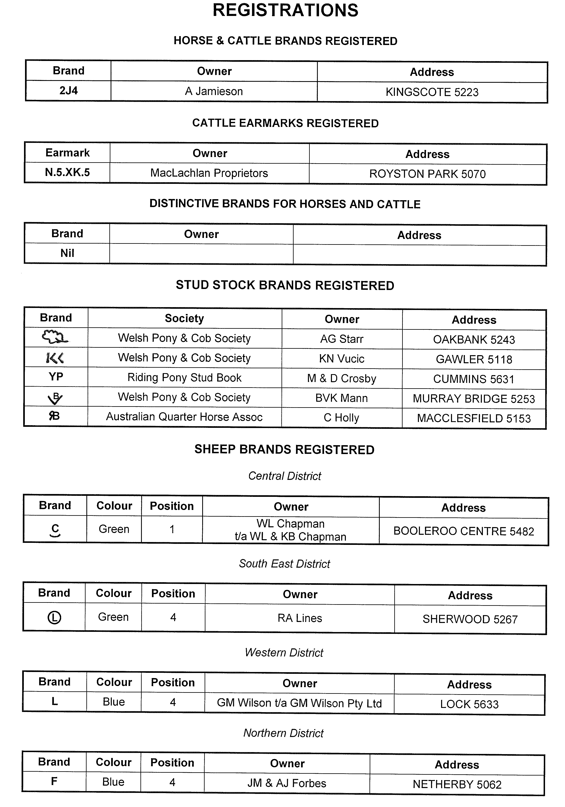
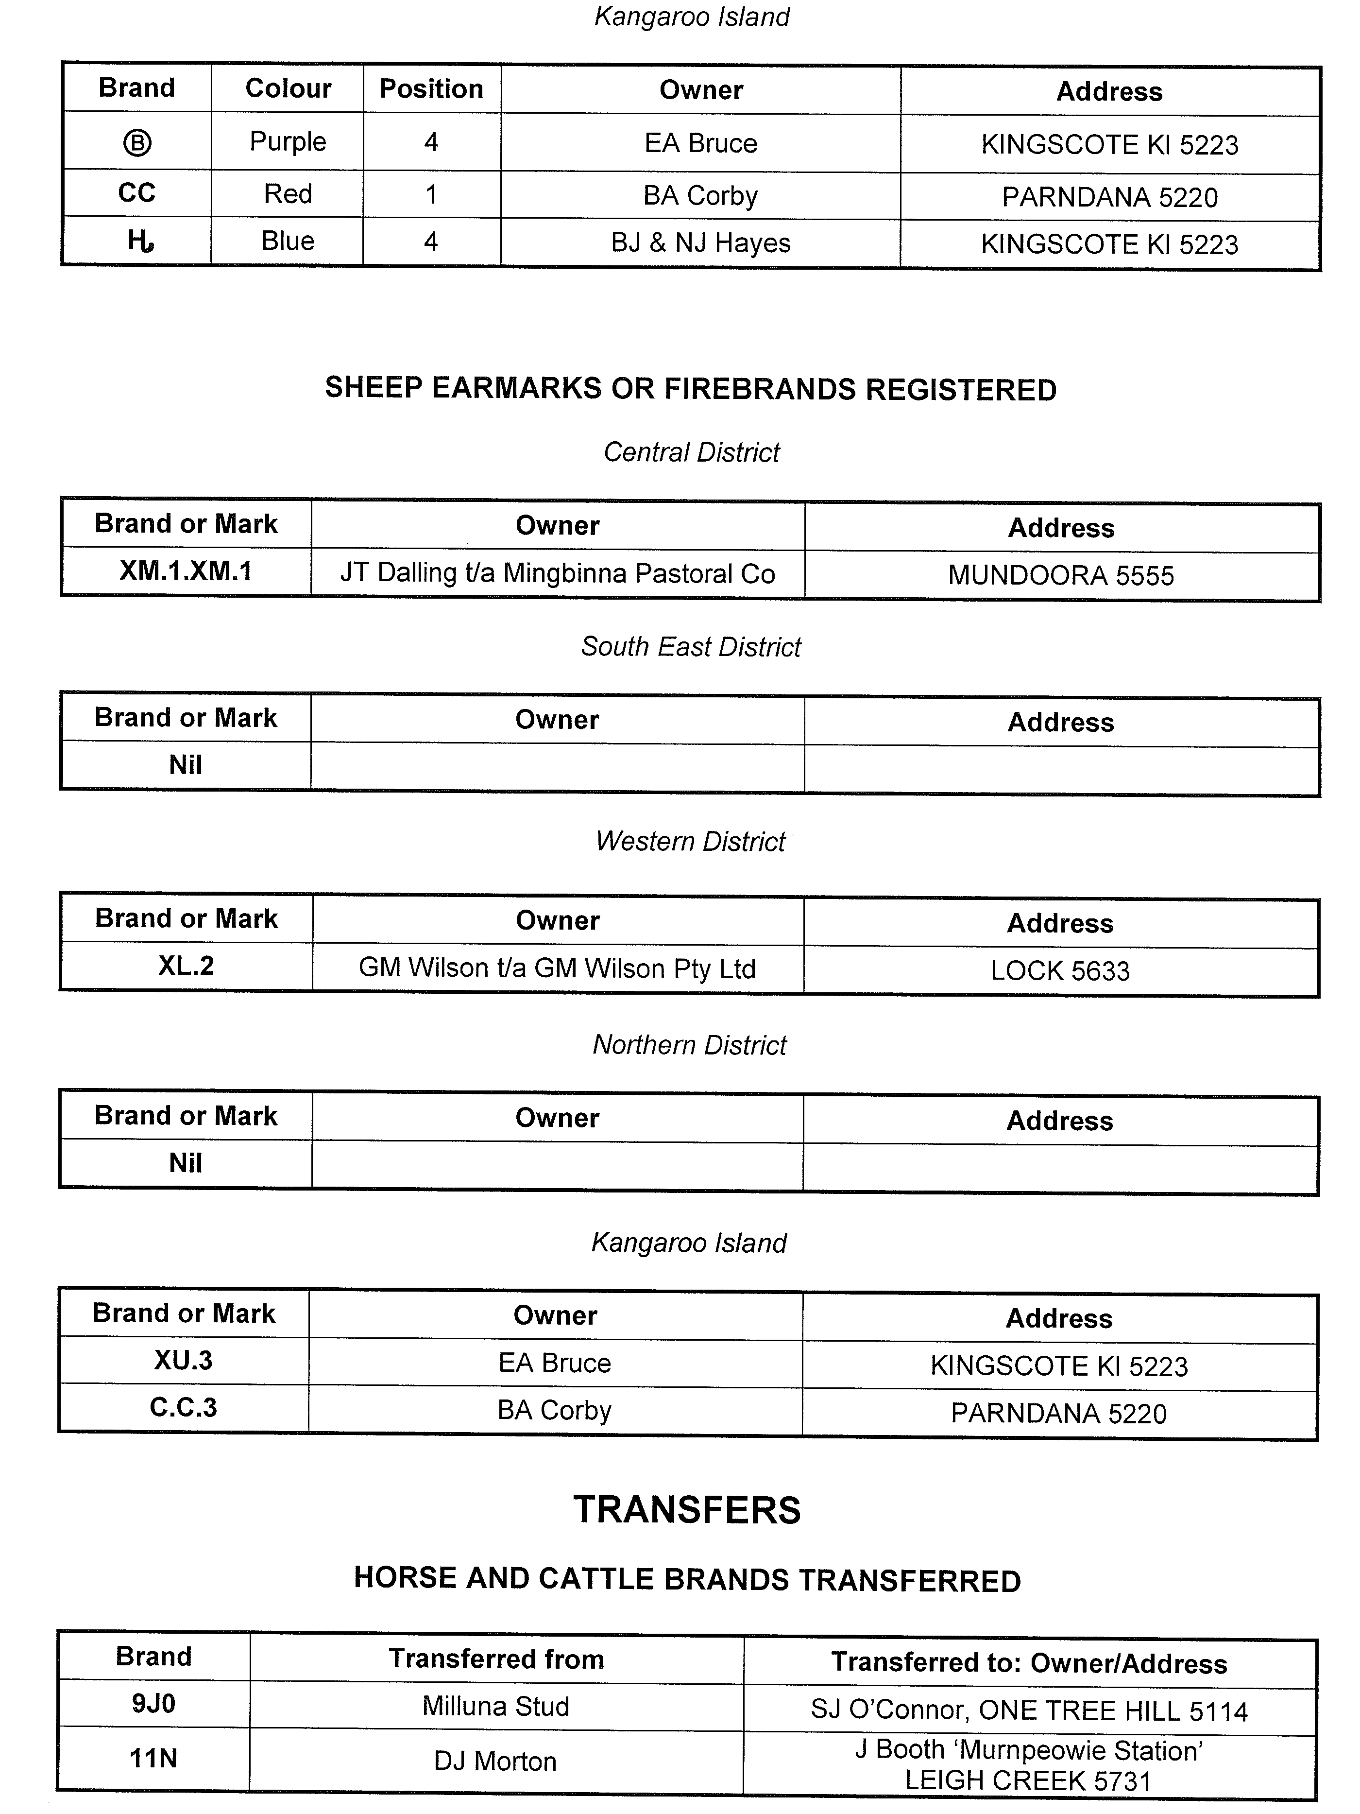
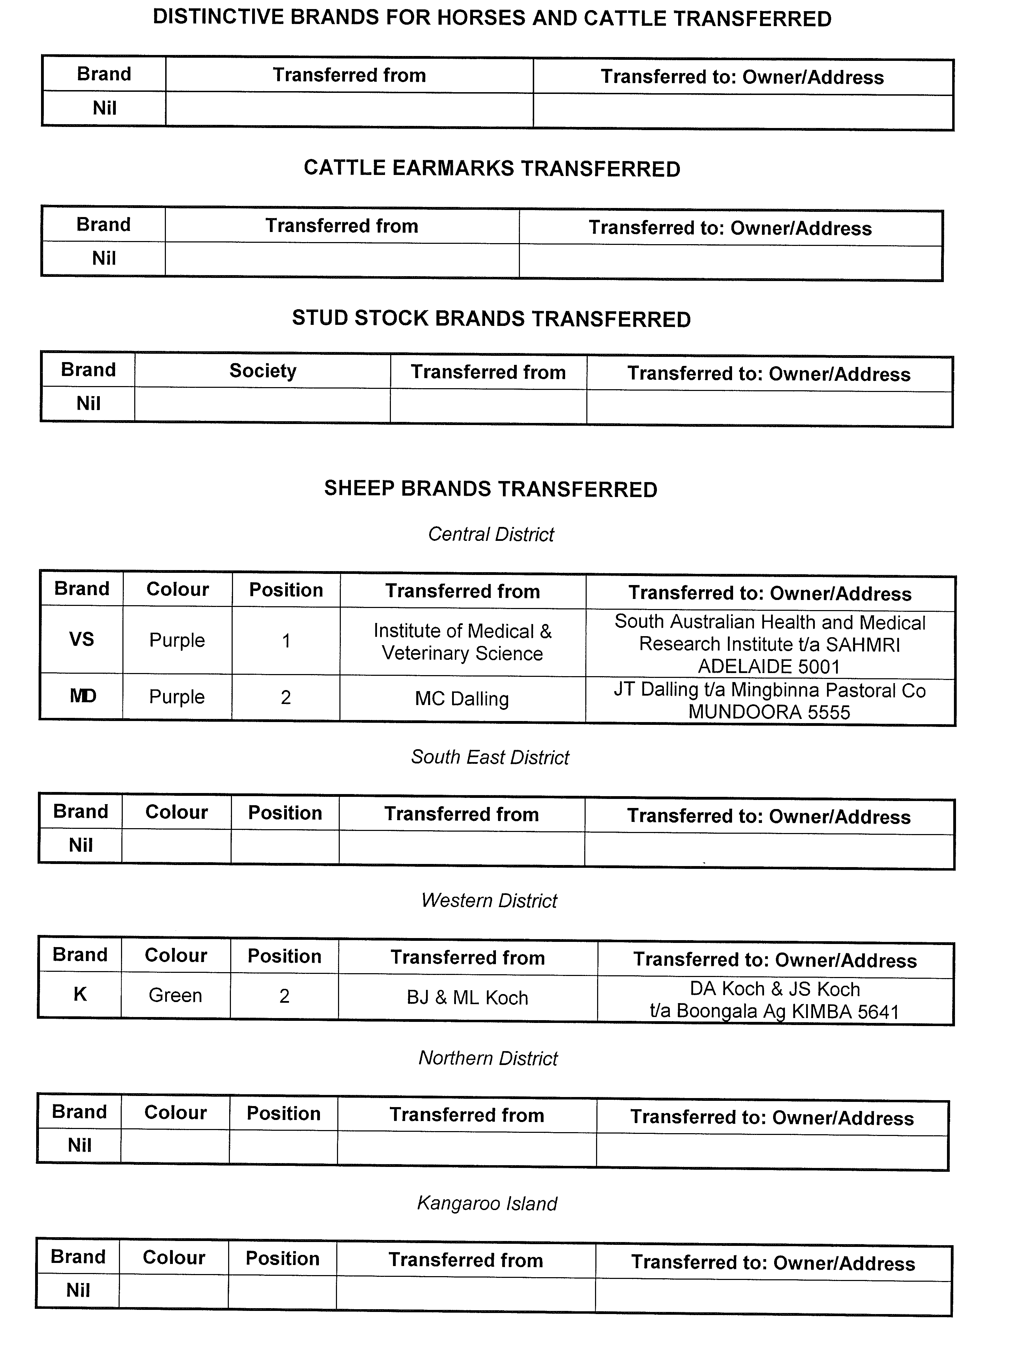
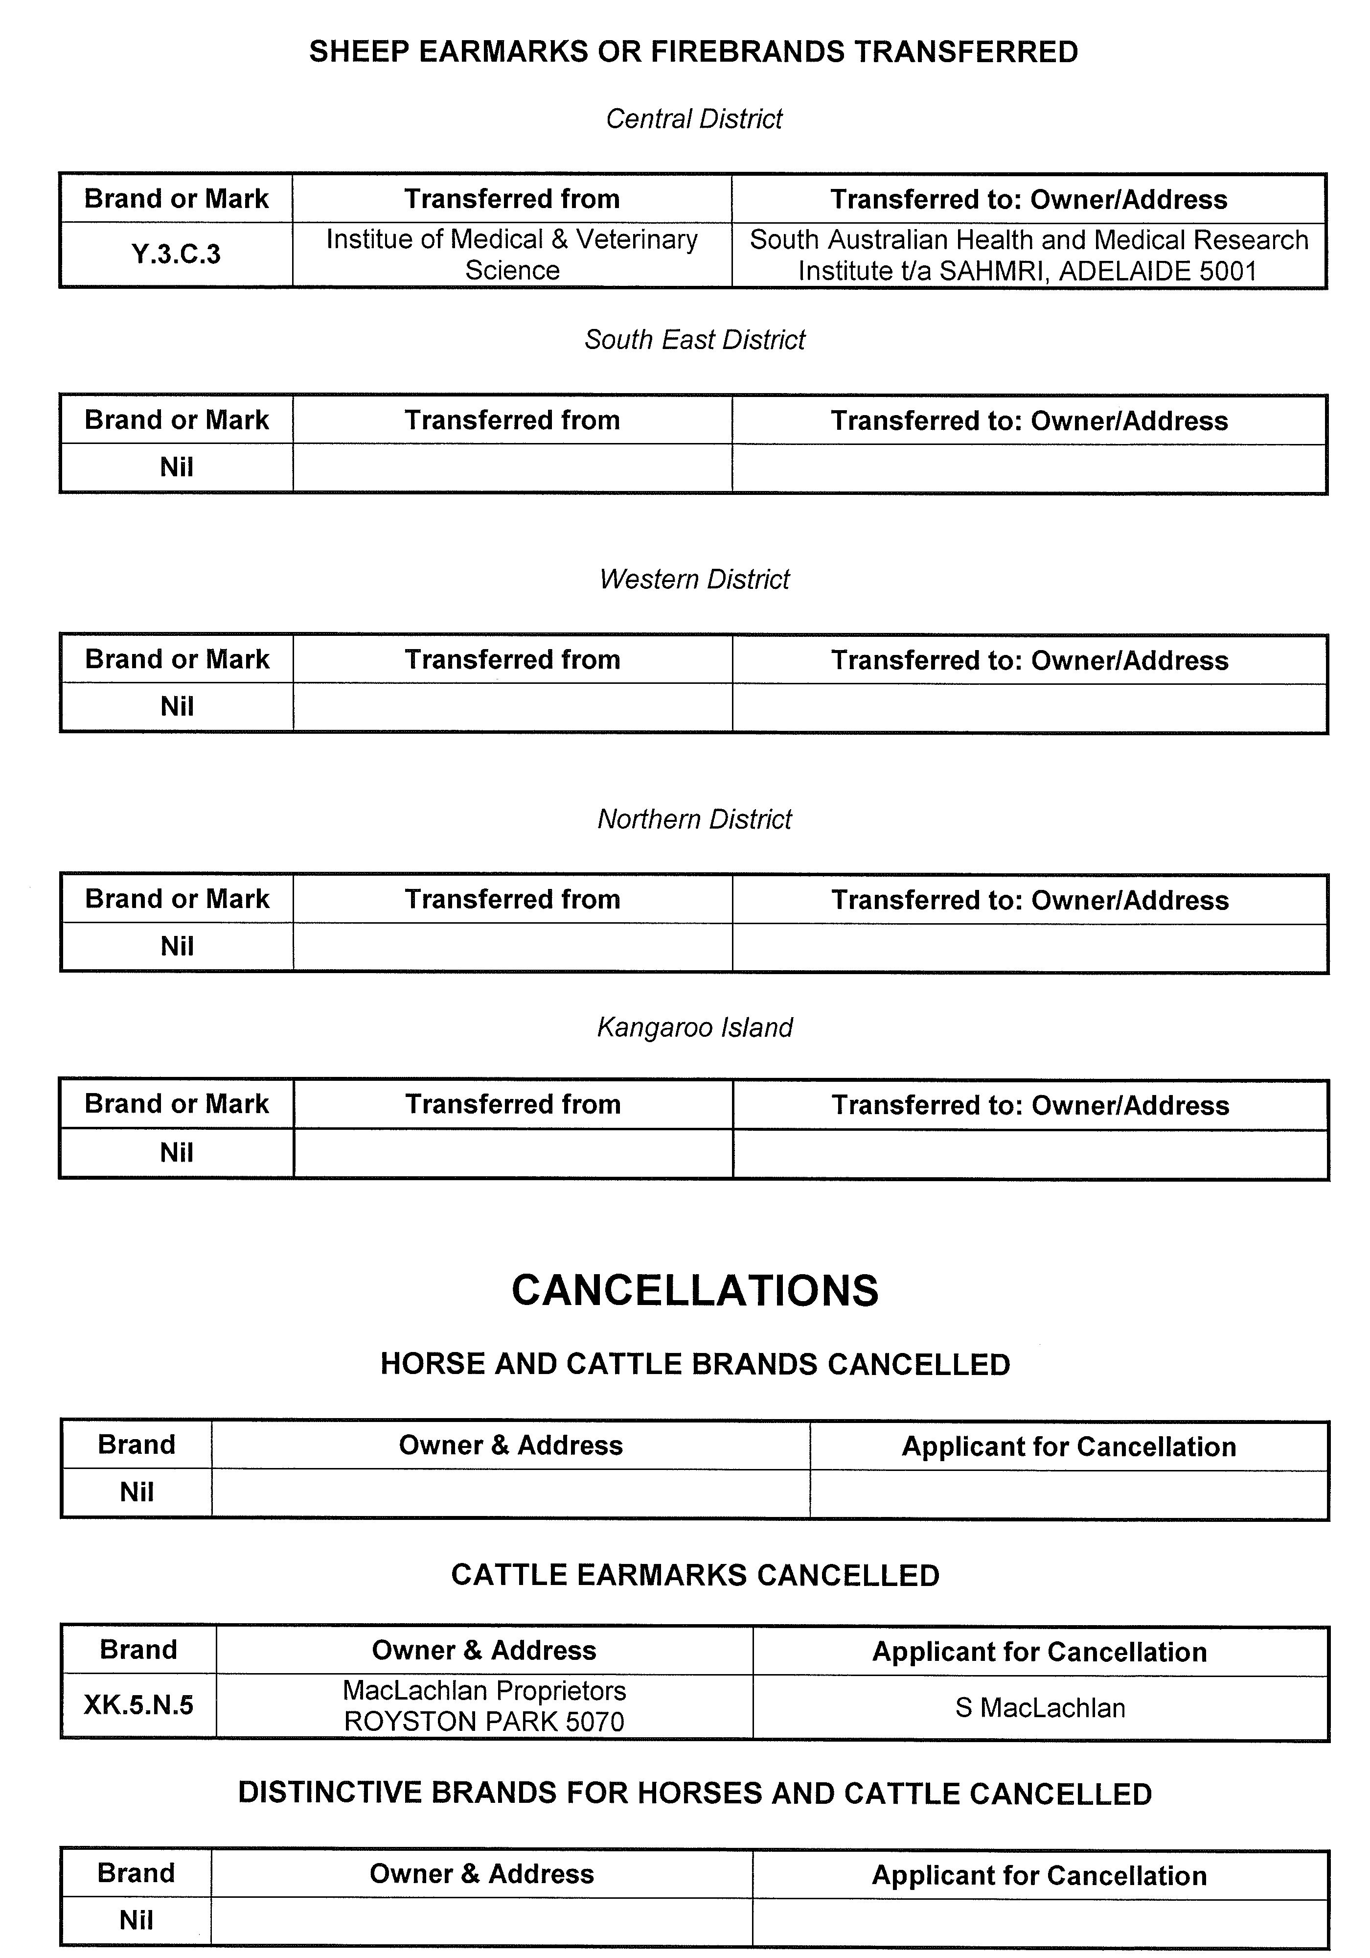
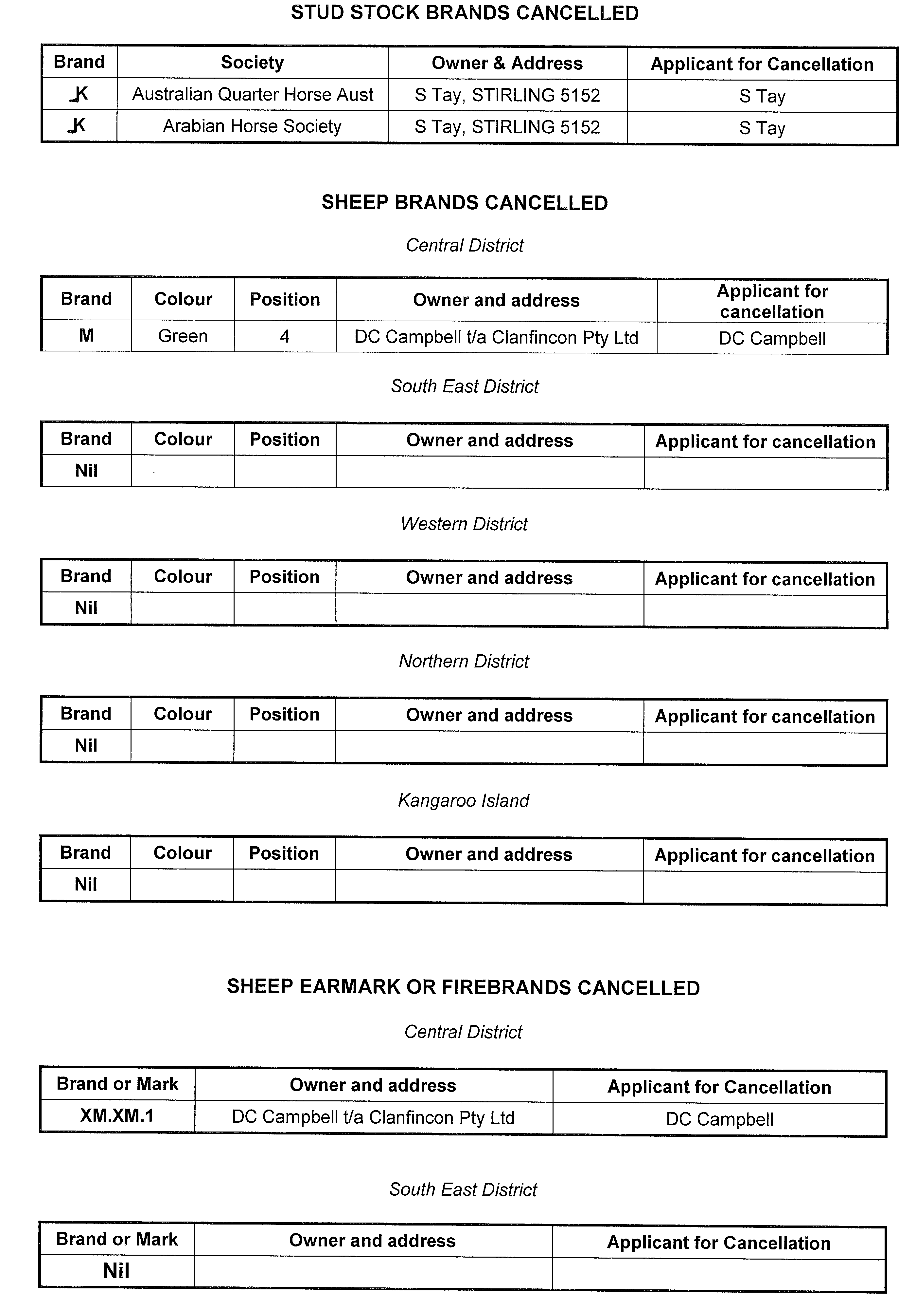

GOVERNMENT GAZETTE ADVERTISEMENT RATES

To apply from 1 July 2012

$  Agents, Ceasing to Act as 47.00  Associations:  Incorporation 23.80  Intention of Incorporation 59.00  Transfer of Properties 59.00  Attorney, Appointment of 47.00  Bailiff’s Sale 59.00  Cemetery Curator Appointed 34.75  Companies:  Alteration to Constitution 47.00  Capital, Increase or Decrease of 59.00  Ceasing to Carry on Business 34.75  Declaration of Dividend 34.75  Incorporation 47.00  Lost Share Certificates:  First Name 34.75  Each Subsequent Name 12.00  Meeting Final 39.25  Meeting Final Regarding Liquidator’s Report on  Conduct of Winding Up (equivalent to ‘Final  Meeting’)  First Name 47.00  Each Subsequent Name 12.00  Notices:  Call 59.00  Change of Name 23.80  Creditors 47.00  Creditors Compromise of Arrangement 47.00  Creditors (extraordinary resolution that ‘the Com-pany be wound up voluntarily and that a liquidator be appointed’) 59.00  Release of Liquidator⎯Application⎯Large Ad. 93.50  ⎯Release Granted 59.00  Receiver and Manager Appointed 54.00  Receiver and Manager Ceasing to Act 47.00  Restored Name 44.00  Petition to Supreme Court for Winding Up 81.50  Summons in Action 69.50  Order of Supreme Court for Winding Up Action 47.00  Register of Interests⎯Section 84 (1) Exempt 105.00  Removal of Office 23.80  Proof of Debts 47.00  Sales of Shares and Forfeiture 47.00  Estates:  Assigned 34.75  Deceased Persons⎯Notice to Creditors, etc. 59.00  Each Subsequent Name 12.00  Deceased Persons⎯Closed Estates 34.75  Each Subsequent Estate 1.55  Probate, Selling of 47.00  Public Trustee, each Estate 12.00 |  | $  Firms:  Ceasing to Carry on Business (each insertion) 31.25  Discontinuance Place of Business 31.25  Land⎯Real Property Act:  Intention to Sell, Notice of 59.00  Lost Certificate of Title Notices 59.00  Cancellation, Notice of (Strata Plan) 59.00  Mortgages:  Caveat Lodgement 23.80  Discharge of 24.90  Foreclosures 23.80  Transfer of 23.80  Sublet 12.00  Leases⎯Application for Transfer (2 insertions) each 12.00  Lost Treasury Receipts (3 insertions) each 34.75  Licensing 69.50  Municipal or District Councils:  Annual Financial Statement⎯Forms 1 and 2 657.00  Electricity Supply⎯Forms 19 and 20 467.00  Default in Payment of Rates:  First Name 93.50  Each Subsequent Name 12.00  Noxious Trade 34.75  Partnership, Dissolution of 34.75  Petitions (small) 23.80  Registered Building Societies (from Registrar-General) 23.80  Register of Unclaimed Moneys⎯First Name 34.75  Each Subsequent Name 12.00  Registers of Members⎯Three pages and over:  Rate per page (in 8pt) 299.00  Rate per page (in 6pt) 395.00  Sale of Land by Public Auction 59.50  Advertisements 3.30  ¼ page advertisement 139.00  ½ page advertisement 279.00  Full page advertisement 546.00  Advertisements, other than those listed are charged at $3.30 per column line, tabular one-third extra.  Notices by Colleges, Universities, Corporations and District Councils to be charged at $3.30 per line.  Where the notice inserted varies significantly in length from that which is usually published a charge of $3.30 per column line will be applied in lieu of advertisement rates listed.  South Australian Government publications are sold on the condition that they will not be reproduced without prior permission from the Government Printer.
All the above prices include GST

GOVERNMENT GAZETTE NOTICES
ALL private advertisements forwarded for publication in the South Australian Government Gazette must be PAID FOR PRIOR TO INSERTION; and all notices, from whatever source, should be legibly written on one side of the paper only and sent to Government Publishing SA so as to be received no later than 4 p.m. Tuesday preceding the day of publication. Phone 8207 1045 or Fax 8207 1040. E-mail: governmentgazette@dpc.sa.gov.au. Send as attachments in Word format. Please include date the notice is to be published and to whom the notice will be charged. The Government Gazette is available online at: www.governmentgazette.sa.gov.au.

MISCELLANEOUS LEGISLATION AND GOVERNMENT PUBLICATIONS PRICES AS FROM 1 JULY 2012

Acts, Bills, Rules, Parliamentary Papers and Regulations
Pages | Main | Amends | Pages | Main | Amends

1-16 | 2.90 | 1.35 | 497-512 | 39.75 | 38.75
17-32 | 3.80 | 2.40 | 513-528 | 40.75 | 39.50
33-48 | 5.00 | 3.55 | 529-544 | 42.25 | 40.75
49-64 | 6.30 | 4.85 | 545-560 | 43.50 | 42.25
65-80 | 7.35 | 6.10 | 561-576 | 44.50 | 43.50
81-96 | 8.55 | 7.10 | 577-592 | 46.00 | 44.00
97-112 | 9.75 | 8.35 | 593-608 | 47.25 | 45.50
113-128 | 10.90 | 9.60 | 609-624 | 48.00 | 47.00
129-144 | 12.20 | 10.80 | 625-640 | 49.25 | 47.50
145-160 | 13.40 | 12.00 | 641-656 | 50.50 | 49.25
161-176 | 14.60 | 13.20 | 657-672 | 51.50 | 49.75
177-192 | 15.90 | 14.40 | 673-688 | 53.00 | 51.50
193-208 | 17.10 | 15.80 | 689-704 | 54.00 | 52.00
209-224 | 18.10 | 16.70 | 705-720 | 55.50 | 53.50
225-240 | 19.30 | 17.90 | 721-736 | 57.00 | 54.50
241-257 | 20.80 | 18.90 | 737-752 | 57.50 | 56.00
258-272 | 21.90 | 20.00 | 753-768 | 59.00 | 57.00
273-288 | 23.00 | 21.70 | 769-784 | 60.00 | 59.00
289-304 | 24.10 | 22.60 | 785-800 | 61.00 | 60.00
305-320 | 25.50 | 24.00 | 801-816 | 62.50 | 60.50
321-336 | 26.50 | 25.10 | 817-832 | 63.50 | 62.50
337-352 | 27.90 | 26.25 | 833-848 | 65.00 | 63.50
353-368 | 28.75 | 27.75 | 849-864 | 66.00 | 64.50
369-384 | 30.25 | 28.75 | 865-880 | 67.50 | 66.00
385-400 | 31.50 | 30.00 | 881-896 | 68.00 | 66.50
401-416 | 32.75 | 31.00 | 897-912 | 69.50 | 68.00
417-432 | 34.00 | 32.50 | 913-928 | 70.00 | 69.50
433-448 | 35.00 | 33.75 | 929-944 | 71.50 | 70.00
449-464 | 36.00 | 34.50 | 945-960 | 72.50 | 71.00
465-480 | 36.50 | 35.75 | 961-976 | 75.50 | 72.00
481-496 | 38.75 | 36.50 | 977-992 | 76.50 | 72.50

Legislation—Acts, Regulations, etc: $
Subscriptions:
Acts 245.00
All Bills as Laid 589.00
Rules and Regulations 589.00
Parliamentary Papers 589.00
Bound Acts 272.00
Index 136.00
Government Gazette
Copy 6.45
Subscription 325.00
Hansard
Copy 17.90
Subscription—per session (issued weekly) 510.00
Cloth bound—per volume 219.00
Subscription—per session (issued daily) 510.00
Legislation on Disk
Whole Database 3 781.00
Annual Subscription for fortnightly updates 1 162.00
Individual Act(s) including updates POA
Notice of Vacancies
Annual Subscription 184.00
Compendium
Subscriptions:
New Subscriptions 2 239.00
Updates 790.00
(All the above prices include GST)

All Legislation, Government Gazette, Hansard and Legislation on disk are available from:
Counter Sales Government Legislation Outlet
and Mail Orders: Service SA Customer Service Centre,
Ground Floor—EDS Centre, 108 North Terrace, Adelaide, S.A. 5000
Phone: 13 23 24 (local call cost), Fax: (08) 8204 1909
Postal: G.P.O. Box 1707, Adelaide, S.A. 5001

Online Shop: www.shop.service.sa.gov.au

Subscriptions and Government Publishing SA
Standing Orders: Plaza Level, Riverside Centre, North Terrace, Adelaide, S.A. 5000
Phone: (08) 8207 1043, (08) 8207 0910, Fax: (08) 8207 1040

[Republished]
IN Government Gazette No. 71 dated 25 October 2012, on pages 4715 and 4716, was printed with typographical errors and should be replaced with the following:

HEALTH CARE ACT 2008
Section 62—Exemptions
Notice by the Minister
TAKE notice that I, John Hill, Minister for Health and Ageing, pursuant to sub-sections 62 (3) (a) and 62 (3) (b) of the Health Care Act 2008 (‘the Act’), do hereby revoke the exemptions granted, by notice dated 19 June 2012, for OneSteel Manufacturing Pty Ltd from the application of Part 6—Division 2 and Division 3, Section 59 of the Act, in relation to emergency and non-emergency ambulance services provided at Iron Baron mine site and in surrounding areas to Iron Baron mine site. This notice of revocation takes effect on 1 November 2012.
Dated 20 October 2012.
John Hill, Minister for Health and Ageing

HEALTH CARE ACT 2008
Section 62—Exemptions
Notice by the Minister
TAKE notice that I, John Hill, Minister for Health and Ageing, pursuant to sub-sections 62 (3) (a) and 62 (3) (b) of the Health Care Act 2008 (‘the Act’), do hereby revoke the exemptions granted, by notice dated 19 June 2012, for Leighton Contractors Pty Ltd from the application of Part 6—Division 2 and Division 3, Section 59 of the Act, in relation to emergency and non-emergency ambulance services provided at Iron Duke, Iron Duchess, Iron Knight and Iron Chieftain mine sites. This notice of revocation takes effect on 1 November 2012.
Dated 20 October 2012.
John Hill, Minister for Health and Ageing

HEALTH CARE ACT 2008
Sections 57 (1) (c) and 62—Exemptions
Notice by the Minister
TAKE notice that I, John Hill, Minister for Health and Ageing, pursuant to sub-section 57 (1) (c) and Section 62 of the Health Care Act 2008, do hereby exempt the person named in Column A of the Schedule from the application of Part 6—Division 2 and Division 3, Section 59 of the Health Care Act 2008, in relation to the emergency ambulance services specified in Column B of the Schedule, and on the conditions (if any) specified in Column C of the Schedule, with effect from 1 November 2012 and for the period expiring on 30 June 2013.
Schedule
Column A | Column B | Column C
Arrium Limited | emergency ambulance services provided at Iron Baron mine site | nil
Arrium Limited | emergency ambulance services provided in surrounding areas to Iron Baron mine site for purposes of rendezvousing with SA Ambulance Service | that the emergency ambulance services are provided either at the request of SA Ambulance Service or, in circumstances where SA Ambulance Service has not made a request, the organisation notifies SA Ambulance Service within a time and with details as requested by SA Ambulance Service
Arrium Limited | emergency ambulance services provided at Iron Duke, Iron Duchess, Iron Knight and Iron Chieftain mine sites | nil
Arrium Limited | emergency ambulance services provided in surrounding areas to Iron Duke, Iron Duchess, Iron Knight and Iron Chieftain mine sites for purposes of rendezvousing with SA Ambulance Service | that the emergency ambulance services are provided either at the request of SA Ambulance Service or, in circumstances where SA Ambulance Service has not made a request, the organisation notifies SA Ambulance Service within a time and with details as requested by SA Ambulance Service

Dated 20 October 2012.
John Hill, Minister for Health and Ageing

HEALTH CARE ACT 2008
Sections 58 (1) (d) and 62—Exemptions
Notice by the Minister
TAKE notice that I, John Hill, Minister for Health and Ageing, pursuant to sub-section 58 (1) (d) and Section 62 of the Health Care Act 2008, do hereby exempt the person named in Column A of the Schedule from the application of Part 6—Division 2 and Division 3, Section 59 of the Health Care Act 2008, in relation to the non-emergency ambulance services specified in Column B of the Schedule, and on the conditions (if any) specified in Column C of the Schedule, with effect from 1 November 2012 and for the period expiring on 30 June 2013.
Schedule
Column A | Column B | Column C
Arrium Limited | non-emergency ambulance services provided at Iron Baron mine site | nil
Arrium Limited | non-emergency ambulance services provided in surrounding areas to Iron Baron mine site for purposes of rendezvousing with SA Ambulance Service | that the organisation notifies SA Ambulance Service of each occasion that non-emergency ambulance services are provided within a time and with details as requested by SA Ambulance Service
Arrium Limited | non-emergency ambulance services provided at Iron Duke, Iron Duchess, Iron Knight and Iron Chieftain mine sites | nil
Arrium Limited | non-emergency ambulance services provided in surrounding areas to Iron Duke, Iron Duchess, Iron Knight and Iron Chieftain mine sites | that the organisation notifies SA Ambulance Service of each occasion that non-emergency ambulance services are provided within a time and with details as requested by SA Ambulance Service

Dated 20 October 2012.
John Hill, Minister for Health and Ageing

MINING ACT 1971
Notice pursuant to Section 29 (1a) and 29 (5) (b) (ii) of the Mining Act 1971
NOTICE is hereby given that the Notice under the Mining Act 1971 (‘the Act’) published on 27 September 2012 in the South Australian Government Gazette at page 4516, is varied in respect of land comprising 331 km² in the Lake Frome Area approximately 180 km east of Leigh Creek and hereinafter referred to as ‘ERA 113’.
Notice is further hereby given that:
(1) Pursuant to subsection 29 (1a) of the Act no applications may be made for a corresponding licence over ERA 113 during the succeeding period listed in Column 4 of the Schedule.
(2) Applications for a corresponding licence may be made during the period listed in Column 5 of the Schedule, and during that period, pursuant to subsection 29 (5) (b) (ii) of the Act, subsection 29 (4) of the Act will not apply in relation to any such applications. (See Note 1)
(3) Plans and co-ordinates for ERA 113 can be obtained at the DMITRE Minerals website:
http://www.minerals.dmitre.sa.gov.au/public_notices,
or by phoning Mineral Tenements on (08) 8463 3103.
(4) This notice becomes effective 1 November 2012.
The Schedule

Column 1 | Column 2 | Column 3 | Column 4 | Column 5 | Column 6
ERA No. | Locality | Area  (km²) | Moratorium Period | Applications  Open Dates | ERA Specific Criteria
113 | Lake Frome Area—Approximately 180 km east of Leigh Creek | 331 | 9 October 2012—  13 January 2013 | 14 January 2013—  18 January 2013 | Great Artesian Basin

Dated 1 November 2012.
J. Martin,
Mining Registrar,
Mineral Resources
Department for Manufacturing, Innovation, Trade, Resources and Energy
Delegate of the Minister for Mineral Resources and Energy (delegated powers
pursuant to Instrument of Delegation dated 31 October 2011)

Note 1: The effect of this notice is that:
• No applications for a corresponding licence may be made during the period 9 October 2012 to 13 January 2013.
• Applications for a corresponding licence may be made from 14 January 2013 to 18 January 2013 (inclusive).
• Applications for a corresponding licence made between 14 January 2013 to 18 January 2013 (inclusive) will not be dealt with under subsection 29 (4) of the Act, but under subsection 29 (6) of the Act, which is on a merits basis.
• If no applications for a corresponding licence are made between 14 January 2013 to 18 January 2013 (inclusive) applications for a corresponding licence made from 19 January 2013 onwards will be dealt with under subsection 29 (4).

MINING ACT 1971
ON 12 July 2012 and at pages 3084-3085 of the South Australian Government Gazette notice was given under subsections 29 (1a) and 29 (5) (b) of the Mining Act 1971 (‘the Notice’).
Confirmation is hereby given that:
(1) The land identified in Columns 1, 2, 3 and 6 of the Schedule became subject to the Notice on the date shown in Column 4 of the Schedule.
(2) Applications for corresponding licences may be made by interested parties in the week shown in Column 5 of the Schedule. Such applications will be dealt with on a merits basis.
(3) Plans and co-ordinates for the land identified in Columns 1, 2, 3 and 6 of the Schedule can be obtained at the DMITRE Minerals website:
http://www.minerals.dmitre.sa.gov.au/public_notices,
or by phoning Mineral Tenements on (08) 8463 3103.
The Schedule

Column 1 | Column 2 | Column 3 | Column 4 | Column 5 | Column 6
ERA No. | Locality | Area  (km²) | Moratorium Period | Applications  Open Dates | ERA Specific Criteria
108 | Elliston Area—Approximately 100 km south-east of Streaky Bay | 994 | 5 November 2012—  30 November 2012 | 3 December 2012—  7 December 2012 | County Musgrave Prescribed Wells Area
109 | Little Mount Finke Area—Approximately 40 km south-west of Tarcoola | 477 | 5 November 2012—  30 November 2012 | 3 December 2012—  7 December 2012 | Yellabinna Regional Reserve

Dated 1 November 2012.
J. Martin,
Mining Registrar,
Mineral Resources
Department for Manufacturing, Innovation, Trade, Resources and Energy
Delegate of the Minister for Mineral Resources and Energy (delegated powers
pursuant to Instrument of Delegation dated 31 October 2011)

MINING ACT 1971
ON 27 September 2012 and at page 4516 of the South Australian Government Gazette notice was given under subsections 29 (1a) and 29(5)(b) of the Mining Act 1971 (‘the Notice’).
Confirmation is hereby given that:
(1) The land identified in Columns 1, 2, 3 and 6 of the Schedule became subject to the Notice on the date shown in Column 4 of the Schedule.
(2) Applications for corresponding licences may be made by interested parties in the week shown in Column 5 of the Schedule. Such applications will be dealt with on a merits basis.
(3) Plans and co-ordinates for the land identified in Columns 1, 2, 3 and 6 of the Schedule can be obtained at the DMITRE Minerals website:
http://www.minerals.dmitre.sa.gov.au/public_notices,
or by phoning Mineral Tenements on (08) 8463 3103.
The Schedule

Column 1 | Column 2 | Column 3 | Column 4 | Column 5 | Column 6
ERA No. | Locality | Area  (km²) | Moratorium Period | Applications  Open Dates | ERA Specific Criteria
110 | Eucla Basin F Area—Approximately 190 km north-north-east of Cook | 976 | 18 October 2012—  2 December 2012 | 3 December 2012—  7 December 2012 | Aboriginal Land
111 | Woolatchie Area—Approximately 175 km east of Marree | 6 | 7 October 2012—  2 December 2012 | 3 December 2012—  7 December 2012 | Great Artesian Basin
112 | Hallett Area—Approximately 50 km north of Burra | 525 | 4 October 2012—  2 December 2012 | 3 December 2012—  7 December 2012 | —

Dated 1 November 2012.
J. Martin,
Mining Registrar,
Mineral Resources
Department for Manufacturing, Innovation, Trade, Resources and Energy
Delegate of the Minister for Mineral Resources and Energy (delegated powers
pursuant to Instrument of Delegation dated 31 October 2011)

MINING ACT 1971
On 16 August 2012 and at page 3498 of the South Australian Government Gazette notice was given under subsections 29 (1a) and 29 (5) (b) of the Mining Act 1971 (‘the Notice’).
Confirmation is hereby given that:
(1) The land identified in Columns 1, 2, 3 and 6 of the Schedule became subject to the Notice on the date shown in Column 4 of the Schedule.
(2) Applications for corresponding licences may be made by interested parties in the week shown in Column 5 of the Schedule. Such applications will be dealt with on a merits basis.
(3) Plans and co-ordinates for the land identified in Columns 1, 2, 3 and 6 of the Schedule can be obtained at the DMITRE Minerals website:
http://www.minerals.dmitre.sa.gov.au/public_notices,
or by phoning Mineral Tenements on (08) 8463 3103.
The Schedule

Column 1 | Column 2 | Column 3 | Column 4 | Column 5 | Column 6
ERA No. | Locality | Area  (km²) | Moratorium Period | Applications  Open Dates | ERA Specific Criteria
105 | Mount Samuel Area—Approximately 50 km south of Leigh Creek | 97 | 7 September 2012—  2 December 2012 | 3 December 2012—  7 December 2012 | Flinders Development Plan—Environmental Class A and B Zones
106 | Blue Hill Area—Approximately 30 km south-west of Marree | 54 | 7 September 2012—  2 December 2012 | 3 December 2012—  7 December 2012 | —
107 | Mount Middleback Area—Approximately 55 km south-west of Whyalla | 26 | 29 September 2012—  2 December 2012 | 3 December 2012—  7 December 2012 | Ironstone Hill Conservation Park (part)

Dated 1 November 2012.
J. Martin,
Mining Registrar,
Mineral Resources
Department for Manufacturing, Innovation, Trade, Resources and Energy
Delegate of the Minister for Mineral Resources and Energy (delegated powers
pursuant to Instrument of Delegation dated 31 October 2011)

Petroleum and Geothermal Energy Act 2000
Grant of Petroleum Exploration Licence—GEL 512
Notice is hereby given that the undermentioned Petroleum Exploration Licence has been granted under the provisions of the Petroleum and Geothermal Energy Act 2000, pursuant to delegated powers dated 21 March 2012.
No. of  Licence | Licensee | Locality | Date of Expiry
GEL 512 | Discovery Energy SA Ltd | Cooper Basin | 25 October 2017

Description of Area—PEL 512
All that part of the State of South Australia, bounded as follows:
Area 1
Commencing at a point being the intersection of latitude 27°15′00″S AGD66 and longitude 139°00′00″E AGD66, thence east to longitude 139°23′00″E GDA94, south to latitude 27°17′00″S GDA94, west to longitude 139°21′30″E GDA94, south to latitude 27°20′00″S GDA94, west to longitude 139°19′00″E GDA94, south to latitude 27°22′30″S GDA94, west to longitude 139°18′00″E GDA94, south to latitude 27°24′30″S GDA94, west to longitude 139°17′30″E GDA94, south to latitude 27°25′30″S GDA94, west to longitude 139°16′30″E GDA94, south to latitude 27°26′30″S GDA94, west to longitude 139°15′00″E GDA94, south to latitude 27°27′30″S GDA94, west to longitude 139°13′30″E GDA94, south to latitude 27°28′30″S GDA94, west to longitude 139°13′00″E GDA94, south to latitude 27°29′30″S GDA94, west to longitude 139°12′00″E GDA94, south to latitude 27°30′00″S GDA94, west to longitude 139°11′00″E GDA94, south to latitude 27°31′00″S GDA94, west to longitude 139°10′30″E GDA94, south to latitude 27°32′30″S GDA94, west to longitude 139°09′30″E GDA94, south to latitude 27°35′00″S AGD66, east to longitude 139°10′00″E GDA94, south to latitude 27°40′00″S GDA94, east to longitude 139°11′00″E GDA94, south to latitude 27°43′00″S GDA94, west to longitude 139°08′00″E GDA94, south to latitude 27°44′00″S GDA94, west to longitude 139°07′00″E GDA94, south to latitude 27°49′00″S GDA94, west to longitude 139°06′00″E GDA94, south to latitude 27°52′00″S GDA94, west to longitude 139°04′00″E GDA94, south to latitude 28°01′00″S GDA94, east to longitude 139°08′00″E GDA94, south to latitude 28°05′00″S AGD66, west to longitude 139°00′00″E AGD66 and north to the point of commencement.
Area 2
Commencing at a point being the intersection of latitude 28°00′25″S AGD66 and longitude 139°29′15″E AGD66, thence east to longitude 139°29′45″E AGD66, south to latitude 28°00′35″S AGD66, east to longitude 139°29′50″E AGD66, south to latitude 28°00′40″S AGD66, east to longitude 139°29′55″E AGD66, south to latitude 28°00′45″S AGD66, east to longitude 139°30′20″E AGD66, south to latitude 28°00′55″S AGD66, east to longitude 139°30′40″E AGD66, south to latitude 28°01′05″S AGD66, east to longitude 139°30′55″E AGD66, south to latitude 28°01′30″S AGD66, east to longitude 139°31′15″E AGD66, south to latitude 28°01′45″S AGD66, east to longitude 139°32′00″E AGD66, south to latitude 28°02′25″S AGD66, west to longitude 139°30′50″E AGD66, north to latitude 28°02′10″S AGD66, west to longitude 139°30′20″E AGD66, north to latitude 28°02′05″S AGD66, west to longitude 139°29′50″E AGD66, north to latitude 28°01′20″S AGD66, west to longitude 139°29′35″E AGD66, north to latitude 28°01′10″S AGD66, west to longitude 139°29′25″E AGD66, north to latitude 28°01′00″S AGD66, west to longitude 139°29′15″E AGD66 and north to the point of commencement.
Area 3
Commencing at a point being the intersection of latitude 28°05′00″S AGD66 and longitude 139°25′00″E AGD66, thence east to longitude 139°34′00″E GDA94, south to latitude 28°07′00″S GDA94, west to longitude 139°33′30″E GDA94, south to latitude 28°07′30″S GDA94, west to longitude 139°33′00″E GDA94, south to latitude 28°09′00″S GDA94, east to longitude 139°35′30″E GDA94, north to latitude 28°08′50″S AGD66, east to longitude 139°35′45″E AGD66, north to latitude 28°08′45″S AGD66, east to longitude 139°36′20″E AGD66, south to latitude 28°09′00″S AGD66, east to longitude 139°36′30″E GDA94, south to latitude 28°10′00″S AGD66, west to longitude 139°36′20″E AGD66, south to latitude 28°10′05″S AGD66, west to longitude 139°36′15″E AGD66, south to latitude 28°10′25″S AGD66, east to longitude 139°36′20″E AGD66, south to latitude 28°10′30″S AGD66, east to longitude 139°36′25″E AGD66, south to latitude 28°10′40″S AGD66, east to longitude 139°36′30″E AGD66, south to latitude 28°10′50″S AGD66, east to longitude 139°36′35″E AGD66, south to latitude 28°10′55″S AGD66, east to longitude 139°36′45″E AGD66, south to latitude 28°11′00″S AGD66, east to longitude 139°37′00″E GDA94, south to latitude 28°11′00″S GDA94, east to longitude 139°38′30″E GDA94, south to latitude 28°12′30″S GDA94, east to longitude 139°40′00″E GDA94, north to latitude 28°11′00″S GDA94, east to longitude 139°44′00″E GDA94, south to latitude 28°12′00″S GDA94, east to longitude 139°45′00″E GDA94, south to latitude 28°13′00″S GDA94, east to longitude 139°46′00″E GDA94, south to latitude 28°15′00″S AGD66, west to longitude 139°10′00″E AGD66, north to latitude 28°05′00″S AGD66, east to longitude 139°18′00″E GDA94, south to latitude 28°09′00″S GDA94, east to longitude 139°20′00″E GDA94, south to latitude 28°13′00″S GDA94, east to longitude 139°23′00″E GDA94, north to latitude 28°10′00″S GDA94, east to longitude 139°25′00″E AGD66 and north to the point of commencement.
Area: 2 366 km² approximately.
Dated 26 October 2012 .
B. A. Goldstein,
Executive Director,
Energy Resources Division,
Department for Manufacturing, Innovation, Trade, Resources and Energy
Delegate of the Minister for Mineral Resources and Energy

NATIONAL GAS LAW
THE Australian Energy Market Commission (AEMC) gives notice under the National Gas Law of the following matters.
Under Sections 311 and 313, the making of the National Gas Amendment (Reference service and rebateable service definitions) Rule 2012 No. 2 and related final determination. All provisions commence on 2 May 2013.
Further details and all documents on the above matter are available on the AEMC’s website www.aemc.gov.au. The relevant documents are also available for inspection at the offices of the AEMC.
Australian Energy Market Commission
Level 5, 201 Elizabeth Street
Sydney, N.S.W. 2000
Telephone: (02) 8296 7800
Facsimile: (02) 8296 7899
1 November 2012.

NATIONAL PARKS AND WILDLIFE (NATIONAL PARKS)
REGULATIONS 2001
Closure of Simpson Desert Regional Reserve and Simpson
Desert Conservation Park
PURSUANT to Regulations 8 (3) (a) and 8 (3) (d) of the National Parks and Wildlife (National Parks) Regulations 2001, I, Grant Anthony Pelton as Director Regional Co-ordination, Partnerships and Stewardship formerly entitled Director, Public Land Management and Operational Support, Regional Services, authorised delegate of the Director of National Parks and Wildlife, close to the public the whole of Simpson Desert Regional Reserve and the whole of Simpson Desert Conservation Park from: 6 p.m. on Friday, 30 November 2012 to 6 p.m. on Friday, March 15 2013.
The purpose of the closure is in the interest of public safety as a result of anticipated high daytime temperatures likely to be experienced in the reserves during the closure period.
Dated 25 October 2012.
G. A. Pelton, Director, Regional Co-ordination, Partnerships and Stewardship, Department of Environment Water and Natural Resources

NATIONAL PARKS AND WILDLIFE (NATIONAL PARKS) REGULATIONS 2001
National Parks and Wildlife Reserves—Fire Restrictions
PURSUANT to Regulation 16 of the National Parks and Wildlife (National Parks) Regulations 2001, I, Edward Gregory Leaman, Director of National Parks and Wildlife, and an authorised delegate of the co-management board of Flinders Ranges National Park, impose fire restrictions for National Parks and Wildlife Reserves as listed in Schedule 1 below.
The purpose of these fire restrictions is to ensure the safety of visitors using the Reserves, and in the interests of protecting the Reserves and neighbouring properties.
Dated 29 October 2012.
E. G. Leaman, Director of National Parks
and Wildlife

Schedule 1
1. Adelaide Metropolitan
All Reserves: All wood fires or solid fuel fires and gas fires are prohibited throughout the year.
For further information, please refer to the DEWNR website www.environment.sa.gov.au or contact the Black Hill office (08) 8336 0901 or CFS Fire Bans Hotline 1300 362 361.
2. Mount Lofty Ranges
Lofty Districts
Belair National Park: All wood fires or solid fuel fires are prohibited throughout the year. Gas fires are permitted in designated areas only, other than on days of total fire ban.
Exception: Designated fixed gas barbeques may be used on days of total fire ban other than when the Director has formally closed the Reserve in accordance with Regulation 8 (3) (b) of the National Parks and Wildlife (National Parks) Regulations 2001.
Black Hill Conservation Park, Brownhill Creek Recreation Park, Cleland Conservation Park, Mark Oliphant Conservation Park, Morialta Conservation Park, Mount George Conservation Park, Onkaparinga River National Park, Para Wirra Recreation Park, and Sandy Creek Conservation Park: All wood fires or solid fuel fires are prohibited throughout the year. Gas fires are permitted in designated areas only, other than on days of total fire ban.
All other Reserves: All wood fires or solid fuel fires and gas fires are prohibited throughout the year.
Fleurieu District
Gum Tree Gully Conservation Park, Hesperilla Conser-
vation Park and Newland Head Conservation Park: All wood fires or solid fuel fires are prohibited throughout the year. Gas fires are permitted, other than on days of total fire ban.
Currency Creek Game Reserve: All wood fires or solid fuel fires are prohibited from 15 November 2012 to 30 April 2013. Gas fires are permitted other than on days of total fire ban.
All other Reserves: All wood fires or solid fuel fires are prohibited from 1 December 2012 to 30 April 2013. Gas fires are permitted other than on days of total fire ban.
For further information, please refer to the DEWNR website www.environment.sa.gov.au or contact the Black Hill Office (08) 8336 0901 or Victor Harbor Office (08) 8552 3677 or CFS Fire Bans Hotline 1300 362 361.
3. Kangaroo Island
Lashmar Conservation Park: All wood fires or solid fuel fires are prohibited throughout the year. Gas fires are permitted other than on days of total fire ban.
Exception: Antechamber Bay Campground: All wood fires or solid fuel fires are prohibited from 1 December 2012 to
30 April 2013, fires are permitted outside of these dates in designated areas only. Gas fires are permitted other than on days of total fire ban.
All other Reserves: All wood fires or solid fuel fires are prohibited throughout the year. Gas fires are permitted other than on days of total fire ban.
For further information, please refer to the DEWNR website www.environment.sa.gov.au or contact the Kingscote Office (08) 8553 4444 or Flinders Chase National Park (08) 8553 4450 or CFS Fire Bans Hotline 1300 362 361.
4. Yorke Peninsula
Innes National Park: All wood fires or solid fuel fires are prohibited from 15 November 2012 to 30 April 2013; fires are permitted outside of these dates in designated areas only. Gas fires are permitted other than on days of total fire ban.
All other Reserves: All wood fires or solid fuel fires are prohibited throughout the year. Gas fires are permitted other than on days of total fire ban.
For further information, please refer to the DEWNR website www.environment.sa.gov.au or contact the Clare Office (08) 8841 3400 or CFS Fire Bans Hotline 1300 362 361.
5. Mid North
Spring Gully Conservation Park, Mokota Conservation Park: All wood fires or solid fuel fires and gas fires are prohibited throughout the year.
All other Reserves: All wood fires or solid fuel fires are prohibited from 15 November 2012 to 30 April 2013. Gas fires are permitted other than on days of total fire ban.
For further information, please refer to the DEWNR website www.environment.sa.gov.au or contact the Clare Office (08) 8841 3400 or CFS Fire Bans Hotline 1300 362 361.
6. Flinders
Flinders Ranges National Park: All wood fires or solid fuel fires are prohibited from 1 November 2012 to 15 April 2013; fires are permitted outside of these dates in designated areas only. Gas fires are permitted other than on days of total fire ban.
Exception: Wilpena Pound: All wood fires, solid fuel fires or gas fires are prohibited throughout the year other than at Cooinda Camp where gas fires are permitted other than on days of total fire ban.
Mount Remarkable National Park: All wood fires or solid fuel fires are prohibited throughout the year. Gas fires are permitted other than on days of total fire ban.
Exception: Mambray Creek Campground: All wood fires or solid fuel fires are prohibited from 1 November 2012 to
15 April 2013, fires are permitted outside of these dates in designated areas only. Gas fires are permitted other than on days of total fire ban.
All other Reserves: All wood fires or solid fuel fires are prohibited throughout the year. Gas fires are permitted other than on days of total fire ban.
For further information, please refer to the DEWNR website www.environment.sa.gov.au or contact the Port Augusta Office (08) 8648 5300 or Wilpena Visitor Centre (08) 8648 0048 or CFS Fire Bans Hotline 1300 362 361.
7. Lower South East
Bool Lagoon Game Reserve, Ewens Ponds Conservation Park, Lake Frome Conservation Park, Lower Glenelg River Conservation Park: All wood fires or solid fuel fires are prohibited throughout the year. Gas fires are permitted other than on days of total fire ban.
Little Dip Conservation Park and Piccaninnie Conservation Park: All wood fires or solid fuel fires are prohibited throughout the year. Gas fires are permitted other than on days of total fire ban.
Exception: Ocean beach foreshores: Wood fires or solid fuel fires are permitted between high water mark and low water mark, other than on days of total fire ban. Gas fires are permitted other than on days of total fire ban.
All other Reserves: All wood fires or solid fuel fires are prohibited from 22 November 2012 to 30 April 2013. Gas fires are permitted other than on days of total fire ban.
For further information, please refer to the DEWNR website www.environment.sa.gov.au or contact the Mount Gambier Office (08) 8735 1177 or CFS Fire Bans Hotline 1300 362 361.

NATURAL RESOURCES MANAGEMENT ACT 2004
Notice of Authorisation to Take Water from the Central Adelaide Prescribed Wells Area
PURSUANT to Section 128 of the Natural Resources Manage-
ment Act 2004 (the Act), I, Paul Caica, Minister for Sustainability, Environment and Conservation (the Minister) in the State of South Australia and the Minister to whom the Act is committed, hereby authorise the taking of water from the Central Adelaide Prescribed Wells Area from the prescribed wells specified in Schedule A, for the purposes set out in Schedule B and subject to the conditions specified in Schedule C.
Schedule A
Prescribed Wells
Well unit numbers 6628-24566 and 6628-24567 both located within Crown Record 5943/442 in the Hundred of Adelaide.
Schedule B
Purpose
For irrigation of the Adelaide Botanic Garden and Botanic Park.
Schedule C
Conditions
1. Water may only be taken during the following periods:
(a) from the date of the publication of this notice to 30 June 2013;
(b) 1 July 2013 to 30 June 2014; and
(c) 1 July 2014 to 30 June 2015.
2. A maximum volume of 200 megalitres of water may be taken from the prescribed wells specified in Schedule A during each of the periods referred to in Clause 1 above.
3. The water user must not take water except through a meter or meters in order to determine the quantity of water taken for the purposes of this notice.
4. The meter or meters must be installed in accordance with South Australian Licensed Water Use Meter Specification approved by the Minister as amended from time to time.
The water user must comply with the provisions applying to meters set out in Regulation 14 of the Natural Resources Management (Financial Provisions) Regulations 2005. It is an offence to contravene or fail to comply with those provisions.
For the purposes of this notice: Adelaide Botanic Garden and Botanic Park have the same meaning as defined from time to time in the Botanic Gardens and State Herbarium Regulations 2007.
Words used in this authorisation that are defined in the Act shall have the meanings as set out in the Act.
This authorisation will commence on the date below and will remain in effect until 30 June 2015 unless earlier varied or revoked.
Dated 28 October 2012.
Paul Caica, Minister for Sustainability, Environment and Conservation

PASSENGER TRANSPORT ACT 1994 AND
PASSENGER TRANSPORT REGULATIONS 2009
PURSUANT to Section 45 (5) of the Passenger Transport Act 1994, I, Patrick Conlon, Acting Minister for Transport Services, hereby impose the following additional conditions upon a taxi licence if the taxi-cab (taxi) has a terminal for electronic payment of fares and any other authorised charges, including payments by credit and debit card and Electronic Funds Transfer at Point of Sale (EFTPOS):
(1) The terminal must be linked by a cable connection or encrypted wireless communication to the taxi and be programmed with the taxi licence number in which it is fitted and used; and
(2) The taxi is not permitted to ply for hire unless:
(a) The service provider for the EFTPOS, electronic financial transaction for the electronic payment of fares and other authorised charges has been approved by the Accreditation and Licensing Centre, Department of Planning, Transport and Infrastructure; and
(b) The EFTPOS terminal is fully operational and accurate, except where there is a temporary failure or malfunction on the part of the service provider for the electronic financial transaction or its network, and such failure or malfunction is not attributable to the driver’s actions, fault with the operation of the taxi or with equipment (including electronic payment facilities) fitted to the taxi-cab.
Pursuant to Section 31 (1) (b) of the Passenger Transport Act 1994, I, Patrick Conlon, Acting Minister for Transport Services, hereby impose the following additional conditions where the accredited person (‘driver’) is driving a vehicle for a taxi service:
(1) The driver must only use a terminal for electronic payment of fares and any other authorised charges, including payments by credit and debit card and EFTPOS, if that terminal is linked by a cable connection wire or encrypted wireless communication to the taxi, and it is programmed with the taxi licence number in which it is fitted and which has been approved by the DPTI, upon application from the licence holder (vehicle owner) of the taxi and has been advised to the Centralised Booking Service to which that taxi belongs.
(2) If there is a failure or malfunction of the terminal, the driver must inform the person who hires a taxi of that failure or malfunction at the start of the journey if the driver has prior knowledge of the failure or malfunction and, if otherwise, as soon as practicable after that failure or malfunction is known to the driver.
(3) When a fare for a hiring of a taxi is paid by a credit or debit card, the driver must produce a printed receipt and provide this receipt to the person who hires the taxi, or the person making payment for the fare (if that person is not the person who hired the taxi), or at any other time upon request. The printed receipt must include the following:
(a) the driver’s signature, unless the receipt has been produced using electronic facilities;
(b) the licence number of the taxi;
(c) the driver’s accreditation number at the time of the transaction;
(d) the driver’s Australian Business Number (ABN);
(e) the Centralised Booking Service to which the taxi is affiliated;
(f) the actual location at which the fare was picked up and dropped off (e.g. landmark name, such as Adelaide Airport, the street address or, at the least, the name of the suburb);
(g) the service provider for the electronic financial transaction;
(h) the details of the credit or debit card used;
(i) all the items which make up the fare or other charges, including separately identified metered fare, GST amounts, and any additional rates and charges (including service fees for the electronic financial transaction);
(j) the total amount paid; and
(k) the time and date of the payment.
(4) Any additional rates and charges (including service fees for the electronic financial transaction) for the service provider(s) for the electronic financial transactions for the electronic payment of fares and other authorised charges are clearly displayed in the taxi.
Pursuant to Regulation 64 (4) (c) of the Passenger Transport Regulations 2009, I, Patrick Conlon, Acting Minister for Transport Services, have determined that the driver of a taxi must accept, in satisfaction of the fare for the hiring of the taxi, payment of the amount of the fare by electronic payment facilities to process a payment, if those facilities are installed in the taxi and if the credit or debit card tendered by the person who has hired the taxi is suitable for that use and accepted by the service provider for the electronic financial transaction, unless there is a failure or malfunction of the terminal, in which circumstances the driver must accept a manual payment alternative using credit or debit facilities.
Pursuant to Regulation 65 (5) (c) of the Passenger Transport Regulations 2009, I, Patrick Conlon, Acting Minister for Transport Services, have determined that a person who hires a taxi must, unless otherwise agreed, pay the legal fare to the driver, and if the person has requested a payment of a fare by an electronic payment facility, tender a credit or debit card suitable for that use.
The conditions imposed by me under Section 45 (5) and 31 (1) (b) of the Passenger Transport Act 1994, and the determinations made by me under Regulation 64 (4) (c) and 64 (5) (c) of the Passenger Transport Regulations 2009, will be effective as of 12.01 a.m. on 1 November 2012.
Taxi licence holders (vehicle owners) must register the compliant EFTPOS facility/facilities to be used with each taxi, with the Accreditation and Licensing Centre, DPTI for approval and advise the relevant Centralised Booking Service(s) by 5 p.m. on 30 November 2012.
Dated 8 October 2012.
Patrick Conlon, Acting Minister for
Transport Services

PUBLIC INTOXICATION ACT 1984
Notice by the Minister for Mental Health and Substance Abuse
Approval of Places Pursuant to Subsection 7 (3) (b) of the
Public Intoxication Act 1984
I, JOHN HILL, Minister for Mental Health and Substance Abuse, hereby approve the places specified in the Schedule to be places for the purposes of paragraph (b) of subsection 7 (3) of the Public Intoxication Act 1984.
The Minister for Mental Health and Substance Abuse may vary or revoke this Notice at any time.
Schedule
Place |  | Address
Ceduna Sobering Up Unit |  | Dowling Crescent, Ceduna, S.A. 5690
Mission Australia Youth Sobering Up Service |  | 5 Milner Street, Hindmarsh, S.A. 5007
Port Augusta Substance Misuse Service—Sobering Up Unit |  | 5 Elizabeth Terrace, Port Augusta, S.A. 5700
The Salvation Army Sobering Up Unit |  | 62A Whitmore Square, Adelaide, S.A. 5000
Umoona Community Council Sobering Up Centre |  | 8 Umoona Road, Coober Pedy, S.A. 5723
Dated 24 October 2012.
John Hill, Minister for Mental Health and Substance Abuse

ROADS (OPENING AND CLOSING) ACT 1991:
SECTION 24
NOTICE OF CONFIRMATION OF ROAD
PROCESS ORDER
Road Closure—Ridge Terrace/Williams Road, Millicent
BY Road Process Order made on 23 May 2012, the Wattle Range Council ordered that:
1. Portions of Ridge Terrace and Williams Road situate adjoining North Terrace, Sections 451, 455 and 1003, Hundred of Mount Muirhead and Allotment 81 in Filed Plan 192053, as more particularly delineated and lettered ‘A’, ‘B’, ‘C’, ‘E’ and the greater portion of ‘D’ on Preliminary Plan No. 11/0049 be closed.
2. Issue Certificates of Title to the Wattle Range Council for the whole of the land subject to closure lettered ‘A’ and the greater portion of ‘D’ which lands are being retained by Council for merging with the adjoining Council owned lands.
3. Issue Certificates of Title to the Wattle Range Council for the whole of the land subject to closure lettered ‘B’ and ‘C’ which lands are being retained by Council for public purposes.
4. Add the whole of the land subject to closure lettered ‘E’ to Section 455, Hundred of Mount Muirhead, which land is dedicated under the Crown Lands Act 1929, for Drainage Purposes
5. The following easements are granted over portions of the land subject to that closure:
Grant to the South Australian Water Corporation easements for water supply and sewerage purposes.
Grant to the Wattle Range Council easements for drainage purposes.
On 20 June 2012 that order was confirmed by the Minister for Transport and Infrastructure conditionally upon the deposit by the Registrar-General of Deposited Plan 89547 being the authority for the new boundaries.
Pursuant to Section 24 (5) of the Roads (Opening and Closing) Act 1991, NOTICE of the order referred to above and its confirmation is hereby given.
Dated 1 November 2012.
K. A. Nisbet, Acting Surveyor-General

SHOP TRADING HOURS ACT 1977
Trading Hours—Exemption
NOTICE is hereby given that pursuant to Section 5 (9) (b) of the Shop Trading Hours Act 1977 (the Act), I, Russell Wortley, Minister for Industrial Relations, do hereby declare non-exempt shops, excluding shops that are solely or predominantly the retail sale of motor vehicles or boats, situated within the Greater Adelaide Shopping District exempt from the provisions of the Act, subject to the following conditions:
• Exemption will apply between the hours of:
— 9 a.m. and 11 a.m. on Sundays, 2 December 2012;
9 December 2012; 16 December 2012 and 23 December 2012; and
— 9 p.m. and 12 midnight on Thursdays, 13 December 2012; 20 December 2012 and Friday, 21 December 2012.
• Normal trading hours prescribed by Section 13 of the Act shall apply at all other times.
• All employees working during these extended hours will do so on a strictly voluntary basis.
• Any and all relevant industrial instruments are to be complied with.
• All occupational health, safety and welfare issues (in particular those relating to extended trading hours) must be appropriately addressed.
Dated 29 October 2012.
Russell Wortley, Minister for Industrial Relations

WATER MAINS AND SEWERS

Office of the South Australian Water Corporation
Adelaide, 1 November 2012

WATER MAINS LAID

Notice is hereby given that the following main pipes or parts of main pipes have been laid down by the South Australian Water Corporation in or near the undermentioned water districts and are now available for a constant supply of water to adjacent land.

ADELAIDE WATER DISTRICT

TOWN OF GAWLER
Across Hillier Road, Evanston. p28
Easements in lot 64 in LTRO DP 82903, Hillier Road, Evanston. p28

CITY OF HOLDFAST BAY
King Street, Glenelg North. p35

CITY OF ONKAPARINGA
Across and in Almond Grove Road, Whites Valley. p9, 10 and 16
Waterworks land (lot 1 in LTRO DP 25583), Aldinga Road, Whites Valley. p9, 10 and 16
Across and in Aldinga Road, Whites Valley. p9-11 and 16
In and across Biscay Road, Whites Valley and Aldinga. p9 and 11-15
Public road north of lot 16 in LTRO DP 24336, Aldinga. p9 and 15
Plains Road, Aldinga. p9 and 15

CITY OF PORT ADELAIDE ENFIELD
Days Road, Angle Park. p17
In and across Murray Street, Angle Park. p17
Orkney Street, Angle Park. p17
In and across Briens Road, Northfield and Gepps Cross. p27
Hanson Road, Wingfield. p34
Princes Street, Wingfield. p34

BAROSSA COUNTRY LANDS WATER DISTRICT

THE BAROSSA COUNCIL
In and across Balmoral Road, Cockatoo Valley. p29-33
The Barracks, Cockatoo Valley. p29 and 32

NANGWARRY WATER DISTRICT

WATTLE RANGE COUNCIL
Across and in Beadnall Drive, Nangwarry. p39

TOD RIVER COUNTRY LANDS WATER DISTRICT

DISTRICT COUNCIL OF KIMBA
In and across Eyre Highway, Kelly. This main is available on application only. p46-49

TOWNSHIP OF WAROOKA WATER DISTRICT

DISTRICT COUNCIL OF YORKE PENINSULA
Fourth Street, Warooka. p38

WATER MAINS ABANDONED

Notice is hereby given that the undermentioned water mains have been abandoned by the South Australian Water Corporation.

ADELAIDE WATER DISTRICT

CITY OF HOLDFAST BAY
King Street, Glenelg North. p35

CITY OF ONKAPARINGA

Aldinga Road, Whites Valley. p9, 10 and 16
Easement in lot 2117 in LTRO DP 46284, Lynton Terrace, Seaford. p36

CITY OF PORT ADELAIDE ENFIELD
Days Road, Angle Park. p17
In and across Murray Street, Angle Park. p17
Orkney Street, Angle Park. p17

BAROSSA COUNTRY LANDS WATER DISTRICT

THE BAROSSA COUNCIL
Balmoral Road, Cockatoo Valley. p29 and 30

NANGWARRY WATER DISTRICT

WATTLE RANGE COUNCIL
Across and in Beadnall Drive, Nangwarry. p39

TOD RIVER COUNTRY LANDS WATER DISTRICT

DISTRICT COUNCIL OF KIMBA
Eyre Highway, Kelly. p46

OUTSIDE NANGWARRY WATER DISTRICT

WATTLE RANGE COUNCIL
Waterworks land (lot 11 in LTRO DP 45617), Beadnall Drive, Nangwarry. p39
Easements in lot 10 in LTRO DP 45617, Beadnall Drive, Nangwarry. p39

WATER MAINS LAID

Notice is hereby given that the undermentioned water mains have been laid down by the South Australian Water Corporation and are not available for a constant supply of water to adjacent land.

YORKE PENINSULA COUNTRY LANDS WATER DISTRICT

DISTRICT COUNCIL OF YORKE PENINSULA
Waterworks land (lot 729 in LTRO FP 196151), Bublacowie Road, Minlaton. p57-62
Across Bublacowie Road, Minlaton. p57-62
Waterworks land (lot 194 in LTRO FP 195616), New Honiton Road, Edithburgh. p63-65

OUTSIDE NANGWARRY WATER DISTRICT

WATTLE RANGE COUNCIL
Waterworks land (lot 11 in LTRO DP 45617), Beadnall Drive, Nangwarry. p39 and 40
Easements in lot 10 in LTRO DP 45617, Beadnall Drive, Nangwarry. p39 and 40

OUTSIDE WATER DISTRICTS

OUTSIDE DISTRICT COUNCILS
Waterworks land (section 23, hundred of Handyside), Eyre Highway. p1-8
Waterworks land (section 13, hundred of Handyside), Eyre Highway. p1-8

SEWERS LAID

Notice is hereby given that the following sewers have been laid down by the South Australian Water Corporation in the undermentioned drainage area and are now available for house connections.

ADELAIDE DRAINAGE AREA

ADELAIDE CITY COUNCIL
Glen Osmond Road, Adelaide. FB 1221 p58
Easement in section 1207, hundred of Adelaide, North Terrace, Adelaide. FB 1223 p6
Across Victoria Drive, Adelaide. FB 1223 p6
Easements in allotment piece 22 in LTRO FP 38386, Frome Road, Adelaide. FB 1223 p6
Across Frome Road, Adelaide. FB 1223 p6
Easements in section 574, hundred of Adelaide, Hackney Road, Adelaide. FB 1223 p6
Port Road, Adelaide. FB 1223 p13
Easements in lot 13 in LTRO DP 85638 and lot 80 in LTRO DP 56872, Port Road, Adelaide. FB 1223 p13
Across and in Port Road, Adelaide. FB 1223 p12
Easement in lot 11 in LTRO DP 85638, Port Road, Adelaide. FB 1223 p12

ADELAIDE HILLS COUNCIL
Baroota Avenue, Rostrevor. FB 1223 p10

CITY OF CHARLES STURT
Easements in lot 3 in LTRO FP 6141, Brebner Drive and lot 17 in LTRO FP 10278, Turner Drive, West Lakes. FB 1223 p8
Across Brebner Drive, West Lakes. FB 1223 p8
East Terrace, Henley Beach. FB 1223 p11

CITY OF HOLDFAST BAY
Harberton Road, South Brighton and Seacliff. FB 1223 p7

CITY OF NORWOOD PAYNEHAM AND ST PETERS
Broad Street, Marden. FB 1221 p60
Across Payneham Road, Marden and Payneham. FB 1221 p60
Easements in lot 4 in LTRO DP 1333, Payneham and lot 204 in LTRO DP 34464, Portrush Road, Payneham. FB 1221 p60
Across Portrush Road, Payneham. FB 1221 p60

CITY OF PORT ADELAIDE ENFIELD
Easement in reserve (lot 148 in LTRO DP 7614) and lot 147 in LTRO DP 7614, Down Drive, Valley View. FB 1223 p3-5
McGregor Terrace, Rosewater. FB 1223 p9

CITY OF UNLEY
Glen Osmond Road, Parkside and Adelaide. FB 1221 p58

CITY OF WEST TORRENS
Streeters Road, North Plympton. FB 1221 p59
Port Road, Thebarton and Adelaide. FB 1223 p13

SEWERS ABANDONED

Notice is hereby given that the undermentioned sewers have been abandoned by the South Australian Water Corporation.

ADELAIDE DRAINAGE AREA

ADELAIDE CITY COUNCIL
Glen Osmond Road, Adelaide. FB 1221 p58
Easement in section 1207, hundred of Adelaide, North Terrace. Adelaide. FB 1223 p6
Across Victoria Drive, Adelaide. FB 1223 p6
Easements in allotment piece 22 in LTRO FP 38386, Frome Road,Adelaide. FB 1223 p6
Across Frome Road, Adelaide. FB 1223 p6
Easements in section 574, hundred of Adelaide, Hackney Road, Adelaide. FB 1223 p6
Port Road, Adelaide. FB 1223 p13
Easements in lot 13 in LTRO DP 85638 and lot 80 in LTRO DP 56872, Port Road, Adelaide. FB 1223 p13
Across and in Port Road, Adelaide. FB 1223 p12
Easement in lot 11 in LTRO DP 85638, Port Road, Adelaide. FB 1223 p12

ADELAIDE HILLS COUNCIL
Baroota Avenue, Rostrevor. FB 1223 p10

CITY OF CHARLES STURT
Easements in lot 3 in LTRO FP 6141, Brebner Drive and lot 17 in LTRO FP 10278, Turner Drive, West Lakes. FB 1223 p8
Across Brebner Drive, West Lakes. FB 1223 p8
East Terrace, Henley Beach. FB 1223 p11

CITY OF HOLDFAST BAY
Harberton Road, South Brighton and Seacliff. FB 1223 p7

CITY OF MARION
Patpa Drive, Sheidow Park—100 mm PVC pumping main. FB 1223 p2

CITY OF NORWOOD PAYNEHAM AND ST PETERS
Broad Street, Marden. FB 1221 p60
Across Payneham Road, Marden and Payneham. FB 1221 p60
Easements in lot 4 in LTRO DP 1333, Payneham and lot 204 in LTRO DP 34464, Portrush Road, Payneham. FB 1221 p60
Across Portrush Road, Payneham. FB 1221 p60

CITY OF PORT ADELAIDE ENFIELD
Easement in reserve (lot 148 in LTRO DP 7614) and lot 147 in LTRO DP 7614, Down Drive, Valley View. FB 1223 p3-5
McGregor Terrace, Rosewater. FB 1223 p9

CITY OF UNLEY
Glen Osmond Road, Parkside and Adelaide. FB 1221 p58

CITY OF WEST TORRENS
Streeters Road, North Plympton. FB 1221 p59
Port Road, Thebarton and Adelaide. FB 1223 p13

SEWERS LAID

Notice is hereby given that the undermentioned sewers have been laid down by the South Australian Water Corporation and are not available for house connections.

ADELAIDE DRAINAGE AREA

CITY OF MARION
Easements in lot 52 in LTRO DP 82111, Spinnaker Circuit, Sheidow Park—100 mm DICL pumping main. FB 1223 p2
Across and in Patpa Drive, Sheidow Park—100 mm DICL pumping main. FB 1223 p2

DELETION

Deletion of notices in “Government Gazette” of 18 October 2012

“SEWER MAINS LAID”

“Notice is hereby given that the following sewers have been laid down by the South Australian Water Corporation in the undermentioned drainage areas and are now available for house connections.”

“ADELAIDE DRAINAGE AREA”

“CITY OF WEST TORRENS”
“South Road, Mile End South and Richmond. FB 1211 p3”

and

“SEWERS ABANDONED”

“Notice is hereby given that the undermentioned sewers have been abandoned by the South Australian Water Corporation.”

“ADELAIDE DRAINAGE AREA”

“CITY OF WEST TORRENS”
“South Road, Mile End South and Richmond. FB 1211 p3”

Delete these notices.

A. J. Ringham, Chief Executive Officer, South Australian Water Corporation.

WILDERNESS PROTECTION REGULATIONS 2006
Wilderness Protection Areas—Fire Restrictions
PURSUANT to Regulation 12 of the Wilderness Protection Regulations 2006, I, Edward Gregory Leaman, Director of National Parks and Wildlife impose fire restrictions for Wilderness Protection Areas as listed in Schedule 1 below.
The purpose of these fire restrictions is to ensure the safety of visitors, and in the interests of protecting the Wilderness Protection Areas and neighbouring properties.
Dated 29 October 2012.
E. G. Leaman, Director of National Parks
and Wildlife

Schedule 1
1. Kangaroo Island
All Wilderness Protection Areas: All wood fires or solid fuel fires are prohibited throughout the year. Gas fires are permitted other than on days of total fire ban.
For further information, please refer to the DEWNR website www.environment.sa.gov.au or contact the Kingscote Office (08) 8553 4444 or Flinders Chase National Park (08) 8553 4450 or CFS Fire Bans Hotline 1300 362 361.

South Australia
Crown Land Management (Revocation of Dedication) Proclamation 2012
under section 19(2) of the Crown Land Management Act 2009

Preamble
1 The following land is dedicated as a reserve for school purposes not intended for ecclesiastical or denominational purposes (see Gazette 30.5.1929 p1104) and has been granted in fee simple:
Allotments 87, 88, 89 and 90, Town of Tarpeena, Hundred of Mingbool, being the whole of the land comprised in Certificate of Title Register Book Volume 5983 Folio 276.
2 It is now intended that the dedication of the land be revoked.
3 On revocation of the dedication the land reverts to the status of unalienated Crown land (see section 19(4) of the Crown Land Management Act 2009).

1—Short title
This proclamation may be cited as the Crown Land Management (Revocation of Dedication) Proclamation 2012.
2—Commencement
This proclamation comes into operation on the day on which it is made.
3—Revocation of dedication of land
The dedication of the land defined in clause 1 of the preamble to this proclamation is revoked.
Made by the Governor
with the advice and consent of the Executive Council
on 1 November 2012
12MSECCS062
South Australia
Liquor Licensing (Dry Areas) Variation
Regulations 2012
under the Liquor Licensing Act 1997

Contents
Part 1—Preliminary
1 Short title
2 Commencement
3 Variation provisions
Part 2—Variation of Liquor Licensing (Dry Areas) Regulations 2012
4 Insertion of Schedule—Lobethal Area 1
Schedule—Lobethal Area 1

Part 1—Preliminary
1—Short title
These regulations may be cited as the Liquor Licensing (Dry Areas) Variation Regulations 2012.
2—Commencement
These regulations come into operation on the day on which they are made.
3—Variation provisions
In these regulations, a provision under a heading referring to the variation of specified regulations varies the regulations so specified.
Part 2—Variation of Liquor Licensing (Dry Areas) Regulations 2012
4—Insertion of Schedule—Lobethal Area 1
After Schedule—Kadina Area 2 insert:
Schedule—Lobethal Area 1

1—Extent of prohibition
The consumption of liquor is prohibited and the possession of liquor is prohibited.
2—Period of prohibition
7 pm on each day to 7 am on the following day, from 7 pm on 9 December 2012 to 7 am on 30 December 2012.
3—Description of area
The area in and adjacent to Lobethal bounded as follows: commencing at the point at which the western boundary of Mill Road meets the north-western boundary of the Adelaide to Lobethal Road, then generally northerly along that boundary of Mill Road and the prolongation in a straight line of that boundary to the point at which it is intersected by the prolongation in a straight line of the northern boundary of Pioneer Avenue, then easterly along that prolongation and boundary of Pioneer Avenue to the point at which it meets the north-western boundary of Main Street, then generally north-easterly and easterly along that boundary of Main Street and the northern boundary of the Lobethal to Mount Torrens Road to the point at which that northern boundary is intersected by the prolongation in a straight line of the eastern boundary of Frick Street, then southerly along that prolongation and boundary of Frick Street to the point at which it is intersected by the prolongation in a straight line of the southern boundary of Kumnick Street, then westerly along that prolongation and boundary of Kumnick Street to the eastern boundary of Ridge Road, then southerly and south-westerly along that boundary of Ridge Road to the point at which it meets the northern boundary of the Lobethal to Woodside Road, then in a straight line by the shortest route to the point at which the eastern boundary of Golf Links Road meets the southern boundary of the Lobethal to Woodside Road, then generally south-westerly along that boundary of Golf Links Road to the point at which it is intersected by the prolongation in a straight line of the southern boundary of the sewage pond in Lot 200 of DP 71985, then westerly along that prolongation to the eastern boundary of Lot 200, then generally north-easterly along that eastern boundary to the north-eastern boundary of Lot 200, then north-westerly along the north-eastern boundary of Lot 200 and the prolongation in a straight line of that boundary across Jeffery Street to the north-western boundary of Jeffery Street, then north-easterly along that boundary of Jeffery Street to the southern boundary of the Lobethal to Woodside Road, then westerly along that boundary of the Lobethal to Woodside Road to the south-eastern boundary of the Adelaide to Lobethal Road, then south-westerly along that boundary of the Adelaide to Lobethal Road to the point at which it is intersected by the prolongation in a straight line of the western boundary of Mill Road, then northerly along that prolongation to the point of commencement.
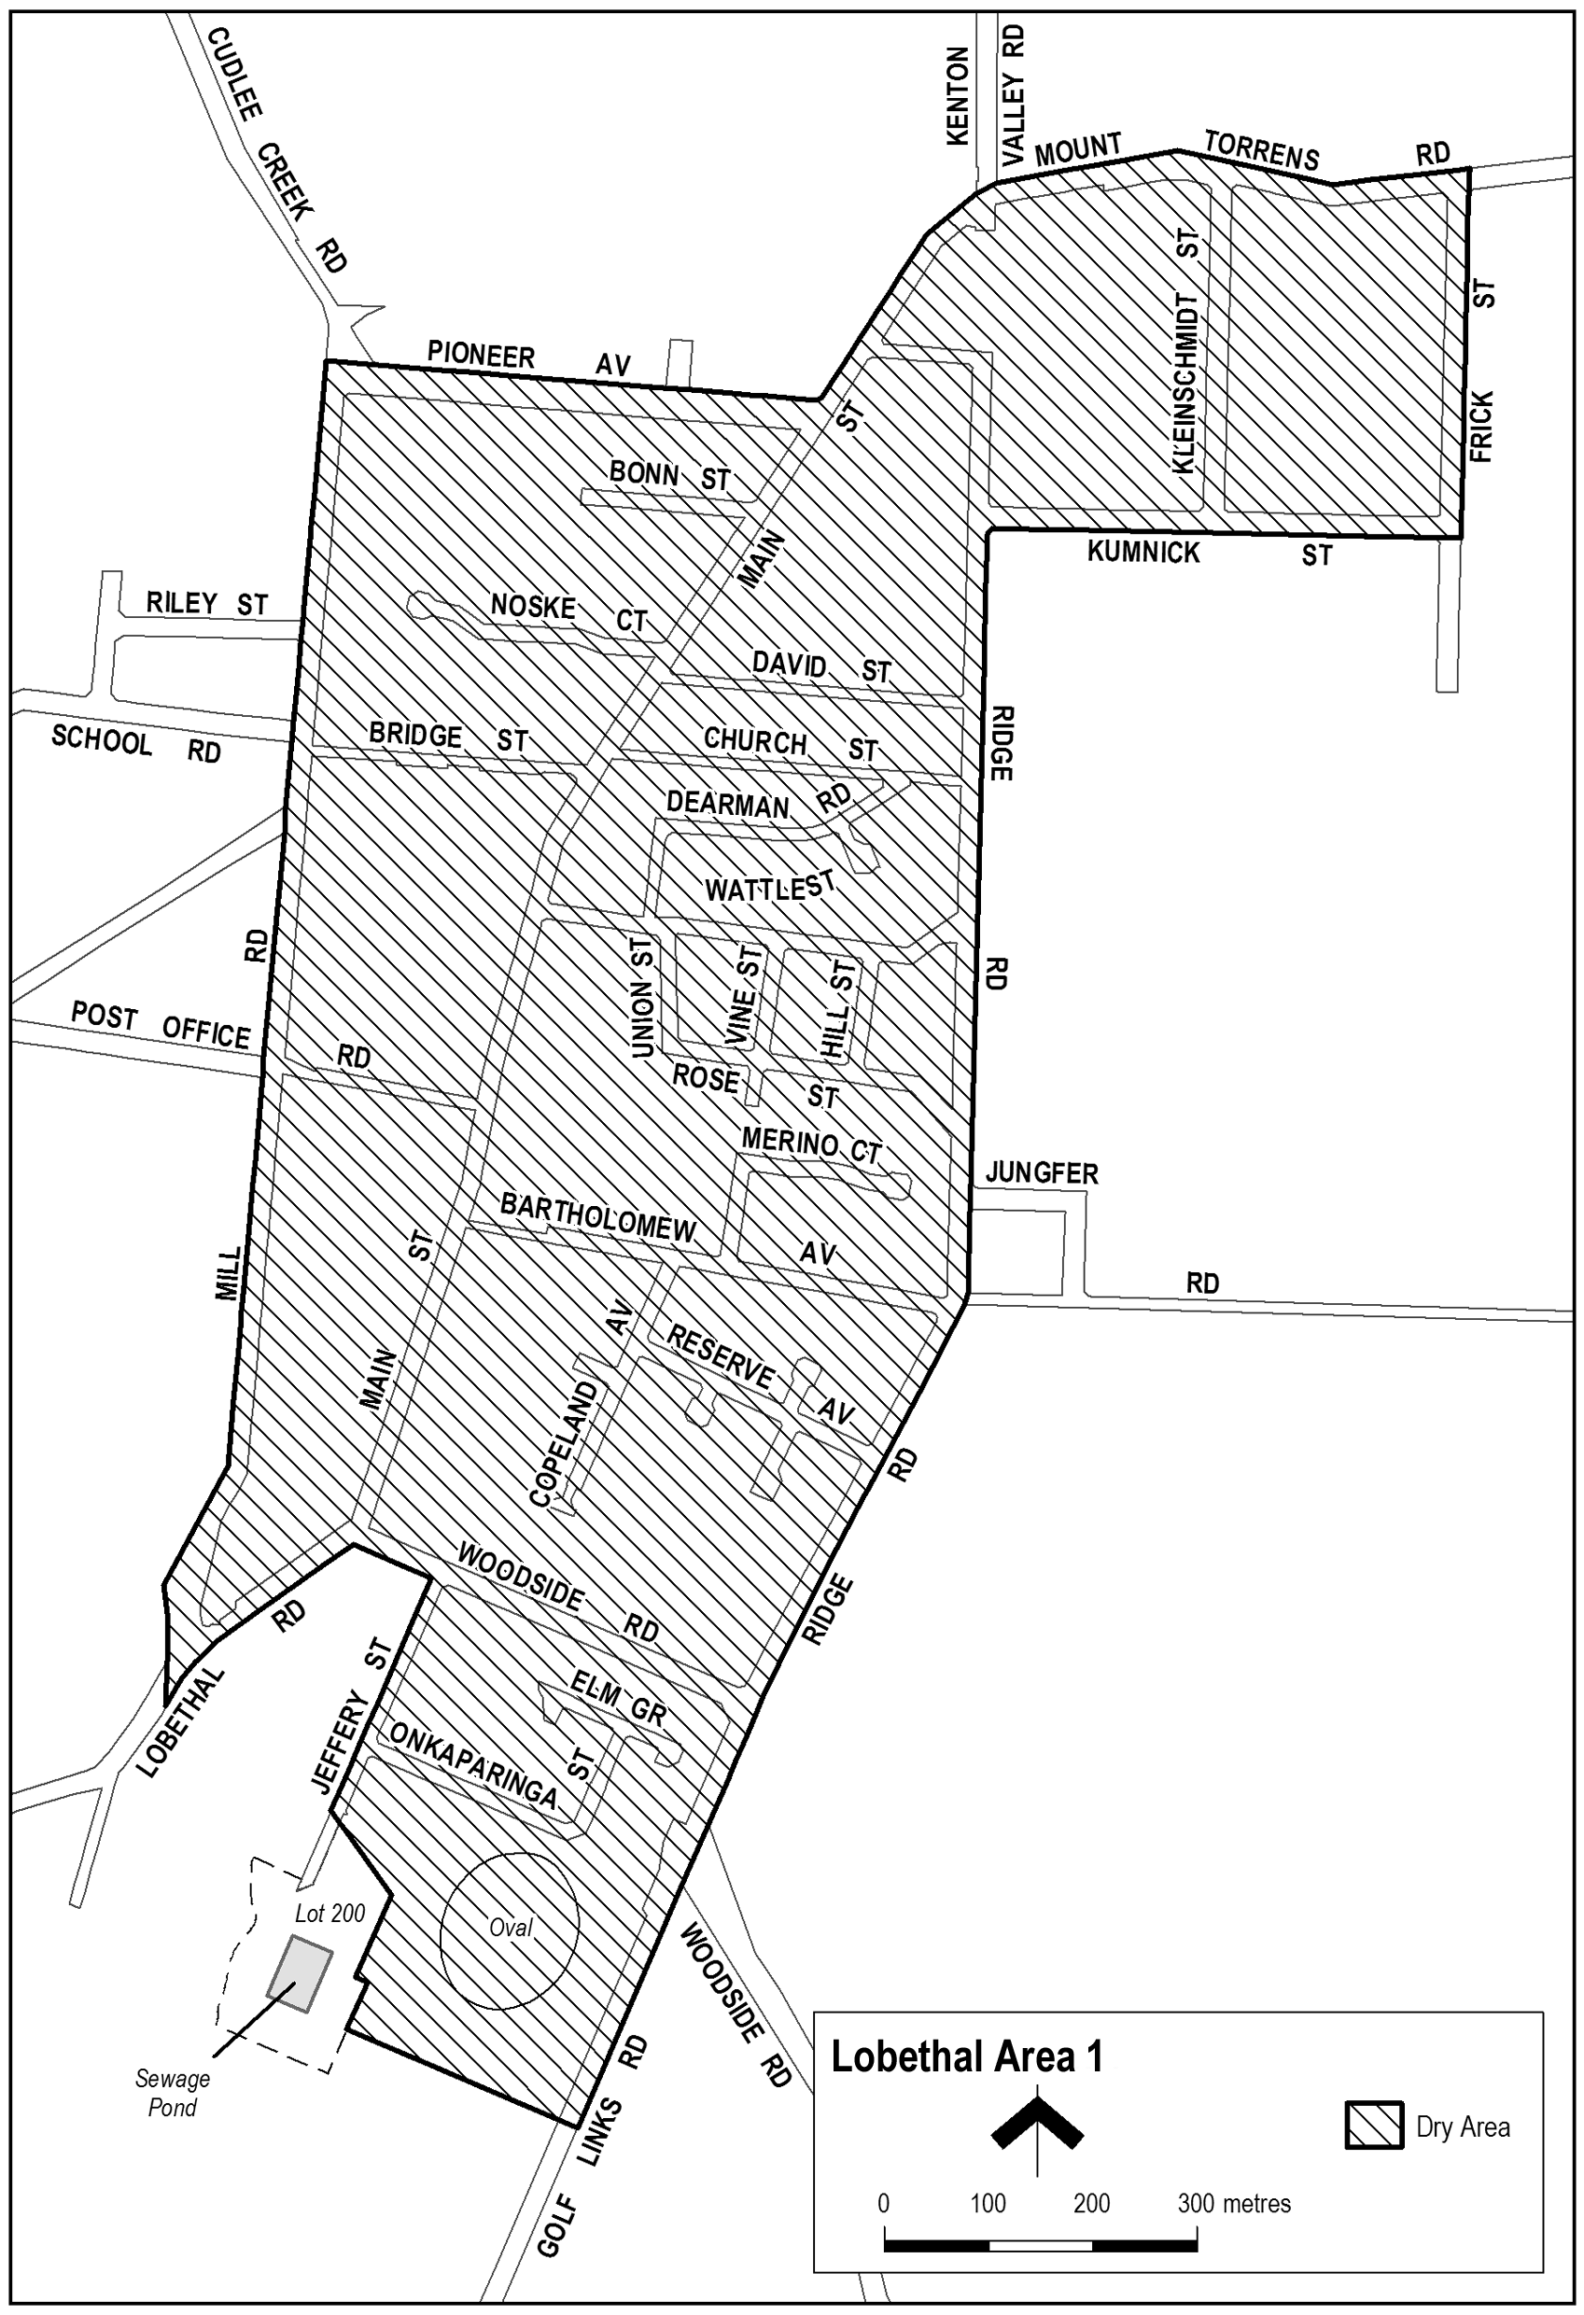
Note—
As required by section 10AA(2) of the Subordinate Legislation Act 1978, the Minister has certified that, in the Minister's opinion, it is necessary or appropriate that these regulations come into operation as set out in these regulations.
Made by the Governor
with the advice and consent of the Executive Council
on 1 November 2012
No 220 of 2012
MLI0022/12CS

South Australia
Liquor Licensing (Dry Areas) Variation
Regulations 2012
under the Liquor Licensing Act 1997

Contents
Part 1—Preliminary
1 Short title
2 Commencement
3 Variation provisions
Part 2—Variation of Liquor Licensing (Dry Areas) Regulations 2012
4 Variation of Schedule—Mount Gambier Area 1
5 Variation of Schedule—Mount Gambier Area 2
6 Variation of Schedule—Mount Gambier Area 3
7 Variation of Schedule—Mount Gambier Area 4
8 Variation of Schedule—Mount Gambier Area 5

Part 1—Preliminary
1—Short title
These regulations may be cited as the Liquor Licensing (Dry Areas) Variation Regulations 2012.
2—Commencement
These regulations come into operation on the day on which they are made.
3—Variation provisions
In these regulations, a provision under a heading referring to the variation of specified regulations varies the regulations so specified.
Part 2—Variation of Liquor Licensing (Dry Areas) Regulations 2012
4—Variation of Schedule—Mount Gambier Area 1
Schedule—Mount Gambier Area 1, clause 2—delete "2012" and substitute:
2017
5—Variation of Schedule—Mount Gambier Area 2
Schedule—Mount Gambier Area 2, clause 2—delete "2012" and substitute:
2017
6—Variation of Schedule—Mount Gambier Area 3
Schedule—Mount Gambier Area 3, clause 2—delete "2012" and substitute:
2017
7—Variation of Schedule—Mount Gambier Area 4
Schedule—Mount Gambier Area 4, clause 2—delete "2012" and substitute:
2017
8—Variation of Schedule—Mount Gambier Area 5
Schedule—Mount Gambier Area 5, clause 2—delete "2012" and substitute:
2017
Note—
As required by section 10AA(2) of the Subordinate Legislation Act 1978, the Minister has certified that, in the Minister's opinion, it is necessary or appropriate that these regulations come into operation as set out in these regulations.
Made by the Governor
with the advice and consent of the Executive Council
on 1 November 2012
No 221 of 2012
MLI0026/12CS
South Australia
Liquor Licensing (Dry Areas) Variation
Regulations 2012
under the Liquor Licensing Act 1997

Contents
Part 1—Preliminary
1 Short title
2 Commencement
3 Variation provisions
Part 2—Variation of Liquor Licensing (Dry Areas) Regulations 2012
4 Insertion of Schedule—Two Wells Area 1
Schedule—Two Wells Area 1

Part 1—Preliminary
1—Short title
These regulations may be cited as the Liquor Licensing (Dry Areas) Variation Regulations 2012.
2—Commencement
These regulations come into operation on the day on which they are made.
3—Variation provisions
In these regulations, a provision under a heading referring to the variation of specified regulations varies the regulations so specified.
Part 2—Variation of Liquor Licensing (Dry Areas) Regulations 2012
4—Insertion of Schedule—Two Wells Area 1
Before Schedule—Victor Harbor Area 1 insert:
Schedule—Two Wells Area 1

1—Extent of prohibition
The consumption of liquor is prohibited and the possession of liquor is prohibited.
2—Period of prohibition
From 5 pm on 14 December 2012 to 5 am on 15 December 2012.
3—Description of area
The area in and adjacent to Two Wells comprising Old Port Wakefield Road between Gawler Road and Drew Street.
Note—
As required by section 10AA(2) of the Subordinate Legislation Act 1978, the Minister has certified that, in the Minister's opinion, it is necessary or appropriate that these regulations come into operation as set out in these regulations.
Made by the Governor
with the advice and consent of the Executive Council
on 1 November 2012
No 222 of 2012
MLI0032/12CS
South Australia
Liquor Licensing (Dry Areas) Variation
Regulations 2012
under the Liquor Licensing Act 1997

Contents
Part 1—Preliminary
1 Short title
2 Commencement
3 Variation provisions
Part 2—Variation of Liquor Licensing (Dry Areas) Regulations 2012
4 Variation of Schedule—Strathalbyn Area 1
2 Period of prohibition
5 Variation of Schedule—Strathalbyn Area 2
2 Period of prohibition

Part 1—Preliminary
1—Short title
These regulations may be cited as the Liquor Licensing (Dry Areas) Variation Regulations 2012.
2—Commencement
These regulations come into operation on the day on which they are made.
3—Variation provisions
In these regulations, a provision under a heading referring to the variation of specified regulations varies the regulations so specified.
Part 2—Variation of Liquor Licensing (Dry Areas) Regulations 2012
4—Variation of Schedule—Strathalbyn Area 1
Schedule—Strathalbyn Area 1, clause 2—delete the clause and substitute:
2—Period of prohibition
The prohibition applies during the following periods:
(a) from 9 pm on each day to 6 am on the following day, until 6 am on 12 February 2014, provided that where, for the purposes of an event of historic, cultural, traditional or community significance, Alexandrina Council authorises the consumption and possession of liquor in the area (or a defined part of the area) for a specified period during the event, the prohibition does not apply in the area (or defined part of the area) during that specified period;
(b) from 7 am to 9 pm on 14 December 2012.
5—Variation of Schedule—Strathalbyn Area 2
Schedule—Strathalbyn Area 2, clause 2—delete the clause and substitute:
2—Period of prohibition
The prohibition applies during the following periods:
(a) from 9 pm on each day to 6 am on the following day, until 6 am on 12 February 2014, provided that where, for the purposes of an event of historic, cultural, traditional or community significance, Alexandrina Council authorises the consumption and possession of liquor in the area (or a defined part of the area) for a specified period during the event, the prohibition does not apply in the area (or defined part of the area) during that specified period;
(b) from 7 am to 9 pm on 14 December 2012.
Note—
As required by section 10AA(2) of the Subordinate Legislation Act 1978, the Minister has certified that, in the Minister's opinion, it is necessary or appropriate that these regulations come into operation as set out in these regulations.
Made by the Governor
with the advice and consent of the Executive Council
on 1 November 2012
No 223 of 2012
MLI0029/12CS
South Australia
Lottery and Gaming Variation Regulations 2012
under the Lottery and Gaming Act 1936

Contents
Part 1—Preliminary
1 Short title
2 Commencement
3 Variation provisions
Part 2—Variation of Lottery and Gaming Regulations 2008
4 Revocation of regulation 48

Part 1—Preliminary
1—Short title
These regulations may be cited as the Lottery and Gaming Variation Regulations 2012.
2—Commencement
These regulations will come into operation 4 months after the day on which they are made (see Subordinate Legislation Act 1978 section 10AA).
3—Variation provisions
In these regulations, a provision under a heading referring to the variation of specified regulations varies the regulations so specified.
Part 2—Variation of Lottery and Gaming Regulations 2008
4—Revocation of regulation 48
Regulation 48—delete the regulation
Made by the Governor
with the advice and consent of the Executive Council
on 1 November 2012
No 224 of 2012
AGO0212/12CS

SENDING COPY?
NOTICES for inclusion in the South Australian Government Gazette should be emailed to:
governmentgazette@dpc.sa.gov.au
Please include the following information in the covering email:
• The date the notice is to be published.
• Whether a proof, quote or return email confirmation is required.
• Contact details.
• To whom the notice is charged if applicable.
• A purchase order if required (chargeable notices).
• Any other details that may impact on the publication of the notice.
Attach:
• Notices in Word format.
• Maps and diagrams in pdf.
• Notices that require sighting an official date and signature before publication in a pdf. If a pdf is not possible then fax the official file(s) to the Government Publishing Fax number listed below.
Fax Transmission: (08) 8207 1040
Phone Enquiries: (08) 8207 1045
NOTE:
Closing time for lodging new copy is 4 p.m. on Tuesday preceding the regular Thursday Gazette.

ADELAIDE CITY COUNCIL
Adelaide Park Lands Authority
(A Subsidiary of Adelaide City Council)
Notice of Appointments
NOTICE is hereby given that the Adelaide City Council, pursuant to Division 2 of Part 2 of the Adelaide Park Lands Act 2005 and Council resolution 12141 of 11 September 2012, having undertaken the required consultation with the Minister for Sustainability, Environment and Conservation, appoints the following persons as members of the Board of Management of the Adelaide Park Lands Authority:
For the purposes of Section 6 (1) (a) (ii) of the Act:
Councillor Anne Moran;
Councillor Tony Williamson;
Councillor Michael Henningsen; and
Deputy Lord Mayor and Councillor David Plumridge
Pursuant to Section 7 (2) of the Act, Council appoints the above members for the period commencing 1 December 2012 and concluding 30 November 2014.
Dated 1 November 2012.
P. Smith, Chief Executive Officer

CITY OF PORT ADELAIDE ENFIELD
Change of Name for a Portion of a Public Road
NOTICE is hereby given that the Council of the City of Port Adelaide Enfield at its meeting held on 9 October 2012, resolved pursuant to Section 219 (1) of the Local Government Act 1999, that the name of a portion of a certain public road located in the suburb of Kilburn be changed as follows:
• The name of the portion of Horley Terrace on Deposited Plan 1515 as marked ‘A’ on Map 1 running between Gladstone Avenue and Jersey Avenue be changed to Chicago Street, Kilburn.
A plan that delineates the portion of public road that is subject to the change of street name, together with a copy of the Council’s resolution are both available for inspection at the Council’s principal office, 163 St Vincent Street, Port Adelaide; The Parks—Library Council Office, 2-46 Cowan Street, Angle Park; Enfield Library—Council Office, 1-9 Kensington Crescent, Enfield and Greenacres—Library Council Office, 2 Fosters Road, Greenacres, during their normal business hours.
H. J. Wierda, City Manager

ADELAIDE HILLS COUNCIL
Vehicle Exclusion—Wenzel Road, Oakbank
NOTICE is hereby given that at the Council meeting held on
23 October 2012, Council resolved:
‘That pursuant to Section 359 of the Local Government Act 1934, all vehicles except emergency vehicles, Council vehicles, vehicles associated with adjoining properties, and horses be excluded from that section of Wenzel Road, Oakbank commencing 460 m east of the eastern side of the intersection of Beasley Road and Wenzel Road extending for 880 m and ending 130 m west of the western side of the intersection of Gillman Road and Wenzel Road for the months of May to November inclusive of each year.’
A. Aitken, Chief Executive Officer

COORONG DISTICT COUNCIL
Coorong District Council Elector Representation Review
NOTICE is hereby given that the Coorong District Council is undertaking a review to determine whether a change of arrangements in respect to elector representation will result in the electors of the area being more adequately and fairly represented.
Pursuant to the provisions of Section 12 (7) of the Local Government Act 1999, notice is hereby given that Council has prepared a representation Options Paper that examines the advantages and disadvantages of the various options available in regards to the composition and structure of Council, and the division of the Council area into wards.
Copies of the representation options paper are available on Council’s website at www.coorong.sa.gov.au and for inspection and/or purchase at the Council Offices, 93A Railway Terrace, Tailem Bend, 49 Princes Highway, Meningie and 37 Becker Terrace, Tintinara.
Interested persons are invited to make a written submission to the Chief Executive Officer, P.O. Box 399, Tailem Bend, S.A. 5260 by close of business on Monday, 17 December 2012.
Information regarding the representation review can be obtained by contacting Timothy Tol on telephone (08) 8572 3611 or email council@coorong.sa.gov.au.
M. Boyd, Chief Executive Officer

KINGSTON DISTRICT COUNCIL
Appointment of Development Assessment Panel Public Officer
NOTICE is hereby given that the Kingston District Council, at its meeting held on Friday, 19 October 2012, appointed Nick Brown, Chief Executive Officer, as the Public Officer to Council’s Development Assessment Panel, pursuant to Section 56A (22) of the Development Act 1993. Nick Brown can be contacted at the Kingston District Council Office, 29 Holland Street, Kingston SE, S.A. 5275, or by telephone on (08) 8767 2033.
N. Brown, Chief Executive Officer

PARTNERSHIP ACT 1891-1975
Notice of Discontinuance of Partnership
TAKE notice that as from 19 October 2012, the partnership of Craig Paddick, 8 Lees Court, Howard Springs, N.T. 0835 and the O’Connor Family Trust, 6 Jobson Street, Aldinga Beach, S.A. 5173 who traded as AC Direct Pty Ltd was dissolved.
Craig Paddick has retired from the partnership.
The O’Connor Family Trust will continue to operate the business under the name of AC Direct Pty Ltd and shall be responsible for all the debts and liabilities thereof.
Dated 19 October 2012.
C. Paddick

IN the matter of the estates of the undermentioned deceased persons:
Baker, Dulcie Jean, late of 84 Reservoir Road, Modbury, of no occupation, who died on 9 August 2012.
Castle, Edna May, late of 55 David Street, Port Pirie, retired nanny, who died on 10 June 2012.
Greatrex, Michael Joseph Foxton, late of 5 Harvey Avenue, Salisbury, retired secretary manager, who died on 1 August 2012.
Hancock, Pauline Ann, late of 18 Mataro Road, Hope Valley, home duties, who died on 1 August 2012.
Jones, Margaret Dawn, late of 2 Jean Street, Oaklands Park, retired clerical assistant, who died on 12 August 2012.
Nelligan, Robert Emmett, late of 276 Portrush Road, Beulah Park, retired customs officer, who died on 9 August 2012.
Thorp, Derek Windsor, late of 3 Kiley Road, Aldgate, retired public servant, who died on 21 August 2012.
Whittington, Shirley Dawn, late of 13 Briscoe Street, Port Noarlunga, home duties, who died on 11 August 2012.
Wills, Maurice Edward, late of 35A Orlando Avenue, Hampstead Gardens, retired author/inventor and science educator, who died on 27 July 2012.
Notice is hereby given pursuant to the Trustee Act 1936, as amended, the Inheritance (Family Provision) Act 1972 and the Family Relationships Act 1975, that all creditors, beneficiaries, and other persons having claims against the said estates are required to send, in writing, to the Office of Public Trustee, G.P.O. Box 1338, Adelaide, S.A. 5001, full particulars and proof of such claims, on or before 30 November 2012, otherwise they will be excluded from the distribution of the said estates; and notice is also hereby given that all persons indebted to the said estates are required to pay the amount of their debts to the Public Trustee or proceedings will be taken for the recovery thereof; and all persons having any property belonging to the said estates are forthwith to deliver same to the Public Trustee.
Dated 1 November 2012.
D. A. Contala, Public Trustee

SALE OF PROPERTY
Auction Date: Wednesday 21 November 2012 at 12 noon
Location: 8 Bondowie Street, Gladstone
NOTICE is hereby given that on the above date at the time and place stated, by virtue of the Warrant of Sale issued out of the Magistrates Court, Action No. 7002 of 2011 directed to the Sheriff of South Australia in an action wherein Fulham Funerals (SA) Pty Ltd is the Plaintiff and Betty Rhonda Eiffe is the Defendant, I Mark Stokes, Sheriff of the State of South Australia, will by my auctioneers, Griffin Real Estate, make sale of the estate, right, title or interest whatsoever it may be of the Defendant Betty Rhonda Eiffe the registered proprietor of an estate in fee simple in the following:
That piece of land situated in the area named Allotment 4 Deposited Plan 325, in the Area named Gladstone, Hundred of Yangya, being the property comprised in Certificate of Title Register Book Volume 5507, Folio 973.
Further particulars from the auctioneers.
Griffin Real Estate
8 Greenhill Road
Wayville, S.A. 5034
Telephone (08) 8372 7872

ATTENTION

CUSTOMERS requiring a proof of their notice for inclusion in the Government Gazette, please note that the onus is on you to inform Government Publishing SA of any subsequent corrections.

For any corrections to your notice please phone 8207 1045 or Fax 8207 1040 before 4 p.m. on Wednesday.

If we do not receive any communication by 10 a.m. on Thursday (day of publication) we will presume the notice is correct and will print it as it is.

Remember—the onus is on you to inform us of any corrections necessary to your notice.

NOTE: Closing time for lodging new copy (electronically, fax or hard copy) is 4 p.m. on Tuesday preceding the day of publication.
Phone: 8207 1045
Fax: 8207 1040
Email: governmentgazette@dpc.sa.gov.au

Printed and published by authority every Thursday by B. MORRIS, Government Printer, South Australia
Price: $6.45, plus postage; to subscribers, $325.00 per annum.
(The above prices are inclusive of GST)

