SUPPLEMENTARY GAZETTE



THE SOUTH AUSTRALIAN

GOVERNMENT GAZETTE
www.governmentgazette.sa.gov.au

PUBLISHED BY AUTHORITY

ALL PUBLIC ACTS appearing in this GAZETTE are to be considered official, and obeyed as such

ADELAIDE, FRIDAY, 30 NOVEMBER 2012

CONTENTS

Page
Health Care Act 2008—Notice. 5292
Tobacco Products Regulation Act 1997—Notice 5293

HEALTH CARE ACT 2008
Notice by the Minister
Declaration of Authorised Quality Improvement Activity and Authorised Person under Section 64
TAKE notice that I, John Hill, Minister for Health and Ageing, pursuant to Sections 64 (1) (a) (i) and (b) (i) do hereby:
DECLARE the Activities described in the Schedule to this declaration (the Activities) to be authorised quality improvement activities to which Part 7 of the Act applies.
DECLARE the Person or group of Persons (including a group formed as a committee) described in the Schedule to this declaration (the Persons) to be an authorised entity for the purposes of carrying out the authorised quality improvement activities to which Part 7 of the Act applies,
being satisfied that:
(a) the performance of the activities within the ambit of the declaration and the functions or activities of the person or group of persons within the ambit of the declaration, would be facilitated by the making of the declaration; and
(b) that the making of the declaration is in the public interest.
Dated 26 November 2012.
John Hill, Minister for Health and Ageing

Schedule
Declaration of Authorised Quality Improvement Activity and Authorised Person under Section 64

Activity | Person or Group of Persons
Review and Analysis for Quality Improvement | Calvary S.A Hospitals—North Adelaide—Clinical Review Sub-Committee
Review and Analysis for Quality Improvement | Calvary S.A Hospitals—Wakefield—Clinical Review Sub-Committee
Incident Review for Quality Improvement | Southern Adelaide Local Health Network—Clinical Review Committee

TOBACCO PRODUCTS REGULATION ACT 1997
Notice by the Minister
Declaration that Smoking is Banned in Certain Public Areas under Section 51
TAKE notice that I, John Hill, Minister for Mental Health and Substance Abuse, pursuant to Section 51 of the Tobacco Products Regulation Act 1997, do hereby declare that smoking is banned in the public areas within the premises located at 72 Woodville Road, Woodville, known as the City of Charles Sturt Civic Centre, on Saturday, 8 December 2012 for the Christmas at Our Place event. To avoid any doubt, smoking is banned during this period in all public areas within the City of Charles Sturt Civic Centre, including the Car Park.
The following map of the premises known as the City of Charles Sturt Civic Centre is provided for ease of reference only.

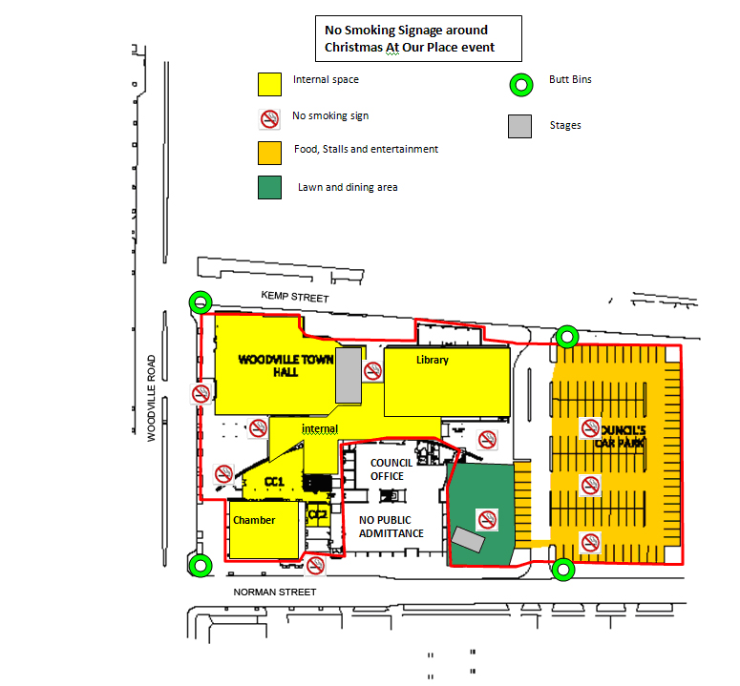

Dated 24 November 2012.
John Hill, Minister for Mental Health and Substance Abuse

B. MORRIS, Government Printer, South Australia

