No. 21 927

THE SOUTH AUSTRALIAN

GOVERNMENT GAZETTE
www.governmentgazette.sa.gov.au

PUBLISHED BY AUTHORITY

ALL PUBLIC ACTS appearing in this GAZETTE are to be considered official, and obeyed as such

ADELAIDE, THURSDAY, 4 APRIL 2013

CONTENTS

Page
Appointments, Resignations, Etc. 928
Associations Incorporation Act 1985—Notice 929
Corporations and District Councils—Notices 953
Development Act 1993—Notice 930
Environment Protection Act 1993—Notices 941
Firearms Act 1977—Notices 929
Fisheries Management Act 2007—Notices 929
Health Care Act 2008—Notice 944
Housing Improvement Act 1940—Notices 943
Liquor Licensing Act 1997—Notices 944
National Gas Law—Notice 945
Natural Resources Management Act 2004—Notice 946
Petroleum and Geothermal Energy Act 2000—Notice 946
Public Trustee Office—Administration of Estates 953
Road Traffic Act 1961—Notices 947
Roads (Opening and Closing) Act 1991—Notice 947
Water Mains and Sewers—Mains Laid,
Replaced, Etc—Notice 948

GOVERNMENT GAZETTE NOTICES
ALL poundkeepers’ and private advertisements forwarded for publication in the South Australian Government Gazette must be PAID FOR PRIOR TO INSERTION; and all notices, from whatever source, should be legibly written on one side of the paper only and sent to Government Publishing SA so as to be received no later
than 4 p.m. on the Tuesday preceding the day of publication. Phone 8207 1045 or Fax 8207 1040. E-mail: governmentgazette@dpc.sa.gov.au. Send as attachments in Word format and please confirm your transmission with a faxed copy of your document, including the date the notice is to be published and to whom the notice will be charged. The Government Gazette is available online at: www.governmentgazette.sa.gov.au

Department of the Premier and Cabinet
Adelaide, 4 April 2013
HIS Excellency the Governor in Executive Council has revoked the appointment of Barry John Kahl as Deputy Member to Neville Tom Highett of the Education and Early Childhood Services Registration and Standards Board of South Australia, effective from 4 April 2013, pursuant to the provisions of the Education and Early Childhood Services (Registration and Standards) Act 2011 and Section 36 of the Acts Interpretation Act 1915.
By command,
Jay Wilson weatherill, Premier
MECD13/047-SC

Department of the Premier and Cabinet
Adelaide, 4 April 2013
HIS Excellency the Governor in Executive Council has been pleased to appoint the undermentioned to the State Opera of South Australia Board, pursuant to the provisions of the State Opera of South Australia Act 1976:
Member: (from 4 April 2013 until 3 April 2016)
Mark Willem de Raad
By command,
Jay Wilson weatherill, Premier
MTS/13/003

Department of the Premier and Cabinet
Adelaide, 4 April 2013
HIS Excellency the Governor in Executive Council has been pleased to appoint the undermentioned to the Education and Early Childhood Services Registration and Standards Board of South Australia, pursuant to the provisions of the Education and Early Childhood Services (Registration and Standards) Act 2011:
Member: (from 5 April 2013 until 28 February 2015)
Trevor John Radloff
Carolyn Edith Grantskalns
Barry John Kahl
Deputy Member: (from 5 April 2013 until 28 February 2014)
Karen Jane Lamont (Deputy to Highett)
Deputy Member: (from 5 April 2013 until 28 February 2015)
Kathleen Susan Cotter (Deputy to Kahl)
Cheryl Sylvia Bauer (Deputy to Grantskalns)
Anne Louise Kibble (Deputy to Radloff)
Mandy Leone Richardson (Deputy to Colmer)
Kathleen Patricia McEvoy (Deputy to Wilson)
Deputy Member: (from 1 March 2014 until 28 February 2015)
Nicholas William Hately (Deputy to Secombe)
Vincent Damien Thomas (Deputy to Sharkey)
Georgina Smith (Deputy to O’Brien)
Merrilyn Joyce Hannaford (Deputy to Atkinson)
By command,
Jay Wilson weatherill, Premier
MECD13/047-SC

Department of the Premier and Cabinet
Adelaide, 4 April 2013
HIS Excellency the Governor in Executive Council has been pleased to appoint the undermentioned to the Guardianship Board, pursuant to the provisions of the Guardianship and Administration Act 1993:
Section 8 (2) Panel Member: (from 4 April 2013 until 3 April 2016)
Thomas Mark Rymill
By command,
Jay Wilson weatherill, Premier
AGO0029/13CS

Department of the Premier and Cabinet
Adelaide, 4 April 2013
HIS Excellency the Governor in Executive Council has been pleased to appoint the undermentioned to the HomeStart Finance Board of Management, pursuant to the provisions of the Housing and Urban Development (Administrative Arrangements) Act 1995:
Member: (from 4 April 2013 until 3 April 2016)
Maria Palumbo
By command,
Jay Wilson weatherill, Premier
MHUD13/007SC

Department of the Premier and Cabinet
Adelaide, 4 April 2013
HIS Excellency the Governor in Executive Council has been pleased to appoint the people listed as Justices of the Peace for South Australia for a period of ten years commencing from 4 April 2013 and expiring on 3 April 2023, it being a condition of appointment that the Justices of the Peace must take the oaths required of a Justice under the Oaths Act 1936 and return the oaths form to the Justice of the Peace Services within 3 months of the date of appointment, pursuant to Section 4 of the Justices of the Peace Act 2005:
Cheryl Ann Bullen
Caterina Carbone
Terri Yvette Church
Colin William Cornish
Graeme Lewis Daniels
Anna Maria Giglio
Tanya Narelle Lehmann
Lynette Margaret Leckie-Matassa
Jason Victor Mammino
Maree Elizabeth Maney
Tonya Ada Mitchell
Barrie Edward Porter
Emily Joy Prause
Julia Elizabeth Price
Elliot Raboy
Manoj Prasanna Koruwage Ranasoma
Najwa Nicole Richards
Graham Reg Robinson
Maria Russo
Mark Schroeder
Mark Alexander Seja
Marion Themeliotis
Jenny Leanne Wormald
Kathryn Jane Young
Po Shan Yu
Peng Zhang
By command,
Jay Wilson weatherill, Premier
JP13/008CS

ASSOCIATIONS INCORPORATION ACT 1985
Section 43A
Deregistration of Associations
NOTICE is hereby given that the Corporate Affairs Commission approves the applications for deregistration received from the associations named below pursuant to Section 43A of the Associations Incorporation Act 1985. Deregistration takes effect on the date of publication of this notice.
Adult Attention Deficit Disorder Support Incorporated
Association of Neonatal Nurses of South Australia Incorporated
Elanora Syp Homes Incorporated
Friends of Child and Family Health Incorporated
Greening of Wasleys Management Committee Incorporated
Ladies Probus Club of West Torresns Incorporated
Maltese Language School of Adelaide Incorporated
Northern Jazz and Swing Club Incorporated
OpenSA Incorporated
Payneham Invitation Homing Pigeon Club Incorporated
Prince of Wales Social Club Incorporated
Riverland Community Radio Safety Group Incorporated
South Australian Consortium of Information Technology and Telecommunications Incorporated
Southern Flinders Australian Native Produce Association Landcare Group Incorporated
Wasleys Institute Management Committee Incorporated
Given at Adelaide, 2 April 2013.
Scott Aitchison, a Delegate of the Corporate Affairs Commission

FIREARMS ACT 1977
Recognised Firearms Club
I DECLARE the Topgun Adelaide Sporting Club Incorporated, to be a recognised firearms club, pursuant to Section 21C of the Firearms Act 1977.
Dated 19 March 2013.
Michael O’Brien, Minister for Police

FIREARMS ACT 1977
Recognised Firearms Club
I DECLARE the Elsewhere Clay Target Club Incorporated, to be a recognised firearms club, pursuant to Section 21C of the Firearms Act 1977.
Dated 19 March 2013.
Michael O’Brien, Minister for Police

FISHERIES MANAGEMENT ACT 2007: SECTION 79
TAKE notice that pursuant to Section 79 of the Fisheries Management Act 2007, it is hereby declared that it shall be unlawful for any persons to engage in the act of, or an act preparatory to or involved in, taking species of the family cephalopoda (squid, cuttlefish and octopus) from the waters specified in Schedule 1, during the period specified in Schedule 2.
Schedule 1
All waters of Spencer Gulf within an area bounded by a line commencing at Point Lowly Lighthouse, then following the eastern boundary of the existing cephalopod closure area to 100 m from the high water mark offshore and then following the coastline 100 m offshore around Point Lowly to a point, position latitude 32°59′38.4″S, longitude 137°47′02.4″E, which is 100 m south of the boat ramp breakwater from the high water mark near Point Lowly.
Schedule 2
From 27 March 2013 to 27 March 2014.
Dated 27 March 2013.
Professor M. Doroudi, Director of Fisheries

FISHERIES MANAGEMENT ACT 2007: SECTION 79
TAKE notice that it is hereby declared that it shall be unlawful for any person to engage in the class of fishing activity specified in Schedule 1 during the period specified in Schedule 2.
Schedule 1
The act of taking cuttlefish (Sepia species) in the waters of northern Spencer Gulf north of the line commencing at the Mean High Water Springs closest to latitude 33°55′39.942″S, longitude 136°34′20.131″E (near Arno Bay) to the Mean High Water Springs closest to latitude 33°55′39.942″S, longitude 137°37′14.527″E (Wallaroo Jetty).
Schedule 2
From 1200 hours on 28 March 2013 until 1200 hours on 27 March 2014.
Dated 28 March 2013.
Professor M. Doroudi, Director of Fisheries

DEVELOPMENT ACT 1993
Section 29 (2) (b) (ii) Amendment to the Adelaide (City) Development Plan
Preamble
IT is necessary to amend the Adelaide (City) Development Plan consolidated on 24 January 2013 and as amended by the approved City Centre Heritage Development Plan Amendment gazetted on 27 March 2013.
Notice
PURSUANT to Section 29 (2) (b) (ii) of the Development Act 1993, I amend the Adelaide (City) Development Plan dated 24 January 2013 and as amended by the approved City Centre Heritage Development Plan Amendment gazetted on 27 March 2013 as follows:
1. Within the existing RA5 Residential (Hurtle West) Zone:
(a) replace the reference to ‘Mixed Use Zone’ with ‘Capital City Zone’ in the first sentence of the first paragraph of the Desired Character;
(b) replace the reference to ‘Mixed Use Zone’ with ‘Capital City Zone’ in the first sentence of the second paragraph of the Desired Character.
2. Within the existing RA 6 Residential (Whitmore East) Zone:
(a) replace the reference to ‘Policy Areas in the adjacent Mixed Use Zone’ with ‘Capital City Zone and Main Street (Adelaide) Zone’ in the first sentence of the first paragraph of the Desired Character.
3. Within the existing Capital City Zone:
(a) delete the word ‘between’ in Principle of Development Control (16) (a);
(b) insert the heading ‘Non-Complying Development’ immediately before Principle of Development Control 36.
4. Within the existing TABLE Adel/5 Significant Trees:
(a) replace the words ‘2m from right hand boundary, 23m from kerb’ with ‘2m from right hand boundary, 25m from kerb on Strangways Terrace’ under the column headed ‘Location on site’ for the Significant Tree identified as Tree Ref No 270;
(b) replace the words ‘90m from right hand boundary, 6m from kerb’ with ‘149m from right hand boundary, 6m from kerb on Strangways Terrace’ under the column headed ‘Location on site’ for the Significant Tree identified as Tree Ref No 271;
(c) replace the words ‘1m from right hand boundary, 8m from kerb’ with ‘62m from right hand boundary, 8m from kerb on Barnard Street’ under the column headed ‘Location on site’ for the Significant Tree identified as Tree Ref No 272;
(d) replace the words ‘75m from right hand boundary, 7m from kerb’ with ‘69m from right hand boundary, 11m from kerb on Barnard Street’ under the column headed ‘Location on site’ for the Significant Tree identified as Tree Ref No 273;
(e) replace the words ‘2m from right hand boundary, 51m from kerb’ with ‘2m from right hand boundary, 54m from kerb on Barnard Street’ under the column headed ‘Location on site’ for the Significant Tree identified as Tree Ref No 871;
(f) replace the words ‘1m from right hand boundary, 30m from kerb’ with ‘1m from right hand boundary, 24.5m from kerb on Strangways Terrace’ under the column headed ‘Location on site’ for the Significant Tree identified as Tree Ref No 277;
(g) replace the words ‘43m from right hand boundary, 20m from kerb’ with ‘42m from right hand boundary, 20m from kerb on Strangways Terrace’ under the column headed ‘Location on site’ for the Significant Tree identified as Tree Ref No 279;
(h) replace the words ‘40m from right hand boundary, 20m from kerb’ with ‘38m from right hand boundary, 20m from kerb on Strangways Terrace’ under the column headed ‘Location on site’ for the Significant Tree identified as Tree Ref No 280;
(i) replace the words ‘43m from right hand boundary, 12m from kerb’ with ‘38m from right hand boundary, 12m from kerb on Strangways Terrace’ under the column headed ‘Location on site’ for the Significant Tree identified as Tree Ref No 284;
(j) replace the words ‘2m from right hand boundary, 5m from kerb’ with ‘1.5m from right hand boundary, 6m from kerb’ under the column headed ‘Location on site’ for the Significant Tree identified as Tree Ref No 286;
(k) insert the words ‘Jacaranda mimosifolia Jacaranda’ under the column heading ‘Species and common name for the Significant Tree identified as Tree Ref No 464;
(l) replace the words ‘13m from right hand boundary, 40m from kerb’ with ‘10m from right hand boundary, 55m from kerb’ under the column headed ‘Location on site’ for the Significant Tree identified as Tree Ref No 526;
(m) replace the words ‘2m from right hand boundary, 26m from kerb’ with ‘1m from right hand boundary, 21m from kerb on northern frontage’ under the column headed ‘Location on site’ for the Significant Tree identified as Tree Ref No 530;
(n) replace the words ‘70m from right hand boundary, 60m from kerb’ with ‘8m from right hand boundary, 19m from kerb on Strangways Terrace’ under the column headed ‘Location on site’ for the Significant Tree identified as Tree Ref No 622;
(o) replace the words ‘55m from right hand boundary, 15m from kerb’ with ‘62m from right hand boundary on Jeffcott Street, 22m from kerb on Jeffcott Street’ under the column headed ‘Location on site’ for the Significant Tree identified as Tree Ref No 623;
(p) replace the words ‘67m from right hand boundary, 15m from kerb’ with ‘60.3m from right hand boundary, 15m from kerb on Jeffcott Street’ under the column headed ‘Location on site’ for the Significant Tree identified as Tree Ref No 624;
(q) replace the words ‘66m from right hand boundary, 6m from kerb’ with ‘56.5m from right hand boundary, 8m from kerb on Jeffcott Street’ under the column headed ‘Location on site’ for the Significant Tree identified as Tree Ref No 625;
(r) replace the words 7m from right hand boundary, 17m from kerb’ with ‘17m from right hand boundary, 7m from kerb on Jeffcott Street’ under the column headed ‘Location on site’ for the Significant Tree identified as Tree Ref No 627;
(s) replace the words ‘50m from right hand boundary, 60m from kerb’ with ‘57m from right hand boundary, 25m from kerb on Jeffcott Street’ under the column headed ‘Location on site’ for the Significant Tree identified as Tree Ref No 628;
(t) replace the words 25m from right hand boundary, 7m from kerb’ with ‘17.5m from right hand boundary, 7m from kerb on Jeffcott Street’ under the column headed ‘Location on site’ for the Significant Tree identified as Tree Ref No 629;
(u) replace the words ‘43m from right hand boundary, 70m from kerb’ with ‘39m from right hand boundary, 24.6m from kerb on Jeffcott Street’ under the column headed ‘Location on site’ for the Significant Tree identified as Tree Ref No 631;
(v) replace the words ‘35m from right hand boundary, 10m from kerb’ with ‘31m from right hand boundary, 9m from kerb on Strangeways Terrace’ under the column headed ‘Location on site’ for the Significant Tree identified as Tree Ref No 632;
(w) replace the words ‘60m from right hand boundary, 42m from kerb’ with ‘54m from right hand boundary, 40m from kerb on Jeffcott Street’ under the column headed ‘Location on site’ for the Significant Tree identified as Tree Ref No 633;
(x) replace the words ‘67m from right hand boundary, 37m from kerb’ with ‘62.2m from right hand boundary, 31.6m from kerb on Jeffcott Street’ under the column headed ‘Location on site’ for the Significant Tree identified as Tree Ref No 635;
(y) replace the words ‘67m from right hand boundary, 30m from kerb’ with ‘63.6m from right hand boundary, 40m from kerb on Jeffcott Street’ under the column headed ‘Location on site’ for the Significant Tree identified as Tree Ref No 636;
(z) replace the words ‘80m from right hand boundary, 80m from kerb’ with ‘61m from right hand boundary, 55m from kerb on Jeffcott Street’ under the column headed ‘Location on site’ for the Significant Tree identified as Tree Ref No 637;
(aa) replace the words ‘42m from right hand boundary, 20m from kerb’ with ‘57m from right hand boundary, 62m from kerb on Jeffcott Street’ under the column headed ‘Location on site’ for the Significant Tree identified as Tree Ref No 638;
(bb) replace the words ‘67m from right hand boundary, 42m from kerb’ with ‘61.2m from right hand boundary, 49.2m from kerb on Jeffcott Street’ under the column headed ‘Location on site’ for the Significant Tree identified as Tree Ref No 882;
(cc) replace the words ‘0m from kerb’ with ‘67m from kerb’ under the column headed ‘Location on site’ for the Significant Tree identified as Tree Ref No 870.
5. Replace:
(a) ADELAIDE (CITY) AFFORDABLE HOUSING MAP Adel/1 (Overlay 15a)
(b) ADELAIDE (CITY) AFFORDABLE HOUSING MAP Adel/1 (Overlay 15b)
(c) ADELAIDE (CITY) RESIDENTIAL (HURTLE WEST) ZONE HERITAGE PLACES AND SIGNIFICANT TREES Fig RA/5
(d) ADELAIDE (CITY) RESIDENTIAL (HURTLE WEST) ZONE HERITAGE PLACES AND SIGNIFICANT TREES Fig RA/6
(e) ADELAIDE (CITY) POLICY AREAS MAP ADEL/55
(f) ADELAIDE (CITY) POLICY AREAS MAP ADEL/56
(g) ADELAIDE (CITY) POLICY AREAS MAP ADEL/60
(h) ADELAIDE (CITY) POLICY AREAS MAP ADEL/61
(i) ADELAIDE (CITY) POLICY AREAS MAP ADEL/62
(j) ADELAIDE (CITY) POLICY AREAS MAP ADEL/55
with contents of Attachment A.
6. Fix the day on which this notice is published in the Gazette as the day on which the Amendment will come into operation.

John Rau, Deputy Premier, Minister for Planning

Attachment A
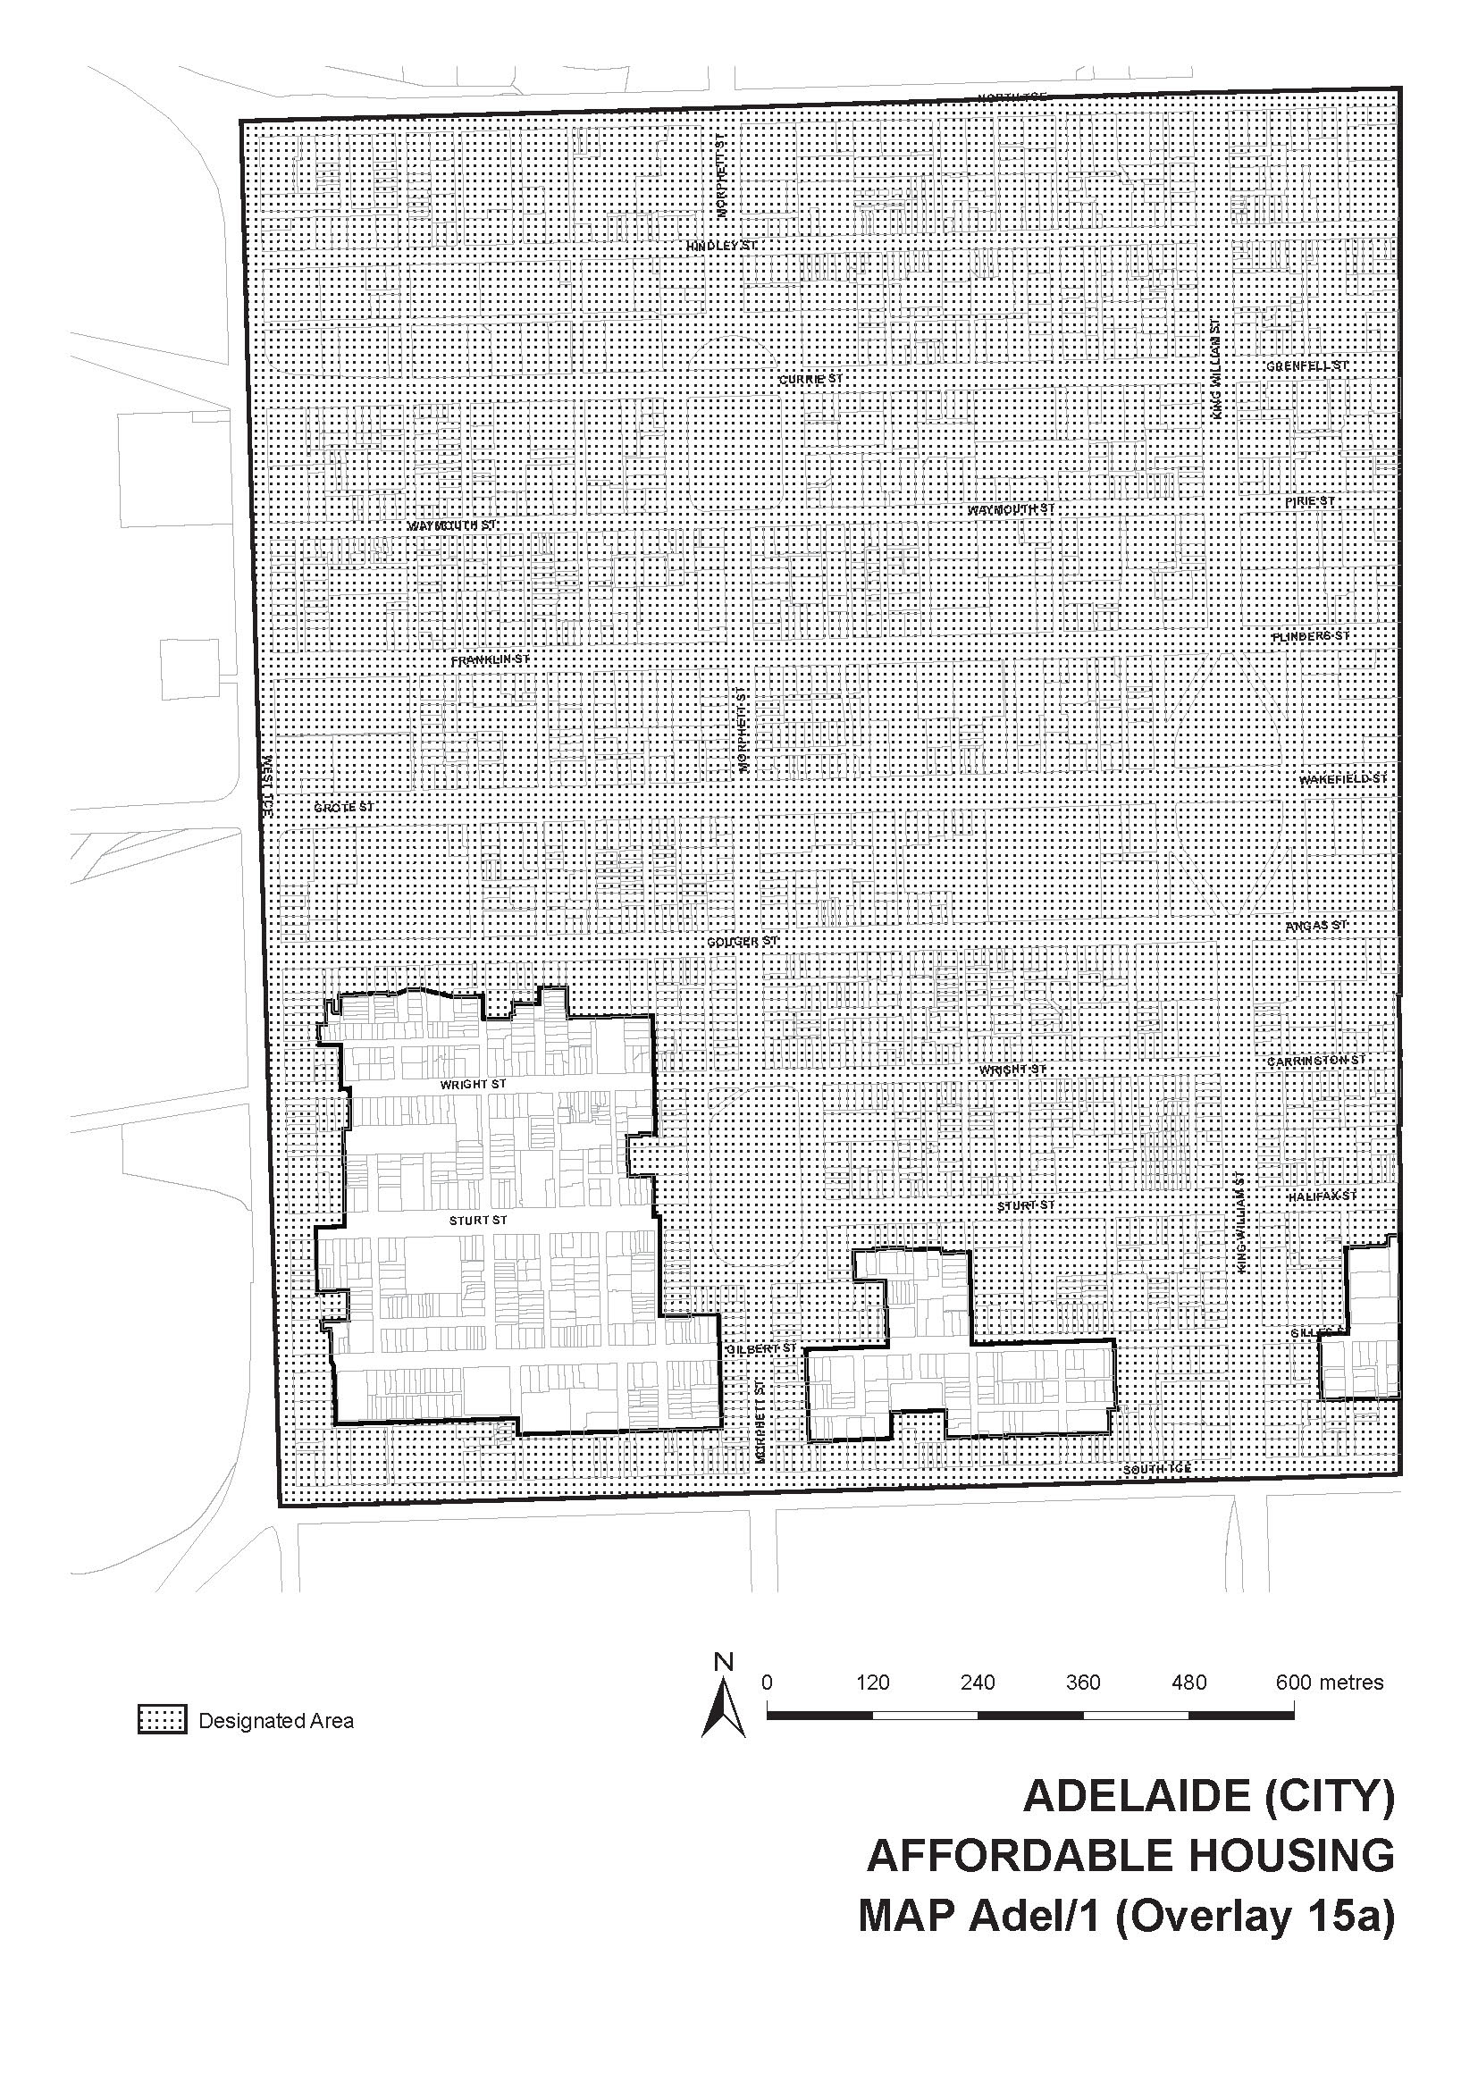
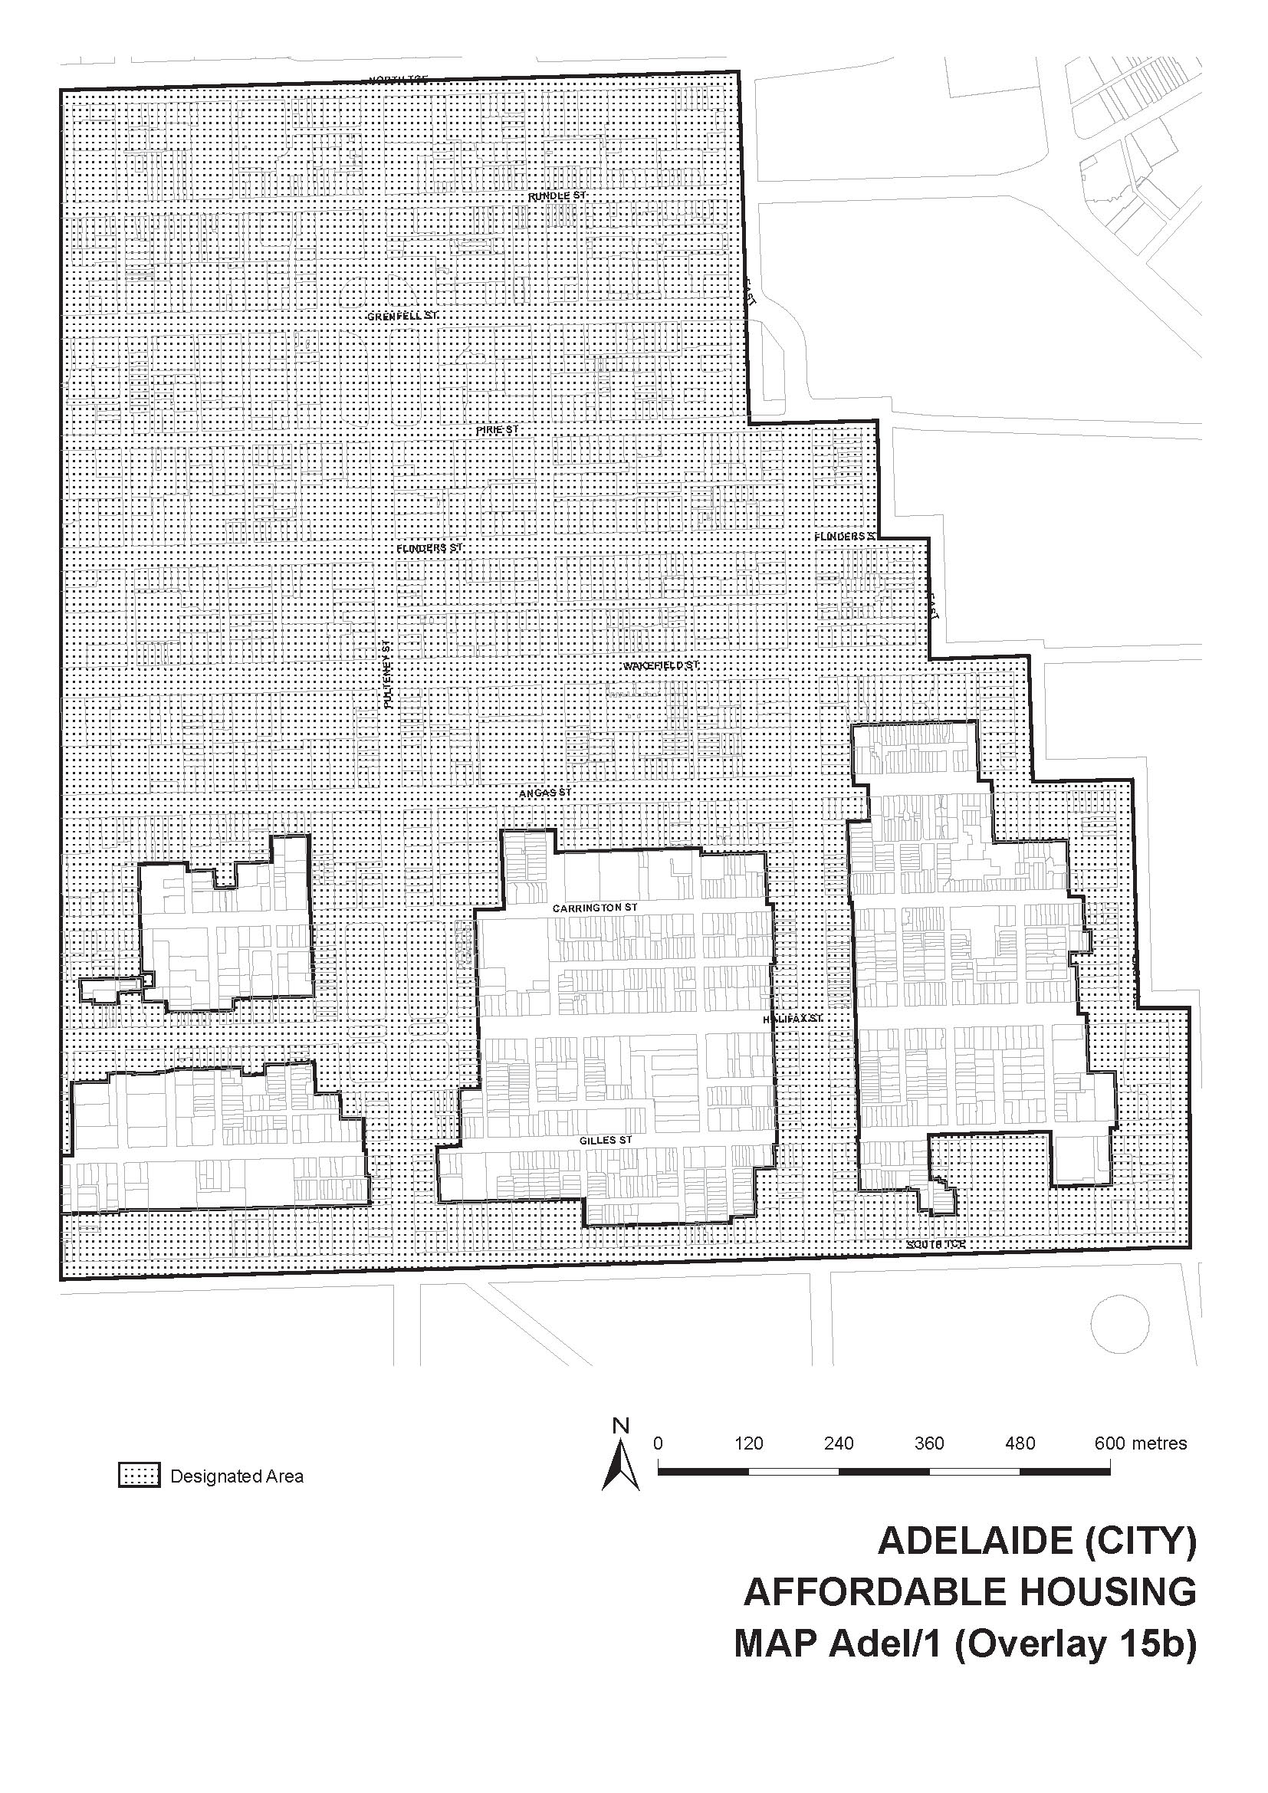

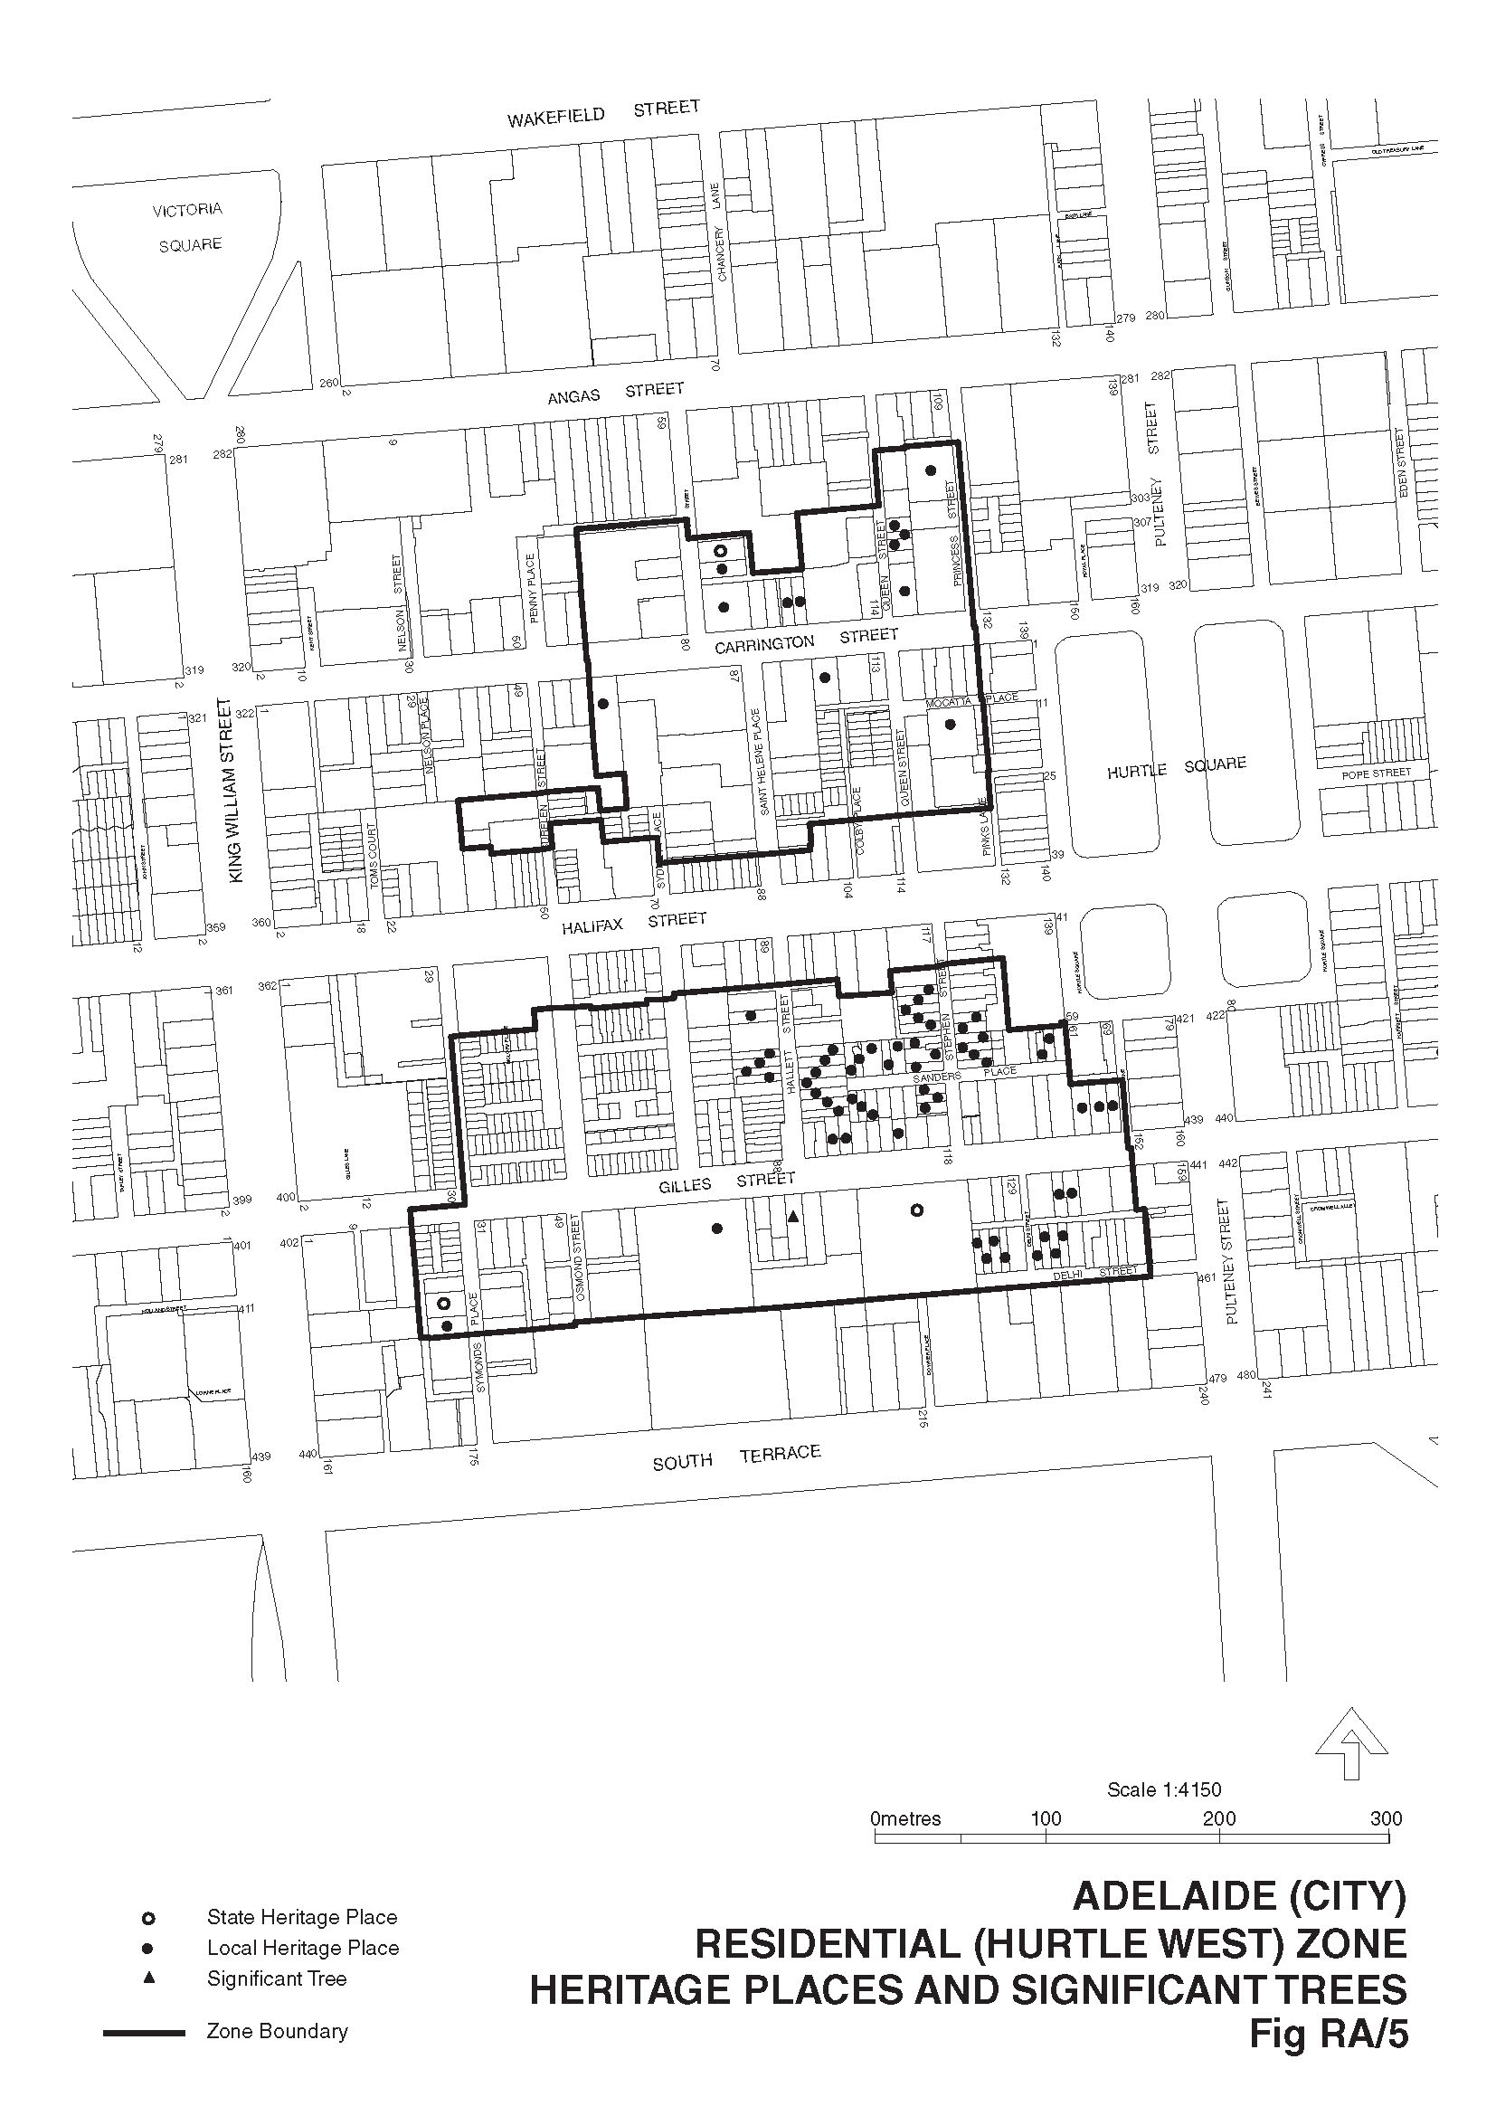

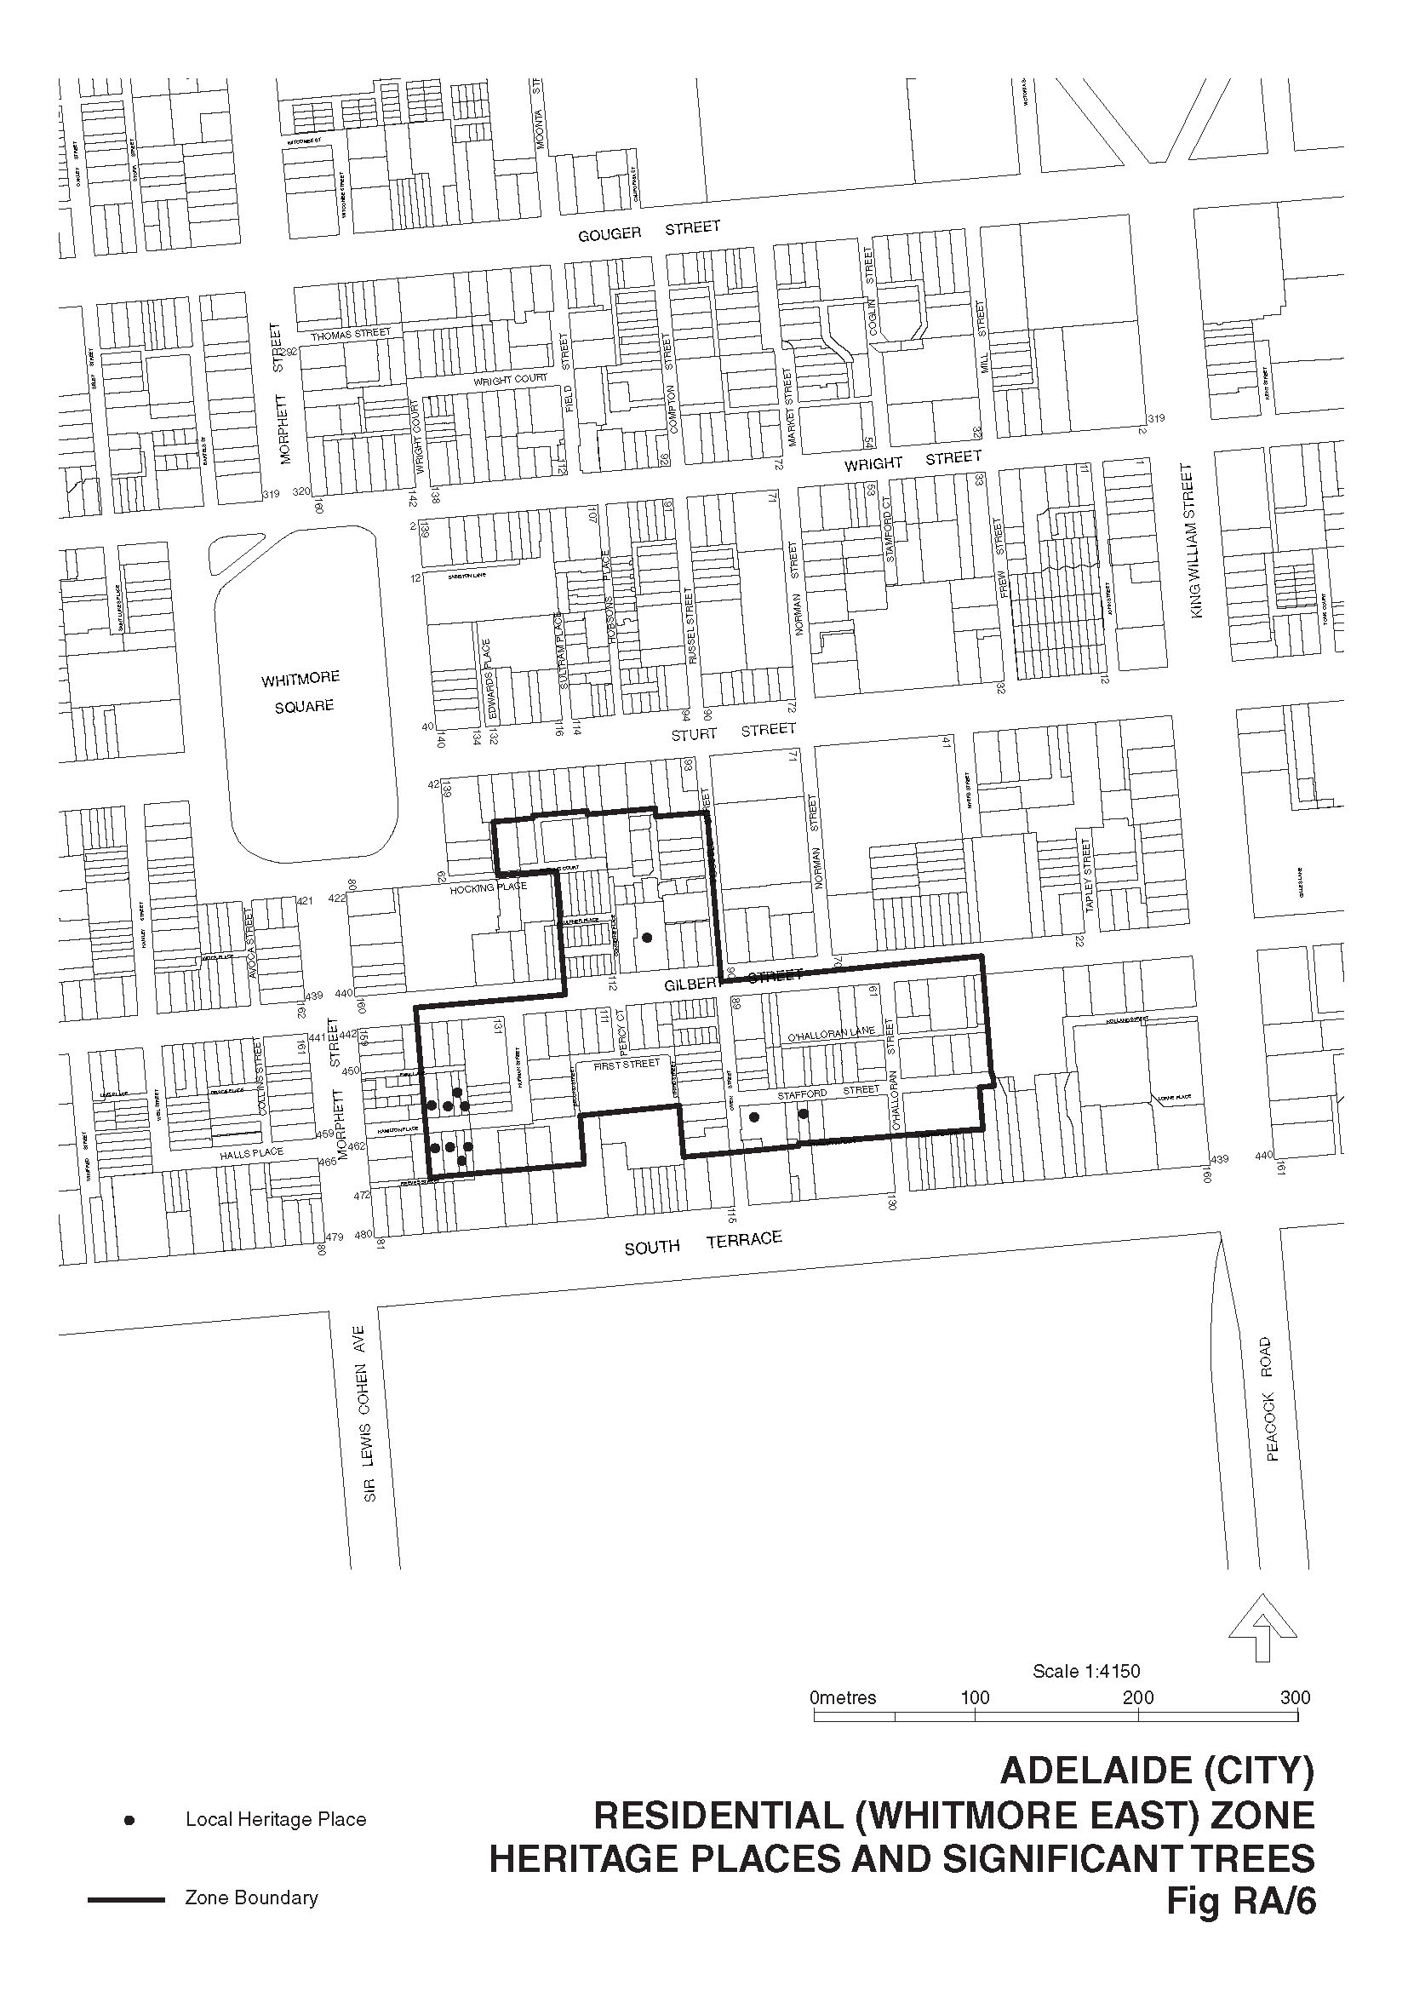

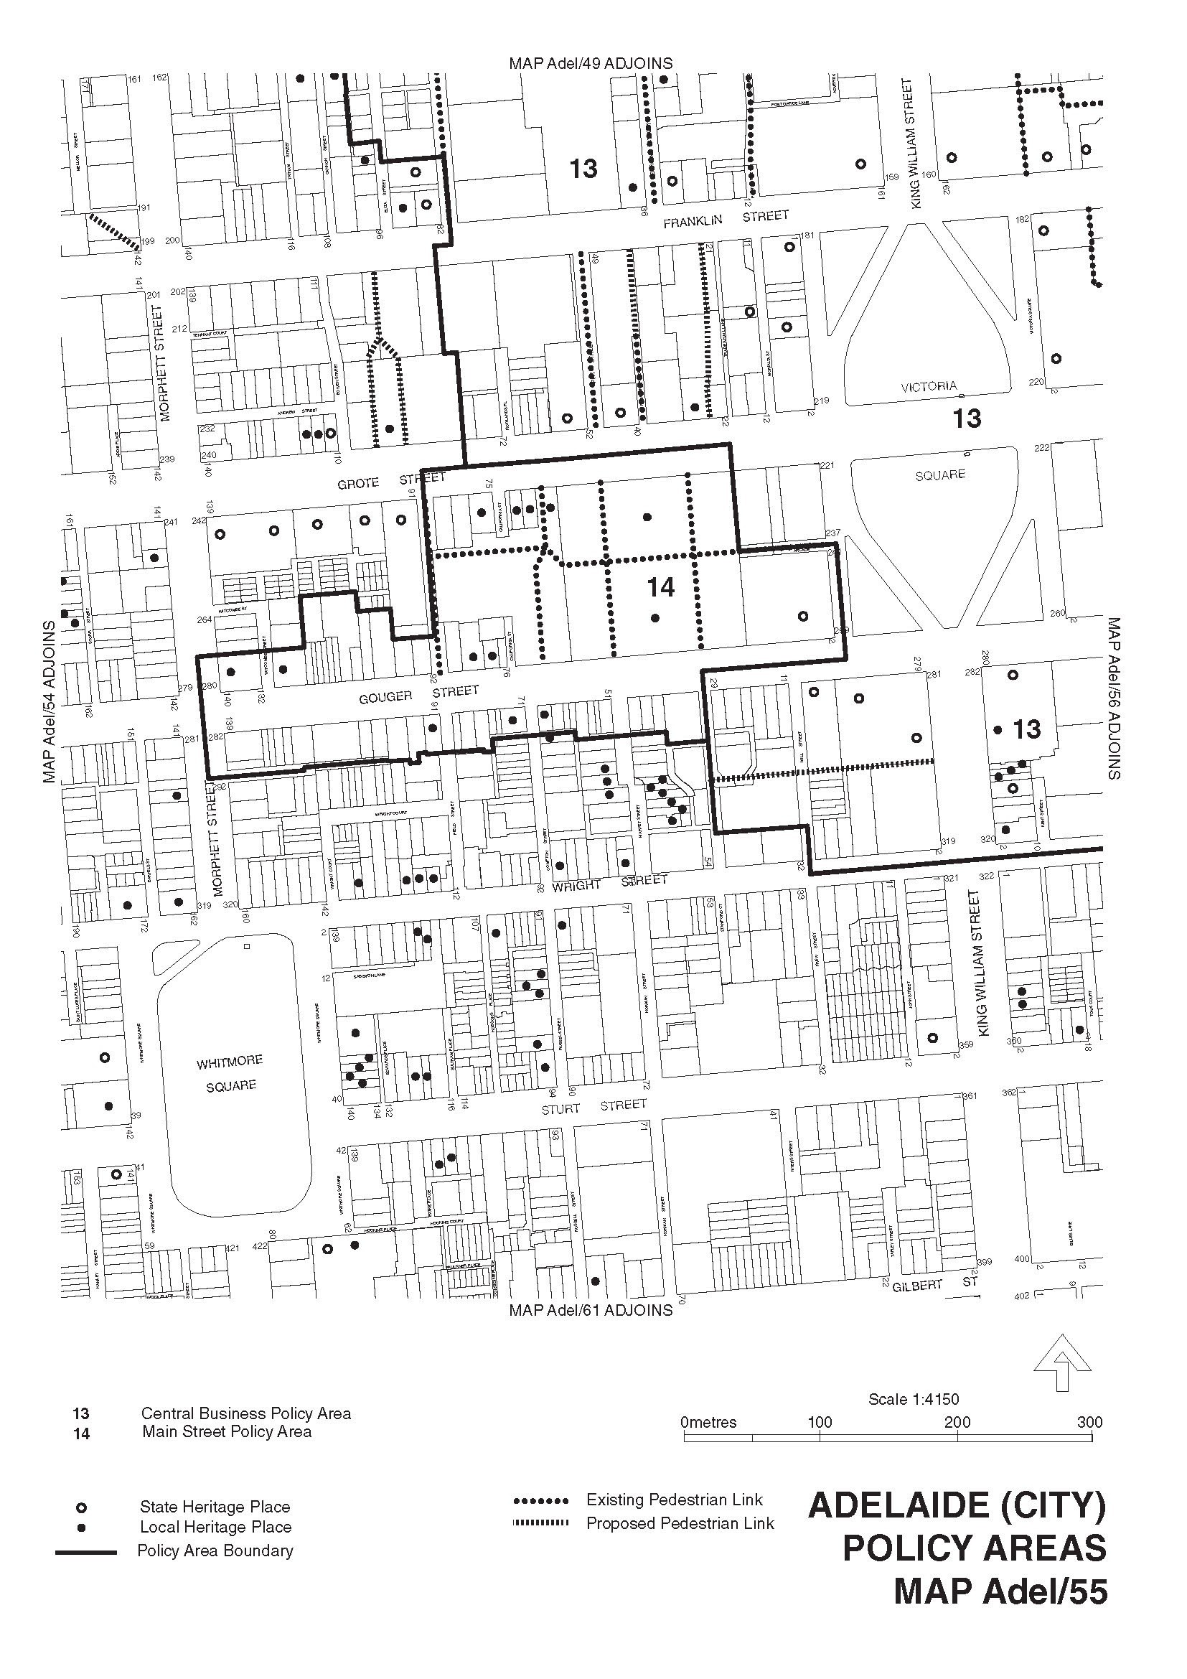

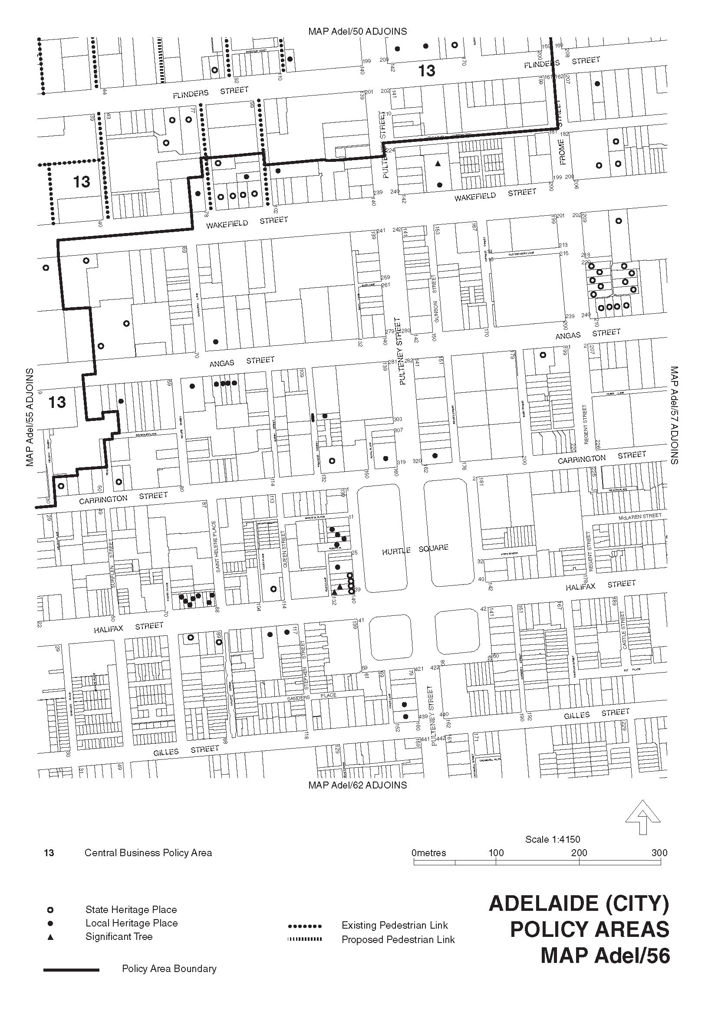

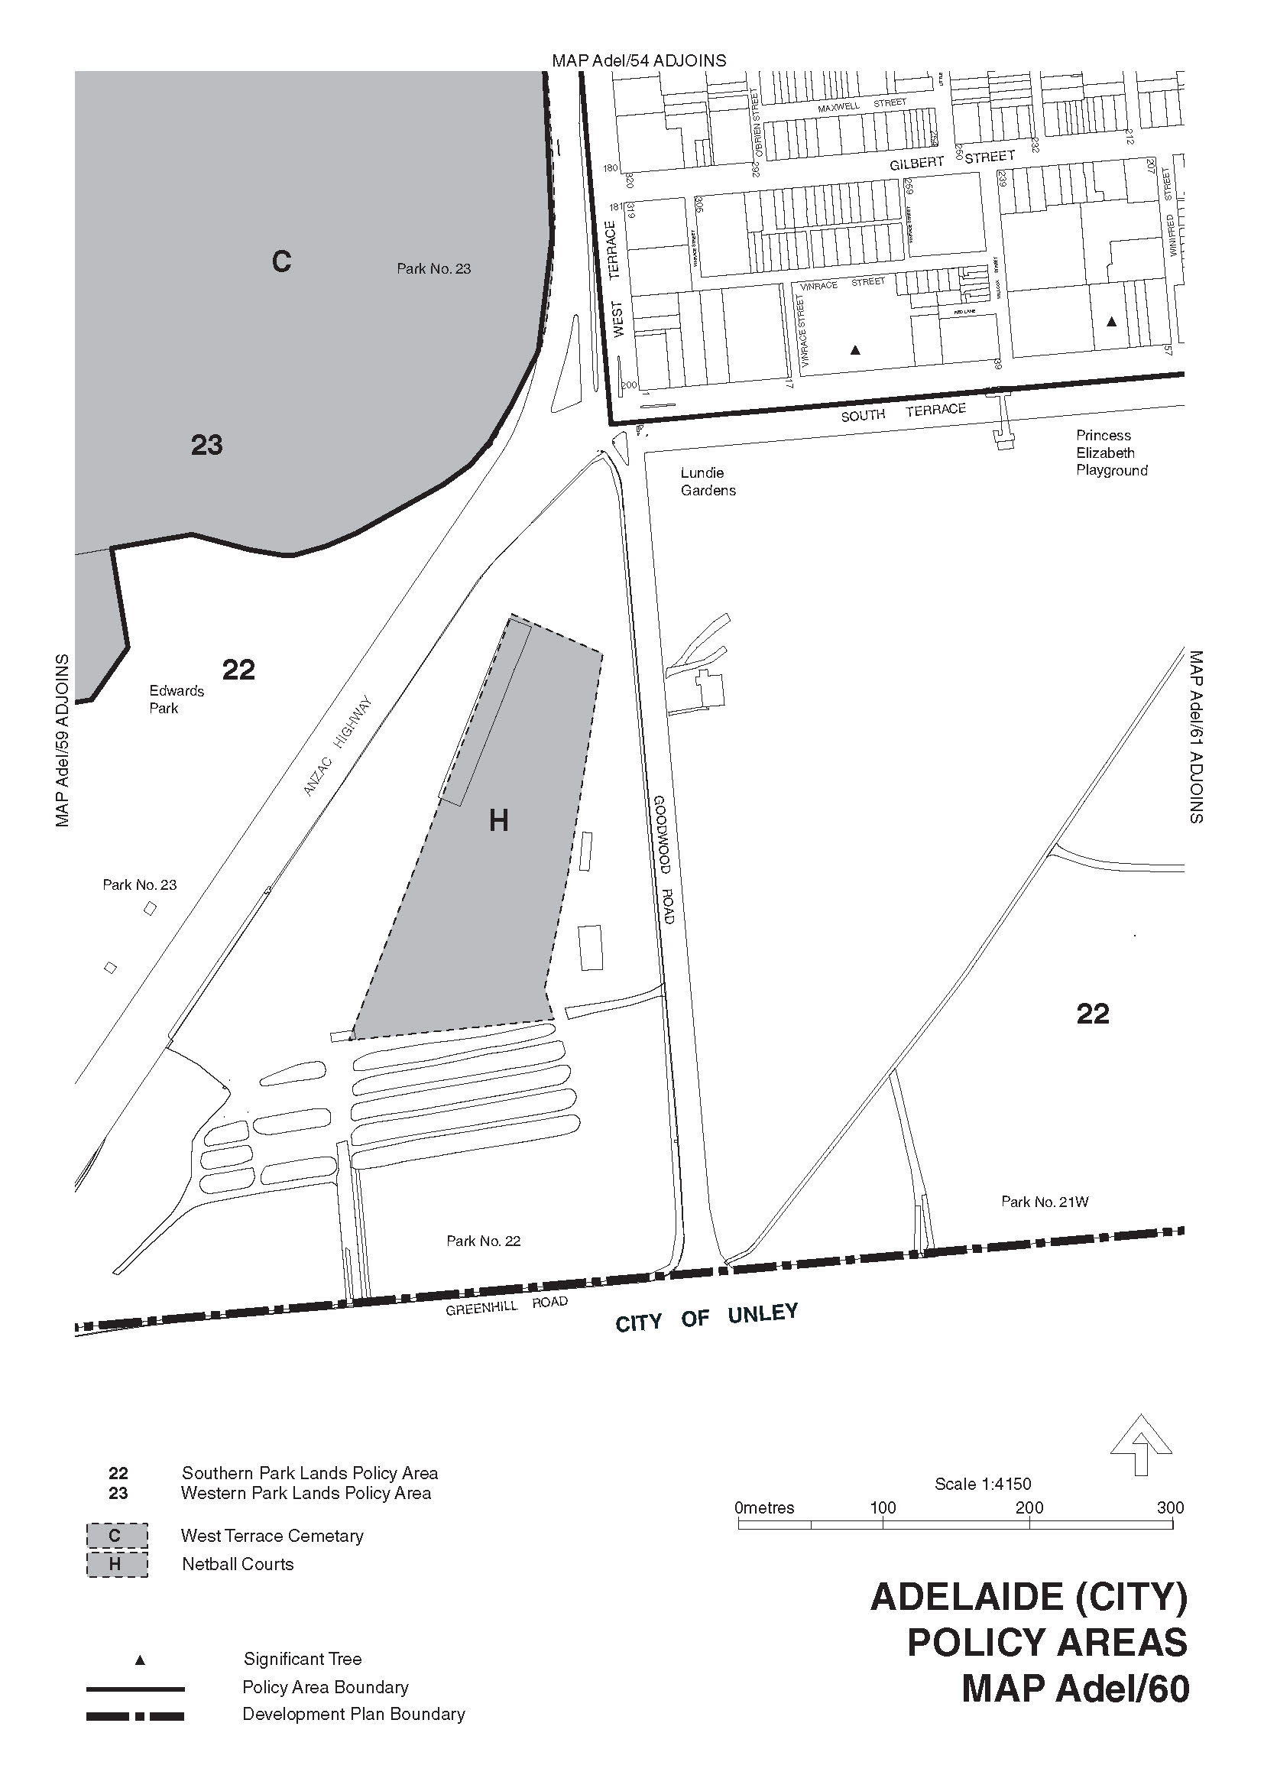

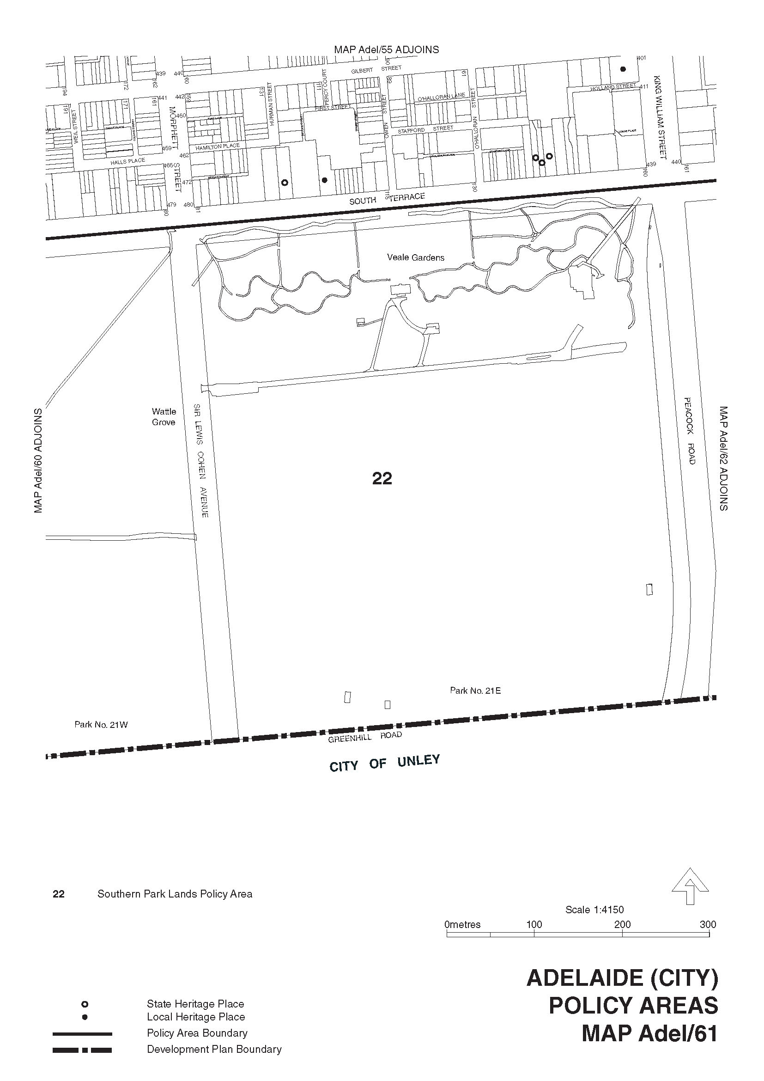

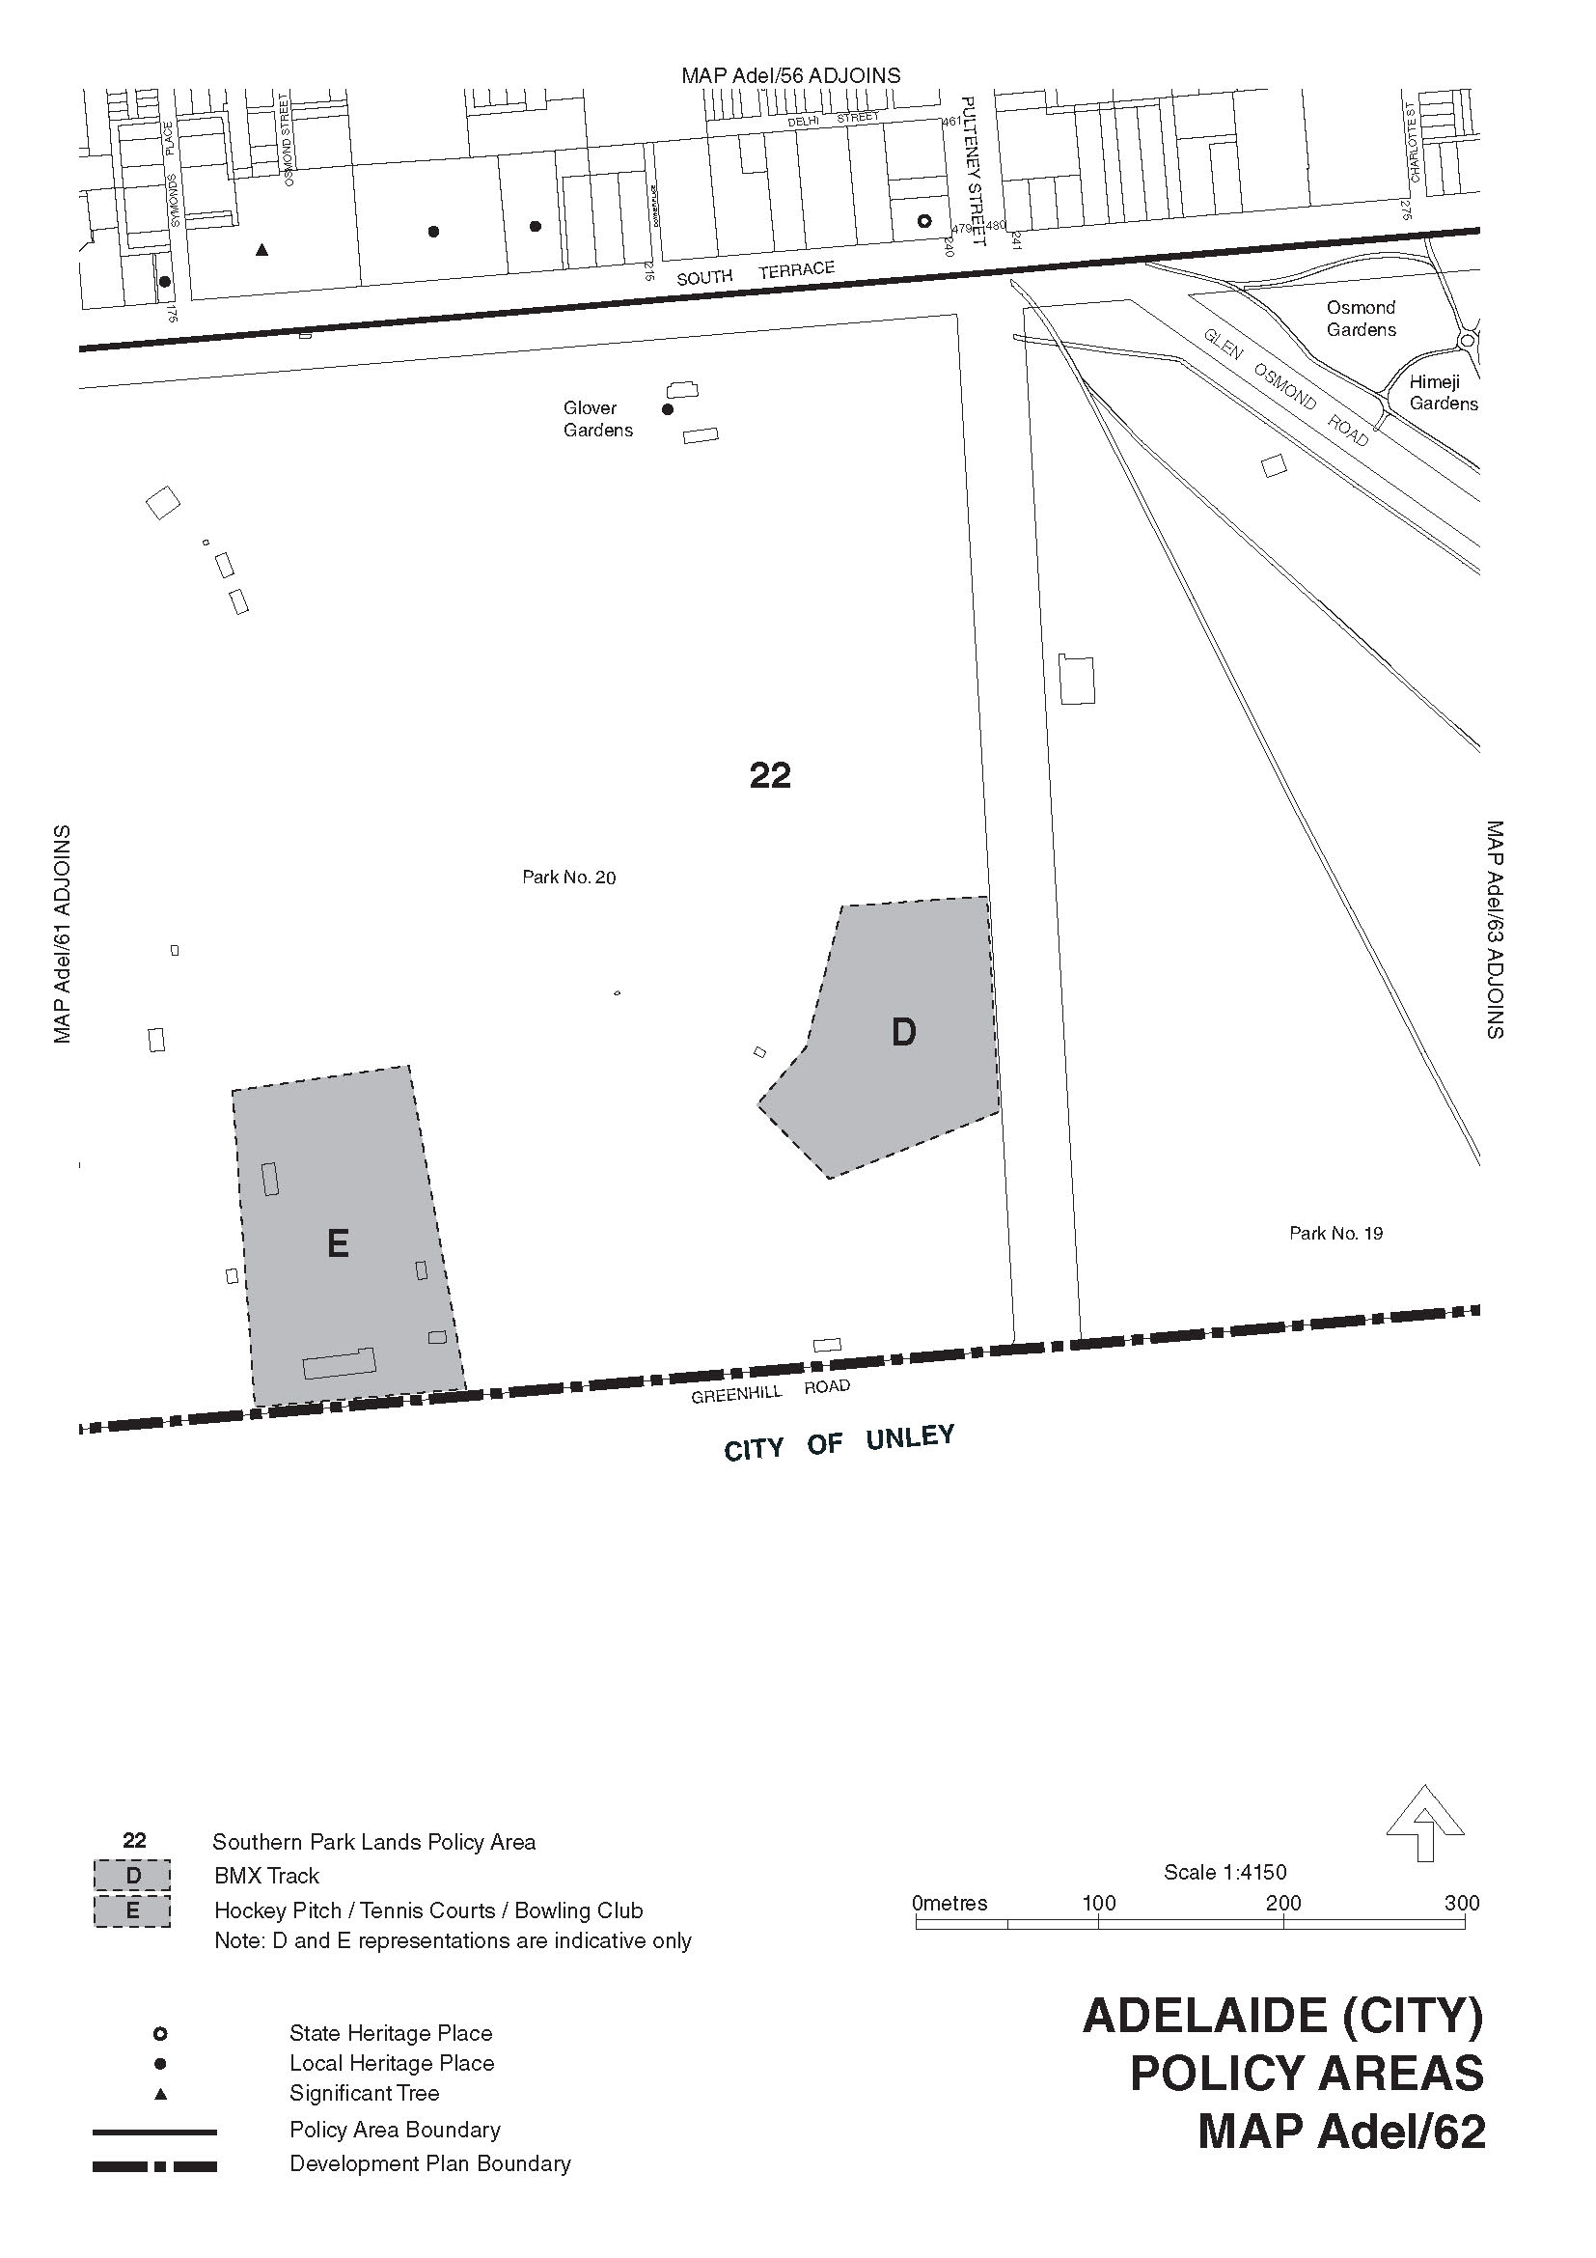

ENVIRONMENT PROTECTION ACT 1993
Variation to Existing Approval of Collection Depot
I, ANDREA KAYE WOODS, Delegate of the Environment Protection Authority (‘the Authority’), pursuant to Section 69 of the Environment Protection Act 1993 (SA) (‘the Act’) hereby:
Variation to Existing Approval of Collection Depot
Vary the approval of the collection depot, listed at Schedule 1 of this Notice, that was granted under the Act prior to the date of this Notice and impose the conditions of this approval to be as follows:
Approval of Collection Depot
The collection depot identified by reference to the following matters is approved:
(a) the name of the collection depot described in Column 1 of Schedule 1 of this Notice;
(b) the name of the proprietor of the depot identified in Column 3 of Schedule 1 of this Notice;
(c) the location of the depot described in Columns 4-6 of Schedule 1 of this Notice.
The collection depot listed at Schedule 1 of this Notice is approved in relation to all classes of containers which were approved under the Act, at or subsequent to the date of this Notice, as Category B Containers.
Conditions of Approval
Impose the following conditions on the approval:
(a) If the Approval Holder’s name or postal address (or both) changes, then the approval Holder must inform the authority in wrting, within 28 days of the change occurring.
(b) If the collection depot is sold to another party, the Approval Holder must inform the Authority in writing, within 28 days of settlement.
(c) The Approval Holder who wishes to cease operation of the depot shall notify the Authority in writing no less than 14 days from the date of closing.
(d) The Approval Holder, or a person acting on his or her behalf, must not pay a refund on, or seek reimbursement for, containers that the Approval Holder, or the person acting on his or her behalf, knows were not purchased in South Australia.
(e) The Approval Holder must ensure that prominent signage is displayed, detailing the offence and the penalties under Section 69 of the Act, for presenting interstate containers for refund.
Schedule 1

Column 1 | Column 2 | Column 3 | Column 4 | Column 5 | Column 6 | Column 7
Depot Name | Company/Trading Name | Proprietors | Depot Location  Street | Depot Location  Suburb | Certificate of Title No. Volume/Folio No. | Collection  Area
McLaren Vale Recycling | W and B Binning Family Trust | William Binning and Bernadette Binning | 6/229 Main Road | McLaren Vale | 5145/924 | Metro
Glen Osmond Recycling Depot | Glen Osmond Recycling Depot | Stuart Gay | 389 Glen Osmond Road | Glen Osmond | 4035/382 | Metro

ENVIRONMENT PROTECTION ACT 1993
Approval of Additional Collection Depots
I, ANDREA KAYE WOODS, Delegate of the Environment Protection Authority (‘the Authority’), pursuant to Section 69 of the Environment Protection Act 1993 (SA) (‘the Act’) hereby:
Approval of Additional Collection Depots
(i) Approval of Collection Depots:
Approve the collection depots identified by reference to the following matters, to receive all containers belonging to a class of containers which is, at or subsequent to, the date of this Notice, approved as Category B Containers:
(a) the name of the collection depot described in Column 1 of Schedule 1 of this Notice;
(b) the name of the proprietor of the depot identified in Column 3 of Schedule 1 of this Notice;
(c) the location of the depot described in Columns 4-6 of Schedule 1 of this Notice; and
(ii) Conditions of Approval:
Impose the following conditions of these approvals:
(a) If the Approval Holder’s name or postal address (or both) changes, then the Approval Holder must inform the Authority in writing, within 28 days of the change occurring.
(b) If the collection depot is sold to another party, the Approval Holder must inform the Authority in writing, within 28 days of settlement.
(c) The Approval Holder who wishes to cease operation of the depot shall notify the Authority in writing no less than 14 days from date of closing.
(d) The Approval Holder, or a person acting on his or her behalf, must not pay a refund on, or seek reimbursement for, containers that the Approval Holder, or the person acting on his or her behalf, knows were not purchased in South Australia.
(e) The Approval Holder must ensure that prominent signage is displayed, detailing the offence and the penalties under Section 69 the Act, for presenting interstate containers for refund.
Schedule 1

Column 1 | Column 2 | Column 3 | Column 4 | Column 5 | Column 6 | Column 7
Depot Name | Company/Trading Name | Proprietors | Depot Location  Street | Depot Location  Suburb | Certificate of Title No. Volume/Folio No. | Collection  Area
Wakefield Plains Recycling | YP Recycling | Neil Drogemuller and Sue Drogemuller | 20 Railway Terrace | Balaklava | Vol. 2659, Folio 119;  Vol. 2297, Folio 46;  Vol. 5321, Folio 992 and  Vol. 5322, Folio 3 | Regional

HOUSING IMPROVEMENT ACT 1940
NOTICE is hereby given that the South Australian Housing Trust Board delegate in the exercise of the powers conferred by the Housing Improvement Act 1940, does hereby declare the houses described in the table hereunder to be substandard for the purposes of Part 7 of the Housing Improvement Act 1940.

No. of House and Street | Locality | Allotment, Section, etc. | Certificate of Title  Volume Folio
Unit 1, 22 Botting Street | Albert Park | Allotment 125 in Deposited Plan 628, Hundred of Yatala | 6098 | 739
24 Costello Road | Loveday | Allotment 14 in Deposited Plan 64866, Hundred of Loveday | 5941 | 26
19 Gum Avenue | Dry Creek | Allotment 40 in Deposited Plan 2904, Hundred of Port Adelaide | 5771 | 36
19 South Avenue | Northfield | Allotment 35 in Deposited Plan 7513, Hundred of Yatala | 5601 | 788
Dated at Adelaide, 4 April 2013. R. Hulm, Director, Corporate Services, Housing SA

HOUSING IMPROVEMENT ACT 1940
WHEREAS by notice published in the Government Gazette on the dates mentioned in the following table the South Australian Housing Trust Board Delegate did declare the houses described in the said table to be substandard for the purposes of Part 7 of the Housing Improvement Act 1940, the South Australian Housing Trust Board delegate in the exercise of the powers conferred by the said Part, does hereby fix as the maximum rental per week which shall be payable subject to Section 55 of the Residential Tenancies Act 1995, in respect of each house described in the following table the amount shown in the said table opposite the description of such house and this notice shall come into force on the date of this publication in the Gazette.

Address of House | Allotment, Section, etc. | Certificate of Title  Volume Folio |  | Date and page of Government Gazette in which notice declaring house to be substandard published | Maximum rental per week  payable in respect of each house  $
Section 244 (also known as 13 Curtis Road), Armstrong Road, Waikerie | Sections 244 and 245 in Hundred Plan 700600, Hundred of Holder | 6048 | 345 | 7.2.13, page 243 | 104.00
8-10 Franklin Street, Port Augusta | Allotments 53 and 54 in Deposited Plan 89548, Hundred of Davenport | 6100  6100 | 900  901 | 24.6.93, page 2152 | 0.00  (unfit for human habitation)
21 Kingsley Avenue, Pooraka | Allotment 43 in Deposited Plan 6852, Hundred of Yatala | 5627 | 467 | 10.1.13, page 17 | 227.00
Lot 65 (previously known as Lot D) Symes Road, Waterloo Corner | Allotment 65 in Filed Plan 114526, Hundred of Port Adelaide | 5787 | 298 | 29.6.95, page 3061 | 0.00  (unfit for human habitation)
Dated at Adelaide, 4 April 2013. R. Hulm, Director, Corporate Services, Housing SA

HOUSING IMPROVEMENT ACT 1940
WHEREAS by notice published in the Government Gazette on the dates mentioned in the following table the South Australian Housing Trust Board Delegate did declare the houses described in the said table to be substandard for the purposes of Part 7 of the Housing Improvement Act 1940, and whereas the South Australian Housing Trust Board delegate is satisfied that each of the houses described hereunder has ceased to be substandard, notice is hereby given that, in exercise of the powers conferred by the said Part, the South Australian Housing Trust does hereby revoke the said declaration in respect of each house.

Address of House | Allotment, Section, etc. | Certificate of Title  Volume Folio |  | Date and page of Government Gazette in which notice declaring house to be substandard published
8850 (also known as Lot 238), Augusta Highway, Merriton | Allotment 238 in Filed Plan 188370, Hundred of Crystal Brook | 5989 | 861 | 26.3.09, page 1125
321 (also known as Sections 349 and 350) Billabong Road, Pompoota | Sections 349 and 350 Hundred Plan 750200, Hundred of Burdett | 6044 | 711 | 29.2.96, page 1333
1 Birdwood Avenue, Allenby Gardens | Allotment 1 and 2 in deposited Plan 86583, Hundred of Yatala | 6089  6089 | 464  465 | 22,02.07, page 555
18 Elizabeth Street, Goodwood | Allotment 244 in Filed Plan 11440, Hundred of Adelaide | 5839 | 541 | 9.5.74, page 1688
522 Henley Beach road, Fulham | Allotment 7 in Filed Plan 106845, Hundred of Adelaide | 5177 | 281 | 15.3.12, page 975
Unit 4, 1 Moronga Street, Salisbury North | Allotments 14 and 24 Primary Community Plan 25335, Hundred of Munno Para | 6033 | 643 | 13.9.12, page 4472
2 Thorngate Street, Thorngate | Allotment 13 in Deposited Plan 63810, Hundred of Yatala | 5914 | 902 | 13.9.12, page 4472
75 Wright Street, Henley Beach | Allotment 81 in Deposited Plan 4590, Hundred of Yatala | 5376 | 461 | 13.10.11, page 4228
Dated at Adelaide, 4 April 2013. R. Hulm, Director, Corporate Services, Housing SA

HEALTH CARE ACT 2008
Section 15
Notice by the Minister
TAKE notice that I, Jack Snelling, Minister for Health and Ageing, do hereby vary a notice made by the Minister for Health and Ageing pursuant to Section 15 of the Health Care Act 2008, (‘the Act’) on 15 December 2009 and published in the South Australian Government Gazette of 23 December 2009, which amongst other things, established the South Australian Institute of Medical Education and Training as a Health Advisory Council. I vary the notice:
1. Pursuant to sub-sections 15 (3) (a) and 15 (4) (a) of the Act, by replacing the entities previously designated to be entities in relation to which the South Australian Institute of Medical Education and Training is established, namely ‘the Minister for Health, the Chief Executive of the Department of Health and the Medical Board of Australia’ with the entities ‘the Minister for Health and Ageing, the Chief Executive of the Department for Health and Ageing and the South Australian Board of the Medical Board of Australia’.
2. Pursuant to sub-sections 15 (3) (c) and 15 (4) (a) of the Act, by replacing the name I assigned to the Health Advisory Council, namely ‘South Australian Institute of Medical Education and Training’ with the name ‘South Australian Medical Education and Training’.
These variations will come into operation on 22 April 2013.
Dated 27 March 2013.
Jack Snelling, Minister for Health and Ageing

LIQUOR LICENSING ACT 1997
Notice of Application
NOTICE is hereby given, pursuant to Section 52 (2) (b) of the Liquor Licensing Act 1997, that Boston Football Club Inc. has applied to the Licensing Authority for a Redefinition of Licensed Area, variation to an Extended Trading Authorisation and variation to a Entertainment Consent in respect of premises situated at Matthew Place, Port Lincoln, S.A. 5606 and known as Boston Football Club.
The application has been set down for hearing on 2 May 2013 at 10.30 a.m.
Conditions
The following licence conditions are sought:
• Redefinition of licensed area to redevelop and extend the clubrooms as per plans lodged with this office.
• Variation to the current Extended Trading Authorisation to apply to the abovementioned areas and to add the following time:
Friday: Midnight to 1 a.m. the following day.
• Variation to the current Entertainment Consent to apply to the areas above and all times of trade, as per plans lodged with this office.
Any person may object to the application by lodging a notice of objection in the prescribed form with the Liquor and Gambling Commissioner and serving a copy of the notice on the applicant at the applicant’s address, at least seven days before the hearing date (viz: 25 April 2013).
The applicant’s address for service is c/o Doug McFarlane, P.O. Box 115, Port Lincoln, S.A. 5607.
The application and certain documents and material (including Plans) relevant to the application may be inspected without fee at a place and during a period specified by the Liquor and Gambling Commissioner, Chesser House, Ground Floor, 91 Grenfell Street, Adelaide, S.A. 5000. Telephone: 8226 8655. Facsimile: 8226 8512. Email: olgc@agd.sa.gov.au.
Dated 26 March 2013.
Applicant

LIQUOR LICENSING ACT 1997
Notice of Application
NOTICE is hereby given, pursuant to Section 52 (2) (b) of the Liquor Licensing Act 1997, that Pinche Gringos Pty Ltd has applied to the Licensing Authority for a Restaurant Licence with Section 34 (1) (c) Authorisation in respect of premises situated at Shop G020, Rundle Place, Adelaide, S.A. 5000 and known as United Latino Cocina.
The application has been set down for hearing on 6 May 2013 at 9.30 a.m.
Any person may object to the application by lodging a notice of objection in the prescribed form with the Liquor and Gambling Commissioner and serving a copy of the notice on the applicant at the applicant’s address, at least seven days before the hearing date (viz: 29 April 2013).
The applicant’s address for service is c/o Sarah Howell, 142 Tynte Street, North Adelaide, S.A. 5006.
The application and certain documents and material (including Plans) relevant to the application may be inspected without fee at a place and during a period specified by the Liquor and Gambling Commissioner, Chesser House, Ground Floor, 91 Grenfell Street, Adelaide, S.A. 5000. Telephone: 8226 8655. Facsimile: 8226 8512. Email: olgc@agd.sa.gov.au.
Dated 27 March 2013.
Applicant

LIQUOR LICENSING ACT 1997
Notice of Application
NOTICE is hereby given, pursuant to Section 52 (2) (b) of the Liquor Licensing Act 1997, that Blaxland Vineyards Ltd has applied to the Licensing Authority for the removal of a Wholesale Liquor Merchant’s Licence in respect of premises situated at 26 Greenock Road, Nuriootpa, S.A. 5355 and to be situated at 175 Fullarton Road, Dulwich, S.A. 5065 and known as Blaxland Vineyards.
The application has been set down for hearing on 6 May 2013 at 10.30 a.m.
Any person may object to the application by lodging a notice of objection in the prescribed form with the Liquor and Gambling Commissioner and serving a copy of the notice on the applicant at the applicant’s address, at least seven days before the hearing date (viz: 29 April 2013).
The applicant’s address for service is c/o Marshall Consulting, 175 Fullarton Road, Dulwich, S.A. 5065 (Attention: Philip Marshall).
The application and certain documents and material (including Plans) relevant to the application may be inspected without fee at a place and during a period specified by the Liquor and Gambling Commissioner, Chesser House, Ground Floor, 91 Grenfell Street, Adelaide, S.A. 5000. Telephone: 8226 8655. Facsimile: 8226 8512. Email: olgc@agd.sa.gov.au.
Dated 27 March 2013.
Applicant

LIQUOR LICENSING ACT 1997
Notice of Application
NOTICE is hereby given, pursuant to Section 52 (2) (b) of the Liquor Licensing Act 1997, that Adelaide Wine Co Pty Ltd has applied to the Licensing Authority for a variation to Conditions and Redefinition of Licensed Area in respect of the premises situated at 87 King William Road, Unley, S.A. 5061 and known as Tomich Hill.
The application has been set down for hearing on 6 May 2013 at 10 a.m.
Conditions
The following licence conditions are sought:
• That weekend trading hours be extended from 2.30 p.m.-6.30 p.m. to 9 a.m.-9 p.m.
• To remove the condition ‘by agreement the maximum number of limited licence applications the licensee is to lodge in any one financial year is limited to four’.
• Remove condition requiring licensee notifying Robert Dillon of any limited licence applications.
• Redefinition of licensed area to include front verandah and lawn area, as per plans lodged with this office.
Any person may object to the application by lodging a notice of objection in the prescribed form with the Liquor and Gambling Commissioner and serving a copy of the notice on the applicant at the applicant’s address, at least seven days before the hearing date (viz: 29 April 2013).
The applicant’s address for service is c/o Tanya Kerr, 87 King William Road, Unley, S.A. 5061.
The application and certain documents and material (including Plans) relevant to the application may be inspected without fee at a place and during a period specified by the Liquor and Gambling Commissioner, Chesser House, Ground Floor, 91 Grenfell Street, Adelaide, S.A. 5000. Telephone: 8226 8655. Facsimile: 8226 8512. Email: olgc@agd.sa.gov.au.
Dated 27 March 2013.
Applicant

LIQUOR LICENSING ACT 1997
Notice of Application
NOTICE is hereby given, pursuant to Section 52 (2) (b) of the Liquor Licensing Act 1997, that M J & R J Nominees Pty Ltd as trustee for S & K Pitman Family Trust has applied to the Licensing Authority for the transfer of a Restaurant Licence with Section 34 (1) (c) Authorisation, Extended Trading Authorisation and Entertainment Consent in respect of premises situated at Shop 14, 17-21 Ocean Street, Victor Harbor, S.A. 5211 to be known as Harbar Victor Harbor.
The application has been set down for hearing on 6 May 2013 at 11 a.m.
Conditions
The following licence conditions are sought:
• Extended Trading Authorisation for the following days and times:
Friday to Saturday: Midnight to 2 a.m. the following day.
• Entertainment Consent to apply to the dining room.
Any person may object to the application by lodging a notice of objection in the prescribed form with the Liquor and Gambling Commissioner and serving a copy of the notice on the applicant at the applicant’s address, at least seven days before the hearing date (viz: 29 April 2013).
The applicant’s address for service is c/o Andrew Wong, 4/82 Hawker Street, Ridleyton, S.A. 5008.
The application and certain documents and material (including Plans) relevant to the application may be inspected without fee at a place and during a period specified by the Liquor and Gambling Commissioner, Chesser House, Ground Floor, 91 Grenfell Street, Adelaide, S.A. 5000. Telephone: 8226 8655. Facsimile: 8226 8512. Email: olgc@agd.sa.gov.au.
Dated 28 March 2013.
Applicant

NATIONAL GAS LAW
THE Australian Energy Market Commission (AEMC) gives notice under the National Gas Law of the following matter.
Under Section 308, the making of a draft determination and draft National Gas Amendment (Pipeline operator cost recovery processes) Rule 2013 (Project Ref. GRC0017). In relation to the draft determination:
• requests for a pre-determination hearing must be received by Thursday, 11 April 2013; and
• submissions must be received by Thursday, 16 May 2013;
Submissions and requests for a hearing should be forwarded to submissions@aemc.gov.au and must cite the Project Ref. in its title. Before submitting your submissions, you must review the AEMC’s privacy statement on its website. Submissions should be submitted in accordance with the AEMC’s Guidelines for making written submissions on Rule change proposals. The AEMC publishes all submissions on its website subject to confidentiality.
All documents in relation to the above matter are published on the AEMC’s website and are available for inspection at the offices of the AEMC.
Australian Energy Market Commission
Level 5, 201 Elizabeth Street
Sydney, N.S.W. 2000
Telephone: (02) 8296 7800
Facsimile: (02) 8296 7899
4 April 2013.

NATURAL RESOURCES MANAGEMENT ACT 2004
Water Allocation Plan
I, IAN HUNTER, Minister for Sustainability, Environment and Conservation, to whom administration of the Natural Resources Management Act 2004, is committed, hereby give notice for the purposes of the Water Allocation Plan for the Southern Basins Prescribed Wells Area adopted under Schedule 4 of the Natural Resources Management Act 2004, of the ‘recent recharge rate of the lens’ as set out below:
Quaternary Aquifer | Recent Recharge Rate of the Lens 2013-2014 (expressed as millimetres per annum)
Coffin Bay A (West) | 29
Coffin Bay B (Central) | 6
Coffin Bay C (East) | 9
Uley Wanilla | 13
Wanilla | 7
Uley East | 22
Uley South | 133
Lincoln A, B and C | 35
Lincoln D | 8
Lincoln D West | 8
Minor Lenses | 13
Dated 2 April 2013.
Ian Hunter, Minister for Sustainability, Environment and Conservation

PETROLEUM AND GEOTHERMAL ENERGY ACT 2000
Application for Grant of Special Facilities Licence—SFL 4
PURSUANT to Section 65 (6) of the Petroleum and Geothermal Energy Act 2000 (the Act) and Delegation dated 21 March 2012, notice is hereby given that an application for the grant of a Special Facilities Licence within the area described below has been received from:
Beach Oil and Gas Pty Ltd
Senex Energy Limited
The application will be determined on or after 2 May 2013.
Description of Application Area
All that part of the State of South Australia, bounded as follows:
A corridor 60 m wide centred on a line between co-ordinates:
356375.76mE 6894805.81mN
356535.01mE 6894805.98mN
356670.61mE 6894799.72mN
357811.45mE 6894758.79mN
361404.44mE 6894638.05mN
363089.66mE 6894583.16mN
365961.05mE 6894486.32mN
365985.99mE 6894486.29mN
366014.61mE 6894485.27mN
367356.64mE 6894440.50mN
367373.30mE 6894440.42mN
367749.36mE 6894427.39mN
368183.03mE 6894348.14mN
367784.26mE 6894424.95mN
368247.42mE 6894337.50mN
367818.78mE 6894419.32mN
368316.80mE 6894329.00mN
368369.04mE 6894324.43mN
368438.80mE 6894327.37mN
368915.57mE 6894378.12mN
368993.93mE 6894382.77mN
369089.92mE 6894383.11mN
370033.84mE 6894345.97mN
371435.67mE 6894295.76mN
371565.36mE 6894309.60mN
371685.89mE 6894377.83mN
371755.50mE 6894430.59mN
371803.83mE 6894468.04mN
371885.17mE 6894518.04mN
371945.76mE 6894523.68mN
372037.63mE 6894496.17mN
372446.25mE 6894345.37mN
372620.51mE 6894283.21mN
372782.08mE 6894248.83mN
373185.52mE 6894235.88mN
373207.63mE 6894235.10mN
373256.72mE 6894234.62mN
373375.23mE 6894230.69mN
376924.25mE 6894109.11mN
378362.70mE 6894059.68mN
383017.32mE 6893900.39mN
384166.57mE 6893860.89mN
383659.24mE 6893879.27mN
388739.13mE 6893704.55mN
388767.66mE 6893703.44mN
390027.09mE 6893660.88mN
394130.63mE 6893520.44mN
394137.46mE 6893520.09mN
394155.50mE 6893519.64mN
394189.62mE 6893519.15mN
394199.26mE 6893518.91mN
395967.32mE 6893473.77mN
397492.99mE 6893463.07mN
397502.22mE 6893462.87mN
397662.03mE 6893461.14mN
397675.53mE 6893461.00mN
398410.24mE 6893454.73mN
399698.06mE 6893445.03mN
399704.47mE 6893445.77mN
399727.65mE 6893445.71mN
401841.31mE 6893429.40mN
401851.83mE 6893429.34mN
401863.82mE 6893428.12mN
401894.91mE 6893428.33mN
401898.18mE 6893428.41mN
407587.10mE 6893384.97mN
407590.09mE 6893385.61mN
408633.57mE 6893376.69mN
413402.26mE 6893340.88mN
413403.11mE 6893340.17mN
413437.44mE 6893340.67mN
413456.84mE 6893341.05mN
414823.71mE 6893328.39mN
414875.50mE 6893334.57mN
414922.09mE 6893357.90mN
414963.08mE 6893390.82mN
414983.52mE 6893418.77mN
414993.20mE 6893434.50mN
415005.13mE 6893454.02mN
415011.32mE 6893463.94mN
415092.51mE 6893525.65mN
415143.10mE 6893532.70mN
415324.19mE 6893532.53mN
415481.22mE 6893532.21mN
415502.63mE 6893532.10mN
415971.71mE 6893527.15mN
415999.74mE 6893524.85mN
416032.12mE 6893512.21mN
416208.46mE 6893414.27mN
416215.45mE 6893410.12mN
416222.98mE 6893404.95mN
416286.23mE 6893358.80mN
416300.40mE 6893349.30mN
416308.62mE 6893344.70mN
417166.99mE 6892856.98mN
417184.12mE 6892847.25mN
417455.46mE 6892692.35mN
417462.79mE 6892687.71mN
417470.86mE 6892682.12mN
417559.20mE 6892612.48mN
417566.04mE 6892607.17mN
417572.64mE 6892602.72mN
417816.45mE 6892464.46mN
419198.08mE 6891681.20mN
420940.60mE 6890699.53mN
420942.60mE 6890697.24mN
420986.39mE 6890679.62mN
421129.09mE 6890591.68mN
421291.22mE 6890468.33mN
421401.17mE 6890404.85mN
421518.13mE 6890404.85mN
421665.82mE 6890403.20mN
421839.60mE 6890401.64mN
421935.87mE 6890399.23mN
421935.88mE 6890344.09mN
421935.87mE 6890334.09mN
and restart pits bounded by co-ordinates:
1
365911m 6894536mN
366011m 6894536mN
366011m 6894436mN
365911m 6894436mN
365911m 6894536mN
2
373136m 6894286mN
373236m 6894286mN
373236m 6894186mN
373136m 6894186mN
373136m 6894286mN
3
382967m 6893950mN
383067m 6893950mN
383067m 6893850mN
382967m 6893850mN
382967m 6893950mN
4
394087m 6893570mN
394187m 6893570mN
394187m 6893470mN
394087m 6893470mN
394087m 6893570mN
5
401845m 6893478mN
401945m 6893478mN
401945m 6893378mN
401845m 6893378mN
401845m 6893478mN
6
413353m 6893390mN
413453m 6893390mN
413453m 6893290mN
413353m 6893290mN
413353m 6893390mN
and Lycium facility area bounded by co-ordinates:
356000mE 6895000mN
356800mE 6895000mN
356800mE 6894400mN
356000mE 6894400mN
356000mE 6895000mN
and Moomba end of line facility bounded by co-ordinates:
421905.87mE 6890364mN
421965.87mE 6890364mN
421965.87mE 6890274mN
421905.87mE 6890274mN
421905.87mE 6890364mN
All co-ordinates in GDA94, Zone 54.
Area: 4.48 km² approximately.
Dated 28 March 2013.
B. A. Goldstein,
Executive Director,
Energy Resources Division
Department for Manufacturing, Innovation, Trade, Resources and Energy
Delegate of the Minister for Mineral
Resources and Energy

ROADS (OPENING AND CLOSING) ACT 1991:
SECTION 24
NOTICE OF CONFIRMATION OF ROAD
PROCESS ORDER
Road Opening and Closing
Waterloo Road, Tarpeena / Wepar
BY Road Process Order made on 20 November 2012, the District Council of Grant ordered that:
1. Portions of Sections 71 and 72, Hundred of Young, more particularly delineated and numbered ‘1’ and ‘2’ on Preliminary Plan No. 12/0028 be opened as road, forming a re-alignment of Waterloo Road
2. Portions of Waterloo Road situated dividing Sections 71 and 72, Hundred of Young, more particularly delineated and lettered ‘A’ and ‘B’ on Preliminary Plan No. 12/0028 be closed.
3. Transfer the whole of the land subject to closure to Frank Ferguson Kentish in accordance with agreement for exchange dated 14 August 2012 entered into between the District Council of Grant and F. F. Kentish.
On 4 January 2013 that order was confirmed by the Minister for Transport and Infrastructure conditionally upon the deposit by the Registrar-General of Deposited Plan 90803 being the authority for the new boundaries.
Pursuant to Section 24 (5) of the Roads (Opening and Closing) Act, 1991, NOTICE of the order referred to above and its confirmation is hereby given.
Dated 4 April 2013.
M. P. Burdett, Surveyor-General

ROAD TRAFFIC ACT 1961
Authorised Officers to Operate Breath Analysing Instruments
I, GARY T. BURNS, Commissioner of Police, do hereby certify that on 26 March 2013, the following persons were authorised by the Commissioner of Police to operate breath analysing instruments as defined in and for the purposes of the:
Road Traffic Act 1961;
Harbors and Navigation Act 1993;
Security and Investigation Agents Act 1995; and
Rail Safety National Law (South Australia) Act 2012.

PD  Number | Officer Name
73808 | Bradbury, Michael David
72506 | Colligan, Peter James
74171 | Davies, Christian Richard
75068 | Mansfield, James Howard
72568 | Stevens, Linsay Fay
72135 | Summers, Kayleen Temperance
73998 | Vincent, Ambrose David

Gary T. Burns, Commissioner of Police

ROAD TRAFFIC ACT 1961
Authorised Officers to Operate Breath Analysing Instruments
I, GARY T. BURNS, Commissioner of Police, do hereby certify that on 26 March 2013, the following persons were authorised by the Commissioner of Police to operate breath analysing instruments as defined in and for the purposes of the:
Road Traffic Act 1961;
Harbors and Navigation Act 1993;
Security and Investigation Agents Act 1995; and
Rail Safety National Law (South Australia) Act 2012.

PD  Number | Officer Name
73805 | Ball, David Andrew
79946 | Beauchamp, Michael David
75010 | Brame, Yvonne Victoria
74291 | Broadbent, Nathan Brooker
73508 | Czeglik, Debra Jayne
73547 | Ghent, Kathryn Lucy
74093 | Hoare, Danielle Lee
74493 | Jones, Daniel Aaran
71727 | McLauchlan, Sarah Kate
74193 | McTaggart, Damian Joseph
73926 | O’Loughlin, Seanagh
73555 | Sargent, Logan George

Gary T. Burns, Commissioner of Police

ROAD TRAFFIC ACT 1961
Authorised Officers to Conduct Drug Screening Tests
I, GARY T. BURNS, Commissioner of Police, do hereby certify that on 26 March 2013, the following persons were authorised by the Commissioner of Police to conduct drug screening tests as defined in and for the purposes of the:
Road Traffic Act 1961;
Harbors and Navigation Act 1993; and
Rail Safety National Law (South Australia) Act 2012.

PD  Number | Officer Name
73805 | Ball, David Andrew
72384 | Coxon, Winston Andrew
71727 | McLauchlan, Sarah Kate
73225 | Moriarty, Daniel Christopher

Gary T. Burns, Commissioner of Police

ROAD TRAFFIC ACT 1961
Authorised Officers to Conduct Oral Fluid Analyses
I, GARY T. BURNS, Commissioner of Police, do hereby certify that on 26 March 2013, the following persons were authorised by the Commissioner of Police to conduct oral fluid analyses as defined in and for the purposes of the:
Road Traffic Act 1961;
Harbors and Navigation Act 1993; and
Rail Safety National Law (South Australia) Act 2012.

PD  Number | Officer Name
73805 | Ball, David Andrew
72384 | Coxon, Winston Andrew
73320 | Dury, Shannon Lisa
71727 | McLauchlan, Sarah Kate
73225 | Moriarty, Daniel Christopher
73362 | Sawe, Sumit Pratap
73845 | Turner, Matthew Nicholas
73073 | Young, Krista Beth

Gary T. Burns, Commissioner of Police

WATER MAINS AND SEWERS

Office of the South Australian Water Corporation
Adelaide, 4 April 2013

WATER MAINS LAID

Notice is hereby given that the following main pipes or parts of main pipes have been laid down by the South Australian Water Corporation in or near the undermentioned water districts and are now available for a constant supply of water to adjacent land.

ADELAIDE WATER DISTRICT

TOWN OF GAWLER
In and across Campbell Circuit, Gawler East. p4 and 5
Henwood Court, Gawler East. p4 and 5

CITY OF ONKAPARINGA
Across and in Wellington Avenue, Sellicks Beach. p3

CITY OF PLAYFORD
Across Womma Road, Penfield. p8
John Edward Parade, Penfield. p8
Easement in allotment piece 1006 in LTRO DP 90203, John Edward Parade, Penfield. p8
In and across Pioneer Way, Penfield. p8
Easements in allotment piece 1007 in LTRO DP 90203, Eyre Circuit, Penfield. p8
Eyre Circuit, Penfield. p8
Lady Ellen Lane, Penfield. p8
King George Lane, Penfield. p8
Market Street, Munno Para. p9 and 10
Cooinda Lane, Munno Para. p9 and 10
Delta Lane, Munno Para. p9 and 10
Ramsar Road, Munno Para. p9 and 10
Easements in lot 8113 in LTRO DP 90994, Peachey Road, Munno Para. p9 and 10
In and across Hawick Avenue, Blakeview. p11 and 12
Minto Street, Blakeview. p11 and 12
Queensberry Way, Blakeview. p15 and 16
Easements in lot 1849 in LTRO DP 89932, Queensberry Way, Blakeview. p15 and 16
Borders Place, Blakeview. p15 and 16

CITY OF PORT ADELAIDE ENFIELD
Warren Avenue, Blair Athol. p1
McNicoll Terrace, Gillman. p2
In and across Waterford Circuit, Northgate. p6 and 7
Easements in lot 4512 in LTRO DP 88391, Waterford Circuit, Northgate. p6 and 7
Cunningham Lane, Northgate. p6 and 7
Easement in lot 4513 in LTRO DP 88391, Cunningham Lane, Northgate. p6 and 7
Bradley Terrace, Northgate. p6 and 7
Hastings Lane, Northgate. p6 and 7

BAROSSA COUNTRY LANDS WATER DISTRICT

TOWN OF GAWLER
Easement in lot 5601 in LTRO DP 89223, Calton Road, Gawler East. p4 and 5

PORT ELLIOT WATER DISTRICT

ALEXANDRINA COUNCIL
Beaumont Street, Port Elliot. p13 and 14

WATER MAINS ABANDONED

Notice is hereby given that the undermentioned water main has been abandoned by the South Australian Water Corporation.

ADELAIDE WATER DISTRICT

CITY OF PORT ADELAIDE ENFIELD
Bradley Terrace, Northgate. p6 and 7

SEWERS LAID

Notice is hereby given that the following sewers have been laid down by the South Australian Water Corporation in the undermentioned drainage area and are now available for house connections.

ADELAIDE DRAINAGE AREA

THE BAROSSA COUNCIL
Across and in Calton Road, Gawler East. FB 1225 p41, 42, 44 and 46

CAMPBELLTOWN CITY COUNCIL
Nicola Court, Paradise. FB 1226 p23
Russell Street, Magill. FB 1226 p24

CITY OF CHARLES STURT
Hurtle Street, Croydon. FB 1226 p29

TOWN OF GAWLER
Sewerage land (lot 7002 in LTRO DP 89229), Calton Road, Gawler East. FB 1225 p41, 42, 44 and 48
Across Calton Road, Gawler East. FB 1225 p41, 42, 44 and 46
In and across Easton Drive, Gawler East. FB 1225 p41-44 and 46
In and across Burford Street, Gawler East. FB 1225 p41, 42 and 44
Easements in lot 7004 in LTRO DP 89230, Campbell Circuit, Gawler East. FB 1225 p41-45
Campbell Circuit, Gawler East. FB 1225 p41, 42 and 45
In and across Treleaven Way, Gawler East. FB 1225 p41, 43 and 45
Swan Place, Gawler East. FB 1225 p41, 43 and 45
Easements in lot 4000 in LTRO DP 89229, Easton Drive and lot 7001 in LTRO DP 89229, Hartley Walk, Gawler East. FB 1225 p41, 42 and 46
Across and in Riggs Lane, Gawler East. FB 1225 p41, 42 and 46
Across and in Hartley Walk, Gawler East. FB 1225 p41, 42 and 46

CITY OF HOLDFAST BAY
Comley Street, Brighton. FB 1226 p27

CITY OF MARION
Thirza Avenue, Mitchell Park. FB 1226 p25
Nunyah Avenue, Morphettville. FB 1226 p28
Across and in Appleby Road, Morphettville. FB 1226 p28

CITY OF NORWOOD PAYNEHAM AND ST PETERS
First Lane, St Peters. FB 1226 p26

CITY OF PLAYFORD
In and across Eldorado Street, Munno Para West. FB 1225 p30-32
Across and in Biarritz Street, Munno Para West. FB 1225 p30-32
Willys Street, Munno Para West. FB 1225 p30-32
Across and in Cadillac Street, Munno Para West. FB 1225 p30-32
In and across Fradd Road, Munno Para West. FB 1225 p30, 31 and 33
Easements in 1001 in LTRO DP 91035, Old Sarum Road, Elizabeth North. FB 1225 p36, 37 and 39
Across and in Old Sarum Road, Elizabeth North. FB 1225 p36, 37 and 39
Rosewood Avenue, Elizabeth North. FB 1225 p36, 37 and 39
Across and in Broadmeadows Road, Elizabeth North. FB 1225 p36-40
Heywood Street, Elizabeth North. FB 1225 p36, 38 and 40
Easements in lot 1849 in LTRO DP 89932, Queensberry Way, Blakeview. FB 1225 p51-53

CITY OF PORT ADELAIDE ENFIELD
Bradley Terrace, Northgate. FB 1225 p49 and 50

CITY OF TEA TREE GULLY
Easements in lot 273 in LTRO DP 10324, Immanuel Drive, lot 8 in LTRO DP 11265, lot 10 in LTRO DP 21299 and lot 2 in LTRO DP 11265, Walford Court, Salisbury Heights. FB 1225 p34 and 35

SEWERS LAID

Notice is hereby given that the undermentioned sewers have been laid down by the South Australian Water Corporation and are not available for house connections.

ADELAIDE DRAINAGE AREA

THE BAROSSA COUNCIL
Across Calton Road, Gawler East—150 mm PVC pumping main. FB 1225 p41, 42 and 47

TOWN OF GAWLER
Sewerage land (lot 7002 in LTRO DP 89229), Calton Road, Gawler East—150 mm PVC pumping main. FB 1225 p41, 42 and 47
Across Calton Road, Gawler East—150 mm PVC pumping main. FB 1225 p41, 42 and 47
Easements in lot 4000 in LTRO DP 89229, Easton Drive and lot 7001 in LTRO DP 89229, Hartley Walk, Gawler East—150 mm PVC pumping main. FB 1225 p41, 42 and 47
Hartley Drive, Gawler East—150 mm PVC pumping main. FB 1225 p41, 42 and 47
Across and in Easton Drive, Gawler East—150 mm PVC pumping main. FB 1225 p41-43 and 47
Easement in lot 7004 in LTRO DP 89230, Campbell Circuit, Gawler East—150 mm PVC pumping main. FB 1225 p41-43 and 47

CITY OF PLAYFORD
In and across Fradd Road, Munno Para West—150 mm PVC pumping main. FB 1225 p30, 31 and 33

A. J. Ringham, Chief Executive Officer, South Australian Water Corporation

GOVERNMENT GAZETTE ADVERTISEMENT RATES

To apply from 1 July 2012

$  Agents, Ceasing to Act as 47.00  Associations:  Incorporation 23.80  Intention of Incorporation 59.00  Transfer of Properties 59.00  Attorney, Appointment of 47.00  Bailiff’s Sale 59.00  Cemetery Curator Appointed 34.75  Companies:  Alteration to Constitution 47.00  Capital, Increase or Decrease of 59.00  Ceasing to Carry on Business 34.75  Declaration of Dividend 34.75  Incorporation 47.00  Lost Share Certificates:  First Name 34.75  Each Subsequent Name 12.00  Meeting Final 39.25  Meeting Final Regarding Liquidator’s Report on  Conduct of Winding Up (equivalent to ‘Final  Meeting’)  First Name 47.00  Each Subsequent Name 12.00  Notices:  Call 59.00  Change of Name 23.80  Creditors 47.00  Creditors Compromise of Arrangement 47.00  Creditors (extraordinary resolution that ‘the Com-pany be wound up voluntarily and that a liquidator be appointed’) 59.00  Release of Liquidator⎯Application⎯Large Ad. 93.50  ⎯Release Granted 59.00  Receiver and Manager Appointed 54.00  Receiver and Manager Ceasing to Act 47.00  Restored Name 44.00  Petition to Supreme Court for Winding Up 81.50  Summons in Action 69.50  Order of Supreme Court for Winding Up Action 47.00  Register of Interests⎯Section 84 (1) Exempt 105.00  Removal of Office 23.80  Proof of Debts 47.00  Sales of Shares and Forfeiture 47.00  Estates:  Assigned 34.75  Deceased Persons⎯Notice to Creditors, etc. 59.00  Each Subsequent Name 12.00  Deceased Persons⎯Closed Estates 34.75  Each Subsequent Estate 1.55  Probate, Selling of 47.00  Public Trustee, each Estate 12.00 |  | $  Firms:  Ceasing to Carry on Business (each insertion) 31.25  Discontinuance Place of Business 31.25  Land⎯Real Property Act:  Intention to Sell, Notice of 59.00  Lost Certificate of Title Notices 59.00  Cancellation, Notice of (Strata Plan) 59.00  Mortgages:  Caveat Lodgement 23.80  Discharge of 24.90  Foreclosures 23.80  Transfer of 23.80  Sublet 12.00  Leases⎯Application for Transfer (2 insertions) each 12.00  Lost Treasury Receipts (3 insertions) each 34.75  Licensing 69.50  Municipal or District Councils:  Annual Financial Statement⎯Forms 1 and 2 657.00  Electricity Supply⎯Forms 19 and 20 467.00  Default in Payment of Rates:  First Name 93.50  Each Subsequent Name 12.00  Noxious Trade 34.75  Partnership, Dissolution of 34.75  Petitions (small) 23.80  Registered Building Societies (from Registrar-General) 23.80  Register of Unclaimed Moneys⎯First Name 34.75  Each Subsequent Name 12.00  Registers of Members⎯Three pages and over:  Rate per page (in 8pt) 299.00  Rate per page (in 6pt) 395.00  Sale of Land by Public Auction 59.50  Advertisements 3.30  ¼ page advertisement 139.00  ½ page advertisement 279.00  Full page advertisement 546.00  Advertisements, other than those listed are charged at $3.30 per column line, tabular one-third extra.  Notices by Colleges, Universities, Corporations and District Councils to be charged at $3.30 per line.  Where the notice inserted varies significantly in length from that which is usually published a charge of $3.30 per column line will be applied in lieu of advertisement rates listed.  South Australian Government publications are sold on the condition that they will not be reproduced without prior permission from the Government Printer.
All the above prices include GST

GOVERNMENT GAZETTE NOTICES
ALL private advertisements forwarded for publication in the South Australian Government Gazette must be PAID FOR PRIOR TO INSERTION; and all notices, from whatever source, should be legibly written on one side of the paper only and sent to Government Publishing SA so as to be received no later than 4 p.m. Tuesday preceding the day of publication. Phone 8207 1045 or Fax 8207 1040. E-mail: governmentgazette@dpc.sa.gov.au. Send as attachments in Word format. Please include date the notice is to be published and to whom the notice will be charged. The Government Gazette is available online at: www.governmentgazette.sa.gov.au.

MISCELLANEOUS LEGISLATION AND GOVERNMENT PUBLICATIONS PRICES AS FROM 1 JULY 2012

Acts, Bills, Rules, Parliamentary Papers and Regulations
Pages | Main | Amends | Pages | Main | Amends

1-16 | 2.90 | 1.35 | 497-512 | 39.75 | 38.75
17-32 | 3.80 | 2.40 | 513-528 | 40.75 | 39.50
33-48 | 5.00 | 3.55 | 529-544 | 42.25 | 40.75
49-64 | 6.30 | 4.85 | 545-560 | 43.50 | 42.25
65-80 | 7.35 | 6.10 | 561-576 | 44.50 | 43.50
81-96 | 8.55 | 7.10 | 577-592 | 46.00 | 44.00
97-112 | 9.75 | 8.35 | 593-608 | 47.25 | 45.50
113-128 | 10.90 | 9.60 | 609-624 | 48.00 | 47.00
129-144 | 12.20 | 10.80 | 625-640 | 49.25 | 47.50
145-160 | 13.40 | 12.00 | 641-656 | 50.50 | 49.25
161-176 | 14.60 | 13.20 | 657-672 | 51.50 | 49.75
177-192 | 15.90 | 14.40 | 673-688 | 53.00 | 51.50
193-208 | 17.10 | 15.80 | 689-704 | 54.00 | 52.00
209-224 | 18.10 | 16.70 | 705-720 | 55.50 | 53.50
225-240 | 19.30 | 17.90 | 721-736 | 57.00 | 54.50
241-257 | 20.80 | 18.90 | 737-752 | 57.50 | 56.00
258-272 | 21.90 | 20.00 | 753-768 | 59.00 | 57.00
273-288 | 23.00 | 21.70 | 769-784 | 60.00 | 59.00
289-304 | 24.10 | 22.60 | 785-800 | 61.00 | 60.00
305-320 | 25.50 | 24.00 | 801-816 | 62.50 | 60.50
321-336 | 26.50 | 25.10 | 817-832 | 63.50 | 62.50
337-352 | 27.90 | 26.25 | 833-848 | 65.00 | 63.50
353-368 | 28.75 | 27.75 | 849-864 | 66.00 | 64.50
369-384 | 30.25 | 28.75 | 865-880 | 67.50 | 66.00
385-400 | 31.50 | 30.00 | 881-896 | 68.00 | 66.50
401-416 | 32.75 | 31.00 | 897-912 | 69.50 | 68.00
417-432 | 34.00 | 32.50 | 913-928 | 70.00 | 69.50
433-448 | 35.00 | 33.75 | 929-944 | 71.50 | 70.00
449-464 | 36.00 | 34.50 | 945-960 | 72.50 | 71.00
465-480 | 36.50 | 35.75 | 961-976 | 75.50 | 72.00
481-496 | 38.75 | 36.50 | 977-992 | 76.50 | 72.50

Legislation—Acts, Regulations, etc: $
Subscriptions:
Acts 245.00
All Bills as Laid 589.00
Rules and Regulations 589.00
Parliamentary Papers 589.00
Bound Acts 272.00
Index 136.00
Government Gazette
Copy 6.45
Subscription 325.00
Hansard
Copy 17.90
Subscription—per session (issued weekly) 510.00
Cloth bound—per volume 219.00
Subscription—per session (issued daily) 510.00
Legislation on Disk
Whole Database 3 781.00
Annual Subscription for fortnightly updates 1 162.00
Individual Act(s) including updates POA
Notice of Vacancies
Annual Subscription 184.00
Compendium
Subscriptions:
New Subscriptions 2 239.00
Updates 790.00
(All the above prices include GST)

All Legislation, Government Gazette, Hansard and Legislation on disk are available from:
Counter Sales Government Legislation Outlet
and Mail Orders: Service SA Customer Service Centre,
Ground Floor—EDS Centre, 108 North Terrace, Adelaide, S.A. 5000
Phone: 13 23 24 (local call cost), Fax: (08) 8204 1909
Postal: G.P.O. Box 1707, Adelaide, S.A. 5001

Online Shop: www.shop.service.sa.gov.au

Subscriptions and Government Publishing SA
Standing Orders: Plaza Level, Riverside Centre, North Terrace, Adelaide, S.A. 5000
Phone: (08) 8207 1043, (08) 8207 0910, Fax: (08) 8207 1040

SENDING COPY?
NOTICES for inclusion in the South Australian Government Gazette should be emailed to:
governmentgazette@dpc.sa.gov.au
Please include the following information in the covering email:
• The date the notice is to be published.
• Whether a proof, quote or return email confirmation is required.
• Contact details.
• To whom the notice is charged if applicable.
• A purchase order if required (chargeable notices).
• Any other details that may impact on the publication of the notice.
Attach:
• Notices in Word format.
• Maps and diagrams in pdf.
• Notices that require sighting an official date and signature before publication in a pdf. If a pdf is not possible then fax the official file(s) to the Government Publishing Fax number listed below.
Fax Transmission: (08) 8207 1040
Phone Enquiries: (08) 8207 1045
NOTE:
Closing time for lodging new copy is 4 p.m. on Tuesday preceding the regular Thursday Gazette.

LIGHT REGIONAL COUNCIL
Review of Elector Representation
NOTICE is hereby given that the Light Regional Council is undertaking a review to determine whether a change of arrangements in respect to elector representation will result in the electors of the area being more adequately and fairly represented.
Pursuant to the provisions of Section 12 (7) of the Local Government Act 1999, notice is hereby given that Council has prepared a representation options paper that examines the advantages and disadvantages of the various options available in regards to the composition and structure of Council, and the division of the Council area into wards.
Copies of the representation options paper are available for inspection via its website at www.light.sa.gov.au and/or from the Council offices at 92 Main Street, Kapunda and 12 Hanson Street, Freeling.
Interested persons are invited to make a written submission to the Chief Executive Officer, P.O. Box 72, Kapunda, S.A. 5373 or email light@light.sa.gov.au by close of business on Monday,
20 May 2013.
Information regarding the representation review can be obtained by contacting Richard Michael, General Manager Business and Governance, on telephone (08) 8525 3200 or email:
light@light.sa.gov.au.
B. Carr, Chief Executive Officer

TATIARA DISTRICT COUNCIL
Resignation of Councillor
NOTICE is hereby given in accordance with Section 54 (6) of the Local Government Act 1999, that a vacancy has occurred in the office of East Ward Councillor, due to the resignation of Councillor Ralph Winter, to take effect from 2 April 2013.
R. J. Harkness, Chief Executive Officer

WAKEFIELD REGIONAL COUNCIL
Review of Elector Representation
NOTICE is hereby given that Wakefield Regional Council is undertaking a review to determine whether a change of arrangements in respect to elector representation will result in the electors of the area being more adequately and fairly represented.
Pursuant to the provisions of Section 12 (7) of the Local Government Act 1999, notice is hereby given that Council has prepared a representation options paper that examines the advantages and disadvantages of the various options available in regards to the composition and structure of Council, and the division of the Council area into wards.
Copies of the representation options paper are available for inspection and/or purchase at the Council offices, Scotland Place, Balaklava.
Interested persons are invited to make a written submission to the Chief Executive Officer, P.O. Box 167, Balaklava, S.A. 5461, by close of business on Monday, 20 May 2013.
Information regarding the representation review can be obtained by contacting Steve Jonas, Corporate Services Manager, on telephone (08) 8862 0800 or email admin@wakefieldrc.sa.gov.au.
C. Atkinson, Chief Executive Officer

IN the matter of the estates of the undermentioned deceased persons:
Boyd, Veronica Sylvia, late of 3 Chrichton Court, Greenwith, home duties, who died on 30 January 2013.
Camm, Wayne Frederick, late of 76 Bower Road, Semaphore Park, retired driver, who died on 12 February 2013.
Couzner, Melvin Sydney Charles, late of 22 Norman Street, Port Pirie, retired motor mechanic, who died on 21 November 2012.
Knight, David William, late of 71 Stokes Terrace, Port Augusta West, retired labourer, who died on 26 December 2012.
Knox, Lance, late of 365 Morphett Road, Oaklands Park, retired chartered accountant, who died on 7 February 2013.
Longmire, Dorothy May, late of 17-23 Grenfell Street, Kent Town, retired registered nurse, who died on 1 January 2013.
Mann, Lorraine Ruby, late of 16-24 Penneys Hill Road, Hackham, retired shop assistant, who died on 6 February 2013.
Murphy, Jennifer Kay, late of 78-96 Dumfries Avenue, Northgate, of no occupation, who died on 30 January 2013.
Sandric, Zorka, late of 7 Railway Terrace, Old Reynella, of no occupation, who died on 10 January 2013.
Smoker, Ronald Alexander, late of 38 Buxton Street, North Adelaide, retired electrician, who died on 26 January 2013.
Thoi, Ngoc Anh, late of 43 Brooker Terrace, Richmond, process worker, who died on 24 November 2012.
Willshire Rosa Muriel, late of Hazel Grove, Ridgehaven, of no occupation, who died on 19 January 2013.
Notice is hereby given pursuant to the Trustee Act 1936, as amended, the Inheritance (Family Provision) Act 1972 and the Family Relationships Act 1975, that all creditors, beneficiaries, and other persons having claims against the said estates are required to send, in writing, to the Office of Public Trustee, G.P.O. Box 1338, Adelaide, S.A. 5001, full particulars and proof of such claims, on or before 3 May 2013, otherwise they will be excluded from the distribution of the said estates; and notice is also hereby given that all persons indebted to the said estates are required to pay the amount of their debts to the Public Trustee or proceedings will be taken for the recovery thereof; and all persons having any property belonging to the said estates are forthwith to deliver same to the Public Trustee.
Dated 4 April 2013.
D. A. Contala, Public Trustee

ATTENTION

CUSTOMERS requiring a proof of their notice for inclusion in the Government Gazette, please note that the onus is on you to inform Government Publishing SA of any subsequent corrections.

For any corrections to your notice please phone 8207 1045 or Fax 8207 1040 before 4 p.m. on Wednesday.

If we do not receive any communication by 10 a.m. on Thursday (day of publication) we will presume the notice is correct and will print it as it is.

Remember—the onus is on you to inform us of any corrections necessary to your notice.

NOTE: Closing time for lodging new copy (electronically, fax or hard copy) is 4 p.m. on Tuesday preceding the day of publication.
Phone: 8207 1045
Fax: 8207 1040
Email: governmentgazette@dpc.sa.gov.au

Printed and published by authority every Thursday by B. MORRIS, Government Printer, South Australia
Price: $6.45, plus postage; to subscribers, $325.00 per annum.
(The above prices are inclusive of GST)

