No. 75 4213



THE SOUTH AUSTRALIAN

GOVERNMENT GAZETTE
www.governmentgazette.sa.gov.au

PUBLISHED BY AUTHORITY

ALL PUBLIC ACTS appearing in this GAZETTE are to be considered official, and obeyed as such

ADELAIDE, THURSDAY, 14 NOVEMBER 2013

CONTENTS

Page
Act Assented To 4214
Appointments, Resignations, Etc. 4214
Controlled Subtances Act 1984—Notice 4217
Corporations and District Councils—Notices 4237
Fisheries Management Act 2007—Notices 4216
Geographical Names Act 1992—Notice 4217
Housing Improvement Act 1940—Notices 4215
Mining Act 1971—Notices 4217
National Electricity Law—Notice 4217
Petroleum and Geothermal Act 2000—Notices 4221
Proclamations 4224
Public Trustee Office—Administration of Estates 4245

REGULATIONS
Radiation Protection and Control Act 1982
(No. 254 of 2013) 4230
Rates and Land Tax Remission Act 1986
(No. 255 of 2013) 4233
Road Traffic Act 1961—Notice 4222
Shop Trading Hours Act 1977—Notice 4221
Transport, Department of—Notices to Mariners 4223
Wilderness Protection Act 1992—Notice 4223

GOVERNMENT GAZETTE NOTICES
ALL poundkeepers’ and private advertisements forwarded for publication in the South Australian Government Gazette must be PAID FOR PRIOR TO INSERTION; and all notices, from whatever source, should be legibly written on one side of the paper only and sent to Government Publishing SA so as to be received no later
than 4 p.m. on the Tuesday preceding the day of publication. Phone 8207 1045 or Fax 8207 1040. E-mail: governmentgazette@dpc.sa.gov.au. Send as attachments in Word format and please confirm your transmission with a faxed copy of your document, including the date the notice is to be published and to whom the notice will be charged. The Government Gazette is available online at: www.governmentgazette.sa.gov.au

Department of the Premier and Cabinet
Adelaide, 14 November 2013
HIS Excellency the Governor directs it to be notified for general information that he has in the name and on behalf of Her Majesty The Queen, this day assented to the undermentioned Acts passed by the Legislative Council and House of Assembly in Parliament assembled, viz.:
No. 61 of 2013—Statutes Amendment (Young Offenders) Act 2013. An Act to amend the Young Offenders Act 1993 and the Criminal Law (Sentencing) Act 1988.
By command,
Thomas Richard Kenyon, for Premier
DPC06/0875

Department of the Premier and Cabinet
Adelaide, 14 November 2013
HIS Excellency the Governor in Executive Council has been pleased to appoint the undermentioned to the State Procurement Board, pursuant to the provisions of the State Procurement Act 2004:
Member: (from 14 November 2013 until 13 November 2015)
David Henchliffe
By command,
Thomas Richard Kenyon, for Premier
T&F13/064CS

Department of the Premier and Cabinet
Adelaide, 14 November 2013
HIS Excellency the Governor in Executive Council has been pleased to appoint the undermentioned to the South Australian Housing Trust Board of Management, pursuant to the provisions of the South Australian Housing Trust Act 1995:
Member: (from 14 January 2014 until 13 January 2015)
Mary Patetsos
Robert Lawrence Boorman
Josephine King
Gregory John Crafter
Malcolm Brian Hemmerling
Amanda Dianne Blair
Presiding Member: (from 14 January 2014 until 13 January 2015)
Mary Patetsos
By command,
Thomas Richard Kenyon, for Premier
DCSICS/13/038

Department of the Premier and Cabinet
Adelaide, 14 November 2013
HIS Excellency the Governor in Executive Council has been pleased to appoint Anne Bampton and Gregory John Parker, as Judges of the Supreme Court of South Australia effective from 14 November 2013, pursuant to the provisions of the Supreme Court Act 1935.
By command,
Thomas Richard Kenyon, for Premier
AGO0164/13CS

Department of the Premier and Cabinet
Adelaide, 14 November 2013
HIS Excellency the Governor in Executive Council has been pleased to appoint Heinz Waldemar Ludwig as a Special Justice of the Peace for South Australia for a term commencing on 25 April 2014 and expiring on 23 April 2019, pursuant to Section 7(1) of the Justices of the Peace Act 2005.
By command,
Thomas Richard Kenyon, for Premier
JP13/068CS

Department of the Premier and Cabinet
Adelaide, 14 November 2013
HIS Excellency the Governor in Executive Council has been pleased to appoint the people listed as Justices of the Peace for South Australia for a period of ten years commencing from 14 November 2013 and expiring on 13 November 2023, it being a condition of appointment that the Justices of the Peace must take the oaths required of a Justice under the Oaths Act 1936 and return the oaths form to the Justice of the Peace Services within 3 months of the date of appointment, pursuant to Section 4 of the Justices of the Peace Act 2005.
Lucian Anthony Barteletti
Christine Margaret Bradshaw
Susan Breuer
Mark Kennion Brindal
Neil Lyall Bryans
Elisa Centofanti
Katrina Ann Channon
Wayne Malcolm Colebatch
Leslie Roy Collins
Philip John Denner
Geoffrey Albert Dodd
Susan Jane Duggin
Stephen Craig Ferguson
Bruce Alfred Francis
John Howard Gatley
Kathleen Elizabeth Halliday
Louise Hillegonda Hay
Ricky Dean Henke
Warren Edward Hobbs
Garry John Hughes
Dianne May Huppatz
George Karapas
Chrisoula Mostaki
Andrew John Nairn
Lynette Eleanor Neumann
Helen Marjorie O’Brien
Krystyna Odermatt
Trevor Theodore Osman
Joy Elizabeth Parry
Richard George Price
Susan Robin Regan
Geoffrey Reseigh
Melissa Anne Rowley
Anne Sowerby Ruston
John Sanderson
Robert Andrew Shepherd
Anthony Philip Smith
Desmond Luke Steele
Geoffrey Linden Steer
Harry Vernon Stephen
Kho Kean Teo
Stephen George Tidemann
Paul Foster Tidswell
Kim Phuong Tran
Anthony Ludwig Van Rhoda
Robert Geoffrey Walter
Albert McIntosh Webster
Maria Jane White
Janice Margaret Woodward
Ennio Michael Zanfagna
By command,
Thomas Richard Kenyon, for Premier
JP13/026CS

Department of the Premier and Cabinet
Adelaide, 14 November 2013
HIS Excellency the Governor in Executive Council has been pleased to confirm and countersign the Deed of Variation to vary the terms of the existing Joint Scheme between the Minister for Education and Child Development and the Corporation of the City of Norwood, Payneham and St Peters, in relation to the use of the Patterson Sports Ground, Felixstow, pursuant to Sections 5 and 7 of the Recreation Grounds (Joint Schemes) Act 1947.
By command,
Thomas Richard Kenyon, for Premier
MECD13/138

HOUSING IMPROVEMENT ACT 1940
NOTICE is hereby given that the South Australian Housing Trust Board delegate in the exercise of the powers conferred by the Housing Improvement Act 1940, does hereby declare the houses described in the table hereunder to be substandard for the purposes of Part 7 of the Housing Improvement Act 1940.

No. of House and Street | Locality | Allotment, Section, etc. | Certificate of Title  Volume Folio
53 Darebin Street | Mile End | Allotment 198 in Deposited Plan 1285, Hundred of Adelaide | 5336 | 478
74 Fosters Road | Hillcrest | Allotment 517 in Deposited Plan 4910, Hundred of Yatala | 5601 | 709
37 Railway Terrace | Snowtown | Allotment 11 in Filed Plan 4838, Hundred of Barunga | 5191 | 165
Dated at Adelaide, 14 November 2013. R. Hulm, Director, Corporate Services, Housing SA (Delegate SAHT)

HOUSING IMPROVEMENT ACT 1940
WHEREAS by notice published in the Government Gazette on the dates mentioned in the following table the South Australian Housing Trust Board Delegate did declare the houses described in the said table to be substandard for the purposes of Part 7 of the Housing Improvement Act 1940, the South Australian Housing Trust Board delegate in the exercise of the powers conferred by the said Part, does hereby fix as the maximum rental per week which shall be payable subject to Section 55 of the Residential Tenancies Act 1995, in respect of each house described in the following table the amount shown in the said table opposite the description of such house and this notice shall come into force on the date of this publication in the Gazette.

Address of House | Allotment, Section, etc. | Certificate of Title  Volume Folio |  | Date and page of Government Gazette in which notice declaring house to be substandard published | Maximum rental per week  payable in respect of each house  $
14 Balk Street, Largs Bay | Allotment 93 in Filed Plan 4424, Hundred of Port Adelaide | 5489 | 343 | 5.9.13, page 3759 | 122.00
5 (also known as 5-7) Birks Street, Parkside | Allotment 3 in Filed Plan 7972, Hundred of Adelaide | 5798 | 358 | 25.9.97, page 886 | 280.00
17 Cairns Street, Norwood | Allotment 1 in Community Plan 22405, Hundred of Adelaide | 5947 | 166 | 6.11.75, page 2407 | 373.00
33 Eighth Street, Bowden | Allotment 200 in Filed Plan 15119, Hundred of Yatala | 5124 | 829 | 24.3.66, page 1547 | 215.00
131D (also known as Unit 4 and rear of hairdressers) Fletcher Road, Peterhead | Allotment 67 in Filed Plan 4774, Hundred of Port Adelaide | 5793 | 362 | 19.9.13, page 3846 | 86.00
6 Guilford Street, Clare | Allotment 206 in Filed Plan 190768, Hundred of Clare | 5370 | 958 | 13.6.85, page 2142 | 0.00  (unfit for human habitation)
101 Haydown Road, Elizabeth Vale | Allotment 133 in Deposited Plan 6814, Hundred of Munno Para | 5287 | 551 | 3.10.13, page 3907 | 143.00
Lots 647 and 648 Main Street, Terowie | Allotments 647 and 648 in Filed Plans 187159 and 187160, Hundred of Terowie | 5854  5854 | 531  555 | 22.8.13, page 3544 | 60.00
47 North Parade, (also known as 45-47), Strathalbyn | Allotment 51 in Filed Plan 159828, Hundred of Strathalbyn | 5737 | 662 | 3.10.13, page 3907 | 232.00
20 Trimmer Terrace, Unley | Allotment 311 in Deposited Plan 1051, Hundred of Adelaide | 5487 | 649 | 3.10.13, page 3907 | 309.00
Dated at Adelaide, 14 November 2013. R. Hulm, Director, Corporate Services, Housing SA (Delegate SAHT)

HOUSING IMPROVEMENT ACT 1940
WHEREAS by notice published in the Government Gazette on the dates mentioned in the following table the South Australian Housing Trust Board Delegate did declare the houses described in the said table to be substandard for the purposes of Part 7 of the Housing Improvement Act 1940, and whereas the South Australian Housing Trust Board delegate is satisfied that each of the houses described hereunder has ceased to be substandard, notice is hereby given that, in exercise of the powers conferred by the said Part, the South Australian Housing Trust does hereby revoke the said declaration in respect of each house.

Address of House | Allotment, Section, etc. | Certificate of Title  Volume Folio |  | Date and page of Government Gazette in which notice declaring house to be substandard published
88 Anderson Walk, Smithfield Plains | Allotment 50 in Deposited Plan 9003, Hundred of Munno Para | 5550 | 100 | 21.3.13, page 862
10 Ayr Street (also known as Flat 1 and Flat 2), Jamestown | Allotment 121 in Filed Plan 187443, Hundred of Belalie | 5858 | 192 | 29.9.83, page 978
Unit 4, 3 Birdwood Avenue, Frewville | Allotment 24 in Deposited Plan 2032, Hundred of Adelaide | 5992 | 158 | 13.6.13, page 2524
31 Gage Street, St Morris | Allotment 3 in Deposited Plan 2477, Hundred of Adelaide | 5774 | 775 | 23.8.84, page 639
64 Halsey Road, Elizabeth East | Allotment 2 in Deposited Plan 59080, Hundred of Munno Para | 5873 | 621 | 5.9.13, page 3759
7 (also known as 7B) MacLagan Avenue, Allenby Gardens | Allotment 297 in Deposited Plan 2918, Hundred of Yatala | 5576 | 751 | 16.2.12, page 777
14 Quick Street, Parafield Gardens | Allotment 37 in Deposited Plan 6993, Hundred of Yatala | 5351 | 590 | 20.12.12, page 5653
54 Rellum Road, Greenacres | Allotments 32, 33, 34 in Deposited Plan 91563, Hundred of Yatala | 6114  6114  6114 | 151  152  153 | 11.10.12, page 4619
Upstairs Unit, Section 255, Stonefield Road, Steinfield | Section 255 in Hundred Plan 120500, Hundred of Brownlow | 5973 | 298 | 12.4.12, page 1386
6 Sudholz Court, Windsor Gardens | Allotment 20 in Deposited Plan 6921, Hundred of Yatala | 5630 | 269 | 19.7.12, page 3146
Lot 60, Truro Road, (also known as 4 Albert Presser Street), Moculta | Allotment 60 in Deposited Plan 81250, Hundred of Moorooroo | 5981 | 371 | 28.8.97, page 468
2 Walker Street, Magill | Allotment 51 in Deposited Plan 35289, Hundred of Adelaide | 5108 | 281 | 31.10.13, page 4111
21 William Street, Alberton | Allotment 40 in Filed Plan 143204, Hundred of Yatala | 6042 | 434 | 10.5.73, page 2051
Dated at Adelaide, 14 November 2013. R. Hulm, Director, Corporate Services, Housing SA (Delegate SAHT)

FISHERIES MANAGEMENT ACT 2007: SECTION 79
Closure of Pipi Fishery—Goolwa Beach
Commercial
TAKE notice that pursuant to Section 79 of the Fisheries Management Act 2007, it is hereby declared that it shall be unlawful for any licensed person to engage in the class of fishing activity specified in Schedule 1, in the area specified in Schedule 2, during the period specified in Schedule 3.
Schedule 1
The act of taking or an act preparatory to the taking of Pipi (Donax deltoides) for the purpose of trade or business.
Schedule 2
The Sir Richard Peninsula between the Murray Mouth and Port Elliot.
Schedule 3
From midnight on 1 November 2013 until midnight on 31 May 2014.
Dated 24 October 2013.
Professor M. Doroudi, Executive Director, Fisheries and Aquaculture

FISHERIES MANAGEMENT ACT 2007: SECTION 79
West Coast Pipi Fishery
Temporary Prohibition of Fishing Activity
I HEREBY declare that it is unlawful for a person to engage in the fishing activity specified in Schedule 1 in the area specified in Schedule 2 during the period specified in Schedule 3.
Schedule 1
The taking of more than 100 Pipi (Donax spp) per person on any one day.
Schedule 2
The waters of the state west of the line of longitude 136°E (‘the West Coast Pipi Fishery’).
Schedule 3
From 1 November 2013 to 31 May 2014 (inclusive).
Dated 29 October 2013.
Professor M. Doroudi, Executive Director, Fisheries and Aquaculture

CONTROLLED SUBSTANCES ACT 1984
Prohibition Order
TAKE notice that on 1 November 2013, I, Dr Stephen Christley, Executive Director, Public Health and Clinical Systems, Department for Health and Ageing made an order under Section 57 (1) (c) of the Controlled Substances Act 1984. The order was served on Nicholas Lagos on 8 November 2013, and took effect on that date. Pursuant to Section 57 (3) of the Controlled Substances Act 1984, the Order is published as follows:
Order Under Section 57 Controlled Substances Act 1984
I, Dr Stephen Christley, Executive Director, Public Health and Clinical Systems, Department for Health and Ageing, having formed the opinion that Mr Nicholas Lagos has supplied a prescription drug in an irresponsible manner, hereby exercise the power delegated by the Minister for Mental Health and Substance Abuse under Section 62A of the Controlled Substances Act 1984 (SA), and make the following order under Section 57 (1) (c) of the Act:
Nicholas Lagos,
Date of birth: 16 July 1946,
is prohibited from supplying, administering or having possession of the following substances or class of substances;
• preparations containing pseudoephedrine.
This order does not apply to any of the above substances, drugs or class of drugs lawfully supplied or prescribed for the treatment of Nicholas Lagos by a registered health practitioner or by a veterinary surgeon for administration to an animal in Nicholas Lagos’ care.
Dated 1 November 2013.
Dr Stephen Christley, Delegate for the Minister for Mental Health and Substance Abuse

GEOGRAPHICAL NAMES ACT 1991
Notice to Alter the Name of a Place
NOTICE is hereby given pursuant to the provisions of the above Act, that I, TOM KOUTSANTONIS, Minister for Transport and Infrastructure, Minister of the Crown to whom the administration of the Geographical Names Act 1991, is committed DO HEREBY alter the name of the rural locality of PORT FLINDERS to WEEROONA ISLAND.
A copy of the plan showing the extent of the subject area can be viewed at:
www.sa.gov.au/landservices/namingproposals
Dated 28 October 2013.
Tom Koutsantonis, Minister for Transport and Infrastructure

MINING ACT 1971
NOTICE is hereby given in accordance with Section 28 (5) of the Mining Act 1971, that the Minister for Mineral Resources and Energy proposes to grant an Exploration Licence over the undermentioned area:
Applicant: Sandfire Resources NL
Location: Alford South area⎯Approximately 135 km north-west of Adelaide.
Term: 2 years
Area in km²: 17
Ref.: 2013/00129
Plan and co-ordinates can be found on the DMITRE website:
http://www.minerals.dmitre.sa.gov.au/public_notices or by phoning
Mineral Tenements on (08) 8463 3103.
J. Martin, Mining Registrar

MINING ACT 1971
NOTICE is hereby given in accordance with Section 28 (5) of the Mining Act 1971, that the Minister for Mineral Resources and Energy proposes to grant an Exploration Licence over the undermentioned area:
Applicant: Sandfire Resources NL
Location: Maitland area⎯Approximately 115 km north-west of Adelaide.
Term: 2 years
Area in km²: 35
Ref.: 2013/00130
Plan and co-ordinates can be found on the DMITRE website:
http://www.minerals.dmitre.sa.gov.au/public_notices or by phoning
Mineral Tenements on (08) 8463 3103.
J. Martin, Mining Registrar

MINING ACT 1971
NOTICE is hereby given in accordance with Section 28 (5) of the Mining Act 1971, that the Minister for Mineral Resources and Energy proposes to grant an Exploration Licence over the undermentioned area:
Applicant: Tasman Resources Limited
Location: Mount Boothby area⎯Approximately 145 km north-west of Naracoorte.
Term: 2 years
Area in km²: 764
Ref.: 2013/00131
Plan and co-ordinates can be found on the DMITRE website:
http://www.minerals.dmitre.sa.gov.au/public_notices or by phoning
Mineral Tenements on (08) 8463 3103.
J. Martin, Mining Registrar

NATIONAL ELECTRICITY LAW
THE Australian Energy Market Commission (AEMC) gives notice under the National Electricity Law as follows:
Under Section 93 (1) (a), the Annual Network Pricing Arrangements Rule request proposed by the Independent Pricing and Regulatory Tribunal of NSW has been consolidated with the Distribution Network Pricing Arrangements Rule request proposed by the Standing Council on Energy And Resources.
Under Section 95, the consolidated Distribution Network Pricing Arrangements Rule request has been initiated (Project Ref ERC0161). The consolidated Rule request seeks to improve the arrangements for distribution businesses to set cost reflective network prices. Submissions must be received by 19 December 2013.
Under Section 107, the period of time for the making of the draft determination on the consolidated Distribution Network Pricing Arrangements Rule request has been extended to 29 August 2014.
Under Section 96 (3), the proposed National Electricity Amendment (AER Authorisation of Software Changes by AEMO) Rule will be made under the standard rule making process in accordance with Part 7 Division 3 (other than Section 96) of the NEL, rather than through an expedited process (Project Ref ERC0151).
Submissions can be made via the AEMC’s website. Before making a submission, please review the AEMC’s privacy statement on its website. Submissions should be made in accordance with the AEMC’s guidelines for making written submissions on Rule change proposals. The AEMC publishes all submissions on its website, subject to confidentiality.
Documents referred to above are available on the AEMC’s website and are available for inspection at the AEMC’s office.
Australian Energy Market Commission
Level 6, 201 Elizabeth Street
Sydney, N.S.W. 2000
Telephone: (02) 8296 7800
www.aemc.gov.au
14 November 2013.

GOVERNMENT GAZETTE ADVERTISEMENT RATES

To apply from 1 July 2013

$  Agents, Ceasing to Act as 48.50  Associations:  Incorporation 24.50  Intention of Incorporation 61.00  Transfer of Properties 61.00  Attorney, Appointment of 48.50  Bailiff’s Sale 61.00  Cemetery Curator Appointed 35.75  Companies:  Alteration to Constitution 48.50  Capital, Increase or Decrease of 61.00  Ceasing to Carry on Business 35.75  Declaration of Dividend 35.75  Incorporation 48.50  Lost Share Certificates:  First Name 35.75  Each Subsequent Name 12.40  Meeting Final 40.50  Meeting Final Regarding Liquidator’s Report on  Conduct of Winding Up (equivalent to ‘Final  Meeting’)  First Name 48.50  Each Subsequent Name 12.40  Notices:  Call 61.00  Change of Name 24.50  Creditors 48.50  Creditors Compromise of Arrangement 48.50  Creditors (extraordinary resolution that ‘the Com-pany be wound up voluntarily and that a liquidator be appointed’) 61.00  Release of Liquidator⎯Application⎯Large Ad. 96.50  ⎯Release Granted 61.00  Receiver and Manager Appointed 55.50  Receiver and Manager Ceasing to Act 48.50  Restored Name 45.25  Petition to Supreme Court for Winding Up 84.00  Summons in Action 71.50  Order of Supreme Court for Winding Up Action 48.50  Register of Interests⎯Section 84 (1) Exempt 108.00  Removal of Office 24.50  Proof of Debts 48.50  Sales of Shares and Forfeiture 48.50  Estates:  Assigned 35.75  Deceased Persons⎯Notice to Creditors, etc. 61.00  Each Subsequent Name 12.40  Deceased Persons⎯Closed Estates 35.75  Each Subsequent Estate 1.60  Probate, Selling of 48.50  Public Trustee, each Estate 12.40 |  | $  Firms:  Ceasing to Carry on Business (each insertion) 32.25  Discontinuance Place of Business 32.25  Land⎯Real Property Act:  Intention to Sell, Notice of 61.00  Lost Certificate of Title Notices 61.00  Cancellation, Notice of (Strata Plan) 61.00  Mortgages:  Caveat Lodgement 24.50  Discharge of 25.75  Foreclosures 24.50  Transfer of 24.50  Sublet 12.40  Leases⎯Application for Transfer (2 insertions) each 12.40  Lost Treasury Receipts (3 insertions) each 35.75  Licensing 71.50  Municipal or District Councils:  Annual Financial Statement⎯Forms 1 and 2 677.00  Electricity Supply⎯Forms 19 and 20 481.00  Default in Payment of Rates:  First Name 96.50  Each Subsequent Name 12.40  Noxious Trade 35.75  Partnership, Dissolution of 35.75  Petitions (small) 24.50  Registered Building Societies (from Registrar-General) 24.50  Register of Unclaimed Moneys⎯First Name 35.75  Each Subsequent Name 12.40  Registers of Members⎯Three pages and over:  Rate per page (in 8pt) 308.00  Rate per page (in 6pt) 407.00  Sale of Land by Public Auction 61.50  Advertisements 3.40  ¼ page advertisement 143.00  ½ page advertisement 287.00  Full page advertisement 562.00  Advertisements, other than those listed are charged at $3.40 per column line, tabular one-third extra.  Notices by Colleges, Universities, Corporations and District Councils to be charged at $3.40 per line.  Where the notice inserted varies significantly in length from that which is usually published a charge of $3.40 per column line will be applied in lieu of advertisement rates listed.  South Australian Government publications are sold on the condition that they will not be reproduced without prior permission from the Government Printer.
All the above prices include GST

GOVERNMENT GAZETTE NOTICES
ALL private advertisements forwarded for publication in the South Australian Government Gazette must be PAID FOR PRIOR TO INSERTION; and all notices, from whatever source, should be legibly written on one side of the paper only and sent to Government Publishing SA so as to be received no later than 4 p.m. Tuesday preceding the day of publication. Phone 8207 1045 or Fax 8207 1040. E-mail: governmentgazette@dpc.sa.gov.au. Send as attachments in Word format. Please include date the notice is to be published and to whom the notice will be charged. The Government Gazette is available online at: www.governmentgazette.sa.gov.au.

MISCELLANEOUS LEGISLATION AND GOVERNMENT PUBLICATIONS PRICES AS FROM 1 JULY 2013

Acts, Bills, Rules, Parliamentary Papers and Regulations
Pages | Main | Amends | Pages | Main | Amends

1-16 | 3.00 | 1.40 | 497-512 | 41.00 | 40.00
17-32 | 3.90 | 2.45 | 513-528 | 42.00 | 40.75
33-48 | 5.15 | 3.65 | 529-544 | 43.50 | 42.00
49-64 | 6.50 | 5.00 | 545-560 | 44.75 | 43.50
65-80 | 7.55 | 6.30 | 561-576 | 45.75 | 44.75
81-96 | 8.80 | 7.30 | 577-592 | 47.50 | 45.25
97-112 | 10.00 | 8.60 | 593-608 | 48.75 | 46.75
113-128 | 11.20 | 9.90 | 609-624 | 49.50 | 48.50
129-144 | 12.60 | 11.10 | 625-640 | 50.50 | 49.00
145-160 | 13.80 | 12.40 | 641-656 | 52.00 | 50.50
161-176 | 15.00 | 13.60 | 657-672 | 53.00 | 51.00
177-192 | 16.40 | 14.80 | 673-688 | 54.50 | 53.00
193-208 | 17.60 | 16.30 | 689-704 | 55.50 | 53.50
209-224 | 18.60 | 17.20 | 705-720 | 57.00 | 55.00
225-240 | 19.90 | 18.40 | 721-736 | 58.50 | 56.00
241-257 | 21.40 | 19.50 | 737-752 | 59.00 | 57.50
258-272 | 22.60 | 20.60 | 753-768 | 61.00 | 58.50
273-288 | 23.70 | 22.40 | 769-784 | 62.00 | 61.00
289-304 | 24.80 | 23.30 | 785-800 | 63.00 | 62.00
305-320 | 26.25 | 24.70 | 801-816 | 64.50 | 62.50
321-336 | 27.25 | 25.75 | 817-832 | 65.50 | 64.50
337-352 | 28.75 | 27.00 | 833-848 | 67.00 | 65.50
353-368 | 29.50 | 28.50 | 849-864 | 68.00 | 66.50
369-384 | 31.25 | 29.50 | 865-880 | 69.50 | 68.00
385-400 | 32.50 | 31.00 | 881-896 | 70.00 | 68.50
401-416 | 33.75 | 32.00 | 897-912 | 71.50 | 70.00
417-432 | 35.00 | 33.50 | 913-928 | 72.00 | 71.50
433-448 | 36.00 | 34.75 | 929-944 | 73.50 | 72.00
449-464 | 37.00 | 35.50 | 945-960 | 74.50 | 73.00
465-480 | 37.50 | 36.75 | 961-976 | 78.00 | 74.00
481-496 | 40.00 | 37.50 | 977-992 | 79.00 | 74.50

Legislation—Acts, Regulations, etc: $
Subscriptions:
Acts 252.00
All Bills as Laid 607.00
Rules and Regulations 607.00
Parliamentary Papers 607.00
Bound Acts 280.00
Index 140.00
Government Gazette
Copy 6.65
Subscription 335.00
Hansard
Copy 18.40
Subscription—per session (issued weekly) 525.00
Cloth bound—per volume 226.00
Subscription—per session (issued daily) 525.00
Legislation on Disk
Whole Database 3 894.00
Annual Subscription for fortnightly updates 1 197.00
Individual Act(s) including updates POA
Notice of Vacancies
Annual Subscription 190.00
Compendium
Subscriptions:
New Subscriptions 2 306.00
Updates 814.00
(All the above prices include GST)

All Legislation, Government Gazette, Hansard and Legislation on disk are available from:
Counter Sales Government Legislation Outlet
and Mail Orders: Service SA Customer Service Centre,
Ground Floor—EDS Centre, 108 North Terrace, Adelaide, S.A. 5000
Phone: 13 23 24 (local call cost), Fax: (08) 8204 1909
Postal: G.P.O. Box 1707, Adelaide, S.A. 5001

Online Shop: www.shop.service.sa.gov.au

Subscriptions and Government Publishing SA
Standing Orders: Plaza Level, Riverside Centre, North Terrace, Adelaide, S.A. 5000
Phone: (08) 8207 1043, (08) 8207 0910, Fax: (08) 8207 1040

PETROLEUM AND GEOTHERMAL ENERGY ACT 2000
Application for Grant of Special Facilities Licence—SFL 10
PURSUANT to Section 65 (6) of the Petroleum and Geothermal Energy Act 2000 (the Act) and Delegation dated 21 March 2012, notice is hereby given that an application for the grant of a Special Facilities Licence within the area described below has been received from:
Senex Energy Limited
The application will be determined on or after 12 December 2013.
Description of Application Area
All that part of the State of South Australia, bounded as follows:
Commencing at a point being the intersection of latitude 27°34′25″S GDA94 and longitude 139°33′50″E GDA94, thence east to longitude 139°34′25″E GDA94, south to latitude 27°34′35″S GDA94, east to longitude 139°34′35″E GDA94, south to latitude 27°35′00″S AGD66, west to longitude 139°33′50″E GDA94 and north to the point of commencement.
Area: 1.04 km² approximately.
Dated 12 November 2013.
B. A. Goldstein,
Executive Director,
Energy Resources Division
Department for Manufacturing, Innovation, Trade, Resources and Energy
Delegate of the Minister for Mineral
Resources and Energy

PETROLEUM AND GEOTHERMAL ENERGY ACT 2000
Statements of Environmental Objectives—5 Yearly Review
PURSUANT to Section 104 (1) of the Petroleum and Geothermal Energy Act 2000 (the Act) I, Barry Goldstein, Executive Director Energy Resources Division, Department for Manufacturing, Innovation, Trade, Resources and Energy as delegate of the Minister for Mineral Resources and Energy, pursuant to delegated powers dated 21 March 2012, do hereby publish the following document as having been approved as a statement of environmental objectives under the Act.
Documents:
1. Beach Energy, Statement of Environmental Objectives—Drilling, Completions and Initial Production Testing in the Otway Basin, South Australia, October 2013.
This document is available for public inspection on the Environmental Register section of DMITRE’s website (www.petroleum.dmitre.sa.gov.au/environment/register) or at the Public Office determined pursuant to Section 107 (1) of the Act to be at:
Energy Resources Division,
Customer Services,
Level 7,
101 Grenfell Street,
Adelaide, S.A. 5000.
Dated 13 November 2013.
B. Goldstein,
Executive Director
Energy Resources Division
Department for Manufacturing, Innovation,
Trade, Resources and Energy
Delegate of the Minister for Mineral
Resources and Energy

PETROLEUM AND GEOTHERMAL ENERGY ACT 2000
Application for Grant of
Associated Activities Licence—AAL 199
PURSUANT to Section 65 (6) of the Petroleum and Geothermal Energy Act 2000 (the Act) and Delegation dated 21 March 2012, notice is hereby given that an application for the grant of an Associated Activities Licence within the area described below has been received from:
Adelaide Energy Limited
The application will be determined on or after 12 December 2013.
Description of Application Area
All that part of the State of South Australia, bounded as follows:
476038mE 5869303mN
476238mE 5869303mN
476238mE 5869153mN
476038mE 5869153mN
476038mE 5869303mN
All co-ordinates in GDA94, Zone 54.
Area: 0.03 km² approximately.
Dated 12 November 2013.
B. A. Goldstein,
Executive Director
Energy Resources Division
Department for Manufacturing, Innovation,
Trade, Resources and Energy
Delegate of the Minister for Mineral
Resources and Energy

SHOP TRADING HOURS ACT 1977
Trading Hours—Exemption
NOTICE is hereby given that pursuant to Section 5 (9) (b) of the Shop Trading Hours Act 1977 (‘the Act’), I, John Rau, MP, Minister for Industrial Relations, do hereby declare non-exempt shops, excluding shops that are solely or predominantly the retail sale of motor vehicles or boats, situated within the Greater Adelaide Shopping District exempt from the provisions of the Act, subject to the following conditions:
• exemption will apply between the hours of:
– 9 a.m. and 11 a.m. on Sundays, 1 December, 8 December, 15 December, 22 December and 29 December 2013; and
– 9 p.m. and 12 midnight on Thursday, 19 December 2013, Friday, 20 December 2013 and Monday, 23 December 2013;
• normal trading hours prescribed by Section 13 of the Act shall apply at all other times;
• all employees working during these extended hours will do so on a strictly voluntary basis;
• any and all relevant industrial instruments are to be complied with; and
• all work health and safety issues (in particular those relating to extended trading hours) must be appropriately addressed.
Dated 7 November 2013.
John Rau, Deputy Premier, Minister for Industrial Relations

ROAD TRAFFIC ACT 1961
NOTICE OF APPROVAL AND EXEMPTION
Pursuant to Section 161A and 163AA of the Road Traffic Act 1961
TRANSPORT OF STOBIE POLES BY SA POWER NETWORKS AND CONTRACTORS
1. REVOCATION OF PREVIOUS NOTICE
1.1 In accordance with the powers delegated to me by the Minister for Transport u
nder Section 163AA Section 12 of the Road Traffic Act 1961, I hereby revoke the Notice titled ‘Transport of Stobie Poles by ETSA Utilities Management Pty Ltd’ dated 26 June 2003.
2. APPROVAL
2.1 Pursuant to Section 161A of the Road Traffic Act 1961, and Regulation 35 of the Road Traffic (Miscellaneous) Regulations 1999, I hereby approve rigid motor vehicle and dog trailer combinations that exceed 19 metres in overall length when transporting stobie poles up to 12 metres in length for travel in South Australia.
3. EXEMPTION
3.1 In accordance with the powers delegated to me by the Minister for Transport, under Section 163AA of the Road Traffic Act 1961, I hereby exempt rigid motor vehicle and dog trailer combinations that exceed 19 metres in overall length while being used for the transport of stobie poles from the following provisions;
(i) Road Traffic (Vehicle Standards) Rules 1999:
• Rule 69 (d)—Length of Combination.
(ii) Road Traffic (Mass and Loading Requirements) Regulations 1999:
• Schedule 1, Part 2, Regulation 7 (2)—Rear projections (warning flags).
Information Note
All other dimension limits specified in the Road Traffic (Vehicle Standards) Rules 1999 must be met.

4. CONDITIONS AND LIMITATIONS APPLYING TO THIS NOTICE
This exemption is subject to the conditions and limitations specified in this notice.
When operating under this Notice you must comply with the following conditions:
4.1 When operating under this Notice, you must carry a legible, current and complete copy of this Notice either in hardcopy or in an electronic format so that it can be read from a device having a visual display (e.g. smart phone, tablet or laptop PC, in vehicle unit) that is carried within the vehicle and that is accessible, to a DPTI Authorised Officer appointed under the Road Traffic Act 1961 or a Police Officer, from outside the vehicle.
4.2 This Notice shall stand alone. It cannot be used in conjunction with any other exemption, Notice or permit.
4.3 That only vehicles owned by SA Power Networks or their contractors shall operate under this Notice.
4.4 The overall length of a rigid truck and dog trailer combinations and its load shall not exceed 21.0 metres
4.5 The constructed overall length of a rigid truck and dog trailer combination (without its load) must not exceed 19 metres.
4.6 The stobie poles must be loaded centrally on the trailer and the load width must not exceed 1 metre.
4.7 The pole(s) shall be delineated with a least three sight boards as follows;
4.7.1 On the rear of the pole, one sight board displaying a vertical surface 750 millimetres long and 300 millimetres high to the sides and a vertical surface 400 millimetres square to the rear.
4.7.2 Along the length of the pole, two sight boards each displaying a vertical surface of 350 millimetres long and 400 millimetres high to the sides
4.7.3 All vertical surfaces of the sight boards to display 100 millimetres wide alternate red and yellow reflective stripes at an angle of 45 degrees.
4.7.4 At night or during periods of low visibility the section of pole(s) that extends past the rear of the trailer must be delineated at the end with a red stop/tail light facing to the rear and side marker lights which display an amber light to the front and a red light to the rear. Side marker lights shall be spaced no greater than 2.0 metres apart.
4.7.5 For the purpose of this notice ‘a period of low visibility’ means any time when, owing to insufficient day light or unfavourable conditions, persons or vehicles on a road are not clearly visible at a distance of 250 metres to a person of normal vision.
5. COMMENCEMENT OF THIS NOTICE
5.1 This Notice is valid valid from 12.01 a.m. on 15 November 2013.
6. AUTHORISATION
Don Hogben, Director, Road Policy and Planning
Department of Planning, Transport and Infrastructure
Delegate for the Minister for Transport and Infrastructure

NOTICE TO MARINERS
No. 31 of 2013
South Australia—Spencer Gulf—Wallaroo—
No. 4 Beacon Damaged—Temporary Beacon Installed
Mariners are advised that the No. 4 Beacon at approximate position 33°54.30′S, 137°34.33′E marking the Wallaroo channel has been damaged. A temporary beacon has been attached to the submerged pile. The temporary beacon is marked with a red lit buoy with the following light characteristics: 2 second white flash/1 second red flash (after dark only). It is not expected that the original beacon will be re-instated for some months.
Mariners are advised to proceed with caution in the vicinity.
Navy Chart affected: Aus 133.
Publication affected: Australian Pilot, Volume 1 (Third Edition, 2011) pages 369-371.
Admiralty List of Lights and Fog Signals—Volume K (2013/14 Edition) No. 1974.6.
Adelaide, 6 November 2013.
Tom Koutsantonis, Minister for Transport
FP 2012/0105
DPTI 2013/01860

NOTICE TO MARINERS
No. 32 of 2013
(Refer former Notice No. 18 of 2012)
South Australia—Port Adelaide—Inner Harbour—
Temporary Repairs to Birkenhead Bridge are now Completed
THE repairs on the Northern and Southern side of the Birkenhead Bridge have been completed.
The scaffolding has now been removed from:
• Northern side and the passage between the Northern Bascule Control tower through piers No. 5 to 8.
• Southern side and the passage between the Southern Bascule control tower through piers No. 1 to 4.
For further information please contact Jeff Gray on 0407 978 375.
Charts affected: Aus 137.
Adelaide, 11 November 2013.
Tom Koutsantonis, Minister for Transport and Infrastructure
DPTI 2013/01860

WILDERNESS PROTECTION ACT 1992
Inspection and Purchase of Annual Report, 2012-2013
I, IAN HUNTER, Minister for Sustainability, Environment and Conservation, hereby give notice under Section 7 (3) (c) of the Wilderness Protection Act 1992, that copies of the 2012-2013 Annual Report of the Wilderness Protection Act 1992 and Wilderness Advisory Committee are available for inspection or purchase at the Department of Environment, Water and Natural Resources, 1 Richmond Road, Keswick, S.A. 5035 (Phone: 8124 4786).
Dated 5 November 2013.
Ian Hunter, Minister for Sustainability, Environment and Conservation

South Australia
South Australian Civil and Administrative Tribunal Act (Commencement) Proclamation 2013
1—Short title
This proclamation may be cited as the South Australian Civil and Administrative Tribunal Act (Commencement) Proclamation 2013.
2—Commencement of Act and suspension of certain provisions
(1) The South Australian Civil and Administrative Tribunal Act 2013 (No 59 of 2013) will come into operation on 14 November 2013.
(2) The operation of the following provisions of the Act is suspended until a day or time or days or times to be fixed by subsequent proclamation or proclamations:
(a) sections 5 to 9 (inclusive);
(b) sections 12 to 27 (inclusive);
(c) Parts 3, 4, 5 and 6;
(d) sections 82 to 92 (inclusive);
(e) section 96.
Made by the Governor
with the advice and consent of the Executive Council
on 14 November 2013
AGO0159/13CS

South Australia
Liquor Licensing (Miscellaneous) Amendment Act (Commencement) Proclamation 2013
1—Short title
This proclamation may be cited as the Liquor Licensing (Miscellaneous) Amendment Act (Commencement) Proclamation 2013.
2—Commencement of suspended provisions
The following provisions of the Liquor Licensing (Miscellaneous) Amendment Act 2013 (No 52 of 2013) will come into operation on 14 November 2013:
(a) section 5(1) and (2);
(b) section 7;
(c) sections 9 to 23 (inclusive);
(d) section 27;
(e) sections 31 to 35 (inclusive);
(f) section 36(1);
(g) section 37;
(h) section 39.
Made by the Governor
with the advice and consent of the Executive Council
on 14 November 2013
MLI0035/13CS

South Australia
Administrative Arrangements (Administration of South Australian Civil and Administrative Tribunal Act) Proclamation 2013
under section 5 of the Administrative Arrangements Act 1994
1—Short title
This proclamation may be cited as the Administrative Arrangements (Administration of South Australian Civil and Administrative Tribunal Act) Proclamation 2013.
2—Commencement
This proclamation comes into operation on the day on which it is made.
3—Administration of Act committed to Attorney General
The administration of the South Australian Civil and Administrative Tribunal Act 2013 is committed to the Attorney General.
Made by the Governor
with the advice and consent of the Executive Council
on 14 November 2013
AGO0159/13CS

South Australia
National Parks and Wildlife (Lake Eyre National Park) Proclamation 2013
under section 28(2) of the National Parks and Wildlife Act 1972
1—Short title
This proclamation may be cited as the National Parks and Wildlife (Lake Eyre National Park) Proclamation 2013.
2—Commencement
This proclamation comes into operation on the day on which it is made.
3—Alteration of name of Lake Eyre National Park
The name assigned to the Lake Eyre National Park is altered to Kati Thanda-Lake Eyre National Park.
Made by the Governor
with the advice and consent of the Executive Council
on 14 November 2013
13MSECCS068

South Australia
South Australian Civil and Administrative Tribunal (Appointment of President) Proclamation 2013
under section 10 of the South Australian Civil and Administrative Tribunal Act 2013
1—Short title
This proclamation may be cited as the South Australian Civil and Administrative Tribunal (Appointment of President) Proclamation 2013.
2—Commencement
This proclamation will come into operation on 14 November 2013.
3—Appointment of President
Gregory John Parker, a Judge of the Supreme Court, is appointed to be the President of the South Australian Civil and Administrative Tribunal from 14 November 2013.
Made by the Governor
after consultation by the Attorney-General with the Chief Justice of the Supreme Court and with the advice and consent of the Executive Council
on 14 November 2013
AGO0164/13CS

South Australia
Youth Court (Designation and Classification of Special Justice) Proclamation 2013
under section 9 of the Youth Court Act 1993
1—Short title
This proclamation may be cited as the Youth Court (Designation and Classification of Special Justice) Proclamation 2013.
2—Commencement
This proclamation will come into operation on 25 April 2014.
3—Designation and classification of special justice
The special justice named in Schedule 1 is—
(a) designated as a special justice of the Youth Court of South Australia; and
(b) classified as a member of the Court's ancillary judiciary.
Schedule 1—Special justice of Court
Heinz Waldemar Ludwig
Made by the Governor
with the advice and consent of the Executive Council
on 14 November 2013
JP13/068CS

South Australia
Radiation Protection and Control (Non-Ionising Radiation) Regulations 2013
under the Radiation Protection and Control Act 1982

Contents
Part 1—Preliminary
1 Short title
2 Commencement
3 Interpretation
Part 2—Radiation protection and control
Division 1—Licence to possess a radiation source
4 Licence to possess a radiation source
Division 2—Prohibition on provision of commercial cosmetic tanning services
5 Offence to provide a commercial cosmetic tanning service
6 Requirement to keep documents and records
Schedule 1—Revocation of regulations
1 Revocation of regulations

Part 1—Preliminary
1—Short title
These regulations may be cited as the Radiation Protection and Control (Non-Ionising Radiation) Regulations 2013.
2—Commencement
These regulations will come into operation on 31 December 2014.
3—Interpretation
In these regulations, unless the contrary intention appears—
Act means the Radiation Protection and Control Act 1982;
cosmetic tanning business means a business consisting of or involving the provision of a cosmetic tanning service;
cosmetic tanning service means a service of tanning human skin for cosmetic purposes by use of a tanning unit;
tanning unit means electrically powered apparatus designed to produce tanning of human skin by exposure of the skin to ultraviolet radiation emitted by the apparatus;
ultraviolet radiation means radiation for which the wavelengths are within the range of 100 to 400 nanometres.
Part 2—Radiation protection and control
Division 1—Licence to possess a radiation source
4—Licence to possess a radiation source
For the purposes of section 33A(2)(b) of the Act, a thing that emits non-ionising radiation is prescribed.
Division 2—Prohibition on provision of commercial cosmetic tanning services
5—Offence to provide a commercial cosmetic tanning service
A person must not, for fee or reward, or in the course of carrying on a business (whether or not for fee or reward), provide or offer to provide, a cosmetic tanning service to another person.
Maximum penalty: $10 000.
6—Requirement to keep documents and records
(1) A person who, before the commencement of these regulations, carried on a cosmetic tanning business must retain a copy of each written consent given by a person to whom a cosmetic tanning service was provided for at least 2 years from the date of the consent and keep it readily available for inspection by an authorised officer.
Maximum penalty: $5 000.
(2) The owner of a tanning unit must—
(a) make a written record detailing any maintenance or servicing of the unit that took place while it was being used to provide a cosmetic tanning service for fee or reward; and
(b) retain the record for at least 2 years; and
(c) keep the record readily available for inspection by an authorised officer.
Maximum penalty: $5 000.
(3) If a person sells or otherwise disposes of a tanning unit that the person has used to provide a cosmetic tanning service for fee or reward, that person must—
(a) make a written record of the date on which the unit was sold or otherwise disposed of and the name and address of the new owner of the unit; and
(b) retain the record for at least 2 years after the sale; and
(c) keep the record readily available for inspection by an authorised officer; and
(d) give the new owner a copy of any records relating to the maintenance and servicing of the unit undertaken in the 2 years preceding the sale or other disposal.
Maximum penalty: $5 000.
Schedule 1—Revocation of regulations
1—Revocation of regulations
The following regulations are revoked:
Radiation Protection and Control (Cosmetic Tanning Units) Regulations 2008
Radiation Protection and Control (Non-ionising Radiation) Regulations 2008.
Made by the Governor
with the advice and consent of the Executive Council
on 14 November 2013
No 254 of 2013
12MSECCS043

South Australia
Rates and Land Tax Remission Variation Regulations 2013
under the Rates and Land Tax Remission Act 1986

Contents
Part 1—Preliminary
1 Short title
2 Commencement
3 Variation provisions
Part 2—Variation of Rates and Land Tax Remission Regulations 2009
4 Variation of regulation 3—Interpretation
5 Variation of regulation 4—Remission of water rates
6 Revocation of regulation 5
7 Variation of regulation 6—Remission of council rates
Schedule 1—Transitional provision
1 Transitional provision

Part 1—Preliminary
1—Short title
These regulations may be cited as the Rates and Land Tax Remission Variation Regulations 2013.
2—Commencement
(1) Subject to this regulation, these regulations will be taken to have come into operation on 1 July 2013.
(2) Regulation 7 will come into operation on 1 July 2014.
3—Variation provisions
In these regulations, a provision under a heading referring to the variation of specified regulations varies the regulations so specified.
Part 2—Variation of Rates and Land Tax Remission Regulations 2009
4—Variation of regulation 3—Interpretation
(1) Regulation 3(1), definition of prescribed card—after paragraph (d) insert:
(da) a Gold Repatriation Health Card issued by the Commonwealth Government to a person with 80 or more overall impairment points under the Military Rehabilitation and Compensation Act 2004 of the Commonwealth; or
(2) Regulation 3(1), definition of sewerage rates—delete the definition
(3) Regulation 3(1), definition of water rates—delete the definition and substitute:
water rates means—
(a) rates under the Irrigation Act 2009; or
(b) rates under the Renmark Irrigation Trust Act 2009.
5—Variation of regulation 4—Remission of water rates
(1) Regulation 4(4)—delete "25%" and substitute:
30%
(2) Regulation 4(5), definition of prescribed maximum remission, (d)—delete paragraph (d) and substitute:
(d) for the financial year commencing 1 July 2012—$265;
(e) for any subsequent financial year—$295;
(3) Regulation 4(5), definition of prescribed minimum remission, (d)—delete paragraph (d) and substitute:
(d) for the financial year commencing 1 July 2012—$155;
(e) for any subsequent financial year—$185;
6—Revocation of regulation 5
Regulation 5—delete the regulation
7—Variation of regulation 6—Remission of council rates
(1) Regulation 6(1)—delete "subregulation (2)" and substitute:
subregulations (1a) and (2)
(2) Regulation 6—after subregulation (1) insert:
(1a) A ratepayer is not entitled to a remission of council rates under this regulation if—
(a) the ratepayer has been granted a rebate of rates under Chapter 10 Part 1 Division 5 of the Local Government Act 1999 (other than under section 166(1)(l) or (m)); or
(b) the ratepayer has been granted a rebate of rates under section 166(1) of the Local Government Act 1999 (other than under paragraph (l) or (m) of that subsection) and the amount of the rebate of rates exceeds the amount of the remission of council rates under subregulation (4) for the relevant financial year.
(3) Regulation 6—after subregulation (4) insert:
(4a) For the purposes of this regulation, the holder of a seniors card will be taken to include a person who has the qualifications to hold such a card and who has applied for the card but who has yet to be issued with the card.
Schedule 1—Transitional provision
1—Transitional provision
The variation made to regulation 4(4) of the Rates and Land Tax Remission Regulations 2009 by these regulations applies in relation to the 2013-2014 financial year and any subsequent financial year until a new percentage is prescribed.
Note—
As required by section 10AA(2) of the Subordinate Legislation Act 1978, the Minister has certified that, in the Minister's opinion, it is necessary or appropriate that these regulations come into operation as set out in these regulations.
Made by the Governor
with the advice and consent of the Executive Council
on 14 November 2013
No 255 of 2013
DCSICS/13/011

SENDING COPY?
NOTICES for inclusion in the South Australian Government Gazette should be emailed to:
governmentgazette@dpc.sa.gov.au
Please include the following information in the covering email:
• The date the notice is to be published.
• Whether a proof, quote or return email confirmation is required.
• Contact details.
• To whom the notice is charged if applicable.
• A purchase order if required (chargeable notices).
• Any other details that may impact on the publication of the notice.
Attach:
• Notices in Word format.
• Maps and diagrams in pdf.
• Notices that require sighting an official date and signature before publication in a pdf. If a pdf is not possible then fax the official file(s) to the Government Publishing Fax number listed below.
Fax Transmission: (08) 8207 1040
Phone Enquiries: (08) 8207 1045
NOTE:
Closing time for lodging new copy is 4 p.m. on Tuesday preceding the regular Thursday Gazette.

CITY OF CHARLES STURT
Elector Representation Review
NOTICE is hereby given that the City of Charles Sturt has reviewed its composition and elector representation arrangements, in accordance with the provisions of Section 12 (4) of the Local Government Act 1999.
Pursuant to Section 12 (13) (a) of the said Act, the Electoral Commissioner has certified that the review undertaken by Council satisfies the requirements of Section 12 of the Local Government Act 1999.
No changes have been made to the council’s composition or elector representation arrangements.
M. Withers, Chief Executive Officer

CITY OF ONKAPARINGA
Roads (Opening and Closing) Act 1991
Corrigendum
IN notice appearing in Government Gazette dated 7 November 2013, on page 4208, the section reading:
‘close the whole of the Public Road (St Patricks Street) ......’
should have read as follows:
‘close the greater portion of the Public Road (St Patricks Street)......’
Dated 14 November 2013.
M. Dowd, Chief Executive Officer

CITY OF WEST TORRENS
Review of Elector Representation
NOTICE is hereby given that the City of West Torrens has completed a review of its elector representation arrangements, including its composition and ward structure, in accordance with the requirements of Section 12 (4) of the Local Government Act 1999 (the Act).
Pursuant to Section 12 (13) (a) of the Act, the Electoral Commissioner has certified that the review undertaken by Council satisfies the requirements of Section 12 of the Act. As such, the following structure will be put into effect as from the day of the first periodic election held after the publication of this notice:
• The elected Council will comprise the Mayor (elected ‘at large’ by the community) and 14 ward councillors.
• The City will be divided into seven wards, as defined in Schedules One to Seven inclusive.
• The wards be identified as Plympton (ward 1), Morphett (ward 2), Hilton (ward 3), Lockleys (ward 4), Keswick (ward 5), Thebarton (ward 6) and Airport (ward 7).
• Each ward will be represented by two ward councillors.
Schedule One
Plympton Ward: Alter and adjust the boundaries of the existing Plympton Ward as follows:
Beginning at the corner of Richmond Road and Grove Avenue, which is the north-eastern corner of Plympton Ward, the boundary travels south along Grove Avenue, west along Galway Avenue, south along Marion Road, east along Murdoch Avenue, south-west along Birdwood Terrace, east along Urrbrae Terrace, south along Gray Street, and south along Beckman Street to the City of West Torrens Boundary. The boundary then follows the City of West Torrens Boundary south-west to Marion Road. The boundary then travels north along Marion Road, west along Lydia Street, south-west along Osborn Terrace, west along Errington Street until it reaches the rear boundary of properties on the south of Gardner Street where it heads west along the rear of those properties until it reaches Streeters Road. The boundary then travels north along Streeters Road, west along Mooringe Avenue, north along Morphett Road to the end of that road, where it follows the Airport Boundary at first to the north and then following the Airport Boundary until it reaches the end of Richmond Road. The boundary then continues east along Richmond Road, returning to Grove Avenue.
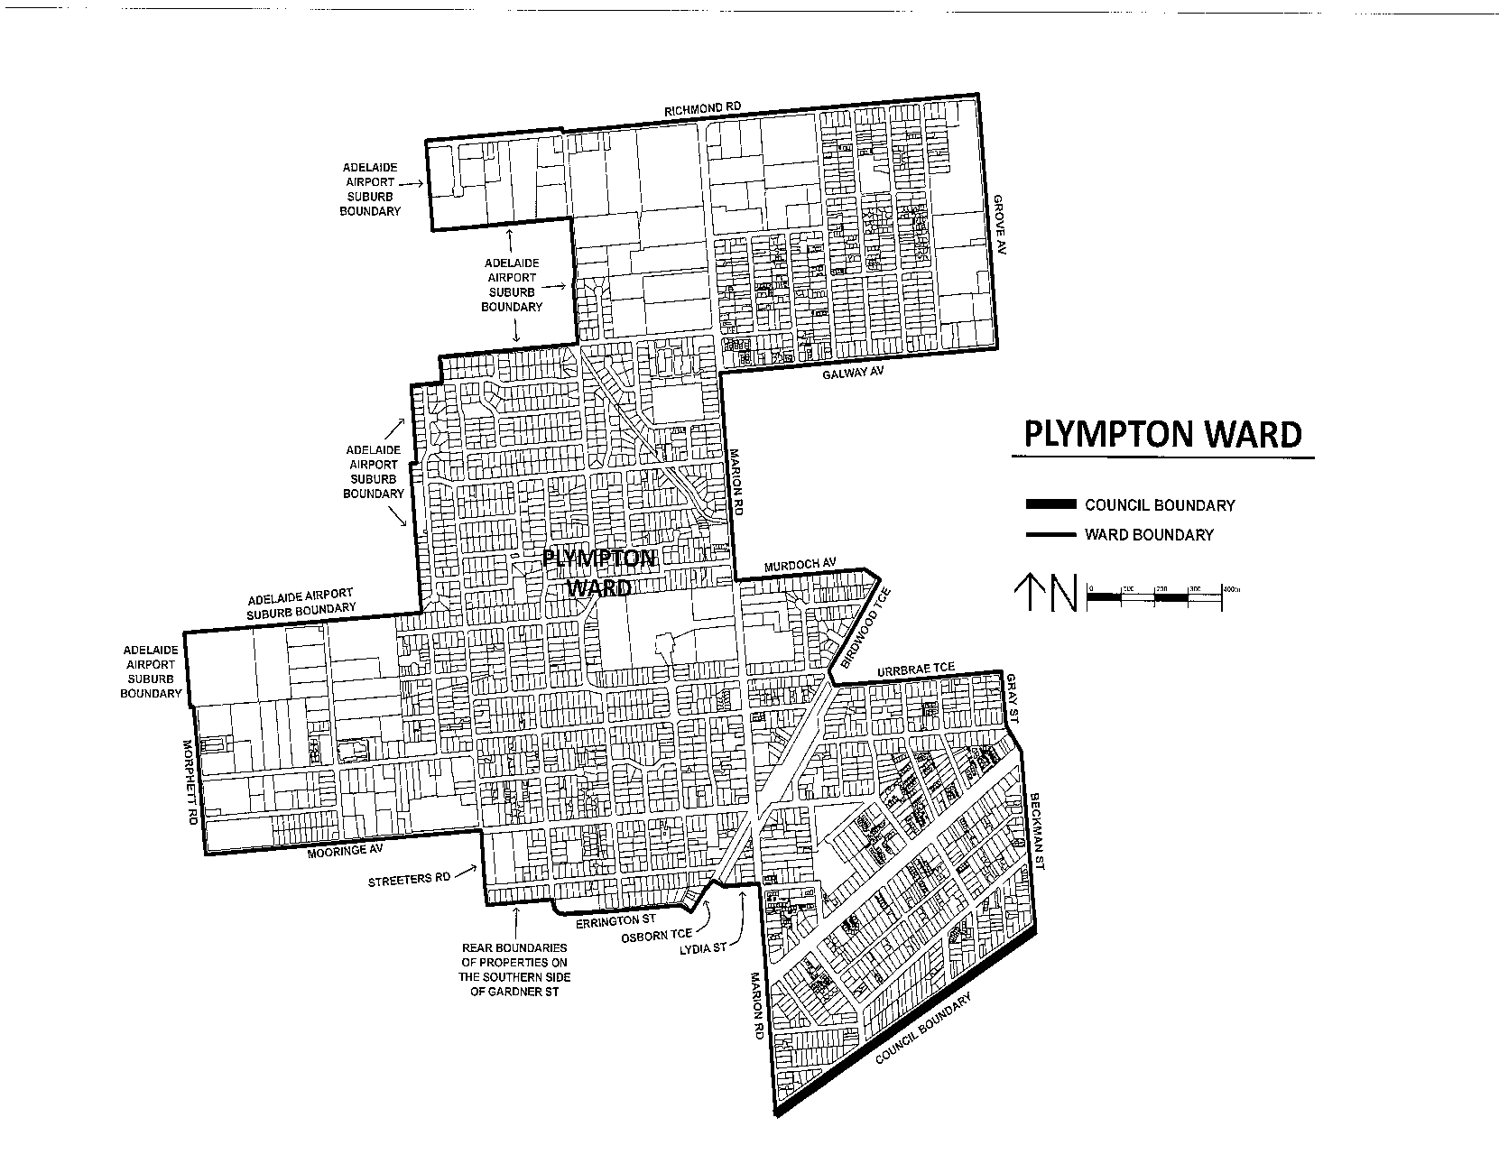
Schedule Two
Morphett Ward: Alter and adjust the boundaries of the existing Morphett Ward as follows:
Beginning at the corner of Lydia Street and Marion Road, which is the north-eastern corner of Morphett Ward, the boundary travels south along Marion Road to the City of West Torrens boundary. The boundary then follows the City of West Torrens Boundary at first south-west and then to Warren Avenue. The boundary travels east along Warren Avenue, continuing north-east and then east along James Melrose Road to Morphett Road, where it then travels south along Morphett Road, east along Mooringe Avenue, south along Streeters Road until it passes Gardner Street where it heads east along the rear boundary of properties on the south of Gardner Street to Errington Street. The boundary then travels south and then east along Errington Street, north-east along Osborn Terrace and then east along Lydia Street, returning to Marion Road.
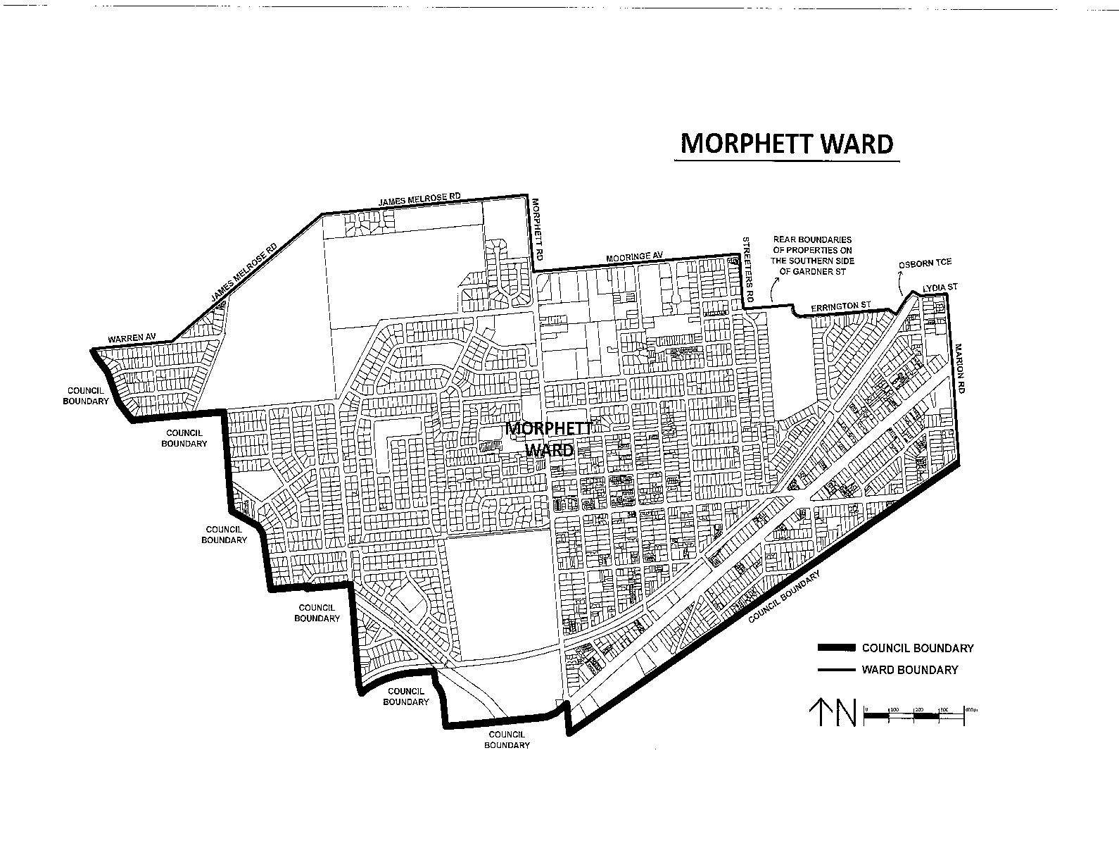
Schedule Three
Hilton Ward: Alter and adjust the boundaries of the existing Hilton Ward as follows:
Beginning at the corner of Tarragon Street and South Road, which is the north-eastern corner of Hilton Ward, the boundary travels south along South Road, west along Davenport Terrace, south along Milner Road, west along Kingston Avenue, south along Brooker Terrace and west along Richmond Road to Morley Street. At Morley Street it follows the Adelaide Airport boundary, initially north and then following the Airport boundary to Sir Donald Bradman Drive. The boundary then travels east along Sir Donald Bradman Drive, north along Marion Road, east along Henley Beach Road, south along Bagot Avenue, east along Tarragon Street, returning to South Road.
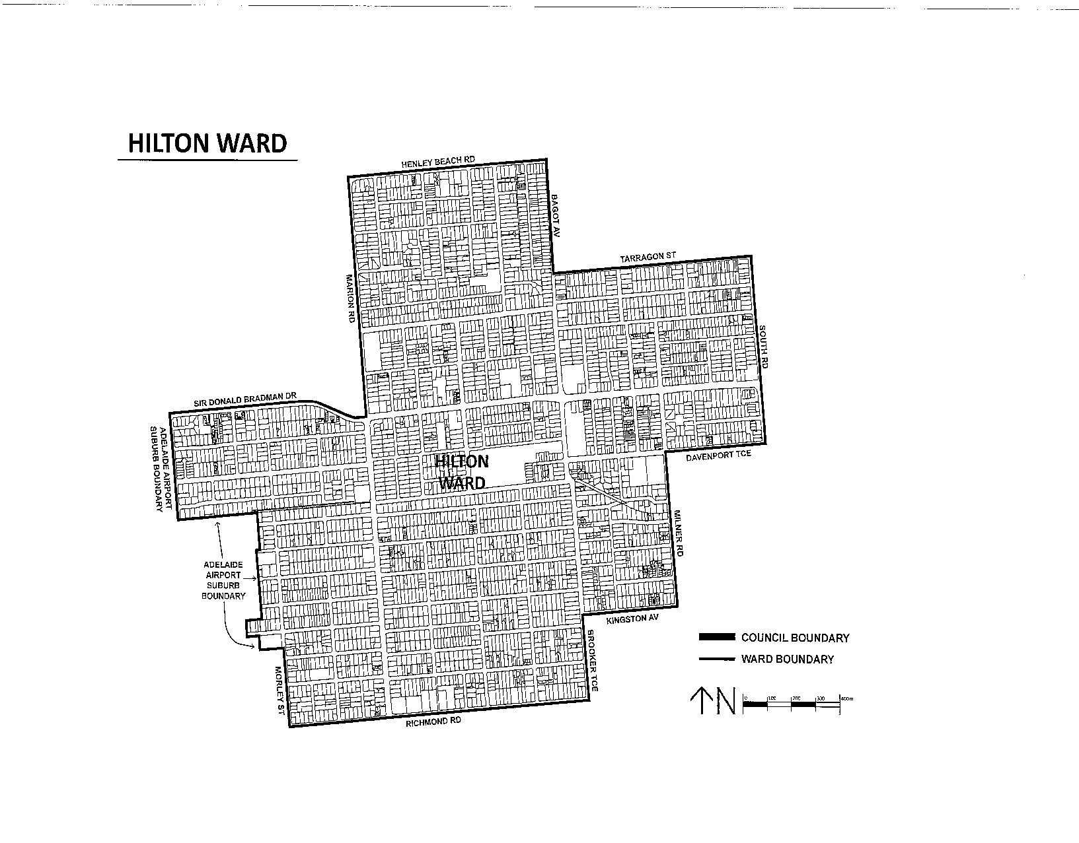
Schedule Four
Lockleys Ward: Alter and adjust the boundaries of the existing Lockleys Ward as follows:
Beginning at the corner of Henley Beach Road and Holbrooks Road, which is the south-eastern corner of Lockleys Ward, the boundary travels west along Henley Beach Road to the City of West Torrens boundary. The boundary then follows the City of West Torrens boundary, initially north and then along the River Torrens until it reaches a point corresponding to the northwards projection of the rear boundaries of the properties on the east of Hayward Avenue. It then follows the eastern boundary of the properties on the eastern side of Hayward Avenue in a southerly direction until it reaches Ashley Street. The boundary then travels west along Ashley Street and south along Holbrooks Road, returning to Henley Beach Road.
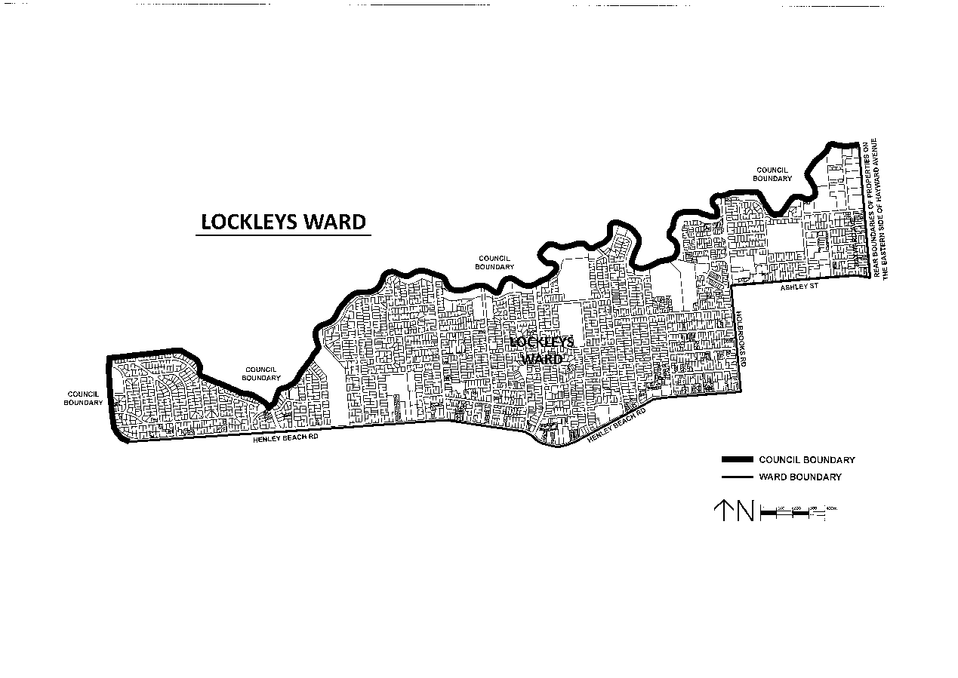
Schedule Five
Keswick Ward: Alter and adjust the boundaries of the existing Keswick Ward as follows:
Beginning at the corner of Beckman Street and Glengyle Terrace, which is the southern corner of Keswick Ward, the boundary travels north along Beckman Street, continuing onto Gray Street, west along Urrbrae Terrace, north-east along Birdwood Terrace to Murdoch Avenue. The boundary then travels west along Murdoch Avenue, north along Marion Road, east along Galway Avenue, north along Grove Avenue continuing onto Brooker Terrace, east along Kingston Avenue, north along Milner Road, east along Davenport Terrace, north along South Road, east along Ballara Street and then north along Victoria Street following it to Horwood Close and then east along Horwood Close continuing parallel through to James Congdon Drive. The boundary then travels north-east along James Congdon Drive to Glover Avenue, following the City of West Torrens boundary to Glengyle Terrace and returning to Beckman Street.
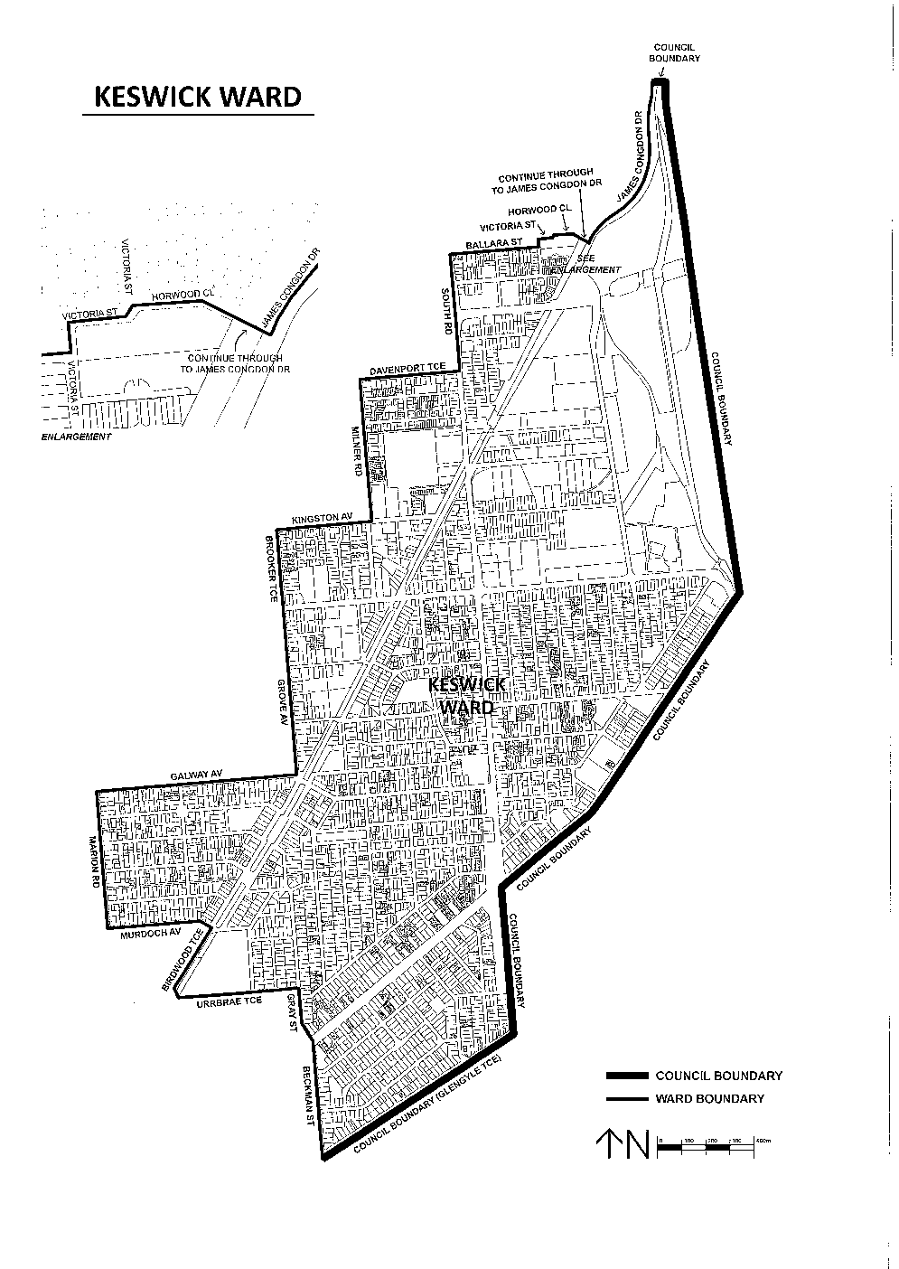
Schedule Six
Thebarton Ward: Alter and adjust the boundaries of the existing Thebarton Ward as follows:
Beginning at the corner of Henley Beach Road and Holbrooks Road, which is a south-western corner of Thebarton Ward, the boundary travels north along Holbrooks Road, east along Ashley Street passing Hayward Avenue until it reaches a point corresponding to the southward projection of the rear boundaries of the properties on the east of Hayward Avenue. The boundary then follows this projection northward to the City of West Torrens boundary. The boundary follows the City of West Torrens boundary initially east, then south to Glover Avenue, continuing down James Condon Drive until turning west onto the parallel projection to Horwood Close, following Horwood Close and then south along Victoria Street, before continuing west along Ballara Street, north along South Road, west along Tarragon Street, north along Bagot Avenue, west along Henley Beach Road, returning to Holbrooks Road.
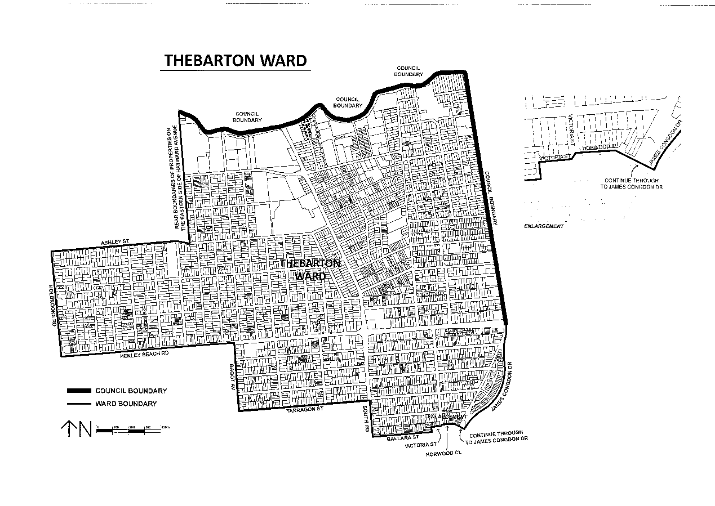
Schedule Seven
Airport Ward: Alter and adjust the boundaries of the existing Airport Ward as follows:
Beginning at the corner of Marion Road and Henley Beach Road, which is the north-eastern corner of the Airport Ward, the boundary travels south along Marion Road, west along Sir Donald Bradman Drive to the boundary of Adelaide Airport. It then follows the Adelaide Airport boundary initially and then in a generally clockwise direction south where it travels at first west then south-west along James Melrose Road, continuing west along Warren Avenue to the City of West Torrens boundary. It then follows the City of West Torrens boundary, initially west and then north to Henley Beach Road where travels east along Henley Beach Road, returning to Marion Road.
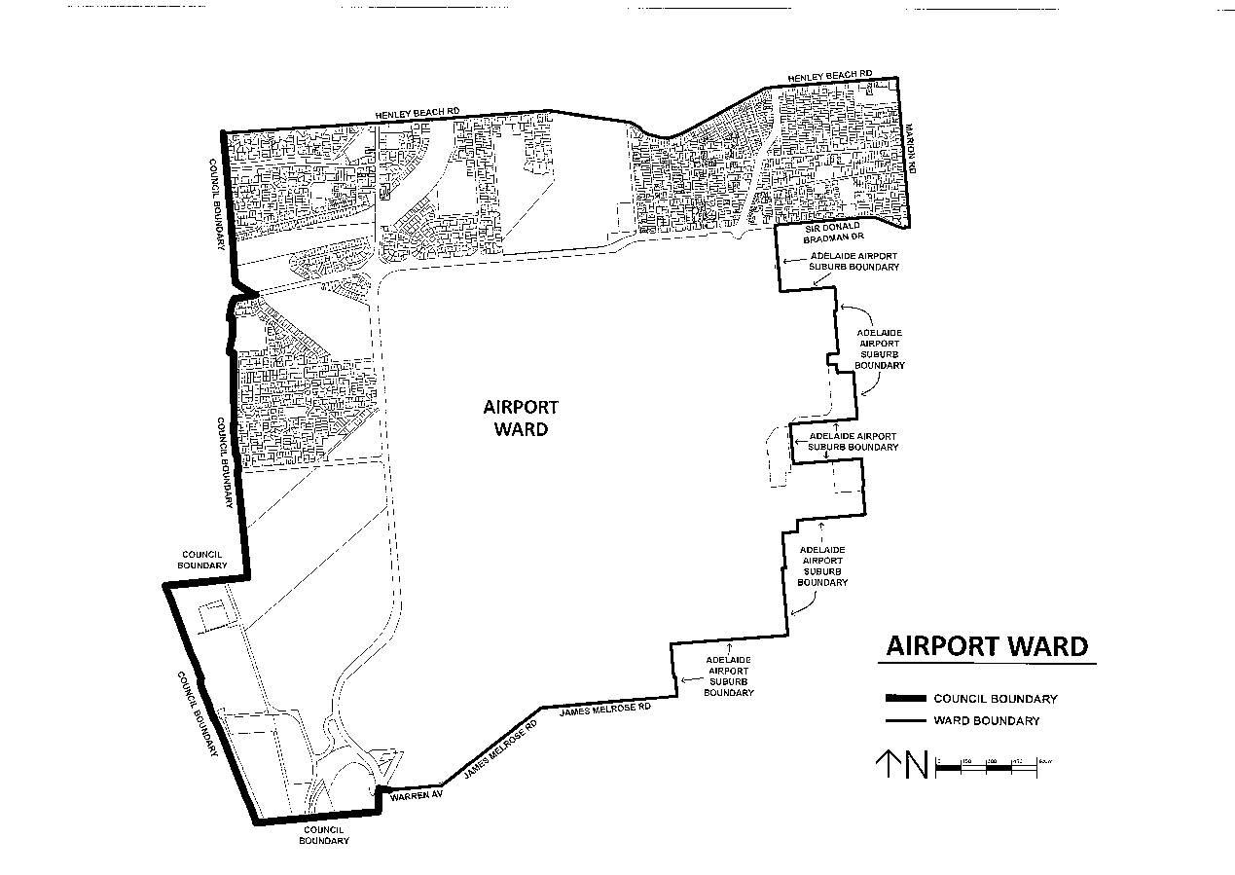

COORONG DISTRICT COUNCIL
Industry and Motorsport Development Plan Amendment—
Public Consultation
NOTICE is hereby given that the Coorong District Council, pursuant to Sections 24 and 25 of the Development Act 1993, has prepared a Development Plan Amendment Report (DPA) to amend its Development Plan(s).
The Amendment will change the Development Plan by proposing to facilitate appropriate industrial and motorsport development within the Council area. Planning policies applying to the following areas and activities have been identified as requiring review and potential amendment to support desired outcomes:
Tailem Bend Motorsport Park;
Industry and Renewable Energy Facilities in Rural Areas;
Industrial Land in Tailem Bend;
Industrial Land in Meningie;
Industrial Land in Tintinara;
Industrial Land in Coonalpyn; and
General Investigations for Industrial Land.
The DPA report will be on public consultation from Friday, 15 November 2013 until 5 p.m. on Friday, 24 January 2014.
Copies of the DPA report are available during normal office hours at Coorong District Council offices located at Meningie, Tailem Bend and Tintinara. Alternatively, the DPA report can be viewed from Friday, 15 November 2013 on Council’s website at www.coorong.sa.gov.au/dpa or during normal office hours at the following locations:
• 49 Princes Highway, Meningie.
• 93A Railway Terrace, Tailem Bend.
• 37 Becker Terrace, Tintinara
Written submissions regarding the DPA should be submitted no later than 5 p.m. on Friday, 24 January 2014. All submissions should be addressed to the Chief Executive Officer, Coorong District Council, P.O. Box 399, Tailem Bend, S.A. 5260 and should clearly indicate whether you wish to be heard in support of your submission at the public hearing. If you wish to lodge your submission electronically, please email it to:
council@coorong.sa.gov.au.
Copies of all submissions will be available for inspection at the offices of the Coorong District Council and on their website at www.coorong.sa.gov.au from Tuesday, 28 January 2014 until the conclusion of the public hearing.
A public hearing will be held on Tuesday, 11 February 2014 at 6 p.m. at the Tailem Bend Town Hall Function Centre, Murray Street, Tailem Bend at which time interested persons may be heard in relation to the DPA and the submissions. The public hearing will not be held if no submissions are received or if no submission makes a request to be heard.
If you would like further information about the DPA, contact Susan Hadley, Senior Planning Officer on 8572 3611 or via email at council@coorong.sa.gov.au.
Dated 15 November 2013.
V. Cammell, Chief Executive Officer

TATIARA DISTRICT COUNCIL
Elector Representation Review
NOTICE is hereby given that Council has reviewed its membership structure as part of the Elector Representation Review process, pursuant to Section 12 of the Local Government Act 1999 and following the required consultation processes, that the Tatiara District Council, at its meeting held on Tuesday, 13 August 2013, resolved that:
1. Council retains the existing name of Tatiara District Council.
2. The principal member of Council will be a mayor, elected by the community at Council-wide elections, as per the result of the recently conducted poll of electors.
3. The Council area not be divided into wards (i.e. Wards be abolished).
4. Council will comprise the mayor and nine area Councillors.
These changes to take effect from the day of the periodic election which will take place in November 2014.
R. Harkness, Chief Executive Officer

IN the matter of the estates of the undermentioned deceased persons:
Cuming, Bruce Henry, late of 49 Arthur Street, Pennington, retired bookkeeper, who died on 16 August 2013.
Cvetkovic, Dragoslav, late of 200 Fosters Road, Oakden, retired engineer, who died on 29 December 2012.
Frohnert, Anezka, late of 46 Eliza Place, Panorama, home duties, who died on 19 July 2013.
Jolly, Mavis Dorothy, late of 2 Hillside Grove, Port Lincoln, retired school teacher, who died on 2 September 2013.
Lehmann, Dulcie Mary Lorraine, late of 58 Chief Street, Brompton, of no occupation, who died on 24 July 2013.
Morris, Jean, late of 39 Fisher Street, Myrtle Bank, of no occupation, who died on 22 August 2013.
Murphy, Catherine Rose, late of 34 Molesworth Street, North Adelaide, of no occupation, who died on 20 August 2013.
Pearce, Phyllis Kathleen, late of 47 Eve Road, Bellevue Heights, of no occupation, who died on 3 September 2013.
Purcell, Roy Ivan, late of 2 Milford Street, Kidman Park, retired electrician, who died on 25 July 2013.
Swindle, Richard Walter, late of 14 Urlwin Road Salisbury, retired motor mechanic, who died on 1 June 2013.
Notice is hereby given pursuant to the Trustee Act 1936, as amended, the Inheritance (Family Provision) Act 1972 and the Family Relationships Act 1975, that all creditors, beneficiaries, and other persons having claims against the said estates are required to send, in writing, to the Office of Public Trustee, G.P.O. Box 1338, Adelaide, S.A. 5001, full particulars and proof of such claims, on or before 13 December 2013, otherwise they will be excluded from the distribution of the said estates; and notice is also hereby given that all persons indebted to the said estates are required to pay the amount of their debts to the Public Trustee or proceedings will be taken for the recovery thereof; and all persons having any property belonging to the said estates are forthwith to deliver same to the Public Trustee.
Dated 14 November 2013.
D. A. Contala, Public Trustee

ATTENTION

CUSTOMERS requiring a proof of their notice for inclusion in the Government Gazette, please note that the onus is on you to inform Government Publishing SA of any subsequent corrections.

For any corrections to your notice please phone 8207 1045 or Fax 8207 1040 before 4 p.m. on Wednesday.

If we do not receive any communication by 10 a.m. on Thursday (day of publication) we will presume the notice is correct and will print it as it is.

Remember—the onus is on you to inform us of any corrections necessary to your notice.

NOTE: Closing time for lodging new copy (electronically, fax or hard copy) is 4 p.m. on Tuesday preceding the day of publication.
Phone: 8207 1045
Fax: 8207 1040
Email: governmentgazette@dpc.sa.gov.au

Printed and published by authority every Thursday by B. MORRIS, Government Printer, South Australia
Price: $6.65, plus postage; to subscribers, $335.00 per annum.
(The above prices are inclusive of GST)

