No. 71 4105



THE SOUTH AUSTRALIAN

GOVERNMENT GAZETTE
www.governmentgazette.sa.gov.au

PUBLISHED BY AUTHORITY

ALL PUBLIC ACTS appearing in this GAZETTE are to be considered official, and obeyed as such

ADELAIDE, THURSDAY, 31 OCTOBER 2013

CONTENTS

Page
Adelaide Park Lands Act 2005—Notice 4107
Appointments, Resignations, Etc. 4106
Australian Energy Market Commission—Notice 4110
Construction Industry Long Service Leave
Act 1987—Notice 4107
Corporations and District Councils—Notices 4149
Fire and Emergency Services Act 2005—Notices 4107
Fisheries Management Act 2007—Notices 4107
Housing Improvement Act 1940—Notices 4111
Mining Act 1971—Notices 4110
National Electricity Law—Notice 4110
National Parks and Wildlife Act 1972—Notices 4114
National Parks and Wildlife (National Parks) Regulations
2001—Notice 4114
Petroleum and Geothermal Energy Act 2000—Notices 4115
Port Augusta Circuit Court—Notice 4116
Page
Proclamations 4130
Public Corporation Act 1993—Notice 4117
Public Sector Act 2009—Notice 4119
Public Trustee Office—Administration of Estates 4155
Real Property Act—Notice 4120

REGULATIONS
Primary Industry Funding Schemes Act 1998—
(No. 246 of 2013) 4136
Liquor Licensing Act 1997—
(No. 247 of 2013) 4138
(No. 248 of 2013) 4140
Road Traffice Act 1961 (No. 249 of 2013) 4141
Road Traffic Act 1961—Notice 4121
Transport, Department of—Notices to Mariners 4128
Water Mains and Sewers—Mains Laid, Replaced, Etc. 4128

GOVERNMENT GAZETTE NOTICES
ALL poundkeepers’ and private advertisements forwarded for publication in the South Australian Government Gazette must be PAID FOR PRIOR TO INSERTION; and all notices, from whatever source, should be legibly written on one side of the paper only and sent to Government Publishing SA so as to be received no later
than 4 p.m. on the Tuesday preceding the day of publication. Phone 8207 1045 or Fax 8207 1040. E-mail: governmentgazette@dpc.sa.gov.au. Send as attachments in Word format and please confirm your transmission with a faxed copy of your document, including the date the notice is to be published and to whom the notice will be charged. The Government Gazette is available online at: www.governmentgazette.sa.gov.au

Department of the Premier and Cabinet
Adelaide, 31 October 2013
HIS Excellency the Governor’s Deputy in Executive Council has been pleased to appoint the undermentioned to the Supported Residential Facilities Advisory Committee, pursuant to the provisions of the Supported Residential Facilities Act 1992:
Member: (from 31 October 2013 until 5 December 2014)
Geoff O’Connell
Deputy Member: (from 31 October 2013 until 5 December 2014)
Sandra Ison (Deputy to Richards)
Lesley Siggery (Deputy to Fox)
Anthony Dew (Deputy to O’Connell)
By command,
Gail Elizabeth Gago, for Premier
DCSICS/13/033

Department of the Premier and Cabinet
Adelaide, 31 October 2013
HIS Excellency the Governor’s Deputy in Executive Council has been pleased to appoint the undermentioned to the State Procurement Board, pursuant to the provisions of the State Procurement Act 2004:
Member: (from 31 October 2013 until 30 October 2015)
Debra Ann Contala
By command,
Ian Keith Hunter, for Premier
T&F13/062CS

Department of the Premier and Cabinet
Adelaide, 31 October 2013
HIS Excellency the Governor’s Deputy in Executive Council has been pleased to appoint the undermentioned to the WorkCover Corporation of South Australia Board of Management, pursuant to the provisions of the WorkCover Corporation Act 1994:
Member: (from 1 November 2013 until 31 October 2015)
William Griggs
Chris Latham
Nigel McBride
Yvonne Sneddon
Member: (from 1 November 2013 until 31 October 2016)
Jane Elizabeth Yuile
Pauline Joanne Denley
Peter Bryden Malinauskas
Chair: (from 1 November 2013 until 31 October 2016)
Jane Elizabeth Yuile
By command,
Ian Keith Hunter, for Premier
IR0064/13CS

Department of the Premier and Cabinet
Adelaide, 31 October 2013
HIS Excellency the Governor’s Deputy in Executive Council has been pleased to appoint Tony Corrighan as a Conciliation Officer of the Workers Compensation Tribunal for a term of five years commencing on 9 February 2014 and expiring on 8 February 2019, pursuant to Section 81 of the Workers Rehabilitation and Compensation Act 1986.
By command,
Ian Keith Hunter, for Premier
IR0060/13CS

Department of the Premier and Cabinet
Adelaide, 31 October 2013
HIS Excellency the Governor’s Deputy in Executive Council has been pleased to appoint the people listed as Justices of the Peace for South Australia for a period of ten years commencing from 31 October 2013 and expiring on 30 October 2023, it being a condition of appointment that the Justices of the Peace must take the oaths required of a Justice under the Oaths Act 1936 and return the oaths form to the Justice of the Peace Services within 3 months of the date of appointment, pursuant to Section 4 of the Justices of the Peace Act 2005:
Andrew John Allen
Paul Anthony Bennett
Harry Adam Coumi
Rodney Kym Crossman
Eva Demosthenous
Ivy Frances Diegmann
Gaetanino Di Sisto
Michele Margaret Doyle
Thomas Frank Easling
Robin Yeats Ellerman
Gordon William Thomas Evans
Erna Gwyneth Franklin
Graeme Ross Godden
Maurice Mclaren Grant
Alexander Robert Haig
Brenton Leslie Henschke
John Owen Hughes
Andrew Michael Jelly
Leslie Glenn Karutz
Peter David Killey
Brett Philip Lydeamore
Jeffrey Charles McEvoy
Rossalynd June Mottram
James Patrick Mulligan
David Albert Norman
Anthony John Park
Janice Eileen Pearce
John Swain Petersen
Peter Wayne Place
John William Pointon
Amanda Louise Reardon
June Laura Savill
Alison Lee Schumann
Glen Ian Searles
Sharon Kaye Seedsman
Anthony Peter Simmons
Geoffrey Robert Nisbet Smith
Cornelus Anthonius Steenwyk
Lynette Carol Stokes
John Michael Sykes
Antal Szabo
Minh Vuong Tran
Susan Ruby Warren
Vanessa Louise Watts
Terrance Michael Wheeldon
Robert Denis Wight
Glen Elliott Williams
Helen Margaret Williams
Joan Clare Zanker
Melvin Kelford Zerner
By command,
Ian Keith Hunter, for Premier
JP13/019CS

ADELAIDE PARK LANDS ACT 2005
Appointments
PURSUANT to Division 2 of Part 2 of the Adelaide Park Lands Act 2005, I, Ian Hunter MLC, Minister for Sustainability, Environment and Conservation, Minister of the Crown to whom the administration of the Adelaide Park Lands Act 2005 is committed, am pleased to appoint the following persons as members of the Board of Management of the Adelaide Park Lands Authority Board of Management:
For the purposes of subsection 6 (1) (b) of the Act:
Rosemary Anne Sharp
Roger Zubrinich
For the purposes of subsections 6 (1) (b) and 6 (4) of the Act:
Stephanie Anne Johnston
For the purposes of subsections 6 (1) (b), 6 (4) and 6 (6) of the Act:
James William Daly (as deputy to Stephanie Johnston)
Elaine Mhairi Bensted (as deputy to Roger Zubrinich)
Pursuant to subsection 7 (2) of the Act, I appoint the above members for the period commencing 31 October 2013 and concluding 12 February 2016.
Dated 28 October 2013.
Ian Hunter, Minister for Sustainability, Environment and Conservation

CONSTRUCTION INDUSTRY LONG SERVICE LEAVE
ACT 1987
Imposition of Levy
NOTICE is hereby given pursuant to Section 26 (8) of the Construction Industry Long Service Leave Act 1987 that the prescribed percentage fixed by the Construction Industry Long Service Leave Board in accordance with that section is 2.25%.
M. Sexton, Presiding Officer

FIRE AND EMERGENCY SERVICES ACT 2005
Section 68
Dissolution of a SACFS Organisation
I, GREGORY HUGH NETTLETON, the Chief Officer of the South Australian Country Fire Service, in accordance with Section 68 (7) and (8) of the Fire and Emergency Services Act 2005 and Section 24 (A) of the Fire and Emergency Services Regulations, hereby dissolve a SACFS organisation known as Ki Ki CFS Brigade.
Dated 28 October 2013.
Greg Nettleton, Chief Officer, SA Country Fire Service

FIRE AND EMERGENCY SERVICES ACT 2005
Section 68
Establishment of a SACFS Organisation
I, GREGORY HUGH NETTLETON, the Chief Officer of the South Australian Country Fire Service, in accordance with Division 5, Section 68 (1) (a) of the Fire and Emergency Services Act 2005, hereby establish a SACFS organisation to be known as Challenger CFS Brigade.
The Brigade area is constituted in relation to the land under the control of Challenger Gold Mine Pty Ltd including access roads from the Stuart Highway.
Dated 28 October 2013.
Greg Nettleton, Chief Officer, SA Country Fire Service

FISHERIES MANAGEMENT ACT 2007: SECTION 79
Closure of Pipi Fishery—Coorong Beach
Recreational
TAKE notice that pursuant to Section 79 of the Fisheries Management Act 2007, it is hereby declared that it shall be unlawful for any unlicensed person to engage in the class of fishing activity specified in Schedule 1, in the area specified in Schedule 2, during the period specified in Schedule 3.

Schedule 1
The act of taking or an act preparatory to the taking of Pipi (Donax deltoides).

Schedule 2
The Younghusband Peninsula between the Murray Mouth and 28 mile crossing.

Schedule 3
From midnight on 1 November 2013 until midnight on 31 May 2014.
Dated 24 October 2013.
Professor M. Doroudi, Executive Director,
Fisheries and Aquaculture

FISHERIES MANAGEMENT ACT 2007
Section 78 (2)
Permit to Release Fish—No. 9902657
Permit holder:
Sarah Rogers
Southern Cross Austereo
128 Greenhill Road
Unley, S.A. 5061
Specified waters:
Mawson Lakes
PURSUANT to Subsection 78 (2) of the Fisheries Management Act 2007, the holder of this permit may release one fish into the freshwaters of Mawson Lakes, subject to the following conditions:

Conditions
1. The permitted activity must be completed on or before 3 November 2013.
2. The permit holder or his agents may only release a maximum of one legal sized Bream (Acanthopagrus spp) that has been caught within the Barker Inlet estuary into the waters specified in this permit.
3. All non-native species of fish taken during the event must be disposed of appropriately at an approved waste facility and must not be used for any commercial purpose.
4. Before conducting the permitted activity, the permit holder or a person acting as her agent must contact PIRSA Fishwatch on 1800 065 522 and answer a series of questions about the permitted activity. Your agent or you will need to have a copy of this permit at the time of making the call, and be able to provide information about the area and time of the permitted activity, the vehicle and/or boats involved, the number of agents undertaking the permitted activity and other related issues.
5. Whilst engaged in the permitted activity, the permit holder or his agents must be in possession of a copy of this permit. It must be produced to a PIRSA Fisheries Officer if requested.
6. The permit holder must not contravene or fail to comply with the Fisheries Management Act 2007 or any regulations made under that Act, except where specifically permitted by this notice.
Dated 24 October 2013.

Professor Mehdi Doroudi, Executive Director Fisheries and Aquaculture

FISHERIES MANAGEMENT ACT 2007: SECTION 79
TAKE note that the notice made under Section 79 of the Fisheries Management Act 2007, dated 23 January 2013, and published in the South Australian Government Gazette dated 31 January 2013, on page 147, being the second notice on that page, referring to the West Coast Prawn Fishery, is hereby varied such that it will not be unlawful for a person fishing pursuant to a West Coast Prawn Fishery licence to use prawn trawl nets in the waters specified in Schedule 1, under the conditions specified in Schedule 2, during the period specified in Schedule 3.
Schedule 1
The waters of the West Coast Prawn Fishery adjacent to Ceduna and Coffin Bay.
Schedule 2
1. Each licence holder must ensure that a representative sample of the catch (a ‘bucket count’) is taken at least three times per night during the fishing activity.
2. Each ‘bucket count’ sample must be accurately weighed to 7 kg where possible and the total number of prawns contained in the bucket must be recorded on the daily catch and effort return.
3. Fishing must cease if one of the following limits is reached:
(a) A total of seven nights of fishing are completed;
(b) The average catch per vessel, per night (for all three vessels) drops below 300 kg for two consecutive nights;
(e) The average prawn ‘bucket count’ for all three vessels exceeds 240 prawns per bucket on any single fishing night in the Coffin Bay area; or
(d) The average prawn ‘bucket count’ for all three vessels exceeds 270 prawns per bucket on any single fishing night in the Ceduna area.
4. The fleet must nominate a licence holder to provide a daily update by telephone or SMS message to the PIRSA Fisheries Manager, to report the average prawn catch per vessel and the average prawn ‘bucket count’ information.
5. No fishing activity may be undertaken between 0630 hours and 2000 hours on any day during the period of this notice.
Schedule 3
From 2000 hours on 2 November 2013 to 0630 hours on
10 November 2013.
Dated 29 October 2013.

B. Milic, Prawn Fisheries Manager

FISHERIES MANAGEMENT ACT 2007: SECTION 115
TAKE notice that pursuant to Section 115 of the Fisheries Management Act 2007, the holders of a Spencer Gulf Prawn Fishery licence issued pursuant to the Fisheries Management (Prawn Fisheries) Regulations 2006, listed in Schedule 1 or their registered masters(the ‘exemption holder’), are exempt from notices made under Section 79 of the Fisheries Management Act 2007, prohibiting prawn fishing activities pursuant to a Spencer Gulf Prawn Fishery licence, insofar as the exemption holder shall not be guilty of an offence when using prawn trawl nets pursuant to their fishery licence for the purpose of undertaking prawn surveys (the ‘exempted activity’), subject to the conditions contained in Schedule 2.
Schedule 1
Licence  No. | Licence Holder | Boat Name
P09 | Bartolomeo Puglisi | Angelina
P38 | Tacoma Pty Ltd | Atlas
P14 | Ross Haldane | Bartallumba K
P33 | Wellmet Pty Ltd | Beauie J
P12 | Fromager Pty Ltd | Brianna-Rene-Adele
P34 | Frane Bralic | Cvita B
P31 | Barry Bowyer | Evelyn-L
P8 | Anton Blaslov | Grozdana B
P13 | Ante Lukin | Kylie
P04 | Robert Bailey | Melanie B
P26 | Ljiljana Vitlov | Michelle
P16 | Barry Evans | Night Stalker
P28 | Eugene Montgomery | Skandia

Schedule 2
1. The exempted activity may only be undertaken from 1 November 2013 until 30 September 2014, unless varied or revoked earlier.
2. For the purposes of this notice the trawl survey areas cannot include any waters of a habitat protection zone or a sanctuary zone of a marine park established under the Marine Parks Act 2007.
3. The exemption holder must comply with all regulations and conditions that apply to fishing activities undertaken pursuant to their licence, in addition to the conditions imposed by this exemption. Exemption No. 9902665.
4. The exemption holder must accurately complete both of the tables attached as Schedule 2 and 3 to this notice, and submit to PIRSA Fisheries and Aquaculture by email to pirsa.fishwatch@sa.gov.au at least one hour prior to the departure of the first vessel from port to engaging in the exempted activity for each survey period.
5. All fish other than prawns, Southern calamari (Sepioteuthis australis) and bugs (Ibacus spp.) taken during the exempted activity must be returned to the water immediately after capture.
6. The exemption holder or an authorised licence holder must not contravene or fail to comply with the Fisheries Management Act 2007, or any other regulations made under that Act except where specifically exempted by this notice.
This notice does not purport to override the provisions or operation of any other Act including, but not limited to, the Marine Parks Act 2007. The exemption holder and his agents must comply with any relevant regulations, permits, requirements and directions from the Department of Environment, Water and Natural Resources when undertaking activities within a marine park.
Dated 25 October 2013.
S. Sloan, Director, Fisheries and Aquaculture Policy

FISHERIES MANAGEMENT ACT 2007: SECTION 115
TAKE notice that pursuant to Section 115 of the Fisheries Management Act 2007, the holder of a prawn fishery licence issued pursuant to the Fisheries Management (Prawn Fisheries) Regulations 2006 (the ‘exemption holder′) or a person acting as their agent is exempt from the notices made under Section 79 of the Fisheries Management Act 2007, prohibiting the taking of King Prawns [Penaeus (melicertus) latisulcatus] in the waters specified in Schedule 1, in that the exemption holder shall not be guilty of an offence when using prawn trawl nets in accordance with the conditions of their fishery licence for the purpose of gear trials (the ‘exempted activity’), subject to the conditions contained in Schedule 2.
Schedule 1
The waters of Spencer Gulf and the West Coast of South Australia contained within the following co-ordinates:
Anxious Bay
Those waters of the west coast bounded by a line commencing at position latitude 33°16.75′S, longitude 134°40.50′E then to position latitude 33°16.75′S, longitude 134°39.25′E then to position latitude 33°17.50′S, longitude 134°40.80′E then to position latitude 33°17.60′S, longitude 134°41.80′E, then to the point of commencement.
Port Lincoln
Those waters of Spencer Gulf bounded by a line commencing at position latitude 34°42.00′S, longitude 135°52.70′E then to position latitude 34°41.70′S, longitude 135°53.40′E then to position latitude 34°43.40′S, longitude 135°54.50′E then to position latitude 34°43.70′S, longitude 135°53.80′E then to the point of commencement.
Wallaroo
Those waters of Spencer Gulf bounded by a line commencing at position latitude 33°53.20′S, longitude 137°32.00′E then to position latitude 33°53.50′S, longitude 137°32.50′E then to position latitude 33°55.00′S, longitude 137°31.50′E then to position latitude 33°54.70′S, longitude 137°31.00′E then to the point of commencement.
Port Pirie
Those waters of Spencer Gulf bounded by a line commencing at position latitude 33°07.90′S, longitude 137°46.50′E then to position latitude 33°08.10′S, longitude 137°46.70′E then to position latitude 33°10.10′S, longitude 137°45.80′E then to position latitude 33°09.90′S, longitude 137°45.60′E then to the point of commencement.
Port Adelaide
Those waters of Gulf St Vincent commencing at position latitude 34°45.00′S, longitude 138°17.00′E then to position latitude 34°47.00′S, longitude 138°17.00′E then to position latitude 34°47.00′S, longitude 138°15.00′E then to position latitude 34°45.00′S, longitude 138°15.00′E then to the point of commencement.
Schedule 2
1. The exempted activity may only be undertaken from 25 October 2013 until 30 September 2014, unless varied or revoked.
2. The exemption holder may only conduct the exempted activity between 0800 hours and 1700 hours on any day.
3. The exemption holder may only engage in the exempted activity in those waters described in Schedule 1 that are greater than 10 m in depth.
4. Any fish taken during the exempted activity are to be returned to the water immediately.
5. The exemption holder must contact PIRSA Fishwatch on 1800 065 522 not less than one hour prior to departure from port and provide the following information:
• a description of the boat to be used including the registration number marked on that boat;
• the estimated time of departure from port;
• the area in which the gear trials are to be conducted;
• the estimated time of return to port;
• the registered master who will be in charge of the boat during the exempted activity; and
• Exemption No. 9902664.
6. While engaged in the exempted activity, the exemption holder must have a copy of this notice on board the vessel or near his person. This notice must be produced to a PIRSA Fisheries Compliance Officer if requested.
7. The exemption holder must contact the PIRSA Fishwatch on 1800 065 522, not less than one hour prior to the boat returning to port and provide the following information;
• a description of the boat used including the registration number marked on that boat;
• the estimated time of return to port;
• Exemption No. 9902664.
8. The exemption holder must not contravene or fail to comply with Fisheries Management Act 2007, or any other regulations made under that Act except whereby specifically exempted by this notice.
This notice does not purport to override the provisions or operation of any other Act including, but not limited to, the Marine Parks Act 2007. The exemption holder and his agents must comply with any relevant regulations, permits, requirements and directions from the Department of Environment, Water and Natural Resources when undertaking activities within a marine park.
Dated 25 October 2013.
S. Sloan, Director, Fisheries and Aquaculture Policy

FISHERIES MANAGEMENT ACT 2007: SECTION 115
TAKE notice that pursuant to Section 115 of the Fisheries Management Act 2007, Jeremy Gramp (the ‘exemption holder’) of the Adelaide and Mount Lofty Ranges Natural Resources Management Board—NRM Education Program, c/o Noarlunga Office, Ramsay Place, Noarlunga Centre, S.A. 5168 or a NRM Education Staff member acting as his agent is exempt from the
provision of Section 70, 71 and 72 (2) of the Fisheries Management Act 2007, and Regulation 7 and 10, Clauses 96, 114 of Schedule 6 of the Fisheries Management (General) Regulations 2007, but only in so far as the exemption holder may collect native fish species for research purposes (the ‘exempted activity’) from the areas specified in Schedule 1, using gear specified in Schedule 2, subject to the conditions set out in Schedule 3, from 30 October 2013 until 29 October 2014, unless varied or revoked earlier.

Schedule 1
The inland waters within the boundary of the Adelaide and Mount Lofty Ranges Natural Resources Management Board boundary.

Schedule 2
• Fyke nets (3 m single or double winged, with minimum 3 mm mesh).

Schedule 3
1. The specimens collected by the exemption holder are for scientific and research purposes only and must not be sold.
2. All native fish must be either returned to the water on completion of scientific evaluation or lodged with the South Australian Museum.
3. All non-native fish must be destroyed and disposed of appropriately.
4. Before conducting the exempted activity, the exemption holder must contact PIRSA Fishwatch on 1800 065 522 and answer a series of questions about the exempted activity. You will need to have a copy of your exemption with you at the time of making the call, and be able to provide information about the area and time of the exempted activity, the vehicles and/or boats involved, the number of agents undertaking the exempted activity and other related issues. Exemption No. 9902658.
5. Within 14 days of the expiry of this notice, the exemption holder must provide a report in writing to the Executive Director Fisheries and Aquaculture, (G.P.O. Box 1625, Adelaide, S.A. 5001), of the results of the project to which this exemption is related.
6. Whilst engaged in the exempted activity the exemption holder or a person acting as his agent must have in their possession a copy of this notice and such a notice must be produced to a Fisheries Officer if requested.
7. The exemption holder must not contravene or fail to comply with the Fisheries Management Act 2007, or any regulations made under that Act or any condition of this notice, except where specifically exempted by this notice.
Dated 29 October 2013.
Professor M. Doroudi, Executive Director,
Fisheries and Aquaculture

FISHERIES MANAGEMENT ACT 2007: SECTION 115
TAKE notice that pursuant to Section 115 of the Fisheries Management Act 2007, the holder of a Prawn Fishery Licence issued pursuant to the Fisheries Management (Prawn Fisheries) Regulations 2006 for the West Coast Prawn Fishery listed in Schedule 1 (the ‘exemption holder’) or their registered master are exempt from closure notices made under Section 79 of the Fisheries Management Act 2007, published in the South Australian Government Gazette, referring to the West Coast Prawn Fishery insofar as the exemption holder may use prawn trawl nets in accordance with the conditions of their fishery licence for the purpose of undertaking a prawn survey (the ‘exempted activity’) during the period specified in Schedule 2, subject to the conditions contained in Schedule 3. Ministerial Exemption No. 9902663.
Schedule 1

Licence  No. | Licence Holder | Boat Name | Survey Area
D01 | Nicholas Paleologoudias | Bosanquet Bay | Venus Bay
D03 | Konstantine Paleologoudias | Limnos | Ceduna

Schedule 2
From 1800 hours on 31 October 2013 until 0630 hours on 1 November 2013.

Schedule 3
1. The exemption holder must operate within the trawl survey area nominated in Schedule 1.
2. For the purposes of this notice the trawl survey areas cannot include any waters of a habitat protection zone or sanctuary zone of any marine park established under the Marine Parks Act 2007.
3. The registered master must keep a ‘skippers log’ to record catch information during the survey.
4. All fish, other than King Prawns, Southern Calamari, Gould’s Squid, Scallops, Octopus and Bugs taken during the exempted activity for survey purposes, are to be returned to the water immediately after capture.
5. Whilst engaged in the exempted activity or unloading the survey catch, the exemption holder must have a copy of this notice on board the boat or near his person. This notice must be produced to a Fisheries Officer if requested.
6. This notice does not purport to override the provisions or operation of any other Act including, but not limited to, the Marine Parks Act 2007. The exemption holder and his agents must comply with any relevant regulations, permits, requirements and directions from the Department of Environment, Water and Natural Resources when undertaking activities within a marine park.
Dated 29 October 2013.
Professor M. Doroudi, Executive Director,
Fisheries and Aquaculture

MINING ACT 1971
NOTICE is hereby given in accordance with Section 28 (5) of the Mining Act 1971, that the Minister for Mineral Resources and Energy proposes to grant an Exploration Licence over the undermentioned area:
Applicant: Kelaray Pty Ltd
Location: Yardea area—Approximately 30 km north-north-west of Kimba.
Term: 2 years
Area in km²: 170
Ref.: 2013/00106
Plan and co-ordinates can be found on the DMITRE website: http://www.minerals.dmitre.sa.gov.au/public_notices or by phoning Mineral Tenements on (08) 8463 3103.
J. Martin, Mining Registrar

MINING ACT 1971
NOTICE is hereby given in accordance with Section 28 (5) of the Mining Act 1971, that the Minister for Mineral Resources and Energy proposes to grant an Exploration Licence over the undermentioned area:
Applicant: PlatSearch NL
Location: Lake Callabonna area—Approximately 200 km east of Marree.
Pastoral Leases: Moolawatana, Frome Downs and Quin-yambie.
Term: 2 years
Area in km²: 490
Ref.: 2013/00107
Plan and co-ordinates can be found on the DMITRE website: http://www.minerals.dmitre.sa.gov.au/public_notices or by phoning Mineral Tenements on (08) 8463 3103.
J. Martin, Mining Registrar

MINING ACT 1971
NOTICE is hereby given in accordance with Section 35A (1) of the Mining Act 1971, that an application for a mining lease over the undermentioned mineral claim has been received. Details of the proposal may be inspected at the Department for Manufacturing, Innovation, Trade, Resources and Energy, Mineral Resources Group, Level 7, 101 Grenfell Street, Adelaide, S.A. 5000:
Applicant: Kent Properties Pty Ltd
Claim Number: 4201
Location: Section 399, Hundred of Mayurra, approx 9 km south-west of Millicent.
Area: 9.58 hectares
Purpose: Recovery of Limestone rubble
Reference: T02811
A copy of the proposal has been provided to the Wattle Range Council and an electronic copy can be found on the DMITRE website:
http://www.minerals.dmitre.sa.gov.au/public_notices/mining_
proposals_open_for_public_comment
Written submissions in relation to the granting of the mining lease are invited to be received at the Department for Manufacturing, Innovation, Trade, Resources and Energy, Attention: Mark Howe, G.P.O. Box 1264, Adelaide, S.A. 5001 no later than 28 November 2013.
Copies of all submissions will be forwarded to the applicant and may be made available for public inspection unless confidentiality is requested.
J. Martin, Mining Registrar

NATIONAL ELECTRICITY LAW
THE Australian Energy Market Commission (AEMC) gives notice under the National Electricity Law as follows:
Under ss 102 and 103, the making of the National Electricity Amendment (Access to NMI Standing Data) Rule 2013 No. 6 and related final determination. All provisions commence on 31 October 2013.
Under s 102, the making of the final determination on the Recovery of Network Support Payments proposal.
Documents referred to above are available on the AEMC’s website and are available for inspection at the AEMC’s office.
Australian Energy Market Commission
Level 6, 201 Elizabeth Street
Sydney, N.S.W. 2000
Telephone: (02) 8296 7800
www.aemc.gov.au
31 October 2013.

NOTICE OF SUPPLEMENTARY REPORT
Electricity and Gas Retail Competition Review in NSW
THE Australian Energy Market Commission (AEMC) has published the supplementary report of its review of competition in the retail electricity and natural gas markets in New South Wales in accordance with the Request for Advice from the Standing Council on Energy and Resources
Documents referred to above are available on the AEMC’s website and are available for inspection at the AEMC’s office.
Australian Energy Market Commission
Level 6, 201 Elizabeth Street
Sydney, N.S.W. 2000
Telephone: (02) 8296 7800
www.aemc.gov.au
31 October 2013.

HOUSING IMPROVEMENT ACT 1940
WHEREAS by notice published in the Government Gazette on the dates mentioned in the following table the South Australian Housing Trust Board Delegate did declare the houses described in the said table to be substandard for the purposes of Part 7 of the Housing Improvement Act 1940, the South Australian Housing Trust Board delegate in the exercise of the powers conferred by the said Part, does hereby fix as the maximum rental per week which shall be payable subject to Section 55 of the Residential Tenancies Act 1995, in respect of each house described in the following table the amount shown in the said table opposite the description of such house and this notice shall come into force on the date of this publication in the Gazette.

Address of House | Allotment, Section, etc. | Certificate of Title  Volume Folio |  | Date and page of Government Gazette in which notice declaring house to be substandard published | Maximum rental per week  payable in respect of each house  $
52 Folland Avenue, Northfield | Allotment 4 in Deposited Plan 4841, Hundred of Yatala | 5303 | 279 | 5.9.13, page 3759 | 176.00
4 (also known as Lot 172) Gawler River Road, Lewiston | Allotment 172 in Filed Plan 163140, Hundred of Adelaide | 5679 | 236 | 5.9.13, page 3759 | 167.00
49 High Street, Glenelg | Allotment 85 in Filed Plan 6534, Hundred of Noarlunga | 5099 | 585 | 28.4.05, page 1012 | 120.00  (Rooms 1, 3, 4 and 5)  110.00  (Room 2)
40 Laffer Street, Barmera | Allotment 488 in Township Plan 741601, Cobdogla Irrigation Area | 5925 | 341 | 22.8.13, page 3544 | 213.00
47 Palm Avenue, Royal Park | Allotment 111 in Filed Plan 215961, Hundred of Yatala | 5691 | 565 | 2.3.95, page 752 | 251.00
17 West Street, Hindmarsh | Allotment 501 in Deposited Plan 58243, Hundred of Yatala | 5873 | 254 | 13.11.80, page 1869 | 149.00
Dated at Adelaide, 31 October 2013. R. Hulm, Director, Corporate Services, Housing SA (Delegate SAHT)

HOUSING IMPROVEMENT ACT 1940
WHEREAS by notice published in the Government Gazette on the dates mentioned in the following table the South Australian Housing Trust Board Delegate did declare the houses described in the said table to be substandard for the purposes of Part 7 of the Housing Improvement Act 1940, and whereas the South Australian Housing Trust Board delegate is satisfied that each of the houses described hereunder has ceased to be substandard, notice is hereby given that, in exercise of the powers conferred by the said Part, the South Australian Housing Trust does hereby revoke the said declaration in respect of each house.

Address of House | Allotment, Section, etc. | Certificate of Title  Volume Folio |  | Date and page of Government Gazette in which notice declaring house to be substandard published
377 Churchill Road, Kilburn | Allotment 193 in Deposited Plan 1515, Hundred of Yatala | 5675 | 47 | 25.5.95, page 2206
25 St Lawrence Avenue, Croydon | Allotment 42 in Deposited Plan 2895, Hundred of Yatala | 5488 | 202 | 30.10.75, page 2214
81 Way Street, Kilburn | Allotment 118 in Deposited Plan 1783, Hundred of Yatala | 5243 | 11 | 24.4.80, page 1132
Dated at Adelaide, 31 October 2013. R. Hulm, Director, Corporate Services, Housing SA (Delegate SAHT)

HOUSING IMPROVEMENT ACT 1940
NOTICE is hereby given that the South Australian Housing Trust Board delegate in the exercise of the powers conferred by the Housing Improvement Act 1940, does hereby declare the houses described in the table hereunder to be substandard for the purposes of Part 7 of the Housing Improvement Act 1940.

No. of House and Street | Locality | Allotment, Section, etc. | Certificate of Title  Volume Folio
16A Edgeworth Street | Prospect | Allotment 57 in Filed Plan 40004, Hundred of Yatala | 6066 | 813
85 Galway Avenue | Broadview | Allotment 79 in Filed Plan 111587, Hundred of Yatala | 5694 | 312
10 Howards Road | Beverley | Allotment 32 in Deposited Plan 2748, Hundred of Yatala | 5713 | 88
10 Kent Street | Thevenard | Allotment 210 in Township Plan 660303, Hundred of Bonython | 5740 | 522
19 Riverview Drive | Paradise | Allotment 10 in Deposited Plan 6405, Hundred of Adelaide | 5631 | 349
2 Walker Street | Magill | Allotment 51 in Deposited Plan 35289, Hundred of Adelaide | 5108 | 281
Dated at Adelaide, 31 October 2013. R. Hulm, Director, Corporate Services, Housing SA (Delegate SAHT)

GOVERNMENT GAZETTE ADVERTISEMENT RATES

To apply from 1 July 2013

$  Agents, Ceasing to Act as 48.50  Associations:  Incorporation 24.50  Intention of Incorporation 61.00  Transfer of Properties 61.00  Attorney, Appointment of 48.50  Bailiff’s Sale 61.00  Cemetery Curator Appointed 35.75  Companies:  Alteration to Constitution 48.50  Capital, Increase or Decrease of 61.00  Ceasing to Carry on Business 35.75  Declaration of Dividend 35.75  Incorporation 48.50  Lost Share Certificates:  First Name 35.75  Each Subsequent Name 12.40  Meeting Final 40.50  Meeting Final Regarding Liquidator’s Report on  Conduct of Winding Up (equivalent to ‘Final  Meeting’)  First Name 48.50  Each Subsequent Name 12.40  Notices:  Call 61.00  Change of Name 24.50  Creditors 48.50  Creditors Compromise of Arrangement 48.50  Creditors (extraordinary resolution that ‘the Com-pany be wound up voluntarily and that a liquidator be appointed’) 61.00  Release of Liquidator⎯Application⎯Large Ad. 96.50  ⎯Release Granted 61.00  Receiver and Manager Appointed 55.50  Receiver and Manager Ceasing to Act 48.50  Restored Name 45.25  Petition to Supreme Court for Winding Up 84.00  Summons in Action 71.50  Order of Supreme Court for Winding Up Action 48.50  Register of Interests⎯Section 84 (1) Exempt 108.00  Removal of Office 24.50  Proof of Debts 48.50  Sales of Shares and Forfeiture 48.50  Estates:  Assigned 35.75  Deceased Persons⎯Notice to Creditors, etc. 61.00  Each Subsequent Name 12.40  Deceased Persons⎯Closed Estates 35.75  Each Subsequent Estate 1.60  Probate, Selling of 48.50  Public Trustee, each Estate 12.40 |  | $  Firms:  Ceasing to Carry on Business (each insertion) 32.25  Discontinuance Place of Business 32.25  Land⎯Real Property Act:  Intention to Sell, Notice of 61.00  Lost Certificate of Title Notices 61.00  Cancellation, Notice of (Strata Plan) 61.00  Mortgages:  Caveat Lodgement 24.50  Discharge of 25.75  Foreclosures 24.50  Transfer of 24.50  Sublet 12.40  Leases⎯Application for Transfer (2 insertions) each 12.40  Lost Treasury Receipts (3 insertions) each 35.75  Licensing 71.50  Municipal or District Councils:  Annual Financial Statement⎯Forms 1 and 2 677.00  Electricity Supply⎯Forms 19 and 20 481.00  Default in Payment of Rates:  First Name 96.50  Each Subsequent Name 12.40  Noxious Trade 35.75  Partnership, Dissolution of 35.75  Petitions (small) 24.50  Registered Building Societies (from Registrar-General) 24.50  Register of Unclaimed Moneys⎯First Name 35.75  Each Subsequent Name 12.40  Registers of Members⎯Three pages and over:  Rate per page (in 8pt) 308.00  Rate per page (in 6pt) 407.00  Sale of Land by Public Auction 61.50  Advertisements 3.40  ¼ page advertisement 143.00  ½ page advertisement 287.00  Full page advertisement 562.00  Advertisements, other than those listed are charged at $3.40 per column line, tabular one-third extra.  Notices by Colleges, Universities, Corporations and District Councils to be charged at $3.40 per line.  Where the notice inserted varies significantly in length from that which is usually published a charge of $3.40 per column line will be applied in lieu of advertisement rates listed.  South Australian Government publications are sold on the condition that they will not be reproduced without prior permission from the Government Printer.
All the above prices include GST

GOVERNMENT GAZETTE NOTICES
ALL private advertisements forwarded for publication in the South Australian Government Gazette must be PAID FOR PRIOR TO INSERTION; and all notices, from whatever source, should be legibly written on one side of the paper only and sent to Government Publishing SA so as to be received no later than 4 p.m. Tuesday preceding the day of publication. Phone 8207 1045 or Fax 8207 1040. E-mail: governmentgazette@dpc.sa.gov.au. Send as attachments in Word format. Please include date the notice is to be published and to whom the notice will be charged. The Government Gazette is available online at: www.governmentgazette.sa.gov.au.

MISCELLANEOUS LEGISLATION AND GOVERNMENT PUBLICATIONS PRICES AS FROM 1 JULY 2013

Acts, Bills, Rules, Parliamentary Papers and Regulations
Pages | Main | Amends | Pages | Main | Amends

1-16 | 3.00 | 1.40 | 497-512 | 41.00 | 40.00
17-32 | 3.90 | 2.45 | 513-528 | 42.00 | 40.75
33-48 | 5.15 | 3.65 | 529-544 | 43.50 | 42.00
49-64 | 6.50 | 5.00 | 545-560 | 44.75 | 43.50
65-80 | 7.55 | 6.30 | 561-576 | 45.75 | 44.75
81-96 | 8.80 | 7.30 | 577-592 | 47.50 | 45.25
97-112 | 10.00 | 8.60 | 593-608 | 48.75 | 46.75
113-128 | 11.20 | 9.90 | 609-624 | 49.50 | 48.50
129-144 | 12.60 | 11.10 | 625-640 | 50.50 | 49.00
145-160 | 13.80 | 12.40 | 641-656 | 52.00 | 50.50
161-176 | 15.00 | 13.60 | 657-672 | 53.00 | 51.00
177-192 | 16.40 | 14.80 | 673-688 | 54.50 | 53.00
193-208 | 17.60 | 16.30 | 689-704 | 55.50 | 53.50
209-224 | 18.60 | 17.20 | 705-720 | 57.00 | 55.00
225-240 | 19.90 | 18.40 | 721-736 | 58.50 | 56.00
241-257 | 21.40 | 19.50 | 737-752 | 59.00 | 57.50
258-272 | 22.60 | 20.60 | 753-768 | 61.00 | 58.50
273-288 | 23.70 | 22.40 | 769-784 | 62.00 | 61.00
289-304 | 24.80 | 23.30 | 785-800 | 63.00 | 62.00
305-320 | 26.25 | 24.70 | 801-816 | 64.50 | 62.50
321-336 | 27.25 | 25.75 | 817-832 | 65.50 | 64.50
337-352 | 28.75 | 27.00 | 833-848 | 67.00 | 65.50
353-368 | 29.50 | 28.50 | 849-864 | 68.00 | 66.50
369-384 | 31.25 | 29.50 | 865-880 | 69.50 | 68.00
385-400 | 32.50 | 31.00 | 881-896 | 70.00 | 68.50
401-416 | 33.75 | 32.00 | 897-912 | 71.50 | 70.00
417-432 | 35.00 | 33.50 | 913-928 | 72.00 | 71.50
433-448 | 36.00 | 34.75 | 929-944 | 73.50 | 72.00
449-464 | 37.00 | 35.50 | 945-960 | 74.50 | 73.00
465-480 | 37.50 | 36.75 | 961-976 | 78.00 | 74.00
481-496 | 40.00 | 37.50 | 977-992 | 79.00 | 74.50

Legislation—Acts, Regulations, etc: $
Subscriptions:
Acts 252.00
All Bills as Laid 607.00
Rules and Regulations 607.00
Parliamentary Papers 607.00
Bound Acts 280.00
Index 140.00
Government Gazette
Copy 6.65
Subscription 335.00
Hansard
Copy 18.40
Subscription—per session (issued weekly) 525.00
Cloth bound—per volume 226.00
Subscription—per session (issued daily) 525.00
Legislation on Disk
Whole Database 3 894.00
Annual Subscription for fortnightly updates 1 197.00
Individual Act(s) including updates POA
Notice of Vacancies
Annual Subscription 190.00
Compendium
Subscriptions:
New Subscriptions 2 306.00
Updates 814.00
(All the above prices include GST)

All Legislation, Government Gazette, Hansard and Legislation on disk are available from:
Counter Sales Government Legislation Outlet
and Mail Orders: Service SA Customer Service Centre,
Ground Floor—EDS Centre, 108 North Terrace, Adelaide, S.A. 5000
Phone: 13 23 24 (local call cost), Fax: (08) 8204 1909
Postal: G.P.O. Box 1707, Adelaide, S.A. 5001

Online Shop: www.shop.service.sa.gov.au

Subscriptions and Government Publishing SA
Standing Orders: Plaza Level, Riverside Centre, North Terrace, Adelaide, S.A. 5000
Phone: (08) 8207 1043, (08) 8207 0910, Fax: (08) 8207 1040

NATIONAL PARKS AND WILDLIFE ACT 1972
Coongie Lakes National Park Draft Management Plan
I, JOHN ERWIN SCHUTZ, Director of National Parks and Wildlife, hereby give notice under the provisions of Section 38 of the National Parks and Wildlife Act 1972 that a draft management plan has been proposed for the Coongie Lakes National Park.
Copies of the draft plan may be inspected at or obtained at the following locations:
• Department of Environment, Water and Natural Resources Customer Service Centre, Level 1, 100 Pirie Street, Adelaide, telephone: 8204 1910.
• Department of Environment, Water and Natural Resources Port Augusta Office, 9 Mackay Street, Port Augusta, telephone: 08 8648 5300.
• www.environment.sa.gov.au/parkmanagement.
Any person may make representations in connection with the draft management plan during the period up to and including
31 January 2014.
Written comments should be forwarded to the Team Leader, Protected Area Management, Department of Environment, Water and Natural Resources, G.P.O. Box 1047, Adelaide, S.A. 5001 or e-mailed to DEWNRProtectedAreaManagement@sa.gov.au.
Dated 31 October 2013.
J. E. Schutz, Director of National Parks and Wildlife, Delegate of the Minister for Sustainability, Environment and Conservation

NATIONAL PARKS AND WILDLIFE ACT 1972
Mount Remarkable National Park Management Plan Amendment
I, IAN HUNTER, Minister for Sustainability, Environment and Conservation, hereby give notice under the provisions of Section 38 of the National Parks and Wildlife Act 1972 that, on 19 September 2013, I adopted an amendment to the plan of management for Mount Remarkable National Park.
Copies of the plan may be obtained from:
• www.environment.sa.gov.au/managing-natural-resources/Park_management/Management_plans
• DEWNR Customer Service Centre (Level 1, 100 Pirie Street, Adelaide, SA 5000);
e-mail DEWNR.CustomerServiceCentre@sa.gov.au; or
telephone 8204 1910.
Dated 19 September 2013.
Ian Hunter, Minister for Sustainability, Environment and Conservation

NATIONAL PARKS AND WILDLIFE (NATIONAL PARKS)
REGULATIONS 2001
Closure of Simpson Desert Regional Reserve and
Simpson Desert Conservation Park
PURSUANT to Regulations 8 (3) (a) and 8 (3) (d) of the National Parks and Wildlife (National Parks) Regulations 2001, I, John Erwin Schutz, Director of National Parks and Wildlife, close to the public the whole of the Simpson Desert Regional Reserve and the whole of Simpson Desert Conservation Park from: 6 p.m. on Saturday, 30 November 2013 until 6 p.m. on Sunday, 15 March 2014.
The purpose of the closure is in the interest of public safety as a result of anticipated high daytime temperatures likely to be experienced in the reserves during the closure period.
Dated 23 October 2013.
J. E. Schutz, Director of National Parks and Wildlife

PETROLEUM AND GEOTHERMAL ACT 2000
Grant of Petroleum Production Licence—PPL 245
PURSUANT to Section 92 (1) of the Petroleum and Geothermal Energy Act 2000, notice is hereby given that the undermentioned Petroleum Production Licence has been granted under the provisions of the Petroleum and Geothermal Energy Act 2000, pursuant to delegated powers dated 21 March 2012.

No. of Licence | Licensee | Locality | Area in km² | Reference
PPL 245 | Beach Energy Limited  Cooper Energy Limited | Cooper Basin, South Australia | 2.11 | F2013/277

Description of Area
All that part of the State of South Australia, bounded as follows:
Commencing at a point being the intersection of latitude 28°00′25″S GDA94 and longitude 139°16′40″E GDA94, thence east to longitude 139°16′55″E GDA94, south to latitude 28°00′40″S GDA94, west to longitude 139°16′50″E GDA94, south to latitude 28°00′48″S GDA94, east to longitude 139°17′18″E GDA94, south to latitude 28°01′00″S GDA94, west to longitude 139°17′15″E GDA94, south to latitude 28°01′10″S GDA94, west to longitude 139°17′10″E GDA94, south to latitude 28°01′20″S GDA94, west to longitude 139°17′05″E GDA94, south to latitude 28°01′25″S GDA94, west to longitude 139°17′00″E GDA94, south to latitude 28°01′30″S GDA94, west to longitude 139°16′35″E GDA94, north to latitude 28°01′25″S GDA94, west to longitude 139°16′30″E GDA94, north to latitude 28°01′20″S GDA94, west to longitude 139°16′25″E GDA94, north to latitude 28°01′05″S GDA94, west to longitude 139°16′20″E GDA94, north to latitude 28°00′40″S GDA94, east to longitude 139°16′30″E GDA94, north to latitude 28°00′35″S GDA94, east to longitude 139°16′35″E GDA94, north to latitude 28°00′30″S GDA94, east to longitude 139°16′40″E GDA94, and north to the point of commencement.
Area: 2.11 km² approximately.
Dated 28 October 2013.
B. A. Goldstein,
Executive Director,
Energy Resources Division,
Department for Manufacturing, Innovation, Trade, Resources and Energy
Delegate of the Minister for Mineral Resources and Energy

PETROLEUM AND GEOTHERMAL ENERGY ACT 2000
Application for the Renewal of Associated Activities Licence
AAL 178
PURSUANT to Section 65 (6) of the Petroleum and Geothermal Energy Act 2000 (the Act) and Delegation dated 21 March 2012, notice is hereby given that an application for the renewal of an Associated Activities Licence within the area described below has been received from:
Stuart Petroleum Pty Ltd
The application will be determined on or after 28 November 2013.
Description of Application Area
All that part of the State of South Australia, bounded as follows:
Area 1
Commencing at a point being the intersection of latitude 28°30′20″S AGD66 and longitude 140°04′30″E AGD66, thence east to longitude 140°05′40″E AGD66, south to latitude 28°30′40″S GDA94, west to longitude 140°05′35″E GDA94, south to latitude 28°30′50″S GDA94, west to longitude 140°05′30″E GDA94, south to latitude 28°30′55″S GDA94, west to longitude 140°05′25″E GDA94, south to latitude 28°31′05″S GDA94, west to longitude 140°05′15″E GDA94, south to latitude 28°31′15″S GDA94, west to longitude 140°05′05″E GDA94, south to latitude 28°31′20″S GDA94, west to longitude 140°04′50″E GDA94, south to latitude 28°31′25″S GDA94, west to longitude 140°04′30″E GDA94, south to latitude 28°31′30″S GDA94, west to longitude 140°03′50″E AGD66, south to latitude 28°31′40″S AGD66, west to longitude 140°03′25″E AGD66, north to latitude 28°31′35″S AGD66, east to longitude 140°03′30″E AGD66, north to latitude 28°31′30″S AGD66, east to longitude 140°03′35″E AGD66, north to latitude 28°31′25″S AGD66, east to longitude 140°03′40″E AGD66, north to latitude 28°31′20″S AGD66, east to longitude 140°03′45″E AGD66, north to latitude 28°31′15″S AGD66, east to longitude 140°03′50″E AGD66, north to latitude 28°30′40″S AGD66, east to longitude 140°04′20″E AGD66, north to latitude 28°30′30″S AGD66, east to longitude 140°04′30″E AGD66, and north to the point of commencement.
Area 2
Commencing at a point being the intersection of latitude 28°30′10″S AGD66 and longitude 140°01′40″E AGD66, thence east to longitude 140°02′30″E AGD66, south to latitude 28°30′20″S AGD66, east to longitude 140°03′00″E AGD66, south to latitude 28°31′20″S AGD66, west to longitude 140°02′50″E GDA94, north to latitude 28°30′35″S GDA94, west to longitude 140°01′05″E GDA94, south to latitude 28°31′30″S AGD66, west to longitude 140°00′50″E AGD66, north to latitude 28°31′20″S AGD66, west to longitude 140°00′30″E AGD66, north to latitude 28°30′50″S AGD66, east to longitude 140°00′40″E AGD66, north to latitude 28°30′40″S AGD66, east to longitude 140°00′50″E AGD66, north to latitude 28°30′30″S AGD66, east to longitude 140°01′10″E AGD66, north to latitude 28°30′20″S AGD66, east to longitude 140°01′40″E AGD66, and north to the point of commencement.
Area 3
Commencing at a point being the intersection of latitude 28°27′55″S AGD66 and longitude 140°04′00″E AGD66, thence east to longitude 140°04′30″E AGD66, south to latitude 28°28′00″S AGD66, east to longitude 140°04′50″E AGD66, south to latitude 28°28′20″S AGD66, west to longitude 140°04′45″E AGD66, south to latitude 28°28′30″S AGD66, west to longitude 140°04′40″E AGD66, south to latitude 28°28′40″S AGD66, west to longitude 140°04′30″E AGD66, south to latitude 28°28′50″S AGD66, west to longitude 140°04′20″E AGD66, south to latitude 28°29′00″S AGD66, west to longitude 140°03′25″E AGD66, north to latitude 28°28′50″S AGD66, west to longitude 140°03′20″E AGD66, north to latitude 28°28′30″S AGD66, east to longitude 140°03′30″E AGD66, north to latitude 28°28′15″S AGD66, east to longitude 140°03′40″E AGD66, north to latitude 28°28′05″S AGD66, east to longitude 140°03′50″E AGD66, north to latitude 28°28′00″S AGD66, east to longitude 140°04′00″E AGD66, and north to the point of commencement.
Area 4
Commencing at a point being the intersection of latitude 28°29′35″S GDA94 and longitude 139°58′40″E GDA94, thence east to longitude 139°59′30″E AGD66, south to latitude 28°30′00″S AGD66, west to longitude 139°59′20″E AGD66, south to latitude 28°30′10″S AGD66, west to longitude 139°59′10″E AGD66, south to latitude 28°30′40″S AGD66, west to longitude 139°58′40″E GDA94, and north to the point of commencement.
Area: 15 km² approximately.
C. D. Cockshell,
Acting Executive Director
Energy Resources Division
Department for Manufacturing, Innovation,
Trade, Resources and Energy
Delegate of the Minister for
Mineral Resources and Energy

THE SUPREME COURT OF SOUTH AUSTRALIA
PORT AUGUSTA CIRCUIT COURT
Sheriff’s Office, Adelaide, 5 November 2013
IN pursuance of a precept from the Supreme Court to me directed, I do hereby give notice that the said Court will sit as a Court of Oyer and Terminer and General Gaol Delivery at the Courthouse at Port Augusta on the day and time undermentioned and all parties bound to prosecute and give evidence and all jurors summoned and all others having business at the said Court are required to attend the sittings thereof and the order of such business will be unless a Judge otherwise orders as follows:
Tuesday, 5 November at 10 a.m. on the first day of the sittings the only business taken will be the arraignment of prisoners in gaol and the passing of sentences on prisoners in gaol committed for sentence; the surrender of prisoners on bail committed for sentence; the surrender of persons in response to ex officio informations or of persons on bail and committed for trial who have signified their intentions to plead guilty and the passing of sentences for all matters listed for disposition by the Supreme Court.
Juries will be summoned for Tuesday, 5 November 2013 and persons will be tried on this and subsequent days of the sittings.
Prisoners in H.M. Gaol and on bail for sentence and for trial at the sittings of the Port Augusta Courthouse, commencing Tuesday, 5 November 2013.
Baker, Kinlsey | Damage property; aggravated serious criminal trespass in a place of residence | On bail
Baynes, Bradley Adam | Assault | On bail
Baynes, Bradley Adam | Application for enforcement of breached bond | On bail
Beckett, Adrian John | Application for enforcement of breached bond | On bail
Blackwell, Jay John Delatore | Possess firearm without a licence; possess unregistered firearm, possess firearm with defaced, altered or removed characters
Brady, Anthony John | Aggravated assault against own child or spouse; aggravated endanger life (3) | In gaol
Campion, Ty Brett; Turner, William George Clive and Flanagan Damian Patrick | Aggravated serious criminal trespass; aggravated assault causing harm; damaging property | On bail  In Gaol  On bail
Carbine, Quade | Application for enforcement of breached bond | On bail
C, S. M. | Persistent sexual exploitation of a child (2) | On bail
Churchill, Nimboy | Aggravated causing serious harm with intent to cause harm | On bail
Coulthard, Damien | Aggravated causing serious harm with intent to cause harm | In gaol
Cullinan, Craig | Aggravated serious criminal trespass in a place of residence; theft | On bail
Debnam, Ian Louis | Indecent assault (3); unlawful sexual intercourse | On bail
Donald, Joe Shane | Trafficking in a controlled drug | On bail
Gill, Alicia Jane | Make untrue declaration; traffic in controlled drug; un-lawful possession | On bail
Gill, Alicia Jane and Grillett, Kenneth Arthur | Traffic in a controlled drug (7); money laundering (3) | On bail
Grant, Scott Douglas | Aggravated take part in sale of controlled drug | In gaol
Grillett, Kenneth | Traffic in a controlled drug; unlawful possession | On bail
Hardy, Bruce Albert | Persistent sexual exploitation of a child; produce child pornography; possess child pornography | On bail
James, Adam | Aggravated serious criminal trespass | On bail
James, Adam | Aggravated serious criminal trespass; theft | On bail
Kelly, James Gregory Gordy | Aggravated serious criminal trespass; dishonestly take property; unlawful possession | In gaol
King, Damien | Rape (3) | On bail
Kite, George John | Aggravated serious criminal trespass in a place of residence; aggravated intentionally cause harm; theft | On bail
K, T. J. and R, D. K. | Unlawful sexual intercourse (5) | On bail
Lennon, Bruce Dwayne | Indecent assault; procure child for sexual activity; false imprisonment | On bail
M, G. L. | Indecent assault (3); engage in sexual intercourse without consent | On bail
Marshall, Joshua Darryl | Aggravated serious criminal trespass in a place of residence; aggravated assault causing harm; damaging property | On bail
Marshall, Joshua Darryl | Application for enforcement of breached bond | On bail
Milligan, Roy Kenneth | Persistent sexual exploitation of a child (2); aggravated indecent assault (8); unlawful sexual intercourse | On bail
Montgomerie, Todd James | Unlawful sexual intercourse (4) | On bail
Morris, Shane Joseph; | Trafficking in a commercial quantity of a controlled drug | On bail
Wilton, William and Hallion, Trevor John Papoulis, Dion George |  | On bail
 |  | On bail
 |  | On bail
 | Cause serious harm | On bail
Parenzan, Matthew John; Parenzan, Shaun David and Watts, Richard Paul | Aggravated serious criminal trespass; theft | On bail  On bail  On Bail  On Bail
Pedler, Nathan James | Traffic in a controlled drug | On bail
Poole, Christopher Lee | Aggravated causing serious harm | On bail
Ryan, Beau Zachary | Aggravated assault; threaten to kill or endanger life | On bail
Siddell, Steven Allan | Aggravated possess child pornography; possess child pornography | On bail
Strugnell, William Eric | Aggravated cause harm by dangerous driving; traffic in a controlled drug | In gaol
Thomas, Paul William Craig | Fail to comply with reporting obligation (2); produce child pornography | On bail
Watson, Toni Cheryl Anne | Aggravated serious criminal trespass | On bail
Webb, Bevan Paul | Rape | On bail
Webb, David John | Indecent assault (8); rape (13) | On bail
Wichen, Sharray Joyce | Disorderly behaviour (2); aggravated assault | In gaol
Wichen, Sharray Joyce | Damage building or motor vehicle | In gaol
Wichen, Sharray Joyce | Fail to comply with on bail agreement | In gaol
Willis, Paul Graham | Rape | In gaol
Yatitja, Graham Troy | Prevent person from attending as witness | In gaol
Young, Christie | Aggravated riot; aggravated assault (2) | On bail
Prisoners On bail must surrender at 10 a.m. of the day appointed for their respective trials. If they do not appear when called upon their recognizances and those of their bail will be estreated and a bench warrant will be issued forthwith.
By order of the Court,
M. A. Stokes, Sheriff

PUBLIC CORPORATIONS ACT 1993
Direction to the South Australian Water Corporation
Background:
1. Pursuant to Section 6 of the Public Corporations Act 1993, and Sections 6 and 7 (2) (f) of the South Australian Water Corporation Act 1994, the South Australian Water Corporation (SA Water) is subject to control and direction by its Minister, and has the functions conferred on it by its Minister.
2. The South Australian Water Corporation Act 1994 is committed to the Minister for Water and the River Murray (the Minister) by way of Gazettal notice dated 21 October 2011 (p. 4289).
3. The Water Industry Act 2012 provides for the regulation of prices for water and sewerage retail services by declaring the water industry to constitute a regulated industry for the purposes of the Essential Services Commission Act 2002 and providing for the Essential Services Commission of South Australia (the Commission) to make a determination under the Essential Services Commission Act 2002 regulating prices, conditions relating to prices, and price-fixing factors for such retail services.
4. In making such a determination, the Commission must comply with the requirements of any pricing order issued by the Treasurer under Section 35 of the Water Industry Act 2012.
5. The Treasurer has, on 24 September 2012, issued such a pricing order (the Initial Pricing Order) which applies to, amongst other things, a determination in respect of drinking water and sewerage retail services provided by SA Water for the three year period commencing 1 July 2013 (the initial regulatory period).
6. As part of the Initial Pricing Order, the Treasurer has required that any determination of the Commission in respect of such services allow SA Water to recover:
(a) the efficient cost of assets to be acquired over the course of the initial regulatory period which are required to support activities that SA Water is required to provide in accordance with a direction under Section 6 of the Public Corporations Act 1993;
(b) the costs of externalities (including water planning and management) as are attributable to and payable by SA Water in accordance with the law, including a direction under Section 6 of the Public Corporations Act 1993; and
(c) such costs (less any relevant contributions to such costs that it receives) that are attributable to activities that SA Water is required to provide in accordance with a direction under Section 6 of the Public Corporations Act 1993, and are either:
(i) specified in the relevant direction, or if not so specified,
(ii) determined by the Commission to be efficient.
7. The Minister considers it appropriate, in the interests of transparency, to direct SA Water to:
(a) provide certain services, in addition to the services it is required to provide pursuant to Section 7 of the South Australian Water Corporation Act 1994 and the Charter for SA Water;
(b) purchase renewable energy or carbon offsets for the purpose of operating the Adelaide Desalination Plant;
(c) maintain State-wide pricing in respect of the drinking water and sewerage retail services it provides to customers;
(d) continue to contribute to water planning and management charges; and
(e) continue to annually reimburse the Minister in respect of fees paid to the Valuer-General for copies of the valuation roll,
the costs of which may be recovered by SA Water in accordance with the terms of the Initial Pricing Order.
8. The Minister intends that this Direction revoke and replace the previous Direction made to SA Water pursuant to Section 6 of the Public Corporations Act 1993 on 25 February 2013 and published in the Gazette on 7 May 2013.
Direction:
I, Ian Hunter, Minister for Water and the River Murray, direct SA Water to purchase or provide the following services, facilities and contributions until further notice, subject to and in accordance with the following provisions:
A. Emergency Management Services
Emergency engineering functional services as required for compliance with the State Emergency Management Plan prepared by the State Emergency Management Committee under the Emergency Management Act 2004, up to the following cost in each financial year of the initial regulatory period:
2013-2014 | 2014-15 | 2015-16
$517 000 | $531 000 | $545 000
The South Australian Government will make the following contributions to SA Water in relation to such costs in each financial year of the initial regulatory period:
2013-2014 | 2014-15 | 2015-16
$517 000 | $531 000 | $545 000
B. Government Radio Network Services
Services required for SA Water’s ongoing connection to and participation in the South Australian Government Radio Network, up to the following cost in each financial year of the initial regulatory period:
2013-2014 | 2014-15 | 2015-16
$520 000 | $533 000 | $546 000
The South Australian Government will make the following contributions to SA Water in relation to such costs in each financial year of the initial regulatory period:
2013-2014 | 2014-15 | 2015-16
$520 000 | $533 000 | $546 000
C. Save the River Murray Levy Administration Services
Administration of the Save the River Murray Levy in accordance with s93 of the Water Industry Act 2012, up to the following cost in each financial year of the initial regulatory period:
2013-2014 | 2014-15 | 2015-16
$60 000 | $60 000 | $60 000
The South Australian Government will make the following contributions to SA Water in relation to such costs in each financial year of the initial regulatory period:
2013-2014 | 2014-15 | 2015-16
$60 000 | $60 000 | $60 000
D. Fluoridation Services
Services required for:
(i) the continuation of the fluoride dosing program in metropolitan Adelaide and the existing country fluoride dosing installations;
(ii) the construction and operation of any new fluoride dosing installations;
as recommended or agreed by or on behalf of the Chief Executive, Department for Health and Ageing, from time to time.
E. Purchase of renewable energy or carbon offsets for the Adelaide Desalination Plant
SA Water must purchase applicable renewable energy certificates (RECs) for the purposes of the operation and maintenance of the Adelaide Desalination Plant and associated infrastructure, or otherwise fully offset the carbon impact of that operation and maintenance, sufficient to maintain South Australia’s commitment at Clause 17 of the Implementation Plan for Augmentation of the Desalination Plant (100 gigalitres per annum), National Partnership Agreement on Water for the Future.
F. State-wide Pricing Facility
SA Water must set tariffs for the provision of the drinking water and sewerage retail services it provides on the basis of State-wide pricing i.e. the tariffs or tariff components for such services must be the same, or result in a similar outcome, for all customers in an equivalent class irrespective of the customer’s location.
The South Australian Government will make the following contributions to SA Water in each financial year of the initial regulatory period in order to support the lowest levels of State-wide tariffs possible:
(i) in relation to SA Water’s drinking water retail services.
2013-2014 | 2014-15 | 2015-16
$67 416 173 | $67 416 173 | $67 416 173
(ii) in relation to SA Water’s sewerage retail services.
2013-2014 | 2014-15 | 2015-16
$40 162 827 | $40 162 827 | $40 162 827
G. Water Planning and Management Charges Contribution
SA Water must make the following contributions to the Department for the Environment, Water and Natural Resources in each financial year of the initial regulatory period in order to support water planning and management activities.
2013-2014 | 2014-15 | 2015-16
$16 710 000 | $531 000 | $545 000
H. Annual reimbursement of fees paid for valuation roll
SA Water must make the following contributions to the Minister in each financial year of the initial regulatory period in order to reimburse the Minister for fees paid to the Valuer-General pursuant to Section 21 (a) of the Valuation of Land Act 1971, for a copy of the valuation roll or any addition, correction or amendment to the roll.
2013-2014 | 2014-15 | 2015-16
$4 432 000 | $4 601 000 | $4 779 000
Dated 9 May 2013.
Ian Hunter, Minister for Water and the River Murray

South Australia

Public Sector (Reorganisation of Public Sector Operations) Notice 2013

under section 9(1) of the Public Sector Act 2009

1 – Short Title
This notice may be cited as the Public Sector (Reorganisation of Public Sector Operations) Notice 2013.

2 – Commencement
This notice will come into operation on 4 November 2013, for employees listed in Schedule 1.

3 – Transfer of Weekly Paid employees
The SA Health employees referred to in Schedule 1 are transferred to employment in the Department of Planning, Transport and Infrastructure pursuant to section 9 of the Public Sector Act 2009. Such employees will continue to be engaged as weekly paid employees and shall be employed pursuant to common law. The employees will be employed on the same basis they were employed prior to the transfer (ongoing, temporary or casual).

Schedule 1

Ricky Brettig
Paul Brown
Christopher Scott
Scott Duffield
Pascal Labhart
Anthony Marinkovich
Gary Rosindale-Smith
Alan Wallace
Made by the Premier

JAY WILSON WEATHERILL,
Premier
Minister for the Public Sector

On 24 October 2013
MFI13PN/10

REAL PROPERTY ACT NOTICE
WHEREAS the persons named at the foot hereof have each respectively for himself made application to have the land set forth and described before his name at the foot hereof brought under the operation of the Real Property Act: Notice is hereby given that unless caveat be lodged with the Registrar-General by some person having estate or interest in the said lands on or before the expiration of the period herein below for each case specified, the said several pieces of land will be brought under the operation of the said Act as by law directed. Diagrams delineating these parcels of land may be inspected at the Lands Titles Registration Office, Adelaide, and in the offices of the several corporations or district councils in which the lands are situated.

The Schedule
No. of  Applica-  tion | Description of Property |  | Name |  | Residence | Date up to and  inclusive of which  caveat may be  lodged
31161 | Portion of Section 2001, Hundred of Kanmantoo in the area named Callington and being Allotments 401, 403 to 413 inclusive in Filed Plan No. 54202 |  | Public Trustee as administrator of John Francis Fisher |  | c/o 211 Victoria Square, Adelaide, S.A. 5000 | 31 December  2013

Dated 31 October 2013, at the Land Titles Registration Office, Adelaide. B. Pike, Registrar-General

ROAD TRAFFIC ACT 1961
NOTICE OF APPROVAL AND EXEMPTION
Pursuant to Sections 161A and 163AA of the Road Traffic Act 1961
EXEMPTION FROM MASS LIMITS FOR ARTICULATED VEHICLES AND
B-DOUBLES CARRYING LIVESTOCK
1. REVOCATION OF PREVIOUS NOTICE AND OTHER EXEMPTION INSTRUMENTS
1.1 I hereby revoke the Notice of Approval and Exemption, titled ‘Exemption from Mass Limits for Articulated Vehicles and B-Doubles Carrying Livestock’ published in the Government Gazette dated 23 December 1998.
2. DEFINITIONS
For the purpose of this Notice:
2.1 Livestock means live animals commonly known as cattle, pigs, sheep and goats.
2.2 An ‘Articulated Vehicle’ is a vehicle combination consisting of a prime mover towing one semi-trailer where:
(i) the prime mover is fitted with a single steer axle and a tandem drive axle group;
(ii) the semi-trailers are fitted with tri-axle groups; and
(iii) except for the steer axle, all axles of the articulated vehicle are fitted with dual tyres.
2.3 A ‘B-Double’ is a vehicle combination consisting of a prime mover towing two semi-trailers where:
(i) the prime mover is fitted with a single steer axle and a tandem drive axle group;
(ii) the semi-trailers are fitted with tri-axle groups;
(iii) except for the steer axle, all axles of the B-Double are fitted with dual tyres;
(iv) the first semi-trailer is connected to the prime mover by a fifth wheel coupling;
(v) the second semi-trailer is connected to the first semi-trailer by a fifth wheel coupling; and
(vi) the constructed overall length of the combination does not exceed 26 metres, when travelling under the conditions of a separate Notice.
2.4 ‘Approved Routes’ are roads that the Minister for Transport (or the Minister’s Delegate) has approved in accordance with Section 161A of the Road Traffic Act 1961.
2.5 ‘DPTI’ means the South Australian Department of Planning, Transport and Infrastructure.
2.6 ‘Maintenance Management Scheme’ means a scheme that is recognised by DPTI as meeting the requirements of the maintenance management module (including audit requirements) of the National Heavy Vehicle Accreditation Scheme (NHVAS).
2.7 ‘National Heavy Vehicle Accreditation Scheme’ (NHVAS) means the comprehensive accreditation package developed by the National Road Transport Commission (now known as the National Transport Commission) and approved by the Australian Transport Council on 14 November 1997.
2.8 A valid NHVAS label means a label issued to a scheme member (whose accreditation status has not been suspended or cancelled); and that is legible and displayed on the nominated vehicle for which the label was originally issued by the accrediting authority.
3. APPROVAL
3.1 Pursuant to Section 161A of the Road Traffic Act 1961, I hereby approve articulated motor vehicles and B-Doubles carrying livestock that exceed prescriptive mass limits on Approved Routes subject to the conditions and limitations specified in this Notice.
4. EXEMPTION
4.1 In accordance with the powers delegated to me by the Minister for Transport, under Section 163AA of the Road Traffic Act 1961, I hereby exempt articulated motor vehicles and B-Double combinations from the following provisions of the:
Road Traffic (Mass and Loading Requirements) Regulations 1999—Schedule 1, Table 1, in so far as it relates to:
(i) tandem axle group fitted with dual tyres (8 tyres—for any vehicle other than a pig trailer 16.5 tonnes);
(ii) triaxle group fitted with dual tyres (12 tyres—for any vehicle other than a pig trailer 20 tonnes); and
Subject to the conditions and limitations specified in this Notice.
5. CONDITIONS AND LIMITATIONS APPLYING TO THIS NOTICE
5.1 Loading
5.1.1 The load shall consist solely of livestock (live animals commonly known as cattle, pigs, sheep and goats) and no general freight.
5.1.2 The load within a trailer shall consist of one specific type of livestock at a time, i.e. no mixed loads. The vehicle combination is allowed to have different loads per trailer.
5.1.3 During the transport of livestock, operators and drivers shall comply with the South Australian Prevention of Cruelty to Animals Act 1985, and the Model Codes of Practice for the Welfare of Animals and the Land Transport of Livestock 2009 (Department of Agriculture, Fisheries & Forestry).
5.1.4 Semi-trailers shall be used with at least two appropriately spaced and constructed pens per deck for cattle and four pens per deck for pigs, sheep and goats.
5.1.5 The number of decks shall be restricted to two decks for cattle, three decks for pigs and four decks for sheep and goats.
5.1.6 Livestock shall not be carried in any upper deck unless all pens forward of those incorporating the loading ramps on the lower decks are fully loaded. Only the pen with the loading ramp on each deck is permitted to remain empty when the decks above are filled.
5.2 Vehicle Dimensions
5.2.1 Articulated Vehicle
5.2.1.1 The overall dimensions of the articulated vehicle shall not exceed:
Length—19.0 metres
Width—2.5 metres
Height—4.6 metres
5.2.1.2 The length available for the carriage of livestock within the semi-trailer shall not exceed 12.5 metres when measured from inside of the front wall or door of the trailer to the inside of the rear wall or door of the trailer. Any internal partition shall be disregarded for the purpose of measurement of the length available for the carriage of livestock.
5.2.2 B-Double
5.2.2.1 The overall dimension of the B-Double shall not exceed:
Length—26.0 metres
Width—2.5 metres
Height—4.6 metres
5.2.2.2 The length available for the carriage of livestock within the second semi-trailer of a B-Double combination shall not exceed 12.5 metres when measured from the inside of the front wall or door of the trailer to the inside of the rear wall or door of the trailer. Any internal partition shall be disregarded for the purpose of measurement of the length available for the carriage of livestock.
5.2.2.3 The aggregate length available for the carriage of livestock within the lead and second semi-trailers shall not exceed 18.8 metres. The length is calculated by adding the dimensions when measured from the inside of the front wall or door to the inside of the rear wall or door of each semi-trailer. Any internal partitions shall be disregarded for the purpose of measurement of the length available for the carriage of livestock.
5.3 Vehicle Specifications, Equipment and Ratings
5.3.1 Prime movers shall have a minimum rated capacity of:
Front Axle—6 tonnes
Tandem Drive Group—17.3 tonnes
Gross Vehicle Mass—23.3 tonnes
Gross Combination Mass—Articulated Vehicle Prime Mover—48.3 tonnes
—B-Double Prime Mover—73.3 tonnes
5.3.2 The vehicle shall not be driven or loaded in excess of the manufacturer’s rated capacity applicable to axle, tyre and coupling capacity, gross vehicle and gross combination mass ratings.
5.3.3 The unladen mass of the prime mover shall not exceed 12 tonnes.
5.3.4 The unladen mass of the semi-trailer used for articulated vehicle operation and the second semi-trailer of a B-Double combination shall not exceed 15 tonnes.
5.3.5 The unladen mass of the lead semi-trailer of a B-Double combination shall not exceed 12 tonnes.
5.3.6 Semi-trailers shall have a minimum tri-axle group rating of 25 tonnes.
5.3.7 For B-Double the ‘D’ rating for the fifth wheel couplings and king pins shall not be less than 119kN.
5.4 Routes and Restrictions
5.4.1 Restrictions
5.4.1.1 Travel is not permitted for any combination operating under this Notice on the following bridges and roads:
(a) The section of the Flinders Highway between Coulta and the intersection with the Coffin Bay Road.
(b) The section of Main North Road between Wilmington and Laura via Melrose and Murray Town.
(c) The section of road between Murray Town and Route 1 near Port Germein via Bangor, commonly known as Port Germein Gorge.
(d) The section of road between Crystal Brook and Gulnare via Narridy.
(e) The section of Main North Road between Gulnare and Clare.
(f) The section of road between Spalding and Clare.
(g) The section of the Spalding/Burra Road between Spalding and the Barrier Highway (Route 32).
(h) The section of road between Clare and Hanson via Farrell Flat.
(i) The section of Ludgvan Street, Burra between the intersection of Ludgvan and Landore Streets and the intersection of Ludgvan and Young Streets.
NOTE: The Burra By-pass route should be used to avoid travel in Burra.
(j) The section of road between Halbury and Auburn
(k) The section of Sturt Highway between Yamba and Renmark.
(l) The section of road between Marrabel and Kapunda.
(m) The section of Greenock/Kapunda Road between Greenock and the intersection of the Gawler/Kapunda Road.
(n) The section of Greenock Road between Greenock and Nuriootpa.
(o) The section of road between Nuriootpa and Sedan via Railway Terrace (Nuriootpa), Angaston and Keyneton.
(p) The section of road between Gawler and Nuriootpa via Barossa Valley Highway, Lyndoch and Tanunda.
(q) The section of road between Mount Torrens and Mount Crawford via Birdwood
(r) The section of road between Birdwood and Mount Pleasant.
(s) The section of the Nairne to Mount Pleasant Road between Harrogate and the intersection of the Birdwood to Palmer Road.
(t) The section of the Old Princes Highway between Mount Barker Road and Adelaide Road intersection and Callington.
(u) The section of road between Kingston SE and Robe.
(v) The section of the Beachport to Robe Road between Beachport and the Beachport to Clay Wells Road intersection.
(w) The section of the Naracoorte to Bordertown Road between the intersection of the Naracoorte to Keith Road and the Kingston SE to Bordertown Road.
(x) All River Murray Ferries and Sea Ferries.
(y) Travel is not permitted to Kangaroo Island.
5.4.2 Articulated Vehicle
5.4.2.1 Travel is not permitted in the ‘Adelaide Area’ except on the routes shown as solid thick black lines in Map 1.
5.4.2.2 For the purpose of this Notice the ‘Adelaide Area’ is defined as the area described in Map 1.
5.4.3 B-Doubles
5.4.3.1 B-Doubles must only operate on the current approved B-Double HML route network(s) published via the DPTI RAVnet Online Mapping System and in accordance with any conditions and limitations specified on those maps.
5.4.3.2 Travel is not permitted on B-Double commodity routes.
5.4.3.3 Travel is not permitted in the ‘Adelaide Area’ except on the routes shown as solid thick black lines in Map 1 and including the Port River Expressway, South Road Connector and Northern Expressway.
5.4.3.4 Travel is not permitted in the Adelaide Hills Area. For the purpose of this Notice the ‘Adelaide Hills Area’ is defined as the area contained within and bounded by the solid broken lines described in Map 2.
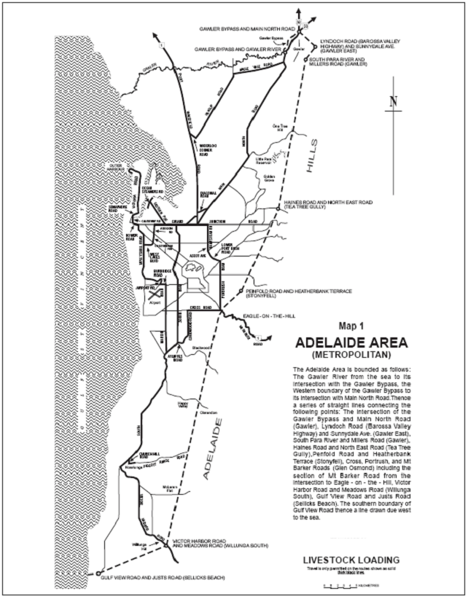
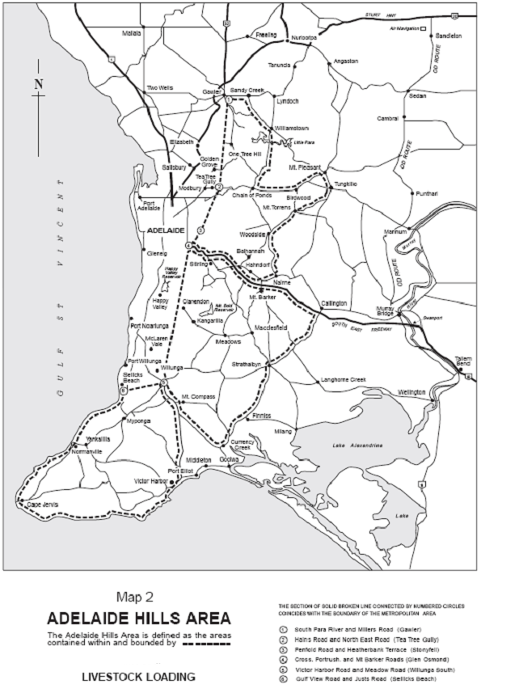
5.5 Fees
For South Australian registered vehicles and vehicles not covered by Section 5.7, a fee shall be paid based on the unladen mass of the semi-trailer in accordance with the following tables:

Articulated Vehicle and Second B-Double Semi-Trailer

Fee Level | Semi-Trailer Unladen Mass (Tonnes) |  | Fee
1 | Up to 12 |  | NIL
2 | 12.01—13 |  | $600
3 | 13.01—14 |  | $1200
4 | 14.01—15 |  | $2200

Lead Semi-Trailer of a B-Double Combination

Fee Level | Semi-Trailer Unladen Mass (Tonnes) |  | Fee
1 | Up to 9 |  | NIL
2 | 9.01—10 |  | $600
3 | 10.01—11 |  | $1200
4 | 11.01—12 |  | $2200

5.6 Inspection and Labels
5.6.1 All South Australian registered vehicles and vehicles not covered by Section 5.7 shall successfully complete a DPTI roadworthy inspection and be affixed with a current DPTI Livestock Loading label (livestock loading label for single articulated vehicles and B-Double livestock loading label for B-Doubles).
5.6.2 Vehicles accredited under the Maintenance Management module of the National Heavy Vehicle Accreditation Scheme (NHVAS) shall have successfully completed an initial DPTI roadworthy inspection and be affixed with a DPTI Livestock Loading label (livestock loading label for single articulated vehicles and B-Double livestock loading label for B-Doubles).
5.6.3 Vehicles accredited under a Maintenance Management scheme shall display both the appropriate DPTI Livestock Loading label and the vehicle Maintenance Management Scheme label.
5.6.4 Labels shall be maintained by the operator in a clean and legible condition at all times for sighting upon request by an Authorised Officer appointed under the Road Traffic Act 1961 or a Police Officer.
5.6.5 All vehicles shall be presented for inspection in a clean and unladen condition.
5.7 Recognition of Other Livestock Loading Schemes
5.7.1 Except for compliance with Section 5.6, single articulated vehicles and B-Doubles registered in Victoria, Queensland, Northern Territory, Western Australia and New South Wales may operate in South Australia in accordance with the terms and conditions of this notice and in accordance with the following requirements:
5.7.1.1 Victorian Registered Vehicles:
Articulated vehicles and B-Doubles shall display approved plates (VLLS) which signify participation in the Victorian Livestock Loading Scheme.
A copy of the Livestock Loading Scheme certificate approved by VicRoads showing the rating, tare weight and semi-trailer load space must be carried by the driver when operating under this exemption and be produced upon request by an Authorised Officer appointed under the Road Traffic Act 1961 or a Police Officer.
5.7.1.2 Queensland Registered Vehicles:
Articulated vehicles and B—Doubles shall have a Modification Plate attached to each vehicle unit in the combination which displays the vehicles maximum axle capacities, tare mass, king pin rating and the code S10.
5.7.1.3 Northern Territory and Western Australia Registered Vehicles:
The permit for the articulated vehicle and/or the B-Double which identifies membership in the Livestock Loading Scheme in their home state or territory shall be carried by the driver when operating under this exemption and be produced upon request by an Authorised Officer appointed under the Road Traffic Act 1961 or a Police Officer.
5.7.1.4 New South Wales Registered Vehicles:
A copy of the New South Wales Government Gazette Notice relating to the ‘Livestock Welfare Mass Management Accreditation Scheme’ shall be carried in the vehicle. Each vehicle unit in the combination must display a label issued by the NSW Department of Transport, Roads and Maritime Services signifying membership in the New South Wales Scheme.
5.8 General Condition
5.8.1 This exemption shall operate only with respect to the vehicles, loads and routes specified and does not relieve the owner and/or driver of the duty to observe all other provisions of the South Australian Road Traffic Act and Regulations.
5.8.2 The conditions set out in this Notice may be overridden at any time by a limitation sign fixed on a bridge, culvert, causeway, road or road ferry.
5.8.3 For articulated vehicle operation, this notice shall stand alone.
5.8.4 For B-Double operation, the conditions and restrictions detailed in this Gazette Notice shall be in addition to, and shall be read in conjunction with the document titled ‘Operation of B-Double Vehicles up to 25m in Length’ and ‘Operation of 26 metre B-Double Vehicles’.
5.8.5 Hauliers operating under the provision of this notice are advised that some parts of the road system, bridges, signs, overhead services and wires and road side furniture may not provide sufficient strength and clearance for the passage of a vehicle/load at the dimensions and mass permitted by this notice.
5.9 When operating under this Notice as an articulated vehicle, you must:
5.9.1 Carry a legible, current and complete copy of this Notice either in hardcopy or in an electronic format so that it can be read from a device having a visual display (e.g. smart phone, tablet or laptop PC, in vehicle unit) that is carried within the vehicle and that is accessible, to a DPTI Authorised Officer appointed under the Road Traffic Act 1961 or a Police Officer, from outside the vehicle.
5.10 When operating under this Notice as a B-Double vehicle you must:
5.10.1 Operate at all times in accordance with the conditions and limitations specified in the ‘Code of Practice for B-Doubles’ and associated B-Double Gazette Notice(s), as issued by DPTI and as amended from time to time.
5.10.2 Carry a legible, current and complete copy of this Notice either in hardcopy or in an electronic format so that it can be read from a device having a visual display (e.g. smart phone, tablet or laptop PC, in vehicle unit) that is carried within the vehicle and that is accessible, to a DPTI Authorised Officer appointed under the Road Traffic Act 1961 or a Police Officer, from outside the vehicle.
5.10.3 Immediately prior to any journey, and using the current approved B-Double HML route network(s) published via the DPTI RAVnet Online Mapping System, determine the entire approved route being travelled/operated on during the particular journey.
6. COMMENCEMENT OF THIS NOTICE
6.1 This Notice is valid from 12.01 a.m. on 1 November 2013.
7. AUTHORISATION
Don Hogben, Director, Road Policy and Planning
Department of Planning, Transport and Infrastructure
Delegate for the Minister for Transport and Infrastructure

NOTICE TO MARINERS
No. 29 of 2013
South Australia—Kangaroo Island—Hog Bay—Penneshaw—Dredging Operations
MARITIME Constructions will be carrying out maintenance dredging of Penneshaw Ferry Harbour (Hog Bay) commencing around 28 October 2013 through until early December 2013.
A cutter suction dredge will be engaged and the material pumped/discharged near Frenchmans Rocks at the eastern most point on Hog Bay beach.
The 650 m long dredge pipe will run across the width of bay during dredging operations. Dredging operations will only take place at night time from 21:00 hours to 09:00 hours.
During the day when the dredge is not operational it will be anchored offshore in Hog Bay and the pipe line lowered to the seabed to allow for free movement of ferries and other vessels.
The dredge will display the lights and shapes as required by the International Regulations for preventing collisions at sea.
Charts affected: Aus 125.
Adelaide, 24 October 2013.
Tom Koutsantonis, Minister for Transport and Infrastructure
DPTI 2013/01860

NOTICE TO MARINERS
No. 30 of 2013
South Australia—Gulf of St Vincent—Glenelg New
Lights Installed
MARINERS are advised that the sectored lights on the breakwater ruins have been replaced with the following:
(1) Northern end of breakwater latitude 34°58.67’S, longitude 138°30.22’E with a north cardinal Marker Qk. Fl. (W), Range 3 nautical miles.
(2) Southern end of breakwater latitude 34°58.85’S, longitude 138°30.22’E with a South Cardinal marker Qk. Fl. (6) plus 1 long 15 secs. Range 3 nautical miles.
Charts affected: Aus 125.
List of Lights: Volume K: 2083 and 2083.2.
Adelaide, 24 October 2013.
Tom Koutsantonis, Minister for Transport and Infrastructure
DPTI 2013/01860

WATER MAINS AND SEWERS

Office of the South Australian Water Corporation
Adelaide, 31 October 2013

WATER MAINS LAID

Notice is hereby given that the following main pipes or parts of main pipes have been laid down by the South Australian Water Corporation in or near the undermentioned water districts and are now available for a constant supply of water to adjacent land.

ADELAIDE WATER DISTRICT

ADELAIDE CITY COUNCIL
In and across King William Street, North Adelaide. p42

ADELAIDE HILLS COUNCIL
Onkaparinga Road, Bridgewater. p49-51
Across South Eastern Freeway, Bridgwater. p51
Darpuna Road, Bridgewater. p51

CITY OF CHARLES STURT
Fifth Street, Bowden. p58 and 59
Across and in Park Terrace, Bowden. p58 and 59
Gibson Street, Bowden. p58 and 59
Gibson Street, Bowden. p60 and 61
Sixth Street, Bowden. p60 and 61
Seventh Street, Bowden. p60 and 61

CITY OF HOLDFAST BAY
Holdfast Promenade, Glenelg. p66

CITY OF MARION
Zante Grove, Park Holme. p65

CITY OF MITCHAM
Dorene Street, St Marys. p48

CITY OF ONKAPARINGA
Castle Street, Old Noarlunga. p41
Lynton Terrace, Seaford. p62 and 63

CITY OF PLAYFORD
Easements in lot 1 in LTRO DP 83692 and lots 608-606 in LTRO DP 6711 (Parkview Walk), Elizabeth Park. p64
Across and in Burdon Walk, Elizabeth Park. p64
Easements in lots 10 and 9 in LTRO DP 53147, lot 51 in LTRO DP 44649, lot 1 in LTRO DP 62102 and lots 597-594 in LTRO DP 6711 (Burdon Street), Elizabeth Park. p64

CITY OF SALISBURY
Carlow Street, Salisbury Downs. p38

CITY OF TEA TREE GULLY
Holden Street, Holden Hill. p20

MOUNT GAMBIER WATER DISTRICT

CITY OF MOUNT GAMBIER
Easements in lot 10 in LTRO DP 1611 (Mickail Court), Wireless East Road, Mount Gambier. p56 and 57

MURRAY BRIDGE WATER DISTRICT

THE RURAL CITY OF MURRAY BRIDGE
Long Island Road, Murray Bridge. p18 and 19

SEWERS LAID

Notice is hereby given that the following sewers have been laid down by the South Australian Water Corporation in the undermentioned drainage areas and are now available for house connections.

ADELAIDE DRAINAGE AREA

CITY OF CHARLES STURT
Sinclair Square, Pennington. FB 1230 p47
McKenzie Court, Royal Park. FB 1230 p55
Fifth Street, Bowden. FB 1231 p23-25
Gibson Street, Bowden. FB 1231 p26-28
Sixth Street, Bowden. FB 1231 p26-28
Public road west of lot 163 in LTRO DP 90924, and north of lots 17 and 18 in LTRO DP 90924, Bowden. FB 1231 p26-28

CITY OF MARION
Easement in lot 9 in LTRO DP 57736, Woodend Road, Sheidow Park. FB 1229 p33
Across Young Street, Sheidow Park and Trott Park. FB 1229 p33
Easement in reserve (lot 890 in LTRO DP 85701), Young Street, and lot 107 in LTRO DP 85701, Kangaroo Thorn Road, Trott Park. FB 1229 p33
Across Kangaroo Thorn Road, Trott Park. FB 1229 p33
Easements in reserve (lot 890 in LTRO DP 85701), Young Street, and lots 105-103, 101 and 102, Kangaroo Thorn Road, Trott Park. FB 1229 p34
Gore Street, Oaklands Park. FB 1232 p1
Parkmore Avenue, Sturt. FB 1232 p2

CITY OF MITCHAM
Cambridge Terrace, Kingswood. FB 1230 p51
Dorene Street, St Marys. FB 1230 p54

CITY OF NORWOOD PAYNEHAM & ST PETERS
Gilding Avenue, Royston Park. FB 1230 p45
Across Brown Street, Norwood. FB 1230 p57
Easement in lot 64 in LTRO FP 138844, Brown Street, Norwood. FB 1230 p57

CITY OF ONKAPARINGA
Emberton Place, Morphett Vale. FB 1230 p50
Dorothea Street, Christies Beach. FB 1230 p52
Eric Road, Old Noarlunga. FB 1230 p53
Across Banks Road, Woodcroft. FB 1229 p54-56
Easement in reserve (lot 1008 in LTRO DP 22225), Woodcroft. FB 1229 p54-56
Across and in Panalatinga Road, Woodcroft. FB 1229 p54-56
Easements in lot 16 in LTRO DP 91820 and lot 14 in LTRO DP 91820, Arkle Place, Woodcroft. FB 1229 p54-56
Arkle Place, Woodcroft. FB 1229 p54-56
Lynton Terrace, Seaford. FB 1231 p29-31

CITY OF PLAYFORD
Easement in lot 702 in LTRO DP 87364, Haydown Road, Elizabeth Vale. FB 1230 p48
Bowman Street, Elizabeth Park. FB 1231 p32-34
Cullen Street, Elizabeth Park. FB 1231 p32-34
Easements in lot 619 in LTRO DP 6711 (Parkview Walk), Elizabeth Park. FB 1231 p32-34
Burdon Street, Elizabeth Park. FB 1231 p32-34
Easements in lots 594-596 in LTRO DP 6711 (Burdon Street), Elizabeth Park. FB 1231 p32-34
Easements in lots 10 and 9 in LTRO DP 53147), Elizabeth Park. FB 1231 p32-34

CITY OF PORT ADELAIDE ENFIELD
Thistle Avenue, Klemzig. FB 1230 p43
Kent Avenue, Clearview. FB 1230 p46
Floriedale Road, Greenacres. FB 1230 p56
Nottage Road, Northgate. FB 1229 p57-59
Haines Road, Northgate. FB 1229 p57-59
Easements in lot 4521 in LTRO DP 92264, East Parkway, Northgate. FB 1229 p57-60
East Parkway, Northgate. FB 1229 p57-59
Fidge Lane, Northgate. FB 1229 p57, 58 and 60
Bertram Lane, Northgate. FB 1229 p57, 58 and 60
Hillier Street, Northgate. FB 1229 p57, 58 and 60
Webb Street, Northgate. FB 1229 p57, 58 and 60
Grand Junction Road, Angle Park. FB 1231 p35-37
South Road, Angle Park. FB 1231 p35-37
Rapid Avenue, Northgate. FB 1230 p60

CITY OF SALISBURY
Carlow Street, Salisbury Downs. FB 1230 p58

CITY OF TEA TREE GULLY
Holden Street, Holden Hill. FB 1230 p44

ALDINGA DRAINAGE AREA

CITY OF ONKAPARINGA
Bristol Street, Aldinga Beach. FB 1230 p49

MOUNT GAMBIER COUNTRY DRAINAGE AREA

CITY OF MOUNT GAMBIER
Easements in lot 10 in LTRO DP 1611, Wireless East Road, Mount Gambier. FB 1196 p10-12

STIRLING COUNTRY DRAINAGE AREA

ADELAIDE HILLS COUNCIL
Lots 5 and 6 in LTRO FP 8131, Wattle Tree Road, Bridgewater—40 mm PE80 pressure sewer system main. This main is available on application only. FB 1230 p20

CORRECTIONS

Correction to notice in ‘Government Gazette’ of 29 August 2013.

“SEWERS LAID”

“Notice is hereby given that the following sewers have been laid down by the South Australian Water Corporation in the undermentioned drainage areas and are now available for house connections.”

“STIRLING COUNTRY DRAINAGE AREA”

“ADELAIDE HILLS COUNCIL”
“Lot 43 in LTRO FP 129597, James Street, Crafers—40 mm PE80 pressure sewer system main. This main is available on application only. FB 1230 p19”
For “FB 1230 p19” read “FB 1230 p30”

Correction to notice in ‘Government Gazette’ of 26 September 2013.

“WATER MAINS LAID”

“Notice is hereby given that the undermentioned water mains have been laid down by the South Australian Water Corporation and are not available for a constant supply of water to adjacent land.”

“OUTSIDE LOXTON COUNTRY LANDS WATER
DISTRICT”

“THE BERRI BARMERA COUNCIL”
“Edwards Road, Loxton North. p1-3”

For ‘THE BERRI BARMERA COUNCIL’ read ‘DISTRICT COUNCIL OF LOXTON WAIKERIE’

A. J. Ringham, Chief Executive Officer, South Australian Water Corporation

South Australia
National Parks and Wildlife (Ettrick Conservation Park—Mining Rights) Proclamation 2013
under section 43 of the National Parks and Wildlife Act 1972

Preamble
1 The Crown land described in Schedule 1 is, by another proclamation made on this day, constituted as a conservation park under section 30(1) of the National Parks and Wildlife Act 1972 and assigned the name Ettrick Conservation Park.
2 It is intended that, by this proclamation, certain existing and future rights of entry, prospecting, exploration or mining be preserved in relation to that land.

1—Short title
This proclamation may be cited as the National Parks and Wildlife (Ettrick Conservation Park—Mining Rights) Proclamation 2013.
2—Commencement
This proclamation comes into operation on the day on which it is made.
3—Interpretation
In this proclamation—
Environment Minister means the Minister for the time being administering the National Parks and Wildlife Act 1972;
Mining Minister means the Minister for the time being administering the Mining Act 1971 or the Minister for the time being administering the Petroleum and Geothermal Energy Act 2000, as the case requires.
4—Existing rights to continue
Subject to clause 6, existing rights of entry, prospecting, exploration or mining under the Mining Act 1971 or the Petroleum and Geothermal Energy Act 2000 may continue to be exercised in respect of the land described in Schedule 1.
5—New rights may be acquired
Rights of entry, prospecting, exploration or mining may, with the approval of the Mining Minister and the Environment Minister, be acquired pursuant to the Mining Act 1971 or the Petroleum and Geothermal Energy Act 2000 in respect of the land described in Schedule 1 and may, subject to clause 6, be exercised in respect of that land.
6—Conditions for exercise of rights
A person in whom rights of entry, prospecting, exploration or mining are vested pursuant to the Mining Act 1971 or the Petroleum and Geothermal Energy Act 2000 (whether those rights were acquired before or after the making of this proclamation) must not exercise those rights in respect of the land described in Schedule 1 unless the person complies with the following conditions:
(a) if work to be carried out in relation to the land in the exercise of those rights is a regulated activity within the meaning of the Petroleum and Geothermal Energy Act 2000, the person must ensure that—
(i) the work is not carried out until a statement of environmental objectives in relation to the activity that has been approved under that Act has also been approved by the Environment Minister; and
(ii) the work is carried out in accordance with the statement as so approved;
(b) if work to be carried out in relation to the land in the exercise of rights under the Mining Act 1971 or the Petroleum and Geothermal Energy Act 2000 has not previously been authorised (whether by inclusion in an approved statement of environmental objectives referred to in paragraph (a) or otherwise), the person must give at least 3 months notice of the proposed work to the Mining Minister and the Environment Minister and supply each Minister with such information relating to the proposed work as the Minister may require;
(c) if directions are agreed between the Mining Minister and the Environment Minister and given to the person in writing in relation to—
(i) carrying out work in relation to the land in a manner that minimises damage to the land (including the land's vegetation and wildlife) and the environment generally; or
(ii) preserving objects, structures or sites of historical, scientific or cultural interest; or
(iii) rehabilitating the land (including the land's vegetation and wildlife) on completion of the work; or
(iv) (where the work is being carried out in the exercise of rights acquired after the making of this proclamation) prohibiting or restricting access to any specified area of the land that the Ministers believe would suffer significant detriment as a result of carrying out the work,
(being directions that do not reduce or otherwise detract from any requirement in respect of any of those matters contained in an approved statement of environmental objectives referred to in paragraph (a)), the person must comply with those directions in carrying out the work;
(d) if a plan of management is in operation under section 38 of the National Parks and Wildlife Act 1972 in respect of the land, the person must have regard to the provisions of the plan of management;
(e) in addition to complying with the other requirements of this proclamation, the person—
(i) must take such steps as are reasonably necessary to ensure that objects, structures and sites of historical, scientific or cultural interest and the land's vegetation and wildlife are not unduly affected by any work; and
(ii) must maintain all work areas in a clean and tidy condition; and
(iii) must, on the completion of any work, obliterate or remove all installations and structures (other than installations and structures designated by the Mining Minister and the Environment Minister as suitable for retention) used exclusively for the purposes of that work;
(f) if no direction has been given by the Mining Minister and the Environment Minister under paragraph (c)(iii), the person must (in addition to complying with any approved statement of environmental objectives referred to in paragraph (a)) rehabilitate the land (including its vegetation and wildlife) on completion of any work to the satisfaction of the Environment Minister.
7—Governor may give approvals, directions
If—
(a) the Mining Minister and the Environment Minister cannot agree as to whether—
(i) approval should be granted or refused under clause 5; or
(ii) a direction should be given under clause 6(c); or
(b) the Environment Minister does not approve a statement of environmental objectives under clause 6(a),
the Governor may, with the advice and consent of the Executive Council—
(c) grant or refuse the necessary approval under clause 5; or
(d) give a direction in writing under clause 6(c); or
(e) grant or refuse the necessary approval under clause 6(a).
Schedule 1—Description of land
Allotment 99 in Deposited Plan 26809, Hundred of Ettrick, County of Russell.
Made by the Governor’s Deputy
with the advice and consent of the Executive Council
on 31 October 2013
13MSECCS066

South Australia
National Parks and Wildlife (Ettrick Conservation Park) Proclamation 2013
under section 30(1) of the National Parks and Wildlife Act 1972
1—Short title
This proclamation may be cited as the National Parks and Wildlife (Ettrick Conservation Park) Proclamation 2013.
2—Commencement
This proclamation comes into operation on the day on which it is made.
3—Constitution of Ettrick Conservation Park
The following Crown land is constituted as a conservation park and assigned the name Ettrick Conservation Park:
Allotment 99 in Deposited Plan 26809, Hundred of Ettrick, County of Russell.
Made by the Governor’s Deputy
being of the opinion that the Crown land described in clause 3 should be protected and preserved for the purpose of conserving any wildlife and the natural features of the land and with the advice and consent of the Executive Council
on 31 October 2013
13MSECCS066

South Australia
Tobacco Products Regulation (Exemption—The Lake) Proclamation 2013
under section 71 of the Tobacco Products Regulation Act 1997
1—Short title
This proclamation may be cited as the Tobacco Products Regulation (Exemption—The Lake) Proclamation 2013.
2—Commencement
This proclamation comes into operation on the day on which it is made.
3—Interpretation
In this proclamation—
Act means the Tobacco Products Regulation Act 1997;
prescribed period means the period commencing on 3 November 2013 and ending on 30 November 2013;
prescribed production means the stage production of The Lake produced by five.point.one.
4—Application of proclamation
This proclamation applies to the following persons:
(a) a person employed by, or in relation to, the prescribed production;
(b) an occupier of The Arch, Holden Street Theatres, 34 Holden Street, Hindmarsh;
(c) an employer with responsibility for a workplace consisting of The Arch in relation to the prescribed production.
5—Exemption from section 46 of the Act
(1) A person to whom this proclamation applies is exempt from the operation of section 46 of the Act in relation to smoking occurring in the course of a performance or rehearsal of the prescribed production during the prescribed period.
(2) An exemption under this clause is subject to the following conditions:
(a) smoking may only occur on a stage on which the prescribed production is being performed or rehearsed, or in a rehearsal room used in relation to the prescribed production;
(b) the area in which smoking may occur under the exemption must be well ventilated;
(c) the audience for a performance of the prescribed production must be warned that there will be smoking during the performance;
(d) a person may only smoke a tobacco product of a kind contemplated by paragraph (g) of the definition of tobacco product in section 4 of the Act.
(3) If a person contravenes or fails to comply with a condition of an exemption specified in subclause (2), the exemption does not, while the contravention or non-compliance continues, operate in that person's favour.
Made by the Governor’s Deputy
with the advice and consent of the Executive Council
on 31 October 2013
HEAC-2013-00087

South Australia
Primary Industry Funding Schemes (Sheep Industry Fund) Variation Regulations 2013
under the Primary Industry Funding Schemes Act 1998

Contents
Part 1—Preliminary
1 Short title
2 Commencement
3 Variation provisions
Part 2—Variation of Primary Industry Funding Schemes (Sheep Industry Fund) Regulations 1999
4 Variation of regulation 7—Application of Fund
5 Insertion of regulation 8A
8A Exchange of information

Part 1—Preliminary
1—Short title
These regulations may be cited as the Primary Industry Funding Schemes (Sheep Industry Fund) Variation Regulations 2013.
2—Commencement
These regulations come into operation on the day on which they are made.
3—Variation provisions
In these regulations, a provision under a heading referring to the variation of specified regulations varies the regulations so specified.
Part 2—Variation of Primary Industry Funding Schemes (Sheep Industry Fund) Regulations 1999
4—Variation of regulation 7—Application of Fund
Regulation 7—after paragraph (c) insert:
(ca) payments to a body that, in the opinion of the Minister, represents sheep producers for 1 or more of the following purposes:
(i) the reasonable operating and management expenses of the body;
(ii) promoting the sheep industry;
(iii) participation of the body in regional, State or national sheep industry forums;
(iv) undertaking or facilitating research and development, or the collection and dissemination to sheep producers of information, relevant to the sheep industry and, in particular, to the improvement of practices in the industry;
(v) fees for affiliation of the body with regional, State or national bodies representing or promoting the interests of the sheep producers;
(vi) other purposes of the body;
5—Insertion of regulation 8A
After regulation 8 insert:
8A—Exchange of information
The Minister may provide a body to which payments are made out of the Fund under regulation 7(ca) with information identifying persons who have paid or been refunded contributions under these regulations.
Note—
As required by section 10AA(2) of the Subordinate Legislation Act 1978, the Minister has certified that, in the Minister's opinion, it is necessary or appropriate that these regulations come into operation as set out in these regulations.
Made by the Governor’s Deputy
with the advice and consent of the Executive Council
on 31 October 2013
No 246 of 2013
13MAFF40CS

South Australia
Liquor Licensing (Dry Areas) Variation Regulations 2013
under the Liquor Licensing Act 1997

Contents
Part 1—Preliminary
1 Short title
2 Commencement
3 Variation provisions
Part 2—Variation of Liquor Licensing (Dry Areas) Regulations 2012
4 Variation of Schedule—Glenelg Area 1
5 Variation of Schedule—Glenelg Area 2
6 Variation of Schedule—Glenelg North Area 1
7 Variation of Schedule—Seacliff Area 4

Part 1—Preliminary
1—Short title
These regulations may be cited as the Liquor Licensing (Dry Areas) Variation Regulations 2013.
2—Commencement
These regulations come into operation on the day on which they are made.
3—Variation provisions
In these regulations, a provision under a heading referring to the variation of specified regulations varies the regulations so specified.
Part 2—Variation of Liquor Licensing (Dry Areas) Regulations 2012
4—Variation of Schedule—Glenelg Area 1
Schedule—Glenelg Area 1, clause 2(b)—delete paragraph (b) and substitute:
(b) the period during which the prohibition in Schedule—Glenelg Area 2 applies.
5—Variation of Schedule—Glenelg Area 2
Schedule—Glenelg Area 2, clause 2—delete "9 pm on 31 December 2012 to 8 am on 1 January 2013." and substitute:
From 9 pm on 31 December 2013 to 6 am on 1 January 2014.
6—Variation of Schedule—Glenelg North Area 1
Schedule—Glenelg North Area 1, clause 2—delete "From 12.01 am on 26 January 2013 to 12.01 am on 27 January 2013." and substitute:
From 12.01 am on 26 January 2014 to 12.01 am on 27 January 2014.
7—Variation of Schedule—Seacliff Area 4
Schedule—Seacliff Area 4, clause 2—delete "From 12.01 am on 26 January 2013 to 12.01 am on 29 January 2013." and substitute:
From 12.01 am on 25 January 2014 to 12.01 am on 28 January 2014.
Note—
As required by section 10AA(2) of the Subordinate Legislation Act 1978, the Minister has certified that, in the Minister's opinion, it is necessary or appropriate that these regulations come into operation as set out in these regulations.
Made by the Governor’s Deputy
with the advice and consent of the Executive Council
on 31 October 2013
No 247 of 2013
MLI0025/13CS

South Australia
Liquor Licensing (Dry Areas) Variation Regulations 2013
under the Liquor Licensing Act 1997

Contents
Part 1—Preliminary
1 Short title
2 Commencement
3 Variation provisions
Part 2—Variation of Liquor Licensing (Dry Areas) Regulations 2012
4 Variation of Schedule—Kimba Area 1

Part 1—Preliminary
1—Short title
These regulations may be cited as the Liquor Licensing (Dry Areas) Variation Regulations 2013.
2—Commencement
These regulations come into operation on the day on which they are made.
3—Variation provisions
In these regulations, a provision under a heading referring to the variation of specified regulations varies the regulations so specified.
Part 2—Variation of Liquor Licensing (Dry Areas) Regulations 2012
4—Variation of Schedule—Kimba Area 1
Schedule—Kimba Area 1, clause 2—delete "From 9 pm on 31 December 2012 to 8 am on 1 January 2013." and substitute:
From 9 pm on 31 December 2013 to 8 am on 1 January 2014.
Note—
As required by section 10AA(2) of the Subordinate Legislation Act 1978, the Minister has certified that, in the Minister's opinion, it is necessary or appropriate that these regulations come into operation as set out in these regulations.
Made by the Governor’s Deputy
with the advice and consent of the Executive Council
on 31 October 2013
No 248 of 2013
MLI0026/13CS
South Australia
Road Traffic (Miscellaneous) Variation Regulations 2013
under the Road Traffic Act 1961

Contents
Part 1—Preliminary
1 Short title
2 Commencement
3 Variation provisions
Part 2—Variation of Road Traffic (Miscellaneous) Regulations 1999
4 Variation of regulation 4—Interpretation
5 Variation of regulation 13B—Apparatus approved as traffic speed analysers
6 Insertion of regulation 13C
13C Interpretation
7 Variation of regulation 14—Apparatus approved as photographic detection devices
8 Variation of regulation 17—Operation and testing of photographic detection devices referred to in regulation 14(1)(a) for offences committed at intersections, marked foot crossings or level crossings
9 Variation of regulation 18—Operation and testing of photographic detection devices referred to in regulation 14(1)(a) for offences committed other than at intersections, marked foot crossings or level crossings
10 Insertion of regulation 18A
18A Operation and testing of photographic detection devices referred to in regulation 14(1)(b) for offences committed other than at intersections, marked foot crossings or level crossings

Part 1—Preliminary
1—Short title
These regulations may be cited as the Road Traffic (Miscellaneous) Variation Regulations 2013.
2—Commencement
These regulations will come into operation on 1 November 2013.
3—Variation provisions
In these regulations, a provision under a heading referring to the variation of specified regulations varies the regulations so specified.
Part 2—Variation of Road Traffic (Miscellaneous) Regulations 1999
4—Variation of regulation 4—Interpretation
(1) Regulation 4(1)—before the definition of reckless or dangerous driving offence insert:
prescribed part, of a photographic detection device, means—
(a) a closed-circuit television camera; or
(b) an induction loop vehicle detector; or
(c) a piezoelectric traffic sensor; or
(d) a Variable Speed Limit Sign,
that forms part of the device;
(2) Regulation 4(1)—after the definition of Transport Department insert:
Variable Speed Limit Sign means a variable illuminated message device that displays or is designed to display a speed limit sign.
(3) Regulation 4(2)—delete "stop line, traffic lights and twin red lights" and substitute:
speed limit sign, stop line, traffic lights, twin red lights and variable illuminated message device
(4) Regulation 4—after subregulation (2) insert:
(2a) In these regulations, a reference to a prescribed part of a photographic detection device—
(a) includes a reference to more than 1 such prescribed part; and
(b) if more than 1 such prescribed part forms part of a photographic detection device, is a reference to any such part.
5—Variation of regulation 13B—Apparatus approved as traffic speed analysers
Regulation 13B—after paragraph (e) insert:
(ea) a REDFLEXred-speed HDX system manufactured by Redflex Traffic Systems Pty Ltd, linked to and used in conjunction with an induction loop vehicle detector, a Variable Speed Limit Sign and a closed-circuit television camera;
(eb) a REDFLEXred-speed HDX system manufactured by Redflex Traffic Systems Pty Ltd, linked to and used in conjunction with an induction loop vehicle detector, a piezoelectric traffic sensor, a Variable Speed Limit Sign and a closed-circuit television camera;
6—Insertion of regulation 13C
Part 3, Division 1—before regulation 14 insert:
13C—Interpretation
For the purposes of this Part, a requirement in this Part relating to the installation or setting up of a photographic detection device of a kind referred to in regulation 14(1)(a) or (b) to provide evidence of offences will be taken to also apply to the removal of such a device (or portion of such a device) with recording media in place to a new location from another location at which it was previously being used to provide evidence of offences.
7—Variation of regulation 14—Apparatus approved as photographic detection devices
(1) Regulation 14(1)—after paragraph (a) insert:
(b) in relation to a reckless or dangerous driving offence, a registration offence or a speeding offence (other than a speeding offence arising out of the same incident as a red light offence)—
(i) a REDFLEXred-speed HDX system manufactured by Redflex Traffic Systems Pty Ltd, linked to and used in conjunction with an induction loop vehicle detector, a Variable Speed Limit Sign and a closed-circuit television camera;
(ii) a REDFLEXred-speed HDX system manufactured by Redflex Traffic Systems Pty Ltd, linked to and used in conjunction with an induction loop vehicle detector, a piezoelectric traffic sensor, a Variable Speed Limit Sign and a closed-circuit television camera;
(2) Regulation 14(1)(c)(ii)—delete "in paragraph (a)" and substitute:
in paragraph (a) or (b)
(3) Regulation 14(1)(d)(i)—after "incorporating" insert:
1 or more of each of
(4) Regulation 14(1)(d)(i)(D)—delete "together with an induction loop vehicle detector; or" and substitute:
(or more than 1 such camera) together with a TIRTL (The Infra-Red Traffic Logger) manufactured by CEOS Industrial Pty Ltd or an induction loop vehicle detector;
(5) Regulation 14(1)(d)(iii)—after "incorporating" insert:
1 or more of each of
8—Variation of regulation 17—Operation and testing of photographic detection devices referred to in regulation 14(1)(a) for offences committed at intersections, marked foot crossings or level crossings
Regulation 17(2)(i) and (ia)—delete paragraphs (i) and (ia)
9—Variation of regulation 18—Operation and testing of photographic detection devices referred to in regulation 14(1)(a) for offences committed other than at intersections, marked foot crossings or level crossings
(1) Regulation 18(1)(b)—delete "are proceeding over" and substitute:
proceed over or continue past
(2) Regulation 18(1)(f) and (g)—delete paragraphs (f) and (g)
10—Insertion of regulation 18A
After regulation 18 insert:
18A—Operation and testing of photographic detection devices referred to in regulation 14(1)(b) for offences committed other than at intersections, marked foot crossings or level crossings
(1) Where a photographic detection device referred to in regulation 14(1)(b) is used to provide evidence of speeding offences committed other than at an intersection, marked foot crossing or level crossing, the following provisions must be complied with:
(a) the induction loop vehicle detector (induction loop) must be installed under the surface of the road;
(b) if a piezoelectric traffic sensor (piezo strip) forms part of the device, the piezo strip must be installed under the surface of the road together with the induction loop;
(c) the camera or cameras forming part of the device (other than a closed-circuit television camera) must be positioned and aimed, and the induction loop and the piezo strip (if any) linked up with the other parts of the device, so that when vehicles proceed over or continue past the part of the road under the surface of which the induction loop and the piezo strip (if any) is (or are) installed, a photograph or series of photographs may be taken of the vehicles;
(d) the Variable Speed Limit Sign (VSLS) must be—
(i) installed so that a speed limit sign displayed by the VSLS applies for the purposes of the Australian Road Rules (whether some or all of the time) to the length of road under the surface of which the induction loop and the piezo strip (if any) is (or are) installed; and
(ii) linked up with the other parts of the device so that the speed limit (if any) indicated by the VSLS, and any changes in that speed limit, may be noted by, and used for the purposes of the operation of, the device;
(e) the closed-circuit television camera must be positioned and aimed, and linked up with the other parts of the device, so that a video recording directed at the speed limit (if any) indicated by the VSLS referred to in paragraph (d) may be made;
(f) the device must be programmed and set to operate so that if a vehicle is detected by the device passing over the induction loop and the piezo strip (if any) at a speed equal to or greater than a speed set on the device (being a speed set for all vehicles or for vehicles of a class, whether determined according to the number of axles of a vehicle or otherwise, that includes the detected vehicle)—
(i) at least 2 electronic records are made of the vehicle—
(A) at least 1 of which is made following a programmed delay after the first is made; and
(B) on at least 1 of which is recorded—
• the speed of the vehicle as detected by the device; and
• the speed limit (if any) indicated at that time by the VSLS referred to in paragraph (d) as noted by the device and the period for which that noted speed limit has remained constant; and
(C) on each of which is recorded the date, time and code for the location at which the record is made, together with the lane in which the vehicle is travelling; and
(ii) the following additional electronic records are made:
(A) a record containing a portion of the video recording referred to in paragraph (e), being a portion of that recording for a programmed period preceding the detection of the vehicle, on which is recorded the date and start and end times for the video recording;
(B) a record containing a still image taken from that portion of video recording, on which is recorded the information referred to in paragraph (f)(i)(C);
(g) subject to paragraph (h), once in every 28 days—
(i) a test must be carried out (by reference to speeds not exceeding the speed limit applying to drivers driving vehicles on the length of road under the surface of which the induction loop and the piezo strip (if any) is (or are) installed, and by reference to vehicles of any number of axles) to ensure that the device detects vehicles passing over the induction loop and the piezo strip (if any) and—
(A) accurately indicates the speed and (if a piezo strip forms part of the device) number of axles of any vehicle so detected and the lane in which the vehicle is travelling; and
(B) makes the video recording and still image referred to in paragraph (f)(ii); and
(ii) the device must be checked to ensure that the device—
(A) indicates the correct date, time and code for the location at which electronic records are made by the device; and
(B) correctly notes the speed limit (if any) indicated by the VSLS referred to in paragraph (d); and
(C) is set to operate in accordance with paragraph (f); and
(iii) if a fault is indicated by the test referred to in subparagraph (i), corrective action must be taken and the test must be repeated until no fault is indicated; and
(iv) if a fault is indicated by the check referred to in subparagraph (ii), corrective action must be taken until no fault is indicated;
(h) if that part of the road surface under which the induction loop and the piezo strip (if any) is (or are) installed has 2 or more lanes for vehicles travelling in the same direction, the test referred to in paragraph (g)(i) is not required to be carried out in relation to each such lane in the same 28 day period provided that, once in every 28 days, the test is carried out in relation to 1 of those lanes and the lane in relation to which the test is carried out is not the same as the lane in relation to which the previous test was carried out;
(i) if—
(i) a test or check; or
(ii) any electronic record referred to in paragraph (f) made by the device,
indicates a fault that has affected the proper operation of the device as required by these regulations, the part of those electronic records affected by the fault must be rejected for evidentiary purposes;
(j) the accuracy with which the device detects vehicle speeds must be tested on the day on which it is used (or on a day within the period of 27 days immediately preceding that day) with a view to the issuing of a certificate under section 175(3)(ba) of the Act.
(2) Where a photographic detection device referred to in regulation 14(1)(b) is used to provide evidence of reckless or dangerous driving offences or registration offences committed other than at an intersection, marked foot crossing or level crossing, the provisions of subregulation (1) must be complied with.
Note—
As required by section 10AA(2) of the Subordinate Legislation Act 1978, the Minister has certified that, in the Minister's opinion, it is necessary or appropriate that these regulations come into operation as set out in these regulations.
Made by the Governor’s Deputy
with the advice and consent of the Executive Council
on 31 October 2013
No 249 of 2013
MRS13/01CS

SENDING COPY?
NOTICES for inclusion in the South Australian Government Gazette should be emailed to:
governmentgazette@dpc.sa.gov.au
Please include the following information in the covering email:
• The date the notice is to be published.
• Whether a proof, quote or return email confirmation is required.
• Contact details.
• To whom the notice is charged if applicable.
• A purchase order if required (chargeable notices).
• Any other details that may impact on the publication of the notice.
Attach:
• Notices in Word format.
• Maps and diagrams in pdf.
• Notices that require sighting an official date and signature before publication in a pdf. If a pdf is not possible then fax the official file(s) to the Government Publishing Fax number listed below.
Fax Transmission: (08) 8207 1040
Phone Enquiries: (08) 8207 1045
NOTE:
Closing time for lodging new copy is 4 p.m. on Tuesday preceding the regular Thursday Gazette.

ADELAIDE CITY COUNCIL
27 Vincent Place Development Plan Amendment—
Public Consultation
NOTICE is hereby given that the Adelaide City Council, pursuant to Sections 24 and 25 of the Development Act 1993, has prepared a Development Plan Amendment Report (DPA) to amend its Development Plan.
The DPA proposes to remove the status of 27 Vincent Place, Adelaide as a Local Heritage (Townscape) Place from the Adelaide (City) Development Plan.
The DPA report will be on public consultation from 31 October 2013 until 29 November 2013. The DPA is available for inspection or downloading at:
• yoursay.adelaidecitycouncil.com (27 Vincent Place DPA).
• Adelaide City Council’s Customer Centre—25 Pirie Street, Adelaide, open Monday to Friday, 8.30 a.m. to 5.30 p.m.
• The Planning Centre—25 Pirie Street, Adelaide, open Monday to Friday, 8.30 a.m. to 5.30 p.m. (opposite the Customer Centre).
• North Terrace Library—Ground Floor, State Library Building, North Terrace, Adelaide, open Monday to Friday, 10 a.m. to 6 p.m. and Saturday to Sunday, noon. to 5 p.m.
• Hutt Street Library—235 Hutt Street, open Monday to Wednesday, 10 a.m. to 6 p.m.; Thursday, 10 a.m. to 8 p.m.; Friday, 10 a.m. to 6 p.m. and Saturday, 11 a.m. to 2 p.m.
• South West Community Centre—171 Sturt Street, open Monday to Friday, 9 a.m. to 5 p.m.
• Grote Street Library—18 Grote Street, open Monday to Thursday, 10 a.m. to 6 p.m.; Friday, 10 a.m. to 8 p.m. and Saturday, 11 a.m. to 3 p.m.
• North Adelaide Library—176 Tynte Street, open Monday to Wednesday, 10 a.m. to 6 p.m.; Thursday, 10 a.m. to 8 p.m.; Friday, 10 a.m. to 6 p.m. and Saturday, 11 a.m. to 2 p.m.
• Box Factory Community Centre—59 Regent Street South, open Monday to Friday, 4 p.m. to 9 p.m. and Saturday, 10 a.m. to 3 p.m.
Hard copies can be made available by contacting staff on 8203 7326.
Written submissions regarding the DPA should be submitted no later than 5 p.m. on 29 November 2013. All submissions should be addressed to:
Chief Executive Officer
Adelaide City Council
(27 Vincent Place DPA)
G.P.O. Box 2252,
Adelaide, S.A. 5001
Submissions should clearly indicate whether you wish to be heard in support of your submission at the public meeting. If you wish to lodge your submission electronically, please go to Council’s web page www.yoursay.adelaidecitycouncil.com and complete the required fields.
Copies of all submissions will be available for inspection at the Customer Centre, 25 Pirie Street, Adelaide from 2 December 2013 until the conclusion of the public meeting. The submissions can also be viewed at www.yoursay.adelaidecitycouncil.com (27 Vincent Place DPA).
A public meeting will be held on Tuesday, 10 December 2013 at 5.30 p.m. at the Adelaide Town Hall, 128 King William Street, Adelaide at which time interested persons may be heard in relation to the DPA and the submissions. If no-one requests to be heard or if no submissions are received the public meeting will not be held.
If you would like further information about the DPA, please contact Council on 8203 7536 (Monday to Tuesday) or 8203 7684 (Wednesday to Friday).
Dated 31 October 2013.
P. Smith, Chief Executive Officer

ADELAIDE CITY COUNCIL
Development Act 1993
Residential and Main Street Development Plan Amendment—Public Consultation
NOTICE is hereby given that the Adelaide City Council, pursuant to Sections 24 and 25 of the Development Act 1993, has prepared a Development Plan Amendment Report (DPA) to amend its Development Plan.
Policy amendments in the draft DPA affect the following areas:
1. Residential areas in the south-east and south-west areas of the City.
2. Main Streets of O’Connell Street and Melbourne Street in North Adelaide, as well as Hutt Street, south of Hume Street.
The DPA report will be on public consultation from 31 October 2013 until 16 January 2014.
Copies of the DPA report are available for inspection during normal office hours at the Customer Centre, 25 Pirie Street, Adelaide, Monday-Friday 8:30 a.m.-5.30 p.m. The DPA report can be inspected on the internet at:
• www.yoursayadelaidecitycouncil.com or during opening hours at the following locations:
• North Terrace Library—Ground Floor, State Library Building, North Terrace, Adelaide, open Monday to Friday, 10 a.m. to 6 p.m. and Saturday to Sunday, noon. to 5 p.m. Closed on public holidays.
• Grote Street Library—18 Grote Street, open Monday to Thursday, 10 a.m. to 6 p.m.; Friday, 10 a.m. to 8 p.m. and Saturday, 11 a.m. to 3 p.m. Closed on Sundays and public holidays
• Hutt Street Library—235 Hutt Street, open Monday to Wednesday, 10 a.m. to 6 p.m.; Thursday, 10 a.m. to 8 p.m.; Friday, 10 a.m. to 6 p.m. and Saturday, 11 a.m. to 2 p.m. Closed on Sundays and public holidays.
• North Adelaide Library—176 Tynte Street, open Monday to Wednesday, 10 a.m. to 6 p.m.; Thursday, 10 a.m. to 8 p.m.; Friday, 10 a.m. to 6 p.m. and Saturday, 11 a.m. to 2 p.m. Closed on Sundays and public holidays
• South West Community Centre—171 Sturt Street, open Monday to Friday, 9 a.m. to 5 p.m.
• Box Factory Community Centre—59 Regent Street South, open Monday to Friday, 4 p.m. to 9 p.m. and Saturday, 10 a.m. to 3 p.m.
Come and see our City Planners at the following Information Sessions:
• Box Factory Community Centre—59 Regent Street South (off Halifax Street), Adelaide. Saturday, 16 November 2013, 10 a.m. to 1 p.m.
• South West Community Centre—171 Sturt Street, Adelaide. Monday ,18 November 2013, 4-7 p.m.
• North Adelaide Community Centre and Library—176 Tynte Street, North Adelaide. Saturday, 30 November 2013, 11 a.m. to 2 p.m.
Copies of the DPA are available on CD upon request and at no cost from Council’s Customer Centre, 25 Pirie Street, Adelaide. Hard copies can be made available by contacting staff on 8203 7326.
Written submissions regarding the DPA should be submitted no later than 5 p.m. on 16 January 2014. All submissions should be addressed to:
Chief Executive Officer,
Adelaide City Council,
(27 Vincent Place DPA),
G.P.O. Box 2252,
Adelaide, S.A. 5001.
Submissions should clearly indicate whether you wish to be heard in support of your submission at the public meeting. If you wish to lodge your submission electronically, please go to Council’s web page www.adelaidecitycouncil.com/consultation and complete the required fields.
Copies of all submissions will be available for inspection at the Customer Centre, 25 Pirie Street, Adelaide from 17 January 2014 until the conclusion of the public meeting.
A public meeting will be held at 5.30 p.m. on Wednesday, 29 January 2014 at the Adelaide Town Hall, 128 King William Street, Adelaide and (if required) 5 p.m. on Thursday, 30 January 2014 at the same location, at which time interested persons may be heard in relation to the DPA and/or the submissions.
The public meeting on Thursday, 30 January 2014 will only be held if all persons wishing to be heard cannot be heard on Wednesday, 29 January 2014.
If you would like further information about the DPA, please contact Council on 8203 7326.
Dated 31 October 2013.
P. Smith, Chief Executive Officer

CITY OF ONKAPRINGA
Place Naming–Orchard Reserve
NOTICE is hereby given that the City of Onkaparinga at its meeting held on 24 September 2013, resolved pursuant to Section 219 of the Local Government Act 1999, the formal place name Orchard Reserve for the open space Allotment 181 in Deposited Plan 78462, Certificate of Title Volume 6018, Folio 251, McLaren Flat bounded by Spring Crescent in the south and Summer Street in the north.
M. Dowd, Chief Executive Officer

CITY OF UNLEY
Review of Elector Representation
NOTICE is hereby given that the City of Unley has completed a review of its elector representation arrangements, including all aspects of the composition of the council and the issue of the division, or potential division, of the area of the council into wards, in accordance with the requirements of Section 12 (4) of the Local Government Act 1999 (the Act).
Pursuant to Section 12 (13) (a) of the Act, the Electoral Commissioner has certified that the review undertaken by Council satisfies the requirements of Section 12 of the Act. As such, the following structure will take effect as from polling day of the periodic Local Government election to be held in November 2014.
• The elected Council will comprise an elected Mayor and 12 ward councillors.
• The City will be divided into six wards, as defined in Schedules 1 to 6 inclusive, with each ward being represented by two ward councillors.
• The wards will be identified as Unley, Parkside, Fullarton, Goodwood, Clarence Park and Unley Park.

Schedule 1
Unley Ward
Comprising all the land contained within the bounds of Greenhill Road (Parkside and Unley); the tram line and Bendall Avenue (Wayville); John Street, Albert Street and Weller Street (Goodwood); Weller Street (Millswood); Mitchell Street and Park Street (Hyde Park); Wattle Street and Duthy Street (Malvern); Duthy Street and Maud Street (Unley); and George Street, Regent Street and Porter Street (Parkside).
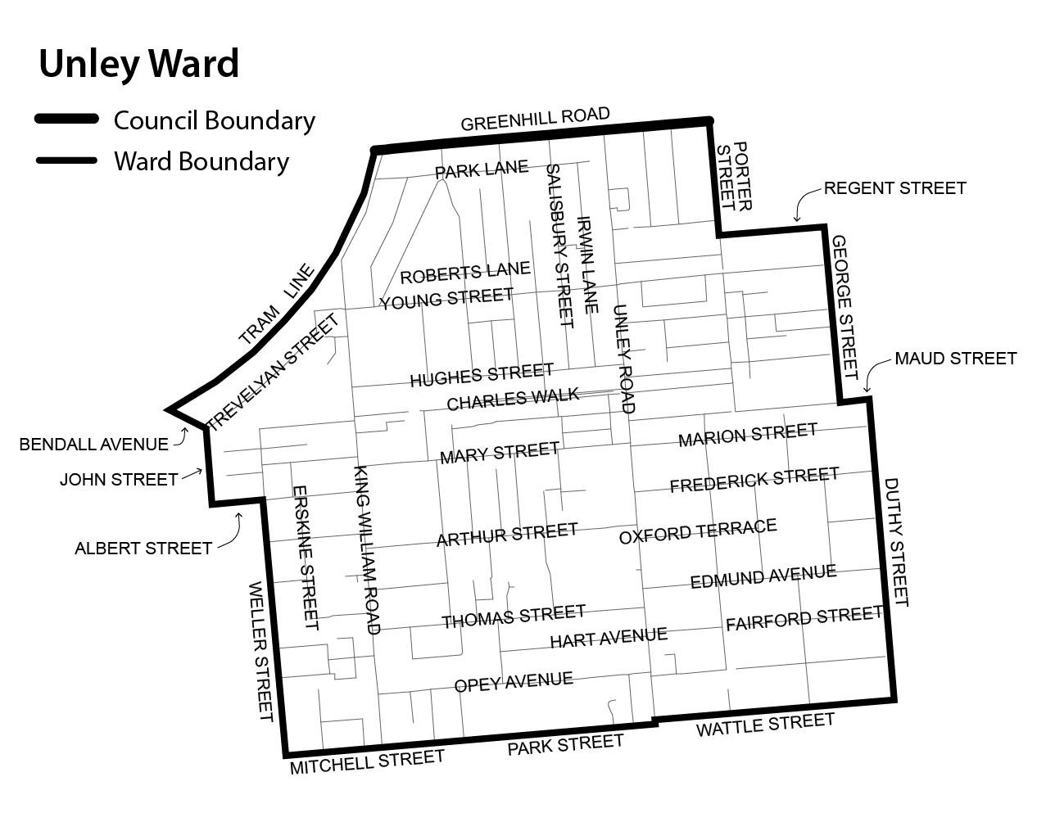

Schedule 2
Parkside Ward
Comprising all the land contained within the bounds of Greenhill Road, Porter Street, Regent Street and George Street (Parkside); Maud Street and Duthy Street (Unley); Wattle Street (Malvern and Fullarton); and Glen Osmond Road (Fullarton and Parkside).

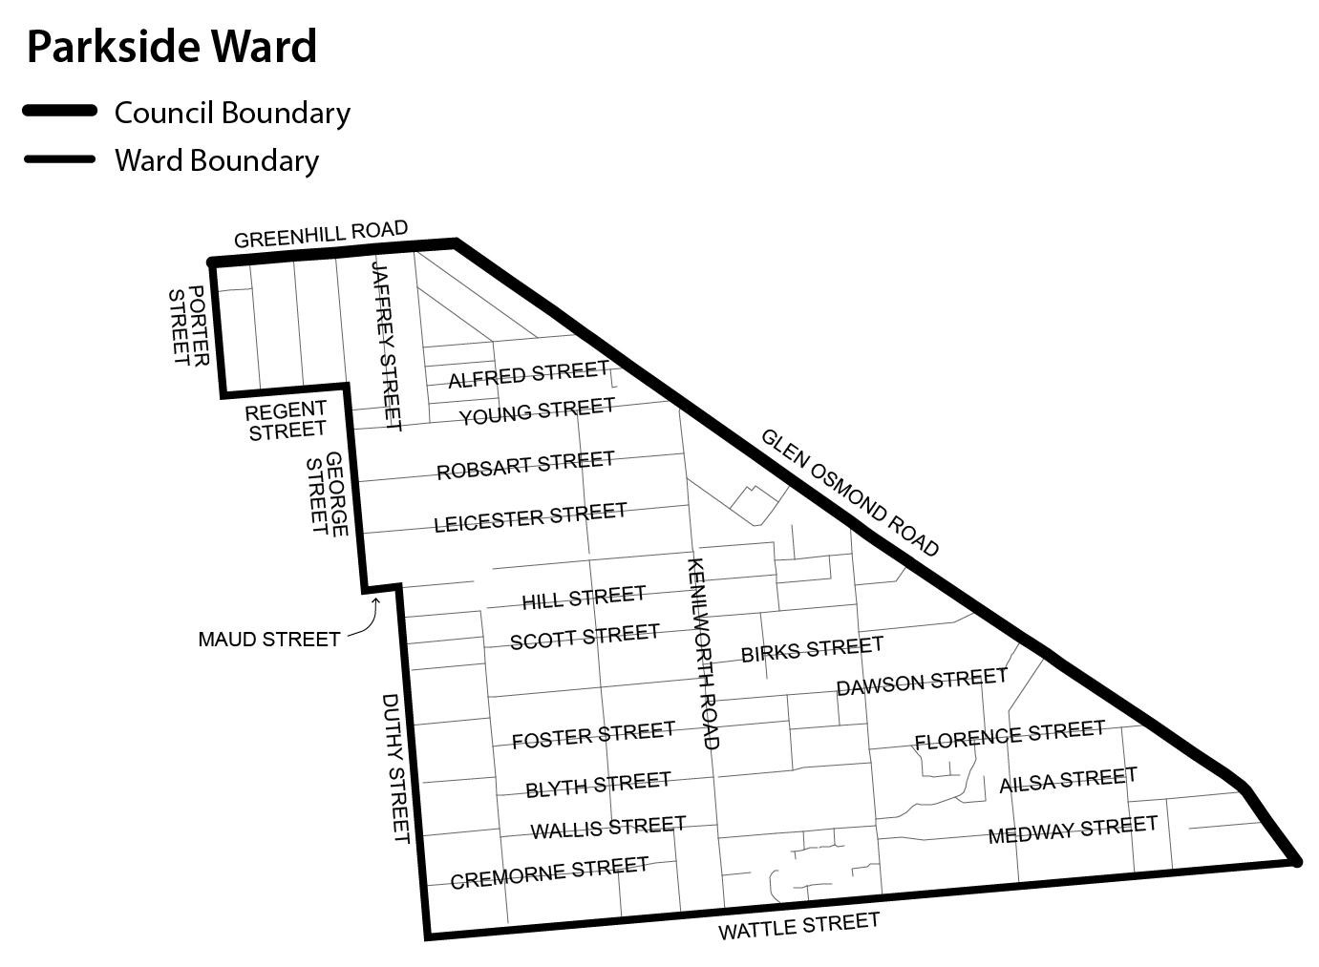

Schedule 3
Fullarton Ward
Comprising all the land contained within the bounds of Wattle Street (Fullarton and Malvern); the suburb boundary (part only) of Malvern; Cross Road (Highgate and Myrtle Bank) and Glen Osmond Road (Myrtle Bank and Fullarton).

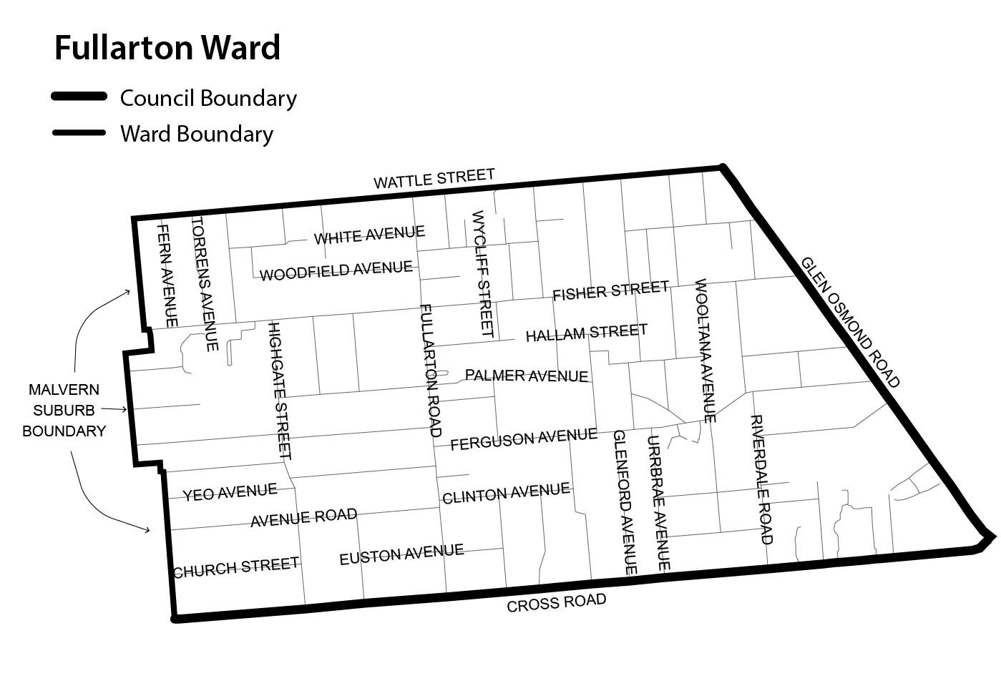

Schedule 4
Goodwood Ward
Comprising all the land contained within the bounds of Greenhill Road (Wayville); Anzac Highway (Keswick, Forestville and Everard Park); South Road and the tram line (Everard Park); the tram line and Victoria Street (Forestville); Victoria Street (Goodwood); Goodwood Road, Mitchell Street and Weller Street (Millswood); Weller Street, Albert Street and John Street (Goodwood); and Bendall Avenue and the tram line (Wayville).

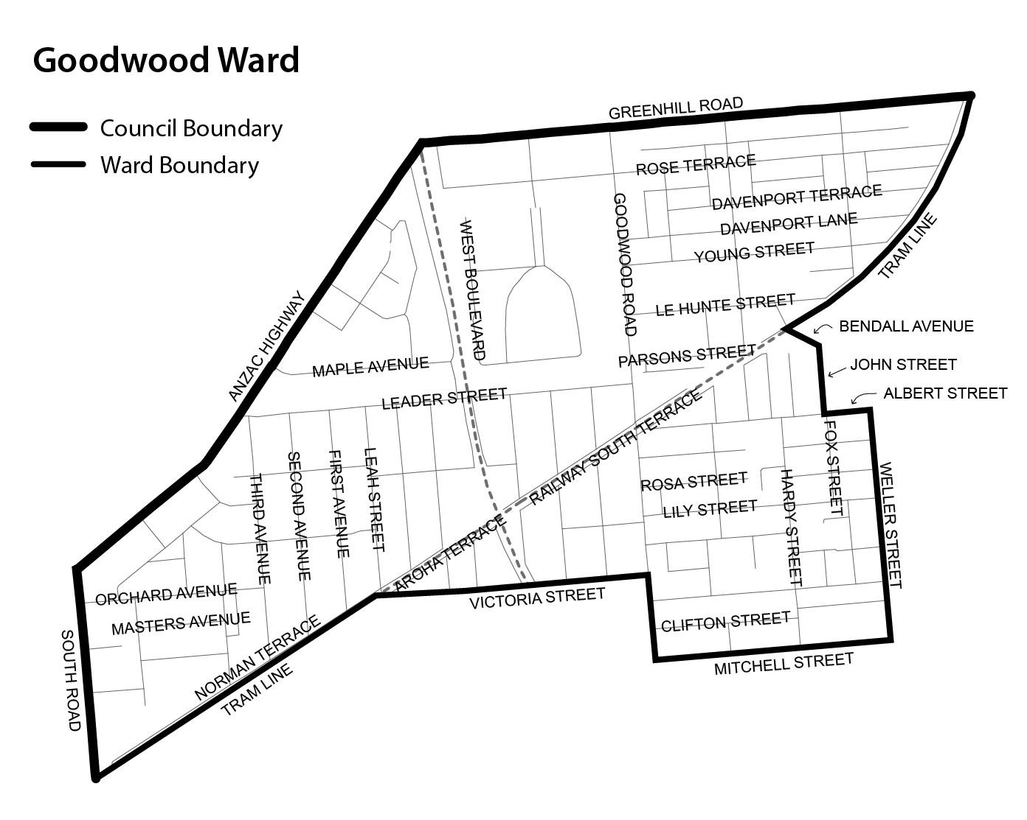

- - - Railway Line

Schedule 5
Clarence Park Ward
Comprising all the land contained within the bounds of Victoria Street (Goodwood); Victoria Street and the tram line (Forestville); the tram line and South Road (Black Forest); Cross Road (Clarence Park); and Goodwood Road (Clarence Park and Millswood).

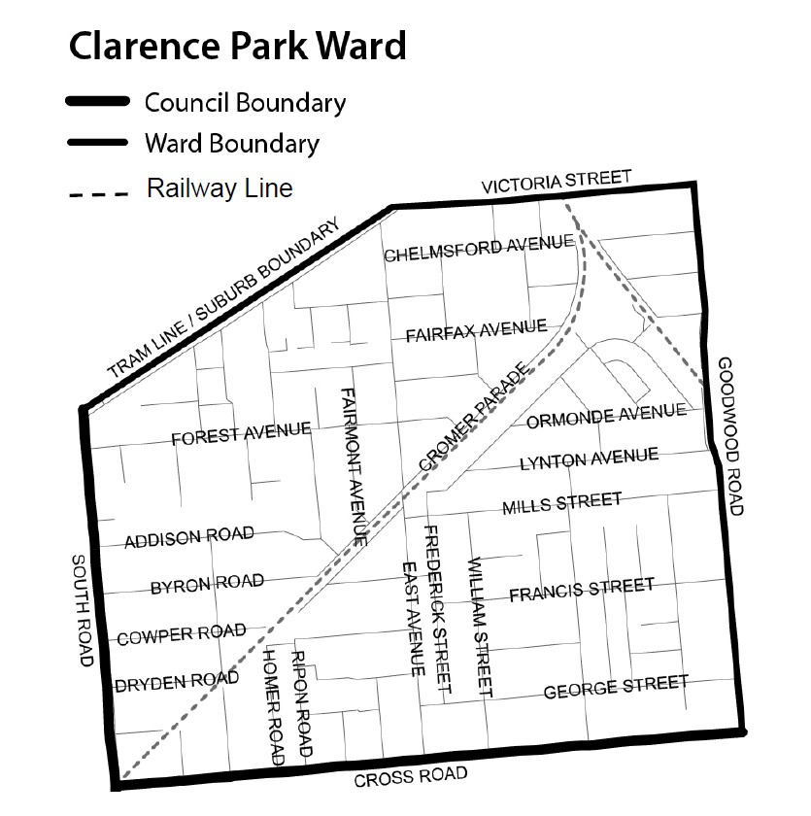

Schedule 6
Unley Park Ward
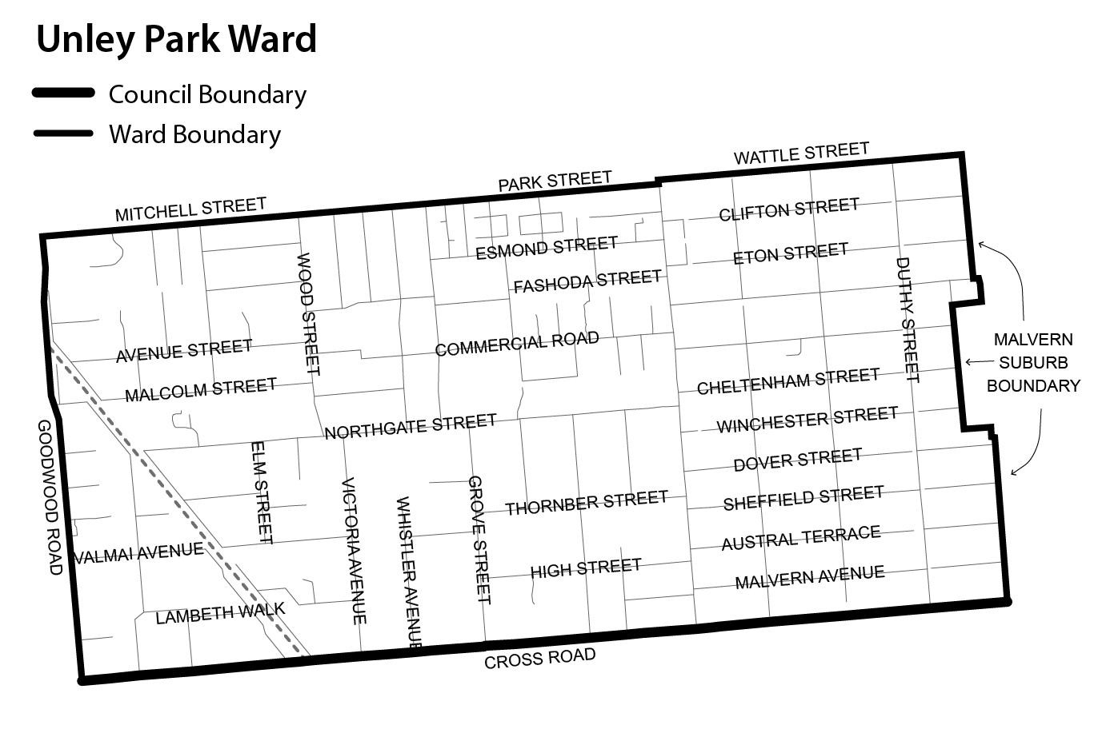
Comprising all the land contained within the bounds of Wattle Street (Malvern); Park Street and Mitchell Street (Hyde Park); Mitchell Street (Millswood); Goodwood Road (Millswood and Kings Park); Cross Road (Kings Park, Unley Park and Malvern); and the suburb boundary (part only) of Malvern.

P. Tsokas, Chief Executive Officer

DISTRICT COUNCIL OF THE COPPER COAST
Assignment of Road Names
NOTICE is hereby given pursuant to the provisions of Section 219 of the Local Government Act 1999, the District Council of the Copper Coast, resolved at its meeting dated 6 October 2010 to assign and change the road names as part of the rural property addressing process as shown on Rack Plan 875.
The Rack Plan can be viewed at:
• The office of the Surveyor-General, 101 Grenfell Street, Adelaide.
• The office of the District Council of the Copper Coast; the District Council of the Copper Coast website:
www.coppercoast.sa.gov.au.
• The Land services website at:
www.landservices.sa.gov.au/3Government/-
Local/RuralRoadMaps.asp.
P. Harder, Chief Executive Officer

DISTRICT COUNCIL OF THE COPPER COAST
Naming of Reserve
NOTICE is hereby given that the District Council of the Copper Coast resolved at its meeting dated 4 April 2012, to name the reserve adjacent South Beach, Port Hughes to Beacon Reserve.
P. Harder, Chief Executive Officer

THE FLINDERS RANGES COUNCIL
Resignation of Councillor
NOTICE is hereby given in accordance with Section 54 (6) of the Local Government Act 1999 that a vacancy has occurred in the office Area Councillor, due to the resignation of Councillor Jannene Cannard.
C. J. Davies, Chief Executive Officer

LIGHT REGIONAL COUNCIL
Declaration of Public Roads
NOTICE is hereby given that the Light Regional Council, pursuant to Section 208 of the Local Government Act 1999, at a Special Meeting of Council held on 2 July 2013, resolved to declare Allotments 60 and 61, being private roads in Deposited Plan 352, known as Ann and George Streets, Wasleys, to be public roads.
Dated 31 October 2013.
B. Carr, Chief Executive Officer

THE DISTRICT COUNCIL OF MALLALA
Roads (Opening and Closing) Act 1991
Road Closing Portion of Kenner Road, Korunye
NOTICE is hereby given pursuant to Section 10 of the said Act, that Council proposes to make a Road Process Order to close and transfer to Glasshouse Custodians Pty Ltd the portion of Kenner Road, situate between Germantown Road and Williams Road shown as ‘A’ on Preliminary Plan No. 13/0038.
A copy of the plan and statement of persons affected are available for public inspection at Council’s office, 2A Wasleys Road, Mallala and the office of the Surveyor-General, 101 Grenfell Street, Adelaide during normal office hours.
Any application for easement or objections must be made in writing within 28 days from 31 October 2013, to the Council, P.O. Box 18, Mallala, S.A. 5502 and the Surveyor-General, G.P.O Box 1354, Adelaide, S.A. 5001, setting out full details.
Where a submission is made, Council will give notification of a meeting to deal with the matter.
C. Mansueto, Chief Executive Officer

IN the matter of the estates of the undermentioned deceased persons:
Bignell, Barry James, late of 17 Hobart Crescent, Banksia Park, business proprietor, who died on 16 January 2013.
Dittmar, Irene Dorothy, late of 4 Frenshams Drive, Woodcroft, home duties, who died on 9 August 2013.
Jeffs, Beryl Dorothea, late of 29 Homestead Avenue, Walkley Heights, of no occupation, who died on 5 August 2013.
Lecor, Winifred Irene, late of 34 Norman Terrace, Everard Park, of no occupation, who died on 10 August 2013.
Mills, Thomas David, late of 43 Henry Street, Whyalla Stuart, retired electrician, who died on 21 July 2013.
Presley, Jesse Elberto, late of 7 Trafford Street, Mansfield Park, of no occupation, who died on 2 July 2013.
Smith, William Thomas, late of 137 Ladywood Road, Modbury Heights, retired electroplater, who died on 29 August 2013.
Stewart, James MacPherson Murray, late of 60 States Road, Morphett Vale, retired marine engineer, who died on 26 April 2012.
Withy, Shirley Elsie, late of 122 Reid Avenue, Magill, home duties, who died on 18 July 2013.
Notice is hereby given pursuant to the Trustee Act 1936, as amended, the Inheritance (Family Provision) Act 1972 and the Family Relationships Act 1975, that all creditors, beneficiaries, and other persons having claims against the said estates are required to send, in writing, to the Office of Public Trustee, G.P.O. Box 1338, Adelaide, S.A. 5001, full particulars and proof of such claims, on or before 29 November 2013, otherwise they will be excluded from the distribution of the said estates; and notice is also hereby given that all persons indebted to the said estates are required to pay the amount of their debts to the Public Trustee or proceedings will be taken for the recovery thereof; and all persons having any property belonging to the said estates are forthwith to deliver same to the Public Trustee.
Dated 31 October 2013.
D. A. Contala, Public Trustee

ATTENTION

CUSTOMERS requiring a proof of their notice for inclusion in the Government Gazette, please note that the onus is on you to inform Government Publishing SA of any subsequent corrections.

For any corrections to your notice please phone 8207 1045 or Fax 8207 1040 before 4 p.m. on Wednesday.

If we do not receive any communication by 10 a.m. on Thursday (day of publication) we will presume the notice is correct and will print it as it is.

Remember—the onus is on you to inform us of any corrections necessary to your notice.

NOTE: Closing time for lodging new copy (electronically, fax or hard copy) is 4 p.m. on Tuesday preceding the day of publication.
Phone: 8207 1045
Fax: 8207 1040
Email: governmentgazette@dpc.sa.gov.au

Printed and published by authority every Thursday by B. MORRIS, Government Printer, South Australia
Price: $6.65, plus postage; to subscribers, $335.00 per annum.
(The above prices are inclusive of GST)

