No. 72 4157
EXTRAORDINARY GAZETTE

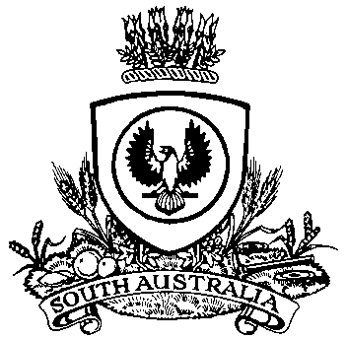

THE SOUTH AUSTRALIAN

GOVERNMENT GAZETTE
www.governmentgazette.sa.gov.au

PUBLISHED BY AUTHORITY

ALL PUBLIC ACTS appearing in this GAZETTE are to be considered official, and obeyed as such

ADELAIDE, THURSDAY, 31 OCTOBER 2013

CONTENTS

Page
Act Assented To 4157
Appointments, Resignations, Etc. 4157
Proclamation 4158

Department of the Premier and Cabinet
Adelaide, 31 October
HIS Excellency the Governor directs it to be notified for general information that he has in the name and on behalf of Her Majesty The Queen, this day assented to the undermentioned Acts passed by the Legislative Council and House of Assembly in Parliament assembled, viz.:
No. 52 of 2013— Liquor Licensing (Miscellaneous) Amendment Act 2013. An Act to amend Liquor Licensing Act 1997.
By command,
John Robert Rau, for Premier
DPC06/0875

Department of the Premier and Cabinet
Adelaide, 31 October 2013
HIS Excellency the Governor in Executive Council has been pleased to appoint Hieu Van Le as Governor’s Deputy of South Australia for the period from 2 p.m. on Monday, 4 November 2013 until 9 p.m. on Sunday, 10 November 2013.
By command,
John Robert Rau, for Premier

South Australia
Liquor Licensing (Miscellaneous) Amendment Act (Commencement) Proclamation 2013
1—Short title
This proclamation may be cited as the Liquor Licensing (Miscellaneous) Amendment Act (Commencement) Proclamation 2013.
2—Commencement of Act and suspension of certain provisions
(1) The Liquor Licensing (Miscellaneous) Amendment Act 2013 (No 52 of 2013) will come into operation on 1 November 2013.
(2) The operation of the following provisions of the Act is suspended until a day or time or days or times to be fixed by subsequent proclamation or proclamations:
(a) section 5;
(b) sections 7 to 41 (inclusive);
(c) Schedule 1 clause 1.
Made by the Governor
with the advice and consent of the Executive Council
on 31 October 2013

B. MORRIS, Government Printer, South Australia

