No. 59 3877
SUPPLEMENTARY GAZETTE



THE SOUTH AUSTRALIAN

GOVERNMENT GAZETTE
www.governmentgazette.sa.gov.au

PUBLISHED BY AUTHORITY

ALL PUBLIC ACTS appearing in this GAZETTE are to be considered official, and obeyed as such

ADELAIDE, TUESDAY, 24 SEPTEMBER 2013

DEVELOPMENT ACT 1993: SECTION 46 (1)
Preamble
Subsection (1) of Section 46 of the Development Act 1993, allows the Minister for Planning to apply that section to a specified kind of development or project if the Minister is of the opinion that a declaration under that section is appropriate or necessary for the proper assessment of development or a project of major environmental, social or economic importance.
Notice
PURSUANT to Section 46 (1) of the Development Act 1993, being of the opinion that a declaration under Section 46 of the Act is appropriate for the proper assessment of development of major environmental, and social and economic importance, I declare that Section 46 of the Act applies to any development of a kind specified in Schedule 1, in that part of the State specified in Schedules 2-8.
Schedule 1
Specified Kinds of Development
Development directly associated with the establishment and operation of an off-shore, deep water product receival and ship loading facility (‘floating wharf’) north-west of Wallaroo on Yorke Peninsula and an associated infrastructure corridor between the ‘Braemar Region’ (in the State’s north-east, as identified on the map annexed to this Notice) and the facility, including any or all of the following elements:
(a) all activities and works associated with the construction and operation of an off-shore product receival and ship loading facility and associated infrastructure, in that part of the State specified in Schedule 2, including:
(i) fixed mooring structures and navigation aids;
(ii) slurry pipelines and process water/return water pipelines that connect to the fixed mooring structures;
(iii) Floating Processing, Storage and Offloading facilities, comprising converted vessels for the processing, storage and ship loading of iron ore;
(iv) reverse osmosis plants installed on each Floating Processing, Storage and Offloading facility; and
(v) on-shore infrastructure, including pump station, electricity sub-station/switch yard and associated buildings and facilities.
(b) all activities and works associated with the construction and operation of an infrastructure corridor, in that part of the State specified in Schedule 3, including:
(i) slurry pipelines and process water/return water pipelines and associated infrastructure;
(ii) pumping stations and associated infrastructure;
(iii) storage tanks and associated infrastructure;
(iv) pressure relief and product storage facilities;
(v) electricity transmission lines;
(vi) optic fibre telecommunications cables and associated infrastructure;
(vii) pipe laydown area;
(viii) workers camps;
(ix) infrastructure control, operations and maintenance base and associated buildings and facilities (near the township of Burra); and
(x) roads.
(c) an electricity transmission line and associated sub-station/switch yard, in that part of the State specified in Schedule 4;
(d) a road, in that part of the State specified in Schedule 5;
(e) a marine supply base associated with Schedule 1 (a), in that part of the State specified in Schedule 6;
(f) an electricity transmission line and associated sub-station/switch yard, in that part of the State specified in Schedule 7;
(g) an electricity transmission line and associated sub-station/switch yard, in that part of the State specified in Schedule 8;
(h) any change in the use of land associated with any development within the ambit of paragraphs (a)-(g);
(i) the undertaking of works for the purposes of, or otherwise related to, roads, parking, stormwater management, water supply, fuel storage, power supply, telecommunications and effluent treatment in connection with the development;
(j) any associated excavation or filling, or the excavation and filling, of any land, or the formation of land for allotments;
(k) the division of land associated with the development; and
(l) any related or ancillary development associated with development within the ambit of preceding paragraphs.
Schedule 2
Specified Part of the State
The following part of the State is specified for the purposes of Schedule 1:
(a) the area of land within a 2 km radius of the intersection of Rees Road and Myponie Point Drive, at Myponie Point, north-west of Wallaroo on Yorke Peninsula; and
(b) the area of water within a 5 km radius of Myponie Point on Yorke Peninsula.
Schedule 3
Specified Part of the State
The following part of the State is specified for the purposes of Schedule 1:
(a) the area of land within a 20 km radius west of a point on the South Australian—New South Wales Border 45 km south of the township of Cockburn in the State’s north-east; and
(b) a corridor of land running from the area described in Schedule 3 (a) to the area described in Schedule 2 (b), via an alignment that passes south of the townships of Burra and Snowtown in the State’s mid-north.
Schedule 4
Specified Part of the State
The following part of the State is specified for the purposes of Schedule 1:
(a) a corridor of land running from the existing 275kV electricity transmission line, near Burra in the State’s mid-north, to the area described in Schedule 3 (b).
Schedule 5
Specified Part of the State
The following part of the State is specified for the purposes of Schedule 1:
(a) a corridor of land running east from Eastern Road, approximately 46 km north-east of Burra in the State’s mid-north, to the area described in Schedule 3 (b).
Schedule 6
Specified Part of the State
The following part of the State is specified for the purposes of Schedule 1:
(a) the area of land within a 10 km radius of the centre of the townships of Wallaroo and Kadina on Yorke Peninsula.
Schedule 7
Specified Part of the State
The following part of the State is specified for the purposes of Schedule 1:
(a) a corridor of land running from the existing Blyth West electricity sub-station, located west of Clare, to the area described in Schedule 3 (b).
Schedule 8
Specified Part of the State
The following part of the State is specified for the purposes of Schedule 1:
(a) a corridor of land running from the existing electricity sub-station, located south of Burra, to the area described in Schedule 3 (b).
Dated 24 September 2013.
John Rau, Minister for Planning

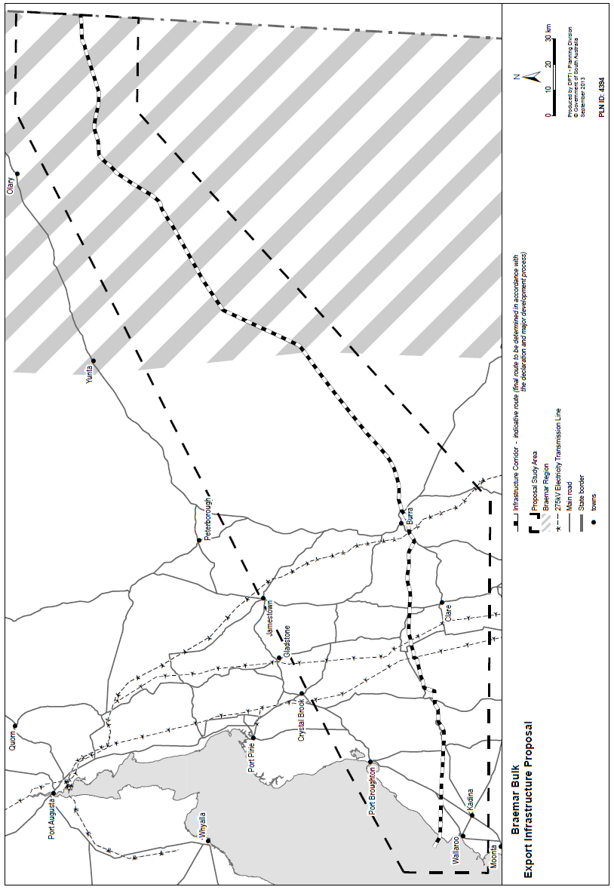

B. MORRIS, Government Printer, South Australia

