No. 28 1497



THE SOUTH AUSTRALIAN

GOVERNMENT GAZETTE
www.governmentgazette.sa.gov.au

PUBLISHED BY AUTHORITY

ALL PUBLIC ACTS appearing in this GAZETTE are to be considered official, and obeyed as such

ADELAIDE, THURSDAY, 17 APRIL 2014

CONTENTS

Page
Appointments, Resignations, Etc. 1498
Corporations and District Councils—Notices 1529
Environment Protection Act 1993—Notices 1500
Fisheries Management Act 2007—Notices 1498
Land Acquisition Act 1969—Notices 1501
Mining Act 1971—Notice 1502
National Electricity Law—Notice 1503
National Energy Retail Law—Notice 1503
National Gas Law—Notice 1504
National Parks and Wildlife (Breakaways Conservation
Park) Regulations 2013—Notice 1503
National Parks and Wildlife (National Parks) Regulations
2001—Notices 1503
Natural Resources Management Act 2004—Notices 1505
Petroleum and Geothermal Energy Act 2000—Notices 1506
Proclamations 1526
Public Trustee Office—Administration of Estates 1530
Roads (Opening and Closing) Act 1991—Notices 1510
RULES
Magistrates Court (Civil) Rules 2013—
(Amendment No. 4) 1511
Magistrates Court Rules 1992—
(Amendment No. 48) 1512
Transport, Department of—Notices to Mariners 1504

GOVERNMENT GAZETTE NOTICES
Notices for publication in the South Australian Government Gazette should be emailed to governmentgazette@dpc.sa.gov.au. Content should be sent as Word format attachment(s). Covering emails should include the date the notice is to be published and to whom the notice will be charged. Closing time for lodgement is 4 p.m. on the Tuesday preceding the regular Thursday publication. Gazette enquiries to: Phone 8207 1045. The Government Gazette is available online at: www.governmentgazette.sa.gov.au.

Department of the Premier and Cabinet
Adelaide, 17 April 2014
HIS Excellency the Governor in Executive Council has been pleased to appoint the undermentioned to the South Australian Government Financing Advisory Board (SAFA), pursuant to the provisions of the Government Financing Authority Act 1982:
Member: (from 17 April 2014 until 16 April 2017)
Anne Westley
Deputy Member: (from 17 April 2014 until 16 April 2017)
Garry Keith Goddard (Deputy to Rowse)
James William Hollamby (Deputy to Westley)
By command,
John James Snelling, for Acting Premier
T&F14-008CS

FISHERIES MANAGEMENT ACT 2007: SECTION 115
TAKE notice that the notice made under Section 115 of the Fisheries Management Act 2007, published in the South Australian Government Gazette dated 27 March 2014, on Page No. 1326, referring to Ministerial Exemption No. ME9902697 issued to Ridley Dry Creek Pty Ltd will be REVOKED effective as at the date of this notice.
Take notice that pursuant to Section 115 of the Fisheries Management Act 2007, Ridley Dry Creek Pty Ltd, 565 Bourke Street, Melbourne, Victoria 3000 (the ‘exemption holder’) and its agents are exempt from Section 70 of the Fisheries Management Act 2007, and Regulations 7 and 10, Clauses 72, 73 and 110 of Schedule 6 and ‘other waters’ as defined in Schedule 7 of the Fisheries Management (General) Regulations 2007, but only insofar as they may use nets to remove carp in the waters set out in Schedule 1 (the ‘exempted activity’), subject to the conditions set out in Schedule 2, from 11 April 2014 until 25 March 2015, unless varied or revoked earlier.
Schedule 1
SA Water Bolivar wastewater treatment plant outfall.
Schedule 2
1. The exemption holders may only take non-native species of fish which must not be returned to the water. All non-native species taken must be disposed of immediately.
2. The non-native species of fish taken must be disposed of pursuant to environment protection legislation and must not be used for any commercial purpose.
3. The mesh size of nets must exceed 12 mm. Where a net is constructed with wire, the mesh size must exceed 50 mm.
4. The exemption holder or its agents must immediately return to the water all native fish captured incidentally while undertaking this exempted activity.
5. The exemption holder or its agents must notify PIRSA in writing at least 24 hours prior to changing the configuration, number and use of nets.
6. The exemption holder may use employees of Ridley Dry Creek Pty Ltd as agents to undertake the exempted activity.
7. The exemption holder must display a copy of this exemption on a notice board at the Ridley Dry Creek Pty Ltd premises at Dry Creek. Exemption No. ME9902699.
8. While engaged in the exempted activity the exemption holder or its agents must be in possession of a copy of this notice and such evidence that shows employment by Ridley Dry Creek Pty Ltd. Both the notice and proof of employment must be produced to a PIRSA Fisheries Officer if requested.
9. The exemption holder must notify the Minister when the exempted activity has been finalised if the activity ceases before the end of the term of this notice.
10. The exemption holders must not contravene or fail to comply with the Fisheries Management Act 2007, or any regulations made under that Act, except where specifically exempted by this notice.
Dated 10 April 2014.
Professor M. Doroudi, Executive Director, Fisheries and Aquaculture

FISHERIES MANAGEMENT ACT 2007: SECTION 115
TAKE notice that pursuant to Section 115 of the Fisheries Management Act 2007, Lara Suitor of the Department of Environment, Water and Natural Resources, 28 Vaughan Terrace, Berri, S.A. 5343 (the ‘exemption holder’), is exempt from Sections 70 and 71 (1) (b) of the Fisheries Management Act 2007, Regulations 7 and 10 and Clauses 39, 43 and 72 of Schedule 6 of the Fisheries Management (General) Regulations 2007, but only insofar as she may engage in the collection of fish from the waters described in Schedule 1, using the gear specified in Schedule 2 (the ‘exempted activity’), subject to the conditions set out in Schedule 3, from 29 March 2014 until 29 March 2015, unless varied or revoked earlier.
Schedule 1
South Australian River Murray wetlands and tributaries between Blanchetown and the Victorian and New South Wales borders.
Schedule 2
• 18 x fyke nets (minimum mesh of 4 mm, maximum leader of 7 m);
• 1 x seine net (minimum mesh of 2 mm and maximum length of 2 m);
• 10 x shrimp traps; and
• 10 x snorkel traps.
Schedule 3
1. The specimens collected by the exemption holder are for scientific and research purposes only and must not be sold.
2. All native fish taken pursuant to the exempted activity must be immediately returned to the water unless retained for the purpose of species identification in accordance with Condition 3 below.
3. A maximum of five native fish of any species (excluding protected species) per location may be retained for the purpose of identification.
4. All non-native species of fish must be destroyed be disposed of appropriately.
5. The exemption holder must notify PIRSA Fishwatch on 1800 065 522 at least two hours prior to conducting the exempted activity and answer a series of questions about the exempted activity. The exemption holder will need to have a copy of the exemption notice at the time of making the call, and be able to provide information about the area and time of the exempted activity, the vehicles and boats involved, the number of agents undertaking the exempted activity and other related questions. Exemption No. ME9902689.
6. The exemption holder must provide a written report detailing the outcomes of the collection of organisms pursuant to this notice to the Executive Director, Fisheries and Aquaculture, (G.P.O. Box 1625, Adelaide, S.A. 5001) upon completion, giving the following details:
• the date, soak time and location of collection;
• the number of nets used;
• the description of all species collected;
• the number of each species collected; and
• any other relevant information.
7. While engaged in the exempted activity, the exemption holder must be in possession of a copy of this notice. Such notice must be produced to a Fisheries Officer if requested.
8. The exemption holder must not contravene or fail to comply with the Fisheries Management Act 2007 or any regulations made under that Act, except where specifically exempted by this notice.
Dated 28 March 2014.
Professor M. Doroudi, Executive Director,
Fisheries and Aquaculture

FISHERIES MANAGEMENT ACT 2007: SECTION 115
TAKE notice that pursuant to Section 115 of the Fisheries Management Act 2007, Callie Nickolai of Natural Resources SA Murray-Darling Basin, 3 Wade Street, Berri. S.A. 5343 or persons acting as her agents (the ‘exemption holders’) are exempt from Sections 70 and 71 (b) of the Fisheries Management Act 2007 and Regulations 7 and 10 and Clauses 39, 43 and 72 of Schedule 6 of the Fisheries Management (General) Regulations 2007, but only insofar as they may engage in the collection of fish from the waters described in Schedule 1 (the ‘exempted activity’), using the gear specified in Schedule 2, subject to the conditions set out in Schedule 3, from 29 March 2014 until 29 March 2015, unless varied or revoked earlier.
Schedule 1
South Australian River Murray wetlands and tributaries, between Blanchetown and the Victorian and New South Wales borders.
Schedule 2
• 2 x dip nets;
• 20 x shrimp traps;
• 25 x fyke nets (the maximum length of which does not exceed 10 m, and minimum mesh size 8.5 mm); and
• 2 x seine nets (the maximum length of which does not exceed 10 m, and minimum mesh size of 10 mm);
Schedule 3
1. The specimens collected by the exemption holder or agents are for scientific and research purposes only and must not be sold.
2. All native fish taken pursuant to the exempted activity must be immediately returned to the water unless retained for the purpose of species identification in accordance with Condition 3 below.
3. A maximum of five native fish of any species (excluding protected species) per location may be retained for the purpose of identification.
4. All non-native species of fish must be destroyed be disposed of appropriately.
5. The exempted activity may be conducted on the exemption holder’s behalf by nominated agents Irene Wegener, Emily Hoffman and Lara Suitor.
6. The exemption holder or agent must notify PIRSA Fishwatch on 1800 065 522 at least two hours prior to conducting the exempted activity and answer a series of questions about the exempted activity. The exemption holder or agent will need to have a copy of the exemption notice at the time of making the call, and be able to provide information about the area and time of the exempted activity, the vehicles and boats involved, the number of agents undertaking the exempted activity and other related questions. Exemption No. ME9902686.
7. The exemption holder must provide a report in writing detailing the outcomes of the research and the collection of organisms pursuant to this notice to the Executive Director, Fisheries and Aquaculture, (G.P.O. Box 1625, Adelaide, S.A. 5001) within three months of the expiry of this notice, giving the following details:
• the date, soak time and location of collection;
• the number of nets used;
• the description of all species collected;
• the number of each species collected; and
• any other relevant information.
8. While engaged in the exempted activity, the exemption holder or agent must be in possession of a copy of this notice. Such notice must be produced to a Fisheries Officer if requested by that officer.
9. The exemption holders or agent must not contravene or fail to comply with the Fisheries Management Act 2007 or any regulations made under that Act, except where specifically exempted by this notice.
Dated 28 March 2014.
Professor M. Doroudi, Executive Director,
Fisheries and Aquaculture

ENVIRONMENT PROTECTION ACT 1993
Revocation of Super Collector Approval
I, ANDREA KAYE WOODS, Delegate of the Environment Protection Authority (‘the Authority’), pursuant to Section 69 of the Environment Protection Act, 1993 (SA) (‘the Act’) hereby”
Revocation of Super Collector Approval:
revoke the approval of the super collector identified by reference to the following matters, which previously was approved to collect, handle and deliver for reuse, recycling or other disposal, containers received from collection depots, whether personally or through an agent.
(a) the name of the super collector described in Column 1 of Schedule 1 of this Notice;
(b) the location of the depot described in Columns 3 of Schedule 1 of this Notice; and
(c) the name of the proprietor of the super collector identified in Column 4 of Schedule 1 of this Notice.
Schedule 1

Column 1 | Column 2 |  | Column 3 |  | Column 4
Name of Super Collector | Company/Trading Name |  | Location of Premises |  | Proprietor
Marine Stores Pty Ltd |  | Marine Stores Pty Ltd |  | 107 Port Road, Thebarton, S.A. 5031 |  | South Australian Brewing Co Pty Ltd and Coopers Brewery Ltd

ENVIRONMENT PROTECTION ACT 1993
Approval of Super Collectors
I, ANDREA KAYE WOODS, Team Leader, Container Deposit Legislation and Delegate of the Environment Protection Authority, pursuant to Section 69 of the Environment Protection Act 1993 (SA) hereby:
1. Approval of Super Collectors:
Approve the Super Collector identified by reference to the following matters, to collect, handle and deliver for reuse, recycling or other disposal, containers received from collection depots, whether personally or through an agent:
(a) the name of the Super Collector described in Column 1 of Schedule 1 of this Notice;
(b) the company or trading name of the Super Collector identified in Column 2 of Schedule 1 of this Notice;
(c) the location of the premises identified by reference to Columns 3 and 5 of Schedule 1 of this Notice; and
(d) the proprietor described in Column 4 of Schedule 1 of this Notice.
2. Conditions of Approval:
(1) The approval holder must ensure that every employee, agent or contractor responsible for carrying out any task under this approval is properly advised as to the general environmental duty, pursuant to Section 25 of the Environment Protection Act 1993, not to undertake an activity that pollutes, or might pollute the environment unless that person takes all reasonable and practical measures to prevent or minimize any resulting environmental harm.
(2) The approval holder must include in the annual return pursuant to Section 69A of the Environment Protection Act 1993, the following information for the quarters July to September, October to December, January to March and April to June:
• the total number of containers sold for each material type (e.g., glass, aluminium, PET, HDPE, LPB);
• the total number of containers returned for each material type;
• the total weight of containers returned for each material type; and
• the rate of return in % for each material type.
(3) The approval holder must notify the Authority in writing of the following circumstances:
• an intention to cease carrying on a business as a Super Collector;
• an intention to transfer the business to another person or company; and
• change of address of the business.
Schedule 1

Column 1 | Column 2 |  | Column 3 |  | Column 4 |  | Column 5
Name of Super Collector | Company/Trading Name |  | Location of Premises |  | Proprietor |  | Certificate of Title
Marine Stores Pty Ltd |  | Marine Stores Pty Ltd |  | 18 Wilson Street, Royal Park, S.A. 5014 |  | South Australian Brewing Co Pty Ltd and Coopers Brewery Ltd |  | Volume 5259, Folio 526

LAND ACQUISITION ACT 1969
(Section 16)
Notice of Acquisition
THE SOUTH AUSTRALIAN WATER CORPORATION (the ‘Authority’), 250 Victoria Square, Adelaide, S.A. 5000, acquires the following interests in the following land:
Definition of Land Acquired
Comprising an unencumbered estate in fee simple in that piece of land marked Reserve being portion of Allotment 70 in Deposited Plan 17614 in the area named Gawler East in the Hundred of Barossa and being a portion of the land comprised in Certificate of Title Volume 4068, Folio 762 and being more particularly delineated as Allotment 82 on Deposited Plan 91797.
This notice is given under Section 16 of the Land Acquisition Act 1969.
Compensation
A person who has or had an interest in the land that is divested or diminished by the acquisition or the enjoyment of which is adversely affected by the acquisition who does not receive an offer of compensation from the Authority may apply to the Authority for compensation.
Inquiries
Inquiries should be directed to:
Kris Hassiotis,
SA Water Corporation
250 Victoria Square,
Adelaide, S.A. 5000,
Phone: (08) 7424 2502.
Dated 17 April 2014.
K. Hassiotis, Manager Property Services

Land Acquisition Act 1969
(Section 16)
Notice of Acquisition
THE SOUTH AUSTRALIAN WATER CORPORATION (the Authority), 250 Victoria Square, Adelaide, S.A. 5000, acquires the following interests in the following land:
An unencumbered estate in fee simple in that piece of land being portion of road reserve situated the corner of Ayling Street and Princess Street abutting Allotment 14 in Filed Plan No. 14372 in the Hundred of Mudla Wirra in the area of Willaston and being more particularly delineated as Allotment 50 in Deposited Plan 91668
This notice is given under Section 16 of the Land Acquisition Act 1969.
Compensation
A person who has or had an interest in the land that is divested or diminished by the acquisition or the enjoyment of which is adversely affected by the acquisition who does not receive an offer of compensation from the Authority may apply to the authority for compensation.
Inquiries
Inquiries should be directed to:
Kris Hassiotis,
SA Water Corporation,
250 Victoria Square,
Adelaide, S.A. 5000
Tel: 08 7424 2502
Dated 17 April 2014.
K. Hassiotis, Manager Property Services

LAND ACQUISITION ACT 1969
(Section 16)
Notice of Acquisition
THE SOUTH AUSTRALIAN WATER CORPORATION (the Authority) of SA Water House, 250 Victoria Square, Adelaide, S.A. 5000 acquires the following interests in the following land:
FIRST An unencumbered estate in fee simple in that piece of land being portion of Allotment 64 in Filed Plan 153665 in the Hundred of Nuriootpa in the Area of Willaston and being portion of the land in Certificate of Title Volume 5675, Folio 59 and being more particularly delineated as Allotment 53 in Deposited Plan 91707.
SECONDLY As appurtenant to the land FIRST above described, a full free and unrestricted right and liberty of entry, egress and regress from time to time and at all times hereafter for the Authority and its agents, servants and workmen with or without vehicles plant equipment and materials in through over across and along that portion of Allotment 54 in Deposited Plan 91707 marked ‘B’ being portion of the land comprised in the said Certificate of Title Volume 5675, Folio 59.
THIRDLY As appurtenant to the land FIRST above described, a full free and unrestricted right and liberty of entry, egress and regress from time to time and at all times hereafter for the Authority and its agents servants and workmen with or without vehicles plant equipment and materials in through over across and along that portion of Allotment 54 in Deposited Plan 91707 marked ‘B’ being portion of the land comprised in the said Certificate of Title Volume 5675, Folio 59 for the purposes hereinafter mentioned and also a full free and unrestricted right and liberty for the Authority and its agents servants and workmen from time to time and at all times hereafter to break the surface of dig open up and use the said piece of land either above or below ground for the purposes of laying down, fixing, taking up, repairing, examining, using and replacing pipes and fittings required for water supply purposes.
This notice is given under Section 16 of the Land Acquisition Act 1969.
Compensation
A person who has or had an interest in the land that is divested or diminished by the acquisition or the enjoyment of which is adversely affected by the acquisition who does not receive an offer of compensation from the Authority may apply to the Authority for compensation.
Inquiries
Inquiries should be directed to:
Kris Hassiotis
SA Water Corporation
250 Victoria Square,
Adelaide, S.A. 5000
Phone (08) 7424 1761
Dated 17 April 2014.
K. Hassiotis, Manager Property Services

Mining Act 1971
Pursuant to Section 15 (5) of the Mining Act 1971 (‘Act’), I advise that the Mineral Resources Division of Department for Manufacturing, Innovation, Trade, Resources and Energy, will be undertaking geoscientific investigations commencing on or after
1 May 2014 and concluding 31 December 2014.
The area of interest is approximately 94 277 km² and includes the entire Noorina; Wyola; Cook and Coompana 1:250 000 map sheets, the western portion of the Nullarbor; Ooldea; Maurice and Wells 1:250 000 map sheets and the southern portion of the Birksgate 1:250 000 map sheet.
Pursuant to Section 15 (7) of the Act, the Minister may refuse to receive or consider an application for a mining tenement in respect of the land described in the notice until the completion date of 31 December 2014.
Please note that the completion date may be extended and/or the area may be altered by further notice in the Gazette. Copies of the plan are available by phoning the Mining Registrar on telephone (08) 8463 3097.
Description of Area
Coompana Area—Approximately 420 km north-west of Ceduna, bounded as follows:
Commencing at a point being the intersection of latitude 28°02′S and longitude 130°40′E, thence east to longitude 131°11′E, south to latitude 28°55′S, east to longitude 131°40′E, south to a northern boundary of Maralinga Nuclear Test Site, then generally south westerly along the boundary of the said test site to latitude 29°49′S, west to longitude 131°13′E, south to a line being low water mark, Great Australian Bight, then generally westerly along the said line to the western border of the State of South Australia, then northerly along the border of the said State to latitude 27°43′S, east to longitude 130°40′E, and south to the point of commencement, all the within latitudes and longitudes being geodetic and expressed in terms of the Australian Geodetic Datum as defined on page 4984 of the Commonwealth Gazette No. 84 dated October 6, 1966 (AGD66).
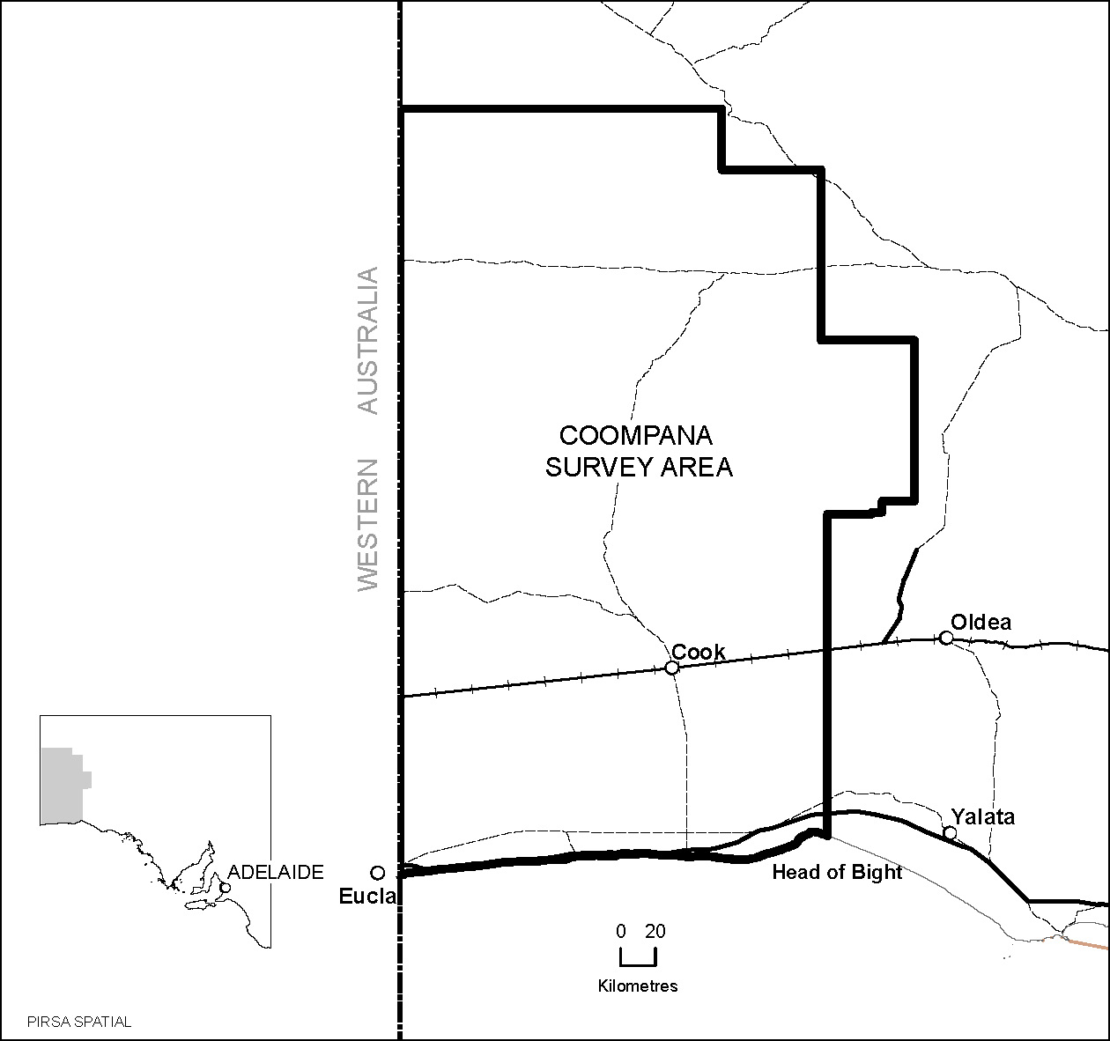
Area: 94 277 km² approximately.

Dated 17 April 2014.
J. Martin, Mining Registrar

NATIONAL PARKS AND WILDLIFE (NATIONAL PARKS) REGULATIONS 2001
Partial Closure of Coorong National Park
PURSUANT to Regulations 8 (3) (a) and 8 (3) (d) of the National Parks and Wildlife (National Parks) Regulations 2001,
I, Vicki Michelle Linton, Acting Director, Regional Co-ordination, Partnerships and Stewardship, formerly entitled Director,
Public Land Management and Operational Support, Regional Services, Authorised Delegate of the Director of National Parks and Wildlife, close to the public, part of Coorong National Park from 6 p.m. on Sunday, 11 May 2014 until 6 a.m. on Friday, 16 May 2014.
This closure applies to the whole of the park south of a line transecting the park east to west at Parnka Point, latitude 35°54′40.7″S, longitude 139°23′42.9″E.
The area impacted includes, but is not limited to: Coorong Lagoon; Stony Well; Jack Point; Policemans Point; Loop Road and Campground; Tea Tree Crossing and Campground; Chinaman Well; 42 Mile Crossing and Campground; 32 Mile Crossing; Wreck Crossing; 28 Mile Crossing and Campground, and Old Coorong Road.
The remainder of the park including the Parnka Point Campground will remain open to the public during this period.
The purpose of the closure is to ensure the safety of the public during a pest control and monitoring program within the reserve during the period indicated.
Dated 15 April 2014.
V. M. Linton, Acting Director,
Regional Co-ordination, Partnerships and
Stewardship, Department of Environment,
Water and Natural Resources

NATIONAL PARKS AND WILDLIFE (NATIONAL PARKS) REGULATIONS 2001
Closure of Gum Lagoon Conservation Park, Hanson Scrub Conservation Park, Martin Washpool Conservation Park,
Messent Conservation Park, Mount Boothby Conservation Park, Mount Monster Conservation Park and Tilley Swamp Conservation Park
PURSUANT to Regulations 8 (3) (a) and 8 (3) (d) of the National Parks and Wildlife (National Parks) Regulations 2001,
I, Vicki Michelle Linton, Acting Director, Regional Co-ordination, Partnerships and Stewardship, which was formerly entitled Executive Director, Public Land Management and Operational Support, Regional Services, Authorised Delegate of the Director of National Parks and Wildlife, close to the public, the whole of Gum Lagoon Conservation Park, the whole of Hanson Scrub Conservation Park, the whole of Martin Washpool Conservation Park, the whole of Messent Conservation Park, the whole of Mount Boothby Conservation Park, the whole of Mount Monster Conservation Park and the whole of Tilley Swamp Conservation Park from 6 p.m. on Sunday, 11 May 2014 until 6 a.m. on Saturday, 17 May 2014.
The purpose of the closure is to ensure the safety of the public during a pest control program within the reserves during the period indicated.
Dated 15 April 2014.
V. M. Linton, Acting Director,
Regional Co-ordination, Partnerships and
Stewardship, Department of Environment,
Water and Natural Resources

NATIONAL PARKS AND WILDLIFE
(BREAKAWAYS CONSERVATION PARK)
REGULATIONS 2013
Partial Closure of Breakaways Conservation Park
PURSUANT to Regulation 19 (3) (d) of the National Parks and Wildlife (Breakaways Conservation Park) Regulations 2013, I, Chevahn Hoad, Executive Officer, Breakaways Co-management Board, Authorised Delegate of the Breakaways Conservation Park Co-management Board, close to the public the section of the Breakaways Conservation Park from the main lookout to the park entrance on the Oodnadatta Track from 6 p.m. on Thursday, 17 April 2014 until 6 a.m. on Tuesday, 22 April 2014.
The purpose of the closure is to ensure the safety of the public after a period of heavy rain and flooding and associated damage to roads within the park.
Dated 16 April 2014.
C. Hoad, Executive Officer, Breakaways Co-management Board

NATIONAL ELECTRICITY LAW
THE Australian Energy Market Commission (AEMC) gives notice under the National Electricity Law as follows:
Under s 95, the Standing Council on Energy and Resources has requested the Expanding competition in the provision of metering and related services proposal (Ref. ERC0169). The proposal seeks to provide a framework that would promote competition in the provision of metering and related services in the National Electricity Market. Submissions must be received by 29 May 2014.
Under s 107, the time for making the draft determination on the Expanding competition in the provision of metering and related services proposal has been extended to 18 December 2014.
Submissions can be made via the AEMC’s website. Before making a submission, please review the AEMC’s privacy statement on its website. Submissions should be made in accordance with the AEMC’s guidelines for making written submissions on Rule change proposals. The AEMC publishes all submissions on its website, subject to confidentiality.
Under ss 102 and 103, the making of the National Electricity Amendment (Connecting embedded generators) Rule 2014 No. 3 and related final determination. All provisions commence on
1 October 2014.
Under ss 102 and 103, the making of the National Electricity Amendment (AER Authorisation of Software Changes by AEMO) Rule 2014 No. 4 and related final determination. All provisions commence on 17 April 2014.
Documents referred to above are available on the AEMC’s website and are available for inspection at the AEMC’s office.
Australian Energy Market Commission
Level 6, 201 Elizabeth Street
Sydney, N.S.W. 2000
Telephone: (02) 8296 7800
Website: www.aemc.gov.au
17 April 2014.

NATIONAL ENERGY RETAIL LAW
THE Australian Energy Market Commission (AEMC) gives notice under the National Energy Retail Law as follows:
Under s 251, the Standing Council on Energy and Resources has requested the Expanding competition in the provision of metering and related services proposal (Ref. RRC0002). The proposal seeks to provide a framework that would promote competition in the provision of metering and related services in the National Electricity Market. Submissions must be received by 29 May 2014.
Under s 266, the time for making the draft determination on the Expanding competition in the provision of metering and related services proposal has been extended to 18 December 2014.
Submissions can be made via the AEMC’s website. Before making a submission, please review the AEMC’s privacy statement on its website. Submissions should be made in accordance with the AEMC’s guidelines for making written submissions on Rule change proposals. The AEMC publishes all submissions on its website, subject to confidentiality.
Documents referred to above are available on the AEMC’s website and are available for inspection at the AEMC’s office.
Australian Energy Market Commission
Level 6, 201 Elizabeth Street
Sydney, N.S.W. 2000
Telephone: (02) 8296 7800
Website: www.aemc.gov.au
17 April 2014.

NATIONAL GAS LAW
THE Australian Energy Market Commission (AEMC) gives notice under the National Gas Law as follows:
Under s 303, the Australian Energy Regulator has requested the Setting the Opening Capital Base proposal (Ref. GRC0025). The proposal seeks to require the economic regulator to make an adjustment to remove any benefit or penalty associated with any difference between estimated capital expenditure and actual capital expenditure when setting the opening capital base for an access arrangement period. Submissions must be received by 22 May 2014.
Submissions can be made via the AEMC’s website. Before making a submission, please review the AEMC’s privacy statement on its website. Submissions should be made in accordance with the AEMC’s guidelines for making written submissions on Rule change proposals. The AEMC publishes all submissions on its website, subject to confidentiality.
Documents referred to above are available on the AEMC’s website and are available for inspection at the AEMC’s office.
Australian Energy Market Commission
Level 6, 201 Elizabeth Street
Sydney, N.S.W. 2000
Telephone: (02) 8296 7800
Website: www.aemc.gov.au
17 April 2014.

NOTICE TO MARINERS
No. 12 of 2014
South Australia—Port Adelaide—Possible Delays to
Works on Birkenhead Bridge
DUE to unforseen complexities in the works and inclement weather the project will take longer than expected. As a result the Birkenhead Bridge will be closed to vessels until the forecasted date of 22 April 2014.
The opening bascule span section has been closed to vessels since Tuesday, 7 January 2014.
Vessels that are low enough to pass under the Bridge will be permitted to do so, except between 9 a.m. and 3 p.m. from the forecasted dates of 14 April 2014 to 17 April 2014 when the bascule span section balancing works are planned to be done.
If it is possible for the Bridge to be opened earlier, notification will be provided.
From the forecasted date of 22 April 2014 for the completion of these works requests to open the bascule span section can be made by telephone on 1800 018 313 or by using call sign ‘Birkenhead Bridge’ on VHF Channel 68 to the Traffic Management Centre of the Department of Planning, Transport and Infrastructure (DPTI). This call out service to open the Bridge to vessels will apply seven days a week.
Please note that from 22 April 2014 any requests for opening the Bridge will require two hours advance notice.
DPTI thanks mariners for their patience during these works which are part of the revitalisation of the Port Precinct.
Chart affected: Aus 137.
Adelaide, 8 April 2014.
Stephen Mullighan, Minister for Transport and Infrastructure
DPTI 2014 /02432

NOTICE TO MARINERS
No. 13 of 2014
South Australia—Spencer Gulf—Thistle Island—
Activation of Defence Practice Area 246
MARINERS are advised that Defence trials involving a submarine will be carried out in this area from 0600 hours (6 a.m.), Thursday, 15 May 2014 to 1800 hours (6 p.m.), Sunday, 18 May 2014.
Designated area R246 is bounded by a circle of radius 2 nautical miles cantered on a position latitude 35°00′05.706″S and longitude 136°15′08.1603″E and also links between the circle and Thistle Island.
Call sign ‘Navy Range Control’ at Thistle Island may be contacted on VHF Marine Band 69 whilst trials are underway.
Mariners are further advised to use extreme caution whilst navigating in the vicinity of the Defence practice area and where possible to keep clear of the area at all times. Vessels entering this defined area during the above period are liable to prosecution.
Charts affected: Aus 343 and 776.
Publication affected: Australia Pilot, Volume 1, (Third Edition, 2011) page 357.
Adelaide, 11 April 2014.
Stephen Mullighan, Minister for Transport and Infrastructure
DPTI 2014 /02432

NOTICE TO MARINERS
No. 14 of 2014
South Australia—River Murray—Katarapko Creek
MARINERS are advised that the issue of fires in the National Park has been resolved and Notice to Mariners No. 2 issued on 21 January 2014 is cancelled.
Katarapko Creek is now open to traffic as previously. However, due to the presence of many snags in the waterway, it is recommended that power driven vessels navigate with caution and slow speeds.
Adelaide, 11 April 2014.
Stephen Mullighan, Minister for Transport and Infrastructure
DPTI 2014/02432

NATURAL RESOURCES MANAGEMENT ACT 2004
Abolishment of Areas and associated NRM Groups within the Adelaide and Mount Lofty Ranges Natural Resources Management Region
PURSUANT to Section 45 and 46 of the Natural Resources Management Act 2004, the Adelaide and Mount Lofty Ranges Natural Resources Management Board abolishes the following established areas and associated NRM Groups of the Adelaide and Mount Lofty Ranges region:
Area | NRM Group Name
Adelaide and Mount Lofty Ranges NRM—Northern Area | Adelaide and Mount Lofty Ranges NRM—Northern Group
Adelaide and Mount Lofty Ranges NRM—Central Hills Area | Adelaide and Mount Lofty Ranges NRM—Central Hills Group
Adelaide and Mount Lofty Ranges NRM—Fleurieu Area | Adelaide and Mount Lofty Ranges NRM—Fleurieu Group

Dated 14 April 2014.
C. Daniels, Presiding Member, Adelaide and Mount Lofty Ranges Natural Resources Management Board

NATURAL RESOURCES MANAGEMENT ACT 2004
Notice of Volume of Water Available for Allocation from the River Murray Consumptive Pool of the River Murray
Prescribed Watercourse
PURSUANT to Section 146 (4) of the Natural Resources Management Act 2004 (‘the Act’), I, Ian Hunter, Minister for Sustainability, Environment and Conservation and Minister to whom the Act is committed, hereby determine the volume of water available from the River Murray Consumptive Pool of the River Murray Prescribed Watercourse for allocation to water access entitlement holders for the period 1 July 2013 to 30 June 2014, to be as set out in Schedule 1 below, as amended:
Schedule 1
Class of Water Access Entitlement | Volume of Water Available  for Allocation | Water Allocation Rate | Water Allocation Rate  as a % of Nominal  Maximum Water  Allocation Rate of  1 kL/unit share
Class of Water Access Entitlement | (kL) | (kL/unit share) | (%)
Class 1 | 8 704 910 | 1 | 100
Class 2 | 50 000 000 | 1 | 100
Class 3a | 544 018 767 | 1 | 100
Class 3b | 21 038 369 | 1 | 100
Class 4 | 4 423 526 | 1 | 100
Class 5 | 5 519 841 | 1 | 100
Class 6 | 130 000 000 | 1 | 100
Class 7 | 38 366 550 | 1 | 100
Class 8 | 22 200 000 | 1 | 100
Class 9 | 37 277 335 | 1 | 100
Words used in this notice that are defined in the Act shall have the meanings as set out in the Act.
This Notice will remain in effect until 30 June 2014, unless earlier varied.
Dated 10 April 2014.
Ian Hunter, Minister for Sustainability, Environment and Conservation

PETROLEUM AND GEOTHERMAL ENERGY ACT 2000
Notice of Invitation of Applications for a
Petroleum Exploration Licence
THIS notice inviting applications for an Exploration Licence is made in substitution of the notice as published in the South Australian Government Gazette, page 3936, dated 10 October 2013.
I, BARRY ALAN GOLDSTEIN, Executive Director Energy Resources Division, Department for Manufacturing, Innovation, Trade, Resources and Energy in the State of South Australia, pursuant to the provisions of the Petroleum and Geothermal Energy Act 2000, and pursuant to delegated powers dated 21 March 2012 and in accordance with Section 22 (1) of the Petroleum and Geothermal Energy Act 2000, on behalf of the Minister for Mineral Resources and Energy (Minister) hereby invite applications for the grant of a Petroleum Exploration Licence (PEL) in respect of each of the areas described below:
BLOCK: CO2013-A
All that part of the State of South Australia, bounded as follows:
Commencing at a point being the intersection of latitude 28°15′00″S AGD66 and longitude 139°25′00″E AGD66, thence east to longitude 139°39′10″E GDA94, south to latitude 28°17′05″S GDA94, east to longitude 139°43′40″E GDA94, north to latitude 28°15′30″S GDA94, east to longitude 139°45′50″E GDA94, south to latitude 28°19′05″S GDA94, west to longitude 139°43′50″E GDA94, north to latitude 28°18′40″S GDA94, west to longitude 139°41′25″E GDA94, south to latitude 28°20′40″S GDA94, east to longitude 139°42′10″E GDA94, south to latitude 28°21′30″S GDA94, east to longitude 139°44′15″E GDA94, south to latitude 28°23′15″S GDA94, west to longitude 139°40′30″E GDA94, south to latitude 28°25′20″S GDA94, west to longitude 139°39′05″E GDA94, south to latitude 28°31′10″S GDA94, east to longitude 139°40′10″E GDA94, south to latitude 28°31′40″S GDA94, east to longitude 139°41′40″E GDA94, south to latitude 28°32′15″S GDA94, east to longitude 139°42′55″E GDA94, south to latitude 28°35′55″S GDA94, west to longitude 139°40′05″E GDA94, south to latitude 28°36′30″S GDA94, west to longitude 139°38′35″E GDA94, south to latitude 28°38′50″S GDA94, east to longitude 139°41′45″E GDA94, north to latitude 28°36′50″S GDA94, east to longitude 139°44′35″E GDA94, south to latitude 28°38′50″S GDA94, east to longitude 139°46′35″E GDA94, north to latitude 28°38′00″S GDA94, east to longitude 139°47′15″E GDA94, north to latitude 28°37′30″S GDA94, east to longitude 139°50′00″E AGD66, south to latitude 28°40′00″S AGD66, west to longitude 139°38′00″E GDA94, north to latitude 28°32′00″S GDA94, west to longitude 139°37′00″E GDA94, north to latitude 28°27′00″S GDA94, west to longitude 139°31′00″E GDA94, north to latitude 28°20′00″S GDA94, west to longitude 139°30′00″E GDA94, north to latitude 28°19′00″S GDA94, west to longitude 139°25′00″E AGD66, and north to the point of commencement,
but excluding the areas bounded as follows:
Commencing at a point being the intersection of latitude 28°23′50″S GDA94 and longitude 139°32′10″E GDA94, thence east to longitude 139°33′40″E GDA94, south to latitude 28°24′30″S GDA94, east to longitude 139°34′55″E GDA94, south to latitude 28°26′10″S GDA94, west to longitude 139°32′10″E GDA94, and north to the point of commencement.
Area: 627 km² approximately.
BLOCK: CO2013-B
All that part of the State of South Australia, bounded as follows:
Commencing at a point being the intersection of latitude 29°00′00″S AGD66 and longitude 139°00′00″E AGD66, thence east to the eastern boundary of National Native Title Tribunal Determination File Number SCD 2012/001 (Registered 2 May 2012), thence generally south-westerly along the boundary of the said Determination to the north-eastern boundary of National Native Title Tribunal Claimant Application File Number SC 2008/2 (Registered 4 November 2008), thence generally south-easterly along the boundary of the said Claimant Application to latitude 29°30′00″S AGD66,
west to longitude 139°00′00″E AGD66 and north to the point of commencement.
Area: 3430.25 km² approximately.
BLOCK: CO2013-C
All that part of the State of South Australia, bounded as follows:
Commencing at a point being the intersection of latitude 28°19′30″S GDA94 and longitude 139°00′00″E AGD66, thence east to longitude 139°12′25″E GDA94, south to latitude 28°26′30″S GDA94, east to longitude 139°18′30″E GDA94, south to latitude 28°35′05″S GDA94, east to longitude 139°25′00″E AGD66, south to latitude 28°40′00″S AGD66, east to longitude 139°57′00″E GDA94, south to latitude 28°41′00″S GDA94, west to longitude 139°52′00″E GDA94, south to latitude 28°46′00″S GDA94, west to longitude 139°51′00″E GDA94, south to latitude 28°47′00″S GDA94, west to longitude 139°50′00″E GDA94, south to latitude 28°48′00″S GDA94, west to longitude 139°49′00″E GDA94, south to latitude 28°53′00″S GDA94, east to longitude 139°55′00″E GDA94, south to latitude 28°54′00″S GDA94, east to longitude 139°59′00″E GDA94, north to latitude 28°53′00″S GDA94, east to longitude 140°01′00″E GDA94, north to latitude 28°51′00″S GDA94, east to longitude 140°04′00″E GDA94, south to latitude 28°53′00″S GDA94, west to longitude 140°03′00″E GDA94, south to latitude 28°54′00″S GDA94, west to longitude 140°00′00″E GDA94, south to latitude 28°57′00″S GDA94, west to longitude 139°58′00″E GDA94, south to latitude 29°00′00″S AGD66, west to longitude 139°48′00″E GDA94, north to latitude 28°51′00″S GDA94, west to longitude 139°41′00″E GDA94, north to latitude 28°47′00″S GDA94, west to longitude 139°35′00″E GDA94, north to latitude 28°44′30″S GDA94, west to longitude 139°30′00″E GDA94, north to latitude 28°43′00″S GDA94, west to longitude 139°25′00″E AGD66, north to latitude 28°40′00″S GDA94, west to longitude 139°00′00″E AGD66 and north to the point of commencement.
Area: 1949.60 km² approximately.
BLOCK: CO2013-D
All that part of the State of South Australia, bounded as follows:
Area 1
Commencing at a point being the intersection of latitude 28°35′00″S AGD66 and longitude 140°50′30″E GDA94, thence east to the eastern border of the State of South Australia, then southerly along the border of the said State to latitude 29°10′00″S GDA94, west to longitude 140°30′00″E AGD66, north to latitude 29°00′00″S AGD66, west to longitude 140°13′00″E GDA94, north to latitude 28°58′00″S GDA94, east to longitude 140°19′30″E GDA94, north to latitude 28°57′00″S GDA94, east to longitude 140°20′00″E GDA94, north to latitude 28°47′00″S GDA94, east to longitude 140°27′00″E GDA94, north to latitude 28°46′00″S GDA94, east to longitude 140°29′00″E GDA94, south to latitude 28°47′00″S GDA94, east to longitude 140°31′00″E GDA94, south to latitude 28°48′00″S GDA94, east to longitude 140°34′00″E GDA94, north to latitude 28°47′00″S GDA94, east to longitude 140°35′00″E GDA94, north to latitude 28°46′00″S GDA94, east to longitude 140°37′00″E GDA94, north to latitude 28°44′00″S GDA94, east to longitude 140°41′00″E GDA94, north to latitude 28°43′00″S GDA94, east to longitude 140°43′00″E GDA94, north to latitude 28°42′00″S GDA94, east to longitude 140°46′00″E GDA94, north to latitude 28°41′00″S GDA94, east to longitude 140°52′00″E GDA94, north to latitude 28°37′00″S GDA94, west to longitude 140°51′00″E GDA94, north to latitude 28°36′00″S GDA94, west to longitude 140°50′30″E GDA94, and north to the point of commencement.
Area 2
Commencing at a point being the intersection of latitude 28°40′00″S AGD66 and longitude 140°06′00″E GDA94, thence east to longitude 140°12′00″E GDA94, south to latitude 28°44′00″S GDA94, west to longitude 140°10′00″E AGD66, south to latitude 28°48′00″S GDA94, west to longitude 140°09′00″E GDA94, north to latitude 28°47′00″S GDA94, west to longitude 140°08′00″E GDA94, north to latitude 28°42′00″S GDA94, west to longitude 140°06′00″E GDA94, and north to the point of commencement.
Area 3
Commencing at a point being the intersection of latitude 28°53′00″S GDA94 and longitude 140°10′00″E AGD66, thence east to longitude 140°12′00″E GDA94, south to latitude 28°57′00″S GDA94, west to longitude 140°10′00″E AGD66, and north to the point of commencement.
Area: 3113.93 km² approximately.
Additional information relating to the four application areas can be found on the DMITRE website at the following address: http://www.petroleum.dmitre.sa.gov.au/licensing/new_acreage_releases/co2013_acreage_release.
Special Conditions
Licence Term
The PELs will be offered for a five-year term with a right of renewal for two further five-year terms at the end of the initial term, with compulsory relinquishment of 33⅓% of the original area at each renewal, subject to prevailing Petroleum and Geothermal Energy Act 2000 provisions.
Security
A minimum $50 000 security (amount subject to review) will be required to be lodged by the licensee prior to entering a year of the licence term in which seismic or well activities are planned, or prior to undertaking earlier seismic or well activities.
Applications
Applications lodged under Section 65 (1) of the Petroleum and Geothermal Energy Act 2000 are required to be made in the approved form as identified on the DVD ‘Cooper Basin CO2013 Acreage Release’ (can be ordered from:
http://www.petroleum.dmitre.sa.gov.au
or the Executive Director, Energy Resources Division at the address below).
Applications:
• must satisfy the requirements of Regulations 4 and 6 of the Regulations under the Petroleum and Geothermal Energy Act 2000;
• must be accompanied by a proposed work program for the first five year term of the licence;
• must be accompanied by a statement of the financial and technical resources available to the applicant; and
• must be accompanied by the scheduled application fee.
Applications close at 4 p.m., Thursday, 29 May 2014 (Australian Central Time).
The following special instructions for lodgement of applications should be observed:
• the application and supporting data, together with the scheduled application fee (currently $3 978 per PEL application), payable to the Department for Manufacturing, Innovation, Trade, Resources and Energy, should be sealed in a plain envelope or package and clearly marked as ‘Application for Area CO2013-A—Commercial-in-Confidence’ or ‘Application for Area CO2013-B—Commercial-in-Confidence’ or ‘Application for Area CO2013-C—Commercial-in Confidence’ or ‘Application for Area CO2013-D—Commercial-in Confidence’; and
• the envelope or package should then be enclosed in another envelope and posted, or delivered by hand to:
Executive Director,
Energy Resources Division,
Department for Manufacturing, Innovation, Trade, Resources and Energy,
Level 7, 101 Grenfell Street,
Adelaide, S.A. 5000
Copies of the basic exploration data pertaining to the area comprising this notice are available from the Energy Resources Division of the Department for Manufacturing, Innovation, Trade, Resources and Energy. Enquiries may be directed to Barry Goldstein, Executive Director, Energy Resources Division (Telephone (08) 8463 3204; email: barry.goldstein@sa.gov.au).
Criteria for Assessment of Applications
The winning bidder will be selected on the basis of the five year work program bid. The work program must include a statement of exploratory operations the applicant proposes to carry out in each
year of the first five-year licence term. The aim of the work program is to evaluate the prospectivity of the licence area and discover regulated resources. It is expected that at least one petroleum exploration well would be included in the five-year work program.
Bids will be assessed taking account of the criteria listed below. It is important to note that the timing of well drilling and seismic acquisition will be taken into account. The most important criteria for assessment of CO2013 work programs are:
• the number of exploration wells to be drilled in the licence area (development wells are not considered);
• the number of years the applicant is prepared to guarantee the program;
• the extent to which proposed wells are supported by seismic data;
• the amount and nature of seismic surveying to be carried out and its timing;
• other data acquisition (e.g. gravity, aeromagnetic or geochemical surveys);
• seismic reprocessing to be carried out;
• adequacy of financial resources and technical expertise available to the applicant; and
• the applicant’s past performance in fulfilling work program commitments elsewhere in Australia.
The Minister is expected to announce the winning bidder for each area, together with details of the work program in June 2014.
Dated 16 April 2014.
B. A. Goldstein,
Executive Director,
Minerals and Energy Resources,
Department for Manufacturing, Innovation, Trade, Resources and Energy
Delegate of the Minister for Mineral
Resources and Energy

PETROLEUM AND GEOTHERMAL ENERGY ACT 2000

Suspension of Petroleum Exploration Licence—PEL 124
PURSUANT to Section 90 of the Petroleum and Geothermal Energy Act 2000, notice is hereby given that the abovementioned Petroleum Exploration Licence has been suspended for the period from and including 28 March 2014 until 27 March 2015, under the provisions of the Petroleum and Geothermal Energy Act 2000, pursuant to delegated powers dated 21 March 2012.
The expiry date of PEL 124 is now determined to be 2 October 2015.

Dated 9 April 2014.
J. S. Zabrowarny,
Acting Executive Director,
Energy Resources Division,
Department for Manufacturing, Innovation, Trade, Resources and Energy
Delegate of the Minister for Mineral
Resources and Energy

PETROLEUM AND GEOTHERMAL ENERGY ACT 2000

Suspension of Petroleum Exploration Licences—
PELs 568 and 569
PURSUANT to Section 90 of the Petroleum and Geothermal Energy Act 2000, notice is hereby given that the abovementioned Petroleum Exploration Licences have been suspended for the period from and including 28 March 2014 until 27 September 2014, under the provisions of the Petroleum and Geothermal Energy Act 2000, pursuant to delegated powers dated 21 March 2012.
The expiry date of PELs 568 and 569 is now determined to be 15 December 2017.

Dated 9 April 2014.
J. S. Zabrowarny,
Acting Executive Director,
Energy Resources Division,
Department for Manufacturing, Innovation, Trade, Resources and Energy
Delegate of the Minister for Mineral
Resources and Energy

Petroleum and Geothermal Energy Act 2000
Grant of Associated Activities Licence—AAL 201
(Adjunct to Petroleum Exploration Licence PEL 516)
NOTICE is hereby given that the undermentioned Associated Activities Licence has been granted with effect from 14 April 2014, under the provisions of the Petroleum and Geothermal Energy Act 2000, pursuant to delegated powers dated 21 March 2012.
No. of  Licence | Licensee | Locality | Reference
AAL 201 | Stuart Petroleum Pty Ltd | Cooper Basin | F2014/000005

Description of Area
All that part of the State of South Australia, bounded as follows:
Area A
Commencing at a point being the intersection of longitude 140°46′40″E AGD66 and latitude 28°00′40″S AGD66, thence east to longitude 140°47′20″E AGD66, south to latitude 28°00′50″S AGD66, east to longitude 140°47′30″E AGD66, south to latitude 28°01′20″S AGD66, east to longitude 140°47′40″E AGD66, south to latitude 28°01′40″S AGD66, east to longitude 140°47′50″E AGD66, south to latitude 28°02′10″S AGD66, west to longitude 140°47′10″E AGD66, north to latitude 28°02′00″S AGD66, west to longitude 140°46′50″E AGD66, north to latitude 28°01′50″S AGD66, west to longitude 140°46′20″E AGD66, north to latitude 28°01′40″S AGD66, west to longitude 140°46′10″E AGD66, north to latitude 28°01′10″S AGD66, east to longitude 140°46′20″E AGD66, north to latitude 28°01′00″S AGD66, east to longitude 140°46′30″E AGD66, north to latitude 28°00′50″S AGD66, east to longitude 140°46′40″E AGD66 and north to the point of commencement.
Area B
Commencing at a point being the intersection of longitude 140°45′00″E GDA94 and latitude 27°59′15″S GDA94, thence east to longitude 140°48′20″E GDA94, south to latitude 27°59′45″S GDA94, east to longitude 140°50′20″E GDA94, south to latitude 28°00′20″S AGD66, west to longitude 140°40′00″E AGD66, south to latitude 28°02′00″S Clarke1858, east to longitude 140°43′00″E Clarke1858, south to latitude 28°03′00″S AGD66, east to longitude 140°44′00″E AGD66, north to latitude 28°02′50″S AGD66, east to longitude 140°46′20″E AGD66, north to latitude 28°02′40″S AGD66, east to longitude 140°46′40″E AGD66, south to latitude 28°03′10″S AGD66, west to longitude 140°46′30″E AGD66, south to latitude 28°03′20″S AGD66, west to longitude 140°45′50″E AGD66, south to latitude 28°03′30″S AGD66, west to longitude 140°45′45″E GDA94,south to latitude 28°04′00″S GDA94, west to longitude 140°45′15″E GDA94, south to latitude 28°04′20″S GDA94, west to longitude 140°44′15″E GDA94, north to latitude 28°04′10″S GDA94, west to longitude 140°43′40″E GDA94, south to latitude 28°04′30″S GDA94, west to longitude 140°43′25″E GDA94, south to latitude 28°04′40″S GDA94, west to longitude 140°43′00″E Clarke1858, south to latitude 28°05′00″S Clarke1858, west to longitude 140°42′00″E Clarke1858, south to latitude 28°07′00″S GDA94, west to longitude 140°41′10″E GDA94, north to latitude 28°04′20″S GDA94, east to longitude 140°42′10″E GDA94, north to latitude 28°02′40″S GDA94, west to longitude 140°39′30″E GDA94, north to latitude 27°59′45″S GDA94, east to longitude 140°45′00″E GDA94 and north to the point of commencement.
Area: 63.5 km² approximately.
Dated 14 April 2014.
B. A. Goldstein,
Executive Director,
Energy Resources Division,
Department for Manufacturing, Innovation, Trade, Resources and Energy
Delegate of the Minister for Mineral Resources and Energy

Petroleum and Geothermal Energy Act 2000
Grant of Associated Activities Licence—AAL 203
(Adjunct to Petroleum Exploration Licence PEL 516)
NOTICE is hereby given that the undermentioned Associated Activities Licence has been granted with effect from 14 April 2014, under the provisions of the Petroleum and Geothermal Energy Act 2000, pursuant to delegated powers dated 21 March 2012.
No. of  Licence | Licensee | Locality | Reference
AAL 203 | Stuart Petroleum Pty Ltd | Cooper Basin | F2014/000027

Description of Area
All that part of the State of South Australia, bounded as follows:
Commencing at a point being the intersection of latitude 28°40′00″S AGD66 and the western boundary of National Native Title Tribunal Claimant Application File No. SC98/01 (Registered 8/01/1998), thence east to longitude 139°56′45″E GDA94, south to latitude 28°40′20″S GDA94, west to the western boundary of National Native Title Tribunal Claimant Application File No. SC98/01 (Registered 8/01/1998) and generally north-easterly along the boundary of the said Claimant Application to the point of commencement.
Area: 5.21 km² approximately.
Dated 14 April 2014.
B. A. Goldstein,
Executive Director,
Energy Resources Division,
Department for Manufacturing, Innovation, Trade, Resources and Energy
Delegate of the Minister for Mineral Resources and Energy

Petroleum and Geothermal Energy Act 2000
Grant of Associated Activities Licence—AAL 204
(Adjunct to Petroleum Exploration Licence PEL 113)
NOTICE is hereby given that the undermentioned Associated Activities Licence has been granted with effect from 14 April 2014, under the provisions of the Petroleum and Geothermal Energy Act 2000, pursuant to delegated powers dated 21 March 2012.
No. of  Licence | Licensee | Locality | Reference
AAL 204 | Stuart Petroleum Pty Ltd | Cooper Basin | F2014/000028

Description of Area
All that part of the State of South Australia, bounded as follows:
Area 1
Commencing at a point being the intersection of latitude 28°28′30″S GDA94 and longitude 139°56′30″E GDA94, thence east to longitude 139°57′45″E GDA94, south to latitude 28°29′30″S AGD66, east to longitude 139°58′00″E AGD66, north to latitude 28°29′20″S AGD66, east to longitude 139°59′30″E AGD66, south to latitude 28°30′00″S AGD66, west to longitude 139°59′20″E AGD66, south to latitude 28°30′10″S AGD66, west to longitude 139°59′10″E AGD66, south to latitude 28°30′40″S AGD66, west to longitude 139°58′00″E AGD66, north to latitude 28°30′30″S AGD66, west to longitude 139°57′50″E AGD66, north to latitude 28°30′20″S AGD66, west to longitude 139°57′40″E AGD66, south to latitude 28°30′15″S GDA94, west to longitude 139°56′30″E GDA94, and north to the point of commencement.
Area 2
Commencing at a point being the intersection of latitude 28°31′50″S AGD66 and longitude 139°59′10″E AGD66, thence east to longitude 140°00′10″E AGD66, south to latitude 28°32′20″S AGD66, west to longitude 140°00′00″E AGD66, south to latitude 28°32′30″S AGD66, west to longitude 139°59′50″E AGD66, south to latitude 28°32′40″S AGD66, west to longitude 139°59′40″E AGD66, south to latitude 28°32′50″S AGD66, west to longitude 139°59′30″E AGD66, south to latitude 28°33′00″S AGD66, west to longitude 139°59′10″E AGD66, south to latitude 28°33′10″S AGD66, west to longitude 139°58′10″E AGD66, north to latitude 28°32′20″S AGD66, east to longitude 139°58′30″E AGD66, north to latitude 28°32′10″S AGD66, east to longitude 139°58′50″E AGD66, north to latitude 28°32′00″S AGD66, east to longitude 139°59′10″E AGD66′ and north to the point of commencement.
Area 3
Commencing at a point being the intersection of latitude 28°35′05″S GDA94 and longitude 139°55′20″E GDA94, thence east to the western boundary of National Native Title Tribunal Claimant Application File Number SC97/4 (Registered 25/11/2003), thence generally south-westerly along the boundary of the said Claimant Application to latitude 28°40′20″S GDA94, west to longitude 139°50′00″E GDA94, north to latitude 28°37′30″S GDA94, east to longitude 139°50′00″E AGD66, north to latitude 28°36′40″S GDA94, east to longitude 139°50′50″E GDA94, north to latitude 28°36′35″S GDA94, east to longitude 139°51′35″E GDA94, north to latitude 28°36′30″S GDA94, east to longitude 139°52′50″E GDA94, north to latitude 28°36′25″S GDA94, east to longitude 139°53′05″E GDA94, north to latitude 28°36′15″S GDA94, east to longitude 139°53′30″E GDA94, north to latitude 28°36′05″S GDA94, east to longitude 139°53′45″E GDA94, north to latitude 28°35′55″S GDA94, east to longitude 139°54′00″E GDA94, north to latitude 28°35′45″S GDA94, east to longitude 139°54′25″E GDA94, north to latitude 28°35′35″S GDA94, east to longitude 139°54′45″E GDA94, north to latitude 28°35′25″S GDA94, east to longitude 139°55′00″E GDA94, north to latitude 28°35′15″S GDA94, east to longitude 139°55′20″E GDA94 and north to the point of commencement.
Area: 63.7 km².
Dated 14 April 2014.
B. A. Goldstein,
Executive Director,
Energy Resources Division,
Department for Manufacturing, Innovation, Trade, Resources and Energy
Delegate of the Minister for Mineral Resources and Energy

ROADS (OPENING AND CLOSING) ACT 1991:
SECTION 24
NOTICE OF CONFIRMATION OF ROAD
PROCESS ORDER
Road Closure—Richardson Avenue, Clare
BY Road Process Order made on 13 January 2014, the Clare and Gilbert Valleys Council ordered that:
1. Portion of Richardson Avenue situate adjoining Main North Road and the northern boundaries of Allotments 30 and 31 in Deposited Plan 67883, more particularly delineated and lettered ‘A’ and ‘B’ on the Preliminary Plan No. 13/0008 be closed.
2. Transfer the whole of the land subject to closure to Grant Scott Thomas in accordance with the Agreement for Transfer dated 9 December 2013, entered into between the Clare and Gilbert Valleys Council and G. S. Thomas.
On 4 March 2014 that order was confirmed by the Minister for Transport and Infrastructure conditionally upon the deposit by the Registrar-General of Deposited Plan 93011 being the authority for the new boundaries.
Pursuant to Section 24 (5) of the Roads (Opening and Closing) Act 1991, NOTICE of the order referred to above and its confirmation is hereby given.
Dated 17 April 2014.
M. P. Burdett, Surveyor-General

ROADS (OPENING AND CLOSING) ACT 1991:
SECTION 24
NOTICE OF CONFIRMATION OF ROAD
PROCESS ORDER
Road Closure—Diment and Nangari Roads, Salisbury North
BY Road Process Order made on 28 November 2013, the City of Salisbury ordered that:
1. Irregularly shaped portions of Diment Road and Nangari Road situate adjoining Marapana Drive, Allotment 50 in Deposited Plan 9591 and Allotment 1 in Deposited Plan 91179, being the greater portion of the land lettered ‘A’ on the Preliminary Plan No. 12/0022 be closed.
2. Issue a Certificate of Title to the City of Salisbury for the whole of the land subject to closure which land is being retained for Council land.
3. The following easements are granted over portions of the land subject to that closure:
Grant to the South Australian Water Corporation easements for water supply and sewerage purposes.
Grant to the Envestra (SA) Limited an easement for gas supply purposes.
On 23 December 2013 that order was confirmed by the Minister for Transport and Infrastructure conditionally upon the deposit by the Registrar-General of Deposited Plan 92783 being the authority for the new boundaries.
Pursuant to Section 24 (5) of the Roads (Opening and Closing) Act 1991, NOTICE of the order referred to above and its confirmation is hereby given.
Dated 17 April 2014.
M. P. Burdett, Surveyor-General

RULES OF COURT
Magistrates Court of South Australia
Amendment 4 to the Magistrates Court (Civil)
Rules 2013
PURSUANT to Section 49 of the Magistrates Court Act 1991 and all other enabling powers, we, the undersigned, do hereby make the following amendments to the Magistrates Court (Civil) Rules 2013 as amended.

1. These Rules may be cited as the ‘Magistrates Court (Civil) Rules 2013 (Amendment 4)’.

2. The Magistrates Court (Civil) Rules 2013, as amended by these amendments apply to and govern all actions commenced in the civil division of the Court on and after the date on which these amendments are gazetted.

3. Rule 68 (5) is inserted as follows:

68 (5) In an action for damages for personal injuries (including a minor civil action) the plaintiff, at the time of service of the claim must file and serve a Form 22 and make discovery to the defendant.

Dated 7 April 2014.

ELIZABETH MARY BOLTON, Chief Magistrate
ANDREW JAMES CANNON, Deputy Chief Magistrate
JANE LOUISE SCHAMMER, Magistrate
SIMON HUGH MILAZZO, Magistrate

RULES OF COURT
Magistrates Court of South Australia
Amendment 48 to the Magistrates Court Rules 1992
PURSUANT to Section 49 of the Magistrates Court Act 1991 and all other enabling powers, we, the undersigned, do hereby make the following amendments to the Magistrates Court Rules 1992 as amended.
1. These Rules may be cited as the ‘Magistrates Court Rules 1992 (Amendment 48)’.
2. The Magistrates Court Rules 1992, as amended by the following amendments apply to and govern all actions commenced in the criminal division of the Court on and after the date on which these amendments are gazetted.
3. Rule 57A.00 is inserted as follows:
57A.00 Firearms Act 1977
57A.01 An application pursuant to Section 27AAB (2) of the Firearms Act 1977 must comply with a Form 23.
4. Rule 61.01 is deleted and replaced with the following:
61.01 An application for a spent conviction order pursuant to Section 8A of the Spent Convictions Act 2009 or an application for an exemption order pursuant to Section 13A of the Spent Convictions Act 2009 must comply with Form 110 and a National Police Check must be attached. Only a National Police Check processed within 6 months before the date of filing a spent conviction order application or exemption order application will be accepted.
5. Rule 65.00 is inserted as follows:
65.00 Controlled Substances Act 1984
65.01 An application pursuant to Section 33T of the Controlled Substances Act 1984 must comply with a Form 23.
6. Rule 66.00 is inserted as follows:
66.00 Marine Safety (Domestic Commercial Vessel) National Law (Application) Act 2013.
66.01 An application for a warrant made pursuant to Schedule 1 Clause 135 (1) of the Marine Safety (Domestic Commercial Vessel) National Law (Application) Act 2013 must comply with Form 116.
66.02 A search warrant must comply with Form 117.
66.03 A duplicate search warrant must comply with Form 118.
7. Form 62 is deleted and replaced with the following Form 62.
8. Forms 112-114 are deleted and replaced with the following Forms 112-114.
9. Forms 116-118 are inserted into the Magistrates Court Criminal Forms.
Dated 7 April 2014.
ELIZABETH MARY BOLTON, Chief Magistrate
ANDREW JAMES CANNON, Deputy Chief Magistrate
JANE LOUISE SCHAMMER, Magistrate
SIMON HUGH MILAZZO, Magistrate



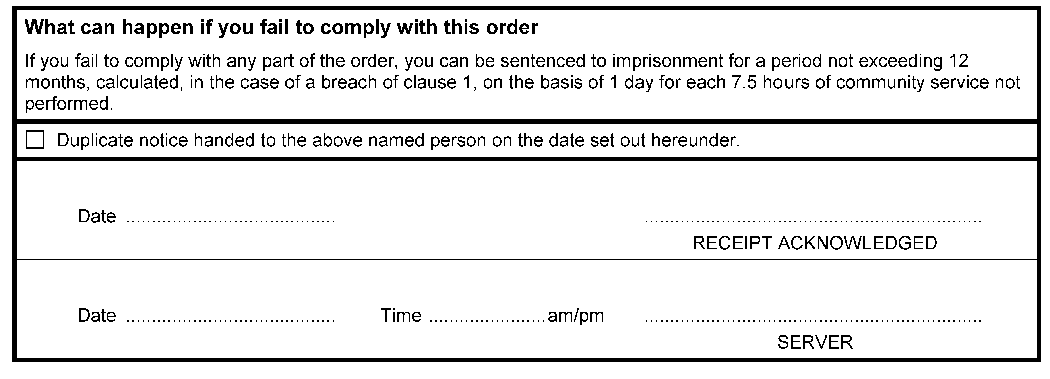

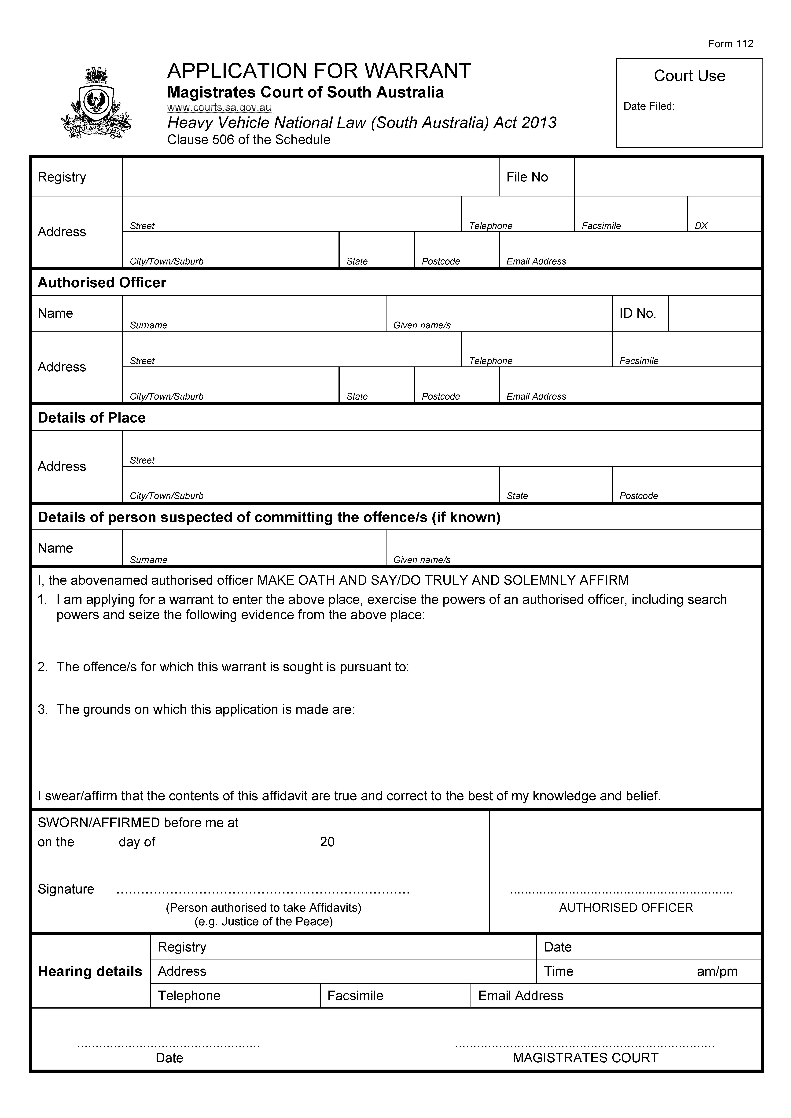

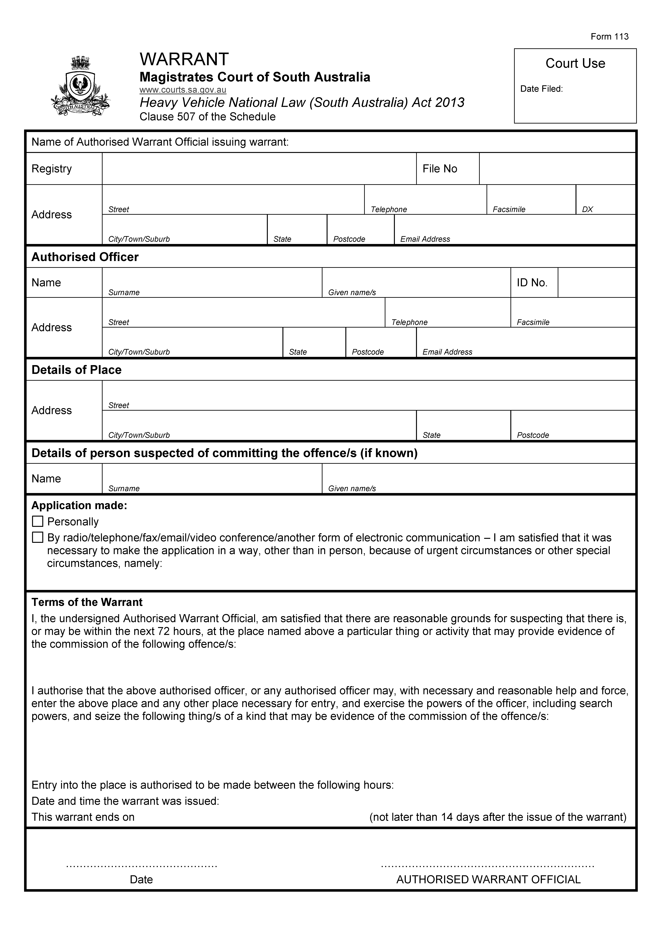

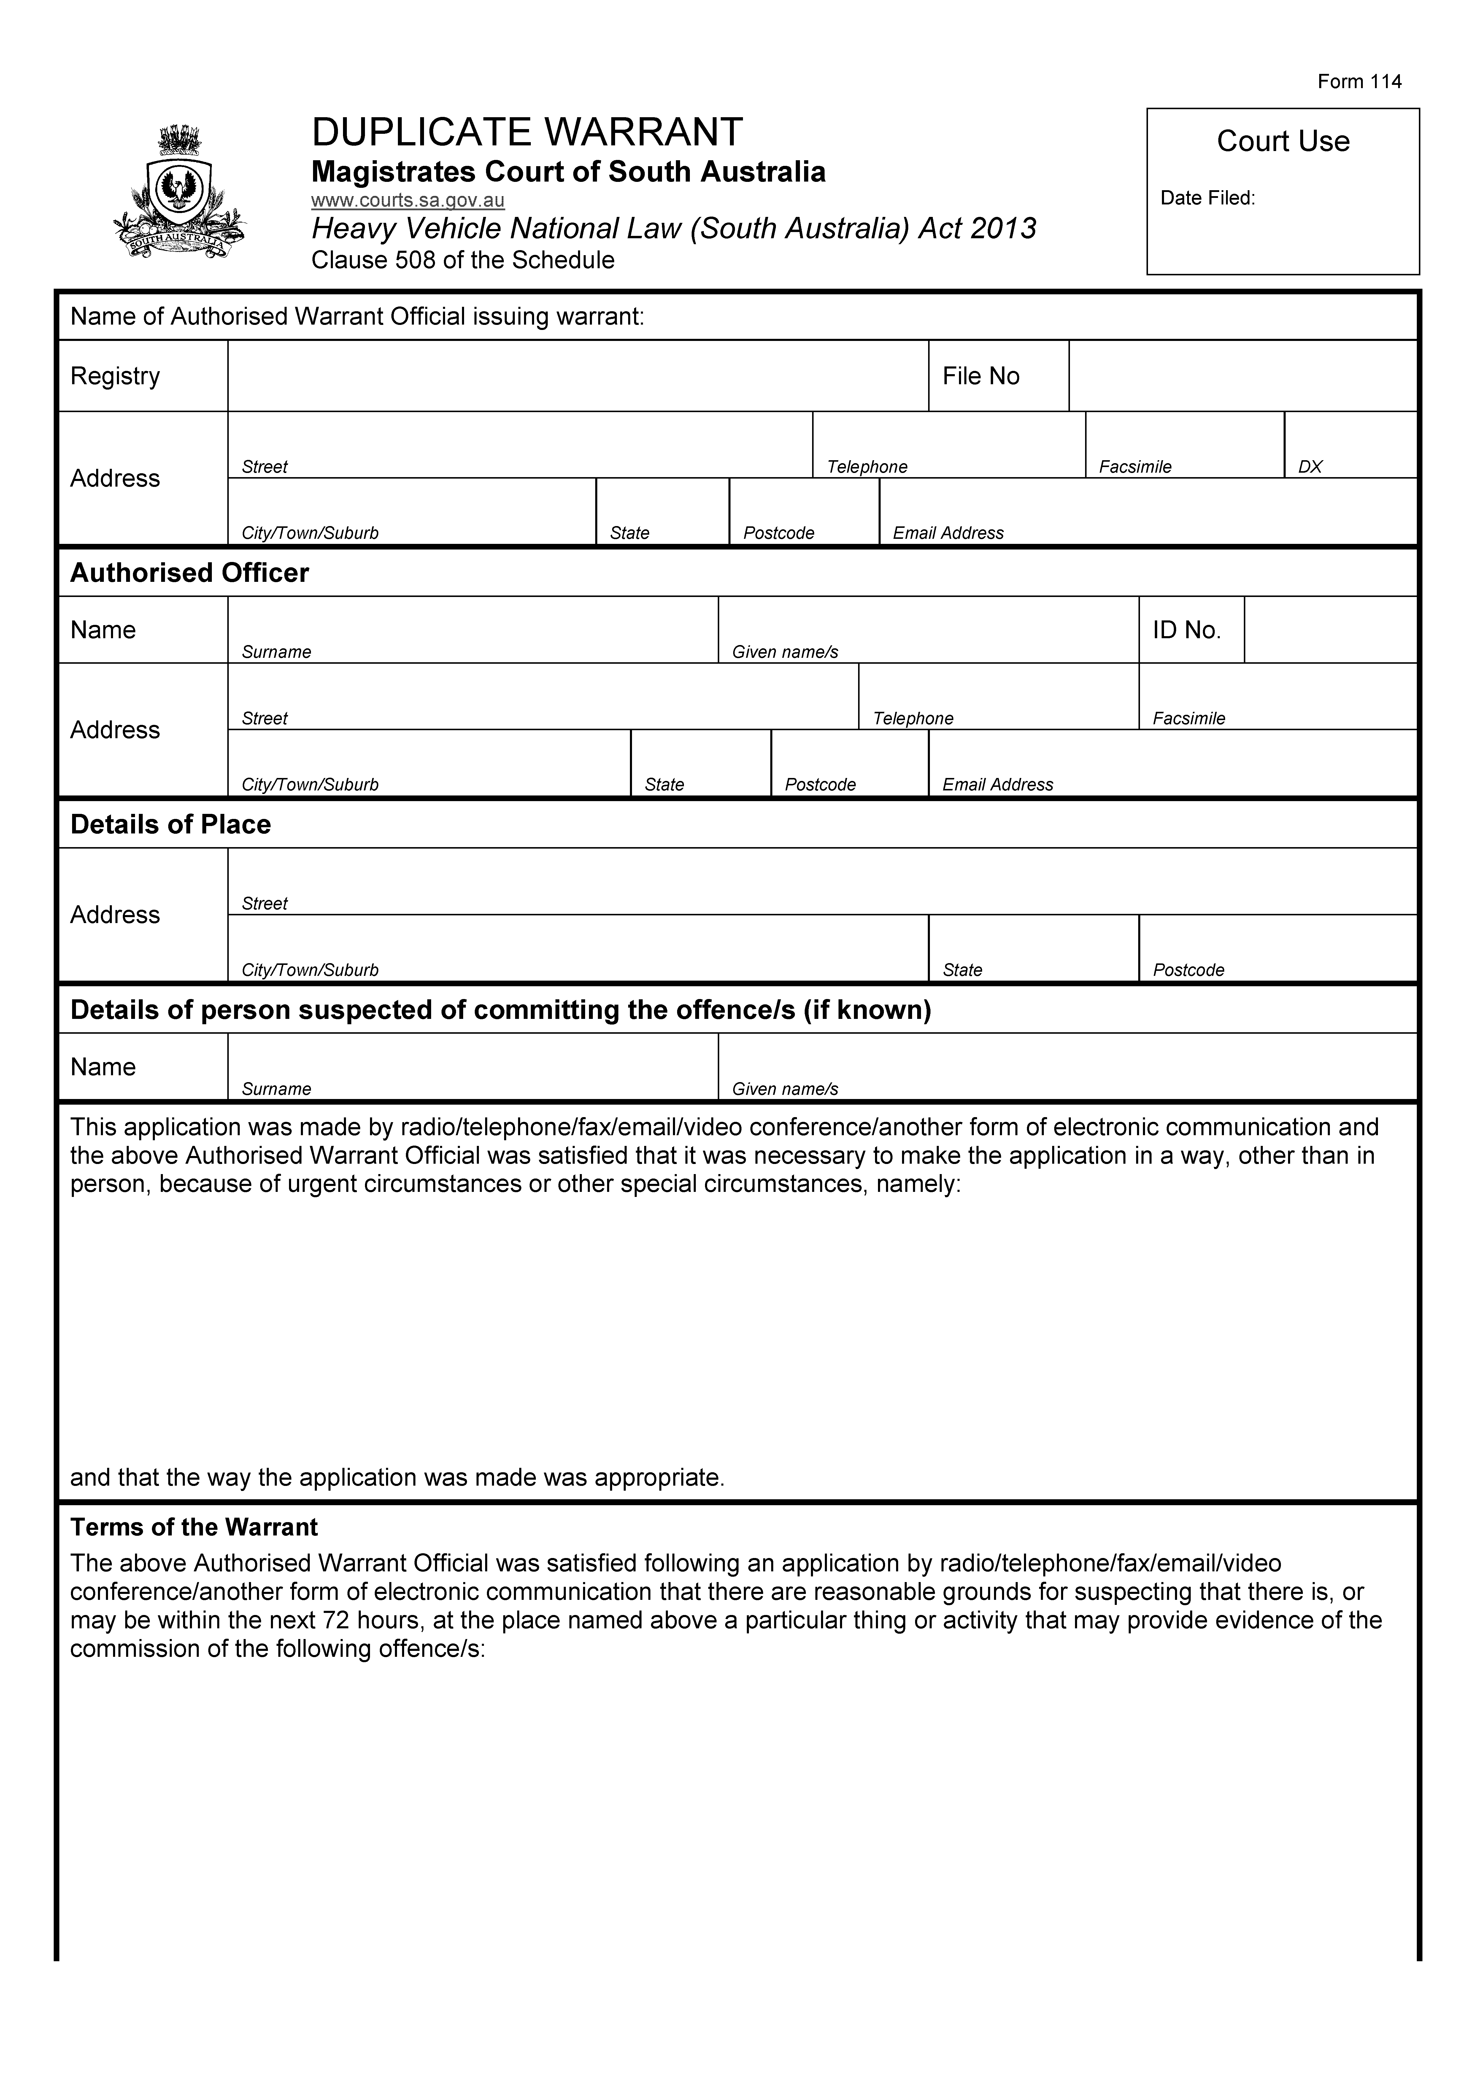

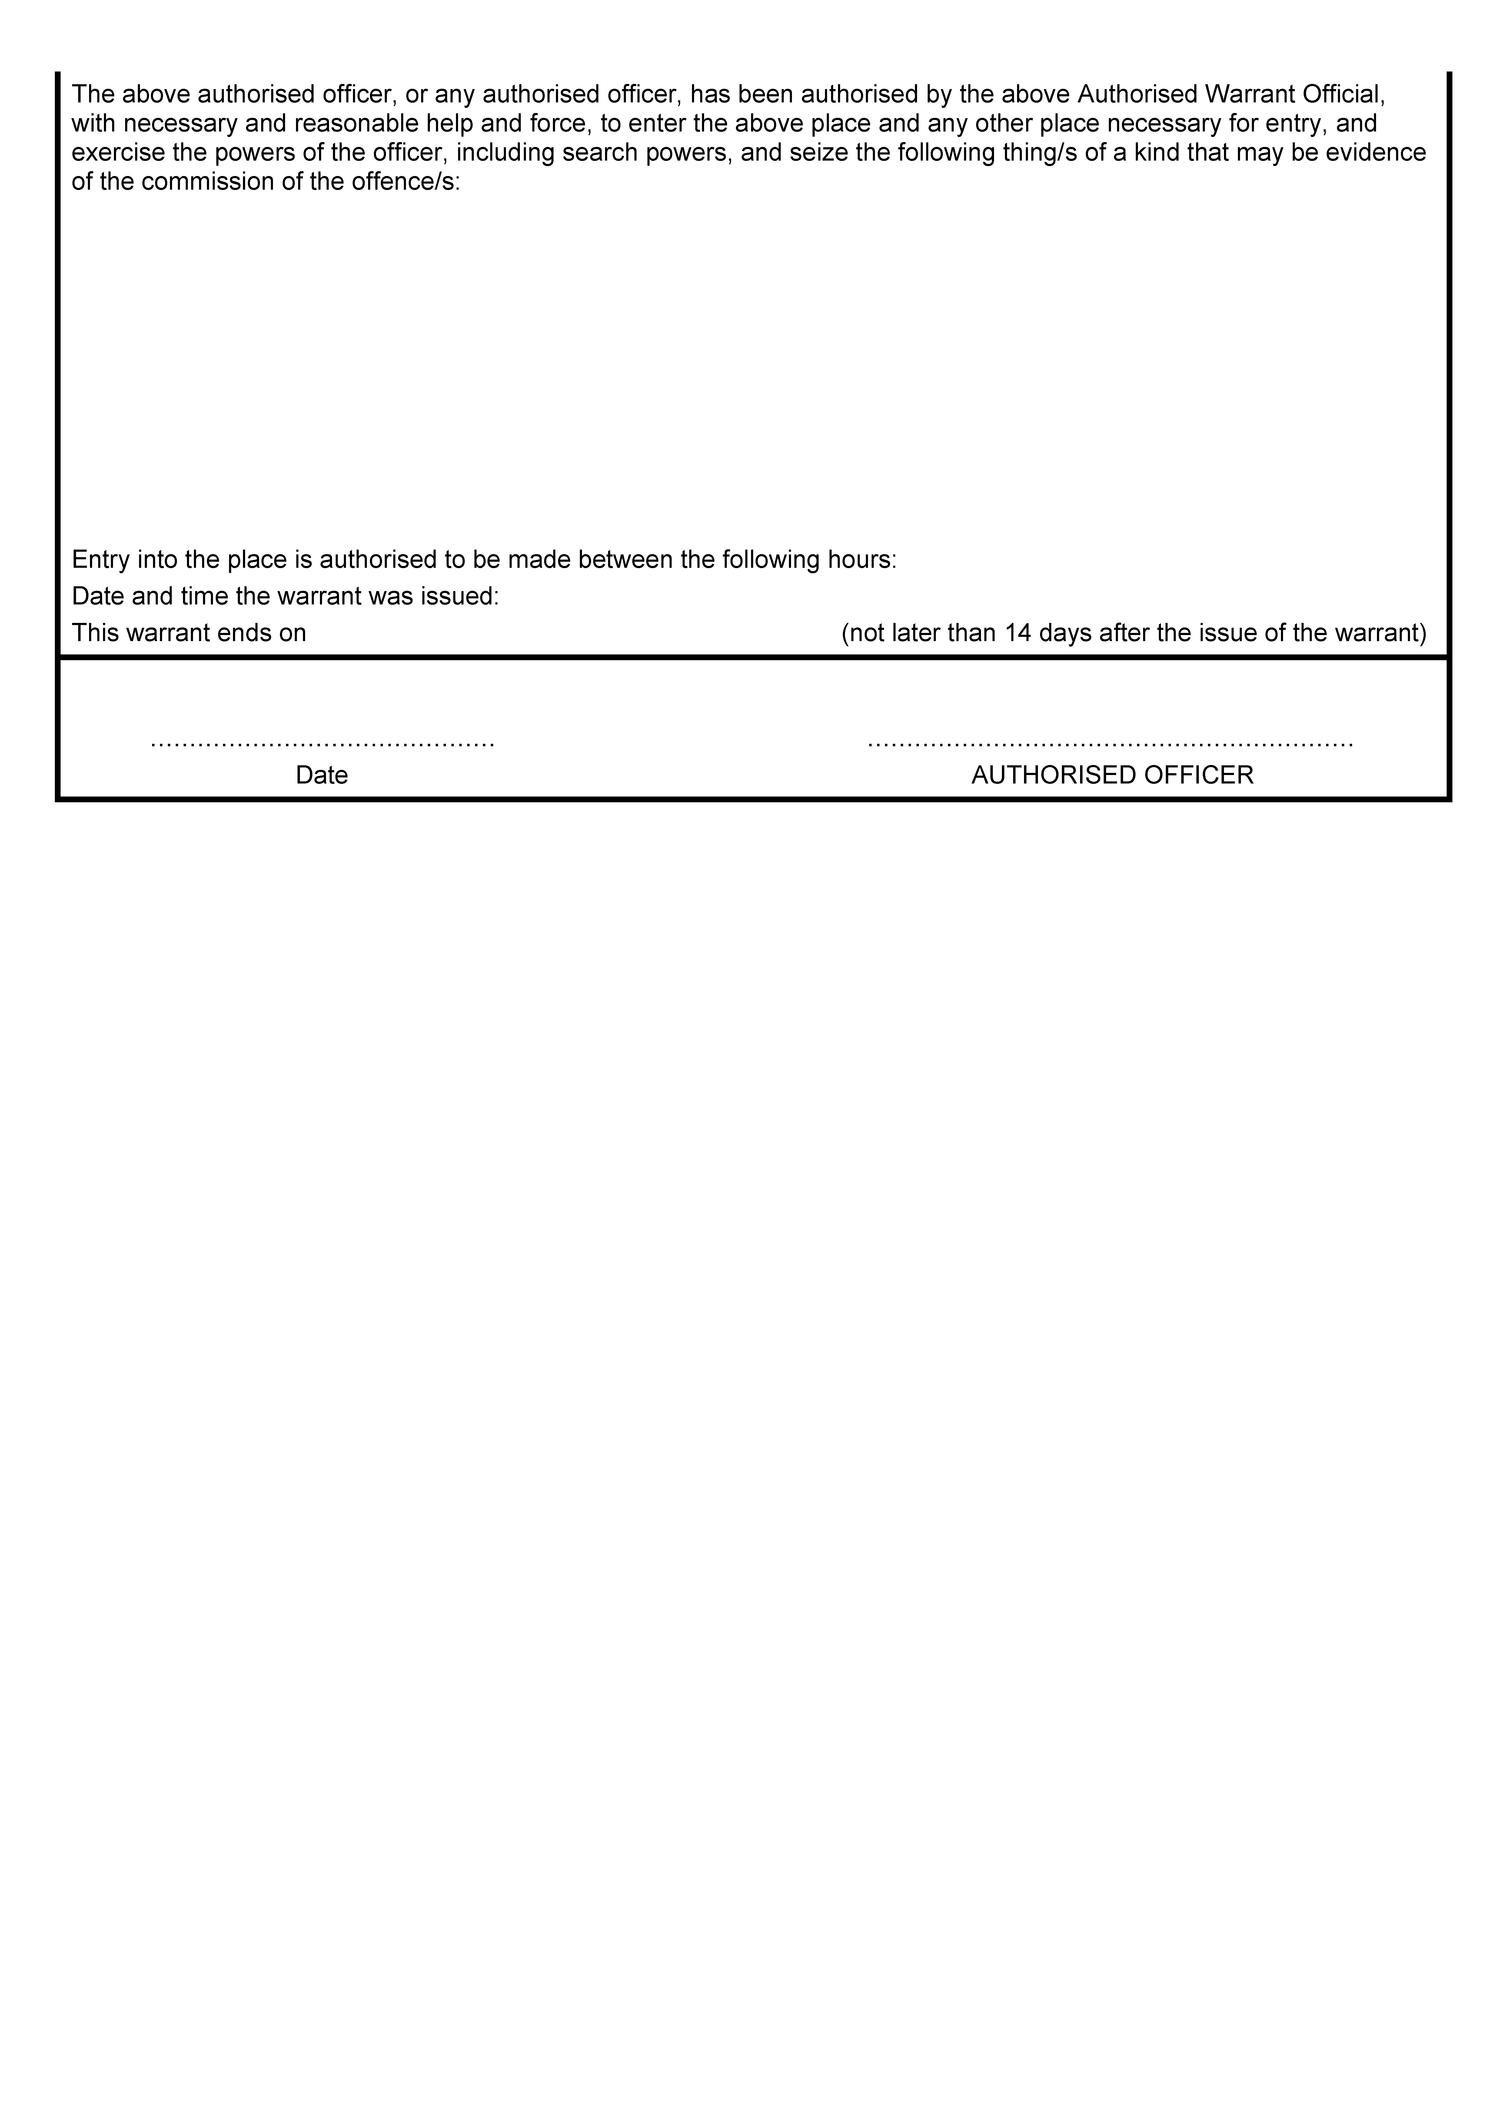

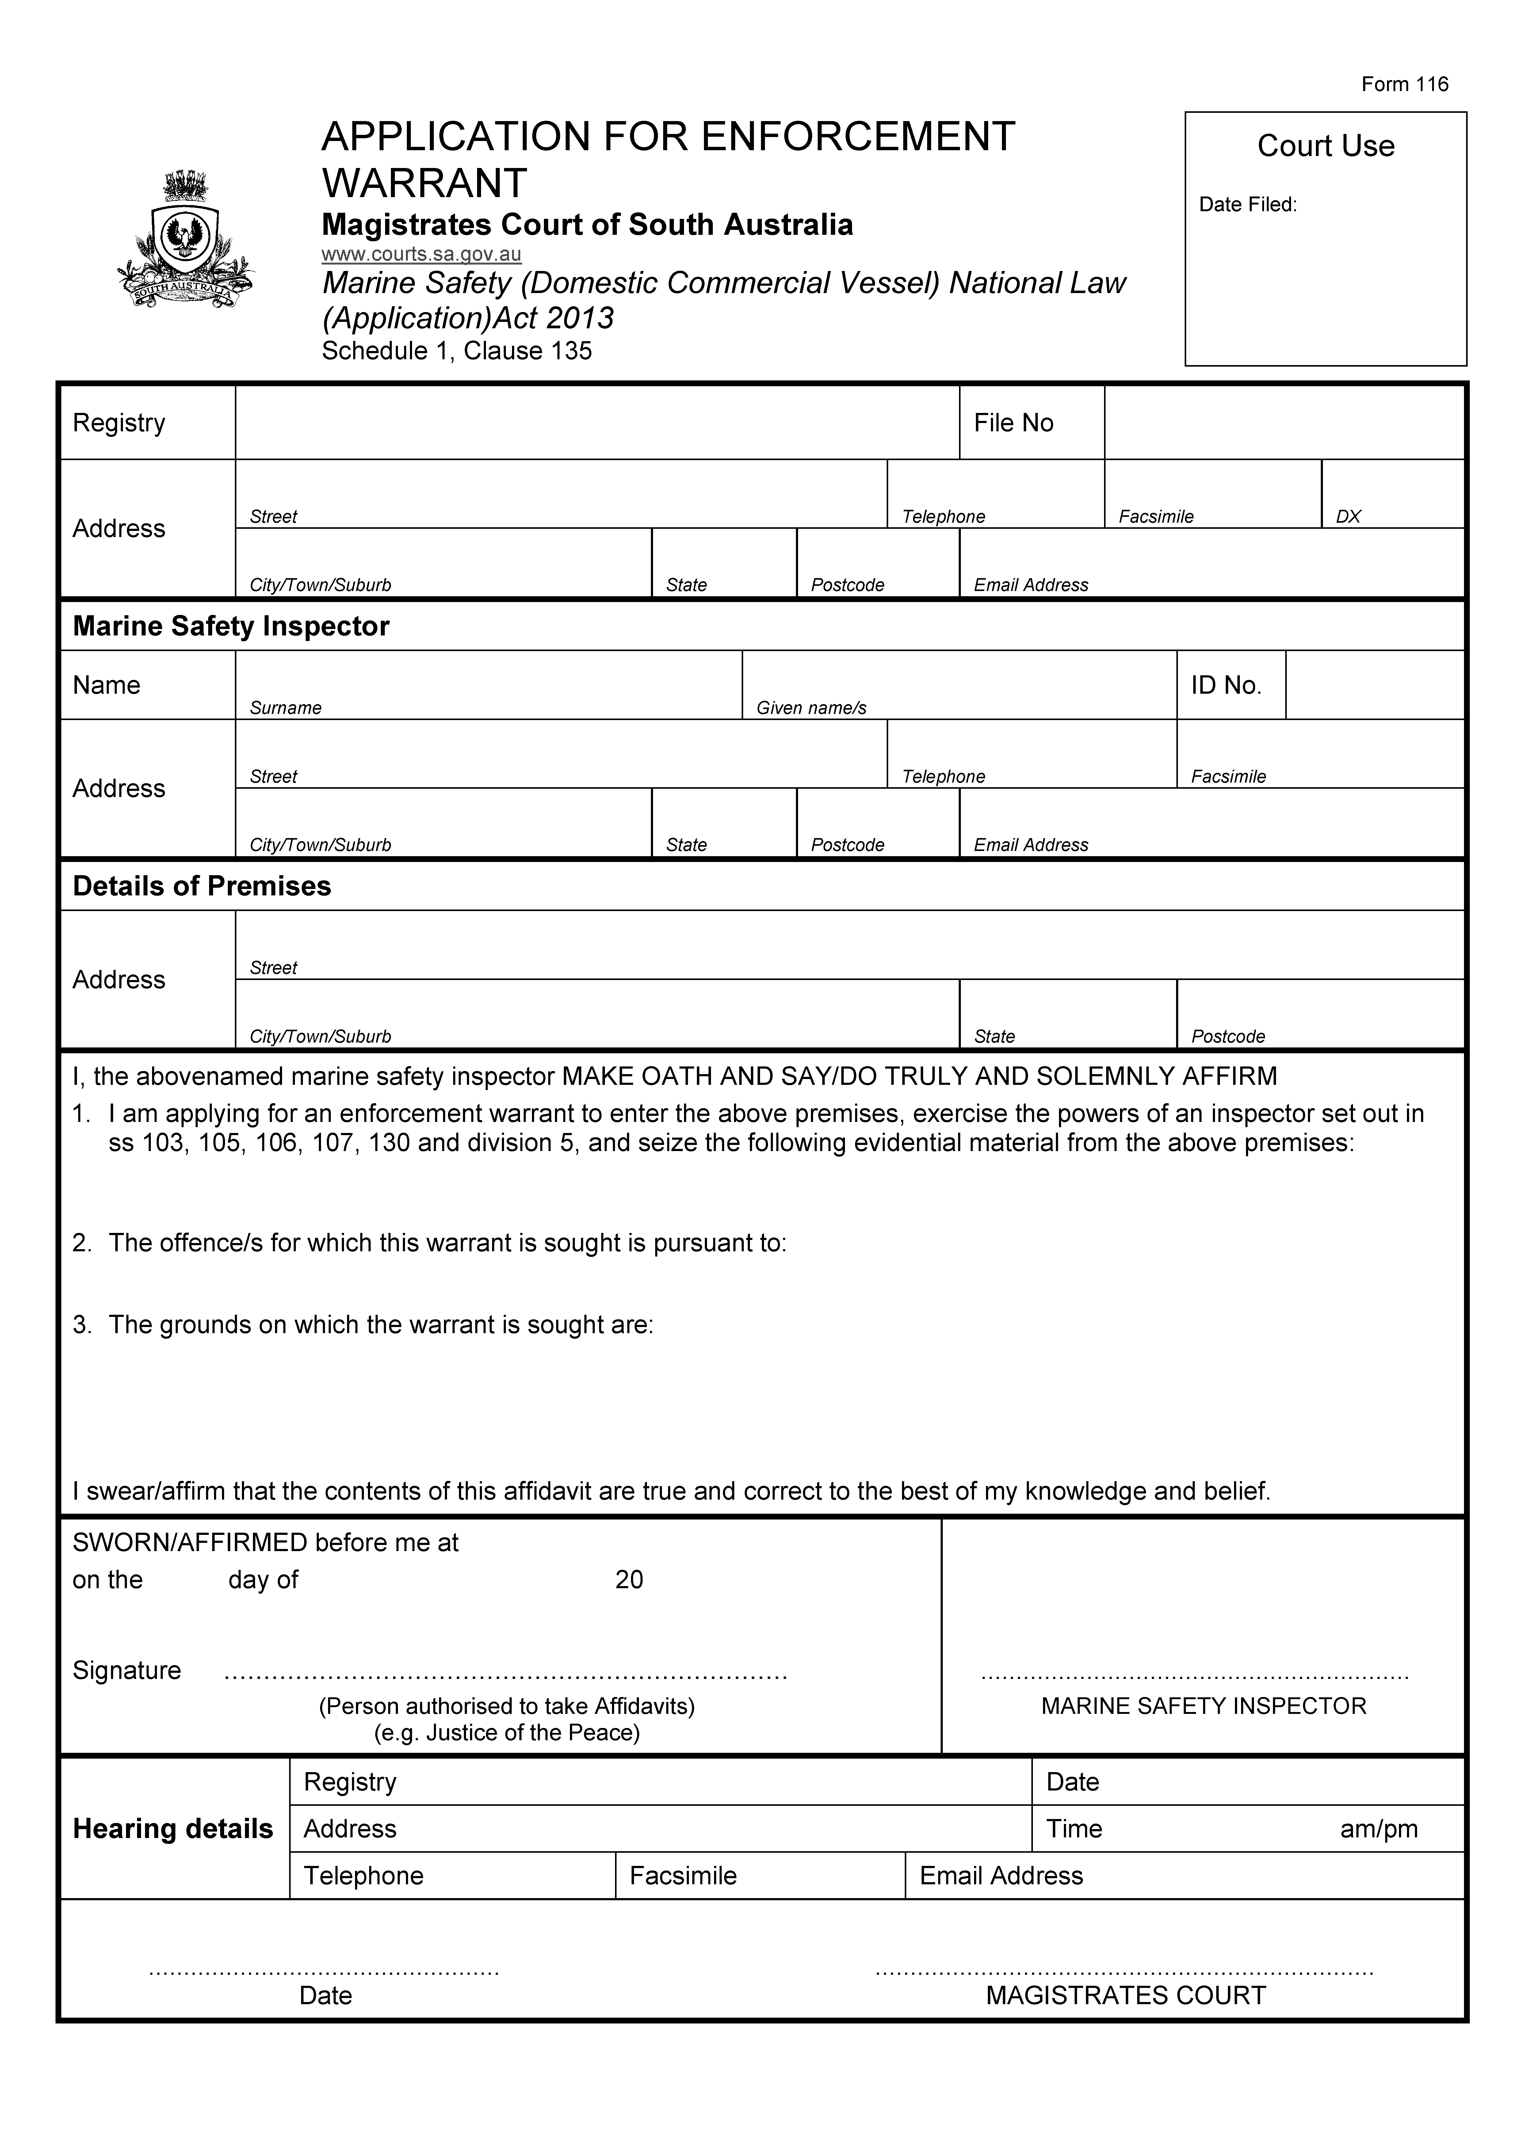



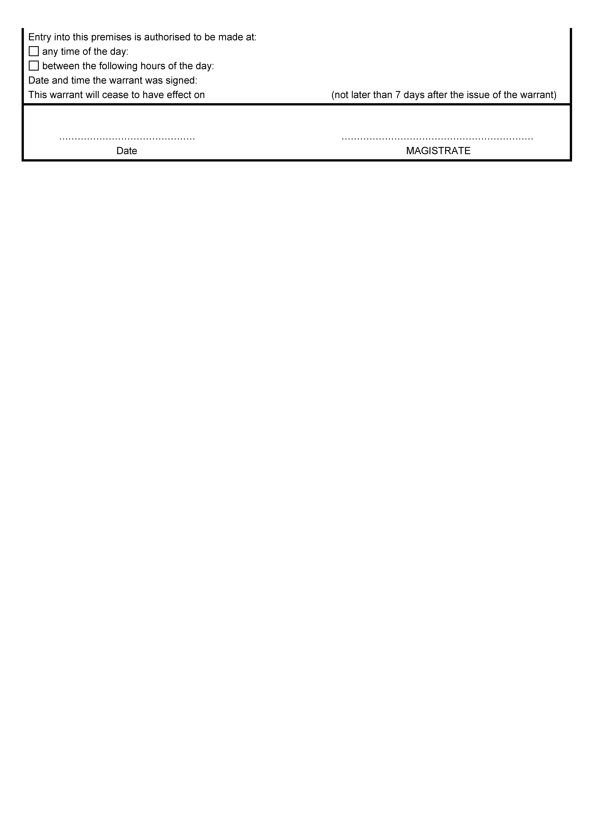



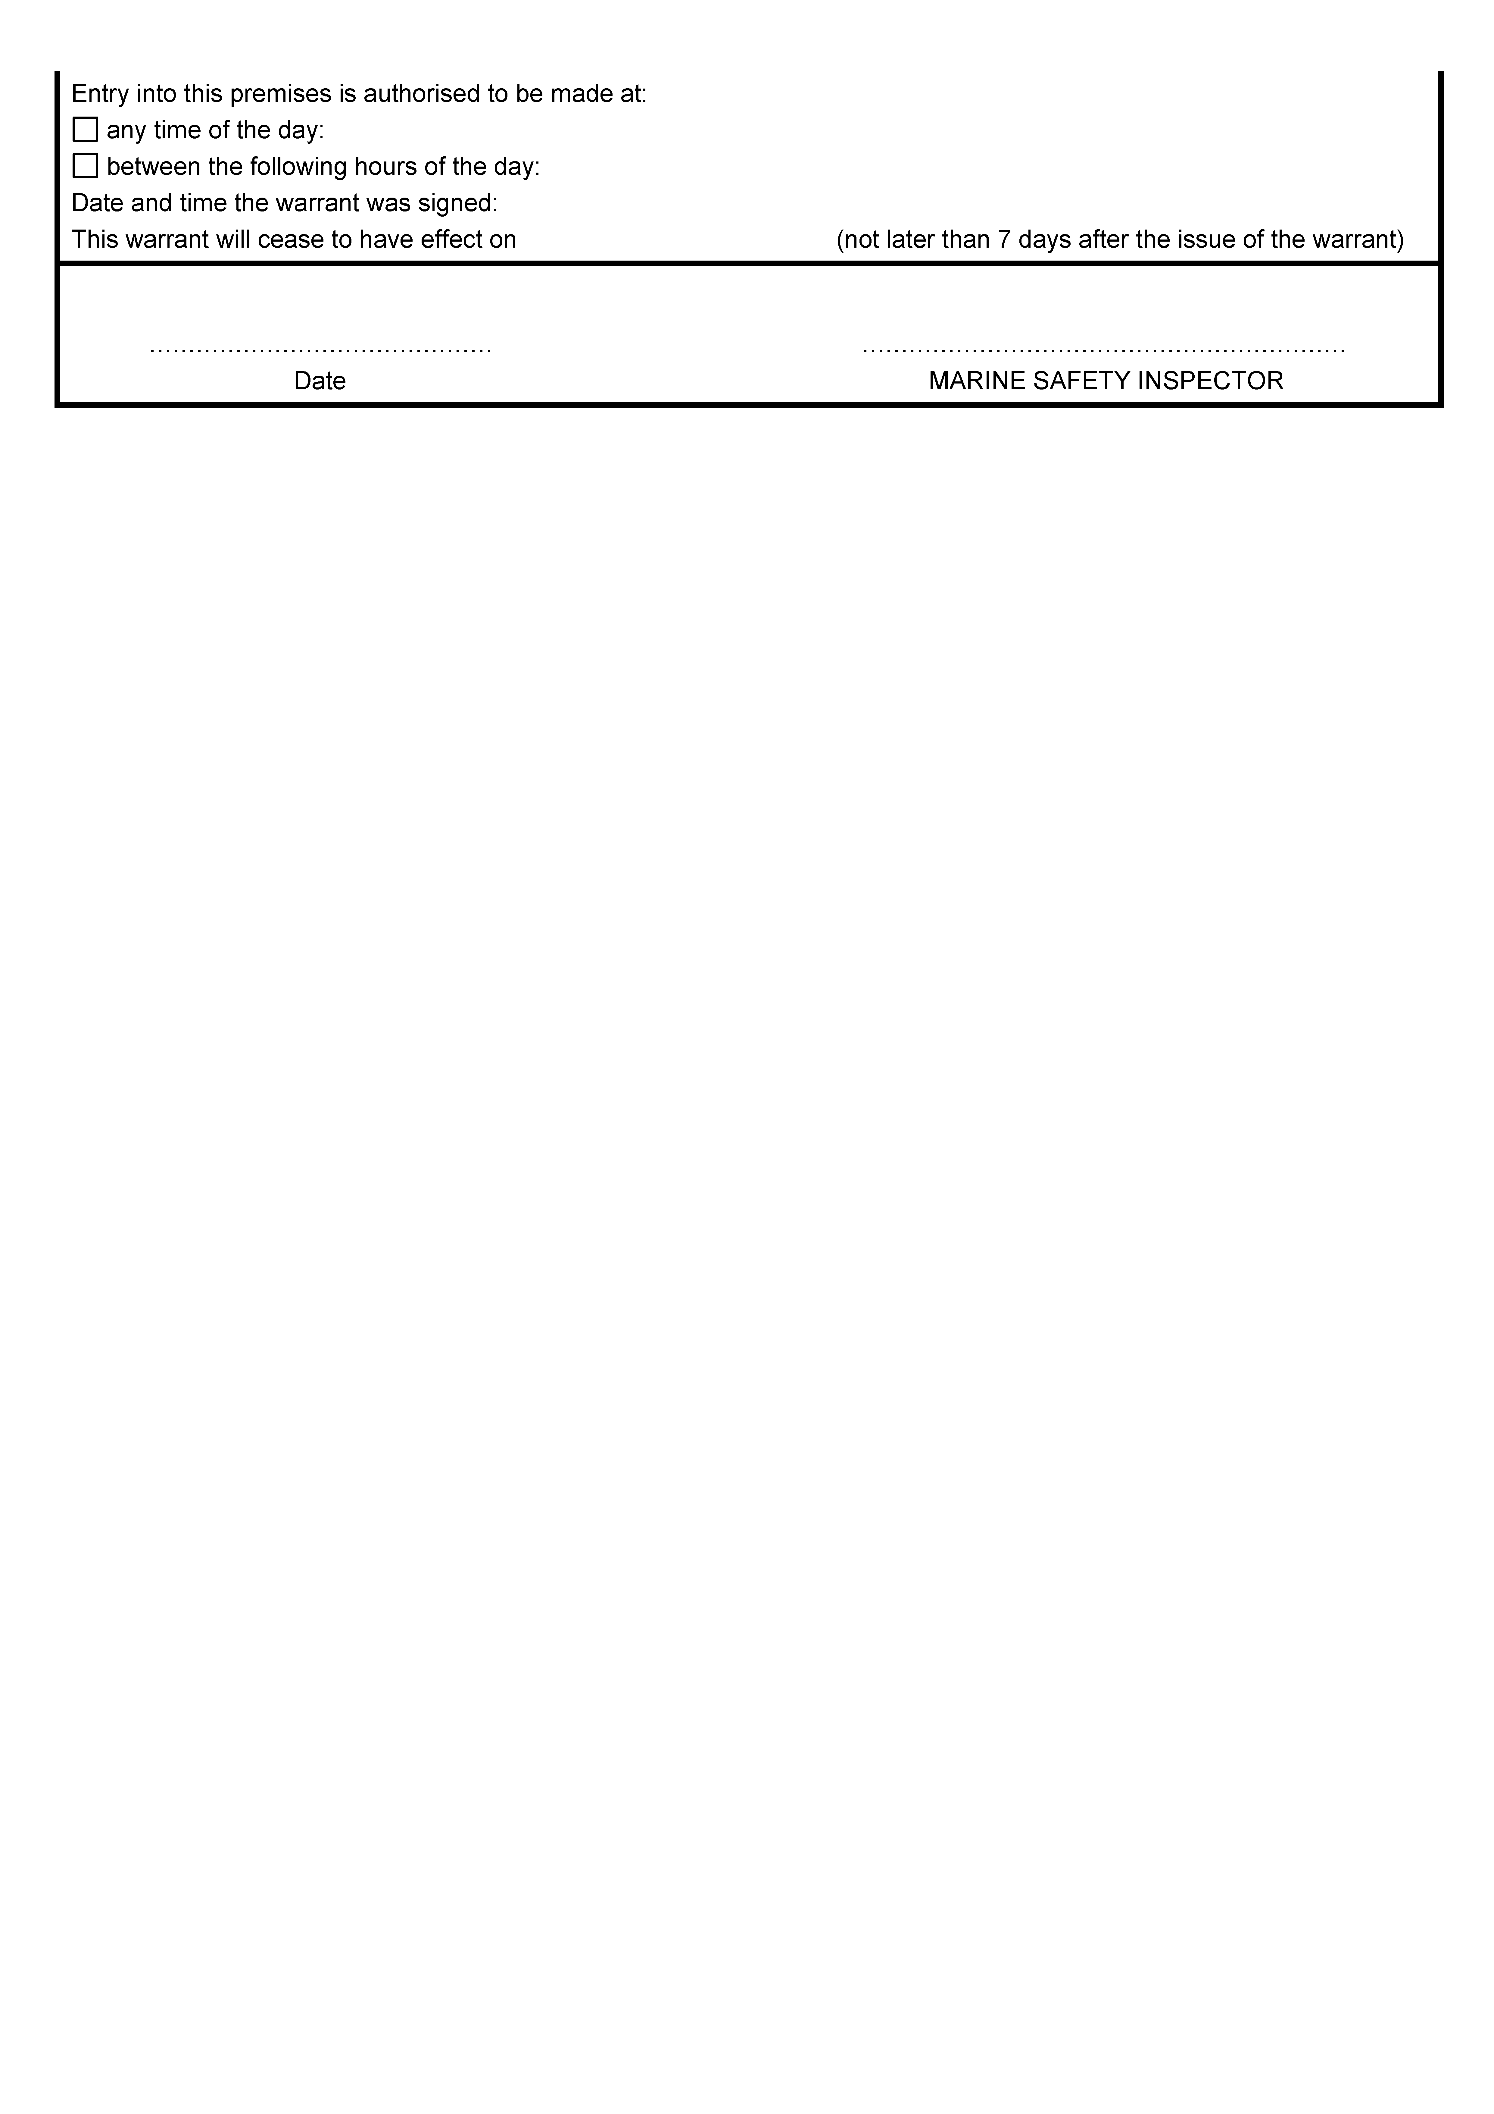
GOVERNMENT GAZETTE ADVERTISEMENT RATES

To apply from 1 July 2013

$  Agents, Ceasing to Act as 48.50  Associations:  Incorporation 24.50  Intention of Incorporation 61.00  Transfer of Properties 61.00  Attorney, Appointment of 48.50  Bailiff’s Sale 61.00  Cemetery Curator Appointed 35.75  Companies:  Alteration to Constitution 48.50  Capital, Increase or Decrease of 61.00  Ceasing to Carry on Business 35.75  Declaration of Dividend 35.75  Incorporation 48.50  Lost Share Certificates:  First Name 35.75  Each Subsequent Name 12.40  Meeting Final 40.50  Meeting Final Regarding Liquidator’s Report on  Conduct of Winding Up (equivalent to ‘Final  Meeting’)  First Name 48.50  Each Subsequent Name 12.40  Notices:  Call 61.00  Change of Name 24.50  Creditors 48.50  Creditors Compromise of Arrangement 48.50  Creditors (extraordinary resolution that ‘the Com-pany be wound up voluntarily and that a liquidator be appointed’) 61.00  Release of Liquidator⎯Application⎯Large Ad. 96.50  ⎯Release Granted 61.00  Receiver and Manager Appointed 55.50  Receiver and Manager Ceasing to Act 48.50  Restored Name 45.25  Petition to Supreme Court for Winding Up 84.00  Summons in Action 71.50  Order of Supreme Court for Winding Up Action 48.50  Register of Interests⎯Section 84 (1) Exempt 108.00  Removal of Office 24.50  Proof of Debts 48.50  Sales of Shares and Forfeiture 48.50  Estates:  Assigned 35.75  Deceased Persons⎯Notice to Creditors, etc. 61.00  Each Subsequent Name 12.40  Deceased Persons⎯Closed Estates 35.75  Each Subsequent Estate 1.60  Probate, Selling of 48.50  Public Trustee, each Estate 12.40 |  | $  Firms:  Ceasing to Carry on Business (each insertion) 32.25  Discontinuance Place of Business 32.25  Land⎯Real Property Act:  Intention to Sell, Notice of 61.00  Lost Certificate of Title Notices 61.00  Cancellation, Notice of (Strata Plan) 61.00  Mortgages:  Caveat Lodgement 24.50  Discharge of 25.75  Foreclosures 24.50  Transfer of 24.50  Sublet 12.40  Leases⎯Application for Transfer (2 insertions) each 12.40  Lost Treasury Receipts (3 insertions) each 35.75  Licensing 71.50  Municipal or District Councils:  Annual Financial Statement⎯Forms 1 and 2 677.00  Electricity Supply⎯Forms 19 and 20 481.00  Default in Payment of Rates:  First Name 96.50  Each Subsequent Name 12.40  Noxious Trade 35.75  Partnership, Dissolution of 35.75  Petitions (small) 24.50  Registered Building Societies (from Registrar-General) 24.50  Register of Unclaimed Moneys⎯First Name 35.75  Each Subsequent Name 12.40  Registers of Members⎯Three pages and over:  Rate per page (in 8pt) 308.00  Rate per page (in 6pt) 407.00  Sale of Land by Public Auction 61.50  Advertisements 3.40  ¼ page advertisement 143.00  ½ page advertisement 287.00  Full page advertisement 562.00  Advertisements, other than those listed are charged at $3.40 per column line, tabular one-third extra.  Notices by Colleges, Universities, Corporations and District Councils to be charged at $3.40 per line.  Where the notice inserted varies significantly in length from that which is usually published a charge of $3.40 per column line will be applied in lieu of advertisement rates listed.  South Australian Government publications are sold on the condition that they will not be reproduced without prior permission from the Government Printer.
All the above prices include GST

GOVERNMENT GAZETTE NOTICES
Notices for publication in the South Australian Government Gazette should be emailed to governmentgazette@dpc.sa.gov.au. Content should be sent as Word format attachment(s). Covering emails should include the date the notice is to be published and to whom the notice will be charged. Closing time for lodgement is 4 p.m. on the Tuesday preceding the regular Thursday publication. Gazette enquiries to: Phone 8207 1045. The Government Gazette is available online at: www.governmentgazette.sa.gov.au.

MISCELLANEOUS LEGISLATION AND GOVERNMENT PUBLICATIONS PRICES AS FROM 1 JULY 2013

Acts, Bills, Rules, Parliamentary Papers and Regulations
Pages | Main | Amends | Pages | Main | Amends

1-16 | 3.00 | 1.40 | 497-512 | 41.00 | 40.00
17-32 | 3.90 | 2.45 | 513-528 | 42.00 | 40.75
33-48 | 5.15 | 3.65 | 529-544 | 43.50 | 42.00
49-64 | 6.50 | 5.00 | 545-560 | 44.75 | 43.50
65-80 | 7.55 | 6.30 | 561-576 | 45.75 | 44.75
81-96 | 8.80 | 7.30 | 577-592 | 47.50 | 45.25
97-112 | 10.00 | 8.60 | 593-608 | 48.75 | 46.75
113-128 | 11.20 | 9.90 | 609-624 | 49.50 | 48.50
129-144 | 12.60 | 11.10 | 625-640 | 50.50 | 49.00
145-160 | 13.80 | 12.40 | 641-656 | 52.00 | 50.50
161-176 | 15.00 | 13.60 | 657-672 | 53.00 | 51.00
177-192 | 16.40 | 14.80 | 673-688 | 54.50 | 53.00
193-208 | 17.60 | 16.30 | 689-704 | 55.50 | 53.50
209-224 | 18.60 | 17.20 | 705-720 | 57.00 | 55.00
225-240 | 19.90 | 18.40 | 721-736 | 58.50 | 56.00
241-257 | 21.40 | 19.50 | 737-752 | 59.00 | 57.50
258-272 | 22.60 | 20.60 | 753-768 | 61.00 | 58.50
273-288 | 23.70 | 22.40 | 769-784 | 62.00 | 61.00
289-304 | 24.80 | 23.30 | 785-800 | 63.00 | 62.00
305-320 | 26.25 | 24.70 | 801-816 | 64.50 | 62.50
321-336 | 27.25 | 25.75 | 817-832 | 65.50 | 64.50
337-352 | 28.75 | 27.00 | 833-848 | 67.00 | 65.50
353-368 | 29.50 | 28.50 | 849-864 | 68.00 | 66.50
369-384 | 31.25 | 29.50 | 865-880 | 69.50 | 68.00
385-400 | 32.50 | 31.00 | 881-896 | 70.00 | 68.50
401-416 | 33.75 | 32.00 | 897-912 | 71.50 | 70.00
417-432 | 35.00 | 33.50 | 913-928 | 72.00 | 71.50
433-448 | 36.00 | 34.75 | 929-944 | 73.50 | 72.00
449-464 | 37.00 | 35.50 | 945-960 | 74.50 | 73.00
465-480 | 37.50 | 36.75 | 961-976 | 78.00 | 74.00
481-496 | 40.00 | 37.50 | 977-992 | 79.00 | 74.50

Legislation—Acts, Regulations, etc.: $
Subscriptions:
Acts 252.00
All Bills as Laid 607.00
Rules and Regulations 607.00
Parliamentary Papers 607.00
Bound Acts 280.00
Index 140.00
Government Gazette
Copy 6.65
Subscription 335.00
Hansard
Copy 18.40
Subscription—per session (issued weekly) 525.00
Cloth bound—per volume 226.00
Subscription—per session (issued daily) 525.00
Legislation on Disk
Whole Database 3 894.00
Annual Subscription for fortnightly updates 1 197.00
Individual Act(s) including updates POA
Notice of Vacancies
Annual Subscription 190.00
Compendium
Subscriptions:
New Subscriptions 2 306.00
Updates 814.00
(All the above prices include GST)

Counter Sales Government Legislation Outlet
and Mail Orders: Service SA Customer Service Centre,
Ground Floor—EDS Centre, 108 North Terrace, Adelaide, S.A. 5000
Phone: 13 23 24 (local call cost), Fax: (08) 8204 1909
Postal: G.P.O. Box 1707, Adelaide, S.A. 5001

Online Shop: www.shop.service.sa.gov.au

Subscriptions and Government Publishing SA
Standing Orders: Plaza Level, Riverside Centre, North Terrace, Adelaide, S.A. 5000
Phone: (08) 8207 1043, (08) 8207 0908, Fax: (08) 8207 1040
Email: AdminGovPubSA@sa.gov.au

South Australia
Legal Practitioners (Miscellaneous) Amendment Act (Commencement) Proclamation 2014
1—Short title
This proclamation may be cited as the Legal Practitioners (Miscellaneous) Amendment Act (Commencement) Proclamation 2014.
2—Commencement of Act and suspension of certain provisions
(1) The Legal Practitioners (Miscellaneous) Amendment Act 2013 (No 44 of 2013) will come into operation on 21 April 2014.
(2) The operation of the following provisions of the Act is suspended until a day or time or days or times to be fixed by subsequent proclamation or proclamations:
(a) Part 2;
(b) Schedule 1;
(c) Schedule 2 (other than clauses 5, 13 and 15).
Made by the Governor
with the advice and consent of the Executive Council
on 17 April 2014
AGO0045/14CS

South Australia
Constitution (First Session of Fifty-Third Parliament) (Time Change) Proclamation 2014
under section 6 of the Constitution Act 1934

Preamble
1 By the Constitution (First Session of Fifty-Third Parliament) Proclamation 2014 (see Gazette 10.4.2014 p1492)—
(a) I fixed 2:30 pm on Tuesday 6 May 2014 as the time for holding the first session of the Fifty-Third Parliament; and
(b) I fixed Parliament House at North Terrace in the City of Adelaide as the place for holding the first session of the Fifty-Third Parliament; and
(c) I summoned the Parliament to meet at the time and place so fixed.
2 Pursuant to section 6(1)(b) of the Constitution Act 1934, I have decided to change the time for holding the first session of the Fifty-Third Parliament from 2:30 pm on Tuesday 6 May 2014 to 11 am on that day.

1—Short title
This proclamation may be cited as the Constitution (First Session of Fifty-Third Parliament) (Time Change) Proclamation 2014.
2—Commencement
This proclamation comes into operation on the day on which it is made.
3—First session of the Fifty-Third Parliament
(1) I fix 11 am on Tuesday 6 May 2014 as the time for holding the first session of the Fifty-Third Parliament.
(2) I summon the Parliament to meet at 11 am on Tuesday 6 May 2014 at Parliament House for the dispatch of business and require all honourable members of the Legislative Council and the House of Assembly, and all officers of the Parliament, to attend accordingly.
Made by the Governor
with the advice and consent of the Executive Council
on 17 April 2014
DPC14/021CS

SENDING COPY?
NOTICES for inclusion in the South Australian Government Gazette should be emailed to:
governmentgazette@dpc.sa.gov.au
Please include the following information in the covering email:
• The date the notice is to be published.
• Whether a proof, quote or return email confirmation is required.
• Contact details.
• To whom the notice is charged if applicable.
• A purchase order if required (chargeable notices).
• Any other details that may impact on the publication of the notice.
Attach:
• Notices in Word format.
• Maps and diagrams in pdf.
• Notices that require sighting an official date and signature before publication in a pdf. If a pdf is not possible then fax the official file(s) to the Government Publishing Fax number listed below.
Fax Transmission: (08) 8207 1040
Phone Enquiries: (08) 8207 1045
NOTE:
Closing time for lodging new copy is 4 p.m. on Tuesday preceding the regular Thursday Gazette.

CITY OF TEA TREE GULLY
Change of ‘Local Government Land’ Classification to ‘Community Land’ Classification
NOTICE is hereby given, pursuant to Section 193 (6) of the Local Government Act 1999, that the Council of the City of Tea Tree Gully at its meeting held on 8 April 2014, included the Community Land classification to the following:
• Allotment 83 in Deposited Plan 7318, Millbank Avenue, Gilles Plains. Described as the whole of Certificate of Title Volume 5608, Folio 472.
J. Moyle, Chief Executive Officer

YORKE PENINSULA COUNCIL
By-law No. 2—Local Government Land
Amendment
NOTICE is hereby given that the Yorke Peninsula Council, at its meeting held on Wednesday, 9 April 2014, resolved as follows in relation to the Council’s By-law No. 2 of 2013—Local Government Land:
1. In exercise of its powers pursuant to Section 246 (3) (e) of the Local Government Act 1999, that for the purposes of Clause 9.14.2 (b) of By-law No. 2 of 2013—Local Government Land:
1.1 The following Local Government Land is a designated camping area for camping in a Recreational Vehicle:
• the designated RV camping area in the Reserve located at 16 West Terrace Ardrossan; and
1.2 The conditions in accordance with which a person may camp on the designated RV camping area are that:
• no person shall camp thereon for more than two consecutive nights; and
• the RV in which the person camps must be a self-contained vehicle (whether towed or self-propelled) that has its own toilet and shower, water tank, black water and grey water collection.
2. In exercise of its powers pursuant to Section 246 (3) (e) of the Local Government Act 1999, that Clause 9.10.1 of By-law No. 2 of 2013—Local Government Land, applies to the Council owned and/or operated boat ramps situated at the following locations:
2.1 Ardrossan
2.2 Black Point
2.3 Port Vincent
2.4 Stansbury
2.5 Edithburgh
2.6 Port Turton
2.7 Port Victoria
3. In exercise of its powers pursuant to Section 246 (3) (e) of the Local Government Act 1999, that for the purpose of Clause 9.14.2 (b) of By-law No. 2 of 2013—Local Government Land:
3.1 The following Local Government Land is a designated camping area:
The Gap; Wauraltee Beach; Goldsmith Beach; Gleesons Landing; Mozzie Flat; The Bamboos ; Barkers Rocks; Gravel Bay; Foul Bay; Kemp Bay; Tiparra Rocks; Burners Beach; Swincers Rocks; Sturt Bay; Troubridge Hill; and
3.2 The conditions in accordance with which a person may camp on any of the above designated camping areas on Local Government Land are:
• no person shall camp on a designated camping area for a period in excess of six consecutive weeks;
• if a person has camped on a designated camping area for six consecutive weeks, that person must not camp on any designated camping area until a further period of four consecutive weeks has expired; and
• no person shall camp on a designated camping area unless the person has paid to Council the relevant fee that applies in respect of that area (if any).
A. Cameron, Chief Executive Officer

YORKE PENINSULA COUNCIL
Development Act 1993
Yorke Peninsula Council Development Plan
Bluff Beach—Development Plan Amendment—
Draft for Public Consultation
THE Yorke Peninsula Council Bluff Beach Development Plan Amendment (DPA) has been prepared by Council under the provisions of the Development Act 1993 and is now available for comment.
The draft DPA reviews a parcel of land to the immediate east of the existing settlement for the purpose of accommodating an extension of the existing settlement zone.
The DPA also proposes to introduce a new policy area over the balance of the affected property, which will remain in the rural living zone, for the purpose of allowing subdivision into allotments within a minimum area of 0.8 hectares.
The draft DPA and Investigations will be available for public inspection from Thursday, 17 April 2014 until Friday, 20 June 2014, during normal office hours at the Yorke Peninsula Council offices located at Maitland (8 Elizabeth Street), Minlaton (18 Main Street), Yorketown (15 Edithburgh Road) and Warooka (Player Street), as well as being accessible on Council’s website at www.yorke.sa.gov.au. A copy of the Development Plan Amendment can be downloaded free of cost from Council’s website or a hard copy purchased from the Council office at Minlaton for $150 (full colour) or for $50 (black and white only), or a CD-ROM copy purchased for $5.
Written submissions regarding the draft amendment will be accepted by the Council until 5 p.m. on Friday, 20 June 2014.
All submissions should be addressed to Council’s Chief Executive Officer, Yorke Peninsula Council, P.O. Box 88, Minlaton,
S.A. 5575. The written submission should clearly indicate whether you will wish to speak at the public meeting on your submission.
Copies of all written submissions received will be available for inspection by interested persons at the Council offices from Monday, 23 June 2014 until the date of the public meeting.
A public meeting will be held on Wednesday, 2 July 2014 at 7 p.m. at the Minlaton Town Hall, Main Street, Minlaton at which time interested persons may be heard in relation to the DPA and the submissions. The public hearing will not be held if no submissions are received or if no submission makes a request to be heard.
If you would like further information about the DPA, contact Council’s planning consultants Access Planning on 8130 7222.
Dated 17 April 2014.
A. Cameron, Chief Executive Officer

IN the matter of the estates of the undermentioned deceased persons:
Biggs, Stanley Roy, late of 10 Suffolk Street, Angle Park, retired fitter, who died on 23 October 2013.
Glavin, Jessie, late of 55-59 Ferguson Avenue, Myrtle Bank, retired nursing sister, who died on 27 January 2014.
Hammond, Audrey Jean, late of 101 Lake Terrace, East Mount Gambier, retired teacher, who died on 20 December 2013.
Kew, John, late of 18 Laurence Street, Dover Gardens, retired conveyancer, who died on 1 February 2014.
Klemettila, Michael Lucas, late of 30 Shillabeer Road, Elizabeth Park, retired storeman, who died on 21 November 2013.
Lord, Judith Suzanne, late of 10 Wirra Wirra Avenue, Enfield, home duties, who died on 29 December 2013.
Murphy, Joan, late of 7 Raymond Grove, Glenelg, retired accountant, who died on 28 December 2013.
Murray, Jean, late of 103 Fisher Street, Fullarton, of no occupation, who died on 20 December 2013.
O’Reilly, Raymond Richard, late of 50 Kesters Road, Para Hills West, retired warrant officer, who died on 24 January 2014.
Pearce, Brian Ross, late of 15 Charles Street, Port Pirie West, retired bank accountant, who died on 17 August 2013.
Stewart, Greta Lorraine, late of 15 Rosemary Street, Woodville West, of no occupation who died on 29 November 2013.
Walters, Thomas Ross, late of 66 Nelson Road, Valley View, retired gardener, who died on 1 September 2006.
Wassink, Elizabeth Maria, late of 8 Wade Street, Whyalla Norrie, home duties, who died on 1 October 2013.
Webb, Louie Daphene, late of 10 Township Road, Marion,
of no occupation, who died on 8 February 2014.
Williams, William Arthur, late of 32 Knighton Road, Elizabeth North, retired mail officer, who died on 4 January 2014.
Notice is hereby given pursuant to the Trustee Act 1936, the Inheritance (Family Provision) Act 1972 and the Family Relationships Act 1975, that all creditors, beneficiaries, and other persons having claims against the said estates are required to send, in writing, to the Office of Public Trustee, G.P.O. Box 1338, Adelaide, S.A. 5001, full particulars and proof of such claims, on or before 16 May 2014, otherwise they will be excluded from the distribution of the said estates; and notice is also hereby given that all persons indebted to the said estates are required to pay the amount of their debts to the Public Trustee or proceedings will be taken for the recovery thereof; and all persons having any property belonging to the said estates are forthwith to deliver same to the Public Trustee.
Dated 17 April 2014.
D. A. Contala, Public Trustee

ATTENTION

CUSTOMERS requiring a proof of their notice for inclusion in the Government Gazette, please note that the onus is on you to inform Government Publishing SA of any subsequent corrections.

For any corrections to your notice please phone 8207 1045 or Fax 8207 1040 before 4 p.m. on Wednesday.

If we do not receive any communication by 10 a.m. on Thursday (day of publication) we will presume the notice is correct and will print it as it is.

Remember—the onus is on you to inform us of any corrections necessary to your notice.

NOTE: Closing time for lodging new copy (electronically, fax or hard copy) is 4 p.m. on Tuesday preceding the day of publication.
Phone: 8207 1045
Fax: 8207 1040
Email: governmentgazette@dpc.sa.gov.au

Printed and published by authority every Thursday by A. MARTIN, Government Printer, South Australia
Price: $6.65, plus postage; to subscribers, $335.00 per annum.
(The above prices are inclusive of GST)

