No. 88 6625
SUPPLEMENTARY GAZETTE

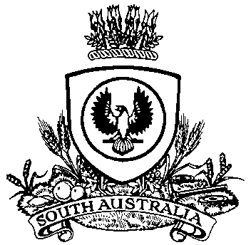

THE SOUTH AUSTRALIAN

GOVERNMENT GAZETTE
www.governmentgazette.sa.gov.au

PUBLISHED BY AUTHORITY

ALL PUBLIC ACTS appearing in this GAZETTE are to be considered official, and obeyed as such

ADELAIDE, TUESDAY, 9 DECEMBER 2014

MARINE PARKS ACT 2007
Temporary Prohibition Notice—Upper Gulf St Vincent
Marine Park
NOTICE is hereby given pursuant to Section 18 (2) of the Marine Parks Act 2007, that it is prohibited for any member of the public to come within 50 m of a carcass of a marine mammal if that carcass is located anywhere within the boundaries of Upper Gulf St Vincent Marine Park.
This prohibition operates for a period of 90 days from the date this notice appears in the Government Gazette.
Failure to comply with this notice may result in liability for criminal prosecution with a maximum penalty of $100 000 or two years’ imprisonment.
For the purpose of this notice, ‘member of the public’ means any person other than:
• a public authority as defined in the Marine Parks Act 2007, or a person authorised by a public authority;
• the Executive Director, Conservation and Land Manage-ment; the Director, National Parks and Wildlife under the National Parks and Wildlife Act 1972; or, the Manager, Marine Parks Unit, Department of Environment, Water and Natural Resources, or a person authorised by these officers; or
• authorised officers under the Marine Parks Act 2007 or the National Parks and Wildlife Act 1972.
Dated 9 December 2014.
B. Grear, Delegate for Ian Hunter, the Minister for Sustainability, Environment and Conservation

A. MARTIN, Government Printer, South Australia

