No. 91 6889
SUPPLEMENTARY GAZETTE

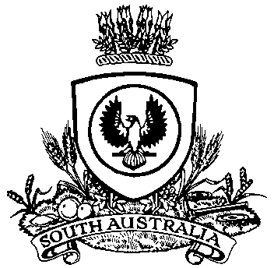

THE SOUTH AUSTRALIAN

GOVERNMENT GAZETTE
www.governmentgazette.sa.gov.au

PUBLISHED BY AUTHORITY

ALL PUBLIC ACTS appearing in this GAZETTE are to be considered official, and obeyed as such

ADELAIDE, WEDNESDAY, 24 DECEMBER 2014

SUMMARY OFFENCES ACT 1953
NOTICE is hereby given in accordance with Section 72A (3) of the Summary Offences Act 1953, that the following event has been declared for the duration of the event between the listed dates.
Event: New Year’s Eve, Semaphore and Henley Beach.
Place: Public place known as Semaphore Foreshore and Henley Square and environs.
Date: 31 December 2014—1 January 2015.
Conditions: Shall be in force from 3 p.m. on 31 December 2014 until 7 a.m. on 1 January 2015.
At this event a police officer may carry out a metal detector search in relation to any person who is in, or attempting to enter or leave the event and any property in the person’s possession.
Chief Inspector Teakle, Delegate of the Commissioner

A. MARTIN, Government Printer, South Australia

