No. 92 6891
SUPPLEMENTARY GAZETTE



THE SOUTH AUSTRALIAN

GOVERNMENT GAZETTE
www.governmentgazette.sa.gov.au

PUBLISHED BY AUTHORITY

ALL PUBLIC ACTS appearing in this GAZETTE are to be considered official, and obeyed as such

ADELAIDE, MONDAY, 29 DECEMBER 2014

PASSENGER TRANSPORT ACT 1994
Concession Card
PURSUANT to Regulation 3 (1) of the Passenger Transport Regulations 2009 I accept the card in Schedule 1 as a non-transferable concession card which entitles the holder to travel on all Adelaide Metro passenger vehicles at concessional fares.
Pursuant to Regulation 149 (1) (c) of the Passenger Transport Regulations 2009, I approve the form of the card in Schedule 1 as a concession card for the purposes of the Passenger Transport Act 1994.
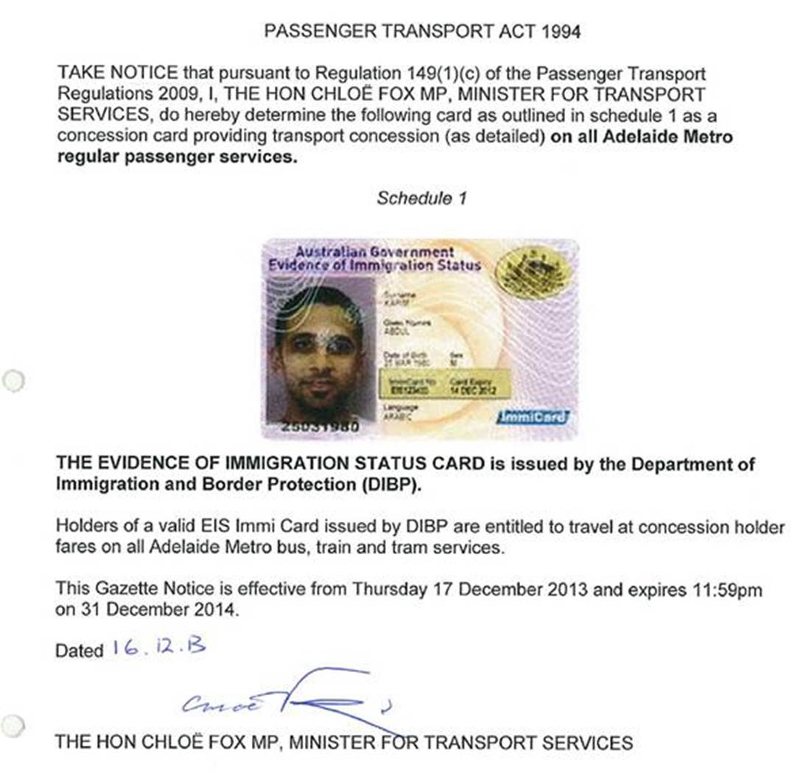
Schedule 1

Above example of the Evidence of Immigration Status card is issued by the Department of Immigration and Border Protection (DIBP).
Holders of an Australian Government Evidence of Immigration Status card (Immi Card) are entitled to travel at concessional fares on all Adelaide Metro bus, train and tram services.
Immi Cards are considered valid for the purposes of transport concessions regardless of expiry date.
Effective until 11.59 p.m. on 31 December 2015.
Dated 31 December 2014.
Stephen Mullighan, Minister for Transport and Infrastructure

A. MARTIN, Government Printer, South Australia

