No. 40 2323
SUPPLEMENTARY GAZETTE

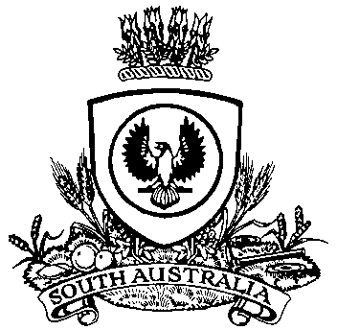

THE SOUTH AUSTRALIAN

GOVERNMENT GAZETTE
www.governmentgazette.sa.gov.au

PUBLISHED BY AUTHORITY

ALL PUBLIC ACTS appearing in this GAZETTE are to be considered official, and obeyed as such

ADELAIDE, THURSDAY, 5 JUNE 2014

MOTOR VEHICLE ACCIDENTS (LIFETIME SUPPORT SCHEME) ACT 2013
Notice of the 2014-2015 Lifetime Support Scheme Fund Levy Schedule
PURSUANT to Section 44 of the Motor Vehicle Accidents (Lifetime Support Scheme) Act 2013, I, Jack Snelling, Minister for Health, having determined, after consultation with the Treasurer and the Lifetime Support Authority, the scheme for the LSS Fund levy,
hereby give notice that the amounts in the schedule below are payable by all persons who apply for any of the following under the
Motor Vehicles Act 1959:
(a) the registration of a motor vehicle;
(b) an exemption from registration in respect of a motor vehicle;
(c) a permit in respect of a motor vehicle.
Dated 5 June 2014.
Jack Snelling, Minister for Health

A. MARTIN, Government Printer, South Australia

