No. 38 2201
EXTRAORDINARY GAZETTE

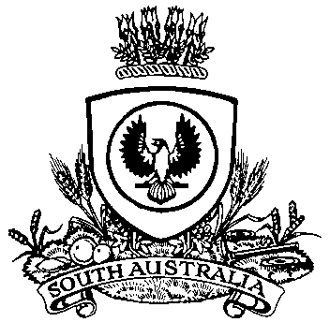

THE SOUTH AUSTRALIAN

GOVERNMENT GAZETTE
www.governmentgazette.sa.gov.au

PUBLISHED BY AUTHORITY

ALL PUBLIC ACTS appearing in this GAZETTE are to be considered official, and obeyed as such

ADELAIDE, THURSDAY, 29 MAY 2014

NATURAL RESOURCES MANAGEMENT ACT 2004
Notice of Contribution in 2014-2015 by Constituent Councils in the Adelaide and Mount Lofty Ranges Natural Resources Management Region
Erratum
IN Government Gazette No. 37, dated 29 May 2014, on page 2154, second notice appearing, because of a typographical error in the table, the correct notice should have read:
PURSUANT to Section 92 of the Natural Resources Management Act 2004, I, Ian Hunter, Minister for Sustainability, Environment and Conservation, having determined the shares of councils pursuant to subsection 92 (4) and having submitted them to the Governor pursuant to subsection 92 (6) and the Governor having approved those shares on 29 May 2014, hereby advise, pursuant to subsection 92 (7), that the shares of the constituent councils
in the Adelaide and Mount Lofty Ranges Natural Resources Management Region will be as follows:

Council | Contribution  $  2014-2015
Adelaide Hills Council | 807 204
Adelaide City Council | 1 375 619
Alexandrina Council | 148 023
The Barossa Council | 390 841
City of Burnside | 1 344 261
Campbelltown City Council | 893 418
City of Charles Sturt | 2 262 327
Town of Gawler | 296 805
Holdfast Bay City Council | 983 968
Light Regional Council | 285 802
District Council of Mallala | 149 414
Corporation of the City of Marion | 1 517 160
City of Mitcham | 1 357 751
District Council of Mount Barker | 90 263
City of Norwood, Payneham and St Peters | 1 014 587
City of Onkaparinga | 2 374 813
City of Playford | 929 851
City of Port Adelaide Enfield | 2 159 472
City of Prospect | 447 232
City of Salisbury | 1 693 565
City of Tea Tree Gully | 1 440 209
Corporation of the City of Unley | 1 089 620
City of Victor Harbor | 359 403
Corporation of the Town of Walkerville | 233 931
City of West Torrens | 1 196 573
District Council of Yankalilla | 172 888
Total | 25 015 000

Dated 29 May 2014.
Ian Hunter, Minister for Sustainability, Environment and Conservation

A. MARTIN, Government Printer, South Australia

