No. 83 6415



THE SOUTH AUSTRALIAN

GOVERNMENT GAZETTE
www.governmentgazette.sa.gov.au

PUBLISHED BY AUTHORITY

ALL PUBLIC ACTS appearing in this GAZETTE are to be considered official, and obeyed as such

ADELAIDE, THURSDAY, 13 NOVEMBER 2014

CONTENTS

Page
Appointments, Resignations, Etc. 6416
Associations Incorporation Act 1985—Notice 6416
Corporations and District Councils—Notices 6460
Development Act 1993—Notice 6417
Environment Protection Act 1993—Notice 6422
Fisheries Management Act 2007—Notices 6428
Genetically Modified Crops Management Act 2004—
Notices 6428
Mining Act 1971—Notices 6429
Motor Vehicles (Specified Event) Notice 2015—Notice 6431
National Electricity Law—Notice 6431
Petroleum and Geothermal Energy Act 2000—Notices 6431
Public Trustee Office—Administration of Estates 6460
REGULATIONS
Director of Public Prosecutions Act 1991
(No. 265 of 2014) 6439
Summary Offences Act 1953 (No. 266 of 2014) 6440
Page
REGULATIONS—continued
Southern State Superannuation Act 2009
(No. 267 of 2014) 6441
Liquor Licensing Act 1997—
(No. 268 of 2014) 6445
(No. 269 of 2014) 6447
Fisheries Management Act 2007—
(No. 270 of 2014) 6450
(No. 271 of 2014) 6456
Roads (Opening and Closing) Act 1991—Notice 6433
Sale of Property 6460
Shop Trading Hours Act 1977—Notice 6433
South Australian Co-operative and Community
Housing Act 1991—Notice 6433
South Australian Motor Sport Act 1984—Notices 6434
South Australian Motor Sport Regulations 2014—
Notice 6436

GOVERNMENT GAZETTE NOTICES
Notices for publication in the South Australian Government Gazette should be emailed to governmentgazette@dpc.sa.gov.au. Content should be sent as Word format attachment(s). Covering emails should include the date the notice is to be published and to whom the notice will be charged. Closing time for lodgement is 4 p.m. on the Tuesday preceding the regular Thursday publication. Gazette enquires to: Phone 8207 1045. The Government Gazette is available online at: www.governmentgazette.sa.gov.au.

Department of the Premier and Cabinet
Adelaide, 13 November 2014
HIS Excellency the Governor in Executive Council has been pleased to appoint the undermentioned to the South Australian Superannuation Board, pursuant to the provisions of the Superannuation Act 1988.
Deputy Member: (from 13 November 2014 until 11 July 2015)
John Robert Wright (Deputy to Black)
By command,
Antonio Piccolo, for Premier
T&F14/081CS

Department of the Premier and Cabinet
Adelaide, 13 November 2014
HIS Excellency the Governor in Executive Council has been pleased to appoint the undermentioned to the History Trust of South Australia, pursuant to the provisions of the History Trust of South Australia Act 1981:
Member: (from 13 November 2014 until 12 November 2015)
Susan Jane Crafter
Martin Read
Presiding Member: (from 13 November 2014 until 12 November 2015)
Susan Jane Crafter
By command,
Antonio Piccolo, for Premier
SACAB007/11

Department of the Premier and Cabinet
Adelaide, 13 November 2014
HIS Excellency the Governor in Executive Council has been pleased to appoint, by Notice in the Government Gazette the people listed in the attached Notice as Justices of the Peace for South Australia, upon the terms and conditions set out in the Notice, pursuant to Section 4 of the Justices of the Peace Act 2005.
Notice of Appointment of Justices of
The Peace for South Australia
Pursuant to Section 4 of the Justices of the Peace Act 2005
I, the Governor in Executive Council, hereby appoint the people listed as Justices of the Peace for South Australia for a period of ten years commencing from 13 November 2014 and expiring on 12 November 2024, it being a condition of appointment that the Justices of the Peace must take the oaths required of a Justice under the Oaths Act 1936 and return the oaths form to the Justice of the Peace Services within 3 months of the date of appointment.
Kent Ashley Andrew
Edward Stanley Avent
Peter David Bartlett
Rose-Marie Suzanne Berry
Peter Douglas Blacker
Rene Martin Borst
Scott Gibson Bradley
Rodney William Buckley
Lynda Jane Byrne
Peter Graham Cook
Michael Peter Corrieri
Neville Shane Dawson
Giuseppe Angelo De Ionno
Beverley Joyce Donaldson
Athanasios Economos
Brenden Doreen Faehrmann
Patricia Lea Favilla
Janice Dawn Ferguson
Rosa Lucia Gagetti
Dana Bridget Gibson
David John Gilbert
Peter Ralph Gill
Neville Roy Hailstone
Manule Harpas
Carolyn Ann Healey
Graham Robert Herrmann
Ian Thomas Kennedy
Anthony Simon Majstrenko
Elizabeth Joanne Malcolm
Patrick Geoffrey McEwen
Jennifer Anne Nosworthy
Jeanette Padman
Stephen Page
Richard Douglas Peat
Richard Alan Price
Brian Joseph Pumfrey
Mitchell Emile Rech
Morris William Rieger
Belinda Jane Robb
Geraldine Rohrle
Francescantonio Romano
Peter Upton Rundle
Marcia May Stewart
Desmond John David Trussell
John Joseph Wallace
Heather Anne Wehr
Ian James Wheller
Peter Raymond Noel Williams
Darrell Leslie Wise
By command,
Antonio Piccolo, for Premier
JP13/061CS

Department of the Premier and Cabinet
Adelaide, 13 November 2014
HIS Excellency the Governor in Executive Council has been pleased to appoint Professor Brenda Wilson, as Governor’s Deputy of South Australia for the period from 1 p.m. on Monday, 17 November 2014 until 10 a.m. on Tuesday, 18 November 2014.
By command,
Antonio Piccolo, for Premier

ASSOCIATIONS INCORPORATION ACT 1985
Deregistration of Associations
NOTICE is hereby given that the Corporate Affairs Commission approves the applications for deregistration received from the associations named below pursuant to Section 43A of the Associations Incorporation Act 1985. Deregistration takes effect on the date of publication of this notice.
Adelaide Plains Marketing Incorporated
African Seventh-Day Adventist Church Incorporated
Inner Wheel Club of Glenelg Incorporated
The Morgan/Cadell Tigers Sports Club Incorporated
Nu-Style Social Club Incorporated
Port Lincoln Civic Hall Management Board Incorporated
SA Independent Schools Targeted Programs Authority Incorporated
South Australian Anglican Schools Commission Incorporated
The Eleventh Ionian Convention Adelaide Incorporated
Torrens Resilience Institute Incorporated
Rotary Club of Adelaide East Incorporated
Rotary Club of Marion Incorporated
SA Health and Community Services Skills Board Incorporated
Given at Adelaide, 11 November 2014.
S. J. Pagliarulo, a Delegate of the Corporate Affairs Commission

DEVELOPMENT ACT 1993, SECTION 29 (2) (b) (ii): AMENDMENT TO THE KANGAROO ISLAND COUNCIL
DEVELOPMENT PLAN
Preamble
It is necessary to correct errors within the Kangaroo Island Council Development Plan dated 26 June 2014.
Notice
PURSUANT to Section 29 (2) (b) (i) of the Development Act 1993, I amend the Kangaroo Island Council Development Plan dated 26 June 2014, as follows:
(a) Replace Zone Map KI/7, Policy Area Map KI/7, Zone Map KI/38 and Precinct Map KI/38 with the contents of ‘Attachment A’:
(b) Fix the day on which this notice is published in the Gazette as the day on which the Amendment will come into operation.
Dated 10 November 2014.
Chris Zafiropoulos, General Manager Planning Statutory Planning—
Development Division, Department of Planning, Transport and
Infrastructure as Delegate of John Rau, Minister for Planning

Attachment A

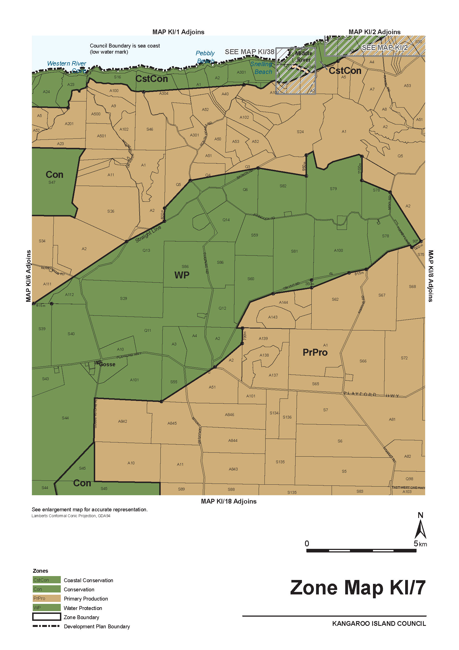
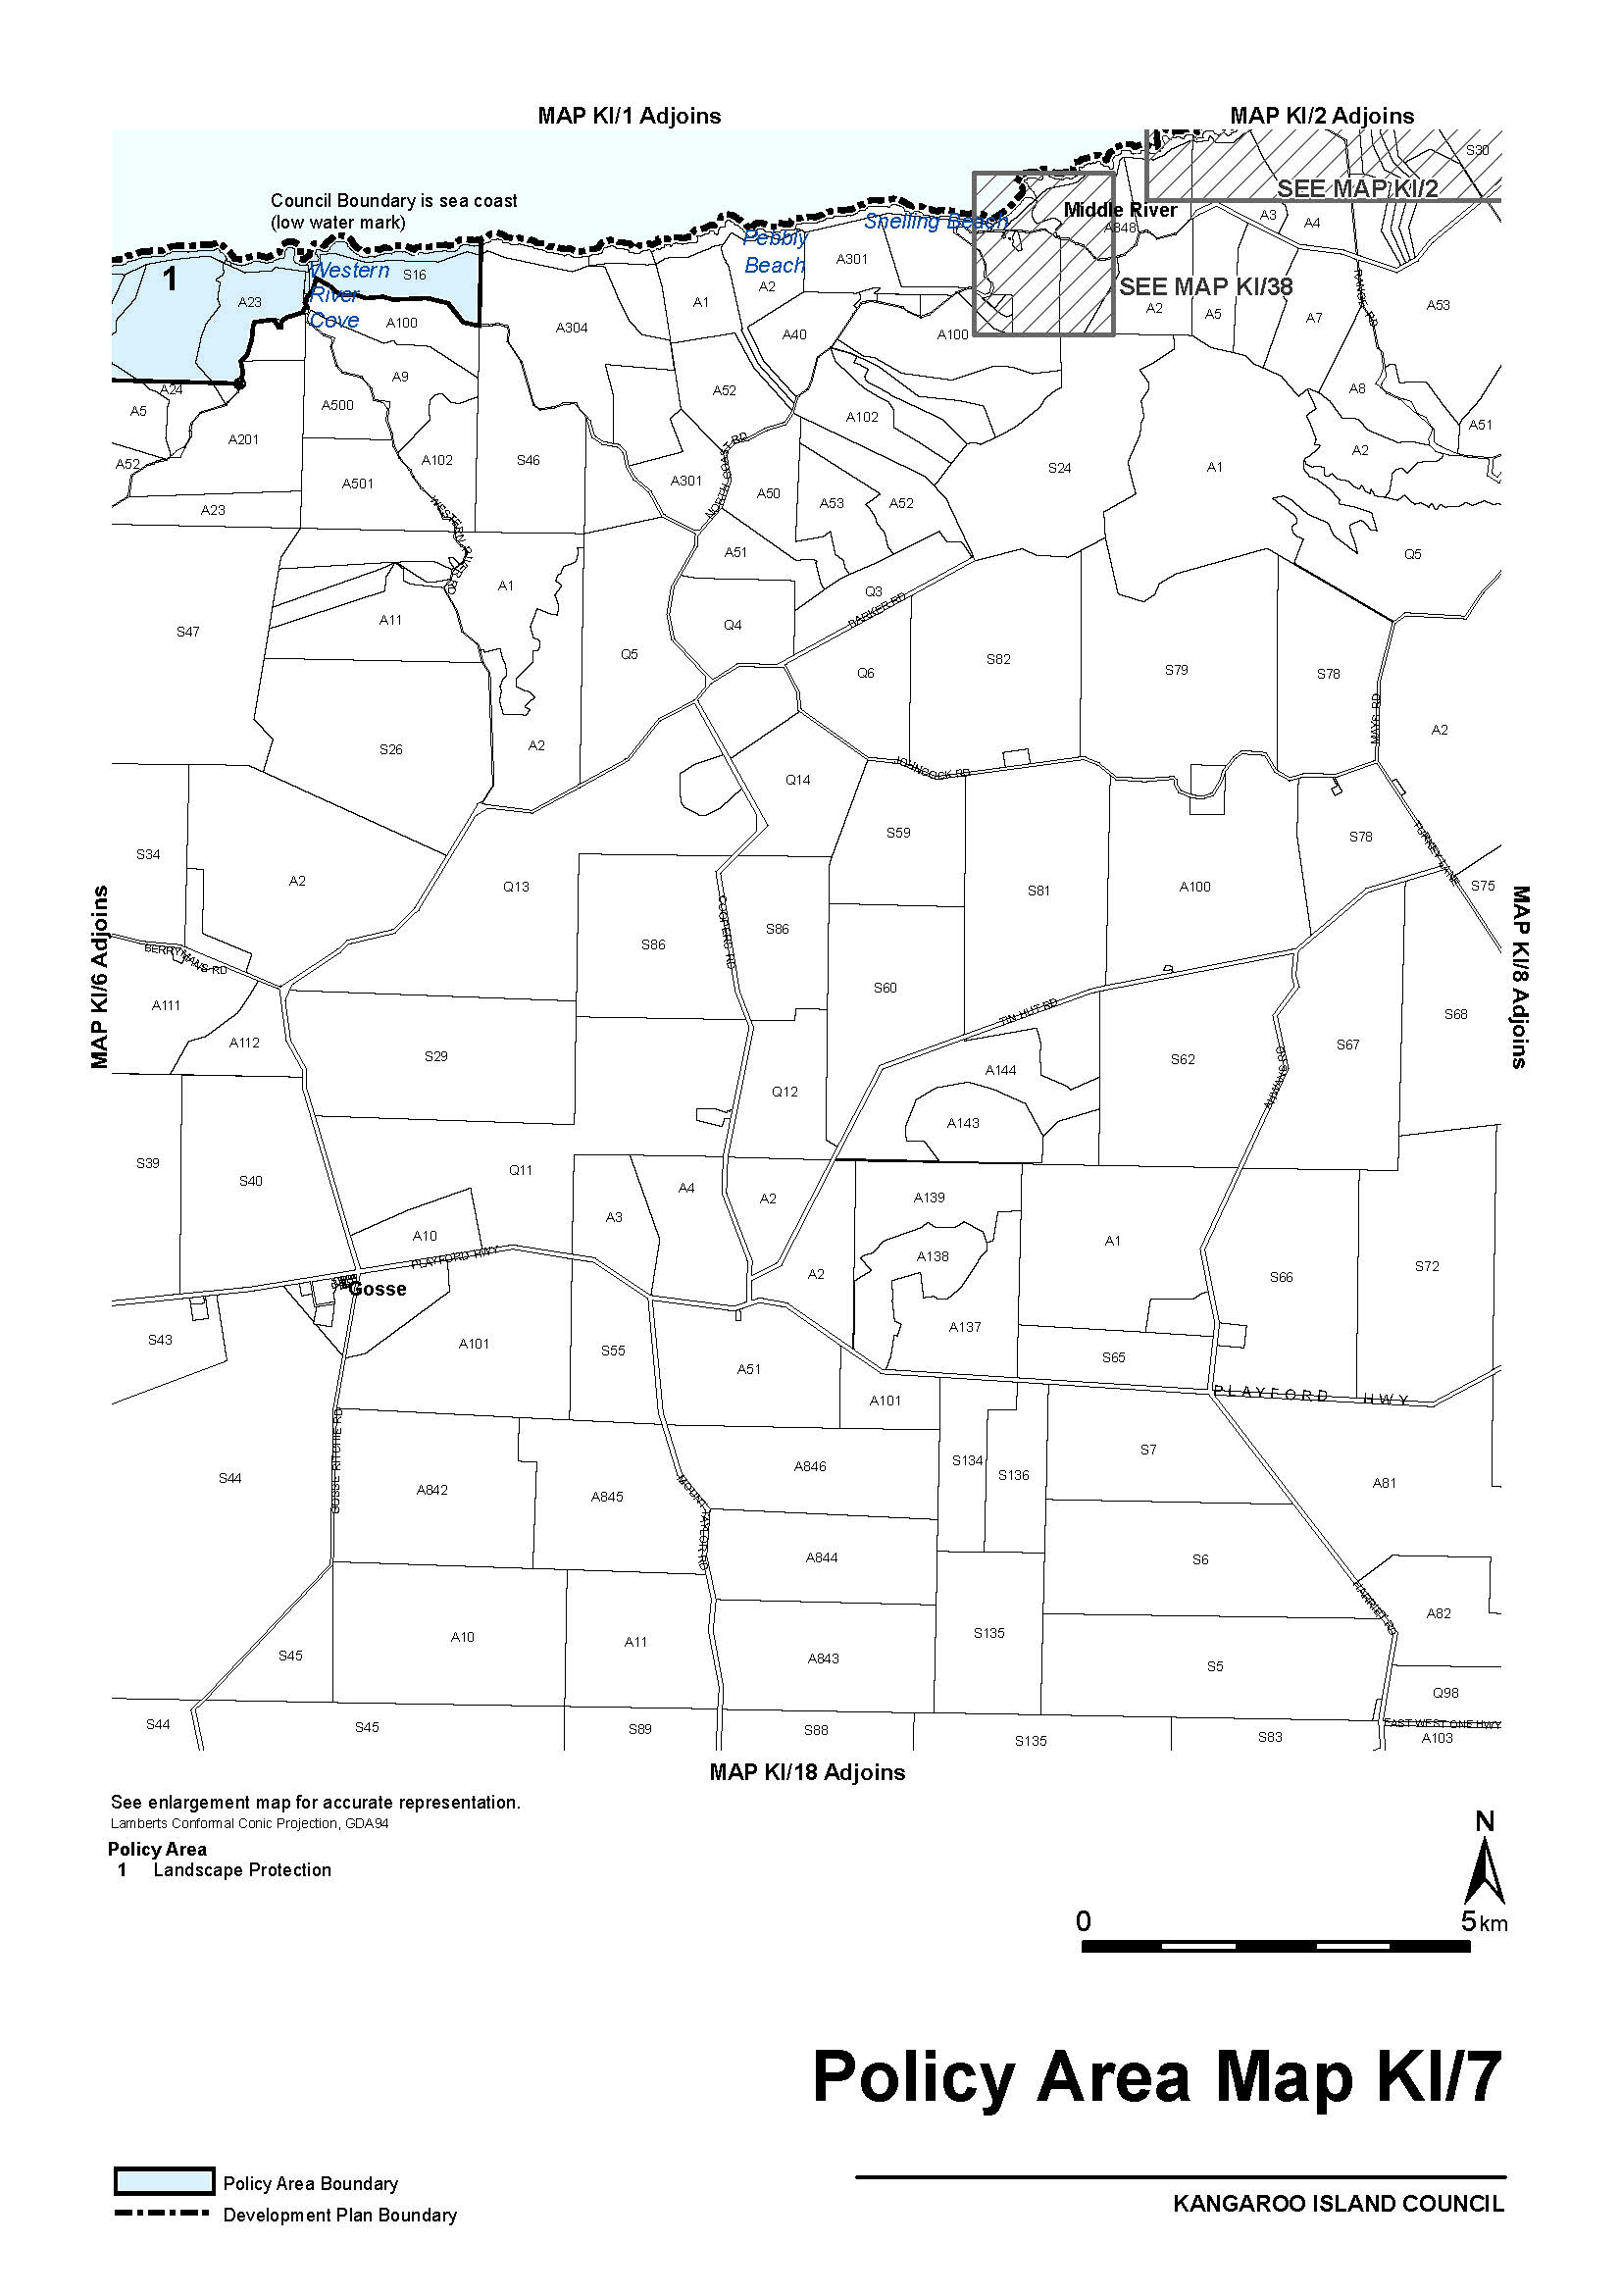
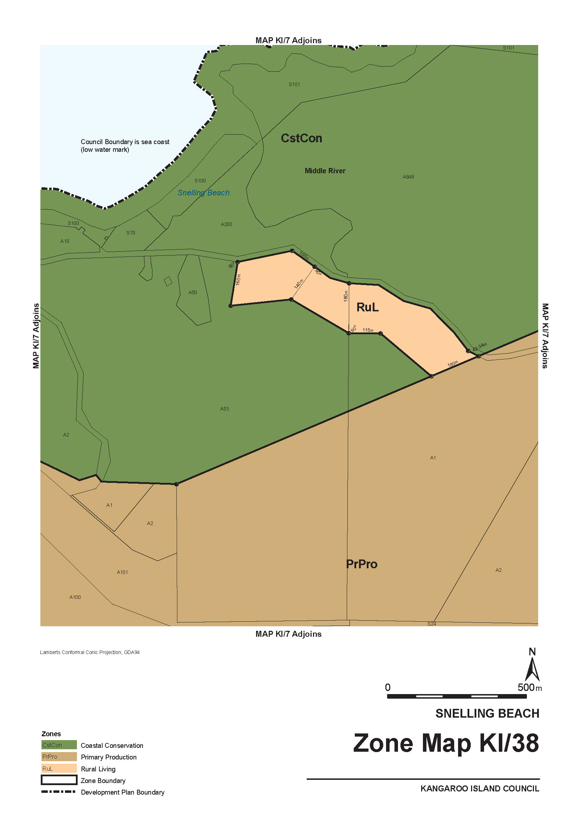
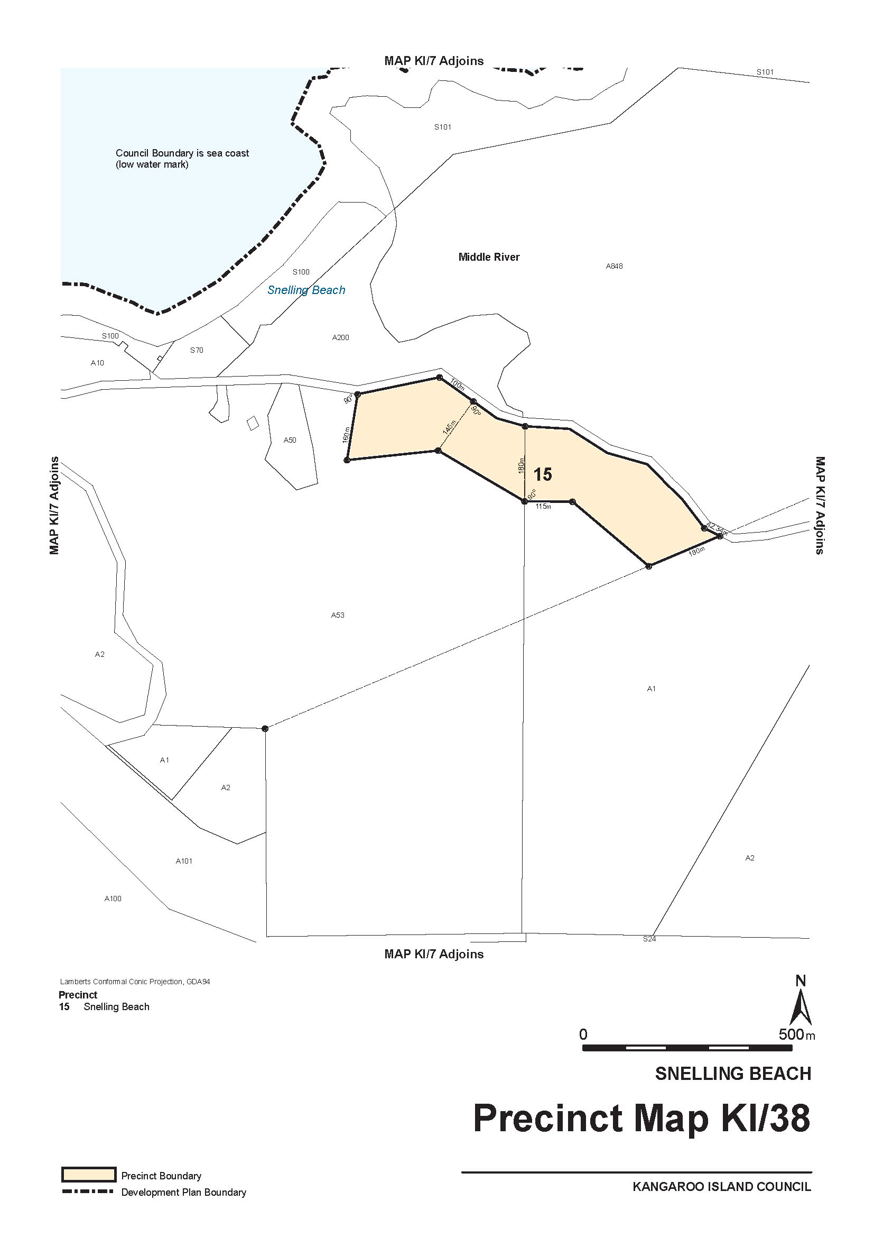

ENVIRONMENT PROTECTION ACT 1993
Approval of Category B Containers
I, ANDREA KAYE WOODS, Team Leader, Container Deposit Legislation and Delegate of the Environment Protection Authority (‘the Authority’), pursuant to Section 68 of the Environment Protection Act 1993 (SA) (‘the Act’) hereby:
Approval of Category B Containers
Approve as Category B Containers, subject to the conditions in subclauses 1, 2, 3 and 4 below, each of the classes of containers identified by reference to the following matters described in the first 4 columns of Schedule 1 of this Notice which are sold in South Australia:
(a) the product which each class of containers shall contain;
(b) the size of the containers;
(c) the type of containers;
(d) the name of the holders of these approvals.
(1) That containers of the class to which the approval relates must bear the refund marking specified by the Authority for containers of that class. The Authority specifies the following refund markings for Category B containers:
(i) ‘10c refund at collection depots when sold in S.A.’, or
(ii) ‘10c refund at S.A./N.T. collection depots in State/Territory of purchase’.
(2) The holder of the approval must have in place an effective and appropriate waste management arrangement in relation to containers of that class. For the purpose of this approval notice the company named in Column 5 of Schedule 1 of this Notice is the nominated super collector.
(3) In the case of an approval in relation to Category B containers that the waste management arrangement must require the holder of the approval to provide specified super collectors with a declaration in the form determined by the Authority in relation to each sale of such containers by the holder of the approval as soon as practicable after the sale.
(4) The holder of these approvals must ensure that if a sticker bearing the refund marking has been approved, and is applied to the container, then the sticker must not be placed on any portion of the opening mechanism or in any other place that would require complete or partial removal of the sticker before the contents may be consumed.
Schedule

Column 1 | Column 2 | Column 3 | Column 4 | Column 5
Product Name | Container Size (mL) | Container Type | Approval Holder | Collection Arrangements
Merito Organic Coconut Water | 520 | Can—Steel | 50 Upmarket Pty Ltd | Statewide Recycling
Norda Frizzante | 750 | Glass | Alessi Beverages Pty Ltd | Statewide Recycling
Norda Naturale | 750 | Glass | Alessi Beverages Pty Ltd | Statewide Recycling
Cricketers Arms Captains IPA | 330 | Glass | Asahi Premium Beverages | Statewide Recycling
Cricketers Arms Spearhead Pale Ale | 330 | Glass | Asahi Premium Beverages | Statewide Recycling
Certified Organic Coconut Water Island Republic | 200 | Glass | Awthentik foods Pty Ltd | Statewide Recycling
Coco Shake With Fresh Mango Juice | 200 | Glass | Awthentik foods Pty Ltd | Statewide Recycling
Coco Shake With Fresh Papaya Juice | 200 | Glass | Awthentik foods Pty Ltd | Statewide Recycling
Coco Shake With Fresh Pineapple Juice | 200 | Glass | Awthentik foods Pty Ltd | Statewide Recycling
Cascade Lemon Lime & Bitters | 200 | Can—Aluminium | Coca Cola Amatil (Aust.) Pty Ltd | Statewide Recycling
Absolute Organic Coconut Water | 330 | LPB—Aseptic | Costco Wholesale Australia Pty Ltd | Statewide Recycling
Angostura Lemon Lime Bitters | 300 | Can—Aluminium | Costco Wholesale Australia Pty Ltd | Statewide Recycling
Angostura Lemon Lime Bitters | 330 | Glass | Costco Wholesale Australia Pty Ltd | Statewide Recycling
Aussie Bodies Protein Revival Chocolate | 375 | LPB—Aseptic | Costco Wholesale Australia Pty Ltd | Statewide Recycling
Boost Energy Lift Multi | 350 | PET | Costco Wholesale Australia Pty Ltd | Statewide Recycling
Boost Supafruit Immune | 350 | PET | Costco Wholesale Australia Pty Ltd | Statewide Recycling
Boost Wildberry Skinny | 350 | PET | Costco Wholesale Australia Pty Ltd | Statewide Recycling
Bundaberg Diet Ginger Beer | 340 | Glass | Costco Wholesale Australia Pty Ltd | Statewide Recycling
Bundaberg Ginger Beer | 375 | Glass | Costco Wholesale Australia Pty Ltd | Statewide Recycling
Bundaberg Lemon Lime Bitters | 340 | Glass | Costco Wholesale Australia Pty Ltd | Statewide Recycling
Devondale Moo Chocolate Milk | 200 | LPB—Aseptic | Costco Wholesale Australia Pty Ltd | Statewide Recycling
Devondale Smoothies Berry Mix | 200 | LPB—Aseptic | Costco Wholesale Australia Pty Ltd | Statewide Recycling
Extra Juicy Apple Juice | 250 | PET | Costco Wholesale Australia Pty Ltd | Statewide Recycling
Foco Coconut Water | 330 | LPB—Aseptic | Costco Wholesale Australia Pty Ltd | Statewide Recycling
Foco Coconut Water Lychee | 330 | LPB—Aseptic | Costco Wholesale Australia Pty Ltd | Statewide Recycling
Foco Coconut Water Mango | 330 | LPB—Aseptic | Costco Wholesale Australia Pty Ltd | Statewide Recycling
Foco Coconut Water Pineapple | 330 | LPB—Aseptic | Costco Wholesale Australia Pty Ltd | Statewide Recycling
Foco Coconut Water Pink Guava | 330 | LPB—Aseptic | Costco Wholesale Australia Pty Ltd | Statewide Recycling
Golden Circle Golden Pash | 250 | LPB—Aseptic | Costco Wholesale Australia Pty Ltd | Statewide Recycling
Golden Circle Pine Orange | 250 | LPB—Aseptic | Costco Wholesale Australia Pty Ltd | Statewide Recycling
Golden Circle Tropical Punch | 250 | LPB—Aseptic | Costco Wholesale Australia Pty Ltd | Statewide Recycling
Harvey Fresh Orange Juice | 250 | LPB—Aseptic | Costco Wholesale Australia Pty Ltd | Statewide Recycling
Just Delicious 100% Apple | 375 | PET | Costco Wholesale Australia Pty Ltd | Statewide Recycling
Just Delicious Purify Mix Fruit | 375 | PET | Costco Wholesale Australia Pty Ltd | Statewide Recycling
Kirkland Signature Organic Lemonade | 2 840 | PET | Costco Wholesale Australia Pty Ltd | Statewide Recycling
Ocean Spray Cranberry Juice | 2 830 | PET | Costco Wholesale Australia Pty Ltd | Statewide Recycling
Ocean Spray Ruby Red Grapefruit | 2 830 | PET | Costco Wholesale Australia Pty Ltd | Statewide Recycling
Paldo Aloe Vera Drink | 1 500 | PET | Costco Wholesale Australia Pty Ltd | Statewide Recycling
Pop Tops Apple & Blackcurrant | 250 | PET | Costco Wholesale Australia Pty Ltd | Statewide Recycling
Pop Tops Apple Drink | 250 | PET | Costco Wholesale Australia Pty Ltd | Statewide Recycling
Preshafruit 100% Pure Coconut Water | 350 | PET | Costco Wholesale Australia Pty Ltd | Statewide Recycling
Prolive Probiotic Drink | 63 | PET | Costco Wholesale Australia Pty Ltd | Statewide Recycling
Sanitarium Up & Go Chocolate | 250 | LPB—Aseptic | Costco Wholesale Australia Pty Ltd | Statewide Recycling
Sanitarium Up & Go Vanilla | 250 | LPB—Aseptic | Costco Wholesale Australia Pty Ltd | Statewide Recycling
Sanpellegrino Aranciata Rossa Blood Orange | 330 | Can—Aluminium | Costco Wholesale Australia Pty Ltd | Statewide Recycling
Sanpellegrino Sparkling Mineral Water | 500 | Glass | Costco Wholesale Australia Pty Ltd | Statewide Recycling
Sanpellegrino Sparkling Mineral Water | 750 | Glass | Costco Wholesale Australia Pty Ltd | Statewide Recycling
V Energy Drink | 250 | Can—Aluminium | Costco Wholesale Australia Pty Ltd | Statewide Recycling
Lick Pier Ginger Beer | 330 | Glass | East 9th Brewing | Statewide Recycling
Mela Rossa Italian Apple Cider | 330 | Glass | Festival City Wines & Spirits Pty Ltd | Statewide Recycling
Peroncino | 250 | Glass | Festival City Wines & Spirits Pty Ltd | Statewide Recycling
Orangina Sparkling Orange Juice | 330 | Glass | Frucor Beverages Australia Pty Ltd | Statewide Recycling
Doubia Sparkling Natural Mineral Water | 750 | Glass | Gaganis Bros | Statewide Recycling
Doubia Sparkling Natural Mineral Water | 330 | Glass | Gaganis Bros | Statewide Recycling
Jayhoon Yogurt Drink | 1 500 | PET | Jayhoon Innovative Food | Statewide Recycling
Jayhoon Yogurt Drink | 350 | PET | Jayhoon Innovative Food | Statewide Recycling
Jayhoon Yogurt Drink | 600 | PET | Jayhoon Innovative Food | Statewide Recycling
Lobo Trad | 330 | Glass | Lobo Juice & Cider Pty Ltd | Marine Stores Ltd
Cocobella Kids Berry | 200 | LPB—Aseptic | Made (Aust.) Pty Ltd | Statewide Recycling
Cocobella Kids Tropical | 200 | LPB—Aseptic | Made (Aust.) Pty Ltd | Statewide Recycling
Cocobella Straight Up | 500 | LPB—Aseptic | Made (Aust.) Pty Ltd | Statewide Recycling
Cocobella Straight Up | 250 | LPB—Aseptic | Made (Aust.) Pty Ltd | Statewide Recycling
Retro Creaming Soda | 375 | Glass | Metro Beverage Company Adelaide Pty Ltd | Statewide Recycling
Retro Lemon Lime | 375 | Glass | Metro Beverage Company Adelaide Pty Ltd | Statewide Recycling
Retro Lemon Squash | 375 | Glass | Metro Beverage Company Adelaide Pty Ltd | Statewide Recycling
Retro Lime Quench | 375 | Glass | Metro Beverage Company Adelaide Pty Ltd | Statewide Recycling
Retro Passion Fruit | 375 | Glass | Metro Beverage Company Adelaide Pty Ltd | Statewide Recycling
Retro Portello | 375 | Glass | Metro Beverage Company Adelaide Pty Ltd | Statewide Recycling
Retro Raspberry | 375 | Glass | Metro Beverage Company Adelaide Pty Ltd | Statewide Recycling
Mismatch Brewing Co Paddys Irish Coffee Milk Stout | 640 | Glass | Mismatch Brewing Company | Marine Stores Ltd
Bjorn to Boogie Watermelon Weizen | 330 | Glass | Moon Dog Brewing Pty Ltd | Marine Stores Ltd
Black Lung IV American Oak Aged Smokey Stout | 330 | Glass | Moon Dog Brewing Pty Ltd | Marine Stores Ltd
Henry Fords Girthsome Fjord Bulgo American India Brown Ale | 330 | Glass | Moon Dog Brewing Pty Ltd | Marine Stores Ltd
Jukebox Hero IPA | 330 | Glass | Moon Dog Brewing Pty Ltd | Marine Stores Ltd
Jumping The Shark 2014 Hungarian Oak Barrel Aged Saffrond Imeprial Red Ale | 375 | Glass | Moon Dog Brewing Pty Ltd | Marine Stores Ltd
Love Tap Double Lager | 330 | Glass | Moon Dog Brewing Pty Ltd | Marine Stores Ltd
Mr Mistoffelees Passion Fruit & Mango Wild Ale | 330 | Glass | Moon Dog Brewing Pty Ltd | Marine Stores Ltd
Acqua Panna | 1 000 | PET | Rio Coffee Pty Ltd | Statewide Recycling
San Pellegrino Sparkling Natural Mineral Water | 1 000 | PET | Rio Coffee Pty Ltd | Statewide Recycling
Sanpellegrino Pompelmo Sparkling Grapefruit | 330 | Can—Aluminium | Rio Coffee Pty Ltd | Statewide Recycling
Sanitarium Reduced Sugar Up & Go Liquid Breakfast Choc Ice Flavour | 250 | LPB—Aseptic | Sanitarium Health & Wellbeing Food Company | Statewide Recycling
Sanitarium Reduced Sugar Up & Go Liquid Breakfast Vanilla Ice Flavour | 250 | LPB—Aseptic | Sanitarium Health & Wellbeing Food Company | Statewide Recycling
Cool Ridge Australian Spring Water | 1 000 | PET | Schweppes Australia Pty Ltd | Statewide Recycling
Sealand Birk Blueberry | 330 | PET | Ten Acre Trading | Statewide Recycling
Sealand Birk Elderflower | 330 | PET | Ten Acre Trading | Statewide Recycling
Sealand Birk Ginger & Lime | 330 | PET | Ten Acre Trading | Statewide Recycling
Sealand Birk Original | 330 | PET | Ten Acre Trading | Statewide Recycling
Sealand Birk Original Carbonated | 250 | Can—Aluminium | Ten Acre Trading | Statewide Recycling
Sealand Birk Raspberry | 330 | PET | Ten Acre Trading | Statewide Recycling
StrangeLove Blood Orange | 275 | Glass | Ten Acre Trading | Statewide Recycling
StrangeLove Cola | 275 | Glass | Ten Acre Trading | Statewide Recycling
StrangeLove Ginger Beer | 275 | Glass | Ten Acre Trading | Statewide Recycling
StrangeLove Grapefruit | 275 | Glass | Ten Acre Trading | Statewide Recycling
Lete Effervescent Ground Water | 750 | Glass | Tricolore Imports Pty Ltd | Statewide Recycling
Vitamin Fix | 150 | Glass | Vitamin Fix | Statewide Recycling

GOVERNMENT GAZETTE ADVERTISEMENT RATES

To apply from 1 July 2014

$  Agents, Ceasing to Act as 49.75  Associations:  Incorporation 25.25  Intention of Incorporation 62.50  Transfer of Properties 62.50  Attorney, Appointment of 49.75  Bailiff’s Sale 62.50  Cemetery Curator Appointed 36.75  Companies:  Alteration to Constitution 49.75  Capital, Increase or Decrease of 62.50  Ceasing to Carry on Business 36.75  Declaration of Dividend 36.75  Incorporation 49.75  Lost Share Certificates:  First Name 36.75  Each Subsequent Name 12.70  Meeting Final 41.50  Meeting Final Regarding Liquidator’s Report on  Conduct of Winding Up (equivalent to ‘Final  Meeting’)  First Name 49.75  Each Subsequent Name 12.70  Notices:  Call 62.50  Change of Name 25.25  Creditors 49.75  Creditors Compromise of Arrangement 49.75  Creditors (extraordinary resolution that ‘the Com-pany be wound up voluntarily and that a liquidator be appointed’) 62.50  Release of Liquidator⎯Application⎯Large Ad. 99.00  ⎯Release Granted 62.50  Receiver and Manager Appointed 57.00  Receiver and Manager Ceasing to Act 49.75  Restored Name 46.50  Petition to Supreme Court for Winding Up 86.50  Summons in Action 73.50  Order of Supreme Court for Winding Up Action 49.75  Register of Interests⎯Section 84 (1) Exempt 111.00  Removal of Office 25.25  Proof of Debts 49.75  Sales of Shares and Forfeiture 49.75  Estates:  Assigned 36.75  Deceased Persons⎯Notice to Creditors, etc. 62.50  Each Subsequent Name 12.70  Deceased Persons⎯Closed Estates 36.75  Each Subsequent Estate 1.65  Probate, Selling of 49.75  Public Trustee, each Estate 12.70 |  | $  Firms:  Ceasing to Carry on Business (each insertion) 33.00  Discontinuance Place of Business 33.00  Land⎯Real Property Act:  Intention to Sell, Notice of 62.50  Lost Certificate of Title Notices 62.50  Cancellation, Notice of (Strata Plan) 62.50  Mortgages:  Caveat Lodgement 25.25  Discharge of 26.50  Foreclosures 25.25  Transfer of 25.25  Sublet 12.70  Leases⎯Application for Transfer (2 insertions) each 12.70  Lost Treasury Receipts (3 insertions) each 36.75  Licensing 73.50  Municipal or District Councils:  Annual Financial Statement⎯Forms 1 and 2 695.00  Electricity Supply⎯Forms 19 and 20 494.00  Default in Payment of Rates:  First Name 99.00  Each Subsequent Name 12.70  Noxious Trade 36.75  Partnership, Dissolution of 36.75  Petitions (small) 25.25  Registered Building Societies (from Registrar-General) 25.25  Register of Unclaimed Moneys⎯First Name 36.75  Each Subsequent Name 12.70  Registers of Members⎯Three pages and over:  Rate per page (in 8pt) 316.00  Rate per page (in 6pt) 418.00  Sale of Land by Public Auction 63.00  Advertisements 3.50  ¼ page advertisement 147.00  ½ page advertisement 295.00  Full page advertisement 577.00  Advertisements, other than those listed are charged at $3.50 per column line, tabular one-third extra.  Notices by Colleges, Universities, Corporations and District Councils to be charged at $3.50 per line.  Where the notice inserted varies significantly in length from that which is usually published a charge of $3.50 per column line will be applied in lieu of advertisement rates listed.  South Australian Government publications are sold on the condition that they will not be reproduced without prior permission from the Government Printer.
All the above prices include GST

GOVERNMENT GAZETTE NOTICES
Notices for publication in the South Australian Government Gazette should be emailed to governmentgazette@dpc.sa.gov.au. Content should be sent as Word format attachment(s). Covering emails should include the date the notice is to be published and to whom the notice will be charged. Closing time for lodgement is 4 p.m. on the Tuesday preceding the regular Thursday publication. Gazette enquiries to: Phone 8207 1045. The Government Gazette is available online at: www.governmentgazette.sa.gov.au.

MISCELLANEOUS LEGISLATION AND GOVERNMENT PUBLICATIONS PRICES AS FROM 1 JULY 2014

Acts, Bills, Rules, Parliamentary Papers and Regulations
Pages | Main | Amends | Pages | Main | Amends

1-16 | 3.10 | 1.45 | 497-512 | 42.00 | 41.00
17-32 | 4.00 | 2.50 | 513-528 | 43.25 | 41.75
33-48 | 5.30 | 3.75 | 529-544 | 44.75 | 43.25
49-64 | 6.70 | 5.15 | 545-560 | 46.00 | 44.75
65-80 | 7.75 | 6.45 | 561-576 | 47.00 | 46.00
81-96 | 9.05 | 7.50 | 577-592 | 48.75 | 46.50
97-112 | 10.30 | 8.85 | 593-608 | 50.00 | 48.00
113-128 | 11.50 | 10.20 | 609-624 | 51.00 | 49.75
129-144 | 12.90 | 11.40 | 625-640 | 52.00 | 50.50
145-160 | 14.20 | 12.70 | 641-656 | 53.50 | 52.00
161-176 | 15.40 | 14.00 | 657-672 | 54.50 | 52.50
177-192 | 16.80 | 15.20 | 673-688 | 56.00 | 54.50
193-208 | 18.10 | 16.70 | 689-704 | 57.00 | 55.00
209-224 | 19.10 | 17.70 | 705-720 | 58.50 | 56.50
225-240 | 20.40 | 18.90 | 721-736 | 60.00 | 57.50
241-257 | 22.00 | 20.00 | 737-752 | 60.50 | 59.00
258-272 | 23.20 | 21.20 | 753-768 | 62.50 | 60.00
273-288 | 24.30 | 23.00 | 769-784 | 63.50 | 62.50
289-304 | 25.50 | 23.90 | 785-800 | 64.50 | 63.50
305-320 | 27.00 | 25.25 | 801-816 | 66.00 | 64.00
321-336 | 28.00 | 26.50 | 817-832 | 67.50 | 66.00
337-352 | 29.50 | 27.75 | 833-848 | 69.00 | 67.50
353-368 | 30.25 | 29.25 | 849-864 | 70.00 | 68.50
369-384 | 32.00 | 30.25 | 865-880 | 71.50 | 70.00
385-400 | 33.50 | 31.75 | 881-896 | 72.00 | 70.50
401-416 | 34.75 | 32.75 | 897-912 | 73.50 | 72.00
417-432 | 36.00 | 34.50 | 913-928 | 74.00 | 73.50
433-448 | 37.00 | 35.75 | 929-944 | 75.50 | 74.00
449-464 | 38.00 | 36.50 | 945-960 | 76.50 | 75.00
465-480 | 38.50 | 37.75 | 961-976 | 80.00 | 76.00
481-496 | 41.00 | 38.50 | 977-992 | 81.00 | 76.50

Legislation—Acts, Regulations, etc.: $
Subscriptions:
Acts 259.00
All Bills as Laid 623.00
Rules and Regulations 623.00
Parliamentary Papers 623.00
Bound Acts 288.00
Index 144.00
Government Gazette
Copy 6.85
Subscription 344.00
Hansard
Copy 18.90
Subscription—per session (issued weekly) 539.00
Cloth bound—per volume 232.00
Subscription—per session (issued daily) 539.00
Legislation on Disk
Whole Database 3 999.00
Annual Subscription for fortnightly updates 1 229.00
Individual Act(s) including updates POA
Notice of Vacancies
Annual Subscription 195.00
Compendium
Subscriptions:
New Subscriptions 2 368.00
Updates 836.00
(All the above prices include GST)

Counter Sales Government Legislation Outlet
and Mail Orders: Service SA Customer Service Centre,
Ground Floor—EDS Centre, 108 North Terrace, Adelaide, S.A. 5000
Phone: 13 23 24 (local call cost), Fax: (08) 8204 1909
Postal: G.P.O. Box 1707, Adelaide, S.A. 5001

Online Shop: www.shop.service.sa.gov.au

Subscriptions and Government Publishing SA
Standing Orders: Plaza Level, Riverside Centre, North Terrace, Adelaide, S.A. 5000
Phone: (08) 8207 1043, (08) 8207 0908, Fax: (08) 8207 1040
Email: AdminGovPubSA@sa.gov.au

FISHERIES MANAGEMENT ACT 2007: SECTION 44
TAKE notice that pursuant to Section 44 (9) and (10) of the Fisheries Management Act 2007, I hereby declare that I have adopted the Management Plan for the South Australian Commercial Northern Zone Rock Lobster Fishery, to take effect on 14 November 2014.
Dated 11 November 2014.
Leon Bignell, Minister for Agriculture, Food and Fisheries

FISHERIES MANAGEMENT ACT 2007: SECTION 115
TAKE notice that pursuant to Section 115 of the Fisheries Management Act 2007 (‘the Act’), a registered master fishing pursuant to a Northern Zone Rock Lobster Fishery Licence (the ‘exemption holder’) is exempt from Regulation 7 and Clause 18 of Schedule 6 of the Fisheries Management (General) Regulations 2007, but only insofar as the exemption holder, or a person acting as their agent, may take Southern Rock Lobster (Jasus edwardsii) using rock lobster pots that do not have escape gaps (‘the exempted activity’), subject to the conditions in Schedule 1, during the period 1 November 2014 until 31 May 2015, unless varied or revoked earlier.
Schedule 1
1. A person fishing pursuant to a Northern Zone Rock Lobster Fishery Licence may only undertake the exempted activity when an employed independent observer is on board the boat and that observer is undertaking catch sampling for research purposes, in accordance with the agreement between the South Australian Northern Zone Rock Lobster Fishermen’s Association and SARDI Aquatic Sciences.
2. Data generated from the exempted activity must be forwarded directly to SARDI Aquatic Sciences. Data may not be copied or provided to additional parties.
3. The observers for the purpose of this exemption are limited to Asher Dezsery, 158 Dawkins Road, Lewiston, S.A. 5501; Grant Borlase, Unit 1/18 Normandy Place, Port Lincoln, S.A. 5606 and Matt Luers, 5 Kay Drive, Port Lincoln, S.A. 5606.
4. Only when an observer is on board a boat can the escape gaps on all rock lobster pots be closed.
5. All escape gaps must be opened as soon as the observer(s) leave the boat.
6. Before conducting the exempted activity, the exemption holder must contact the PIRSA Fishwatch on 1800 065 522 and answer a series of questions about the exempted activity. You will need to have a copy of your exemption with you at the time of making the call, and be able to provide the following details:
1. Name of the person making the call;
2. Licence number;
3. Name of the boat and its registration number;
4. The name of the Registered Master on board the boat;
5. Port of departure;
6. Number of days at sea; and
7. Exemption No. 9902746.
7. While engaged in the exempted activity, the exemption holder must have in their possession a copy of this notice and produce a copy of this notice if requested by a Fisheries Officer.
8. The exemption holder shall not contravene or fail to comply with the Fisheries Management Act 2007, or any regulations made under that Act, except where specifically exempted by this notice.
This notice does not purport to override the provisions or operation of any other Act including, but not limited to, the Marine Parks Act 2007. The exemption holder and his agents must comply with any relevant regulations, permits, requirements and directions from the Department of Environment, Water and Natural Resources when undertaking activities within a marine park.
Dated 27 October 2014.
S. Sloan, Director, Fisheries and Aquaculture Policy

FISHERIES MANAGEMENT ACT 2007: SECTION 115
TAKE notice that pursuant to Section 115 of the Fisheries Management Act 2007, the holder of a Northern Zone Rock Lobster Fishery licence issued pursuant to the Fisheries Management (Rock Lobster Fisheries) Regulations 2006, (the ‘exemption holders’) are exempted from the provisions of Regulation 4 the Fisheries Management (Vessel Monitoring Scheme) Regulations 2007, but only insofar as the exemption holder shall not be guilty of an offence when using a registered boat that is endorsed on the licence without a fitted and approved vessel monitoring unit (the ‘exempted activity’), subject to the conditions specified in Schedule 1, from 1 November 2014 until 31 May 2015, unless this notice is varied or revoked earlier.
Schedule 1
1. The registered boat used pursuant to this exemption must be 7.5 m or less in length.
2. The exemption holder may only conduct the exempted activity when fishing for species other than southern rock lobster (Jasus edwardsii) and giant crabs (Pseudocarinus gigas).
3. The exemption holder must ensure that only a master registered on their Northern Zone Rock Lobster Fishery Licence undertakes the exempted activity. Exemption No. 9902745.
4. The exemption holder must notify PIRSA Fisheries and Aquaculture by calling 1800 065 522 prior to engaging in the exempted activity and providing the following information:
• the name of the licence holder making the call;
• the fishery licence number of the licence on which the registered boat is endorsed;
• the name of the boat and the commercial boat registration number;
• the time and date the exempted activity will commence; and
• the time and date the exempted activity will cease.
5. An exemption holder must ensure that no rock lobster pots are on board the registered boat at any time during the exempted activity.
6. An exemption holder must not take or have on board the registered boat any rock lobster during the exempted activity.
7. An exemption holder must not contravene or fail to comply with the Fisheries Management Act 2007, or any other regulations made under that Act, except where specifically exempted by this notice.
This notice does not purport to override the provisions or operation of any other Act including, but not limited to, the Marine Parks Act 2007. The exemption holder and his agents must comply with any relevant regulations, permits, requirements and directions from the Department of Environment, Water and Natural Resources when undertaking activities within a marine park.
Dated 31 October 2014.
S. Sloan, Director, Fisheries and Aquaculture Policy

GENETICALLY MODIFIED CROPS MANAGEMENT
ACT 2004
Revocation of Exemptions
PURSUANT to Section 6 (5) (a) of the Genetically Modified Crops Management Act 2004 (‘the Act’), I, Leon Bignell, Minister for Agriculture, Food and Fisheries, revoke the following exemptions issued under the Act:
(1) Exemption issued to Bayer CropScience Pty Ltd pursuant to Section 6 (2) (a) (i) of the Act dated 1 July 2004;
(2) Exemption issued to Bayer CropScience Pty Ltd pursuant to Section 6 (2) (a) (i) of the Act dated 1 September 2005;
(3) Exemption issued to Nugrain Pty Ltd pursuant to Section
6 (2) (a) (ii) of the Act dated 30 November 2006;
(4) Exemption issued to Bayer CropScience Pty Ltd pursuant to Section 6 (2) (a) (i) of the Act dated 1 November 2007;
(5) Exemption issued to the University of Adelaide pursuant to Section 6 (2) (a) (i) of the Act dated 17 July 2008;
(6) Exemption issued to the University of Adelaide pursuant to Section 6 (2) (a) (ii) of the Act dated 27 August 2009; and
(7) Exemption issued to the University of Adelaide pursuant to Section 6 (2) (a) (ii) of the Act dated 25 August 2011.
Dated 28 October 2014.
Leon Bignell, Minister for Agriculture, Food and Fisheries

GENETICALLY MODIFIED CROPS MANAGEMENT
ACT 2004
Exemption Notice
PURSUANT to Section 6 (2) (a) (i) of the Genetically Modified Crops Management Act 2004, I, Leon Bignell, Minister for Agriculture Food and Fisheries, issue an exemption to the University of Adelaide for the purposes of experimental cultivation of genetically modified wheat and barley, in accordance with Licence DIR 128 and its variations as issued by the Office of the Gene Technology Regulator, subject to the following condition (in addition to the conditions of Licence DIR 128):
Plantings are to be confined to Glenthorne Farm, at O’Halloran Hill, in the Local Government area of Marion.
Before any planting the following information for each site must be provided to the Nominated Officer in PIRSA.
(a) the GPS co-ordinates to identify the perimeter of every area, using the GDA 94 datum (or nominated equivalent that allows conversion to this datum);
(b) the contact details of the landowner or his representative to enable authorised officers to seek consent to entry;
(c) identification of the GMO types proposed to be grown at the area, and the area of each that is to be sown; and
(d) estimated date of planting, flowering and harvest of the site.
For the purpose of this Notice, I nominate the following person as the Nominated Officer within PIRSA to whom communication should be directed:
Manager, Surveillance and Plant Pest Control
Biosecurity SA
Plant and Food Standards,
33 Flemington Street,
Glenside, S.A. 5065
Telephone: (08) 8207 7807
Facsimile: (08) 8207 7844
This Exemption remains in force until the termination of DIR 128, or until revoked.
Dated 31 October 2014.
Leon Bignell, Minister for Agriculture, Food and Fisheries

GENETICALLY MODIFIED CROPS MANAGEMENT
ACT 2004
Notice to Vary Exemption
PURSUANT to Section 6 (2) (a) (i) of the Genetically Modified Crops Management Act 2004, I, Leon Bignell MP, Minister for Agriculture Food and Fisheries, vary the exemption issued to the University of Adelaide under Section 6 (2) (a) (i) of the Act by notice published in the Government Gazette on 5 August 2010 (hereafter the Exemption Notice) by inserting the following condition:
Plantings are to be confined to Glenthorne Farm, at O’Halloran Hill, in the Local Government area of Marion.
Dated 31 October 2014.
Leon Bignell, Minister for Agriculture, Food and Fisheries

MINING ACT 1971
NOTICE is hereby given in accordance with Section 28 (5) of the Mining Act 1971, that the Minister for Mineral Resources and Energy proposes to grant an Exploration Licence over the undermentioned area:
Applicant: Rum Jungle Resources Ltd
Location: Lake Torrens 1 Area—approximately 55 km west-south-west of Leigh Creek.
Pastoral Leases: Witchelina, Beltana and Nilpena.
Term: 2 years
Area in km²: 880
Ref.: 2013/00215
Plan and co-ordinates can be found on the Department of State Development website: http://www.minerals.statedevelopment.sa.
gov.au/public_notices or by phoning Mineral Tenements on
(08) 8463 3103.
J. Martin, Mining Registrar

MINING ACT 1971
NOTICE is hereby given in accordance with Section 28 (5) of the Mining Act 1971, that the Minister for Mineral Resources and Energy proposes to grant an Exploration Licence over the undermentioned area:
Applicant: Rum Jungle Resources Ltd
Location: Lake Torrens 2 Area—approximately 80 km south-west of Leigh Creek.
Pastoral Lease: Motpena
Term: 2 years
Area in km²: 505
Ref.: 2013/00216
Plan and co-ordinates can be found on the Department of State Development website: http://www.minerals.statedevelopment.sa.
gov.au/public_notices or by phoning Mineral Tenements on
(08) 8463 3103.
J. Martin, Mining Registrar

MINING ACT 1971
NOTICE is hereby given in accordance with Section 28 (5) of the Mining Act 1971, that the Minister for Mineral Resources and Energy proposes to grant an Exploration Licence over the undermentioned area:
Applicant: Rum Jungle Resources Ltd
Location: Lake Frome South Area—approximately 130 km east-south-east of Leigh Creek.
Pastoral Leases: Wertaloona and Frome Downs.
Term: 2 years
Area in km²: 949
Ref.: 2014/00084
Plan and co-ordinates can be found on the Department of State Development website: http://www.minerals.statedevelopment.sa.
gov.au/public_notices or by phoning Mineral Tenements on
(08) 8463 3103.
J. Martin, Mining Registrar

MINING ACT 1971
NOTICE is hereby given in accordance with Section 28 (5) of the Mining Act 1971, that the Minister for Mineral Resources and Energy proposes to grant an Exploration Licence over the undermentioned area:
Applicant: Rum Jungle Resources Ltd
Location: Lake Frome Area—approximately 130 km east of Leigh Creek.
Term: 2 years
Area in km²: 995
Ref.: 2014/00085
Plan and co-ordinates can be found on the Department of State Development website: http://www.minerals.statedevelopment.sa.
gov.au/public_notices or by phoning Mineral Tenements on
(08) 8463 3103.
J. Martin, Mining Registrar

MINING ACT 1971
NOTICE is hereby given in accordance with Section 28 (5) of the Mining Act 1971, that the Minister for Mineral Resources and Energy proposes to grant an Exploration Licence over the undermentioned area:
Applicant: Rum Jungle Resources Ltd
Location: Lake Frome North Area—approximately 140 km east-north-east of Leigh Creek.
Pastoral Lease: Frome Downs
Term: 2 years
Area in km²: 774
Ref.: 2014/00086
Plan and co-ordinates can be found on the Department of State Development website: http://www.minerals.statedevelopment.sa.
gov.au/public_notices or by phoning Mineral Tenements on
(08) 8463 3103.
J. Martin, Mining Registrar

MINING ACT 1971
NOTICE is hereby given in accordance with Section 28 (5) of the Mining Act 1971, that the Minister for Mineral Resources and Energy proposes to grant an Exploration Licence over the undermentioned area:
Applicant: Rum Jungle Resources Ltd
Location: Lake Torrens South Area—approximately 110 km north of Port Augusta.
Term: 2 years
Area in km²: 736
Ref.: 2014/00089
Plan and co-ordinates can be found on the Department of State Development website: http://www.minerals.statedevelopment.sa.
gov.au/public_notices or by phoning Mineral Tenements on
(08) 8463 3103.
J. Martin, Mining Registrar

MINING ACT 1971
NOTICE is hereby given in accordance with Section 28 (5) of the Mining Act 1971, that the Minister for Mineral Resources and Energy proposes to grant an Exploration Licence over the undermentioned area:
Applicant: Rum Jungle Resources Ltd
Location: Lake Torrens North Area—approximately 25 km north-east of Andamooka.
Pastoral Lease: Mulgaria
Term: 2 years
Area in km²: 617
Ref.: 2014/00090
Plan and co-ordinates can be found on the Department of State Development website: http://www.minerals.statedevelopment.sa.
gov.au/public_notices or by phoning Mineral Tenements on
(08) 8463 3103.
J. Martin, Mining Registrar

MINING ACT 1971
NOTICE is hereby given in accordance with Section 28 (5) of the Mining Act 1971, that the Minister for Mineral Resources and Energy proposes to grant an Exploration Licence over the undermentioned area:
Applicant: Trafford Resources Limited
Location: Mount Christie Area—approximately 120 km north-west of Tarcoola.
Pastoral Leases: Mulgathing, Mobella and Commonwealth Hill.
Term: 2 years
Area in km²: 204
Ref.: 2014/00160
Plan and co-ordinates can be found on the Department of State Development website: http://www.minerals.statedevelopment.sa.
gov.au/public_notices or by phoning Mineral Tenements on
(08) 8463 3103.
J. Martin, Mining Registrar

MINING ACT 1971
NOTICE is hereby given in accordance with Section 28 (5) of the Mining Act 1971, that the Minister for Mineral Resources and Energy proposes to grant an Exploration Licence over the undermentioned area:
Applicant: OZ Minerals Prominent Hill Operations Pty Ltd
Location: Balta Baltana South Area—approximately 40, 80 and 90 km south-east of Coober Pedy.
Pastoral Leases: Anna Creek and McDouall Peak.
Term: 2 years
Area in km²: 86
Ref.: 2014/00212
Plan and co-ordinates can be found on the Department of State Development website: http://www.minerals.statedevelopment.sa.
gov.au/public_notices or by phoning Mineral Tenements on
(08) 8463 3103.
J. Martin, Mining Registrar

MINING ACT 1971
NOTICE is hereby given in accordance with Section 28 (5) of the Mining Act 1971, that the Minister for Mineral Resources and Energy proposes to grant an Exploration Licence over the undermentioned area:
Applicant: Marmota Energy Limited
Location: Moolawatana Area—approximately 180 km north-east of Leigh Creek.
Pastoral Leases: Moolawatana and Frome Downs.
Term: 2 years
Area in km²: 116
Ref.: 2014/00213
Plan and co-ordinates can be found on the Department of State Development website: http://www.minerals.statedevelopment.sa.
gov.au/public_notices or by phoning Mineral Tenements on
(08) 8463 3103.
J. Martin, Mining Registrar

MINING ACT 1971
NOTICE is hereby given in accordance with Section 28 (5) of the Mining Act 1971, that the Minister for Mineral Resources and Energy proposes to grant an Exploration Licence over the undermentioned area:
Applicant: OneSteel Manufacturing Pty Ltd
Location: Moonabie Area—approximately 100 km south-west of Port Augusta.
Term: 2 years
Area in km²: 155
Ref.: 2014/00215
Plan and co-ordinates can be found on the Department of State Development website: http://www.minerals.statedevelopment.sa.
gov.au/public_notices or by phoning Mineral Tenements on
(08) 8463 3103.
J. Martin, Mining Registrar

MOTOR VEHICLES (SPECIFIED EVENT) NOTICE 2015
PURSUANT to Regulation 25 (4) of the Motor Vehicles Regulations 2010.
1. Short title
This notice may be cited as the Motor Vehicles (Specified Event) Notice 2015.
2. Commencement
This notice will come into operation on the day it is published in the Government Gazette.
3. Specified event, period and conditions
In accordance with Regulation 25 (4) of the Motor Vehicles Regulations 2010, and with the concurrence of the Minister for Transport and Infrastructure (as the Minister responsible for the operation of the Motor Vehicles Act 1959), I, the Minister for Tourism:
(a) specify the Santos Tour Down Under as an event; and
(b) specify the period commencing at 12.01 a.m. on 3 January 2015 and ending at 11.58 p.m. on 31 January 2015 as the period during which motor vehicles approved by me may be driven, or caused to stand, on a road in relation to the Santos Tour Down Under; and
(c) specify that the following condition applies to driving such a motor vehicle, or causing such a motor vehicle to stand, on a road in relation to the Santos Tour Down Under:
All such vehicles must display number plate covers of a design approved by the Registrar of Motor Vehicles over their vehicle number plates at all times during the period specified in paragraph (b).
Dated 4 October 2014.
Leon Bignell, Minister for Tourism

NATIONAL ELECTRICITY LAW
THE Australian Energy Market Commission (AEMC) gives notice under the National Electricity Law as follows:
Under ss 102 and 103, the making of the National Electricity Amendment (Connecting Embedded Generators Under Chapter 5A) Rule 2014 No. 8 and related final determination. All provisions commence on 1 March 2015. Documents referred to above are available on the AEMC’s website and are available for inspection at the AEMC’s office.
Australian Energy Market Commission
Level 6, 201 Elizabeth Street
Sydney, N.S.W. 2000
Telephone: (02) 8296 7800
www.aemc.gov.au
13 November 2014.

PETROLEUM AND GEOTHERMAL ENERGY ACT 2000
Cessation of Suspension Petroleum Exploration Licence—
PEL 101
PURSUANT to Section 90 of the Petroleum and Geothermal Energy Act 2000, notice is hereby given that the suspension of PEL 101 dated 9 July 2014 has been ceased under the provisions of the Petroleum and Geothermal Energy Act 2000, with effect from 11 November 2014, pursuant to delegated powers dated 21 March 2012.
The expiry date of PEL 101 is now determined to be 18 March 2016.
Dated 10 November 2014.
B. A. Goldstein,
Executive Director,
Energy Resources Division,
Department of State Development,
Delegate of the Minister for Mineral
Resources and Energy

PETROLEUM AND GEOTHERMAL ENERGY ACT 2000
Statement of Environmental Objectives for Geophysical Activities in the Cooper Basin, South Australia
PURSUANT to Section 104 (1) of the Petroleum and Geothermal Energy Act 2000 (the Act), I, Barry Alan Goldstein, Executive Director, Energy Resources Division, Department of State Development (DSD), as delegate of the Minister for Mineral Resources and Energy, pursuant to delegated powers dated
21 March 2012, do hereby publish the following document as having been approved as a statement of environmental objectives under the Act.
Documents:
• Statement of environmental objectives for geophysical activities in the Cooper Basin, South Australia (November 2014).
This document is available for public inspection on the Environmental Register section of the Energy Resources Division’s website: (http://www.petroleum.statedevelopment.sa.
gov.au/environment/register) or at the Public Office determined pursuant to Section 107 (1) of the Act to be located at:
Energy Resources Division,
Customer Services,
Level 7,
101 Grenfell Street,
Adelaide, S.A. 5000
Dated 5 November 2014.
N. Panagopoulos,
for B. A. Goldstein,
Executive Director,
Energy Resources Division,
Mineral and Energy Resources Group,
Delegate of the Minister for Mineral
Resources and Energy

PETROLEUM AND GEOTHERMAL ENERGY ACT 2000
Surrender of Petroleum Exploration Licence—PEL 610
NOTICE is hereby given that I have accepted the surrender of the below mentioned petroleum exploration licence under the provisions of the Petroleum and Geothermal Energy Act 2000, pursuant to delegated powers dated 21 March 2012.
No. of  Licence | Licensee | Date of Surrender | Reference
PEL 610 | Dunstone | 5 November 2014 | F2012/000456

Dated 5 November 2014.
N. Panagopoulos,
Acting Executive Director,
Energy Resources Division,
Department of State Development,
Delegate of the Minister for Mineral Resources and Energy

ROADS (OPENING AND CLOSING) ACT 1991:
SECTION 24
NOTICE OF CONFIRMATION OF ROAD
PROCESS ORDER
Road Closure—McClaren Flat
BY Road Process Order made on 18 September 2014, the City of Onkaparinga ordered that:
1. The whole of the un-named public road situate southeast of McClaren Flat Road and adjoining Allotment 6 in Filed Plan 6691 and Pieces 104 and 105 in Deposited Plan 46346, more particularly delineated and lettered ‘A’ and ‘B’ respectively on the Preliminary Plan No. 14/0015 be closed.
2. Transfer the whole of the land subject to closure lettered ‘A’ to Kym George Sauerbier in accordance with the Agreement for Transfer dated 3 September 2014 entered into between the City of Onkaparinga and K. G. Sauerbier.
3. Transfer the whole of the land subject to closure lettered ‘B’ to Angelomaria Maglieri and Caterina Melva Maglieri in accordance with the Agreement for Transfer dated 5 September 2014 entered into between the City of Onkaparinga and A. and C. M. Maglieri.
On 11 November 2014 that order was confirmed by the Minister for Transport and Infrastructure conditionally upon the deposit by the Registrar-General of Deposited Plan 94972 being the authority for the new boundaries.
Pursuant to Section 24 (5) of the Roads (Opening and Closing) Act 1991, NOTICE of the order referred to above and its confirmation is hereby given.
Dated 13 November 2014.
M. P. Burdett, Surveyor-General

SHOP TRADING HOURS ACT 1977
Trading Hours—Exemption
NOTICE is hereby given that pursuant to Section 5 (9) (b) of the Shop Trading Hours Act 1977 (‘the Act’), I, John Rau, MP, Minister for Industrial Relations, do hereby declare non-exempt shops, excluding shops that are solely or predominantly the retail sale of motor vehicles or boats, situated within the Greater Adelaide Shopping District, exempt from the provisions of the Act subject to the following conditions:
• exemption will apply between the hours of:
o 9 a.m. and 11 a.m. on Sundays, 30 November,
7 December, 14 December, 21 December and
28 December 2014; and
o 9 p.m. and 12 midnight on Thursday, 18 December 2014, Friday, 19 December 2014 and Tuesday,
23 December 2014;
• normal trading hours prescribed by Section 13 of the Act shall apply at all other times;
• all employees working during these extended hours will do so on a strictly voluntary basis;
• any and all relevant industrial instruments are to be complied with; and
• all work health and safety issues (in particular those relating to extended trading hours) must be appropriately addressed.
Dated 10 November 2014.
John Rau, Deputy Premier, Minister for Industrial Relations

SOUTH AUSTRALIAN CO-OPERATIVE AND
COMMUNITY HOUSING ACT 1991
Dissolution of Housing Co-operatives
NOTICE is hereby given pursuant to Section 78 (2) of the South Australian Co-operative and Community Housing Act 1991, that the Minister’s delegate declares that:
Pulse Housing Co-operative Inc.
Whalers Housing Co-operative Inc.
Wirranendi Inc.
Lutus Housing Co-operative Inc.
Hills, Vales and Coast Housing Co-operative Inc.
Turtle Housing Co-operative Inc.
Fenix Housing Co-operative Inc.
Glasshouse Housing Co-operative Inc.
Genesis Housing Co-operative Inc.
Oasis Housing Co-operative Inc.
Riverland Housing Co-operative Inc.
SPACE Co-operative Inc.
Australian Salvadorean Housing Co-operative Inc.
Independent Housing Co-operative Inc.
defunct and has cancelled their incorporation, whereupon they are considered dissolved on the publication of this notice.
J. Herrmann, Housing Regulator
and Registrar, Office of Housing Regulation, Delegate of the Minister for Housing

SOUTH AUSTRALIAN MOTOR SPORT ACT 1984 SECTION 20 (1)—
DECLARATION OF AREA, PERIOD AND PRESCRIBED WORKS PERIOD
Notice by the Minister
PURSUANT to Section 20 (1) of the South Australian Motor Sport Act 1984, I, the Minister to whom the administration of that Act has been committed, in respect of the motor sport event promoted by the South Australian Motor Sport Board under the name ‘2015 Clipsal 500 Adelaide’, acting on the recommendation of the Board, declare:
(a) that the area delineated on the plan in the schedule will be the declared area under the Act for the purposes of the event;
(b) that the period commencing on 25 February and ending on 1 March 2015 (both days inclusive) will be the declared period under the Act for the purposes of the event; and
(c) that the prescribed works period in respect of works necessary for the purpose of staging the Clipsal 500 Adelaide, be the period commencing on 21 November 2014 and concluding on 10 May 2015.

Dated 4 November 2014.
Leon Bignell, Minister

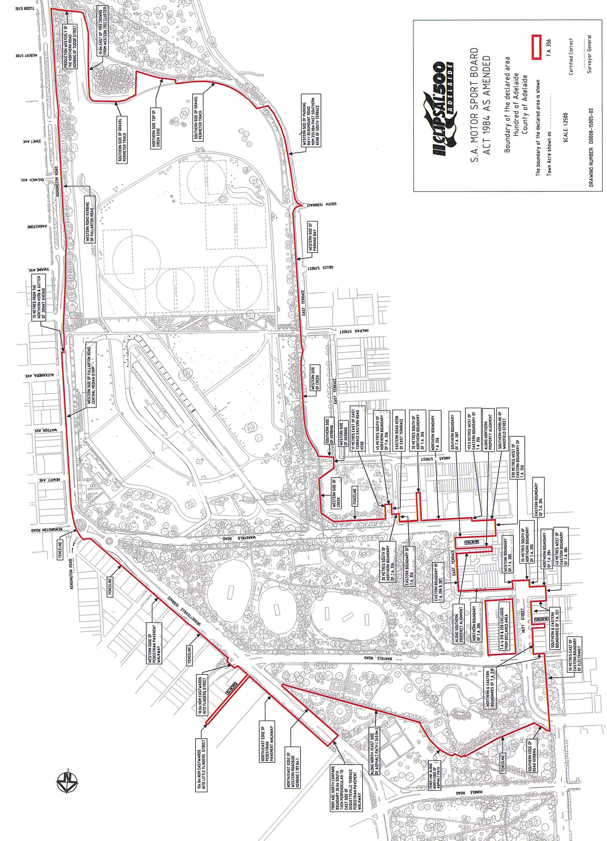
SOUTH AUSTRALIAN MOTOR SPORT ACT 1984 SECTION 26—
AVAILABILITY OF PLANS FOR PUBLIC INSPECTION
Notice by the Minister
PURSUANT to Section 26 of the South Australian Motor Sport Act 1984, I, the Minister to whom the administration of that Act has been committed, hereby designates the offices of the South Australian Motor Sport Board, 164 Fullarton Road, Dulwich, S.A. 5065 as the place at which may be inspected by members of the public plans of all works proposed to be carried out by the South Australian Motor Sport Board in relation to the event known as the ‘Clipsal 500 Adelaide’.
Dated 4 November 2014.
Leon Bignell, Minister for Tourism

SOUTH AUSTRALIAN MOTOR SPORT REGULATIONS 2014
REGULATION 10—OPENING AND CLOSING TIME OF THE DECLARED AREA
Notice by the South Australian Motor Sport Board
PURSUANT to Regulation 10 of the South Australian Motor Sport Regulations 2014, I, the Minister to whom the administration of that Act has been committed, hereby fix the following opening and closing times in respect of declared areas for each day of the declared period:
Day Opening Time Closing Time
Thursday, 26 February 2015 8 a.m. 12 midnight
Friday, 27 February 2015 8 a.m. 12 midnight
Saturday, 28 February 2015 8 a.m. 12 midnight
Sunday, 1 March 2015 8 a.m. 12 midnight
Dated 4 November 2014.
Leon Bignell, Minister for Tourism

CONDITIONS OF SALE
SOUTH AUSTRALIAN MOTOR SPORT REGULATIONS 2014 REGULATION 11—CONDITIONS IMPOSED ON TICKETS
Notice by the South Australian Motor Sport Board
PURSUANT to Regulation 11 of the South Australian Motor Sport Regulations 1999, the Minister, to whom the administration of that Act has been committed, hereby imposes the following conditions in respect of each of the permits, authorisations and tickets to the event known as the ‘Clipsal 500 Adelaide’ (the ‘Event’) in addition to the terms and conditions contained on the back of each ticket:
• Except to the extent permitted by the, Competition and Consumer Act 2010 (‘CCA’), including under the Australian Consumer Law as set out in Schedule 2 to the CCA and given effect under Part XI of the CCA, and under the same or similar provisions of the Fair Trading Act (SA) 1987, as amended from time to time, tickets cannot be exchanged or refunded after purchase. Tickets remain the property of The South Australian Motor Sport Board (the Board). The Board reserves the right to confiscate and or return tickets to the purchaser during the Event. Tickets are non-transferable on the day or during the day of presentation and must be retained at all times and produced if requested. Patrons requesting a pass out must subject themselves to an indelible ink-stamp on their hand (or such other method at exit as the Board directs), which together with a valid ticket clipped for that day must be presented to regain entry. The Board’s authorised representative reserves the right to prohibit entry or evict persons under the influence of drugs or alcohol, who are disorderly, or engage in offensive or other inappropriate behaviour, vandalism or evade legal admission. The Board’s authorised representative has the right to refuse entry to patrons carrying prohibited items or confiscate those items. The Board reserves the right to refuse admittance to or evict from the Event any person with reasonable cause.
• The Board reserves the right to add, withdraw or substitute any drivers, performers, concert artists, acts and bands or activities associated with the Event, vary programs, seating arrangements, audience capacity, gate opening and closing times and determine and publish additional conditions from time to time.
• A person cannot make, reproduce or use any form of still or moving picture or any sound recording (footage) of the motorsport event as defined in the South Australian Motor Sport Act 1984 or any part of it for profit, gain, public advertisement, display or for any other purpose except for the private enjoyment of the person making the footage, without the consent of the Board; and will on demand assign all rights thereto to the Board or its nominees.
Any ticket purchased and the ticketholder’s entry to and presence at the Event is subject to these conditions of sale, conditions of entry displayed at the Event entrances and the South Australian Motor Sport Act 1984, as amended and its Regulations.
Details are freely available from www.clipsal500.com.au or Clipsal 500 Adelaide, P.O. Box V8, Kent Town, S.A. 5071.
CONDITIONS OF ENTRY
Patrons may not, without prior written consent of the Board bring any of the following items into the Event: any alcoholic beverages; any glass bottles (excluding medical requirements) or containers or glass objects (excluding sunglasses, binoculars and prescription glasses); any beverage container with the manufacturer’s seal broken; any drinks coolers or ice boxes (other than a soft walled style cooler bag); any structure or item that may be used to erect a structure, or which is capable of supporting the weight of a person including, without limitation, any chairs, lounges, benches or stools (other than a folding chair or stool); no animals;
no weapons of any kind; no fireworks; signs/banners/clothing or any other items displaying commercial, political, religious or offensive messages or logos; any items which could reasonably be deemed to cause public nuisance or offence to any user of the venue.
The Board reserves the right to conduct bag searches. Personnel will request that all patrons carrying bags into the Event open them for inspection. Patrons refusing to consent to a bag search will or may be refused entry into the venue.
The Board may refuse entry, or remove you from the Event if in the Board’s opinion you breach these terms and conditions, interfere with the enjoyment or safety of other persons, or present a lost, stolen, counterfeit, damaged or unreadable ticket.
The ticketholder attending the Event hereby acknowledges and agrees as follows:
• The Ticketholder has read and understood the Conditions of Sale and Conditions of Entry (the ‘Conditions’) and agrees to be bound by the Conditions; and intends the Conditions to have full contractual effect.
• Where relevant, the Ticketholder and any third party who purchases a ticket on behalf of the Ticketholder (‘the third party’) each warrant that the third party had the Ticketholder’s full authority to act as the Ticketholder’s agent for the purposes of buying the ticket and accepting the Conditions.
• Where concessions or companion cards are applicable, suitable and valid identification must be provided for collection of tickets and at entry gate for admission to the venue. The Student Discount offer is only applicable to Trackside (General Admission) tickets and Pit Entry Grandstand. This offer is only available to full time students.
• The Family Grandstand Pass offer entitles patrons to purchase four reserved seats for the price of three and provides
four-day reserved Grandstand seats for two adults and two children (aged 17 years and under) or one adult and
three children (aged 17 years and under). Family Grandstand Passes are only applicable to Brabham Straight, Pit Entry and Barry Sheene Pit Straight (Sections J-K).
• Trackside (General Admission) tickets do not gain access or entry to any grandstand or reserved grandstand seating areas or the Gold Zone of the circuit.
• Oasis tickets provide access to a restricted area of the Clipsal 500 Adelaide circuit only. The Oasis is accessible from the city via Gate 6 on East Terrace and 7 on Dequetteville Terrace and located in Rymill Park, north of Bartels Road known as Park 14. Oasis tickets do not provide access to the whole Clipsal 500 event or any access south of Bartels Road—an upgrade ticket is required to be purchased at an additional cost to access the full event, including concerts and TrAction Zone.
• A Family Trackside (General Admission) ticket provides daily entry to the Event for two adults and two children (aged 17 years and under) or one adult and three children (aged 17 years and under).
• Platform tickets do not gain access or entry to any grandstand seating area.
• Access into grandstands and other facilities is with the appropriate ticket.
• Single day grandstand tickets are available for Barry Sheene Pit Straight L and Pirie Street Grandstands and only provide access to the venue and seat in said grandstand on the day identified on the single-day ticket.
• Junior Grandstand tickets are available for Pit Entry and Pirie Street Grandstands. Children must be 15 years and under to purchase this ticket type. A maximum of four junior tickets for one full paying adult may be purchased.
• Group Bookings of 10 or more of the same full price ticket type will be entitled to a 10% discount off each ticket.
This offer excludes Family Grandstand tickets, Family trackside tickets, Student discounted tickets and Special
seating/ Companion Cards.
• School Group Bookings may be made for School Groups attending the event on Thursday, 26 February 2015 only. Students aged 13 years and older and teachers/parents/guardians will receive a Trackside (General Admission) tickets for $10 each including GST. Students aged 12 years and younger and accompanied by a full paying adult will be admitted free.
• Special seating areas for persons with a permanent disability and their carer holding a Companion Card have been made available at Clipsal 500 Adelaide. The areas accessible with a Companion Card are Trackside (inc. Multi-day Super Pass), Pit Entry and Pirie Street Grandstands. Special seating areas for persons who are wheelchair bound are available in the Chicane and Hairpin Grandstand areas.
• Advertised Early-Bird ticket pricing is only applicable up to and including 31 January 2015. The price will increase as advertised from 1 February 2015.
Children aged 12 years and under are provided with free access to the Event only provided:
• they are accompanied and supervised at all times by a paying adult guardian aged 18 and over; and
• Corporate and Event credential holders are ineligible for this offer.
For entry of a child aged between four years and 12 years of age (inclusive) into the same grandstand or Gold Platform area with an accompanying paying adult guardian (if the adult guardian has an applicable ticket) a separate ticket for the child must be purchased.
Children aged three years and under may be provided with free access to the same grandstand or Gold Platform area with an accompanying paying adult guardian (if the adult guardian has an applicable ticket) provided:
• when in a grandstand or Gold Platform, they sit at all times on the lap of the accompanying adult guardian and do not occupy their own seat; and
• if a child causes disruption to other patrons in a grandstand or reserved seating area they and their accompanying adult guardian will be required to exit the grandstand at the direction of the Board.
• Corporate and Event credential holders are ineligible for this offer.
The Clipsal 500 Fair Go Policy applies to the offer of free entry to children 12 and under to ensure that all Clipsal 500 patrons can enjoy equal and safe access to the Event. The Board reserves the right to refuse entry where the number of children accompanying any adult guardian is deemed by the Board (or its authorised employees, contractors or agents) to be excessive for any operational, health, safety or other reason. In the ordinary course, not more than three complimentary children per adult guardian ticket would be appropriate.
For further information relating to entry terms and conditions, visit www.clipsal500.com.au.
Motorsport is dangerous. The SA Motor Sport Board (‘Board’) will not be liable for personal injury or property damage.
In exchange for being able to attend or participate in the event, (and as a condition of the purchase or issue of a ticket);
• You agree to release the Confederation of Australian Motorsport Ltd (‘CAMS’) and Australian Motorsport Commission Ltd, promoters, sponsor organisations, land owners and lessees, organisers of the event, their respective servants, officials, representatives and agents (collectively, the ‘Associated Entities’) from all liability for your death, personal injury (including burns), psychological trauma, loss or damage (including property damage) (‘harm’) howsoever arising from your participation in or attendance at the event, except to the extent prohibited by law; you agree that CAMS and the Associated Entities do not make any warranty, implied or express, that the event services will be provided with due care and skill or that any materials provided in connection with the services will be fit for the purpose for which they are supplied; and you agree to attend or participate in the event at your own risk.
• You acknowledge that the risks associated with attending or participating in the event include the risk that you may suffer harm as a result of: motor vehicles (or parts of them) colliding with other motor vehicles, persons or property; acts of violence and other harmful acts (whether intentional or inadvertent) committed by persons attending or participating in the event; and the failure or unsuitability of facilities (including grand-stands, fences and guard rails) to ensure the safety of persons or property at the event.
• You acknowledge that motorsport is dangerous and that accidents causing harm can and do happen and may happen to you. You accept the conditions of, and acknowledge the risks arising from, attending or participating in the event and being provided with the event services by CAMS and the Associated Entities.
• The ticketholder expressly consents to the recording and use of their image and/or voice (together ‘Likeness’) for the purposes of worldwide commercial exploitation of their Likeness by the Board or any entity or person authorized by the Board, in any form the Board may decide or approve and without any payment or compensation to the Ticketholder.
The recording of the ticketholder’s Likeness may be undertaken using a variety of methods, including by television cameras and photography.
HIGH DANGER AREAS
The Ticketholder on entering into pit lane and/or pit paddock: is fully aware and recognizes that pit lane and pit paddock are extremely dangerous and there is a real possibility of an accident causing injury, death, property damage or other losses in those areas; is fully aware that it is a condition of entry that they enter the pit lane and pit paddock and other high danger areas of the events ground at their own risk.
SEVERANCE
If anything in these Conditions of Entry is unenforceable, illegal or void then it is severed and the rest of the Conditions of Entry remain in force.
Dated 4 November 2014.
Leon Bignell, Minister for Tourism

South Australia
Director of Public Prosecutions Regulations 2014
under the Director of Public Prosecutions Act 1991

Contents
1 Short title
2 Commencement
3 Powers of Director

1—Short title
These regulations may be cited as the Director of Public Prosecutions Regulations 2014.
2—Commencement
These regulations come into operation on the day on which they are made.
3—Powers of Director
(1) For the purposes of section 7(1)(h) of the Act, if the Director holds an appointment, commission or authority to prosecute offences against the laws of the Commonwealth, the function of instituting, preparing and conducting proceedings in accordance with the appointment, commission or authority is assigned to the Director.
(2) In this regulation—
Act means the Director of Public Prosecutions Act 1991.
Note—
As required by section 10AA(2) of the Subordinate Legislation Act 1978, the Minister has certified that, in the Minister's opinion, it is necessary or appropriate that these regulations come into operation as set out in these regulations.
Made by the Governor
with the advice and consent of the Executive Council
on 13 November 2014
No 265 of 2014
AGO0015/14CS

South Australia
Summary Offences (Weapons) Variation Regulations 2014
under the Summary Offences Act 1953

Contents
Part 1—Preliminary
1 Short title
2 Commencement
3 Variation provisions
Part 2—Variation of Summary Offences (Weapons) Regulations 2012
4 Variation of regulation 5—Prohibited weapons

Part 1—Preliminary
1—Short title
These regulations may be cited as the Summary Offences (Weapons) Variation Regulations 2014.
2—Commencement
These regulations come into operation on the day on which they are made.
3—Variation provisions
In these regulations, a provision under a heading referring to the variation of specified regulations varies the regulations so specified.
Part 2—Variation of Summary Offences (Weapons) Regulations 2012
4—Variation of regulation 5—Prohibited weapons
Regulation 5(n)—delete "and" and substitute:
or
Note—
As required by section 10AA(2) of the Subordinate Legislation Act 1978, the Minister has certified that, in the Minister's opinion, it is necessary or appropriate that these regulations come into operation as set out in these regulations.
Made by the Governor
with the advice and consent of the Executive Council
on 13 November 2014
No 266 of 2014
AGO0139/14CS
South Australia
Southern State Superannuation Variation Regulations 2014
under the Southern State Superannuation Act 2009

Contents
Part 1—Preliminary
1 Short title
2 Commencement
3 Variation provisions
Part 2—Variation of Southern State Superannuation Regulations 2009
4 Variation of regulation 26—Purpose of Part
5 Variation of regulation 31—Variation of voluntary insurance
6 Variation of regulation 33—Variation of voluntary insurance—prescribed members
7 Variation of regulation 34—Amount of invalidity/death insurance benefits and amount of premiums
8 Variation of regulation 41—Variation of voluntary death insurance
9 Variation of regulation 42—Amount of voluntary death insurance benefits and amount of premiums
10 Variation of regulation 47—Amount of benefits and premiums
11 Variation of regulation 48—Terms and conditions

Part 1—Preliminary
1—Short title
These regulations may be cited as the Southern State Superannuation Variation Regulations 2014.
2—Commencement
These regulations come into operation on the day on which they are made.
3—Variation provisions
In these regulations, a provision under a heading referring to the variation of specified regulations varies the regulations so specified.
Part 2—Variation of Southern State Superannuation Regulations 2009
4—Variation of regulation 26—Purpose of Part
Regulation 26—after "continues" insert:
(with variations)
5—Variation of regulation 31—Variation of voluntary insurance
Regulation 31—delete "A member" and substitute:
Subject to regulation 34, a member
6—Variation of regulation 33—Variation of voluntary insurance—prescribed members
Regulation 33(1)—delete "A prescribed" and substitute:
Subject to regulation 34, a prescribed
7—Variation of regulation 34—Amount of invalidity/death insurance benefits and amount of premiums
(1) Regulation 34(2)—delete "There" and substitute:
Subject to this regulation, there
(2) Regulation 34(6)—delete subregulation (6) and substitute:
(6) An applicant for voluntary invalidity/death insurance may, on or after the day on which this subregulation comes into operation, apply for standard insurance cover.
(6a) The Board may not provide fixed insurance cover to a member, or increase the level of a member's fixed insurance cover, on an application for voluntary invalidity/death insurance, or for an increase in voluntary invalidity/death insurance, received by the Board on or after the day on which this subregulation comes into operation.
(6b) A member who has fixed insurance cover may not take out standard insurance cover.
(6c) Despite subregulation (6b), the Board may grant an application for standard insurance cover made by a member who has fixed insurance cover if the standard insurance cover does not apply until after the fixed insurance cover has ceased.
8—Variation of regulation 41—Variation of voluntary death insurance
Regulation 41—delete "A spouse" and substitute:
Subject to regulation 42, a spouse
9—Variation of regulation 42—Amount of voluntary death insurance benefits and amount of premiums
(1) Regulation 42(2)—delete "There" and substitute:
Subject to this regulation, there
(2) Regulation 42(3)—delete subregulation (3) and substitute:
(3) An applicant for voluntary death insurance may, on or after the day on which this subregulation comes into operation, apply for standard insurance cover.
(3a) The Board may not provide fixed insurance cover to a spouse member, or increase the level of a spouse member's fixed insurance cover, on an application for voluntary death insurance, or for an increase in voluntary death insurance, received by the Board on or after the day on which this subregulation comes into operation.
(3b) A spouse member who has fixed insurance cover may not take out standard insurance cover.
(3c) Despite subregulation (3b), the Board may grant an application for standard insurance cover made by a spouse member who has fixed insurance cover if the standard insurance cover does not apply until after the fixed insurance cover has ceased.
10—Variation of regulation 47—Amount of benefits and premiums
(1) Regulation 47(1)—delete "or fixed insurance cover"
(2) Regulation 47—after subregulation (1) insert:
(1a) The Board may not provide fixed insurance cover (within the meaning of regulation 34) to a public sector superannuation beneficiary, or increase the level of a public sector superannuation beneficiary's fixed insurance cover, on an application for invalidity/death insurance, or for an increase in invalidity/death insurance, received by the Board on or after the day on which this subregulation comes into operation.
(1b) If a public sector superannuation beneficiary has fixed insurance cover within the meaning of regulation 34 (taken out on an application under this regulation received by the Board before the day on which this subregulation comes into operation), the amount of invalidity/death insurance benefits, and the amount of premiums in respect of those benefits, are the amounts fixed by that regulation.
(1c) A public sector superannuation beneficiary who has fixed insurance cover may not take out standard insurance cover.
(1d) Despite subregulation (1c), the Board may grant an application for standard insurance cover made by a public sector superannuation beneficiary who has fixed insurance cover if the standard insurance cover does not apply until after the fixed insurance cover has ceased.
(3) Regulation 47(2)—delete "or fixed insurance cover"
(4) Regulation 47—after subregulation (2) insert:
(3) The Board may not provide fixed insurance cover (within the meaning of regulation 42) to the spouse of a public sector superannuation beneficiary, or increase the level of a spouse's fixed insurance cover, on an application for death insurance, or for an increase in death insurance, received by the Board on or after the day on which this subregulation comes into operation.
(4) If the spouse of a public sector superannuation beneficiary has fixed insurance cover within the meaning of regulation 42 (taken out under this regulation on an application received by the Board before the day on which this subregulation comes into operation), the amount of death insurance benefits, and the amount of premiums in respect of those benefits, are the amounts fixed by that regulation.
(5) If the spouse of a public sector superannuation beneficiary has fixed insurance cover, he or she may not take out standard insurance cover.
(6) Despite subregulation (5), the Board may grant an application for standard insurance cover made by the spouse of a public sector superannuation beneficiary who has fixed insurance cover if the standard insurance cover does not apply until after the fixed insurance cover has ceased.
11—Variation of regulation 48—Terms and conditions
Regulation 48(7)(a)—after "invalidity/death insurance" insert:
(whether fixed insurance cover or standard insurance cover)
Note—
As required by section 10AA(2) of the Subordinate Legislation Act 1978, the Minister has certified that, in the Minister's opinion, it is necessary or appropriate that these regulations come into operation as set out in these regulations.
Made by the Governor
with the approval of the Treasurer and following consultation by the Minister for Finance with the South Australian Superannuation Board and with the advice and consent of the Executive Council
with the advice and consent of the Executive Council
on 13 November 2014
No 267 of 2014
T&F13/080CS

South Australia
Liquor Licensing (Dry Areas) Variation Regulations 2014
under the Liquor Licensing Act 1997

Contents
Part 1—Preliminary
1 Short title
2 Commencement
3 Variation provisions
Part 2—Variation of Liquor Licensing (Dry Areas) Regulations 2012
4 Variation of Schedule—Arno Bay Area 1
5 Variation of Schedule—Robe Area 1
6 Variation of Schedule—Robe Area 2
7 Variation of Schedule—Spalding Area 1
8 Variation of Schedule—Two Wells Area 1
9 Variation of Schedule—Unley Area 1

Part 1—Preliminary
1—Short title
These regulations may be cited as the Liquor Licensing (Dry Areas) Variation Regulations 2014.
2—Commencement
These regulations come into operation on the day on which they are made.
3—Variation provisions
In these regulations, a provision under a heading referring to the variation of specified regulations varies the regulations so specified.
Part 2—Variation of Liquor Licensing (Dry Areas) Regulations 2012
4—Variation of Schedule—Arno Bay Area 1
Schedule—Arno Bay Area 1, clause 2—delete "From 11 pm on 31 December 2013 to 8 am on 1 January 2014." and substitute:
From 11 pm on 31 December 2014 to 8 am on 1 January 2015.
5—Variation of Schedule—Robe Area 1
Schedule—Robe Area 1, clause 2—delete "From 12 noon on 31 December 2013 to 12 noon on 1 January 2014." and substitute:
From 12 noon on 31 December 2014 to 12 noon on 1 January 2015.
6—Variation of Schedule—Robe Area 2
Schedule—Robe Area 2, clause 2—delete "From 12 noon on 31 December 2013 to 12 noon on 1 January 2014." and substitute:
From 12 noon on 31 December 2014 to 12 noon on 1 January 2015.
7—Variation of Schedule—Spalding Area 1
Schedule—Spalding Area 1, clause 2—delete "From 12 noon on 15 February 2014 to 12 noon on 16 February 2014." and substitute:
From 12 noon on 14 February 2015 to 12 noon on 15 February 2015.
8—Variation of Schedule—Two Wells Area 1
Schedule—Two Wells Area 1, clause 2—delete "From 5 pm on 13 December 2013 to 5 am on 14 December 2013." and substitute:
From 5 pm on 12 December 2014 to 5 am on 13 December 2014.
9—Variation of Schedule—Unley Area 1
Schedule—Unley Area 1, clause 2—delete "From 4 pm on 23 January 2014 to 1 am on 24 January 2014." and substitute:
From 4 pm on 20 January 2015 to 1 am on 21 January 2015.
Note—
As required by section 10AA(2) of the Subordinate Legislation Act 1978, the Minister has certified that, in the Minister's opinion, it is necessary or appropriate that these regulations come into operation as set out in these regulations.
Made by the Governor
with the advice and consent of the Executive Council
on 13 November 2014
No 268 of 2014
14MBSC19CS

South Australia
Liquor Licensing (Dry Areas) Variation Regulations 2014
under the Liquor Licensing Act 1997

Contents
Part 1—Preliminary
1 Short title
2 Commencement
3 Variation provisions
Part 2—Variation of Liquor Licensing (Dry Areas) Regulations 2012
4 Variation of Schedule—Mannum Area 2
5 Variation of Schedule—Mannum Area 3
6 Variation of Schedule—Mannum Area 4
7 Variation of Schedule—Mannum Area 5
8 Insertion of Schedules
Schedule—Mannum Area 6
Schedule—Mannum Area 7

Part 1—Preliminary
1—Short title
These regulations may be cited as the Liquor Licensing (Dry Areas) Variation Regulations 2014.
2—Commencement
These regulations come into operation on the day on which they are made.
3—Variation provisions
In these regulations, a provision under a heading referring to the variation of specified regulations varies the regulations so specified.
Part 2—Variation of Liquor Licensing (Dry Areas) Regulations 2012
4—Variation of Schedule—Mannum Area 2
Schedule—Mannum Area 2, clause 2—delete "From 11 pm on each day to 8 am on the following day, until 8 am on 23 May 2017." and substitute:
The prohibition applies during the following periods:
(a) from 11 pm on each day to 8 am on the following day, until 8 am on 23 May 2017;
(b) from 6 pm to 11 pm on 31 December 2014.
5—Variation of Schedule—Mannum Area 3
Schedule—Mannum Area 3, clause 2—delete "From 11 pm on each day to 8 am on the following day, until 8 am on 23 May 2017." and substitute:
The prohibition applies during the following periods:
(a) from 11 pm on each day to 8 am on the following day, until 8 am on 23 May 2017;
(b) from 6 pm to 11 pm on 31 December 2014.
6—Variation of Schedule—Mannum Area 4
Schedule—Mannum Area 4, clause 2—delete "From 11 pm on each day to 8 am on the following day, until 8 am on 23 May 2017." and substitute:
The prohibition applies during the following periods:
(a) from 11 pm on each day to 8 am on the following day, until 8 am on 23 May 2017;
(b) from 6 pm to 11 pm on 31 December 2014.
7—Variation of Schedule—Mannum Area 5
Schedule—Mannum Area 5, clause 2—delete "From 11 pm on each day to 8 am on the following day, until 8 am on 23 May 2017." and substitute:
The prohibition applies during the following periods:
(a) from 11 pm on each day to 8 am on the following day, until 8 am on 23 May 2017;
(b) from 6 pm to 11 pm on 31 December 2014.
8—Insertion of Schedules
After Schedule—Mannum Area 5 insert:
Schedule—Mannum Area 6

1—Extent of prohibition
The consumption of liquor is prohibited and the possession of liquor is prohibited.
2—Period of prohibition
From 6 pm on 31 December 2014 to 8 am on 1 January 2015.
3—Description of area
The area adjacent to Mannum, generally known as Bolto Reserve, bounded on the south-east by the north-western boundary of Section 909, Hundred of Younghusband, on the south-west by the north-eastern boundary of Section 914, Hundred of Younghusband, on the north-west by the River Murray and on the north-east by the south-western boundary of Lot 94 Deposited Plan 49431 and the prolongation in a straight line north-westerly and south-easterly of that boundary.
Schedule—Mannum Area 7

1—Extent of prohibition
The consumption of liquor is prohibited and the possession of liquor is prohibited.
2—Period of prohibition
From 6 pm on 31 December 2014 to 8 am on 1 January 2015.
3—Description of area
The area adjacent to Mannum, generally known as Haythorpe Reserve, bounded on the south-east by the north-western boundary of the carriageway of Hunter Road, on the south-west by the south-western boundary of Section 727, Hundred of Younghusband and the prolongation in a straight line south-easterly and north-westerly of that boundary, on the north-west by the River Murray and on the north-east by the south-western boundary of Section 397, Hundred of Younghusband and the prolongation in a straight line north-westerly and south-easterly of that boundary.
Note—
As required by section 10AA(2) of the Subordinate Legislation Act 1978, the Minister has certified that, in the Minister's opinion, it is necessary or appropriate that these regulations come into operation as set out in these regulations.
Made by the Governor
with the advice and consent of the Executive Council
on 13 November 2014
No 269 of 2014
14MBSC20CS

South Australia
Fisheries Management (Prawn Fisheries) Variation Regulations 2014
under the Fisheries Management Act 2007

Contents
Part 1—Preliminary
1 Short title
2 Commencement
3 Variation provisions
Part 2—Variation of Fisheries Management (Prawn Fisheries) Regulations 2006
4 Variation of regulation 3—Interpretation
5 Variation of regulation 6—Transfer of licence
6 Variation of regulation 7—Registration
7 Insertion of regulations 9 to 11
9 Individual fishing nights entitlement scheme—Gulf St. Vincent Prawn Fishery
10 Catch and disposal records—Gulf St. Vincent Prawn Fishery
11 Periodic returns
8 Revocation of regulation 13

Part 1—Preliminary
1—Short title
These regulations may be cited as the Fisheries Management (Prawn Fisheries) Variation Regulations 2014.
2—Commencement
These regulations will come into operation on 15 November 2014.
3—Variation provisions
In these regulations, a provision under a heading referring to the variation of specified regulations varies the regulations so specified.
Part 2—Variation of Fisheries Management (Prawn Fisheries) Regulations 2006
4—Variation of regulation 3—Interpretation
Regulation 3(1)—after the definition of surveyed length insert:
trawl net has the same meaning as in the Fisheries Management (General) Regulations 2007;
5—Variation of regulation 6—Transfer of licence
Regulation 6(1)(b)—delete "regulation 13" and substitute:
regulation 11
6—Variation of regulation 7—Registration
Regulation 7(2)(b)—delete paragraph (b) and substitute:
(b) the continuous brake power rating of the main engine of the boat does not exceed 336 kw; and
7—Insertion of regulations 9 to 11
After regulation 8 insert:
9—Individual fishing nights entitlement scheme—Gulf St. Vincent Prawn Fishery
(1) In this regulation—
amalgamated gear means trawl nets set up as a triple rig with an overall headline length not exceeding 43.89 metres;
closed season means—
(a) the period commencing on 25 December in any year and ending on the last day of February in the following year; or
(b) the period commencing on 1 August in any year and ending on 31 October in the same year;
fishery means the Gulf St. Vincent Prawn Fishery;
fishing night means a night occurring during a prescribed period;
fishing nights entitlement, in relation to a licence in respect of the fishery and a fishing season, means the maximum number of nights during which the holder of the licence may lawfully take aquatic resources under the licence during that fishing season, being the product of—
(a) the unit entitlement under the licence; and
(b) the unit value for the fishery and the fishing season,
subject to any variation applying during that fishing season;
fishing season means the period comprising prescribed period 1 in any year and the prescribed period 2 ending on 31 July in the following year;
night means the period between sunset on 1 day and sunrise on the next day;
prescribed period means—
(a) prescribed period 1; or
(b) prescribed period 2;
prescribed period 1 means—
(a) the period commencing on 15 November 2014 and ending on 24 December 2014; or
(b) a period commencing on 1 November in any subsequent year and ending on 24 December in the same year;
prescribed period 2 means a period commencing on 1 March in any year and ending on 31 July in the same year;
unit entitlement means the number of fishing night units for the time being allocated to a licence in respect of the fishery;
unit value means the value of a fishing night unit determined by the Minister for the fishery and a fishing season.
(2) The Minister will, for the purposes of this regulation, determine—
(a) the total number of nights on which aquatic resources may be lawfully taken by holders of licences in respect of the fishery during a prescribed period in a fishing season; and
(b) the number of fishing night units that are to be required for the holder of a licence in respect of the fishery to lawfully take aquatic resources under the licence on a night during a prescribed period in a fishing season; and
(c) the number of fishing night units that are to be required for the holder of a licence in respect of the fishery to lawfully take aquatic resources under the licence on a night during a prescribed period in a fishing season by using amalgamated gear; and
(d) the number of fishing night units that are to be allocated to each licence in respect of the fishery on the commencement of the fishing season ending on 31 July 2015.
(3) The Minister may, for the purposes of this regulation, determine that fishing night units are to be of 2 or more classes.
(4) The Minister may impose or vary conditions on licences in respect of the fishery fixing fishing night entitlements as follows:
(a) on the commencement of the fishing season beginning on 15 November 2014, the Minister may allocate an equal number of fishing night units to each licence in respect of the fishery (having regard to the matters determined by the Minister under subregulation (2));
(b) on joint application made to the Minister by the holders of any 2 licences in respect of the fishery, the Minister may vary the conditions of the licences so as to increase the unit entitlement under 1 of the licences and decrease the unit entitlement under the other licence by a corresponding number of units;
(c) a variation of a unit entitlement under paragraph (b) may be expressed to apply only for the fishing season during which the variation is made.
(5) An application to vary unit entitlements must—
(a) be made in a manner and form approved by the Minister; and
(b) must be signed by the applicants and completed in accordance with the instructions contained in the form; and
(c) must be accompanied by the appropriate fee (if any) fixed by the Fisheries Management (Fees) Regulations 2007.
(6) The holder of a licence in respect of the fishery must not engage in a fishing activity under the licence—
(a) during daylight hours; or
(b) during a closed season.
Maximum penalty: $5 000.
Expiation fee: $315.
(7) The holder of a licence in respect of the fishery must not engage in a fishing activity under the licence by using amalgamated gear without the approval of the Minister.
Maximum penalty: $5 000.
Expiation fee: $315.
10—Catch and disposal records—Gulf St. Vincent Prawn Fishery
(1) In this regulation—
approved CDR form means a catch and disposal record form approved by the Minister;
CDR book means a book containing approved CDR forms.
(2) The holder of a licence in respect of the Gulf St. Vincent Prawn Fishery or the registered master of a registered boat from which aquatic resources are taken under such a licence must comply with the following provisions:
(a) before the aquatic resources are removed from the boat, he or she must complete and sign an approved CDR form;
(b) he or she must deliver the completed CDR form to the Minister within 48 hours after the aquatic resources are removed from the boat;
(c) he or she must ensure that the CDR book is kept aboard the boat until all the forms in the book are completed;
(d) he or she must deliver a completed CDR book to the Minister within 14 days of its completion.
Maximum penalty: $5 000.
Expiation fee: $315.
11—Periodic returns
(1) The holder of a licence in respect of the Gulf St. Vincent Prawn Fishery must—
(a) complete a return, in a form determined by the Minister, in respect of a trawl shot carried out during a fishing night; and
(b) include in the return such information as the Minister requires; and
(c) date and sign the return and certify that the information contained in the return is complete and accurate; and
(d) post or deliver the return to the Minister within 48 hours after unloading the aquatic resources taken by that trawl shot.
Maximum penalty: $5 000.
Expiation fee: $315.
(2) The holder of a licence in respect of the Spencer Gulf Prawn Fishery or West Coast Prawn Fishery must—
(a) complete a return, in a form determined by the Minister, in respect of each calendar month during the currency of the licence; and
(b) include in the return such information as the Minister requires; and
(c) date and sign the return and certify that the information contained in the return is complete and accurate; and
(d) post or deliver the return to the Minister within 15 days of the end of the month to which it relates.
Maximum penalty: $5 000.
Expiation fee: $315.
(3) If the holder of a licence in respect of the Spencer Gulf Prawn Fishery or West Coast Prawn Fishery takes no aquatic resources under the licence during a particular calendar month, he or she is required by subregulation (2) to furnish a return in respect of that period indicating that no aquatic resources were taken.
(4) The holder of a licence in respect of a prawn fishery must—
(a) make a copy of each return he or she completes under this regulation before the return is sent or delivered to the Minister; and
(b) retain a copy for the period of 12 months from the last day of the month to which the return relates.
Maximum penalty: $5 000.
Expiation fee: $315.
(5) In this regulation—
fishing night has the same meaning as in regulation 9;
trawl shot means setting, towing and retrieval of a trawl net used as a single rig or trawl nets used as a double or triple rig.
8—Revocation of regulation 13
Regulation 13—delete the regulation
Note—
As required by section 10AA(2) of the Subordinate Legislation Act 1978, the Minister has certified that, in the Minister's opinion, it is necessary or appropriate that these regulations come into operation as set out in these regulations.
Made by the Governor
with the advice and consent of the Executive Council
on 13 November 2014
No 270 of 2014
14MAFF0049

South Australia
Fisheries Management (General) Variation Regulations 2014
under the Fisheries Management Act 2007

Contents
Part 1—Preliminary
1 Short title
2 Commencement
3 Variation provisions
Part 2—Variation of Fisheries Management (General) Regulations 2007
4 Variation of Schedule 6—Classes of fishing activities prescribed for purposes of section 70 of Act

Part 1—Preliminary
1—Short title
These regulations may be cited as the Fisheries Management (General) Variation Regulations 2014.
2—Commencement
These regulations will come into operation on 15 November 2014.
3—Variation provisions
In these regulations, a provision under a heading referring to the variation of specified regulations varies the regulations so specified.
Part 2—Variation of Fisheries Management (General) Regulations 2007
4—Variation of Schedule 6—Classes of fishing activities prescribed for purposes of section 70 of Act
(1) Schedule 6, Part 1, Division 3, clause 16—delete clause 16 and substitute:
16—Use of prawn trawl net of unlawful specifications in certain coastal waters
(1) The taking of prawn by a licensed person in coastal waters (other than Gulf St. Vincent) by using a prawn trawl net that has a mesh size of less than 45 mm (as measured from the middle of the knot).
(2) In subclause (1)—
Gulf St. Vincent has the same meaning as in the Fisheries Management (Prawn Fisheries) Regulations 2006.
(2) Schedule 6, Part 1, Division 6, clause 25—delete clause 25 and substitute:
25—Use of trawl nets and boats in Gulf St. Vincent Prawn Fishery
The taking of fish by a licensed person under a licence in respect of the Gulf St. Vincent Prawn Fishery in Gulf St. Vincent (as defined in the Fisheries Management (Prawn Fisheries) Regulations 2006)—
(a) by use of—
(i) a boat that has—
(A) an overall length exceeding 15.2 m; and
(B) a main engine the continuous brake power rating of which exceeds 224 kw; and
(ii) —
(A) a single trawl net with a headline length exceeding 27.43 m; or
(B) 2 trawl nets set up as a double rig with a combined headline length exceeding 27.43 m; or
(C) 3 trawl nets set up as a triple rig with a combined headline length exceeding 27.43 m; or
(D) a trawl net or trawl nets other than as a single, double or triple rig.
(b) by use of—
(i) a boat that has—
(A) an overall length exceeding 22 m; and
(B) a main engine the continuous brake power rating of which exceeds 336 kw; and
(ii) —
(A) a single trawl net with a headline length exceeding 29.26 m; or
(B) 2 trawl nets set up as a double rig with a combined headline length exceeding 29.26 m; or
(C) 3 trawl nets set up as a triple rig with a combined headline length exceeding 43.89 m; or
(D) a trawl net or trawl nets other than as a single, double or triple rig.
Note—
As required by section 10AA(2) of the Subordinate Legislation Act 1978, the Minister has certified that, in the Minister's opinion, it is necessary or appropriate that these regulations come into operation as set out in these regulations.
Made by the Governor
with the advice and consent of the Executive Council
on 13 November 2014
No 271 of 2014
14MAFF0049

SENDING COPY?
NOTICES for inclusion in the South Australian Government Gazette should be emailed to:
governmentgazette@dpc.sa.gov.au
Please include the following information in the covering email:
• The date the notice is to be published.
• Whether a proof, quote or return email confirmation is required.
• Contact details.
• To whom the notice is charged if applicable.
• A purchase order if required (chargeable notices).
• Any other details that may impact on the publication of the notice.
Attach:
• Notices in Word format.
• Maps and diagrams in pdf.
• Notices that require sighting an official date and signature before publication in a pdf. If a pdf is not possible then fax the official file(s) to the Government Publishing Fax number listed below.
Fax Transmission: (08) 8207 1040
Phone Enquiries: (08) 8207 1045
NOTE:
Closing time for lodging new copy is 4 p.m. on Tuesday preceding the regular Thursday Gazette.

LIGHT REGIONAL COUNCIL
Roseworthy Township Expansion Development Amendment Report—Notice of Declaration of Separate Rate
NOTICE is hereby given that at its Ordinary Meeting held on
28 October 2014, in relation to funding the Roseworthy Township Expansion Development Plan Amendment (DPA), the Light Regional Council, in exercise of the powers contained within Chapter 10 of the Local Government Act 1999, resolved (amongst other matters):
1. Notes that the declaration of a separate rate for the purposes of funding the Roseworthy Township Expansion Development Plan Amendment must be considered in the context of Council’s Caretaker Policy.
2. In making its decision, acknowledges that the declaration of a separate rate would (ordinarily) constitute a significant decision for the purposes of Council’s Caretaker Policy.
3. Determines, in accordance with Clause 8.7 of the Caretaker Policy, that it is appropriate to make a decision to declare the separate rate during the election period as it completes an activity already commenced and previously endorsed by Council well before Caretaker Period.
Following the adoption of the above resolution, Council:
1. Having undertaken public consultation in accordance with Section 151 of the Local Government Act 1999 (‘the Act’) and Council’s Public Consultation Policy, formally resolves to utilise Section 154 of the Act to declare a separate rate over those rateable assessments the subject of the Development Plan Amendment (DPA) study area, as the means by which the Roseworthy Township Expansion DPA is to be funded.
2. Noting Item 1 above, hereby declares a separate rate (based on the value of the land subject to the rate) of $0.0198410 to be levied against the capital valuation of each rateable assessment comprised within the Roseworthy Township Expansion DPA study area for the 2014-2015 financial year (declaration of a separate rate for the 2015-2016 financial year will form part of the Annual Business Plan and Budget for that financial year). The rateable assessments the subject of the proposed separate rate application are detailed below:
Assessment Number (Light) | Assessment Number (VG)
5523 | 3151443507
5846 | 3151443259
5522 | 3151442002
5521 | 3151440007
5519 | 3151434002
5520 | 3151435005
5059 | 3150834004
5518 | 315143300X
5053 | 3150824009
5052 | 3150823006
7911 | 3150822011
7912 | 3150826012
5054 | 3150825001

B. Carr, Chief Executive Officer

WAKEFIELD REGIONAL COUNCIL
Roads (Opening and Closing) Act 1991
Road Closure—War Memorial Drive, Balaklava
NOTICE is hereby given, pursuant to Section 10 of the Roads (Opening and Closing) Act 1991, that the Wakefield Regional Council proposes to make a Road Process Order to close the unmade portion of War Memorial Drive generally situated between John Street and Railway Terrace as delineated and lettered ‘A’ and ‘B’ on the Preliminary Plan No. PP14/0032.
Closed road ‘A’ is to merge with adjoining Allotment 104 in D93921 and ‘B’ with allotment comprised of pieces 100*, 101* and 102* in D93921.
A copy of the plan and a statement of persons affected are available for public inspection at the Council Office, Scotland Place, Balaklava, S.A. 5461 and the Adelaide Office of the Surveyor-General during normal office hours.
Any application for easement or objection must set out the full name, address and details of the submission and must be fully supported by reasons.
The application for easement or objection must be made in writing to the Council, Scotland Place, Balaklava, S.A. 5461 within 28 days of this notice and a copy must be forwarded to the Surveyor-General, G.P.O. Box 1354, Adelaide, S.A. 5001. Where a submission is made, the Council will give notification of a meeting at which the matter will be considered.
C. Atkinson, Chief Executive Officer

IN the matter of the estates of the undermentioned deceased persons:
Barratt, Ronald Emile, late of 22 Harrow Terrace, Kingswood, retired life assurance officer, who died on 20 October 2014.
Bennier, John Laurence, late of 200 Fosters Road, Oakden, retired storeman, who died on 7 November 2013.
Bugeja, Gregory John, late of 2 Jelley Street, Woodville, retired musician, who died on 23 September 2014.
Freund, Erna Margarete, late of 28 Liddell Drive, Huntfield Heights, widow, who died on 12 August 2014.
John, Vyma Estelle, late of 58 McKinna Road, Christie Downs, home duties, who died on 31 May 2014.
Keeler, Kenneth, late of 3 O’Loughlin Terrace, Ceduna, retired labourer, who died on 12 July 2014.
Magi, Artur, late of 35 First Avenue, Kilkenny, retired panel beater, who died on 20 March 2014.
Noble, Patricia Mary, late of 9 Western Avenue, Pasadena, home duties, who died on 1 September 2014.
Robinson, Scott Alexander, late of 30 Mulberry Road, Glenside, of no occupation, who died on 1 February 2014.
Thompson, David Carlyle, late of 18 Hack Street, Mount Barker, retired baker, who died on 30 July 2014.
Turner, Robert Mark, late of 7 Christie Avenue, Toorak Gardens, retired clerical officer, who died on 6 September 2014.
Notice is hereby given pursuant to the Trustee Act 1936, as amended, the Inheritance (Family Provision) Act 1972 and the Family Relationships Act 1975, that all creditors, beneficiaries, and other persons having claims against the said estates are required to send, in writing, to the Office of Public Trustee, G.P.O. Box 1338, Adelaide, S.A. 5001, full particulars and proof of such claims, on or before 12 December 2014, otherwise they will be excluded from the distribution of the said estates; and notice is also hereby given that all persons indebted to the said estates are required to pay the amount of their debts to the Public Trustee or proceedings will be taken for the recovery thereof; and all persons having any property belonging to the said estates are forthwith to deliver same to the Public Trustee.
Dated 13 November 2014.
D. A. Contala, Public Trustee

SALE OF PROPERTY
Auction Date: Wednesday, 26 November 2014 at 11 a.m.
Location: 5 Day Street, Kapunda, S.A. 5373
NOTICE is hereby given that on the above date at the time and place stated, by virtue of the Warrant of Sale issued out of the Magistrates Court of Tanunda, Action No. 32 of 2013 directed to the Sheriff of South Australia in an action wherein Kapunda Hardware and Garden Centre Pty Ltd is the Plaintiff and Mark Harris is the Defendant, I, Steve Ferguson, Sheriff of the State of South Australia, will by my auctioneers, Hambours Real Estate, make sale of the estate, right, title or interest whatsoever it may be of the Defendant, Mark Harris the registered proprietor of an estate in fee simple in the following:
That piece of land situated in the area named Kapunda, being
5 Day Street, Kapunda, Hundred of Kapunda, being the property comprised in Certificate of Title Register Book Volume 5253, Folio 608.
Further particulars from the auctioneers.
Hambours Real Estate
65 Main Street
Kapunda, S.A. 5373
Telephone 08 8566 2209

ATTENTION

CUSTOMERS requiring a proof of their notice for inclusion in the Government Gazette, please note that the onus is on you to inform Government Publishing SA of any subsequent corrections.

For any corrections to your notice please phone 8207 1045 or Fax 8207 1040 before 4 p.m. on Wednesday.

If we do not receive any communication by 10 a.m. on Thursday (day of publication) we will presume the notice is correct and will print it as it is.

Remember—the onus is on you to inform us of any corrections necessary to your notice.

NOTE: Closing time for lodging new copy (electronically, fax or hard copy) is 4 p.m. on Tuesday preceding the day of publication.
Phone: 8207 1045
Fax: 8207 1040
Email: governmentgazette@dpc.sa.gov.au

Printed and published by authority every Thursday by A. MARTIN, Government Printer, South Australia
Price: $6.65, plus postage; to subscribers, $335.00 per annum.
(The above prices are inclusive of GST)

