No. 86 6523



THE SOUTH AUSTRALIAN

GOVERNMENT GAZETTE
www.governmentgazette.sa.gov.au

PUBLISHED BY AUTHORITY

ALL PUBLIC ACTS appearing in this GAZETTE are to be considered official, and obeyed as such

ADELAIDE, THURSDAY, 27 NOVEMBER 2014

CONTENTS

Page
Acts Assented To 6524
Appointments, Resignations, Etc. 6524
Corporations and District Councils—Notices 6568
Development Act 1993—Notices 6525
Development Regulations 2008—Notice 6526
Fisheries Management Act 2007—Notices 6543
Health Care Act 2008—Notice 6543
Mining Act 1971—Notice 6544
National Electricity Law—Notice 6544
National Gas Law—Notice 6544
National Parks and Wildlife (National Parks) Regulations
2001—Notice 6544
Petroleum and Geothermal Energy Act 2000—
[Republished] 6545
Proclamations 6554
Public Trustee Office—Administration of Estates 6569
REGULATIONS
SACE Board of South Australia Act 1983—
(No. 275 of 2014) 6562
Liquor Licensing Act 1997 (No. 276 of 2014) 6565
Roads (Opening and Closing) Act 1991—Notices 6546
Road Traffic Act 1961—Notices 6546
South Australian Housing Trust Act 1995—Notices 6550
Summary Offences Act 1953—Notices 6552
Transport, Department of—Notice to Mariners 6552
Water Mains and Sewers—Mains Laid, Replaced, Etc. 6552

GOVERNMENT GAZETTE NOTICES
Notices for publication in the South Australian Government Gazette should be emailed to governmentgazette@dpc.sa.gov.au. Content should be sent as Word format attachment(s). Covering emails should include the date the notice is to be published and to whom the notice will be charged. Closing time for lodgement is 4 p.m. on the Tuesday preceding the regular Thursday publication. Gazette enquires to: Phone 8207 1045. The Government Gazette is available online at: www.governmentgazette.sa.gov.au.

Department of the Premier and Cabinet
Adelaide, 27 November 2014
HIS Excellency the Governor directs it to be notified for general information that he has in the name and on behalf of Her Majesty The Queen, this day assented to the undermentioned Acts passed by the Legislative Council and House of Assembly in Parliament assembled, viz.:
No. 19 of 2014—Civil Liability (Disclosure of Information) Amendment Act 2014. An Act to amend the Civil Liability Act 1936.
No. 20 of 2014—Independent Commissioner Against Corruption (Miscellaneous) Amendment Act 2014. An Act to amend the Independent Commissioner Against Corruption Act 2012; and to make related amendments to the Criminal Investigation (Covert Operations) Act 2009 and the Crown Proceedings Act 1992.
By command,
John Robert Rau, Acting Premier
DPC06/0875

Department of the Premier and Cabinet
Adelaide, 27 November 2014
HIS Excellency the Governor in Executive Council has been pleased to appoint the undermentioned to the Superannuation Funds Management Corporation of South Australia Board (Funds SA), pursuant to the provisions of the Superannuation Funds Management Corporation of South Australia Act 1995:
Director: (from 2 December 2014 until 1 December 2017)
James Leslie Baulderstone
Kathryn Anne Presser
By command,
John Robert Rau, Acting Premier
T&F14/088CS

Department of the Premier and Cabinet
Adelaide, 27 November 2014
HIS Excellency the Governor in Executive Council has been pleased to appoint the undermentioned to the Remuneration Tribunal, pursuant to the provisions of the Remuneration Act 1990:
Member: (from 27 November 2014 until 1 October 2017)
Peter John Alexander
By command,
John Robert Rau, Acting Premier
DPC14/095CS

Department of the Premier and Cabinet
Adelaide, 27 November 2014
HIS Excellency the Governor in Executive Council has been pleased to appoint the Honourable Susan Elizabeth Close, MP, Minister for Manufacturing and Innovation, Minister for Automotive Transformation and Minister for the Public Sector to be also Acting Minister for Investment and Trade, Acting Minister for Defence Industries and Acting Minister for Veterans’ Affairs for the period from 4 December 2014 to 11 December 2014 inclusive, during the absence of the Honourable Martin Leslie James Hamilton-Smith, MP.
By command,
John Robert Rau, Acting Premier
MINT14/006CS

Department of the Premier and Cabinet
Adelaide, 27 November 2014
HIS Excellency the Governor in Executive Council has been pleased to appoint the Honourable John James Snelling, MP, Minister for Health, Minister for Mental Health and Substance Abuse, Minister for the Arts and Minister for Health Industries to be also Acting Deputy Premier for the periods from 15 December
2014 until 19 December 2014 inclusive, and from 19 January 2015 until 23 January 2015 inclusive, during the absence of the Honourable John Robert Rau, MP.
By command,
John Robert Rau, Acting Premier
DPC14/091CS

Department of the Premier and Cabinet
Adelaide, 27 November 2014
HIS Excellency the Governor in Executive Council has been pleased to appoint the Honourable Tom Koutsantonis, MP, Treasurer, Minister for Finance, Minister for State Development, Minister for Mineral Resources and Energy and Minister for Small Business to be also Acting Attorney-General, Acting Minister for Justice Reform and Acting Minister for Industrial Relations for the periods from 15 December 2014 until 19 December 2014 inclusive, and from 19 January 2015 until 23 January 2015 inclusive, during the absence of the Honourable John Robert Rau, MP.
By command,
John Robert Rau, Acting Premier
DPC14/091CS

Department of the Premier and Cabinet
Adelaide, 27 November 2014
HIS Excellency the Governor in Executive Council has been pleased to appoint the Honourable Stephen Campbell Mullighan, MP, Minister for Transport and Infrastructure, Minister Assisting the Minister for Planning and Minister Assisting the Minister for Housing and Urban Development to be also Acting Minister for Planning and Acting Minister for Housing and Urban Development for the periods from 15 December 2014 until 19 December 2014 inclusive, and from 19 January 2015 until 23 January 2015 inclusive, during the absence of the Honourable John Robert Rau, MP.
By command,
John Robert Rau, Acting Premier
DPC14/091CS

Department of the Premier and Cabinet
Adelaide, 27 November 2014
HIS Excellency the Governor in Executive Council has been pleased to appoint the Honourable Leon William Kennedy Bignell, MP, Minister for Agriculture, Food and Fisheries, Minister for Forests, Minister for Tourism, Minister for Recreation and Sport and Minister for Racing to be also Acting Minister for Sustainability, Environment and Conservation, Acting Minister for Water and the River Murray and Acting Minister for Aboriginal Affairs and Reconciliation for the period from 22 December 2014 until 4 January 2015 inclusive, during the absence of the Honourable Ian Keith Hunter, MLC.
By command,
John Robert Rau, Acting Premier
DPC14/091CS

Department of the Premier and Cabinet
Adelaide, 27 November 2014
HIS Excellency the Governor in Executive Council has been pleased to appoint the Honourable Leon William Kennedy Bignell, MP, Minister for Agriculture, Food and Fisheries, Minister for Forests, Minister for Tourism, Minister for Recreation and Sport and Minister for Racing to be also Acting Minister for Regional Development and Acting Minister for Local Government for the period from 3 January 2015 until 18 January 2015 inclusive, during the absence of the Honourable Geoffrey Graeme Brock, MP.
By command,
John Robert Rau, Acting Premier
DPC14/091CS

Department of the Premier and Cabinet
Adelaide, 27 November 2014
HIS Excellency the Governor in Executive Council has been pleased to appoint the Honourable Tom Koutsantonis, MP, Treasurer, Minister for Finance, Minister for State Development, Minister for Mineral Resources and Energy and Minister for Small Business to be also Acting Minister for Transport and Infrastructure, Acting Minister Assisting the Minister for Planning and Acting Minister Assisting the Minister for Housing and Urban Development for the period from 29 December 2014 until 4 January 2015 inclusive, during the absence of the Honourable Stephen Campbell Mullighan, MP.
By command,
John Robert Rau, Acting Premier
DPC14/091CS

Department of the Premier and Cabinet
Adelaide, 27 November 2014
HIS Excellency the Governor in Executive Council has been pleased to appoint Patricia May Casey as a Special Justice of the Peace for South Australia for a term commencing on 14 January 2015 and expiring on 13 January 2020, pursuant to Section 7 (1) of the Justices of the Peace Act 2005.
By command,
John Robert Rau, Acting Premier
JP14/030CS

DEVELOPMENT ACT 1993
Minda Brighton Campus and General Section Amendments Development Plan Amendment Prepared by the Minister—
for Public Consultation
NOTICE is hereby given that the Minister for Planning, pursuant to Sections 24 and 26 of the Development Act 1993, has prepared a Minda Brighton Campus and General Section Amendments Development Plan Amendment (DPA) to amend the Holdfast Bay Council Development Plan.
The DPA proposes to amend policy in the Holdfast Bay Council Development Plan applying to the Minda Brighton Campus (the Campus), as well as related changes to the general section of the Development Plan.
Key changes proposed include amendments to built form policy applying to the Campus site (allowing medium density multi-storey development), preservation of the secondary dune area on the western part of the site, and allowing small scale commercial activity including shops, offices and consulting rooms. A number of changes to the general section of the Development Plan relating to multi storey development are also proposed.
The DPA will be on public consultation from 27 November 2014 to 12 February 2015.
Officers from the Department of Planning, Transport and Infrastructure will be available to discuss the proposed changes at a DPA Community Open Day to be held in the South Australian Learning Centre, Minda Brighton Campus, 12-16 King George Avenue, North Brighton on Saturday, 13 December 2014 from 10 a.m. until 2 p.m.
Copies of the DPA for viewing are available during normal office hours at:
• The Department of Planning, Transport and Infrastructure, Level 5, 136 North Terrace, Adelaide.
• City of Holdfast Bay, 24 Jetty Road, Brighton.
The DPA can also be viewed on the Minda Brighton Campus and General Section amendment webpage, which can be accessed via www.sa.gov.au/planning/ministerialdpas.
Written submissions regarding the DPA should be submitted no later than 5 p.m. on 12 February 2015. Submissions should be addressed to:
The Presiding Member, Development Policy Advisory Committee Minda Brighton Campus and General Section Amendments DPA:
• by post: c/o Department of Planning, Transport and Infrastructure, G.P.O. Box 1815, Adelaide, S.A. 5001; or
• by email: dpac@sa.gov.au.
Your submission should clearly indicate whether you wish to be heard at the public meeting.
Copies of all public submissions will be available for inspection by interested persons at the Department of Planning, Transport and Infrastructure, Level 5, 136 North Terrace, from 13 February 2015 until the conclusion of the public meeting, and will also be available for viewing on the Minda Brighton Campus and General Section amendment webpage, which can be accessed via www.sa.gov.au/planning/ministerialdpas.
The public meeting will be held on Tuesday, 3 March 2015 at 7 p.m. in the Glenelg Surf Life Saving Club, 20 The Holdfast Promenade, Glenelg Foreshore at which time interested persons may appear to be heard in relation to the DPA and the submissions. The public meeting may not be held if no submissions are received or if no-one requests to be heard. Please check the Minda Brighton Campus and General Section amendment webpage (or the Development Policy Advisory Committee website at www.dpac.sa.gov.au) before the scheduled date of the meeting to find out whether it is being held.
If you would like more information about the DPA, please contact Daniel Clapp on telephone number 7109 7015 or via email at daniel.clapp@sa.gov.au.
Dated 27 November 2014.
M. Vranat, Secretary, Development Policy Advisory Committee

DEVELOPMENT ACT 1993, SECTION 25 (17): TOWN OF GAWLER HILLIER DEVELOPMENT PLAN AMENDMENT
Preamble
1. The Hillier Development Plan Amendment (the Amendment) by the Town of Gawler has been finalised in accordance with the provisions of the Development Act 1993.
2. The Minister for Planning has decided to approve the Amendment.
Notice
PURSUANT to Section 25 of the Development Act 1993, I—
(a) approve the Amendment; and
(b) fix the day on which this notice is published in the Gazette as the day on which the Amendment will come into operation.
Dated 21 November 2014.
John Rau, Deputy Premier, Minister for Planning

DEVELOPMENT ACT 1993, SECTION 25 (17): CITY OF HOLDFAST BAY BETTER DEVELOPMENT PLAN
CONVERSION DEVELOPMENT PLAN AMENDMENT
Preamble
1. The Better Development Plan Conversion Development Plan Amendment (the Amendment) by the City of Holdfast Bay has been finalised in accordance with the provisions of the Development Act 1993.
2. The Minister for Planning has decided to approve the Amendment.
Notice
PURSUANT to Section 25 of the Development Act 1993, I—
(a) approve the Amendment; and
(b) fix the day on which this notice is published in the Gazette as the day on which the Amendment will come into operation.
Dated 21 November 2014.
John Rau, Deputy Premier, Minister for Planning

DEVELOPMENT REGULATIONS 2008
Complying Development—Regulation 8A and Schedule 4
Areas to be revoked and determined by the Minister for the Purposes of
Schedule 4—Complying development, Clause 2B—New dwellings
Preamble
For the purposes of Section 35 of the Development Act 1993, the development of new dwellings that are located within areas determined by the Minister and that meet the requirements of Clause 2B of Schedule 4 of the Development Regulations 2008, will be complying development.
The Minister has decided to amend the existing determined area within the City of Holdfast Bay under which Clause 2B of Schedule 4 applies. To give effect to this adjustment, the Minister has decided to revoke the existing determined areas for the City of Holdfast Bay and apply a new determined area.
Notice
PURSUANT to Schedule 4, Part 2B (1) of the Development Regulations 2008, I, John Rau, being the Minister administering the Development Act 1993 have revoked all existing determined areas applying to the City of Holdfast Bay as previously published in the Government Gazette.
Further, I have determined that Clause 2B of Schedule 4 will, in the City of Holdfast Bay, apply in relation to the shaded areas shown on the Residential Code Maps attached to this Notice marked ‘ATTACHMENT A’ and fix the day on which this Notice is published in the Government Gazette as the day on which the determined area will apply.
Attachment A
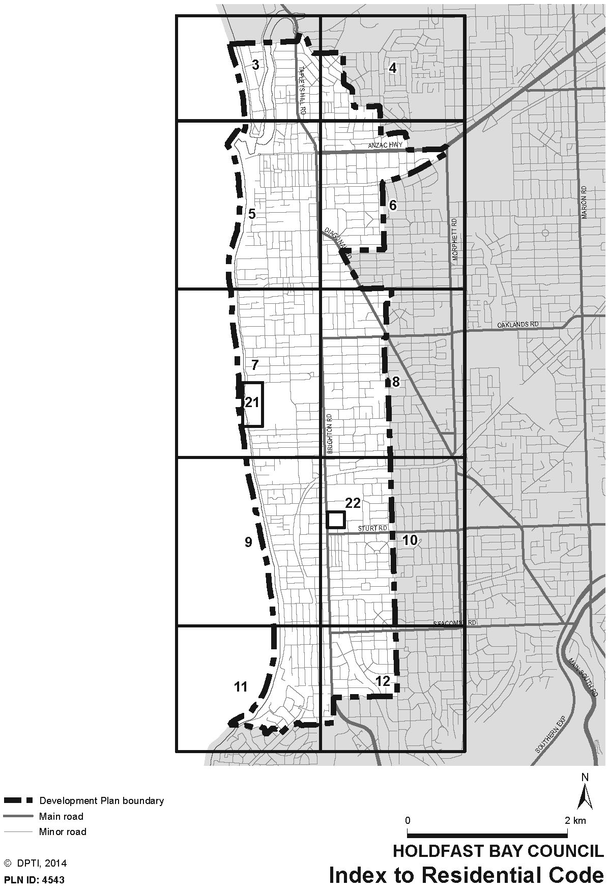
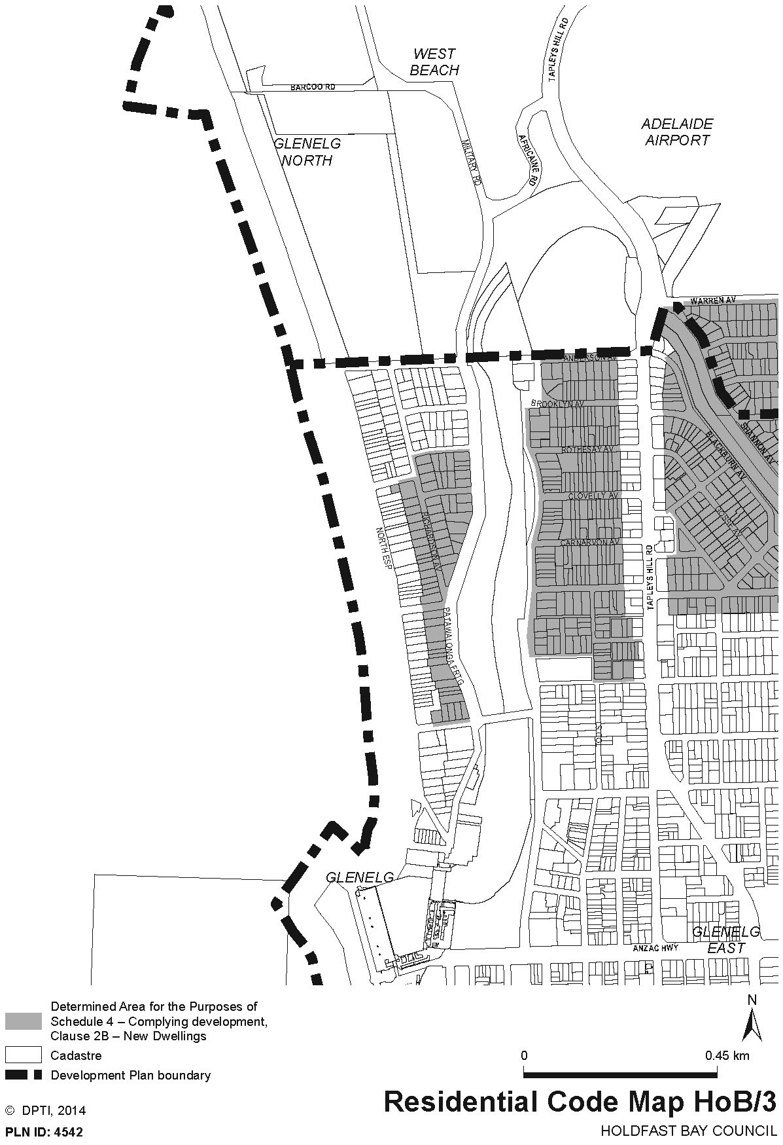
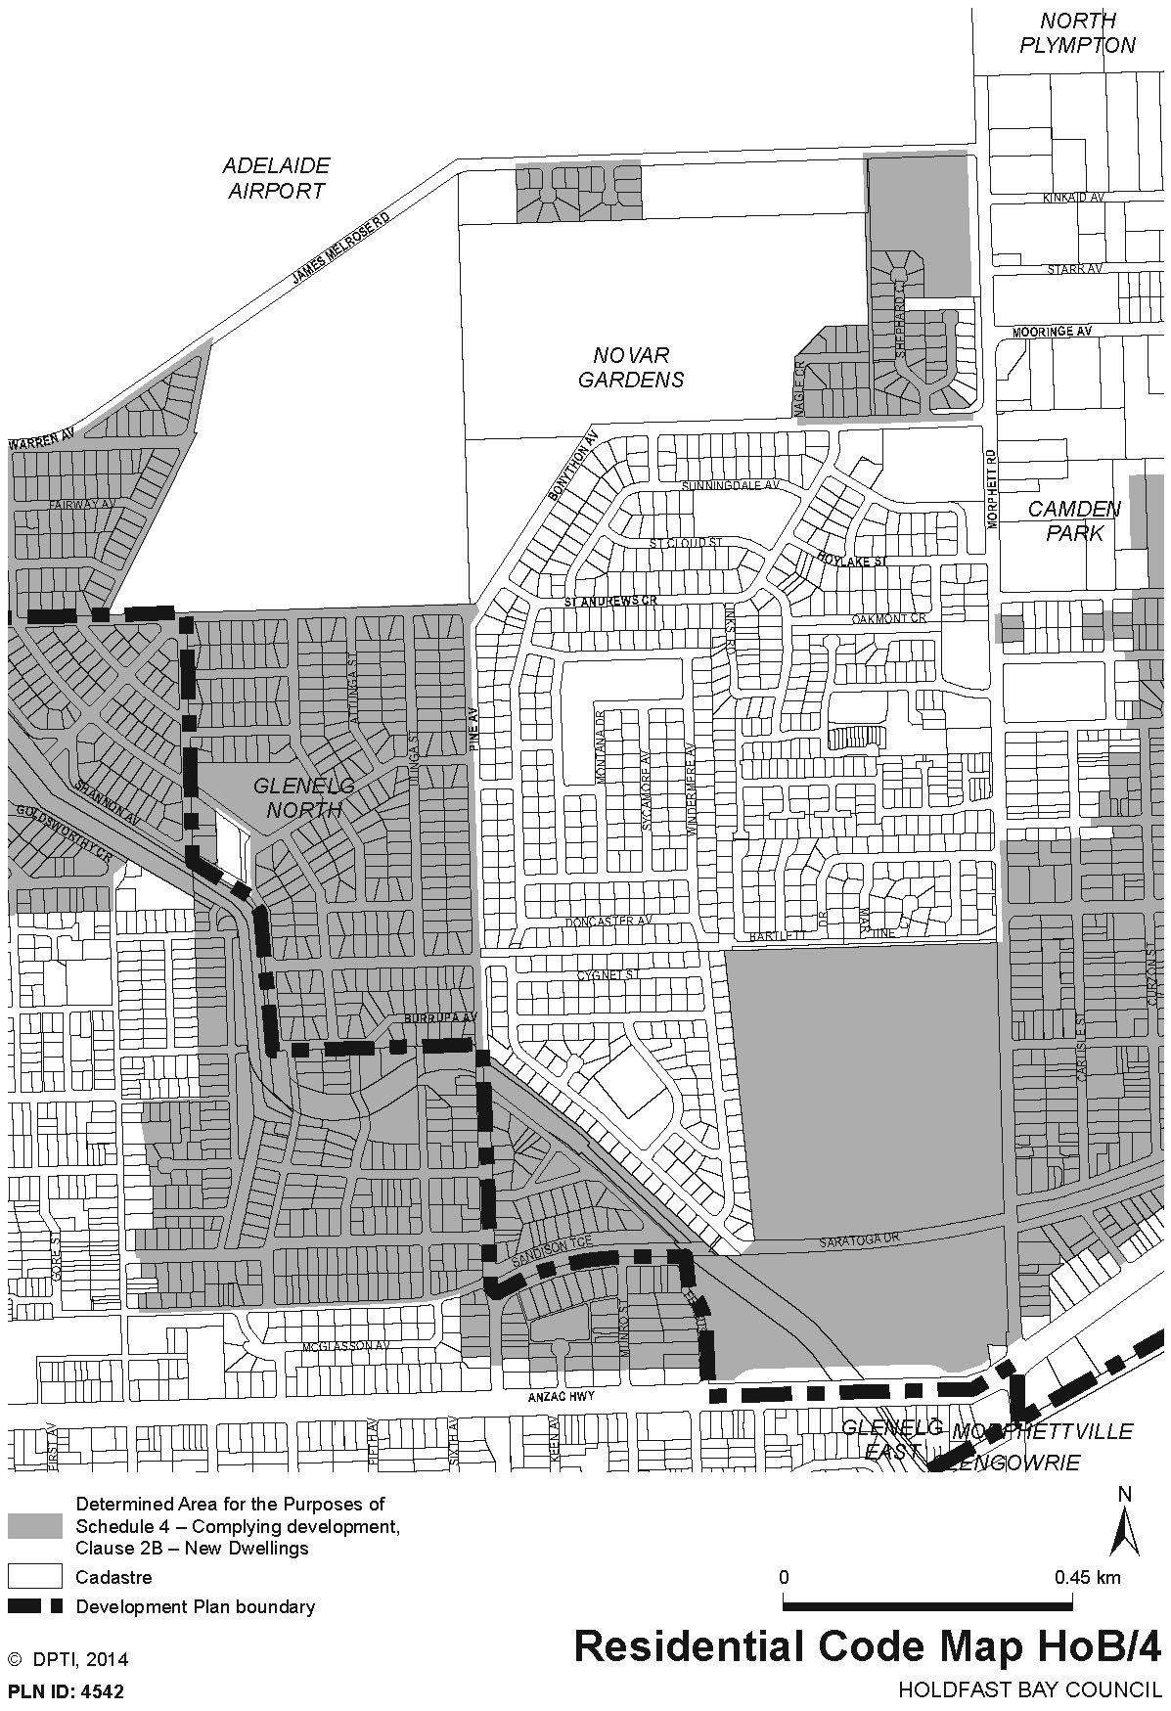
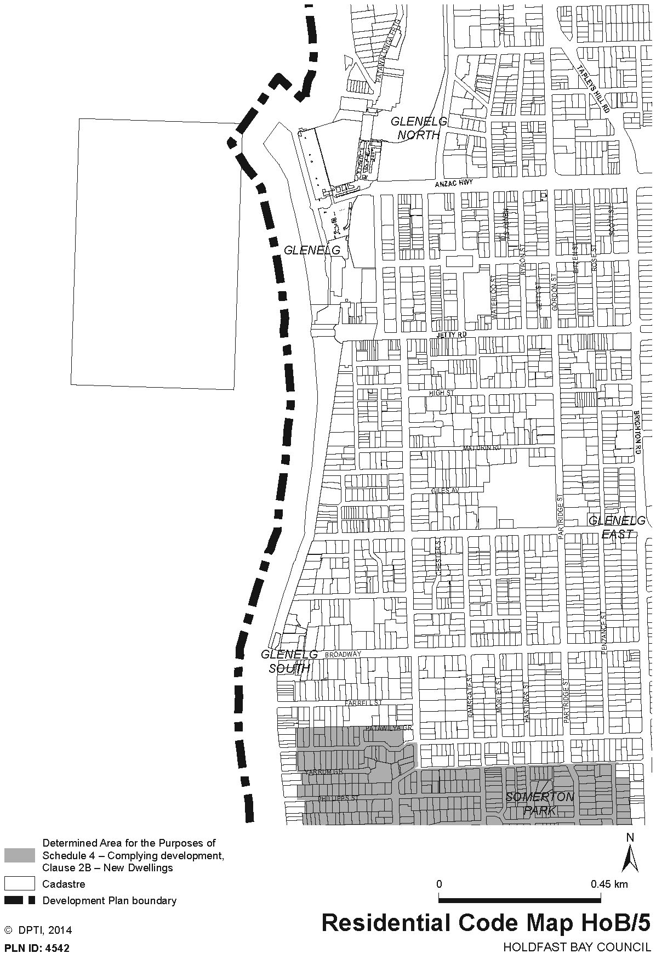
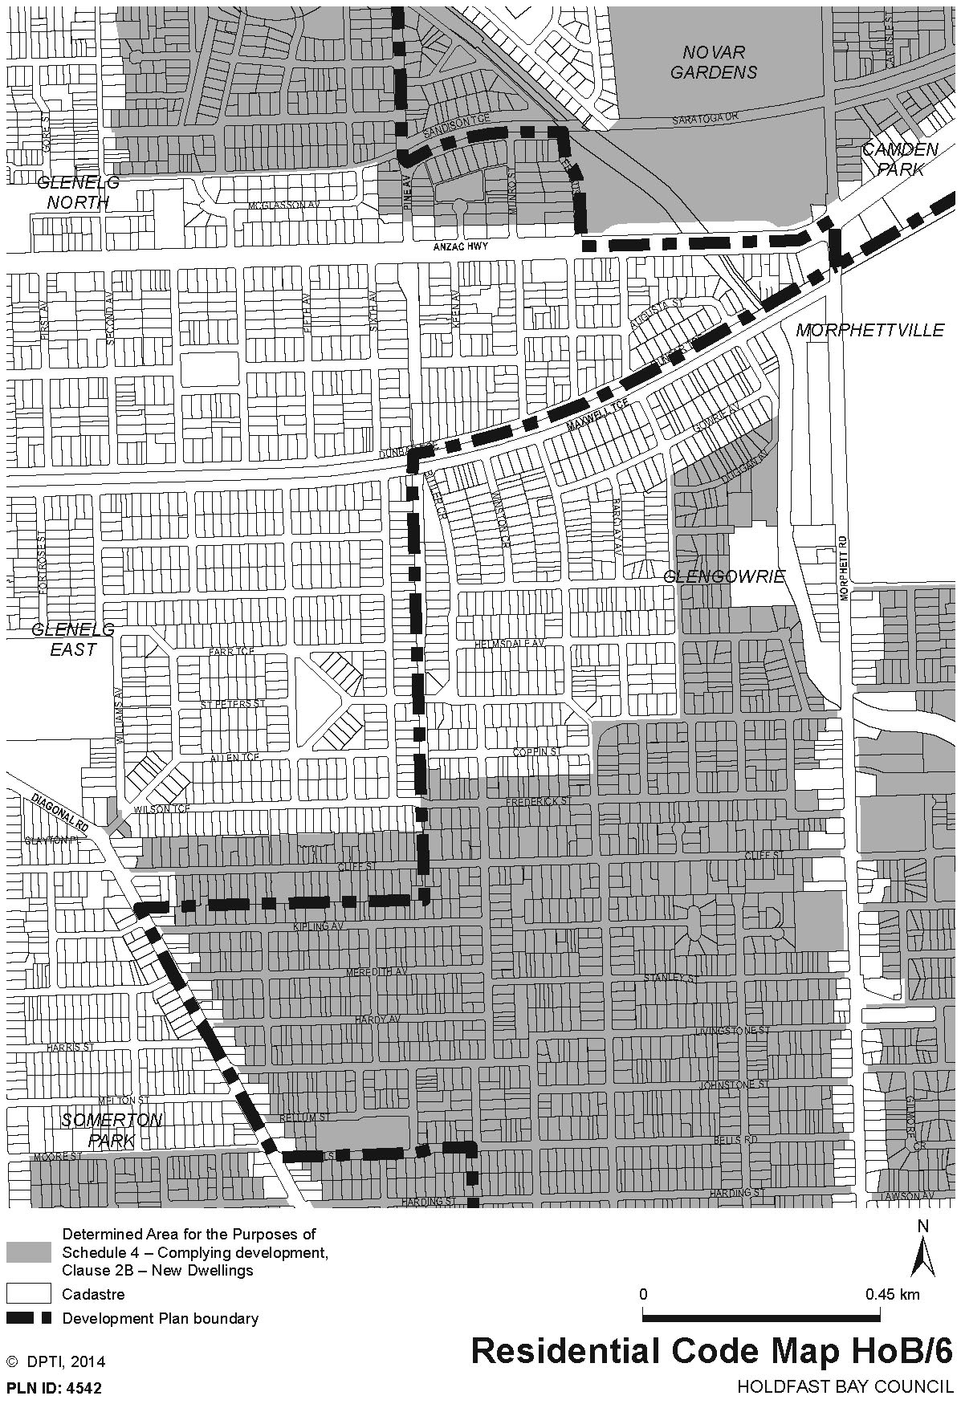
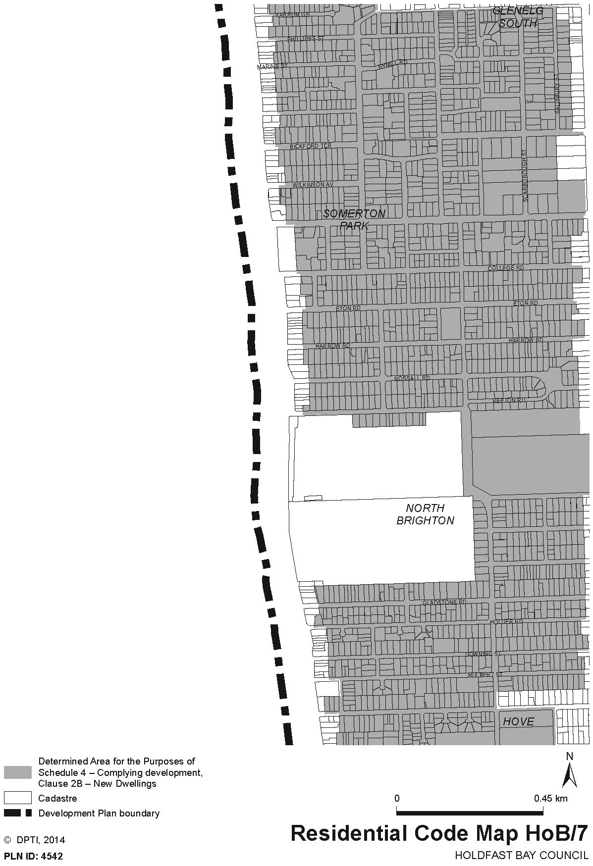
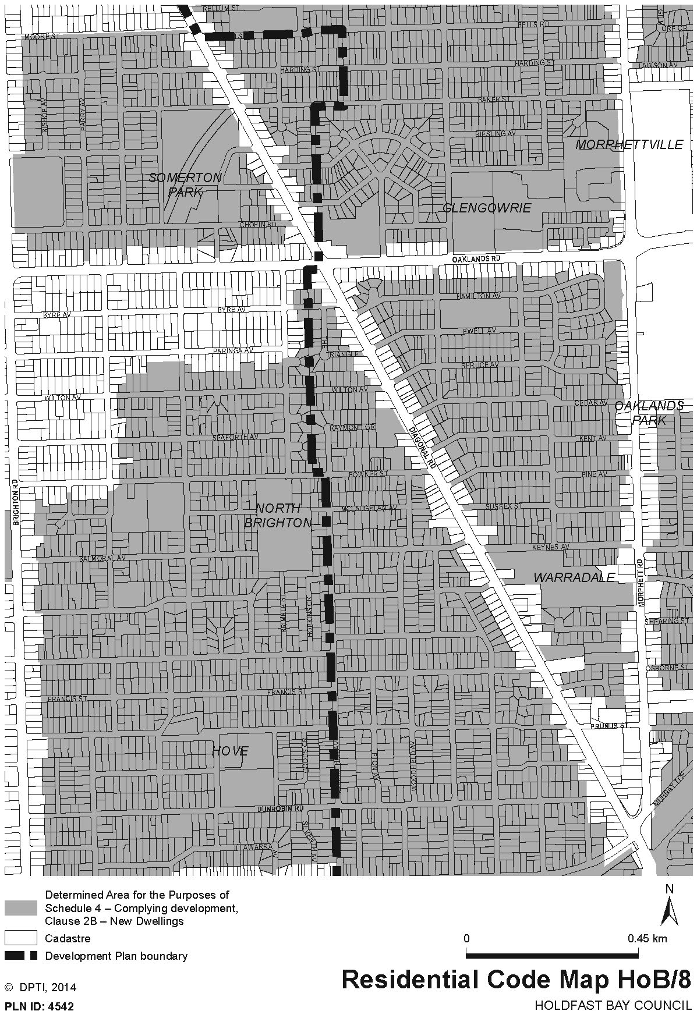
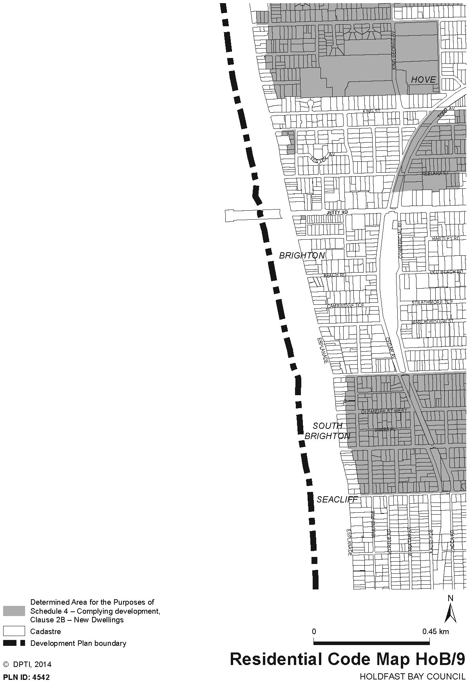
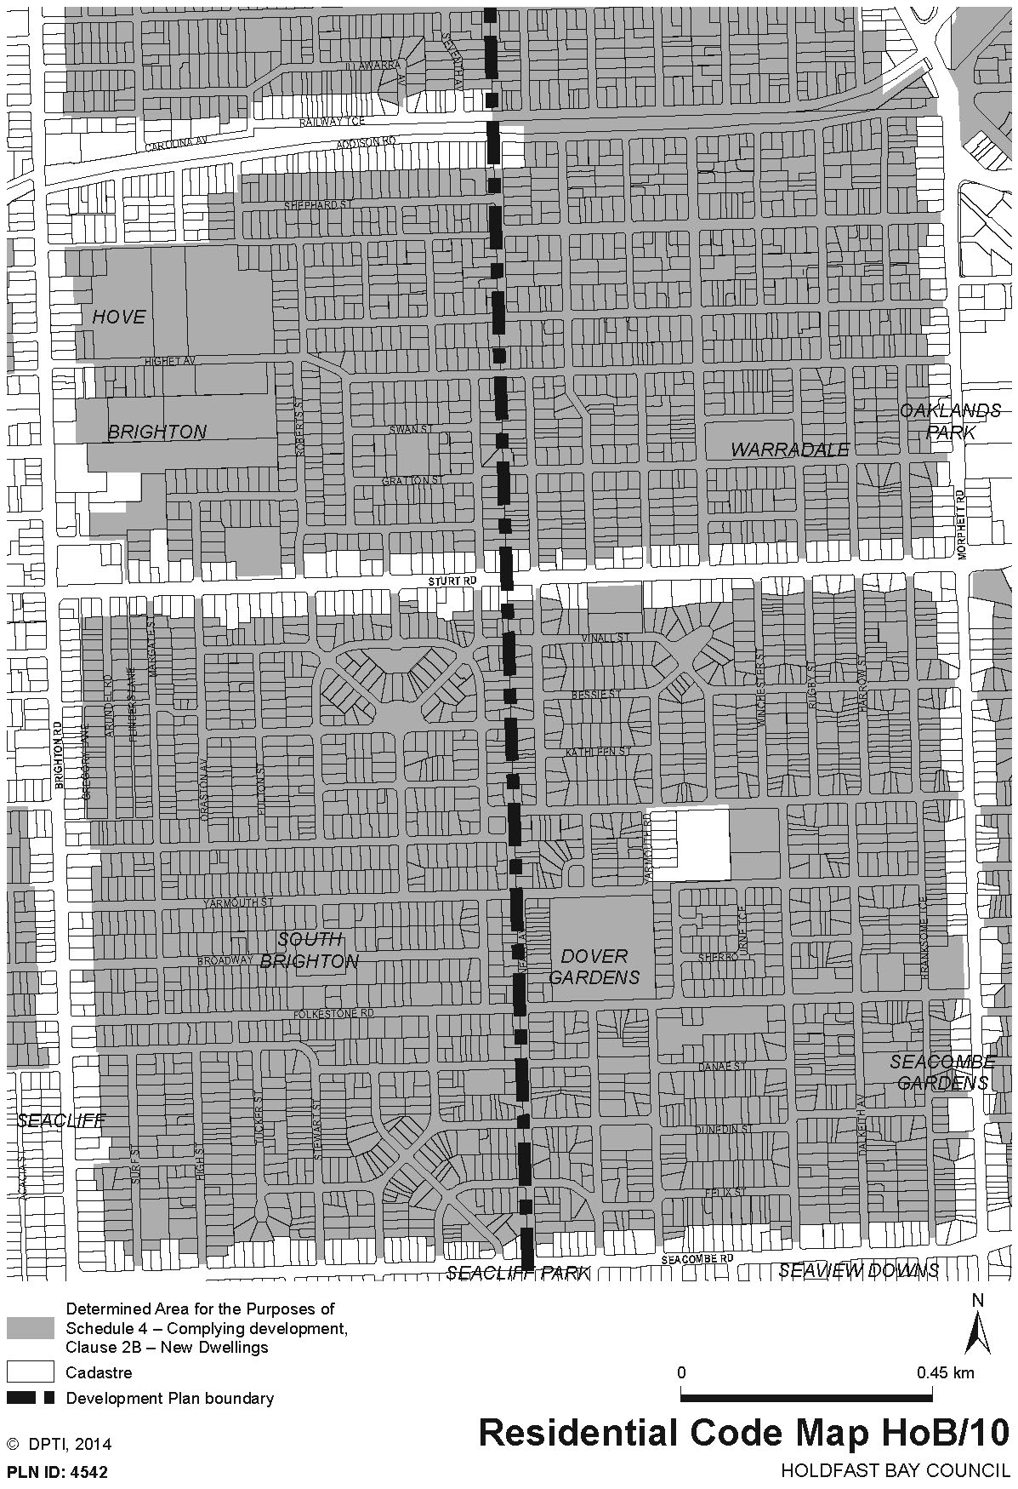
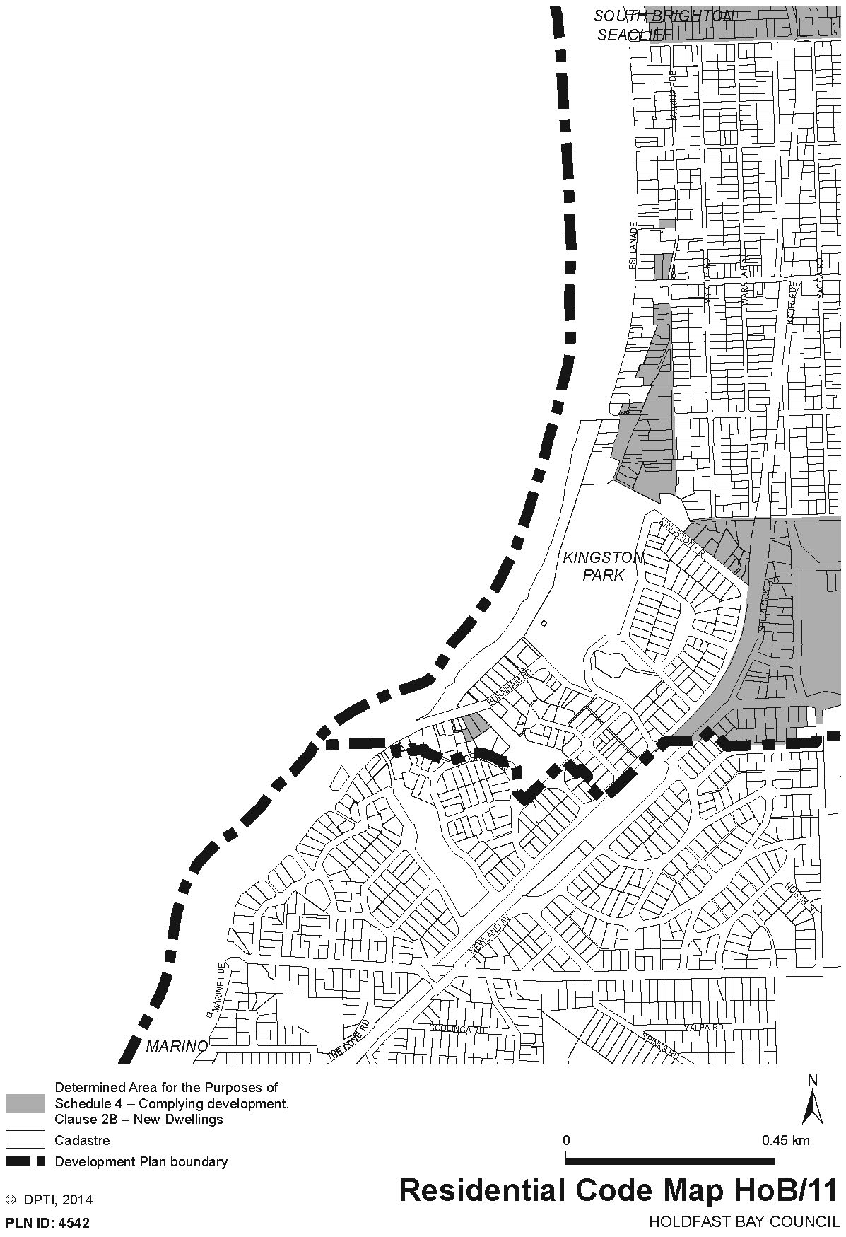
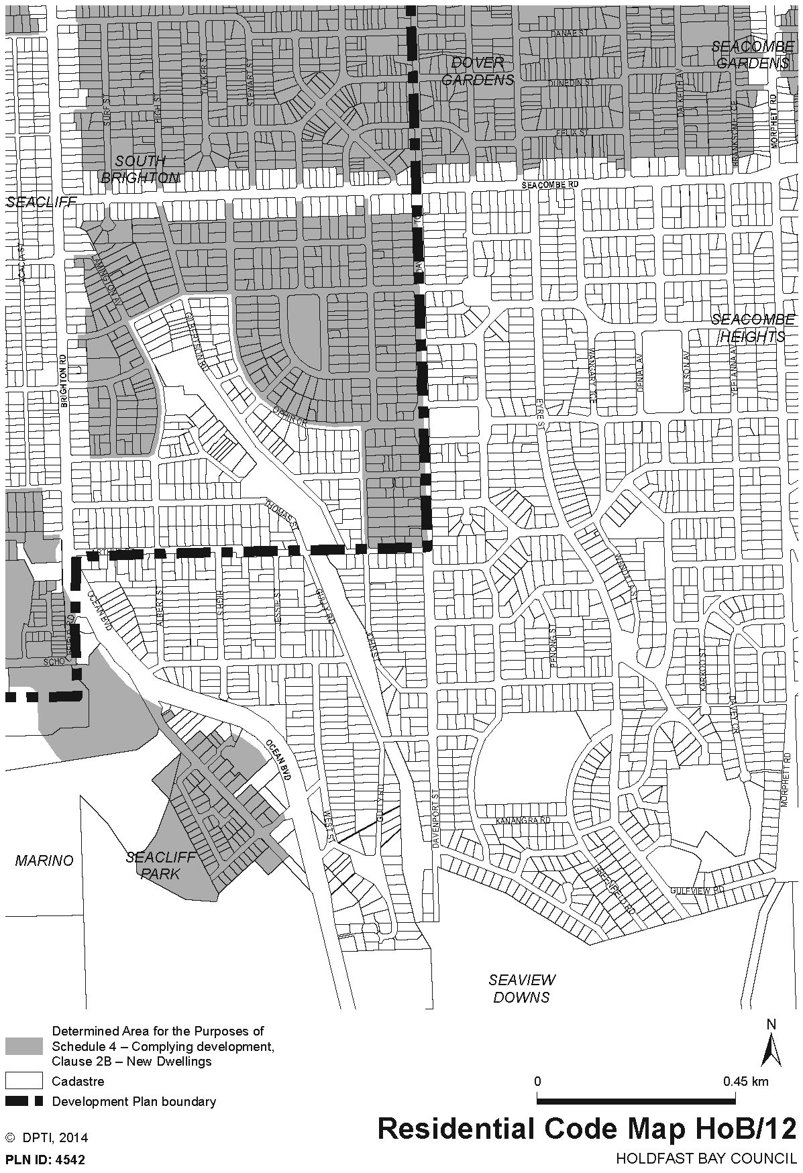
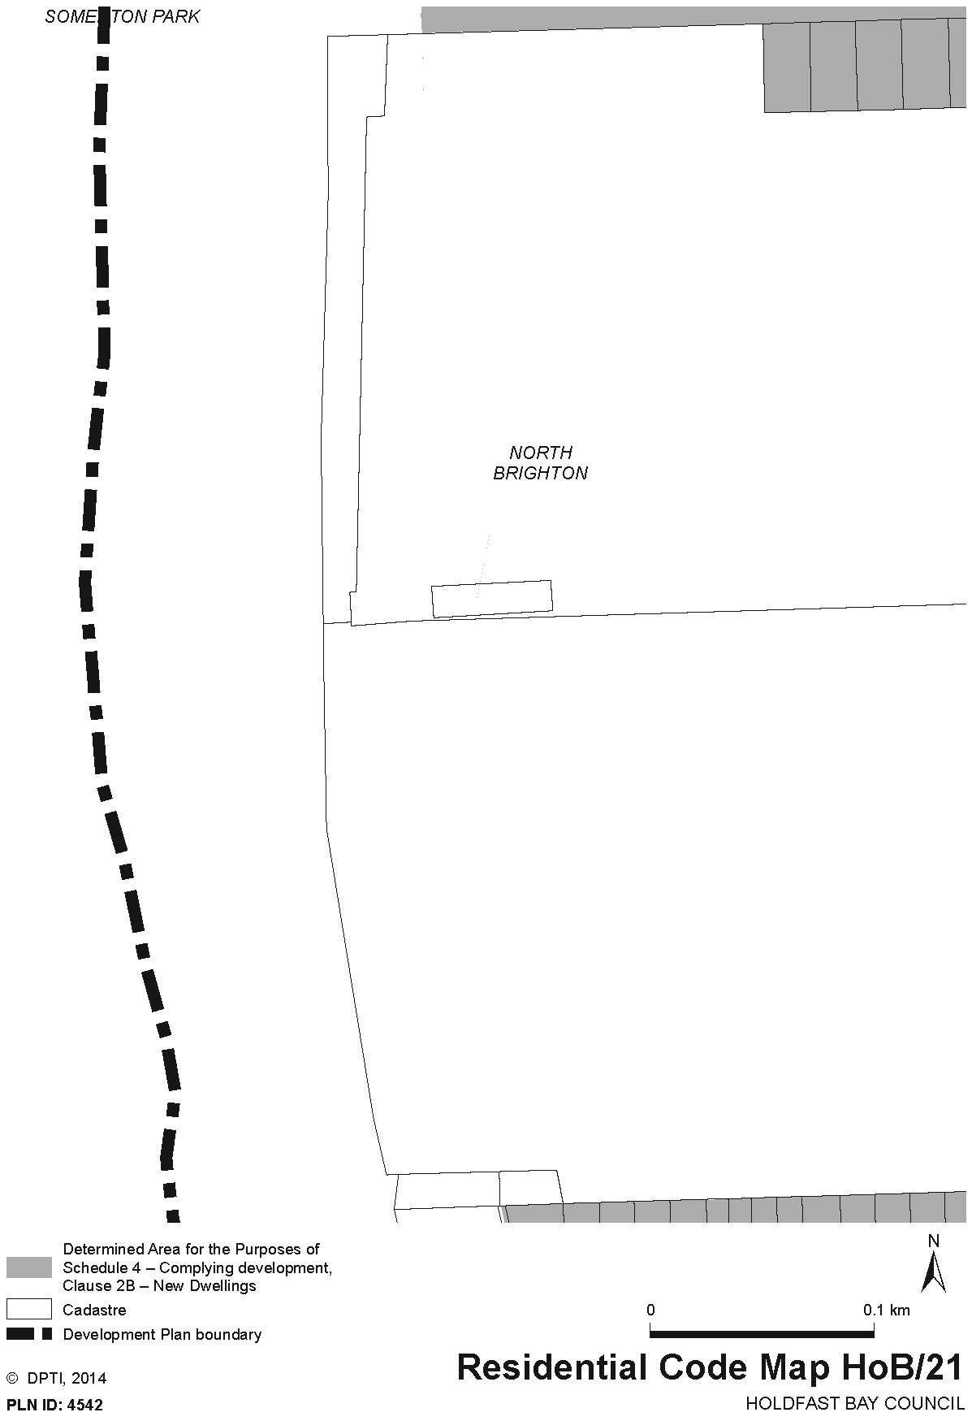
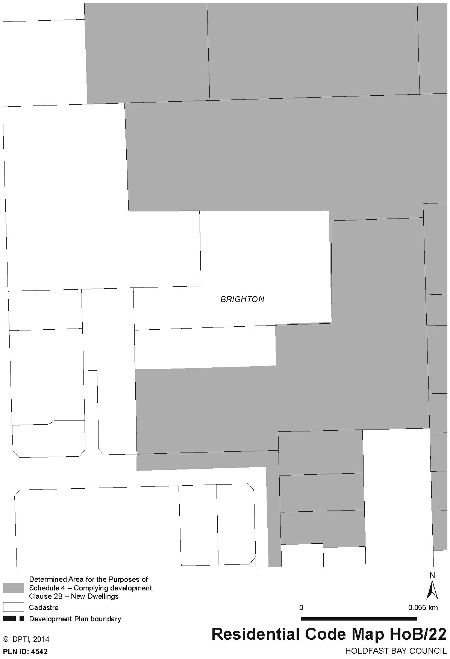
Dated 21 November 2014.
John Rau, Deputy Premier, Minister for Planning

GOVERNMENT GAZETTE ADVERTISEMENT RATES

To apply from 1 July 2014

$  Agents, Ceasing to Act as 49.75  Associations:  Incorporation 25.25  Intention of Incorporation 62.50  Transfer of Properties 62.50  Attorney, Appointment of 49.75  Bailiff’s Sale 62.50  Cemetery Curator Appointed 36.75  Companies:  Alteration to Constitution 49.75  Capital, Increase or Decrease of 62.50  Ceasing to Carry on Business 36.75  Declaration of Dividend 36.75  Incorporation 49.75  Lost Share Certificates:  First Name 36.75  Each Subsequent Name 12.70  Meeting Final 41.50  Meeting Final Regarding Liquidator’s Report on  Conduct of Winding Up (equivalent to ‘Final  Meeting’)  First Name 49.75  Each Subsequent Name 12.70  Notices:  Call 62.50  Change of Name 25.25  Creditors 49.75  Creditors Compromise of Arrangement 49.75  Creditors (extraordinary resolution that ‘the Com-pany be wound up voluntarily and that a liquidator be appointed’) 62.50  Release of Liquidator⎯Application⎯Large Ad. 99.00  ⎯Release Granted 62.50  Receiver and Manager Appointed 57.00  Receiver and Manager Ceasing to Act 49.75  Restored Name 46.50  Petition to Supreme Court for Winding Up 86.50  Summons in Action 73.50  Order of Supreme Court for Winding Up Action 49.75  Register of Interests⎯Section 84 (1) Exempt 111.00  Removal of Office 25.25  Proof of Debts 49.75  Sales of Shares and Forfeiture 49.75  Estates:  Assigned 36.75  Deceased Persons⎯Notice to Creditors, etc. 62.50  Each Subsequent Name 12.70  Deceased Persons⎯Closed Estates 36.75  Each Subsequent Estate 1.65  Probate, Selling of 49.75  Public Trustee, each Estate 12.70 |  | $  Firms:  Ceasing to Carry on Business (each insertion) 33.00  Discontinuance Place of Business 33.00  Land⎯Real Property Act:  Intention to Sell, Notice of 62.50  Lost Certificate of Title Notices 62.50  Cancellation, Notice of (Strata Plan) 62.50  Mortgages:  Caveat Lodgement 25.25  Discharge of 26.50  Foreclosures 25.25  Transfer of 25.25  Sublet 12.70  Leases⎯Application for Transfer (2 insertions) each 12.70  Lost Treasury Receipts (3 insertions) each 36.75  Licensing 73.50  Municipal or District Councils:  Annual Financial Statement⎯Forms 1 and 2 695.00  Electricity Supply⎯Forms 19 and 20 494.00  Default in Payment of Rates:  First Name 99.00  Each Subsequent Name 12.70  Noxious Trade 36.75  Partnership, Dissolution of 36.75  Petitions (small) 25.25  Registered Building Societies (from Registrar-General) 25.25  Register of Unclaimed Moneys⎯First Name 36.75  Each Subsequent Name 12.70  Registers of Members⎯Three pages and over:  Rate per page (in 8pt) 316.00  Rate per page (in 6pt) 418.00  Sale of Land by Public Auction 63.00  Advertisements 3.50  ¼ page advertisement 147.00  ½ page advertisement 295.00  Full page advertisement 577.00  Advertisements, other than those listed are charged at $3.50 per column line, tabular one-third extra.  Notices by Colleges, Universities, Corporations and District Councils to be charged at $3.50 per line.  Where the notice inserted varies significantly in length from that which is usually published a charge of $3.50 per column line will be applied in lieu of advertisement rates listed.  South Australian Government publications are sold on the condition that they will not be reproduced without prior permission from the Government Printer.
All the above prices include GST

GOVERNMENT GAZETTE NOTICES
Notices for publication in the South Australian Government Gazette should be emailed to governmentgazette@dpc.sa.gov.au. Content should be sent as Word format attachment(s). Covering emails should include the date the notice is to be published and to whom the notice will be charged. Closing time for lodgement is 4 p.m. on the Tuesday preceding the regular Thursday publication. Gazette enquiries to: Phone 8207 1045. The Government Gazette is available online at: www.governmentgazette.sa.gov.au.

MISCELLANEOUS LEGISLATION AND GOVERNMENT PUBLICATIONS PRICES AS FROM 1 JULY 2014

Acts, Bills, Rules, Parliamentary Papers and Regulations
Pages | Main | Amends | Pages | Main | Amends

1-16 | 3.10 | 1.45 | 497-512 | 42.00 | 41.00
17-32 | 4.00 | 2.50 | 513-528 | 43.25 | 41.75
33-48 | 5.30 | 3.75 | 529-544 | 44.75 | 43.25
49-64 | 6.70 | 5.15 | 545-560 | 46.00 | 44.75
65-80 | 7.75 | 6.45 | 561-576 | 47.00 | 46.00
81-96 | 9.05 | 7.50 | 577-592 | 48.75 | 46.50
97-112 | 10.30 | 8.85 | 593-608 | 50.00 | 48.00
113-128 | 11.50 | 10.20 | 609-624 | 51.00 | 49.75
129-144 | 12.90 | 11.40 | 625-640 | 52.00 | 50.50
145-160 | 14.20 | 12.70 | 641-656 | 53.50 | 52.00
161-176 | 15.40 | 14.00 | 657-672 | 54.50 | 52.50
177-192 | 16.80 | 15.20 | 673-688 | 56.00 | 54.50
193-208 | 18.10 | 16.70 | 689-704 | 57.00 | 55.00
209-224 | 19.10 | 17.70 | 705-720 | 58.50 | 56.50
225-240 | 20.40 | 18.90 | 721-736 | 60.00 | 57.50
241-257 | 22.00 | 20.00 | 737-752 | 60.50 | 59.00
258-272 | 23.20 | 21.20 | 753-768 | 62.50 | 60.00
273-288 | 24.30 | 23.00 | 769-784 | 63.50 | 62.50
289-304 | 25.50 | 23.90 | 785-800 | 64.50 | 63.50
305-320 | 27.00 | 25.25 | 801-816 | 66.00 | 64.00
321-336 | 28.00 | 26.50 | 817-832 | 67.50 | 66.00
337-352 | 29.50 | 27.75 | 833-848 | 69.00 | 67.50
353-368 | 30.25 | 29.25 | 849-864 | 70.00 | 68.50
369-384 | 32.00 | 30.25 | 865-880 | 71.50 | 70.00
385-400 | 33.50 | 31.75 | 881-896 | 72.00 | 70.50
401-416 | 34.75 | 32.75 | 897-912 | 73.50 | 72.00
417-432 | 36.00 | 34.50 | 913-928 | 74.00 | 73.50
433-448 | 37.00 | 35.75 | 929-944 | 75.50 | 74.00
449-464 | 38.00 | 36.50 | 945-960 | 76.50 | 75.00
465-480 | 38.50 | 37.75 | 961-976 | 80.00 | 76.00
481-496 | 41.00 | 38.50 | 977-992 | 81.00 | 76.50

Legislation—Acts, Regulations, etc.: $
Subscriptions:
Acts 259.00
All Bills as Laid 623.00
Rules and Regulations 623.00
Parliamentary Papers 623.00
Bound Acts 288.00
Index 144.00
Government Gazette
Copy 6.85
Subscription 344.00
Hansard
Copy 18.90
Subscription—per session (issued weekly) 539.00
Cloth bound—per volume 232.00
Subscription—per session (issued daily) 539.00
Legislation on Disk
Whole Database 3 999.00
Annual Subscription for fortnightly updates 1 229.00
Individual Act(s) including updates POA
Notice of Vacancies
Annual Subscription 195.00
Compendium
Subscriptions:
New Subscriptions 2 368.00
Updates 836.00
(All the above prices include GST)

Counter Sales Government Legislation Outlet
and Mail Orders: Service SA Customer Service Centre,
Ground Floor—EDS Centre, 108 North Terrace, Adelaide, S.A. 5000
Phone: 13 23 24 (local call cost), Fax: (08) 8204 1909
Postal: G.P.O. Box 1707, Adelaide, S.A. 5001

Online Shop: www.shop.service.sa.gov.au

Subscriptions and Government Publishing SA
Standing Orders: Plaza Level, Riverside Centre, North Terrace, Adelaide, S.A. 5000
Phone: (08) 8207 1043, (08) 8207 0908, Fax: (08) 8207 1040
Email: AdminGovPubSA@sa.gov.au

FISHERIES MANAGEMENT ACT 2007: SECTION 79
Goolwa Beach Closure
Closure of Pipi Fishery—Recreational
TAKE notice that pursuant to Section 79 of the Fisheries Management Act 2007, it is hereby declared that it shall be unlawful for any person to engage in the class of fishing activity specified in Schedule 1, in the area specified in Schedule 2, during the period specified in Schedule 3.
Schedule 1
The act of taking or an act preparatory to the taking of Pipi (Donax deltoides).
Schedule 2
The Sir Richard Peninsula between the Murray Mouth and Middleton Point, near Mill Terrace, Middleton.
Schedule 3
From 9 a.m. on 18 November 2014 until 11:59 p.m. on 17 December 2014.
Dated 17 November 2014.
K. Rowling, Director Fisheries and Aquaculture Policy

FISHERIES MANAGEMENT ACT 2007 SECTION 79
TAKE notice that the notice made under Section 79 of the Fisheries Management Act 2007, dated 18 November 2014 published in the South Australian Government Gazette dated 20 November 2014, on page 6467 being the first notice on the page referring to the Spencer Gulf Prawn Fishery is hereby revoked.
Take note that the notice made under Section 79 of the Fisheries Management Act 2007, dated 7 January 2014, and published in the South Australian Government Gazette dated 9 January 2014, on page 5, being the first notice on that page, referring to the Spencer Gulf Prawn Fishery, is hereby varied such that it will not be unlawful for a person fishing pursuant to a Spencer Gulf Prawn Fishery Licence to use prawn trawl nets in the areas specified in Schedule 1, during the period specified in Schedule 2, and under the conditions specified in Schedule 3.
Schedule 1
1. The waters of the Spencer Gulf Prawn Fishery that are:
(a) South of the following co-ordinates: Latitude 33°15.20′S, longitude 137°52.00′E, then to position latitude 33°15.20′S, longitude 137°40.60′E, then to position 33°10.00′S, longitude 137°43.70′E, then to position latitude 33°10.00′S, longitude 137°41.00′E, then to position latitude 33°15.50′S, longitude 137°33.24′E, then to position latitude 33°18.50′S, longitude 137°35.00′E, then to position latitude 33°23.00′S, longitude 137°35.00′E, then to position latitude 33°25.00′S, longitude 137°34.60′E, then to position latitude 33°25.00′S, longitude 137°29.70′E, then to position latitude 33°29.00 S, longitude 137°29.70′E, then to position latitude 33129.00′S, longitude 137°16.00′E.
(b) Except the waters contained within and bounded by the following co-ordinates, which shall remain closed to fishing:
(a) Commencing at latitude 33°41.00′S, longitude 137°06.00′E, then to position latitude 33°56.00′S, longitude 137°16.00′E, then to position latitude 34°13.00′S, longitude 136°58.00′E, then to position latitude 34°13.00′S, longitude 136°49.00′E, then to position latitude 34°13.50′S, longitude 136°49.00′E, then to position latitude 34°13.50′S, longitude 136°45.70′E, then to position latitude 34°03.00′S, longitude 136°51.00′E, then to position latitude 33°54.00′S, longitude 137°07.00′E, then to position latitude 33°50.20′S, longitude 137°07.00′E, then to position latitude 33°50.20′S, longitude 136°52.70′E, then to position latitude 33°54.00′S, longitude 136°56.00′E, then to position latitude 33°56.50′S, longitude 136°51.00′E, then to position latitude 33°50.20′S, longitude 136°45.30′E, then to position latitude 33°50.20′S, longitude 136°43.00′E; and,
(b) Commencing at the area known as the ‘Wardang Closure’ latitude 34°10.00′S, longitude 137°28.00′E, then to position latitude 34°21.00′S, longitude 137°12.00′E, then to position latitude 34°45.00’S, longitude 137°15.00′E, then to position latitude 34°48.53′S, longitude 137°09.45′E, then to position latitude 34°48.53′S, longitude 137°06.00′E, then to position latitude 34°50.75′S, longitude 137°06.00′E, then to position latitude 34°54.00′S, longitude 137°01.00′E; and,
(c) Commencing at the area known as the ‘Wallaroo and Port Broughton Closure’ latitude 33°17.00′S, longitude 137°53.00′E, then to position latitude 33°37.00′S, longitude 137°33.00′E, then to position latitude 33°49.00′S, longitude 137°29.00′E, then to position latitude 33°54.00′S, longitude 137°38.00′E.
Schedule 2
Commence at sunset on 24 November 2014 and end at sunrise on 30 November 2014.
Schedule 3
1. The co-ordinates in Schedule 1 are defined as degrees decimal minutes and based on the World Geodetic System 1984 (WGS 84).
2. No fishing activity may be undertaken between the prescribed times of sunrise and sunset for Adelaide (as published in the South Australian Government Gazette pursuant to the requirements of the Proof of Sunrise and Sunset Act 1923) during the period specified in Schedule 2.
3. Fishing must cease in the area specified in Schedule 1 if the total catch for pre-Christmas fishing runs including 25 October 2014 to 3 November 2014, 18 November 2014 to 24 November 2014 and the dates of this notice, reach a total of 450 tonnes.
4. Fishing must cease in an area if the average prawn bucket count for all vessels exceeds 260 prawns per bucket count.
5. Fishing must cease in the fishery if:
(a) in the area known as the Mid/North Gulf area (north of the Southern Gulf area) if the average catch per vessel, per night (for all vessels) drops below 400 kg; and
(b) in the area known as the Southern Gulf area the average catch per vessel over two consecutive nights falls below 350 kg.
6. No fishing activity may occur without the authorisation of Co-ordinator at Sea, Greg Palmer or other nominated Co-ordinator at Sea appointed by the Spencer Gulf and West Coast Prawn Fishermen’s Association.
7. The authorisation of the Co-ordinator at Sea must be in writing, signed and record the day, date and permitted fishing area within the waters of Schedule 1 in the form of a notice sent to the fishing fleet or vary an earlier authorisation issued by the Co-ordinator at Sea.
8. The Co-ordinator at Sea must cause a copy of any authorisation for fishing activity or variation of same, made under this notice to be emailed to the Prawn Fisheries Manager immediately after it is made.
9. The Co-ordinator at Sea must keep records of all authorisations issued pursuant to this notice.
Dated 24 November 2014.
B. Milic, Prawn Fisheries Manager

HEALTH CARE ACT 2008
Dissolution of a Health Advisory Council
Notice by the Minister
TAKE notice that I, Jack Snelling, Minister for Health, pursuant to Section 15 (4) (c) of the Health Care Act 2008, hereby dissolve the Health and Medical Research Advisory Council established on 4 February 2010, as a Health Advisory Council, pursuant to Section 15 (1) of the Health Care Act 2008. The dissolution of the Health and Medical Research Advisory Council is effective from the date of this notice.
Dated 21 November 2014.
Jack Snelling, Minister for Health

MINING ACT 1971
NOTICE is hereby given in accordance with Section 28 (5) of the Mining Act 1971, that the Minister for Mineral Resources and Energy proposes to grant an Exploration Licence over the undermentioned area:
Applicant: Golden Cross Operations Pty Ltd
Location: Codna Hill Area—Approximately 115 km east- south-east of Coober Pedy.
Pastoral Lease: Anna Creek
Term: 2 years
Area in km²: 281
Ref.: 2014/00229
Plan and co-ordinates can be found on the Department of State Development website: http://www.minerals.statedevelopment.sa. gov.au/public_notices or by phoning Mineral Tenements on (08) 8463 3103.
J Martin, Mining Registrar, Department of State Development

NATIONAL PARKS AND WILDLIFE (NATIONAL PARKS) REGULATIONS 2001
Closure of Caroona Creek Conservation Park
PURSUANT to Regulations 8 (3) (a) and 8 (3) (d) of the National Parks and Wildlife (National Parks) Regulations 2001, I, Grant Anthony Pelton, Director, Regional Co-ordination, Partnerships and Stewardship, formerly entitled Director, Public Land Management and Operational Support, Regional Services, authorised delegate of the Director of National Parks and Wildlife, close to the public, the whole of Caroona Creek Conservation Park from 6 a.m. on Sunday, 4 January 2015 until 6 p.m. on Saturday, 10 January 2015.
The purpose of the closure is to ensure the safety of the public during a pest control and monitoring program within the reserve during the period indicated.
Use of firearms within the Reserve
Pursuant to Regulations 8 (4), 20 (1) and 41 of the National Parks Regulations 2001, I, Grant Anthony Pelton, Director, Regional Co-ordination, Partnerships and Stewardship, formerly entitled Director, Public Land Management and Operational Support, Regional Services, authorised delegate of the Director of National Parks and Wildlife, grant permission to members of the SSAA Conservation and Wildlife Management (SA) Inc., in
possession of both a current Hunting Permit and a firearm to enter and remain in Caroona Creek Conservation Park from 6 a.m. on Sunday, 4 January 2015 until 6 p.m. on Saturday, 10 January 2015.
This permission is conditional upon the observance by each of those persons of the requirements of the National Parks and Wildlife Act 1972, National Parks Regulations 2001, and the National Parks and Wildlife (Hunting) Regulations 1996, including those requiring compliance with the Director’s requests, requirements and orders of a Warden.
Dated 25 November 2014.
G. A. Pelton, Director, Regional Co-ordination, Partnerships and Stewardship, Department of Environment, Water and Natural Resources

NATIONAL GAS LAW
THE Australian Energy Market Commission (AEMC) gives notice under the National Gas Law as follows:
Under s 311, the making of the final determination on the Portfolio Rights Trading 2014 proposal.
Australian Energy Market Commission
Level 6, 201 Elizabeth Street,
Sydney, N.S.W. 2000
Phone: (02) 8296 7800
Website: www.aemc.gov.au
27 November 2014.

NATIONAL ELECTRICITY LAW
THE Australian Energy Market Commission (AEMC) gives notice under the National Electricity Law as follows:
Under ss 102 and 103, the making of the National Electricity Amendment (Distribution Network Pricing Arrangements) Rule 2014 No. 9 and related final determination. All provisions commence on
1 December 2014.
Australian Energy Market Commission
Level 6, 201 Elizabeth Street,
Sydney, N.S.W. 2000
Phone: (02) 8296 7800
Website: www.aemc.gov.au
27 November 2014.

[Republished]
In Government Gazette No. 84 dated 20 November 2014, page 6472, was printed with an error in the table. This notice should be replaced with the following.
Petroleum and Geothermal Energy Act 2000
Grant of Petroleum Exploration Licence—PEL 650
NOTICE is hereby given that the undermentioned Petroleum Exploration Licence has been granted under the provisions of the Petroleum and Geothermal Energy Act 2000, pursuant to delegated powers dated 21 March 2012.
No. of  Licence | Licensee | Locality | Expiry
PEL 650 | ARP TriEnergy Pty Limited | Leigh Creek | 17 November 2019

Description of Area
All that part of the State of South Australia, bounded as follows:
Commencing at a point being the intersection of the eastern boundary of Section 419, Out of Hundreds (Copley) and a north-eastern boundary of Section 420, Out of Hundreds (Copley), thence generally south-easterly along the boundary of the said Section 420 to a northern boundary of Allotment 130, Filed Plan 218172, thence beginning easterly along the boundary of the said Allotment 130 to a northern boundary of Section 1255, Out of Hundreds (Copley), thence beginning easterly along the boundary of the said Section 1255, to an eastern boundary of Allotment 129, Filed Plan 218172, thence beginning southerly along the boundary of the said Allotment 129 to a southern boundary of Allotment Piece 3003, Deposited Plan 57039, thence beginning westerly along the boundary of the said Allotment Piece 3003 to a north-western boundary of Section 420, Out of Hundreds (Copley), thence generally north-easterly along the boundary of the said Section 420 to the south-eastern boundary of Allotment Piece 5003, Deposited Plan 57039, thence beginning north-westerly along the boundary of the said Allotment Piece 5003 to a western boundary of Section 534, Out of Hundreds (Copley), thence beginning north-westerly along the boundary of the said Section 534 to a western boundary of Section 325, Out of Hundred (Copley), thence generally north-westerly along the boundary of the said Section 325 to a western boundary of Section 419, Out of Hundreds (Copley), thence beginning north-westerly along the boundary of the said Section 419 to the point of commencement.
Area: 93.40 km² approximately.
Dated 18 November 2014.
B. A. Goldstein,
Executive Director,
Energy Resources Division,
Department of State Development,
Delegate of the Minister for Mineral Resources and Energy

ROADS (OPENING AND CLOSING) ACT 1991:
SECTION 24
NOTICE OF CONFIRMATION OF ROAD
PROCESS ORDER
Road Closure—Temple Road, Clare
BY Road Process Order made on 17 June 2014, the Clare and Gilbert Valleys Council ordered that:
1. Portion of Temple Road situate east of King Street and adjoining Allotments 91 and 92 in Filed Plan 209559, more particularly delineated and lettered ‘A’ and ‘B’ respectively in Preliminary Plan No. 12/0032 be closed.
2. Transfer the whole of the land subject to closure to the Catholic Church Endowment Society Inc. in accordance with Agreement for Transfer dated 17 June 2014 entered into between the Clare and Gilbert Valleys Council and Catholic Church Endowment Society Inc.
On 6 October 2014 that order was confirmed by the Minister for Transport and Infrastructure conditionally upon the deposit by the Registrar-General of Deposited Plan 94174 being the authority for the new boundaries.
Pursuant to Section 24 (5) of the Roads (Opening and Closing) Act 1991, NOTICE of the order referred to above and its confirmation is hereby given.
Dated 27 November 2014.
M. P. Burdett, Surveyor-General

ROADS (OPENING AND CLOSING) ACT 1991:
SECTION 24
NOTICE OF CONFIRMATION OF ROAD
PROCESS ORDER
Road Closure—Burr Street, Robe
BY Road Process Order made on 22 October 2014, The District Council of Robe ordered that:
1. Portion of Burr Street situate south of O’Halloran Street and adjoining Allotment 91 in Filed Plan 207233, more particularly delineated and lettered ‘A’ in Preliminary Plan No. 14/0016 be closed.
2. Transfer the whole of the land subject to closure to Richard Mortimer White and Elizabeth Ann White in accordance with Agreement for Transfer dated 17 July 2014 entered into between The District Council of Robe and R. M. and E. A. White.
On 21 November 2014 that order was confirmed by the Minister for Transport and Infrastructure conditionally upon the deposit by the Registrar-General of Deposited Plan 95091 being the authority for the new boundaries.
Pursuant to Section 24 (5) of the Roads (Opening and Closing) Act 1991, NOTICE of the order referred to above and its confirmation is hereby given.
Dated 27 November 2014.
M. P. Burdett, Surveyor-General

ROAD TRAFFIC ACT 1961
Authorised Officers to Operate Drug Screening Tests
I, GARY T. BURNS, Commissioner of Police, do hereby notify that on and from 17 November 2014, the following persons were authorised by the Commissioner of Police to conduct drug screening tests as defined in and for the purposes of the:
Road Traffic Act 1961;
Harbors and Navigation Act 1993; and
Rail Safety National Law (South Australia) Act 2012.

PD  Number | Officer Name
21847 | Kearney, Paul Andrew
49027 | Murch, Randal Marc
58674 | Wearn, Andrew John
74878 | Williams, Darren Charles

Gary T. Burns, Commissioner of Police

ROAD TRAFFIC ACT 1961
Authorised Officers to Operate Breath Analysing Instruments
I, GARY T. BURNS, Commissioner of Police, do hereby certify that on and from 28 September 2014, the following persons were authorised by the Commissioner of Police to operate breath analysing instruments as defined in and for the purposes of the:
Road Traffic Act 1961;
Harbors and Navigation Act 1993;
Security and Investigation Industry Act 1995; and
Rail Safety National Law (South Australia) Act 2012.

PD  Number | Officer Name
74958 | Allt, Aidan Joseph
74853 | Bennett, Adam Patrick
74304 | Blackwell, Julian Oliver
74760 | Komoll, Nicholas Ian
75177 | Long, Daniel James
75251 | Twamley, Samantha Kate
74880 | Warren, Benjamin Edward

Gary T. Burns, Commissioner of Police

ROAD TRAFFIC ACT 1961
SOUTH AUSTRALIA LIGHT TRAILER (CITRUS) EXEMPTION NOTICE 2014
PURPOSE
1. The purpose of this notice is to exempt light trailers when carrying citrus fruit from the braking, lighting and mudguard requirements of the Road Traffic (Light Vehicle Standards) Rules 2013, as stated in this notice.
AUTHORISING PROVISION
2. This notice is made under Section 163AA of the Road Traffic Act 1961 (the Act).
TITLE
3. This notice may be cited as the ‘South Australia Light Trailer (Citrus) Exemption Notice 2014’.
COMMENCEMENT
4. This notice commences on 1 December 2014.
EXPIRY
5. This notice expires on 31 October 2019.
DEFINITIONS
6. Unless otherwise stated, words or expressions used in this notice have the same meaning as in the Act and Regulations made under the Act.
7. In this notice:
‘ATM’ (aggregate trailer mass), is the total maximum mass of the trailer, as stated by the manufacturer, together with its load and the mass imposed on the towing vehicle by the trailer when the towing vehicle and trailer are on a horizontal surface.
‘laden mass’ means the total maximum mass of the trailer, together with its load and the mass imposed on the towing vehicle by the trailer when the towing vehicle and trailer are on a horizontal surface.
‘low visibility’ means any time, when, owing to insufficient daylight or unfavourable conditions, persons or vehicles on a road are not clearly visible at a distance of 250 m to a person of normal vision.
APPLICATION
8. This notice applies to:
(a) a light trailer when towed by a light motor vehicle;
(b) one or two light trailers when towed by a tractor; and
(c) a light trailer when towed by a heavy motor vehicle.
Note 1: ‘Light’ refers to a vehicle or trailer with a GVM or ATM of 4.5 tonnes or less.
Note 2: A heavy vehicle towing a light trailer is a heavy vehicle combination under the Heavy Vehicle National Law. The exemptions and conditions specified in this notice apply to the light trailer when towed by a heavy vehicle.
Note 3: An individual light motor vehicle, individual light trailer and a light motor vehicle and trailer combination must comply with the Act and Regulations made under the Act, except where exempt by this notice.
Note 4: A light motor vehicle (not being a tractor) is only permitted to tow one trailer under Regulation 65 of the Road Traffic (Miscellaneous) Regulations 2014.
EXEMPTION FROM PRESCRIBED LIGHT VEHICLE STANDARDS
9. This notice exempts light trailers described in Clause 8 from the following provisions of the Road Traffic (Light Vehicle Standards) Rules 2013:
Braking
(a) Rule 20—Compliance with third edition ADRs, but only in so far as it relates to ADR 38—Trailer Braking Systems, Section 4—Design requirements for trailers up to 4.5 tonnes ‘ATM’;
(b) Rule 129 (1)—Trailer braking requirements; and
(c) Rule 130—Operation of brakes on trailers.
Lighting
(d) Part 8—Lights and reflectors.
Mudguards
(e) Rule 34—Mudguards and spray suppression.
CONDITIONS
10. This exemption only applies while the trailers are transporting citrus fruit from a place of production to a place of processing and return.
Note 5: When being transported (laden or unladen) as a load, citrus trailer bins must be secured to the trailer in accordance with the requirements of the Load Restraint Guide. The guide can be found at http://www.ntc.gov.au/heavy-vehicles/safety/load-restraint-guide.
11. The trailer(s) must not be towed between the hours of sunset and sunrise as specified in the Proof of Sunrise and Sunset Act 1923, as amended, and published in the South Australian Government Gazette, or during periods of low visibility.
12. The mass of each trailer, including any load, must not exceed 1.9 tonnes.
13. The trailer(s) must not be towed at a speed greater than 25 km/h.
14. At least one rear-facing red reflector, not over 1.5 m above ground level must be fitted at the rear of the trailer(s).
15. The reflectors must comply with the requirements of Rule 105—General requirements for reflectors, of the Road Traffic (Light Vehicle Standards) Rules 2013.
16. Brake lights and direction indicators must be fitted to the rear of the trailer(s), if the brake lights and direction indicators of the towing vehicle are not clearly visible at all time to other drivers approaching from the rear.
17. If required to be fitted to the trailer(s), the brake lights must comply with Division 9—Brake lights and the direction indicators must comply with Division 11—Direction indicator lights, of the Road Traffic (Light Vehicle Standards) Rules 2013.
18. When operating under this notice, a legible, current and complete copy of this notice, either in hard copy or in electronic format so that it can be read from a device having a visual display (e.g. smart phone, tablet or laptop PC, In-Vehicle-Unit), must be carried in the towing vehicle, and that is accessible to a Department of Planning, Transport and Infrastructure Authorised Officer appointed under the Road Traffic Act 1961 or a Police Officer, from outside the vehicle.
DECLARATION
I, David Craig Rogers, Delegate for the Minister for Transport and Infrastructure, hereby exempt light trailers from the stated vehicle standards specified in this notice to the extent and on the conditions specified in this notice.
D. Rogers, Acting Director,
Transport Safety Regulation, Transport Services Division,
Delegate for the Minister for Transport and Infrastructure

ROAD TRAFFIC ACT 1961
SOUTH AUSTRALIA LIGHT TRAILER BRAKE EXEMPTION NOTICE 2014
PURPOSE
1. The purpose of this notice is to exempt light trailers from the braking requirements of the Road Traffic (Light Vehicle Standards) Rules 2013, as stated in this notice.
AUTHORISING PROVISION
2. This notice is made under Section 163AA of the Road Traffic Act 1961 (the Act).
TITLE
3. This notice may be cited as the ‘South Australia Light Trailer Brake Exemption Notice 2014’.
COMMENCEMENT
4. This notice commences on 1 December 2014.
EXPIRY
5. This notice expires on 31 October 2019.
DEFINITIONS
6. Unless otherwise stated, words or expressions used in this notice have the same meaning as in the Act and Regulations made under the Act.
7. In this notice:
‘ATM’ (aggregate trailer mass), is the total maximum mass of the trailer, as stated by the manufacturer, together with its load and the mass imposed on the towing vehicle by the trailer when the towing vehicle and trailer are on a horizontal surface.
‘laden mass’ means the total maximum mass of the trailer, together with its load and the mass imposed on the towing vehicle by the trailer when the towing vehicle and trailer are on a horizontal surface.
APPLICATION
8. This notice applies to:
(a) a light trailer when towed by a light motor vehicle, and
(b) a light trailer when towed by a heavy motor vehicle, in accordance with the ‘South Australia Heavy Vehicle Standards (Six Tonne Trailer Brakes) Exemption (Notice) 2014 (No. 1)’.
Note 1: A heavy vehicle towing a light trailer is a heavy vehicle combination under the Heavy Vehicle National Law.
Note 2: ‘Light’ refers to a vehicle or trailer with a GVM or ATM of 4.5 tonnes or less.
Note 3: An individual light motor vehicle, individual light trailer and a light motor vehicle and trailer combination must comply with the Act and Regulations made under the Act, except where exempt by this notice.
EXEMPTION FROM PRESCRIBED LIGHT VEHICLE STANDARDS
9. This notice exempts light trailers described in Clause 8 from the following provisions of the Road Traffic (Light Vehicle Standards) Rules 2013:
(a) Rule 20—Compliance with third edition ADRs, but only in so far as it relates to ADR 38—Trailer Braking Systems, Section 4—Design requirements for trailers up to 4.5 tonnes ‘ATM’;
(b) Rule 129 (1)—Trailer braking requirements; and
(c) Rule 130—Operation of brakes on trailers.
CONDITIONS
10. The laden mass of the light trailer must not exceed 4.5 tonnes or the lesser of:
(a) The ATM specified for the trailer;
(b) the GTM specified for the trailer (the mass transmitted through the trailer axle(s) to the ground); or
(c) a mass limit for the towing vehicle as specified in the Road Traffic (Light Vehicle Mass and Loading Requirements) Regulations 2013, Schedule 1, Part 1—Light vehicle mass limits.
Note: The GTM cannot exceed the ATM specified for a trailer.
11. The trailer must not be towed at a speed greater than 25 km/h.
Note: When towed by a heavy vehicle, the trailer must not be towed at a speed greater than 25 km/h.
12. When operating under this notice, a legible, current and complete copy of this notice, either in hard copy or in electronic format so that it can be read from a device having a visual display (e.g. smart phone, tablet or laptop PC, In-Vehicle-Unit), must be carried in the towing vehicle, and that is accessible to a Department of Planning, Transport and Infrastructure Authorised Officer appointed under the Act or a Police Officer, from outside the vehicle.
DECLARATION
I, David Craig Rogers, Delegate for the Minister for Transport and Infrastructure, hereby exempt light trailers from the braking requirements specified in this notice to the extent and on the conditions specified in this notice.
D. Rogers, Acting Director,
Transport Safety Regulation, Transport Services Division,
Delegate for the Minister for Transport and Infrastructure

SOUTH AUSTRALIAN HOUSING TRUST ACT 1995
Transfer of assets of the South Australian Housing Trust

PURSUANT to the provisions of Section 23 of the South Australian Housing Trust Act 1995, Zoe Bettison, Minister for Social Housing, with the concurrence of Tom Koutsantonis, Treasurer, gives notice of the transfer of properties listed in Schedule 1 from the South Australian Housing Trust to Access 2 Place Ltd.

Schedule 1

Address | Certificate of Title |  | Certificate of Title Description
Address | Volume | Folio | Plan | Parcel
39A Nottage Road, Northgate | 6108 | 316 | CP27699 | Lot 2
16-18 Byron Street, Mansfield Park | 6076 | 212 | DP84661 | Lot 250
2 Heinrich Street, Mansfield Park | 6065 | 556 | DP84842 | Lot 426
4 Heinrich Street, Mansfield Park | 6065 | 557 | DP84842 | Lot 427

Hon Zoe Bettison MP Hon Tom Koutsantonis MP
Minister for Social Housing Treasurer

Dated: 16 July 2014. Dated: 25 September 2014.

SOUTH AUSTRALIAN HOUSING TRUST ACT 1995
Transfer of assets of the South Australian Housing Trust

PURSUANT to the provisions of Section 23 of the South Australian Housing Trust Act 1995, Zoe Bettison, Minister for Social Housing, with the concurrence of Tom Koutsantonis, Treasurer, gives notice of the transfer of properties listed in Schedule 1 from the South Australian Housing Trust to Access 2 Place Ltd.

Schedule 1

Address | Certificate of Title |  | Certificate of Title Description
Address | Volume | Folio | Plan | Parcel
8A and 8B Francis Road, Brahma Lodge | 5600 | 640 | DP8103 | A32
69 and 71 Ridley Grove, Woodville Gardens | 5224 | 599 | DP40683 | A13
1-4/22 Butterfield Road, Elizabeth Park | 6121 | 919 | DP92469 | A800
1/22 and 2/22 Florence Avenue, Blair Athol | 5702 | 745 | DP4335 | A110
1 Dunbar Avenue, Morphettville | 6092 | 205 | DP88914 | A70
8 Houston Street, Morphettville | 6093 | 166 | DP89088 | A105
10 Houston Street, Morphettville | 6093 | 165 | DP89088 | A104
12 Houston Street, Morphettville | 6093 | 164 | DP89088 | A103

Hon Zoe Bettison MP Hon Tom Koutsantonis MP
Minister for Social Housing Treasurer

Dated: 10 July 2014. Dated: 29 July 2014.

SUMMARY OFFENCES ACT 1953
Declaration of an Event
NOTICE is hereby given in accordance with Section 72A (3) of the Summary Offences Act 1953, that the following event has been declared for the duration of the event between the listed dates:
Event: Stereosonic 2014
Place: Public place known as the Adelaide Showgrounds.
Date: 5 December 2014 and 6 December 2014.
Conditions: May be subject to conditions specified in the notice.
At this event a police officer may carry out a metal detector search in relation to any person who is in, or attempting to enter or leave the event and any property in the person’s possession.
Superintendent Rieniets, Delegate of the Commissioner

SUMMARY OFFENCES ACT 1953
Declaration of an Event
NOTICE is hereby given in accordance with Section 72A (3) of the Summary Offences Act 1953, that the following event has been declared for the duration of the event between the listed dates.
Event: New Year’s Eve Glenelg.
Place: Glenelg area as declared by the New Year’s Eve 2014, Glenelg Dry Zone Extension.
Date: 31 December 2014 to 1 January 2015.
Conditions: Shall be in force from 6 p.m. on 31 December 2014 until 6 a.m. on 1 January 2015.
At this event a police officer may carry out a metal detector search in relation to any person who is in, or attempting to enter or leave the event and any property in the person’s possession.
Superintendent Rieniets, Delegate of the Commissioner

NOTICE TO MARINERS
No. 44 of 2014
South Australia—Thevenard—Yatala Channel—
Draft Restrictions
MARINERS are advised that the results of recurrent annual hydrographic surveys of the Yatala Channel at Thevenard, show that siltation has occurred between beacons 12 and 16 for a width of 40 metres as measured from the north western edge of the Channel.
The working depth in this section of the Channel has temporarily been reduced from 8.2 metres as referred to Lowest Astronomical Tide (LAT) to 7.8 metres LAT.
Mariners are advised to use caution in this area of the Yatala Channel.
Navy Chart affected: Aus. 122
Publication affected: Australian Pilot, Volume 1 (Fourth Edition, 2014) pages 347 to 349.
Adelaide, 19 November 2014.
Stephen Mullighan, Minister for Transport and Infrastructure
FP 2012/0105
DPTI 2014/02432

WATER MAINS AND SEWERS

Office of the South Australian Water Corporation
Adelaide, 27 November 2014

WATER MAINS LAID

Notice is hereby given that the following main pipes or parts of main pipes have been laid down by the South Australian Water Corporation in or near the undermentioned water districts and are now available for a constant supply of water to adjacent land.

ADELAIDE WATER DISTRICT

CITY OF MARION
Easements in lot 90 in LTRO DP 93980, South Road, Clovelly Park. p48 and 49

DISTRICT COUNCIL OF MOUNT BARKER
Hawthorn Road, Mount Barker. p2
Withers Court, Mount Barker. p46
Graham Close, Mount Barker. p46

CITY OF ONKAPARINGA
Old Coach Road, Maslin Beach. p3
Warburton Drive, Woodcroft. p50 and 51
Sunrise Drive, Woodcroft. p50 and 51
Easements in lots 2000 and 1001 in LTRO DP 93063 (to be Sunrise Drive, Saturn Court, Scope Road, Sky Street, Rainbow Lane and Mundulla Avenue), Woodcroft. p50 and 51

CITY OF PLAYFORD
Swinden Crescent, Blakeview. p47
Margaret Street, Blakeview. p47
Roxburgh Crescent, Blakeview. p47
McAdam Street, Munno Para. p57-58
Callinan Street, Munno Para. p57-58
Jonas Street, Munno Para. p57-58
Moore Street, Munno Para. p57-58
Freeman Avenue, Munno Para. p57-58
Healy Street, Munno Para. p57-58
Newchurch Street, Munno Para. p57-58
Lakes Entrance, Blakeview. p59
Broadwater Place, Blakeview. p59

CITY OF SALISBURY
Barli Street, Pooraka. p1

CITY OF WEST TORRENS
Across South Road, Thebarton and Torrensville. p41
Easements in lot 11 in LTRO DP 93587, South Road, Torrensville. p41

GOOLWA WATER DISTRICT

ALEXANDRINA COUNCIL
Neighbour Avenue, Goolwa Beach. p21 and 22

KADINA WATER DISTRICT

DISTRICT COUNCIL OF THE COPPER COAST
Hay Street, Kadina. p40

MUNDALLIO COUNTRY LANDS WATER DISTRICT

CITY OF PORT AUGUSTA
Across McConnal Road, Stirling North. p62
Public road west of lot 3 in LTRO DP 777782, Stirling North. p62

MURRAY BRIDGE WATER DISTRICT

THE RURAL CITY OF MURRAY BRIDGE
Easements in lot 26 in LTRO DP 54732, Torrens Road, and lot 96 in LTRO FP 16734, Gawler Street (to be Timothy James Court), Riverglades. p60

NURIOOTPA WATER DISTRICT

THE BAROSSA COUNCIL
Easements in lot 2000 in LTRO DP 87383 (to be Moore Avenue), Nuriootpa. p52

PORT AUGUSTA WATER DISTRICT

CITY OF PORT AUGUSTA
Shirley Street, Port Augusta West. p53-56
Cheetham Drive, Port Augusta West. p53 and 54
Alschin Boulevard, Port Augusta West. p53 and 55
Shingles Road, Port Augusta West. p53 and 56

PORT PIRIE WATER DISTRICT

PORT PIRIE REGIONAL COUNCIL
Joffre Street, Risdon Park. p39

WHYALLA WATER DISTRICT

THE CORPORTATION OF THE CITY OF WHYALLA
Oborn Street, Whyalla Norrie. p42

SEWERS LAID

Notice is hereby given that the following sewers have been laid down by the South Australian Water Corporation in the undermentioned drainage areas and are now available for house connections.

ADELAIDE DRAINAGE AREA

CITY OF BURNSIDE
Pembroke Street, Kensington Park. FB 1240 p20

CAMPBELLTOWN CITY COUNCIL
Shakespeare Avenue, Magill. FB 1240 p17

CITY OF CHARLES STURT
Lowe Street, Royal Park. FB 1240 p29
Thistle Avenue, Flinders Park. FB 1240 p31
Barker Avenue, Flinders Park. FB 1240 p32

CITY OF MARION
Easements in lot 90 in LTRO DP 93980, South Road, Clovelly Park. FB 1241 p10-12

CITY OF ONKAPARINGA
Easements in lots 2000 and 1001 in LTRO DP 93063 (to be Sunrise Drive, Saturn Court, Scop Road, Sky Street and Rainbow Lane), Woodcroft. FB 1241 p 13-17
Warburton Drive, Woodcroft. FB 1241 p13, 15 and 17
Sunrise Drive, Woodcroft. FB 1241 p13, 14 and 16

CITY OF PLAYFORD
Margaret Street, Blakeview. FB 1241 p7-9
Callinan Street, Munno Para. FB 1241 p18-20
McAdam Street, Munno Para. FB 1241 p18-20
Moore Street, Munno Para. FB 1241 p18-20
Freeman Avenue, Munno Para. FB 1241 p18-20
Slade Street, Munno Para. FB 1241 p18-20
Easements in lot 1879 in LTRO DP 93866, Park Terrace, and lot 1851 in LTRO DP 93856, Main Terrace, Blakeview. FB 1241 p21-23
Lakes Entrance, Blakeview. FB 1241 p21-23
Broadwater Place, Blakeview. FB 1241 p21-23

CITY OF PORT ADELAIDE ENFIELD
Kenmair Street, Mansfield Park. FB 1240 p21

CITY OF SALISBURY
Barkey Street, Para Hills. FB 1240 p23

CITY OF WEST TORRENS
Tennyson Street, Kurralta Park. FB 1240 p19
Rutland Avenue, Lockleys. FB 1240 p22

MOUNT GAMBIER COUNTRY DRAINAGE AREA

CITY OF MOUNT GAMBIER
Webber Street, Mount Gambier. FB 1096 p31

PORT AUGUSTA COUNTRY DRAINAGE AREA

CITY OF PORT AUGUSTA
Tamblyn Street, Port Augusta West. FB 1240 p25

PORT PIRIE COUNTRY DRAINAGE AREA

PORT PIRIE REGIONAL COUNCIL
Smale Street, Risdon Park. FB 1240 p24

STIRLING COUNTRY DRAINAGE AREA

ADELAIDE HILLS COUNCIL
Junction Road, Balhanna. FB 1240 p15
Yappo Road, Aldgate. FB 1240 p16
Spencer Street, Stirling. FB 1240 p18
Lot 8 in LTRO DP 51175, Wattle Tree Road, Bridgewater—
40 mm PE80 pressure sewer system main. This main is available on application only. FB 1240 p30

WHYALLA COUNTRY DRAINAGE AREA

THE CORPORATION OF THE CITY OF WHYALLA
Sugg Street, Whyalla Norrie. FB 1240 p26
Farrell Street, Whyalla. FB 1240 p27

A. J. Ringham, Chief Executive Officer, South Australian Water Corporation

South Australia
Independent Commissioner Against Corruption (Miscellaneous) Amendment Act (Commencement) Proclamation 2014
1—Short title
This proclamation may be cited as the Independent Commissioner Against Corruption (Miscellaneous) Amendment Act (Commencement) Proclamation 2014.
2—Commencement of Act
The Independent Commissioner Against Corruption (Miscellaneous) Amendment Act 2014 (No 20 of 2014) will come into operation on 27 November 2014.
Made by the Governor
with the advice and consent of the Executive Council
on 27 November 2014
AGO0168/14CS

South Australia
Tobacco Products Regulation (Exemption—Black Diggers) Proclamation 2014
under section 71 of the Tobacco Products Regulation Act 1997
1—Short title
This proclamation may be cited as the Tobacco Products Regulation (Exemption—Black Diggers) Proclamation 2014.
2—Commencement
This proclamation comes into operation on the day on which it is made.
3—Interpretation
In this proclamation—
Act means the Tobacco Products Regulation Act 1997;
prescribed period means the period commencing on 8 March 2015 and ending on 21 March 2015;
prescribed production means the stage production of Black Diggers produced by Queensland Theatre Company.
4—Application of proclamation
This proclamation applies to the following persons:
(a) a person employed by, or in relation to, the prescribed production;
(b) an occupier of Her Majesty's Theatre, 58 Grote Street, Adelaide;
(c) an employer with responsibility for a workplace consisting of Her Majesty's Theatre in relation to the prescribed production.
5—Exemption from section 46 of the Act
(1) A person to whom this proclamation applies is exempt from the operation of section 46 of the Act in relation to smoking occurring in the course of a performance or rehearsal of the prescribed production during the prescribed period.
(2) An exemption under this clause is subject to the following conditions:
(a) smoking may only occur on a stage on which the prescribed production is being performed or rehearsed, or in a rehearsal room used in relation to the prescribed production;
(b) the area in which smoking may occur under the exemption must be well ventilated;
(c) the audience for a performance of the prescribed production must be warned that there will be smoking during the performance;
(d) a person may only smoke a tobacco product of a kind contemplated by paragraph (g) of the definition of tobacco product in section 4 of the Act.
(3) If a person contravenes or fails to comply with a condition of an exemption specified in subclause (2), the exemption does not, while the contravention or non-compliance continues, operate in that person's favour.
Made by the Governor
with the advice and consent of the Executive Council
on 27 November 2014
HEAC-2014-00074

South Australia
Youth Court (Designation and Classification of Special Justice) Proclamation 2014
under section 9 of the Youth Court Act 1993
1—Short title
This proclamation may be cited as the Youth Court (Designation and Classification of Special Justice) Proclamation 2014.
2—Commencement
This proclamation will come into operation on 14 January 2015.
3—Designation and classification of special justice
The special justice named in Schedule 1 is—
(a) designated as a special justice of the Youth Court of South Australia; and
(b) classified as a member of the Court's ancillary judiciary.
Schedule 1—Special justice of Court
Patricia May Casey
Made by the Governor
with the advice and consent of the Executive Council
on 27 November 2014
JP14/030CS

South Australia
Administrative Arrangements (Transfer of Assets, Rights and Liabilities to Minister for Public Sector) Proclamation 2014
under section 7 of the Administrative Arrangements Act 1994
1—Short title
This proclamation may be cited as the Administrative Arrangements (Transfer of Assets, Rights and Liabilities to Minister for Public Sector) Proclamation 2014.
2—Commencement
This proclamation comes into operation on the day on which it is made.
3—Transfer of certain assets, rights and liabilities to Minister for Public Sector
(1) The assets, rights or liabilities of the Minister for Finance attributable to any contract or other instrument listed in Schedule 1, or attributable to any other contract or other instrument entered into or created for the purpose of supplementing, replacing, amending or novating any of the contracts or other instruments listed in that Schedule, are transferred to the Minister for the Public Sector.
(2) The assets, rights or liabilities of the Treasurer attributable to any contract or other instrument listed in Schedule 2, or attributable to any other contract or other instrument entered into or created for the purpose of supplementing, replacing, amending or novating any of the contracts or other instruments listed in that Schedule, are transferred to the Minister for the Public Sector.
Schedule 1—Contracts and other instruments relating to Minister for Finance

 | Description of contract or other instrument | Date of execution
1 | Electricity Retail Agreement with AGL South Australia Pty Ltd | 3 July 2013
2 | Deed for the Supply of Fuel and Lubricants (Fuel Card) with BP Australia Pty Ltd | 18 April 2013
3 | Deed for the Supply of Fuel and Lubricants (Fuel Card) with Caltex Australia Pty Ltd | 18 April 2013
4 | Deed for the Supply of Fuel and Lubricants (Fuel Card) with The Shell Company of Australia Ltd (now trading as Viva Energy Australia Ltd) | 2 July 2013
5 | Deed for the Supply of Fuel and Lubricants (Fuel Card) with Mogas Regional Pty Ltd | 18 April 2013
6 | Deed for the Provision of Bulk Fuels and Lubricants with BP Australia Pty Ltd | 18 April 2013
7 | Deed for the Provision of Bulk Fuels and Lubricants with Caltex Australia Petroleum Pty Ltd | 18 April 2013
8 | Deed for the Provision of Bulk Fuels and Lubricants with United Petroleum Pty Ltd | 18 April 2013
9 | Deed for the Provision of Bulk Fuels and Lubricants with Mogas Regional Pty Ltd | 18 April 2013
10 | Deed of Agreement for the Provision of Audit and Financial Advisory Services with BDO Advisory | 19 November 2012
11 | Deed of Agreement for the Provision of Audit and Financial Advisory Services with Bentleys | 19 November 2012
12 | Deed of Agreement for the Provision of Audit and Financial Advisory Services with Deloitte | 19 November 2012
13 | Deed of Agreement for the Provision of Audit and Financial Advisory Services with EY | 19 November 2012
14 | Deed of Agreement for the Provision of Audit and Financial Advisory Services with Galpins | 19 November 2012
15 | Deed of Agreement for the Provision of Audit and Financial Advisory Services with KPMG | 19 November 2012
16 | Deed of Agreement for the Provision of Audit and Financial Advisory Services with PWC | 19 November 2012
17 | Agreement for the Provision of Postal Services with Australia Post | 22 October 2012
18 | Services Agreement for the Supply of General Auction Services with Graysonline | 20 April 2012
19 | Complex Contract for the Supply of Goods with Staples | 9 October 2012
20 | Complex Contract for the Supply of Goods with OfficeMax | 9 October 2012
21 | Travel Management Services Deed of Agreement with Carlson Wagonlit Travel | 12 February 2014
22 | Agreement for the Provision of Maintenance, Support and Hosting of the MyLearning System with Code 42 Pty Ltd | 14 November 2011
23 | Agreement relating to Techsmart for Maintenance and Support of eMite Operational Reporting and Analytical System with Emite Pty Ltd | 22 July 2013
24 | Agreement for the Provision of Support and Maintenance Services relating to SA Tenders - Mobile Applications with ICG Pty Ltd | 4 September 2014
25 | Agreement for Printing and Distribution of Payslips and Payment Summaries 2013 with Phoenix Society Inc. (trading as POST HASTE) | 20 February 2013
26 | Agreement for the Provision of Services relating to the Online Learning Catalogue with Skillsoft Asia Pacific | 16 July 2013
27 | Agreement for the Provision of Software Maintenance and Support Services to a Number of Identified Peripheral Software Applications that Interface with Masterpiece with SWOOD Financial Solutions | 2 May 2012
28 | Agreement for the Provision of Software Maintenance and Support Services to a Number of Identified Peripheral Software Applications that Interface with Masterpiece with Deloitte Touche Tohmatsu | 2 May 2012
29 | Deed of Agreement for the Provision of Discounted Airflights with Qantas | 29 January 2014
30 | Deed of Agreement for the Provision of Discounted Airflights with Virgin Australia | 29 January 2014
31 | Deed of Agreement for the Provision of Discounted Airflights with Regional Express (REX) | 29 January 2014
32 | Agreement relating to the Security Events Management System (SEIM) with Data#3 Limited | 21 July 2013
33 | Agreement for the Provision of Services relating to Financial Viability Checks with Dun and Bradstreet | 28 January 2014
Schedule 2—Contracts and other instruments relating to Treasurer

 | Description of contract or other instrument | Date of execution
1 | Deed of Agreement for the Provision of Temporary Staff Services with Ajilion Pty Ltd | 19 August 2011
2 | Deed of Agreement for the Provision of Temporary Staff Services with Bluestone Recruitment | 19 August 2011
3 | Deed of Agreement for the Provision of Temporary Staff Services with Candle ICT | 19 August 2011
4 | Deed of Agreement for the Provision of Temporary Staff Services with Careerlink | 19 August 2011
5 | Deed of Agreement for the Provision of Temporary Staff Services with Challenge Recruitment | 19 August 2011
6 | Deed of Agreement for the Provision of Temporary Staff Services with DFP Recruitment | 19 August 2011
7 | Deed of Agreement for the Provision of Temporary Staff Services with Excel Recruitment | 19 August 2011
8 | Deed of Agreement for the Provision of Temporary Staff Services with Hays Recruitment | 19 August 2011
9 | Deed of Agreement for the Provision of Temporary Staff Services with Locher | 19 August 2011
10 | Deed of Agreement for the Provision of Temporary Staff Services with McArthur | 19 August 2011
11 | Deed of Agreement for the Provision of Temporary Staff Services with Paxus | 19 August 2011
12 | Deed of Agreement for the Provision of Temporary Staff Services with Peoplebank | 19 August 2011
13 | Deed of Agreement for the Provision of Temporary Staff Services with Randstad | 19 August 2011
14 | Deed of Agreement for the Provision of Temporary Staff Services with Rexco | 19 August 2011
15 | Deed of Agreement for the Provision of Temporary Staff Services with Ross | 19 August 2011
16 | Deed of Agreement for the Provision of Temporary Staff Services with Stillwell | 19 August 2011
17 | Deed of Agreement for the Provision of Temporary Staff Services with Talent International | 19 August 2011
18 | Deed of Agreement for the Provision of Temporary Staff Services with Talent2 | 19 August 2011
19 | Procurement Software License Agreement with Basware | 22 September 2009
20 | E-Procurement Support and Maintenance Agreement with Basware | 22 September 2009
21 | Basware Connectivity Service Agreement with Basware | 14 November 2011
22 | Software Licence and Maintenance and Support Agreement with Infor Global Solutions (ANZ) Pty Ltd | 29 November 2010
23 | Agreement relating to the South Australian Government and Western Australian Government Tenders and Contracts Website with The State of Western Australia (acting through the Department of Treasury and Finance) | 29 May 2009
24 | Agreement relating to the South Australian Government and Victorian Government Tenders and Contracts Website with The State of Victoria | 7 August 2009
25 | Agreement relating to the Use of CA Software with CA (Pacific) Pty Ltd | 29 November 2010
Made by the Governor
with the advice and consent of the Executive Council
on 27 November 2014
MPS14/CS013

South Australia
SACE Board of South Australia Variation Regulations 2014
under the SACE Board of South Australia Act 1983

Contents
Part 1—Preliminary
1 Short title
2 Commencement
3 Variation provisions
Part 2—Variation of SACE Board of South Australia Regulations 2008
4 Variation of regulation 3—Interpretation
5 Revocation of regulation 5
6 Substitution of Schedule 1
Schedule 1—Fees

Part 1—Preliminary
1—Short title
These regulations may be cited as the SACE Board of South Australia Variation Regulations 2014.
2—Commencement
These regulations will come into operation on 1 January 2015.
3—Variation provisions
In these regulations, a provision under a heading referring to the variation of specified regulations varies the regulations so specified.
Part 2—Variation of SACE Board of South Australia Regulations 2008
4—Variation of regulation 3—Interpretation
(1) Regulation 3, definition of Act—delete the definition
(2) Regulation 3, definition of prescribed qualification requirements—delete "prescribed qualification" and substitute:
prescribed certification
5—Revocation of regulation 5
Regulation 5—delete the regulation
6—Substitution of Schedule 1
Schedule 1—delete the Schedule and substitute:
Schedule 1—Fees

1 | Registration fee  For registration as an assessment centre of an educational institution not in receipt of financial assistance from the State | $1 949.00 per year
 | (Registration entitles the institution to services similar to that extended by the Board to educational institutions in receipt of financial assistance from the State.)
2 | Student fee  For enrolment, assessment and certification of a student of an educational institution not in receipt of financial assistance from the State or a full fee paying overseas student (within the meaning of the Education and Early Childhood Services (Registration and Standards) Act 2011)—
 | (a) in the case of a student enrolled at Stage 1 studying fewer than 40 credits | $151.00 per student
 | (b) in the case of a student enrolled at Stage 1 studying 40 credits or more | $280.00 per student
 | (c) in the case of a student enrolled at Stage 2 studying fewer than 40 credits | $330.00 per student
 | (d) in the case of a student enrolled at Stage 2 studying 40 credits or more | $622.00 per student
3 | Late enrolment fee  For enrolment of a student for assessment of completion of prescribed certification requirements after the closing date for receipt of enrolments set by the Board in any year | $102.00 per student
4 | Clerical check fee  For checking, at the request of a student, the clerical processes and procedures involved in determining a result in a subject | $12.50 per subject
5 | Student assessment summary fee  For access to information about the contribution of examination marks and moderated school assessment marks to the final result of a Year 12 level subject | $11.50 per subject
6 | Return of student material fee  For access of students to their assessment materials | $20.00 per subject
7 | Statement fee  For a statement or certified record replacing— | $23.00 per record or statement
 | (a) a statement of results awarded in a specified year; or
 | (b) a certified record of studies undertaken towards completion of the prescribed certification requirements (SACE Record of Achievement); or
 | (c) a certified record of results in individual subjects or requirements comprised in the prescribed certification requirements (SACE Statement of Results) issued
8 | Replacement fee for SACE Certificate  For a replacement copy of a South Australian Certificate of Education | $40.00
9 | Subject outline fee  For a copy of a subject outline | $11.00 if 80 pages or less  $15.50 if more than 80 pages
10 | Professional development of educators and assessors fees
 | (a) for provision of the following Assessment for Educators course modules (per group):
 | (i) Principles and Language of Assessment | $2 500.00
 | (ii) Authentic Assessment - Purpose and Design | $2 500.00
 | (iii) Assessment Strategies | $2 500.00
 | (iv) Feedback and Data | $2 500.00
 | (v) Moderation and Reporting | $2 500.00
 | (vi) for all course modules listed in subparagraphs (i) to (v) | $10 000.00
 | (b) for provision of Certified Educational Assessor Course (5 modules) (per person) | $1 000.00
Note—
As required by section 10AA(2) of the Subordinate Legislation Act 1978, the Minister has certified that, in the Minister's opinion, it is necessary or appropriate that these regulations come into operation as set out in these regulations.
Made by the Governor
on the recommendation of the SACE Board of South Australia and with the advice and consent of the Executive Council
on 27 November 2014
No 275 of 2014
MECD14/107

South Australia
Liquor Licensing (Dry Areas) Variation
Regulations 2014
under the Liquor Licensing Act 1997

Contents
Part 1—Preliminary
1 Short title
2 Commencement
3 Variation provisions
Part 2—Variation of Liquor Licensing (Dry Areas) Regulations 2012
4 Insertion of Schedule—Strathalbyn Area 3
Schedule—Strathalbyn Area 3

Part 1—Preliminary
1—Short title
These regulations may be cited as the Liquor Licensing (Dry Areas) Variation Regulations 2014.
2—Commencement
These regulations come into operation on the day on which they are made.
3—Variation provisions
In these regulations, a provision under a heading referring to the variation of specified regulations varies the regulations so specified.
Part 2—Variation of Liquor Licensing (Dry Areas) Regulations 2012
4—Insertion of Schedule—Strathalbyn Area 3
After Schedule—Strathalbyn Area 2 insert:
Schedule—Strathalbyn Area 3

1—Extent of prohibition
The consumption of liquor is prohibited and the possession of liquor is prohibited.

2—Period of prohibition
Continuous, provided that where, for the purposes of an event of historic, cultural, traditional or community significance, Alexandrina Council authorises the consumption and possession of liquor in the area (or a defined part of the area) for a specified period during the event, the prohibition does not apply in the area (or defined part of the area) during that specified period.
3—Description of area
The area in Strathalbyn, generally known as the Strathalbyn Skate Park (located in Lot 510 DP 72267 adjacent to the boundary between that Lot and Lot 508 DP 72267), comprising the whole of the built structures of the skating area together with all land that lies within 5 metres of any part of the outer boundary of any of those built structures.
Note—
As required by section 10AA(2) of the Subordinate Legislation Act 1978, the Minister has certified that, in the Minister's opinion, it is necessary or appropriate that these regulations come into operation as set out in these regulations.
Made by the Governor
with the advice and consent of the Executive Council
on 27 November 2014
No 276 of 2014
14MBSC21CS

SENDING COPY?
NOTICES for inclusion in the South Australian Government Gazette should be emailed to:
governmentgazette@dpc.sa.gov.au
Please include the following information in the covering email:
• The date the notice is to be published.
• Whether a proof, quote or return email confirmation is required.
• Contact details.
• To whom the notice is charged if applicable.
• A purchase order if required (chargeable notices).
• Any other details that may impact on the publication of the notice.
Attach:
• Notices in Word format.
• Maps and diagrams in pdf.
• Notices that require sighting an official date and signature before publication in a pdf. If a pdf is not possible then fax the official file(s) to the Government Publishing Fax number listed below.
Fax Transmission: (08) 8207 1040
Phone Enquiries: (08) 8207 1045
NOTE:
Closing time for lodging new copy is 4 p.m. on Tuesday preceding the regular Thursday Gazette.

CITY OF CHARLES STURT
Notice of Appointment of Members to the City of Charles Sturt Development Assessment Panel
NOTICE is hereby given that the City of Charles Sturt in accordance with Section 56A (5) of the Development Act 1993, resolved on 24 November 2014 the following appointments to its Development Assessment Panel:
• Barbara Wasylenko;
• Stuart Ghent; and
• Paul Sykes.
Pursuant to Section 56A (3) (b) and (c) (ii) of the Development Act 1993. The members are appointed from 24 November 2014 until 23 November 2016.
Development Assessment Panel Public Officer contact details:
M. Withers, Public Officer,
City of Charles Sturt,
Development Assessment Panel,
72 Woodville Road,
Woodville, S.A. 5011
Telephone (08) 8408 1111

PORT AUGUSTA CITY COUNCIL
Street Naming
PURSUANT to Section 219 of the Local Government Act 1999, Council at its meeting held on Monday, 27 October 2014, resolved to allocate the following street names to private roads within the suburb of Davenport and as outlined within Rack Plan 1075:
Putji Yapa Street
Buzzacott Close
Umeewarra Road
Nunn Close
Wichen Close
Shaw Street
Markunji Street
Warren Crescent
Ookara Street
Lang Crescent
Bartlett Parade
McKenzie Road
Simmons Street
Wami Kata Road
Ninta Bunda Close
Murray Close
Cantle Crescent
Reece Drive
J. Banks, City Manager

DISTRICT COUNCIL OF CLEVE
Appointments
NOTICE is hereby given that at the ordinary meeting of Council held Monday, 17 November 2014, Council agreed that the following appointments be made:
• Mayor: Roger Nield—4 Year Term
• Deputy: Bryan Trigg—2 Year Term
At the same meeting Council Members agreed that Council meetings will be held on the second Tuesday of each month commencing at 2 p.m. and will be held in the Council Chambers situated at 10 Main Street, Cleve.
P. J. Arnold, Chief Executive Officer

DISTRICT COUNCIL OF CLEVE
Change of Meeting Date
NOTICE is hereby given that the normal January Council Meeting will now be held on Tuesday, 20 January 2015, commencing at 2 p.m. in the Council Chambers, Main Street, Cleve in lieu of Tuesday, 13 January 2014.
P. J. Arnold, Chief Executive Officer

KANGAROO ISLAND COUNCIL
Development Act—Development Assessment Panel
Appointments
NOTICE is hereby given that the Kangaroo Island Council gives notice in accordance with the requirements of Section 56A (5) of the Development Act 1993, of the appointment and term of appointment of the following persons as members of the Council Development Assessment Panel, established pursuant to Section 56A (1) of the Development Act 1993:
Name | Term of Appointment
Jayne Bates, OAM  Presiding | 1 December 2014—1 December 2016
Janice Kelly OAM | 1 December 2014—1 December 2016
David Ellis | 1 December 2014—1 December 2016
Roger Hartley | 1 December 2014—1 December 2016
Graeme Connell | 1 December 2014—1 December 2016
Joy Willson | 1 December 2014—1 December 2016
Pip Masters | 1 December 2014—1 December 2016
It was further resolved by Council to appoint its Chief Executive Officer as the Public Officer of the Council Development Assessment Panel, whose function includes ensuring the proper investigation of complaints about the conduct of a member of the Panel. The contact details of the Public Officer are:
Chief Executive Officer Public Officer,
Kangaroo Island Council,
P.O. Box 121,
Kingscote, S.A. 5223.
Telephone: (08) 8553 4500
A. Boardman, Chief Executive Officer

DISTRICT COUNCIL OF ROBE
Notice of Appointment of Public Officer to the District Council of Robe—Development Assessment Panel
NOTICE is hereby given that the District Council of Robe, in accordance with the requirements of Section 56A (23) of the Development Act 1993, appoints the Council’s Chief Executive, Roger Sweetman, to the position of Public Officer for the District Council of Robe’s Development Assessment Panel, pursuant to Section 56A (22) of the Development Act 1993, on 18 November 2014.
The contact details of the Public Officer are as follows:
Roger Sweetman,
District Council of Robe,
1 Royal Circus,
P.O. Box 1,
Robe, S.A. 5276
Telephone: (08) 8768 2003
Email: roger@robe.sa.gov.au
R. Sweetman, Chief Executive

DISTRICT COUNCIL OF ROBE
Time and Place of Ordinary Meetings
THE District Council of Robe, pursuant to Section 81 of the Local Government Act, resolved that the ordinary meetings of Council will be held on the 2nd Tuesday of the month commencing at 6 p.m. at the Council Chambers, 1 Royal Circus, Robe.
R. Sweetman, Chief Executive

DISTRICT COUNCIL OF TUMBY BAY
Results of a poll to determine the status of the
Principal Member of Council
Count summary:
Formal Ballot Papers: 1 269
Informal Ballot Papers: 5
Poll Question:
Are you in favour of changing from a Mayor elected by the Councillors to a Mayor directly elected by the community?
Results:
Yes 749
No 520
Changes to Council’s composition will take effect at the next periodical election.
K. Mousley, Returning Officer

IN the matter of the estates of the undermentioned deceased persons:
Andersen, Ronald Eric, late of 37 Hoods Road, Northfield, retired systems engineer, who died on 1 May 2014.
Beauglehole, Winifred Ailus, late of 18 Cudmore Terrace, Marleston, of no occupation, who died on 17 July 2014.
Bentham, Robert Flitcroft, late of 8 Mine Street, Kadina, retired truck driver, who died on 26 September 2014.
Cecere, Lina, late of 17 Hay Street, Salisbury, home duties, who died on 21 September 2014.
Clarke, Frank, late of 124 Wallace Street, Nowra, New South Wales, retired senior technical officer, who died on 24 August 2014.
De’Buell, Gloria-Dawn Rose, late of 19B O’Malley Street, Berri, retired school teacher, who died on 24 June 2014.
Gibbs-Hough, Elaine Flora, late of 28 Liddell Drive, Huntfield Heights, of no occupation, who died on 19 August 2014.
Hamilton, John Joseph, late of 20 Alpha Road, Prospect, retired storeman, who died on 26 May 2014.
Hoile, Edward Murray, late of 66 Nelson Road, Valley View, of no occupation, who died on 23 July 2014.
Hughes, Alwyn Charles, late of 78-96 Dumfries Avenue, Northgate, of no occupation who died on 2 July 2014.
Johnson, Maurice Levi, late of 7-8 Oakmont Court, Salisbury East, retired syrup maker, who died on 28 August 2014.
King, Eunice Annie, late of 181-193 Days Road, Regency Park, of no occupation, who died on 26 June 2014.
Madigan, John Vivian, late of 9 Symonds Street, Risdon Park, retired maintenance fitter, who died on 4 July 2014.
Mann, Reta Sophia, late of 15 North Terrace, Maitland, home duties, who died on 4 February 2014.
Morton, Ila Mabel, late of 7 Lancelot Drive, Daw Park, retired public servant, who died on 6 September 2014.
Navasaitis, Sylvia Eleanor, late of 29 Austral Terrace, Morphettville, of no occupation, who died on 20 September 2014.
Okun, Josip late of War Memorial Drive, Balaklava, of no occupation, who died on 7 April 2014.
Pike, Lindsay Keith, late of Calle 49 #551-CX 74-AY, Centro Merida, Yucatan, Mexico, retired architect, who died on 20 February 2014.
Raftery, John Charles, late of 2-10 First Street, Brompton, retired clerk, who died on 4 June 2014.
Smith, Lance Alexander, late of 12 Vincent Street, South Plympton, retired driver, who died on 16 June 2014.
Strawbridge, Brian Robert, late of 10 Hoylake Crescent, Fairview Park, of no occupation, who died on 22 August 2014.
Tiainen, Kaisu Eila late, of 66 Nelson Road, Valley View, of no occupation, who died on 28 August 2014.
Vanda, Jillian May, late of 21 Peppermint Grove, Noarlunga Downs, business manager, who died on 6 August 2014.
Williams, Alec Clarence, late of 150 Adams Road, Craigmore, retired postal manager, who died on 24 September 2014.
Notice is hereby given pursuant to the Trustee Act 1936, as amended, the Inheritance (Family Provision) Act 1972 and the Family Relationships Act 1975, that all creditors, beneficiaries, and other persons having claims against the said estates are required to send, in writing, to the Office of Public Trustee, G.P.O. Box 1338, Adelaide, S.A. 5001, full particulars and proof of such claims, on or before 9 January 2015, otherwise they will be excluded from the distribution of the said estates; and notice is also hereby given that all persons indebted to the said estates are required to pay the amount of their debts to the Public Trustee or proceedings will be taken for the recovery thereof; and all persons having any property belonging to the said estates are forthwith to deliver same to the Public Trustee.
Dated 27 November 2014.
D. A. Contala, Public Trustee

ATTENTION

CUSTOMERS requiring a proof of their notice for inclusion in the Government Gazette, please note that the onus is on you to inform Government Publishing SA of any subsequent corrections.

For any corrections to your notice please phone 8207 1045 or Fax 8207 1040 before 4 p.m. on Wednesday.

If we do not receive any communication by 10 a.m. on Thursday (day of publication) we will presume the notice is correct and will print it as it is.

Remember—the onus is on you to inform us of any corrections necessary to your notice.

NOTE: Closing time for lodging new copy (electronically, fax or hard copy) is 4 p.m. on Tuesday preceding the day of publication.
Phone: 8207 1045
Fax: 8207 1040
Email: governmentgazette@dpc.sa.gov.au

Printed and published by authority every Thursday by A. MARTIN, Government Printer, South Australia
Price: $6.65, plus postage; to subscribers, $335.00 per annum.
(The above prices are inclusive of GST)

