No. 22 1335
SUPPLEMENTARY GAZETTE



THE SOUTH AUSTRALIAN

GOVERNMENT GAZETTE
www.governmentgazette.sa.gov.au

PUBLISHED BY AUTHORITY

ALL PUBLIC ACTS appearing in this GAZETTE are to be considered official, and obeyed as such

ADELAIDE, WEDNESDAY, 1 APRIL 2015

CONTENTS

Page
RULES OF COURT
District Court Criminal Rules 2014
(Amendment No. 1) 1336
District Court Civil Rules 2006
(Amendment No. 29) 1337
Supreme Court Civil Rules 2006
(Amendment No. 28) 1342

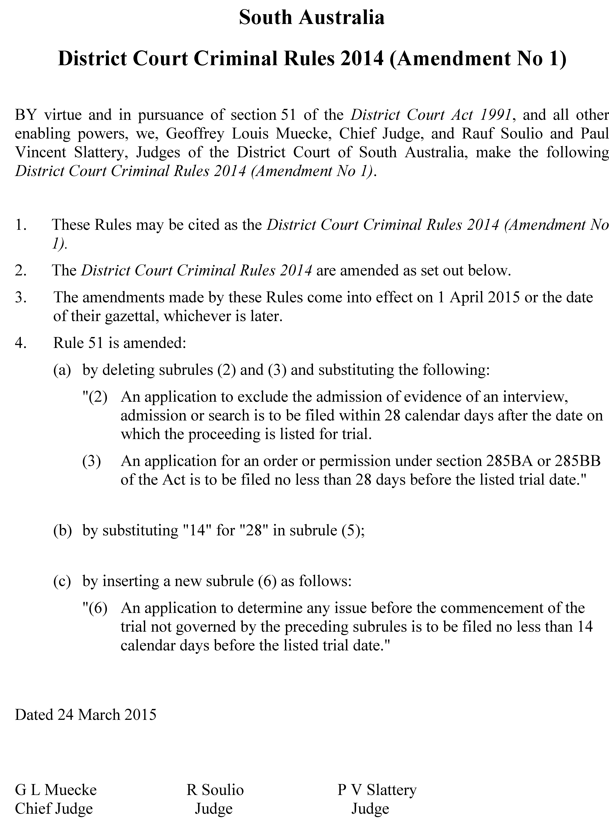
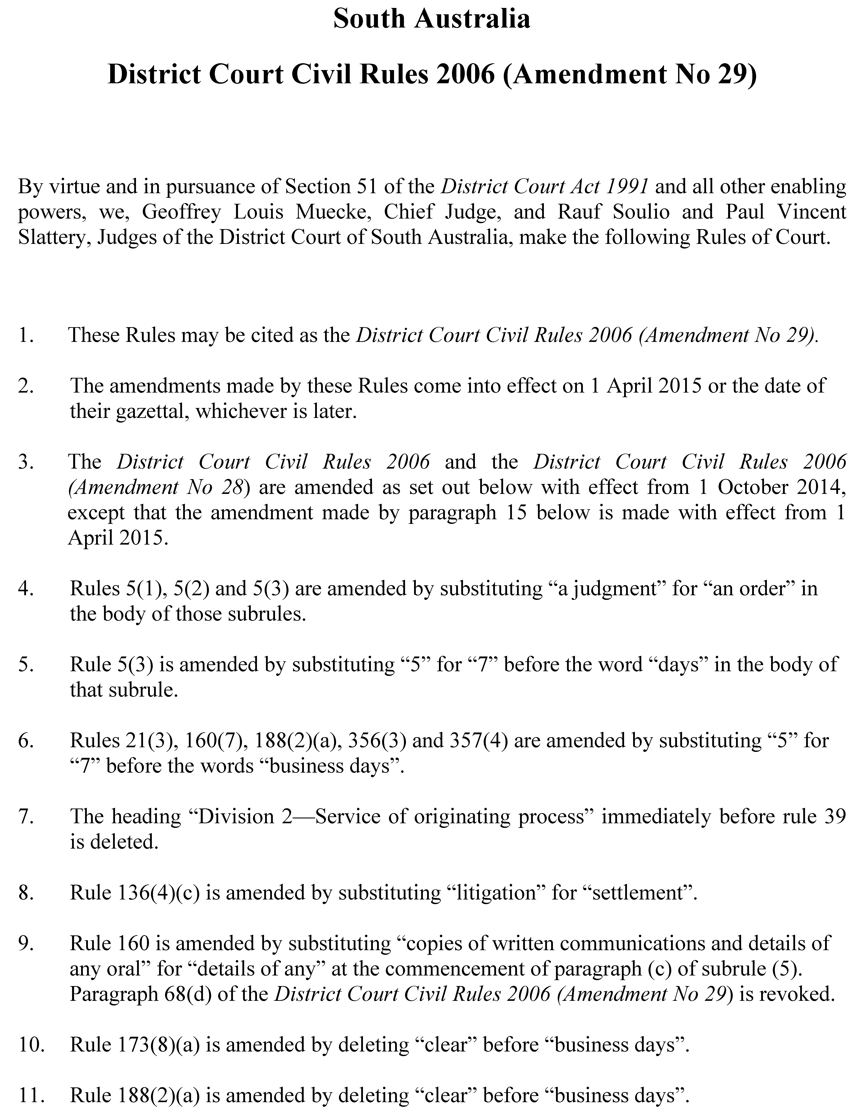
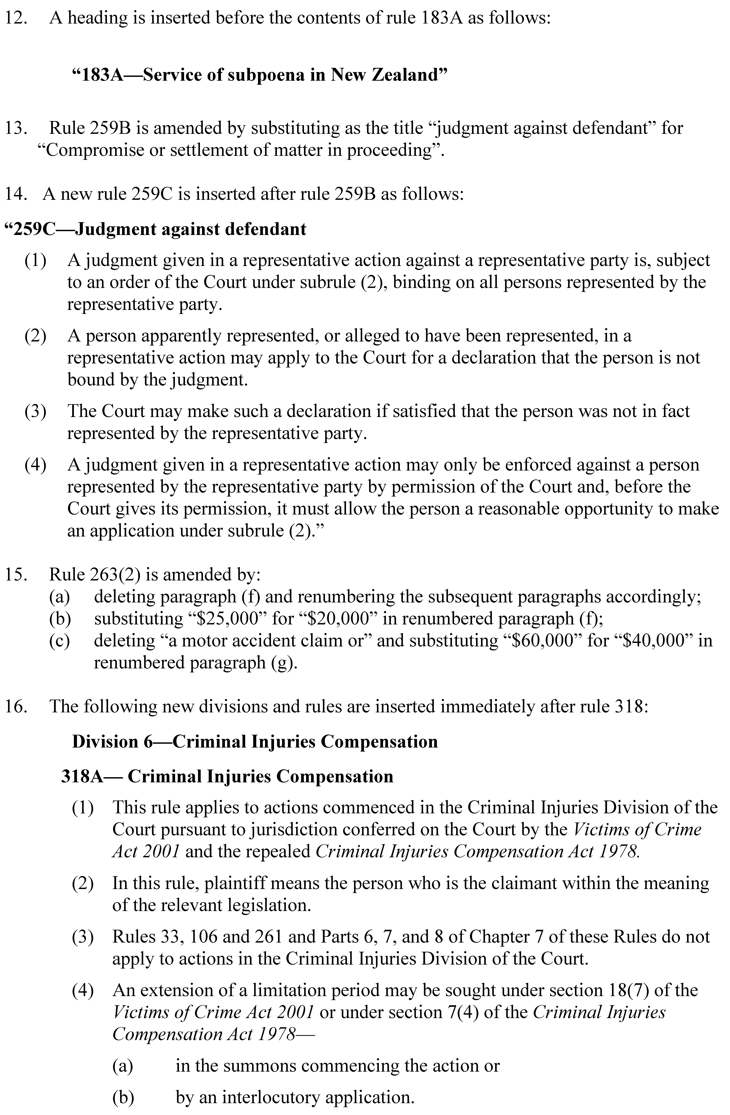
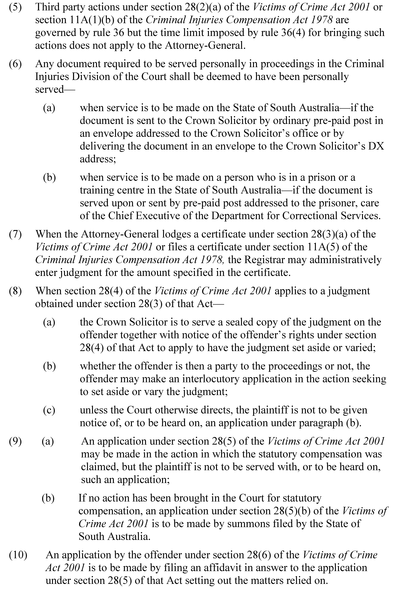
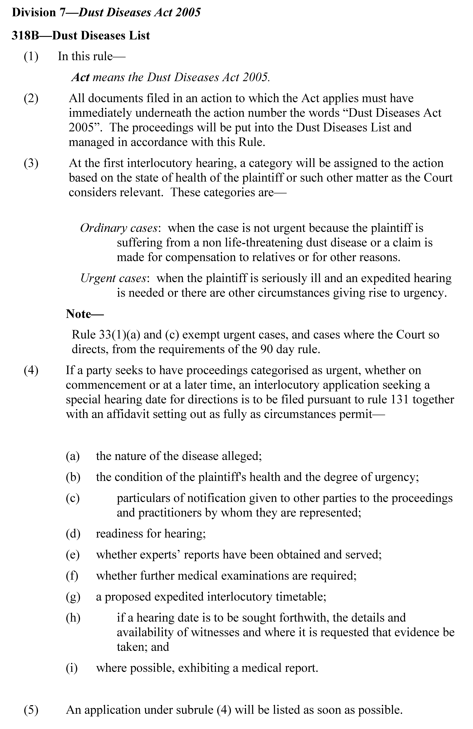

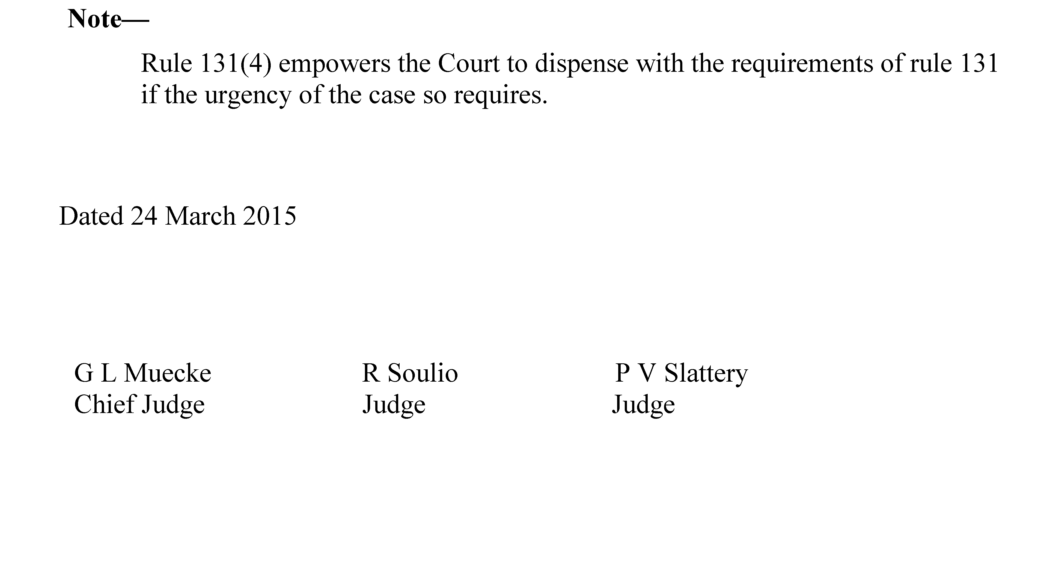

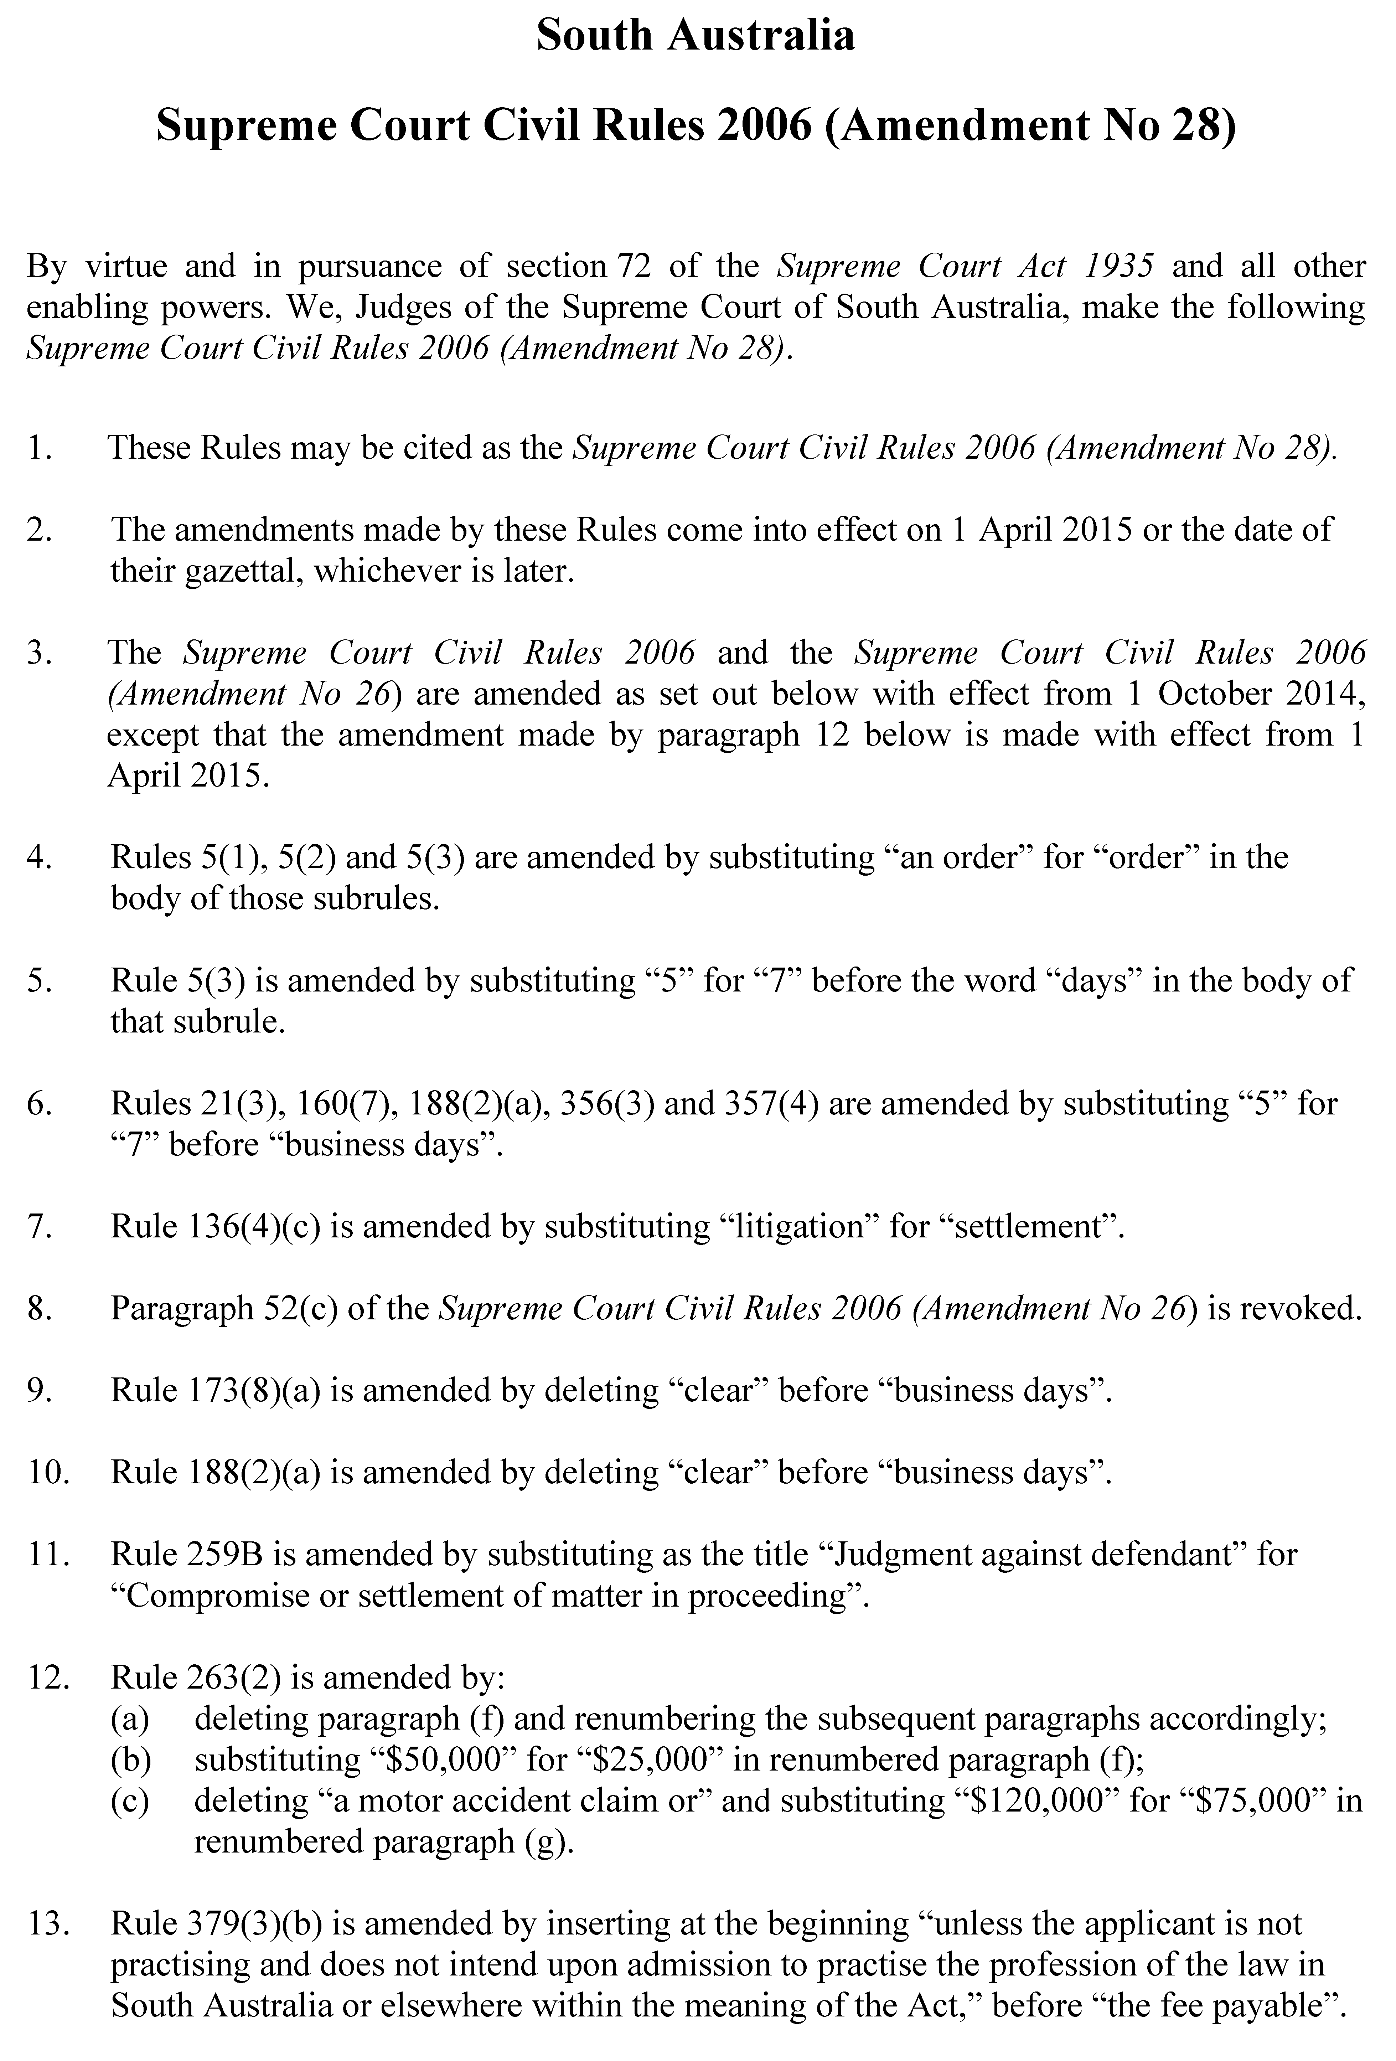

GIVEN under our hands and the Seal of the Supreme Court of South Australia
this 26th day of February 2015.

________________ KOURAKIS CJ ________________ GRAY J

________________ SULAN J ________________ VANSTONE J

________________ KELLY J ________________ PEEK J

________________ BLUE J ________________ STANLEY J

_______________ NICHOLSON J _________________ BAMPTON J

_________________ PARKER J ________________ LOVELL J

P. McMAHON, Government Printer, South Australia

