No. 26 1549



THE SOUTH AUSTRALIAN

GOVERNMENT GAZETTE
www.governmentgazette.sa.gov.au

PUBLISHED BY AUTHORITY

ALL PUBLIC ACTS appearing in this GAZETTE are to be considered official, and obeyed as such

ADELAIDE, THURSDAY, 23 APRIL 2015

CONTENTS

Page
Appointments, Resignations, Etc. 1550
Corporations and District Councils—Notices 1609
Development Act 1993—Notices 1550
Fisheries Management Act 2007—Notices 1569
Geographical Names Act 1991—Notice 1570
Housing Improvement Act 1940—Notices 1572
Mining Act 1971—Notices 1570
Motor Vehicles (Approval of Motor Bikes
and Motor Trikes) Notice 2015 1573
National Electricity Law—Notice 1593
National Gas Law—Notice 1593
National Parks and Wildlife Act 1972—Notice 1593
Petroleum and Geothermal Energy Act 2000—Notices 1591
Proclamation 1596
Public Trustee Office—Administration of Estates 1609
REGULATIONS
Primary Produce (Food Safety Schemes) Act 2004—
(No. 40 of 2015) 1597
Real Property Act 1886 (No. 41 of 2015) 1600
Community Titles Act 1996 (No. 42 of 2015) 1603
Registration of Deeds Act 1935 (No. 43 of 2015) 1605
Strata Titles Act 1988 (No. 44 of 2015) 1606
Roads (Opening and Closing) Act 1991—Notice 1593
Unclaimed Moneys Act 1891—Notices 1610

GOVERNMENT GAZETTE NOTICES
Notices for publication in the South Australian Government Gazette should be emailed to governmentgazette@dpc.sa.gov.au. Content should be sent as Word format attachment(s). Covering emails should include the date the notice is to be published and to whom the notice will be charged. Closing time for lodgement is 4 p.m. on the Tuesday preceding the regular Thursday publication. Gazette enquiries to: Phone 8207 1045. The Government Gazette is available online at: www.governmentgazette.sa.gov.au.

Department of the Premier and Cabinet
Adelaide, 23 April 2015
HIS Excellency the Governor in Executive Council has revoked the appointment of Sherree Lee Goldsworthy as a Member of the Third Party Premiums Committee, effective from 23 April 2015, pursuant to the provisions of the Motor Vehicles Act 1959 and Section 36 of the Acts Interpretation Act 1915.
By command,
Jay Wilson Weatherill, Premier
T&F15/033CS

Department of the Premier and Cabinet
Adelaide, 23 April 2015
HIS Excellency the Governor in Executive Council has been pleased to appoint the undermentioned to the Third Party Premiums Committee, pursuant to the provisions of the Motor Vehicles Act 1959:
Member: (from 23 April 2015)
Emma Megan Kokar
By command,
Jay Wilson Weatherill, Premier
T&F15/033CS

Department of the Premier and Cabinet
Adelaide, 23 April 2015
HIS Excellency the Governor in Executive Council has been pleased to appoint the undermentioned to the Adelaide Festival Centre Trust, pursuant to the provisions of the Adelaide Festival Centre Trust Act 1971:
Member: (from 23 April 2015 until 22 April 2016)
Donald Edward Farrell
By command,
Jay Wilson Weatherill, Premier
ASACAB167-11

Department of the Premier and Cabinet
Adelaide, 23 April 2015
HIS Excellency the Governor in Executive Council has been pleased to appoint the undermentioned to the Independent Gambling Authority, pursuant to the provisions of the Independent Gambling Authority Act 1995:
Member: (from 1 May 2015 until 30 April 2017)
Margaret Wallace
By command,
Jay Wilson Weatherill, Premier
15MBSC06CS

Department of the Premier and Cabinet
Adelaide, 23 April 2015
HIS Excellency the Governor in Executive Council has been pleased to appoint Kim Hargrave to act in the office of Judge of the Supreme Court of South Australia on an auxiliary basis, for a period commencing on 1 May 2015 and expiring on 30 July 2015, pursuant to the Judicial Administration (Auxiliary Appointments and Powers) Act 1988.
By command,
Jay Wilson Weatherill, Premier
AGO0051/15CS

Department of the Premier and Cabinet
Adelaide, 23 April 2015
HIS Excellency the Governor in Executive Council has been pleased to appoint William Muirhead as Agent-General for South Australia in the United Kingdom for a term commencing on 23 April 2015 and expiring on 15 December 2017, pursuant to the provisions of the Agent-General Act 1901.
By command,
Jay Wilson Weatherill, Premier
DPC15/024CS

Department of the Premier and Cabinet
Adelaide, 23 April 2015
HIS Excellency the Governor in Executive Council has been pleased to appoint Robert Murray Manton as a Member of the ANZAC Day Commemoration Council for a period commencing on 23 April 2015 and expiring on 22 April 2018 or until such time as he ceases to hold the position of Director, Veterans SA, whichever is sooner, pursuant to Section 7 of the ANZAC Day Commemoration Act 2005.
By command,
Jay Wilson Weatherill, Premier
DPC15/029CS

DEVELOPMENT ACT 1993
Alteration to the Building Code of Australia
Preamble
1. The Building Code of Australia being Volumes One and Two in the National Construction Code series as in force from time to time is adopted by the Development Regulations 2008, as part of the Building Rules under the Development Act 1993.
2. The Building Code of Australia is altered annually for national adoption on 1 May each year.
3. The Development Act 1993 requires that notice of the alteration must be published before the alteration can take effect.
Notice
PURSUANT to Section 4 (7) of the Development Act 1993, notice is given of an alteration to the 2014 edition of the Building Code of Australia being Volumes One and Two in the National Construction Code series. The Code has been amended and republished as BCA 2015 by the Australian Building Codes Board.
BCA 2015, as modified by the variations and additions for South Australia contained in the Appendix to that Code, will take effect for the purposes of the Development Act 1993 on 1 May 2015, with the following alteration:
(a) SA Table 1 and SA H3.2 of Volume One—Minister’s Specification SA H3.2 Concessions and additional requirements for farm buildings (dated 2004) is replaced with Minister’s Specification SA H3.2 Concessions for farm buildings (dated 2015).
Dated 7 April 2015.
S. Moseley, General Manager, Information and Strategy Directorate, Development Division, Department of Planning, Transport and Infrastructure as Delegate of John Rau, Minister for Planning

DEVELOPMENT ACT 1993
Alteration to Minister’s Specification SA H3.2—
Concessions for Farm Buildings
Preamble
1. Section 108 (6) of the Development Act 1993 provides that a code adopted by the regulations may refer to a standard or other document prepared or published by a prescribed body.
2. Regulation 106 (2) prescribes the Minister as a prescribed body for the purposes of Section 108 (6).
3. The Building Code of Australia as in force from time to time is adopted by the Development Regulations 2008 as part of the Building Rules under the Development Act 1993.
4. SA Part H3 of the Building Code of Australia (Volume One of the National Construction Code Series) refers to ‘Minister’s Specification SA H3.2’.
Notice
PURSUANT to Section 4 (7) and Section 108 (6) of the Development Act 1993, notice is given that ‘Minister’s Specification SA H3.2—Concessions and additional requirements for farm buildings’, dated July 2004, has been amended and republished by the Department of Planning, Transport and Infrastructure as ‘Minister’s Specification SA H3.2—Concessions for farm buildings—2015 edition’.
The alterations to Minister’s Specification SA H3.2 will take effect for the purposes of the Development Act 1993 on 1 May 2015.
Minister’s Specification SA H3.2—Concessions and additional requirements for farm buildings’, dated July 2004, will be withdrawn on 1 May 2015.
Dated 21 April 2015.
S. Moseley, General Manager, Information and Strategy Directorate, Development Division, Department of Planning, Transport and Infrastructure as Delegate of John Rau, Minister for Planning

DEVELOPMENT ACT 1993, SECTION 25 (17): DISTRICT COUNCIL OF FRANKLIN HARBOUR COASTAL AND GENERAL DEVELOPMENT PLAN AMENDMENT FOR APPROVAL
Preamble
1. The Coastal and General Development Plan Amendment (the Amendment) by the District Council of Franklin Harbour has been finalised in accordance with the provisions of the Development Act 1993.
2. The Minister for Planning has decided to approve the Amendment.
Notice
PURSUANT to Section 25 of the Development Act 1993, I:
(a) approve the Amendment; and
(b) fix the day on which this notice is published in the Gazette as the day on which the Amendment will come into operation.
Dated 10 April 2015.
John Rau, Deputy Premier, Minister for Planning

DEVELOPMENT ACT 1993, SECTION 29
Amendment To The Cleve Council Development Plan
Preamble
It is necessary to amend the Cleve Council Development Plan (the Plan) dated 26 April 2013 to address an inconsistency in the Plan.
Notice
PURSUANT to Section 29 (2) (b) (i) of the Development Act 1993, I:
1. Amend the Plan as follows:
(a) within the Primary Production Zone:
(i) insert the following text as Objective 5 and consecutively renumber the existing Objective 5 to Objective 6:
‘Protection of rural support infrastructure for the bulk handling and transportation of farm commodities situated at Mangalo.’
(ii) insert the following text after the last paragraph in the Desired Character section:
‘Heggaton and Mangalo
Development within the Hundred of Heggaton and the Hundred of Mangalo will include a range of different types of farming activities, as well as appropriate value-adding uses. Large allotments of greater than 40 hectares in size will be maintained to prevent the reduced viability of primary production and to protect the scenic quality of the rural landscape. Development (including land division) will not lead to a reduction in the ability of land within these areas to be used for primary production purposes and will not result in the establishment of rural-residential land-uses.
New buildings will generally be associated with existing clusters of buildings and will be of complementary scale and mass, while also being of appropriate dimensions to serve their intended function. New dwellings will generally be single storey and will include pitched roofs, verandas and porches to address climatic issues. Isolated new buildings, including large sheds, will be located and designed to blend with the existing landscape, with appropriate earthworks and building design to suit the natural landform. Other structures will be of a form that blends with, and does not detract from, the scenic qualities and function of the primary production area.
The open rural landscape is the dominant character element and new development will maintain that character, with new buildings appropriately sited, designed and screened by vegetation. New buildings will be constructed using materials and colours that blend with the rural landscape and are traditionally used within the rural environment including corrugated steel, stone and timber.’
(iii) replace Principle of Development Control 11 with:
‘Land outside of the Hundred of Heggaton and the Hundred of Mangalo should only be divided if one or more of the following apply:
(a) no additional allotments are created
(b) an owner of land wishes to create a separate allotment of not greater than 5 hectare in area to contain one of two habitable houses on the land, each of which was built or under construction before 30 June 2002
(c) the land division is to facilitate horticulture, floriculture, agriculture, animal keeping, or land based aquaculture.’
(iv) INSERT new Principle of Development Control 12:
‘Land division within the Hundred of Heggaton or the Hundred of Mangalo areas should only occur under one of the following circumstances, where:
(a) no additional allotments of less than 40 hectares are created
(b) an owner of land wishes to create a separate allotment of not greater than 5 hectares to contain one of two existing dwellings on the land, each of which was built or under construction before 29 August 1985
(c) one additional allotment of 5 hectares or less in an area is being excised from the land held in a Certificate of Title existing prior to 29 August 1985, where the allotment is to provide a separate title for the erection of a dwelling for a relative of the registered proprietor of the subject land, or a person being in employment on the land.’
(v) replace the Complying Development Compliance Criteria / Conditions with the following:
‘Provided:
(a) all buildings are set back 50 m or more from the existing road boundary
(b) within the Hundred of Heggaton or the Hundred of Mangalo, the building’s external materials, cladding and roofing are not:
(i) damaged in any way
(ii) punctured
(iii) rusted
(iv) stained
(v) weathered.’
(vi) within the non-complying table, insert the following Forms of Development and exceptions in alphabetical order:
Form of Development | Exceptions
Bank within the Hundred of Heggaton or the Hundred of Mangalo
Horticulture involving the growing of olives within the Hundred of Heggaton or the Hundred of Mangalo | Except where the location for the growing of olives achieves (a) and (b):  (a) at least 500 m from all of the following:  (i) a National Park  (ii) a Conservation Park  (iii) a Wilderness Protection Area  (iv) the edge of a substantially intact stratum of native vegetation greater than 5 hectares in area  (b) 50 m from the edge of a substantially intact stratum of native vegetation 5 hectares or less in area.
Motor showroom within the Hundred of Heggaton or the Hundred of Mangalo
Warehouse within the Hundred of Heggaton or the Hundred of Mangalo
(vii) Within the non-complying table replace the exceptions for Form of Development land division with the following:
Form of Development | Exceptions
Land Division | Except:  (a) outside of the Hundreds of Heggaton or Mangalo, where:  (i) the division creates an additional allotment greater than 40 hectares  (ii) the division involves boundary rationalisation, where the number of resulting allotments is not more than the number that existed prior to rationalisation  (iii) an allotment no greater than 5 hectares is to be created to contain one of two habitable houses on the land, each of which was built or under construction before 30 June 2002  (b) within the Hundred of Heggaton or Hundred of Mangalo, where one of the following circumstances applies:  (i) no additional allotments of less than 40 hectares are created  (ii) an owner of land wishes to create a separate allotment of 5 hectares or less to contain one of two existing dwellings on the land, each of which was built or under construction before 29 August 1985  (iii) one additional allotment of 5 hectares or less in an area is being excised from the land held in a Certificate of Title existing prior to 29 August 1985, where the allotment is to provide a separate title for the erection of a dwelling for a relative of the registered proprietor of the subject land.
(viii) Within the Public Notification category 2 listing, insert the following form of development in alphabetical order:
‘Bulk commodity handling and storage facility within within the Hundred of Heggaton or the Hundred of Mangalo.’
(b) replace Council Preface Map, Council Index Map, Location Map Cle/1, Overlay Map Cle/1—Transport, Overlay Map Cle/1—Development Constraints, Overlay Map FrH/1—Heritage and Zone Map Cle/1 with the contents of ‘ATTACHMENT A’.
2. Fix the day on which this notice is published in the Gazette as the day on which the Section 29 Amendment will come into operation.
Dated 20 March 2015.
S. Moseley,
General Manager, Information and Strategy Directorate
Development Division
Department of Planning, Transport and Infrastructure
As Delegate of John Rau, Minister for Planning

Attachment A
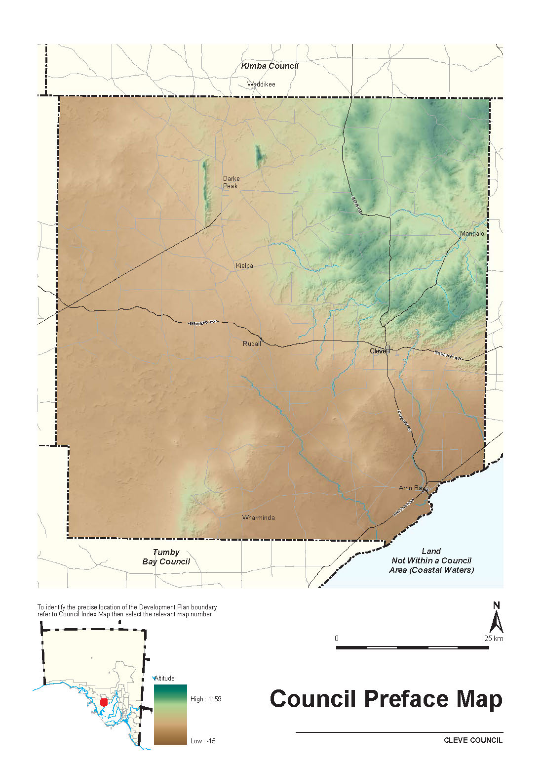

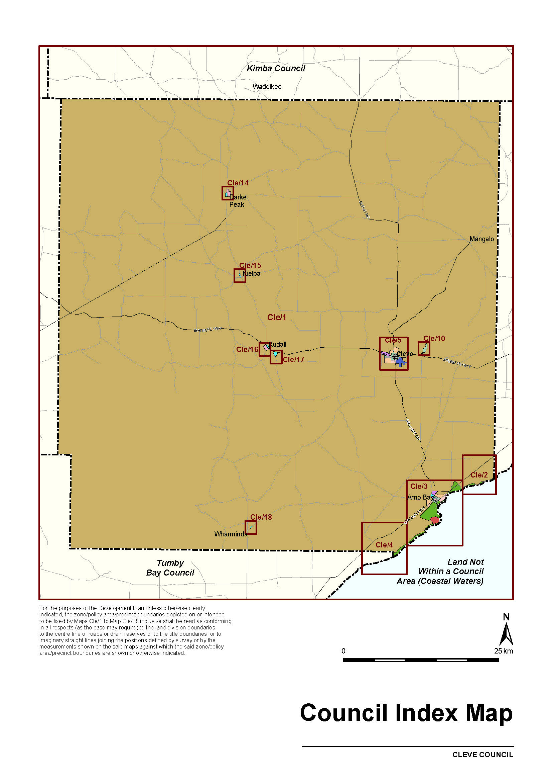

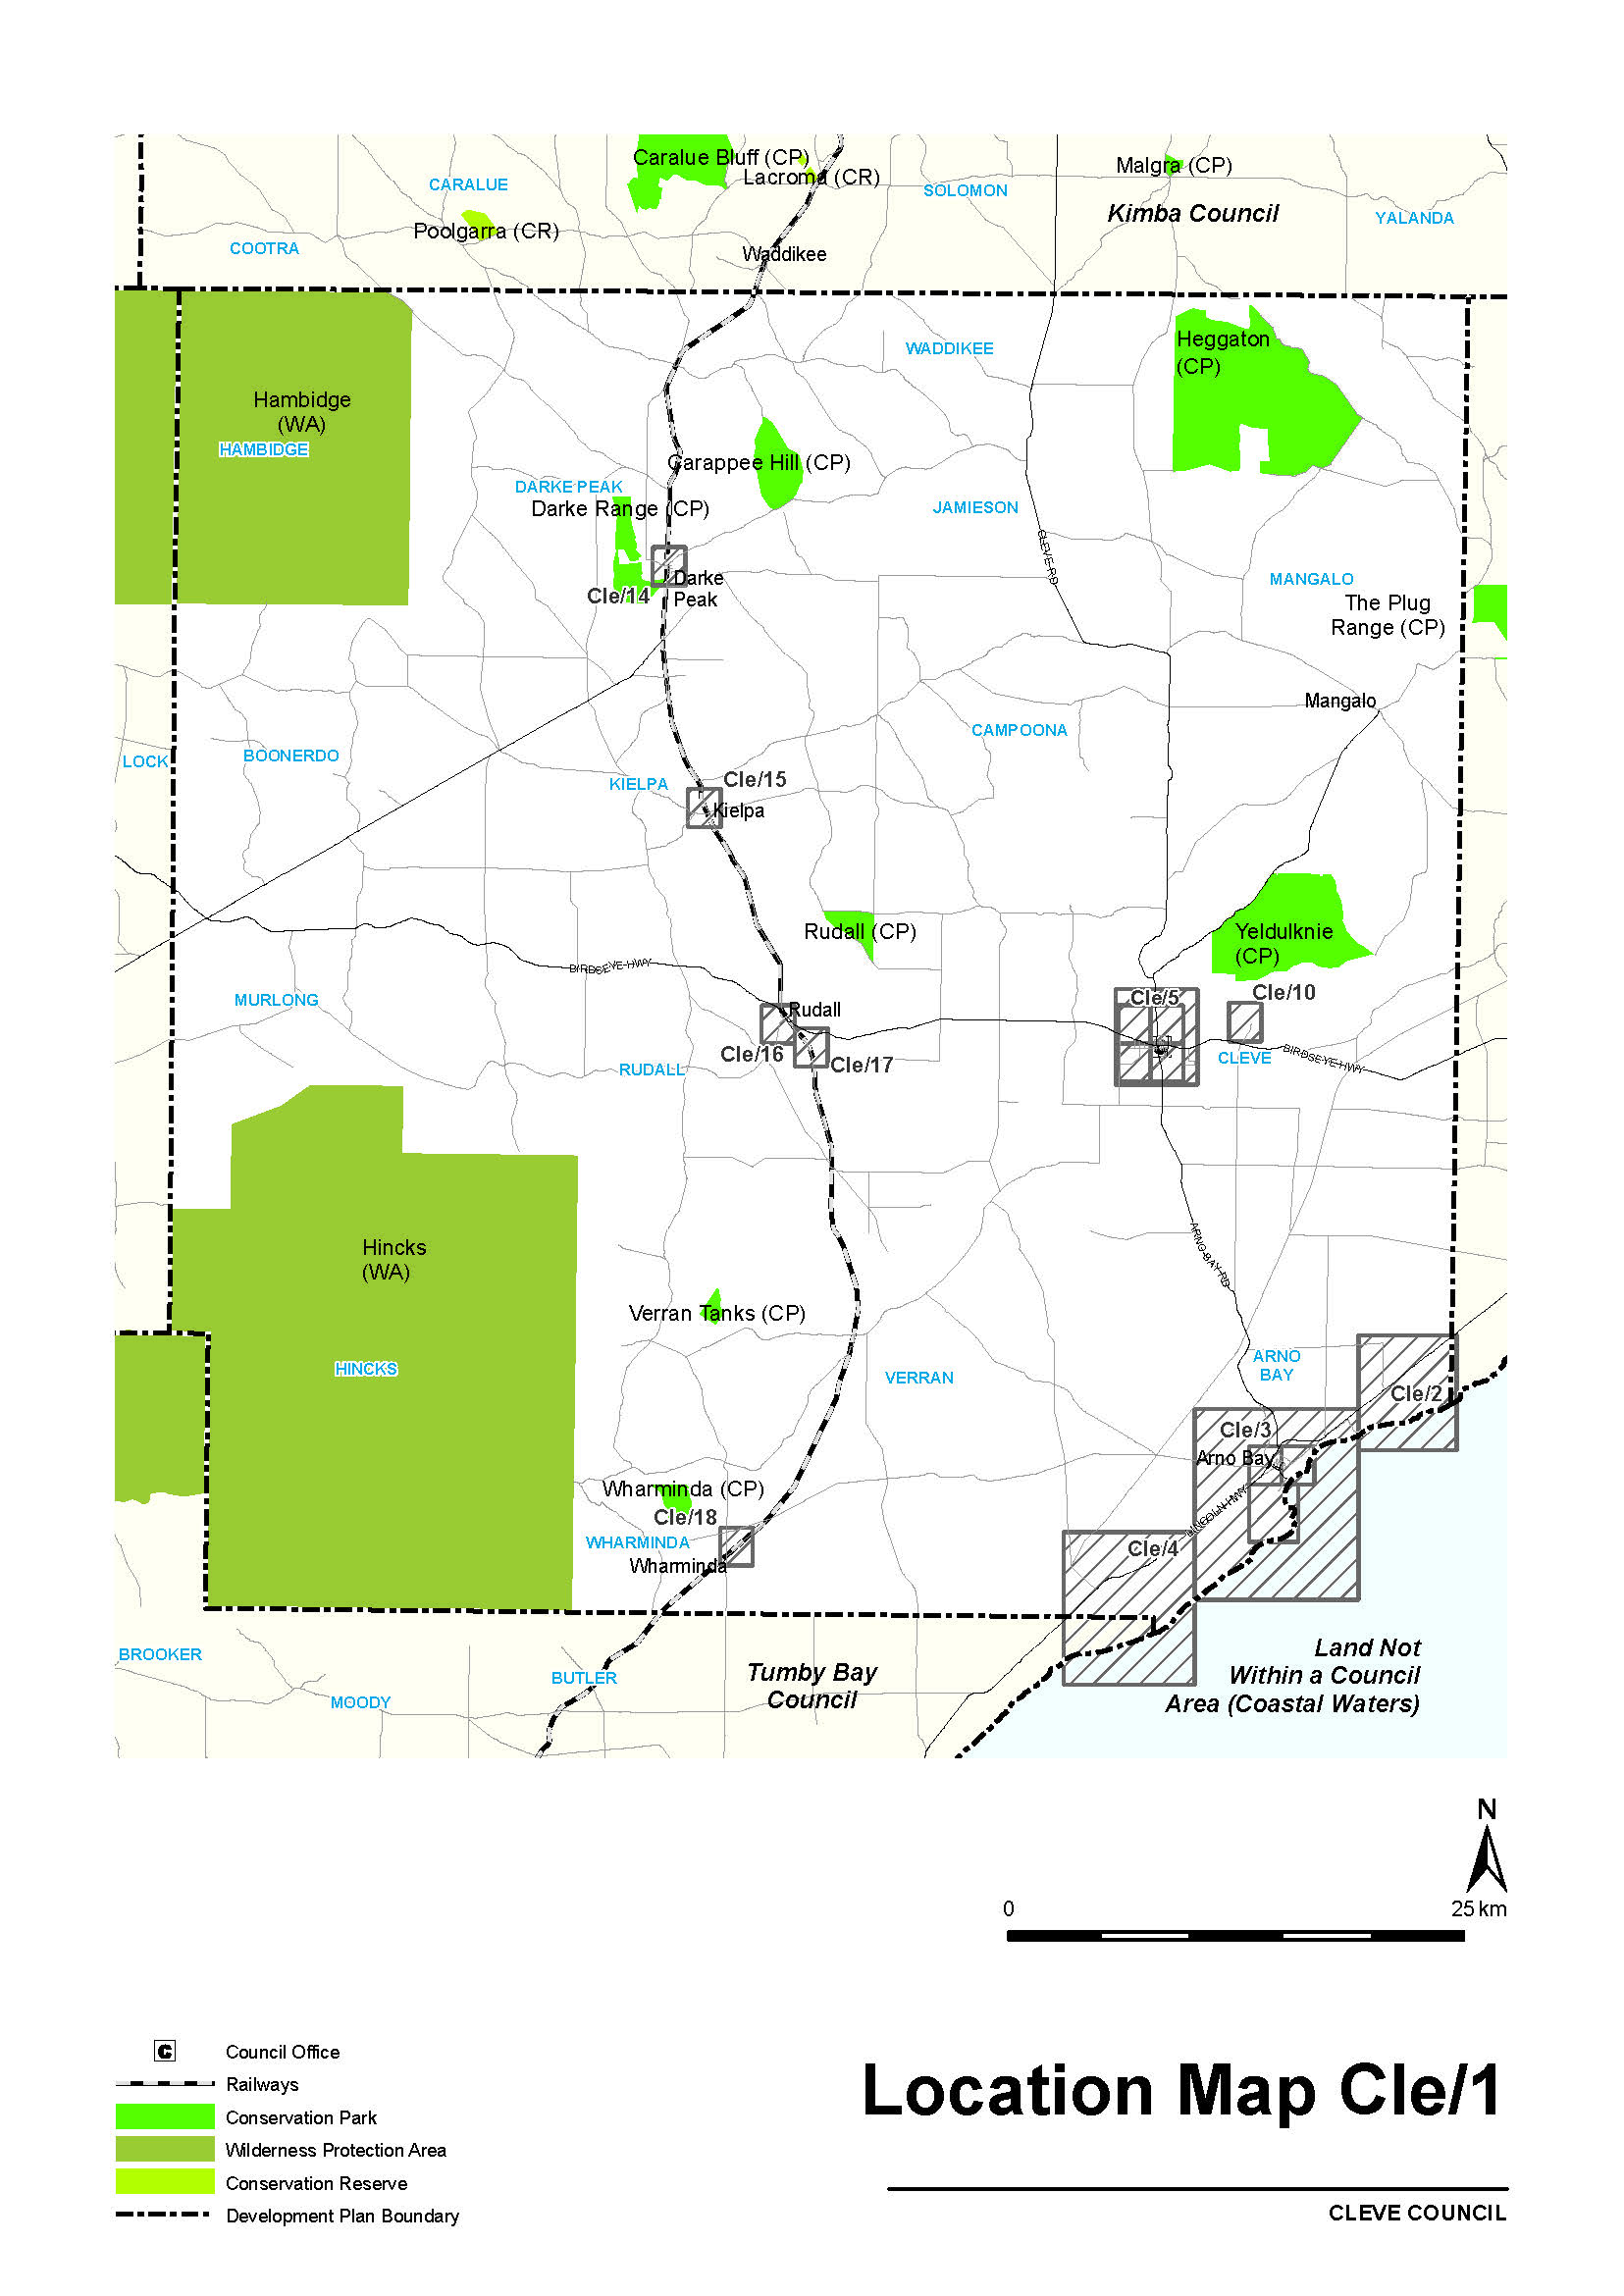

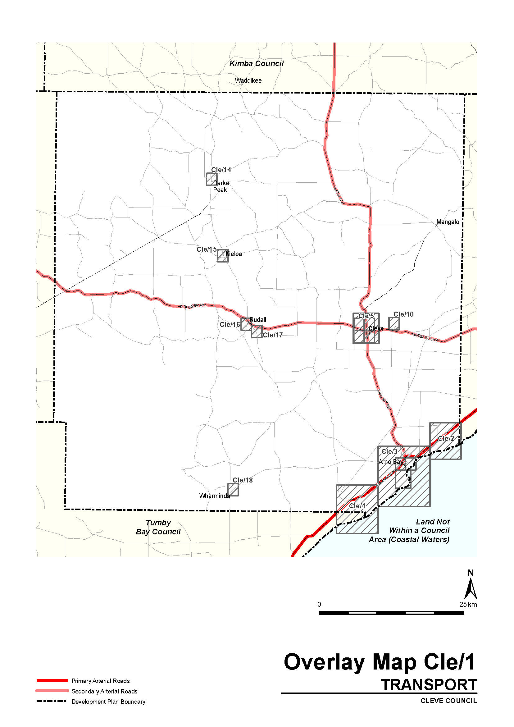

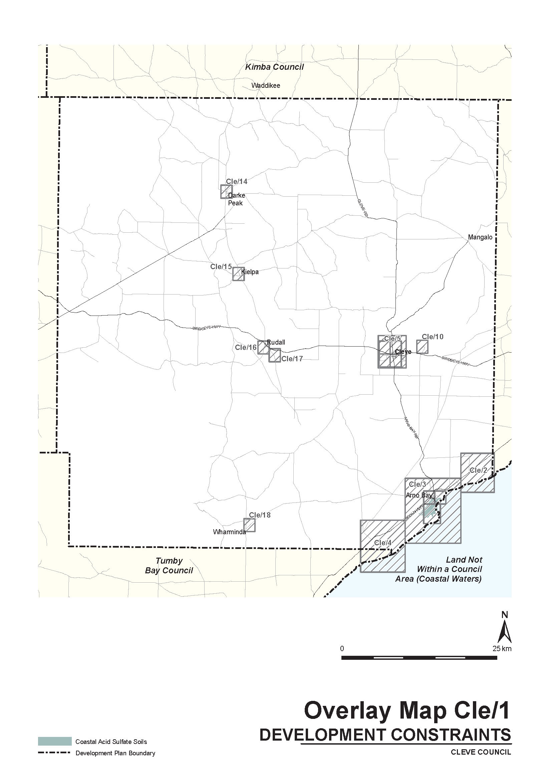

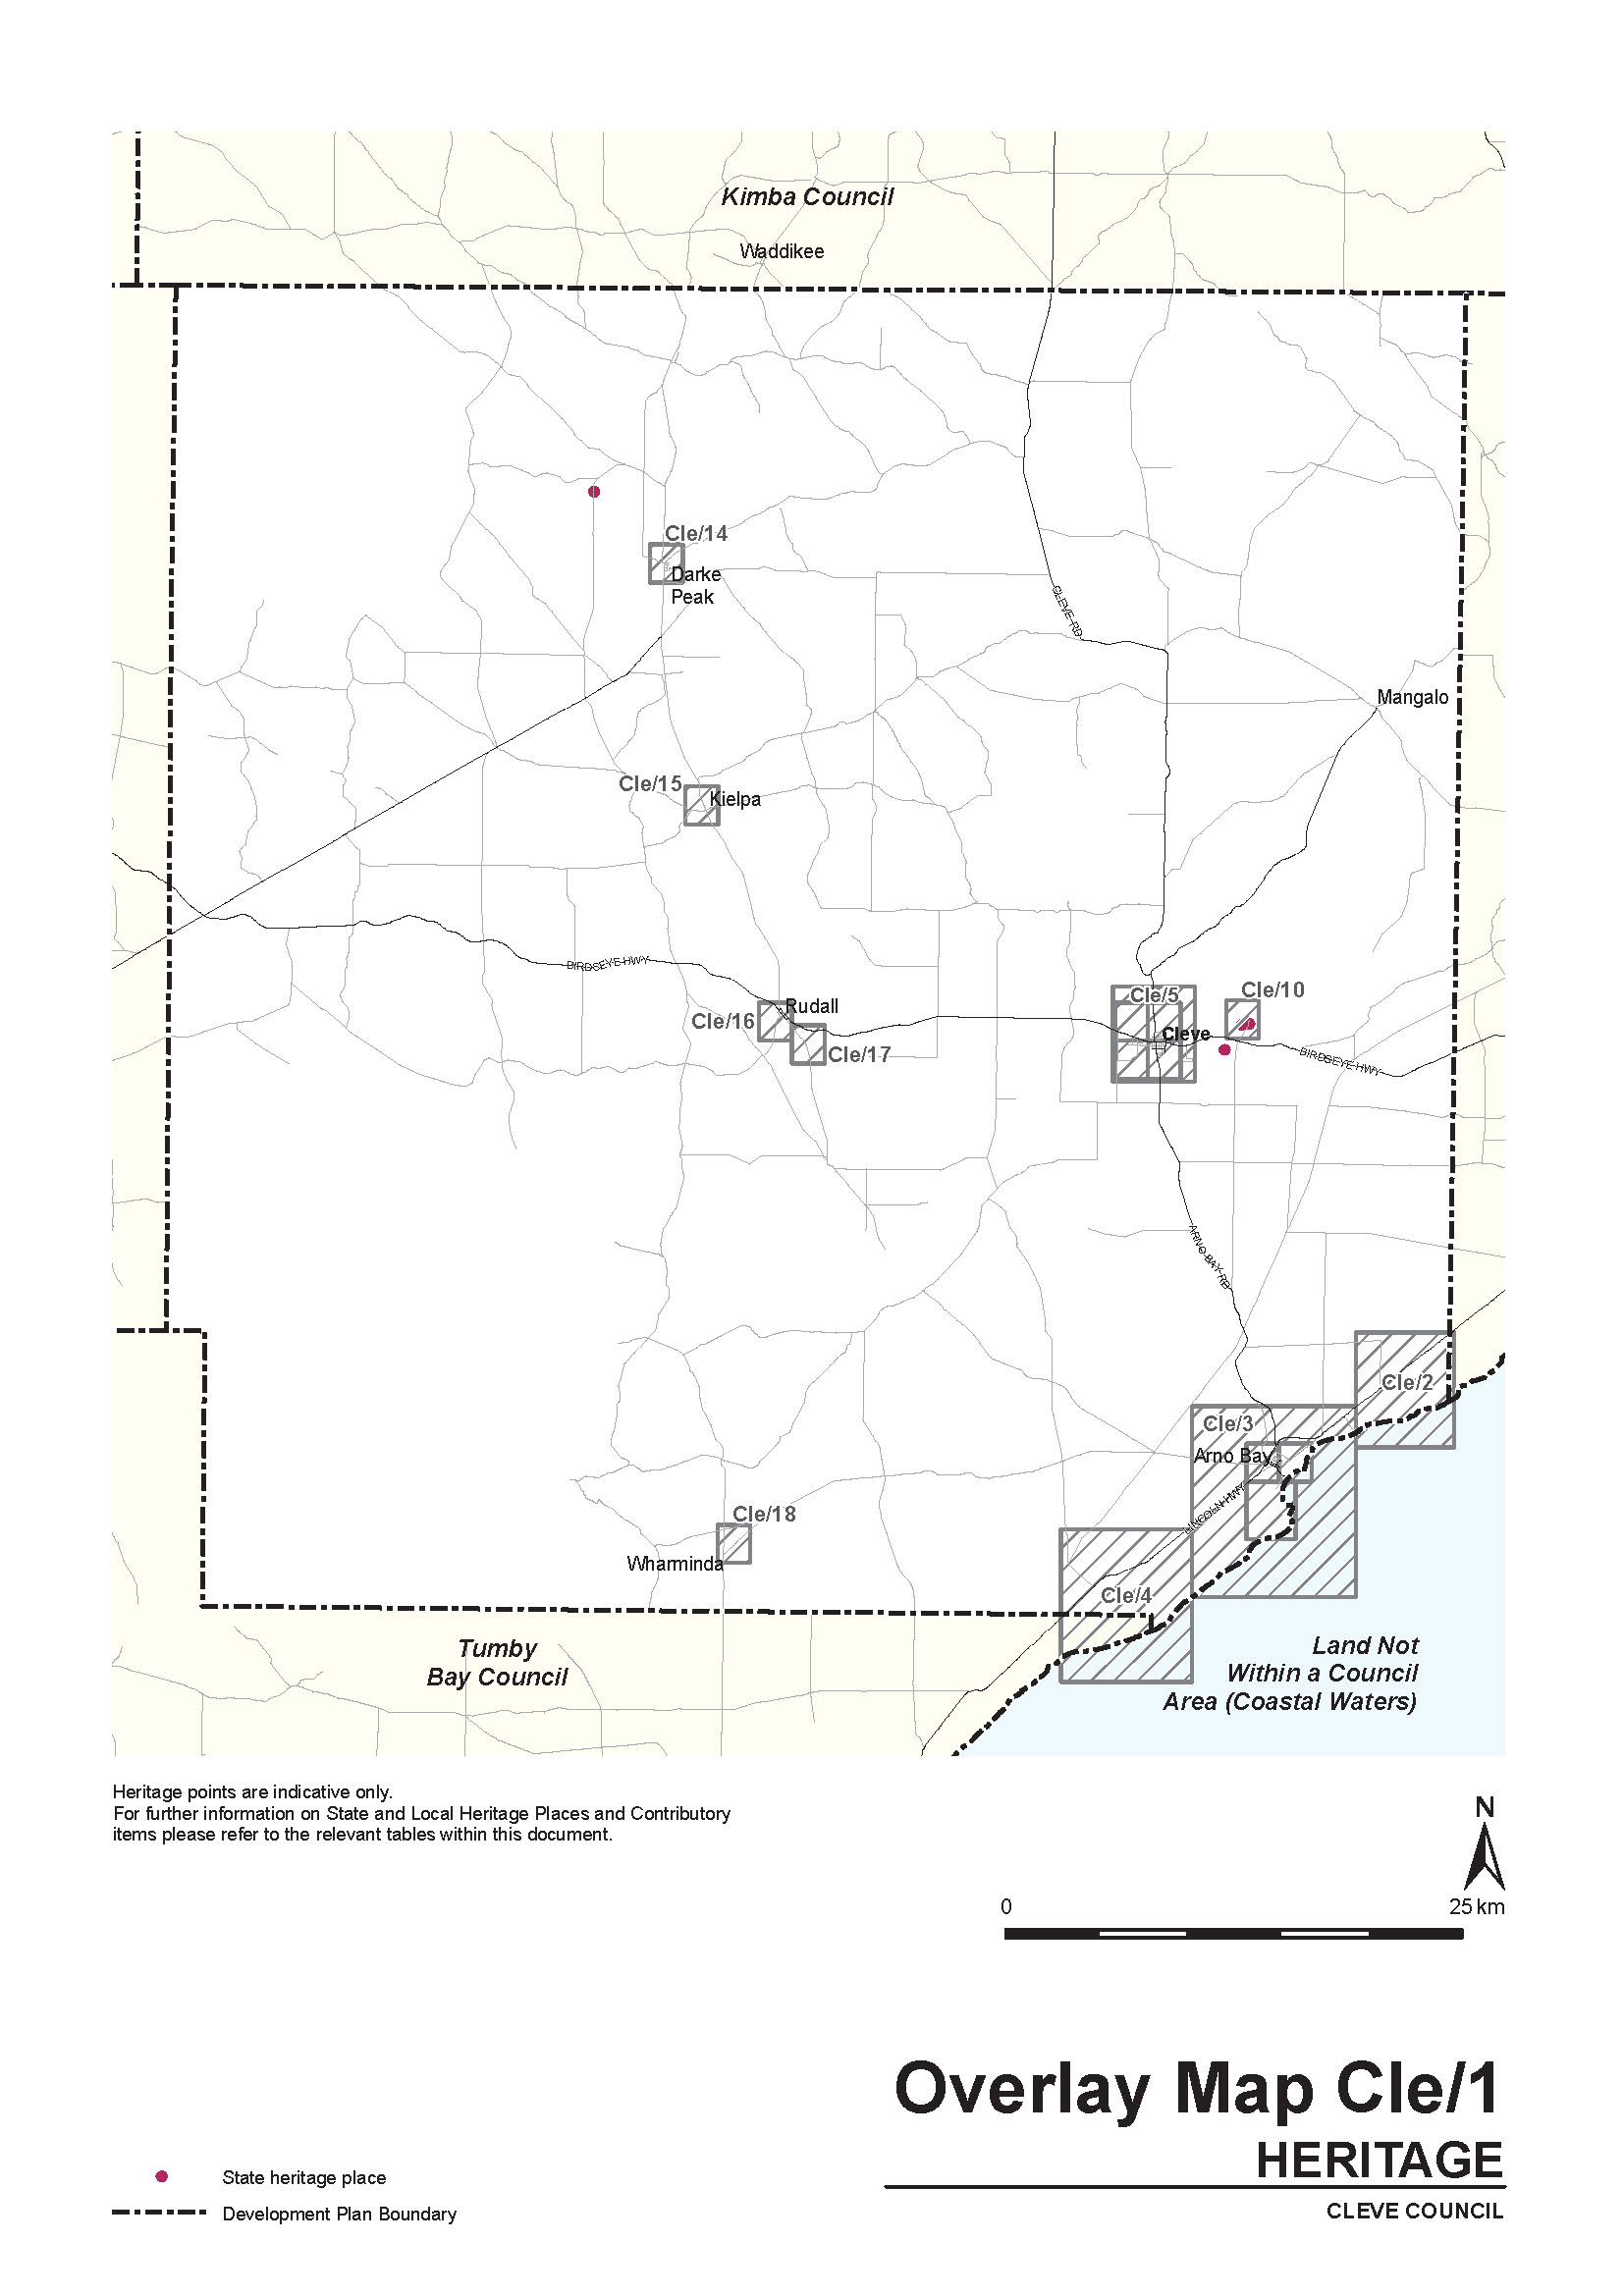

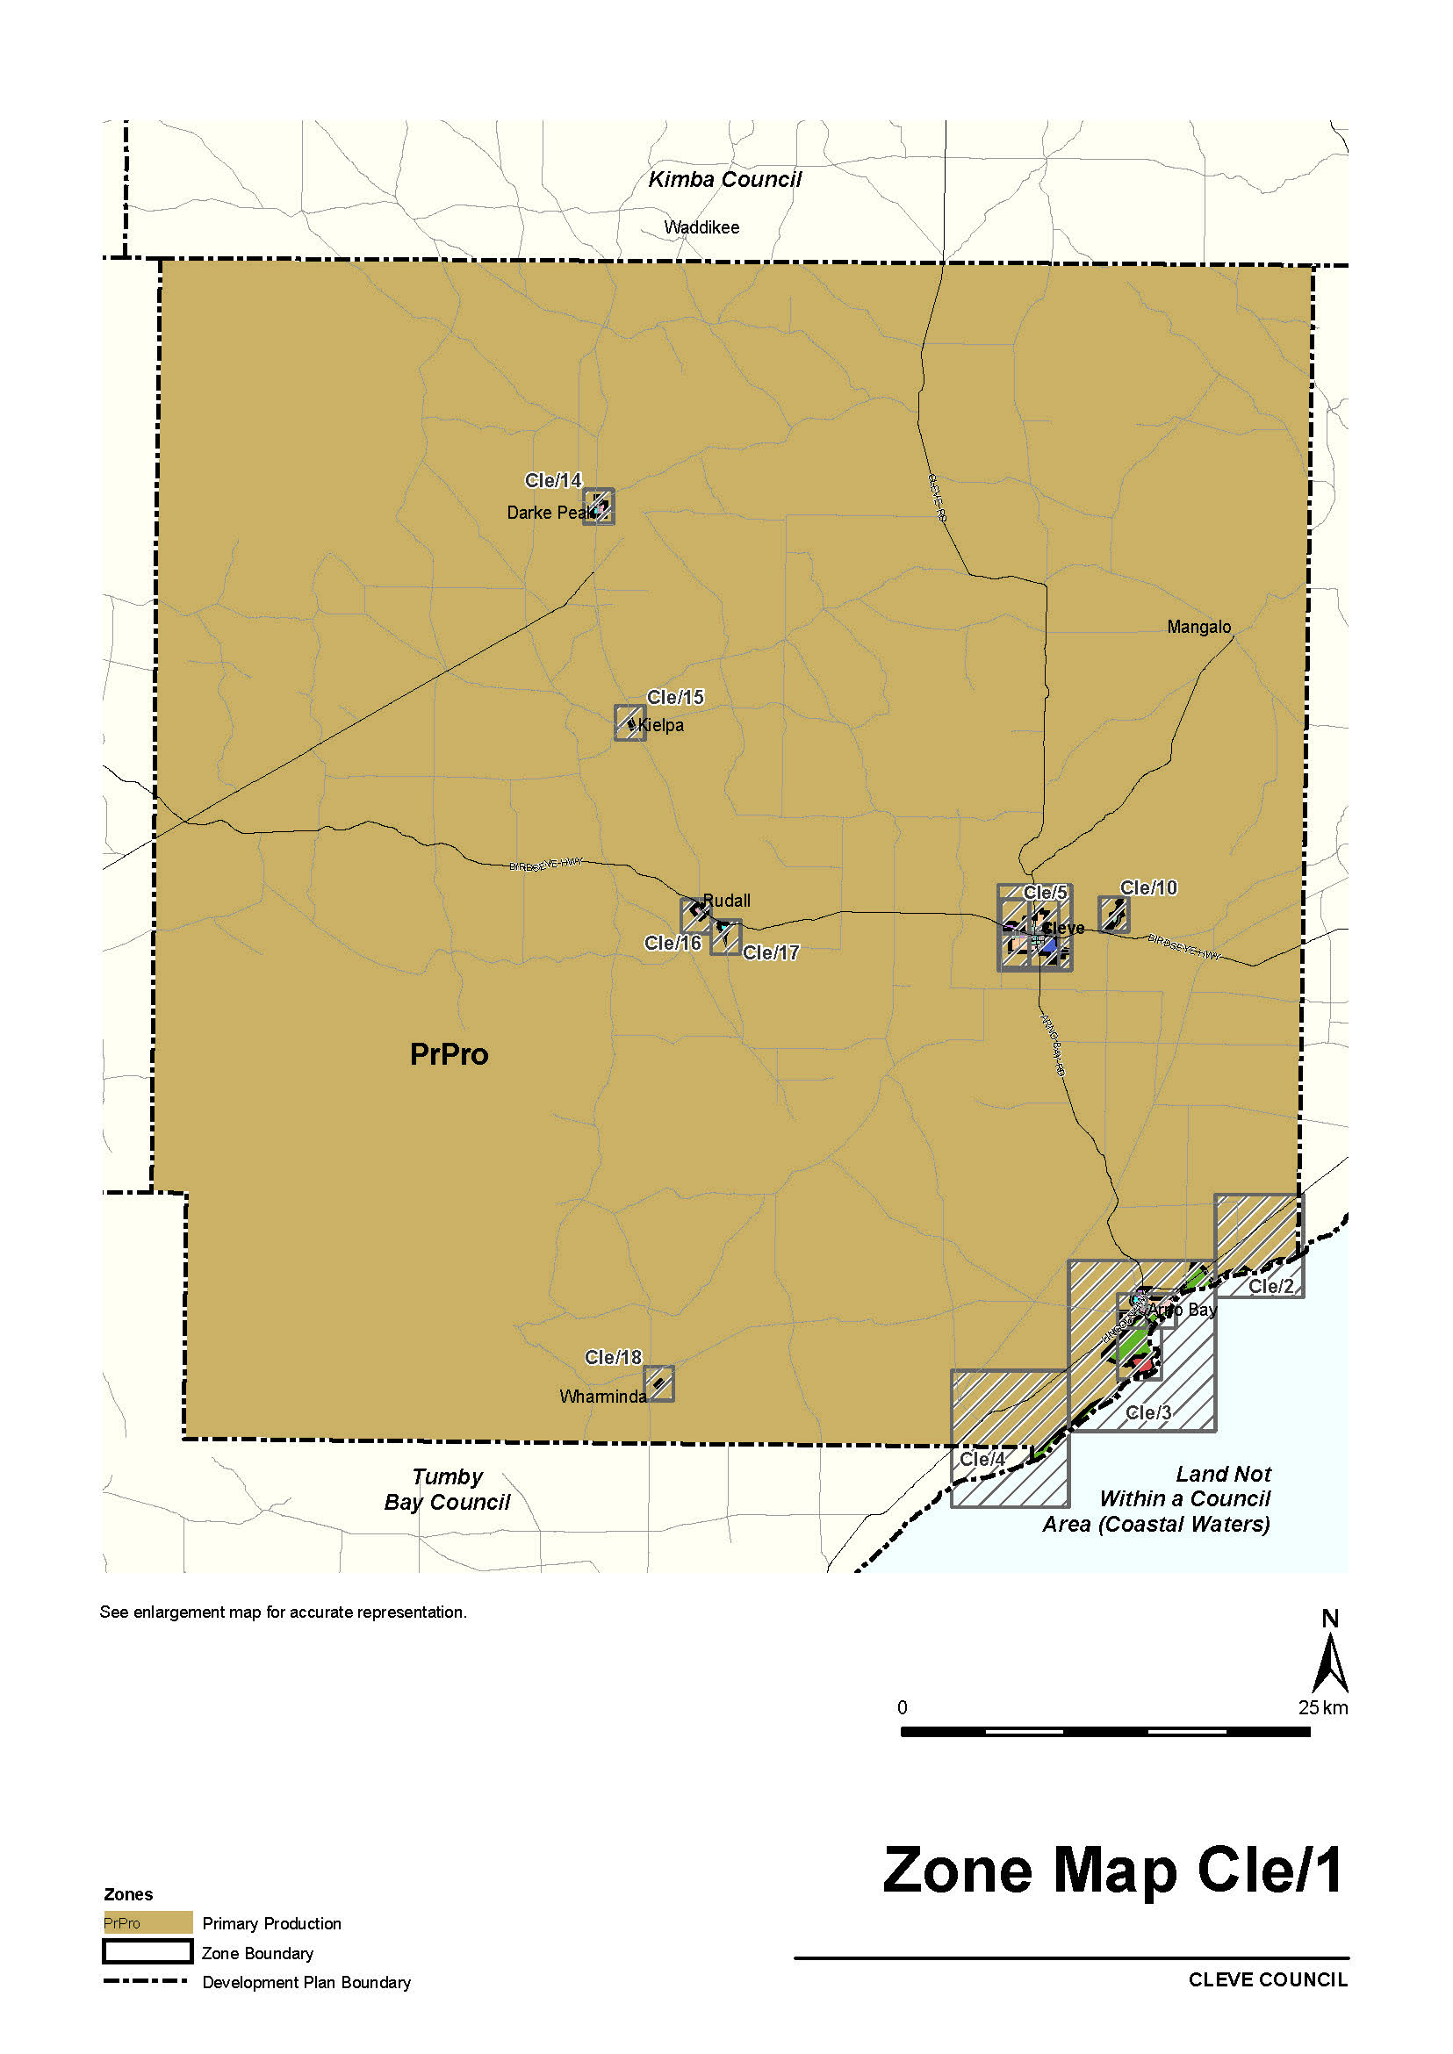
DEVELOPMENT ACT 1993
Section 29
Amendment to the Franklin Harbour Council Development Plan
Preamble
It is necessary to amend the Franklin Harbour Council Development Plan (the Plan) dated 25 October 2012 and as amended by the approved and gazetted General and Coastal Development Plan Amendment dated [23 April 2015] to address an inconsistency in the Plan.
Notice
PURSUANT to Section 29 (2) (b) (i) of the Development Act 1993, I:
1. Amend the Plan as follows:
(a) Within the Primary Production Zone, delete Objective 4 and consecutively renumber remaining Objective 5.
(b ) Replace Council Preface Map, Council Index Map, Location Map FrH/1, Overlay Map FrH/1—Transport, Overlay Map FrH/1—Development Constraints, Overlay Map FrH/1—Natural Resources and Zone Map Cle/1 with the contents of ‘ATTACHMENT A’.
2. Fix the day on which this notice is published in the Gazette as the day on which the Section 29 Amendment will come into operation.
Dated 20 March 2015.
S. Moseley,
General Manager, Information and Strategy Directorate
Development Division
Department of Planning, Transport and Infrastructure
As Delegate of John Rau, Minister for Planning

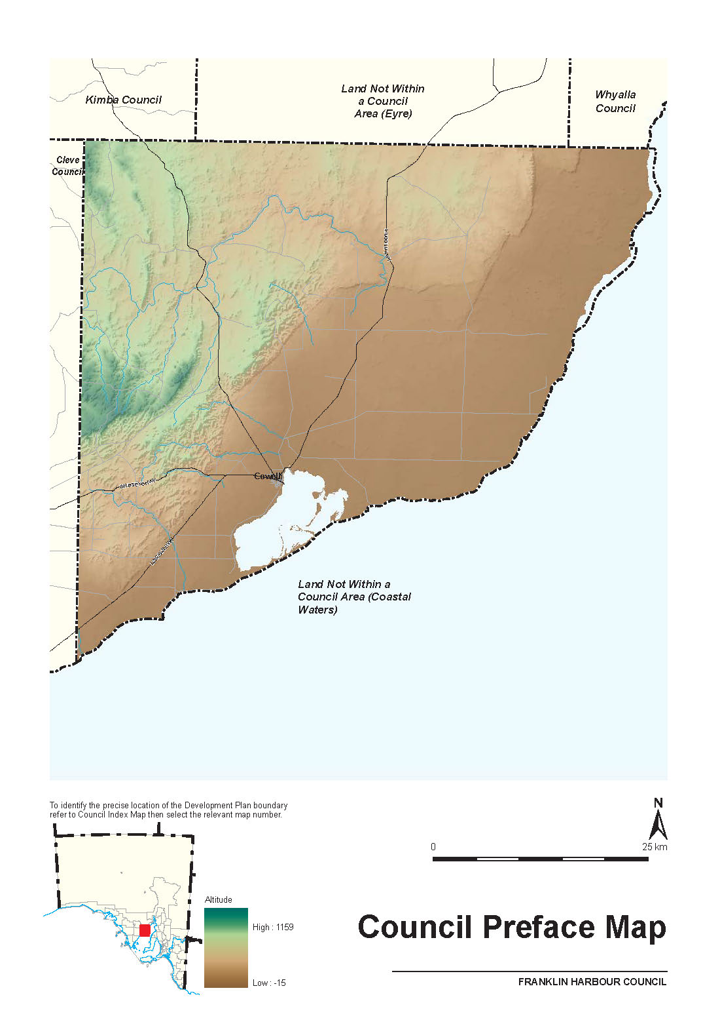
ATTACHMENT A
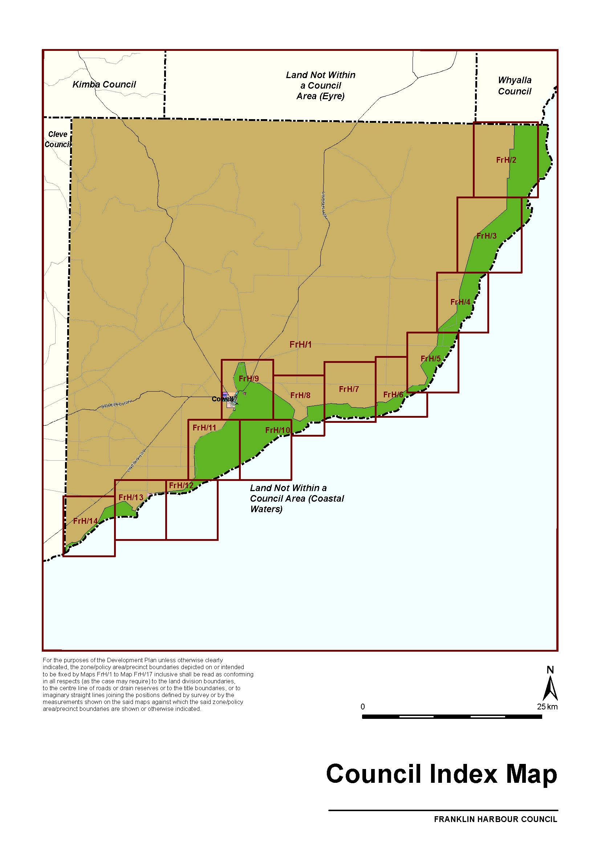
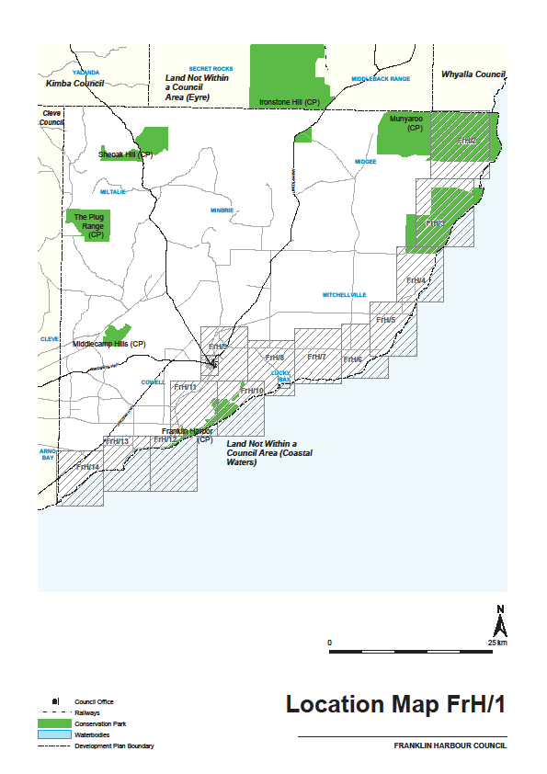
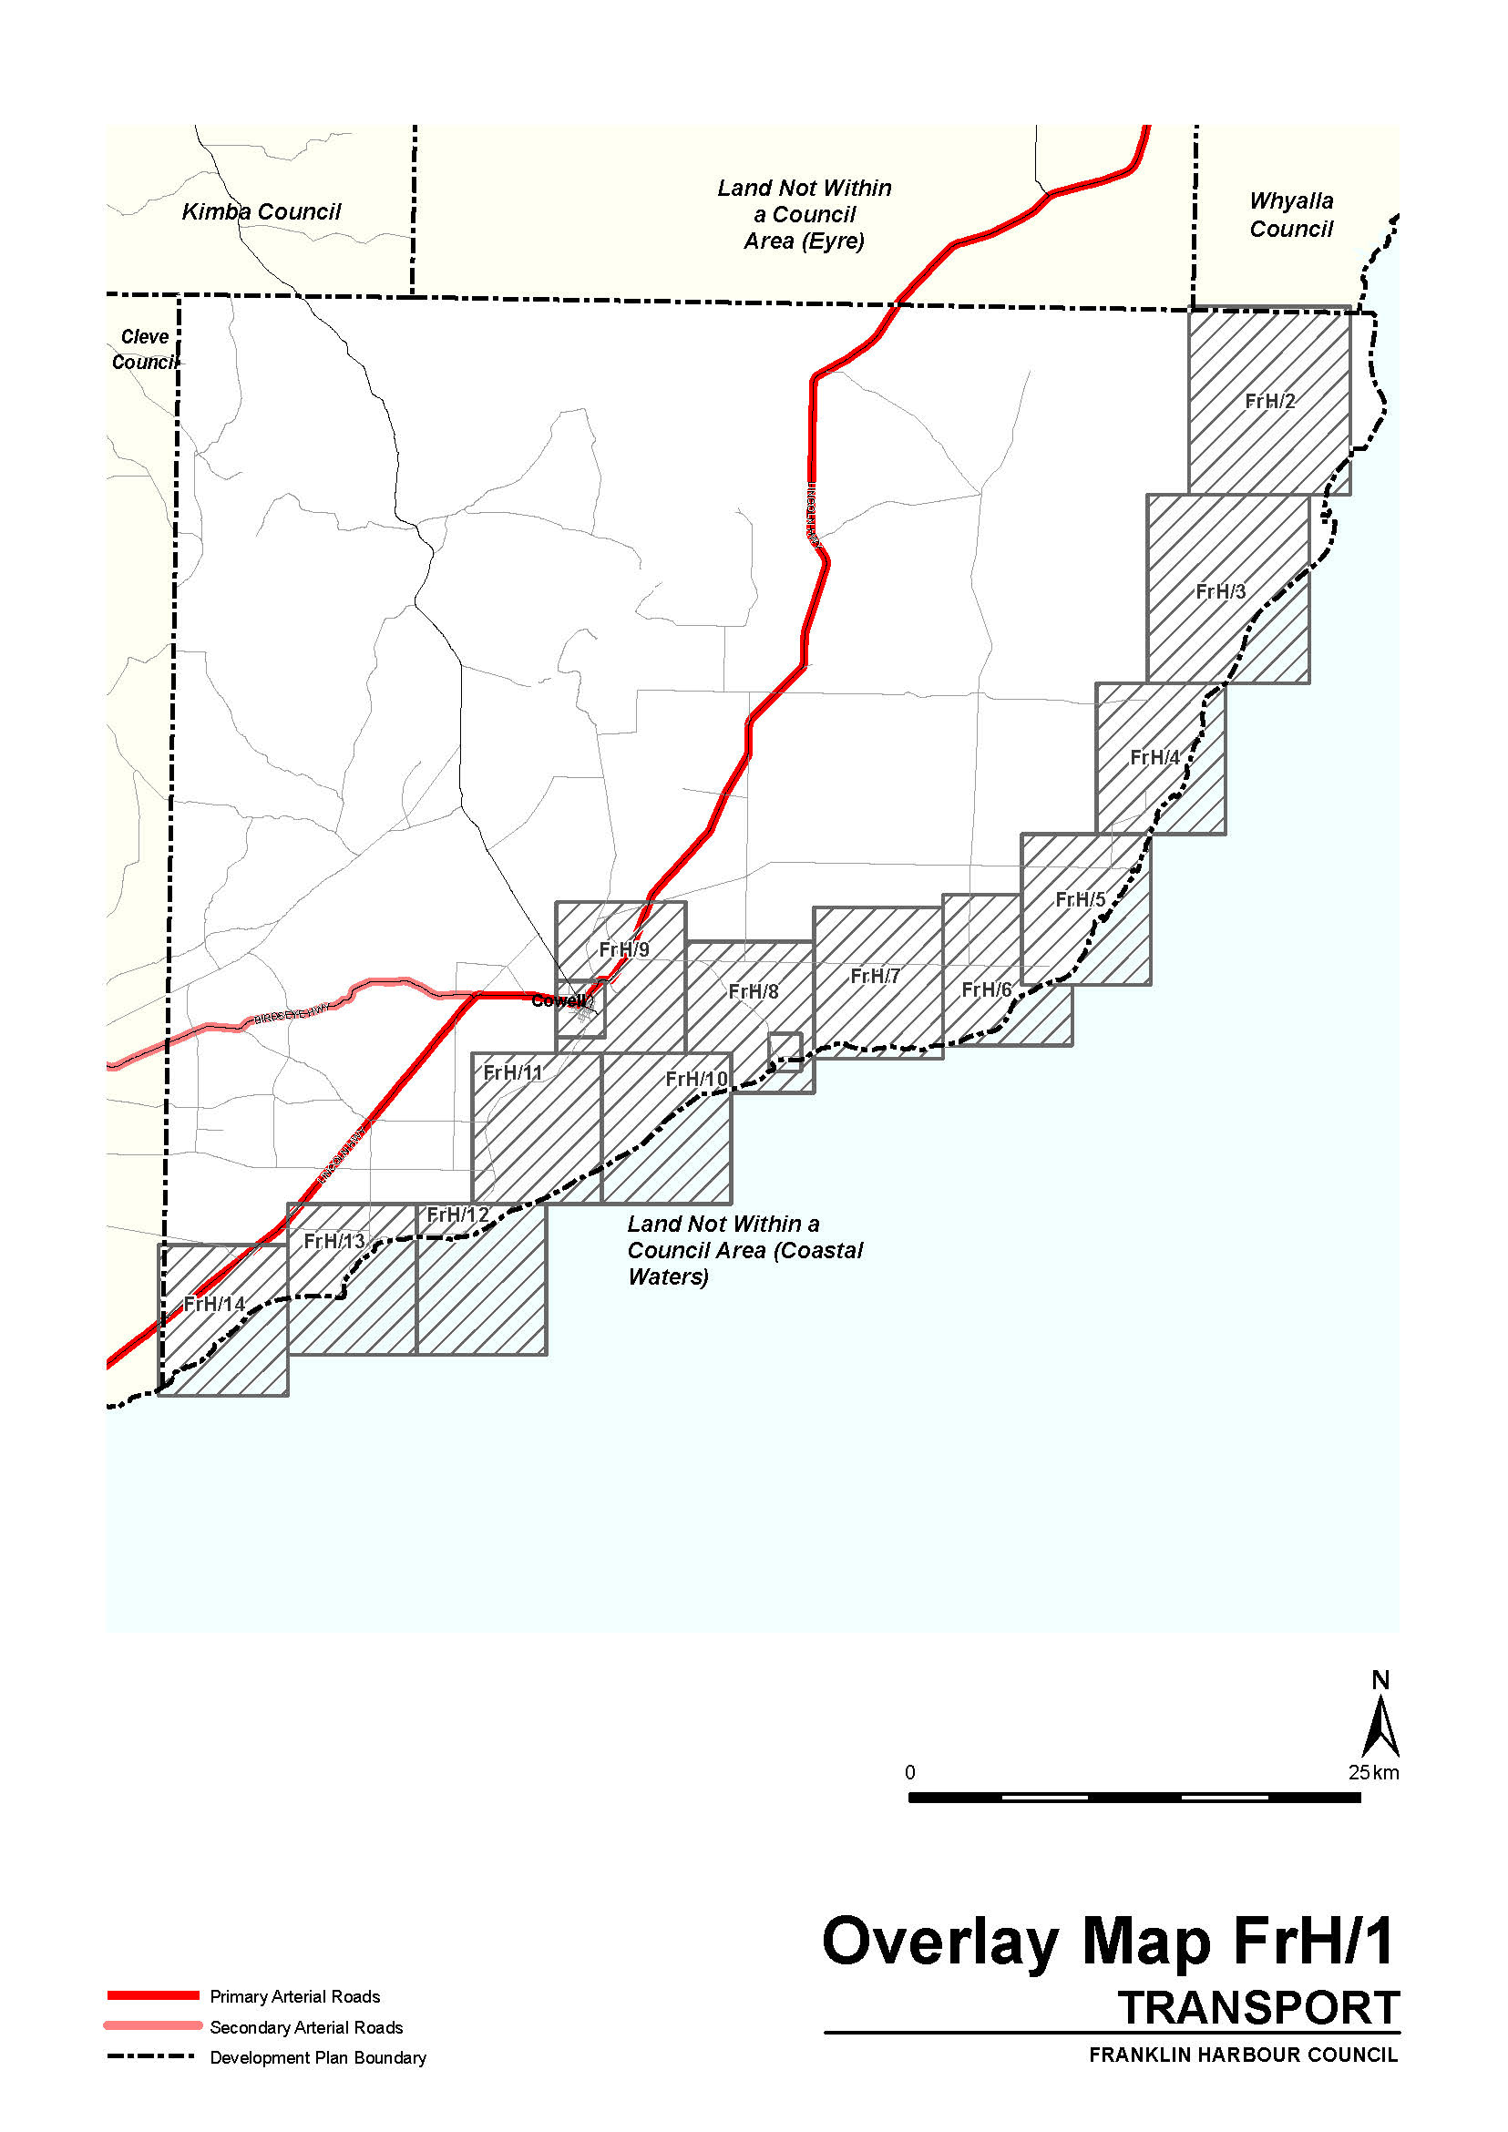
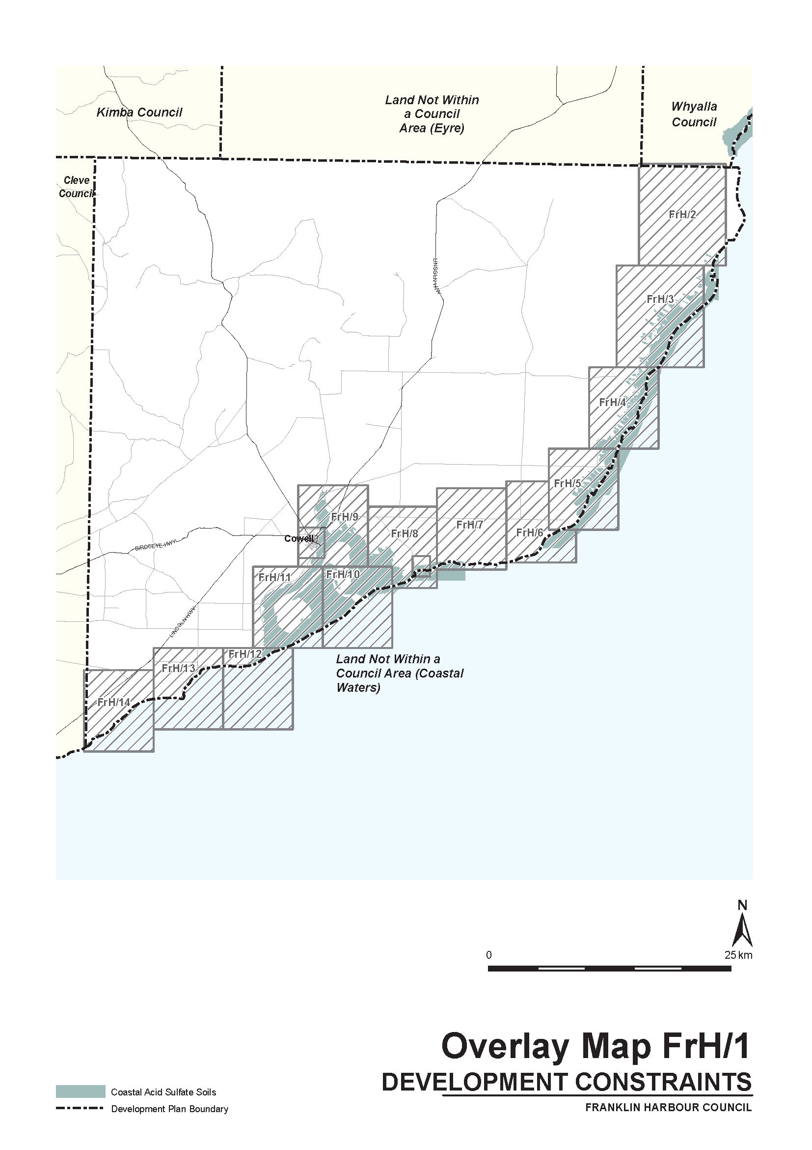
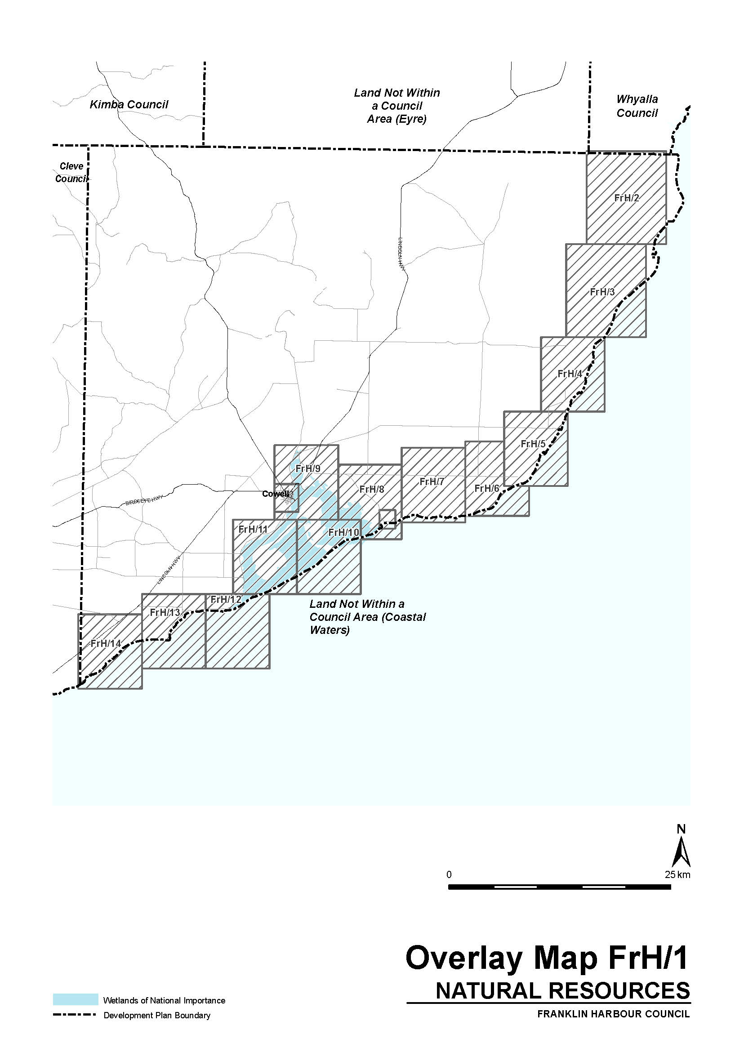

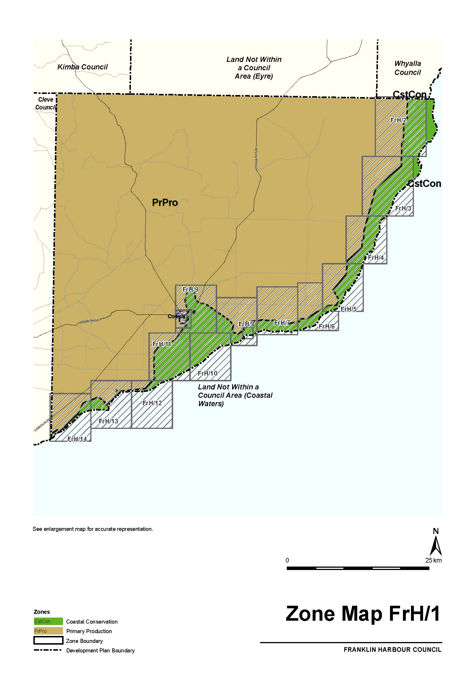

FISHERIES MANAGEMENT ACT 2007: SECTION 79
TAKE note that the notice made under Section 79 of the Fisheries Management Act 2007, dated 12 January 2015, and published in the South Australian Government Gazette dated 15 January 2015, on page 280, being the first notice on that page, referring to the Spencer Gulf Prawn Fishery, is hereby varied such that it will not be unlawful for a person fishing pursuant to a Spencer Gulf Prawn Fishery Licence to use prawn trawl nets in the areas specified in Schedule 1, during the period specified in Schedule 2, and under the conditions specified in Schedule 3.
Schedule 1
1. The waters of the Spencer Gulf Prawn Fishery that are:
South of the following co-ordinates:
Latitude 33°34.00′S, longitude 137°14.00′E. then to position latitude 33°34.00′S, longitude 137°34.00′E. then to position latitude 33°38.00′S, longitude 137°34.00′E. then to position latitude 33°46.00′S, longitude 137°44.00′E.
2. Except the waters contained within and bounded by the following co-ordinates, which shall remain closed to fishing:
(a) The area known as the Southern Closure:
Latitude 33° 41.00 S, longitude 137° 06.00 E, then to position latitude 33°52.00′S, longitude 137°15.00′E, then to position latitude 33°54.00′S, longitude 137°09.00′E, then to position latitude 33°59.00′S, longitude 137°12.00′E, then to position latitude 34°14.00′S, longitude 136°57.00′E, then to position latitude 34°14.00′S, longitude 136°52.00′E, then to position latitude 34°18.00′S, longitude 136°49.00′E, then to position latitude 34°18.00′S, longitude 136°42.00′E, then to position latitude 34°07.00′S, longitude 136°48.00′E, then to position latitude 33°55.00′S, longitude 136°34.00′E.
(b) the area known as the ‘Wardang Closure’:
Latitude 34°10.00′S, longitude 137°28.00′E, then to position latitude 34°21.00′S, longitude 137°12.00′E, then to position latitude 34°45.00′S, longitude 137°15.00′E, then to position latitude 34°48.53′S, longitude 137°09.45′E, then to position latitude 34°48.53′S, longitude 137°06.00′E, then to position latitude 34°50.75′S, longitude 137°06.00′E, then to position latitude 34°54.00′S, longitude 137°01.00′E.
Schedule 2
Commencing at sunset on 20 April 2015 and end at sunrise on 29 April 2015.
Schedule 3
1. The co-ordinates in Schedule 1 are defined as degrees, decimal minutes and based on the World Geodetic System 1984 (WGS 84).
2. No fishing activity may be undertaken between the prescribed times of sunrise and sunset for Adelaide (as published in the South Australian Government Gazette pursuant to the requirements of the Proof of Sunrise and Sunset Act 1923) during the period specified in Schedule 2.
3. Fishing must cease:
(a) in the fishing area known as the ‘Mid/North Gulf’ area (as described in the Management Plan for the South Australian Commercial Spencer Gulf Prawn Fishery October 2014) if the average catch per vessel, per night (for all vessels) drops below 500 kg; and
(b) after the Mid/North Gulf area is closed; in the fishing area known as the ‘Southern Gulf’ area (as described in the Management Plan for the South Australian Commercial Spencer Gulf Prawn Fishery October 2014) if the average catch per vessel over two consecutive nights falls below 350 kg.
4. Fishing must cease:
(a) in an area in the Mid/North Gulf if the average prawn bucket count for all vessels exceeds 260 prawns per 7 kg; and
(b) after the Mid/North Gulf area is closed; in an area in the Southern Gulf if the average prawn bucket count for all vessels exceeds 260 prawns per 7 kg.
5. No fishing activity may occur without the authorisation of
Co-ordinator at Sea, Greg Palmer, or other nominated Co-ordinator at Sea appointed by the Spencer Gulf and West Coast Prawn Fishermen’s Association.
6. The authorisation of the Co-ordinator at Sea must be in writing, signed and record the day, date and permitted fishing area within the waters of Schedule 1 in the form of a notice sent to the fishing fleet or vary an earlier authorisation issued by the
Co-ordinator at Sea.
7. The Co-ordinator at Sea must cause a copy of any authorisation for fishing activity or variation of same, made under this notice to be emailed to the Prawn Fisheries Manager immediately after it is made.
8. The Co-ordinator at Sea must keep records of all authorisations issued pursuant to this notice.
Dated 20 April 2015.
B. Milic, Prawn Fisheries Manager

FISHERIES MANAGEMENT ACT 2007: SECTION 115
TAKE notice that pursuant to Section 115 of the Fisheries Management Act 2007, the holder of Western Zone Abalone Fishery licence issued pursuant to the Fisheries Management (Abalone Fisheries) Regulations 2006 (the ‘exemption holders’) or their registered master are exempt from the provisions of Part 2, Clause 5 of Schedule 2 and Clause 118 of Schedule 6 of the Fisheries Management (General) Regulations 2007 in that the exemption holder shall not be guilty of an offence when taking Roe’s abalone (Haliotis roei) that is undersize, from the waters of the Western Zone, as defined in the Fisheries Management (Abalone Fisheries) Regulations 2006 (the exempted activity) subject to the conditions specified in Schedule 1 from 14 April 2015 to 31 December 2015, unless varied or revoked earlier.
Schedule 1
1. While engaged in the exempted activity, the exemption holders may only take Roe’s abalone (Haliotis roei) provided that it is not less than 75 mm in shell length. All Roe’s abalone (Haliotis roei) must be landed in shell.
2. The exempted activity may not occur within any aquatic reserve or any sanctuary zone established under the Marine Parks Act 2007.
3. Upon completion of the day’s fishing activities the exemption holders shall each complete the Roei Daily Catch and Effort Return Form provided by the South Australian Research and Development Institute (SARDI). The completed Roei Daily Catch and Effort Return Forms must be returned to SARDI within 15 days of the end of the month to which it relates. Exemption No. ME9902761.
4. The catch of Roe’s abalone (Haliotis roei) is to be stored separately from other species of taken abalone in an approved bag or bin and the estimated whole weight must be recorded on Part A of the CDR1 form.
5. All Roe’s abalone (Haliotis roei) taken pursuant to this notice shall be delivered to one of the registered fish processors listed in Schedule 2 of this notice for weighing, within 48 hours of landing, within the State of South Australia.
6. The exemption holders shall not, during the period of this notice, take a combined total quantity of Roe’s abalone (Haliotis roei) that exceeds 500 kg each (whole weight).
7. The exemption holders shall not contravene or fail to comply with the Fisheries Management Act 2007, or any regulations made under that Act except where specifically exempted by this notice.
8. While engaged in the exempted activity the exemption holders must have in his possession a copy of this notice and produce a copy of the notice if required by a PIRSA Fisheries Compliance Officer. Exemption No. ME9902761.
Schedule 2
FP0005 | FP0118
Dover Fisheries Pty Ltd | Southern Ocean Rock
23 Wilson Street | Lobster Pty Ltd
Royal Park, S.A. 5014 | P.O. Box 2389
 | Port Lincoln, S.A. 5606
FP0008 | FP0246
Western Abalone | Sou’rn Waters Marine
Processors Pty Ltd | Prods Pty Ltd
P.O. Box 914 | 26 North Quay Boulevard
Port Lincoln, S.A. 5606 | Port Lincoln, S.A. 5606
FP0030 | FP0379
SAFCOL Australia Pty Ltd | Hot Dog Fisheries Pty Ltd
P.O. Box 1085 | 81-83 Flinders Drive
Elizabeth Vale, S.A. 5112 | Cape Jervis, S.A. 5204
FP0103 | FP0565
First Class Australasia  Pty Ltd | Streaky Bay Marine  Products Pty Ltd
1196-1200 Old Port Road | 24 Flinders Drive
Royal Park, S.A. 5014 | Streaky Bay, S.A. 5680

This notice does not purport to override the provisions or operation of any other Act including, but not limited to, the Marine Parks Act 2007. The exemption holders and their agents must comply with any relevant regulations, permits, requirements and directions from the Department of Environment, Water and Natural Resources when undertaking activities within a marine park.
Dated 14 April 2015.
S. Sloan, Director, Fisheries and Aquaculture and Policy

FISHERIES MANAGEMENT ACT 2007: SECTION 115
TAKE notice that pursuant to Section 115 of the Fisheries Management Act 2007, each of the registered fish processors specified in Schedule 1 (hereinafter referred to as the ‘exemption holder’) are exempt from the provisions of Part 2, Clause 5 of Schedule 2 of the Fisheries Management (General) Regulations 2007 and Regulation 8 of the Fisheries Management (Fish Processors) Regulations 2007, but only insofar that the exemption holder shall not be guilty of an offence when possessing and processing undersized Roe’s abalone (Haliotis roei) consigned by the holder of a Western Zone Abalone Fishery Licence (the exempted activity) subject to the conditions specified in Schedule 2 from 15 April 2015 to 31 December 2015, unless varied or revoked earlier.
Schedule 1
FP0005 | FP0118
Dover Fisheries Pty Ltd | Southern Ocean Rock
23 Wilson Street | Lobster Pty Ltd
Royal Park, S.A. 5014 | P.O. Box 2389
 | Port Lincoln, S.A. 5606
FP0008 | FP0246
Western Abalone | Sou’rn Waters Marine
Processors Pty Ltd | Prods Pty Ltd
P.O. Box 914 | 26 North Quay Boulevard
Port Lincoln, S.A. 5606 | Port Lincoln, S.A. 5606
FP0030 | FP0379
SAFCOL Australia Pty Ltd | Hot Dog Fisheries Pty Ltd
P.O. Box 1085 | 81-83 Flinders Drive
Elizabeth Vale, S.A. 5112 | Cape Jervis, S.A. 5204
FP0103 | FP0565
First Class Australasia  Pty Ltd | Streaky Bay Marine  Products Pty Ltd
1196-1200 Old Port Road | 24 Flinders Drive
Royal Park, S.A. 5014 | Streaky Bay, S.A. 5680

Schedule 2
1. The exemption holder may not possess or process Roe’s abalone (Haliotis roei) that is less than 75 mm in shell length under this exemption.
2. The exemption holder must ensure that each bag or bin of Roe’s abalone (Haliotis roei) is processed separately to other species of abalone consigned.
3. The exemption holder must record the weight of Roe’s abalone (Haliotis roei) separately to other species of abalone consigned on Part B of the CDR1 Form.
4. While engaged in the exempted activity the exemption holder must have in his possession a copy of this notice and produce a copy of the notice if required by a PIRSA Fisheries Compliance Officer. Exemption No. ME9902769.
5. The exemption holder must not contravene or fail to comply with the Fisheries Management Act 2007, or any regulations made under that Act except where specifically exempted by this notice.
Dated 15 April 2015.
K. Rowling, Acting Director, Fisheries and Aquaculture and Policy

GEOGRAPHICAL NAMES ACT 1991
Notice to Alter the Boundaries of Places
NOTICE is hereby given pursuant to the provisions of the above Act, that I, MICHAEL BURDETT, Surveyor-General and Delegate appointed by Stephen Mullighan, Minister for Transport and Infrastructure, Minister of the Crown to whom the administration of the Geographical Names Act 1991, is committed DO HEREBY exclude from the rural locality of CHAIN OF PONDS and include into the rural locality of CUDLEE CREEK the area marked (A) shown on the plan so that the whole of DP.45505 A250 is within the one locality of CUDLEE CREEK.
Copies of the plan for this naming proposal can be viewed at:
• the office of Adelaide Hills Council;
• the Office of the Surveyor-General, 101 Grenfell Street, Adelaide; or
• the Land Services web-site at:
www.sa.gov.au/landservices/namingproposals
Dated 21 April 2015.
M. Burdett, Surveyor-General, Department of Planning, Transport and Infrastructure
DPTI.2014/21644/01

MINING ACT 1971
NOTICE is hereby given in accordance with Section 28 (5) of the Mining Act 1971, that the Minister for Mineral Resources and Energy proposes to grant an Exploration Licence over the undermentioned area:
Applicant: Uranium One Australia Pty Ltd
Location: Yarramba Area—Approximately 90 km north-east of Olary.
Pastoral Leases: Yarramba, Mulyungarie, Kalkaroo, Boolcoomata and Wompinie.
Term: 2 years
Area in km²: 452
Ref.: 2014/00228
Plan and co-ordinates can be found on the Department of State Development website: http://www.minerals.statedevelopment.sa.
gov.au/public_notices or by phoning Mineral Tenements on (08) 8463 3103.
J. Martin, Mining Registrar

MINING ACT 1971
NOTICE is hereby given in accordance with Section 28 (5) of the Mining Act 1971, that the Minister for Mineral Resources and Energy proposes to grant an Exploration Licence over the undermentioned area:
Applicant: Uranium One Australia Pty Ltd
Location: Katchiewilleroo Dam Area—Approximately 100 km north-north-west of Olary.
Pastoral Leases: Curnamona, Kalabity, Erudina and Frome Downs.
Term: 2 years
Area in km²: 652
Ref.: 2014/00239
Plan and co-ordinates can be found on the Department of State Development website: http://www.minerals.statedevelopment.sa.
gov.au/public_notices or by phoning Mineral Tenements on (08) 8463 3103.
J. Martin, Mining Registrar

MINING ACT 1971
NOTICE is hereby given in accordance with Section 28 (5) of the Mining Act 1971, that the Minister for Mineral Resources and Energy proposes to grant an Exploration Licence over the undermentioned area:
Applicant: Uranium One Australia Pty Ltd
Location: Goulds Dam Area—Approximately 100 km north-west of Olary.
Pastoral Leases: Kalabity, Erudina and Frome Downs.
Term: 2 years
Area in km²: 334
Ref.: 2014/00240
Plan and co-ordinates can be found on the Department of State Development website: http://www.minerals.statedevelopment.sa.
gov.au/public_notices or by phoning Mineral Tenements on (08) 8463 3103.
J. Martin, Mining Registrar

MINING ACT 1971
NOTICE is hereby given in accordance with Section 28 (5) of the Mining Act 1971, that the Minister for Mineral Resources and Energy proposes to grant an Exploration Licence over the undermentioned area:
Applicant: Tasman Resources Limited
Location: Pandurra Area—Approximately 50 km west of Port Augusta.
Pastoral Leases: Pandurra and Wartaka.
Term: 2 years
Area in km²: 75
Ref.: 2014/00255
Plan and co-ordinates can be found on the Department of State Development website: http://www.minerals.statedevelopment.sa.
gov.au/public_notices or by phoning Mineral Tenements on (08) 8463 3103.
J. Martin, Mining Registrar

HOUSING IMPROVEMENT ACT 1940
WHEREAS by notice published in the Government Gazette on the dates mentioned in the following table the South Australian Housing Trust Board Delegate did declare the houses described in the said table to be substandard for the purposes of Part 7 of the Housing Improvement Act 1940, the South Australian Housing Trust Board Delegate in the exercise of the powers conferred by the said Part, does hereby fix as the maximum rental per week which shall be payable subject to Section 55 of the Residential Tenancies Act 1995, in respect of each house described in the following table the amount shown in the said table opposite the description of such house and this notice shall come into force on the date of this publication in the Gazette.

Address of House | Allotment, Section, etc. | Certificate of Title  Volume Folio |  | Date and page of Government Gazette in which notice declaring house to be substandard published | Maximum rental per week  payable in respect of each house  $
30 Ballard Road, Smithfield Plains | Allotment 112 in Deposited Plan 7868, Hundred of Munno Para | 5156 | 733 | 26.2.15, page 822 | 120.00
Dated at Adelaide, 23 April 2015. R. Hulm, Director, Corporate Services, Housing SA (Delegate SAHT)

HOUSING IMPROVEMENT ACT 1940
WHEREAS by notice published in the Government Gazette on the dates mentioned in the following table the South Australian Housing Trust Board Delegate did declare the houses described in the said table to be substandard for the purposes of Part 7 of the Housing Improvement Act 1940, and whereas the South Australian Housing Trust Board Delegate is satisfied that each of the houses described hereunder has ceased to be substandard, notice is hereby given that, in exercise of the powers conferred by the said Part, the South Australian Housing Trust does hereby revoke the said declaration in respect of each house.

Address of House | Allotment, Section, etc. | Certificate of Title  Volume Folio |  | Date and page of Government Gazette in which notice declaring house to be substandard published
69 Hughes Street, Unley | Allotment 139 in Filed Plan 12739,  Hundred of Adelaide | 5808 | 251 | 17.10.13, page 3997
Dated at Adelaide, 23 April 2015. R. Hulm, Director, Corporate Services, Housing SA (Delegate SAHT)

South Australia
Motor Vehicles (Approval of Motor Bikes and Motor Trikes) Notice 2015
under the Motor Vehicles Act 1959
1—Short title
This notice may be cited as the Motor Vehicles (Approval of Motor Bikes and Motor Trikes) Notice 2015.
2—Commencement
This notice will come into operation on the date of publication in this Gazette.
3—Approved motor bikes and motor trikes
For the purposes of Schedules 2 and 3 of the Motor Vehicles Regulations 2010 and the transitional provisions of the Motor Vehicles Variation Regulations 2005 (No. 233 of 2005), the motor bikes and motor trikes specified in Schedule 1 are approved.

Schedule 1—Approved motor bikes and motor trikes
1—Motor bikes and motor trikes with an engine capacity not exceeding 260 ml
All motor bikes and motor trikes with an engine capacity not exceeding 260 milliliters and a power to weight ratio not exceeding 150 kilowatts per tonne other than the following:
Suzuki RGV250
Kawasaki KR250 (KR-1 and KR1s models)
Honda NSR250
Yamaha TZR250
Aprilia RS250
2—Motor bikes and motor trikes with an engine capacity not less than 261 ml and not exceeding 660 ml
The motor bikes and motor trikes listed in the table below.

MAKE | MODEL | VARIANT NAME | YEAR | CAPACITY
AJS | MODEL 18 | MODEL 18 | pre 1963 | 497
 | MODEL 20 (formerly known as Model 30) | MODEL 20 | 1955-61 | 498
ALDY | All models | All models | Sep-13 | under 125
APRILIA | Moto 6.5 | Moto 6.5 | 1998-99 | 649
 | Mojito | Mojito | All | 50
 | M35 | SR MAX 300 | 2012 | 278
 | PEGASO 650 | DUAL SPORTS | 1994-01 | 652
 | PEGASO 650 | OUTBACK | 2000-01 | 652
 | PEGASO 650 | Factory 650 | 2007-08 | 660
 | PEGASO 650 I.E. | OUTBACK | 2001-02 | 652
 | PEGASO 650 I.E. | DUAL SPORTS | 2001-06 | 652
 | RXV 4.5 | RXV 4.5 | 2006-08 | 449
 | RXV450 | VPV | 2010 | 449
 | RXV 5.5 | RXV 5.5 | 2006-08 | 549
 | RXV550 | VPZ | 2010 | 553
 | RS125/SBK | RS125/SBK | 2013 | 125
 | SR 50R | SR 50R | All | 50
 | SR MT 50 | SR MT 50 | All | 49
 | SR MT 125 | SR MT 125 | All | 124
 | SCRABEO 200 | SCRABEO 200 | All | 181
 | SCARABEO 300 | VRG | 2009 | 278
 | SCARABEO 400 | SCARABEO 400 | 2007 | 399
 | SCARABEO 500 | SCARABEO 500 | 2007-08 | 460
 | SPORTCITY 300 | SPORTCITY300 | 2010-12 | 300
 | STRADA 650 | ROAD | 2006-08 | 659
 | STRADA 650 | TRAIL | 2006-08 | 659
ASIAWING | LD450 | ODES MCF450 | 2011-13 | 449
 | SXV 4.5 | SXV 450 | 2006-08 | 449
 | SXV5.5 | SXV 550 | 2006-08 | 553
 | SXV 5.5 | SXV 5.5 | 2006-08 | 553
ATK | 605 | 605 | 1995 | 598
BENELLI | VELVET DUSK | VELVET DUSK | 2003-05 | 383
 | P25 | 600RS | 0 | 600
 | P25 | GT600 RESTRICTED | 2014-15 | 600
 | P25 | BN 600 RESTRICTED | 2013-14 | 600
BETA | RR E3 | RR350 | 2011 | 349
 | RR E3 | RR400 | 2010-11 | 398
 | RR E3 | RR450 | 2010-11 | 449
 | RR450 | RR450 | 2008 | 448
 | RR450 | RR450 | 2000-07 | 448
 | RR E3 | RR520 | 2010-11 | 498
 | RR525 | RR525 | 2008 | 510
 | RR525 | RR525 | 2000-07 | 510
 | FUPA RR E3 | RR 2T 300 | 2012 | 293
BMW | C650 | C600 Sport | 2011-13 | 647
 | C650 | C650 GT/GS | 2011-13 | 647
 | F650 | FUNDURO | 1995-00 | 652
 | F650CS | SCARVAR | 2002-05 | 652
 | F650CS | SE ROAD | 2004-06 | 652
 | F650GS (does not include models manufactured after Nov 2007 with 800ml engine) | DAKAR | 2000-08 | 652
 | F650GS | F650GS | 2000-08 | 652
 | F650ST | F650ST | 1998 | 652
 | F650 | G650 GS | 2009-13 | 652
 | F650 | G650 GS Serato | 2012-2013 | 652
 | G 450 X | G 450 X | 2008-10 | 450
 | G650GS | Serato | All | 650
 | R45 | R45 | All | 453
 | R50 | R50 | 1969 | 499
 | R60 | R60 | 1967 | 590
 | R65 | R65 | 1981-88 | 650
 | R65LS | R65LS | 1982-86 | 650
 | R69 | R69 | 1961 | 600
 | F650GD | F650 | 2000 | 652
BOLWELL | LM25W | FIRENZE | 2009 | 263
BOLLINI | All models | All models under 250 | All | 250
BSA | A50 | A50 | 1964-70 | 500
 | A65 | A65 | 1966-69 | 650
 | A7 | A7 | 1961 | 500
 | B40 | B40 | 1969 | 350
 | B44 | B44 | 1967-71 | 440
 | B50 | B50 | 1971 | 495
 | B50SS GOLDSTAR | B50SS GOLDSTAR | 1971 | 498
 | G650 GS | G650 GS | 2010 | 652
 | G650 GS Serato | G650 GS | 2010 | 652
 | GOLD STAR | GOLD STAR | 1962 | 500
 | LIGHTNING | LIGHTNING | 1964 | 654
 | SPITFIRE MKIII | SPITFIRE MKIII | 1967 | 650
 | THUNDERBOLT | THUNDERBOLT | 1968 | 499
Buell | Blast | STREET FIGHTER | 2002-07 | 491
Bug | SEE KYMCO
BULTACO | ALPINA | ALPINA | 1974 | 350
 | FRONTERA | FRONTERA | 1974 | 360
 | SHERPA | SHERPA | 1974 | 350
CAlIFORNIA SCOOTER | All models under 250cc | All models under 250cc | 2014 | 249
CAGIVA | 360WR | 360WR | 1998-02 | 348
 | 410TE | 410TE | 1996 | 399
 | 610TEE | 610TEE | 1998 | 576
 | 650 ALAZZURA | 650 ALAZZURA | 1984-88 | 650
 | 650 ELFANT | 650 ELFANT | 1985-88 | 650
 | CANYON 500 | DUAL SPORTS | 1999-06 | 498
 | CANYON 600 | DUAL SPORTS | 1996-98 | 601
 | RIVER 600 | RIVER 600 | 1995-98 | 601
 | W16 600 | W16 600 | 1995-97 | 601
CFMOTO | All models | All models till Sep 14 | 2012-13 | under 650
 | CF650 | CF650NK-LAM | 2012-13 | 649
 | CF650 | CF650NK-LAM | 2013 | 649
COSSCK | 650 | Ural | 1974 | 649
DAELIM | All Models | All Models under 250 | All | under 250
DERBI | Boulevard 50 | Boulevard 50 |  | 50
 | GP1 250 | GP1 250 |  | 250
 | MULHACEN | MULHACEN | 2008 | 659
 | RAMBLA | RA 300 | 2010 | 278
DNEPER | K650 | K650 | 1972 | 650
 | DNEIPNER | DNEIPNER | 1974 | 650
 | K650 | K650 DNEPR | 1967-74 | 650
 | MT9 | MT9 | 1974 | 650
DUCATI | 400 MONSTER | 400 MONSTER | 2002 | 398
 | 400 SIE | 400 S I E monster |  | 398
 | 400 SS JUNIOR | 400 SS | 1989-96 | 398
 | 400SS | 400SS | 1992-95 | 398
 | 500SL | PANTAH | 1984 | 499
 | 500 DESMO | 500 Sport Desmo | 1978 | 497
 | 600 MONSTER | 600 MONSTER | 1994-01 | 583
 | 600 MONSTER | DARK | 1998-01 | 583
 | 600 S | 600 SUPERSPORT | 1994-97 | 583
 | 600M | 600M | 1994-01 | 583
 | 600SL | PANTAH | 1980-84 | 583
 | 600SS | 600SS | 1994-98 | 583
 | 620 MONSTER LITE | M620 LITE | 2003-07 | 618
 | 620 MULTISTRADA LITE | MTS620 24.5Kw | 2005-07 | 618
 | 659 Monster | Monster 659 | All | 659
 | DM 350 | 350 | pre 85 | 350
 | DM 450 | 450 | pre 85 | 448
 | DM450 | DM450 | 1972 | 450
 | DM500 | DM500 | 1981-84 | 498
 | F3 | 350 F3 | 1986-1989 | 349
 | F4 | 400 F4 | 1986 | 400
 | M4 | M620ie LITE | 2003-04 | 620
 | M5 | Monster 659 | 2011 | 659
EAGLE WING | Cino 125 | Cino 125 | All | 125
 | Elegante 125 | Elegante 125 | All | 125
ENFIELD | BULLET | CLASSIC | 1993-08 | 499
see also Royal Enfield | BULLET | DELUXE | 1993-08 | 499
 | BULLET | ELECTRA ROAD | 2006-08 | 499
 | BULLET 350 | DELUXE | 1988-01 | 346
 | BULLET 350 | SUPERSTAR | 1988-95 | 346
 | BULLET 350 | CLASSIC | 1993-01 | 346
 | BULLETT 500 | 500 | 1995 | 499
 | BULLET 65 | ROAD | 2003-04 | 499
 | LIGHTNING | ROAD | 2000-08 | 499
 | MILITARY | ROAD | 2002-08 | 499
 | TAURAS | DIESEL | 2001 | 325
 | BULLET 350 STD | Royal Enfield | 1960-90 | 346
FANTIC | TZ | EC300 | 2011-12 | 300
 | TZ | Gas Gas EC30 | 2012 | 300
FONZARELLI | 125 | 125 | 2014-15 | Electric
GAS-GAS | EC300 | SM SUPERMOTARD | 2002 | 299
 | EC300 | ENDURO | 2001-02 | 299
 | EC400 | FSE ENDURO | 2002-03 | 399
 | EC450 | FSE ENDURO | 2003-05 | 449
 | EC450 | FSE SUPERMOTARD | 2003-08 | 449
 | EC450 | FSR ENDURO | 2006-08 | 449
 | FS 400 | FS40A | 2006 | 398
 | FS 450 | FS45 | 2006 | 443
 | FS 500 | FS50 | 2006 | 503
 | FSE 400 | 400 | 2002 | 398
 | FSE 450 | 450 | 2003-08 | 398
 | PAMPERA | 320 TRAIL | 1998-02 | 333
 | PAMPERA | 400 TRAIL | 2006-08 | 399
 | PAMPERA | 450 | 2007-08 | 443
 | SM400 | SUPERMOTARD | 2003-08 | 399
 | SM450 | SUPERMOTARD | 2003-08 | 443
 | TT300 | EC300 | 1998-08 | 295
GILERA | FUOCO 500 | FUOCO 500 | 2007-13 | 493
 | NEXUS 500 | NEXUS 500 | 2003-08 | 460
HARLEY DAVIDSON | SS350 | Sprint | 1969-1974 | 350
 | XGS SERIES | Street 500 | 2014-15 | 494
HONDA | 600V TRANSLAP | 600V TRANSLAP | 1988 | 583
 | BROS | BROS | 1992 | 399
 | C70 | DREAM | pre 1970 | 305
 | CB100 | CB100 | All | 100
 | CB125e | CB125e | All | 125
 | CB175 | CB 175 K1-K6 | 1969-1974 | 175
 | CB200 | CB200 | All | 200
 | CB350 | CB350 | 1969 | 348
 | CB350F | CB350F | 1973 | 325
 | CB360 | CB360 | 1973-74 | 360
 | CB400 | CB400 | 1981 -2013 | 395
 | CB400 | CB400 | 2008 | 408
 | CB400F | CB400F | 1975-77 | 408
 | CB400N | CB400N | 1981 | 395
 | CB400T | CB400T | 1977 | 408
 | CB400 ABS | CB400 ABS | 2008 - 2013 | 399
 | CB450 | CB450 | 1967-75 | 450
 | CB500 | CB500 | 1977 | 498
 | CB500F | CB500FA | 2012 | 471
 | CB500X | CB500XA | 2013 | 471
 | CB550 | CB550 | 1974-78 | 544
 | CB650 | CB650 | All | 650
 | CBR125R | CBR125RR | 2004 | 124.7
 | CBR250R | CBR250RR | 1986-1996 | 249.6
 | CBR500R | CBR500RA | 2012 | 471
 | CBX550 | CBX550F | 1982-85 | 572
 | CX500 | CX500 | 1979 | 500
 | CJ360 | CJ360 | 1976 | 356
 | CL450 | CL450 | 1965-77 | 444
 | CRF150 | 150R/RB | All | 149
 | CRF250 | CRF 250 (L/X/F/M/R) versions | 2013 | 249
 | CRF250L | CRF250L | 2013 | 249
 | CRF400R | CRF400R | 2013 | 399
 | CRF450X | CRF450X | 2005-08 | 449
 | CX500 | CX500 | 1977-82 | 495
 | CX650 | CX650 | 1983-85 | 647
 | DEAUVILLE | NT650V | 2002-06 | 647
 | Fortza 300 | NSS300 Forza | All | 279
 | FJS400A | SW-T400 | 2009 | 399
 | FT500 | FT500 | 1984 | 498
HONDA cont. | FTS600D | SILVERWING | 2006-08 | 582
 | GB400 | GB400 | All | 399
 | GB500 | GB507 | 1987-91 | 498
 | GL400 | GL400 | 1985 | 396
 | NF02 | SH300 | 2009 | 279
 | NSS300 | NSS300 | 2013 | 279
 | NT400 | NT400 | 1989-92 | 400
 | NT650V | DEAUVILLE | 2003-06 | 647
 | NTV650 | REVERE | 1989-92 | 647
 | NX650 | DOMINATOR | 1988-00 | 644
 | PCX150 | PCX150 | 153
 | REVERE | REVERE | 1990 | 647
 | RVF400 | OBI RVF400 | 1992-96 | 399
 | SH150i | SH150i | 2005 | 152.7
 | SL350 | SL350 | 1972 | 348
 | OBI RVF400 VFR400 | OBI RVF400 Otobai import model only | All | 400
 | Steed | steed | 2002 | 398
 | Today 50 | Today | All | 50
 | VT400 | VT 400 | All | 398
 | VT400C | SHADOW | 2009 | 399
 | VT500 | VT500 | 1983-87 | 491
 | VT600C | VT600C | 1993-00 | 583
 | VT600C | SHADOW VLX | 1988-2008 | 583
 | VTR250 | Interceptor | 1997-2013 | 249
 | XBR500 | XBR500 | 1986-89 | 499
 | XBR500SH | XBR500 | 1986-89 | 499
 | XL350 | XL350 | 1984-87 | 339
 | XL500 | XL500 | 1979-84 | 498
 | XL600 | XL600 | 1984-89
 | XL600R | XL600R | 1984-87 | 589
 | XL600RMG | XL600RMG | 1986-88 | 591
 | XL600VH | TRANSALP | 1987-89 | 583
 | XL650V | TRANSALP | 2002-08 | 647
 | XL650 | TRANSALP | 2005 | 647
 | XL650 | XL650 | All | 250
 | XR250 | XR250R | All
 | XR350 | XR350 | 1983 | 339
 | XR350R | XR350R | 1983-84 | 339
 | XR350R | XR350R | 1985-86 | 353
 | XR400 | XR400 | 1996-08 | 397
 | XR400 MOTARD | XR400M | 1996-08 | 397
 | XR400R | XR400R | 1996-08 | 397
 | XR500 | XR500 | 1979-85 | 498
 | XR500R | XR500R | 1983-84 | 498
 | XR600 | XR600 | 1985 | 591
 | XR600R | XR600R | 1985-00 | 591
 | XR650L | XR650L/ XR650R | 2001-06 | 644
 | XR650R | XR650R | 2000-06 | 649
HUNTER | DD350E-6C | DAYTONA | 2010-13 | 320
 | DD350E-6C | SPYDER | 2010-13 | 320
 | DD350E-2 | BOBBER | 2011-13 | 320
HUSABERG | FE250 | ENDURO | All | 250
 | FE350 | ENDURO | All | 350
 | FE400 | ENDURO | All | 399
 | FE450 | ENDURO | 2008-14 | 449
 | FE501E | ENDURO | 1997-12 | 501
 | FE501 | ENDURO | 2012-14 | 510
 | FE570 | ENDURO | 2008-10 | 565
 | FE600E | ENDURO | 1997-00 | 595
 | FE650E | ENDURO | 2004-08 | 628
 | FE650E | ENDURO | 2000-04 | 644
 | FS450E | ENDURO | 2004 | 449
 | FS450 | SUPERMOTARD | 2008-10 | 449
 | FS570 | SUPERMOTARD | 2009-10 | 565
 | FS650C/E | SUPERMOTARD | 2004-08 | 628
 | FS650E | SUPERMOTARD | 2002-04 | 644
 | FE (Enduro) 4E8 | FE4E8 | 2000 | 399
 | FE (Enduro) 5E8 | FE5E8 | 2000 | 501
 | FE (Enduro) 7E8 | FE7E8 | 2000 | 644
 | FE550 | FE550 | 2004 | 550
 | TE300 | TE Series | 2010-14 | 293
HUSQVARNA | 300WR | WR300 | 2008-12 | 298
 | 310TE | TE310 A3 | 2009-13 | 303
 | 310TE | TE310 A2 | 2008-10 | 298
 | 350TE | TE350 | 1995 | 349
 | 400SM | SUPERMOTARD | 2002-04 | 400
 | 400TE | ENDURO | 2000-01 | 400
 | 410TE | ENDURO | 1998-00 | 400
 | 410TE | ENDURO | 1994-97 | 415
 | 450SM/R/RR | SUPERMOTARD | 2003-08 | 449
 | 450TC | MOTOCROSS | 2001-08 | 449
 | 450TE | ENDURO | 2001-07 | 449
 | 450TE-IE | ENDURO | 2007-08 | 449
 | 450TXC | TRAIL | 2007-08 | 449
 | A3 | A3 TE250-310 | 2012 | 303
 | A6 SMR 449 | A600AB | 2010-12 | 450
 | A6 TE 449 | A600AATE449 | 2010-13 | 450
 | A6 SMR 511 | A601AB | 2010-12 | 478
 | A6 TE 511 | A601AATE511 | 2010-13 | 478
 | A6 SMR 511 | A602AB | 2012 | 478
 | A8 | TR650 TERRA | 2013 | 652
 | A8 | TR650 STRADA | 2013 | 652
 | 510SM | SUPERMOTARD | 2006-10 | 501
 | 510TC | MOTOCROSS | 2004-07 | 501
 | 510TE | ENDURO | 2004-08 | 501
 | 510TE | ENDURO | 1984-85 | 505
 | 510TE | ENDURO | 1986-90 | 510
 | 510TE-IE | TE510IE | 2008 | 510
 | 570TE | 570TE(RP) | 2000 | 577
 | 610SM | SUPERMOTARD | 2000-08 | 577
 | TE610 | TE610(RP), dual sports | 2000 on | 577
 | AE430 | ENDURO | 1986-88 | 430
 | SM 450ie | SM 450ie | 2008 | 449
 | SM 510ie | SM 510ie | 2009 | 501
 | SMS630 | A401AB SMS630 | 2010-on | 600
 | SMR449 | SMR449 | 2011 | 449.6
 | SMR511 | SMR511 | 2012 | 447.5
 | FE250 | FE Enduro | All | 511
 | TE125 | TE125 | All | 125
 | TE250/ R | ENDURO TE250 | 2010 | 250
 | TE | TE300 | 2014 on | 298
 | FE | FE350 | 2014 on | 350
 | FE | FE450 | 2014 on | 449
 | FE | FE501 | 2014 on | 501
 | TE300 | TE300 TE310R | 2013 | 304.44
 | TE310R | ENDURO 2013 | 2013 | 302.44
 | TE449 | Enduro 2014 | 2013 | 449.6
 | TE510 | Enduro 2013 | 2013 | 477.5
 | TE310ie | TE310ie | 2008 | 298
 | TE630 | A401AA TE630 | 2010-on | 600
 | TR650 | TR650 Terra | 2013 | 652
 | TR650 | Strada ABS |  | 652
 | WR125 | ENDURO |  | 124.82
 | WR250 | ENDURO |  | 249.3
 | WR260 | ENDURO | 1990-91 | 260
 | WR300 | ENDURO | 2010-13 | 293
 | WR360 | ENDURO | 1991-03 | 349
 | WR400 | ENDURO | 1984-88 | 396
 | WR430 | ENDURO | 1988 | 430
HYOSUNG | GT 250 EFI | GT 250EFI | All | 249
 | GT250R EFI | GT250R EFI | All | 249
 | GT650 EFI | GT650EFI Lams | All | 647
 | GT650R EFI | GT650R EFI Learner | All | 647
 | GV650C/S | Lams model | All | 647
 | GT650L | Comet | 2005-09 | 647
 | GT650RL | Comet | 2005-09 | 647
 | GT650SL | Comet | 2005-09 | 647
 | GT650-40 | GT650R | 2010-12 | 647
 | GT650S-40 | GT650S | 2010-13 | 647
 | GT650-40 | GT650 | 2010-12 | 647
 | GT650R | GT650R-40 | 2012-13 | 647
 | GT650 Comet | GT650-40 | 2012-13 | 647
 | GT650S | GT650SL-40 | 2012 | 647
 | GT650S | GT650SH40 | 2012 | 647
 | GV250 | Aquila/EFI | All | 249
 | GV650C | Aguila Classic | 2010-13 | 647
 | GV650L | Aquila | 2008-13 | 647
 | GV650S | Aquila sports EFI
 | GV650-40 | Aquila | 2010-12 | 647
INDIAN | VELO | VELO | 1969 | 500
JAWA | 350 | 350 | 1974 | 350
 | 634 ROAD | 634 ROAD | 1984-85 | 343
 | 638 ROAD | 638 ROAD | 1985-86 | 343
JONWAY | MALIBU | MALIBU 320 | 2012 | 320
KAWASAKI | BR250E | Z250SL/Z250SL ABS | 2014 | 249
 | EN400 | Vulcan | 1986 | 400
 | EN450 | 450LTD | 1985-87 | 454
 | EN500 | Vulcan | 1990-02 | 500
 | ER-5 | ER500 | 1999-06 | 498
 | ER-6NL ABS | ER-6nl ABS learner model | 2012-2014 | 649
 | ER-650C | ER-6nL | 2009 | 649
 | ER-650C | ER-6nL ABS | 2009-11 | 649
 | Ninja 250 | 250R | 1986-current | 249
 | ER650F | ER-6NL ABS | 2011-12 | 649
 | EX300A | EX300B Ninja/ special | 2014 | 296
 | EX650F | Ninja 650RL ABS | 2011-12 | 649
 | NINJA 300 SPECIAL | NINJA 300 | 2013-14 | 296
 | EX400 | GPX 400R | 1987-94 | 399
 | Ninja 650 L model | Ninja 650RL | 2009 | 649
 | Ninja 650 | Ninja 650RL ABS | 2009-11 | 649
 | Ninja 650 | Ninja 650L ABS | 2011-14 | 649
 | NINJA 650L | NINJA 650L | 2013 | 649
 | EX650C | NINJA 650RL | 2009-10 | 649
 | EX650C | NINJA 650RL ABS | 2009-11 | 649
 | GPZ550 | GPZ550 | 1981-90 | 553
 | GT550 | Z550 | 1984-88 | 553
 | KL600 | KLR600 | 1984-87 | 564
 | KL650 | KLR650 | 1987-99 | 651
 | KLE500 | DUAL SPORTS | 1992-08 | 498
 | KLR600 | KL600 | 1984-87 | 564
 | KLR650E | KL650E | 1987-2012 | 651
 | KL650E | KLR650 | 2013-2014 | 651
 | KLX150 | KLX150E/KLX150 L | All
 | KLX250S | KLX250S | All | 249
 | KLX250SF | KLX250SF | 2013 | 249
 | KLX300R | KLX300R | 1996-04 | 292
 | KLX400 | KLX400 | 2003 | 400
 | KLX450R | KLX450R | 2007-14 | 449
 | KLX650 | KLX650 | 1989-95 | 651
 | KLX650R | ENDURO | 1993-04 | 651
 | KZ400 | KZ400 | 1974-84 | 398
 | KZ440 | KZ440 | 1985 | 443
 | KZ500 | KZ500 | 1979 | 497
 | KZ550 | KZ550 | 1986 | 547
 | LE650D | Versys 650L ABS | 2010 | 649
 | LE650D | Versys 650L ABS | 2011-14 | 649
 | LTD440 | LTD440 | 1982 | 443
 | LX400 | LX400 Eliminator | 1989 | 398
 | S2 | S2 | 1972 | 346
 | S3 | S3 | 1974 | 400
 | KLE500 | Versys 650L ABS | 2013 | 649
 | KLE650F | Versys 650lL ABS | 2014 | 649
 | EN650B | Vulcan S ABS/ABS L | 2014 | 649
 | Versys650L | Versys650L | 2013 | 649
 | W400 | EJ400AE | 2006-09 | 399
 | Z400B2 | KZ400B2 | 1979 | 398
 | W1 650 | W650 | 1965-70 | 623
 | Z400D | KZ400D | 1975 | 398
 | Z500 | Z500 | 1980 | 498
 | ZR550 | ZEPHYR | 1991-99 | 553
 | ZZR400 | ZZR400 | 1991 | 399
 | ZZR400 | ZZR400 | 1992 | 399
KTM | 2T-EXC | 300 EXC | 2012 | 293
 | 125 Duke | 125 exc | All | 125
 | 200 Duke | 200 exc | All | 193
 | 250 Duke | 250 EXC/F | All | 250
 | 300 exc | 300exc | All | 300
 | 390 Duke | 390 Duke | All | 390
 | 125 EXC | 125 EXC | All | 125
 | 200 EXC | 200 EXC | All | 193
 | 250 EXC/F | 250 EXC/F | All | 249
 | 300EXC | ENDURO | 84-2011 | 293
 | 300EXC-E | ENDURO | 2007-08 | 293
 | 300GS | ENDURO | 1990-95 | 280
 | 350EXC-F | ENDURO | 2011-on | 347
 | 350EXC Special-R | ENDURO | 2005-06 | 350
 | 360EXC | ENDURO | 1996-98 | 360
 | 380EXC | ENDURO | 2000 | 368
 | RC390 | RC390 | all | 390
 | 4T-EXC RACING | 350 EXC-F | 2012 | 350
 | 4T-EXC RACING | 450 EXC | 2012 | 449
 | 4T-EXC RACING | 500 EXC | 2012 | 510
 | 400EXC | ENDURO | 2008-11 | 393
 | 400GS | ENDURO | 1993-99 | 400
 | 400SC | 400SC | 1996-98 | 400
 | 400TE | 400TE | 2001 | 400
 | 450EXC | ENDURO | 2002-07 | 448
 | 450EXC | ENDURO | 2005-11 | 449
 | 450EXC | ENDURO | 2011-on | 449
 | 500EXC | ENDURO | 2011-on | 510
 | 500GS | ENDURO | 1984-91 | 553
 | 510EXC | ENDURO | 1999-02 | 510
 | 520EXC | ENDURO | 2000-02 | 510
 | 525EXC | ENDURO | 2002-05 | 510
 | 525EXC-R | ENDURO | 2005-07 | 510
 | 530EXC | ENDURO | 2008-11 | 510
 | 600 ENDURO | ENDURO | 1987-93 | 553
 | 600 ENDURO INCAS | ENDURO | 1989-90 | 553
 | 625SMC | 625SMC | 2004 | 609
 | 660 SMC | 4T-EGS | 2004 | 654
 | 690 Rally Replica | 4T-EGS | 2010 | 654
 | Freeride | Freeride (MY12 on) | 2012 | 350
 | IS DUKE | 390 DUKE (C3) | 2013 | 373
KYMCO | All model | All models |  | under 300
 | Bug Xciting | 500i | 2008 | 498
 | Bug Xciting | 500Ri | 2005-08 | 498
 | Bug Xciting | 500 | 2005-08 | 498
 | Downtown 300i | V20000 (300i) ABS | 2010-12 | 298
LAMBRETTA | All model | Lambretta | pre 2008 | under 660
LARO | DD350E-6C | Pro Street 350 | 2011 | 320
 | Cruiser250 | cruiser 250 |  | 234
 | SPT series | SPT350 | 2011 | 320
 | V Retro 250 | retro250 |  | 249
LAVERDA | 500 | 500 | 1979 | 497
LIFAN | All model | All models | 2009-10 | under 300
 | LF400 | LF400 | 2009 | 399
LIFENG | Regal Raptor | CRUISER 350 | 2011 | 320
LONCIN | LX 250-8 | LX250-8 | all | 250
MAGELLI | 250 R SE | 250 R SE | all | 250
 | 250S | 250S | all | 250
MAICO | Enduro | 500E | 1984-88 | 488
MATCHLESS | G12 | G12, 650 | pre 1966 | 646
 | G80 | HARRIS | 1988-90 | 494
 | G80 | G80 | pre 1963 | 497
 | 650 | G11, G12, Model 31 | 1958-66 | 646
 | 500 | G80 Major | 1949-66 | 500
MCI | All models | All models under 250 | all | 250
MBK | FALCONE | YAMAHA XT660R | 2005-08 | 660
 | YAMAHA XT660X | YAMAHA XT660X | 2005-08 | 660
MONTESA | COTA 330 | TRIAL | 1985-86 | 328
 | COTA 335 | TRIAL | 1986-88 | 327
 | COTA 348T | TRIAL | 1984-87 | 305
 | COTA 350 | TRIAL | 1984-85 | 349
MOTO GUZZI | 350 GT | 350 GT | 1992 | 350
 | Falcone | Falcone | 1972 | 498
 | V35 | V35 | 1977-90 | 346
 | V50 | V50 | 1977-79 | 490
 | V50 | Monza | 1980-85 | 490
 | V65 | V65 | 1982-94 | 643
 | V65 | Lario | 1984-89 | 643
MOTO MORINI | 3.5 ROAD | 3.5 ROAD | 1984-85 | 344
 | 350 SPORT | 350 SPORT | 1974-85 | 344
 | 500 CAMEL | TRAIL | 1984-86 | 479
 | 500 SEI | 500 SEI | 1984-85 | 479
 | 500 STRADA | 500 STRADA | 1977-85 | 479
 | 500W | 500 V-twin | 1977
MUZ | BAGHIRA | ENDURO | 1999-02 | 660
 | MASTIFF | SUPERMOTARD | 1999-02 | 660
 | SKORPION | REPLICA | 1998-02 | 660
 | SKORPION | SPORT | 1998-02 | 660
 | SKORPION | TRAVELLER | 1998-02 | 660
 | SKORPION | TOUR | 1998-02 | 660
MV AGUSTA | 350 | 350 | 1972-76 | 349
NORTON | 650SS | 650SS | 1961-68 | 650
 | ES2 | ES2 | pre 1963 | 490
 | MANXMAN | b | 1961 | 650
 | MODEL 50 | MODEL 50 | 1933-63 | 348
 | MODEL 88 | DOMINATOR | pre 1966 | 497
 | NAVIGATOR | NAVIGATOR | 1964 | 350
OZ TRIKE | FUN 500 | FUN 500 | pre 2008 | 500
PANTHER | MODEL 100 | 600 | pre 1963 | 598
 | MODEL 120 | 650 | pre 1966 | 645
PEUGEOT | GEOPOLIS | AEAA | 2007-08 | 399
 | SATELIS | AEAA | 2007-08 | 399
 | SATELIS | AFAA | 2007-08 | 493
PGO | All models | All models under 220 | All | 220
PIAGGIO | All Models | All models | 2010-13 | under 350
 | MP3 300 | MP3 300 | 2010-13 | 278
 | MP3 400 | MP3 400 | 2013 | 399
 | MP3 500 | MP3 500 | 2011-13 | 493
 | X7 Evo 300 | Evo 300 | 2009-13 | 278
 | X8 400 | X8 400 | 2007-13 | 399
 | X9 500 | X9 500 | 2001-13 | 460
 | XEVO 400ie | XEVO 400ie | 2007-13 | 399
QJ MOTORCYCLES | BJ60 | BJ60 | All | 600
 | P25 | BJ600 | All | 600
RICKMAN | 650 | Triumph | 1964 | 649
RIYA | All models | All models | until 2012 | under 300
 | RY300T (RY) | RY300T | 2012-15 | 288
ROYAL ENFIELD | All models under 660 | All models under 660 | till 2014
 | BULLET | BULLET 350/500 | 1988-01 | 500
 | BULLET | BULLET 500 | 1993-13 | 499
 | BULLET | ELECTRA | 2005-13 | 499
 | BULLET | CLASSIC | 2005-13 | 499
 | BULLET | UCE | 2009-13 | 499
 | LIGHTNING | LIGHTNING 500 | 2000-08 | 350
 | TAURUS | DIESEL 324 | 1997 | 324
 | TAURUS | DIESEL 325 | 2000-01 | 325
 | UMI CONTINENTAL | CONTINENTAL GT | 2015 | 535
 | UMI BULLET | BULLET 500 | 2015 | 499
RS HONDA | XR400M | MOTARD | 2005-08 | 397
RUDGE WHITWORTH | 650 | Rudge | pre 1961 | 650
SACH | All models | All models | 1980-2013 | 125
SHERCO | S4 | ENDURO | 2005-06 | under 125
 | S4 | ENDURO 250 | 2010 | 248
 | S4 | ENDURO 450 | 2010 | 448
 | S4 | ENDURO 510 | 2010 | 510
 | S4 | ENDURO 300 | 2010 | 290
SUZUKI | AN400 | BURGMAN | 2008-14 | 400
 | AN650 | BURGMAN | 2002-14 | 638
 | Burgman 650 | Burgman 650 | All | 638
 | Burgman 400ABS | Burgman 400ABS | All | 400
 | DR350 | All | 1991-98 | 349
 | DR400 | DR400 | 1999 | 400
 | DR500 | All | 1981-84 | 498
 | DR600R | DR600R | 1985-90 | 598
 | DR650 | All | 1990-08 | 644
 | DR650SE | DR650SE | 1997-14 | 644
 | DR-Z250 | DR-Z250 | All | 249
 | DR-Z400E | DR-Z400E | 2000-13 | 398
 | DR-Z400S | DR-Z400S | 2005-13 | 398
 | DR-Z400SM | DR-Z400SM | 2005-13 | 398
 | DL650AUE | V Strom | 2004-2014 | 645
 | Gladius | SVF650 | 2009-2014 | 645
 | GN125 | GN125 | All | 125
 | GZ/GN250 | Marauder | All | 250
 | GN400 | GN400 | 1980-81 | 400
 | GR650 | All | 1983-88 | 651
 | GS400 | GS400 | 1976-82 | 400
 | GS450 | All | 1981-89 | 450
 | GS450E | GS450E | 1977-89 | 450
 | GS500 | GS500 | 2000-13 | 487
 | GS500E | GS500E | 1976-99 | 492
 | GS500F | GS500F | 2003-13 | 487
 | GS550 | All | 1977-82 | 549
 | GSR400 | GSR400 | 2006-08 | 398
 | GSX400 | F | 1981-04 | 398
 | GSX400 | E | 1981-84 | 398
 | GSX650F | GSX650F /FU | 2008-11 | 656
 | GT250 | GT250 Hustler | All | 250
 | GT380 | GT380 | 1973-78 | 380
 | GT500 | GT500 | 1976-78 | 500
 | GT550 | GT550 | 1973-78 | 550
 | Intruder VL/LC 250 | Intruder VL/LC 250 | All | 249
 | Inazuma 250 | Inazuma | 2013 | 248
 | KATANA 550 | KATANA 550 | 1981-83 | 550
 | LS650 | SAVAGE | 1986-89 | 652
 | PE400 | PE400 | 1980-81 | 400
 | RE5 | ROTARY | 1974 | 500
 | SFV650U | SFV650U | 2009-12 | 645
 | SP370 | ENDURO | 1978 | 370
 | SV650S LAMS | SV650SU LAMs gladdius | 2008/2013 | 645
 | SV650SU | SV650SU | 2009-12 | 645
 | TU250X | TU250X | All | 249
 | T500 | T500 | 1970-74 | 500
 | TS400 | TS400 | 1976 | 400
 | XF650 | FREEWIND | 1997-01 | 644
SYM | All Models | All models under 400 | 2008-12 | 400
 | CITYCOM 300 | LH30W | 2008-12 | 263
 | FIRENZE | LM30W | 2009-12 | 263
 | KX | A9 | 2012 | 399
TGB | All Models | All models under 300 | 2012 | 300
 | CU | XMOTION | 2012 | 264
 | DJ | DJC | 2012 | 264
TM | 300E | ENDURO | 2000-08 | 294
 | 3002T | ENDURO | 2010 | 297
 | 400E | ENDURO | 2002-03 | 400
 | 450E | ENDURO | 2003-08 | 449
 | 450MX | 450MX | 2008 | 449
 | 4504T | ENDURO | 2010 | 450
 | 530E | ENDURO | 2003-08 | 528
 | 530MX | 530MX | 2008 | 528
 | 5304T | ENDURO | 2010 | 528
 | 300 ENDURO | TM300E | 2000 | 297
 | 450 | TM450 | 2003 | 450
 | 530 | TN530 | 2003 | 528
 | TM300 | TM300 | 2002 | 297
 | TM400 | TM400 | 2002 | 400
TORINO | All Models | All models | 2013 | under 250
TRIUMPH | 21 | 21 | 1963 | 350
 | DAYTONA 500 | DAYTONA 500 | 1970 | 490
 | Street triple | LAMs Street Triple  659 L67Ls7 | 2014 | 659
 | T100 | TIGER | pre-1970 | 498
 | T120 | BONNEVILLE | 1959 and 1974 | 649
 | TR5 | TROPHY | 1969 | 449
 | TR6 | TROPHY | 1961 - 73 | 649
 | TR7 | TIGER | 1971 | 649
 | TRIBSA | TRIBSA | 1960-70 | 650
 | THUNDERBIRD 650 Note: Only includes models manufactured up to and including 1983 | 6T, TR65 | 1949-66 | 649
URAL | DNEIPNER | DNEIPNER | 1974 | 650
 | K650 | K650 | 1967-74 | 650
 | MT9 | MT9 | 1974 | 650
VELOCETTE | THRUXTON | THRUXTON | 1965-67 | 499
 | VENOM | VENOM | 1955-70 | 499
VESPA | All Models | All models | until 1/9/2013 | 50-300
 | GTS 300 Super | GTS 300 S | 2008-13 | 278
 | GTS 300 Super | GTS 300 S | 2010 | 278
 | GTV 300 VM | GTV | 2010 | 278
VOR | 400 ENDURO | 400 ENDURO | 2000 | 399
 | 450 ENDURO | 450 ENDURO | 2002 | 450
 | 500 ENDURO | 500 ENDURO | 2001 | 503
 | 530 ENDURO | 530 ENDURO | 2001 | 530
 | VOR ENDURO | 400SM | 2000-01 | 399
 | VOR ENDURO | 500SM | 2000-01 | 503
XINGYUE | XY400Y | XY400Y | 2008-09 | 400
YAMAHA | DT400 | DT400 | 1976-77 | 400
 | GS125 | GS125 | 1980s | 124
 | FZR 250 | FZR 250 | All | 249
 | FZ6R | FZ6R | All | 600
 | FZ600 | FZ600 | All | 600
 | IT426 | IT426 | 1987 | 426
 | IT465 | IT465 | 1987 | 465
 | IT490 | IT490 | 1983 | 490
 | MT-03 | MT03 | 2011 | 660
 | MT 07 | MT07LF | 2015 | 655
 | MX400 | MX400 | 1976 | 400
 | RD350 | RD350 | to 1975 | 350
 | RD350LC | LC350 | 1980-86 | 350
 | RD400 | RD400 | 1976 | 398
 | RT2 | RT2 | 1970 | 360
 | RT350 | RT350 | 1972 | 347
 | SR185 | SR185 | All | 185
 | SR250 | SR251 | All | 249
 | SR400 | SR400 | All | 400
 | SR400 | SR400 | 2001-08 | 399
 | SR500 | SR500 | 1978-1981 | 499
 | SRX400 | SRX400 | 1985-90 | 400
 | SRX600 | SRX600 | 1996 | 608
 | SZR660 | SZR660 | 1997 | 659
 | Tenere | Tenere | All | 660
 | T MAX | Tmax 530 | All | 530
 | TT250R | TT250R | All | 223
 | TT350 | TT350 | 1986-01 | 346
 | TT500 | TT500 | 1975 | 500
 | TT600 | TT600 | 1990-1995 | 595
 | TT600E | TT600E | 1997 | 595
 | TT600R | TT600R | 1998-2000 | 595
 | TTR230 | TT-R230 | All | 230
 | TX650 | TX650 | 1976 | 653
 | Virago | XV250 | All | 250
 | WR250R | WR250R | All | 250
 | WR250F | WR250F | All | 250
 | WR400F | WR400F | 1998 - 2000 | 399
 | WR450 | WR450 | 2002 | 450
 | WR426F | Belgarda import ONLY | 2001 | 426
 | WR450F | WR450F | 2003-05 | 450
 | WR450F | WR450F | 2006-13 | 450
 | XC125 | vity | All | 125
 | XJ550 | XJ550 | 1981-82 | 528
 | XJ6 | XJ6FL/NL (25kW) | 2009-13 | 600
 | XJ6 | XJ6SL (25kW) | 2010-12 | 600
 | XJ6 | XJ6NL (35kw) | 2012 | 600
 | XJ650R | XJ650 | 1980-1986 | 653
 | XJR400 | ZJR400 | 1999 | 400
 | XJR400 | 4HM | 2003 | 399
 | XS250 | XS250 | 1978-1982 | 249
 | XS400 | XS400 | 1978-82 | 391
 | XP500 | XP500 | 2000-11 | 499
 | XP500 | XP500 | 2012 | 530
 | XS650 | XS650 | 1972-1984 | 653
 | XT250 | XT250 |  | 249
 | XT350 | XT350 | 1985-99 | 346
 | XT500 | XT500 | 1976-81 | 499
 | XT550 | XT550 | 1982-84 | 552
 | XT600 | XT600 | 1983-04 | 590
 | XT660R | XT660R | 2004-12 | 659
 | XT660X | XT660X | 2004-12 | 659
 | XT660Z T N R | XT660Z | 2012 | 660
 | XT600Z | Tenere | 1988-89 | 595
 | XTZ660 | XT660Z Tenere | 1991-2012 | 659
 | XV400 | XV400 Virago | 1983 | 399
 | XV535 | XV535 Virago | All years | 535
 | XVS400 | XVS400 Dragstar | 2001-03 | 400
 | XVS650 | XVS650 | 1997-2012 | 400
 | XVS650A/custom | XVS650 custom and classic | 2000-12 | 649
 | XZ400 | XZ400 | 1982 | 399
 | XZ550 | XZ550 | 1982-83 | 550
 | YP400 | MAJESTY | 2008-12 | 395
 | YZF-R15 | YZF-R15 | 2013 | 150
Zero | DS | Zero DS | until 2015 | Electric
 | S | Zero S | until 2015 | Electric
Zongshen | ZS250GS | ZS250GS | All | 250

Note:
All motorcycles built before December 1960 with an engine capacity not exceeding 660 ml are approved.
All motorcycles with electric powered engines are approved.
Schedule 2—Revocation
The Motor Vehicles (Approval of Motor Bikes and Motor Trikes) Notice 2015 made on
16 March 2015 (Gazette No. 16, 12 March 2015 p1067) is revoked.

Ron Shanks
DEPUTY REGISTRAR OF MOTOR VEHICLES
23 April 2015

PETROLEUM AND GEOTHERMAL ENERGY ACT 2000
Grant of Gas Storage Exploration Licence—GSEL 653
NOTICE is hereby given that the undermentioned Gas Storage Exploration Licence has been granted under the provisions of the Petroleum and Geothermal Energy Act 2000.
No. of  Licence | Licensee | Locality | Date of Expiry
GEL 653 | Beach Energy Limited  Great Artesian Oil and Gas Pty Ltd  Drillsearch Gas Pty Limited | Cooper Basin | 16 April 2020

Description of Area
All that part of the State of South Australia, bounded as follows:
Commencing at a point being the intersection of latitude 28°05′00″S Clarke1858 and longitude 139°54′10″E AGD66, thence east to longitude 139°55′00″E Clarke1858, south to latitude 28°06′00″S Clarke1858, west to longitude 139°54′50″E AGD66, south to latitude 28°06′30″S AGD66, west to longitude 139°54′25″E AGD66, south to latitude 28°07′20″S AGD66, west to longitude 139°54′15″E AGD66, north to latitude 28°07′15″S AGD66, west to longitude 139°53′20″E AGD66, south to latitude 28°07′30″S AGD66, west to longitude 139°53′10″E AGD66, south to latitude 28°07′40″S AGD66, west to longitude 139°53′00″E AGD66, south to latitude 28°07′50″S AGD66, west to longitude 139°52′50″E AGD66, south to latitude 28°08′30″S AGD66, east to longitude 139°53′00″E AGD66, south to latitude 28°08′40″S AGD66, east to longitude 139°53′30″E AGD66, south to latitude 28°11′10″S AGD66, west to longitude 139°53′00″E AGD66, south to latitude 28°11′30″S AGD66, west to longitude 139°52′40″E AGD66, south to latitude 28°11′50″S AGD66, west to longitude 139°52′10″E AGD66, south to latitude 28°12′30″S AGD66, west to longitude 139°51′50″E AGD66, south to latitude 28°12′40″S AGD66, west to longitude 139°51′40″E AGD66, south to latitude 28°12′50″S AGD66, west to longitude 139°51′30″E AGD66, south to latitude 28°13′00″S AGD66, west to longitude 139°51′10″E AGD66, south to latitude 28°13′10″S AGD66, west to longitude 139°51′00″E AGD66, south to latitude 28°13′20″S AGD66, west to longitude 139°50′50″E AGD66, south to latitude 28°13′30″S AGD66, west to longitude 139°50′40″E AGD66, south to latitude 28°13′40″S AGD66, west to longitude 139°50′30″E AGD66, south to latitude 28°14′10″S AGD66, east to longitude 139°51′10″E AGD66, north to latitude 28°14′00″S AGD66, east to longitude 139°51′30″E AGD66, north to latitude 28°13′50″S AGD66, east to longitude 139°51′40″E AGD66, south to latitude 28°15′00″S AGD66, west to longitude 139°46′00″E GDA94, north to latitude 28°13′00″S GDA94, west to longitude 139°45′00″E GDA94, north to latitude 28°12′00″S GDA94, west to longitude 139°44′00″E GDA94, north to latitude 28°11′00″S GDA94, west to longitude 139°40′00″E GDA94, south to latitude 28°12′30″S GDA94, west to longitude 139°38′30″E GDA94, north to latitude 28°11′00″S GDA94, west to longitude 139°37′00″E GDA94, north to latitude 28°11′00″S AGD66, east to longitude 139°37′05″E AGD66, north to latitude 28°10′55″S AGD66, east to longitude 139°37′10″E AGD66, north to latitude 28°10′50″S AGD66, east to longitude 139°37′15″E AGD66, north to latitude 28°10′45″S AGD66, east to longitude 139°37′20″E AGD66, north to latitude 28°10′30″S AGD66, west to longitude 139°37′10″E AGD66, north to latitude 28°10′25″S AGD66, west to longitude 139°36′55″E AGD66, north to latitude 28°10′20″S AGD66, west to longitude 139°36′50″E AGD66, north to latitude 28°10′10″S AGD66, west to longitude 139°36′45″E AGD66, north to latitude 28°10′00″S AGD66, west to longitude 139°36′30″E GDA94, north to latitude 28°09′00″S AGD66, east to longitude 139°36′40″E AGD66, north to latitude 28°08′35″S AGD66, east to longitude 139°36′45″E AGD66, north to latitude 28°08′30″S AGD66, east to longitude 139°36′55″E AGD66, north to latitude 28°08′15″S AGD66, west to longitude 139°36′40″E AGD66, north to latitude 28°08′10″S AGD66, east to longitude 139°37′10″E AGD66, south to latitude 28°08′20″S AGD66, east to longitude 139°37′20″E AGD66, south to latitude 28°08′30″S AGD66, east to longitude 139°38′20″E AGD66, south to latitude 28°08′40″S AGD66, east to longitude 139°39′20″E AGD66, north to latitude 28°08′20″S AGD66, east to longitude 139°39′30″E AGD66, north to latitude 28°08′00″S AGD66, west to longitude 139°39′10″E AGD66, north to latitude 28°07′50″S AGD66, west to longitude 139°39′00″E AGD66, north to latitude 28°07′40″S AGD66, west to longitude 139°38′40″E AGD66, north to latitude 28°07′30″S AGD66, west to longitude 139°38′20″E AGD66, north to latitude 28°07′20″S AGD66, west to longitude 139°38′10″E AGD66, north to latitude 28°07′10″S AGD66, west to longitude 139°38′00″E Clarke1858, north to latitude 28°07′00″S AGD66, west to longitude 139°37′30″E AGD66, north to latitude 28°06′50″S AGD66, west to longitude 139°35′40″E AGD66, south to latitude 28°07′30″S AGD66, east to longitude 139°35′50″E AGD66, south to latitude 28°07′40″S AGD66, west to longitude 139°35′15″E AGD66, south to latitude 28°07′45″S AGD66, west to longitude 139°35′05″E AGD66, south to latitude 28°07′50″S AGD66, west to longitude 139°34′50″E AGD66, south to latitude 28°07′55″S AGD66, west to longitude 139°34′35″E AGD66, south to latitude 28°08′00″S AGD66, west to longitude 139°34′30″E AGD66, south to latitude 28°08′05″S AGD66, west to longitude 139°34′25″E AGD66, south to latitude 28°08′25″S AGD66, east to longitude 139°34′30″E AGD66, south to latitude 28°08′30″S AGD66, east to longitude 139°34′35″E AGD66, south to latitude 28°08′35″S AGD66, east to longitude 139°34′45″E AGD66, south to latitude 28°08′40″S AGD66, east to longitude 139°35′00″E AGD66, south to latitude 28°08′45″S AGD66, east to longitude 139°35′25″E AGD66, south to latitude 28°08′50″S AGD66, east to longitude 139°35′30″E GDA94, south to latitude 28°09′00″S GDA94, west to longitude 139°33′00″E GDA94, north to latitude 28°07′30″S GDA94, east to longitude 139°33′30″E GDA94, north to latitude 28°07′00″S GDA94, east to longitude 139°34′00″E GDA94, north to latitude 28°05′00″S AGD66, east to longitude 139°54′10″E AGD66, and north to the point of commencement.
But excluding the areas bounded as follows:
Commencing at a point being the intersection of latitude 28°09′30″S AGD66 and longitude 139°38′25″E AGD66 thence east to longitude 139°38′45″E AGD66, south to latitude 28°09′40″S AGD66, east to longitude 139°38′50″E AGD66, south to latitude 28°09′45″S AGD66, east to longitude 139°38′55″E AGD66, south to latitude 28°10′05″S AGD66, west to longitude 139°38′35″E AGD66, south to latitude 28°10′10″S AGD66, west to longitude 139°38′30″E AGD66, south to latitude 28°10′15″S AGD66, west to longitude 139°38′05″E AGD66, north to latitude 28°10′00″S AGD66, east to longitude 139°38′10″E AGD66, north to latitude 28°09′50″S AGD66, east to longitude 139°38′15″E AGD66, north to latitude 28°09′45″S AGD66, east to longitude 139°38′20″E AGD66, north to latitude 28°09′35″S AGD66, east to longitude 139°38′25″E AGD66, and north to the point of commencement; and
Commencing at a point being the intersection of latitude 28°09′50″S AGD66 and longitude 139°50′50″E AGD66, thence east to longitude 139°51′20″E AGD66, south to latitude 28°10′00″S AGD66, east to longitude 139°51′50″E AGD66, south to latitude 28°10′20″S AGD66, east to longitude 139°52′20″E AGD66, south to latitude 28°11′00″S AGD66, west to longitude 139°52′10″E AGD66, south to latitude 28°11′10″S AGD66, west to longitude 139°51′40″E AGD66, south to latitude 28°11′50″S AGD66, west to longitude 139°50′50″E AGD66, north to latitude 28°11′40″S AGD66, west to longitude 139°50′40″E AGD66, north to latitude 28°10′30″S AGD66, west to longitude 139°50′30″E AGD66, north to latitude 28°10′10″S AGD66, east to longitude 139°50′40″E AGD66, north to latitude 28°10′00″S AGD66, east to longitude 139°50′50″E AGD66, and north to the point of commencement; and
Commencing at a point being the intersection of latitude 28°10′15″S AGD66 and longitude 139°47′30″E AGD66, thence east to longitude 139°48′00″E AGD66, south to latitude 28°10′20″S AGD66, east to longitude 139°48′10″E AGD66, south to latitude 28°10′25″S AGD66, east to longitude 139°48′30″E AGD66, south to latitude 28°10′45″S AGD66, west to longitude 139°48′20″E AGD66, south to latitude 28°10′50″S AGD66, west to longitude 139°47′50″E AGD66, south to latitude 28°10′55″S AGD66, west to longitude 139°47′25″E AGD66, north to latitude 28°10′45″S AGD66, west to longitude 139°47′20″E AGD66, north to latitude 28°10′30″S AGD66, east to longitude 139°47′25″E AGD66, north to latitude 28°10′25″S AGD66, east to longitude 139°47′30″E AGD66, and north to the point of commencement; and
Commencing at a point being the intersection of latitude 28°14′30″S AGD66 and longitude 139°46′38″E AGD66, thence east to longitude 139°46′46″E AGD66, south to latitude 28°14′38″S AGD66, west to longitude 139°46′44″E AGD66, south to latitude 28°14′48″S AGD66, west to longitude 139°46′38″E AGD66, and north to the point of commencement; and
Commencing at a point being the intersection of latitude 28°08′50″S GDA94 and longitude 139°52′00″E GDA94, thence east to longitude 139°52′40″E GDA94, south to latitude 28°09′20″S GDA94, west to longitude 139°52′30″E GDA94, south to latitude 28°09′35″S GDA94, west to longitude 139°52′10″E GDA94, north to latitude 28°09′30″S GDA94, west to longitude 139°51′55″E GDA94, north to latitude 28°09′20″S GDA94, west to longitude 139°51′47″E GDA94, north to latitude 28°09′00″S GDA94, east to longitude 139°52′00″E GDA94, and north to the point of commencement.
Area: 406.14 km² approximately.
Dated 17 April 2015.
B. Goldstein,
Executive Director
Energy Resources Division
Department of State Development
Delegate of the Minister for Mineral Resources and Energy

PETROLEUM AND GEOTHERMAL ENERGY ACT 2000
Grant of Petroleum Retention Licences PRLs 175, 176, 177, 178 and 179
NOTICE is hereby given that the undermentioned Petroleum Retention Licences have been granted under the provisions of the Petroleum and Geothermal Energy Act 2000.

No. of Licence | Licensees | Locality | Expiry
PRL 175
PRL 176 | Beach Energy Limited
PRL 177 | Great Artesian Oil and Gas Pty Ltd | Cooper Basin | 15 April 2020
PRL 178 | Drillsearch Gas Pty Limited
PRL 179

Further information about the licences including descriptions of the licence areas is available for viewing on the Department of State Development Petroleum website via the following link:
http://www.petroleum.statedevelopment.sa.gov.au/licensing/register/petroleum_retention_licences2
Dated 16 April 2015.
B. Goldstein,
Executive Director
Energy Resources Division
Department of State Development
Delegate of the Minister for Mineral Resources and Energy

NATIONAL GAS LAW
THE Australian Energy Market Commission (AEMC) gives notice under the National Gas Law as follows:
Under ss 311 and 313, the making of the National Gas Amendment (Removal of Gas Bulletin Board emergency information page) Rule 2015 No. 1 and related final determination. All provisions commence on 7 May 2015. Documents referred to above are available on the AEMC’s website and are available for inspection at the AEMC’s office.
Australian Energy Market Commission
Level 6, 201 Elizabeth Street
Sydney, N.S.W. 2000
Phone: (02) 8296 7800
www.aemc.gov.au
23 April 2015.

NATIONAL ELECTRICITY LAW
THE Australian Energy Market Commission (AEMC) gives notice under the National Electricity Law as follows:
Under s 95, AEMC has requested the Minor Rule Changes 2015 proposal (Ref. ERC0185). The proposal seeks to correct minor errors and make non-material changes to the Rules. The AEMC intends to expedite the proposal under s 96 as it considers the proposed Rule is non-controversial, subject to requests not to do so. Written requests not to expedite the proposal must be received by 7 May 2015. Submissions must be received by 21 May 2015.
Submissions can be made via the AEMC’s website. Before making a submission, please review the AEMC’s privacy statement on its website. Submissions should be made in accordance with the AEMC’s guidelines for making written submissions on Rule change proposals. The AEMC publishes all submissions on its website, subject to confidentiality.
Written requests should be sent to submissions@aemc.gov.au and cite the reference in the title. Before sending a request, please review the AEMC’s privacy statement on its website. Documents referred to above are available on the AEMC’s website and are available for inspection at the AEMC’s office.
Australian Energy Market Commission
Level 6, 201 Elizabeth Street,
Sydney, N.S.W. 2000
Phone: (02) 8296 7800
Website: www.aemc.gov.au
23 April 2015.

NATIONAL PARKS AND WILDLIFE ACT 1972
Flinders Ranges National Park Draft Management Plan
I, JOHN ERWIN SCHUTZ, Director of National Parks and Wildlife, hereby give notice under the provisions of Section 38 of the National Parks and Wildlife Act 1972, that a draft management plan has been proposed for the Flinders Ranges National Park.
Copies of the draft plan may be inspected at or obtained at the following locations:
• Department of Environment, Water and Natural Resources Customer Service Centre, Level 1, 100 Pirie Street, Adelaide, telephone: (08) 8204 1910.
• Department of Environment, Water and Natural Resources Port Augusta Office, 9 Mackay Street, Port Augusta, telephone: (08) 8648 5300.
• www.environment.sa.gov.au/parkmanagement
Any person may make representations in connection with the draft management plan during the period up to and including
31 July 2015.
Written comments should be forwarded to the Co-ordinator, Protected Area Management, Department of Environment, Water and Natural Resources, G.P.O. Box 1047, Adelaide, S.A. 5001 or DEWNRProtectedAreaManagement@sa.gov.au.
J. E. Schutz, Director of National Parks and Wildlife, Delegate of the Minister for Sustainability, Environment and Conservation

ROADS (OPENING AND CLOSING) ACT 1991:
SECTION 24
NOTICE OF CONFIRMATION OF ROAD
PROCESS ORDER
Road Closure—Washpool Road, Wellington East / Tailem Bend
BY Road Process Order made on 20 November 2014, The Coorong District Council ordered that:
1. Portion of Washpool Road situated between Allotment 25 in the Deposited Plan 45440 and Allotment 50 in Deposited Plan 62867, more particularly delineated and lettered ‘A’ on Preliminary Plan No. 13/0016 be closed.
2. Issue a Certificate of Title to The Coorong District Council for the whole of the land subject to closure which land is being retained by Council for Council purposes.
3. The following easements are granted over portions of the road closed by this order:
Grant to The Coorong District Council an easement for water supply purposes.
Grant a Free and Unrestricted Right of Way appurtenant to Allotment 25 in Deposited Plan 45440.
On 21 April 2015 that order was confirmed by the Minister for Transport and Infrastructure conditionally upon the deposit by the Registrar-General of Deposited Plan 95549 being the authority for the new boundaries.
Pursuant to Section 24 (5) of the Roads (Opening and Closing) Act 1991, NOTICE of the order referred to above and its confirmation is hereby given.
Dated 23 April 2015.
M. P. Burdett, Surveyor-General

GOVERNMENT GAZETTE ADVERTISEMENT RATES

To apply from 1 July 2014

$  Agents, Ceasing to Act as 49.75  Associations:  Incorporation 25.25  Intention of Incorporation 62.50  Transfer of Properties 62.50  Attorney, Appointment of 49.75  Bailiff’s Sale 62.50  Cemetery Curator Appointed 36.75  Companies:  Alteration to Constitution 49.75  Capital, Increase or Decrease of 62.50  Ceasing to Carry on Business 36.75  Declaration of Dividend 36.75  Incorporation 49.75  Lost Share Certificates:  First Name 36.75  Each Subsequent Name 12.70  Meeting Final 41.50  Meeting Final Regarding Liquidator’s Report on  Conduct of Winding Up (equivalent to ‘Final  Meeting’)  First Name 49.75  Each Subsequent Name 12.70  Notices:  Call 62.50  Change of Name 25.25  Creditors 49.75  Creditors Compromise of Arrangement 49.75  Creditors (extraordinary resolution that ‘the Com-pany be wound up voluntarily and that a liquidator be appointed’) 62.50  Release of Liquidator⎯Application⎯Large Ad. 99.00  ⎯Release Granted 62.50  Receiver and Manager Appointed 57.00  Receiver and Manager Ceasing to Act 49.75  Restored Name 46.50  Petition to Supreme Court for Winding Up 86.50  Summons in Action 73.50  Order of Supreme Court for Winding Up Action 49.75  Register of Interests⎯Section 84 (1) Exempt 111.00  Removal of Office 25.25  Proof of Debts 49.75  Sales of Shares and Forfeiture 49.75  Estates:  Assigned 36.75  Deceased Persons⎯Notice to Creditors, etc. 62.50  Each Subsequent Name 12.70  Deceased Persons⎯Closed Estates 36.75  Each Subsequent Estate 1.65  Probate, Selling of 49.75  Public Trustee, each Estate 12.70 |  | $  Firms:  Ceasing to Carry on Business (each insertion) 33.00  Discontinuance Place of Business 33.00  Land⎯Real Property Act:  Intention to Sell, Notice of 62.50  Lost Certificate of Title Notices 62.50  Cancellation, Notice of (Strata Plan) 62.50  Mortgages:  Caveat Lodgement 25.25  Discharge of 26.50  Foreclosures 25.25  Transfer of 25.25  Sublet 12.70  Leases⎯Application for Transfer (2 insertions) each 12.70  Lost Treasury Receipts (3 insertions) each 36.75  Licensing 73.50  Municipal or District Councils:  Annual Financial Statement⎯Forms 1 and 2 695.00  Electricity Supply⎯Forms 19 and 20 494.00  Default in Payment of Rates:  First Name 99.00  Each Subsequent Name 12.70  Noxious Trade 36.75  Partnership, Dissolution of 36.75  Petitions (small) 25.25  Registered Building Societies (from Registrar-General) 25.25  Register of Unclaimed Moneys⎯First Name 36.75  Each Subsequent Name 12.70  Registers of Members⎯Three pages and over:  Rate per page (in 8pt) 316.00  Rate per page (in 6pt) 418.00  Sale of Land by Public Auction 63.00  Advertisements 3.50  ¼ page advertisement 147.00  ½ page advertisement 295.00  Full page advertisement 577.00  Advertisements, other than those listed are charged at $3.50 per column line, tabular one-third extra.  Notices by Colleges, Universities, Corporations and District Councils to be charged at $3.50 per line.  Where the notice inserted varies significantly in length from that which is usually published a charge of $3.50 per column line will be applied in lieu of advertisement rates listed.  South Australian Government publications are sold on the condition that they will not be reproduced without prior permission from the Government Printer.
All the above prices include GST

GOVERNMENT GAZETTE NOTICES
Notices for publication in the South Australian Government Gazette should be emailed to governmentgazette@dpc.sa.gov.au. Content should be sent as Word format attachment(s). Covering emails should include the date the notice is to be published and to whom the notice will be charged. Closing time for lodgement is 4 p.m. on the Tuesday preceding the regular Thursday publication. Gazette enquiries to: Phone 8207 1045. The Government Gazette is available online at: www.governmentgazette.sa.gov.au.

MISCELLANEOUS LEGISLATION AND GOVERNMENT PUBLICATIONS PRICES AS FROM 1 JULY 2014

Acts, Bills, Rules, Parliamentary Papers and Regulations
Pages | Main | Amends | Pages | Main | Amends

1-16 | 3.10 | 1.45 | 497-512 | 42.00 | 41.00
17-32 | 4.00 | 2.50 | 513-528 | 43.25 | 41.75
33-48 | 5.30 | 3.75 | 529-544 | 44.75 | 43.25
49-64 | 6.70 | 5.15 | 545-560 | 46.00 | 44.75
65-80 | 7.75 | 6.45 | 561-576 | 47.00 | 46.00
81-96 | 9.05 | 7.50 | 577-592 | 48.75 | 46.50
97-112 | 10.30 | 8.85 | 593-608 | 50.00 | 48.00
113-128 | 11.50 | 10.20 | 609-624 | 51.00 | 49.75
129-144 | 12.90 | 11.40 | 625-640 | 52.00 | 50.50
145-160 | 14.20 | 12.70 | 641-656 | 53.50 | 52.00
161-176 | 15.40 | 14.00 | 657-672 | 54.50 | 52.50
177-192 | 16.80 | 15.20 | 673-688 | 56.00 | 54.50
193-208 | 18.10 | 16.70 | 689-704 | 57.00 | 55.00
209-224 | 19.10 | 17.70 | 705-720 | 58.50 | 56.50
225-240 | 20.40 | 18.90 | 721-736 | 60.00 | 57.50
241-257 | 22.00 | 20.00 | 737-752 | 60.50 | 59.00
258-272 | 23.20 | 21.20 | 753-768 | 62.50 | 60.00
273-288 | 24.30 | 23.00 | 769-784 | 63.50 | 62.50
289-304 | 25.50 | 23.90 | 785-800 | 64.50 | 63.50
305-320 | 27.00 | 25.25 | 801-816 | 66.00 | 64.00
321-336 | 28.00 | 26.50 | 817-832 | 67.50 | 66.00
337-352 | 29.50 | 27.75 | 833-848 | 69.00 | 67.50
353-368 | 30.25 | 29.25 | 849-864 | 70.00 | 68.50
369-384 | 32.00 | 30.25 | 865-880 | 71.50 | 70.00
385-400 | 33.50 | 31.75 | 881-896 | 72.00 | 70.50
401-416 | 34.75 | 32.75 | 897-912 | 73.50 | 72.00
417-432 | 36.00 | 34.50 | 913-928 | 74.00 | 73.50
433-448 | 37.00 | 35.75 | 929-944 | 75.50 | 74.00
449-464 | 38.00 | 36.50 | 945-960 | 76.50 | 75.00
465-480 | 38.50 | 37.75 | 961-976 | 80.00 | 76.00
481-496 | 41.00 | 38.50 | 977-992 | 81.00 | 76.50

Legislation—Acts, Regulations, etc.: $
Subscriptions:
Acts 259.00
All Bills as Laid 623.00
Rules and Regulations 623.00
Parliamentary Papers 623.00
Bound Acts 288.00
Index 144.00
Government Gazette
Copy 6.85
Subscription 344.00
Hansard
Copy 18.90
Subscription—per session (issued weekly) 539.00
Cloth bound—per volume 232.00
Subscription—per session (issued daily) 539.00
Legislation on Disk
Whole Database 3 999.00
Annual Subscription for fortnightly updates 1 229.00
Individual Act(s) including updates POA
Notice of Vacancies
Annual Subscription 195.00
Compendium
Subscriptions:
New Subscriptions 2 368.00
Updates 836.00
(All the above prices include GST)

Counter Sales Government Legislation Outlet
and Mail Orders: Service SA Customer Service Centre,
Ground Floor—EDS Centre, 108 North Terrace, Adelaide, S.A. 5000
Phone: 13 23 24 (local call cost), Fax: (08) 8204 1909
Postal: G.P.O. Box 1707, Adelaide, S.A. 5001

Online Shop: www.shop.service.sa.gov.au

Subscriptions and Government Publishing SA
Standing Orders: Plaza Level, Riverside Centre, North Terrace, Adelaide, S.A. 5000
Phone: (08) 8207 1043, (08) 8207 0908, Fax: (08) 8207 1040
Email: AdminGovPubSA@sa.gov.au

South Australia
Highways (Road Closure—Public Road, Christie Downs) Proclamation 2015
under section 27AA of the Highways Act 1926
1—Short title
This proclamation may be cited as the Highways (Road Closure—Public Road, Christie Downs) Proclamation 2015.
2—Commencement
This proclamation comes into operation on the day on which it is made.
3—Road closure
The portions of public road delineated as allotments 22 and 23 in approved Plan No F59491 lodged in the Lands Titles Registration Office are closed.
Made by the Governor
on the recommendation of the Commissioner of Highways and with the advice and consent of the Executive Council
on 23 April 2015
MTR/15/009

South Australia
Primary Produce (Food Safety Schemes) (Dairy Industry) Variation Regulations 2015
under the Primary Produce (Food Safety Schemes) Act 2004

Contents
Part 1—Preliminary
1 Short title
2 Commencement
3 Variation provisions
Part 2—Variation of Primary Produce (Food Safety Schemes) (Dairy Industry) Regulations 2005
4 Variation of regulation 3—Interpretation
5 Substitution of regulation 18
18 Compliance with Standard 4.2.4 of Food Standards Code

Part 1—Preliminary
1—Short title
These regulations may be cited as the Primary Produce (Food Safety Schemes) (Dairy Industry) Variation Regulations 2015.
2—Commencement
These regulations come into operation on the day on which they are made.
3—Variation provisions
In these regulations, a provision under a heading referring to the variation of specified regulations varies the regulations so specified.
Part 2—Variation of Primary Produce (Food Safety Schemes) (Dairy Industry) Regulations 2005
4—Variation of regulation 3—Interpretation
(1) Regulation 3(1), definitions of dairy primary production business and dairy processing business—delete the definitions and substitute:
dairy primary production business means a business, or an enterprise or activity carried on for a commercial purpose, that involves the production of milk for human consumption and includes the keeping, grazing, feeding and milking of animals and the storage of milk on the premises at which the animals were milked;
dairy processing business means a business, or an enterprise or activity carried on for a commercial purpose, that involves the manufacture of dairy products;
(2) Regulation 3(1), definition of dairy transport business—delete the definition and substitute:
dairy products means—
(a) milk (as defined in these regulations); and
(b) any other product included in the definition of dairy product in Standard 4.2.4 of the Food Standards Code;
dairy transport business means a business, or an enterprise or activity carried on for a commercial purpose, involving the collection and transport of milk from a dairy primary production business to a dairy processing business or the transport of bulk milk or dairy products between dairy processors;
(3) Regulation 3(1), definition of milk—delete the definition and substitute:
milk means milk (including colostrum) derived from a cow, goat, sheep or buffalo;
5—Substitution of regulation 18
Regulation 18—delete the regulation and substitute:
18—Compliance with Standard 4.2.4 of Food Standards Code
(1) In this regulation, a reference to Standard 4.2.4 of the Food Standards Code is a reference to that Standard as modified by subregulation (4).
(2) An accredited producer must ensure that the activities under the accreditation are carried on in compliance with the provisions of Standard 4.2.4 of the Food Standards Code applicable to those activities.
(3) The Authority may, on application, exempt an accredited producer from compliance with specified provisions of Standard 4.2.4 of the Food Standards Code if satisfied that satisfactory alternative arrangements have been made by the producer or in order to allow the producer a specified period within which to comply.
(4) Standard 4.2.4 of the Food Standards Code is modified as follows:
(a) a reference to a dairy primary production business is to be taken to be a reference to a dairy primary production business as defined in these regulations;
(b) a reference to a dairy processing business is to be taken to be a reference to a dairy processing business as defined in these regulations;
(c) a reference to dairy products is to be taken to be a reference to dairy products as defined in these regulations;
(d) a reference to a dairy transport business is to be taken to be a reference to a dairy transport business as defined in these regulations;
(e) a reference to milk is to be taken to be a reference to milk as defined in these regulations.
Note—
As required by section 10AA(2) of the Subordinate Legislation Act 1978, the Minister has certified that, in the Minister's opinion, it is necessary or appropriate that these regulations come into operation as set out in these regulations.
Made by the Governor
with the advice and consent of the Executive Council
on 23 April 2015
No 40 of 2015
14MAFF0040

South Australia
Real Property (Fees) Variation Regulations 2015
under the Real Property Act 1886

Contents
Part 1—Preliminary
1 Short title
2 Commencement
3 Variation provisions
Part 2—Variation of Real Property Regulations 2009
4 Variation of Schedule 1—Fees payable to Registrar-General

Part 1—Preliminary
1—Short title
These regulations may be cited as the Real Property (Fees) Variation Regulations 2015.
2—Commencement
These regulations will come into operation on 27 April 2015.
3—Variation provisions
In these regulations, a provision under a heading referring to the variation of specified regulations varies the regulations so specified.
Part 2—Variation of Real Property Regulations 2009
4—Variation of Schedule 1—Fees payable to Registrar-General
(1) Schedule 1, table, items 23 to 26—delete items 23 to 26 (inclusive) and substitute:

23 | For searching the Register Book—
 | (a) comprising a search statement from the Registrar-General's unregistered document system, a copy of the original certificate of title and a check search | $26.50
 | (b) comprising a search of the electronic records of the original certificate of title, the Registrar-General's unregistered document system and a check search, including access to the relevant plan image and all registered instruments and dealings recorded on that certificate of title | $32.50
24 | For a copy—
 | (a) of a registered instrument | $10.00
 | (b) of a plan deposited or accepted for filing by the Registrar-General | $10.00
 | (c) of a cancelled original certificate of title | no fee
 | (d) of any instrument, entry, document or record not otherwise specifically provided for | $10.00
25 | For requesting any of the following under the South Australian Integrated Land Information System (SAILIS):
 | (a) a check search of a specified certificate of title | no fee
 | (b) the details of a specified document | no fee
 | (c) the location of a specified document or plan | no fee
 | (d) the details of a specified plan | no fee
 | (e) a list of the numbers assigned to plans lodged in respect of a specified Section of land in a Hundred | no fee
 | (f) the details of the delivery of a specified item | no fee
 | (g) the details of the delivery of documents relating to—
 | (i) a specified agent code | no fee
 | (ii) a specified delivery slip | no fee
 | (h) the details of a specified agent code | no fee
 | (i) in respect of a specified document—a search of—
 | (i) the series in which the document was lodged; and | no fee
 | (ii) any other series into which the document may, subsequently, have been moved, prior to registration of the document | no fee
 | (j) a search of the location of, and the numbers assigned to, documents lodged in a specified series | no fee
 | (k) a record of all documents lodged or registered under a specified name | no fee
(2) Schedule 1, table, items 34 to 36—delete items 34 to 36 (inclusive) and substitute:

34 | For a copy of any of the following documents under the Bills of Sale Act 1886:
 | (a) a document filed under section 11A of the Bills of Sale Act 1886 | $10.00
 | (b) a registered bill of sale or a discharge, extension or renewal of a bill of sale | $10.00
 | (c) any other document | $10.00
35 | For a copy of a plan under the Strata Titles Act 1988 (including provision of the unit entitlement sheet) | $10.00
36 | For a copy of a plan under the Community Titles Act 1996 (including provision of the lot entitlement sheet) | $10.00

Note—
As required by section 10AA(2) of the Subordinate Legislation Act 1978, the Minister has certified that, in the Minister's opinion, it is necessary or appropriate that these regulations come into operation as set out in these regulations.
Made by the Governor
with the advice and consent of the Executive Council
on 23 April 2015
No 41 of 2015
MFI/14/043

South Australia
Community Titles (Fees) Variation Regulations 2015
under the Community Titles Act 1996

Contents
Part 1—Preliminary
1 Short title
2 Commencement
3 Variation provisions
Part 2—Variation of Community Titles Regulations 2011
4 Variation of Schedule 2—Fees

Part 1—Preliminary
1—Short title
These regulations may be cited as the Community Titles (Fees) Variation Regulations 2015.
2—Commencement
These regulations will come into operation on 27 April 2015.
3—Variation provisions
In these regulations, a provision under a heading referring to the variation of specified regulations varies the regulations so specified.
Part 2—Variation of Community Titles Regulations 2011
4—Variation of Schedule 2—Fees
(1) Schedule 2, table, item 7—delete "$9.15" and substitute:
$10.00
(2) Schedule 2, table, item 10—delete "$9.15" and substitute:
$10.00
Note—
As required by section 10AA(2) of the Subordinate Legislation Act 1978, the Minister has certified that, in the Minister's opinion, it is necessary or appropriate that these regulations come into operation as set out in these regulations.
Made by the Governor
with the advice and consent of the Executive Council
on 23 April 2015
No 42 of 2015
MFI/14/043

South Australia
Registration of Deeds (Fees) Variation Regulations 2015
under the Registration of Deeds Act 1935

Contents
Part 1—Preliminary
1 Short title
2 Commencement
3 Variation provisions
Part 2—Variation of Registration of Deeds (Fees) Regulations 2004
4 Variation of Schedule 1—Fees

Part 1—Preliminary
1—Short title
These regulations may be cited as the Registration of Deeds (Fees) Variation Regulations 2015.
2—Commencement
These regulations will come into operation on 27 April 2015.
3—Variation provisions
In these regulations, a provision under a heading referring to the variation of specified regulations varies the regulations so specified.
Part 2—Variation of Registration of Deeds (Fees) Regulations 2004
4—Variation of Schedule 1—Fees
Schedule 1, item 4—delete "$9.15" and substitute:
$10.00
Note—
As required by section 10AA(2) of the Subordinate Legislation Act 1978, the Minister has certified that, in the Minister's opinion, it is necessary or appropriate that these regulations come into operation as set out in these regulations.
Made by the Governor
with the advice and consent of the Executive Council
on 23 April 2015
No 43 of 2015
MFI/14/043
South Australia
Strata Titles (Fees) Variation Regulations 2015
under the Strata Titles Act 1988

Contents
Part 1—Preliminary
1 Short title
2 Commencement
3 Variation provisions
Part 2—Variation of Strata Titles (Fees) Regulations 2001
4 Variation of Schedule 1—Fees payable to Registrar-General

Part 1—Preliminary
1—Short title
These regulations may be cited as the Strata Titles (Fees) Variation Regulations 2015.
2—Commencement
These regulations will come into operation on 27 April 2015.
3—Variation provisions
In these regulations, a provision under a heading referring to the variation of specified regulations varies the regulations so specified.
Part 2—Variation of Strata Titles (Fees) Regulations 2001
4—Variation of Schedule 1—Fees payable to Registrar-General
(1) Schedule 1, table, item 1(a)—delete "$152" and substitute:
$283
(2) Schedule 1, table, item 1(b)—delete "$152" and substitute:
$283
(3) Schedule 1, table, item 6(a)—delete "$413" and substitute:
$283
Note—
As required by section 10AA(2) of the Subordinate Legislation Act 1978, the Minister has certified that, in the Minister's opinion, it is necessary or appropriate that these regulations come into operation as set out in these regulations.
Made by the Governor
with the advice and consent of the Executive Council
on 23 April 2015
No 44 of 2015
MFI/14/043

SENDING COPY?
NOTICES for inclusion in the South Australian Government Gazette should be emailed to:
governmentgazette@dpc.sa.gov.au
Please include the following information in the covering email:
• The date the notice is to be published.
• Whether a proof, quote or return email confirmation is required.
• Contact details.
• To whom the notice is charged if applicable.
• A purchase order if required (chargeable notices).
• Any other details that may impact on the publication of the notice.
Attach:
• Notices in Word format.
• Maps and diagrams in pdf.
• Notices that require sighting an official date and signature before publication in a pdf. If a pdf is not possible then fax the official file(s) to the Government Publishing Fax number listed below.
Fax Transmission: (08) 8207 1040
Phone Enquiries: (08) 8207 1045
NOTE:
Closing time for lodging new copy is 4 p.m. on Tuesday preceding the regular Thursday Gazette.

CORPORATION OF THE CITY OF ADELAIDE
By-law Made Under The Local Government Act 1999
By-law No. 13—Miscellaneous Variation By-law 2015
To vary the Council’s by-laws and for related purposes.
Part 1—Preliminary
1. Short Title
This by-law may be cited as the Miscellaneous Variation
By-law 2015.
2. Commencement
This by-law will come into operation four months after the day on which it is published in the Gazette in accordance with
Section 249 (5) of the Local Government Act 1999.
3. Variation Provisions
In this by-law, a provision under a heading referring to the variation of a specified by-law varies the by-law so specified.
Part 2—Variation to By-law No. 3—
Local Government Land
4. Removal of Clause 2.3.3
Clause 2.3.3—delete the clause.
5. Variation to Clause 2.18
5.1 Clause 2.18 clause heading—delete ‘Firearms and’.
5.2 Clause 2.18—delete ‘firearms or’.
6. Removal of Clause 3.4.1
Clause 3.4.1—delete the clause.
7. Removal of Clause 3.7
Clause 3.7—delete the clause.
Part 3—Variation to By-law No. 4—Roads
8. Variation to Clause 2.3A.2
8.1 Clause 2.3A.2 clause heading—delete ‘, Firearms’.
8.2 Clause 2.3A.2—delete ‘firearms or’.
9. Removal of Clause 2A.3.1
Clause 2A.3.1—delete the clause.
10. Removal of Clause 2A.6
Clause 2A.6—delete the clause.
11. Removal of Clause 2A.7
Clause 2A.7—delete the clause.
The foregoing by-law was duly made and passed at a meeting of the Corporation of the City of Adelaide held on 14 April 2015, by an absolute majority of the members for the time being constituting the Council, there being at least two-thirds of the members present.
S. Hains, Acting Chief Executive Officer

DISTRICT COUNCIL OF CLEVE
Change of Meeting Date
NOTICE is hereby given that the normal May Council Meeting will now be held on Wednesday, 13 May 2015 commencing at 2 p.m. in the Council Chambers, Main Street, Cleve, in lieu of Tuesday, 12 May 2015.
P. J. Arnold, Chief Executive Officer

DISTRICT COUNCIL OF THE COPPER COAST
Roads (Opening and Closing) Act 1991
Road Closure—Third Street, Paskeville
NOTICE is hereby given, pursuant to Section 10 of the Roads (Opening and Closing) Act 1991, that the District Council of the Copper Coast proposes to make a Road Process Order to:
Close portion of Third Street, situated between Railway Terrace and Fifth Street, Paskeville as delineated and lettered ‘A’ on the Preliminary Plan No. 15/0004.
Closed road ‘A’ is to merge with the adjoining allotments 44 and 45 in the Town of Paskeville.
A copy of the plan and a statement of persons affected are available for public inspection at the Council Office, 51 Taylor Street, Kadina, S.A. 5554 and the Adelaide Office of the Surveyor-General during normal office hours.
Any application for easement or objection must set out the full name, address and details of the submission and must be fully supported by reasons.
The application for easement or objection must be made in writing to the Council, P.O. Box 396, Kadina, S.A. 5554 within 28 days of this notice and a copy must be forwarded to the Surveyor-General, G.P.O. Box 1354, Adelaide, S.A. 5001. Where a submission is made, the Council will give notification of a meeting at which the matter will be considered.
Dated 23 April 2015.
P. Harder, Chief Executive Officer

IN the matter of the estates of the undermentioned deceased persons:
Conlon, Irene Vera, late of 1 Lancaster Avenue, Colonel Light Gardens, home duties, who died on 10 January 2015.
Dorosz, Stanislaus, late of 1 North Terrace, Hackney, of no occupation, who died on 16 January 2015.
Gilbertson, John, late of 18 Gloucester Avenue, Belair, retired postal officer, who died on 31 January 2015.
Hall, John William, late of The Terrace, Port Pirie, retired slaughterman and truck driver, who died on 17 August 2011.
Jones, Audrey Fay, late of 81-93 Regency Road, Croydon Park, of no occupation, who died on 29 June 2014.
Kellett, Elaine Joan, late of 393 Morphett Road, Oaklands Park, of no occupation, who died on 24 February 2015.
Oatway, Gloria Eva, late of 200-208 Adams Road, Craigmore, of no occupation, who died on 26 October 2014.
Spaeth, Barbara Ellen, late of 59 George Street, Paradise, of no occupation, who died on 6 December 2014.
Stovell, Margaret Jean, late of Pridham Boulevard, Aldinga Beach, of no occupation, who died on 7 February 2015.
Williams, Joyce, late of 52 Dunrobin Road, Hove, retired school teacher, who died on 24 January 2015.
Notice is hereby given pursuant to the Trustee Act 1936, as amended, the Inheritance (Family Provision) Act 1972 and the Family Relationships Act 1975, that all creditors, beneficiaries, and other persons having claims against the said estates are required to send, in writing, to the Office of Public Trustee, G.P.O. Box 1338, Adelaide, S.A. 5001, full particulars and proof of such claims, on or before 22 May 2015, otherwise they will be excluded from the distribution of the said estates; and notice is also hereby given that all persons indebted to the said estates are required to pay the amount of their debts to the Public Trustee or proceedings will be taken for the recovery thereof; and all persons having any property belonging to the said estates are forthwith to deliver same to the Public Trustee.
Dated 23 April 2015.
D. A. Contala, Public Trustee

UNCLAIMED MONEYS ACT 1891
Register of Unclaimed Moneys held by Neways International (Australia Pty Ltd) for the year ended 2006

Name and Address of Owner |  | Amount $ | Date
Accurate Alignment | PO Box 589 Mermaid Beach Qld 4218 | 40.15 | 15.12.06
Adams, Sharon | 3 Trent Circuit Alexandra Hills Qld 4161 | 255.47 | 20.07.06
Alexander, Lynne | PO Box 497 Highlands Qld 4352 | 58.33 | 18.08.06
Angell-Johnson, Cindy | 678 Crusoe Road Lockwood South Vic 3551 | 94.85 | 15.12.06
Bailey, Nellie | Unit 96, John Lund Drive Hope Island Qld 4212 | 32.29 | 15.12.06
Bailey, Nellie | Unit 96, John Lund Drive Hope Island Qld 4212 | 44.34 | 20.10.06
Bailey, Nellie | Unit 96, John Lund Drive Hope Island Qld 4212 | 165.47 | 20.11.06
Belmonte, Monica | 1 Forest Place Carindale Qld 4152 | 33.86 | 20.10.06
Benbow, Hayley | 136 Karrinyup Road Karrinyup WA 6018 | 50.05 | 20.03.06
Benson, Lucy | 16 Cross Road Bedfordale WA 6112 | 72.71 | 20.11.06
Benson, Lucy | 16 Cross Road Bedfordale WA 6112 | 101.23 | 20.09.06
Bishop, Patricia | 11 Briar Avenue Medindie SA 5081 | 30.58 | 20.09.06
Blaikie, Susan | 32 Cambridge Street Red Hill Qld 4059 | 19.67 | 20.10.06
Bright, Debra | Lagoons Estate 16 Lagoons Circuit Nelson Bay NSW 2315 | 11.88 | 20.09.06
Cafcaros, Alexander | Unit 2, 2 Templeman Crescent Hillsdale NSW 2036 | 236.85 | 19.05.06
Calderwood, Judith | 10 Albert Street Kilmore Vic 3764 | 19.39 | 20.02.06
Calderwood, Judith | 10 Albert Street Kilmore Vic 3764 | 27.62 | 18.08.06
Campbell, Philip | PO Box 1128 Broadbeach Qld 4218 | 32.07 | 20.06.06
Carpenter, Alison | 50 Boyle Avenue Rockingham WA 6168 | 25.09 | 15.12.06
Chefwan Solution Pty Ltd | PO Box 130 Eastwood NSW 2122 | 89.78 | 15.12.06
Chen, Marina | PO Box 352 Bulleen Vic 3105 | 15.40 | 20.04.06
Chong, Jaclyn | 30 Renown Avenue Wiley Park NSW 2195 | 58.75 | 20.04.06
Chong, Jaclyn | 30 Renown Avenue Wiley Park NSW 2195 | 116.86 | 20.06.06
Christis, Dimitrios | 3/1 Fewing Street Clovelly NSW 2031 | 52.45 | 15.12.06
Clark, James | PO Box 843 Kenmore Qld 4069 | 38.32 | 20.02.06
Clay, Ross | 65 Boyd Street Dandenong North Vic 3175 | 34.72 | 15.12.06
Cliff, Thomas | PO Box 8071 Gundaroo NSW 2620 | 19.02 | 20.03.06
Cole, Francis | PO Box 307 Margate Tas 7054 | 11.82 | 20.10.06
Contador, Leonardo | 4 Gingko Crescent Regents Park Qld 4118 | 18.13 | 18.08.06
Coogan, Brian | 14 Robert Street Collingwood Vic 3066 | 85.90 | 20.07.06
Cook, Michelle | 14 Groundlark Close East Cannington WA 6107 | 16.80 | 20.11.06
Davis, Lesley | PO Box 130 Proserpine Qld 4800 | 37.97 | 20.10.06
De Jong, Anna-Adell | 650 Chapman Road Geraldton WA 6530 | 28.95 | 20.10.06
Desaubin, Gail | 7 Peacock Street Cloverdale WA 6105 | 19.56 | 18.08.06
Devine, Kate | 1/1 Station Street Fairfield Vic 3078 | 12.95 | 20.06.06
Devlin, Jennifer | PO Box 19 Inverell NSW 2360 | 21.17 | 20.10.06
Donges, Philip | Mail Service 886 Yelarbon Qld 4388 | 262.24 | 20.10.06
Dorsett, Janita | 12/177 Cross Road Westbourne Park SA 5041 | 12.70 | 20.10.06
Drinkwater, Nicole | 32 Pingrup Lane Scarboough WA 6019 | 36.74 | 20.11.06
Dudley, Jan | 93 Maroochy Waters Drive Maroochydore Qld 4558 | 23.61 | 20.11.06
Ehlert, Robyn | PO Box 2030 Normanville SA 5204 | 11.95 | 20.06.06
Ellis, Patsy | C/o 27C Austral Street Penshurst NSW 2222 | 32.49 | 19.05.06
Evans, Graham | 7 Murphy Street Ipswich Qld 4305 | 46.53 | 20.06.06
Evans, Graham | 7 Murphy Street Ipswich Qld 4305 | 54.19 | 20.04.06
Ferguson, Timothy | 43 Birdsville Crescent Leumeah NSW 2560 | 33.36 | 18.08.06
Fermoyle, Robyn | 17 Bonchester Court Duncraig WA 6023 | 14.10 | 18.08.06
Ferro, Lisa | 23 Melaleuca Place Brookfield Qld 4069 | 15.89 | 20.02.06
Flynn, Denise | 2 Adele Court Ringwood Vic 3134 | 27.80 | 20.11.06
Fraser, Kathryn | 119 Sylvester Street Coolgardie WA 6429 | 37.49 | 15.12.06
Frazzetto, Teresa | 57 Somerset Road Campbellfield Vic 3061 | 24.92 | 20.02.06
Gacheche, Mumbi | 10/402 Heidelberg Warrandyte Warrandyte Vic 3113 | 32.67 | 20.09.06
Giufre, Gabrielle | 17 Dianthus Street Wakerley Qld 4154 | 161.57 | 20.09.06
Goldie, Amanda | 68 Inverness Avenue The Basin Vic 3154 | 42.29 | 20.04.06
Grabham, Gordon | 45 Allowah Street West Waratah NSW 2298 | 36.03 | 20.04.06
Gray, Peter | 375 Camp Mt Road Camp Mt Qld 4520 | 26.80 | 18.08.06
Greenwell, Paul | PO Box 36 Forrestfield WA 6058 | 36.01 | 20.09.06
Guy, Lesley | PO Box 8043 Allenstown Qld 4700 | 16.28 | 20.10.06
Hamilton, Evelyn | 29 Bellevue Avenue Highton Vic 3216 | 37.98 | 20.10.06
Harlock, Danielle | 3 Thompson Road Bassendean WA 6054 | 36.06 | 20.04.06
Hata, Bo | 78 Rosebery Road Guildford NSW 2161 | 94.32 | 20.09.06
He, Jess | 6/288 Chalmers Street Redfern NSW 2010 | 18.27 | 20.10.06
Hegge, Ingrid | 66 Virginia Avenue Maddington WA 6109 | 33.63 | 20.02.06
Hegge, Ingrid | 66 Virginia Avenue Maddington WA 6109 | 54.05 | 20.11.06
Heyman, Tiffanie | 44 Kokoda Crescent Beacon Hill NSW 2100 | 24.53 | 15.12.06
Ho, Tin Yau | 18 Aubin Street Neutral Bay NSW 2089 | 25.80 | 15.12.06
Hodge, Colleen | 17 Cormorant Crescent Jacobs Well Qld 4208 | 10.83 | 19.05.06
Hoffman, Gerard | 42 The Boulevard Mount Hawthorn WA 6016 | 17.89 | 18.08.06
Hoffman, Gerard | 42 The Boulevard Mount Hawthorn WA 6016 | 39.06 | 20.01.06
Hottes, Ben | Unit 162, The Reserve 251 Varsity Parade Varsity Lakes Qld 4227 | 164.37 | 20.03.06
Icim, Bill | 43 Davis Cup Court Oxenford Qld 4210 | 42.65 | 15.12.06
Innes, Mark | PO Box 1254 Batemans Bay NSW 2536 | 24.48 | 20.06.06
Jackson, Michelle | 32/448 Ann Street Brisbane Qld 4000 | 17.40 | 19.05.06
Jenkins, Graham | 1/14 Georgia Crescent Werribee Vic 3030 | 40.73 | 20.09.06
Kacunic, Diane | 160 Annangrove Road Annangrove NSW 2156 | 20.36 | 20.03.06
Kaufman, Evelin | 1 Gumnut Close Glenning Valley NSW 2261 | 65.46 | 20.10.06
Kelly, Chris | 91 John Street Eltham Vic 3095 | 20.64 | 20.03.06
Kennedy, Kerrie | 86 Victoria Street Fitzroy Vic 3065 | 25.07 | 15.12.06
Kimpton, Emma | 17 Munro Street Mitcham Vic 3132 | 11.11 | 20.03.06
Konrad, Joanne | 2 Skiff Close Ascot WA 6104 | 63.88 | 20.03.06
Kovacevic, Dorian | 10 Isabel Street Loganlea Qld 4131 | 20.94 | 20.04.06
Lang, Dianne | 2/1A Wattle Road Maidstone Vic 3012 | 25.10 | 19.05.06
Liao, Kathryn | 57 Karilla Avenue Lane Cove NSW 2066 | 239.23 | 18.08.06
Linken Unit Trust | 54 Clydesdale Street Champion Lakes WA 6112 | 37.61 | 20.04.06
M & I Pope Developments Pty Ltd | 41 Grosvenor Street Glandore SA 5037 | 50.43 | 20.11.06
MacDonald, Katie | 2/82 Blyth Street Brunswick Vic 3056 | 55.47 | 20.06.06
Maclachlan, Maryanne | PO Box 222 Palmwoods Qld 4555 | 60.97 | 20.02.06
Mann, Judy | PO Box 376 Tenterfield NSW 2372 | 20.25 | 20.09.06
Mann, Judy | PO Box 376 Tenterfield NSW 2372 | 46.73 | 20.03.06
Marriott-Somerville, Tracy | 103 Inlet Drive Denmark WA 6333 | 10.60 | 20.10.06
Mavrovelis, Cathy | 8 Andrew Street Beulah Park SA 5067 | 21.93 | 15.12.06
Maxwell, Pamela | 237 Pitt Street Eltham Vic 3095 | 22.04 | 20.02.06
McBride, Stephen | PO Box 2668 Boulder WA 6432 | 67.06 | 19.05.06
McIntosh, Tina | Stanley Park PO Box 1147 Roma Qld 4455 | 22.93 | 20.09.06
McKay, Margaret | 17 Thomas Coke Drive Thornton NSW 2322 | 60.36 | 18.08.06
McNamara, Margaret | PO Box 428 Camden NSW 2570 | 11.67 | 20.04.06
Medcraft, Kylie | 17 Swift Street Frankston Vic 3199 | 17.54 | 20.01.06
Melville, Kristin | 8 Sunningdale Street South Bunbury WA 6230 | 30.39 | 19.05.06
Metcalf, Marcia | PO Box 177 Dowerin WA 6461 | 14.52 | 19.05.06
Milgate, Roslyn | 51 Marshall Street Wodonga Vic 3690 | 40.30 | 19.05.06
Miller, Tarnya | 1065 Portarlington Road Curlewis Vic 3222 | 75.44 | 20.07.06
Mills, Matt | 130 Killarney Crescent Capalaba Qld 4157 | 18.72 | 19.05.06
Milton, Brett | 4 Ruth Street Como WA 6152 | 73.93 | 20.09.06
Moody, Donna | 37 Frank Street Kirwan Qld 4817 | 20.19 | 18.08.06
Nankervis, Janet | 15 Chevrolet Avenue Shepparton Vic 3630 | 63.49 | 20.06.06
Oddball Enterprizes | 17 Canidius Street Rosemeadow NSW 2560 | 37.44 | 19.05.06
Papavasiliou, Joy | 194 Auburn Road Hawthorn Vic 3122 | 13.35 | 20.11.06
Paull, Nancy | 2/2 Templeman Crescent Hillsdale NSW 2036 | 43.23 | 20.02.06
Pettitt, Lyn | 22 Bailey Street Tweed Heads NSW 2485 | 25.44 | 20.04.06
Pettitt, Debbie | 18 Bluegum Boulevard Banora Point NSW 2486 | 35.36 | 18.08.06
Preston, Susan | 67 Cooper Street Madeley WA 6065 | 29.49 | 20.11.06
Rayward, Lillian | 17 Breakwater Crescent Point Cook Vic 3030 | 30.92 | 20.02.06
Rettay, Michelle | 56 Tolley Court Hamilton Hill WA 6163 | 47.37 | 20.01.06
Rizza, Mark | Unit 1, 10 Delitate Court Werribee Vic 3030 | 20.09 | 20.03.06
Rocca, Maria | 21 Launer Avenue Rostrevor SA 5073 | 177.23 | 20.02.06
Rogers, Samuel | 32 Georgiana Street York WA 6302 | 29.94 | 20.06.06
Russell, Judith | 39 Commercial Road Hyde Park SA 5061 | 16.32 | 15.12.06
Said, Rana | 31 Laura Grove Avondale Heights Vic 3034 | 43.74 | 15.12.06
Savic, Isabella | 2/45 Washington Street Toorak Vic 3142 | 38.43 | 20.11.06
Sheahan, Jennifer | 10 Weyburn Court Heidelberg Vic 3084 | 65.46 | 20.04.06
Sherwood, Christine | PO Box 21 Moculta SA 5353 | 14.46 | 19.05.06
Sivaram, Priya | 6/73 Eastern Road Quakers Hill NSW 2763 | 79.31 | 20.09.06
Smith, Suzanne | 841 Woodlands Road Gatton Qld 4343 | 11.87 | 20.07.06
Staughton, Michelle | 1/42A Lansdowne Road St Kilda East Vic 3183 | 34.08 | 18.08.06
Stidston, Wendy | 7 Fairbrother Drive Happy Valley SA 5159 | 12.71 | 20.11.06
Stojanoski, Menka | 611/1 Roy Street Melbourne Vic 3004 | 36.59 | 20.06.06
Suter, Matthew | 167 York Road Mount Evelyn Vic 3796 | 67.05 | 20.02.06
Thurrowgood, Scott | 3 Springsong Pass Chirnside Park Vic 3116 | 24.18 | 20.06.06
Toigo, Raelene | 2 Hird Road Success WA 6164 | 29.78 | 20.11.06
Toovey, Shirleen | 8 Weld Street Northam WA 6401 | 13.44 | 20.06.06
Towers, Dianne | 392 Colac-Lavershill Road Barongarook Vic 3249 | 41.62 | 20.01.06
Trouton, Patricia | 1 Harbut Street Holland Park Qld 4121 | 30.29 | 20.09.06
Tung, Mandy | 11 Lasburn Crescent Carlingford NSW 2118 | 18.90 | 20.10.06
Tupou, Josiah | 48 Caraway Street Springfield Lakes Qld 4300 | 13.79 | 15.12.06
Tusa, Irene | 118 Lynnegrove Avenue Corinda Qld 4075 | 15.95 | 15.12.06
Vesotsky, Trudy | 155 Ral Ral Avenue Renmark SA 5341 | 86.64 | 20.10.06
Walters, Victoria | PO Box 11738 Cleveland DC Qld 4163 | 14.46 | 20.06.06
Walters, Victoria | PO Box 11738 Cleveland DC Qld 4163 | 23.27 | 20.10.06
Wendt, Yasmin | 2/3 Huntingdale Road Chadstone Vic 3148 | 16.33 | 20.03.06
Western Engineered Maintenance | 6 Orian Street Belmont WA 6104 | 18.67 | 20.09.06
Williamson, Sarah | PO Box 764 Toodyay WA 6566 | 10.09 | 20.03.06
Wood, Maggie | 21 Monterey Road Bileola Plateau NSW 2107 | 54.43 | 15.12.06
Zoltkowski Family Trust | 15 Christina Close Ferny Grove Qld 4055 | 261.35 | 18.08.06

UNCLAIMED MONEYS ACT 1891
Register of Unclaimed Moneys held by Neways International (Australia Pty Ltd) for the year ended 2007

Name and Address of Owner |  | Amount $ | Date
Anderson, Ranjani | 30 Disraeli Street Indooroopilly Qld 4068 | 11.83 | 13.12.07
Angel, Judy | PO Box 2023 New Farm Qld 4005 | 12.55 | 13.12.07
Antunovic, Tony | 11 House Circuit Banks ACT 2906 | 13.75 | 19.03.07
Antunovic, Tony | 11 House Circuit Banks ACT 2906 | 22.96 | 20.04.07
Antunovic, Tony | 11 House Circuit Banks ACT 2906 | 35.75 | 19.11.07
Antunovic, Tony | 11 House Circuit Banks ACT 2906 | 38.40 | 19.06.07
Antunovic, Tony | 11 House Circuit Banks ACT 2906 | 46.61 | 17.08.07
Antunovic, Tony | 11 House Circuit Banks ACT 2906 | 52.04 | 18.10.07
Antunovic, Tony | 11 House Circuit Banks ACT 2906 | 84.09 | 17.05.07
Antunovic, Tony | 11 House Circuit Banks ACT 2906 | 149.29 | 19.09.07
Appo, Tatum | 6 French Street Tugan Qld 4224 | 19.27 | 13.12.07
Arthy, Matthew | 23 Montego Way Forest Lake Qld 4078 | 36.40 | 19.03.07
B & S Shell Pty Ltd | 22 Scotts Angle Road Wattle Glen Vic 3096 | 18.38 | 17.05.07
Bailey, Elizabeth | 2 Glendale Crescent Jandakot WA 6164 | 38.23 | 18.10.07
Bailey, Nellie | Unit 96, John Lund Drive Hope Island Qld 4212 | 48.64 | 20.04.07
Bailey, Nellie | Unit 96, John Lund Drive Hope Island Qld 4212 | 56.95 | 20.02.07
Baldock, Judith | 152 Williams Street Gooseberry Hill WA 6076 | 44.84 | 19.03.07
Bannister, Michael | 26 Bowden Grove Marion SA 5043 | 91.85 | 19.07.07
Bartleet, Nicole | PO Box 85 Crafers SA 5152 | 19.50 | 17.05.07
Beani, Shannon | 565 Warrowie Road Irrewarra Vic 3249 | 18.43 | 19.11.07
Bearsley, Gaynor | 879 Glenferrie Road Glenferrie Vic 3101 | 13.19 | 13.12.07
Bell, Patricia | 3 Crabbe Place Karrinyup WA 6018 | 51.79 | 19.03.07
Benson, Melissa | PO Box 868 Hervey Bay Qld 4655 | 14.39 | 20.04.07
Benson, Lucy | 16 Cross Road Bedfordale WA 6112 | 175.77 | 18.10.07
Blaikie, Susan | 32 Cambridge St Red Hill Qld 4059 | 17.38 | 19.06.07
Bold, Tracy | PO Box 289 Portarlington Vic 3223 | 70.16 | 19.06.07
Bolton, Wendy | 38 Tennyson Drive Truganina Vic 3207 | 49.20 | 20.04.07
Borsic, Frances | 33A Koombana Avenue South Hedland WA 6722 | 14.74 | 19.07.07
Boylan, Tanya | 29 Davenport Drive Coonarr Qld 4670 | 14.44 | 17.08.07
Bradley, Denise | 41 Osborne Road Lane Cove NSW 2066 | 25.24 | 20.04.07
Briggs, Colin | 13 Foundry Street Toowoomba Qld 4350 | 23.41 | 19.07.07
Bright, Debra | 16 Lagoons Circuit Lagoons Estate Nelson Bay NSW 2315 | 15.64 | 19.03.07
Brown, Dallas | PO Box 130 Quairading WA 6383 | 42.21 | 20.02.07
Burnett, Bob | 58 Mastons Road Karangi NSW 2450 | 35.49 | 19.06.07
Burton, Elizabeth | 1 Trove Lane Landsdale WA 6065 | 64.06 | 20.04.07
Butler, Toni | 13/1533B Albany Highway Beckenham WA 6107 | 103.96 | 17.05.07
Byrne Family Trust | 82 Burnell Street Russell Lea NSW 2046 | 34.01 | 17.05.07
Calderwood, Judith | 10 Albert Street Kilmore Vic 3764 | 15.97 | 19.01.07
Calderwood, Judith | 10 Albert Street Kilmore Vic 3764 | 16.80 | 20.02.07
Campbell, Maree | 45 Murilla Street Miles Qld 4415 | 15.36 | 13.12.07
Canino, Anna-Maree | 9 Joffre Road Pascoe Vale Vic 3044 | 16.09 | 17.05.07
Catavitello, Zoe | 10 Noranda Place Noranda WA 6062 | 45.12 | 19.09.07
Cemazar, Masa | 172/7 Land Street Toowong Qld 4066 | 42.45 | 19.03.07
Cemazar, Peter | 172/7 Land Street Toowong Qld 4066 | 60.43 | 13.12.07
Chan, Suet Hung | 39 Candlebark Lane Nunawading Vic 3131 | 17.61 | 17.05.07
Chantawat, Jitravadee | 116 Triton Street Tweed Heads NSW 2486 | 21.28 | 13.12.07
Clark, Vanessa | PO Box 1357 Griffith NSW 2680 | 20.37 | 18.10.07
Clark, Lynette | 18 Satellite Retreat Kiara WA 6054 | 30.34 | 19.07.07
Clark, James | PO Box 843 Kenmore Qld 4069 | 61.33 | 17.05.07
Cliff, Jodie | PO Box 8071 Gundaroo NSW 2620 | 17.07 | 17.08.07
Cochrane, Jean | 58 Sherlocks Road Pine Mountain Qld 4306 | 10.29 | 17.05.07
Cockburn, Murray | PO Box 1350 Proserpine Qld 4800 | 13.29 | 19.11.07
Cockburn, Murray | PO Box 1350 Proserpine Qld 4800 | 19.92 | 19.06.07
Cole, Francis | PO Box 307 Margate Tas 7054 | 35.43 | 19.09.07
Colyer, Marie-Claire | 1 Wood Street Lane Cove NSW 2066 | 40.65 | 19.01.07
Connolly, Leonie | 7 Tallowwood Place Taigum Qld 4018 | 25.49 | 19.07.07
Connolly, Leonie | 7 Tallowwood Place Taigum Qld 4018 | 26.04 | 19.06.07
Coram, Wendy | 5 Bonville Glen Jandakot WA 6164 | 17.84 | 19.09.07
Corsaro, Silvana | 110 Queen Street Berry NSW 2535 | 83.33 | 19.11.07
Corsaro, Silvana | 110 Queen Street Berry NSW 2535 | 218.12 | 19.07.07
Cossill, Fiona | 43/3 Marina Crescent Runaway Bay Qld 4216 | 48.92 | 19.07.07
Crawford, Josephine | 52 Vinall Street Dover Gardens SA 5048 | 12.60 | 19.11.07
Critchley, Toni | 61 Pearce Street Hill Top NSW 2575 | 18.63 | 19.06.07
Cummins, Therese | 3 Orchard Court Grahamvale Vic 3630 | 22.15 | 20.04.07
Curtis, Virginia | 11 Lakeside Drive Sanctuary Lakes Vic 3030 | 35.14 | 19.07.07
Curtis, Virginia | 11 Lakeside Drive Sanctuary Lakes Vic 3030 | 37.43 | 19.06.07
D’Adamo, Peter | 17 Maroochydore Way Clarkson WA 6030 | 10.23 | 17.05.07
D’Adamo, Peter | 17 Maroochydore Way Clarkson WA 6030 | 13.88 | 19.07.07
D’Antoine, Jeff | 4/12 Angel Street Eight Mile Plains Qld 4113 | 32.33 | 19.07.07
Davidson, Lisa | 1/17 Winifred Street Essendon Vic 3040 | 42.32 | 17.05.07
de Livera, Lisa | 21 Bundooran Avenue Cranbourne Vic 3977 | 18.93 | 17.08.07
de Livera, Lisa | 21 Bundooran Avenue Cranbourne Vic 3977 | 83.39 | 19.09.07
De Silva, Jennifer | 30 Lilian Parade Eltham Vic 3095 | 198.17 | 20.02.07
Deguara, Joanne | 111 Sunrise Road Eumundi Qld 4562 | 80.73 | 19.11.07
Della-Bona, Jeanette | 1/15 Whale View Bunbury WA 6230 | 39.77 | 19.06.07
Dewar, Denise | 4 Hutchinson Road Burekup WA 6227 | 61.14 | 19.11.07
Dobbrick, Larisa | 8 Katherine Road Calliope Qld 4680 | 11.34 | 17.05.07
Doherty, Kathryn | 4 Cato Court Rockingham WA 6168 | 27.85 | 19.01.07
Donnellan, Renee | 22 Rustic Rd Sharon Qld 4670 | 10.86 | 19.01.07
Donnellan, Renee | 22 Rustic Rd Sharon Qld 4670 | 26.48 | 13.12.07
Dorosz, Troy | 60 Barnet Close Swinger Hill ACT 2606 | 12.45 | 18.10.07
Dorsett, Janita | 12/177 Cross Road Westbourne Park SA 5041 | 40.28 | 19.06.07
Douglas, Richard | 16 Dalgarno Close Oxley ACT 2903 | 10.42 | 17.08.07
Dower, Julia | 7 Willa Avenue Viewbank Vic 3085 | 343.32 | 13.12.07
Draper, Maria | 72 Settlers Hill Crescent Croydon Hills Vic 3136 | 61.62 | 19.11.07
Draper, Lisa | 72 Settlers Hill Crescent Croydon Hills Vic 3136 | 76.33 | 19.09.07
Draper, Lisa | 72 Settlers Hill Crescent Croydon Hills Vic 3136 | 96.51 | 19.11.07
Draper, Lisa | 72 Settlers Hill Crescent Croydon Hills Vic 3136 | 98.19 | 18.10.07
Draper, Maria | 72 Settlers Hill Crescent Croydon Hills Vic 3136 | 116.10 | 19.09.07
Draper, Maria | 72 Settlers Hill Crescent Croydon Hills Vic 3136 | 231.86 | 18.10.07
Drayton, Christine | PO Box 70 Bingara NSW 2404 | 13.24 | 20.04.07
Dreha, Deeanna | 3 Pindari Terrace Green Point NSW 2251 | 16.89 | 19.09.07
Dyson, Gilbert | 35 Clynden Avenue East Malvern Vic 3145 | 32.93 | 13.12.07
Dzanovski, Christina | 72 Torbay Street Macleod Vic 3085 | 14.44 | 17.05.07
Egel, Phil | 10 Aragon Street Fullarton SA 5063 | 11.15 | 18.10.07
Ellis, Tara | PO Box 4230 Alice Springs NT 0871 | 44.58 | 19.09.07
Evans, Luke | 22 Pritchard Place Glenmore Park NSW 2745 | 11.81 | 20.04.07
Evans, Luke | 22 Pritchard Place Glenmore Park NSW 2745 | 32.41 | 17.05.07
Ferguson, Elizabeth | Applewood 9699 Bruxner Highway Bonshaw NSW 2361 | 90.11 | 19.09.07
Ferriman, Andrew | 16 Stevenage Street Huntingdale WA 6110 | 16.43 | 19.11.07
Ferriman, Andrew | 16 Stevenage Street Huntingdale WA 6110 | 23.89 | 20.02.07
Fink, Cheryl | RMB 1413 Murray Valley Highway Echuca Vic 3564 | 10.43 | 20.02.07
Fleetwood, Diane | 12 Badilla Crescent Proserpine Qld 4800 | 31.26 | 17.08.07
Flynn, Fiona | 8 Muiron Close Ridgewood WA 6030 | 45.49 | 19.06.07
Forkgen, Lance | Just Hockey 273 Lutwytche Road Windsor Qld 4030 | 10.99 | 19.06.07
Franklin, Rosallie | 56 Old Kent Road Ruse NSW 2560 | 15.16 | 17.05.07
Fraser, Kathryn | 119 Sylvester Street Coolgardie WA 6429 | 15.22 | 17.05.07
Fraser, Kathryn | 119 Sylvester Street Coolgardie WA 6429 | 25.25 | 20.02.07
Frioni, Victor | 153 Didbrook Street Robertson Qld 4109 | 21.59 | 17.05.07
Frioni, Cristina | 232 Arcoona Road Yandina Creek Qld 4561 | 144.99 | 19.06.07
Gan, Jze | 11/426 Cleveland Street Surry Hills NSW 2010 | 10.13 | 19.09.07
Gibbs, David | 14 Rose Avenue Niddrie Vic 3042 | 23.74 | 19.09.07
Gilmour, Jennifer | C/o Contour Hair Design 5 Gannawarra Street Currimundi Qld 4551 | 34.95 | 19.06.07
Giuffre, Doria | Unit D, 8 Wilcock Avenue Balcatta WA 6905 | 14.72 | 20.04.07
Goldie, Amanda | 68 Inverness Avenue The Basin Vic 3154 | 12.01 | 19.09.07
Gomez, Norma | PO Box 189 Waterford Qld 4133 | 42.27 | 19.01.07
Gordin, Jeff | 23 The Boulevard Ivanhoe Vic 3079 | 60.31 | 19.06.07
Goriss, Gregg | 12/215 Creek Street Mt Gravatt East Qld 4122 | 14.95 | 17.05.07
Gralton, Robyn | 121A Pallert Street Middle Park Qld 4074 | 45.00 | 18.10.07
Grant, Rayne | 711/12 Gregory Street Westcourt Qld 4870 | 35.56 | 18.10.07
Grant, Liz | 41 Cutevan Crescent Riddells Creek Vic 3431 | 40.87 | 19.09.07
Greaves, Janine | 16 Clematis Way Busselton WA 6280 | 10.98 | 19.01.07
Greene, Gregory | 108 Kennington Avenue Quakers Hill NSW 2763 | 12.49 | 18.10.07
Greenwell, Paul | PO Box 36 Forrestfield WA 6058 | 18.25 | 19.01.07
Grundy, Emma | 1/18 Filburn Street Scarborough WA 6019 | 31.87 | 18.10.07
Grundy, Emma | 1/18 Filburn Street Scarborough WA 6019 | 54.01 | 13.12.07
Hallworth, Frank | 1/5 Cross Road Chelsea Vic 3196 | 17.06 | 19.09.07
Hamid, Shirley | 85 Paramount Circuit Mcdowall Qld 4053 | 110.97 | 19.03.07
Hamid, Shirley | 85 Paramount Circuit Mcdowall Qld 4053 | 119.52 | 19.06.07
Hamilton, Susan | 24 Boona St Petrie Qld 4502 | 26.59 | 19.03.07
Hamilton, Evelyn | 29 Bellevue Avenue Highton Vic 3216 | 96.11 | 19.11.07
Harman, Nicole | 408 Richards Street Ballarat Vic 3350 | 103.35 | 18.10.07
Hartley, Kerrie | 10 Kamilaroi Road Gunnedah NSW 2380 | 20.67 | 13.12.07
Harty, Leo | 55 Parkland Crescent Mickleham Vic 3064 | 42.52 | 17.08.07
Herz, Amanda | 3/17 Kett Street Lower Plenty Vic 3093 | 20.40 | 19.11.07
Hewton, Deborah | 47 Philip Road Dalkeith WA 6009 | 32.05 | 17.08.07
Hewton, Deborah | 47 Philip Road Dalkeith WA 6009 | 33.83 | 13.12.07
Heyman, Tiffanie | 44 Kokoda Crescent Beacon Hill NSW 2100 | 13.36 | 20.04.07
Hird, David | 7 Alpinia Street Cornubia Qld 4130 | 10.33 | 19.11.07
Holloway, Sandra | 101 Fisken Road Mount Helen Vic 3350 | 10.32 | 13.12.07
Holmes, Madonna | PO BOX 2496 Ringwood North Vic 3134 | 40.20 | 19.01.07
House, Carmel | 27 Lethebys Road Eaglehawk Vic 3556 | 14.84 | 13.12.07
Howard, Moana-Maree | 22 Magella Avenue Hoolywell Qld 4216 | 10.52 | 18.10.07
Howlett, Bronwyn | 31 Virgil Avneue Yokine WA 6060 | 10.31 | 19.06.07
Hume, Janet | 1 Kaurie Place Wagga Wagga NSW 2650 | 42.43 | 19.09.07
Hummerston, Gary | 2/45 Calais Road Scarborough WA 6019 | 12.40 | 13.12.07
Huxley, Mark | 20 Arcaman Street Southlake WA 6164 | 12.57 | 19.03.07
Ianni, Maria | 9 Riverside Mews Henricks Avenue Drummoyne NSW 2047 | 17.17 | 13.12.07
Iasiello, Nadia | 14 North Boulevard Tea Tree Gully SA 5091 | 31.00 | 20.02.07
Ismail, Nick | 12 Sophora Court Lower Templestowe Vic 3107 | 24.92 | 19.07.07
Ismail, Nick | 12 Sophora Court Lower Templestowe Vic 3107 | 40.42 | 19.03.07
Jackson, Simon | 86 Charles Street Northcote Vic 3070 | 27.12 | 19.03.07
Jewell, Jacqueline | PO Box 12 Theodore Qld 4719 | 10.57 | 17.08.07
Jira, Michaela | 5/21 Thorpe Street Balmoral Qld 4171 | 13.78 | 20.04.07
Jones, Sandra | 8 Cawdor Lane Darch WA 6065 | 33.39 | 13.12.07
Jones, Keith | PO Box 1093 Runaway Bay Qld 4216 | 35.55 | 19.07.07
Julies House for Hair | 16 The Circuit Lilydale Vic 3140 | 13.49 | 17.08.07
Kalinowski, Martin | 13 Blanche Street Brighton East Vic 3187 | 10.85 | 19.09.07
Kassem, Sabrina | 8/12 Dellwood Street Granville NSW 2142 | 83.48 | 19.06.07
Kaye, Eva | 130 Ford Road Rochedale Qld 4123 | 12.70 | 19.09.07
Kelly, Brian | 93/1 Sauvignon Parade Upper Coomera Qld 4209 | 24.11 | 19.09.07
Kene, Tembisa | 7/31 Warrs Road Maribyrnong Vic 3032 | 25.58 | 18.10.07
Kollmeyer, Christof | 52/3 Wulumay Close Rozelle NSW 2039 | 70.64 | 17.08.07
Korkes, Romeo | 6 Waverley Street Fairfield West NSW 2165 | 21.37 | 18.10.07
Korobacz, Konrad | PO Box 479 Mullumbinby NSW 2482 | 13.79 | 19.06.07
Kos, Fadila | 4 Camellia Way Beechboro WA 6063 | 19.51 | 19.09.07
Kos, Fadila | 4 Camellia Way Beechboro WA 6063 | 56.93 | 19.06.07
Kovacevic, Damijan | 8 Trinette Street Shailer Park Qld 4128 | 17.18 | 20.04.07
Kropik, Beth | 501/45 The Esplanade Cotton Tree Qld 4558 | 33.60 | 19.06.07
Laider, Christopher | 1/104 Marine Parade Kingscliff NSW 2487 | 14.45 | 17.05.07
Lakay, Boyd | 1/14 Waterloo Crescent East Perth WA 6004 | 13.65 | 13.12.07
Lambropoulos, Nick | PO Box 44 Carlton South Vic 3053 | 22.33 | 19.09.07
Lamers, Genevieve | 24 Collins Street Brighton Vic 3186 | 16.85 | 17.08.07
Lamond, Eloise | PO Box 6174 Kangaroo Valley NSW 2577 | 11.87 | 17.08.07
Lee, Melinda | 5 Belair Court Caroline Springs Vic 3023 | 15.86 | 19.01.07
Lee, Dianne | 25 McLennans Road Plenty Vic 3090 | 87.58 | 19.09.07
Lennon, Chantelle | 24 Cootamundra Circuit Melton Vic 3337 | 14.08 | 19.06.07
Leonard, Steven | 2B Pindari Avenue Camden NSW 2570 | 13.17 | 13.12.07
Leonard, Steven | 2B Pindari Avenue Camden NSW 2570 | 49.12 | 19.06.07
Lester, Emina | 5 Langham Street Nedlands WA 6009 | 13.91 | 13.12.07
Lowery, Karen | PO Box 807 Humpty Doo NT 0836 | 19.10 | 19.07.07
Lowery, Karen | PO Box 807 Humpty Doo NT 0836 | 51.69 | 17.08.07
Lull-Barranco, Pablo | 7/14 Bishop Street St Lucia Qld 4067 | 97.01 | 20.04.07
Lunn, Mark | 37 Olinda Road Windsor Gardens SA 5087 | 46.43 | 19.06.07
M & I Pope Developments Pty Ltd | 41 Grosvenor Street Glandore SA 5037 | 52.74 | 19.09.07
Malesa, Jeffery | 12 Cormorant Place Mt Eliza Vic 3930 | 19.52 | 19.09.07
Mangan, Gerry | 37 Gleneagles Crescent Albany Creek Qld 4035 | 22.77 | 19.03.07
Martinez, Rebecca | 35 Esmonde Place Coorparoo Qld 4151 | 64.78 | 20.04.07
Matthews, Craig | 127 Acanthus Avenue Burleigh Heads Qld 4220 | 14.67 | 20.02.07
Maughan, Simon | 135 (Lot 184) Ronlyn Road Furnissdale WA 6210 | 11.77 | 13.12.07
Maughan, Simon | 135 (Lot 184) Ronlyn Road Furnissdale WA 6210 | 19.69 | 19.06.07
McCarter, Lyn | 3336 Moorabool Street Geelong Vic 3220 | 18.38 | 19.09.07
McCulloch, Wendy | 40 Bishop Street Box Hill Vic 3128 | 10.11 | 19.11.07
McDonald, David | 280 Gibbs Road Banjup WA 6164 | 12.64 | 13.12.07
McGuire, Gabrielle | 97 Winchester Crescent Cooks Gap NSW 2850 | 37.52 | 19.01.07
Mirabella, John | 10 Canooka Avenue Ashwood Vic 3147 | 266.38 | 19.01.07
Mitchell, Sheryl | 15 Glenwood Grove Horsley NSW 2530 | 35.10 | 19.01.07
Mitchell, Sheryl | 15 Glenwood Grove Horsley NSW 2530 | 36.10 | 17.05.07
Mogg, Joanne | 1/214 Kings Road Pimlico Qld 4812 | 32.10 | 19.11.07
Montana, Lissa | 2104/2 Dind Street Milsons Point NSW 2061 | 39.12 | 19.11.07
Moran, Joseph | PO Box 524 Balgowlah NSW 2093 | 11.26 | 20.04.07
Morrison, Yvonne | 79 Palmer Street Dubbo NSW 2830 | 56.01 | 19.11.07
Mukhopadhyay, Bani | 10 Milan Street Doncaster East Vic 3109 | 11.36 | 19.09.07
Munro, Desma | PO Box 388 Bowen Qld 4805 | 45.23 | 17.05.07
Murgadas-Davis, Nuria | PO Box 296 Hamilton Island Qld 4803 | 40.51 | 17.08.07
Murray, Teresa | 27 Collingrove Place Forrest Lake Qld 4078 | 39.90 | 19.09.07
Ngo, Hien | 108 Rochedale Road Mount Claremont WA 6010 | 10.85 | 19.09.07
Nicholson, Lorna | 31A Laura Street Clontarf Qld 4019 | 13.45 | 19.09.07
Nicholson, Lee | 2 Ellendale Crescent Daisy Hill Qld 4127 | 34.18 | 19.07.07
Nicosia, Teresa | RMB 1584 Koonoomoo Road Cobram Vic 3694 | 24.83 | 20.02.07
Nunes, Andre | PO Box 2 Nightcliff NT 0814 | 35.75 | 19.06.07
O’Keeffe, Antoinette | 1 Mill Court Viewbank Vic 3084 | 31.87 | 19.07.07
O’Reilly, Maxine | 44 Morfitt Street Mandurah WA 6210 | 51.65 | 19.07.07
Orszanski, Katherine | 53 Boles Street Gladstone Qld 4680 | 26.55 | 13.12.07
Osborne, Annika | 2 Walsh Street Newtown Qld 4305 | 69.99 | 19.06.07
Osman, Stuart | 13 Glauca Street Andrews Qld 4220 | 38.75 | 19.06.07
Ozga, Andrew | 18 Corconda Street Clearview SA 5085 | 340.81 | 19.01.07
Park, Maxine | PO Box 177 Mango Hill Qld 4509 | 41.28 | 18.10.07
Partington, Ryan | 1/76 Marine Parade Cottesloe WA 6011 | 28.96 | 19.07.07
Pavlis, Mary | 17 Franciscan Avenue Lockleys SA 5032 | 16.08 | 19.07.07
Pavlou, Paul | 1205 Gap Road Wimbledon Heights Phillip Island Vic 3922 | 40.68 | 20.02.07
Pellew, Rebecca | 145 Penfold Road Stoneyfell SA 5066 | 42.77 | 19.11.07
Perrie, John | PO Box 1032 Oxenford Qld 4210 | 30.60 | 17.05.07
Phillips, Amanda | 8 Ruth Court Modbury SA 5092 | 19.83 | 18.10.07
Pieper, Alison | PO Box 89 Diamond Creek Vic 3089 | 19.73 | 19.11.07
Piesse, Bob | 4 Seafarer Court Patterson Lakes Vic 3197 | 12.32 | 20.04.07
Pokia, Maria | 36 Harrington Drive Narre Warren South Vic 3185 | 14.26 | 18.10.07
Postans, Margaret | 8 Somerset Close Gladstone Qld 4680 | 23.25 | 19.06.07
Previti, Maria | 13 Dorking Place Morley WA 6062 | 11.75 | 19.11.07
Proudfoot, Harold | PO Box 7 Wagin WA 6315 | 11.75 | 19.11.07
Proudfoot, Harold | PO Box 7 Wagin WA 6315 | 19.18 | 13.12.07
Prowse, Miia | 65 Grover Avenue Cromer NSW 2099 | 101.72 | 19.11.07
Purvis, Mark | 29 Gawler Way Calista WA 6169 | 44.20 | 19.11.07
Ramsden, Lyndon | 73A Mountain Street Mt Gravatt Qld 4122 | 14.73 | 18.10.07
Rayner, Jason | 7 Elida Street Mount Archer Qld 4701 | 73.22 | 17.08.07
Regan, Nichola | 150 Karrinyup Road Karrinyup WA 6018 | 18.36 | 19.01.07
Rettay, Michelle | 56 Tolley Court Hamilton Hill WA 6163 | 18.02 | 19.09.07
Retter, Tony | 48 Chevallum Road Palmwoods Qld 4555 | 12.77 | 19.11.07
Reynolds, David | 11 Henwood Street Blackburn South Vic 3130 | 23.03 | 17.05.07
Richard, Joelle | 7 Mallee Close Caloundra Qld 4551 | 18.23 | 18.10.07
Riel, Rebecca | 116 Ziebarths Road Biloela Qld 4715 | 41.12 | 19.11.07
Robin, Leah | 18/55-57 Kingsway Cronulla NSW 2230 | 15.54 | 17.08.07
Rombach, Erich | 24 Collins Street Brighton Vic 3186 | 14.69 | 17.08.07
Rowles, Shirley | PO Box 4263 South Mackay Qld 4740 | 23.80 | 19.09.07
Rybak, Anita | 80 Born Road Casuarina WA 6167 | 16.12 | 19.07.07
Rybak, Stasia | 80 Born Road Casuarina WA 6167 | 210.48 | 19.11.07
Ryle, Sharon | 3 Music Court Condon Qld 4815 | 27.47 | 20.04.07
Said, Rana | 31 Laura Grove Avondale Heights Vic 3034 | 29.00 | 19.01.07
Savic, Isabella | 2/45 Washington Street Toorak Vic 3142 | 44.47 | 19.06.07
Schipper, Ronald | 51 Serrell Street East Malvern Vic 3145 | 16.20 | 19.01.07
Schneider, Grant | 26 Marmora Terrace Osborne SA 5017 | 27.66 | 20.04.07
Schneider, Grant | 26 Marmora Terrace Osborne SA 5017 | 44.08 | 19.11.07
Schneider, Grant | 26 Marmora Terrace Osborne SA 5017 | 55.81 | 17.08.07
Scott, Helen | 10/14 Tanti Ave Mornington Vic 3931 | 41.22 | 20.02.07
Seeto, Dianne | 52 Neerim Road Castle Cove NSW 2069 | 102.14 | 17.08.07
Shakespeare, Janelle | PO Box 5067 Kahibah NSW 2290 | 25.89 | 20.04.07
Sharp, Graham | 113 Niels Road Habana Qld 4740 | 19.55 | 13.12.07
Sheehan, Emma | 87 Daintree Street Cloncurry Qld 4824 | 28.64 | 19.11.07
Sheppard-Barton, Julia | 8 Norman Road Mount Martha Vic 3934 | 47.56 | 19.11.07
Shields, Kay | 4 Varna Court Keilor Downs Vic 3038 | 14.29 | 19.09.07
Shorter, Tanya | 37 Loyola Way Attadale WA 6156 | 18.72 | 19.06.07
Simpson, Margaret | 246A Campbell Street Toowoomba Qld 4350 | 15.24 | 19.09.07
Sivaram, Priya | 6/73 Eastern Road Quakers Hill NSW 2763 | 93.74 | 19.03.07
Smith, Lesley | 14 Laurette Avenue Thornlands Qld 4164 | 39.29 | 13.12.07
Snell, Dayle | 4 Strickland Court Greensborough Vic 3088 | 20.12 | 19.06.07
Snell, Dayle | 4 Strickland Court Greensborough Vic 3088 | 32.41 | 17.08.07
Snell, Dayle | 4 Strickland Court Greensborough Vic 3088 | 36.86 | 19.03.07
Snell, Dayle | 4 Strickland Court Greensborough Vic 3088 | 77.95 | 18.10.07
Stewart, Kerri-Lyn | 16/38 Brougham Street Fairfield Qld 4103 | 188.45 | 19.03.07
Stidston, Wendy | 7 Fairbrother Drive Happy Valley SA 5159 | 13.79 | 19.06.07
Stiller, Lisa | Lofty Ridge Guluguba Qld 4418 | 19.27 | 17.05.07
Strauss, Dale | 44 Vale Park Donvale Vic 3111 | 12.13 | 17.05.07
Sullivan, Vera | 41 Barnes Street Goomeri Qld 4601 | 34.50 | 17.05.07
Tassone, Tina | 1 Crafter Court Wellard WA 6170 | 23.03 | 19.09.07
Taylor, Leon | Suite 330/236 Bryants Road Loganholme Qld 4129 | 15.53 | 19.06.07
Taylor, Andrea | 6A Riversdale Avenue Carrum Vic 3197 | 22.97 | 19.07.07
T’Hart, Nicole | 22 Gordon Street Albany WA 6330 | 22.75 | 20.02.07
T’Hart, Nicole | 22 Gordon Street Albany WA 6330 | 24.85 | 17.05.07
Thompson, Cheryl | 9 St Ives Street Mount Louisa Qld 4814 | 10.84 | 20.04.07
Thompson, Cheryl | 9 St Ives Street Mount Louisa Qld 4814 | 10.84 | 19.06.07
Thompson, Fiona | ‘Oak Park’ Bonshaw NSW 2361 | 18.81 | 13.12.07
Tindall, Margaret | 18 May Court Toowoomba Qld 4350 | 33.80 | 19.03.07
Tobiolo, Silvana | 1/112 Millcrest Street Doubleview WA 6018 | 38.82 | 20.04.07
Toi, Deidre | 58 Dally Street Clifton Hill Vic 3068 | 29.77 | 20.04.07
Tracy, Alexis | 299 Prenzlau Road Prenzlau Qld 4311 | 12.37 | 19.09.07
Treagus, Kristin | 7/26 Barnsbury Road Balwyn Vic 3103 | 37.35 | 19.06.07
Trushin, Anna | 18 Mornington Court Wellington Point Qld 4160 | 13.15 | 18.10.07
Trushin, Anna | 18 Mornington Court Wellington Point Qld 4160 | 14.41 | 19.09.07
Van Veen, Raylene | PO Box 1069 Bowen Qld 4805 | 34.69 | 19.09.07
Veloz, Yenny | 82 Matthews Way Wakerley Qld 4154 | 64.29 | 17.08.07
Ventrice, Giuseppina | 159 John Liston Drive Newport Vic 3015 | 11.66 | 13.12.07
Vescovi, Vin | 6 Dewint Court Scoresby Vic 3179 | 12.69 | 19.07.07
Vico, Angela | 2051/1 Ocean Street Burleigh Heads Qld 4220 | 59.01 | 17.05.07
Vizcaino, Samuel | 172/7 Land Street Toowong Qld 4066 | 325.75 | 19.06.07
Waldon, Shelley | 34 Park Drive Maribyrnong Vic 3032 | 12.53 | 17.08.07
Walsh, Amy | 197 Faulkner Street Armidale NSW 2350 | 14.05 | 17.05.07
Ward, Kay | 14 Osborne Street Geralton WA 6530 | 17.82 | 18.10.07
Ward, Kay | 14 Osborne Street Geralton WA 6530 | 36.83 | 17.08.07
Ward, Kay | 14 Osborne Street Geralton WA 6530 | 46.03 | 19.09.07
Watts, Julie | PO Box 5014 Gladstone Qld 4680 | 28.87 | 19.01.07
Wedmaier, Peter | 15/11 Wylde Street Potts Point NSW 2011 | 38.51 | 17.08.07
Wells, Mary | 25 Jardine Street Rockhampton Qld 4700 | 16.42 | 18.10.07
Wells, Mary | 25 Jardine Street Rockhampton Qld 4700 | 20.68 | 19.11.07
Wells, Mary | 25 Jardine Street Rockhampton Qld 4700 | 57.85 | 19.09.07
Werfel, Katherine | 66A Alpine Road Seacombe Heights SA 5047 | 125.72 | 19.06.07
Wesley, Glendon | 92 York Street Bedford WA 6052 | 35.04 | 19.03.07
Westlake, David | 9 Gairns Court Croydon Vic 3136 | 15.29 | 19.06.07
White, Juliette | 19 Claremont Glen Berwick Vic 3806 | 30.52 | 20.02.07
Whitney, Davyd | 78 Brittania Street Manly Qld 4178 | 10.45 | 18.10.07
Williams, Scott | 3 Naismith Place Kambah ACT 2902 | 10.55 | 19.11.07
Williams World, | 57 Redward Avenue Greenacres SA 5086 | 76.61 | 17.05.07
Williamson, Naomi | 1053 Bralgon Street Albury NSW 2640 | 36.33 | 19.09.07
Wilson, Jana | 6 Bilkurra Street Middle Park Qld 4074 | 13.10 | 18.10.07
Wood, Richelle | 21 Matthew Street Emu Heights NSW 2750 | 38.69 | 19.03.07
Worsley, Linda | PO Box 455 CMB 19 Via Winnelle NT 0822 | 12.47 | 19.06.07
Wright, Amber | 10 Patterson Street Dysart Qld 4745 | 13.43 | 20.02.07
Wynhorst, Christine | 15 Vellender Road Bedfordale WA 6112 | 109.53 | 20.04.07
Younan, Maria | 23 Taylor Street Thornbury Vic 3071 | 14.75 | 19.09.07
Young, Patricia | 59 Latrobe Street East Brisbane Qld 4169 | 11.74 | 19.11.07
Young, Elizabeth | 82 Birkley Road Manly NSW 2095 | 26.12 | 17.08.07
Young, Elizabeth | 82 Birkley Road Manly NSW 2095 | 69.33 | 19.03.07
Zarkovic, Noreen | 17-19 Hawthorne Street Heritage Park Qld 4118 | 20.18 | 20.02.07
Zemljic, Colette | 112 Wanda Road Upper Mt Gravatt Qld 4122 | 61.17 | 19.11.07

ATTENTION

CUSTOMERS requiring a proof of their notice for inclusion in the Government Gazette, please note that the onus is on you to inform Government Publishing SA of any subsequent corrections.

For any corrections to your notice please phone 8207 1045 or Fax 8207 1040 before 4 p.m. on Wednesday.

If we do not receive any communication by 10 a.m. on Thursday (day of publication) we will presume the notice is correct and will print it as it is.

Remember—the onus is on you to inform us of any corrections necessary to your notice.

NOTE: Closing time for lodging new copy (electronically, fax or hard copy) is 4 p.m. on Tuesday preceding the day of publication.
Phone: 8207 1045
Fax: 8207 1040
Email: governmentgazette@dpc.sa.gov.au

Printed and published by authority every Thursday by P. McMAHON, Government Printer, South Australia
Price: $6.65, plus postage; to subscribers, $335.00 per annum.
(The above prices are inclusive of GST)

