No. 27 1619



THE SOUTH AUSTRALIAN

GOVERNMENT GAZETTE
www.governmentgazette.sa.gov.au

PUBLISHED BY AUTHORITY

ALL PUBLIC ACTS appearing in this GAZETTE are to be considered official, and obeyed as such

ADELAIDE, THURSDAY, 30 APRIL 2015

CONTENTS

Page
Appointments, Resignations, Etc. 1620
Corporations and District Councils—Notices 1657
Development Act 1993—Notice 1621
Environment Protection Act 1993—Notice 1624
Equal Opportunity Tribunal—Notices 1625
Mining Act 1971—Notices 1625
Motor Vehicles Act 1959—Notices 1627
Natural Resources Management Act 2004—Notice 1637
Petroleum and Geothermal Energy Act 2000—Notice 1633
Professional Standards Act 2004—Notice 1634
Public Trustee Office—Administration of Estates 1657
Road Traffic Act 1961—Notice 1637
Treasurer’s Quarterly Statement 1647

RULES
Magistrates Court (Civil) Rules 2013—
(Amendment No. 8) 1638
Water Mains and Sewers—Mains Laid, Replaced, Etc. 1653

GOVERNMENT GAZETTE NOTICES
Notices for publication in the South Australian Government Gazette should be emailed to governmentgazette@dpc.sa.gov.au. Content should be sent as Word format attachment(s). Covering emails should include the date the notice is to be published and to whom the notice will be charged. Closing time for lodgement is 4 p.m. on the Tuesday preceding the regular Thursday publication. Gazette enquiries to: Phone 8207 1045. The Government Gazette is available online at: www.governmentgazette.sa.gov.au.

Department of the Premier and Cabinet
Adelaide, 30 April 2015
HIS Excellency the Governor in Executive Council has been pleased to appoint the undermentioned to the Council for the Care of Children, pursuant to the provisions of the Children’s Protection Act 1993:
Member: (from 30 April 2015 until 29 April 2017)
Elisabeth Burtnik
By command,
Gail Elizabeth Gago, for Premier
MECD15/030

Department of the Premier and Cabinet
Adelaide, 30 April 2015
HIS Excellency the Governor in Executive Council has been pleased to appoint the Honourable John James Snelling, MP, Minister for Health, Minister for Mental Health and Substance Abuse, Minister for the Arts and Minister for Health Industries to be also Acting Premier for the period from 23 May 2015 to 30 May 2015 inclusive, during the absence of the Honourable Jay Wilson Weatherill, MP.
By command,
Gail Elizabeth Gago, for Premier
DPC15/032CS

Department of the Premier and Cabinet
Adelaide, 30 April 2015
HIS Excellency the Governor in Executive Council has been pleased to appoint the Honourable Tom Koutsantonis, MP, Treasurer, Minister for Finance, Minister for State Development, Minister for Mineral Resources and Energy and Minister for Small Business to be also Acting Deputy Premier for the period from 16 May 2015 to 29 May 2015 inclusive, during the absence of the Honourable John Robert Rau, MP.
By command,
Gail Elizabeth Gago, for Premier
DPR0004/15CS

Department of the Premier and Cabinet
Adelaide, 30 April 2015
HIS Excellency the Governor in Executive Council has been pleased to appoint the Honourable Ian Keith Hunter, MLC, Minister for Sustainability, Environment and Conservation, Minister for Water and the River Murray and Minister for Climate Change to be also Acting Attorney-General, Acting Minister for Justice Reform and Acting Minister for Industrial Relations for the period from 16 May 2015 to 29 May 2015 inclusive, during the absence of the Honourable John Robert Rau, MP.
By command,
Gail Elizabeth Gago, for Premier
DPR0004/15CS

Department of the Premier and Cabinet
Adelaide, 30 April 2015
HIS Excellency the Governor in Executive Council has been pleased to appoint the Honourable Antonio Piccolo, MP, Minister for Disabilities, Minister for Police, Minister for Correctional Services, Minister for Emergency Services and Minister for Road Safety to be also Acting Minister for Planning and Acting Minister for Housing and Urban Development for the period from 16 May 2015 to 29 May 2015 inclusive, during the absence of the Honourable John Robert Rau, MP.
By command,
Gail Elizabeth Gago, for Premier
DPR0004/15CS

Department of the Premier and Cabinet
Adelaide, 30 April 2015
HIS Excellency the Governor in Executive Council has been pleased to appoint the Honourable Susan Elizabeth Close, MP, Minister for Education and Child Development and Minister for the Public Sector to be also Acting Minister for Child Protection Reform for the period from 16 May 2015 to 29 May 2015 inclusive, during the absence of the Honourable John Robert Rau, MP.
By command,
Gail Elizabeth Gago, for Premier
DPR0004/15CS

Department of the Premier and Cabinet
Adelaide, 30 April 2015
HIS Excellency the Governor in Executive Council has been pleased to appoint the Honourable Kyam Joseph Maher, MLC, Minister for Manufacturing and Innovation, Minister for Automotive Transformation and Minister for Aboriginal Affairs and Reconciliation to be also Acting Minister for Transport and Infrastructure, Acting Minister Assisting the Minister for Planning and Acting Minister Assisting the Minister for Housing and Urban Development for the period from 2 May 2015 to 17 May 2015 inclusive, during the absence of the Honourable Stephen Campbell Mullighan, MP.
By command,
Gail Elizabeth Gago, for Premier
MTR/15/006

DEVELOPMENT ACT 1993, SECTION 29:
Amendment to The Gawler (CT) Development Plan
Preamble
It is necessary to amend the Gawler (CT) Council Development Plan (the Plan) dated 27 November 2014.
Notice
PURSUANT to Section 29 (2) (b) (ii ) of the Development Act 1993, I—
1. Amend the Plan as follows:
(a) replace Gawler River Flood Prone Areas Fig FI/2 with the contents of ‘Attachment A’; and
(b) replace Gawler River Flood Prone Areas Fig FI/3 with the contents of ‘Attachment B’.
2. Fix the day on which this notice is published in the Gazette as the day on which the Section 29 Amendment will come into operation.
Dated 23 April 2015.
S. Moseley, General Manager,
Information and Strategy Directorate, Development Division,
Department of Planning, Transport and Infrastructure
as Delegate of John Rau, Minister for Planning

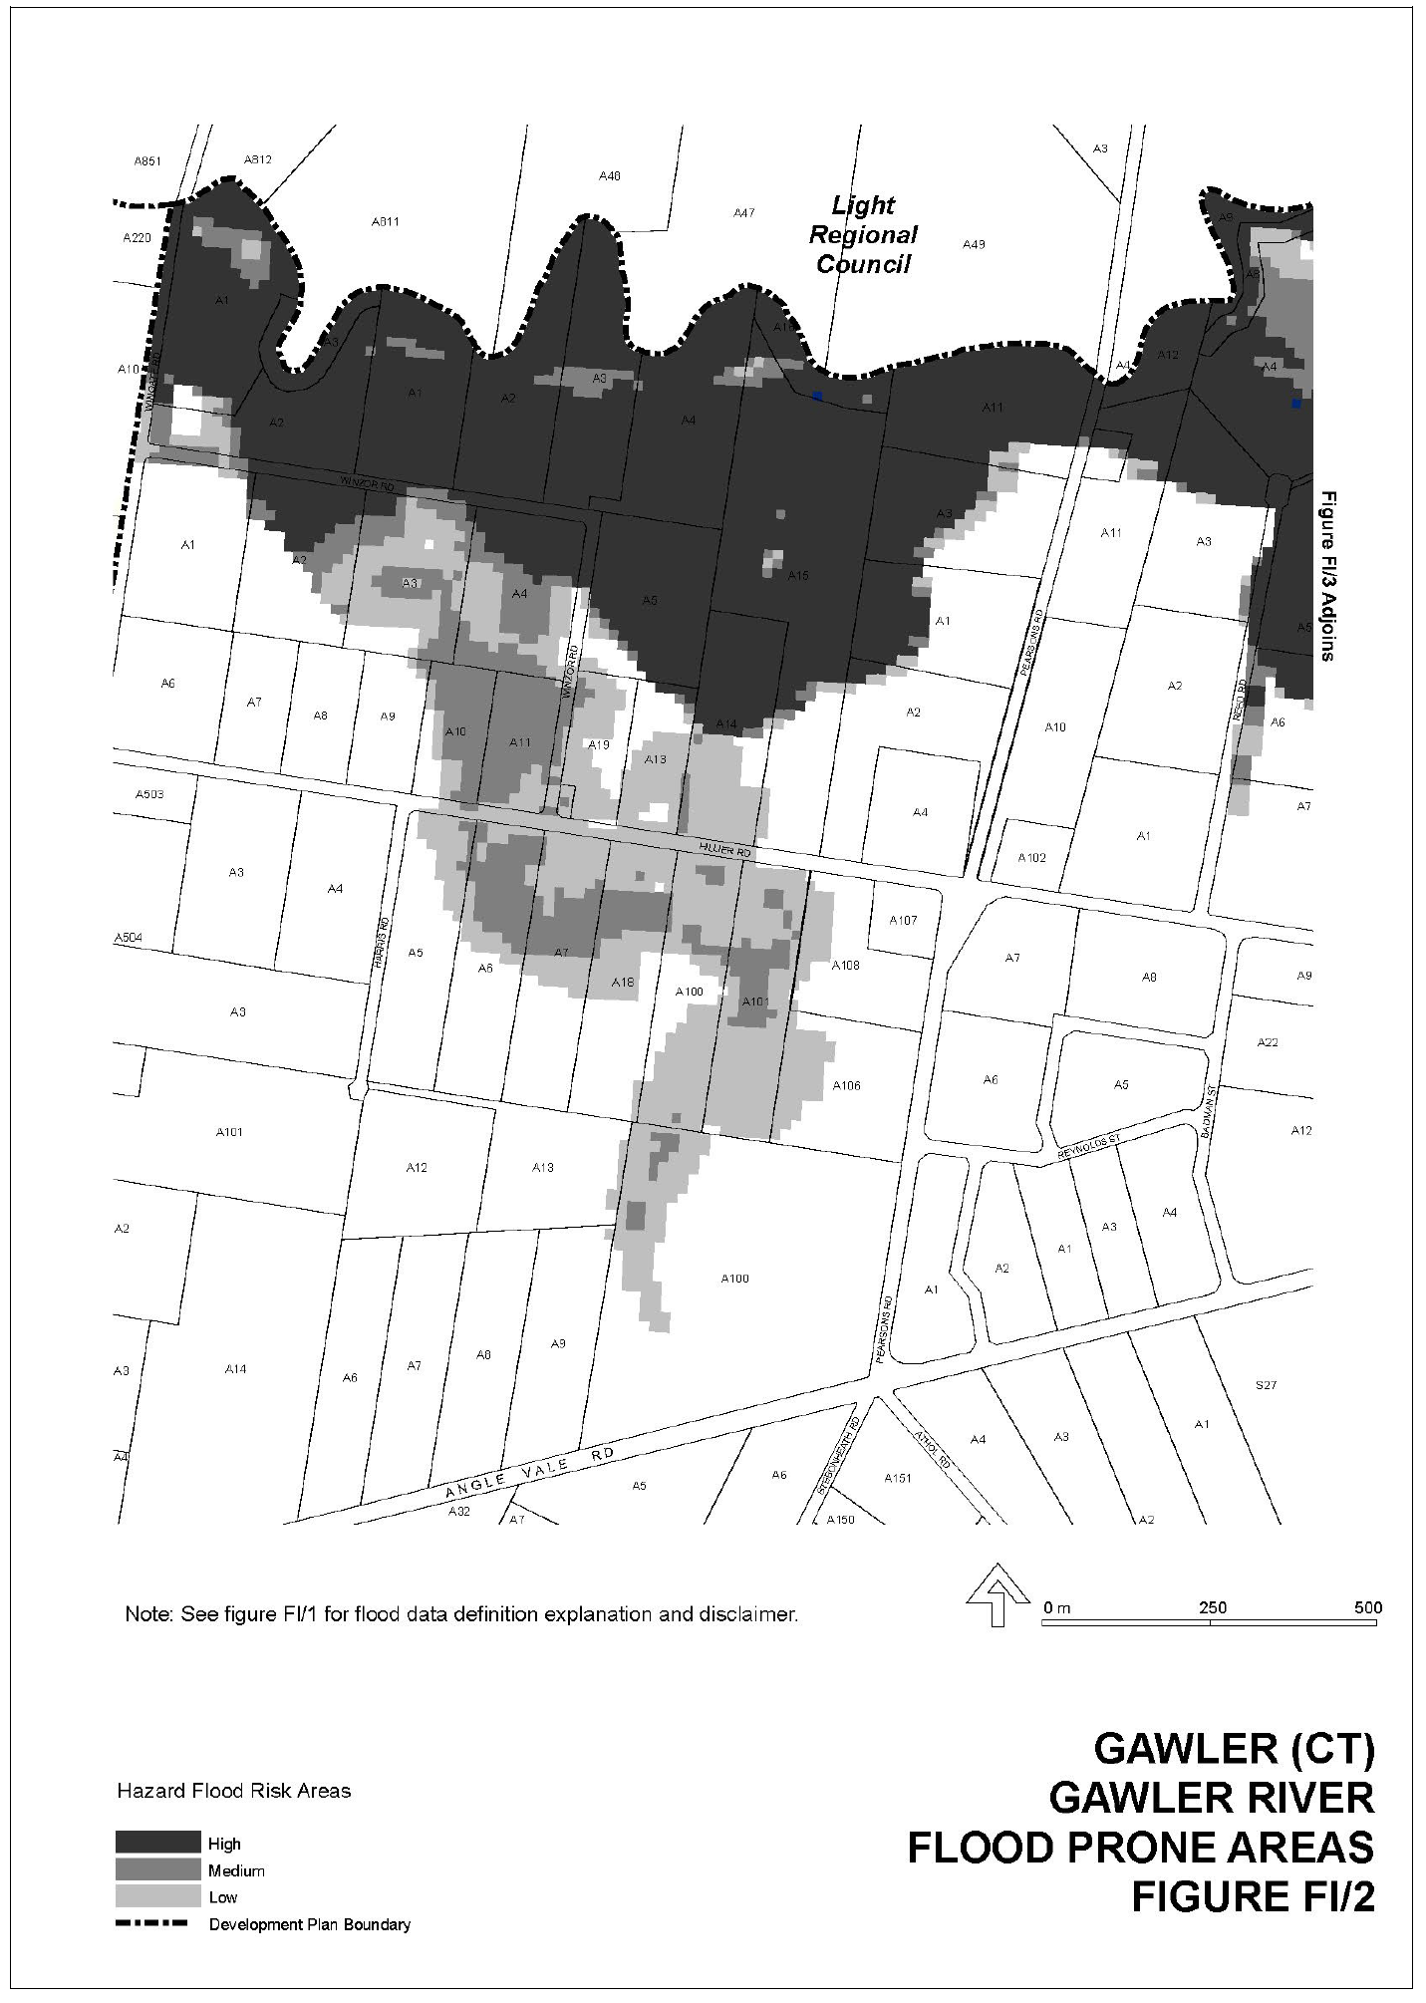
Attachment A
Attachment B

ENVIRONMENT PROTECTION ACT 1993
Revocation of Approval of Category B Containers
I, ANDREA KAYE WOODS, Delegate of the Environment Protection Authority (‘the Authority’), pursuant to Section 68 of the Environment Protection Act 1993 (SA) (‘the Act’) hereby revoke the approvals of the classes of Category B containers sold in South Australia as identified by reference to the following matters, which are described in the first 4 columns of Schedule 1 of this Notice:
(a) the product which each class of containers shall contain;
(b) the size of the containers;
(c) the type of containers; and
(d) the name of the holders of these approvals.
These approvals are revoked as the Authority is satisfied that the waste management arrangement between the approval holder and the party named in column 5 of Schedule 1 of this Notice has been cancelled.
Schedule 1

Column 1 | Column 2 | Column 3 | Column 4 | Column 5
Product Name | Container Size (mL) | Container Type | Approval Holder | Collection Arrangements
Caprio Apple Raspberry | 2 000 | LPB—Aseptic | F & G Kruse Global Trading | Marine Stores Ltd
Caprio Multivitamin | 2 000 | LPB—Aseptic | F & G Kruse Global Trading | Marine Stores Ltd
Caprio Orange | 2 000 | LPB—Aseptic | F & G Kruse Global Trading | Marine Stores Ltd
Caprio Pink Grapefruit | 2 000 | LPB—Aseptic | F & G Kruse Global Trading | Marine Stores Ltd
Tymbark Fruit Drink with Stroh Apple Peach Strawberry | 200 | LPB—Aseptic | F & G Kruse Global Trading | Marine Stores Ltd
Tymbark Fruit Drink with Stroh Multifruit Carrot | 200 | LPB—Aseptic | F & G Kruse Global Trading | Marine Stores Ltd
Tymbark Fruit Drink with Stroh Orange Peach Pear | 200 | LPB—Aseptic | F & G Kruse Global Trading | Marine Stores Ltd
Tymbark Fruit of The World Passion | 1 000 | LPB—Aseptic | F & G Kruse Global Trading | Marine Stores Ltd
Tymbark Fruit of The World Sour Cherry | 1 000 | LPB—Aseptic | F & G Kruse Global Trading | Marine Stores Ltd
Tymbark Fruit of the World Cactus | 1 000 | LPB—Aseptic | F & G Kruse Global Trading | Marine Stores Ltd
Tymbark Fruit of the World Coconut | 1 000 | LPB—Aseptic | F & G Kruse Global Trading | Marine Stores Ltd
Tymbark Fruit of the World Green Banana | 1 000 | LPB—Aseptic | F & G Kruse Global Trading | Marine Stores Ltd
Tymbark Fruit of the World Lime | 1 000 | LPB—Aseptic | F & G Kruse Global Trading | Marine Stores Ltd
Tymbark Fruit of the World Mango | 1 000 | LPB—Aseptic | F & G Kruse Global Trading | Marine Stores Ltd
Tymbark Fruit of the World Pomegranate | 1 000 | LPB—Aseptic | F & G Kruse Global Trading | Marine Stores Ltd
Brewcult Acid Freaks Balsamic Baltic Porter | 500 | Glass | Safe Hands trading as Experience It/Birra Italiana | Statewide Recycling
Brewcult Cant Fight The Funk Farmhouse IPA | 500 | Glass | Safe Hands trading as Experience It/Birra Italiana | Statewide Recycling
Brewcult Get Down American Brown | 500 | Glass | Safe Hands trading as Experience It/Birra Italiana | Statewide Recycling
Brewcult Hop Zone Session IPA | 330 | Glass | Safe Hands trading as Experience It/Birra Italiana | Statewide Recycling
Brewcult Hop Zone Session IPA | 500 | Glass | Safe Hands trading as Experience It/Birra Italiana | Statewide Recycling
Brewcult Keep on Truckin | 500 | Glass | Safe Hands trading as Experience It/Birra Italiana | Statewide Recycling
Brewcult Supa Fly Rye IPA | 500 | Glass | Safe Hands trading as Experience It/Birra Italiana | Statewide Recycling

EQUAL OPPORTUNITY TRIBUNAL
No. 2008 of 2014
In the matter of an Application for an Exemption Pursuant to Section 92 of the Equal Opportunity Act 1984—
By Courts Administration Authority
Before His Honour Judge Costello and
Members Altman and Yapp
UPON the application of Courts Administration Authority by application dated 15 December 2014 and upon reading the affidavits of J. A. Burgess in support of the application and upon hearing on 13 April 2015, D. White, for the Applicant, the Tribunal ordered as follows:
1. Pursuant to Section 92 of the Equal Opportunity Act 1984 (‘the Act’), the Applicant is exempted from compliance with Section 30 of the Act in relation to the advertisement for and the selection and employment of female legal practitioners in the Applicant’s ‘Step Up to the Bar’ Program.
2. The above exemption is to remain in force for a period of three years commencing 13 April 2015.
Dated 13 April 2015.
J. F. Costello, Presiding Officer

EQUAL OPPORTUNITY TRIBUNAL
No. 2008 of 2014
Notice of Exemption
Before Presiding Officer Costello
Members Altman And Yapp
I HEREBY certify that on 13 April 2015, the Equal Opportunity Tribunal of South Australia, on the application of Courts Administration Authority, made the following orders for exemption:
1. Pursuant to Section 92 of the Equal Opportunity Act 1984 (‘the Act’) the Applicant is exempted from compliance with Section 30 of the Act in relation to the advertisement for and the selection and employment of female legal practitioners in the Applicant’s ‘Step Up to the Bar’ Program.
2. The above exemption is to remain in force for a period of three years commencing 13 April 2015.
Dated 20 April 2015.
P. Hocking, Registrar, Equal Opportunity Tribunal

MINING ACT 1971
NOTICE is hereby given in accordance with Section 28 (5) of the Mining Act 1971, that the Minister for Mineral Resources and Energy proposes to grant an Exploration Licence over the undermentioned area:
Applicant: Panda Mining Pty Ltd
Location: Algebuckina Area—Approximately 140 km north-east of Coober Pedy.
Pastoral Leases: The Peake and Allandale.
Term: 2 years
Area in km²: 124
Ref.: 2014/00257
Plan and co-ordinates can be found on the Department of State Development website: http://www.minerals.statedevelopment.sa.
gov.au/public_notices or by phoning Mineral Tenements on (08) 8463 3103.
J. Martin, Mining Registrar

MINING ACT 1971
NOTICE is hereby given in accordance with Section 28 (5) of the Mining Act 1971, that the Minister for Mineral Resources and Energy proposes to grant an Exploration Licence over the undermentioned area:
Applicant: Panda Mining Pty Ltd
Location: Parakylia Area—Approximately 40 km west-north-west of Roxby Downs.
Pastoral Leases: Parakylia and Roxby Downs.
Term: 2 years
Area in km²: 217
Ref.: 2014/00261
Plan and co-ordinates can be found on the Department of State Development website: http://www.minerals.statedevelopment.sa.
gov.au/public_notices or by phoning Mineral Tenements on (08) 8463 3103.
J. Martin, Mining Registrar

MINING ACT 1971
NOTICE is hereby given in accordance with Section 28 (5) of the Mining Act 1971, that the Minister for Mineral Resources and Energy proposes to grant an Exploration Licence over the undermentioned area:
Applicant: Hillgrove Resources Limited
Location: Wheal Ellen Mine Area—Approximately 40 km south-east of Adelaide.
Term: 1 year
Area in km²: 4
Ref.: 2014/00162
Plan and co-ordinates can be found on the Department of State Development website: http://www.minerals.statedevelopment.sa.
gov.au/public_notices or by phoning Mineral Tenements on (08) 8463 3103.
J. Martin, Mining Registrar

MINING ACT 1971
NOTICE is hereby given in accordance with Section 28 (5) of the Mining Act 1971, that the Minister for Mineral Resources and Energy proposes to grant an Exploration Licence over the undermentioned area:
Applicant: Hillgrove Resources Limited
Location: Kanmantoo Area—Approximately 40 km east of Adelaide.
Term: 1 year
Area in km²: 489
Ref.: 2014/00203
Plan and co-ordinates can be found on the Department of State Development website: http://www.minerals.statedevelopment.sa.
gov.au/public_notices or by phoning Mineral Tenements on (08) 8463 3103.
J. Martin, Mining Registrar

MINING ACT 1971
NOTICE is hereby given in accordance with Section 28 (5) of the Mining Act 1971, that the Minister for Mineral Resources and Energy proposes to grant an Exploration Licence over the undermentioned area:
Applicant: Panda Mining Pty Ltd
Location: Mount Soward Area—Approximately 120 km north-east of Tarcoola.
Pastoral Leases: McDouall Peak.
Term: 2 years
Area in km²: 184
Ref.: 2015/00006
Plan and co-ordinates can be found on the Department of State Development website: http://www.minerals.statedevelopment.sa.
gov.au/public_notices or by phoning Mineral Tenements on (08) 8463 3103.
J. Martin, Mining Registrar

MINING ACT 1971
PURSUANT to Section 15 (5) of the Mining Act 1971 (the Act), I advise that the Mineral Resources Division of Department of State Development, will be undertaking geoscientific investigations commencing on 7 May 2015 and concluding on 7 January 2016.
The area of interest is approximately 1 794 km² and includes Yardea and Port Augusta 1:250 000 map sheets.
Pursuant to Section 15 (7) of the Act, the Minister may refuse to receive or consider an application of a mining tenement in respect of the land described in the notice until the completion date of 7 January 2016.
Description of Area
Northern Eyre Peninsula Area—Approximately 130 km and 85 km north-west of Kimba and 120 km north-east of Kimba, bounded as follows:
Area A
Commencing at a point being the intersection of latitude 32°16’S and longitude 135°13′E, thence east to longitude 135°30′E, south to latitude 32°30′S, west to longitude 135°13′E and north to the point of commencement.
Area B
Commencing at a point being the intersection of latitude 32°36′S and longitude 135°32′E, thence east to longitude 135°48′E, south to latitude 32°48′S, west to longitude 135°32′E and north to the point of commencement.
Area C
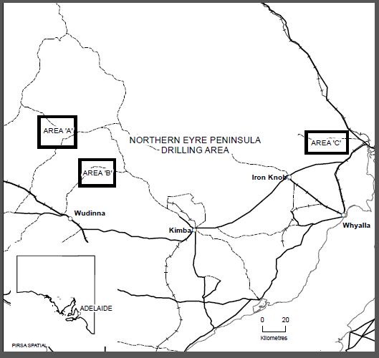
Commencing at a point being the intersection of latitude 32°23′S and longitude 137°17′E, thence east to longitude 137°36′E, south to latitude 32°33′S, west to longitude 137°17′E and north to the point of commencement.
All the within latitudes and longitudes are geodetic and expressed in terms of the Australian Geodetic Datum as defined on page 4984 of Commonwealth Gazette No. 84 dated October 6, 1966 (AGD66).

Reference: MER F2014/000909
Dated 7 May 2015.
J. Martin, Mining Registrar

South Australia
Motor Vehicles (Conditional Registration—Recognition of Motor Vehicle Clubs) Notice 2015
under the Motor Vehicles Act 1959
1—Short title
This notice may be cited as the Motor Vehicles (Conditional Registration—Recognition of Motor Vehicle Clubs) Notice 2015.
2—Commencement
This notice comes into operation on the day on which it is made.
3—Interpretation
In this notice—

Act means the Motor Vehicles Act 1959;

Code of Practice means the ‘Code of Practice for Historic Vehicles, Prescribed Left Hand Drive Vehicles and Street Rod Vehicles’ published by the Department of Planning, Transport and Infrastructure;

Conditional Registration Scheme or Scheme means the scheme for conditional registration of historic, prescribed left hand drive and street rod motor vehicles under section 25 of the Act and regulations 15 and 16 of the Motor Vehicles Regulations 2010;

Federation means the Federation of Historic Motoring Clubs Inc;

MR334 form means an ‘Approval for Conditional Registration of a Historic, Prescribed Left Hand Drive or Street Rod Vehicle MR334 Form’;

Registrar means the Registrar of Motor Vehicles;
Regulations means the Motor Vehicles Regulations 2010.
4—Recognition of motor vehicles clubs
The motor vehicle clubs specified in Schedule 1 are, subject to the conditions set out in clause 5, recognised for the purposes of regulation 16 of the Regulations.
5—Conditions of recognition
A motor vehicle club specified in Schedule 1 must comply with the following conditions:
  - the club must maintain a constitution approved by the Registrar;
  - the club must nominate and have members authorised by the Registrar (authorised persons) to approve motor vehicles for registration under the Scheme; to inspect members’ vehicles; and to issue prescribed log books to club members for each of their vehicles to record vehicle use;
  - the club must obtain from each member before the end of each year a statutory declaration made by the member verifying the eligibility of their motor vehicle to be registered under section 25 of the Act for the Scheme and detailing any modifications made to the vehicle during that year;
  - the club’s authorised persons must undertake inspections of members’ motor vehicles and ensure that the vehicles are eligible, in keeping with the requirements in regulations 15 and 16 of the Regulations and the criteria set out in the Code of Practice, to be registered under section 25 of the Act−
- on entry to the Conditional Registration Scheme;
- when requested to do so by the Registrar;
- when members’ annual statutory declarations disclose that their vehicles have been modified since the entry inspection and/or previous inspection;
- periodically at least once every 3 years;
(e) the club’s authorised persons must validate a member’s log book annually and must not do so unless a member’s statutory declaration has been received for the purposes of paragraph (c) and the relevant vehicle inspection requirements of paragraph (d) have been met;
(f) the club must cancel a member’s log book when a member resigns, must record all approved variations to a vehicle’s condition in a member’s log book for that vehicle, must ensure that a statutory declaration is provided when a member’s log book is lost or destroyed and must forward copies of log book return sheets to the Federation annually;
(g) the club must create and maintain records detailing all its financial members, its authorised persons, all members’ motor vehicles for which a MR334 form has been issued, all motor vehicle inspections undertaken for the purposes of paragraph (d), all statutory declarations received and log books issued;
(h) the club must keep records for a period of 5 years from the date of the document and these records include all duplicate MR334 forms, all records of motor vehicle inspections undertaken in accordance with paragraph (d), all statutory declarations provided by members for the purposes of paragraphs (c) and (f) , all log books issued by reference to their serial number, the member’s name and the vehicle for which it was issued, all copy exemption documents issued to members for their motor vehicles in accordance with section 163AA of the Road Traffic Act 1961 and to make all such records available for inspection or provide copies of the records at the request of the Registrar for audit purposes;
(i) the club must ensure, as far as practicable, that all members comply with the Code of Practice and all members’ motor vehicles continue to meet the eligibility requirements set out in the Regulations and Code of Practice;
(j) the club, as far as practicable, must report to the Registrar or the Federation details of members and motor vehicles not complying with the conditions and criteria set out in the Code of Practice for the Scheme;
(k) the club must provide to the Registrar, within 2 months after the end of the club’s financial year, an annual report detailing members from that financial year with vehicles registered under the Scheme who are no longer financial members of the club;
(l) the club must notify the Registrar within 14 days on official club letterhead of resolution to cease operation as a club and must provide the club records specified in paragraph (h) to the Registrar within 7 days of its dissolution.
Note—
Under regulation 16(3)(c) of the Motor Vehicles Regulations 2010, the Registrar may, by notice in the Gazette, withdraw the recognition of a motor vehicle club if satisfied that the club has contravened or failed to comply with a condition applying to its recognition by the Registrar, or if there is other good cause to withdraw the recognition.

Schedule 1—Recognised motor vehicle clubs
Historic motor vehicle club

The Peterborough United Machine Preservation Society Incorporated

Made by the Registrar of Motor Vehicles

Julie Holmes

On 21 April 2015.

South Australia
Motor Vehicles (Conditional Registration—Recognition of Motor Vehicle Clubs) Notice 2015
under the Motor Vehicles Act 1959
1—Short title
This notice may be cited as the Motor Vehicles (Conditional Registration—Recognition of Motor Vehicle Clubs) Notice 2015.
2—Commencement
This notice comes into operation on the day on which it is made.
3—Interpretation
In this notice—

Act means the Motor Vehicles Act 1959;

Code of Practice means the ‘Code of Practice for Historic Vehicles, Prescribed Left Hand Drive Vehicles and Street Rod Vehicles’ published by the Department of Planning, Transport and Infrastructure;

Conditional Registration Scheme or Scheme means the scheme for conditional registration of historic, prescribed left hand drive and street rod motor vehicles under section 25 of the Act and regulations 15 and 16 of the Motor Vehicles Regulations 2010;

Federation means the Federation of Historic Motoring Clubs Inc;

MR334 form means an ‘Approval for Conditional Registration of a Historic, Prescribed Left Hand Drive or Street Rod Vehicle MR334 Form’;

Registrar means the Registrar of Motor Vehicles;
Regulations means the Motor Vehicles Regulations 2010.
4—Recognition of motor vehicles clubs
The motor vehicle clubs specified in Schedule 1 are, subject to the conditions set out in clause 5, recognised for the purposes of regulation 16 of the Regulations.
5—Conditions of recognition
A motor vehicle club specified in Schedule 1 must comply with the following conditions:
  - the club must maintain a constitution approved by the Registrar;
  - the club must nominate and have members authorised by the Registrar (authorised persons) to approve motor vehicles for registration under the Scheme; to inspect members’ vehicles; and to issue prescribed log books to club members for each of their vehicles to record vehicle use;
  - the club must obtain from each member before the end of each year a statutory declaration made by the member verifying the eligibility of their motor vehicle to be registered under section 25 of the Act for the Scheme and detailing any modifications made to the vehicle during that year;
  - the club’s authorised persons must undertake inspections of members’ motor vehicles and ensure that the vehicles are eligible, in keeping with the requirements in regulations 15 and 16 of the Regulations and the criteria set out in the Code of Practice, to be registered under section 25 of the Act−
- on entry to the Conditional Registration Scheme;
- when requested to do so by the Registrar;
- when members’ annual statutory declarations disclose that their vehicles have been modified since the entry inspection and/or previous inspection;
- periodically at least once every 3 years;
(e) the club’s authorised persons must validate a member’s log book annually and must not do so unless a member’s statutory declaration has been received for the purposes of paragraph (c) and the relevant vehicle inspection requirements of paragraph (d) have been met;
(f) the club must cancel a member’s log book when a member resigns, must record all approved variations to a vehicle’s condition in a member’s log book for that vehicle, must ensure that a statutory declaration is provided when a member’s log book is lost or destroyed and must forward copies of log book return sheets to the Federation annually;
(g) the club must create and maintain records detailing all its financial members, its authorised persons, all members’ motor vehicles for which a MR334 form has been issued, all motor vehicle inspections undertaken for the purposes of paragraph (d), all statutory declarations received and log books issued;
(h) the club must keep records for a period of 5 years from the date of the document and these records include all duplicate MR334 forms, all records of motor vehicle inspections undertaken in accordance with paragraph (d), all statutory declarations provided by members for the purposes of paragraphs (c) and (f) , all log books issued by reference to their serial number, the member’s name and the vehicle for which it was issued, all copy exemption documents issued to members for their motor vehicles in accordance with section 163AA of the Road Traffic Act 1961 and to make all such records available for inspection or provide copies of the records at the request of the Registrar for audit purposes;
(i) the club must ensure, as far as practicable, that all members comply with the Code of Practice and all members’ motor vehicles continue to meet the eligibility requirements set out in the Regulations and Code of Practice;
(j) the club, as far as practicable, must report to the Registrar or the Federation details of members and motor vehicles not complying with the conditions and criteria set out in the Code of Practice for the Scheme;
(k) the club must provide to the Registrar, within 2 months after the end of the club’s financial year, an annual report detailing members from that financial year with vehicles registered under the Scheme who are no longer financial members of the club;
(l) the club must notify the Registrar within 14 days on official club letterhead of resolution to cease operation as a club and must provide the club records specified in paragraph (h) to the Registrar within 7 days of its dissolution.
Note—
Under regulation 16(3)(c) of the Motor Vehicles Regulations 2010, the Registrar may, by notice in the Gazette, withdraw the recognition of a motor vehicle club if satisfied that the club has contravened or failed to comply with a condition applying to its recognition by the Registrar, or if there is other good cause to withdraw the recognition.

Schedule 1—Recognised motor vehicle clubs
Historic motor vehicle clubs and Prescribed left-hand drive motor vehicle clubs

Wanderers Motor Club on Eyre Incorporated

Made by the Registrar of Motor Vehicles

Julie Holmes

On 16 April 2015.

Petroleum and Geothermal Energy Act 2000
Grant of Gas Storage Exploration Licence—GSEL 652
NOTICE is hereby given that the undermentioned Gas Storage Exploration Licence has been granted under the provisions of the Petroleum and Geothermal Energy Act 2000.
No. of  Licence | Licensees | Locality | Expiry
GSEL 652 | Acer Energy Pty Limited  Mid Continent Equipment  (Australia) Pty Ltd | Cooper Basin | 26 April 2020

Description of Area
All that part of the State of South Australia, bounded as follows:
Area 1
Commencing at a point being the intersection of latitude 27°13′00″S GDA94 and longitude 140°23′50″E AGD66, thence east to longitude 140°24′50″E GDA94, south to latitude 27°14′20″S GDA94, west to longitude 140°23′30″E AGD66, north to latitude 27°14′00″S AGD66, east to longitude 140°23′50″E AGD66 and north to the point of commencement.
Area 2
Commencing at a point being the intersection of latitude 27°16′40″S GDA94 and longitude 140°21′30″E GDA94, thence east to longitude 140°22′50″E GDA94, south to latitude 27°17′40″S GDA94, east to longitude 140°24′20″E GDA94, north to latitude 27°17′10″S GDA94, east to longitude 140°25′30″E GDA94, south to latitude 27°17′40″S GDA94, east to longitude 140°29′00″E GDA94, north to latitude 27°17′00″S GDA94, east to longitude 140°30′00″E AGD66, south to latitude 27°18′00″S GDA94, west to longitude 140°27′40″E GDA94, south to latitude 27°18′40″S GDA94, west to longitude 140°25′50″E GDA94, north to latitude 27°18′20″S GDA94, west to longitude 140°24′50″E GDA94, south to latitude 27°18′40″S GDA94, west to longitude 140°23′10″E GDA94, north to latitude 27°18′20″S GDA94, west to longitude 140°22′20″E GDA94, south to latitude 27°21′20″S AGD66, west to longitude 140°22′10″E AGD66, south to latitude 27°22′30″S AGD66, east to longitude 140°22′40″E GDA94, south to latitude 27°23′30″S GDA94, west to longitude 140°22′20″E GDA94, south to latitude 27°25′00″S AGD66, west to longitude 140°20′00″E AGD66, north to latitude 27°18′20″S GDA94, east to longitude 140°21′30″E GDA94 and north to the point of commencement.
Area 3
Commencing at a point being the intersection of latitude 27°19′20″S GDA94 and longitude 140°27′40″E GDA94, thence east to longitude 140°28′40″E GDA94, south to latitude 27°20′00″S GDA94, east to longitude 140°29′20″E GDA94, south to latitude 27°20′50″S GDA94, west to longitude 140°29′00″E GDA94, south to latitude 27°22′30″S GDA94, west to longitude 140°28′10″E GDA94, south to latitude 27°24′20″S GDA94, west to longitude 140°27′30″E GDA94, south to latitude 27°25′00″S GDA94, west to longitude 140°25′00″E AGD66, north to latitude 27°25′00″S AGD66, west to longitude 140°25′00″E GDA94, north to latitude 27°24′00″S GDA94, east to longitude 140°25′30″E GDA94, north to latitude 27°23′10″S GDA94, east to longitude 140°26′30″E GDA94, north to latitude 27°22′00″S GDA94, west to longitude 140°26′00″E GDA94, north to latitude 27°21′10″S GDA94, east to longitude 140°26′30″E GDA94, north to latitude 27°19′50″S GDA94, east to longitude 140°27′40″E GDA94 and north to the point of commencement.
Area 4
Commencing at a point being the intersection of latitude 27°20′00″S AGD66 and longitude 140°31′30″E GDA94, thence east to longitude 140°35′00″E AGD66, south to latitude 27°23′00″S GDA94, west to longitude 140°33′50″E GDA94, north to latitude 27°22′40″S GDA94, west to longitude 140°32′00″E GDA94, south to latitude 27°23′20″S GDA94, west to longitude 140°31′00″E GDA94, north to latitude 27°22′20″S GDA94, east to longitude 140°31′20″E GDA94, north to latitude 27°21′10″S GDA94, east to longitude 140°31′30″E GDA94 and north to the point of commencement.
Area: 153.24 km² approximately.
Dated 27 April 2015.
B. A. Goldstein,
Executive Director,
Energy Resources Division,
Department of State Development,
Delegate of the Minister for Mineral Resources and Energy

PROFESSIONAL STANDARDS ACT 2004
New South Wales Bar Association Scheme
PURSUANT to Section 14 (1) of the Professional Standards Act 2004, I authorise the publication in the Gazette of the New South Wales Bar Association Scheme.
Pursuant to Section 15 (1) (a) of the Professional Standards Act 2004, I specify 1 July 2015 as the date of commencement of the New South Wales Bar Association Scheme.
Dated 27 April 2015.
John Rau, Deputy Premier, Attorney-General

Preamble
OCCUPATIONAL ASSOCIATION
The New South Wales Bar Association (ACN 000 033 652) is an Australian Public Company, Limited by Guarantee. The Association’s current Scheme commenced on 1 July 2010. The NSW Bar Association’s website is www.nswbar.asn.au.
The occupational group represented by the Association is barristers holding a New South Wales practising certificate. The Scheme only applies to barristers who hold a New South Wales practising certificate, who are members of the Association and who hold approved professional indemnity insurance as provided for in the Scheme. The number of members eligible to be covered by the Scheme is approximately 2 100.
The Association’s objectives are outlined in Clause 3 of the Constitution and include:
• to promote the administration of justice;
• to promote, maintain and improve the interests and standards of local practising barristers;
• to make recommendations with respect to legislation, law reform, rules of court and the business and procedure of courts;
• to seek to ensure that the benefits of the administration of justice are reasonably and equally available to all members of the community;
• to arrange and promote continuing legal education;
• to promote fair and honourable practice amongst barristers; to suppress, discourage and prevent malpractice and professional misconduct;
• to inquire into questions as to professional conduct and etiquette of barristers;
• to confer and co-operate with bodies in Australia or elsewhere representing the profession of the law;
• to encourage professional, educational, cultural and social relations amongst the members of the Bar Association; and
• to make donations to charities and such other objects in the public interest as determined from time to time by the Bar Council.
NATURE AND OPERATION OF THE SCHEME
The Scheme operates for the purpose of improving the occupational standards of barristers and to protect the consumers of their services. The Scheme limits the civil liability of barristers to whom it applies. The Scheme is intended to operate in New South Wales, the Australian Capital Territory, the Northern Territory, Queensland, Victoria, Western Australia and South Australia.
The liability limited by the Scheme includes, to the extent permitted by the Act, all civil liability arising (in tort, contract or otherwise) directly or vicariously from anything done or omitted by a member of the Association or to any person to whom the Scheme applies in acting in the performance of his or her occupation. The Scheme does not apply to liability for damages arising from any matter to which the Act does not apply, including, but not limited to, liability for damages arising from death or personal injury to a person, a breach of trust, fraud or dishonesty.
The Scheme does not affect damages which are below $1.5 million. The Scheme limits liability for damages to $1.5 million provided the person has insurance which is not less than $1.5 million. To date, there has never been a successful claim against a NSW barrister that has reached $1.5 million in damages.
RISK MANAGEMENT
The Association has adopted many risk management strategies, including:
• requirements for professional entry to practice at the Bar;
• continuing professional development in the areas of ethics and regulation of the profession; management; substantive law, practice and procedure, and evidence, advocacy, mediation and other barristers’ skills;
• codes of ethical conduct;
• technical standards and guidance;
• advisory and support services;
• complaints and discipline systems; and
• claims monitoring.
The Bar Association will continue to report annually on the implementation and monitoring of its risk management strategies, the effect of those strategies and any changes made or proposed to be made to them.
COMPLAINTS AND DISCIPLINE
Scheme members are subject to a complaints and discipline system operating under the Legal Profession Act 2004 (NSW). All scheme members must comply with the provisions of the Legal Profession Act 2004 (NSW) and Legal Profession Regulation 2005.
STANDARDS OF INSURANCE
Scheme members are required to have approved professional indemnity insurance before they are issued with a practising certificate. The NSW Attorney General determines the statutory minimum level of professional indemnity insurance required to be taken out by barristers and also approves the professional indemnity insurance policies on offer by brokers each year. The professional indemnity insurance taken out by NSW barristers covers them for liability in all Australian States and Territories.
CLAIMS MONITORING
The Association will continue to request that the Attorney General’s Order approving the policies for NSW barristers each year requires that the brokers/insurers provide the Association with claims data so that the Association can continue to monitor claims made against its members. The Association will continue to maintain its long established relationship with the insurers. The Bar Association will continue to report annually to the Professional Standards Council on claims monitoring, tactics, performance measures and monitoring systems.
SCHEME ADMINISTRATION
Responsibility for administration of the scheme and ensuring that it complies with the requirements of the Professional Standards Act 1994 (NSW) and of the Professional Standards Council rests with the Executive Director; who is assisted on a day to day basis by the Association’s Policy Lawyer.
DURATION
The scheme will remain in force for a period of 5 years from 1 July 2015 unless it is revoked, extended or ceases in accordance with Section 32 of the Professional Standards Act.

THE NEW SOUTH WALES BAR ASSOCIATION SCHEME
Professional Standards Act 1994 (NSW)
1. Occupational Association
The New South Wales Bar Association (the Bar Association) is an occupational association whose business address is Selborne Chambers, 174 Phillip Street, Sydney. The New South Wales Bar Association Scheme (the scheme) is a scheme under the Professional Standards Act 1994 (NSW) (the Act). The scheme applies in New South Wales, the Australian Capital Territory, the Northern Territory, Queensland, Victoria, Western Australia and South Australia.
2. Persons to Whom the Scheme Applies (Participating Members and Other Persons)
2.1 The scheme applies to persons referred to in Clause 2.2 and Clause 2.3 of this scheme.
2.2 All members of the Bar Association who hold a NSW barrister’s practising certificate issued by the Bar Association and who have professional indemnity insurance that is required under law to be held by New South Wales barristers in order to practise.
2.3 Persons to whom the scheme applies:
2.3.1 In New South Wales by virtue of Sections 18, 19, 20 and 20A of the Act; and
2.3.2 In the Australian Capital Territory, the Northern Territory, Queensland, Victoria, Western Australia and South Australia by virtue of the comparable provisions to Sections 18 and 19 of the Act in the corresponding legislation of those jurisdictions; and
2.3.3 In the Australian Capital Territory, the Northern Territory, Victoria, Western Australia and South Australia by virtue of the comparable provision to Section 20 of the Act in the corresponding legislation of those jurisdictions; and
2.3.4 In Queensland by virtue of Section 21A of the Professional Standards Act 2004 (Qld), and in Western Australia by virtue of Section 34A of the Professional Standards Act 1997 (WA).
3. Limitation of Liability
3.1 Subject to Clause 3.3 below, a person to whom the scheme applies against whom a cause of action relating to occupational liability is brought, is not liable in damages in relation to that cause of action for anything done or omitted on or after the commencement of the scheme above a monetary ceiling (a maximum amount of liability) of $1 500 000.
3.2 For the purposes of the operation of the scheme in NSW ‘occupational liability’ has the same meaning as it has in the Act and excludes any liability which may not from time to time be limited pursuant to the Act. Similarly, for the purposes of the operation of the scheme in other jurisdictions in which it applies i.e. ACT, Northern Territory, Queensland, Victoria, Western Australia and South Australia, ‘occupational liability’ has the same meaning as it has in the corresponding legislation of those jurisdictions and excludes any liability which may not from time to time be limited pursuant to that legislation.
3.3 The person to whom the scheme applies must be able to satisfy the court that they have the benefit of:
3.3.1 an insurance policy insuring them against that occupational liability, and
3.3.2 an insurance policy under which the amount payable in respect of the occupational liability relating to that cause of action is not less than the maximum amount of liability specified in the scheme in relation to the person to whom the scheme applies and the kind of work to which the cause of action relates at the time at which the act or omission giving rise to the cause of action occurred.
4. Commencement and Duration
4.1 The scheme is intended to commence on 1 July 2015 and is to remain in force until 30 June 2020 unless:
4.1.1 in the case of New South Wales, in accordance with Section 32 of the Act it is earlier revoked or ceases to have effect or its period of operation is extended for a period of up to 12 months; or
4.1.2 in so far as the scheme operates in the Australian Capital Territory, the Northern Territory, Queensland, Victoria, Western Australia and South Australia, in accordance with the law of those jurisdictions its operation in those jurisdictions is earlier revoked or ceases to have effect or its period of operation is extended for a period of up to 12 months, or it ceases to have effect in New South Wales.
4.2 In the event the scheme is published in the Gazette of any jurisdiction after 1 July 2015, the scheme will commence on such day 2 months after the date of its publication in that jurisdiction and is to remain in force for 5 years from that date of commencement subject to Clause 4.1.1, and Clause 4.1.2.

NATURAL RESOURCES MANAGEMENT ACT 2004
Grant of Exemption from the Water Levy for the Eastern Mount Lofty Ranges Prescribed Water Resources Area
PURSUANT to Section 114 (10) (c) of the Natural Resources Management Act 2004 (the Act), I, Ian Hunter, Minister for Sustainability, Environment and Conservation (the Minister) in the State of South Australia and the Minister to whom administration of the Act is committed, hereby grant an exemption from the requirement to pay the water levy declared by notice in the Government Gazette (page 2156) on 29 May 2014, to persons authorised by a water licence to take water from the Eastern Mount Lofty Ranges Prescribed Water Resources Area, with respect to water allocated as ‘Taking LABA (Flood)’ or ‘Taking LABA (Flood Delivery)’.
For the purpose of this Notice:
‘Taking LABA (Flood)’ means an allocation granted to take water sourced from a watercourse in surface water management zones 426AR026 and/or 426BR062, or that flows from these zones, and to be taken by means of a pump or flood gate for the purpose of flood irrigation.
‘Taking LABA (Flood Delivery)’ means an allocation granted to take water sourced from a watercourse in surface water management zones 426AR026 and/or 426BR062, or that flows from these zones, and to be taken by means of a pump or flood gate as a delivery supplement for the purpose of flood irrigation.
‘LABA’ means a Lower Angas Bremer Allocation.
This notice will take effect from the date of publication of this notice in the Government Gazette.
Dated 24 April 2015.
Ian Hunter, Minister for Sustainability, Environment and Conservation

ROAD TRAFFIC ACT 1961
Authorised Officers to Operate Breath Analysing Instruments
I, GARY T. BURNS, Commissioner of Police, do hereby certify that on and from 21 April 2015, the following persons were authorised by the Commissioner of Police to operate breath analysing instruments as defined in and for the purposes of the:
Road Traffic Act 1961;
Harbors and Navigation Act 1993;
Security and Investigation Agents Act 1995; and
Rail Safety National Law (South Australia) Act 2012.

PD  Number | Officer Name
75390 | Evans, Haydn Thomas
74573 | Haupt, David Andrew
74406 | Hordacre, Anthony Peter
79579 | Hunt, Trevor John
75350 | John, Kate Louise
72847 | Leahy, Matthew Douglas
75181 | Norman, Gregory John
75253 | Williams, Rhys Gwyn

Gary T. Burns, Commissioner of Police

RULES OF COURT
Magistrates Court of South Australia
Amendment 8 to the Magistrates Court (Civil)
Rules 2013
PURSUANT to Section 49 of the Magistrates Court Act 1991 and all other enabling powers, we, the undersigned, do hereby make the following amendments to the Magistrates Court (Civil) Rules 2013 as amended.
1. These Rules may be cited as the “Magistrates Court (Civil) Rules 2013 (Amendment 8)”.
2. The Magistrates Court (Civil) Rules 2013 as amended by these amendments apply to and govern all actions commenced in the civil division of the Court on and after the date on which these amendments are gazetted.
3. Form 1A is deleted and replaced with Form 1A.
4. Form 3D is deleted and replaced with Form 3D.
5. Form 35 is deleted and replaced with Form 35.
6. Form 43 is deleted and replaced with Form 43.
7. Rule 144 is inserted as follows:
WORK HEALTH AND SAFETY ACT 2012
144. (1) An application for a search warrant made pursuant to Section 167 of the Work Health and Safety Act 2012 must comply with Form 57.
(2) A search warrant must comply with Form 58.
8. Forms 57 and 58 are inserted.
Signed on the 22nd day of April 2015.
ELIZABETH BOLTON, Chief Magistrate
ANDREW JAMES CANNON, Deputy Chief Magistrate
JANE LOUISE SCHAMMER, Magistrate
SIMON HUGH MILAZZO, Magistrate

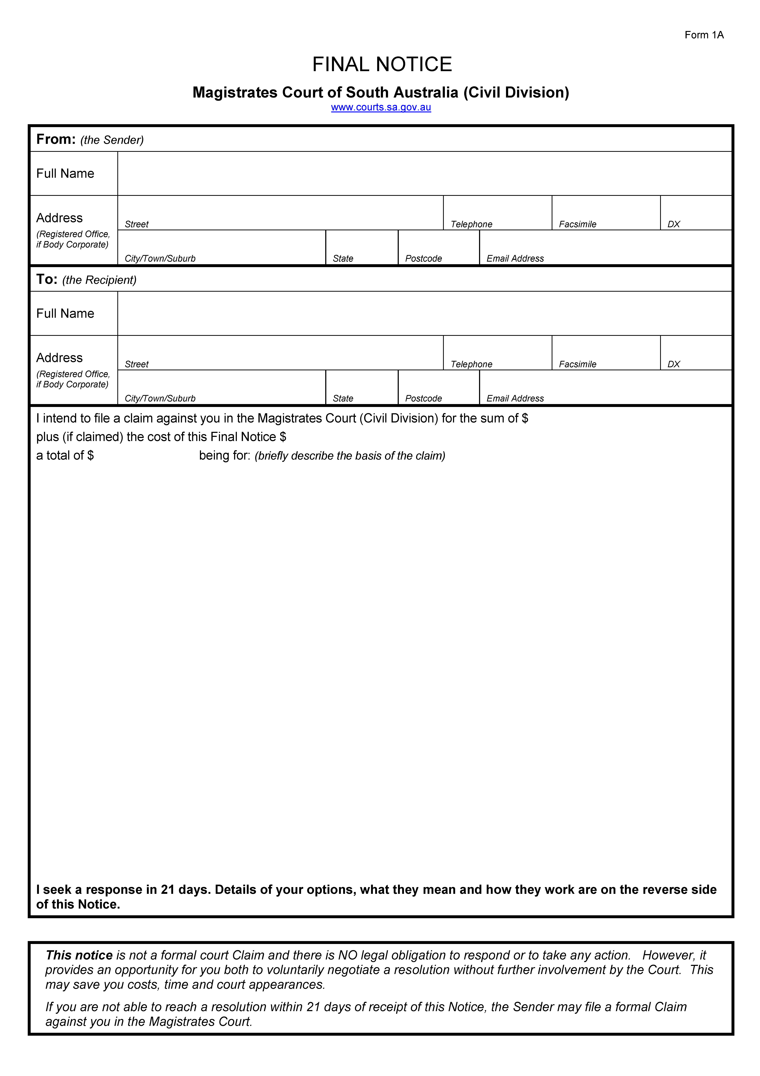
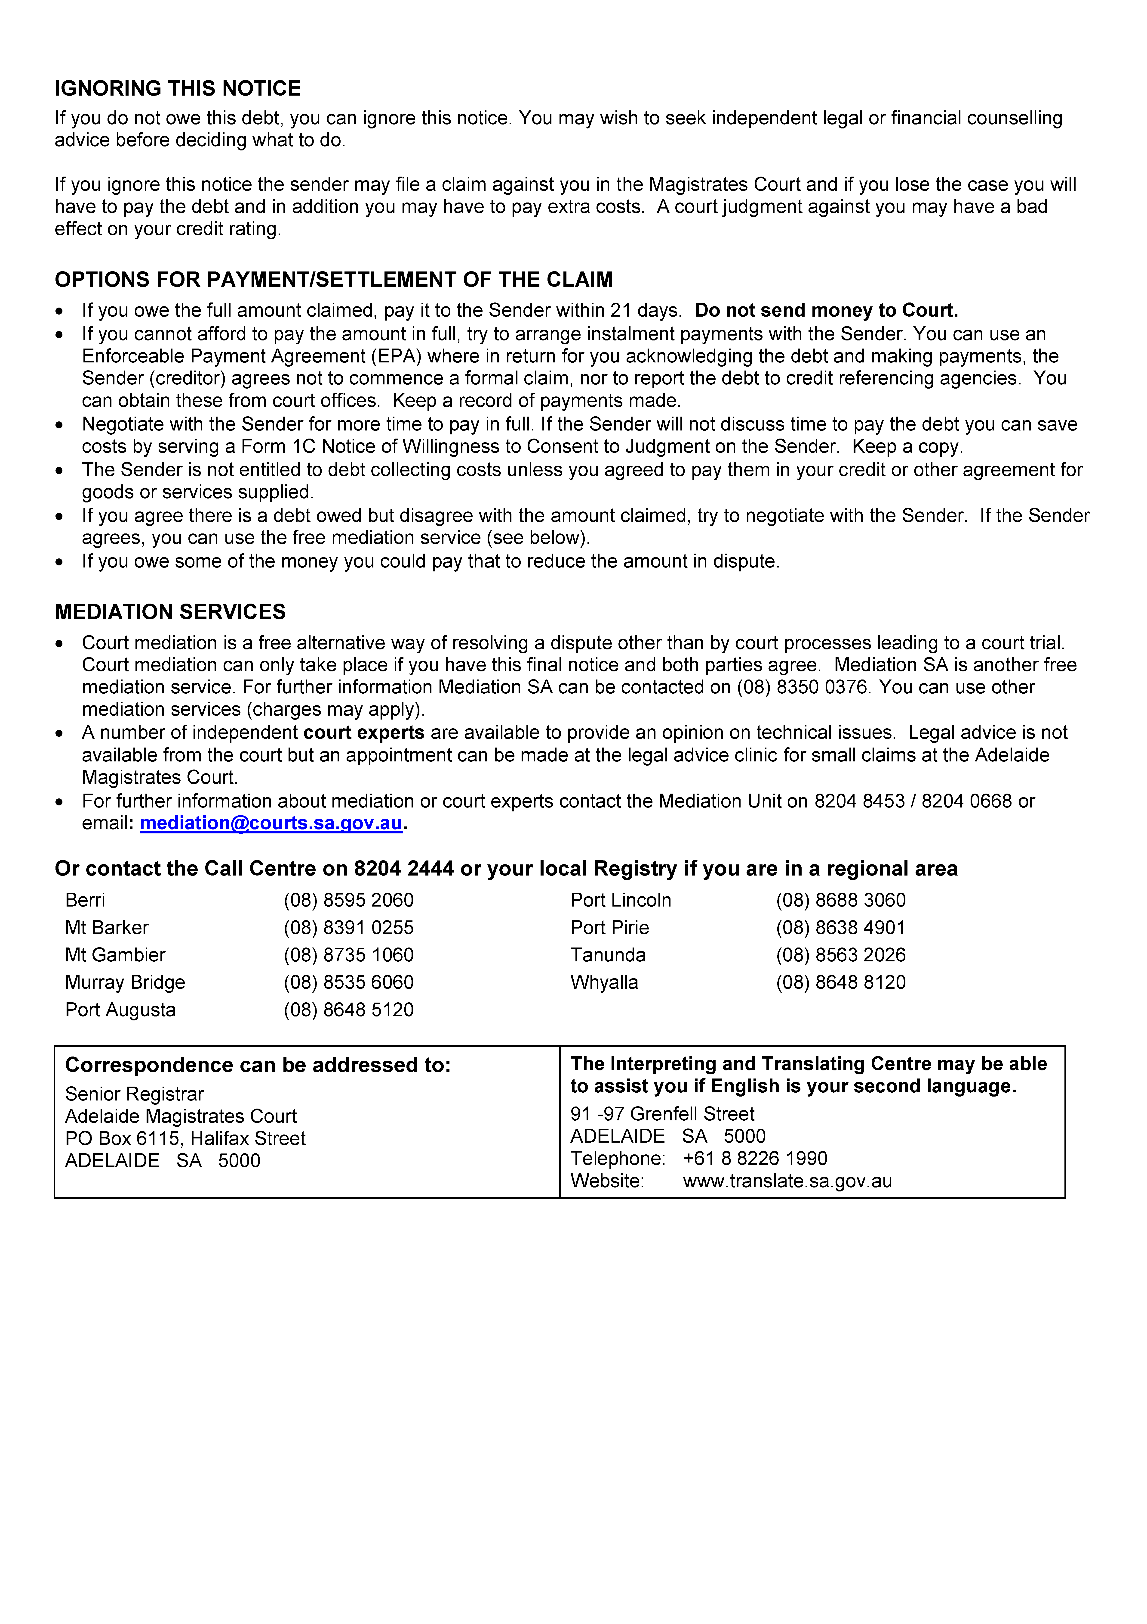

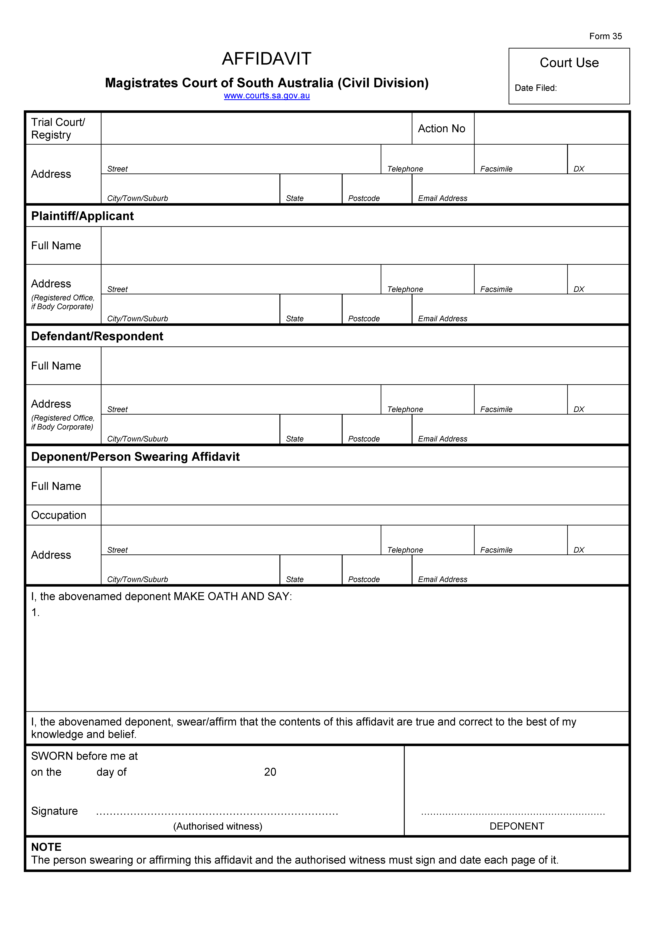



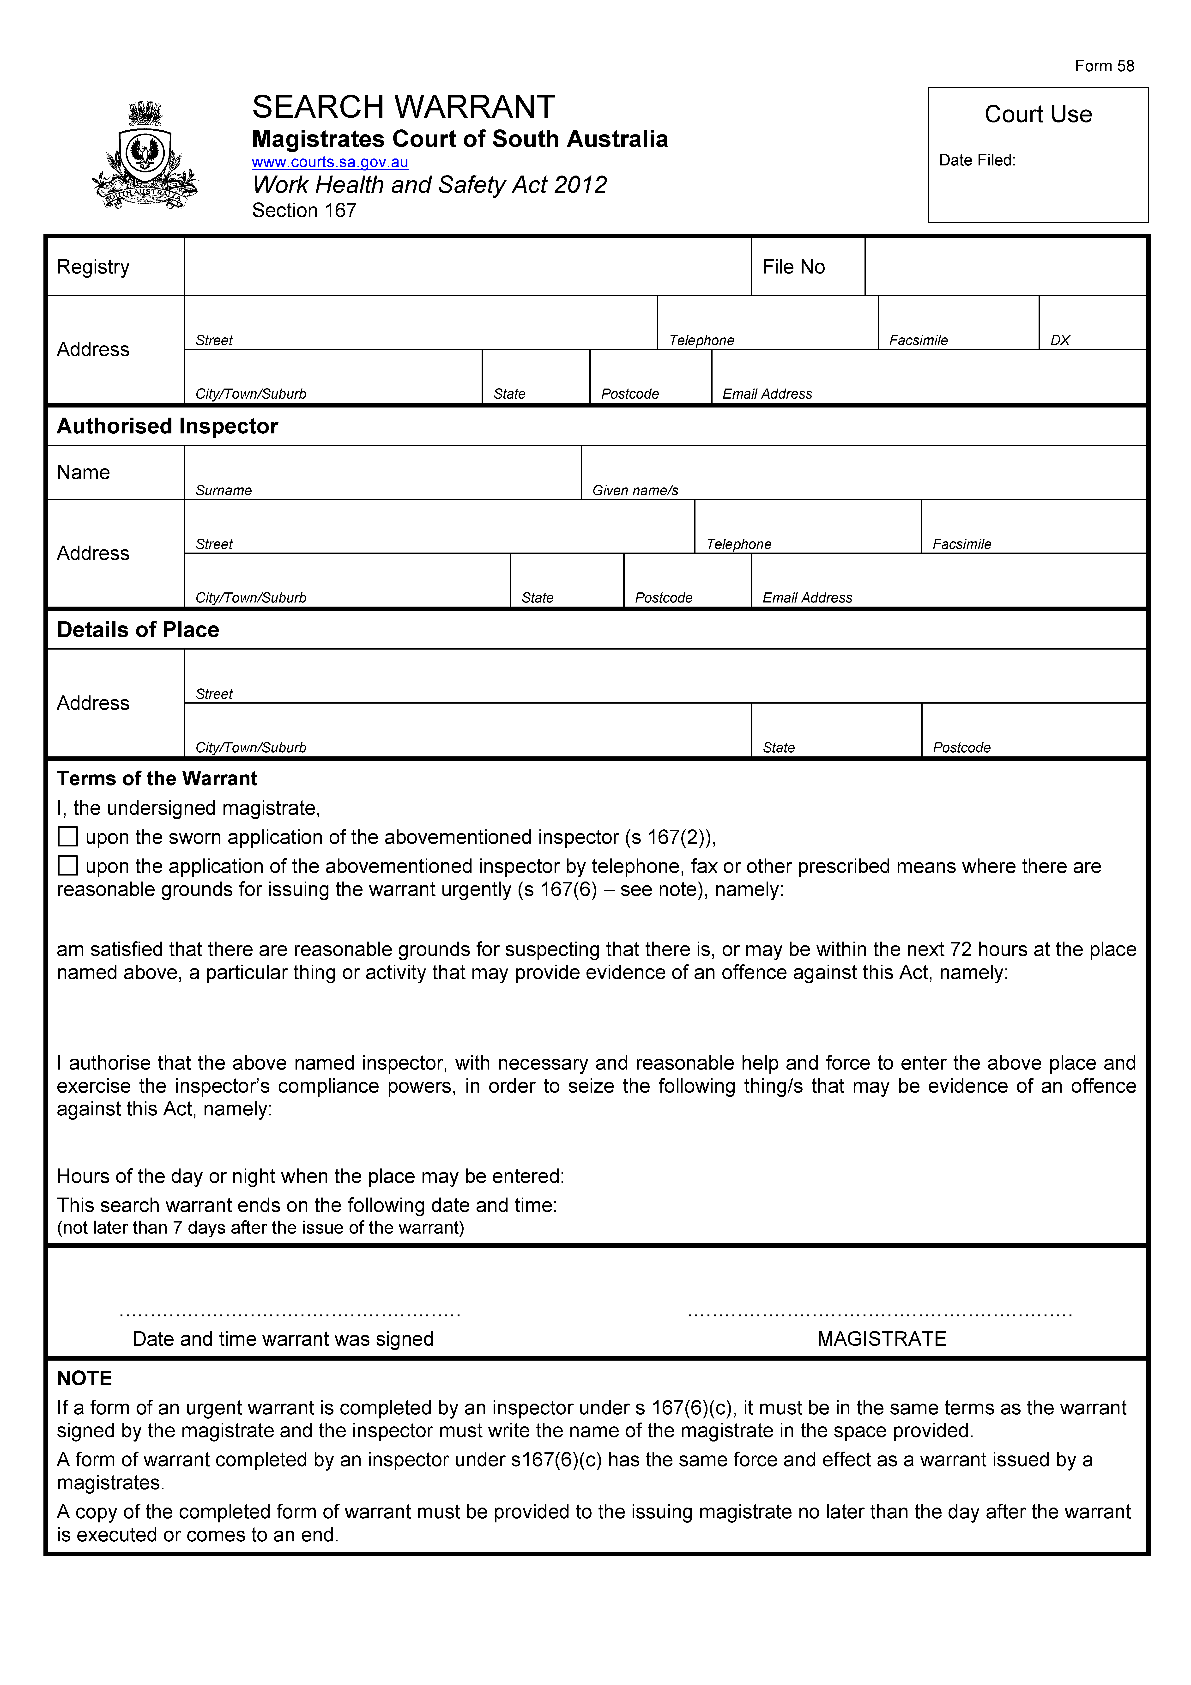

Government

of South Australia

TREASURER’S

QUARTERLY STATEMENT

for the

THREE MONTHS ended on

31 DECEMBER 2014 and 31 DECEMBER, 2013

Presented by the

Honourable T. Koutsantonis M.P.

Treasurer of South Australia

GOVERNMENT OF SOUTH AUSTRALIA
COMMENTARY TO THE STATEMENT OF THE AMOUNTS CREDITED TO
AND ISSUED FROM THE CONSOLIDATED ACCOUNT FOR THE QUARTERS ENDED
31 DECEMBER 2014 AND 31 DECEMBER 2013
Receipts
Taxation
Payroll tax receipts for the six months to December 2014 were higher than for the same period in 2013, mainly due to growth in taxable payrolls.
Stamp duty receipts in the December quarter 2014 were higher than a year earlier, mainly due to conveyance duty for several large transactions being received in November 2014.
Stamp duty receipts for the six months to December 2014 were lower than for the same period in 2013, mainly due to the receipt of duty on a very large transaction in August 2013.
Gambling tax receipts in the December quarter 2014 were lower than a year earlier, mainly due to lower gaming machine spend in clubs and hotels.
Gambling tax receipts for the six months to December 2014 were higher than last year, mainly due to timing differences in the recognition of gambling payments into the Consolidated Account.
Land tax receipts for the six months to December 2014 were higher than the same period in 2013, mainly due to the timing of two large land tax payments made by the South Australian Housing Trust.
Royalties
Royalty receipts in the December quarter 2014 were higher than the same period a year earlier due to a combination of higher gas and condensate production, partially offset by lower crude production, and the timing of monthly royalty payments.
Royalty receipts for the six months to December 2014 were lower than the same period in 2013, mainly due to large producers transitioning to monthly payments in 2013-14.
Fees and charges
Fees and Charges for the six months to December 2014 were higher than for the same period in 2014 mainly due to increases in guarantee fees which are in line with the increase in budget in 2014-15.
Commonwealth – General Purpose Payments
Growth in general purpose grants for the six months to December 2014 compared to the same period last year is not indicative of underlying Goods and Services Tax (GST) revenue growth. This is because monthly grants are paid according to a payment schedule prepared by the Commonwealth Government rather than in accordance with the actual emerging monthly GST collections.
Receipts for the 6 months ended 31 December 2014 are slightly higher than originally anticipated, mainly due to the annual adjustment for actual collections received by the Commonwealth in 2013-14.
Commonwealth – Specific Purpose Payments
Specific Purpose Payments (SPPs) for the December quarter 2014 were lower than for the same period a year ago, mainly because the recurrent SPP for Government schools is now being paid directly to the Department of Education and Child Development under the new National Education Reform Agreement.
Commonwealth – National Partnership Payments
Underlying National Partnership (NP) payments for the six months to December 2014 were lower than the same period last year, primarily because the Commonwealth Government is no longer funding the NP on Certain Concessions for Pensioner Concession Card and Senior Card Holders. Additionally, no payments have yet been received for the Remote Indigenous Housing NP in 2014-15.
Other receipts
Other receipts for the first six months to December 2014 were higher than the same period in 2013, mainly due to the return of equity from SA Water.
Payments
Payments of appropriation are made to Public Authority bank accounts in accordance with cash flow requests.
Payments to the Department of Planning, Transport and Infrastructure for the December quarter 2014 are lower than for the same period in 2014, mainly due to the payment of higher equity contributions in the December quarter 2013 to fund completed projects.
Payments for various Acts for the December quarter 2014 are lower than the same period in 2013, mainly due to the reduction in first home owner grants.
Note
Caution should be exercised in interpreting the quarterly statement of Consolidated Account transactions. Unlike the State Budget, which comprises transactions on an accrual basis, the information reflected in the quarterly statements is limited to cash transactions. Also, the Consolidated Account does not capture all the transactions undertaken by the general government sector (in particular, it does not record receipts to and payments from special deposit accounts). Finally, the timing of receipts and payments could be volatile within a particular year. As a result, apparently large movements between years may only be due to changes in the timing of receipts and payments and therefore may not have consequences for the underlying budget position.

WATER MAINS AND SEWERS

Office of the South Australian Water Corporation
Adelaide, 30 April 2015

WATER MAINS LAID

Notice is hereby given that the following main pipes or parts of main pipes have been laid down by the South Australian Water Corporation in or near the undermentioned water districts and are now available for a constant supply of water to adjacent land.

ADELAIDE WATER DISTRICT

TOWN OF GAWLER
Haywood Court, Evanston Gardens. p44 and 45
Wood Street, Evanston Gardens. p44 and 45

CITY OF PLAYFORD
Park Terrace, Blakeview. p48-50
Tower Way, Blakeview. p48 and 50
Kirkstile Street, Blakeview. p48 and 49
Hawick Avenue, Blakeview. p48 and 49
Blue Lake Drive, Blakeview. p48 and 48

CITY OF PORT ADELAIDE ENFIELD
Worra Street, Northgate. p46 and 47
Tiara Street, Northgate. p46 and 47
Patta Avenue, Northgate. p46 and 47
Condon Drive, Northgate. p46 and 47

CITY OF SALISBURY
Across Whites Road, Paralowie. p42
Greentree Boulevard, Paralowie. p42
Mallee Road, Paralowie. p42
Rivergum Circuit, Paralowie. p42 and 43

CITY OF TEA TREE GULLY
Loral Street, Modbury. p41

CUMMINS WATER DISTRICT

DISTRICT COUNCIL OF LOWER EYRE PENINSULA
Sabey Road, Cummins. p72
East Terrace, Cummins. p72

SEWERS LAID

Notice is hereby given that the following sewers have been laid down by the South Australian Water Corporation in the undermentioned drainage area and are now available for house connections.

ADELAIDE DRAINAGE AREA

CAMPBELLTOWN CITY COUNCIL
Wyn Street, Campbelltown. FB 1244 p10

CITY OF CHARLES STURT
Agnes Street, Seaton. FB 1244 p2

TOWN OF GAWLER
Myall Street, Gawler West. FB 1244 p4
Easements in lot 805 in LTRO DP 94391, Greenwood Avenue, Evanston Gardens. FB 1243 p 52-54
Haywood Court, Evanston Gardens. FB 1243 p 52-54
Wood Street, Evanston Gardens. FB 1243 p 52-54

CITY OF MARION
Filmer Avenue, Glengowrie. FB 1244 p5

CITY OF PLAYFORD
Park Terrace, Blakeview. FB 1243 p58-60
Blue Lake Drive, Blakeview. FB 1243 p58-60

CITY OF PORT ADELAIDE ENFIELD
Islington Court, Dudley Park. FB 1244 p3
Worra Street, Northgate. FB 1243 p55-57
Tiara Street, Northgate. FB 1243 p55-57
Patta Avenue, Northgate. FB 1243 p55-57
Condon Drive, Northgate. FB 1243 p55-57
Northfield Road, Northfield. FB 1244 p9

CITY OF PROSPECT
Easement in lot 33 in LTRO DP 2379 (proposed lot 1 in
LD 050/D016/13), Camroc Avenue, Prospect. FB 1244 p11

CITY OF SALISBURY
Across Kings Road, Paralowie. FB 1245 p1-3
Havenwood Court, Paralowie. FB 1245 p1-3
Rivergum Circuit, Paralowie. FB 1245 p1-4
Green Tree Boulevard, Paralowie. FB 1245 p1-4

CITY OF TEA TREE GULLY
Kelly Road, Modbury North. FB 1242 p60
Loral Street, Modbury. FB 1244 p1
Dampier Avenue, Hope Valley. FB 1244 p6

A. J. Ringham, Chief Executive Officer, South Australian Water Corporation

GOVERNMENT GAZETTE ADVERTISEMENT RATES

To apply from 1 July 2014

$  Agents, Ceasing to Act as 49.75  Associations:  Incorporation 25.25  Intention of Incorporation 62.50  Transfer of Properties 62.50  Attorney, Appointment of 49.75  Bailiff’s Sale 62.50  Cemetery Curator Appointed 36.75  Companies:  Alteration to Constitution 49.75  Capital, Increase or Decrease of 62.50  Ceasing to Carry on Business 36.75  Declaration of Dividend 36.75  Incorporation 49.75  Lost Share Certificates:  First Name 36.75  Each Subsequent Name 12.70  Meeting Final 41.50  Meeting Final Regarding Liquidator’s Report on  Conduct of Winding Up (equivalent to ‘Final  Meeting’)  First Name 49.75  Each Subsequent Name 12.70  Notices:  Call 62.50  Change of Name 25.25  Creditors 49.75  Creditors Compromise of Arrangement 49.75  Creditors (extraordinary resolution that ‘the Com-pany be wound up voluntarily and that a liquidator be appointed’) 62.50  Release of Liquidator⎯Application⎯Large Ad. 99.00  ⎯Release Granted 62.50  Receiver and Manager Appointed 57.00  Receiver and Manager Ceasing to Act 49.75  Restored Name 46.50  Petition to Supreme Court for Winding Up 86.50  Summons in Action 73.50  Order of Supreme Court for Winding Up Action 49.75  Register of Interests⎯Section 84 (1) Exempt 111.00  Removal of Office 25.25  Proof of Debts 49.75  Sales of Shares and Forfeiture 49.75  Estates:  Assigned 36.75  Deceased Persons⎯Notice to Creditors, etc. 62.50  Each Subsequent Name 12.70  Deceased Persons⎯Closed Estates 36.75  Each Subsequent Estate 1.65  Probate, Selling of 49.75  Public Trustee, each Estate 12.70 |  | $  Firms:  Ceasing to Carry on Business (each insertion) 33.00  Discontinuance Place of Business 33.00  Land⎯Real Property Act:  Intention to Sell, Notice of 62.50  Lost Certificate of Title Notices 62.50  Cancellation, Notice of (Strata Plan) 62.50  Mortgages:  Caveat Lodgement 25.25  Discharge of 26.50  Foreclosures 25.25  Transfer of 25.25  Sublet 12.70  Leases⎯Application for Transfer (2 insertions) each 12.70  Lost Treasury Receipts (3 insertions) each 36.75  Licensing 73.50  Municipal or District Councils:  Annual Financial Statement⎯Forms 1 and 2 695.00  Electricity Supply⎯Forms 19 and 20 494.00  Default in Payment of Rates:  First Name 99.00  Each Subsequent Name 12.70  Noxious Trade 36.75  Partnership, Dissolution of 36.75  Petitions (small) 25.25  Registered Building Societies (from Registrar-General) 25.25  Register of Unclaimed Moneys⎯First Name 36.75  Each Subsequent Name 12.70  Registers of Members⎯Three pages and over:  Rate per page (in 8pt) 316.00  Rate per page (in 6pt) 418.00  Sale of Land by Public Auction 63.00  Advertisements 3.50  ¼ page advertisement 147.00  ½ page advertisement 295.00  Full page advertisement 577.00  Advertisements, other than those listed are charged at $3.50 per column line, tabular one-third extra.  Notices by Colleges, Universities, Corporations and District Councils to be charged at $3.50 per line.  Where the notice inserted varies significantly in length from that which is usually published a charge of $3.50 per column line will be applied in lieu of advertisement rates listed.  South Australian Government publications are sold on the condition that they will not be reproduced without prior permission from the Government Printer.
All the above prices include GST

GOVERNMENT GAZETTE NOTICES
Notices for publication in the South Australian Government Gazette should be emailed to governmentgazette@dpc.sa.gov.au. Content should be sent as Word format attachment(s). Covering emails should include the date the notice is to be published and to whom the notice will be charged. Closing time for lodgement is 4 p.m. on the Tuesday preceding the regular Thursday publication. Gazette enquiries to: Phone 8207 1045. The Government Gazette is available online at: www.governmentgazette.sa.gov.au.

MISCELLANEOUS LEGISLATION AND GOVERNMENT PUBLICATIONS PRICES AS FROM 1 JULY 2014

Acts, Bills, Rules, Parliamentary Papers and Regulations
Pages | Main | Amends | Pages | Main | Amends

1-16 | 3.10 | 1.45 | 497-512 | 42.00 | 41.00
17-32 | 4.00 | 2.50 | 513-528 | 43.25 | 41.75
33-48 | 5.30 | 3.75 | 529-544 | 44.75 | 43.25
49-64 | 6.70 | 5.15 | 545-560 | 46.00 | 44.75
65-80 | 7.75 | 6.45 | 561-576 | 47.00 | 46.00
81-96 | 9.05 | 7.50 | 577-592 | 48.75 | 46.50
97-112 | 10.30 | 8.85 | 593-608 | 50.00 | 48.00
113-128 | 11.50 | 10.20 | 609-624 | 51.00 | 49.75
129-144 | 12.90 | 11.40 | 625-640 | 52.00 | 50.50
145-160 | 14.20 | 12.70 | 641-656 | 53.50 | 52.00
161-176 | 15.40 | 14.00 | 657-672 | 54.50 | 52.50
177-192 | 16.80 | 15.20 | 673-688 | 56.00 | 54.50
193-208 | 18.10 | 16.70 | 689-704 | 57.00 | 55.00
209-224 | 19.10 | 17.70 | 705-720 | 58.50 | 56.50
225-240 | 20.40 | 18.90 | 721-736 | 60.00 | 57.50
241-257 | 22.00 | 20.00 | 737-752 | 60.50 | 59.00
258-272 | 23.20 | 21.20 | 753-768 | 62.50 | 60.00
273-288 | 24.30 | 23.00 | 769-784 | 63.50 | 62.50
289-304 | 25.50 | 23.90 | 785-800 | 64.50 | 63.50
305-320 | 27.00 | 25.25 | 801-816 | 66.00 | 64.00
321-336 | 28.00 | 26.50 | 817-832 | 67.50 | 66.00
337-352 | 29.50 | 27.75 | 833-848 | 69.00 | 67.50
353-368 | 30.25 | 29.25 | 849-864 | 70.00 | 68.50
369-384 | 32.00 | 30.25 | 865-880 | 71.50 | 70.00
385-400 | 33.50 | 31.75 | 881-896 | 72.00 | 70.50
401-416 | 34.75 | 32.75 | 897-912 | 73.50 | 72.00
417-432 | 36.00 | 34.50 | 913-928 | 74.00 | 73.50
433-448 | 37.00 | 35.75 | 929-944 | 75.50 | 74.00
449-464 | 38.00 | 36.50 | 945-960 | 76.50 | 75.00
465-480 | 38.50 | 37.75 | 961-976 | 80.00 | 76.00
481-496 | 41.00 | 38.50 | 977-992 | 81.00 | 76.50

Legislation—Acts, Regulations, etc.: $
Subscriptions:
Acts 259.00
All Bills as Laid 623.00
Rules and Regulations 623.00
Parliamentary Papers 623.00
Bound Acts 288.00
Index 144.00
Government Gazette
Copy 6.85
Subscription 344.00
Hansard
Copy 18.90
Subscription—per session (issued weekly) 539.00
Cloth bound—per volume 232.00
Subscription—per session (issued daily) 539.00
Legislation on Disk
Whole Database 3 999.00
Annual Subscription for fortnightly updates 1 229.00
Individual Act(s) including updates POA
Notice of Vacancies
Annual Subscription 195.00
Compendium
Subscriptions:
New Subscriptions 2 368.00
Updates 836.00
(All the above prices include GST)

Counter Sales Government Legislation Outlet
and Mail Orders: Service SA Customer Service Centre,
Ground Floor—EDS Centre, 108 North Terrace, Adelaide, S.A. 5000
Phone: 13 23 24 (local call cost), Fax: (08) 8204 1909
Postal: G.P.O. Box 1707, Adelaide, S.A. 5001

Online Shop: www.shop.service.sa.gov.au

Subscriptions and Government Publishing SA
Standing Orders: Plaza Level, Riverside Centre, North Terrace, Adelaide, S.A. 5000
Phone: (08) 8207 1043, (08) 8207 0908, Fax: (08) 8207 1040
Email: AdminGovPubSA@sa.gov.au

SENDING COPY?
NOTICES for inclusion in the South Australian Government Gazette should be emailed to:
governmentgazette@dpc.sa.gov.au
Please include the following information in the covering email:
• The date the notice is to be published.
• Whether a proof, quote or return email confirmation is required.
• Contact details.
• To whom the notice is charged if applicable.
• A purchase order if required (chargeable notices).
• Any other details that may impact on the publication of the notice.
Attach:
• Notices in Word format.
• Maps and diagrams in pdf.
• Notices that require sighting an official date and signature before publication in a pdf. If a pdf is not possible then fax the official file(s) to the Government Publishing Fax number listed below.
Fax Transmission: (08) 8207 1040
Phone Enquiries: (08) 8207 1045
NOTE:
Closing time for lodging new copy is 4 p.m. on Tuesday preceding the regular Thursday Gazette.

DISTRICT COUNCIL OF GRANT
Declaration of Public Road
NOTICE is hereby given that, at a Council meeting held on Monday, 20 April 2015, pursuant to Section 208 of the Local Government Act 1999, Council declared the following to be a public road, and pursuant to Section 219 formally adopted the following road name:
Land marked as Public Road on Deposited Plan 95254, Allotment 202, Hundred of Gambier, and hereby assigns the name ‘Racecourse Crescent’.
T. Smart, Chief Executive Officer

WAKEFIELD REGIONAL COUNCIL
Declaration of Public Roads—Notice of Intention
NOTICE is hereby given, pursuant to Section 210 (2) (b) of the Local Government Act 1999, that the Wakefield Regional Council intends to declare the land identified as Allotment 31 in Deposited Plan 1796 contained in Certificate of Title Volume 754, Folio 178 and known as Florence Street to be Public Road.
C. Atkinson, Chief Executive Officer

IN the matter of the estates of the undermentioned deceased persons:
Bonecki, Gertrude, late of 246 Worongary Road, Worongary, Queensland, home duties, who died on 16 December 2014.
Glover, Rachel, late of 7 Swain Road, Victor Harbor, retired school teacher, who died on 28 December 2013.
Gray, Therese Parmer, late of 17 Port Road, Queenstown,
home duties, who died on 7 December 2014.
Hilton, Doris Mary, late of 29 Homestead Avenue, Walkley Heights, of no occupation, who died on 14 May 2014.
Juncken, Edward Charles, late of 8 Fletcher Road, Mount Barker, retired manager, who died on 3 November 2014.
Matthews, Doris Gladys, late of 52 The Esplanade, Semaphore, of no occupation, who died on 30 November 2014.
Needs, Ruth Edith, late of 7 Walsall Street, Kensington Park, married woman, who died on 12 February 2015.
Wilks, Robert William, late of 16-24 Penneys Hill Road, Hackham, of no occupation, who died on 17 January 2015.
Yeates, Glen Ross, late of 4 Gliddon Street, Port Lincoln, waterside worker, who died on 24 January 2015.
Notice is hereby given pursuant to the Trustee Act 1936, as amended, the Inheritance (Family Provision) Act 1972 and the Family Relationships Act 1975, that all creditors, beneficiaries, and other persons having claims against the said estates are required to send, in writing, to the Office of Public Trustee, G.P.O. Box 1338, Adelaide, S.A. 5001, full particulars and proof of such claims, on or before 29 May 2015, otherwise they will be excluded from the distribution of the said estates; and notice is also hereby given that all persons indebted to the said estates are required to pay the amount of their debts to the Public Trustee or proceedings will be taken for the recovery thereof; and all persons having any property belonging to the said estates are forthwith to deliver same to the Public Trustee.
Dated 30 April 2015.
D. A. Contala, Public Trustee

ATTENTION

CUSTOMERS requiring a proof of their notice for inclusion in the Government Gazette, please note that the onus is on you to inform Government Publishing SA of any subsequent corrections.

For any corrections to your notice please phone 8207 1045 or Fax 8207 1040 before 4 p.m. on Wednesday.

If we do not receive any communication by 10 a.m. on Thursday (day of publication) we will presume the notice is correct and will print it as it is.

Remember—the onus is on you to inform us of any corrections necessary to your notice.

NOTE: Closing time for lodging new copy (electronically, fax or hard copy) is 4 p.m. on Tuesday preceding the day of publication.
Phone: 8207 1045
Fax: 8207 1040
Email: governmentgazette@dpc.sa.gov.au

Printed and published by authority every Thursday by P. McMAHON, Government Printer, South Australia
Price: $6.65, plus postage; to subscribers, $335.00 per annum.
(The above prices are inclusive of GST)

