No. 50 3927
EXTRAORDINARY GAZETTE

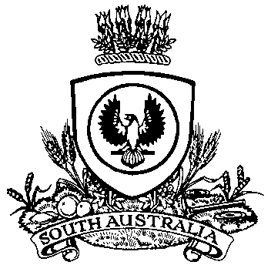

THE SOUTH AUSTRALIAN

GOVERNMENT GAZETTE
www.governmentgazette.sa.gov.au

PUBLISHED BY AUTHORITY

ALL PUBLIC ACTS appearing in this GAZETTE are to be considered official, and obeyed as such

ADELAIDE, MONDAY, 24 AUGUST 2015

Department of the Premier and Cabinet
Adelaide, 24 August 2015
HIS Excellency the Governor in Executive Council has been pleased to appoint the Honourable John James Snelling MP, Minister for Health, Minister for Mental Health and Substance Abuse, Minister for the Arts and Minister for Health Industries to be also Acting Treasurer, Acting Minister for Finance, Acting Minister for State Development, Acting Minister for Mineral Resources and Energy and Acting Minister for Small Business for the period from 25 August 2015 until 30 August 2015 inclusive, during the absence of the Honourable Tom Koutsantonis, MP.
By command,
Tom Koutsantonis, for Premier
T&F15/071CS

P. McMAHON, Government Printer, South Australia

