No. 53 4189



THE SOUTH AUSTRALIAN

GOVERNMENT GAZETTE
www.governmentgazette.sa.gov.au

PUBLISHED BY AUTHORITY

ALL PUBLIC ACTS appearing in this GAZETTE are to be considered official, and obeyed as such

ADELAIDE, THURSDAY, 10 SEPTEMBER 2015

CONTENTS

Page
Appointments, Resignations, Etc. 4190
Aquaculture Act 2001—Notice 4190
Aquaculture (Approval of Tumby Bay Zones Policy)
Notice 2015 4194
Aquaculture (Zones—Tumby Bay) Policy 2015 4195
Corporations and District Councils—Notices 4229
Development Act 1993—Notices 4190
Fisheries Management Act 2007—Erratum 4190
Fisheries Management (Rock Lobster Fisheries)
Regulations 2006—Notice 4191
Gaming Machines Regulations 2005—Notice 4191
Housing Improvement Act 1940—Notices 4200
Land Acquisition Act 1969—Notice 4191
Motor Vehicles (Accident Towing Roster Scheme) Zones
Notice 2015 4201
Page
National Electricity Law—Notice 4191
National Gas Law—Notice 4192
Petroleum and Geothermal Energy Act 2000—
Notice 4218
Proclamations 4221
Public Trustee Office—Administration of Estates 4229

REGULATIONS
Civil Liability Act 1936 (No. 206 of 2015) 4226
Roads (Opening and Closing) Act 1991—
Notices 4192
Road Traffic Act 1961—Notices 4192
Superannuation Act 1988—Notice 4193
Superannuation Funds Management Corporation of South
Australia Act 1995—Notice 4193

GOVERNMENT GAZETTE NOTICES
Notices for publication in the South Australian Government Gazette should be emailed to governmentgazette@dpc.sa.gov.au. Content should be sent as Word format attachment(s). Covering emails should include the date the notice is to be published and to whom the notice will be charged. Closing time for lodgement is 4 p.m. on the Tuesday preceding the regular Thursday publication. Gazette enquiries to: Phone 8207 1045. The Government Gazette is available online at: www.governmentgazette.sa.gov.au.

Department of the Premier and Cabinet
Adelaide, 10 September 2015
HIS Excellency the Governor in Executive Council has been pleased to appoint the undermentioned to the South Eastern Water Conservation and Drainage Board, pursuant to the provisions of the South Eastern Water Conservation and Drainage Act 1992:
Member: (from 10 September 2015 until 9 September 2019)
Kay Rasheed
By command,
John Robert Rau, for Premier
15MSECCS046

Department of the Premier and Cabinet
Adelaide, 10 September 2015
HIS Excellency the Governor in Executive Council has been pleased to appoint the undermentioned to the Parole Board of South Australia, pursuant to the provisions of the Correctional Services Act 1982:
Member: (from 10 September 2015 until 9 September 2018)
Terence Robert Groom
David Henry Haebich
Katherine McLachlan
Second Deputy Presiding Member: (from 10 September 2015 until 9 September 2018)
Terence Robert Groom
Deputy Member: (from 10 September 2015 until 9 September 2018)
Andrew Kyprianou (Deputy to McLachlan)
Denis George Edmonds (Deputy to Haebich)
By command,
John Robert Rau, for Premier
MCS15/07CS

AQUACULTURE ACT 2001
Grant of Aquaculture Lease
PURSUANT to the provisions of Section 22 of the Aquaculture Act 2001, notice is hereby given of the grant of the following leases for the purpose of aquaculture in the waters of the State:
LA00359
LA00360
LA00361
Further details are available for the above leases on the Aquaculture Public Register, which can be found at http://www.pir.sa.gov.au/aquaculture/public_register or by contacting Aquaculture Leasing and Licensing on 8226 0900.
E. Kaese, Leasing and Licensing Officer

DEVELOPMENT ACT 1993, SECTION 25 (17): CITY OF SALISBURY—SAINTS ROAD NEIGHBOURHOOD CENTRE RETAIL LIMIT REVIEW DEVELOPMENT PLAN AMENDMENT
Preamble
1. The Saints Road Neighbourhood Centre Retail Limit Review Development Plan Amendment (the Amendment) by the City of Salisbury has been finalised in accordance with the provisions of the Development Act 1993.
2. The Minister for Planning has decided to approve the Amendment.
Notice
PURSUANT to Section 25 of the Development Act 1993, I:
(a) approve the Amendment; and
(b) fix the day on which this notice is published in the Gazette as the day on which the Amendment will come into operation.
Dated 2 September 2015.
John Rau, Deputy Premier, Minister for Planning

DEVELOPMENT ACT 1993, SECTION 25 (17): CITY OF TEA TREE GULLY—MODBURY REGIONAL GROWTH AREAS DEVELOPMENT PLAN AMENDMENT
Preamble
1. The Modbury Regional Growth Areas Development Plan Amendment (the Amendment) by the City of Tea Tree Gully has been finalised in accordance with the provisions of the Development Act 1993.
2. The Minister for Planning has decided to approve the Amendment.
Notice
PURSUANT to Section 25 of the Development Act 1993, I:
(a) approve the Amendment; and
(b) fix the day on which this notice is published in the Gazette as the day on which the Amendment will come into operation.
Dated 2 September 2015.
John Rau, Deputy Premier, Minister for Planning

DEVELOPMENT ACT 1993, SECTION 26 (9): EMPLOYMENT LANDS (GILLMAN/DRY CREEK AND WINGFIELD) AND GENERAL SECTION AMENDMENTS DEVELOP-MENT PLAN AMENDMENT
Preamble
1. The ‘Employment Lands (Gillman/Dry Creek and Wingfield) and General Section Amendments Development Plan Amend-ment’ (the Amendment) has been finalised in accordance with the provisions of the Development Act 1993.
2. The Minister for Disabilities, Police, Correctional Services, Emergency Services and Road Safety has decided to approve the Amendment.
Notice
PURSUANT to Section 26 of the Development Act 1993, I:
(a) approve the Amendment; and
(b) fix the day on which this notice is published in the Gazette as the day on which the Amendment will come into operation.
Dated 29 July 2015.
Tony Piccolo,
Minister for Disabilities,
Minister for Police,
Minister for Correctional Services,
Minister for Emergency Services,
Minister for Road Safety,
Delegate for the Minister for Planning

FISHERIES MANAGEMENT ACT 2007: SECTION 115
Exemption No. ME9902796
Erratum
TAKE notice that the Ministerial exemption notice issued pursuant to Section 115 of the Fisheries Management Act 2007, in the name of Leslie Morrison, of the School of Biological Sciences at Flinders University, Sturt Road, Bedford Park, dated 21 August 2015, being the second notice published on page 3931 of the South Australian Government Gazette dated 27 August 2015, is hereby varied by deleting the first paragraph of Schedule 1 and inserting the following:
Schedule 1
For the purposes of teaching appropriate sampling techniques, the collection of aquatic organisms from all waters of South Australia, including the River Murray Protection Area, excluding the Adelaide Dolphin Sanctuary, aquatic reserves (unless otherwise authorised under the Act), marine park restricted access zones and sanctuary zones (unless otherwise authorised under the Marine Parks Act 2007).
Dated 3 September 2015.
S. Sloan, Director, Fisheries and Aquaculture Policy

FISHERIES MANAGEMENT (ROCK LOBSTER FISHERIES)
REGULATIONS 2006
TAKE notice that, in relation to the nominated certification stations listed in Column 1 below, the corresponding times specified in Columns 2 and 3 are, for the purposes of sub-regulations 22 (2) and 23 (2) of the Fisheries Management (Rock Lobster Fisheries) Regulations 2006 under the Fisheries Management Act 2007, the times during which the requirements in sub-regulations 22 (1) and 23 (1) do not apply.
This notice applies from 1 October 2015 until 31 May 2016, unless varied or revoked earlier.
Column 1 | Column 2 | Column 3
Certification Station | Start Time | Finish Time
Beachport | 8.30 a.m. | 5 p.m.
Blackfellows Caves | 8.30 a.m. | 5 p.m.
Cape Jaffa | 8.30 a.m. | 5 p.m.
Carpenter Rocks | 8.30 a.m. | 5 p.m.
Port MacDonnell | 8.30 a.m. | 5 p.m.
Robe | 8.30 a.m. | 5 p.m.
Southend | 8.30 a.m. | 5 p.m.
Dated 1 September 2015.
M. Snart, Fisheries Regional Manager, Limestone Coast, Delegate of the Minister for Agriculture, Food and Fisheries

GAMING MACHINES REGULATIONS 2005
Notice Under Regulation 5B
Trading Round for Gaming Machine Entitlements
TAKE notice that pursuant to Regulation 5B of the Gaming Machine Regulations 2005, I, Dini Soulio, Liquor and Gambling Commissioner have established a trading round for the purchase and sale of gaming machine entitlements. This trading round will be known as Trading Round 10/2015.
Offers to purchase or sell gaming machine entitlements in Trading Round 10/2015 are invited from persons eligible to do so in accordance with the Gaming Machines Regulations 2005. The closing date and time for the submission of offers is:
FRIDAY, 16 OCTOBER 2015 at 5 p.m.
The determination of offers that are to be regarded as accepted will occur on Thursday, 19 November 2015 (known as the Trading Day).
An administration fee of $110 (per entitlement) applies for Trading Round 10/2015 for the submission of offers to purchase entitlements. There is no fee for the submission of offers to sell entitlements.
Offers to purchase or sell gaming machine entitlements in Trading Round 10/2015 may only be made on the application forms available from the Consumer and Business Services website at www.cbs.sa.gov.au by following the ‘Find a Gaming Machine Trading Round’ link.
Application forms and supporting documentation should be submitted in a sealed envelope clearly marked ‘Trading Round Offers’ and may only be lodged:
In the Tender Box at:
Consumer and Business Services,
Trading Round 10/2015,
Customer Service Centre (Concierge Desk),
Chesser House,
91 Grenfell Street,
Adelaide, S.A. 5000.
Or by Mail at:
Consumer and Business Services,
Trading Round 10/2015,
P.O. Box 3241,
Rundle Mall, S.A. 5000.
Applications received after the closing date and time (including those submitted by mail) will not be considered for inclusion in this trading round.
Applications forwarded by email or facsimile will not be accepted under any circumstances.
TRADING ROUND ENQUIRIES
Phone: (08) 8204 9442 or Email: gmetrade@agd.sa.gov.au
Dated 10 September 2015.
Dini Soulio, Liquor and Gambling Commissioner

LAND ACQUISITION ACT 1969
(Section 16)
Notice of Acquisition
THE COMMISSIONER OF HIGHWAYS (the ‘Authority’), 136 North Terrace, Adelaide, S.A. 5000, acquires the following interests in the following land:
Definition of Land Acquired
Comprising an unencumbered estate in fee simple in that piece of land situated at 1455 Main South Road, Bedford Park, S.A. 5042, being the whole of Allotments 7, 8 and 9 in Deposited Plan No 4934 comprised in Certificates of Title Volume 5316, Folios 766 and 767.
This notice is given under Section 16 of the Land Acquisition Act 1969.
Compensation
A person who has or had an interest in the land that is divested or diminished by the acquisition or the enjoyment of which is adversely affected by the acquisition who does not receive an offer of compensation from the Authority may apply to the Authority for compensation.
Inquiries
Inquiries should be directed to:
Ric Lohmeyer,
G.P.O. Box 1533,
Adelaide, S.A. 5001
Telephone: (08) 7424 7026
Dated 8 September 2015.
The Common Seal of the Commissioner of Highways was hereto affixed by authority of the Commissioner in the presence of:
A. J. Berry, Manager, Real Estate Services, (Authorised Officer), Department of Planning, Transport and Infrastructure
DPTI 2010/22254/01

NATIONAL ELECTRICITY LAW
THE Australian Energy Market Commission (AEMC) gives notice under the National Electricity as follows:
Under s 107, the time for making the draft determination on the Meter Replacement Processes proposal has been extended to 17 December 2015.
Under s 99, the making of a draft determination and related draft rule on the Embedded Networks proposal (Ref. ERC0179). Written requests for a pre-determination hearing must be received by 17 September 2015. Submissions must be received by 22 October 2015.
Under s 107, the time for the making of the final determination on the Embedded Networks proposal has been extended to 17 December 2015.
Submissions can be made via the AEMC’s website. Before making a submission, please review the AEMC’s privacy statement on its website. Submissions should be made in accordance with the AEMC’s guidelines for making written submissions on Rule change proposals. The AEMC publishes all submissions on its website, subject to confidentiality.
Written requests should be sent to submissions@aemc.gov.au and cite the reference in the title. Before sending a request, please review the AEMC’s privacy statement on its website.
Documents referred to above are available on the AEMC’s website and are available for inspection at the AEMC’s office.
Australian Energy Market Commission
Level 6, 201 Elizabeth Street
Sydney, N.S.W. 2000
Telephone: (02) 8296 7800
www.aemc.gov.au
10 September 2015.

NATIONAL GAS LAW
THE Australian Energy Market Commission (AEMC) gives notice under the National Gas Law as follows:
Under s 303, AEMO has requested the DWGM operating schedules proposal (Ref. GRC0034). The proposal seeks to change the National Gas Rules to clarify the process AEMO is to follow in producing operating schedules in the Victorian Declared Wholesale Gas Market. The AEMC intends to expedite the proposal under s 304 as it considers the proposed Rule is non-controversial, subject to requests not to do so. Written requests not to expedite the proposal must be received by 24 September 2015. Submissions must be received by 8 October 2015.
Under s 303, AEMO has requested the DWGM-AMDQ Allocation proposal (Ref. GRC0029). The proposal seeks to create and allocate AMDQ credit certificates in the Victorian Declared Wholesale Gas Market. Submissions must be received by 8 October 2015.
Submissions can be made via the AEMC’s website. Before making a submission, please review the AEMC’s privacy statement on its website. Submissions should be made in accordance with the AEMC’s guidelines for making written submissions on Rule change proposals. The AEMC publishes all submissions on its website, subject to confidentiality.
Written requests should be sent to submissions@aemc.gov.au and cite the reference in the title. Before sending a request, please review the AEMC’s privacy statement on its website.
Documents referred to above are available on the AEMC’s website and are available for inspection at the AEMC’s office.
Australian Energy Market Commission
Level 6, 201 Elizabeth Street
Sydney, N.S.W. 2000
Telephone: (02) 8296 7800
www.aemc.gov.au
10 September 2015

ROADS (OPENING AND CLOSING) ACT 1991
Road Closure—Bath Lane, Adelaide
NOTICE is hereby given, pursuant to Section 10 of the Roads (Opening and Closing) Act 1991, that the DEVELOPMENT ASSESSMENT COMMISSION proposes to make a Road Process Order to close portion of Bath Lane situated north of Angas Street and merge with the adjoining Allotment 12 in Deposited Plan 31326, more particularly delineated and lettered ‘B’ on the Preliminary Plan No. 15/0025
A copy of the plan and a statement of persons affected are available for public inspection at the offices of the Council, Customer Centre, 25 Pirie Street, Adelaide and the Adelaide office of the Surveyor-General, 101 Grenfell Street, Adelaide, during normal office hours.
Any person is entitled to object to the proposed road process, or any person affected by the proposed closure is entitled to apply for an easement to be granted in that person’s favour over the land subject to the proposed closure. Such objection or application for an easement must set out the full name and address of the person making the objection or application and must be fully supported by reasons. Any application for an easement must give full particulars of the nature and location of the easement and where made by a person as the owner of adjoining or nearby land, specify the land to which the easement is to be annexed.
The application for easement or objection must be made in writing to the Development Assessment Commission, 136 North Terrace, Adelaide, S.A. 5000 within 28 days of this notice and a copy must be forwarded to the Surveyor-General, P.O. Box 1354, Adelaide, S.A. 5000. Where a submission is made, the Development Assessment Commission will give notification of a meeting at which the matter will be considered.
Commission Contact: Jason Bailey. Phone 7109 7161.
Dated 10 September 2015.
M. P. Burdett, Surveyor-General

ROADS (OPENING AND CLOSING) ACT 1991:
SECTION 24
NOTICE OF CONFIRMATION OF ROAD
PROCESS ORDER
Road Closure—
War Memorial Drive, Balaklava
BY Road Process Order made on 3 August 2015, the Wakefield Regional Council ordered that:
1. An un-made portion of War Memorial Drive situated between John Street and Railway Terrace, more particularly delineated and lettered ‘A’ and ‘B’ on the Preliminary Plan No. 14/0032 be closed.
2. Issue a Certificate of Title to the Wakefield Regional Council for the whole of the land subject to closure lettered ‘A’ which land is being retained by Council for merging with the adjoining Council reserve.
3. The whole of the land subject to closure lettered ‘B’ be transferred to the Minister for Transport and Infrastructure in accordance with agreement for transfer dated 21 November 2014 entered into between the Wakefield Regional Council and Minister for Transport and Infrastructure.
4. The following easement be granted over portion of a road closed by this order:
Grant to Distribution Lessor Corporation an easement for overhead electricity supply purposes.
On 8 September 2015 that order was confirmed by the Minister for Transport and Infrastructure conditionally upon the deposit by the Registrar-General of Deposited Plan 110732 being the authority for the new boundaries.
Pursuant to Section 24 (5) of the Roads (Opening and Closing) Act 1991, NOTICE of the order referred to above and its confirmation is hereby given.
Dated 10 September 2015.
M. P. Burdett, Surveyor-General

ROAD TRAFFIC ACT 1961
Authorised Officers to Conduct Oral Fluid Analyses
I, GRANT STEVENS, Commissioner of Police, do hereby notify that on and from 1 September 2015, the following persons were authorised by the Commissioner of Police to conduct oral fluid analyses as defined in and for the purposes of the:
Road Traffic Act 1961;
Harbors and Navigation Act 1993; and
Rail Safety National Law (South Australia) Act 2012.

PD  Number | Officer Name
35266 | Daly, Andrew Glenn
18407 | Luke, Andrew Damian
Grant Stevens, Commissioner of Police

ROAD TRAFFIC ACT 1961
Authorised Officers to Conduct Drug Screening Tests
I, GRANT STEVENS, Commissioner of Police, do hereby notify that on and from 31 August 2015, the following persons were authorised by the Commissioner of Police to conduct drug screening tests as defined in and for the purposes of the:
Road Traffic Act 1961;
Harbors and Navigation Act 1993; and
Rail Safety National Law (South Australia) Act 2012.

PD  Number | Officer Name
94034 | Hirst, John Adrian
Grant Stevens, Commissioner of Police

ROAD TRAFFIC ACT 1961
Authorised Officers to Operate Breath Analysing Instruments
I, GRANT STEVENS, Commissioner of Police, do hereby notify that on and from 25 January 2012, the following persons were authorised by the Commissioner of Police to operate breath analysing instruments as defined in and for the purposes of the:
Road Traffic Act 1961;
Harbors and Navigation Act 1993;
Security and Investigation Industry Act 1995; and
Rail Safety National Law (South Australia) Act 2012.

PD  Number | Officer Name
74714 | Patton, Mark
74903 | Smith, Michael David
Grant Stevens, Commissioner of Police

ROAD TRAFFIC ACT 1961
Authorised Officers to Operate Breath Analysing Instruments
I, GRANT STEVENS, Commissioner of Police, do hereby notify that on and from 31 August 2015, the following persons were authorised by the Commissioner of Police to operate breath analysing instruments as defined in and for the purposes of the:
Road Traffic Act 1961;
Harbors and Navigation Act 1993;
Security and Investigation Industry Act 1995; and
Rail Safety National Law (South Australia) Act 2012.

PD  Number | Officer Name
75543 | Altamura, Natasha Cherie
74534 | Blandford, Nicholas Jonathon
74306 | Bradtke, Joshua Paul
74643 | Finey, Peter Thomas
75233 | Herden, Rebekah Jane
94034 | Hirst, John Adrian
39787 | Jones, Andrew Neale
75582 | Keenan, Paul Francis
75294 | Lawley-Sinclair, Raymond
74615 | Schulze, Matthew David
72894 | Wills, David Gary
Grant Stevens, Commissioner of Police

SUPERANNUATION ACT 1988
Super SA
Election of Two Board Members
PURSUANT to Regulation 17 under the Act, I hereby declare Jan McMahon and Bill Griggs elected to fill the two vacancies on the South Australian Superannuation Board. The number of first preferences received for each candidate was as follows:
Healy, Roseanne 2 979 votes
Szuster, Nic 1 534 votes
McMahon, Jan 5 175 votes
Griggs, Bill 4 262 votes
Moffatt (Cafasso), Nadia 668 votes
Brown, Andrew 1 145 votes
At the conclusion of the distribution of preferences, Jan McMahon was elected with 7 281 votes and Bill Griggs was elected with 6 307 votes. 2 175 votes were deemed to be ‘exhausted’ as the ballot papers did not contain continuing preferences and were unable to be distributed.
The term of office for the successful candidates commences on 2 October 2015 and expires on 1 October 2018.
Dated 10 September 2015.
D. Gully, Returning Officer
ECSA 310/14

SUPERANNUATION FUNDS MANAGEMENT CORPORATION OF SOUTH AUSTRALIA ACT 1995
Funds SA
Election of One Board Member
PURSUANT to Regulation 15 under the Act, I hereby declare Kevin Crawshaw elected to fill the vacancy on the Superannuation Funds Management Corporation of South Australia Board. The number of first preferences received for each candidate was as follows:
Szuster, Nic 2 512 votes
Healy, Roseanne 5 760 votes
Crawshaw, Kevin 7 795 votes
At the conclusion of the distribution of preferences, Kevin Crawshaw was elected with 8 501 votes. Roseanne Healy received 6 507 votes and 1 059 votes were deemed to be ‘exhausted’ as the ballot papers did not contain continuing preferences and were unable to be distributed.
The term of office for the successful candidate commences on
2 October 2015 and expires on 1 October 2018.
Dated 10 September 2015.
D. Gully, Returning Officer
ECSA 310/14

South Australia
Aquaculture (Approval of Tumby Bay Zones Policy) Notice 2015
under section 12 of the Aquaculture Act 2001
1—Short title
This notice may be cited as the Aquaculture (Approval of Tumby Bay Zones Policy) Notice 2015.
2—Approval of aquaculture policy
(1) The Aquaculture (Zones—Tumby Bay) Policy 2015 is approved.
(2) The policy comes into operation on the day on which this notice is published in the Gazette.
Made by the Minister for Agriculture, Food and Fisheries
On 30 August 2015

South Australia
Aquaculture (Zones—Tumby Bay) Policy 2015
under the Aquaculture Act 2001

Contents
Part 1—Preliminary
1 Short title
2 Interpretation
3 Object of policy
4 Prescription of criteria does not limit matters that may be taken into account
Part 2—Tumby Bay aquaculture zone
5 Identification of aquaculture zone
6 Class of permitted aquaculture
7 Prescribed criteria
8 Variation or revocation of Gazette notice
Part 3—Tumby Bay aquaculture exclusion zone
9 Identification of aquaculture exclusion zone
Schedule 1—Descriptions of zones
1 Description of Tumby Bay aquaculture zone
2 Description of Tumby Bay aquaculture exclusion zone
Schedule 2—Map of zones

Part 1—Preliminary
1—Short title
This policy may be cited as the Aquaculture (Zones—Tumby Bay) Policy 2015.
2—Interpretation
(1) In this policy, unless the contrary intention appears—
Act means the Aquaculture Act 2001;
algae means eukaryotic macroalgae;
bivalve molluscs includes clams, cockles, mussels, oysters, pipis, razorfish and scallops;
finfish means all members of the classes Actinopterygii, Elasmobranchii and Myxini;
lease means an aquaculture lease;
licence means an aquaculture licence;
prescribed wild caught tuna means members of the genera Allothunnus, Auxis, Euthunnus, Katsuwonus, and Thunnus that have been taken from the wild.
(2) For the purposes of identification of zones in this policy, unless the contrary intention appears, all lines are geodesics based on the Geocentric Datum of Australia 1994 (GDA94) as defined in the Commonwealth of Australia Gazette GN35 of 6 September 1995 and all co-ordinates are expressed in terms of GDA94.
Note—
Unless the contrary intention appears, terms used in this policy that are defined in the Act have the respective meanings assigned to those terms by the Act.
3—Object of policy
Pursuant to section 11 of the Act, this policy—
(a) identifies an aquaculture zone and an aquaculture exclusion zone; and
(b) specifies for an aquaculture zone—
(i) the classes of aquaculture permitted in the zone; and
(ii) prescribed criteria to be taken into account in the determination of applications for licences or in the making of other decisions under the Act in relation to the zone.
4—Prescription of criteria does not limit matters that may be taken into account
This policy does not limit the matters that may be taken into account in the determination of applications for licences or in the making of other decisions under the Act.
Part 2—Tumby Bay aquaculture zone
5—Identification of aquaculture zone
The Tumby Bay aquaculture zone comprises the State waters described in Schedule 1 clause 1.
6—Class of permitted aquaculture
The classes of aquaculture permitted in the Tumby Bay aquaculture zone are—
(a) the farming of aquatic animals (other than prescribed wild caught tuna) in a manner that involves regular feeding; and
(b) the farming of bivalve molluscs; and
(c) the farming of algae.
7—Prescribed criteria
(1) In the determination of applications for licences and in the making of other decisions under the Act in relation to the Tumby Bay aquaculture zone, the following prescribed criteria must be taken into account:
(a) the total area in the zone subject to lease must not exceed 1 300 hectares of which at least 5 hectares must be used or available for use for the farming of aquatic organisms for the purposes of research or for the purposes of trade, or a business, established for educational purposes;
(b) the biomass of the aquatic animals (other than prescribed wild caught tuna) being farmed in the zone in a manner that involves regular feeding must not exceed—
(i) an amount that would, in the opinion of the Minister, have an environmental impact on the zone equivalent to the environmental impact that 2 100 tonnes of finfish would have on the zone; or
(ii) if some other amount is specified by the Minister by notice in the Gazette, that other amount;
(c) the biomass of bivalve molluscs being farmed in the zone must not exceed 16 200 tonnes, or, if some other amount is specified by the Minister by notice in the Gazette, that other amount.
(2) However, a notice under subclause (1)(c) must not increase the biomass of bivalve molluscs that may be farmed in the zone unless the Minister is satisfied that the increase would not compromise the overall productivity of the bivalve mollusc industry being carried on in the zone.
8—Variation or revocation of Gazette notice
(1) The Minister may vary or revoke a notice in the Gazette made under clause 7 by subsequent notice in the Gazette.
(2) The power to vary or revoke a notice under subclause (1) is exercisable in the same way, and subject to the same conditions, as the power to make the notice.
Part 3—Tumby Bay aquaculture exclusion zone
9—Identification of aquaculture exclusion zone
The Tumby Bay aquaculture exclusion zone comprises the State waters described in Schedule 1 clause 2.
Schedule 1—Descriptions of zones
1—Description of Tumby Bay aquaculture zone
The Tumby Bay aquaculture zone comprises—
(a) the State waters of or near Tumby Bay contained within and bounded by a line commencing at 34°21′48″ South, 136°14′18″East (Point 1), then easterly to 34°21′53″ South, 136°17′05″ East (Point 2), then southerly to 34°24′20″ South, 136°16′53″ East (Point 3), then south-westerly to 34°27′31″ South, 136°14′19″ East (Point 4), then north-westerly to 34°25′09.29″ South, 136°10′51.98″ East (Point 5), then north-westerly to 34°23′45″ South, 136°10′26″ East (Point 6), then north-easterly to the point of commencement; and
(b) the State waters of or near Tumby Bay contained within and bounded by a line commencing at 34°25′35.09″ South, 136°10′01.09″ East (Point 7), then south-easterly to 34°28′54″ South, 136°12′40″ East (Point 8), then south-westerly to 34°29′11.82″ South, 136°12′18.42″ East (Point 9), then south-westerly to 34°29′53″ South, 136°11′56″ East (Point 10), then south-westerly to 34°31′11″ South, 136°09′19″ East (Point 11), then north-westerly to 34°30′13″ South, 136°08′37″ East (Point 12), then north-easterly to 34°29′16″ South, 136°08′56″ East (Point 13), then north-easterly to 34°26′06.37″ South, 136°09′15.44″ East (Point 14), then north-easterly to 34°25′41.99″ South, 136°09′41.98″ East (Point 15), then north-easterly to the point of commencement.
Note—
The point references in this description are references to the corresponding points in the map in Schedule 2 showing the Tumby Bay aquaculture zone.
2—Description of Tumby Bay aquaculture exclusion zone
The Tumby Bay aquaculture exclusion zone comprises the State waters of or near Tumby Bay contained within and bounded by a line commencing at mean high water springs closest to 34°19′18.86″ South, 136°12′11.56″ East (Point 16), then south-easterly to a point 1 000 metres seaward of the mean high water springs closest to 34°19′38.19″ South, 136°12′43.13″ East (Point 17), then south-easterly to 34°21′48″ South, 136°14′18″ East (Point 1), then south-westerly to 34°23′45″ South, 136°10′26″ East (Point 6), then south-easterly to 34°25′09.29″ South, 136°10′51.98″ East (Point 5), then south-easterly to 34°27′31″ South, 136°14′99″ East (Point 4), then south-westerly to 34°28′11″ South, 136°13′45″ East (Point 18), then south-westerly to 34°28′54″ South, 136°12′40″ East (Point 8), then north-westerly to 34°25′35.09″ South, 136°10′01.09″ East (Point 7), then south-westerly to 34°25′41.99″ South, 136°09′41.98″ East (Point 15), then south-westerly to 34°26′06.37″ South, 136°09′15.44″ East (Point 14), then south-westerly to 34°29′16″ South, 136°08′56″ East (Point 13), then south-westerly to 34°30′13″ South, 136°08′37″ East (Point 12), then north-westerly to a point 1 000 metres seaward of the mean high water springs closest to 34°29′55.14″ South, 136°07′37.97″ East (Point 19), then generally south-westerly following a line 1 000 metres seaward of the mean high water springs to the location closest to 34°33′03.10″ South, 136°05′50.96″ East (Point 20), then north-westerly to the location on mean high water springs closest to 34°32′37.77″ South, 136°05′20.17″ East (Point 21), then beginning south-easterly following the line of mean high water springs to the point of commencement.
Note—
The point references in this description are references to the corresponding points in the map in Schedule 2 showing the Tumby Bay aquaculture exclusion zone.
Schedule 2—Map of zones
The map in this Schedule is provided for convenience of reference only.
Tumby Bay aquaculture zone and Tumby Bay aquaculture exclusion zone
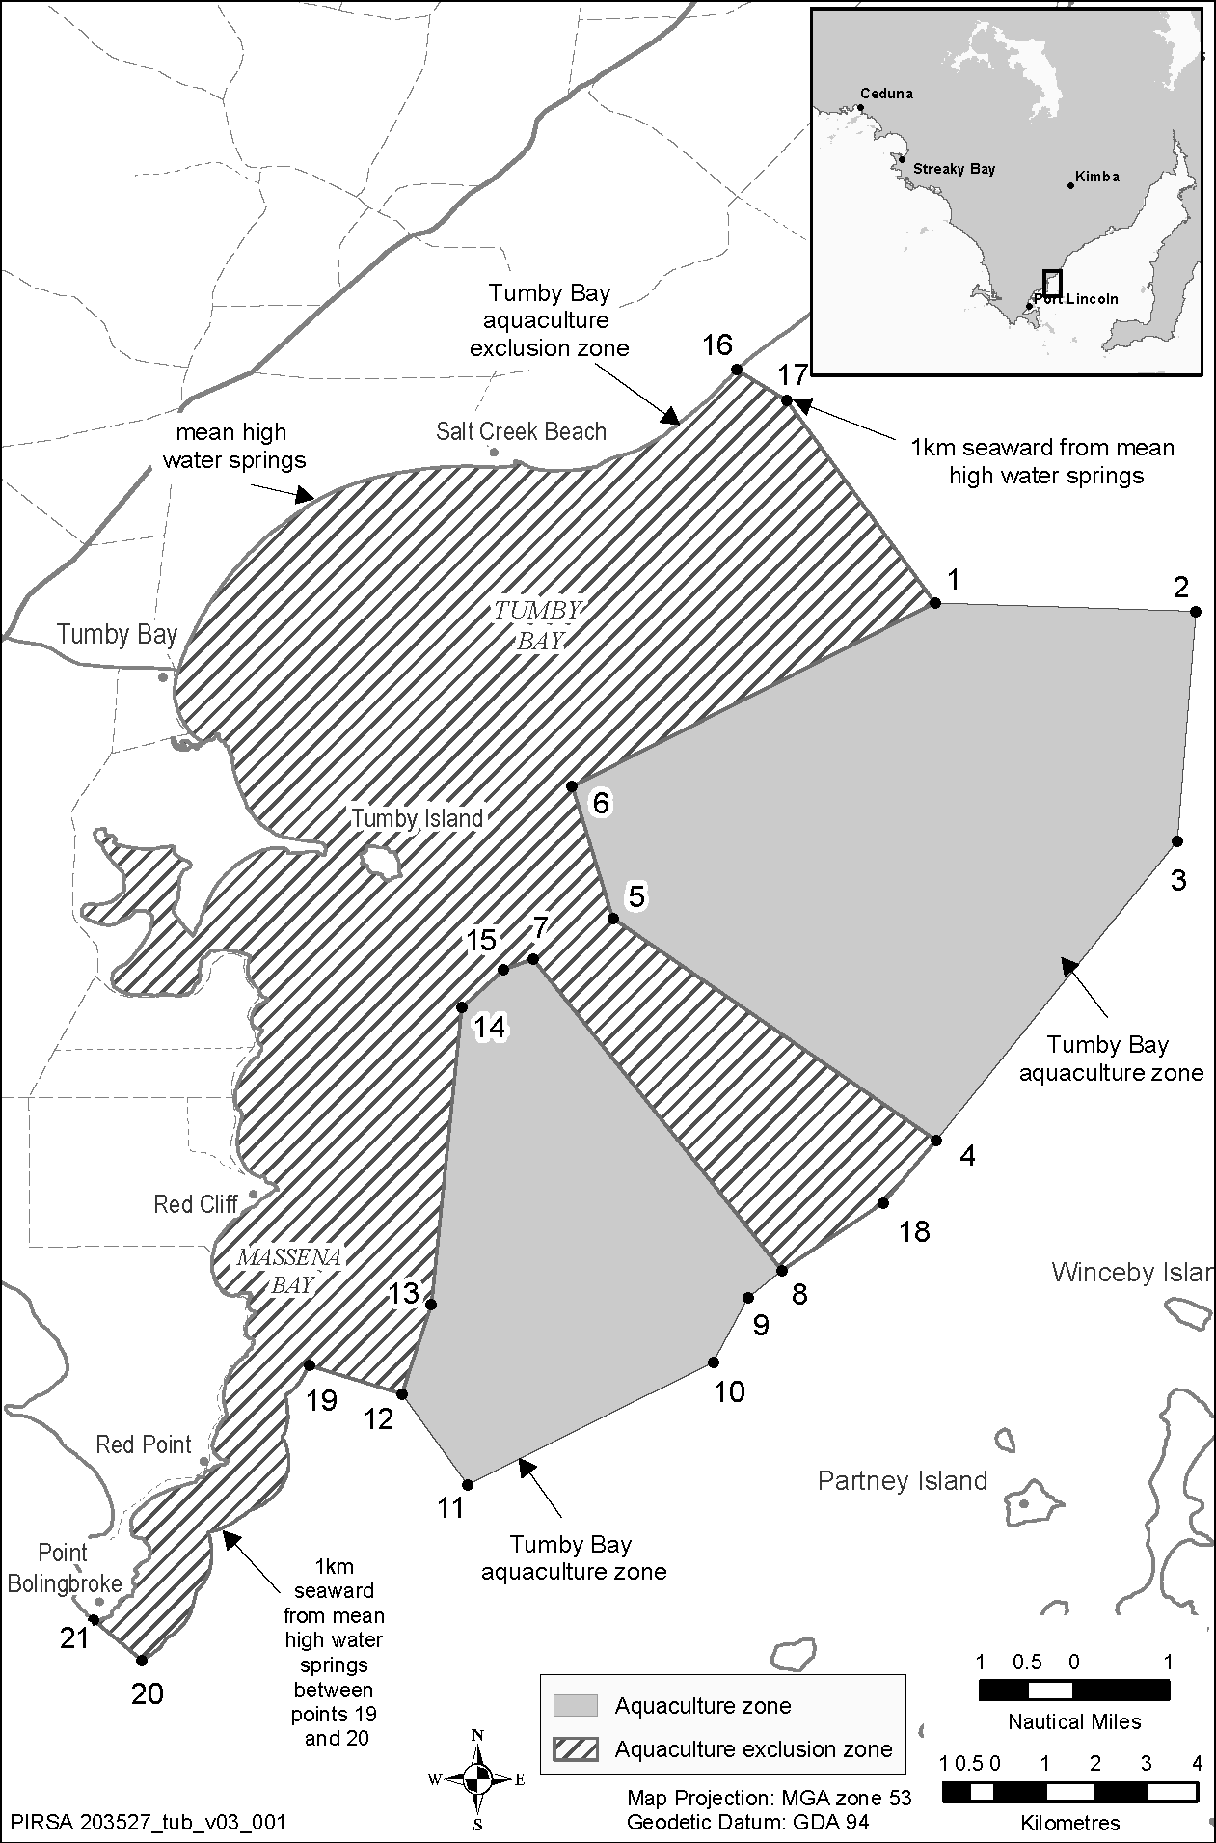

HOUSING IMPROVEMENT ACT 1940
NOTICE is hereby given that the South Australian Housing Trust Board Delegate in the exercise of the powers conferred by the Housing Improvement Act 1940, does hereby declare the houses described in the table hereunder to be substandard for the purposes of Part 7 of the Housing Improvement Act 1940.

No. of House and Street | Locality | Allotment, Section, etc. | Certificate of Title  Volume Folio
90 Henry Street | West Croydon, S.A. 5008 | Allotment 102 in Deposited Plan 1987, Hundred of Yatala | 5728 | 27
Lot 3, Old Port Wakefield Road | Virginia, S.A. 5120 | Allotment 3 in Deposited Plan 5816, Hundred of Munno Para | 5635 | 440
96 Mead Street, | Birkenhead, S.A. 5015 | Allotment 5 in Filed Plan 3887, Hundred of Port Adelaide | 5825 | 96
Dated at Adelaide, 10 September 2015. P. Reardon, Director, Property and Contract Management, Housing SA (Delegate SAHT)

HOUSING IMPROVEMENT ACT 1940
WHEREAS by notice published in the Government Gazette on the dates mentioned in the following table, the South Australian Housing Trust Board Delegate did declare the houses described in the said table to be substandard for the purposes of Part 7 of the Housing Improvement Act 1940, the South Australian Housing Trust Board Delegate in the exercise of the powers conferred by the said Part, does hereby fix as the maximum rental per week which shall be payable subject to Section 55 of the Residential Tenancies Act 1995, in respect of each house described in the following table the amount shown in the said table opposite the description of such house and this notice shall come into force on the date of this publication in the Gazette.

Address of House | Allotment, Section, etc. | Certificate of Title  Volume Folio |  | Date and page of Government Gazette in which notice declaring house to be substandard published | Maximum rental per week  payable in respect of each house  $
1/40 Hughes Street, Mile End, S.A. 5031 | Allotment 3 in Filed Plan 5971, Hundred of Adelaide | 5786 | 301 | 16.7.2015, page 3449 | 157.00
58 Venn Avenue, Bordertown, S.A. 5268 | Allotment 366 in Filed Plan 204702, Hundred of Tatiara | 5705 | 426 | 16.7.2015, page 3449 | 89.00
16 Robertson Street, Moana, S.A. 5169 | Allotment 132 in Deposited Plan 3752, Hundred of Willunga | 5358 | 596 | 16.7.2015, page 3449 | 130.00
Dated at Adelaide, 10 September 2015. P. Reardon, Director, Property and Contract Management, Housing SA (Delegate SAHT)

HOUSING IMPROVEMENT ACT 1940
WHEREAS by notice published in the Government Gazette on the dates mentioned in the following table, the South Australian Housing Trust Board Delegate did declare the houses described in the said table to be substandard for the purposes of Part 7 of the Housing Improvement Act 1940, and whereas the South Australian Housing Trust Board Delegate is satisfied that each of the houses described hereunder has ceased to be substandard, notice is hereby given that, in exercise of the powers conferred by the said Part, the South Australian Housing Trust does hereby revoke the said declaration in respect of each house.

Address of House | Allotment, Section, etc. | Certificate of Title  Volume Folio |  | Date and page of Government Gazette in which notice declaring house to be substandard published
6 Pepper Street, Magill, S.A. 5072 | Allotment 28 in Deposited Plan 85706, Hundred of Adelaide | 5265  6092 | 329  754 | 24.8.95, page 508
1/395 King William Street, Adelaide, S.A. 5000 (Upstairs Flat) | Allotment 325 in Filed Plan 182787, Hundred of Adelaide | 4396  5541 | 39  179 | 30.11.95, page 1513
15 Johnston Road, Elizabeth Downs, S.A. 5113 | Allotment 238 in Deposited Plan 7072, Hundred of Munno Para | 5552 | 833 | 21.5.2014, page 2165
Dated at Adelaide, 10 September 2015. P. Reardon, Director, Property and Contract Management, Housing SA (Delegate SAHT)

South Australia
Motor Vehicles (Accident Towing Roster Scheme) Zones Notice 2015
under Regulation 5 of the Motor Vehicles (Accident Towing Roster Scheme) Regulations 2015.
1—Short title
This Notice may be cited as the Motor Vehicles (Accident Towing Roster Scheme) Zones Notice 2015.
2—Commencement
This Notice will come into operation at 0001 hours on 14 October 2015.
3—Interpretation
In this Notice:
declared area means the areas specified in Schedule 1 to the Motor Vehicles (Accident Towing Roster Scheme) Regulations 2015;
Regulations means the Motor Vehicles (Accident Towing Roster Scheme) Regulations 2015.
4—Revocation
The notices dated 17 August 1993 published in the Gazette on 26 August 1993 (pages 969—986), 19 June 1999 published in the Gazette on 24 June 1999 (pages 3159-3161), 18 February 2000 published in the Gazette on 2 March 2000 (pages 1249-1252) and all other previous notices made for the purposes of dividing the declared area into zones for general accident towing and heavy vehicle accident towing are revoked.
5—Declaration
Pursuant to Regulation 5 (a) of the Regulations, made under the Motor Vehicles Act 1959,
I, Stephen Campbell Mullighan, the Minister for Transport and Infrastructure, declare that the declared area is divided into the following zones:
• 15 zones for the purpose of general accident towing as detailed in Annexure A of this Notice; and
• single zone for the purpose of heavy vehicle accident towing being the whole of the declared area.
6—Authorisation

HON STEPHEN MULLIGHAN MP
MINISTER FOR TRANSPORT AND INFRASTRUCTURE
4 September 2015

ANNEXURE A
Zone 1
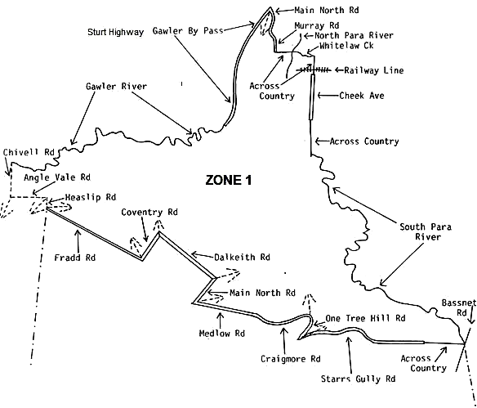
Zone 1
From—Chivell Road, Angle Vale and Gawler River, south to Angle Vale Road, Angle Vale, east to Heaslip Road, Angle Vale, south to Fradd Road, Angle Vale, south-east to Coventry Road, Munno Para West, north-east to Dalkeith Road, Munno Para, south-east to Main North Road, Munno Para, south-west to Medlow Road, Munno Para, follow east to Craigmore Road, Yattalunga, east to One Tree Hill Road, south to Starrs Gully Road, follow north–east and east till end and then east across country to where South Para River and Bassnet Road cross, follow river north and north-west to a point directly in line with the southern most point of Cheek Avenue, gAWLER EAST, north across country to Cheek Avenue, GAWLER EAST, north to railway line, north across country to Whitelaw Creek, follow west to North Para River, due west across country to Murray Road, HEWETT, north to Main North Road, Willaston, north to Sturt Highway (Gawler Bypass), Gawler Belt, follow Bypass south-west and south to Gawler River, follow river west to Chivell Road, Angle Vale.

Zone 2
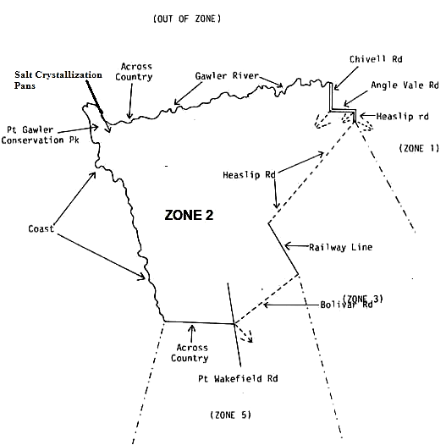

Zone 2
From—Chivell Road, Angle Vale and Gawler River, south to Angle Vale Road, Angle Vale, east to Heaslip Road, Angle Vale, south-west to railway line, south-east to Bolivar Road, Direk, south-west to Port Wakefield Road, Bolivar, west across country to the coast, follow north-west to Port Gawler Conservation Park, east across Salt Crystallization Pans, north-east across country to Gawler River, follow river east to Chivell Road, Angle Vale.

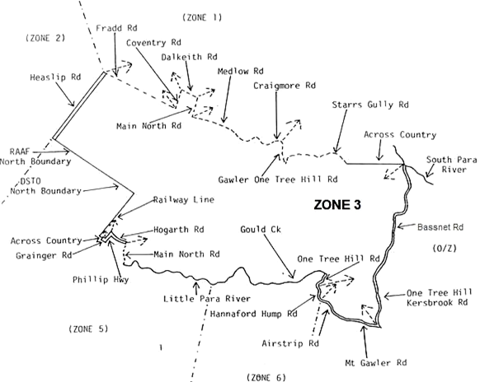
Zone 3

Zone 3
From—Heaslip and Fradd Road, Angle Vale, south-east along Fradd Road to Coventry Road, MUNNO PARA WEST, north-east to Dalkeith Road, MUNNO PARA, south-east to Main North Road, Munno Para, south-west to Medlow Road, MUNNO PARA, east to Craigmore Road, Yattalunga, follow east to One Tree Hill Road, south to Starrs Gully Road, follow north-east and east till end and then east across country to where South Para River and Bassnet Road cross, south along Bassnet Road, to Kersbrook Road, south-west to Mount Gawler Road, south-west to Airstrip Road, west to Hannaford Hump Road, north-west to One Tree Hill Road, north to Gould Creek, follow creek west through Little Para Reservoir, to Little Para River, follow river west to Main North Road, Hillbank, follow north to Hogarth Road, ELIZABETH VALE, follow west and north-west to Philip Highway, ELIZABETH SOUTH, follow south to Grainger Road, ELIZABETH SOUTH, follow west till end across Kettering Road, and west across country to railway line, follow line north-east to a point directly in line with the northern boundary of the Defence Science and Technology Organisation, north-west across country to the northern boundary of the Defence Science and Technology Organisation, follow boundary north-west to the northern boundary of the EDINBURGH RAAF base, follow boundary north-west till end and across country directly in line with boundary to Heaslip Road, PENFIELD, follow north-east to Fradd Road, ANGLE VALE.
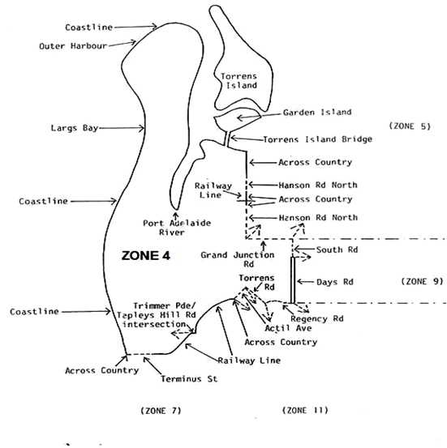
Zone 4

Zone 4
From—western end of Terminus Street, GRANGE, east to Railway Line, east and north-east to the intersection of Trimmer Parade and Tapleys Hill Road, SEATON, including the whole of the intersection then to the continuation of the Railway Line and follow north-east to a point in line with the southern most point of Actil Avenue, ST CLAIR, north across country to Actil Avenue, ST CLAIR, north-east to Torrens Road, WOODVILLE NORTH, south-east to Regency Road, KILKENNY, north-east and east to Days Road, FERRYDEN PARK, north to South Road, REGENCY PARK, north to Grand Junction Road, ANGLE VALE, west to Hanson Road North, WINGFIELD, north till end and across country and across railway line to the continuation of Hanson Road North, WINGFIELD, north till end, north across country to coast follow coast west to Outer Harbour, follow coast south to a point in line with Terminus Street, GRANGE, east across country to Terminus Street, GRANGE.

Annex to Zone 4 Description
From—the southern commencement of the Torrens Island Bridge, north to Torrens Island and encompassing the whole of Torrens Island and Garden Island.
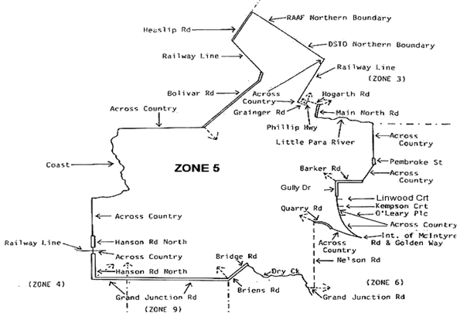
Zone 5
Zone 5
From—junction of Bolivar Road and Port Wakefield Road, BOLIVAR, follow Bolivar Road north-east to railway line, follow line north-west to Heaslip Road, PENFIELD, north-east to a point directly in line with the northern most boundary of the Edinburgh RAAF Base, follow boundary south-east to the northern most boundary of the Defence Science and Technology Organisation, follow south-east till end and south-east across country to the railway line, follow railway line south-west to a point directly in line with Grainger Road, ELIZABETH SOUTH, east across country and across Kettering Road, to Grainger Road, ELIZABETH SOUTH, south-east to Philip Highway, ELIZABETH SOUTH, north-east to Hogarth Road, ELIZABETH SOUTH, south-east and east to Main North Road, ELIZABETH GROVE, south to Little Para River, follow river east to a point directly in line with the northern most point of Pembroke Street, SALISBURY HEIGHTS, south across country and across Coomurra Drive, to the junction of Target Hill Road and Pembroke Street, SALISBURY HEIGHTS, follow Pembroke Street south to end and south across Immanuel Drive and across country to the eastern junction of Harvey Crescent and Green Valley Drive, SALISBURY HEIGHTS, south-west across country and across The Grove Way to the eastern most point of Barker Road, GULFVIEW HEIGHTS, follow west to Gully Drive, GULFVIEW HEIGHTS, follow south to end, south across country and across Wynn Vale Drive, to the western most point of Linwood Court, WYNN VALE, south across country to the western most point of Kempson Court, south across country to the western most point of O’Leary Place, south across country to the intersection of McIntyre Road and the Golden Way, north-west across country to the eastern most end of Quarry Road, GULFVIEW HEIGHTS, follow north-west and west to Nelson Road, PARA HILLS, south to Grand Junction Road, VALLEY VIEW, west to Dry Creek, VALLEY VIEW, follow creek north-west and west to Bridge Road, WALKLEY HEIGHTS, south-west to Briens Road, NORTHFIELD, south-west to Grand Junction Road, NORTHFIELD, west to Hanson Road, WINGFIELD, north till end and across country and across railway line to the continuation of Hanson Road North, WINGFIELD, north till end and north across country to coast, follow coast north to a point in line with the junction of Bolivar and Port Wakefield Roads, BOLIVAR, east across SALT CRYSTALLIZATION PANS, east across country to BOLIVAR and Port Wakefield Roads, BOLIVAR.

Zone 6
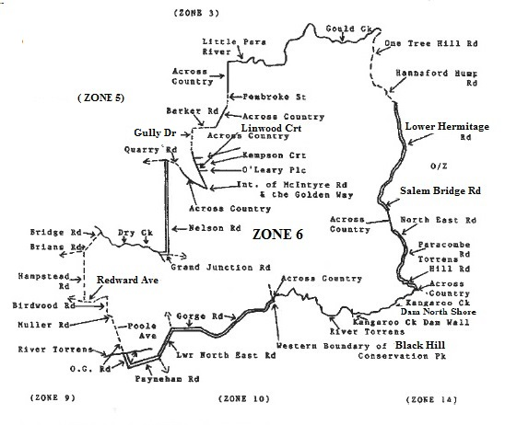
Zone 6
From—junction of Barker Road and Gully Drive, GULFVIEW HEIGHTS, south along Gully Drive till its end, south across country and across Wynn Vale Drive, to the western most point of Linwood Court, WYNN VALE, south across country to the western most point of Kempson Court, south across country to the western most point of O’Leary Place, south across country to the intersection of McIntyre Road and The Golden Way, north-west across country to the eastern most end of Quarry Road, GULFVIEW HEIGHTS, follow north-west and west to Nelson Road, PARA HILLS, south to Grand Junction Road, VALLEY VIEW, west to Dry Creek, VALLEY VIEW, follow creek north-west and west to Bridge Road, WALKLEY HEIGHTS, south-west to Hampstead Road, NORTHFIELD south to Redward Avenue, GREENACRES, east to Birdwood Road, GREENACRES, south across Muller Road to Poole Avenue, HAMPSTEAD GARDENS, south-east to O.G. Road, KLEMZIG, south to Payneham Road, PAYNEHAM, north-east to Lower North East Road, CAMPBELLTOWN, north east to Gorge Road, CAMPBELLTOWN, follow Gorge Road east and north east to a point in line with the north-western most point of Black Hill Conservation Park, north across country to River Torrens, ATHELSTONE, follow river east to Kangaroo Creek Dam Wall, follow northern shore of Kangaroo Creek Dam, north-east to a point in line with the intersection of Torrens Hill Road and Gorge Road, PARACOMBE, west across country to Torrens Hill Road, north and north-west to Paracombe Road, north to North East Road, north-west to the junction of Blackhill Road, north-west across country to Salem Bridge Road, north-west to Lower Hermitage Road, north to Hannaford Hump Road, north to One Tree Hill Road, north to Gould Creek, follow creek west through Little Para Reservoir, to Little Para River, follow river west to a point in line with the northern most point of Pembroke Street, SALISBURY HEIGHTS, south across country to the northern most point of PEMBROKE STREET, follow Pembroke Street south to end and south across Immanuel Drive, south across country to the eastern junction of Harvey Crescent and Green Valley Drive, south-west across country and across The Grove Way, to the eastern most point of Barker Road, GULFVIEW HEIGHTS, west to Gully Drive, GULFVIEW HEIGHTS.

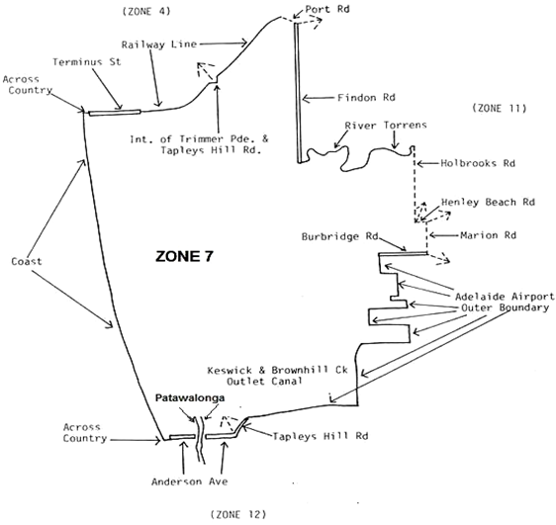
Zone 7

Zone 7
From—the coast at a point in line with Terminus Street, GRANGE, east across country to Terminus Street, GRANGE, east to railway line, follow line east and north-east to the intersection of Trimmer Parade and Tapleys Hill Road, SEATON, excluding the whole of the intersection then to the continuation of the railway line and follow north-east to Port Road, WOODVILLE WEST, follow south-east to Findon Road, WOODVILLE WEST, south to River Torrens, follow river east to Holbrooks Road, UNDERDALE, south to Henley Beach Road, BROOKLYN PARK, east to Marion Road, BROOKLYN PARK, south to Burbridge Road, BROOKLYN PARK, west to a point directly in line with the Adelaide Airport Boundary, adjacent to Clifford Street, BROOKLYN PARK, follow Airport outer boundary south, east, south, west, south, east, south, west, south, east, south, west, south, west to Keswick and Brownhill Creek Outlet Canal at a point in line with Morphett Road, NORTH PLYMPTON, follow canal south-west to Tapleys Hill Road, GLENELG NORTH, south-west to Anderson Avenue, GLENELG NORTH, west across the Patawalonga till end and west across country to the coast, follow coast north to a point in line with Terminus Street, GRANGE.

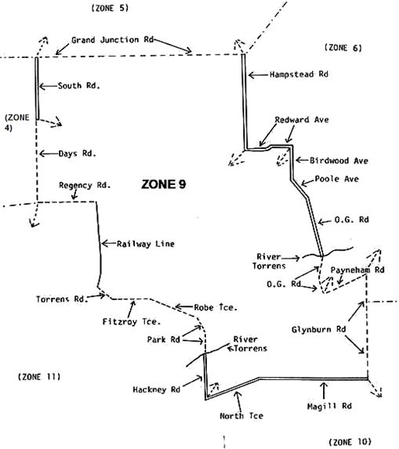
Zone 9

Zone 9
From—South Road and Grand Junction Road, REGENCY PARK, follow Grand Junction Road east to Hampstead Road, NORTHFIELD, south to Redward Avenue, GREENACRES, east to Birdwood Avenue, GREENACRES, south across Muller Road to Poole Avenue, HAMPSTEAD GARDENS, south across North East Road to O.G. Road, KLEMZIG, south to Payneham Road, PAYNEHAM, north-east to Glynburn Road, GLYNDE, south to Magill Road, ST MORRIS, west to North Terrace, KENT TOWN, south-west to Hackney Road, HACKNEY, north-west to Park Road, GILBERTON, north-west to Robe Terrace, MEDINDIE, north-west to Fitzroy Terrace, FITZROY, west to Torrens Road, OVINGHAM, north-west to railway line, north to Regency Road, DUDLEY PARK, west to Days Road, REGENCY PARK, north to South Road, REGENCY PARK, north to Grand Junction Road, REGENCY PARK.

Zone 10
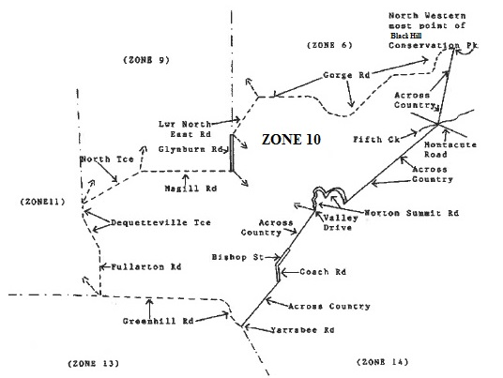

Zone 10
From—North Terrace and Dequetteville Terrace, KENT TOWN, follow Dequetteville Terrace, south-east to Fullarton Road, ROSE PARK, south to Greenhill Road, DULWICH, follow Greenhill Road east and south-east to a point in line with the western end of Yarrabee Road, GREENHILL, north-east across country Whitbread Grove and Coach Road, SKYE, junction, follow Coach Road north-west and north to Bishop Street, SKYE, north until end, then north-east across country across Old Norton Summit Road, and Woodland Way, to the intersection of Norton Summit Road and Valley Drive, TERINGIE, north, south-east, north and south-east along Norton Summit Road, past Morialta Falls Reserve, to a point in line with the eastern end of Woodland Way, TERINGIE, north-east across Morialta Falls Reserve, to where Montacute Road and Fifth Creek join, north west across country across BLACK HILL CONSERVATION PARK to Gorge Road, ATHELSTONE, to a point in line with the north western most point of BLACK HILL CONSERVATION PARK follow Gorge Road south west and west to Lower North East Road, CAMPBELLTOWN, south west to Glynburn Road, HECTORVILLE, south to Magill Road, ST MORRIS, west to North Terrace, KENT TOWN, south-west to Dequetteville Terrace, KENT TOWN.

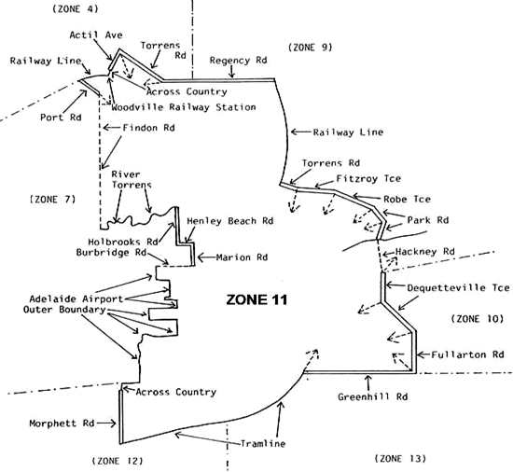
Zone 11

Zone 11
From—the junction of Actil Avenue and Torrens Road, WOODVILLE NORTH, follow Torrens Road, south-east to Regency Road, KILKENNY, north-east and east to railway line, follow line south to Torrens Road, OVINGHAM, south-west to Fitzroy Terrace, FITZROY, east to Robe Terrace, MEDINDIE, south-east to Park Road, GILBERTON, south-east and south to Hackney Road, HACKNEY, south to Dequetteville Terrace, KENT TOWN, south and south-east to Fullarton Road, ROSE PARK, south to Greenhill Road, EASTWOOD, west to tramline, follow line south-west to Morphett Road, NORTH PLYMPTON, north till end and north across country to Keswick and Brownhill Creek Outlet Canal and the Adelaide Airport Outer Boundary, then follow Adelaide Airport Outer Boundary east, north, east, north, east, north, west, north, east, north, west, north, east, north, east and north to Burbridge Road, BROOKLYN PARK, east to Marion Road, BROOKLYN PARK, north to Henley Beach Road, BROOKLYN PARK, west to Holbrooks Road, UNDERDALE, north to River Torrens, follow river west to Findon Road, KIDMAN PARK, north to Port Road, WOODVILLE WEST, north-east to railway line, follow east to a point in line with the southern end of Actil Avenue south, ST CLAIR, north across country to Actil Avenue south, ST CLAIR, north-east to Torrens Road, WOODVILLE NORTH.

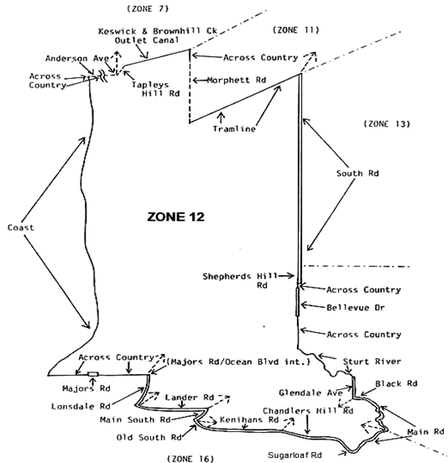
Zone 12

Zone 12
From—the coast at a point in line with the western end of Anderson Avenue, GLENELG NORTH, east across country to Anderson Avenue, GLENELG NORTH, east across the Patawalonga to Tapleys Hill Road, GLENELG NORTH, north-east to KESWICK and Brownhill Creek Outlet Canal, follow north-east to a point in line with Morphett Road, NORTH PLYMPTON, south across country to Morphett Road, North Plympton, south to tramway line, MORPHETTVILLE, north-east to South Road, GLANDORE, south to Shepherds Hill Road, BEDFORD PARK, south across overpass, across country to Bellevue Drive, BELLEVUE HEIGHTS, south across country and across Eve Road, BELLEVUE HEIGHTS, to Sturt River, follow south-east to a point in line with the western most point of Glendale Avenue, ABERFOYLE PARK, south-east to Black Road, FLAGSTAFF HILL, east to Main Road, COROMANDEL VALLEY, south-east and south to Sugarloaf Road, HAPPY VALLEY, west to Chandlers Hill Road, ABERFOYLE PARK, west and north-west to Kenihans Road, HAPPY VALLEY, west to Old South Road, HAPPY VALLEY, north-west to Main South Road, HAPPY VALLEY, north-east to Lander Road, O’HALLORAN HILL, west and north-west to Lonsdale Road, TROTT PARK, north-east and north to Majors Road, TROTT PARK, west across country to Majors Road, MARINO, due west across country across The Cove Road to the coast at a point in line with Majors Road, then follow coastline north to a point in line with Anderson Avenue, GLENELG NORTH.

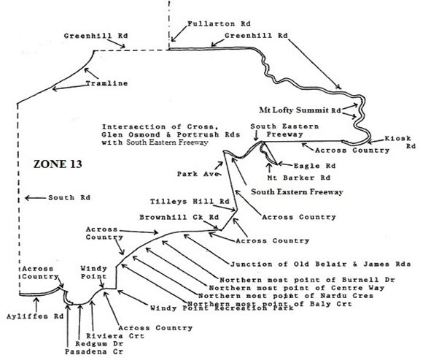
Zone 13

Zone 13
From—the junction of tramline and Greenhill Road, UNLEY, follow Greenhill Road, east and south-east to Mt Lofty Summit Road, SUMMERTOWN, south to Kiosk Road, west to Cleland Conservation Park Kiosk, then south-west across country to the northern most point of the South Eastern Freeway up-track at the north eastern end of the DEVILS ELBOW INTERCHANGE fly over, south west across the South Eastern Freeway following the north eastern end of the DEVILS ELBOW INTERCHANGE fly over to the southern most point of the South Eastern Freeway down track, south east across country to the south eastern most point of Eagle Road, LEAWOOD GARDENS at its junction with Mount Barker Road, follow Mount Barker Road north-west to where it joins the South Eastern Freeway at the DEVILS ELBOW INTERCHANGE, follow South Eastern Freeway south west and north west to its junction with Glen Osmond Road, Portrush Road and Cross Road, south east across country to the eastern most point of Park Avenue, URRBRAE, south-east across country to the eastern most point of Tilleys Hill Road, BELAIR, south-west across country to the southern most point of Brownhill Creek Road, BELAIR, west across country to the junction of Old Belair and James Road, BELAIR, west across country to the northern most point of Burnell Drive, BELAIR, south-west across country to the northern most point of Centre Way, BELAIR, south-west across country to the northern most point of Nardu Crescent, BELAIR, south-west across country to the northern end of Baly Court, south across country to Windy Point Recreation Park, BELAIR, west through park to Windy Point, BELAIR, south-west across country to the southern most point of Riviera Court, PASADENA, west across country to the southern most point of Redgum Drive, PASADENA, north-west across country to Pasadena Crescent, PASADENA, north to Redgum Drive, PASADENA, north-west across country to Ayliffes Road, ST MARYS, west to South Road, ST MARYS, north to tramline, follow line north-east to Greenhill Road, UNLEY.

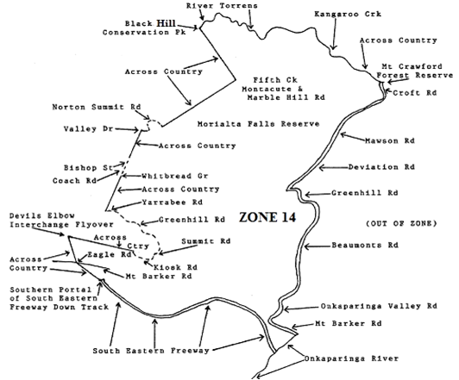
Zone 14

Zone 14
From—the Kangaroo Creek Reservoir Dam Wall, north-west along the River Torrens, to a point in line with the western most boundary of Black Hill Conservation Park, south-east across country to where Montacute and Marble Hill Road, Montacute and Fifth Creek join, south-west across country through Morialta Falls Reserve to Norton Summit Road, TERINGIE, at a point in line with the eastern most point of Woodland Way, TERINGIE, follow Norton Summit Road, TERINGIE, west, south-west and south to Valley Drive, TERINGIE, south-west across country and across Woodland Way and across Old Norton Summit Road, to the northern most end of Bishop Street, SKYE, south to Coach Road, SKYE, south to Whitbread Grove, SKYE, south-west across country to Greenhill Road, GREENHILL, at a point in line with the western end of Yarrabee Road, GREENHILL, follow Greenhill Road east to Summit Road, SUMMERTOWN, south to Kiosk Road, west leading into Cleland Conservation Park, follow west to Kiosk, then south-west across country to the northern most point of the South Eastern Freeway up-track at the north eastern end of the DEVILS ELBOW INTERCHANGE fly over, south west across the South Eastern Freeway following the north eastern end of the DEVILS ELBOW INTERCHANGE flyover to the southern most point of the South Eastern Freeway down track, south east across country to the south eastern most point of Eagle Road, LEAWOOD GARDENS, at its junction with Mount Barker Road, south across Mount Barker Road and south-east across country to the South Eastern Freeway, at the southern portal of the down track TUNNEL (and including the SOUTH EASTERN FREEWAY tunnels), follow the South Eastern Freeway south-east to Onkaparinga River, follow river north to Mount Barker Road, VERDUN, north-west to Onkaparinga Valley Road, VERDUN, north-east to Beaumonts Road, VERDUN, north to Greenhill Road, VERDUN, north-west to Deviation Road, CAREY GULLY, north-east to Mawson Road, north and north-east to Croft Road, north to boundary of Mount Crawford Forest Reserve, north-west across country to start of Kangaroo Creek, follow creek north-west through Kangaroo Creek Reservoir to the Kangaroo Creek Reservoir Dam Wall.

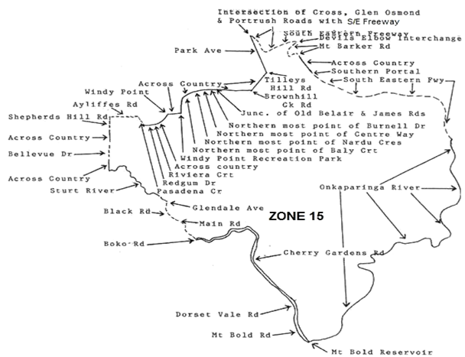
Zone 15

Zone 15
From—the junction of Shepherds Hill Road and South Road, ST MARYS, south along Shepherds Hill Road, to Sturt Road, BELLEVUE HEIGHTS, south across country to Bellevue Drive, BELLEVUE HEIGHTS, south till its end then across country to Sturt River, follow river south-east to a point in line with the western most point of Glendale Avenue, ABERFOYLE PARK, south-east to Black Road, ABERFOYLE PARK, east to Main Road, COROMANDEL VALLEY, south-east to Boko Road, COROMANDEL VALLEY, east to Cherry Gardens Road, COROMANDEL VALLEY, south-east and north-east to Dorset Vale Road, CHERRY GARDENS, south-east to the commencement of the unsealed section of Mount Bold Road, follow south to the junction of Scenic Road, ECHUNGA, and follow un-named and unsealed road south to Mount Bold Reservoir, follow northern shore east and north-east to Onkaparinga River, follow river north-east to South Eastern Freeway, VERDUN, follow Freeway north-west to the southern portal of the South Eastern Freeway down track TUNNEL, north west across country to Mount Barker Road, LEAWOOD GARDENS, at a point in line with the south eastern end of Eagle Road, follow Mount Barker Road, north west to its junction with the South Eastern Freeway at the DEVILS ELBOW INTERCHANGE, follow South Eastern Freeway south west and north west to its junction with Cross Road, Portrush Road and Glen Osmond Road, south east across country to the eastern most point of Park Avenue, URRBRAE, south-east across country to the eastern most point of Tilleys Hill Road, BELAIR, south-west across country to the southern most point of Brownhill Creek Road, BELAIR, west across country to the junction of Old Belair Road and James Road, BELAIR, west across country to Burnell Drive, BELAIR, south-west across country to western most point of Centre Way, BELAIR, south-west across country to the western most point of Nardu Crescent, BELAIR, south-west across country to the northern end of Baly Court, south across country to Windy Point Recreation Park, BELAIR, south west across country to the southern most point of Riviera Court, PASADENA, west across country to the southern most point of Redgum Drive, west across country to Pasadena Crescent, PASADENA, north to Redgum Road, PASADENA, north to Ayliffes Road, ST MARYS, west to Shepherds Hill Road, ST MARYS.
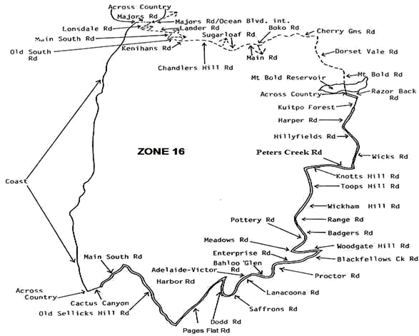
Zone 16

Zone 16
From—the coast at a point in line with the western end of Majors Road, MARINO, east across country to Majors Road, MARINO, east across country to the intersection of Ocean Boulevard, Majors Road and Lonsdale Road, follow Lonsdale Road, TROTT PARK, south-west to Lander Road, TROTT PARK, east to Main South Road, O’HALLORAN HILL, south-west to Old South Road, HAPPY VALLEY, south-east to Kenihans Road, HAPPY VALLEY, east to Chandlers Hill Road, HAPPY VALLEY, east to Sugar Loaf Road, HAPPY VALLEY, north-east to Main Road, COROMANDEL VALLEY, north-east to Boko Road, east to Cherry Gardens Road, east and north-east to Dorset Vale Road, ECHUNGA, south-east to the commencement of the unsealed section of Mount Bold Road, ECHUNGA, follow south to the junction of Scenic Road, ECHUNGA, and follow unnamed and unsealed road south to Mount Bold Reservoir, south across reservoir and across country to Razor Back Road, east to commencement of Kuitpo Forest, follow boundary of Kuitpo Forest south-west to Harper Road, south-west to Hillyfields Road, south-east to Wicks Road, follow to Peters Creek Road, north-west to Knotts Hill Road, west to Toops Hill Road, south to Wickham Hill Road, to Range Road, south to Badgers Road, south-east and south-west to Pottery Road, south to Meadows Road, east to Woodgate Hill Road, east to Blackfellows Creek Road, south-west to Enterprise Road, west to Proctor Road, south to Bahloo Glen Road, follow west to Adelaide to Victor Harbor Road, north-west to Lanacoona Road, south-west to Saffrons Road, north-west to Dodd Road, north to Pages Flat Road, south-west to Old Sellicks Hill Road, north and north west to Main South Road, south-west to Cactus Canyon Road, north-west across country to the coast, follow coast north to a point in line with the western end of Majors Road, MARINO.

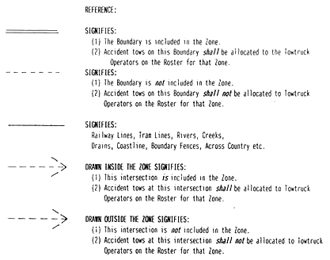
Petroleum and Geothermal Energy Act 2000
Grant of Associated Activities Licence—AAL 232
(Adjunct to Petroleum Exploration Licence PEL 156)
NOTICE is hereby given that the undermentioned Associated Activities Licence has been granted with effect from 1 September 2015, under the provisions of the Petroleum and Geothermal Energy Act 2000, pursuant to delegated powers dated 21 March 2012.
No. of  Licence | Licensees | Locality | Reference
AAL 232 | Vamgas Pty Ltd  Santos Ltd  Delhi Petroleum Pty Ltd  Origin Energy Resources Ltd  Santos (NARNL Cooper) Pty Ltd | Cooper Basin | F2015/000418

Description of Area
All that part of the State of South Australia, bounded as follows:
Commencing at a point being the intersection of latitude 27°14′20″S GDA94 and longitude 140°33′25″E GDA94, thence east to longitude 140°41′15″E GDA94, south to latitude 27°21′10″S GDA94, west to longitude 140°33′25″E GDA94, and north to the point of commencement.
Area: 162.98 km² approximately.
Dated 1 September 2015.
B. A. Goldstein,
Executive Director,
Energy Resources Division,
Department of State Development,
Delegate of the Minister for Mineral Resources and Energy

GOVERNMENT GAZETTE ADVERTISEMENT RATES

To apply from 1 July 2015

$  Agents, Ceasing to Act as 51.00  Associations:  Incorporation 26.00  Intention of Incorporation 64.00  Transfer of Properties 64.00  Attorney, Appointment of 51.00  Bailiff’s Sale 64.00  Cemetery Curator Appointed 37.75  Companies:  Alteration to Constitution 51.00  Capital, Increase or Decrease of 64.00  Ceasing to Carry on Business 37.75  Declaration of Dividend 37.75  Incorporation 51.00  Lost Share Certificates:  First Name 37.75  Each Subsequent Name 13.00  Meeting Final 42.50  Meeting Final Regarding Liquidator’s Report on  Conduct of Winding Up (equivalent to ‘Final  Meeting’)  First Name 51.00  Each Subsequent Name 13.00  Notices:  Call 64.00  Change of Name 26.00  Creditors 51.00  Creditors Compromise of Arrangement 51.00  Creditors (extraordinary resolution that ‘the Com-pany be wound up voluntarily and that a liquidator be appointed’) 64.00  Release of Liquidator⎯Application⎯Large Ad. 101.00  ⎯Release Granted 64.00  Receiver and Manager Appointed 58.50  Receiver and Manager Ceasing to Act 51.00  Restored Name 47.75  Petition to Supreme Court for Winding Up 88.50  Summons in Action 75.50  Order of Supreme Court for Winding Up Action 51.00  Register of Interests⎯Section 84 (1) Exempt 114.00  Removal of Office 26.00  Proof of Debts 51.00  Sales of Shares and Forfeiture 51.00  Estates:  Assigned 37.75  Deceased Persons⎯Notice to Creditors, etc. 64.00  Each Subsequent Name 13.00  Deceased Persons⎯Closed Estates 37.75  Each Subsequent Estate 1.70  Probate, Selling of 51.00  Public Trustee, each Estate 13.00 |  | $  Firms:  Ceasing to Carry on Business (each insertion) 33.75  Discontinuance Place of Business 33.75  Land⎯Real Property Act:  Intention to Sell, Notice of 64.00  Lost Certificate of Title Notices 64.00  Cancellation, Notice of (Strata Plan) 64.00  Mortgages:  Caveat Lodgement 26.00  Discharge of 27.25  Foreclosures 26.00  Transfer of 26.00  Sublet 13.00  Leases⎯Application for Transfer (2 insertions) each 13.00  Lost Treasury Receipts (3 insertions) each 37.75  Licensing 75.50  Municipal or District Councils:  Annual Financial Statement⎯Forms 1 and 2 712.00  Electricity Supply⎯Forms 19 and 20 506.00  Default in Payment of Rates:  First Name 101.00  Each Subsequent Name 13.00  Noxious Trade 37.75  Partnership, Dissolution of 37.75  Petitions (small) 26.00  Registered Building Societies (from Registrar-General) 26.00  Register of Unclaimed Moneys⎯First Name 37.75  Each Subsequent Name 13.00  Registers of Members⎯Three pages and over:  Rate per page (in 8pt) 324.00  Rate per page (in 6pt) 428.00  Sale of Land by Public Auction 64.50  Advertisements 3.60  ¼ page advertisement 151.00  ½ page advertisement 302.00  Full page advertisement 591.00  Advertisements, other than those listed are charged at $3.60 per column line, tabular one-third extra.  Notices by Colleges, Universities, Corporations and District Councils to be charged at $3.60 per line.  Where the notice inserted varies significantly in length from that which is usually published a charge of $3.60 per column line will be applied in lieu of advertisement rates listed.  South Australian Government publications are sold on the condition that they will not be reproduced without prior permission from the Government Printer.
All the above prices include GST

GOVERNMENT GAZETTE NOTICES
Notices for publication in the South Australian Government Gazette should be emailed to governmentgazette@dpc.sa.gov.au. Content should be sent as Word format attachment(s). Covering emails should include the date the notice is to be published and to whom the notice will be charged. Closing time for lodgement is 4 p.m. on the Tuesday preceding the regular Thursday publication. Gazette enquiries to: Phone 8207 1045. The Government Gazette is available online at: www.governmentgazette.sa.gov.au.

MISCELLANEOUS LEGISLATION AND GOVERNMENT PUBLICATIONS PRICES AS FROM 1 JULY 2015

Acts, Bills, Rules, Parliamentary Papers and Regulations
Pages | Main | Amends | Pages | Main | Amends

1-16 | 3.20 | 1.50 | 497-512 | 43.00 | 42.00
17-32 | 4.10 | 2.55 | 513-528 | 44.25 | 42.75
33-48 | 5.45 | 3.85 | 529-544 | 45.75 | 44.25
49-64 | 6.85 | 5.30 | 545-560 | 47.25 | 45.75
65-80 | 7.95 | 6.60 | 561-576 | 48.25 | 47.25
81-96 | 9.30 | 7.70 | 577-592 | 50.00 | 47.75
97-112 | 10.60 | 9.05 | 593-608 | 51.00 | 49.25
113-128 | 11.80 | 10.50 | 609-624 | 52.50 | 51.00
129-144 | 13.20 | 11.70 | 625-640 | 53.50 | 52.00
145-160 | 14.60 | 13.00 | 641-656 | 55.00 | 53.50
161-176 | 15.80 | 14.30 | 657-672 | 56.00 | 54.00
177-192 | 17.20 | 15.60 | 673-688 | 57.50 | 56.00
193-208 | 18.60 | 17.10 | 689-704 | 58.50 | 56.50
209-224 | 19.60 | 18.10 | 705-720 | 60.00 | 58.00
225-240 | 20.90 | 19.40 | 721-736 | 61.50 | 59.00
241-257 | 22.50 | 20.50 | 737-752 | 62.00 | 60.50
258-272 | 23.80 | 21.70 | 753-768 | 64.00 | 61.50
273-288 | 24.90 | 23.60 | 769-784 | 65.00 | 64.00
289-304 | 26.25 | 24.50 | 785-800 | 66.00 | 65.00
305-320 | 27.75 | 26.00 | 801-816 | 67.50 | 65.50
321-336 | 28.75 | 27.25 | 817-832 | 69.00 | 67.50
337-352 | 30.25 | 28.50 | 833-848 | 70.50 | 69.00
353-368 | 31.00 | 30.00 | 849-864 | 72.00 | 70.00
369-384 | 32.75 | 31.00 | 865-880 | 73.50 | 72.00
385-400 | 34.25 | 32.50 | 881-896 | 74.00 | 72.50
401-416 | 35.50 | 33.50 | 897-912 | 75.50 | 74.00
417-432 | 37.00 | 35.25 | 913-928 | 76.00 | 75.50
433-448 | 38.00 | 36.75 | 929-944 | 77.50 | 76.00
449-464 | 39.00 | 37.50 | 945-960 | 78.50 | 77.00
465-480 | 39.50 | 38.75 | 961-976 | 82.00 | 78.00
481-496 | 42.00 | 39.50 | 977-992 | 83.00 | 78.50

Legislation—Acts, Regulations, etc.: $
Subscriptions:
Acts 265.00
All Bills as Laid 639.00
Rules and Regulations 639.00
Parliamentary Papers 639.00
Bound Acts 295.00
Index 148.00
Government Gazette
Copy 7.00
Subscription 353.00
Hansard
Copy 19.40
Subscription—per session (issued weekly) 552.00
Cloth bound—per volume 238.00
Subscription—per session (issued daily) 552.00
Legislation on Disk
Whole Database 4 099.00
Annual Subscription for fortnightly updates 1 260.00
Individual Act(s) including updates POA
Notice of Vacancies
Annual Subscription 200.00
Compendium
Subscriptions:
New Subscriptions 2 427.00
Updates 857.00
(All the above prices include GST)

Counter Sales Government Legislation Outlet
and Mail Orders: Service SA Customer Service Centre,
Ground Floor—EDS Centre, 108 North Terrace, Adelaide, S.A. 5000
Phone: 13 23 24 (local call cost), Fax: (08) 8204 1909
Postal: G.P.O. Box 1707, Adelaide, S.A. 5001

Online Shop: www.shop.service.sa.gov.au

Subscriptions and Government Publishing SA
Standing Orders: Plaza Level, Riverside Centre, North Terrace, Adelaide, S.A. 5000
Phone: (08) 8207 1043, (08) 8207 0908, Fax: (08) 8207 1040
Email: AdminGovPubSA@sa.gov.au

South Australia
Civil Liability (Disclosure of Information) Amendment Act (Commencement) Proclamation 2015
1—Short title
This proclamation may be cited as the Civil Liability (Disclosure of Information) Amendment Act (Commencement) Proclamation 2015.
2—Commencement of Act
The Civil Liability (Disclosure of Information) Amendment Act 2014 (No 19 of 2014) will come into operation on 2 October 2015.
Made by the Governor
with the advice and consent of the Executive Council
on 10 September 2015
AGO0108/15CS

South Australia
Administrative Arrangements (Administration of Occupational Health, Safety and Welfare Act) Proclamation 2015
under section 5 of the Administrative Arrangements Act 1994
1—Short title
This proclamation may be cited as the Administrative Arrangements (Administration of Occupational Health, Safety and Welfare Act) Proclamation 2015.
2—Commencement
This proclamation comes into operation on the day on which it is made.
3—Administration of Act committed to Attorney-General
The administration of the Occupational Health, Safety and Welfare Act 1986 is committed to the Attorney-General.
Made by the Governor
with the advice and consent of the Executive Council
on 10 September 2015

South Australia
Administrative Arrangements (Administration of Work Health and Safety Act) Proclamation 2015
under section 5 of the Administrative Arrangements Act 1994
1—Short title
This proclamation may be cited as the Administrative Arrangements (Administration of Work Health and Safety Act) Proclamation 2015.
2—Commencement
This proclamation comes into operation on the day on which it is made.
3—Administration of Act committed to Attorney-General
The administration of the Work Health and Safety Act 2012 is committed to the Attorney-General.
Made by the Governor
with the advice and consent of the Executive Council
on 10 September 2015

South Australia
Highways (Road Closure—Public Road, Coorabie) Proclamation 2015
under section 27AA of the Highways Act 1926
1—Short title
This proclamation may be cited as the Highways (Road Closure—Public Road, Coorabie) Proclamation 2015.
2—Commencement
This proclamation comes into operation on the day on which it is made.
3—Road closure
The portions of public road delineated as allotments 1 and 2 in approved Plan No F59564 lodged in the Lands Titles Registration Office are closed.
Made by the Governor
on the recommendation of the Commissioner of Highways and with the advice and consent of the Executive Council
on 10 September 2015
MTR/15/033

South Australia
Tobacco Products Regulation (Exemption—Mortido) Proclamation 2015
under section 71 of the Tobacco Products Regulation Act 1997
1—Short title
This proclamation may be cited as the Tobacco Products Regulation (Exemption—Mortido) Proclamation 2015.
2—Commencement
This proclamation comes into operation on the day on which it is made.
3—Interpretation
In this proclamation—
Act means the Tobacco Products Regulation Act 1997;
prescribed period means the period commencing on 12 October 2015 and ending on 9 November 2015;
prescribed production means the stage production of Mortido produced by the State Theatre Company of South Australia.
4—Application of proclamation
This proclamation applies to the following persons:
(a) a person employed by, or in relation to, the prescribed production;
(b) an occupier of the Dunstan Playhouse at the Adelaide Festival Centre;
(c) an employer with responsibility for a workplace consisting of the Dunstan Playhouse in relation to the prescribed production.
5—Exemption from section 46 of the Act
(1) A person to whom this proclamation applies is exempt from the operation of section 46 of the Act in relation to smoking occurring in the course of a performance or rehearsal of the prescribed production during the prescribed period.
(2) An exemption under this clause is subject to the following conditions:
(a) smoking may only occur on a stage on which the prescribed production is being performed or rehearsed, or in a rehearsal room used in relation to the prescribed production;
(b) the area in which smoking may occur under the exemption must be well ventilated;
(c) the audience for a performance of the prescribed production must be warned that there will be smoking during the performance;
(d) a person may only smoke a tobacco product of a kind contemplated by paragraph (g) of the definition of tobacco product in section 4 of the Act.
(3) If a person contravenes or fails to comply with a condition of an exemption specified in subclause (2), the exemption does not, while the contravention or non-compliance continues, operate in that person's favour.
Made by the Governor
with the advice and consent of the Executive Council
on 10 September 2015
HEAC-2015-00063
South Australia
Civil Liability Variation Regulations 2015
under the Civil Liability Act 1936

Contents
Part 1—Preliminary
1 Short title
2 Commencement
3 Variation provisions
Part 2—Variation of Civil Liability Regulations 2013
4 Insertion of Part 5
Part 5—Miscellaneous
26 Prescribed information (Section 75A of Act)

Part 1—Preliminary
1—Short title
These regulations may be cited as the Civil Liability Variation Regulations 2015.
2—Commencement
These regulations will come into operation on the day on which section 75A of the Civil Liability Act 1936 comes into operation.
3—Variation provisions
In these regulations, a provision under a heading referring to the variation of specified regulations varies the regulations so specified.
Part 2—Variation of Civil Liability Regulations 2013
4—Insertion of Part 5
After regulation 25 insert:
Part 5—Miscellaneous
26—Prescribed information (Section 75A of Act)
(1) For the purposes of section 75A of the Act, the following information is prescribed:
(a) information (other than information relating to the personal affairs of a person) contained in a document to which access has been granted pursuant to an application under the Freedom of Information Act 1991;
(b) information contained in a document of a kind to which access would (having regard to any policy document applicable to the relevant agency) be likely to be granted pursuant to an application under the Freedom of Information Act 1991;
(c) information contained in contracts or other documents disclosed pursuant to a policy document;
(d) information released pursuant to a disclosure policy (however described) that applies to the whole of Government;
(e) information released in accordance with the Declaration of Open Data;
(f) information consisting of submissions from members of the public made in the course of consultation undertaken by the Government.
(2) In this regulation—
Declaration of Open Data means the Declaration of Open Data made by the Premier in September 2013, as in force from time to time;
personal affairs has the same meaning as in the Freedom of Information Act 1991;
policy document means—
(a) a document containing interpretations, rules, guidelines, statements of policy, practices or precedents; or
(b) a document containing particulars of any administrative scheme; or
(c) a document containing a statement of the manner, or intended manner, of administration of any legislative instrument or administrative scheme; or
(d) any other document of a similar kind,
applicable to a public sector agency and relating to the disclosure of information held by the agency.
Note—
As required by section 10AA(2) of the Subordinate Legislation Act 1978, the Minister has certified that, in the Minister's opinion, it is necessary or appropriate that these regulations come into operation as set out in these regulations.
Made by the Governor
with the advice and consent of the Executive Council
on 10 September 2015
No 206 of 2015
AGO0108/15CS

SENDING COPY?
NOTICES for inclusion in the South Australian Government Gazette should be emailed to:
governmentgazette@dpc.sa.gov.au
Please include the following information in the covering email:
• The date the notice is to be published.
• Whether a proof, quote or return email confirmation is required.
• Contact details.
• To whom the notice is charged if applicable.
• A purchase order if required (chargeable notices).
• Any other details that may impact on the publication of the notice.
Attach:
• Notices in Word format.
• Maps and diagrams in pdf.
• Notices that require sighting an official date and signature before publication in a pdf. If a pdf is not possible then fax the official file(s) to the Government Publishing Fax number listed below.
Fax Transmission: (08) 8207 1040
Phone Enquiries: (08) 8207 1045
NOTE:
Closing time for lodging new copy is 4 p.m. on Tuesday preceding the regular Thursday Gazette.

CITY OF ADELAIDE
Resignation of Councillor
NOTICE is hereby given in accordance with Section 54 (6) of the Local Government Act 1999, that a vacancy has occurred in the office of Area Councillor, due to the resignation of Councillor Robert Simms, to take effect from 15 September 2015.
J. Booth, Acting Chief Executive Officer

CITY OF ADELAIDE
Close of Roll for Supplementary Election
DUE to the resignation of a member of the Council, a supplementary election will be necessary to fill the vacancy of Area Councillor.
The voters roll for this supplementary election will close at 5 p.m. on Wednesday, 30 September 2015.
You are entitled to vote in the election if you are on the State electoral roll. If you have recently turned 18 or changed your residential or postal address you must complete an electoral enrolment form, available from post offices or online at www.ecsa.sa.gov.au.
If you are not eligible to enrol on the State electoral roll you may still be entitled to enrol to vote if you own or occupy a property. Contact the Council to find out how.
Nominations to fill the vacancy will open on Thursday, 22 October 2015 and will be received until 12 noon on Thursday, 5 November 2015.
The election will be conducted entirely by post with the return of ballot material to reach the Returning Officer no later than 12 noon on Monday, 7 December 2015.
D. Gully, Returning Officer

CITY OF WEST TORRENS
Roads (Opening And Closing) Act 1991
Road Closure—Main Street, Lockleys
NOTICE is hereby given, pursuant to Section 10 of the Roads (Opening and Closing) Act 1991, that the City of West Torrens proposes to make a Road Process Order to close an unmade portion of Main Street and merge with the adjoining Pieces 7 and 8 in Filed Plan 42467 and Allotment 18 in Filed Plan 17669, more particularly delineated and lettered ‘A’ and ‘B’ respectively on Preliminary Plan No. 15/0023.
A copy of the plan and a statement of persons affected are available for public inspection at the office of the Council, 165 Sir Donald Bradman Drive, Hilton and the Adelaide office of the Surveyor-General, 101 Grenfell Street, Adelaide, during normal office hours.
Any application for easement or objections must be made in writing within 28 days of this notice to the City of West Torrens, 165 Sir Donald Bradman Drive, Hilton, S.A. 5033 and the Surveyor-General, G.P.O. Box 1354, Adelaide S.A. 5001. If a submission is made, Council will give notification of the meeting at which the matter will be considered.
Dated 7 September 2015.
D. Moore, Acting Chief Executive Officer

DISTRICT COUNCIL OF LOXTON WAIKERIE
Revocation of Community Land Classification
NOTICE is hereby given that Council at its meeting held on 15 November 2013, resolved to revoke the Community Land Classification applicable to Lot 112 within Certificate of Title 5968/941, having complied with all requirements in relation to Section 194 of the Local Government Act 1999.
Council, at its meeting held on 21 August 2015, resolved to revoke the Community Land Classification applicable to Allotment 29 within Certificate of Title 5841/775 and Allotment 132 within Certificate of Title 5851/ 775, having complied with all requirements in relation to Section 194 of the Local Government Act 1999.
P. Ackland, Chief Executive Officer

DISTRICT COUNCIL OF RENMARK PARINGA
Roads (Opening and Closing) Act 1991
Road Closure—Endeavour Court, Paringa
NOTICE is hereby given, pursuant to Section 10 of the Roads (Opening and Closing) Act 1991, that the District Council of Renmark Paringa proposes to make a Road Process Order to close and merge with Allotments 24, 23, 21 and 22 in Deposited Plan 28784 the whole of Endeavour Court situate north of Industry Road, more particularly delineated and lettered ‘A’, ‘B’ ‘C’ and ‘D’ (respectively) on Preliminary Plan No. 15/0016.
A copy of the plan and a statement of persons affected are available for public inspection at the Office of the Council, 61 Eighteenth Street, Renmark and the Adelaide Office of the Surveyor-General during normal office hours.
Any application for easement or objection must set out the full name, address and details of the submission and must be fully supported by reasons.
The application for easement or objection must be made in writing to the Council, P.O. Box 730, Renmark, S.A. 5341 within 28 days of this notice and a copy must be forwarded to the Surveyor-General, G.P.O. Box 1354, Adelaide, S.A. 5001. Where a submission is made, the Council will give notification of a meeting at which the matter will be considered.
Dated 7 September 2015.
T. Siviour, Chief Executive Officer

IN the matter of the estates of the undermentioned deceased persons:
Andrew, Trevor Stanley, late of 10 Watson Street, Risdon Park, of no occupation, who died on 23 April 2015.
Bennett, Vera Irene, late of 12 Brixton Road, Elizabeth North, home duties, who died on 7 June 2015.
Kesic, Mane, late of 81 Tapleys Hill Road, Hendon, retired labourer, who died on 22 March 2015.
McClure, Patricia, late of 155 Edward Street, Melrose Park, of no occupation, who died on 11 April 2015.
Norman, Kathleen May, late of 9 Luhrs Road, Payneham South, retired education officer, who died on 5 April 2008.
Pryde, Derek William, late of 21 Windlass Square, Seaford Rise, retired press operator, who died on 13 June 2015.
Ragless, Winifred Jean, late of 17A Harrow Street, Dover Gardens, home duties, who died on 3 July 2015.
Wutzke, Elaine Jean, late of 1 Steele Street, Campbelltown, of no occupation, who died on 20 May 2015.
Notice is hereby given pursuant to the Trustee Act 1936, the Inheritance (Family Provision) Act 1972 and the Family Relationships Act 1975 that all creditors, beneficiaries, and other persons having claims against the said estates are required to send, in writing, to the office of Public Trustee at G.P.O. Box 1338, Adelaide S.A. 5001, full particulars and proof of such claims, on or before 9 October 2015, otherwise they will be excluded from the distribution of the said estate; and notice is also hereby given that all persons indebted to the said estates are required to pay the amount of their debts to the Public Trustee or proceedings will be taken for the recovery thereof; and all persons having any property belonging to the said estates are forthwith to deliver same to the Public Trustee.
Dated 10 September 2015.
D. A. Contala, Public Trustee

ATTENTION

CUSTOMERS requiring a proof of their notice for inclusion in the Government Gazette, please note that the onus is on you to inform Government Publishing SA of any subsequent corrections.

For any corrections to your notice please phone 8207 1045 or Fax 8207 1040 before 4 p.m. on Wednesday.

If we do not receive any communication by 10 a.m. on Thursday (day of publication) we will presume the notice is correct and will print it as it is.

Remember—the onus is on you to inform us of any corrections necessary to your notice.

NOTE: Closing time for lodging new copy (electronically, fax or hard copy) is 4 p.m. on Tuesday preceding the day of publication.
Phone: 8207 1045
Fax: 8207 1040
Email: governmentgazette@dpc.sa.gov.au

Printed and published by authority every Thursday by P. McMAHON, Government Printer, South Australia
Price: $7.00, plus postage; to subscribers, $353.00 per annum.
(The above prices are inclusive of GST)

