No. 46 3213
SUPPLEMENTARY GAZETTE

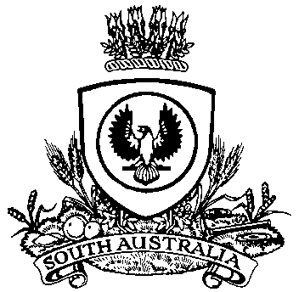

THE SOUTH AUSTRALIAN

GOVERNMENT GAZETTE
www.governmentgazette.sa.gov.au

PUBLISHED BY AUTHORITY

ALL PUBLIC ACTS appearing in this GAZETTE are to be considered official, and obeyed as such

ADELAIDE, FRIDAY, 12 AUGUST 2016

NATURAL RESOURCES MANAGEMENT ACT 2004
Notice of Volume of Water Available for Allocation from the River Murray Consumptive Pool
PURSUANT to Section 146 (4) of the Natural Resources Management Act 2004 (‘the Act’), I, Ian Hunter, Minister for Sustainability, Environment and Conservation for the State of South Australia and Minister to whom the Act is committed, hereby determine the volume of water available from the River Murray Consumptive Pool of the River Murray Prescribed Watercourse for allocation to water access entitlement holders for the period 1 July 2016 to 30 June 2017, is set out in Schedule 1 below:
Schedule 1
Class of Water Access Entitlement | Volume of Water Available  for Allocation | Water Allocation Rate | Water Allocation Rate as a %  of Nominal Maximum Water Allocation Rate of  1 kL/unit share
Class of Water Access Entitlement | (kL) | (kL/unit share) | (%)
Class 1 | 8 704 910 | 1.00 | 100
Class 2 | 50 000 000 | 1.00 | 100
Class 3a | 550 674 502 | 1.00 | 100
Class 3b | 14 052 049 | 1.00 | 100
Class 4 | 4 423 526 | 1.00 | 100
Class 5 | 5 568 841 | 1.00 | 100
Class 6 | 130 000 000 | 1.00 | 100
Class 7 | 38 366 550 | 1.00 | 100
Class 8 | 22 200 000 | 1.00 | 100
Class 9 | 42 502 135 | 1.00 | 100
This Notice will remain in effect until 30 June 2017, unless earlier varied.
Dated 11 August 2016.
Ian Hunter, Minister for Sustainability, Environment and Conservation

P. McMAHON, Government Printer, South Australia

