No. 47 3215



THE SOUTH AUSTRALIAN

GOVERNMENT GAZETTE
www.governmentgazette.sa.gov.au

PUBLISHED BY AUTHORITY

ALL PUBLIC ACTS appearing in this GAZETTE are to be considered official, and obeyed as such

ADELAIDE, THURSDAY, 18 AUGUST 2016

CONTENTS

Page
Appointments, Resignations, Etc. 3216
Building Work Contractors Act 1995—Notice 3216
Corporations and District Councils—Notices 3288
Land Acquisition Act 1969—Notices 3216
Liquor Licensing (Dry Areas) Notice 2016 3221
Mining Act 1971—Notices 3217
National Electricity Law—Notice 3219
National Gas Law—Notice 3219
Petroleum and Geothermal Energy Act 2000—Notices 3219
Proclamations 3233
Public Trustee Office—Administration of Estates 3289
REGULATIONS
Native Title (South Australia) Act 1994—
(No. 194 of 2016) 3236
National Parks and Wildlife Act 1972—
(No. 195 of 2016) 3255
Primary Industry Funding Schemes Act 1998—
(No. 196 of 2016) 3279
Subordinate Legislation Act 1978—
(No. 197 of 2016) 3282
Roads (Opening and Closing) Act 1991—Notice 3220

GOVERNMENT GAZETTE NOTICES
Notices for publication in the South Australian Government Gazette should be emailed to GovernmentGazetteSA@sa.gov.au. Content should be sent as Word format attachment(s). Covering emails should include the date the notice is to be published and to whom the notice will be charged. Closing time for lodgement is 4 p.m. on the Tuesday preceding the regular Thursday publication. Gazette enquiries to: Phone 8207 1045. The Government Gazette is available online at: www.governmentgazette.sa.gov.au.

Department of the Premier and Cabinet
Adelaide, 18 August 2016
HER Excellency the Governor’s Deputy in Executive Council has been pleased to appoint the Honourable John Robert Rau, MP, Deputy Premier, Attorney-General, Minister for Justice Reform, Minister for Planning, Minister for Industrial Relations, Minister for Child Protection Reform, Minister for the Public Sector, Minister for Consumer and Business Services and Minister for the City of Adelaide to be also Acting Premier for the period from
16 September 2016 to 21 September 2016 inclusive, during the absence of the Honourable Jay Wilson Weatherill, MP.
By command,
Zoe Lee Bettison, for Premier
DPC 16/055CS

BUILDING WORK CONTRACTORS ACT 1995
Exemption
TAKE notice that, pursuant to Section 45 of the Building Work Contractors Act 1995, I, George Kamencak, Acting Commissioner for Consumer Affairs, do hereby exempt the licensee named in Schedule 1 from the application of Division 3 of Part 5 of the above Act in relation to domestic building work described in Schedule 2 and subject to the conditions specified in Schedule 3.
Schedule 1
Sydney John Weir (BLD 10538)
Schedule 2
Construction of a two storey, three bedroom house on land situated at Allotment 122 in Filed Plan No. 12739 being a portion of the land described in Certificate of Title Volume 5436, Folio 676, more commonly known as 36 Hughes Street, Unley.
Schedule 3
1. This exemption is limited to domestic building work personally performed by the licensee in relation to the building work described in Schedule 2.
2. This exemption does not apply to any domestic building work the licensee contracts to another building work contractor, for which that contractor is required by law to hold building indemnity insurance.
3. That the licensee does not transfer his interest in the land prior to five years from the date of completion of the building work the subject of this exemption, without the prior authorisation of the Commissioner for Consumer Affairs. Before giving such authorisation, the Commissioner for Consumer Affairs may require the licensee to take any reasonable steps to protect the future purchaser(s) of the property, including but not limited to:
• Providing evidence that an adequate policy of building indemnity insurance is in force to cover the balance of the five-year period from the date of completion of the building work the subject of this exemption;
• Providing evidence of an independent expert inspection of the building work the subject of this exemption;
• Making an independent expert report available to prospective purchasers of the property; and
• Giving prospective purchasers of the property notice of the absence of a policy of building indemnity insurance.
Dated 15 August 2016.
G. Kamencak,
Acting Commissioner for Consumer Affairs,
Delegate for the Minister
for Consumer and Business Services
Ref.: 610/14-00116

LAND ACQUISITION ACT 1969
(Section 16)
Notice of Acquisition
THE COMMISSIONER OF HIGHWAYS (the ‘Authority’),
136 North Terrace, Adelaide, S.A. 5000, acquires the following interests in the following land:
Mining Lease ML 391 granted under the Mining Act 1971 comprised in that piece of land.
Firstly: Being a portion of Allotment 100 in Deposited Plan No. 44233 comprised in Certificate of Title Volume 5913,
Folio 768 and being the whole of the land numbered
Allotment 16 in approved plan D112813 that has been lodged
in the Land Titles Office,
Secondly: Being a portion of Allotment 106 in Deposited Plan No. 44233 comprised in Crown Record Volume 5902, Folio 103 and being the whole of the land numbered
Allotment 26 in approved plan D112817 that has been lodged
in the Land Titles Office.
This notice is given under Section 16 of the Land Acquisition Act 1969.
Compensation
A person who has or had an interest in the land that is divested or diminished by the acquisition or the enjoyment of which is adversely affected by the acquisition who does not receive an offer of compensation from the Authority may apply to the Authority for compensation.
Inquiries
Inquiries should be directed to:
Peter Jackel,
G.P.O. Box 1533,
Adelaide, S.A. 5001
Telephone: (08) 8204 1223
Dated 16 August 2016.
The Common Seal of the Commissioner of Highways was hereto affixed by authority of the Commissioner in the presence of:
M. Elgazzar, Manager,
Portfolio and Acquisition Services
(Authorised Officer),
Department of Planning,
Transport and Infrastructure
DPTI 2009/03920/01 & 2015/16687/01

LAND ACQUISITION ACT 1969
(Section 16)
Notice of Acquisition
THE COMMISSIONER OF HIGHWAYS (the ‘Authority’),
136 North Terrace, Adelaide, S.A. 5000, acquires the following interests in the following land:
Mining Lease ML 390 granted under the Mining Act 1971, comprised in that piece of land being a portion of Allotment 100 in Deposited Plan No. 44233 comprised in Certificate of Title Volume 5913, Folio 768 and being the whole of the land numbered Allotment 16 in approved plan D112813 that has been lodged in the Lands Titles Office.
This notice is given under Section 16 of the Land Acquisition Act 1969.
Compensation
A person who has or had an interest in the land that is divested or diminished by the acquisition or the enjoyment of which is adversely affected by the acquisition who does not receive an offer of compensation from the Authority may apply to the Authority for compensation.
Inquiries
Inquiries should be directed to:
Peter Jackel,
G.P.O. Box 1533,
Adelaide, S.A. 5001
Telephone: (08) 8204 1223
Dated 16 August 2016.
The Common Seal of the Commissioner of Highways was hereto affixed by authority of the Commissioner in the presence of:
M. Elgazzar, Manager,
Portfolio and Acquisition Services
(Authorised Officer),
Department of Planning,
Transport and Infrastructure
DPTI 2009/03920/01

LAND ACQUISITION ACT 1969
(Section 16)
Notice of Acquisition
THE COMMISSIONER OF HIGHWAYS (the ‘Authority’),
136 North Terrace, Adelaide, S.A. 5000, acquires the following interests in the following land:
Mining Lease ML 392 granted under the Mining Act 1971, comprised in that piece of land being a portion of Allotment 106 in Deposited Plan No. 44233 comprised in Crown Record Volume 5902, Folio 103 and being the whole of the land numbered Allotment 26 in plan D112817 that has been lodged in the Lands Titles Office.
This notice is given under Section 16 of the Land Acquisition Act 1969.
Compensation
A person who has or had an interest in the land that is divested or diminished by the acquisition or the enjoyment of which is adversely affected by the acquisition who does not receive an offer of compensation from the Authority may apply to the Authority for compensation.
Inquiries
Inquiries should be directed to:
Peter Jackel,
G.P.O. Box 1533,
Adelaide, S.A. 5001
Telephone: (08) 8204 1223
Dated 16 August 2016.
The Common Seal of the Commissioner of Highways was hereto affixed by authority of the Commissioner in the presence of:
M. Elgazzar, Manager,
Portfolio and Acquisition Services
(Authorised Officer),
Department of Planning,
Transport and Infrastructure
DPTI 2015/16687/01

LAND ACQUISITION ACT 1969
(Section 16)
Notice of Acquisition
THE COMMISSIONER OF HIGHWAYS (the ‘Authority’),
136 North Terrace, Adelaide, S.A. 5000, acquires the following interests in the following land:
Mining Lease ML 418 granted under the Mining Act 1971, comprised in that piece of land.
Firstly: Being portion of Allotment 56 in Filed Plan 114617 comprised in Certificate of Title Volume 5828, Folio 520 and being the whole of the land numbered Allotment 37 in plan D112821 that has been lodged in the Lands Titles Office,
Secondly: Being portion of Allotment 6 in Filed Plan 126162 comprised in Certificate of Title Volume 5810, Folio 662 and being the whole of the land numbered Allotment 39 in plan D112822 that has been lodged in the Lands Titles Office,
Thirdly: Being the whole of Allotment 93 in Filed Plan 207067, being the land contained in General Registry Office Memorial Number 82 Book 382, and shown on plan FP207067.
This notice is given under Section 16 of the Land Acquisition Act 1969.
Compensation
A person who has or had an interest in the land that is divested or diminished by the acquisition or the enjoyment of which is adversely affected by the acquisition who does not receive an offer of compensation from the Authority may apply to the Authority for compensation.
Inquiries
Inquiries should be directed to:
Peter Jackel,
G.P.O. Box 1533,
Adelaide, S.A. 5001
Telephone: (08) 8204 1223
Dated 16 August 2016.
The Common Seal of the Commissioner of Highways was hereto affixed by authority of the Commissioner in the presence of:
M. Elgazzar, Manager,
Portfolio and Acquisition Services
(Authorised Officer),
Department of Planning,
Transport and Infrastructure
DPTI: 2015/16684/01, 2015/16683/01, and 2015/16279/01

MINING ACT 1971
NOTICE is hereby given in accordance with Section 28 (5) of the Mining Act 1971 that the delegate of the Minister for Mineral Resources and Energy intends to grant an Exploration Licence over the area described below:
Applicant: Nasaco Resources Pty Ltd.
Location: Hayes Dam Area—Approximately 105 km south-south-west of Moomba.
Pastoral Lease: Lindon.
Term: 1 year.
Area in km²: 485.
Reference number: 2015/00090.
Plan and co-ordinates can be found on the Department of State Development website: http://www.minerals.statedevelopment.sa.
gov.au/exploration/public_notices or by contacting Mineral Tenements on (08) 8463 3103.
Community information on mineral exploration licence processes and requirements under the Mining Act 1971 is available from: http://www.minerals.statedevelopment.sa.gov.au/
land_access/community_information or hard copy on request to Mineral Tenements.
J. Martin, Mining Registrar

MINING ACT 1971
NOTICE is hereby given in accordance with Section 28 (5) of the Mining Act 1971 that the delegate of the Minister for Mineral Resources and Energy intends to grant an Exploration Licence over the area described below:
Applicant: FMG Resources Pty Ltd.
Location: Hidden Swamp Area—Approximately 70 km north-west of Andamooka.
Pastoral Lease: Billa Kalina.
Term: 2 years.
Area in km²: 145.
Reference number: 2015/00238.
Plan and co-ordinates can be found on the Department of State Development website: http://www.minerals.statedevelopment.sa.
gov.au/exploration/public_notices or by contacting Mineral Tenements on (08) 8463 3103.
Community information on mineral exploration licence processes and requirements under the Mining Act 1971 is available from: http://www.minerals.statedevelopment.sa.gov.au/
land_access/community_information or hard copy on request to Mineral Tenements.
J. Martin, Mining Registrar

MINING ACT 1971
NOTICE is hereby given in accordance with Section 28 (5) of the Mining Act 1971 that the delegate of the Minister for Mineral Resources and Energy intends to grant an Exploration Licence over the area described below:
Applicant: Havilah Resources Limited.
Location: Oratan Area—Approximately 80 km south-east of Olary.
Pastoral Lease: Manunda, Lilydale, Netley Gap.
Term: 2 years.
Area in km²: 107.
Reference number: 2016/00014.
Plan and co-ordinates can be found on the Department of State Development website: http://www.minerals.statedevelopment.sa.
gov.au/exploration/public_notices or by contacting Mineral Tenements on (08) 8463 3103.
Community information on mineral exploration licence processes and requirements under the Mining Act 1971 is available from: http://www.minerals.statedevelopment.sa.gov.au/
land_access/community_information or hard copy on request to Mineral Tenements.
J. Martin, Mining Registrar

MINING ACT 1971
NOTICE is hereby given in accordance with Section 28 (5) of the Mining Act 1971 that the delegate of the Minister for Mineral Resources and Energy intends to grant an Exploration Licence over the area described below:
Applicant: Renascor Resources Limited.
Location: Western Lake Gairdner Area—Approximately
100 km south-east of Tarcoola.
Pastoral Lease: Kokatha.
Term: 2 years.
Area in km²: 421.
Reference number: 2016/00021.
Plan and co-ordinates can be found on the Department of State Development website: http://www.minerals.statedevelopment.sa.
gov.au/exploration/public_notices or by contacting Mineral Tenements on (08) 8463 3103.
Community information on mineral exploration licence processes and requirements under the Mining Act 1971 is available from: http://www.minerals.statedevelopment.sa.gov.au/
land_access/community_information or hard copy on request to Mineral Tenements.
J. Martin, Mining Registrar

MINING ACT 1971
NOTICE is hereby given in accordance with Section 28 (5) of the Mining Act 1971 that the delegate of the Minister for Mineral Resources and Energy intends to grant an Exploration Licence over the area described below:
Applicant: PNX Metals Limited.
Location: Bald Hill North Area—Immediately west of Burra.
Term: 2 years.
Area in km²: 69.
Reference number: 2016/00053.
Plan and co-ordinates can be found on the Department of State Development website: http://www.minerals.statedevelopment.sa.
gov.au/exploration/public_notices or by contacting Mineral Tenements on (08) 8463 3103.
Community information on mineral exploration licence processes and requirements under the Mining Act 1971 is available from: http://www.minerals.statedevelopment.sa.gov.au/
land_access/community_information or hard copy on request to Mineral Tenements.
J. Martin, Mining Registrar

MINING ACT 1971
NOTICE is hereby given in accordance with Section 28 (5) of the Mining Act 1971 that the delegate of the Minister for Mineral Resources and Energy intends to grant an Exploration Licence over the area described below:
Applicant: Centrex Metals Limited.
Location: Minbrie Area—Approximately 20 km north-west of Cowell.
Term: 2 years.
Area in km²: 117.
Reference number: 2016/00054.
Plan and co-ordinates can be found on the Department of State Development website: http://www.minerals.statedevelopment.sa.
gov.au/exploration/public_notices or by contacting Mineral Tenements on (08) 8463 3103.
Community information on mineral exploration licence processes and requirements under the Mining Act 1971 is available from: http://www.minerals.statedevelopment.sa.gov.au/
land_access/community_information or hard copy on request to Mineral Tenements.
J. Martin, Mining Registrar

MINING ACT 1971
NOTICE is hereby given in accordance with Section 28 (5) of the Mining Act 1971 that the delegate of the Minister for Mineral Resources and Energy intends to grant an Exploration Licence over the area described below:
Applicant: Centrex Metals Limited.
Location: Green Patch Area—Immediately north-west of Port Lincoln.
Term: 2 years.
Area in km²: 76.
Reference number: 2016/00055.
Plan and co-ordinates can be found on the Department of State Development website: http://www.minerals.statedevelopment.sa.
gov.au/exploration/public_notices or by contacting Mineral Tenements on (08) 8463 3103.
Community information on mineral exploration licence processes and requirements under the Mining Act 1971 is available from: http://www.minerals.statedevelopment.sa.gov.au/
land_access/community_information or hard copy on request to Mineral Tenements.
J. Martin, Mining Registrar

MINING ACT 1971
NOTICE is hereby given in accordance with Section 28 (5) of the Mining Act 1971 that the delegate of the Minister for Mineral Resources and Energy intends to grant an Exploration Licence over the area described below:
Applicant: Havilah Resources Limited.
Location: Benagerie Area—Approximately 90 km north of Olary.
Pastoral Lease: Mooleulooloo, Yarramba, Mulyungarie, Quinyamble.
Term: 2 years.
Area in km²: 585.
Reference number: 2016/00064.
Plan and co-ordinates can be found on the Department of State Development website: http://www.minerals.statedevelopment.sa.
gov.au/exploration/public_notices or by contacting Mineral Tenements on (08) 8463 3103.
Community information on mineral exploration licence processes and requirements under the Mining Act 1971 is available from: http://www.minerals.statedevelopment.sa.gov.au/
land_access/community_information or hard copy on request to Mineral Tenements.
J. Martin, Mining Registrar

MINING ACT 1971
NOTICE is hereby given in accordance with Section 28 (5) of the Mining Act 1971 that the delegate of the Minister for Mineral Resources and Energy intends to grant an Exploration Licence over the area described below:
Applicant: Havilah Resources Limited.
Location: Border Block Area—Approximately 90 km north-east of Olary.
Pastoral Lease: Mundi Mundi, Mulyungarie.
Term: 2 years.
Area in km²: 35.
Reference number: 2016/00089.
Plan and co-ordinates can be found on the Department of State Development website: http://www.minerals.statedevelopment.sa.
gov.au/exploration/public_notices or by contacting Mineral Tenements on (08) 8463 3103.
Community information on mineral exploration licence processes and requirements under the Mining Act 1971 is available from: http://www.minerals.statedevelopment.sa.gov.au/
land_access/community_information or hard copy on request to Mineral Tenements.
J. Martin, Mining Registrar

MINING ACT 1971
NOTICE is hereby given in accordance with Section 28 (5) of the Mining Act 1971 that the delegate of the Minister for Mineral Resources and Energy intends to grant an Exploration Licence over the area described below:
Applicant: Havilah Resources Limited.
Location: Mundaerno Hill Area—Approximately 60 km north-east of Olary.
Pastoral Lease: Boolcoomata, Wompinie.
Term: 2 years.
Area in km²: 58.
Reference number: 2016/00090.
Plan and co-ordinates can be found on the Department of State Development website: http://www.minerals.statedevelopment.sa.
gov.au/exploration/public_notices or by contacting Mineral Tenements on (08) 8463 3103.
Community information on mineral exploration licence processes and requirements under the Mining Act 1971 is available from: http://www.minerals.statedevelopment.sa.gov.au/
land_access/community_information or hard copy on request to Mineral Tenements.
J. Martin, Mining Registrar

NATIONAL ELECTRICITY LAW
THE Australian Energy Market Commission (AEMC) gives notice under the National Electricity Law as follows:
Under s 107, the time for making the final determination on the Register of Large Generator connections (Ref. ERC0205) proposal has been extended to 15 September 2016.
Under s 95, the Australian Energy Regulator has requested the Rate of Return Guidelines Review (Ref. ERC0207) proposal. The proposal seeks to extend the timeframe to review the current Rate of Return Guideline. The AEMC intends to expedite the proposal under s 96 as it considers the proposed Rule non-controversial, subject to requests not to do so. Written requests not to expedite the proposal must be received by 1 September 2016. Submissions must be received by 15 September 2016.
Under s 107, the time for making the final determination on the Rate of Return Guidelines Review (Ref. ERC0207) proposal has been extended to 13 October 2016.
Submissions can be made via the AEMC’s website. Before making a submission, please review the AEMC’s privacy statement on its website. Submissions should be made in accordance with the AEMC’s guidelines for making written submissions on Rule change proposals. The AEMC publishes all submissions on its website, subject to confidentiality.
Written requests should be sent to submissions@aemc.gov.au and cite the reference in the title. Before sending a request, please review the AEMC’s privacy statement on its website.
Documents referred to above are available on the AEMC’s website and are available for inspection at the AEMC’s office.
Australian Energy Market Commission
Level 6, 201 Elizabeth Street,
Sydney, N.S.W. 2000
Telephone: (02) 8296 7800
www.aemc.gov.au
18 August 2016.

NATIONAL GAS LAW
THE Australian Energy Market Commission (AEMC) gives notice under the National Gas Law as follows:
Under s 317, the time for making the draft determination on the Gas Day Harmonisation (Ref. GRC0036) proposal has been extended to 17 November 2016.
Under s 303, the Australian Energy Regulator has requested the Rate of Return Guidelines Review proposal (Ref. GRC0038). The proposal seeks to extend the timeframe to review the current Rate of Return Guideline. The AEMC intends to expedite the proposal under s 304 as it considers the proposed Rule is non-controversial, subject to requests not to do so. Written requests not to expedite the proposal must be received by 1 September 2016. Submissions must be received by 15 September 2016.
Under s 317, the time for the making of the final determination on the Rate of Return Guidelines Review (Ref. GRC0038) proposal has been extended to 13 October 2016.
Submissions can be made via the AEMC’s website. Before making a submission, please review the AEMC’s privacy statement on its website. Submissions should be made in accordance with the AEMC’s guidelines for making written submissions on Rule change proposals. The AEMC publishes all submissions on its website, subject to confidentiality.
Written requests should be sent to submissions@aemc.gov.au and cite the reference in the title. Before sending a request, please review the AEMC’s privacy statement on its website.
Documents referred to above are available on the AEMC’s website and are available for inspection at the AEMC’s office.
Australian Energy Market Commission
Level 6, 201 Elizabeth Street,
Sydney, N.S.W. 2000
Telephone: (02) 8296 7800
www.aemc.gov.au
18 August 2016.

PETROLEUM AND GEOTHERMAL ENERGY ACT 2000
Suspension of Condition
Extension of Licence Term
Petroleum Retention Licences—
PRLs 183, 184, 185, 186, 187, 188, 189 and 190
PURSUANT to Section 76A of the Petroleum and Geothermal Energy Act 2000, notice is hereby given that Condition 12.1 of the abovementioned petroleum retention licences (PRLs) has been suspended for the period from 3 November 2016 to 2 November 2017 inclusive, under the provisions of the Petroleum and Geothermal Energy Act 2000, pursuant to delegated powers dated 21 March 2012.
The terms of the abovementioned PRLs have been extended by a period corresponding to the period of suspension, such that PRLs 183-190 will now expire on 2 November 2021.
Dated 16 August 2016.
B. A. Goldstein, Executive Director,
Energy Resources Division,
Department of State Development,
Delegate of the Minister for Mineral Resources and Energy

PETROLEUM AND GEOTHERMAL ENERGY ACT 2000
Suspension of Petroleum Exploration Licences—
PELs 138, 147 and 148
Gas Storage Exploration Licences—
GSELs 576, 577, 578, 579, 580, 581, 582 and 583
PURSUANT to Section 90 of the Petroleum and Geothermal Energy Act 2000, notice is hereby given that the abovementioned Exploration Licences have been suspended under the provisions of the Petroleum and Geothermal Energy Act 2000, pursuant to delegated powers dated 21 March 2012.
Petroleum Exploration Licence PEL 138 has been suspended for the period from 24 August 2016 to 23 August 2017 inclusive.
The expiry date of PEL 138 is now determined to be 15 April 2021.
Petroleum Exploration Licences PELs 147 and 148, and Gas Storage Exploration Licences GSELs 576, 577, 578, 579, 580, 581, 582 and 583 have been suspended for the period from
22 August 2016 to 21 August 2017 inclusive.
The expiry date of PELs 147 and 148 and GSELs 576, 577, 578, 579, 580, 581, 582 and 583 is now determined to be 28 July 2022.
Dated 10 August 2016.
B. A. Goldstein, Executive Director,
Energy Resources Division,
Department of State Development,
Delegate of the Minister for Mineral Resources and Energy

ROADS (OPENING AND CLOSING) ACT 1991:
SECTION 24
NOTICE OF CONFIRMATION OF ROAD
PROCESS ORDER
Road Closure—Little Torrens Avenue, West Hindmarsh
BY Road Process Order made on 1 April 2016, City of Charles Sturt ordered that:
1. Portion of Little Torrens Avenue situated west of McDonnell Avenue and adjoining Allotment A in Road Plan 8124, more particularly delineated and lettered ‘A’ on Preliminary Plan No. 15/0019 be closed.
2. Transfer the whole of the land subject to closure to Samuel Peter Loveder and Vanessa Loveder in accordance with the agreement for transfer dated 18 December 2015, entered into between City of Charles Sturt and Samuel Peter Loveder and Vanessa Loveder.
3. The following easement is granted over portion of the land subject to that closure:
Grant to Distribution Lessor Corporation an easement for underground electricity supply purposes.
On 12 August 2016 that order was confirmed by the Minister for Transport and Infrastructure conditionally upon the deposit by the Registrar-General of Deposited Plan 113288 being the authority for the new boundaries.
Pursuant to Section 24 (5) of the Roads (Opening and Closing) Act 1991, NOTICE of the order referred to above and its confirmation is hereby given.
Dated 18 August 2016.
M. P. Burdett, Surveyor-General

South Australia
Liquor Licensing (Dry Areas) Notice 2016
under section 131(1a) of the Liquor Licensing Act 1997

1—Short title
This notice may be cited as the Liquor Licensing (Dry Areas) Notice 2016.
2—Commencement
This notice comes into operation on 30 December 2016.
3—Interpretation
(1) In this notice—
principal notice means the Liquor Licensing (Dry Areas) Notice 2015 published in the Gazette on 5.1.15, as in force from time to time.
(2) Clause 3 of the principal notice applies to this notice as if it were the principal notice.
4—Consumption etc of liquor prohibited in dry areas
(1) Pursuant to section 131 of the Act, the consumption and possession of liquor in the area described in the Schedule is prohibited in accordance with the provisions of the Schedule.
(2) The prohibition has effect during the periods specified in the Schedule.
(3) The prohibition does not extend to private land in the area described in the Schedule.
(4) Unless the contrary intention appears, the prohibition of the possession of liquor in the area does not extend to—
(a) a person who is genuinely passing through the area if—
(i) the liquor is in the original container in which it was purchased from licensed premises; and
(ii) the container has not been opened; or
(b) a person who has possession of the liquor in the course of carrying on a business or in the course of his or her employment by another person in the course of carrying on a business; or
(c) a person who is permanently or temporarily residing at premises within the area or on the boundary of the area and who enters the area solely for the purpose of passing through it to enter those premises or who enters the area from those premises for the purpose of leaving the area.
(5) Schedule 2—Port Elliot Area 2 in this notice shall operate in addition to Schedule—Port Elliot Area 1 in the principal notice.

Schedule 1—Hayborough Area 1

1—Extent of prohibition
The consumption of liquor is prohibited and the possession of liquor is prohibited.
2—Period of prohibition
From 6.00pm on 30 December 2016 to 6.00am on 2 January 2017.
3—Description of area
The area in and adjacent to Hayborough generally known as the Chiton Rocks Surf
Lifesaving Club car park and the adjacent beach, being the area bounded on the north by
the northern boundaries of Lot 469 DP 3482 and Lot 440 DP 3207, on the west by the
prolongation in a straight line of the western boundary of Lot 433 DP 3207, on the south
by the low water mark of Encounter Bay and on the east by the prolongation in a straight line of the western boundary of Lot 463 DP 3482.

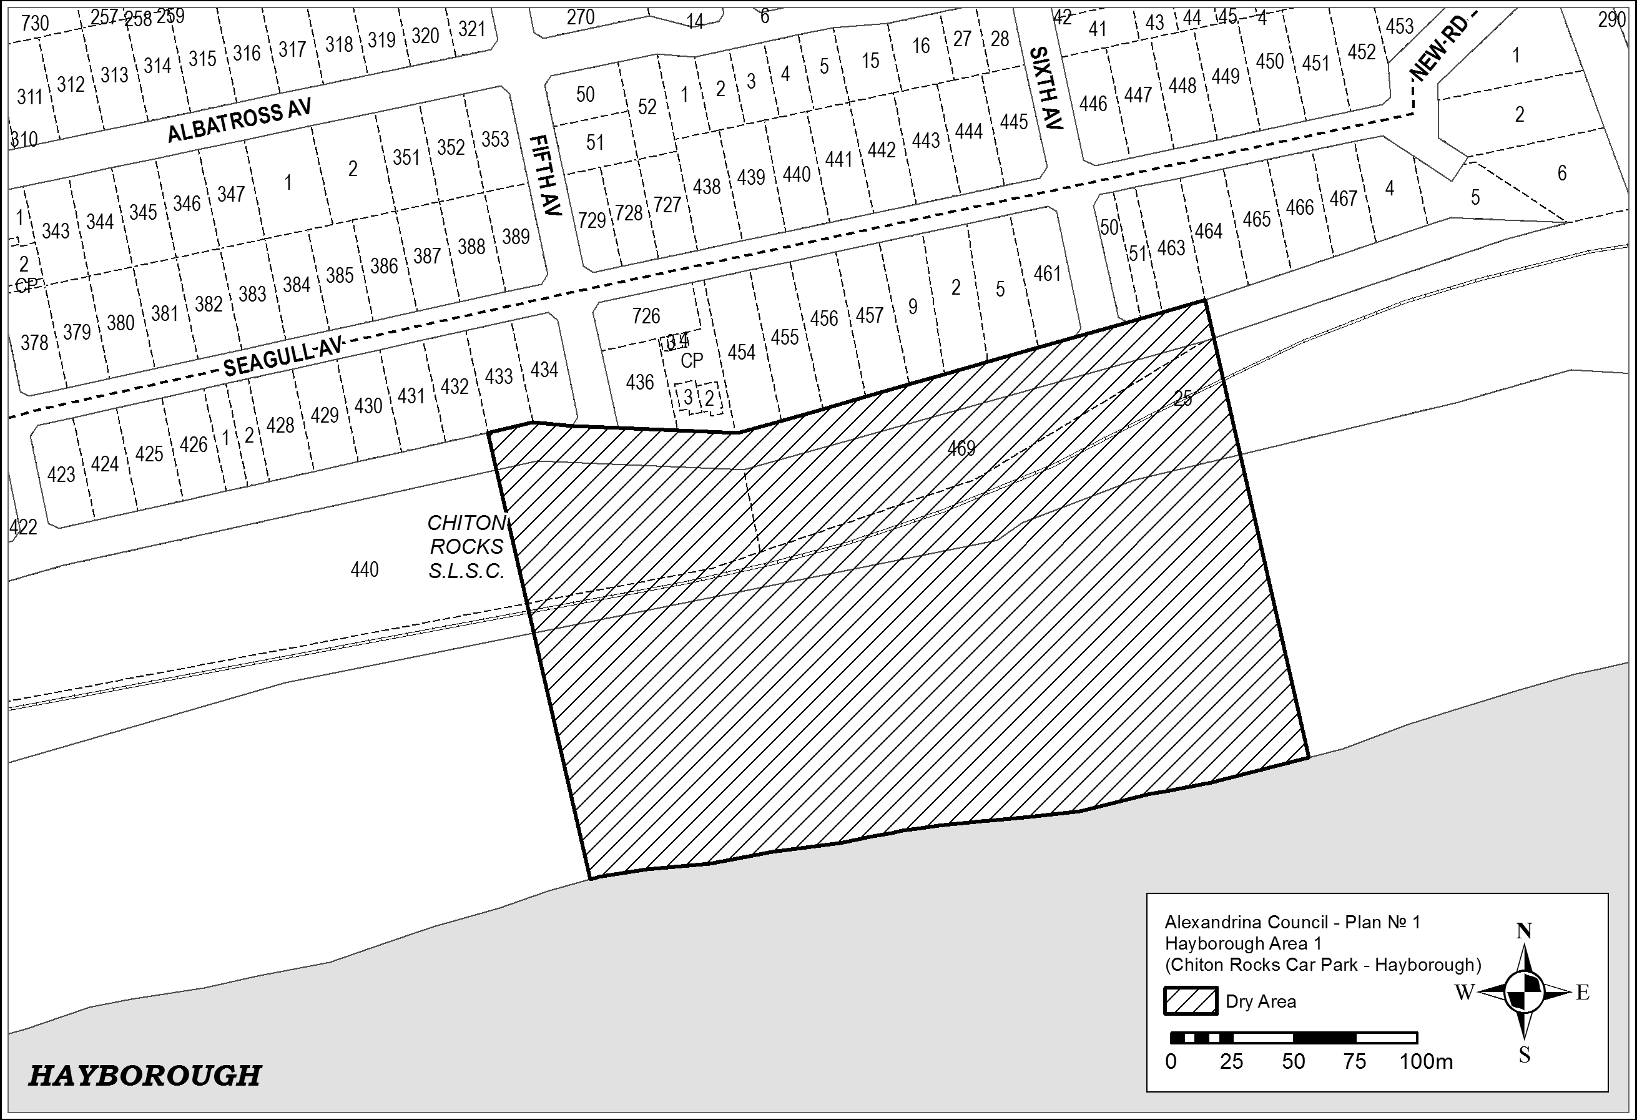

Schedule 2—Port Elliot Area 2

1—Extent of prohibition
The consumption of liquor is prohibited and the possession of liquor is prohibited.
2—Period of prohibition
From 6.00pm on 30 December 2016 to 6.00am on 2 January 2017.
3—Description of area
The area in and adjacent to Port Elliot bounded as follows: commencing at the point at
which the eastern boundary of Lot 26 of DP 74300 meets the northern boundary of
Railway Terrace (approximately 50 metres west of the western boundary of
Bennett Road), then easterly along the northern boundary of Railway Terrace to the
western boundary of Carfax Street, then northerly along that boundary of Carfax Street
to the point at which it is intersected by the prolongation in a straight line of the northern
boundary of Battunga Avenue, then generally easterly, south-easterly and easterly along
that prolongation and boundary of Battunga Avenue and the prolongation in a straight
line of that boundary to the eastern boundary of Rosetta Terrace, then southerly along
that boundary of Rosetta Terrace to the northern boundary of Barbara Street, then
easterly along that boundary of Barbara Street to the point at which it intersects the
eastern boundary of Hutton Street, then southerly along that boundary of Hutton Street to
the northern boundary of Merrilli Place, then easterly along that boundary of Merrilli
Place to the point at which it is intersected by the prolongation in a straight line of the
eastern boundary of The Esplanade, then south-easterly along that prolongation and
boundary of The Esplanade to the western boundary of Lot 101 of DP 46201, then
south-easterly and easterly along the western and southern boundaries of Lot 101 and the
southern boundaries of the adjoining Lots to the western boundary of The Strand, then
northerly along that boundary of The Strand to the point at which it intersects the
southern boundary of Torrens Street, then in a straight line by the shortest route (across
The Strand) to the point at which the southern boundary of Murray Place meets the
eastern boundary of The Strand, then easterly and north-easterly along that boundary of
Murray Place to the point at which it meets the prolongation in a straight line of the
southern boundary of Freeling Street, then north-easterly along that prolongation of the
southern boundary of Freeling Street to the point at which it intersects the low water
mark of Horseshoe Bay, then generally south-westerly, south-easterly, south-westerly
and westerly along the low water mark to the point at which the low water mark is
intersected by the prolongation in a straight line of the eastern boundary of Lot 26 of
DP 74300, then northerly along that prolongation of the eastern boundary of Lot 26 to
the point of commencement. The area includes the whole of any wharf, jetty, boat ramp,
breakwater or other structure that projects below the low water mark from within the
area described above (as well as any area beneath such a structure).
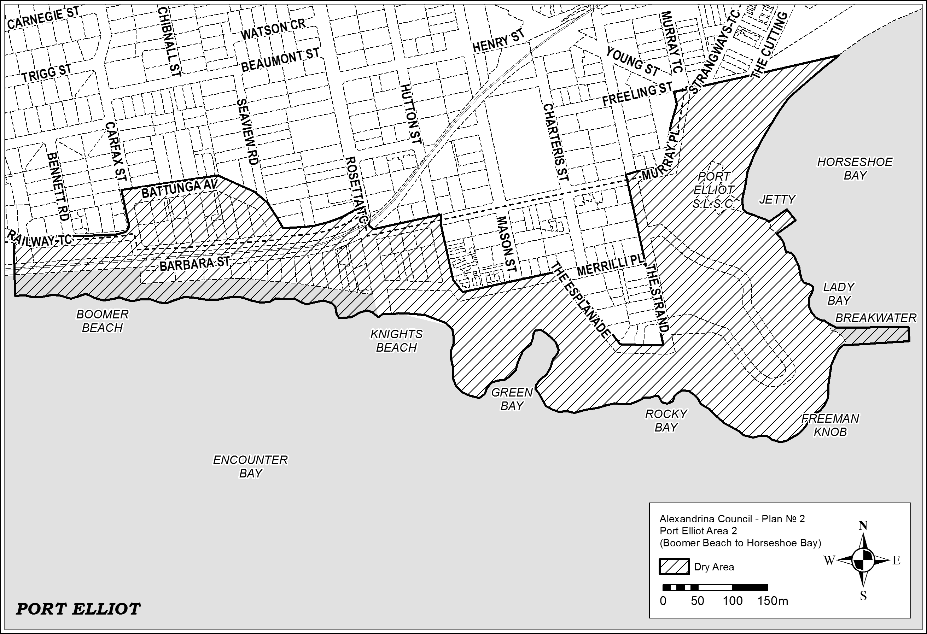
Schedule 3—Middleton Area 1

1—Extent of prohibition
The consumption of liquor is prohibited and the possession of liquor is prohibited.
2—Period of prohibition
From 6.00pm on 30 December 2016 to 6.00am on 2 January 2017.
3—Description of area
The area in and adjacent to Middleton bounded as follows: commencing at the point at
which the prolongation in a straight line of the western boundary of Basham Beach Road
intersects the high water mark of Encounter Bay, then north-westerly along that
prolongation and boundary to the point at which it is intersected by the prolongation in a
straight line of the southern boundary of Set Road, then north-easterly along that
prolongation and boundary of Set Road to the western boundary of Seaview Avenue,
then generally south-easterly and north-easterly along that boundary of Seaview Avenue
to the point at which it meets the eastern boundary of Lot 101 DP 10654, then
south-easterly along that boundary of Lot 101 to the south-western corner of Lot 19
DP 3145, then generally north-easterly along the south-eastern boundary of Lot 19, the
south-eastern boundaries of the adjoining Lots and the northern boundary of Ocean
Parade to the south-eastern corner of Lot 133 FP 166507, then generally north-easterly
and northerly along the easternmost boundaries of Lot 133 and the adjoining Lots
(including the eastern boundary of Dover Road) to the north-eastern corner of Lot 39
DP 3262, then in a straight line by the shortest route to the north-western corner of
Lot 160 DP 9417, then easterly along the southern boundary of the Esplanade to the
western boundary of Lot 3 DP 13398, then northerly, easterly and southerly along the
western, northern and eastern boundaries of that Lot to its south-eastern corner, then
along the northern boundary of Section 345, Hundred of Goolwa, (the southern boundary
of Surfer's Parade) to the point at which it is intersected by the prolongation in a straight
line of the eastern boundary of Lot 39 DP 6156, then along that prolongation to the point
at which it intersects the high water mark of Encounter Bay, then generally westerly and south-westerly along the high water mark to the point of commencement.

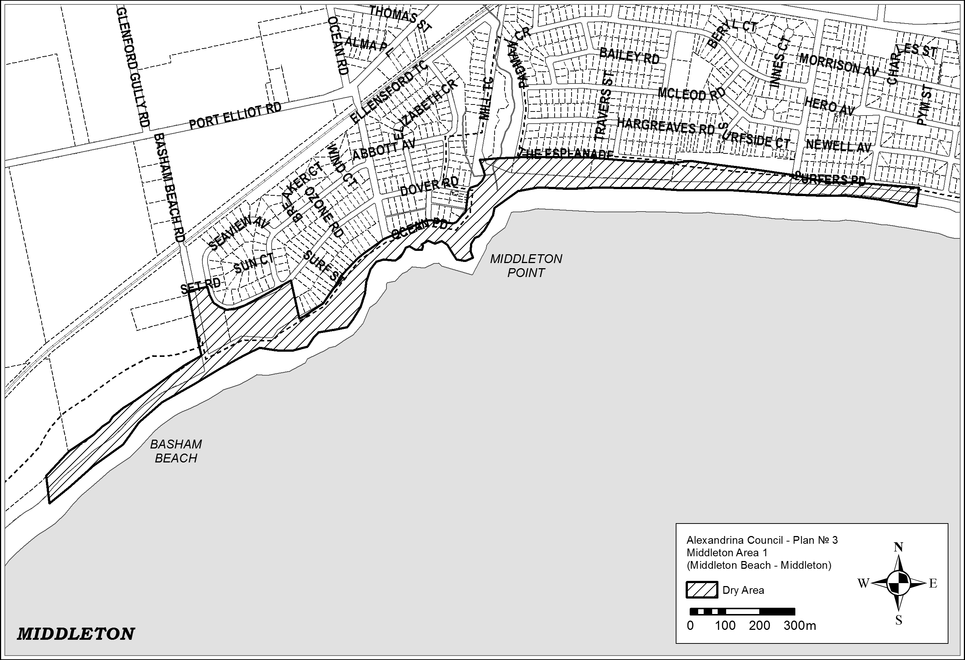
Schedule 4—Goolwa Beach Area 1

1—Extent of prohibition
The consumption of liquor is prohibited and the possession of liquor is prohibited.
2—Period of prohibition
From 6.00pm on 30 December 2016 to 6.00am on 2 January 2017.
3—Description of area
The area in Goolwa Beach and Goolwa South (generally known as the Goolwa Beach
car park) bounded as follows: commencing at the north-eastern corner of Section 279,
Hundred of Goolwa, then westerly and southerly along the northern and western
boundaries of Section 279 to the northern boundary of Section 367, Hundred of Goolwa,
then southerly and easterly along the western and southern boundaries of Section 367 to
the south-eastern corner of the Section, then in a straight line by the shortest route to the
south-western corner of Section 368, Hundred of Goolwa, then easterly and northerly
along the southern and eastern boundaries of Section 368 to the southern boundary of
Section 278, Hundred of Goolwa, then northerly and westerly along the eastern and
northern boundaries of Section 278 to the north-western corner of the Section, then in a
straight line by the shortest route across Goolwa Beach Road to the point of
commencement.
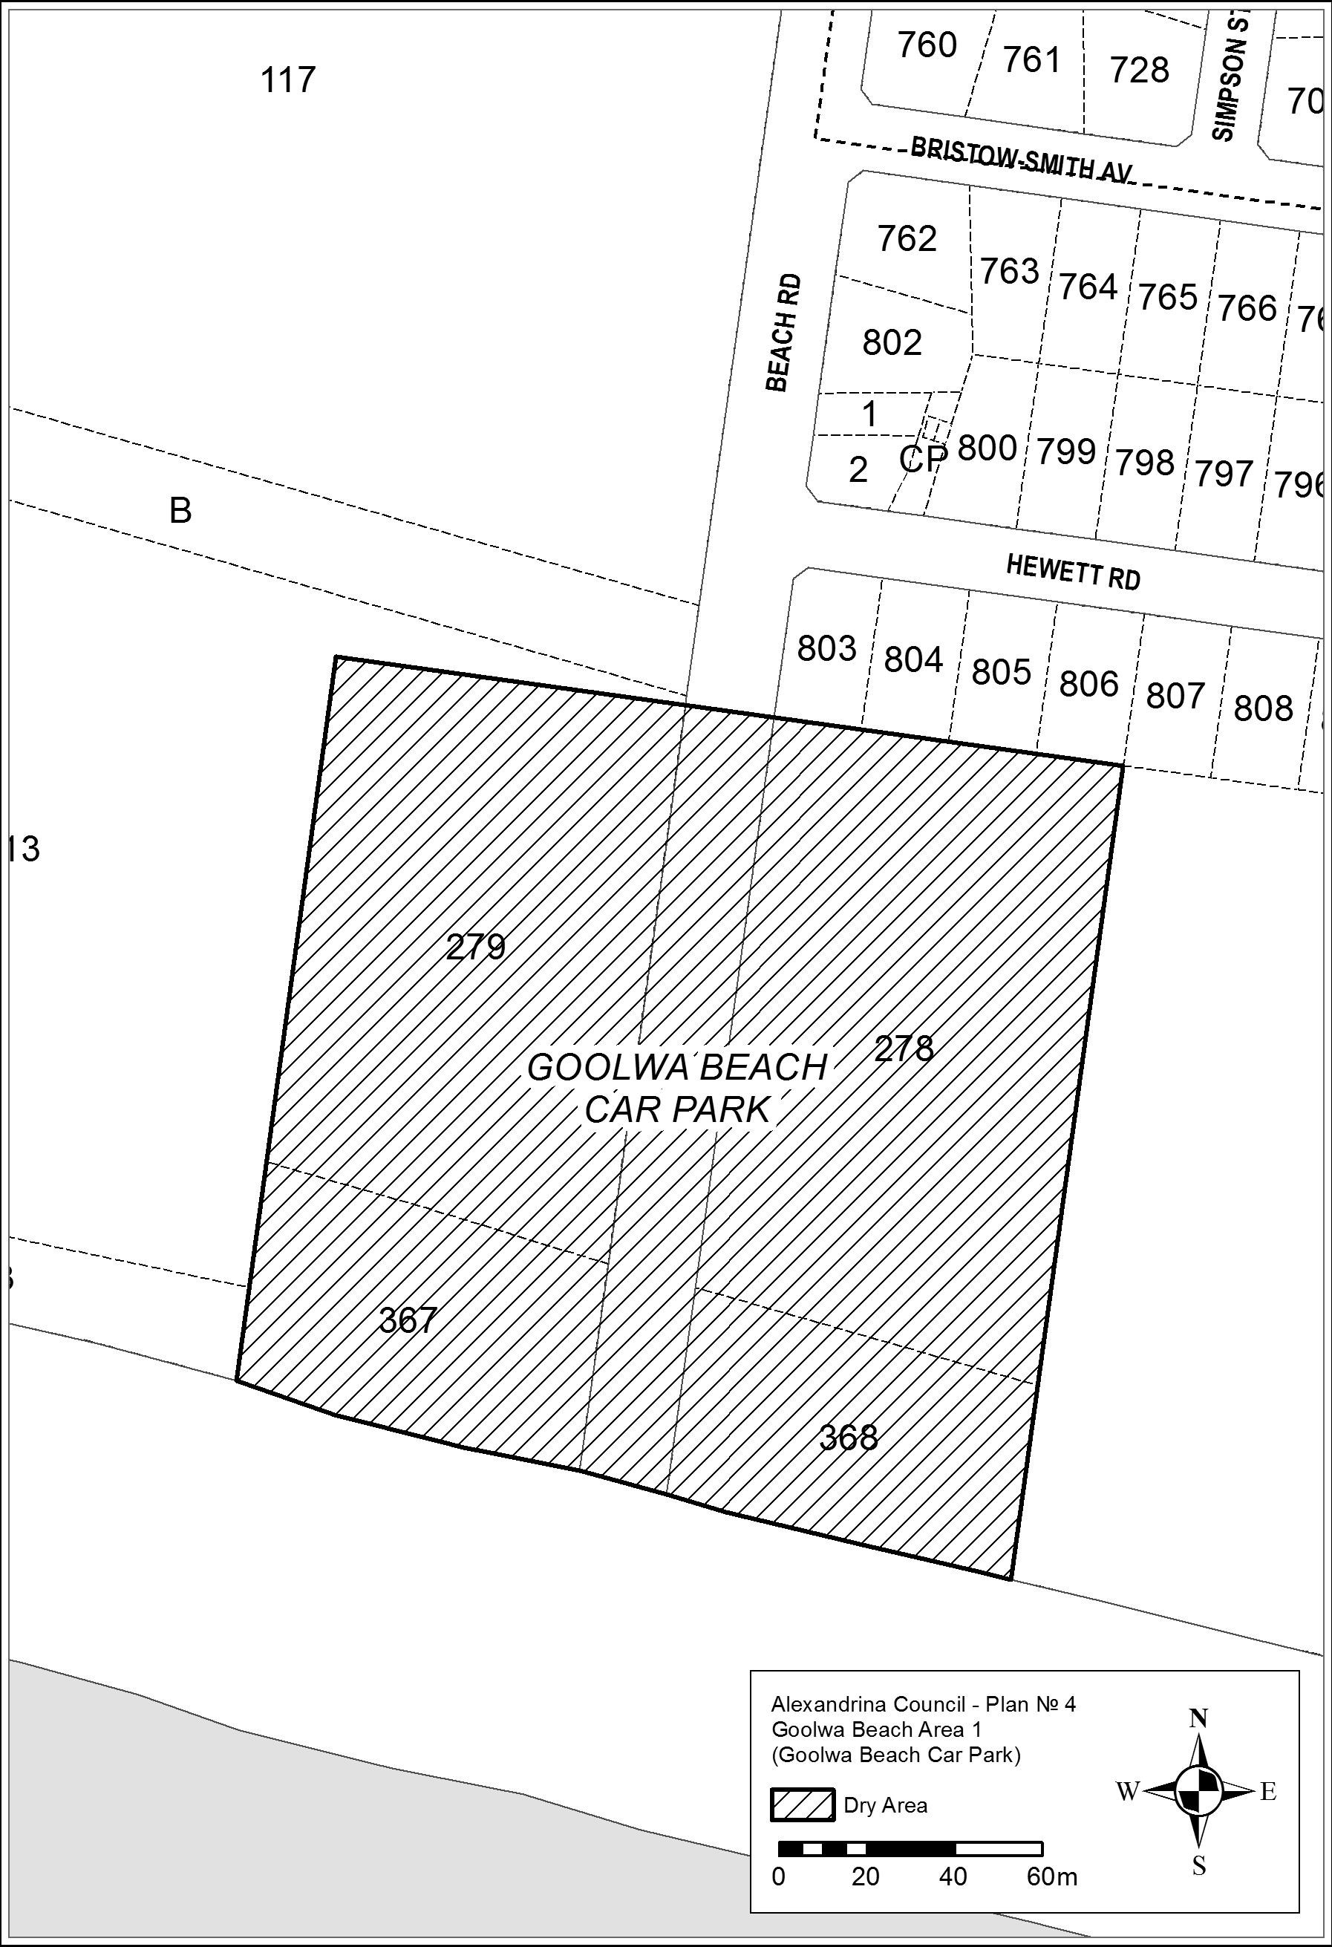

Schedule 5—Goolwa Area 2

1—Extent of prohibition
The consumption of liquor is prohibited and the possession of liquor is prohibited.
2—Period of prohibition
From 6.00pm on 30 December 2016 to 6.00am on 2 January 2017.
3—Description of area
The area in Goolwa bounded as follows: commencing at the northern corner of Lot 500
DP 67581, then south-easterly along the north-eastern boundary of Lot 500 and the
north-eastern boundaries of the adjoining Lots to the eastern corner of Lot 1 DP 62245,
then in a straight line by the shortest route across Hays Street to the north-western
boundary of Lot 210 FP 166584, then north-easterly along that boundary of Lot 210 and
the north-western boundary of Lot 2 FP 11114 to the north-eastern boundary of the Lot,
then in a straight line by the shortest route across Cutting Road to the westernmost corner of Lot 3 FP 11114, then north-easterly along the north-western boundary of Lot 3 to the south-western boundary of Lot 500 DP 66808, then north-westerly along that boundary of Lot 500 and the south-western boundary of Lot 190 TP 150401 to the north-western boundary of Lot 190, then north-easterly along that boundary of Lot 190 and the
prolongation in a straight line of that boundary to the point at which the prolongation
intersects the centre line of Laurie Lane, then north-westerly along that centre line and
the prolongation in a straight line of that centre line to the point at which it intersects the
prolongation in a straight line of the south-eastern boundary of Lot 7 DP 46829, then
south-westerly along that prolongation and boundary of Lot 7 to the north-eastern
boundary of Lot 215 TP 150401, then north-westerly along that boundary of Lot 215 to
the westernmost point at which it ceases to have a common boundary with Lot 12
FP 103236, then north-westerly along the south-western boundary of Lot 12 to the
westernmost corner of the Lot, then in a straight line by the shortest route across Porter
Street to the point at which the north-eastern boundary of Lot 138 TP 150401 changes
direction, then south-easterly along the north-eastern boundary of Lot 138 and the
north-eastern boundaries of the adjoining Lots to the eastern corner of Lot 155
TP 150401, then in a straight line by the shortest route across Wildman Street to the
northern corner of Lot 166 TP 150401, then in a straight line by the shortest route across
Porter Street to the western corner of Lot 500 DP 67581, then north-easterly along the
north-western boundary of Lot 500 to the point of commencement.

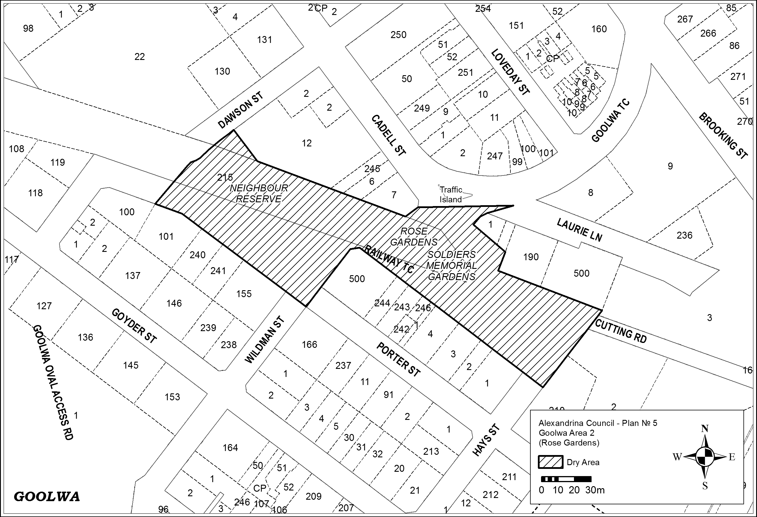
Schedule 6—Basham Beach Area 1

1—Extent of prohibition
The consumption of liquor is prohibited and the possession of liquor is prohibited.
2—Period of prohibition
From 6.00pm on 30 December 2016 to 6.00am on 2 January 2017.
3—Description of area
Commencing at the point at which the western boundary of Basham Beach Road,
Middleton, intersects the southern boundary of the railway reserve for the Victor Harbor
Tourist Railway, then south-easterly along that boundary of Basham Beach Road to the
northern boundary of Lot 96 FP 166155, then south-westerly, south-easterly and
north-easterly along the northern, western and southern boundaries of Lot 96 to the
western boundary of Basham Beach Road, then south-easterly along that boundary of
Basham Beach Road and the prolongation in a straight line of that boundary to the low
water mark of Encounter Bay, then generally south-westerly, southerly, south-easterly,
easterly, southerly, south-westerly and north-westerly along the low water mark to the
prolongation in a straight line of the western boundary of Lot 2 DP 52281, then northerly
along that prolongation and boundary of Lot 2 to the southern boundary of Lot 1
DP 52281 (the southern boundary of the Port Elliot Caravan Park), then generally
easterly, south-easterly, north-easterly and northerly along that boundary of Lot 1 and the
eastern boundary of Lot 858 FP 166107 to the northern boundary of Lot 858, then
south-westerly along the northern boundary of Lot 858 and the northern boundaries of
the adjoining allotments to the eastern boundary of the railway reserve for the Victor
Harbor Tourist Railway, then generally north-easterly along that boundary of the railway
reserve to the point of commencement.
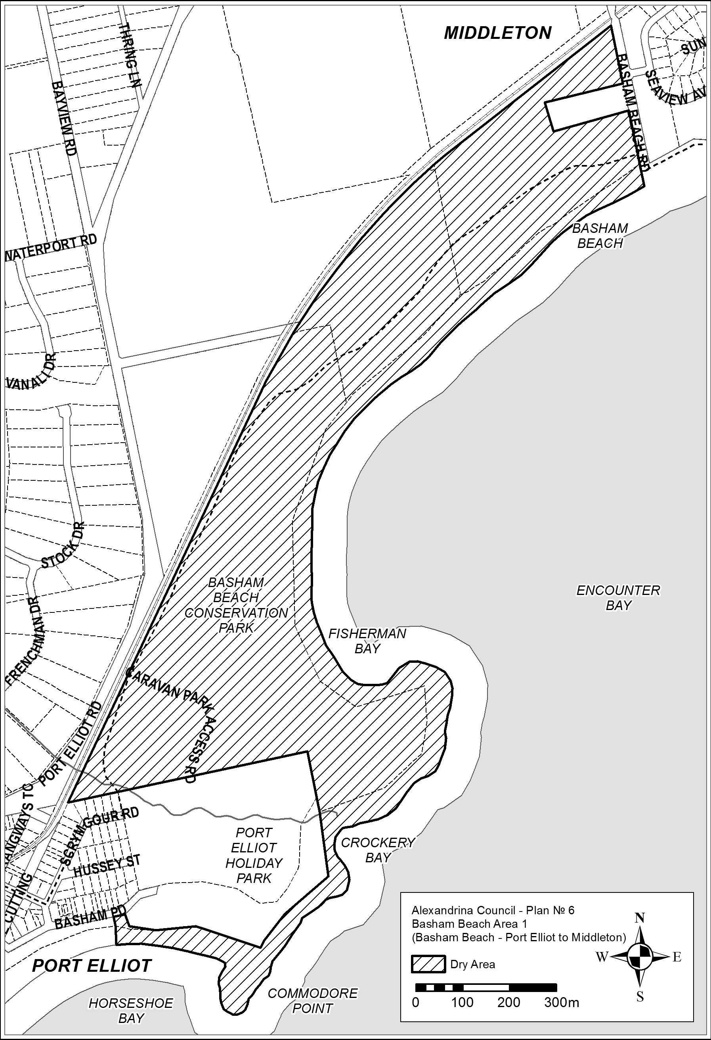

Made by the Acting Liquor and Gambling Commissioner
on 3 August 2016

South Australia
South Australian Civil and Administrative Tribunal (Appointment of Acting President) Proclamation 2016
under section 12 of the South Australian Civil and Administrative Tribunal Act 2013
1—Short title
This proclamation may be cited as the South Australian Civil and Administrative Tribunal (Appointment of Acting President) Proclamation 2016.
2—Commencement
This proclamation comes into operation on the day on which it is made.
3—Appointment of Acting President
Susanne Denise Cole, a Judge of the District Court and a Deputy President of the South Australian Civil and Administrative Tribunal, is appointed to be Acting President of the South Australian Civil and Administrative Tribunal from 24 August 2016 to 27 September 2016 (inclusive).
Made by the Governor’s Deputy
with the advice and consent of the Executive Council
on 18 August 2016
AGO0101/16CS

South Australia
Youth Court (Designation and Classification of Magistrate) Proclamation 2016
under section 9 of the Youth Court Act 1993
1—Short title
This proclamation may be cited as the Youth Court (Designation and Classification of Magistrate) Proclamation 2016.
2—Commencement
This proclamation will come into operation on 26 September 2016.
3—Designation and classification of Magistrate
The Magistrate named in Schedule 1 is—
(a) designated as a Magistrate of the Youth Court of South Australia; and
(b) classified as a member of the Court's principal judiciary; and
(c) declared to be a member of the Court's principal judiciary for a term of 1 year.
Schedule 1—Magistrate of the Court
Luke Anthony Davis
Made by the Governor’s Deputy
with the advice and consent of the Executive Council
on 18 August 2016
AGO0103/16CS

South Australia
Youth Court (Designation and Classification of Magistrate) Proclamation 2016
under section 9 of the Youth Court Act 1993
1—Short title
This proclamation may be cited as the Youth Court (Designation and Classification of Magistrate) Proclamation 2016.
2—Commencement
This proclamation comes into operation on the day on which it is made.
3—Designation and classification of Magistrate
The Magistrate named in Schedule 1 is—
(a) designated as a Magistrate of the Youth Court of South Australia; and
(b) classified as a member of the Court's principal judiciary; and
(c) declared to be a member of the Court's principal judiciary for a term of 1 year.
Schedule 1—Magistrates of the Court
Melanie Jane Little
Made by the Governor’s Deputy
with the advice and consent of the Executive Council
on 18 August 2016
AGO0103/16CS

South Australia
Native Title (South Australia) Regulations 2016
under the Native Title (South Australia) Act 1994

Contents
1 Short title
2 Commencement
3 Interpretation
4 Commonwealth and State Ministers
5 Information to be included in State Native Title Register
6 Fee for inspection of State Native Title Register
7 Forms
8 Amendment of applications
9 Notice of certain applications involving native title questions
10 Notice of hearing of certain native title questions
11 Notification of Commonwealth Registrar
12 Principles of eligibility for nomination as registered representative of native title holders
13 Functions of registered representative of native title holders
14 Requirement for consultation and consent
15 Evidence of consultation and consent
16 Service where existence of native title, or identity of native title holders, uncertain
Schedule 1—Forms
Schedule 2—Revocation of Native Title (South Australia) Regulations 2001
1 Revocation of Native Title (South Australia) Regulations 2001

1—Short title
These regulations may be cited as the Native Title (South Australia) Regulations 2016.
2—Commencement
These regulations will come into operation on 1 September 2016.
3—Interpretation
In these regulations, unless the contrary intention appears—
Act means the Native Title (South Australia) Act 1994;
common law holder of native title means the person or persons who are recognised at common law as holding the native title;
interested person means—
(a) the registered representative of claimants to, or holders of, native title in the land; and
(b) a person whose interests would be affected by the existence of native title in the land (including a person who proposes to carry out mining operations on the land); and
(c) a representative Aboriginal body; and
(d) the State Minister; and
(e) the Commonwealth Minister; and
(f) the council (within the meaning of the Local Government Act 1999) of the area in which the land is situated;
offshore place has the same meaning as in the Commonwealth Act;
prescribed print size, in relation to a notice in a publication, means a print size at least as large as that used for most of the editorial content of the publication;
relevant special-interest publication, in relation to a notice, means a newspaper or magazine that—
(a) caters mainly or exclusively for the interests of Aboriginal peoples; and
(b) circulates in the geographical area to which the notice relates or, if the area is an offshore place, the geographical area closest to it; and
(c) is published at least once a month.
4—Commonwealth and State Ministers
For the purposes of the Act—
(a) the Commonwealth Minister applicable, in relation to section 207A of the Commonwealth Act, under section 19A of the Acts Interpretation Act 1901 of the Commonwealth is designated as the Commonwealth Minister; and
(b) the Attorney-General of the State is designated as the State Minister.
5—Information to be included in State Native Title Register
(1) The State Native Title Register must contain the following information in relation to each decision recorded in the register:
(a) the name of the body that made the decision;
(b) the date on which the decision was made;
(c) a description of the land covered by the decision;
(d) a description of the matters decided, including if the decision is that native title exists in land—
(i) a description of the common law holders; and
(ii) a description of the nature and extent of the rights and interests conferred by the native title;
(e) if the decision is that native title exists in land—the name and address of the body corporate representing the common law holders (and a notation of whether the body corporate holds the native title in trust).
(2) The State Native Title Register must contain the following information in relation to each claim to native title in land registered under the Act:
(a) the date on which the claimant application was made;
(b) the date on which the claim is entered on the register;
(c) a description of the land covered by the claim;
(d) a description of the persons who it is claimed hold the native title;
(e) a description of the rights conferred by the native title claimed that the Registrar considers can, prima facie, be established.
(3) The State Native Title Register must contain a note of each claimant application (but the applicant is not to be taken to be a registered claimant until the claim is registered), unless the application is so defective that, in the opinion of the Registrar, it cannot be properly noted.
(4) A note of an application may be altered or removed by the Registrar in accordance with the rules.
(5) The Registrar may include in the State Native Title Register such other details about claims, decisions or native title declarations as the Registrar thinks appropriate.
6—Fee for inspection of State Native Title Register
(1) For the purposes of section 17(3) of the Act, the fee for inspection of the State Native Title Register is an amount equal to the fee set under the Environment, Resources and Development Court Act 1993 for inspection of material under section 47(1) of that Act.
(2) The Registrar may waive, remit or reduce the fee on account of the poverty of the person by whom the fee is payable or for any other proper reason.
7—Forms
If the form of an application or other document under the Act is set out in Schedule 1, the application or document must be made in that form and must include the information and be accompanied by the documents required by that form.
8—Amendment of applications
(1) An application may be made at any time to amend an earlier application for a native title declaration, for variation of a native title declaration or for compensation for an act extinguishing or otherwise affecting native title in land.
(2) For example, the amendment may include contraction of the area of land in which native title is claimed, reduction of the scope of native title claimed, substitution of the registered representative of claimants or substitution or joinder of persons as applicants to the application.
(3) However, an application may not be amended to include an area of land that was not covered by the original application unless—
(a) the application is a claimant application; and
(b) the amendment includes an area of land covered by a claimant application or applications with which the application is combined.
(4) If an amendment includes the substitution of the registered representative of the claimants or the representative in a claim for compensation (see section 27A of the Act), the Registrar must be provided with an affidavit sworn by the new representative stating the factual basis on which it is asserted that the new representative is authorised to deal with matters arising in relation to the application on behalf of the Aboriginal group concerned.
(5) In the case of a claimant application, the fact that the Registrar is considering the claim does not prevent amendment of the application.
(6) In the case of an application recorded or noted on the State Native Title Register, the amendment must be noted on the register.
9—Notice of certain applications involving native title questions
(1) This regulation applies to—
(a) an application for a native title declaration; and
(b) an application for variation or revocation of a native title declaration; and
(c) an application for compensation for an act extinguishing or otherwise affecting native title; and
(d) an application to amend an earlier application for a native title declaration, or for compensation for an act extinguishing or otherwise affecting native title, in a way that affects the nature or extent of a claim to native title or the area of land covered by the application.
(2) The Registrar must as soon as practicable after receiving an application to which this regulation applies, give notice of the application and send a copy of the application (together with a copy of any statutory declaration or other document that accompanied the application) to—
(a) the State Minister; and
(b) the relevant representative Aboriginal body.
(3) In the case of a claimant application, the Registrar must also give the State Minister and the relevant representative Aboriginal body notice of the result of the proceedings for registering the claim as soon as practicable after those proceedings are concluded.
(4) The Registrar must, as soon as practicable after receiving an application to which this regulation applies other than a claimant application—
(a) give notice of the application to—
(i) all who hold or may hold native title in the land to which the application relates; and
(ii) any person who has a registered interest in the land; and
(iii) any person who holds a mining tenement over the land; and
(iv) the council (within the meaning of the Local Government Act 1999) of the area in which the land to which the application relates is situated; and
(v) the Commonwealth Minister; and
(b) give public notice of the application.
(5) In the case of a claimant application, the Registrar must, as soon as practicable after proceedings for registering the claim are concluded—
(a) give the persons and bodies referred to in subregulation (4)(a) notice of the application and the result of the proceedings; and
(b) give public notice of the application and the result of the proceedings.
(6) Notice (including public notice) of an application given under this regulation—
(a) must include—
(i) details of the application; and
(ii) a clear description of the area to which the application relates; and
(iii) a statement of how further information about the application can be obtained; and
(b) must state that an interested person may apply to the Court—
(i) in the case of an application other than a claimant application—within 3 months after all requirements for service and publication of the notice of application have been completed;
(ii) in the case of a claimant application—within 3 months after all requirements for service of the notice of the result of the proceedings for registering the claim have been completed,
to be joined as a party to the proceedings; and
(c) in the case of an application for a native title declaration—
(i) must state that a declaration that the land is subject to, or not subject to, native title may be made even though no person claiming native title in the land is joined as a party to the proceedings; and
(ii) must include a statement to the effect that as there can be only 1 native title declaration for an area, if a person who claims to hold native title in relation to the area does not become a party to the application, there may be no other opportunity for the Court to take into account the person's claim; and
(d) in the case of a non-claimant application—must include a statement to the effect that the area covered by the application may be subject to section 24FA protection (as defined in section 24FB of the Commonwealth Act) unless, at the end of the period of 3 months after all requirements for service of the notice have been completed, the area is covered by a relevant native title claim (as defined in section 24FE of the Commonwealth Act); and
(e) in the case of an application for compensation for an act extinguishing or otherwise affecting native title in relation to land for which a native title declaration has not been made—
(i) must state that at the conclusion of the proceedings the Court must make a native title declaration; and
(ii) must state that a declaration that the land is subject to, or not subject to, native title may be made even though no person claiming native title in the land is joined as a party to the proceedings; and
(iii) must include a statement to the effect that as there can be only 1 native title declaration for an area, if a person who claims to hold native title in relation to the area does not become a party to the application, there may be no other opportunity for the Court to take into account the person's claim.
(7) Public notice given under this regulation must be published (in the prescribed print size)—
(a) by advertisement in 1 or more newspapers that circulate generally throughout the area to which the notice relates or, if the area is an offshore place, the geographical area closest to it; and
(b) in a relevant special-interest publication.
(8) The Registrar must keep available for public inspection—
(a) in respect of each claimant application—a record of the date on which all requirements for service of notice of the results of the proceedings for registering the claim were completed;
(b) in respect of each other application to which this regulation applies—a record of the date on which all requirements for service and publication of notice of the application were completed.
(9) In this regulation—
claimant application includes an application for the amendment of a claimant application requiring the Registrar to reconsider the registration of a claim (see section 19A(4) of the Act).
10—Notice of hearing of certain native title questions
(1) When the Court is to hear a native title question, the Registrar must give reasonable notice of the hearing to—
(a) all who hold or may hold native title in the land to which the proceedings relate; and
(b) any person who has a registered interest in the land; and
(c) any person who holds a mining tenement over the land; and
(d) the council (within the meaning of the Local Government Act 1999) of the area in which the land to which the proceedings relate is situated.
(2) A notice of hearing to a person who is not a party to the relevant proceedings must state that an interested person may apply to the Court, within 3 months after all requirements for service of the notice have been completed, to be joined as a party to the proceedings.
(3) The Registrar must keep available for public inspection, in respect of each hearing for which notice must be given under this regulation, a record of the date on which all requirements for service of notice of the hearing were completed.
(4) This regulation does not apply in relation to a native title question that arises—
(a) on an application of which notice has been given under regulation 9;
(b) in proceedings under Division 1 of Part 4 of the Land Acquisition Act 1969;
(c) in proceedings under Part 9B of the Mining Act 1971;
(d) in proceedings under Part 7 of the Opal Mining Act 1995.
11—Notification of Commonwealth Registrar
(1) The Registrar must, as soon as practicable after receiving any of the following applications, send a copy of the application (together with a copy of any statutory declaration or other document that accompanied the application) to the Commonwealth Registrar:
(a) an application for a native title declaration;
(b) an application for variation or revocation of a native title declaration;
(c) an application for compensation for an act extinguishing or otherwise affecting native title;
(d) an application to amend an earlier application for a native title declaration, or for compensation for an act extinguishing or otherwise affecting native title, in a way that affects the nature or extent of a claim to native title or the area of land covered by the application.
(2) The Registrar must notify the Commonwealth Registrar as soon as practicable of—
(a) the details of any claims registered in the State Native Title Register; and
(b) the amendment or removal of any claims from the State Native Title Register; and
(c) the withdrawal or dismissal of an application for a native title declaration, variation or revocation of a native title declaration or compensation for an act extinguishing or otherwise affecting native title; and
(d) the proposed date of any hearing of proceedings in the Court involving a native title question (together with a brief description of the native title question involved); and
(e) the decision of the Court on a native title question (including, in the case of a decision recorded in the register, all of the information recorded in relation to the decision).
12—Principles of eligibility for nomination as registered representative of native title holders
A body corporate is eligible for nomination as the registered representative of native title holders if—
(a) it is an Aboriginal association within the meaning of the Corporations (Aboriginal and Torres Strait Islander) Act 2006 of the Commonwealth; and
(b) it is incorporated under that Act for the purpose of performing the functions of a registered representative of native title holders (and that purpose is set out in its objects); and
(c) all of its members are persons proposed to be recognised in a native title declaration as the holders of native title in land (although they need not be members of the same Aboriginal group if the native title declaration applies to more than 1 Aboriginal group).
13—Functions of registered representative of native title holders
The functions of a registered representative of native title holders are—
(a) if the representative holds the native title in trust—
(i) to act as trustee of the native title for the common law holders; and
(ii) to deal with the native title as trustee to the extent authorised by the law of the Commonwealth or the State (for example, the representative could enter into an indigenous land use agreement under the Commonwealth Act to surrender the native title or to authorise an act that will affect the native title); and
(iii) to take action to protect the native title and to protect and enforce the rights of the common law holders including rights to compensation; and
(iv) to hold money (including money received by way of compensation or other consideration payable in relation to the native title) on trust and to invest or otherwise apply the money as directed by the common law holders of the native title; and
(v) to consult with the common law holders in accordance with regulation 14; and
(vi) to perform any other function in relation to the native title as directed by the common law holders;
(b) if the representative does not hold the native title in trust—
(i) to act as agent or representative of the common law holders of the native title in respect of matters relating to the native title; and
(ii) to hold money (including money received by way of compensation or other consideration payable in relation to the native title) on trust and to invest or otherwise apply the money as directed by the common law holders of the native title; and
(iii) to consult with the common law holders in accordance with regulation 14; and
(iv) to perform any other functions in relation to the native title as directed by the common law holders.
14—Requirement for consultation and consent
Before a registered representative of native title holders deals with the native title or acts in a way that will affect the native title1, the representative must—
(a) ensure that the common law holders of the native title understand the purposes and nature of the proposed dealing or act by—
(i) consulting, and considering the views of, the representative Aboriginal body for the area in which the land concerned is situated; and
(ii) if the representative considers it appropriate and practicable—giving notice of those views to the common law holders; and
(b) ensure that the common law holders of the native title consent to the proposed dealing or act by following either—
(i) a process of decision making recognised by the traditional laws or customs of the common law holders; or
(ii) a process of decision making agreed to and adopted by the common law holders in relation to the decision or in relation to decisions of that kind.
Explanatory note—
1 For example, by the representative entering into an indigenous land use agreement (either as trustee, agent or representative) under the Commonwealth Act to surrender the native title or to authorise an act that will affect the native title.
15—Evidence of consultation and consent
(1) Subject to this regulation, in any proceedings, a certificate signed by at least 5 members of a registered representative of native title holders certifying—
(a) that the common law holders have been consulted about a proposed dealing with the native title and have consented to the dealing (as required by these regulations); or
(b) that the relevant representative Aboriginal body has been consulted about a proposed dealing with native title and its views considered by the representative (as required by these regulations),
will, in the absence of proof to the contrary, be taken to be proof of the matters so certified.
(2) In the case of a certificate certifying that the common law holders have been consulted about a proposed dealing with native title and have consented to the dealing, the members signing the certificate must—
(a) if fewer than 5 members are common law holders of the native title concerned—include those common law holders;
(b) in any other case—each be a common law holder of the native title concerned.
(3) In the case of a certificate certifying that the relevant representative Aboriginal body has been consulted about a proposed dealing with native title and its views considered by the representative, the certificate must be accompanied by a certificate signed by an authorised member of the relevant representative Aboriginal body certifying that the body has been consulted about the proposed dealing with native title.
(4) If native title is dealt with by the registered representative of the native title holders, the representative must, at the written request of a person who has a substantial interest in the matter, ensure that the person is provided with copies (certified by the representative to be true and correct copies) of certificates of the kind referred to in this regulation.
(5) In any proceedings a copy of a certificate of a kind referred to in this regulation certified by the registered representative of the native title holders to be a true and correct copy is to be given the same status as the original certificate.
16—Service where existence of native title, or identity of native title holders, uncertain
(1) For the purposes of section 30(1)(a)(i) of the Act, notice of the nature and effect of a right to negotiate notice (within the meaning of that section) must be given by publishing the prescribed information (in the prescribed print size)—
(a) by advertisement in 1 or more newspapers that circulate generally throughout the area to which the notice relates or, if the area is an offshore place, the geographical area closest to it; and
(b) in a relevant special-interest publication.
(2) In this regulation—
prescribed information means—
(a) the name and address for service of the person giving notice; and
(b) the information required to be included in the right to negotiate notice by or under the Act under which the notice is given; and
(c) a clear description of the nature and effect of the right to negotiate notice; and
(d) a statement of how further information can be obtained.
Schedule 1—Forms
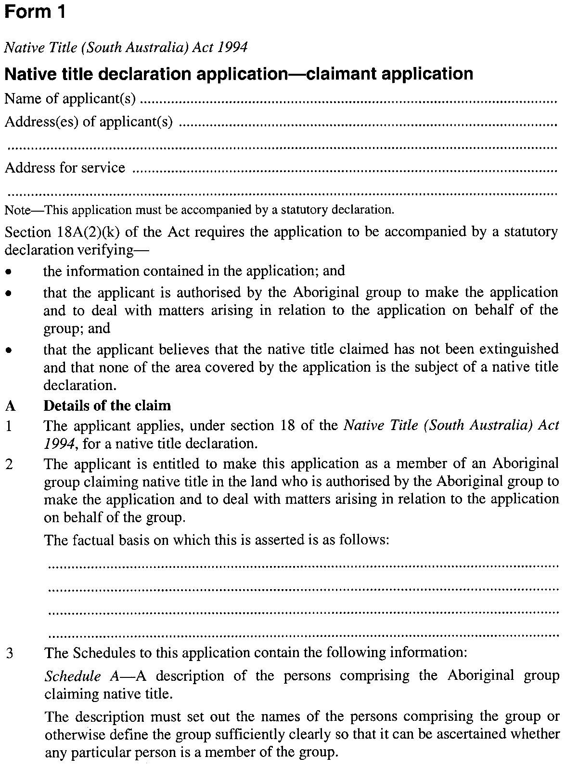
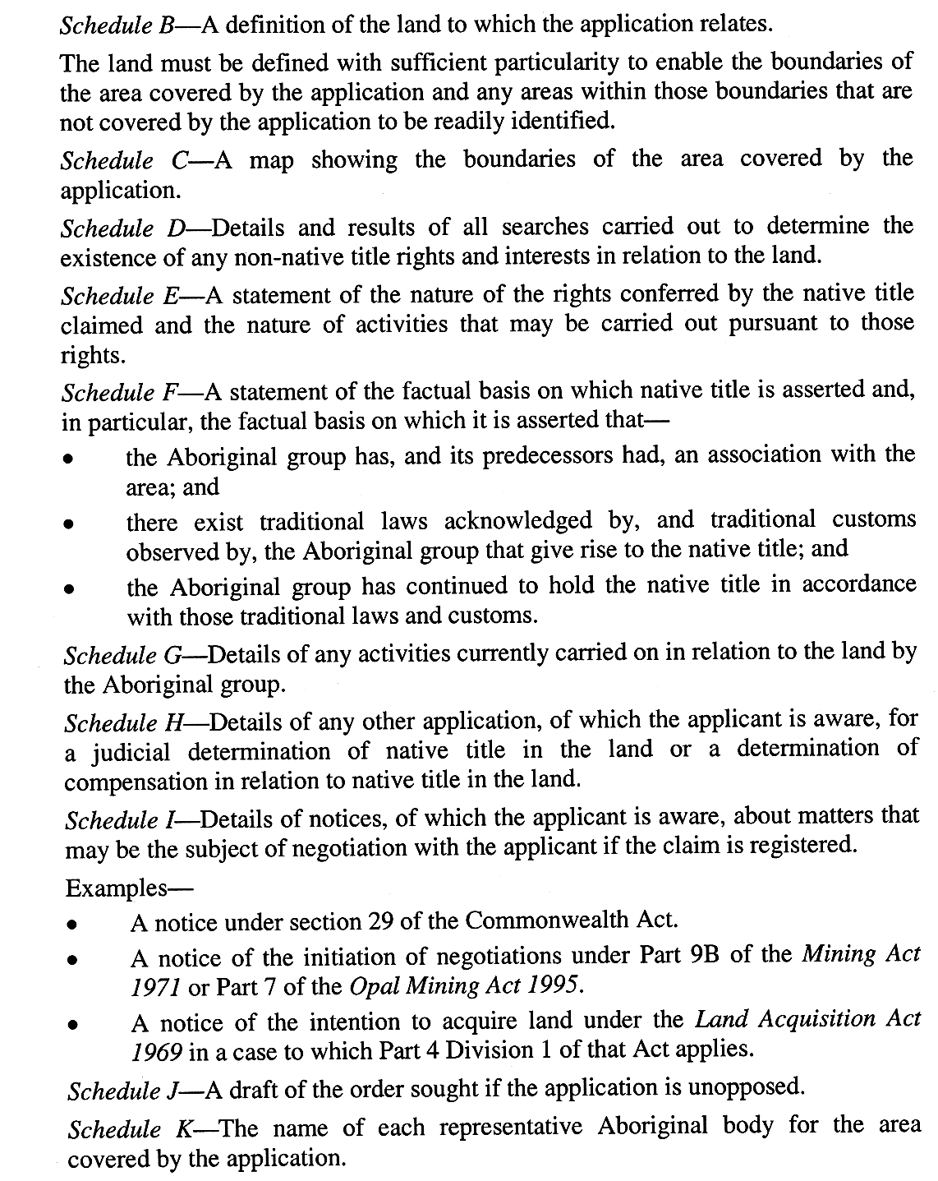
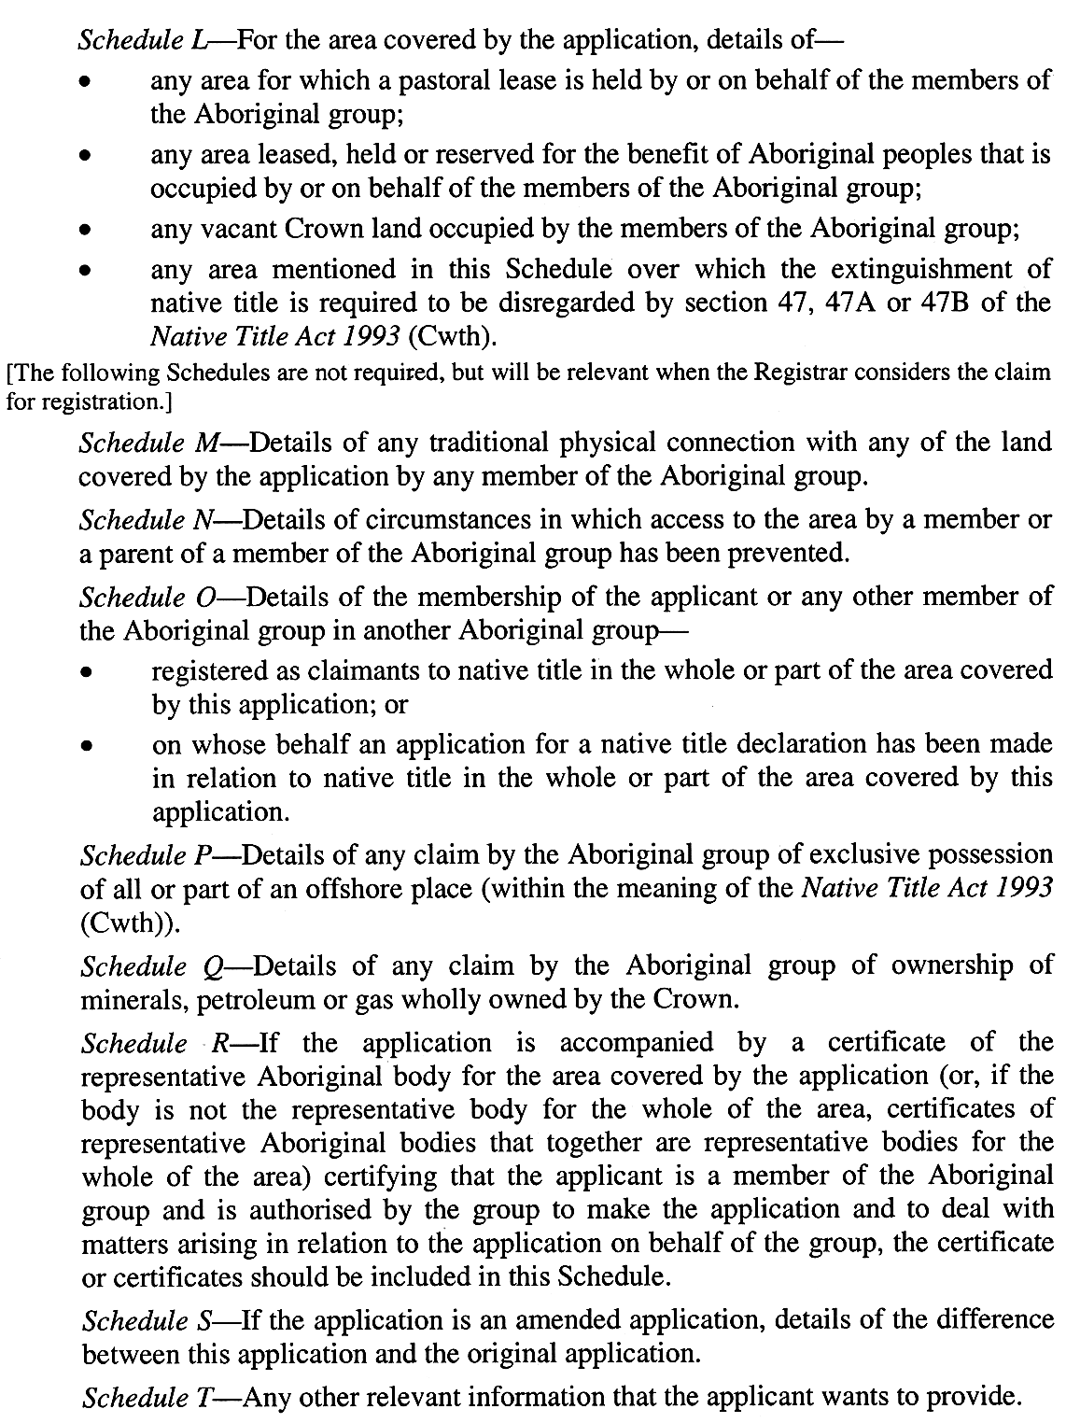
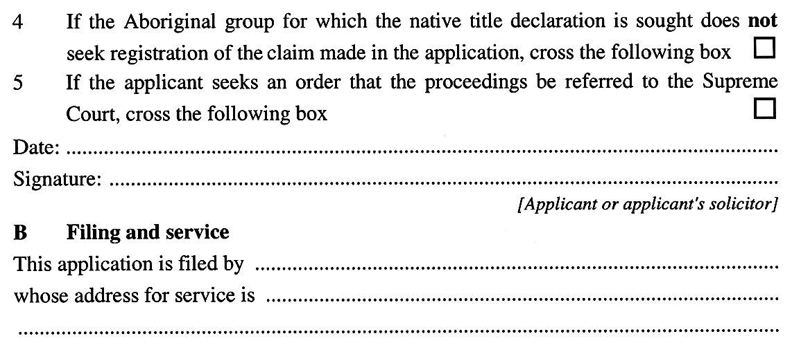
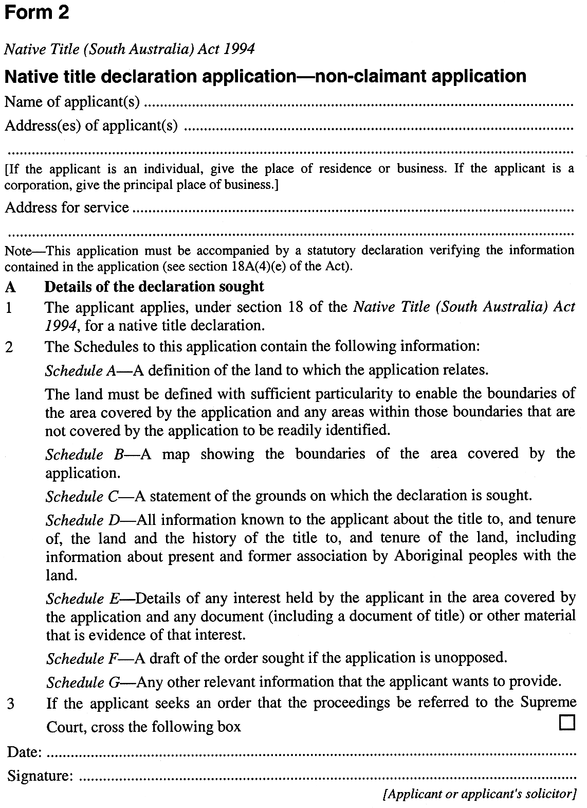

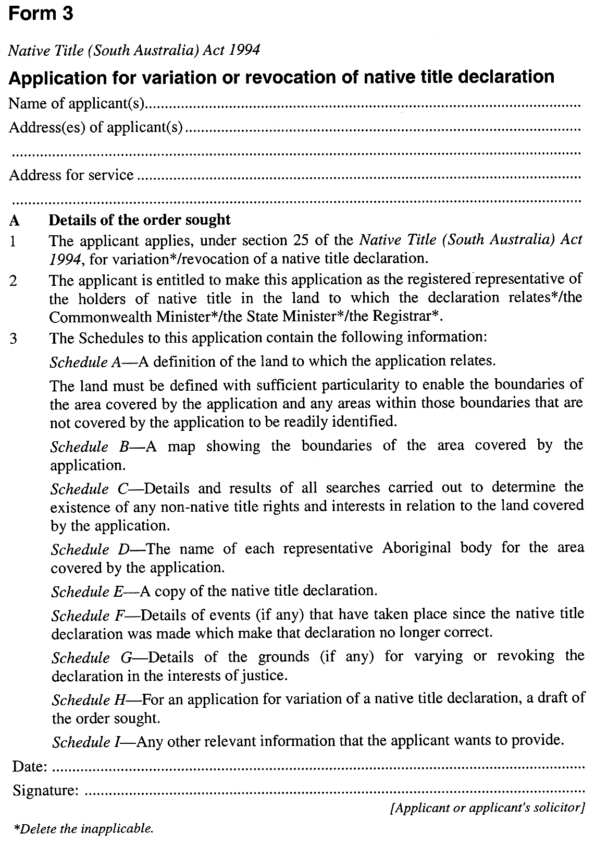

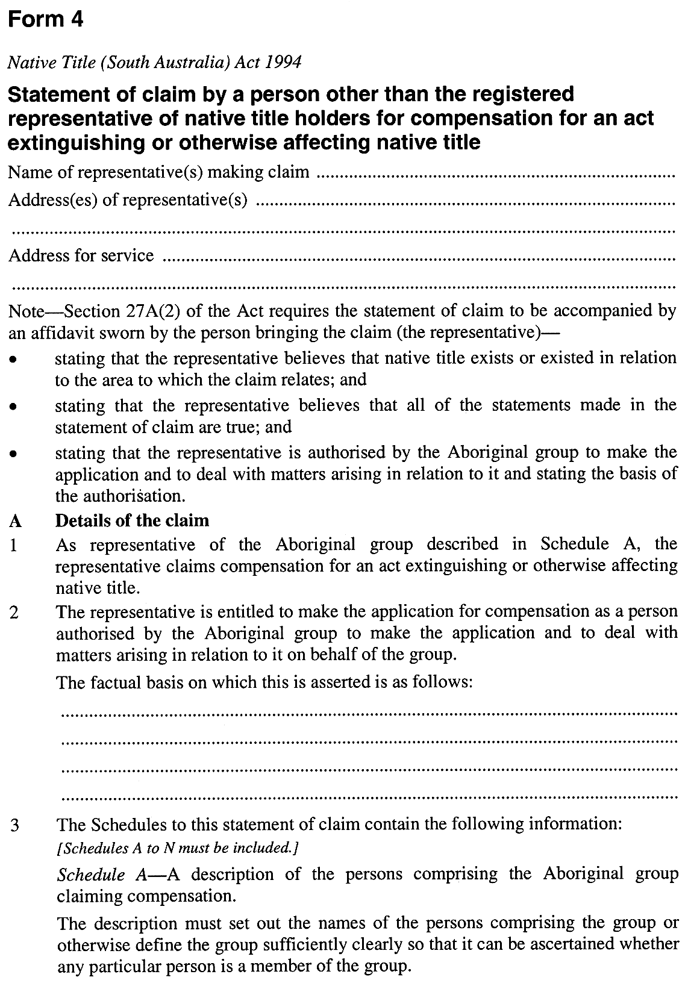
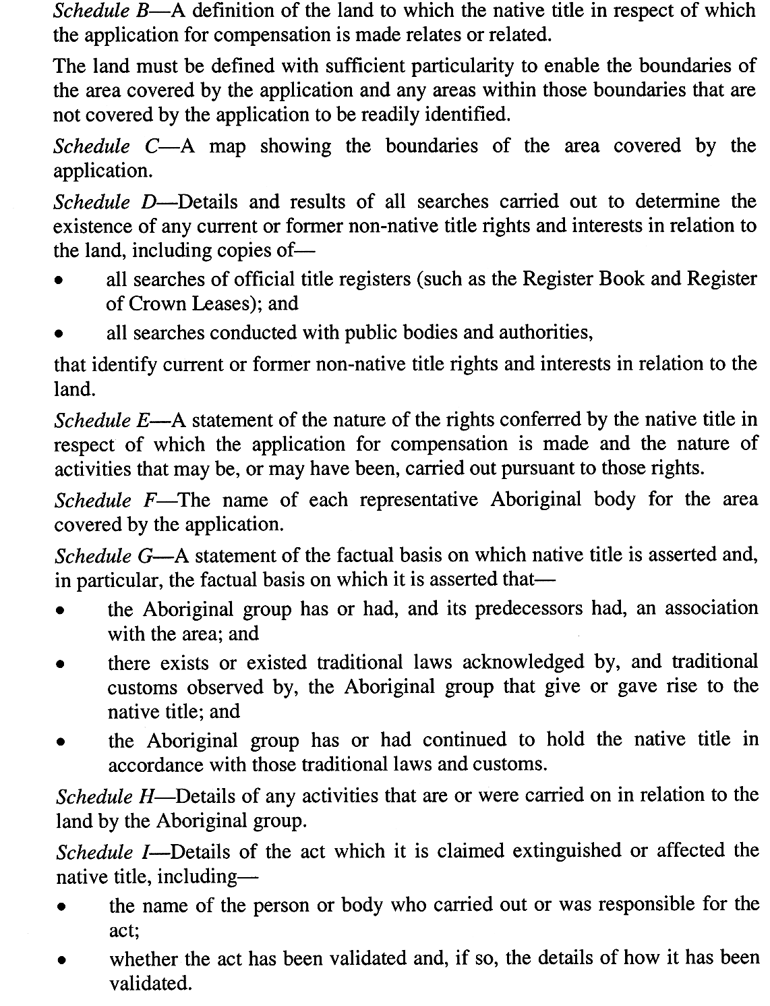
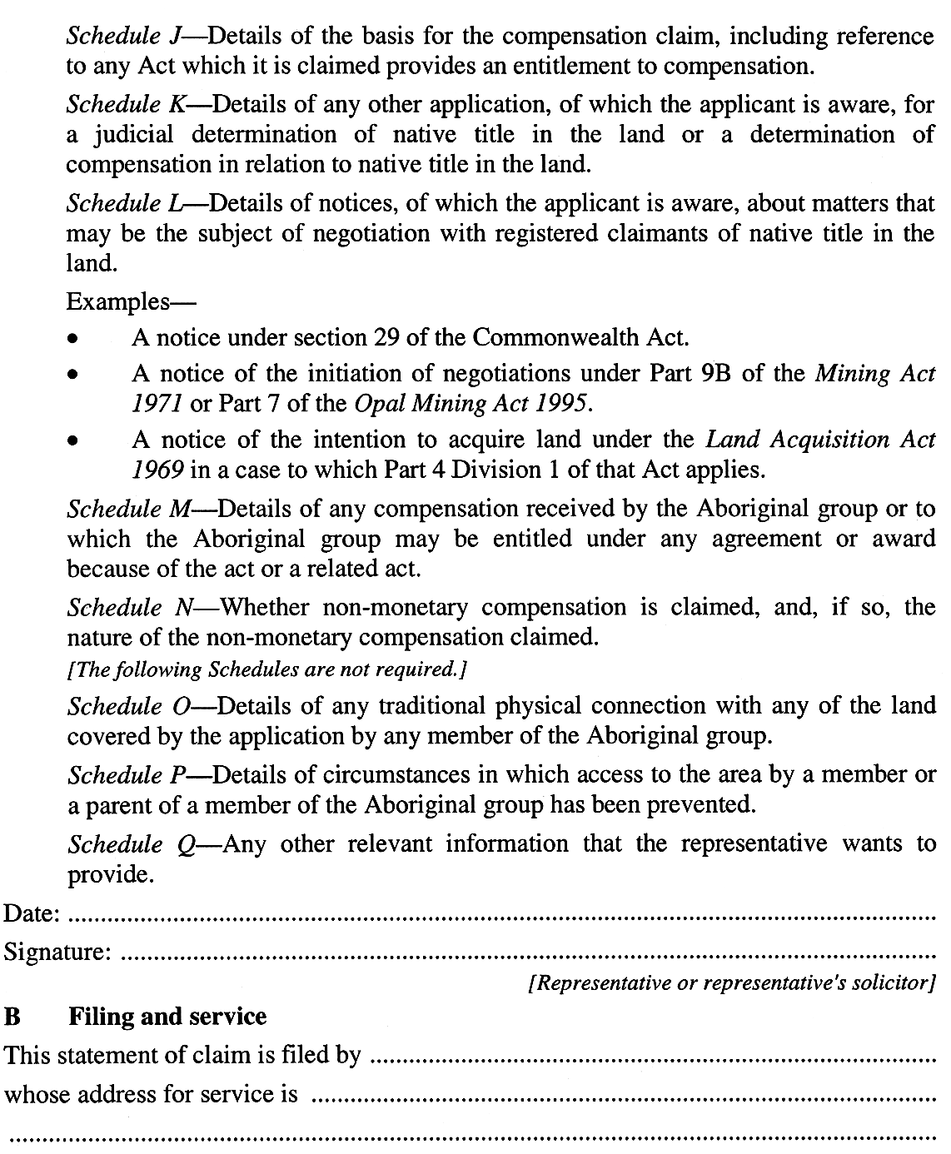
Schedule 2—Revocation of Native Title (South Australia) Regulations 2001
1—Revocation of Native Title (South Australia) Regulations 2001
The Native Title (South Australia) Regulations 2001 are revoked.
Note—
As required by section 10AA(2) of the Subordinate Legislation Act 1978, the Minister has certified that, in the Minister's opinion, it is necessary or appropriate that these regulations come into operation as set out in these regulations.
Made by the Governor’s Deputy
with the advice and consent of the Executive Council
on 18 August 2016
No 194 of 2016
AGO0104/16CS

South Australia
National Parks and Wildlife (Wildlife) Regulations 2016
under the National Parks and Wildlife Act 1972

Contents
1 Short title
2 Commencement
4 Interpretation
5 Application
6 Taking of native plants
7 Release of animals
8 Information to be provided on application for section 58 or 60C permit
9 Records and returns in relation to sections 58 and 60C permits
9A Director to supply record books, returns etc
9B Electronic form of record books, returns etc
10 Class 2 permits
11 Premises from which animals are sold
12 Advertisement to include permit number
13 Purchase etc only from permit holder
14 Labelling containers of protected animals, carcasses or eggs
15 Dealing in juvenile birds or mammals
16 Importing protected animals, carcasses and eggs
17 Exporting protected animals, carcasses and eggs
18 Standards for keeping protected animals
19 Cross-breeding
20 Conditions of emu farming permits
21 Sealed tags for emus
22 Declaration of royalty
23 Notification of change of address
24 Permit not to be used by another
25 General offence
Schedule 1—Fees
Schedule 2—Form of section 53(4) report
Schedule 3—Classes of permits
1 Reference to classes of permits
2 Classes of permits
Schedule 4—Information required in returns provided under regulation 9(2)
Schedule 5—Times for provision of returns in relation to sections 58 and 60C permits
Schedule 6—Prescribed species for purposes of section 58(1)(a) of the Act
Schedule 7—Species excluded by proclamation under section 58(4) of the Act
Schedule 8—Prescribed species: section 58(2)(a)
Schedule 9—Royalty
Schedule 10—Revocation and transitional provisions
Part 1—Preliminary
1 Interpretation
Part 2—Revocation of National Parks and Wildlife (Wildlife) Regulations 2001
2 Revocation of regulations
Part 3—Transitional provisions
3 Permits granted before the commencement of these regulations
4 Required period for provision of information or other actions
5 Applications, requests etc made under revoked regulations
6 Approvals, authorisations, exemptions etc granted before the commencement of these regulations

1—Short title
These regulations may be cited as the National Parks and Wildlife (Wildlife) Regulations 2016.
2—Commencement
These regulations come into operation on the day on which they are made.
4—Interpretation
(1) In these regulations, unless the contrary intention appears—
the Act means the National Parks and Wildlife Act 1972;
commercial harvesting authority has the same meaning as in the National Parks and Wildlife (Kangaroo Harvesting) Regulations 2003;
kangaroo field processor, kangaroo meat processor and kangaroo skin tanner have the same meaning as in the National Parks and Wildlife (Kangaroo Harvesting) Regulations 2003;
personal use of a kangaroo that has been taken has the same meaning as in the National Parks and Wildlife (Kangaroo Harvesting) Regulations 2003;
the record book—see regulation 9(1);
the return book—see regulation 9(3);
section 58 permit means a permit granted under section 58 of the Act;
section 59 permit means a permit granted under section 59 of the Act;
section 60C permit means a permit granted under section 60C of the Act;
section 60J permit means a permit granted under section 60J of the Act;
specialist animal means an animal of a specialist species;
specialist species means a species of protected animal that—
(a) is not excluded by proclamation under section 58(4) of the Act; and
(b) is not listed in Schedule 6.
(2) A reference in these regulations to a class of permit is a reference to a permit of that class described in Schedule 3.
5—Application
A warden is not subject to these regulations in relation to the performance of his or her functions or the exercise of his or her powers as a warden and an employee of the Department is not subject to these regulations in relation to the performance of the duties of his or her employment.
6—Taking of native plants
A person must, within 14 days after the expiration or revocation of a permit granted to him or her under section 49 of the Act, provide the Director with the following information in writing:
(a) the species and number of native plants taken pursuant to the permit; and
(b) the date on which they were taken; and
(c) the location at which they were taken.
7—Release of animals
(1) A person must, within 14 days after releasing an animal pursuant to a permit granted under section 55 of the Act, provide the Director with the following information in writing:
(a) the species of the animal released; and
(b) the date and time of release; and
(c) if more than one animal was released at that time—the number of animals of each species released; and
(d) the exact location at which each animal was released.
(2) The person referred to in subregulation (1) must provide the Director with such further information in writing in relation to the release as the Director requires.
8—Information to be provided on application for section 58 or 60C permit
A person must, when applying for a section 58 or section 60C permit, provide the Director with—
(a) a written statement setting out—
(i) the species of protected animals (if any) and the number of individuals of each species in the applicant's possession; and
(ii) the number of carcasses, eggs or skins (if any) of protected animals in the applicant's possession and the species to which those animals belong; and
(b) such other information as the Director may require.
9—Records and returns in relation to sections 58 and 60C permits
(1) The holder of a class 1, 1A, 2, 3, 3A or 12 permit must keep a record of the following information in a book (the record book) supplied by the Director for that purpose:
(a) the species of animals, and the number of individuals of each species, acquired or disposed of pursuant to the permit; and
(b) the date of acquisition or disposal; and
(c) the name and address of, and the number of the permit held by, the person from whom the animals were acquired or to whom the animals were disposed; and
(d) the species of animals, and the number of individuals of each species, born to animals kept pursuant to the permit; and
(e) the species of animals, and the number of individuals of each species, that have died or escaped while being kept pursuant to the permit; and
(f) all other information that must be included in a return by virtue of subregulation (2).
(2) The holder of a section 58 permit (other than a class 2 or class 10 permit) or a section 60C permit must at the times indicated in Schedule 5 provide the Director with a return that has been signed by the holder of the permit and that sets out the information required by Schedule 4.
(3) The permit holder must use a return supplied by the Director for that purpose (whether supplied individually or bound in the form of a book (the return book)) and a copy of each return must be kept by the permit holder.
(4) The holder of a class 2 permit must submit the record book, or a copy of the record book, to the Director within 14 days after 30 September, 31 December, 31 March and 30 June in each year.
(5) The record book must be kept in a safe and secure place at the place at which the animals to which the records relate are kept and, if the permit holder keeps animals at more than 1 place, separate records must be kept at each place at which animals are kept.
(6) Submission of a record book to the Director by the holder of a class 2 permit under subregulation (4) will not be taken to be in breach of subregulation (5).
(7) Copies of returns must be kept in a safe and secure place—
(a) in the case of a class 1, 1A, 3, 3A or 12 permit—at the principal place at which animals to which the returns relate are kept; and
(b) in the case of a class 11 permit—at the permit holder's principal place of residence; and
(c) in the case of a class 7 or 8 permit—at the principal place at which the permit holder carries on the business of processing or tanning.
(8) Where a transaction or event occurs in respect of which an entry must be made in the record book or in a return, the entry must be made within 48 hours after the occurrence of that transaction or event.
(9) A permit holder must notify the Director of any loss of, or damage to, the record book or copies of returns within 7 days after becoming aware of that loss or damage.
(10) A person who has the custody or control of the record book or copies of returns (including a person who has custody or control as agent or employee of the permit holder) must, if requested by a warden, produce the book or copies for inspection by the warden.
(11) A permit holder who is charged with an offence against the Act or these regulations must, at the request of the Director or a warden, produce to the court that hears the charge any record book, return book or individual return under his or her custody or control that is, in the opinion of the Director or warden, relevant to the charge.
(13) Subject to this regulation, a person must not sell or give an animal pursuant to a class 1 or 3 permit unless—
(a) the animal was bred by the permit holder; or
(b) the animal has been in the possession of the permit holder for at least 6 months.
(14) Subject to this regulation, a person must not sell an animal pursuant to a class 2 permit unless the animal has been in the possession of the permit holder for at least 7 days.
(15) An animal may be sold or given in contravention of subregulation (13) or sold in contravention of subregulation (14) with the approval of the Director or a warden.
(16) A reference in this regulation to a warden does not include a warden who is a member of the police force.
(17) The Director may, on such conditions as the Director thinks fit, exempt a person from compliance with any provision of this regulation.
9A—Director to supply record books, returns etc
(1) Where a person, as a consequence of the grant of a permit, is required by or under the Act to record information in a record book, return book or return supplied by the Director, the Director must supply the necessary book or individual return forms (as appropriate) to that person on the grant of the permit.
(2) If further books are required by the permit holder as the result of the loss of those provided or because animals are required to be kept in more than 1 place, the Director may require the payment of the fee in Schedule 1 for the supply of each additional book.
9B—Electronic form of record books, returns etc
Where a person is required by these regulations to record information in a record book, return book or return, and the Director authorises the book or return to be kept in electronic form or provided to the Director by means of an electronic communication—
(a) a reference in these regulations to a record book, return book or return includes a reference to the book or return in that electronic form; and
(b) a reference in these regulations to the provision or submission of a record book, return book or return to the Director includes a reference to provision or submission by means of that authorised electronic communication; and
(c) a reference in these regulations to the supply by the Director of a record book, return book or return includes a reference to the supply by the Director of a template or other structure for that electronic form of the book or return; and
(d) a reference in these regulations to the production of a record book, return book or return at the request of a warden, or to a court at the request of the Director or a warden, means production in the form (electronic or printed) requested.
10—Class 2 permits
(1) A person must not carry on the business of a dealer in protected animals or the carcasses or eggs of protected animals except at premises approved by the Director.
(2) An application for the Director's approval—
(a) must be in a form approved by the Director; and
(b) must be accompanied by such information as the Director requires; and
(c) must be accompanied by the prescribed fee.
(3) The holder of a class 2 permit must display at all premises at which he or she carries on the business of a dealer in protected animals a certificate signed by or on behalf of the Director to the effect that the dealer is the holder of a class 2 permit.
(4) The certificate may include such further information as the Director thinks fit.
11—Premises from which animals are sold
(1) A person must not sell an animal pursuant to a section 58 permit unless—
(a) in the case of a class 2 permit—the premises from which the animal is sold have been approved by the Director pursuant to these regulations;
(b) in any other case—the premises from which the animal is sold—
(i) are the premises at which the animal was kept pursuant to the permit or any other permit; or
(ii) are premises approved by the Director for the purposes of sale.
(2) The premises from which a protected animal is sold (whether pursuant to a permit or not) must afford protection to the animal from weather conditions that would be likely to cause distress to the animal.
12—Advertisement to include permit number
Where section 58 of the Act requires that the sale of a protected animal be authorised by a permit granted under that section, a person who advertises the animal for sale must state in the advertisement the number of the permit that authorises the sale.
13—Purchase etc only from permit holder
(1) A person must not purchase a protected animal or the carcass or eggs of a protected animal or receive a protected animal or the carcass or eggs of a protected animal as a gift from a person who is required by the Act to hold a permit authorising the sale or gift if that person—
(a) does not hold the required permit; or
(b) does not hold any additional written authorisation from the Director for the sale or gift that he or she is required to hold as a condition of the permit.
(2) A person who sells or gives a protected animal or the carcass or eggs of a protected animal pursuant to a section 58 permit must, if requested by the prospective purchaser or donee, produce the permit (and any other document that he or she is required to hold under subregulation (1)) for inspection.
14—Labelling containers of protected animals, carcasses or eggs
(1) Where a protected animal or the carcass or egg of a protected animal is consigned or conveyed from the premises at which the animal is or was kept pursuant to a section 58 permit, the holder of the permit must ensure that the receptacle or container containing the animal, carcass or egg has securely attached to it a label clearly displaying the following information:
(a) the permit holder's name and residential or business address; and
(b) the number of the permit; and
(c) the name and address of the person to whom the animal, carcass or egg is being consigned or conveyed and, if that person also holds a section 58 permit, the number of that permit.
(2) A person must not knowingly transport a protected animal or the carcass or egg of a protected animal from premises at which the animal is or has been kept pursuant to a section 58 permit unless a label is attached to the receptacle or package containing the animal, carcass or egg in accordance with this regulation.
15—Dealing in juvenile birds or mammals
(1) Subject to this regulation, a person must not sell a bird or mammal that is a protected animal or is of a species listed in Schedule 10 of the Act if—
(a) in the case of a bird—the bird is too young to fly or to feed itself; or
(b) in the case of a mammal—the mammal is unweaned.
(2) Subregulation (1) does not apply—
(a) to the sale of an emu pursuant to a section 60C permit; or
(b) if the sale is made pursuant to a permit granted under the Act that expressly authorises the sale of such a young bird or unweaned mammal.
16—Importing protected animals, carcasses and eggs
(1) A person who intends importing a protected animal or the carcass or egg of a protected animal must—
(a) at least 48 hours before importation give the Director notice in writing stating—
(i) the species of the animal which is, or the carcass or egg of which is, to be imported; and
(ii) the name and address of the person who had possession of the animal, carcass or egg before importation and the name and address of the person who will have possession of the animal, carcass or egg after importation; and
(iii) the manner of importation; and
(iv) the time and place of importation; and
(b) if the proposed importation does not proceed—inform the Director of that fact within 48 hours after he or she first becomes aware that it will not proceed; and
(c) if the importation does proceed but 1 or more of the particulars of the importation differ from those stated under paragraph (a)—inform the Director of the variation within 48 hours after the importation takes place.
(2) A person who imports a protected animal or the carcass or egg of a protected animal pursuant to a section 59 permit must not dispose of the animal, carcass or egg for 7 days after importation without the written authority of the Director or a warden.
(3) The reference in subregulation (2) to a warden does not include a warden who is a member of the police force.
17—Exporting protected animals, carcasses and eggs
(1) A person who exports an animal or the carcass or egg of an animal pursuant to a section 59 permit must ensure that—
(a) the original permit; or
(b) in the case of a class 2 permit—a photocopy of the original permit; or
(c) in the circumstances prescribed by subregulation (2)—a facsimile of the original permit transmitted to the person by the Minister,
is securely attached in a conspicuous position to the receptacle or package containing the protected animal, carcass or egg.
(2) If a facsimile referred to in subregulation (1) can be read without difficulty, it may be used instead of the original permit by a person who is the holder of a class 1, 1A, 2, 3, 3A, 7, 8 or 12 permit in relation to the animal, carcass or egg being exported.
(3) A person must not knowingly transport for export a protected animal or the carcass or egg of a protected animal unless a permit to export, or a facsimile of such a permit, is attached to the receptacle or package containing the animal, carcass or egg in accordance with this regulation.
18—Standards for keeping protected animals
(1) A person who keeps a protected animal must—
(a) keep the animal in a cage or enclosure that is adequate in size and is constructed and maintained so as to—
(i) provide adequate shelter in all circumstances; and
(ii) prevent the animal from escaping; and
(iii) protect the animal against predators; and
(iv) enable the cage or enclosure to be locked or otherwise secured against intruders; and
(v) as far as is practicable, facilitate the inspection of the animal by a warden under the Act; and
(b) ensure that the cage or enclosure in which the animal is kept—
(i) is maintained in a clean and sanitary condition; and
(ii) except when the person is present—is securely locked or otherwise secured against intruders; and
(c) keep an adequate supply of clean water in the cage or enclosure; and
(d) provide sufficient and appropriate food in the cage or enclosure; and
(e) not keep the animal with another animal that is likely to injure or kill it; and
(f) protect the animal from weather conditions that would be likely to cause it distress; and
(fa) provide the animal with adequate heat or ultra-violet light from an artificial source if the animal is of a species that requires such heat or light for its well-being; and
(g) not permit the animal to suffer distress from any other cause that can reasonably be avoided; and
(h) produce the animal for inspection at the request of a warden.
(2) If, in the opinion of a warden, a person is contravening or is failing to comply with a requirement of subregulation (1) in relation to an animal, the warden may remove the animal from that person's possession or control.
(3) A warden is not bound to return an animal removed under subregulation (2) unless the warden is satisfied that there will not be a further contravention of, or non-compliance with, subregulation (1) in relation to that animal.
19—Cross-breeding
A person must not, without the approval of the Director, permit a protected animal to mate with an animal of another species or sub-species if conception and a live birth may result from the union.
20—Conditions of emu farming permits
(1) A class 12 permit is subject to the following conditions in addition to any conditions imposed by the Act or the Minister:
(a) that the holder of the permit must not acquire an emu, or the egg of an emu, in the course of carrying on the business of farming emus, from a person who does not hold a class 12 permit; and
(b) that the holder of the permit must not sell a live emu to a person who does not hold a class 12 permit; and
(c) that the holder of the permit must comply with the requirements of the emu code of management (see subregulation (4)) relating to fencing, gates and emu handling facilities and must maintain fences, gates and handling facilities in accordance with those requirements in a proper state of repair; and
(d) that the holder of the permit must not send an emu for slaughter to an abattoir or slaughterhouse unless—
(i) the abattoir or slaughterhouse has been approved for that purpose by the Director; and
(ii) the holder of the permit has been issued with a sealed tag in relation to the emu by the Director; and
(iii) the permit holder has taken all reasonable steps to ensure that the tag is delivered to the person in charge of the abattoir or slaughterhouse when the emu is delivered; and
(e) that the holder of the permit must not slaughter an emu, or cause an emu to be slaughtered, on his or her property without the written approval of the Director; and
(f) that the holder of the permit must, if an emu is slaughtered or dies in any other manner on his or her property, attach a sealed tag (issued to the permit holder by the Director) to the skin of the emu in the manner provided by these regulations before the skin leaves the property; and
(g) that the holder of the permit must comply with regulation 21 insofar as that regulation is applicable to him or her.
(2) The Director may, by written notice given to a permit holder, waive compliance by the permit holder with a condition referred to in subregulation (1).
(4) In subregulation (1)—
emu code of management means the code of management for the time being adopted under section 60D of the Act in relation to emu farming.
21—Sealed tags for emus
(1) The Director may issue sealed tags for attachment to the skins of emus in accordance with these regulations.
(2) A person must not sell or supply a sealed tag to another person except in accordance with these regulations or, in the case of a tag attached to an emu skin, when selling or supplying the skin to another person.
(3) The person in charge of an abattoir or slaughterhouse at which an emu is slaughtered must ensure that a sealed tag issued by the Director for that purpose is attached to the skin of the emu in the manner provided by these regulations.
(4) A person must not remove, or attempt to remove, a sealed tag from the skin of an emu unless—
(a) the person carries on the business of tanning or dealing in skins pursuant to a class 8 permit and removes, or attempts to remove, the tag in the course of carrying on that business; or
(b) the person is authorised in writing to do so by the Director.
(5) When a sealed tag is removed from an emu skin, it must be removed with sufficient care to ensure that letters, numbers or other identifying marks on, or forming part of, the tag are preserved.
(6) Tags must be kept for at least 12 months after removal unless the Director authorises their earlier destruction or disposal and must be produced for inspection by a warden on request.
(7) A person who has possession of a sealed tag that has not yet been attached to the skin of an emu or that has been removed from an emu skin and is being kept in accordance with subregulation (6) must keep it in a place that is secure against theft, loss and damage but if the tag is stolen, lost or damaged the person must inform the Director in writing of the identity of the tag as soon as practicable.
(8) A sealed tag must be attached to the skin of an emu by enclosing at least 2 centimetres of skin in the tag and pulling the strap of the tag so that the tag is secured by the last notch in the strap.
(9) A person must not alter or damage a sealed tag—
(a) that has not been attached to a skin; or
(b) that has been attached to a skin but has not been removed from the skin; or
(c) that has been removed from a skin but which must be kept in accordance with these regulations.
22—Declaration of royalty
The amounts set out in Schedule 9 are declared as royalty on animals of the classes specified in that Schedule.
23—Notification of change of address
A person to whom a permit has been granted under the Act and who changes his or her address during the period that the permit remains in force must, within 14 days after changing his or her address, notify the Director of the new address.
24—Permit not to be used by another
A person to whom a permit has been granted under the Act must not allow or permit that permit to be used by any other person.
25—General offence
A person who contravenes or fails to comply with a provision of these regulations is guilty of an offence.
Maximum penalty: $1 000.
Expiation fee: $150.
Schedule 1—Fees

1 | On application for a take permit under section 53(1)(d) of the Act |  |  |  | $53.00
2 | On application for the following permits under section 58, section 60C or section 60J, of the Act:
 | Permits |  |  | Fee for a period of 1, 3 or 5 years (a period of less than 1 year but more than 6 months will be taken to be 1 year) ending on 30 June | Fee for a period of 6 months or less ending on 30 June
 | Keep and sell permits under section 58 of the Act
 |  | Class 1 |  | $70.00 per year | $38.50
 |  | Class 1A |  | Nil | Nil
 |  | Class 2 (Schedule 6 animals only) |  | $1 059.00 per year | $583.00
 |  | Class 2 (Schedule 6 and specialist animals) |  | $1 516.00 per year | $832.00
 |  | Class 3 |  | $123.00 per year | $67.00
 |  | Class 3A |  | Nil | Nil
 |  | Class 7 |  | $2 088.00 per year | $1 146.00
 |  | Class 8 |  | $1 042.00 per year | $574.00
 |  | Class 10 |  | Nil | Nil
 |  | Class 11 |  | $36.00 per year | $19.60
 | Farming permits under section 60C of the Act
 |  | Class 12 (Emus) |  | $464.00 | $253.00
 |  |  | plus, for each additional property to which permit applies | $187.00 | $102.00
 | Harvesting permits under section 60J of the Act
 |  | Class 13 (Kangaroos) |  | $524.00 per year | $287.00
 |  | Class 14 (Kangaroos) |  | $1 042.00 per year | $573.00
3 | On application for an additional record or return book under regulation 9A(2) |  |  |  | $11.40
4 | On application for approval of premises under regulation 10 or 11 |  |  |  | $216.00
Schedule 2—Form of section 53(4) report
A person to whom a permit to take protected animals or the eggs of protected animals has been granted under section 53 of the Act must, within 14 days after the expiration or revocation of the permit, deliver to the Minister a report in the following form:

Report on taking protected animals or eggs
The Director,
National Parks and Wildlife,
GPO Box 1047, Adelaide,
SA 5001
Permit number:
Name of permit holder:
Address:
Summary of animals taken
Species | Number (indicate sex) | Date taken | Property from which taken
Date:
Signature:
If the permit authorises the taking of protected animals and no protected animal was taken pursuant to the permit, the report must state that fact.
Summary of eggs taken
Species | Number | Date taken | Property from which taken
Date:
Signature:
If the permit authorises the taking of eggs of protected animals and no eggs were taken pursuant to the permit, the report must state that fact.
Schedule 3—Classes of permits
1—Reference to classes of permits
Permits described in the left hand column of the table in clause 2 will be referred to as permits of the class specified in the right hand column opposite that description.
2—Classes of permits
Permits issued under section 58, 60C or 60J of the Act:

Description | Class
A section 58 permit that entitles the holder (being a person who does not carry on the business of dealing in protected animals) to keep 2 or more of the animals of the species listed in Schedule 6 or to sell or give 1 or more of the animals of the species listed in Schedule 6 | Class 1
A section 58 permit that entitles the holder (being a person who does not carry on the business of dealing in protected animals) to keep 2 or more of the animals of the species listed in Schedule 6 that have been rescued as sick, injured or orphaned animals and, if authorised in writing by the Director, to give 1 or more of the animals | Class 1A
A section 58 permit that entitles the holder in the course of carrying on the business of dealing in protected animals to keep and sell—  (a) animals of the species listed in Schedule 6; and  (b) specialist animals identified in the permit by reference to the species or other class to which they belong | Class 2
A section 58 permit that entitles the holder (being a person who does not carry on the business of dealing in protected animals) to keep, sell or give specialist animals identified in the permit by reference to the species or other class to which they belong | Class 3
A section 58 permit that entitles the holder (being a person who does not carry on the business of dealing in protected animals) to keep specialist animals identified in the permit by reference to the species or other class to which they belong that have been rescued as sick, injured or orphaned animals and, if authorised in writing by the Director, to give the animals | Class 3A
A section 58 permit that entitles the holder to sell carcasses and parts of carcasses of kangaroos after processing | Class 7
A section 58 permit that entitles the holder to sell skins of kangaroos or any other protected animal after tanning | Class 8
A section 58 permit that entitles the holder to have possession or control of eggs of a protected animal | Class 10
A section 58 permit that entitles the holder to have possession or control of, and to sell or give, eggs of a protected animal | Class 11
A section 60C permit that entitles the holder (subject to any limitations, restrictions or conditions)—  (a) to take an emu, or the eggs of an emu, from the wild or to slaughter or destroy in any other manner an emu in captivity; or  (b) to keep an emu or to have possession or control of the eggs of an emu; or  (c) to sell an emu or the carcass or eggs of an emu,  in the course of carrying on the business of farming emus | Class 12
A section 60J permit that entitles the holder (subject to any limitations, restrictions or conditions) to harvest kangaroos on land owned by the holder, or by a member of the family or the employer of the holder, and to sell or use the carcasses of the kangaroos that have been harvested | Class 13
A section 60J permit that entitles the holder (subject to any limitations, restrictions or conditions) to harvest kangaroos on land other than (or in addition to) land owned by the holder, or by a member of the family or the employer of the holder, and to sell or use the carcasses of the kangaroos that have been harvested | Class 14
Schedule 4—Information required in returns provided under regulation 9(2)

Class of Permit | Information Required
1 and 3 | Period of return  Name and address  Permit number  Date of return  Common name of species  Species code  Stock at beginning of period  Breeding results  Imports  Purchases (including gifts and other sources)  Escapes and deaths  Sales  Exports  Other disposals  Stock on hand
1A and 3A | Period of return  Name and address  Permit number  Date of return  Common name of species  Species code  Stock at beginning of period  Breeding results  Imports  Receipts (including gifts and other sources)  Escapes and deaths  Exports  Other disposals  Stock on hand
7  (Kangaroo meat processor) | Month and year to which return relates  Kangaroo meat processor's permit number  Name of meat processor  Address of processing works  Date of purchases  Kangaroo field processor's/supplier's permit number  Name of field processor/supplier  Property where kangaroos taken  Commercial harvesting authority number  Number of red kangaroo carcasses  Number of western grey kangaroo carcasses  Number of euro carcasses  Total weight (kg) for kangaroos received  Date received for any imports  Import permit number  Name of supplier  Description of imported goods  Quantity imported (kg)  Date any exports dispatched  Export permit number  Name of recipient  Quantity exported (kg)  Date dispatched for local sales (skins, carcasses)  Recipient's name  Recipient's permit number  Description of goods (skins, carcasses) sold locally  Quantity sold (kg).
8  (Kangaroo skin tanner) | Month and year to which return relates  Kangaroo skin tanner's permit number  Name of tanner  Address of tannery  Date of purchases  Supplier's name  Supplier's permit number  Number of kangaroo skins  Date received for any imports  Import permit number  Date of sales  Recipient's name and address  Export permit number.
12 | Permit number  Name of the permit holder  Address of the permit holder  Location of farming property  Date of the return  Stock at the beginning of the period  Escapes and deaths  Sales for slaughter or live trade  Stock on hand.
Schedule 5—Times for provision of returns in relation to sections 58 and 60C permits
Returns must be provided to the Director under regulation 9(2) within 14 days after the days set out below:

Class of Permit | Day
Classes 1 and 1A | 30 June
Classes 3 and 3A | 28 February, 30 June
Classes 7 and 8 | the last day of each month
Class 11 | 30 June
Class 12 | 30 June
Schedule 6—Prescribed species for purposes of section 58(1)(a) of the Act
This Schedule is a list of species prescribed for the purposes of section 58(1)(a) of the Act.

Species code | Common name | Zoological name
 | Mammals
M1262 | Agile Wallaby | Macropus agilis
U1274 | Antilopine Wallaroo | Macropus antilopinus
Y1260 | Black-striped Wallaby | Macropus dorsalis
K1181 | Brush-tailed Bettong | Bettongia penicillata
C1129 | Common Ringtail Possum | Pseudocheirus peregrinus
U1266 | Common Wallaroo | Macropus robustus
M1246 | Dama Wallaby | Macropus eugenii
S1265 | Eastern Grey Kangaroo | Macropus giganteus
A1072 | Fat-tailed Dunnart | Smithopsis crassicaudata
Z1263 | Kangaroo Island Kangaroo | Macropus fuliginosus fuliginosus
Z1175 | Long-nosed Potoroo | Potorous tridactylus
Y1480 | Mitchell's Hopping Mouse | Notomys mitchelli
K1245 | Parma Wallaby | Macropus parma
W1275 | Red Kangaroo | Macropus rufus
G1235 | Red-bellied Pademelon | Thylogale billardierii
E1234 | Red-legged Pademelon | Thylogale stigmatica
Y1236 | Red-necked Pademelon | Thylogale thetis
K1261 | Red-necked Wallaby | Macropus rufogriseus
W1187 | Rufus Bettong | Aepyrymnus rufescens
C1137 | Squirrel Glider | Petaurus norfolcensis
E1138 | Sugar Glider | Petaurus breviceps
E1242 | Swamp Wallaby | Wallabia bicolor
M1182 | Tasmanian Bettong | Bettongia gaimardi
Z1467 | Western Chestnut Mouse | Pseudomys nanus
Z1263 | Western Grey Kangaroo | Macropus fuliginosus
 | Birds
G0283 | Adelaide Rosella | Platycerus elegans adelaidae
C0281 | Australian King Parrot | Alisterus scapularis
G0291 | Australian Ringneck | Barnardius zonarius barnardi
G0207 | Australian Shelduck | Tadorna tadornoides
G0135 | Banded Plover | Vanellus tricolor
Y0208 | Black Duck | Anas superciliosa
A0424 | Black Faced Cuckoo-shrike | Coracina novaehollandiae
W0203 | Black Swan | Cygnus atratus
S0017 | Black-breasted Button Quail | Turnix melanogaster
G0055 | Black-tailed Native Hen | Gallinula ventralis
Z0667 | Black-throated Finch (Diggles) | Poephila cincta atropgialis
Z0667 | Black-throated Finch (Parsons) | Poephila cincta cincta
M8010 | Blue-cheeked Rosella | Platycercus adscitus amathusia
M0306 | Blue-winged Parrot | Neophema chrysostoma
M0242 | Boobook Owl | Ninox novaeseelandiae
C0029 | Brown Cuckoo-dove | Macropygia amboinensis
G0011 | Brown Quail | Coturnix australis
W0035 | Brush Bronzewing | Phaps elegans
E0206 | Burdekin Duck | Tadorna radjah
M0198 | Cape Barren Goose | Cereopsis novaehollandiae
U0210 | Chestnut Teal | Anas castanea
Y0292 | Cloncurry Parrot | Barnardius barnardi macgillivrayi
Y0664 | Crimson Finch | Neochmia phaeton
E0282 | Crimson Rosella | Platycercus elegans
A0652 | Diamond Firetail | Stagonopleura guttata
Q0288 | Eastern Rosella | Platycercus eximius
K8029 | Eclectus Parrot | Eclectus roratus macgilivrayi
C0001 | Emu | Dromaius novaehollandiae
A0036 | Flock Pigeon | Phaps histrionica
A0300 | Golden-shouldered Parrot | Psephotus chrysopterygius
K0285 | Green Rosella | Platycercus caledonicus
W0211 | Grey Teal | Anas gracilis
G0215 | Hard head Duck | Aythya australis
C0301 | Hooded Parrot | Psephotus dissimilis
M0322 | Laughing Kookaburra | Dacelo novaeguineae
U0018 | Little Button Quail | Turnix velox
Q0260 | Little Lorikeet | Glossopsitta pusilla
Z0199 | Magpie Goose | Anseranas semipalmata
U0270 | Major Mitchell's Cockatoo | Cacatua leadbeateri
S0669 | Masked Finch | Poephila personata
C0133 | Masked Lapwing | Vanellus miles
Q0296 | Mulga Parrot | Psephotus varius
Z0287 | Northern Rosella | Platycercus venustus
M0014 | Painted Button-quail | Turnix varia
M0286 | Pale-headed Rosella | Platycercus adscitus
Q0040 | Partridge Pigeon | Geophaps smithii
Z0659 | Pictorella Mannikin | Heteromunia pectoralis
C0205 | Plumed Whistling-Duck | Dendrocygna eytoni
C0661 | Plum-headed Finch | Neochmia modesta
M0294 | Port Lincoln Parrot | Barnardius zonarius myrtae
G0259 | Purple-crowned Lorikeet | Glossopsitta porphyrocephala
K0013 | Red-backed Button-quail | Turnix maculosa
E0662 | Red-browed Finch | Neochmia temporalis
E0290 | Red-capped Parrot | Purpureicephalus spurius
W0019 | Red-chested Button-quail | Turnix pyrrhothorax
M8002 | Red-vented Blue Bonnet | Northiella haematogaster haematorrhous
A0280 | Red-winged Parrot | Aprosmictus erythropterus
M0278 | Regent Parrot | Polytelis anthopeplus
Q0308 | Rock Parrot | Neophema petrophila
U0042 | Spinifex Pigeon | Geophaps plumifera
C0133 | Spur-winged Plover | Vanellus miles novaehollandiae
G0039 | Squatter Pigeon | Geophaps scripta
S0529 | Superb Blue Wren | Malurus cyaneus cyaneus
K0277 | Superb Parrot | Polytelis swainsonii
K0313 | Tawny Frogmouth | Podargus strigoides
U0026 | Torres Strait Pigeon | Ducula bicolor
C0257 | Varied Lorikeet | Psitteuteles versicolor
A0204 | Wandering Whistling-Duck | Dendrocygna arcuata
S0289 | Western Rosella | Platycercus icterotis
S0669 | White eared Masked Finch | Poephila personata leucotis
A0028 | White-headed Pigeon | Columba leucomela
A0044 | Wonga Pigeon | Leucosarcia melanoleuca
U0202 | Wood Duck | Chenonetta jubata
Y0284 | Yellow Rosella | Platycercus elegans flaveolus
M0658 | Yellow-rumped Mannikin | Lonchura flaviprymna
S0297 | Yellow-vented Blue Bonnet | Northiella haematogaster haematogaster
 | Reptiles
S2161 | Adelaide Snake-lizard | Delma molleri
Y2028 | Australian Snapping Turtle | Elseya dentata
K2109 | Beaded Gecko | Diplodactylus damaeus
S2137 | Beaked Gecko | Rhynchoedura ornata
K2425 | Black Rock Skink | Egernia saxatilis
G2775 | Black soil bearded Dragon | Pogona brevis
Q2612 | Black-headed Python | Aspidites melanocephalus
M2283 | Black-tailed Monitor | Varanus tristis
U2578 | Blotched Blue-tongued Lizard | Tiliqua nigrolutea
S2129 | Broad tailed Gecko | Phyllurus platurus
U2438 | Broad-banded Sand Swimmer | Eremiascincus richardsonii
A2016 | Broad-shelled River Turtle | Chelodina expansa
U2630 | Brown Tree Snake | Boiga irregularis
U2170 | Burton's Legless Lizard | Lialis burtonis
Q04212 | Western Australian Carpet Python | Morelia spilota imbricata
C2625 | Carpet Python | Morelia spilota
Q2196 | Central Netted Dragon | Ctenophorus nuchalis
S2577 | Centralian Blue-tongued Lizard | Tiliqua multifasciata
W2623 | Centralian Python | Morelia bredli
G2619 | Children's Python | Antaresia childreni
E2174 | Common Scaly-foot | Pygopus lepidopodus
C2633 | Common Tree Snake | Dendrelaphis punctualata
A2180 | Crested Dragon | Ctenophorus cristatus
Y2408 | Cunningham's Skink | Egernia cunninghamii
C2413 | Desert Skink | Egernia inornata
S04213 | Diamond Python | Morelia spilota spilota
K2177 | Eastern Bearded Dragon | Pogona barbata
U2374 | Eastern Desert Ctenotus | Ctenotus regius
W2375 | Eastern Striped Skink | Ctenotus robustus
A2252 | Eastern Water Dragon | Physignathus lesueurii
K2257 | Eyrean Earless Dragon | Tympanocryptis tetraporophora
M2054 | Fat-tailed Gecko | Diplodactylus conspicillatus
Z2135 | Giant Cave Gecko | Pseudothecadactylus lindneri
Z2427 | Gidgee Skink | Egernia stokesii
E2246 | Gilbert's Dragon | Amphibolurus gilberti
W2287 | Heath Goanna | Varanus rosenbergi
G2175 | Hooded Scaly-foot | Pygopus nigriceps
A2412 | Hosmer's Skink | Egernia hosmeri
Y2204 | Inland Bearded Dragon | Pogona vitticeps
M2194 | Jacky Dragon | Amphibolurus muricatus
Z2055 | Jewelled Gecko | Strophurus elderi
E2414 | King's Skink | Egernia kingii
C2033 | Krefft's River Turtle | Emydura krefftii
K2417 | Land Mullet | Egernia major
G2255 | Lined Earless Dragon | Tympanocryptis lineata
G2247 | Long-nosed Water Dragon | Amphibolurus longirostris
W2411 | Major Skink | Egernia frerei
K2185 | Mallee Dragon | Ctenphorus fordi
Z2267 | Marbled velvet Gecko | Oedura marmorata
M2418 | Masked Rock Skink | Egernia margaretae
U2666 | Masters' Snake | Drysdalia masterii
G2273 | Merten's Water Monitor | Varanus mertensi
K2187 | Military Dragon | Ctenphorus isolepis
S2437 | Narrow-banded Sand Swimmer | Eremiascincus fasciolatus
K2053 | North Spiny-tailed Gecko | Strophurus ciliaris
C2085 | Northern Dtella | Gehyra australis
Q2128 | Northern Leaf tailed Gecko | Saltuarius cornutus
Q2020 | Northern Snake-necked Turtle | Chelodina rugosa
G2019 | Oblong River Turtle | Chelodina oblonga
W2463 | Ocellated Skink | Niveoscincus ocellatus
S2621 | Olive Python | Liasis olivaceus
W2199 | Painted Dragon | Ctenphorus pictus
W2111 | Pale Knob Tailed Gecko | Nephrurus laevissimus
Y2184 | Peninsula Dragon | Ctenophorus fionni
Y2052 | Pink-blotched Gecko | Diplodactylus byrnei
Z2575 | Pink-tongued Skink | Cyclodomorphus gerrardii
Q2268 | Pygmy Mulga Monitor | Varanus gilleni
G2203 | Red-barred Dragon | Ctenophorus vadnappa
G2263 | Ridge-tailed Monitor | Varanus acanthurus
G2271 | Sand Goanna | Varanus gouldii
G2343 | Sandhill Ctenotus | Ctenotus brooksi
K2029 | Saw-shell Turtle | Elseya latisternum
M2638 | Slaty-grey Snake | Stegonotus cucullatus
A2112 | Smooth Knob-tailed Gecko | Nephrurus levis
C2245 | Southern Rainforest Dragon | Hypsilurus spinipes
W2059 | Southern Spiny-tailed Gecko | Strophurus intermedius
Y2124 | Southern Velvet Gecko | Oedura tryoni
C2561 | Southern Water Skink | Eulamprus tympanum
W2279 | Spencer's Monitor | Varanus spenceri
U2110 | Spiny Knob-tail Gecko | Nephrurus asper
K2281 | Spotted tree Monitor | Varanus timorensis
C2113 | Starred Knob-tailed Gecko | Nephrurus stellatus
C2077 | Stone Gecko | Diplodactylus vittatus
Y2280 | Storr's Monitor | Varanus storri
C2181 | Tawny Dragon | Ctenophorus decresii
A2076 | Tessellated Gecko | Diplodactylus tessellatus
Q2620 | Water Python | Liasis fuscus
W2579 | Western Blue-tongued Skink | Tiliqua occipitalis
A2200 | Western Netted Dragon | Ctenophorus reticulatus
U2058 | Western Stone Gecko | Diplodactylus granariensis
S2613 | Woma Python | Aspidites ramsayi
S2285 | Yellow-spotted Monitor | Varanus panoptes
Schedule 7—Species excluded by proclamation under section 58(4) of the Act
Note—
This Schedule records the species excluded by proclamation under section 58(4) of the Act and is included for information purposes only. The proclamation under section 58(4) may be revoked or varied from time to time in which event this Schedule will no longer be accurate.

Species code | Common name | Zoological name
 | Mammals
K1113 | Common Brushtail Possum | Trichosurus vulpecula
S1469 | Plains Mouse Plains Rat | Pseudomys australis
K1481 | Spinifex Hopping Mouse | Notomys alexis
 | Reptiles
S2525 | Adelaide Snake-eye Skink | Morethia adelaidensis
U2138 | Barking Gecko | Nephrurus milii
G2475 | Bougainville's Skink | Lerista bougainvilli
C2105 | Bynoe's Gecko | Heteronotia binoei
W2519 | Dwarf Skink | Menetia greyii
Y2580 | Eastern Blue-tongued Lizard | Tiliqua scincoides
K2557 | Eastern Water Skink | Eulamprus quoyii
U2446 | Four-toed Earless Skink | Hemiergis peronii
Z2451 | Garden Skink | Lampropholis guichenoti
C2017 | Long-necked Turtle | Chelodina longicollis
M2126 | Marbled Gecko | Christinus marmoratus
E2034 | Murray River Turtle | Emydura macquarii
G2379 | Sandplain Ctenotus | Ctenotus schomburgkii
Z2583 | Sleepy Lizard | Tiliqua rugosa
K2441 | Three toed Earless Skink | Hemiergis decresiensis
A2092 | Tree Dtella | Gehyra variegata
S2429 | Tree Skink | Egernia striolata
E2430 | White's Skink | Egernia whitii
 | Birds
Q0032 | Bar-shouldered Dove | Geopelia humeralis
S0705 | Black-backed Magpie | Gymnorhina tibicen tibicen
Y0304 | Bourke's Parrot | Neopsephotus bourkii
K0657 | Chestnut-breasted Mannikin | Lonchura castaneothorax
E00274 | Cockatiel | Nymphicus hollandicus
U0034 | Common Bronze-wing | Phaps chalcoptera
W0043 | Crested Pigeon | Ocyphaps lophotes
Z00031 | Diamond Dove | Geopelia cuneata
G0655 | Double Bar (Black rump) | Taeniopygia bichenovii annulosa
G0655 | Double Bar (White rump) | Taeniopygia bichenovii
Z0307 | Elegant Parrot | Neophema elegans
E0670 | Gouldian Finch | Erythrura gouldiae
S0033 | Green winged Pigeon | Chalcophaps indica
Y00012 | King Quail | Coturnix chinesis
C0637 | Little Wattlebird | Anthochaera chrysoptera
A0272 | Long-billed Corella | Cacatua tenuirostris
M0666 | Long-tailed Finch (Hecks) | Poephila acuticauda
M0666 | Long-tailed Finch (Longtail) | Poephila acuticauda
W0415 | Murray Magpie | Grallina cyanoleuca
E0258 | Musk Lorikeet | Glossopsitta concinna
Z0631 | New Holland Honeyeater | Phylidonyris novaehollandiae
U0634 | Noisy Miner | Manorina melanocephala
E0654 | Painted Finch | Emblema pictum
Q04168 | Peaceful Dove | Geopelia striata
Z0279 | Princess Parrot | Polytelis alexandrae
U0254 | Rainbow Lorikeet | Trichoglossus haematodus
W0255 | Red-collared Lorikeet | Trichoglossus rubritorquis
Z0295 | Red-rumped Parrot | Psephotus haematonotus
A0256 | Scaly-breasted Lorikeet | Trichoglossus chlorolepidotus
G0303 | Scarlet-chested Parrot | Neophema splendida
C0125 | Silver Gull | Larus novaehollandiae
G0663 | Star Finch | Neochmia ruficauda
S0009 | Stubble Quail | Coturnix pectoralis
Q04176 | Sulphur-crested Cockatoo | Cacatua galerita
E0054 | Tasmanian Native Hen | Gallinula mortierii
E0302 | Turquoise Parrot | Neophema pulchella
K0293 | Twenty-eight Parrot | Barnardius zonarius
A0272 | Western Corella | Cacatua pastinator
S0625 | White plumed honeyeater | Meliphreptus pencillata
S0705 | White-backed Magpie | Gymnorhina tibicen leuconota
 | Amphibians
G3207 | Southern Bell Frog | Litoria raniformis
C3029 | Smooth Frog | Geocrinia laevis
Schedule 8—Prescribed species: section 58(2)(a)
The species Emu (Dromaius Novaehollandiae) is prescribed for the purposes of section 58(2)(a) of the Act.
Schedule 9—Royalty

1 | An animal taken in accordance with a notice under section 52 of the Act or pursuant to a permit granted under section 53(1)(a), (b) or (d) of the Act, being—
 | (a) an animal of an endangered species | $326.00
 | (b) an animal of a vulnerable species | $161.00
 | (c) an animal of a rare species | $80.50
 | (d) an animal of any other species of protected animal | $40.25
2 | A kangaroo taken for personal use pursuant to a permit granted under section 53(1)(c) of the Act | $1.60
3 | An animal taken pursuant to a permit granted under section 60J of the Act | $1.60
Schedule 10—Revocation and transitional provisions
Part 1—Preliminary
1—Interpretation
In this Schedule—
the revoked regulations means the National Parks and Wildlife (Wildlife) Regulations 2001.
Part 2—Revocation of National Parks and Wildlife (Wildlife) Regulations 2001
2—Revocation of regulations
The National Parks and Wildlife (Wildlife) Regulations 2001 are revoked.
Part 3—Transitional provisions
3—Permits granted before the commencement of these regulations
A reference in these regulations to a permit granted under a provision of the Act includes a reference to such a permit whether granted before or after the commencement of these regulations.
4—Required period for provision of information or other actions
(1) A requirement under a provision of the revoked regulations that a return, report or other information be provided, or other action be taken, within a specified period, will, where that period has commenced but not expired before the commencement of these regulations, be taken to be a requirement under the corresponding provision of these regulations that the relevant action be taken within the portion of that period that remains after the commencement of these regulations.
(2) If an action referred to in subclause (1) is required to be taken under the revoked regulations within a period that may extend beyond the expiry or revocation of a permit to which the action relates, subclause (1) applies despite the expiry or revocation of such a permit before the commencement of these regulations.
5—Applications, requests etc made under revoked regulations
Subject to clause 4, an application or a request, or the provision of a return, report or other information, made or undertaken before the commencement of these regulations pursuant to and in accordance with a provision of the revoked regulations will be taken to have been made or undertaken pursuant to and in accordance with the corresponding provision of these regulations.
6—Approvals, authorisations, exemptions etc granted before the commencement of these regulations
Subject to these regulations, an approval, authorisation, exemption, waiver, certificate, notification or requirement by the Director or a warden given or made for the purposes of the revoked regulations that remains in effect immediately before the commencement of these regulations, will be taken to have been given or made by the Director or a warden for the purposes of the corresponding provision of these regulations.
Note—
As required by section 10AA(2) of the Subordinate Legislation Act 1978, the Minister has certified that, in the Minister's opinion, it is necessary or appropriate that these regulations come into operation as set out in these regulations.
Made by the Governor’s Deputy
with the advice and consent of the Executive Council
on 18 August 2016
No 195 of 2016
16MSECCS0040

South Australia
Primary Industry Funding Schemes (Apiary Industry Fund) Regulations 2016
under the Primary Industry Funding Schemes Act 1998

Contents
1 Short title
2 Commencement
3 Interpretation
4 South Australian Apiary Industry Fund
5 Contributions to Fund
6 Application of Fund
7 Exclusion from benefits of person in default in relation to contributions
Schedule 1—Revocation of Primary Industry Funding Schemes (Apiary Industry Fund) Regulations 2001

1—Short title
These regulations may be cited as the Primary Industry Funding Schemes (Apiary Industry Fund) Regulations 2016.
2—Commencement
These regulations will come into operation on 1 September 2016.
3—Interpretation
In these regulations, unless the contrary intention appears—
Act means the Primary Industry Funding Schemes Act 1998;
Fund—see regulation 4;
registration period means a period for which a person is registered as a beekeeper under the Livestock Act 1997;
revoked regulations means the Primary Industry Funding Schemes (Apiary Industry Fund) Regulations 2001.
4—South Australian Apiary Industry Fund
(1) The South Australian Apiary Industry Fund (the Fund) established under the revoked regulations continues in existence.
(2) The Fund will continue to be administered by the Minister.
(3) The Fund consists of—
(a) the amount in the Beekeeper's Compensation Fund on the repeal of the Apiaries Act 1931 paid into the Fund under the Livestock Regulations 1998; and
(b) contributions paid or collected in accordance with the revoked regulations; and
(c) contributions paid or collected in accordance with these regulations; and
(d) income of the Fund from investment; and
(e) any other sums received by the Minister for payment into the Fund.
5—Contributions to Fund
(1) Subject to this regulation, a person must, for each registration period (or part of a registration period) for which the person makes an application for registration or renewal of registration as a beekeeper, pay to the Minister as a contribution to the Fund an amount calculated at $1 for each hive kept by the person at the prescribed date.
(2) The contribution must be paid at the time the application for registration or renewal of registration as a beekeeper is made.
(3) A person may, by notice in writing to the Minister, within the 12 months following a registration period in respect of which the person has paid contributions, make a claim for a refund in respect of those contributions.
(4) If the person satisfies the Minister that the person is entitled to a refund, the Minister must pay to the person an amount determined in accordance with the following formula:
where—
R is the amount of the refund;
C is the amount of contributions paid by the person in respect of the registration period for which the claim is made;
M is the number of whole months for which the person was registered as a beekeeper (and had paid contributions) in the registration period in respect of which the claim is made;
I is the annual short term interest for the financial year preceding the commencement of the registration period in respect of which the claim is made (as published by the Reserve Bank of Australia) expressed as a percentage.
(5) No contribution is payable—
(a) by a person who, on the prescribed date, keeps less than 5 hives; or
(b) in respect of hives that are kept—
(i) for the purposes of instruction in an educational institution approved by the Minister; or
(ii) for the purposes of a program approved by the Minister involving the keeping of hives at ports and the monitoring of those hives to detect the presence of disease.
(6) In this regulation—
prescribed date means—
(a) in relation to contributions to be paid by a person in respect of a registration period (or part of a registration period) for which the person makes an application for registration as a beekeeper—the date of the application;
(b) in relation to contributions to be paid by a person in respect of a registration period for which the person makes an application for renewal of registration as a beekeeper—31 January preceding the registration period for which the application for renewal is made;
registration as a beekeeper means registration under section 17 of the Livestock Act 1997 as a beekeeper.
6—Application of Fund
The Fund may be applied by the Minister for any of the following purposes:
(a) the undertaking of programs relating to the apiary industry or apiary products or any other aspect of the apiary industry that the Minister considers will benefit the apiary industry;
(b) payment of the expenses of administering the Fund;
(c) repayment of contributions to the Fund under regulation 5.
7—Exclusion from benefits of person in default in relation to contributions
(1) A person who is in default in relation to contributions to the Fund is not entitled to receive direct benefits or services funded by payments from the Fund.
(2) A person is in default in relation to contributions to the Fund if, within the immediately preceding 2 registration periods—
(a) all or some of the contributions payable to the Fund by the person have not been paid; or
(b) the person has been refunded a contribution from the Fund.
Schedule 1—Revocation of Primary Industry Funding Schemes (Apiary Industry Fund) Regulations 2001
The Primary Industry Funding Schemes (Apiary Industry Fund) Regulations 2001 are revoked.
Note—
As required by section 10AA(2) of the Subordinate Legislation Act 1978, the Minister has certified that, in the Minister's opinion, it is necessary or appropriate that these regulations come into operation as set out in these regulations.
Made by the Governor’s Deputy
with the advice and consent of the Executive Council
on 18 August 2016
No 196 of 2016
16MAFF0022

South Australia
Subordinate Legislation (Postponement of Expiry) Regulations 2016
under the Subordinate Legislation Act 1978

Contents
1 Short title
2 Commencement
3 Interpretation
4 Postponement of expiry for 1 year—Regulations made before 1 January 2006
5 Expiry of obsolete regulations
Schedule 1—Postponement of expiry
Schedule 2—Expiry of obsolete regulations
Schedule 3—Revocation of Subordinate Legislation (Postponement of Expiry) Regulations 2015

1—Short title
These regulations may be cited as the Subordinate Legislation (Postponement of Expiry) Regulations 2016.
2—Commencement
These regulations come into operation on the day on which they are made.
3—Interpretation
In these regulations—
Act means the Subordinate Legislation Act 1978.
4—Postponement of expiry for 1 year—Regulations made before 1 January 2006
The expiry under Part 3A of the Act of the regulations listed in Schedule 1 is postponed for a period of 1 year commencing on 1 September 2016.
5—Expiry of obsolete regulations
The regulations listed in Schedule 2 will expire under the Act on 1 September 2016.
Schedule 1—Postponement of expiry
Adelaide Dolphin Sanctuary Regulations 2005 made under the Adelaide Dolphin Sanctuary Act 2005
Adoption Regulations 2004 made under the Adoption Act 1988
Agricultural and Veterinary Products (Control of Use) Regulations 2004 made under the Agricultural and Veterinary Products (Control of Use) Act 2002
Art Gallery Regulations 2002 made under the Art Gallery Act 1939
Australian Crime Commission (South Australia) Regulations 2004 made under the Australian Crime Commission (South Australia) Act 2004
Australian Energy Market Commission Establishment Regulations 2005 made under the Australian Energy Market Commission Establishment Act 2004
Children's Services (Registered Children's Services Centres) Regulations 2003 made under the Children's Services Act 1985
Construction Industry Long Service Leave Regulations 2003 made under the Construction Industry Long Service Leave Act 1987
Controlled Substances (Pesticides) Regulations 2003 made under the Controlled Substances Act 1984
Coroners Regulations 2005 made under the Coroners Act 2003
Criminal Law Consolidation (Witness Payment) Regulations 2004 made under the Criminal Law Consolidation Act 1935
Dangerous Substances Regulations 2002 made under the Dangerous Substances Act 1979
District Court (Fees) Regulations 2004 made under the District Court Act 1991
Electronic Transactions Regulations 2002 made under the Electronic Transactions Act 2000
Environment, Resources and Development Court Regulations 2005 made under the Environment, Resources and Development Court Act 1993
Essential Services Commission Regulations 2004 made under the Essential Services Commission Act 2002
Fences Regulations 2003 made under the Fences Act 1975
Fire and Emergency Services Regulations 2005 made under the Fire and Emergency Services Act 2005
Fisheries Management (Charter Boat Fishery) Regulations 2005 made under the Fisheries Management Act 2007
Food Regulations 2002 made under the Food Act 2001
Freedom of Information (Fees and Charges) Regulations 2003 made under the Freedom of Information Act 1991
Freedom of Information (General) Regulations 2002 made under the Freedom of Information Act 1991
Gaming Machines Regulations 2005 made under the Gaming Machines Act 1992
Gene Technology Regulations 2002 made under the Gene Technology Act 2001
Hairdressers Regulations 2003 made under the Hairdressers Act 1988
Health and Community Services Complaints Regulations 2005 made under the Health and Community Services Complaints Act 2004
Heritage Places Regulations 2005 made under the Heritage Places Act 1993
Highways (Port River Expressway Project) Regulations 2004 made under the Highways Act 1926
Judges' Pensions Regulations 2003 made under the Judges' Pensions Act 1971
Juries (Remuneration for Jury Service) Regulations 2002 made under the Juries Act 1927
Land Acquisition Regulations 2004 made under the Land Acquisition Act 1969
Legislation Revision and Publication Regulations 2002 made under the Legislation Revision and Publication Act 2002
Limitation of Actions (Section 45A Notice) Regulations 2004 made under the Limitation of Actions Act 1936
Listening and Surveillance Devices Regulations 2003 made under the Listening and Surveillance Devices Act 1972
Local Government Finance Authority Regulations 2005 made under the Local Government Finance Authority Act 1983
Long Service Leave Regulations 2002 made under the Long Service Leave Act 1987
Magistrates Court (Fees) Regulations 2004 made under the Magistrates Court Act 1991
Maralinga Tjarutja Land Rights (Establishment of Co-management Board) Regulations 2004 made under the Maralinga Tjarutja Land Rights Act 1984
National Parks and Wildlife (Kangaroo Harvesting) Regulations 2003 made under the National Parks and Wildlife Act 1972
National Parks and Wildlife (Unnamed Conservation Park—Maralinga Tjarutja Lands) Regulations 2004 made under the National Parks and Wildlife Act 1972
National Parks and Wildlife (Vulkathunha—Gammon Ranges National Park) Regulations 2005 made under the National Parks and Wildlife Act 1972
Native Vegetation Regulations 2003 made under the Native Vegetation Act 1991
Natural Resources Management (Financial Provisions) Regulations 2005 made under the Natural Resources Management Act 2004
Natural Resources Management (General) Regulations 2005 made under the Natural Resources Management Act 2004
Natural Resources Management (Transitional Provisions—Levies) Regulations 2005 made under the Natural Resources Management Act 2004
Offshore Minerals Regulations 2002 made under the Offshore Minerals Act 2000
Parliamentary Superannuation Regulations 2003 made under the Parliamentary Superannuation Act 1974
Petroleum (Submerged Lands) Regulations 2005 made under the Petroleum (Submerged Lands) Act 1982
Police Superannuation Regulations 2002 made under the Police Superannuation Act 1990
Primary Industry Funding Schemes (Adelaide Hills Wine Industry Fund) Regulations 2003 made under the Primary Industry Funding Schemes Act 1998
Primary Industry Funding Schemes (Citrus Growers Fund) Regulations 2005 made under the Primary Industry Funding Schemes Act 1998
Primary Industry Funding Schemes (McLaren Vale Wine Industry Fund) Regulations 2003 made under the Primary Industry Funding Schemes Act 1998
Primary Produce (Food Safety Schemes) (Dairy Industry) Regulations 2005 made under the Primary Produce (Food Safety Schemes) Act 2004
Prohibition of Human Cloning for Reproduction Regulations 2003 made under the Prohibition of Human Cloning for Reproduction Act 2003
Public Corporations (Adelaide Film Festival) Regulations 2002 made under the Public Corporations Act 1993
Public Corporations (Economic Development Board) Regulations 2002 made under the Public Corporations Act 1993
Public Intoxication Regulations 2004 made under the Public Intoxication Act 1984
Radiation Protection and Control (Transport of Radioactive Substances) Regulations 2003 made under the Radiation Protection and Control Act 1982
Registration of Deeds (Fees) Regulations 2004 made under the Registration of Deeds Act 1935
Research Involving Human Embryos Regulations 2003 made under the Research Involving Human Embryos Act 2003
River Murray Regulations 2003 made under the River Murray Act 2003
Sheriff's Regulations 2005 made under the Sheriff's Act 1978
Shop Trading Hours Regulations 2003 made under the Shop Trading Hours Act 1977
South Australian Local Government Grants Commission Regulations 2004 made under the South Australian Local Government Grants Commission Act 1992
South Australian Museum Regulations 2004 made under the South Australian Museum Act 1976
State Procurement Regulations 2005 made under the State Procurement Act 2004
Strata Titles Regulations 2003 made under the Strata Titles Act 1988
Subordinate Legislation (General) Regulations 2002 made under the Subordinate Legislation Act 1978
Superannuation (Transfer of Electricity Industry Members) Regulations 2002 made under the Superannuation Act 1988
Supreme Court Regulations 2005 made under the Supreme Court Act 1935
Tobacco Products Regulations 2004 made under the Tobacco Products Regulation Act 1997
Valuation of Land Regulations 2005 made under the Valuation of Land Act 1971
Veterinary Practice Regulations 2005 made under Veterinary Practice Act 2003
Victims of Crime (Fund and Levy) Regulations 2003 made under the Victims of Crime Act 2001
Victims of Crime (Statutory Compensation) Regulations 2004 made under the Victims of Crime Act 2001
Volunteers Protection Regulations 2004 made under the Volunteers Protection Act 2001
West Beach Recreation Reserve Regulations 2003 made under the West Beach Recreation Reserve Act 1987
Wine Grapes Industry Regulations 2004 made under the Wine Grapes Industry Act 1991
Schedule 2—Expiry of obsolete regulations
Primary Produce (Food Safety Schemes) (Citrus Industry Advisory Committee) Regulations 2005 made under the Primary Produce (Food Safety Schemes) Act 2004
Schedule 3—Revocation of Subordinate Legislation (Postponement of Expiry) Regulations 2015
The Subordinate Legislation (Postponement of Expiry) Regulations 2015 are revoked.
Note—
As required by section 10AA(2) of the Subordinate Legislation Act 1978, the Minister has certified that, in the Minister's opinion, it is necessary or appropriate that these regulations come into operation as set out in these regulations.
Made by the Governor’s Deputy
with the advice and consent of the Executive Council
on 18 August 2016
No 197 of 2016
AGO0064/16CS

SENDING COPY?
NOTICES for inclusion in the South Australian Government Gazette should be emailed to:
GovernmentGazetteSA@sa.gov.au
Please include the following information in the covering email:
• The date the notice is to be published.
• Whether a proof, quote or return email confirmation is required.
• Contact details.
• To whom the notice is charged if applicable.
• A purchase order if required (chargeable notices).
• Any other details that may impact on the publication of the notice.
Attach:
• Notices in Word format.
• Maps and diagrams in pdf.
• Notices that require sighting an official date and signature before publication in a pdf. If a pdf is not possible then fax the official file(s) to the Government Publishing Fax number listed below.
Fax Transmission: (08) 8207 1040
Phone Enquiries: (08) 8207 1045
NOTE:
Closing time for lodging new copy is 4 p.m. on Tuesday preceding the regular Thursday Gazette.

CITY OF MITCHAM
Close of Nominations
Supplementary Election for Councillor in The Park Ward
At the close of nominations at 12 noon on Thursday, 11 August 2016, the following people were accepted as candidates and are listed in the order in which they will appear on the ballot paper.
Nominations Received
Councillor for The Park Ward—(1 Vacancy)
Leong, Kai
Silbereisen, Jane
Floyd, Peter
Lush, Sarah
Gamtcheff, Mark
Bange, Jane
Postal Voting
The election will be conducted by post. Ballot papers and pre-paid envelopes for each voting entitlement will be posted between Tuesday, 23 August and Monday, 29 August 2016, to every person, or designated person of a body corporate or group listed on the voters roll at roll close on Thursday, 30 June 2016. Voting is voluntary.
A person who has not received voting material by Monday,
29 August 2016 and believes they are entitled to vote should contact the Deputy Returning Officer on (08) 7424 7422.
Completed voting material must be returned to reach the Returning Officer no later than 12 noon on Monday, 12 September 2016.
A ballot box will be provided at the Council office, 131 Belair Road, Torrens Park, for electors wishing to hand deliver their completed voting material during office hours.
Vote Counting Location
The scrutiny and counting of votes will take place at the Electoral Commission of South Australia, Level 6, 60 Light Square, Adelaide, as soon as practicable after 12 noon on Monday, 12 September 2016. A provisional declaration will be made at the conclusion of the election count.
Campaign Donations Return
All candidates must forward a Campaign Donations Return to the Council Chief Executive Officer within 30 days after the conclusion of the election.
D. Gully, Returning Officer

CITY OF SALISBURY
Local Government Act 1999
Proposed Revocation of Classification as Community Land
NOTICE is hereby given, pursuant to Section 194 (2) (b) of the Local Government Act 1999, that the City of Salisbury is considering the revocation of the community land classification of the following land:
• Allotment 163 (Joe Costello Reserve) in Deposited Plan 7792, Certificate of Title Volume 6174, Folio 123.
Council has prepared a report on this proposal pursuant to Section 194 (2) (a) of the Act which are available for inspection at Council’s Office, 120 Cross Keys Road, Salisbury South, during normal business hours.
Council invites written submissions on these proposals within 21 days of this notice and must be addressed to: Chief Executive Officer, City of Salisbury, P.O. Box 8, Salisbury, S.A. 5108.
The Council will consider all submissions containing objections received by 8 September 2016.
A request for a copy of the plan, and any enquiries relating to the proposal may be directed to Tim Starr on (08) 8406 8577.
Dated 18 August 2016.
J. Harry, Chief Executive Officer

CITY OF TEA TREE GULLY
Supplementary Election for Councillor in Water Gully Ward
NOMINATIONS to be a candidate for election as a member of City of Tea Tree Gully will be received between Thursday,
25 August and 12 noon Thursday, 8 September 2016. Candidates must submit a profile of not more than 150 words with their nomination form and may also provide a photograph, predominantly head and shoulders, taken within the previous
12 months.
Nomination kits are available from the Council Office,
571 Montague Road, Modbury.
A briefing session for intending candidates will be held at
7 p.m. on Monday, 22 August 2016, in the Banksia Room, Civic Centre, 571 Montague Road, Modbury.
D. Gully, Returning Officer

CITY OF VICTOR HARBOR
Review of Elector Representation
NOTICE is hereby given that the City of Victor Harbor is undertaking a review to determine whether a change of arrangements are required in respect to elector representation so as to ensure that the electors of the area are being adequately and fairly represented.
Pursuant to the provisions of Section 12 (7) of the Local Government Act 1999, notice is hereby given that Council has prepared a representation options paper that examines the advantages and disadvantages of the various options available in regards to the composition and structure of Council, and the possible division of the Council area into wards.
Copies of the representation options paper are available on the Council's website (www.victor.sa.gov.au) and for inspection and/or purchase at the Council office, 1 Bay Road, Victor Harbor.
Written submissions are invited from interested persons from Thursday, 18 August 2016 and should be directed to the Chief Executive Officer, City of Victor Harbor, P.O. Box 11, Victor Harbor, S.A. 5211, or emailed to localgov@victor.sa.gov.au by close of business on Friday, 30 September 2016.
Information regarding the representation review can be obtained by contacting Deb Blagrove, Governance Officer, on telephone (08) 8551 0500 or localgov@victor.sa.gov.au.
K. Jessep, Acting Chief Executive Officer

DISTRICT COUNCIL OF MALLALA
Supplementary Election for Councillor in Lewiston Ward
NOMINATIONS to be a candidate for election as a member of District Council of Mallala will be received between Thursday,
25 August and 12 noon Thursday, 8 September 2016. Candidates must submit a profile of not more than 150 words with their nomination form and may also provide a photograph, predominantly head and shoulders, taken within the previous
12 months.
Nomination kits are available from the Council’s principal office, 2a Wasleys Road, Mallala.
A briefing session for intending candidates will be held at 4 p.m. on Monday, 29 August 2016 at the Council Chambers, Redbanks Road, Mallala.
D. Gully, Returning Officer

DISTRICT COUNCIL OF STREAKY BAY
Roads (Opening and Closing) Act 1991
Flinders Drive, Streaky Bay
NOTICE is hereby given, pursuant to Section 10 of the Roads (Opening and Closing) Act 1991, that the District Council of Streaky Bay proposes to make a Road Process Order to close portion of Allotment 89 in Deposited Plan 85783, named Flinders Drive adjoining the northern boundary of Allotment 14 in Deposited Plan 85783, more particularly delineated and lettered ‘A’ on Preliminary Plan No. PP 16/0022. The closed road is to be transferred to William David Campbell and Jacqueline Campbell and merged with Allotment 14 in Deposited Plan 85783.
A copy of the Preliminary Plan and a statement of persons affected are available for public inspection at the offices of the District Council of Streaky Bay, 29 Alfred Terrace, Streaky Bay, and at the Adelaide Offices of the Surveyor-General during normal office hours.
Any application for easement or objection must set out the full name, address and details of the submission and must be fully supported by reasons. The application for easement or objection must be made in writing to the District Council of Streaky Bay, P.O. Box 179, Streaky Bay, S.A. 5680, within 28 days of this notice and a copy must be forwarded to the Surveyor-General at G.P.O. Box 1354, Adelaide, S.A. 5001.
Where a submission is made the Council will give notification of a meeting at which the matter will be considered.
Dated 18 August 2016.
J. Hentschke, Chief Executive Officer

IN the matter of the estates of the undermentioned deceased persons:
Bilkens, Gunivaldis, late of 333 Marion Road, North Plympton, retired draughtsman, who died on 17 April 2016.
Carew, Austin Joseph, late of 342 Marion Road, North Plympton, retired public servant, who died on 13 April 2016.
Easton, Bronte Ward, late of Everard Street, Largs Bay, of no occupation, who died on 2 June 2013.
Robbins, Catherine Susan, late of 13-15 Ballater Avenue, Campbelltown, of no occupation, who died on 4 January 2016.
Sitters, Graham Stanley, late of 40 Avro Avenue, Hendon, of no occupation, who died on 16 May 2014.
Walton, Reginald John, late of First Street, Minlaton, retired fitter, who died on 21 March 2016.
Notice is hereby given pursuant to the Trustee Act 1936, the Inheritance (Family Provision) Act 1972 and the Family Relationships Act 1975, that all creditors, beneficiaries, and other persons having claims against the said estates are required to send, in writing, to the office of Public Trustee, G.P.O. Box 1338, Adelaide, S.A. 5001, full particulars and proof of such claims, on or before the 16 September 2016, otherwise they will be excluded from the distribution of the said estate; and notice is also hereby given that all persons indebted to the said estates are required to pay the amount of their debts to the Public Trustee or proceedings will be taken for the recovery thereof; and all persons having any property belonging to the said estates are forthwith to deliver same to the Public Trustee.
Dated 18 August 2016.
D. A. Contala, Public Trustee

ATTENTION

CUSTOMERS requiring a proof of their notice for inclusion in the Government Gazette, please note that the onus is on you to inform Government Publishing SA of any subsequent corrections.

For any corrections to your notice please phone 8207 1045 or Email before 4 p.m. on Wednesday.

If we do not receive any communication by 10 a.m. on Thursday (day of publication) we will presume the notice is correct and will print it as it is.

Remember—the onus is on you to inform us of any corrections necessary to your notice.

NOTE: Closing time for lodging new copy (electronically, fax or hard copy) is 4 p.m. on Tuesday preceding the day of publication.
Phone: 8207 1045
Fax: 8207 1040
Email: GovernmentGazetteSA@sa.gov.au

Printed and published by authority every Thursday by P. McMAHON, Government Printer, South Australia
Price: $7.21, plus postage; to subscribers, $361.90 per annum.
(The above prices are inclusive of GST)

