No. 75 4449



THE SOUTH AUSTRALIAN

GOVERNMENT GAZETTE
www.governmentgazette.sa.gov.au

PUBLISHED BY AUTHORITY

ALL PUBLIC ACTS appearing in this GAZETTE are to be considered official, and obeyed as such

ADELAIDE, THURSDAY, 24 NOVEMBER 2016

CONTENTS

Page
Acts Assented To 4450
Appointments, Resignations, Etc. 4450
Collections for Charitable Purposes Act 1939—Notice 4456
Corporations and District Councils—Notices 4520
Development Act 1993—Notices 4450, 4463
Electoral Act 1985—Notice 4451
Fisheries Management Act 2007—Notice 4451
Liquor Licencing Act 1997—Notice 4464
Mining Act 1971—Notices 4451, 4469
National Electricity Law—Notice 4453
National Parks and Wildlife (National Parks)
Regulations 2016—Corrigendum 4470
Petroleum and Geothermal Energy Act 2000—Notice 4453
Private Advertisement 4521
Proclamation 4509
Professional Standards Act 2004—Notice 4471
Public Trustee Office—Administration of Estates 4521
Page
Riverbank Act 1997—Notice 4506
Road Traffic Act 1961—Notice 4453
REGULATIONS
SACE Board of South Australia Act 1983
(No. 266 of 2016) 4510
South Australian Civil and Administrative
Tribunal Act 2013 (No. 267 of 2016) 4513
Serious and Organised Crime (Control) Act 2008
(No. 268 of 2016) 4515
Children’s Protection Act 1993 (No. 269 of 2016) 4517
RULES OF COURT
Magistrates Court Rules 1992—
(Amendment No. 59) 4473
Supreme Court Special Applications Supplementary
Rules 2014—(Amendment No. 4) 4503
Transport, Department of—Notices to Mariners 4453
Water Mains and Sewers—Mains Laid, Replaced Etc 4454

GOVERNMENT GAZETTE NOTICES
Notices for publication in the South Australian Government Gazette should be emailed to governmentgazette@dpc.sa.gov.au. Content should be sent as Word format attachment(s). Covering emails should include the date the notice is to be published and to whom the notice will be charged. Closing time for lodgement is 4 p.m. on the Tuesday preceding the regular Thursday publication. Gazette enquiries to: Phone 8207 1045. The Government Gazette is available online at: www.governmentgazette.sa.gov.au.

Department of the Premier and Cabinet
Adelaide, 24 November 2016
HIS Excellency the Governor directs it to be notified for general information that he has in the name and on behalf of Her Majesty The Queen, this day assented to the undermentioned Acts passed by the Legislative Council and House of Assembly in Parliament assembled, viz.:
No. 54 of 2016—Independent Commissioner Against Corruption (Miscellaneous) Amendment Act 2016. An Act to amend the Independent Commissioner Against Corruption Act 2012; and to make related amendments to the Criminal Law Consolidation Act 1935, the Judicial Conduct Commissioner Act 2015 and the Ombudsman Act 1972.
By command,
Jay Wilson Weatherill, Premier
DPC16/0084

Department of the Premier and Cabinet
Adelaide, 24 November 2016
HIS Excellency the Governor in Executive Council has been pleased to appoint the undermentioned to the Adelaide Festival Corporation Board, pursuant to the provisions of the Adelaide Festival Corporation Act 1998:
Member: (from 3 December 2016 until 2 December 2017)
Peter John Dunstone Goers
Member: (from 3 December 2016 until 2 December 2019)
Ulrike Klein
By command,
Jay Wilson Weatherill, Premier
ASACAB005-12

Department of the Premier and Cabinet
Adelaide, 24 November 2016
HIS Excellency the Governor in Executive Council has been pleased to appoint the undermentioned to Libraries Board of South Australia, pursuant to the provisions of the Libraries Act 1982:
Member: (from 24 November 2016 until 23 November 2019)
Janet May Hunter Finlay
By command,
Jay Wilson Weatherill, Premier
ASACAB003-10

Department of the Premier and Cabinet
Adelaide, 24 November 2016
HIS Excellency the Governor in Executive Council has been pleased to appoint the Honourable John James Snelling, MP, Minister for Health, Minister for the Arts and Minister for Health Industries to be appointed as Acting Minister for Disabilities and Acting Minister for Mental Health and Substance Abuse for the period from 2 January 2017 until 9 January 2017 inclusive, during the absence of the Honourable Leesa Anne Vlahos, MP.
By command,
Jay Wilson Weatherill, Premier
DPC16/097CS

Department of the Premier and Cabinet
Adelaide, 24 November 2016
HIS Excellency the Governor in Executive Council has been pleased to appoint the Honourable Martin Leslie James Hamilton-Smith, MP, Minister for Investment and Trade, Minister for Small Business, Minister for Defence Industries and Minister for Veterans’ Affairs to be appointed as Acting Treasurer, Acting Minister for Finance, Acting Minister for State Development and Acting Minister for Mineral Resources and Energy for the period from 2 January 2017 until 15 January 2017 inclusive, during the absence of the Honourable Tom Koutsantonis, MP.
By command,
Jay Wilson Weatherill, Premier
DPC16/097CS

Department of the Premier and Cabinet
Adelaide, 24 November 2016
HIS Excellency the Governor in Executive Council has been pleased to appoint the Honourable Susan Elizabeth Close, MP, Minister for Education and Child Development and Minister for Higher Education and Skills to be appointed as Acting Minister for Agriculture, Food and Fisheries, Acting Minister for Forests, Acting Minister for Tourism, Acting Minister for Recreation and Sport and Acting Minister for Racing for the period from 31 December 2016 until 13 January 2017 inclusive, during the absence of the Honourable Leon William Kennedy Bignell, MP.
By command,
Jay Wilson Weatherill, Premier
DPC16/097CS

DEVELOPMENT ACT 1993, SECTION 25 (17): INTEGRATED WATER MANAGEMENT DEVELOPMENT PLAN AMENDMENT
Preamble
1. The Integrated Water Management Development Plan Amendment (the Amendment) has been finalised in accordance with the provisions of the Development Act 1993.
2. The Amendment will amend the following Development Plans:
Alexandrina Council;
Berri Barmera Council;
Coorong District Council;
Goyder Council;
Loxton Waikerie Council;
Mid Murray Council;
Mount Barker Council;
Rural City of Murray Bridge; and
Renmark Paringa Council.
3. The Minister for Planning has decided to approve the Amendment.
Notice
PURSUANT to Section 25 of the Development Act 1993, I—
(a) approve the Amendment; and
(b) fix the day on which this notice is published in the Gazette as the day on which the Amendment will come into operation.
Dated 16 November 2016.
John Rau, Deputy Premier,
Minister for Planning

ELECTORAL ACT 1985
Part 6—Registration of Political Parties
NOTICE is hereby given, pursuant to Section 42 of the Electoral Act 1985, that I have this day registered the following political party:
Name of Party: Animal Justice Party.
Dated 24 November 2016.
D. N. Gully, Acting Electoral Commissioner
ECSA 140/2016

FISHERIES MANAGEMENT ACT 2007: SECTION 79
Revocation
TAKE note that the notice made under Section 79 of the Fisheries Management Act 2007, published in the South Australian Government Gazette on page number 4295, dated
3 November 2016, being the first notice on that page, referring to the ‘Closure of Pipi Fishery—Recreational Goolwa Beach Closure’ dated 31 October 2016, will be revoked as of 12.01 a.m. on 23 November 2016.
Dated 21 November 2016.
S. Sloan, Director,
Fisheries and Aquaculture Policy

MINING ACT 1971
NOTICE is hereby given in accordance with Section 28 (5) of the Mining Act 1971, that the delegate of the Minister for Mineral Resources and Energy intends to grant an Exploration Licence over the area described below:
Applicant: BMV Properties Pty Ltd
Location: Oolgelima Creek area—Approximately 30 km north-east of Coober Pedy.
Pastoral Lease: Mount Barry and Anna Creek.
Term: 2 years
Area in km²: 282
Ref.: 2016/00096
Plan and co-ordinates can be found on the Department of State Development website: http://www.minerals.statedevelopment.sa.
gov.au/exploration/public_notices or by contacting Mineral Tenements on (08) 8463 3103.
Community information on mineral exploration licence processes and requirements under the Mining Act 1971 is available from: http://www.minerals.statedevelopment.sa.gov.au/
land_access/community_information or hard copy on request to Mineral Tenements.
J. Martin, Mining Registrar

MINING ACT 1971
NOTICE is hereby given in accordance with Section 28 (5) of the Mining Act 1971, that the delegate of the Minister for Mineral Resources and Energy intends to grant an Exploration Licence over the area described below:
Applicant: Terramin Australia Limited
Location: Bremer area—Immediately west and north-east of Strathalbyn.
Term: 2 years
Area in km²: 387
Ref.: 2016/00100
Plan and co-ordinates can be found on the Department of State Development website: http://www.minerals.statedevelopment.sa.
gov.au/exploration/public_notices or by contacting Mineral Tenements on (08) 8463 3103.
Community information on mineral exploration licence processes and requirements under the Mining Act 1971 is available from: http://www.minerals.statedevelopment.sa.gov.au/
land_access/community_information or hard copy on request to Mineral Tenements.
J. Martin, Mining Registrar

MINING ACT 1971
NOTICE is hereby given in accordance with Section 28 (5) of the Mining Act 1971, that the delegate of the Minister for Mineral Resources and Energy intends to grant an Exploration Licence over the area described below:
Applicant: FMG Resources Pty Ltd
Location: Bamboo Lagoon area—Approximately 200 km south-east of Coober Pedy.
Pastoral Lease: Billa Kalina.
Term: 2 years
Area in km²: 368
Ref.: 2016/00104
Plan and co-ordinates can be found on the Department of State Development website: http://www.minerals.statedevelopment.sa.
gov.au/exploration/public_notices or by contacting Mineral Tenements on (08) 8463 3103.
Community information on mineral exploration licence processes and requirements under the Mining Act 1971 is available from: http://www.minerals.statedevelopment.sa.gov.au/
land_access/community_information or hard copy on request to Mineral Tenements.
J. Martin, Mining Registrar

Mining Act 1971
Notice is hereby given in accordance with Section 28 (5) of the Mining Act 1971, that the delegate of the Minister for Mineral Resources and Energy intends to grant an Exploration Licence over the area described below:
Applicant: Lady Alice Mines Pty Ltd
Location: Minnipa area—Approximately 85 km east of Streaky Bay.
Term: 2 years
Area in km²: 956
Ref.: 2016/00124
Plan and co-ordinates can be found on the Department of State Development website: http://www.minerals.statedevelopment.sa.
gov.au/exploration/public_notices or by contacting Mineral Tenements on (08) 8463 3103.
Community information on mineral exploration licence processes and requirements under the Mining Act 1971 is available from: http://www.minerals.statedevelopment.sa.gov.au/
land_access/community_information or hard copy on request to Mineral Tenements.
J. Martin, Mining Registrar

MINING ACT 1971
NOTICE is hereby given in accordance with Section 28 (5) of the Mining Act 1971, that the delegate of the Minister for Mineral Resources and Energy intends to grant an Exploration Licence over the area described below:
Applicant: Archer Energy & Resources Pty Ltd
Location: Carrieton area—Approximately 70 km east-north-east of Port Augusta.
Term: 2 years
Area in km²: 183
Ref.: 2016/00134
Plan and co-ordinates can be found on the Department of State Development website: http://www.minerals.statedevelopment.sa.
gov.au/exploration/public_notices or by contacting Mineral Tenements on (08) 8463 3103.
Community information on mineral exploration licence processes and requirements under the Mining Act 1971 is available from: http://www.minerals.statedevelopment.sa.gov.au/
land_access/community_information or hard copy on request to Mineral Tenements.
J. Martin, Mining Registrar

MINING ACT 1971
NOTICE is hereby given in accordance with Section 28 (5) of the Mining Act 1971, that the delegate of the Minister for Mineral Resources and Energy intends to grant an Exploration Licence over the area described below:
Applicant: Hamelin Gully Pty Ltd
Location: Benda Range area—Approximately 45 km south-west of Olary.
Pastoral Lease: Netley Gap, Wadnaminga, Oulnina, Devonborough Downs, Lilydale, Winnininnie, Oulnina Park and Benda.
Term: 2 years
Area in km²: 731
Ref.: 2016/00137
Plan and co-ordinates can be found on the Department of State Development website: http://www.minerals.statedevelopment.sa.
gov.au/exploration/public_notices or by contacting Mineral Tenements on (08) 8463 3103.
Community information on mineral exploration licence processes and requirements under the Mining Act 1971 is available from: http://www.minerals.statedevelopment.sa.gov.au/
land_access/community_information or hard copy on request to Mineral Tenements.
J. Martin, Mining Registrar

Mining Act 1971
NOTICE is hereby given in accordance with Section 28 (5) of the Mining Act 1971, that the delegate of the Minister for Mineral Resources and Energy intends to grant an Exploration Licence over the area described below:
Applicant: Lincoln Minerals Limited
Location: Nantuma area—Approximately 130 km south-east of Streaky Bay.
Term: 2 years
Area in km²: 166
Ref.: 2016/00138
Plan and co-ordinates can be found on the Department of State Development website: http://www.minerals.statedevelopment.sa.
gov.au/exploration/public_notices or by contacting Mineral Tenements on (08) 8463 3103.
Community information on mineral exploration licence processes and requirements under the Mining Act 1971 is available from: http://www.minerals.statedevelopment.sa.gov.au/
land_access/community_information or hard copy on request to Mineral Tenements.
J. Martin, Mining Registrar

MINING ACT 1971
NOTICE is hereby given in accordance with Section 28 (5) of the Mining Act 1971, that the delegate of the Minister for Mineral Resources and Energy intends to grant an Exploration Licence over the area described below:
Applicant: Chanspa Pty Ltd
Location: Bendleby area—Approximately 105 km north-east of Port Augusta.
Pastoral Lease: Worumba, Holowilena South, Holowilena, Three Creeks, Wilcowie, Minburra and Witchitie.
Term: 1 year
Area in km²: 976
Ref.: 2016/00139
Plan and co-ordinates can be found on the Department of State Development website: http://www.minerals.statedevelopment.sa.
gov.au/exploration/public_notices or by contacting Mineral Tenements on (08) 8463 3103.
Community information on mineral exploration licence processes and requirements under the Mining Act 1971 is available from: http://www.minerals.statedevelopment.sa.gov.au/
land_access/community_information or hard copy on request to Mineral Tenements.
J. Martin, Mining Registrar

MINING ACT 1971
NOTICE is hereby given in accordance with Section 28 (5) of the Mining Act 1971, that the delegate of the Minister for Mineral Resources and Energy intends to grant an Exploration Licence over the area described below:
Applicant: OZ Minerals Carrapateena Pty Ltd, OZM Carrapateena Pty Ltd
Location: Mid Lake Torrens area—Approximately 140 km north of Port Augusta.
Pastoral Lease: Bosworth and Pernatty.
Term: 2 years
Area in km²: 267
Ref.: 2016/00140
Plan and co-ordinates can be found on the Department of State Development website: http://www.minerals.statedevelopment.sa.
gov.au/exploration/public_notices or by contacting Mineral Tenements on (08) 8463 3103.
Community information on mineral exploration licence processes and requirements under the Mining Act 1971 is available from: http://www.minerals.statedevelopment.sa.gov.au/
land_access/community_information or hard copy on request to Mineral Tenements.
J. Martin, Mining Registrar

MINING ACT 1971
NOTICE is hereby given in accordance with Section 28 (5) of the Mining Act 1971, that the delegate of the Minister for Mineral Resources and Energy intends to grant an Exploration Licence over the area described below:
Applicant: PNX Metals Limited
Location: Clare area—Approximately 35 km west-north-west of Burra.
Term: 2 years
Area in km²: 157
Ref.: 2016/00141
Plan and co-ordinates can be found on the Department of State Development website: http://www.minerals.statedevelopment.sa.
gov.au/exploration/public_notices or by contacting Mineral Tenements on (08) 8463 3103.
Community information on mineral exploration licence processes and requirements under the Mining Act 1971 is available from: http://www.minerals.statedevelopment.sa.gov.au/
land_access/community_information or hard copy on request to Mineral Tenements.
J. Martin, Mining Registrar

MINING ACT 1971
NOTICE is hereby given in accordance with Section 28 (5) of the Mining Act 1971, that the delegate of the Minister for Mineral Resources and Energy intends to grant an Exploration Licence over the area described below:
Applicant: Lincoln Minerals Limited
Location: Lake Gilles area—Approximately 40 km north-east of Kimba.
Pastoral Lease: Uno.
Term: 2 years
Area in km²: 98
Ref.: 2016/00142
Plan and co-ordinates can be found on the Department of State Development website: http://www.minerals.statedevelopment.sa.
gov.au/exploration/public_notices or by contacting Mineral Tenements on (08) 8463 3103.
Community information on mineral exploration licence processes and requirements under the Mining Act 1971 is available from: http://www.minerals.statedevelopment.sa.gov.au/
land_access/community_information or hard copy on request to Mineral Tenements.
J. Martin, Mining Registrar

NATIONAL ELECTRICITY LAW
THE Australian Energy Market Commission (AEMC) gives notice under the National Electricity Law as follows:
Under ss 102 and 103, the making of the National Electricity Amendment (Demand Response Mechanism and Ancillary Services Unbundling) Rule 2016 No. 10 (Ref. ERC0186) and related final determination. All provisions commence on 1 July 2017.
Under s 99, the making of a draft determination and related draft rule on the Transmission Connections and Planning Arrangements proposal (Ref. ERC0192). Written requests for a pre-determination hearing must be received by 1 December 2016. Submissions must be received by 27 January 2017.
Submissions can be made via the AEMC’s website. Before making a submission, please review the AEMC’s privacy statement on its website. Submissions should be made in accordance with the AEMC’s Guidelines for making written submissions on Rule change proposals. The AEMC publishes all submissions on its website, subject to confidentiality.
Written requests should be sent to submissions@aemc.gov.au and cite the reference in the title. Before sending a request, please review the AEMC’s privacy statement on its website.
Documents referred to above are available on the AEMC’s website and are available for inspection at the AEMC’s office.
Australian Energy Market Commission
Level 6, 201 Elizabeth Street
Sydney, N.S.W. 2000
Telephone: (02) 8296 7800
www.aemc.gov.au
24 November 2016.

NOTICE TO MARINERS
No. 37 of 2016
South Australia—Gulf of St Vincent—
North Haven Channels—Reduced Water Depths
FOLLOWING the recent heavy storms the water depths of the entrance channels to the North Haven Marina and boat ramp have reduced considerably.
Dredging is currently in progress to rectify the problem.
In the meantime mariners are advised to exercise extreme caution when navigating in the area.
Charts affected: Aus 125
Adelaide, 21 November 2016.
Stephen Mullighan, Minister for
Transport and Infrastructure
DPTI 2016/01670/01
www.dpti.sa.gov.au

NOTICE TO MARINERS
No. 39 of 2016
Port Adelaide River—Diver Derrick Bridges Navigation Pass
Obstruction to Vessel Traffic
Mariners are advised that the navigation pass beneath the Diver Derrick Bridges will be restricted between 7 a.m. and 5 p.m. on the days of Thursday, 24 November 2016 and Wednesday,
30 November 2016.
Tug and barge operations will be conducted between dock 2 and the bridge during these times which may encroach into the channel. Vessel operators that require access during these times are advised to contact the tug on VHF channel 16 to request safe passage.
Mariners are advised to operate with caution in this vicinity and to avoid the area if possible.
Adelaide, 22 November 2016.
Stephen Mullighan, Minister for
Transport and Infrastructure
DPTI 2016/01670/01
www.dpti.sa.gov.au

PETROLEUM AND GEOTHERMAL ENERGY ACT 2000
Statement of Environmental Objectives—
New Regulated Activities
PURSUANT to Section 104 (1) of the Petroleum and Geothermal Energy Act 2000 (the Act) I, Barry Goldstein, Executive Director, Energy Resources Division, Department of State Development as delegate of the Minister for Mineral Resources and Energy, pursuant to delegated powers dated 21 March 2012, do hereby publish the following document as having been approved as a statement of environmental objectives under the Act.
Document
• PEL 182 Controlled Access Zone Drilling, Completions and Well Operations—Statement of Environmental Objectives (SEO), Senex Energy, November 2016.
This document is available for public inspection on the Environmental Register section of DSD’s website: www.petroleum.statedevelopment.sa.gov.au/legislation_and_compliance/environmental_register, or at the Public Office determined pursuant to Section 107 (1) of the Act to be at:
Energy Resources Division
Customer Services
Level 7, 101 Grenfell Street,
Adelaide, S.A. 5000
Dated 18 November 2016.
B. A. Goldstein,
Executive Director,
Energy Resources Division,
Department of State Development,
Delegate of the Minister for Mineral Resources and Energy

ROAD TRAFFIC ACT 1961
Authorised Officers to Operate Breath Analysing Instruments
I, GRANT STEVENS, Commissioner of Police, do hereby notify that on and from 16 November 2016, the following persons were authorised by the Commissioner of Police to operate breath analysing instruments as defined in and for the purposes of the:
Road Traffic Act 1961;
Harbors and Navigation Act 1993;
Security and Investigation Industry Act 1995; and
Rail Safety National Law (South Australia) Act 2012.

PD Number | Officer Name
75540 | Hancock, Gavin
74802 | Hill, Luke Fletcher
73762 | Jennings, Matthew Mark
75509 | Weston, Damian John
75038 | Wright, Darryl Peter
Grant Stevens, Commissioner of Police

WATER MAINS AND SEWERS

Office of the South Australian Water Corporation
Adelaide, 24 November 2016.

WATER MAINS LAID

Notice is hereby given that the following main pipes or parts of main pipes have been laid down by the South Australian Water Corporation in or near the undermentioned water districts and are now available for a constant supply of water to adjacent land.

ADELAIDE WATER DISTRICT

CAMPBELLTOWN CITY COUNCIL
Claireville Road, Campbelltown. p27-31

TOWN OF GAWLER
Kellys Road, Willaston. p13

CITY OF HOLDFAST BAY
James Lane, South Brighton. p17

CITY OF ONKAPARINGA
Easements in lot 3351 in LTRO DP 112985, Robinson Road (proposed roads Towler, Clark, Riley, Le Hunte and Hudson in LD145/D135/12), Seaford Heights. p7 and 8
Easements in allotment piece 1005 in LTRO DP 113623, lot 1003 in LTRO DP 113623 and lot 1001 in LTRO DP 111454 (proposed road Cobalt Road in Land Division number 145/D086/12), Moana. p19 and 20

CITY OF PORT ADELAIDE ENFIELD
Across Naweena Road, Regency Park. p14
Easement in lot 1005 in LTRO DP 58412, Naweena Road, Regency Park. p14
Across and in Gallipoli Drive, Regency Park. p14
Railway Terrace, Taperoo. p16

CITY OF WEST TORRENS
Netley Avenue, Lockleys. p32

MOUNT GAMBIER WATER DISTRICT

CITY OF MOUNT GAMBIER
Easements in lot 307 in LTRO DP 81857 (proposed roads Lake View Drive, Lake View Court, Blue Water Court and Ridge Road in Land Division number 381/D025/14), Lakes Park Drive, OB Flat. p18

DISTRICT COUNCIL OF GRANT
Easements in lot 50 in LTRO DP 14805 (proposed road Hillview Lane in Land Division number 732/D006/15), McKay Road, Compton. p23

NURIOOTPA WATER DISTRICT

THE BAROSSA COUNCIL
Across Sturt highway, Nuriootpa. p22
Easements in section 801 in LTRO DP 112670 (proposed roads Oak Court and Centenary Avenue in Land Division number 960/D050/07), Sturt Highway, Nuriootpa. p22

PORT AUGUSTA WATER DISTRICT

CITY OF PORT AUGUSTA
Addison Road, Port Augusta West. p34 and 35
Downey Close, Port Augusta West. p34 and 35
Coffey Place, Port Augusta West. p34 and 35
Easements in lot 5020 in LTRO DP 113469 (proposed roads shown as Road 1, Road 3, Road 4 and Road 5 in Land Division number 660/D018/07), Port Augusta West. p34 and 35

STANSBURY WATER DISTRICT

DISTRICT COUNCIL OF YORKE PENINSULA
Ceres Street, Stansbury. p9
South Terrace, Stansbury. p9

TWO WELLS WATER DSITRICT

MALLALA DISTRICT COUNCIL
Easements in lot 379 in LTRO FP 174846 (proposed roads shown as Road ‘A’ and Road ‘B’ in Land Division number 312/D021/09), Gawler Road, Two Wells. p24

SEWERS LAID

Notice is hereby given that the following sewers have been laid down by the South Australian Water Corporation in the undermentioned drainage areas and are now available for house connections.

ADELAIDE DRAINAGE AREA

CAMPBELLTOWN CITY COUNCIL
Verco Avenue, Campbelltown. FB 1264 p6

CITY OF CHARLES STURT
Alexander Avenue, Devon Park. FB 1261 p1-3
Robins Avenue, Findon. FB 1262 p59
Russ Avenue, Seaton. FB 1262 p60
Foster Street, Allenby Gardens. FB 1264 p1
Seaview Road, Henley Beach South. FB 1264 p4
Francis Street, Kidman Park. FB 1264 p7

CITY OF HOLDFAST BAY
James Lane, South Brighton. FB 1264 p5

CITY OF MARION
Across and in Robert Street, South Plympton. FB 1264 p8

CITY OF ONKAPARINGA
Easements in lot 3351 in LTRO DP 112985, Robinson Road and lot 1006 in LTRO DP 112779, Robinson Road (proposed roads Towler, Le Hunte, Hudson, Carson Lane and Standish Lane in LD145/D135/12), Seaford Heights. FB 1261 p4-7
Brecon Street, Morphett Vale. FB 1264 p2
Easement in part allotment 1005 in LTRO DP 113623, lot 1003 in LTRO DP 113623 and lot 1001 in LTRO DP 111454, Commercial Road (proposed to be Cobalt Road in LD 145/D086/12), Moana. FB 1261 p12-14

CITY OF PLAYFORD
Easement in lot 2 in LTRO DP 111051, Curtis Road, Angle Vale. FB 1261 p8-11
Across and in Curtis Road, Angle Vale. FB 1261 p8-11
Across Peachey Road, Munno Para. FB 1264 p3
Medina Lane, Munno Para. FB 1264 p3

CITY OF PORT ADELAIDE ENFIELD
Islington Court, Dudley Park. FB 1262 p55
Bolingbroke Avenue, Devon Park. FB 1262 p56
Chaucer Street, Clearview. FB 1262 p58

CITY OF SALISBURY
Richmond Road, Parafield Gardens. FB 1262 p54

CITY OF WEST TORRENS
Easement in lots 360 and 361 in LTRO DP 6147, Farncomb Road, Fulham. FB 1262 p57

MOUNT GAMBIER COUNTRY DRAINAGE AREA

CITY OF MOUNT GAMBIER
Easement in lots 40-43 in LTRO DP 111613, Telopea Court, Worrolong. FB 1254 p9
Lakes Park Drive, OB Flat. FB 1254 p3 and 4
Easements in lot 307 in LTRO DP 81857 (proposed roads Lakes Park Dr, Lakes View Ct and Ridge Rd in LD 381/D025/14), OB Flat. FB 1254 p3 and 4

NARACOORTE COUNTRY DRAINAGE AREA

NARACOORTE LUCINDALE COUNCIL
Cedar Avenue, Naracoorte. FB 1254 p8

PORT AUGUSTA COUNTRY DRAINAGE AREA

PORT AUGUSTA CITY COUNCIL
Easements in lot 5020 in LTRO DP 113469, Eyre Highway (proposed road in LD 660/D018/07 to be Downey Close), Port Augusta West. FB 1261 p15, 16, 18 and 19
Downey Close, Port Augusta West. FB 1261 p15, 16, 18 and 19

R. Cheroux, Chief Executive Officer,
South Australian Water Corporation

COLLECTIONS FOR CHARITABLE PURPOSES ACT 1939
Instrument of Delegation
I, JOHN RAU, Minister for Consumer and Business Services, hereby delegate, pursuant to Section 5 of the Collections for Charitable Purposes Act 1939 (the Act), to the person for the time being occupying the office of the Liquor and Gambling Commissioner all of the powers and functions vested in, imposed on, or delegated to the Minister for Consumer and Business Services under the Act and in any code of practice issued for the purposes of the Act except for the power to issue a code of practice for the purposes of the Act and the powers and functions in Sections 16, 17, 18 and 19 of the Act. A power or function delegated by this notice may be further delegated.
Dated 18 November 2016.
John Rau, Minister for Consumer and Business Services

South Australia

Collections for Charitable Purposes (Charities Code of Practice) Notice 2016

for the purposes of the Collections for Charitable Purposes Act 1939

1 Short title

This notice may be cited as the Collections for Charitable Purposes (Code of Practice) Notice 2016.

2 Commencement

This notice comes into operation on 1 December 2016.

3 Code of Practice

(1) The Schedule sets out the code of practice issued for the purposes of the Collections for Charitable Purposes Act 1939.

Schedule 1—Charities Code of Practice

Part 1—Preliminary

1 Citation

This code of practice may be cited as the Charities Code of Practice under the Collections for Charitable Purposes Act 1939.

2 Commencement

This code of practice came into operation on 1 March 2013 and was amended on 1 December 2016.

3 Purpose of the code

The purpose of this code of practice is to:

  - establish required practices for the conduct and management of charitable collections within South Australia;

  - ensure collection activities give confidence to potential donors in the charity sector;

  - ensure donors are given the opportunity to make informed decisions about donating;

  - ensure donors’ rights to privacy are respected;

  - ensure that the decision not to donate is respected;

  - ensure collectors’ rights are respected by licensees; and

  - ensure compliance with the provisions and objects of the Collections for Charitable Purposes Act 1939.

4 Interpretation

- In this code of practice:

annual cost means the cost to the donor for a period of twelve months from the commencement of the ongoing collection agreement and includes the ongoing donation and any other charges associated with the ongoing collection agreement.

charity means the holder of a section 6 licence pursuant to the Collections for Charitable Purposes Act 1939. A Commonwealth registered entity on giving written notice to the Minister, is taken to hold a section 6 licence for the purposes of the Act.

collector means a person who (either personally or through the agency of another person)—
- collects, or attempts to collect, money or property wholly or partly for a charitable purpose; or
- charges, or attempts to charge, for admission to an entertainment in relation to which it is held out that the proceeds are to be devoted wholly or partly to a charitable purpose; or
- obtains, or attempts to obtain, money wholly or partly for a charitable purpose by the sale of a disc, badge, token, flower, ribbon or other device; or
- obtains, or attempts to obtain, a bequest, devise or other grant of money or property wholly or partly for a charitable purpose.

commonwealth registered entity means an entity registered under the Australian Charities and Not-for-profits Commission Act 2012 of the Commonwealth.

contact details means the name of a contact person and their contact address, a telephone number and an email address if applicable.

display promotional material means any poster, placecard, notice or sign and includes any advertisement in a newspaper, magazine or other publication.

event means an organised event at which funds may be collected for a charitable purpose irrespective of where the event is held.

non-residential premises means any premises not for occupation as a place of residence, including, but not limited to, any premises in respect of which a licence granted under the Liquor Licensing Act 1997, as amended, is in force, coffee shops, retail shops, shopping centres and any outdoor or footpath areas associated with those premises.

ongoing collection agreement means an agreement between a donor and a charity for the regular payment of donations on an ongoing basis.

public space means a place where the public is permitted to have access whether upon payment of money or not, other than an event or non- residential premises.

residential premises means a privately owned home or place of dwelling.

supervision means monitoring the collection activity and ensuring that it is carried out in a manner that does not put the safety of the collector at risk.

termination notification means notification of the termination of an ongoing collection agreement and includes notification given verbally, or in writing or by any electronic means.

unsolicited collection means where a person acts as a collector and where a relationship has not been established with the potential donor.

- Expressions defined in the Collections for Charitable Purposes Act 1939
have the same meanings in this code of practice.

5 Mandatory nature of the code

- Under section 12(2)(b) of the Collections for Charitable Purposes Act 1939, a licence may be granted subject to any conditions that the Minister thinks fit, including conditions requiring the holder of the licence or any other person authorised by the holder of the licence, to comply with provisions of a code of practice issued by the Minister.

- This code of practice is in addition to, and does not derogate from, licence conditions imposed by or under the Collections for Charitable Purposes Act 1939.

- Failure to comply with a provision in this code of practice will be a breach of licence condition and may result in disciplinary action in accordance with the Collections for Charitable Purposes Act 1939.

Part 2—Required practices

6 Hours and Location of Collection Activities

Unless otherwise authorised by the Minister or the Commissioner, a person may only act as a collector as follows:

- unsolicited collection at a residential premises (door to door) on:

  - Weekdays—between the hours of 9am and 6pm;
  - Saturdays—between the hours of 9am and 5pm;
  - Sundays—between the hours of 11am and 5pm; and
  - Public Holidays (other than Good Friday, Easter Sunday or Christmas Day)—between the hours of 11am and 5pm.

- unsolicited collection by telephone in accordance with the existing restrictions under the Australian Communications and Media Authority’s Telecommunica-tions (Do Not Call Register) (Telemarketing and Research Calls) Industry Standard 2007, including, but not limited to, the following restrictions which prevent calls on:

  - a weekday before 9am;
  - a weekday after 8pm;
  - a Saturday before 9am;
  - a Saturday after 5pm;
  - a Sunday; or
  - a Public Holiday as defined in the Telecommunications (Do Not Call Register) (Telemarketing and Research Calls) Industry Standard 2007.

- unsolicited collection in a public space on:

  - Weekdays—between the hours of 7am and 6pm;
  - Saturdays—between the hours of 9am and 5pm;
  - Sundays—between the hours of 11am and 5pm; and
  - Public Holidays (other than Good Friday, Easter Sunday or Christmas Day)—between the hours of 11am and 5pm.

- at an event—only in those areas of the event, and for the period of time, authorised by the organiser of the event.

- unsolicited collection at a non-residential premises—only in those areas of the premises, and for the period of time, authorised by the owner or the person in charge of the premises.

- Collection on Good Friday, Easter Sunday or Christmas Day is prohibited except for collection made via the internet.

7 Identification requirements for collectors

- The charity must ensure that collectors participating in unsolicited collections at a residential premises, non-residential premises, in a public space or collections at an event, wear a badge that includes the following details:

  - whether the collector is a volunteer or paid collector;
  - the collector’s name or, if the person is issued with a unique identifier by the holder of the section 6 licence under which the person is authorised to act as a collector, that unique identifier;
  - the name of the licensed charity; and
  - the telephone contact or website details of the charity.

- The charity must ensure that collectors wear the badge in a manner so that it is visible to the public at all times.

- The charity must ensure that collectors participating in unsolicited collections by telephone disclose the following details:

  - whether the collector is a volunteer or paid collector;
  - the collector’s name or, if the person is issued with a unique identifier by the holder of the section 6 licence under which the
person is authorised to act as a collector, that unique identifier;
and
  - the name of the licensed charity.

8 Ongoing collection agreements

In relation to ongoing collection agreements the following requirements apply:

- If a charity contacts a potential donor by telephone to negotiate an ongoing collection agreement, the following information must be provided to the potential donor, prior to the agreement being made:

  - the amount of the proposed ongoing donation;
  - the annual cost to the donor;
  - the proposed frequency of the ongoing donation;
  - a statement that the donor has a right to terminate an ongoing collection agreement at any time; and
  - details about how the donor can terminate the ongoing collection agreement.

- If a charity allows an ongoing collection agreement to be made over the internet, the following information must be provided to the potential donor on the same page as that on which the donor confirms and accepts the terms of the agreement:

  - the amount of the proposed ongoing donation;
  - the annual cost to the donor;
  - the proposed frequency of the ongoing donation;
  - a statement that the donor has a right to terminate an ongoing collection agreement at any time; and
  - details about how the donor can terminate the ongoing collection agreement.

- Within ten business days of the agreement being made, the charity must provide to the donor, written confirmation of the terms of the agreement. If an ongoing collection agreement is entered into by telephone or internet, the charity must provide the donor with written confirmation of the agreement by email or post.

- Written confirmation must include:

  - the amount of the agreed ongoing donation;
  - the annual cost to the donor;
  - the frequency of the agreed ongoing donation;
  - the date of the commencement of the agreement;
  - a statement that the donor has a right to terminate an ongoing collection agreement at any time; and
  - details about how the donor can terminate the ongoing collection agreement.

- Upon receipt of a termination notification from a donor with an ongoing collection agreement, the charity must immediately terminate that agreement.
- Any donation collected after receipt of notification from a donor to terminate an ongoing collection agreement must be refunded within ten business days.

- Any termination of an ongoing collection agreement must be confirmed in writing by email or post to the donor within ten business days of the donor’s request to terminate the agreement.

9 Promotion of collection activities

A charity must ensure the promotion of collection activities complies with the following requirements:

- charity websites must include either on the home page, or by way of a link from the home page, the following details:

  - the charity’s name;
  - the purpose for which funds are being collected; and
  - contact details of the charity.

- display promotional material must include the following details:

  - the charity’s name;
  - the purpose for which funds are being collected; and
  - contact details of the charity.

- radio advertising must include the following details:

  - the charity’s name; and
  - the purpose for which funds are being collected.

- television advertising must include the following details:

  - the charity’s name; and
  - the purpose for which the funds are being collected.

- internet advertising must include the following details:

  - the charity’s name;
  - the purpose for which funds are being collected; and
  - the charity’s website (if any).

10 Receipts

- Upon request by the donor, the charity must ensure that collectors issue a receipt for any monetary donation of $2 or greater.

- The charity must ensure that receipts issued include the following details:

  - the date the receipt was issued;
  - a unique receipt number;
  - the amount of the donation received; and
  - the charity’s name.

11 Health and safety of collectors

- The charity must ensure that no person under the age of 15 years acts as a collector, unless they are under the supervision of a responsible adult over the age of 18 years.

- If a charity allows a person under the age of 15 years to act as a collector, the charity must prepare and maintain a written underage collection policy that addresses collection activities by persons under the age of 15 years.

- The charity must prepare and maintain a written health and safety policy that sets out procedures to:

  - protect collectors from exposure to extreme weather conditions, including a provision to suspend the collection activities of volunteer collectors when extreme weather conditions affect the area in which they are collecting; and

  - monitor collectors who work alone and to identify circumstances in which it is inappropriate to work alone.

12 Disclosure by collectors - Information sheet

- The charity must develop and provide to all collectors, an information sheet that is available to view on the charity’s website and upon request to a member of the public.

- The information sheet must contain the following information:

  - the name, contact details and website of the charity;

  - the purpose for which the funds are being collected;

  - details of restrictions on collection hours;

  - requirement to provide a receipt, on request, for monetary donations of $2 or more;

  - details in relation to ongoing collection agreements including the requirement for written confirmation and how donors can cease an ongoing collection agreement;

  - a summary of the charity’s health and safety policy (including the extreme weather policy) and how to obtain a copy; and

  - a summary of the charity’s underage collection policy and how to obtain a copy.

Made by John Rau, Minister for Consumer and Business Services

Dated 18 November 2016.

DEVELOPMENT ACT 1993, SECTION 29: AMENDMENT TO THE LIGHT REGIONAL COUNCIL DEVELOPMENT PLAN
Preamble
1. It is necessary to amend the Light Regional Council Development Plan (the Plan) dated 10 November 2016 in order to take action to correct an error.
Notice
PURSUANT to Section 29 (2) (b) (ii) of the Development Act 1993, I amend the Plan as follows:
(a) Replace Precinct Map Lig/33 with the contents of ‘Attachment A’; and
(b) Fix the day on which this notice is published in the Gazette as the day on which the Section 29 Amendment will come into operation.
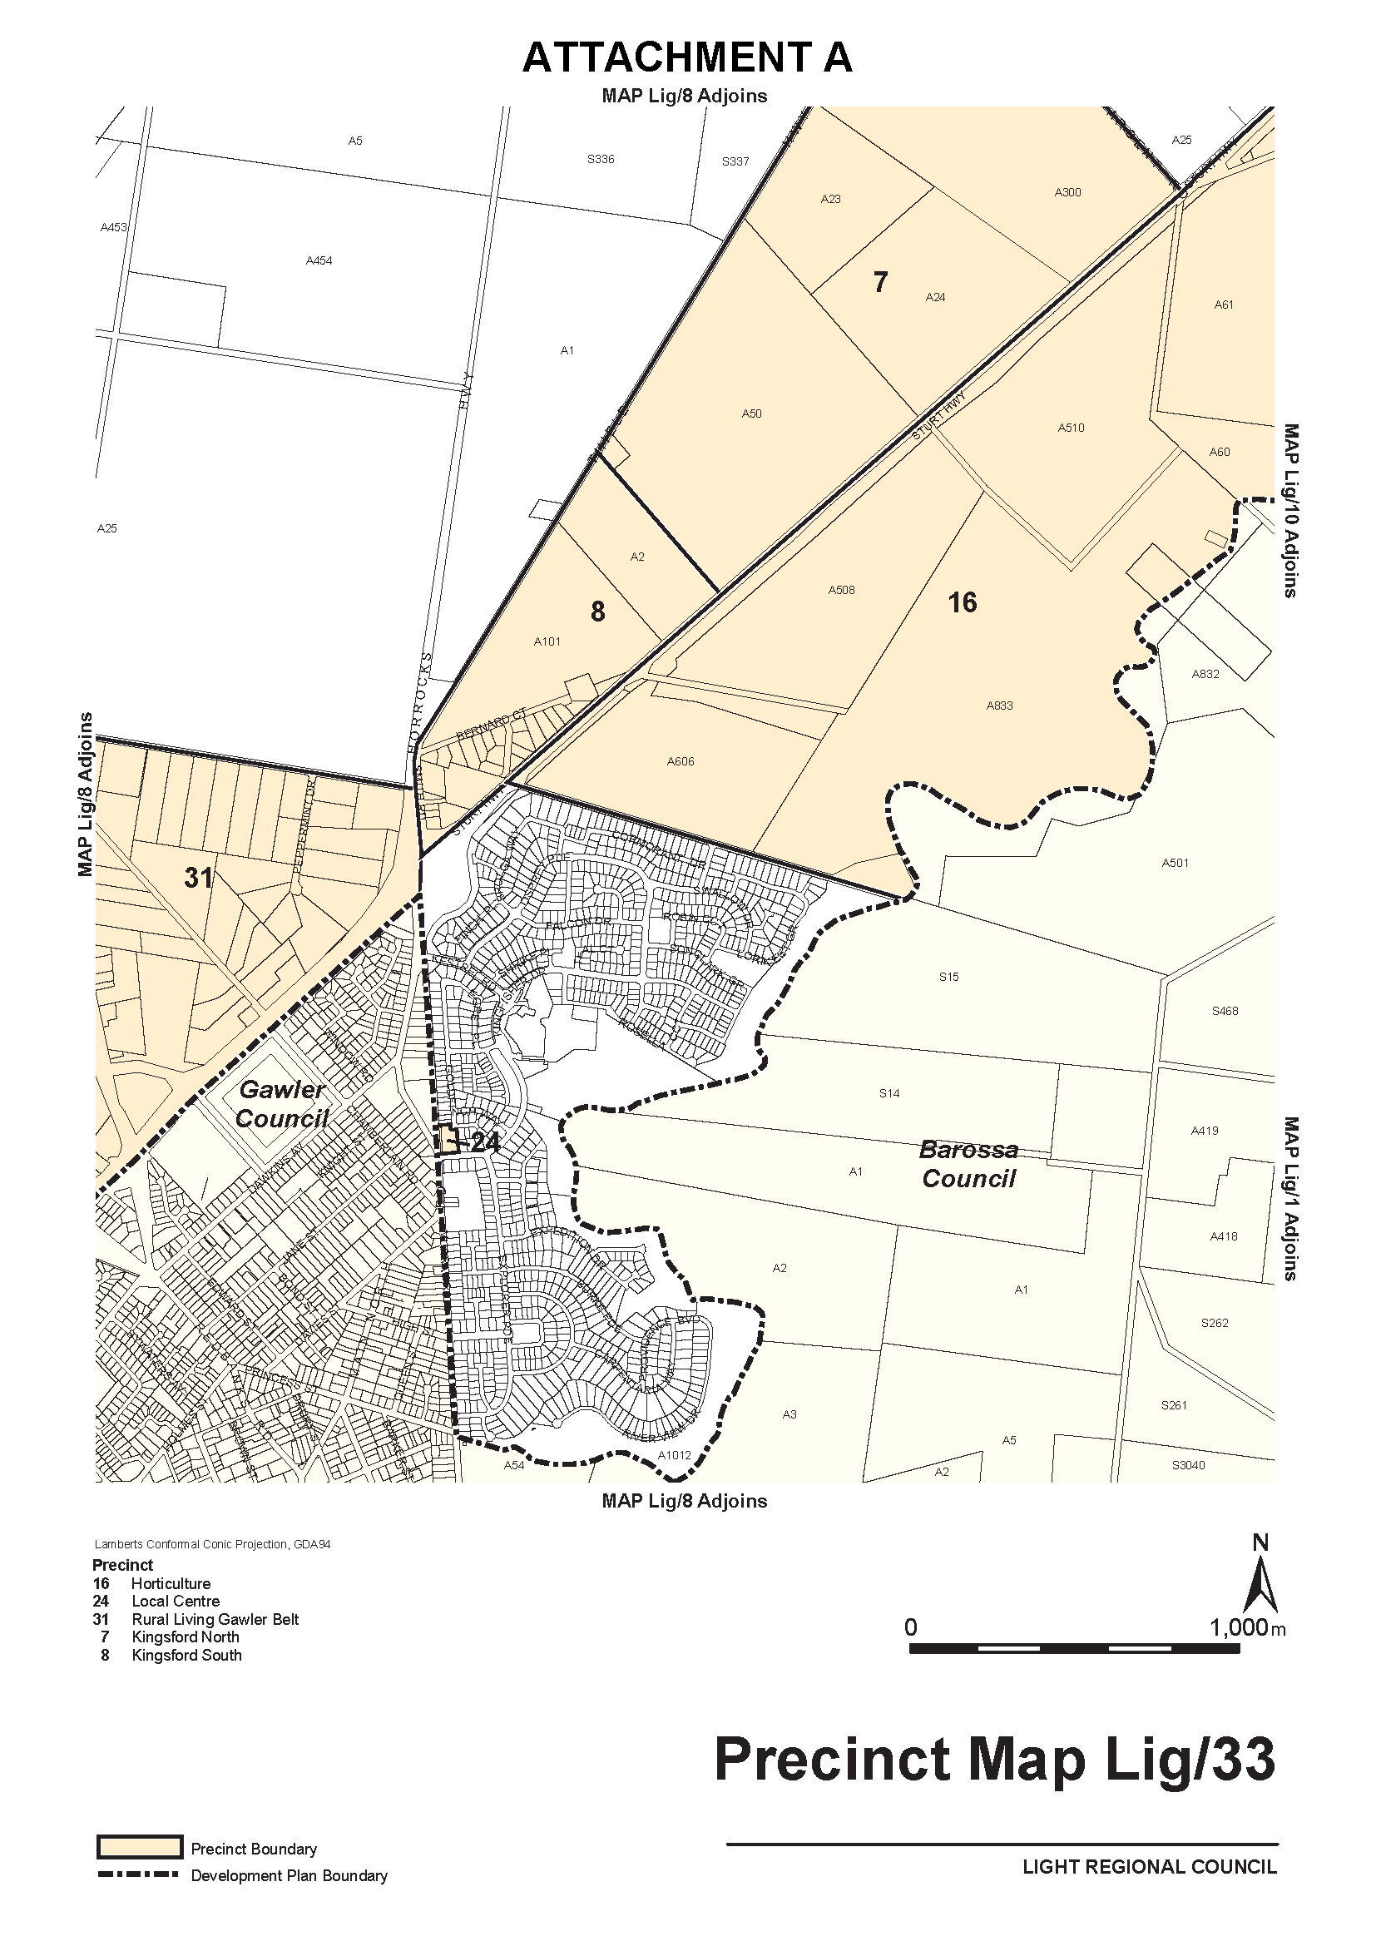
Attachment A

Dated 18 November 2016.
S. Smith, General Manager, Planning and Development,
Development Division, Department of Planning, Transport and Infrastructure

South Australia
Liquor Licensing (Dry Areas) Notice 2016
under section 131(1a) of the Liquor Licensing Act 1997

1—Short title
This notice may be cited as the Liquor Licensing (Dry Areas) Notice 2016.
2—Commencement
This notice comes into operation on 31 December 2016.
3—Interpretation
(1) In this notice—
principal notice means the Liquor Licensing (Dry Areas) Notice 2015 published in the Gazette on 5.1.15, as in force from time to time.
(2) Clause 3 of the principal notice applies to this notice as if it were the principal notice.
4—Consumption etc of liquor prohibited in dry areas
(1) Pursuant to section 131 of the Act, the consumption and possession of liquor in the area described in the Schedule is prohibited in accordance with the provisions of the Schedule.
(2) The prohibition has effect during the periods specified in the Schedule.
(3) The prohibition does not extend to private land in the area described in the Schedule.
(4) Unless the contrary intention appears, the prohibition of the possession of liquor in the area does not extend to—
(a) a person who is genuinely passing through the area if—
(i) the liquor is in the original container in which it was purchased from licensed premises; and
(ii) the container has not been opened; or
(b) a person who has possession of the liquor in the course of carrying on a business or in the course of his or her employment by another person in the course of carrying on a business; or
(c) a person who is permanently or temporarily residing at premises within the area or on the boundary of the area and who enters the area solely for the purpose of passing through it to enter those premises or who enters the area from those premises for the purpose of leaving the area.

Schedule—Robe Area 1

1—Extent of prohibition
The consumption of liquor is prohibited and the possession of liquor is prohibited.
2—Period of prohibition
From 12 noon on 31 December 2016 to 12 noon on 1 January 2017.
3—Description of area
The area in and adjacent to Robe bounded as follows: commencing at the western end of the northern boundary of Dawson Drive, then in a straight line by the shortest route to the low water mark of Guichen Bay on the eastern side of the entrance to Fox's Lake, then in a straight line by the shortest route (across the entrance) to the low water mark on the western side of the entrance, then generally westerly along the low water mark to the eastern side of the entrance to Lake Butler, then in a straight line by the shortest route (across the entrance) to the eastern boundary of the breakwater on the western side of the entrance to the lake, then northerly, north-easterly, westerly and south-westerly around the outer boundary of the breakwater back to the low water mark on the shore on the western side of the breakwater, then generally north-westerly and southerly along the low water mark to the point at which it is intersected by the prolongation in a straight line of the southern boundary of Evans Cave Road (the northern boundary of Section 363 Hundred of Waterhouse), then generally easterly along that prolongation and boundary of Evans Cave Road, and the prolongation in a straight line of that boundary, to the eastern boundary of Robe Street, then northerly along that boundary of Robe Street to the southern boundary of Beacon Hill Road, then generally easterly along that boundary of Beacon Hill Road to the point at which it meets the north-eastern boundary of Lot 5 of DP 78111, then generally south-easterly and easterly along that boundary of Lot 5 and easterly and north-easterly along the northern boundary of Section 289 Hundred of Waterhouse to the eastern boundary of Section 289, then in a straight line by the shortest route to the south-western corner of Lot 11 of DP 64831, then easterly along the southern boundary of Lot 11 and the prolongation in a straight line of that boundary to the point at which the prolongation intersects the eastern boundary of Nora Creina Road, then northerly along that boundary of Nora Creina Road to the point at which it meets the southern boundary of Wildfield Road, then generally easterly along that boundary of Wildfield Road and the prolongation in a straight line of that boundary to the point at which the prolongation intersects the northern boundary of Southern Ports Highway, then generally north-westerly and south-westerly along that boundary of Southern Ports Highway and the northern boundary of Main Road to the eastern boundary of Dawson Drive, then generally north-westerly and westerly along that boundary of Dawson Drive to the point of commencement. The area includes any wharf, jetty, boat ramp, breakwater or other structure projecting below low water mark from within the area described above (as well as any area beneath such a structure).

Schedule—Robe Area 2

1—Extent of prohibition
The consumption of liquor is prohibited and the possession of liquor is prohibited.
2—Period of prohibition
From 12 noon on 31 December 2016 to 12 noon on 1 January 2017.
3—Description of area
The area in and adjacent to Robe bounded as follows: commencing at the western end of the northern boundary of Dawson Drive, then in a straight line by the shortest route to the low water mark of Guichen Bay on the eastern side of the entrance to Fox's Lake, then generally north-easterly along the low water mark to the point at which it is intersected by the prolongation in a straight line of the northern boundary of Section 573 Hundred of Waterhouse, then easterly along that prolongation and boundary of Section 573 to the eastern boundary of the Section, then generally southerly and south-westerly along that boundary of Section 573 to the north-eastern boundary of Section 390 Hundred of Waterhouse, then south-easterly along that boundary of Section 390 to the point at which it is intersected by the prolongation in a straight line of the northern boundary of Dennis Avenue, then easterly along that prolongation and boundary of Dennis Avenue, and the prolongation in a straight line of that boundary, to the point at which the prolongation intersects the western boundary of Lot 223 of FP 205569, then generally south-westerly and southerly along that boundary of Lot 223 and the prolongation in a straight line of that boundary to the point at which the prolongation intersects the south-eastern boundary of Southern Ports Highway, then south-westerly along that boundary to the western boundary of Lot 2 of FP 9707, then southerly along that boundary of Lot 2 to the southern boundary of the Lot, then generally north-westerly and south-westerly along the northern boundary of Southern Ports Highway and the northern boundary of Main Road to the eastern boundary of Dawson Drive, then generally north-westerly and westerly along that boundary of Dawson Drive to the point of commencement.
Made by the Acting Liquor and Gambling Commissioner
On 17 November 2016.

MINING ACT 1971
PURSUANT to Section 15 (5) of the Mining Act 1971 (the Act), I advise that the Mineral Resources Division of the Department of State Development will be undertaking geoscientific investigations in an area of interest located on the Port Augusta 1:250 000 map sheet totalling approximately 551 km². The investigations will commence on 1 January 2017 and the expected completion date is 31 July 2017.
Pursuant to Section 15 (7) of the Act, the Minister may refuse to receive or consider applications for mining tenements in respect of the land described in the notice until the completion date of 31 July 2017. The completion date may be extended by further notice in the Gazette.
Description of Area
ILLEROO AREA—Approximately 30 km west of Port Augusta, bounded as follows:
Commencing at a point being the intersection of latitude 32°23′S and longitude 137°17′E, thence east to longitude 137°36′E, south to latitude 32°33′S, west to longitude 137°17′E, and north to the point of commencement, all the within latitudes and longitudes being geodetic and expressed in terms of the Australian Geodetic Datum as defined on page 4984 of Commonwealth Gazette number 84, dated 6 October 1966 (AGD66).

Reference: MER F2014/000909
Dated 24 November 2016.
J. Martin, Mining Registrar

IN Government Gazette No. 74 dated 17 November 2016, on page 4440, the notice was published with errors, please replace with this one:
NATIONAL PARKS AND WILDLIFE (NATIONAL PARKS) REGULATIONS 2016
Cycling Within Reserves
Corrigendum
PURSUANT of Regulation 10 of the National Parks and Wildlife (National Parks) Regulations 2016, I, John Erwin Schutz, Director of National Parks and Wildlife, hereby grant permission for the riding of bicycles on the designated trails (in addition to those designated on 20 December 2012) within Cleland Conservation Park, proclaimed under the National Parks and Wildlife Act 1972.
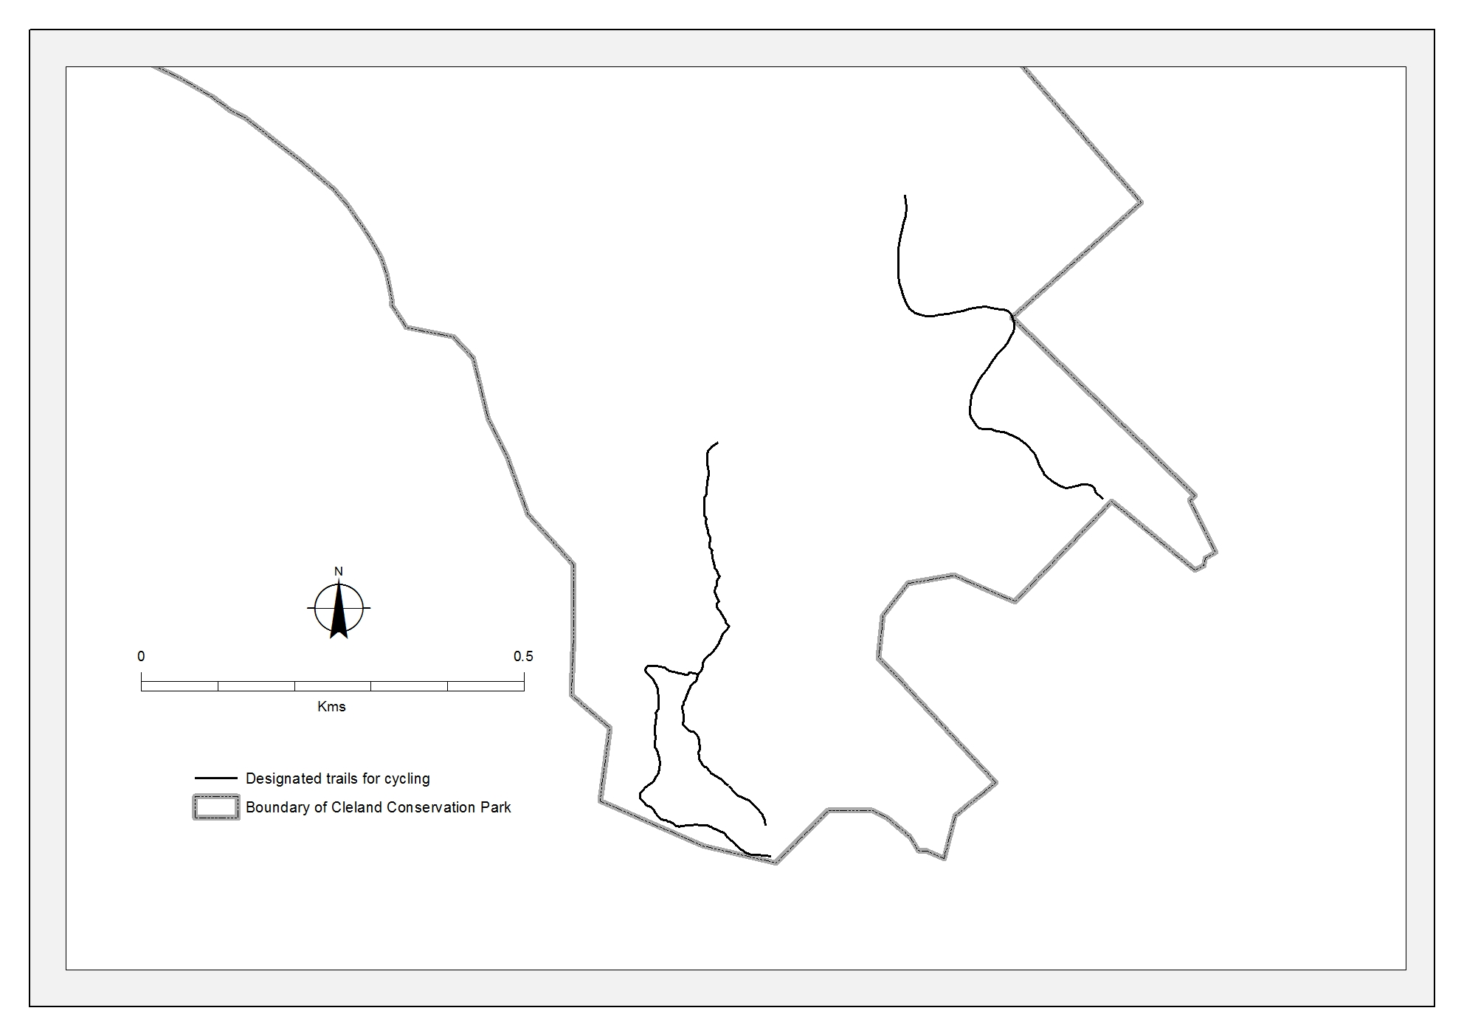
Designated trails are shown in the map below.

Dated 3 November 2016.
J. E. Schutz, Director of National Parks and Wildlife

PROFESSIONAL STANDARDS ACT 2004
RICS Valuers Limited Scheme
PURSUANT to Section 14 (1) of the Professional Standards Act 2004, I authorise the publication in the Gazette of the RICS Valuers Limited Scheme, amended by instrument in accordance with Section 18 of the Professional Standards Act 2004.
Pursuant to Section 15 (1) (b) of the Professional Standards Act 2004, the date of commencement of the RICS Valuers Limited Scheme will be 2 months after the date of publication.
Dated 22 November 2016.
John Rau, Attorney-General

PROFESSIONAL STANDARDS ACT 1994 (NSW)
Instrument Amending the RICS Valuers Limited Scheme
Preamble
A. The RICS Valuers Limited (‘RICSV Limited’) is a voluntary occupational association for valuers. It is a national organisation whose principal place of business is in Sydney, New South Wales.
B. The RICSV Limited Scheme (‘the scheme’) commenced on 1 January 2016.
C. This instrument of amendment has been prepared by the RICSV Limited under Section 16A of the Professional Standards Act 1994 (NSW) (‘the Act’) to amend the Scheme.
Amendment to the Scheme
This instrument to amend the scheme under Section 16 of the Act is prepared by the RICSV, whose business address is Suite 1, Level 9, 1 Castlereagh Street, Sydney, N.S.W. 2000. Amendments are as below.
Persons to Whom the Scheme Applies
Clause 2.1: delete ‘The scheme applies to all members of RICS Valuers Limited’ and replace with ‘The scheme applies to all members of RICSV Limited’.
Insert new Clause 2.3 ‘Upon application by a member to whom the scheme applies, RICSV Limited may exempt the member from the scheme, provided that the scheme does not apply to the person by operation of Sections 18, 19 or 20 of the Act.’
Limitation of Liability
Clause 3.2 (a): delete ‘of a kind which complies with the standards determined by the RICSV Limited’ and replace with ‘of a kind which complies with the RICSV Insurance Standards.’
Clause 3.3: insert the phrase ‘in relation to a Valuation’ thus ‘The monetary ceiling (maximum amount of liability) in relation to a Valuation required for the purposes of limitation of liability under this scheme at the time at which the act or omission giving rise to the cause of action occurred is to be determined according to the following table.’
Conferral of Discretionary Authority
Clause 4.1: delete ‘the RICS Valuers Limited’ and replace with the defined term ‘the RICSV Limited’ thus Pursuant to Section
24 of the Act, this scheme confers to the RICSV Limited a discretionary authority to specify, on application by a person to whom the scheme applies, in relation to that person a higher monetary ceiling (maximum amount of liability) not exceeding $20 million, in relation to the person either in all cases or in any specified case or class of case.
Definitions
Clause 6.1: delete ‘RICSV means the RICS Valuers Limited’ and replace with ‘RICSV Limited means the RICS Valuers Limited.’
Insert the phrase ‘in any future amendments’ in the definition ‘Property Value’ thus: ‘Property Value means the value of a property as at the date of the Valuation as determined under Market Value or as defined by the International Valuation Standards Council (IVSC) in any future amendments.’
Insert new definition ‘Valuation means an opinion or estimate of value made in writing by an individual member of RICSV Limited, or countersigned by an individual member of RICSV Limited pursuant to a client’s written instructions.’
Commencement
The amendments to the scheme made by this instrument will commence after publication in the appropriate Government Gazette(s).

PROFESSIONAL STANDARDS ACT 1994 (NSW)
RICS Valuers Limited Scheme
Preamble
A. The RICS Valuers Limited (RICSV Limited) is an occupational association.
B. The RICSV Limited has made an application to the Professional Standards Council, constituted by the Professional Standards Act 1994 (NSW) (the Act), for a scheme under the Act.
C. The scheme is prepared by the RICSV Limited for the purposes of limiting occupational liability to the extent to which such liability may be limited under the Act.
D. The RICSV Limited has furnished the Council with a detailed list of the risk management strategies intended to be implemented in respect of its members and the means by which those strategies are intended to be implemented.
E. The scheme is intended to commence on 1 January 2016 and remain in force for five (5) years from its commencement unless, prior to that time, it is revoked, its operation ceases, or it is extended pursuant to Section 32 of the Act.
F. The scheme is intended to apply in New South Wales, Victoria, South Australia, the Australian Capital Territory, the Northern Territory, Queensland, and Western Australia.
RICS Valuers Limited Scheme
1. Occupational Association
1.1 The RICSV Limited Scheme (the scheme) is a scheme under the Professional Standards Act 1994 (NSW) (the Act), prepared by the RICS Valuers Limited (RICSV Limited) whose business address is: Suite 1, Level 9, 1 Castlereagh Street, Sydney, N.S.W. 2000.
2. Persons to Whom the Scheme Applies
2.1 The scheme applies to all members of RICSV Limited.
2.2 This scheme also applies to all persons to whom the scheme applied under Clause 2.1 at the time of any act or omission giving rise to occupational liability.
2.3 Upon application by a member to whom the scheme applies, RICSV Limited may exempt the member from the scheme, provided that the scheme does not apply to the person by operation of Sections 18, 19 or 20 of the Act.
3. Limitation of Liability
3.1 This scheme only affects the liability for damages arising from a single cause of action to the extent to which the liability results in damages exceeding $1 000 000.
3.2 If a person, who was at the time of the act or omission giving rise to occupational liability, a person to whom the scheme applied, against whom a proceeding relating to occupational liability is brought, is able to satisfy the court that such person has the benefit of an insurance policy:
(a) of a kind which complies with the RICSV Insurance Standards;
(b) insuring such person against that occupational liability; and
(c) under which the amount payable in respect of that occupational liability is not less than the monetary ceiling specified in this scheme,
that person is not liable in damages in relation to that cause of action above the monetary ceiling specified in this scheme.
3.3 The monetary ceiling (maximum amount of liability) in relation to a Valuation required for the purposes of limitation of liability under this scheme at the time at which the act or omission giving rise to the cause of action occurred is to be determined according to the following table:
Class | Description | Band | Monetary Ceiling
1 | Property Value A | $0 million to < $3 million | $1 million
2 | Property Value B | $3 million to < $5 million | $2 million
3 | Property Value C | $5 million to < $10 million | $3 million
4 | Property Value D | $10 million to < $20 million | $4 million
For properties valued at above $20 million the ceiling will be 20% of the value of the property on the day of the Valuation, up to $10 million.
3.4 Clause 3.2 only affects liability for damages arising from a single cause of action to the extent to which the liability results in damages exceeding such amount as is specified in Clause 3.1.
3.5 This scheme limits the occupational liability in respect of a cause of action founded on an act or omission occurring during the period when the scheme was in force of any person to whom the scheme applied at the time the act or omission occurred.
3.6 Notwithstanding anything to the contrary contained in this Scheme if, in particular circumstances giving rise to occupational liability, the liability of any person who is subject to this Scheme should be capped both by this Scheme and also by any other Scheme under Professional Standards Legislation (whether of this jurisdiction or under the law of any other Australian state or territory) and, if the amount of such caps should differ, then the cap on the liability of such persons arising from such circumstances which is higher shall be the applicable cap.
4. Conferral of Discretionary Authority
4.1 Pursuant to Section 24 of the Act, this scheme confers to the RICSV Limited a discretionary authority to specify, on application by a person to whom the scheme applies, in relation to that person a higher monetary ceiling (maximum amount of liability) not exceeding $20 million, in relation to the person either in all cases or in any specified case or class of case.
5. Duration
5.1 This scheme will be in force for a period of 5 years from the date of commencement.
6. Definitions
6.1 Relevant definitions for the purposes of the scheme are as follows:
‘RICSV Limited’ means the RICS Valuers Limited.
‘RICSV Insurance Standards’ mean the insurance standards approved by the RICSV from time to time.
‘The Act’ means the Professional Standards Act 1994 (NSW).
‘Property Value’ means the value of a property as at the date of the Valuation as determined under Market Value or as defined by the International Valuation Standards Council (IVSC) in any future amendments.
‘Market Value’ means the estimated amount for which an asset or liability should exchange on the valuation date between a willing buyer and a willing seller in an arm’s length transaction, after proper marketing and where the parties had each acted knowledgeably, prudently and without compulsion or as defined by the International Valuation Standards Council (IVSC) in any future amendments.
‘Valuation means’ an opinion or estimate of value made in writing by an individual member of RICSV Limited, or countersigned by an individual member of RICSV Limited pursuant to a client’s written instruction.

RULES OF COURT
Magistrates Court of South Australia
Amendment 59 to the Magistrates Court Rules 1992
PURSUANT to section 49 of the Magistrates Court Act 1991 and all other enabling powers, we, the undersigned, do hereby make the following amendments to the Magistrates Court Rules 1992 as amended.
1. These Rules may be cited as the ‘Magistrates Court Rules 1992 (Amendment 59)’.
2. The Magistrates Court Rules 1992 as amended by the following amendments apply to and govern all actions commenced in the Criminal Division of the Court on and after the date on which these amendments are gazetted.
3. Rules 18.08 – 18.08B are deleted and replaced with the following:
18.08 An application for variation or revocation of an Intervention Order made by someone other than a person protected under the Order must comply with a Form 31 and must be served personally. The application must be accompanied by the Form 31 Annexure.
18.08A An application for variation or revocation of an Intervention Order made by a person protected under the Order must comply with a Form 30A and must be served personally. The application must be accompanied by the Form 30A Annexure.
18.08B The Form 30A Annexure and Form 31 Annexure, containing the contact details of the protected person(s), must be stored electronically, separately from the hard file and any hardcopy of the document must be subsequently destroyed.
4. The following is inserted after r 18.15
18.15A The Form 41 Annexure, containing the contact details of the applicant, must accompany the Form 41. The Form 41 Annexure must be stored electronically, separately from the hard file and any hardcopy of the document must be subsequently destroyed.
5. Rule 28A.09 is amended to delete ‘Goods Securities Act 1986’ and replace it with ‘Personal Property Securities Act 2009 (Cth)’.
6. The following is inserted directly after r 41.10:
41.11 A Home Detention Order made pursuant to s 33BB(1) of the Criminal Law (Sentencing) Act 1988 shall comply with Form 139.
41.12 An application to vary or revoke a condition of a bond or to discharge a bond pursuant to s 44 of the Criminal Law (Sentencing) Act 1988 shall comply with Form 138.
7. Rule 49A.03 is deleted and replaced with:
49A.03 A duplicate warrant made pursuant to regulation 10(4)(e) of the Road Traffic (Miscellaneous) Regulations 2014 shall comply with Form 92.
8. Rule 69.01 is amended to delete ‘Magistrates Court (Fees) Regulations 1992, Sheriff’s Regulations 1992’ and replace it with ‘Magistrates Court (Fees) Regulations 2004, Sheriff’s Regulations 2005’.
9. Form 28 is deleted and replaced with Form 28.
10. Form 28AA is deleted and replaced with Form 28AA.
11. Form 30 is deleted and replaced with Form 30.
12. Form 30A is inserted.
13. Form 31 is deleted and replaced with Form 31.
14. Form 41 is deleted and replaced with Form 41.
15. Form 46 is deleted and replaced with Form 46.
16. Form 92 is deleted and replaced with Form 92.
17. Form 102C is deleted and replaced with Form 102C.
18. Form 138 is inserted.
19. Form 139 is inserted.
Signed on the 21st day of November 2016.
Mary-Louise Hribal, Chief Magistrate
Andrew James Cannon, Deputy Chief Magistrate
Ian White, Magistrate
Lynette Duncan, Magistrate

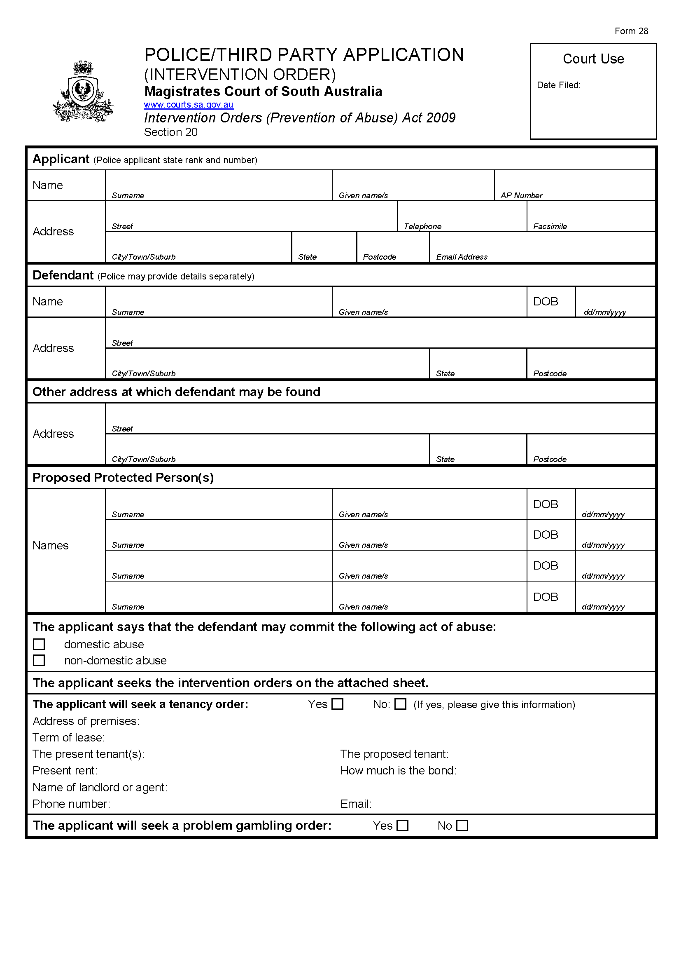
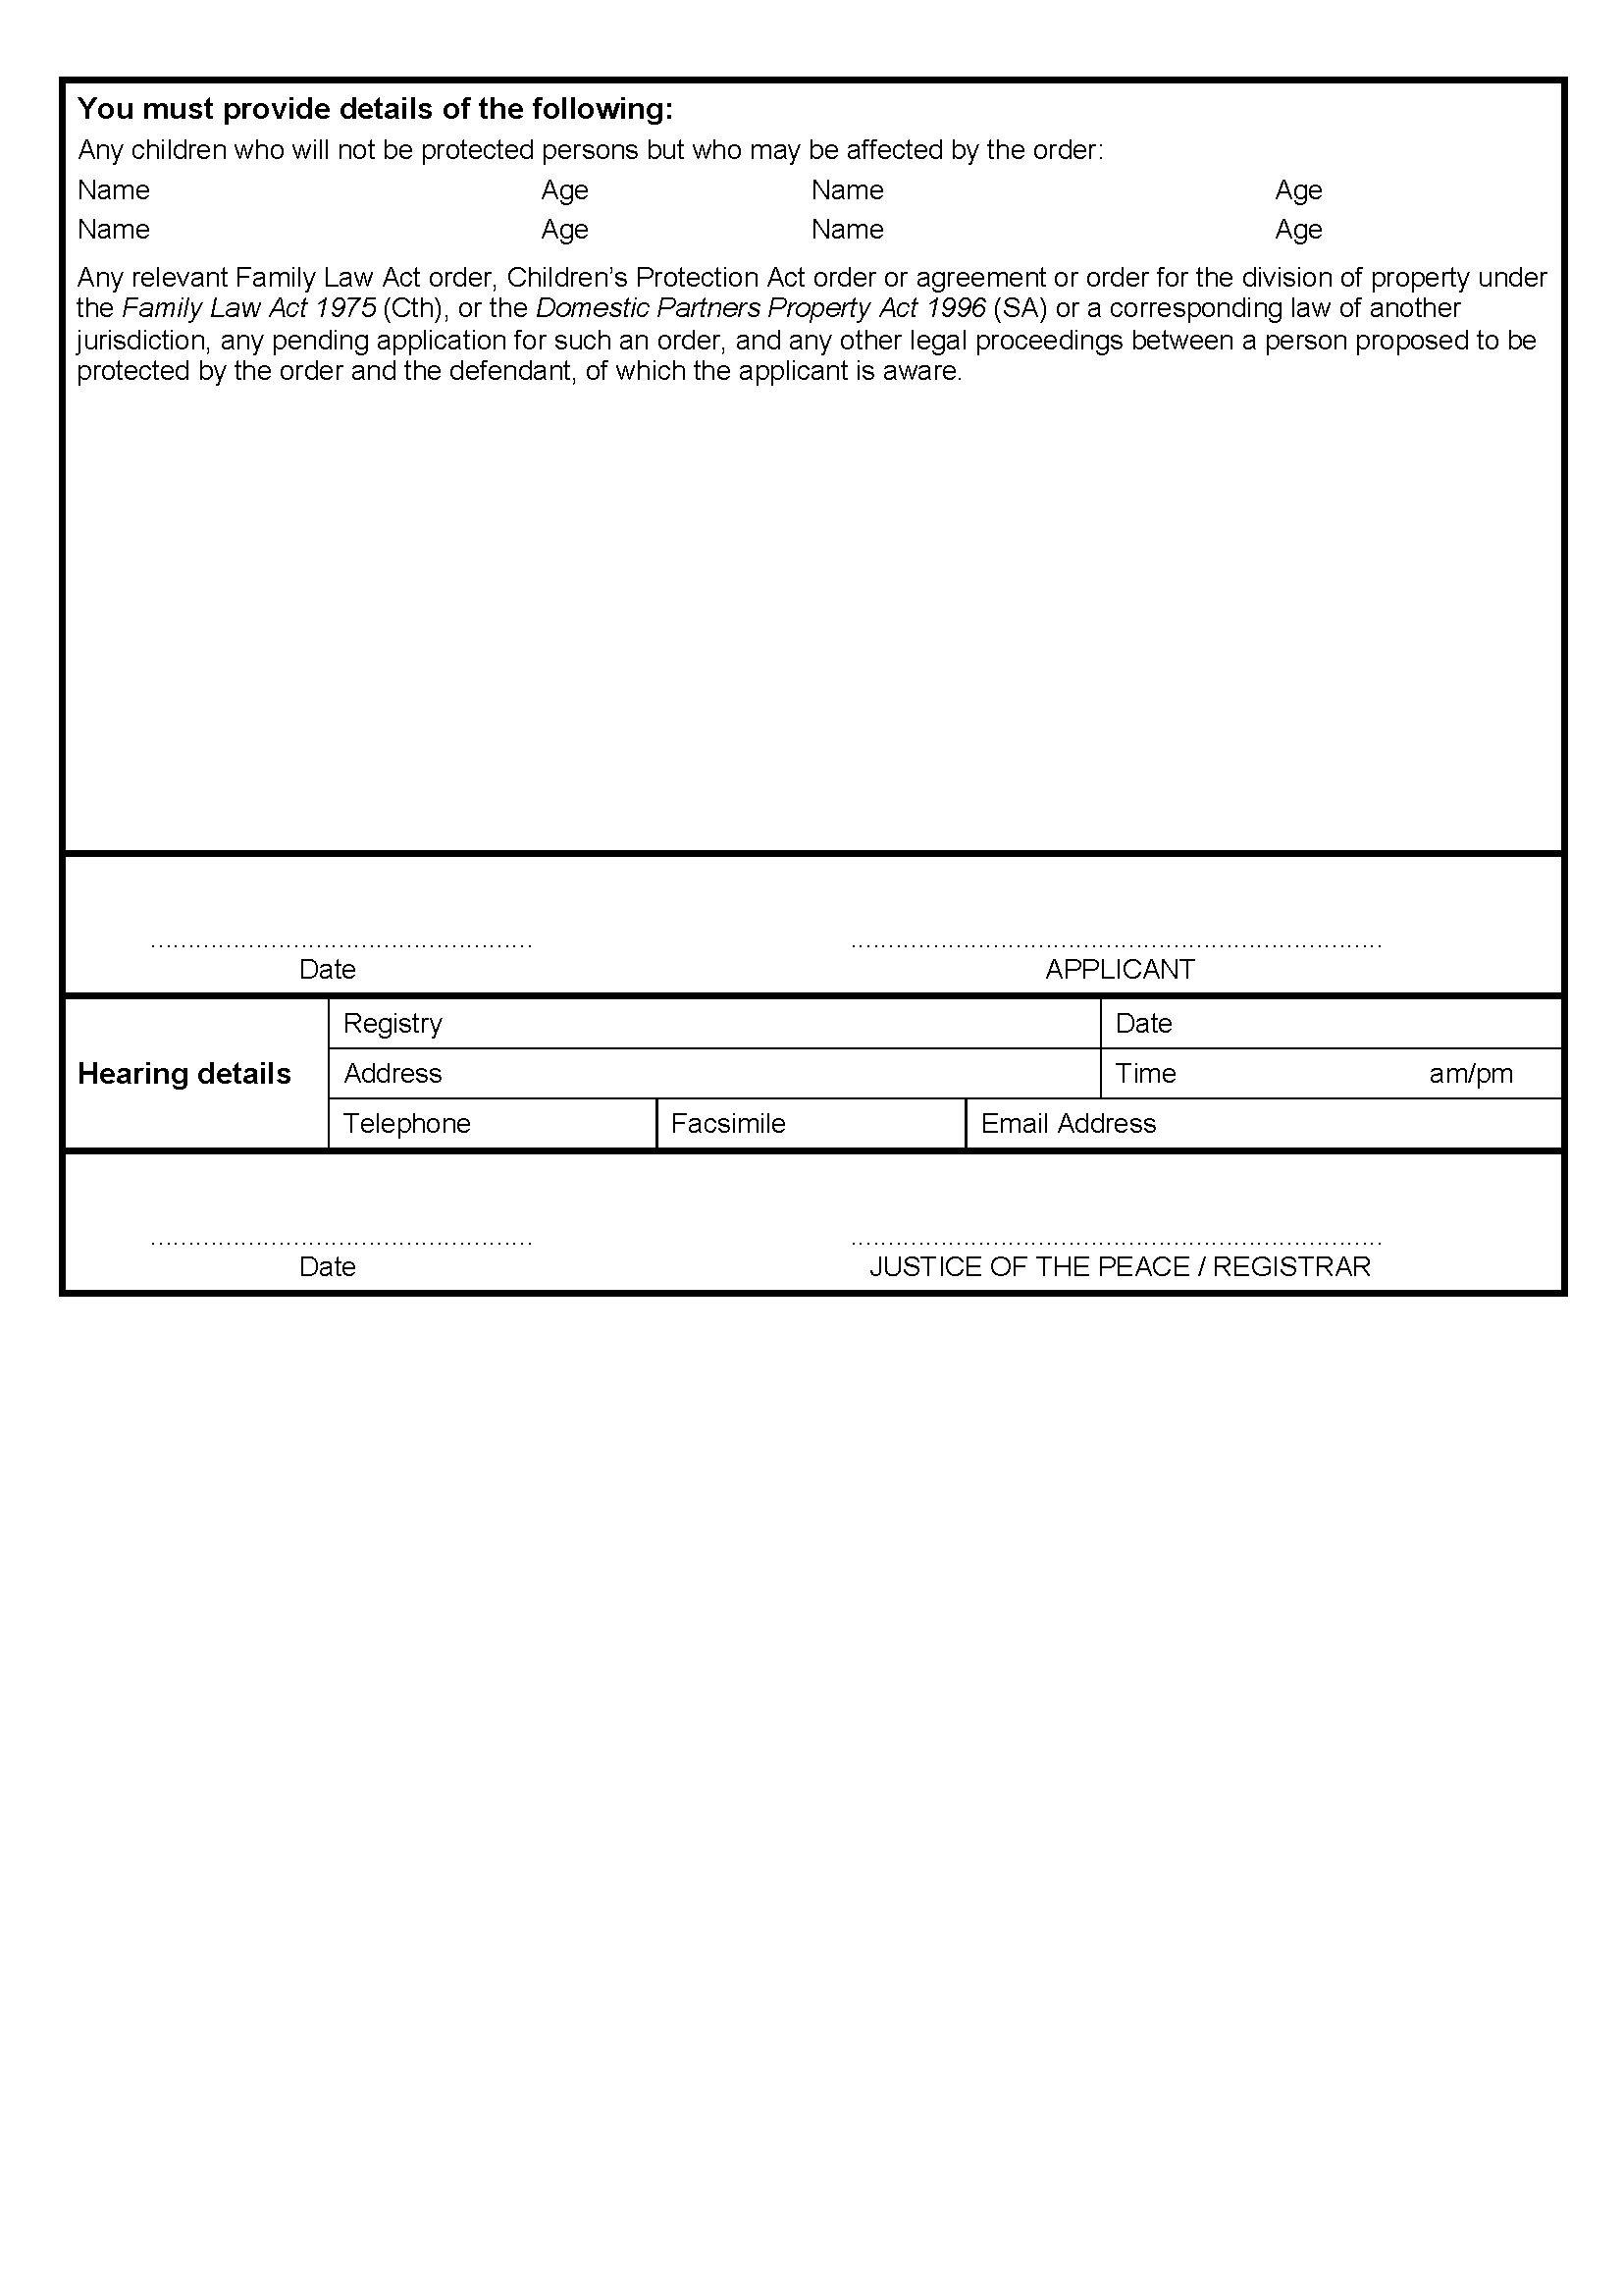
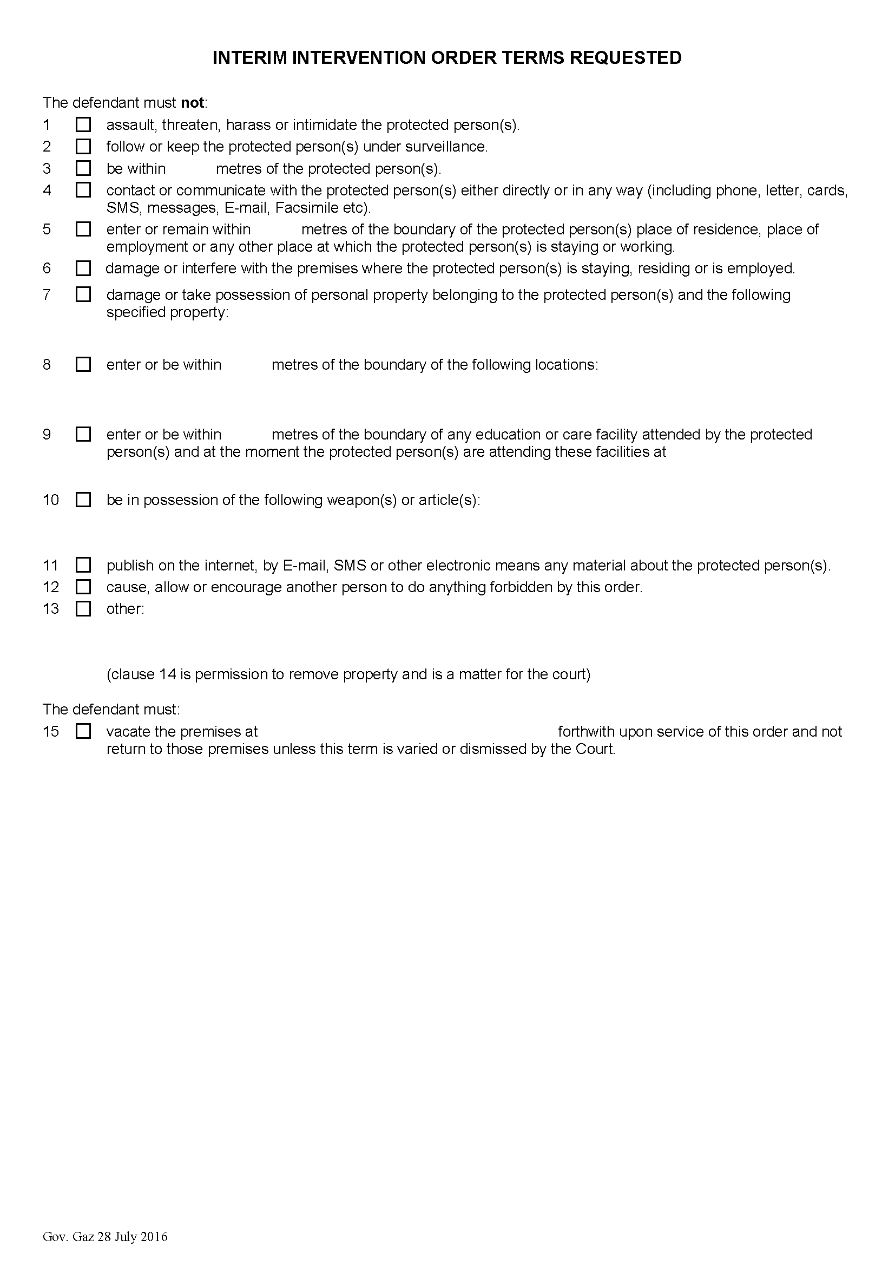
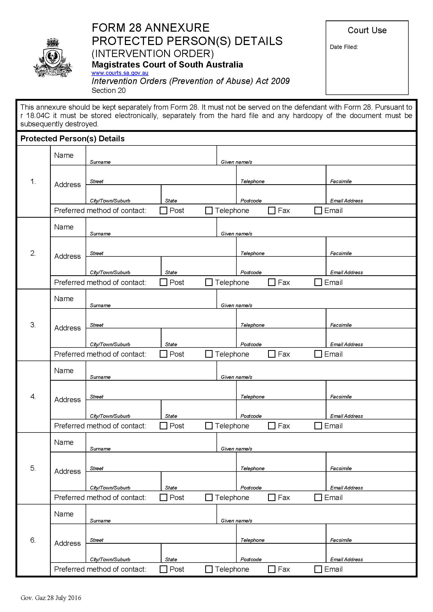
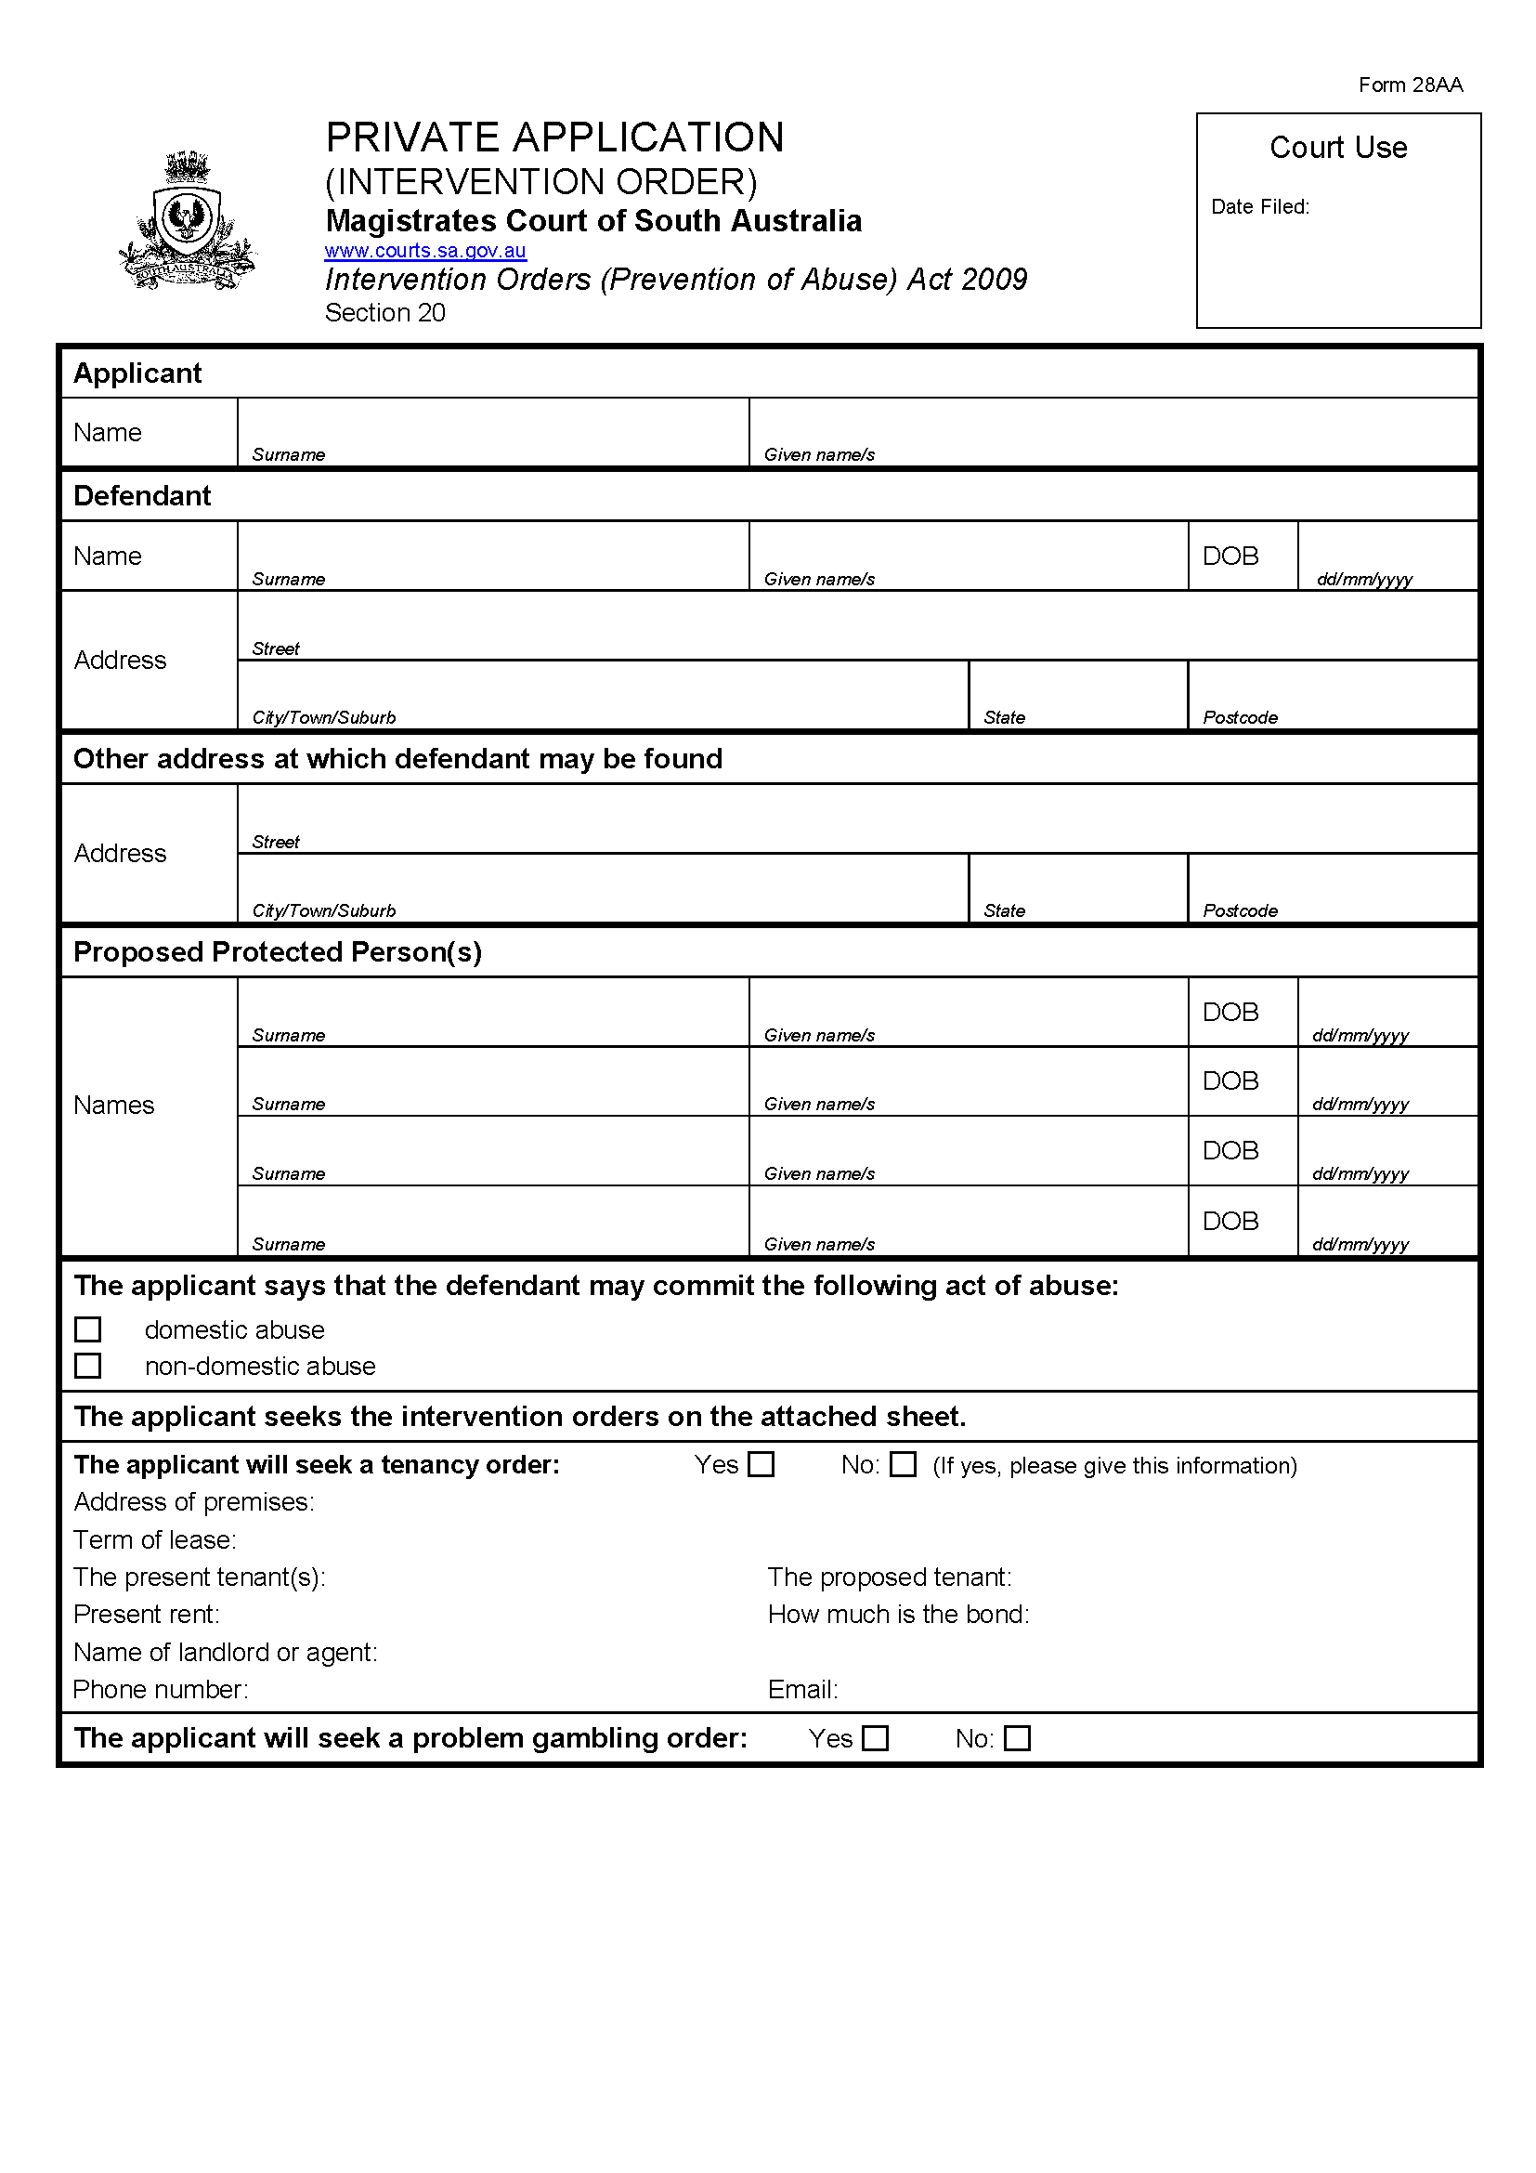
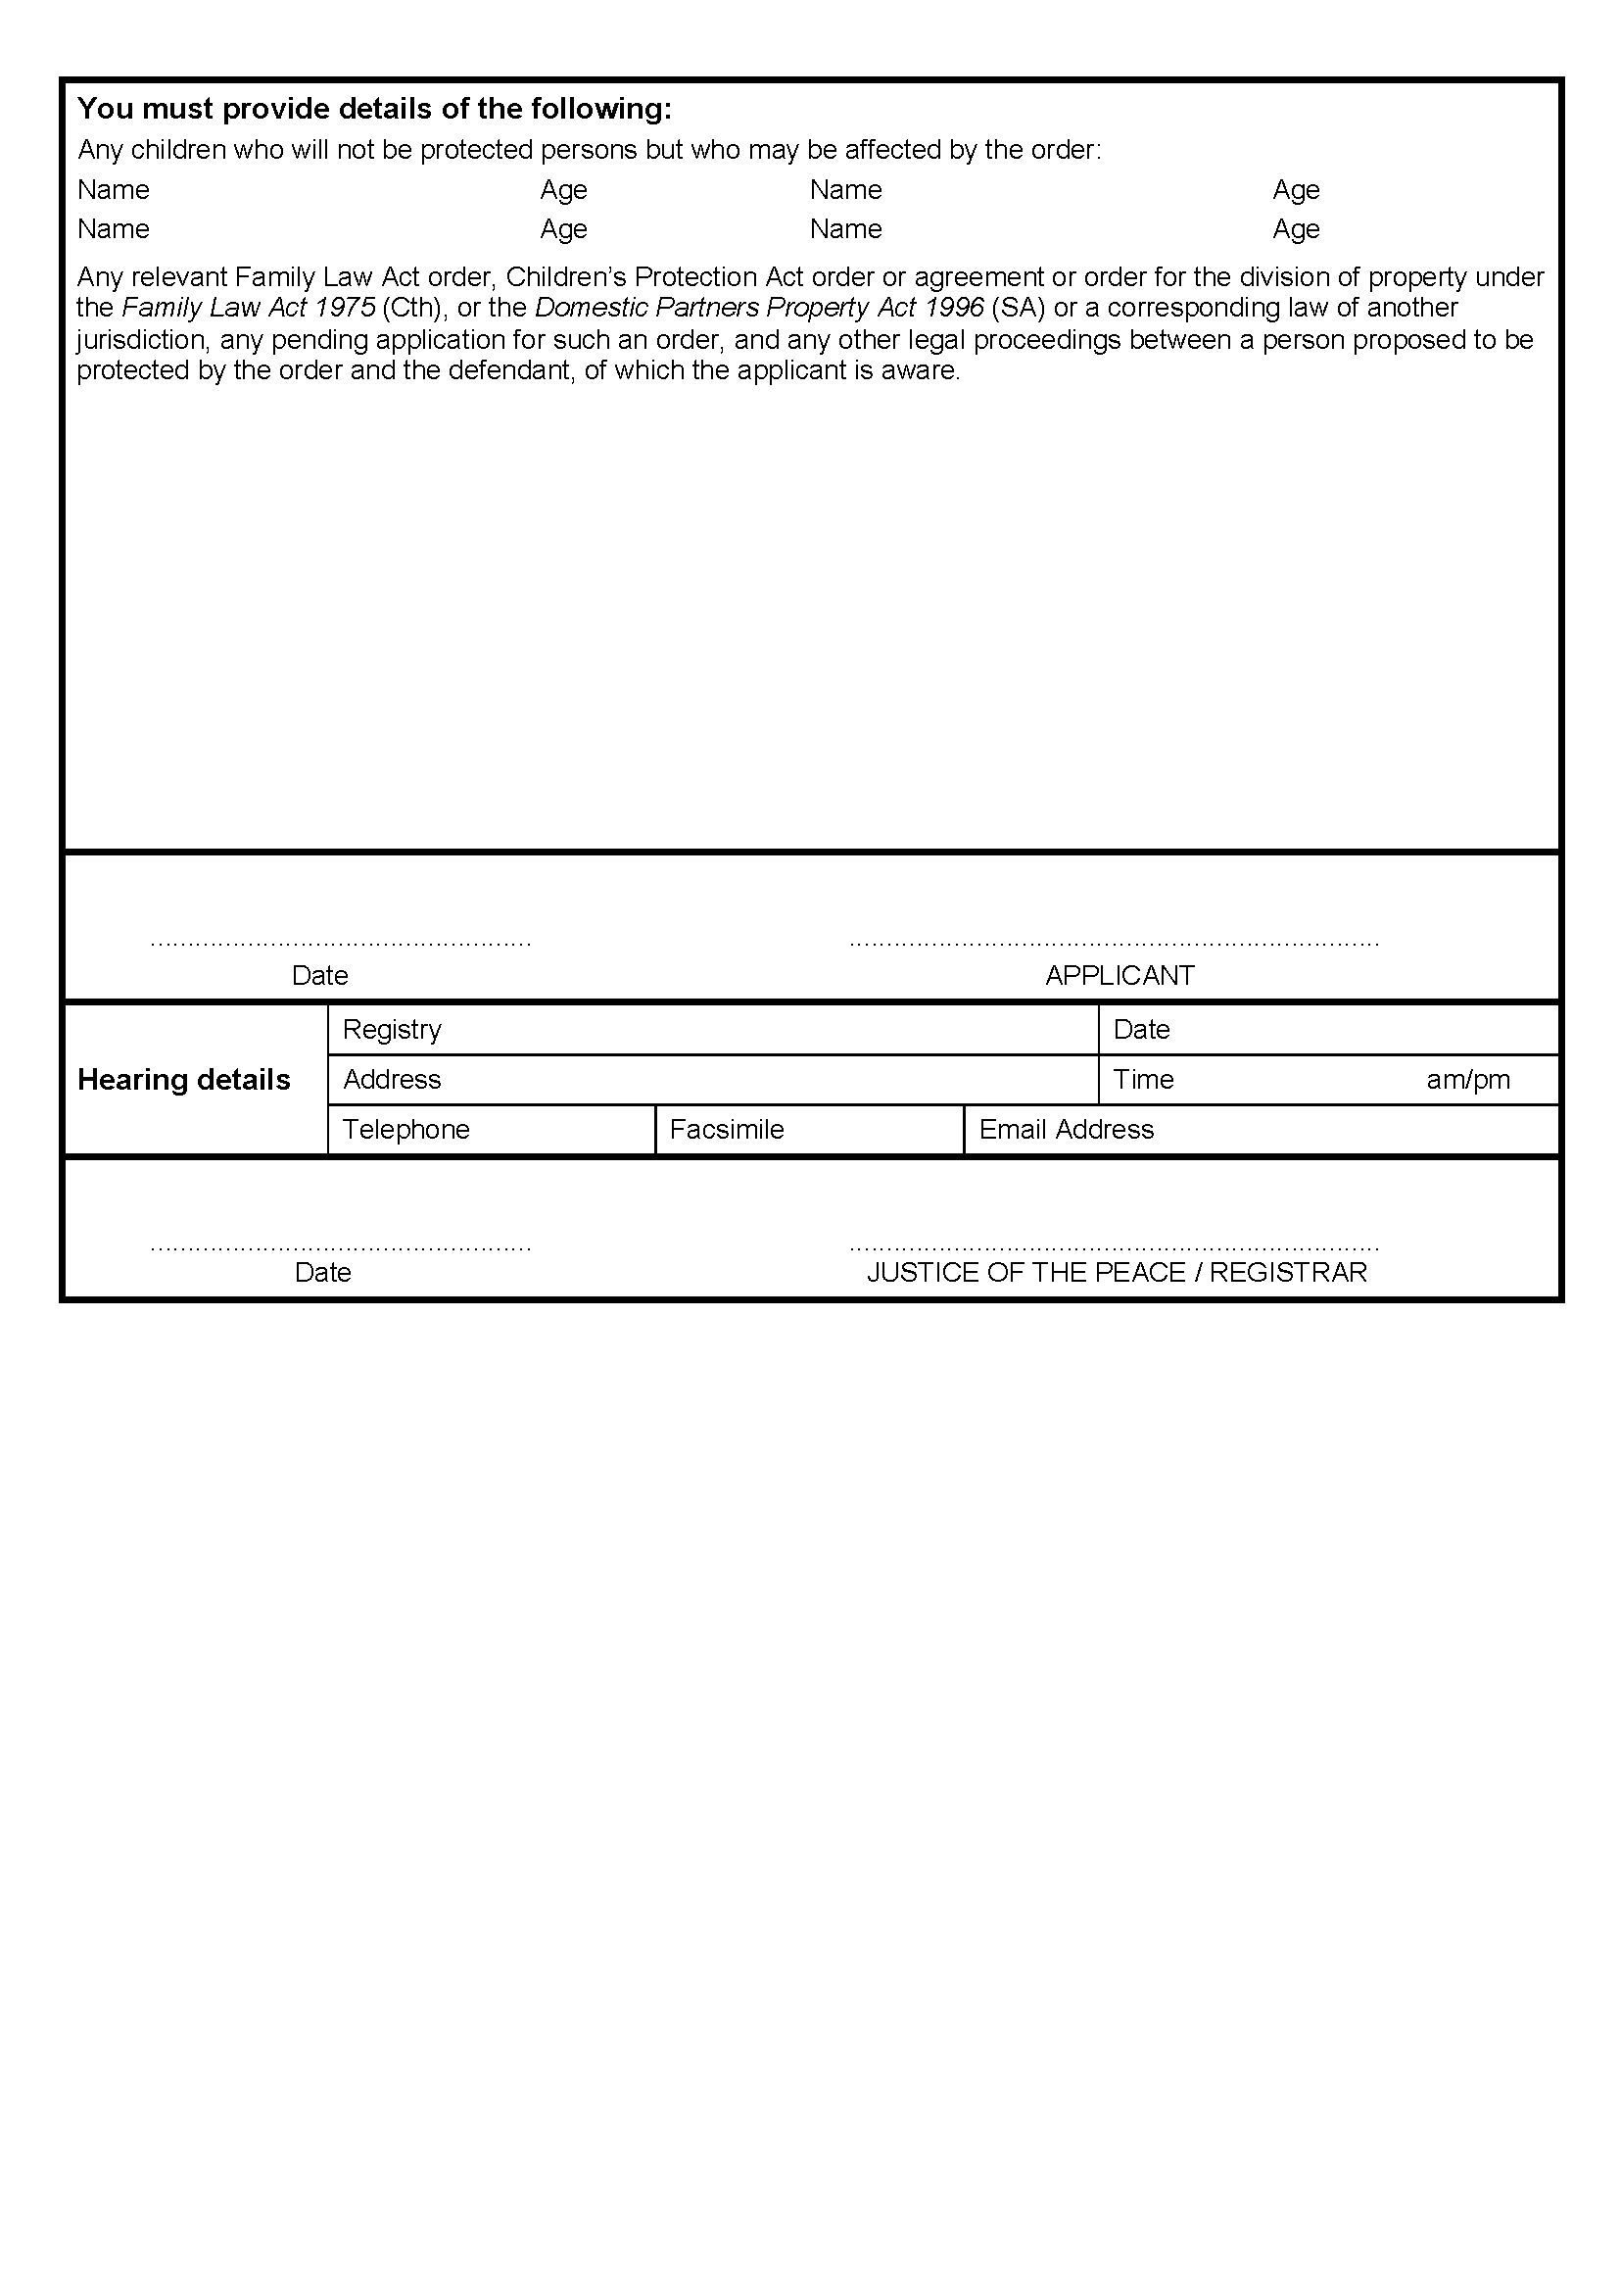
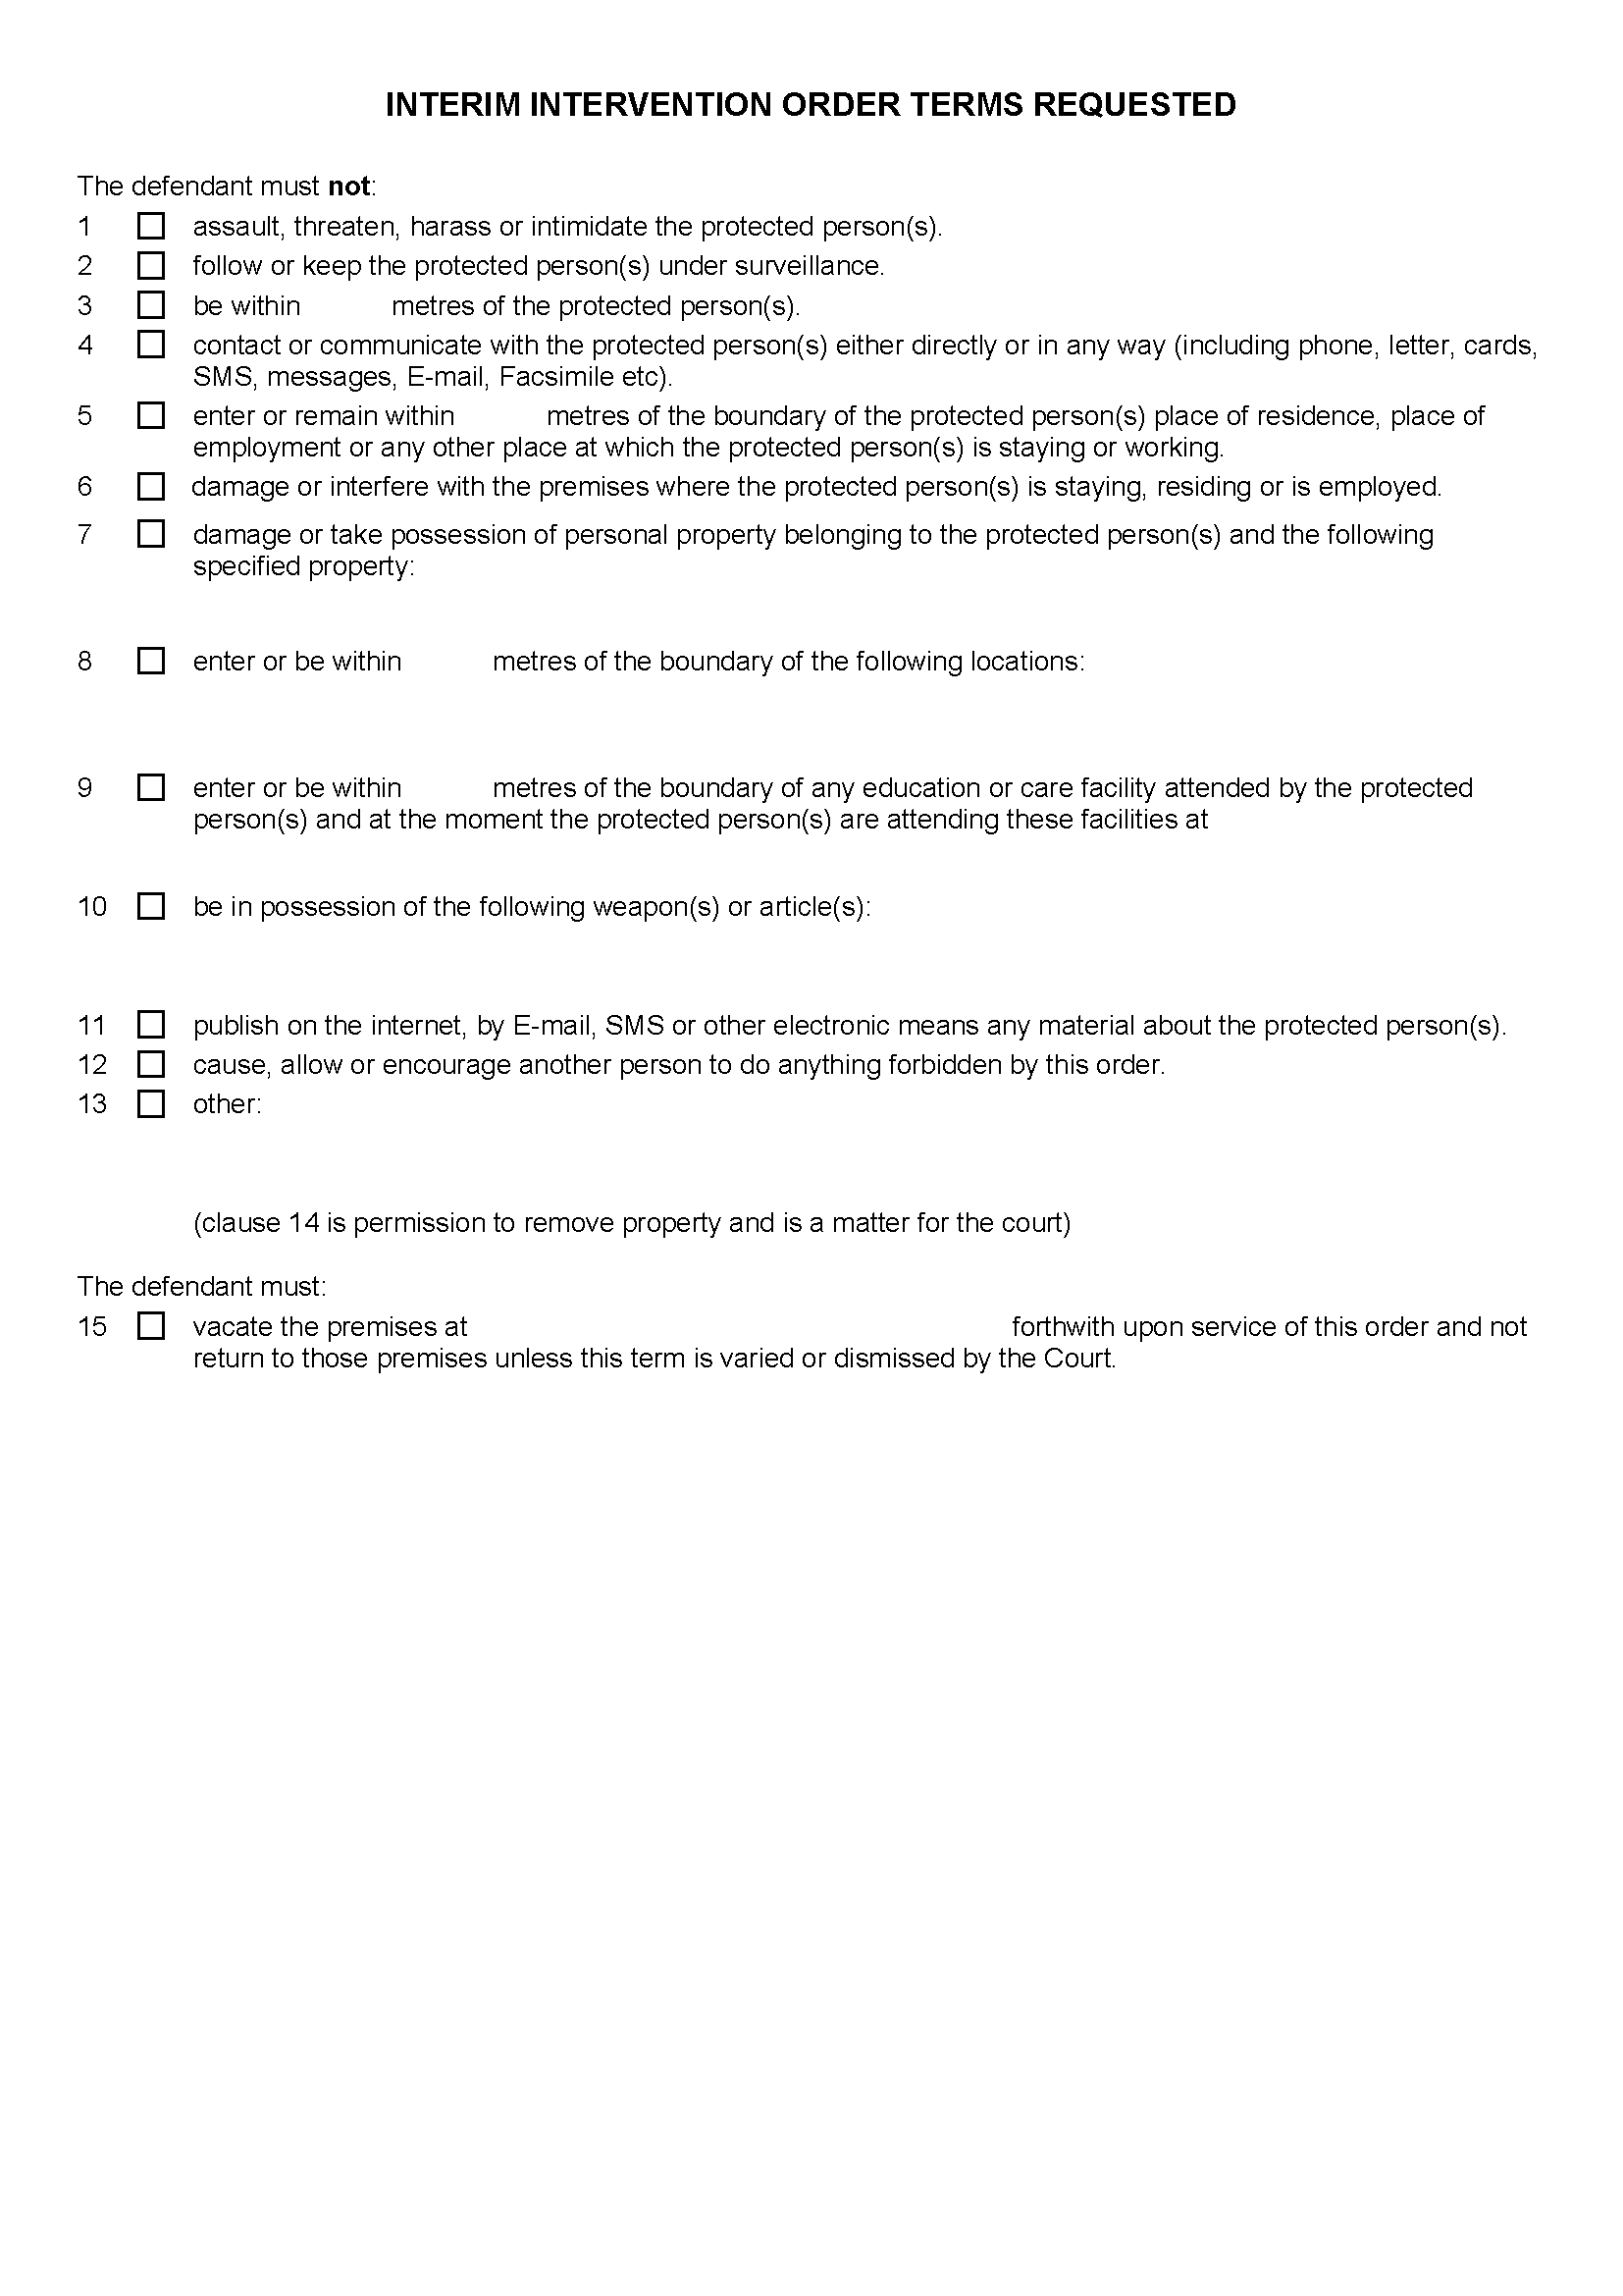
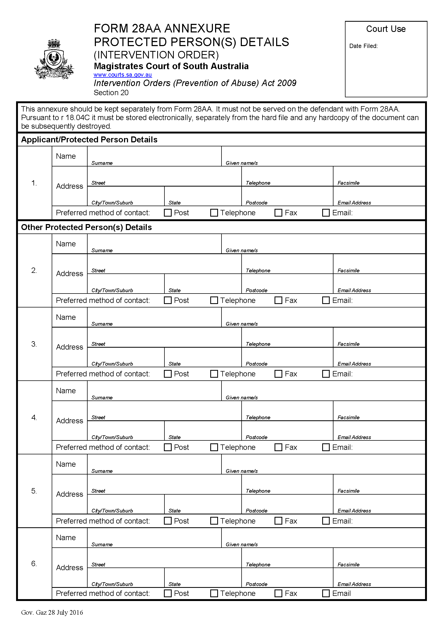
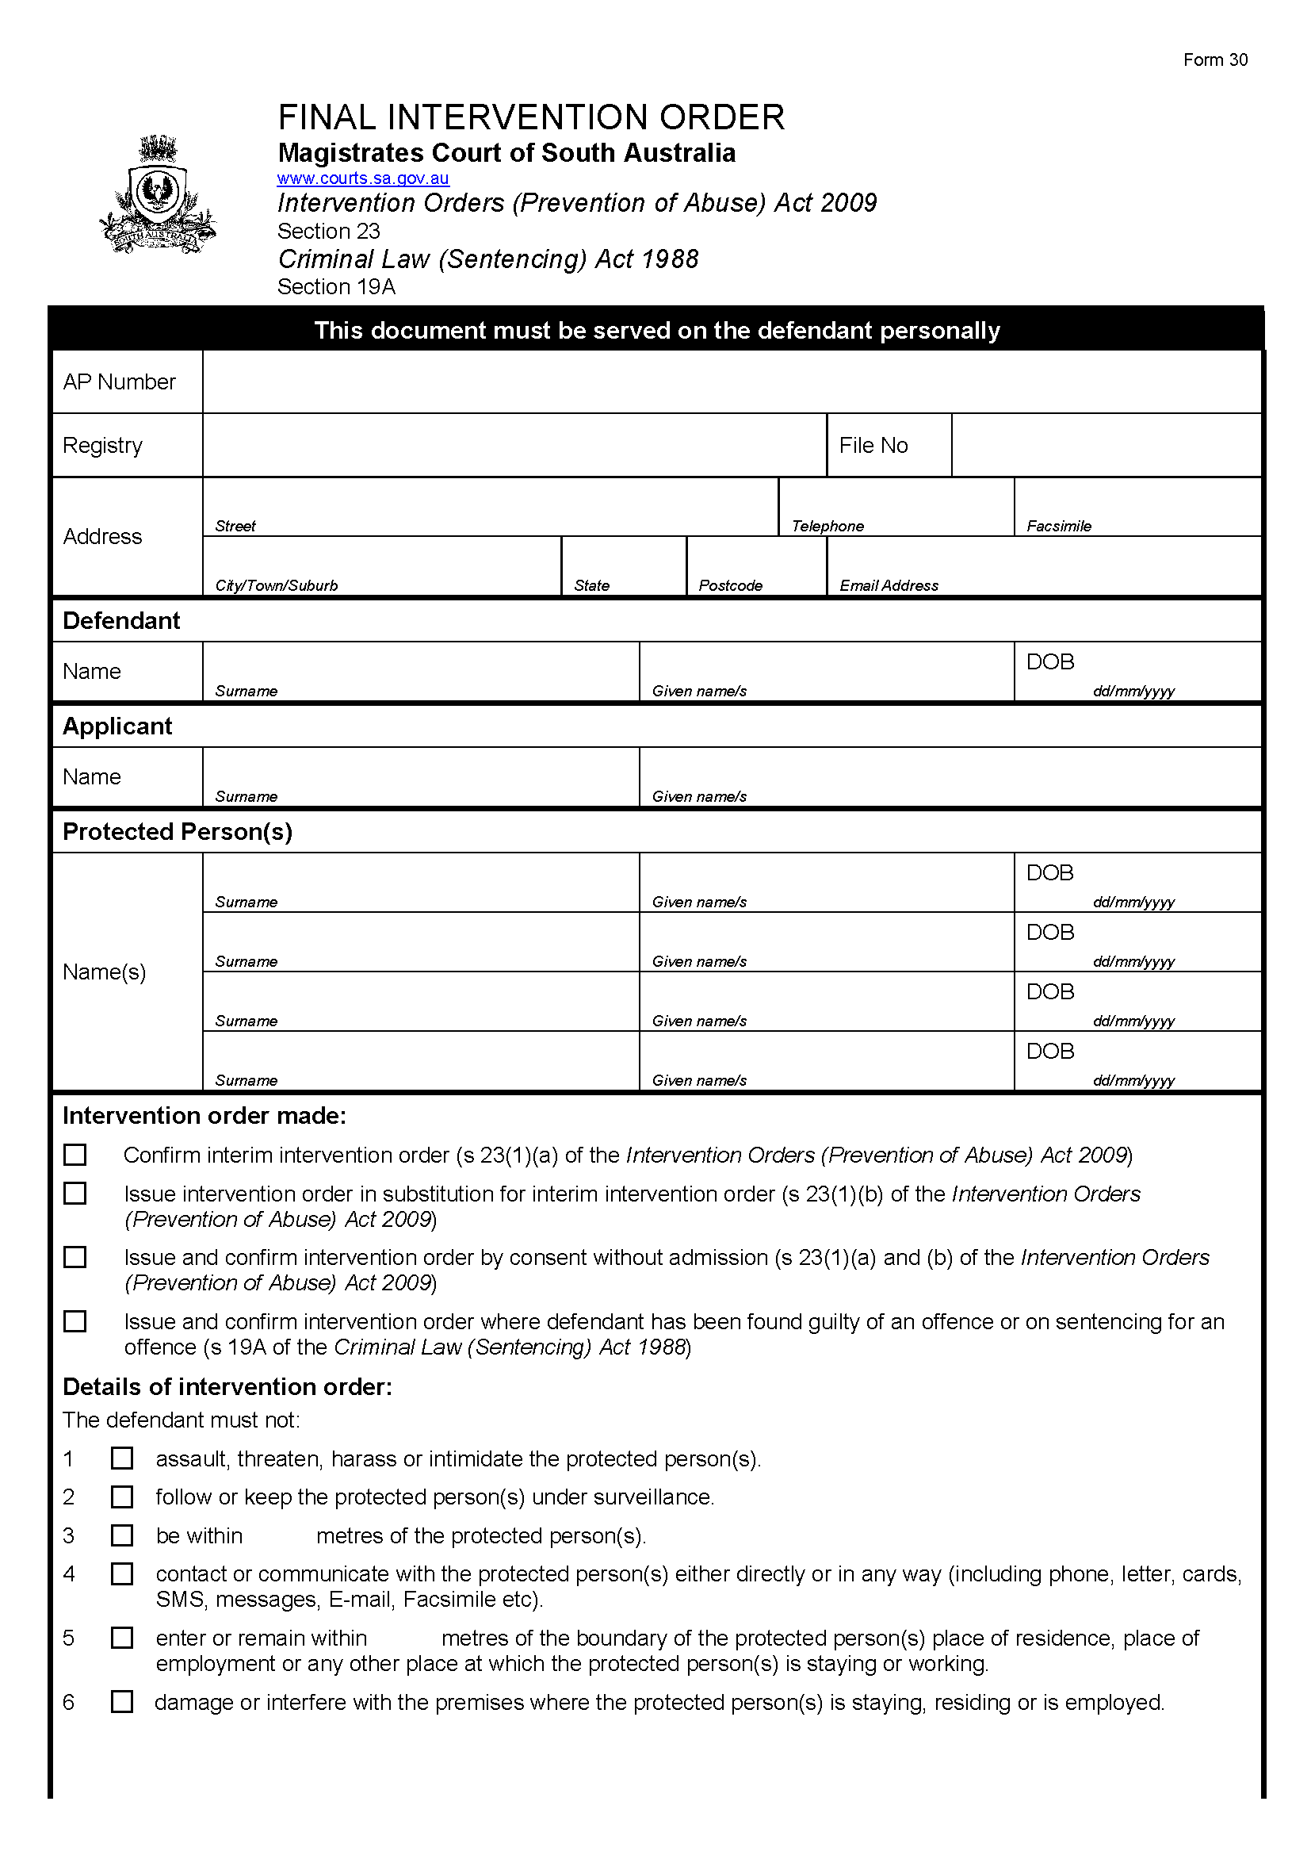
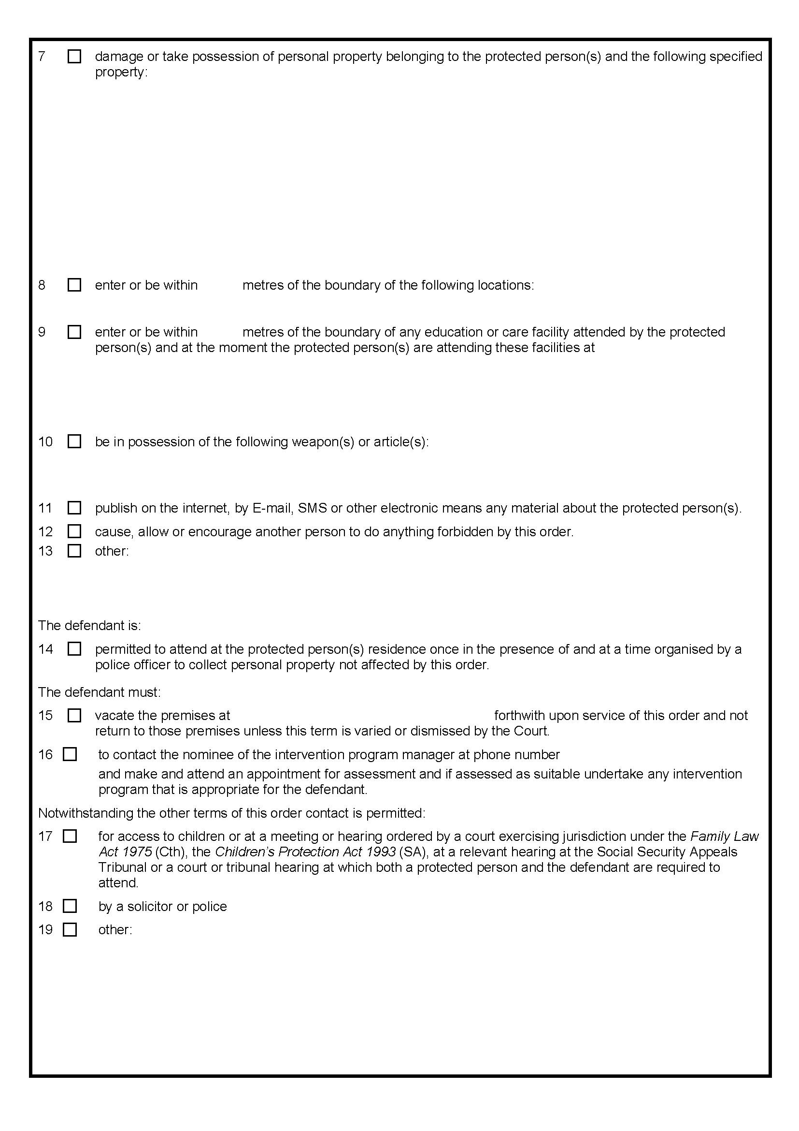
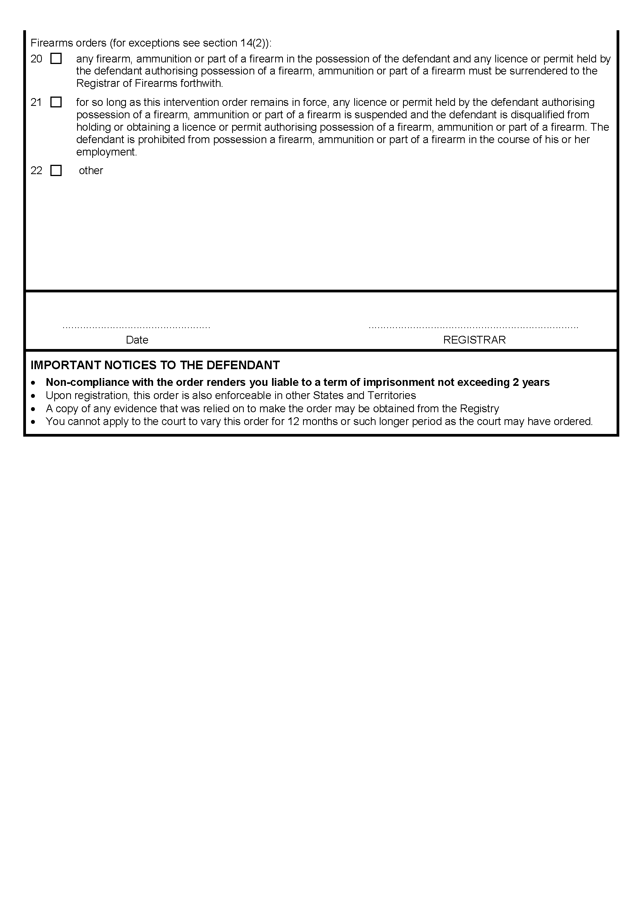
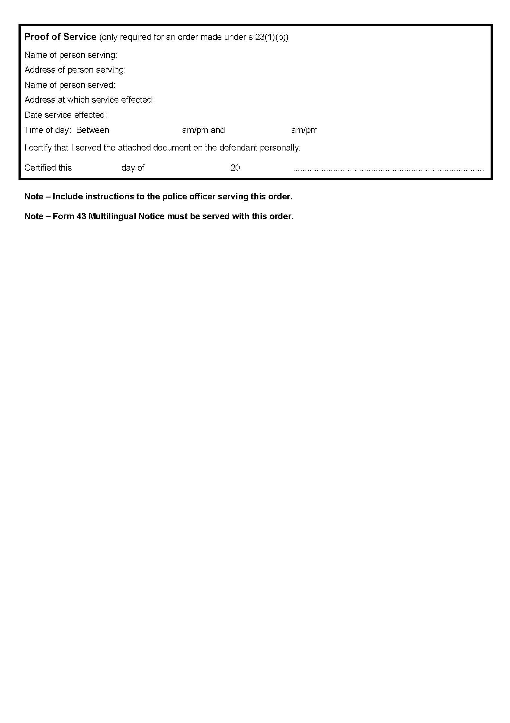
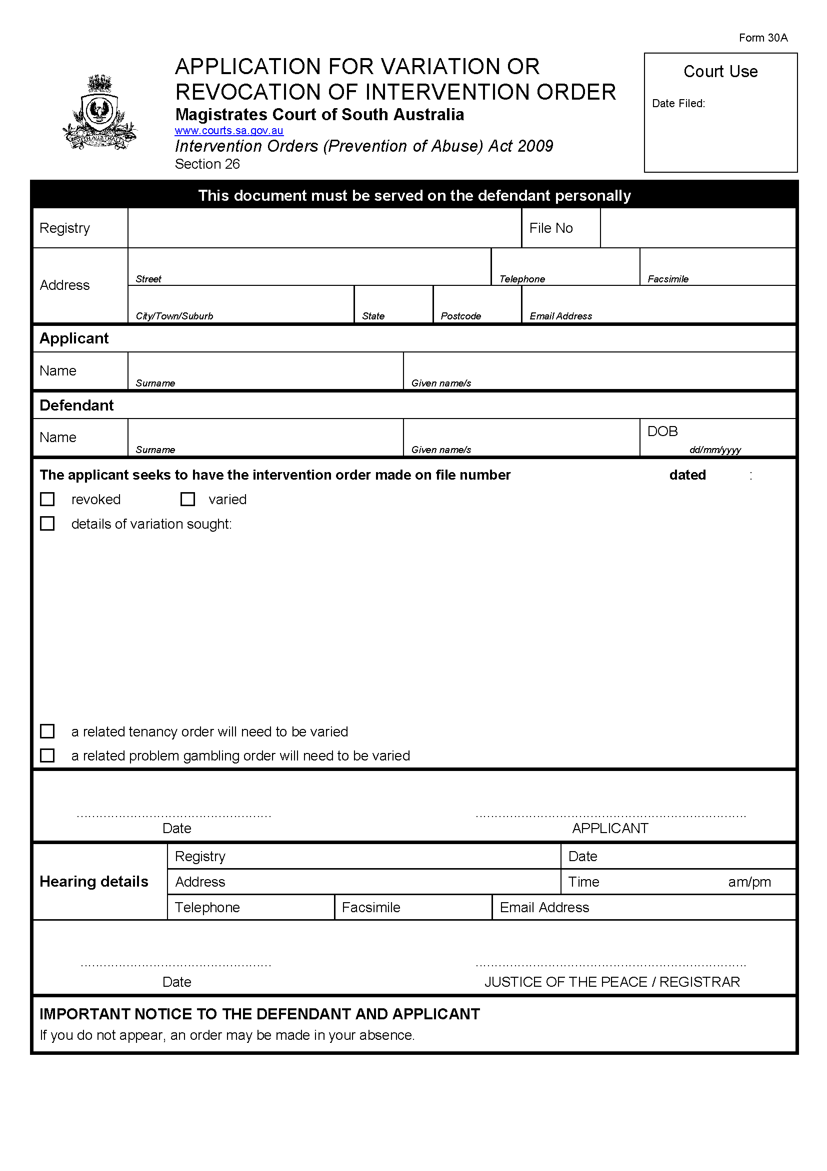
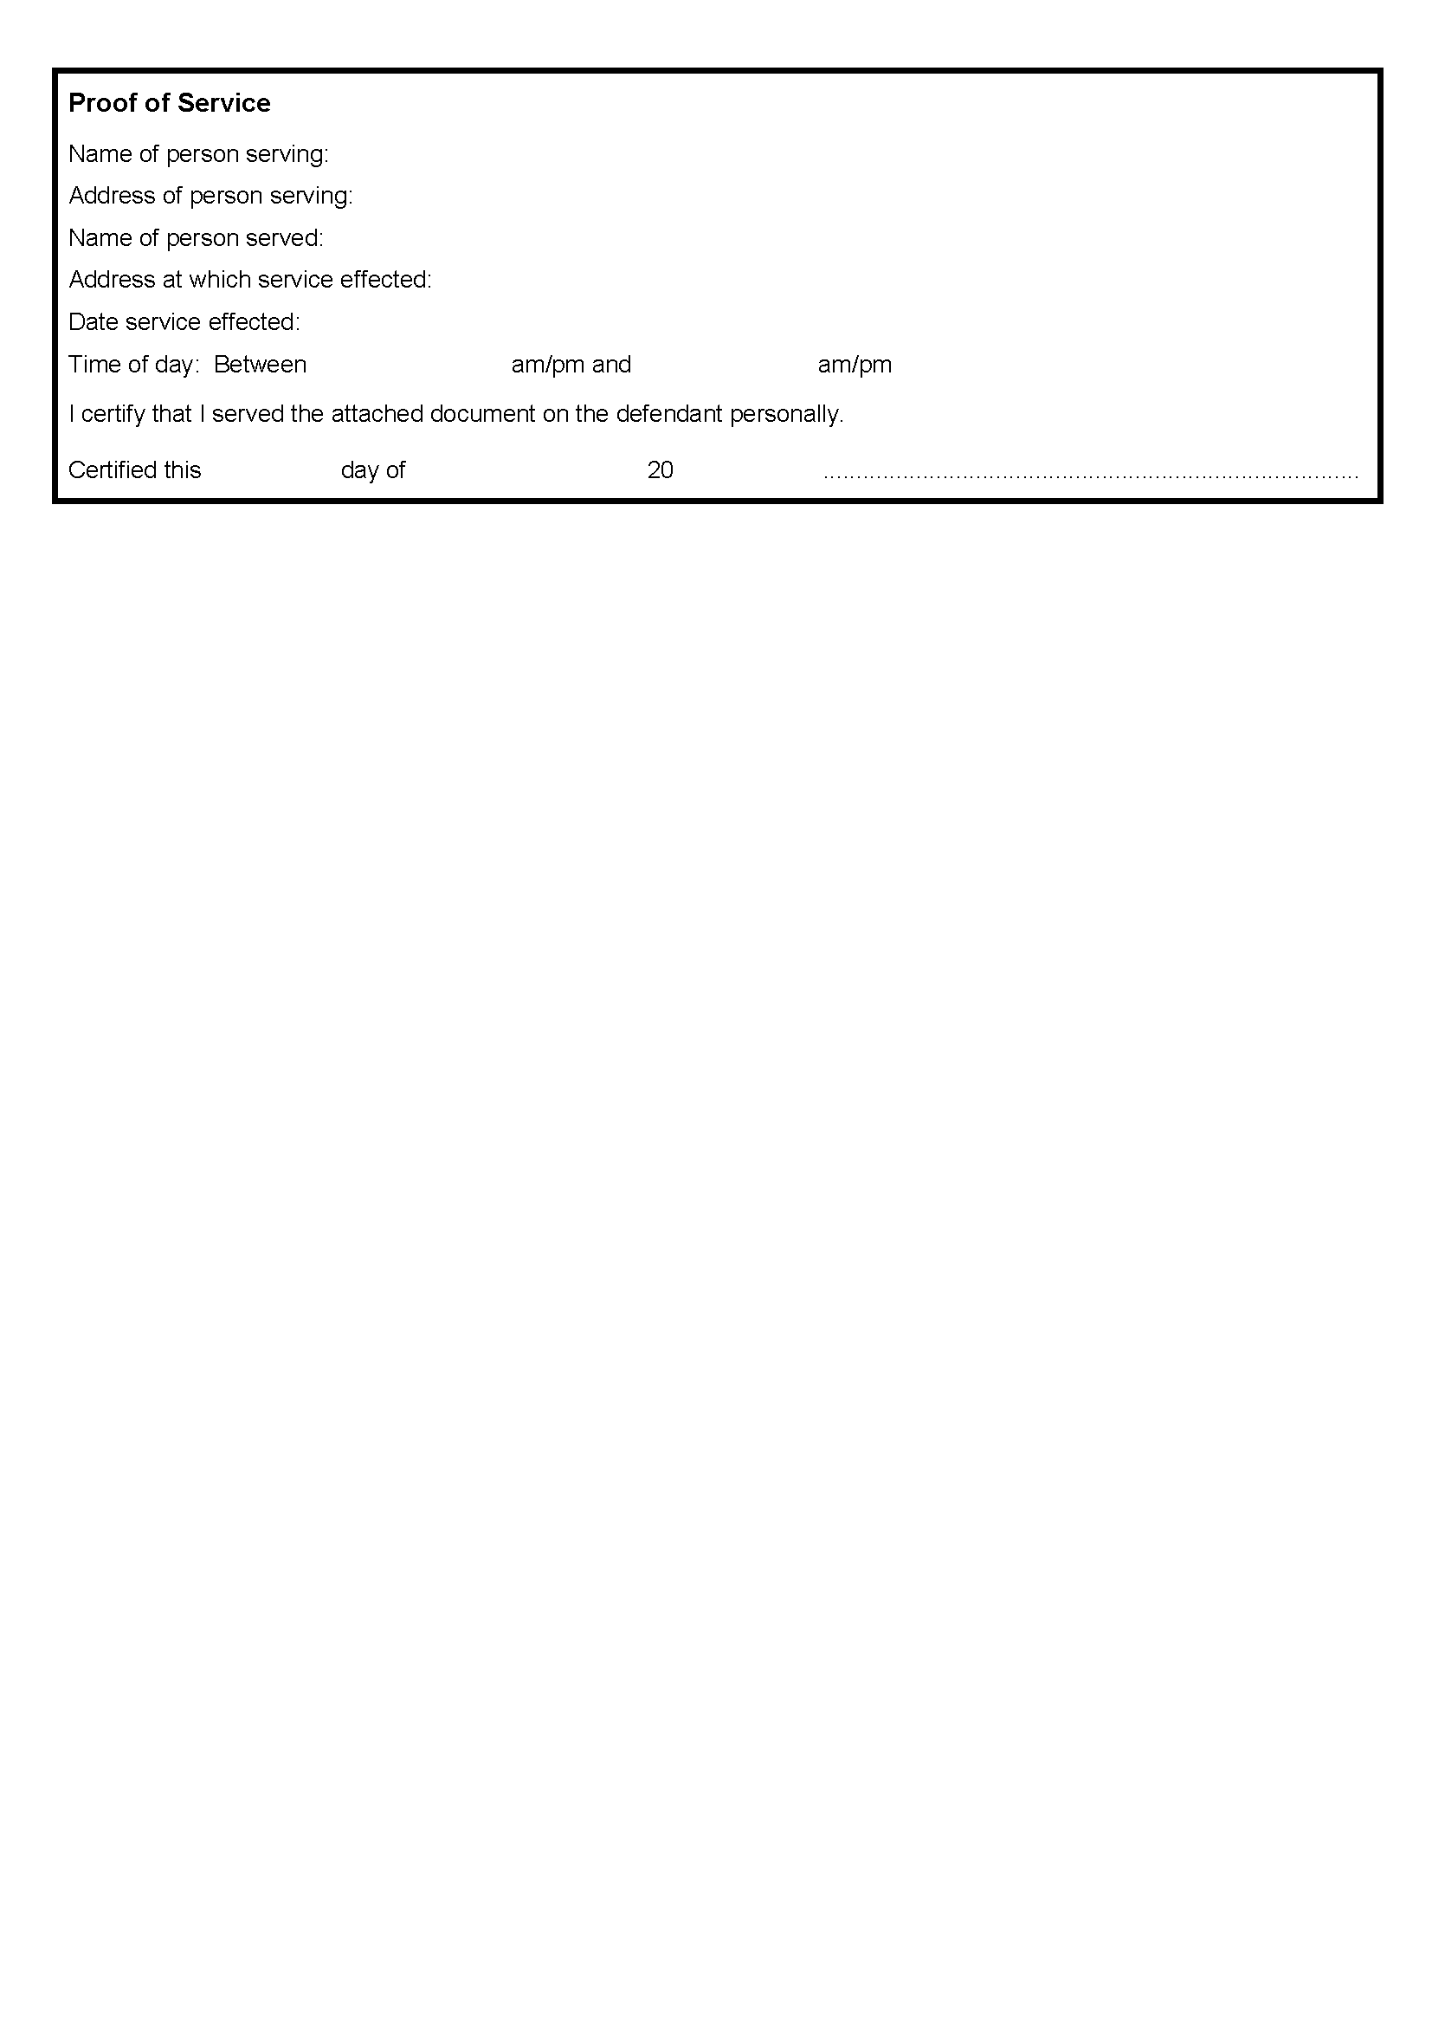
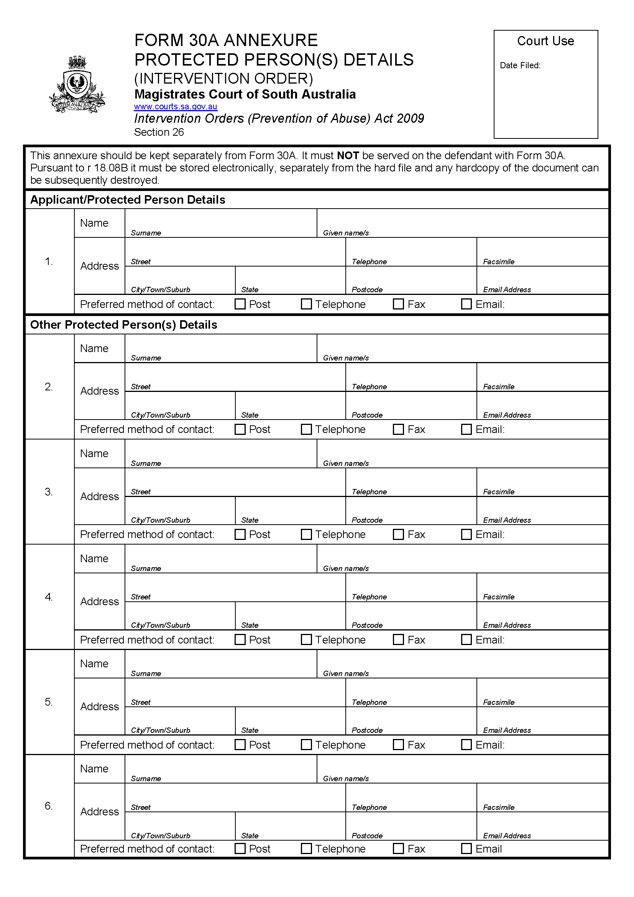
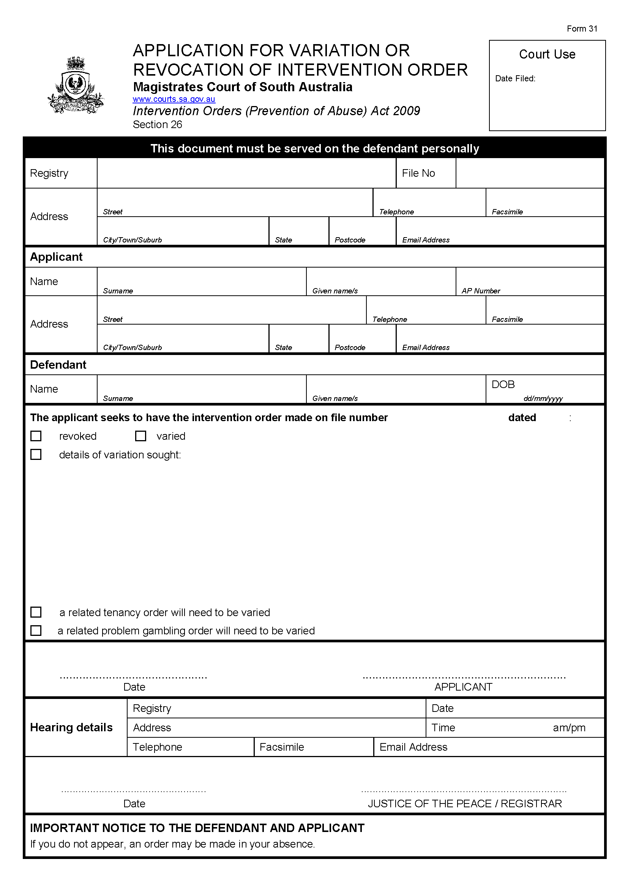
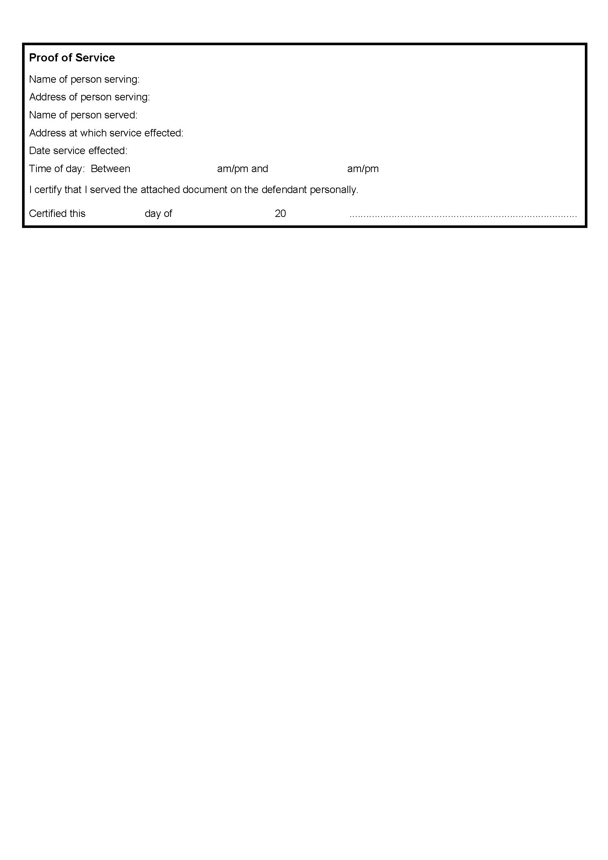
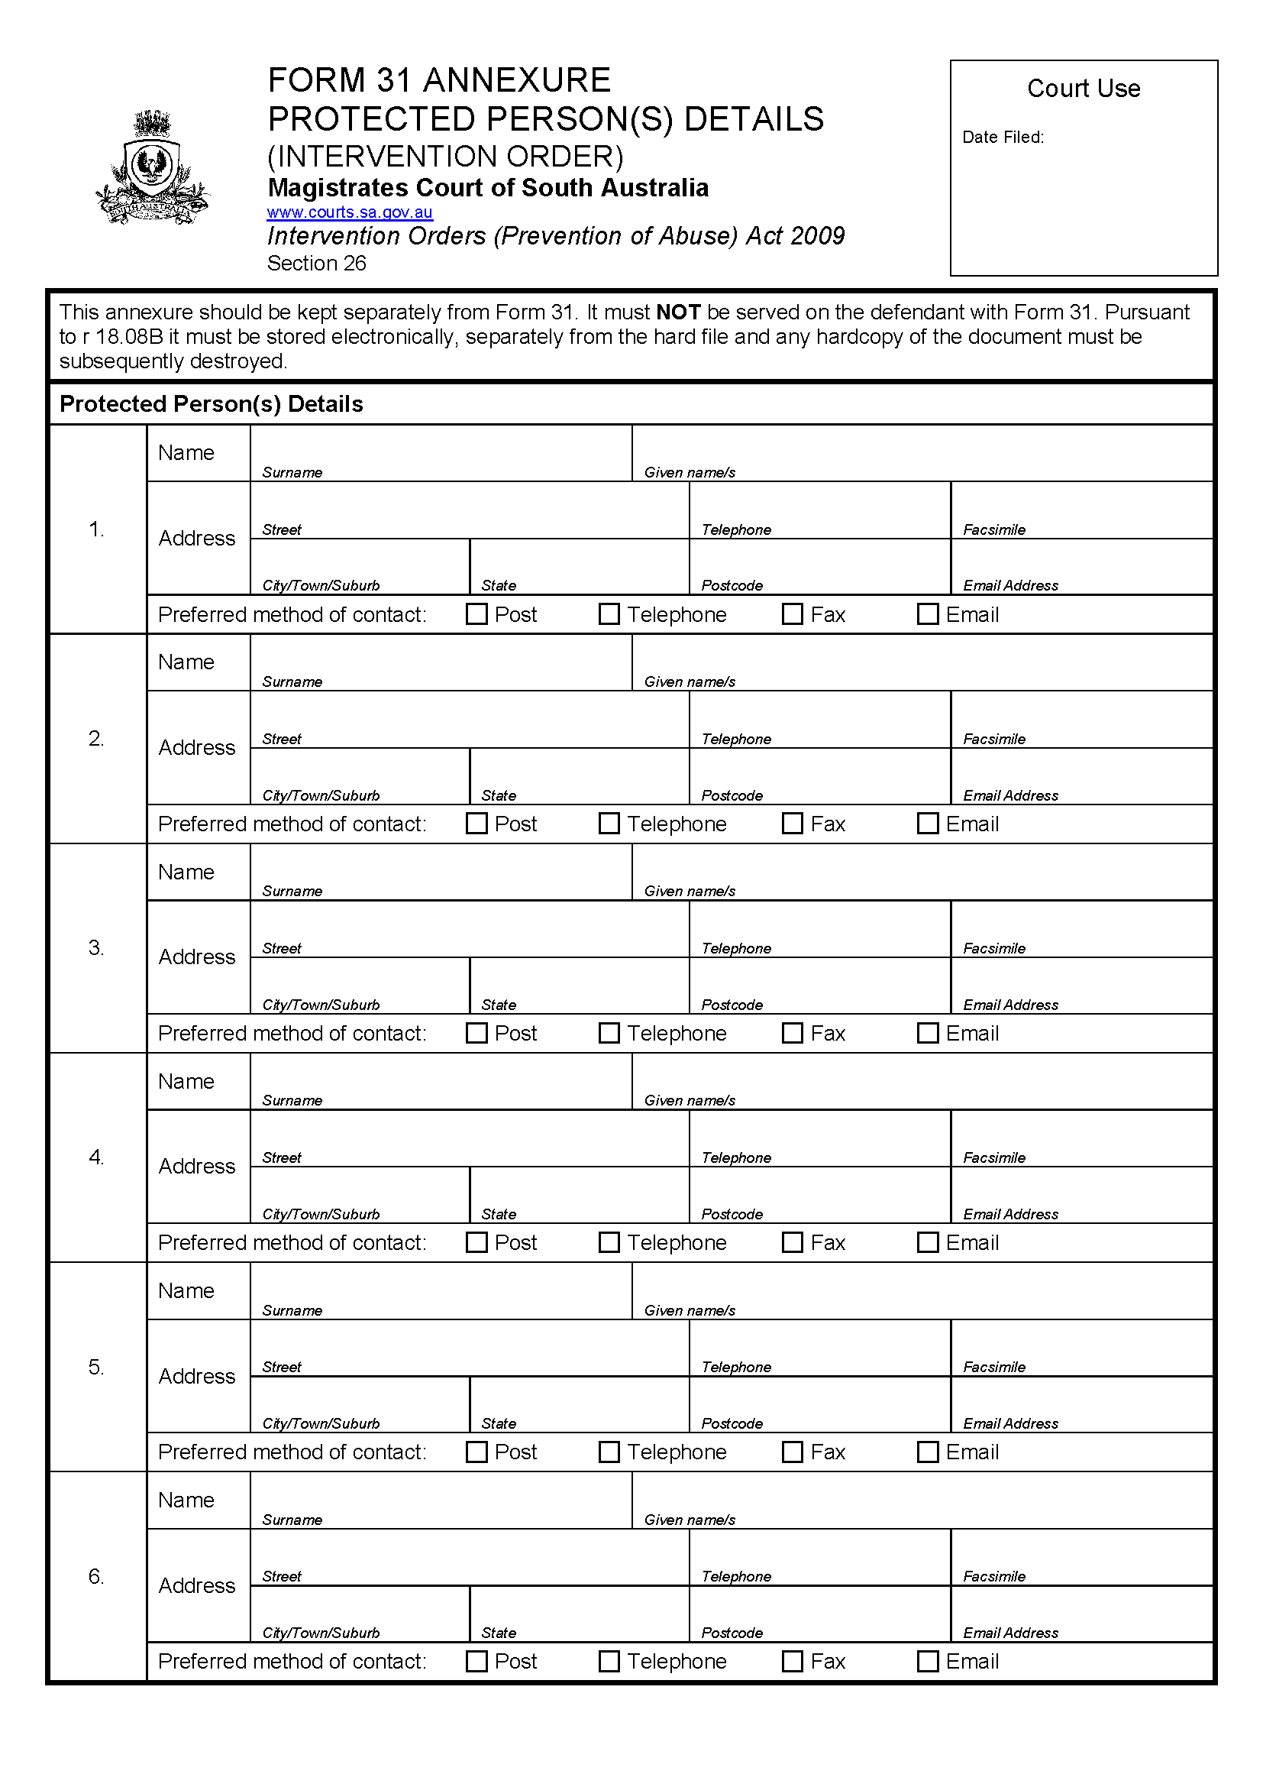
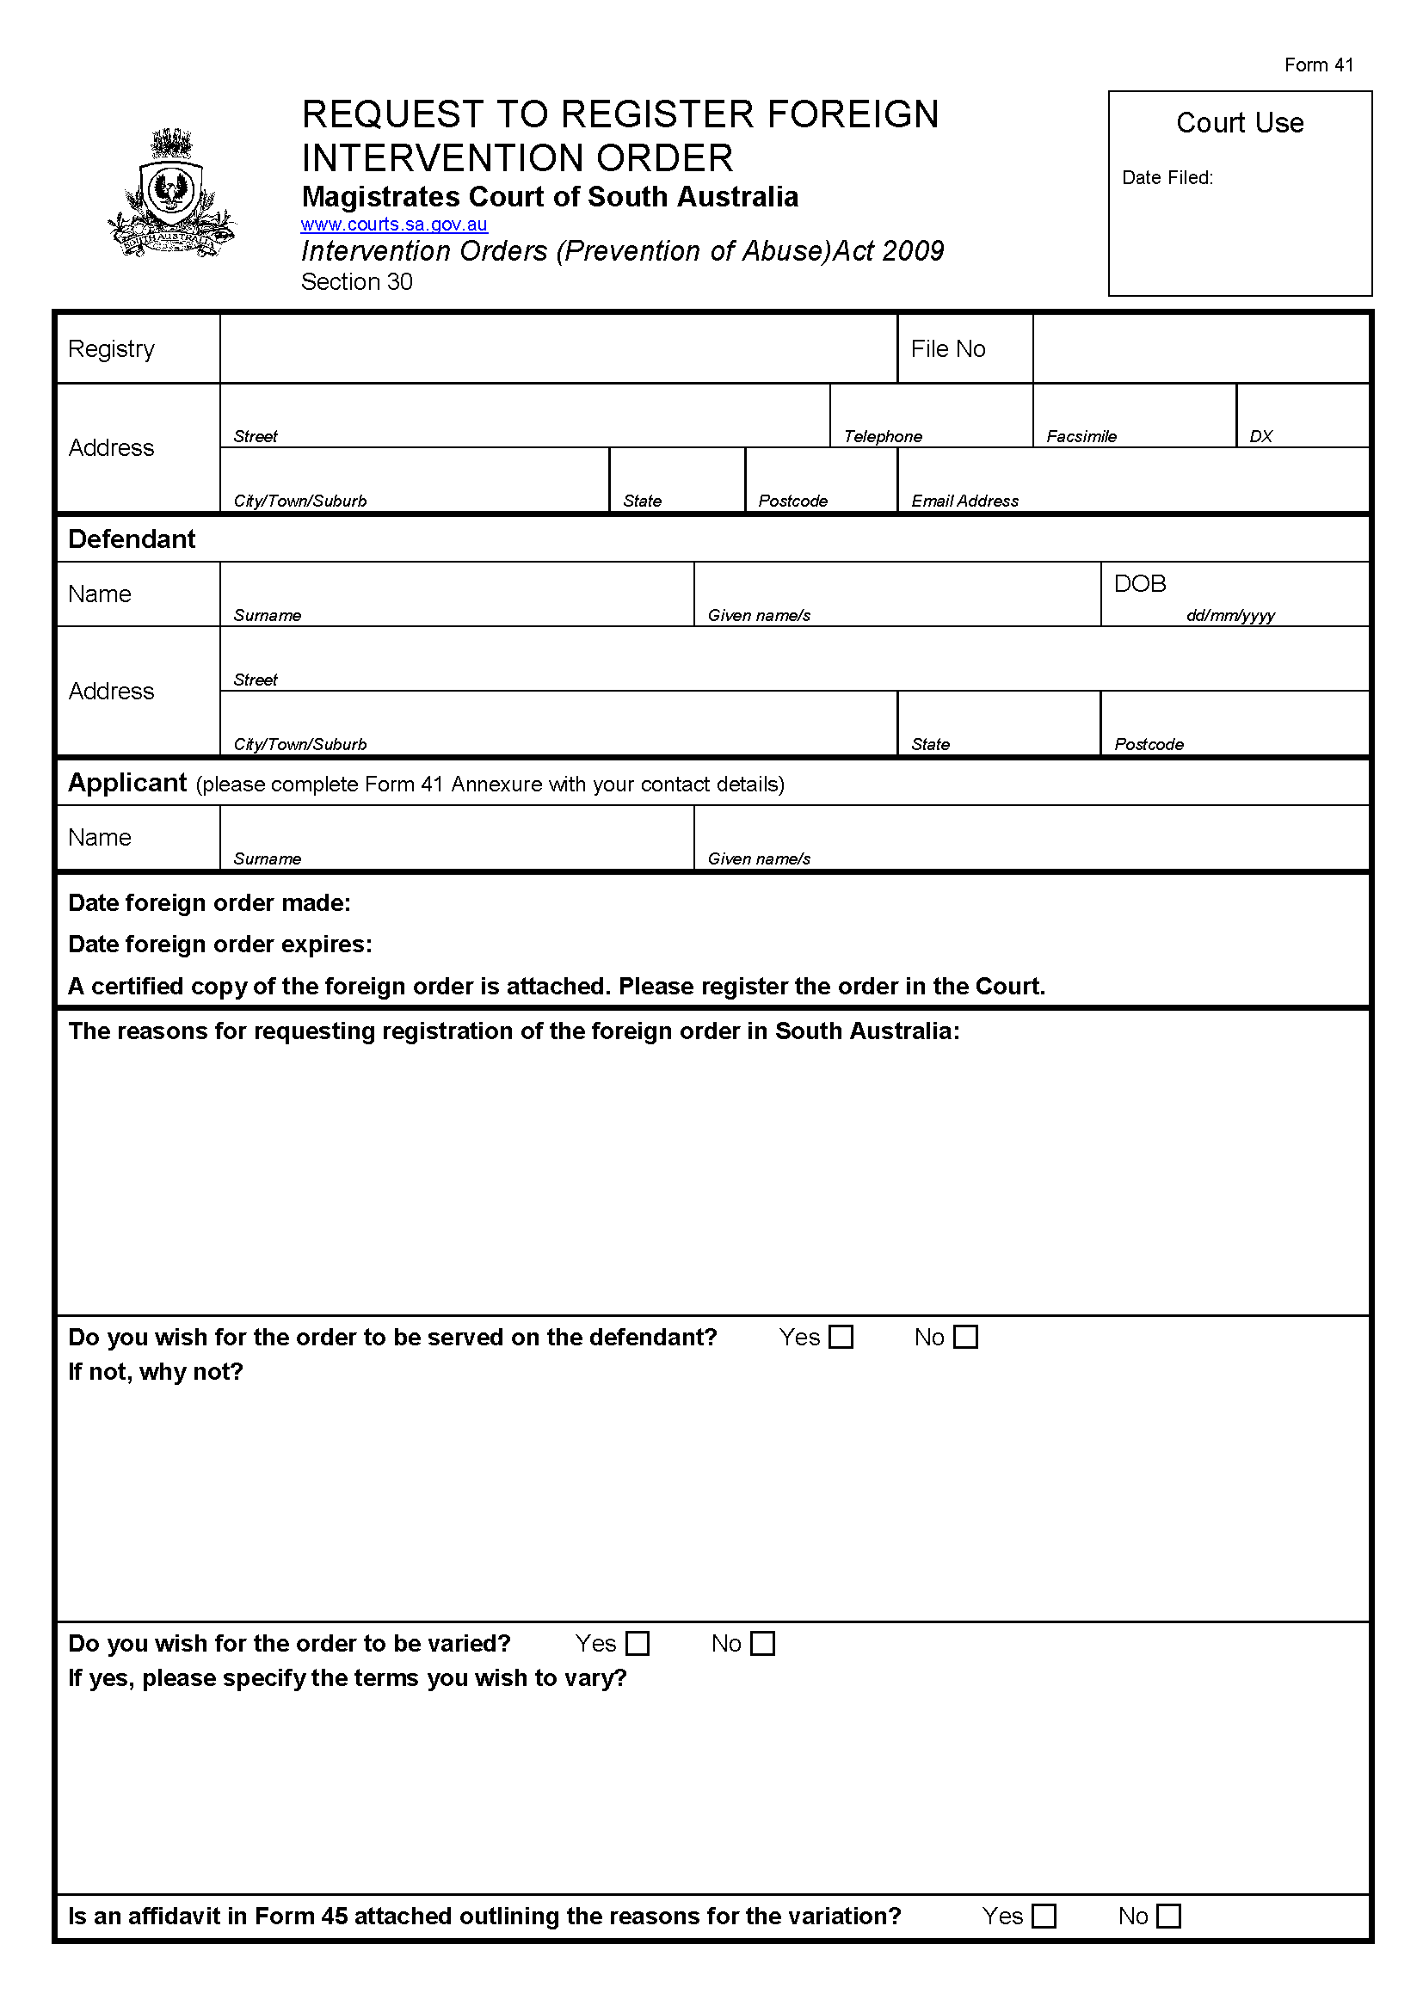
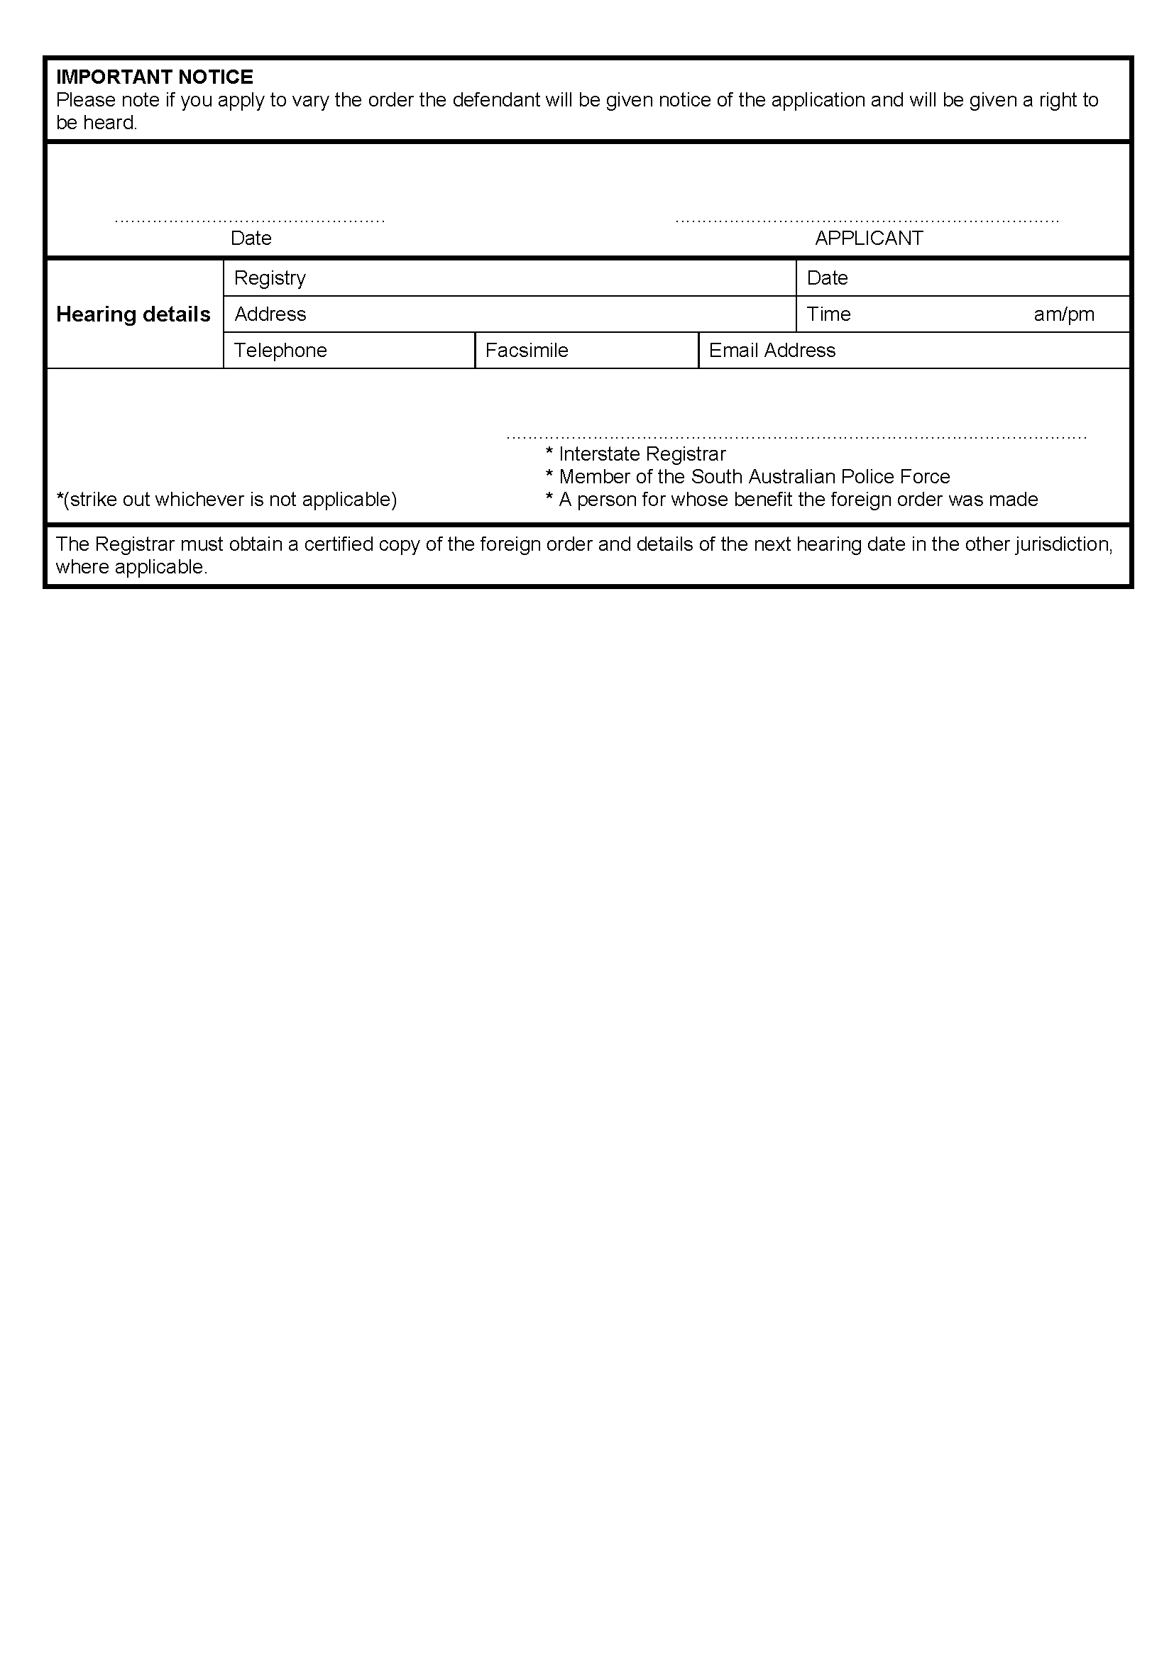
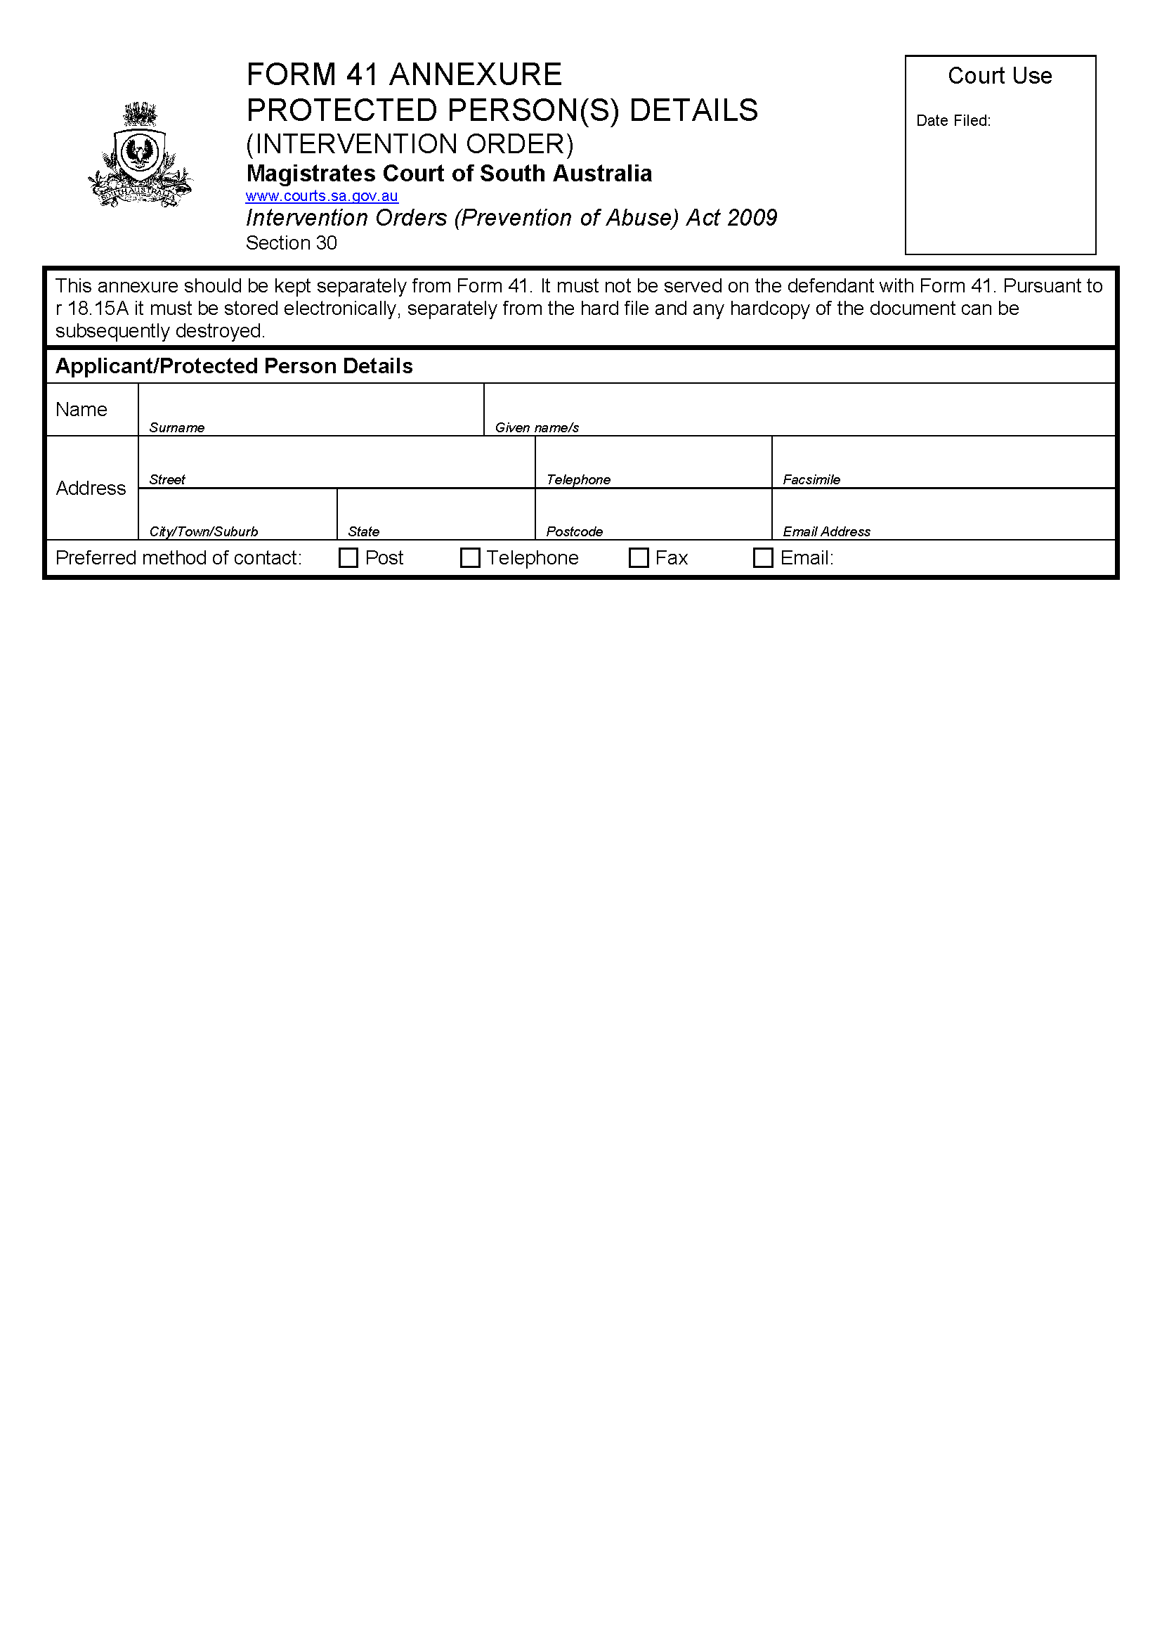
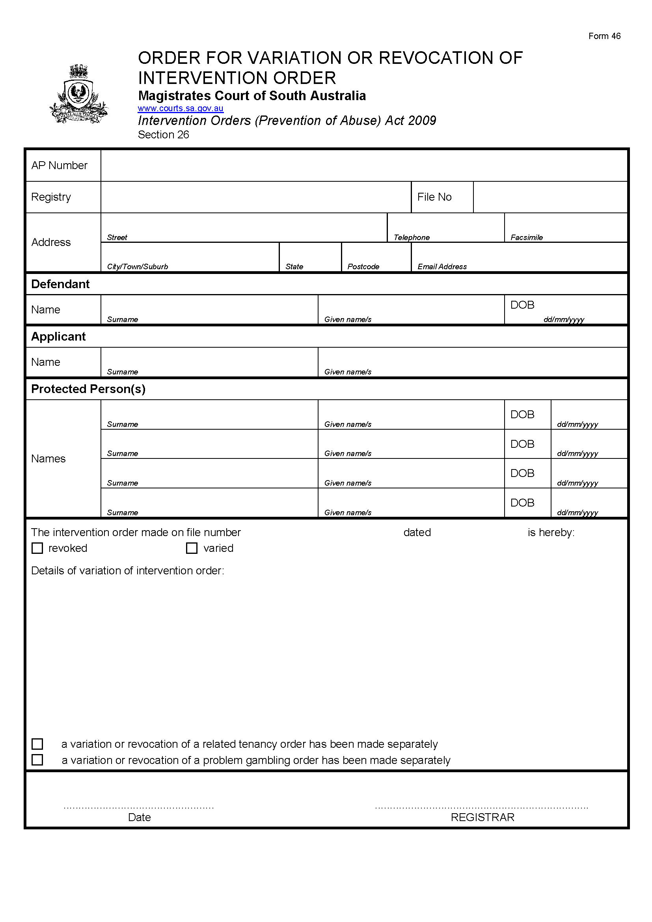
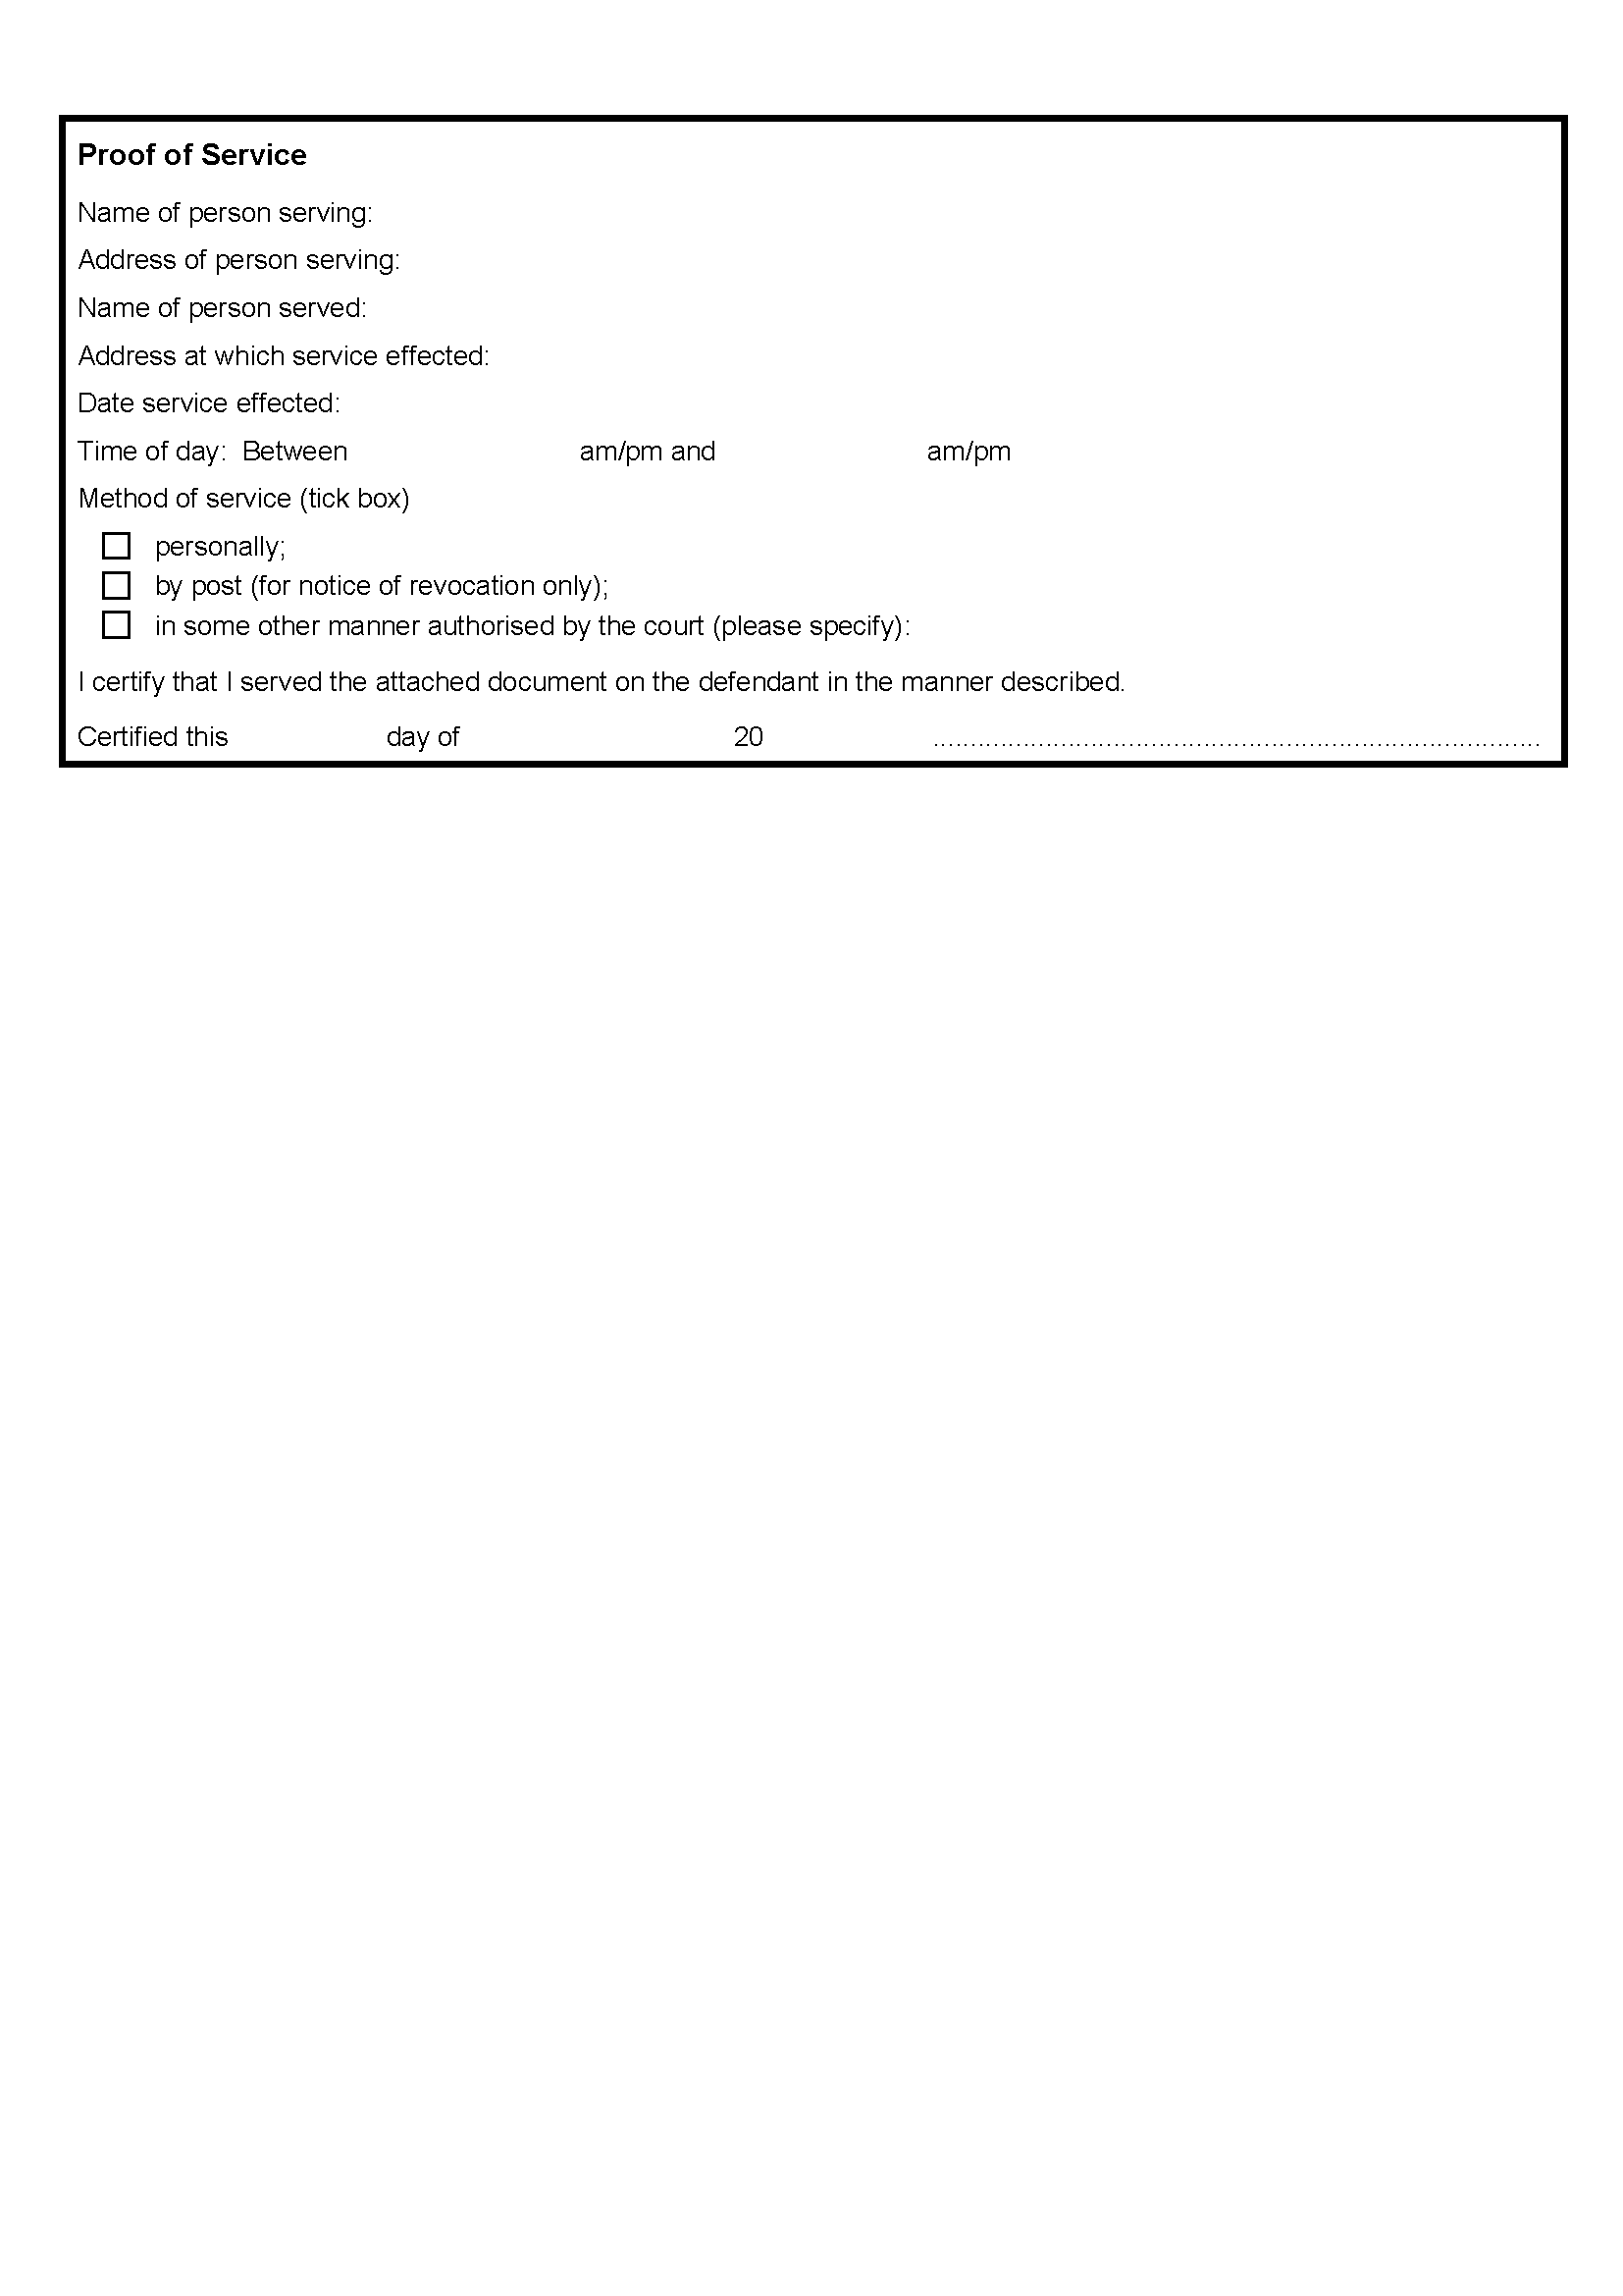

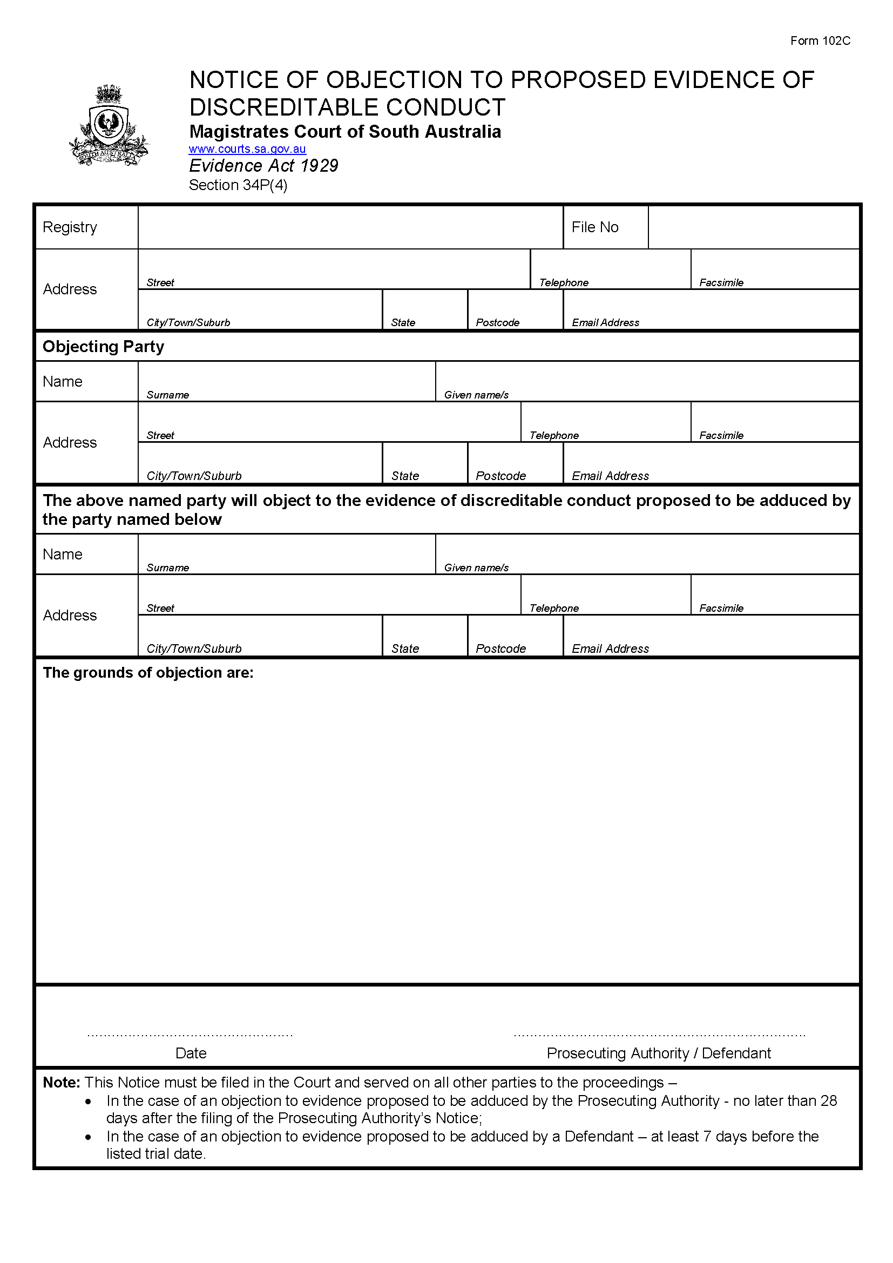
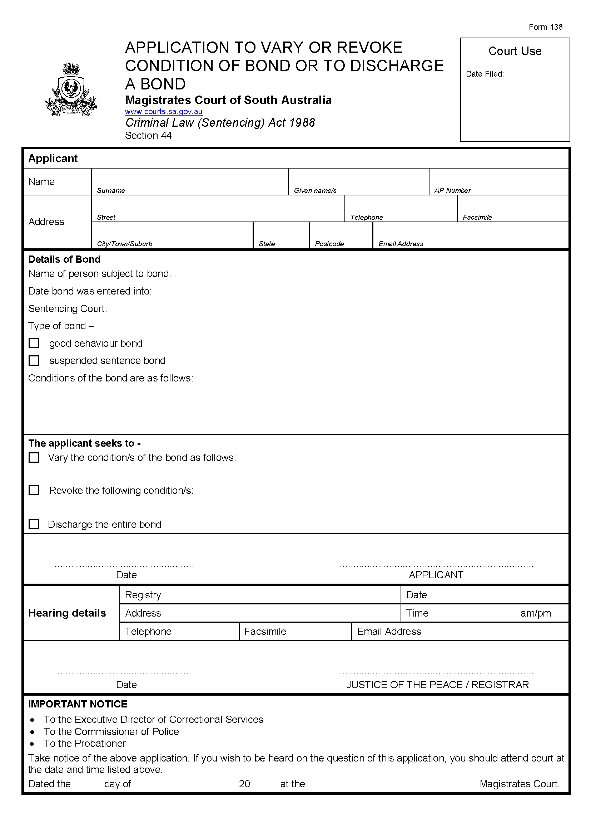
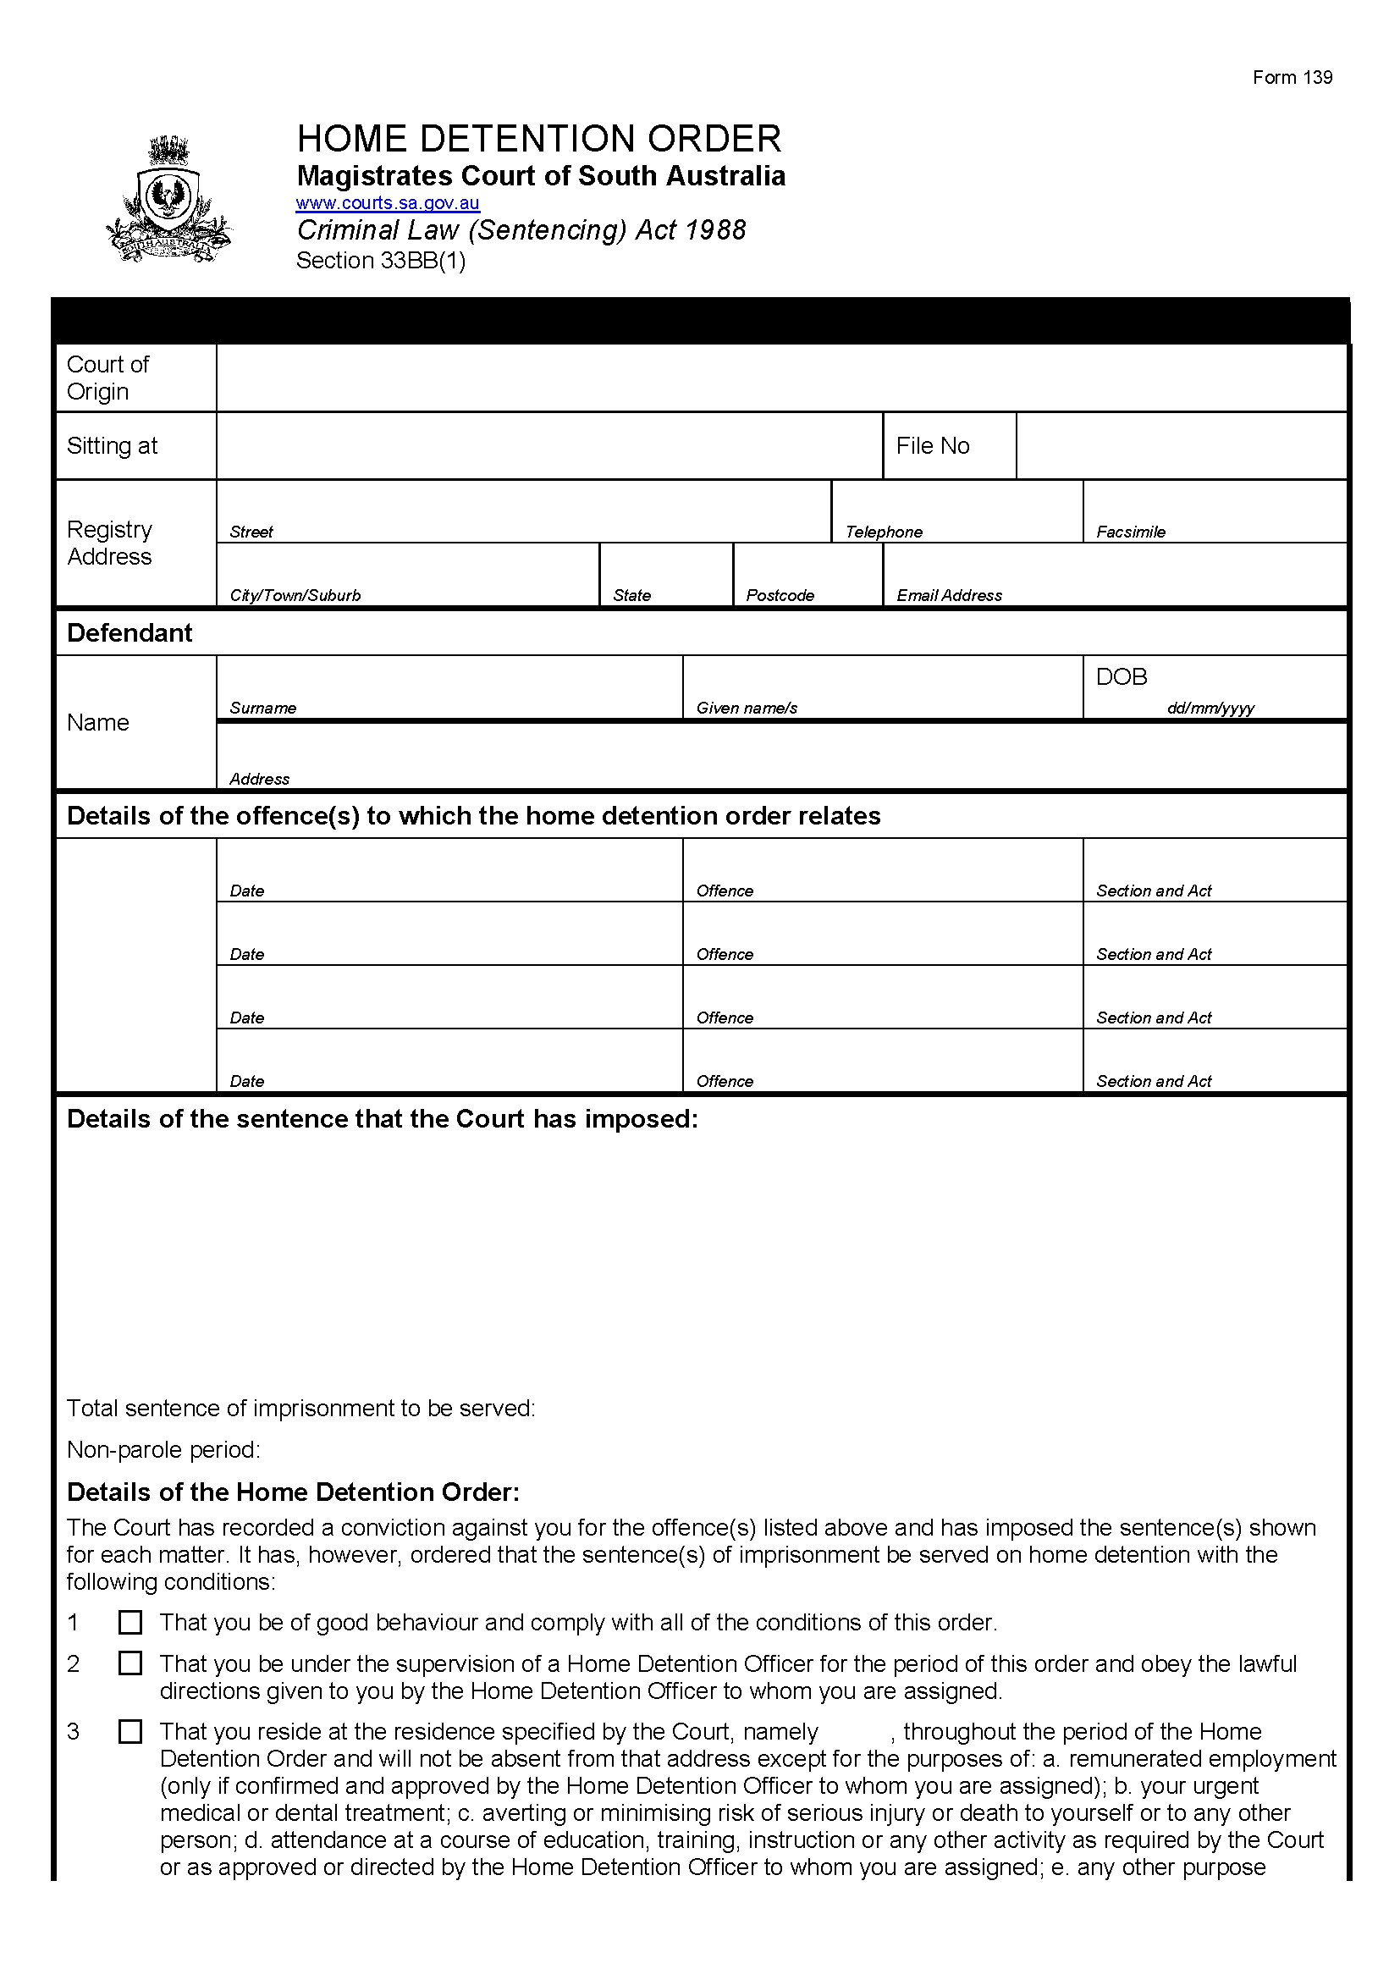


South Australia
Supreme Court Special Applications Supplementary Rules 2014
(Amendment No 4)
BY virtue and in pursuance of section 72 of the Supreme Court Act 1935, and all other enabling powers, we, Judges of the Supreme Court of South Australia, make the following Supreme Court Special Applications Supplementary Rules 2014 (Amendment No 4).
1. These Rules may be cited as the Supreme Court Special Applications Supplementary Rules 2014 (Amendment No 4).
2. The Supreme Court Special Applications Supplementary Rules 2014 are amended as set out below.
3. The amendments made by these Rules come into effect on 1 December 2016 or the date of their gazettal, whichever is later.
4. New Form SA8A is added to the Schedule to the Supreme Court Special Applications Supplementary Rules 2014 immediately after Form SA8.
GIVEN under our hands and the Seal of the Supreme Court of South Australia this 31st day of October 2016.
Chris Kourakis, Chief Judge
Ann Vanstone, Judge
David Peek, Judge
Malcolm Blue, Judge
Tim Stanley, Judge
Kevin Nicholson, Judge
Anne Bampton, Judge
Greg Parker, Judge
David Lovell, Judge
Samuel Doyle, Judge
Martin Hinton, Judge

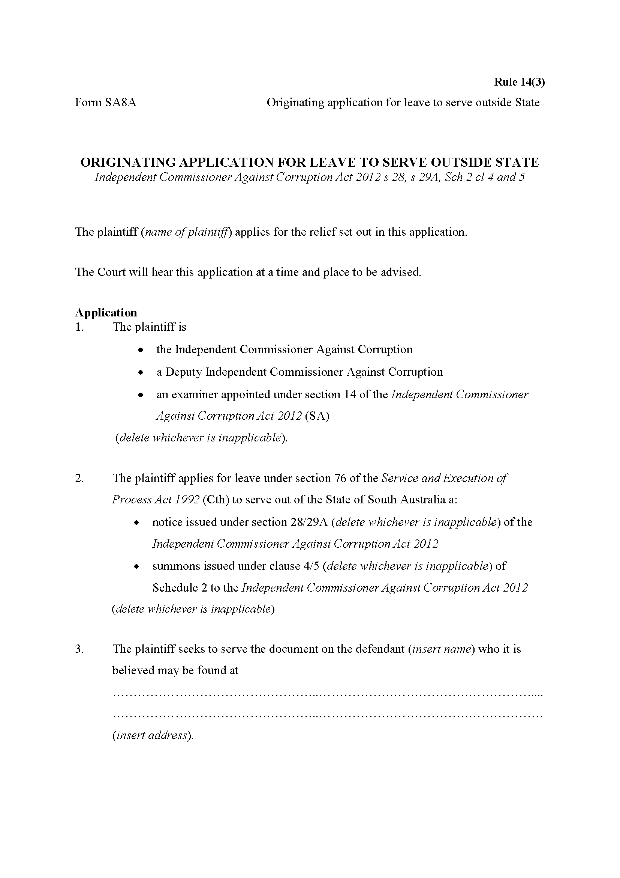
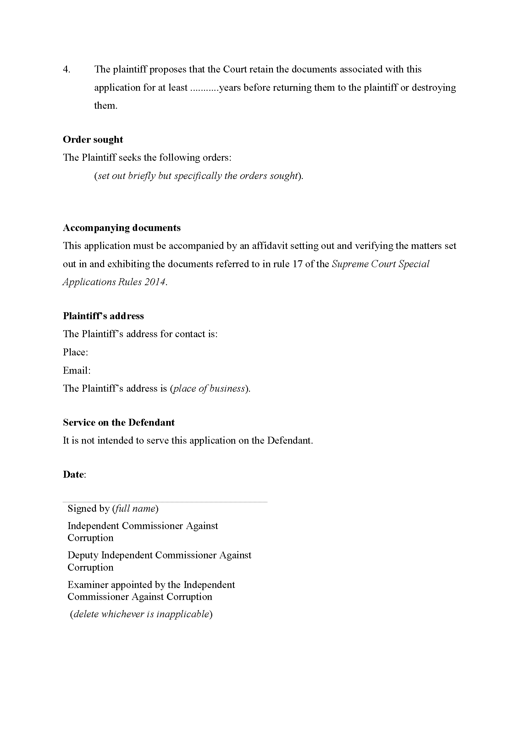

South Australia
Riverbank (Festival Plaza Redevelopment Project—Suspension of Existing Rights and Interests) Notice 2016
under Schedule 1 clause 2(1) of the Riverbank Act 1997
1—Short title
This notice may be cited as the Riverbank (Festival Plaza Redevelopment Project—Suspension of Existing Rights and Interests) Notice 2016.
2—Commencement
This notice comes into operation on the day on which it is made.
3—Interpretation
In this notice—
Act means the Riverbank Act 1997;
designated area has the same meaning as in Schedule 1 of the Act;
designated project means the Festival Plaza Redevelopment Project declared by the Riverbank (Declaration of Designated Project) Notice 2016 (see Gazette 06.10.2016 p3944) to be a designated project for the purposes of Schedule 1 clause 1(2) of the Act;
rights-holder means any party holding a right or interest in, or in relation to, the designated area (including rights or interests arising in any manner described in Schedule 1 clause 2(10) of the Act).
4—Suspension and substitution of rights and interests
(1) The table in Schedule 1 sets out, for each of the rights-holders—
(a) the right or interest of the rights-holder that is suspended for the purposes of facilitating and supporting the undertaking of the designated project; and
(b) the part of the designated area in respect of which the right or interest of the rights-holder is suspended.
(2) The rights and interests set out in the table in Schedule 1 are suspended as set out in that table.
(3) New rights or interests are granted in substitution for rights or interests suspended under subclause (2) as follows:
(a) in the case of a right of access by vehicle, the affected rights-holder is, in substitution, granted—
(i) an alternative right of access by vehicle via the western or eastern parts of Festival Drive or via Station Road; and
(ii) such other rights of access,
as may be notified, from time to time, by or on behalf of the Minister in accordance with subclause (4);
(b) in the case of any other right or interest, the affected rights-holder is, in substitution, granted such other rights or interests as may be notified, from time to time, by or on behalf of the Minister in accordance with subclause (4).
(4) If the Minister is satisfied that the grant of substituted rights or interests to an affected rights-holder would not have an adverse impact on any aspect of the designated project, the Minister, or a person acting on behalf of the Minister, may give the affected rights-holder notice (in such manner as the Minister determines to be appropriate for the purposes of this subclause) of the substituted rights or interests (and such notice may specify the days on which, or times at which, the rights-holder may exercise the substituted rights or interests or impose any other condition in relation to the exercise of the substituted rights or interests).
(5) Except to the extent specified in subclauses (3) and (4), no other rights or interests are granted in substitution for a right or interest suspended under this notice.
(6) For the avoidance of doubt, a suspension of rights or interests under this notice continues until varied or revoked by subsequent notice in the Gazette made by the Minister in accordance with Schedule 1 clause 2(6) of the Act.
Schedule 1—Existing rights and interests suspended

Rights-holders | Description of right or interest that is suspended | Part of designated area
Adelaide Festival Centre Trust  Adelaide Station and tenants  Casino | Right of access to subject land by vehicle or on foot | GP 248/1998 ID  CD11
Casino | Right to dig, open up and remain on subject land with plant and equipment | GP248/1998 ID  CD8
Adelaide Convention Centre  Adelaide Festival Centre Trust  Hotel  Casino  Riverside Building | Right of access to subject land by vehicle or on foot | GP 248/1998 ID  G12
Adelaide Convention Centre  Adelaide Festival Centre Trust  Hotel  Adelaide Station and tenants  Casino | Right of access to subject land on foot | GP 248/1988 ID  H21
Adelaide Convention Centre | Right of access over subject land by vehicle or on foot to drainage system | GP 248/1988 ID  N17
Adelaide Convention Centre  Adelaide Festival Centre Trust  Hotel  Adelaide Station and tenants  Casino | Right of access to subject land by vehicle or on foot | GP 248/1988 ID  RD1  RD2
Casino | Right of access to subject land by vehicle or on foot | GP 248/1988 ID  CD3  CD9
Adelaide Convention Centre  Casino | Right of access over subject land by vehicle or on foot to grease trap | GP 248/1988 ID  GT2
South Australian Water Corporation | Easement for sewerage purposes over those portions of subject land marked A and B in D46426 (RTC 8442297) | Pieces 1 and 3 and Allotment 9 in D46426
Any other rights-holder | Right of access to subject land by vehicle or on foot  Right to dig, open up and remain on subject land with plant and equipment  Right of access over subject land by vehicle or on foot to drainage system | Whole of designated area
Made by the Governor
on the recommendation of the Minister and with the advice and consent of the Executive Council
on 24 November 2016
MHUD\16\042

South Australia
Crown Land Management (Revocation of Dedication) Proclamation 2016
under section 19(2) of the Crown Land Management Act 2009

Preamble
1 The following land is dedicated as a reserve for hospital purposes (see Gazette 24.9.1936 p625) and has been granted in fee simple:
Allotment 4, Town of Tarcoola South in the area named Tarcoola, Out of Hundreds (Tarcoola), being the whole of the land comprised in Certificate of Title Register Book Volume 5729 Folio 388.
2 The following land is dedicated for hospital purposes (see Gazette 13.6.1946 p1063) and has been granted in fee simple:
Allotment 2, Town of Tarcoola South in the area named Tarcoola, Out of Hundreds (Tarcoola), being the whole of the land comprised in Certificate of Title Register Book Volume 5715 Folio 129.
3 It is now intended that the dedication of the land referred to in clause 1, and the dedication of the land referred to in clause 2, be revoked.
4 On revocation of the dedication the relevant land reverts to the status of unalienated Crown land (see section 19(4) of the Crown Land Management Act 2009).

1—Short title
This proclamation may be cited as the Crown Land Management (Revocation of Dedication) Proclamation 2016.
2—Commencement
This proclamation comes into operation on the day on which it is made.
3—Revocation of dedication of land
The dedication of the land defined in clause 1 of the preamble to this proclamation, and the dedication of the land defined in clause 2 of the preamble, are revoked.
Made by the Governor
with the advice and consent of the Executive Council
on 24 November 2016
16MSECCS048

South Australia
SACE Board of South Australia (Fees) Variation Regulations 2016
under the SACE Board of South Australia Act 1983

Contents
Part 1—Preliminary
1 Short title
2 Commencement
3 Variation provisions
Part 2—Variation of SACE Board of South Australia Regulations 2008
4 Substitution of Schedule 1
Schedule 1—Fees

Part 1—Preliminary
1—Short title
These regulations may be cited as the SACE Board of South Australia (Fees) Variation Regulations 2016.
2—Commencement
These regulations will come into operation on 1 January 2017.
3—Variation provisions
In these regulations, a provision under a heading referring to the variation of specified regulations varies the regulations so specified.
Part 2—Variation of SACE Board of South Australia Regulations 2008
4—Substitution of Schedule 1
Schedule 1—delete the Schedule and substitute:
Schedule 1—Fees

1 | Registration fee  For registration as an assessment centre of an educational institution located in Australia that is not in receipt of financial assistance from the State | $2 034.00 per year
 | (Registration entitles the institution to services similar to that extended by the Board to educational institutions in receipt of financial assistance from the State.)
2 | Student fee  For enrolment, assessment and certification of a student of an educational institution located in Australia that is not in receipt of financial assistance from the State or a full fee paying overseas student (within the meaning of the Education and Early Childhood Services (Registration and Standards) Act 2011)—
 | (a) in the case of a student enrolled at Stage 1 studying fewer than 40 credits | $170.00 per student
 | (b) in the case of a student enrolled at Stage 1 studying 40 credits or more | $320.00 per student
 | (c) in the case of a student enrolled at Stage 2 studying fewer than 40 credits | $375.00 per student
 | (d) in the case of a student enrolled at Stage 2 studying 40 credits or more | $705.00 per student
3 | Late enrolment fee  For enrolment of a student for assessment of completion of prescribed certification requirements after the closing date for receipt of enrolments set by the Board in any year | $107.00 per student
4 | Clerical check fee  For checking, at the request of a student, the clerical processes and procedures involved in determining a result in a subject | $14.00 per subject
5 | Student assessment summary fee  For access to information about the contribution of examination marks and moderated school assessment marks to the final result of a Year 12 level subject | $13.00 per subject
6 | Return of student material fee  For access of students to their assessment materials | $22.00 per subject

7 | Statement fee  For a statement or certified record replacing— | $25.00 per record or statement
 | (a) a statement of results awarded in a specified year; or
 | (b) a certified record of studies undertaken towards completion of the prescribed certification requirements (SACE Record of Achievement); or
 | (c) a certified record of results in individual subjects or requirements comprised in the prescribed certification requirements (SACE Statement of Results) issued
8 | Replacement fee for SACE Certificate  For a replacement copy of a South Australian Certificate of Education | $42.00
9 | Subject outline fee  For a copy of a subject outline | $13.00 if 80 pages or less  $17.00 if more than 80 pages
10 | Professional development of educators and assessors fees
 | (a) for provision of the following Assessment for Educators course modules (per group):
 | (i) Principles and Language of Assessment | $2 815.00
 | (ii) Authentic Assessment - Purpose and Design | $2 815.00
 | (iii) Assessment Strategies | $2 815.00
 | (iv) Feedback and Data | $2 815.00
 | (v) Moderation and Reporting | $2 815.00
 | (vi) for all course modules listed in subparagraphs (i) to (v) | $11 265.00
 | (b) for provision of Certified Educational Assessor Course (5 modules) (per person) | $1 130.00
Note—
As required by section 10AA(2) of the Subordinate Legislation Act 1978, the Minister has certified that, in the Minister's opinion, it is necessary or appropriate that these regulations come into operation as set out in these regulations.
Made by the Governor
with the advice and consent of the Executive Council
on 24 November 2016
No 266 of 2016
MECD16/081

South Australia
South Australian Civil and Administrative Tribunal Variation Regulations 2016
under the South Australian Civil and Administrative Tribunal Act 2013

Contents
Part 1—Preliminary
1 Short title
2 Commencement
3 Variation provisions
Part 2—Variation of South Australian Civil and Administrative Tribunal Regulations 2015
4 Substitution of regulation 9
9 Enforcement of monetary orders

Part 1—Preliminary
1—Short title
These regulations may be cited as the South Australian Civil and Administrative Tribunal Variation Regulations 2016.
2—Commencement
These regulations will come into operation on 11 December 2016.
3—Variation provisions
In these regulations, a provision under a heading referring to the variation of specified regulations varies the regulations so specified.
Part 2—Variation of South Australian Civil and Administrative Tribunal Regulations 2015
4—Substitution of regulation 9
Regulation 9—delete the regulation and substitute:
9—Enforcement of monetary orders
A party to the proceedings, or a person in favour of whom the monetary order is otherwise made, is recognised for the purposes of section 89(1) of the Act.
Note—
As required by section 10AA(2) of the Subordinate Legislation Act 1978, the Minister has certified that, in the Minister's opinion, it is necessary or appropriate that these regulations come into operation as set out in these regulations.
Made by the Governor
with the advice and consent of the Executive Council
on 24 November 2016
No 267 of 2016
AGO0130/16CS

South Australia
Serious and Organised Crime (Control) Variation Regulations 2016
under the Serious and Organised Crime (Control) Act 2008

Contents
Part 1—Preliminary
1 Short title
2 Commencement
3 Variation provisions
Part 2—Variation of Serious and Organised Crime (Control) Regulations 2008
4 Variation of regulation 6—Prescribed forms of association

Part 1—Preliminary
1—Short title
These regulations may be cited as the Serious and Organised Crime (Control) Variation Regulations 2016.
2—Commencement
These regulations will come into operation on the day on which the Youth Justice Administration Act 2016 comes into operation.
3—Variation provisions
In these regulations, a provision under a heading referring to the variation of specified regulations varies the regulations so specified.
Part 2—Variation of Serious and Organised Crime (Control) Regulations 2008
4—Variation of regulation 6—Prescribed forms of association
(1) Regulation 6(1)(e)—after "Family and Community Services Act 1972" insert:
or the Youth Justice Administration Act 2016
(2) Regulation 6(1)(g)—delete "section 40 of the Young Offenders Act 1993" and substitute:
section 34 of the Youth Justice Administration Act 2016
(3) Regulation 6(2)(d)—after "Family and Community Services Act 1972" insert:
or the Youth Justice Administration Act 2016
(4) Regulation 6(2)(e)—delete "section 40 of the Young Offenders Act 1993" and substitute:
section 34 of the Youth Justice Administration Act 2016
Note—
As required by section 10AA(2) of the Subordinate Legislation Act 1978, the Minister has certified that, in the Minister's opinion, it is necessary or appropriate that these regulations come into operation as set out in these regulations.
Made by the Governor
with the advice and consent of the Executive Council
on 24 November 2016
No 268 of 2016
DCSICS/16/034

South Australia
Children's Protection Variation Regulations 2016
under the Children's Protection Act 1993

Contents
Part 1—Preliminary
1 Short title
2 Commencement
3 Variation provisions
Part 2—Variation of Children's Protection Regulations 2010
4 Variation of regulation 4—Aboriginal and Torres Strait Islander Child Placement Principle
5 Variation of regulation 5—Definition of Department
6 Variation of regulation 10—Prescribed functions

Part 1—Preliminary
1—Short title
These regulations may be cited as the Children's Protection Variation Regulations 2016.
2—Commencement
These regulations will come into operation on the day on which the Youth Justice Administration Act 2016 comes into operation.
3—Variation provisions
In these regulations, a provision under a heading referring to the variation of specified regulations varies the regulations so specified.
Part 2—Variation of Children's Protection Regulations 2010
4—Variation of regulation 4—Aboriginal and Torres Strait Islander Child Placement Principle
(1) Regulation 4(1)—delete "section 4(5)" and substitute:
section 5(a1)
(2) Regulation 4(1)(a)—delete paragraph (a) and substitute:
(a) when dealing with a matter relating to placement of an Aboriginal or Torres Strait Islander child, consideration must be given to the child's cultural needs and identity;
(3) Regulation 4(1)(b)—delete "subject to the fundamental principles,"
(4) Regulation 4(2)—delete subregulation (2)
5—Variation of regulation 5—Definition of Department
Regulation 5—delete ", under the Minister, responsible for the administration of the Act is prescribed" and substitute:
responsible for assisting a Minister in the administration of the Act is prescribed
6—Variation of regulation 10—Prescribed functions
Regulation 10(d)—after "the Young Offenders Act 1993" insert:
, the Youth Justice Administration Act 2016
Note—
As required by section 10AA(2) of the Subordinate Legislation Act 1978, the Minister has certified that, in the Minister's opinion, it is necessary or appropriate that these regulations come into operation as set out in these regulations.
Made by the Governor
with the advice and consent of the Executive Council
on 24 November 2016
No 269 of 2016
MECD16/085

SENDING COPY?
NOTICES for inclusion in the South Australian Government Gazette should be emailed to:
GovernmentGazetteSA@sa.gov.au
Please include the following information in the covering email:
• The date the notice is to be published.
• Whether a proof, quote or return email confirmation is required.
• Contact details.
• To whom the notice is charged if applicable.
• A purchase order if required (chargeable notices).
• Any other details that may impact on the publication of the notice.
Attach:
• Notices in Word format.
• Maps and diagrams in pdf.
• Notices that require sighting an official date and signature before publication in a pdf. If a pdf is not possible then fax the official file(s) to the Government Publishing Fax number listed below.
Fax Transmission: (08) 8207 1040
Phone Enquiries: (08) 8207 1045
NOTE:
Closing time for lodging new copy is 4 p.m. on Tuesday preceding the regular Thursday Gazette.

CITY OF CHARLES STURT
Appointment
PURSUANT to Section 56A (22) of the Development Act 1993, Council appointed the Chief Executive Officer, Paul Sutton as Public Officer in relation to the City of Charles Sturt Council Development Assessment Panel.
Contact details for the Public Officer are:
P. Sutton, Public Officer,
City of Charles Sturt, Development Assessment Panel,
72 Woodville Road,
Woodville, S.A. 5011.
Telephone: (08) 8408 1111.
The appointment is until 30 November 2018 or until such time as the provisions of Section 83 of the Planning, Development and Infrastructure Act 2016 become operational, whichever is the shorter period.
P. Sutton, Chief Executive Officer

CITY OF MOUNT GAMBIER
Review of Elector Representation
NOTICE is hereby given that the City of Mount Gambier has undertaken a review to determine whether a change of arrangements in respect to elector representation will result in the electors of the area being more adequately and fairly represented.
As an outcome of this review Council proposes the following:
Proposal
(1) The principal member of Council continue to be a Mayor elected by the community.
(2) The council area not be divided into wards (i.e. retain the existing ‘no wards’ structure), with all area councillors having to be elected by the community at council-wide elections.
(3) The Council comprise eight area councillors in addition to the Mayor.
Report
Council has prepared a report which details the review process, public consultation undertaken and the proposal Council now considers should be carried into effect.
A copy of the Representation Review Report is available on the Council website (www.haveyoursaymountgambier.sa.gov.au), or a copy can be inspected and/or purchased at the Council Office,
10 Watson Terrace, Mount Gambier.
Written Submissions
Written submissions are invited from interested persons from Thursday, 24 November 2016 and should be directed to the Chief Executive Officer, P.O. Box 56, Mount Gambier, S.A. 5290, or emailed to city@mountgambier.sa.gov.au by close of business on Friday, 16 December 2016.
Information regarding the elector representation review can be obtained by contacting Michael McCarthy, Manager—Governance and Property, on telephone (08) 8721 2555 or emailing city@mountgambier.sa.gov.au.
M. McShane, Chief Executive Officer

PORT AUGUSTA CITY COUNCIL
Proposal to Amend Community Land Management Plans
COUNCIL at its meeting held on 24 October 2016, resolved to adopt a draft Community Land Management Plan structure and proposal to subsequently amend its Community Land Management Plans and to commence a public consultation and engagement process, pursuant to Section 198 of the Local Government Act 1999.
J. Banks, Chief Executive Officer

DISTRICT COUNCIL OF CLEVE
Change of Meeting Time
NOTICE is hereby given that the normal December Council Meeting will now commence at 7.30 p.m. in lieu of 2 p.m. in the Council Chambers, Main Street, Cleve, on Tuesday, 13 December 2016.
P. Arnold, Chief Executive Officer

NORTHERN AREAS COUNCIL
Public Consultation
Review of Elector Representation
NOTICE is hereby given that the Council has undertaken a review to determine whether alterations are required in respect to elector representation, including ward boundaries and the composition of Council. As an outcome of this review Council proposes the following.
- The principal member of Council continue to be a chairperson, selected by and from amongst the elected members of Council.
(2) The title of the principal member of Council continues to be Mayor.
(3) The Council area be divided into four wards.
(4) The future elected body of Council comprise nine
(9) elected members (ward councillors).
(5) The proposed wards be identified as Belalie Ward (previous Jamestown Ward); Broughton Ward (previous Spalding Ward); Rocky River Ward; and Yackamoorundie Ward.
Report
Council has prepared a Representation Review Report which details the review process, the public consultation undertaken and the proposal Council considers should be carried into effect. A copy of this report is available on the Council’s website (www.nacouncil.sa.gov.au), or a copy can be inspected and/or purchased at any of the Council offices, (i.e. 94 Ayr Street, Jamestown; 14 Fifth Street, Gladstone; and/or 11 Main Street, Spalding).
Written Submissions
Written submissions are invited from interested persons from Thursday, 24 November 2016 and should be directed to the Chief Executive Officer, P.O. Box 120, Jamestown, S.A. 5491, or emailed to ceo@nacouncil.sa.gov.au by close of business on Friday, 16 December 2016.
Further information regarding the elector representation review can be obtained by contacting Colin Byles, Chief Executive Officer, on telephone (08) 8664 1139 or emailing ceo@nacouncil.sa.gov.au.
Any person(s) making a written submission will be given the opportunity to appear before a meeting of Council or Council Committee to be heard in support of their submission.
C. Byles, Chief Executive Officer

DISTRICT COUNCIL OF ROBE
Roads (Opening and Closing) Act 1991
Road Closure—Public Road, Robe
NOTICE is hereby given, pursuant to Section 10 of the Roads (Opening and Closing) Act 1991, that the District Council of Robe hereby gives notice of its intent to implement a Road Process Order to:
(i) Close portion of Public Road and merge with the adjoining Allotment 198 in F205544 in Hundred of Waterhouse, shown delineated as ‘A’ on Preliminary Plan No. 16/0038.
(ii) Close portion of Public Road and merge with the adjoining Section 516, Hundred of Waterhouse, shown delineated as ‘B’ on Preliminary Plan No. 16/0038.
A copy of the plan and a statement of persons affected are available for public inspection at the office of the Council at Royal Circus, Robe, S.A. 5276 and the Adelaide Office of the Surveyor-General during normal office hours, or can be viewed on the Council’s website www.council.robe.sa.gov.au.
Any application for easement or objection must set out the full name, address and details of the submission and must be fully supported by reasons. The application for easement or objection must be made in writing to the Council, P.O. Box 1, Robe, S.A. 5276, within 28 days of this notice and a copy must be forwarded to the Surveyor-General, G.P.O. Box 1354, Adelaide, S.A. 5001. Where a submission is made, the Council will give notification of a meeting at which the matter will be considered.
Dated 24 November 2016.
R. Sweetman, Chief Executive Officer

IN the matter of the estates of the undermentioned deceased persons:
Berry, Patricia Maud, late of 15 Rosemary Street, Woodville West, of no occupation, who died on 26 March 2016.
Brown, Daphne Myrtle, late of 470 Churchill Road, Kilburn, of no occupation, who died on 15 September 2016.
Butler, Sheila Mary, late of 5 Bradford Court, Enfield, of no occupation, who died on 2 August 2016.
Clark, Adrian David, late of 4 Burns Street, Waikerie, retired postman, who died on 10 September 2016.
Dannenberg, Erica Gertrude Mathilde, late of 64 Buxton Street, North Adelaide, home duties, who died on 9 May 2014.
de Tenon, Margaret Evelyn, late of 27 Bridge Street, Tanunda, of no occupation, who died on 1 June 2016.
Doble, Janice Ruth, late of 1 Watt Street, Westbourne Park, of no occupation, who died on 13 July 2016.
Graham, Julie Ann, late of 60 Craig Street, Richmond, service officer, who died on 27 September 2013.
Jaroszek, Antonina, late of 2 Ayliffes Road, St Marys, retired factory worker, who died on 19 May 2016.
Jones, Elizabeth Enid, late of 1 Duffield Street, Gawler East, of no occupation, who died on 14 March 2016.
Kicic, Stephan Mark, late of 2 Kerrison Street, Henley Beach, caterer, who died on 12 August 2016.
Kimber, Gloria Edith, late of 38 Birch Road, Stirling, widow, who died on 25 July 2016.
Klose, Reinhold, late of 29 Austral Terrace, Morphettville, retired concrete finisher, who died on 1 August 2016.
Norton, Cyril Mervyn, late of 9 Flett Street, Risdon Park, retired truck driver, who died on 14 June 2016.
Pujals, Olive Keziah Jane, late of 25 Roopena Street, Ingle Farm, of no occupation, who died on 7 August 2016.
Read, Kevin John, late of 175 Main South Road, Yankalilla, retired bus driver, who died on 2 September 2016.
Roberts, Regwyn Lenard, late of 41 Burley Griffin Boulevard, Brompton, retired building supervisor, who died on
23 July 2016.
Slee, Francis Charles, late of 10 Morton Road, Christie Downs, retired factory hand, who died on 24 August 2016.
Smart, Marian June, late of 80 Moseley Street, Glenelg South, of no occupation, who died on 18 June 2016.
Taeger, Lisette, late of 19 Aldersey Street, McLaren Vale, of no occupation, who died on 4 September 2016.
Tait, Norma Mavis, late of 2 Jean Street, Oaklands Park, of no occupation, who died on 18 June 2016.
Todd, Joyce Lorraine, late of 50 Gulfview Road, Christies Beach, retired canteen assistant, who died on 15 August 2016.
Williams, Dorothy Grace, late of South Terrace, Jamestown, of no occupation, who died on 31 May 2016.
Notice is hereby given pursuant to the Trustee Act 1936, the Inheritance (Family Provision) Act 1972 and the Family Relationships Act 1975, that all creditors, beneficiaries, and other persons having claims against the said estates are required to send, in writing, to the office of Public Trustee, G.P.O. Box 1338, Adelaide, S.A. 5001, full particulars and proof of such claims, on or before 23 December 2016, otherwise they will be excluded from the distribution of the said estate; and notice is also hereby given that all persons indebted to the said estates are required to pay the amount of their debts to the Public Trustee or proceedings will be taken for the recovery thereof; and all persons having any property belonging to the said estates are forthwith to deliver same to the Public Trustee.
Dated 24 November 2016.
D. A. Contala, Public Trustee

TRUSTEES ACT 1936
Deceased Estates
Notice to Creditors and Claimants
NOTICE is hereby given that Creditors and other persons having claims (to which Section 29 of the Trustees Act 1936, relates) in respect of the estate of the deceased are required by the Executor to send particulars of their claim to it within two (2) months of the date of publication hereof, after which date the Executor may convey or distribute the assets having regard only to the claims of which the Executor then has notice.
Crawford, Margaret Joyce, formerly of 19 Parkmore Avenue, Sturt, South Australia, but late of Unit 50, 3 Richard Street, Mansfield Park, South Australia, retired cook, who died on
14 December 2015.
Dated 24 November 2016.
S. Efraimov, c/o Equity Trustees
Wealth Services Limited,
Level 2, 575 Bourke Street,
Melbourne, Vic. 3000

ATTENTION

CUSTOMERS requiring a proof of their notice for inclusion in the Government Gazette, please note that the onus is on you to inform Government Publishing SA of any subsequent corrections.

For any corrections to your notice please phone 8207 1045 or Email before 4 p.m. on Wednesday.

If we do not receive any communication by 10 a.m. on Thursday (day of publication) we will presume the notice is correct and will print it as it is.

Remember—the onus is on you to inform us of any corrections necessary to your notice.

NOTE: Closing time for lodging new copy (electronically, fax or hard copy) is 4 p.m. on Tuesday preceding the day of publication.
Phone: 8207 1045
Fax: 8207 1040
Email: GovernmentGazetteSA@sa.gov.au

Printed and published by authority every Thursday by P. McMAHON, Government Printer, South Australia
Price: $7.21, plus postage; to subscribers, $361.90 per annum.
(The above prices are inclusive of GST)

