No. 65 3997



THE SOUTH AUSTRALIAN

GOVERNMENT GAZETTE
www.governmentgazette.sa.gov.au

PUBLISHED BY AUTHORITY

ALL PUBLIC ACTS appearing in this GAZETTE are to be considered official, and obeyed as such

ADELAIDE, THURSDAY, 13 OCTOBER 2016

CONTENTS

Page
Administrative Arrangements Act 1994—Notice 3998
Appointments, Resignations, Etc. 3998
Corporations and District Councils—Notices 4033
Dangerous Substances Act 1979—Notice 3998
Development Act 1993—Notice 4005
Environment Protection Act 1993—Notices 4014
Fisheries Management Act 2007—Notices 3998
Housing Improvement Act 1940—
Corrigendum 4017
Land Acquisition Act 1969—Notice 4003
National Electricity Law—Notice 4003
National Gas Law—Notice 4003
National Parks and Wildlife (National Parks) Regulations
2001—Notices 4003
Petroleum and Geothermal Energy Act 2000—
Notices 4004, 4017
Private Advertisement 4034
Public Trustee Office—Administration of Estates 4034
REGULATIONS
Harbors and Navigation 1993 (No. 241 of 2016) 4029
Return to Work Act 2014—Notice 4019
Road Traffic Act 1961—Notices 4004, 4027

GOVERNMENT GAZETTE NOTICES
Notices for publication in the South Australian Government Gazette should be emailed to governmentgazette@dpc.sa.gov.au. Content should be sent as Word format attachment(s). Covering emails should include the date the notice is to be published and to whom the notice will be charged. Closing time for lodgement is 4 p.m. on the Tuesday preceding the regular Thursday publication. Gazette enquiries to: Phone 8207 1045. The Government Gazette is available online at: www.governmentgazette.sa.gov.au.

Department of the Premier and Cabinet
Adelaide, 13 October 2016
HER Excellency the Governor in Executive Council has been pleased to appoint the Honourable John Robert Rau, MP, Deputy Premier, Attorney-General, Minister for Justice Reform, Minister for Planning, Minister for Industrial Relations, Minister for Child Protection Reform, Minister for the Public Sector, Minister for Consumer and Business Services and Minister for the City of Adelaide to be also Acting Premier for the period from 14 October 2016 to 19 October 2016 inclusive, during the absence of the Honourable Jay Wilson Weatherill, MP.
By command,
TOM KOUTSANTONIS, for Premier
DPC16/088CS

Department of the Premier and Cabinet
Adelaide, 13 October 2016
HER Excellency the Governor in Executive Council has accepted the resignations and revoked the appointments of Julie-Anne Holmes as Registrar of Motor Vehicles and Ronald Shanks and Timothy Peter Harker as Deputy Registrars of Motor Vehicles with effect from 13 October 2016, pursuant to the Motor Vehicles Act 1959 and the Acts Interpretation Act 1915.
By command,
TOM KOUTSANTONIS, for Premier
MTR/16/058

Department of the Premier and Cabinet
Adelaide, 13 October 2016
HER Excellency the Governor in Executive Council has been pleased to appoint Timothy Peter Harker as the Registrar of Motor Vehicles and Paul Anthony Gelston and Emma Megan Kokar as Deputy Registrars of Motor Vehicles commencing on 13 October 2016, pursuant to Section 7 of the Motor Vehicles Act 1959.
By command,
TOM KOUTSANTONIS, for Premier
MTR/16/058

ADMINISTRATIVE ARRANGEMENTS ACT 1994
Delegation Under Section 9
I, STEPHEN CAMPBELL MULLIGHAN, Minister for Housing and Urban Development, hereby delegate pursuant to Section 9 of the Administrative Arrangements Act 1994, all of my functions and powers under the Urban Renewal Act with respect to the activity described in Schedule 1 of this instrument to Kyam Maher, Minister for Manufacturing and Innovation.
Further, I, Stephen Campbell Mullighan, Minister for Housing and Urban Development, hereby authorise Kyam Maher, Minister for Manufacturing and Innovation, to enter into and execute any contract, agreement or other instrument, by the affixation of my common seal or otherwise as the instrument requires, on my behalf as Minister for Housing and Urban Development, and to perform any function on my behalf in respect of any right, liability or asset vested in the Minister for Housing and Urban Development, in relation to the activity described in Schedule 1 of this instrument.
This instrument of delegation and authorisation has effect from the day on which it is published in the Government Gazette. It endures until revoked or varied by further notice.
Schedule 1
The Tonsley Redevelopment Project undertaken by Renewal SA of 61 hectares of the former Mitsubishi Motors vehicle assembly plant site at Clovelly Park to create a sustainable mixed-use employment, education, services, retail and residential precinct.
Dated 6 October 2016.
Stephen Campbell Mullighan,
Minister for Housing and Urban Development

DANGEROUS SUBSTANCES ACT 1979
I, MARIE BOLAND, Executive Director, SafeWork SA, hereby revoke the appointment of the following persons as Authorised Officers for the purposes of the Dangerous Substances Act 1979, pursuant to Section 7 (4) of that Act:
• Nicholas Perry
• Helen Elisabeth Shaw
Dated 31 August 2016.
M. Boland, Executive Director,
SafeWork SA

FISHERIES MANAGEMENT ACT 2007: SECTION 115
TAKE notice that pursuant to Section 115 of the Fisheries Management Act 2007, Elouise Schultz of the Department of Environment, Water and Natural Resources (DEWNR), 11 Helen Street, Mount Gambier, S.A. 5290, (the ‘exemption holder’) or her agents are exempt from the provision of Sections 70 and 71 of the Fisheries Management Act 2007 and Regulation 7 and Clauses 38, 41, 72, 80, 96 and 114 of Schedule 6 of the Fisheries Management (General) Regulations 2007, but only insofar as she may engage in the collection of native and non-native fish (the ‘exempted activity’) from waters as specified in Schedule 1, using the gear specified in Schedule 2, subject to the conditions specified in Schedule 3, from 7 October 2016 until 31 October 2017, unless varied or revoked earlier.
Schedule 1
The South East region of South Australia, including wetlands, streams, drains and coastal waters, but excluding marine parks as per attached map.
Schedule 2
• 2 Seine nets with maximum length of 25 m and minimum mesh size of 6 mm.
• 1 Dip net per person with a diameter of 0.5 m and minimum mesh size 6 mm.
• 20 Fyke nets with maximum width of 10 m and minimum mesh size of 3 mm.
• 2 Dive torches—waterproof torch (various brands).
• 20 Crab pots (Munyana nets) with 60 mm stretch mesh, 0.76 m diameter steel hoops with 2 eye shaped 0.18 x 0.12 m flexible entrances—for sampling of Glenelg Spiny Crayfish only.
• 12 Bait nets with maximum length of 400 mm, minimum mesh size 1 mm and maximum inlet size 60 mm.
• 20 Opera house nets—5 mm stretch mesh, 635 x 445 mm base and 220 mm deep, 60 mm entrances.
Schedule 3
1. All native fish must be returned alive to the water immediately on completion of scientific evaluation.
2. All non-native fish species collected must be destroyed and disposed of appropriately.
3. The specimens collected by the exemption holder and agents are for scientific and research purposes only and must not be sold.
4. The exempted activity may only be conducted by the exemption holder or her nominated agents. Agents include employees of DEWNR and consultants Nick Whiterod and David Mossop. Any exempted activity is to be conducted in the presence of a DEWNR employee.
5. While engaging in the exempted activity, the exemption holder and agents must be in possession of a copy of this exemption. It must be produced to a Fisheries Officer if requested.
6. Before conducting the exempted activity, the exemption holder or agents must contact PIRSA Fishwatch on 1800 065 522 and answer a series of questions about the exempted activity. They will need to have a copy of the exemption at the time of making the call, and be able to provide information about the area and time of the exempted activity, the vehicles and/or boats involved, the number of agents undertaking the exempted activity and other related questions. Exemption No. ME9902884.
7. The exemption holder must provide a report in writing detailing the outcomes of the collection of fish pursuant to this notice to the Director, Fisheries and Aquaculture Policy, (G.P.O. Box 1625, Adelaide, S.A. 5001) within 14 days of expiry of this exemption, giving the following details:
• the date and time of collection;
• location of collection site;
• the description of all species collected; and
• the number and length of each species collected.
8. The exemption holder must not contravene or fail to comply with the Fisheries Management Act 2007 or any regulations made under that Act, except where specifically exempted by this notice.
Dated 7 October 2016.
S. Sloan, Director,
Fisheries and Aquaculture Policy

FISHERIES MANAGEMENT ACT 2007: SECTION 115
TAKE notice that pursuant to Section 115 of the Fisheries Management Act 2007, Port Lincoln Salmon Pty Ltd of P.O. Box 1635, Port Lincoln, S.A. 5606, holder of Marine Scalefish Fishery Licence No. M210, or registered master on that licence (the ‘exemption holder’), is exempt from Regulation 7 (b) (i) and Part 1 of Schedule 7 of the Fisheries Management (General) Regulations 2007, but only insofar as the exemption holder may use a registered Purse Seine Net to take Australian Salmon for trade or business in the waters described in Schedule 1 (the ‘exempted activity’), subject to the conditions set out in Schedule 2, from 7 October 2016 until 7 October 2017, unless varied or revoked earlier.
Schedule 1
The waters of Spencer Gulf near Wedge Island as provided for in Schedule 7 of the Fisheries Management (General) Regulations 2007 bounded as follows:
Commencing at the high water mark at the most northern point of Wedge Island latitude 35°07′.956″S and longitude 136°27′.041″E, then in a north easterly direction to the most western point of North Islet, latitude 35°07′.029″S and longitude 136°27′.814″E, then following the line of the high water mark along the southern coastline to the most eastern point of North Islet, latitude 35°07′.251″S and longitude 136°28′.740″E, then south easterly direction to the high water mark of the most north easterly point of Wedge Island latitude 35°09′.705″S and longitude 136°29′.663″E, then following the line of high water along the northern coastline to the point of commencement.
Schedule 2
1. The exemption holder may only undertake the activity pursuant to this exemption when fishing from a boat that is registered on Marine Scalefish Fishery Licence No. M210.
2. The exemption holder may fish for a maximum of five days within the area listed in Schedule 1 during the period of this notice.
3. The exempted activity may only be undertaken using a Purse Seine net, registered on Marine Scalefish Fishery Licence No. M210 and with dimensions of 900 m length, 13 m depth and mesh size less than 50 mm.
4. Any species other than Australian Salmon captured during the exempted activity must be returned to the water immediately.
5. The exempted activity is prohibited at the following times:
(a) the period commencing at 0100 hours on 23 December 2016 and ending at midnight on 1 January 2017;
(b) the period commencing at 0100 hours on the Thursday preceding Easter Sunday in 2017 and ending at midnight on the following Monday;
(c) the period commencing at 0100 hours on a Thursday and ending at midnight on the following Sunday if the Friday in that period is a public holiday; and
(d) the period commencing at 0100 hours on a Friday to midnight on the following Monday if that Monday is a public holiday.
6. The exemption holder must notify PIRSA Fishwatch on 1800 065 522 prior to conducting the exempted activity and answer a series of questions about the exempted activity. The exemption holder will need to have a copy of the exemption at the time of making the call, and be able to provide information about the area and time of the exempted activity, and the boats involved in undertaking the exempted activity and other related questions. Exemption No. 9902889.
7. Whilst engaged in the exempted activity the exemption holder must be in possession of a copy of this notice. Such notice must be produced to a Fisheries Officer if requested.
8. The exemption holder must not contravene or fail to comply with the Fisheries Management Act 2007 or any regulations made under that Act, except where specifically exempted by this notice.
This notice does not purport to override the provisions or operation of any other Act including, but not limited to, the Marine Parks Act 2007 and the Defence Act 1903 (Commonwealth). The exemption holder and his/her agents must comply with any relevant prohibitions, restrictions, regulations, permits, requirements and directions from the Department of Environment, Water and Natural Resources when undertaking activities within a marine park.
Dated 6 October 2016.
S. Sloan, Director,
Fisheries and Aquaculture Policy

FISHERIES MANAGEMENT ACT 2007: SECTION 78 (2)
Permit to Release Fish
Permit holder:
South Australian Fly Fishers Association Inc.
Robert Miller
P.O. Box 489,
North Adelaide, S.A. 5006
Permit Number:
MP0046
Specified waters:
Light River, Finniss River, Broughton River, Wakefield River, Hindmarsh River and Currency Creek.
PURSUANT to subsection 78 (2) of the Fisheries Management Act 2007, the holder of this permit or his agent may release Rainbow Trout (Oncorhynchus Mykiss) and Brown Trout (Salmo Trutta) into the specified waters subject to the following conditions:
Conditions
1. The permit holder or his agents may only release Rainbow and Brown Trout pursuant to this permit.
2. The permitted activity must be completed between 10 October 2016 and 30 November 2016, unless otherwise varied or revoked.
3. The permit holder may only release a maximum of:
• 8 000 Brown Trout and 20 000 Rainbow Trout into Broughton River;
• 18 000 Brown Trout and 6 000 Rainbow Trout into Wakefield River;
• 25 000 Rainbow Trout into Light River;
• 5 000 Brown Trout into Finnis River;
• 2 000 Brown Trout into Hindmarsh River; and
• 2 000 Brown Trout and 2 000 Rainbow Trout into Currency Creek.
4. Brown and Rainbow Trout fingerlings must only be obtained from a licensed aquaculture facility.
5. Brown and Rainbow Trout for release must not be collected from rivers, streams, creeks, lakes or other inland waters of this State unless approved by the Minister for Agriculture, Food and Fisheries.
6. The permit holder must take appropriate measures to reduce fouling organisms, parasites and other non-native species being translocated during the release of any Rainbow Trout and Brown Trout.
7. The permit holder must not import any live Brown and/or Rainbow Trout (ova, fry or adult) into South Australia without prior written approval from the Minister for Agriculture, Food and Fisheries in accordance with the Livestock (Restrictions on Entry of Aquaculture Stock) Notice 2014. Such an approval must be made available upon request by a Fisheries Officer or an authorised officer.
8. The permit holder must obtain a health certificate from an independent registered veterinarian and histopathology results from a NATA accredited laboratory that rules out infectious and notifiable diseases for the batch of Brown and Rainbow Trout to be released. This must be provided to and approved by PIRSA Fisheries and Aquaculture prior to release, marked attention Dr Shane Roberts.
9. Failure to submit a health certificate for the Brown and Rainbow Trout to be released as per Condition 9 may result in revocation of this permit.
10. Before conducting the permitted activity, the permit holder or a person acting as their agent must contact Fishwatch on 1800 065 522 and answer a series of questions about the permitted activity. Your agent or you will need to have a copy of this permit at the time of making the call, and be able to provide information about the area and time of the permitted activity, the vehicle and/or boats involved, the number of agents undertaking the permitted activity and other related issues. Permit No. MP0046.
11. The permit holder must provide a brief written report detailing the source of all Brown and Rainbow Trout ova, fry or adult fish, their numbers and report on the date, time and place of each release and the approximate numbers released. The report must be submitted to the Director, Fisheries and Aquaculture Policy, (G.P.O. Box 1625, Adelaide, S.A. 5001) within a month of each release.
12. While engaging in the permitted activity, the permit holder or his agents must be in possession of a copy of this permit. It must be produced to a PIRSA Fisheries Officer, if requested.
13. The permit holder must not contravene or fail to comply with the Fisheries Management Act 2007 or any regulations made under that Act, except where specifically permitted by this notice.
Dated 10 October 2016.
S. Sloan, Director,
Fisheries and Aquaculture Policy

FISHERIES MANAGEMENT ACT 2007: SECTIONS 76, 77
Permit to Undertake Activities within an Aquatic Reserve
Permit Holder:
A/Professor Sophie Leterme
Flinders University
Sturt Road, Bedford Park, S.A. 5042
Permit Number:
MP0048
Specified Waters:
Port Noarlunga Reef Aquatic Reserve and Port Noarlunga Reef Shrimp Zone.
PURSUANT to Section 76 and 77 of the Fisheries Management Act 2007, the holder of this permit and her agents may engage in research sampling as part of the completion of Honours and PhD degrees, an activity that will disturb the bed of the waters of the Port Noarlunga Reef Aquatic Reserve and Port Noarlunga Reef Shrimp Zone, subject to the following conditions:
Conditions
1. This permit is valid until 29 September 2017, unless otherwise varied or revoked.
2. A person acting as an agent of the permit holder must possess a copy of a signed letter from the permit holder stating that they are acting as an agent during the permitted activity and carry their identification card issued by Flinders University. Undergraduate students acting as an agent must be accompanied by the permit holder or a current university staff or a current post graduate student.
3. The permit holder and agents are permitted to undertake sediment sampling using Eppendorf tubes, collecting organisms through plankton traps and conduct water quality testing. The permit holder and agents must ensure reasonable steps are taken to minimise disturbance of waterbeds and/or animals and plants whilst undertaking the permitted activity.
4. At least 1 hour before conducting the permitted activity, the permit holder or a person acting as an agent must contact PIRSA Fishwatch on 1800 065 522 and answer a series of questions about the permitted activity. The permit holder or a person acting as an agent will need to have a copy of this permit at the time of making the call, and be able to provide information about the area and time of the permitted activity, the vehicle and/or boats involved, the number of agents undertaking the permitted activity and other related issues.
5. While engaging in the permitted activity, the permit holder or their agents must be in possession of a copy of this permit. It must be produced to a PIRSA Fisheries Officer if requested.
6. The permit holder must not contravene or fail to comply with the Fisheries Management Act 2007 or any regulations made under that Act, except where specifically permitted by this notice.
This permit does not purport to override the provisions or operation of any other Act including, but not limited to, the Marine Parks Act 2007. The permit holder and their agents must comply with any relevant regulations, permits, requirements and directions from the Department of Environment, Water and Natural Resources when undertaking activities within the Encounter Marine Park.
Dated 10 October 2016.
S. Sloan, Director,
Fisheries and Aquaculture Policy

FISHERIES MANAGEMENT ACT 2007: SECTION 78 (1)
Permit to Release Fish
Permit Holder:
PIRSA Fisheries and Aquaculture
Level 14, 25 Grenfell Street,
Adelaide, S.A. 5000
Agents:
Tian Shi
Keith Rowling
Peter Teakle
Danny Simpson
Permit Number:
MP0036
Specified Waters:
Kingston on Murray and Swan Reach of SA River Murray.
PURSUANT to subsection 78 (2) of the Fisheries Management Act 2007, the holder of this permit or his agent may undertake stock enhancement in the specified waters subject to the following conditions:
Conditions
1. The permitted activity must be completed before 29 February 2016, unless otherwise varied or revoked.
2. The permit holder or their agents may only release the following number of fish in the specified waters: Kingston on Murray and Swan Reach of SA River Murray.
Species | Number
Murray Cod  Maccullochella peelii peelii | 100 000 (approximately  50 000 at each location)
3. Release of the species listed above may only be made into other waters with the prior written approval of the Minister for Agriculture, Food and Fisheries or his/her delegate.
4. The permit holder must provide appropriate hatchery accreditation and health certification in accordance with MOU that all fish must:
(a) be accompanied by a declaration signed by the supplier stating that there have been no notifiable diseases or unexplained disease outbreaks at the facility during the past 24 months; and
(b) be obtained from an aquaculture facility with an approved fish health accreditation program; for the purpose of this document this refers to the NSW Hatchery Quality Assurance Program; and
(c) be accompanied by a stock health certificate (batch certificate) by a suitably qualified aquatic veterinarian; or
(d) an approved Fish Health Certification Program (FHCP); and
(e) be transported in an appropriate medium and containers that are free from diseases, parasites, chemicals and associated pest fish species.
Prior to releasing fish pursuant to this notice to the Director, Fisheries and Aquaculture Policy and marked attention to
Dr Shane Roberts.
5. Before conducting the permitted activity, the permit holder or a person acting as an agent must contact PIRSA Fishwatch on 1800 065 522 and answer a series of questions about the permitted activity. Your agent or you will need to have a copy of this permit at the time of making the call, and be able to provide information about the area and time of the permitted activity, the vehicle and/or boats involved, the number of agents undertaking the permitted activity and other related issues.
6. The permit holder must provide a brief written report detailing the date, time and place of each release of fish, the species released and approximate numbers of each species. The report must be submitted to the Director, Fisheries and Aquaculture Policy, (G.P.O. Box 1625, Adelaide, S.A. 5001) within 14 days of the expiry of this permit.
7. While engaging in the permitted activity, the permit holder or his agents must be in possession of a copy of this permit. It must be produced to a PIRSA Fisheries Officer if requested.
8. The permit holder must liaise with PIRSA Fisheries and Aquaculture and the Department for Environment, Water and Natural Resources and implement an appropriate monitoring program in the waters of Kingston on Murray and Swan Reach of the South Australian River Murray during 2016.
9. The permit holder must not contravene or fail to comply with the Fisheries Management Act 2007 or any regulations made under that Act, except where specifically permitted by this notice.
Dated 2 February 2016.
A. Fistr, Acting Director,
Fisheries and Aquaculture Policy

FISHERIES MANAGEMENT ACT 2007: SECTION 115
TAKE notice that pursuant to Section 115 of the Fisheries Management Act 2007, the holder of a prawn fishery licence issued pursuant to the Fisheries Management (Prawn Fisheries) Regulations 2006 (the ‘exemption holder’) or their registered masters, are exempt from any closure notice made under Section 79 of the Fisheries Management Act 2007 prohibiting the taking of King Prawns, Penaeus (melicertus) latisulcatus, in the waters specified in Schedule 1, in that the exemption holder shall not be guilty of an offence when using prawn trawl nets in accordance with the conditions of their fishery licence for the purpose of trialling fishing gear (the ‘exempted activity’), subject to the conditions contained in Schedule 2.
Schedule 1
The waters of Spencer Gulf, West Coast of South Australia and the Gulf St Vincent contained within the following co-ordinates:
Anxious Bay
Those waters of the west coast bounded by a line commencing at position latitude 33°16.75′S, longitude 134°40.50′E then to position latitude 33°16.75′S, longitude 134°39.25′E then to position latitude 33°17.50′S, longitude 134°40.80′E then to position latitude 33°17.60′S, longitude 134°41.80′E, then to the point of commencement.
Port Lincoln
Those waters of Spencer Gulf bounded by a line commencing at position latitude 34°42.00′S, longitude 135°52.70′E then to position latitude 34°41.70′S, longitude 135°53.40′E then to position latitude 34°43.40′S, longitude 135°54.50′E then to position latitude 34°43.70′S, longitude 135°53.80′E then to the point of commencement.
Wallaroo
Those waters of Spencer Gulf bounded by a line commencing at position latitude 33°53.20′S, longitude 137°32.00′E then to position latitude 33°53.50′S, longitude 137°32.50′E then to position latitude 33°55.00′S, longitude 137°31.50′E then to position latitude 33°54.70′S, longitude 137°31.00′E then to the point of commencement.
Port Pirie
Those waters of Spencer Gulf bounded by a line commencing at position latitude 33°07.90′S, longitude 137°46.50′E then to position latitude 33°08.10′S, longitude 137°46.70′E then to position latitude 33°10.10′S, longitude 137°45.80′E then to position latitude 33°09.90′S, longitude 137°45.60′E then to the point of commencement.
Port Adelaide
Those waters of Gulf St Vincent commencing at position latitude 34°45.00′S, longitude 138°17.00′E then to position latitude 34°47.00′S, longitude 138°17.00′E then to position latitude 34°47.00′S, longitude 138°15.00′E then to position latitude 34°45.00′S, longitude 138°15.00′E then to the point of commencement.
Schedule 2
1. The exempted activity may only be undertaken from 8 October 2016 until 7 October 2017, unless varied or revoked.
2. The exemption holder may only conduct the exempted activity between 0800 hours and 1700 hours on any day.
3. The exemption holder may only engage in the exempted activity in those waters described in Schedule 1 that are greater than 10 m in depth.
4. Any fish taken during the exempted activity are to be returned to the water immediately.
5. The exemption holder must contact PIRSA Fishwatch on 1800 065 522 not less than one hour prior to departure from port and provide the following information:
• a description of the boat to be used including the registration number marked on that boat;
• the estimated time of departure from port;
• the area in which the gear trials are to be conducted;
• the estimated time of return to port;
• the registered master who will be in charge of the boat during the exempted activity; and
• Exemption No. ME9902880.
6. While engaged in the exempted activity, the exemption holder must have a copy of this notice on board the vessel or near his person. This notice must be produced to a PIRSA Fisheries Officer if requested.
7. The exemption holder must contact the PIRSA Fishwatch on 1800 065 522, not less than one hour prior to the boat returning to port and provide the following information:
• a description of the boat used including the registration number marked on that boat;
• the estimated time of return to port; and
• Exemption number ME9902880.
8. The exemption holder must not contravene or fail to comply with Fisheries Management Act 2007, or any other regulations made under that Act except whereby specifically exempted by this notice.
Dated 7 October 2016.
S. Sloan, Director,
Fisheries and Aquaculture Policy

FISHERIES MANAGEMENT ACT 2007: SECTION 115
TAKE notice that pursuant to Section 115 of the Fisheries Management Act 2007, SA Water Corporation (the ‘exemption holder’) and its employees listed in Schedule 1, are exempt from Section 70 of the Fisheries Management Act 2007 and Regulation 7, Clauses 72 and 121 of Schedule 6 and Schedule 7 of the Fisheries Management (General) Regulations 2007, but only insofar as the exemption holder shall not be guilty of an offence when emptying a ‘Carp separation cage’ in the proper exercise of their duties with SA Water at the sites listed and subject to the conditions specified in Schedule 2 (the ‘exempted activity’), from 30 September 2016 until 31 August 2017, unless varied or revoked earlier. Exemption No. 9902872.
Schedule 1
1. The following SA Water Corporation employees will operate on behalf of SA Water (the ‘exemption holder’):
Robbie Bonner;
Barry Cabol;
Darren Carter;
Bob Savage;
Tim Westerman;
Kym Drogemuller;
Brenton Ebert;
Nigel Rutherford;
Jamie Walker;
Scott Jenke;
Jim Walker;
Tony Waye;
Peter Webber;
Darren Davies; and
Simon Rathbone.
Schedule 2
1. The Carp separation cages are on site at the locations along the River Murray listed below:
Lock One—Blanchetown;
Lock Two—Taylorville;
Lock Three—Overland Corner;
Lock Four—Bookpurnong;
Lock Five—Paringa; and
Lock Six—Murtho.
All activity under this exemption will occur within the
150 metre exclusion zones of the River Murray proper.
2. The exemption holder may only take and retain European Carp (Family Cyprinidae) and non-native species when undertaking the exempted activity.
3. Non-native species must not be returned to the water and must be disposed of appropriately.
4. All non-native species collected by the holder of a commercial River Fishery licence must be recorded in the catch and return logbook of that licence holder.
5. Any native species taken in the course of the exempted activity must be returned to the water immediately.
6. Information on native species taken in the course of the exempted activity must be recorded and reported to South Australian Research and Development Institute (SARDI) Aquatic Sciences within 15 days of the end the month to which it relates.
7. Failure to submit a report to SARDI Aquatic Sciences as per Condition 6 may result in further exemptions not being supported.
8. A copy of the exemption notice must be kept at each Lock location, and the staff carrying out the activity must be able to produce a copy of the notice if required by a Fisheries Officer.
Dated 30 September 2016.
S. Sloan, Director,
Fisheries and Aquaculture Policy

FISHERIES MANAGEMENT ACT 2007: SECTION 115
Ministerial Exemption No. ME9902898
TAKE notice that pursuant to Section 115 of the Fisheries Management Act 2007, all holders of a Blue Crab Fishery licence allowing access to the waters of Spencer Gulf (the ‘exemption holders’), and their registered masters are exempt from Section 70 of the Fisheries Management Act 2007, and Regulation 7, Clause 35 of Schedule 6 of the Fisheries Management (General) Regulations 2007, but only insofar as they may take prescribed crustacean species during the period commencing 12.01 a.m. on 21 December 2016 and ending 11.59 p.m. on 19 February 2017, excluding weekends and gazetted public holidays (the ‘exempted activity’) for the purpose of trade or business, in the waters described in Schedule 1 and subject to the conditions set out in Schedule 2 unless varied or revoked earlier.
Schedule 1
1. The exempted activity may only be undertaken within the Spencer Gulf Blue Crab Fishing Zone as prescribed under the Fisheries Management (Blue Crab Fishery) Regulations 2013 excluding the following areas:
All waters landward of a line commencing closest to Mean High Water Springs at latitude 34°26.750′S, longitude 137°24.988′E following a line westerly to a point closest to latitude 34°26.750′S, longitude 137°22.558′E then following a line counter-clockwise around northern Spencer Gulf extending 2 nautical miles to the seaward from Mean High Water Springs to a point closest to latitude 34°26.750′S, longitude 136°09.371′E then westerly to along the geodesic to Mean High Water Springs at latitude 34°26.750′S, longitude 136°06.960′E.
Schedule 2
2. The exemption holders may only take up to a maximum of 15 percent of the total of the 2016-2017 annual quota entitlement endorsed on their licence in Spencer Gulf.
3. Exemption holders must complete and submit the South Australian Blue Crab Fishery Catch and Effort Return forms for all crustaceans taken pursuant to this notice, consistent with the Fisheries Management (Blue Crab Fishery) Regulations 2013 and fill in any additional form provided by the Aquatic Sciences arm of the South Australian Research and Development Institute.
4. Exemption holders must comply with all licence conditions when undertaking the exempted activity, except where specifically exempted by this notice.
5. While engaged in the exempted activity, exemption holders must be in possession of a copy of this notice. This notice must be produced to a Fisheries Officer if requested.
6. The exemption holders must not contravene or fail to comply with the Fisheries Management Act 2007, or any regulations made under that Act, except where specifically exempted by this notice.
This notice does not purport to override the provisions or operation of any other Act including, but not limited to, the Marine Parks Act 2007 and the Defence Act 1903 (Commonwealth). The exemption holder and his/her agents must comply with any relevant prohibitions, restrictions, regulations, permits, requirements and directions from the Department of Environment, Water and Natural Resources when undertaking activities within a marine park.
Dated 7 October 2016.
S. Sloan, Director,
Fisheries and Aquaculture Policy

LAND ACQUISITION ACT 1969
(Section 16)
Notice of Acquisition
THE COMMISSIONER OF HIGHWAYS (‘the Authority’),
136 North Terrace, Adelaide, S.A. 5000, acquires the following interests in the following land:
Definition of Land Acquired
Comprising an unencumbered estate in fee simple in that piece of land being a portion of Allotment 51 in Filed Plan No. 114512 comprised in Certificate of Title Volume 5439, Folio 799 and being the whole of the land numbered Allotment 504 in plan numbered D112844 that has been lodged in the Lands Titles Office.
This notice is given under Section 16 of the Land Acquisition Act 1969.
Compensation
A person who has or had an interest in the land that is divested or diminished by the acquisition or the enjoyment of which is adversely affected by the acquisition who does not receive an offer of compensation from the Authority may apply to the Authority for compensation.
Inquiries
Inquiries should be directed to:
Cristina Florea,
G.P.O. Box 1533,
Adelaide, S.A. 5001
Telephone: (08) 7424 7010
Dated 30 September 2016.
The Common Seal of the Commissioner of Highways was hereto affixed by authority of the Commissioner in the presence of:
M. Elgazzar, Manager,
Portfolio and Acquisition Services,
(Authorised Officer),
Department of Planning,
Transport and Infrastructure
DPTI: 2009/03595/01

NATIONAL ELECTRICITY LAW
THE Australian Energy Market Commission (AEMC) gives notice under the National Electricity Law as follows:
Under ss 102 and 103, the making of the National Electricity Amendment (Rate of Return Guidelines Review) Rule 2016 No. 9 (Ref. ERC0207) and related final determination. All provisions commence on 20 October 2016.
Documents referred to above are available on the AEMC’s website and are available for inspection at the AEMC’s office.
Australian Energy Market Commission
Level 6, 201 Elizabeth Street,
Sydney, N.S.W. 2000
Telephone: (02) 8296 7800
www.aemc.gov.au
13 October 2016.

NATIONAL GAS LAW
THE Australian Energy Market Commission (AEMC) gives notice under the National Gas Law as follows:
Under ss 311 and 313, the making of the National Gas Amendment (Rate of Return Guidelines Review) Rule 2016 No. 2 (Ref. GRC0038) and related final determination. All provisions commence on 20 October 2016.
Documents referred to above are available on the AEMC’s website and are available for inspection at the AEMC’s office.
Australian Energy Market Commission
Level 6, 201 Elizabeth Street,
Sydney, N.S.W. 2000
Telephone: (02) 8296 7800
www.aemc.gov.au
13 October 2016.

NATIONAL PARKS AND WILDLIFE (NATIONAL PARKS) REGULATIONS 2001
Closure of Vulkathunha—Gammon Ranges National Park
PURSUANT to Regulations 8 (3) (a) and 8 (3) (d) of the National Parks and Wildlife (National Parks) Regulations 2001, I, Grant Anthony Pelton, Director, Regional Programs, Parks and Regions, authorised delegate of the Vulkathunha-Gammon Ranges National Park Co-management Board, close to the public, the whole of Vulkathunha-Gammon Ranges National Park from 6 a.m. on Sunday, 30 October 2016 until 9 p.m. on Saturday, 5 November 2016.
The purpose of the closure is to ensure the safety of the public during a pest control and monitoring program within the reserve during the period indicated.
Dated 10 October 2016.
G. A. Pelton, Director,
Regional Programs, Parks and Regions Group,
Department of Environment, Water and Natural Resources

NATIONAL PARKS AND WILDLIFE (NATIONAL PARKS) REGULATIONS 2001
Closure of Simpson Desert Regional Reserve and
Simpson Desert Conservation Park
PURSUANT to Regulations 8 (3) (a) and 8 (3) (d) of the National Parks and Wildlife (National Parks) Regulations 2001, I, Grant Anthony Pelton, Director, Regional Programs, Parks and Regions Group, delegate of the Director of National Parks and Wildlife, close to the public the whole of the Simpson Desert Regional Reserve and the whole of Simpson Desert Conservation Park from 6 p.m. on Wednesday, 30 November 2016 until 6 p.m. on Wednesday, 15 March 2017.
The purpose of the closure is in the interest of public safety as a result of anticipated high daytime temperatures likely to be experienced in the reserves during the closure period.
Dated 10 October 2016.
G. A. Pelton, Director,
Regional Programs, Parks and Regions Group,
Department of Environment, Water and Natural Resources

NATIONAL PARKS AND WILDLIFE (NATIONAL PARKS) REGULATIONS 2001
Partial Closure of Ikara-Flinders Ranges National Park
PURSUANT to Regulations 8 (3) (a) and 8 (3) (d) of the National Parks and Wildlife (National Parks) Regulations 2001, I, Grant Anthony Pelton, Director, Regional Programs, Parks and Regions Group, an authorised delegate of the Flinders Ranges National Park Co-management Board, close to the public, parts of
Ikara-Flinders Ranges National Park from 6 p.m. on Wednesday, 30 November 2016 until 6 a.m. on Wednesday, 1 March 2017.
The partial closure applies to:
Cooinda Campground; and
The following walking/hiking trails from where they diverge from the Heysen Trail:
• St Marys Peak (Ngarri Munlanha) Hike—loop route (inside trail);
• Malloga Falls Hike;
• Cooinda Camp Trail;
• St Marys Peak (Ngarri Munlanha) Hike—direct route (outside trail); and
The following walking/hiking trail from where it diverges from the Boom and Bust Trail (formerly known as the Drought Buster Hike):
• Mount Ohlssen-Bagge Hike.
A map identifying the partial closure is available for viewing and/or downloading at the following website www.parks.sa.gov.au.
The purpose of the closure is in the interest of public safety as a result of anticipated high daytime temperatures likely to be experienced in these remote areas within the reserve during the period indicated.
Dated 10 October 2016.
G. A. Pelton, Director,
Regional Programs, Parks and Regions Group,
Department of Environment, Water and Natural Resources

NATIONAL PARKS AND WILDLIFE (NATIONAL PARKS) REGULATIONS 2016
Closure of Venus Bay Conservation Park
PURSUANT to Regulations 8 (3) (a) and 8 (3) (d) of the National Parks and Wildlife (National Parks) Regulations 2016, I, Grant Anthony Pelton, Director, Regional Programs, Parks and Regions, authorised delegate of the Director of National Parks and Wildlife, close to the public, the whole of Venus Bay Conservation Park, from 9 a.m. on Tuesday, 1 November until 6 p.m. on Sunday,
13 November 2016.
The purpose of the closure is to ensure the safety of the public during a pest control and monitoring program within the reserve during the period indicated.
Dated 5 October 2016.
G. A. Pelton, Director,
Regional Programs, Parks and Regions Group,
Department of Environment, Water and Natural Resources

PETROLEUM AND GEOTHERMAL ENERGY ACT 2000
Suspension of Petroleum Exploration Licence—PEL 71
PURSUANT to Section 90 of the Petroleum and Geothermal Energy Act 2000, notice is hereby given that the abovementioned Petroleum Exploration Licence has been suspended for the period from and including 26 September 2016 until 25 March 2017, under the provisions of the Petroleum and Geothermal Energy Act 2000, pursuant to delegated powers dated 21 March 2012.
The expiry date of PEL 71 is now determined to be 5 May 2020.
Dated 6 October 2016.
B. A. Goldstein, Executive Director,
Energy Resources Division,
Department of State Development,
Delegate of the Minister for Mineral Resources and Energy

PETROLEUM AND GEOTHERMAL ENERGY ACT 2000
Suspension of Petroleum Exploration Licence—PEL 81
PURSUANT to Section 90 of the Petroleum and Geothermal Energy Act 2000, notice is hereby given that the abovementioned Petroleum Exploration Licence has been suspended for the period from and including 1 October 2016 until 31 March 2017, under the provisions of the Petroleum and Geothermal Energy Act 2000, pursuant to delegated powers dated 21 March 2012.
The expiry date of PEL 81 is now determined to be 24 June 2018.
Dated 6 October 2016.
B. A. Goldstein, Executive Director,
Energy Resources Division,
Department of State Development,
Delegate of the Minister for Mineral Resources and Energy

ROAD TRAFFIC ACT 1961
Authorised Officers to Conduct Drug Screening Tests
I, GRANT STEVENS, Commissioner of Police, do hereby notify that on and from 30 September 2016, the following persons were authorised by the Commissioner of Police to conduct drug screening tests as defined in and for the purposes of the:
Road Traffic Act 1961;
Harbors and Navigation Act 1993; and
Rail Safety National Law (South Australia) Act 2012.

PD  Number | Officer Name
75290 | Bailey, Paul Robert
75799 | Gallamore, Anna Louise
73822 | Gurney, Debra Anne
73495 | Lademan, Chanelle Marie
75375 | Meyer, Kevin James
73969 | O’Neil, Mark Daniel
74998 | Piercey, Giles Roger James

Grant Stevens, Commissioner of Police

ROAD TRAFFIC ACT 1961
Authorised Officers to Conduct Oral Fluid Analyses
I, GRANT STEVENS, Commissioner of Police, do hereby notify that on and from 30 September 2016, the following persons were authorised by the Commissioner of Police to conduct oral fluid analyses as defined in and for the purposes of the:
Road Traffic Act 1961;
Harbors and Navigation Act 1993; and
Rail Safety National Law (South Australia) Act 2012.

PD  Number | Officer Name
75290 | Bailey, Paul Robert
75799 | Gallamore, Anna Louise
73822 | Gurney, Debra Anne
74136 | Hawyes, Matthew
73495 | Lademan, Chanelle Marie
75375 | Meyer, Kevin James
73969 | O’Neil, Mark Daniel
74998 | Piercey, Giles Roger James
Grant Stevens, Commissioner of Police

DEVELOPMENT ACT 1993: SECTION 48
Decision by the Minister for Planning
Preamble
1. On 5 June 2003, a major development declaration was made for the subdivision and development of land at Buckland Park near Virginia north of Adelaide (‘the declaration’). The Minister for Urban Development and Planning (‘the Minister’) gave notice in the Government Gazette that he was of the opinion that it was appropriate for the proper assessment of the development of major environmental, social or economic importance that Section 46 of the Development Act 1993 (‘the Act’) applied to any development of a kind listed in Schedule 1 of that notice in parts of the State listed in Schedule 2 of that notice.
2. The declaration was varied by notice in the Government Gazette on 4 January 2007, to, amongst other things, expand the major development declaration.
3. A proposal from Walker Corporation Pty Ltd (‘the proponent’) to develop a substantial staged residential and commercial development at Buckland Park was the subject of a development application lodged in May 2007 (‘the major development’).
4. The declaration was varied again by notice in the Government Gazette on 12 June 2008, to include some extra land parcels within the major development declaration.
5. The major development was the subject of an Environmental Impact Statement (‘EIS’), which was completed and put on public display on 19 September 2007, and an Assessment Report was produced, and was assessed in accordance with Section 46 and Section 46B of the Act. By notice in the Government Gazette on 4 February 2010, the Governor:
(a) granted provisional development authorisation subject to conditions (in Part B of the notice), with specified reserved matters (in Part A of the notice), for the following components:
(i) land division, creating 8 super lots which include the 5 residential land division stages, employment lands, recreation/water management and transport infrastructure areas shown in plans 19000p01-r3, r5 and r6, 5 November 2009 (Fyfe Engineers Surveyors);
(ii) Stage 1 land division (Super Lot 1 under the land division application) which comprised 614 residential allotments, a school site, display centre and shopping /community centre over 62.23 hectares;
(iii) proposed partial closure of Legoe Road under Part 7A (Section 34C (2) (a) (ii)) of the Roads (Opening and Closing) Act 1991 (to take effect on a day to be fixed by subsequent order of the Governor or Minister published in the Gazette);
(iv) construction of a Neighbourhood Centre as set out in the detailed drawings; and
(v) construction of a display village as detailed by the proponent.
(b) specified the period up until 1 February 2012 as the time within which substantial work must be commenced on site, failing which the Governor may cancel the authorisation.
Future stages of the major development (2-5) will be determined when detailed land division applications are lodged.
6. The proponent requested modifications to the provisional development authorisation to allow more practicality in implementing the proposal and satisfying the reserved matters and conditions of the authorisation. In summary, the matters related to:
(a) the requirement for a scheme description;
(b) affordable housing requirements;
(c) the requirement for a construction environment management plan;
(d) signage associated with the proposed neighbourhood centre; and
(e) various elements of the Schedule of Commitments.
7. In response to the request, by notice in the Government Gazette on 21 October 2010, the Minister for Urban Development and Planning (under delegation) varied the provisional development authorisation by:
(a) removing specified reserved matters entirely from the authorisation;
(b) revoking and varying specified conditions;
(c) attaching new conditions;
(d) reserving remaining specific matters for further assessment;
(e) specifying that the reserved matters must be completed by 31 October 2011; and
(f) specifying the period up until 31 October 2013 as the time within which substantial work must be commenced on site, failing which the Governor may cancel the authorisation.
8. On 23 December 2010 a Development Plan Amendment (‘DPA’) was authorised by the Minister which provides policy guidance for the residential, commercial and other uses of Buckland Park as expressed in the provisional development authorisation for the major development.
9. The proponent requested further modifications to satisfy the reserved matters related to employment of a Community Worker (d)(4) (letter dated 8 November 2010), provision of power through an electricity provider (d)(9) (letter dated 8 November 2010), negotiation with DECS/Virginia Primary School on the need for demountable class rooms (d)(11) (letter dated 10 November 2010) and liaison with the City of Playford in relation to provisions of library services (d)(6) (letter dated 2 December 2010). By notice in the Government Gazette on 10 March 2011, the Presiding Member of the Development Assessment Commission (under delegation) varied the provisional development authorisation by:
(a) moving reserved matters (d)(4) and (d)(9) to conditions; and
(b) removing reserved matters (d)(6) and (d)(11) entirely from the provisional development authorisation as they were assessed as having been satisfied.
10. The proponent requested further modifications on 28 February 2011 (as altered by a letter dated 11 July 2011), for an amended land division plan for Stage 1 (including a further 5 sub stages). The number of allotments was reduced from 614 to 609 (for the entire Stage 1), with an increase in open space of 7.4 hectares. The road hierarchy and lot layout was also amended following discussions with the City of Playford and other agencies. A request to increase the number of display homes from 32 to 45 was also dated 11 March 2011. By notice in the Government Gazette on 15 September 2011, the Presiding Member of the Development Assessment Commission (under delegation) varied the provisional development authorisation by:
(a) moving the following from reserved matters to conditions:
(i) draft Residential Guidelines and Encumbrance [reserved matter (a) from Schedule 1] (letter dated 11 April 2011);
(ii) provision of an Affordable Housing Plan, in relation to the land division for Stage 1 [reserved matter (b) from Schedule 1] (letter dated 15 April 2011);
(iii) Community Bus timetabling and staffing (Playford Council) [reserved matter D3] (letter dated 1 June 2011);
(iv) agreement for water services (SA Water) [reserved matter D6] (letter dated 8 November 2010);
(v) agreement for gas services (APA) [reserved matter D7] (letter dated 21 June 2011);
(vi) proponent to prepare a Recreation Facilities Strategy for Stage 1 in collaboration with the City of Playford’s Buckland Park Project Control Group [reserved matter D4] (letter dated 6 July 2011); and
(vii) final design drawings for the signalised intersection of Legoe Road with Port Wakefield Road to the satisfaction of Department for Transport, Energy and Infrastructure (‘DTEI’) [reserved matter D1] (letter from DTEI to proponent dated 29 June 2011).
(b) removing the following reserved matter entirely from the provisional development authorisation as it was assessed as having been satisfied:
(i) a reconfigured land division plan to create a 40 m buffer between the SA Potato grower’s horticultural activity (on the southern side of Stage 1 land division) and the outer boundary of the subdivision area [reserved matter (c)] (Amended Stage 1 plan was submitted by proponent on 28 February 2011);
(ii) attaching a new reserved matter requiring the proponent to prepare a concept design of the ultimate grade separated intersection with Legoe Road and Port Wakefield Road (D9); and
(iii) granting an extension of time until 31 December 2011 to satisfy the remaining reserved matters (D2, D5 and D8) (in response to a request by letter dated 5 August 2011).
11. By notice in the Government Gazette on 22 December 2011, the Presiding Member of the Development Assessment Commission (under delegation) varied the development authorisation (no longer a provisional development authorisation as all reserved matters were deemed to be satisfied or moved to conditions) by moving the following reserved matters to conditions:
(a) reserved matter D(2) regarding emergency access and D(8) regarding the flood access plan for Port Wakefield Road (letter from proponent dated 15 November 2011 approved by the relevant authorities) were deemed to be satisfied and made conditions;
(b) reserved matter D(5) regarding Maintenance schedules and handover and defects liability periods was deemed to be satisfied (letters received from the proponent and the City of Playford dated 16 August 2011) and made a condition (included in the Landscape and engineering designs information);
(c) reserved matter D(9) (letter from proponent dated 7 December 2011) regarding the grade separated intersection of Legoe Road and Port Wakefield Road was approved by DTEI (minute of 8 December 2011 from Director, Road Transport Policy and Planning of DTEI to Director, Planning and Assessment at DPLG) was deemed to be satisfied and made a condition; and
(d) reserved matters (e), (f) and (g) regarding building rules assessment and display village design were removed as reserved matters and made conditions to provide consistency with other recent prior decisions under Section 48 of the Act.
12. In response to a request by the proponent (letters dated 15 December 2011 and 3 July 2012), by notice in the Government Gazette on 24 January 2013, the Presiding Member of DAC (under delegation varied the development authorisation by:
(a) removing the obligation to provide recycled water (purple pipes) to individual homes (letter dated 13 July 2012 Section 4 only, with attached letters from SA Water dated 14 May 2012 and email dated 7 November 2012 (specifying that the removal of the obligation shall be limited to individual homes only), a letter from the Corporation of the City of Playford dated 21 November 2012 and an email dated 26 November 2012); and
(b) delaying the obligation to handover the substation site to ETSA Utilities (now known as SA Power Networks) from prior to electrification of Stage 1 to December 2014 (letter dated 13 July 2012 Section 5 only with attached letter from ETSA dated 15 June 2012).
13. In response to a request by the proponent, by notice in the Government Gazette on 23 December 2013, the Governor varied the development authorisation to:
(a) provide a permanent pump station, temporary tanks for the storage of waste water for up to 350 allotments (in Stage 1) and associated infrastructure to be located within the proposed ‘Stage 5’ of the Superlot area (letter and report dated 2 May 2013); and
(b) provide an allotment for the proposed pump station and holding tanks within the proposed ‘Stage 5’ (application for land division (292/D079/12) dated 17 October 2012)—(‘the proposed amended major development’).
14. The proponent sought to vary the development authorisation (Report dated August 2013 Revision B) for Stage 1 (which has been renamed ‘Precinct 1’ by the Proponent) by amending
(a) Land Division and residential mix;
(b) Neighbourhood centre location/design and timing (temporary to permanent);
(c) Display village location; and
(d) Primary School location.
15. The proponent also requested the removal of the need for separate (DAC) approval of the display village as the City of Playford has authority to make decisions on dwellings at Buckland Park and is be able to make decisions about the display homes. The following would be removed from the existing decision notice:
(a) Paragraph 1(a) delete the wording ‘Display Village’;
(b) Remove listed drawing titled ‘Precinct 1 Display Plan’;
(c) Removal of conditions 47 and 48; and
(d) Amendment of Part B, note 1(a) to remove the reference to display village.
(ii) This was approved in the decision notice of 3 July 2014.
16. The proponent sought (letter of 17 December 2014) further minor amendment of Precinct 1. The proposed changes were to its sequencing of stages. The existing Stage 5 is now identified as Stage 3 and existing Stage 3 is now identified as Stage 5. A small area was added to Stage 1 from Stage 4 (all of Stage 1 is now east of the drainage channel). Some lots increased in size and some medium density lots were removed, resulting in a reduction of total lots from 556 to 525.
17. There have also been 2 minor road alignment changes. Modified plans were provided and have replaced 5 existing approved plans.
18. The proponent in a letter received previously requested an extension of time for ‘substantial commencement’ up until 31 October 2017.
19. More than five years have elapsed since the EIS was completed and put on public display. As required by Section 48 (4) of the Act, it has been reviewed to see if it should be amended under Section 47 and no amendment was found to be necessary. I am satisfied, for the purposes of Section 48B of the Act, that the proposed amended major development (and associated documents) is within the ambit of the EIS and Assessment Report as originally prepared under Division 2 of Part 4 of the Act.
20. I am satisfied that an appropriate EIS and Assessment Report that encompass the proposed amended major development have previously been prepared (in accordance with Section 46B, Division 2 of Part 4 of the Act) as required by Section 48 (3) (b) of the Act, and have had regard, when considering the proposed amended major development, to all relevant matters under Section 48 (5) of the Act.
21. I have decided to grant development authorisation to the proposed amended major development under Section 48 (7a) of the Act, subject to conditions as provided for in Section 48 (7) of the Act, as well as 48 (2) (b) (i).
22. For ease of reference, I have decided in this notice to number the documents incorporated in the entire major development authorisation and have reproduced the development authorisation in its entirety herein with the conditions pertaining to this amended major development authorisation in bold and italics.
23. Where Stage 1 has been referred to the amended reference Precinct 1 is also included.
No new conditions or notes are attached.
‘Substantial Commencement’ is intended to extend the time for substantial commencement, upon previous application from the proponent (which is the completion of the road intersection with Port Wakefield Road—at Grade) to 31 October 2017.
Decision
PURSUANT to Section 48 of the Act, l, and having regard to the matters set out in Section 48 (5) and all other relevant matters, I:
(a) grant a development authorisation to the proposed amended major development under Section 48 (7a) subject to the conditions set out in Part A below;
(b) specify all matters relating to this development authorisation as matters in respect of which conditions of this authorisation may be varied, revoked, or new conditions attached; and
(c) specify for the purposes of Section 48 (11) (b) the period up until 31 October 2017 as the time within which substantial work must be commenced on site, failing which I may cancel this authorisation.
Part A: Conditions of Development Authorisation
1. Except where minor amendments may be required by other legislation, or conditions imposed herein, the major development shall be undertaken in strict accordance with the following documents:
(a) Development Application from Walker Corporation dated May 2007 (except to the extent that it may be varied by a subsequent document in this paragraph);
(b) Buckland Park Environmental Impact Statement and Appendices dated March 2009 Walker Corporation (except to the extent that it may be varied by a subsequent document in this paragraph);
(c) Buckland Park Response Document and Appendices dated October 2009 Walker Corporation (except to the extent that it may be varied by a subsequent document in this paragraph);
(d) Letter dated 10 November 2009 from Walker Corporation—Additional information on Sea Level Rise;
(e) Letter dated 10 November 2009 from Walker Corporation—Additional information on Access during a Flood Event;
(f) Letter dated 12 November 2009 from Walker Corporation—Redesigned illustrations of the Super Lot Proposal for the Master Plan;
(g) Letter dated 17 November 2009 from Walker Corporation—Additional Information on Mosquitoes;
(h) Letter dated 18 November 2009 from the Walker Corporation—Schedule of Infrastructure;
(i) Letter dated 24 November 2009 from Walker Corporation—Additional Information on Flood and Stormwater;
(j) Drawing Numbers specified below provided in consolidated maps dated 9 November 2009 Cover sheet Revision 3;
(k) Letter dated 17 December 2009 setting out the details of the ‘Display Homes’ in the display village;
(l) Assessment Report prepared by the Minister for Urban Development and Planning dated January 2010;
(m) Letter dated 1 March 2010 Re Provisional Approval February 2010;
(n) Letter dated 19 July 2010 from Walker Corporation Reserved Matter d (6) re Water provision/SA Water;
(o) Letter dated 8 November 2010 from Walker Corporation Reserved Matter d (6) re Water and wastewater provision;
(p) Letter dated 8 November 2010 from Walker Corporation—Reserved Matter (d) (9) Electricity provision;
(q) Letter dated 8 November 2010 from Walker Corporation—Reserved Matter (d) (4) Community Worker;
(r) Letter dated 22 November 2010 from Walker Corporation—wording of OEMMP condition;
(s) Letter dated 2 December 2010 from Walker Corporation—Reserved Matter (d) (6) Library Services;
(t) Letter dated 10 November 2010 from Walker Corporation—Reserved Matter (d) (11) DECS/Virginia Primary;
(u) Letter dated 28 February from Walker Corporation description of proposed modifications including Stage 1 (later amended in letter from 11 July 2011);
(v) Letter dated 11 March 2011 from Walker Corporation proposed modifications to Display home numbers to 45;
(w) Letter dated 11 April 2011 from Walker Corporation Reserved Matter (a) Draft Residential guidelines and draft encumbrance document;
(x) Letter dated 15 April 2011 from Walker Corporation—Reserved Matter (b) Affordable Housing;
(y) Letter dated 1 June 2011 from Walker Corporation—Reserved Matter d (3) Community Bus;
(z) Letter dated 21 June 2011 from Walker Corporation—Reserved Matter d (7) provision of gas;
(aa) Letter dated 29 June 2011 from DTEI—Reserved matter d (1);
(bb) Letter dated 6 July 2011 from Walker Corporation—Reserved Matter D (4) Recreational Strategy;
(cc) Letter dated 1 July 2011 from Walker Corporation—Amended Super Lot plan with grade separation intersection land allowance;
(dd) Letter dated 11 July 2011 from Walker Corporation with final Land Division plans;
(ee) Letter dated 5 August 2011 from Walker Corporation for time extension on completion of reserve matters to
21 December 2011;
(ff) Letter dated 16 August 2011 from Walker Corporation re D (5) landscaping maintenance schedules and handover and defects liability periods (including Report from Swanbury and Penglase August 2011, Ref 10127, Rev E);
(gg) Letter dated 6 September 2011 from City of Playford re D (5);
(hh) Letter dated 15 November 2011 from Walker Corporation re reserved matter D2 (second emergency access);
(ii) Letter dated 15 November 2011 from Walker Corporation re reserved matter D8 (Flood access plan);
(jj) Minute from Director Transport Policy and Planning DTEI to Director Planning and Assessment DPLG dated 10 November 2011, re D (8) (Flood access plan);
(kk) Letter dated 7 December 2011 from Walker Corporation re reserved matter D9 (ultimate grade separated intersection);
(ll) Minute from Director Transport Policy and Planning DTEI to Director Planning and Assessment dated 8 December 2011 Re D (9) ultimate grade separated intersection;
(mm) Letter from Walker Corporation of 5 December 2011 for extension of time for completion of the Port Wakefield Road intersection from 31 October 2013 to 31 October 2014;
(nn) Letter from Walker Corporation of 13 July 2012, Sections 4 and 5 only with attached letters from SA Water (14 May 2012) and ETSA;
(oo) Email from Walker Corporation on 7 November 2012 relating to the use of recycled water to individual homes;
(pp) Letter from City of Playford re removal of Purple Pipes obligation dated 21 November 2012;
(qq) Email from City of Playford ‘clarification of Council correspondence re Recycled Water Infrastructure for Buckland Park’ dated 26 November 2012;
(rr) Letter from EPA dated 24 July 2012 commenting on separation distances for proposed WWMF;
(ss) Letter from Walker Corporation of 3 May 2013 and the attached ‘Development Application for a Waste Water Management Facility’;
(tt) Email from Department of Health and Ageing (Tony Farror) dated 31 March 2013;
(uu) Letter from the City of Playford dated 21 June 2013;
(vv) Land Division application 292/D079/12 dated 17 October 2012;
Application to amend Buckland Park Authorisation, Precinct 1 dated August 2013(Revision B);
(ww) Letter from the City of Playford dated 25 October 2013;
(xx) Letter from the Walker Corporation regarding Precinct 1 amendment dated 4 November 2013;
(yy) Email from Walker Corporation to DPTI 12 May 2014;
(zz) Letter from Walker Corporation dated 17 December 2014; and
(aaa) Letter from Walker Corporation dated 25 March 2015 for an extension of time for the intersection with Port Wakefield Road.
DRAWINGS
REF | REV | AUTHOR | TITLE | DATE
2108183A-SK-019 | F | Parsons Brinckerhoff | Buckland Park proposed interchange | With letter of  7 December 2011
A056410 | Issue C | Alexander Symonds | Superlot concept Plan Division Sheets 1-3 | 15 June 2011
A056410.P PROP1 | Issue S | Alexander  Symonds | Precinct 1 Concept Land Division Sheets 1-6 modification | 16 December 2014
A056410.LM1 | Rev J | Walker Corporation & Alexander Symonds | Precinct 1 Residential Allotment Mix Modification | 11 December 2014
A056410.00P1 PC1 | Rev G | Walker Corp & Alexander Symonds | Precinct 1 Residential Pedestrian and cycling network Modification | 16 December 2014
A056410.00P1 FC1 | Rev G | Walker Corp & Alexander Symonds | Precinct 1 Residential Special Fencing Control Modification | 16 December 2014
A056410.00AH  (for info only) | Rev G | Walker Corp &Alexander Symonds | Precinct 1 Affordable housing Modification | 16 December 2014
ARO1.01 Precinct 1 | Rev B | Walker Corp | Residential Land Use | 4 November 2013
NEIGHBOURHOOD CENTRE
2. A Traffic Management Plan for the Neighbourhood Centre and Display Village shall be submitted to the City of Playford for approval prior to the issue of a Building Rules certification for its construction. The Plan should include:
• Designs for vehicle circulation, manoeuvring and loading areas.
• Loading and unloading facilities for commercial vehicles which mitigate potential conflicts with other traffic and pedestrians, and which are located to mitigate visual impacts.
• Connections between the Neighbourhood Centres and Display Village and associated facilities, considering the Playford Development Plan, the potential to share parking between various facilities, pedestrians and bike access, and availability of bus services.
3. The layout of parking areas for the Neighbourhood centre shall meet the Australian/New Zealand Standard 2890.1:2004, Parking Facilities—off-street car parking and line markings and Australian Standard 2890.2-2002 Parking Facilities—off-street commercial vehicle facilities (including service areas).
4. Access and egress from the car parking areas of the Neighbourhood centre shall be designed in accordance with the Australian/New Zealand Standard 2890.1 2004, Parking Facilities, Part 1 off street car parking.
5. All car parking areas, driveways and vehicle manoeuvring areas for the neighbourhood centre and display village shall be properly maintained at all times.
6. Any traffic control devices shall be designed and constructed in accordance with the main standard of the Manual of Uniform Traffic Control Devices—AS 1742.
7. Lighting shall be provided within the car parking area of the Neighbourhood Centre including the open space/park/playground and land division in accordance with: Street lighting and lighting for outdoor car parks AS/NZS; lighting for roads and public spaces, in particular, lighting for outdoor car parks AS/NZS.
8. Access and egress from the car parking areas of the Neighbourhood centre shall be designed in accordance with the Australian/New Zealand Standards for Commercial vehicles 2890.2.
9. Detailed architectural and landscape plans for the Neighbourhood Centre and associated buildings shall be submitted to the City of Playford for approval prior to issue of a Building Rules certification for its construction. The plans shall include:
• An articulated and high quality architectural statement to Riverlea Boulevarde.
• The Community Space.
• The incorporation of building plant located on the roof into contained area that is not openly visible.
• Water play and playground details.
• Landscaped areas and pedestrian routes.
10. Proponent to commit to employment of a Community worker after discussions with the City of Playford on the role and employment conditions of the worker.
ENGINEERING DESIGN
11. Stormwater Management Plan for stage 1 (Precinct 1) be negotiated with City of Playford, the Environment Protection Agency (EPA) and the Department of Environment, Water and Natural Resources and to the satisfaction of the Development Assessment Commission as delegate of the Minister.
12. Water-sensitive urban design measures and practices shall be adopted for the management of run-off, including stormwater capture and reuse.
13. Proponent to prepare water storage treatment and re-use system within Precinct 1 for City of Playford approval.
14. Final detailed design of the lake shall be submitted to Council for approval.
15. A Management Agreement shall be entered into with the Council regarding the lake’s construction, operation, maintenance and handover to Council. It shall include the following provisions:
• Establishment of an on-going lake management working party comprising Council and Walker representatives.
• Dual connections to the lake to allow interaction between each water supply.
• Discharge of all stormwater runoff from the Neighbourhood Centre into the lake.
• Establishment of a water quality testing regime.
• Annual reporting of maintenance and management costs to the working party.
• Walker will manage and maintain the lake for a period of 10 years.
• At the commencement of management of Year 9, Walker and Council will conduct a practical completion walk-over and Walker will provide Council with a dilapidation report which describes the asset wear of the lake. The parameters of the dilapidation report will be agreed by Council prior to its preparation.
• At the completion of management Year 10, Walker and Council will conduct a final Completion walk over.
• At the time of handover to Council the lake must be supplied with water from a renewable source (WRSV or ASR system).
16. The proponent will prepare a revised landscape strategy for Precinct 1, which will:
• set desired character;
• set urban design objectives;
• set design themes and principles;
• nominate street tree themes;
• design pedestrian paths and cycle ways (including provision for bicycle parking);
• include Management plans for landscape items; and
• include the already agreed maintenance schedules, handover and defects liability periods provided in the Swanbury and Penglase Report of August 2011, Ref 10127, Rev E.
17. The Precinct 1 landscape strategy will be reviewed in conjunction with the City of Playford to ensure consistency with the amended Precinct 1 plans.
18. A signalised intersection at the junction of Port Wakefield Road/Legoe Road must be provided by the proponent to the satisfaction of Department of Planning, Transport and Infrastructure (DPTI) and approved by the Development Assessment Commission on behalf of the Minister.
19. Detailed design of local roads to be constructed and commissioned in accordance with City of Playford specifications and to the City of Playford’s approval.
20. Road Typologies for Precinct 1 shall be reviewed and collated within a separate road typology document for the approval of the City of Playford.
21. Any traffic control devices for residential areas shall be designed and constructed in accordance with the main standard of the Manual of Uniform Traffic Control Devices—AS 1742.
22. Engineering construction plans for roads, drainage and footpaths and intersections to the satisfaction of the City of Playford.
23. Any Traffic control devices for the commercial and industrial areas shall be designed and constructed in accordance with the main standard of the Manual of Uniform Traffic Control Devices—AS 1742.
24. Cut and fill batters required for road works shall be in accordance with the requirements of the Engineering Design Guidelines of the City of Playford.
25. Proponent to enter into an agreement with an electricity provider for the provision of required upgrades.
26 Final Design drawings for the signalised intersection of Legoe Road with Port Wakefield Road to the satisfaction of the Department of Planning, Transport and Infrastructure.
27. Proponent to enter into an agreement with a licensed water entity for all water and wastewater requirements for Stage 1
(Precinct 1) (where appropriate).
28. Detailed design of the lake feature in Precinct 1 is subject to agreement by the City of Playford.
29. The detailed design for the Neighbourhood Centre (including architectural elements, community space, open space areas, traffic movement and car parking) is subject to agreement by the City of Playford and the Development Assessment Commission.
WASTE WATER MANAGEMENT FACILITY FOR STAGE 1 (WWMF)
Noise
30. The plant building to be constructed of:
(a) 200 mm block walls or 100 mm precast concrete walls.
(b) Metal deck roof (e.g colour bond or equivalent).
31. No natural ventilation or un-attenuated louvers in the building enclosure Double Solid Core door with compression acoustic seals (a metal roller door is not recommended).
32. Ventilation system (air inlet and air outlet) with sound power level not exceeding 77dBA re 10-12W.
33. The generator to be located on the western side of the plant building (shielded from the eastern and south eastern residences) and housed in an acoustic attenuator so its total sound power is less than 85dBA. The location of the generator is critical and must be on the western side of the building.
34. Sewer pumps to be located within the plant building.
Road Access
35. The temporary roadway is proposed to follow the Right of Way outlined in Land Division 292/D079/12 which aligns with the creation of a public road as identified within approved Stage 1 subdivision plans referenced in the this Gazette Notice.
36. Prior to construction, indicative design detail for the temporary roadway must be submitted to the City of Playford for review. The design of the roadway should include:
• Appropriate capture and disposal of stormwater runoff.
• Appropriate signage is considered for the junction of the temporary roadway to Riverlea Boulevard.
• Proposed maintenance requirements are outlined to ensure the integrity of the temporary roadway is monitored and replaced when necessary.
• A management plan for decommissioning the temporary roadway is prepared, so as to ensure that temporary road material is removed from site prior to construction of the final roadway.
37. Final design detail for the construction of the road way as a public road will be required to be submitted to Council prior to construction.
Management Plans
38. A Facility Management Plan must be prepared in conjunction with SA Water, the system operator and Walker Corporation prior to the Facility’s commissioning.
Bunding of Storage Tanks
39. The wastewater storage tanks to be installed with a bunded compound. This must be designed to meet the requirements of the EPA guideline ‘Bunding and Spill Management (2007)’.
Odour Management
40. Prior to the operation of the WWMF, an odour monitoring plan for the operation of the pump station and storage tanks must be prepared to the reasonable satisfaction of the EPA and must be implemented as per the plan details.
41. Prior to the operation of the WWMF, a management plan for the operation of the bi-filtration bed fitted to the vacuum pump station must be prepared to the reasonable satisfaction of the EPA and must be implemented at all times during the operation of the pump station.
Future Uses
42. It is noted that the temporary storage tanks for the WWMF will be sited within a future residential area (both roadways and allotments). As such, upon decommissioning of the storage tanks a site contamination audit should be undertaken to ensure that this area is suitable for future residential development.
43. If development is delayed, adequate measures should be in place to ensure management and maintenance of the facility by Walker Corporation.
LAND DIVISION FOR WWMF
44. While this allotment may be required to be created as part of the initial construction works for the site, if the required infrastructure is not installed, the proposed allotment should not be utilised for any future residential purposes.
45. SA Water Corporation advise that all internal piping that crosses the allotment boundaries must be severed or redirected at the developers/owners cost to ensure that the pipework relating to each allotment is contained within its boundaries.
RESIDENTIAL DEVELOPMENT
46. Residential Guidelines and an Encumbrance document incorporating all details as per the Response Document shall be provided for any Community titled and Torrens Titled allotments.
47. Proponent to review and implement the agreed (with City of Playford) Recreation Facilities Strategy (May 2010) for Stage 1 (Precinct 1) as required.
PRIOR TO COMMENCEMENT OF CONSTRUCTION WORK
48. A construction Environment Monitoring and Management Plan for Stage 1 is completed to the satisfaction of the Environment Protection Agency and the Development Assessment Commission on behalf of the Minister.
49. Operational Environment Monitoring and Management Plans for the Neighbourhood Centre are completed to the satisfaction of the Environment Protection Agency (EPA) and the Development Assessment Commission on behalf of the Minister.
50. Compliance with the Building Rules in relation to the Neighbourhood Centre of the Major Development for Stage 1 (Precinct 1) prior to construction.
DURING CONSTRUCTION
51. Normal operating hours for construction activities and construction truck movements to and from the site shall be from 7 a.m. to 7 p.m. Monday to Saturday inclusive.
52. Stockpiled soils shall be suitably managed to control dust emissions, erosion and weed infestation.
53. Undeveloped allotments shall be left in a neat and tidy condition, with soil surfaces stabilised to minimise erosion.
PRIOR TO REGISTRATION OF NEW ALLOTMENTS
54. The Proponent must:
(a) enter into a legally binding agreement with the Minister for Planning or his delegate dedicating a portion of the total Stage 1 residential allotments to the provision of affordable housing such that 15 per cent of the total residential development will meet the ‘affordable housing criteria’ as determined by the Minister by notice in the South Australian Government Gazette on October 2009 as amended by further notice from time to time; and
(b) provide a plan, developed to the satisfaction of the Director, Affordable Housing and Asset Strategy within the Department of Families and Communities, for Stage 1 of the development showing the proposed location of the 15 per cent of dwellings that will meet the affordable housing criteria.
55. The proponent shall provide 2 copies of certified surveyed plans for Stage 1, which satisfy compliance with Section 51 and the subsequent issue of Certificates of Title.
56. Landscaping and streetscaping of the common areas of the site shall commence prior to the issuing of the Certificates of Title for Stage 1 of the land division, and when established shall be maintained in good health and condition at all times. A plant shall be replaced if and when it dies or becomes seriously diseased. A weed control plan shall also be implemented.
57. That the acoustic barriers and fencing surrounding the open space and along any boulevards shall be treated with a suitable anti-graffiti coating to facilitate easy removal of graffiti.
58. Proponent to provide accurate projections of resident populations to allow Department of Health to plan for local and regional health services prior to the registration of the first residential allotment, and thereafter at 12 month intervals.
59. Final agreement between the City of Playford and the proponent for the provision, timetabling and staffing of the community bus to be provided by the proponent as per the Infrastructure Schedule in the supporting information provided by the proponent in November 2009.
DURING THE NEIGHBOURHOOD CENTRE’S OPERATION
60. All car parking areas, driveways and vehicle manoeuvring areas for the neighbourhood centre and display village shall be properly maintained at all times.
61. Waste disposal vehicles and general delivery vehicles shall only service the Neighbourhood Centre development between the hours of 7 a.m. and 7 p.m. Monday to Saturday inclusive, and shall only load or unload within the confines of the subject land.
62. The waste and any general storage areas of the Neighbourhood Centre buildings and car parking areas shall be kept in a neat, tidy safe, healthy condition, contained and hidden from view at all times.
‘SUBSTANTIAL COMMENCEMENT’.
Substantial Commencement will be deemed to be the completion of the road intersection works with Port Wakefield Road.
The development to which this development authorisation relates must be commenced by substantial work (the intersection with Port Wakefield Road) on the site of the development by 31 October 2017, failing which I may cancel the development authorisation.
Part B: Notes to Proponent
1. The following is advised to the proponent:
(a) Building Rules
The proponent must obtain a Building Rules assessment and certification from either the City of Playford or a private certifier (at the proponent’s option) and forward to the Minister all relevant certification documents as outlined in Regulation 64 of the Development Regulations 2008 in relation to the building works for the Neighbourhood Centre ; and
Pursuant to Development Regulation 64, the proponent is especially advised that the City of Playford or private certifier conducting a Building Rules assessment must:
• provide to the Minister for Planning a certification in the form set out in Schedule 12A of the Development Regulations 2008 in relation to the building works in question; and
• to the extent that may be relevant and appropriate:
(i) issue a Schedule of Essential Safety Provisions under Division 4 of Part 12;
(ii) assign a classification of the buildings under these regulations; and
(iii) ensure that the appropriate levy has been paid under the Construction Industry Training Fund 1993.
Regulation 64 of the Development Regulations 2008 provides further information about the type and quantity of all Building Rules certification documentation for major developments required for referral to the Minister for Planning. The City of Playford or private certifier undertaking Building Rules assessments must ensure that the assessment and certification are consistent with the provisional development authorisation (including its Conditions and Notes).
(b) A Construction, Environmental Management and Monitoring Plan covering preconstruction and construction phases
A Construction Environmental Management and Monitoring Plan (CEMMP) covering both pre-construction and construction phases shall be prepared in consultation with the EPA, before its submission to the Development Assessment Commission on behalf of the Minister. The CEMMP shall include the following:
• reference to, and methods of adherence to, all relevant EPA policies and codes of practice for construction sites, including the inclusion of a copy of Schedule 1 of the Environment Protection Act 1993, as an Appendix to the Construction Environmental Management and Monitoring Plan to ensure contractors are aware of EPA requirements;
• address management issues during construction and including a site audit (or as required by EPA);
• timing, staging and methodology of the construction process and working hours (refer also to conditions outlining working hours);
• a risk assessment relating to the potential impacts of construction activities;
• traffic management strategies during construction, including transport beyond the development site;
• management of infrastructure services during construction;
• control and management of construction noise, vibration, dust and mud;
• stormwater and groundwater management during construction;
• control and management of any floodwater risk across the site;
• identification and management of contaminated soils and groundwater, should these be encountered;
• site security, fencing and safety and management of impacts on local amenity for residents, traffic and pedestrians;
• disposal of construction waste, any hazardous waste and refuse in an appropriate manner according to the nature of the waste;
• protection and cleaning of roads and pathways as appropriate; and
• overall site cleanup.
The CEMMP should be prepared taking into consideration, and with explicit reference to, relevant Environment Protection Authority policies and guideline documents, including the Environment Protection (Noise) Policy 2007.
(c) Operational Environment Management Plan
The Operational Environment Management Plan would need to be prepared the commercial components, to the reasonable satisfaction of the EPA, the Department of Environment, Water and Natural Resources and the City of Playford, prior to construction commencing, for approval by the Development Assessment commission on behalf of the Minister.
2. The proponent is advised that noise emissions from the Neighbourhood centre and residential (display village) development will be subject to the Environment Protection (Noise) Policy 2007 and the Environment Protection Act 1993.
3. If the development is not substantially commenced by 31 October 2017, the Governor may cancel this development authorisation.
4. The proponent is advised of the General Environmental Duty under Section 25 of the Environment Protection Act 1993, which provides that a person must not undertake any activity, which pollutes, or may pollute, without taking all reasonable and practical measures to prevent or minimise harm to the environment.
5. The proponent is advised of the requirement to comply with the EPA’s ‘Stormwater Pollution Prevention Code of Practice for the Building and Construction Industry’ during demolition and construction of the development.
6. The proponent is advised that the Development Act 1993 outlines the roles and responsibilities of the applicant and the City of Playford for matters relating to building works during and after construction of the neighbourhood centre and associated works.
7. Partial closure of Legoe Road under Part 7A (Section 34C (2) (a) (ii)) of the Roads (Opening and Closing) Act 1991, as described in drawing number 19000PO2—r5 Issue 5—Sheets 1-4 to take effect on a day to be fixed by subsequent order of the Governor or Planning Minister published in the Gazette, once surveyed Land Division plans have been submitted and alternate physical access is provided to all affected allotments.
8. Section 51 of the Development Act 1993 will apply to the land division in that the proponent will need to satisfy the requirements of this Section in order to implement this land division, including completion of the signalised intersection at the junction of Port Wakefield Road/Legoe Road.
9. This approval does not include any approval for dwellings as it is not part of this application.
10. This approval does not include any approval for signs (as defined as ‘Development’ under the Development Act 1993) as it is not part of this application.
11. The provisions of the Food Act 2001, and associated food regulations apply.
12. Any Sanitation units installed in the Neighbourhood Centre will be installed as per the requirements of the Public and Environmental Health Act (1987).
13. That provision shall be made for secure storage of shopping trolleys within the neighbourhood complex at night to the reasonable satisfaction of the City of Playford.
14. In addition to the Building Code of Australia, the proponent must comply with the Commonwealth Disability Discrimination Act 1992, in planning access for the disabled.
15. The main standard for traffic control devices is the Manual of Uniform Traffic Control Devices—AS 1742. There are many standards under AS 1742 covering the various traffic control devices that may need to be referred to.
16. As per Schedule 8, Item 23, Development Regulations 2008, and the Affordable Housing Act 2007 for the proposal to include 15 per cent affordable housing.
17. The proponent should note that they and their contractors must comply with the requirements of the Aboriginal Heritage Act 1988.
18. The proponent should note that they and their contractors must comply with the Adelaide Dolphin Sanctuary Act 2005 and the general duty of care under that Act.
19. Proponent to undertake vegetation surveys and to complete a Significant Environmental Benefit (SEB) with attached Vegetation Management Plans to the satisfaction of the Department of Environment, Water and Natural Resources for Stages 2-5 where native vegetation exists on the site (there is no native vegetation in Stage 1).
20. Approval for further Road closures under the Roads (Opening and Closing Act) 1991, will be required in future stages of the development and will proceed through the normal (Council) process in relation to this matter.
20A. The proponent must take all reasonable and practicable measures to prevent odour impacts at sensitive receivers (in the form of environmental nuisance) from all odour sources including the pump stations, storage tanks and the effluent transfer and transport.
20B. The management plan for the biofiltration bed associated with the WWMF should include how aspects of the biofiltration such as moisture control, microbial efficiency, condition and maintenance will be monitored and managed.
21. The Minister has a specific power to require testing, monitoring and auditing under Section 48C of the Act.
Given under my hand at Adelaide, 29 September 2016.
John Rau, Minister for Planning

ENVIRONMENT PROTECTION ACT 1993
Approval of Category B Containers
I, ANDREA KAYE WOODS, Team Leader, Container Deposit Legislation and Delegate of the Environment Protection Authority (‘the Authority’), pursuant to Section 68 of the Environment Protection Act 1993 (SA) (‘the Act’) hereby:
Approval of Category B Containers
Approve as Category B Containers, subject to the conditions in subclauses (1), (2), (3) and (4) below, each of the classes of containers identified by reference to the following matters described in the first 4 columns of Schedule 1 of this Notice which are sold in South Australia:
(a) the product which each class of containers shall contain;
(b) the size of the containers;
(c) the type of containers; and
(d) the name of the holders of these approvals.
(1) That containers of the class to which the approval relates must bear the refund marking specified by the Authority for containers of that class. The Authority specifies the following refund markings for Category B containers:
(i) ‘10c refund at collection depots when sold in SA’; or
(ii) ‘10c refund at SA/NT collection depots in State/Territory of purchase’
(2) The holder of the approval must have in place an effective and appropriate waste management arrangement in relation to containers of that class. For the purpose of this approval notice the company named in Column 5 of Schedule 1 of this Notice is the nominated super collector.
(3) In the case of an approval in relation to Category B containers that the waste management arrangement must require the holder of the approval to provide specified super collectors with a declaration in the form determined by the Authority in relation to each sale of such containers by the holder of the approval as soon as practicable after the sale.
(4) The holder of these approvals must ensure that if a sticker bearing the refund marking has been approved, and is applied to the container, then the sticker must not be placed on any portion of the opening mechanism or in any other place that would require complete or partial removal of the sticker before the contents may be consumed.
Schedule 1

Column 1 |  | Column 2 |  | Column 3 |  | Column 4 |  | Column 5
Product Name |  | Container  Size (mL) |  | Container Type |  | Approval Holder |  | Collection  Arrangements
4 Pines Brewing Indian Summer Ale | 375 |  | Can—Aluminium |  | 4 Pines Brewing Company Wholesale Pty Ltd |  | Marine Stores Ltd
ROAR Electrolyte Infusions Coconut Water + B Vitamins | 591 |  | PET |  | Brands 4 Life Pty Ltd |  | N/A—See Notes
ROAR Performance Fruit Slam Fruit Punch | 591 |  | PET |  | Brands 4 Life Pty Ltd |  | N/A—See Notes
ROAR Performance Green Rush Lemon Lime Cherry | 591 |  | PET |  | Brands 4 Life Pty Ltd |  | N/A—See Notes
ROAR Performance Iced Out Blue Raspberry | 591 |  | PET |  | Brands 4 Life Pty Ltd |  | N/A—See Notes
ROAR Performance Patriot Punch Rainbow Ice | 591 |  | PET |  | Brands 4 Life Pty Ltd |  | N/A—See Notes
Ipro Sport Isotonic Berry | 500 |  | PET |  | Champion Commodities Pty Ltd |  | Statewide Recycling
Ipro Sport Isotonic Citrus | 500 |  | PET |  | Champion Commodities Pty Ltd |  | Statewide Recycling
Ipro Sport Isotonic Orange | 500 |  | PET |  | Champion Commodities Pty Ltd |  | Statewide Recycling
Mojo Kombucha Live Sparkling Probiotic Blueberry & Ginger Bliss | 330 |  | Glass |  | Costco Wholesale Australia Pty Ltd |  | Statewide Recycling
Mojo Kombucha Live Sparkling Probiotic Ginger Tonic | 330 |  | Glass |  | Costco Wholesale Australia Pty Ltd |  | Statewide Recycling
Mojo Kombucha Live Sparkling Probiotic Raspberry Passion | 330 |  | Glass |  | Costco Wholesale Australia Pty Ltd |  | Statewide Recycling
Nexba Natural Cola Sparkling Sugar Free | 375 |  | Can—Aluminium |  | Costco Wholesale Australia Pty Ltd |  | Statewide Recycling
Mastiqua Mediterranean Sparkling Drink with Mastiha Water | 330 |  | Glass |  | Festival Distributors Pty Ltd |  | Marine Stores Ltd
Hell Good Cold Brew Coffee | 190 |  | PET |  | Hell Good |  | Statewide Recycling
Phats Raspberry Bubbly | 375 |  | Can—Aluminium |  | High Spirits Wholesale |  | Statewide Recycling
Phats Raspberry Bubbly | 1 250 |  | PET |  | High Spirits Wholesale |  | Statewide Recycling
Phats Tropical Ginger Bubbly | 375 |  | Can—Aluminium |  | High Spirits Wholesale |  | Statewide Recycling
Phats Tropical Punch Bubbly | 375 |  | Can—Aluminium |  | High Spirits Wholesale |  | Statewide Recycling
Phats Tropical Punch Bubbly | 1 250 |  | PET |  | High Spirits Wholesale |  | Statewide Recycling
Krombacher Dark | 500 |  | Glass |  | Kollaras Trading Company |  | Marine Stores Ltd
Krombacher Non Alcoholic Pils | 330 |  | Glass |  | Kollaras Trading Company |  | Marine Stores Ltd
Krombacher Pils | 330 |  | Glass |  | Kollaras Trading Company |  | Marine Stores Ltd
Krombacher Weizen | 500 |  | Glass |  | Kollaras Trading Company |  | Marine Stores Ltd
La Goudale | 330 |  | Glass |  | Kollaras Trading Company |  | Marine Stores Ltd
La Goudale | 750 |  | Glass |  | Kollaras Trading Company |  | Marine Stores Ltd
The Daily Juice Company Multi V Heroes | 250 |  | HDPE |  | Lion Dairy & Drinks |  | Marine Stores Ltd
Panhead Hardtail Henry Oaked Stout | 440 |  | Can—Aluminium |  | Lion Pty Ltd |  | Marine Stores Ltd
Panhead Lola Deville Rosehip + Hibiscus Saison | 440 |  | Can—Aluminium |  | Lion Pty Ltd |  | Marine Stores Ltd
Panhead Port Road Pilsner | 330 |  | Glass |  | Lion Pty Ltd |  | Marine Stores Ltd
Panhead Supercharger APA | 330 |  | Glass |  | Lion Pty Ltd |  | Marine Stores Ltd
Panhead Whitewall WPA | 330 |  | Glass |  | Lion Pty Ltd |  | Marine Stores Ltd
Prism Spring Lager | 375 |  | Can—Aluminium |  | Lion Pty Ltd |  | Marine Stores Ltd
Mornington Hop Culture Session IPA | 330 |  | Can—Aluminium |  | Mornington Peninsula Brewery Pty Ltd |  | Statewide Recycling
Mornington Mosaic IPA | 330 |  | Can—Aluminium |  | Mornington Peninsula Brewery Pty Ltd |  | Statewide Recycling
Mornington Sorachi | 330 |  | Can—Aluminium |  | Mornington Peninsula Brewery Pty Ltd |  | Statewide Recycling
Nudie Nothing But 4 2/3 Oranges Double Pulp | 400 |  | PET |  | Nudie Foods Pty Ltd |  | Statewide Recycling
Nudie Nothing But Summer Goodness Limited Edition Pineapple Pear Mint | 400 |  | PET |  | Nudie Foods Pty Ltd |  | Statewide Recycling
The Urban Remedy Detoxing Lemon Elixir | 450 |  | PET |  | Preshafood Ltd |  | Statewide Recycling
The Urban Remedy Energising Mango Juice | 450 |  | PET |  | Preshafood Ltd |  | Statewide Recycling
The Urban Remedy Hail To Kale Green Juice | 450 |  | PET |  | Preshafood Ltd |  | Statewide Recycling
The Urban Remedy Heart Beet Juice | 450 |  | PET |  | Preshafood Ltd |  | Statewide Recycling
The Urban Remedy Reviving Carrot Juice | 450 |  | PET |  | Preshafood Ltd |  | Statewide Recycling
The Urban Remedy The Antioxidant Juice | 450 |  | PET |  | Preshafood Ltd |  | Statewide Recycling
Pepsi Max Vanilla | 600 |  | PET |  | Schweppes Australia Pty Ltd |  | Statewide Recycling
Pepsi Max Vanilla | 440 |  | Can—Aluminium |  | Schweppes Australia Pty Ltd |  | Statewide Recycling
Pepsi Max Vanilla | 375 |  | Can—Aluminium |  | Schweppes Australia Pty Ltd |  | Statewide Recycling
Pepsi Max Vanilla | 1 250 |  | PET |  | Schweppes Australia Pty Ltd |  | Statewide Recycling
Schweppes Bitters Soda Blood Orange | 300 |  | Glass |  | Schweppes Australia Pty Ltd |  | Statewide Recycling
Schweppes Bitters Soda Grapefruit & Lime | 300 |  | Glass |  | Schweppes Australia Pty Ltd |  | Statewide Recycling
Schweppes Bitters Soda Lime | 300 |  | Glass |  | Schweppes Australia Pty Ltd |  | Statewide Recycling
INVO Coconut Water Mango Passion | 250 |  | PET |  | Soulfresh Group Pty Ltd |  | Statewide Recycling
INVO Coconut Water Organic | 250 |  | PET |  | Soulfresh Group Pty Ltd |  | Statewide Recycling
Neighbourhood Fruit Orange & Passionfruit Quencher | 1 500 |  | PET |  | Soulfresh Group Pty Ltd |  | Statewide Recycling
Neighbourhood Fruit Orange & Passionfruit Quencher | 450 |  | PET |  | Soulfresh Group Pty Ltd |  | Statewide Recycling
Cape Grim Natural Water Sparkling | 330 |  | Glass |  | The Cape Grim Water Company Pty Ltd |  | Marine Stores Ltd
Cape Grim Natural Water Sparkling | 880 |  | Glass |  | The Cape Grim Water Company Pty Ltd |  | Marine Stores Ltd
Cape Grim Natural Water Still | 880 |  | Glass |  | The Cape Grim Water Company Pty Ltd |  | Marine Stores Ltd
Cape Grim Natural Water Still | 330 |  | Glass |  | The Cape Grim Water Company Pty Ltd |  | Marine Stores Ltd
Cape Grim Natural Water Still | 1 500 |  | PET |  | The Cape Grim Water Company Pty Ltd |  | Marine Stores Ltd
Cape Grim Natural Water Still | 500 |  | PET |  | The Cape Grim Water Company Pty Ltd |  | Marine Stores Ltd
The Hills Cider Cloudy Apple | 330 |  | Glass |  | The Hills Cider Company Pty Ltd |  | Marine Stores Ltd
Coco Rum Original | 250 |  | Can—Aluminium |  | Think Spirits Pty Ltd |  | Statewide Recycling
Coco Vodka Guava | 250 |  | Can—Aluminium |  | Think Spirits Pty Ltd |  | Statewide Recycling
Coco Vodka Original | 250 |  | Can—Aluminium |  | Think Spirits Pty Ltd |  | Statewide Recycling
Coco Vodka Pineapple | 250 |  | Can—Aluminium |  | Think Spirits Pty Ltd |  | Statewide Recycling
Woolshed Brewery AAAM BER Amber Ale | 330 |  | Glass |  | Woolshed Brewery |  | Marine Stores Ltd
Woolshed Brewery Cherax Desttructor IPA | 330 |  | Glass |  | Woolshed Brewery |  | Marine Stores Ltd
Woolshed Brewery Firehouse Coffee Stout | 640 |  | Glass |  | Woolshed Brewery |  | Marine Stores Ltd
Woolshed Brewery Summer Ale | 330 |  | Glass |  | Woolshed Brewery |  | Marine Stores Ltd
Woolshed Brewery Utopia Apple + Pear Cider | 330 |  | Glass |  | Woolshed Brewery |  | Marine Stores Ltd
Woolshed Brewery Utopia Hard Lemonade | 330 |  | Glass |  | Woolshed Brewery |  | Marine Stores Ltd
Yogi Nectar Sparkling Citrus Live Probiotic Kefir | 750 |  | Glass |  | Yogi Nectar Pty Ltd |  | Marine Stores Ltd
Yogi Nectar Sparkling Citrus Live Probiotic Kefir | 330 |  | Glass |  | Yogi Nectar Pty Ltd |  | Marine Stores Ltd
Yogi Nectar Sparkling Lime Live Probiotic Kefir | 330 |  | Glass |  | Yogi Nectar Pty Ltd |  | Marine Stores Ltd
Yogi Nectar Sparkling Original Live Probiotic Kefir | 750 |  | Glass |  | Yogi Nectar Pty Ltd |  | Marine Stores Ltd
Yogi Nectar Sparkling Original Live Probiotic Kefir | 330 |  | Glass |  | Yogi Nectar Pty Ltd |  | Marine Stores Ltd
Zontes Footstep Bolle Felici Prosecco | 330 |  | Can—Aluminium |  | Zontes Footstep Pty Ltd |  | Statewide Recycling
Zontes Footstep Scarlet Ladybird Rose | 330 |  | Can—Aluminium |  | Zontes Footstep Pty Ltd |  | Statewide Recycling

ENVIRONMENT PROTECTION ACT 1993
Approval of Additional Collection Depots
I, ANDREA KAYE WOODS, Delegate of the Environment Protection Authority (‘the Authority’), pursuant to Section 69 of the Environment Protection Act, 1993 (SA) (‘the Act’) hereby:
(i) Approval of Additional Collection Depots:
Approve the collection depots identified by reference to the following matters, to receive all containers belonging to a class of containers which is, at or subsequent to, the date of this Notice, approved as Category B Containers:
(a) the name of the collection depot described in Column 1 of Schedule 1 of this Notice;
(b) the name of the company identified in Column 2 of Schedule 1 of this Notice;
(c) the name of the proprietor of the depot identified in Column 3 of Schedule 1 of this Notice;
(d) the location of the depot described in Columns 4-7 of Schedule 1 of this Notice; and
(ii) Conditions of Approval:
Impose the following conditions of these approvals:
(a) If the Approval Holder’s name or postal address (or both) changes, then the Approval Holder must inform the Authority in writing, within 28 days of the change occurring.
(b) If the collection depot is sold to another party, the Approval Holder must inform the Authority in writing, within
28 days of settlement.
(c) The Approval Holder who wishes to cease operation of the depot shall notify the Authority in writing no less than 14 days from the date of closing.
(d) The Approval Holder, or a person acting on his or her behalf, must not pay a refund on, or seek reimbursement for containers that the Approval Holder, or the person acting on his or her behalf, knows were not purchased in South Australia.
(e) The Approval Holder must ensure that prominent signage is displayed, detailing the offence and the penalties under Section 69 of the Act, for presenting interstate containers for refund.
Schedule 1

Column 1 | Column 2 | Column 3 | Column 4 | Column 5 | Column 6 | Column 7
Depot Name | Company/Trading Name | Proprietors | Depot Location  Street | Depot Location  Suburb | Certificate of Title No. Volume/Folio No. | Collection  Area
Penola Recyclables | Boundary Park Estate ATF MacKillop Enterprises | Anne-Marie Williams | 6 Abbey Road | Penola | Vol. 6104, Folio 8 | Regional

ENVIRONMENT PROTECTION ACT 1993
Revocation of Collection Depot Approval
I, ANDREA KAYE WOODS, Delegate of the Environment Protection Authority (‘the Authority’), pursuant to Section 69 of the Environment Protection Act 1993 (SA) (‘the Act’) hereby:
Revocation of Collection Depot Approval
Revoke the approval of the collection depot identified by reference to the following matters, which previously received all containers belonging to a class of containers that were approved as Category B Containers:
(a) the name of the collection depot described in Column 1 of Schedule 1 of this Notice;
(b) the name of the proprietor of the depot identified in Column 3 of Schedule 1 of this Notice; and
(c) the location of the depot described in Columns 4-6 of Schedule 1 of this Notice.
Schedule 1

Column 1 | Column 2 | Column 3 | Column 4 | Column 5 | Column 6 | Column 7
Depot Name | Company/Trading Name | Proprietors | Depot Location  Street | Depot Location  Suburb | Certificate of Title No. Volume/Folio No. | Collection  Area
MacKillop Enterprises Trust trading as Penola Recyclables | MacKillop Enterprises Trust trading as Penola Recyclables | Anne-Marie Williams | 4 Riddoch Street | Penola | 5209, 698;  5209, 699 | Regional

HOUSING IMPROVEMENT ACT 1940
Corrigendum
IN Government Gazette No. 62 (Supplementary Issue), dated 6 October 2016, on page 3938, first entry below, was printed with the incorrect maximum rent of $250 per week payable in respect of each house details under rent control properties and should be replaced with the following:

Address of House | Allotment, Section, etc. | Certificate of Title  Volume Folio |  | Date and page of Government Gazette in which notice declaring house to be substandard published | Maximum rental per week  payable in respect of each house  $
204 Gorge Road,  Newton, S.A. 5074 | Allotment 15 in Deposited Plan 19950, Hundred of Adelaide | 5351 | 762 | 19.5.2016, page 1470 | 150.00
Dated at Adelaide, 6 October 2016. P. Reardon, Director, Property and Contract Management, Housing SA (Delegate SAHT)

PETROLEUM AND GEOTHERMAL ENERGY ACT 2000
Grant of Associated Activities Licence—AAL 242
(Adjunct to Petroleum Production Licence—PPL 253)
NOTICE is hereby given that the undermentioned Associated Activities Licence has been granted with effect from 6 October 2016, under the provisions of the Petroleum and Geothermal Energy Act 2000, pursuant to delegated powers dated 21 March 2012.

No. of Licence | Licensee | Area in km² | Locality | Reference
AAL 242 | Beach Energy Limited  Great Artesian Oil and Gas Pty Ltd | 4.99 | Cooper Basin | MER-2016/0966

Description of Area
All that part of the State of South Australia, bounded as follows:
335911.94mE, 6932910.04mN
336013.49mE, 6932813.33mN
336073.27mE, 6932725.27mN
336108.82mE, 6932718.00mN
336246.17mE, 6932680.83mN
336329.86mE, 6932616.05mN
336398.58mE, 6932442.53mN
336410.61mE, 6932196.84mN
336432.94mE, 6931997.55mN
336531.68mE, 6931543.81mN
336537.90mE, 6931082.16mN
336400.97mE, 6931080.31mN
336419.65mE, 6929695.34mN
336145.83mE, 6929691.64mN
336152.07mE, 6929229.99mN
336015.17mE, 6929228.14mN
335833.25mE, 6928727.27mN
335701.10mE, 6928715.67mN
335570.11mE, 6928728.42mN
335431.00mE, 6928910.43mN
335376.51mE, 6928735.38mN
335373.01mE, 6928639.05mN
335360.01mE, 6928540.23mN
335360.01mE, 6928436.22mN
335219.59mE, 6928181.39mN
335037.57mE, 6928243.80mN
334949.91mE, 6928416.82mN
334925.57mE, 6928574.48mN
334927.89mE, 6928667.22mN
334919.48mE, 6928833.29mN
334919.48mE, 6928942.43mN
334893.03mE, 6929038.34mN
334869.87mE, 6929130.95mN
334863.26mE, 6929269.85mN
334840.11mE, 6929404.79mN
334830.19mE, 6929504.01mN
334820.26mE, 6929573.46mN
334816.96mE, 6929649.53mN
334807.04mE, 6929722.29mN
334830.19mE, 6929804.97mN
334846.72mE, 6929907.50mN
334833.49mE, 6930000.10mN
334833.49mE, 6930168.78mN
334880.69mE, 6930372.15mN
334861.64mE, 6930526.67mN
334812.95mE, 6930710.82mN
334751.57mE, 6930926.72mN
334726.17mE, 6931074.89mN
334702.88mE, 6931256.92mN
334658.21mE, 6931432.82mN
334644.98mE, 6931492.36mN
334621.83mE, 6931548.58mN
334592.06mE, 6931707.33mN
334678.07mE, 6931842.21mN
334810.34mE, 6931885.92mN
334899.64mE, 6931905.77mN
334972.40mE, 6931919.00mN
335028.62mE, 6931932.23mN
335096.07mE, 6931762.56mN
335142.68mE, 6931651.00mN
335138.44mE, 6931361.16mN
335135.79mE, 6931112.45mN
335167.54mE, 6930924.60mN
335317.41mE, 6930799.69mN
335479.75mE, 6930789.66mN
335530.02mE, 6930622.97mN
335606.75mE, 6930410.77mN
335556.48mE, 6930175.29mN
335548.54mE, 6930037.71mN
335599.87mE, 6929860.51mN
335612.04mE, 6929722.86mN
335654.38mE, 6929582.63mN
335678.69mE, 6929461.49mN
335921.98mE, 6929264.83mN
336115.73mE, 6929262.64mN
336107.72mE, 6929768.87mN
336085.65mE, 6930020.25mN
336014.21mE, 6930218.69mN
335932.19mE, 6930324.52mN
335802.54mE, 6930636.73mN
335641.15mE, 6931118.27mN
335466.52mE, 6931583.41mN
335377.80mE, 6931814.48mN
335336.65mE, 6931878.13mN
335316.18mE, 6931959.03mN
335320.11mE, 6932057.25mN
335304.39mE, 6932179.05mN
335284.75mE, 6932340.13mN
335280.82mE, 6932489.42mN
335280.82mE, 6932611.22mN
335284.75mE, 6932733.01mN
335288.68mE, 6932890.17mN
335402.61mE, 6932854.81mN
335536.19mE, 6932862.66mN
335610.84mE, 6932886.24mN
335657.99mE, 6932956.96mN
335809.89mE, 6932952.30mN
335911.94mE, 6932910.04mN
All co-ordinates in GDA94, Zone 54.
Area: 4.99 km² approximately.
Dated 6 October 2016.
B. A. GOLDSTEIN,
Executive Director,
Energy Resources Division,
Department of State Development,
Delegate of the Minister for Mineral Resources and Energy

RETURN TO WORK ACT 2014
Remissions and Supplementary Payments Scheme 2016
Preamble
Section 147 (1) of the Return to Work Act 2014 (‘the Act’) provides for the Return to Work Corporation of South Australia (‘the Corporation’) to impose a supplementary payment on an employer or grant an employer a remission of part of a premium or fee having regard to the matters specified in Section 147 (2) of the Act.
Pursuant to Section 147 (5) of the Act a remission or supplementary payment will be provided or is payable in accordance with a scheme approved by the Minister.
Notice
Pursuant to Section 147 (5) of the Act, I hereby approve the scheme for the payment of supplementary payments and the providing of remissions in the terms set out in this notice.
Item 1 Preliminary Matters
1.1 This Scheme is the ‘Remissions and Supplementary Payment Scheme 2016’ (Scheme).
1.2 This Scheme will commence on 19 September 2016.
Item 2 Definitions
2.1 In this Scheme:
Base premium means the base premium for the period in which a supplement is applied as referred to in Schedule B;
Claim cost means costs associated with the relevant claim that is the subject of the supplement as referred to in Schedule B;
Corporation Act means the Return to Work Corporation of South Australia Act 1994;
Exemplary compliance means a commendable example or model behaviour in regards to actions within the law, regulation or obligation;
Financial year means the 12 months ending on 30 June;
Non-compliance means failure or refusal to comply with a law, regulation or obligation set out in Schedule A;
Remission means an abatement of part of a premium or fee that would otherwise be payable by the employer;
Review Period means financial year; and
Supplementary Payment or Supplement means an amount additional to premiums or fees payable by the employer.
2.2 A word or term having a defined meaning in the Act has, unless the contrary intention appears, the same meaning in this Scheme.
Item 3 Terms of Determination
A. Imposition of Supplementary Payments and Granting of Remissions of Premiums
3.1 This Scheme shall apply to all employers who are required to register pursuant to Section 128 of the Act.
3.2 In respect of the period from [date to be inserted] until [date to be inserted] and each successive financial year thereafter a single Supplement may be imposed on a particular employer that conducts itself in that Review Period in one or more of the manners described in Schedule A—Non-Compliances.
3.3 In respect of a Review Period a single Remission may be granted on a particular employer which conducts itself within that Review Period in one or more of the manners described in Schedule C—Exemplary Compliance.
3.4 The amount of the Supplement imposed on a particular employer which conducts itself in that Review Period in one or more of the manners described in Schedule A—Non-Compliances will be as set out in Schedule B—Supplementary Payments.
3.5 The amount of the Supplement or Remission applicable to a particular employer for a Review period, will be the net effect of each Supplement or Remission applicable during that period.
3.6 A redetermination regarding the imposition of a Supplement or the granting of a Remission is appropriate by reason of new material information that was not available and could not reasonably have been discovered by due enquiry at the time that the original determination was made.
B. Operational Application
3.7 A Supplement or Remission may later be reduced or revoked as determined by the Corporation in accordance with Section 147 (4) of the Act.
3.8 In the case of a particular employer that has incurred more than two consecutive Supplements, a further Non-Compliance may incur the employer a Supplement in excess of that specified in Schedule B as determined by the Corporation.
C. Payment of Remissions and Supplements
3.9 Any Remission granted to a particular employer pursuant to Section 147 of the Act under this Scheme will be granted by the Corporation by reducing the amount of the Remission from a subsequent payment due by the employer to the Corporation.
3.10 Any Supplement imposed on a particular employer pursuant to Section 147 of the Act under this Scheme will be paid by the employer to the Corporation within 21 days of receiving a notification from the Corporation of the liability for the Supplement.
Item 4 Grounds of Determination
4.1 The Remissions and Supplements to be granted or imposed under this Scheme comprise a just and equitable means of applying Section 147 of the Act having regard to the objects of the Act and the primary objects of the Corporation and, in particular, the objects of the Act to:
(a) establish a return to work scheme that ensures that employers’ costs are contained within reasonable limits so that the impact of employment-related injuries on South Australia business is minimised (Section 3 (2) (b) of the Act);
(b) ensure a reasonable balance between the interests of workers and the interests of employers (Section 3 (2) (c) of the Act); and
(c) support activities that are aimed at reducing the incidence of work injuries (Section 3 (2) (e) of the Act).
Item 5 Notice of Determination
That notice of this Scheme is published in the South Australian Government Gazette.
I also provide for information the Corporation’s Guide to the Remission and Supplementary Payments Scheme in Attachment A.
Dated 19 September 2016.
John Rau, Minister for Industrial Relations

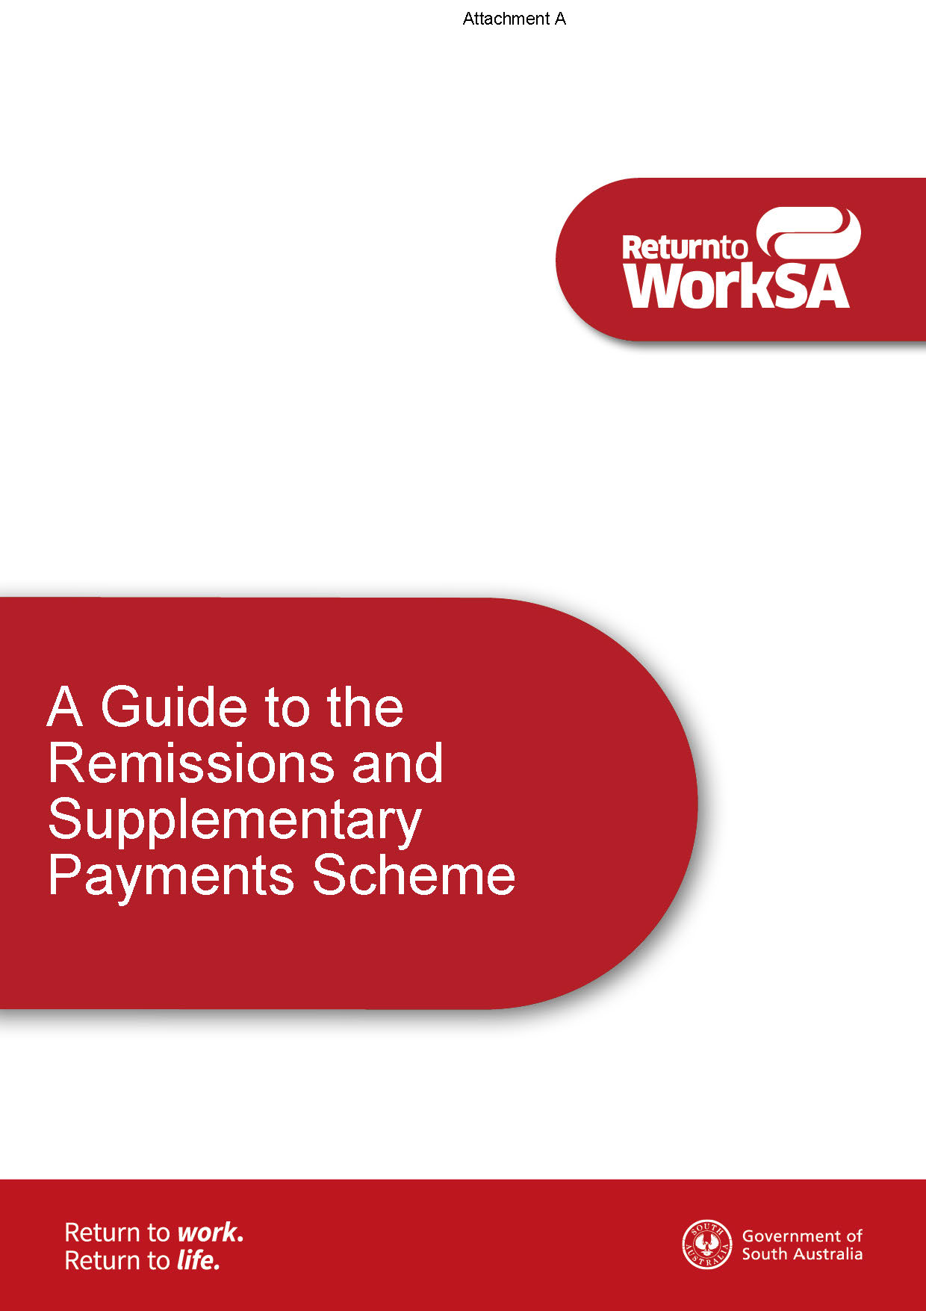
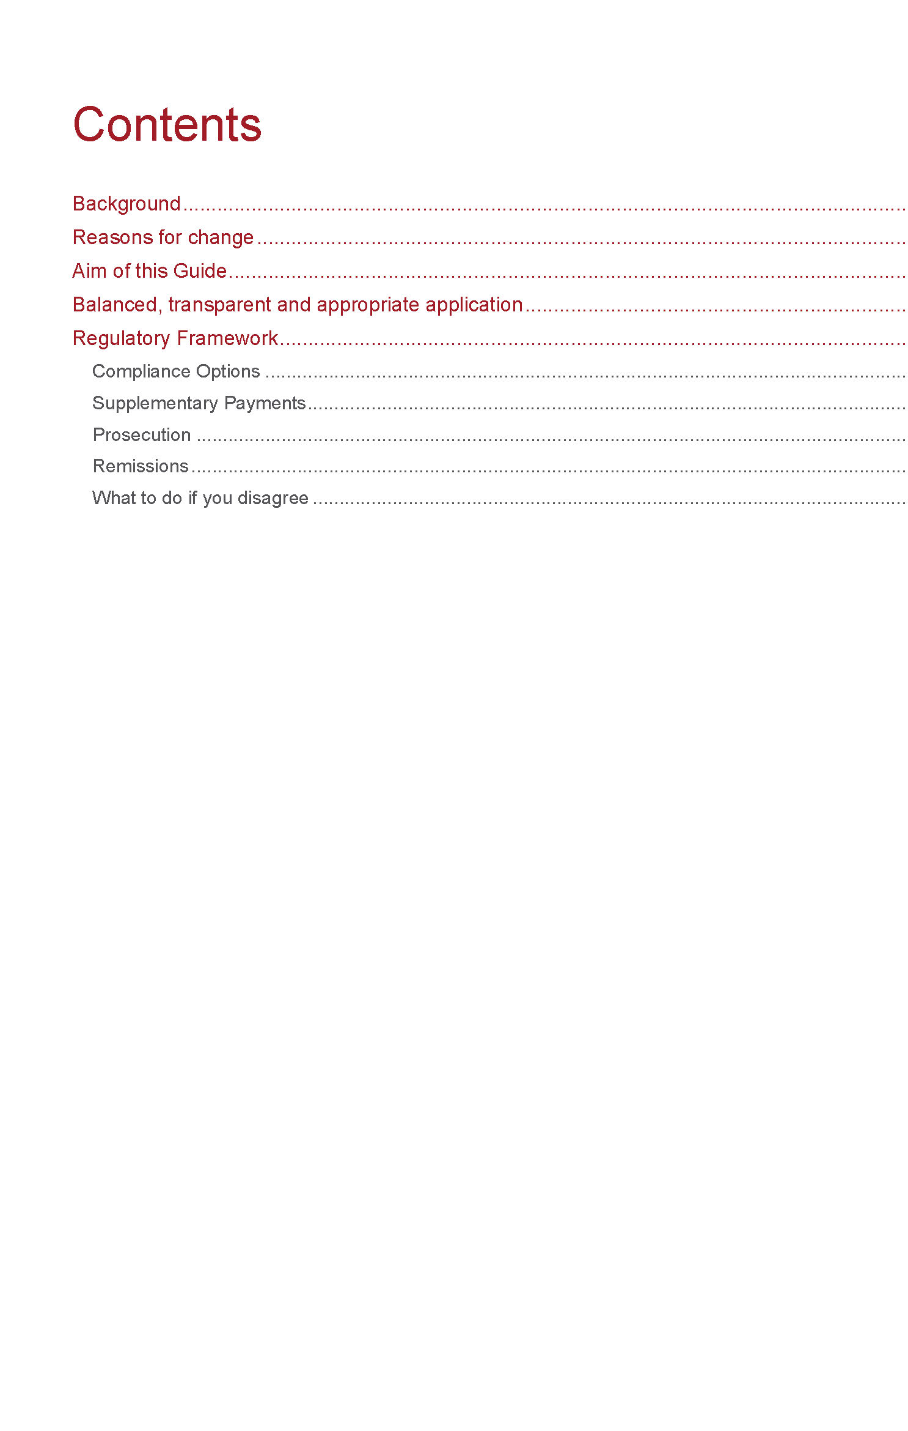
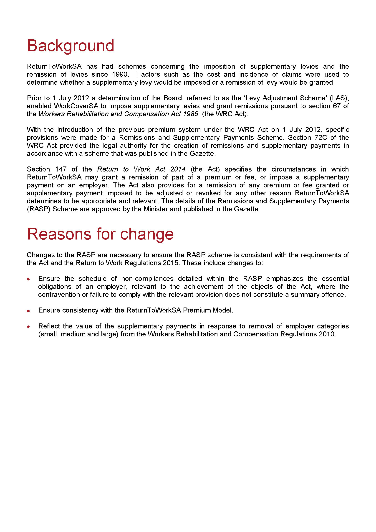
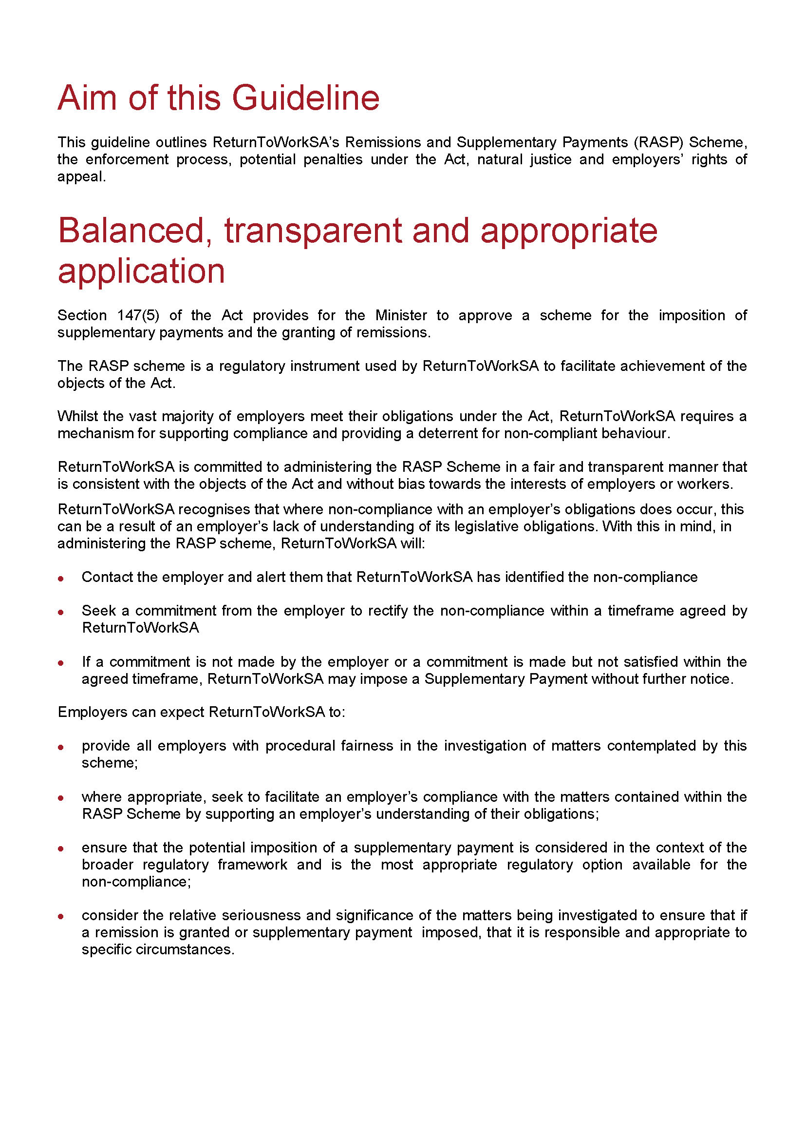
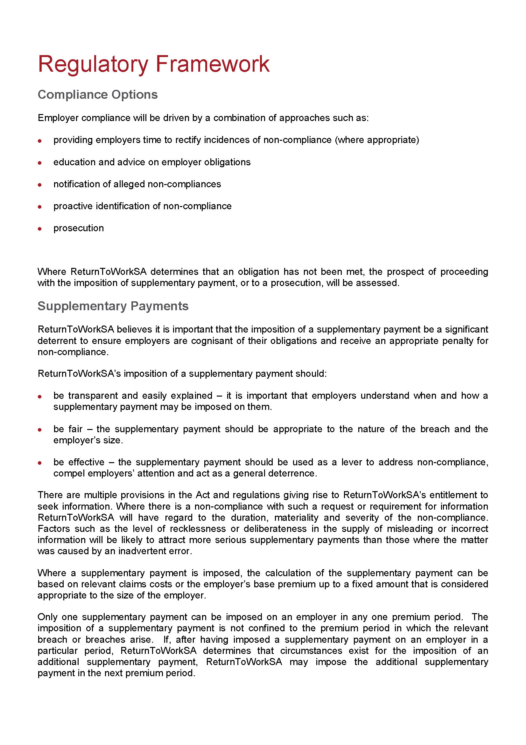
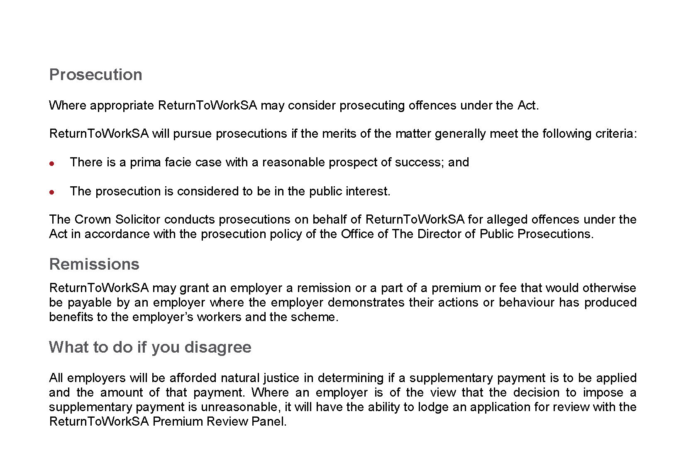

South Australia
Road Traffic (Land Yachts) Notice 2016
under Section 161A of the Road Traffic Act 1961
1—Short Title
This Notice may be cited as the Road Traffic (Land Yachts) Notice 2016.
2—Commencement
This Notice will come into operation on the day on which it is published in the Government Gazette.
3—Interpretation
In this Notice—
Act means the Road Traffic Act 1961 (SA);
Land Yacht means a light vehicle:
- which has three wheels; and
- is designed and constructed to be propelled by wind only, through the use of a sail.
4—Approval
In accordance with the powers delegated to me by the Minister for Transport and Infrastructure, under Section 161A of the Act, I hereby approve a land yacht to be driven on or over a road subject to the following conditions.
5—Conditions
The land yachts are only to be operated:
1. within the area defined as the Port Gawler Foreshore which abuts Sections 708 and 709, Hundred of Port Gawler and is limited to the frontage of the above sections which is abutting the Off-Road Vehicle Park;
2. between the hours of sunrise to sunset;
3. in accordance with the conditions and/or by-laws imposed by the District Council of Mallala; and
4. in a manner which will not endanger the safety of any other person or in a manner which may cause damage to property.
6—Revocation
The Notice titled ‘Exemption for Land Yachts’ appearing in the South Australian Government Gazette, dated 12 October 2000, is hereby revoked.
7—Authorisation
Made by the
General Manager, Planning and Transport Policy, Development Division
Department of Planning, Transport and Infrastructure
Delegate for the Minister for Transport and Infrastructure

South Australia
Harbors and Navigation (Restricted Area Henley Beach) Variation Regulations 2016
under the Harbors and Navigation Act 1993

Contents
Part 1—Preliminary
1 Short title
2 Commencement
3 Variation provisions
Part 2—Variation of Harbors and Navigation Regulations 2009
4 Variation of Schedule 5—Restricted areas

Part 1—Preliminary
1—Short title
These regulations may be cited as the Harbors and Navigation Variation Regulations 2016.
2—Commencement
These regulations come into operation on the day on which they are made.
3—Variation provisions
In these regulations, a provision under a heading referring to the variation of specified regulations varies the regulations so specified.
Part 2—Variation of Harbors and Navigation Regulations 2009
4—Variation of Schedule 5—Restricted areas
(1) Schedule 5, clause 1—after the description and maps relating to the Goolwa restricted areas insert:
Henley Beach
The portion of the waters of Gulf St. Vincent at Henley Beach bounded as follows:
• on the north by a straight line being the production seaward of the north alignment of Grange Road;
• on the south by a straight line being the production seaward of the north alignment of the River Torrens outfall;
• on the east by the high water mark;
• on the west by a line 200 metres from, and parallel to, the low water mark.
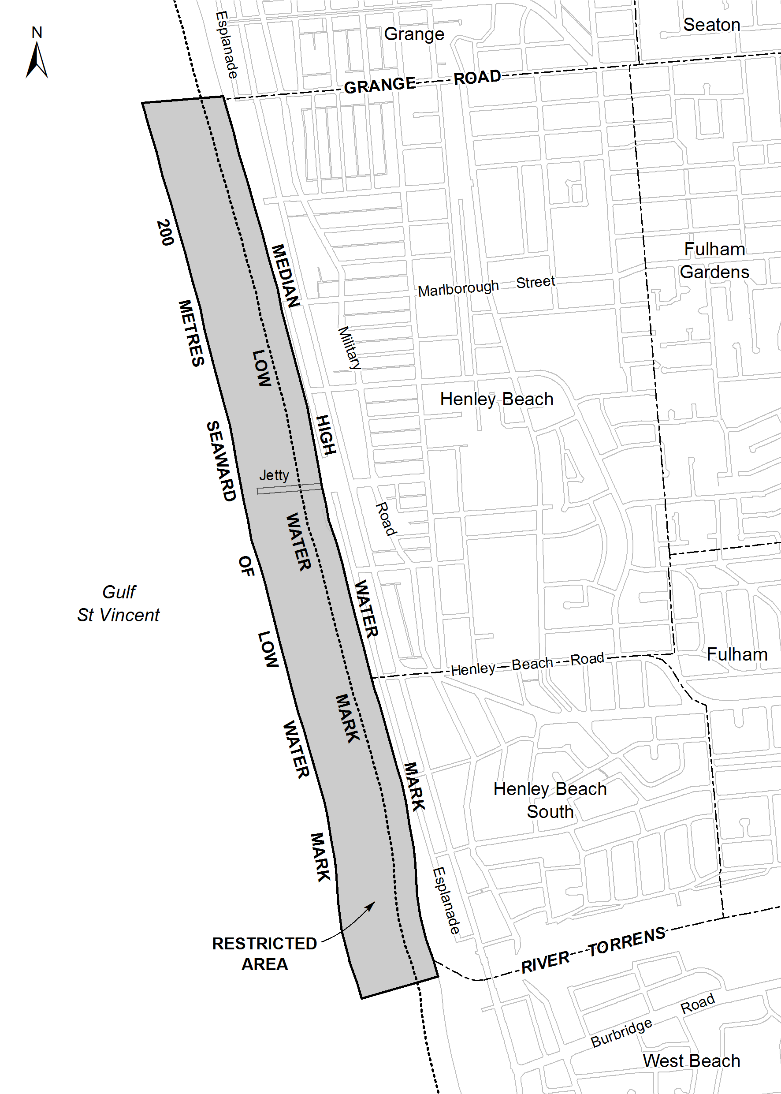
(2) Schedule 5, clause 2—after item 17 insert:
18. a person must not operate a vessel fitted with an engine in the specified waters at any time between sunrise and sunset on any day during the period between 1 December and 31 March (inclusive) in any year.
(3) Schedule 5, clause 3, table—after the entry relating to Goolwa Area 8 insert:

Henley Beach | Control 18
(4) Schedule 5—after clause 4A insert:
4AB—Non-application of controls to certain vessels at Henley Beach
The control set out in the table in clause 3 in relation to Henley Beach does not apply to a person operating a vessel fitted with an engine that is in the specified waters for the purposes of launching or retrieving a vessel by use of the boat ramp near the Grange Sailing Club for a race or practice involving rowing, sailing or other similar activity.
Note—
As required by section 10AA(2) of the Subordinate Legislation Act 1978, the Minister has certified that, in the Minister's opinion, it is necessary or appropriate that these regulations come into operation as set out in these regulations.
Made by the Governor’s Deputy
with the advice and consent of the Executive Council
on 13 October 2016
No 241 of 2016
MTR/16/057

SENDING COPY?
NOTICES for inclusion in the South Australian Government Gazette should be emailed to:
GovernmentGazetteSA@sa.gov.au
Please include the following information in the covering email:
• The date the notice is to be published.
• Whether a proof, quote or return email confirmation is required.
• Contact details.
• To whom the notice is charged if applicable.
• A purchase order if required (chargeable notices).
• Any other details that may impact on the publication of the notice.
Attach:
• Notices in Word format.
• Maps and diagrams in pdf.
• Notices that require sighting an official date and signature before publication in a pdf. If a pdf is not possible then fax the official file(s) to the Government Publishing Fax number listed below.
Fax Transmission: (08) 8207 1040
Phone Enquiries: (08) 8207 1045
NOTE:
Closing time for lodging new copy is 4 p.m. on Tuesday preceding the regular Thursday Gazette.

KINGSTON DISTRICT COUNCIL
Review of Elector Representation
NOTICE is hereby given that the Kingston District Council is undertaking a review to determine whether a change of arrangements are required in respect to elector representation so as to ensure that the electors of the area being adequately and fairly represented.
Pursuant to the provisions of Section 12 (7) of the Local Government Act 1999, notice is hereby given that Council has prepared a Representation Options Paper which examines the advantages and disadvantages of the various options available in regards to the composition and structure of Council, and the division (or not) of the Council area into wards.
A copy of the Representation Options Paper is available on Council’s website (www.kingstondc.sa.gov.au), or a copy can be inspected and/or purchased at the Council offices, 29 Holland Street, Kingston SE.
Written submissions are invited from interested persons from Wednesday, 12 October 2016 and should be directed to the Chief Executive Officer, P.O. Box 321, Kingston SE, S.A. 5275, or emailed to info@kingstondc.sa.gov.au by close of business on Friday, 25 November 2016.
Information regarding the elector representation review can be obtained by contacting Heather Schinckel, Manager of Corporate and Community Services, on telephone (08) 8767 2033 or by emailing info@kingstondc.sa.gov.au.
A. Macdonald, Chief Executive Officer

MID MURRAY COUNCIL
Roads (Opening and Closing) Act 1991
Road Closure—Crawford Crescent, Mannum
NOTICE is hereby given, pursuant to Section 10 of the Roads (Opening and Closing) Act 1991, that the Mid Murray Council proposes to make a Road Process Order to close portion of the Public Road (Crawford Crescent) adjoining Allotment 5 in Deposited Plan 8302 and Allotment 101 in Deposited Plan 63329 in the Hundred of Finniss, shown more particularly delineated and lettered ‘C’ and ‘D’ on the Preliminary Plan No. 16/0028.
Closed Road ‘C’ is to be merged with adjoining Allotment 5 in Deposited Plan 8302. Closed Road ‘D’ is to be merged with adjoining Allotment 101 in Deposited Plan 63329.
A copy of the plan and a statement of persons affected are available for public inspection at the offices of the Council at Mid Murray Council, 49 Adelaide Road, Mannum and the Adelaide office of the Surveyor-General during normal office hours.
Any application for easement or objection must set out the full name, address and details of the submission and must be fully supported by reasons.
The application for easement or objection must be made in writing to the Council at Mid Murray Council, P.O. Box 28, Mannum, S.A. 5238, within 28 days of this notice and a copy must be forwarded to the Surveyor-General at G.P.O. Box 1354, Adelaide, S.A. 5001. Where a submission is made, the Council will give notification of a meeting at which the matter will be considered.
Dated 13 October 2016.
R. Peate, Chief Executive Officer

PORT PIRIE REGIONAL COUNCIL
Street Numbering Changes—Magor Road, Port Pirie South
NOTICE is hereby given that pursuant to Section 220 of the Local Government Act 1999, Council has implemented consecutive street renumbering of properties on Magor Road Port Pirie South, from Una Street on the southern side and Harris Road on the northern side through to Wauchopes Road Port Pirie South.
Further information on the new street numbering is available at Council’s Administration Centre, 115 Ellen Street, Port Pirie, Council’s website www.pirie.sa.gov.au or call Rate Administrator Ray Van Keulen on (08) 8633 9734.
Dr A. Johnson, Chief Executive Officer

[Republished]
IN Government Gazette No. 40, dated 7 July 2016, page 2919, this notice was published with an error and should be replaced with the following:
DISTRICT COUNCIL OF ROBE
Adoption of Valuation and Declaration of Rates 2016-2017
NOTICE is hereby given that the District Council of Robe at a meeting held on 28 June 2016 and in relation to the financial year ending 30 June 2017, adopted the 2016-2017 Annual Business Plan and Budget and resolved as follows:
1. Adopted for rating purposes, the capital valuations of the Valuer-General totalling $1 003 175 720.
2. Declared a single General Rate of 0.3560 cents in the dollar on the assessed Capital Values of all rateable land in its area.
3. Imposed an annual service charge of $330 for the Garbage and Recycling Collection Service based on the level of usage of the service, on all land to which Council provides or makes available the prescribed service. Imposed an annual service charge of $186 for the Garbage Collection Service based on the level of usage of the service, on all land within the Boatswains Point area to which Council provides or makes available the prescribed service.
4. Imposed an annual service charge based on the nature and level of usage of the service and varying according to whether the land is vacant or occupied on all land to which Council provides or makes available the prescribed services for the collection, treatment or disposal of waste known as Community Waste Water Management System in respect of all land serviced by these schemes as follows:
Occupied $499 per property unit
Unoccupied $402 per property unit
5. Declared a minimum amount payable in respect of any one piece of rateable land in the amount of $654.
6. Declared a separate rate based on a fixed charge amount that depends upon the use of the land to recover the contribution to the South East Natural Resources Management Board as follows:
Residential, Vacant and Other $72.10
Commercial $133
Industrial $162
Primary Production $299
R. Sweetman, Chief Executive Officer

IN the matter of the estates of the undermentioned deceased persons:
Buczynski, Richard Michael, late of 5 Boston Street, Port Augusta, retired electrical fitter, who died on 1 June 2016.
McDonald, John Alexander, late of 6 Haddington Street, Valley View, retired truck driver, who died on 30 July 2016.
McGonnell, Margaret Jackson Burns, late of 10 Morton Road, Christie Downs, of no occupation, who died on 29 April 2016.
Mead, Gordon Donald, late of 98 Springfield Drive, Norman Gardens, Queensland, retired clerical officer, who died on 27 March 2016.
Phillis, Bryce Vincent, late of 47 John Lewis Drive, Port Broughton, retired fitter and turner, who died on 6 May 2016.
Prince, Dean Robert, late of 200 Fosters Road, Oakden, of no occupation, who died on 4 May 2016.
Sinclair, Marilyn Mundie, late of 324 Military Road, Semaphore Park, retired nurse’s aide, who died on 4 July 2016.
Talbot, Bruce Lloyd, late of 59 Shueard Road, Cobdogla, retired truck driver, who died on 3 February 2015.
Notice is hereby given pursuant to the Trustee Act 1936, the Inheritance (Family Provision) Act 1972 and the Family Relationships Act 1975, that all creditors, beneficiaries, and other persons having claims against the said estates are required to send, in writing, to the office of Public Trustee, G.P.O. Box 1338, Adelaide, S.A. 5001, full particulars and proof of such claims, on or before 11 November 2016, otherwise they will be excluded from the distribution of the said estate; and notice is also hereby given that all persons indebted to the said estates are required to pay the amount of their debts to the Public Trustee or proceedings will be taken for the recovery thereof; and all persons having any property belonging to the said estates are forthwith to deliver same to the Public Trustee.
Dated 13 October 2016.
D. A. Contala, Public Trustee

IN the matter of the estate of the undermentioned deceased person:
Norman, Ruth Mary, late of 61 Silkes Road, Paradise, South Australia, who died on 22 June 2016.
Notice is hereby given pursuant to the Trustee Act 1936, as amended, the Inheritance (Family Provision) Act 1972 and the Family Relationships Act 1975, that all creditors, beneficiaries and other persons having claims against the abovenamed estate are directed to send full particulars and evidence of such claims to the undersigned on or before 14 November 2016, otherwise they will be excluded from the distribution of the said estate; and notice is also hereby given that all persons who are indebted to the above estate are required to pay the amount of their debt to the undersigned or proceedings will be taken for the recovery thereof; and all persons having any property belonging to the said estate are forthwith to deliver the same to the undersigned.
Finlaysons (Lawyers),
81 Flinders Street, Adelaide 5000

ATTENTION

CUSTOMERS requiring a proof of their notice for inclusion in the Government Gazette, please note that the onus is on you to inform Government Publishing SA of any subsequent corrections.

For any corrections to your notice please phone 8207 1045 or Email before 4 p.m. on Wednesday.

If we do not receive any communication by 10 a.m. on Thursday (day of publication) we will presume the notice is correct and will print it as it is.

Remember—the onus is on you to inform us of any corrections necessary to your notice.

NOTE: Closing time for lodging new copy (electronically, fax or hard copy) is 4 p.m. on Tuesday preceding the day of publication.
Phone: 8207 1045
Fax: 8207 1040
Email: GovernmentGazetteSA@sa.gov.au

Printed and published by authority every Thursday by P. McMAHON, Government Printer, South Australia
Price: $7.21, plus postage; to subscribers, $361.90 per annum.
(The above prices are inclusive of GST)

