No. 67 4039



THE SOUTH AUSTRALIAN

GOVERNMENT GAZETTE
www.governmentgazette.sa.gov.au

PUBLISHED BY AUTHORITY

ALL PUBLIC ACTS appearing in this GAZETTE are to be considered official, and obeyed as such

ADELAIDE, THURSDAY, 20 OCTOBER 2016

CONTENTS

Page
Appointments, Resignations, Etc. 4040
Corporations and District Councils—Notices 4092
Development Act 1993—Notices 4040, 4047
Fisheries Management Act 2007—Notices 4040
[Republished] 4040
Housing Improvement Act 1940—Notices 4052
Mining Act 1971—Notices 4044
Motor Vehicles Act 1959—Notices 4054
Proclamations 4070
Public Trustee Office—Administration of Estates 4093
REGULATIONS
Fisheries Management Act 2007—
(No. 242 of 2016) 4074
(No. 243 of 2016) 4077
(No. 244 of 2016) 4079
(No. 245 of 2016) 4080
(No. 246 of 2016) 4081
(No. 247 of 2016) 4083
(No. 248 of 2016) 4086
(No. 249 of 2016) 4089
Retirement Villages Act 1987—Notice 4046
Return to Work Act 2014—Notice
[Republished] 4060
Sale of Property—Notice 4093
South Australian Public Health Act 2011—Notice 4046
South Australian Housing Trust Regulations 2010—Notice 4069
Transport Department of—Notices to Mariners 4045

GOVERNMENT GAZETTE NOTICES
Notices for publication in the South Australian Government Gazette should be emailed to governmentgazette@dpc.sa.gov.au. Content should be sent as Word format attachment(s). Covering emails should include the date the notice is to be published and to whom the notice will be charged. Closing time for lodgement is 4 p.m. on the Tuesday preceding the regular Thursday publication. Gazette enquiries to: Phone 8207 1045. The Government Gazette is available online at: www.governmentgazette.sa.gov.au.

Department of the Premier and Cabinet
Adelaide, 20 October 2016
HIS Excellency the Governor’s Deputy in Executive Council has been pleased to appoint the undermentioned to the Return to Work Corporation of South Australia Board of Management, pursuant to the provisions of the Return to Work Corporation of South Australia Act 1994:
Member: (from 1 November 2016 until 31 October 2019)
Jane Elizabeth Yuile
Joseph Karl Szakacs
Pauline Joanne Denley.
Chair: (from 1 November 2016 until 31 October 2019)
Jane Elizabeth Yuile.
By command,
Geoffrey Graeme Brock, for Premier
MIR0035/16CS

DEVELOPMENT ACT 1993: SECTION 29, AMENDMENT TO THE ALEXANDRINA COUNCIL DEVELOPMENT PLAN
Preamble
It is necessary to amend the Alexandrina Council Development Plan (the Plan) dated 12 May 2016.
Notice
PURSUANT to Section 29 (2) (b) (i) of the Development Act 1993, I—
1. Amend the Plan as follows:
(a) insert the following exemption for Motel in the non-complying development table in the Open Space Zone:
‘Motel—Except where it is located within the Goolwa Wharf and Surrounds Policy Area 6’
(b) replace the exemption for Restaurant in the non-complying development table in the Open Space Zone with:
‘Except where it is located within the Goolwa Wharf and Surrounds Policy Area 6’
(c) replace the exemption for Shop or group of shops in the non-complying development table in the Open Space Zone with:
‘Except where (a) or (b) apply:
(a) it is located within the Goolwa Wharf and Surrounds Policy Area 6;
(b) it is located outside of the Goolwa Wharf and Surrounds Policy Area 6 and it has a gross leasable area less than 80 square metres.’
2. Fix the day on which this notice is published in the Gazette as the day on which the Section 29 Amendment will come into operation.
Dated 11 October 2016.
A. Allen, Acting General Manager,
Planning and Development, Development Division,
Department of Planning, Transport and Infrastructure
As Delegate of John Rau, Minister for Planning

[Republished]
IN Government Gazette No. 55 dated 15 September 2016, on page 3721, third notice appearing read ‘7 Admella 110’ should read
‘7 Admella 120’. The corrected notice is as follows:
FISHERIES MANAGEMENT ACT 2007
Undersized Fish in the Southern Abalone Fishery
TAKE notice that for the purposes of Clause 5 (2) (a) of Part 2 of Schedule 2 of the Fisheries Management (General) Regulations 2007, I hereby declare that Blacklip Abalone (Haliotis rubra) taken in an abalone fishing area of the Southern Zone Abalone Fishery is undersized if its length is less than that specified below:

Abalone  Fishing area* | Location | Minimum legal length (mm)
1 | Cape Jaffa | 125
2 | Nora Creina | 125
3 | Beachport | 125
4 | Rivoli Bay | 120
5 | South End | 125
6 | Number 2 Rocks | 125
7 | Admella | 120
8 | Carpenters Rocks | 125
9 | Gerloff Bay | 110
10 | Blackfellows Caves | 125
11 | Middle Point | 120
12 | Port MacDonnell | 120
13 | East Port MacDonnell | 110
*As prescribed in Regulation 15 and defined in Schedule 2 of the Fisheries Management (Abalone Fisheries) Regulations 2006.
Dated 5 August 2016.
A. Fistr, Acting Director,
Fisheries and Aquaculture Policy

FISHERIES MANAGEMENT ACT 2007: SECTION 78 (2)
Permit to Release Fish
Permit holder:
RecFish SA
Danny Simpson
6 Mary Street,
Hindmarsh, S.A. 5007
Agents:
David Ciaravolo
Ian Fitzgerald
Michael Sierp
Permit Number:
MP0029
Specified waters:
Bundaleer Reservoir
PURSUANT to subsection 78 (2) of the Fisheries Management Act 2007, the holder of this permit or his agent may release Rainbow Trout (Oncorhynchus mykiss) and Brown Trout (Salmo trutta) into specified waters subject to the following conditions:
Conditions
1. The permit holder or their agents may only release Rainbow and Brown Trout pursuant to this permit.
2. The permitted activity must be completed between 14 October 2016 and 31 December 2018, unless otherwise varied or revoked.
3. The permit holder or their agents may only release the following in the specified waters (per year):
Species | Life stage (i.e. egg, fry, fingerling, broodstock, etc.) | Size (length and/or weight) | Number to be stocked
Brown Trout (Salmo trutta) | Fry | 20-30 mm,  2 g | 5 000-10 000
Rainbow Trout (Oncorhynchus mykiss) | Fry | 20-30 mm,  2 g | 5 000-10 000
Brown Trout (Salmo trutta) | Fingerling | 50-60 mm,  4 g | 5 000-10 000
Rainbow Trout (Oncorhynchus mykiss) | Fingerling | 50-60 mm,  4 g | 5 000-10 000
Brown Trout (Salmo trutta) | Juvenile | 280-320 mm, 0.6-1 kg | 200-1 000
Rainbow Trout (Oncorhynchus mykiss) | Juvenile | 280-320 mm, 0.6-1 kg | 200-1 000
4. The fish for release must only be obtained from a licensed aquaculture facility.
5. The fish for release must not be collected from rivers, streams, creeks, lakes or other inland waters of this State unless approved by the Minister for Agriculture, Food and Fisheries.
6. The permit holder must take appropriate measures to reduce fouling organisms, parasites and other non-native species being translocated during the release of any fish.
7. The permit holder must not import any fish for release
(ova, fry or adult) into South Australia without prior written approval from the Minister for Agriculture, Food and Fisheries in accordance with the Livestock (Restrictions on Entry of Aquaculture Stock) Notice 2014 or the Livestock Act 1997.
Such an approval must be made available upon request by a Fisheries Officer or an authorised officer.
8. The permit holder must provide hatchery accreditation and health certification to Dr Shane Roberts, Manager, Aquatic Animal Health Officer (G.P.O. Box 1625, Adelaide, S.A. 5001) before the release of any fish pursuant to this permit.
9. For the purposes of Condition 8 of this permit hatchery accreditation and health certification must be provided for every year of the duration of this permit and include:
• a declaration signed by the supplier attesting that there have been no notifiable diseases or unexplained disease outbreaks at the facility during the past 24 months;
• evidence that the fish to be released were obtained from an aquaculture facility that is an accredited hatchery as determined by the State government regulator; and
• a stock health certificate (batch certificate) signed by a suitably qualified aquatic veterinarian and results of batch testing of fish from a NATA accredited laboratory where infectious and notifiable disease has been ruled out; or
• documentation of regular testing for disease surveillance purposes, such as: an approved Fish Health Certification Program (FHCP) certification.
10. All fish to be released under this permit must be transported in an appropriate medium and in containers that are free from diseases, parasites, chemicals and associated pest fish species.
11. This permit does not purport to override the provisions or operation of any policies or legislation such as the Water Industry Act 2012 and SA Water Corporation Act 1994 of SA Water governing access and activities in the Bundaleer Reservoir. The permit holder must have written approval to release the fish into the specified waters from SA Water Corporation prior to conducting the permitted activity.
12. Before undertaking activities under this permit, the permit holder or a person acting as an agent must contact PIRSA Fishwatch on 1800 065 522 and answer a series of questions about the activity. The caller will need to have a copy of this permit at the time of making the call, and be able to provide information about the area and time of the permitted activity, the vehicle and/or boats involved, the number of agents undertaking the permitted activity and other related issues. Permit No. MP0029.
13. The permit holder must provide a brief written report detailing the date, time and place of each release of fish, the species released and approximate numbers of each species. The report must be submitted to the Director, Fisheries and Aquaculture Policy, (G.P.O. Box 1625, Adelaide, S.A. 5001) by 31 December for each year of the permit.
14. While engaged in the permitted activity, the permit holder or a person acting as his agent must be in possession of a copy of this permit. It must be produced to a PIRSA Fisheries Officer if requested.
15. The permit holder must not contravene or fail to comply with the Fisheries Management Act 2007 or any regulations made under that Act, except where specifically permitted by this notice.
Dated 11 October 2016.
S. Sloan, Director,
Fisheries and Aquaculture Policy

FISHERIES MANAGEMENT ACT 2007: SECTION 79
TAKE note that the notice made under Section 79 of the Fisheries Management Act 2007, dated 18 December 2015, and published in the South Australian Government Gazette on 24 December 2015, on page 5304, being the sixth notice on that page, referring to the West Coast Prawn Fishery, is hereby varied such that it will not be unlawful for a person fishing, pursuant to a West Coast Prawn Fishery licence to use prawn trawl nets in the waters specified in Schedule 1, under the conditions specified in Schedule 2, during the period specified in Schedule 3.
Schedule 1
The waters of the West Coast Prawn Fishery adjacent to Coffin Bay and Ceduna.
Schedule 2
1. Each licence holder must ensure that a representative sample of the catch (a ‘bucket count’) is taken at least three times per night during the fishing activity.
2. Each ‘bucket count’ sample must be accurately weighed to
7 kg where possible and the total number of prawns contained in the bucket must be recorded on the daily catch and effort return.
3. Fishing must cease if one of the following limits is reached:
(a) A total of 14 nights of fishing are completed;
(b) the average catch per vessel, per night (for all three vessels) drops below 300 kg for two consecutive nights;
(c) the average prawn ‘bucket count’ for all three vessels exceeds 270 prawns per bucket on any single fishing night in the Ceduna area; or
(d) the average prawn ‘bucket count’ for all three vessels exceeds 240 prawns per bucket on any single fishing night in the Coffin Bay area.
4. The fleet must nominate a licence holder to provide a daily update by telephone or SMS message to the PIRSA Fisheries Manager, to report the average prawn catch per vessel and the average prawn ‘bucket count’ information.
5. No fishing activity may be undertaken after the expiration of 30 minutes from the prescribed time of sunrise and no fishing activity may be undertaken before the prescribed time of sunset for Adelaide (as published in the South Australian Government Gazette, pursuant to the requirements of the Proof of Sunrise and Sunset Act 1923) during the period specified in Schedule 3.
Schedule 3
Commence at sunset on 21 November 2016 and end after the expiration of 30 minutes from sunrise on 7 December 2016.
Dated 11 October 2016.
S. Shanks, Prawn Fisheries Manager

FISHERIES MANAGEMENT ACT 2007: SECTION 90 (2)
Department of Primary Industries and
Regions SA—Fisheries Division
NOTICE is hereby given pursuant to Section 90 (2) of the Fisheries Management Act 2007, that the following items have been seized by Officers of the Department of Primary Industries and Regions SA, Fisheries and Aquaculture:
1 Brown Shrimp trap with green string
The above items were suspected to have been used, or intended to be used, in contravention of the Fisheries Management Act 2007, and were taken into possession at Robe, South Australia on 14 October 2016.
After the expiration of one month from the date of this notice the items listed above shall, on the order of the Minister for Agriculture, Food and Fisheries, be forfeited to the Crown and shall be either disposed of by sale or destruction.
The above items may be viewed at the Kingston office of the Department of Primary Industries and Regions SA, Fisheries and Aquaculture.
Dated 18 October 2016.
B. Balmer, Prosecutions Co-ordinator

FISHERIES MANAGEMENT ACT 2007: SECTION 115
TAKE notice that pursuant to Section 115 of the Fisheries Management Act 2007 (‘the Act’), Dr Charlie Huveneers
(the ‘exemption holder’), or current university staff members and post graduate students of the School of Biological Sciences at Flinders University, Sturt Road, Bedford Park and Matthew McMillan from University of Adelaide, Adelaide, South Australia, acting as his agent, are exempt from Section 70 of the Fisheries Management Act 2007, Regulation 7 and Clauses 38 (b), 72, 114 and 123 of Schedule 6 of the Fisheries Management (General) Regulations 2007, but only insofar as the exemption holder may undertake research locating pupping grounds and assess natal origins of School Shark (Galeorhinus galeus) in the area specified in Schedule 1, using the gear specified in Schedule 2,
(the ‘exempted activity’), subject to the conditions specified in Schedule 3, from 13 October 2016 until 31 August 2017, unless varied or revoked earlier.
Schedule 1
• All marine waters of South Australia, excluding aquatic reserves (unless otherwise authorised under the Act), marine parks (unless otherwise under the Marine Parks Act 2007) and the Adelaide Dolphin Sanctuary.
Schedule 2
• A longline (maximum length 2.2 km, maximum 1.7 mm leaders with a maximum of 200 hooks and maximum 14/0 size hooks).
Schedule 3
1. The exemption holder or agent must be in attendance (within 50 m) of the longline at all times.
2. The exemption holder or agent must inspect the long line every hour.
3. A longline must be buoyed with one end consisting of two black 4 litre buoys and the other end consisting of one yellow 4 litre buoy with the Ministerial Exemption number clearly written on the buoys not less than 70 mm in height. The floats must comply with Regulation 13 of the Fisheries Management (General) Regulations 2007 and marked with exemption holder or Ministerial Exemption number.
4. The exemption holder or agent must ensure seabird bycatch mitigation techniques are adopted during the monitoring. The exemption holder must modify or stop longlining if seabirds are present during the setting process.
5. The exemption holder or agent must ensure that all School Shark are returned to the water as soon as practicable after the recording of biological data. All other species caught must be returned to the water immediately.
6. The specimens collected by the exemption holder are for scientific research purposes only and must not be used for any commercial purpose.
7. The exemption holder or agent must not collect specimens for aquaculture research purposes pursuant to this notice.
8. At least one hour before conducting an exempted activity, the exemption holder or agent must contact PIRSA Fishwatch on 1800 065 522 and answer a series of questions about the exempted activity. The exemption holder or agent will need to have a copy of this notice in their possession at the time of making the call, and be able to provide information about the area and time of the exempted activity, the specific gear to be used, vehicles and/or boats involved, the number of permit holders undertaking the exempted activity and other related questions. Exemption No. ME9902888.
9. The exemption holder must provide a report in writing detailing the activities carried out pursuant to this notice to the Director, Fisheries and Aquaculture Policy (G.P.O. Box 1625, Adelaide, S.A. 5001) by 23 September 2017, with the following details:
• the date and location of sampling;
• the gear used;
• the number and description of all species caught and their fate;
• the number and description of any samples/biopsies collected;
• any interactions with protected species and their fate; and
• any other information regarding size, breeding or anything deemed relevant or of interest that is able to be volunteered.
10. While engaged in the exempted activity, the exemption holder and agent must be in possession of a signed copy of this notice and carry their identification card issued by Flinders University. Such notice and identification must be produced to a PIRSA Fisheries Officer if requested.
11. A person acting as an agent of the exemption holder must possess a copy of a signed letter from the exemption holder stating that they are acting as an agent during the exempted activity and carry their identification card issued by Flinders or Adelaide University.
12. The exemption holder, or agent must not contravene or fail to comply with the Act or any regulations made under the Act, except where specifically exempted by this notice.
This notice does not purport to override the provisions or operation of any other Act including, but not limited to, the Marine Parks Act 2007 and the Adelaide Dolphin Sanctuary. The exemption holder and his agents must comply with any relevant regulations, permits, requirements and directions from the Department of Environment, Water and Natural Resources when undertaking activities within a marine park.
Dated 12 October 2016.
S. Sloan, Director,
Fisheries and Aquaculture Policy

FISHERIES MANAGEMENT ACT 2007: SECTION 115
TAKE notice that pursuant to Section 115 of the Fisheries Management Act 2007 (‘the Act’), Leslie Morrison (the ‘exemption holder’), or current university staff or post graduate students of the School of Biological Sciences at Flinders University, Sturt Road, Bedford Park, acting as her agent, are exempt from Sections 70 and 71 (2) of the Fisheries Management Act 2007, Regulation 7 and Clauses 38 (b), 39, 40, 72, 96, 100, 114 and 118 of Schedule 6 of the Fisheries Management (General) Regulations 2007, but only insofar as they may engage in the activities specified in Schedule 1, using the gear specified in Schedule 2, (the ‘exempted activity’), subject to the conditions specified in Schedule 3, from 13 October 2016 until 31 August 2017, unless varied or revoked earlier.
Schedule 1
For the purposes of teaching appropriate scientific sampling techniques, the collection of aquatic organisms and research from all waters of South Australia, including the River Murray Protection Area, excluding aquatic reserves (unless otherwise authorised under the Act), marine parks (unless otherwise authorised under the Marine Parks Act 2007) and the Adelaide Dolphin Sanctuary.
For the purposes of undertaking the following research project, monitoring populations of European Green Crab (Carcinus maenas) (in conjunction with Permit No: MP0050).
Schedule 2
Teaching Activities
• 2 plankton nets where each net is a funnel shaped,
fine-meshed net that is towed through the water to collect plankton with a maximum diameter of 1 m, a maximum depth of 1.6 m and a maximum mesh size of 38 mm.
• 2 seine nets with a maximum mesh size of 5 mm and maximum length of 20 m.
• Plastic corer (10 cm diameter, 20 cm length).
• Sweep/dip nets.
Research Activities
• Hooped bait net.
• A fyke net (main compartment being a maximum of 6 m and a maximum 4 m wing).
• 2 plankton nets where each net is a funnel shaped, fine-meshed net that is towed through the water to collect plankton with a maximum diameter of 1 m, a maximum depth of 1.6 m and a maximum mesh size of 38 mm.
• 2 seine nets with a maximum mesh of 5 mm and maximum length of 20 m.
• Plastic corer (10 cm diameter, 20 cm length).
• Sweep/dip nets.
Schedule 3
1. Any equipment used to collect and hold fish during the exempted activity must be decontaminated prior to and after undertaking the research activities.
2. The Ministerial exemption holder or agent must ensure that the fyke net and hooped bait net have floats attached and must comply with Regulation 13 of the Fisheries Management (General) Regulations 2007 and marked with exemption holder or Ministerial Exemption number.
3. The Ministerial exemption holder or agent is permitted to remove European Green Crab from intertidal reef areas.
4. All species caught pursuant to this notice that are not being collected for scientific, education and research purposes must be returned to the water as soon as practicable, except for species declared as noxious under the Act. Noxious species must not be returned to the water and must be disposed of appropriately.
5. The Ministerial exemption holder or agent must ensure when in possession and/or control of Green Shore Crab that the Permit No. MP0050 is used in conjunction with this Ministerial Exemption.
6. All protected species incidentally taken while undertaking the exempted activity may be measured and recorded and must be returned to the water as soon as reasonably practicable. Protected Species must not be retained.
7. The specimens collected by the exemption holder are for scientific, education and research purposes only and must not be used for any commercial purpose.
8. The exemption holder must not collect specimens for aquaculture research purposes pursuant to this notice.
9. Organisms collected pursuant to this notice must not be released once they have been kept separate to their natural environment at the University.
10. At least one hour before conducting an exempted activity, the exemption holder must contact PIRSA Fishwatch on 1800 065 522 and answer a series of questions about the exempted activity. The exemption holder will need to have a copy of this notice in their possession at the time of making the call, and be able to provide information about the area and time of the exempted activity, the specific gear to be used, vehicles and/or boats involved, the number of permit holders undertaking the exempted activity and other related questions. Exemption No. ME9902877.
11. The exemption holder must provide a report in writing detailing the activities carried out, pursuant to this notice to the Director, Fisheries and Aquaculture, (G.P.O. Box 1625, Adelaide, S.A. 5001) by 23 September 2017 with the following details:
• the date and location of sampling;
• the gear used;
• the number and description of all species caught and their fate;
• the number and description of any samples/biopsies collected;
• any interactions with protected species and their fate; and
• any other information regarding size, breeding or anything deemed relevant or of interest that is able to be volunteered.
12. While engaged in the exempted activity, the exemption holder and agents must be in possession of a signed copy of this notice and carry their identification card issued by Flinders University. Such notice and identification must be produced to a PIRSA Fisheries Officer if requested.
13. A person acting as an agent of the exemption holder must possess a copy of a signed letter from the exemption holder stating that they are acting as an agent during the exempted activity and carry their identification card issued by Flinders University.
14. The exemption holder, or agent must not contravene or fail to comply with the Act or any regulations made under the Act, except where specifically exempted by this notice.
This notice does not purport to override the provisions or operation of any other Act including, but not limited to, the Marine Parks Act 2007 and the River Murray Act 2003. The exemption holder and her agents must comply with any relevant regulations, permits, requirements and directions from the Department of Environment, Water and Natural Resources when undertaking activities within a marine park.
Dated 12 October 2016.
S. Sloan, Director,
Fisheries and Aquaculture Policy

FISHERIES MANAGEMENT ACT 2007: SECTION 115
TAKE notice that pursuant to Section 115 of the Fisheries Management Act 2007, Neil MacDonald of the Southern Fishermen’s Association, 7 Sunburt Street, Ingle Farm, S.A. 5098 (the ‘exemption holder’) and his nominated agents are exempt from Sections 70, 72 (1) and 72 (2) (a) of the Fisheries Management Act 2007, and Regulation 7 and Clauses 3 (b), 12, 15, 38 (a), 40, 72 (a) of Schedule 6 of the Fisheries Management (General) Regulations 2007, during the period specified in Schedule 1 (unless varied or revoked earlier), but only insofar as they use the device described in Schedule 2 to take permitted species prescribed under the Fisheries Management (Lakes and Coorong Fishery) Regulations 2009, for the purpose of trade or business (the ‘exempted activity’), subject to the conditions specified in Schedule 3. Exemption No. ME9902894.
Schedule 1
From 5 p.m. on 11 October 2016 until 11.59 p.m. 31 March 2017.
Schedule 2
A power hauling net that is a maximum of 600 m in length, a maximum of 10 m in depth, has attached to it a foot rope which exceeds 150 m in length when measured from the first purse ring to the last purse ring or a rope or ropes the length or combined lengths to a maximum to 100 m and a mesh size in the pocket of the net:
(a) in the case of a pocket with a mesh knotted in a standard manner—less than 32 mm; or
(b) in any other case—less than 34 mm; or
(c) has a mesh size in the net (other than in the pocket) that is less than 30 mm.
Schedule 3
1. The exempted activity must be undertaken under the direction of staff from the South Australian Research and Development Institute (SARDI).
2. The exempted activity may only be undertaken in the waters of the Lakes and Coorong as defined in the Fisheries Management (General) Regulations 2007.
3. The exempted activity may only be conducted by the exemption holder or his nominated agents. The nominated agents include Shannon Gill, Marine Scalefish Fishery licence holder M154 and her registered master David Wilks and their nominated agents.
4. The exemption holder or agents must not use a power hauling net that exceeds 400 m in length in Coorong (Area 1) and Coorong (Area 2).
5. The exemption holder is permitted to sell fish caught under this exempted activity, the exemption holder must ensure that all funds derived from the sale of fish taken pursuant to the exempted activity is provided back to SARDI.
6. While engaged in the exempted activity, the exemption holder or agent must be in possession of a copy of this notice. This notice must be produced to a Fisheries Officer if requested.
7. Before conducting the exempted activity, the exemption holder or agents must contact PIRSA Fishwatch on 1800 065 522 and answer a series of questions about the exempted activity. They will need to have a copy of the exemption at the time of making the call, and be able to provide information about the area and time of the exempted activity, the vehicles and/or boats involved, the number of agents undertaking the exempted activity and other related questions. Exemption No. ME9902894.
8. The exemption holder must provide a report in writing detailing the outcomes of the collection of fish, pursuant to this notice to the Director Fisheries and Aquaculture Policy, (G.P.O. Box 1625, Adelaide, S.A. 5001) by 31 March 2017, giving the following details:
• the date and time of collection;
• data on catch composition (target and non-target fish species);
• length data for all fish landed;
• numbers of fish (by species) damaged by fur seals;
• presence/absence of damage to fishing gear;
• the presence/absence of fur seals;
• the costs associated with the purchase and operation (e.g. gear/infrastructure and fuel and labour); and
• total funds made from sale of fish and dates provided to SARDI.
9. The exemption holder or agent must not contravene or fail to comply with the Fisheries Management Act 2007 or any regulations made under that Act, except where specifically exempted by this notice.
This notice does not purport to override the provisions or operation of any other Act including, but not limited to, the National Parks and Wildlife Act 1972. The exemption holder and his/her agents must comply with any relevant regulations, permits, requirements and directions from the Department of Environment, Water and Natural Resources when undertaking activities within the Coorong National Park.
Dated 11 October 2016.
S. Sloan, Director,
Fisheries and Aquaculture Policy

MINING ACT 1971
NOTICE is hereby given in accordance with Section 28 (5) of the Mining Act 1971 that the delegate of the Minister for Mineral Resources and Energy intends to grant an Exploration Licence over the area described below:
Applicant: Teale and Associates Pty Ltd, Adrian Mark Brewer.
Location: Prospect Hill area—Approximately 150 km east of Marree.
Pastoral Lease: Murnpeowie, Moolowatana.
Term: 2 years .
Area in km²: 45.
Reference number: 2016/00049.
Plan and co-ordinates can be found on the Department of State Development website: http://www.minerals.statedevelopment.sa.
gov.au/exploration/public_notices or by contacting Mineral Tenements on (08) 8463 3103.
Community information on mineral exploration licence processes and requirements under the Mining Act 1971 is available from: http://www.minerals.statedevelopment.sa.gov.au/
land_access/community_information or hard copy on request to Mineral Tenements.
J. Martin, Mining Registrar

MINING ACT 1971
NOTICE is hereby given in accordance with Section 28 (5) of the Mining Act 1971 that the delegate of the Minister for Mineral Resources and Energy intends to grant an Exploration Licence over the area described below:
Applicant: Vitruvius Tobias Ltd.
Location: James Range area—Approximately 70 km north-east of Port Augusta.
Term: 1 year.
Area in km²: 416.
Reference number: 2016/00082.
Plan and co-ordinates can be found on the Department of State Development website: http://www.minerals.statedevelopment.sa.
gov.au/exploration/public_notices or by contacting Mineral Tenements on (08) 8463 3103.
Community information on mineral exploration licence processes and requirements under the Mining Act 1971 is available from: http://www.minerals.statedevelopment.sa.gov.au/
land_access/community_information or hard copy on request to Mineral Tenements.
J. Martin, Mining Registrar

MINING ACT 1971
NOTICE is hereby given in accordance with Section 28 (5) of the Mining Act 1971 that the delegate of the Minister for Mineral Resources and Energy intends to grant an Exploration Licence over the area described below:
Applicant: PepinNini Minerals Limited.
Location: Toondulya Bluff area—Approximately 100 km north-east of Streaky Bay.
Pastoral Lease: Pinjarra, Kondoolka, Hiltaba.
Term: 2 years .
Area in km²: 390.
Reference number: 2016/00092.
Plan and co-ordinates can be found on the Department of State Development website: http://www.minerals.statedevelopment.sa.
gov.au/exploration/public_notices or by contacting Mineral Tenements on (08) 8463 3103.
Community information on mineral exploration licence processes and requirements under the Mining Act 1971 is available from: http://www.minerals.statedevelopment.sa.gov.au/
land_access/community_information or hard copy on request to Mineral Tenements.
J. Martin, Mining Registrar

MINING ACT 1971
NOTICE is hereby given in accordance with Section 28 (5) of the Mining Act 1971 that the delegate of the Minister for Mineral Resources and Energy intends to grant an Exploration Licence over the area described below:
Applicant: Debnal Pty Ltd.
Location: Eucolo Creek area—Approximately 25 km west of Woomera.
Pastoral Lease: Wirraminna, Arcoona.
Term: 1 year.
Area in km² 107 .
Reference number: 2016/00120.
Plan and co-ordinates can be found on the Department of State Development website: http://www.minerals.statedevelopment.sa.
gov.au/exploration/public_notices or by contacting Mineral Tenements on (08) 8463 3103.
Community information on mineral exploration licence processes and requirements under the Mining Act 1971 is available from: http://www.minerals.statedevelopment.sa.gov.au/
land_access/community_information or hard copy on request to Mineral Tenements.
J. Martin, Mining Registrar

MINING ACT 1971
NOTICE is hereby given in accordance with Section 28 (5) of the Mining Act 1971 that the delegate of the Minister for Mineral Resources and Energy intends to grant an Exploration Licence over the area described below:
Applicant: Lady Alice Mines Pty Ltd .
Location: Wudinna area—Approximately 105 km east-south-east of Streaky Bay.
Term: 2 years .
Area in km²: 926.
Reference number: 2016/00125.
Plan and co-ordinates can be found on the Department of State Development website: http://www.minerals.statedevelopment.sa.
gov.au/exploration/public_notices or by contacting Mineral Tenements on (08) 8463 3103.
Community information on mineral exploration licence processes and requirements under the Mining Act 1971 is available from: http://www.minerals.statedevelopment.sa.gov.au/
land_access/community_information or hard copy on request to Mineral Tenements.
J. Martin, Mining Registrar

MINING ACT 1971
NOTICE is hereby given in accordance with Section 35A (1) of the Mining Act 1971, that an application for a Mineral Lease over the undermentioned mineral claim has been received:
Applicant: Craig Edward Marschall.
Claim Number: 4139.
Location: Section 77, Hundred of Sturt (Approximately 15 km north-east of Morgan).
Area: 9.45 hectares approximately.
Purpose: Industrial Minerals (Gypsum).
Reference: T02794.
Details of the proposal may be inspected at the Department of State Development, Mineral Resources Division, Level 7,
101 Grenfell Street, Adelaide, S.A. 5000.
A copy of the proposal has been provided to the Mid Murray Council and an electronic copy of the proposal can be found on the Department of State Development website: http://minerals.
statedevelopment.sa.gov.au/mining/public_notices_mining.
Written submissions in relation to this application are invited to be received at the Department of State Development, Mining Regulation, Attention: Business Support Officer, G.P.O. Box 320, Adelaide, S.A. 5001, by no later than 17 November 2016.
The delegate of the Minister for Mineral Resources and Energy is required to have regard to these submissions in determining whether to grant or refuse the application and, if so, the terms and conditions on which it should be granted.
When you make a written submission, that submission becomes a public record. Your submission will be provided to the applicant and may be made available for public inspection unless confidentiality is requested.
J. Martin, Mining Registrar

MINING ACT 1971
Notice of Extension of Declaration of Exemption of Land
WHEREAS by Notice of Declaration of Exemption of Land published in the South Australian Government Gazette on
25 October 2012 at pages 4726-4727, pursuant to Section 9A (1) (c) of the Mining Act 1971 (‘the Act’), I declared the land described in the Notice of Declaration of Exemption of Land to be exempt from Parts 4, 5, 6, 6A, 8, 8A and 9A of the Act for two years from the date thereof.
AND WHEREAS by further notice published in the South Australian Government Gazette on 23 October 2014 at page 6155, pursuant to Section 9A (9) of the Act, I extended the Declaration of Exemption of Land for two years from the date thereof.
PURSUANT to Section 9A (9) of the Act, I, Tom Koutsantonis, Minister for Mineral Resources and Energy, give further notice that I extend the Declaration of Exemption of Land.
AND I specify that the extension of the Declaration of Exemption of Land shall be in force for a period of two years from the date hereof.
Dated 20 October 2016.
Tom Koutsantonis,
Minister for Mineral Resources and Energy

NOTICE TO MARINERS
No. 31 of 2016
South Australia—Gulf St Vincent—Spencer Gulf—
Restricted Zones
Former Notice No.18 of 2015
THE general public and mariners in particular are reminded that maritime security zones have been established under the Maritime Transport and Offshore Facilities Security Act 2003, within the boundaries of the security regulated ports of Port Adelaide,
Port Giles, Wallaroo, Port Pirie, Port Lincoln and Thevenard.
These include water-side restricted zones at and around commercial shipping berths and jetties, and may include ship security zones around commercial ships. Access to the zones is controlled and any unauthorised entry into the zones is prohibited and is an offence under the Maritime Transport and Offshore Facilities Security Regulations 2003, penalties apply.
The water-side restricted zones are clearly marked with land-based signage and mariners are advised to exercise caution and maintain a clearance distance of 50 metres from the wharf or jetty face at all times. Details/maps of the boundaries of the established zones can be found at http://www.flindersports.com.au/security/
restricted-zones.
Persons must display a valid Maritime Security Identification Card (MSIC) while within the zones.
The unauthorised possession of weapons or prohibited items within the zones is prohibited and is an offence under the Maritime Transport and Offshore Facilities Security Act 2003, penalties apply.
Adelaide, 13 October 2016.
Stephen Mullighan,
Minister for Transport and Infrastructure
FP2012/0105
DPTI 2016/01670/01
www.flindersports.com.au
www.dpti.sa.gov.au

NOTICE TO MARINERS
No. 32 of 2016
South Australia—River Murray—Paringa—
Bridge Maintenance
MARINERS are advised that the centre fixed span of the Paringa Bridge, River Murray will be closed for navigation to all vessels from 24 October 2016 until 24 November 2016, for essential maintenance of the bridge deck.
The closed span on the Port side of the River will be indicated by a lit special mark and a buoy line on upstream and downstream sides. The lifting span on the Starboard side of the river will be unaffected by these works.
Mariners are advised to operate with caution in this vicinity and to use the lifting span to navigate under the bridge.
Adelaide, 12 October 2016.
Stephen Mullighan,
Minister for Transport and Infrastructure
DPTI 2016/01670/01
www.dpti.sa.gov.au

RETIREMENT VILLAGES ACT 1987
Section 36 (1)
Voluntary Termination of Retirement Village Scheme
TAKE NOTICE that I, Zoe Bettison, Minister for Ageing, pursuant to Section 36 (1) of the Retirement Villages Act 1987, (the Act), hereby terminate the Opportunity Shop Retirement Village Scheme situated at 12 Murtho Street, Renmark, S.A. 5341 and comprising all of the land and improvements in Certificate of Title Register Book Volume 5467, Folio 187. I do so being satisfied for the purposes of Section 36 (2) of the Act that there were no longer any retirement village residents in occupation. The date of termination was 24 August 2016.
Dated 17 October 2016.
Zoe Bettison, Minister For Ageing

SOUTH AUSTRALIAN PUBLIC HEALTH ACT 2011
Notice by the Minister for Health
Section 51 (23) (b)—Appointments
TAKE notice that I, Jack Snelling, Minister for Health, pursuant to Section 51 (23) (b) of the South Australian Public Health Act 2011, do hereby declare the undermentioned entity as a Public Health Partner Authority:
• Kidsafe SA
Dated 17 October 2016.
Jack Snelling, Minister for Health

DEVELOPMENT ACT 1993, SECTION 29: AMENDMENT TO THE LAND NOT WITHIN A COUNCIL AREA
(COASTAL WATERS) DEVELOPMENT PLAN
Preamble
It is necessary to amend the Land Not Within a Council Area (Coastal Waters) Development Plan dated 4 July 2013.
Section 29 (1) (b) of the Development Act 1993 (the Act) allows the Minister administering the Act to amend a Development Plan to include a plan, policy, standard, document or code, which is prepared under another Act and falls within a class prescribed by Regulation 14 of the Development Regulations 2008. A policy under the Aquaculture Act 2001 is prescribed under the regulation.
Notice
PURSUANT to Section 29 (1) (b) of the Development Act 1993, I, amend the Land Not Within A Council Area (Coastal Waters) Development Plan dated 4 July 2013 and as amended by the Section 29 (1) (b) amendment gazetted 31 July 2014 as follows:
(a) Within the Aquaculture Zone, change references to Maps within the first paragraph to read ‘Zone Maps LNWCA(CW)/1 to 17 and 20 to 25’.
(b) Replace Index Maps LNWCA(CW)/A, LNWCA(CW)/B and LNWCA(CW)/C with the contents of ‘ATTACHMENT A’.
(c) Insert an additional Zone Map after Zone Map LNWCA(CW)/24, namely: LNWCA(CW)/25, the contents of
‘ATTACHMENT B’.
(d) Fix the day on which this notice is published in the Gazette as the day on which the Section 29 amendment will come into operation.
Dated 12 October 2016.
John Rau, Deputy Premier, Minister for Planning

Attachment A
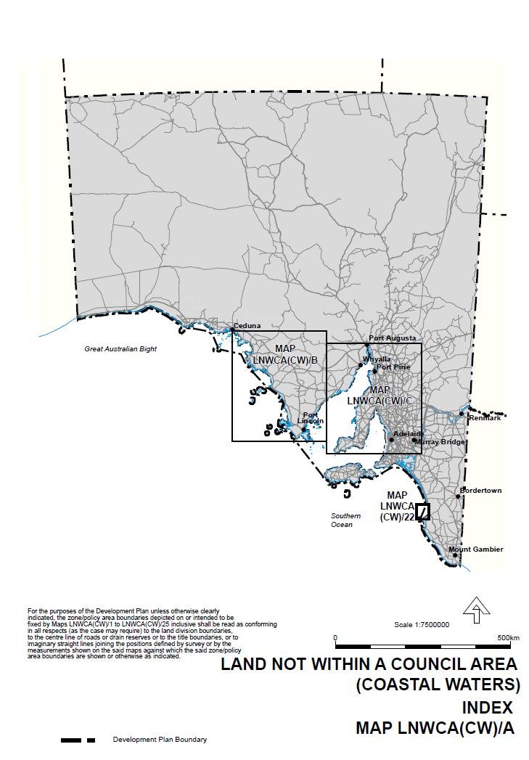
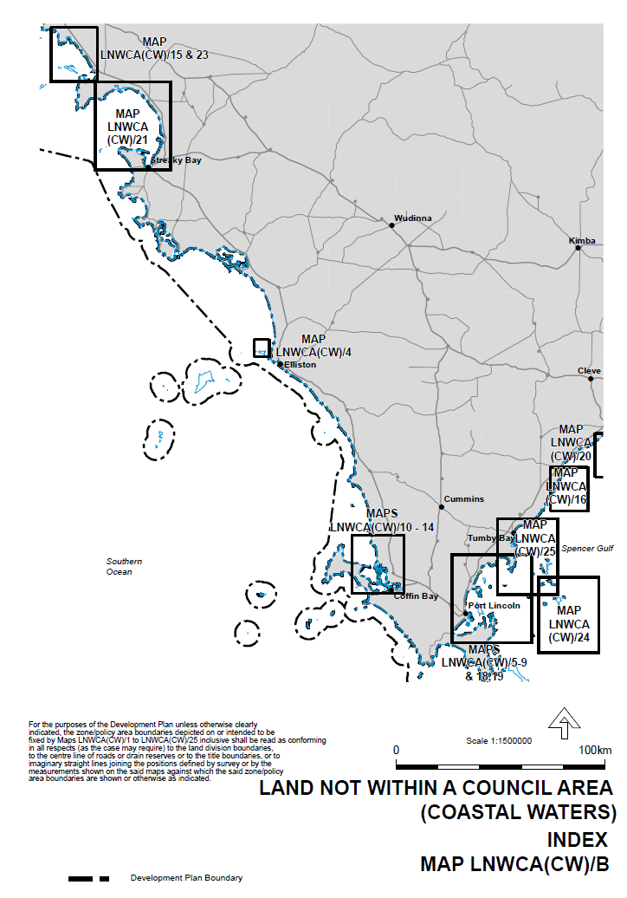
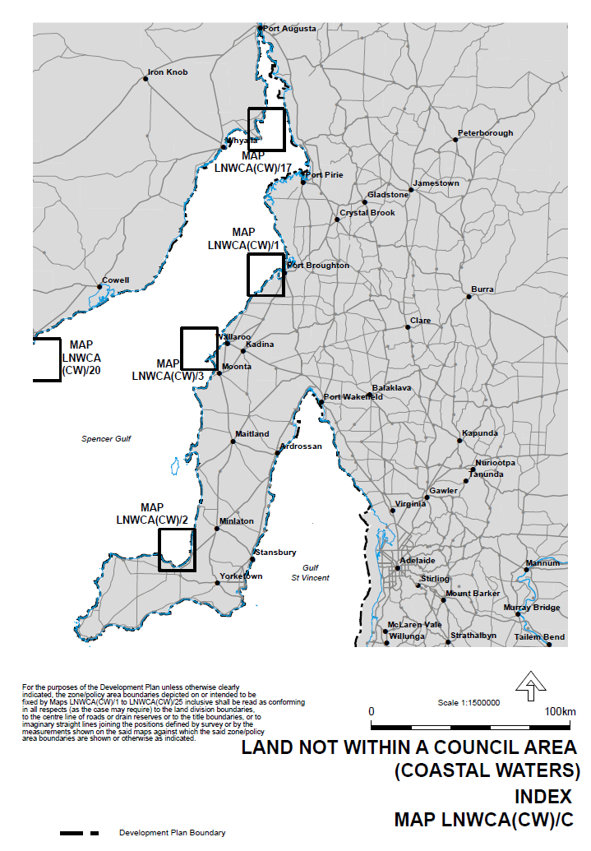
Attachment B
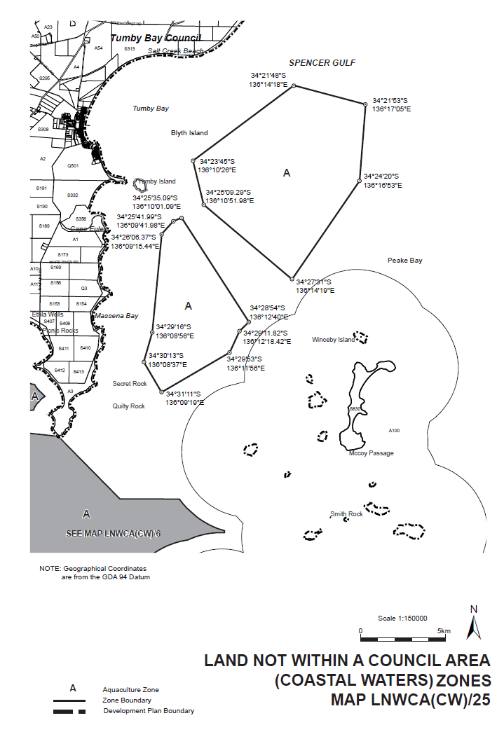

HOUSING IMPROVEMENT ACT 1940
NOTICE is hereby given that the South Australian Housing Trust Board Delegate in the exercise of the powers conferred by the Housing Improvement Act 1940, does hereby declare the houses described in the table hereunder to be substandard for the purposes of Part 7 of the Housing Improvement Act 1940.
Address of House |  | Allotment, Section, etc. | Certificate of Title  Volume Folio
4 Kondoparinga Road, Meadows, S.A. 5201 |  | Allotment 825 in Filed Plan 5650, Hundred of Kuitpo | 5494 | 886
8 Chirton Street, Elizabeth North, S.A. 5113 |  | Allotment 374 in Deposited Plan 6358, Hundred of Munno Para | 5605 | 681
35 Dulkara Road, Ingle Farm, S.A. 5098 |  | Allotment 76 in Deposited Plan 7896, Hundred of Yatala | 5201 | 243
5 Plymouth Street, Enfield, S.A. 5085 |  | Allotment 358 in Deposited Plan 2976, Hundred of Yatala | 5676 | 489
112 Park Terrace, Salisbury Plain, S.A. 5109 |  | Allotment 34 in Deposited Plan 7474, Hundred of Yatala | 5297 | 864
26 George Parade, Sellicks Beach, S.A. 5174 |  | Allotment 274 in Deposited Plan 6907, Hundred of Willunga | 5623 | 320
30 Garden Terrace, Underdale, S.A. 5032 |  | Allotment 78 in Filed Plan 124472, Hundred of Adelaide | 5781 | 637
10 Charles Street, Balaklava, S.A. 5461 |  | Allotment 623 in Filed Plan 175943, Hundred of Balaklava | 5730 | 411
3 George Street, Port Wakefield, S.A. 5550 |  | Allotment 123 in Filed Plan 11560, Hundred of Inkerman | 5475 | 6
Dated at Adelaide, 20 October 2016. P. Reardon, Director, Property and Contract Management, Housing SA (Delegate SAHT)

HOUSING IMPROVEMENT ACT 1940
WHEREAS by notice published in the Government Gazette on the dates mentioned in the following table the South Australian Housing Trust Board Delegate did declare the houses described in the said table to be substandard for the purposes of Part 7 of the Housing Improvement Act 1940, and whereas the South Australian Housing Trust Board Delegate is satisfied that each of the houses described hereunder has ceased to be substandard, notice is hereby given that, in exercise of the powers conferred by the said Part, the South Australian Housing Trust does hereby revoke the said declaration in respect of each house.

Address of House | Allotment, Section, etc. | Certificate of Title  Volume Folio |  | Date and page of Government Gazette in which notice declaring house to be substandard published
85 Galway Avenue, Broadview, S.A. 5083 | Allotment 79 in Filed Plan 111587, Hundred of Yatala | 5694  6169  6169 | 312  222  223 | 31.10.13, page 4111
68 Tait Street, Renown Park, S.A. 5008 | Allotment 23 in Filed Plan 117805, Hundred of Yatala | 1335  5402  6176 | 182  397  980 | 26.5.94, page 1277
12 Myall Avenue, Murray Bridge, S.A. 5253 | Allotment 251 in Deposited Plan 71501, Hundred of Mobilong | 5981 | 716 | 22.3.07, page 848
Lot 1 Mallee Highway, Geranium, S.A. 5301 (Arkoona South Farm also known as 6879 Mallee Highway, previously known as Lot 1 Government Road) | Allotment 1 in Deposited Plan 18140, Hundred of Price | 5352 | 322 | 12.7.90, page 324
32 Heytesbury Road, Davoren Park, S.A. 5113 (also known as 34) | Allotment 494 in Deposited Plan 7339, Hundred of Munno Para | 5529 | 218 | 22.5.14, page 2080
Dated at Adelaide, 20 October 2016. P. Reardon, Director, Property and Contract Management, Housing SA (Delegate SAHT)

HOUSING IMPROVEMENT ACT 1940
WHEREAS by notice published in the Government Gazette on the dates mentioned in the following table the South Australian Housing Trust Board Delegate did declare the houses described in the said table to be substandard for the purposes of Part 7 of the Housing Improvement Act 1940, the South Australian Housing Trust Board Delegate in the exercise of the powers conferred by the said Part, does hereby fix as the maximum rental per week which shall be payable subject to Section 55 of the Residential Tenancies Act 1995, in respect of each house described in the following table the amount shown in the said table opposite the description of such house and this notice shall come into force on the date of this publication in the Gazette.

Address of House | Allotment, Section, etc. | Certificate of Title  Volume Folio |  | Date and page of Government Gazette in which notice declaring house to be substandard published | Maximum rental per week  payable in respect of each house  $
45 Hamilton Road, Woodville North, S.A. 5012 | Allotment 19 in Deposited Plan 3774, Hundred of Yatala | 6011 | 994 | 25.8.16, page 3399 | 162.00
Dated at Adelaide, 20 October 2016. P. Reardon, Director, Property and Contract Management, Housing SA (Delegate SAHT)

South Australia
Motor Vehicles (Conditional Registration—Recognition of Motor Vehicle Clubs) Notice 2016
under the Motor Vehicles Act 1959
1—Short title
This notice may be cited as the Motor Vehicles (Conditional Registration—Recognition of Motor Vehicle Clubs) Notice 2016.
2—Commencement
This notice comes into operation on the day on which it is made.
3—Interpretation
In this notice—

Act means the Motor Vehicles Act 1959;

Code of Practice means the ‘Code of Practice for Historic Vehicles, Prescribed Left Hand Drive Vehicles and Street Rod Vehicles’ published by the Department of Planning, Transport and Infrastructure;

Conditional Registration Scheme or Scheme means the scheme for conditional registration of historic, prescribed left hand drive and street rod motor vehicles under section 25 of the Act and regulations 15 and 16 of the Motor Vehicles Regulations 2010;

Federation means the Federation of Historic Motoring Clubs Inc;

MR334 form means an ‘Approval for Conditional Registration of a Historic, Prescribed Left Hand Drive or Street Rod Vehicle MR334 Form’;

Registrar means the Registrar of Motor Vehicles;
Regulations means the Motor Vehicles Regulations 2010.
4—Recognition of motor vehicles clubs
The motor vehicle clubs specified in Schedule 1 are, subject to the conditions set out in clause 5, recognised for the purposes of regulation 16 of the Regulations.
5—Conditions of recognition
A motor vehicle club specified in Schedule 1 must comply with the following conditions:
  - the club must maintain a constitution approved by the Registrar;
  - the club must nominate and have members authorised by the Registrar (authorised persons) to approve motor vehicles for registration under the Scheme; to inspect members’ vehicles; and to issue prescribed log books to club members for each of their vehicles to record vehicle use;
  - the club must obtain from each member before the end of each year a statutory declaration made by the member verifying the eligibility of their motor vehicle to be registered under section 25 of the Act for the Scheme and detailing any modifications made to the vehicle during that year;
  - the club’s authorised persons must undertake inspections of members’ motor vehicles and ensure that the vehicles are eligible, in keeping with the requirements in regulations 15 and 16 of the Regulations and the criteria set out in the Code of Practice, to be registered under section 25 of the Act−
- on entry to the Conditional Registration Scheme;
- when requested to do so by the Registrar;
- when members’ annual statutory declarations disclose that their vehicles have been modified since the entry inspection and/or previous inspection;
- periodically at least once every 3 years;
(e) the club’s authorised persons must validate a member’s log book annually and must not do so unless a member’s statutory declaration has been received for the purposes of paragraph (c) and the relevant vehicle inspection requirements of paragraph (d) have been met;
(f) the club must cancel a member’s log book when a member resigns, must record all approved variations to a vehicle’s condition in a member’s log book for that vehicle, must ensure that a statutory declaration is provided when a member’s log book is lost or destroyed and must forward copies of log book return sheets to the Federation annually;
(g) the club must create and maintain records detailing all its financial members, its authorised persons, all members’ motor vehicles for which a MR334 form has been issued, all motor vehicle inspections undertaken for the purposes of paragraph (d), all statutory declarations received and log books issued;
(h) the club must keep records for a period of 5 years from the date of the document and these records include all duplicate MR334 forms, all records of motor vehicle inspections undertaken in accordance with paragraph (d), all statutory declarations provided by members for the purposes of paragraphs (c) and (f) , all log books issued by reference to their serial number, the member’s name and the vehicle for which it was issued, all copy exemption documents issued to members for their motor vehicles in accordance with section 163AA of the Road Traffic Act 1961 and to make all such records available for inspection or provide copies of the records at the request of the Registrar for audit purposes;
(i) the club must ensure, as far as practicable, that all members comply with the Code of Practice and all members’ motor vehicles continue to meet the eligibility requirements set out in the Regulations and Code of Practice;
(j) the club, as far as practicable, must report to the Registrar or the Federation details of members and motor vehicles not complying with the conditions and criteria set out in the Code of Practice for the Scheme;
(k) the club must provide to the Registrar, within 2 months after the end of the club’s financial year, an annual report detailing members from that financial year with vehicles registered under the Scheme who are no longer financial members of the club;
(l) the club must notify the Registrar within 14 days on official club letterhead of resolution to cease operation as a club and must provide the club records specified in paragraph (h) to the Registrar within 7 days of its dissolution.
Note—
Under regulation 16(3)(c) of the Motor Vehicles Regulations 2010, the Registrar may, by notice in the Gazette, withdraw the recognition of a motor vehicle club if satisfied that the club has contravened or failed to comply with a condition applying to its recognition by the Registrar, or if there is other good cause to withdraw the recognition.

Schedule 1—Recognised motor vehicle clubs
Historic motor vehicle clubs and Prescribed left-hand drive motor vehicle clubs

55-56-57 Classic Chevrolet Club of South Australia Incorporated

Made by the Registrar of Motor Vehicles

On 14 October 2016

South Australia
Motor Vehicles (Conditional Registration—Recognition of Motor Vehicle Clubs) Notice 2016
under the Motor Vehicles Act 1959
1—Short title
This notice may be cited as the Motor Vehicles (Conditional Registration—Recognition of Motor Vehicle Clubs) Notice 2016.
2—Commencement
This notice comes into operation on the day on which it is made.
3—Interpretation
In this notice—

Act means the Motor Vehicles Act 1959;

Code of Practice means the ‘Code of Practice for Historic Vehicles, Prescribed Left Hand Drive Vehicles and Street Rod Vehicles’ published by the Department of Planning, Transport and Infrastructure;

Conditional Registration Scheme or Scheme means the scheme for conditional registration of historic, prescribed left hand drive and street rod motor vehicles under section 25 of the Act and regulations 15 and 16 of the Motor Vehicles Regulations 2010;

Federation means the Federation of Historic Motoring Clubs Inc;

MR334 form means an ‘Approval for Conditional Registration of a Historic, Prescribed Left Hand Drive or Street Rod Vehicle MR334 Form’;

Registrar means the Registrar of Motor Vehicles;
Regulations means the Motor Vehicles Regulations 2010.
4—Recognition of motor vehicles clubs
The motor vehicle clubs specified in Schedule 1 are, subject to the conditions set out in clause 5, recognised for the purposes of regulation 16 of the Regulations.
5—Conditions of recognition
A motor vehicle club specified in Schedule 1 must comply with the following conditions:
(a) the club must maintain a constitution approved by the Registrar;
(b) the club must nominate and have members authorised by the Registrar (authorised persons) to approve motor vehicles for registration under the Scheme; to inspect members’ vehicles; and to issue prescribed log books to club members for each of their vehicles to record vehicle use;
(c) the club must obtain from each member before the end of each year a statutory declaration made by the member verifying the eligibility of their motor vehicle to be registered under section 25 of the Act for the Scheme and detailing any modifications made to the vehicle during that year;
(d) the club’s authorised persons must undertake inspections of members’ motor vehicles and ensure that the vehicles are eligible, in keeping with the requirements in regulations 15 and 16 of the Regulations and the criteria set out in the Code of Practice, to be registered under section 25 of the Act−
- on entry to the Conditional Registration Scheme;
- when requested to do so by the Registrar;
- when members’ annual statutory declarations disclose that their vehicles have been modified since the entry inspection and/or previous inspection;
- periodically at least once every 3 years;
(e) the club’s authorised persons must validate a member’s log book annually and must not do so unless a member’s statutory declaration has been received for the purposes of paragraph (c) and the relevant vehicle inspection requirements of paragraph (d) have been met;
(f) the club must cancel a member’s log book when a member resigns, must record all approved variations to a vehicle’s condition in a member’s log book for that vehicle, must ensure that a statutory declaration is provided when a member’s log book is lost or destroyed and must forward copies of log book return sheets to the Federation annually;
(g) the club must create and maintain records detailing all its financial members, its authorised persons, all members’ motor vehicles for which a MR334 form has been issued, all motor vehicle inspections undertaken for the purposes of paragraph (d), all statutory declarations received and log books issued;
(h) the club must keep records for a period of 5 years from the date of the document and these records include all duplicate MR334 forms, all records of motor vehicle inspections undertaken in accordance with paragraph (d), all statutory declarations provided by members for the purposes of paragraphs (c) and (f) , all log books issued by reference to their serial number, the member’s name and the vehicle for which it was issued, all copy exemption documents issued to members for their motor vehicles in accordance with section 163AA of the Road Traffic Act 1961 and to make all such records available for inspection or provide copies of the records at the request of the Registrar for audit purposes;
(i) the club must ensure, as far as practicable, that all members comply with the Code of Practice and all members’ motor vehicles continue to meet the eligibility requirements set out in the Regulations and Code of Practice;
(j) the club, as far as practicable, must report to the Registrar or the Federation details of members and motor vehicles not complying with the conditions and criteria set out in the Code of Practice for the Scheme;
(k) the club must provide to the Registrar, within 2 months after the end of the club’s financial year, an annual report detailing members from that financial year with vehicles registered under the Scheme who are no longer financial members of the club;
(l) the club must notify the Registrar within 14 days on official club letterhead of resolution to cease operation as a club and must provide the club records specified in paragraph (h) to the Registrar within 7 days of its dissolution.
Note—
Under regulation 16(3)(c) of the Motor Vehicles Regulations 2010, the Registrar may, by notice in the Gazette, withdraw the recognition of a motor vehicle club if satisfied that the club has contravened or failed to comply with a condition applying to its recognition by the Registrar, or if there is other good cause to withdraw the recognition.

Schedule 1—Recognised motor vehicle clubs
Historic motor vehicle clubs, Prescribed left-hand drive motor vehicle clubs and Street Rod motor vehicle clubs

The Reapers Hot Rod and Custom Car Club Adelaide Australia Incorporated

Made by the Registrar of Motor Vehicles

On 14 October 2016

[Republished]
IN Government Gazette No. 65 dated 13 October 2016, on pages 4019-4026, the original of this notice was published with omissions, please replace with the following:
RETURN TO WORK ACT 2014
Remissions and Supplementary Payments Scheme 2016
Preamble
Section 147 (1) of the Return to Work Act 2014 (‘the Act’) provides for the Return to Work Corporation of South Australia (‘the Corporation’) to impose a supplementary payment on an employer or grant an employer a remission of part of a premium or fee having regard to the matters specified in Section 147 (2) of the Act.
Pursuant to Section 147 (5) of the Act a remission or supplementary payment will be provided or is payable in accordance with a scheme approved by the Minister.
Notice
PURSUANT to Section 147 (5) of the Act, I hereby approve the scheme for the payment of supplementary payments and the providing of remissions in the terms set out in this notice.
Item 1—Preliminary matters
1.1 This Scheme is the ‘Remissions and Supplementary Payments Scheme 2016’ (‘Scheme’).
1.2 This Scheme will commence on 19 September 2016.
Item 2—Definitions
2.1 In this Scheme:
Base premium means the base premium for the period in which a supplement is applied as referred to in Schedule B.
Claim cost means costs associated with the relevant claim that is the subject of the supplement as referred to in Schedule B.
Corporation Act means the Return to Work Corporation of South Australia Act 1994.
Exemplary compliance means a commendable example or model behaviour in regards to actions within the law, regulation or obligation.
Financial year means the 12 months ending on 30 June.
Non-compliance means failure or refusal to comply with a law, regulation or obligation set out in Schedule A.
Remission means an abatement of part of a premium or fee that would otherwise be payable by the employer.
Review Period means financial year.
Supplementary Payment or Supplement means an amount additional to premiums or fees payable by the employer.
2.2 A word or term having a defined meaning in the Act has, unless the contrary intention appears, the same meaning in this Scheme.
Item 3—Terms of Determination
A. Imposition of Supplementary Payments and Granting of Remissions of Premiums
3.1 This Scheme shall apply to all employers who are required to register pursuant to Section 128 of the Act.
3.2 In respect of the period from 19 September 2016 until 30 June 2017 and each successive financial year thereafter a single Supplement may be imposed on a particular employer that conducts itself in that Review Period in one or more of the manners described in Schedule A—Non-Compliances.
3.3 In respect of a Review Period a single Remission may be granted to a particular employer which conducts itself within that Review Period in one or more of the manners described in Schedule C—Exemplary Compliance.
3.4 The amount of the Supplement imposed on a particular employer which conducts itself in that Review Period in one or more of the manners described in Schedule A—Non-Compliances will be as set out in Schedule B—Supplementary Payments.
3.5 The amount of the Supplement or Remission applicable to a particular employer for a Review period, will be the net effect of each Supplement or Remission applicable during that period.
3.6 A redetermination regarding the imposition of a Supplement or the granting of a Remission is appropriate by reason of new material information that was not available and could not reasonably have been discovered by due enquiry at the time that the original determination was made.
B. Operational Application
3.7 A Supplement or Remission may later be reduced or revoked as determined by the Corporation in accordance with Section 147 (4) of the Act.
3.8 In the case of a particular employer that has incurred more than two consecutive Supplements, a further Non-Compliance may incur the employer a Supplement in excess of that specified in Schedule B as determined by the Corporation.
C. Payment of Remissions and Supplements
3.9 Any Remission granted to a particular employer pursuant to Section 147 of the Act under this Scheme will be granted by the Corporation by reducing the amount of the Remission from a subsequent payment due by the employer to the Corporation.
3.10 Any Supplement imposed on a particular employer pursuant to Section 147 of the Act under this Scheme will be paid by the employer to the Corporation within 21 days of receiving a notification from the Corporation of the liability for the Supplement.
Item 4—Grounds of Determination
4.1 The Remissions and Supplements to be granted or imposed under this Scheme comprise a just and equitable means of applying Section 147 of the Act having regard to the objects of the Act and the primary objects of the Corporation and , in particular, the objects of the Act to:
(a) establish a return to work scheme that ensures that employers’ costs are contained within reasonable limits so that the impact of employment-related injuries on South Australia business is minimised (Section 3 (2) (b) of the Act);
(b) ensure a reasonable balance between the interests of workers and the interests of employers (Section 3 (2) (c) of the Act); and
(c) support activities that are aimed at reducing the incidence of work injuries (Section 3 (2) (e) of the Act).
Item 5—Notice of Determination
That notice of this Scheme is published in the South Australian Government Gazette.
I also provide for information the Corporation’s Guide to the Remission and Supplementary Payments Scheme in Attachment A.
Dated 19 September 2016.
John Rau, Minister for Industrial Relations

Schedule A
Non-Compliances
1. Failure to Comply with a Recovery/Return to Work Plan
An employer that fails to comply with an obligation binding on that employer under a recovery/return to work plan pursuant of Section 25 of the Act.
2. Failure to Provide Suitable Employment
An employer that fails to provide suitable employment for a worker of that employer and the worker:
(a) has been incapacitated for work in consequence of a work injury; and
(b) is able to return to work;
(a) whether on a full-time or part-time basis and whether or not to his or her previous employment, and
(b) with the employer from who’s employment the injury arose, and
(c) being employment for which the worker is fit and, subject to that qualification, so far as reasonably practicable is the same as, or equivalent to, the employment in which the worker was working immediately before the incapacity;
unless the employer demonstrates the conditions of Section 18 (2) of the Act to the satisfaction of the Corporation.
3. Failure to Remunerate Accurately
An employer:
(a) that provides alternative or modified duties to a worker who has been incapacitated for work in consequence of a work injury under employment or an arrangement that falls outside the worker’s contract of service from which the injury arose; and
(b) that does not pay the worker an appropriate wage or salary in respect of those duties (unless otherwise determined by the Corporation).
4. Federal Minimum Wage Safety Net
An employer of an injured worker whose worker’s average weekly earnings or weekly payments of income support have been adjusted by the Federal minimum wage safety net, pursuant to Section 5 (15) (b) and/or Section 42 of the Act.
5. Failure to Give Notice of Termination of Employment
An employer that does not give at least 28 days’ notice to the Corporation of the proposed termination of the employment of a worker who has suffered a work injury (being the employer from whose employment the injury arose) unless the employer demonstrates to the satisfaction of the Corporation that the conditions of Section 20 (2) of the Act have been met.
6. Failure Regarding Return to Work Co-ordinators (‘Co-ordinator’)
An employer that fails to:
(a) ensure its co-ordinator is performing the functions as detailed in Section 26 (4) of the Act; or
(b) comply with any training or operational guidelines published by the Corporation for the purposes of Section 26 (5) (c) of the Act.
7. Failure to Comply with an Audit or Inspection
An employer, whose workplace is subject to an audit or inspection undertaken by ReturnToWorkSA, fails to comply or fails to provide such assistance or hinders or obstructs in the exercise of the audit or inspection.
8. Unsatisfactory Conduct by the Employer
The Corporation is satisfied on reasonable grounds that unsatisfactory conduct by the employer in relation to the retention, employment or re-employment of injured workers causes a worker to resign from employment with the employer, be unwilling or unable to return to such employment with the employer or refuse such offer of employment with the employer (as the case may be), and this results in the worker receiving an entitlement to compensation or to receive an increased amount of compensation under the Act.
9. Failure to Pay Compensation to a Worker
An employer who is liable to pay compensation to a worker and fails to make the payment within 14 days if not disputed or forthwith after a dispute, for the lesser of the period of incapacity or the excess liability period.
10. Failure to provide information required by the Corporation or provision of materially incorrect, misleading or deceptive information
Failure to provide information required by the Corporation under the Act or regulations or the provision of materially incorrect, misleading and/or deceptive information by or on behalf of an employer to the Corporation in connection with any matter relevant to the Return to Work Act 2014 or any regulation, premium order or premium provision. For clarification, the omission of materially relevant information will be considered included in this description.
Schedule B
Supplementary Payments
 | Non-compliances | Amount up to
1. | Failure to comply with a recovery/return to work plan | 100% of income support costs related to the relevant worker for the period of the relevant recovery/return to work plan.
2. | Failure to provide suitable employment | In respect of each worker to which the failure applies the maximum amount of compensation payable having regard  to Sections 5 (15) (c) and 39 of the Act.
3. | Failure to remunerate worker accurately | $50,000
4. | Federal minimum wage safety net | 150% of the additional entitlement as a result of the application of Section 5 (15) (b) and/or 42 of the Act
5. | Failure to give notice of termination of employment | In respect of each worker to which the failure applies the maximum amount of compensation payable having regard  to Sections 5 (15) (c) and 39 of the Act.
6. | Failure regarding return to work co-ordinators (‘co-ordinator’) | $10,000
7. | Failure to comply with an audit or inspection | $10,000
8. | Unsatisfactory conduct by the employer | 50% of base premium
9. | Failure to pay compensation to a worker | 15% of base premium
10. | Failure to provide information required by the Corporation or provision of materially incorrect, misleading or deceptive information | 50% of base premium

Schedule C
Exemplary Compliance
1. An exemplary performing employer that has implemented and addressed the matters set out in the criteria in Section 147 (2) (a) to (h) of the Act in such a way to provide consequential benefits to the employers’ workers and the Return to Work scheme.

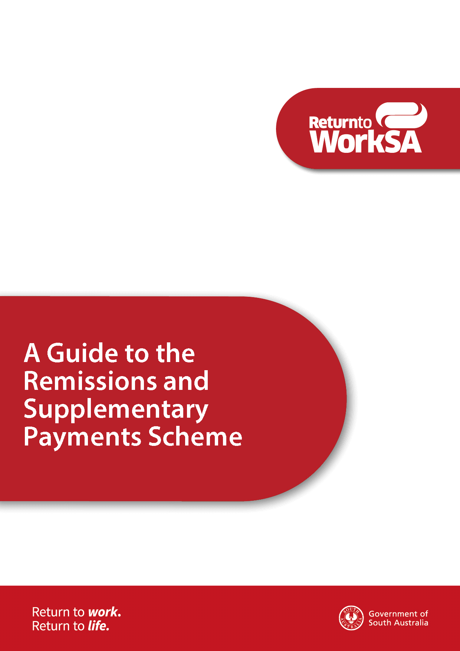
Attachment A
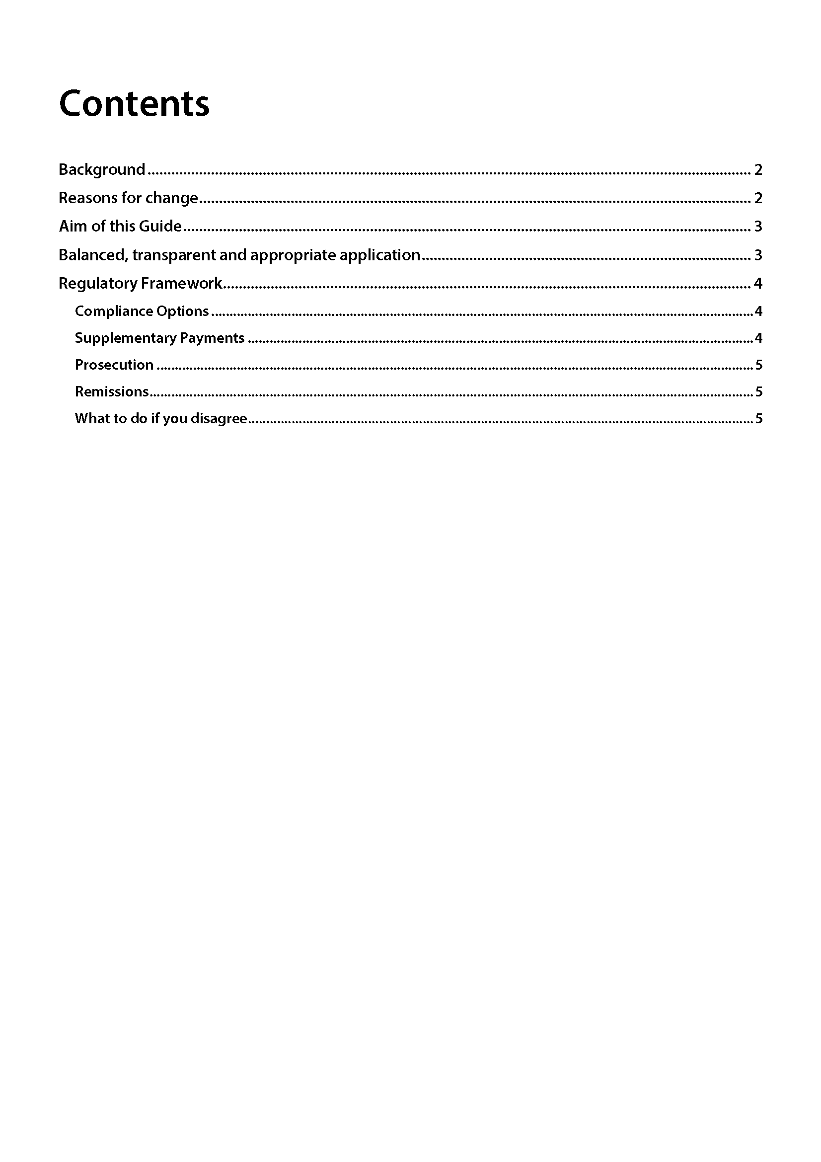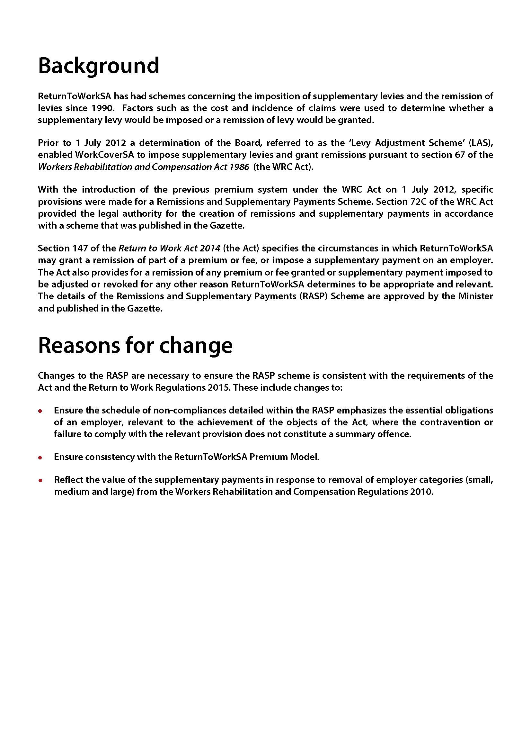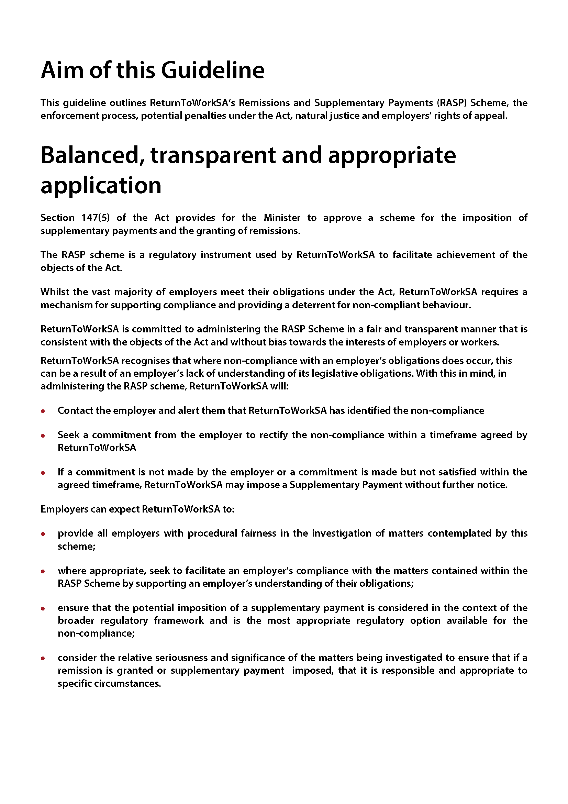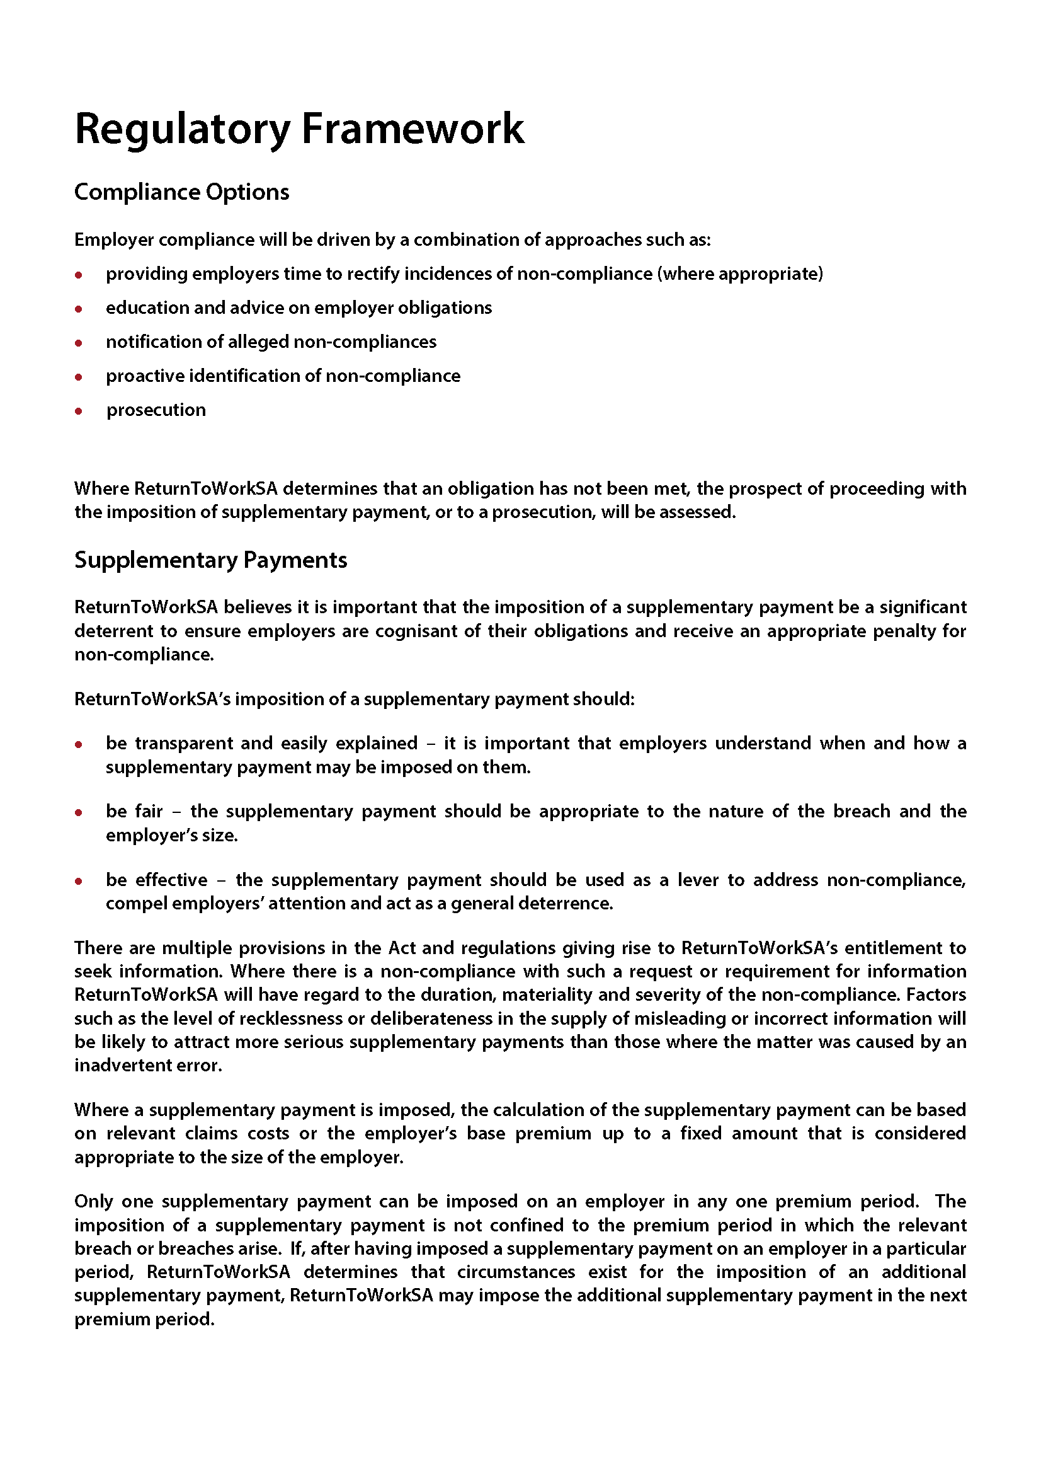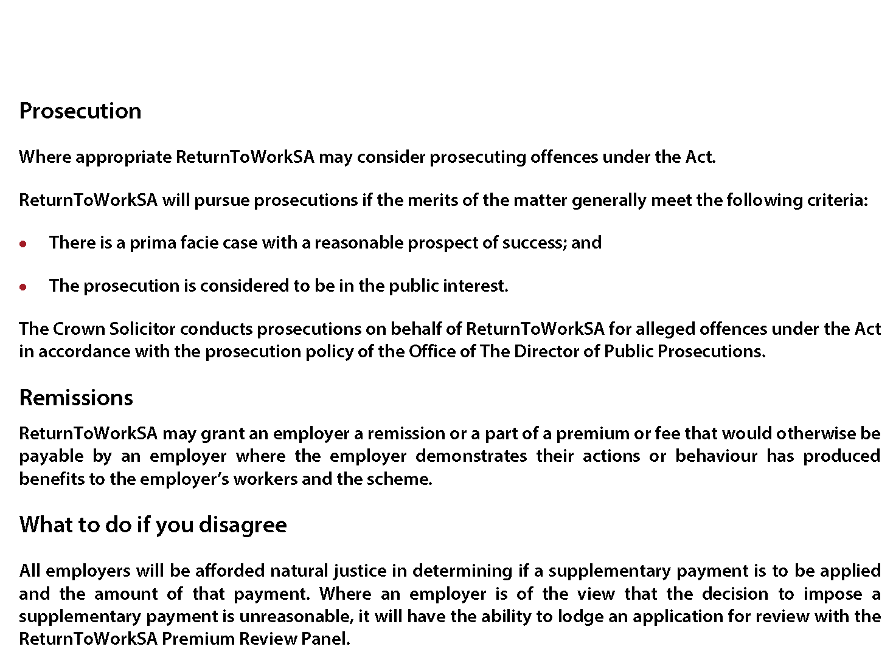

SOUTH AUSTRALIAN HOUSING TRUST REGULATIONS 2010
Notice Under Regulation 4
Determination of Criteria for the Purposes of the Concept of Affordable Housing
1. Application
This Notice applies to:
(a) applications for development authorisation under the Development Act 1993 (SA); and
(b) policies under Development Plans pursuant to the Development Act 1993 (SA).
2. Determination of Criteria
(1) Land or a dwelling that is the subject of an application or policy to which this Notice applies will fall within the concept of affordable housing for the purposes of the South Australian Housing Trust Regulations 2010 (SA) if:
(a) the Dwelling is to be offered for sale to an Eligible Buyer (as described in paragraph 2 (2) of this Notice) either at or below the price described in row two in the table set out below (having regard to the location of the Dwelling as described in Column two and three of that table) (‘Price’), or at a price approved under Clause 2 (3) of this Notice in accordance with the terms of a legally binding agreement referred to in paragraph 2 (l) (d); or
(b) the Land is a Torrens Title allotment and is offered for sale to an Eligible Buyer at or below the price described in row three in the table set out below (having regard to the location of the Land as described in Column two and three of that table) (‘Price’); or
(c) the Land or Dwelling is purchased by an Eligible Buyer described in paragraphs 2 (2) (b), 2 (2) (c), or 2 (2) (d) for more than the Price; or
(d) the Minister responsible for administering the South Australian Housing Trust Regulations 2010 (SA) otherwise determines, in the Minister’s absolute discretion, that the Land or Dwelling constitutes affordable housing for the purposes of the South Australian Housing Trust Regulations 2010 (SA); and
(e) in the case of an application for a development authorisation—a legally binding agreement between the developer/owner and a Minister, or instrumentality of the Crown in right of the State or Council (constituted under the Local Government Act 1999 (SA)), is in place to ensure that the sale and/or purchase of the Land or Dwelling complies with the requirements set out in this Notice.
Affordability Indicators  (June 2016) | Greater Adelaide and Regional Cities* | Rest of State#
House and land purchase price (inclusive of GST) | $320 000 | $255 000
Land purchase price (inclusive of GST) | $144 000 | $114 750
* ‘Greater Adelaide’ means Greater Adelaide as defined in Map D1 the 30 Year Plan for Greater Adelaide, a volume of the South Australian Planning Strategy published in 2010. Regional Cities are Roxby Downs, Mount Gambler, Murray Bridge, Port Augusta,
Port Pine, Whyalla and Port Lincoln.
# ‘Rest of State’ means all areas in the State of South Australia excluding Greater Adelaide and the Regional Cities described above.
(2) An Eligible Buyer is:
(a) a person who is assessed as being eligible by Renewal SA;
(b) the South Australian Housing Trust or a registered housing association or a registered housing co-operative under the South Australian Co-operative and Community Housing Act 1991 (SA);
(c) a person (natural or corporate) approved to provide affordable rental under the ‘National Rental Affordability Scheme’;
(d) a person (natural or corporate) subject to an affordable housing facilitation agreement with a Minister, or instrumentality of the Crown in right of the State; or
(e) any class of persons, declared from time to time by the Minister responsible for administering the South Australian Housing Trust Regulations 2010 (SA).
(3) If a Dwelling:
(a) has features which make it more energy efficient and environmentally sustainable; or
(b) is on a small allotment within close proximity of public transport; or
(c) is offered for sale in conjunction with a financing product that increases an Eligible Buyers purchasing capacity; or
(d) provides for dual occupancy living
as outlined in the ‘Including 15% Affordable Housing in Your Development’ industry guidelines published from time to time by Renewal SA, the developer/owner may seek approval from the Minister with applications for approval directed to the Chief Executive, Renewal SA for a variation of the Price by up to 15%.
Dated 12 October 2016.
Stephen Mullighan, Minister for Housing and Urban Development

South Australia
Fisheries Management (Abolition of Aquatic Reserve) Proclamation 2016
under section 4 of the Fisheries Management Act 2007

Preamble
1 By proclamation made under section 48 of the Fisheries Act 1982 on 22 June 1995 (Gazette 22.06.1995 p2296) an area of land and waters was constituted as a marine park and assigned the name Great Australian Bight Marine Park Whale Sanctuary.
2 By clause 8 of Schedule 1 of the Fisheries Management Act 2007, any waters, or land and waters, constituting a marine park under section 48 of the Fisheries Act 1982 immediately before the commencement of clause 8 was, on that commencement, taken to constitute an aquatic reserve under section 4 of the Fisheries Management Act 2007.
3 By proclamation made on 15 November 2007 (Gazette 15.11.2007 p4241) clause 8 of Schedule 1 of the Fisheries Management Act 2007 came into operation on 1 December 2007.
4 It is now proposed to abolish the aquatic reserve known as the Great Australian Bight Marine Park Whale Sanctuary.

1—Short title
This proclamation may be cited as the Fisheries Management (Abolition of Aquatic Reserve) Proclamation 2016.
2—Commencement
This proclamation comes into operation on the day on which it is made.
3—Abolition of aquatic reserve
The aquatic reserve named in Schedule 1 is abolished.
Schedule 1—Abolition of aquatic reserve
Great Australian Bight Marine Park Whale Sanctuary
Made by the Governor’s Deputy
with the advice and consent of the Executive Council
on 20 October 2016
15MAFF039

South Australia
Fisheries Management (Aquatic Reserves) Proclamation 2016
under section 4 of the Fisheries Management Act 2007
1—Short title
This proclamation may be cited as the Fisheries Management (Aquatic Reserves) Proclamation 2016.
2—Commencement
This proclamation will come into operation on the day on which the Fisheries Management (Aquatic Reserves) Regulations 2016 come into operation.
3—Abolition of aquatic reserves
The aquatic reserves named in Schedule 1 are abolished.
4—Alteration of boundaries of Coobowie Aquatic Reserve
The boundaries of the Coobowie Aquatic Reserve are altered so that the boundaries of that Reserve are as specified in Schedule 2.
Schedule 1—Abolition of aquatic reserves
Aldinga Reef Aquatic Reserve
American River Aquatic Reserve
Bales Beach Aquatic Reserve
Blanche Harbour—Douglas Bank Aquatic Reserve
Goose Island Aquatic Reserve
Point Labatt Aquatic Reserve
Port Noarlunga Reef Aquatic Reserve
Seal Bay Aquatic Reserve
Whyalla—Cowled's Landing Aquatic Reserve
Yatala Harbour—Upper Spencer Gulf Aquatic Reserve

Schedule 2—Alteration of boundaries of Coobowie Aquatic Reserve
The waters of or near Salt Creek Bay contained within and bounded by a line commencing at Mean High Water Springs closest to 35°03′16.05″ South, 137°43′47.88″ East, then generally north-westerly following the line of Mean High Water Springs to the location closest to 35°03′15.22″ South, 137°43′40.37″ East (Beach Road), then generally north-westerly following the said road to the line of Mean High Water Springs closest to 35°3′9.39″ South, 137°43′38.81″ East, then beginning easterly following the line of Mean High Water Springs to the location closest to 35°02′40.48″ South, 137°45′31.20″ East, then south-westerly to the point of commencement, but excluding any land or waters so encompassed that lie landward of the line of Mean High Water Springs.
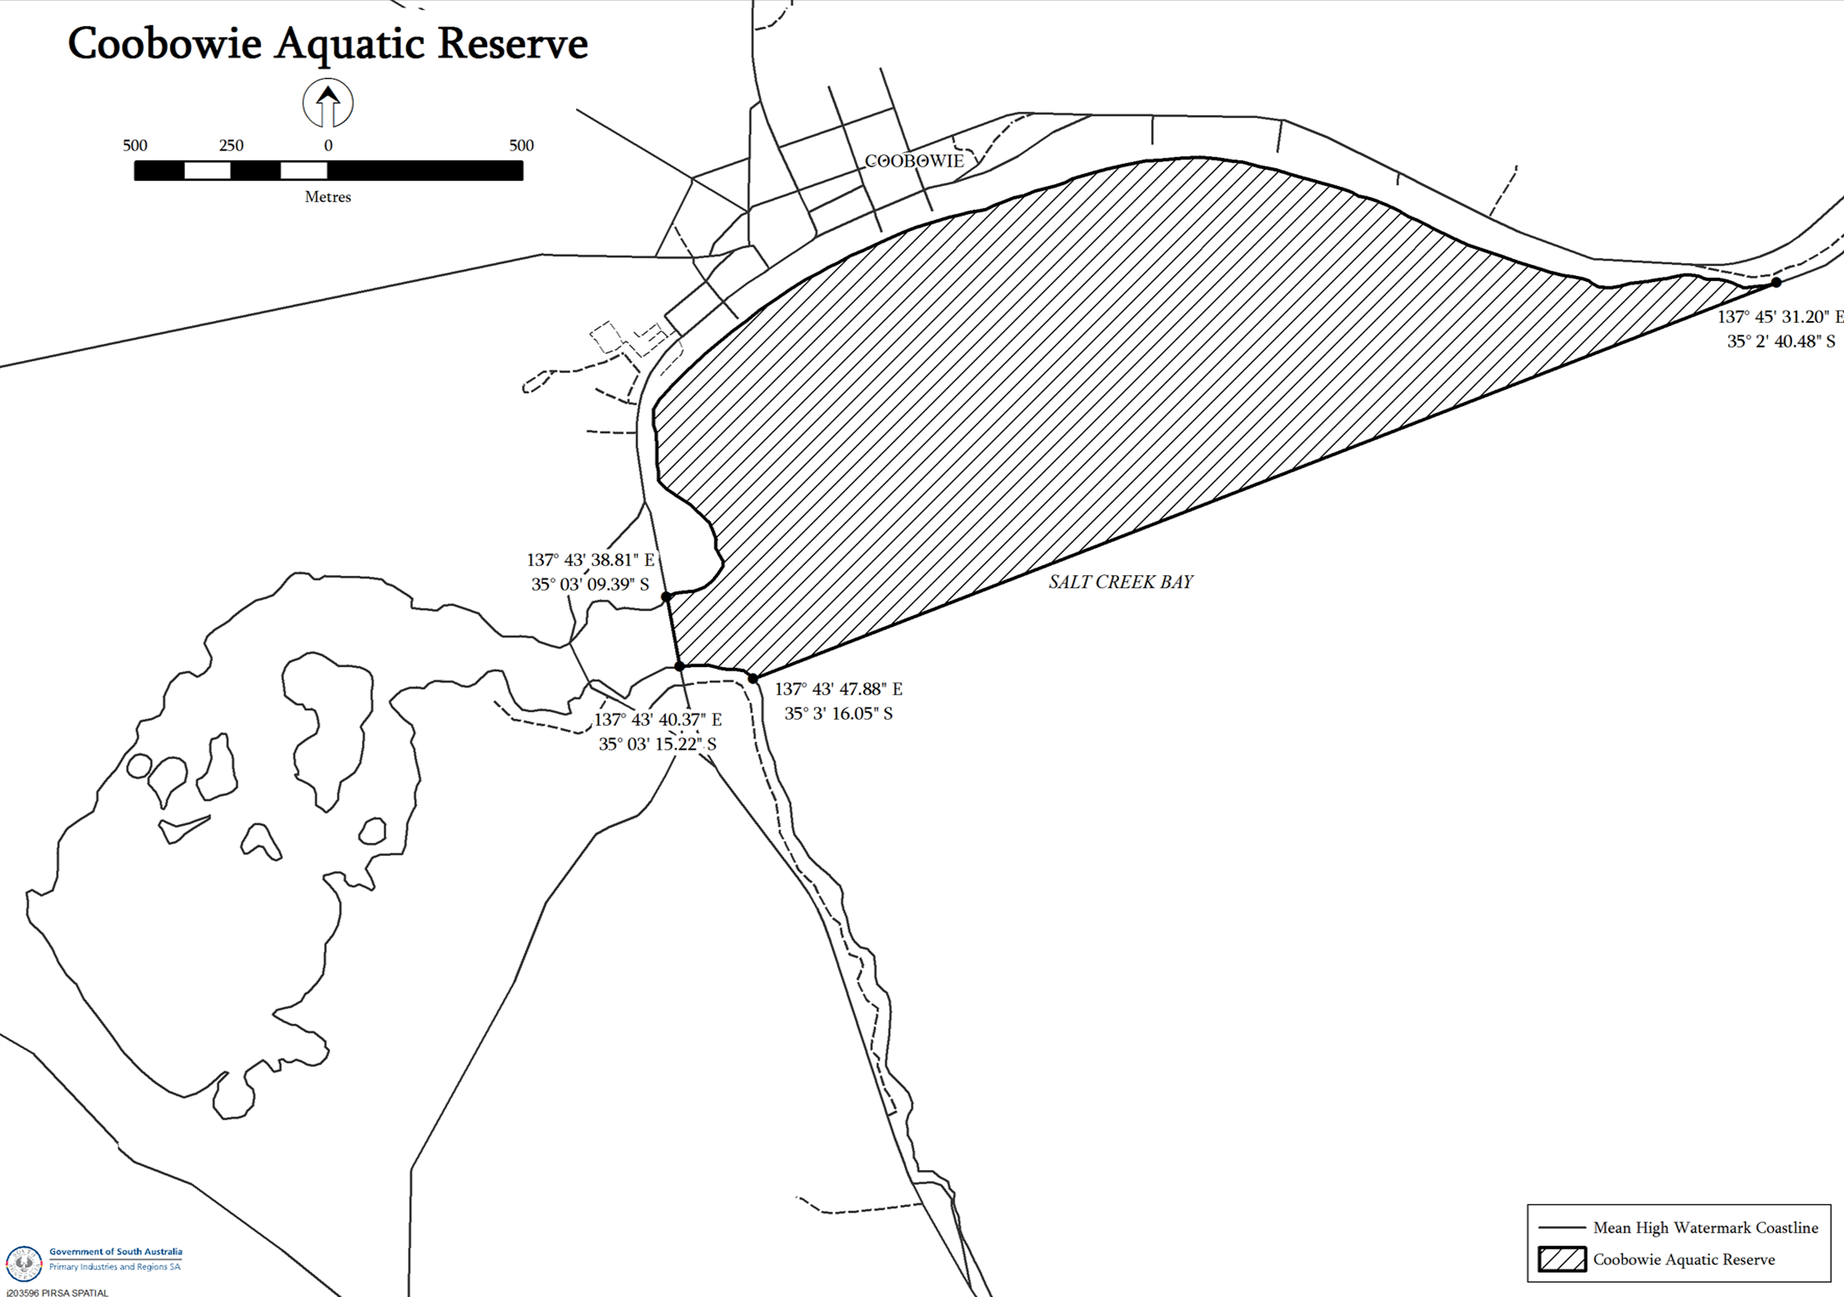
Notes—
1 All lines in the spatial description above are geodesics based on the Geocentric Datum of Australia 1994 (GDA94) as defined in the Commonwealth of Australia Gazette GN35 of 6 September 1995 and all co-ordinates are expressed in terms of GDA94.
2 The map above is provided for convenience of reference only.
Made by the Governor’s Deputy
with the advice and consent of the Executive Council
on 20 October 2016
15MAFF039

South Australia
National Parks and Wildlife (Chowilla Game Reserve) Proclamation 2016
under section 32(2) of the National Parks and Wildlife Act 1972
1—Short title
This proclamation may be cited as the National Parks and Wildlife (Chowilla Game Reserve) Proclamation 2016.
2—Commencement
This proclamation comes into operation on the day on which it is made.
3—Alteration of boundaries of Chowilla Game Reserve
The boundaries of the Chowilla Game Reserve are altered by excluding from the Reserve the following land:
Allotment 200 in approved plan No D112998, Out of Hundreds (Chowilla and Renmark), County of Hamley, lodged in the Lands Titles Registration Office;
The Allotment comprising Pieces 203, 207, 208 and 209 in approved plan No D112998, Out of Hundreds (Renmark), County of Hamley, lodged in the Lands Titles Registration Office.
Made by the Governor’s Deputy
with the advice and consent of the Executive Council
on 20 October 2016
16MSECCS041

South Australia
Fisheries Management (General) Variation Regulations 2016
under the Fisheries Management Act 2007

Contents
Part 1—Preliminary
1 Short title
2 Commencement
3 Variation provisions
Part 2—Variation of Fisheries Management (General) Regulations 2007
4 Variation of regulation 3—Interpretation
5 Variation of Schedule 2—Undersize fish
6 Variation of Schedule 6—Classes of fishing activities prescribed for purposes of section 70 of Act
7 Variation of Schedule 7—Areas in which use of fish nets is prohibited under section 70 of Act
8 Variation of Schedule 10—Expiation fees

Part 1—Preliminary
1—Short title
These regulations may be cited as the Fisheries Management (General) Variation Regulations 2016.
2—Commencement
These regulations will come into operation 4 months after the day on which they are made (see Subordinate Legislation Act 1978 (section 10AA)).
3—Variation provisions
In these regulations, a provision under a heading referring to the variation of specified regulations varies the regulations so specified.
Part 2—Variation of Fisheries Management (General) Regulations 2007
4—Variation of regulation 3—Interpretation
(1) Regulation 3(1)—after the definition of Greenlip Abalone insert:
Gulf St. Vincent means the waters contained within Gulf St. Vincent north of the geodesic from the location on Mean High Water Springs closest to 35°10′04.74″ South, 137°40′38.64″ East (Troubridge Point, Yorke Peninsula) to the location on Mean High Water Springs closest to 35°36′48.51″ South, 138°05′44.01″ East (Cape Jervis, Fleurieu Peninsula);
(2) Regulation 3(1)—after the definition of spear gun insert:
Spencer Gulf means the waters contained within Spencer Gulf north of the geodesic from the location on Mean High Water Springs closest to 34°59′07.15″ South, 136°00′11.06″ East (Cape Catastrophe, Eyre Peninsula) to the location on Mean High Water Springs closest to 35°17′59.60″ South, 136°52′50.11″ East (Cape Spencer, Yorke Peninsula);
5—Variation of Schedule 2—Undersize fish
Schedule 2, clause 14, table—delete the item relating to Snook and substitute:

Snook (Sphyraena novaehollandiae)—
(a) if taken by a licensed person | 41
(b) if taken by an unlicensed person | 45
6—Variation of Schedule 6—Classes of fishing activities prescribed for purposes of section 70 of Act
(1) Schedule 6, clause 4—delete "or" after paragraphs (a), (b) and (c) and substitute in each case:
and
(2) Schedule 6, clause 75—delete the clause
(3) Schedule 6, clause 82—delete the clause
(4) Schedule 6, clause 94—delete the clause
(5) Schedule 6, clause 99(c)(iii)—delete subparagraph (iii)
7—Variation of Schedule 7—Areas in which use of fish nets is prohibited under section 70 of Act
Schedule 7, Part 1, Germein Bay—delete the description of the waters and substitute:
The waters of or near Germein Bay contained within and bounded by a line commencing at 33°06′55.80″ South, 137°56′19.86″ East (marine navigation mark 4410/703), then north-westerly to 33°02′41.90″ South, 137°49′33.09″ East (marine navigation mark 4410/100), then north-easterly to 33°00′35.89″ South, 137°57′03.39″ East (the northern most point of the Port of Port Pirie), then north-easterly to Mean High Water Springs closest to 33°00′19.65″ South, 137°57′58.53″ East (Ward Point), then beginning south-easterly following the line of Mean High Water Springs to the location closest to 33°09′40.38″ South, 137°56′19.82″ East, then north to the point of commencement, but excluding any land or waters so encompassed that lie landward of the line of Mean High Water Springs.
8—Variation of Schedule 10—Expiation fees
(1) Schedule 10, table, item relating to clause 75—delete the item
(2) Schedule 10, table—after the item relating to clause 80 insert:

81 | Taking fish in Lake George using fish net of unlawful specifications | $200
(3) Schedule 10, table, item relating to clause 82—delete the item
(4) Schedule 10, table, item relating to clause 122—after the entries relating to Murray Cod insert:

• taking razorfish | $100
Made by the Governor’s Deputy
with the advice and consent of the Executive Council
on 20 October 2016
No 242 of 2016
15MAFF0081

South Australia
Fisheries Management (Marine Scalefish Fisheries) Variation Regulations 2016
under the Fisheries Management Act 2007

Contents
Part 1—Preliminary
1 Short title
2 Commencement
3 Variation provisions
Part 2—Variation of Fisheries Management (Marine Scalefish Fisheries) Regulations 2006
4 Variation of regulation 9—Transfer of licences
5 Insertion of regulations 18D and 18E
18D Restriction on use of sand crab pots
18E Restriction on carriage of devices on registered boat

Part 1—Preliminary
1—Short title
These regulations may be cited as the Fisheries Management (Marine Scalefish Fisheries) Variation Regulations 2016.
2—Commencement
These regulations will come into operation 4 months after the day on which they are made (see Subordinate Legislation Act 1978 (section 10AA)).
3—Variation provisions
In these regulations, a provision under a heading referring to the variation of specified regulations varies the regulations so specified.
Part 2—Variation of Fisheries Management (Marine Scalefish Fisheries) Regulations 2006
4—Variation of regulation 9—Transfer of licences
Regulation 9(5)(g)—delete paragraph (g)
5—Insertion of regulations 18D and 18E
After regulation 18C insert:
18D—Restriction on use of sand crab pots
The holder of a licence in respect of the Marine Scalefish Fishery must not take aquatic resources (other than sand crabs) in the waters of the Fishery using a sand crab pot.
Maximum penalty: $5 000.
Expiation fee: $315.
18E—Restriction on carriage of devices on registered boat
(1) If sand crab pots are carried on a registered boat used under a licence in respect of the Marine Scalefish Fishery, registered devices of any other kind must not be carried on the boat at the same time.
(2) If subregulation (1) is contravened, the registered owner and registered master of the registered boat are each guilty of an offence.
Maximum penalty: $5 000.
Expiation fee: $315.
Made by the Governor’s Deputy
with the advice and consent of the Executive Council
on 20 October 2016
No 243 of 2016
15MAFF0081

South Australia
Fisheries Management (Lakes and Coorong Fishery) Variation Regulations 2016
under the Fisheries Management Act 2007

Contents
Part 1—Preliminary
1 Short title
2 Commencement
3 Variation provisions
Part 2—Variation of Fisheries Management (Lakes and Coorong Fishery) Regulations 2009
4 Variation of regulation 6—Transfer of licence

Part 1—Preliminary
1—Short title
These regulations may be cited as the Fisheries Management (Lakes and Coorong Fishery) Variation Regulations 2016.
2—Commencement
These regulations will come into operation 4 months after the day on which they are made (see Subordinate Legislation Act 1978 (section 10AA)).
3—Variation provisions
In these regulations, a provision under a heading referring to the variation of specified regulations varies the regulations so specified.
Part 2—Variation of Fisheries Management (Lakes and Coorong Fishery) Regulations 2009
4—Variation of regulation 6—Transfer of licence
Regulation 6(3)(e)—delete paragraph (e)
Made by the Governor’s Deputy
with the advice and consent of the Executive Council
on 20 October 2016
No 244 of 2016
15MAFF0081

South Australia
Fisheries Management (Rock Lobster Fisheries) Variation Regulations 2016
under the Fisheries Management Act 2007

Contents
Part 1—Preliminary
1 Short title
2 Commencement
3 Variation provisions
Part 2—Variation of Fisheries Management (Rock Lobster Fisheries) Regulations 2006
4 Variation of regulation 6—Transfer of licence

Part 1—Preliminary
1—Short title
These regulations may be cited as the Fisheries Management (Rock Lobster Fisheries) Variation Regulations 2016.
2—Commencement
These regulations will come into operation 4 months after the day on which they are made (see Subordinate Legislation Act 1978 (section 10AA)).
3—Variation provisions
In these regulations, a provision under a heading referring to the variation of specified regulations varies the regulations so specified.
Part 2—Variation of Fisheries Management (Rock Lobster Fisheries) Regulations 2006
4—Variation of regulation 6—Transfer of licence
Regulation 6(3)(g)—delete paragraph (g)
Made by the Governor’s Deputy
with the advice and consent of the Executive Council
on 20 October 2016
No 245 of 2016
15MAFF0081

South Australia
Fisheries Management (Demerit Points) Variation Regulations 2016
under the Fisheries Management Act 2007

Contents
Part 1—Preliminary
1 Short title
2 Commencement
3 Variation provisions
Part 2—Variation of Fisheries Management (Demerit Points) Regulations 2009
4 Variation of Schedule 1—Demerit points offences and demerit points

Part 1—Preliminary
1—Short title
These regulations may be cited as the Fisheries Management (Demerit Points) Variation Regulations 2016.
2—Commencement
These regulations will come into operation 4 months after the day on which they are made (see Subordinate Legislation Act 1978 (section 10AA)).
3—Variation provisions
In these regulations, a provision under a heading referring to the variation of specified regulations varies the regulations so specified.
Part 2—Variation of Fisheries Management (Demerit Points) Regulations 2009
4—Variation of Schedule 1—Demerit points offences and demerit points
(1) Schedule 1, Part 1, clause 2, table, items relating to clauses 75, 82 and 94—delete the items
(2) Schedule 1, Part 2, clause 10, table—after the item relating to regulation 18C insert:

reg 18D | Holder of licence in respect of Marine Scalefish Fishery taking aquatic resources other than sand crabs using sand crab pot—
 | (a) if the offence is expiated | 20
 | (b) in any other case—
 | (i) first offence | 60
 | (ii) second offence | 80
 | (iii) third or subsequent offence | 100
reg 18E(2) | Being registered owner or registered operator of registered boat on which are carried sand crab pots and other kinds of registered devices at the same time—
 | (a) if the offence is expiated | 20
 | (b) in any other case—
 | (i) first offence | 60
 | (ii) second offence | 80
 | (iii) third or subsequent offence | 100
Made by the Governor’s Deputy
with the advice and consent of the Executive Council
on 20 October 2016
No 246 of 2016
15MAFF0081

South Australia
Fisheries Management (Aquatic Reserves) Regulations 2016
under the Fisheries Management Act 2007

Contents
1 Short title
2 Commencement
3 Interpretation
4 Authorised access to, and fishing activities in, aquatic reserves
Schedule 1—Revocation of Fisheries Management (Aquatic Reserves) Regulations 2008

1—Short title
These regulations may be cited as the Fisheries Management (Aquatic Reserves) Regulations 2016.
2—Commencement
These regulations will come into operation 4 months after the day on which they are made (see Subordinate Legislation Act 1978 (section 10AA)).
3—Interpretation
(1) In these regulations—
Act means the Fisheries Management Act 2007;
Coobowie Fishing Zone means the Coobowie Aquatic Reserve excluding the waters of or near Salt Creek Swamp west of the main road causeway;
West Island Encounter Bay Exclusion Zone means that portion of the West Island Encounter Bay Aquatic Reserve contained within and bounded by a line commencing at Mean High Water Springs closest to 35°36′20.75″ South, 138°35′33.16″ East, then generally south-westerly following the line of Mean High Water Springs to the location closest to 35°36′27.84″ South, 138°35′21.14″ East, then westerly to a line 100 metres seaward of Mean High Water Springs closest to 35°36′27.84″ South, 138°35′16.99″ East, then generally north-easterly following a line 100 metres seaward of Mean High Water Springs to the location closest to 35°36′17.51″ South, 138°5′3.16″ East, then southerly to the point of commencement;
West Island Encounter Bay Fishing Zone means that portion of the West Island Encounter Bay Aquatic Reserve comprising the waters contained within and bounded by a line commencing at 200 metres seaward of Mean High Water Springs (King Beach) closest to 35°6′2.61″ South, 138°35′08.34″ East, then south-easterly to a line 100 metres seaward of Mean High Water Springs (West Island) closest to 35°36′17.90″ South, 138°35′35.62″ East, then beginning generally westerly following a line 100 metres seaward of Mean High Water Springs (West Island) to the location closest to 35°36′38.04″ South, 138°35′20.46″ East, then north-westerly to a line 200 metres seaward of Mean High Water Springs (King Head) closest to 35°36′24.15″ South, 138°34′58.14″ East, then beginning north-easterly following a line 200 metres seaward of Mean High Water Springs to the point of commencement.
(2) In these regulations—
(a) words and expressions used that are defined in the Fisheries Management (General) Regulations 2007 have the same respective meanings as in those regulations; and
(b) a reference to a named aquatic reserve is a reference to the aquatic reserve of that name constituted under section 4 of the Act; and
(c) all lines in spatial descriptions are geodesics based on the Geocentric Datum of Australia 1994 (GDA94) as defined in the Commonwealth of Australia Gazette GN35 of 6 September 1995, and all coordinates are expressed in terms of GDA94.
4—Authorised access to, and fishing activities in, aquatic reserves
For the purposes of section 76 of the Act—
(a) a person may enter and remain in any of the following aquatic reserves:
(i) Barker Inlet—St. Kilda Aquatic Reserve;
(ii) Coobowie Aquatic Reserve;
(iii) St. Kilda—Chapman Creek Aquatic Reserve;
(iv) Troubridge Hill Aquatic Reserve;
(v) West Island Encounter Bay Aquatic Reserve (other than the West Island Encounter Bay Exclusion Zone); and
(b) a person may engage in a fishing activity (including an act preparatory to, or involved in, the taking of an aquatic resource) in an aquatic reserve as follows:
(i) Barker Inlet—St. Kilda Aquatic Reserve—
(A) taking fish by using a rod and line or hand line;
(B) taking bloodworms (Class Polychaeta) for bait by using a hand net;
(ii) Coobowie Fishing Zone—
(A) taking fish by using a hand line or rod and line;
(B) taking fish for bait from the shore by any means;
(iii) St. Kilda—Chapman Creek Aquatic Reserve—
(A) taking Blue Swimmer Crab (Portunus pelagicus) by hand or by using a crab net or crab rake;
(B) taking fish by using a hand line or rod and line from the northern side of the breakwater;
(iv) Troubridge Hill Aquatic Reserve—taking fish by using a hand line or rod and line;
(v) West Island Encounter Bay Fishing Zone—taking fish by using a hand line or rod and line.
Note—
In this regulation, common and scientific fish names are given according to AS 5300—2015 Australian Fish Names Standard, as amended from time to time.
Schedule 1—Revocation of Fisheries Management (Aquatic Reserves) Regulations 2008
The Fisheries Management (Aquatic Reserves) Regulations 2008 are revoked.
Made by the Governor’s Deputy
with the advice and consent of the Executive Council
on 20 October 2016
No 247 of 2016
15MAFF039

South Australia
Fisheries Management (General) Variation Regulations 2016
under the Fisheries Management Act 2007

Contents
Part 1—Preliminary
1 Short title
2 Commencement
3 Variation provisions
Part 2—Variation of Fisheries Management (General) Regulations 2007
4 Variation of Schedule 6—Classes of fishing activities prescribed for purposes of section 70 of Act
5 Variation of Schedule 7—Areas in which use of fish nets is prohibited under section 70 of Act
6 Variation of Schedule 9—Areas in which explosive devices must not be carried while diving
7 Variation of Schedule 10—Expiation fees

Part 1—Preliminary
1—Short title
These regulations may be cited as the Fisheries Management (General) Variation Regulations 2016.
2—Commencement
These regulations will come into operation on the day on which the Fisheries Management (Aquatic Reserves) Regulations 2016 come into operation.
3—Variation provisions
In these regulations, a provision under a heading referring to the variation of specified regulations varies the regulations so specified.
Part 2—Variation of Fisheries Management (General) Regulations 2007
4—Variation of Schedule 6—Classes of fishing activities prescribed for purposes of section 70 of Act
(1) Schedule 6, clause 31(b)—delete paragraph (b) and substitute:
(b) in the waters of or near False Bay contained within and bounded by a line commencing at Mean High Water Springs closest to 33°04′26.61″ South, 137°32′58.50″ East, then beginning north-easterly following the line of Mean High Water Springs to the location closest to 32°59′41.12″ South, 137°45′31.96″ East (Stony Point), then south-westerly to 33°05′12.75″ South, 137°34′10.86″ East, then north-westerly to 33°04′26.05″ South, 137°33′24.19 East, then westerly to the point of commencement; or
(2) Schedule 6—after clause 128 insert:
129—Taking fish near Horseshoe Reef
The taking of fish from within 25 metres of any part of Horseshoe Reef (35°8′14.6″ South, 138°27′49.1″ East) that becomes exposed at low water.
130—Taking fish in certain parts of Onkaparinga River
The taking of fish (other than the taking of fish by using a hand line or rod and line or the taking of shrimp (Suborder Natantia) by using a shrimp net)—
(a) upstream from the mouth of the Onkaparinga River at a point closest to 35°09′53.26″ South, 138°28′13.51″ East, to the bridge on Main South Road at Noarlunga (D V Fleming Bridge) closest to 35°10′33.36″ South, 138°29′55.85″ East; or
(b) in that portion of the waters of the estuary from the mouth of the Onkaparinga River at a point closest to 35°09′53.26″ South, 138°28′13.51″ East, to the bridge on Main South Road at Noarlunga (D V Fleming Bridge) closest to 35°10′33.36″ South, 138°29′55.85″ East.
5—Variation of Schedule 7—Areas in which use of fish nets is prohibited under section 70 of Act
Schedule 7, Part 1, Outer Harbor to Aldinga—delete the description of waters under the heading "Outer Harbor to Aldinga" and substitute:
The waters of or near Gulf St. Vincent contained within and bounded by a line commencing at the intersection of the southernmost breakwater at Outer Harbor with Mean High Water Springs closest to 34°46′59.00″ South, 138°28′40.45″ East, then beginning south-easterly following the line of Mean High Water Springs to the location closest to 35°17′00.75″ South, 138°26′33.51″ East, then westerly to a line 600 metres seaward of Mean High Water Springs closest to 35°17′00.76″ South, 138°26′09.77″ East, then beginning north-easterly following a line 600 metres seaward of Mean High Water Springs to the southernmost breakwater at Outer Harbor closest to 34°47′10.42″ South, 138°28′21.35″ East, then north-easterly following the breakwater to the point of commencement, but excluding any land or waters so encompassed that lie landward of the line of Mean High Water Springs.
6—Variation of Schedule 9—Areas in which explosive devices must not be carried while diving
Schedule 9, item 4—delete item 4 and substitute:
4 The waters of Gulf St. Vincent contained within and bounded by a line commencing at the intersection of the southernmost breakwater at Outer Harbor with Mean High Water Springs at the location closest to 34°46′59.00″ South, 138°28′40.45″ East, then beginning south-easterly following the line of Mean High Water Springs to the location closest to 35°07′52.63″ South, 138°28′11.09″ East, then south-westerly to a line 600 m seaward of Mean High Water Springs closest to 35°07′56.15″ South, 138°27′47.30″ East, then beginning northerly following a line 600 m seaward of Mean High Water Springs to the southernmost breakwater at Outer Harbor closest to 34°47′10.42″ South, 138°28′21.35″ East, then north-easterly following the breakwater to the point of commencement.
7—Variation of Schedule 10—Expiation fees
Schedule 10—after the item relating to clause 128 insert:

129 | Taking fish near Horseshoe Reef | $100
130 | Taking fish in certain parts of Onkaparinga River | $100
Made by the Governor’s Deputy
with the advice and consent of the Executive Council
on 20 October 2016
No 248 of 2016
15MAFF039

South Australia
Fisheries Management (Demerit Points) Variation Regulations 2016
under the Fisheries Management Act 2007

Contents
Part 1—Preliminary
1 Short title
2 Commencement
3 Variation provisions
Part 2—Variation of Fisheries Management (Demerit Points) Regulations 2009
4 Variation of Schedule 1—Demerit point offences and demerit points

Part 1—Preliminary
1—Short title
These regulations may be cited as the Fisheries Management (Demerit Points) Variation Regulations 2016.
2—Commencement
These regulations will come into operation on the day on which the Fisheries Management (Aquatic Reserves) Regulations 2016 come into operation.
3—Variation provisions
In these regulations, a provision under a heading referring to the variation of specified regulations varies the regulations so specified.
Part 2—Variation of Fisheries Management (Demerit Points) Regulations 2009
4—Variation of Schedule 1—Demerit point offences and demerit points
Schedule 1, Part 1, clause 2, table—after the item relating to clause 128 insert:

clause 129 | Taking fish near Horseshoe Reef—
 | (a) if the offence is expiated | 5
 | (b) in any other case—
 | (i) first offence | 15
 | (ii) second offence | 20
 | (iii) third or subsequent offence | 25
clause 130 | Taking fish in certain parts of Onkaparinga River—
 | (a) if the offence is expiated | 5
 | (b) in any other case—
 | (i) first offence | 15
 | (ii) second offence | 20
 | (iii) third or subsequent offence | 25
Made by the Governor’s Deputy
with the advice and consent of the Executive Council
on 20 October 2016
No 249 of 2016
15MAFF039

SENDING COPY?
NOTICES for inclusion in the South Australian Government Gazette should be emailed to:
GovernmentGazetteSA@sa.gov.au
Please include the following information in the covering email:
• The date the notice is to be published.
• Whether a proof, quote or return email confirmation is required.
• Contact details.
• To whom the notice is charged if applicable.
• A purchase order if required (chargeable notices).
• Any other details that may impact on the publication of the notice.
Attach:
• Notices in Word format.
• Maps and diagrams in pdf.
• Notices that require sighting an official date and signature before publication in a pdf. If a pdf is not possible then fax the official file(s) to the Government Publishing Fax number listed below.
Fax Transmission: (08) 8207 1040
Phone Enquiries: (08) 8207 1045
NOTE:
Closing time for lodging new copy is 4 p.m. on Tuesday preceding the regular Thursday Gazette.

CITY OF PLAYFORD
Roads (Opening and Closing) Act 1991
Proposed Road Closure—Portion Argent Road
(formerly Penfield Road), Edinburgh
NOTICE is hereby given pursuant to Section 10 of the Roads (Opening and Closing) Act 1991, that the City of Playford proposes to make a Road Process Order to close a portion of Argent Road, Edinburgh, subject to any easements that may be required. The portion of road to be closed is described as portion of Allotment 21 in Deposited Plan 17993 and delineated in Preliminary Plan No. 16/0034.
The portion of road to be closed marked ‘A’ on the plan is to be merged with adjoining land described as Allotment 26 in Deposited Plan 17993 in Certificate of Title 5847/156.
A copy of the plan and statement of persons affected are available for public inspection at Playford Civic Centre,
10 Playford Boulevard, Elizabeth; Playford Operations Centre,
12 Bishopstone Road, Davoren Park; Stretton Centre, 307 Peachey Road, Munno Para and the office of the Surveyor-General,
101 Grenfell Street, Adelaide, during normal office hours.
Any application for easement or objection must be made in writing within 28 days from 20 October 2016, to the Council,
12 Bishopstone Road, Davoren Park, S.A. 5113 and the Surveyor-General, G.P.O. Box 1354, Adelaide, S.A. 5001, and must set out the full name, address and details of the submission. Where a submission is made, Council will give notification of a meeting at which the matter will be considered.
Enquiries relating to this proposal can be directed to Laura Tully on (08) 8256 0138.
Dated 20 October 2016.
M. Hemmerling, Chief Executive Officer

CITY OF PLAYFORD
Development Act 1993
City of Playford, Munno Para Bowls Club Site Development Plan Amendment—Public Consultation
NOTICE is hereby given that the City of Playford, pursuant to Sections 24 and 25 of the Development Act 1993, has prepared a Development Plan Amendment (DPA) to amend its Development Plan.
The Amendment proposes to change the Development Plan by altering the zoning of approximately 2.7 hectares of land owned by the City of Playford at the corner of Main North Road and Curtis Road, Munno Para from Suburban Neighbourhood to Commercial.
The DPA report will be on public consultation from 20 October 2016 until 17 November 2016.
The DPA report and additional information can be viewed on the Internet at www.playford.sa.gov.au/munnoparabowlsclub or during normal office hours at the following locations:
• Customer Service, Playford Civic Centre, 10 Playford Boulevard, Elizabeth, S.A. 5112.
• Stretton Centre, 307 Peachey Road, Munno Para.
• Customer Service, Playford Operations Centre, 12 Bishopstone Road, Davoren Park, S.A. 5113.
Written submissions regarding the DPA should be submitted no later than 5 p.m. on 17 November 2016. All submissions should be addressed to ‘Munno Para Bowls Club Site Development Plan Amendment’, City of Playford, 12 Bishopstone Road, Davoren Park, S.A. 5113 or emailed to bowlsiteconsultation@playford.sa.gov.au
and should clearly indicate whether you wish to be heard in support of your submission at the public hearing on 22 November 2016.
Copies of all submissions will be available for inspection during office hours at the Operations Centre, 12 Bishopstone Road, Davoren Park, S.A. 5113 from 18 November until the conclusion of the public hearing.
The public hearing will be held on 22 November 2016 commencing at 7 p.m. at the Civic Centre, Playford Boulevard, Elizabeth. Interested persons may be heard in relation to the DPA and the submissions. The public hearing will not be held if there are no submissions received or if no submission makes a request to be heard.
Informal information sessions at the Munno Para Bowls Club, Mingari Street, Munno Para with Council staff in attendance will be held to provide the opportunity for questions to be answered:
• Wednesday, 2 November 2016, anytime between 3 p.m. and 7 p.m.
• Thursday, 3 November 2016, anytime between 10 a.m. and 1 p.m.
If you would like further information about the DPA, contact Paul Johnson on 8256 0156 or by email: phjohnson@playford.sa.gov.au.
Dated 13 October 2016.
M. Hemmerling, Chief Executive Officer

CITY OF PORT ADELAIDE ENFIELD
Review of Elector Representation
NOTICE is hereby given that the City of Port Adelaide Enfield has undertaken a review to determine whether alterations are required in respect to elector representation, including ward boundaries and the composition of council.
Report
Council has prepared a report which details the review process, public consultation undertaken and a proposal council considers could be carried into effect. A copy of this report is available from 163 St Vincent Street, Port Adelaide, during office hours or on the council website www.portenf.sa.gov.au.
Written Submissions
Written submissions are invited from interested persons from Thursday, 20 October, and should be directed to the Chief Executive Officer, P.O. Box 110, Port Adelaide, S.A. 5015, or emailed to customer.service@portenf.sa.gov.au, to be received by 5 p.m. on Friday, 11 November 2016.
Any person(s) making a written submission will be invited to appear before a meeting of council or council committee to be heard in respect of their submission.
Information regarding the representation review can be obtained by contacting Danniele Worden, Senior Governance Advisor, on (08) 8405 6898.
M. Withers, Chief Executive Officer

CITY OF WEST TORRENS
Close of Roll for Supplementary Election
DUE to the resignation of a member of the Council, a supplementary election will be necessary to fill the vacancy of Councillor for Keswick Ward.
The voters roll for this supplementary election will close at
5 p.m. on Monday, 31 October 2016.
You are entitled to vote in the election if you are on the State electoral roll. If you have recently turned 18 or changed your residential or postal address you must complete an electoral enrolment form, available from post offices or online at www.ecsa.sa.gov.au.
If you are not eligible to enrol on the State electoral roll you may still be entitled to enrol to vote if you own or occupy a property. Contact the Council to find out how.
Nominations to fill the vacancy will open on Thursday,
24 November 2016 and will be received until 12 noon on Thursday, 8 December 2016.
The election will be conducted entirely by post with the return of ballot material to reach the Deputy Returning Officer no later than 12 noon on Monday, 30 January 2017.
D. Gully, Returning Officer

CITY OF WEST TORRENS
Allocation of Road Name
NOTICE is hereby given that the City of West Torrens, at its meeting held on 4 October 2016, issued a resolution, pursuant to Section 219 (1) of the Local Government Act 1999, that the name of the road extending Main Street Lockleys, be named Main Street.
T. Buss, Chief Executive Officer

CITY OF WEST TORRENS
Resignation of Councillor
NOTICE is hereby given in accordance with Section 54 (6) of the Local Government Act 1999, that a vacancy has occurred in the office of Councillor for Keswick Ward as a result of the resignation of Councillor Rishi Dua.
T. Buss, Chief Executive Officer

BERRI BARMERA COUNCIL
Review of Elector Representation
NOTICE is hereby given that the Berri Barmera Council is undertaking a review to determine whether a change of arrangements are required in respect to elector representation so as to ensure that the electors of the area are being adequately and fairly represented.
Pursuant to the provisions of Section 12 (7) of the Local Government Act 1999, notice is hereby given that Council has prepared a Representation Options Paper which examines the advantages and disadvantages of the various options available in regards to the composition and structure of Council, and the division of the Council area into wards.
A copy of the Representation Options Paper is available on Council’s website (www.berribarmera.sa.gov.au), or a copy can be inspected and/or purchased at the Council offices, 19 Wilson Street, Berri.
Written submissions are invited from interested persons from Thursday, 20 October 2016 and should be directed to the Chief Executive Officer, P.O. Box 229, Berri, S.A. 5343, or emailed to bbc@bbc.sa.gov.au by close of business on Friday, 2 December 2016.
Information regarding the elector representation review can be obtained by contacting the Chief Executive Officer on telephone 8582 1922 or by emailing bbc@bbc.sa.gov.au.
D. Beaton, Chief Executive Officer

KANGAROO ISLAND COUNCIL
Periodic Review of Elector Representation
NOTICE is hereby given that the Kangaroo Island Council has undertaken a review to determine whether a change of arrangements in respect to elector representation is required to ensure the area’s Electors are adequately and fairly represented.
Pursuant to the provisions of Section 12 (9) of the Local Government Act 1999, Council has prepared an Elector Representation Report having undertaken a review that examined the preferred options regarding the composition and structure of Council, and the division of Council into wards. As an outcome of this review, Council proposes to maintain the status quo. Electronic copies of the report are available on the Council website at www.kangarooisland.sa.gov.au, hard copies of the report are available for inspection and/or purchase at the Council Office, 43 Dauncey Street, Kingscote, and the Penneshaw Community Business Centre, 99 Middle Terrace, Penneshaw.
Interested persons are invited to make a written submission to the Chief Executive Officer prior to 5 p.m. on 10 November 2016 and can be forwarded to Council via the following:
Website Feedback Form: www.kangarooisland.sa.gov.au
Post: P.O. Box 121, Kingscote, S.A. 5223
Email: kicouncil@kicouncil.sa.gov.au
Hand deliver to: 43 Dauncey Street, Kingscote, S.A. 5223
Any person making a written submission will be given an opportunity to appear before Council at a Public Hearing to be conducted on Wednesday, 16 November, 5 p.m., at the Council Chambers, 43 Dauncey Street, Kingscote.
Information regarding the representation review can be obtained by contacting David Altmann on telephone (08) 8553 4500 or email to kicouncil@kicouncil.sa.gov.au.
A. Boardman, Chief Executive Officer

IN the matter of the estates of the undermentioned deceased persons:
Aistrope, Amy Elizabeth, late of 12 Barton Road, Elizabeth Downs, home duties, who died on 25 August 2016.
Bandt, John Edward, late of 6 Clare Avenue, Sheidow Park, plumber, who died on 5 August 2015.
Foot, Reginald Phillip, late of 14 Frew Street, Fullarton, retired wood machinist, who died on 23 May 2016.
Garrett, Joan Gladys, late of 4 Kangaroo Thorn Road, Trott Park, of no occupation, who died on 13 July 2016.
Gaskin, Hilda Jean, late of 5 Bolton Street, Mansfield Park, home duties, who died on 18 August 2016.
Headland, Barbara, late of 49 Second Avenue, Klemzig, home duties, who died on 22 July 2016.
Herba, Karol, late of 8 Muhlhan Avenue, Windsor Gardens, retired brick layer, who died on 4 June 2016.
Lorrain, Joy Marie, late of 74 Cresdee Road, Campbelltown, retired receptionist, who died on 21 June 2016.
Quick, Colleen Mary, late of 63 Labrina Avenue, Prospect, of no occupation, who died on 13 July 2016.
Sherriff, Arthur John, late of 15 Halliday Street, Risdon Park, retired waterside worker, who died on 29 April 2016.
Spangler, Wilfred Frank, late of 26 Regent Street, Parkside, retired staff officer, who died on 1 August 2016.
Wilksch, Lenard Arthur, late of 1215 Grand Junction Road, Hope Valley, retired engineer, who died on 16 August 2016.
Notice is hereby given pursuant to the Trustee Act 1936, the Inheritance (Family Provision) Act 1972 and the Family Relationships Act 1975, that all creditors, beneficiaries, and other persons having claims against the said estates are required to send, in writing, to the office of Public Trustee, G.P.O. Box 1338, Adelaide, S.A. 5001, full particulars and proof of such claims, on or before the 18 November 2016, otherwise they will be excluded from the distribution of the said estate; and notice is also hereby given that all persons indebted to the said estates are required to pay the amount of their debts to the Public Trustee or proceedings will be taken for the recovery thereof; and all persons having any property belonging to the said estates are forthwith to deliver same to the Public Trustee.
Dated 20 October 2016.
D. A. Contala, Public Trustee

SALE OF PROPERTY
Auction Date: Friday, 4 November 2016 at 12 noon
Location: Unit 4, 23A Morialta Drive, Smithfield, S.A.
NOTICE is hereby given that on the above date at the time and place stated, by virtue of the Warrant of Sale issued out of the Magistrates Court of South Australia, Action No. AMCCI 3679 of 2015, directed to the Sheriff of South Australia in an action wherein Community Corporation No. 22229 Inc is the Plaintiff and Robert William Wilkins is the Defendant, I, Mark Stokes, Sheriff of the State of South Australia, will by my auctioneers, Mark Griffin Real Estate, make sale of the estate, right, title or interest whatsoever it may be of the Respondent, Robert William Wilkins the registered proprietor of an estate in fee simple in the following:
That piece of land situated in the area named Reynella, being Unit 3, 23A Morialta Drive, Smithfield, Hundred of Munno Para, being the property comprised in Certificate of Title Register Book Volume 5915, Folio 519.
Further particulars from the auctioneers:
Griffin Real Estate,
22 Greenhill Road,
Wayville, S.A. 5034.
Telephone 0413 214 858.

ATTENTION

CUSTOMERS requiring a proof of their notice for inclusion in the Government Gazette, please note that the onus is on you to inform Government Publishing SA of any subsequent corrections.

For any corrections to your notice please phone 8207 1045 or Email before 4 p.m. on Wednesday.

If we do not receive any communication by 10 a.m. on Thursday (day of publication) we will presume the notice is correct and will print it as it is.

Remember—the onus is on you to inform us of any corrections necessary to your notice.

NOTE: Closing time for lodging new copy (electronically, fax or hard copy) is 4 p.m. on Tuesday preceding the day of publication.
Phone: 8207 1045
Fax: 8207 1040
Email: GovernmentGazetteSA@sa.gov.au

Printed and published by authority every Thursday by P. McMAHON, Government Printer, South Australia
Price: $7.21, plus postage; to subscribers, $361.90 per annum.
(The above prices are inclusive of GST)

