No. 69 4211



THE SOUTH AUSTRALIAN

GOVERNMENT GAZETTE
www.governmentgazette.sa.gov.au

PUBLISHED BY AUTHORITY

ALL PUBLIC ACTS appearing in this GAZETTE are to be considered official, and obeyed as such

ADELAIDE, THURSDAY, 27 OCTOBER 2016

CONTENTS

Page
Acts Assented To 4212
Appointments, Resignations, Etc. 4212
Community Titles Act 1996—Notice 4212
Corporations and District Councils—Notices 4282
Fire and Emergency Services Act 2005—Notice 4212
Fisheries Management Act 2007—Notices 4213, 4223
Mining Act 1971—Notices 4213, 4225
National Electricity Law—Notice 4213
National Energy Retail Law—Notice 4214
National Gas Law—Notice 4214
National Parks and Wildlife (Breakaways Conservation
Park) Regulations 2013—Notice 4214
National Parks and Wildlife (National Parks)
Regulations 2016—Notices 4215
National Parks and Wildlife (Un-named Conservation
Park—Maralinga Tjarutja Lands) Regulations 2004—
Notice 4214
Native Title (South Australia) Act 1994—Notice 4213
Page
Petroleum and Geothermal Energy Act 2000—Notices 4218
Port Augusta Circuit Court—Notice 4218
Proclamations 4237
Public Sector Act 2009—Notice 4233
Public Trustee Office—Administration of Estates 4283
REGULATIONS
Hairdressers Act 1998 (No. 250 of 2016) 4245
Major Events Act 2013 (No. 251 of 2016) 4247
Family Relationships Act 1975 (No. 252 of 2016) 4271
Local Government Act 1999 (No. 253 of 2016) 4274
Roads (Opening and Closing) Act 1991—Notices 4220
RULES OF COURT
Magistrates Court (Civil) Rules 2013—
(Amendment 15) 4226
Training and Skills Development Act 2008—Notice 4227
Water Mains and Sewers—Mains Laid, Replaced Etc. 4221
Wilderness Protection Regulations 2006—Notice 4222

GOVERNMENT GAZETTE NOTICES
Notices for publication in the South Australian Government Gazette should be emailed to governmentgazette@dpc.sa.gov.au. Content should be sent as Word format attachment(s). Covering emails should include the date the notice is to be published and to whom the notice will be charged. Closing time for lodgement is 4 p.m. on the Tuesday preceding the regular Thursday publication. Gazette enquiries to: Phone 8207 1045. The Government Gazette is available online at: www.governmentgazette.sa.gov.au.

Department of the Premier and Cabinet
Adelaide, 27 October 2016
HIS Excellency the Governor directs it to be notified for general information that he has in the name and on behalf of Her Majesty The Queen, this day assented to the undermentioned Acts passed by the Legislative Council and House of Assembly in Parliament assembled, viz.:
No. 48 of 2016— Children and Young People (Oversight and Advocacy Bodies) Act 2016. An Act to establish the Commissioner for Children and Young People; to continue the Guardian for Children and Young People, the Child Death and Serious Injury Review Committee; to establish the Child Development Council; and for other purposes.
By command,
Kyam Joseph Maher, for Premier
DPC06/0875

Department of the Premier and Cabinet
Adelaide, 27 October 2016
HIS Excellency the Governor in Executive Council has been pleased to appoint the undermentioned to the Adelaide Festival Centre Trust, pursuant to the provisions of the Adelaide Festival Centre Trust Act 1971:
Member: (from 27 October 2016 until 26 October 2019)
Philip James Hoffmann
By command,
Kyam Joseph Maher, for Premier
ASACAB167-11

Department of the Premier and Cabinet
Adelaide, 27 October 2016
HIS Excellency the Governor in Executive Council has been pleased to appoint the undermentioned to the Art Gallery Board, pursuant to the provisions of the Art Gallery Act 1939:
Member: (from 10 December 2016 until 9 December 2019)
Adrian Gary Tisato
By command,
Kyam Joseph Maher, for Premier
ASACAB007-02

Department of the Premier and Cabinet
Adelaide, 27 October 2016
HIS Excellency the Governor in Executive Council has been pleased to appoint the Honourable John James Snelling, MP, Minister for Health, Minister for the Arts and Minister for Health Industries to be also Acting Treasurer, Acting Minister for Finance, Acting Minister for State Development and Acting Minister for Mineral Resources and Energy for the period from 1 November 2016 until 4 November 2016 inclusive, during the absence of the Honourable Tom Koutsantonis, MP.
By command,
Kyam Joseph Maher, for Premier
T&F16/079CS

Department of the Premier and Cabinet
Adelaide, 27 October 2016
HIS Excellency the Governor in Executive Council has been pleased to appoint the Honourable Ian Keith Hunter, MLC, Minister for Sustainability, Environment and Conservation, Minister for Water and the River Murray and Minister for Climate Change to be also Acting Minister for Agriculture, Food and Fisheries, Acting Minister for Forests, Acting Minister for Tourism, Acting Minister for Recreation and Sport and Acting Minister for Racing for the period from 5 November 2016 to 13 November 2016 inclusive, during the absence of the Honourable Leon William Kennedy Bignell, MP.
By command,
Kyam Joseph Maher, for Premier
16MAFF0072

Department of the Premier and Cabinet
Adelaide, 27 October 2016
HIS Excellency the Governor in Executive Council has been pleased to appoint Kevin Patrick Duggan as the review agency for the Independent Commissioner Against Corruption to conduct the review required by Section 6D (1) of the Listening and Surveillance Devices Act 1972, for a term commencing on 27 October 2016 and expiring on 23 July 2017, pursuant to Section 3 of the Listening and Surveillance Devices Act 1972.
By command,
Kyam Joseph Maher, for Premier
AGO0121/16CS

Department of the Premier and Cabinet
Adelaide, 27 October 2016
HIS Excellency the Governor in Executive Council has been pleased to appoint Kevin Patrick Duggan as the review agency for the Independent Commissioner Against Corruption to conduct the review required by Section 32 of the Surveillance Devices Act 2016, for a term commencing on 27 October 2016 and expiring on 23 July 2017, pursuant to Section 3 (1) of the Surveillance Devices Act 2016 and Section 14C of the Acts Interpretation Act 1915.
By command,
Kyam Joseph Maher, for Premier
AGO0121/16CS

COMMUNITY TITLES ACT 1996
Exemption
PURSUANT to Section 104 (4) of the Community Titles Act 1996 (the Act), I, the Honourable John Rau MP, Attorney-General, exempt the community corporation named in Schedule 1 from compliance with Section 104 (3) of the Act, subject to the condition set out in Schedule 2, for a period of one year commencing on the day on which this notice is published in the Gazette.
Schedule 1—Exempt Community Corporation
Aldinga Arts Eco Village Community Corporation 21109 Inc.
Schedule 2—Condition of Exemption
A policy of fidelity guarantee insurance must insure the exempt community corporation in the amount of:
(a) $100 000; or
(b) the maximum total balance of the community corporation’s bank accounts at any time in the preceding three years, whichever is the lesser.
However, if the maximum total balance of the community corporation’s bank accounts at any time in the preceding three years is less than $50 000, a policy of fidelity guarantee insurance must insure the exempt community corporation in the amount of $50 000.
Dated 24 October 2016.
John Rau, Deputy Premier, Attorney-General

FIRE AND EMERGENCY SERVICES ACT 2005
Section 78
Fire Danger Season
THE South Australian Country Fire Service hereby:
1. Fixes the date of the Fire Danger Season within the part of the State defined as the Eastern Eyre Peninsula Fire Ban District so as to commence on 1 November 2016 and to end on 15 April 2017.
2. Fixes the date of the Fire Danger Season within the part of the State defined as the Lower Eyre Peninsula Fire Ban District so as to commence on 1 November 2016 and to end on 15 of April 2017.
3. Fixes the date of the Fire Danger Season within the part of the State defined as the North-East Pastoral Fire Ban District so as to commence on 1 November 2016 and to end on 31 March 2017.
4. Fixes the date of the Fire Danger Season within the part of the State defined as the North-West Pastoral Fire Ban District so as to commence on 1 November 2016 and to end on 31 March 2017.
5. Fixes the date of the Fire Danger Season within the part of the State defined as the West Coast Fire Ban District so as to commence on 1 November 2016 and to end on 15 April 2017.
G. Nettleton, Chief Officer

FISHERIES MANAGEMENT ACT 2007: SECTION 79
TAKE notice that it is hereby declared that it shall be unlawful for any person to engage in the class of fishing activity specified in Schedule 1 during the period specified in Schedule 2.
Schedule 1
The act of taking or an act preparatory to or involved in the taking of Snapper (Chrysophrys auratus) in all waters of the State.
Schedule 2
1200 hours on 1 November 2016 until 1200 hours on
15 December 2016.
Dated 21 October 2016.
S. Sloan, Director,
Fisheries and Aquaculture Policy

FISHERIES MANAGEMENT ACT 2007: SECTION 79
TAKE notice that it is hereby declared that it shall be unlawful for any person to engage in the class of fishing activity specified in Schedule 1 in the areas described in Schedule 2 during the period specified in Schedule 3.
Schedule 1
The act of taking or an act preparatory to or involved in the taking of Snapper (Chrysophrys auratus); and/or the possession of Snapper (Chrysophrys auratus).
Schedule 2
In the waters of the Spencer Gulf contained within and bounded by a line at a radius of 4 km from the following navigation points:
• latitude 137°32.600′E, longitude 33°28.900′S;
• latitude 137°36.300′E, longitude 33°36.300′S;
• latitude 137°19.100′E, longitude 33°54.700′S;
• latitude 136°50.900′E, longitude 33°58.900′S;
In the waters of the Gulf St Vincent contained within and bounded by a line at a radius of 4 km from the following navigation point:
• latitude 138°00.000′E, longitude 34°25.860′S.
Schedule 3
1200 hours on 15 December 2016 until 1200 hours on 31 January 2017.
For the purpose of this notice the spatial descriptions are geodesics based on the Geocentric Datum of Australia 1994 (GDA94).
Dated 21 October 2016.
S. Sloan, Director,
Fisheries and Aquaculture Policy

FISHERIES MANAGEMENT ACT 2007: SECTION 90 (2)
NOTICE is hereby given pursuant to Section 90 (2) of the Fisheries Management Act, 2007, that the following items have been seized by Officers of the Department of Primary Industries and Regions SA, Fisheries and Aquaculture.
1 Monofilament mesh net with green rope on float line and lead line, orange floats and blue and yellow rope attached to one end
The above items were suspected to have been used, or intended to be used, in contravention of the Fisheries Management Act 2007, and were taken into possession at Fitzgerald Bay on 25 June 2015.
After the expiration of one month from the date of this notice the items listed above shall, on the order of the Minister for Agriculture, Food and Fisheries, be forfeited to the Crown and shall be either disposed of by sale or destruction.
The above items may be viewed at the Whyalla Office of the Department of Primary Industries and Regions SA, Fisheries and Aquaculture.
Dated 21 October 2016.
B. Balmer, Prosecutions Co-ordinator

MINING ACT 1971
NATIVE TITLE (SOUTH AUSTRALIA) ACT 1994
Notice pursuant to Section 35A (1) of the Mining Act 1971 and Part 5 of the Native Title (South Australia) Act 1994
NOTICE is hereby given in accordance with Section 35A (1) of the Mining Act 1971, and Part 5 of the Native Title (South Australia) Act 1994, that an application for an Extractive Minerals Lease over the undermentioned mineral claim has been received:
Applicant: Quasar Resources Pty Ltd
Claim Number: 4406
Location: Allotment 34, Deposited Plan 42204 (Wooltana area, approximately 25 km north-east of Arkaroola Village)
Area: 4.32 hectares approximately
Purpose: Construction Materials—Gravel (Natural)
Reference: 2016/001083
Details of the proposal may be inspected at the Department of State Development, Mineral Resources Division, Level 7,
101 Grenfell Street, Adelaide, S.A. 5000. An electronic copy of the proposal can be found on the Department of State Development website: http://minerals.statedevelopment.sa.gov.au
/mining/public_notices_mining.
Written submissions in relation to this application are invited to be received at the Department of State Development, Mining Regulation, Attention: Business Support Officer, G.P.O. Box 320, Adelaide, S.A. 5001 by no later than 24 November 2016.
The delegate of the Minister for Mineral Resources and Energy is required to have regard to these submissions in determining whether to grant or refuse the application and, if so, the terms and conditions on which it should be granted.
When you make a written submission, that submission becomes a public record. Your submission will be provided to the applicant and may be made available for public inspection unless confidentiality is requested.
J. Martin, Mining Registrar

NATIONAL ELECTRICITY LAW
THE Australian Energy Market Commission (AEMC) gives notice under the National Electricity Law as follows:
Under s 95, the AER has requested the Replacement expenditure planning arrangements (Ref. ERC0209) proposal. The proposal seeks to increase the transparency of network asset replacement decisions by service providers. Submissions must be received by 24 November 2016.
Under s 107, the time for making the draft determination on the Replacement expenditure planning arrangements (Ref. ERC0209) proposal has been extended to 13 April 2017.
Under s 99, the making of a draft determination and related
draft rule on the Retailer-distributor credit support requirements proposal (Ref. ERC0183). Written requests for a pre-determination hearing must be received by 3 November 2016. Submissions must be received by 22 December 2016.
Under s 99, the making of a draft determination on the Improving the accuracy of customer transfers proposal (Ref. ERC0195). Written requests for a pre-determination hearing must be received by 3 November 2016. Submissions must be received by 22 December 2016.
Under s 99, the making of a draft determination on the
Using estimated reads for customer transfers proposal (Ref. ERC0196). Requests for a pre-determination hearing must be received by 3 November 2016. Submissions must be received by 22 December 2016.
Submissions can be made via the AEMC’s website. Before making a submission, please review the AEMC’s privacy statement on its website. Submissions should be made in accordance with the AEMC’s Guidelines for making written submissions on Rule change proposals. The AEMC publishes all submissions on its website, subject to confidentiality.
Written requests should be sent to submissions@aemc.gov.au and cite the reference in the title. Before sending a request, please review the AEMC’s privacy statement on its website.
Documents referred to above are available on the AEMC’s website and are available for inspection at the AEMC’s office.
Australian Energy Market Commission
Level 6, 201 Elizabeth Street,
Sydney, N.S.W. 2000
Telephone: (02) 8296 7800
Website: www.aemc.gov.au
27 October 2016.

NATIONAL ENERGY RETAIL LAW
THE Australian Energy Market Commission (AEMC) gives notice under the National Energy Retail Law as follows:
Under s 256, the making of a draft determination and related draft rule on the Improving the accuracy of customer transfers (Ref. RRC0007) proposal. Written requests for a pre-determination hearing must be received by 3 November 2016. Submissions must be received by 22 December 2016.
Under s 256, the making of a draft determination on the Using estimated reads for customer transfers proposal (Ref. RRC0008). Requests for a pre-determination hearing must be received by
3 November 2016. Submissions must be received by
22 December 2016.
Submissions can be made via the AEMC’s website. Before making a submission, please review the AEMC’s privacy statement on its website. Submissions should be made in accordance with the AEMC’s Guidelines for making written submissions on Rule change proposals. The AEMC publishes all submissions on its website, subject to confidentiality.
Written requests should be sent to submissions@aemc.gov.au and cite the reference in the title. Before sending a request, please review the AEMC’s privacy statement on its website.
Documents referred to above are available on the AEMC’s website and are available for inspection at the AEMC’s office.
Australian Energy Market Commission
Level 6, 201 Elizabeth Street,
Sydney, N.S.W. 2000
Telephone: (02) 8296 7800
www.aemc.gov.au
27 October 2016.

NATIONAL GAS LAW
THE Australian Energy Market Commission (AEMC) gives notice under the National Gas Law as follows:
Under s 308, the making of a draft determination and related draft rule on the Retailer-distributor credit support requirements (Ref. GRC0032) proposal. Written requests for a pre-determination hearing must be received by 3 November 2016. Submissions must be received by 22 December 2016.
Under s 308, the making of a draft determination on the Improving the accuracy of customer transfers (Ref. GRC0037) proposal. Requests for a pre-determination hearing must be received by 3 November 2016. Submissions must be received by 22 December 2016.
Submissions can be made via the AEMC’s website. Before making a submission, please review the AEMC’s privacy statement on its website. Submissions should be made in accordance with the AEMC’s Guidelines for making written submissions on Rule change proposals. The AEMC publishes all submissions on its website, subject to confidentiality.
Written requests should be sent to submissions@aemc.gov.au and cite the reference in the title. Before sending a request, please review the AEMC’s privacy statement on its website.
Documents referred to above are available on the AEMC’s website and are available for inspection at the AEMC’s office.
Australian Energy Market Commission
Level 6, 201 Elizabeth Street,
Sydney, N.S.W. 2000
Telephone: (02) 8296 7800
www.aemc.gov.au
27 October 2016.

NATIONAL PARKS AND WILDLIFE (BREAKAWAYS CONSERVATION PARK) REGULATIONS 2013
Breakaways Conservation Park—Fire Restrictions
PURSUANT to Regulation 25 of the National Parks and Wildlife (Breakaways Conservation Park) Regulations 2013, the Breakaways Conservation Park Co-management Board imposes fire restrictions for Breakaways Conservation Park as follows:
All wood fires are prohibited. Gas fires or liquid fuel fires are permitted other than on days of total fire ban.
The purpose of these fire restrictions is to ensure the safety of visitors using the reserve, and in the interests of protecting the reserve and neighbouring properties.
For further information, please refer to the DEWNR website: www.environment.sa.gov.au or contact the District Council of Coober Pedy, Breakaways@cpcouncil.sa.gov.au or (08) 8672 4600 or CFS Fire Ban Hotline 1300 362 361.
Dated 27 October 2016.
I. Crombie, Board Chairperson

NATIONAL PARKS AND WILDLIFE (UN-NAMED CONSERVATION PARK—MARALINGA TJARUTJA LANDS) REGULATIONS 2004
Mamungari Conservation Park—Fire Restrictions
PURSUANT to Regulation 12 of the National Parks and Wildlife (Unnamed Conservation Park—Maralinga Tjarutja Lands) Regulations 2004, the Maralinga Lands Unnamed Conservation Park Co-management Board imposes fire restrictions for Mamungari Conservation Park as follows:
All wood fires or solid fuel fires are prohibited from
1 November 2016 to 31 March 2017. Gas fires or liquid fuel fires are permitted other than on days of total fire ban.
The purpose of these fire restrictions is to ensure the safety of visitors using the reserve, and in the interests of protecting the reserve and neighbouring properties.
For further information, please refer to the DEWNR website www.environment.sa.gov.au or contact either the Alinytjara Wilurara Natural Resources Centre (08) 8625 3706, Eyre Peninsula Natural Resources Centre (08) 8688 3111 or CFS Fire Bans Hotline 1300 362.
Dated 20 October 2016.
J. Mungee, Board Chairperson

NATIONAL PARKS AND WILDLIFE (NATIONAL PARKS) REGULATIONS 2016
Nguat Ngaut Conservation Park—Fire Restrictions
PURSUANT to Regulation 15 of the National Parks and Wildlife (National Parks) Regulations 2016, the Ngaut Ngaut Conservation Park Co-management Board imposes fire restrictions for Ngaut Ngaut Conservation Park as follows:
All wood fires or solid fuel fires are prohibited from
1 November 2016 to 31 March 2017. Gas fires or liquid fuel fires are permitted other than on days of total fire ban.
The purpose of these fire restrictions is to ensure the safety of visitors using the reserve, and in the interests of protecting the reserve and neighbouring properties.
For further information, please refer to the DEWNR website www.environment.sa.gov.au or contact the SA Murray-Darling Basin Natural Resources Centres at Berri (08) 8580 1800 or Murray Bridge (08) 8532 9100 or CFS Fire Bans Hotline 1300 362 361.
Dated 18 October 2016.
I. Campbell, Board Chairperson

NATIONAL PARKS AND WILDLIFE (NATIONAL PARKS) REGULATIONS 2016
Yumbarra Conservation Park—Fire Restrictions
PURSUANT to Regulation 15 of the National Parks and Wildlife (National Parks) Regulations 2016, the Yumbarra Conservation Park Co-management Board imposes fire restrictions for Yumbarra Conservation Park as follows:
All wood fires or solid fuel fires are prohibited from
1 November 2016 to 31 March 2017. Gas fires or liquid fuel fires are permitted other than on days of total fire ban.
The purpose of these fire restrictions is to ensure the safety of visitors using the reserve, and in the interests of protecting the reserve and neighbouring properties.
For further information, please refer to the DEWNR website www.environment.sa.gov.au or contact either the Alinytjara Wilurara Natural Resources Centre (08) 8625 3706, Eyre Peninsula Natural Resources Centre (08) 8688 3111 or CFS Fire Bans Hotline 1300 362.
Dated 21 October 2016.
M. J. Ward, Board Chairperson

NATIONAL PARKS AND WILDLIFE (NATIONAL PARKS) REGULATIONS 2016
National Parks and Wildlife Reserves—Fire Restrictions
PURSUANT to Regulation 15 of the National Parks and Wildlife (National Parks) Regulations 2016, I, John Erwin Schutz, Director of National Parks and Wildlife and authorised delegate of the Witjira National Park Co-management Board, and also authorised delegate of the co-management boards of Ikara-Flinders Ranges National Park, Lake Gairdner National Park, Vulkathunha-Gammon Ranges National Park in my capacity as Group Executive Director, Parks and Regions, impose fire restrictions for National Parks and Wildlife Reserves located in the South Australian Country Fire Service Fire Ban Districts as listed in Schedule 1 below.
The purpose of these fire restrictions is to ensure the safety of visitors using the Reserves, and in the interests of protecting the Reserves and neighbouring properties.
Dated 19 October 2016.
J. E. Schutz, Director,
National Parks and Wildlife and
Group Executive Director, Parks and Regions,
Department of Environment and Natural Resources

Schedule 1
1. Adelaide Metropolitan
All Reserves: All wood fires, solid fuel fires, gas fires and liquid fuel fires are prohibited throughout the year.
For further information, please refer to the DEWNR website www.environment.sa.gov.au or contact the Adelaide and Mount Lofty Ranges Natural Resources Centre (08) 8273 9100 or CFS Fire Bans Hotline 1300 362 361.
2. Mount Lofty Ranges
Belair National Park: All wood fires or solid fuel fires are prohibited throughout the year. Gas fires or liquid fuel fires are permitted in designated areas only, other than on days of total fire ban.
Exception: Designated fixed gas barbeques may be used on days of total fire ban other than when the Director has formally closed the Reserve in accordance with Regulation 7 (3) (b) of the National Parks and Wildlife (National Parks) Regulations 2016.
Black Hill Conservation Park, Brownhill Creek Recreation Park, Cleland Conservation Park, Gum Tree Gully Conservation Park, Hesperilla Conservation Park, Mark Oliphant Conservation Park, Morialta Conservation Park, Mount George Conservation Park, Newland Head Conservation Park, O’Halloran Hill Recreation Park, Onkaparinga River National Park, Para Wirra Recreation Park, Sandy Creek Conservation Park, Shepherds Hill Recreation Park, Sturt Gorge Recreation Park: All wood fires or solid fuel fires are prohibited throughout the year. Gas fires or liquid fuel fires are permitted in designated areas only, other than on days of total fire ban.
Aldinga Scrub Conservation Park, Blackwood Forest Recreation Park, Charleston Conservation Park, Eric Bonython Conservation Park, Eurilla Conservation Park, Ferries—McDonald Conservation Park, Finniss Conservation Park, Giles Conservation Park, Greenhill Recreation Park, Horsnell Gully Conservation Park, Kenneth Stirling Conservation Park, Kyeema Conservation Park, Moana Sands Conservation Park, Montacute Conservation Park, Mount Billy Conservation Park, Mount Magnificent Conservation Park, Mylor Conservation Park, Myponga Conservation Park, Nixon-Skinner Conservation Park, Port Gawler Conservation Park, Scott Conservation Park, Scott Creek Conservation Park, Spring Mount Conservation Park, Stipiturus Conservation Park, Talisker Conservation Park, The Knoll Conservation Park, Tolderol Game Reserve, Totness Recreation Park, Waitpinga Conservation Park, Wiljani Conservation Park, Yulte Conservation Park: All wood fires, solid fuel fires, liquid fuel and gas fires are prohibited throughout the year.
All other Reserves: All wood fires or solid fuel fires are prohibited from 1 December 2016 to 30 April 2017. Gas fires or liquid fuel fires are permitted other than on days of total fire ban.
For further information, please refer to the DEWNR website www.environment.sa.gov.au or contact the Adelaide and Mount Lofty Ranges Natural Resources Centre (08) 8273 9100, SA Murray-Darling Basin Natural Resources Centre (08) 8532 9100 or CFS Fire Bans Hotline 1300 362 361.
3. Kangaroo Island
Lashmar Conservation Park: All wood fires or solid fuel fires are prohibited throughout the year. Gas fires or liquid fuel fires are permitted other than on days of total fire ban.
Exception: Antechamber Bay Campground—All wood fires or solid fuel fires are prohibited from 1 December 2016 to 30 April 2017, fires are permitted outside of these dates in designated areas only. Gas fires or liquid fuel fires are permitted other than on days of total fire ban.
Cape Gantheaume Conservation Park: All wood fires or solid fuel fires are prohibited throughout the year. Gas fires or liquid fuel fires are permitted other than on days of total fire ban.
Exception: Sewer Beach carpark—All wood fires or solid fuel fires are prohibited from 1 December 2016 to 30 April 2017, fires are permitted outside of these dates in designated areas only. Gas fires or liquid fuel fires are permitted other than on days of total fire ban.
Kelly Hill Conservation Park: All wood fires or solid fuel fires are prohibited throughout the year. Gas fires or liquid fuel fires are permitted other than on days of total fire ban.
Exception: Tea Tree Campsite, Grassdale—All wood fires or solid fuel fires are prohibited from 1 December 2016 to 30 April 2017, fires are permitted outside of these dates in designated areas only. Gas fires or liquid fuel fires are permitted other than on days of total fire ban.
All other Reserves: All wood fires or solid fuel fires are prohibited throughout the year. Gas fires or liquid fuel fires are permitted other than on days of total fire ban.
For further information, please refer to the DEWNR website www.environment.sa.gov.au or contact the Kangaroo Island Natural Resources Centre (08) 8553 4444 or CFS Fire Bans Hotline 1300 362 361.
4. Mid North
Mokota Conservation Park, Mimbara Conservation Park, Spring Gully Conservation Park and Port Gawler Conservation Park: All wood fires, solid fuel fires, Gas fires or liquid fuel fires are prohibited throughout the year.
Clements Gap Conservation Park: All wood fires or solid fuel fires are prohibited throughout the year. Gas fires or liquid fuel fires are permitted other than on days of total fire ban.
All other Reserves: All wood fires or solid fuel fires are prohibited from 15 November 2016 to 30 April 2017. Gas fires or liquid fuel fires are permitted other than on days of total fire ban.
For further information, please refer to the DEWNR website www.environment.sa.gov.au or contact the Northern and Yorke Natural Resources Centre (08) 8841 3400 or CFS Fire Bans Hotline 1300 362 361.
5. Yorke Peninsula
Innes National Park: All wood fires or solid fuel fires are prohibited from 15 November 2016 to 30 April 2017; fires are permitted outside of these dates in designated areas only. Gas fires or liquid fuel fires are permitted other than on days of total fire ban.
All other Reserves: All wood fires or solid fuel fires are prohibited throughout the year. Gas fires or liquid fuel fires are permitted other than on days of total fire ban.
For further information, please refer to the DEWNR website www.environment.sa.gov.au or contact the Northern and Yorke Natural Resources Centre (08) 8841 3400 or CFS Fire Bans Hotline 1300 362 361.
6. Murraylands
Bandon Conservation Park, Billiatt Conservation Park, Brookfield Conservation Park, Carcuma Conservation Park, Ettrick Conservation Park, Karte Conservation Park, Lowan Conservation Park, Marne Valley Conservation Park, Mowantjie Willauwar Conservation Park, Ngarkat Conservation Park, Peebinga Conservation Park, Poonthie Ruwe Conservation Park, Ridley Conservation Park, Swan Reach Conservation Park: All wood fires or solid fuel fires are prohibited from 15 November 2016 to 15 April 2017. Gas fires or liquid fuel fires are permitted other than on days of total fire ban.
Ngaut Ngaut Conservation Park: Please refer to separate notice published by the Ngaut Ngaut Conservation Park
Co-management Board.
All other Reserves: All wood fires or solid fuel fires are prohibited throughout the year.
For further information, please refer to the DEWNR website www.environment.sa.gov.au or contact the SA Murray-Darling Basin Natural Resources Centres at Berri (08) 8580 1800 or Murray Bridge (08) 8532 9100 or CFS Fire Bans Hotline 1300 362 361.
7. Riverland
Cooltong Conservation Park, Hogwash Bend Conservation Park, Pooginook Conservation park, All wood fires or solid fuel fires are prohibited throughout the year.
All other Reserves: All wood fires or solid fuel fires are prohibited from 15 November 2016 to 15 April 2017. Gas fires or liquid fuel fires are permitted other than on days of total fire ban.
For further information, please refer to the DEWNR website www.environment.sa.gov.au or contact either the SA Murray-Darling Basin Natural Resources Centres at Berri (08) 8580 1800 or Murray Bridge (08) 8532 9100 or CFS Fire Bans Hotline 1300 362 361.
8. Upper South East
Aberdour Conservation Park, Bunbury Conservation Reserve, Mount Monster Conservation Park, Poocher Swamp Game Reserve, and Potters Scrub Conservation Park: All wood fires or solid fuel fires are prohibited throughout the year. Gas fires or liquid fuel fires are permitted other than on days of total fire ban.
Coorong National Park: All wood fires or solid fuel fires are prohibited throughout the year. Gas fires or liquid fuel fires are permitted other than on days of total fire ban.
Exception: Ocean beach foreshores—Wood fires or solid fuel fires are permitted between high water mark and low water mark, other than on days of total fire ban. Gas fires or liquid fuel fires are permitted other than on days of total fire ban.
Gum Lagoon Conservation Park: All wood fires or solid fuel fires are prohibited from 15 November 2016 to 15 April 2017. Gas fires or liquid fuel fires are permitted other than on days of total fire ban.
All other Reserves: All wood fires or solid fuel fires are prohibited from 15 November 2016 to 15 April 2017. Gas fires or liquid fuel fires are permitted other than on days of total fire ban.
For further information, please refer to the DEWNR website www.environment.sa.gov.au or contact the South East Natural Resources Centre (08) 8735 1177 or CFS Fire Bans Hotline 1300 362 361.
9. Lower South East
Bool Lagoon Game Reserve, Ewens Ponds Conservation Park, Hacks Lagoon Conservation Park, Lake Frome Conservation Park, Paranki Lagoon Conservation Park, Bernoulli Conservation Reserve, and Lower Glenelg River Conservation Park: All wood fires or solid fuel fires are prohibited throughout the year. Gas fires or liquid fuel fires are permitted other than on days of total fire ban.
Coorong National Park: All wood fires or solid fuel fires are prohibited throughout the year. Gas fires or liquid fuel fires are permitted other than on days of total fire ban.
Exception: Ocean beach foreshores—Wood fires or solid fuel fires are permitted between high water mark and low water mark, other than on days of total fire ban. Gas fires or liquid fuel fires are permitted other than on days of total fire ban.
Piccaninnie Ponds Conservation Park: All wood fires or solid fuel fires are prohibited throughout the year. Gas fires or liquid fuel fires are permitted other than on days of total fire ban.
Exception: Ocean beach foreshores—Wood fires or solid fuel fires are permitted between high water mark and low water mark, other than on days of total fire ban. Gas fires or liquid fuel fires are permitted other than on days of total fire ban.
Gum Lagoon Conservation Park: All wood fires or solid fuel fires are prohibited from 22 November 2016 to 30 April 2017. Gas fires or liquid fuel fires are permitted other than on days of total fire ban.
All other Reserves: All wood fires or solid fuel fires are prohibited from 22 November 2016 to 30 April 2017. Gas fires or liquid fuel fires are permitted other than on days of total fire ban.
For further information, please refer to the DEWNR website www.environment.sa.gov.au or contact the South East Natural Resources Centre (08) 8735 1177 or CFS Fire Bans Hotline 1300 362 361.
10. Flinders
Ikara-Flinders Ranges National Park: All wood fires or solid fuel fires are prohibited from 1 November 2016 to
15 April 2017; fires are permitted outside of these dates in designated areas only. Gas fires or liquid fuel fires are permitted other than on days of total fire ban.
Exception: Within Wilpena Pound—All wood fires, solid fuel fires, liquid fuel or gas fires are prohibited throughout the year other than at Cooinda Camp where gas fires or liquid fuel fires are permitted other than on days of total fire ban.
Mount Remarkable National Park: All wood fires or solid fuel fires are prohibited throughout the year. Gas fires or liquid fuel fires are permitted other than on days of total fire ban.
Exception: Mambray Creek Campground—All wood fires or solid fuel fires are prohibited from 1 November 2016 to 15 April 2017, fires are permitted outside of these dates in designated areas only. Gas fires or liquid fuel fires are permitted other than on days of total fire ban.
All other Reserves: All wood fires or solid fuel fires are prohibited throughout the year. Gas fires or liquid fuel fires are permitted other than on days of total fire ban.
For further information, please refer to the DEWNR website www.environment.sa.gov.au or contact the SA Arid Lands Natural Resources Centre (08) 8648 5300, Northern and Yorke Natural Resources Centre (08) 8841 3400 or Wilpena Visitor Centre (08) 8648 0048 or CFS Fire Bans Hotline 1300 362 361.
11. North East Pastoral
Chowilla Regional Reserve, Danggali Conservation Park, Ediacara Conservation Park, Innamincka Regional Reserve, Kati Thanda-Lake Eyre National Park, Lake Frome Regional Reserve, Lake Torrens National Park, Pualco Range Conservation Park, Simpson Desert Conservation Park, Simpson Desert Regional Reserve, Vulkathunha-Gammon Ranges National Park, Wabma Kadarbu Mound Springs Conservation Park: All wood fires or solid fuel fires are prohibited from 1 November 2016 to 31 March 2017. Gas fires or liquid fuel fires are permitted other than on days of total fire ban.
Malkamba-Coongie Lakes National Park: All wood fires or solid fuel fires are prohibited throughout the year. Gas fires or liquid fuel fires are permitted other than on days of total fire ban.
Witjira National Park: All wood fires are prohibited throughout the year. Solid fuel fires are prohibited from
1 November 2016 to 31 March 2017; solid fuel fires are permitted outside of these dates in portable fire pits, braziers with trays, or similar receptacles, other than on days of total fire ban. Gas fires or liquid fuel fires are permitted other than on days of total fire ban.
Exception: Mount Dare Campground—Gas fires or liquid fuel fires are permitted other than on days of total fire ban. Wood fires and solid fuel fires are prohibited from
1 November 2016 to 31 March2017. Wood fires or solid fuel fires are otherwise permitted providing the following conditions are met:
(a) it is not a total fire ban day;
(b) wood has been supplied from outside the park;
(c) a person is in attendance; and
(d) the fire is extinguished before departure.
All other Reserves: All wood fires, solid fuel fires, gas fires and liquid fuel fires are prohibited throughout the year.
For further information, please refer to the DEWNR website www.environment.sa.gov.au or contact the SA Arid Lands Natural Resources Centre (08) 8648 5300, SA Murray-Darling Basin Natural Resources Centre (08) 8595 2111 or CFS Fire Bans Hotline 1300 362 361.
12. Eastern Eyre Peninsula
Caralue Bluff Conservation Park, Carappee Hill Conservation Park, Darke Range Conservation Park, Franklin Harbor Conservation Park, Heggaton Conservation Park, Hincks Conservation Park, Ironstone Hill Conservation Park, Lake Gilles Conservation Park, Malgra Conservation Park, Middle Camp Hills Conservation Park, Munyaroo Conservation Park, Pinkawillinie Conservation Park, Rudall Conservation Park, Sheoak Hill Conservation Park, The Plug Range Conservation Park, Verran Tanks Conservation Park, Wharminda Conservation Park, Whyalla Conservation Park, Yeldulknie Conservation Park: All wood fires or solid fuel fires are prohibited from 1 November 2016 to 15 April 2017. Gas fires or liquid fuel fires are permitted other than on days of total fire ban.
All other Reserves: All wood fires, solid fuel fires, gas fires and liquid fuel fires are prohibited throughout the year.
For further information, please refer to the DEWNR website www.environment.sa.gov.au or contact the Eyre Peninsula Natural Resources Centre (08) 8688 3111 or CFS Fire Bans Hotline 1300 362 361.
13. North West Pastoral
Lake Gairdner National Park, Lake Torrens National Park and Tallaringa Conservation Park: All wood fires or solid fuel fires are prohibited from 1 November 2016 to 31 March 2017. Gas fires and liquid fuel fires are permitted other than on days of total fire ban.
All other Reserves: All wood fires, solid fuel fires, gas fires and liquid fuel fires are prohibited throughout the year.
For further information, please refer to the DEWNR website www.environment.sa.gov.au or contact either
the Alinytjara Wilurara Natural Resources Centre (08) 8625 3706, Eyre Peninsula Natural Resources Centre (08) 8688 3111 or CFS Fire Bans Hotline 1300 362 361.
14. Lower Eyre Peninsula
Coffin Bay National Park, Lincoln National Park, Kathai Conservation Park, Lincoln Conservation Park, Moody Tanks Conservation Park, Murrunatta Conservation Park, Sleaford Mere Conservation Park, Tucknott Scrub Conservation Park, Wanilla Conservation Park, Wanilla Land Settlement Conservation Park, Shannon Conservation Park. All wood fires or solid fuel fires are prohibited from 1 November 2016 to 15 April 2017. Gas fires are permitted other than on days of total fire ban.
Exception: Coffin Bay National Park, Lincoln Nation Park. Wood fires or solid fuel fires are permitted between high water mark and low water mark, providing the following conditions are applied:
(a) it is not a total fire ban day;
(b) wood has been supplied from outside the park;
(c) a person is in attendance; and
(d) the fire is extinguished before departure.
Exception: Surfleet Cove Campground (Lincoln National Park)—All wood fires or solid fuel fires are prohibited to low water mark between Surfleet Point and Spalding Cove throughout the year. Gas fires or liquid fuel fires are permitted other than on days of total fire ban.
All other Reserves: All wood fires, solid fuel fires, gas fires and liquid fuel fires are prohibited throughout the year.
For further information, please refer to the DEWNR website www.environment.sa.gov.au or contact the Eyre Peninsula Natural Resources Centre (08) 8688 3111 or CFS Fire Bans Hotline 1300 362 361.
15. West Coast
Acraman Creek Conservation Park, Barwell Conservation Park, Bascombe Well Conservation Park, Boondina Conservation Park, Calpatana Waterhole Conservation Park, Cape Blanche Conservation Park, Cartoola Recreation Park, Chadinga Conservation Park, Cocata Conservation Park, Fowlers Bay Conservation Park, Gawler Ranges National Park, Kulliparu Conservation Park, Lake Gillies Conservation Park, Lake Newland Conservation Park, Nullarbor Regional Reserve, Nullarbor National Park, Peachna Conservation Park, Pinkawillinie Conservation Park, Pureba Conservation Park, Sceale Bay Conservation Park, Scearcy Bay Conservation Park, Venus Bay Conservation Park, Wahgunyah Conservation Park, Yellabinna Regional Reserve and Yumbarra Conservation Park: All wood fires or solid fuel fires are prohibited from 1 November 2016 to 15 April 2017. Gas fires or liquid fuel fires are permitted other than on days of total fire ban.
All other Reserves: All wood fires, solid fuel fires, gas fires and liquid fuel fires are prohibited throughout the year.
For further information, please refer to the DEWNR website www.environment.sa.gov.au or contact the Eyre Peninsula Natural Resources Centre (08) 8688 3111, Alinytjara Wilurara Natural Resources Centre (08) 8625 3706 or CFS Fire Bans Hotline 1300 362 361.

PETROLEUM AND GEOTHERMAL ENERGY ACT 2000
Suspension of Geothermal Exploration Licence—GEL 181
PURSUANT to Section 90 of the Petroleum and Geothermal Energy Act 2000, notice is hereby given that the abovementioned Geothermal Exploration Licence has been suspended for the period from and including 1 August 2016 until 31 July 2017, under the provisions of the Petroleum and Geothermal Energy Act 2000, pursuant to delegated powers dated 21 March 2012.
The expiry date of GEL 181 is now determined to be 21 November 2018.
Dated 20 October 2016.
B. A. Goldstein, Executive Director,
Energy Resources Division,
Department of State Development,
Delegate of the Minister for Mineral Resources and Energy

PETROLEUM AND GEOTHERMAL ENERGY ACT 2000
Temporary Cessation of Suspension
Petroleum Exploration Licence—PEL 94
Associated Activities Licence—AAL 200
PURSUANT to Section 90 of the Petroleum and Geothermal Energy Act 2000, notice is hereby given that the suspension of PEL 94 and AAL 200 dated 30 March 2016, has been temporarily ceased under the provisions of the Petroleum and Geothermal Energy Act 2000, for the period 26 October 2016 to 27 October 2016 inclusive, pursuant to delegated powers dated 21 March 2012.
The expiry date of PEL 94 and AAL 200 remain as 4 November 2018.
Dated 25 October 2016.
E. Alexander, Acting Executive Director,
Energy Resources Division,
Department of State Development,
Delegate of the Minister for Mineral Resources and Energy

PETROLEUM AND GEOTHERMAL ENERGY ACT 2000
Temporary Cessation of Suspension
Petroleum Exploration Licence—PEL 494
PURSUANT to Section 90 of the Petroleum and Geothermal Energy Act 2000, notice is hereby given that the suspension of PEL 494 dated 16 March 2016, has been temporarily ceased under the provisions of the Petroleum and Geothermal Energy Act 2000, for the period 25 October 2016 to 31 October 2016 inclusive, pursuant to delegated powers dated 21 March 2012.
The expiry date of PEL 494 remains as 23 March 2021.
Dated 24 October 2016.
B. A. Goldstein, Executive Director,
Energy Resources Division,
Department of State Development,
Delegate of the Minister for Mineral Resources and Energy

PETROLEUM AND GEOTHERMAL ENERGY ACT 2000
Temporary Cessation of Suspension
Petroleum Exploration Licence—PEL 94
Associated Activities Licence—AAL 200
PURSUANT to Section 90 of the Petroleum and Geothermal Energy Act 2000, notice is hereby given that the suspension of PEL 94, dated 30 March 2016, has been temporarily ceased under the provisions of the Petroleum and Geothermal Energy Act 2000, for the period 15 September 2016 to 22 September 2016 inclusive, and that the suspension of AAL 200 dated 30 March 2016 has been temporarily ceased under the provisions of the Petroleum and Geothermal Energy Act 2000, for the periods 24 May 2016 until 27 May 2016 and 15 September 2016 to 22 September 2016 inclusive, pursuant to delegated powers dated 21 March 2012.
The expiry date of PEL 94 and AAL 200 remain as 4 November 2018.
Dated 7 September 2016.
N. Panagopoulos, Acting Executive Director,
Energy Resources Division,
Department of State Development,
Delegate of the Minister for Mineral Resources and Energy

THE DISTRICT COURT OF SOUTH AUSTRALIA
PORT AUGUSTA CIRCUIT COURT
Sheriff’s Office, Adelaide, 1 November 2016
IN pursuance of a precept from the District Court to me directed,
I do hereby give notice that the said Court will sit as a Court of Oyer and Terminer and General Gaol Delivery at the Courthouse at Port Augusta on the day and time undermentioned and all parties bound to prosecute and give evidence and all jurors summoned and all others having business at the said Court are required to attend the sittings thereof and the order of such business will be unless a Judge otherwise orders as follows:
Tuesday, 1 November 2016 at 10 a.m. on the first day of the sittings the only business taken will be the arraignment of prisoners in gaol and the passing of sentences on prisoners in gaol committed for sentence; the surrender of prisoners on bail committed for sentence; the surrender of persons in response to
ex officio informations or of persons on bail and committed for trial who have signified their intentions to plead guilty and the passing of sentences for all matters listed for disposition by the District Court.
Juries will be summoned for Tuesday, 1 November 2016 and persons will be tried on this and subsequent days of the sittings.
Prisoners in H.M. Gaol and on bail for sentence and for trial at the sittings of the Port Augusta Courthouse, commencing Tuesday, 1 November 2016.
Adams, Rena |  | Aggravated robbery | In gaol
Alvey, John Stanley, Edwards, Tania Marie |  | Aggravated causing harm with intent to cause harm | On bail On bail
Ashman, Travis |  | Fail to comply with bail agreement; aggravated threaten life; contravene term of intervention order; damage property (3); aggravated assault; assault | On bail
Bennier, Michael Edward John |  | Fail to comply with bail agreement (7); contravene term of intervention order (11); prevent person from attending as witness (2) | On bail
Betts, Cecil |  | Aggravated serious criminal trespass in a place of residence; aggravated threaten to cause harm | On bail
Bilney, Wesley Patrick |  | Threaten to kill or endanger life – aggravated offence; contravene term of intervention order; fail to comply with bail agreement | On bail
Boland, Kyran |  | Contravene term of intervention order (3); fail to comply with bail agreement (3); aggravated serious criminal trespass in a place of residence; aggravated assault | In gaol
Borgas, Amanda |  | Endangering life; causing harm by dangerous driving; leaving accident scene after causing harm by careless driving; dangerous driving | On bail
Brady, David Roy |  | Threaten to kill or endanger life (2); aggravated serious criminal trespass; damage property | In gaol
Brassel, Carl Patrick |  | Possess firearm without a licence; possess unregistered firearm; fail to comply with bail agreement | On bail
Bright, Wayne |  | Possessing a class h firearm without a licence; failing to keep class h firearm secure; failing to store ammunition in a locked container | In gaol
Brooks, David Sommerville |  | Aggravated assault (2); rape (5) | On bail
Bryant, Jessop |  | Contravene term of intervention order (2); aggravated assault | On bail
Burgoyne, Aileen Gertrude |  | Aggravated serious criminal trespass in a place of residence; aggravated assault | On bail
Carbine, Quade William |  | Application for enforcement of a breach bond | In gaol
Chimney, Bevan |  | Causing harm with intent to cause harm; rape | In gaol
Chynoweth, Renee Ann |  | Aggravated serious criminal trespass in a place of residence; theft | On bail
Clarke, John William |  | Engage in indecent filming of a person; distribute image; rape; blackmail | On bail
Cockburn, Travis Damian |  | Possess a controlled precursor to manufacture controlled drug; traffic in a controlled drug; possess prescribed equipment | On bail
Coe, Mark Steven |  | Persistent sexual exploitation of a child; aggravated indecent assault (5); unlawful sexual intercourse (5); indecent behaviour | In gaol
Coulthard, Cecil |  | Aggravated serious criminal trespass in a place of residence; assault (2); damage property | In gaol
Crossman, Nigel Colin |  | Traffic in a controlled drug; unlawful possession | In gaol
Dale, Jeff |  | Carnal knowledge | On bail
Dejewski, Daniel Henryk |  | Aggravated possessing a firearm without a licence; possess unregistered firearm; fail to comply with regulations; fail to store | In gaol
Ellis, Brandon John |  | Aggravated possess firearm without licence | On bail
Evans, Richard William |  | Possess a controlled drug for sale | In gaol
Field, Kirt Raymond and Prince, Brook Jessica |  | Drive or use motor vehicle without consent (2); endanger life (3); aggravated assault against a police officer (2); damage property aggravated recklessly cause harm to another (3) | In gaol On bail
Forbes, Joshua |  | Aggravated cause serious harm (2); aggravated dangerous driving; drive or use motor vehicle without consent; drive or use motor vehicle without number plates | In gaol
Fosdike, Zackary James |  | Endanger life; recklessly cause serious harm; arson; damage property | In gaol
Fox, Clayton Denis |  | Aggravated threatening to damage property (3); aggravated damaging property; aggravated assault; aggravated threatening life | In gaol
Gable, Adam Joseph |  | Aggravated threatening life; contravene a term of an intervention order; damage property | In gaol
Grantham, Malcolm Bruce |  | Persistent sexual exploitation of a child (2); rape; common assault | On bail
Harding, Dwayne John |  | Sell controlled drug (3) | On bail
Henley, Rylan Bruce |  | Dissuade witness | In gaol
Hickey, Melissa Charmaine |  | Persistent sexual exploitation of a child (2); unlawful sexual intercourse (5); inciting or procuring an act of gross indecency (2); aggravated producing child exploitation material (2); gross indecency (5); aggravated indecent assault | On bail
Jenkins, Adam Eric |  | Aggravated serious criminal trespass in a place of residence; theft | On bail
Jessop, Justin Eric |  | Aggravated serious criminal trespass in a place of residence; theft | On bail
Lackmann, Gerold-Otto |  | Aggravated assault; contravene intervention order; blackmail; engage in sexual intercourse without consent (7); distribute invasive image without consent (2) | In gaol
Loader, Carl Frankland |  | Rape (2); aggravated serious criminal trespass in a place of residence | In gaol
Low, Kevin Alfred |  | Cultivate up to prescribed number of cannabis plants; traffic in a controlled drug | On bail
Lowes, Simon |  | Aggravated indecent assault | On bail
Martin, Nathan |  | Aggravated theft | In gaol
McCallum, Daniel Jacob |  | Serious criminal trespass; theft (8); unlawful possession | On bail
Meyers, Brodie Jake |  | Aggravated assault; aggravated causing serious harm with intent to cause serious harm | On bail
Milosevic, Ljubisa |  | Aggravated threaten to cause harm (2); aggravated assault; threatening to cause harm; assault | On bail
Montzka, John |  | Traffic in a controlled drug; possess prescription drug; | In gaol
Morris, Anthony John |  | Assault (2); aggravated serious criminal trespass in a place of residence; damage property | In gaol
Moss, Andrew Roland |  | Traffic in a controlled drug | On bail
Murray, Scott William |  | Aggravated criminal trespass | On bail
Pace, Joel Lloyd |  | Possess controlled drug or sale; fail to comply with directions | In gaol
Parsons, Darby James |  | Aggravated serious criminal in a place of residence; assault; aggravated assault causing harm; aggravated threatening to cause harm | On bail
Peel, Priscilla |  | Aggravated serious criminal trespass | In gaol
Phillis, Kevin Ronald |  | Indecent assault | On bail
P, R W |  | Unlawful sexual intercourse; indecent assault | On bail
P, S J |  | Unlawful sexual intercourse; indecent assault | On bail
Prosek, Roman |  | Aggravated indecent assault (3) | On bail
Rawlins, Jesse Schuster |  | Traffic in a controlled drug | In gaol
Reich, Alex Charles |  | Aggravated recklessly causing serious harm | In gaol
Retsas, George |  | Aggravated traffic in a controlled drug | On bail
Riddle, Allan Edwin |  | Trafficking in a controlled drug; cultivating controlled plants for sale; possessing prescribed equipment; possess a firearm without a licence; possessing an unregistered firearm; fail to keep firearm secure | On bail
Sauney, Michael Desmond |  | Aggravated indecent assault | On bail
Savaidis, Adrian John |  | Communicate to make a child amenable to sexual activity | On bail
Singer, Roland Matthew |  | Aggravated causing death by dangerous driving; aggravated causing serious harm by dangerous driving; duty to hold licence or learner’s permit; give false answer to identity of driver | In gaol
Smith, Jason Luke |  | Aggravated possess child exploitation material (3); possess child exploitation material (2) | On bail
Surace, Joshua |  | Manufacture a controlled drug | On bail
T, A |  | Persistent sexual exploitation of child (2) | On bail
Van Gelder, Christopher Jan |  | Persistent sexual exploitation of a child | On bail
Walkington, Jordan David |  | Aggravated endanger life; aggravated driving without due care | On bail
Watson, Peter |  | Engage in sexual intercourse without consent (2) | In gaol
Waye, Ian Patrick |  | Aggravated serious criminal trespass in a place of residence; damage property | In gaol
Weetra, Howard Clyde |  | Arson | In gaol
W, R |  | Carnal knowledge of a person 12 (2); indecent assault (12); unlawful sexual intercourse with a person under 12; aggravated indecent assault (3); gross indecency | On bail
W, P G L |  | Rape (2) | On bail
W, P G L |  | Indecent assault (6); unlawful sexual intercourse with a person under 17 (2); prevent person from attending as a witness | On bail
Windlass, Ikuta Terrance |  | Aggravated causing serious harm; contravene a term of an intervention order | In gaol
Wonga, Frank |  | Aggravated Assault; aggravated endanger life; contravene a term or an intervention order (3); drive under disqualification | In gaol
Woods, Dylan |  | Traffic in a controlled | On bail
Grantham, Natasha |  | Drug | On bail
Woods, Matthew |  |  | In gaol
Cleary, Robert Trevor |  |  | On bail
Woods, Tyrone Shane  Lawrie, Leroy Mitchell  Wilson, Robert Kenneth |  | Aggravated serious criminal trespass in a non-residential building; theft; drive or use motor vehicle without consent | In gaol  In gaol  In gaol
Yost Jasmin Joy |  | Aggravated causing harm with intent to cause harm; theft | On bail
Prisoners on bail must surrender at 10 a.m. of the day appointed for their respective trials. If they do not appear when called upon their recognizances and those of their bail will be estreated and a bench warrant will be issued forthwith.
By order of the Court,
M. Stokes, Sheriff

ROADS (OPENING AND CLOSING) ACT 1991:
SECTION 24
NOTICE OF CONFIRMATION OF ROAD
PROCESS ORDER
Road Opening and Closing—Public Road, Petwood
BY Road Process Order made on 10 October 2016, the Mount Barker District Council ordered that:
1. Portion of piece 8* in Deposited Plan 30943, more particularly delineated and numbered ‘1’ on Preliminary Plan No. 14/0018 is to be opened. Forming realignment of Public Road.
2. The portion of Public Road situated adjoining pieces 7* and 8* in Deposited Plan 30943, more particularly delineated and lettered ‘A’ on Preliminary Plan No. 14/0018 is to be closed.
3. The road being opened in Schedule 1 is being exchanged for the land being closed in Schedule 2 in accordance with the following orders:
(i) Transfer the whole of land subject to closure lettered ‘A’ to Charles William Wegener in accordance with the agreement for Exchange 5 February 2016, entered into between the Mount Barker District Council and Charles William Wegener.
On 25 October 2016 that order was confirmed by the Minister for Transport and Infrastructure, conditionally upon the deposit by the Registrar-General of Deposited Plan 114030 being the authority for the new boundaries.
Pursuant to Section 24 (5) of the Roads (Opening and Closing) Act 1991, NOTICE of the order referred to above and its confirmation is hereby given.
Dated 27 October 2016.
M. P. Burdett, Surveyor-General
DPTI 14/0018

ROADS (OPENING AND CLOSING) ACT 1991:
SECTION 24
NOTICE OF CONFIRMATION OF ROAD
PROCESS ORDER
Road Closure—Public Road, Elwomple
BY Road Process Order made on 8 August 2016, The Coorong District Council ordered that:
1. Portion of the Public Road, situated between adjoining Allotment 20 in Filed Plan 6160 and Section 416 Hundred of Seymour, more particularly delineated and lettered ‘A’ in Preliminary Plan No. 15/0038 be closed.
2. Transfer the whole of the land subject to closure lettered ‘A’ to Peregrine Corporation Pty Ltd in accordance with the agreement for transfer dated 15 June 2016, entered into between The Coorong District Council and the Peregrine Corporation Pty Ltd.
On 25 October 2016 that order was confirmed by the Minister for Transport and Infrastructure conditionally upon the deposit by the Registrar-General of Deposited Plan 113883 being the authority for the new boundaries.
Pursuant to Section 24 (5) of the Roads (Opening and Closing) Act 1991, NOTICE of the order referred to above and its confirmation is hereby given.
Dated 27 October 2016.
M. P. Burdett, Surveyor-General
DPTI 15/0038

WATER MAINS AND SEWERS

Office of the South Australian Water Corporation
Adelaide, 27 October 2016

WATER MAINS LAID

Notice is hereby given that the following main pipes or parts of main pipes have been laid down by the South Australian Water Corporation in or near the undermentioned water districts and are now available for a constant supply of water to adjacent land.

ADELAIDE WATER DISTRICT

CITY OF CHARLES STURT
Jack Johnson Court, Devon Park. p6 and 7
Easements in lot 3000 in LTRO DP 112638 (shown as Road A in Land Division number 252/D335/14), Exeter Terrace, Devon Park. p6 and 7
Sweeney Terrace, Woodville West. p21

CITY OF MARION
Soho Street, Warradale. p10

CITY OF PLAYFORD
Easement in lot 8017 in LTRO DP 92800, Clementine Avenue (proposed road Cypress St in LD 292/G031/11), Munno Para.
p28 and 29

CITY OF PORT ADELAIDE ENFIELD
Cedarwood Grove, Blair Athol. p22 and 23

CITY OF PROSPECT
Maud Street, Prospect. p11

MOUNT GAMBIER WATER DISTRICT

CITY OF MOUNT GAMBIER
Easements in lot 909 in LTRO DP 111613, Australis Avenue, (proposed road Peppercress Ct in LD 732/D013/09), Worrolong. p27

PORT LINCOLN WATER DISTRICT

CITY OF PORT LINCOLN
Shannon Avenue, Port Lincoln. p15
Alsace Crescent, Port Lincoln. p15

TWO WELLS WATER DISTRICT

DISTRICT COUNCIL OF MALLALA
Gawler River Road, Lewiston. p8 and 9

SEWERS LAID

Notice is hereby given that the following sewers have been laid down by the South Australian Water Corporation in the undermentioned drainage areas and are now available for house connections.

ADELAIDE DRAINAGE AREA

CITY OF BURNSIDE
Oban Street, Beulah Park. FB 1262 p50

CAMPBELLTOWN CITY COUNCIL
Tandanya Avenue, Hectorville. FB 1262 p37

CITY OF CHARLES STURT
Laurel Street, Pennington. FB 1262 p35
Across Exeter Terrace, Devon Park. FB 1258 p54-56
Easement in lot 3000 in LTRO DP 112638 (LD 252/D335/14), Exeter Terrace, Devon Park. FB 1258 p54-56

CITY OF HOLDFAST BAY
Adelphi Crescent, Glenelg North. FB 1260 p39

CITY OF ONKAPARINGA
Diana Crescent, Morphett Vale. FB 1260 p40
Ethel Wache Lane, Port Noarlunga. FB 1262 p48

CITY OF PLAYFORD
Easements in lot 8017 in LTRO DP 92800, Clementine Avenue (proposed road Cypress St in LD 292/G031/11), Munno Para. FB 1258 p59 and 60

CITY OF PORT ADELAIDE ENFIELD
Easement in lot 43 in LTRO DP 6631, Burton Road, Valley View. FB 1262 p23
Fleet Avenue, Hillcrest. FB 1262 p38
Across Marmion Avenue, Blair Athol. FB 1258 p57 and 58
Cedarwood Grove, Blair Athol. FB 1258 p57 and 58
Eddy Street, Enfield. FB 1262 p51

CITY OF PROSPECT
Maud Street, Prospect. FB 1262 p36

CITY OF SALISBURY
Malcolm Street, Salisbury. FB 1262 p34

MOUNT GAMBIER COUNTRY DRAINAGE AREA

CITY OF MOUNT GAMBIER
Australis Avenue, Worrolong. FB 1254 p6 and 7
Easements in lot 909 in LTRO DP 111613, Australis Avenue (proposed roads Australis Ave and Peppercress Ct in LD 732/D013/09), Worrolong. FB 1254 p6 and 7

STIRLING COUNTRY DRAINAGE AREA

ADELAIDE HILLS COUNCIL
Easement in lot 54 in LTRO FP 29210, Longwood Road, Heathfield. FB 1262 p22

R. Cheroux, Chief Executive Officer,
South Australian Water Corporation

WILDERNESS PROTECTION REGULATIONS 2006
Wilderness Protection Areas—Fire Restrictions
PURSUANT to Regulation 12 of the Wilderness Protection Regulations 2006, I, John Erwin Schutz, Director of National Parks and Wildlife impose fire restrictions for Wilderness Protection Areas located in the South Australian Country Fire Service Fire Ban Districts as listed in Schedule 1 below.
The purpose of these fire restrictions is to ensure the safety of visitors, and in the interests of protecting the Wilderness Protection Areas and neighbouring properties.
Dated 19 October 2016.
J. E. Schutz, Director of
National Parks and Wildlife

Schedule 1
1. Kangaroo Island
All Wilderness Protection Areas: All wood fires or solid fuel fires are prohibited throughout the year. Gas fires or liquid fuel fires are permitted other than on days of total fire ban.
For further information, please refer to the DEWNR website www.environment.sa.gov.au or contact the Kangaroo Island Natural Resources Centre (08) 8553 4444 or CFS Fire Bans Hotline 1300 362 361.
2. Eastern Eyre Peninsula
All Wilderness Protection Areas: All wood fires or solid fuel fires are prohibited throughout the year. Gas fires or liquid fuel fires are permitted other than on days of total fire ban.
For further information, please refer to the DEWNR website www.environment.sa.gov.au or contact the Eyre Peninsula Natural Resources Centre (08) 8688 3111 or CFS Fire Bans Hotline 1300 362 361.
3. Lower Eyre Peninsula
All Wilderness Protection Areas: All wood fires or solid fuel fires are prohibited to low water mark throughout the year. Gas fires or liquid fuel fires are permitted other than on days of total fire ban.
For further information, please refer to the DEWNR website www.environment.sa.gov.au or contact the Eyre Peninsula Natural Resources Centre (08) 8688 3111 or CFS Fire Bans Hotline 1300 362 361.
4. Murraylands
All Wilderness Protection Areas: All wood fires, solid fuel fires and gas fires or liquid fuel fires are prohibited throughout the year.
For further information, please refer to the DEWNR website www.environment.sa.gov.au or contact the SA Murray-Darling Basin Natural Resources Centre at Berri (08) 8580 1800 or Murray Bridge (08) 8532 9100 or CFS Fire Bans Hotline 1300 362 361.
5. North East Pastoral
All Wilderness Protection Areas: All wood fires or solid fuel fires are prohibited throughout the year. Gas fires or liquid fuel fires are permitted other than on days of total fire ban.
Danggali Wilderness Area: All wood fires or solid fuel fires and gas fires or liquid fuel fires are prohibited throughout the year.
For further information, please refer to the DEWNR website www.environment.sa.gov.au or contact the Natural Resources Centre (08) 8580 1800 or Natural Resources Centre (08) 8532 9100 or CFS Fire Bans Hotline 1300 362 361.
6. North West Pastoral
Yellabinna Wilderness Protected Area: All wood fires or solid fuel fires are prohibited from 1 November 2016 to
31 March 2017. Gas fires or liquid fuel fires are permitted other than on days of total fire ban.
For further information, please refer to the DEWNR website www.environment.sa.gov.au or contact the Alinytjara Wilurara Natural Resources Centre (08) 8625 5690 or Eyre Peninsula Natural Resources Centre (08) 8688 3111 or CFS Fire Bans Hotline 1300 362 361.
7. West Coast
Nullarbor Wilderness Protection Area: All wood fires or solid fuel fires are prohibited from 1 November 2016 to
15 April 2017. Gas fires or liquid fuel fires are permitted other than on days of total fire ban.
For further information, please refer to the DEWNR website www.environment.sa.gov.au or contact the Alinytjara Wilurara Natural Resources Centre (08) 8625 5690 or Eyre Peninsula Natural Resources Centre (08) 8688 3111 or CFS Fire Bans Hotline 1300 362 361.

FISHERIES MANAGEMENT ACT 2007: SECTION 115
TAKE notice that pursuant to Section 115 of the Fisheries Management Act 2007, the holders of a Spencer Gulf Prawn Fishery licence issued pursuant to the Fisheries Management (Prawn Fisheries) Regulations 2006, listed in Schedule 1 or their registered masters (the ‘exemption holders’), are exempt from notices made under Section 79 of the Fisheries Management Act 2007, prohibiting prawn fishing activities pursuant to a Spencer Gulf Prawn Fishery licence, insofar as the exemption holder shall not be guilty of an offence when using prawn trawl nets pursuant to their fishery licence for the purpose of undertaking prawn surveys (the ‘exempted activity’), subject to the conditions contained in Schedule 2.
Schedule 1
Licence Number | Licence Holder | Boat Name
P06 | Nora Davies | Lunar Sea
P09 | Bartolomeo Puglisi | Angelina
P38 | Tacoma Pty Ltd | Atlas
P14 | Ross Haldane | Bartallumba K
P33 | Wellmet Pty Ltd | Beauie J
P12 | Fromager Pty Ltd | Brianna-Rene-Adele
P34 | Frane Bralic | Cvita B
P31 | Barry Bowyer | Evelyn-L
P08 | Anton Blaslov | Grozdana B
P13 | Ante Lukin | Kylie
P04 | Robert Bailey | Melanie B
P26 | Ljiljana Vitlov | Michelle
P16 | Barry Evans | Night Stalker
P28 | Eugene Montgomery | Skandia
P21 | Spencer Gulf Nominees Pty Ltd | Kyett
P24 | Thornhill Pty Ltd | Sandy S
P30 | Clarence Hood | Roslyn Ann
P18 | S & M Letinic Nominees Pty Ltd | Marija L
P19 | Lukina Fisheries Pty Ltd | Lukina

Schedule 2
1. The exempted activity may only be undertaken from 14 October 2016 until 14 October 2017, unless varied or revoked earlier.
2. For the purposes of this notice the trawl survey areas cannot include any waters of a habitat protection zone or a sanctuary zone of a marine park established under the Marine Parks Act 2007.
3. The exemption holders must comply with all regulations and conditions that apply to fishing activities undertaken, pursuant to their licence, in addition to the conditions imposed by this exemption. Exemption Number ME9902882.
4. The exemption holders must ensure that both of the tables attached (Attachment 1 and 2) to this notice are accurately completed by Greg Palmer, Co-ordinator-at-Sea, Spencer Gulf and West Coast Prawn Fishermen’s Association and are submitted to PIRSA Fisheries and Aquaculture by email to pirsa.fishwatch@sa.gov.au at least one hour prior to the departure of the first vessel from port to engaging in the exempted activity for each survey period.
5. All fish other than prawns, Southern Calamari (Sepioteuthis australis) and Balmain Bugs (Ibacus spp.) taken during the exempted activity must be returned to the water immediately after capture.
6. The exemption holder or an authorised licence holder must not contravene or fail to comply with the Fisheries Management Act 2007, or any other regulations made under that Act except where specifically exempted by this notice.
This notice does not purport to override the provisions or operation of any other Act including, but not limited to, the Marine Parks Act 2007. The exemption holder and his agents must comply with any relevant regulations, permits, requirements and directions from the Department of Environment, Water and Natural Resources when undertaking activities within a marine park.
Attachment 1
Table 1 (A): Survey Exemption Report for the Spencer Gulf Prawn Fishery

Required fields | Vessel 1 | Vessel 2 | Vessel 3 | Vessel 4 | Vessel 5 | Vessel 6 | Vessel 7 | Vessel 8 | Vessel 9
1. Licence Prefix
2. Licence No.
3. Port commencing from
4. Earliest date leaving port
5. Earliest time leaving port
6. Port of return
7. Activity undertaken
8. Name of person conducting activity
9. Dates of trawling commencement
10. Times of trawling
11. Where will activity take place?

Attachment 2
Table 1 (B): Survey Exemption Report for the Spencer Gulf Prawn Fishery

Required fields | Vessel 10 | Vessel 11 | Vessel 12 | Vessel 13 | Vessel 14 | Vessel 15 | Vessel 16 | Vessel 17 | Vessel 18
1. Licence Prefix
2. Licence No.
3. Port commencing from
4. Earliest date leaving port
5. Earliest time leaving port
6. Port of return
7. Activity undertaken
8. Name of person conducting activity
9. Dates of trawling commencement
10. Times of trawling
11. Where will activity take place?

Dated 13 October 2016.
S. Sloan, Executive Director, Fisheries and Aquaculture,
Delegate of the Minister for Agriculture and Fisheries

MINING ACT 1971
PURSUANT to Section 15 (5) of the Mining Act 1971 (‘the Act’), I advise that the Mineral Resources Division of the Department of State Development, will continue to undertake geoscientific investigations within the amended area from the commencement date of 6 June 2016 until the completion date of 31 December 2017.
Pursuant to Section 15 (7) of the Act, the Minister will not refuse to receive or consider an application for a mining tenement in respect of the land described in the notice.
Please note that the completion date may be extended and/or the area may be altered by further notice in the Gazette. Copies of the plan are available by phoning Mineral Tenements on (08) 8463 3103.
Description of Area
COOMPANA 3 AREA—V2—Approximately 345 km north-west of Ceduna, bounded as follows:
Commencing at a point being the intersection of the western border of the State of South Australia and the southern boundary of Maralinga Tjarutja Aboriginal Lands, then generally north easterly along the boundary of the said Aboriginal Lands to longitude 131°46′E, south to a southern boundary of Nullarbor Regional Reserve, then generally westerly, northerly and westerly along the boundary of the said Regional Reserve to longitude 130°02′E, south to a line being low water mark, Great Australian Bight, then generally south westerly along the said line to the western border of the State of South Australia, and north to the point of commencement, all the within latitudes and longitudes being geodetic and expressed in terms of the Australian Geodetic Datum as defined on p. 4984 of Commonwealth Gazette No. 84 dated October 6 1966 (AGD66).
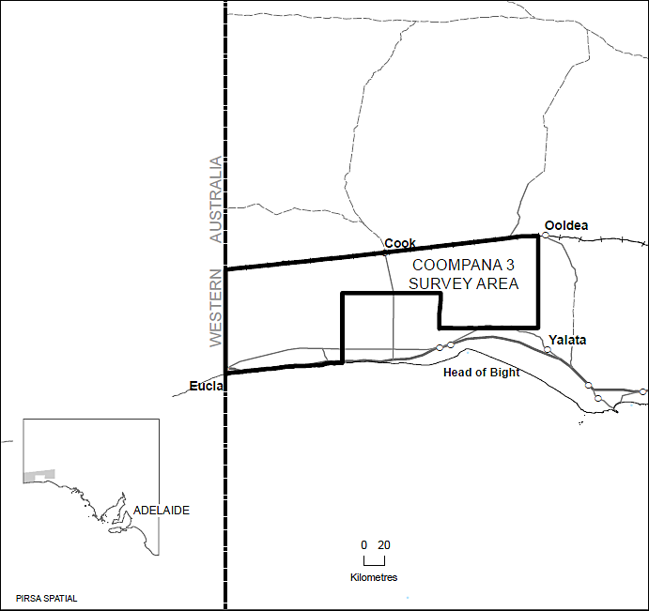
Area: 20 566 km² and includes Cook, Ooldea, Coompana and Nullarbor: 1:250 000 map sheets.

Dated 27 October 2016.
Reference: MER F2014/0000363 J. Martin, Mining Registrar

RULES OF COURT
Magistrates Court of South Australia
Amendment 15 to the Magistrates Court (Civil) Rules 2013
PURSUANT to Section 49 of the Magistrates Court Act 1991 and all other enabling powers, we, the undersigned, do hereby make the following amendments to the Magistrates Court (Civil) Rules 2013 as amended.
1. These Rules may be cited as the ‘Magistrates Court (Civil) Rules 2013 (Amendment 15)’.
2. The Magistrates Court (Civil) Rules 2013 (‘the Rules’) as amended by these amendments apply to and govern all actions commenced in the civil division of the Court on and after the date on which these amendments are gazetted.
3. Rule 120 (1) is deleted and replaced with the following:
(1) The fees payable in relation to an action or proceeding in the Court are the fees prescribed in the Magistrates Court (Fees) Regulations 2004, Sheriff’s Regulations 2005 and any other relevant Act or Regulations under which an action is commenced.
4. Rule 126 is repealed.
Dated 14 October 2016.
M. Hribal, Chief Magistrate
A. Cannon, Deputy Chief Magistrate
I. White, Magistrate
L. Duncan, Magistrate

TRAINING AND SKILLS DEVELOPMENT ACT 2008

Part 4—Apprenticeships/Traineeships

Pursuant to the provision of the Training and Skills Development Act 2008, the Training and Skills Commission (TaSC) gives notice that determines the following
Trades or Declared Vocations in addition to the gazette notices of:

- 25 September 2008 | - 23 October 2008 | - 13 November 2008 | - 4 December 2008
- 18 December 2008 | - 29 January 2009 | - 12 February 2009 | - 5 March 2009
- 12 March 2009 | - 26 March 2009 | - 30 April 2009 | - 18 June 2009
- 25 June 2009 | - 27 August 2009 | - 17 September 2009 | - 24 September 2009
- 9 October 2009 | - 22 October 2009 | - 3 December 2009 | - 17 December 2009
- 4 February 2010 | - 11 February 2010 | - 18 February 2010 | - 18 March 2010
- 8 April 2010 | - 6 May 2010 | - 20 May 2010 | - 3 June 2010
- 17 June 2010 | - 24 June 2010 | - 8 July 2010 | - 9 September 2010
- 23 September 2010 | - 4 November 2010 | - 25 November 2010 | - 16 December 2010
- 23 December 2010 | - 17 March 2011 | - 7 April 2011 | - 21 April 2011
- 19 May 2011 | - 30 June 2011 | - 21 July 2011 | - 8 September 2011
- 10 November 2011 | - 24 November 2011 | - 1 December 2011 | - 8 December 2011
- 16 December 2011 | - 22 December 2011 | - 5 January 2012 | - 19 January 2012
- 1 March 2012 | - 29 March 2012 | - 24 May 2012 | - 31 May 2012
- 7 June 2012 | - 14 June 2012 | - 21 June 2012 | - 28 June 2012
- 5 July 2012 | - 12 July 2012 | - 19 July 2012 | - 2 August 2012
- 9 August 2012 | - 30 August 2012 | - 13 September 2012 | - 4 October 2012
- 18 October 2012 | - 25 October 2012 | - 8 November 2012 | - 29 November 2012
- 13 December 2012 | - 25 January 2013 | - 14 February 2013 | - 21 February 2013
- 28 February 2013 | - 7 March 2013 | - 14 March 2013 | - 21 March 2013
- 28 March 2013 | - 26 April 2013 | - 23 May 2013 | - 30 May 2013
- 13 June 2013 | - 20 June 2013 | - 11 July 2013 | - 1 August 2013
- 8 August 2013 | - 15 August 2013 | - 29 August 2013 | - 6 February 2014
- 12 June 2014 | - 28 August 2014 | - 4 September 2014 | - 16 October 2014
- 23 October 2014  101. 27 May 2015  105. 30 June 2016  109. 27 October 2016 | - 5 February 2015  - 18 June 2015  106. 28 July 2016 | - 26 March 2015  - 3 December 2015  107. 8 September 2016 | - 16 April 2015  - 7 April 2016  - 22 September 2016

Trades or Declared Vocations and Required Qualifications and
Training Contract Conditions for the
Agriculture, Horticulture and Conservation and Land Management Training Package AHC

*Trade/ #Declared Vocation/ Other Occupation | Code | Title | Nominal Term of Training Contract | Probationary Period
Horticulture # | AHC30716 | Certificate III in Horticulture | 36 months | 90 days

Trades or Declared Vocations and Required Qualifications and
Training Contract Conditions for the
Australian Meat Processing Training Package AMP

*Trade/ #Declared Vocation/ Other Occupation | Code | Title | Nominal Term of Training Contract | Probationary Period
Meat Processor (Abattoirs) # | AMP20316 | Certificate II in Meat processing (Abattoirs) | 12 months | 60 days
Meat Processor (Boning Operations) # | AMP30116 | Certificate III in Meat Processing (Boning Room) | 24 months | 60 days
Meat Processor (Smallgoods) # | AMP20216 | Certificate II in Meat Processing (Smallgoods) | 12 months | 60 days
Meat Slicer # | AMP30216 | Certificate III in Meat Processing (Food Services) | 24 months | 60 days
Quality Assurance Monitor/Officer # | AMP30616 | Certificate III in Meat Processing (General) | 24 months | 60 days
Rendering Plant Operator # | AMP30416 | Certificate III in Meat Processing (Rendering) | 24 months | 60 days
Slaughter Floor Operator # | AMP30516 | Certificate III in Meat Processing (Slaughtering) | 24 months | 60 days
Smallgoods Maker * | AMP31016 | Certificate III in Meat Processing (Smallgoods - Manufacture) | 48 months | 90 days

Trades or Declared Vocations and Required Qualifications and
Training Contract Conditions for the
Automotive Retail, Service and Repair Training Package AUR
*Trade/ #Declared Vocation/ Other Occupation | Code | Title | Nominal Term of Training Contract | Probationary Period
Agricultural Mechanical Technician * | AUR30416 | Certificate III in Agricultural Mechanical Technology | 48 months | 90 days
Automotive Air Conditioning Serviceperson # | AUR20216 | Certificate II in Automotive Air Conditioning Technology | 12 months | 60 days
Automotive Braking System Specialist # | AUR21316 | Certificate II in Automotive Braking System Technology | 12 months | 60 days
Automotive Driveline and Transmission Specialist # | AUR21616 | Certificate II in Automotive Driveline System Technology | 12 months | 60 days
Automotive Electrical Component Installer # | AUR20416 | Certificate II in Automotive Electrical Technology | 12 months | 60 days
Automotive Electrician * | AUR30316 | Certificate III in Automotive Electrical Technology | 48 months | 90 days
Automotive Engine Cylinder Head Repair Specialist # | AUR21516 | Certificate II in Automotive Cylinder Head Reconditioning | 12 months | 60 days
Automotive Engine Reconditioner # | AUR31316 | Certificate III in Automotive Engine Reconditioning | 48 months | 90 days
Automotive Glazing Technician # | AUR32216 | Certificate III in Automotive Glazing Technology | 48 months | 90 days
Automotive Heavy Diesel Fuel Technician # | AUR31416 | Certificate III in Automotive Diesel Fuel Technology | 48 months | 90 days
Automotive Light and Heavy Vehicle Repair Technician # | AUR32016 | Certificate III in Alternative Fuel Technology | 48 months | 90 days
Automotive Radiator Repair Specialist * | AUR21416 | Certificate II in Automotive Cooling System Technology | 12 months | 60 days
Automotive Refinishing Technician # | AUR32416 | Certificate III in Automotive Refinishing Technology | 48 months | 90 days
Automotive Serviceperson * | AUR20516 | Certificate II in Automotive Servicing Technology | 12 months | 60 days
Automotive Tyre Fitter * | AUR21916 | Certificate II in Automotive Tyre Servicing Technology | 12 months | 60 days
Automotive Underbody Repair Technician/Mechanic # | AUR32516 | Certificate III in Automotive Underbody Technology | 48 months | 90 days
Automotive Vehicle Serviceperson (Underbody) * | AUR21216 | Certificate II in Automotive Underbody Technology | 12 months | 60 days
Bicycle Repair Technician # | AUR30216 | Certificate III in Bicycle Workshop Operations | 36 months | 90 days
Bicycle Service and Sales Assistant * | AUR20316 | Certificate II in Bicycle Mechanical Technology | 12 months | 60 days
Customer Servicing (Automotive Sales) * | AUR31016 | Certificate III in Automotive Sales | 36 months | 90 days
Diesel Engine Technician # | AUR31516 | Certificate III in Automotive Diesel Engine Technology | 48 months | 90 days
Drivetrain Repair Technician # | AUR31616 | Certificate III in Automotive Drivetrain Technology | 48 months | 90 days
Elevating Work Platform Technician # | AUR31916 | Certificate III in Elevating Work Platform Technology | 48 months | 90 days
Exhaust Fitter * | AUR21716 | Certificate II in Automotive Exhaust System Technology | 12 months | 60 days
Forklift Technician # | AUR31716 | Certificate III in Forklift Technology | 48 months | 90 days
Heavy Commercial Trailer Technician # | AUR31816 | Certificate III in Heavy Commercial Trailer Technology | 48 months | 90 days
Heavy Commercial Vehicle Technician # | AUR31116 | Certificate III in Heavy Commercial Vehicle Mechanical Technology | 48 months | 90 days
Light Vehicle Mechanical Technician # | AUR30616 | Certificate III in Light Vehicle Mechanical Technology | 48 months | 90 days
Marine Technician # | AUR30516 | Certificate III in Marine Mechanical Technology | 48 months | 90 days
Mobile Plant Technician # | AUR31216 | Certificate III in Mobile Plant Technology | 48 months | 90 days
Motorcycle Repair Technician # | AUR30816 | Certificate III in Motorcycle Mechanical Technology | 48 months | 90 days
Office Administrator – Vehicle Service Centre * | AUR30116 | Certificate III in Automotive Administration | 24 months | 60 days
Outdoor Power Equipment Mechanic # | AUR30716 | Certificate III in Outdoor Power Equipment Technology | 48 months | 90 days
Parts Interpreter # | AUR31016 | Certificate III in Automotive Sales | 36 months | 90 days
Service Station Attendant * | AUR21116 | Certificate II in Automotive Sales | 12 months | 60 days
Steering and Suspension System Specialist * | AUR21816 | Certificate II in Automotive Steering and Suspension System Technology | 12 months | 60 days
Vehicle Body Repair Assistant * | AUR20916 | Certificate II in Automotive Body Repair Technology | 12 months | 60 days
Vehicle Body Repair Technician # | AUR32116 | Certificate III in Automotive Body Repair Technology | 48 months | 90 days
Vehicle Trimming Technician # | AUR32316 | Certificate III in Automotive and Marine Trimming Technology | 48 months | 90 days

Trades or Declared Vocations and Required Qualifications and
Training Contract Conditions for the
Hair and Beauty Services Training Package SHB
*Trade/ #Declared Vocation/ Other Occupation | Code | Title | Nominal Term of Training Contract | Probationary Period
Hairdressing * | SHB30416 | Certificate III in Hairdressing | 42 months | 90 days

Trades or Declared Vocations and Required Qualifications and
Training Contract Conditions for the
Property Services Training Package CPP

*Trade/ #Declared Vocation/ Other Occupation | Code | Title | Nominal Term of Training Contract | Probationary Period
Asset Maintenance * | CPP30115 | Certificate III in Urban Pest Management | 24 months | 60 days
Asset Maintenance * | CPP30316 | Certificate III in Cleaning Operations | 12 months | 60 days
Asset Maintenance * | CPP40416 | Certificate IV in Cleaning Management | 24 months | 60 days
Cartographer * | CPP50216 | Diploma of Spatial Information Services | 36 months | 90 days
GIS Assistant * | CPP40316 | Certificate IV in Spatial Information Services | 36 months | 90 days
GIS Officer * | CPP50216 | Diploma of Spatial Information Services | 36 months | 90 days
Mapping Officer * | CPP50216 | Diploma of Spatial Information Services | 36 months | 90 days
Spatial Information * | CPP30216 | Certificate III in Surveying and Spatial Information Services | 18 months | 60 days
Survey Technician * | CPP50116 | Diploma of Surveying | 48 months | 90 days
Surveyor’s Assistant * | CPP40216 | Certificate IV in Surveying | 24 months | 60 days
Technical Officer in the Spatial Information Industry * | CPP40316 | Certificate IV in Spatial Information Services | 36 months | 90 days
Technician / Surveyor * | CPP50216 | Diploma of Spatial Information Services | 36 months | 90 days
Town Planner’s Assistant * | CPP40316 | Certificate IV in Spatial Information Services | 36 months | 90 days
Town Planning Officer / Assistant * | CPP50216 | Diploma of Spatial Information Services | 36 months | 90 days

Trades or Declared Vocations and Required Qualifications and
Training Contract Conditions for the
Retail Services Training Package SIR
*Trade/ #Declared Vocation/ Other Occupation | Code | Title | Nominal Term of Training Contract | Probationary Period
Customer Service Provider (General Retail) # | SIR20216 | Certificate II in Retail Services | 12 months | 60 days
Customer Service Provider (General Retail) # | SIR30216 | Certificate III in Retail | 12 months | 60 days
Retail Executive (General Retail) # | SIR50116 | Diploma of Retail Leadership | 24 months | 60 days
Retail Manager (General Retail) # | SIR40316 | Certificate IV in Retail Management | 24 months | 60 days
Wholesale Service Provider (General Retail) # | SIR30316 | Certificate III in Business to Business Sales | 24 months | 60 days

South Australia
Public Sector (Reorganisation of Public Sector
Operations) Notice 2016
under section 9(1) of the Public Sector Act 2009
1—Short title
This notice may be cited as the Public Sector (Reorganisation of Public Sector Operations) Notice 2016.
2—Commencement
This notice will come into operation on 1 November 2016.
3—Transfer of employees
The employees of the Department for Education and Child Development specified in Schedule 1 are transferred to the Department for Child Protection on the same basis of engagement as applied before the transfer.
Schedule 1—Employees being transferred

1—Employees of the Office for Corporate Services
The following employees of the Office for Corporate Services:
Susan Adey
Frank Beddison
Anna Bui
Vansu Bui
Tim Burton
Thomas Carney
Kristy Carter
Nhan Chau
Sophie-Ann Christian
Carla Corbitt
Tina Crawford
Jenny Dale
David Dawkins
Tanya Dayman
Andrew Ditty
Simone Donker
Sherylee Donnon
Luisa Girolamo
Frank Guidace
Adrian Grivell
Fotini Hatzinikolaou
Terry Hollands
Tony Horan
Liya Huang
Joshua Hunt
Peter Jeffrey
Katherine Johnson
May Mae Khoo
Alexandra Krack
Harshad Lalwani
Jack Last
Don Leong
Kane Li
Steve Martens
Ana Martic
Laura McCurdy
David McGowan
Kim McLean
Ben Menz
Christopher Morgan
Kylie Myers
Sally Neihuus
Juanita Paestner
Despina Parente
Terence Parkhurst
Maria Piantadosi
Philip Portella
Stephen Raftery
Ian Slade
Linda Smith
Shwetha Srinivas
Ben Stock
Patricia Stoddart
Jenny Suter
Yve-Berlin Taylor
Mark Thiele
Helen Thompson
Minh Truong
Suzie Vari
Lakshmi Veerapandian
Nhung Vo
Raymond Warren
Hugh Wells
Kerstin Wojciechowski
Stephanie Wu
Gerald Yates
2—Employees of the Office for Strategy and Performance
The following employees of the Office for Strategy and Performance:
Esther Daniel
Amanda West
3—Employees of the Office of the Minister for Education and Child Development
The following employees of the Office of the Minister for Education and Child Development:
Caitlin Gant
Rachael Grauwelman-Smith
James Rosser
Ann-Marie Staniford
4—Employees of the Office for Child Protection
All employees of the Office for Child Protection with the exception of the following employees:
Lucas Abbott
Caitlin Anear
Edward August
Mechell August
Paul Banytis
Necia Billinghurst
Alex Buckley
Rosemary Byron-Scott
Kouv Chang
Sally Chapman
Amanda Clarke
Melissa Clarke
Benjamin Coll
Kendall Crowe
Wendy Dale
Isabella Daziani
Malcolm Downes
Rachel Ephraums
Jodie Evans
Alan Fairley
Justine Hall
Tania Harrap
David Harrington
Kerry Harte
Michelle Hopkins
Glenn Kerrigan
Christina Loprete
Belinda Lorek
Janis Luks
Ilona MacDonald
Magdelena Madden
Lauren Maksimovic
Susan Marks
Chris McEwen
Tony Minniecon
John Munro
Ruth Naughton
Nicole Pilkington
Myles Preiss
Donald Reynolds
Nicos Rodosthenous
Anthony Satanek
Matthew Schulz
Amanda Shaw
Una Sibly
Simon Van Niekerks
Melanie Vennix
Sharyn Watts
Made by the Premier
on 22 October 2016
DPC16/091CS

South Australia
Statutes Amendment (Commonwealth Registered Entities) Act (Commencement) Proclamation 2016
1—Short title
This proclamation may be cited as the Statutes Amendment (Commonwealth Registered Entities) Act (Commencement) Proclamation 2016.
2—Commencement of Act
(1) Subject to subclause (2), the Statutes Amendment (Commonwealth Registered Entities) Act 2016 (No 24 of 2016) (the Act) will come into operation on 1 December 2016.
(2) Part 2 of the Act will come into operation on 1 January 2017.
Made by the Governor
with the advice and consent of the Executive Council
on 27 October 2016
CBS0021/16CS

South Australia
Summary Offences (Filming and Sexting Offences) Amendment Act (Commencement) Proclamation 2016
1—Short title
This proclamation may be cited as the Summary Offences (Filming and Sexting Offences) Amendment Act (Commencement) Proclamation 2016.
2—Commencement of Act
The Summary Offences (Filming and Sexting Offences) Amendment Act 2016 (No 39 of 2016) will come into operation on 28 October 2016.
Made by the Governor
with the advice and consent of the Executive Council
on 27 October 2016
AGO0169/15CS

South Australia
Administrative Arrangements (Interpretative Provisions) Proclamation 2016
under section 8 of the Administrative Arrangements Act 1994
1—Short title
This proclamation may be cited as the Administrative Arrangements (Interpretative Provisions) Proclamation 2016.
2—Commencement
This proclamation will come into operation on 1 November 2016.
3—Interpretative provisions
(1) A reference to the "Chief Executive" in the Adoption Act 1988 will have effect as if it were a reference to the Chief Executive of the Department for Child Protection.
(2) A reference to the "Department" in the Family and Community Services Act 1972 will have effect as if it were a reference to the Department for Child Protection.
(3) A reference to the "Department" in regulation 5 of the Children's Protection Regulations 2010 will have effect as if it were a reference to the Department for Child Protection.
(4) A reference to the "Chief Executive" in an order or document made or prepared for the purposes of Part 4 or 5 of the Children's Protection Act 1993 before the effective date and still in force on the effective date will have effect as if it were a reference to the Chief Executive of the Department for Child Protection.
(5) A reference to the "Department for Education and Child Development" in the instrument of delegation signed by the Commonwealth Minister for Immigration and Border Protection under the Immigration (Guardianship of Children) Act 1946 will have effect as if it were a reference to the Department for Child Protection.
(6) In this clause—
effective date means the date on which this proclamation comes into operation.
Made by the Governor
with the advice and consent of the Executive Council
on 27 October 2016
DPC16/091CS

South Australia
Public Sector (Department for Child Protection) Proclamation 2016
under sections 26 and 28 of the Public Sector Act 2009
1—Short title
This proclamation may be cited as the Public Sector (Department for Child Protection) Proclamation 2016.
2—Commencement
This proclamation will come into operation on 1 November 2016.
3—Establishment of administrative unit and designation of responsible Minister
(1) A department is established and assigned the title Department for Child Protection.
(2) The Minister for Education and Child Development is designated as the Department's Minister with responsibility for the Department.
Made by the Governor
with the advice and consent of the Executive Council
on 27 October 2016
DPC16/091CS

South Australia
National Parks and Wildlife (Adelaide International Bird Sanctuary National Park—Winaityinaityi Pangkara—Mining Rights) Proclamation 2016
under section 43 of the National Parks and Wildlife Act 1972

Preamble
1 The Crown land described in Schedule 1 is, by another proclamation made on this day, constituted as a national park under section 28(1) of the National Parks and Wildlife Act 1972 and assigned the name Adelaide International Bird Sanctuary National Park—Winaityinaityi Pangkara.
2 It is intended that, by this proclamation, certain existing and future rights of entry, prospecting, exploration or mining be preserved in relation to that land.

1—Short title
This proclamation may be cited as the National Parks and Wildlife (Adelaide International Bird Sanctuary National Park—Winaityinaityi Pangkara—Mining Rights) Proclamation 2016.
2—Commencement
This proclamation comes into operation on the day on which it is made.
3—Interpretation
In this proclamation—
Environment Minister means the Minister for the time being administering the National Parks and Wildlife Act 1972;
Mining Minister means the Minister for the time being administering the Mining Act 1971 or the Minister for the time being administering the Petroleum and Geothermal Energy Act 2000, as the case requires.
4—Existing rights to continue
Subject to clause 6, existing rights of entry, prospecting, exploration or mining under the Mining Act 1971 or the Petroleum and Geothermal Energy Act 2000 may continue to be exercised in respect of the land described in Schedule 1.

5—New rights may be acquired
Rights of entry, prospecting, exploration or mining may, with the approval of the Mining Minister and the Environment Minister, be acquired pursuant to the Mining Act 1971 or the Petroleum and Geothermal Energy Act 2000 in respect of the land described in Schedule 1 and may, subject to clause 6, be exercised in respect of that land.
6—Conditions for exercise of rights
A person in whom rights of entry, prospecting, exploration or mining are vested pursuant to the Mining Act 1971 or the Petroleum and Geothermal Energy Act 2000 (whether those rights were acquired before or after the making of this proclamation) must not exercise those rights in respect of the land described in Schedule 1 unless the person complies with the following conditions:
(a) if work to be carried out in relation to the land in the exercise of those rights is a regulated activity within the meaning of the Petroleum and Geothermal Energy Act 2000, the person must ensure that—
(i) the work is not carried out until a statement of environmental objectives in relation to the activity that has been approved under that Act has also been approved by the Environment Minister; and
(ii) the work is carried out in accordance with the statement as so approved;
(b) if work to be carried out in relation to the land in the exercise of rights under the Mining Act 1971 or the Petroleum and Geothermal Energy Act 2000 has not previously been authorised (whether by inclusion in an approved statement of environmental objectives referred to in paragraph (a) or otherwise), the person must give at least 3 months notice of the proposed work to the Mining Minister and the Environment Minister and supply each Minister with such information relating to the proposed work as the Minister may require;
(c) if directions are agreed between the Mining Minister and the Environment Minister and given to the person in writing in relation to—
(i) carrying out work in relation to the land in a manner that minimises damage to the land (including the land's vegetation and wildlife) and the environment generally; or
(ii) preserving objects, structures or sites of historical, scientific or cultural interest; or
(iii) rehabilitating the land (including the land's vegetation and wildlife) on completion of the work; or
(iv) (where the work is being carried out in the exercise of rights acquired after the making of this proclamation) prohibiting or restricting access to any specified area of the land that the Ministers believe would suffer significant detriment as a result of carrying out the work,

(being directions that do not reduce or otherwise detract from any requirement in respect of any of those matters contained in an approved statement of environmental objectives referred to in paragraph (a)), the person must comply with those directions in carrying out the work;
(d) if a plan of management is in operation under section 38 of the National Parks and Wildlife Act 1972 in respect of the land, the person must have regard to the provisions of the plan of management;
(e) in addition to complying with the other requirements of this proclamation, the person—
(i) must take such steps as are reasonably necessary to ensure that objects, structures and sites of historical, scientific or cultural interest and the land's vegetation and wildlife are not unduly affected by any work; and
(ii) must maintain all work areas in a clean and tidy condition; and
(iii) must, on the completion of any work, obliterate or remove all installations and structures (other than installations and structures designated by the Mining Minister and the Environment Minister as suitable for retention) used exclusively for the purposes of that work;
(f) if no direction has been given by the Mining Minister and the Environment Minister under paragraph (c)(iii), the person must (in addition to complying with any approved statement of environmental objectives referred to in paragraph (a)) rehabilitate the land (including its vegetation and wildlife) on completion of any work to the satisfaction of the Environment Minister.
7—Governor may give approvals, directions
If—
(a) the Mining Minister and the Environment Minister cannot agree as to whether—
(i) approval should be granted or refused under clause 5; or
(ii) a direction should be given under clause 6(c); or
(b) the Environment Minister does not approve a statement of environmental objectives under clause 6(a),
the Governor may, with the advice and consent of the Executive Council—
(c) grant or refuse the necessary approval under clause 5; or
(d) give a direction in writing under clause 6(c); or
(e) grant or refuse the necessary approval under clause 6(a).
Schedule 1—Description of land
Allotments 249, 250 and 251 in Deposited Plan 29513, Hundred of Dublin, County of Gawler;
Sections 399, 429, 433, 437, 440, 441, 442, 443, 444, 445E, 510 and 515, Hundred of Dublin, County of Gawler;
Sections 147, 179 and 823, Hundred of Port Gawler, County of Gawler.
Made by the Governor
with the advice and consent of the Executive Council
on 27 October 2016
16MSECCS045

South Australia
National Parks and Wildlife (Adelaide International Bird Sanctuary National Park—Winaityinaityi Pangkara) Proclamation 2016
under section 28(1) of the National Parks and Wildlife Act 1972
1—Short title
This proclamation may be cited as the National Parks and Wildlife (Adelaide International Bird Sanctuary National Park—Winaityinaityi Pangkara) Proclamation 2016.
2—Commencement
This proclamation comes into operation on the day on which it is made.
3—Constitution of Adelaide International Bird Sanctuary National Park—Winaityinaityi Pangkara
The following Crown land is constituted as a national park and assigned the name Adelaide International Bird Sanctuary National Park—Winaityinaityi Pangkara:
Allotments 249, 250 and 251 in Deposited Plan 29513, Hundred of Dublin, County of Gawler;
Sections 399, 429, 433, 437, 440, 441, 442, 443, 444, 445E, 510 and 515, Hundred of Dublin, County of Gawler;
Sections 147, 179 and 823, Hundred of Port Gawler, County of Gawler.
Made by the Governor
being of the opinion that the Crown land described in clause 3 is of national significance by reason of the wildlife and natural features of the land and with the advice and consent of the Executive Council
on 27 October 2016
16MSECCS045

South Australia
Hairdressers Regulations 2016
under the Hairdressers Act 1988

Contents
1 Short title
2 Commencement
3 Interpretation
4 Prescribed qualifications
Schedule 1—Revocation of Hairdressers Regulations 2003

1—Short title
These regulations may be cited as the Hairdressers Regulations 2016.
2—Commencement
These regulations come into operation on the day on which they are made.
3—Interpretation
In these regulations—
Act means the Hairdressers Act 1988;
AISC means the Australian Industry and Skills Committee established by the COAG Industry and Skills Council;
COAG Industry and Skills Council means the Industry and Skills Council established by the Council of Australian Governments;
revoked regulations means the Hairdressers Regulations 2003.
4—Prescribed qualifications
For the purposes of paragraph (b) of the definition of prescribed qualifications in section 4 of the Act, the following are declared to be prescribed qualifications:
(a) Certificate III in Hairdressing (SHB30416) from the SHB Hairdressing and Beauty Services Training Package endorsed by AISC on 21 March 2016; or
(b) Certificate III in Barbering (SHB30516) from the SHB Hairdressing and Beauty Services Training Package endorsed by AISC on 21 March 2016; or
(c) in the case of a person who, immediately before the commencement of these regulations, had qualifications declared by the revoked regulations to be prescribed qualifications—those qualifications; or
(d) in the case of a person who, immediately before the commencement of these regulations, had commenced some but not yet completed all of the units of competency referred to in regulation 4(a) of the revoked regulations—a certificate evidencing the successful completion of the units of competency referred to in that regulation awarded after the commencement of these regulations.
Schedule 1—Revocation of Hairdressers Regulations 2003
The Hairdressers Regulations 2003 are revoked.
Note—
As required by section 10AA(2) of the Subordinate Legislation Act 1978, the Minister has certified that, in the Minister's opinion, it is necessary or appropriate that these regulations come into operation as set out in these regulations.
Made by the Governor
with the advice and consent of the Executive Council
on 27 October 2016
No 250 of 2016
CBS0014/16CS

South Australia
Major Events (Santos Tour Down Under 2017) Regulations 2016
under the Major Events Act 2013

Contents
1 Short title
2 Commencement
3 Interpretation
4 Major event
5 Event organiser
6 Major event period
7 Major event venue
8 Controlled areas
9 Application of Part 3 of Act
10 Advertising controlled airspace
11 Expiry of regulations
Schedule 1—Descriptions relating to major event venues, controlled areas and advertising controlled airspace
1 Description of Adelaide City Council Tour Village
2 Description of official race route for People's Choice Classic Stage (Adelaide)
3 Description of official race route for Stage 1 (Unley to Lyndoch)
4 Description of controlled area for Santos Women's Tour Stage 4 (Victoria Park/Pakapakanthi)
5 Description of official race route for Stage 2 (Stirling to Paracombe)
6 Description of official race route for Stage 3 (Glenelg to Victor Harbor)
7 Description of official race route for Stage 4 (Norwood to Campbelltown)
8 Description of official race route for Stage 5 (McLaren Vale to Willunga Hill)
9 Description of official race route for Stage 6 (Adelaide)
Schedule 2—Maps of controlled areas

1—Short title
These regulations may be cited as the Major Events (Santos Tour Down Under 2017) Regulations 2016.
2—Commencement
These regulations come into operation on the day on which they are made.
3—Interpretation
In these regulations, unless the contrary intention appears—
Act means the Major Events Act 2013;
controlled area—see regulation 8;
event organiser—see regulation 5;
major event—see regulation 4;
major event period—see regulation 6.
4—Major event
The Santos Tour Down Under 2017, including any event authorised by the event organiser as being officially associated with the Santos Tour Down Under 2017, is declared to be a major event.
5—Event organiser
The South Australian Tourism Commission is designated as the event organiser for the major event.
6—Major event period
The major event period for which the major event is in force is the period commencing on 14 January 2017 and ending on 22 January 2017.
7—Major event venue
The major event venue for the purposes of the major event is declared to be—
(a) for the duration of the major event period—
(i) the following areas in connection with the Adelaide City Council Tour Village:
(A) the area comprising the Adelaide City Council Tour Village (described in Schedule 1 clause 1);
(B) any public place or part of a public place that is within 50 metres of the boundary of that area; and
(ii) the media centre and other communications facilities for the media for the major event; and
(iii) all physical infrastructure associated with the major event; and
(b) on 15 January 2017—
(i) the portion of road described in Schedule 1 clause 2 comprising the official race route for the People's Choice Classic Stage (Adelaide); and
(ii) any public place or part of a public place that is within 50 metres of the boundary of that portion of road; and
(c) on 17 January 2017—
(i) the following areas in connection with Stage 1 (Unley to Lyndoch):
(A) the portion of road described in Schedule 1 clause 3 comprising the official race route for Stage 1 (Unley to Lyndoch);
(B) any public place or part of a public place that is within 50 metres of the boundary of that portion of road; and
(ii) the following areas in connection with the Santos Women's Tour Stage 4 (Victoria Park/Pakapakanthi):
(A) the racing circuit known as Victoria Park Criterium Circuit (as shown on the map of Santos Women's Tour Stage 4 (Victoria Park/Pakapakanthi) Controlled Area in Schedule 2) comprising the official race route for the Santos Women's Tour Stage 4 (in Victoria Park/Pakapakanthi);
(B) any public place or part of a public place that is within 50 metres of the outer boundary of that racing circuit; and
(d) on 18 January 2017—
(i) the portion of road described in Schedule 1 clause 5 comprising the official race route for Stage 2 (Stirling to Paracombe); and
(ii) any public place or part of a public place that is within 50 metres of the boundary of that portion of road; and
(e) on 19 January 2017—
(i) the portion of road described in Schedule 1 clause 6 comprising the official race route for Stage 3 (Glenelg to Victor Harbor); and
(ii) any public place or part of a public place that is within 50 metres of the boundary of that portion of road; and
(f) on 20 January 2017—
(i) the portion of road described in Schedule 1 clause 7 comprising the official race route for Stage 4 (Norwood to Campbelltown); and
(ii) any public place or part of a public place that is within 50 metres of the boundary of that portion of road; and
(g) on 21 January 2017—
(i) the portion of road described in Schedule 1 clause 8 comprising the official race route for Stage 5 (McLaren Vale to Willunga Hill); and
(ii) any public place or part of a public place that is within 50 metres of the boundary of that portion of road; and
(h) on 22 January 2017—
(i) the portion of road described in Schedule 1 clause 9 comprising the official race route for Stage 6 (Adelaide); and
(ii) any public place or part of a public place that is within 50 metres of the boundary of that portion of road.
8—Controlled areas
The controlled areas for the major event are declared to be—
(a) for the duration of the major event period—
(i) the area comprising the Adelaide City Council Tour Village (described in Schedule 1 clause 1); and
(ii) the 250 metre buffer zone (comprising any public place or part of a public place that is within 250 metres from the boundary of the area referred to in subparagraph (i)),
as shown on the map in Schedule 2 titled "Adelaide City Council Tour Village Controlled Area"; and
(b) on 15 January 2017—
(i) the portion of road comprising the official race route for the People's Choice Classic Stage (Adelaide) (described in Schedule 1 clause 2); and
(ii) the 250 metre buffer zone (comprising any public place or part of a public place that is within 250 metres from the boundary of the road referred to in subparagraph (i)),
as shown on the map in Schedule 2 titled "People's Choice Classic Stage (Adelaide) Controlled Area"; and
(c) on 17 January 2017—
(i) the following areas in connection with Stage 1 (Unley to Lyndoch) (as shown on the map in Schedule 2 titled "Stage 1 (Unley to Lyndoch) Controlled Area"):
(A) the portion of road described in Schedule 1 clause 3 comprising the official race route for Stage 1 (Unley to Lyndoch);
(B) the 250 metre buffer zone (comprising any public place or part of a public place that is within 250 metres from the boundary of the road referred to in subsubparagraph (A)); and
(ii) the following area in connection with the Santos Women's Tour Stage 4 (Victoria Park/Pakapakanthi) (as shown on the map in Schedule 2 titled "Santos Women's Tour Stage 4 (Victoria Park/Pakapakanthi) Controlled Area"):
(A) the area of Victoria Park/Pakapakanthi described in Schedule 1 clause 4;
(B) the 250 metre buffer zone (comprising any public place or part of a public place that is within 250 metres from the boundary of the area referred to in subsubparagraph (A); and
(d) on 18 January 2017—
(i) the portion of road comprising the official race route for Stage 2 (Stirling to Paracombe) (described in Schedule 1 clause 5); and
(ii) the 250 metre buffer zone (comprising any public place or part of a public place that is within 250 metres from the boundary of the road referred to in subparagraph (i)),
as shown on the map in Schedule 2 titled "Stage 2 (Stirling to Paracombe) Controlled Area"; and
(e) on 19 January 2017—
(i) the portion of road comprising the official race route for Stage 3 (Glenelg to Victor Harbor) (described in Schedule 1 clause 6); and
(ii) the 250 metre buffer zone (comprising any public place or part of a public place that is within 250 metres from the boundary of the road referred to in subparagraph (i)),
as shown on the map in Schedule 2 titled "Stage 3 (Glenelg to Victor Harbor) Controlled Area"; and
(f) on 20 January 2017—
(i) the portion of road comprising the official race route for Stage 4 (Norwood to Campbelltown) (described in Schedule 1 clause 7); and
(ii) the 250 metre buffer zone (comprising any public place or part of a public place that is within 250 metres from the boundary of the road referred to in subparagraph (i)),
as shown on the map in Schedule 2 titled "Stage 4 (Norwood to Campbelltown) Controlled Area"; and
(g) on 21 January 2017—
(i) the portion of road comprising the official race route for Stage 5 (McLaren Vale to Willunga Hill) (described in Schedule 1 clause 8); and
(ii) the 250 metre buffer zone (comprising any public place or part of a public place that is within 250 metres from the boundary of the road referred to in subparagraph (i)),
as shown on the map in Schedule 2 titled "Stage 5 (McLaren Vale to Willunga Hill) Controlled Area"; and
(h) on 22 January 2017—
(i) the portion of road comprising the official race route for Stage 6 (Adelaide) (described in Schedule 1 clause 9); and
(ii) the 250 metre buffer zone (comprising any public place or part of a public place that is within 250 metres from the boundary of the road referred to in subparagraph (i)),
as shown on the map in Schedule 2 titled "Stage 6 (Adelaide) Controlled Area".
9—Application of Part 3 of Act
The following provisions of Part 3 of the Act are declared to apply to the major event:
(a) sections 10 to 13 inclusive;
(b) Part 3 Division 4.
10—Advertising controlled airspace
For the purposes of section 7(3)(e) of the Act, the prescribed period for which airspace is declared to be advertising controlled airspace is—
(a) the duration of the major event period in respect of—
(i) the following areas in connection with the Adelaide City Council Tour Village:
(A) the area described in Schedule 1 clause 1 comprising the Adelaide City Council Tour Village;
(B) any public place or part of a public place that is within 50 metres of the boundary of that area; and
(ii) the media centre and other communications facilities for the media for the major event; and
(iii) all physical infrastructure associated with the major event; and
(b) 15 January 2017 in respect of—
(i) the portion of road described in Schedule 1 clause 2 comprising the official race route for the People's Choice Classic Stage (Adelaide); and
(ii) any public place or part of a public place that is within 50 metres of the boundary of that portion of road; and
(c) 17 January 2017 in respect of—
(i) the following areas in connection with Stage 1 (Unley to Lyndoch):
(A) the portion of road described in Schedule 1 clause 3 comprising the official race route for Stage 1 (Unley to Lyndoch);
(B) any public place or part of a public place that is within 50 metres of the boundary of that portion of road; and
(ii) the following areas in connection with the Santos Women's Tour Stage 4 (Victoria Park/Pakapakanthi):
(A) the racing circuit known as Victoria Park Criterium Circuit (as shown on the map of Santos Women's Tour Stage 4 (Victoria Park/Pakapakanthi) Controlled Area in Schedule 2) comprising the official race route for the Santos Women's Tour Stage 4 (in Victoria Park/Pakapakanthi);
(B) any public place or part of a public place that is within 50 metres of the outer boundary of that racing circuit; and
(d) 18 January 2017 in respect of—
(i) the portion of road described in Schedule 1 clause 5 comprising the official race route for Stage 2 (Stirling to Paracombe); and
(ii) any public place or part of a public place that is within 50 metres of the boundary of that portion of road; and
(e) 19 January 2017 in respect of—
(i) the portion of road described in Schedule 1 clause 6 comprising the official race route for Stage 3 (Glenelg to Victor Harbor); and
(ii) any public place or part of a public place that is within 50 metres of the boundary of that portion of road; and
(f) 20 January 2017 in respect of—
(i) the portion of road described in Schedule 1 clause 7 comprising the official race route for Stage 4 (Norwood to Campbelltown); and
(ii) any public place or part of a public place that is within 50 metres of the boundary of that portion of road; and
(g) 21 January 2017 in respect of—
(i) the portion of road described in Schedule 1 clause 8 comprising the official race route for Stage 5 (McLaren Vale to Willunga Hill); and
(ii) any public place or part of a public place that is within 50 metres of the boundary of that portion of road; and
(h) 22 January 2017 in respect of—
(i) the portion of road described in Schedule 1 clause 9 comprising the official race route for Stage 6 (Adelaide); and
(ii) any public place or part of a public place that is within 50 metres of the boundary of that portion of road.
11—Expiry of regulations
These regulations will expire on 27 February 2017.
Schedule 1—Descriptions relating to major event venues, controlled areas and advertising controlled airspace
1—Description of Adelaide City Council Tour Village
The Adelaide City Council Tour Village comprises the area in Adelaide known as Victoria Square/Tarntanyangga bounded as follows: commencing at the point at which the southern boundary of Franklin Street/Flinders Street intersects with the eastern boundary of the portion of road (running generally north-easterly to south-westerly) known as Victoria Square, then south-westerly and southerly along that boundary, then in a straight line by the shortest route across Grote Street to the point at which the southern boundary of Grote Street intersects with the eastern boundary of the portion of road (running generally north-westerly to south-easterly) known as Victoria Square, then southerly and south-easterly along that boundary to its intersection with the northern boundary of Gouger Street/Angas Street, then easterly along that boundary to its intersection with the western boundary of the portion of road (running generally north-easterly to south-westerly) known as Victoria Square, then north-easterly and northerly along that boundary, then in a straight line by the shortest route across Wakefield Street to the point at which the northern boundary of Wakefield Street intersects with the western boundary of the portion of road (running generally north-westerly to south-easterly) known as Victoria Square, then northerly and north-westerly along that boundary to its intersection with the southern boundary of Franklin Street/Flinders Street, then westerly along that boundary to the point of commencement.
2—Description of official race route for People's Choice Classic Stage (Adelaide)
The official race route for the People's Choice Classic Stage (Adelaide) comprises the portion of road commencing in Adelaide at the intersection of Hutt Street and Wakefield Street, then easterly along Wakefield Street to its intersection with East Terrace then easterly along East Terrace to its intersection with Wakefield Road then easterly along Wakefield Road to its intersection with Dequetteville Terrace, then north-westerly along Dequetteville Terrace to its intersection with Bartels Road, then westerly along Bartels Road to its intersection with East Terrace then westerly along East Terrace to its intersection with Hutt Street then southerly along Hutt Street to the point of commencement.
3—Description of official race route for Stage 1 (Unley to Lyndoch)
The official race route for Stage 1 (Unley to Lyndoch) comprises the portion of road commencing at the intersection of Mitchell Street and King William Road in Hyde Park, then northerly along King William Road to its intersection with Peacock Road, then northerly along Peacock Road to its intersection with King William Street, then northerly along King William Street to its intersection with the western portion of the road known as Victoria Square, then generally northerly along Victoria Square to its intersection with King William Street, then northerly along King William Street to its intersection with King William Road, then generally northerly along King William Road to its intersection with O’Connell Street, then north-westerly along O’Connell Street to its intersection with Prospect Road, then generally northerly along Prospect Road to its intersection with Regency Road, then westerly along Regency Road to its intersection with South Road, then generally north-westerly along South Road to its intersection with the North South Motorway, then generally north-westerly along the North South Motorway to its intersection with the Wingfield Ramp to Salisbury, then north-easterly and south-easterly along the Wingfield Ramp to Salisbury to its intersection with Salisbury Highway, then generally easterly and north-easterly along Salisbury Highway to its intersection with Elder Smith Road, then south-easterly along Elder Smith Road to its intersection with Main North Road, then north-easterly along Main North Road to its intersection with Black Top Road, then generally north-easterly and easterly along Black Top Road to its intersection with One Tree Hill Road, then north-easterly along One Tree Hill Road to its intersection with Kersbrook Road, then generally south-easterly along Kersbrook Road to its intersection with Scott Street in Kersbrook, then north-easterly along Scott Street until it becomes South Para Road, then generally north-easterly and northerly along South Para Road until it becomes Victoria Terrace in Williamstown, then generally north-easterly along Victoria Terrace to its intersection with Queen Street, then north-westerly along Queen Street until it becomes Lyndoch Valley Road, then generally northerly along Lyndoch Valley Road to its intersection with Barossa Valley Way, then north-westerly, westerly and south-westerly along Barossa Valley Way to its intersection with Williamstown Road, then generally southerly and south-easterly along Williamstown Road to its intersection with Yettie Road, then generally south-easterly and southerly along Yettie Road to its intersection with Queen Street in Williamstown, then south-easterly along Queen Street to its intersection with George Street, then south-westerly along George Street to its intersection with Victoria Terrace.
4—Description of controlled area for Santos Women's Tour Stage 4 (Victoria Park/Pakapakanthi)
(1) The controlled area for Santos Women's Tour Stage 4 (Victoria Park/Pakapakanthi) comprises the area of parklands in Adelaide known as Victoria Park/Pakapakanthi bounded by roads as follows: commencing at the intersection of Greenhill Road and Fullarton Road, then northerly along Fullarton Road to its intersection with Britannia roundabout, then north-westerly around Britannia roundabout to its intersection with Wakefield Road, then westerly along Wakefield Road to its intersection with East Terrace, then southerly and easterly along East Terrace to its intersection with the northern portion of Beaumont Road, then generally southerly along the northern portion of Beaumont Road to its intersection with the walkway/cycleway then generally south-easterly along the walkway/cycleway to its intersection with the southern portion of Beaumont Road, then generally southerly along the southern portion of Beaumont Road to its intersection with Greenhill Road, then easterly to the place of commencement.
(2) In this clause, a reference to a particular road is a reference to the boundary of that road that is furthermost from the Victoria Park Criterium Circuit (as shown on the map of Santos Women's Tour Stage 4 (Victoria Park/Pakapakanthi) Controlled Area in Schedule 2).
5—Description of official race route for Stage 2 (Stirling to Paracombe)
The official race route for Stage 2 (Stirling to Paracombe) comprises the portion of road commencing at the intersection of Mount Barker Road and Avenue Road in Stirling, then generally south-westerly along Avenue Road until it becomes Longwood Road, then generally southerly, south-easterly and south-westerly along Longwood Road to its intersection with Bradbury Road, then north-easterly along Bradbury Road to its intersection with Cross Street in Mylor, then easterly along Cross Street to its intersection with Strathalbyn Road, then generally north-easterly, westerly, and north-westerly along Strathalbyn Road to its intersection with Mount Barker Road at the roundabout in Aldgate, then generally north-westerly along Mount Barker Road to its intersection with Pomona Road, then north-easterly along Pomona Road to its intersection with Gould Road, then north-easterly along Gould Road to its intersection with Old Mount Barker Road, then generally north-westerly along Old Mount Barker Road to its intersection with Piccadilly Road, then generally north-easterly along Piccadilly Road to its intersection with Swamp Road, then generally easterly and northerly along Swamp Road to its intersection with Kidney Street in Uraidla, then easterly along Kidney Street to its intersection with Days Road, then northerly along Days Road to its intersection with Greenhill Road, then generally northerly, north-westerly, south-westerly and westerly along Greenhill Road to its intersection with Tregarthen Road, then northerly along Tregarthen Road to its intersection with Woods Hill Road, then generally north-easterly and northerly along Woods Hill Road to its intersection with Lobethal Road, then generally north-westerly along Lobethal Road to its intersection with Norton Summit Road, then generally north-westerly along Norton Summit Road to its intersection with Glen Stuart Road, then northerly along Glen Stuart Road to its intersection with Morialta Road, then easterly along Morialta Road to its intersection with Stradbroke Road, then generally northerly along Stradbroke Road to its intersection with Montacute Road, then easterly along Montacute Road to its intersection with Maryvale Road, then northerly along Maryvale Road to its intersection with Gorge Road, then generally north-easterly and easterly along Gorge Road to its intersection with Torrens Hill Road, then generally westerly along Torrens Hill Road to its intersection with Paracombe Road, then generally westerly along Paracombe Road to its intersection with Hurst Road.
6—Description of official race route for Stage 3 (Glenelg to Victor Harbor)
The official race route for Stage 3 (Glenelg to Victor Harbor) comprises the portion of road commencing at the intersection of Anzac Highway and Colley Terrace in Glenelg, then southerly along Colley Terrace to its intersection with Jetty Road, then easterly along Jetty Road to its intersection with Brighton Road, then southerly along Brighton Road to its intersection with Diagonal Road, then south-easterly along Diagonal Road to its intersection with Morphett Road, then south-easterly and southerly along Morphett Road to its intersection with Diagonal Road, then south-easterly along Diagonal Road to its intersection with Sturt Road, then easterly along Sturt Road to its intersection with Marion Road, then southerly along Marion Road to its intersection with the entrance road to the Southern Expressway, then south-easterly along that entrance road until it becomes the Southern Expressway, then generally south-easterly and southerly along the Southern Expressway to its intersection with Main South Road, then south-westerly along Main South Road to its intersection with Patapinda Road, then generally south-westerly, southerly, westerly, northerly and north-westerly along Patapinda Road to its intersection with Main South Road, then generally south-westerly, southerly and south-easterly along Main South Road to its intersection with Main Street in Yankalilla, then generally south-easterly along Main Street until it becomes Inman Valley Road, then generally easterly and south-easterly along Inman Valley Road to its intersection with George Main Road in Victor Harbor, then generally easterly along George Main Road to its intersection with Victoria Street, then generally easterly along Victoria Street to its intersection with Island Street, then south-easterly along Island Street to its intersection with the Esplanade, then generally easterly along the Esplanade to its intersection with Flinders Parade, then northerly along Flinders Parade until it becomes Bridge Terrace, then generally northerly along Bridge Terrace to its intersection with Grantley Avenue, then north-westerly along Grantley Avenue to its intersection with Hindmarsh Road, then generally north-easterly along Hindmarsh Road to its intersection with Adelaide Road, then northerly and north-westerly along Adelaide Road until it becomes Victor Harbor Road, then north-westerly along Victor Harbor Road to its intersection with Welch Road, then westerly and south-westerly along Welch Road until it becomes Armstrong Road, then generally south-westerly along Armstrong Road to its intersection with the access road to George Main Road, then south-easterly along that access road to its intersection with George Main Road.
7—Description of official race route for Stage 4 (Norwood to Campbelltown)
The official race route for Stage 4 (Norwood to Campbelltown) comprises the portion of road commencing at the intersection of Edward Street and The Parade in Norwood, then easterly along The Parade to its intersection with Glynburn Road, then northerly along Glynburn Road to its intersection with Lower North East Road, then generally north-easterly along Lower North East Road to its intersection with Grand Junction Road, then south-easterly along Grand Junction Road to its intersection with Lower North East Road, then generally easterly and north-easterly along Lower North East Road to its intersection with North East Road, then generally easterly along North East Road to its intersection with South Para Road, then generally northerly and north-easterly along South Para Road to its intersection with Checker Hill Road, then generally easterly along Checker Hill Road to its intersection with Forreston Road, then southerly along Forreston Road until it becomes Randell Terrace in Gumeracha, then southerly along Randell Terrace to its intersection with Albert Street, then north-easterly along Albert Street until it becomes Torrens Valley Road, then generally easterly along Torrens Valley Road until it becomes Shannon Street in Birdwood, then north-easterly along Shannon Street to its intersection with Olivedale Street, then north-easterly along Olivedale Street until it becomes Torrens Valley Road, then generally north-easterly along Torrens Valley Road to its intersection with Williamstown Road in Mount Pleasant, then north-westerly along Williamstown Road until it becomes Cricks Mill Road, then generally north-westerly along Cricks Mill Road to its intersection with Warren Road, then generally north-westerly along Warren Road to its intersection with Springton Road, then generally south-easterly along Springton Road until it becomes Williamstown Road in Springton, then generally south-easterly along Williamstown Road to its intersection with Eden Valley Road, then generally south-westerly along Eden Valley Road until it becomes Melrose Street in Mount Pleasant, then south-westerly along Melrose Street to its intersection with Tungkillo Road, then generally south-easterly along Tungkillo Road to its intersection with Randell Road, then south-easterly along Randell Road to its intersection with Terlinga Road, then generally southerly and south-westerly along Terlinga Road to its intersection with Onkaparinga Valley Road in Mount Torrens, then generally south-westerly along Onkaparinga Valley Road to its intersection with Graeber Road in Charleston, then westerly along Graeber Road to its intersection with Woodside Road, then generally north-westerly along Woodside Road to its intersection with Main Street in Lobethal, then north-easterly along Main Street to its intersection with Pioneer Avenue, then generally westerly and north-westerly along Pioneer Avenue until it becomes Cudlee Creek Road, then generally north-westerly and northerly along Cudlee Creek Road to its intersection with Gorge Road, then generally south-westerly and westerly along Gorge Road to its intersection with Maryvale Road, then southerly along Maryvale Road to its intersection with Crestwood Drive.
8—Description of official race route for Stage 5 (McLaren Vale to Willunga Hill)
The official race route for Stage 5 (McLaren Vale to Willunga Hill) comprises—
(a) the portion of road commencing at the intersection of Main Road and Tatachilla Road in McLaren Vale, then generally south-easterly and southerly along Main Road to its intersection with Aldinga Road, then westerly along Aldinga Road to its intersection with Main South Road, then generally south-westerly and southerly along Main South Road to its intersection with Norman Road, then westerly along Norman Road to its intersection with the Esplanade, then generally northerly along the Esplanade until it becomes Lower Esplanade, then generally northerly along Lower Esplanade until it becomes the Esplanade again, then generally northerly and north-easterly along the Esplanade until it becomes Jetty Road, then generally south-easterly along Jetty Road to its intersection with Port Road, then south-easterly and easterly along Port Road to its intersection with Main South Road, then north-easterly and northerly along Main South Road to its intersection with Tatachilla Road, then easterly along Tatachilla Road to its intersection with Caffrey Street, then northerly along Caffrey Street to its intersection with Main Road, then south-easterly along Main Road to the place of commencement; and
(b) the portion of road commencing at the intersection of Aldinga Road and High Street in Willunga, then generally south-easterly along High Street to its intersection with Old Willunga Hill Road, then generally south-easterly along Old Willunga Hill Road to its intersection with Brookman Road, then north-easterly along Brookman Road to its intersection with Range Road, then generally north-easterly along Range Road to its intersection with Pennys Hill Road, then generally north-westerly and northerly along Pennys Hill Road until it becomes McMurtrie Road, then westerly along McMurtrie Road to its intersection with Main Road.
9—Description of official race route for Stage 6 (Adelaide)
The official race route for Stage 6 (Adelaide) comprises the portion of road commencing in Adelaide at the intersection of King William Road and the access road to War Memorial Drive, then generally south-westerly and westerly along War Memorial Drive to its intersection with Montefiore Road, then generally northerly along Montefiore Road to its intersection with the road known as "Montefiore Hill", then north-easterly along Montefiore Hill to its intersection with Pennington Terrace, then south-easterly along Pennington Terrace to its intersection with King William Road, then southerly along King William Road until it becomes King William Street, then southerly along King William Street to its intersection with Flinders and Franklin Streets in Adelaide.
Schedule 2—Maps of controlled areas
The maps in this Schedule show the controlled areas declared for the major event.
Adelaide City Council Tour Village Controlled Area
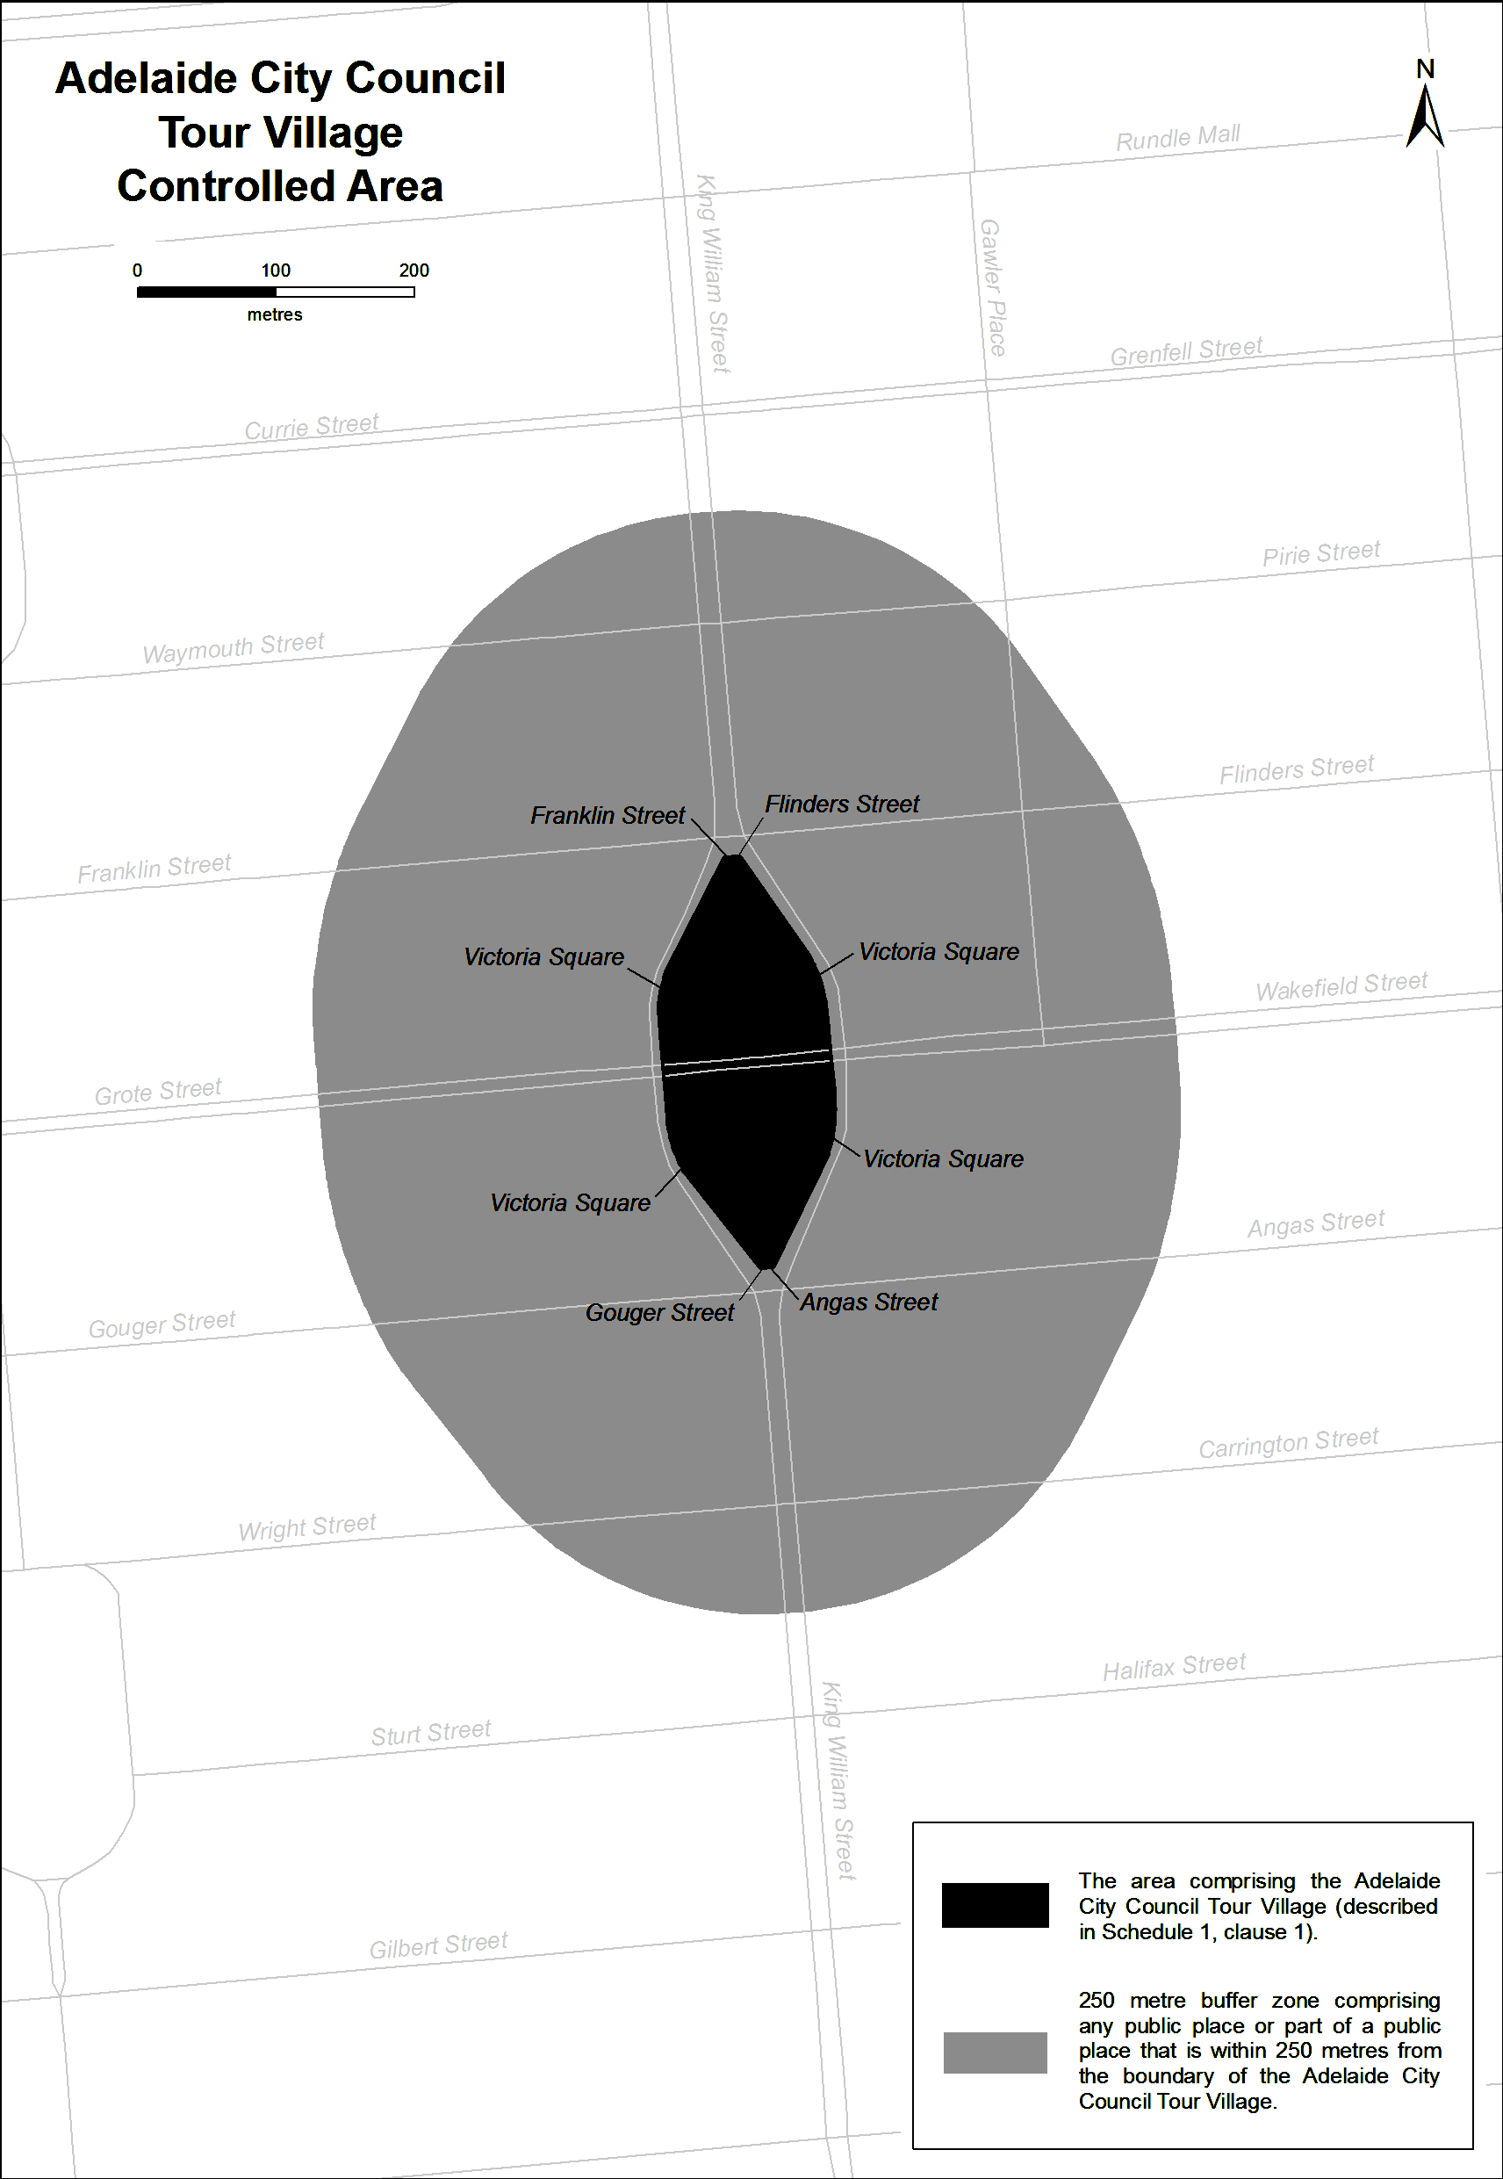
People's Choice Classic Stage (Adelaide) Controlled Area
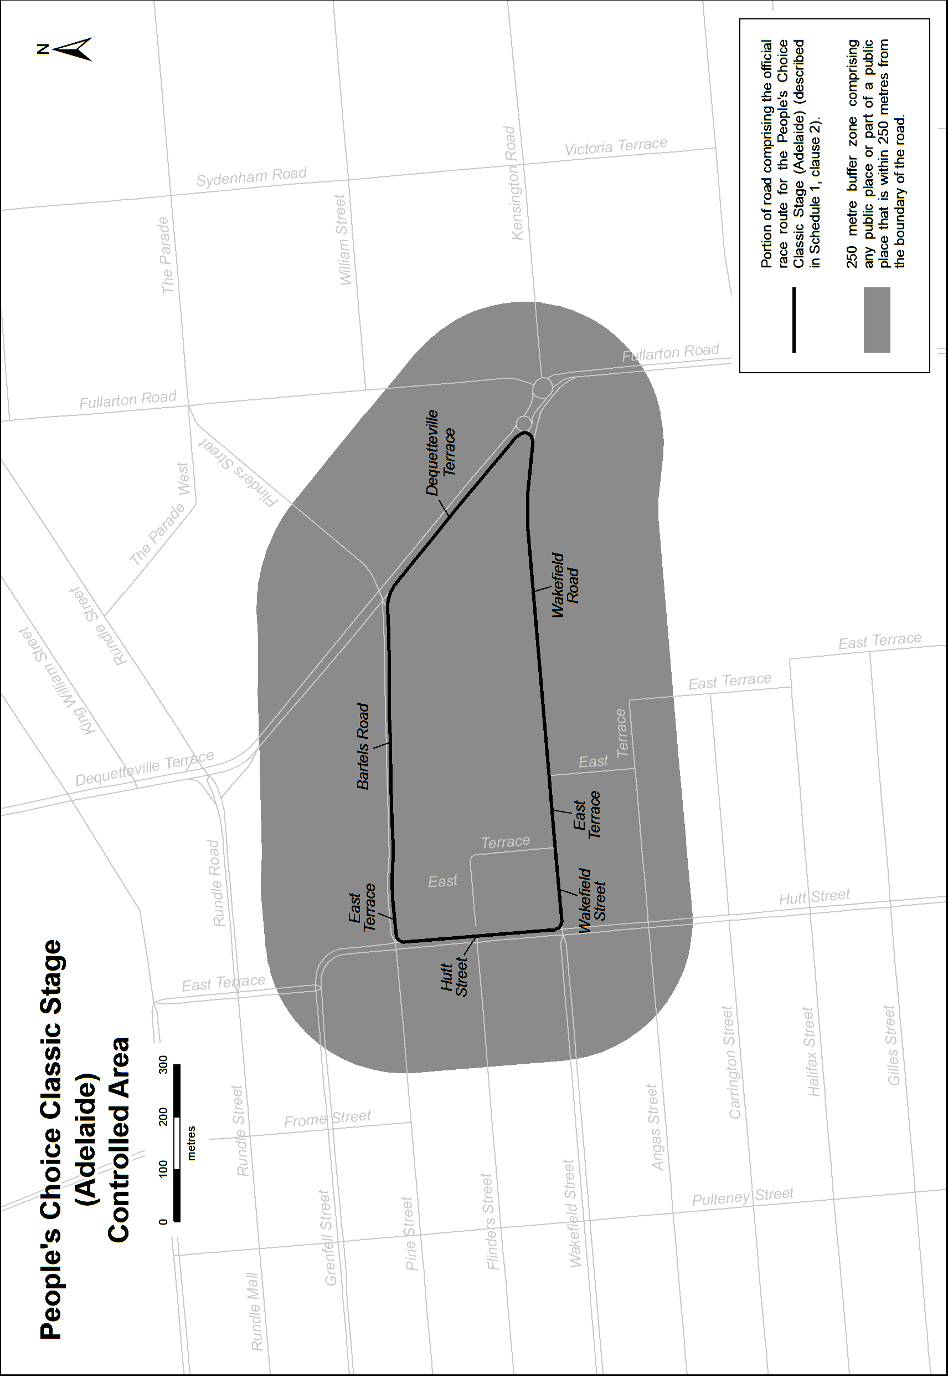
Stage 1 (Unley to Lyndoch) Controlled Area
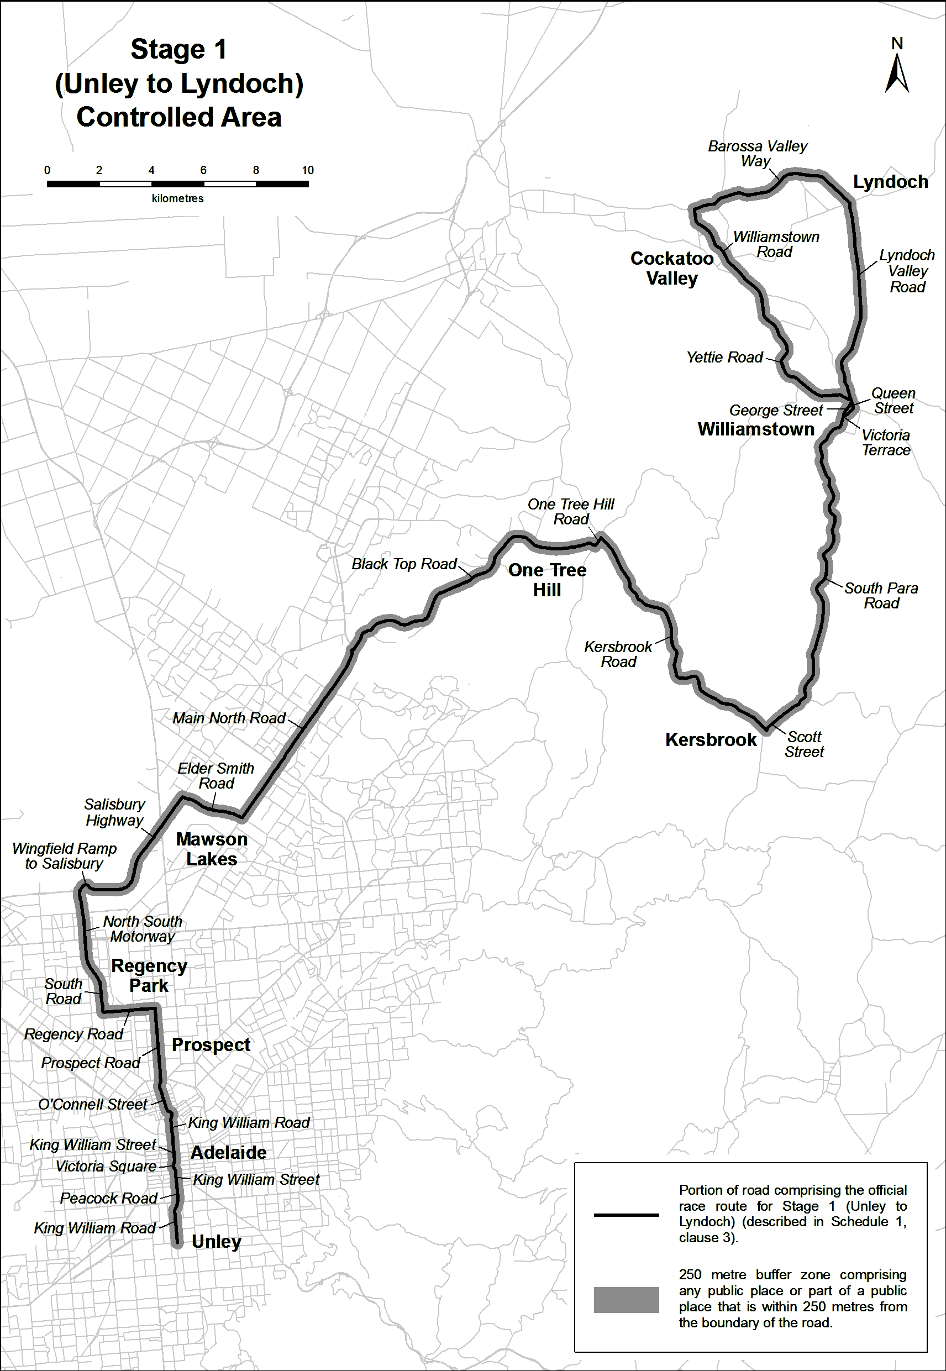
Santos Women's Tour Stage 4 (Victoria Park/Pakapakanthi) Controlled Area
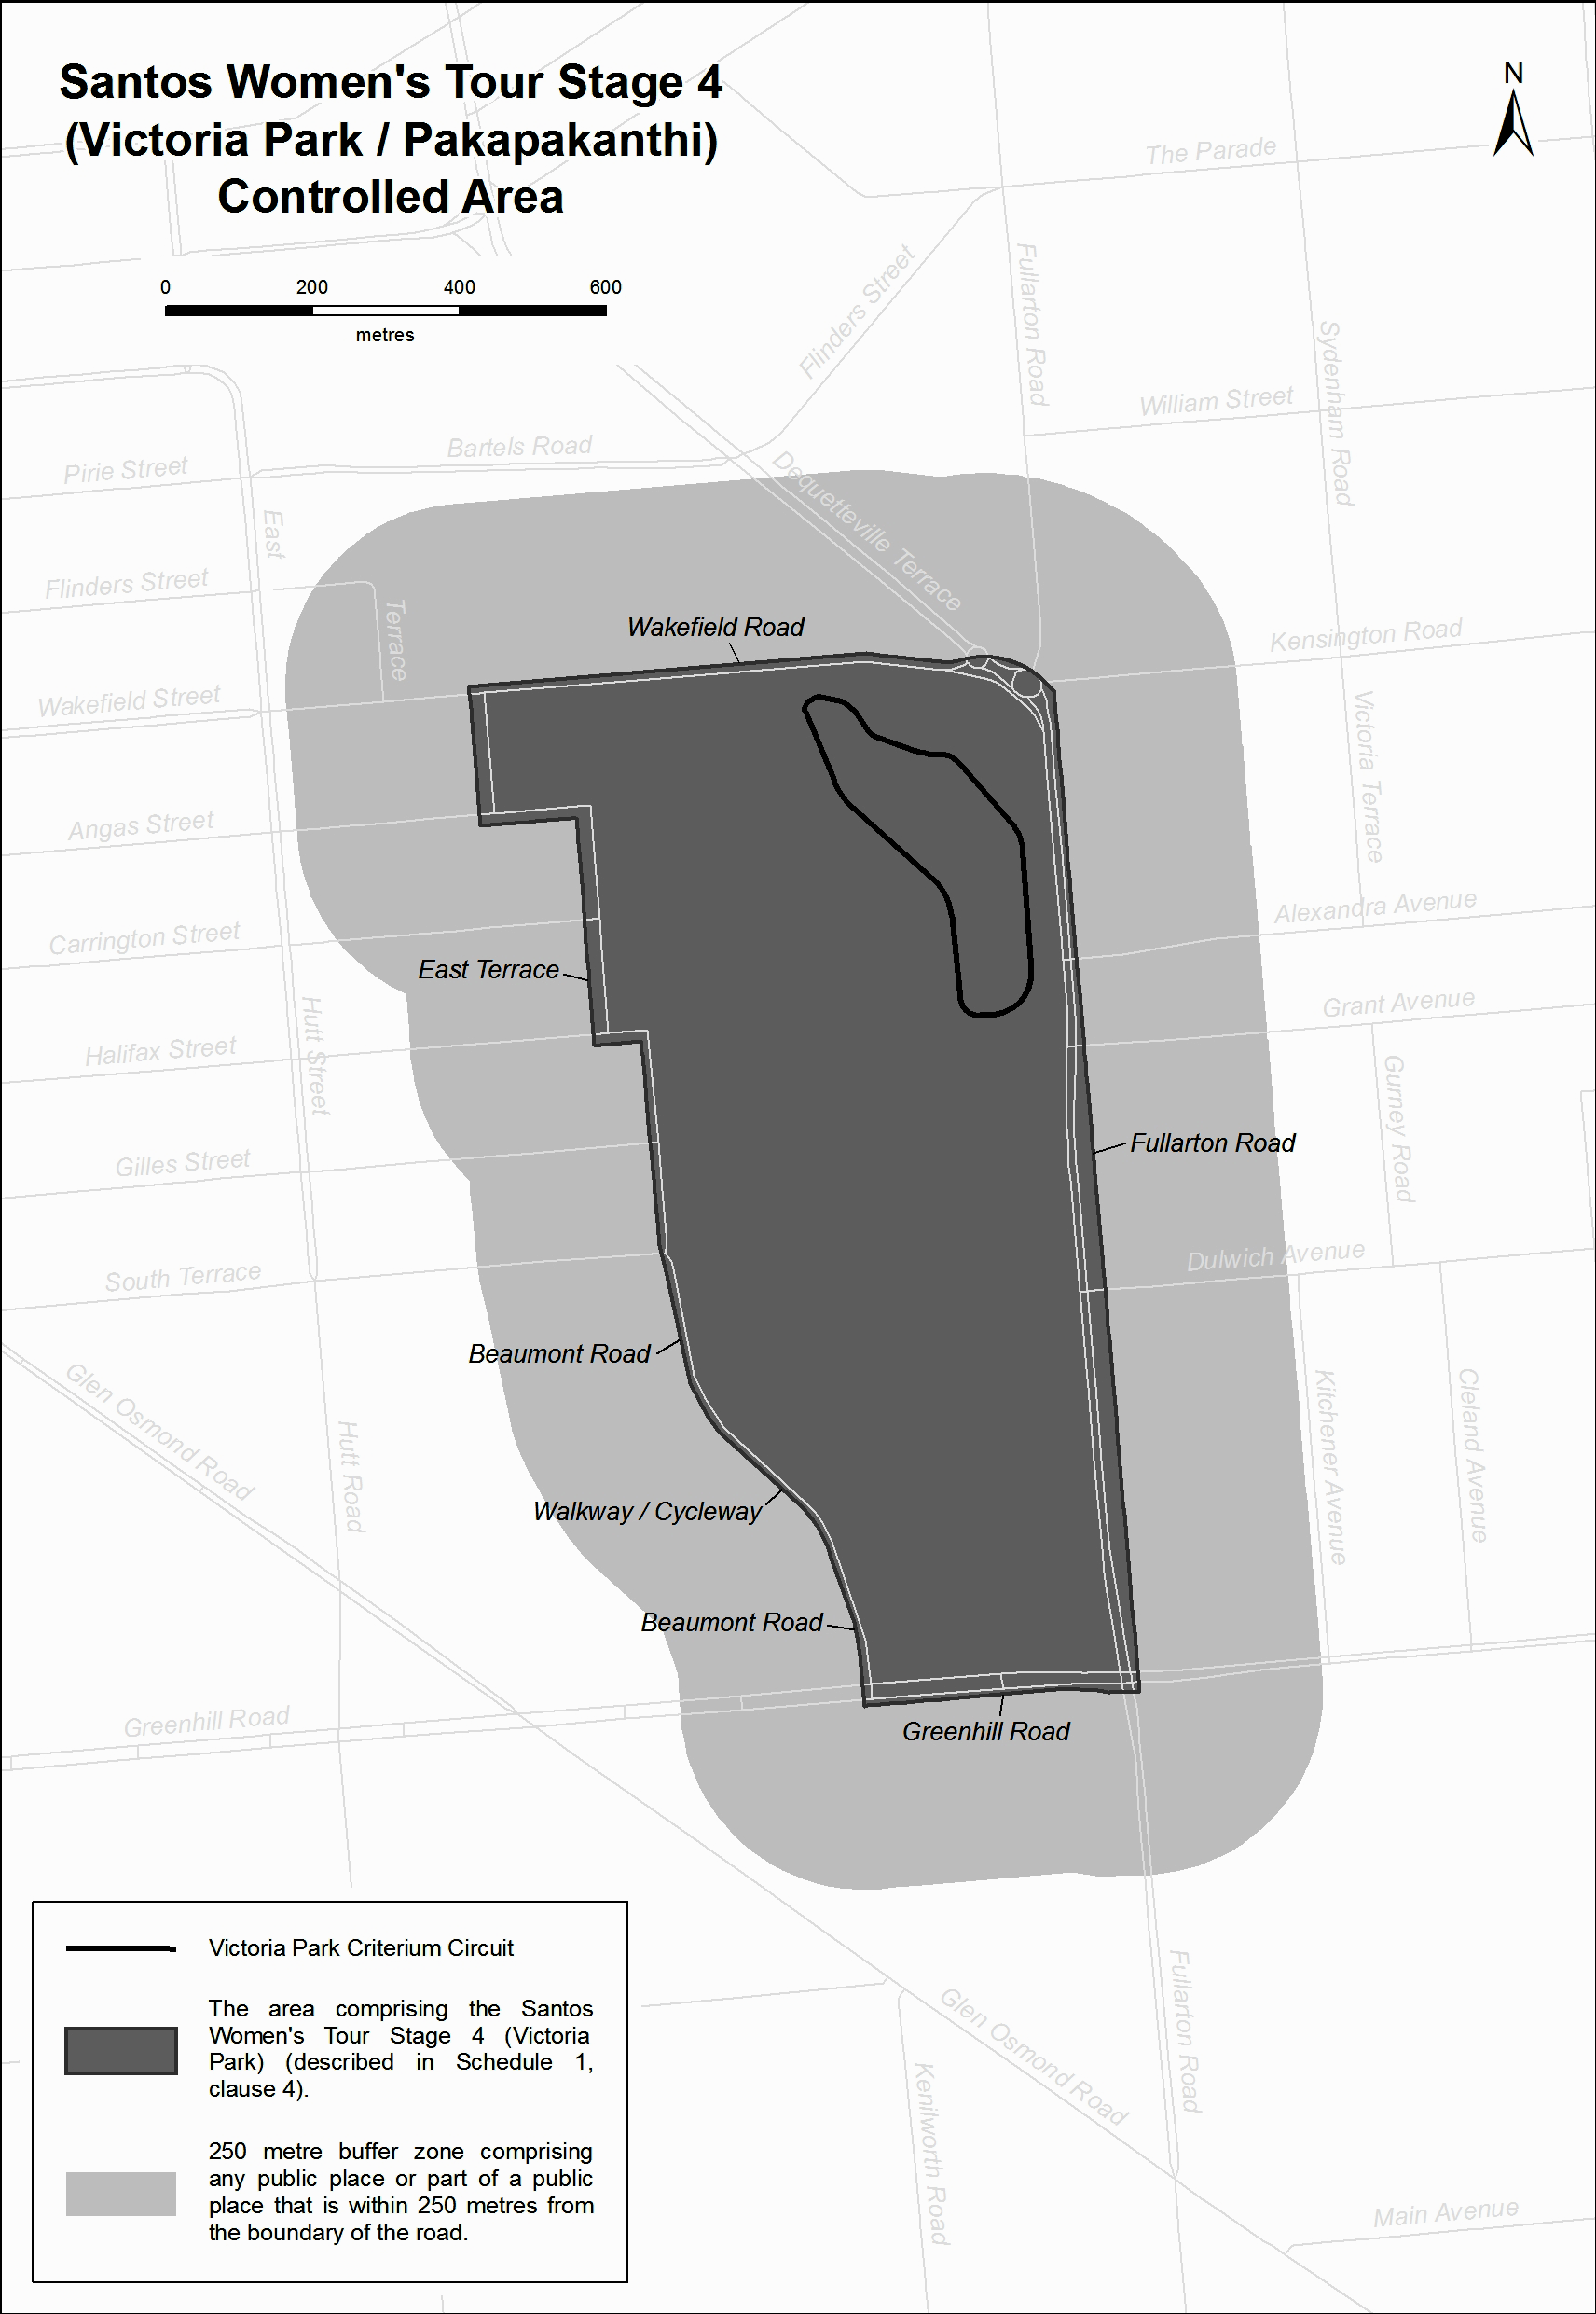
Stage 2 (Stirling to Paracombe) Controlled Area
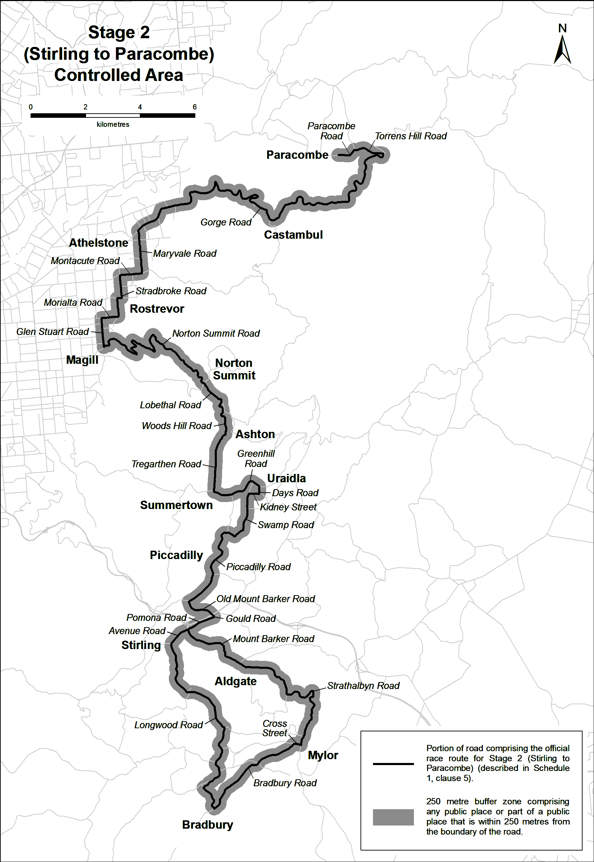
Stage 3 (Glenelg to Victor Harbor) Controlled Area
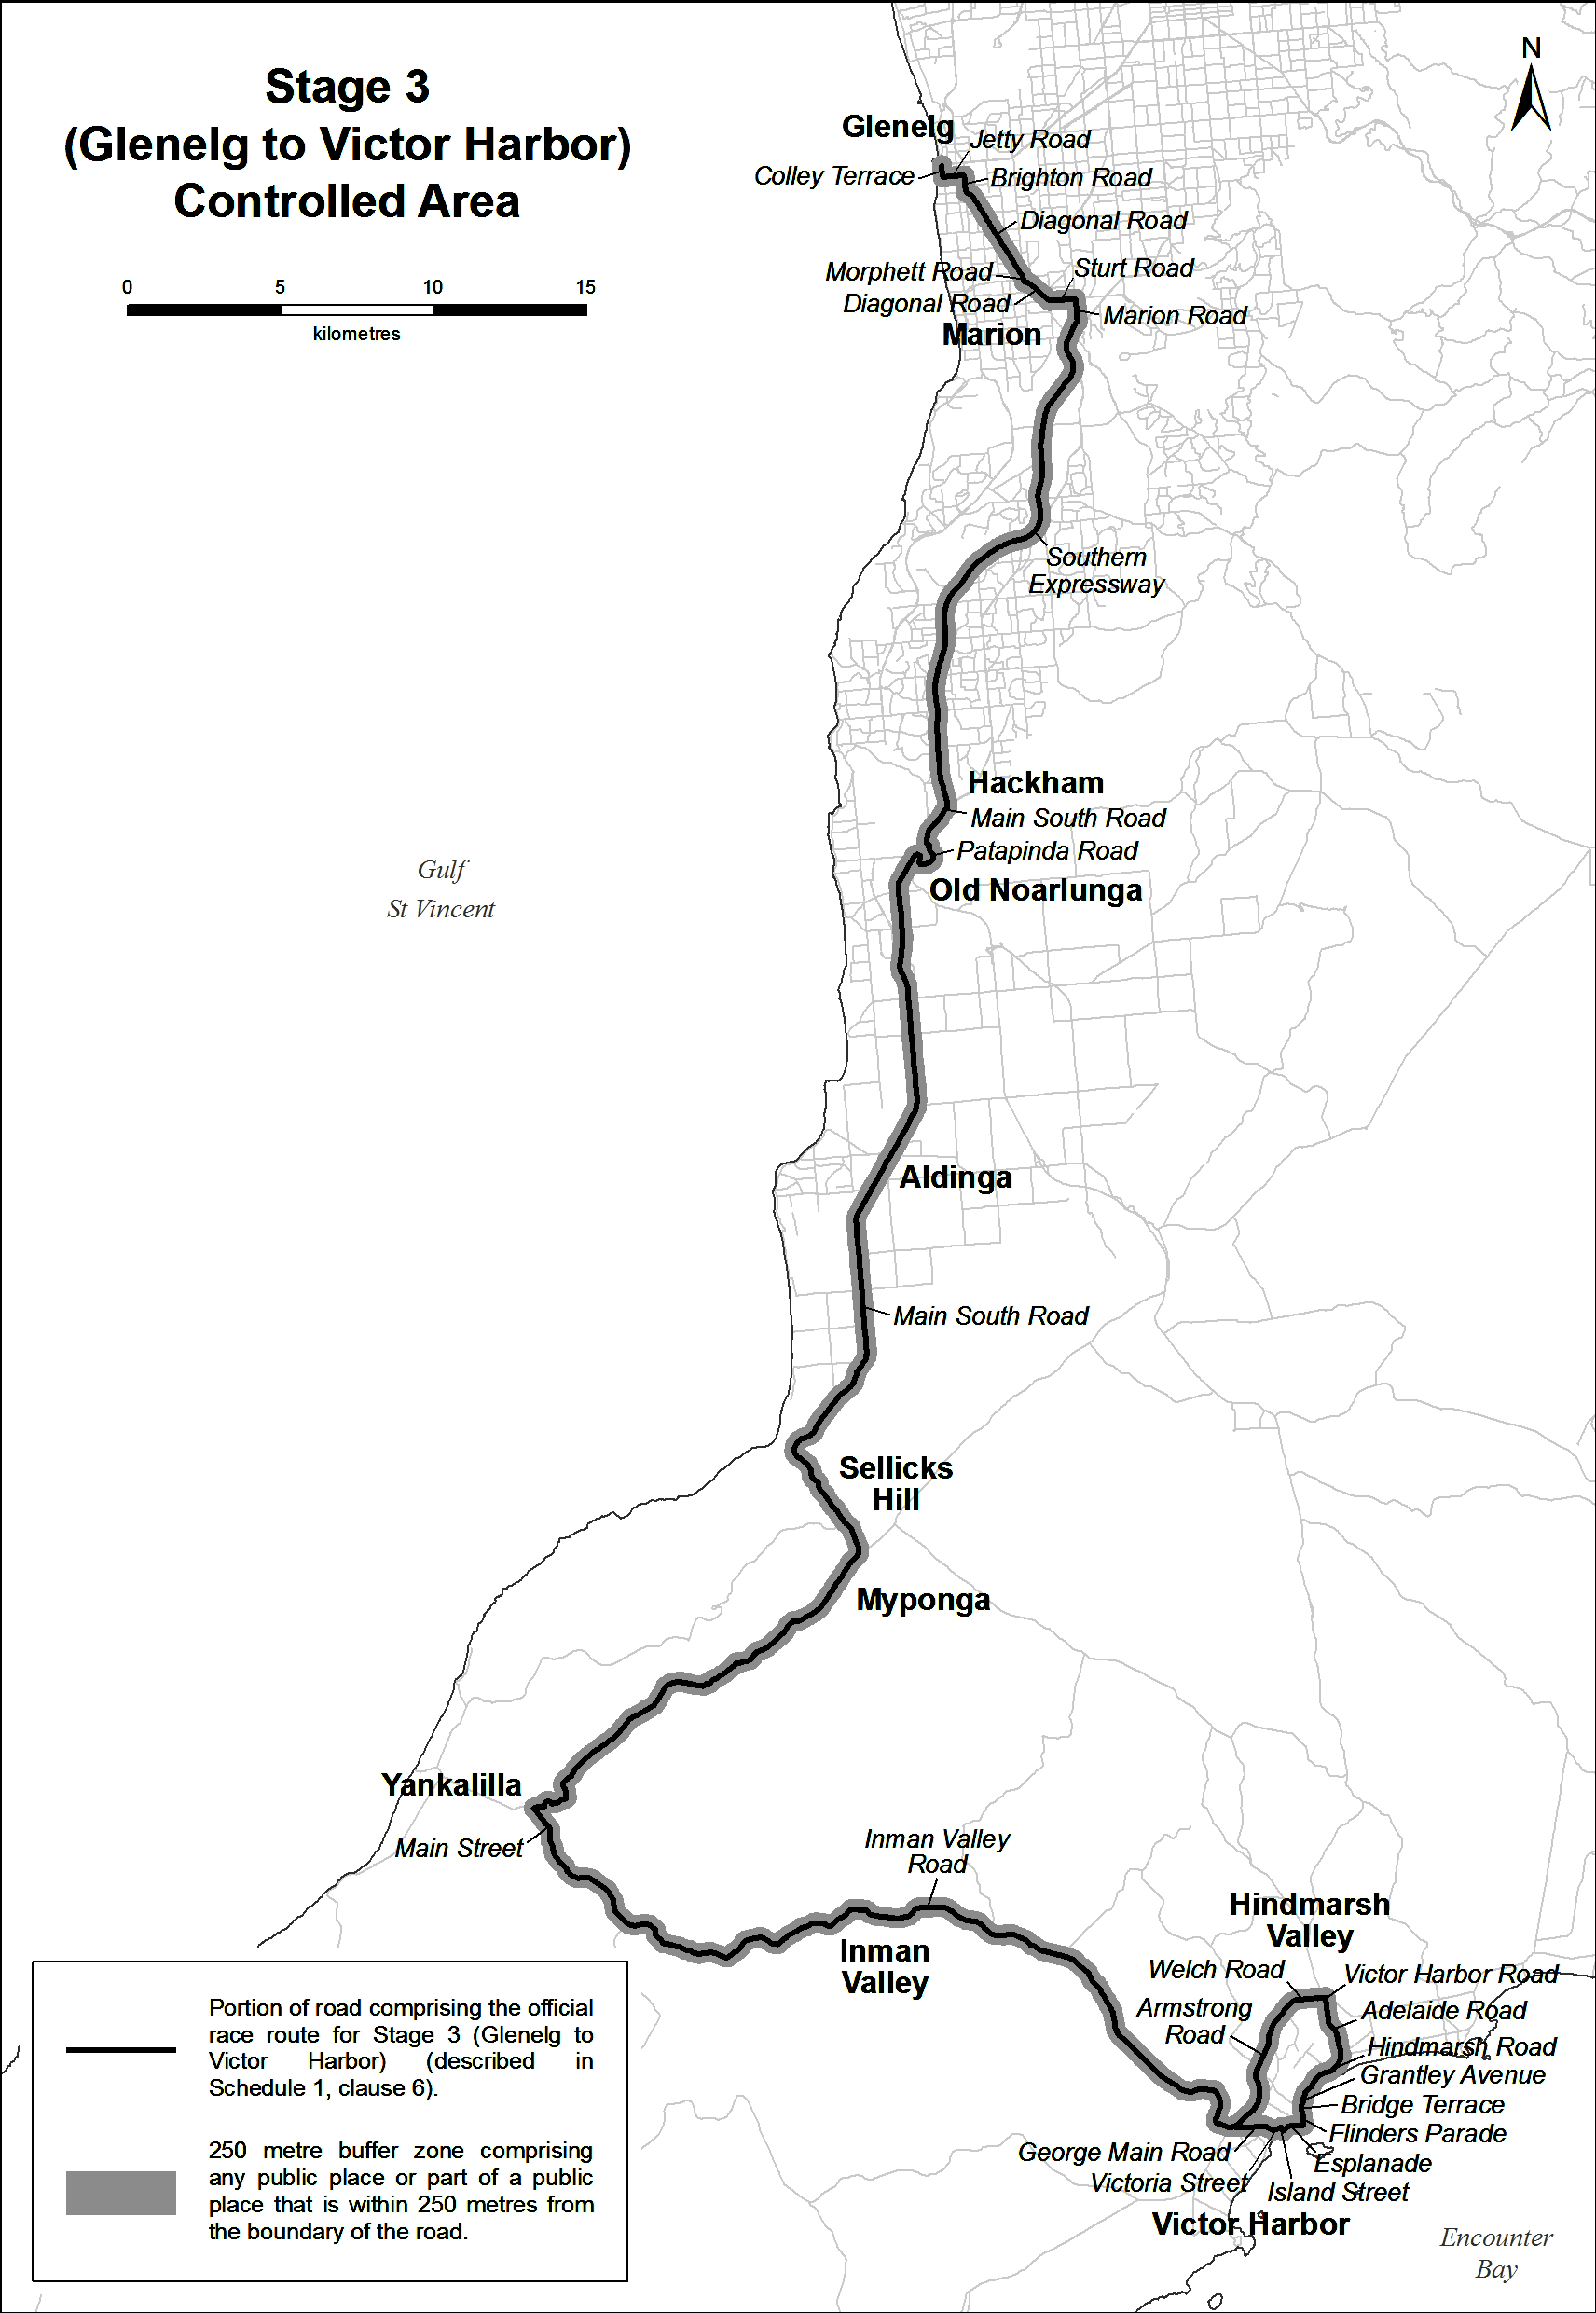
Stage 4 (Norwood to Campbelltown) Controlled Area
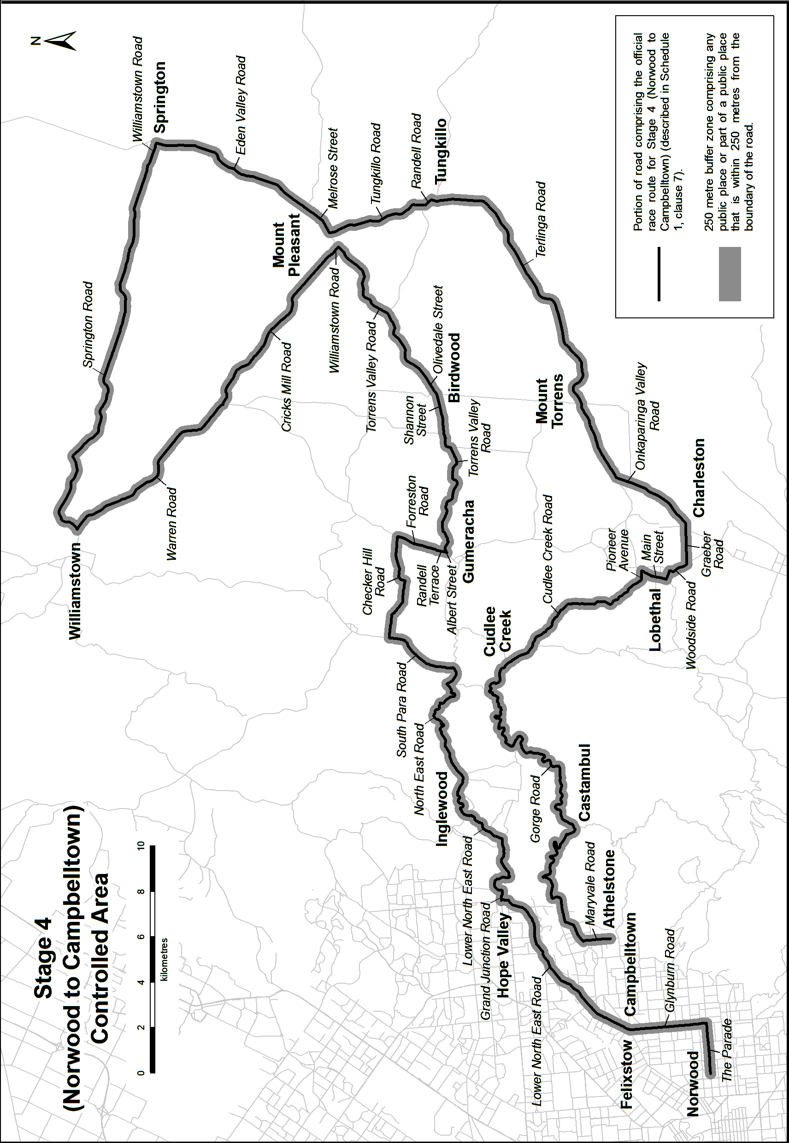
Stage 5 (McLaren Vale to Willunga Hill) Controlled Area
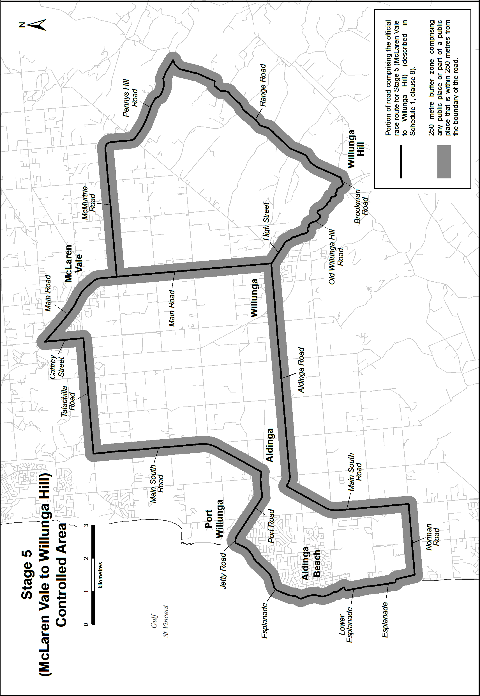
Stage 6 (Adelaide) Controlled Area
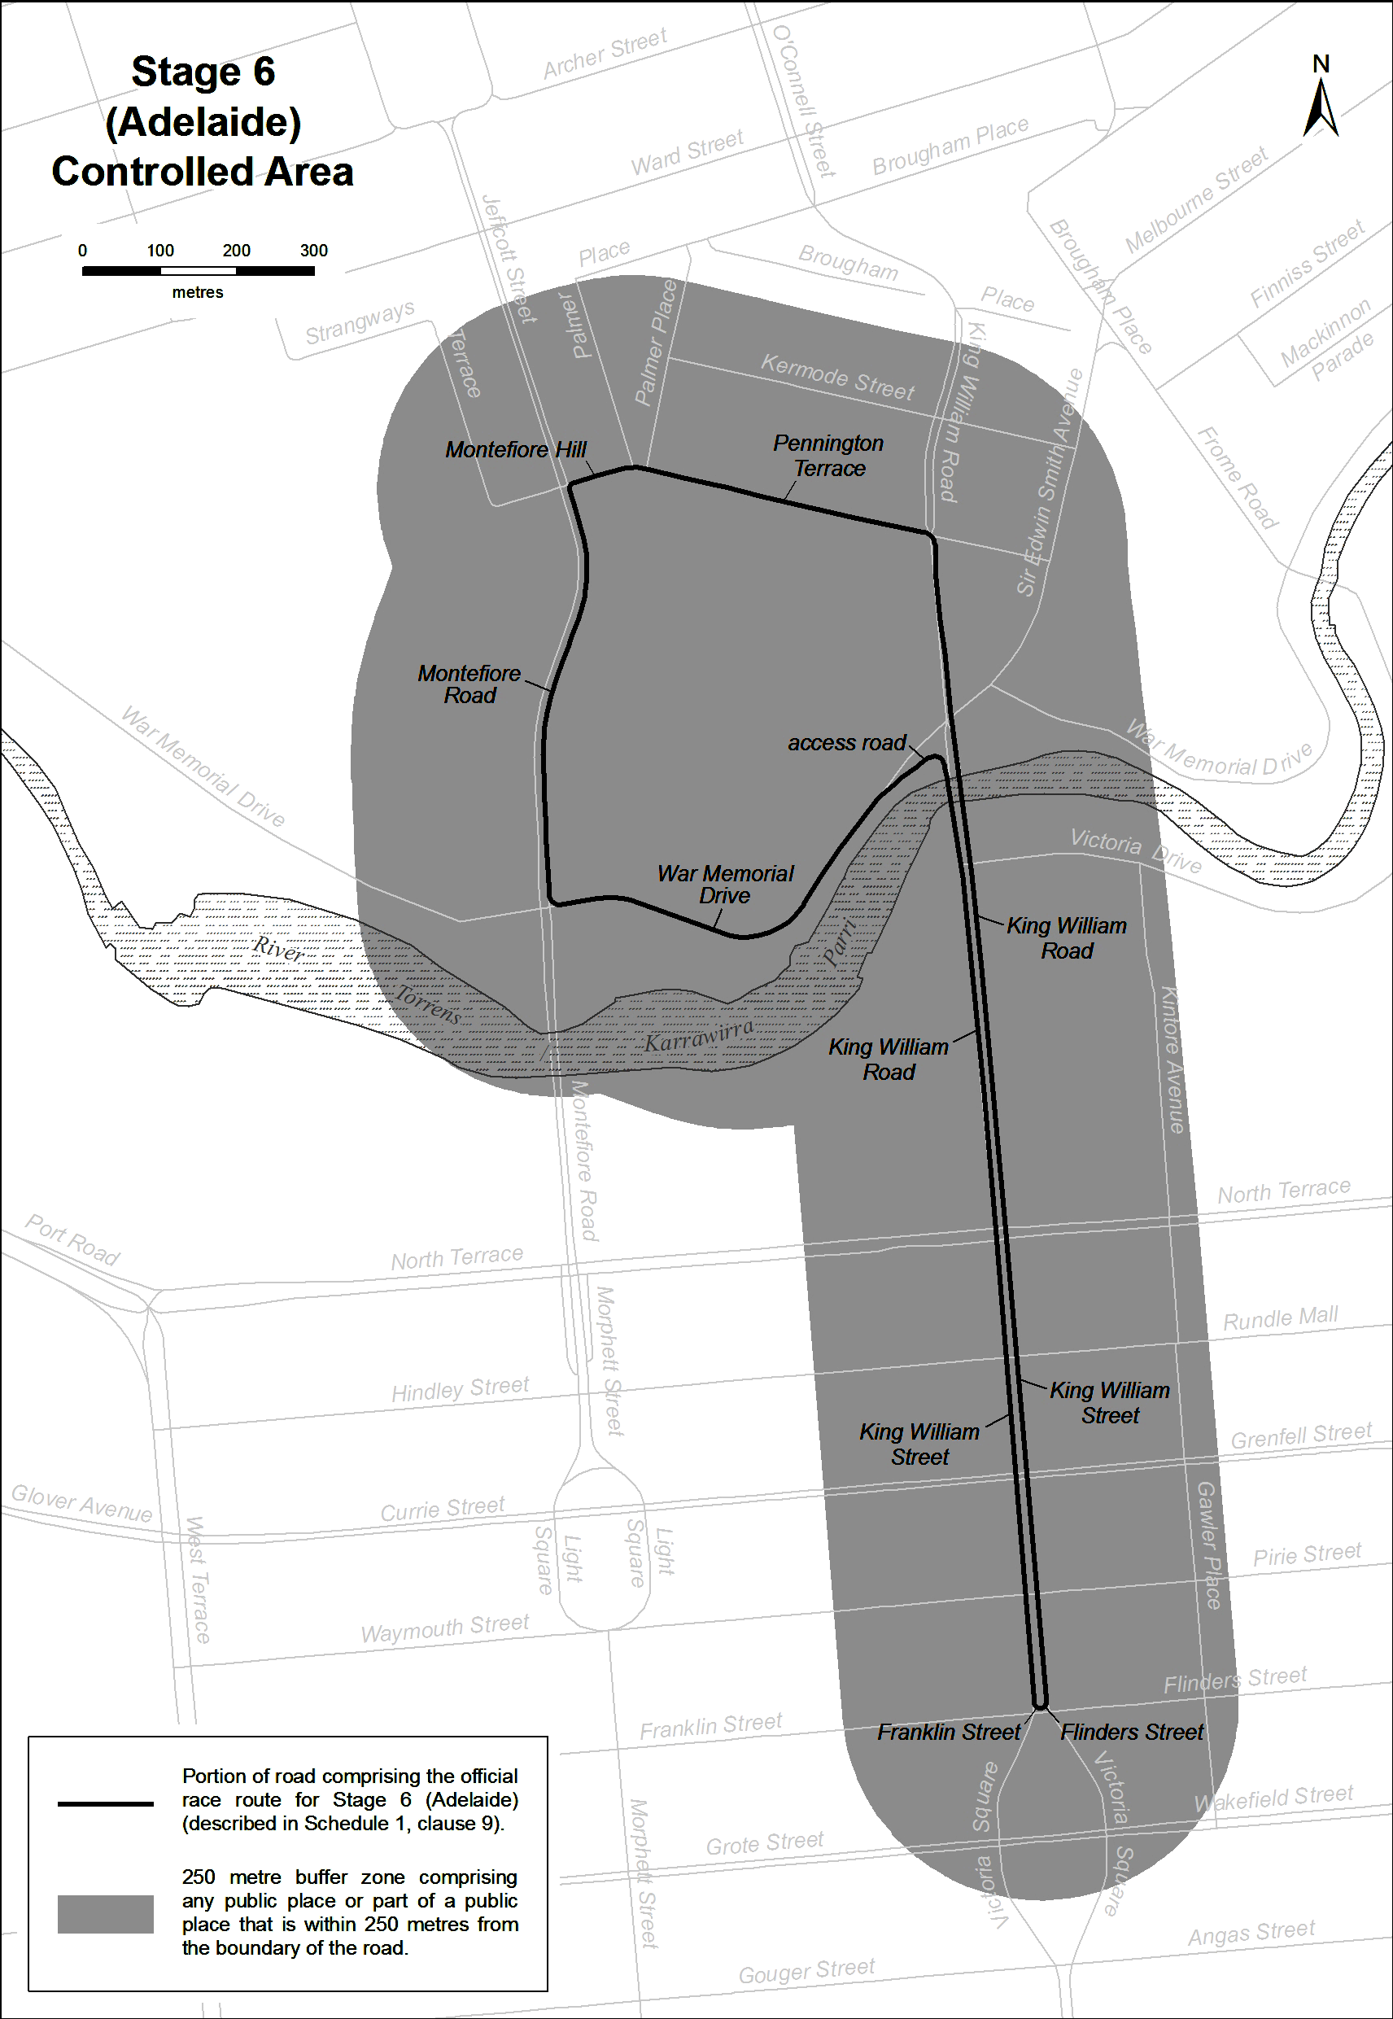
Note—
As required by section 10AA(2) of the Subordinate Legislation Act 1978, the Minister has certified that, in the Minister's opinion, it is necessary or appropriate that these regulations come into operation as set out in these regulations.
Made by the Governor
with the advice and consent of the Executive Council
on 27 October 2016
No 251 of 2016
16MTOUR0011

South Australia
Family Relationships Variation Regulations 2016
under the Family Relationships Act 1975

Contents
Part 1—Preliminary
1 Short title
2 Commencement
3 Variation provisions
Part 2—Variation of Family Relationships Regulations 2010
4 Insertion of regulation 3B and 3C
3B Persons and bodies to be consulted in preparation of State Framework for Altruistic Surrogacy
3C Requirements for preparation of and consultation on State Framework for Altruistic Surrogacy

Part 1—Preliminary
1—Short title
These regulations may be cited as the Family Relationships Variation Regulations 2016.
2—Commencement
These regulations will come into operation 4 months after the day on which they are made (see Subordinate Legislation Act 1978).
3—Variation provisions
In these regulations, a provision under a heading referring to the variation of specified regulations varies the regulations so specified.
Part 2—Variation of Family Relationships Regulations 2010
4—Insertion of regulation 3B and 3C
After regulation 3A—insert:
3B—Persons and bodies to be consulted in preparation of State Framework for Altruistic Surrogacy
For the purposes of section 10FA(4)(a)(iv) of the Act the following persons and bodies are prescribed:
(a) the Minister to whom the administration of the Assisted Reproductive Treatment Act 1988 is committed;
(b) the Australian Human Rights Commission;
(c) the Council for the Care of Children;
(d) the Donor Conception Support Group;
(e) The Fertility Society of Australia;
(f) the Health Consumers Alliance of South Australia Incorporated;
(g) the Office for Women;
(h) a person with knowledge and experience in the area of law relating to assisted reproductive treatment or surrogacy;
(i) a person with knowledge and experience in relation to the adoption of children.
3C—Requirements for preparation of and consultation on State Framework for Altruistic Surrogacy
For the purposes of section 10FA(4) of the Act, the State Framework for Altruistic Surrogacy (the State Framework) is to be prepared, and public consultation undertaken, in accordance with the following:
(a) after consultation with the persons and bodies referred to in section 10FA(4)(a) of the Act, the Minister must prepare a draft of the State Framework and a report containing an explanation of the purpose and effect of the draft State Framework;
(b) the Minister must cause the draft State Framework and the report to be published on a website determined by the Minister together with a notice—
(i) stating the places at which the draft State Framework and the report are to be made available for inspection; and
(ii) inviting interested persons to make written submissions in relation to the draft State Framework within the period specified in the notice (being not less than 60 days from the date of publication of the notice);
(c) after consulting with the persons and bodies referred to in section 10FA(4)(a) of the Act on—
(i) the provisions of the draft State Framework; and
(ii) any alterations that the Minister proposes should be made to the draft State Framework (including as a result of matters raised in any written submissions received in response to the draft State Framework under paragraph (b)),
the Minister may—
(iii) approve the draft State Framework as the State Framework for Altruistic Surrogacy; or
(iv) alter the draft State Framework and approve the draft State Framework as altered as the State Framework for Altruistic Surrogacy; or
(v) decline to approve the draft State Framework as the State Framework for Altruistic Surrogacy;
(d) after approving the State Framework for Altruistic Surrogacy, the Minister must cause it to be published in the Gazette.
Made by the Governor
with the advice and consent of the Executive Council
on 27 October 2016
No 252 of 2016
AGO0124/16CS

South Australia
Local Government (General) Variation Regulations 2016
under the Local Government Act 1999

Contents
Part 1—Preliminary
1 Short title
2 Commencement
3 Variation provisions
Part 2—Variation of Local Government (General) Regulations 2013
4 Substitution of regulation 8AAA—Conflicts of interest—ordinary business matters etc
8AAA Conflicts of interest—ordinary business matters etc
8AAB Conflicts of interest—special provisions relating to subsidiaries and committees
5 Insertion of regulation 8AB
8AB Informal gatherings and discussions
6 Variation of Schedule 1—Forms
7 Variation of Schedule 3—Local government sector employers

Part 1—Preliminary
1—Short title
These regulations may be cited as the Local Government (General) Variation Regulations 2016.
2—Commencement
These regulations will come into operation on 24 November 2016.
3—Variation provisions
In these regulations, a provision under a heading referring to the variation of specified regulations varies the regulations so specified.
Part 2—Variation of Local Government (General) Regulations 2013
4—Substitution of regulation 8AAA—Conflicts of interest—ordinary business matters etc
Regulation 8AAA—delete the regulation and substitute:
8AAA—Conflicts of interest—ordinary business matters etc
(1) For the purposes of sections 74(6) and 75A(6) of the Act, the following matters are prescribed:
(a) the preparation, discussion, conduct, consideration or determination of a review under section 12 of the Act;
(b) the preparation, discussion, adoption or revision of a policy relating to allowances and benefits payable to members if the policy relates to allowances and benefits payable equally to each member (rather than allowances and benefits payable to particular members or particular office holders);
(c) the preparation, discussion, adoption or alteration of a training and development policy under section 80A of the Act;
(d) the preparation, discussion, adoption or amendment of a strategic management plan under section 122 of the Act;
(e) the adoption or revision of an annual business plan;
(f) the adoption or revision of a budget;
(g) the declaration of rates (other than a separate rate) or a charge with the character of a rate, and any preparation or discussion in relation to such a declaration;
(h) a discussion or decision of a matter at a meeting of a council if the matter—
(i) relates to a matter that was discussed before a meeting of a subsidiary or committee of the council; and
(ii) the relevant interest in the matter is the interest of the council that established the committee or which appointed, or nominated for appointment, a member of the board of management of the council subsidiary or regional subsidiary.
(2) For the purposes of section 75(3)(b) of the Act, a member of a council who is a member, officer or employee of an agency or instrumentality of the Crown (within the meaning of section 73(4) of the Act) will not be regarded as having an interest in a matter before the council by virtue of being a member, officer or employee of the agency or instrumentality if the matter does not directly concern the agency or instrumentality.
8AAB—Conflicts of interest—special provisions relating to subsidiaries and committees
For the purposes of sections 74(6) and 75A(6) of the Act, the following matters are prescribed:
(a) a matter to be discussed, or in relation to which a recommendation or decision is to be made, at a meeting of a council subsidiary if—
(i) the discussion, recommendation or decision relates to the purpose for which the subsidiary is established; and
(ii) the relevant interest in the matter is the interest of the council which appointed, or nominated for appointment, a member of the board of management of the subsidiary;
(b) a matter to be discussed, or in relation to which a recommendation or decision is to be made, at a meeting of a regional subsidiary if—
(i) the discussion, recommendation or decision relates to the purpose for which the subsidiary is established; and
(ii) the relevant interest in the matter is the interest of a council which appointed, or nominated for appointment, a member of the board of management of the subsidiary; and
(iii) the relevant benefit or loss would be enjoyed or suffered in common with all or a substantial proportion of the constituent councils of the subsidiary;
(c) a matter to be discussed, or in relation to which a recommendation is to be made, at a meeting of a committee of a council established under section 41 of the Act if—
(i) the discussion or recommendation relates to the purpose for which the committee is established; and
(ii) the relevant interest in the matter is the interest of the council that established the committee.
5—Insertion of regulation 8AB
After regulation 8AA insert:
8AB—Informal gatherings and discussions
(1) For the purposes of section 90(8b) of the Act, a council must ensure that its policy on the holding of informal gatherings or discussions—
(a) provides that designated informal gatherings or discussions must be held at a place open to the public, unless the designated informal gathering or discussion is one that the council or chief executive officer has declared may be held in confidence; and
(b) provides that the council or chief executive officer will only declare that a designated informal gathering or discussion may be held in confidence—
(i) on a case by case basis; and
(ii) if the designated informal gathering or discussion—
(A) is a planning session of a general or strategic nature; or
(B) is a briefing relating to—
• information; or
• a matter,
of a confidential nature within the ambit of section 90(3) of the Act; and
(c) provides for procedures relating to the holding of designated informal gatherings or discussions; and
(d) provides for publication on the council's website of details relating to designated informal gatherings or discussions, including—
(i) in all cases—
(A) the place, date and time at which the designated informal gathering or discussion will be held; and
(B) the matter that is to be discussed at the designated informal gathering or discussion; and
(C) whether or not the designated informal gathering or discussion is to be held at a place open to the public; and
(ii) in the case of a designated informal gathering or discussion that will be held in confidence—the reason for the designated informal gathering or discussion being held in confidence.
(2) In this regulation—
designated informal gathering or discussion means an event organised and conducted by or on behalf of the council or chief executive officer to which members of the council or council committee (as the case may be) have been invited and that involves discussion of a matter that is, or is intended to be, part of the agenda for a formal meeting of the council or council committee.
6—Variation of Schedule 1—Forms
(1) Form 1—delete the Form and substitute:
Form 1—Notice of proposal
Local Government Act 1999
(section 28)
PUBLIC NOTICE is given of a proposal submitted under section 28 of the Local Government Act 1999.
The proposal relates to the following councils and their areas:
The following information is provided in relation to the proposal:
The Local Government Act 1999 provides that a poll of electors must be conducted in relation to the proposal if the required number of electors request a poll. To request a poll, the following steps must be taken:
You should direct any questions concerning the matters contained in this notice to:
(2) Forms 8 and 9—delete Forms 8 and 9 and substitute:
Form 8—Removal of vehicles—warning notice (section 237(1))
Date and time of issue:
Name and contact details of authorised officer:
Council:
Description of vehicle (registration number, make, model, etc):
Location of vehicle:
Warning—
(a) this vehicle has been left at the stated location for at least 24 hours; and
(b) if the vehicle is not moved within 24 hours of the time of issue of this notice—
(i) the vehicle may be removed by an authorised officer to an appropriate place; and
(ii) notification of the removal of the vehicle will be given to the owner of the vehicle; and
(iii) if the owner of the vehicle does not, within 1 month after service of the notice referred to in subparagraph (ii)—
(A) take possession of the vehicle; and
(B) pay all expenses in connection with the removal, custody and maintenance of the vehicle and of serving, posting or publishing the notice,
the council will take steps to sell or dispose of the vehicle in accordance with section 237 of the Local Government Act 1999.
Form 9—Removal of vehicles—notice (section 237(4))
Date and time of service/postage (person-to-person registered post):
Name and contact details of authorised officer:
Council:
Description of vehicle (registration number, make, model, etc):
Date and time of removal of vehicle:
Location from which vehicle was removed:
Take note—
(a) your vehicle has been removed; and
(b) if you do not, within 1 month after service of this notice—
(i) take possession of the vehicle; and
(ii) pay all expenses in connection with the removal, custody and maintenance of the vehicle and of serving, posting or publishing this notice,
the council will take steps to sell or dispose of the vehicle in accordance with section 237 of the Local Government Act 1999.
7—Variation of Schedule 3—Local government sector employers
(1) Schedule 3, list of councils—delete "District Council of Yorke Peninsula" and substitute:

Yorke Peninsula Council
(2) Schedule 3, list of Regional subsidiaries established under section 43 of Act—after "Highbury Landfill Authority" insert:

Limestone Coast Local Government Association
(3) Schedule 3, list of Regional subsidiaries established under section 43 of Act—delete "Provincial Cities Association of South Australia"
(4) Schedule 3, list of Regional subsidiaries established under section 43 of Act—delete "South East Local Government Association Inc"
(5) Schedule 3, list of Regional subsidiaries established under section 43 of Act—delete "Waste Care SA"
(6) Schedule 3, list of Regional subsidiaries established under section 43 of Act—delete "Western Region Waste Management Authority"
Note—
As required by section 10AA(2) of the Subordinate Legislation Act 1978, the Minister has certified that, in the Minister's opinion, it is necessary or appropriate that these regulations come into operation as set out in these regulations.
Made by the Governor
with the advice and consent of the Executive Council
on 27 October 2016
No 253 of 2016
16LG08CS

SENDING COPY?
NOTICES for inclusion in the South Australian Government Gazette should be emailed to:
GovernmentGazetteSA@sa.gov.au
Please include the following information in the covering email:
• The date the notice is to be published.
• Whether a proof, quote or return email confirmation is required.
• Contact details.
• To whom the notice is charged if applicable.
• A purchase order if required (chargeable notices).
• Any other details that may impact on the publication of the notice.
Attach:
• Notices in Word format.
• Maps and diagrams in pdf.
• Notices that require sighting an official date and signature before publication in a pdf. If a pdf is not possible then fax the official file(s) to the Government Publishing Fax number listed below.
Fax Transmission: (08) 8207 1040
Phone Enquiries: (08) 8207 1045
NOTE:
Closing time for lodging new copy is 4 p.m. on Tuesday preceding the regular Thursday Gazette.

CITY OF HOLDFAST BAY
Roads Opening and Closing Act 1991
Public Road Glenelg North
IN accordance with Section 10 of the Roads (Opening and Closing) Act 1991, notice is hereby given that City of Holdfast Bay proposes to make a Road Process Order to close an irregularly-shaped portion of Public Road Glenelg North generally situate dividing allotment 2 in Deposited Plan 60861 from Unit 2 and portion of Unit 3 in Strata Plan 714 more particularly delineated and lettered ‘A’ on Preliminary Plan No. 16/0033.
It is proposed that the portion of road to be closed marked ‘A’ be transferred to Peter John Bijok and merged with said allotment 2 in Deposited Plan 60861.
A preliminary plan of the proposal, and a statement, are available for public inspection at the Holdfast Bay Council Office, 24 Jetty Road, Brighton, between the hours of 9 a.m. and 4.45 p.m., Monday to Friday or at the Adelaide Office of the Surveyor-General, during normal office hours.
Any person may object to the proposal (and any adjoining landowner or other person substantially affected by the proposed road closure may apply for an easement relative to the closure). Such objection (or application for an easement) must be made in writing to the City of Holdfast Bay within 28 days of the date of this notice. If a submission is made, the City of Holdfast Bay is required to give notice of a time and place at which a meeting will be held to consider the matter, so that the person making the submission (or a representative) may attend to support the submission, if desired.
Any submission must set out the full name and address of the person making the submission, and must be fully supported by reasons (and any application for the grant of an easement must give full particulars of the nature and location of the easement and, where made by a person as the owner of adjoining or nearby land, specify the land to which the easement is to be annexed). A copy of the submission must be forwarded to the Surveyor-General at Adelaide.
Dated 27 October 2016.
J. Lynch, Chief Executive Officer

CITY OF TEA TREE GULLY
Election Results
Supplementary Election for Councillor for Water Gully Ward Conducted on Monday, 10 October 2016
Formal Ballot Papers: 2 759
Informal Ballot Papers: 4
Quota: 1 380
Candidates | First  Preference  Votes | Elected/  Excluded | Votes at  Election/  Exclusion | Count
Dave, Hemant | 82 |  | 82
Powell, David James  John | 260 |  | 260
Disney, Rosalie | 520 |  | 520
Field, Peter | 1 897 | Elected | 1 897 | 1
D. Gully, Returning Officer

ADELAIDE PLAINS COUNCIL
(FORMERLY DISTRICT COUNCIL OF MALLALA)
Results of Supplementary Election for Councillor
for Lewiston Ward Conducted on Monday, 10 October 2016
Formal Ballot Papers: 311
Informal Ballot Papers: 1
Quota: 156
Candidates | First  Preference  Votes | Elected/  Excluded | Votes at  Election/  Exclusion | Count
Wasley, Mark | 77 |  | 130
Panella, Margherita | 68 | Excluded | 68 | 2
Maiolo, Frank | 68 | Excluded | 74 | 3
Di Troia, Carmine | 98 | Elected | 132 | 4
D. Gully, Returning Officer

SOUTHERN MALLEE DISTRICT COUNCIL
Public Consultation
Review of Elector Representation
NOTICE is hereby given that the Council has undertaken a review to determine whether alterations are required in respect to elector representation, including ward boundaries and the composition of Council.
As an outcome of this review Council proposes the following:
1. the principal member of Council continue to be a chairperson, selected by and from amongst the elected members of Council;
2. the title of the principal member of Council continue to be Mayor;
3. the Council area not be divided into wards (i.e. wards be abolished); and
4. the future elected body of Council comprise seven elected members (area councillors) who shall represent the whole of the Council area and shall be elected by the community at council-wide elections.
Report
Council has prepared a Representation Review Report which details the review process, the public consultation undertaken and the proposal Council considers should be carried into effect.
A copy of this report is available on the Council website www.southernmallee.sa.gov.au, or a copy can be inspected and/or purchased at the Council offices at Day Street, Pinnaroo and Railway Terrace North, Lameroo.
Written Submissions
Written submissions are invited from interested persons and
should be directed to the Chief Executive Officer, P.O. Box 49, Pinnaroo, S.A. 5304 or emailed to council@southernmallee.sa.gov.au by the close of business on Friday, 18 November 2016.
Further information regarding the elector representation review can be obtained by contacting Mia Dohnt, Chief Executive Officer, on telephone (08) 8577 8002.
Any person(s) making a written submission will be given the opportunity to appear before a meeting of Council or Council Committee to be heard in support of their submission.
M. Dohnt, Chief Executive Officer

IN the matter of the estates of the undermentioned deceased persons:
Cabrita, Antonio Jose, late of Pridham Boulevard, Aldinga Beach, retired construction worker, who died on 18 May 2016.
Cox, Joy Christine, late of 9 Helmsman Terrace, Seaford, retired shop proprietor, who died on 12 July 2016.
Davies, Jacqueline Anne, late of 10 Guy Street, Christie Downs, home duties, who died on 29 September 2015.
Harvey, Pamela June, late of 7 Kym Street, Port Noarlunga South, home duties, who died on 12 July 2015.
March, Joy Lorraine, late of corner of Fort Street and Sylvan Way, Grange, of no occupation, who died on 30 July 2016.
Matthews, Josephine Carla, late of 4 Weemala Crescent, Rostrevor, home duties, who died on 11 April 2016.
McKenzie, Margaret Lilian, late of corner of Fort Street and Sylvan Way, Grange, of no occupation, who died on
14 July 2016.
Mead, Geoffrey Bertram, late of 200-208 Adams Road, Craigmore, retired industrial engineer, who died on
5 September 2016.
Rice, Mavis Irene, late of 100 Seaford Road, Seaford, of no occupation, who died on 19 April 2016.
Robinson, Peter, late of 50 Thornton Street, Kensington, of no occupation, who died on 8 July 2016.
Rose, Una Helen, late of 6 Booth Avenue, Linden Park, retired typist, who died on 3 February 2016.
Velic, Dzemal, late of Walnut Avenue, Mildura, Victoria, of no occupation, who died on 8 January 2016.
Notice is hereby given pursuant to the Trustee Act 1936, the Inheritance (Family Provision) Act 1972 and the Family Relationships Act 1975, that all creditors, beneficiaries, and other persons having claims against the said estates are required to send, in writing, to the office of Public Trustee, G.P.O. Box 1338, Adelaide, S.A. 5001, full particulars and proof of such claims, on or before 25 November 2016, otherwise they will be excluded from the distribution of the said estate; and notice is also hereby given that all persons indebted to the said estates are required to pay the amount of their debts to the Public Trustee or proceedings will be taken for the recovery thereof; and all persons having any property belonging to the said estates are forthwith to deliver same to the Public Trustee.
Dated 27 October 2016.
D. A. Contala, Public Trustee

ATTENTION

CUSTOMERS requiring a proof of their notice for inclusion in the Government Gazette, please note that the onus is on you to inform Government Publishing SA of any subsequent corrections.

For any corrections to your notice please phone 8207 1045 or Email before 4 p.m. on Wednesday.

If we do not receive any communication by 10 a.m. on Thursday (day of publication) we will presume the notice is correct and will print it as it is.

Remember—the onus is on you to inform us of any corrections necessary to your notice.

NOTE: Closing time for lodging new copy (electronically, fax or hard copy) is 4 p.m. on Tuesday preceding the day of publication.
Phone: 8207 1045
Fax: 8207 1040
Email: GovernmentGazetteSA@sa.gov.au

Printed and published by authority every Thursday by P. McMAHON, Government Printer, South Australia
Price: $7.21, plus postage; to subscribers, $361.90 per annum.
(The above prices are inclusive of GST)

