No. 56 3767



THE SOUTH AUSTRALIAN

GOVERNMENT GAZETTE
www.governmentgazette.sa.gov.au

PUBLISHED BY AUTHORITY

ALL PUBLIC ACTS appearing in this GAZETTE are to be considered official, and obeyed as such

ADELAIDE, THURSDAY, 22 SEPTEMBER 2016

CONTENTS

Page
Anangu Pitjantjatjara Yankunytjatjara Land
Rights Act 1981—Notice 3768
Appointments, Resignations, Etc. 3768
Authorised Betting Operations Act 2000—Notice 3774
Corporations and District Councils—Notices 3873
Development Act 1993—Notice 3775
Environment Protection Act 1993—Notice 3777
Fisheries Management Act 2007—Notices 3768
Housing Improvement Act 1940—Notices 3781
Land Acquisition Act 1969—Notices 3769
Liquor Licensing Act 1997—Notices 3782
Mining Act 1971—Notices 3770
Motor Vehicles Act 1959—Notice 3815
Motor Vehicles Regulations 2010—Notice 3816
National Electricity Law—Notice 3772
Natural Resources Management Act 2004—Notice 3772
Petroleum and Geothermal Energy Act 2000—Notices 3772
Proclamations 3826
Public Trustee Office—Administration of Estates 3884
Page
REGULATIONS
Major Events Act 2013—
(No. 228 of 2016) 3839
Second-hand Vehicle Dealers Act 1995—
(No. 229 of 2016) 3844
National Parks and Wildlife Act 1972—
(No. 230 of 2016) 3854
(No. 231 of 2016) 3870
RULES
District Court Civil Rules 2006—
(Amendment No. 34) 3819
Supreme Court Civil Rules 2006—
(Amendment No. 33) 3821
Supreme Court Civil Supplementary Rules 2014—
(Amendment No. 7) 3823
Real Property Act 1886—Notice 3818
Roads (Opening and Closing) Act 1991—Notices 3773
Tobacco Products Regulations Act 1997—Notice 3824
Training and Skills Development Act 2008—Notice 3825
Transport, Department of—Notices to Mariners 3772

GOVERNMENT GAZETTE NOTICES
Notices for publication in the South Australian Government Gazette should be emailed to GovernmentGazetteSA@sa.gov.au. Content should be sent as Word format attachment(s). Covering emails should include the date the notice is to be published and to whom the notice will be charged. Closing time for lodgement is 4 p.m. on the Tuesday preceding the regular Thursday publication. Gazette enquiries to: Phone 8207 1045. The Government Gazette is available online at: www.governmentgazette.sa.gov.au.

Department of the Premier and Cabinet
Adelaide, 22 September 2016
HIS Excellency the Governor in Executive Council has been pleased to appoint the undermentioned to the History Trust of South Australia, pursuant to the provisions of the History Trust of South Australia Act 1981:
Member: (from 22 September 2016 until 21 September 2019)
Peter David Monteath
Member: (from 25 November 2016 until 24 November 2019)
Peter Dunstone Goers
Presiding Member: (from 13 November 2016 until 13 July 2019)
Elizabeth Ho
By command,
Martin Leslie James Hamilton-Smith, for Acting Premier
ASACAB006-02

Department of the Premier and Cabinet
Adelaide, 22 September 2016
HIS Excellency the Governor in Executive Council has been pleased to appoint the undermentioned to the HomeStart Finance Board of Management, pursuant to the provisions of the Urban Renewal Act 1995:
Member: (from 27 September 2016 until 26 September 2019)
Jim Constantine Kouts
Presiding Member: (from 27 September 2016 until
26 September 2019)
Jim Constantine Kouts
By command,
Martin Leslie James Hamilton-Smith, for Acting Premier
MHUD/16/024

Department of the Premier and Cabinet
Adelaide, 22 September 2016
HIS Excellency the Governor in Executive Council has been pleased to appoint the Honourable John Robert Rau, MP, Deputy Premier, Attorney-General, Minister for Justice Reform, Minister for Planning, Minister for Industrial Relations, Minister for Child Protection Reform, Minister for the Public Sector, Minister for Consumer and Business Services and Minister for the City of Adelaide to be also Acting Premier for the period from 10 October 2016 to 12 October 2016 inclusive, during the absence of the Honourable Jay Wilson Weatherill, MP.
By command,
Martin Leslie James Hamilton-Smith, for Acting Premier
DPC16/085CS

Department of the Premier and Cabinet
Adelaide, 22 September 2016
HIS Excellency the Governor in Executive Council has been pleased to appoint the Honourable Peter Bryden Malinauskas, MLC, Minister for Police, Minister for Correctional Services, Minister for Emergency Services and Minister for Road Safety to be also Acting Minister for Employment, Acting Minister for Aboriginal Affairs and Reconciliation, Acting Minister for Manufacturing and Innovation, Acting Minister for Automotive Transformation and Acting Minister for Science and Information Economy for the period from 24 September 2016 to 4 October 2016 inclusive, during the absence of the Honourable Kyam Joseph Maher, MLC.
By command,
Martin Leslie James Hamilton-Smith, for Acting Premier
MSIE16/CS006

ANANGU PITJANTJATJARA YANKUNYTJATJARA
LAND RIGHTS ACT 1981
Anangu Pitjantjatjara Yankunytjatjara Executive Board Supplementary Election for Pipalyatjara/Kalka
IN accordance with Clause 17 of Schedule 3 under the Anangu Pitjantjatjara Yankunytjatjara Land Rights Act 1981, I, David Gully, Returning Officer, hereby declare Mr Albert Fox elected to the Anangu Pitjantjatjara Yankunytjatjara Executive Board to represent the Pipalyatjara and Kalka communities.
The result of the election was as follows:
Candidate | No. of Votes
Richard Kanari | 18
Albert Fox | 30
TOTAL | 48
D. Gully, Returning Officer

FISHERIES MANAGEMENT ACT 2007
Fisheries Management (Rock Lobster Fisheries) Regulations 2006
TAKE notice that, in relation to the nominated certification stations listed in Column 1 below, the corresponding times specified in Columns 2 and 3 are, for the purposes of
sub-regulations 22 (2) and 23 (2) of the Fisheries Management
(Rock Lobster Fisheries) Regulations 2006, under the Fisheries Management Act 2007, the times during which the requirements
in sub-regulations 22 (1) and 23 (1) do not apply.
This notice applies from 1 October 2016 until 31 May 2017, unless varied or revoked earlier.
Column 1 | Column 2 | Column 3
Certification station | Start Time | Finish Time
Beachport | 8.30 a.m. | 5 p.m.
Blackfellows Caves | 8.30 a.m. | 5 p.m.
Cape Jaffa | 8.30 a.m. | 5 p.m.
Carpenter Rocks | 8.30 a.m. | 5 p.m.
Port MacDonnell | 8.30 a.m. | 5 p.m.
Robe | 8.30 a.m. | 5 p.m.
Southend | 8.30 a.m. | 5 p.m.
Dated 25 August 2016.
M. Snart, Fisheries Regional Manager,
Limestone Coast, Delegate of the Minister
for Agriculture Food and Fisheries

FISHERIES MANAGEMENT ACT 2007: SECTION 115
TAKE notice that pursuant to Section 115 of the Fisheries Management Act 2007, licence holders in the Marine Scalefish Fishery endorsed with a condition fixing a Sardine quota entitlement on the licence (the ‘exemption holders’) are exempt from Regulation 4 (1) of the Fisheries Management (Vessel Monitoring Scheme) Regulations 2007, but only insofar as the exemption holders are permitted to undertake fishing activities using a registered boat, pursuant to the licence without a Vessel Monitoring Scheme (VMS) unit installed (the ‘exempted activity’), subject to conditions specified in Schedule 1, from 15 September 2016 until 15 September 2017, unless varied or revoked earlier.
Schedule 1
1. The registered boat used pursuant to the exempted activity must be 7.5 m or less in length.
2. While engaged in the exempted activity, the registered boat may not be used for the taking of Sardine using a Sardine net or the holding or transport of any Sardine.
3. While engaged in the exempted activity no other fishing activities may be undertaken pursuant to that licence.
4. The exemption holder must notify PIRSA Fishwatch on
1800 065 522 at least 2 hours prior to conducting the exempted activity and answer a series of questions about the exempted activity. The exemption holder will need to have a copy of the exemption at the time of making the call, and be able to provide information about the area and time of the exempted activity, the vehicle and boats involved, the number of agents undertaking the exempted activity and other related questions. Exemption No. 9902883.
5. While engaged in the exempted activity, the exemption holder must have in their possession a copy of this notice, and produce that notice to a PIRSA Fisheries Officer upon request.
6. The exemption holder must not contravene or fail to comply with the Fisheries Management Act 2007, or any other Regulations made under that Act, except where specifically exempted by this notice.
This notice does not purport to override the provisions or operation of any other Act including, but not limited to, the Marine Parks Act 2007. The exemption holder and his or her agents must comply with any relevant regulations, permits, requirements and directions from the Department of Environment, Water and Natural Resources when undertaking activities within a marine park.
Dated 14 September 2016.
S. Sloan, Director,
Fisheries and Aquaculture Policy

LAND ACQUISITION ACT 1969
(Section 16)
Notice of Acquisition
THE SOUTH EASTERN WATER CONSERVATION AND DRAINAGE BOARD (the ‘Authority’), of P.O. Box 335, Millicent, S.A. 5280, acquires the following interests in the following land:
Comprising an unencumbered estate in fee simple in portion of Allotment comprising Pieces 222, 223, 224, 225 and 226 in Deposited Plan 59181 in Certificate of Title Volume 5893, Folio 15, being the whole of the land identified as an Allotment comprising pieces 305, 306, 307, 308 and 309 in D113183 lodged in the Lands Titles Office.
This notice is given under Section 16 of the Land Acquisition Act 1969.
Compensation
A person who has or had an interest in the land that is divested or diminished by the acquisition or the enjoyment of which is adversely affected by the acquisition who does not receive an offer of compensation from the Authority may apply to the Authority for compensation.
Inquiries
Inquiries should be directed to:
Brett Pendlebury,
P.O. Box 1046,
Mount Gambier, S.A. 5290
Mobile: 0447 973 160
Dated 19 September 2016.
Signed and Sealed, Mr Francis Newman Brennan, Presiding Member of the South Eastern Water Conservation and Drainage Board.
Witness to Affixing of Seal
Name of Witness: Brett Pendlebury,
Address: 11 Helen Street,
Mount Gambier, S.A. 5290
DPTI: 2015/17507/01

LAND ACQUISITION ACT 1969
(Section 16)
Notice of Acquisition
THE SOUTH EASTERN WATER CONSERVATION AND DRAINAGE BOARD (the ‘Authority’), of P.O. Box 335, Millicent, S.A. 5280, acquires the following interests in the following land:
Comprising an unencumbered estate in portion of Allotment comprising Pieces 5, 6 and 7 in Deposited Plan 60360 in Crown Lease Volume 6172, Folio 789, being the whole of the land identified as Allotment comprising Pieces 301 and 302 in D113239 lodged in the Lands Titles Office.
This notice is given under Section 16 of the Land Acquisition Act 1969.
Compensation
A person who has or had an interest in the land that is divested or diminished by the acquisition or the enjoyment of which is adversely affected by the acquisition who does not receive an offer of compensation from the Authority may apply to the Authority for compensation.
Inquiries
Inquiries should be directed to:
Brett Pendlebury,
P.O. Box 1046,
Mount Gambier, S.A. 5290
Mobile: 0447 973 160
Dated 19 September 2016.
Signed and Sealed, Mr Francis Newman Brennan, Presiding Member of the South Eastern Water Conservation and Drainage Board.
Witness to Affixing of Seal
Name of Witness: Brett Pendlebury,
Address: 11 Helen Street,
Mount Gambier, S.A. 5290
DPTI: 2015/17518/01

LAND ACQUISITION ACT 1969
(Section 16)
Notice of Acquisition
THE SOUTH EASTERN WATER CONSERVATION AND DRAINAGE BOARD (the ‘Authority’), of P.O. Box 335, Millicent, S.A. 5280, acquires the following interests in the following land:
Comprising an unencumbered estate in fee simple in portion of Allotment comprising Pieces 220 and 221 in Deposited Plan 59183 in Certificate of Title Volume 5893, Folio 312, being whole of the land identified as Allotment comprising Pieces 323 and 324 in D113184 lodged in the Lands Titles Office.
This notice is given under Section 16 of the Land Acquisition Act 1969.
Compensation
A person who has or had an interest in the land that is divested or diminished by the acquisition or the enjoyment of which is adversely affected by the acquisition who does not receive an offer of compensation from the Authority may apply to the Authority for compensation.
Inquiries
Inquiries should be directed to:
Brett Pendlebury,
P.O. Box 1046,
Mount Gambier, S.A. 5290
Mobile: 0447 973 160
Dated 24 August 2016.
Signed and Sealed, Mr Francis Newman Brennan, Presiding Member of the South Eastern Water Conservation and Drainage Board.
Witness to Affixing of Seal
Name of Witness: Brett Pendlebury,
Address: 11 Helen Street,
Mount Gambier, S.A. 5290
DPTI: 2015/17508/01

LAND ACQUISITION ACT 1969
(Section 16)
Notice of Acquisition
THE SOUTH EASTERN WATER CONSERVATION AND DRAINAGE BOARD (the ‘Authority’), of P.O. Box 335, Millicent, S.A. 5280, acquires the following interests in the following land:
Comprising an unencumbered estate in fee simple in portion of Allotment comprising Pieces 218 and 219 in Deposited Plan 59179 and portion of Allotment comprising Pieces 250 and 251 in Deposited Plan 62716 in Certificate of Title Volume 5914, Folio 777, being whole of the land identified as Allotment 303 in D113185 lodged in the Lands Titles Office.
This notice is given under Section 16 of the Land Acquisition Act 1969.
Compensation
A person who has or had an interest in the land that is divested or diminished by the acquisition or the enjoyment of which is adversely affected by the acquisition who does not receive an offer of compensation from the Authority may apply to the Authority for compensation.
Inquiries
Inquiries should be directed to:
Brett Pendlebury,
P.O. Box 1046,
Mount Gambier, S.A. 5290
Mobile: 0447 973 160
Dated 19 September 2016.
Signed and Sealed, Mr Francis Newman Brennan, Presiding Member of the South Eastern Water Conservation and Drainage Board.
Witness to Affixing of Seal
Name of Witness: Brett Pendlebury,
Address: 11 Helen Street,
Mount Gambier, S.A. 5290
DPTI: 2015/17511/01

LAND ACQUISITION ACT 1969
(Section 16)
Notice of Acquisition
THE SOUTH EASTERN WATER CONSERVATION AND DRAINAGE BOARD (the ‘Authority’), of P.O. Box 335, Millicent, S.A. 5280, acquires the following interests in the following land:
Comprising an estate in fee simple in that piece of land being portion of Allotment comprising Pieces 12, 13 and 14 in Filed Plan 52889 in Certificate of Title Volume 6070, Folio 940, and being whole of the land identified as Allotment 116 in D113346 lodged in the Lands Titles Office, subject only to the existing easement(s) over the land marked ‘D’ in the said Certificate of Title.
This notice is given under Section 16 of the Land Acquisition Act 1969.
Compensation
A person who has or had an interest in the land that is divested or diminished by the acquisition or the enjoyment of which is adversely affected by the acquisition who does not receive an offer of compensation from the Authority may apply to the Authority for compensation.
Inquiries
Inquiries should be directed to:
Brett Pendlebury,
P.O. Box 1046,
Mount Gambier, S.A. 5290
Mobile: 0447 973 160
Dated 19 September 2016.
Signed and Sealed, Mr Francis Newman Brennan, Presiding Member of the South Eastern Water Conservation and Drainage Board.
Witness to Affixing of Seal
Name of Witness: Brett Pendlebury,
Address: 11 Helen Street,
Mount Gambier, S.A. 5290
DPTI: 2015/17313/01

MINING ACT 1971
NOTICE is hereby given in accordance with Section 28 (5) of the Mining Act 1971 that the delegate of the Minister for Mineral Resources and Energy intends to grant an Exploration Licence over the area described below:
Applicant: Peninsula Resources Limited
Location: Lake Gilles Area—Approximately 95 km south-west of Port Augusta .
Pastoral Lease: Gilles Downs, Corunna
Term: One year
Area in km²: 232
Reference number: 2016/00047
Plan and co-ordinates can be found on the Department of State Development website: http://www.minerals.statedevelopment.sa.
gov.au/exploration/public_notices or by contacting Mineral Tenements on (08) 8463 3103.
Community information on mineral exploration licence processes and requirements under the Mining Act 1971 is available from: http://www.minerals.statedevelopment.sa.gov.au/
land_access/community_information or hard copy on request to Mineral Tenements.
J. Martin, Mining Registrar

MINING ACT 1971
NOTICE is hereby given in accordance with Section 28 (5) of the Mining Act 1971 that the delegate of the Minister for Mineral Resources and Energy intends to grant an Exploration Licence over the area described below:
Applicant: Pirie Resources Pty Ltd
Location: Carpie Puntha Area—Approximately 30 km south-east of Kimba .
Term: Two years
Area in km²: 499
Reference number: 2016/00057
Plan and co-ordinates can be found on the Department of State Development website: http://www.minerals.statedevelopment.sa.
gov.au/exploration/public_notices or by contacting Mineral Tenements on (08) 8463 3103.
Community information on mineral exploration licence processes and requirements under the Mining Act 1971 is available from: http://www.minerals.statedevelopment.sa.gov.au/
land_access/community_information or hard copy on request to Mineral Tenements.
J. Martin, Mining Registrar

MINING ACT 1971
NOTICE is hereby given in accordance with Section 28 (5) of the Mining Act 1971 that the delegate of the Minister for Mineral Resources and Energy intends to grant an Exploration Licence over the area described below:
Applicant: Jodama Pty Ltd
Location: Umberatana Area—Approximately 80 km north-east of Leigh Creek.
Pastoral Lease: Umberatana, Yankaninna
Term: One year
Area in km²: 52
Reference number: 2016/00065
Plan and co-ordinates can be found on the Department of State Development website: http://www.minerals.statedevelopment.sa.
gov.au/exploration/public_notices or by contacting Mineral Tenements on (08) 8463 3103.
Community information on mineral exploration licence processes and requirements under the Mining Act 1971 is available from: http://www.minerals.statedevelopment.sa.gov.au/
land_access/community_information or hard copy on request to Mineral Tenements.
J. Martin, Mining Registrar

MINING ACT 1971
NOTICE is hereby given in accordance with Section 28 (5) of the Mining Act 1971 that the delegate of the Minister for Mineral Resources and Energy intends to grant an Exploration Licence over the area described below:
Applicant: BMV Properties Pty Ltd
Location: Coober Pedy Area—Approximately 20 km north of Coober Pedy.
Pastoral Lease: Mount Barry
Term: Two years
Area in km²: 497
Reference number: 2016/00067
Plan and co-ordinates can be found on the Department of State Development website: http://www.minerals.statedevelopment.sa.
gov.au/exploration/public_notices or by contacting Mineral Tenements on (08) 8463 3103.
Community information on mineral exploration licence processes and requirements under the Mining Act 1971 is available from: http://www.minerals.statedevelopment.sa.gov.au/
land_access/community_information or hard copy on request to Mineral Tenements.
J. Martin, Mining Registrar

MINING ACT 1971
NOTICE is hereby given in accordance with Section 28 (5) of the Mining Act 1971 that the delegate of the Minister for Mineral Resources and Energy intends to grant an Exploration Licence over the area described below:
Applicant: Gawler Resources Pty Ltd
Location: Yeltanna Hill Area—Approximately 115 km west-north-west of Whyalla.
Pastoral Lease: Bungeroo, Yeltana, Uno
Term: Two years
Area in km²: 170
Reference number: 2016/00080
Plan and co-ordinates can be found on the Department of State Development website: http://www.minerals.statedevelopment.sa.
gov.au/exploration/public_notices or by contacting Mineral Tenements on (08) 8463 3103.
Community information on mineral exploration licence processes and requirements under the Mining Act 1971 is available from: http://www.minerals.statedevelopment.sa.gov.au/
land_access/community_information or hard copy on request to Mineral Tenements.
J. Martin, Mining Registrar

MINING ACT 1971
NOTICE is hereby given in accordance with Section 28 (5) of the Mining Act 1971 that the delegate of the Minister for Mineral Resources and Energy intends to grant an Exploration Licence over the area described below:
Applicant: BMV Properties Pty Ltd
Location: Oolgelima Area—Approximately 50 km east-north-east of Coober Pedy.
Pastoral Lease: Anna Creek
Term: Two years
Area in km²: 594
Reference number: 2016/00095
Plan and co-ordinates can be found on the Department of State Development website: http://www.minerals.statedevelopment.sa.
gov.au/exploration/public_notices or by contacting Mineral Tenements on (08) 8463 3103.
Community information on mineral exploration licence processes and requirements under the Mining Act 1971 is available from: http://www.minerals.statedevelopment.sa.gov.au/
land_access/community_information or hard copy on request to Mineral Tenements.
J. Martin, Mining Registrar

MINING ACT 1971
NOTICE is hereby given in accordance with Section 28 (5) of the Mining Act 1971 that the delegate of the Minister for Mineral Resources and Energy intends to grant an Exploration Licence over the area described below.
Applicant: Yandan Gold Mines Pty Ltd
Location: Parkvilla Area—Approximately 125 km east-south-east of Port Augusta.
Term: Two years
Area in km²: 104
Reference number: 2016/00103
Plan and co-ordinates can be found on the Department of State Development website: http://www.minerals.statedevelopment.sa.
gov.au/exploration/public_notices or by contacting Mineral Tenements on (08) 8463 3103.
Community information on mineral exploration licence processes and requirements under the Mining Act 1971 is available from: http://www.minerals.statedevelopment.sa.gov.au/
land_access/community_information or hard copy on request to Mineral Tenements.
J. Martin, Mining Registrar

MINING ACT 1971
NOTICE is hereby given in accordance with Section 28 (5) of the Mining Act 1971 that the delegate of the Minister for Mineral Resources and Energy intends to grant an Exploration Licence over the area described below.
Applicant: Yandan Gold Mines Pty Ltd
Location: Mergenia Area—Approximately 30 km north-north-east of Peterborough.
Term: Two years
Area in km²: 393
Reference number: 2016/00112
Plan and co-ordinates can be found on the Department of State Development website: http://www.minerals.statedevelopment.sa.
gov.au/exploration/public_notices or by contacting Mineral Tenements on (08) 8463 3103.
Community information on mineral exploration licence processes and requirements under the Mining Act 1971 is available from: http://www.minerals.statedevelopment.sa.gov.au/
land_access/community_information or hard copy on request to Mineral Tenements.
J. Martin, Mining Registrar

NATIONAL ELECTRICITY LAW
THE Australian Energy Market Commission (AEMC) gives notice under the National Electricity Law as follows:
Under ss 102 and 103, the making of the National Electricity Amendment (Application of Offsets in the Prudential Margin Calculation) Rule 2016 No. 8 (Ref. ERC0188) and related final determination. Schedule 1 commences 20 October 2017, Schedule 2 commences 29 September 2016.
Under s 99, the making of a draft determination and related draft rule on the Local Generation Network Credits proposal (Ref. ERC0191). Written requests for a pre-determination hearing must be received by 29 September 2016. Submissions must be received by 3 November 2016.
Submissions can be made via the AEMC’s website. Before making a submission, please review the AEMC’s privacy statement on its website. Submissions should be made in accordance with the AEMC’s Guidelines for making written submissions on Rule change proposals. The AEMC publishes all submissions on its website, subject to confidentiality.
Written requests should be sent to submissions@aemc.gov.au and cite the reference in the title. Before sending a request, please review the AEMC’s privacy statement on its website. Documents referred to above are available on the AEMC’s website and are available for inspection at the AEMC’s office.
Australian Energy Market Commission
Level 6, 201 Elizabeth Street
Sydney, N.S.W. 2000
Telephone: (02) 8296 7800
www.aemc.gov.au
22 September 2016.

NATURAL RESOURCES MANAGEMENT ACT 2004
Notice of Levy Payable in 2016-2017 by Persons who Occupy Land Outside Council Areas in the South Australian Arid Lands Natural Resources Management Region
PURSUANT to Section 97 of the Natural Resources Management Act 2004 (‘the Act’) I, Ian Hunter, Minister for Sustainability, Environment and Conservation, having determined the levy payable by persons who occupy land outside council areas in the South Australian Arid Lands Natural Resources Management Region, and having received, as required by Section 97 (1) of the Act, the approval of His Excellency the Governor in Executive Council, hereby declare a fixed rate of:
$60 per rateable property <10 hectares;
$200 per rateable property >10-<100 hectares;
$400 per rateable property >100-<100 000 hectares; or
$700 per rateable property >100 000 hectares.
The approval of this Declaration was granted by His Excellency the Governor in Executive Council on 22 September 2016.
Dated 22 September 2016.
Ian Hunter, Minister for Sustainability,
Environment and Conservation

NOTICE TO MARINERS
No. 26 of 2016
South Australia—St Kilda Marina Channel—4 Knot Speed Zone
MARINERS are advised that a 4 knot speed zone now applies in the St Kilda Marina and channel out to the St Kilda entrance beacon located latitude 34°44'59.72"S, longitude 138°31'10.51"E, and the starboard lateral beacon located latitude 34°45'0.47"S, longitude 138°31'11.51"E.
Swimming is not permitted in this area.
Chart affected: Aus 130.
Adelaide, September 2016.
Stephen Mullighan, Minister for
Transport and Infrastructure
DPTI 2016/01670/01
www.dpti.sa.gov.au

NOTICE TO MARINERS
No. 27 of 2016
South Australia—Change to Speed Limit on River Murray—
Long Island—Murray Bridge
MARINERS are advised that the 4 knot speed zone—Restricted area, Schedule 5, Part 1, Clause 1, Murray Bridge, Area 3—adjacent to Long Island Marina Murray Bridge, has now been removed.
Normal River Murray traffic regulations apply.
Mariners are advised to exercise caution when navigating in the area.
Adelaide, 14 September 2016.
Stephen Mullighan, Minister for
Transport and Infrastructure
DPTI 2016/01670/01
www.dpti.sa.gov.au

NOTICE TO MARINERS
No. 28 of 2016
South Australia—Spencer Gulf—Thistle Island—
Activation of Defence Practice Area 246
MARINERS are advised that Defence trials involving a submarine will be carried out in this area from 0600 hours (6.00 a.m.), Tuesday, 27 September 2016 to 1800 hours (6.00 p.m.), Friday,
30 September 2016.
Designated area R246 is bounded by a circle of radius 2 nautical miles centred on a position latitude 35°00'05.706" South and longitude 136°15'08.1603" East, and also links between the circle and Thistle Island.
Call sign ‘Navy Range Control’ at Thistle Island may be contacted on VHF Marine band 69 whilst trials are underway.
Mariners are further advised to use extreme caution whilst navigating in the vicinity of the Defence Practice area and where possible to keep clear of the area at all times. Vessels entering this defined area during the above period are liable to prosecution.
Charts affected: Aus 134, 343, 345 and 776.
Publication affected: Australian Pilot Volume 1, Third Edition (2011).
Adelaide, September 2016.
Stephen Mullighan, Minister for
Transport and Infrastructure
DPTI 2016/01670/01
www.dpti.sa.gov.au

PETROLEUM AND GEOTHERMAL ENERGY ACT 2000
Suspension of Condition Extension of Licence
Term Petroleum Exploration Licence—PEL 638
PURSUANT to Section 76A of the Petroleum and Geothermal Energy Act 2000, notice is hereby given that Condition 1 of Petroleum Exploration Licence PEL 638 has been suspended for the period from and including 9 November 2016 to 2 May 2017, under the provisions of the Petroleum and Geothermal Energy Act 2000, pursuant to delegated powers dated 21 March 2012.
The term of PEL 638 has been extended by a period corresponding to the period of suspension, such that PEL 638 will now expire on 2 May 2017.
The effect of this suspension of licence Condition 1 would not have altered the outcome of the original competitive tender process.
Dated 16 September 2016.
N. PANAGOPOULOS,
Acting Executive Director,
Energy Resources Division,
Department of State Development,
Delegate of the Minister for Mineral Resources and Energy

PETROLEUM AND GEOTHERMAL ENERGY ACT 2000
Temporary Cessation of Suspension
Petroleum Exploration Licence—PEL 494
PURSUANT to Section 90 of the Petroleum and Geothermal Energy Act 2000, notice is hereby given that the suspension of PEL 494 dated 16 March 2016, has been temporarily ceased under the provisions of the Petroleum and Geothermal Energy Act 2000, for the period 21 September 2016 to 23 September 2016 inclusive, pursuant to delegated powers dated 21 March 2012.
The expiry date of PEL 494 remains as 23 March 2021.
Dated 19 September 2016.
N. PANAGOPOULOS,
Acting Executive Director,
Energy Resources Division,
Department of State Development,
Delegate of the Minister for Mineral Resources and Energy

ROADS (OPENING AND CLOSING) ACT 1991:
SECTION 24
NOTICE OF CONFIRMATION OF ROAD
PROCESS ORDER
Road Closure—Public Road, Elizabeth Park
BY Road Process Order made on 30 March 2016, City of Playford ordered that:
1. The whole of the Public Road (Walkway) situated between Daniel Street and Davey Street, more particularly delineated and lettered ‘A’ and ‘B’ on Preliminary Plan No. 15/0039 be closed.
2. Transfer the whole of the land subject to closure to South Australian Housing Trust in accordance with the agreement for transfer dated 30 March 2016 entered into between City of Playford and South Australian Housing Trust.
3. The following easement is granted over portion of the land subject to that closure:
Grant to Distribution Lessor Corporation an easement for underground electricity supply purposes.
On 20 September 2016, that order was confirmed by the Minister for Transport and Infrastructure conditionally upon the deposit by the Registrar-General of Deposited Plan 112680 being the authority for the new boundaries.
Pursuant to Section 24 (5) of the Roads (Opening and Closing) Act, 1991, NOTICE of the order referred to above and its confirmation is hereby given.
Dated 22 September 2016.
M. P. Burdett, Surveyor-General

ROADS (OPENING AND CLOSING) ACT 1991:
SECTION 24
NOTICE OF CONFIRMATION OF ROAD
PROCESS ORDER
Road Closure—Main Street, Lockleys
BY Road Process Order made on 10 June 2016, City of West Torrens ordered that:
1. Portion of the Public Road known as Main Street, situated adjoining Allotment 18 in File Plan 17669, more particularly delineated and lettered ‘B’ in the Preliminary Plan No. 15/0023 be closed.
2. Issue a Certificate of Title to Main Street Holdings Pty Ltd for the whole of the land subject to closure lettered ‘B’ in accordance with the agreement of transfer dated 2 May 2016, entered into between City of West Torrens and Main Street Holdings Pty ltd.
On 20 September 2016, that order was confirmed by the Minister for Transport and Infrastructure conditionally upon the deposit by the Registrar-General of Deposited Plan 113567 being the authority for the new boundaries.
Pursuant to Section 24 (5) of the Roads (Opening and Closing) Act, 1991, NOTICE of the order referred to above and its confirmation is hereby given.
Dated 22 September 2016.
M. P. Burdett, Surveyor-General
DPTI 15/0023

South Australia
GR Notice No. 8 of 2016
Approved Betting Contingencies
(Fantasy Sports) Variation Notice 2016
[15 September 2016]
By this notice, the Independent Gambling Authority approves, for all betting operations, contingencies related to sporting or other events within and outside Australia, as follows:
1 Citation, authorising provisions, revocation, etc
(1) This notice may be cited as the Approved Betting Contingencies (Fantasy Sports) Variation Notice 2016.
(2) This notice is authorised by section 4 of the Authorised Betting Operations Act 2000.
2 Purpose and approval of contingencies
This notice varies the Approved Betting Contingencies Notice 2016 to allow the form of betting on sports known as fantasy betting.
3 Approval of Contingency
  - In the list of bet types in Item 2 of Schedule 1 of the Approved Betting Contingencies Notice 2016, after “Exact margin, ”, insert “Fantasy Sports Betting, ”.

  - In Schedule 2 of the Approved Betting Contingencies Notice 2016, after the definition of Exact Set Score, insert—

“ Fantasy Points
means points attributed to an Entrant (or group of Entrants) in an Event by reference to a scoring scheme based on statistics relevant to the Event published in advance of the commencement of the Event.
Fantasy Sports Betting
means—
    - the proposition that a specified Entrant will have attributed—
      - a certain number of Fantasy Points; or
      - more Fantasy Points than another Entrant or group of Entrants;
    - the proposition that a specified Entrant or group of Entrants (Entrant specified by the first bettor) will have attributed more Fantasy Points than another Entrant or group of Entrants specified by another bettor or bettors, or specified otherwise (Entrants specified by others).”.

This notice is published, as required by section 4(1) of the Authorised Betting Operations Act 2000.

Tina Stephenson
Assistant Director, Independent Gambling Authority
15 September 2016

DEVELOPMENT ACT 1993: SECTION 46 (1)
Preamble
Subsection (1) of Section 46 of the Development Act 1993, allows the Minister for Planning to apply that section to a specified kind of development or project if the Minister is of the opinion that a declaration under that section is appropriate or necessary for the proper assessment of development or a project of major environmental, social or economic importance.
Notice
PURSUANT to Section 46 (1) of the Development Act 1993, being of the opinion that a declaration under that section is appropriate for the proper assessment of development of major economic importance, I declare that Section 46 of the Act applies to all development of a kind specified in Schedule 1, in that part of the State specified in Schedule 2.

Schedule 1
The following kinds of development are specified:
(a) the construction of a building and/or any works within the site specified in Schedule 2 for one or more of the following purposes:
(i) offices premises;
(ii) retail premises;
(iii) commercial premises including café(s), a restaurant, and gymnasium;
(iv) accommodation premises for business related purposes; and
(v) car parking.
(b) The undertaking of works for the purposes of, or otherwise related to; water supply, electricity supply, telecommunications, stormwater, effluent disposal, roads and car parking, and any other ancillary or associated infrastructure in connection with the development;
(c) a change in the use of land associated with any development within the ambit of a preceding paragraph;
(d) the division of an allotment associated with any development within the ambit of a preceding paragraph; and
(e) any related or ancillary development associated with development within the ambit of a preceding paragraph.
Schedule 2
The whole of the land comprised in the table below, as shown on the attached map in Schedule 3:
Plan Parcel | Title
D410 A23 | CT 5271/714
D61746 A12 | CT 5933/307
D61746 A13 | CT 5933/308
F103498 A8 | CT 5134/144
F139174 A94 | CT 5272/818
F139175 A95 | CT 5265/136
F139176 A96 | CT 5272/819

Schedule 3
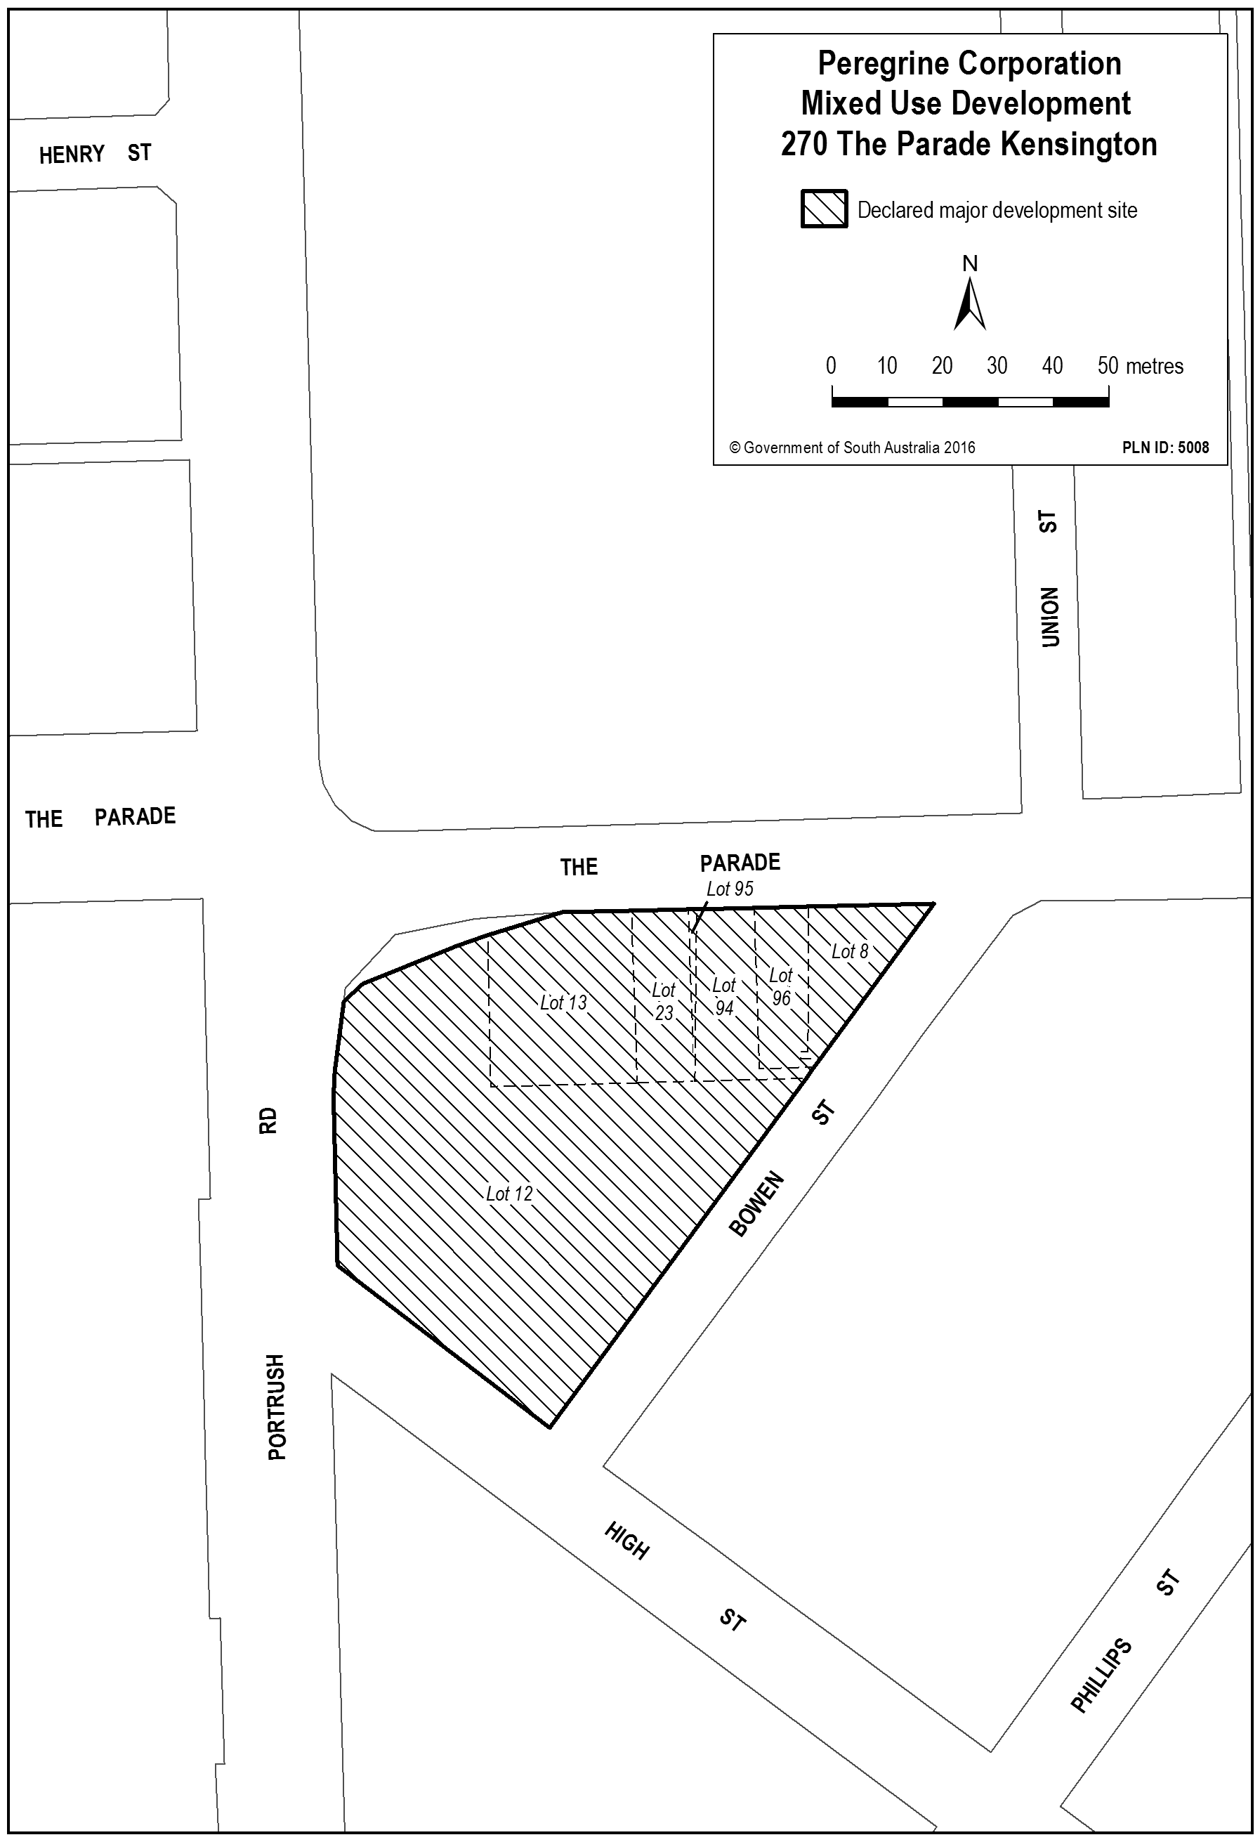
Dated 15 September 2016.
J. TePohe, Acting Chief Executive
as delegate of the Minister for Planning

ENVIRONMENT PROTECTION ACT 1993
Approval of Category B Containers
I, ANDREA KAYE WOODS, Team Leader, Container Deposit Legislation and Delegate of the Environment Protection Authority
(‘the Authority’), pursuant to Section 68 of the Environment Protection Act 1993 (SA) (‘the Act’) hereby:
Approval of Category B Containers
Approve as Category B Containers, subject to the conditions in subclauses (1), (2), (3) and (4) below, each of the classes of containers identified by reference to the following matters described in the first 4 columns of Schedule 1 of this Notice which are sold in South Australia:
(a) the product which each class of containers shall contain;
(b) the size of the containers;
(c) the type of containers; and
(d) the name of the holders of these approvals.
(1) That containers of the class to which the approval relates must bear the refund marking specified by the Authority for containers of that class. The Authority specifies the following refund markings for Category B containers:
(i) ‘10c refund at collection depots when sold in SA’, or
(ii) ‘10c refund at SA/NT collection depots in State/Territory of purchase’.
(2) The holder of the approval must have in place an effective and appropriate waste management arrangement in relation to containers of that class. For the purpose of this approval notice the company named in Column 5 of Schedule 1 of this Notice is the nominated super collector.
(3) In the case of an approval in relation to category B containers that the waste management arrangement must require the holder of the approval to provide specified super collectors with a declaration in the form determined by the Authority in relation to each sale of such containers by the holder of the approval as soon as practicable after the sale.
(4) The holder of these approvals must ensure that if a sticker bearing the refund marking has been approved, and is applied to the container, then the sticker must not be placed on any portion of the opening mechanism or in any other place that would require complete or partial removal of the sticker before the contents may be consumed.
Schedule 1

Column 1 |  | Column 2 |  | Column 3 |  | Column 4 |  | Column 5
Product Name |  | Container  Size (mL) |  | Container Type |  | Approval Holder |  | Collection  Arrangements
4 Pines Keller Door Hoppy Doppel Bock | 500 |  | Glass |  | 4 Pines Brewing Company Wholesale Pty Ltd |  | Marine Stores Ltd
Aqua Essence Alka 8 Water For Life | 1 000 |  | PET |  | Aquaessence BMTG Pty Ltd |  | Statewide Recycling
Aqua Essence Alka 8 Water For Life | 500 |  | PET |  | Aquaessence BMTG Pty Ltd |  | Statewide Recycling
Aqua Essence Alka 8 Water For Life | 300 |  | PET |  | Aquaessence BMTG Pty Ltd |  | Statewide Recycling
Aqua Essence Alka 8 Water For Life | 1 500 |  | PET |  | Aquaessence BMTG Pty Ltd |  | Statewide Recycling
Aqua Essence Alka 8 Water For Life | 2 000 |  | PET |  | Aquaessence BMTG Pty Ltd |  | Statewide Recycling
Mist Wood Gin With Elderflower & Lime | 320 |  | Glass |  | Asahi Premium Beverages |  | Statewide Recycling
Somersby Apple Cider | 500 |  | Can—Aluminium |  | Asahi Premium Beverages |  | Statewide Recycling
Somersby Apple Cider | 750 |  | Glass |  | Asahi Premium Beverages |  | Statewide Recycling
The Cider Lab Packham Pear | 330 |  | Glass |  | Asahi Premium Beverages |  | Statewide Recycling
The Cider Lab Pink Lady Apple | 330 |  | Glass |  | Asahi Premium Beverages |  | Statewide Recycling
The Cider Lab Royal Gala Apple | 330 |  | Glass |  | Asahi Premium Beverages |  | Statewide Recycling
Black and Brew Cold Brewed Coffee | 330 |  | Glass |  | Black And Brew |  | Statewide Recycling
Boeing Pure Spring Water | 600 |  | PET |  | Boeing Defence Australia |  | Statewide Recycling
Jack Daniels Gentleman Jack Double Mellowed Tennessee Whiskey Cola | 375 |  | Can—Aluminium |  | Brown Forman Australia Pty Ltd |  | Statewide Recycling
Burleigh Brewing Twisted Palm Tropical Pale Ale | 330 |  | Glass |  | Burleigh Brewing Company |  | Statewide Recycling
Becks Beer | 330 |  | Glass |  | Carlton & United Breweries Pty Ltd |  | Marine Stores Ltd
Becks Beer | 330 |  | Glass |  | Carlton & United Breweries Pty Ltd |  | Marine Stores Ltd
Bonamys Apple Cider | 330 |  | Glass |  | Carlton & United Breweries Pty Ltd |  | Marine Stores Ltd
Budweiser | 355 |  | Glass |  | Carlton & United Breweries Pty Ltd |  | Marine Stores Ltd
Cerveza Negra Modelo | 355 |  | Glass |  | Carlton & United Breweries Pty Ltd |  | Marine Stores Ltd
Cerveza Pacifico Clara | 355 |  | Glass |  | Carlton & United Breweries Pty Ltd |  | Marine Stores Ltd
Corona Extra | 355 |  | Glass |  | Carlton & United Breweries Pty Ltd |  | Marine Stores Ltd
Corona Extra | 355 |  | Can—Aluminium |  | Carlton & United Breweries Pty Ltd |  | Marine Stores Ltd
Hoegaarden Wit Blanche | 330 |  | Glass |  | Carlton & United Breweries Pty Ltd |  | Marine Stores Ltd
Leffe Blonde | 330 |  | Glass |  | Carlton & United Breweries Pty Ltd |  | Marine Stores Ltd
Leffe Radieuse | 330 |  | Glass |  | Carlton & United Breweries Pty Ltd |  | Marine Stores Ltd
Stella Artois | 330 |  | Glass |  | Carlton & United Breweries Pty Ltd |  | Marine Stores Ltd
Stella Artois Belgium | 330 |  | Glass |  | Carlton & United Breweries Pty Ltd |  | Marine Stores Ltd
Stella Artois Legere | 330 |  | Glass |  | Carlton & United Breweries Pty Ltd |  | Marine Stores Ltd
Slow Cow | 250 |  | Can—Aluminium |  | Chicane Marketing |  | Statewide Recycling
Club Beer OClock Lager | 330 |  | Can—Aluminium |  | Clubs - Club |  | Marine Stores Ltd
Mount Franklin Australias Premium Spring Water | 110 |  | PET |  | Coca Cola Amatil (Aust) Pty Ltd |  | Statewide Recycling
Dr Tims Traditional Ale | 440 |  | Can—Aluminium |  | Coopers Brewery Ltd |  | Marine Stores Ltd
Coconut Collective Organic Coconut Water Original | 330 |  | LPB—Aseptic |  | Costco Wholesale Australia Pty Ltd |  | Statewide Recycling
Paul Brassac Organic Sparkling Juice Apple With Peach Flavour | 750 |  | Glass |  | Costco Wholesale Australia Pty Ltd |  | Statewide Recycling
Paul Brassac Organic Sparkling Juice Apple With Pomegranate Flavour | 750 |  | Glass |  | Costco Wholesale Australia Pty Ltd |  | Statewide Recycling
Sunraysia Organic Orange Juice | 200 |  | Flexible Pouch—PE/PET |  | Costco Wholesale Australia Pty Ltd |  | Statewide Recycling
V Energy Guarana Drink | 300 |  | Can—Aluminium |  | Costco Wholesale Australia Pty Ltd |  | Statewide Recycling
Fuck The Rent Golden Ale | 330 |  | Glass |  | Craft Revolution Pty Ltd |  | Statewide Recycling
Future Memoirs Of A Root Beer | 330 |  | Glass |  | Craft Revolution Pty Ltd |  | Statewide Recycling
Omission Brewing Company Lager | 355 |  | Glass |  | Craft Revolution Pty Ltd |  | Statewide Recycling
Omission Brewing Company Pale Ale | 355 |  | Glass |  | Craft Revolution Pty Ltd |  | Statewide Recycling
Red Dragon Living Elixir Organic Turmeric Ginger Beer | 1 250 |  | PET |  | Delicious & Nutritious Foods Co. T/as Red Dragon Organics |  | Statewide Recycling
Red Dragon Living Elixir Organic Turmeric Ginger Beer | 350 |  | PET |  | Delicious & Nutritious Foods Co. T/as Red Dragon Organics |  | Statewide Recycling
Red Dragon Living Elixir Organic Turmeric Ginger Beer With Honey | 1 250 |  | PET |  | Delicious & Nutritious Foods Co. T/as Red Dragon Organics |  | Statewide Recycling
Red Dragon Living Elixir Organic Turmeric Ginger Beer With Honey | 350 |  | PET |  | Delicious & Nutritious Foods Co. T/as Red Dragon Organics |  | Statewide Recycling
Red Dragon Organic Ginger Beer | 1 250 |  | PET |  | Delicious & Nutritious Foods Co. T/as Red Dragon Organics |  | Statewide Recycling
Red Dragon Organic Ginger Beer | 350 |  | PET |  | Delicious & Nutritious Foods Co. T/as Red Dragon Organics |  | Statewide Recycling
Captain Morgan Original Spiced Gold | 375 |  | PET |  | Diageo Australia Pty Ltd |  | Statewide Recycling
Smirnoff Pure Classic Lime & Soda | 300 |  | Glass |  | Diageo Australia Pty Ltd |  | Statewide Recycling
Smirnoff Pure Cranbery Apple & Soda | 300 |  | Glass |  | Diageo Australia Pty Ltd |  | Statewide Recycling
Smirnoff Pure Ginger Lime & Soda | 300 |  | Glass |  | Diageo Australia Pty Ltd |  | Statewide Recycling
Smirnoff Pure Passionfruit Lime & Soda | 300 |  | Glass |  | Diageo Australia Pty Ltd |  | Statewide Recycling
Bachata | 330 |  | Glass |  | Direct Brand Distributors |  | Marine Stores Ltd
Boddingtons | 440 |  | Can—Aluminium |  | Direct Brand Distributors |  | Marine Stores Ltd
Caffreys Ale | 440 |  | Can—Aluminium |  | Direct Brand Distributors |  | Marine Stores Ltd
Carling | 500 |  | Can—Aluminium |  | Direct Brand Distributors |  | Marine Stores Ltd
Corona | 710 |  | Glass |  | Direct Brand Distributors |  | Marine Stores Ltd
Fentimans Sparkling Lime & Jasmine | 275 |  | Glass |  | Direct Brand Distributors |  | Marine Stores Ltd
Murrays Angry Man | 330 |  | Glass |  | Direct Brand Distributors |  | Marine Stores Ltd
Murrays Fred IPA | 330 |  | Glass |  | Direct Brand Distributors |  | Marine Stores Ltd
Murrays Moon Boy | 330 |  | Glass |  | Direct Brand Distributors |  | Marine Stores Ltd
Murrays Whale Ale | 330 |  | Glass |  | Direct Brand Distributors |  | Marine Stores Ltd
Oranjeboom | 500 |  | Can—Aluminium |  | Direct Brand Distributors |  | Marine Stores Ltd
Oranjeboom | 330 |  | Glass |  | Direct Brand Distributors |  | Marine Stores Ltd
Salitos Cerveza | 330 |  | Glass |  | Direct Brand Distributors |  | Marine Stores Ltd
Salitos Tequila | 330 |  | Glass |  | Direct Brand Distributors |  | Marine Stores Ltd
Tyskie | 500 |  | Can—Aluminium |  | Direct Brand Distributors |  | Marine Stores Ltd
DAX German Pilsner | 330 |  | Glass |  | Fernbrew Pty Ltd Trading as DAquinos Bond Wholesalers |  | Statewide Recycling
Castello Premium Lager | 660 |  | Glass |  | Festival City Wines & Spirits Pty Ltd |  | Statewide Recycling
Castello Rossa Lager | 330 |  | Glass |  | Festival City Wines & Spirits Pty Ltd |  | Statewide Recycling
Little Dove New World Pale Ale | 330 |  | Glass |  | Gage Roads Brewing Co |  | Statewide Recycling
Coles Cloudy Apple Juice | 500 |  | PET |  | Grove Fruit Juice Pty Ltd |  | Statewide Recycling
Coles Cloudy Orange Juice | 500 |  | PET |  | Grove Fruit Juice Pty Ltd |  | Statewide Recycling
Coles Orange & Mango Fruit Drink | 2 000 |  | HDPE |  | Grove Fruit Juice Pty Ltd |  | Statewide Recycling
Coles Orange Fruit Drink | 2 000 |  | HDPE |  | Grove Fruit Juice Pty Ltd |  | Statewide Recycling
Country Orchard 100% Orange Juice | 500 |  | PET |  | Grove Fruit Juice Pty Ltd |  | Statewide Recycling
OKF Aloe Vera King Natural Mango | 1 500 |  | PET |  | HMF Food Production GMBH & Co KG |  | Statewide Recycling
OKF Aloe Vera King Natural Original | 1 500 |  | PET |  | HMF Food Production GMBH & Co KG |  | Statewide Recycling
Health Lab Balance Strawberry Protein Smoothie | 250 |  | PET |  | Health Lab Pty Ltd |  | Statewide Recycling
Health Lab Craving Kicker Choc Protein Smoothie | 250 |  | PET |  | Health Lab Pty Ltd |  | Statewide Recycling
Health Lab Revive Me Coffee Protein Smoothie | 250 |  | PET |  | Health Lab Pty Ltd |  | Statewide Recycling
Muscle Milk Protein Banana Flavour | 414 |  | HDPE |  | Hormel Foods Australia Pty Ltd |  | Statewide Recycling
Muscle Milk Protein Cafe Latte Flavour | 414 |  | HDPE |  | Hormel Foods Australia Pty Ltd |  | Statewide Recycling
Muscle Milk Protein Chocolate Flavour | 414 |  | HDPE |  | Hormel Foods Australia Pty Ltd |  | Statewide Recycling
Muscle Milk Protein Vanilla Flavour | 414 |  | HDPE |  | Hormel Foods Australia Pty Ltd |  | Statewide Recycling
The Cide Project 2016 Dry Vintage Cider | 500 |  | Glass |  | Kalangadoo Cider Co Pty Ltd t/as The Cide Project |  | Statewide Recycling
Balance Orange | 500 |  | PET |  | Lion Dairy & Drinks |  | Marine Stores Ltd
Balance Orange | 2 000 |  | HDPE |  | Lion Dairy & Drinks |  | Marine Stores Ltd
Barrel Aged White Rabbit Jackalope | 750 |  | Glass |  | Lion Pty Ltd |  | Marine Stores Ltd
Barrel Aged White Rabbit Red 2016 | 750 |  | Glass |  | Lion Pty Ltd |  | Marine Stores Ltd
Emersons 1812 Hoppy Pale Ale | 500 |  | Glass |  | Lion Pty Ltd |  | Marine Stores Ltd
Emersons Bird Dog India Pale Ale | 500 |  | Glass |  | Lion Pty Ltd |  | Marine Stores Ltd
Emersons Bookbinder Session Ale | 500 |  | Glass |  | Lion Pty Ltd |  | Marine Stores Ltd
Emersons Daredevil Red Pale Ale | 500 |  | Glass |  | Lion Pty Ltd |  | Marine Stores Ltd
Emersons London Porter | 500 |  | Glass |  | Lion Pty Ltd |  | Marine Stores Ltd
Emersons NZ Pilsner | 500 |  | Glass |  | Lion Pty Ltd |  | Marine Stores Ltd
Emersons Phantom Lord Hopped Stout | 500 |  | Glass |  | Lion Pty Ltd |  | Marine Stores Ltd
Little Creatures Single Batch VHA Double IPA | 640 |  | Glass |  | Lion Pty Ltd |  | Marine Stores Ltd
Macs Great White | 330 |  | Glass |  | Lion Pty Ltd |  | Marine Stores Ltd
Macs Hop Rocker | 330 |  | Glass |  | Lion Pty Ltd |  | Marine Stores Ltd
Macs Three Wolves | 330 |  | Glass |  | Lion Pty Ltd |  | Marine Stores Ltd
Malt Shovel Brewers Hoppy Hefe | 568 |  | Glass |  | Lion Pty Ltd |  | Marine Stores Ltd
Speights 5 Malt Old Dark | 330 |  | Glass |  | Lion Pty Ltd |  | Marine Stores Ltd
Speights Distinction Ale | 330 |  | Glass |  | Lion Pty Ltd |  | Marine Stores Ltd
Speights Triple Malt Old Dark | 330 |  | Glass |  | Lion Pty Ltd |  | Marine Stores Ltd
Lobo Cloudy Cider Apple & Pear | 330 |  | Glass |  | Lobo Juice & Cider Pty Ltd |  | Marine Stores Ltd
Mischief Brew Coffee | 500 |  | Glass |  | Mischief Brew |  | Statewide Recycling
Mischief Brew Coffee | 330 |  | Glass |  | Mischief Brew |  | Statewide Recycling
Nexba Natural Cola Sparkling Sugar Free | 300 |  | Glass |  | Nexba Beverages |  | Statewide Recycling
Nexba Natural Cola Sparkling Sugar Free | 500 |  | Glass |  | Nexba Beverages |  | Statewide Recycling
Nexba Natural Lemon Sparkling Sugar Free | 300 |  | Glass |  | Nexba Beverages |  | Statewide Recycling
Nexba Natural Orange Sparkling Sugar Free | 300 |  | Glass |  | Nexba Beverages |  | Statewide Recycling
Nippys Yosip Mango Banana Drinking Yoghurt | 250 |  | HDPE |  | Nippys Fruit Juices Pty Ltd |  | Statewide Recycling
Nippys Yosip Mixed Berry Drinking Yoghurt | 250 |  | HDPE |  | Nippys Fruit Juices Pty Ltd |  | Statewide Recycling
One Pure Natural New Zealand Artesian Water | 320 |  | PET |  | One Pure International Group Limited |  | Statewide Recycling
One Pure Natural New Zealand Artesian Water Sparkling | 750 |  | Glass |  | One Pure International Group Limited |  | Statewide Recycling
One Pure Natural New Zealand Artesian Water Sparkling | 300 |  | Glass |  | One Pure International Group Limited |  | Statewide Recycling
One Pure Natural New Zealand Artesian Water Sport | 750 |  | PET |  | One Pure International Group Limited |  | Statewide Recycling
One Pure Natural New Zealand Artesian Water Still | 1 500 |  | PET |  | One Pure International Group Limited |  | Statewide Recycling
One Pure Natural New Zealand Artesian Water Still | 500 |  | PET |  | One Pure International Group Limited |  | Statewide Recycling
One Pure Natural New Zealand Artesian Water Still | 300 |  | Glass |  | One Pure International Group Limited |  | Statewide Recycling
One Pure Natural New Zealand Artesian Water Still | 750 |  | Glass |  | One Pure International Group Limited |  | Statewide Recycling
Mojo Low Sugar Organic Crafted Kombucha Live Sparkling Probiotic Ginger | 450 |  | Glass |  | Organic & Raw Trading Company Pty Ltd |  | Flagcan Distributors
Mojo Low Sugar Organic Crafted Kombucha Live Sparkling Probiotic Strawberry Hibiscus | 450 |  | Glass |  | Organic & Raw Trading Company Pty Ltd |  | Flagcan Distributors
Oro Naturally Sparkling Artesian Mineral Water | 750 |  | Glass |  | Oro Luxury Water |  | Statewide Recycling
Oro Naturally Sparkling Artesian Mineral Water | 250 |  | Glass |  | Oro Luxury Water |  | Statewide Recycling
Stappi Chinotto | 750 |  | Glass |  | P & T Basile Pty Ltd t/as Basile Imports |  | Statewide Recycling
Ballast Point Brewing Company Pineapple Sculpin India Pale Ale | 355 |  | Glass |  | Pinnacle Drinks |  | Marine Stores Ltd
Cerveza Dos Equis XX Lager Especial | 355 |  | Can—Aluminium |  | Pinnacle Drinks |  | Marine Stores Ltd
Karl Strauss Brewing Company Pintail Pale Ale | 355 |  | Glass |  | Pinnacle Drinks |  | Marine Stores Ltd
Karl Strauss Brewing Company Red Trolley Ale | 355 |  | Glass |  | Pinnacle Drinks |  | Marine Stores Ltd
Karl Strauss Brewing Company Tower 10 IPA | 355 |  | Glass |  | Pinnacle Drinks |  | Marine Stores Ltd
Saint Archer Blonde Ale | 355 |  | Can—Aluminium |  | Pinnacle Drinks |  | Marine Stores Ltd
Saint Archer Double Ale | 355 |  | Can—Aluminium |  | Pinnacle Drinks |  | Marine Stores Ltd
Saint Archer IPA | 355 |  | Can—Aluminium |  | Pinnacle Drinks |  | Marine Stores Ltd
Saint Archer White Ale | 355 |  | Can—Aluminium |  | Pinnacle Drinks |  | Marine Stores Ltd
Sanitarium Up & Go Energize Choc Coconut Flavour | 500 |  | PET |  | Sanitarium Health & Wellbeing |  | Statewide Recycling
Sanitarium Up & Go Liquid Breakfast Raspberry & Yoghurt Coconut Flavour | 500 |  | PET |  | Sanitarium Health & Wellbeing |  | Statewide Recycling
Cor De Coco Coconut Double Shot Espresso | 280 |  | Glass |  | The Completely Coconut Company Pty Ltd |  | Statewide Recycling
Cor De Coco Coconut Mochacinno | 280 |  | Glass |  | The Completely Coconut Company Pty Ltd |  | Statewide Recycling
Cor De Coco Coconut Vanilla Latte | 280 |  | Glass |  | The Completely Coconut Company Pty Ltd |  | Statewide Recycling
East Imperial Old World Tonic | 150 |  | Glass |  | Think Spirits Pty Ltd |  | Statewide Recycling
East Imperial Yuzu Tonic | 150 |  | Glass |  | Think Spirits Pty Ltd |  | Statewide Recycling
The Juice Lab Cloudy Apple Reduced 50% Sugar | 1 500 |  | PET |  | Thirsty Brothers Pty Ltd |  | Statewide Recycling
The Juice Lab Gimme Green | 900 |  | PET |  | Thirsty Brothers Pty Ltd |  | Statewide Recycling
The Juice Lab Love Potion | 900 |  | PET |  | Thirsty Brothers Pty Ltd |  | Statewide Recycling
The Juice Lab Orange Reduced 50% Sugar | 1 500 |  | PET |  | Thirsty Brothers Pty Ltd |  | Statewide Recycling
The Juice Lab Pulp Free Orange Reduced 50% Sugar | 1 500 |  | PET |  | Thirsty Brothers Pty Ltd |  | Statewide Recycling
The Juice Lab Rise & Shine | 900 |  | PET |  | Thirsty Brothers Pty Ltd |  | Statewide Recycling
The Juice Lab Tonix Kick Start | 200 |  | PET |  | Thirsty Brothers Pty Ltd |  | Statewide Recycling
The Juice Lab Tonix Super C | 200 |  | PET |  | Thirsty Brothers Pty Ltd |  | Statewide Recycling
The Juice Lab Tonix You Beauty | 200 |  | PET |  | Thirsty Brothers Pty Ltd |  | Statewide Recycling
Gentlemans Collection Batch No 5 2016 Shiraz | 187 |  | PET |  | Treasury Wine Estates Limited |  | Marine Stores Ltd
Joes Classics Aloe Vera Juice Blueberry | 500 |  | HDPE |  | Trident Sales & Distribution Australia |  | Statewide Recycling
Joes Classics Aloe Vera Juice Lychee | 500 |  | HDPE |  | Trident Sales & Distribution Australia |  | Statewide Recycling
Joes Classics Aloe Vera Juice Original | 500 |  | HDPE |  | Trident Sales & Distribution Australia |  | Statewide Recycling
Joes Classics Aloe Vera Juice Peach | 500 |  | HDPE |  | Trident Sales & Distribution Australia |  | Statewide Recycling
Mountain Falls Lightly Sparkling Pure Spring Water | 500 |  | HDPE |  | Trident Sales & Distribution Australia |  | Statewide Recycling
Coles Lightly Sparkling Spring Water | 1 250 |  | PET |  | Tru Blu Beverages Pty Limited |  | Flagcan Distributors
Coles Lightly Sparkling Spring Water Lemon Flavour | 1 250 |  | PET |  | Tru Blu Beverages Pty Limited |  | Flagcan Distributors
Coles Lightly Sparkling Spring Water Lime Flavour | 1 250 |  | PET |  | Tru Blu Beverages Pty Limited |  | Flagcan Distributors
Bearded Lady Bourbon Whiskey & Cola 10% | 375 |  | Can—Aluminium |  | Vok Beverages Pty Ltd |  | Statewide Recycling
Bearded Lady Bourbon Whiskey & Cola 8% | 375 |  | Can—Aluminium |  | Vok Beverages Pty Ltd |  | Statewide Recycling
Three Oaks Cider Co Adelaide Hills Crushed Apple | 375 |  | Can—Aluminium |  | Vok Beverages Pty Ltd |  | Statewide Recycling

HOUSING IMPROVEMENT ACT 1940
Sub-Standard Declaration
NOTICE is hereby given that the South Australian Housing Trust Board Delegate in the exercise of the powers conferred by the Housing Improvement Act 1940, does hereby declare the houses described in the table hereunder to be substandard for the purposes of Part 7 of the Housing Improvement Act 1940.

Address of House |  | Allotment, Section, etc. | Certificate of Title  Volume Folio
14 Kauri Road, Hawthorndene, S.A. 5051 |  | Allotments 93 and 94, Deposited Plan 3385,  Hundred of Adelaide | 5719 | 986
Dated at Adelaide, 22 September 2016. R. Reardon, Director, Property and Contract Management, Housing SA (Delegate SAHT)

HOUSING IMPROVEMENT ACT 1940
Sub-Standard Revocations
WHEREAS by notice published in the Government Gazette on the dates mentioned in the following table the South Australian Housing Trust Board Delegate did declare the houses described in the said table to be substandard for the purposes of Part 7 of the Housing Improvement Act 1940, and whereas the South Australian Housing Trust Board Delegate is satisfied that each of the houses described hereunder has ceased to be substandard, notice is hereby given that, in exercise of the powers conferred by the said Part, the South Australian Housing Trust does hereby revoke the said declaration in respect of each house.

Address of House | Allotment, Section, etc. | Certificate of Title  Volume Folio |  | Date and page of Government Gazette in which notice declaring house to be substandard published
7/7 Barcoo Road, Para Hills, S.A. 5096  (Also known as 7-9 Barcoo Road) | Unit 7, Strata Plan 1503,  Hundred of Yatala | 5054 | 815 | 29.1.2015, Page 437
Lot 1, Proper Bay Road, Port Lincoln, S.A. 5606 (Previously known as Section 10) | Allotment 1, Deposited Plan 25947, Hundred of Lincoln | 5426 | 770 | 28.7.1988, Page 533
17 Mulgundawah Road, Murray Bridge, S.A. 5253 | Allotment 23, Deposited Plan 4201, Hundred of Mobilong | 2168  5659 | 101  367 | 2.6.2016, Page 1930
11 Landrien Court, Golden Grove, S.A. 5125 | Allotment 85 Deposited Plan 24587, Hundred of Yatala | 5284 | 143 | 11.8.2016, Page 3157
Dated at Adelaide, 22 September 2016. R. Reardon, Director, Property and Contract Management, Housing SA (Delegate SAHT)

South Australia
Liquor Licensing (Dry Areas) Notice 2016
under section 131(1) of the Liquor Licensing Act 1997
1—Short title
This notice may be cited as the Liquor Licensing (Dry Areas) Notice 2016.
2—Commencement
This notice comes into operation on 22 September 2016.
3—Interpretation
(1) In this notice—
principal notice means the Liquor Licensing (Dry Areas) Notice 2015 published in the Gazette on 5.1.15, as in force from time to time.
(2) Clause 3 of the principal notice applies to this notice as if it were the principal notice.
4—Consumption etc of liquor prohibited in dry areas
(1) Pursuant to section 131 of the Act, the consumption and possession of liquor in the area described in the Schedule is prohibited in accordance with the provisions of the Schedule.
(2) The prohibition has effect during the periods specified in the Schedule.
(3) The prohibition does not extend to private land in the area described in the Schedule.
(4) Unless the contrary intention appears, the prohibition of the possession of liquor in the area does not extend to—
(a) a person who is genuinely passing through the area if—
(i) the liquor is in the original container in which it was purchased from licensed premises; and
(ii) the container has not been opened; or
(b) a person who has possession of the liquor in the course of carrying on a business or in the course of his or her employment by another person in the course of carrying on a business; or
(c) a person who is permanently or temporarily residing at premises within the area or on the boundary of the area and who enters the area solely for the purpose of passing through it to enter those premises or who enters the area from those premises for the purpose of leaving the area.
(5) The Schedule is in substitution for Schedule—Adelaide Park Lands Area 1 in the principal notice.
Schedule 1—Adelaide Park Lands Area 1

1—Extent of prohibition
The consumption of liquor is prohibited and the possession of liquor is prohibited.
2—Period of prohibition
From 8 pm on each day to 11 am on the following day, until 11 am on 22 September 2017.
3—Description of area
The area in and adjacent to Adelaide and North Adelaide, generally known as the Adelaide Park Lands, together with other land, bounded as follows: commencing at the point at which the western boundary of Fullarton Road, Adelaide, meets the northern boundary of Greenhill Road, Adelaide, then westerly along that northern boundary of Greenhill Road and the prolongation in a straight line of that boundary to the point at which it intersects the western boundary of Lot 8 DP 83004, then generally northerly along that western boundary of Lot 8 and the western boundaries of Lot 50 FP 219636 and Lot 24 DP 90434 to the north-western corner of Lot 24 DP 90434, then in a straight line by the shortest route to the south-western corner of Lot 74 DP 56872, then generally northerly along the eastern boundary of James Congdon Drive, Adelaide, to the south-western boundary of Port Road, Adelaide, then in a straight line by the shortest route across Port Road to the north-eastern boundary of Port Road, then generally northerly along that boundary of Port Road to the point at which the eastern boundary of Port Road meets the south-eastern boundary of Park Terrace, North Adelaide, then generally north-easterly along that south-eastern boundary of Park Terrace, easterly along the southern boundary of Fitzroy Terrace, North Adelaide, and south-easterly along the south-western boundary of Robe Terrace, North Adelaide, to the point at which the south-western boundary of Robe Terrace meets the south-western boundary of Mann Road, North Adelaide, then in a straight line by the shortest route to the point at which the south-western boundary of Park Road, North Adelaide, meets the eastern boundary of Northcote Terrace, North Adelaide, then generally south-easterly and southerly along that boundary of Park Road, southerly along the western boundary of Hackney Road, Adelaide, and southerly and south-easterly along the south-western boundary of Dequetteville Terrace, Adelaide, and the prolongation in a straight line of that boundary to the point at which the prolongation in a straight line of the south-western boundary of Dequetteville Terrace meets the western boundary of Fullarton Road, Adelaide, then southerly along the western boundary of Fullarton Road to the point of commencement, but excluding any part of that area that is within—
(a) the area defined in Schedule—Adelaide Area 1 as the area to which the prohibition in that Schedule applies; or
(b) an area defined in Schedule—Adelaide Area 1 as an area excluded from the area to which the prohibition in that Schedule applies; or
(c) the area defined in Schedule—North Adelaide Area 1 as the area to which the prohibition in that Schedule applies.

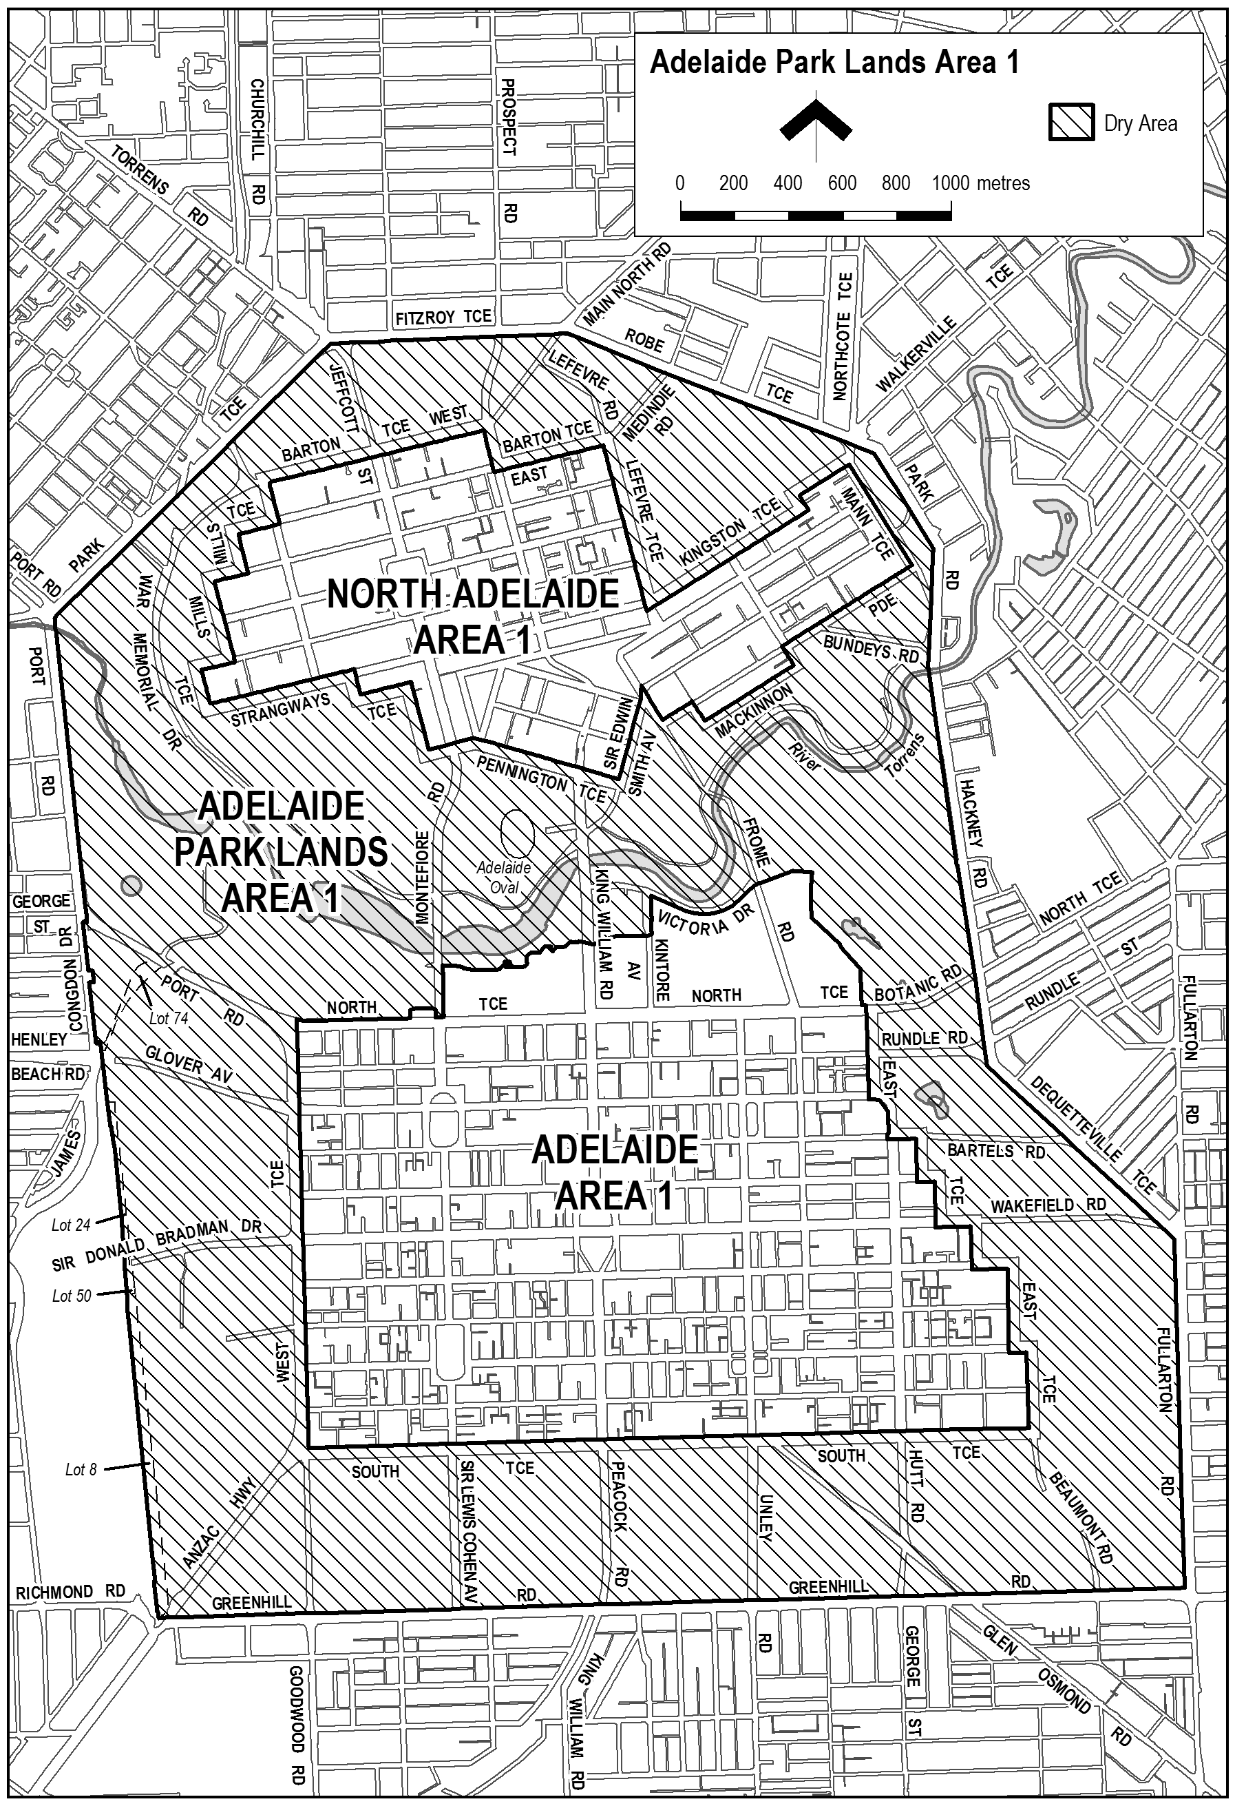
Made by the Minister for Consumer and Business Services
On 19 September 2016.
South Australia
Liquor Licensing (Dry Areas) Notice 2016
under section 131(1) of the Liquor Licensing Act 1997

1—Short title
This notice may be cited as the Liquor Licensing (Dry Areas) Notice 2016.
2—Commencement
This notice comes into operation on 22 September 2016.
3—Interpretation
(1) In this notice—
principal notice means the Liquor Licensing (Dry Areas) Notice 2015 published in the Gazette on 5.1.15, as in force from time to time.
(2) Clause 3 of the principal notice applies to this notice as if it were the principal notice.
4—Consumption etc of liquor prohibited in dry areas
(1) Pursuant to section 131 of the Act, the consumption and possession of liquor in the area described in the Schedule is prohibited in accordance with the provisions of the Schedule.
(2) The prohibition has effect during the periods specified in the Schedule.
(3) The prohibition does not extend to private land in the area described in the Schedule.
(4) Unless the contrary intention appears, the prohibition of the possession of liquor in the area does not extend to—
(a) a person who is genuinely passing through the area if—
(i) the liquor is in the original container in which it was purchased from licensed premises; and
(ii) the container has not been opened; or
(b) a person who has possession of the liquor in the course of carrying on a business or in the course of his or her employment by another person in the course of carrying on a business; or
(c) a person who is permanently or temporarily residing at premises within the area or on the boundary of the area and who enters the area solely for the purpose of passing through it to enter those premises or who enters the area from those premises for the purpose of leaving the area.
(5) The Schedule is in substitution for Schedule—Woodcroft Area 1 in the principal notice.

Schedule— Woodcroft Area 1

1—Extent of prohibition
The consumption of liquor is prohibited and the possession of liquor is prohibited.
2—Period of prohibition
From 8pm on each day to 6am on the following day.
3—Description of area
Reserve area in Woodcroft, as follows: commencing at the point at which the southern boundary of Pimpala Road, Woodcroft, meets the western boundary of Dressage Avenue, then westerly along the southern boundary of Pimpala Road to the point at which it meets the eastern boundary of the first allotment of private land on that side of Pimpala Road, then generally southerly and south-easterly along the eastern boundaries of that allotment and the adjoining allotments and road reserves (including the eastern boundaries of Stables Lane, Cleveland Court, Grooms Way, Polo Court, Bay Place, Headland Crescent and Farriers Way) to the fence marking the north-western boundary of the pine tree plantation, then north-easterly along that fence line to the point at which it first meets the southern boundary of an adjoining allotment of private land (being an allotment bounded on the north by Dressage Avenue), then generally westerly and north-westerly along the southern boundaries of that allotment and the adjoining allotments and road reserves (including the southern boundaries of Connemara Way and Caspian Court) to the south-western corner of the southernmost allotment adjoining the western boundary of Caspian Court, then generally north-westerly and northerly along the western boundaries of that allotment and the adjoining allotments and road reserves (including the western boundaries of Sandalwood Grove and Piaffe Lane) to the north-western corner of the westernmost allotment adjoining the northern boundary of Piaffe Lane, then generally north-easterly along the northern boundary of that allotment and the adjoining allotments to the western boundary of Dressage Avenue, then northerly along the western boundary of Dressage Avenue to the point of commencement.
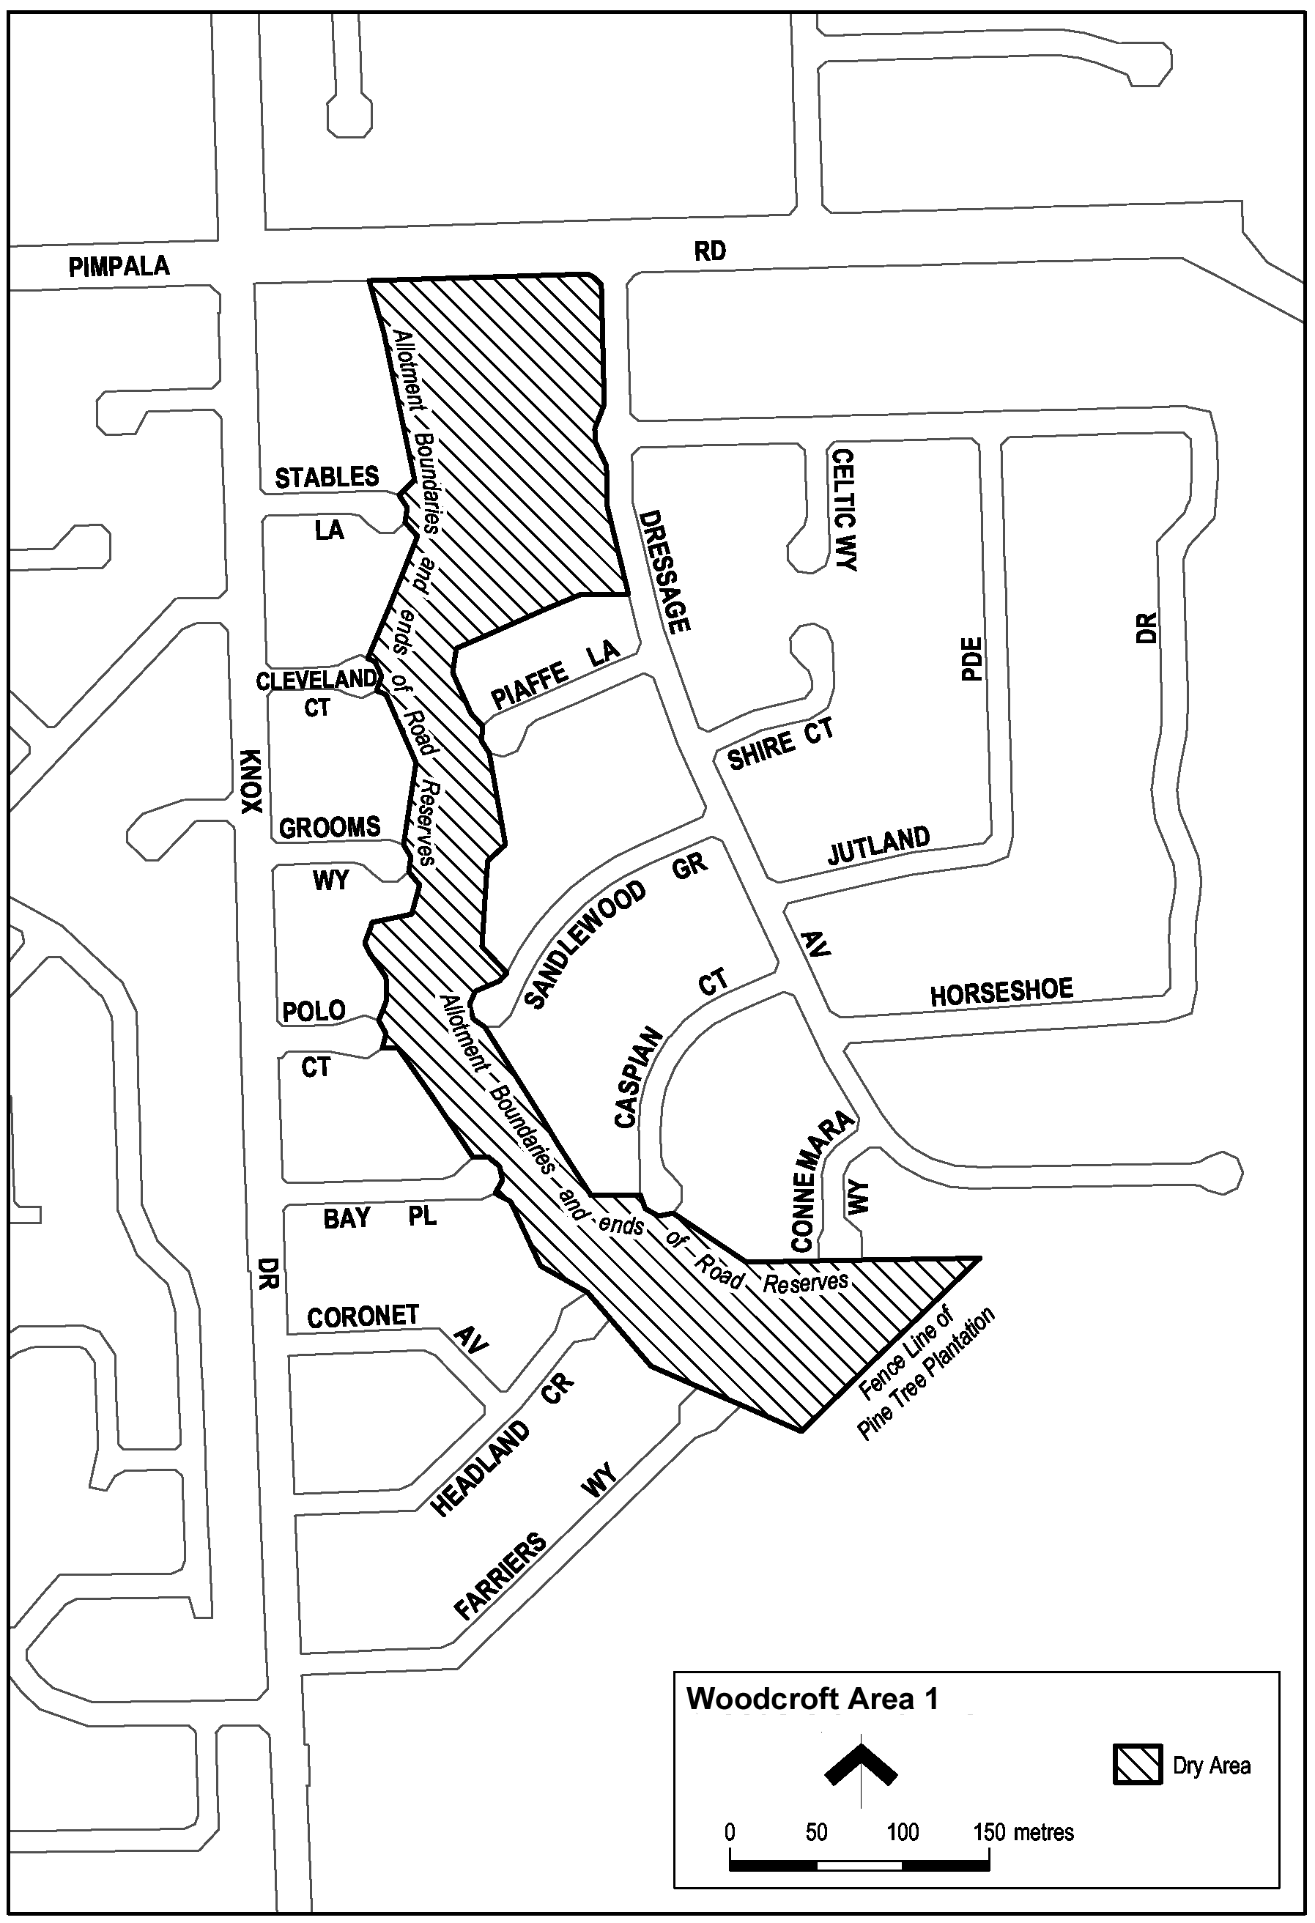
Made by the Minister for Consumer and Business Services
On 19 September 2016.
South Australia
Liquor Licensing (Dry Areas) Notice 2016
under section 131(1) of the Liquor Licensing Act 1997

1—Short title
This notice may be cited as the Liquor Licensing (Dry Areas) Notice 2016.
2—Commencement
This notice comes into operation on 22 September 2016.
3—Interpretation
(1) In this notice—
principal notice means the Liquor Licensing (Dry Areas) Notice 2015 published in the Gazette on 5.1.15, as in force from time to time.
(2) Clause 3 of the principal notice applies to this notice as if it were the principal notice.
4—Consumption etc of liquor prohibited in dry areas
(1) Pursuant to section 131 of the Act, the consumption and possession of liquor in the area described in the Schedule is prohibited in accordance with the provisions of the Schedule.
(2) The prohibition has effect during the periods specified in the Schedule.
(3) The prohibition does not extend to private land in the area described in the Schedule.
(4) Unless the contrary intention appears, the prohibition of the possession of liquor in the area does not extend to—
(a) a person who is genuinely passing through the area if—
(i) the liquor is in the original container in which it was purchased from licensed premises; and
(ii) the container has not been opened; or
(b) a person who has possession of the liquor in the course of carrying on a business or in the course of his or her employment by another person in the course of carrying on a business; or
(c) a person who is permanently or temporarily residing at premises within the area or on the boundary of the area and who enters the area solely for the purpose of passing through it to enter those premises or who enters the area from those premises for the purpose of leaving the area.
(5) The Schedule is in substitution for Schedule—Noarlunga Centre Area 1 in the principal notice.

Schedule— Noarlunga Centre Area 1

1—Extent of prohibition
The consumption of liquor is prohibited and the possession of liquor is prohibited.
2—Period of prohibition
Continuous.
3—Description of area
The area in the City of Onkaparinga includes all land bounded on the south and east by Goldsmith Drive, on the north by Beach Road and on the west by Dyson Road.
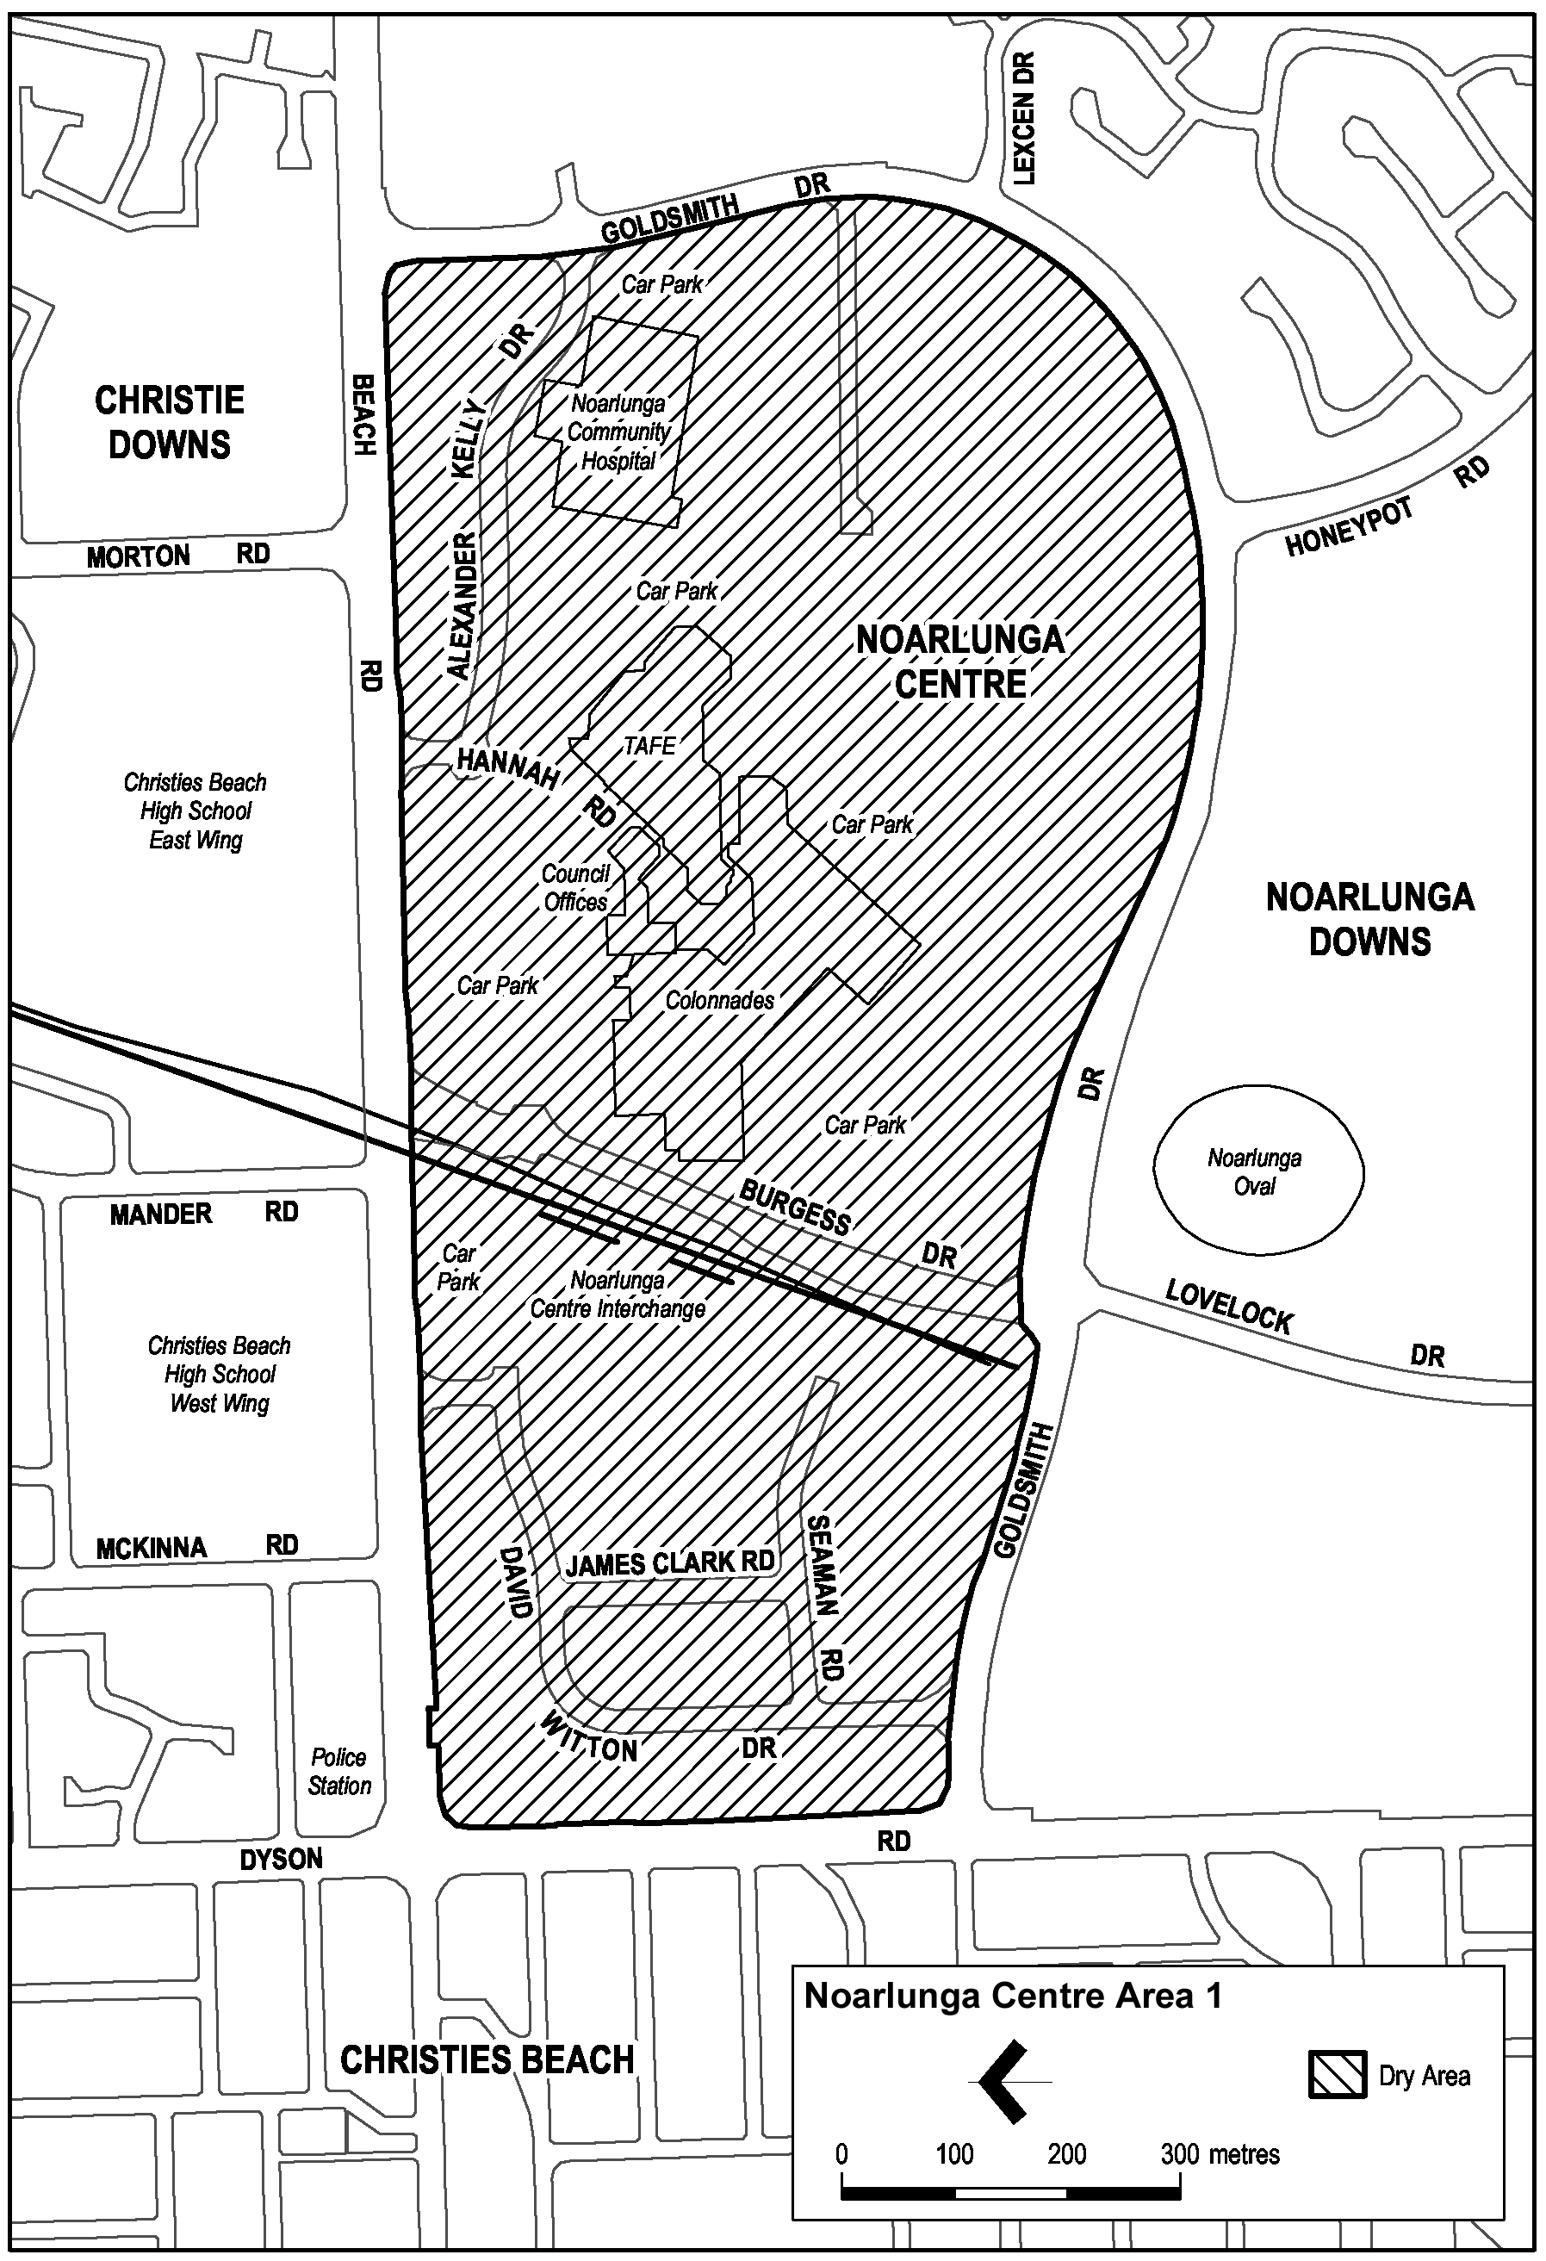
Made by the Minister for Consumer and Business Services
On 19 September 2016.

South Australia
Liquor Licensing (Dry Areas) Notice 2016
under section 131(1) of the Liquor Licensing Act 1997

1—Short title
This notice may be cited as the Liquor Licensing (Dry Areas) Notice 2016.
2—Commencement
This notice comes into operation on 22 September 2016.
3—Interpretation
(1) In this notice—
principal notice means the Liquor Licensing (Dry Areas) Notice 2015 published in the Gazette on 5.1.15, as in force from time to time.
(2) Clause 3 of the principal notice applies to this notice as if it were the principal notice.
4—Consumption etc of liquor prohibited in dry areas
(1) Pursuant to section 131 of the Act, the consumption and possession of liquor in the area described in the Schedule is prohibited in accordance with the provisions of the Schedule.
(2) The prohibition has effect during the periods specified in the Schedule.
(3) The prohibition does not extend to private land in the area described in the Schedule.
(4) Unless the contrary intention appears, the prohibition of the possession of liquor in the area does not extend to—
(a) a person who is genuinely passing through the area if—
(i) the liquor is in the original container in which it was purchased from licensed premises; and
(ii) the container has not been opened; or
(b) a person who has possession of the liquor in the course of carrying on a business or in the course of his or her employment by another person in the course of carrying on a business; or
(c) a person who is permanently or temporarily residing at premises within the area or on the boundary of the area and who enters the area solely for the purpose of passing through it to enter those premises or who enters the area from those premises for the purpose of leaving the area.
(5) The Schedule is in substitution for Schedule—Christies Beach Area 1 in the principal notice.

Schedule— Christies Beach Area 1

1—Extent of prohibition
The consumption of liquor is prohibited and the possession of liquor is prohibited.
2—Period of prohibition
From 6pm on each day to 6am on the following day.
3—Description of area
The area at Christies Beach bounded as follows: commencing at the point at which the prolongation in a straight line of the southern boundary of Benny Avenue intersects the low water mark of Gulf St. Vincent, then generally north-easterly and northerly along the low water mark to the mouth of Christie Creek, then generally easterly and north-easterly along the southern bank of Christie Creek to its intersection with the prolongation in a straight line of the eastern boundary of Fletcher Drive, then south-westerly and southerly along that prolongation and the eastern boundary of Fletcher Drive to the northern boundary of Gulfview Road, then easterly along that boundary of Gulfview Road to its intersection with the prolongation in a straight line of the eastern boundary of Grundy Terrace, then generally southerly along that prolongation and the eastern boundary of Grundy Terrace, Sydney Crescent, Grundy Terrace and Witton Road to the intersection between the eastern boundary of Witton Road and the southern boundary of Benny Avenue, then westerly along that southern boundary of Benny Avenue and the prolongation in a straight line of that boundary to the point of commencement, but excluding the Christies Beach Caravan Park.
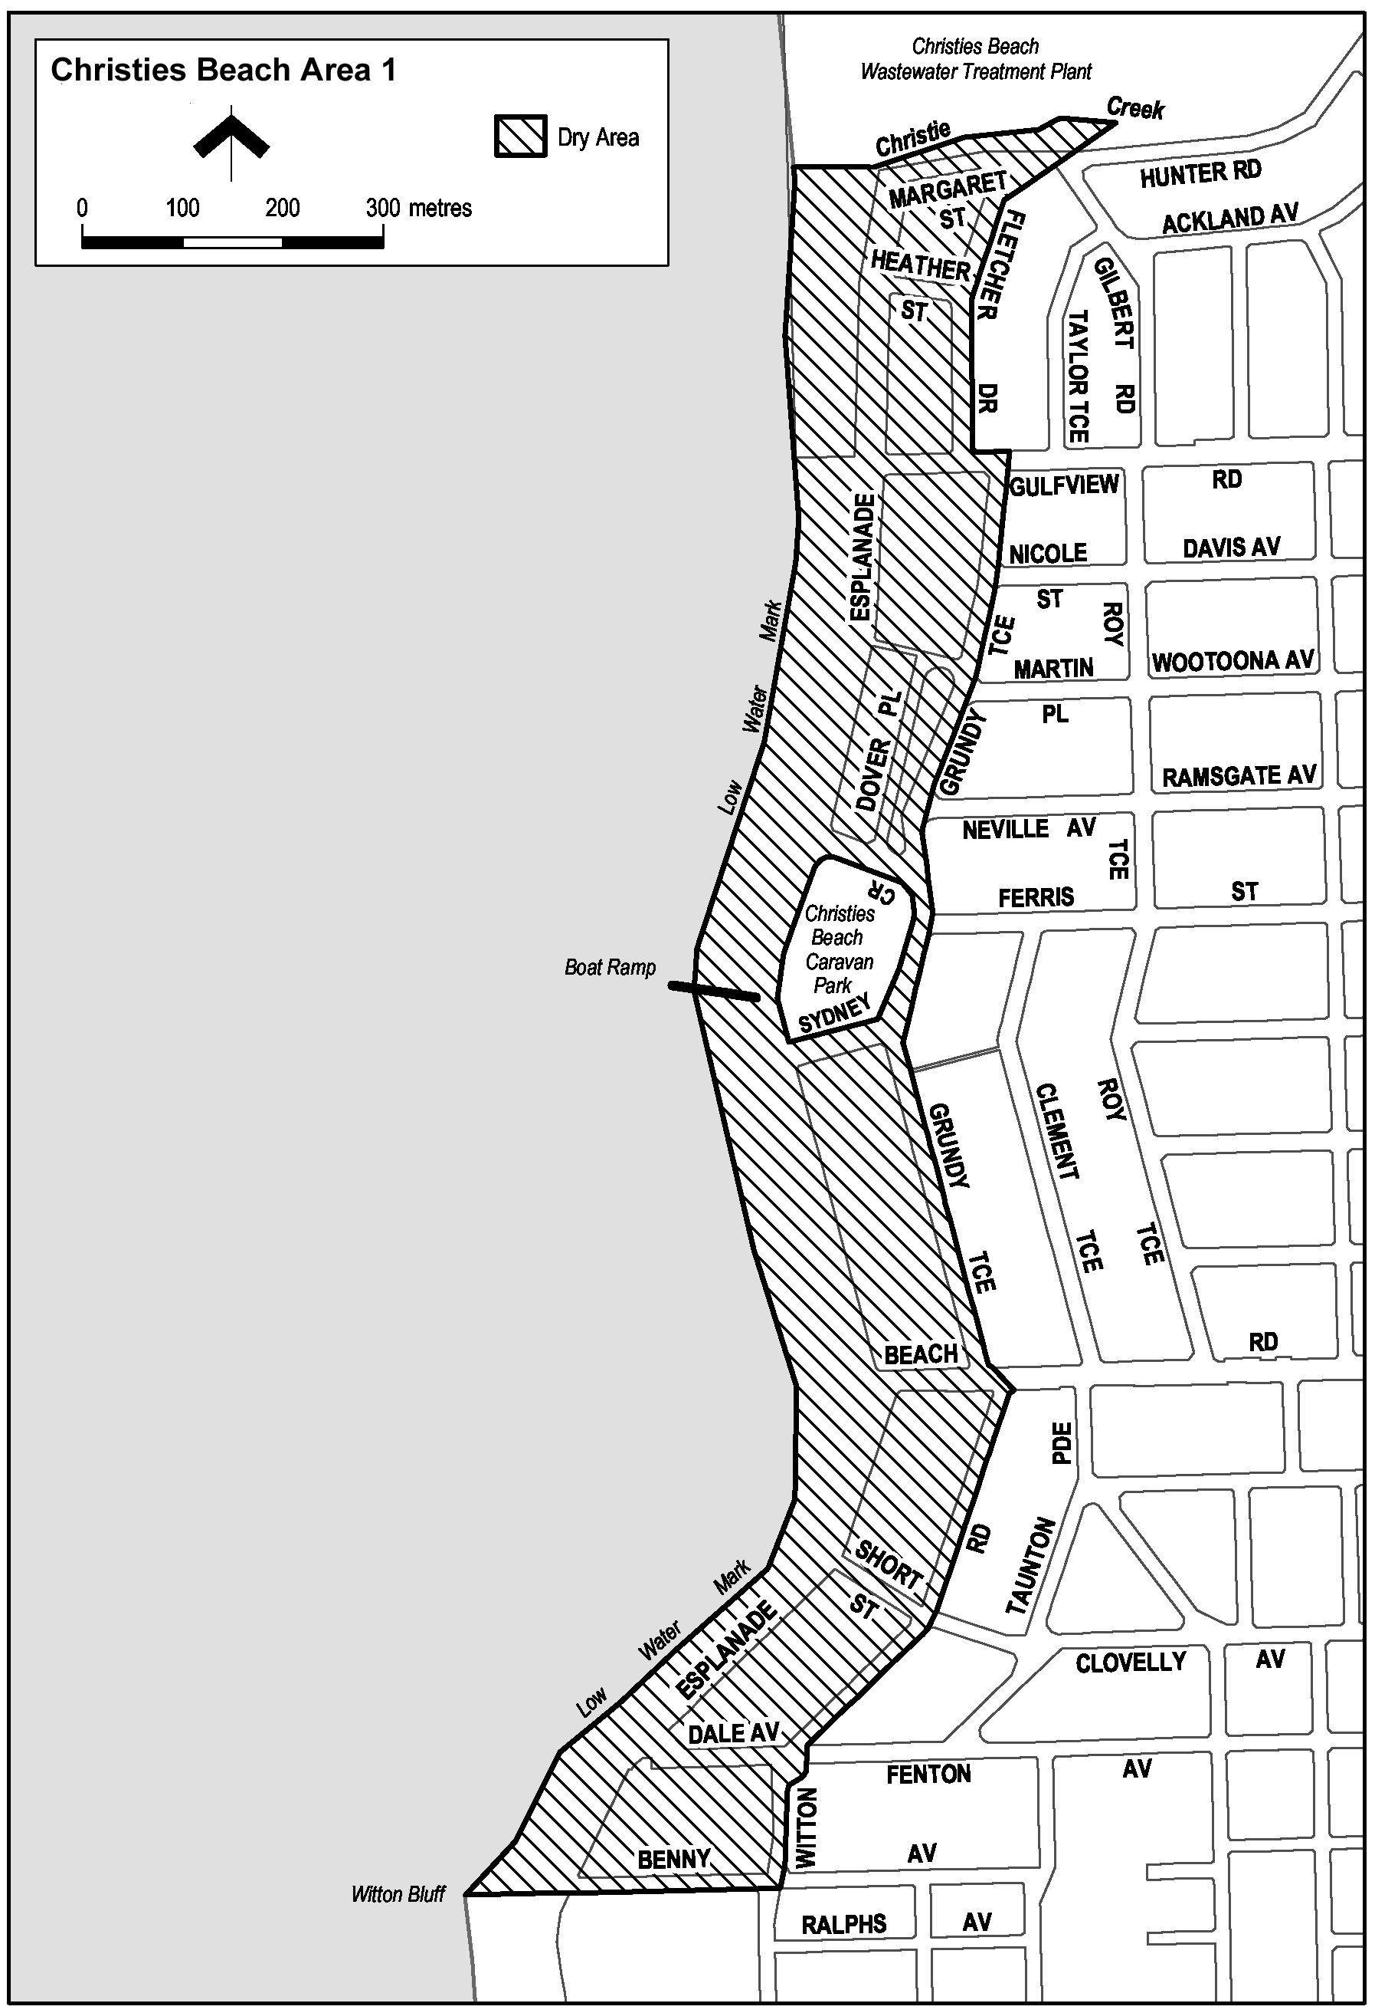
Made by the Minister for Consumer and Business Services
On 20 September 2016.
South Australia
Liquor Licensing (Dry Areas) Notice 2016
under section 131(1) of the Liquor Licensing Act 1997

1—Short title
This notice may be cited as the Liquor Licensing (Dry Areas) Notice 2016.
2—Commencement
This notice comes into operation on 22 September 2016.
3—Interpretation
(1) In this notice—
principal notice means the Liquor Licensing (Dry Areas) Notice 2015 published in the Gazette on 5.1.15, as in force from time to time.
(2) Clause 3 of the principal notice applies to this notice as if it were the principal notice.
4—Consumption etc of liquor prohibited in dry areas
(1) Pursuant to section 131 of the Act, the consumption and possession of liquor in the area described in the Schedule is prohibited in accordance with the provisions of the Schedule.
(2) The prohibition has effect during the periods specified in the Schedule.
(3) The prohibition does not extend to private land in the area described in the Schedule.
(4) Unless the contrary intention appears, the prohibition of the possession of liquor in the area does not extend to—
(a) a person who is genuinely passing through the area if—
(i) the liquor is in the original container in which it was purchased from licensed premises; and
(ii) the container has not been opened; or
(b) a person who has possession of the liquor in the course of carrying on a business or in the course of his or her employment by another person in the course of carrying on a business; or
(c) a person who is permanently or temporarily residing at premises within the area or on the boundary of the area and who enters the area solely for the purpose of passing through it to enter those premises or who enters the area from those premises for the purpose of leaving the area.
(5) The Schedule is in substitution for Schedule—Morphett Vale Area 1 in the principal notice.

Schedule— Morphett Vale Area 1

1—Extent of prohibition
The consumption of liquor is prohibited and the possession of liquor is prohibited.
2—Period of prohibition
From 8pm on each day to 6am on the following day.
3—Description of area
Reserve area in Morphett Vale, as follows: commencing at the point at which the south-eastern corner of the southern end of Alexander Avenue, Morphett Vale, meets the western boundary of the railway reserve that adjoins the eastern boundary of Alexander Avenue, then southerly along that western boundary of the railway reserve (the boundary approximately indicated by the line along which the land rises sharply to the level of the railway reserve) to the point at which the boundary of the railway reserve meets the eastern boundary of Albert Terrace, then in a straight line by the shortest route across Albert Terrace to the north-eastern corner of the northernmost allotment of private land adjoining the western boundary of Albert Terrace, then generally south-westerly along the northern boundaries of that allotment and the adjoining allotments (and the western boundary of the final such allotment) to the northern boundary of Yeldham Drive, then generally westerly and south-westerly along the northern boundary of Yeldham Drive to the north-eastern corner of the next allotment of private land adjoining the northern boundary of Yeldham Drive, then generally westerly and south-westerly along the northern boundaries of that allotment and the adjoining allotments to the eastern boundary of Main South Road, then northerly along that boundary of Main South Road to the south-western corner of Lot 12, Main South Road, then north-easterly and northerly along the southern and eastern boundaries of Lot 12 to the point at which the eastern boundary meets the southern boundary of Timothy Road, then easterly and north-easterly along that boundary of Timothy Road to the southern boundary of the first allotment of private land that adjoins that same side of Timothy Road, then north-easterly along the southern boundary of that allotment to its south-eastern corner, then northerly along the eastern boundary of that allotment and the two adjoining allotments to the north-eastern corner of the second adjoining allotment, then easterly along the southern boundary of the adjoining allotments and the southern boundary of Alexander Avenue to the point of commencement.
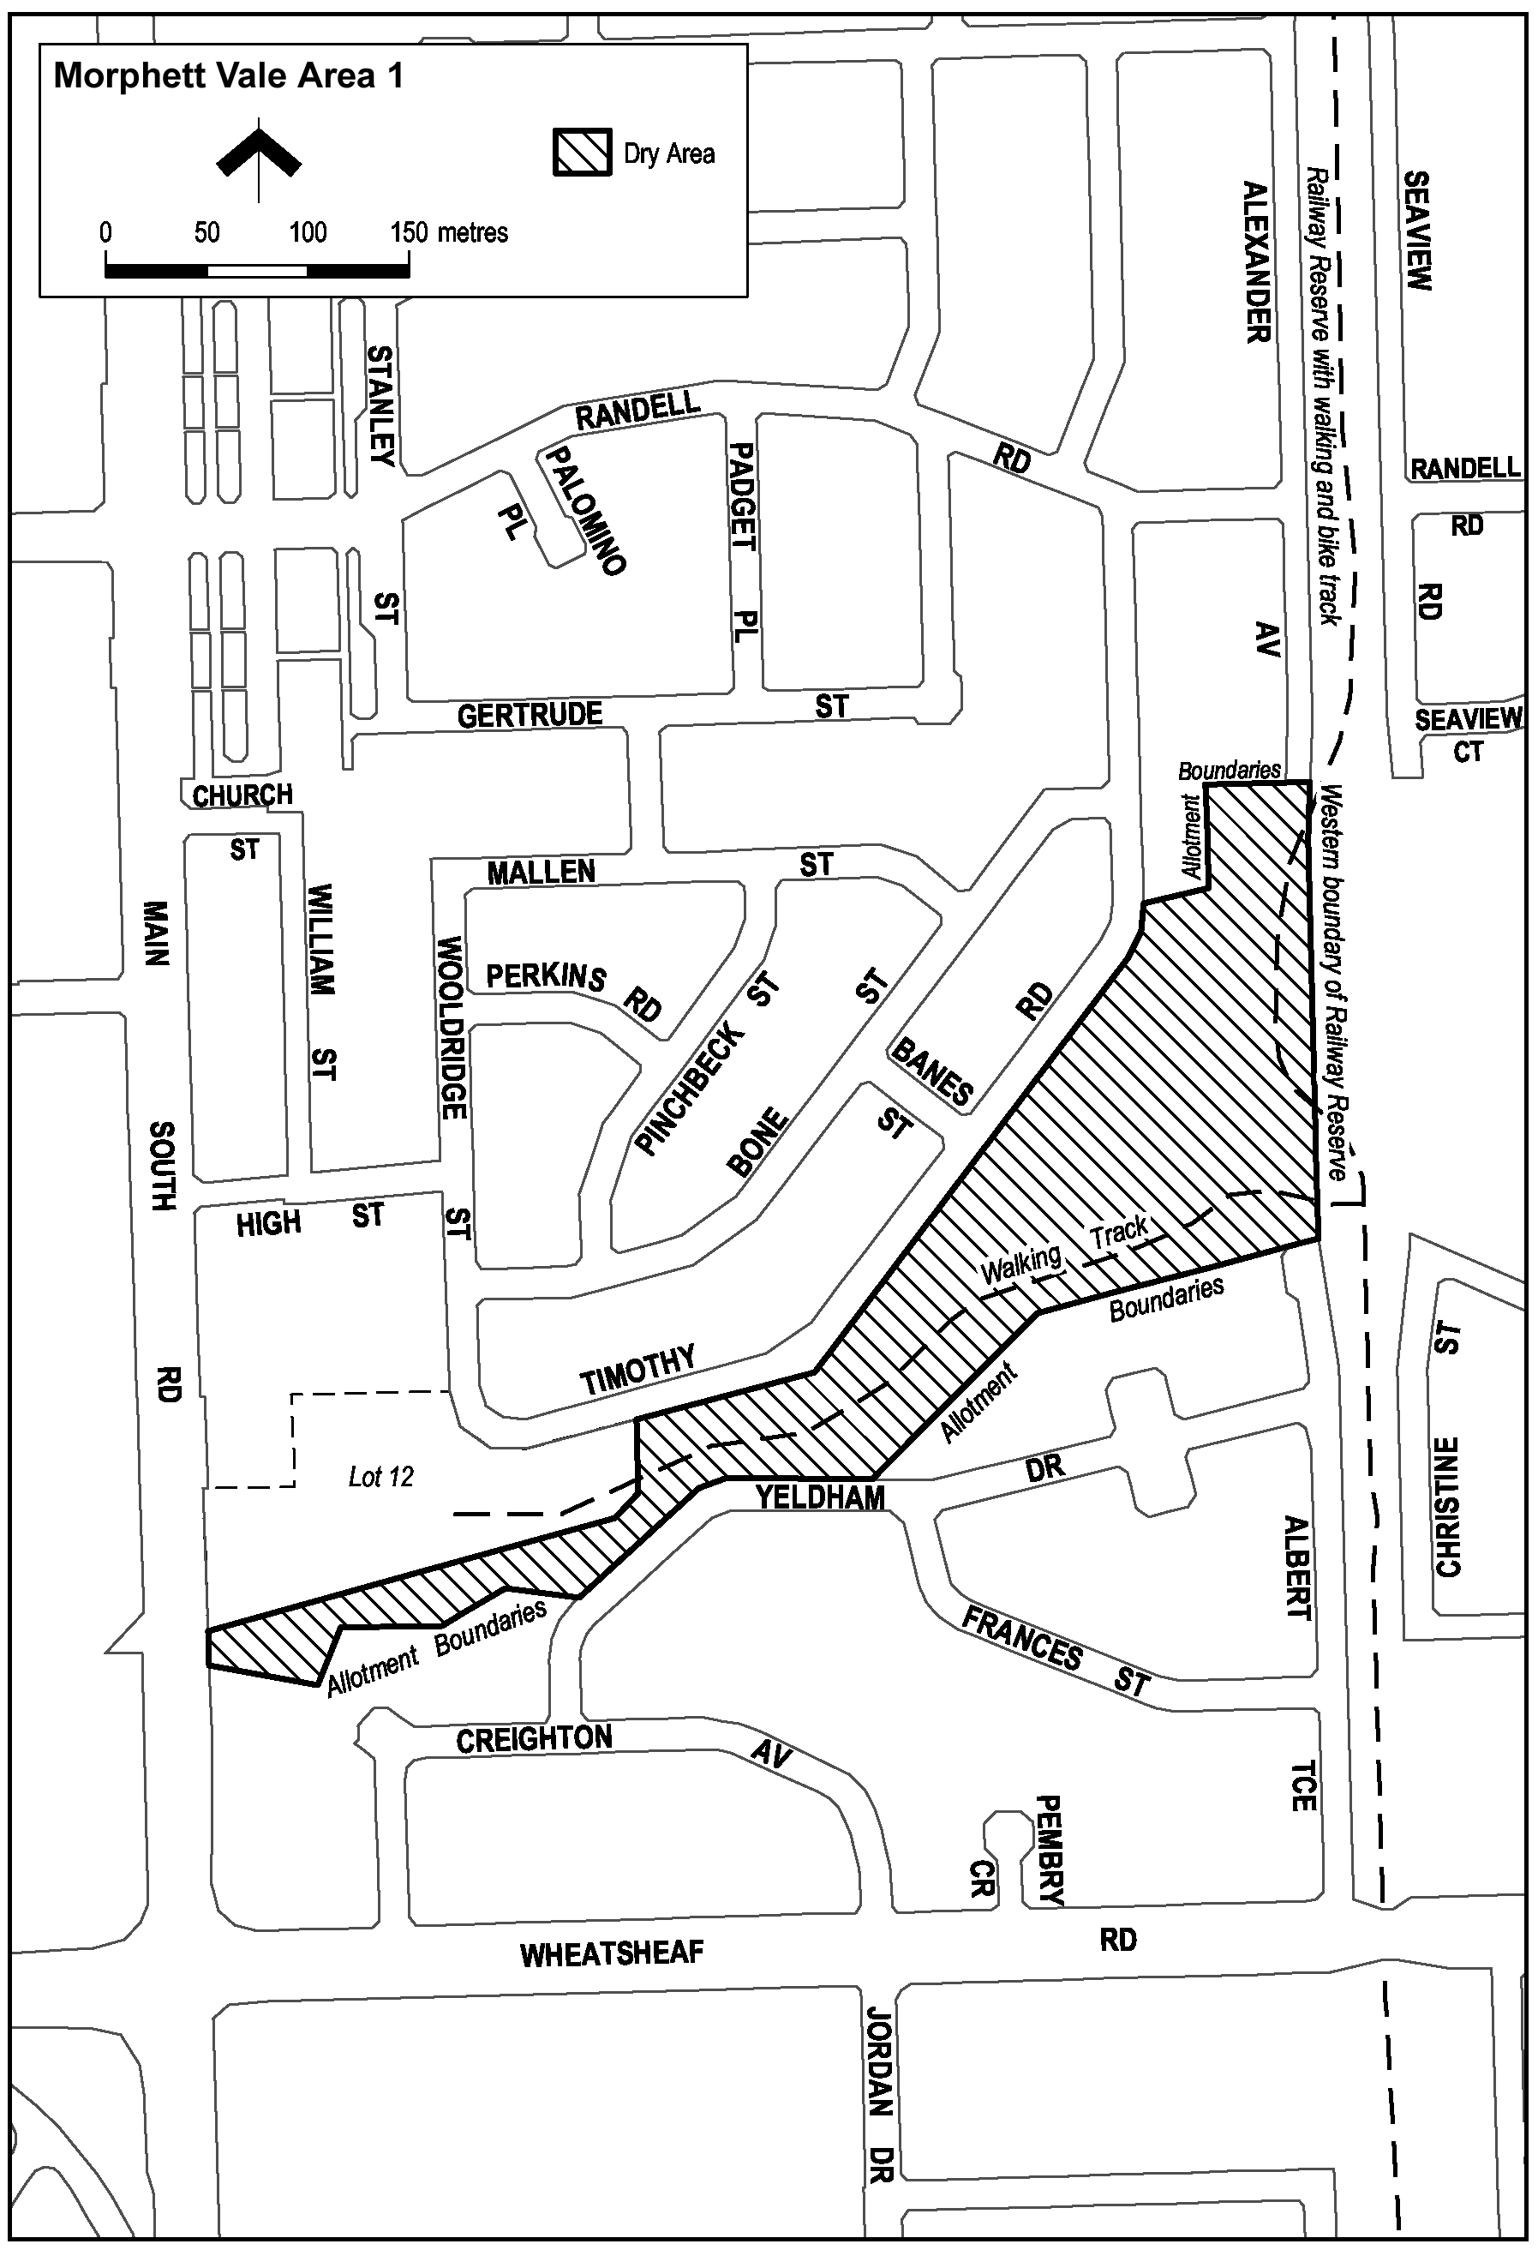
Made by the Minister for Consumer and Business Services
On 19 September 2016.
South Australia
Liquor Licensing (Dry Areas) Notice 2016
under section 131(1) of the Liquor Licensing Act 1997

1—Short title
This notice may be cited as the Liquor Licensing (Dry Areas) Notice 2016.
2—Commencement
This notice comes into operation on 22 September 2016.
3—Interpretation
(1) In this notice—
principal notice means the Liquor Licensing (Dry Areas) Notice 2015 published in the Gazette on 5.1.15, as in force from time to time.
(2) Clause 3 of the principal notice applies to this notice as if it were the principal notice.
4—Consumption etc of liquor prohibited in dry areas
(1) Pursuant to section 131 of the Act, the consumption and possession of liquor in the area described in the Schedule is prohibited in accordance with the provisions of the Schedule.
(2) The prohibition has effect during the periods specified in the Schedule.
(3) The prohibition does not extend to private land in the area described in the Schedule.
(4) Unless the contrary intention appears, the prohibition of the possession of liquor in the area does not extend to—
(a) a person who is genuinely passing through the area if—
(i) the liquor is in the original container in which it was purchased from licensed premises; and
(ii) the container has not been opened; or
(b) a person who has possession of the liquor in the course of carrying on a business or in the course of his or her employment by another person in the course of carrying on a business; or
(c) a person who is permanently or temporarily residing at premises within the area or on the boundary of the area and who enters the area solely for the purpose of passing through it to enter those premises or who enters the area from those premises for the purpose of leaving the area.
(5) The Schedule is in substitution for Schedule—Aberfoyle Park Area 1 in the principal notice.

Schedule— Aberfoyle Park Area 1

1—Extent of prohibition
The consumption of liquor is prohibited and the possession of liquor is prohibited.
2—Period of prohibition
From 8 pm on each day to 6 am on the following day.
3—Description of area
Reserve area in Aberfoyle Park, as follows: commencing at the point at which the western boundary of Carrickalinga Boulevard, Aberfoyle Park, meets the southern boundary of Taylors Road, then westerly along the northern boundary of Aberfoyle Park High School and the Hub Sports Centre to the eastern boundary of Park Avenue, then northerly in a straight line across Taylors Road West to the south-eastern corner of the allotment of private land that lies on the corner of Taylors Road West and Brook Drive (on the northern side of Taylors Road West and on the eastern side of Brook Drive), then northerly along the eastern boundary of that allotment and the row of adjoining allotments to the north-eastern corner of the northernmost such allotment, then westerly along the northern boundary of that allotment to Brook Drive, then north-westerly and westerly along the northern boundary of Brook Drive to the northern boundary of the next allotment of private land that adjoins that boundary of Brook Drive (being an allotment joining the western end of Brook Drive), then westerly along the northern boundary of that allotment to the north-western corner of that allotment, then northerly along the fence line that crosses the creek that lies to the north of the allotment to the south-western corner of the southernmost allotment adjoining the western boundary of the westernmost portion of Delta Crescent, then easterly and north-easterly along the southern boundary of that allotment and of Delta Crescent to the south-western corner of the next allotment of private land adjoining that same boundary of Delta Crescent, then generally easterly and north-easterly along the southern boundaries of that allotment and all adjoining allotments of private land (and of Canberra Drive and Wilma Court) to the southern boundary of the Aberfoyle Campus Schools, then north-easterly and easterly along that southern boundary and the southern boundaries of the adjoining allotments of private land (the boundaries approximately indicated by a fence and then by a pathway) to the western boundary of Hub Drive, then south-easterly and southerly along the western boundary of Hub Drive to the north-eastern corner of the next allotment of private land adjoining that western boundary of Hub Drive, then westerly along the northern boundaries of that allotment and all adjoining allotments of private land (and of Redcraze Street) to the eastern boundary of Carrickalinga Boulevard, then north-westerly, westerly and southerly along the road boundary on that side of Carrickalinga Boulevard to the point of commencement.

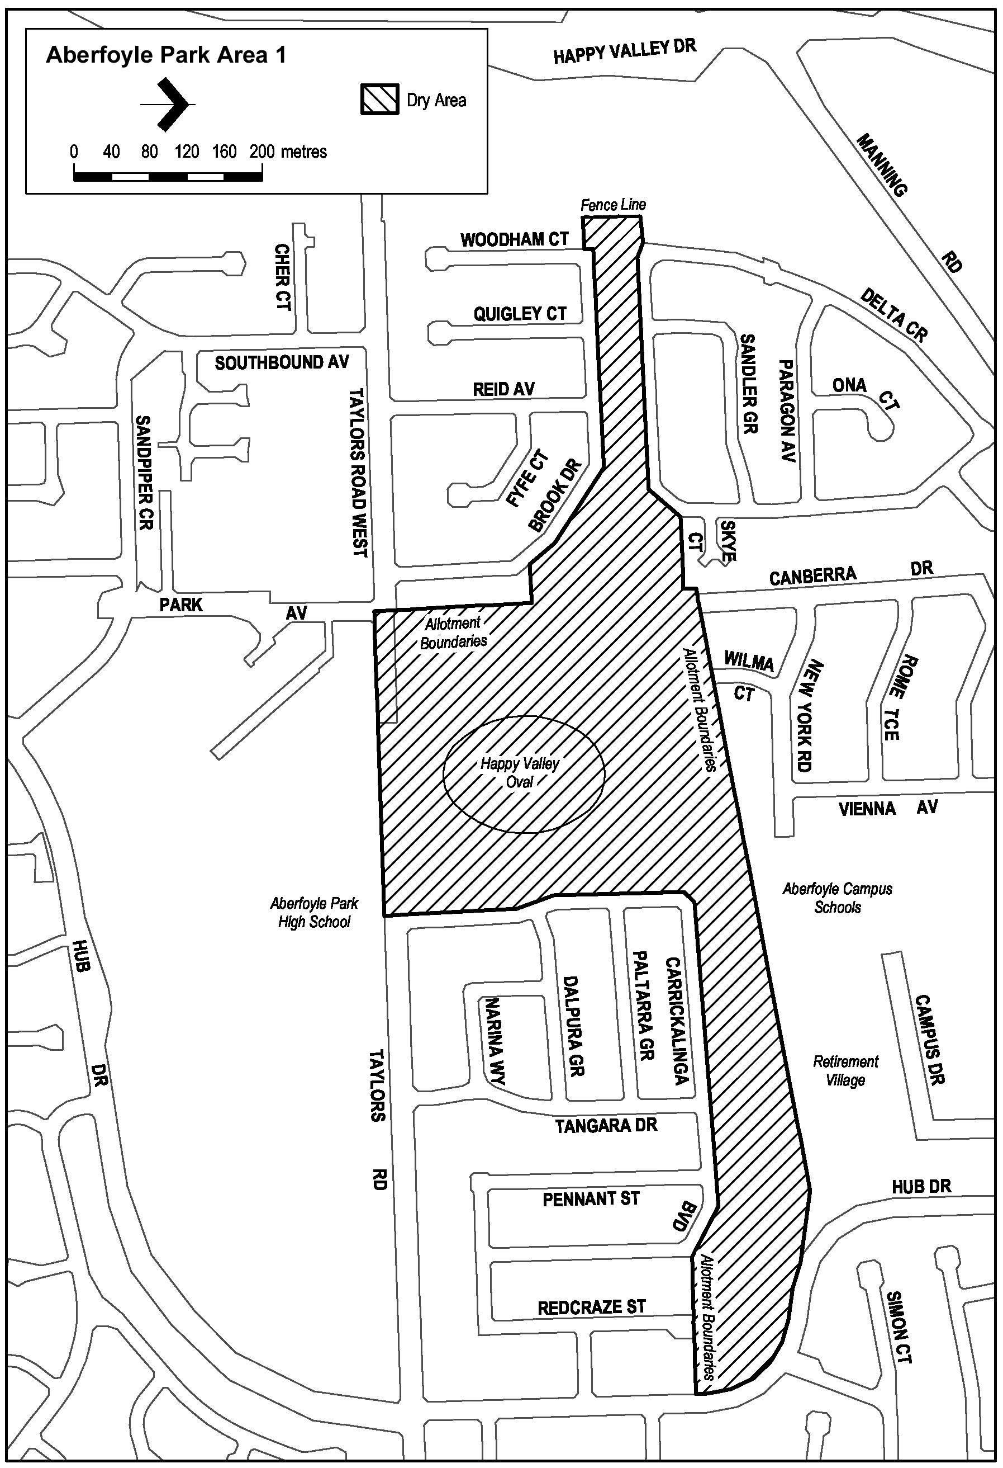
Made by the Minister for Consumer and Business Services
On 19 September 2016.
South Australia
Liquor Licensing (Dry Areas) Notice 2016
under section 131(1) of the Liquor Licensing Act 1997

1—Short title
This notice may be cited as the Liquor Licensing (Dry Areas) Notice 2016.
2—Commencement
This notice comes into operation on 22 September 2016.
3—Interpretation
(1) In this notice—
principal notice means the Liquor Licensing (Dry Areas) Notice 2015 published in the Gazette on 5.1.15, as in force from time to time.
(2) Clause 3 of the principal notice applies to this notice as if it were the principal notice.
4—Consumption etc of liquor prohibited in dry areas
(1) Pursuant to section 131 of the Act, the consumption and possession of liquor in the area described in the Schedule is prohibited in accordance with the provisions of the Schedule.
(2) The prohibition has effect during the periods specified in the Schedule.
(3) The prohibition does not extend to private land in the area described in the Schedule.
(4) Unless the contrary intention appears, the prohibition of the possession of liquor in the area does not extend to—
(a) a person who is genuinely passing through the area if—
(i) the liquor is in the original container in which it was purchased from licensed premises; and
(ii) the container has not been opened; or
(b) a person who has possession of the liquor in the course of carrying on a business or in the course of his or her employment by another person in the course of carrying on a business; or
(c) a person who is permanently or temporarily residing at premises within the area or on the boundary of the area and who enters the area solely for the purpose of passing through it to enter those premises or who enters the area from those premises for the purpose of leaving the area.
(5) The Schedule is in substitution for Schedule—Port Noarlunga Area 2 in the principal notice.

Schedule— Port Noarlunga Area 2

1—Extent of prohibition
The consumption of liquor is prohibited and the possession of liquor is prohibited.
2—Period of prohibition
From 8pm on each day to 6am on the following day.
3—Description of area
The area at Port Noarlunga known as the Jubilee Park Reserve (together with adjacent land) bounded as follows: commencing at the point at which the low water mark on the southern side of the Onkaparinga River intersects the eastern side of the Saltfleet Street Bridge, then generally south-easterly along that side of the Bridge and along the eastern boundary of Saltfleet Street to the point at which the eastern boundary of Saltfleet Street meets the northern boundary of Britain Drive, then easterly in a straight line to the low water mark on the western side of the Onkaparinga River, then generally northerly and westerly along the low water mark on that side of the Onkaparinga River to the point of commencement, but excluding the Jubilee Park Reserve Adventure Playground (as defined in Schedule—Port Noarlunga Area 3).
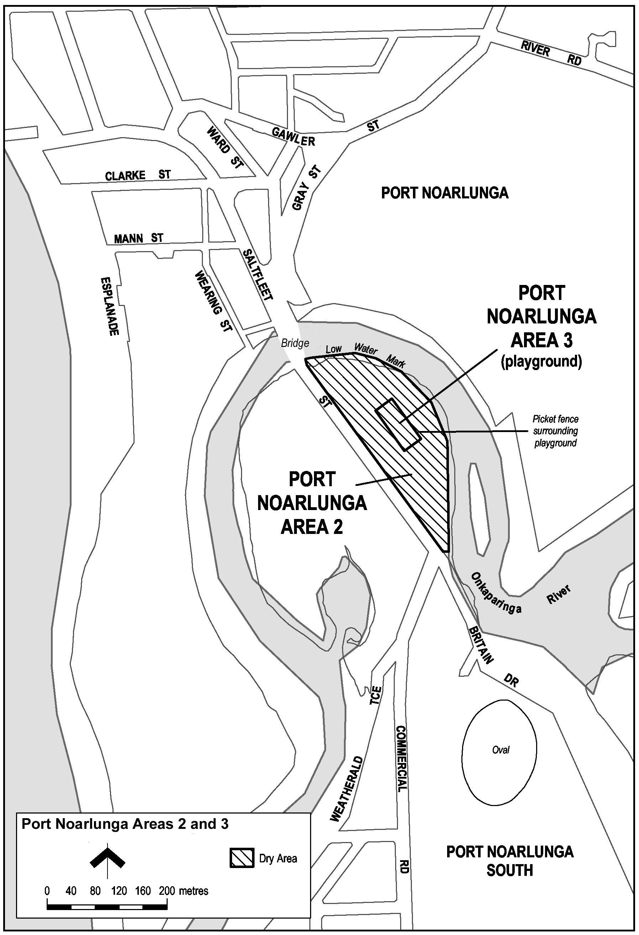
Made by the Minister for Consumer and Business Services
On 19 September 2016.

South Australia
Liquor Licensing (Dry Areas) Notice 2016
under section 131(1) of the Liquor Licensing Act 1997

1—Short title
This notice may be cited as the Liquor Licensing (Dry Areas) Notice 2016.
2—Commencement
This notice comes into operation on 22 September 2016.
3—Interpretation
(1) In this notice—
principal notice means the Liquor Licensing (Dry Areas) Notice 2015 published in the Gazette on 5.1.15, as in force from time to time.
(2) Clause 3 of the principal notice applies to this notice as if it were the principal notice.
4—Consumption etc of liquor prohibited in dry areas
(1) Pursuant to section 131 of the Act, the consumption and possession of liquor in the area described in the Schedule is prohibited in accordance with the provisions of the Schedule.
(2) The prohibition has effect during the periods specified in the Schedule.
(3) The prohibition does not extend to private land in the area described in the Schedule.
(4) Unless the contrary intention appears, the prohibition of the possession of liquor in the area does not extend to—
(a) a person who is genuinely passing through the area if—
(i) the liquor is in the original container in which it was purchased from licensed premises; and
(ii) the container has not been opened; or
(b) a person who has possession of the liquor in the course of carrying on a business or in the course of his or her employment by another person in the course of carrying on a business; or
(c) a person who is permanently or temporarily residing at premises within the area or on the boundary of the area and who enters the area solely for the purpose of passing through it to enter those premises or who enters the area from those premises for the purpose of leaving the area.
(5) The Schedule is in substitution for Schedule—Moana Area 2 in the principal notice.

Schedule— Moana Area 2

1—Extent of prohibition
The consumption of liquor is prohibited and the possession of liquor is prohibited.
2—Period of prohibition
Continuous.
3—Description of area
The part of Section 589, Hundred of Willunga, west of the portion of the Esplanade that lies between the Moana Sands Conservation Park and Wentworth Street, that is constructed as car parks, together with the toilet block situated between the car parks.
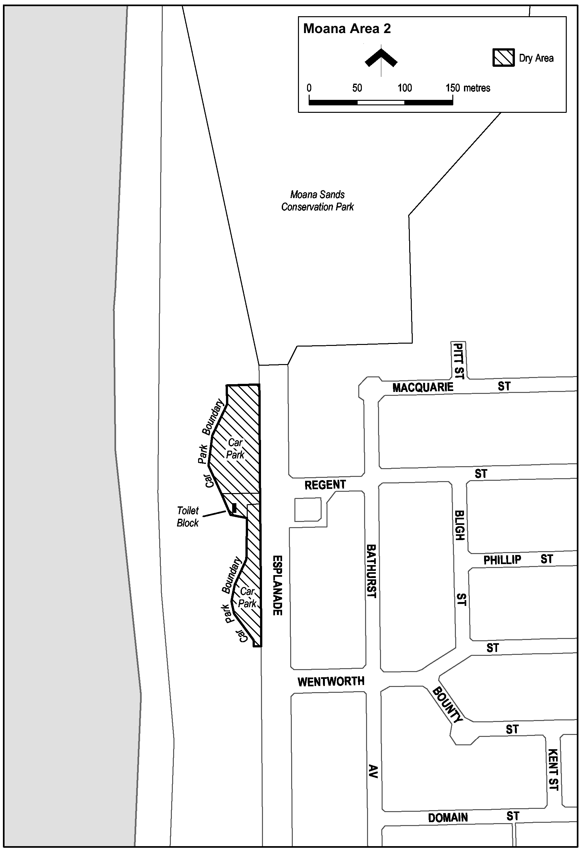
Made by the Minister for Consumer and Business Services
On 19 September 2016.

South Australia
Liquor Licensing (Dry Areas) Notice 2016
under section 131(1) of the Liquor Licensing Act 1997

1—Short title
This notice may be cited as the Liquor Licensing (Dry Areas) Notice 2016.
2—Commencement
This notice comes into operation on 22 September 2016.
3—Interpretation
(1) In this notice—
principal notice means the Liquor Licensing (Dry Areas) Notice 2015 published in the Gazette on 5.1.15, as in force from time to time.
(2) Clause 3 of the principal notice applies to this notice as if it were the principal notice.
4—Consumption etc of liquor prohibited in dry areas
(1) Pursuant to section 131 of the Act, the consumption and possession of liquor in the area described in the Schedule is prohibited in accordance with the provisions of the Schedule.
(2) The prohibition has effect during the periods specified in the Schedule.
(3) The prohibition does not extend to private land in the area described in the Schedule.
(4) Unless the contrary intention appears, the prohibition of the possession of liquor in the area does not extend to—
(a) a person who is genuinely passing through the area if—
(i) the liquor is in the original container in which it was purchased from licensed premises; and
(ii) the container has not been opened; or
(b) a person who has possession of the liquor in the course of carrying on a business or in the course of his or her employment by another person in the course of carrying on a business; or
(c) a person who is permanently or temporarily residing at premises within the area or on the boundary of the area and who enters the area solely for the purpose of passing through it to enter those premises or who enters the area from those premises for the purpose of leaving the area.
(5) The Schedule is in substitution for Schedule—Port Noarlunga Area 1 in the principal notice.

Schedule— Port Noarlunga Area 1

1—Extent of prohibition
The consumption of liquor is prohibited and the possession of liquor is prohibited.
2—Period of prohibition
Continuous.
3—Description of area
The area in and adjacent to Port Noarlunga bounded as follows: commencing at the point at which the southern boundary of Saltfleet Street meets the eastern boundary of Section 1647 Hundred of Noarlunga, then southerly along that eastern boundary of Section 1647 to the southern boundary of the Section (the northern boundary of Clarke Street), then westerly along the southern boundary of Section 1647 to the western boundary of the Section, then north-westerly along the western boundary of Section 1647 and the prolongation in a straight line of that boundary to the point at which the prolongation is intersected by the prolongation in a straight line of the southern boundary of Lot 86 FP 151862, then south-westerly along that prolongation of the southern boundary of Lot 86 to the low water mark on the eastern side of Gulf St Vincent, then generally north-westerly along the low water mark to the point at which it is intersected by the prolongation in a straight line of the northern boundary of Lot 87 FP 151863, then north-easterly along that prolongation of the northern boundary of Lot 87 to the south-western boundary of the Esplanade, then generally south-easterly and easterly along that boundary of the Esplanade and the southern boundary of Saltfleet Street to the point of commencement. The area does not include any part of the Noarlunga Jetty (or any area beneath the jetty), or any land used for the purpose of carrying on a business, that falls within the area described above.
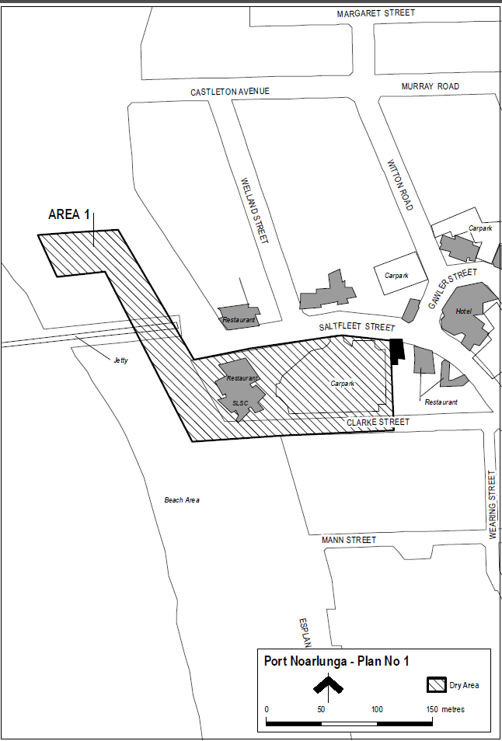
Made by the Minister for Consumer and Business Services
On 19 September 2016.
South Australia
Liquor Licensing (Dry Areas) Notice 2016
under section 131(1) of the Liquor Licensing Act 1997

1—Short title
This notice may be cited as the Liquor Licensing (Dry Areas) Notice 2016.
2—Commencement
This notice comes into operation on 22 September 2016.
3—Interpretation
(1) In this notice—
principal notice means the Liquor Licensing (Dry Areas) Notice 2015 published in the Gazette on 5.1.15, as in force from time to time.
(2) Clause 3 of the principal notice applies to this notice as if it were the principal notice.
4—Consumption etc of liquor prohibited in dry areas
(1) Pursuant to section 131 of the Act, the consumption and possession of liquor in the area described in the Schedule is prohibited in accordance with the provisions of the Schedule.
(2) The prohibition has effect during the periods specified in the Schedule.
(3) The prohibition does not extend to private land in the area described in the Schedule.
(4) Unless the contrary intention appears, the prohibition of the possession of liquor in the area does not extend to—
(a) a person who is genuinely passing through the area if—
(i) the liquor is in the original container in which it was purchased from licensed premises; and
(ii) the container has not been opened; or
(b) a person who has possession of the liquor in the course of carrying on a business or in the course of his or her employment by another person in the course of carrying on a business; or
(c) a person who is permanently or temporarily residing at premises within the area or on the boundary of the area and who enters the area solely for the purpose of passing through it to enter those premises or who enters the area from those premises for the purpose of leaving the area.
(5) The Schedule is in substitution for Schedule—Moana Area 1 in the principal notice.

Schedule— Moana Area 1

1—Extent of prohibition
The consumption of liquor is prohibited and the possession of liquor is prohibited.
2—Period of prohibition
Continuous.
3—Description of area
Commencing at the point at which the northern boundary of Robertson Road intersects the eastern boundary of the Esplanade, then southerly along the eastern boundary of the Esplanade to its intersection with the northern boundary of Nashwauk Crescent, then easterly along that northern boundary of Nashwauk Crescent to the point at which it meets the eastern boundary of Griffiths Drive, then in a straight line by the shortest route across Nashwauk Crescent to the southern boundary of the car park and reserve area opposite the southern end of Griffiths Drive, then generally south-westerly and westerly along that boundary of the car park and reserve area and the southern boundary of Moana Crescent to the eastern boundary of the Esplanade, then southerly along that eastern boundary of the Esplanade to the southern boundary of the Esplanade, then westerly along the southern boundary to the western boundary of the Esplanade, then northerly along the western boundary to the southern boundary of the car park, then westerly along the southern boundary of the car park to the sea-wall that forms the western boundary of the car park, then in a straight line by the shortest route to the high water mark, then generally southerly along the high water mark to its intersection with a fence extending from high to low water mark at a point approximately in line with the westerly prolongation of Macquarie Street, then westerly along that fence to low water mark, then generally northerly along low water mark to its intersection with the prolongation in a straight line of the northern boundary of Robertson Road, then easterly along that prolongation to the point of commencement

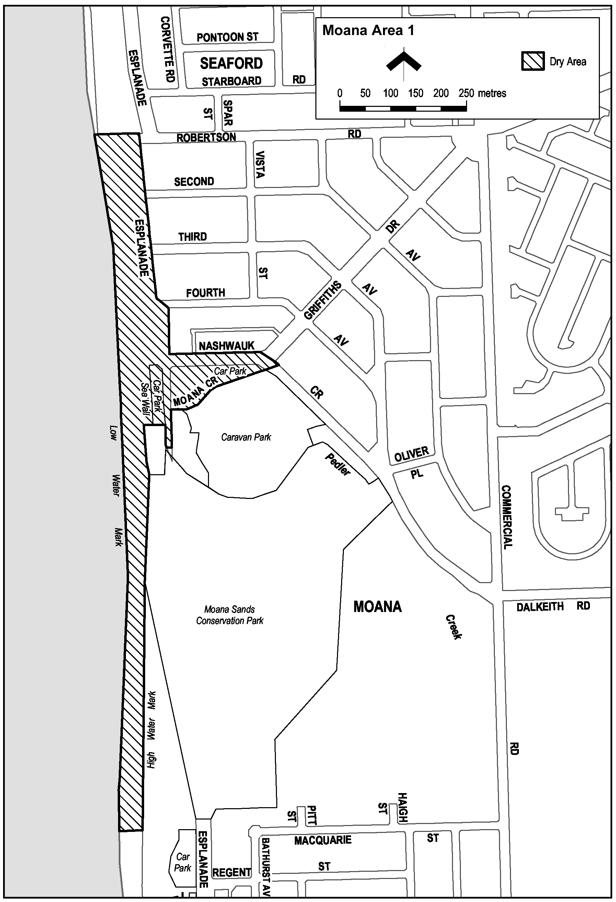
Made by the Minister for Consumer and Business Services
On 19 September 2016.

South Australia
Liquor Licensing (Dry Areas) Notice 2016
under section 131(1) of the Liquor Licensing Act 1997

1—Short title
This notice may be cited as the Liquor Licensing (Dry Areas) Notice 2016.
2—Commencement
This notice comes into operation on 22 September 2016.
3—Interpretation
(1) In this notice—
principal notice means the Liquor Licensing (Dry Areas) Notice 2015 published in the Gazette on 5.1.15, as in force from time to time.
(2) Clause 3 of the principal notice applies to this notice as if it were the principal notice.
4—Consumption etc of liquor prohibited in dry areas
(1) Pursuant to section 131 of the Act, the consumption and possession of liquor in the area described in the Schedule is prohibited in accordance with the provisions of the Schedule.
(2) The prohibition has effect during the periods specified in the Schedule.
(3) The prohibition does not extend to private land in the area described in the Schedule.
(4) Unless the contrary intention appears, the prohibition of the possession of liquor in the area does not extend to—
(a) a person who is genuinely passing through the area if—
(i) the liquor is in the original container in which it was purchased from licensed premises; and
(ii) the container has not been opened; or
(b) a person who has possession of the liquor in the course of carrying on a business or in the course of his or her employment by another person in the course of carrying on a business; or
(c) a person who is permanently or temporarily residing at premises within the area or on the boundary of the area and who enters the area solely for the purpose of passing through it to enter those premises or who enters the area from those premises for the purpose of leaving the area.
(5) The Schedule is in substitution for Schedule—Port Noarlunga Area 3 in the principal notice.

Schedule— Port Noarlunga Area 3

1—Extent of prohibition
The consumption of liquor is prohibited and the possession of liquor is prohibited.
2—Period of prohibition
Continuous.
3—Description of area
The area at Port Noarlunga as follows: that portion of the Jubilee Park Reserve (and adjacent land) defined in Schedule—Port Noarlunga Area 2 that is enclosed within a picket fence and is known as the Jubilee Park Reserve Adventure Playground.

Made by the Minister for Consumer and Business Services
On 19 September 2016.

South Australia
Motor Vehicles (Guidelines for Medical Testing) Notice 2016
under section 80(2) of the Motor Vehicles Act 1959

1—Short title
This notice may be cited as the Motor Vehicles (Guidelines for Medical Testing) Notice 2016.
2—Commencement
This notice will come into operation on Saturday, 1 October 2016.
3—Adoption of guidelines for conduct of medical tests of competence to drive
For the purpose of section 80(2) of the Motor Vehicles Act 1959 (“the Act”) the guidelines and policies contained within the publication entitled Assessing Fitness to Drive published by Austroads Incorporated in 2016 (ISBN 978-1-925451-10-8), as amended from time to time, are adopted, except when the Registrar of Motor Vehicles (“Registrar”) is of the opinion that it is appropriate, considering the nature/or type of driving tasks to be performed or to be performed by the holder of, or applicant for, a licence or learner’s permit, to require the person to meet the Medical Standards for Licensing—Commercial Vehicle Driver Standards (referred to as “Commercial Standards” within this publication) (“Commercial Standards”). In these circumstances the medical tests required by the Registrar under section 80 of the Act must be conducted in accordance with the Commercial Standards and the results of those medical tests must be applied by the Registrar in accordance with the Commercial Standards, regardless of the class of licence or learner’s permit held or being applied for.
4—Revocation of previous notices
All previous notices pursuant to section 80(2) of the Act publishing or adopting guidelines or policies are hereby revoked.
5—Transitional provisions
For the purpose of section 80(2) of the Act, the guidelines and policies contained within the publication entitled Assessing Fitness to Drive published by Austroads Incorporated in 2012 (ISBN 978-1-921991-01-1) are also adopted for use until 31 December 2016. For the avoidance of any doubt, after this date the only guidelines and policies adopted or published by me for the purpose of section 80(2) of the Act are those referred to in clause 3 of this notice.
Made by the Minister for Road Safety
pursuant to a delegation by the Minister for Transport on 15 December 2011 (published in the Government Gazette on 15 December 2011).

Peter Malinauskas, MLC
19 September 2016.

Motor Vehicles (Specified Event) Notice 2017

Pursuant to regulation 25(4) of the Motor Vehicles Regulations 2010

1.—Short title

This notice may be cited as the Motor Vehicles (Specified Event) Notice 2017.

2.—Commencement

This notice will come into operation on the day it is published in the Government Gazette.

3.—Specified event, period and conditions

In accordance with regulation 25(4) of the Motor Vehicles Regulations 2010, and with the concurrence of the Minister for Transport and Infrastructure (as the Minister responsible for the operation of the Motor Vehicles Act 1959), I, the Minister for Tourism:

(a) specify the Santos Tour Down Under as an event; and

(b) specify the period commencing at 12.01 a.m. on 2nd January 2017 and ending at 11.58 p.m. on 30th January 2017 as the period during which motor vehicles approved by me may be driven, or caused to stand, on a road in relation to the Santos Tour Down Under; and
(c) specify that the following condition applies to driving such a motor vehicle, or causing such a motor vehicle to stand, on a road in relation to the Santos Tour Down Under:
All such vehicles must display number plate covers of a design approved by the Registrar of Motor Vehicles over their vehicle number plates at all times during the period specified in paragraph (b).

Dated 15 September 2016.

Leon Bignell, Minister for Tourism

REAL PROPERTY ACT NOTICE
WHEREAS the persons named at the foot hereof have each respectively for himself made application to have the land set forth and described before his name at the foot hereof brought under the operation of the Real Property Act: Notice is hereby given that unless caveat be lodged with the Registrar-General by some person having estate or interest in the said lands on or before the expiration of the period herein below for each case specified, the said several pieces of land will be brought under the operation of the said Act as by law directed. Diagrams delineating these parcels of land may be inspected at the Lands Titles Registration Office, Adelaide, and in the offices of the several corporations or district councils in which the lands are situated.

The Schedule
No. of  Applica-  tion | Description of Property |  | Name |  | Residence | Date up to and  inclusive of which  caveat may be  lodged

32006 | Portion of Town Acre 861, City of Adelaide and more particularly defined as Private Road on L.T.O. B 2314 |  | Channel 9 South Australia  Pty Ltd |  | 24 Artman Road, Willoughby,  N.S.W. 2068 | 23 November 2016

Dated 22 September 2016, at the Lands Titles Registration Office, Adelaide. B. Pike, Registrar-General

South Australia
District Court Civil Rules 2006
(Amendment No. 34)
BY virtue and in pursuance of Section 51 of the District Court Act 1991 and all other enabling powers, we, Geoffrey Thomas Muecke, Chief Judge, and Rauf Soulio and Paul Vincent Slattery, Judges of the District Court of South Australia, make the following Rules of Court.
1. These Rules may be cited as the District Court Civil Rules 2006 (Amendment
No. 34).
2. The amendments made by these Rules come into effect on 1 October 2016 or the date of their gazettal, whichever is later.
3. The District Court Civil Rules 2006 are amended as set out below.
4. Rule 40A (d) (iii) is amended by substituting “rule 247” for “[equivalent of Victorian Order 37A]”.
5. Rule 40E is amended by substituting “a notice of address for service or defence” for “an appearance”.
6. Rule 40F (l) is amended by substituting “file a notice of address for service or defence” for “enter an appearance”.
7. Rule 54 is amended by:
(a) inserting a new subrule (8) as follows:
“(8) For the avoidance of doubt, nothing in this rule prevents the Court permitting an amendment to add a cause of action that is statute barred or introduce a defendant against whom a fresh action would be statute barred on the basis that the amendment not relate back to the commencement of the action and the addition or introduction be subject to the subsequent granting of an extension of time under section 48 of the Limitations of Actions Act 1936 or other statutory power.
Note—
See Brook v Flinders University of South Australia (1988) 47 SASR 119.”
(b) renumbering existing subrule (8) as subrule (9).
8. Rule 74 is amended by:
(a) deleting subrules (5) and (6); and
(b) inserting the following note at the end of the rule:
“Note—
Rule 54 governs applications to introduce a defendant against whom a fresh action would be statute barred.”
9. Rule 160 is amended by inserting new paragraphs (2A), (2B) and (2C) as follows:
“(2A) A party requesting an expert report is to set out in a letter to the expert—
(a) the assumptions the expert is requested to make for the purpose of expressing an opinion;
(b) the materials provided to the expert for the purpose of expressing an opinion;
(c) the questions on which the expert is asked to express opinion.
(2B) A party requesting an expert report is within five business days of sending a letter to an expert under subrule (2A) to serve on each other party to the action a copy of the letter.
(2C) To the extent practicable, when preparing a report (a responsive report) in response to or in the same field of expertise and dealing with the same subject matter as an expert report by another expert (a prior expert), an expert should confer with the prior expert about the assumptions and opinions the subject of their respective reports.”
10. Rule 160 (3) is amended by renumbering existing paragraph (g) as (i) and inserting new paragraphs (g) and (h) as follows:
“(g) identify whether the expert has complied with subrule (2C) and if not why not;
(h) identify the differences (if any) in assumptions made and opinions expressed compared to those made and expressed by a prior expert (if any);”
11. Rule 160 (7) (a) is amended by deleting “or within 5 business days after”.
12. New subrules (8) to (11) are inserted in Rule 160 as follows:
“(8) Notwithstanding subrule (3) but without affecting the obligation of a party to serve expert reports complying with subrule (3) by the relevant time limit in accordance with subrule (1), a party is at liberty at any time before the relevant time limit to obtain and serve a summary expert report that does not comply with subrule (3).
(9) For the purpose of this rule, a summary expert report is a report that sets out in summary form assumptions made and opinions held by an expert on issues relevant in the action.
(10) For the avoidance of doubt, an expert report (including a summary expert report) served under this rule is not subject to legal professional privilege and may be the subject of questions at trial and, if otherwise admissible, may be tendered in evidence at trial.
(11) If a party obtains an expert report (including a summary expert report) before the relevant time limit, unless the Court otherwise orders, the party is within five business days of receipt to serve a copy of the report on each other party to the action.”
Dated 13 September 2016.
G. T. Muecke, Chief Judge
R. Soulio, Judge
P. V. Slattery, Judge

South Australia
Supreme Court Civil Rules 2006
(Amendment No. 33)
BY virtue and in pursuance of Section 72 of the Supreme Court Act 1935 and all other enabling powers, we, Judges of the Supreme Court of South Australia, make the following Supreme Court Civil Supplementary Rules 2014 (Amendment No. 33).
1. These Rules may be cited as the Supreme Court Civil Rules 2006 (Amendment No. 33).
2. The amendments made by these Rules come into effect on 1 October 2016 or the date of their gazettal, whichever is later.
3. The Supreme Court Civil Rules 2006 are amended as set out below.
4. Rule 40A (d) (iii) is amended by substituting “rule 247” for “[equivalent of Victorian Order 37A]”.
5. Rule 40E is amended by substituting “a notice of address for service or defence” for “an appearance”.
6. Rule 40F (l) is amended by substituting “file a notice of address for service or defence” for “enter an appearance”.
7. Rule 54 is amended by:
(a) inserting a new subrule (8) as follows:
“(8) For the avoidance of doubt, nothing in this rule prevents the Court permitting an amendment to add a cause of action that is statute barred or introduce a defendant against whom a fresh action would be statute barred on the basis that that the amendment not relate back to the commencement of the action and the addition or introduction be subject to the subsequent granting of an extension of time under Section 48 of the Limitations of Actions Act 1936 or other statutory power.
Note—
See Brook v Flinders University of South Australia (1988) 47 SASR 119.”
(b) is renumbering existing subrule (8) as subrule (9).
8. Rule 74 is amended by:
(a) deleting subrules (5) and (6); and
(b) inserting the following note at the end of the rule:
“Note—
Rule 54 governs applications to introduce a defendant against whom a fresh action would be statute barred.”
9. Rule 160 is amended by inserting new subrules (2A), (2B) and (2C) as follows:
“(2A) A party requesting an expert report is to set out in a letter to the expert—
(a) the assumptions the expert is requested to make for the purpose of expressing an opinion;
(b) the materials provided to the expert for the purpose of expressing an opinion;
(c) the questions on which the expert is asked to express opinion.
(2B) A party requesting an expert report is within five business days of sending a letter to an expert under subrule (2A) to serve on each other party to the action a copy of the letter.
(2C) To the extent practicable, when preparing a report (a responsive report) in response to or in the same field of expertise and dealing with the same subject matter as an expert report by another expert (a prior expert), an expert should confer with the prior expert about the assumptions and opinions the subject of their respective reports.”
10. Rule 160 (3) is amended by renumbering existing paragraph (g) as (i) and inserting new paragraphs (g) and (h) as follows:
“(g) identify whether the expert has complied with subrule (2C) and if not why not;
(h) identify the differences (if any) in assumptions made and opinions expressed compared to those made and expressed by a prior expert (if any);”
11. Rule 160 (7) (a) is amended by deleting “or within 5 business days after”.
12. New subrules (8) to (11) are inserted in Rule 160 as follows:
“(8) Notwithstanding subrule (3) but without affecting the obligation of a party to serve expert reports complying with subrule (3) by the relevant time limit in accordance with subrule (1), a party is at liberty at any time before the relevant time limit to obtain and serve a summary expert report that does not comply with subrule (3).
(9) For the purpose of this rule, a summary expert report is a report that sets out in summary form assumptions made and opinions held by an expert on issues relevant in the action.
(10) For the avoidance of doubt, an expert report (including a summary expert report) served under this rule is not subject to legal professional privilege and may be the subject of questions at trial and, if otherwise admissible, may be tendered in evidence at trial.
(11) If a party obtains an expert report (including a summary expert report) before the relevant time limit, unless the Court otherwise orders, the party is within five business days of receipt to serve a copy of the report on each other party to the action.”
GIVEN under our hands and the Seal of the Supreme Court of South Australia, this
29th day of August 2016.
C. Kourakis, CJ
A. M. Vanstone, J
P. Kelly, J
D. H. Peek, J
M. F. Blue, J
T. L. Stanley, J
K. G. Nicholson, J
A. E. Bampton, J
D. C. Lovell, J
S. Doyle, J
M. Hinton, J

South Australia
Supreme Court Civil Supplementary Rules 2014
(Amendment No. 7)
BY virtue and in pursuance of Section 72 of the Supreme Court Act 1935 and all other enabling powers, we, Judges of the Supreme Court of South Australia, make the following Supreme Court Civil Supplementary Rules 2014 (Amendment No. 7).
1. These Rules may be cited as the Supreme Court Civil Supplementary Rules 2014 (Amendment No. 7).
2. The amendments made by these Rules come into effect on 1 October 2016 or the date of their gazettal, whichever is later.
3. The Supreme Court Civil Supplementary Rules 2014 are amended as set out below.
4. Supplementary rule 219 is amended by:
(1) amending subrule (5) by adding “to 30 September 2016” after “1 October 2015”;
(2) inserting a new subrule immediately after subrule (5) as follows:
“(6) For work done in the period from 1 October 2016, the costs specified in Schedule 2 are to be increased by 23.33%.”
GIVEN under our hands and the Seal of the Supreme Court of South Australia, this
2nd day of September 2016.
C. Kourakis, CJ
A. M. Vanstone, J
P. Kelly, J
D. H. Peek, J
M. F. Blue, J
T. L. Stanley, J
K. G. Nicholson, J
A. E. Bampton, J
D. C. Lovell, J
S. Doyle, J
M. Hinton, J

TOBACCO PRODUCTS REGULATION ACT 1997
Notice by the Minister
Declaration that Smoking is Banned in Certain Public Areas Under Section 51
TAKE notice that, I, Leesa Vlahos, Minister for Mental Health and Substance Abuse, pursuant to Section 51 of the Tobacco Products Regulation Act 1997, do hereby declare that smoking is banned during the 2016 Ceduna Oysterfest on Saturday, 1 October 2016 and Sunday, 2 October 2016, in the public areas within the area located at the O’Loughlin Terrace foreshore park lawns, extending to the Ceduna Sailing Club Boat Ramp in the South and to the closest edge of the Day Terrace carpark in the North. To avoid any doubt, smoking is banned during this period in all public areas within these boundaries, except where there is a designated ‘smoking allowed’ area that will be clearly signed.
The following map of the area known as the Ceduna Oysterfest 2016 No Smoking Zone is provided for ease of reference only.
Ceduna Oysterfest 2016 No-Smoking Zone
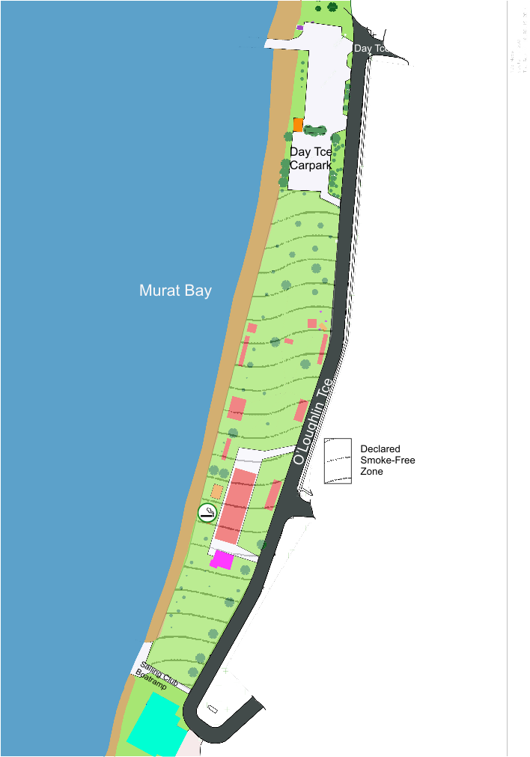
Dated 13 September 2016.
Leesa Vlahos, Minister for Mental Health and Substance Abuse

TRAINING AND SKILLS DEVELOPMENT ACT 2008

Part 4—Apprenticeships/Traineeships

Pursuant to the provision of the Training and Skills Development Act 2008, the Training and Skills Commission (TaSC) gives notice that determines the following
Trades or Declared Vocations in addition to the gazette notices of:

- 25 September 2008 | - 23 October 2008 | - 13 November 2008 | - 4 December 2008
- 18 December 2008 | - 29 January 2009 | - 12 February 2009 | - 5 March 2009
- 12 March 2009 | - 26 March 2009 | - 30 April 2009 | - 18 June 2009
- 25 June 2009 | - 27 August 2009 | - 17 September 2009 | - 24 September 2009
- 9 October 2009 | - 22 October 2009 | - 3 December 2009 | - 17 December 2009
- 4 February 2010 | - 11 February 2010 | - 18 February 2010 | - 18 March 2010
- 8 April 2010 | - 6 May 2010 | - 20 May 2010 | - 3 June 2010
- 17 June 2010 | - 24 June 2010 | - 8 July 2010 | - 9 September 2010
- 23 September 2010 | - 4 November 2010 | - 25 November 2010 | - 16 December 2010
- 23 December 2010 | - 17 March 2011 | - 7 April 2011 | - 21 April 2011
- 19 May 2011 | - 30 June 2011 | - 21 July 2011 | - 8 September 2011
- 10 November 2011 | - 24 November 2011 | - 1 December 2011 | - 8 December 2011
- 16 December 2011 | - 22 December 2011 | - 5 January 2012 | - 19 January 2012
- 1 March 2012 | - 29 March 2012 | - 24 May 2012 | - 31 May 2012
- 7 June 2012 | - 14 June 2012 | - 21 June 2012 | - 28 June 2012
- 5 July 2012 | - 12 July 2012 | - 19 July 2012 | - 2 August 2012
- 9 August 2012 | - 30 August 2012 | - 13 September 2012 | - 4 October 2012
- 18 October 2012 | - 25 October 2012 | - 8 November 2012 | - 29 November 2012
- 13 December 2012 | - 25 January 2013 | - 14 February 2013 | - 21 February 2013
- 28 February 2013 | - 7 March 2013 | - 14 March 2013 | - 21 March 2013
- 28 March 2013 | - 26 April 2013 | - 23 May 2013 | - 30 May 2013
- 13 June 2013 | - 20 June 2013 | - 11 July 2013 | - 1 August 2013
- 8 August 2013 | - 15 August 2013 | - 29 August 2013 | - 6 February 2014
- 12 June 2014 | - 28 August 2014 | - 4 September 2014 | - 16 October 2014
- 23 October 2014  101. 27 May 2015  105. 30 June 2016 | - 5 February 2015  - 18 June 2015  106. 28 July 2016 | - 26 March 2015  - 3 December 2015  107. 8 September 2016 | - 16 April 2015  - 7 April 2016  - 22 September 2016

Trades or Declared Vocations and Required Qualifications and
Training Contract Conditions for the
Business Services Training Package BSB

*Trade/ #Declared Vocation/ Other Occupation | Code | Title | Nominal Term of Training Contract | Probationary Period
Frontline Manager # | BSB42015 | Certificate IV in Leadership and Management | 24 Months | 60 Days
Management # | BSB52415 | Diploma of Marketing and Communication | 24 Months | 60 Days
Management # | BSB61315 | Advanced Diploma of Marketing and Communication | 24 Months | 60 Days
Manager # | BSB51915 | Diploma of Leadership and Management | 24 Months | 60 Days
Marketing Officer # | BSB42415 | Certificate IV in Marketing and Communication | 24 Months | 60 Days

South Australia
National Parks and Wildlife (Cape Blanche Conservation Park) Proclamation 2016
under section 30(2) of the National Parks and Wildlife Act 1972
1—Short title
This proclamation may be cited as the National Parks and Wildlife (Cape Blanche Conservation Park) Proclamation 2016.
2—Commencement
This proclamation comes into operation on the day on which it is made.
3—Alteration of boundaries of Cape Blanche Conservation Park
The boundaries of the Cape Blanche Conservation Park are altered by adding to the Park the following Crown land:
Block 8, Hundred of Wrenfordsley, County of Robinson;
Allotment 101 in Deposited Plan 91267, Out of Hundreds (Elliston).
Made by the Governor
with the advice and consent of the Executive Council
on 22 September 2016
16MSECCS044

South Australia
National Parks and Wildlife (Kaiserstuhl Conservation Park) Proclamation 2016
under section 30(2) of the National Parks and Wildlife Act 1972
1—Short title
This proclamation may be cited as the National Parks and Wildlife (Kaiserstuhl Conservation Park) Proclamation 2016.
2—Commencement
This proclamation comes into operation on the day on which it is made.
3—Alteration of boundaries of Kaiserstuhl Conservation Park
The boundaries of the Kaiserstuhl Conservation Park are altered by adding to the Park the following Crown land:
Section 724, Hundred of Moorooroo, County of Light.
Made by the Governor
with the advice and consent of the Executive Council
on 22 September 2016
16MSECCS044

South Australia
National Parks and Wildlife (Kinchina Conservation Park) Proclamation 2016
under section 30(1) of the National Parks and Wildlife Act 1972
1—Short title
This proclamation may be cited as the National Parks and Wildlife (Kinchina Conservation Park) Proclamation 2016.
2—Commencement
This proclamation comes into operation on the day on which it is made.
3—Constitution of Kinchina Conservation Park
The following Crown land is constituted as a conservation park and assigned the name Kinchina Conservation Park:
Section 489, Hundred of Mobilong, County of Sturt;
Allotments 100 and 105 in Deposited Plan 77623, Hundred of Mobilong, County of Sturt;
Allotments 21 and 22 in Deposited Plan 12046, Hundred of Mobilong, County of Sturt;
Allotments 1 and 16 in Filed Plan 15648, Hundred of Mobilong, County of Sturt;
Allotment 329 in Filed Plan 167144, Hundred of Mobilong, County of Sturt;
Allotment 333 in Filed Plan 167148, Hundred of Mobilong, County of Sturt;
Allotment 2 in Filed Plan 14028, Hundred of Mobilong, County of Sturt;
Allotment 55 in Filed Plan 41832, Hundred of Mobilong, County of Sturt.
Made by the Governor
being of the opinion that the Crown land described in clause 3 should be protected and preserved for the purpose of conserving any wildlife and the natural features of the land and with the advice and consent of the Executive Council
on 22 September 2016
16MSECCS044

South Australia
National Parks and Wildlife (Kinchina Conservation Park—Mining Rights) Proclamation 2016
under section 43 of the National Parks and Wildlife Act 1972

Preamble
1 The Crown land described in Schedule 1 is, by another proclamation made on this day, constituted as a conservation park under section 30(1) of the National Parks and Wildlife Act 1972 and assigned the name Kinchina Conservation Park.
2 It is intended that, by this proclamation, certain existing and future rights of entry, prospecting, exploration or mining be preserved in relation to that land.

1—Short title
This proclamation may be cited as the National Parks and Wildlife (Kinchina Conservation Park—Mining Rights) Proclamation 2016.
2—Commencement
This proclamation comes into operation on the day on which it is made.
3—Interpretation
In this proclamation—
Environment Minister means the Minister for the time being administering the National Parks and Wildlife Act 1972;
Mining Minister means the Minister for the time being administering the Mining Act 1971 or the Minister for the time being administering the Petroleum and Geothermal Energy Act 2000, as the case requires.
4—Existing rights to continue
Subject to clause 6, existing rights of entry, prospecting, exploration or mining under the Mining Act 1971 or the Petroleum and Geothermal Energy Act 2000 may continue to be exercised in respect of the land described in Schedule 1.
5—New rights may be acquired
Rights of entry, prospecting, exploration or mining may, with the approval of the Mining Minister and the Environment Minister, be acquired pursuant to the Mining Act 1971 or the Petroleum and Geothermal Energy Act 2000 in respect of the land described in Schedule 1 and may, subject to clause 6, be exercised in respect of that land.
6—Conditions for exercise of rights
A person in whom rights of entry, prospecting, exploration or mining are vested pursuant to the Mining Act 1971 or the Petroleum and Geothermal Energy Act 2000 (whether those rights were acquired before or after the making of this proclamation) must not exercise those rights in respect of the land described in Schedule 1 unless the person complies with the following conditions:
(a) if work to be carried out in relation to the land in the exercise of those rights is a regulated activity within the meaning of the Petroleum and Geothermal Energy Act 2000, the person must ensure that—
(i) the work is not carried out until a statement of environmental objectives in relation to the activity that has been approved under that Act has also been approved by the Environment Minister; and
(ii) the work is carried out in accordance with the statement as so approved;
(b) if work to be carried out in relation to the land in the exercise of rights under the Mining Act 1971 or the Petroleum and Geothermal Energy Act 2000 has not previously been authorised (whether by inclusion in an approved statement of environmental objectives referred to in paragraph (a) or otherwise), the person must give at least 3 months notice of the proposed work to the Mining Minister and the Environment Minister and supply each Minister with such information relating to the proposed work as the Minister may require;
(c) if directions are agreed between the Mining Minister and the Environment Minister and given to the person in writing in relation to—
(i) carrying out work in relation to the land in a manner that minimises damage to the land (including the land's vegetation and wildlife) and the environment generally; or
(ii) preserving objects, structures or sites of historical, scientific or cultural interest; or
(iii) rehabilitating the land (including the land's vegetation and wildlife) on completion of the work; or
(iv) (where the work is being carried out in the exercise of rights acquired after the making of this proclamation) prohibiting or restricting access to any specified area of the land that the Ministers believe would suffer significant detriment as a result of carrying out the work,
(being directions that do not reduce or otherwise detract from any requirement in respect of any of those matters contained in an approved statement of environmental objectives referred to in paragraph (a)), the person must comply with those directions in carrying out the work;
(d) if a plan of management is in operation under section 38 of the National Parks and Wildlife Act 1972 in respect of the land, the person must have regard to the provisions of the plan of management;

(e) in addition to complying with the other requirements of this proclamation, the person—
(i) must take such steps as are reasonably necessary to ensure that objects, structures and sites of historical, scientific or cultural interest and the land's vegetation and wildlife are not unduly affected by any work; and
(ii) must maintain all work areas in a clean and tidy condition; and
(iii) must, on the completion of any work, obliterate or remove all installations and structures (other than installations and structures designated by the Mining Minister and the Environment Minister as suitable for retention) used exclusively for the purposes of that work;
(f) if no direction has been given by the Mining Minister and the Environment Minister under paragraph (c)(iii), the person must (in addition to complying with any approved statement of environmental objectives referred to in paragraph (a)) rehabilitate the land (including its vegetation and wildlife) on completion of any work to the satisfaction of the Environment Minister.
7—Governor may give approvals, directions
If—
(a) the Mining Minister and the Environment Minister cannot agree as to whether—
(i) approval should be granted or refused under clause 5; or
(ii) a direction should be given under clause 6(c); or
(b) the Environment Minister does not approve a statement of environmental objectives under clause 6(a),
the Governor may, with the advice and consent of the Executive Council—
(c) grant or refuse the necessary approval under clause 5; or
(d) give a direction in writing under clause 6(c); or
(e) grant or refuse the necessary approval under clause 6(a).
Schedule 1—Description of land
Section 489, Hundred of Mobilong, County of Sturt;
Allotments 100 and 105 in Deposited Plan 77623, Hundred of Mobilong, County of Sturt;
Allotments 21 and 22 in Deposited Plan 12046, Hundred of Mobilong, County of Sturt;
Allotments 1 and 16 in Filed Plan 15648, Hundred of Mobilong, County of Sturt;
Allotment 329 in Filed Plan 167144, Hundred of Mobilong, County of Sturt;
Allotment 333 in Filed Plan 167148, Hundred of Mobilong, County of Sturt;
Allotment 2 in Filed Plan 14028, Hundred of Mobilong, County of Sturt;
Allotment 55 in Filed Plan 41832, Hundred of Mobilong, County of Sturt.
Made by the Governor
with the advice and consent of the Executive Council
on 22 September 2016
16MSECCS044

South Australia
National Parks and Wildlife (Monarto Woodlands Conservation Park) Proclamation 2016
under section 30(1) of the National Parks and Wildlife Act 1972
1—Short title
This proclamation may be cited as the National Parks and Wildlife (Monarto Woodlands Conservation Park) Proclamation 2016.
2—Commencement
This proclamation comes into operation on the day on which it is made.
3—Constitution of Monarto Woodlands Conservation Park
The following Crown land is constituted as a conservation park and assigned the name Monarto Woodlands Conservation Park:
Allotments 2, 5, 11, 14 and 16 in Filed Plan 13913, Hundred of Monarto, County of Sturt;
Allotment 54 in Filed Plan 160693, Hundred of Monarto, County of Sturt;
Allotment 55 in Filed Plan 160694, Hundred of Monarto, County of Sturt;
Allotment 56 in Filed Plan 160695, Hundred of Monarto, County of Sturt;
Allotment 100 in Deposited Plan 53491, Hundred of Monarto, County of Sturt;
Section 262, Hundred of Monarto, County of Sturt;
Allotment 151 in Filed Plan 14720, Hundred of Mobilong, County of Sturt;
Allotment 2 in Deposited Plan 85503, Hundred of Mobilong, County of Sturt;
Allotment 2 in Deposited Plan 110445, Hundred of Mobilong, County of Sturt;
Allotment 160 in Filed Plan 14719, Hundred of Mobilong, County of Sturt.
Made by the Governor
being of the opinion that the Crown land described in clause 3 should be protected and preserved for the purpose of conserving any wildlife and the natural features of the land and with the advice and consent of the Executive Council
on 22 September 2016
16MSECCS044

South Australia
National Parks and Wildlife (Monarto Woodlands Conservation Park—Mining Rights) Proclamation 2016
under section 43 of the National Parks and Wildlife Act 1972

Preamble
1 The Crown land described in Schedule 1 is, by another proclamation made on this day, constituted as a conservation park under section 30(1) of the National Parks and Wildlife Act 1972 and assigned the name Monarto Woodlands Conservation Park.
2 It is intended that, by this proclamation, certain existing and future rights of entry, prospecting, exploration or mining be preserved in relation to that land.

1—Short title
This proclamation may be cited as the National Parks and Wildlife (Monarto Woodlands Conservation Park—Mining Rights) Proclamation 2016.
2—Commencement
This proclamation comes into operation on the day on which it is made.
3—Interpretation
In this proclamation—
Environment Minister means the Minister for the time being administering the National Parks and Wildlife Act 1972;
Mining Minister means the Minister for the time being administering the Mining Act 1971 or the Minister for the time being administering the Petroleum and Geothermal Energy Act 2000, as the case requires.
4—Existing rights to continue
Subject to clause 6, existing rights of entry, prospecting, exploration or mining under the Mining Act 1971 or the Petroleum and Geothermal Energy Act 2000 may continue to be exercised in respect of the land described in Schedule 1.
5—New rights may be acquired
Rights of entry, prospecting, exploration or mining may, with the approval of the Mining Minister and the Environment Minister, be acquired pursuant to the Mining Act 1971 or the Petroleum and Geothermal Energy Act 2000 in respect of the land described in Schedule 1 and may, subject to clause 6, be exercised in respect of that land.
6—Conditions for exercise of rights
A person in whom rights of entry, prospecting, exploration or mining are vested pursuant to the Mining Act 1971 or the Petroleum and Geothermal Energy Act 2000 (whether those rights were acquired before or after the making of this proclamation) must not exercise those rights in respect of the land described in Schedule 1 unless the person complies with the following conditions:
(a) if work to be carried out in relation to the land in the exercise of those rights is a regulated activity within the meaning of the Petroleum and Geothermal Energy Act 2000, the person must ensure that—
(i) the work is not carried out until a statement of environmental objectives in relation to the activity that has been approved under that Act has also been approved by the Environment Minister; and
(ii) the work is carried out in accordance with the statement as so approved;
(b) if work to be carried out in relation to the land in the exercise of rights under the Mining Act 1971 or the Petroleum and Geothermal Energy Act 2000 has not previously been authorised (whether by inclusion in an approved statement of environmental objectives referred to in paragraph (a) or otherwise), the person must give at least 3 months notice of the proposed work to the Mining Minister and the Environment Minister and supply each Minister with such information relating to the proposed work as the Minister may require;
(c) if directions are agreed between the Mining Minister and the Environment Minister and given to the person in writing in relation to—
(i) carrying out work in relation to the land in a manner that minimises damage to the land (including the land's vegetation and wildlife) and the environment generally; or
(ii) preserving objects, structures or sites of historical, scientific or cultural interest; or
(iii) rehabilitating the land (including the land's vegetation and wildlife) on completion of the work; or
(iv) (where the work is being carried out in the exercise of rights acquired after the making of this proclamation) prohibiting or restricting access to any specified area of the land that the Ministers believe would suffer significant detriment as a result of carrying out the work,
(being directions that do not reduce or otherwise detract from any requirement in respect of any of those matters contained in an approved statement of environmental objectives referred to in paragraph (a)), the person must comply with those directions in carrying out the work;
(d) if a plan of management is in operation under section 38 of the National Parks and Wildlife Act 1972 in respect of the land, the person must have regard to the provisions of the plan of management;

(e) in addition to complying with the other requirements of this proclamation, the person—
(i) must take such steps as are reasonably necessary to ensure that objects, structures and sites of historical, scientific or cultural interest and the land's vegetation and wildlife are not unduly affected by any work; and
(ii) must maintain all work areas in a clean and tidy condition; and
(iii) must, on the completion of any work, obliterate or remove all installations and structures (other than installations and structures designated by the Mining Minister and the Environment Minister as suitable for retention) used exclusively for the purposes of that work;
(f) if no direction has been given by the Mining Minister and the Environment Minister under paragraph (c)(iii), the person must (in addition to complying with any approved statement of environmental objectives referred to in paragraph (a)) rehabilitate the land (including its vegetation and wildlife) on completion of any work to the satisfaction of the Environment Minister.
7—Governor may give approvals, directions
If—
(a) the Mining Minister and the Environment Minister cannot agree as to whether—
(i) approval should be granted or refused under clause 5; or
(ii) a direction should be given under clause 6(c); or
(b) the Environment Minister does not approve a statement of environmental objectives under clause 6(a),
the Governor may, with the advice and consent of the Executive Council—
(c) grant or refuse the necessary approval under clause 5; or
(d) give a direction in writing under clause 6(c); or
(e) grant or refuse the necessary approval under clause 6(a).
Schedule 1—Description of land
Allotments 2, 5, 11, 14 and 16 in Filed Plan 13913, Hundred of Monarto, County of Sturt;
Allotment 54 in Filed Plan 160693, Hundred of Monarto, County of Sturt;
Allotment 55 in Filed Plan 160694, Hundred of Monarto, County of Sturt;
Allotment 56 in Filed Plan 160695, Hundred of Monarto, County of Sturt;
Allotment 100 in Deposited Plan 53491, Hundred of Monarto, County of Sturt;
Section 262, Hundred of Monarto, County of Sturt;
Allotment 151 in Filed Plan 14720, Hundred of Mobilong, County of Sturt;
Allotment 2 in Deposited Plan 85503, Hundred of Mobilong, County of Sturt;
Allotment 2 in Deposited Plan 110445, Hundred of Mobilong, County of Sturt;

Allotment 160 in Filed Plan 14719, Hundred of Mobilong, County of Sturt.
Made by the Governor
with the advice and consent of the Executive Council
on 22 September 2016
16MSECCS044

South Australia
National Parks and Wildlife (Searcy Bay Conservation Park) Proclamation 2016
under section 30(2) of the National Parks and Wildlife Act 1972
1—Short title
This proclamation may be cited as the National Parks and Wildlife (Searcy Bay Conservation Park) Proclamation 2016.
2—Commencement
This proclamation comes into operation on the day on which it is made.
3—Alteration of boundaries of Searcy Bay Conservation Park
The boundaries of the Searcy Bay Conservation Park are altered by adding to the Park the following Crown land:
Allotment 101 in Deposited Plan 91268, Hundred of Wrenfordsley, County of Robinson.
Made by the Governor
with the advice and consent of the Executive Council
on 22 September 2016
16MSECCS044

South Australia
Major Events (Australia v South Africa Cricket Test
Match 2016) Regulations 2016
under the Major Events Act 2013

Contents
1 Short title
2 Commencement
3 Interpretation
4 Major event
5 Event organiser
6 Major event period
7 Major event venue
8 Controlled area
9 Application of certain provisions of Act
10 Advertising controlled airspace
11 Expiry of regulations
Schedule 1—Description of controlled area
1 Description of controlled area
Schedule 2—Map of controlled area

1—Short title
These regulations may be cited as the Major Events (Australia v South Africa Cricket Test Match 2016) Regulations 2016.
2—Commencement
These regulations come into operation on the day on which they are made.
3—Interpretation
In these regulations, unless the contrary intention appears—
Act means the Major Events Act 2013;
controlled area—see regulation 8;
major event—see regulation 4;
major event period—see regulation 6;
major event venue—see regulation 7.
4—Major event
The Australia v South Africa cricket test match to be held during the period commencing on 24 November 2016 and ending on 28 November 2016 in Adelaide is declared to be a major event.
5—Event organiser
Cricket Australia is designated as the event organiser for the major event.
6—Major event period
The major event period for which the declaration of the major event is in force is a period commencing on 24 November 2016 and ending on 28 November 2016.
7—Major event venue
The major event venue for the purposes of the major event is declared to be the Adelaide Oval Core Area (within the meaning of the Adelaide Oval Redevelopment and Management Act 2011).
8—Controlled area
The controlled area for the major event during the major event period is declared to be the hatched area shown on the map in Schedule 2 and described in Schedule 1 clause 1.
9—Application of certain provisions of Act
Sections 9 to 13 (inclusive) of the Act are declared to apply to the major event.
10—Advertising controlled airspace
For the purposes of section 7(3)(e) of the Act, the airspace that is within unaided sight of the major event venue is declared to be advertising controlled airspace during the major event period.
11—Expiry of regulations
These regulations will expire on 29 November 2016.
Schedule 1—Description of controlled area
1—Description of controlled area
The controlled area comprises the area in Adelaide bounded as follows: commencing at the intersection of the prolongation in an easterly direction of the northern boundary of Festival Drive and the eastern boundary of King William Road, then northerly along the eastern boundary of King William Road to its intersection with the northern boundary of Pennington Terrace, then north-westerly along that boundary to its intersection with the northern boundary of the portion of road known as "Montefiore Hill", then westerly along that boundary to its intersection with the western boundary of Jeffcott Street, then southerly along that boundary in a straight line by the shortest route across Montefiore Hill to its intersection with the western boundary of Montefiore Road, then generally southerly along that boundary to its intersection with the prolongation in a westerly direction of the northern boundary of Festival Drive, then in an easterly direction along that boundary to its intersection with the prolongation in a northerly direction of the eastern boundary of the built structure comprising the Intercontinental Hotel, then in a southerly direction along that prolongation to the northeastern most point of that built structure, then in a southerly direction along the eastern boundary of that built structure to its intersection with the northern boundary of the built structure comprising the Adelaide Railway Station, then following that boundary in an easterly direction to the northeastern most point of that built structure, then in a northerly direction following the prolongation by the shortest route of the eastern boundary of that built structure to its intersection with the northern boundary of Festival Drive, then in a generally easterly direction along that boundary to the point of commencement, but excluding the built structures comprising and immediately adjacent to the Adelaide Festival Centre, the Intercontinental Hotel and the Adelaide Convention Centre Complex.
Schedule 2—Map of controlled area
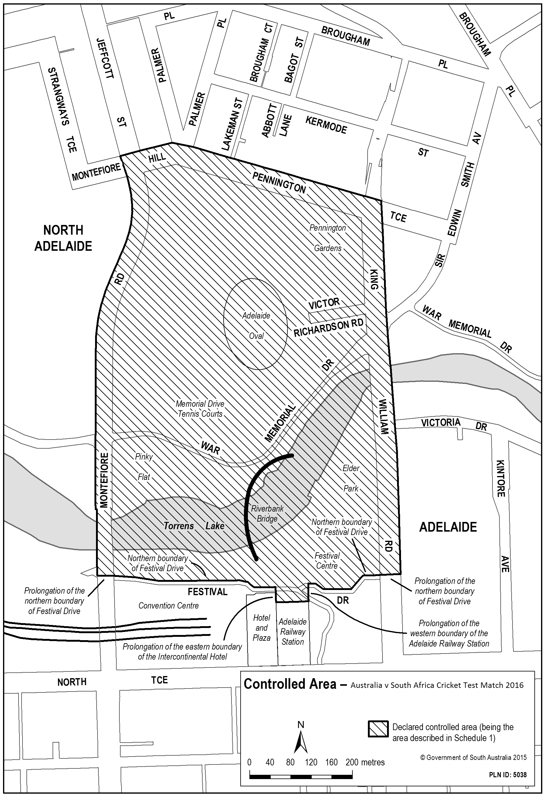
Note—
As required by section 10AA(2) of the Subordinate Legislation Act 1978, the Minister has certified that, in the Minister's opinion, it is necessary or appropriate that these regulations come into operation as set out in these regulations.
Made by the Governor
with the advice and consent of the Executive Council
on 22 September 2016
No 228 of 2016
16MTOUR0015

South Australia
Second-hand Vehicle Dealers Variation Regulations 2016
under the Second-hand Vehicle Dealers Act 1995

Contents
Part 1—Preliminary
1 Short title
2 Commencement
3 Variation provisions
Part 2—Variation of Second-hand Vehicle Dealers Regulations 2010
4 Variation of regulation 6—Forms
5 Variation of regulation 22—Second-hand Vehicles Compensation Fund (Schedule 3 of Act)
6 Variation of regulation 23—Waiver of rights (section 33 of Act)
7 Variation of Schedule 2—Forms
8 Variation of Schedule 4—Defects in vehicles
Part 1—Defects in accessories
9 Variation of Schedule 6—Waiver of rights

Part 1—Preliminary
1—Short title
These regulations may be cited as the Second-hand Vehicle Dealers Variation Regulations 2016.
2—Commencement
These regulations come into operation on the day on which they are made.
3—Variation provisions
In these regulations, a provision under a heading referring to the variation of specified regulations varies the regulations so specified.
Part 2—Variation of Second-hand Vehicle Dealers Regulations 2010
4—Variation of regulation 6—Forms
Regulation 6—after "Times New Roman" wherever occurring insert:
or Calibri
5—Variation of regulation 22—Second-hand Vehicles Compensation Fund (Schedule 3 of Act)
Regulation 22(3)—delete "the educational program relating to the provisions contained in the Second-hand Vehicle Dealers (Cooling-off Rights) Amendment Act 2009" and substitute:
an educational program approved by the Commissioner
6—Variation of regulation 23—Waiver of rights (section 33 of Act)
(1) Regulation 23(2), penalty provision—delete the penalty provision and substitute:
Maximum penalty: $5 000.
Expiation fee: $315.
(2) Regulation 23(4), penalty provision—delete the penalty provision and substitute:
Maximum penalty: $5 000.
Expiation fee: $315.
7—Variation of Schedule 2—Forms
(1) Schedule 2, Form 1—before the heading to Part A insert:
Dealer Reference or Stock No:
(2) Schedule 2, Form 1, Part A, The dealer—after the last list item (and accompanying Note) insert:
Has the vehicle ever been recorded as wrecked, written-off or having suffered significant damage as a result of exposure to water? (Yes or No)
(3) Schedule 2, Form 1, Part B—delete Part B and substitute:
Part B
Duty to repair—Part 4 of the Second-hand Vehicle Dealers Act 1995
The following is only a brief summary of the extent of the duty to repair. Full details must be given to a purchaser by the dealer at the time of sale (as well as a copy of this notice).

Sale price | Duty to repair
Up to and including $3 000 | No duty to repair—but vehicle must be roadworthy at time of sale.
$3 001—$6 000 | 2 months or 3 000 kilometres, whichever occurs first.
Over $6 000 | 3 months or 5 000 kilometres, whichever occurs first.
This vehicle cannot be registered until it is converted to right-hand configuration to the standard required by the Registrar of Motor Vehicles, and the dealer does not accept a duty to perform that work as part of a duty to repair.
[Strike out if not applicable]
The dealer does not accept a duty to repair any defect in the following accessories, being accessories not originally fitted by the vehicle's manufacturer, or not produced or approved by the manufacturer for fitting to vehicles of that kind:
[List accessories]
If the dealer is under a duty to repair a defect in the vehicle, the purchaser must deliver the vehicle to the following agreed place of repair:
[Insert name and address]
If no place of repair has been agreed on, the purchaser must deliver the vehicle to any of the following registered premises of the dealer:
[Insert names and addresses]
(4) Schedule 2, Form 2—delete "Consumer and Business Affairs" wherever occurring and substitute in each case:
Consumer and Business Services
(5) Schedule 2, Form 3, Part 2—delete "(for example radios, tape players and air-conditioners)"
(6) Schedule 2, Form 3, Part 2—delete "Consumer and Business Affairs" wherever occurring and substitute in each case:
Consumer and Business Services
(7) Schedule 2, Form 5—delete Form 5 and substitute:
Form 5—Particulars to be included in a contract for the sale of a second-hand vehicle by a dealer
Second-hand Vehicle Dealers Act 1995

Dealer Reference or Stock No:
Name in which dealer is licensed:
Business address:
Make: |  | Model: |  | Body Type: | Colour: | Body—  Trim—
Year of  manufacture: | Year of first  registration: | Registration  No: |  | Expiry date: | Engine No: | VIN No:
DETAILS OF PURCHASE |  | $ | c | METHOD OF PAYMENT | $ | c
Cash Price |  |  |  | Deposit
Additional options, accessories etc* |  |  |  | Trade-in allowance*
Total price of vehicle |  |  |  | Less pay-out  (Name of financier: )

 |  |  | Amount of deposit to be paid if contract rescinded (and preferred method of payment of refund)
Registration (number of months) |  |  | Equity (Deficiency)
3rd Party compulsory insurance |  |  | Less refund to purchaser
Stamp duty and/or transfer fee |  |  | Net equity (or deficiency)
Dealer to arrange above YES/NO |  |  | Total deposit and trade-in
Vehicle insurance: [company] |  |  | Payable on delivery
Other (give full details including other parties to whom payment must be made) |  |  | (Amount payable on delivery includes amount to be financed where applicable)
TOTAL PAYABLE |  |  | TOTAL PAYMENT
Options/accessories/additional work included in this amount | $ | c | *Trade-in details
 |  |  | Make: | Model:
 |  |  | Body Type: | Colour: | Body:
 |  |  |  |  | Trim:
 |  |  | Year of Manufacture: | Year of 1st Registration:
 |  |  | Registration No: | Expiry Date:
 |  |  | Engine No: | Odometer: kms
 |  |  | Payout to:
 |  |  | Account No: | Valid until:
TOTAL

*Address to which vehicle is to be delivered for repair of defects under the Second-hand Vehicle Dealers Act 1995.
REPAIRER'S NAME:
ADDRESS:
*The vehicle may be delivered to any of the following registered premises of the dealer for repair:
COOLING-OFF RIGHTS
*This contract is subject to a 2 day cooling-off period under section 18B of the Second-hand Vehicle Dealers Act 1995 expiring on [insert date and time when period is to expire]
The purchaser under a contract that is subject to a cooling-off period under the Second-hand Vehicle Dealers Act 1995, may, within 2 clear business days after signing the contract (the cooling-off period), by giving the dealer written notice that he or she does not wish to proceed with the purchase, rescind the contract. The written notice must be given to the dealer before the end of the cooling-off period. If this occurs, the contract is rescinded. (The 2 day period may include a Saturday but will not include a Sunday or public holiday.)
If the contract is rescinded by the purchaser, the dealer is entitled to keep 2% of the contract price or $100, whichever is the lesser. The purchaser is entitled to the return of the balance of any deposit paid to the dealer by the end of the next clear business day.
*This contract is not subject to a 2 day cooling-off period under section 18B of the Second-hand Vehicle Dealers Act 1995.
A purchaser who wishes to be bound by the contract may waive his or her right to the cooling-off period by signing the Waiver of Cooling-off Rights document provided by the dealer.
I acknowledge that, before the signing of the contract for the purchase of the vehicle, I was informed of/I did not request* the name and address of—
(a) the last owner of the vehicle (who was not a dealer)*;
(b) the person who leased the vehicle from the last owner of the vehicle (who was not a dealer) under a vehicle leasing agreement*.
Signature of purchaser:
Any purported exclusion, limitation, modification or waiver of your rights under the Act is void. The only way you can give away your rights under the Second-hand Vehicle Dealers Act 1995 is if you have signed a waiver document in accordance with the Second-hand Vehicle Dealers Regulations 2010.
In addition to any statutory warranty that may apply, you also have rights under the Australian Consumer Law that cannot be excluded.
*Strike out whichever does not apply.
(8) Schedule 2, Form 6—delete Form 6 and substitute:
Form 6—Particulars to be included in a contract for the sale of a second-hand motorcycle by a dealer
Second-hand Vehicle Dealers Act 1995

Name in which dealer is licensed:
Business address:
Make: |  | Model: |  |  | Colour:
Year of  manufacture: | Year of first  registration: | Registration  No: |  | Expiry date: | Engine No: | VIN  No:
DETAILS OF PURCHASE |  | $ | c | METHOD OF PAYMENT | $ | c
Cash Price |  |  |  | Deposit
Additional options, accessories etc* |  |  |  | Trade-in allowance*
Total price of motorcycle |  |  |  | Less pay-out
 |  |  |  | Amount of deposit to be paid if contract rescinded (and preferred method of payment of refund)
Registration (number of months) |  |  |  | Equity (Deficiency)
3rd Party compulsory insurance |  |  |  | Less refund to purchaser
Stamp duty and/or transfer fee |  |  |  | Net equity (or deficiency)
Dealer to arrange above YES/NO |  |  |  | Total deposit and trade-in
Motorcycle insurance: [company] |  |  |  | Payable on delivery
Other (give full details including other parties to whom payment must be made) |  |  |  | (Amount payable on delivery includes amount to be financed where applicable)
TOTAL PAYABLE |  |  |  | TOTAL PAYMENT
Options/accessories/additional work included in this amount |  | $ | c | *Trade-in details
 |  |  |  | Make: | Model:
 |  |  |  |  | Colour:
 |  |  |  | Year of Manufacture: | Year of 1st Registration:
 |  |  |  | Registration No: | Expiry Date:
 |  |  |  | Engine No: | Odometer: kms
 |  |  |  | Payout to:
 |  |  |  | Account No: | Valid until:
TOTAL

COOLING-OFF RIGHTS
*This contract is subject to a 2 day cooling-off period under section 18B of the Second-hand Vehicle Dealers Act 1995 expiring on [insert date and time when period is to expire]
The purchaser under a contract that is subject to a cooling-off period under the Second-hand Vehicle Dealers Act 1995, may, within 2 clear business days after signing the contract (the cooling-off period), by giving the dealer written notice that he or she does not wish to proceed with the purchase, rescind the contract. The written notice must be given to the dealer before the end of the cooling-off period. If this occurs, the contract is rescinded. (The 2 day period may include a Saturday but will not include a Sunday or public holiday.)
If the contract is rescinded by the purchaser, the dealer is entitled to keep 2% of the contract price or $100, whichever is the lesser. The purchaser is entitled to the return of the balance of any deposit paid to the dealer by the end of the next clear business day.
*This contract is not subject to a 2 day cooling-off period under section 18B of the Second-hand Vehicle Dealers Act 1995.

A purchaser who wishes to be bound by the contract may waive his or her right to the cooling-off period by signing the Waiver of Cooling-off Rights document provided by the dealer.
I acknowledge that, before the signing of the contract for the purchase of the vehicle, I was informed of/I did not request* the name and address of—
(a) the last owner of the vehicle (who was not a dealer)*;
(b) the person who leased the vehicle from the last owner of the vehicle (who was not a dealer) under a vehicle leasing agreement*.
Signature of purchaser:
Any purported exclusion, limitation, modification or waiver of your rights under the Act is void. The only way you can give away your rights under the Second-hand Vehicle Dealers Act 1995 is if you have signed a waiver document in accordance with the Second-hand Vehicle Dealers Regulations 2010.
IMPORTANT INFORMATION
There is no duty to repair second-hand motorcycles under the Second-hand Vehicle Dealers Act 1995.
*Strike out whichever does not apply.
(9) Schedule 2, Form 7—before the heading to Part A insert:
Dealer Reference or Stock No:
(10) Schedule 2, Form 7, Part A, The Dealer—after the last list item insert:
Has the vehicle ever been recorded as wrecked, written-off or having suffered significant damage as a result of exposure to water? (Yes or No)
(11) Schedule 2, Form 7, Part B—delete Part B and substitute:
Part B
Duty to repair—Part 4 of the Second-hand Vehicle Dealers Act 1995
The following is only a brief summary of the extent of the duty to repair. Full details must be given to a purchaser by the auctioneer at the time of sale (as well as a copy of this notice).

Sale price | Duty to repair
Up to and including $3 000 | No duty to repair—but vehicle must be roadworthy at time of sale.
$3 001—$6 000 | 2 months or 3 000 kilometres, whichever occurs first.
Over $6 000 | 3 months or 5 000 kilometres, whichever occurs first.
This vehicle cannot be registered until it is converted to right-hand configuration to the standard required by the Registrar of Motor Vehicles, and the seller does not accept a duty to perform that work as part of a duty to repair.
[Strike out if not applicable]
The seller does not accept a duty to repair any defect in the following accessories, being accessories not originally fitted by the vehicle's manufacturer, or not produced or approved by the manufacturer for fitting to vehicles of that kind:
[List accessories]
If the dealer is under a duty to repair a defect in the vehicle, the purchaser must deliver the vehicle to the following agreed place of repair:
[Insert name and address]
If no place of repair has been agreed on, the purchaser must deliver the vehicle to any of the following registered premises of the dealer:
[Insert names and addresses]
(12) Schedule 2, Form 7—after Part C insert:
In addition to any statutory warranty that may apply, you also have rights under the Australian Consumer Law that cannot be excluded.
(13) Schedule 2, Form 9, Part 2—delete "(for example radios, tape players and air-conditioners)"
(14) Schedule 2, Form 9, Part 2—delete "Consumer and Business Affairs" wherever occurring and substitute in each case:
Consumer and Business Services
(15) Schedule 2, Form 11, The vehicle—after the last list item insert:
Has the vehicle ever been recorded as wrecked, written-off or having suffered significant damage as a result of exposure to water? (Yes or No)
8—Variation of Schedule 4—Defects in vehicles
Schedule 4, Part 1—delete Part 1 and substitute:
Part 1—Defects in accessories
A dealer is not under a duty to repair a defect in an accessory not originally fitted by the vehicle's manufacturer, or not produced or approved by the manufacturer for fitting to vehicles of that kind if the dealer has stated in the Section 16 Notice or in the Auction Notice (as the case may be) that the dealer does not accept a duty to repair a defect in that accessory.
9—Variation of Schedule 6—Waiver of rights
(1) Schedule 6, Document 1, Part 1—delete "Consumer and Business Affairs" wherever occurring and substitute in each case:
Consumer and Business Services
(2) Schedule 6, Document 1, Part 2, Notes, item 3—delete "Consumer and Business Affairs" and substitute:
Consumer and Business Services
(3) Schedule 6, Document 2—delete Document 2 and substitute:
Document 2—Waiver of cooling-off rights
This is an important document. It takes away some of your legal rights. Read it carefully. This form must be completed in duplicate.
Cooling-off rights
The Second-hand Vehicle Dealers Act 1995 gives you the right to change your mind about buying a second-hand vehicle.
Under section 18B of the Second-hand Vehicle Dealers Act 1995, you have 2 clear business days after signing the contract to change your mind about buying the vehicle. These 2 days are called the cooling-off period. If you change your mind, you must, before the end of the cooling-off period, give the dealer written notice that you do not wish to go ahead with the purchase. This notice means that the contract is rescinded.
If the contract is rescinded, the dealer is entitled to keep 2% of the contract price or $100, whichever is the lesser. The dealer may decide to take this amount out of any deposit you have already paid. You are entitled to the return of the rest of any deposit you paid to the dealer (less 2% of the contract price or $100, whichever is the lesser).
You are entitled to give up (or waive) your cooling-off right by signing this document. If you sign this document, you will lose your right to rescind the sales contract under section 18B of the Second-hand Vehicle Dealers Act 1995. This decision should not be taken lightly. You should not sign this document unless you are absolutely certain you want to buy the vehicle and are sure you won't change your mind about the sale.
If you decide to go ahead and waive your cooling-off rights by signing this document, you must give the completed and signed copy of the document to the dealer and keep the other copy for your records.
A dealer or salesperson employed by the dealer who has been involved in any way in the transaction for the sale of the vehicle must not be a witness to the signing of this document.
Details of transaction
Date contract was made:
Make and model of vehicle:
Registration No:
Engine No:
Vehicle identification No:
Year of manufacture:
Dealer's name:
Dealer's licence No:
Dealer's business address:
Dealer's telephone No:
Waiving your cooling-off rights
I acknowledge that section 18B of the Second-hand Vehicle Dealers Act 1995 gives me the right to decide within 2 clear business days not to go ahead with the purchase and to rescind the contract.
I acknowledge that by signing this document I will lose my right to cancel the contract for the sale of the vehicle.
Purchaser's name:
Purchaser's telephone No:
Purchaser's address:
Purchaser's signature:
Date:
Name of witness:
Address of witness:
Signature of witness:
Date:
Note—
As required by section 10AA(2) of the Subordinate Legislation Act 1978, the Minister has certified that, in the Minister's opinion, it is necessary or appropriate that these regulations come into operation as set out in these regulations.
Made by the Governor
with the advice and consent of the Executive Council
on 22 September 2016
No 229 of 2016
CBS0001/16CS

South Australia
National Parks and Wildlife (Co-management Boards) Regulations 2016
under the National Parks and Wildlife Act 1972

Contents
Part 1—Preliminary
1 Short title
2 Commencement
3 Interpretation
Part 2—Continuation and composition of co-management boards
4 Ikara-Flinders Ranges National Park co-management board
5 Kanku-Breakaways Conservation Park co-management board
6 Lake Gairdner National Park co-management board
7 Ngaut Ngaut Conservation Park co-management board
8 Vulkathunha-Gammon Ranges National Park co-management board
9 Witjira National Park co-management board
10 Yumbarra Conservation Park co-management board
Part 3—Procedures of co-management boards
11 Gender balance
12 Terms and conditions
13 Remuneration
14 Chairperson and deputy chairperson
15 Functions and powers of co-management boards
16 Procedures of co-management boards
17 Conflict of interest
18 Vacancies or defects in appointment of members
19 Delegations
20 Additional delegations—Ikara-Flinders Ranges National Park co-management board
21 Minister may call meetings
22 Control and management of parks during suspension of co-management board
23 Annual report
Schedule 1—Revocations and transitional provisions
Part 1—Revocation of regulations
1 Revocation of regulations
Part 2—Transitional provisions
2 Interpretation
3 References
4 Membership of co-management boards
5 Delegations

Part 1—Preliminary
1—Short title
These regulations may be cited as the National Parks and Wildlife (Co-management Boards) Regulations 2016.
2—Commencement
These regulations will come into operation 4 months after the day on which they are made.
3—Interpretation
In these regulations, unless the contrary intention appears—
Act means the National Parks and Wildlife Act 1972;
Adnyamathanha person means a member of the Native Title Holders as defined in the determination of native title made by the Federal Court of Australia in the Adnyamathanha No. 2 Native Title Claim SAD 6002/98 on 30 March 2009;
AMYAC means the Antakirinja Matu-Yankunytjatjara Aboriginal Corporation incorporated under the Corporations (Aboriginal and Torres Strait Islander) Act 2006 of the Commonwealth;
Antakirinja Matuntjara Yankunytjatjara person means a member of the Native Title Holders as defined in the determination of native title made by the Federal Court of Australia in Native Title Claim SAD 6007/98 on 11 May 2011;
ATLA means the Adnyamathanha Traditional Lands Association (Aboriginal Corporation) RNTBC incorporated under the Corporations (Aboriginal and Torres Strait Islander) Act 2006 of the Commonwealth;
Far West Coast person means a member of the Native Title Holders as defined in the determination of native title made by the Federal Court of Australia in Native Title Claim SAD 6008 of 1998 on 5 December 2013;
FWCAC means the Far West Coast Aboriginal Corporation incorporated under the Corporations (Aboriginal and Torres Strait Islander) Act 2006 of the Commonwealth;
Gawler Ranges person means a member of the Native Title Holders as defined in the determination of native title made by the Federal Court of Australia in Native Title Claim SAD 6020/98 on 19 December 2011;
GRAC means the Gawler Ranges (Aboriginal Corporation) incorporated under the Corporations (Aboriginal and Torres Strait Islander) Act 2006 of the Commonwealth;
IAC means the Irrwanyere Aboriginal Corporation incorporated under the Corporations (Aboriginal and Torres Strait Islander) Act 2006 of the Commonwealth;
Lower Southern Arrernte person means a member of the native title claim group in the Eringa (SAD 6010/98), the Eringa No 2 (SAD 6002/99) or the Irranwanyere Mt Dare (SAD 66/05) native title claims;
MACAI means the Mannum Aboriginal Community Association Incorporated;
MACAI member means a person represented by Mannum Aboriginal Community Association Incorporated;
park means a conservation park or national park in relation to which a co-management board is continued under these regulations;
relevant co-management agreement means—
(a) in relation to the Ikara-Flinders Ranges National Park—the co-management agreement for that national park, as in force from time to time;
(b) in relation to the Kanku-Breakaways Conservation Park—the co-management agreement for that conservation park, as in force from time to time;
(c) in relation to the Lake Gairdner National Park—the co-management agreement for that national park, as in force from time to time;
(d) in relation to the Ngaut Ngaut Conservation Park—the co-management agreement for that conservation park, as in force from time to time;
(e) in relation to the Vulkathunha-Gammon Ranges National Park—the co-management agreement for that national park, as in force from time to time;
(f) in relation to the Witjira National Park—the co-management agreement for that national park, as in force from time to time;
(g) in relation to the Yumbarra Conservation Park—the co-management agreement for that conservation park, as in force from time to time;
relevant co-management board means—
(a) in relation to the Ikara-Flinders Ranges National Park—the Ikara-Flinders Ranges National Park co-management board;
(b) in relation to the Kanku-Breakaways Conservation Park—the Kanku-Breakaways Conservation Park co-management board;
(c) in relation to the Lake Gairdner National Park—the Lake Gairdner National Park co-management board;
(d) in relation to the Ngaut Ngaut Conservation Park—the Ngaut Ngaut Conservation Park co-management board;
(e) in relation to the Vulkathunha-Gammon Ranges National Park—the Vulkathunha-Gammon Ranges National Park co-management board;
(f) in relation to the Witjira National Park—the Witjira National Park co-management board;
(g) in relation to the Yumbarra Conservation Park—the Yumbarra Conservation Park co-management board;
relevant nominating body means—
(a) in relation to the Ikara-Flinders Ranges National Park co-management board—ATLA;
(b) in relation to the Kanku-Breakaways Conservation Park co-management board—AMYAC;
(c) in relation to the Lake Gairdner National Park co-management board—GRAC;
(d) in relation to the Ngaut Ngaut Conservation Park co-management board—MACAI;
(e) in relation to the Vulkathunha-Gammon Ranges National Park co-management board—ATLA;
(f) in relation to the Witjira National Park co-management board—IAC;
(g) in relation to Yumbarra Conservation Park co-management board—FWCAC;
relevant park means—
(a) in relation to the Ikara-Flinders Ranges National Park co-management board—Ikara-Flinders Ranges National Park;
(b) in relation to the Kanku-Breakaways Conservation Park co-management board—Kanku-Breakaways Conservation Park;
(c) in relation to the Lake Gairdner National Park co-management board—Lake Gairdner National Park;
(d) in relation to the Ngaut Ngaut Conservation Park co-management board—Ngaut Ngaut Conservation Park;
(e) in relation to the Vulkathunha-Gammon Ranges National Park co-management board—Vulkathunha-Gammon Ranges National Park;
(f) in relation to the Witjira National Park co-management board—Witjira National Park;
(g) in relation to the Yumbarra Conservation Park co-management board—Yumbarra Conservation Park;
Wangkangurru person means a member of the native title claim group in the Wangkangurru/Yarlulandi (SAD 6016/98) native title claim.
Part 2—Continuation and composition of co-management boards
4—Ikara-Flinders Ranges National Park co-management board
(1) The Ikara-Flinders Ranges National Park Co-management board continues as the co-management board for the Ikara-Flinders Ranges National Park.
Note—
The Flinders Ranges National Park Co-management board was established as the co-management board for the park by the National Parks and Wildlife (Flinders Ranges National Park) Regulations 2011—see Gazette 3.11.2011 p4414.
The name of the park has been altered to Ikara-Flinders Ranges National Park—see Gazette 19.11.2015 p4980 and the name of the co-management board is altered accordingly.
(2) Subject to subregulation (3), the Ikara-Flinders Ranges National Park co-management board consists of 8 members appointed by the Minister of whom—
(a) 4 must be Adnyamathanha people appointed on the nomination of ATLA; and
(b) 3 must be officers of the Department; and
(c) 1 must be a person nominated by the Minister who has qualifications or experience that may, in the opinion of the Minister, be of benefit to the board.
(3) If ATLA refuses or fails to nominate an Adnyamathanha person in relation to a particular office under subregulation (2)(a), the Minister may appoint a suitable Adnyamathanha person to fill the office.
(4) The Minister may appoint a person to be a deputy of a member appointed under subregulation (2) and a person so appointed may act as a member of the board in the absence of the member.
(5) A requirement or qualification specified by this regulation in relation to an appointment of a member extends to an appointment of a deputy of that member.
5—Kanku-Breakaways Conservation Park co-management board
(1) The Kanku-Breakaways Conservation Park co-management board continues as the co-management board for the Kanku-Breakaways Conservation Park.
Note—
The Breakaways Conservation Park Co-management board was established as the co-management board for the park by the National Parks and Wildlife (Breakaways Conservation Park) Regulations 2013—see Gazette 1.8.2013 p3401.
The name of the park has been altered to Kanku-Breakaways Conservation Park—see Gazette 19.11.2015 p4979 and the name of the co-management board is altered accordingly.
(2) Subject to subregulation (3), the Kanku-Breakaways Conservation Park co-management board consists of 7 members appointed by the Minister of whom—
(a) 4 must be Antakirinja Matuntjara Yankunytjatjara people appointed on the nomination of AMYAC; and
(b) 2 must be persons nominated by the District Council of Coober Pedy; and
(c) 1 must be an officer of the Department.
(3) If AMYAC refuses or fails to nominate an Antakirinja Matuntjara Yankunytjatjara person in relation to a particular office under subregulation (2)(a), the Minister may appoint a suitable Antakirinja Matuntjara Yankunytjatjara person to fill the office.
(4) The Minister may appoint a person to be a deputy of a member appointed under subregulation (2) and a person so appointed may act as a member of the board in the absence of the member.
(5) A requirement or qualification specified by this regulation in relation to an appointment of a member extends to an appointment of a deputy of that member.
6—Lake Gairdner National Park co-management board
(1) The Lake Gairdner National Park Co-management board continues as the co-management board for the Lake Gairdner National Park.
Note—
The Lake Gairdner National Park co-management board was established as the co-management board for the park by the National Parks and Wildlife (Lake Gairdner National Park) Regulations 2013—see Gazette 1.8.2013 p3417.
(2) Subject to subregulation (3), the Lake Gairdner National Park co-management board consists of 8 members appointed by the Minister of whom—
(a) 4 must be Gawler Ranges people appointed on the nomination of GRAC; and
(b) 3 must be officers of the Department; and
(c) 1 must be a person nominated by the Minister who has qualifications or experience that may, in the opinion of the Minister, be of benefit to the board.
(3) If GRAC refuses or fails to nominate a Gawler Ranges person in relation to a particular office under subregulation (2)(a), the Minister may appoint a suitable Gawler Ranges person to fill the office.
(4) The Minister may appoint a person to be a deputy of a member appointed under subregulation (2) and a person so appointed may act as a member of the board in the absence of the member.
(5) A requirement or qualification specified by this regulation in relation to an appointment of a member extends to an appointment of a deputy of that member.
7—Ngaut Ngaut Conservation Park co-management board
(1) The Ngaut Ngaut Conservation Park Co-management board continues as the co-management board for the Ngaut Ngaut Conservation Park.
Note—
The Ngaut Ngaut Conservation Park Co-management board was established as the co-management board for the park by the National Parks and Wildlife (Ngaut Ngaut Conservation Park) Regulations 2014—see Gazette 20.11.2014 p6483.
(2) Subject to subregulation (3), the Ngaut Ngaut Conservation Park co-management board consists of 6 members appointed by the Minister of whom—
(a) 3 must be MACAI members appointed on the nomination of MACAI; and
(b) 2 must be officers of the Department; and
(c) 1 must be a person nominated by the Minister who has qualifications or experience that may, in the opinion of the Minister, be of benefit to the board.
(3) If MACAI refuses or fails to nominate a MACAI member in relation to a particular office under subregulation (2)(a), the Minister may appoint a suitable MACAI member to fill the office.
(4) Despite any other provision of these regulations, during any period in which appointments of members to the board are not sufficient for the board to constitute a quorum at a meeting of the board, the Park is under the management of the Director.
(5) The Minister may appoint a person to be a deputy of a member appointed under subregulation (2) and a person so appointed may act as a member of the board in the absence of the member.
(6) A requirement or qualification specified by this regulation in relation to an appointment of a member extends to an appointment of a deputy of that member.
8—Vulkathunha-Gammon Ranges National Park co-management board
(1) The Vulkathunha-Gammon Ranges National Park Co-management board continues as the co-management board for the Vulkathunha-Gammon Ranges National Park.
Note—
The Vulkathunha-Gammon Ranges National Park Co-management board was established as the co-management board for the park by the National Parks and Wildlife (Vulkathunha-Gammon Ranges National Park) Regulations 2005—see Gazette 15.12.2005 p4364.
(2) Subject to subregulation (3), the Vulkathunha-Gammon Ranges National Park co-management board consists of 8 members appointed by the Minister of whom—
(a) 4 must be Adnyamathanha people appointed on the nomination of ATLA; and
(b) 3 must be officers of the Department; and
(c) 1 must be a person nominated by the Minister who has qualifications or experience that may, in the opinion of the Minister, be of benefit to the board.
(3) If ATLA refuses or fails to nominate an Adnyamathanha person in relation to a particular office under subregulation (2)(a), the Minister may appoint a suitable Adnyamathanha person to fill the office.
(4) The Minister may appoint a person to be a deputy of a member appointed under subregulation (2) and a person so appointed may act as a member of the board in the absence of the member.
(5) A requirement or qualification specified by this regulation in relation to an appointment of a member extends to an appointment of a deputy of that member.
9—Witjira National Park co-management board
(1) The Witjira National Park Co-management board continues as the co-management board for the Witjira National Park.
Note—
The Witjira National Park Co-management board was established as the co-management board for the park by the National Parks and Wildlife (Witjira National Park) Regulations 2011—see Gazette 16.8.2007 p3385.
(2) Subject to subregulation (3), the Witjira National Park co-management board consists of 7 members appointed by the Minister of whom—
(a) 2 must be Lower Southern Arrernte people appointed on the nomination of IAC; and
(b) 2 must be Wangkangurru people appointed on the nomination of IAC; and
(c) 2 must be officers of the Department; and
(d) 1 must be a person nominated by the Minister who has qualifications or experience that may, in the opinion of the Minister, be of benefit to the board.
(3) If IAC refuses or fails to nominate a Lower Southern Arrernte person in relation to a particular office under subregulation (2)(a), or a Wangkangurru person in relation to a particular office under subregulation (2)(b), the Minister may, after consultation with IAC, appoint a suitable Lower Southern Arrernte person or Wangkangurru person (as the case requires) to fill the office.
(4) The Minister may appoint a person to be a deputy of a member appointed under subregulation (2) and a person so appointed may act as a member of the board in the absence of the member.
(5) A requirement or qualification specified by this regulation in relation to an appointment of a member extends to an appointment of a deputy of that member.
10—Yumbarra Conservation Park co-management board
(1) The Yumbarra Conservation Park Co-management board continues as the co-management board for the Yumbarra Conservation Park.
Note—
The Yumbarra Conservation Park Co-management board was established as the co-management board for the park by the National Parks and Wildlife (Yumbarra Conservation Park) Regulations 2015—see Gazette 22.1.2015 p352.
(2) Subject to subregulation (3), the Yumbarra Conservation Park co-management board consists of 8 members appointed by the Minister of whom—
(a) 4 must be Far West Coast people appointed on the nomination of FWCAC; and
(b) 3 must be officers of the Department; and
(c) 1 must be a person nominated by the Minister who has qualifications or experience that may, in the opinion of the Minister, be of benefit to the board.
(3) If FWCAC refuses or fails to nominate a Far West Coast person in relation to a particular office under subregulation (2)(a) the Minister may appoint a suitable Far West Coast person to fill the office.
(4) The Minister may appoint a person to be a deputy of a member of the board appointed under subregulation (2) and a person so appointed may act as a member of the board in the absence of the member.
(5) A requirement or qualification specified by this regulation in relation to an appointment of a member of the board extends to an appointment of a deputy of that member.
Part 3—Procedures of co-management boards
11—Gender balance
The following provisions apply in relation to the gender balance on co-management boards:
(a) nominations and appointments to a co-management board should be made, as far as is reasonably practicable, in order to achieve a gender balance on each board;
(b) the following co-management boards must have at least 1 female member, and at least 1 male member:
(i) the Ikara-Flinders Ranges National Park co-management board;
(ii) the Ngaut Ngaut Conservation Park co-management board;
(iii) the Witjira National Park co-management board.
12—Terms and conditions
(1) A member of a co-management board will be appointed on conditions determined by the Minister and for a term not exceeding 4 years as specified in the instrument of appointment and, at the expiration of a term of appointment, is eligible for reappointment.
(2) The Minister may remove a member of a co-management board from office—
(a) for breach of, or non-compliance with, a condition of appointment; or
(b) for misconduct; or
(c) for failure or incapacity to carry out official duties satisfactorily.
(3) However, the Minister may only remove a member of a co-management board who is a member nominated by the relevant nominating body after consultation with the nominating body.
(4) The office of a member of a co-management board becomes vacant if the member—
(a) dies; or
(b) completes a term of office and is not reappointed; or
(c) resigns by written notice to the Minister; or
(d) ceases to satisfy the qualification by virtue of which the member was eligible for appointment to the board; or
(e) is removed from office under subregulation (2).
(5) If a casual vacancy occurs in the office of a member of a co-management board, the Minister may appoint a suitable person (including a person who was a deputy to a member) to fill the vacancy, and that person will hold office for the balance of the term of his or her predecessor.
13—Remuneration
A member of a co-management board (other than a member who is an officer of the Department or a member who is nominated by the Minister and is a member of the Public Service) is entitled to remuneration, allowances and expenses determined by the Minister.
14—Chairperson and deputy chairperson
The Minister must appoint 2 of the members of each co-management board as chairperson and deputy chairperson of the board respectively in accordance with any requirements in the co-management agreement.
15—Functions and powers of co-management boards
(1) The functions of a co-management board are to carry out the functions assigned to it under the Act or by the co-management agreement or the Minister.
(2) A co-management board has the power to do anything necessary, expedient or incidental to the performance of its functions.
(3) Without limiting the generality of subregulation (2), a co-management board may enter into any form of contract, agreement or arrangement.
(4) A co-management board for a park must perform its functions, and exercise its power, in a manner that is consistent with the co-management agreement.
16—Procedures of co-management boards
(1) A co-management board must meet at least 2 times in each financial year.
(2) A quorum of a co-management board consists of—
(a) in the case of the Ikara-Flinders Ranges National Park co-management board—6 members (of whom at least 3 must be Adnyamathanha people and at least 3 must be members nominated by the Minister or appointed as officers of the Department);
(b) in the case of the Kanku-Breakaways Conservation Park co-management board—5 members (of whom at least 3 must be Antakirinja Matuntjara Yankunytjatjara people nominated by AMYAC, at least 1 must be a member appointed as nominated by the District Council of Coober Pedy and 1 must be the member appointed as officer of the Department);
(c) in the case of the Lake Gairdner National Park co-management board—6 members (of whom at least 3 must be Gawler Ranges people and at least 3 must be members nominated by the Minister or appointed as officers of the Department);
(d) in the case of the Ngaut Ngaut Conservation Park co-management board—4 members (of whom at least 2 must be MACAI members and at least 2 must be members nominated by the Minister or appointed as officers of the Department);
(e) in the case of the Vulkathunha-Gammon Ranges National Park co-management board—6 members (of whom at least 3 must be Adnyamathanha people and at least 3 must be members nominated by the Minister or appointed as officers of the Department);
(f) in the case of the Witjira National Park co-management board—5 members (of whom at least 3 must be Lower Southern Arrernte or Wangkangurru people and at least 2 must be members nominated by the Minister or appointed as officers of the Department);
(g) in the case of the Yumbarra Conservation Park co-management board—6 members (of whom at least 3 must be Far West Coast people and at least 3 must be members nominated by the Minister or appointed as officers of the Department).
(3) A meeting of a co-management board will be chaired by the chairperson or, in the absence of the chairperson, by the deputy chairperson or, in the absence of both, the members present at a meeting of the board must choose 1 of their number to preside at the meeting.
(4) Subject to this regulation, a decision carried by a majority of the votes cast by members of a co-management board at a meeting is a decision of the board.
(5) Each member present at a meeting of a co-management board has 1 vote on any question arising for decision.
(6) If a co-management board is unable to decide a question arising for decision, the question must be referred to the Minister for decision (and the decision of the Minister will be taken to be a decision of the board).
(7) The following provisions apply in relation to a decision of the Minister under subregulation (6):
(a) the Minister must have regard to any written submission made by the relevant nominating body that is received by the Minister not more than 30 days after the date of the meeting at which the co-management board was unable to decide the question;
(b) the Minister must, in the case of the Witjira National Park co-management board, have regard to any submission made by a member appointed on the nomination of IAC;
(c) the Minister may have regard to any other matter the Minister thinks fit.
(8) The Minister may direct a co-management board to implement, or cause to be implemented, a decision of the Minister under subregulation (6).
(9) A conference by telephone or other electronic means between the members of a co-management board will, for the purposes of this regulation, be taken to be a meeting of the board at which the participating members are present if—
(a) notice of the conference is given to all members in the manner determined by the board for the purpose; and
(b) each participating member is capable of communicating with every other participating member during the conference.
(10) A proposed resolution of a co-management board becomes a valid decision of the board despite the fact that it is not voted on at a meeting of the board if—
(a) notice of the proposed resolution is given to all members of the board in accordance with procedures determined by the board; and
(b) a quorum of the board (as specified, for each board, in subregulation (2)) expresses concurrence in the proposed resolution by letter, fax, email or other written communication setting out the terms of the resolution.
(11) A co-management board must have accurate minutes kept of its meetings.
(12) Subject to these regulations, a co-management board may determine its own procedures.
17—Conflict of interest
(1) A member of a co-management board who has a direct or indirect personal or pecuniary interest in a matter decided or under consideration by the board—
(a) must, as soon as reasonably practicable, disclose in writing to the board full and accurate details of the interest; and
(b) must not take part in any discussion by the board relating to that matter; and
(c) must not vote in relation to that matter; and
(d) must be absent from the meeting room when any such discussion or voting is taking place.
Maximum penalty: $2 000.
(2) This regulation does not apply to a member of a co-management board—
(a) in respect of an interest that is shared in common with the traditional owners of the relevant park generally, or a substantial section of such traditional owners; and
(b) in relation to a matter in which the member has an interest while the member remains unaware that he or she has an interest in the matter (but in any proceedings against the member the burden will lie on the member to prove that he or she was not, at the material time, aware of his or her interest).
(3) The Minister may, by notice in the Gazette, exempt a member of a co-management board (conditionally or unconditionally) from the application of a provision of this regulation, and may, by further notice in the Gazette, vary or revoke such an exemption.
(4) Non-compliance by a member of a co-management board with a duty imposed by this regulation constitutes a ground for removal of the member from office.
(5) If a member or former member of a co-management board is convicted of an offence against this regulation, the court by which the person is convicted may, in addition to imposing a penalty, order the convicted person to pay to the Minister—
(a) if the court is satisfied that the person or any other person made a profit as a result of the offence—an amount equal to the profit; and
(b) if the court is satisfied that any loss or damage has been suffered as a result of the offence—compensation for the loss or damage.
(6) If a member or former member of a co-management board has committed an offence against this regulation (whether or not proceedings have been brought for the offence), the Minister may recover from the person by action in a court of competent jurisdiction—
(a) if the person or any other person made a profit as a result of the offence—an amount equal to the profit; and
(b) if any loss or damage has been suffered as a result of the offence—compensation for the loss or damage.
18—Vacancies or defects in appointment of members
An act or proceeding of a co-management board is not invalid by reason only of a vacancy in its membership or a defect in the appointment of a member.
19—Delegations
(1) Subject to regulation 20, a co-management board may delegate any of its functions or powers (other than this power of delegation)—
(a) to a member of the board; or
(b) to an officer of the Department; or
(c) in addition, in the case of the Kanku-Breakaways Conservation Park co-management board—to the District Council of Coober Pedy or an employee of the District Council of Coober Pedy.
Note—
Note that the Ikara-Flinders Ranges National Park co-management board has additional delegation powers under regulation 20.
(2) A delegation—
(a) must be in writing; and
(b) may be made subject to conditions and limitations specified in the instrument of delegation; and
(c) is revocable at will and does not derogate from the power of the board to act in a matter.
(3) A delegated function or power may, if the instrument of delegation so provides, be further delegated.
20—Additional delegations—Ikara-Flinders Ranges National Park co-management board
(1) The following additional delegation powers apply in relation to the Ikara-Flinders Ranges National Park co-management board:
(a) the Ikara-Flinders Ranges National Park co-management board may, in accordance with the relevant co-management agreement—
(i) delegate to the Minister, or a person or body nominated by the Minister, the powers specified in clause 5 of the co-management agreement;
(ii) delegate the powers (if any) specified in Schedule 4 of the co-management agreement;
(b) a delegation under paragraph (a)(i)—
(i) must be in writing; and
(ii) is subject to the conditions or limitations (if any) specified in clause 5 of the co-management agreement but must not be made subject to any other conditions or limitations; and
(iii) subject to subparagraph (iv), is not revocable; and
(iv) will by force of this regulation be revoked—
(A) on the Lease or the Contract for Services Agreement ceasing to be in force for any reason; or
(B) on the expiry of the Resort Term;
(c) while a delegation under paragraph (a)(i) is in force, the board must not exercise or purport to exercise a power the subject of the delegation;
(d) a delegation under paragraph (a)(ii)—
(i) must be in writing; and
(ii) is subject to the conditions or limitations (if any) specified in the co-management agreement relating to such a delegation; and
(iii) may be made subject to any other conditions and limitations specified in the instrument of delegation; and
(iv) does not derogate from the power of the board to act in a matter; and
(v) is not revocable.
(2) In this regulation—
Contract for Services Agreement, Lease and Resort Term have the same meanings as in the relevant co-management agreement.
21—Minister may call meetings
(1) The Minister may call a meeting of a co-management board—
(a) if 2 or more successive meetings of the board are inquorate; or
(b) if the chairperson of the board refuses or fails to call a meeting of the board—
(i) in the case of the Yumbarra Conservation Park co-management board—within 8 months after the previous meeting; or
(ii) in the case of the Ngaut Ngaut Conservation Park co-management board—within 6 months after the previous meeting; or
(iii) in any other case—within 4 months after the previous meeting.
(2) The Minister may direct members to attend a meeting of a co-management board called under subregulation (1).
22—Control and management of parks during suspension of co-management board
If a co-management board is under a period of suspension under section 43I of the Act—
(a) the relevant park will be under the control of the Minister and under the management of the Director during that period; and
(b) the Minister and the Director must endeavour, where appropriate, to give effect to the objects set out in section 43E of the Act during that period.
23—Annual report
For the purposes of section 43L of the Act, the annual report of the co-management board for a park must include the following:
(a) information relating to traditional hunting activities in the park carried out in accordance with section 68D of the Act;
(b) information relating to the effect of traditional hunting activities in the park carried out in accordance with section 68D of the Act on native plants and protected animals or the eggs of protected animals (in particular endangered species, vulnerable species and rare species);
(c) information relating to the operations and work programs undertaken by or on behalf of the board;
(d) information relating to park infrastructure;
(e) any other information required by the Minister.
Schedule 1—Revocations and transitional provisions
Part 1—Revocation of regulations
1—Revocation of regulations
The following regulations are revoked:
(a) the National Parks and Wildlife (Flinders Ranges National Park) Regulations 2011;
(b) the National Parks and Wildlife (Lake Gairdner National Park) Regulations 2013;
(c) the National Parks and Wildlife (Ngaut Ngaut Conservation Park) Regulations 2014;
(d) the National Parks and Wildlife (Vulkathunha—Gammon Ranges National Park) Regulations 2005;
(e) the National Parks and Wildlife (Witjira National Park) Regulations 2007;
(f) the National Parks and Wildlife (Yumbarra Conservation Park) Regulations 2015.
Part 2—Transitional provisions
2—Interpretation
In this Part—
revoked regulations means the regulations revoked under Part 1 of this Schedule.
3—References
A reference in a contract, lease, licence or other document in force immediately before the commencement of this Part to any of the revoked regulations, or a provision of any of the revoked regulations will, on that commencement, be taken to be a reference to these regulations, or the corresponding provision or provisions of these regulations.
4—Membership of co-management boards
A member of a co-management board holding office under the revoked regulations immediately before the commencement of this clause will, on that commencement, continue in office under these regulations for the balance of his or her term of office.
5—Delegations
Without limiting section 15 of the Acts Interpretation Act 1915, a delegation in force under the revoked regulations immediately before the commencement of this Part will, on that commencement, be taken to be a delegation under these regulations.
Made by the Governor
with the advice and consent of the Executive Council
on 22 September 2016
No 230 of 2016
16MSECCS016

South Australia
National Parks and Wildlife (Breakaways Conservation Park) Variation Regulations 2016
under the National Parks and Wildlife Act 1972

Contents
Part 1—Preliminary
1 Short title
2 Commencement
3 Variation provisions
Part 2—Variation of National Parks and Wildlife (Breakaways Conservation Park) Regulations 2013
4 Variation of Preamble
5 Variation of regulation 1—Short title
6 Variation of regulation 3—Interpretation
7 Revocation of Part 2

Part 1—Preliminary
1—Short title
These regulations may be cited as the National Parks and Wildlife (Breakaways Conservation Park) Variation Regulations 2016.
2—Commencement
These regulations will come into operation immediately after the commencement of the National Parks and Wildlife (Co-management Boards) Regulations 2016.
3—Variation provisions
In these regulations, a provision under a heading referring to the variation of specified regulations varies the regulations so specified.
Part 2—Variation of National Parks and Wildlife (Breakaways Conservation Park) Regulations 2013
4—Variation of Preamble
Preamble—after clause 4 insert:
5 The name of the park has been altered to Kanku-Breakaways Conservation Park.
Note—
See Gazette 19.11.2015 p4979.
5—Variation of regulation 1—Short title
Regulation 1—delete "Breakaways" and insert:
Kanku-Breakaways
6—Variation of regulation 3—Interpretation
(1) Regulation 3, definition of Board—delete the definition and substitute:
Board means the Kanku-Breakaways Conservation Park co-management board continued as the co-management board for the Kanku-Breakaways Conservation Park under the National Parks and Wildlife (Co-management Boards) Regulations 2016;
(2) Regulation 3, definition of Park—delete the definition and substitute:
Park means the Kanku-Breakaways Conservation Park;
7—Revocation of Part 2
Part 2—delete the Part
Made by the Governor
with the advice and consent of the Executive Council
on 22 September 2016
No 231 of 2016
16MSECCS016

SENDING COPY?
NOTICES for inclusion in the South Australian Government Gazette should be emailed to:
GovernmentGazetteSA@sa.gov.au
Please include the following information in the covering email:
• The date the notice is to be published.
• Whether a proof, quote or return email confirmation is required.
• Contact details.
• To whom the notice is charged if applicable.
• A purchase order if required (chargeable notices).
• Any other details that may impact on the publication of the notice.
Attach:
• Notices in Word format.
• Maps and diagrams in pdf.
• Notices that require sighting an official date and signature before publication in a pdf. If a pdf is not possible then fax the official file(s) to the Government Publishing Fax number listed below.
Fax Transmission: (08) 8207 1040
Phone Enquiries: (08) 8207 1045
NOTE:
Closing time for lodging new copy is 4 p.m. on Tuesday preceding the regular Thursday Gazette.

CITY OF HOLDFAST BAY
Roads (Opening and Closing) Act 1991
Rutland Avenue, Brighton
IN accordance with Section 10 of the Roads (Opening and Closing) Act 1991, notice is hereby given that City of Holdfast Bay proposes to make a Road Process Order to close a rectangular-shaped portion of Rutland Avenue, Brighton, generally situate dividing allotment 58 in Filed Plan 145786 from allotment 9 in Deposited Plan No. 2138 more particularly delineated and lettered ‘A’ on Preliminary Plan 16/0030.
It is proposed that the portion of road to be closed marked ‘A’ be transferred to MRS Harmony Brighton Central Pty Ltd and merged with said allotments 58 in Filed Plan 145786 and 9 in Deposited Plan No. 2138.
A preliminary plan of the proposal, and a statement, are available for public inspection at the Holdfast Bay Council Office, 24 Jetty Road, Brighton, between the hours of 9 a.m. and 4.45 p.m. Monday to Friday, or at the Adelaide office of the Surveyor-General during normal office hours.
Any person may object to the proposal (and any adjoining landowner or other person substantially affected by the proposed road closure may apply for an easement relative to the closure). Such objection (or application for an easement) must be made in writing to the City of Holdfast Bay, within 28 days of the date of this notice. If a submission is made, the City of Holdfast Bay is required to give notice of a time and place at which a meeting will be held to consider the matter, so that the person making the submission (or a representative) may attend to support the submission, if desired. Any submission must set out the full name and address of the person making the submission, and must be fully supported by reasons (and any application for the grant of an easement must give full particulars of the nature and location of the easement and, where made by a person as the owner of adjoining or nearby land, specify the land to which the easement is to be annexed). A copy of the submission must be forwarded to the Surveyor-General at Adelaide.
Dated 22 September 2016.
J. Lynch, Chief Executive Officer
PP/16/0030

CITY OF NORWOOD PAYNEHAM & ST PETERS
Amendment of Community Land Management Plan
for Dunstone Grove-Linde Reserve
PURSUANT to Chapter 11 of the Local Government Act 1999, at the Council meeting held on 5 September 2016, the Corporation of the City of Norwood Payneham & St Peters adopted the proposal to amend the Dunstone Grove-Linde Reserve Community Land Management Plan.
A copy of the plan is available from the Council Office, Norwood Town Hall, 175 The Parade, Norwood, S.A. 5067.
M. Barone, Chief Executive Officer

CITY OF PORT ADELAIDE ENFIELD
Development Act 1993
Light Industry Zone, Northfield Development Plan Amendment—
Draft for Public Consultation
NOTICE is hereby given that the City of Port Adelaide Enfield has prepared the Light Industry Zone, Northfield Development Plan Amendment (DPA) to amend the Port Adelaide Enfield (City) Development Plan. The proposed amendments include:
• Rezoning the land from the Light Industry Zone to the Suburban Neighbourhood Zone
The Suburban Neighbourhood Zone allows for retail and commercial development in conjunction with residential development.
• Amending the Desired Character Statement of the Suburban Neighbourhood Zone
It is proposed to amend the desired character statement of the Suburban Neighbourhood Zone so that it recognizes issues specific to the subject land.
• Introducing a new Concept Plan for the Suburban Neighbourhood Zone specific to the subject land
The Concept Plan is proposed to structure where land uses will be located and show new access arrangements.
• Introducing new overlay maps
It is proposed to introduce new overlay maps to recognize the need to provide for affordable housing and manage noise and air emissions.
Availability of the DPA Document
The Development Plan Amendment will be on public consultation from 22 September 2016 to 5 p.m. on Friday,
18 November 2016 and will be available for public inspection during normal office hours at:
• The Port Adelaide Enfield Civic Centre, 163 St Vincent Street, Port Adelaide;
• Enfield Library-Council Office, 1 Kensington Crescent, Enfield;
• Greenacres Library-Council Office, 2 Fosters Road, Greenacres;
• Port Adelaide Library, 2-4 Church Street, Port Adelaide; or
• Semaphore Library, 14 Semaphore Road, Semaphore.
A copy of the Development Plan Amendment is also available on Council’s website: www.portenf.sa.gov.au. The document may also be purchased at the Port Adelaide Enfield Civic Centre,
163 St Vincent Street, Port Adelaide for $25.50.
Written Submissions
Written submissions regarding the draft Development Plan Amendment will be accepted by the City of Port Adelaide Enfield until 5 p.m. on Friday, 18 November 2016 and should be addressed to:
Chief Executive Officer,
City of Port Adelaide Enfield,
P.O. Box 110,
Port Adelaide, S.A. 5015.
Interested persons making a written submission should clearly indicate in the submission whether they wish to speak on their submission at the Public Meeting—see below for details.
Written submissions may be lodged electronically by email to customer.service@portenf.sa.gov.au (the text ‘Light Industry Zone, Northfield DPA—Submission’ must be included in the subject header).
Copies of all submissions received will be available for inspection by interested persons at the City of Port Adelaide Enfield Civic Centre, 163 St Vincent Street, Port Adelaide, from 9 a.m. on Monday, 21 November 2016 until the conclusion of the Public Meeting.
Public Meeting
A Public Meeting is scheduled for 7 p.m. on Tuesday,
6 December 2016 in the Hillcrest Community Centre, 27-31 Queensborough Avenue, Hillcrest.
Dated 22 September 2016.
M. Withers, Chief Executive Officer

CITY OF UNLEY
Development Act 1993
Unley Central Precinct Development Plan Amendment
THE City of Unley has prepared a Development Plan Amendment (DPA), pursuant to Sections 24 and 25 of the Development Act 1993 to amend the Unley (City) Development Plan. Changes proposed include:
- Minor expansion of the District Centre Zone at Marion Street, Mornington Road and Thomas Street.
- Support for an increased mixture of land uses and density of development, including residential.
- Varied building heights across the zone from 2 storey at the zone interface up to 5 to 11 stories in core areas.
- Inclusion of policy regarding desired character and built form urban design outcomes.
- Inclusion of Concept Plans for Building Setbacks, Building Heights and Connections and Key Areas.
- Revised parking (car and bicycle) requirements for development in the zone.
- Application of Noise and Air Emissions and Affordable Housing polices within the zone.
- Consequential edits to maps, figures and tables to reflect the changed zone and policy.
The DPA will be on consultation from 22 September 2016 until
18 November 2016.
For further information:
- View the DPA (or purchase a copy for $20) and associated explanatory information at the Council office, (181 Unley Road, Unley during business hours), Unley Library, or online at unley.sa.gov.au.
- Attend an Information Session at the Unley Civic Centre. Drop in anytime between:
- 5.30 p.m. to 7.30 p.m., Wednesday, 5 October 2016; or
- 11 a.m. to 1 p.m., Saturday, 8 October 2016.
To comment on the DPA:
Feedback will be received until 5 p.m., 18 November 2016 and can be made in the following ways:
- Provide your comments online at yoursay.unley.sa.gov.au.
- Send an email with ‘Unley Central DPA’ in the subject heading to pobox1@unley.sa.gov.au.
- Send a written submission and/or a completed Feedback Sheet (available at the Council office and Library displays, or online at unley.sa.gov.au) to ‘Unley Central DPA’,
P.O. Box 1, Unley, S.A. 5061 or fax 8271 4886.
Copies of all submissions received will be available for inspection by interested persons at the Council office from
23 November 2016 until the Public Meeting.
A Public Meeting will be held at 7 p.m. on Tuesday,
6 December 2016 before the City Strategy and Development Committee (as delegate of the Council) at the Unley Civic Centre, Oxford Terrace, Unley. As part of submissions it should be indicated if there is a wish to speak at the Public Meeting. The Public Meeting may not be held if no submission makes a request to be heard.
Dated 22 September 2016.
P. Tsokas, Chief Executive Officer

DISTRICT COUNCIL OF MALLALA
Council Name Change
NOTICE is hereby given pursuant to Section 13 of the Local Government Act 1999, that the District Council of Mallala at its Ordinary Council Meeting held on Monday, 15 August 2016, resolved to formally change its name from ‘District Council of Mallala’ to ‘Adelaide Plains Council’.
Dated 23 September 2016.
J. Miller, Chief Executive Officer

DISTRICT COUNCIL OF CEDUNA
Car Parking Fund
NOTICE is hereby given that the Minister for Planning has approved the establishment of a Carparking Fund by the District Council of Ceduna, pursuant to Section 50A of the Development Act 1993.
Details of the Fund are as follows:
Name of the Fund:
Ceduna (DC) Carparking Fund
Designated Area:
The Carparking Fund applies to the following designated areas of the District Council of Ceduna Development Plan:
• Regional Town Centre Zone as delineated on Zone Map Ced/24;
• Policy Area 8 (McKenzie Street) as delineated on Policy Area Maps Ced/24 and 25, of the Commercial Zone as delineated on Zone Maps Ced/24 and 25; and
• Local Town Centre Zone as delineated on Zone Map Ced/28.
Contribution Rates:
The Council has determined that the contribution rates for car parking space will be:
Contribution for 1st and 2nd car parking space—$1 000 per space;
Contribution for 3rd and 4th car parking space—$1 500 per space;
Contribution for 5th and 6th car parking space—$2 000 per space; and
Contribution for any additional car parking spaces—$4 500 per space.
G.M. Moffatt, Chief Executive Officer

DISTRICT COUNCIL OF THE COPPER COAST
Exclusion from Community Land Classification
NOTICE is hereby given pursuant to Section 193 (6) of the Local Government Act 1999 that the District Council of the Copper Coast at its meeting held on 7 October 2015, resolved pursuant to Section 193 (4) (a) of the Local Government Act 1999, that the following parcel of land be excluded from the Classification as Community Land:
- The whole of Plymouth Place, Moonta Bay, more particularly delineated and letters ‘A’ and ‘B’ on Preliminary Plan No. 16/0006.
P. Harder, Chief Executive Officer

DISTRICT COUNCIL OF GRANT
Road (Opening and Closing) Act 1991
Unmade Road Reserve, Compton
NOTICE is hereby given, pursuant to Section 10 of the Roads (Opening and Closing) Act, 1991, that the District Council of Grant hereby gives notice of its intent to implement a Road Process Order to close the Unmade Road Reserve and merge with the adjoining Allotment 201 in Deposited Plan 112582 and Allotment 12 in Deposited Plan 71618, more particularly delineated and lettered as ‘A’ and ‘B’ in Preliminary Plan No. 16/0029.
A copy of the plan and a statement of persons affected are available for public inspection at the office of the Council, 324 Commercial Street West, Mount Gambier and the Adelaide office of the Surveyor-General during normal office hours or can be viewed on Council’s website: www.dcgrant.sa.gov.au.
Any application for easement or objection must set out the full name, address and details of the submission and must be fully supported by reasons. The application for easement or objection must be made in writing to the Council, P.O. Box 724, Mount Gambier, S.A. 5290, within 28 days of this notice and a copy must be forwarded to the Surveyor-General, G.P.O. Box 1354, Adelaide, S.A. 5001. Where a submission is made, the Council will give notification of a meeting at which the matter will be considered.
Dated 29 September 2016.
T. Smart, Chief Executive Officer

SOUTHERN MALLEE DISTRICT COUNCIL
Roads (Opening and Closing) Act 1991
Proposed Road Closure—Portion of Fisher Road, Parilla
NOTICE is hereby given, pursuant to Section 10 of the Roads (Opening and Closing) Act 1991, that the Southern Mallee District Council proposes to make a Road Process Order to close and then merge a portion of road into the adjoining property located at
21 Foale Road, Parilla, being Allotment 50 in Deposited Plan 21324, Certificate of Title Volume 5231, Folio 512. The portion of road is more particularly delineated and marked ‘A’ on Preliminary Plan No. 16/0031, and is a portion of the public road known as ‘Fischer Road’ (which road is located between Foale Road and the Mallee Highway, Parilla) adjoining Allotment 50 in Deposited Plan 21324.
A copy of the Preliminary Plan and a statement of persons affected are available for public inspection at the offices of the Council located at Day Street, Pinnaroo, S.A. 5304, and at the Adelaide Offices of the Surveyor-General during normal office hours.
Any person is entitled to object to the proposed road closure via written submission. An objection must state whether the objector wishes to make submissions to the Council at any meeting held by the Council for this purpose.
A person affected by the proposed closure is entitled to apply for an easement to be granted in that person’s favour over the land subject to the proposed closure.
An objection or application for an easement must set out the full name and address of the person making the objection or application and must be fully supported by reasons.
An application for an easement must give full particulars of the nature and location of the easement that is being applied for and, where made by a person as the owner of adjoining or nearby land, specify the land to which the easement is to be annexed.
An objection or application for an easement must be made in writing to the Council by post to P.O. Box 49, Pinnaroo, S.A. 5304, or via email to council@southernmallee.sa.gov.au within
28 days of the date of publication of this notice and a copy must be forwarded to the Surveyor-General, G.P.O. Box 1354, Adelaide, S.A. 5001.
Where an objection or application for an easement is received, the Council will give notification of a meeting at which the matter will be considered so that the objector and/or applicant may attend if so desired.
Dated 22 September 2016.
M. Dohnt, Chief Executive Officer

TATIARA DISTRICT COUNCIL
By-law Made Under the Local Government Act 1999
By-law No. 1—Permits and Penalties
A by-law to provide for and regulate permits and penalties issued by Council.
Part 1—Preliminary
1. Title
This by-law may be cited as the Permits and Penalties By-law 2016.
2. Objectives
The objects of this by-law are to provide for the good rule and government of the Council area, and for the convenience, comfort and safety of its community by:
2.1 the issuing of permits under Council by-laws; and
2.2 the imposition of penalties for breaches of Council
by-laws.
3. Commencement
This by-law comes into operation four months after the day on which it is published in the South Australian Government Gazette.
4. Application
This by-law applies throughout the Council area.
5. Interpretation
5.1 In this by-law, unless the contrary intention appears:
5.1.1 Act means the Local Government Act 1999;
5.1.2 Council means the Tatiara District Council; and
5.1.3 person includes a body corporate.
5.2 This by-law is to be interpreted as being subject to the Act, other Acts and the general law of South Australia.
Part 2—Permits and Penalties
6. Permits
6.1 In any by-law of the Council, unless the contrary intention appears permission means permission of the Council granted in writing prior to the act, event or activity to which it relates.
6.2 Where a by-law requires that permission be obtained, any person seeking the grant of permission must submit a written application to the Council in the form (if any) and accompanied by the fee (if any) prescribed by the Council.
6.3 The Council may attach such conditions as it thinks fit to a grant of permission, and may vary or revoke such conditions or impose new conditions by notice in writing to the person granted permission.
6.4 A person granted permission must comply with every condition applying to the permission.
6.5 The Council may suspend or revoke a grant of permission at any time by notice in writing to the person granted permission.
7. Offences and Penalties
7.1 A person who acts in contravention of any by-law of the Council is guilty of an offence.
7.2 The maximum penalty specified by Section 246 (3) (g) of the Act for the breach of a by-law applies to any breach of a by-law of the Council.
7.3 Subject to any resolution of the council to the contrary, the expiation fee for a breach of a by-law is a fee equivalent to 25 per cent of the maximum fine applicable to a breach of the by-law.
7.4 Where a breach of a by-law of the Council continues, the maximum penalty specified by Section 246 (3) (g) of the Act for a continuing offence applies.
This by-law was duly made and passed at a meeting of the Council held on 13 September 2016, by an absolute majority of the members for the time being constituting the Council, there being at least two-thirds of the members present.
R. J. Harkness, Chief Executive Officer

TATIARA DISTRICT COUNCIL
By-law Made Under the Local Government Act 1999
By-law No. 2—Moveable Signs
A by-law to regulate the construction and placement of moveable signs on roads.
Part 1–Preliminary
1. Title
This by-law may be cited as the Moveable Signs By-law 2016.
2. Objectives
The object of this by-law is to set standards for moveable signs on roads:
2.1 to protect the comfort and safety of road users and members of the public;
2.2 to enhance the amenity of roads and surrounding parts of the Council area;
2.3 to prevent nuisances occurring on roads;
2.4 to prevent unreasonable interference with the use of a road; and
2.5 for the good rule and government of the Council area.
3. Commencement
This by-law will come into operation four months after the day on which it is published in the South Australian Government Gazette.
4. Application
4.1 The Council’s Permits and Penalties By-law 2016 operates in respect of:
4.1.1 permissions required by or given under this
by-law; and
4.1.2 penalties for breach of this by-law.
4.2 This by-law applies throughout the Council area.
5. Interpretation
5.1 In this by-law, unless the contrary intention appears:
5.1.1 Act means the Local Government Act 1999;
5.1.2 authorised person has the same meaning as in the Act;
5.1.3 banner means a sign that is made from non-rigid and lightweight material which is mounted to a building or other structure by its ends or corners;
5.1.4 business premises means premises from which a business is being conducted;
5.1.5 Council means the Tatiara District Council;
5.1.6 footpath area means:
(a) that part of a road between the property boundary of the road and the edge of the carriageway on the same side as that boundary; or
(b) a footway, lane or other place made or constructed for the use of pedestrians and not for the use of vehicles;
5.1.7 road has the same meaning as in the Act;
5.1.8 tear drop sign means a sign in the style of a tear drop or feather sign; and
5.1.9 vehicle has the same meaning as in the Road Traffic Act 1961.
5.2 This by-law is to be interpreted as being subject to the Act, other Acts and the general law of South Australia.
Part 2—Moveable Signs
6. Construction and design
A moveable sign (other than a banner) placed on a footpath area must:
6.1 be of kind known as an ‘A’ frame or sandwich board sign, an inverted ‘T’ sign, a flat sign, a tear drop sign or, with the permission of the Council, a sign of some other kind;
6.2 be designed, constructed and maintained in good quality and condition;
6.3 be of strong construction and sufficiently stable or securely fixed when in position so as to keep its position in adverse weather conditions;
6.4 have no sharp or jagged edges or corners;
6.5 not be, in the opinion of an authorised person, unsightly or offensive in appearance or content;
6.6 be constructed of timber, cloth, metal, plastic or plastic coated cardboard, or a mixture of such materials;
6.7 other than a teardrop sign not exceed 0.9 metres in height, 0.6 metres in width and 0.6 metres in depth;
6.8 in the case of an ‘A’ frame or sandwich board sign:
6.8.1 be hinged or joined at the top;
6.8.2 be of such construction that its sides are securely fixed or locked in position when erected; and
6.8.3 not have a base area in excess of 0.6 square metres;
6.9 in the case of teardrop sign, not exceed 2.5 metres in height from the ground, 0.6 metres in width and
0.6 metres in depth;
6.10 in the case of an inverted ‘T’ sign, not contain struts or members that run between the display area and the base of the sign; and
6.11 not rotate, contain flashing parts or lights or be illuminated internally.
7. Placement
7.1 Subject to this Clause 7, a moveable sign (other than a banner) may be placed:
7.1.1 on a footpath that is at least 2.5 metres wide;
7.1.2 at least 1.5 metres from:
(a) where the road has a kerb, the kerb;
(b) where the road has no kerb but a shoulder, the shoulder; or
(c) where the road has neither a kerb nor a shoulder, the edge of the carriageway.
7.2 A moveable sign must not be placed:
7.2.1 closer than 2 metres from, or tied, fixed or attached to, another fixed object (including another moveable sign), tree, bush, plant or structure other than the entrance to premises;
7.2.2 on the sealed part of a footpath, if there is an unsealed part on which the sign can be placed in accordance with this by-law;
7.2.3 on a landscaped area, other than landscaping that comprises only lawn;
7.2.4 on a median strip, traffic island, roundabout or other traffic control device on a road;
7.2.5 within 10 metres of an intersection of two or more roads;
7.2.6 on a footpath area with a minimum height clearance from a structure above it of less than
2 metres;
7.2.7 on a designated parking area or within 1 metre of an entrance to premises;
7.2.8 so as to obstruct a vehicle door when opened, provided that the vehicle is lawfully parked on the road;
7.2.9 so as to interfere with the reasonable movement of persons or vehicles using the footpath or road in the vicinity of where the moveable sign is placed; or
7.2.10 in such a position or in such circumstances that the safety of a user of the footpath area or road is at risk.
8. Appearance
A moveable sign placed on the footpath area of a road must, in the opinion of an authorised person:
8.1 be painted or otherwise detailed in a competent and professional manner;
8.2 be attractive, legible and simply worded to convey a precise message;
8.3 be of such design and contain such colours which are compatible with the architectural design of the premises adjacent to the sign, and which relate well to the town scope and overall amenity of the locality in which it is situated;
8.4 contain combinations of colour and typographical styles which blend in with and reinforce the heritage qualities of the locality and the buildings where it is situated;
8.5 not have balloons, flags, streamers or other things attached to it; and
8.6 not rotate or contain flashing parts.
9. Banners
A person must not erect or display a banner on a building or structure on a road without the Council’s permission.
10. Restrictions
10.1 A moveable sign must:
10.1.1 be limited to one moveable sign for each business premises;
10.1.2 not, without the Council's permission, be displayed on or attached to or adjacent to a vehicle that is parked on Local Government land (including roads) primarily for the purpose of advertising or offering for sale a product (including the vehicle) or business to which the sign relates;
10.1.3 only display material which advertises a business being conducted on premises adjacent to the moveable sign or the goods and services available from that business;
10.1.4 only be displayed when the business premises to which it relates is open to the public; and
10.1.5 not be displayed during the hours of darkness unless clearly lit.
10.2 Notwithstanding compliance with this by-law, if in the opinion of the Council a footpath area is unsafe for a moveable sign to be displayed, either permanently or for a period of time, the Council may prohibit or restrict the display of a moveable sign on such conditions as the Council thinks fit.
11. Exemptions
11.1 Clauses 10.1.1, 10.1.3 and 10.1.4 of this by-law do not apply to a moveable sign which:
11.1.1 advertises a garage sale taking place from residential premises;
11.1.2 is a directional sign to an event run by a community organisation or charitable body; or
11.1.3 is a flat sign which only contains a newspaper headline and the name of a newspaper or magazine.
11.2 A requirement of this by-law will not apply where the Council has granted permission for the moveable sign to be displayed contrary to that requirement.
11.3 This by-law will not apply to a moveable sign which is:
11.3.1 placed on a road pursuant to an authorisation under the Act or another Act;
11.3.2 designed to direct people to the open inspection of any land or building that is available for purchase or lease;
11.3.3 related to a State or Commonwealth election and is displayed during the period commencing on the issue of the writ of writs for the election and ending at the close of polls on polling day; or
11.3.4 related to an election held under the Act or the Local Government (Elections) Act 1999 and is displayed during the period commencing 4 weeks immediately before the date that has been set (either by or under either Act) for polling day and ending at the close of voting on polling day.
12. Removal of moveable signs
The owner or other person responsible for a moveable sign must remove or relocate the moveable sign at the request of an authorised person:
12.1 if, in the opinion of an authorised person, and not withstanding compliance with this by-law, there is any hazard or obstruction or there is likely to be a hazard or obstruction arising out of the location of the moveable sign; or
12.2 for the purpose of special events, parades, roadworks or in any other circumstances which, in the opinion of the authorised person, require relocation or removal of the moveable sign to protect public safety or to protect or enhance the amenity of a particular locality.
Part 3—Enforcement
13. Recovery of expenses
Where the Council incurs expenses by action taken under Section 262 (3) of the Act to carry out an order issued for the breach of a by-law under Section 262 (1) of the Act, the Council may recover those expenses as a debt from the person who failed to comply with the order by an action in a court of competent jurisdiction pursuant to Section 144 (1) of the Act.
This by-law was duly made and passed at a meeting of the Council held on 13 September 2016, by an absolute majority of the members for the time being constituting the Council, there being at least two-thirds of the members present.
R. J. Harkness, Chief Executive Officer

TATIARA DISTRICT COUNCIL
By-law Made Under the Local Government Act 1999
By-law No. 3—Roads
A by-law to regulate certain activities on roads in the Council area.
Part 1—Preliminary
1. Title
This by-law may be cited as the Roads By-law 2016.
2. Objectives
The objectives of this by-law are to manage and regulate the use of roads in the Council area:
2.1 to protect the convenience, comfort and safety of road users and members of the public;
2.2 to prevent damage to buildings and structures on roads;
2.3 to prevent certain nuisances occurring on roads; and
2.4 for the good rule and government of the Council area.
3. Commencement
This by-law comes into operation four months after the day on which it is published in the South Australian Government Gazette.
4. Application
4.1 The Council’s Permits and Penalties By-law 2016 operates in respect of:
4.1.1 permissions required by or given under this
by-law; and
4.1.2 penalties for breach of this by-law.
4.2 Subject to Clauses 4.3, 4.4, 4.5 and 4.6, this by-law applies throughout the Council area.
4.3 Clause 6.2.3 of this by-law only applies in such part or parts of the Council area as the Council may, by resolution determine in accordance with Section 246 (3) (e) of the Act.
4.4 Clause 6.3 of this by-law applies throughout the Council area except in such part or parts of the Council area as the Council may, by resolution determine in accordance with Section 246 (3) (e) of the Act.
4.5 This by-law does not apply to a Police officer, emergency worker, Council officer or employee acting in the course and within the scope of that person’s normal duties, or to a contractor while performing work for the Council and while acting under the supervision of a Council officer.
4.6 Clause 6.5 of this by-law does not apply to electoral matter authorised by a candidate and which is related to:
4.6.1 a Commonwealth or State election and occurs during the period commencing on the issue of the writ or writs for the election and ending at the close of polls on polling day;
4.6.2 an election under the Act or the Local Government (Elections) Act 1999 and occurs during the period commencing four weeks immediately before the date that has been set (either by or under either Act) for polling day and ending at the close of voting on polling day; or
4.6.3 occurs during the course of and for the purpose of a referendum.
5. Interpretation
5.1 In this by-law, unless the contrary intention appears:
5.1.1 Act means the Local Government Act 1999;
5.1.2 animal includes birds, insects and poultry but does not include a dog or a cat;
5.1.3 camp includes setting up a camp, or causing a tent or, subject to the Road Traffic Act 1961, a caravan or motor home, to remain on the land for the purpose of staying overnight, whether or not any person is in attendance or sleeps on the road;
5.1.4 Council means the Tatiara District Council;
5.1.5 effective control means a person exercising effective control of an animal either:
(a) by means of a physical restraint; or
(b) by command, the animal being in close proximity to the person, and the person being able to see the animal at all times;
5.1.6 electoral matter has the same meaning as in the Electoral Act 1995, provided that such electoral matter is not capable of causing physical damage or injury to a person within its immediate vicinity;
5.1.7 emergency worker has the same meaning as in the Road Traffic (Road Rules—Ancillary and Miscellaneous Provisions) Regulations 2014; and
5.1.8 vehicle has the same meaning as in the Road Traffic Act 1961.
5.2 This by-law is to be interpreted as being subject to the Act, other Acts and the general law of South Australia.
Part 2—Use of Roads
6. Activities requiring permission
No person shall without the permission of the Council on any road:
6.1 Amplification
Use an amplifier or other device whether mechanical or electrical for the purpose of broadcasting announcements or advertisements;
6.2 Animals
6.2.1 Cause or allow an animal to stray onto, move over, or graze on a road except where the Council has set aside a track or other area for use by or in connection with an animal of that kind, and provided the animal or animals are under effective control;
6.2.2 Lead, herd or exercise an animal in such a manner as to cause a nuisance or endanger the safety of a person; or
6.2.3 Lead, herd or exercise any horse, cattle, camel or sheep on any road to which the Council has determined this Clause applies;
6.3 Camping and tents
Other than in an area to which Council has determined by resolution that this Clause does not apply:
6.3.1 Erect a tent or other structure of calico, canvas, plastic or other similar material as a place of habitation; or
6.3.2 Camp or sleep overnight;
6.4 Obstructions
Erect, install or place or cause to be erected, installed or placed any structure, object or material of any kind so as to obstruct a road, footway, water-channel, or watercourse in a road;
6.5 Posting of bills
Post or allow or cause to be posted any bills, advertisements, or other papers or items on a building or structure on a road;
6.6 Preaching
Preach, harangue, solicit or canvass for religious or charitable purposes;
6.7 Public exhibitions and displays
6.7.1 Sing, busk, play a recording or use a music instrument, or perform similar activities;
6.7.2 Conduct or hold a concert, festival, show, circus, performance or a similar activity;
6.7.3 Erect a stage or structure for the purpose of conducting or holding a concert, festival, show, circus, performance or a similar activity; or
6.7.4 Cause any public exhibitions or displays;
6.8 Soliciting
Ask for or receive or indicate a desire for a donation of money or any other thing;
6.9 Vehicles
Repair, wash, paint, panel beat or perform other work of a similar nature to a vehicle, except for running repairs in the case of a vehicle breakdown.
Part 3—Enforcement
7. Recovery of expenses
If a person breaches this by-law and does not comply with an order of an authorised person made pursuant to Section 262 (1) of the Act in respect of a breach of this by-law, the Council may recover its costs incurred in carrying out the order under Section 262 (3) of the Act from the person who failed to comply with the order as a debt by an action in a court of competent jurisdiction.
8. Removal of animals and objects
An authorised person may remove an animal or object that is on a road in breach of a by-law if no person is in charge, or apparently in charge, of the animal or object.
9. Liability of vehicle owners
9.1 For the purpose of this Clause 9, owner in relation to a motor vehicle has the same meaning as contained in Section 4 of the Act.
9.2 The owner and the driver of a motor vehicle driven, parked or standing in contravention of this by-law are each guilty of an offence and liable to the penalty prescribed for that offence.
This by-law was duly made and passed at a meeting of the Council held on 13 September 2016, by an absolute majority of the members for the time being constituting the Council, there being at least two-thirds of the members present.
R. J. Harkness, Chief Executive Officer

TATIARA DISTRICT COUNCIL
By-law Made Under the Local Government Act 1999
By-law No. 4—Local Government Land
A by-law to regulate access to and use of Local Government land (other than roads).
Part 1—Preliminary
1. Title
This by-law may be cited as the Local Government Land
By-law 2016.
2. Objectives
The objectives of this by-law are to regulate the access to and use of Local Government land (other than roads):
2.1 to prevent and mitigate nuisances;
2.2 to prevent damage to Local Government land;
2.3 to protect the convenience, comfort and safety of members of the public;
2.4 to enhance the amenity of the Council area; and
2.5 for the good rule and government of the area.
3. Commencement
This by-law comes into operation four months after the day on which it is published in the South Australian Government Gazette.
4. Application
4.1 The Council’s Permits and Penalties By-law 2016 operates in respect of:
4.1.1 permissions required by or given under this
by-law; and
4.1.2 penalties for breach of this by-law.
4.2 Subject to Clauses 4.3, 4.4, 4.5 and 4.6, this by-law applies throughout the Council area.
4.3 Clauses 7.3, 7.23.3, 7.23.4, 7.25.2, 8.4 and 8.11.2 of this by-law only apply in such part or parts of the Council area as the Council may, by resolution determine in accordance with Section 246 (3) (e) of the Act.
4.4 Clauses 7.13, 7.36, 8.1.3 and 8.1.4 of this by-law apply throughout the Council area except in such part or parts of the Council area as the Council may by resolution determine in accordance with Section 246 (3) (e) of the Act.
4.5 This by-law does not apply to a Police officer, emergency worker, Council officer or employee acting in the course and within the scope of that person's normal duties, or to a contractor while performing work for the Council and while acting under the supervision of a Council officer.
4.6 Clauses 7.1, 7.7, 7.14, 7.16 and 7.29 of this by-law do not apply to an electoral matter authorised by a candidate and which is related to:
4.6.1 a Commonwealth or State election and occurs during the period commencing on the issue of the writ or writs for the election and ending at the close of polls on polling day;
4.6.2 an election under the Act or the Local Government (Elections) Act 1999 and occurs during the period commencing four weeks immediately before the date that has been set (either by or under either Act) for polling day and ending at the close of voting on polling day; or
4.6.3 occurs during the course of and for the purpose of a referendum.
5. Interpretation
5.1 In this by-law, unless the contrary intention appears:
5.1.1 Act means the Local Government Act 1999;
5.1.2 animal or animals includes birds and insects but does not include a dog;
5.1.3 authorised person has the same meaning as in the Act;
5.1.4 boat includes a raft, pontoon or personal watercraft or other similar device;
5.1.5 camp includes setting up a camp, or causing a tent, caravan or motor home to remain on the land for the purpose of staying overnight, whether or not any person is in attendance or sleeps on the land;
5.1.6 Council means the Tatiara District Council;
5.1.7 electoral matter has the same meaning as in the Electoral Act 1985, provided that such electoral matter is not capable of causing physical damage or injury to any person within its immediate vicinity;
5.1.8 effective control means a person exercising effective control of an animal either:
(a) by means of a physical restraint; or
(b) by command, the animal being in close proximity to the person and the person being able to see the animal at all times;
5.1.9 emergency worker has the same meaning as in the Road Traffic (Road Rules—Ancillary and Miscellaneous Provisions) Regulations 2014;
5.1.10 funeral ceremony means a memorial service and does not include a burial;
5.1.11 liquor has the same meaning as in the Liquor Licensing Act 1997;
5.1.12 Local Government land means all land owned by the Council or under the Council's care, control and management (except roads);
5.1.13 offensive includes threatening, abusive, insulting or annoying behaviour and offend has a complementary meaning;
5.1.14 personal watercraft means a device that:
(a) is propelled by a motor;
(b) has a fully enclosed hull;
(c) is designed not to retain water if capsized;
(d) is designed to be operated by a person who sits astride, stands, or kneels on the device,
and includes a device commonly referred to as a jet ski;
5.1.15 recreation ground means Local Government land commonly used for playing sports or games, or accommodating the spectators at any sport or game, and any area contiguous thereto and used in connection with it;
5.1.16 tobacco product has the same meaning as in the Tobacco Products Regulation Act 1997;
5.1.17 vehicle has the same meaning as in the Road Traffic Act 1961; and
5.1.18 waters includes a body of water, including a pond, lake, river, creek or wetlands under the care, control and management of the Council.
5.2 This by-law is to be interpreted as being subject to the Act, other Acts and the general law of South Australia.
Part 2—Access to Local Government Land
6. Access
A person must not without permission, enter or remain on any Local Government land:
6.1 where entry fees or charges are payable, without paying those fees or charges; or
6.2 where the land has been enclosed by fences and/or walls and gates that have been closed and locked.
Part 3—Use of Local Government Land
7. Activities requiring permission
A person must not, without the permission of the Council, do any of the following on Local Government land:
7.1 Advertising
Subject to Clause 4.6 display, paint or erect any sign or hoarding for the purpose of commercial advertising or any other purpose other than in accordance with the Council's Moveable Signs By-law 2016;
7.2 Aircraft
Subject to the Civil Aviation Act 1988 (Cth), land any aircraft on, or take off any aircraft from the land;
7.3 Alcohol
Consume, carry or be in possession or in charge of any liquor on Local Government land comprising parks or reserves to which the Council has determined this Clause applies;
7.4 Amplification
Use an amplifier or other mechanical or electrical device for the purpose of broadcasting sound, or magnifying sound, to an audience;
7.5 Animals
Subject to Clause 8.1:
7.5.1 Cause or allow an animal to stray onto, move over, graze or be left unattended on Local Government land;
7.5.2 Cause or allow an animal to enter, swim, bathe or remain in any waters located on Local Government land; or
7.5.3 Lead, herd or exercise an animal, except where the Council has set aside a track or other area for use by or in connection with an animal of that kind, and provided that the animal or animals are under effective control;
7.6 Aquatic life
Introduce any aquatic life into any waters located on Local Government land;
7.7 Attachments
Attach anything to a tree, plant, equipment, fence, post, structure or fixture on Local Government land;
7.8 Bees
Place or allow to remain any hive of bees on Local Government land;
7.9 Boats
Subject to the provisions of the Harbors and Navigation Act 1993:
7.9.1 launch or retrieve a motor propelled boat to or from any waters on Local Government land;
7.9.2 propel, float or otherwise use a motor propelled boat on or in any waters;
7.9.3 hire out a boat or otherwise use a boat for commercial purposes; or
7.9.4 moor a boat on any waters or to a pontoon attached to Local Government land;
7.10 Bridge jumping
Jump or dive from a bridge on Local Government land;
7.11 Buildings
Use a building, or structure on Local Government land for a purpose other than its intended purpose;
7.12 Burials and memorials
7.12.1 Bury, intern or spread:
(a) the ashes of any human; or
(b) animal remains;
7.12.2 Erect any memorial;
7.13 Camping and tents
7.13.1 Erect a tent or other structure of calico, canvas, plastic or similar material as a place of habitation;
7.13.2 Camp or sleep overnight except:
(a) in a caravan park the proprietor of which has been given permission to operate the caravan park on that land; or
(b) in an area that the Council has, by resolution, designated for camping and in accordance with any time limits and other conditions determined by resolution of the Council;
7.14 Canvassing
Subject to Clause 4.6, convey any advertising, religious or other message to any bystander, passer-by or other person;
7.15 Defacing property
Deface, paint, spray, write, cut names, letters or make marks on any tree, rock, gate, fence, building, sign, bridge or property of the Council;
7.16 Distribution
Subject to Clause 4.6, place on a vehicle (without the consent of the owner of the vehicle), or give out or distribute any hand bill, book, notice, leaflet, or other printed matter to any bystander, passer-by or other person;
7.17 Donations
Ask for or receive or indicate that he or she desires a donation of money or any other thing;
7.18 Entertainment and busking
7.18.1 Sing, busk or play a recording or use a musical instrument for the apparent purpose of either entertaining others or receiving money; or
7.18.2 Conduct or hold a concert, festival, show, public gathering, circus, meeting, performance or any other similar activity;
7.19 Equipment
Use an item of equipment, facilities or property belonging to the Council if that person is of or over the age indicated by a sign or notice as the age limit for using such equipment, facility or property;
7.20 Fires
Subject to the Fire and Emergency Services Act 2005, light a fire except:
7.20.1 in a place provided by the Council for that purpose; or
7.20.2 in a portable barbeque, as long as the barbeque is used in an area that is clear of flammable material for a distance of at least 4 metres;
7.21 Fireworks
Ignite or discharge any fireworks;
7.22 Flora and Fauna
Subject to the Native Vegetation Act 1991 and the National Parks and Wildlife Act 1972:
7.22.1 damage, pick, disturb, interfere with or remove any plant or flower;
7.22.2 cause or allow an animal to stand or walk on any flower bed or garden plot;
7.22.3 deposit, dig, damage, disturb, interfere with or remove any soil, stone, wood, clay, gravel, pebbles, timber, bark or any part of the land;
7.22.4 take, interfere with, tease, harm or disturb any animal, bird or aquatic creature or the eggs or young of any animal, bird or aquatic creature;
7.22.5 pick, collect, take, interfere with or disturb any fruit, nuts, berries or native seeds;
7.22.6 disturb, interfere with or damage any burrow, nest or habitat of any animal or bird;
7.22.7 use, possess or have control of any device for the purpose of killing or capturing any animal, bird or aquatic creature; or
7.22.8 burn any timber or dead wood;
7.23 Games
7.23.1 Participate in, promote or organise any organised competition or sport, as distinct from organised social play;
7.23.2 Play or practice any game which involves kicking, hitting or throwing a ball or other object on Local Government land which may detract from or be likely to detract from another person’s lawful use and enjoyment of that land;
7.23.3 Play or practice the game of golf on Local Government land to which the Council has resolved this Clause applies; or
7.23.4 Engage or participate in or conduct any organised group fitness activity or training on Local Government land to which the Council has determined this Clause applies;
7.24 Litter
Subject to the Local Nuisance and Litter Control Act 2016, and Clause 8.15:
7.24.1 Throw, cast, place, deposit or leave any rubbish, dirt or refuse of any kind whatsoever except in a garbage container provided for that purpose;
7.24.2 Deposit any soil, clay, stone, gravel, green waste or other putrescible waste or any other matter;
7.25 Model aircraft, boats and cars
Subject to the Civil Aviation Safety Regulations 1998:
7.25.1 fly or operate a model aircraft, boat or model or remote control vehicle in a manner which may cause or be likely to cause injury or discomfort to a person being on or in the vicinity of the land or detract from or be likely to detract from another person’s lawful use of and enjoyment of the land; or
7.25.2 fly or operate a model aircraft, boat or model or remote control vehicle on any Local Government land to which the Council has resolved this Clause applies;
7.26 Overhanging articles
Suspend or hang an article or object from a building, verandah, pergola, post or other structure on Local Government land where it might present a nuisance or danger to a person using the land or be of an unsightly nature;
7.27 Playing area
Use or occupy a recreation ground:
7.27.1 in such a manner as to damage or be likely to damage the surface of the recreation ground or infrastructure (above and under ground level);
7.27.2 in a manner contrary to the purpose for which the recreation ground was intended to be used or occupied; or
7.27.3 contrary to directions of the Council made by resolution and indicated on a sign displayed adjacent to the recreation ground;
7.28 Pontoons
Install or maintain a pontoon or jetty in any waters;
7.29 Posting of bills
Post or allow or cause to be posted any bills, advertisements or other papers or items on a building or structure on Local Government land or in a public place;
7.30 Preaching
Preach, harangue or solicit for religious purposes;
7.31 Ropes
Place a buoy, cable, chain, hawser, rope or net in or across any waters;
7.32 Swimming
Subject to the provisions of the Harbors and Navigation Act 1993, swim in, bathe or enter any waters except:
7.32.1 in an area which the Council has determined may be used for such purposes; and
7.32.2 in accordance with any conditions that the Council may have determined by resolution apply to such use;
7.33 Trading
Sell, buy, offer or display anything for sale;
7.34 Vehicles
7.34.1 Drive or propel a vehicle except on an area or road constructed and set aside by the Council for that purpose;
7.34.2 Promote, organise or take part in a race, test or trial of any kind in which vehicles take part, except on an area properly constructed for that purpose; or
7.34.3 Repair, wash, paint, panel beat or carry out other work to a vehicle, except for running repairs in the case of a breakdown;
7.35 Wedding, functions and special events
7.35.1 Hold, conduct or participate in a marriage ceremony, funeral or special event;
7.35.2 Erect a marquee, stage or structure for the purpose of holding or conducting a wedding, funeral or special event; or
7.35.3 Hold or conduct any filming for a commercial purpose;
7.36 Wheeled recreational vehicles
Subject to the Road Traffic Act 1961, ride on a skateboard, use roller skates or blades or similar devices on Local Government land other than in an area to which the Council has determined by resolution this paragraph does not apply.
8. Prohibited activities
No person shall on Local Government land:
8.1 Animals
8.1.1 Cause or allow any animal to enter, swim, bathe or remain in any waters to the inconvenience, annoyance or danger of any other person bathing or swimming;
8.1.2 Cause or allow an animal to damage a flowerbed, garden plot, tree, lawn or like thing or place;
8.1.3 Lead, herd, drive, ride or exercise any horse, cattle, camel or sheep or permit any horse, cattle, camel or sheep to be led, herded, driven, ridden or exercised on any land other than an area to which the Council has determined this Clause does not apply; or
8.1.4 Allow any horse, cattle, camel or sheep to be let loose or left unattended on any land other than an area to which the Council has determined this Clause does not apply;
8.2 Annoyance
Do anything likely to offend or unreasonably interfere with any other person:
8.2.1 using that land; or
8.2.2 occupying nearby premises, by making a noise or creating a disturbance;
8.3 Equipment
Subject to Clause 7.15, use any item of equipment, facilities or property belonging to the Council other than in the manner and for the purpose for which it was designed, constructed or intended to be used or in such manner as is likely to damage or destroy it;
8.4 Fishing
Fish in any waters to which the Council has determined this Clause applies;
8.5 Glass
Wilfully break any glass, china or other brittle material;
8.6 Interference with land
Interfere with, alter or damage the land (including a building, structure or fixture located on the land) including:
8.6.1 altering the construction or arrangement of the land to permit or facilitate access from an adjacent property;
8.6.2 erecting or installing a structure in, on, across, under or over the land;
8.6.3 changing or interfering with the construction, arrangement or materials of the land;
8.6.4 planting a tree or other vegetation on the land, interfering with the vegetation on the land or removing vegetation from the land; or
8.6.5 otherwise use the land in a manner contrary to the purpose for which the land is intended to be used;
8.7 Interference with permitted use
Interrupt, disrupt or interfere with any other person’s use of Local Government land which is permitted or for which permission has been granted;
8.8 Nuisance
Behave in such a manner as to cause discomfort, inconvenience, annoyance or offence to any other person;
8.9 Playing games
Play or practice a game or sport:
8.9.1 which is likely to cause damage to the land or anything on it;
8.9.2 which endangers the safety or interferes with the comfort of any person; or
8.9.3 in any area where a sign indicates that the game or sport is prohibited;
8.10 Rubbish and rubbish dumps
8.10.1 Interfere with, remove or take away any rubbish that has been discarded at any rubbish dump on Local Government land; or
8.10.2 Remove, disperse or interfere with any rubbish (including bottles, newspapers, cans, containers or packaging) that has been discarded in a Council rubbish bin on Local Government land;
8.11 Smoking
Subject to the Tobacco Products Regulation Act 1997, smoke, hold or otherwise have control over an ignited tobacco product:
8.11.1 in any building; or
8.11.2 on any land to which the Council has determined this Clause applies;
8.12 Solicitation
Tout or solicit customers for the parking of vehicles or for any other purpose whatsoever;
8.13 Throwing objects
Throw, roll, project or discharge a stone, substance or other missile, excluding sport and recreational equipment designed to be used in that way;
8.14 Toilets
In any public convenience on Local Government land:
8.14.1 urinate other than in a urinal or pan or defecate other than in a pan set apart for that purpose;
8.14.2 deposit anything in a pan, urinal or drain which is likely to cause a blockage;
8.14.3 use it for a purpose for which it was not designed or constructed; or
8.14.4 enter a toilet that is set aside for use of the opposite sex except:
(a) where a child under the age of eight years is accompanied by an adult parent or guardian of that sex;
(b) to provide assistance to a disabled person; or
(c) in the case of a genuine emergency;
8.15 Waste
Subject to the Local Nuisance and Litter Control Act 2016:
8.15.1 Deposit or leave on Local Government land:
(a) anything obnoxious or offensive;
(b) any offal, dead animal, dung or filth; or
(c) any mineral, mineral waste, industrial waste or bi-products;
8.15.2 Foul or pollute any waters; or
8.15.3 Deposit in a receptacle any rubbish emanating from domestic or trade purposes, unless designated by a sign or signs.
Part 4—Enforcement
9. Recovery of expenses
If a person breaches this by-law and fails to comply with an order of an authorised person made pursuant to Section 262 (1) of the Act, the Council may recover expenses incurred in carrying out the order under Section 262 (3) of the Act from the person who failed to comply with the order as a debt by an action in a court of competent jurisdiction pursuant to Section 144 (1) of the Act.
10. Removal of animals and objects
An authorised person may remove an animal or object that is on Local Government land in breach of a by-law if no person is in charge of, or apparently in charge of, the animal or object.
11. Liability of vehicle owners
11.1 For the purposes of this Clause 11, owner in relation to a motor vehicle has the same meaning as contained in Section 4 of the Act.
11.2 The owner and the driver of a motor vehicle which is driven, propelled, used or worked on in contravention of this by-law are each guilty of an offence and liable to the penalty prescribed for the offence.
This by-law was duly made and passed at a meeting of the Council held on 13 September 2016, by an absolute majority of the members for the time being constituting the Council, there being at least two-thirds of the members present.
R. J. Harkness, Chief Executive Officer

TATIARA DISTRICT COUNCIL
By-law Made Under the Local Government Act 1999
By-law No. 5—Dogs
A by-law for the management and control of dogs in the Council area.
Part 1—Preliminary
1. Title
This by-law may be cited as the Dogs By-law 2016.
2. Objectives
The object of this by-law is to control and manage dogs in the Council area:
2.1 to reduce the incidence of environmental nuisance caused by dogs;
2.2 to promote responsible dog ownership;
2.3 to protect the convenience, comfort and safety of members of the public; and
2.4 for the good rule and government of the Council area.
3. Commencement
This by-law comes into operation four months after the day on which it is published in the South Australian Government Gazette.
4. Application
4.1 The Council’s Permits and Penalties By-law 2016 operates in respect of:
4.1.1 permissions required by or given under this
by-law; and
4.1.2 penalties for breach of this by-law.
4.2 Subject to Clause 4.3, this by-law applies throughout the Council area.
4.3 Clauses 8.1 and 9.2, of this by-law only apply in such part or parts of the Council area as the Council may,
by resolution determine in accordance with Section 246 (3) (e) of the Act.
5. Interpretation
5.1 In this by-law, unless the contrary intention appears:
5.1.1 Act means the Local Government Act 1999;
5.1.2 approved kennel establishment means a building, structure or area approved by a relevant authority, pursuant to the Development Act 1993, for the keeping of dogs on a temporary or permanent basis;
5.1.3 assistance dog means a dog trained and used for the purpose of assisting a person who is wholly or partially disabled;
5.1.4 children’s playground means an enclosed area in which equipment (such as slides, swings or similar devices) is installed for the purpose of children’s play or, within 5 metres of such equipment if it is not in an enclosed area;
5.1.5 Council means the Tatiara District Council;
5.1.6 dog has the same meaning as in the Dog and Cat Management Act 1995;
5.1.7 effective control means a person exercising effective control of a dog either:
(a) by means of a physical restraint (as defined under the Dog and Cat Management Act 1995); or
(b) by command, the dog being in close proximity to the person and the person being able to see the dog at all times;
5.1.8 keep includes the provision of food or shelter;
5.1.9 premises includes land, whether used or occupied for domestic or non-domestic purposes, except an approved kennel establishment;
5.1.10 small dwelling means a self-contained residence that is:
(a) a residential flat;
(b) a strata unit;
(c) on an allotment less than 450 square metres in area;
(d) a community title; or
(e) without a secure yard of at least 100 square metres in area;
5.1.11 working dog means a dog used principally for droving or tending livestock.
5.2 This by-law is to be interpreted as being subject to the Act, other Acts and the general law of South Australia.
Part 2—Limits on Dog Numbers
6. Limits on dog numbers in private premises
6.1 Subject to Clause 6.3, a person must not, without the Council's permission keep:
6.1.1 in a township, more than one dog in a small dwelling;
6.1.2 more than two dogs in any premises other than a small dwelling in any township; and
6.1.3 more than three dogs in any premises outside any township (other than working dogs).
6.2 For the purposes of Clause 6.1, ‘dog’ means a dog that is three months of age or older or, a dog that has lost its juvenile teeth.
6.3 Clause 6.1 does not apply to:
6.3.1 any approved kennel establishment provided it is operating in accordance with all required approvals and consents; or
6.3.2 any business involving the keeping of dogs provided that the business is registered in accordance with the Dog and Cat Management Act 1995, and is operating in accordance with all required approvals and consents.
6.4 No dog is to be kept on any premises where, in the opinion of an authorised person, there is no secure or appropriate area where a dog may be effectively confined.
Part 3—Dog Controls
7. Dog exercise areas
7.1 Subject to Clauses 8 and 9 of this by-law, a person may for the purpose of exercising a dog enter:
7.1.1 a park in the Council area; or
7.1.2 any other area of Local Government land designated by the Council as a dog exercise area.
7.2 Where a person enters a park or other area of Local Government land designated as a dog exercise area for the purpose of exercising a dog, he or she must ensure that the dog is under his or her effective control at all times.
8. Dog on leash areas
A person must not, without the Council's permission, allow a dog under that person's control, charge or authority (except an assistance dog that is required to remain off-lead in order to fulfil its functions) to be or remain:
8.1 on Local Government land or a public place to which the Council has determined that this Clause applies; or
8.2 on any park or reserve during times when organised sport is being played, unless the dog is secured by a strong leash not exceeding 2 metres in length which is either tethered securely to a fixed object capable of securing the dog or held by a person capable of controlling the dog and preventing it from being a nuisance or a danger to other persons.
9. Dog prohibited areas
A person must not allow a dog under that person’s control, charge or authority (except an accredited assistance dog) to enter or remain:
9.1 on any children's playground on Local Government land; or
9.2 on any other Local Government land or public place to which the Council has determined that this Clause applies.
10. Dog faeces
No person is to allow a dog under that person's control, charge or authority to be in a public place or on Local Government land unless that person has in their possession a bag or other suitable container for the collection and lawful disposal of any faeces that the dog may deposit (for the purpose of complying with their obligation to dispose of dog faeces deposited in a public place under Section 45 A (6) of the Dog and Cat Management Act 1995).
Part 4—Enforcement
11. Recovery of expenses
If a person breaches this by-law and does not comply with an order made against them by an authorised person pursuant to Section 262 (1) of the Act, the Council may recover expenses incurred in carrying out the order under Section 262 (3) of the Act from the person who failed to comply with the order as a debt by an action in a court of competent jurisdiction pursuant to Section 144 (1) of the Act.
This by-law was duly made and passed at a meeting of the Council held on 13 September 2016, by an absolute majority of the members for the time being constituting the Council, there being at least two-thirds of the members present.
R. J. Harkness, Chief Executive Officer

TATIARA DISTRICT COUNCIL
By-law Made Under the Local Government Act 1999
By-law No. 6—Cats
A by-law for the control and management of cats within the Council’s area.
Part 1—Preliminary
1. Title
This by-law may be cited as the Cats By-law 2016.
2. Objects
The object of this by-law is to control and manage cats in the Council area:
2.1 to promote responsible cat ownership;
2.2 to reduce the incidence of the public and environmental nuisance caused by cats;
2.3 to protect the comfort and safety of members of the public; and
2.4 for the good rule and government of the Council area.
3. Commencement
This by-law comes into operation four months after the day on which it is published in the South Australian Government Gazette.
4. Application
4.1 The Council’s Permits and Penalties By-law 2016 operates in respect of:
4.1.1 permissions required or given under this by-law; and
4.1.2 penalties for breach of this by-law.
4.2 This by-law applies throughout the Council area.
5. Definitions
5.1 In this by-law:
5.1.1 Act means the Local Government Act 1999;
5.1.2 cat means an animal of the species ‘felis catus’ which is at least 3 months of age or has lost its juvenile canine teeth;
5.1.3 Council means the Tatiara District Council;
5.1.4 keep includes the provision of food or shelter;
5.1.5 nuisance means:
(a) unreasonably interfering with the peace, comfort or convenience of a person;
(b) causing injury to a person’s real or personal property; or
(c) being obnoxious, offensive or hazardous to health; and
5.1.6 premises includes land and a part of any land whether used or occupied for domestic or other purposes except land that is used for an approved cattery operating in accordance with all required approvals and consents.
5.2 This by-law is to be interpreted as being subject to the Act, other Acts and the general law of South Australia.
Part 2—Limits on Cat Numbers
6. Limit on cat numbers
6.1 Subject to Clause 6.2, a person must not keep more than 3 cats on any premises without Council’s permission.
6.2 Clause 6.1 does not apply to premises comprising a business involving the keeping of cats provided that the business is operating in accordance with all required approvals and consents.
7. Cats not to be a nuisance
An owner or occupier of premises is guilty of an offence if a cat kept or allowed to remain on the premises causes a nuisance by reason of:
7.1 noise or odour created by the cat;
7.2 wandering from the land; or
7.3 the aggressive nature of the cat.
Part 3—Enforcement
8. Recovery of expenses
If a person breaches this by-law and does not comply with an order made against them by an authorised person pursuant to Section 262 (1) of the Act, the Council may recover expenses incurred in carrying out the order under Section 262 (3) of the Act from the person who failed to comply with the order as a debt by an action in a court of competent jurisdiction pursuant to Section 144 (1) of the Act.
This by-law was duly made and passed at a meeting of the Council held on 13 September 2016, by an absolute majority of the members for the time being constituting the Council, there being at least two-thirds of the members present.
R. J. Harkness, Chief Executive Officer

IN the matter of the estates of the undermentioned deceased persons:
Franklin, Phillip William, late of 23 Hurlstone Street, Peterborough, of no occupation, who died on 11 May 2016.
Gajdzinski, Andrew Kacper Ernst, late of Rangeview Drive, Carey Gully, of no occupation, who died on 20 January 2011.
Kirsten, Betty Rose, late of 1 Myzantha Street, Lockleys, of no occupation, who died on 4 December 2015.
McAra, William Brand, late of 25-27 Captain Robertson Drive, Golden Grove, of no occupation, who died on 7 July 2016.
Mogridge, Althea June, late of 3 Frederik Street, Port Elliot, of no occupation, who died on 17 July 2016.
Paterson, Patricia Frances, late of 25 Roopena Street, Ingle Farm, widow, who died on 19 April 2016.
Schechter, Charlotte, late of 2 Malken Way, Findon, retired market research interviewer, who died on 24 May 2016.
Schenscher, Georgina, late of Blamey Road, Elizabeth East, of no occupation, who died on 22 June 2016.
Skipper, Gweneth Phyllis, late of corner Fort Street and Sylvan Way, Grange, of no occupation, who died on 20 June 2016.
Notice is hereby given pursuant to the Trustee Act 1936, the Inheritance (Family Provision) Act 1972 and the Family Relationships Act 1975, that all creditors, beneficiaries, and other persons having claims against the said estates are required to send, in writing, to the office of Public Trustee, G.P.O. Box 1338, Adelaide, S.A. 5001, full particulars and proof of such claims, on or before the 21 October 2016, otherwise they will be excluded from the distribution of the said estate; and notice is also hereby given that all persons indebted to the said estates are required to pay the amount of their debts to the Public Trustee or proceedings will be taken for the recovery thereof; and all persons having any property belonging to the said estates are forthwith to deliver same to the Public Trustee.
Dated 22 September 2016.
D. A. Contala, Public Trustee

ATTENTION

CUSTOMERS requiring a proof of their notice for inclusion in the Government Gazette, please note that the onus is on you to inform Government Publishing SA of any subsequent corrections.

For any corrections to your notice please phone 8207 1045 or Email before 4 p.m. on Wednesday.

If we do not receive any communication by 10 a.m. on Thursday (day of publication) we will presume the notice is correct and will print it as it is.

Remember—the onus is on you to inform us of any corrections necessary to your notice.

NOTE: Closing time for lodging new copy (electronically, fax or hard copy) is 4 p.m. on Tuesday preceding the day of publication.
Phone: 8207 1045
Fax: 8207 1040
Email: GovernmentGazetteSA@sa.gov.au

Printed and published by authority every Thursday by P. McMAHON, Government Printer, South Australia
Price: $7.21, plus postage; to subscribers, $361.90 per annum.
(The above prices are inclusive of GST)

