No. 57 3887



THE SOUTH AUSTRALIAN

GOVERNMENT GAZETTE
www.governmentgazette.sa.gov.au

PUBLISHED BY AUTHORITY

ALL PUBLIC ACTS appearing in this GAZETTE are to be considered official, and obeyed as such

ADELAIDE, THURSDAY, 29 SEPTEMBER 2016

CONTENTS

Page
Acts Assented To 3888
Appointments, Resignations, Etc. 3888
Corporations and District Councils—Notices 3917
Development Act 1993—Notice 3899
Education Regulations 2012—Notice 3888
Essential Services Commission Act 2002—Notice 3889
Health Care Act 2008—Notices 3890
Land Agents Act 1994—Notice 3890
Mining Act 1971—Notices 3891
Partnership Act 1891—Notice 3918
Petroleum and Geothermal Energy Act 2000—Notice 3893
Port Augusta Circuit Court—Notice 3897
Proclamation 3912
Public Trustee Office—Administration of Estates 3918
REGULATIONS
Local Government Finance Authority Act 1983—
(No. 232 of 2016) 3914
Remuneration Tribunal—Determination and Reports 3893
Road Traffic Act 1961—Notice 3897
RULES
District Court Civil Supplementary Rules 2014
(Amendment No. 6) 3911
Transport, Department of—Notices to Mariners 3890
Water Mains and Sewers—Mains Laid, Replaced, Etc. 3897

GOVERNMENT GAZETTE NOTICES
Notices for publication in the South Australian Government Gazette should be emailed to GovernmentGazetteSA@sa.gov.au.Content should be sent as Word format attachment(s). Covering emails should include the date the notice is to be published and to whom the notice will be charged. Closing time for lodgement is 4 p.m. on the Tuesday preceding the regular Thursday publication. Gazette enquiries to: Phone 8207 1045. The Government Gazette is available online at: www.governmentgazette.sa.gov.au.

Department of the Premier and Cabinet
Adelaide, 29 September 2016
HIS Excellency the Governor directs it to be notified for general information that he has in the name and on behalf of Her Majesty The Queen, this day assented to the undermentioned Acts passed by the Legislative Council and House of Assembly in Parliament assembled, viz.:
No. 38 of 2016—Anangu Pitjantjatjara Yankunytjatjara Land Rights (Miscellaneous) Amendment Act 2016. An Act to amend the Anangu Pitjantjatjara Yankunytjatjara Land Rights Act 1981.
No. 39 of 2016—Summary Offences (Filming and Sexting Offences) Amendment Act 2016. An Act to amend the Summary Offences Act 1953.
No. 40 of 2016—ASER (Restructure) (Facilitation of Riverbank Development) Amendment Act 2016. An Act to amend the ASER (Restructure) Act 1997.
No. 41 of 2016—Justices of the Peace (Miscellaneous) Amendment Act 2016. An Act to amend the Justices of the Peace Act 2005.
No. 42 of 2016—Notaries Public Act 2016. An Act to provide for the admission and enrolment of notaries public and to regulate the practice of notaries public; to make related amendments to the Legal Practitioners Act 1981; and for other purposes.
No. 43 of 2016—Summary Procedure (Abolition of Complaints) Amendment Act 2016. An Act to amend the Summary Procedure Act 1921 and to make related amendments to the Acts Interpretation Act 1915.
No. 44 of 2016—Legal Practitioners (Miscellaneous) Amendment Act 2016. An Act to amend the Legal Practitioners Act 1981.
No. 45 of 2016—Residential Tenancies (Miscellaneous) Amendment Act 2016. An Act to amend the Residential Tenancies Act 1995.
No. 46 of 2016—Judicial Administration (Auxiliary Appointments and Powers) (Qualification for Appointment) Amendment Act 2016. An Act to amend the Judicial Administration (Auxiliary Appointments and Powers) Act 1988.
By command,
Martin Leslie James Hamilton-Smith, for Premier
DPC06/0875

Department of the Premier and Cabinet
Adelaide, 29 September 2016
HIS Excellency the Governor in Executive Council has been pleased to appoint the undermentioned to the State Theatre Company of South Australia Board, pursuant to the provisions of the State Theatre Company of South Australia Act 1972:
Member: (from 31 December 2016 until 30 December 2019)
Judith Anne Winstanley Levy
Presiding Member: (from 20 December 2016 until 22 June 2017)
Justine Scott Jamieson
By command,
Martin Leslie James Hamilton-Smith, for Premier
ASACAB004-11

Department of the Premier and Cabinet
Adelaide, 29 September 2016
HIS Excellency the Governor in Executive Council has been pleased to appoint Professor Brenda Wilson as Governor’s Deputy of South Australia for the period from 6 a.m. on Wednesday,
5 October 2016 until 8 a.m. on Friday, 14 October 2016.
By command,
Martin Leslie James Hamilton-Smith, for Premier

Department of the Premier and Cabinet
Adelaide, 29 September 2016
HIS Excellency the Governor in Executive Council has been pleased to appoint the Honourable the Chief Justice Christopher John Kourakis as Governor’s Deputy of South Australia for the period from 8 a.m. on Friday, 14 October 2016 until 9 p.m. on Sunday, 23 October 2016.
By command,
Martin Leslie James Hamilton-Smith, for Premier

Department of the Premier and Cabinet
Adelaide, 29 September 2016
HIS Excellency the Governor in Executive Council has been pleased to appoint the Honourable Peter Bryden Malinauskas, MLC, Minister for Police, Minister for Correctional Services, Minister for Emergency Services and Minister for Road Safety to be also Acting Minister for Education and Child Development and Acting Minister for Higher Education and Skills for the period from 1 October 2016 to 4 October 2016 inclusive, during the absence of the Honourable Susan Elizabeth Close, MP.
By command,
Martin Leslie James Hamilton-Smith, for Premier
MECD16/068

Department of the Premier and Cabinet
Adelaide, 29 September 2016
HIS Excellency the Governor in Executive Council has been pleased to appoint the Honourable Kyam Joseph Maher, MLC, Minister for Employment, Minister for Aboriginal Affairs and Reconciliation, Minister for Manufacturing and Innovation, Minister for Automotive Transformation and Minister for Science and Information Economy to be also Acting Minister for Education and Child Development and Acting Minister for Higher Education and Skills for the period from 5 October 2016 to
16 October 2016 inclusive, during the absence of the Honourable Susan Elizabeth Close, MP.
By command,
Martin Leslie James Hamilton-Smith, for Premier
MECD16/068

Department of the Premier and Cabinet
Adelaide, 29 September 2016
HIS Excellency the Governor in Executive Council has been pleased to appoint Geoffrey Ronald Knight as a part-time Commissioner of the Essential Services Commission of South Australia for a period commencing on 2 October 2016 and expiring on 30 June 2020, pursuant to Sections 12 and 13 of the Essential Services Commission Act 2002.
By command,
Martin Leslie James Hamilton-Smith, for Premier
T&F16/068CS

EDUCATION REGULATIONS 2012
Notice of Policy by the Minister for Education and
Child Development
PURSUANT to Regulation 60 (2) (a) of the Education Regulations 2012, I, the Minister for Education and Child Development publish the following Capacity Management Plan for the purposes of the enrolment of a child at the Burnside Primary School:
CAPACITY MANAGEMENT PLAN
Burnside Primary School
This Capacity Management Plan sets out the conditions for enrolment at Burnside Primary School (‘the school’).
Capacity of School
The school has a current estimated built capacity of 800 students.
School Enrolment Limit
The number of students entering at Reception in any given year is limited to 100 students.
Criteria for Enrolment
Year level: Reception
Priority consideration will be given to applications for enrolment from parents of prospective reception students to attend the following school year, if they have been living inside the school zone prior to the end of week 10, term 3 and whose application is received by this time.
If more than 100 applications for enrolment are received from parents living in the school zone by the end of week 10 term 3, places will be offered based on whether any, all or a combination of the following applies:
• The child has siblings currently enrolled in the school;
• The length of time the child has lived in the school zone; and/or
• The distance of the child’s residence from the school.
The school will notify parents of the outcome of this process by the beginning of week 1, term 4. Unsuccessful applicants will be placed on the enrolment register, and referred for enrolment to other neighbouring schools.
Families who move into the school zone after the end of
week 10, term 3 will only have their applications considered if or when vacancies exist, with priority consideration afforded to those applicants already on the enrolment register. If no vacancies exist the applicants will be placed on the enrolment register and referred for enrolment to other neighbouring schools.
Intensive English Language Centre (IELC) students
Any Reception student offered enrolment at the school and who is eligible to attend an Intensive English Language Centre (IELC), will be able to attend the IELC during Reception and begin Year 1 at the school the following year.
Out of zone applications with siblings currently at the school
Applications for enrolment from parents of prospective Reception students, who live outside the school’s zone and have older siblings who currently attend the school, will only be given consideration for enrolment if:
• all reception applications from parents of children living in the school zone have been considered; and
• the school is under its student enrolment limit of 100 Reception students as at the end of week 10, term 3.
In these cases, places will be offered based on the distance from the school of the child’s residence and other personal needs.
Year levels: 1 to 7
Applications for enrolment from parents of prospective students living inside the school zone will be considered if or when vacancies exist, with priority consideration afforded to those applicants already on the enrolment register.
In these cases, applications will be considered based on siblings at the school, the length of time the child has lived in the school zone and the distance of the child’s residence from the school.
The school will notify parents by the beginning of week 1, term 4 if a vacancy is available for their child to attend the following school year.
If no vacancies exist the applicants will be encouraged to remain at their current primary school, or referred for enrolment to other neighbouring schools, and upon an applicant’s request placed on the school’s enrolment register.
Out of zone applications with siblings currently at the school
Applications for enrolment from parents of prospective students, who live outside the school’s zone and have siblings who currently attend the school, will not be considered for enrolment.
International Education Program
No new international students will be offered enrolment at the school.
Special Circumstances
Enrolment for special consideration for compelling or unusual reasons, including but not limited to students under the guardianship of the Minister may be given by the Principal, in consultation with the Education Director. These will be assessed on a case by case basis.
Burnside Primary School zone
A school zone is a geographic area surrounding the school from which the school accepts its core intake of students. Burnside Primary School operates within the following zone:
• North along Devereux Road, west along Greenhill Road, north along Kennaway Street, east along Stirling Street, north along Northumberland Street, east along Newcastle Street, north along Tusmore Avenue, east along Stanley Street, north along Glynburn Road, east along The Parade, south on Penfold Road, east on Kensington Road, along the eastern boundary of the hills face zone, north on Bayview Crescent, west along Dashwood Road to Devereaux Road.
A school zone map (guide only) is available at: https://www.decd.sa.gov.au/sites/g/files/net691/f/burnside_primary_school_zone_map.pdf.
Enrolment Register
Only applications for enrolment from parents of a child living in the school zone will be placed on the register.
Parents whose child’s name has been placed on the enrolment register will only be contacted if vacancies become available.
The enrolment register will be reviewed and updated annually by the school.
Where a child’s name appears on the register is confidential and will only be disclosed as required by law.
Enrolment Process
All parents are required to complete the school enrolment form and provide the school with a copy of the following:
• proof of the child's identity and date of birth;
• proof of the child's residential address; and
• copies of any family law or other relevant court orders.
Upon receipt of the above to the satisfaction of the school the processing of the parents’ enrolment application may begin.
Parents will be invited to attend a pre-enrolment interview or information session with the school once a vacancy is offered.
Monitoring and enforcement
It is the responsibility of the parents applying for enrolment to be able to verify to the satisfaction of the school that the information provided is true and factual.
The Principal is responsible for the implementation of this Capacity Management Plan and all decisions on enrolments.
This Capacity Management Plan will be reviewed annually.
Dated 25 September 2016.
Susan Close, Minister for Education and
Child Development

ESSENTIAL SERVICES COMMISSION ACT 2002
Electricity Transmission Code
NOTICE is hereby given that:
1. Pursuant to Section 28 (2) of the Essential Services Commission Act 2002, the Essential Services Commission has varied the Electricity Transmission Code (designated as TC/09) to apply to the electricity supply industry, a regulated industry under the Electricity Act 1996.
2. The variation will take effect on and from 1 July 2018.
3. The variation incorporates revised transmission reliability standards which ElectraNet Pty Ltd must meet in providing electricity transmission services.
4. A copy of the Electricity Transmission Code as varied and the reasons for this variation may be inspected or obtained from the Essential Services Commission, Level 1, 151 Pirie Street, Adelaide and are also available at: www.escosa.sa.gov.au.
5. Queries in relation to the Electricity Transmission Code may be directed to the Essential Services Commission,
1st Floor, 151 Pirie Street, Adelaide, S.A. 5000. Telephone
(08) 8463 4444, Freecall 1800 633 592 or email escosa@escosa.sa.gov.au.
Execution:
The seal of the Essential Services Commission was affixed to the Electricity Transmission Code with due authority by the Chairperson of the Essential Services Commission on
15 September 2016.
B. Rowse, Chairperson,
Essential Services Commission

HEALTH CARE ACT 2008
Notice by the Minister
Declaration of Authorised Research Activity and Authorised Person Under Section 64
TAKE notice that I, John James Snelling, Minister for Health, pursuant to Sections 64 (1) (a) (ii) and (b) (ii) do hereby:
DECLARE the Activities described in the Schedule to this declaration (the Activities) to be authorised research activities to which Part 7 of the Act applies, and
DECLARE the Person or group of Persons (including a group formed as a committee) described in the Schedule to this declaration (the Persons) to be an authorised entity for the purposes of carrying out the authorised research activities to which Part 7 of the Act applies,
being satisfied that:
(a) the performance of the activities within the ambit of the declaration and the functions or activities of the person or group of persons within the ambit of the declaration, would be facilitated by the making of the declaration; and
(b) that the making of the declaration is in the public interest.
Dated 27 September 2016.
John James Snelling,
Minister for Health

Schedule
Declaration of Authorised Research Activity and Authorised Person Under Section 64
Activity | Person or Group of Persons
South Australian Clinical Cancer Registry | South Australian Clinical Cancer Registry Central Co-ordination Unit
South Australian Clinical Cancer Registry governance | South Australian Clinical Cancer Registry Steering Committee
South Australian Clinical Cancer Registry research | South Australian Clinical Cancer Registry Research Governance Committee

HEALTH CARE ACT 2008
Notice by the Minister
Declaration of Authorised Quality Improvement Activity and Authorised Person Under Section 64
TAKE notice that I, John James Snelling, Minister for Health, pursuant to Sections 64 (1) (a) (i) and (b) (i) do hereby:
DECLARE the Activities described in the Schedule to this declaration (the Activities) to be authorised quality improvement activities to which Part 7 of the Act applies, and
DECLARE the Person or group of Persons (including a group formed as a committee) described in the Schedule to this declaration (the Persons) to be an authorised entity for the purposes of carrying out the authorised quality improvement activities to which Part 7 of the Act applies,
being satisfied that:
(a) the performance of the activities within the ambit of the declaration and the functions or activities of the person or group of persons within the ambit of the declaration, would be facilitated by the making of the declaration; and
(b) that the making of the declaration is in the public interest.
Dated 27 September 2016.
John James Snelling,
Minister for Health

Schedule
Declaration of Authorised Quality Improvement Activity and Authorised Person Under Section 64
Activity | Person or Group of Persons
South Australian Clinical Cancer Registry | South Australian Clinical Cancer Registry Central Co-ordination Unit
South Australian Clinical Cancer Registry governance | South Australian Clinical Cancer Registry Steering Committee
South Australian Clinical Cancer Registry quality improvement | South Australian Clinical Cancer Registry Quality Improvement Committee

LAND AGENTS ACT 1994
Exemption
TAKE notice that, pursuant to Section 51 of the Land Agents Act 1994 (‘the Act’), I, George Kamencak, Acting Commissioner for Consumer Affairs, do hereby exempt Ms Lissa Patricia Fox from the requirement of Section 8A (b) (ii) of the Act for a conviction for the offence of obtaining financial advantage dated
30 March 2009.
This exemption applies until 30 March 2019.
Dated 21 September 2016.
G. Kamencak, Acting Commissioner
for Consumer Affairs.
Ref: 16CBS0181

NOTICE TO MARINERS
No. 26 of 2016
South Australia—St Kilda Marina Channel—4 Knot Speed Zone
MARINERS are further advised that a 4 knot speed zone now applies in the St Kilda Marina and channel out to the St Kilda entrance beacon located latitude 34°44′59.72″S, longitude 138°31′10.51″E and the starboard lateral beacon located latitude 34°45′0.47″S, longitude 138°31′11.51″E.
Swimming is not permitted in this area.
Chart affected: Aus 130.
Adelaide, September 2016.
Stephen Mullighan, Minister for
Transport and Infrastructure
DPTI 2016/01670/01
www.dpti.sa.gov.au

NOTICE TO MARINERS
No. 27 of 2016
South Australia—Change to Speed Limit on River Murray—
Long Island—Murray Bridge
MARINERS are advised that the 4 knot speed zone adjacent to Long Island Marina Murray Bridge has now been removed.
Normal River Murray traffic regulation apply.
Mariners are advised to exercise caution when navigating in the area.
Charts affected: Aus 781.
Adelaide, 14 September 2016.
Stephen Mullighan, Minister for
Transport and Infrastructure
DPTI 2016/01670/01
www.dpti.sa.gov.au

NOTICE TO MARINERS
No. 28 of 2016
South Australia—Spencer Gulf—Thistle Island—Activation of Defence Practice Area 246
MARINERS are advised that Defence trials involving a submarine will be carried out in this area from 6 a.m. on Tuesday,
27 September 2016 to 6 p.m. on Friday, 30 September 2016.
Designated area R246 is bounded by a circle of radius 2 nautical miles cantered on a position Latitude 35°00′05.706″S and Longitude 136°15′08.1603″E and also links between the circle and Thistle Island.
Call sign ‘Navy Range Control’ at Thistle Island may be contacted on VHF Marine band 69 while trials are underway.
Mariners are further advised to use extreme caution while navigating in the vicinity of the Defence Practice area and where possible to keep clear of the area at all times. Vessels entering this defined area during the above period are liable to prosecution.
Charts affected: Aus 134, 343, 345 and 776.
Publication affected: Australian Pilot Volume 1, 3rd Edition (2011).
Adelaide, September 2016.
Stephen Mullighan, Minister for
Transport and Infrastructure
DPTI 2016/01670/01
www.dpti.sa.gov.au

NOTICE TO MARINERS
No. 29 of 2016
South Australia—Gulf St Vincent—Port Adelaide
Anchorage—Obstruction
MARINERS are advised that an obstruction on the seabed has been detected approximately 1.5 nautical miles west south west of the Port Adelaide Anchorage at approximate WSGS 84 position 34°48.62′S, 138°18.07′E.
Mariners are advised to exercise caution in the vicinity and avoid anchoring within a 0.5 nautical mile radius of this position until further notice.
Navy Chart affected: Aus 130.
Publication affected: Australian Pilot, Volume 1 (Fourth Edition, 2014) page 399.
Adelaide, 16 September 2016.
Stephen Mullighan, Minister for
Transport and Infrastructure
FP 2012/0105
DPTI 2016/01670/01
www.dpti.sa.gov.au
www.flindersports.com.au

MINING ACT 1971
NOTICE is hereby given in accordance with Section 28 (5) of the Mining Act 1971, that the delegate of the Minister for Mineral Resources and Energy intends to grant Exploration Licences over the areas described below:
Applicant: Hamelin Gully Pty Ltd
Location: Yunta area—Approximately 80 km west-south-west of Olary.
Pastoral Lease: Tiverton, Manunda, Oulnina Park, Winnininnie
Term: 2 years
Area in km²: 618 km
Reference No.: 2015/00139
Plan and co-ordinates can be found on the Department of State Development website: http://www.minerals.statedevelopment.sa.
gov.au/exploration/public_notices or by contacting Mineral Tenements on (08) 8463 3103.
Community information on mineral exploration licence processes and requirements under the Mining Act 1971 is available from: http://www.minerals.statedevelopment.sa.gov.au/
land_access/community_information or hard copy on request to Mineral Tenements.
J. Martin, Mining Registrar

MINING ACT 1971
NOTICE is hereby given in accordance with Section 28 (5) of the Mining Act 1971, that the delegate of the Minister for Mineral Resources and Energy intends to grant Exploration Licences over the areas described below:
Applicant: Hamelin Gully Pty Ltd
Location: Goode Hill area—Approximately 20 km south-east of Olary.
Pastoral Lease: Witchelina
Term: 2 years
Area in km²: 98 km
Reference No.: 2015/00219
Plan and co-ordinates can be found on the Department of State Development website: http://www.minerals.statedevelopment.sa.
gov.au/exploration/public_notices or by contacting Mineral Tenements on (08) 8463 3103.
Community information on mineral exploration licence processes and requirements under the Mining Act 1971 is available from: http://www.minerals.statedevelopment.sa.gov.au/
land_access/community_information or hard copy on request to Mineral Tenements.
J. Martin, Mining Registrar

MINING ACT 1971
NOTICE is hereby given in accordance with Section 28 (5) of the Mining Act 1971, that the delegate of the Minister for Mineral Resources and Energy intends to grant Exploration Licences over the areas described below:
Applicant: BHP Billiton Olympic Dam Corporation Pty Ltd
Location: Island Dam area—Approximately 80 km north-east of Woomera.
Pastoral Lease: Bosworth
Term: 2 years
Area in km²: 130
Reference No.: 2016/00042
Plan and co-ordinates can be found on the Department of State Development website: http://www.minerals.statedevelopment.sa.
gov.au/exploration/public_notices or by contacting Mineral Tenements on (08) 8463 3103.
Community information on mineral exploration licence processes and requirements under the Mining Act 1971 is available from: http://www.minerals.statedevelopment.sa.gov.au/
land_access/community_information or hard copy on request to Mineral Tenements.
J. Martin, Mining Registrar

MINING ACT 1971
NOTICE is hereby given in accordance with Section 28 (5) of the Mining Act 1971, that the delegate of the Minister for Mineral Resources and Energy intends to grant Exploration Licences over the areas described below:
Applicant: Adavale Minerals Pty Ltd
Location: Lake Arthur East area—Approximately 75 km east of Marree.
Pastoral Lease: Murnpeowie, Mount Lyndhurst
Term: 2 years
Area in km²: 125
Reference No.: 2016/00060
Plan and co-ordinates can be found on the Department of State Development website: http://www.minerals.statedevelopment.sa.
gov.au/exploration/public_notices or by contacting Mineral Tenements on (08) 8463 3103.
Community information on mineral exploration licence processes and requirements under the Mining Act 1971 is available from: http://www.minerals.statedevelopment.sa.gov.au/
land_access/community_information or hard copy on request to Mineral Tenements.
J. Martin, Mining Registrar

MINING ACT 1971
NOTICE is hereby given in accordance with Section 28 (5) of the Mining Act 1971, that the delegate of the Minister for Mineral Resources and Energy intends to grant Exploration Licences over the areas described below:
Applicant: Adavale Minerals Pty Ltd
Location: Lake Arthur area—Approximately 65 km east of Marree.
Pastoral Lease: Murnpeowie, Mount Lyndhurst, Mundowdna, Clayton
Term: 2 years
Area in km²: 295
Reference No.: 2016/00061
Plan and co-ordinates can be found on the Department of State Development website: http://www.minerals.statedevelopment.sa.
gov.au/exploration/public_notices or by contacting Mineral Tenements on (08) 8463 3103.
Community information on mineral exploration licence processes and requirements under the Mining Act 1971 is available from: http://www.minerals.statedevelopment.sa.gov.au/
land_access/community_information or hard copy on request to Mineral Tenements.
J. Martin, Mining Registrar

MINING ACT 1971
NOTICE is hereby given in accordance with Section 28 (5) of the Mining Act 1971, that the delegate of the Minister for Mineral Resources and Energy intends to grant Exploration Licences over the areas described below:
Applicant: Red Metals Limited
Location: Barton area—Approximately 190 km north-west of Ceduna.
Term: 2 years
Area in km²: 292
Reference No.: 2016/00087
Plan and co-ordinates can be found on the Department of State Development website: http://www.minerals.statedevelopment.sa.
gov.au/exploration/public_notices or by contacting Mineral Tenements on (08) 8463 3103.
Community information on mineral exploration licence processes and requirements under the Mining Act 1971 is available from: http://www.minerals.statedevelopment.sa.gov.au/
land_access/community_information or hard copy on request to Mineral Tenements.
J. Martin, Mining Registrar

MINING ACT 1971
NOTICE is hereby given in accordance with Section 28 (5) of the Mining Act 1971, that the delegate of the Minister for Mineral Resources and Energy intends to grant Exploration Licences over the areas described below:
Applicant: Mawson Gold NL
Location: Waukaringa area—Approximately. 35 km north of Yunta.
Pastoral Lease: Melton, Koonamore
Term: 2 years
Area in km²: 122
Reference No.: 2016/00107
Plan and co-ordinates can be found on the Department of State Development website: http://www.minerals.statedevelopment.sa.
gov.au/exploration/public_notices or by contacting Mineral Tenements on (08) 8463 3103.
Community information on mineral exploration licence processes and requirements under the Mining Act 1971 is available from: http://www.minerals.statedevelopment.sa.gov.au/
land_access/community_information or hard copy on request to Mineral Tenements.
J. Martin, Mining Registrar

MINING ACT 1971
NOTICE is hereby given in accordance with Section 28 (5) of the Mining Act 1971, that the delegate of the Minister for Mineral Resources and Energy intends to grant Exploration Licences over the areas described below:
Applicant: Mintech Resources Pty Ltd
Location: Bonnie Brae area—Approximately 60 km west of Olary.
Pastoral Lease: Mount Victor, Florina, Winnininnie
Term: 2 years
Area in km²: 139
Reference No.: 2016/00108
Plan and co-ordinates can be found on the Department of State Development website: http://www.minerals.statedevelopment.sa.
gov.au/exploration/public_notices or by contacting Mineral Tenements on (08) 8463 3103.
Community information on mineral exploration licence processes and requirements under the Mining Act 1971 is available from: http://www.minerals.statedevelopment.sa.gov.au/
land_access/community_information or hard copy on request to Mineral Tenements.
J. Martin, Mining Registrar

MINING ACT 1971
NOTICE is hereby given in accordance with Section 28 (5) of the Mining Act 1971, that the delegate of the Minister for Mineral Resources and Energy intends to grant Exploration Licences over the areas described below:
Applicant: Goldus Pty Ltd
Location: Teetulpa Goldfield area—Approximately 70 km west-north-west of Olary.
Pastoral Lease: Mount Victor, Weekeroo, Florina, Winnininnie
Term: 2 years
Area in km²: 110
Reference No.: 2016/00109
Plan and co-ordinates can be found on the Department of State Development website: http://www.minerals.statedevelopment.sa.
gov.au/exploration/public_notices or by contacting Mineral Tenements on (08) 8463 3103.
Community information on mineral exploration licence processes and requirements under the Mining Act 1971 is available from: http://www.minerals.statedevelopment.sa.gov.au/
land_access/community_information or hard copy on request to Mineral Tenements.
J. Martin, Mining Registrar

PETROLEUM AND GEOTHERMAL ENERGY ACT 2000
Statements of Environmental Objectives—5 Yearly Review
PURSUANT to Section 104 (1) of the Petroleum and Geothermal Energy Act 2000 (the Act) I, Nick Panagopoulos, Acting Executive Director, Energy Resources Division, Department of State Development as delegate of the Minister for Mineral Resources and Energy, pursuant to delegated powers dated
21 March 2012, do hereby publish the following document as having been approved as a statement of environmental objectives under the Act.
Document
• APA Group, Statement of Environmental Objectives (SEO) for Pipeline License 16 South East South Australia Gas Pipeline (PL16), September 2016.
This document is available for public inspection on the Environmental Register section of DSD’s website: www.petroleum.statedevelopment.sa.gov.au/legislation_and_compliance/environmental_register, or at the Public Office determined pursuant to Section 107 (1) of the Act to be at:
Energy Resources Division
Customer Services
Level 7, 101 Grenfell Street
Adelaide, S.A. 5000
Dated 23 September 2016.
N. Panagopoulos,
Acting Executive Director,
Energy Resources Division,
Department of State Development,
Delegate of the Minister for Mineral Resources and Energy

DETERMINATION AND REPORT OF THE
REMUNERATION TRIBUNAL
No. 11 of 2016
Accommodation and Meal Allowances—Judicial Officers,
Court Officers and Statutory Officers
Scope of Determination
The Remuneration Tribunal (‘the Tribunal’) is given jurisdiction under Section 13 of the Remuneration Act 1990 (‘the Act’), to determine the remuneration payable to judicial officers and certain other court officers. The Tribunal is also given jurisdiction under Section 14 of the Act to determine the remuneration payable to holders of certain statutory public offices. The Act defines remuneration as including; salary, allowances, expenses, fees and any other benefit of a pecuniary nature.
This Determination deals with the accommodation and meal allowances payable to judicial officers, certain other court officers, and those statutory officers whose position comes within the ambit of Section 14.
Section 8 of the Act requires the Tribunal to sit at least once in each year for the purpose of determining or reviewing previous determinations made under the Act.
A. Report
Procedural History
On 20 July 2016 the Courts Administration Authority (‘CAA’) wrote to the Tribunal requesting a review of the travelling and accommodation allowances applicable to the judiciary. The Tribunal subsequently wrote to the parties who are subject to this Determination, advising of an annual general review and also that the Tribunal would be considering overseas travelling and accommodation allowances. The closing date for submissions was set at 29 August 2016. After receipt of written submissions, the Tribunal convened in relation to this matter on 7 September 2016.
Submissions
The Judicial Remuneration Coordinating Committee (‘JRCC’) submitted that:
• The Tribunal should consider increasing existing rates for travel and accommodation allowances in line with annual adjustments made to those allowances for the South Australian public sector.
• The Tribunal should consider a Determination for official overseas travel by judicial officers in accordance with the approach taken by the Commonwealth Remuneration Tribunal’s Determination affecting Commonwealth judicial officers.
The Crown Solicitor’s Office (‘CSO’) on behalf of the Premier submitted that:
• The Premier supports the submissions of the JRCC; but also submits that in relation to proposal for overseas travelling allowances, additional provisions should be included in the public interest regarding ‘general principles’, ‘no double payment’ and ‘meals paid for’.
The Courts Administration Authority (‘CAA’) submitted that:
• The Chief Justice of the Supreme Court will be travelling to Port Moresby, Papua New Guinea and Tanzania in the near future. The CAA submit that the Tribunal should determine that the Chief Justice be entitled to overseas travelling and accommodation allowances as prescribed by the Commonwealth Remuneration Tribunal.
Conclusions
In relation to the accommodation and meal allowances payable to Judges, Court Officers and Statutory Officers that are within the scope of this Determination, the level of the allowances have been varied to reflect the increased costs that have occurred since the Tribunal last adjusted those allowances in Determination 6 of 2015. The Tribunal is satisfied that it is appropriate to adjust the relevant allowances commensurately with the annual adjustment made to accommodation and meal allowances for the South Australian public sector, as per the Commissioner for Public Sector Employment’s Determination 3.2, issued and effective from 22 December 2015.
The Tribunal considers that, where international travel is required, it is more appropriate for a Determination in relation to accommodation and meals to be made for the particular circumstances of the relevant travel, which may vary considerably, having regard to the destination and the availability and cost of accommodation and meals. The Tribunal recently made two such Determinations, in relation to travel to Singapore and Papua New Guinea by the Chief Justice. The CAA have advised the Tribunal that the Chief Justice will travel to Tanzania in the near future. The Tribunal will make a Determination in relation to this travel after providing the Chief Justice with an opportunity to make a submission relevant to the specific circumstances of this travel. Should no submission be received, the Tribunal’s intention would be to make a Determination in similar terms to Determination 1 of 2016 and Determination 10 of 2016 for the purpose of travel to Singapore and Papua New Guinea.
The Tribunal has given consideration to whether a Determination should be made in relation to class of travel. The Tribunal is not persuaded that the frequency of travel by judicial officers of the state is sufficient to warrant the making of a uniform Determination for the purpose of regulating the class of travel in all circumstances. Moreover, to the knowledge of the Tribunal, the requirement for international travel is unusual. Accordingly, the Tribunal considers that the appropriate class of travel is a matter that may be dealt with conveniently by administrative decision of the appropriate delegate, having regard to all the relevant circumstances of such travel.
B. Determination
1. Interpretation
‘Court Officer’ means a Commissioner of the Environment, Resources and Development Court.
‘Judge’ means any of the following members of the judiciary:
the Chief Justice of the Supreme Court; Puisne Judges of the Supreme Court;
Masters of the Supreme Court;
the Chief Judge of the District Court;
Judges of the Environment, Resources and Development Court;
Masters of the District Court;
Other District Court Judges;
the Chief Magistrate (as a Judge of the District Court);
the Deputy Chief Magistrate;
Magistrates;
the Supervising Industrial Magistrate;
other Industrial Magistrates;
the State Coroner;
the Deputy State Coroner;
the Senior Judge of the Industrial Relations Court and President of the South Australian Employment Tribunal;
the President of the Industrial Relations Commission and Judge of the Industrial Relations Court; and
other Judges of the Industrial Relations Court who hold joint commissions in Fair Work Australia and the Industrial Relations Commission of South Australia.
‘Statutory Officer’ means any of the following statutory office holders:
Deputy Presidents of the Industrial Relations Commission;
Commissioners of the Industrial Relations Commission;
the Auditor General;
the Electoral Commissioner;
the Deputy Electoral Commissioner; and
the Health and Community Services Complaints Commissioner.
2. Accommodation and Meal Allowances
A person who actually incurs expenditure when travelling on official business and which necessitates absence from home overnight shall be paid an allowance as follows:
2.1 Within Metropolitan Adelaide as defined by the Development Act 1993—at the rate of two hundred and ninety nine dollars ($299) for each day which involves an overnight absence, for meals and accommodation.
2.2 Outside Metropolitan Adelaide as defined by the Development Act 1993 but within the State—at the rate of two hundred and eighty six dollars ($286) for each day that involves an overnight absence, for meals and accommodation.
2.3 Interstate—at the rate of five hundred and thirty dollars ($530) for Sydney and four hundred and sixty four dollars ($464) for cities other than Sydney for each day which involves an overnight absence, for meals and accommodation.
2.4 When an additional period of less than 24 hours absence occurs without overnight accommodation consecutive with and immediately following a period of absence in paragraph 2.1, 2.2 or 2.3, then a further payment calculated at the rate of one half of the allowance shall be paid with respect to the excess hours.
2.5 Reimbursement is not to be made for lunch during single day absences within South Australia.
2.6 Employees who travel interstate and return on the same day may be reimbursed for lunch on the basis of actual expenditure up to twenty-three dollars and seventy cents ($23.70).
3. Date of Operation
The allowances prescribed in Clause 2 of this Determination shall operate on and from 27 September 2016, and supersede those prescribed in previous Determinations covering persons whose office is listed herein.
Dated 27 September 2016.
J. Lewin, President
P. Alexander, Member
P. Martin, Member

DETERMINATION AND REPORT OF THE
REMUNERATION TRIBUNAL
No. 12 of 2016
Accommodation and Meal Allowances for
Ministers of The Crown and Officers and Members of Parliament
A. Report
1. Introduction
1.1 Section 4 (1) (c) of the Parliamentary Remuneration Act 1990, confers jurisdiction on the Remuneration Tribunal to determine from time to time electorate allowances and other allowances and expenses for Members of Parliament.
1.2 Section 3 of the Remuneration Act 1990, defines such allowances and expenses as remuneration, and Section 8 (2) of the Act requires the Tribunal to review previous determinations of remuneration under the Act at least once in each year.
1.3 The last Determination in relation to accommodation and meal allowances was Determination and Report 8 of 2014. The Tribunal conducted its annual review of that Determination in 2015 and decided to leave the Travelling and Accommodation allowances as provided for in Determination No. 8 of 2014. A report was issued by the Tribunal in those terms.
2. Procedural History
2.1 Section 10 (2) of the Remuneration Act 1990, requires that before the making of a Determination affecting the remuneration of a particular person, or persons of a particular class, the Tribunal must allow that person, or persons of that class, a reasonable opportunity to make submissions.
2.2 The Tribunal wrote to those parties who are within the scope of this Determination on 1 August 2016 inviting submissions. The correspondence to the parties gave notice of the Tribunal’s intention to review Determination No. 8 of 2014 generally, and in addition, the Tribunal notified the parties that the following specific areas of Determination No. 8 of 2014 would be reviewed:
• Confirm whether payment of an allowance is conditional upon overnight absence and/or when actual expenditure has occurred;
• Confirm what types of expenses are to be met by the allowance; and
• Clarify the meaning of ‘plus any extra expenditure necessarily incurred’.
2.3 The closing date for submissions was 29 August 2016, and no submissions were received from the parties.
3. Accommodation and Meal Allowances for Ministers of the Crown and the Leader and Deputy Leader of the Opposition
3.1 This allowance provides financial assistance to Ministers of the Crown and the Leader and Deputy Leader of the Opposition, for accommodation and meal expenses involved in travelling in an official capacity within South Australia and interstate.
3.2 Having regard to the increased accommodation and meal allowances granted to the South Australian public sector, the Tribunal is of the view that justification exists to increase these allowances.
3.3 The Tribunal has therefore determined to provide equivalent increases to the accommodation and meal allowances for Ministers of the Crown, the Leader of the Opposition and the Deputy Leader of the Opposition.
4. Country Members Accommodation Allowance
4.1 This allowance provides financial assistance to a Member of either House of Parliament whose usual place of residence is more than 75 kilometres by road (by the most direct route) from the Adelaide General Post Office (‘G.P.O.’), and who is required to stay in Adelaide overnight in order to attend to either parliamentary duties or the Member’s duty to be actively involved in community affairs. A modest level of financial assistance is also provided to a Member whose permanent residence is outside metropolitan Adelaide but who does not qualify for the existing accommodation allowance because they do not live more than 75 kilometres from the G.P.O.
4.2 Having regard to the increased accommodation allowances granted to the South Australian public sector, the Tribunal is of the view that justification exists to increase the allowances for Country Members of Parliament.
4.3 Consequently, the Tribunal has determined to provide equivalent increases to the accommodation allowances for Country Members of Parliament.
B. Determination
1. Scope of Determination
This Determination applies to Ministers of the Crown, the Leader and Deputy Leader of the Opposition, and to Country Members of Parliament.
2. Accommodation and Meal Allowances
2.1 A Minister who actually incurs expenditure when travelling on official business and which necessitates absence from home overnight shall be paid an allowance as follows:
2.1.1 Outside Metropolitan Adelaide, as defined by the Development Act 1993, but within the State—at the rate of two hundred and seventy eight dollars ($278) per day for accommodation and meals;
2.1.2 Interstate—at the rate of four hundred and ninety nine dollars ($499) per day for Sydney, and at the rate of four hundred and forty one dollars ($441) per day for places other than Sydney, for accommodation and meals;
2.1.3 Provided that, where it is necessary and appropriate, reasonable additional expenditure to that prescribed by the allowances in 2.1.1 and 2.1.2 for the purposes of accommodation and meals may be incurred.
2.2 The allowances provided by this clause shall also be payable to the Leader of the Opposition for expenditure actually incurred when travelling on official business, and to the Deputy Leader of the Opposition when he or she deputises, at the Leader’s request, for the Leader of the Opposition in his or her official capacity.
3. Country Members Accommodation Allowance
Part A
A Member of either House of Parliament:
(a) whose usual place of residence is more than 75 kilometres by road from the General Post Office at Adelaide (by the most direct route); and
(b) who is required to stay in Adelaide overnight in order to attend not only to parliamentary duties but also to the Member’s duty to be actively involved in community affairs and to represent and assist constituents in dealings with governmental and other public agencies and authorities;
shall be paid an accommodation allowance of two hundred and twenty two dollars ($222) for each such night up to a maximum of one hundred and thirty five (135) nights per annum, with the total allowance payable not to exceed twenty nine thousand, nine hundred and seventy dollars ($29,970) for the twelve month period commencing on and from 1 July 2016.
Part B
A Member of either House of Parliament:
(a) whose usual place of residence is less than 75 kilometres by road from the General Post Office at Adelaide (by the most direct route), but is outside Metropolitan Adelaide (as defined by the Development Act 1993); and
(b) who is required to stay in Adelaide overnight in order to attend not only to parliamentary duties but also to the Member’s duty to be actively involved in the community;
shall be paid an accommodation allowance of two hundred and twenty two dollars ($222) for each such night up to a maximum of fifteen (15) nights during each twelve month period commencing on and from 1 July 2016.
4. Date of Operation
The allowances prescribed in Clauses 2 and 3 of this Determination shall operate with effect from 27 September 2016, and supersede those prescribed previously in Determination No. 8 of 2014.
Dated 27 September 2016.
J. Lewin, President
P. Alexander, Member
P. Martin, Member

DETERMINATION AND REPORT OF THE
REMUNERATION TRIBUNAL
No. 13 of 2016
2016 Judicial Security Allowance
A. Report
1. Scope of Determination
The Remuneration Tribunal (‘the Tribunal’) is given jurisdiction under Section 13 of the Remuneration Act 1990, (‘the Act’) to determine the remuneration payable to the judiciary and holders of the public offices listed in that section of the Act. The Tribunal is also given jurisdiction under Section 14 of the Act to determine the remuneration payable to holders of certain other public offices where jurisdiction is conferred on the Tribunal by any other Act, or by proclamation by the Governor.
This Determination and report sets out the security allowance payable to:
The Chief Justice, Judges and Masters of the Supreme Court;
The Chief Judge, Judges and Masters of the District Court;
The Senior Judge, Judges and Magistrates of the Industrial Relations Court;
The Chief Magistrate and the Magistrates of the Magistrates Court;
The State Coroner and the Deputy Coroner;
The Commissioners of the Environment, Resources and Development Court and Commission; and
The President, Deputy Presidents and Commissioners of the Industrial Relations Commission.
2. Procedural History
The Judicial Remuneration Coordinating Committee (‘JRCC’) in submissions made in 2014 and 2015, foreshadowed an allowance for the provision of personal and home security for judicial officers. Subsequently, on 13 May 2016, the JRCC made an application to the Tribunal for a Determination in relation to an annual allowance payable for the purposes of judicial security.
In accordance with Section 10 (2) of the Act, the Tribunal, by letter dated 16 May 2016, invited the JRCC to make submissions in relation to the claim for judicial security allowance. The Tribunal also invited the Premier, as Minister responsible for the Act, to make a submission in the public interest.
The JRCC, as well as the Crown Solicitor’s Office on behalf of the Premier, were given the opportunity to make oral submissions at a hearing convened on 24 May 2016. A further hearing was conducted by the Tribunal on 7 September 2016, at which time the Tribunal considered more comprehensive submissions from the parties.
3. Submissions
The JRCC submitted the following:
• The allowance is intended to meet some of the costs incurred for security at judicial officers’ private residences;
• There have been at least two occasions recently in which the houses of judges have been invaded;
• The basis on which the claim is fixed at $1 000 per annum reflects the cost of providing security monitoring on an annual basis but it will be for the member of the judiciary to determine how the allowance is used for security purposes;
• That the operative date of the proposed allowance be 1 July 2016;
• This is just one of a number of measures being taken to increase the security of judicial infrastructure and the judiciary. Other measures include security risk assessments of the court precinct; and
• Approximately 80 to 90 members of the judiciary already have arrangements for alarm monitoring systems so a ‘one-size fits all’ arrangement will not work. The use of the allowance needs to be discretionary for each member.
The Crown Solicitor’s Office, on behalf of the Premier, submitted the following:
• The Premier supports the claim made by the JRCC to award an annual allowance of $1 000 per annum for judicial security to all Judges; Magistrates; Commissioners of the Industrial Relations Commission of South Australia; the State Coroner and Deputy State Coroner; the Masters of the Supreme Court of South Australia and the District Court of South Australia;
• The proposed security allowance is the result of a consultation and budgetary process undertaken by officers of the Courts Administration Authority (‘CAA’) and the JRCC. This is just one of a range of security measures implemented to address security issues for the judiciary both at the courts precinct and at the residences of judicial officers;
• An allowance, as opposed to a reimbursement of costs incurred, is the preferred method of payment to members of the judiciary as it will avoid unnecessary administrative complexity; and
• The operative date for the allowance should be from 1 July 2016, as submitted by the JRCC.
4. Summary and Conclusions
Based on the submissions of the parties and all of the information before it, the Tribunal is of the view that the claim for the provision of a judicial security allowance is an appropriate measure in the context of the overall chain of security applicable to those persons within the scope of this Determination.
In the early 21st Century, what might comprise the place of employment has attracted a broader perception than simply a workshop, office, construction site, or other similar geographically defined location. With the growth of the service economy and contemporary employment practices, such as working from home and more mobile employment activity, the law has grown to accommodate a more expansive conception of where work is performed.
The Tribunal has noted that prevalent use of information technology and remote access has become a feature of judicial officers’ employment and that judicial officers frequently, if not consistently, perform their duties not only at the court buildings and their chambers, but commonly are required to work from home in the performance of their duties. The Tribunal considers it appropriate that the employer, in this case the state of South Australia, should have due regard to the Work Health and Safety (‘WHS’) risks associated with judicial officers’ employment.
On the material before it, the Tribunal is satisfied that a substantive level of risk to the personal safety of judicial officers exists, which should be recognised as extending to the time a judicial officer performs work at the courts, their chambers and at their private residence.
The Tribunal is substantially influenced by the consent of the parties in relation to the means by which the WHS risks to judicial officers are to be managed. Had the Tribunal approached this matter de novo it may have determined a different solution. However, there is no case before the Tribunal which presents an alternative to the consent of the parties and the Tribunal defers to that consensus.
B. Determination
1. The Tribunal determines that a security allowance of one thousand dollars ($1 000) per annum for expenditures for the purpose of personal security at the judicial officers residence shall be payable to the following office holders:
The Chief Justice, Judges and Masters of the Supreme Court;
The Chief Judge, Judges and Masters of the District Court;
The Senior Judge, Judges and Magistrates of the Industrial Relations Court;
The Chief Magistrate and the Magistrates of the Magistrates Court;
The State Coroner and the Deputy Coroner;
The Commissioners of the Environment, Resources and Development Court and Commission; and
The President, Deputy Presidents and Commissioners of the Industrial Relations Commission.
2. The allowance is payable fortnightly and at a fortnightly rate of the annual amount payable at Clause 1 of this Determination.
3. The operative date of this Determination shall be 1 July 2016.
Dated 27 September 2016.
J. Lewin, President
P. Alexander, Member
P. Martin, Member

ROAD TRAFFIC ACT 1961
Authorised Officers to Operate Breath Analysing Instruments
I, GRANT STEVENS, Commissioner of Police, do hereby notify that on and from 19 September 2016, the following persons were authorised by the Commissioner of Police to operate breath analysing instruments as defined in and for the purposes of the:
Road Traffic Act 1961;
Harbors and Navigation Act 1993;
Security and Investigation Agents Act 1995; and
Rail Safety National Law (South Australia) Act 2012.

PD  Number | Officer Name
75353 | Austin, Jake Craig
75847 | Basher, Emma Louise
75799 | Gallamore, Anna Louise
75782 | Gracin, Ante
75870 | Holden, Robert John
75902 | Leedham, Richard John
83676 | Lumsden, Matthew James
75905 | Manning, Troy Jason
73766 | Matheson, Timothy John
75857 | Moreton, Christopher James
75573 | Morris, Joshua Paul
79548 | Shaw, Tristan Charles
Grant Stevens, Commissioner of Police

THE SUPREME COURT OF SOUTH AUSTRALIA
PORT AUGUSTA CIRCUIT COURT
Sheriff’s Office, Adelaide, 4 October 2016
IN pursuance of a precept from the Supreme Court to me directed, I do hereby give notice that the said Court will sit as a Court of Oyer and Terminer and General Gaol Delivery at the Courthouse at Port Augusta on the day and time undermentioned and all parties bound to prosecute and give evidence and all jurors summoned and all others having business at the said Court are required to attend the sittings thereof and the order of such business will be unless a Judge otherwise orders as follows:
Tuesday, 4 October 2016 at 10 a.m. on the first day of the sittings the only business taken will be the arraignment of prisoners in gaol and the passing of sentences on prisoners in gaol committed for sentence; the surrender of prisoners on bail committed for sentence; the surrender of persons in response to ex officio informations or of persons on bail and committed for trial who have signified their intentions to plead guilty and the passing of sentences for all matters listed for disposition by the Supreme Court.
Juries will be summoned for Tuesday, 4 October 2016 and persons will be tried on this and subsequent days of the sittings.
Prisoners in H.M. Gaol and on bail for sentence and for trial at the sittings of the Port Augusta Courthouse, commencing Tuesday, 4 October 2016.
Ferguson, Danny |  | Murder | In gaol
Prisoners on bail must surrender at 10 a.m. of the day appointed for their respective trials. If they do not appear when called upon their recognizances and those of their bail will be estreated and a bench warrant will be issued forthwith.
By order of the Court,
M. Stokes, Sheriff

WATER MAINS AND SEWERS

Office of the South Australian Water Corporation
Adelaide, 29 September 2016

WATER MAINS LAID

Notice is hereby given that the following main pipes or parts of main pipes have been laid down by the South Australian Water Corporation in or near the undermentioned water districts and are now available for a constant supply of water to adjacent land.

ADELAIDE WATER DISTRICT

CITY OF CHARLES STURT
Easements in lot 501 in LTRO DP 91689 (proposed roads Rondo Avenue and Timms Street in Land Division number 252/D150/14), Findon. p26 and 27

CITY OF ONKAPARINGA
Across Karko Drive, Moana. p1-3
Easements in lots 1000 and 1002 in LTRO DP 111454 (proposed roads Peacock Place, Sapphire Green, Teal Avenue, Cobalt Road and Turquoise Crescent in Land Division number 145/D086/12), Karko Drive, Moana. p1-3

CITY OF PORT ADELAIDE ENFIELD
Swindon Street, Clearview. p23
Peppercorn Way, Lightsview. p55 and 56
Harrow Road, Lightsview. p55 and 56
Winchester Lane, Lightsview. p55 and 56

CITY OF SALISBURY
Boardwalk Drive, Paralowie. p67-70
Barque Street, Paralowie. p67 and 68
Treetop Court, Paralowie. p67 and 68
Chesser Row, Paralowie. p67 and 68
Cottage Close, Paralowie. p67 and 68
Easement in reserve (lot 24 in LTRO DP 112705), Boardwalk Drive, Paralowie. p67 and 68
Wildwood Street, Paralowie. p67 and 68

CITY OF UNLEY
Railway Terace, Goodwood. p71

CITY OF WEST TORRENS
Main Street, Lockleys. p50 and 51
Easements in lot 18 in LTRO FP 17669 (proposed roads shown as Road 1 and Road 2 in Land Division number 211/D122/14),
Lockleys. p50 and 51

OUTSIDE ADELAIDE WATER DISTRICT

DISTRICT COUNCIL OF MOUNT BARKER
In and across Aston Parade, Mount Barker. p28 and 29
Easements in allotment piece 3024 in LTRO DP 113525, Aston Parade, Mount Barker. p28-30
Grasmere Avenue, Mount Barker. p28 and 29
Wimbledon Close, Mount Barker. p28-30
Easement in reserve (lot 1004 in LTRO DP 113525), Wimbledon Close, Mount Barker. p28 and 29
Primrose Court, Mount Barker. p28 and 30
Seymour Drive, Mount Barker. p28-30
Marlow Close, Mount Barker. p28 and 30
Hemingford Way, Mount Barker. p28 and 30
Innes Lane, Mount Barker. p28 and 29

BAROSSA COUNTRY LANDS WATER DISTRICT

CITY OF PLAYFORD
Sheedy Road, Virginia. p58 and 59
Juniper Boulevard, Virginia. p58-60
Castleton Court, Virginia. p58 and 59
Clover Court, Virginia. p58 and 59
Easements in lot 610 in LTRO DP 11289, Clover Court, Virginia. p58 and 59
Laurel Way, Virginia. p58 and 60
Myrtle Green, Virginia. p58 and 60

TOWNSHIP OF MINTARO WATER DISTRICT

CLARE AND GILBERT VALLEY COUNCIL
King Street, Mintaro. p53

SEWERS LAID

Notice is hereby given that the following sewers have been laid down by the South Australian Water Corporation in the undermentioned drainage areas and are now available for house connections.

ADELAIDE DRAINAGE AREA

CITY OF BURNSIDE
Mingara Avenue, Stonyfell. FB 1260 p41

CAMPBELLTOWN CITY COUNCIL
O’Leary Court, Newton. FB 1260 p58
Easements in lot 50 in LTRO DP 87269, Ballater Avenue and lots 710-708 in LTRO DP 113060, Clairville Road, Campbelltown.
FB 1260 p59
Buttery Avenue, Rostrevor. FB 1262 p21

CITY OF CHARLES STURT
Buccleuch Avenue, Findon. FB 1260 p27
Across Nambour Crescent, West Lakes Shore. FB 1260 p38
Mooloola Way, West Lakes Shore. FB 1260 p38
Fleetwood Crescent, Henley Beach. FB 1260 p39
Across Warner Avenue, Findon. FB 1258 p40-42
Easement in lot 501 in LTRO DP 91689 (proposed road Timms Street), Warner Avenue, Findon. FB 1258 p40-42
Parukala Street, Flinders Park. FB 1260 p60

TOWN OF GAWLER
Allwood Drive, Gawler East. FB 1260 p33
Across Heinrich Street, Gawler East. FB 1260 p33
East Terrace, Gawler East. FB 1262 p20

CITY OF HOLDFAST BAY
Hastings Road, Brighton. FB 1260 p32
Maitland Terrace, Seacliff. FB 1260 p49

CITY OF MARION
Frederick Street, Glengowrie. FB 1260 p44
Woodfield Avenue, Warradale. FB 1260 p45

CITY OF MITCHAM
Coolidge Avenue, Lower Mitcham. FB 1260 p28
In and across Quinlan Avenue, Pasadena. FB 1260 p30
Barcroft Street, Pasadena. FB 1260 p30

CITY OF NORWOOD PAYNEHAM AND ST PETERS
McCormack Avenue, Payneham South. FB 1260 p42

CITY OF ONKAPARINGA
Bristol Street, Aldinga Beach. FB 1260 p46
Easement in lots 218 and 217 in LTRO DP 3752 (proposed lot 11 in LD 145/D076/14), Commercial Road, Moana. FB 1260 p47
Elizabeth Road, Morphett Vale. FB 1260 p50
Across and in Kenihans Road, Happy Valley. FB 1260 p51

CITY OF PLAYFORD
Easement in lots 55-57 in LTRO DP 113124, Davey Street, Elizabeth Park. FB 1260 p31

CITY OF PORT ADELAIDE ENFIELD
Auburn Crescent, Croydon Park. FB 1260 p29
Southbury Crescent, Enfield. FB 1260 p40
Heather Avenue, Windsor Gardens. FB 1260 p43
Horley Terrace, Kilburn. FB 1260 p57
In and across Peppercorn Way, Lightsview. FB 1258 p46-48
In and across Harrow Road, Lightsview. FB 1258 p46-48
Winchester Lane, Lightsview. FB 1258 p46-48
Alfred Street, Broadview. FB 1262 p8

CITY OF SALISBURY
In and across Boardwalk Drive, Paralowie. FB 1258 p49-53
Easements in reserves lots 122 and 121 in LTRO DP 112705, Boardwalk Drive, Paralowie. FB 1258 p49, 50 and 52
Barque Street, Paralowie. FB 1258 p49, 50 and 53
Wildwood Street, Paralowie. FB 1258 p49, 50 and 53
Chesser Row, Paralowie. FB 1258 p49, 50 and 53
Cottage Close, Paralowie. FB 1258 p49, 50 and 53
Treetop Court, Paralowie. FB 1258 p49, 50 and 53

CITY OF UNLEY
Railway North Terrace, Goodwood. FB 1262 p18

CITY OF WEST TORRENS
Penong Avenue, Camden Park. FB 1260 p48
Main Street, Lockleys. FB 1258 p43-45
Easements in lot 18 in LTRO FP 17669 (LD 211/D122/14), Main Street, Lockleys. FB 1258 p43-45

MOUNT GAMBIER COUNTRY DRAINAGE AREA

CITY OF MOUNT GAMBIER
Wyatt Street, Mount Gambier. FB 1262 p17

STIRLING COUNTRY DRAINAGE AREA

ADELAIDE HILLS COUNCIL
Across Fern Hill Road, Bridgewater—40 mm PE100 pressure sewer system main. This main is available on application only. FB 1260 p52
Lot 44 in LTRO FP 8131, Fern Hill Road, Bridgewater—40 mm PE100 pressure sewer system main. This main is available on application only. FB 1260 p52
Easement in lot 14 in LTRO DP 2665 (proposed lot 140 in
LD 473/D035/12), Ayers Hill Road, Stirling. FB 1260 p56

VICTOR HARBOR COUNTRY DRAINAGE AREA

CITY OF VICTOR HARBOR
McDonald Street, Hayborough. FB 1262 p19

OUTSIDE ADELAIDE DRAINAGE AREA

CITY OF ONKAPARINGA
Kenihans Road, Happy Valley. (Exclusion Zone) FB 1260 p51

R. Cheroux,
Chief Executive Officer,
South Australian Water Corporation

DEVELOPMENT ACT 1993, SECTION 29: AMENDMENT TO THE TEA TREE GULLY COUNCIL DEVELOPMENT PLAN
Preamble
It is necessary to amend the Tea Tree Gully Council Development Plan (the Plan) dated 5 May 2016.
Notice
PURSUANT to Section 29 (2) (b) (i) of the Development Act 1993, I:
1. Amend the Plan as follows:
(a) replace Zone Map TTG/21, Policy Area Map TTG/21, Precinct Map TTG/21 with the contents of ‘Attachment A’;
(b) replace Zone Map TTG/36, Policy Area Map TTG/36, Precinct Map TTG/36 with the contents of ‘Attachment B’; and
(c) replace Concept Plan Map TTG/14, TTG/15, TTG/16, TTG/17, TTG/18 with the contents of ‘Attachment C’;
2. Fix the day on which this notice is published in the Gazette as the day on which the Section 29 Amendment will come into operation.
Dated 26 September 2016.
S. Smith, General Manager, Planning and Development,
Development Division,
Department of Planning, Transport and Infrastructure
As Delegate of John Rau, Minister for Planning

ATTACHMENT A
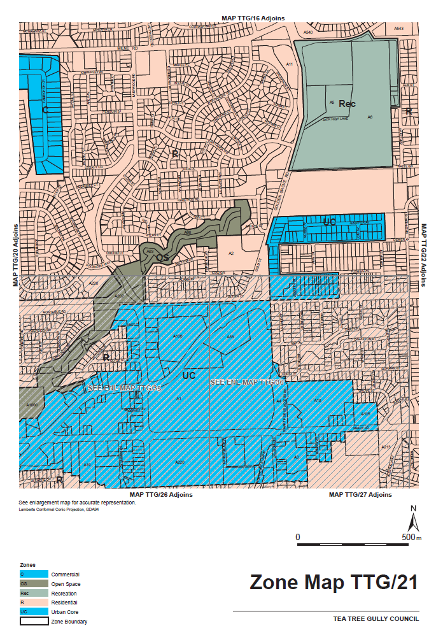
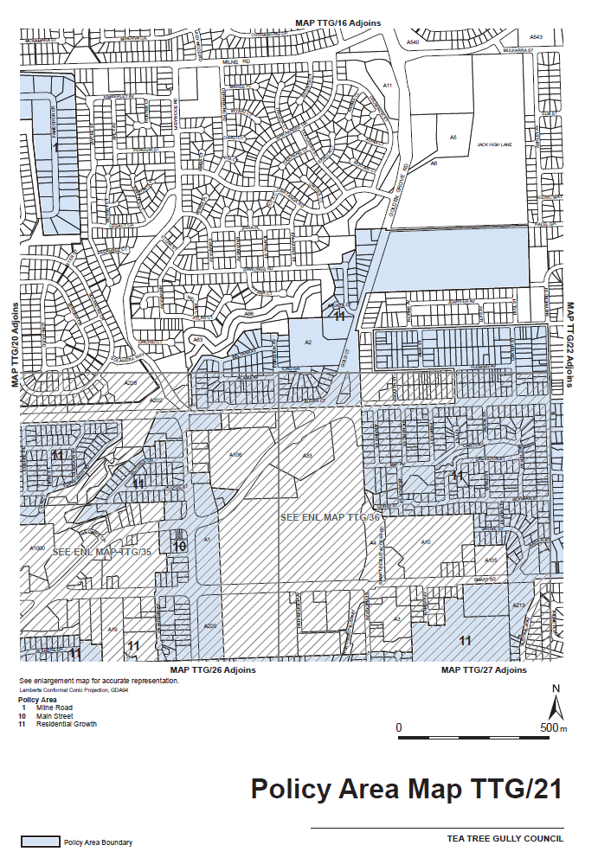
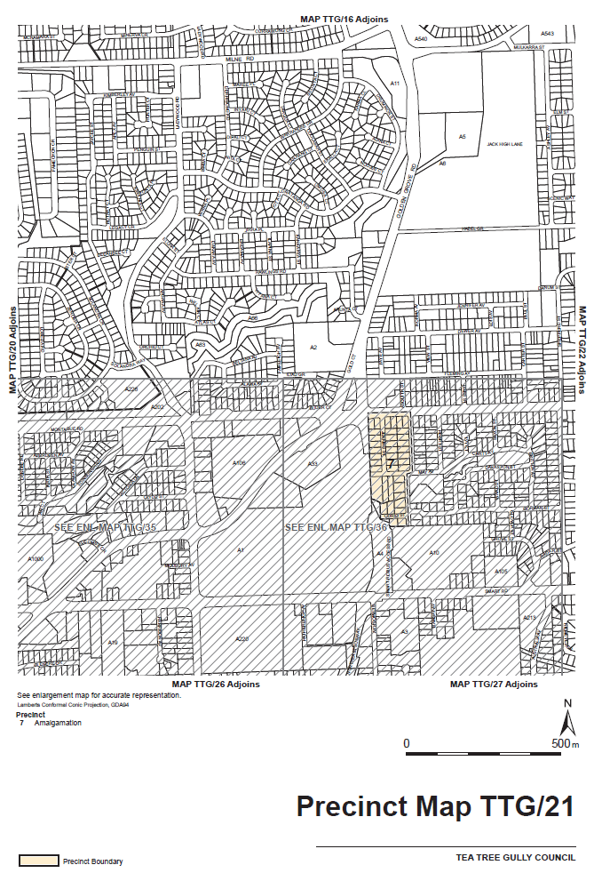
ATTACHMENT B
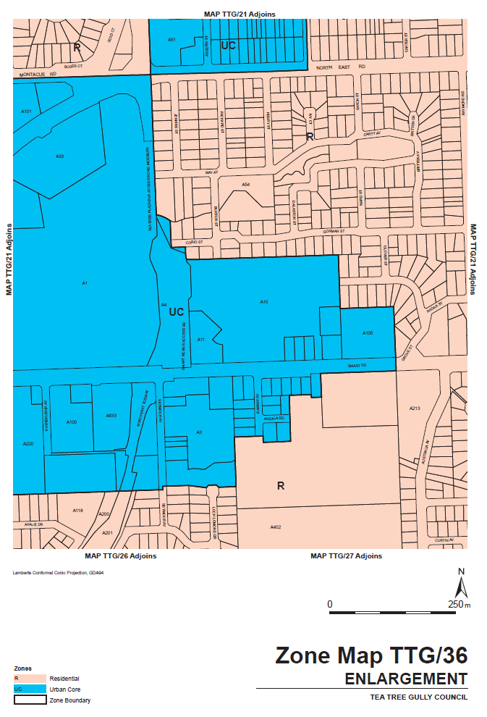
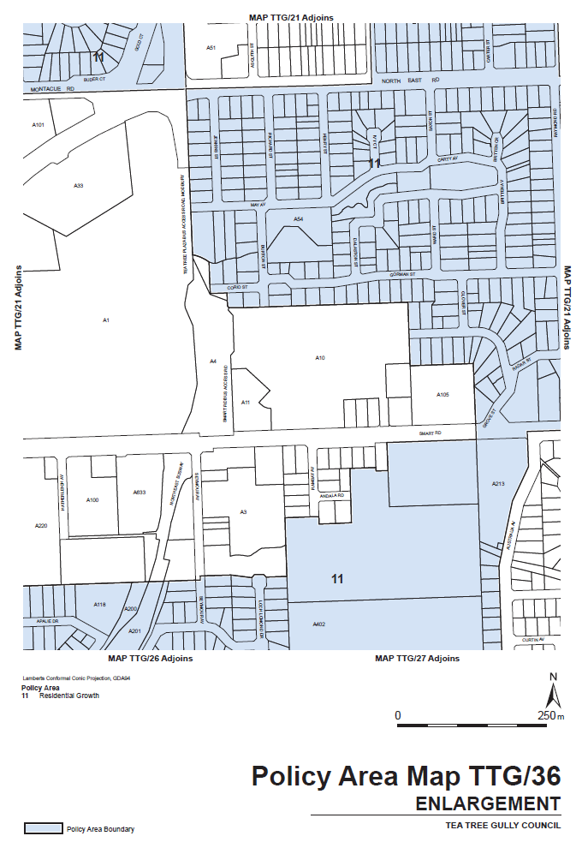
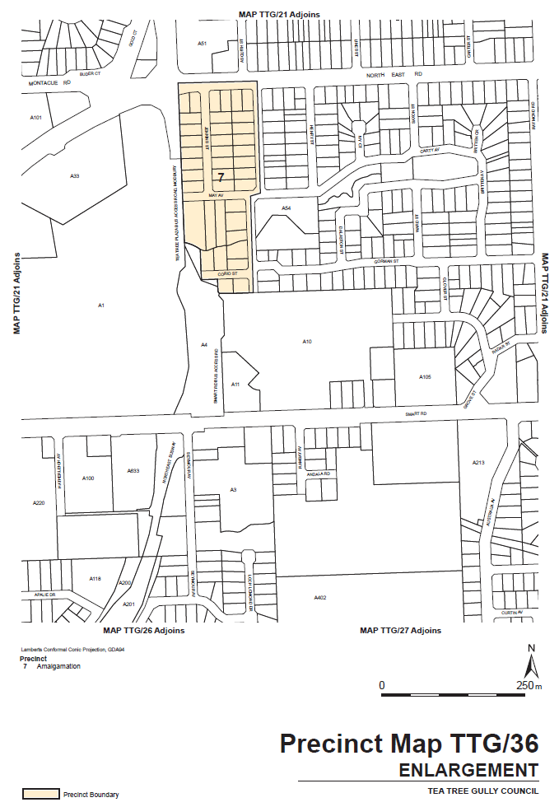
ATTACHMENT C
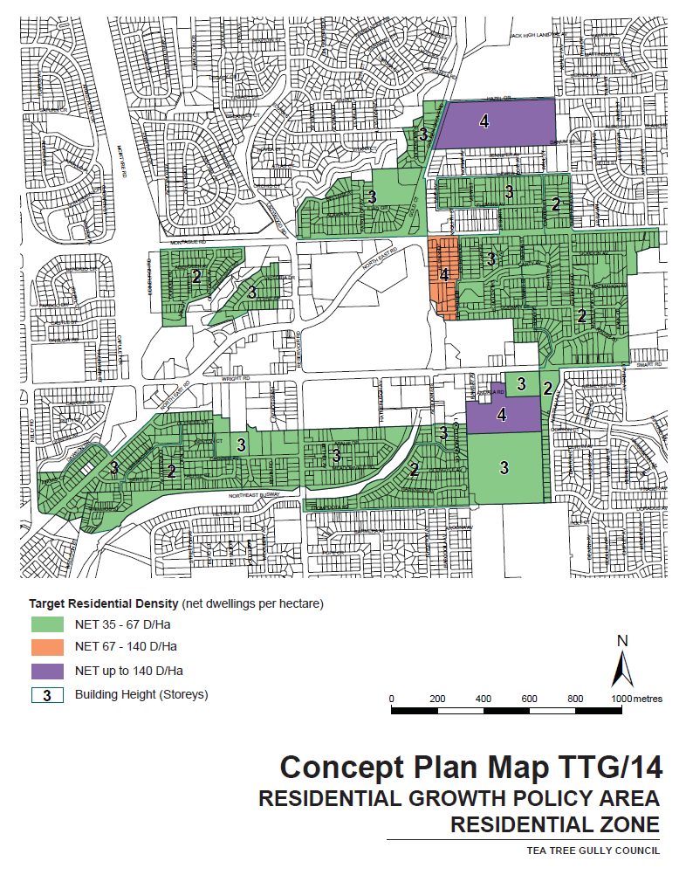
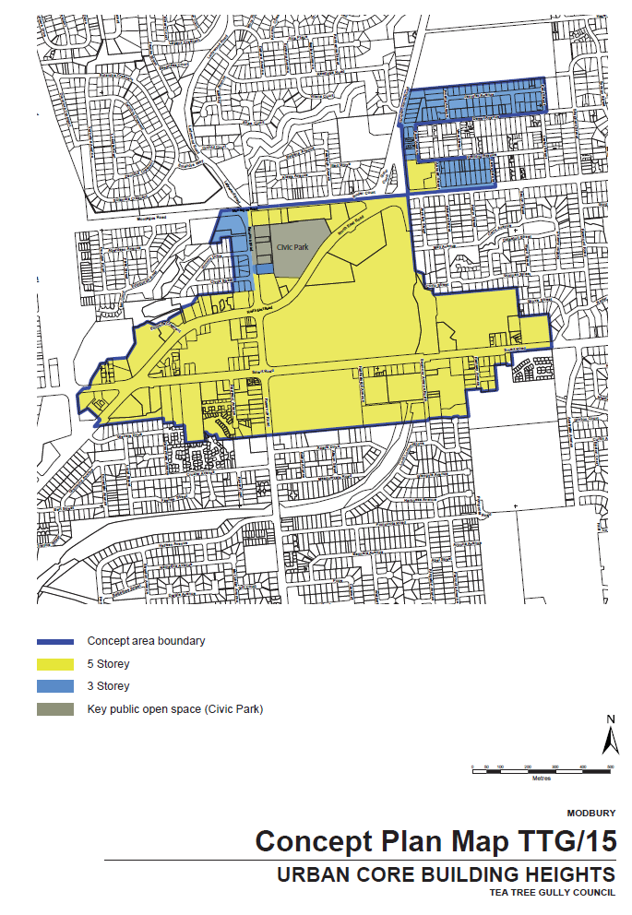
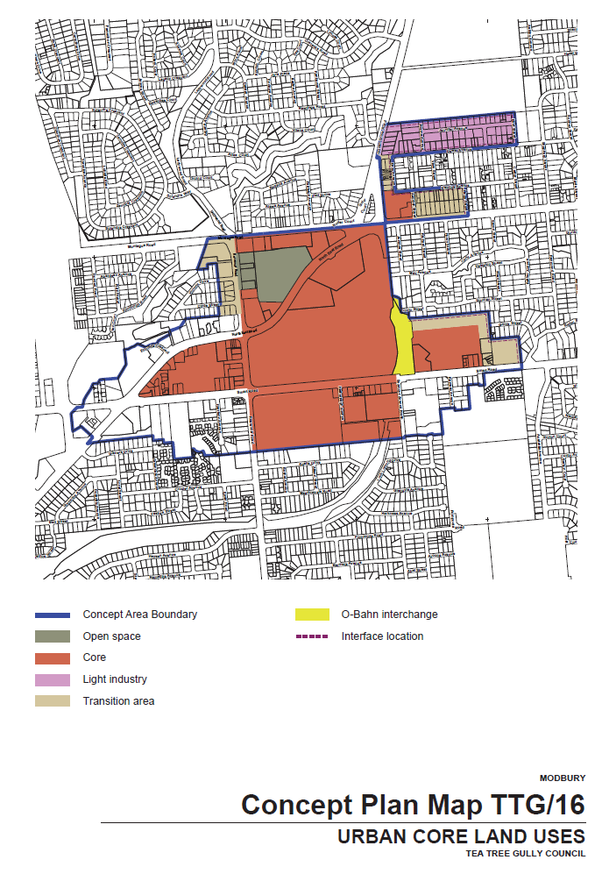
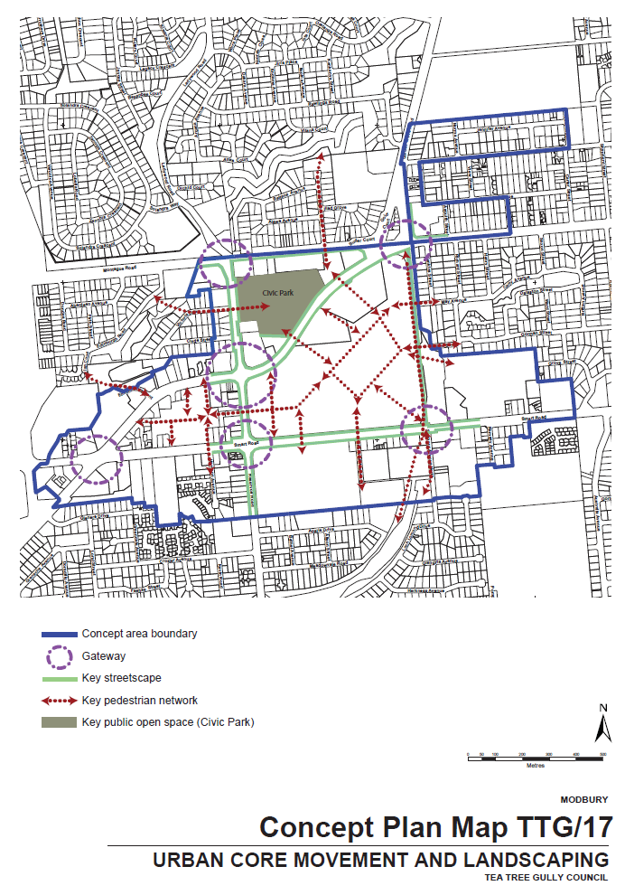
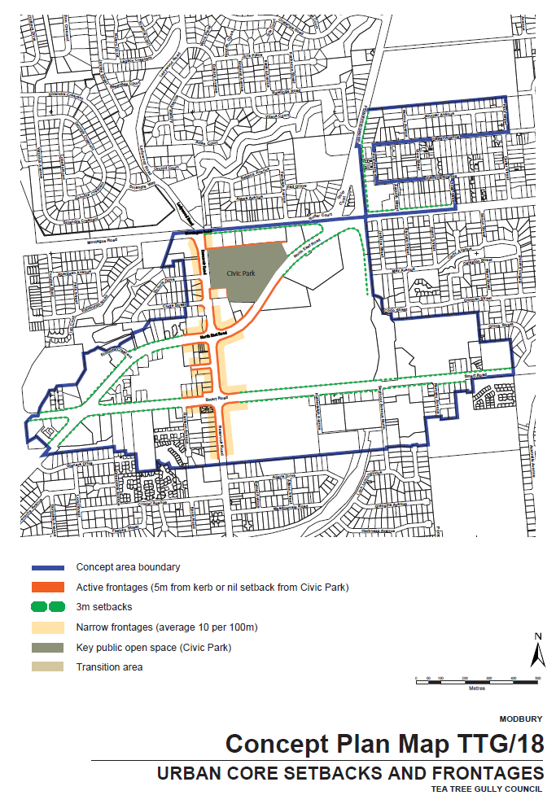

South Australia
District Court Civil Supplementary Rules 2014
(Amendment No. 6)

BY virtue and in pursuance of Section 51 of the District Court Act 1991, and all other enabling powers, we, Geoffrey Louis Muecke, Chief Judge, and Rauf Soulio and Paul Vincent Slattery, Judges of the District Court of South Australia, make the following Rules of Court.
1. These Rules may be cited as the ‘District Court Civil Supplementary Rules 2014 (Amendment No 6)’.
2. The amendments made by these Rules come into effect on 1 October 2016 or the date of their gazettal, whichever is later.
3. The ‘District Court Civil Supplementary Rules 2014’ are amended as set out below.
4. Supplementary rule 219 is amended by:
(1) amending subrule (5) by adding ‘to 30 September 2016’ after ‘1 October 2015’;
(2) inserting a new subrule immediately after subrule (5) as follows:
‘(6) For work done in the period from 1 October 2016, the costs specified in Schedule 2 are to be increased by 23.33%.’
Dated 20 September 2016.
G. L. Muecke, Chief Judge
R. Soulio, Judge
P. V. Slattery, Judge

South Australia
Railways (Operations and Access) (Application of Access Regime) Proclamation 2016
under section 7 of the Railways (Operations and Access) Act 1997
1—Short title
This proclamation may be cited as the Railways (Operations and Access) (Application of Access Regime) Proclamation 2016.
2—Commencement
This proclamation comes into operation on the day on which it is made.
3—Interpretation
In this proclamation—
Act means the Railways (Operations and Access) Act 1997;
Flinders Power Partnership means the partnership between Flinders Power Holdings GMBH, Flinders Labuan (No. 1) Ltd and Flinders Labuan (No. 2) Ltd;
freight terminal means an area set aside for transferring goods to a train from another transport service (including another service provided by train), or from a train to another transport service (including another service provided by train), whether or not the goods are held, kept or stored at the terminal for a period of time pending transfer to the train or to the other transport service;
Generation Lessor Corporation means the Generation Lessor Corporation established under the Public Corporations (Generation Lessor Corporation) Regulations 2010;
Interstate Mainline Track means the Interstate Mainline Track as defined by the Railways Agreement set out in the Schedule to the Non-Metropolitan Railways (Transfer) Act 1997 (as that Agreement is amended from time to time);
Leigh Creek Line means the rail corridors specified in Schedule 5 of the Railways Agreement set out in the Schedule to the Non-Metropolitan Railways (Transfer) Act 1997 (or in any other relevant instrument modifying or varying any such corridor);
private siding means a private siding within the meaning of the Rail Safety National Law (South Australia) Act 2012, that is used or maintained to provide access to an area that is used (or predominantly used) by the person who owns, controls or manages the siding (or any other person) for a purpose other than transport purposes;
Rail Commissioner means the Rail Commissioner established under the Rail Commissioner Act 2009.
4—Application of access regime
(1) Subject to subclause (2), the access regime under the Act is declared to apply to railway services associated with the provision (or the provision and operation) of railway infrastructure by an operator.
(2) Subclause (1) does not apply to or in relation to—
(a) services associated with the Interstate Mainline Track, including associated crossing and passing loops, but not including infrastructure that is declared to be accessible under subclause (3); or
(b) services associated with the rail bridge constructed under Stage 3 of the Port River Expressway Project (the principal features of which are contained in Part 2 Division 1 of Schedule 1 of the Highways (Port River Expressway Project) Regulations 2004); or
(c) services associated with the tram track from the Adelaide Entertainment Centre to Glenelg; or
(d) services associated with any track on Eyre Peninsula owned by OneSteel Manufacturing Pty Limited or any company or person to whom ownership of any such track is transferred with the approval of the Minister; or
(e) services associated with the Leigh Creek Line (but only for such time as the sublease in existence at the time this proclamation comes into operation, under which the Line is sublet by the Generation Lessor Corporation to the Flinders Power Partnership, remains in force); or
(f) freight terminals; or
(g) private sidings; or
(h) services established on a non-profit basis—
(i) for heritage value or amusement; or
(ii) to provide services to tourists.
(3) For the purposes of subclause (2)(a), the following infrastructure is declared to be accessible:
(a) buildings, installations and equipment for—
(i) the embarkation and disembarkation of passengers; or
(ii) the loading and unloading of goods, other than buildings, installations and equipment situated at a freight terminal; and
(b) railway yards and sidings (including associated track structures, supports, lines, posts and signs); and
(c) railway infrastructure under the care and control of the Rail Commissioner for the purposes of providing services associated with the Interstate Mainline Track.
5—Revocation
To the extent that it is required, the proclamation declaring the application of the access scheme under section 7 of the Act made on 7 May 1998 (see Gazette 7.5.1998 p2116, as varied, is revoked.
Made by the Governor
with the advice and consent of the Executive Council
on 29 September 2016
MTR/16/056

South Australia
Local Government Finance Authority Regulations 2016
under the Local Government Finance Authority Act 1983

Contents
1 Short title
2 Commencement
3 Interpretation
4 Prescribed local government bodies
Schedule 1—Revocation of Local Government Finance Authority Regulations 2005

1—Short title
These regulations may be cited as the Local Government Finance Authority Regulations 2016.
2—Commencement
These regulations will come into operation on 1 October 2016.
3—Interpretation
In these regulations—
Act means the Local Government Finance Authority Act 1983.
4—Prescribed local government bodies
For the purposes of paragraph (c) of the definition of prescribed local government body in section 3 of the Act, the following bodies are prescribed:
(a) Institute of Public Works Engineering Australia (South Australian Division) Incorporated;
(b) Local Government Professionals South Australia Incorporated;
(c) Murray Darling Association Incorporated.
Schedule 1—Revocation of Local Government Finance Authority Regulations 2005
The Local Government Finance Authority Regulations 2005 are revoked.
Note—
As required by section 10AA(2) of the Subordinate Legislation Act 1978, the Minister has certified that, in the Minister's opinion, it is necessary or appropriate that these regulations come into operation as set out in these regulations.
Made by the Governor
with the advice and consent of the Executive Council
on 29 September 2016
No 232 of 2016
T&F16/027CS

SENDING COPY?
NOTICES for inclusion in the South Australian Government Gazette should be emailed to:
GovernmentGazetteSA@sa.gov.au
Please include the following information in the covering email:
• The date the notice is to be published.
• Whether a proof, quote or return email confirmation is required.
• Contact details.
• To whom the notice is charged if applicable.
• A purchase order if required (chargeable notices).
• Any other details that may impact on the publication of the notice.
Attach:
• Notices in Word format.
• Maps and diagrams in pdf.
• Notices that require sighting an official date and signature before publication in a pdf. If a pdf is not possible then fax the official file(s) to the Government Publishing Fax number listed below.
Fax Transmission: (08) 8207 1040
Phone Enquiries: (08) 8207 1045
NOTE:
Closing time for lodging new copy is 4 p.m. on Tuesday preceding the regular Thursday Gazette.

CITY OF MITCHAM
Election Results
Supplementary Election for Councillor for The Park Ward,
Conducted on Monday, 12 September 2016
Formal Ballot Papers: 1 884
Informal Ballot Papers: 1
Quota: 943
Candidates | First  Preference  Votes | Votes at Conclusion of Election
Leong, Kai | 88 | 88
Silbereisen, Jane | 237 | 273
Floyd, Peter | 134 | 137
Lush, Sarah | 468 | 733
Gamtcheff, Mark | 230 | 327
Bange, Jane | 727 | Quota
At the conclusion of the election Jane Bange was elected having obtained quota.
D. Gully, Returning Officer

CITY OF UNLEY
Development Act 1993
Unley Central Precinct Development Plan Amendment (DPA)
Corrigendum
IN Government Gazette No. 56, dated 22 September 2016, in the last notice appearing on page 3873, regarding the DPA, the first dot point refers to the minor expansion of the District Centre Zone at ‘Marion’ Street—this should in fact read as ‘Mary’ Street. The notice content is otherwise correct.
We apologise for any inconvenience that may have been caused.
Dated 29 September 2016.
P. T. Sokas, Chief Executive Officer

DISTRICT COUNCIL OF GRANT
Road (Opening and Closing) Act 1991
Unmade Road Reserve, Compton
NOTICE is hereby given, pursuant to Section 10 of the Roads (Opening and Closing) Act 1991, that the District Council of Grant hereby gives notice of its intent to implement a Road Process Order to close the Unmade Road Reserve and merge with the adjoining Allotment 201 in Deposited Plan 112582 and Allotment 12 in Deposited Plan 71618, more particularly delineated and lettered as ‘A’ and ‘B’ in Preliminary Plan No. 16/0029.
A copy of the plan and a statement of persons affected are available for public inspection at the office of the Council, 324 Commercial Street West, Mount Gambier and the Adelaide office of the Surveyor-General during normal office hours or can be viewed on Council’s website: www.dcgrant.sa.gov.au.
Any application for easement or objection must set out the full name, address and details of the submission and must be fully supported by reasons. The application for easement or objection must be made in writing to the Council, P.O. Box 724, Mount Gambier, S.A. 5290, within 28 days of this notice and a copy must be forwarded to the Surveyor-General, G.P.O. Box 1354, Adelaide, S.A. 5001. Where a submission is made, the Council will give notification of a meeting at which the matter will be considered.
Dated 29 September 2016.
T. Smart, Chief Executive Officer
[*]

DISTRICT COUNCIL OF MOUNT REMARKABLE
Change to Road Names
NOTICE is hereby given that at a meeting of Council held on
20 September 2016, Council resolved pursuant to Section 219 (1) of the Local Government Act 1999, to change the name of the following roads:
• ODonohue Road, Hammond amend to ‘ODonoghue’;
• Jaffreys Road, amend spelling to ‘Jaffrey Road’;
• Science Road, Murray Town rename to ‘Gecko Road’;
• Pipeline Road, Baroota—Remove;
• Unnamed Road, Melrose name ‘Joppich Road’;
• Unnamed Road, Booleroo Centre name ‘Creek Road’;
• Unnamed Road, Wirrabara name ‘Hunts Road’;
• Unnamed Road, Hammond/Bruce name ‘Carn Road’;
• Unnamed Road, Bruce name ‘Abbott Road’;
• Unnamed Road, Wilmington name ‘Grazier Road’; and
• Rename the section of Jacobs Road, from West of the Telowie Road intersection be named ‘Davis Road’.
W. Hart, Chief Executive Officer

DISTRICT COUNCIL OF PETERBOROUGH
Review of Elector Representation
NOTICE is hereby given that the District Council of Peterborough is undertaking a review to determine whether a change of arrangements are required in respect to elector representation. This will result in the electors of the area being more adequately and fairly represented.
Pursuant to the provisions of Section 12 (7) of the Local Government Act 1999, notice is hereby given that council has prepared a representation options paper that examines the advantages and disadvantages of the various options available in regards to the composition and structure of council, and the division of the council area into wards.
Copies of the representation options paper are available on the Council’s website at www.peterborough.sa.gov.au and for inspection and/or purchase at the Council office, 108 Main Street, Peterborough, S.A. 5422.
Written submissions are invited from interested persons
from 21 September 2016 and should be directed to
Peter McGuinness, CEO, District Council of Peterborough,
P.O. Box 121, Peterborough, S.A. 5422 or email council@peterborough.sa.gov.au to be received by close of business on Friday, 11 November 2016.
Information regarding the representation review can be obtained by contacting Peter McGuinness on telephone (08) 8651 3566 or email council@peterborough.sa.gov.au.
P. McGuinness, Chief Executive Officer

DISTRICT COUNCIL OF YANKALILLA
Review of Elector Representation
NOTICE is hereby given that the District Council of Yankalilla is undertaking a review to determine whether a change of arrangements is required in respect to elector representation so as to ensure that the electors of the area are being adequately and fairly represented.
Pursuant to the provisions of Section 12 (7) of the Local Government Act 1999, notice is hereby given that Council has prepared a representation options paper that examines the advantages and disadvantages of the various options available in regards to the composition and structure of Council, and the possible division of the Council area into wards.

Copies of the representation options paper are available on the Council’s website (www.yankalilla.sa.gov.au) and for inspection and/or purchase at the Council office, 1 Charles Street, Yankalilla.
Written submissions are invited from interested persons from Thursday, 29 September 2016 and should be directed to the Chief Executive, District Council of Yankalilla, P.O. Box 9, Yankalilla, S.A. 5203, or online www.yoursayyankalilla.com.au or emailed to consultation@yankalilla.sa.gov.au by close of business on Friday, 11 November 2016.
Information regarding the representation review can be found on Council’s website (www.yankalilla.sa.gov.au) or by contacting Matt Robertson, Strategy and Policy Planner on telephone
(08) 8558 0200.
N. Morris, Chief Executive

YORKE PENINSULA COUNCIL
Notice of Application of Local Government Land By-law
PURSUANT to Section 246 (4a) of the Local Government Act 1999 (‘the Act’), notice is hereby given that at its meeting on
14 September 2016, in exercise of its powers under Section
246 (3) (e) of the Act, the Council resolved to apply Clause 9.10.1 of By-law No. 2—Local Government Land 2013, to the Port Vincent Foreshore Boat Ramp, located at Marine Parade,
Port Vincent (PTL:7, CR 5753177). The effect of the Council’s decision is that a short term ticket or launch permit as defined in Clause 9.10.2 of the by-law is required to authorise the launch of a boat from this Boat Ramp.
Further details regarding the Council’s by-laws, including a copy of the Local Government Land By-law, is available for inspection on the Council’s website http://yorke.sa.gov.au and at the Council’s offices at Maitland during business hours.
A. Cameron, Chief Executive Officer

IN the matter of the estates of the undermentioned deceased persons:
Brooks, Violet Jean, late of 7 Langhorne Creek Road, Strathalbyn, of no occupation, who died on 31 July 2016.
Button, Daniel Theodore, late of 28 Liddell Drive, Huntfield Heights, retired postman, who died on 23 July 2016.
Holloway, Frederick George, late of 95 Awoonga Road, Hope Valley, retired telephonist, who died on 9 February 2016.
Howard, Garry Allan, late of 134A Pleasant Avenue, South Plympton, of no occupation, who died on 20 May 2016.
Lowen, Meriel Kathleen, late of 9 Moorea Court, West Lakes, home duties, who died on 27 June 2016.
Macsai, Ilona, late of 50 Kesters Road, Para Hills West, retired cook, who died on 14 June 2016.
Markham, William James, late of 8 Alfred Avenue, Seaton, retired builder, who died on 3 June 2016.
Monks, Betty Doreen, late of 77 Sydenham Road, Norwood, of no occupation, who died on 1 July 2016.
Sanderson, Fay, late of 1A Mount Barker Road, Hahndorf, of no occupation, who died on 5 May 2016.
Notice is hereby given pursuant to the Trustee Act 1936, the Inheritance (Family Provision) Act 1972 and the Family Relationships Act 1975, that all creditors, beneficiaries, and other persons having claims against the said estates are required to send, in writing, to the office of Public Trustee, G.P.O. Box 1338, Adelaide, S.A. 5001, full particulars and proof of such claims, on or before 28 October 2016, otherwise they will be excluded from the distribution of the said estate; and notice is also hereby given that all persons indebted to the said estates are required to pay the amount of their debts to the Public Trustee or proceedings will be taken for the recovery thereof; and all persons having any property belonging to the said estates are forthwith to deliver same to the Public Trustee.
Dated 29 September 2016.
D. A. Contala, Public Trustee

PARTNERSHIP ACT 1891
Notice of Discontinuance of Partnership
TAKE notice that as from 5 December 2015, the partnership of Dung Phuong Tong of 4 Benton Street, Mawson Lakes, S.A. 5095 and Thuy Kim Nguyen, who traded as Thanh Thinh Land Investment was dissolved.
Dated 27 September 2016.
D. P. Tong, Partner

ATTENTION

CUSTOMERS requiring a proof of their notice for inclusion in the Government Gazette, please note that the onus is on you to inform Government Publishing SA of any subsequent corrections.

For any corrections to your notice please phone 8207 1045 or Email before 4 p.m. on Wednesday.

If we do not receive any communication by 10 a.m. on Thursday (day of publication) we will presume the notice is correct and will print it as it is.

Remember—the onus is on you to inform us of any corrections necessary to your notice.

NOTE: Closing time for lodging new copy (electronically, fax or hard copy) is 4 p.m. on Tuesday preceding the day of publication.
Phone: 8207 1045
Fax: 8207 1040
Email: GovernmentGazetteSA@sa.gov.au

Printed and published by authority every Thursday by P. McMAHON, Government Printer, South Australia
Price: $7.21, plus postage; to subscribers, $361.90 per annum.
(The above prices are inclusive of GST)

