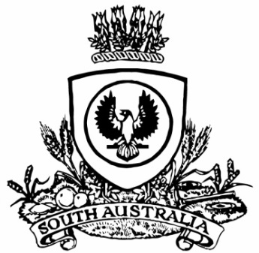
No. 80 4895
SUPPLEMENTARY GAZETTE
THE SOUTH AUSTRALIAN
GOVERNMENT GAZETTE
Published by Authority

Adelaide, Tuesday, 5 December 2017

Department of the Premier and Cabinet
Adelaide, 5 December 2017
His Excellency the Governor in Executive Council has removed PETER VAUGHAN from the office of Director and Chair of the TAFE SA Board of Directors, effective from 5 December 2017 - pursuant to section 8(3) of the TAFE SA Act 2012.
By command,
Martin Leslie James Hamilton-Smith, for Premier
MHES17/029

Department of the Premier and Cabinet
Adelaide, 5 December 2017
His Excellency the Governor in Executive Council has been pleased to appoint PAULINE JOANNE DENLEY as the Chair of the TAFE SA Board of Directors for a term commencing on 5 December 2017 and expiring on 30 June 2018 or until the appointment of a subsequent Chair of the TAFE SA Board of Directors, whichever is sooner - pursuant to the provisions of the TAFE SA Act 2012.
By command,
Martin Leslie James Hamilton-Smith, for Premier
MHES17/029

