No. 16 895
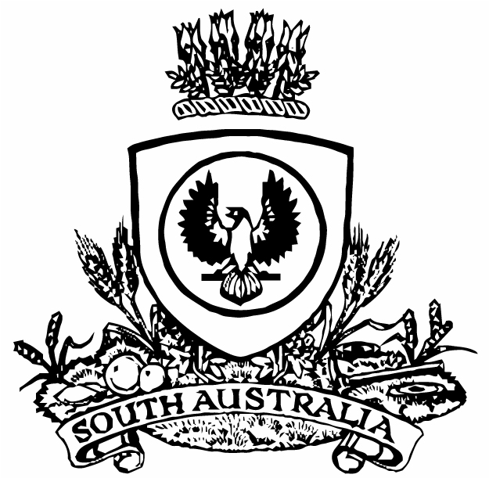
SUPPLEMENTARY GAZETTE
THE SOUTH AUSTRALIAN
GOVERNMENT GAZETTE
Published by Authority

Adelaide, Monday, 20 March 2017

FISHERIES MANAGEMENT ACT 2007: SECTION 115
Erratum
NOTICE is hereby given that notice ME9902887 published in the Government Gazette No.15, dated 15 March 2017, beginning as last notice on page 854 and continuing to 855 was published in error without my knowledge and authorisation as delegate of the Minister.
This Ministerial Exemption was not authorised and therefore has and continues to have no effect.
No activities have been or will be undertaken pursuant to notice ME9902887.
Dated 20 March 2017.
S. Sloan, Director,
Fisheries and Aquaculture Policy

