
No. 76 4559

THE SOUTH AUSTRALIAN
GOVERNMENT GAZETTE
Published by Authority

Adelaide, Tuesday, 14 November 2017

Contents

Acts Assented To 4560
Appointments, Resignations, Etc. 4560
Controlled Substances Act 1984 (SA)—Notice 4561
Corporations and District Councils—Notices 4635
Development Act 1993—Notice 4561
Equal Opportunity Act 1984—Notice 4561
Fisheries Management Act 2007—Notices 4562
Fisheries Management (Prawn Fisheries)
Regulations 2006—Notices 4563
Housing Improvement Act 2016—Notices 4563
Land Acquisition Act 1969—Notice 4564
Liquor Licensing Act 1997—Notice 4564
Local Government Act 1999—Notices 4567
Mental Health Act 2009—Notices 4567
Mining Act 1971—Notices 4567
Motor Vehicles Act 1959—Notice 4569
National Parks and Wildlife (National Parks)
Regulations 2016—Notices 4571
Partnership Act 1891—Notice. 4636
Petroleum and Geothermal Energy Act 2000—Notices 4571
Proclamation 4580
Professional Standards Act 2004 (SA)—Notice 4572
Public Trustee Office—Administration of Estates 4636
Regulations
Local Government Act 1999 (No. 307 of 2017) 4581
Remuneration Tribunal—Report & Determination 4572
Roads (Opening and Closing) Act 1991—Notices 4579
Rules of Court
Magistrates Court Rules 1992 (Amendment 64) 4585
Trustees Act 1936—Notice 4636

Department of the Premier and Cabinet
Adelaide, 14 November 2017
HIS Excellency the Governor directs it to be notified for general information that he has in the name and on behalf of Her Majesty
The Queen, this day assented to the undermentioned Acts passed by the Legislative Council and House of Assembly in Parliament assembled, viz.:
No. 45 of 2017—Environment Protection (Waste Reform) Amendment Act 2017. An Act to amend the Environment Protection Act 1993; and to make a consequential amendment to the Motor Vehicles Act 1959.
No. 46 of 2017—Work Health and Safety (Representative Assistance) Amendment Act 2017. An Act to amend the Work Health and Safety Act 2012.
No. 47 of 2017—Criminal Law Consolidation (Criminal Organisations) Amendment Act 2017. An Act to amend the Criminal Law Consolidation Act 1935.
By command,
Ian Keith Hunter, for Premier

Department of the Premier and Cabinet
Adelaide, 14 November 2017
HIS Excellency the Governor in Executive Council has been pleased to appoint the undermentioned to the State Bushfire Coordination Committee, pursuant to the provisions of the Fire and Emergency Services Act 2005:
Member: From 14 November 2017 until 13 November 2020
Philip Leslie Kilsby
Ann De Piaz
Wayne Brian Thorley
Noel Graeme Bamford
Fiona Jane Gill
Chris Gibson
Jim Psyridis
Franco Crisci
Anita Allen
Elena Gaye Petrenas
James Scott Crocker
John Nairn
Shiralee Ann Reardon
Maurice Colm Roche
William Raymond McIntosh
Christopher Brian Daniels
Peter Ross White
Naomi Rea
Deputy Member: From 14 November 2017 until 13 November 2020
David Colliar (Deputy to Kilsby)
Fiona Dunstan (Deputy to De Piaz)
Jonathan David Lindner (Deputy to Thorley)
Craig William Patterson (Deputy to Bamford)
Ian Tanner (Deputy to Gill)
Jackie Crampton (Deputy to Gibson)
Jennifer Slocombe (Deputy to Psyridis)
Steven Barone (Deputy to Crisci)
Denise LeBlond (Deputy to Allen)
Justine Barbara Drew (Deputy to Petrenas)
Jacqueline Frizenschaf (Deputy to Crocker)
Kylie Marie Egan (Deputy to Nairn)
Heidi Lee Greaves (Deputy to Reardon)
Mary-Anne Healy (Deputy to Roche)
Mark Robert Sutton (Deputy to McIntosh)
Eric Malcolm Sommerville (Deputy to Daniels)
Donald Stuart Gilbertson (Deputy to White)
Timothy Michael Welch Kelly (Deputy to Rea)
By command,
Ian Keith Hunter, for Premier
MES17/12CS

Department of the Premier and Cabinet
Adelaide, 14 November 2017
HIS Excellency the Governor in Executive Council has been pleased to appoint the Honourable Kyam Joseph Maher, MLC, Minister for Employment, Minister for Aboriginal Affairs and Reconciliation, Minister for Manufacturing and Innovation, Minister for Automotive Transformation and Minister for Science and Information Economy to be also Acting Minister for Investment and Trade, Acting Minister for Small Business, Acting Minister for Defence and Space Industries, Acting Minister for Health Industries and Acting Minister for Veterans’ Affairs for the period from 17 November 2017 to 26 November 2017 inclusive, during the absence of the Honourable Martin Leslie James Hamilton-Smith, MP.
By command,
Ian Keith Hunter, for Premier
17MINT/772CS

Department of the Premier and Cabinet
Adelaide, 14 November 2017
HIS Excellency the Governor in Executive Council has been pleased to appoint the Honourable the Chief Justice Christopher John Kourakis as Governor’s Deputy of South Australia for the period from 9.00am on Monday, 20 November 2017 until 1.15pm on Tuesday, 21 November 2017.
By command,
Ian Keith Hunter, for Premier

Department of the Premier and Cabinet
Adelaide, 14 November 2017
HIS Excellency the Governor in Executive Council has been pleased to appoint Brian Stuart McKenny to the position of Chief Psychiatrist, for a term commencing on 18 November 2017 and expiring on 17 January 2018, pursuant to Section 89 of the Mental Health Act 2009.
By command,
Ian Keith Hunter, for Premier
HEAC-2017-00077

CONTROLLED SUBSTANCES ACT 1984 (SA)
Subsection 57 (2)
Revocation of Prohibition Order
TAKE notice that on 15 September 2017, I, Professor Paddy Phillips, Chief Medical Officer & Chief Public Health Officer, Public Health & Clinical Systems, Department for Health and Ageing (“DHA”), exercised the power delegated to me under section 62A of the Controlled Substances Act 1984 (SA) (“the Act”), and made an Order under subsection 57 (2) of the Act. Pursuant to section 57 (3) of the Act, the Order is published as follows:
The Prohibition Order made on 14 June 2011 under subsection 57 (1) (c) of the Act in relation to
Dr Ramsay SALLIS – date of birth 19/03/1963
is hereby REVOKED.
Professor Paddy Phillips, Delegate Minister for Mental Health and Substance Abuse

DEVELOPMENT ACT 1993
Section 46(4)—Notice
Preamble
1. Subsection (4) of section 46 of the Development Act 1993 provides that the Minister may, by notice in the Gazette, revoke a declaration previously made under subsection (1) of that section.
2. I have decided to revoke the following declaration made under section 46 of the Development Act 1993.
Notice
PURSUANT to subsection (4) of section 46 of the Development Act 1993, I revoke the following declaration under section 46 of the Development Act 1993:
- the declaration published in the Gazette on 19 April 2017 at page 1075, relating to applications for development of a retirement village (within the meaning of the Retirement Villages Act 2016) and/or residential care facility (for the purposes of the Aged Care Act 1997[Commonwealth]), and any associated or ancillary development.
Dated 13 November 2017.
John Rau, Minister for Planning

EQUAL OPPORTUNITY ACT 1984
South Australian Employment Tribunal
No: 4329/2017
Notice of an Exemption before Deputy President Judge Farrell
I HEREBY certify that on 2 November 2017, the South Australian Employment Tribunal, on the application of the Naval Group Australia Pty Ltd made the following orders for exemption:
- Pursuant to s92(1) of the Equal Opportunity Act 1984 (SA), Naval Group Australia Pty Ltd is exempted from compliance with the provisions of sections 52, 53, 54 and 103 of the Act subject to the following conditions:
- The exemption will apply only to conduct by the applicant where:
- that conduct is necessary to enable it to enter into and/or perform contractual undertakings requiring access to ITAR and EAR controlled materials;
- it has taken all steps that are reasonably available (including steps which might be taken in negotiating and performing the terms of its agreements and contracts in the USA) to avoid the necessity for engaging in conduct which would otherwise be in breach of sections 52, 53, and 54 of the Act.
- Where, in the exercise of the exemption, an employee or contract worker is moved from a project involving the use of ITAR or EAR controlled materials to any other work controlled by the applicant or any of its related entities, the applicant must, through a duly authorised officer explain to the person why he or she is being transferred and must otherwise take all reasonable steps to avoid or limit harm or loss to that person.
- Where the applicant uses a system of security passes to reflect the fact of access to ITAR or EAR controlled materials or levels of access to any security sensitive material by employees and contract workers, the passes may be coded but not in such a way as to identify the nationality or place of birth of the persons or the reasons for that person’s level of access.
- All information relating to security passes, security clearance levels, and access to ITAR and EAR controlled materials shall be restricted to the applicant’s general counsel, designated authorised company personnel with responsibility for export/import operations, human resources, legal, compliance, and similar functions, or their properly appointed nominees on a “need to know” basis.
- The applicant’s employment policies shall refer to the terms of this exemption, including all conditions attaching to it, and to make it clear that the purpose of the request for information regarding nationality and place of birth is made solely so that the applicant can ensure compliance with obligations pursuant to the laws of the USA relating to defence matters.
- The applicant must report to the Commissioner for Equal Opportunity within one week of 30 June of every year during which this exemption remains in force about its compliance with the exemption requirements and any changes in its procedures to reflect amendments to the ITAR, and as to how its employees and contractors are affected.
- This order will not permit the applicant to terminate any employee’s employment on the grounds of nationality or place of birth.
- The exemption is granted for a period of three years commencing from 2 November 2017.
Dated 7 November 2017.
A Guthleben, A/Registrar, South Australian Employment Tribunal

FISHERIES MANAGEMENT ACT 2007
Items Seized
NOTICE is hereby given pursuant to Section 90 (2) of the Fisheries Management Act, 2007, that the following items have been seized by Officers of the Department of Primary Industries and Regions SA, Fisheries and Aquaculture at DAVENPORT CREEK on 2/11/2017:
1) 2 X 250 m small mesh nets
The above items were suspected to have been used, or intended to be used, in contravention of the Fisheries Management Act, 2007, and were taken into possession at:
DAVENPORT CREEK
After the expiration of one month from the date of this notice the items listed above shall, on the order of the Minister for Agriculture, Food and Fisheries, be forfeited to the Crown and shall be either disposed of by sale or destruction.
The above items may be viewed at the Ceduna office of the Department of Primary Industries and Regions SA, Fisheries and Aquaculture.
Dated 6 November 2017.
Bree Balmer, Prosecutions Coordinator

FISHERIES MANAGEMENT ACT 2007
Section 115
Ministerial Exemption ME9902973
TAKE notice that pursuant to section 115 of the Fisheries Management Act 2007 (the Act), a licence holder or a registered master of a Northern Zone Rock Lobster Fishery licence (the ‘exemption holder’) is exempt from clause 18(1)(a) of Schedule 6 of the Fisheries Management (General) Regulations 2007, but only insofar as the exemption holders are permitted to operate rock lobster pots set in waters specified in Schedule 1, less than 100 metres depth without a pot spike, being a metal rod fastened to the base of the pot, subject to conditions specified in Schedule 1, from 9 November 2017 until 9 November 2018, unless varied or revoked earlier.
Schedule 1
Waters of the Northern Zone excluding Sanctuary Zones and Restricted Area Zones of any Marine Park.
Schedule 2
- The rock lobster pots used pursuant to this exemption must have a cove mouth opening (inner or outer) that is:
  - A rigid metal frame rectangular or square in shape with two opposite sides opening to not more than 135 mm; or
  - A rigid metal frame circular in shape opening to not more than 150 mm in diameter.
- The exemption holder must complete a South Australian Managed Fisheries Wildlife Interaction Form recording any interaction between the exempted rock lobster pots and threatened, endangered or protected species (TEPS).
- Completed South Australian Managed Fisheries Wildlife Interaction Forms must be submitted to SARDI within 28 days of any interaction.
- Whilst engaged in the exempted activity, the exemption holder must have in their possession a copy of this notice, and produce that notice to a PIRSA Fisheries Officer upon request.
- The exemption holder must not contravene or fail to comply with the Fisheries Management Act 2007, or any other regulations made under that Act, except where specifically exempted by this notice.
This notice does not purport to override the provisions or operation of any other Act including, but not limited to, the Marine Parks Act 2007. The exemption holder must comply with any relevant regulations, permits, requirements and directions from the Department of Environment, Water and Natural Resources when undertaking activities within a marine park.
Dated 9 November 2017.
Sean Sloan, A/Executive Director, Fisheries and Aquaculture,
Delegate of the Minister for Agriculture, Food and Fisheries

FISHERIES MANAGEMENT (PRAWN FISHERIES) REGULATIONS 2006
Removal of Northern Closure Area in the Gulf Saint Vincent Prawn Fishery
TAKE NOTICE that the notice made under Regulation 9A of the Fisheries Management (Prawn Fisheries) Regulations 2006, the notice dated 19 April 2017, referring to the closure of the area of the Gulf Saint Vincent Prawn Fishery north of latitude 34°55ʹS is hereby revoked.
Dated 31 October 2017.
Sean Sloan, A/ Executive Director,
Delegate of the Minister for Agriculture, Food and Fisheries

FISHERIES MANAGEMENT (PRAWN FISHERIES) REGULATIONS 2006
Temporary Prohibition on Fishing Activities in an Area of the Gulf Saint Vincent Prawn Fishery
TAKE notice that pursuant to regulation 9A of the Fisheries Management (Prawn Fisheries) Regulations 2006, the activities of the class specified in Schedule 1 are prohibited in the waters of the Gulf Saint Vincent Prawn Fishery north of the line of latitude 34° 55ʹS during the period specified in Schedule 2 unless this notice is varied or revoked.
Schedule 1
The act of taking or an act preparatory to or involved in the taking of King Prawns (Melicertus latisulcatus) pursuant to a Gulf Saint Vincent Prawn Fishery Licence.
Schedule 2
From 1800 hours on 1 March 2018 to 1800 hours on 31 July 2018.
Dated 14 November 2017.
Sean Sloan, A/ Executive Director, Fisheries and Aquaculture
Delegate of the Minister for Agriculture, Food and Fisheries

HOUSING IMPROVEMENT ACT 2016
Rent Control
THE Minister for Social Housing Delegate in the exercise of the powers conferred by the Housing Improvement Act 2016, does hereby fix the maximum rental per week which shall be payable subject to Section 55 of the Residential Tenancies Act 1995, in respect of each house described in the following table. The amount shown in the said table shall come into force on the date of this publication in the Gazette.
Address of Premises | Allotment  Section | Certificate of Title  Volume/Folio | Maximum Rental  per week payable
22 Conington Crescent, Morphett Vale SA 5162 | Allotment 191 Deposited Plan 6958  Hundred of Noarlunga | CT5349/519 | $230.00
5 Warner Road, Belalie North SA 5491 | Allotments 1 & 2 Deposited Plan 18770  Hundred of Belalie | CT5280/699, CT5280/700 | $100.00
Dated 14 November 2017.
Tim Baker, Director, Property and Contract Management, Housing SA,
Delegate of Minister for Social Housing

HOUSING IMPROVEMENT ACT 2016
Rent Control Revocations
WHEREAS the Minister for Social Housing Delegate is satisfied that each of the houses described hereunder has ceased to be unsafe or unsuitable for human habitation for the purposes of the Housing Improvement Act 2016, notice is hereby given that, in exercise of the powers conferred by the said Act, the Minister for Social Housing does hereby revoke the said Rent Control in respect of each property.
Address of Premises | Allotment  Section | Certificate of Title  Volume/Folio
20 Griffiths Drive, Moana SA 5169 | Allotment 195 Deposited Plan 3752  Hundred of Willunga | CT4185/804, CT5715/639
Unit 1/ 21 Peace Avenue, Victor Harbor SA 5211 | Allotment 70 Filed Plan 218176  Hundred of Encounter Bay | CT5824/361
3 Orient Street, QUORN SA 5433 (AKA Lot 3) | Allotment 3 Deposited Plan 925  Hundred of Pichi Richi | CT482/49, CT5291/750
1 Illawarra Court, Craigmore SA 5114 | Allotment 247 Deposited Plan 10909  Hundred of Munno Para | CT5737/108
Dated 14 November 2017.
Tim Baker, Director, Property and Contract Management, Housing SA,
Delegate of Minister for Social Housing

LAND ACQUISITION ACT 1969
(Section 16) Form 5
Notice of Acquisition
- Notice of Acquisition
THE Commissioner of Highways (the Authority), of 50 Flinders Street, Adelaide 5000, acquires the following interests in the following land:
Comprising an estate in fee simple in that piece of land being a portion of Allotment 130 in Filed Plan No 252675 comprised in Certificate of Title Volume 6193 Folio 395, and being the whole of the land numbered Allotment 202 in D89056 lodged in the Lands Titles Office, subject to the following in the said Certificate of Title: existing easement(s) over the land marked A on F252675 to the Minister for Infrastructure created by (Transfer 3767003) and marked F in D89056.
This notice is given under section 16 of the Land Acquisition Act 1969.
- Compensation
A person who has or had an interest in the land that is divested or diminished by the acquisition or the enjoyment of which is adversely affected by the acquisition who does not receive an offer of compensation from the Authority may apply to the Authority for compensation.
- Inquiries
Inquiries should be directed to:
Carlene Russell
GPO Box 1533
Adelaide SA 5001
Telephone: (08) 8343 2512
Dated 7 November 2017.
The Common Seal of the Commissioner of Highways was hereto affixed by authority of the Commissioner in the presence of:
Mohammed Elgazzar, Manager Portfolio and Acquisition Services
(Authorised Officer), Department of Planning, Transport and Infrastructure
DPTI 2015/06371/01

South Australia
Liquor Licensing (Dry Areas) Notice 2017
under section 131(1) of the Liquor Licensing Act 1997
1—Short title
This notice may be cited as the Liquor Licensing (Dry Areas) Notice 2017.
2—Commencement
This notice comes into operation on 1 December 2017.
3—Interpretation
(1) In this notice—
principal notice means the Liquor Licensing (Dry Areas) Notice 2015 published in the Gazette on 5.1.15, as in force from time to time.
(2) Clause 3 of the principal notice applies to this notice as if it were the principal notice.
4—Consumption etc of liquor prohibited in dry areas
(1) Pursuant to section 131 of the Act, the consumption and possession of liquor in the area described in the Schedule is prohibited in accordance with the provisions of the Schedule.
(2) The prohibition has effect during the periods specified in the Schedule.
(3) The prohibition does not extend to private land in the area described in the Schedule.
(4) Unless the contrary intention appears, the prohibition of the possession of liquor in the area does not extend to—
(a) a person who is genuinely passing through the area if—
(i) the liquor is in the original container in which it was purchased from licensed premises; and
(ii) the container has not been opened; or
(b) a person who has possession of the liquor in the course of carrying on a business or in the course of his or her employment by another person in the course of carrying on a business; or
(c) a person who is permanently or temporarily residing at premises within the area or on the boundary of the area and who enters the area solely for the purpose of passing through it to enter those premises or who enters the area from those premises for the purpose of leaving the area.
Schedule—Peterborough Area 1
1—Extent of prohibition
The consumption of liquor is prohibited and the possession of liquor is prohibited.
2—Period of prohibition
Continuous.
3—Description of area
The area in Peterborough bounded as follows: commencing at the point at which the southern boundary of Main Street meets the eastern boundary of Silver Street, then southerly along that boundary of Silver Street to the point at which it meets the northern boundary of Railway Terrace, then in a straight line by the shortest route in a westerly direction, across Silver Street to the northern corner of Railway Terrace and Silver Street, then in a straight line along the northern boundary of Railway Terrace to the point at which the eastern boundary of Hurlstone Street meets the northern boundary of Railway Terrace, then in a straight line by the shortest route across Hurlstone Street (approximately 12 metres to the western corner of Railway Terrace and Hurlstone Street), then westerly along the northern side of Railway Terrace for approximately 255 metres to the point at which that northern side of Railway Terrace is intersected by the prolongation in a straight line of the eastern boundary of Torr Street, then northerly along that prolongation and boundary of Torr Street to the point at which the eastern boundary of Torr Street meets the southern boundary of Kitchener Street, to the eastern boundary of Howard Street, then southerly along that boundary of Howard Street to the northern boundary of Main Street, then easterly along that boundary of Main Street to the western boundary of Cotton Road, then southerly along the prolongation in a straight line of the western boundary of Cotton Road to the southern boundary of Main Street, then westerly along that boundary of Main Street to the point of commencement.
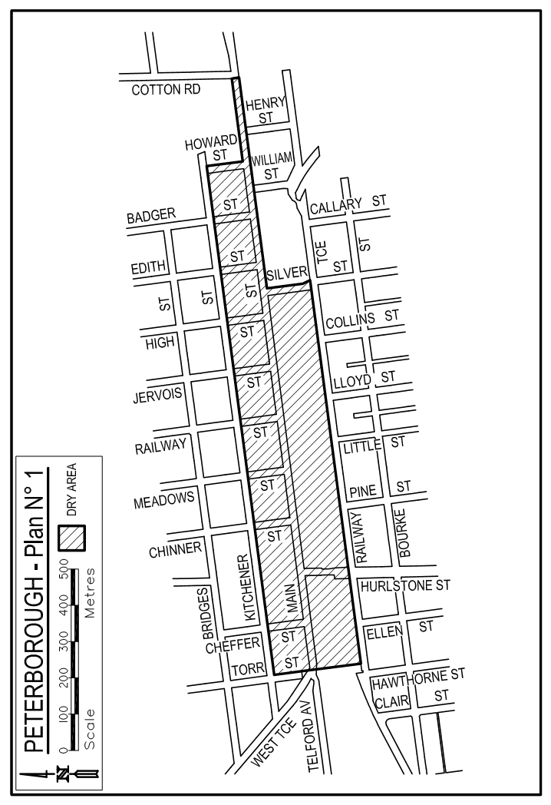
Made by the Minister for Consumer and Business Services
on 9 November 2017

LOCAL GOVERNMENT ACT 1999
2009 Port Pirie Stormwater Management Plan
NOTICE is hereby given in accordance with clause 19(4) of Schedule 1A of the Local Government Act 1999 that the 2009 Port Pirie Stormwater Management Plan prepared by the Port Pirie Regional Council was approved by the Stormwater Management Authority on
2 November 2017.
Dated 2 November 2017.
Executed for and on behalf of the Stormwater Management Authority by its Presiding Member pursuant to a resolution of the Board and in the presence of:
Stephen Hains, Presiding Member
Witness—David Trebilcock, General Manager

LOCAL GOVERNMENT ACT 1999
2017 Two Wells Stormwater Management Plan
NOTICE is hereby given in accordance with clause 19(4) of Schedule 1A of the Local Government Act 1999 that the 2017 Two Wells Stormwater Management Plan prepared by the Adelaide Plains Council was approved by the Stormwater Management Authority on 2 November 2017.
Dated 2 November 2017.
Executed for and on behalf of the Stormwater Management Authority by its Presiding Member pursuant to a resolution of the Board and in the presence of:
Stephen Hains, Presiding Member
Witness—David Trebilcock, General Manager

MENTAL HEALTH ACT 2009
Approved Treatment Centre
NOTICE is hereby given in accordance with Section 96 of the Mental Health Act 2009, that the Chief Psychiatrist has determined from
6 November 2017 that:
Ward 18V will become part of the Flinders Medical Centre Approved Treatment Centre located at Flinders Drive, Bedford Park SA 5042
Dr Brian McKenny, Acting Chief Psychiatrist

MENTAL HEALTH ACT 2009
Authorised Mental Health Professionals
NOTICE is hereby given in accordance with Section 94(1) of the Mental Health Act 2009, that the Chief Psychiatrist has determined the following persons as Authorised Mental Health Professionals commencing from the date of Gazettal:
Denise Westwood
George Christie
Robert Eckermann
A person’s determination as an Authorised Mental Health Professional will expire three years after the date of Gazettal.
Dr B. McKenny, Acting Chief Psychiatrist

MINING ACT 1971
Notice pursuant to section 28(5) of the Mining Act 1971
NOTICE is hereby given in accordance with Section 28(5) of the Mining Act 1971 that the delegate of the Minister for Mineral Resources and Energy intends to grant an Exploration Licence over the area described below:
Applicant: Wellington Exploration Pty Ltd
Location: Minlaton Area – approx. 100 km west-northwest of Adelaide
Term: Five years
Area in km²: 509
Reference number: 2012/00281
Plan and co-ordinates can be found on the Department of the Premier and Cabinet website: http://www.minerals.dpc.sa.gov.au/exploration/public_notices or by contacting Mineral Tenements on 08 8463 3103.
Community information on mineral exploration licence processes and requirements under the Mining Act 1971 is available from: http://www.minerals.dpc.sa.gov.au/land_access/community_information or hard copy on request to Mineral Tenements.
J Martin, Mining Registrar,
Department of the Premier and Cabinet,
Delegate of the Minister for Mineral Resources and Energy

MINING ACT 1971
Notice pursuant to section 28(5) of the Mining Act 1971
NOTICE is hereby given in accordance with Section 28(5) of the Mining Act 1971 that the delegate of the Minister for Mineral Resources and Energy intends to grant an Exploration Licence over the area described below:
Applicant: Boston Minerals Pty Ltd
Location: Sheoak Hill Area – approx. 100 km northeast of Port Lincoln
Term: One year
Area in km²: 439
Reference number: 2015/00113
Plan and co-ordinates can be found on the Department of the Premier and Cabinet website: http://www.minerals.dpc.sa.gov.au/exploration/public_notices or by contacting Mineral Tenements on 08 8463 3103.
Community information on mineral exploration licence processes and requirements under the Mining Act 1971 is available from: http://www.minerals.dpc.sa.gov.au/land_access/community_information or hard copy on request to Mineral Tenements.
J Martin, Mining Registrar,
Department of the Premier and Cabinet,
Delegate of the Minister for Mineral Resources and Energy

MINING ACT 1971
Notice pursuant to section 28(5) of the Mining Act 1971
NOTICE is hereby given in accordance with Section 28(5) of the Mining Act 1971 that the delegate of the Minister for Mineral Resources and Energy intends to grant an Exploration Licence over the area described below:
Applicant: Boston Minerals Pty Ltd
Location: Lock Area – approx. 125 km north-northeast of Port Lincoln
Term: One year
Area in km²: 234
Reference number: 2015/00114
Plan and co-ordinates can be found on the Department of the Premier and Cabinet website: http://www.minerals.dpc.sa.gov.au/exploration/public_notices or by contacting Mineral Tenements on 08 8463 3103.
Community information on mineral exploration licence processes and requirements under the Mining Act 1971 is available from: http://www.minerals.dpc.sa.gov.au/land_access/community_information or hard copy on request to Mineral Tenements.
J Martin, Mining Registrar,
Department of the Premier and Cabinet,
Delegate of the Minister for Mineral Resources and Energy

MINING ACT 1971
Notice pursuant to section 28(5) of the Mining Act 1971
NOTICE is hereby given in accordance with Section 28(5) of the Mining Act 1971 that the delegate of the Minister for Mineral Resources and Energy intends to grant an Exploration Licence over the area described below:
Applicant: Woomera Exploration Limited
Location: Mount Carulinia Area – approx. 20 km northwest of Oodnadatta
Pastoral Leases: Todmorden, Allandale
Term: One year
Area in km²: 401
Reference number: 2017/00155
Plan and co-ordinates can be found on the Department of the Premier and Cabinet website: http://www.minerals.dpc.sa.gov.au/exploration/public_notices or by contacting Mineral Tenements on 08 8463 3103.
Community information on mineral exploration licence processes and requirements under the Mining Act 1971 is available from: http://www.minerals.dpc.sa.gov.au/land_access/community_information or hard copy on request to Mineral Tenements.
J Martin, Mining Registrar,
Department of the Premier and Cabinet,
Delegate of the Minister for Mineral Resources and Energy

MINING ACT 1971
Notice pursuant to section 28(5) of the Mining Act 1971
NOTICE is hereby given in accordance with Section 28(5) of the Mining Act 1971 that the delegate of the Minister for Mineral Resources and Energy intends to grant an Exploration Licence over the area described below:
Location: Whymlet Area – approx. 60 km northeast of Tarcoola
Pastoral Lease: North Well
Term: One year
Area in km²: 266
Reference number: 2017/00182
Plan and co-ordinates can be found on the Department of the Premier and Cabinet website: http://www.minerals.dpc.sa.gov.au/exploration/public_notices or by contacting Mineral Tenements on 08 8463 3103.
Community information on mineral exploration licence processes and requirements under the Mining Act 1971 is available from: http://www.minerals.dpc.sa.gov.au/land_access/community_information or hard copy on request to Mineral Tenements.
J Martin, Mining Registrar,
Department of the Premier and Cabinet,
Delegate of the Minister for Mineral Resources and Energy

South Australia

Motor Vehicles (ARRB Autonomous Vehicle Trial)
Notice 2017 No 2

under Part 4A of the Motor Vehicles Act 1959

1 Short Title

This Notice may be cited as the Motor Vehicles (ARRB Autonomous Vehicles Trial) Notice 2017 No 2.

2 Commencement and operation

This Notice will come into operation at 12:01 am on Saturday 18 November 2017 and will expire at 11:59 pm on that day.

3 Interpretation

In this Notice―

Act means the Motor Vehicles Act 1961 (SA);
ARRB means ARRB Group Limited;
authorised vehicle means the EasyMile EZ10 used by ARRB for participation in the ARRB Autonomous Vehicles Trial.

4 Authorisation

I hereby authorise, under section 134D of the Act, ARRB, the owner(s) of the authorised vehicle and any drivers and operators authorised by ARRB or the vehicle owner(s), to undertake a trial of automotive technology in accordance with Part 4A of the Act and the exemptions herein, subject to the conditions herein.

5 Exemptions

5.1 I hereby exempt, under section 134E of the Act, the authorised vehicle from the following legislative requirements:

Road Traffic Act 1961 section 110B – Motor vehicle must bear vehicle identification plate
Road Traffic (Light Vehicles Standards) Rules 2013

5.2 Subject to clause 5.3, I hereby exempt ARRB, the owner(s) of the authorised vehicle and any authorised drivers and operators of that vehicle from the following legislative requirements:

Motor Vehicles Act 1959 section 9 – Duty to register a vehicle
Road Traffic Act 1961 section 110C – Offences regarding vehicle identification plate
Road Traffic Act 1961 section 117 – Liability of driver for breach of light vehicle standards
Road Traffic Act 1961 section 118 – Liability of operator for breach of light vehicle standards
Australian Road Rules Part 12 – Restrictions on stopping and parking

5.3 The exemption from the requirements of sections 117 and 118 of the Road Traffic Act 1961 does not extend to the requirement to maintain the vehicle in a safe condition within the meaning of section 116 of that Act.

6 Conditions

The authorised vehicle may only operate within the area of the City of Charles Sturt designated in the Schedule to this Notice.

The authorised vehicle must operate in accordance with the Safe Work Method Statement as agreed from time to time between ARRB and the Department of Planning, Transport and Infrastructure.

7 Execution

Dated 13 November 2017.
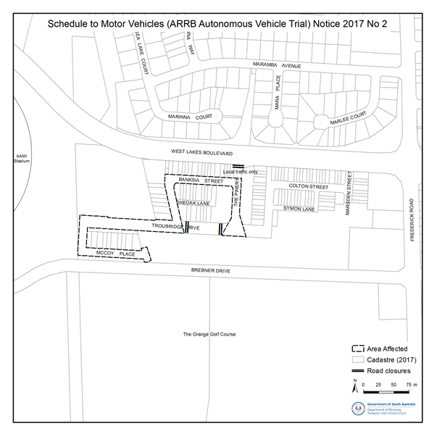
Hon Stephen Mullighan MP
Minister for Transport and Infrastructure

NATIONAL PARKS AND WILDLIFE (NATIONAL PARKS) REGULATIONS 2016
Closure of Simpson Desert Regional Reserve and Simpson Desert Conservation Park
PURSUANT to Regulations 7 (3) (a) and 7 (3) (d) of the National Parks and Wildlife (National Parks) Regulations 2016, I, Grant Anthony Pelton, Director, Regional Programs, Parks and Regions Group, delegate of the Director of National Parks and Wildlife, close to the public the whole of the Simpson Desert Regional Reserve and the whole of Simpson Desert Conservation Park from:
6 p.m. on Thursday, 30 November 2017 until 6 p.m. on Thursday, 15 March 2018.
The purpose of the closure is in the interest of public safety as a result of anticipated high daytime temperatures likely to be experienced in the reserves during the closure period.
Dated 8 November 2017.
G. A. Pelton, Director, Regional Programs, Parks and Regions Group,
Department of Environment, Water and Natural Resources

NATIONAL PARKS AND WILDLIFE (NATIONAL PARKS) REGULATIONS 2016
Partial Closure of Ikara-Flinders Ranges National Park
PURSUANT to Regulations 7 (3) (a) and 7 (3) (d) of the National Parks and Wildlife (National Parks) Regulations 2016, I, Grant Anthony Pelton, Director, Regional Programs, Parks and Regions Group, an authorised delegate of the Ikara-Flinders Ranges National Park Co-management Board, close to the public, parts of Ikara-Flinders Ranges National Park from 6 p.m. on Thursday, 30 November 2017 until 6 a.m. on Thursday, 1 March 2018.
The partial closure applies to:
Cooinda Campground; and
The following walking/hiking trails from where they diverge from the Heysen Trail:-
- St Mary Peak (Ngarri Mudlanha) Hike – loop route (inside trail)
- Malloga Falls Hike
- Cooinda Camp Trail
- St Mary Peak (Ngarri Mudlanha) Hike – direct route (outside trail); and
The following walking/hiking trail from where it diverges from the Boom and Bust Trail (formerly known as the Drought Buster Hike):-
- Mount Ohlssen-Bagge Hike
A map identifying the partial closure is available for viewing and/or downloading at the following website: www.parks.sa.gov.au
The purpose of the closure is in the interest of public safety as a result of anticipated high daytime temperatures likely to be experienced in these remote areas within the reserve during the period indicated.
Dated 8 November 2017.
G. A. Pelton, Director, Regional Programs, Parks and Regions Group,
Department of Environment, Water and Natural Resources

PETROLEUM AND GEOTHERMAL ENERGY ACT 2000
Application for Grant of Associated Activities Licence AAL 255
PURSUANT to section 65(6) of the Petroleum and Geothermal Energy Act 2000 and Delegation dated 31 March 2017, notice is hereby given that an application for the grant of an Associated Activities Licence within the area described below has been received from:
Beach Energy Limited
Great Artesian Oil and Gas Pty Ltd
The application will be determined on or after 28 November 2017.
Description of Application Area
All that part of the State of South Australia, bounded as follows:
All coordinates in GDA94, Zone 54
Area 1 | Area 2 | Area 3
347925.00mE 6941555.00mN | 348125.00mE 6941155.00mN | 347596.00mE 6943015.00mN
348048.00mE 6941152.00mN | 348100.00mE 6941154.00mN | 347618.00mE 6942817.00mN
347760.00mE 6941145.00mN | 347895.00mE 6941811.00mN | 347629.00mE 6942745.00mN
347409.00mE 6941296.00mN | 347715.00mE 6942423.00mN | 347641.00mE 6942624.00mN
347078.00mE 6941179.00mN | 347637.00mE 6943110.00mN | 347653.00mE 6942515.00mN
346730.00mE 6941102.00mN | 347638.00mE 6943149.00mN | 347241.10mE 6942456.62mN
346491.00mE 6941097.00mN | 347647.00mE 6943176.00mN | 347076.65mE 6942454.55mN
346481.00mE 6941893.01mN | 347656.00mE 6943198.00mN | 347075.10mE 6942577.66mN
346645.07mE 6941895.08mN | 347739.00mE 6943131.00mN | 346855.82mE 6942574.90mN
346644.29mE 6941956.63mN | 347898.00mE 6942913.00mN | 346854.28mE 6942698.01mN
346918.38mE 6941960.08mN | 348004.00mE 6942691.00mN | 346744.64mE 6942696.63mN
346917.60mE 6942021.63mN | 348042.00mE 6942467.00mN | 346743.09mE 6942819.73mN
347082.05mE 6942023.69mN | 348046.00mE 6942159.00mN | 346468.98mE 6942816.28mN
347080.51mE 6942146.80mN | 348013.00mE 6941935.00mN | 346459.00mE 6943613.00mN
347244.96mE 6942148.86mN | 347939.00mE 6941750.00mN | 346758.00mE 6943617.00mN
347242.35mE 6942357.01mN | 348125.00mE 6941155.00mN | 347150.00mE 6943539.00mN
347360.00mE 6942376.00mN |  | 347453.00mE 6943364.00mN
347356.00mE 6942401.00mN |  | 347617.00mE 6943230.00mN
347662.00mE 6942440.00mN |  | 347597.00mE 6943185.00mN
347667.00mE 6942408.00mN |  | 347587.00mE 6943143.00mN
347691.00mE 6942325.00mN |  | 347587.00mE 6943106.00mN
347776.00mE 6942039.00mN |  | 347596.00mE 6943015.00mN
347869.00mE 6941719.00mN
347925.00mE 6941555.00mN
AREA: 2.77 square kilometres approximately
Dated 9 November 2017.
Barry A. Goldstein, Executive Director,
Energy Resources Division, Department of the Premier and Cabinet,
Delegate of the Minister for Mineral Resources and Energy

PETROLEUM AND GEOTHERMAL ENERGY ACT 2000
Application for Grant of Special Facilities Licence SFL 14
PURSUANT to section 65(6) of the Petroleum and Geothermal Energy Act 2000 (the Act) and Delegation dated 31 March 2017, notice is hereby given that an application for the grant of a Special Facilities Licence within the area described below has been received from:
Veolia Environmental Services (Australia) Pty Ltd
The application will be determined on or after 12 December 2017.
Description of Application Area
All that part of the State of South Australia, bounded as follows:
28° 06' 28.30" S 140° 11' 31.40" E
28° 06' 28.50" S 140° 11' 38.70" E
28° 06' 31.60" S 140° 11' 38.80" E
28° 06' 32.00" S 140° 11' 37.40" E
28° 06' 32.10" S 140° 11' 31.40" E
28° 06' 28.30" S 140° 11' 31.40" E
All coordinates in GDA94
AREA: 0.02 square kilometres approximately
Dated 9 November 2017.
Barry A. Goldstein, Executive Director,
Energy Resources Division, Department of the Premier and Cabinet,
Delegate of the Minister for Mineral Resources and Energy

PROFESSIONAL STANDARDS ACT 2004 (SA)
Instrument of Appointment
Background
    - The Professional Standards Council (“the Council”) is established pursuant to section 42 of the Professional Standards Act 2004 (SA) (“the Act”).
    - Pursuant to section 43 of the Act, the Council is to consist of up to 11 people appointed by the Minister (“members”) who have such experience, skills and qualifications as the Minister considers appropriate.
    - Pursuant to section 44 of the Act, the provisions relating to the conditions of appointment for members of the Council are provided for in Schedule 2 of the Act.
Appointment
PURSUANT to the provision in section 43 of the Act, I, John Rau, Attorney-General for the State of South Australia, DO HEREBY APPOINT TERRY EVANS to be a member of the Professional Standards Council for the period from the date of this instrument of appointment to 31 December 2020 and to hold such appointment subject to the provisions of the Act and on the conditions set forth in this instrument of appointment.
Dated 3 November 2017.
John Rau, Attorney-General

REPORT OF THE REMUNERATION TRIBUNAL
No. 9 of 2017
Conveyance Allowance – Judges, Court Officers and Statutory Officers
INTRODUCTION
- The Remuneration Tribunal (“the Tribunal”) has jurisdiction under section 13 of the Remuneration Act 1990 (“the Act”), to determine the remuneration payable to judicial officers. The Tribunal also has jurisdiction, under section 14 of the Act, to determine the remuneration payable to holders of certain statutory public offices, some of whom are subject to this Report. The Act defines remuneration as including; salary, allowances, expenses, fees and any other benefit of a pecuniary nature.
- Section 8(2) of the Act provides that the Tribunal must sit at least once in each year for the purpose of determining, or reviewing previous determinations of remuneration, made under the Act.
- This report deals with the conveyance allowances payable to Judges, Court Officers and those statutory officers to whom it currently applies. Conveyance allowance is provided for meeting the costs associated with leasing a motor vehicle through Fleet SA.
BACKGROUND
- The last review of the conveyance allowance was conducted in 2016, which resulted in the Tribunal making Determination 9 of 2016. The cost of leasing a particular vehicle is set by Fleet SA and is expressed as a monetary amount in terms of Total Remuneration Package Value (“TRPV”). Historically, the Tribunal has determined conveyance allowances having regard to TRPVs corresponding to Holden vehicles as scheduled in the Fleet SA Judicial Vehicle Schedule.
- The Tribunal’s previous Determinations have provided for three levels of conveyance allowance for the various officers within the scope of its Determination, which were benchmarked to the TRPV of three different Holden vehicles. Those amounts are set out as follows:
- An amount which is the higher of (a) $17,541; and (b) the amount determined from time to time by Fleet SA as the annual charge payable by Executives for a Holden Calais VF II V-Series Sedan, less the sum of $758.
- An amount which is the higher of (a) $16,551; and (b) the amount determined from time to time by Fleet SA as the annual charge payable by Executives for a Holden Calais VF II Sedan, less the sum of $758.
- An amount which is the higher of (a) $15,298; and (b) the amount determined from time to time by Fleet SA as the annual charge payable by Executives for a Holden Commodore VF II Evoke Sedan, less the sum of $758.
- The effect of the previous Determinations was to provide that, should a judicial officer select one of the locally made vehicles and the TRPV of that vehicle was greater than the monetary allowance prescribed by the Determination, there would be no additional charge to a judicial officer who chose such a vehicle.
- Previously, only in limited circumstances could judicial officers select a different vehicle to those listed in a schedule of vehicles compiled by Fleet SA (clause 3.2 of Determination 9 of 2016).
SUBMISSIONS
- The Tribunal, by letters dated 6 July 2017, invited written and oral submissions from the affected parties for consideration by the Tribunal for the purposes of its review. Written submissions were filed by the Judicial Remuneration Coordinating Committee (“JRCC”) and the Crown Solicitor’s Office (“CSO”) on behalf of the Hon. Premier. The Tribunal also provided an opportunity for the making of oral submissions on 22 August 2017. The Tribunal heard oral submissions from the JRCC and the CSO on behalf of the Hon. Premier. A summary of the written and oral submissions put to the Tribunal is provided below.
- The JRCC submitted that:
- The current list of judicial vehicles is not an adequate selection for judicial officers, as part of the terms and conditions of the vehicle use are that the vehicle must be made available for the performance of judicial duties, which include overnight travel to circuit courts with files, luggage, and other Courts Administration Authority officers.
- It makes no sense to fix the amount of conveyance allowance by using the TRPV of vehicles that are unavailable for lease.
- If the Tribunal is minded to make a determination of a conveyance allowance that does not include the benchmarking of locally made vehicles, then the amounts of (1) $18,975, (2) $16,659, and (3) $15,681 are appropriate for the three different levels of conveyance allowance within the Tribunal’s Determination. These amounts correspond to three similar vehicles from the current Judicial Vehicle Schedule.
- The JRCC does not oppose any necessary amendments to the conveyance allowance Determination as a direct consequence of the commencement of the Statues Amendment (South Australian Employment Tribunal) Act 2016 (SA) and the South Australian Employment Tribunal Act 2014 (SA).
- That the Tribunal not defer the conveyance allowance review to a later date, having regard to section 8(2) of the Act, which provides that the Tribunal must sit once in each year for the purpose of determining, or reviewing previous determinations of remuneration.
- The CSO on behalf of the Honourable Premier, submitted that:
- The current list of judicial vehicles is an adequate selection for judicial officers, and that the list of judicial vehicles is similar to those provided by Fleet SA to Public Sector Executives.
- Historically, it is clear that the Tribunal has adopted a public policy position to fix the conveyance allowance in such a way that supports the local manufacturing industry. It may be necessary for the Tribunal to consider a new approach in light of the cessation of locally produced vehicles in South Australia.
- The Tribunal should consider changes to its conveyance allowance Determination that are consistent with the provisions of the Statues Amendment (South Australian Employment Tribunal) Act 2016 (SA) and the South Australian Employment Tribunal Act 2014 (SA).
- That the Tribunal adjourn the current proceedings until the matter of Government fleet vehicles is resolved at a whole-of-government level.
EXPANSION OF THE SOUTH AUSTRALIAN EMPLOYMENT TRIBUNAL
- As from 1 July 2017, the jurisdiction of the South Australian Employment Tribunal (“SAET”) expanded upon the dissolution of the Industrial Relations Court and Industrial Relations Commission of South Australia. These changes were brought about by the Statutes Amendment (South Australian Employment Tribunal) Act 2016 and make necessary a number of changes to the scope of the application of the Tribunal’s conveyance allowance Determination. The submissions on behalf of the Premier and the JRCC are in accord in relation to the appropriate changes. Such changes will be made in the Determination arising from this Report. The consequence will be removal of some designated office holders to which Determination 9 of 2016 applied.
- The effect of the legislative changes has resulted in the scope of application of the accompanying Determination being amended to cover the following office holders:
- the Chief Justice of the Supreme Court;
- the Puisne Judges of the Supreme Court;
- the President of the South Australian Employment Tribunal;
- the Judges of the South Australian Employment Tribunal;
- the Magistrates of the South Australian Employment Tribunal;
- the Judges of the Environment, Resources and Development Court;
- the Deputy Presidents of the South Australian Employment Tribunal;
- the Chief Judge of the District Court;
- the other District Court Judges;
- the Chief Magistrate;
- the Deputy Chief Magistrate;
- the other Magistrates;
- the Masters of the Supreme Court;
- the Masters of the District Court;
- the State Coroner;
- the Deputy State Coroners;
- the Commissioners of the Environment, Resources and Development Court;
- the Auditor-General;
- the Electoral Commissioner;
- the Deputy Electoral Commissioner; and
- the Health and Community Services Complaints Commissioner.
The HONOURABLE PREMIER’s APPLICATION FOR AN ADJOURNMENT
- After commencement of the Tribunal’s review, on 29 August 2017, the CSO on behalf of the Honourable Premier made an application for an adjournment to proceedings until such time as the matter of Government fleet vehicles can be resolved at a whole-of-Government level. The Tribunal has decided to conclude the current review without adjourning the proceedings. For reasons which will become apparent below, the Tribunal sees no necessity to defer the conclusion of the current review.
CONsideration OF ALLOWANCE
- The history of the conveyance allowance for the office holders within the scope of the Tribunal’s Determination has featured a significant public policy concern to support local vehicle production in South Australia. At this point, no motor vehicles will be produced in South Australia. Accordingly, the Tribunal intends to remove reference to the Holden vehicles in the conveyance allowance Determination and provide only a money amount of allowance.
- Moreover, the Tribunal accepts the Premier’s submission that the current schedule of vehicles, compiled by Fleet SA, as tabled in the proceedings, is an adequate selection of vehicles. The Tribunal notes that the schedule of vehicles compiled and managed by Fleet SA may be updated from time-to-time by Fleet SA, to accommodate changing circumstances, should they arise. The Tribunal will remove the current provisions providing for selection of alternative vehicles. As a consequence, the choice of vehicle will be a matter for the judicial officers to select from the schedule of vehicles compiled by Fleet SA, as varied from time to time.
- The Tribunal has given consideration to the information before it, which includes a schedule of vehicles and appropriate calculations of TRPV which provide a basis on which to determine an adequate monetary value of the conveyance allowance. The Tribunal has concluded that the conveyance allowance will no longer be dependent on the TRPV of any particular vehicle, and that the current monetary amounts of the conveyance allowance remain adequate.
- A Determination will issue accordingly.
Dated 8 November 2017.
John Lewin, President
Peter Alexander, Member
Pamela Martin, Member

DETERMINATION OF THE REMUNERATION TRIBUNAL
No. 9 of 2017
Conveyance Allowance – Judges, Court Officers and Statutory Officers
DETERMINATION
- INTERPRETATION
  - In this Determination, unless the contrary appears:
“Court Officer” means Commissioners of the Environment, Resources and Development Court;
“Executives” means persons appointed to an executive position under the Public Sector Act 2009;
“Judges” means any of the following members of the judiciary:
the Chief Justice of the Supreme Court;
the Puisne Judges of the Supreme Court;
the President of the South Australian Employment Tribunal;
the Deputy Presidents of the South Australian Employment Tribunal;
the Judges of the Environment, Resources and Development Court;
the Judges of the South Australian Employment Tribunal;
the Chief Judge of the District Court;
the other District Court Judges;
the Chief Magistrate (as a Judge of the District Court);
the Deputy Chief Magistrate;
the Magistrates of the South Australian Employment Tribunal;
the other Magistrates;
the Masters of the Supreme Court;
the Masters of the District Court;
the State Coroner; and
the Deputy State Coroner.
“Registrar” means the "Registrar” within the meaning of the South Australian Employment Tribunal Act 2014 (SA).
“Relevant authority” means:
(a) the State Courts Administrator in relation to Judges and Court Officers;
(b) the Registrar in relation to the presidential members of the South Australian Employment Tribunal; and
(c) the Director, Fleet SA in relation to other Statutory Officers.
“Retirement” bears the same meaning as in the Judges’ Pensions Act 1971, the Superannuation Act 1988 and the Southern State Superannuation Act 2009.
“Resignation” bears the same meaning as in the Judges’ Pensions Act 1971, the Superannuation Act 1988, and the Southern State Superannuation Act 2009.
“Statutory Officers” means any of the following statutory office holders:
the Auditor-General;
the Electoral Commissioner;
the Deputy Electoral Commissioner; and
the Health and Community Services Complaints Commissioner.
  - For the purposes of this Determination, “salary” bears the same meaning as in the Judges’ Pensions Act 1971, Southern State Superannuation Act 2009, and in the Superannuation Act 1988, to the intent and effect that any amount paid by way of conveyance allowance is not “salary”, and that any abatement or reduction of salary in accordance with this Determination will not affect the determination of entitlements or obligations pursuant to those Acts.
- CONVEYANCE ALLOWANCES
  - Amount of Allowances
Subject to the conditions set out in this Determination, Judges, Court Officers and Statutory Officers are entitled to receive a conveyance allowance payable fortnightly at an annual rate as follows:
2.1.1 For:
Judges of the Supreme Court;
the Chief Judge of the District Court;
the President of the South Australian Employment Tribunal; and
the Auditor-General;
an amount of $17,541.
2.1.2 For:
Judges of the District Court;
the Chief Magistrate;
Judges of the South Australian Employment Tribunal;
Judges of the Environment, Resources and Development Court;
Masters of the Supreme Court;
the Electoral Commissioner; and
the Health and Community Services Complaints Commissioner;
an amount of $16,551.
2.1.3 For:
the Deputy Chief Magistrate;
Magistrates;
Masters of the District Court;
the State Coroner;
the Deputy State Coroner;
Magistrates of the South Australian Employment Tribunal;
Commissioners of the Environment, Resources and Development Court; and
the Deputy Electoral Commissioner;
an amount of $15,298.
2.1.4 JUDGE HANNON
The Honourable Judge Hannon was appointed on 1 January 2015 as Deputy President of the South Australian Employment Tribunal (“SAET”).
Section 69(6) of the Statutes Amendment (South Australian Employment Tribunal) Act 2016 provides:
“The salary and allowances of a person to whom subsection (5)(a) applies will not be reduced during the person’s term of office as a member of the Tribunal.”
Those provisions apply to Judge Hannon. At the relevant time Judge Hannon was entitled to the level of conveyance allowance applicable to a Judge of the Supreme Court and those other judicial officers listed at paragraph 2.1.1 above. Accordingly, it is noted that Judge Hannon continues to be entitled to the level of conveyance allowance applicable at the time immediately prior to his appointment as a Deputy President of SAET. This Determination therefore does not affect or effect the level of conveyance allowance to which Judge Hannon is entitled.

2.2. Part Time Appointees

Where a person to whom this Determination applies is appointed on a part time basis, that person is entitled to receive a conveyance allowance at a pro rata amount of the relevant allowance in clause 2.1, based on the number of ordinary hours worked as a proportion of the full time equivalent.

2.3. Temporary Appointees

Where a person who is not provided with a vehicle in their substantive position is appointed on a temporary basis to act as a Judge, Court Officer or Statutory Officer, that person is entitled after the expiration of the first calendar month of service to receive a conveyance allowance in accordance with clause 2.1.
  - Use of Taxis and Private Vehicles
2.4.1. Judges and Court Officers
A Judge or Court Officer is not entitled to use a government fleet vehicle allocated to the Courts Administration Authority, or to engage taxis or hire car at the expense of the State Courts Administrator, or to seek the payment of any additional allowance for the use of a private vehicle, whether for official or unofficial purposes unless:
- it has been certified by the State Courts Administrator that it was inefficient or not cost effective for the Judge or Court Officer to use the vehicle available for their official and private use; or
- such use or engagement is consistent with a general direction given by the Chief Judicial Officer of the relevant Court, or in the case of Court Officers, the presiding officer of the relevant Tribunal, as to the circumstances where the vehicle available for official and private use, need not be used by reason of efficiency and cost effectiveness.
For the presidential members of the South Australian Employment Tribunal, the Registrar is the relevant approval authority.
An example of circumstances where such certification or general directions may be given is for journeys to and from the airport, where it may be more efficient or cost effective to use a taxi.
2.4.2. Statutory Officers
A Statutory Officer must not engage a taxi or hire car, and is not entitled to the payment of any additional allowance for the use of a private vehicle, whether for official or unofficial purposes, unless it is inefficient or not cost effective to use the vehicle available for the Officer’s official and private use.
2.4.3. Amount of Reimbursement
Where any person subject to this Determination is seeking payment of an additional allowance to cover the use of a private motor vehicle for official purposes, reimbursement of the cost will be made, calculated at the rate per kilometre at a rate equating to that pursuant to the SA Public Sector Salaried Employees Interim Award.
- VEHICLES FOR OFFICIAL AND PRIVATE USE
  - Selection of Vehicle
Persons who are subject to this Determination are entitled, in accordance with the conditions specified herein, to elect to have allocated to them a motor vehicle of any model and type from the Judicial Vehicle Schedule compiled by Fleet SA, as varied from time to time. Notice of the selected motor vehicle should be made in writing as follows:
- by Judges and Court Officers to the State Courts Administrator;
- by members of the South Australian Employment Tribunal to the Registrar, including members who are Statutory Officers; and
- by other Statutory Officers to the Director, Fleet SA.
The annual charge payable for each vehicle, determined by Fleet SA on the same basis as the calculation made in respect of the use of motor vehicles by Executives, is set out in the Judicial Vehicle Schedule compiled by Fleet SA.
  - Temporary Appointees
Persons appointed on a temporary basis to act as a Judge, Court Officer or Statutory Officer are not entitled to make an election under clause 3.1.
  - Charges for Use of Vehicles
The amount payable by a Judge, Court Officer or Statutory Officer for the use of a selected vehicle is the amount set out in the Fleet SA Judicial Vehicle Schedule adjacent to the description of the type of vehicle.
Where a person to whom this Determination applies is appointed on a part time basis, and elects pursuant to clause 3.1 to have a motor vehicle, the charge payable by that person pursuant to clause 3.4 shall be an amount determined by Fleet SA, which may be greater than the standard charge to a full time officer to appropriately reflect the proportionately greater private use of such a motor vehicle.
  - Payment of Vehicle Charges
If a Judge, Court Officer or Statutory Officer makes an election under clause 3.1 and a vehicle is supplied in accordance with that election, then the salary and allowances otherwise payable to the Judge, Court Officer or Statutory Officer must be abated and reduced so as to offset the charges for the use of the vehicle for the period during which the Judge, Court Officer or Statutory Officer has the use of the vehicle.
  - New Models or Types
3.5.1. If a new type of vehicle, or a new model of a type specified in the Schedules becomes available for selection in terms of 3.1 after the date of election but before the placement of a binding order, the Judge, Court Officer, or Statutory Officer is entitled to withdraw the original election and elect to take the new model or type of vehicle.
    - The annual charge payable for a new model or new type of vehicle is that amount determined by Fleet SA as the annual charge for private use of the vehicle by Executives. The annual charge takes into account the following:
      - purchase price and depreciation;
      - fuel, maintenance, insurance and registration costs and interest rates; (operating costs are calculated on the basis of an average of 70% private usage);
      - Goods and Services Tax (GST);
      - Fringe Benefits Tax (FBT) based on an attributed business rate of 20,000 kilometres per year; and
      - the vehicle being retained for 3 years or 60,000 kilometres travelled, whichever first occurs.
    - If a model or type of vehicle selected by a Judge, Court Officer or Statutory Officer becomes unavailable before the placement of a binding order, the Judge, Court Officer or Statutory Officer must be advised accordingly and allowed to make a further election under clause 3.1.
    - If a model becomes unavailable after the date of placement of a binding order and a later or better model vehicle is supplied, any Judge, Court Officer or Statutory Officer who has selected the unavailable vehicle is liable only to pay the annual charge for the vehicle as selected, and not the charge payable for the vehicle as supplied.
  - Accessories
The Judge, Court Officer or Statutory Officer may choose to have manufacturer approved accessories fitted to the vehicle. The full cost of the accessories and the expense of having them fitted (including any tax incurred) is payable by the Judge, Court Officer or Statutory Officer. When the vehicle is due for return the Judge, Court Officer or Statutory Officer may have personally-installed accessories removed from the vehicle, providing the Judge, Court Officer or Statutory Officer meets the full cost of restoring the vehicle to the same condition as if the accessories had not been fitted. No compensation will be paid if options are left on the vehicle unless agreed by the relevant authority.
Options such as airbags, ABS brake systems and cruise control may not be removed, and tow bars must not be reinstalled on another vehicle.
  - Retention of Vehicle
Having made an election and receiving the vehicle, the Judge, Court Officer or Statutory Officer must keep the vehicle for a period equivalent to the period determined from time to time by Fleet SA as the period for the replacement of vehicles provided to Executives.
At the conclusion of that period the Judge, Court Officer or Statutory Officer will be entitled to make a new election, or, if he or she does not make an election, to be paid the allowance.
  - Conditions of Use
The vehicle will be fully maintained, serviced and insured by the relevant authority.
Parking for the vehicle will be made available at or near the place of duty of the Judge, Court Officer, or Statutory Officer and the vehicle will be available for private and official use, subject to the following:
    - The Judge, Court Officer, or Statutory Officer must make the vehicle available for official use (including for official use by the Judge, Court Officer, or Statutory Officer) at all times whilst the vehicle is parked at or near the usual place of work of the Judge, Court Officer, or Statutory Officer, and the Judge, Court Officer or Statutory Officer, does not require the vehicle for private use.

3.8.2 The Judge, Court Officer, or Statutory Officer will be authorised by the relevant authority to refuel the vehicle provided the vehicle is fuelled in accordance with any requirements specified by Fleet SA, which may include requirements that the vehicle be fuelled using a particular brand of motor fuel and that it be only fuelled in South Australia. (If fuelled otherwise than in accordance with those requirements, it will be at the cost of the Judge, Court Officer, or Statutory Officer).
    - The Judge, Court Officer, or Statutory Officer must make the vehicle available as required by the relevant authority for the purposes of the maintenance and repair of the vehicle and must deliver the vehicle to such place as the relevant authority may specify for that purpose.
    - The relevant authority will ensure that Judges, Court Officers and Statutory Officers are insured (which may be pursuant to Government “self-insurance”) in respect of compulsory third party liability, third party property damage and any property damage to the vehicle and will hold the Judge, Court Officer, or Statutory Officer harmless in respect of any such property damage. Personal items within the vehicle need not be covered. The Judge, Court Officer, or Statutory Officer must comply with any requirements of the insurance policy of which the member is aware or should have been aware.
    - The Judge, Court Officer or Statutory Officer will be responsible for any driving or parking fines for offences incurred.
    - The vehicle is available to the Judge, Court Officer or Statutory Officer while on leave. Where the Judge, Court Officer or Statutory Officer is absent from duty for a period greater than 7 days then the Judge, Court Officer, or Statutory Officer will be responsible for fuelling the vehicle until returning to duty.
    - Vehicles may be driven interstate during periods of leave and there is no limit to privately travelled kilometres. Fuel charges for private interstate trips are entirely the personal responsibility of the Judge, Court Officer, or Statutory Officer.
  - Special Conditions of Use
Notwithstanding anything else in this Determination:
    - where any damage is the result of a wilful or deliberate act of any person, the relevant authority may take such action as he or she thinks fit to recover the cost of such damage;
    - the insurance and discharges are not applicable if the driver is under the influence of drugs and/or alcohol;
    - the insurance and discharges are not applicable if the insurance has been brought to the attention of the Judge, Court Officer or Statutory Officer and is avoided by an action of the driver of the vehicle; and
    - where the insurance policy contains an excess clause, then the Judge, Court Officer or Statutory Officer will be liable to repay the relevant authority the amount of that excess (or any part thereof) in the event that it becomes payable by reason of the driver of the vehicle being blameworthy for any of the damage giving rise to a claim on the policy when the vehicle is being used other than for official use.
  - Care of Vehicle
The Judge, Court Officer or Statutory Officer is responsible for ensuring that reasonable care is taken of the vehicle. Off street parking at the home of the person concerned is to be used if available and reasonable steps are to be taken to ensure its security. Where any damage to a vehicle supplied to a:
    - Judge or Court Officer is, in the opinion of the Courts Administration Council, the consequence of a serious breach of the obligations imposed by this clause, the Judge, or Court Officer must, on demand, pay the Courts Administration Authority the proper cost of rectification of such damage;
    - Statutory Officer is, in the opinion of the Director, Fleet SA, the consequence of a serious breach of the obligations imposed by this clause, the Statutory Officer concerned must, on demand, pay to Fleet SA the proper cost of rectification of such damage; and
    - Presidential member of the South Australian Employment Tribunal is, in the opinion of the Registrar, the consequence of a serious breach of the obligations imposed by this clause, the Member concerned must, on demand, pay to the Tribunal the proper cost of rectification of such damage.
  - Additional Drivers
The vehicle may be driven by any other Government employee who requires the vehicle for official use.
Judges, Court Officers, and Statutory Officers, must nominate to the relevant authority the names of any persons to use the vehicle at times when it is not required to be available for official use and, subject to the control and direction of the Judge, Court Officer or Statutory Officer, such persons will be authorised to use the vehicle upon such nomination.
Approval is required from the relevant authority for the vehicle to be driven by holders of any form of provisional licence or learner’s permit. Approval is also required if any other category of person not otherwise mentioned, is to drive the vehicle.
3.12. Right to Purchase
At any time during the 12 months immediately preceding the date of his or her retirement or resignation, a Judge, Court Officer, or Statutory Officer may, by notice in writing to the relevant authority, elect to purchase the vehicle then allocated to him or her as at the date of his or her retirement or resignation or at the end of the lease period. After such notification has been given, the relevant authority must take such steps as are necessary to ensure that it can sell the vehicle to the member.

3.13 No Changeover
A Judge, Court Officer or Statutory Officer who makes an election under clause 3.12 shall not be permitted or required to hand a vehicle in for normally scheduled changeover where that changeover would occur between the date of election and the date of retirement/resignation/end of lease period.

3.14 Conditions of Purchase
The conditions in relation to a purchase made following an election under clause 3.12 shall be:

3.14.1 The price will be the fair market value for such a vehicle sold without any statutory warranty.

3.14.2 The price will be agreed between the Director, Fleet SA, and the Judge, Court Officer or Statutory Officer, due regard being had to prices generally recovered for such vehicles at Fleet SA public auctions.

3.14.3 Failing such agreement, the price will be determined by an independent valuer agreed by the parties. Where the prospective retiree/resignee is a:

3.14.3.1. Judge or Court Officer, any fee payable to such a valuer shall be borne in equal shares by the prospective retiree/resignee and the State Courts Administrator;

3.14.3.2. Statutory Officer, any fee payable to such a valuer shall be borne in equal shares with half payable by the respective retiree/resignee and the other half being payable from funds appropriated to pay expenses associated with the statutory office held by the retiree/resignee; and

3.14.3.3. Presidential member of the South Australian Employment Tribunal, any fee payable to such a valuer shall be borne in equal shares by the prospective retiree/resignee and the Registrar.

3.14.4. The price shall be payable in full on, or prior to, the date of retirement/resignation of the Judge, Court Officer or Statutory Officer.

4. DATE OF OPERATION

4.1 The conveyance allowances prescribed in Clause 2.1 are operative from 1 July 2017.

4.2 If a Judge, Court Officer or Statutory Officer currently has the use of a vehicle pursuant to a previous Determination of the Remuneration Tribunal, the conveyance allowance and annual charge payable under the previous Determination will continue to apply. Clause 2 of this Determination will have no effect until that Judge, Court Officer or Statutory Officer takes delivery of a vehicle pursuant to this Determination, or elects not to receive a vehicle.

4.3 This Determination replaces in entirety Determination 9 of 2016.
Dated 8 November 2017.
John Lewin, President
Peter Alexander, Member
Pamela Martin, Member

ROADS (OPENING AND CLOSING) ACT 1991
Section 24
Notice of Confirmation of Road Process Order
Road Closure – Murbko Road, Murbko
BY Road Process Order made on 4 August 2017, the District Council of Loxton Waikerie ordered that:
- Portion of the Public Road (Murbko Road) situated adjoining Allotment 100 in Deposited Plan 73548, more particularly delineated and lettered ‘A’ in Preliminary Plan 16/0024 be closed.
- Transfer the whole of the land subject to closure to Mary Stoeff and Denise Jane Jessen in accordance with the Agreement for Transfer dated 4 August 2017 entered into between the District Council of Loxton Waikerie and Mary Stoeff and Denise Jane Jessen.
On 10 November 2017 that order was confirmed by the Minister for Transport and Infrastructure conditionally upon the deposit by the Registrar-General of Deposited Plan 116751 being the authority for the new boundaries.
Pursuant to section 24(5) of the Roads (Opening and Closing) Act 1991, NOTICE of the Order referred to above and its confirmation is hereby given.
Dated 14 November 2017.
M. P. Burdett, Surveyor-General

ROADS (OPENING AND CLOSING) ACT 1991
Section 24
Notice of Confirmation of Road Process Order
Road Closure – Public Road adjacent Lincoln Highway, Hundred of Playford
BY Road Process Order made on 22 May 2017, The District Council of Franklin Harbour ordered that:
- Portion of the Public Road adjacent to Lincoln Highway, Hundred of Playford, more particularly delineated and lettered ‘A’ in Preliminary Plan 17/0004 be closed.
- Issue a Certificate of Title to The District Council of Franklin Harbour for the whole of the land subject to closure which land is being retained by Council.
On 10 November 2017 that order was confirmed by the Minister for Transport and Infrastructure conditionally upon the deposit by the Registrar-General of Deposited Plan 116167 being the authority for the new boundaries.
Pursuant to section 24(5) of the Roads (Opening and Closing) Act 1991, NOTICE of the Order referred to above and its confirmation is hereby given.
Dated 14 November 2017.
M. P. Burdett, Surveyor-General

ROADS (OPENING AND CLOSING) ACT 1991
Section 24
Notice of Confirmation of Road Process Order
Road Closure – Public Road, Hundred of Riddoch
BY Road Process Order made on 10 October 2017, the Wattle Range Council ordered that:
- The whole of the Public Road, situated adjoining the western boundary of Section 411, Hundred of Riddoch, more particularly delineated and lettered ‘A’ in Preliminary Plan 17/0012 be closed.
- Transfer the whole of the land subject to closure to Anthony Duan Williams and Valerie Gai Williams in accordance with the Agreement for Transfer dated 24 April 2017 entered into between the Wattle Range Council and Anthony Duan Williams and Valerie Gai Williams.
On 10 November 2017 that order was confirmed by the Minister for Transport and Infrastructure conditionally upon the deposit by the Registrar-General of Deposited Plan 117003 being the authority for the new boundaries.
Pursuant to section 24(5) of the Roads (Opening and Closing) Act 1991, NOTICE of the Order referred to above and its confirmation is hereby given.
Dated 14 November 2017.
M. P. Burdett, Surveyor-General

South Australia
Local Government (Mobile Food Vendors) Amendment Act (Commencement) Proclamation 2017
1—Short title
This proclamation may be cited as the Local Government (Mobile Food Vendors) Amendment Act (Commencement) Proclamation 2017.
2—Commencement
The Local Government (Mobile Food Vendors) Amendment Act 2017 (No 33 of 2017) will come into operation on 1 March 2018.
Made by the Governor
with the advice and consent of the Executive Council
on 14 November 2017
17LG08CS

South Australia
Local Government (General) (Mobile Food Vendors) Variation Regulations 2017
under the Local Government Act 1999

Contents
Part 1—Preliminary
1 Short title
2 Commencement
3 Variation provisions
Part 2—Variation of Local Government (General) Regulations 2013
4 Insertion of regulations 25A to 25C
25A Permits for business purposes—mobile food vendors
25B Requirements relating to cancellation of permits
25C Requirements relating to location rules

Part 1—Preliminary
1—Short title
These regulations may be cited as the Local Government (General) (Mobile Food Vendors) Variation Regulations 2017.
2—Commencement
These regulations will come into operation on the day on which the Local Government (Mobile Food Vendors) Amendment Act 2017 comes into operation.
3—Variation provisions
In these regulations, a provision under a heading referring to the variation of specified regulations varies the regulations so specified.
Part 2—Variation of Local Government (General) Regulations 2013
4—Insertion of regulations 25A to 25C
After regulation 25 insert:
25A—Permits for business purposes—mobile food vendors
(1) In accordance with section 224(2) of the Act, the following requirements relating to conditions of a permit for the purposes of a mobile food vending business are prescribed:
(a) a council is prohibited from imposing a condition restricting the kind of food that may be sold by the mobile food vending business;
(b) a condition imposed by a council requiring the payment of a fee in relation to the permit—
(i) must allow the permit holder to elect to pay either an annual or monthly fee; and
(ii) must not require the payment of a fee exceeding—
(A) in the case of an annual fee—$2000 per year (excluding GST); or
(B) in the case of a monthly fee—$200 per month (excluding GST);
(c) a council must ensure that the permit is subject to—
(i) a condition requiring the permit holder to have insurance of a kind specified by the council (such as public liability insurance); and
(ii) conditions requiring that the operation of the mobile food vending business not unduly interfere with—
(A) vehicles driven on roads; or
(B) vehicles parking or standing on roads; or
(C) a parking area for people with disabilities (within the meaning of rule 203(2) of the Australian Road Rules); or
(D) public transport or cycling infrastructure (such as bus zones, taxi zones and bike lanes); or
(E) other road related infrastructure; or
(F) infrastructure designed to give access to roads, footpaths and buildings; and
(iii) conditions requiring compliance with requirements under—
(A) the Food Act 2001; and
(B) the South Australian Public Health Act 2011; and
(C) the Environment Protection Act 1993; and
(D) the Local Nuisance and Litter Control Act 2016; and
(E) the Motor Vehicles Act 1959 and Road Traffic Act 1961; and
(F) any law or legislative provision relating to electrical or gas installations or appliances; and
(G) any other relevant law or legislative provision relating to health, safety or the environment.
(2) In accordance with section 222(1a) of the Act, a council is not required to grant a permit for the purposes of a mobile food vending business under that subsection if the vehicle proposed to be used would unduly obstruct the use of public roads in a manner that cannot be adequately addressed by conditions under section 224 of the Act.
25B—Requirements relating to cancellation of permits
(1) If a council cancels a permit for the purposes of a mobile food vending business under section 225(1)(a) of the Act, the following requirements apply to the person who held the permit (prior to its cancellation):
(a) if the person holds a permit for the purposes of a mobile food vending business granted by another council, the person must inform that council of the cancellation as soon as is reasonably practicable after receiving notice of the cancellation;
(b) if, during the prohibited period, the person applies to another council for a permit for the purposes of a mobile food vending business, the person must inform that council of the cancellation as soon as is reasonably practicable after receiving notice of the cancellation.
(2) A person who fails to comply with a requirement under subregulation (1) is guilty of an offence.
Maximum penalty: $500.
(3) In this regulation—
prohibited period means the period, specified by a council that cancels a permit for the purposes of a mobile food vending business, during which an application to the council for such a permit may not be made by or on behalf of the person who held the permit (prior to its cancellation).
25C—Requirements relating to location rules
(1) For the purposes of section 225A(2)(a) of the Act, a council, in adopting or amending its location rules—
(a) must ensure that its location rules provide for a reasonable distance between mobile food vending businesses and fixed food businesses during the operating hours of fixed food businesses, taking into account the—
(i) location; and
(ii) number; and
(iii) operating hours,
of fixed food businesses in the council area; and
(b) must take into account the effect of the operation of mobile food vending businesses on—
(i) vehicle and pedestrian traffic, footpaths, driveways, access points to buildings and parking areas for people with disabilities; and
(ii) the requirements relating to, and availability of, parking spaces at the locations in which mobile food vending businesses may operate under the location rules; and
(iii) residents and businesses at the locations in which mobile food vending businesses may operate under the location rules; and
(c) must ensure that its location rules are consistent with any other relevant requirement under regulation 25A (including any relevant requirement under a law or legislative provision referred to in that regulation).
(2) A council's location rules may show the locations within the council area in which mobile food vending businesses are permitted to operate by use of maps.
(3) A council must ensure that a copy of its location rules is published on its website.
(4) In this regulation—
fixed food business means a business the primary purpose of which is the retail sale of food or beverages that is carried on at fixed premises.
Note—
As required by section 10AA(2) of the Subordinate Legislation Act 1978, the Minister has certified that, in the Minister's opinion, it is necessary or appropriate that these regulations come into operation as set out in these regulations.
Made by the Governor
with the advice and consent of the Executive Council
on 14 November 2017
No 307 of 2017
17LG08CS

RULES OF COURT
Magistrates Court of South Australia
Amendment 64 to the Magistrates Court Rules 1992
PURSUANT to section 49 of the Magistrates Court Act 1991 and all other enabling powers, we, the undersigned, do hereby make the following amendments to the Magistrates Court Rules 1992 as amended.
- These Rules may be cited as the ‘Magistrates Court Rules 1992 (Amendment 64)’.
- The Magistrates Court Rules 1992 (‘the Rules’) as amended by these amendments apply to and govern all actions commenced in the criminal division of the Court on and after the date on which the Intervention Orders (Prevention of Abuse) (Recognition of National Domestic Violence Orders) Amendment Act 2017 commences.
- Rule 18.02 is amended to delete “protection” and replace it with “intervention” and to delete “he” and replace it with “they”. Rule 18.02 is further amended to delete “with details of the AP number” and replace it with “with the reference number”.
- Rule 18.03 is amended to delete “or the confirmation of the order” and replace it with “or the issuing of a final order”.
- Rule 18.08 is amended to insert, after “Annexure”, “, however the annexure must not be served with the application for variation or revocation”.
- Rule 18.08A is amended to delete “30A” and replace it with “31AA” wherever occurring.
- Rule 18.08A is further amended to insert, after “Annexure”, “, however the annexure must not be served with the application for variation or revocation”.
- Rule 18.08B is amended to delete “Form 30A” and replace it with “Form 31”, and to delete “Form 31” and replace it with “Form 31AA”.
- Rule 18.14 is amended to delete “or Tenancy Order”.
- Rule 18.17 is amended to delete “or Intervention Order must be served with a multilingual notice in Form 43” and replace it with “or Intervention Order that is served on or provided to a defendant must be served with a multilingual notice in Form 43”.
- Rule 18.18 is amended to insert, after “Section”, “34 or Section”.
- Rule 18.26 is deleted.
- Rule 18.27 is amended to delete “involving domestic abuse” and replace it with “under the Intervention Orders (Prevention of Abuse) Act 2009”.
- Rule 18 is amended to insert the following, after rule 18.29:
Nationally Recognised Domestic Violence Orders
18.30 An application for a declaration that a domestic violence order is a recognised domestic violence order pursuant to s 29ZE of the Intervention Orders (Prevention of Abuse) Act 2009 must comply with Form 46A.
18.31 The Form 46A Annexure containing the contact details of the protected person(s) must be stored electronically, separately from the hard file and any hardcopy of the document must be subsequently destroyed.
18.32 Where the Court makes a declaration pursuant to s 29ZD(1) of the Intervention Orders (Prevention of Abuse) Act 2009, a notice of the declaration must comply with Form 46B.
18.33 Where the Court makes a declaration pursuant to s 29ZD(1) of the Intervention Orders (Prevention of Abuse) Act 2009, the Principal Registrar must, as soon as practicable, notify the prescribed public sector agencies of the declaration.
18.34 Where the Court varies or revokes a nationally recognised domestic violence order that was issued interstate, or declares an interstate domestic violence order to be a recognised domestic violence order, the Principal Registrar must, as soon as practicable, notify the Court in which the order was made of the variation, revocation or declaration.
18.35 A certificate issued pursuant to s 29W(1) of the Intervention Orders (Prevention of Abuse) Act 2009 must comply with Form 45A.
- Rule 18AA.01 is deleted and replaced as follows:
An intervention order issued under s 23A of the Bail Act 1985 must comply with Form 29AA and must be served on the defendant in accordance with s 21 of the Intervention Orders (Prevention of Abuse) Act 2009.
- Rule 18AAA.01 is deleted and replaced as follows:
An intervention order issued under s 19A of the Criminal Law (Sentencing) Act 1988 must comply with Form 30 and must be served on the defendant in accordance with s 23 of the Intervention Orders (Prevention of Abuse) Act 2009.
- Form 28 is deleted and replaced with Form 28.
- Form 28AA is deleted and replaced with Form 28AA.
- Form 29 is deleted and replaced with Form 29.
- Form 29AA is deleted and replaced with Form 29AA.
- Form 30 is deleted and replaced with Form 30.
- Form 31 is deleted and replaced with Form 31.
- Form 30A is deleted and replaced with Form 31AA.
- Form 36 is deleted and replaced with Form 36.
- Form 38 is deleted and replaced with Form 38.
- Form 40 is deleted and replaced with Form 40.
- Form 41 is deleted and replaced with Form 41.
- Form 42 is deleted and replaced with Form 42.
- Form 43 is deleted and replaced with Form 43.
- Form 44 is deleted and replaced with Form 44.
- Form 45A is inserted.
- Form 46 is deleted and replaced with Form 46.
- Form 46A is inserted.
- Form 46B is inserted.
Signed on the 13th day of November 2017.
Mary-Louise Hribal, Chief Magistrate
Brett Jonathon Dixon, Magistrate
Briony Kennewell, Magistrate
Gregory Charles Fisher, Magistrate

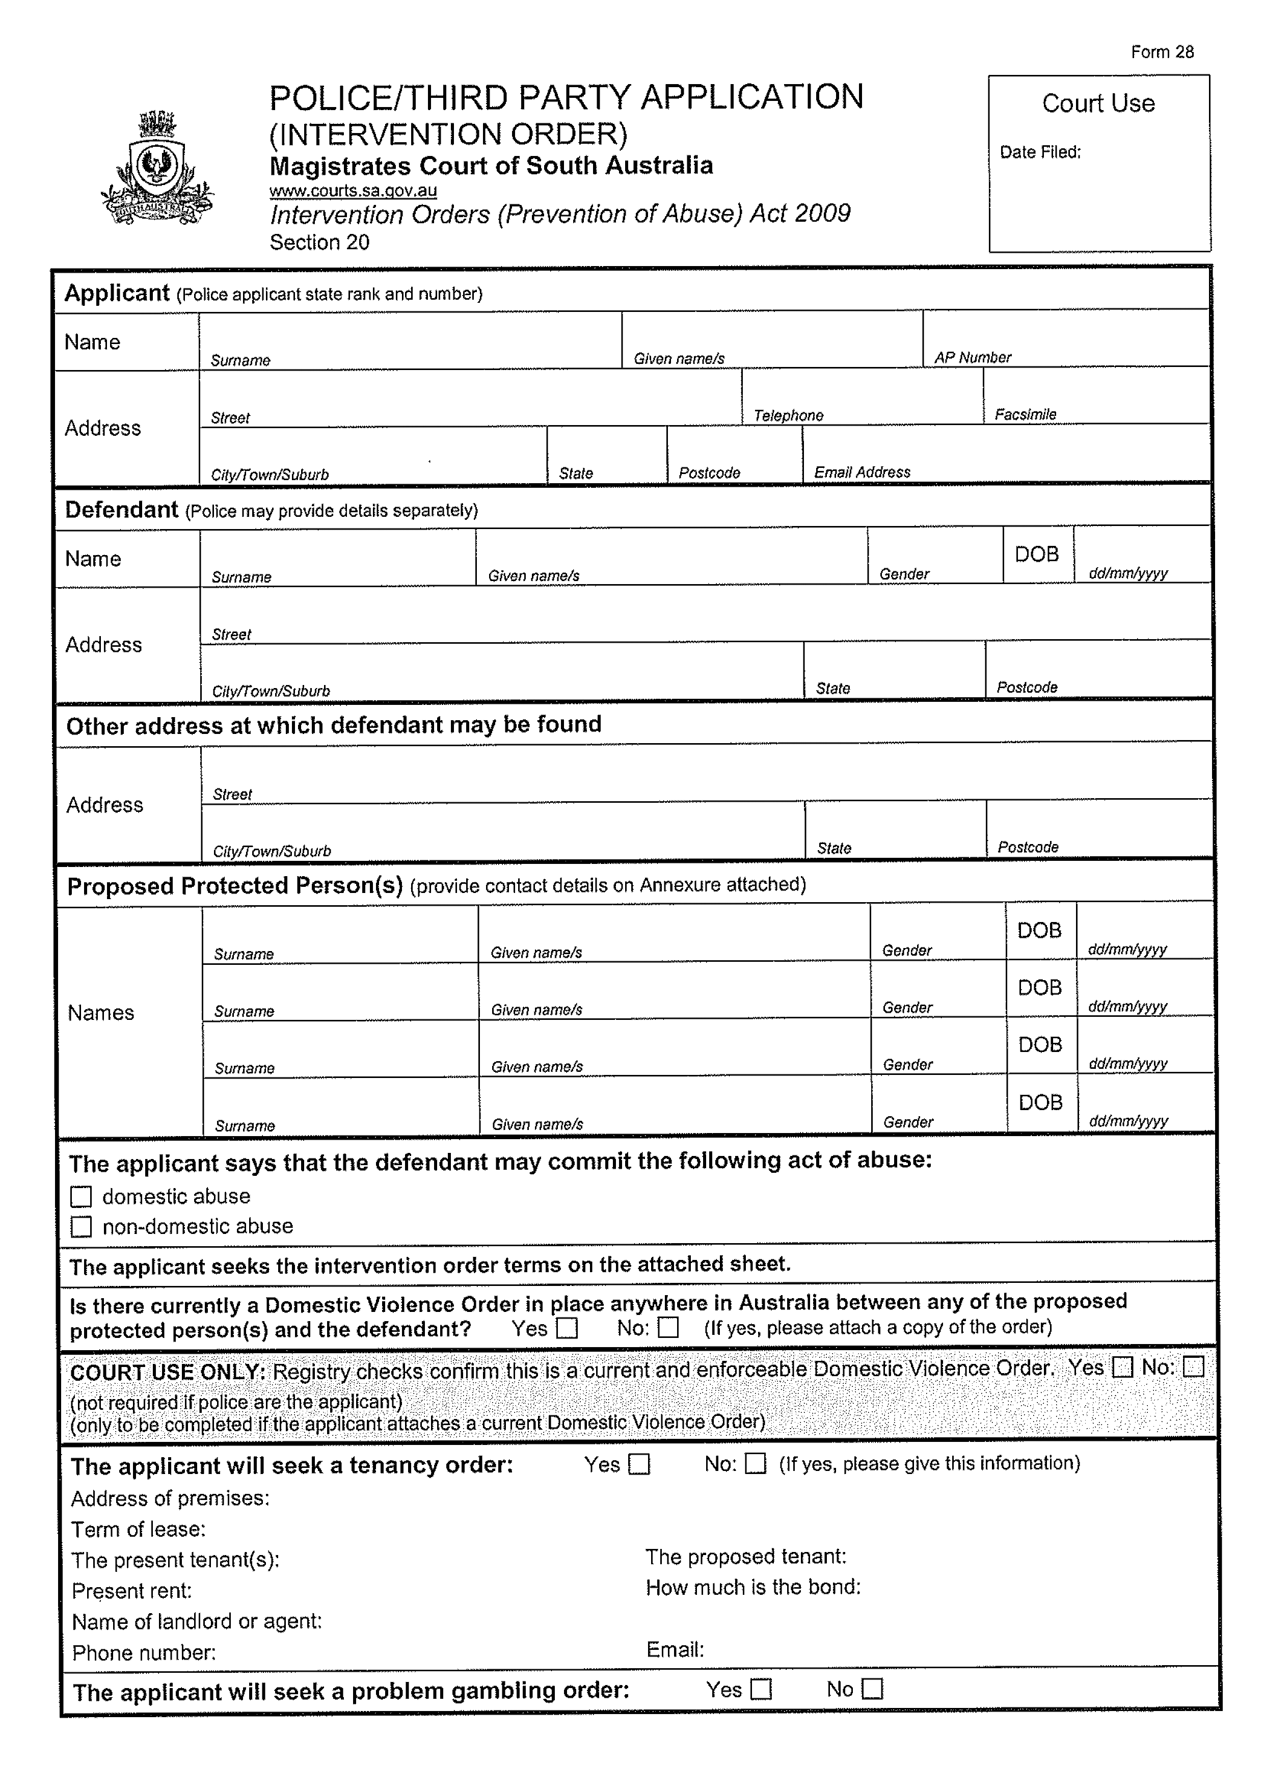
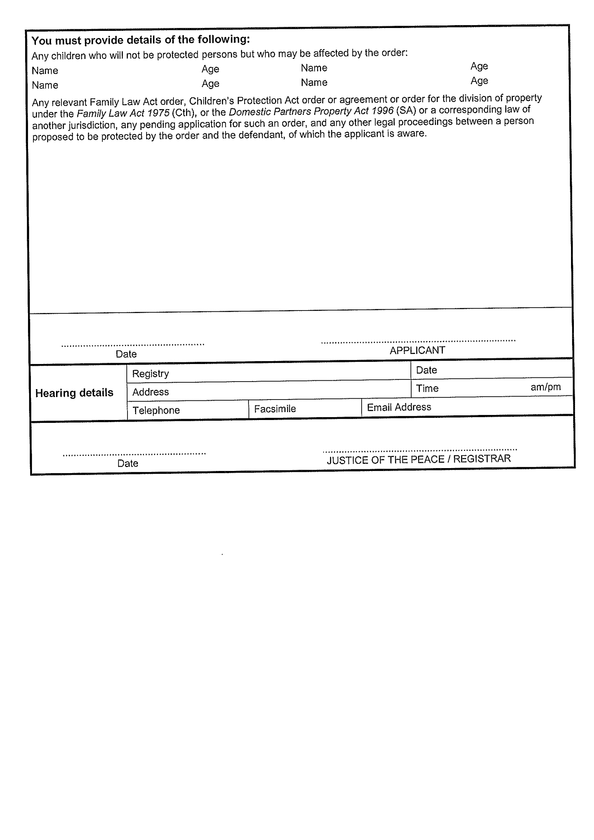
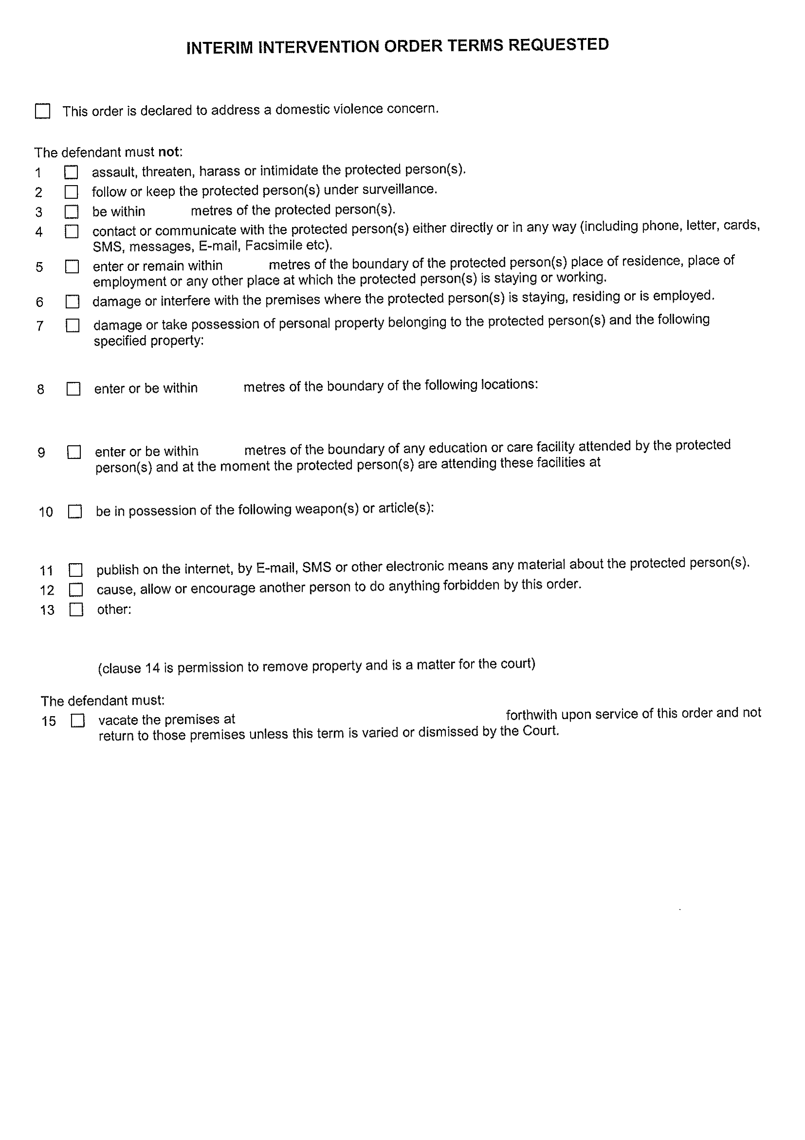
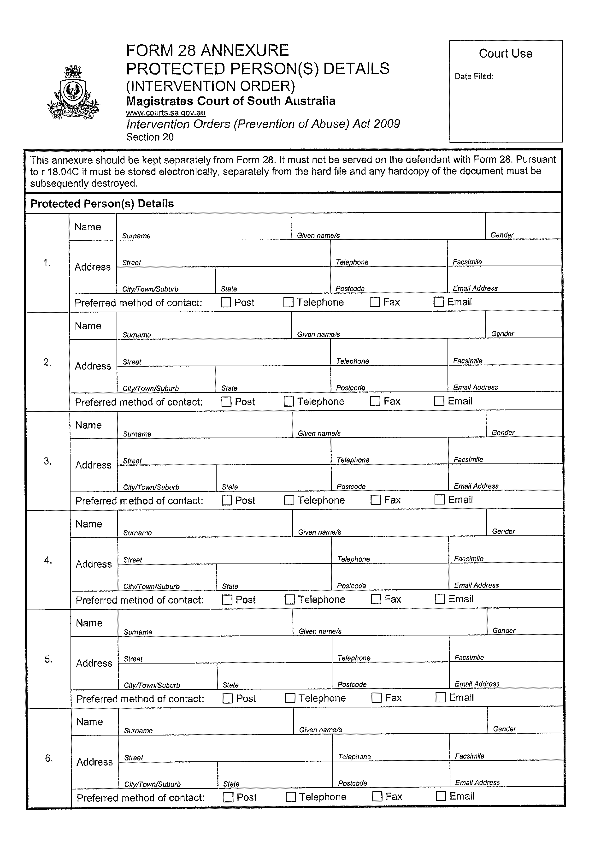
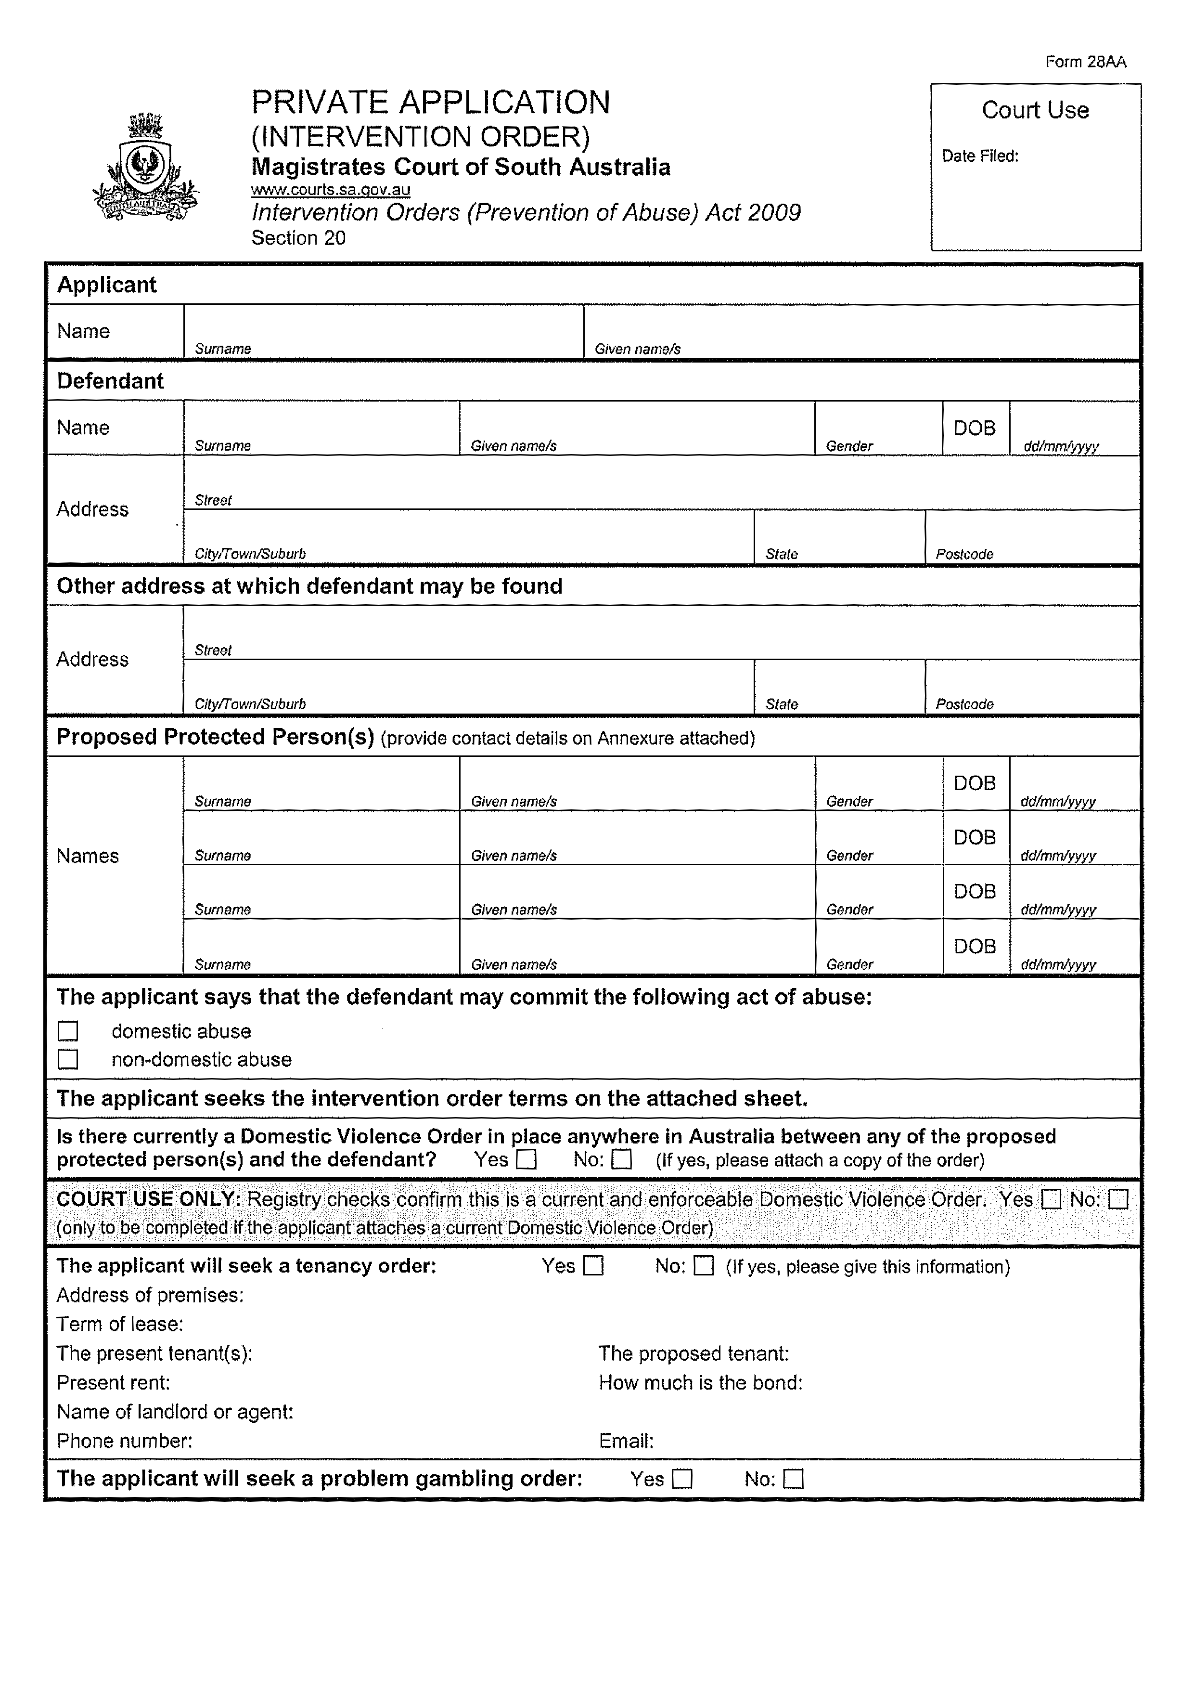
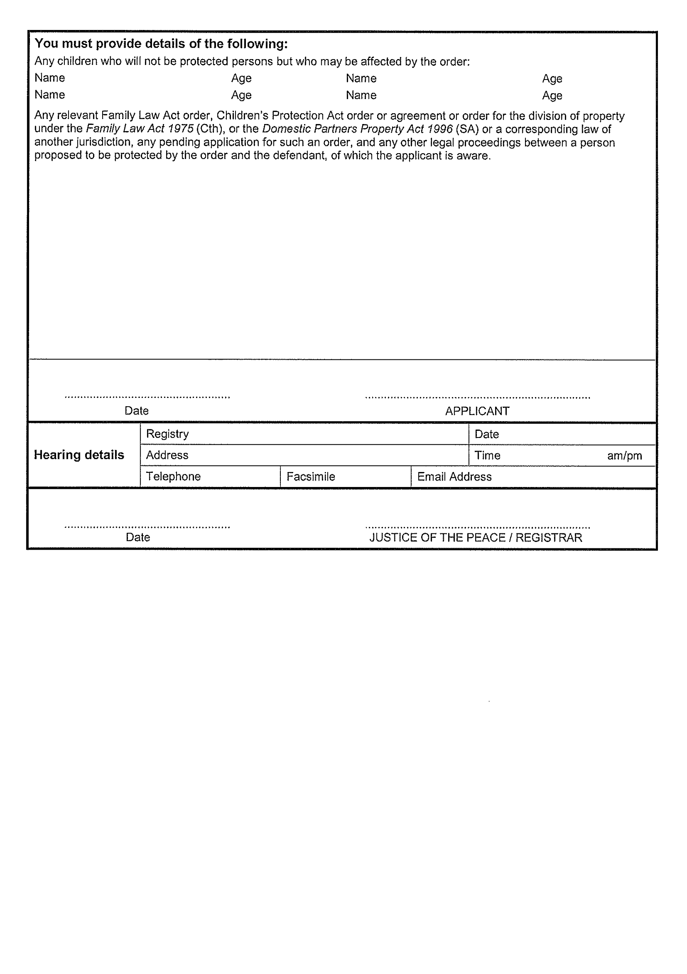
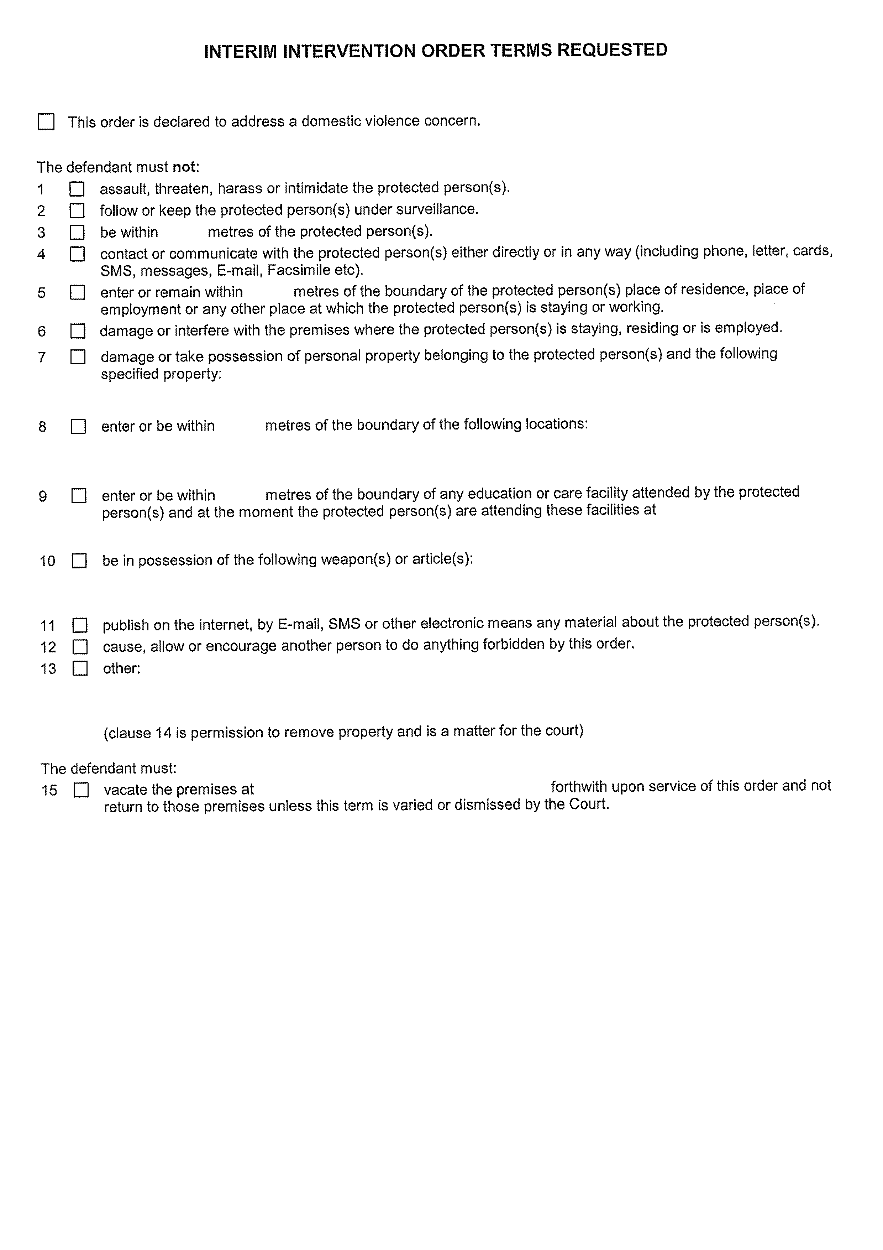
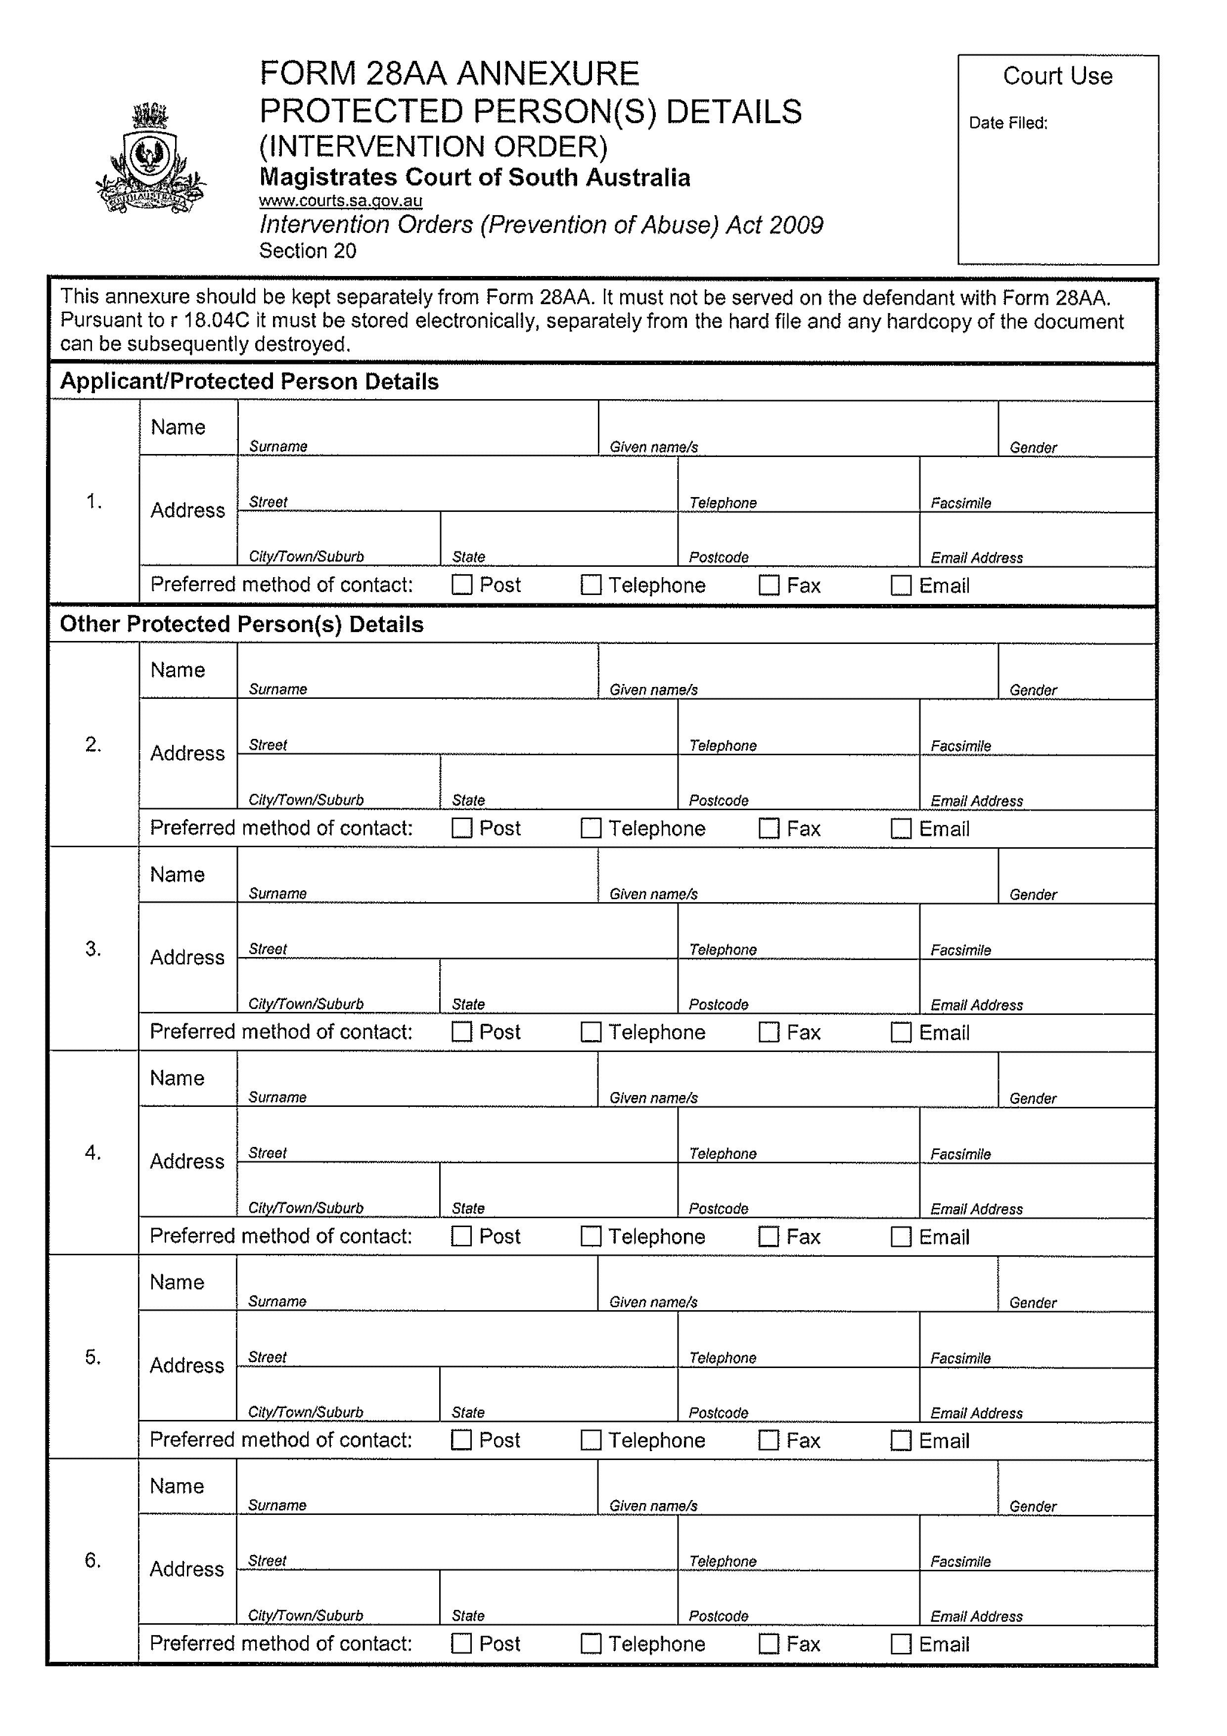
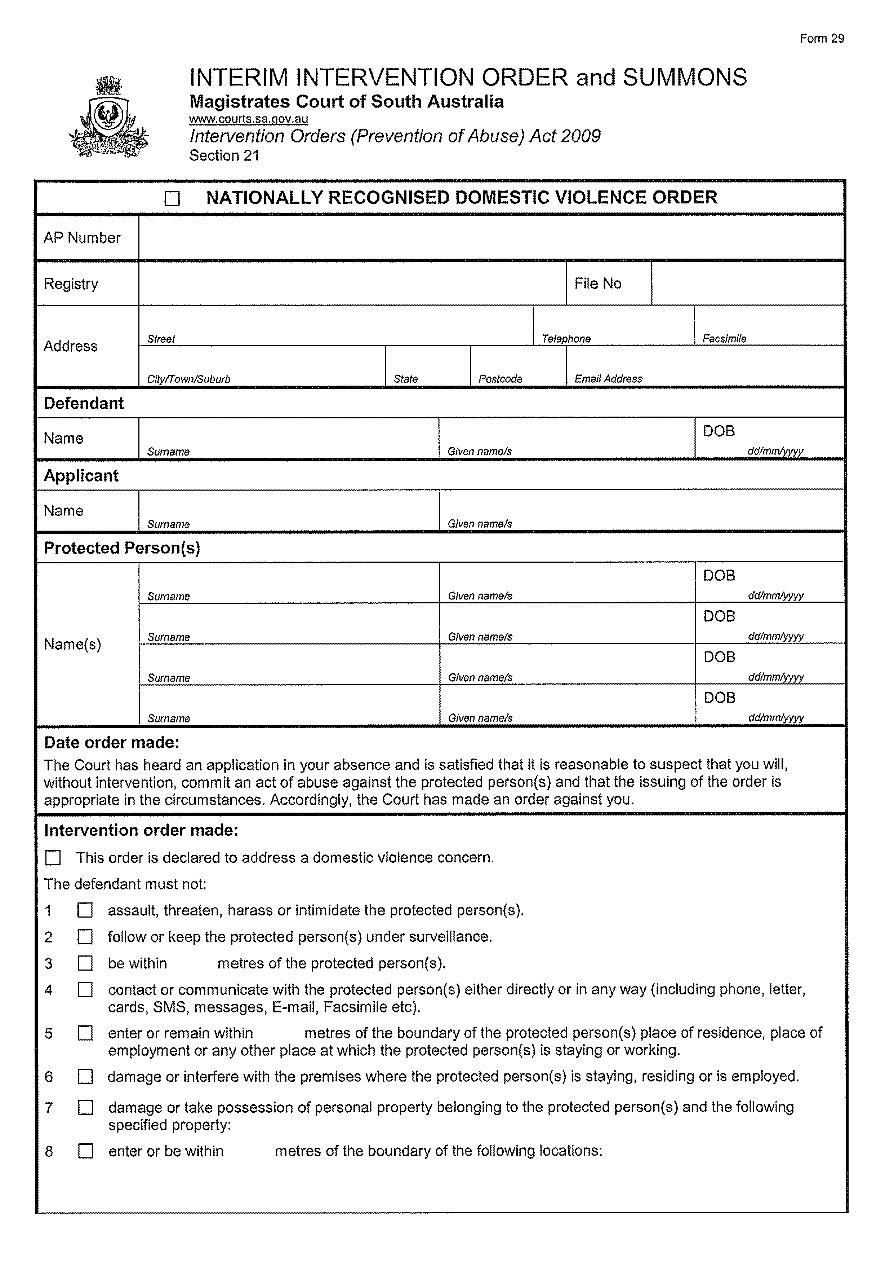
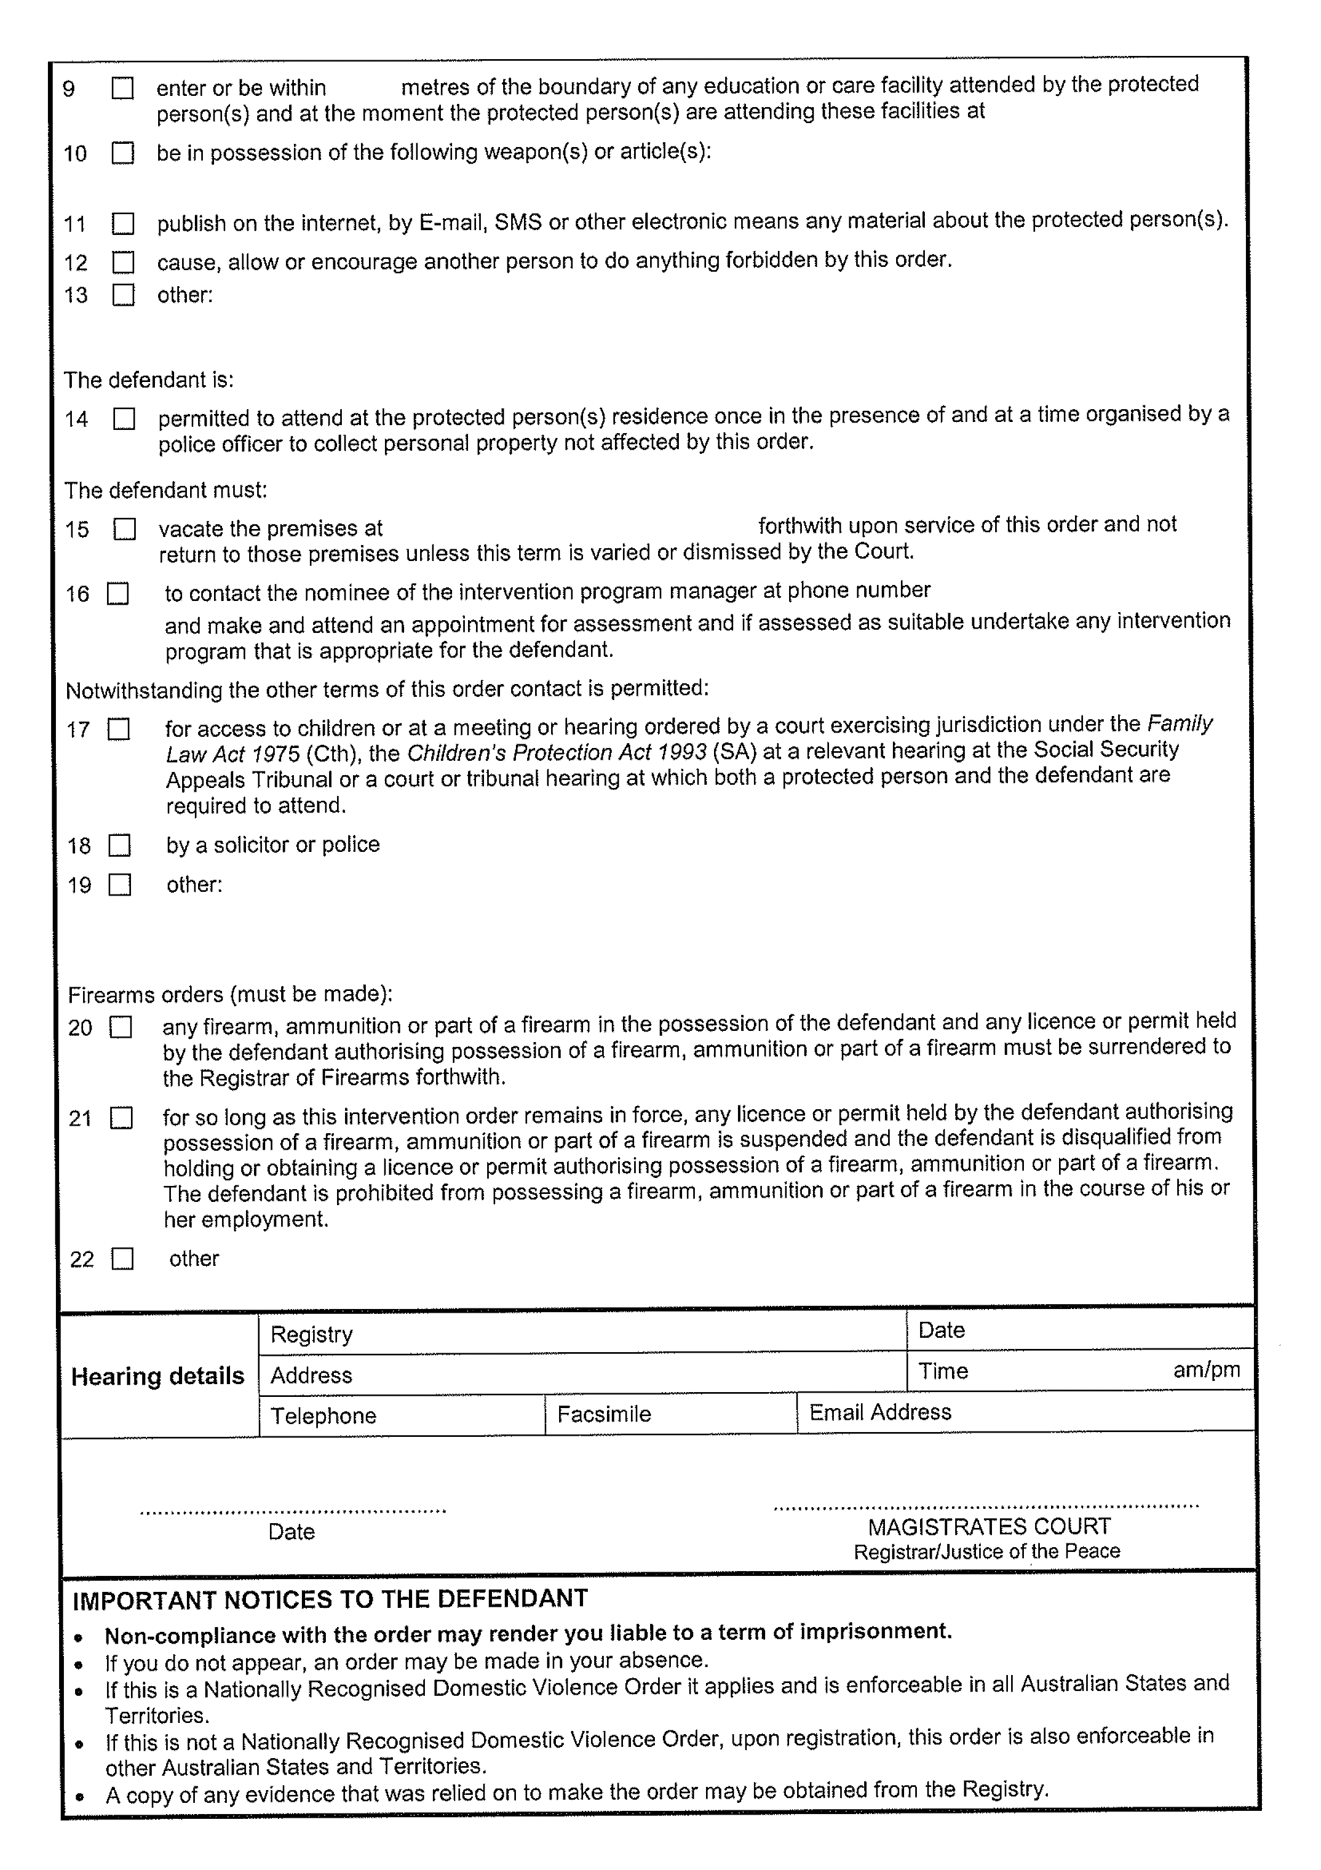
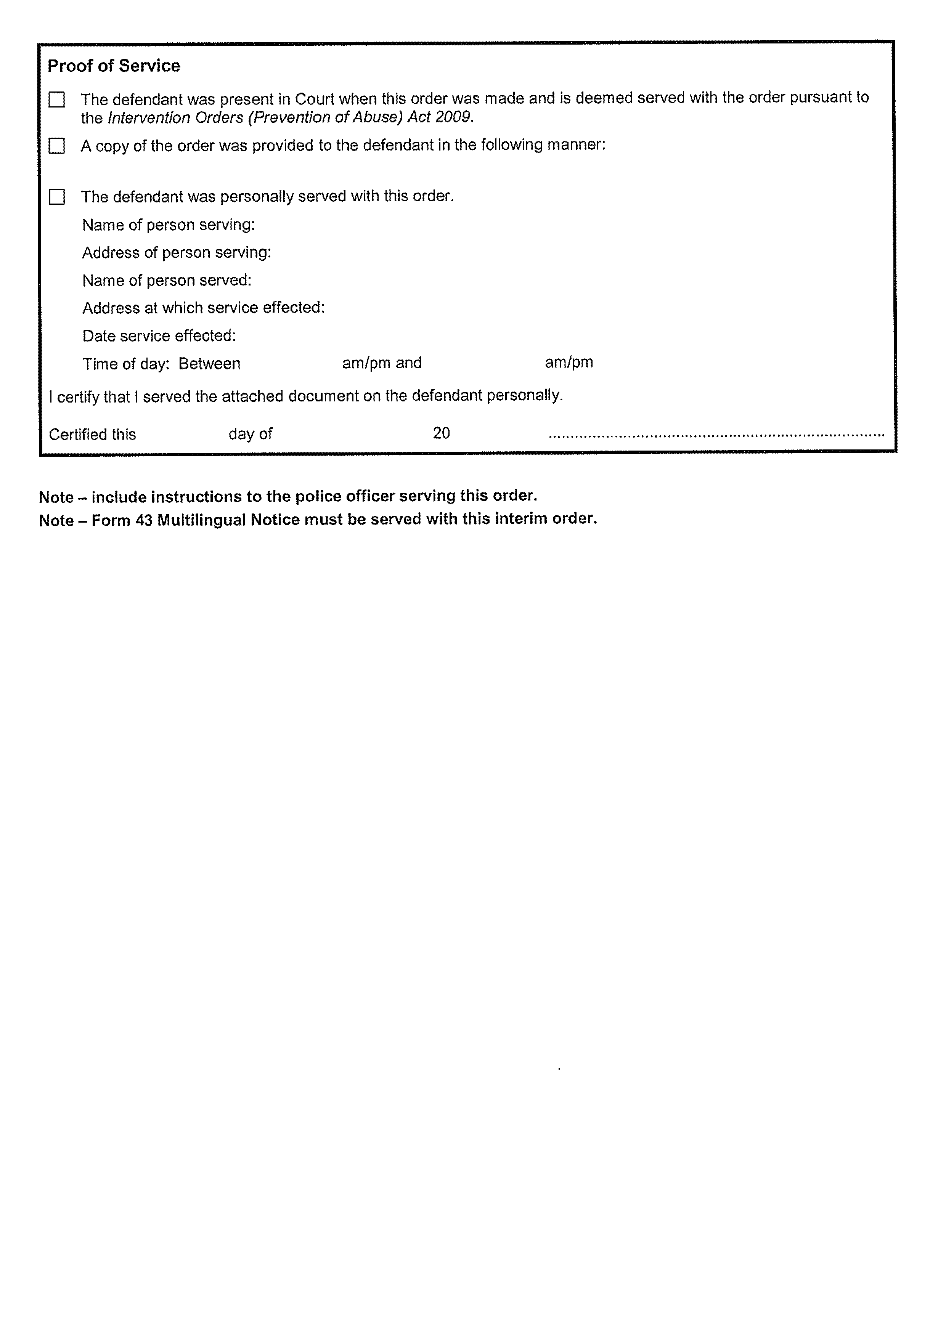
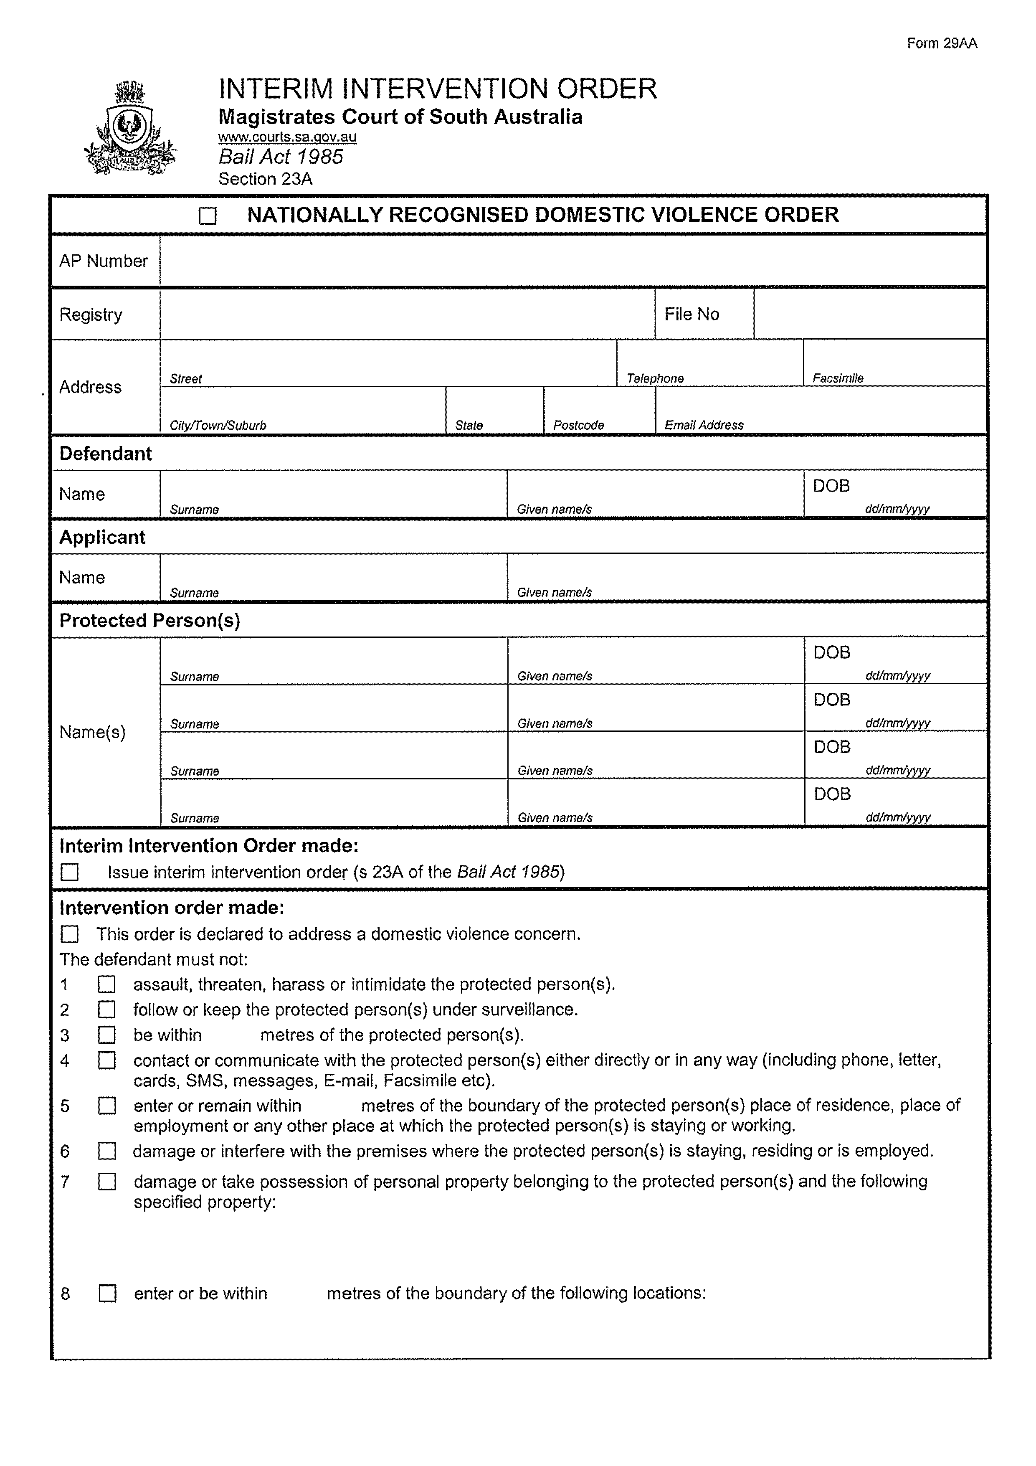
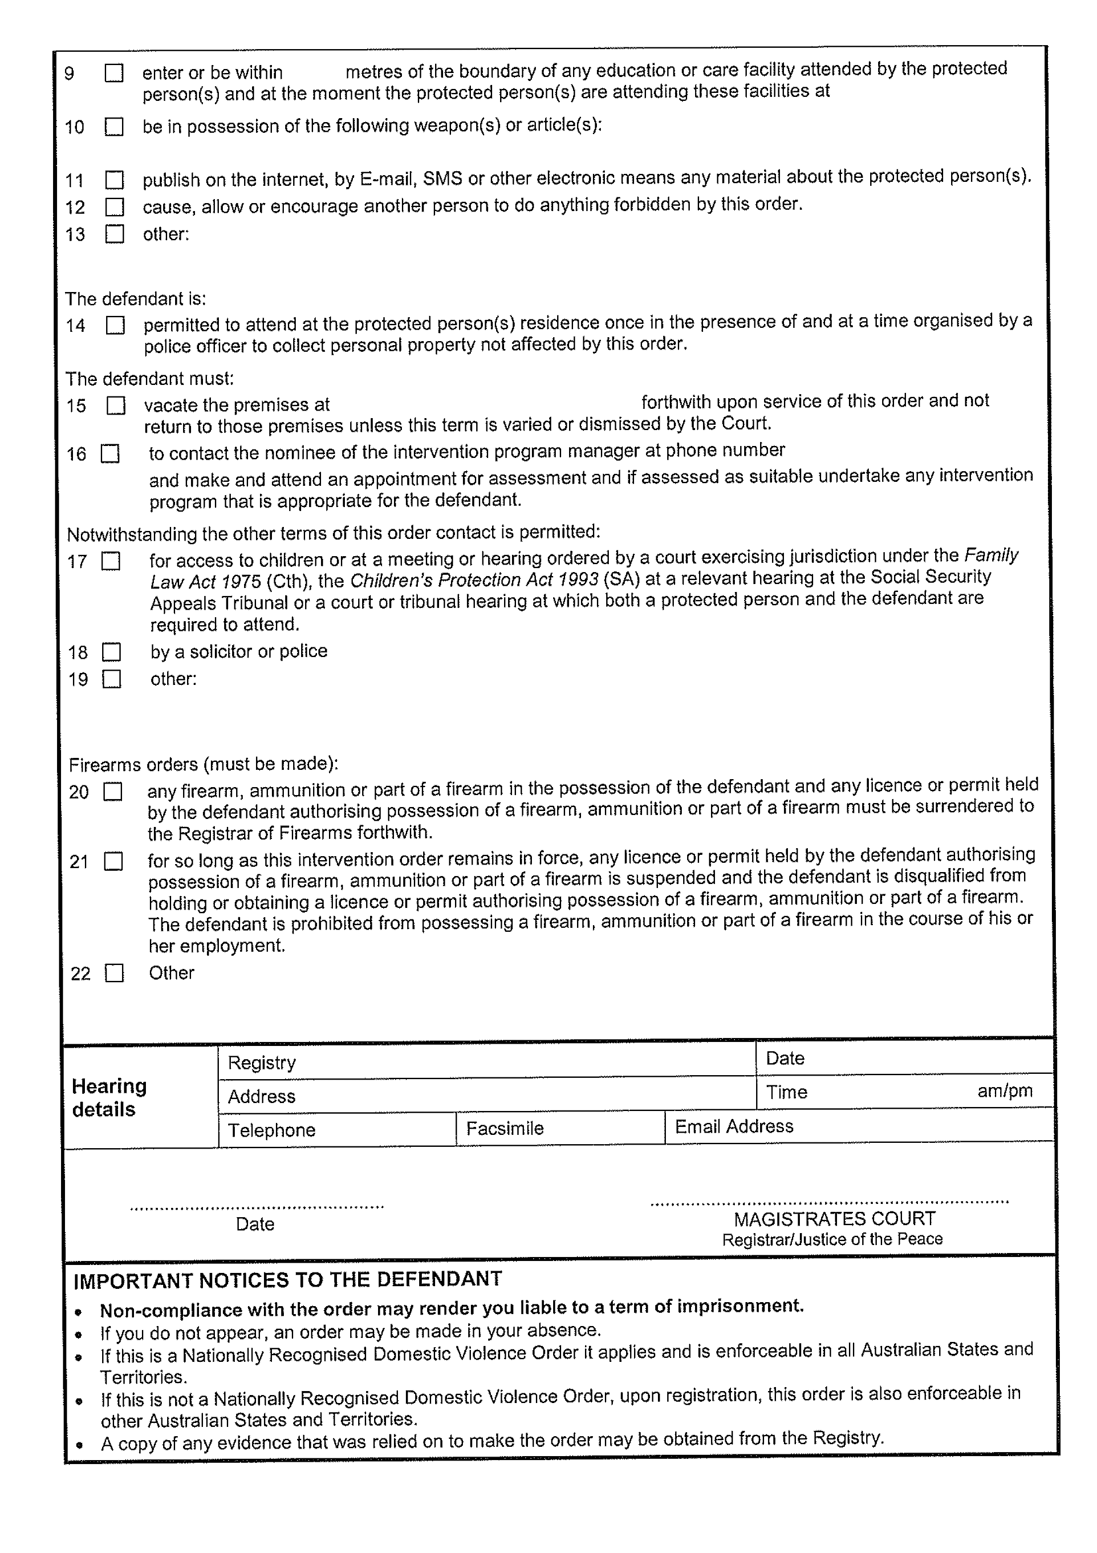
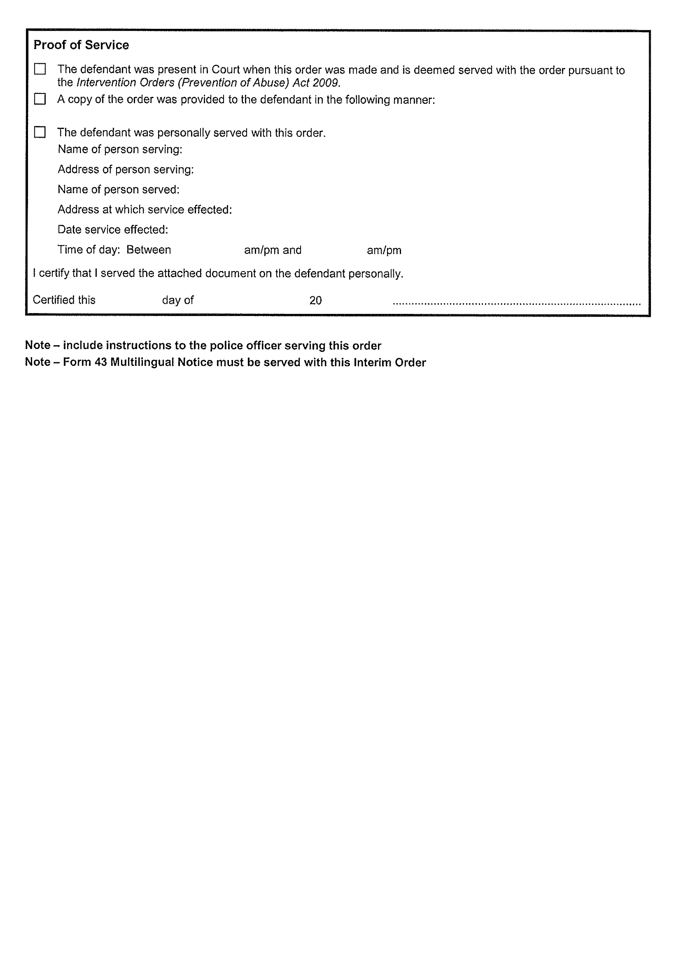
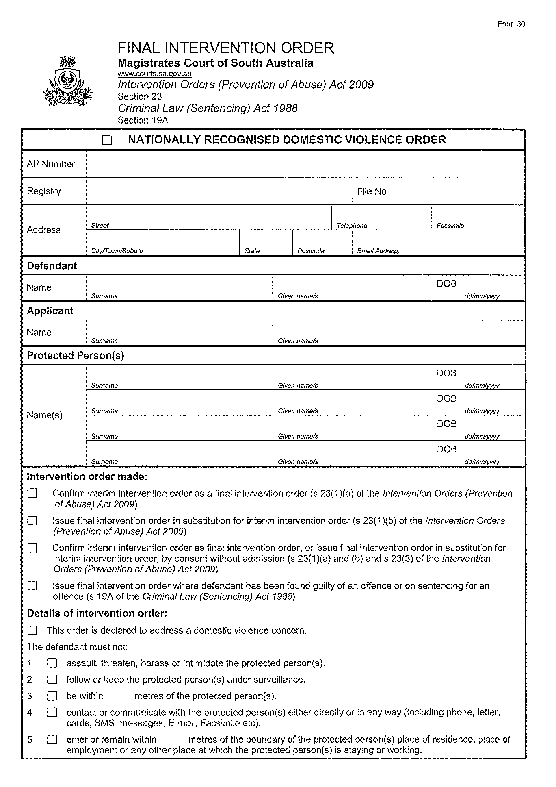
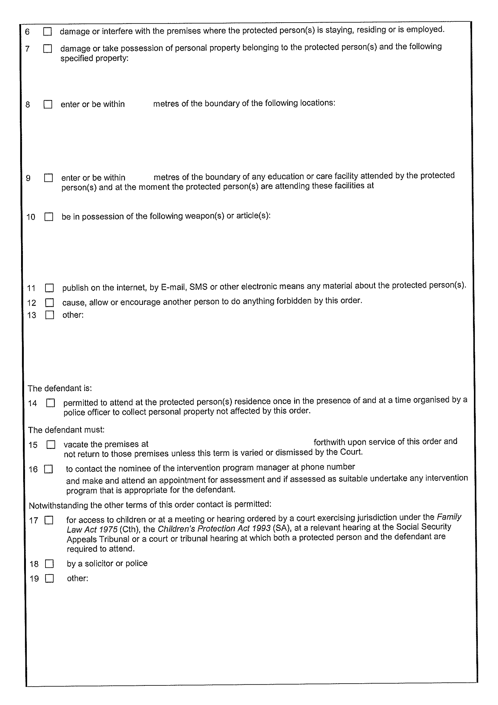
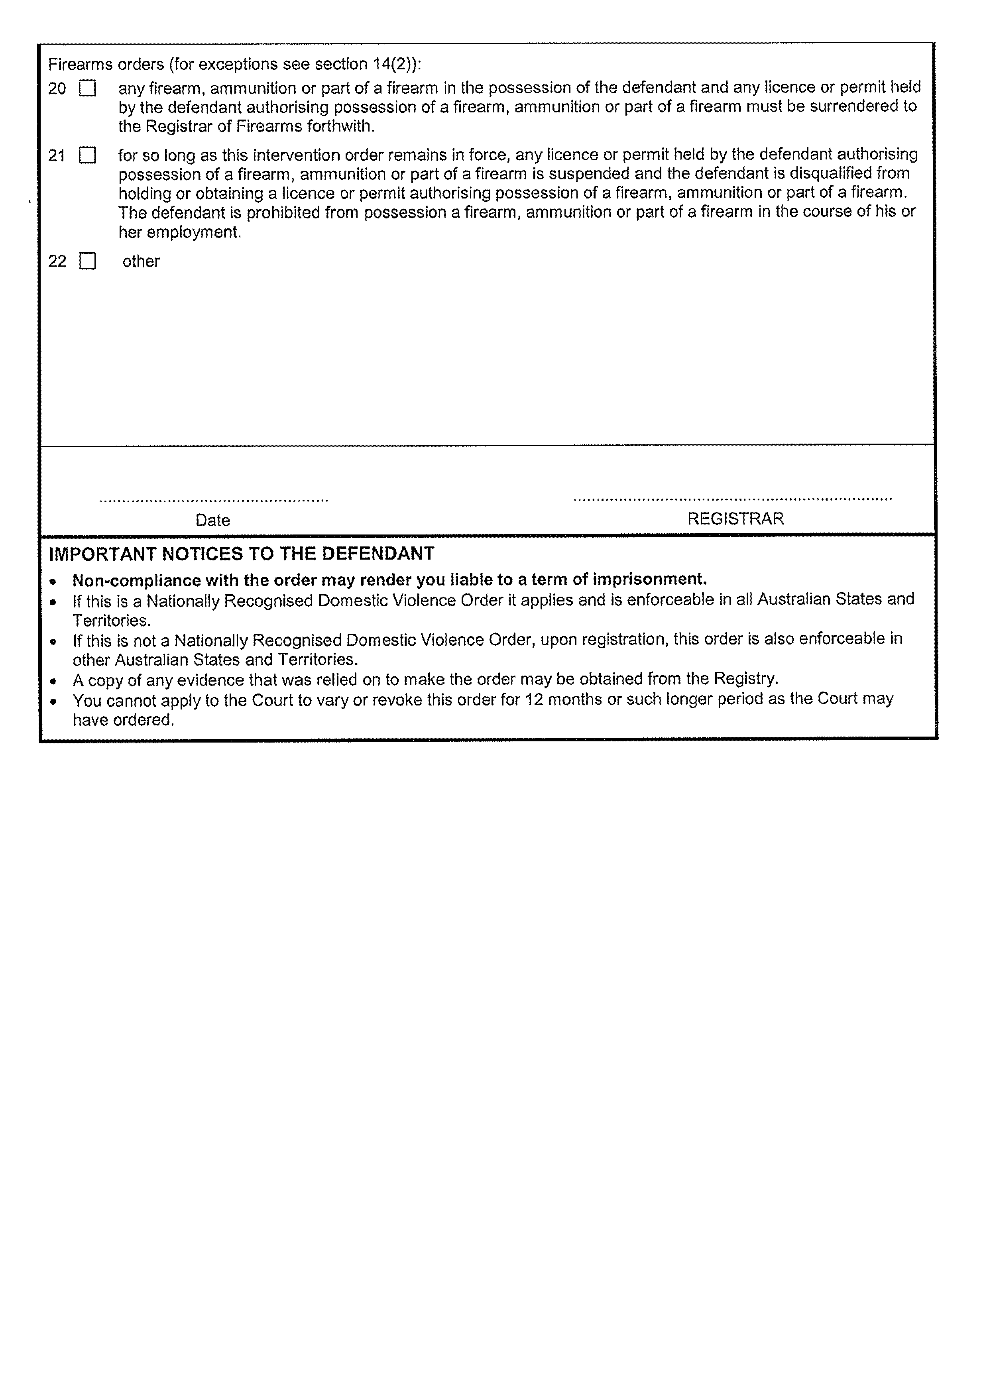
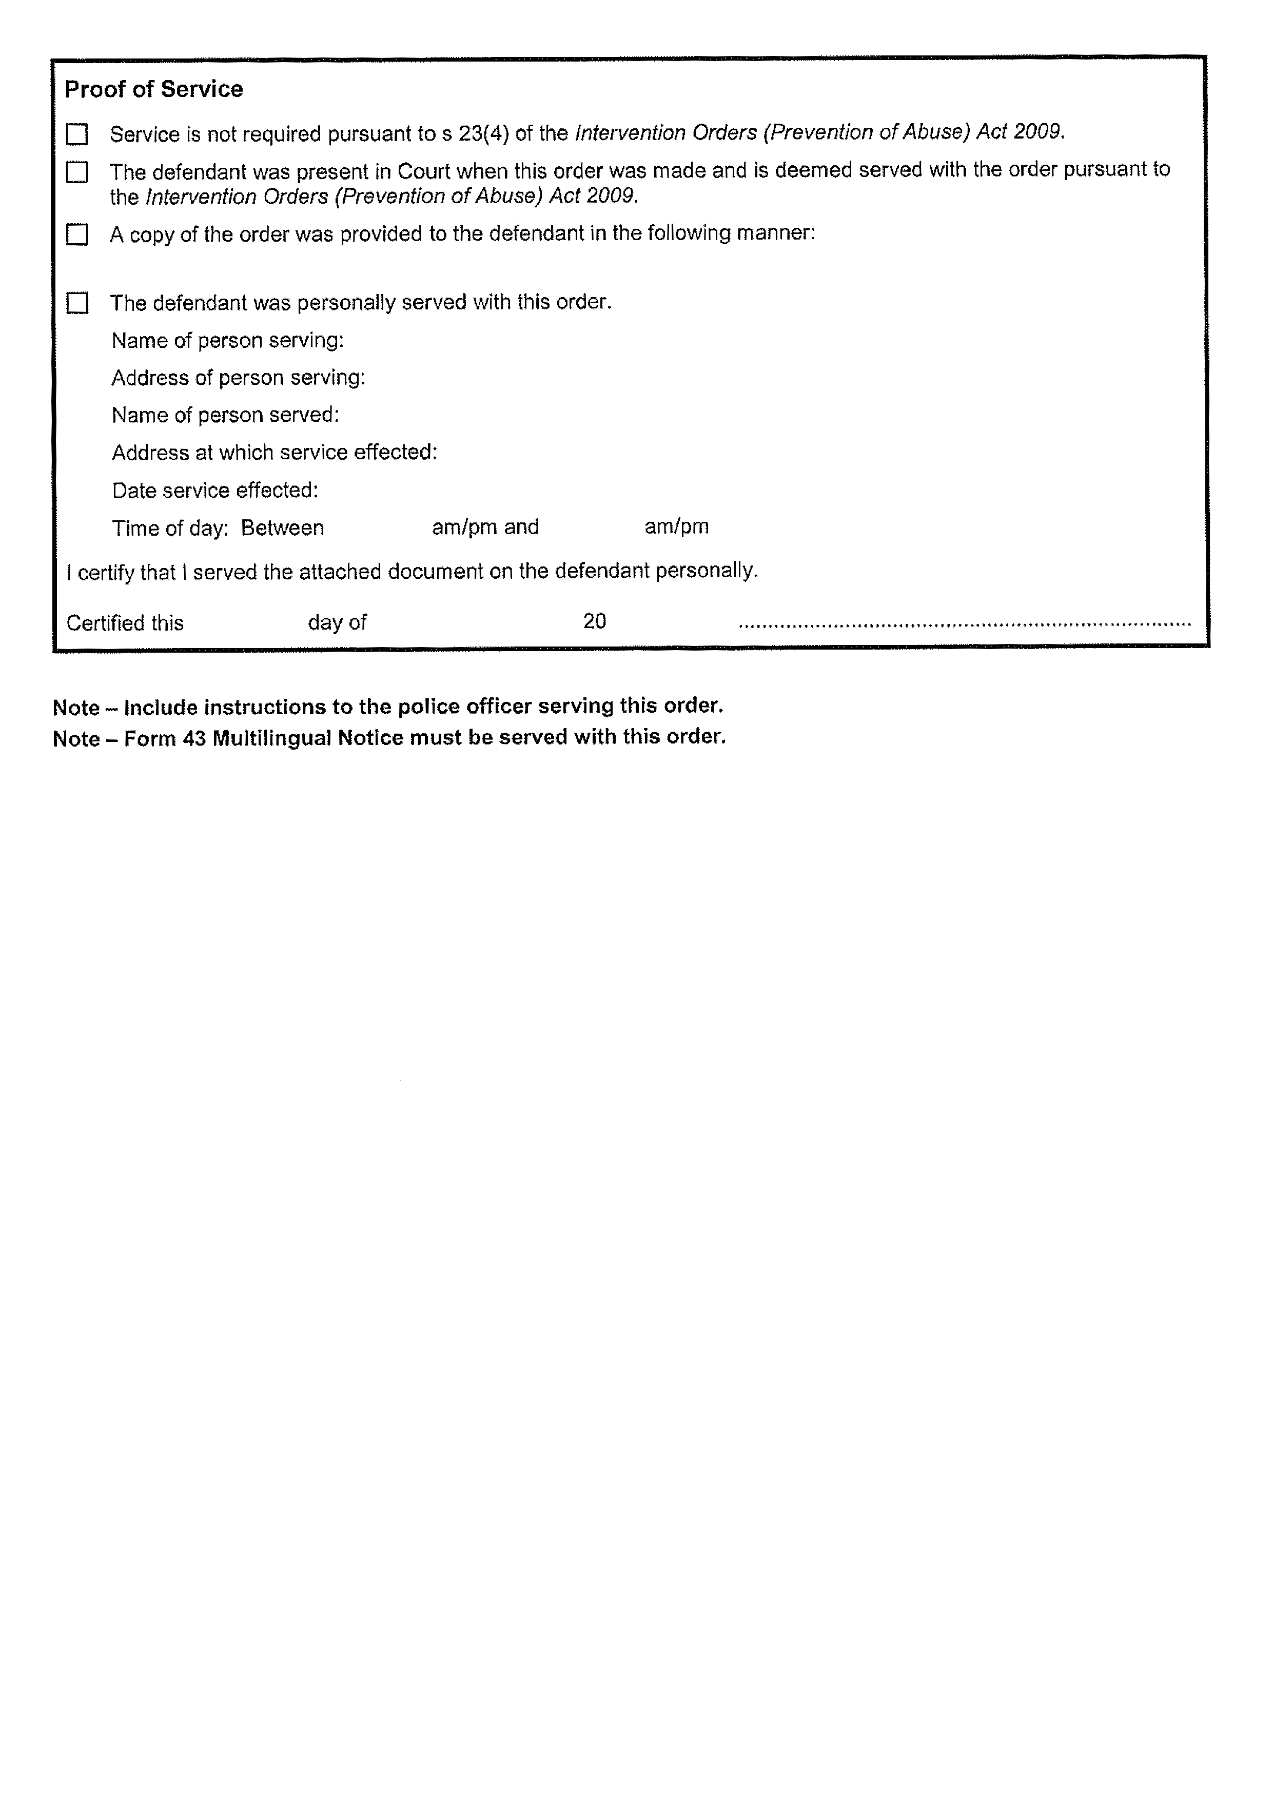
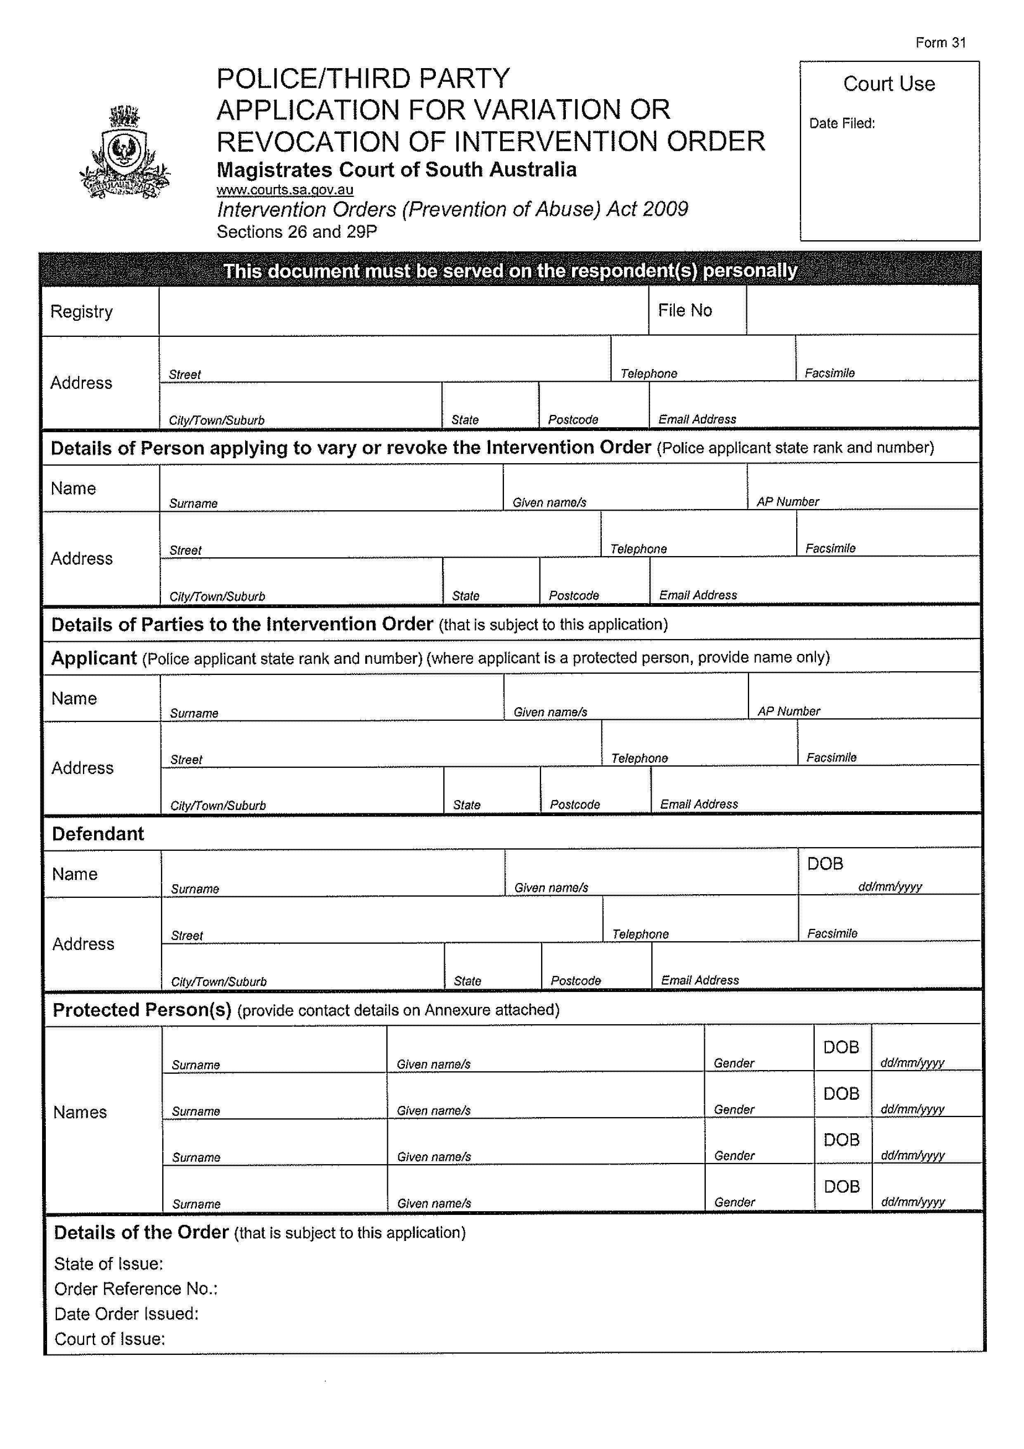
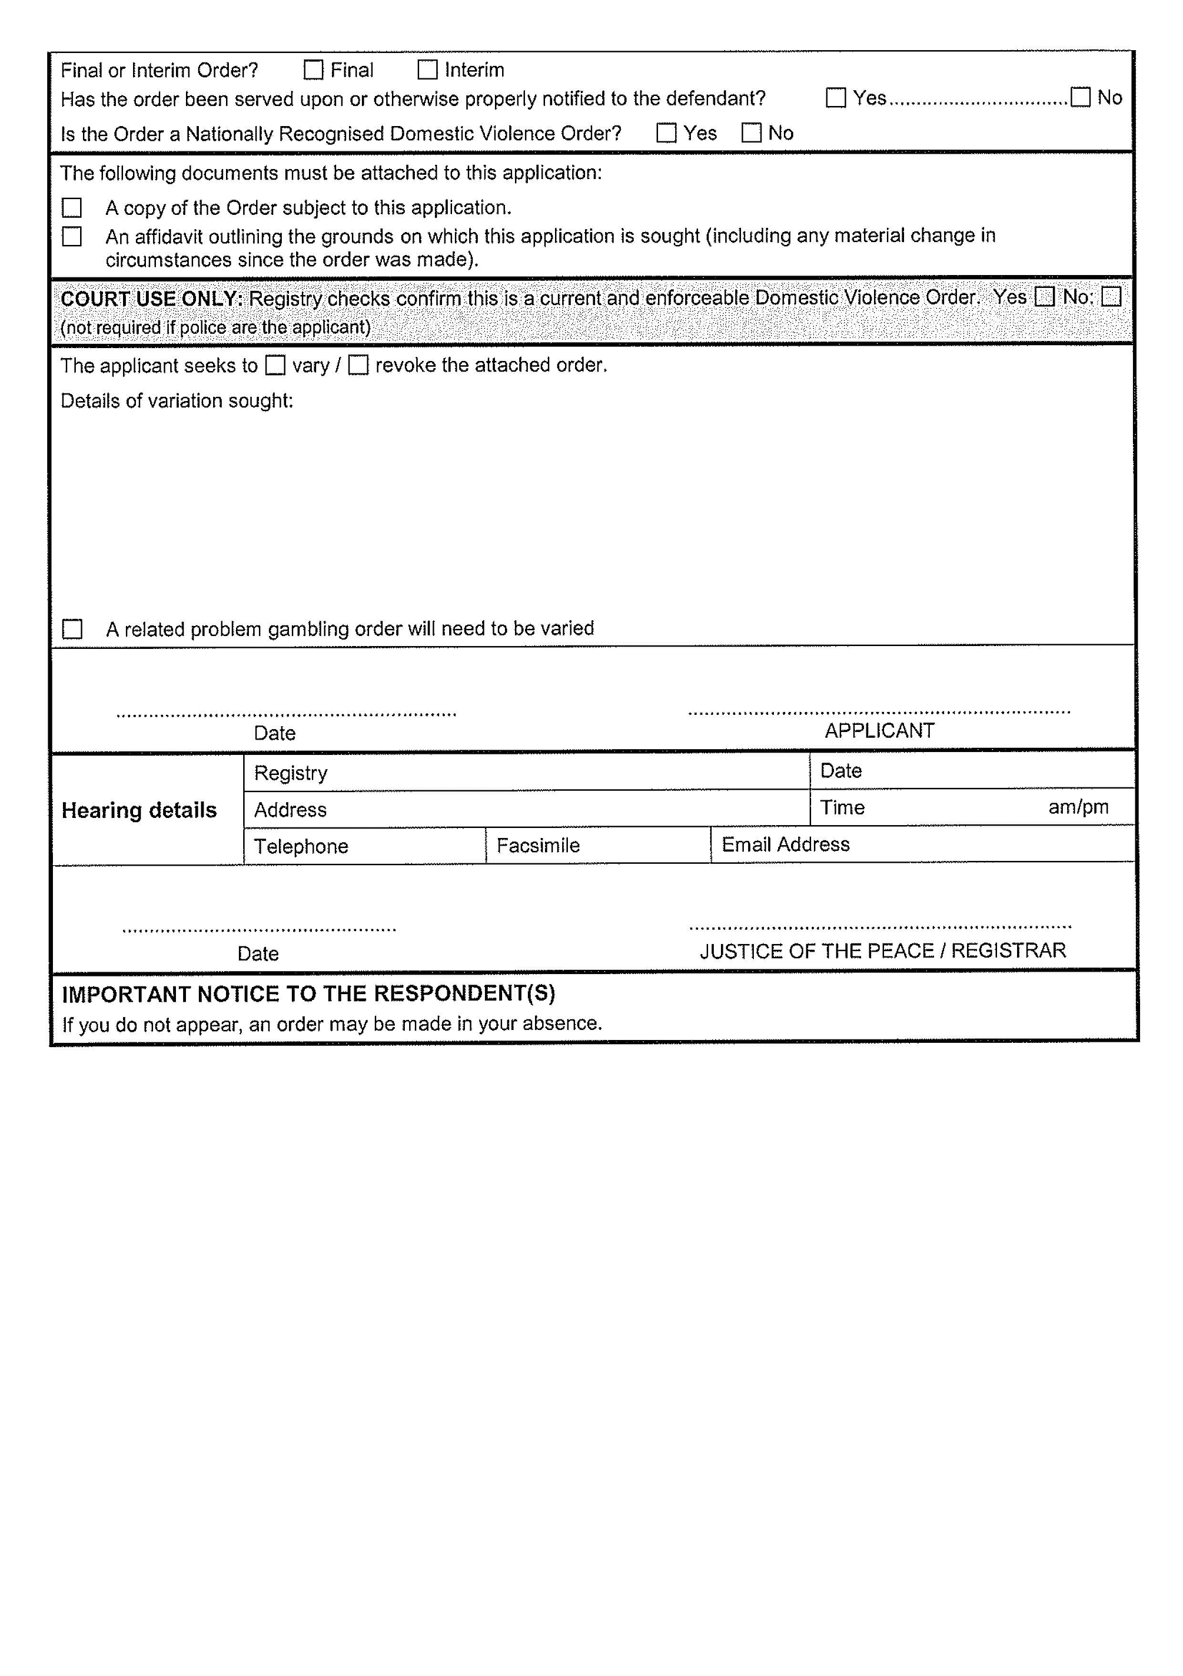
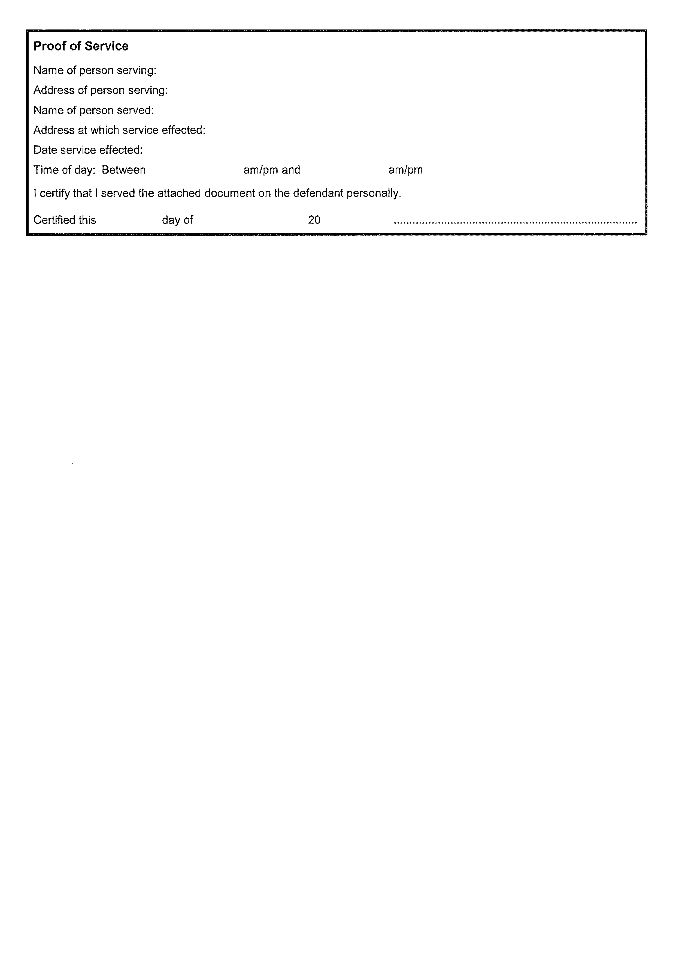
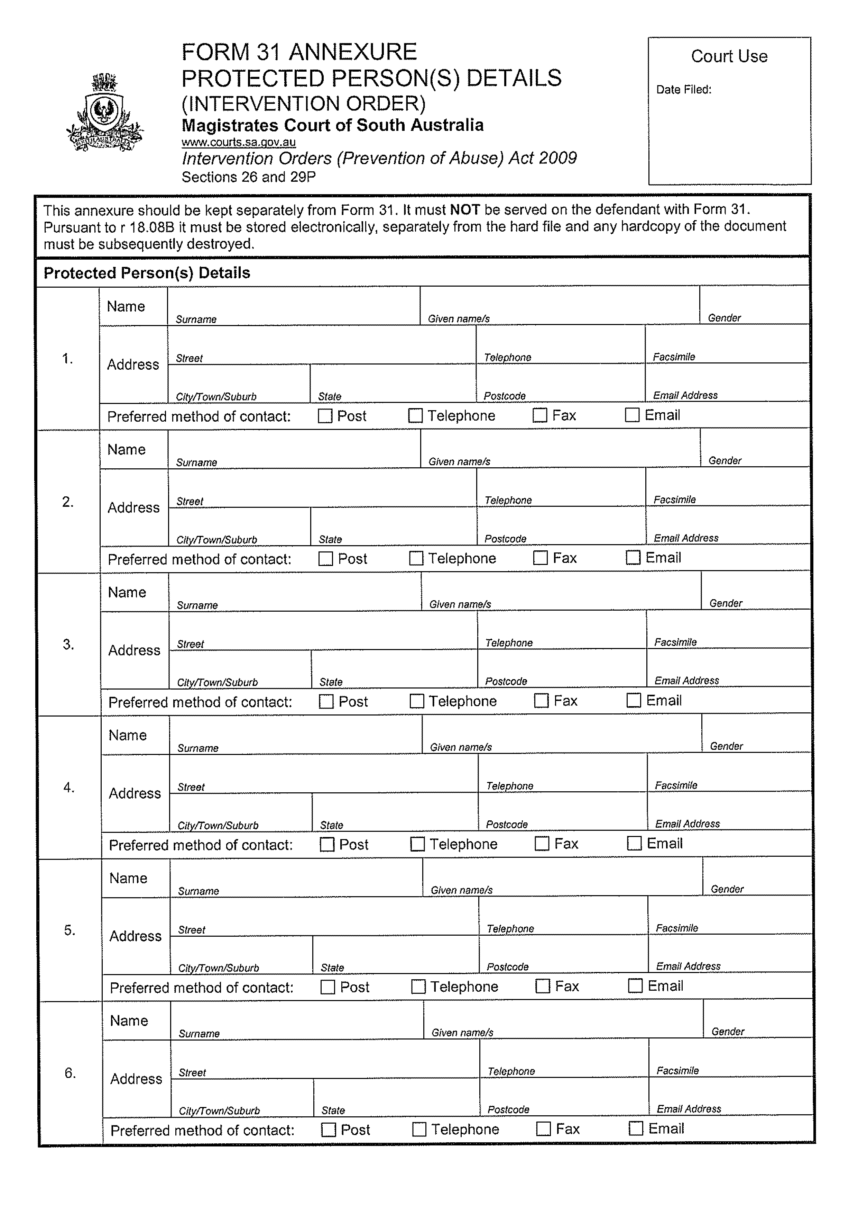
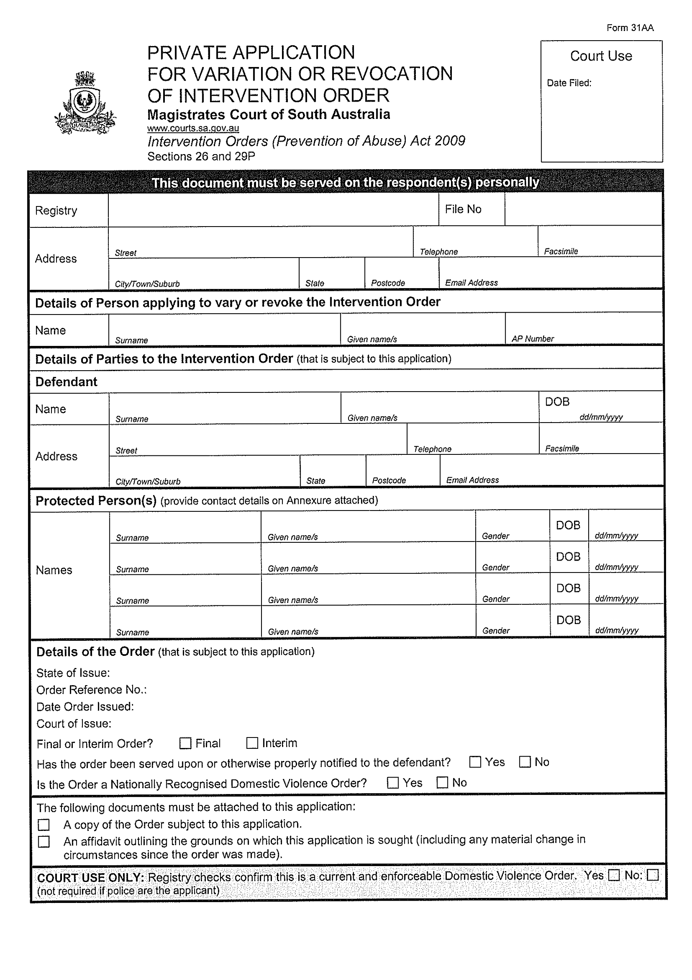
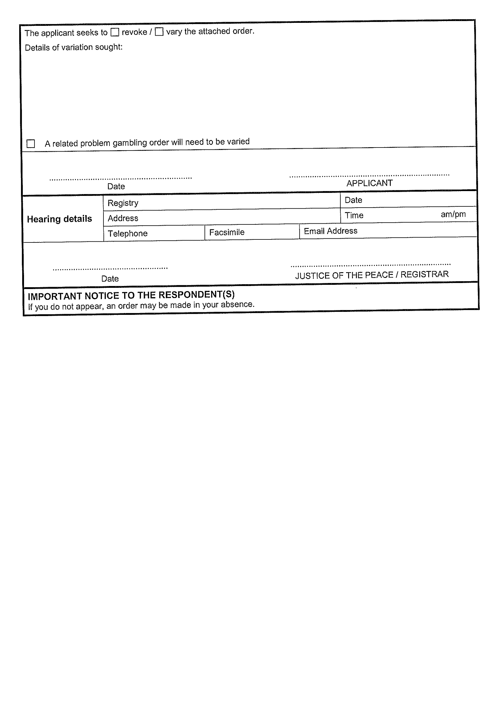
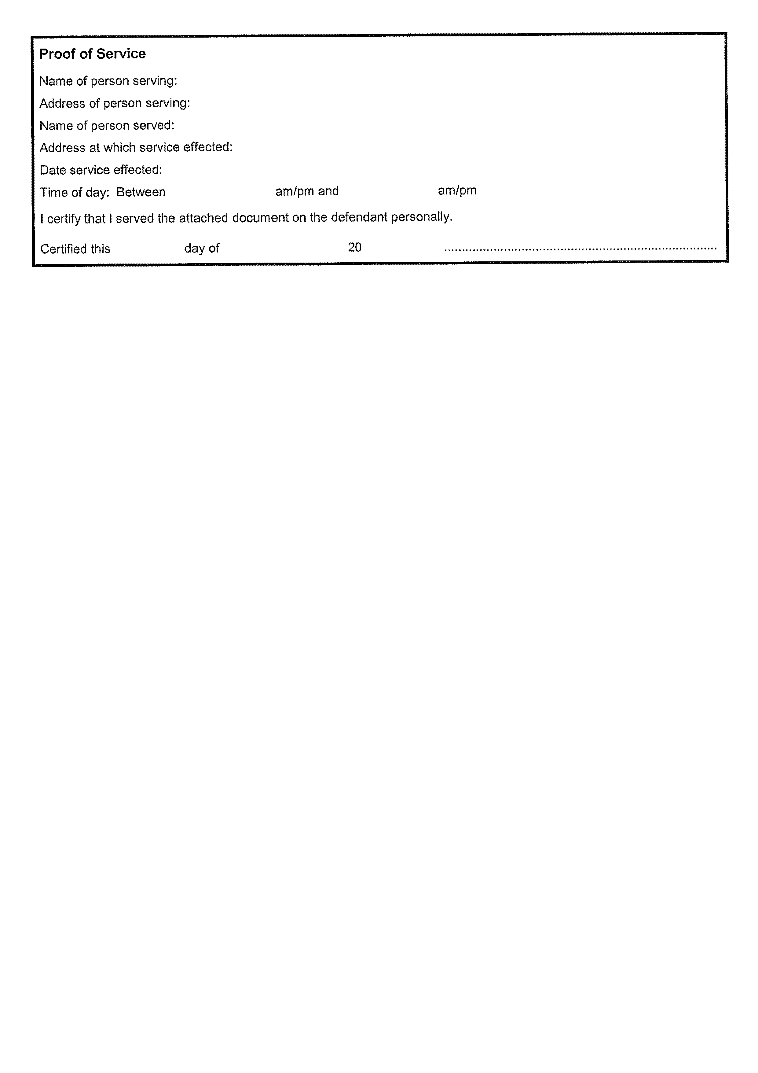
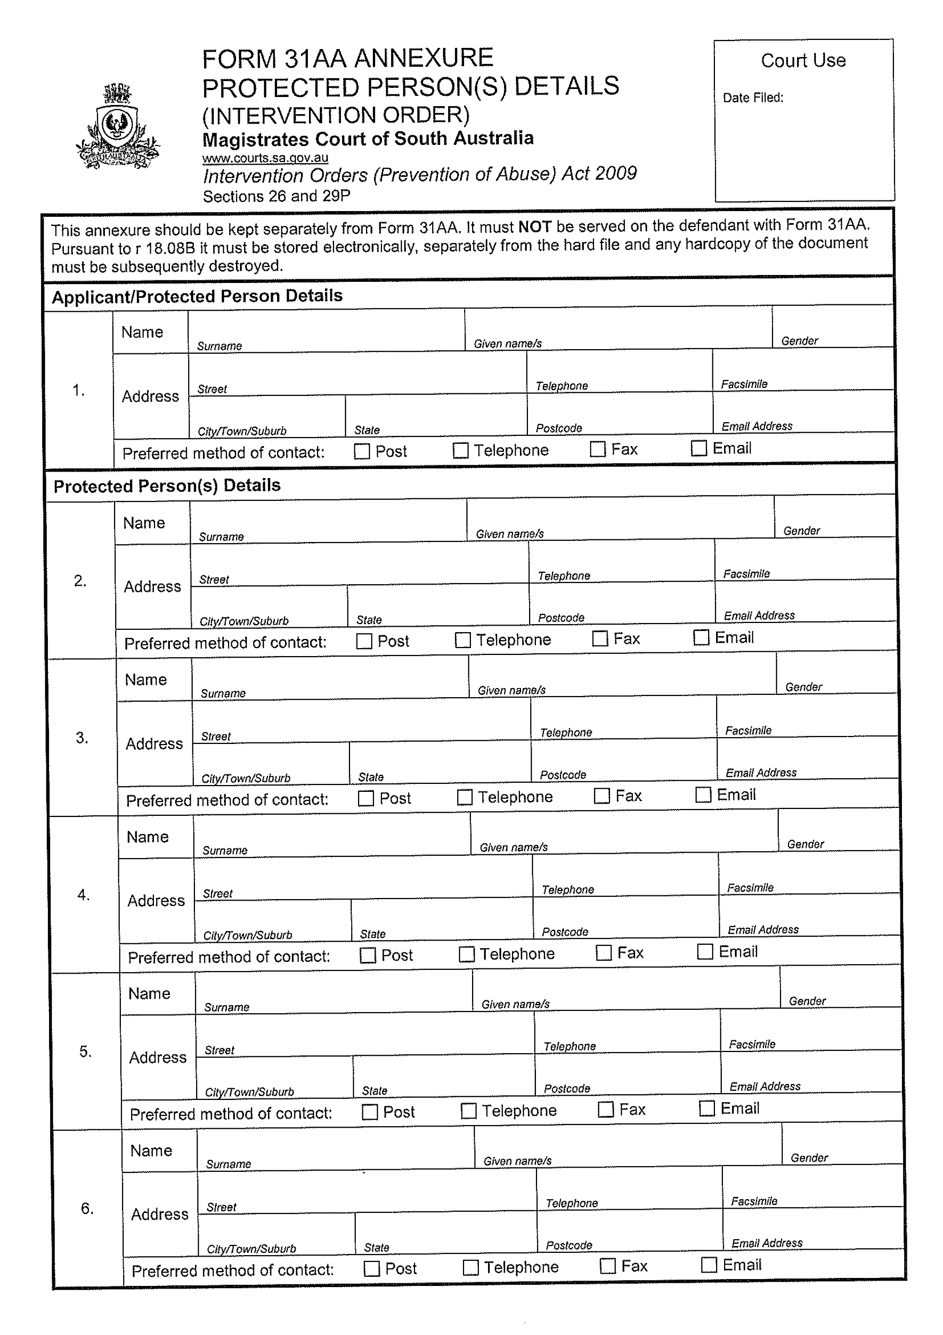
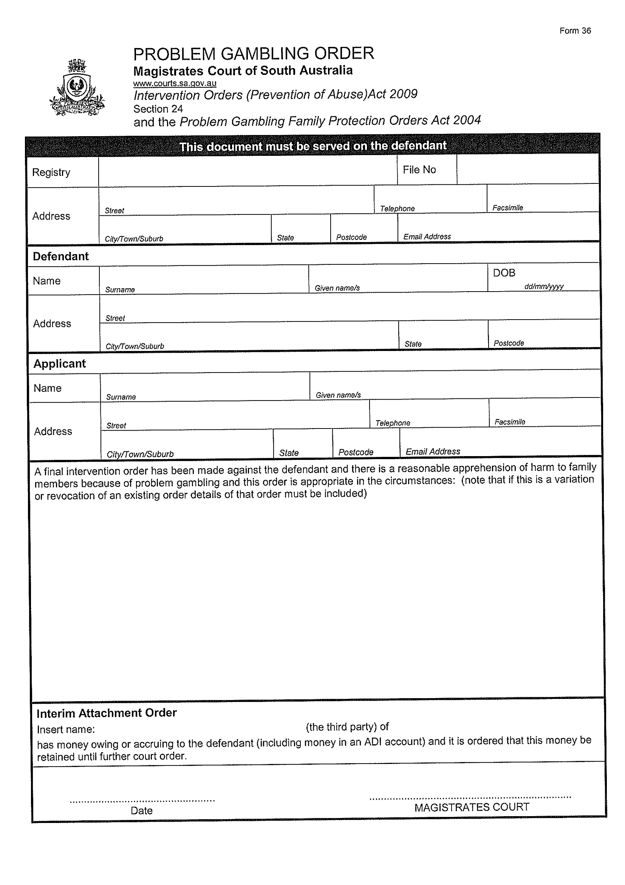
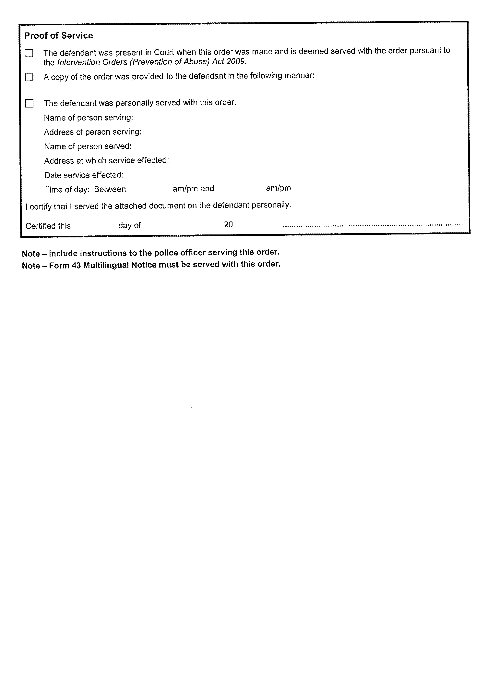
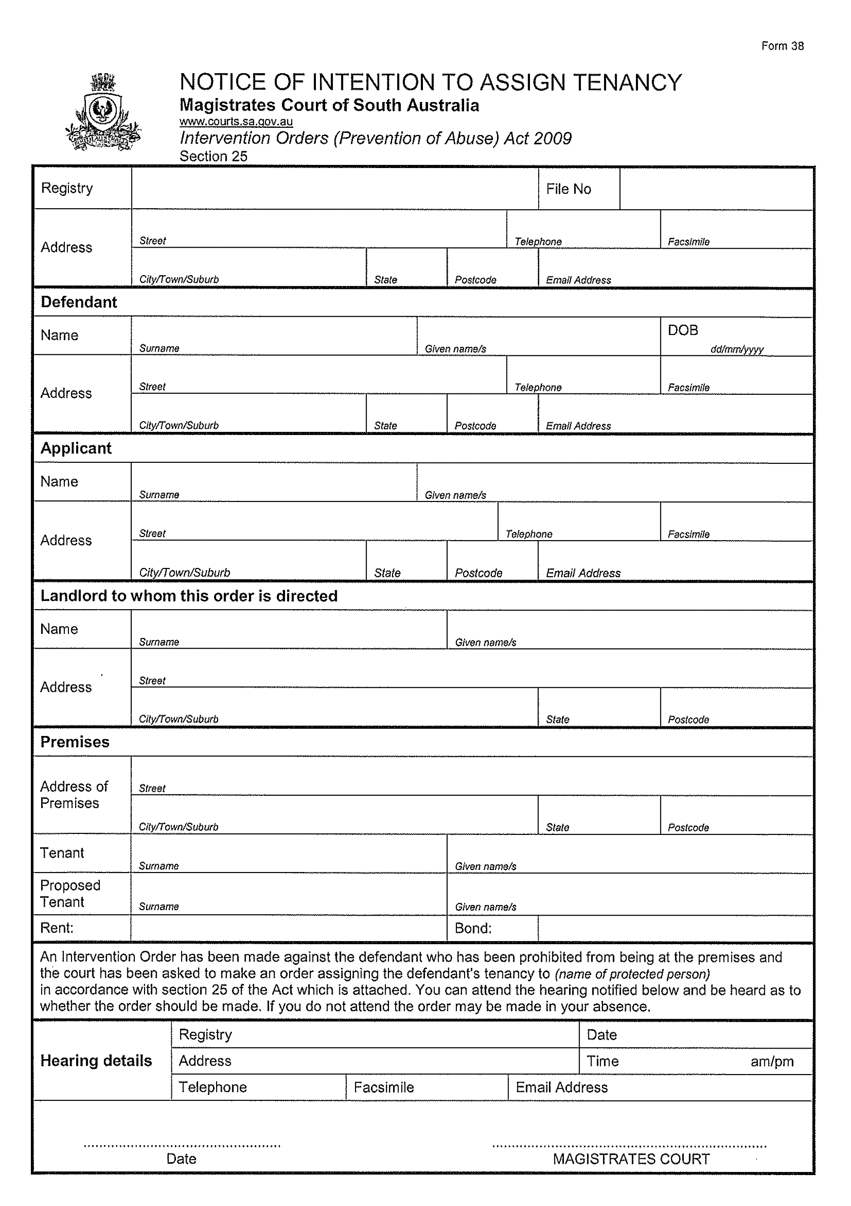
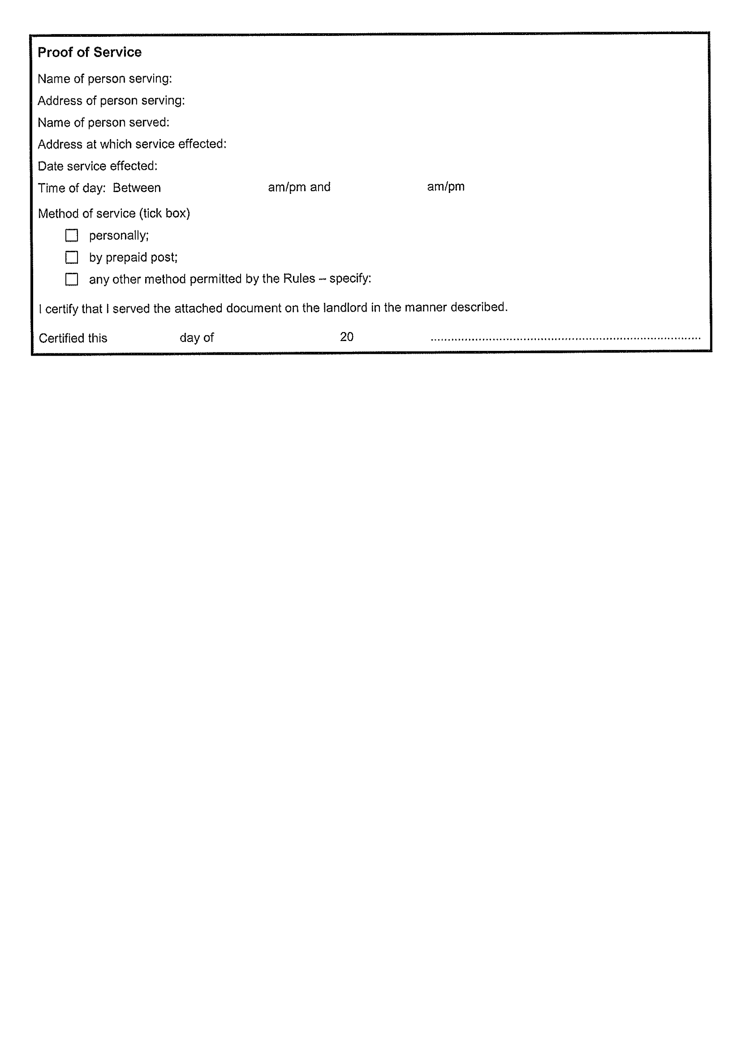
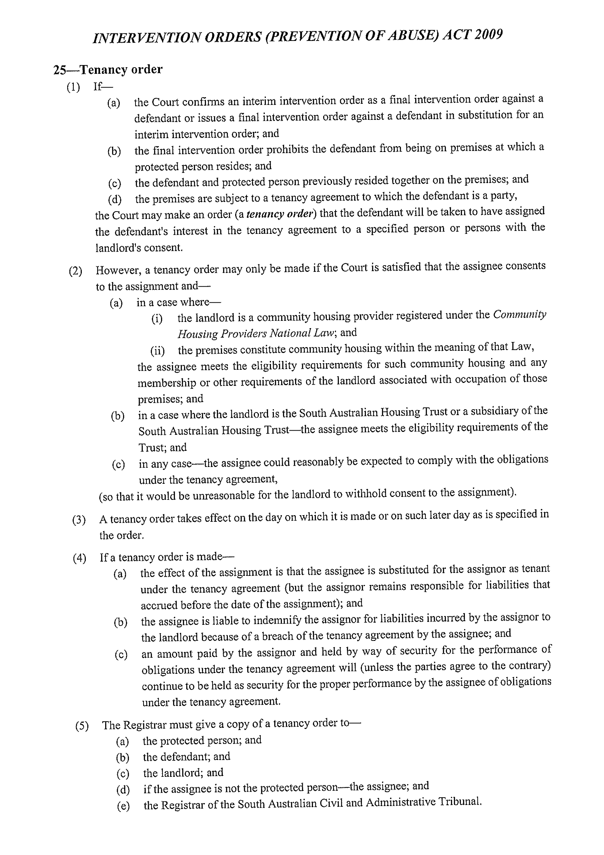
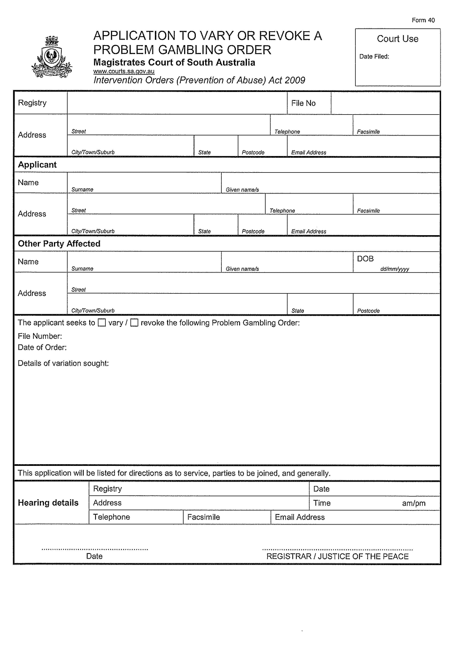
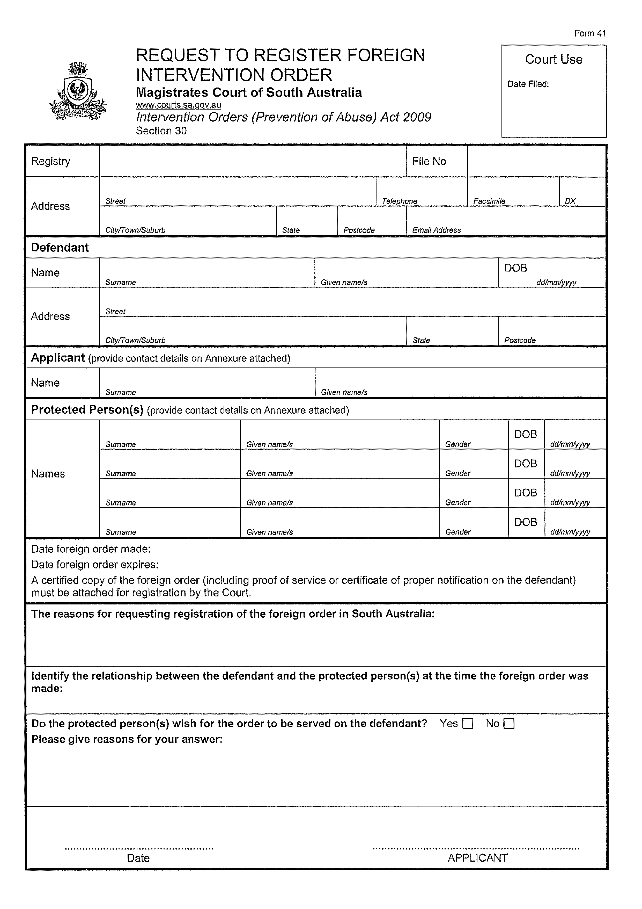
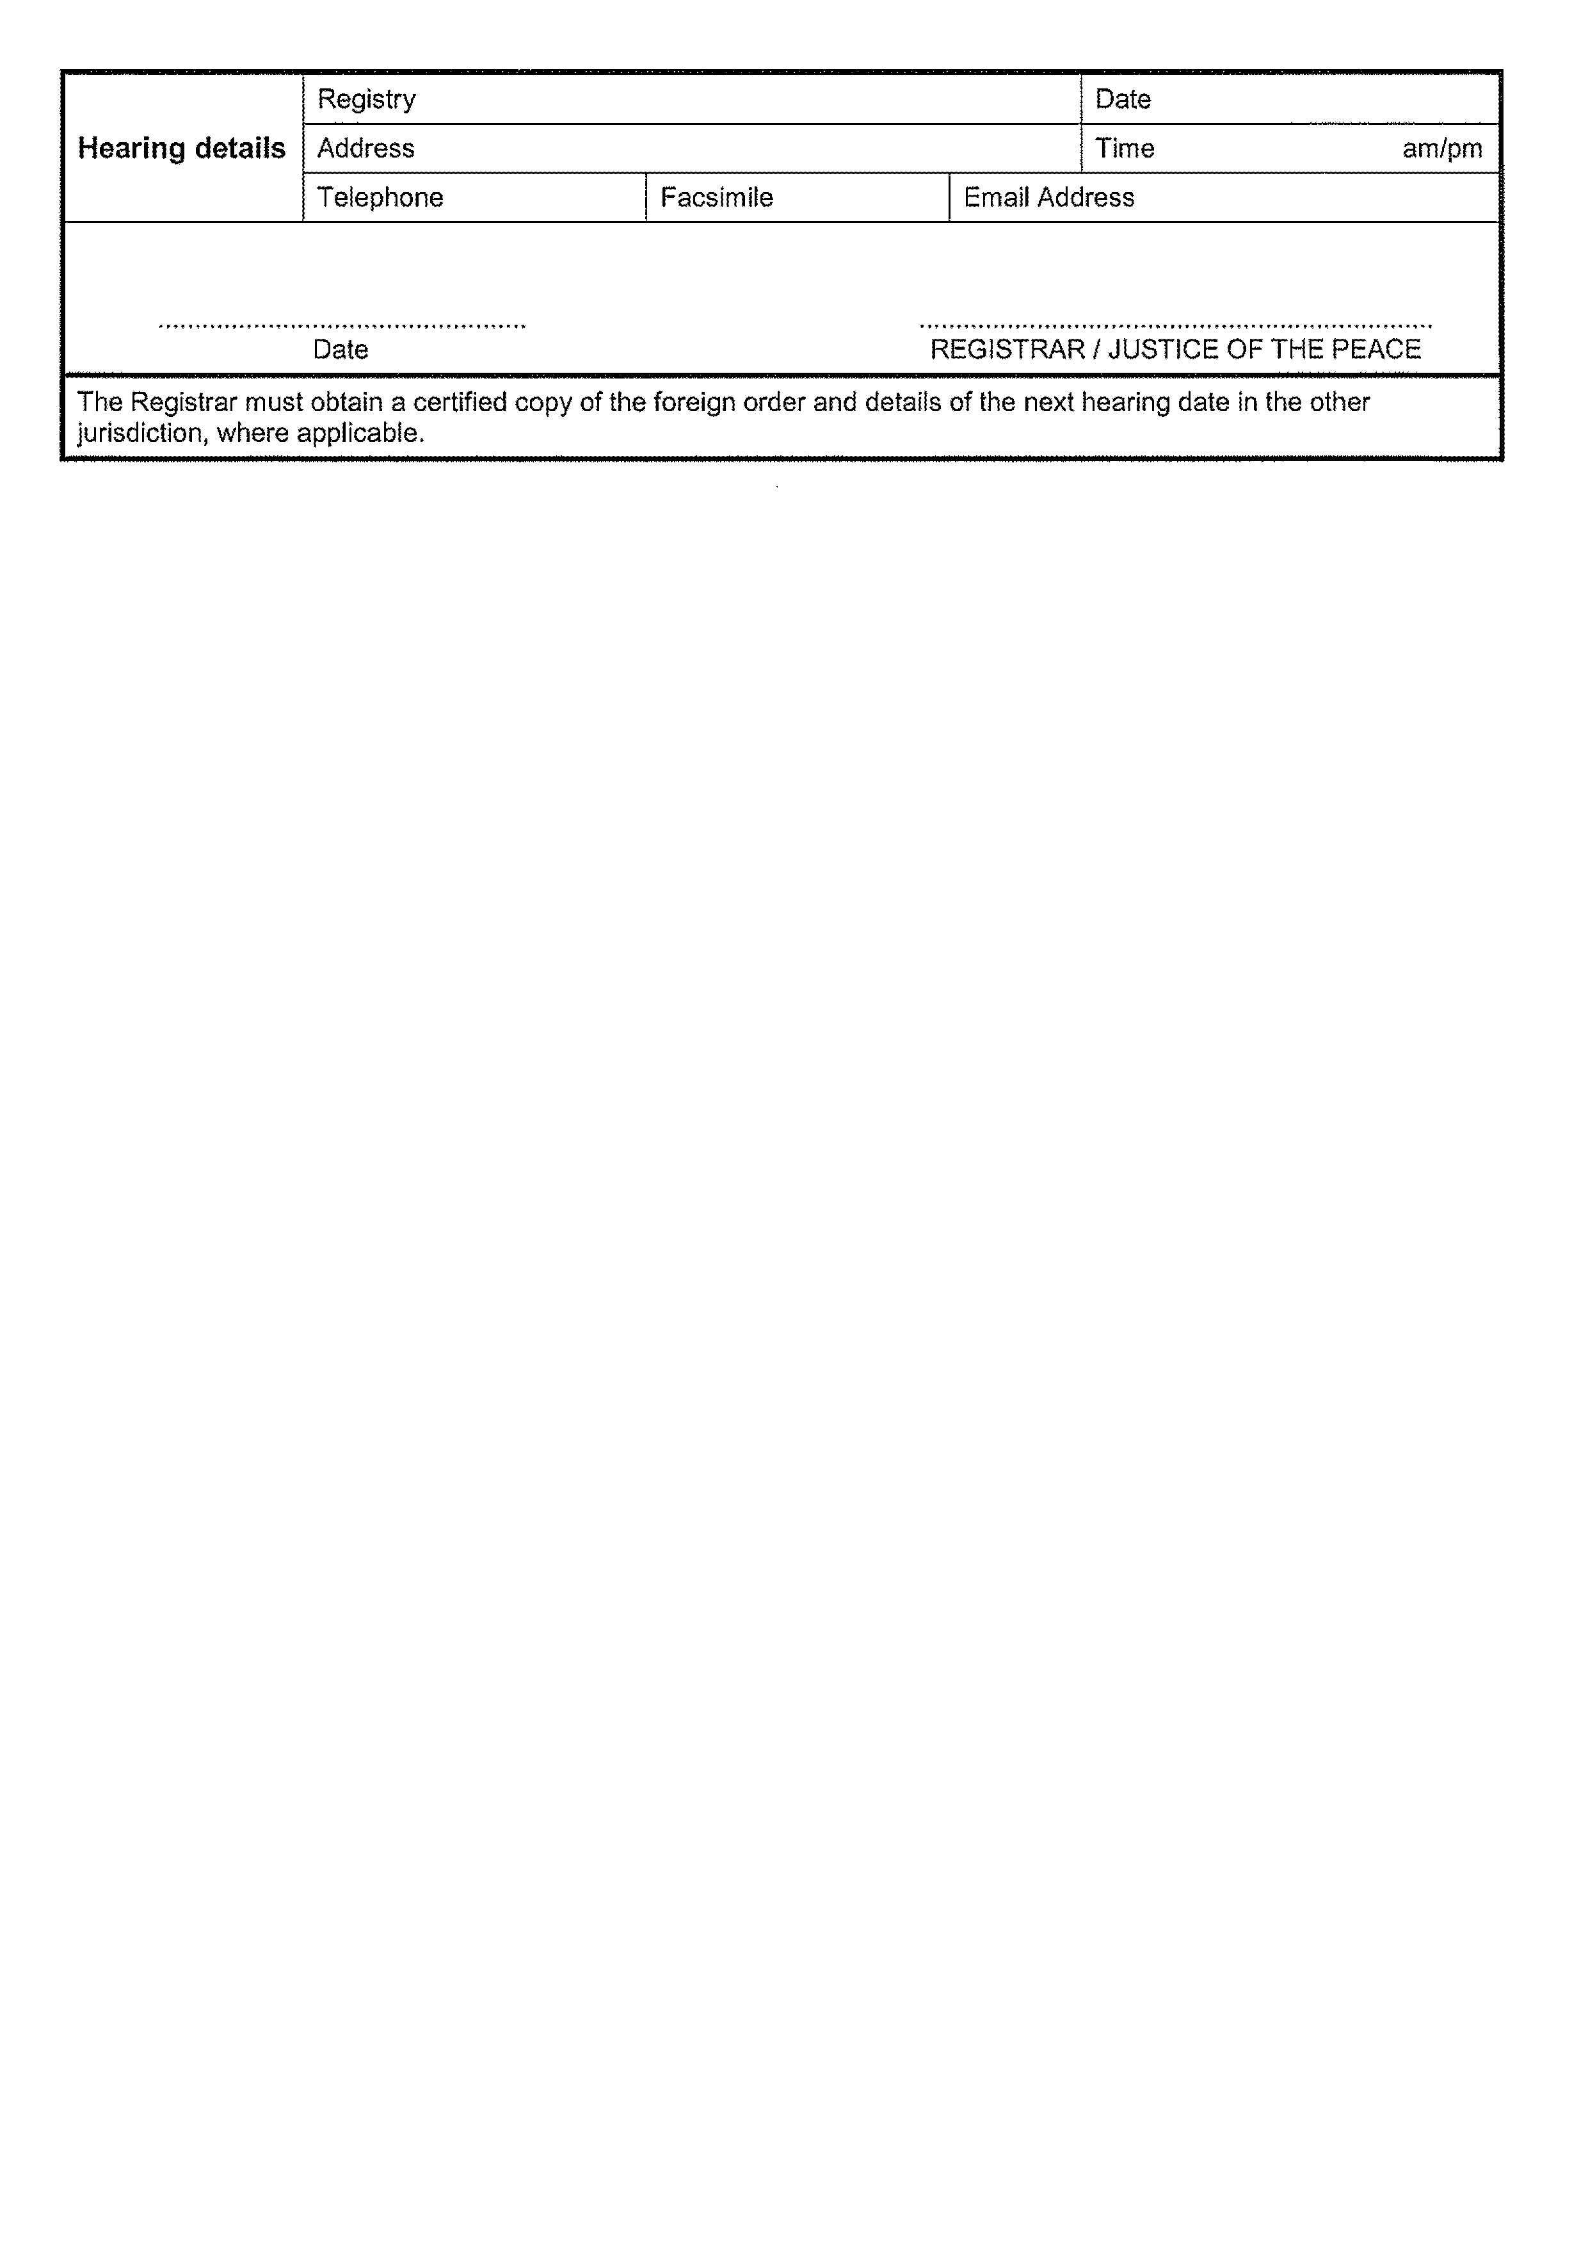
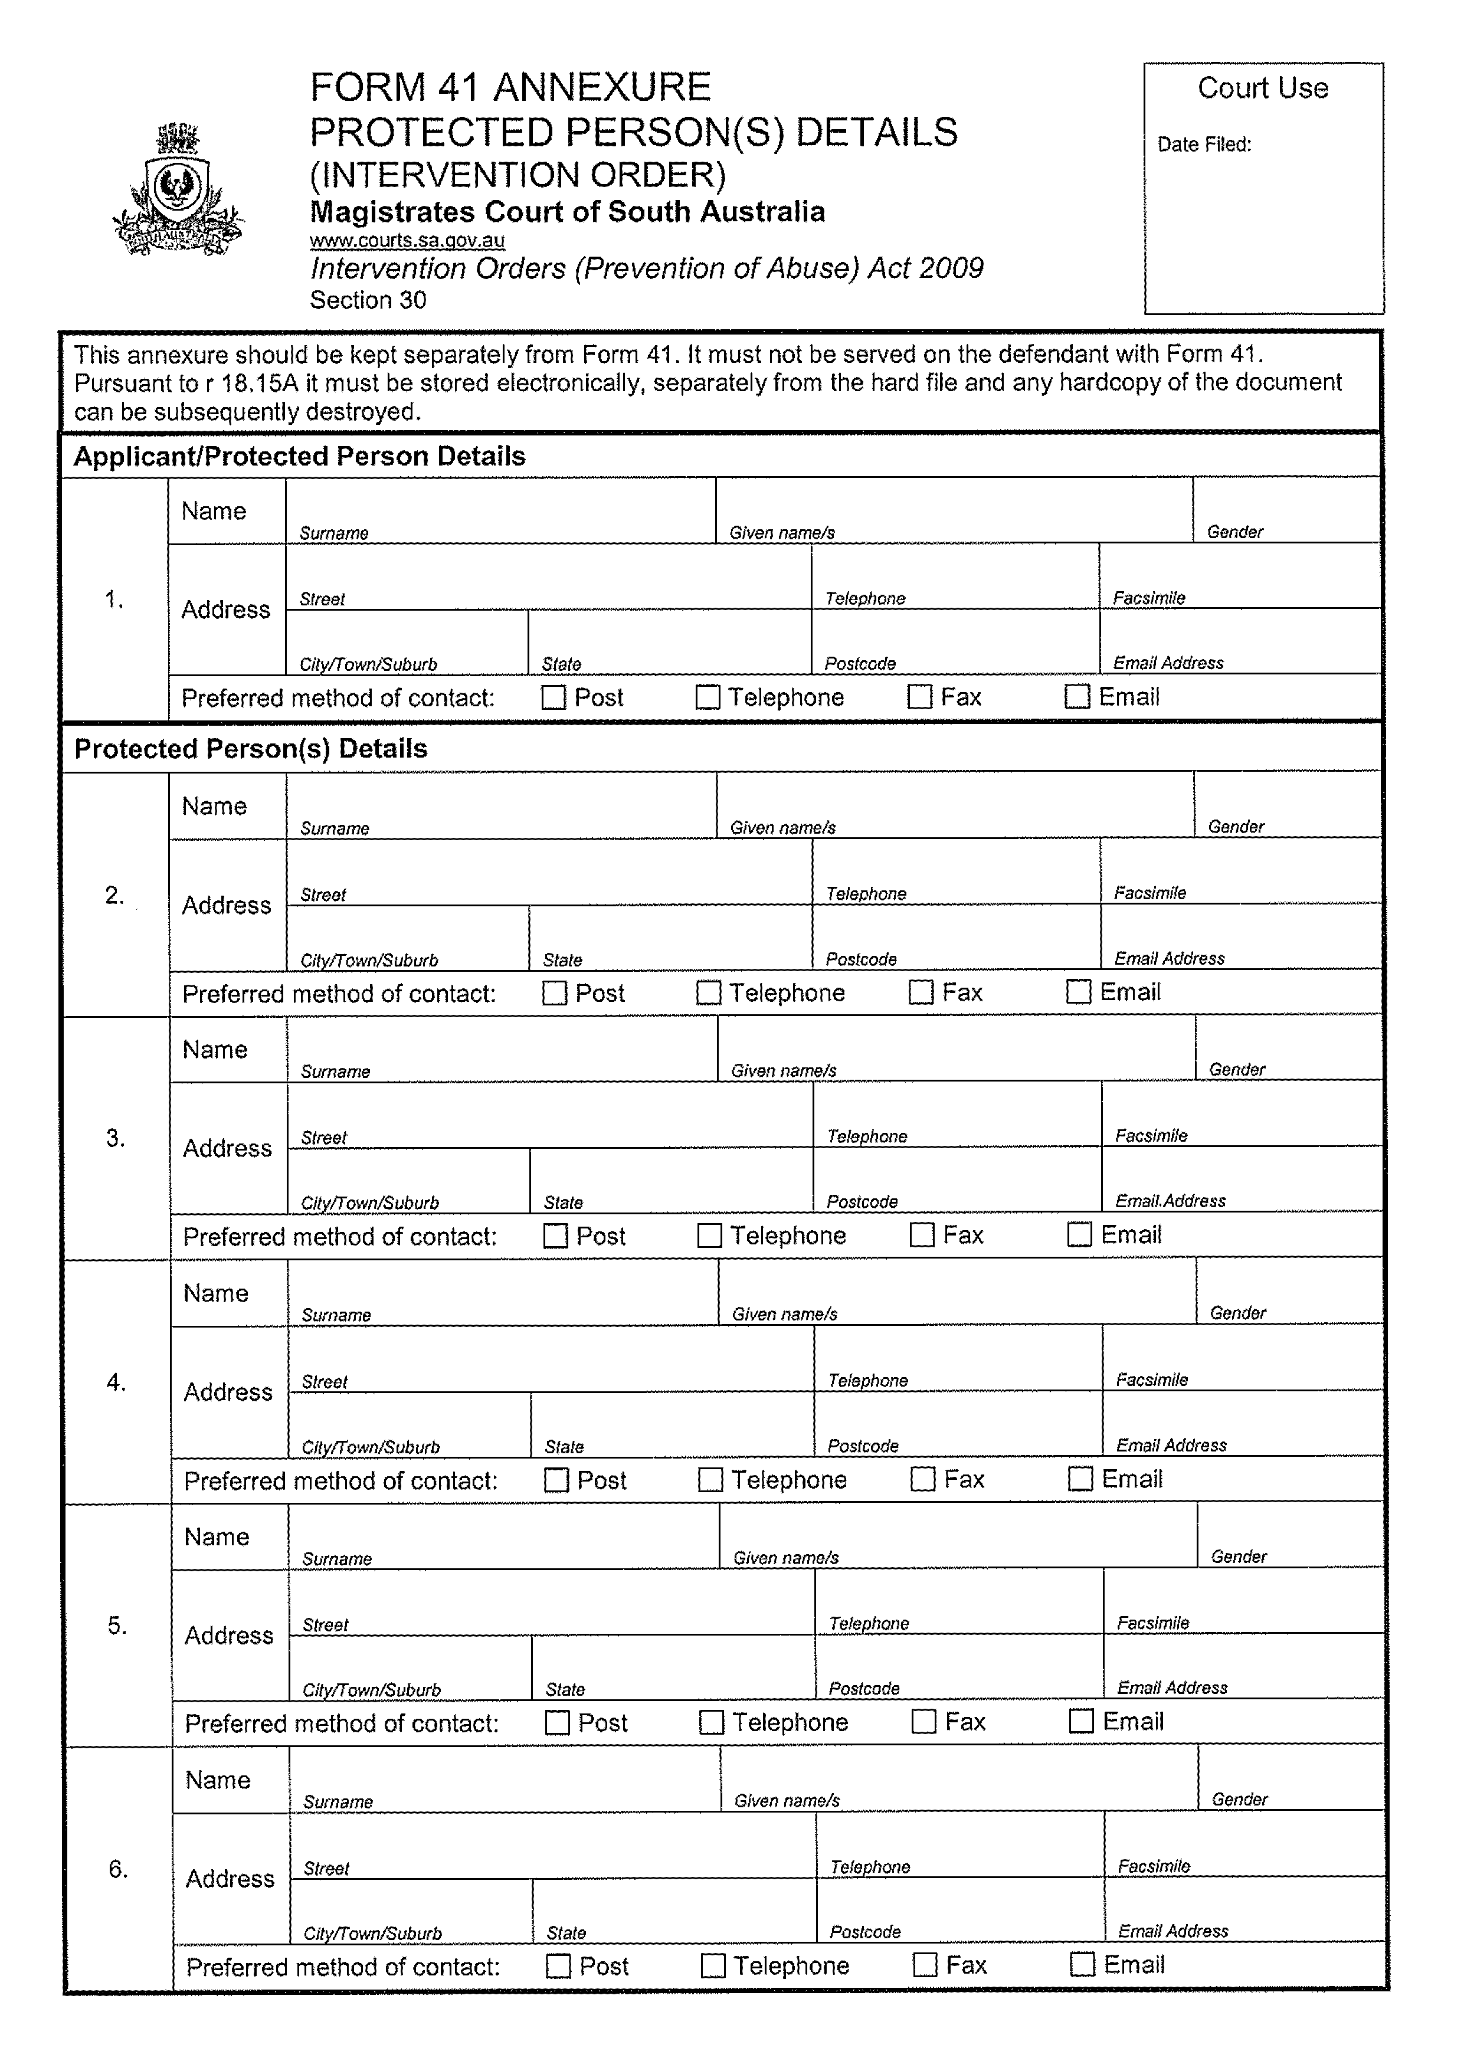
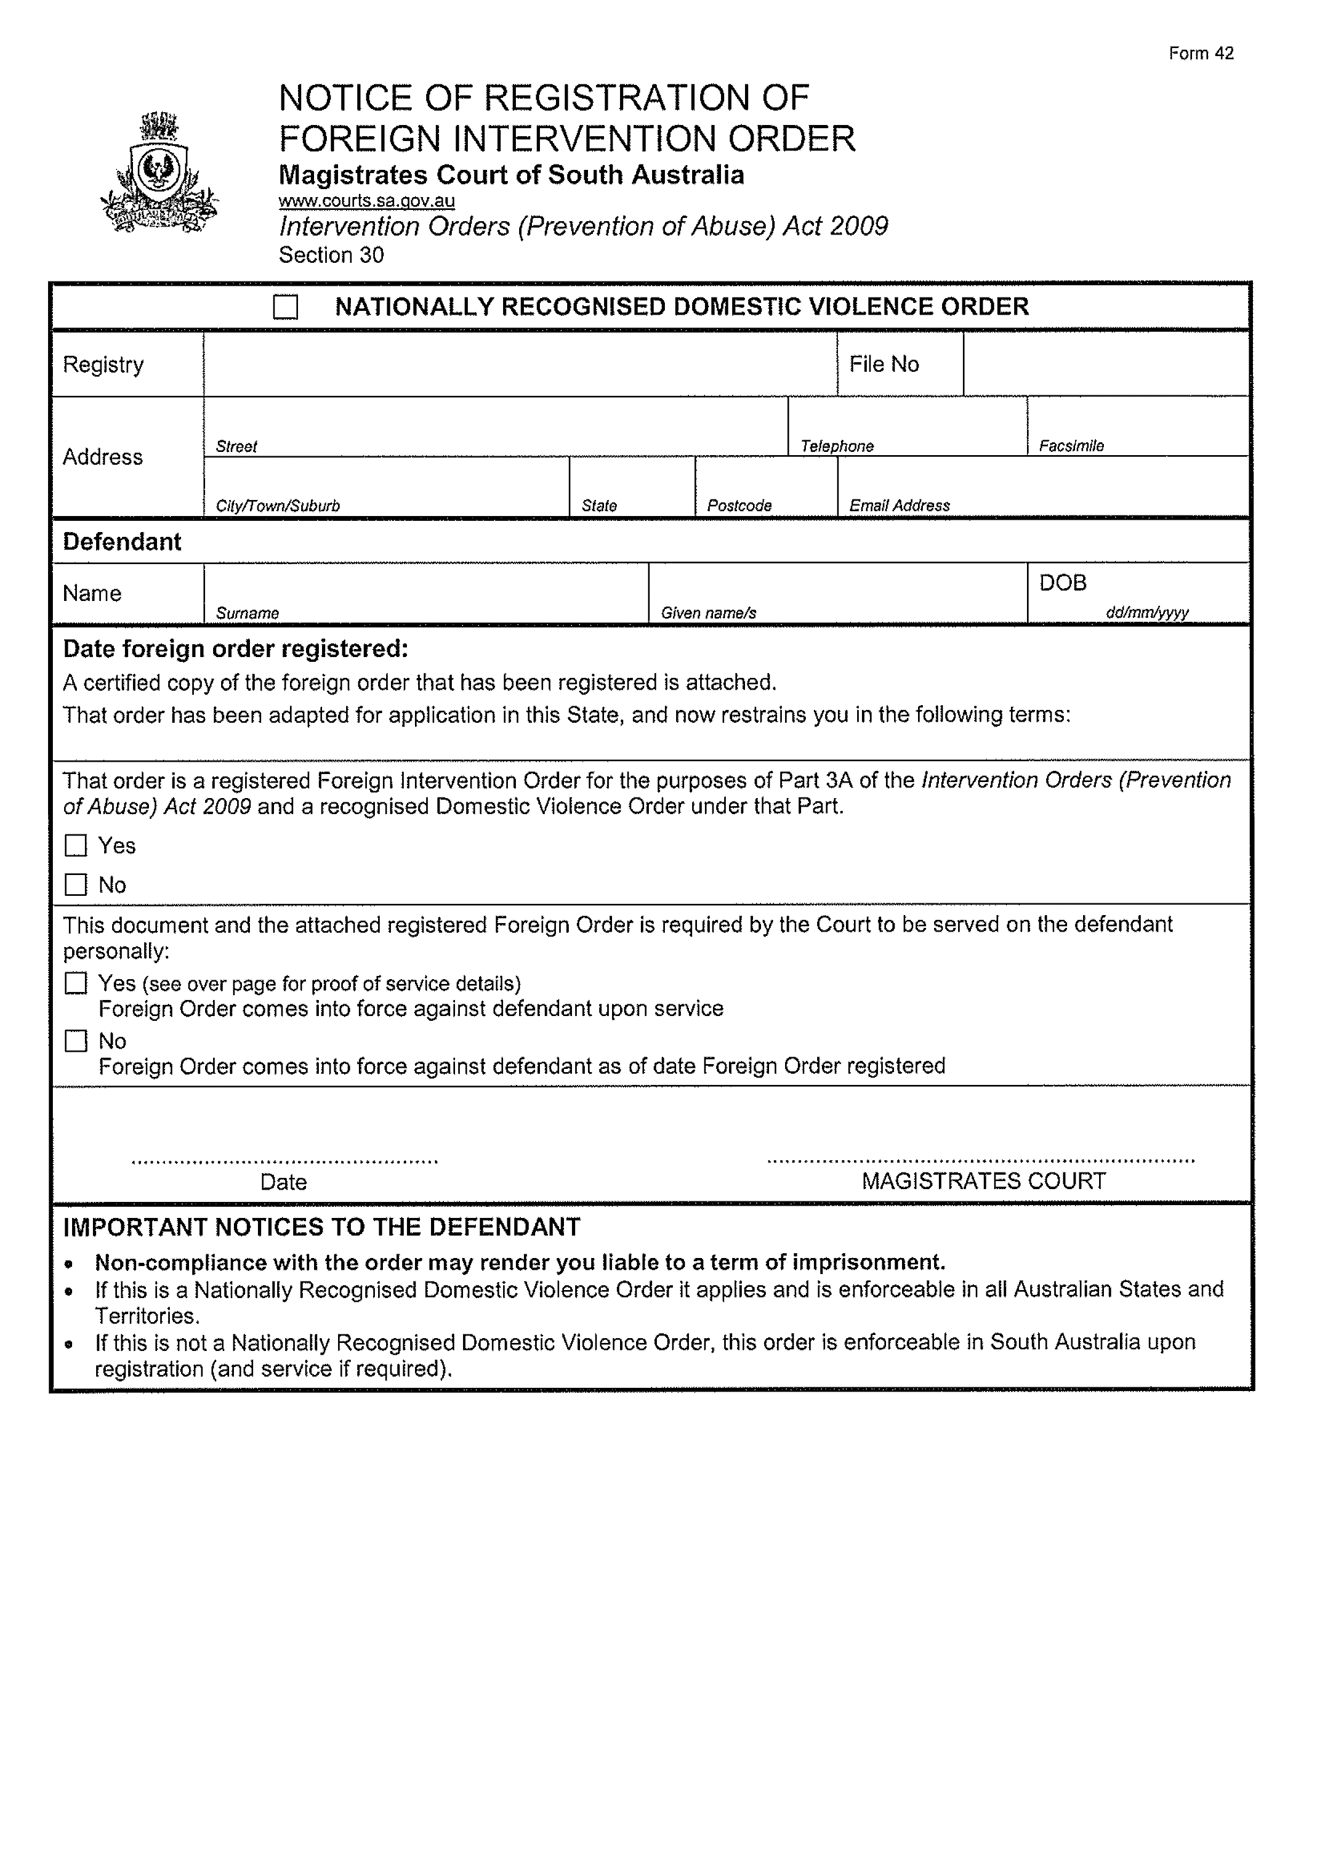
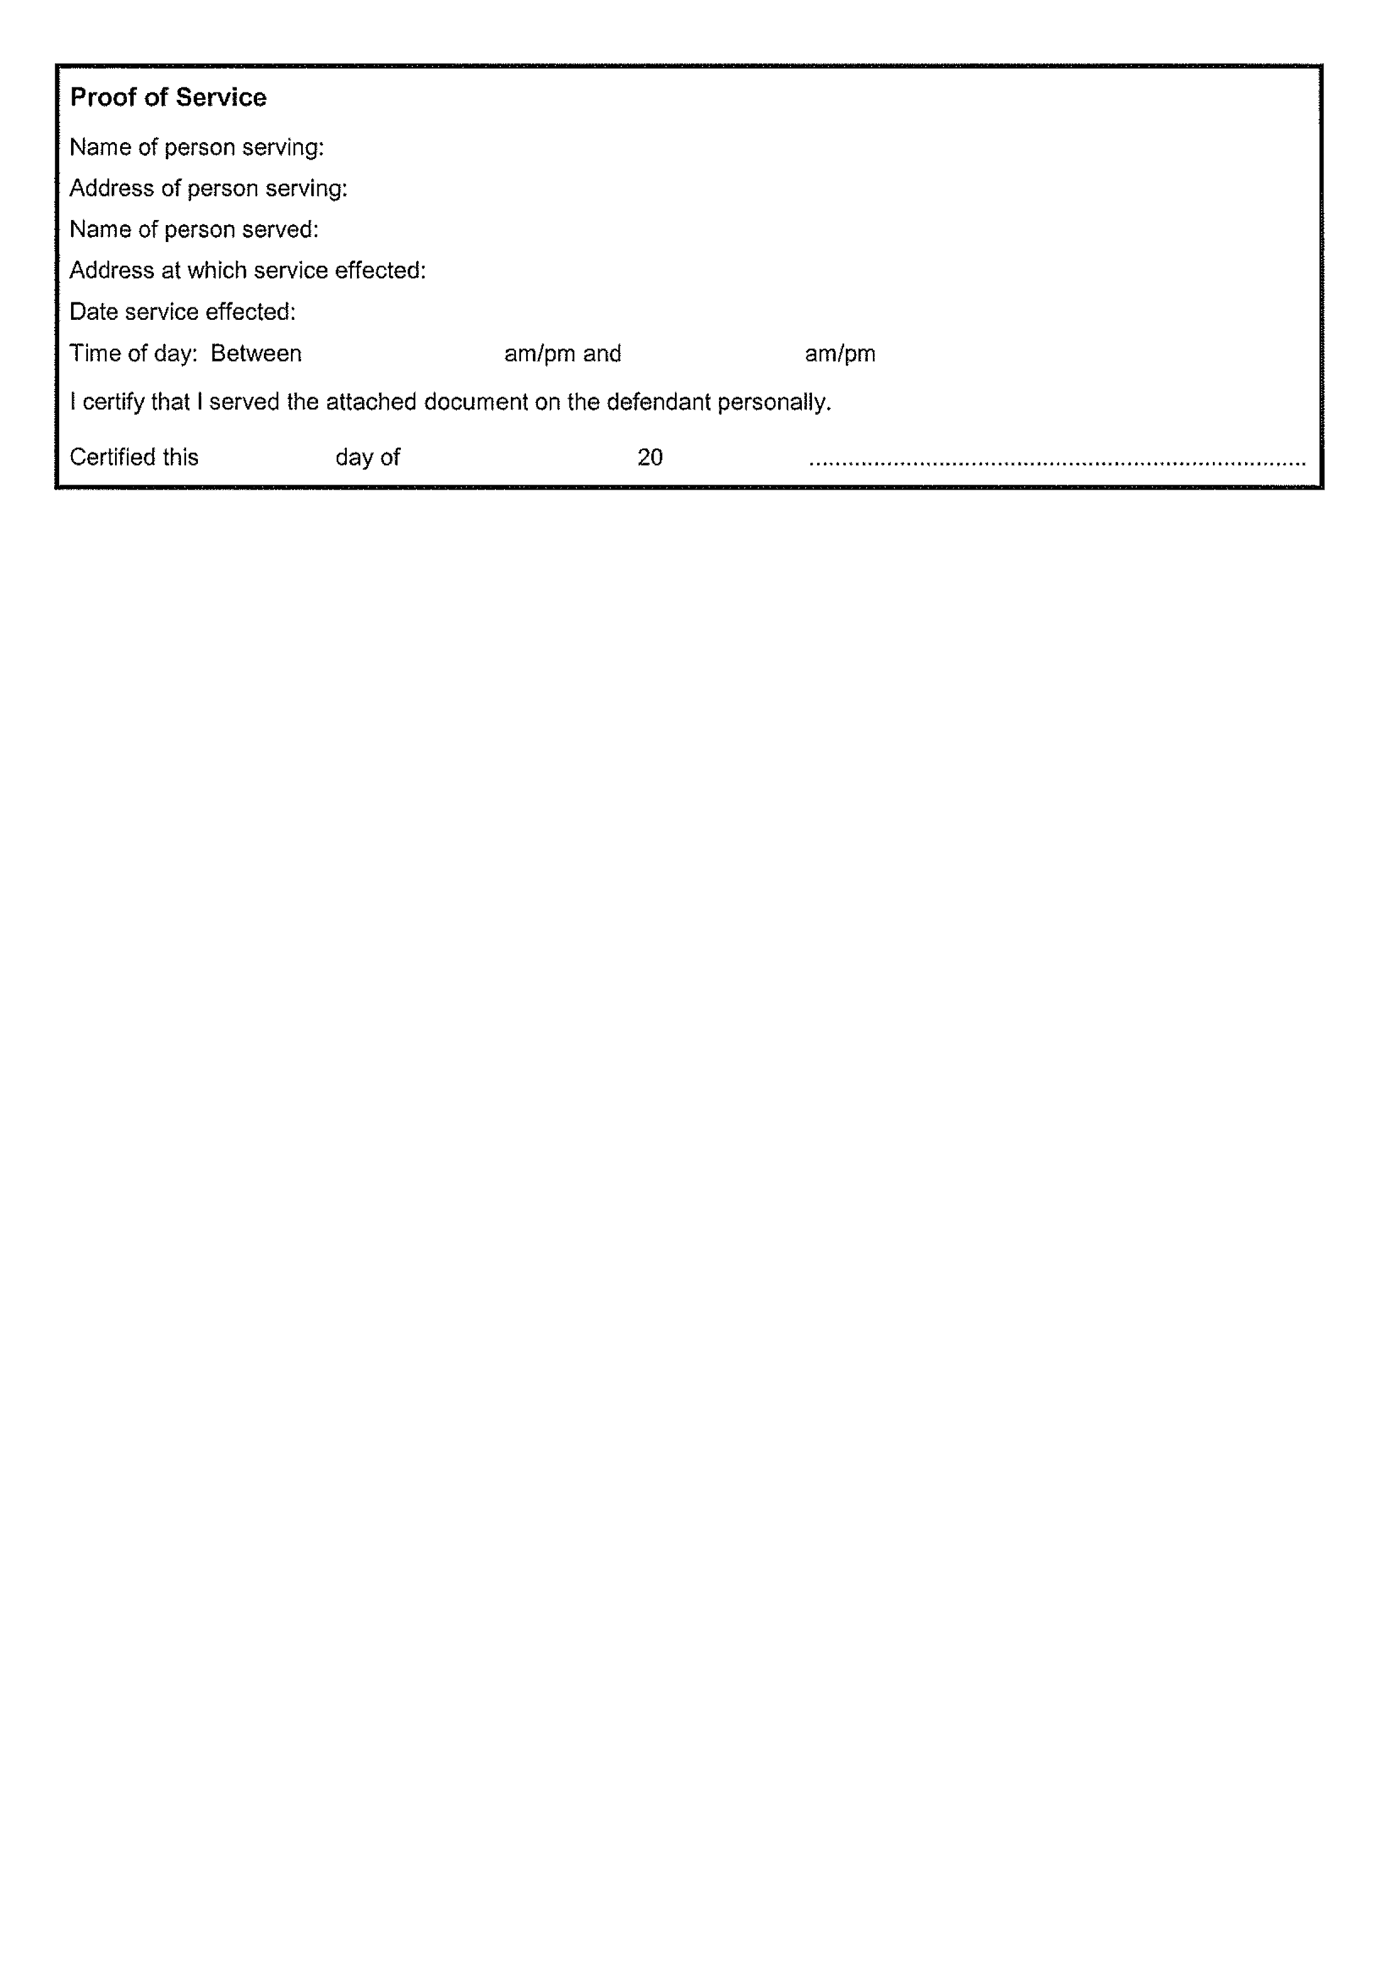
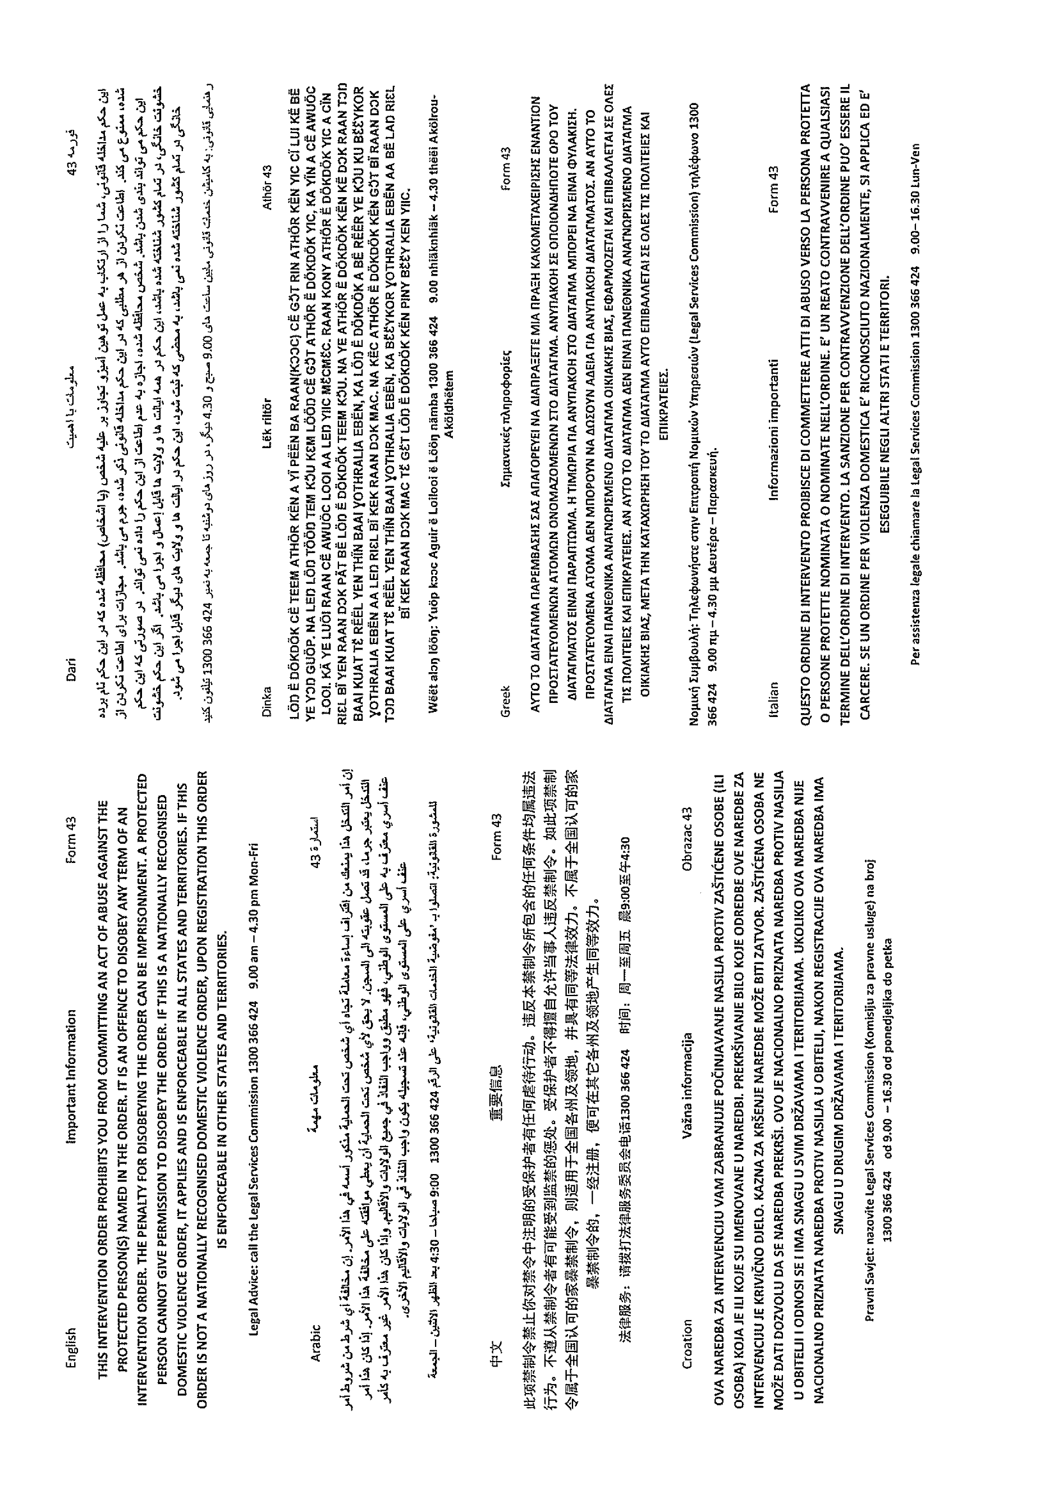
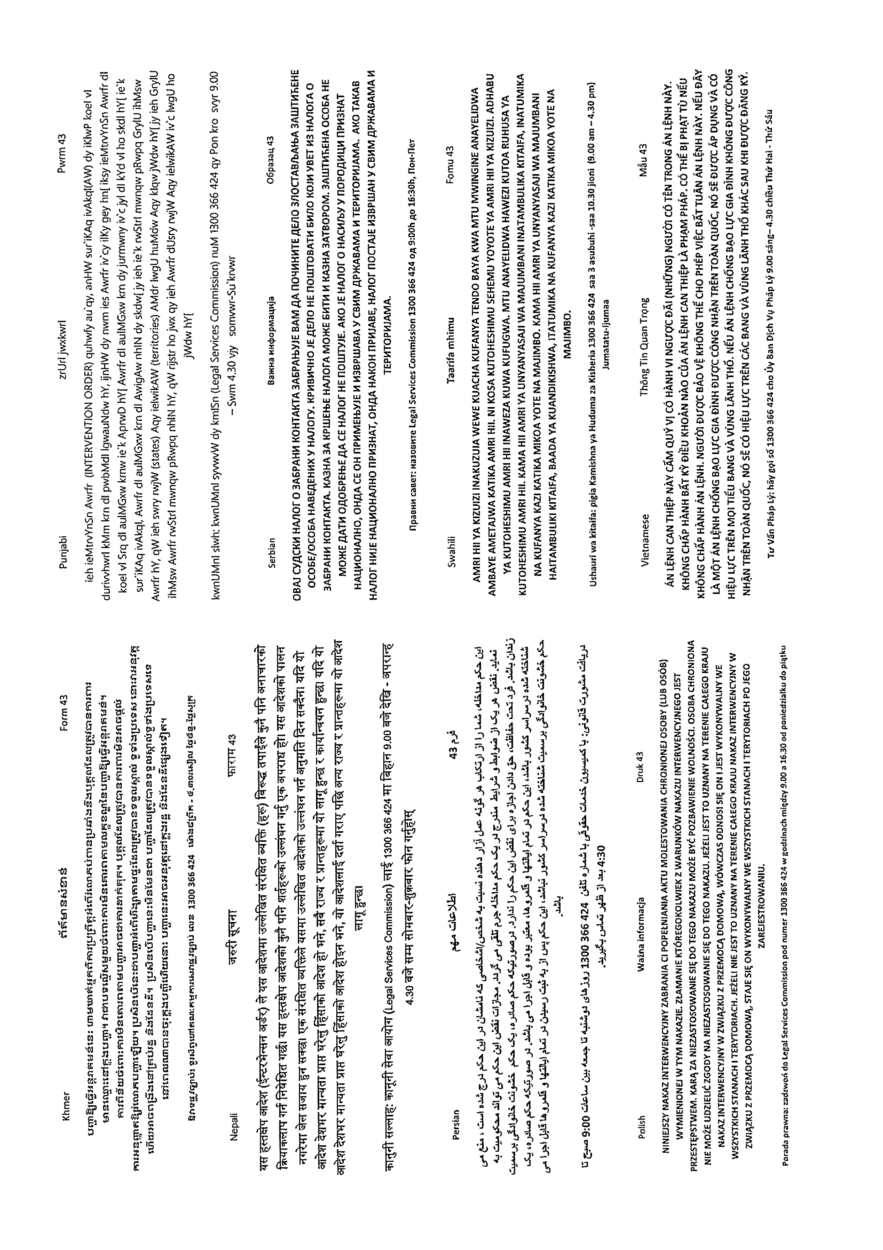
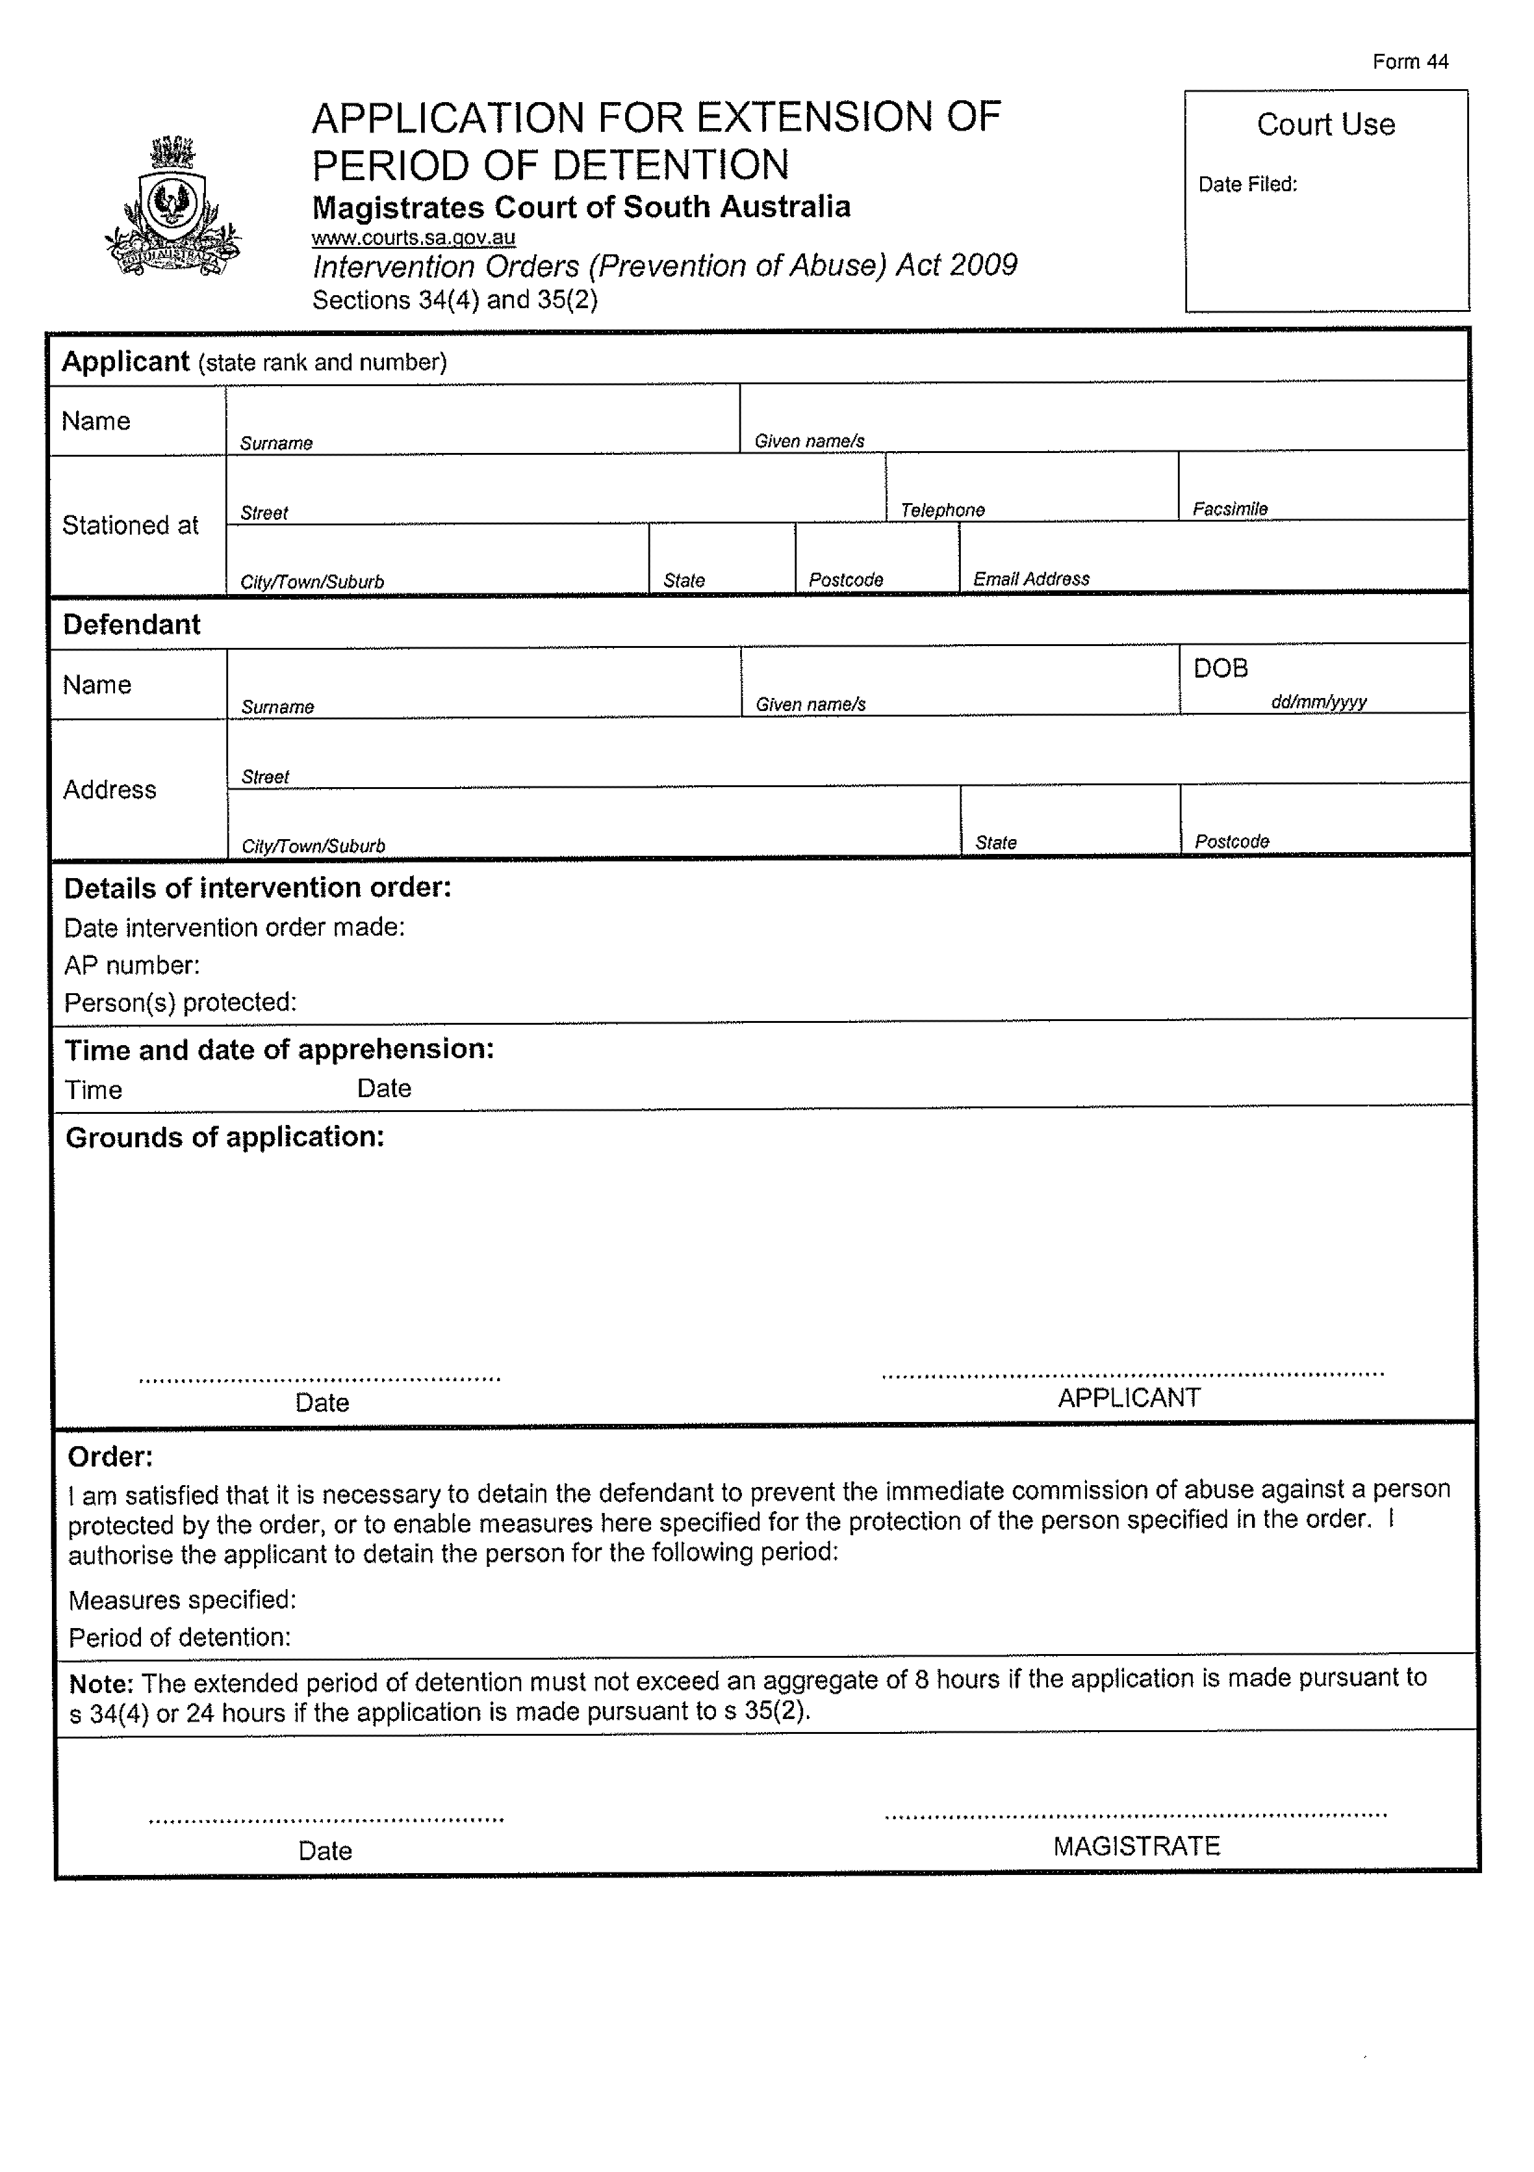
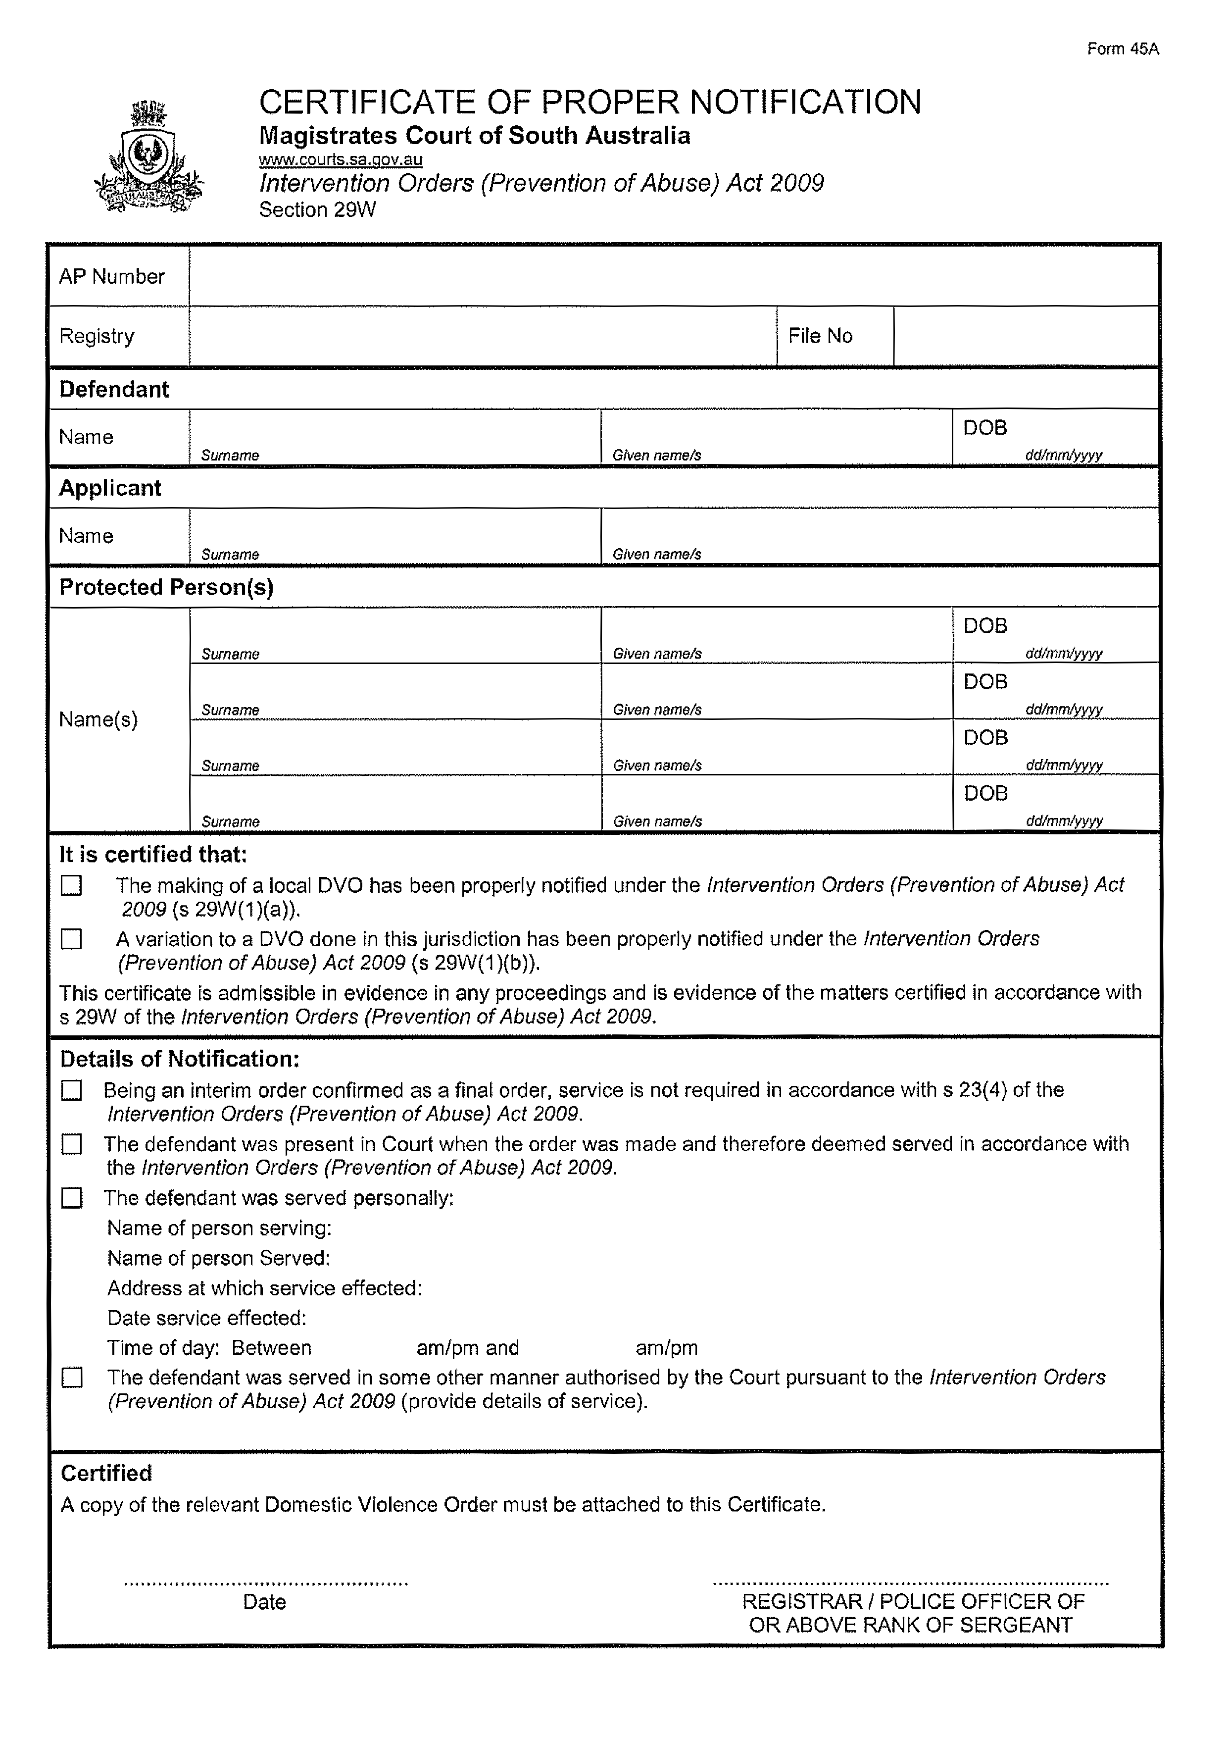
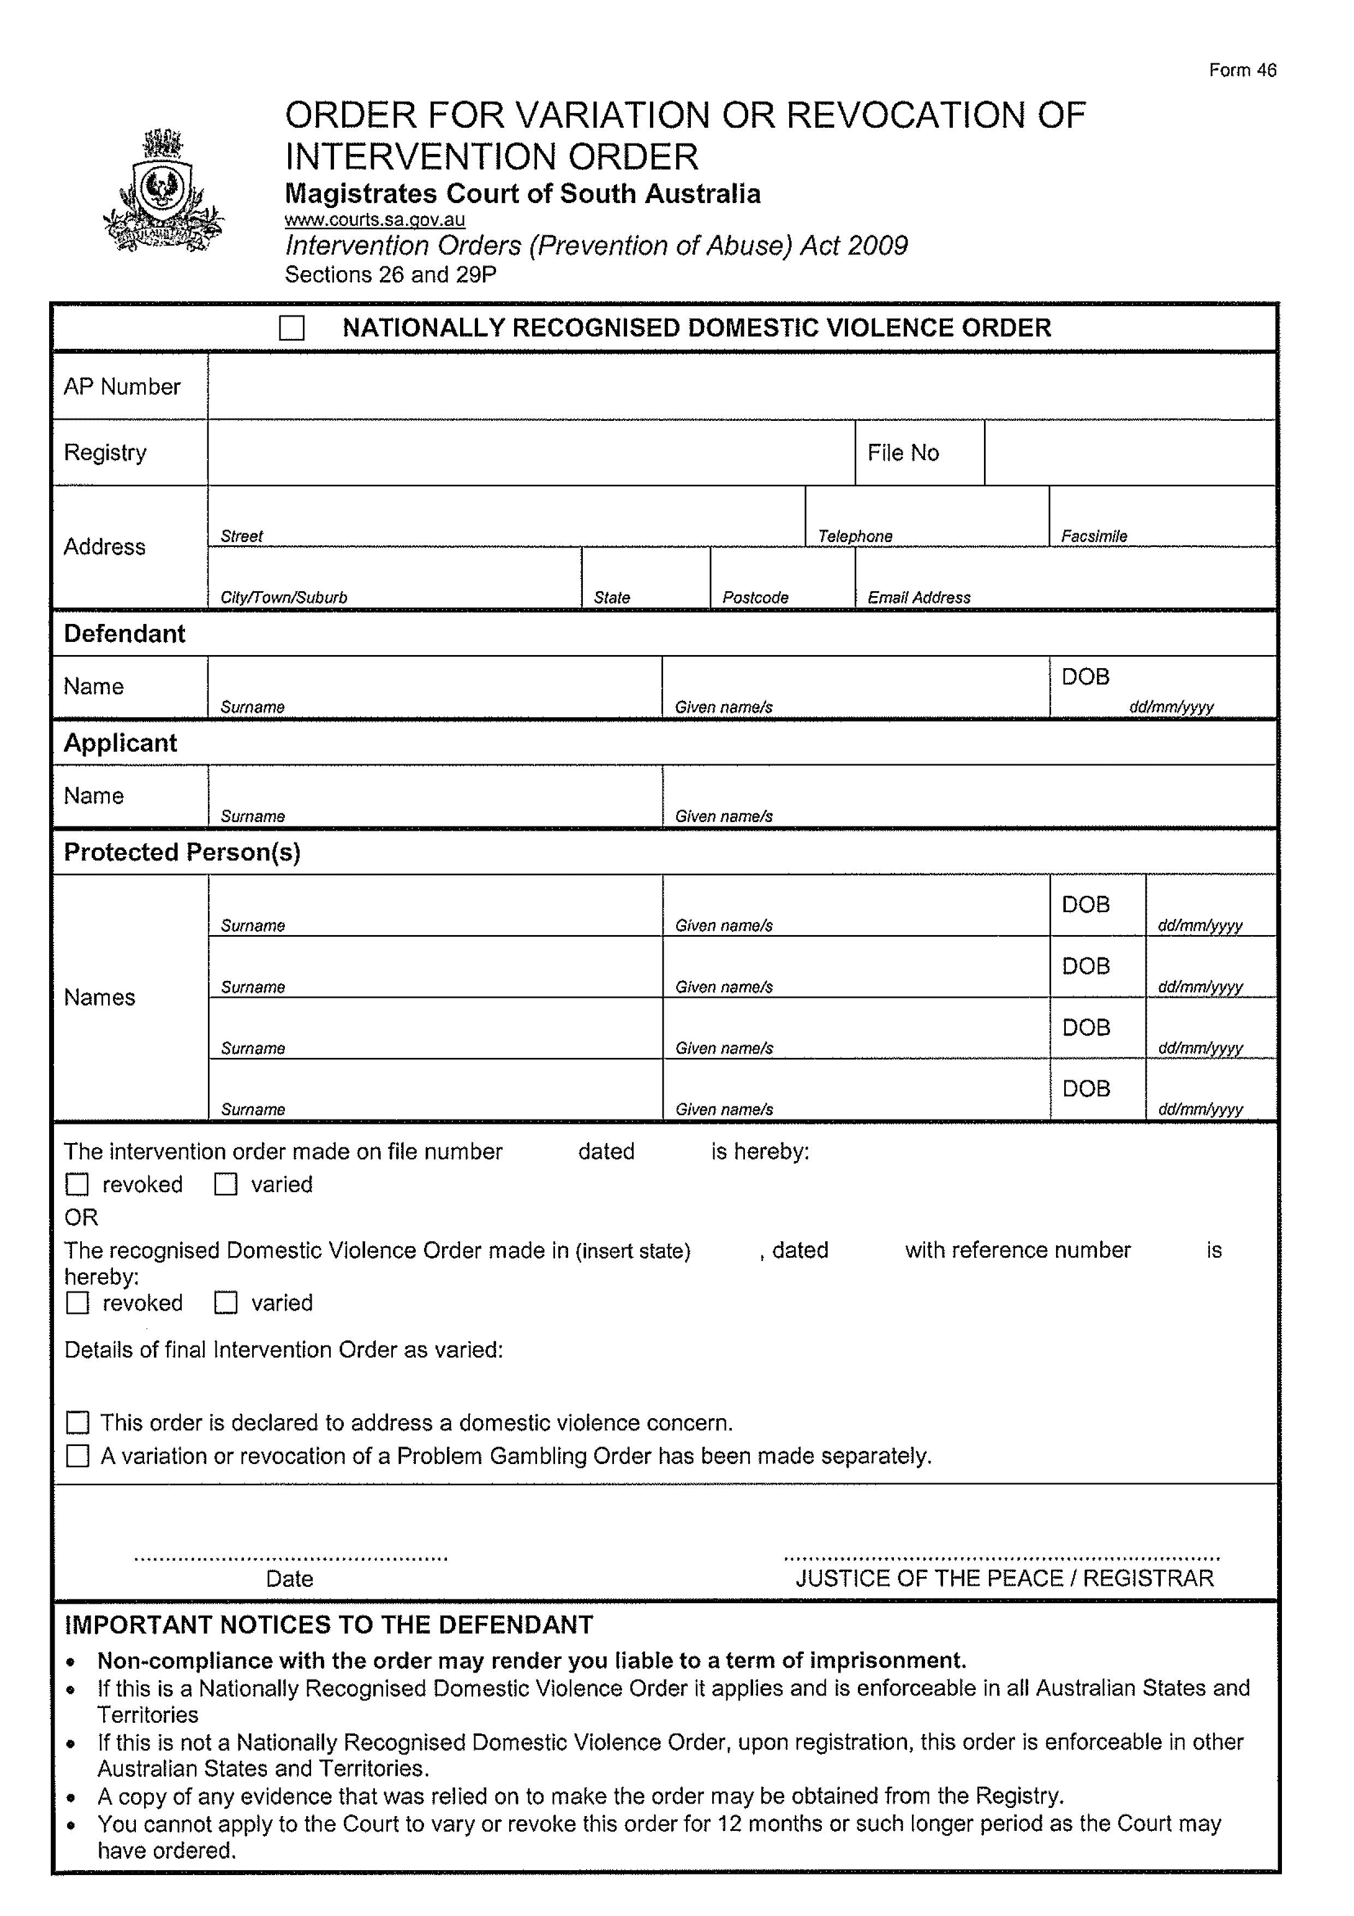
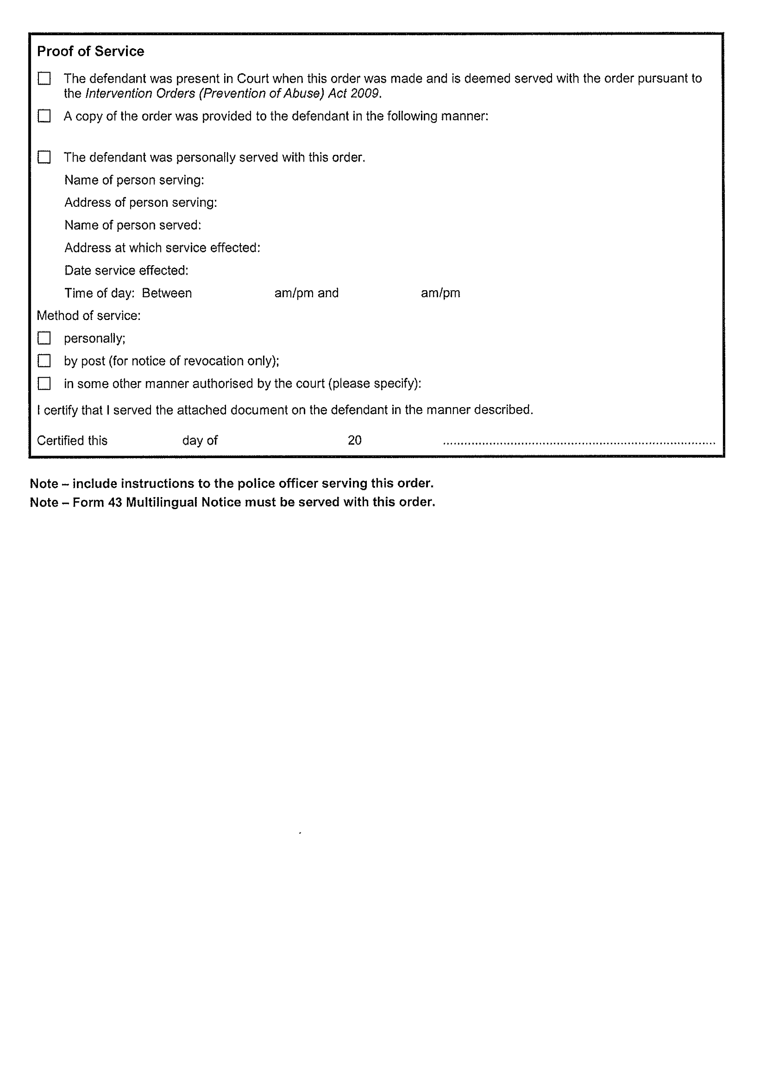
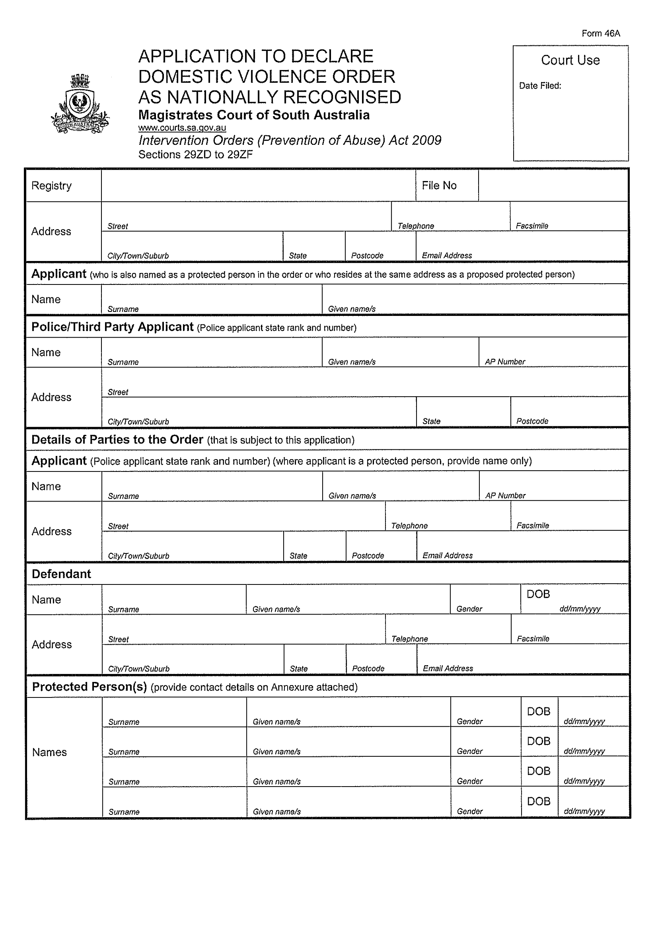
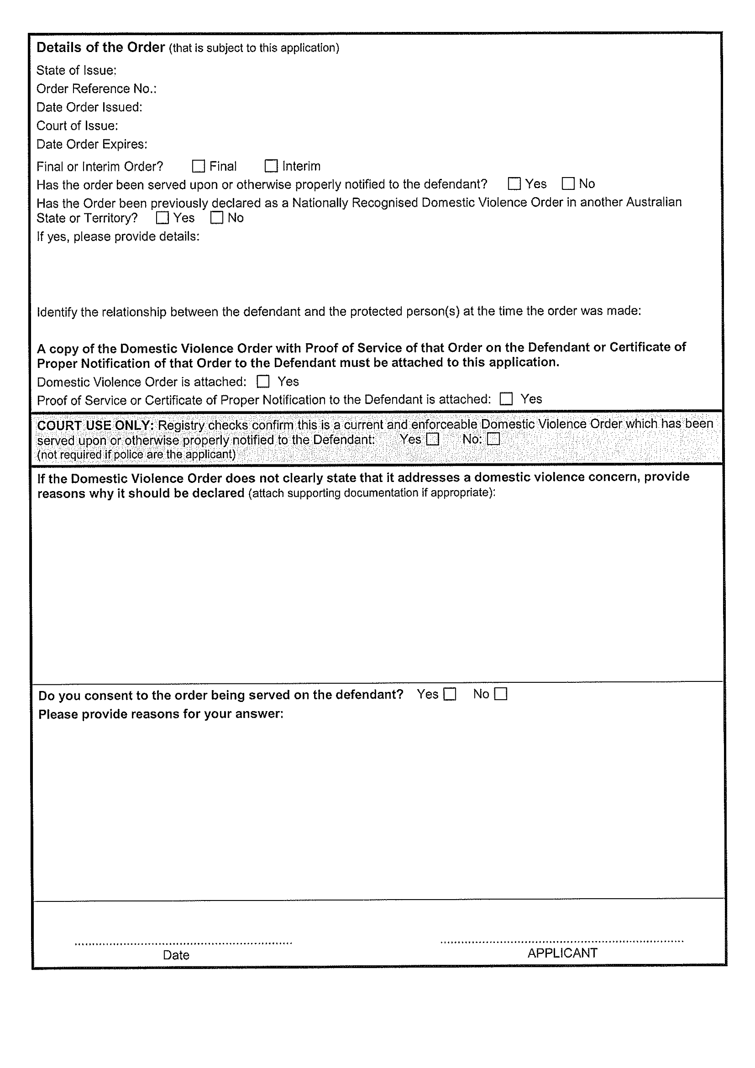
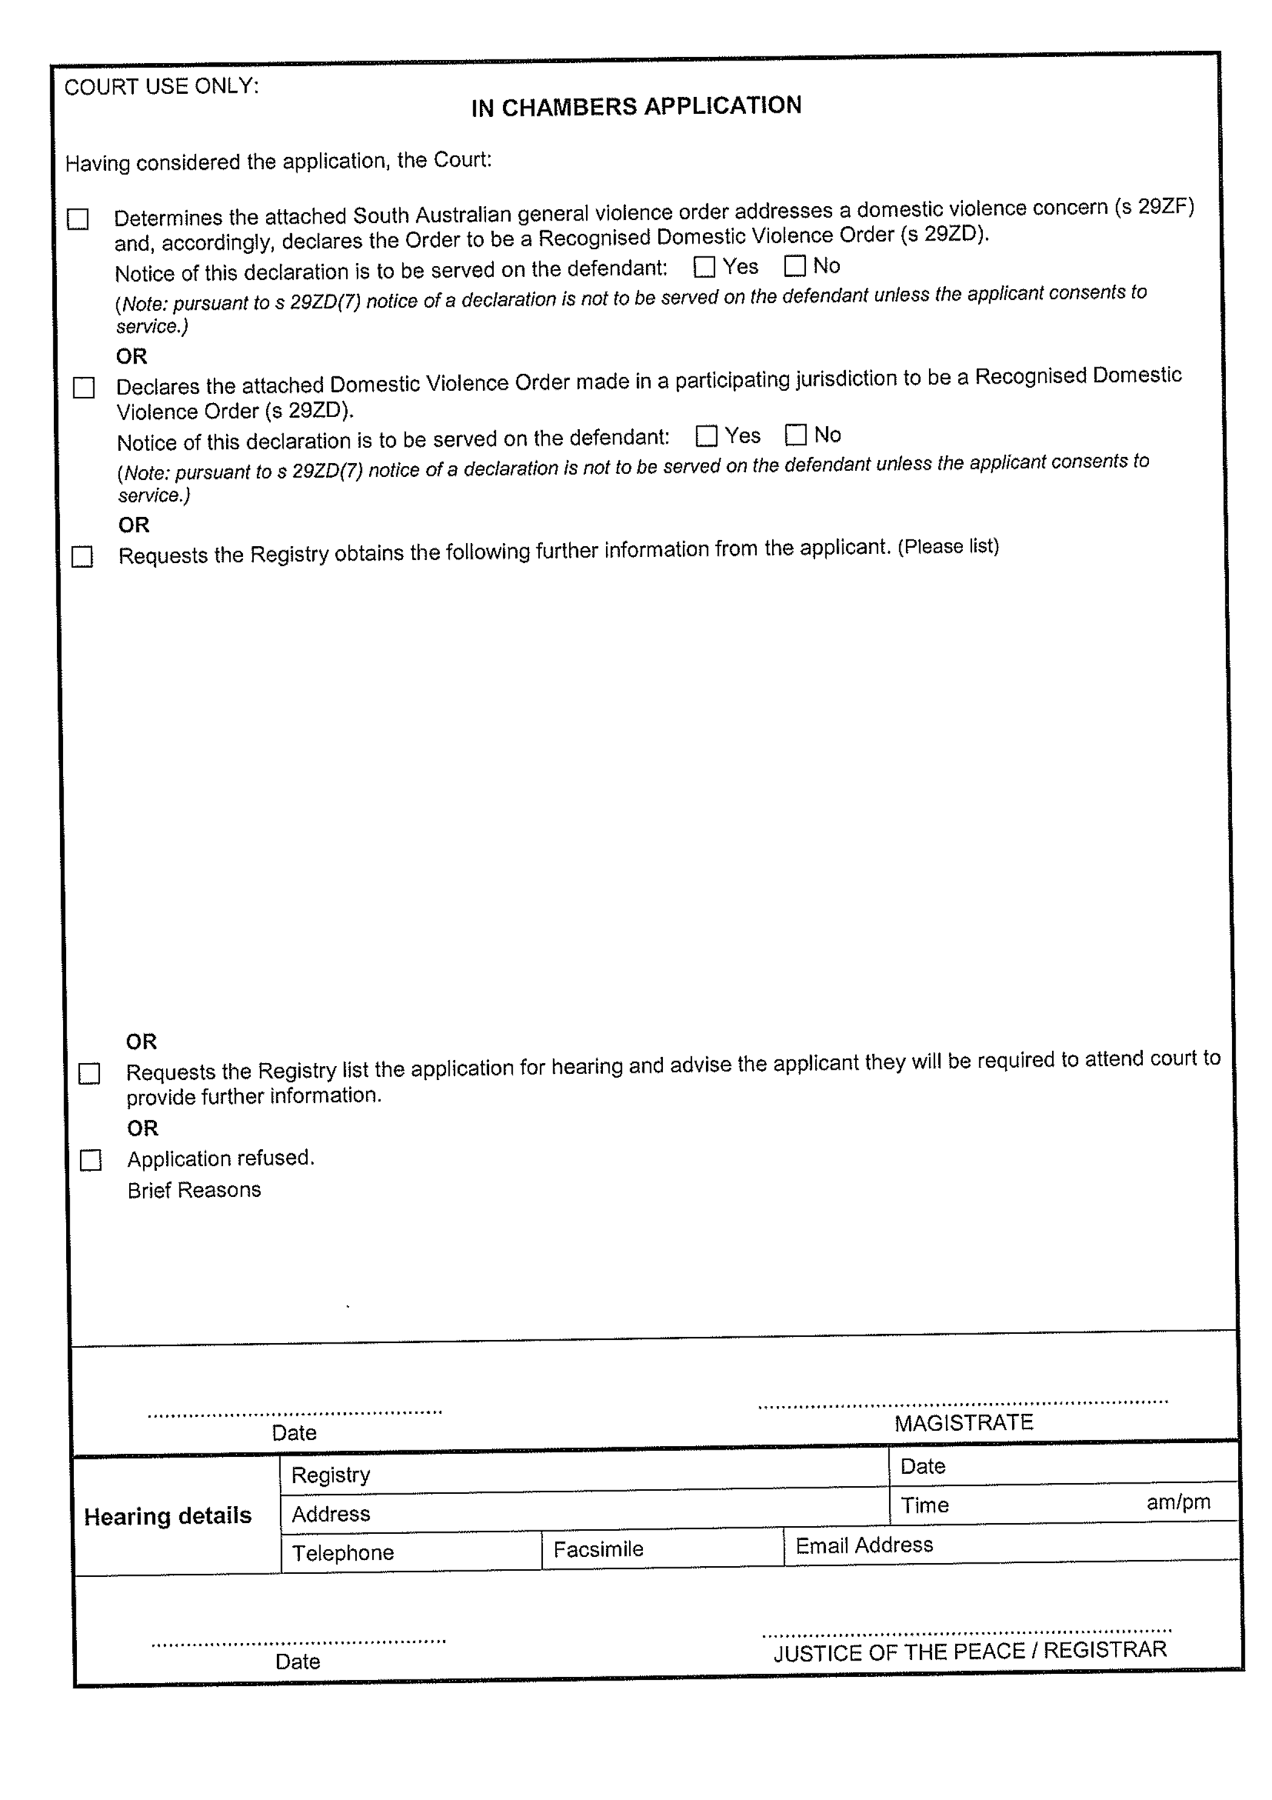
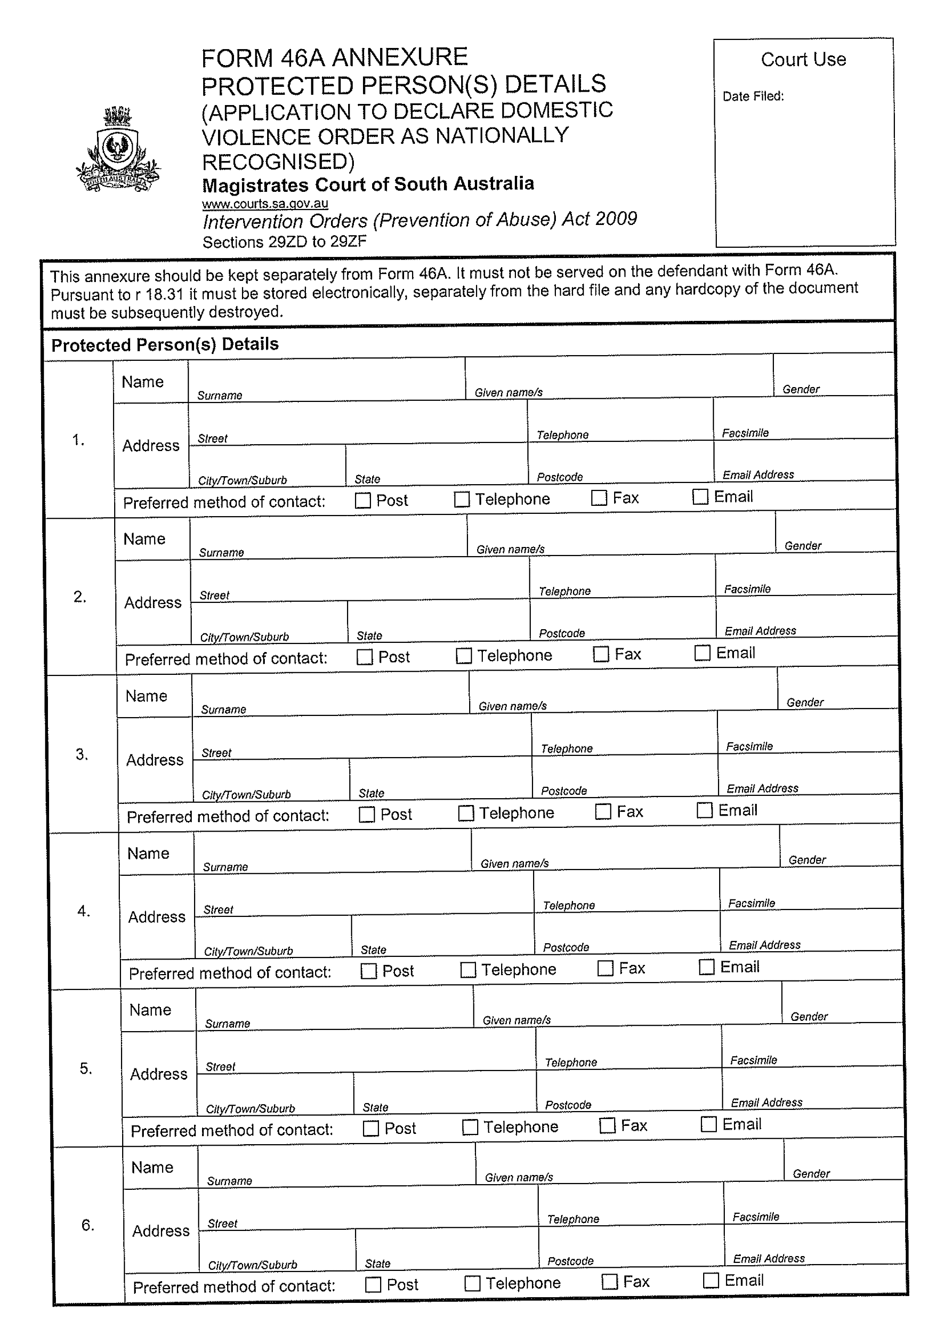
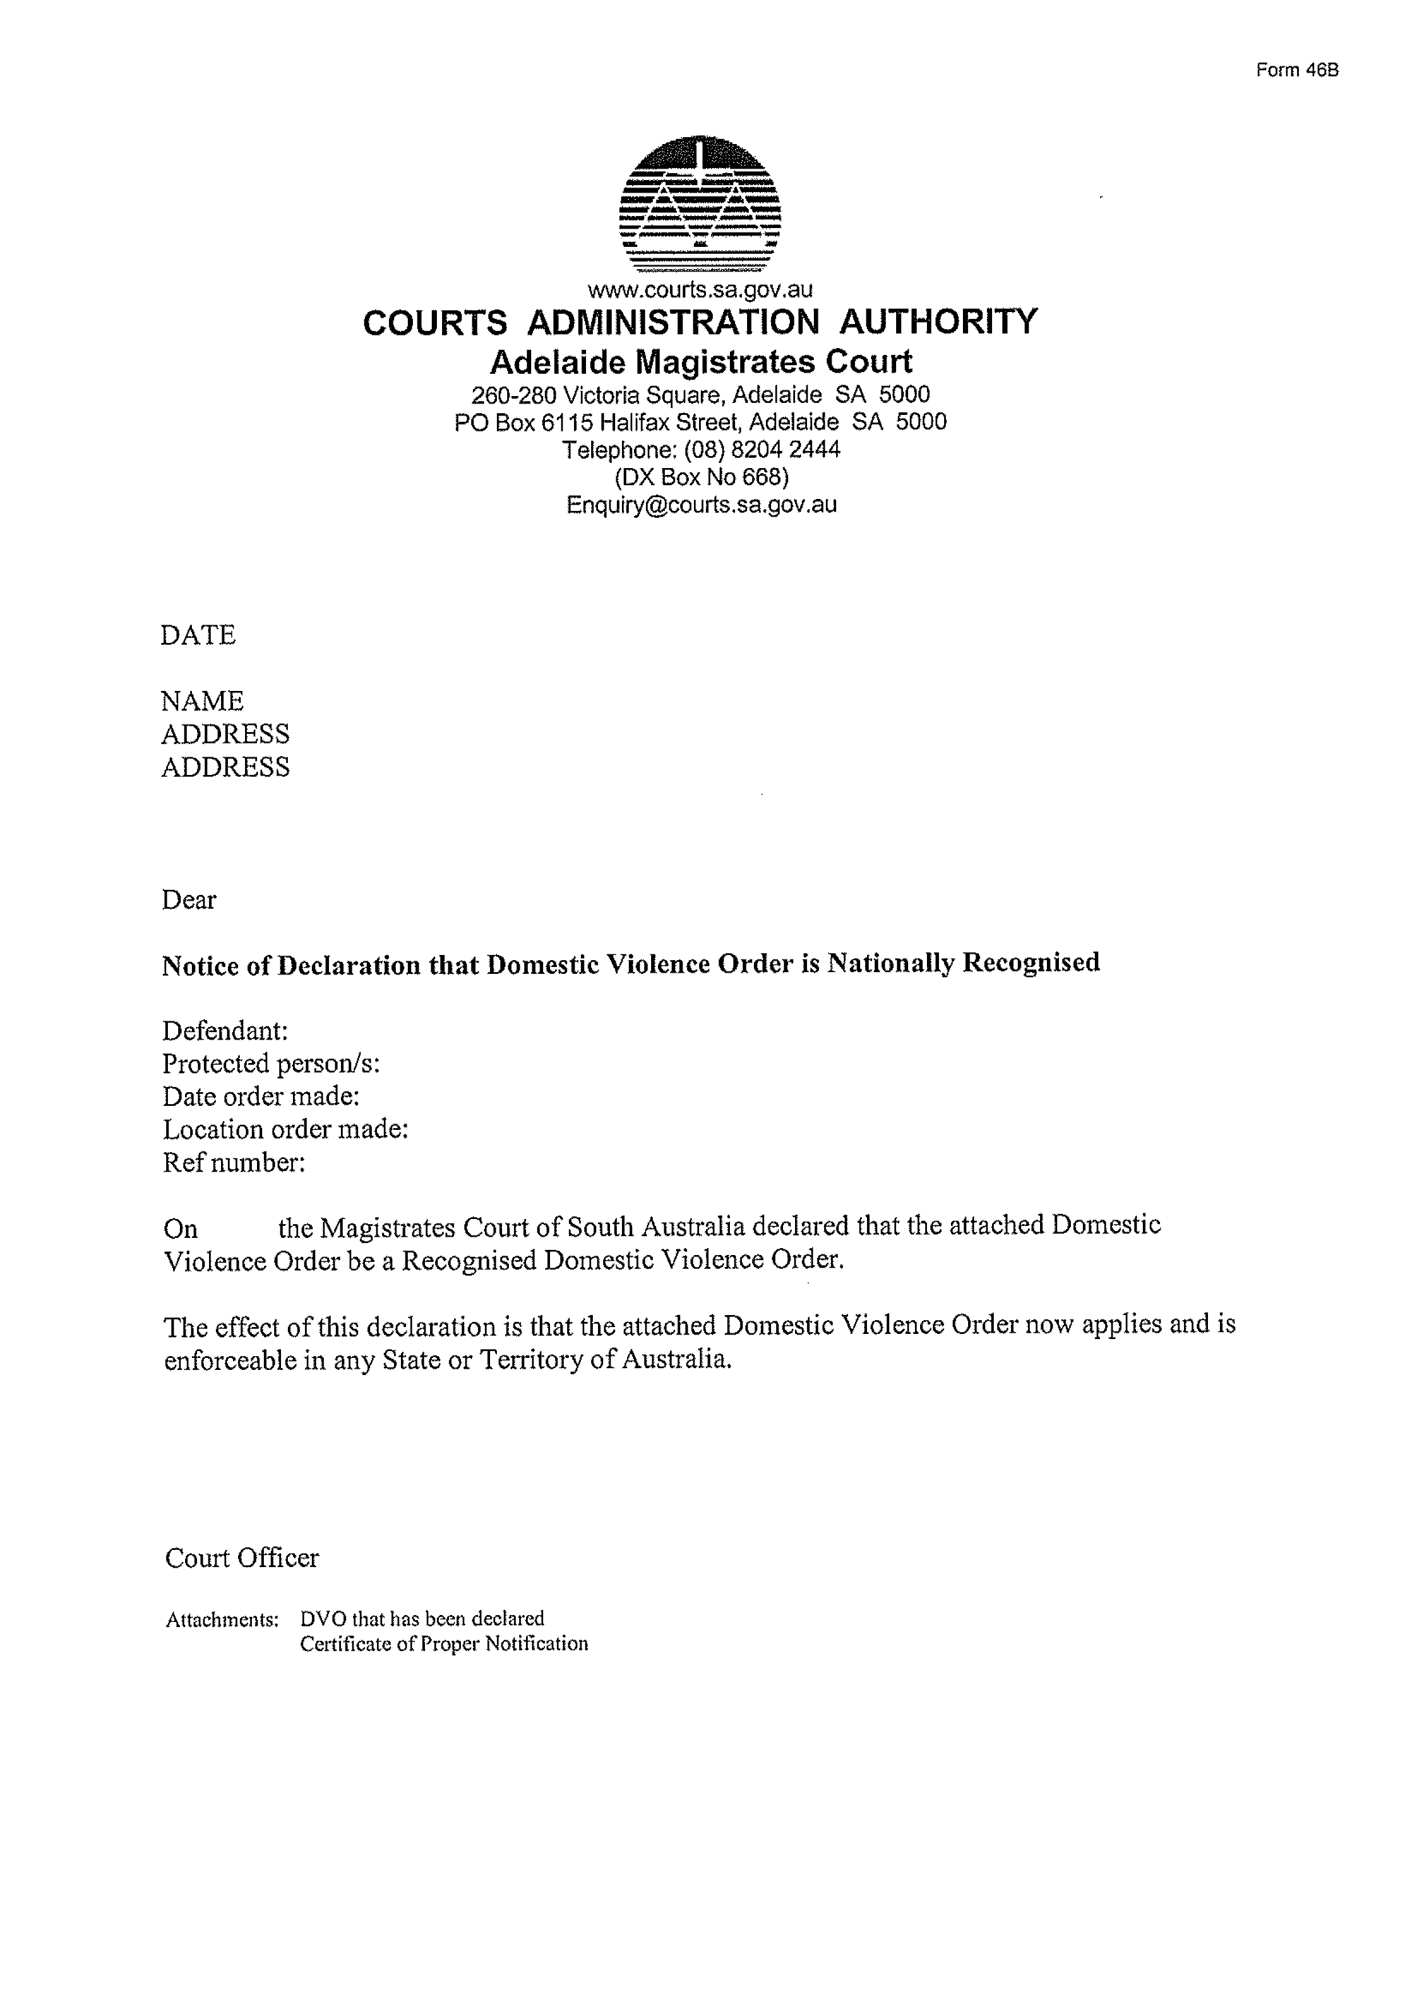

THE COPPER COAST COUNCIL
Roads (Opening and Closing) Act 1991
Road Closure – Frances Terrace, Kadina
As part of the Kadina CBD development, Council intend to close portion of Frances Terrace to allow for expansion of car parking. Notice is hereby given, pursuant to section 10 of the Roads (Opening and Closing) Act 1991, that the Copper Coast Council proposes to make a Road Process Order.
To close and merge with Allotment 2 in D73437, portion of Frances Terrace as delineated and lettered ‘A’ on the Preliminary Plan No 17/0060.
A copy of the plan and a statement of persons affected are available for public inspection at the Council Office, 51 Taylor Street, Kadina SA 5554 and the Adelaide Office of the Surveyor-General during normal office hours.
Any application for easement or objection must set out the full name, address and details of the submission and must be fully supported by reasons.
The application for easement or objection must be made in writing to the Council PO Box 396, Kadina SA 5554 within 28 days of this notice and a copy must be forwarded to the Surveyor-General at GPO Box 1354 Adelaide 5001. Where a submission is made, the Council will give notification of a meeting at which the matter will be considered.
Dated 14 November 2017.
Peter Harder, Chief Executive Officer

DISTRICT COUNCIL OF FRANKLIN HARBOUR
Close of Nominations
Supplementary Election for Area Councillor
Nominations Received
AT the close of nominations at 12 noon on Thursday 9 November 2017 the following people were accepted as candidates and are listed in the order in which they will appear on the ballot paper.
Area Councillor - 1 Vacancy
FRANKLIN, Sharran Lee
REHN, Terry
Postal Voting
The election will be conducted by post. Ballot papers and pre-paid envelopes for each voting entitlement will be posted between Tuesday 21 November 2017 and Monday 27 November 2017 to every person, or designated person of a body corporate or group listed on the voters roll at roll close on Friday 29 September 2017. Voting is voluntary.
A person who has not received voting material by Monday 27 November 2017 and believes they are entitled to vote should contact the Deputy Returning Officer on 08 8629 2231.
Completed voting material must be returned to reach the Deputy Returning Officer no later than 12 noon on Monday 11 December 2017.
A ballot box will be provided at the Council Office, 6 Main St, Cowell for electors wishing to hand deliver their completed voting material during office hours.
Vote Counting Location
The scrutiny and counting of votes will take place at the Council Chambers, 6 Main St, Cowell as soon as practicable after 12 noon on Monday 11 December 2017. A provisional declaration will be made at the conclusion of the election count.
Campaign Donations Return
All candidates must forward a Campaign Donations Return to the Council Chief Executive Officer within 30 days after the conclusion of the election.
Mick Sherry, Returning Officer

DISTRICT COUNCIL OF TUMBY BAY
Development Act 1993
Tumby Bay Township Development Plan Amendment
NOTICE is hereby given that no submissions received during the public consultation on the Tumby Bay Township Development Plan Amendment requested to be heard at the public meeting, scheduled for Wednesday 15 November 2017.
Accordingly, the public meeting will not be held.
Trevor Smith, Chief Executive Officer

WAKEFIELD REGIONAL COUNCIL
Close of Roll for Supplementary Election
DUE to the resignation of a member of the Council, a supplementary election will be necessary to fill the vacancy of Councillor for Central Ward.
The voters roll for this supplementary election will close at 5.00pm on Thursday 30 November 2017.
You are entitled to vote in the election if you are on the State electoral roll. If you have recently turned 18 or changed your residential or postal address you must complete an electoral enrolment form, available from post offices or online at www.ecsa.sa.gov.au
If you are not eligible to enrol on the State electoral roll you may still be entitled to enrol to vote if you own or occupy a property. Contact the Council to find out how.
Nominations to fill the vacancy will open on Thursday 11 January 2018 and will be received until 12 noon on Thursday 25 January 2018.
The election will be conducted entirely by post with the return of ballot material to reach the Returning Officer no later than 12 noon on Monday 26 February 2018.
Mick Sherry, Returning Officer

WUDINNA DISTRICT COUNCIL
Close of Nominations
Supplementary Election for Area Councillor
AT the close of nominations at 12 noon on Thursday 9 November 2017, Candice Lea was elected unopposed as the only nominated candidate for the position. No election will be necessary.
Mick Sherry, Returning Officer

IN the matter of the estates of the undermentioned deceased persons:
ANDERSON Heather Daphne late of 12 King George Avenue North Brighton of no occupation who died 9 June 2017
DAVIS Laurel Joyce late of 550 Portrush Road Glen Osmond of no occupation who died 1 September 2017
FOULDS Walter Harold late of 176 Furlong Road St Albans Victoria Retired Bricklayer who died 4 September 2017
HEWETT Kerri late of 9 Willoughby Street Stirling North of no occupation who died 28 March 2017
HINKS Peggy Joan late of 15 Halliday Street Risdon Park of no occupation who died 16 September 2017
HORN Aloisia late of 86 Oaklands Road Glengowrie Retired Dressmaker who died 17 April 2017
KORTE Margreta Pearl late of 22 Norman Street Port Pirie of no occupation who died 22 May 2017
LINDER George Bertram late of 36 Artesian Road West Two Wells Truck Driver who died 18 June 2017
MACKELLAR Harold Ronald Boyd late of 80 Moseley Street Glenelg South of no occupation who died 8 August 2017
MERCHANT Gwendoline Annie late of 2 The Strand Mawson Lakes of no occupation who died 23 May 2017
SEVO Bosko late of 69 Petherton Road Davoren Park Agricultural Engineer who died 11 May 2017
SIMM Allan late of 20 - 36 Gardenia Drive Parafield Gardens Retired Railway Shunter who died 5 July 2017
SPAIN Kevin John late of 100 James Hardy Way Woodcroft Retired Draftsman who died 3 July 2017
VAN VUGT Catherine late of 8A Sandery Avenue Seacombe Gardens Retired Public Servant who died 11 July 2017
VAUGHAN Kenneth late of 6 Booth Avenue Linden Park of no occupation who died 15 November 2016
WALDRON Barbara Edna late of 110 Strathfield Terrace Largs North of no occupation who died 5 September 2017
ZAMMIT Manuel late of 84 Reservoir Road Modbury of no occupation who died 6 September 2017
ZANDER Andrew Norman late of Towers Road Millicent Retired Mill Hand who died 14 August 2017
Notice is hereby given pursuant to the Trustee Act 1936, the Inheritance (Family Provision) Act 1972 and the Family Relationships Act 1975 that all creditors, beneficiaries, and other persons having claims against the said estates are required to send, in writing, to the office of Public Trustee at GPO Box 1338, Adelaide, 5001, full particulars and proof of such claims, on or before the 15 December 2017 otherwise they will be excluded from the distribution of the said estate; and notice is also hereby given that all persons indebted to the said estates are required to pay the amount of their debts to the Public Trustee or proceedings will be taken for the recovery thereof; and all persons having any property belonging to the said estates are forthwith to deliver same to the Public Trustee.
Dated 14 November 2017.
D A Contala, Public Trustee

TRUSTEES ACT 1936
Deceased Estates
Notice to Creditors and Claimants
PHYLLIS IRENE NEWTON late of 11 Osborne Street, Goolwa, South Australia, Australia, Home Duties, deceased.
Creditors and other persons having claims (to which Section 29 of the Trustees Act 1936, relates) in respect of the estate of the deceased, who died on 7 June 2017, are required by the executor, Equity Trustees Wealth Services Limited of Level 1, 575 Bourke Street, Melbourne, Victoria, 3000 to send particulars of their claims to it, care of Lou Caiafa, Equity Trustees Wealth Services Limited of Level 1, 575 Bourke Street, Melbourne, Victoria, 3000 within two (2) months of the date of publication hereof, after which date the executor may convey or distribute the assets having regard only to the claims of which the executor then has notice.
Dated 14 November 2017.
Equity Trustees Wealth Services Limited as Executor

PARTNERSHIP ACT 1891
Notice pursuant to Sections 36(2) and 37 (as Amended)
Dissolution of Partnership
NOTICE is hereby given that on the 3rd day of October 2017 the partnership between Mark Sandy Ruta in his capacity as the sole trustee of the MRM Property Investments Trust of 2e Sixth Avenue, Glenelg East, in the State of South Australia 5045 and Frank Anthony Ruta in his capacity as the sole trustee of the FDR Investment Trust of 20 Lynch Avenue, Bundoora, in the State of Victoria 3083 and trading as Pullman Expresso was dissolved and ceased trading.
The said Frank Anthony Ruta in his capacity as the sole trustee of the FDR Investment Trust will not be liable for any debts or other liabilities of any form incurred on and from the 3rd day of October 2017.
All enquiries to:
Mr Attila Meister
Meister Mertiris Lawyers
9th Floor, West Wing, 50 Grenfell Street
Adelaide SA 5000
PH: 84107700

Notice Submission

The weekly South Australian Government Gazette is issued on Tuesday afternoon, except where Executive Council meets on Wednesday, wherein publishing will occur on that day.
The next scheduled publication date is displayed on the website: www.governmentgazette.sa.gov.au.

Notices for gazettal, along with enquiries, can be directed to:

Email governmentgazettesa@sa.gov.au
Phone (08) 8207 1025

Gazette notices should be emailed in the following formats:

• Notices as individual Word files
• Maps, images, and diagrams as single, complete objects within Word files
• Content containing official signatures for authorisation—notices as Word files and the signed documentation as PDF files

Please provide the following information in your email:

• Date the notice is to be gazetted
• Email address and phone number of the person authorising the submission
• Notification of whether a quote is required for chargeable notices
• Name of the person and organisation to be charged for the notice, if applicable
• A purchase order if required
• Details that may impact on publication of the notice

Notices must be submitted before 4 p.m. Friday, the week preceding intended gazettal.
Proofs of formatted content are supplied for all notices, with necessary alterations to be returned before 4 p.m. on the day preceding publication.
Submitted notices will be gazetted unless notification is received before 10 a.m. on the day of publication.

Printed and published weekly by authority of Sinead O’Brien, Government Printer, South Australia
$7.35 per issue (plus postage), $370.00 per annual subscription—GST inclusive
Online publications: www.governmentgazette.sa.gov.au

