
No. 70 4259

THE SOUTH AUSTRALIAN
GOVERNMENT GAZETTE
Published by Authority

Adelaide, Tuesday, 10 October 2017

Contents

Acts Assented To 4260
Appointments, Resignations, Etc. 4260
Corporations and District Councils—Notices 4274
Development Act 1993—Notices 4260
Education Act 1972—Notice 4266
Essential Services Commission Act 2002—Notice 4276
Fire and Emergency Services Act 2005—Notice 4266
Health Care Act 2008—Notice 4266
Land Acquisition Act 1969—Notice 4268
Mining Act 1971—Notices 4268
National Electricity Law—Notice 4269
National Gas Law—Notice 4269
Petroleum and Geothermal Energy Act 2000—Notice 4270
Remuneration Tribunal—Report and Determination 4270
Public Trustee Office—Administration of Estates 4275
Regulations
Criminal Law (Forensic Procedures) Act 2007—
(No. 290 of 2017) 4272

Department of the Premier and Cabinet
Adelaide, 10 October 2017
HIS Excellency the Governor directs it to be notified for general information that he has in the name and on behalf of Her Majesty The Queen, this day assented to the undermentioned Acts passed by the Legislative Council and House of Assembly in Parliament assembled, viz.:
No. 37 of 2017—Summary Offences (Interviewing Vulnerable Witnesses) Amendment Act 2017. An Act to amend the Summary Offences Act 1953.
No. 38 of 2017—Statutes Amendment (Transport Online Transactions and Other Matters) Act 2017. An Act to amend the Harbors and Navigation Act 1993, the Heavy Vehicle National Law (South Australia) Act 2013, the Highways Act 1926, the Motor Vehicles Act 1959 and the Road Traffic Act 1961.
No. 39 of 2017—Statutes Amendment (Universities) Act 2017. An Act to amend the Flinders University of South Australia Act 1966 and the University of Adelaide Act 1971.
No. 40 of 2017—Southern State Superannuation (Parental Leave) Amendment Act 2017. An Act to amend the Southern State Superannuation Act 2009.
By command,
Jay Wilson Weatherill, Premier
DPC06/0875

Department of the Premier and Cabinet
Adelaide, 10 October 2017
HIS Excellency the Governor in Executive Council has been pleased to appoint the undermentioned to the Adelaide Festival Centre Trust, pursuant to the provisions of the Adelaide Festival Centre Trust Act 1971:
Member: From 10 October 2017 until 9 October 2020
Mary Eve Wyndham Hamilton
By command,
Jay Wilson Weatherill, Premier
ASACAB167/11

Department of the Premier and Cabinet
Adelaide, 10 October 2017
HIS Excellency the Governor in Executive Council has been pleased to appoint the undermentioned to the South Australian Film Corporation, pursuant to the provisions of the South Australian Film Corporation Act 1972:
Member: From 13 October 2017 until 12 October 2020
Miriam Amena Silva
By command,
Jay Wilson Weatherill, Premier
ASACAB17/240

Department of the Premier and Cabinet
Adelaide, 10 October 2017
HIS Excellency the Governor in Executive Council has been pleased to appoint the Honourable Stephen Campbell Mullighan, MP, Minister for Transport and Infrastructure and Minister for Housing and Urban Development to be also Acting Minister for Investment and Trade, Acting Minister for Small Business, Acting Minister for Defence and Space Industries, Acting Minister for Health Industries and Acting Minister for Veterans’ Affairs for the period from 16 October 2017 to 23 October 2017 inclusive, during the absence of the Honourable Martin Leslie James Hamilton-Smith, MP.
By command,
Jay Wilson Weatherill, Premier
17MINT/578CS

DEVELOPMENT ACT 1993
Section 29
Amendment to the Rural City of Murray Bridge Development Plan
Preamble
It is necessary to amend the Murray Bridge Council Development Plan (the Plan) dated 2 May 2017.
PURSUANT to section 29 (2)(b)(i) and 29(2)(b)(ii) of the Development Act 1993, I —
- Amend the Plan as follows:
a. Replace Zone Map MuBr/7 with the contents of ‘Attachment A’
- Fix the day on which this notice is published in the Gazette as the day on which the section 29 Amendment will come into operation.
Dated 27 September 2017.
Sally Smith, General Manager, Planning and Development,
Development Division, Department of Planning, Transport and Infrastructure,
As Delegate of John Rau, Minister for Planning

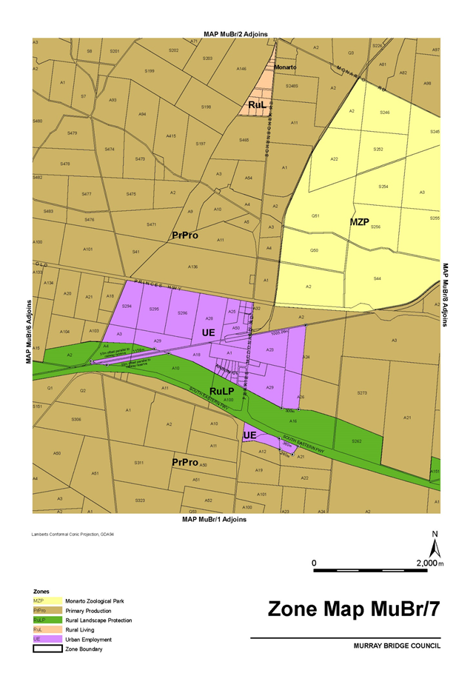
Attachment A

DEVELOPMENT ACT 1993
Section 29
Amendment to the Campbelltown City Council Development Plan
Preamble
It is necessary to amend the Campbelltown City Council Development Plan (the Plan) dated 22 August 2017.
PURSUANT to section 29 (2)(b)(i) and section 29(2)(b)(ii) of the Development Act 1993, I—
- Amend the Plan as follows:
  - Within PDC 1 of the Mixed Use Zone, remove the following forms of envisaged land uses: ‘light industry’; ‘recycling collection depot’ and ‘row dwelling’.
  - In the Mixed Use Zone, remove ‘shop or group of shops’ as a non-complying form of development.
  - Within the Urban Corridor Zone, remove the exception in the non-complying list for ‘Fuel depot’ – ‘except where located within the Business Policy Area 8’.
  - In the Urban Employment Zone, remove Objective 4 and renumber the subsequent objectives.
  - In the Urban Employment Zone under non-complying development, remove the exception for ‘Fuel depot’.
  - In Table Cam/1 – Off Street Vehicle Parking Requirements replace the sixth row with the contents of ‘Attachment A‘
  - Replace Overlay Map Cam/3 – Affordable Housing with the contents of ‘Attachment B’.
  - Replace Concept Plan Map Cam/2 – Residential Zone Low Density Policy Area with the contents of ‘Attachment C’
  - Replace Concept Plan Map Cam/4 – Lower North East Road Urban Corridor with the contents of ‘Attachment D’.
- Fix the day on which this notice is published in the Gazette as the day on which the section 29 Amendment will come into operation.
Dated 27 September 2017.
Sally Smith, General Manager, Planning and Development,
Development Division, Department of Planning, Transport and Infrastructure,
As Delegate of John Rau, Minister for Planning

Attachment A
Group dwelling  Residential flat building
  Parameter | Average spaces per dwelling 400 metres from the District Centre, high frequency bus stop, tram stop or O-Bahn interchange | Average spaces per dwelling in any other circumstances
  1 bedroom | 0.75 | 1
  2 bedrooms | 1 | 1.5
  3 + bedrooms | 1.25 | 2
  Additional visitor car parking space per dwelling | 0.25 | 0.25

Attachment B
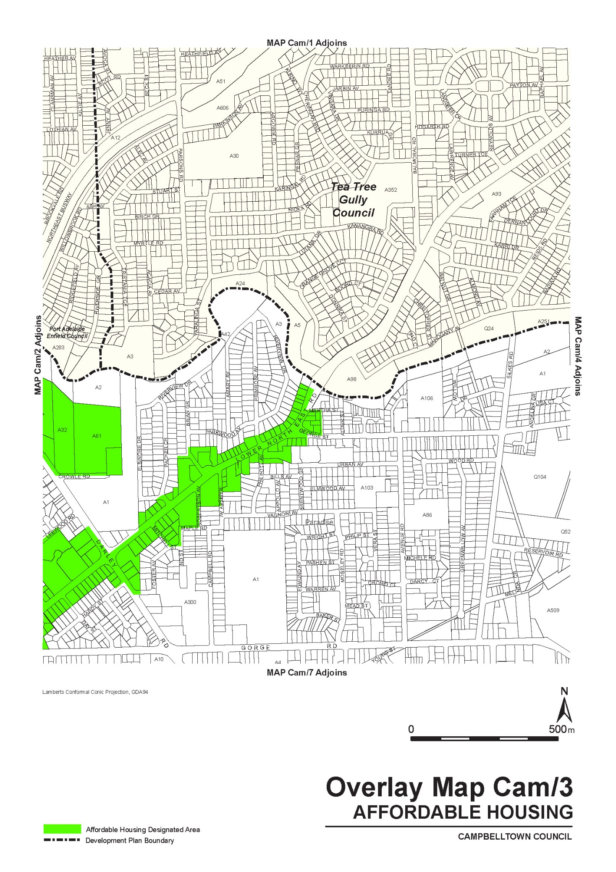
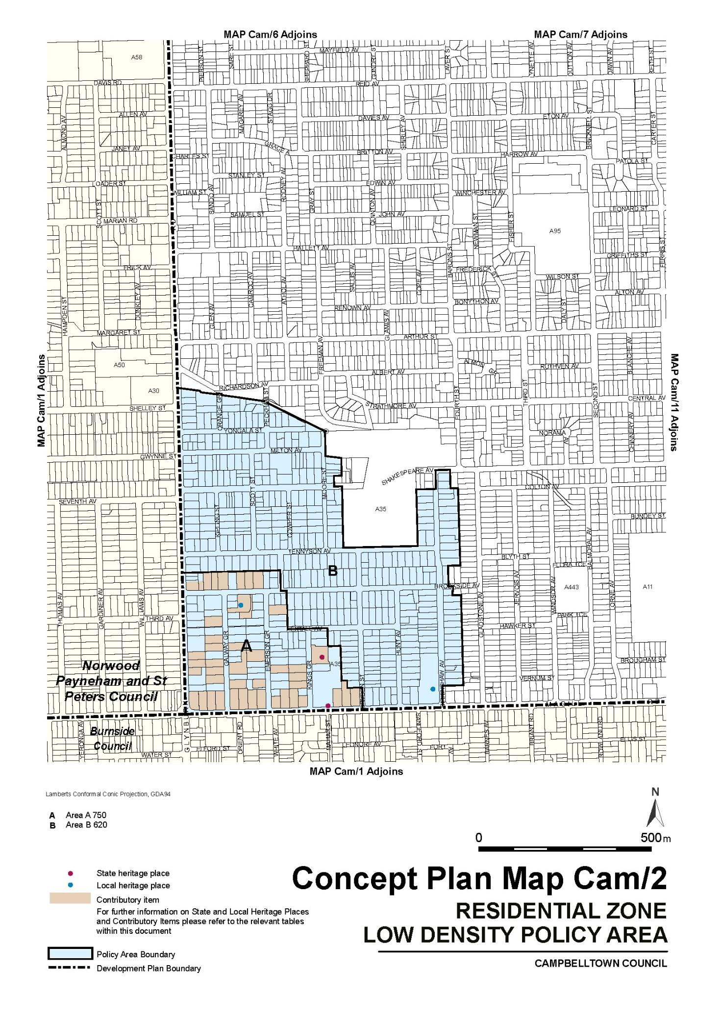
Attachment C

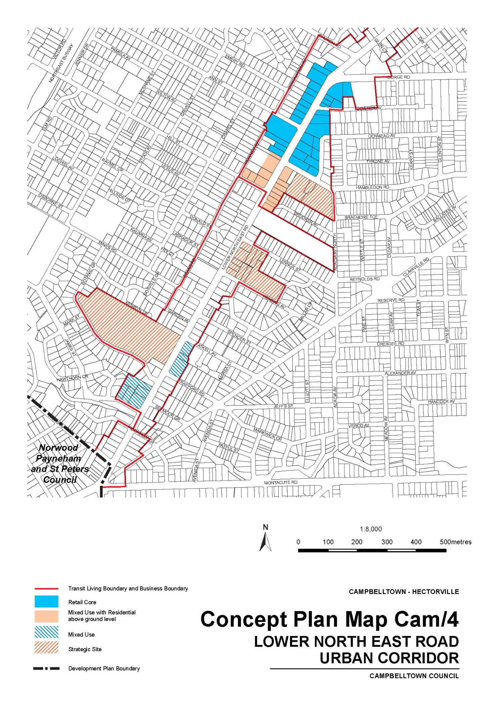
Attachment D

EDUCATION ACT 1972
Notice fixing charges for dependents of subclass 457 visa holders
PURSUANT to section 106B of the Education Act 1972, I fix the following charges payable in respect of a dependent of a person who is the subject of a temporary work (skilled) visa (subclass 457) issued under the Migration Act 1958 of the Commonwealth for education in a Government school (also referred to as the ‘Temporary Residents 457 Visa student contribution fee per school year’). These charges have effect from 1 January 2018:
- Charges for dependent subclass 457 visa student: $
  - for primary education 5 200
  - for secondary education 6 200
subject to any applicable fee reductions or exemptions.
- Where more than one dependent of a primary subclass 457 visa holder is subject to a charge under this notice, the full amount of the charge payable under paragraph 1 will apply to the eldest of those dependents. The second and any subsequent dependents will be subject to the full charge that would otherwise be payable under paragraph 1 less 10%.
- The charge otherwise payable under paragraphs 1 and 2 above will, if the family income is below the upper threshold, be reduced as follows:
Where the family income is more than $58,000, but less than the upper threshold rounded down to the nearest whole thousand dollars, the charge payable is a proportion of the charge indicated in paragraph 1, calculated according to the following formula:
A - $58,000
$10,000 + (B x $10,000)
Where A = family income rounded down to the nearest whole thousand dollars; and
B = the number of dependents of the primary subclass 457 visa holder enrolled in Government schools
- Where the family income is $58 000 or less, rounded down to the nearest whole thousand dollars, no tuition charge will be payable by any dependents of the primary subclass 457 visa holder under this notice.
- Charge for student enrolled for part of school year – if a dependent student is enrolled at a Government school for part of a school year, the charge payable is a proportion of the charge calculated in accordance with paragraphs 1,2 and 3 being the proportion that the number of school weeks for the whole or part of which the student is enrolled bears to 40.
- For the purposes of this notice:
family income means the estimated combined gross income of a primary subclass 457 visa holder and their spouse or partner for a twelve month period commencing on 1 January of the school year for which the charge is payable or the date on which the dependent student subject to a charge under this notice first commences at a Government school, whichever is the later.
Gross income includes any salary sacrifice and overtime payments.
The upper threshold for the purposes of family income is calculated in the following way: $
  - For the first dependent student at a government school 78 000
  - For each additional dependent student at a government school add 10 000
Dated 2 October 2017.
K Weston, Acting Chief Executive,
Department for Education and Child Development

FIRE AND EMERGENCY SERVICES ACT 2005
Section 78
Fire Danger Season
THE South Australian Country Fire Service hereby:
- Fixes the date of the Fire Danger Season within the part of the State defined as the North East Pastoral Fire Ban District so as to commence on the 15th of October 2017.
- Fixes the date of the Fire Danger Season within the part of the State defined as the North West Pastoral Fire Ban District so as to commence on the 15th of October 2017.
Andrew Stark, Acting Chief Officer,
SA Country Fire Service

HEALTH CARE ACT 2008
Sections 57(1) (c), 58 (1) (d) and 62 – Exemptions
Notice by the Minister
TAKE notice that I, Peter Bryden Malinauskas, Minister for Health, pursuant to sub-section 57(1)(c), 58 (1) (d) and section 62 of the Health Care Act 2008, do hereby exempt the persons named in Column A of the Schedule from the application of Part 6 – Division 2 and Division 3, Section 59 of the Health Care Act 2008, in relation to the emergency ambulance services and non-emergency ambulance services specified in Column B of the Schedule, and on the conditions (if any) specified in Column C of the Schedule, with effect on and from 1 July 2017 and for the period expiring on 30 June 2018.
Schedule
Column A | Column B | Column C
SIMEC Mining | Emergency ambulance services provided at the Iron Knob mine site. | Nil.
SIMEC Mining | Emergency ambulance services provided in surrounding areas to the Iron Knob mine site for purposes of rendezvousing with SA Ambulance Service. | That the emergency services are provided either at the request of SA Ambulance Service or, in circumstances where SA Ambulance Service has not made a request, the organisation notifies SA Ambulance Service as soon as practical to determine if SA Ambulance Service have a more appropriate response or can support the response.
SIMEC Mining | Emergency ambulance services provided at Iron Duke, Iron Duchess, Iron Knight and Iron Chieftain mine sites. | Nil.
SIMEC Mining | Emergency ambulance services provided in surrounding areas to Iron Duke, Iron Duchess, Iron Knight and Iron Chieftain mine sites for purposes of rendezvousing with SA Ambulance Service. | That the emergency services are provided either at the request of SA Ambulance Service or, in circumstances where SA Ambulance Service has not made a request, the organisation notifies SA Ambulance Service as soon as practical to determine if SA Ambulance Service have a more appropriate response or can support the response.
SIMEC Mining | Emergency ambulance services provided at Iron Baron mine site. | Nil.
SIMEC Mining | Emergency ambulance services provided in surrounding areas to Iron Baron mine site for the purpose of rendezvousing with SA Ambulance Service. | That the emergency services are provided either at the request of SA Ambulance Service or, in circumstances where SA Ambulance Service has not made a request, the organisation notifies SA Ambulance Service as soon as practical to determine if SA Ambulance Service have a more appropriate response or can support the response.
SIMEC Mining | Non-emergency ambulance services provided at the Iron Knob mine site. | Nil.
SIMEC Mining | Non-emergency ambulance services provided in surrounding areas to the Iron Knob mine site. | That the organisation notifies SA Ambulance Service of each occasion that non-emergency ambulance services are provided within a time and with details as requested by SA Ambulance Service.
SIMEC Mining | Non-emergency ambulance services provided at Iron Duke, Iron Duchess, Iron Knight and Iron Chieftain mine sites. | Nil.
SIMEC Mining | Non-emergency ambulance services provided in surrounding areas to Iron Duke, Iron Duchess, Iron Knight and Iron Chieftain mine sites. | That the organisation notifies SA Ambulance Service of each occasion that non-emergency ambulance services are provided within a time and with details as requested by SA Ambulance Service.
SIMEC Mining | Non-emergency ambulance services provided at Iron Baron mine site. | Nil.
SIMEC Mining | Non-emergency ambulance services provided in surrounding areas to Iron Baron mine site for purposes of rendezvousing with SA Ambulance Service. | That the organisation notifies SA Ambulance Service of each occasion that non-emergency ambulance services are provided within a time and with details as requested by SA Ambulance Service.
WPG Resources Ltd | Emergency ambulance services provided at surrounding pastoral properties on the Challenger Gold mine access road and the Tarcoola Gold Mine | That the emergency services are provided either at the request of SA Ambulance Service or, in circumstances where SA Ambulance Service has not made a request, the organisation notifies SA Ambulance Service as soon as practical to determine if SA Ambulance Service have a more appropriate response or can support the response.
WPG Resources Ltd | Non-emergency ambulance services provided at the Challenger Gold Mine and the Tarcoola Gold Mine | Nil
WPG Resources Ltd | Non-emergency ambulance services provided at surrounding pastoral properties on the Challenger Gold mine access road and the Tarcoola Gold Mine | That the organisation notifies SA Ambulance Service of each occasion that non-emergency ambulance services are provided within a time and with details as requested by SA Ambulance Service.
Dated 2 October 2017.
Peter Bryden Malinauskas, Minister for Health

LAND ACQUISITION ACT 1969
(Section 16)
Form 5—Notice of Acquisition
- Notice of acquisition
THE Commissioner of Highways (the Authority), of 50 Flinders Street, Adelaide SA 5000, acquires the following interests in the following land:
Comprising an estate in fee simple in that piece of land being whole of Lot 21 in Community Plan 27808 comprised in Certificate of Title Volume 6115 Folio 439 and whole of Lot 20 in Community Plan 27808 comprised in Certificate of Title Volume 6193 Folio 738, together with the easement(s) over the land marked ‘A’ on CP 27808 (T 1582788)
This notice is given under section 16 of the Land Acquisition Act 1969.
- Compensation
A person who has or had an interest in the land that is divested or diminished by the acquisition or the enjoyment of which is adversely affected by the acquisition who does not receive an offer of compensation from the Authority may apply to the Authority for compensation.
- Inquiries
Inquiries should be directed to:
Carlene Russell
GPO Box 1533
Adelaide SA 5001
Telephone: (08) 8343 2512
Dated 6 October 2017.
The Common Seal of the Commissioner of Highways was hereto affixed by authority of the Commissioner in the presence of:
Mohammed Elgazzar, Manager Portfolio and Acquisition Services
(Authorised Officer), Department of Planning, Transport and Infrastructure
DPTI 2016/10099/03

MINING ACT 1971
Notice pursuant to section 28(5) of the Mining Act 1971
NOTICE is hereby given in accordance with Section 28(5) of the Mining Act 1971 that the delegate of the Minister for Mineral Resources and Energy intends to grant an Exploration Licence over the area described below
Applicant: Menninnie Metals Pty Ltd
Location: Reid Lookout Area – approx. 70 km west of Port Augusta
Pastoral Leases: Carriewerloo, Siam, Yudnapinna, Wartaka
Term: Two years
Area in km²: 716
Reference number: 2017/00188
Plan and co-ordinates can be found on the Department of the Premier and Cabinet website: http://www.minerals.dpc.sa.gov.au/exploration/public_notices or by contacting Mineral Tenements on 08 8463 3103.
Community information on mineral exploration licence processes and requirements under the Mining Act 1971 is available from: http://www.minerals.dpc.sa.gov.au/land_access/community_information or hard copy on request to Mineral Tenements.
J Martin, Mining Registrar,
Department of the Premier and Cabinet,
Delegate of the Minister for Mineral Resources and Energy

MINING ACT 1971
Notice pursuant to section 28(5) of the Mining Act 1971
NOTICE is hereby given in accordance with Section 28(5) of the Mining Act 1971 that the delegate of the Minister for Mineral Resources and Energy intends to grant an Exploration Licence over the area described below
Applicant: Menninnie Metals Pty Ltd
Location: Siam Area – approx. 90 km west of Port Augusta
Pastoral Leases: Siam, Nonning, Wartaka
Term: Two years
Area in km²: 379
Reference number: 2017/00189
Plan and co-ordinates can be found on the Department of the Premier and Cabinet website: http://www.minerals.dpc.sa.gov.au/exploration/public_notices or by contacting Mineral Tenements on 08 8463 3103.
Community information on mineral exploration licence processes and requirements under the Mining Act 1971 is available from: http://www.minerals.dpc.sa.gov.au/land_access/community_information or hard copy on request to Mineral Tenements.
J Martin, Mining Registrar,
Department of the Premier and Cabinet,
Delegate of the Minister for Mineral Resources and Energy

MINING ACT 1971
Notice pursuant to section 28(5) of the Mining Act 1971
NOTICE is hereby given in accordance with Section 28(5) of the Mining Act 1971 that the delegate of the Minister for Mineral Resources and Energy intends to grant an Exploration Licence over the area described below
Applicant: FMG Resources Pty Ltd
Location: Roxby Downs Area – approx. 55 km southwest of Andamooka
Pastoral Leases: Roxby Downs, Purple Downs, Parakylia
Term: Two years
Area in km²: 192
Reference number: 2017/00191
Plan and co-ordinates can be found on the Department of the Premier and Cabinet website: http://www.minerals.dpc.sa.gov.au/exploration/public_notices or by contacting Mineral Tenements on 08 8463 3103.
Community information on mineral exploration licence processes and requirements under the Mining Act 1971 is available from: http://www.minerals.dpc.sa.gov.au/land_access/community_information or hard copy on request to Mineral Tenements.
J Martin, Mining Registrar,
Department of the Premier and Cabinet,
Delegate of the Minister for Mineral Resources and Energy

MINING ACT 1971
Notice pursuant to section 28(5) of the Mining Act 1971
NOTICE is hereby given in accordance with Section 28(5) of the Mining Act 1971 that the delegate of the Minister for Mineral Resources and Energy intends to grant an Exploration Licence over the area described below
Applicant: FMG Resources Pty Ltd
Location: Pernatty Area – approx. 65 km southeast of Woomera
Pastoral Leases: Oakden Hills, Pernatty
Term: Two years
Area in km²: 35
Reference number: 2017/00195
Plan and co-ordinates can be found on the Department of the Premier and Cabinet website: http://www.minerals.dpc.sa.gov.au/exploration/public_notices or by contacting Mineral Tenements on 08 8463 3103.
Community information on mineral exploration licence processes and requirements under the Mining Act 1971 is available from: http://www.minerals.dpc.sa.gov.au/land_access/community_information or hard copy on request to Mineral Tenements.
J Martin, Mining Registrar,
Department of the Premier and Cabinet,
Delegate of the Minister for Mineral Resources and Energy

NATIONAL ELECTRICITY LAW
THE Australian Energy Market Commission (AEMC) gives notice under the National Electricity Law as follows:
Under ss 102 and 103, the making of the National Electricity Amendment (Secondary trading of settlement residue distribution units) Rule 2017 No. 13 (Ref. ERC0220) and related final determination. All provisions commence on 20 October 2017.
Under ss 102 and 103, the making of the National Electricity Amendment (Pricing during market suspension) Rule 2017 No. 14 (Ref. ERC0224) and related final determination. All provisions commence on 1 December 2017.
Documents referred to above are available on the AEMC’s website and are available for inspection at the AEMC’s office.
Australian Energy Market Commission
Level 6, 201 Elizabeth Street
Sydney NSW 2000
Telephone: (02) 8296 7800
www.aemc.gov.au
Dated 10 October 2017.

NATIONAL GAS LAW
THE Australian Energy Market Commission (AEMC) gives notice under the National Gas Law as follows:
Under ss 311 and 313, the making of the National Gas Amendment (Changes to periodic review of market parameters in STTM) Rule 2017 No. 4 (Ref. GRC0042) and related final determination. All provisions commence on 10 October 2017.
Documents referred to above are available on the AEMC’s website and are available for inspection at the AEMC’s office.
Australian Energy Market Commission
Level 6, 201 Elizabeth Street
Sydney NSW 2000
Telephone: (02) 8296 7800
www.aemc.gov.au
Dated 10 October 2017.

PETROLEUM AND GEOTHERMAL ENERGY ACT 2000
Application for Grant of Associated Activities Licence AAL 251
PURSUANT to section 65(6) of the Petroleum and Geothermal Energy Act 2000 and Delegation dated 31 March 2017, notice is hereby given that an application for the grant of an Associated Activities Licence within the area described below has been received from:
Victoria Oil Exploration (1977) Pty Ltd
Acer Energy Pty Limited
The application will be determined on or after 7 November 2017.
Description of Application Area
The application covers an area of approximately 4.56 square kilometres located north of Moomba in the South Australian Cooper Basin.
A map and GIS data for the application area is available from the Department of the Premier and Cabinet website at the following location: https://sarig.pir.sa.gov.au/Map or by contacting the Department of the Premier and Cabinet, Energy Resources Division on telephone (08) 8463 3204.
Dated 5 October 2017.
Barry A. Goldstein, Executive Director,
Energy Resources Division, Department of the Premier and Cabinet,
Delegate of the Minister for Mineral Resources and Energy

REPORT OF THE REMUNERATION TRIBUNAL
No. 8 of 2017
Electoral Districts Boundaries Commission
INTRODUCTION
- The Remuneration Tribunal (“the Tribunal”) has jurisdiction under section 14 of the Remuneration Act 1990 (“the Act”) and section 78(7) of the Constitution Act 1934 (“the Constitution Act”), to determine the remuneration payable to the members of the Electoral Districts Boundaries Commission (other than the chairman).
BACKGROUND
- The Constitution Act provides for the establishment of an Electoral Districts Boundaries Commission (“the Commission”) to review and carry out periodic redistribution of the boundaries of the State’s House of Assembly electoral districts. The Commission has perpetual succession and the functions of a Royal Commission.
- The members of the Commission are:
- the most senior Supreme Court puisne judge available, appointed by the Chief Justice, to be the Chairman;
- the Electoral Commissioner; and
- the Surveyor-General.
- Section 78(7) of the Constitution Act states, “The members of the Commission (other than the Chairman) are entitled to remuneration determined by the Remuneration Tribunal.”
- The last Determination made by the Tribunal under section 78(7) of the Constitution Act was in 2012, whereby the Tribunal determined an allowance $16,550 for the Electoral Commissioner and $11,585 for the Surveyor-General.
- The Tribunal notes that historically, Determinations of remuneration made under section 78(7) of the Constitution Act have been made on a four yearly basis, and have prescribed a one off payment as compensation for the work performed by the relevant members of the Commission.
- The Tribunal notes that at the time of the Commission in 2016, the Deputy Electoral Commissioner was acting as Electoral Commissioner, due to the vacancy of that office.
SUBMISSIONS
- In accordance with section 10(2) of the Act¹ the Tribunal invited submissions from the affected parties to be taken into consideration as part of the review. A time was also made available for the making of oral submissions on 22 August 2017. Submissions were received from the Chair of the Commission, the Electoral Commissioner, the Deputy Electoral Commissioner, the Surveyor-General and the Crown Solicitor’s Office on behalf of the Honourable Premier.
- A summary of the submissions received is as follows:
The Chair of the Commission (Her Honour Justice Vanstone) submitted that:
- The Commission undertook a significantly greater workload than previous Commissions, due to undertaking a greater number of public consultations and having the Commission’s order unsuccessfully challenged before the Full Court of the Supreme Court of South Australia.
- A schedule of hours was provided for the Acting Electoral Commissioner and the Surveyor-General for the performance of their respective duties as part of the Commission.
The Electoral Commissioner (Mr Michael Sherry) submitted that:
- The Constitution Act 1934 binds the Electoral Commissioner to participate as a member of the Commission.
- The remuneration of the Commission should be at least consistent with that of the Electoral Commissioner.
- The duration and complexity of each Commission can differ significantly.
The Deputy Electoral Commissioner (Mr David Gully) and the Surveyor General (Mr Michael Burdett) submitted that:
- Any assessment acknowledges that each member was required to maintain their base workload in addition to their obligations as members of the Commission.
- That each member expended many hours outside normal work hours.
- The length of service with respect to the work of the Commissioner will ensure for a period of at least 12 months.
- The statutory obligation placed upon each member requires them to operate at a very senior level and possibly significantly higher than their substantive level.
- The “public position” under which the Commission is viewed, scrutinised and judged needs to be given full consideration.
- The remuneration of the two members of the Commission should be equal.
The Crown Solicitor’s Office, on behalf of the Honourable Premier submitted that:
- The period for which the additional duties were performed is significant (12 months).
- General industrial/wage fixation principles should be taken into account by the Tribunal, including relevant benchmarks in the public employment setting.
- The methodology and the amounts of the respective allowance are matters for the Tribunal in the exercise of its discretion.
CONCLUSION
- The Tribunal is required by Section 101(1) of the Fair Work Act 1994 (SA) to have due regard to principles, guidelines, conditions practices or procedures adopted by the South Australian Employment Tribunal (“SAET”). That section is set out as follows:
101—State industrial authorities to apply principles
(1) In arriving at a determination affecting remuneration or working conditions, a State industrial authority must have due regard to and may apply and give effect to principles, guidelines, conditions, practices or procedures adopted by SAET under this Part.
(2) However, principles adopted under this Part are not applicable to enterprise agreements.
(3) In this section—
State industrial authority means—
(a) SAET; or
(b) the Remuneration Tribunal; or
(c) the Commissioner for Public Sector Employment; or
(d) another person or body declared by regulation to be a State industrial authority.
- The Tribunal has had due regard accordingly as required by the relevant legislative provisions, and has taken into consideration movements in minimum remuneration determined by SAET since Determination 5 of 2012².
- The Tribunal notes that the Deputy Electoral Commissioner and the Surveyor-General have submitted that the remuneration of the two offices that are subject to the Tribunal’s Determination should be equal. The Tribunal accepts that submission, and is of the view that the value of the work should be properly apprehended as equivalent.
- The Tribunal also considers that the highest order of the work performed by the relevant members of the Commission is the most appropriate consideration in determining a monetary amount of remuneration for the relevant office holders performing the work of the Commission.
- Having regard to the nature and extent of the additional work undertaken by the members of the Commission (other than the Chairman) in producing the 2016 Report of the Electoral Districts Boundaries Commission, the Tribunal is of the view that:
- The Acting Electoral Commissioner should be entitled to be paid an allowance of $18,963; and
- The Surveyor-General should be entitled to be paid an allowance of $18,963.
- A Determination will issue accordingly.
¹ Before the Tribunal makes a determination affecting the remuneration of a particular person, or persons of a particular class, the Tribunal must allow that person, or the persons of that class, a reasonable opportunity to make submissions orally or in writing to the Tribunal.
² Determination 5 of 2012 – Electoral Districts Boundaries Commission
Dated 3 October 2017.
John Lewin, President
Peter Alexander, Member
Pamela Martin, Member

DETERMINATION OF THE REMUNERATION TRIBUNAL
No. 8 of 2017
Electoral Districts Boundaries Commission
DETERMINATION
- In accordance with section 78(7) of the Constitutions Act 1934, having regard to the nature and extent of the work performed by the members of the Electoral Districts Boundaries Commission (other than the Chairman) producing the 2016 Report of the Electoral Districts Boundaries Commission, the Remuneration Tribunal hereby determines that:
- The Acting Electoral Commissioner (Mr David Gully) and the Surveyor-General (Mr Michael Burdett) shall each be entitled to be paid an amount of $18,963.
Dated 3 October 2017.
John Lewin, President
Peter Alexander, Member
Pamela Martin, Member

South Australia
Criminal Law (Forensic Procedures) (Prescribed Authority) Variation Regulations 2017
under the Criminal Law (Forensic Procedures) Act 2007

Contents
Part 1—Preliminary
1 Short title
2 Commencement
3 Variation provisions
Part 2—Variation of Criminal Law (Forensic Procedures) Regulations 2007
4 Insertion of regulation 5B
5B Release and disclosure for scientific purposes—prescribed authority

Part 1—Preliminary
1—Short title
These regulations may be cited as the Criminal Law (Forensic Procedures) (Prescribed Authority) Variation Regulations 2017.
2—Commencement
These regulations come into operation on the day on which they are made.
3—Variation provisions
In these regulations, a provision under a heading referring to the variation of specified regulations varies the regulations so specified.
Part 2—Variation of Criminal Law (Forensic Procedures) Regulations 2007
4—Insertion of regulation 5B
After regulation 5A insert:
5B—Release and disclosure for scientific purposes—prescribed authority
For the purposes of section 50A(1) of the Act, a person for the time being performing the duties, or holding or acting in the position, of Director of Forensic Science SA is a prescribed authority.
Note—
As required by section 10AA(2) of the Subordinate Legislation Act 1978, the Minister has certified that, in the Minister's opinion, it is necessary or appropriate that these regulations come into operation as set out in these regulations.
Made by the Governor
with the advice and consent of the Executive Council
on 10 October 2017
No 290 of 2017
AGO0121/17CS

ADELAIDE HILLS COUNCIL
Roads (Opening and Closing) Act 1991
Proposed Road Closing—Portion of Lobethal Road, Lobethal
NOTICE is hereby given, pursuant to section 10 of the Roads (Opening and Closing) Act 1991, that ADELAIDE HILLS COUNCIL proposes to make a Road Process Order to close and then merge portion of Lobethal Road, Lobethal into the adjoining property, being Allotment 62 in Deposited Plan 74988, Certificate of Title 6004/394. The portion of road is more particularly delineated and marked "E" on Preliminary Plan No. 17 /45. A copy of the Preliminary Plan and a statement of persons affected are available for public inspection during normal office hours at the offices of the Council at the:
- Stirling Service Centre, 63 Mount Barker Road, Stirling
- Woodside Service Centre 26 Onkaparinga Valley Road, Woodside,
- Gumeracha Civic Centre, 45 Albert Street, Gumeracha, or on Council's website ahc.sa.gov.au
plus at the Adelaide office of the Surveyor-General at 101 Grenfell Street, Adelaide.
Any person is entitled to object to the proposed road process via a written submission. An objection must state whether the objector wishes to make a deputation to the Council in relation to the proposed road process. The Council will give notification of a meeting at which the matter will be considered so the person making the deputation or a representative may attend, is so desired.
Any person affected by the proposed closure is entitled to apply for an easement to be granted in that person's favour over the land subject to the proposed closure. The Council will give notification of a meeting at which the matter will be considered, so that the person making the objection or a representative may attend, if so desired.
An objection or application for an easement must set out the full name and address of the person making the objection or application and must be fully supported by reasons.
Any application for an easement must give full particulars of the nature and location of the easement and where made by a person as the owner of adjoining or nearby land, specify the land to which the easement is to be annexed.
The objection or application for an easement must be made in writing to the Council at PO Box 44, Woodside, SA, 5244, WITHIN 28 DAYS OF THIS NOTICE (by 5.00pm on 9/11/2017) and a copy must also be forwarded to the Surveyor-General at GPO Box 1354, Adelaide 5001.
Dated 28 September 2017.
A. Aitken, Chief Executive Officer

ADELAIDE HILLS COUNCIL
Roads (Opening and Closing) Act 1991
Proposed Road Closing—Portions of Mill Road, Lobethal
NOTICE is hereby given, pursuant to section 10 of the Roads (Opening and Closing) Act 1991, that ADELAIDE HILLS COUNCIL proposes to make a Road Process Order to close and then merge portions of Mill Road, Lobethal into the adjoining properties, being Allotment 202 in Deposited Plan 65382, Certificate of Title 5933/649. Allotment 87 in Filed Plan 4620, Certificate of Title 5897/519. Allotment 201 in Deposited Plan 60535, Certificate of Title 5897 /516. The portions of road are more particularly delineated and marked 'A', 'B' and 'C' on Preliminary Plan No. 17/44. A copy of the Preliminary Plan and a statement of persons affected are available for public inspection during normal office hours at the offices of the Council at the:
- Stirling Service Centre, 63 Mount Barker Road, Stirling
- Woodside Service Centre 26 Onkaparinga Valley Road, Woodside,
- Gumeracha Civic Centre, 45 Albert Street, Gumeracha, or on Council's website ahc.sa.gov.au
plus at the Adelaide office of the Surveyor-General at 101 Grenfell Street, Adelaide.
Any person is entitled to object to the proposed road process via a written submission. An objection must state whether the objector wishes to make a deputation to the Council in relation to the proposed road process. The Council will give notification of a meeting at which the matter will be considered so the person making the deputation or a representative may attend, is so desired.
Any person affected by the proposed closure is entitled to apply for an easement to be granted in that person's favour over the land subject to the proposed closure. The Council will give notification of a meeting at which the matter will be considered, so that the person making the objection or a representative may attend, if so desired.
An objection or application for an easement must set out the full name and address of the person making the objection or application and must be fully supported by reasons.
Any application for an easement must give full particulars of the nature and location of the easement and where made by a person as the owner of adjoining or nearby land, specify the land to which the easement is to be annexed.
The objection or application for an easement must be made in writing to the Council at PO Box 44, Woodside, SA, 5244, WITHIN 28 DAYS OF THIS NOTICE (by 5.00pm on 9/11/2017) and a copy must also be forwarded to the Surveyor-General at GPO Box 1354, Adelaide 5001.
Dated 28 September 2017.
A. Aitken, Chief Executive Officer

DISTRICT COUNCIL OF CEDUNA
Review of Elector Representation
NOTICE is hereby given that the District Council of Ceduna, in accordance with the requirements of Section 12(4) of the Local Government Act 1999, has reviewed its composition and elector representation arrangements.
Pursuant to Section 12(13)(a) of the said Act, the Electoral Commissioner has certified on 5 October 2017, that the review undertaken by Council satisfies the requirements of the Act and may therefore now be put into effect as from the day of the first periodic election held after the publication of this notice.
As a result of the review, the representation arrangements are as follows:
- The principal member of Council continue to be a Mayor elected by the community.
- The Council area not be divided into wards (retain the existing “no wards” structure).
- The Council continue to comprise eight (8) area councillors and the Mayor.
G.M. Moffatt, Chief Executive Officer

CLARE & GILBERT VALLEYS COUNCIL
Elector Representation Review
NOTICE is hereby given that the Clare & Gilbert Valleys Council has completed a review of its composition and elector representation arrangements in accordance with the requirements of Section 12 (4) of the Local Government Act 1999 (the Act).
Pursuant to Section 12 (13) (a) of the Act, the Electoral Commissioner has certified that the review undertaken by Council satisfies the requirements of Section 12 of the Act. As such, the following structure will be put into effect as of the day of the first periodic Local Government election held after the publication of this notice.
- The principal member of Council will be a mayor, elected by the community.
- The Council area will not be divided into wards.
- The future elected body of Council will comprise the mayor and nine (9) area councillors.
John Coombe OAM, Acting Chief Executive Officer

COPPER COAST COUNCIL
Exclusion from Community Land Classification
NOTICE is hereby given that the Copper Coast Council at a meeting held on 4th October 2017, resolved pursuant to Section 193(4)(a) of the Local Government Act 1999, that upon acquisition the following parcel of land will be excluded from the Community Land Classification:
- Allotment 109 Frances Terrace, Kadina
Peter Harder, Chief Executive Officer

DISTRICT COUNCIL OF KIMBA
Temporary Road Closure
NOTICE is hereby given that at a Council meeting held on 13th September, 2017, Council resolved the following:
That:
1) The District Council of Kimba exercise the power subject to Section 33 of the Road Traffic Act 1961 and clause F of the Instrument of General Approval of the Minister dated 22nd August 2013 to make an order that High Street, from the boundary of the Café/Park to the boundary of the Kimba Soldiers Memorial Institute be closed between 9.00am and 3.00pm on Tuesday 24th October, 2017 for the purpose of an “Arts Big Day Out”.
Debra Larwood, Chief Executive Officer

DISTRICT COUNCIL OF MOUNT REMARKABLE
Change to Road Names
NOTICE is hereby given that at a meeting of Council held on 19 September 2017, Council resolved pursuant to Section 219 (1) of the Local Government Act 1999, to change the name of the following roads:
- Glori Di Road, amended spelling to Gloria Dei Road
- Unnamed Road, 372 & 373 Hd Gregory Wilmington to be named Fairview Road
W. Hart, Chief Executive Officer

IN the matter of the estates of the undermentioned deceased persons:
COLDWELL Barry John late of 4A Fern Court Parafield Gardens Fleet Manager who died 2 June 2017
GIDDINGS William Roy late of 126 Moscow Street Peterborough Retired Fitter who died 20 July 2017
KOLAN Zygmunt late of 75 - 79 Hilltop Drive Oakden of no occupation who died 10 March 2017
LIDEFJALL Gunnar late of 147 St Bernards Road Rostrevor of no occupation who died 4 December 2016
SETTECITO Pietro late of 28A Eleventh Street Bowden Bulldozer Driver who died 4 July 2017
TAYLOR Kathleen Ann late of 16 War Memorial Drive Balaklava of no occupation who died 6 May 2017
WATTS Robert Reginald late of Corner of Bay and Kilsby Roads Mount Gambier Mechanic who died 6 February 2015
Notice is hereby given pursuant to the Trustee Act 1936, the Inheritance (Family Provision) Act 1972 and the Family Relationships Act 1975 that all creditors, beneficiaries, and other persons having claims against the said estates are required to send, in writing, to the office of Public Trustee at GPO Box 1338, Adelaide, 5001, full particulars and proof of such claims, on or before the 10 November 2017 otherwise they will be excluded from the distribution of the said estate; and notice is also hereby given that all persons indebted to the said estates are required to pay the amount of their debts to the Public Trustee or proceedings will be taken for the recovery thereof; and all persons having any property belonging to the said estates are forthwith to deliver same to the Public Trustee.
Dated 10 October 2017.
D A Contala, Public Trustee

ESSENTIAL SERVICES COMMISSION ACT 2002
Price determination for essential maritime services
NOTICE is hereby given that:
1. Pursuant to section 25(1) of the Essential Services Commission Act 2002, the Essential Services Commission has made a Price Determination which applies to the South Australian ports industry, a regulated industry under the Maritime Services (Access) Act 2000.
2. The price determination will take effect on and from 31 October 2017 up to and including 30 October 2022.
3. The price determination sets out requirements relating to:
3.1. the publishing of prices for the provision of essential maritime services by regulated service providers, and
3.2. the monitoring and reporting of prices associated with the provision of essential maritime services by the Essential Services Commission.
4. A copy of the price determination and the statement of reasons for making it may be inspected or obtained from the Essential Services Commission, Level 1, 151 Pirie Street, Adelaide and is also available at www.escosa.sa.gov.au.
5. Queries in relation to the price determination may be directed to the Essential Services Commission, Level 1, 151 Pirie Street, Adelaide. Telephone (08) 8463 4444, Freecall 1800 633 592 or email escosa@escosa.sa.gov.au.
Execution:
The seal of the Essential Services Commission was affixed to the price determination with due authority by the Chairperson of the Essential Services Commission.
Dated 27 September 2017.
B. Rowse, Chairperson, Essential Services Commission

Notice Submission

The weekly South Australian Government Gazette is issued on Tuesday afternoon, except where Executive Council meets on Wednesday, wherein publishing will occur on that day.
The next scheduled publication date is displayed on the website: www.governmentgazette.sa.gov.au.

Notices for gazettal, along with enquiries, can be directed to:

Email governmentgazettesa@sa.gov.au
Phone (08) 8207 1045

Notices for gazettal are to be emailed in the following formats:

• Notices as individual Word files (.doc)
• Maps, images, and diagrams as separate PDF files (.pdf)
• Content requiring official signature for authorisation—notices as Word files
as well as signed documentation as PDF files

Please provide the following information in your email:

• Date the notice is to be gazetted
• Notification of whether a proof, quote, or return email confirmation is required
• Email address and phone number of the person authorising the submission
• Name of the person and organisation to be charged for the notice, if applicable, and a purchase order if required
• Details that may impact on publication of the notice

Notices must be submitted before 4 p.m. Friday, the week preceding intended gazettal.
Proofs of formatted content are supplied upon request, with necessary alterations to be returned before 4 p.m. the day preceding publication.
Submitted notices will be gazetted unless notification is received before 10 a.m. the day of publication.

Printed and published weekly by authority of Sinead O’Brien, Government Printer, South Australia
$7.35 per issue (plus postage), $370.00 per annual subscription—GST inclusive
Online publications: www.governmentgazette.sa.gov.au

