
No. 59 3943

THE SOUTH AUSTRALIAN
GOVERNMENT GAZETTE
Published by Authority

Adelaide, Tuesday, 5 September 2017

Contents

Appointments, Resignations, Etc. 3944
Air Transport (Route Licensing—Passenger
Services) Act 2002—Notice 3946
Corporations and District Councils—Notices 3967
Dangerous Substances Act 1979—Notice 3946
Development Act 1993—Notice 3947
Electricity Act 1996—Erratum 3947
Gas Act 1997—Erratum 3947
Geographical Names Act 1991—Notice 3947
Housing Improvement Act 2016—
Republished 3948
Notices 3948
Liquor Licensing Act 1997— Republished 3949
Mining Act 1971—Notices 3959
National Electricity Law—Notice 3960
Partnership Act 1891 (SA)—Notice 3960
Petroleum and Geothermal Energy Act 2000—
Notice 3961
Plumbers, Gas Fitters and Electricians Act 1995—
Notices 3961
Proof of Sunrise and Sunset Act 1923—Notice 3962
Proclamations 3964
Public Trustee Office—Administration of Estates 3968
Roads (Opening and Closing) Act 1991—Notice 3963
Road Traffic Act 1961—Notice 3963
Trustees Act 1936—Notice 3969

Department of the Premier and Cabinet
Adelaide, 5 September 2017
HIS Excellency the Governor in Executive Council has been pleased to appoint the undermentioned to the Police Disciplinary Tribunal, pursuant to the provisions of the Police Complaints and Discipline Act 2016:
Panel Member: (from 18 September 2017 until 28 April 2020)
Kylie Sue Schulz
By command,
Zoe Lee Bettison, for Premier
AGO0114/17CS

Department of the Premier and Cabinet
Adelaide, 5 September 2017
HIS Excellency the Governor in Executive Council has been pleased to appoint the undermentioned to the Protective Security Officers Disciplinary Tribunal, pursuant to the provisions of the Protective Security Act 2007:
Panel Member: (from 18 September 2017 until 28 April 2020)
Kylie Sue Schulz
By command,
Zoe Lee Bettison, for Premier
AGO0114/17CS

Department of the Premier and Cabinet
Adelaide, 5 September 2017
His Excellency the Governor in Executive Council has been pleased to appoint the Honourable John Robert Rau, MP, Deputy Premier, Attorney-General, Minister for Justice Reform, Minister for Planning, Minister for Industrial Relations, Minister for Child Protection Reform, Minister for the Public Sector, Minister for Consumer and Business Services and Minister for the City of Adelaide to be also Acting Premier for the period from 9 September 2017 to 16 September 2017 inclusive, during the absence of the Honourable Jay Wilson Weatherill, MP.
By command,
Zoe Lee Bettison, for Premier
DPC17/055CS

Department of the Premier and Cabinet
Adelaide, 5 September 2017
HIS Excellency the Governor in Executive Council has been pleased to appoint the Honourable John Robert Rau, MP, Deputy Premier, Attorney-General, Minister for Justice Reform, Minister for Planning, Minister for Industrial Relations, Minister for Child Protection Reform, Minister for the Public Sector, Minister for Consumer and Business Services and Minister for the City of Adelaide to be also Acting Treasurer, Acting Minister for Finance, Acting Minister for State Development and Acting Minister for Mineral Resources and Energy for the period from 11 September 2017 until 24 September 2017 inclusive, during the absence of the Honourable Tom Koutsantonis, MP.
By command,
Zoe Lee Bettison, for Premier
T&F17/061CS

Department of the Premier and Cabinet
Adelaide, 5 September 2017
HIS Excellency the Governor in Executive Council has been pleased to appoint the Honourable Susan Elizabeth Close, MP, Minister for Education and Child Development and Minister for Higher Education and Skills to be also Acting Minister for Investment and Trade, Acting Minister for Small Business, Acting Minister for Defence Industries and Acting Minister for Veterans’ Affairs for the period from 9 September 2017 to 20 September 2017 inclusive, during the absence of the Honourable Martin Leslie James Hamilton-Smith, MP.
By command,
Zoe Lee Bettison, for Premier
17MINT/511CS

Department of the Premier and Cabinet
Adelaide, 5 September 2017
HIS Excellency the Governor in Executive Council has been pleased to appoint Kylie Sue Schulz as a Magistrate commencing on 18 September 2017 - pursuant to the provisions of the Magistrates Act 1983.
By command,
Zoe Lee Bettison, for Premier
AGO0114/17CS

Department of the Premier and Cabinet
Adelaide, 5 September 2017
HIS Excellency the Governor in Executive Council has been pleased to appoint Kevin Patrick Duggan as the review agency for the Independent Commissioner Against Corruption to conduct the review required by section 5 of the Telecommunications (Interception) Act 2012 for a term commencing on 5 September 2017 and expiring on 4 March 2020 - pursuant to section 2 of the Telecommunications (Interception) Act 2012.
By command,
Zoe Lee Bettison, for Premier
AGO0099/17CS

Department of the Premier and Cabinet
Adelaide, 5 September 2017
HIS Excellency the Governor in Executive Council has been pleased to appoint Kevin Patrick Duggan as the review agency for the Independent Commissioner Against Corruption to conduct the review required by section 6D(1) of the Listening and Surveillance Devices Act 1972 for a term commencing on 5 September 2017 and expiring on 4 March 2020 - pursuant to section 3 of the Listening and Surveillance Devices Act 1972.
By command,
Zoe Lee Bettison, for Premier
AGO0099/17CS

Department of the Premier and Cabinet
Adelaide, 5 September 2017
HIS Excellency the Governor in Executive Council has been pleased to appoint Kevin Patrick Duggan as the review agency for the Independent Commissioner Against Corruption to conduct the review required by section 32 of the Surveillance Devices Act 2016 for a term commencing on 5 September 2017 and expiring on 4 March 2020 - pursuant to section 3(1) of the Surveillance Devices Act 2016 and section 14C of the Acts Interpretation Act 1915.
By command,
Zoe Lee Bettison, for Premier
AGO0099/17CS

Department of the Premier and Cabinet
Adelaide, 5 September 2017
HIS Excellency the Governor in Executive Council has been pleased to appoint Bethany Caldeira as Acting Public Advocate for a term commencing on 11 September 2017 and expiring on 24 September 2017 inclusive - pursuant to section 19 of the Guardianship and Administration Act 1993 and section 36 of the Acts Interpretation Act 1915.
By command,
Zoe Lee Bettison, for Premier
AGO0081/17CS

Department of the Premier and Cabinet
Adelaide, 5 September 2017
HIS Excellency the Governor in Executive Council has been pleased to appoint, by Notice in the Government Gazette the people listed in the attached Notice as Justices of the Peace for South Australia, upon the terms and conditions set out in the Notice - pursuant to Section 4 of the Justices of the Peace Act 2005.
NOTICE OF APPOINTMENT OF JUSTICES OF THE PEACE FOR SOUTH AUSTRALIA
Pursuant to Section 4 of the Justices of the Peace Act 2005
I, the Governor in Executive Council, hereby appoint the people listed as Justices of the Peace for South Australia for a period of ten years as set out below, it being a condition of appointment that the Justices of the Peace must take the oaths required of a Justice under the Oaths Act 1936 and return the oaths form to the Justice of the Peace Services within 3 months of the date of appointment.
For a term commencing on 27 September 2017 and expiring on 26 September 2027:
Michael Joseph Bombardieri
Margaret Janine Campbell
Josephine Verna Kunde
John Jeremy Lewis
Louise Anne-Marie London
Necia Ann Matthews
Sandra Gaye Maudslay
Narelle Elizabeth Pearks
Georgia Shaye Ross
Grant Sutton Schuyler
Kurt Justin Towers
Geoffrey Scott Treloar

For a term commencing on 4 October 2017 and expiring on 3 October 2027:
David Jeffrey Allen
Jasmyn Karma Allen
Michael Colin Appelby
Dennis James Barter
Ian Kelvin Benjamin
Brian Leslie Bennett
Wendy Brearley
Peter Michael Buckle
Beverly Anne Puust
Georgina Louise Stauner
Jan Lynette Sutherland
Bree Rebecca Taylor
By command,
Zoe Lee Bettison, for Premier
JP17/012CS

Department of the Premier and Cabinet
Adelaide, 5 September 2017
HIS Excellency the Governor in Executive Council has removed from the office of Justice of the Peace George Apap, effective from
5 September 2017 - pursuant to Section 11(5)(a) of the Justices of the Peace Act 2005.
By command,
Zoe Lee Bettison, for Premier
JP17/013CS

AIR TRANSPORT (ROUTE LICENSING—PASSENGER SERVICES) ACT 2002
Declaration of Adelaide—Port Augusta Route
Preamble
Section 5(1) of the Air Transport (Route Licensing—Passenger Services) Act 2002 (‘the Act’) provides that the Minister may, by notice in the Gazette, declare a route between two airports in the State to be a declared route for the purpose of the Act.
A notice extending a declaration of a route between Adelaide Airport and Port Augusta was published in the Gazette on 12 January 2017 (see Gazette 12 January 2017, page 42).
The Minister revokes and replaces that declaration pursuant to section 5 of the Act.
Declaration of Adelaide—Port Augusta Route
NOTICE is hereby given pursuant to section 5 (1) of the Act, that the route between Adelaide Airport and Port Augusta is to be a declared route for the purpose of the Act.
Pursuant to section 5 (2) of the Act, details of the declaration are as follows:
(a) the declared route constitutes any route that an aircraft may take when flying between Adelaide and Port Augusta airports;
(b) one route service licence will be made available for the route; and
(c) conditions that may be fixed in relation to the route service are specified in section 8 (1) of the Act;
(d) pursuant to an open tender process, an operator has been successful in applying for a route service licence for the declared
route. In the event that the operator’s route service licence comes to an end, further information on the process for making
an application will be provided by separate notice in the Gazette.
This declaration will commence on the date of its publication.
Pursuant to Section 5 (5) of the Act, this declaration will be valid for a period from its commencement until 31 December 2019.
Revocation
NOTICE is hereby given pursuant to section 5 (11) (d) of the Act, that I revoke the declaration under the Act published in the Gazette on 12 January 2017 (see Gazette 12 January 2017, p. 42) from the day on which this declaration commences.
Dated 5 September 2017.
Stephen Mullighan, Minister for Transport and Infrastructure

DANGEROUS SUBSTANCES ACT 1979
Revoke the Appointment of Authorised Officers
I, MARTYN CAMPBELL, Executive Director, SafeWork SA, hereby revoke the appointment of the following persons as Authorised Officers for the purposes of the Dangerous Substances Act 1979 pursuant to section 7(4) of that Act:
• David Lawrence OPPERMANN
• Michael Lloyd GOODMAN
• Graham Ross GIBBS
Dated 31 August 2017.
Martyn Campbell, Executive Director, SafeWork SA

DEVELOPMENT ACT 1993
Morphettville Racecourse Development Plan Amendment
Prepared by the Minister for Public Consultation
NOTICE is hereby given that the Minister for Planning, pursuant to sections 24 and 26 of the Development Act 1993, has prepared a Morphettville Racecourse Development Plan Amendment (DPA) to amend the following Development Plans:
- Marion Council Development Plan Amendment
- West Torrens Council Development Plan Amendment
The DPA proposes to rezone land north of the racetrack, including land identified as surplus to the Racecourse, to support medium to high density residential and mixed use development.
In addition, the DPA seeks to rezone land fronting Morphett Road as follows:
- Land containing the tram barns and service area from Commercial Zone to Industry Zone – Infrastructure Policy Area which better reflects the existing use and long term intention for the site
- Land adjacent and south of the tram barns site rezoned to Urban Core Zone providing for mixed use and residential developments that can take advantage of the Morphett Road frontage and access to public transport.
The DPA will be on public consultation from 5 September 2017 to 3 November 2017.
There will be a public information session as follows:
Where: The Highway (Function Room 1), 290 Anzac Highway Plympton
When: Saturday 7 October 2017 from 11.00am to 1.30pm
For more information and to view the DPA online visit the amendment webpage on the SA Planning Portal: www.saplanningportal.sa.gov.au/en/consultation
Copies of the DPA also are available during normal office hours at the Department of Planning, Transport and Infrastructure, Level 5, 50 Flinders Street, Adelaide and the following locations:
- City of West Torrens
165 Sir Donald Bradman Drive, Hilton
Monday to Friday, 8.30 am to 5.30 pm (Phone: 8416 6333)
- City of West Torrens
245 Sturt Road, Sturt
Monday to Friday, 8.30 am to 5.00 pm (Phone: 8375 6699)
- Department of Planning, Transport and Infrastructure
Level 5, 50 Flinders Street Square, Adelaide
Monday to Friday, 9.00 am to 5.00 pm (Phone: 7109 7007)
Written submissions regarding the DPA should be submitted no later than 5.00 pm on 3 November 2017:
- on the SA Planning Portal: www.saplanningportal.sa.gov.au/en/consultation
- by post: GPO Box 1815, Adelaide SA 5001
Submissions should be marked Morphettville Racecourse DPA and sent to The Chair, State Planning Commission, c/- Department of Planning, Transport and Infrastructure.
Your submission should clearly indicate whether you wish to be heard at the public meeting.
Copies of all public submissions will be available for inspection by interested persons at the Department of Planning, Transport and Infrastructure, Level 5, 50 Flinders Street, Adelaide, from 4 November 2017 until the conclusion of the public meeting, and will also be available for viewing online in the Morphettville Racecourse amendment webpage at:
- www.sa.gov.au/planning/ministerialdpas
A public meeting will be held on 15 November 2017 at 7.00pm at The Highway, 290 Anzac Highway, Plympton, at which time interested persons may appear to be heard in relation to the DPA and the submissions. The public meeting may not be held if no submissions are received or if no-one requests to be heard. Please check the Morphettville Racecourse amendment webpage at www.saplanningportal.sa.gov.au/en/consultation before the scheduled date of the meeting to find out whether it is being held.
If you would like more information about the DPA, please contact the department on phone number 7109 7007.
S. Marin, Executive Officer, State Planning Commission

ELECTRICITY ACT 1996
GAS ACT 1997
Erratum
Ministerial Notice—Retailer Energy Efficiency Scheme
IN the South Australian Government Gazette, dated 29 August 2017, on page 3725, the subheading ‘Minimum Specification for an Energy Audit’ was published with an error and should read as follows: Minimum Specification for Energy Efficiency Activities.

GEOGRAPHICAL NAMES ACT 1991

Notice to Alter the Boundaries of a Place and Assign a Name to a Place
NOTICE is hereby given pursuant to Section 11B (1) of the Geographical Names Act 1991, that I, STEPHEN MULLIGHAN, Minister for Transport and Infrastructure, Minister of the Crown to whom the administration of the Geographical Names Act 1991 is committed DO HEREBY:
- Exclude from the suburb of MINLATON that area marked (A) shown highlighted in blue on the plan.
- Assign the name PARSONS BEACH to the area marked (A)
Copies of the plan showing the extent of the subject area can be viewed at:
- the office of the Surveyor-General, 101 Grenfell Street, Adelaide
- the office of the Yorke Penninsula Council
- the Land Services web-site at: www.sa.gov.au/landservices/namingproposals
Dated 19 April 2016.
Hon Stephen Mullighan MP, Minister for Transport and Infrastructure
DPTI 2016/11797/01

[Republished]
HOUSING IMPROVEMENT ACT 2016
Rent Control
IN Government Gazette No. 57 dated 29 August 2017, on page 3772, the first notice on the page under Rent Control properties was printed without a Maximum Rental per week payable in respect of each house. It is replaced by the following notice:
THE Minister for Social Housing Delegate in the exercise of the powers conferred by the Housing Improvement Act 2016, does hereby fix the maximum rental per week which shall be payable subject to Section 55 of the Residential Tenancies Act, 1995, in respect of each house described in the following table. The amount shown in the said table shall come into force on the date of this publication in the Gazette.
Address of House | Allotment  Section | Certificate of Title  Volume/Folio | Maximum Rental per week payable in respect of each house
37 Coglin Street, Brompton SA 5007 | Allotment 221 Deposited Plan 459 Hundred of Yatala | CT2785/4, CT5530/596,  CT6135/816, CT6162/42 | 0.00  Unfit for Human Habitation
Dated 29 August 2017.
Tim Baker, Director, Property and Contract Management, Housing SA,
(Delegate of Minister for Social Housing)

HOUSING IMPROVEMENT ACT 2016
Rent Control
THE Minister for Social Housing Delegate in the exercise of the powers conferred by the Housing Improvement Act 2016, does hereby fix the maximum rental per week which shall be payable subject to Section 55 of the Residential Tenancies Act, 1995, in respect of each house described in the following table. The amount shown in the said table shall come into force on the date of this publication in the Gazette.
Address of House | Allotment  Section | Certificate of Title  Volume/Folio | Maximum Rental per week payable in respect of each house
Lot 2 Brideson Road, Bute SA 5560 | Allotment 2 Deposited Plan 70111 Hundred of Wiltunga | CT5961/887 | 60.00
Dated 5 September 2017.
Tim Baker, Director, Property and Contract Management, Housing SA,
(Delegate of Minister for Social Housing)

HOUSING IMPROVEMENT ACT 2016
Rent Control Revocations
WHEREAS the Minister for Social Housing Delegate is satisfied that each of the houses described hereunder has ceased to be unsafe or unsuitable for human habitation for the purposes of the Housing Improvement Act 2016, notice is hereby given that, in exercise of the powers conferred by the said Act, the Minister for Social Housing does hereby revoke the said Rent Control in respect of each property.
Address of House | Allotment  Section | Certificate of Title  Volume/Folio
36 Gordon Street, Naracoorte SA 5271 | Allotment 134 Town of Naracoorte South Hundred of Naracoorte | CT5488/856
6 Tolmer Place, Norwood SA 5067 | Allotment 30 Deposited Plan 82680  Hundred of Adelaide | CT3718/10, CT5710/24, CT6058/703
9 Musgrave Street, Goodwood SA 5034  (Boarding House - One house with number 9A) | Allotment 703 Deposited Plan 110707  Hundred of Adelaide | CT3859/178, CT5575/960, CT6166/127
Dated 5 September 2017.
Tim Baker, Director, Property and Contract Management, Housing SA,
(Delegate of Minister for Social Housing)

[Republished]
IN Government Gazette No. 54 dated 15 August 2017, the notice appearing on page 3542 is being replaced by the following notice:
South Australia
Liquor Licensing (Dry Areas) Notice 2017
under section 131(1a) of the Liquor Licensing Act 1997
1—Short title
This notice may be cited as the Liquor Licensing (Dry Areas) Notice 2017.
2—Commencement
This notice comes into operation on 30 December 2017.
3—Interpretation
(1) In this notice—
principal notice means the Liquor Licensing (Dry Areas) Notice 2015 published in the Gazette on 5.1.15, as in force from time to time.
(2) Clause 3 of the principal notice applies to this notice as if it were the principal notice.
4—Consumption etc of liquor prohibited in dry areas
(1) Pursuant to section 131 of the Act, the consumption and possession of liquor in the area described in the Schedule is prohibited in accordance with the provisions of the Schedule.
(2) The prohibition has effect during the periods specified in the Schedule.
(3) The prohibition does not extend to private land in the area described in the Schedule.
(4) Unless the contrary intention appears, the prohibition of the possession of liquor in the area does not extend to—
(a) a person who is genuinely passing through the area if—
(i) the liquor is in the original container in which it was purchased from licensed premises; and
(ii) the container has not been opened; or
(b) a person who has possession of the liquor in the course of carrying on a business or in the course of his or her employment by another person in the course of carrying on a business; or
(c) a person who is permanently or temporarily residing at premises within the area or on the boundary of the area and who enters the area solely for the purpose of passing through it to enter those premises or who enters the area from those premises for the purpose of leaving the area.
Schedule 1 — Port Elliot Area 4

1—Extent of prohibition
The consumption of liquor is prohibited and the possession of liquor is prohibited.
2—Period of prohibition
From 6pm on 30 December 2017 to 6am on 2 January 2018.
3—Description of area
Chiton Rocks Surf Life Saving Club - Car Park Area and adjacent beach area to the low water mark. The area adjacent to Victor Harbor generally known as the Chiton Rocks Surf Lifesaving Club car park and the adjacent beach, being the area bounded on the north by the northern boundaries of Lot 469 DP 3482 and Lot 440 DP 3207, on the west by the prolongation in a straight line of the western boundary of Lot 433 DP 3207, on the south by the low water mark on Encounter Bay and on the east by the prolongation in a straight line of the eastern boundary of Lot 463 DP 3482.

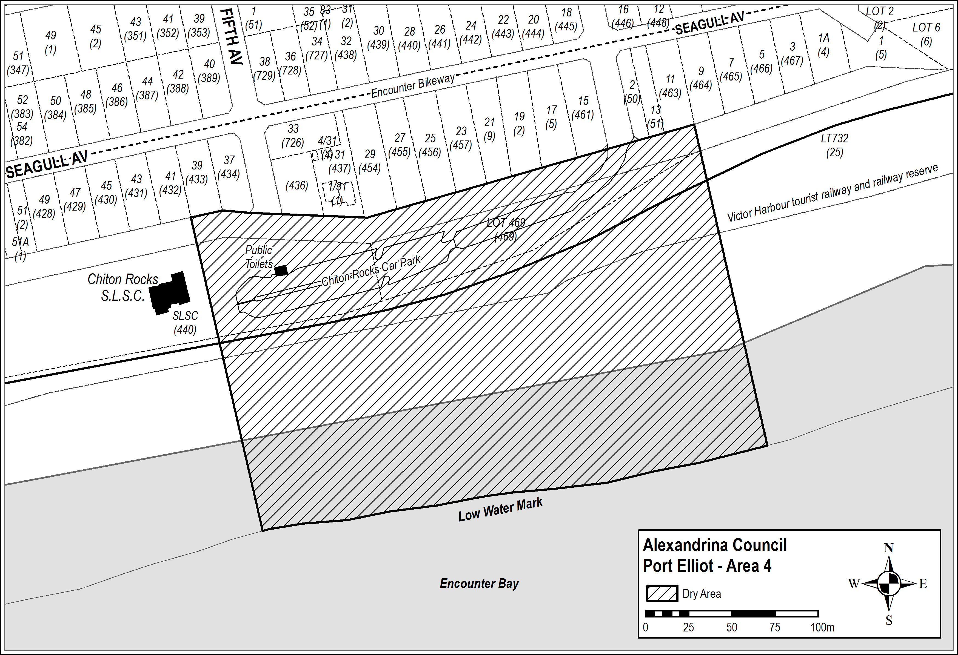

Schedule 2 — Port Elliot Area 2

1—Extent of prohibition
The consumption of liquor is prohibited and the possession of liquor is prohibited.
2—Period of prohibition
From 6pm on 30 December 2017 to 6am on 2 January 2018.
3—Description of area

The area in and adjacent to Port Elliot bounded as follows: commencing at the point at which the eastern boundary of Lot 26 of DP 74300 meets the northern boundary of Railway Terrace (approximately 50 metres west of the western boundary of Bennett Road), then easterly along the northern boundary of Railway Terrace to the western boundary of Carfax Street, then northerly along that boundary of Carfax Street to the point at which it is intersected by the prolongation in a straight line of the northern boundary of Battunga Avenue, then generally easterly, south easterly and easterly along that prolongation and boundary of Battunga Avenue and the prolongation in a straight line of that boundary to the eastern boundary of Rosetta Terrace, then southerly along that boundary of Rosetta Terrace to the northern boundary of Barbara Street, then easterly along that boundary of Barbara Street to the point at which it intersects the eastern boundary of Hutton Street, then southerly along that boundary of Hutton Street to the northern boundary of Merrilli Place, then easterly along that boundary of Merrilli Place to the point at which it is intersected by the prolongation in a straight line of the eastern boundary of The Esplanade, then south easterly along that prolongation and boundary of The Esplanade to the western boundary of Lot 101 of DP 46201, then south easterly and easterly along the western and southern boundaries of Lot 101 and the southern boundaries of the adjoining Lots to the western boundary of The Strand, then northerly along that boundary of The Strand to the point at which it intersects the southern boundary of Barbara Street, then in a straight line by the shortest route (across The Strand) to the point at which the southern boundary of Murray Place meets the eastern boundary of The Strand, then easterly and north easterly along that boundary of Murray Place to the point at which it meets the prolongation in a straight line of the southern boundary of Freeling Street, then north easterly along that prolongation of the southern boundary of Freeling Street to the point at which it intersects the low water mark of Horseshoe Bay, then generally south westerly, south easterly, south westerly and westerly along the low water mark to the point at which the low water mark is intersected by the prolongation in a straight line of the eastern boundary of Lot 26 of DP 74300, then northerly along that prolongation of the eastern boundary of Lot 26 to the point of commencement. The area includes the whole of any wharf, jetty, boat ramp, breakwater or other structure that projects below the low water mark from within the area described above (as well as any area beneath such a structure).

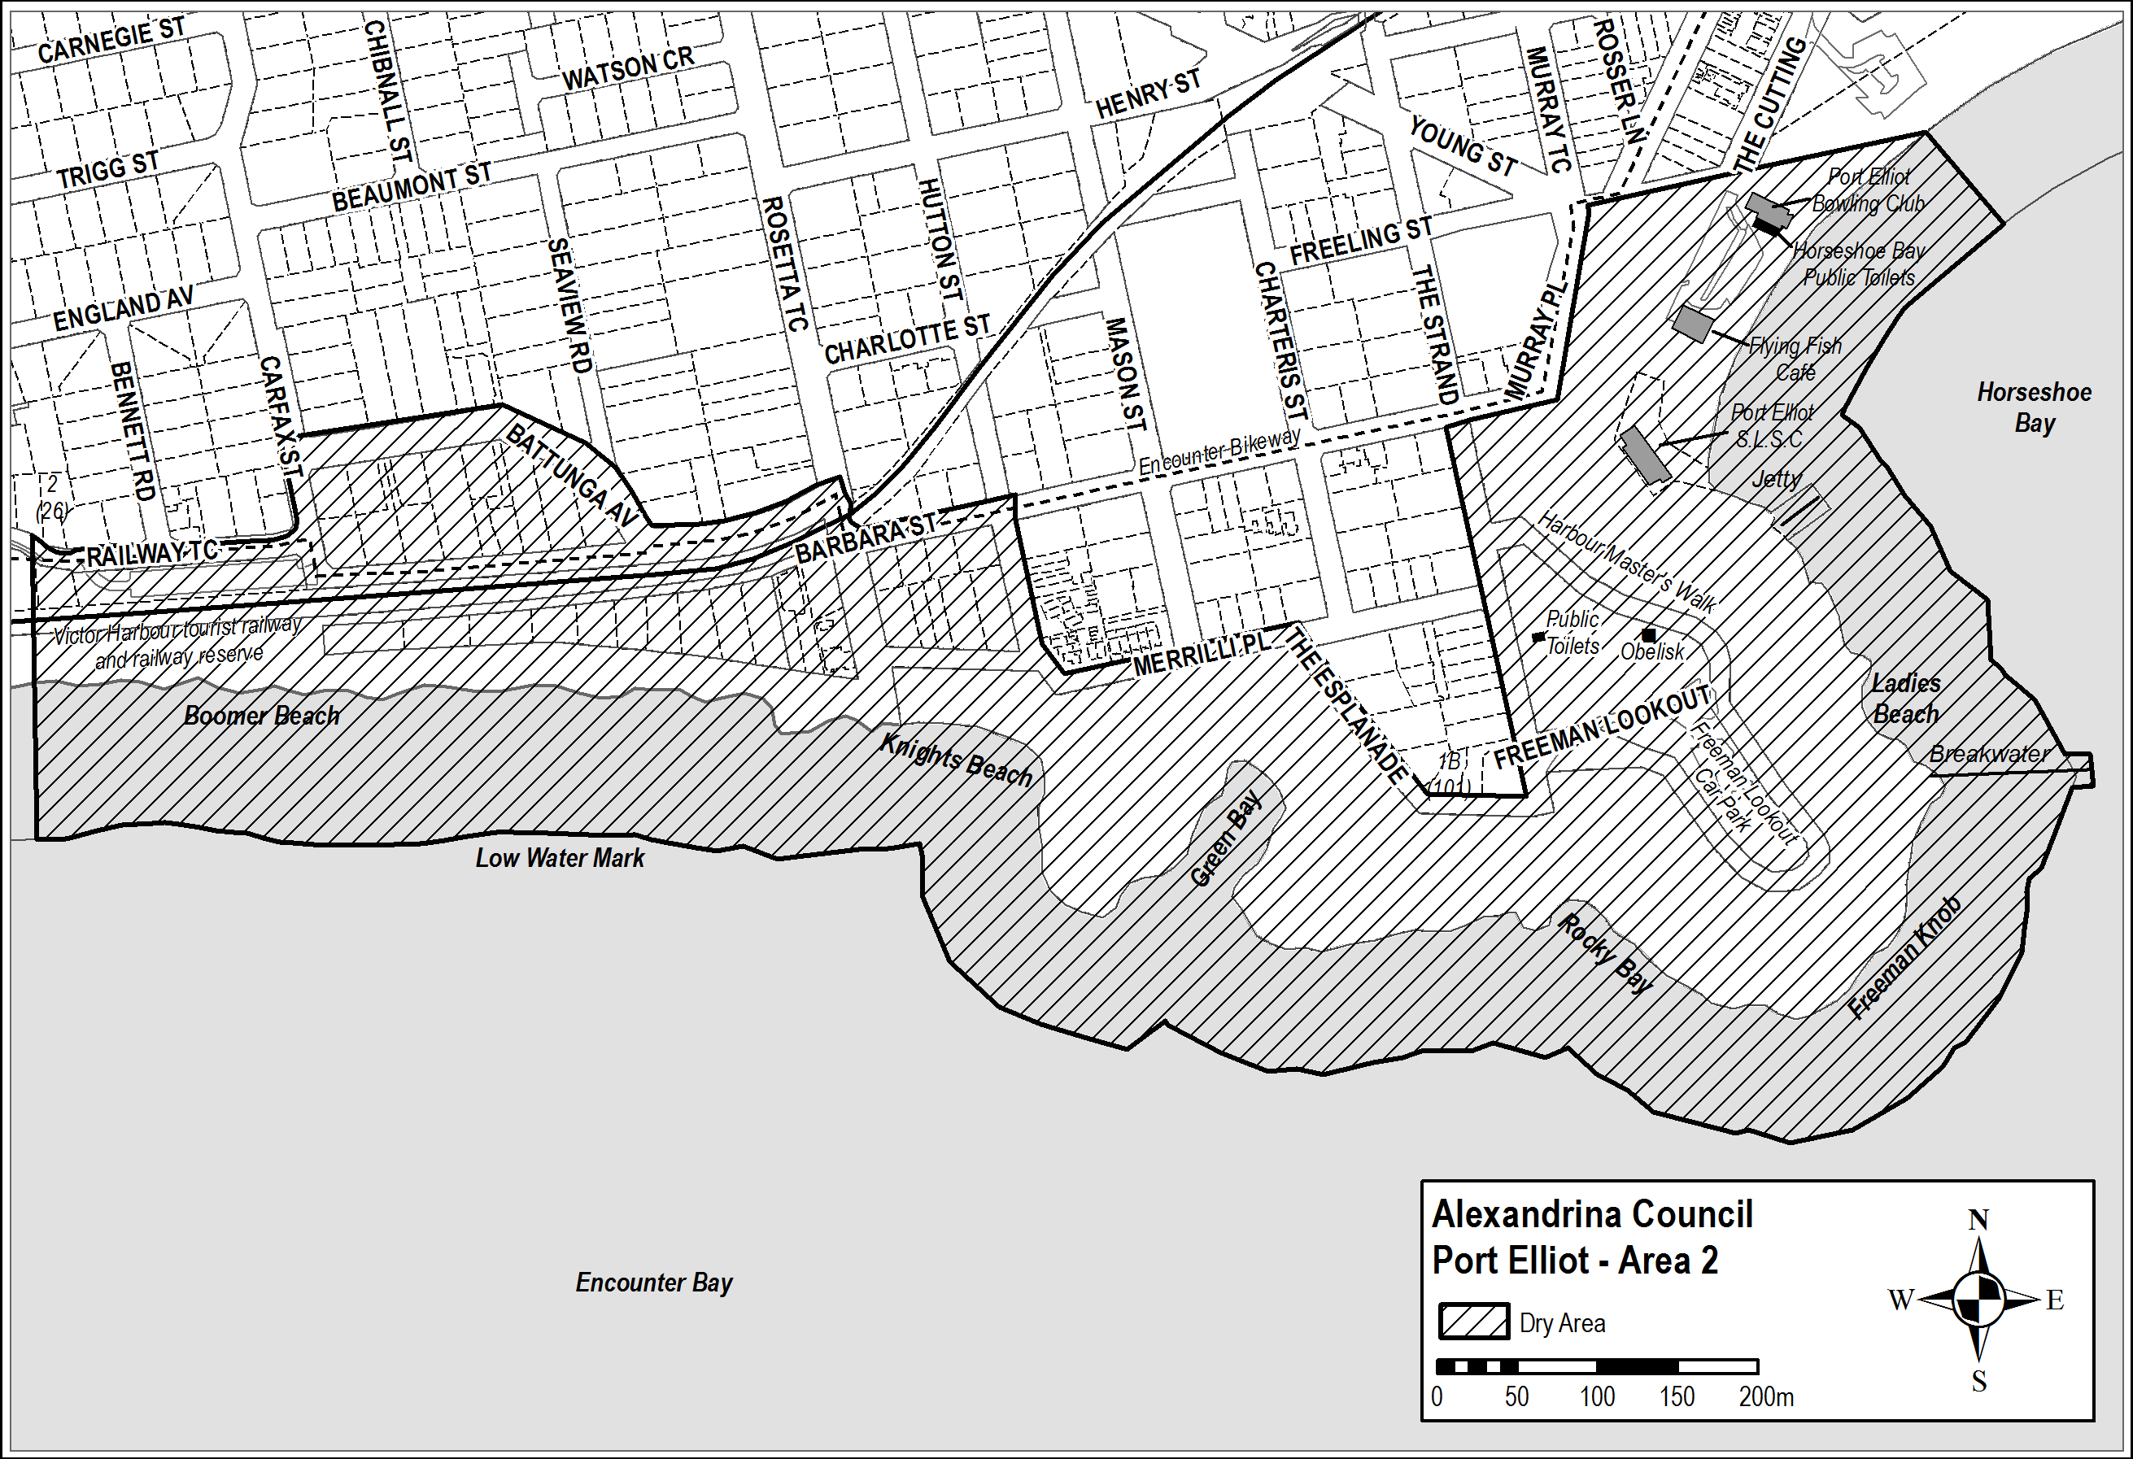

Schedule 3 — Middleton Area 1

1—Extent of prohibition
The consumption of liquor is prohibited and the possession of liquor is prohibited.
2—Period of prohibition
From 6pm on 30 December 2017 to 6am on 2 January 2018.
3—Description of area

The area in and adjacent to Middleton bounded as follows: commencing at the point at which the prolongation in a straight line of the western boundary of Basham Beach Road intersects the high water mark of Encounter Bay, then north westerly along that prolongation and boundary to the point at which it is intersected by the prolongation in a straight line of the southern boundary of Set Road, then north easterly along that prolongation and boundary of Set Road to the western boundary of Seaview Avenue, then generally south easterly and north easterly along that boundary of Seaview Avenue to the point at which it meets the eastern boundary of Lot 101 DP 10654, then south easterly along that boundary of Lot 101 to the south western corner of Lot 19 DP 3145, then generally north easterly along the south eastern boundary of Lot 19, the south eastern boundaries of the adjoining Lots and the northern boundary of Ocean Parade to the south eastern corner of Lot 133 FP 166507, then generally north easterly and northerly along the easternmost boundaries of Lot 133 and the adjoining Lots (including the eastern boundary of Dover Road) to the north eastern corner of Lot 39 DP 3262, then in a straight line by the shortest route to the north western corner of Lot 160 DP 9417, then easterly along the southern boundary of the Esplanade to the western boundary of Lot 3 DP 13398, then northerly, easterly and southerly along the western, northern and eastern boundaries of that Lot to its south eastern corner, then along the northern boundary of Section 345, Hundred of Goolwa, (the southern boundary of Surfer's Parade) to the point at which it is intersected by the prolongation in a straight line of the eastern boundary of Lot 39 DP 6156, then along that prolongation to the point at which it intersects the high water mark of Encounter Bay, then generally westerly and south westerly along the high water mark to the point of commencement.

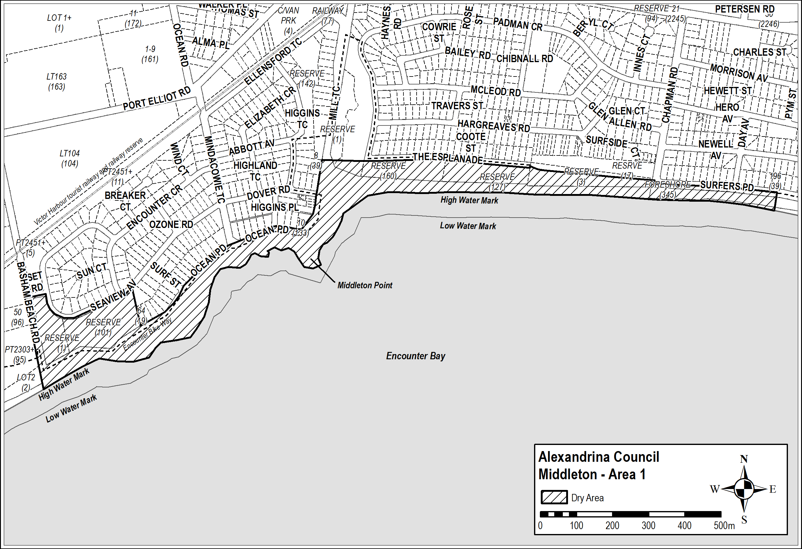

Schedule 4 — Goolwa Beach Area 1

1—Extent of prohibition
The consumption of liquor is prohibited and the possession of liquor is prohibited.
2—Period of prohibition
From 6pm on 30 December 2017 to 6am on 2 January 2018.
3—Description of area
The area in Goolwa Beach and Goolwa South (generally known as the Goolwa Beach car park) bounded as follows: commencing at the north eastern corner of Section 279, Hundred of Goolwa, then westerly and southerly along the northern and western boundaries of Section 279 to the northern boundary of Section 367, Hundred of Goolwa, then southerly and easterly along the western and southern boundaries of Section 367 to the south eastern corner of the Section, then in a straight line by the shortest route to the south western corner of Section 368, Hundred of Goolwa, then easterly and northerly along the southern and eastern boundaries of Section 368 to the southern boundary of Section 278, Hundred of Goolwa, then northerly and westerly along the eastern and northern boundaries of Section 278 to the north western corner of the Section, then in a straight line by the shortest route across Goolwa Beach Road to the point of commencement.

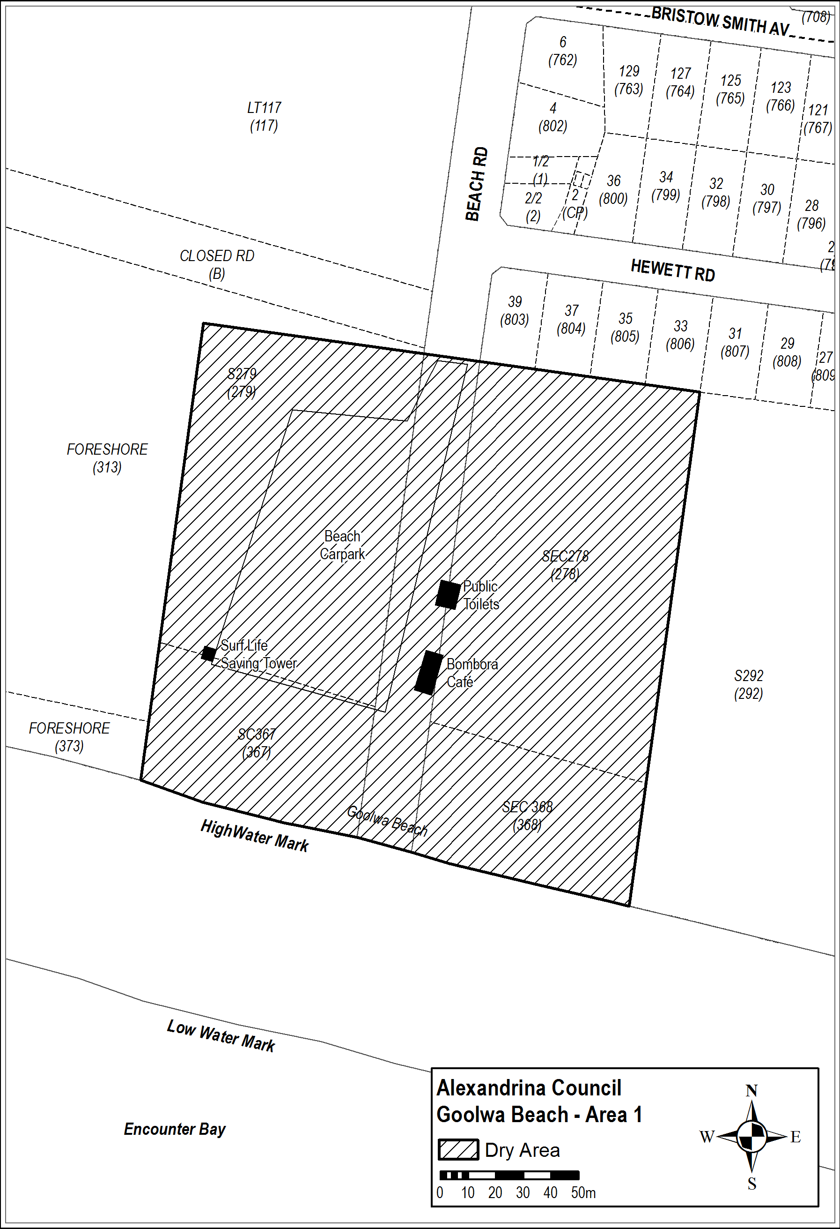

Schedule 5 — Goolwa Area 2

1—Extent of prohibition
The consumption of liquor is prohibited and the possession of liquor is prohibited.
2—Period of prohibition
From 6pm on 30 December 2017 to 6am on 2 January 2018.
3—Description of area
The area in Goolwa bounded as follows: commencing at the northern corner of Lot 500 DP 67581, then south easterly along the north eastern boundary of Lot 500 and the north eastern boundaries of the adjoining Lots to the eastern corner of Lot 1 DP 62245, then in a straight line by the shortest route across Hays Street to the north western boundary of Lot 210 FP 166584, then north easterly along that boundary of Lot 210 and the north western boundary of Lot 2 FP 11114 to the north eastern boundary of the Lot, then in a straight line by the shortest route across Cutting Road to the westernmost corner of Lot 3 FP 11114, then north easterly along the north western boundary of Lot 3 to the south western boundary of Lot 500 DP 66808, then north westerly along that boundary of Lot 500 and the south western boundary of Lot 190 TP 150401 to the north western boundary of Lot 190, then north easterly along that boundary of Lot 190 and the prolongation in a straight line of that boundary to the point at which the prolongation intersects the centre line of Laurie Lane, then north westerly along that centre line and the prolongation in a straight line of that centre line to the point at which it intersects the prolongation in a straight line of the south eastern boundary of Lot 7 DP 46829, then south westerly along that prolongation and boundary of Lot 7 to the north eastern boundary of Lot 215 TP 150401, then north westerly along that boundary of Lot 215 to the westernmost point at which it ceases to have a common boundary with Lot 12 FP 103236, then north westerly along the south western boundary of Lot 12 to the westernmost corner of the Lot, then in a straight line by the shortest route across Porter Street to the point at which the north eastern boundary of Lot 138 TP 150401 changes direction, then south easterly along the north eastern boundary of Lot 138 and the north eastern boundaries of the adjoining Lots to the eastern corner of Lot 155 TP 150401, then in a straight line by the shortest route across Wildman Street to the northern corner of Lot 166 TP 150401, then in a straight line by the shortest route across Porter Street to the western corner of Lot 500 DP 67581, then north easterly along the north western boundary of Lot 500 to the point of commencement.

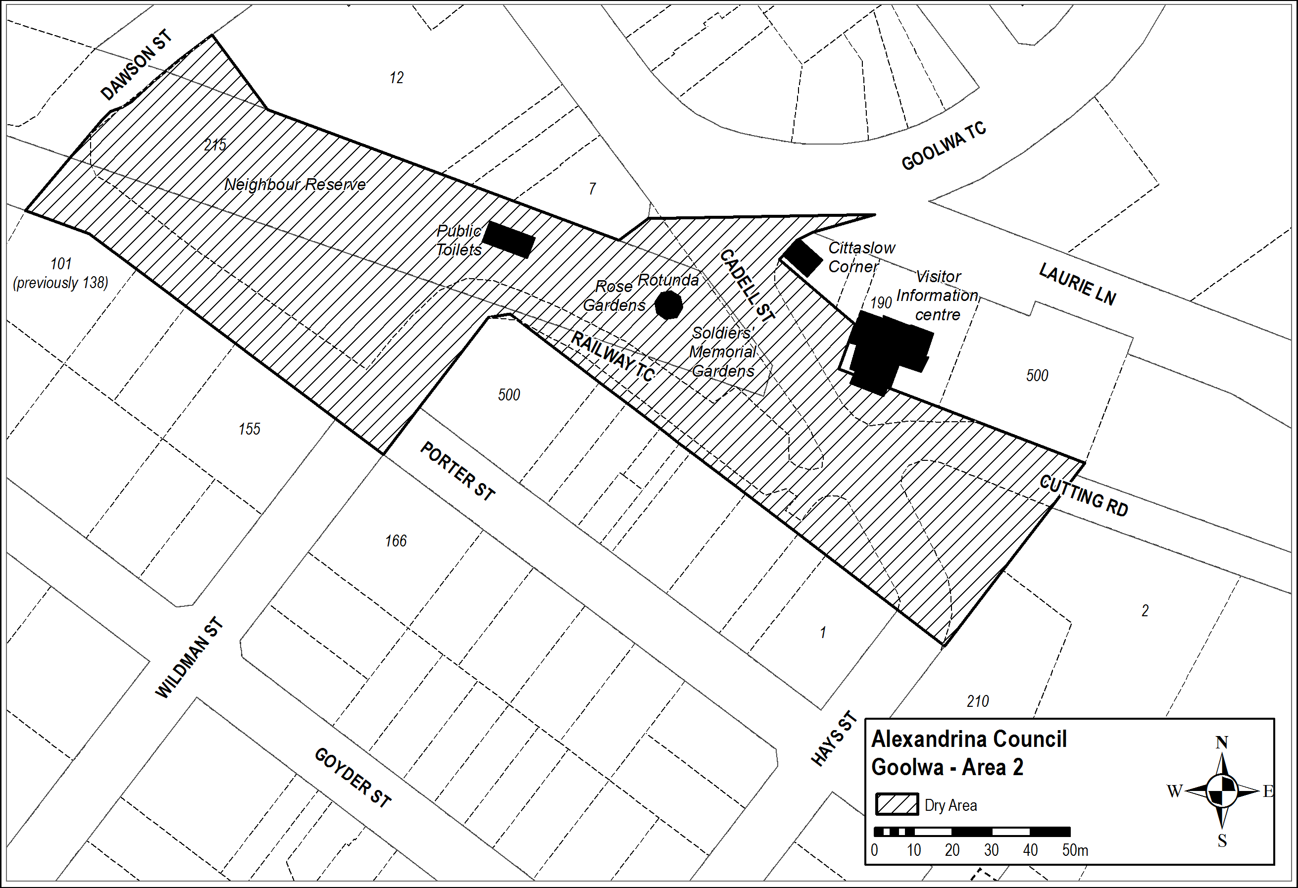

Schedule 6 — Basham Beach Area 1

1—Extent of prohibition
The consumption of liquor is prohibited and the possession of liquor is prohibited.
2—Period of prohibition
From 6pm on 30 December 2017 to 6am on 2 January 2018.
3—Description of area
Commencing at the point at which the western boundary of Basham Beach Road, Middleton, intersects the southern boundary of the railway reserve for the Victor Harbor Tourist Railway, then south easterly along that boundary of Basham Beach Road to the northern boundary of Lot 96 FP 166155, then south westerly, south easterly and north easterly along the northern, western and southern boundaries of Lot 96 to the western boundary of Basham Beach Road, then south easterly along that boundary of Basham Beach Road and the prolongation in a straight line of that boundary to the low water mark of Encounter Bay, then generally south westerly, southerly, south easterly, easterly, southerly, south westerly and north westerly along the low water mark to the prolongation in a straight line of the western boundary of Lot 2 DP 52281, then northerly along that prolongation and boundary of Lot 2 to the southern boundary of Lot 1 DP 52281 (the southern boundary of the Port Elliot Caravan Park), then generally easterly, south easterly, north easterly and northerly along that boundary of Lot 1 and the eastern boundary of Lot 858 FP 166107 to the northern boundary of Lot 858, then south westerly along the northern boundary of Lot 858 and the northern boundaries of the adjoining allotments to the eastern boundary of the railway reserve for the Victor Harbor Tourist Railway, then generally north easterly along that boundary of the railway reserve to the point of commencement.

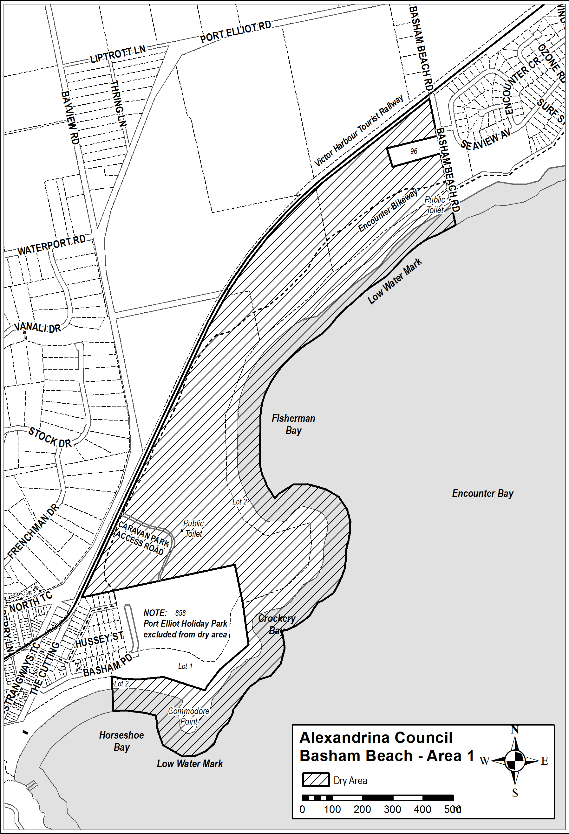
Made by the Liquor and Gambling Commissioner
On 9 August 2017

MINING ACT 1971
Notice pursuant to section 28(5) of the Mining Act 1971
NOTICE is hereby given in accordance with Section 28(5) of the Mining Act 1971 that the delegate of the Minister for Mineral Resources and Energy intends to grant an Exploration Licence over the area described below
Applicant: Yandan Gold Mines Pty Ltd
Location: Oakden Hills area – approx. 100 km northwest of Port Augusta
Pastoral Lease: Oakden Hills, Yalymboo
Term: One year
Area in km²: 490
Reference number: 2017/00049
Plan and co-ordinates can be found on the Department of the Premier and Cabinet website:
http://www.minerals.dpc.sa.gov.au/exploration/public_notices or by contacting Mineral Tenements on 08 8463 3103.
Community information on mineral exploration licence processes and requirements under the Mining Act 1971 is available from: http://www.minerals.dpc.sa.gov.au/land_access/community_information or hard copy on request to Mineral Tenements.
J. Martin, Mining Registrar,
Department of the Premier and Cabinet,
Delegate of the Minister for Mineral Resources and Energy

MINING ACT 1971
Notice pursuant to section 28(5) of the Mining Act 1971
NOTICE is hereby given in accordance with Section 28(5) of the Mining Act 1971 that the delegate of the Minister for Mineral Resources and Energy intends to grant an Exploration Licence over the area described below
Applicant: Golden Cross Operations Pty Ltd
Location: Coober Pedy area – approx. 15 km northeast of Coober Pedy
Pastoral Leases: Mount Clarence
Term: Two years
Area in km²: 189
Reference number: 2017/00118
Plan and co-ordinates can be found on the Department of the Premier and Cabinet website:
http://www.minerals.dpc.sa.gov.au/exploration/public_notices or by contacting Mineral Tenements on 08 8463 3103.
Community information on mineral exploration licence processes and requirements under the Mining Act 1971 is available from: http://www.minerals.dpc.sa.gov.au/land_access/community_information or hard copy on request to Mineral Tenements.
J. Martin, Mining Registrar,
Department of the Premier and Cabinet,
Delegate of the Minister for Mineral Resources and Energy

MINING ACT 1971
Notice pursuant to section 28(5) of the Mining Act 1971
NOTICE is hereby given in accordance with Section 28(5) of the Mining Act 1971 that the delegate of the Minister for Mineral Resources and Energy intends to grant an Exploration Licence over the area described below
Applicant: Maudray International Pty Ltd
Location: Outalpa area - approx. 20 km northwest of Olary
Pastoral Leases: Outalpa, Abminga
Term: Two years
Area in km²: 96
Reference number: 2017/00131
Plan and co-ordinates can be found on the Department of the Premier and Cabinet website: http://www.minerals.dpc.sa.gov.au/exploration/public_notices or by contacting Mineral Tenements on 08 8463 3103.
Community information on mineral exploration licence processes and requirements under the Mining Act 1971 is available from: http://www.minerals.dpc.sa.gov.au/land_access/community_information or hard copy on request to Mineral Tenements.
J. Martin, Mining Registrar,
Department of the Premier and Cabinet,
Delegate of the Minister for Mineral Resources and Energy

MINING ACT 1971
Notice pursuant to section 28(5) of the Mining Act 1971
NOTICE is hereby given in accordance with Section 28(5) of the Mining Act 1971 that the delegate of the Minister for Mineral Resources and Energy intends to grant an Exploration Licence over the area described below
Applicant: Quasar Resouces Pty Ltd
Location: McDouall Peak area – approx. 100 km south-southeast of Coober Pedy
Pastoral Leases: McDouall Peak
Term: Two years
Area in km²:330
Reference number: 2017/00147
Plan and co-ordinates can be found on the Department of the Premier and Cabinet website: http://www.minerals.dpc.sa.gov.au/exploration/public_notices or by contacting Mineral Tenements on 08 8463 3103.
Community information on mineral exploration licence processes and requirements under the Mining Act 1971 is available from: http://www.minerals.dpc.sa.gov.au/land_access/community_information or hard copy on request to Mineral Tenements.
J. Martin, Mining Registrar,
Department of the Premier and Cabinet,
Delegate of the Minister for Mineral Resources and Energy

MINING ACT 1971
Notice pursuant to section 28(5) of the Mining Act 1971
NOTICE is hereby given in accordance with Section 28(5) of the Mining Act 1971 that the delegate of the Minister for Mineral Resources and Energy intends to grant an Exploration Licence over the area described below
Applicant: FMG Resources Pty Ltd
Location: Illeroo area – approx. 25 km west of Port Augusta
Pastoral Leases: Pandurra, Illeroo, Carriewerloo
Term: Two years
Area in km²: 533
Reference number: 2017/00173
Plan and co-ordinates can be found on the Department of the Premier and Cabinet website: http://www.minerals.dpc.sa.gov.au/exploration/public_notices or by contacting Mineral Tenements on 08 8463 3103.
Community information on mineral exploration licence processes and requirements under the Mining Act 1971 is available from: http://www.minerals.dpc.sa.gov.au/land_access/community_information or hard copy on request to Mineral Tenements.
J. Martin, Mining Registrar,
Department of the Premier and Cabinet,
Delegate of the Minister for Mineral Resources and Energy

NATIONAL ELECTRICITY LAW
THE Australian Energy Market Commission (AEMC) gives notice under the National Electricity Law as follows:
On 29 August 2017, the AEMC gave notice of the making of a draft determination and related draft rule on the Contestability of energy services proposal (Ref. ERC0206). That notice incorrectly stated that submissions must be received by 10 October 2017. The correct date is 31 October 2017.
Under s 99, the making of a draft determination and related draft rule on the Five minute settlement proposal (Ref. ERC0201). Written requests for a pre-determination hearing must be received by 12 September 2017. Submissions must be received by 17 October 2017.
Submissions can be made via the AEMC’s website. Before making a submission, please review the AEMC’s privacy statement on its website. Submissions should be made in accordance with the AEMC’s Guidelines for making written submissions on Rule change proposals. The AEMC publishes all submissions on its website, subject to confidentiality.
Written requests should be sent to submissions@aemc.gov.au and cite the reference in the title. Before sending a request, please review the AEMC’s privacy statement on its website.
Documents referred to above are available on the AEMC’s website and are available for inspection at the AEMC’s office.
Australian Energy Market Commission
Level 6, 201 Elizabeth Street
Sydney NSW 2000
Telephone: (02) 8296 7800
www.aemc.gov.au
Dated 5 September 2017.

PARTNERSHIP ACT 1891 (SA)
Discontinuance of Partnership
TAKE notice that as from 16 August 2017 the partnership of TYSON POTTER and RUTH POTTER of 21 Graham Road, Darlington in the State of South Australia, and DANIEL DOWLING and JODIE DUBSKY of 23 Alderman Avenue, Seacombe Gardens in the State of South Australia, who traded as Aesthetico Fitness, was dissolved.
TYSON POTTER and RUTH POTTER have retired from the partnership.
DANIEL DOWLING and JODIE DUBSKY will continue to operate the business under the name of Aesthetico Fitness and shall be responsible for all the debts and liabilities thereof.
Dated 16 August 2017.
Tyson Potter
Ruth Potter

PETROLEUM AND GEOTHERMAL ENERGY ACT 2000
Suspension of Condition
Extension of Licence Term
Petroleum Exploration Licence PEL 93
PURSUANT to section 76A of the Petroleum and Geothermal Energy Act 2000, notice is hereby given that Condition 1 of Petroleum Exploration Licence PEL 93 has been suspended for the period from and including 5 November 2017 to 4 February 2018, under the provisions of the Petroleum and Geothermal Energy Act 2000, pursuant to delegated powers dated 31 March 2017.
The term of PEL 93 has been extended by a period corresponding to the period of suspension, such that PEL 93 will now expire on 4 February 2018.
Dated 30 August 2017.
Barry A. Goldstein, Executive Director,
Energy Resources Division, Department of the Premier and Cabinet,
Delegate of the Minster for Mineral Resources and Energy

PLUMBERS, GAS FITTERS AND ELECTRICIANS ACT 1995
Exemption
I DINI SOULIO, Commissioner for Consumer Affairs, as delegate of the Minister for Consumer and Business Services, pursuant to section 29 of the Plumbers, Gas Fitters and Electricians Act 1995 (the Act), hereby exempt Consolidated Power Projects Australia Pty Ltd (ACN 075 411 219) from compliance with section 12 of the Act, subject to the conditions set out in Schedule 1.
Schedule 1
- This exemption applies only to the Hornsdale 100MW Battery Project being undertaken near the township of Jamestown, South Australia.
- This exemption applies only to electrical workers performing work under the authority of an exemption from Section 13 of
the Act.
Dated 28 August 2017.
Dini Soulio, Commissioner for Consumer Affairs,
Delegate of the Minister for Consumer and Business Services

PLUMBERS, GAS FITTERS AND ELECTRICIANS ACT 1995
Exemption
I DINI SOULIO, Commissioner for Consumer Affairs, as delegate of the Minister for Consumer and Business Services, pursuant to section 29 of the Plumbers, Gas Fitters and Electricians Act 1995 (the Act), hereby exempt each of the individuals listed below from sections 6 and 13 of the Act, subject to the conditions set out in Schedule 1.
 | Name |  | Name |  | Name
1 | Adrian Clarke | 31 | Ed Warren | 61 | Mariano Filippa
2 | Alistair (AJ) Booth | 32 | Elias Abu Saba | 62 | Mark Brooks
3 | Alexandra Bulgakov | 33 | Elmar Palma | 63 | Mark Whitacre
4 | Andreas Bosch | 34 | Elon Musk | 64 | Martin Cotterell
5 | Andy Guinn | 35 | Evan Rowan | 65 | Martin Degener
6 | Audrey Oda | 36 | Fengfeng Tao | 66 | Matt Drazenovich
7 | Austin Kennedy | 37 | Hannah Burroughs | 67 | Matt Kurihara
8 | Ba Quan | 38 | Hans Harder | 68 | Michael Jaradah
9 | Basel Zohny | 39 | Henry Nguyen | 69 | Michael Koopmans
10 | Blake Aydt | 40 | Jack Gaynor | 70 | Michel Engelen
11 | Ben West | 41 | Jarius Ace | 71 | Nick Kirkby
12 | Brett Jacobson | 42 | Jason Tran | 72 | Ohad Benjamin
13 | Brian Dow | 43 | Jay Manley | 73 | Oliver Staton
14 | Calvin Lai | 44 | JB Straubel | 74 | Pranesh Somasundaram
15 | Charmath Wijeratne | 45 | Jeremy Howes | 75 | Preet Kang
16 | Charith Perera | 46 | Jimit Doshi | 76 | Rasmus Buntzen
17 | Clay Shi Yu | 47 | John Messina | 77 | Ronald Horn
18 | Coco Wong | 48 | Jonathan Hongpananon | 78 | Sam Van Embden
19 | Cyril Daran | 49 | Joseph Goldman | 79 | Sandeep Sirpatil
20 | Dan Barrett | 50 | Joseph Vitolla | 80 | Satish Thuta
21 | Daniel Dixon | 51 | Julianne Kline | 81 | Steven Hwu
22 | Daniel Talancon | 52 | Keith Merkel | 82 | Tarm Casebolt
23 | Danny Rivas | 53 | Kenneth Hee | 83 | Taylor Wantabe
24 | David Favaloro | 54 | Kenji Abiru | 84 | Thomas Parsonage
25 | David Pollard | 55 | Kia Filsoof | 85 | Tom-Christian Freiwald
26 | Devin Sezgen | 56 | Kim Kilday | 86 | Tommy Joyner
27 | Dirk Pauw | 57 | Kurt Lyu | 87 | Tony Delaney
28 | Douglas Cox | 58 | Lilla Smith | 88 | Toviah Hirschberg
29 | Drew Baglino | 59 | Luis Lau | 89 | Tsugu Suzuki
30 | Ed McCullough | 60 | Marcus Henry | 90 | Varun Natraj
 |  |  |  | 91 | Vincent Wiguna
 |  |  |  | 92 | Vlad Gantvarg
 |  |  |  | 93 | William Wilson
 |  |  |  | 94 | Yazmin Najeera
 |  |  |  | 95 | Yuval Joseph
Schedule 1
- This exemption applies only to electrical work performed on the Hornsdale 100MW Battery Project being undertaken near the township of Jamestown, South Australia.
- This exemption is in force from 28 August 2017 to 31 December 2017 inclusive.
Dated 28 August 2017.
Dini Soulio, Commissioner for Consumer Affairs,
Delegate of the Minister for Consumer and Business Services

PROOF OF SUNRISE AND SUNSET ACT 1923
Almanac for October, November and December 2017
PURSUANT to the requirements of the Proof of Sunrise and Sunset Act, 1923, I Michael Francis Deegan, Chief Executive, Department of Planning, Transport and Infrastructure at the direction of the Honourable the Minister for Transport, publish in the Schedule hereto an almanac setting out the times of sunrise and sunset on every day for the three calendar months October, November and December 2017.
Dated at Adelaide, 1 September 2017.
M. F. Deegan, Chief Executive,
Department of Planning, Transport and Infrastructure

THE SCHEDULE
Sunrise & Sunset times for Adelaide 2017, Latitude: South 34˚ 56', Longitude: East 138˚ 36', GMT +9.50 hours (Daylight saving GMT +10.5 hours).
 | October |  |  |  |  |  |  | November |  |  |  |  |  |  | December
 | Rise |  |  | Set |  |  |  | Rise |  |  | Set |  |  |  | Rise |  |  | Set
Date | hr | min |  | hr | min |  |  | hr | min |  | hr | min |  |  | hr | min |  | hr | min
*1 | 06 | 53 |  | 19 | 19 |  |  | 06 | 14 |  | 19 | 45 |  |  | 05 | 55 |  | 20 | 14
2 | 06 | 51 |  | 19 | 19 |  |  | 06 | 13 |  | 19 | 46 |  |  | 05 | 55 |  | 20 | 15
3 | 06 | 50 |  | 19 | 20 |  |  | 06 | 12 |  | 19 | 47 |  |  | 05 | 55 |  | 20 | 16
4 | 06 | 48 |  | 19 | 21 |  |  | 06 | 11 |  | 19 | 48 |  |  | 05 | 55 |  | 20 | 17
5 | 06 | 47 |  | 19 | 22 |  |  | 06 | 10 |  | 19 | 49 |  |  | 05 | 55 |  | 20 | 18
6 | 06 | 46 |  | 19 | 22 |  |  | 06 | 09 |  | 19 | 50 |  |  | 05 | 55 |  | 20 | 19
7 | 06 | 44 |  | 19 | 23 |  |  | 06 | 08 |  | 19 | 51 |  |  | 05 | 55 |  | 20 | 19
8 | 06 | 43 |  | 19 | 24 |  |  | 06 | 07 |  | 19 | 52 |  |  | 05 | 55 |  | 20 | 20
9 | 06 | 41 |  | 19 | 25 |  |  | 06 | 06 |  | 19 | 53 |  |  | 05 | 55 |  | 20 | 21
10 | 06 | 40 |  | 19 | 26 |  |  | 06 | 06 |  | 19 | 54 |  |  | 05 | 55 |  | 20 | 22
11 | 06 | 39 |  | 19 | 27 |  |  | 06 | 05 |  | 19 | 55 |  |  | 05 | 55 |  | 20 | 23
12 | 06 | 37 |  | 19 | 27 |  |  | 06 | 04 |  | 19 | 56 |  |  | 05 | 55 |  | 20 | 23
13 | 06 | 36 |  | 19 | 28 |  |  | 06 | 03 |  | 19 | 57 |  |  | 05 | 55 |  | 20 | 24
14 | 06 | 35 |  | 19 | 29 |  |  | 06 | 03 |  | 19 | 58 |  |  | 05 | 56 |  | 20 | 25
15 | 06 | 34 |  | 19 | 30 |  |  | 06 | 02 |  | 19 | 59 |  |  | 05 | 56 |  | 20 | 25
16 | 06 | 32 |  | 19 | 31 |  |  | 06 | 01 |  | 20 | 00 |  |  | 05 | 56 |  | 20 | 26
17 | 06 | 31 |  | 19 | 32 |  |  | 06 | 01 |  | 20 | 01 |  |  | 05 | 57 |  | 20 | 27
18 | 06 | 30 |  | 19 | 32 |  |  | 06 | 00 |  | 20 | 02 |  |  | 05 | 57 |  | 20 | 27
19 | 06 | 28 |  | 19 | 33 |  |  | 05 | 59 |  | 20 | 03 |  |  | 05 | 57 |  | 20 | 28
20 | 06 | 27 |  | 19 | 34 |  |  | 05 | 59 |  | 20 | 04 |  |  | 05 | 58 |  | 20 | 28
21 | 06 | 26 |  | 19 | 35 |  |  | 05 | 58 |  | 20 | 05 |  |  | 05 | 58 |  | 20 | 29
22 | 06 | 25 |  | 19 | 36 |  |  | 05 | 58 |  | 20 | 06 |  |  | 05 | 59 |  | 20 | 29
23 | 06 | 24 |  | 19 | 37 |  |  | 05 | 58 |  | 20 | 07 |  |  | 05 | 59 |  | 20 | 30
24 | 06 | 22 |  | 19 | 38 |  |  | 05 | 57 |  | 20 | 08 |  |  | 06 | 00 |  | 20 | 30
25 | 06 | 21 |  | 19 | 39 |  |  | 05 | 57 |  | 20 | 09 |  |  | 06 | 00 |  | 20 | 31
26 | 06 | 20 |  | 19 | 40 |  |  | 05 | 56 |  | 20 | 10 |  |  | 06 | 01 |  | 20 | 31
27 | 06 | 19 |  | 19 | 41 |  |  | 05 | 56 |  | 20 | 11 |  |  | 06 | 02 |  | 20 | 31
28 | 06 | 18 |  | 19 | 41 |  |  | 05 | 56 |  | 20 | 12 |  |  | 06 | 02 |  | 20 | 32
29 | 06 | 17 |  | 19 | 42 |  |  | 05 | 56 |  | 20 | 12 |  |  | 06 | 03 |  | 20 | 32
30 | 06 | 16 |  | 19 | 43 |  |  | 05 | 55 |  | 20 | 13 |  |  | 06 | 04 |  | 20 | 32
31 | 06 | 15 |  | 19 | 44 |  |  |  |  |  |  |  |  |  | 06 | 04 |  | 20 | 32
*NOTE: Daylight Saving Time is subject to change.
Sunrise and Sunset times calculated on 17/11/16.

ROADS (OPENING AND CLOSING) ACT 1991: SECTION 24
Notice of Confirmation of Road Process Order

Road Closure – Public Road, Parilla
BY Road Process Order made on 28 February 2017, the Southern Mallee District Council ordered that:
- Portion of Public Road, situated between Allotment 50 in Deposited Plan 21324 and Section 26 Hundred of Parilla, more particularly delineated and lettered ‘A’ in the Preliminary Plan No. 16/0031 be closed.
- Transfer the whole of the land subject to closure lettered ‘A’ to Stephen Richard Carn and Michelle Renee Carn in accordance with the agreement for transfer dated 24 October 2016 entered into between the Southern Mallee Council and Stephen Richard Carn and Michelle Renee Carn.
On 30/08/2017 that order was confirmed by the Minister for Transport and Infrastructure conditionally upon the deposit by the Registrar-General of Deposited Plan 114777 being the authority for the new boundaries.
Pursuant to section 24(5) of the Roads (Opening and Closing) Act, 1991, NOTICE of the Order referred to above and its confirmation is hereby given.
Dated 5 August 2017.

M. P. Burdett, Surveyor-General

ROAD TRAFFIC ACT 1961
Authorised Officers to Operate Breath Analysing Instruments
I, GRANT STEVENS, Commissioner of Police, do hereby notify that on and from 25 August, 2017, the following persons were authorised by the Commissioner of Police to operate breath analysing instruments as defined in and for the purposes of the:
Road Traffic Act 1961;
Harbors and Navigation Act 1993;
Security and Investigation Industry Act 1995; and
Rail Safety National Law (South Australia) Act 2012.
PD Number Officer Name
76111 BOOKER, THOMAS JAMES
74434 CREDLIN, STEVEN JAMES
72483 GILLESPIE, MARCEL ANTON
76092 GORE, MICHAEL JON
11576 HEAVER, PETER BADEN
75618 KENNY, THOMAS DAVID
75118 LUESTNER, SARAH ELIZABETH
79045 NAIR, DANIEL DAS
74995 PACKER, KAREN
76007 QUEALE, ADAM HAMILTON
75953 RUSSELL, WILLIAM JOHN
73937 WASLEY, ALEXANDER DAVID
GRANT STEVENS, Commissioner of Police

South Australia
Parliament (Joint Services) (Staffing) Amendment Act (Commencement) Proclamation 2017
1—Short title
This proclamation may be cited as the Parliament (Joint Services) (Staffing) Amendment Act (Commencement) Proclamation 2017.
2—Commencement of Act
The Parliament (Joint Services) (Staffing) Amendment Act 2017 (No 29 of 2017) will come into operation on 5 September 2017.
Made by the Governor
with the advice and consent of the Executive Council
on 5 September 2017
DPC17/057CS

South Australia
South Australian Civil and Administrative Tribunal (Designation of Magistrate as Member of Tribunal) Proclamation 2017
under section 18 of the South Australian Civil and Administrative Tribunal Act 2013
1—Short title
This proclamation may be cited as the South Australian Civil and Administrative Tribunal (Designation of Magistrate as Member of Tribunal) Proclamation 2017.
2—Commencement
This proclamation will come into operation on 18 September 2017.
3—Designation of magistrate as member of Tribunal
The following magistrate holding office under the Magistrates Act 1983 is designated as a member of the South Australian Civil and Administrative Tribunal:
Kylie Sue Schulz
Made by the Governor
on the recommendation of the Attorney-General after consultation by the Attorney-General with the President of the South Australian Civil and Administrative Tribunal and the Chief Magistrate and with the advice and consent of the Executive Council
on 5 September 2017
AGO0114/17CS
South Australia
Youth Court (Designation and Classification of Magistrate) Proclamation 2017
under section 9 of the Youth Court Act 1993

Preamble
1 His Honour David John White, a magistrate holding office under the Magistrates Act 1983, is designated under section 9 of the Youth Court Act 1993 as a magistrate of the Youth Court of South Australia and classified as a member of the Court's ancillary judiciary (see Gazette 11.7.17 p2850).
2 It is now intended that, by this proclamation, His Honour continue to be designated as a magistrate of the Youth Court of South Australia but that he now be classified as a member of the Court's principal judiciary for a term of 1 year.
3 For that purpose, it is intended that, by this proclamation, the designation and classification referred to in clause 1 above be revoked and replaced by a designation and classification in accordance with clause 2 above.

1—Short title
This proclamation may be cited as the Youth Court (Designation and Classification of Magistrate) Proclamation 2017.
2—Commencement
This proclamation will come into operation on 29 September 2017.
3—Revocation of proclamation
The Youth Court (Designation and Classification of Magistrate) Proclamation 2017 (Gazette 11.7.2017 p2850) is revoked.
4—Designation and classification of magistrate
The magistrate named in Schedule 1 is—
(a) designated as a magistrate of the Youth Court of South Australia; and
(b) classified as a member of the Court's principal judiciary; and
(c) declared to be a member of the Court's principal judiciary for a term of 1 year commencing on 29 September 2017.
Schedule 1—Magistrate of the Court
David John White
Made by the Governor
with the advice and consent of the Executive Council
on 5 September 2017
AGO0114/17CS
South Australia
Youth Court (Designation and Classification of Magistrate) Proclamation 2017
under section 9 of the Youth Court Act 1993
1—Short title
This proclamation may be cited as the Youth Court (Designation and Classification of Magistrate) Proclamation 2017.
2—Commencement
This proclamation will come into operation on 18 September 2017.
3—Designation and classification of magistrate
The magistrate named in Schedule 1 is—
(a) designated as a magistrate of the Youth Court of South Australia; and
(b) classified as a member of the Court's ancillary judiciary.
Schedule 1—Magistrate of the Court
Kylie Sue Schulz
Made by the Governor
with the advice and consent of the Executive Council
on 5 September 2017
AGO0114/17CS

CITY OF ADELAIDE
Revocation of Community Land Classification Central Market Arcade Land
NOTICE is hereby given pursuant to Section 194 of the Local Government Act 1999 that at the meeting of the Council of the City of Adelaide held on 8 August 2017 and upon approval from the Minister for Planning, Council resolved to finalise the revocation of the following parcels of land from the classification of Community Land:
- Portion of 22-60 Gouger Street, Adelaide – Portion of Allotment 11 in Filed Plan 26448 described in Certificate of Title Volume 6118 Folio 750; and
- Victoria Square Arcade, Adelaide – Allotment 91 in Filed Plan 212881 described in Certificate of Title Volume 6118 Folio 752.
M. Goldstone, Chief Executive Officer

CITY OF VICTOR HARBOR
Adoption of Community Management Plan
NOTICE is hereby given, pursuant to section 197(3) of the Local Government Act 1999, And having complied with the provisions of section 197 (1)(a) and (b), that the City of Victor Harbor at its meeting held on 28 August 2017, adopted the Community Land Management Plan relating to Tabernacle Church Cemetery Reserve.
G. Sheridan, Acting Chief Executive Officer

CITY OF VICTOR HARBOR
Review of Elector Representation
NOTICE is hereby given that the City of Victor Harbor, in accordance with the requirements of Section 12 (4) of the Local Government Act 1999, has reviewed its composition and elector representation arrangements.
Pursuant to Section 12(13)(a) of the said Act, the Electoral Commissioner has certified on 27 July 2017, that the review undertaken by Council satisfies the requirements of Section 12 and may therefore now be put into effect as from the day of the first periodic election held after the publication of this notice.
As a result of the review the representation arrangements are as follows:
- The Principal Member of Council continue to be a Mayor, elected by the community at council-wide elections.
- The Council area not be divided into wards (retain the existing ‘no wards’ structure) and
- The Council continue to comprise nine (9) area councillors and the Mayor.
G. Sheridan, Acting Chief Executive Officer

DISTRICT COUNCIL OF BARUNGA WEST
Appointment of Members to Council’s Assessment Panel
PURSUANT to subsection 83(1)(b) of the Planning, Development and Infrastructure Act 2016, Council at its meeting held 13 June 2017, resolved to appoint the following members to Council’s Assessment Panel to take effect from 1 October 2017:
Presiding Member Mr John Brak
Elected Member Mr James Bettess
Independent Member Mr Stephen Horsell
Independent Member Mr Dean Rodda
Independent Member Mr Mark Weedon
These appointments shall expire on the 30 June 2019.
A. Cole, Chief Executive Officer

KINGSTON DISTRICT COUNCIL
Local Government Act 1999
Proposed Revocation of Community Land Classification
PURSUANT to Section 194 of the Local Government Act 1999, the Kingston District Council wishes to notify the community that it proposes to revoke the Community Land Classification of the whole of the following Council owned property, known as 160 Marine Parade, Kingston SE (Subject Land):
• Undeveloped Reserve – Allotment 82 in Deposited Plan 5289, Certificate of Title Volume 2703 Folio 119, in the area of ‘Wyomi’ Kingston SE SA 5275
The revocation of the community land classification is proposed as the Subject Land is surplus to Council’s requirements and has been identified as under utilised.
A copy of the Community Consultation Report is available on Council's website (www.kingstondc.sa.gov.au), or a copy can be obtained at the Council office, 29 Holland Street, Kingston SE SA 5275.
Written submissions are invited from interested persons and must be received by 5:00pm Friday, 29 September 2017. Submissions are to be directed to the Kingston District Council, PO Box 321, Kingston SE SA 5275, or emailed to rates@kingstondc.sa.gov.au.
Information regarding the Community Consultation Report can be obtained by contacting Chelsea Burns, Rates & Property Officer, at the Council office on 8767 2033.
Andrew MacDonald, Chief Executive Officer

TATIARA DISTRICT COUNCIL
Roads (Opening and Closing) Act 1991
Road Closure
NOTICE is hereby given, pursuant to section 10 of the Roads (Opening and Closing) Act 1991, that the Tatiara District Council proposes to make a Road Process Order to close and Vest in the Crown the unnamed public road situate adjoining Section 5 and Portion of Section 8, Hundred of Shaugh, more particularly delineated and lettered ‘A’, on Preliminary Plan No. 17/0019.
A copy of the plan and a statement of persons affected are available for public inspection at the Council office, 43 Woolshed Street, Bordertown and the Adelaide Office of the Surveyor-General during normal office hours.
Any application for easement or objection must set out the full name, address and details of the submission and must be fully supported by reasons.
The application for easement or objection must be made in writing to the Council, 43 Woolshed Street, Bordertown SA 5268 WITHIN 28 DAYS OF THIS NOTICE and a copy must be forwarded to the Surveyor-General at GPO Box 1354, Adelaide 5001. Where a submission is made, the Council will give notification of a meeting at which the matter will be considered.
Dated 6 September 2017.
Rob Harkness, Chief Executive Officer

WATTLE RANGE COUNCIL

Road Naming – Parklands Terrace
NOTICE is hereby given that at a meeting of Wattle Range Council held on Tuesday, 8 August 2017, pursuant to Section 219 of the Local Government Act 1999 and in accordance with Council Policy 5.1 – Naming of Roads, Council resolved to assign the name of a portion of South West Terrace to ‘Parklands Terrace’ located in Beachport. As depicted in the plan below this is an extension of the existing Parklands Terrace.
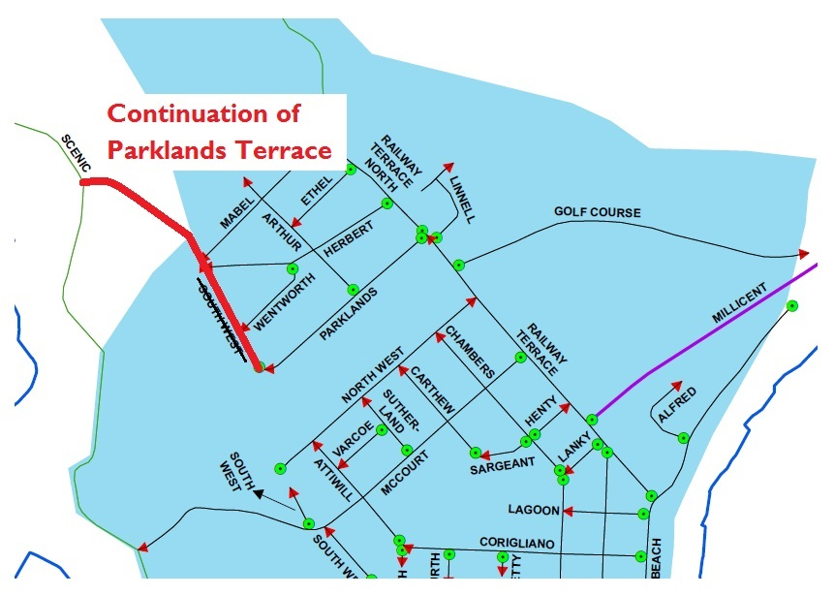
Ben Gower, Chief Executive Officer

IN the matter of the estates of the undermentioned deceased persons:
GILES Patricia Joyce Louise late of Sylvan Way Grange of no occupation who died 29 June 2017
KING Elva May late of 437 Salisbury Highway Parafield Gardens of no occupation who died 23 May 2017
LANDON Jean Emily late of 9 Luhrs Road Payneham South of no occupation who died 13 May 2017
MELLOR Barbara Kaye late of 17 Port Road Queenstown of no occupation who died 1 March 2017
Notice is hereby given pursuant to the Trustee Act 1936, the Inheritance (Family Provision) Act 1972 and the Family Relationships Act 1975 that all creditors, beneficiaries, and other persons having claims against the said estates are required to send, in writing, to the office of Public Trustee at GPO Box 1338, Adelaide, 5001, full particulars and proof of such claims, on or before the 6 October 2017 otherwise they will be excluded from the distribution of the said estate; and notice is also hereby given that all persons indebted to the said estates are required to pay the amount of their debts to the Public Trustee or proceedings will be taken for the recovery thereof; and all persons having any property belonging to the said estates are forthwith to deliver same to the Public Trustee.
Dated 5 September 2017.
D. A. Contala, Public Trustee

TRUSTEES ACT 1936
Deceased Estates
Notice to Creditors and Claimants
JILL BEAGLEHOLE formerly of 39 Frontenac Avenue, Panorama, South Australia, Australia but late of 24 Norseman Avenue, Westbourne Park, South Australia, Australia, Home Duties, deceased.
Creditors and other persons having claims (to which Section 29 of the Trustees Act 1936, relates) in respect of the estate of the deceased, who died on 24 January 2017, are required by the executor, Equity Trustees Wealth Services Limited of Level 1, 575 Bourke Street, Melbourne, Victoria, 3000 to send particulars of their claims to it, care of Lou Caiafa, Equity Trustees Wealth Services Limited of Level 1, 575 Bourke Street, Melbourne, Victoria, 3000 within two (2) months of the date of publication hereof, after which date the executor may convey or distribute the assets having regard only to the claims of which the executor then has notice.
Dated 5 September 2017.
Equity Trustees Wealth Services Limited as Executor

Notice Submission

The weekly South Australian Government Gazette is issued on Tuesday afternoon, except where Executive Council meets on Wednesday, wherein publishing will occur on that day.
The next scheduled publication date is displayed on the website: www.governmentgazette.sa.gov.au.

Notices for gazettal, along with enquiries, can be directed to:

Email governmentgazettesa@sa.gov.au
Phone (08) 8207 1045

Notices for gazettal are to be emailed in the following formats:

• Notices as individual Word files (.doc)
• Maps, images, and diagrams as separate PDF files (.pdf)
• Content requiring official signature for authorisation—notices as Word files
as well as signed documentation as PDF files

Please provide the following information in your email:

• Date the notice is to be gazetted
• Notification of whether a proof, quote, or return email confirmation is required
• Email address and phone number of the person authorising the submission
• Name of the person and organisation to be charged for the notice, if applicable, and a purchase order if required
• Details that may impact on publication of the notice

Notices must be submitted before 4 p.m. Friday, the week preceding intended gazettal.
Proofs of formatted content are supplied upon request, with necessary alterations to be returned before 4 p.m. the day preceding publication.
Submitted notices will be gazetted unless notification is received before 10 a.m. the day of publication.

Printed and published weekly by authority of Sinead O’Brien, Government Printer, South Australia
$7.35 per issue (plus postage), $370.00 per annual subscription—GST inclusive
Online publications: www.governmentgazette.sa.gov.au

