
No. 61 4049
SUPPLEMENTARY GAZETTE
THE SOUTH AUSTRALIAN
GOVERNMENT GAZETTE
Published by Authority

Adelaide, Friday, 15 September 2017

MAJOR EVENTS ACT 2013
Section 6B
PURSUANT to section 6B of the Major Events Act 2013 I, Leon Bignell, Minister for Tourism hereby declare:
- the Australian Football League match, First Preliminary Final to be held on Friday 22 September 2017 in Adelaide is to be a major event (the major event);
- the major event period for which the major event is in force is from the date this notice is published in the Gazette and ending on Saturday 23 September 2017;
- the major event venue for the major event is to be the Adelaide Oval Core Area (within the meaning of the Adelaide Oval Redevelopment and Management Act 2011);
- the Australian Football League is designated as the event organiser for the major event;
- sections 9, 10, 11, 12 and 13 of the Act is to apply to the major event;
- the controlled area for the major event during the major event period is to be the hatched area shown on the map in Schedule 1.
Dated 14 September 2017.
Leon Bignell MP, Minister for Tourism

Schedule 1
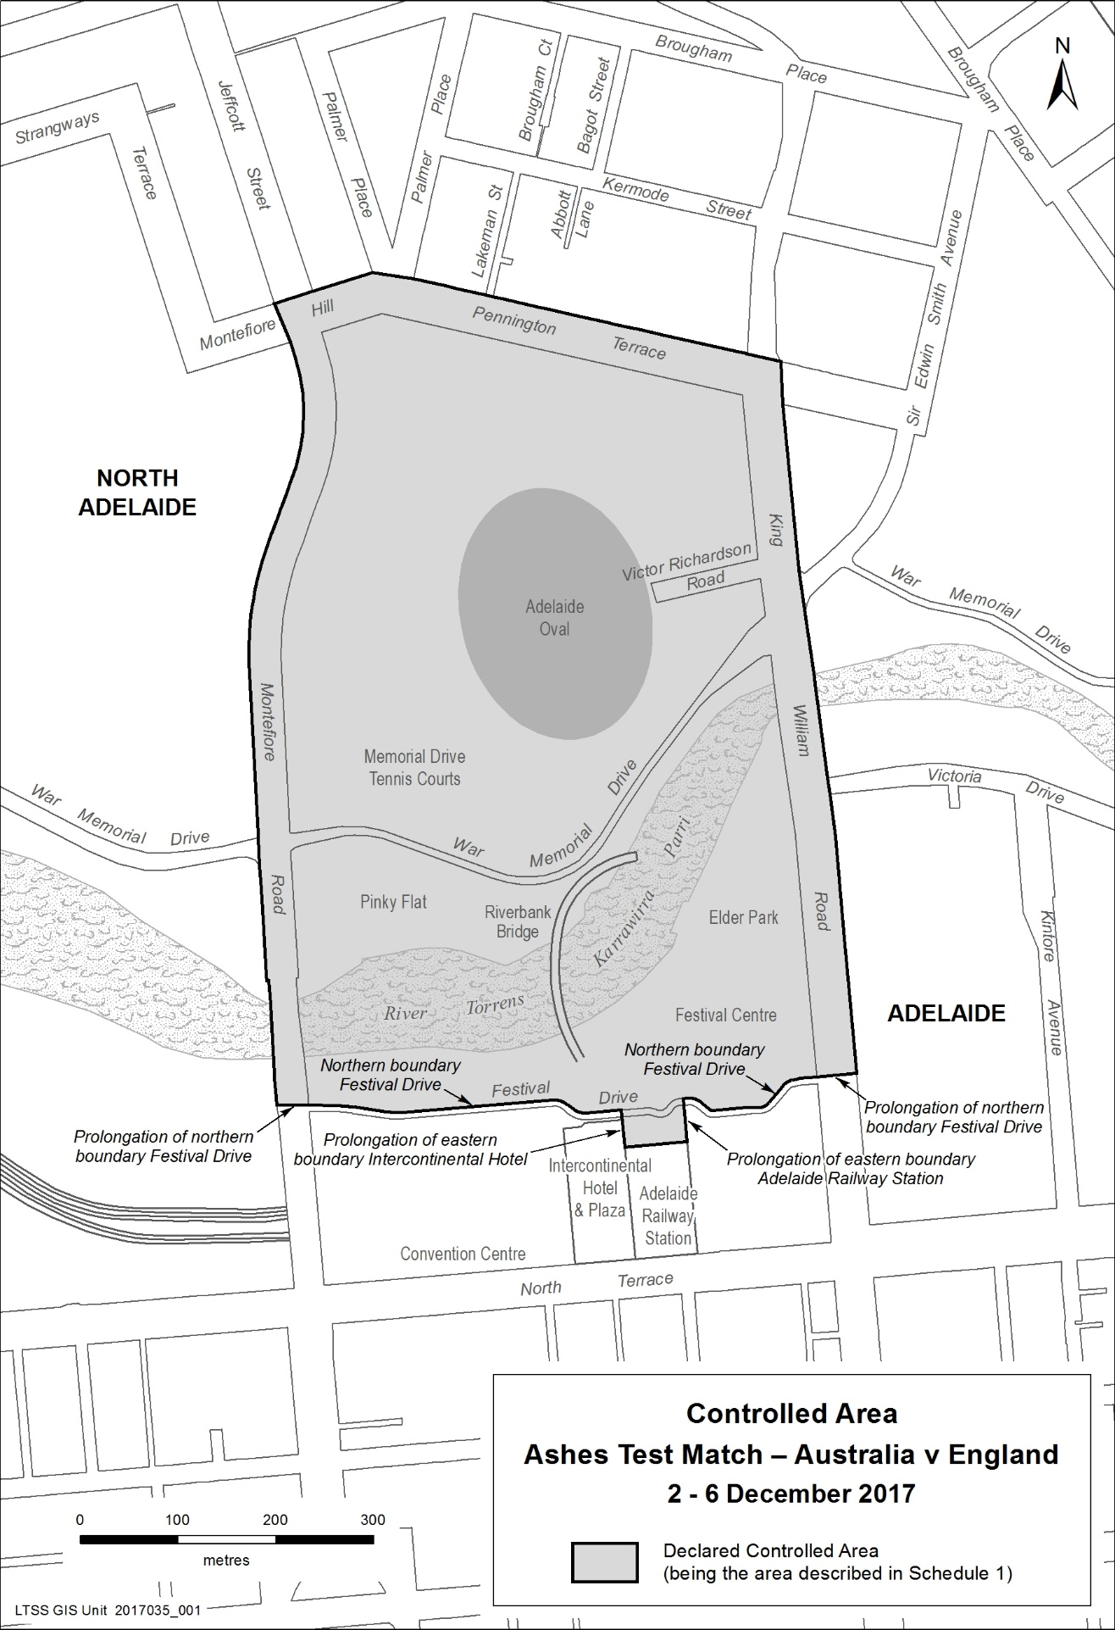
Controlled Area
Australian Football League Match
First Preliminary Final
22 September 2017

