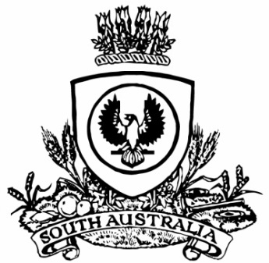
No. 66 4217
SUPPLEMENTARY GAZETTE
THE SOUTH AUSTRALIAN
GOVERNMENT GAZETTE
Published by Authority

Adelaide, Thursday, 28 September 2017

TOBACCO PRODUCTS REGULATION ACT 1997
Notice by the Minister
Declaration that smoking is banned in certain public areas under Section 51
TAKE NOTICE that I Hon Peter Malinauskas MLC, Minister for Mental Health and Substance Abuse, pursuant to section 51 of the Tobacco Products Regulation Act 1997, do hereby declare that smoking is banned during the 2017 Ceduna Oysterfest from 6pm on Friday 29 September to 11pm on Sunday 1 October 2017, in the public areas within the area located at the O’Loughlin Terrace foreshore park lawns, extending to the Ceduna Sailing Club Boat Ramp in the South and to the closest edge of the Day Terrace carpark in the North. To avoid any doubt, smoking is banned during this period in all public areas within these boundaries, except where there is a designated “smoking allowed” area that will be clearly signed.
The following map of the area known as the Ceduna Oysterfest 2017 No Smoking Zone is provided for ease of reference only.
Dated 27 September 2017.
Hon Peter Malinauskas MLC,
Minister for Mental Health and Substance Abuse

Ceduna Oysterfest 2017 No-Smoking Zone
