
THE SOUTH AUSTRALIAN
GOVERNMENT GAZETTE
Published by Authority

Adelaide, Thursday, 6 December 2018

Contents

Acts Assented To 4132
Appointments, Resignations, Etc. 4132
Building Work Contractors Act 1995—Notice 4134
Corporations and District Councils—Notices 4203
Education Regulations 2012—Notice 4134
Environment Protection Act 1993—Notices 4136
Fire and Emergency Services Act 2005—Notices 4143
Geographical Names Act 1991—Notice 4143
Housing Improvement Act 2016—Notice 4143
Justices of the Peace Act 2005—Notices 4144
Land Acquisition Act 1969—Notices 4144
Local Government (Elections) Act 1999—Notice 4221
Mining Act 1971—Notice 4146
Motor Vehicles Regulations 2010—Notice 4147
National Electricity Law—Notice 4255
National Energy Retail Law—Notice 4256
National Gas Law—Notice 4256
Pastoral Land Management and Conservation Act 1989—
Notice 4147
Petroleum and Geothermal Energy Act 2000—Notice 4148
Proclamation 4157
Public Sector Act 2009—Notice 4148
Regulations
Radiation Protection and Control Act 1982—
(No. 242 of 2018) 4167
(No. 243 of 2018) 4169
SACE Board of South Australia Act 1983—
(No. 244 of 2018) 4174
Gaming Machines Act 1992—(No. 245 of 2018) 4175
Casino Act 1997—(No. 246 of 2018) 4177
Remuneration Tribunal—Reports and Determinations 4150
Return to Work Act 2014—Notice 4155
Rules of Court
Youth Court (Adoption) Rules 2018 4179
Training and Skills Development Act 2008—Notice 4155

Department of the Premier and Cabinet
Adelaide, 6 December 2018
His Excellency the Governor directs it to be notified for general information that he has in the name and on behalf of Her Majesty The Queen, this day assented to the undermentioned Acts passed by the Legislative Council and House of Assembly in Parliament assembled, viz.:
No. 36 of 2018—Sentencing (Miscellaneous) Amendment Act 2018
An Act to amend the Sentencing Act 2017.
No. 37 of 2018—Health and Community Services Complaints (Miscellaneous) Amendment Act 2018
An Act to amend the Health and Community Services Complaints Act 2004.
No. 38 of 2018—Statutes Amendment (Domestic Violence) Act 2018
An Act to amend the Bail Act 1985, the Criminal Law Consolidation Act 1935, the Evidence Act 1929 and the Intervention Orders (Prevention of Abuse) Act 2009.
No. 39 of 2018—Tobacco Products Regulation (E-Cigarettes and Review) Amendment Act 2018
An Act to amend the Tobacco Products Regulation Act 1997.
By command,
Steven Spence Marshall
Premier

Department of the Premier and Cabinet
Adelaide, 6 December 2018
His Excellency the Governor in Executive Council has been pleased to appoint the undermentioned to the South Australian Country Arts Trust, pursuant to the provisions of the South Australian Country Arts Trust Act 1992:
Member: from 6 December 2018 until 5 December 2021
Andrew Birtwistle-Smith
By command,
Steven Spence Marshall
Premier
DPC18/068CS

Department of the Premier and Cabinet
Adelaide, 6 December 2018
His Excellency the Governor in Executive Council has been pleased to appoint the undermentioned to the Training Centre Review Board, pursuant to the provisions of the Young Offenders Act 1993:
Member: from 6 December 2018 until 5 December 2021
Suraya Naidoo
Deputy Member: from 6 December 2018 until 5 December 2021
Katherine Sarah Hawkins (Deputy to Naidoo)
Deputy Member: from 6 December 2018 until 11 March 2021
Lisa Jo-Anne Smith (Deputy to Forrest)
Simon Watkins (Deputy to Windle)
Deputy Member: from 6 December 2018 until 13 July 2019
Jacqueline Taylor (Deputy to Boltje)
Nikki Lamshed (Deputy to Dee)
By command,
Steven Spence Marshall
Premier
AGO0139-18CS

Department of the Premier and Cabinet
Adelaide, 6 December 2018
His Excellency the Governor in Executive Council has been pleased to appoint the undermentioned to the Training and Skills Commission, pursuant to the provisions of the Training and Skills Development Act 2008:
Member: from 1 January 2019 until 31 December 2020
Michael Rodney Boyce
Andrew Stanley Keough
Steven Paul Griffiths
Sally Denene Mary Joan Neville
Adrienne Leigh Nieuwenhuis
Marie Ann Paterson
Dino Charles Rossi
Steven Blake Shearer
Maree Lyn Wauchope
Juanita Ann Walker
Amy Marie Williams
Deputy Member: from 1 January 2019 until 31 December 2020
Shaun James de Bruyn (Deputy to Neville)
Elizabeth June Cohen (Deputy to Walker)
Andrew Michael Curtis (Deputy to Williams)
Andrew Stuart Downs (Deputy to Shearer)
Anthony Oscar Penney (Deputy to Rossi)
Robert Alexander Potter (Deputy to Paterson)
Alexis Nicholas Watt (Deputy to Nieuwenhuis)
John William Godwin (Deputy to Keough)
Chair: from 1 January 2019 until 31 December 2020
Michael Rodney Boyce
Deputy Chair: from 1 January 2019 until 31 December 2020
Adrienne Leigh Nieuwenhuis
By command,
Steven Spence Marshall
Premier
18IS/025CS

Department of the Premier and Cabinet
Adelaide, 6 December 2018
His Excellency the Governor in Executive Council has been pleased to appoint the undermentioned to the South Australian Health Practitioners Tribunal, pursuant to the provisions of the Health Practitioner Regulation National Law (South Australia) Act 2010:
Member: from 7 December 2018 until 6 December 2021
Andrew Ross Kellie
Antonio Cocchiaro
Casey Nottage
Colin Dolling
David Charles Allan Walsh
David Maynard Close
Dennis Kingsley Ankor
Gary Champion
Geoffrey Ian Stranks
Geoffrey David Martin
Gus Czechowicz
Jayanthi Jayakaran
Julian Monfries
Kenneth Haydn Baillie
Lucia Gagliardi
Michael McEvoy
Oliver Ralph Frank
Robert Menz
Stephen William Byrne
Thomas Craig Paterson
Amy Elizabeth Seymour-Walsh
Ashleigh Frier
Daniel John Pelzer
Jarred Gilbert
Stephen Paul Tasker
Alison Helen Gosling
Catherine Wright
Lorraine Amos
Mardy Hunt
Lyn Carman
Sandra Grace
Phillip Raymond Donato
Jared Strawbridge
Peter Desmond Roberts
John Russell Nelson
Michelle Audrey Devine
Kimberley Horn
Jeniffer Lazarus
By command,
Steven Spence Marshall
Premier
HEAC-2018-00046

Department of the Premier and Cabinet
Adelaide, 6 December 2018
His Excellency the Governor in Executive Council has been pleased to appoint the undermentioned to the Superannuation Funds Management Corporation of South Australia Board, pursuant to the provisions of the Superannuation Funds Management Corporation of South Australia Act 1995:
Director: from 10 December 2018 until 9 December 2021
Melinda Jane Jeffreys
By command,
Steven Spence Marshall
Premier
T&F18/126CS

Department of the Premier and Cabinet
Adelaide, 6 December 2018
His Excellency the Governor in Executive Council has been pleased to appoint William Muirhead as Agent-General for South Australia in London on a 0.6 FTE basis (three days a week) for a term commencing on 1 April 2019 and expiring on 31 March 2021 - pursuant to the provisions of the Agent-General Act 1901.
By command,
Steven Spence Marshall
Premier
DPC18/078CS

Building Work Contractors Act 1995
Exemption
TAKE notice that, pursuant to section 45 of the Building Work Contractors Act 1995, I, Dini Soulio, Commissioner for Consumer Affairs, do hereby exempt the licensee named in Schedule 1 from the application of Division 3 of Part 5 of the above Act in relation to domestic building work described in Schedule 2 and subject to the conditions specified in Schedule 3.
Schedule 1
James Michael Burnell (BLD 250591)
Schedule 2
Construction in relation to a new two storey dwelling on land situated at Allotment 6538, town of Whyalla in the area named Whyalla Playford Hundred of Randell, being a portion of the land described in Certificate of Title Volume 5997 Folio 232, more commonly known as 30 Norrie Avenue, Whyalla, South Australia 5600.
Schedule 3
- This exemption is limited to domestic building work personally performed by the licensee in relation to the building work described in Schedule 2.
- This exemption does not apply to any domestic building work the licensee contracts to another building work contractor, for which that contractor is required by law to hold building indemnity insurance.
- That the licensee does not transfer his interest in the land prior to five years from the date of completion of the building work the subject of this exemption, without the prior authorisation of the Commissioner for Consumer Affairs. Before giving such authorisation, the Commissioner for Consumer Affairs may require the licensee to take any reasonable steps to protect the future purchaser(s) of the property, including but not limited to:
- Providing evidence that an adequate policy of building indemnity insurance is in force to cover the balance of the five-year period from the date of completion of the building work the subject of this exemption;
- Providing evidence of an independent expert inspection of the building work the subject of this exemption;
- Making an independent expert report available to prospective purchasers of the property;
- Giving prospective purchasers of the property notice of the absence of a policy of building indemnity insurance.
Dated: 27 November 2018
Dini Soulio
Commissioner for Consumer Affairs
Delegate for the Attorney-General

EDUCATION REGULATIONS 2012
Notice of Policy by the Minister for Education
PURSUANT to Regulation 60(2)(a) of the Education Regulations 2012, I, the Minister for Education publish the following Capacity Management Plan for the purposes of the enrolment of a child at the Henley High School:
Capacity Management Plan
Henley High School
This Capacity Management Plan sets out the conditions for enrolment at Henley High School (“the school”).
Capacity of School
The school has a current school enrolment capacity of 1,300 mainstream students.
Henley High School zone
A school zone is a defined area from which the school accepts its core intake of students. Henley High School operates a school zone, within the area bounded by:
Grange Road, Tapleys Hill Road, Milton Avenue, Debney Street, Motley Avenue, the River Torrens, Tapleys Hill Road, Anderson Avenue and the Gulf St Vincent Coast.
A school zone map (guide only) is available at: https://www.education.sa.gov.au/findaschool
Student Enrolment Numbers
The student enrolment ceiling for year 8 is limited to 210, unless there are more applications that have met the enrolment criteria below.
The maximum number of international students who can be offered enrolment at the school in the International Education Program is limited to 75 students across all year levels.
Special interest program
The school’s specialist sport program is limited as follows:
- Maximum of 45 out of zone enrolments in each year level, depending on in-zone enrolment demand.
Selective entry numbers are included in the 210 year 8 enrolment ceiling. Entries to the program are subject to the eligibility requirements published by the school, available from: http://www.henleyhs.sa.edu.au/section/programs/specialist-sports-program
Supported learning centre
The school’s supported learning centre is a regional facility catering for a maximum of 24 students with disabilities.
Placement in the supported learning centre is determined through the department’s state-wide panel process for placement in an inclusive education option.
Criteria for Enrolment
Year level: 8
Applications for enrolment from parents of prospective year 8 students require that the student must be enrolled in a government or non-government school in South Australia at the time the parents apply for enrolment through the Year 7-8 transition process (administered by the Department for Education).
The applicant must meet one of the following requirements to be eligible for a year 8 allocation through the Year 7-8 transition process:
- the child is living in the Henley High School zone
- the child has received and accepted an offer for selective entry by the school to participate in their specialist sport program
- the child identifies as Aboriginal and/or Torres Strait Islander through the Enter for Success program (by the end of term 4)
- the child has been granted enrolment due to special or extenuating circumstances, including but not limited to a child in care where there is a custody or guardianship order made under the Children and Young People (Safety) Act 2017.
Application for Year 8 students living outside the zone with siblings currently at the school
Applications for enrolment from parents of prospective Year 8 students, who live outside the school’s zone and have older siblings who currently attend the school, will only be given consideration for enrolment if:
- the school is under its year 8 student enrolment ceiling of 210 students as at the end of Week 10, Term 2; and
- the student has applied through the department’s Year 7-8 transition process; and
- the sibling did not enter the school through the school’s special interest program, and is currently enrolled and will be attending the school in the same calendar year.
In these cases, places will be offered based on the distance of the child’s residence to the school and other personal needs such as curriculum, transportation/location convenience, and social/family links.
Late applications for year 8 from students living in the school zone
Families who move into the school zone, or who are already living in the school zone but lodge their application for enrolment after the department’s Year 7-8 transition process is completed (end of term 2), will have their applications considered if or when vacancies exist, with priority consideration afforded to those applicants already on the school’s enrolment register.
In these cases, applications will be considered based on siblings at the school, the distance of the child’s residence from the school and any other personal needs, such as curriculum (excluding special interest programs), transportation/location convenience, and social/family links.
The school will notify parents if a vacancy is available for their child to attend.
If no vacancies exist, the applicants upon request, will be placed on the enrolment register and referred for enrolment to other neighbouring schools.
Year level: 9 -12
Applications for enrolment from parents of prospective students living in the school zone will be considered if or when vacancies exist, with priority consideration afforded to those applicants already on the enrolment register.
In these cases, applications will be considered based on siblings at the school, the distance of the child’s residence from the school and any other personal needs, such as curriculum, transportation/location convenience, and social/family links.
The school will notify parents if a vacancy is available for their child to attend.
If no vacancies exist the applicants will be encouraged to remain at their current high school, or referred for enrolment to other neighbouring schools, and upon an applicant’s request will be placed on the school’s enrolment register.
Out of zone applications with siblings currently at the school
There is no automatic entry for siblings who live outside of the school zone to enrol at Henley High School.
Special Circumstances
Enrolment applications for special consideration based on compelling or unusual reasons, including but not limited to a child in care where there is custody or guardianship orders made under the Children and Young People (Safety) Act 2017, may be granted by the Principal in consultation with the Education Director. These applications will be assessed on a case by case basis.
Enrolment Register
Parents whose child’s name has been placed on the enrolment register will be contacted if vacancies become available.
The enrolment register will be reviewed and updated annually by the school.
The position that a child’s name appears on the register is confidential and will only be disclosed as required by law.
Monitoring and enforcement
It is the responsibility of the parents applying for enrolment to be able to verify to the satisfaction of the school that the information provided is true and factual.
The Principal is responsible for the implementation of this Capacity Management Plan and all decisions on enrolments.
This Capacity Management Plan will be reviewed annually.
Dated: 1 December 2018
John Gardner
Minister for Education

Environment Protection Act 1993
Section 68
Approval of Category B Containers
I, Eliseo Palumbo, Team Leader, Container Deposit Legislation and Delegate of the Environment Protection Authority ('the Authority'), pursuant to Section 68 of the Environment Protection Act, 1993 (SA) ('the Act') hereby:
Approval of Category B Containers:
Approve as Category B Containers, subject to the conditions in subclauses 1, 2, 3 and 4 below, each of the classes of containers identified by reference to the following matters described in the first 4 columns of Schedule 1 of this Notice which are sold in South Australia:
- the product which each class of containers shall contain;
- the size of the containers;
- the type of containers;
- the name of the holders of these approvals.
1. That containers of the class to which the approval relates must bear the refund marking specified by the Authority for containers of that class. The Authority specifies the following refund markings for Category B containers:
- "10c refund at collection depots when sold in SA",
Or
- "10c refund at SA/NT collection depots in State/Territory of purchase",
Or
- "10c refund at collection depots/points in participating state/territory of purchase".
2. The holder of the approval must have in place an effective and appropriate waste management arrangement in relation to containers of that class. For the purpose of this approval notice the company named in column 5 of Schedule 1 of this Notice is the nominated super collector.
3. In the case of an approval in relation to category B containers that the waste management arrangement must require the holder of the approval to provide specified super collectors with a declaration in the form determined by the Authority in relation to each sale of such containers by the holder of the approval as soon as practicable after the sale";
4. The holder of these approvals must ensure that if a sticker bearing the refund marking has been approved, and is applied to the container, then the sticker must not be placed on any portion of the opening mechanism or in any other place that would require complete or partial removal of the sticker before the contents may be consumed.
Schedule 1
Column 1  Product  Name | Column 2  Container Size | Column 3  Container  Type | Column 4  Approval  Holder | Column 5  Collection Arrangements
Cricketers Arms Pale Ale | 375 ml | Can - Aluminium | Asahi Premium Beverages | Statewide Recycling
Cricketers Arms Pale Ale | 330 ml | Glass | Asahi Premium Beverages | Statewide Recycling
Estrella Damm | 330 ml | Can - Aluminium | Asahi Premium Beverages | Statewide Recycling
Peroni Nastro Azzurro | 330 ml | Can - Aluminium | Asahi Premium Beverages | Statewide Recycling
Peroni Red | 330 ml | Glass | Asahi Premium Beverages | Statewide Recycling
Bod Kombucha No 8 Cherry Vanilla Oak | 330 ml | Glass | Bod Conscious Enterprises | Statewide Recycling
Bod Living Soda With Probiotics Zero Sugar Creamy Soda | 330 ml | Glass | Bod Conscious Enterprises | Statewide Recycling
Bod Living Soda With Probiotics Zero Sugar Kola | 330 ml | Glass | Bod Conscious Enterprises | Statewide Recycling
Bod Living Soda with Probiotics Zero Sugar Yuzu | 330 ml | Glass | Bod Conscious Enterprises | Statewide Recycling
Bod Probiotic H20 Lightly Sparkling Mineral Water | 500 ml | Glass | Bod Conscious Enterprises | Statewide Recycling
Garage Project Wild Ale | 330 ml | Glass | Brewwell Limited T/AS Garage Project | Statewide Recycling
Jack Daniels Tennessee Rye Whiskey | 50 ml | PET | Brown-Forman Australia | Statewide Recycling
Woodford Reserve | 50 ml | PET | Brown-Forman Australia | Statewide Recycling
Made By Cow Cold Pressed Raw Probiotic Kefir Yoghurt Manuka Honey & Vanilla Bean | 750 ml | HDPE | CBH Fresh Trading As Made By Cow | Statewide Recycling
Made By Cow Cold Pressed Raw Probiotic Kefir Yoghurt Manuka Honey & Vanilla Bean | 300 ml | HDPE | CBH Fresh Trading As Made By Cow | Statewide Recycling
Made By Cow Cold Pressed Raw Probiotic Kefir Yoghurt Natural | 750 ml | HDPE | CBH Fresh Trading As Made By Cow | Statewide Recycling
Made By Cow Cold Pressed Raw Probiotic Kefir Yoghurt Natural | 300 ml | HDPE | CBH Fresh Trading As Made By Cow | Statewide Recycling
Coca Cola Caramel & Coffee No Sugar | 250 ml | Can - Aluminium | Coca-Cola Amatil (Aust) Pty Ltd | Statewide Recycling
Coca Cola Coffee & Chocolate No Sugar | 250 ml | Can - Aluminium | Coca-Cola Amatil (Aust) Pty Ltd | Statewide Recycling
V8 Power Blend Healthy Greens | 300 ml | PET | Campbell Soups Australia | Statewide Recycling
V8 Power Blend Purple Power | 300 ml | PET | Campbell Soups Australia | Statewide Recycling
Mount Franklin Lemon & Lime | 600 ml | PET | Coca Cola Amatil (Aust) Pty Ltd | Statewide Recycling
Mount Franklin Lightly Sparkling Australian Sparkling Spring Water | 250 ml | Can - Aluminium | Coca Cola Amatil (Aust) Pty Ltd | Statewide Recycling
Mount Franklin Pineapple & Mint | 600 ml | PET | Coca Cola Amatil (Aust) Pty Ltd | Statewide Recycling
Mount Franklin Strawberry | 600 ml | PET | Coca Cola Amatil (Aust) Pty Ltd | Statewide Recycling
Fix Hellas | 330 ml | Can - Aluminium | Coopers Brewery Ltd | Marine Stores Ltd
Mythos Hellenic Beer | 330 ml | Can - Aluminium | Coopers Brewery Ltd | Marine Stores Ltd
Captain Morgan Cola Barrel Serve | 250 ml | Can - Aluminium | Diageo Australia Limited | Statewide Recycling
Hawkesbury Brewing Co Draught | 375 ml | Can - Aluminium | Drink Craft Pty Ltd | Statewide Recycling
Hawkesbury Brewing Co Ginger Beer | 375 ml | Can - Aluminium | Drink Craft Pty Ltd | Statewide Recycling
Hawkesbury Brewing Co Gold | 375 ml | Can - Aluminium | Drink Craft Pty Ltd | Statewide Recycling
Hawkesbury Brewing Co Lager | 375 ml | Can - Aluminium | Drink Craft Pty Ltd | Statewide Recycling
Hawkesbury Brewing Co Pacific Ale | 375 ml | Can - Aluminium | Drink Craft Pty Ltd | Statewide Recycling
Hawkesbury Brewing Co Pale Ale | 375 ml | Can - Aluminium | Drink Craft Pty Ltd | Statewide Recycling
Hawkesbury Brewing Co Rose Beer | 375 ml | Can - Aluminium | Drink Craft Pty Ltd | Statewide Recycling
Hawkesbury Brewing Co Session Ale | 375 ml | Can - Aluminium | Drink Craft Pty Ltd | Statewide Recycling
Hawkesbury Brewing Co Stout | 375 ml | Can - Aluminium | Drink Craft Pty Ltd | Statewide Recycling
Little Fat Lamb Brewed Berry | 500 ml | Can - Aluminium | Drink Craft Pty Ltd | Statewide Recycling
Little Fat Lamb Brewed Ginger | 500 ml | Can - Aluminium | Drink Craft Pty Ltd | Statewide Recycling
Little Fat Lamb Brewed Lemon | 500 ml | Can - Aluminium | Drink Craft Pty Ltd | Statewide Recycling
Little Fat Lamb Brewed Strawberry & Lime | 500 ml | Can - Aluminium | Drink Craft Pty Ltd | Statewide Recycling
Little Fat Lamb Brewed Tropical | 500 ml | Can - Aluminium | Drink Craft Pty Ltd | Statewide Recycling
Little Fat Lamb Hard Apple | 500 ml | Can - Aluminium | Drink Craft Pty Ltd | Statewide Recycling
Stinger Triple Distilled Vodka Blueberry | 275 ml | Glass | Drink Craft Pty Ltd | Statewide Recycling
Stinger Triple Distilled Vodka Creaming Soda | 275 ml | Glass | Drink Craft Pty Ltd | Statewide Recycling
Stinger Triple Distilled Vodka Fruit Tingler | 275 ml | Glass | Drink Craft Pty Ltd | Statewide Recycling
Stinger Triple Distilled Vodka Straw Berries & Cream | 275 ml | Glass | Drink Craft Pty Ltd | Statewide Recycling
Jacobinus Hefe Weizen | 500 ml | Glass | Drinkwell Beverages | Statewide Recycling
C4 On The Go RTD Blue Razz | 346 ml | Polypropylene | Export Corporation Australia T/AS Nutrition System Pty Ltd | Statewide Recycling
C4 On The Go RTD Fruit Punch | 346 ml | Polypropylene | Export Corporation Australia T/AS Nutrition System Pty Ltd | Statewide Recycling
C4 Sparkling PURPLE FROST Zero Sugar | 473 ml | Can - Aluminium | Export Corporation Australia T/AS Nutrition System Pty Ltd | Statewide Recycling
Crankt 20g Protein Gluten Free Banana | 375 ml | PET | Freedom Foods Group Trading Pty Ltd | Statewide Recycling
Crankt 20g Protein Gluten Free Choc Honeycomb | 375 ml | PET | Freedom Foods Group Trading Pty Ltd | Statewide Recycling
Crankt 20g Protein Gluten Free Chocolate | 375 ml | PET | Freedom Foods Group Trading Pty Ltd | Statewide Recycling
Crankt 20g Protein Gluten Free Coffee | 375 ml | PET | Freedom Foods Group Trading Pty Ltd | Statewide Recycling
Crankt 20g Protein Gluten Free Vanilla | 375 ml | PET | Freedom Foods Group Trading Pty Ltd | Statewide Recycling
Crankt Max 30g Protein Gluten Free Banana | 450 ml | PET | Freedom Foods Group Trading Pty Ltd | Statewide Recycling
Crankt Max 30g Protein Gluten Free Choc Honeycomb | 450 ml | PET | Freedom Foods Group Trading Pty Ltd | Statewide Recycling
Crankt Max 30g Protein Gluten Free Double Espresso | 450 ml | PET | Freedom Foods Group Trading Pty Ltd | Statewide Recycling
Woolworths Chocolate Flavoured Milk Low Fat | 200 ml | LPB - Aseptic | Freedom Foods Group Trading Pty Ltd | Statewide Recycling
Woolworths Strawberry Flavoured Milk Low Fat | 200 ml | LPB - Aseptic | Freedom Foods Group Trading Pty Ltd | Statewide Recycling
Mizone Sport Blackcurrant | 500 ml | PET | Frucor Suntory Australia Pty Ltd. | Statewide Recycling
V Blue Gurana Energy Drink | 200 ml | Can - Aluminium | Frucor Suntory Australia Pty Ltd. | Statewide Recycling
V Sugarfree Tropical Gurana Energy Drink | 500 ml | Can - Aluminium | Frucor Suntory Australia Pty Ltd. | Statewide Recycling
V Sugarfree Tropical Gurana Energy Drink | 275 ml | Aluminium | Frucor Suntory Australia Pty Ltd. | Statewide Recycling
V Sugarfree Tropical Gurana Energy Drink | 250 ml | Can - Aluminium | Frucor Suntory Australia Pty Ltd. | Statewide Recycling
On Sparkling AE Blue Lemon | 355 ml | Can - Aluminium | Glanbia Performance Nutrition Pty Limited | Statewide Recycling
On Sparkling AE Grape | 355 ml | Can - Aluminium | Glanbia Performance Nutrition Pty Limited | Statewide Recycling
On Sparkling AE Strawberry | 355 ml | Can - Aluminium | Glanbia Performance Nutrition Pty Limited | Statewide Recycling
On Sparkling AE Watermelon | 355 ml | Can - Aluminium | Glanbia Performance Nutrition Pty Limited | Statewide Recycling
Living Coconut Kefir Mylk Natural | 250 ml | Glass | Green Street Kitchen | Statewide Recycling
Living Coconut Kefir Mylk Natural | 500 ml | Glass | Green Street Kitchen | Statewide Recycling
Water Kefir Sparkling GS Probiotic Spring Water | 300 ml | Glass | Green Street Kitchen | Statewide Recycling
Wild Brew Co Cultured Coconut Milk Kefir Dutch Cacao | 500 ml | PET | Green Street Kitchen | Statewide Recycling
Wild Brew Co Cultured Coconut Milk Kefir Natural | 500 ml | PET | Green Street Kitchen | Statewide Recycling
Wild Brew Co Cultured Coconut Milk Kefir Sunshine | 500 ml | PET | Green Street Kitchen | Statewide Recycling
Wild Brew Co Cultured Coconut Milk Kefir Wildberry | 500 ml | PET | Green Street Kitchen | Statewide Recycling
Moccona Ice Brew Single Shot | 390 ml | PET | Jacobs Douwe Egberts Au Pty Ltd | Marine Stores Ltd
Moccona Ice Brew Single Shot with Coconut | 390 ml | PET | Jacobs Douwe Egberts Au Pty Ltd | Marine Stores Ltd
The Juice Farm Apple | 250 ml | PET | Juice And Co Pty Ltd | Marine Stores Ltd
The Juice Farm Apple + Blackcurrant | 250 ml | PET | Juice And Co Pty Ltd | Marine Stores Ltd
The Juice Farm Apple + Guava | 250 ml | PET | Juice And Co Pty Ltd | Marine Stores Ltd
The Juice Farm Lemonade | 250 ml | PET | Juice And Co Pty Ltd | Marine Stores Ltd
The Juice Farm Mango + Apple | 250 ml | PET | Juice And Co Pty Ltd | Marine Stores Ltd
The Juice Farm Orange | 250 ml | PET | Juice And Co Pty Ltd | Marine Stores Ltd
The Juice Farm Orange + Apple + Mango | 250 ml | PET | Juice And Co Pty Ltd | Marine Stores Ltd
The Juice Farm Orange + Apple + Passionfruit | 250 ml | PET | Juice And Co Pty Ltd | Marine Stores Ltd
The Juice Farm Tropical | 250 ml | PET | Juice And Co Pty Ltd | Marine Stores Ltd
Becks | 500 ml | Can - Aluminium | Kollaras Trading Company | Marine Stores Ltd
Brewmanity Brewing Co Social Beast Pale | 375 ml | Can - Aluminium | Kollaras Trading Company | Marine Stores Ltd
Cirque Natural Spring Water | 350 ml | HDPE | Kollaras Trading Company | Marine Stores Ltd
Cirque Natural Spring Water | 1500 ml | HDPE | Kollaras Trading Company | Marine Stores Ltd
Cirque Natural Spring Water | 600 ml | HDPE | Kollaras Trading Company | Marine Stores Ltd
Grolsch Premium Lager | 500 ml | Can - Aluminium | Kollaras Trading Company | Marine Stores Ltd
Stella Artois | 500 ml | Can - Aluminium | Kollaras Trading Company | Marine Stores Ltd
Heineken 00 Pure Malt Lager | 330 ml | Glass | Lion Pty Ltd | Marine Stores Ltd
Steinlager Classic | 330 ml | Glass | Lion Pty Ltd | Marine Stores Ltd
West End My Brew | 330 ml | Glass | Lion Pty Ltd | Marine Stores Ltd
50 Dalrymples | 375 ml | Can - Aluminium | Little Bang Brewing Company Pty Ltd | Marine Stores Ltd
AFD APA | 375 ml | Can - Aluminium | Little Bang Brewing Company Pty Ltd | Marine Stores Ltd
AFD Dark Ale | 375 ml | Can - Aluminium | Little Bang Brewing Company Pty Ltd | Marine Stores Ltd
AFD IPA | 375 ml | Can - Aluminium | Little Bang Brewing Company Pty Ltd | Marine Stores Ltd
AFD Lager | 375 ml | Can - Aluminium | Little Bang Brewing Company Pty Ltd | Marine Stores Ltd
AFD Saison | 375 ml | Can - Aluminium | Little Bang Brewing Company Pty Ltd | Marine Stores Ltd
AFD Sour | 375 ml | Can - Aluminium | Little Bang Brewing Company Pty Ltd | Marine Stores Ltd
Beard Fiction | 375 ml | Can - Aluminium | Little Bang Brewing Company Pty Ltd | Marine Stores Ltd
Breakfast at Stepney | 375 ml | Can - Aluminium | Little Bang Brewing Company Pty Ltd | Marine Stores Ltd
Breakfast in Hell | 375 ml | Can - Aluminium | Little Bang Brewing Company Pty Ltd | Marine Stores Ltd
Brown Falcon | 375 ml | Can - Aluminium | Little Bang Brewing Company Pty Ltd | Marine Stores Ltd
Chataeu Du Meanux Faux | 375 ml | Can - Aluminium | Little Bang Brewing Company Pty Ltd | Marine Stores Ltd
Chipotle Panther | 375 ml | Can - Aluminium | Little Bang Brewing Company Pty Ltd | Marine Stores Ltd
Dark Arts | 375 ml | Can - Aluminium | Little Bang Brewing Company Pty Ltd | Marine Stores Ltd
Dingbat | 375 ml | Can - Aluminium | Little Bang Brewing Company Pty Ltd | Marine Stores Ltd
Dingbat Black | 375 ml | Can - Aluminium | Little Bang Brewing Company Pty Ltd | Marine Stores Ltd
Exoplanet | 375 ml | Can - Aluminium | Little Bang Brewing Company Pty Ltd | Marine Stores Ltd
Fils Pils | 375 ml | Can - Aluminium | Little Bang Brewing Company Pty Ltd | Marine Stores Ltd
Fruity Juice | 375 ml | Can - Aluminium | Little Bang Brewing Company Pty Ltd | Marine Stores Ltd
Fudgebeast | 375 ml | Can - Aluminium | Little Bang Brewing Company Pty Ltd | Marine Stores Ltd
Galactopus | 375 ml | Can - Aluminium | Little Bang Brewing Company Pty Ltd | Marine Stores Ltd
Galoaktopus | 375 ml | Can - Aluminium | Little Bang Brewing Company Pty Ltd | Marine Stores Ltd
Geezer Pleaser | 375 ml | Can - Aluminium | Little Bang Brewing Company Pty Ltd | Marine Stores Ltd
Gluten Reduced APA | 375 ml | Can - Aluminium | Little Bang Brewing Company Pty Ltd | Marine Stores Ltd
Gluten Reduced Dark Ale | 375 ml | Can - Aluminium | Little Bang Brewing Company Pty Ltd | Marine Stores Ltd
Gluten Reduced IPA | 375 ml | Can - Aluminium | Little Bang Brewing Company Pty Ltd | Marine Stores Ltd
Gluten Reduced Lager | 375 ml | Can - Aluminium | Little Bang Brewing Company Pty Ltd | Marine Stores Ltd
Gluten Reduced Saison | 375 ml | Can - Aluminium | Little Bang Brewing Company Pty Ltd | Marine Stores Ltd
Gluten Reduced Sour | 375 ml | Can - Aluminium | Little Bang Brewing Company Pty Ltd | Marine Stores Ltd
Happyland | 375 ml | Can - Aluminium | Little Bang Brewing Company Pty Ltd | Marine Stores Ltd
Hello Cherrise | 375 ml | Can - Aluminium | Little Bang Brewing Company Pty Ltd | Marine Stores Ltd
Henry | 375 ml | Can - Aluminium | Little Bang Brewing Company Pty Ltd | Marine Stores Ltd
IRA | 375 ml | Can - Aluminium | Little Bang Brewing Company Pty Ltd | Marine Stores Ltd
Little Banger | 375 ml | Can - Aluminium | Little Bang Brewing Company Pty Ltd | Marine Stores Ltd
May Contain Traces of Panther | 375 ml | Can - Aluminium | Little Bang Brewing Company Pty Ltd | Marine Stores Ltd
Methoxy Pyrazine | 375 ml | Can - Aluminium | Little Bang Brewing Company Pty Ltd | Marine Stores Ltd
Miracle Hop Tonic | 375 ml | Can - Aluminium | Little Bang Brewing Company Pty Ltd | Marine Stores Ltd
Monosodium Gosemate | 375 ml | Can - Aluminium | Little Bang Brewing Company Pty Ltd | Marine Stores Ltd
Obfuscation | 375 ml | Can - Aluminium | Little Bang Brewing Company Pty Ltd | Marine Stores Ltd
SNEIPA | 375 ml | Can - Aluminium | Little Bang Brewing Company Pty Ltd | Marine Stores Ltd
SNEIPA Guava | 375 ml | Can - Aluminium | Little Bang Brewing Company Pty Ltd | Marine Stores Ltd
SNEIPA Mango | 375 ml | Can - Aluminium | Little Bang Brewing Company Pty Ltd | Marine Stores Ltd
SNEIPA Papaya | 375 ml | Can - Aluminium | Little Bang Brewing Company Pty Ltd | Marine Stores Ltd
SNEIPA Passionfruit | 375 ml | Can - Aluminium | Little Bang Brewing Company Pty Ltd | Marine Stores Ltd
SNEIPA Pineapple | 375 ml | Can - Aluminium | Little Bang Brewing Company Pty Ltd | Marine Stores Ltd
Sasquoctopus | 375 ml | Can - Aluminium | Little Bang Brewing Company Pty Ltd | Marine Stores Ltd
Schwang | 375 ml | Can - Aluminium | Little Bang Brewing Company Pty Ltd | Marine Stores Ltd
Schwangberry | 375 ml | Can - Aluminium | Little Bang Brewing Company Pty Ltd | Marine Stores Ltd
Schwangcherry | 375 ml | Can - Aluminium | Little Bang Brewing Company Pty Ltd | Marine Stores Ltd
Scratchy Vinyl | 375 ml | Can - Aluminium | Little Bang Brewing Company Pty Ltd | Marine Stores Ltd
She | 375 ml | Can - Aluminium | Little Bang Brewing Company Pty Ltd | Marine Stores Ltd
Sigularity | 375 ml | Can - Aluminium | Little Bang Brewing Company Pty Ltd | Marine Stores Ltd
Sludgebeast | 375 ml | Can - Aluminium | Little Bang Brewing Company Pty Ltd | Marine Stores Ltd
St Simons | 375 ml | Can - Aluminium | Little Bang Brewing Company Pty Ltd | Marine Stores Ltd
Strawberry Pils | 375 ml | Can - Aluminium | Little Bang Brewing Company Pty Ltd | Marine Stores Ltd
Sturt Street Saison | 375 ml | Can - Aluminium | Little Bang Brewing Company Pty Ltd | Marine Stores Ltd
Super Lucky Cider | 375 ml | Can - Aluminium | Little Bang Brewing Company Pty Ltd | Marine Stores Ltd
Thats What She Said | 375 ml | Can - Aluminium | Little Bang Brewing Company Pty Ltd | Marine Stores Ltd
The Sour Peachy Thingy | 375 ml | Can - Aluminium | Little Bang Brewing Company Pty Ltd | Marine Stores Ltd
Uncommon Cloud | 375 ml | Can - Aluminium | Little Bang Brewing Company Pty Ltd | Marine Stores Ltd
Undercover Fashion Police | 375 ml | Can - Aluminium | Little Bang Brewing Company Pty Ltd | Marine Stores Ltd
Vulgar Display | 375 ml | Can - Aluminium | Little Bang Brewing Company Pty Ltd | Marine Stores Ltd
Witbier | 375 ml | Can - Aluminium | Little Bang Brewing Company Pty Ltd | Marine Stores Ltd
Xenomorph DNA Elixer | 375 ml | Can - Aluminium | Little Bang Brewing Company Pty Ltd | Marine Stores Ltd
Zapf | 375 ml | Can - Aluminium | Little Bang Brewing Company Pty Ltd | Marine Stores Ltd
Mismatch Brewing Co Mandarin Berliner Weisse | 375 ml | Can - Aluminium | Mismatch Brewing Company | Marine Stores Ltd
Goat Very Enjoyable Beer | 375 ml | Can - Aluminium | Mountain Goat Beer Pty Ltd | Statewide Recycling
Mountain Goat North Street Gose | 330 ml | Glass | Mountain Goat Beer Pty Ltd | Statewide Recycling
Pagan Cider Tasmania Apricot & Apple | 750 ml | Glass | Pagan Produce Pty Ltd | Marine Stores Ltd
Pagan Cider Tasmania Blueberry & Apple | 330 ml | Glass | Pagan Produce Pty Ltd | Marine Stores Ltd
Pagan Cider Tasmania Peach & Apple | 750 ml | Glass | Pagan Produce Pty Ltd | Marine Stores Ltd
Pagan Cider Tasmania Strawberry & Apple | 330 ml | Glass | Pagan Produce Pty Ltd | Marine Stores Ltd
Absolut Botanik Berry Lime | 375 ml | Can - Aluminium | Pernod Ricard Winemakers Pty Ltd | Marine Stores Ltd
Kahlua Espresso Martini | 200 ml | Can - Aluminium | Pernod Ricard Winemakers Pty Ltd | Marine Stores Ltd
Napoleone & Co Cider Apple | 330 ml | Glass | Phoenix Beers Pty Ltd as Trustee for Phoenix Beers Unit Trust | Marine Stores Ltd
Napoleone & Co Cider Pear | 330 ml | Glass | Phoenix Beers Pty Ltd as Trustee for Phoenix Beers Unit Trust | Marine Stores Ltd
Sierra Nevada Hop Bullet | 355 ml | Can - Aluminium | Phoenix Beers Pty Ltd as Trustee for Phoenix Beers Unit Trust | Marine Stores Ltd
Sierra Nevada Nooner Pilsner | 355 ml | Can - Aluminium | Phoenix Beers Pty Ltd as Trustee for Phoenix Beers Unit Trust | Marine Stores Ltd
Sierra Nevada Otra Vez With Lime & Agave | 355 ml | Can - Aluminium | Phoenix Beers Pty Ltd as Trustee for Phoenix Beers Unit Trust | Marine Stores Ltd
Remedy Organic Switchel Blood Orange | 330 ml | Glass | Remedy Kombucha P/L | Marine Stores Ltd
Remedy Organic Switchel Finger Lime | 330 ml | Glass | Remedy Kombucha P/L | Marine Stores Ltd
Riot Blanc | 250 ml | Can - Aluminium | Riot Wine Co | Flagcan Distributors
Riot Cuvee | 250 ml | Can - Aluminium | Riot Wine Co | Flagcan Distributors
Riot Rose | 250 ml | Can - Aluminium | Riot Wine Co | Flagcan Distributors
Riot Rouge | 250 ml | Can - Aluminium | Riot Wine Co | Flagcan Distributors
30th Anniversary DIPA | 473 ml | Can - Aluminium | Slo Brew Australia Pty Ltd | Statewide Recycling
Hazy Honey Blonde Ale | 355 ml | Can - Aluminium | Slo Brew Australia Pty Ltd | Statewide Recycling
Stone and Wood Pacific Ale | 375 ml | Can - Aluminium | Stone & Wood Brewing Company | Statewide Recycling
Westcliff Sparkling Apple & Blackcurrant Juice | 1500 ml | PET | Stute Nahrungsmittelwerke GmbH & Co. KG | Statewide Recycling
Westcliff Sparkling Apple & Rhubarb Juice | 1500 ml | PET | Stute Nahrungsmittelwerke GmbH & Co. KG | Statewide Recycling
The Hills Cider Company Apple & Cherry | 330 ml | Glass | The Hills Cider Company Pty Ltd | Marine Stores Ltd
A & W Cream Soda | 355 ml | Can - Aluminium | Trident Sales & Distribution Australia | Statewide Recycling
A & W Root Beer | 355 ml | Can - Aluminium | Trident Sales & Distribution Australia | Statewide Recycling
Aloe Mate Aloe Vera Lychee | 500 ml | HDPE | Trident Sales & Distribution Australia | Statewide Recycling
Aloe Mate Aloe Vera Lychee | 1500 ml | HDPE | Trident Sales & Distribution Australia | Statewide Recycling
Aloe Mate Aloe Vera Mango | 500 ml | HDPE | Trident Sales & Distribution Australia | Statewide Recycling
Aloe Mate Aloe Vera Original | 500 ml | HDPE | Trident Sales & Distribution Australia | Statewide Recycling
Aloe Mate Aloe Vera Original | 1500 ml | HDPE | Trident Sales & Distribution Australia | Statewide Recycling
Aloe Mate Aloe Vera Peach | 500 ml | HDPE | Trident Sales & Distribution Australia | Statewide Recycling
Barbie Tropical Flavour 50% Juice With Spring Water | 250 ml | PET | Trident Sales & Distribution Australia | Statewide Recycling
Batman Apple Blackcurrant Flavour 50% Juice With Spring Water | 250 ml | PET | Trident Sales & Distribution Australia | Statewide Recycling
Cars Apple Flavour 50% Juice With Spring Water | 250 ml | PET | Trident Sales & Distribution Australia | Statewide Recycling
Classic H20 Purified Water | 600 ml | PET | Trident Sales & Distribution Australia | Statewide Recycling
Coca Cola Cherry Coke | 355 ml | Can - Aluminium | Trident Sales & Distribution Australia | Statewide Recycling
Coca Cola Vanilla Coke | 355 ml | Can - Aluminium | Trident Sales & Distribution Australia | Statewide Recycling
Crackin Coco Coconut Water | 330 ml | LPB - Aseptic | Trident Sales & Distribution Australia | Statewide Recycling
Despicable Me Orange Flavour 50% Juice With Spring Water | 250 ml | PET | Trident Sales & Distribution Australia | Statewide Recycling
Disney Frozen Apple Blackcurrant Flavour 50% Juice With Spring Water | 250 ml | PET | Trident Sales & Distribution Australia | Statewide Recycling
Disney Frozen Orange Flavour 50% Juice With Spring Water | 250 ml | PET | Trident Sales & Distribution Australia | Statewide Recycling
Disney Moana Apple Blackcurrant Flavour 50% Juice With Spring Water | 250 ml | PET | Trident Sales & Distribution Australia | Statewide Recycling
Disney Princess Apple Blackcurrant Flavour 50% Juice With Spring Water | 250 ml | PET | Trident Sales & Distribution Australia | Statewide Recycling
Disney Princess Apple Flavour 50% Juice With Spring Water | 250 ml | PET | Trident Sales & Distribution Australia | Statewide Recycling
Dora The Explorer Orange Flavour 50% Juice With Spring Water | 250 ml | PET | Trident Sales & Distribution Australia | Statewide Recycling
Dr Pepper | 355 ml | Can - Aluminium | Trident Sales & Distribution Australia | Statewide Recycling
Dr Pepper Cherry | 355 ml | Can - Aluminium | Trident Sales & Distribution Australia | Statewide Recycling
Dreamworks Trolls Apple Flavour 50% Juice With Spring Water | 250 ml | PET | Trident Sales & Distribution Australia | Statewide Recycling
Emoji Apple Flavour 50% Juice With Spring Water | 250 ml | PET | Trident Sales & Distribution Australia | Statewide Recycling
Emoji Orange Flavour 50% Juice With Spring Water | 250 ml | PET | Trident Sales & Distribution Australia | Statewide Recycling
Fanta Berry | 355 ml | Can - Aluminium | Trident Sales & Distribution Australia | Statewide Recycling
Fanta Grape | 355 ml | Can - Aluminium | Trident Sales & Distribution Australia | Statewide Recycling
Fanta Pineapple | 355 ml | Can - Aluminium | Trident Sales & Distribution Australia | Statewide Recycling
Finding Dory Tropical Flavour 50% Juice With Spring Water | 250 ml | PET | Trident Sales & Distribution Australia | Statewide Recycling
Grenade Protein Shake Banana Armour | 330 ml | HDPE | Trident Sales & Distribution Australia | Statewide Recycling
Grenade Protein Shake Cookies & Cream | 330 ml | HDPE | Trident Sales & Distribution Australia | Statewide Recycling
Grenade Protein Shake Fudge Brownie | 330 ml | HDPE | Trident Sales & Distribution Australia | Statewide Recycling
Grenade Protein Shake White Chocolate | 330 ml | HDPE | Trident Sales & Distribution Australia | Statewide Recycling
Incredibles 2 Apple Blackcurrant Flavour 50% Juice With Spring Water | 250 ml | PET | Trident Sales & Distribution Australia | Statewide Recycling
Joes Classics Apple & Blackcurrant Juice | 350 ml | Glass | Trident Sales & Distribution Australia | Statewide Recycling
Joes Classics Green Smoothie Juice | 350 ml | Glass | Trident Sales & Distribution Australia | Statewide Recycling
Joes Sippers Batman Wildberry | 250 ml | HDPE | Trident Sales & Distribution Australia | Statewide Recycling
Joes Sippers Frozen Raspberry | 250 ml | HDPE | Trident Sales & Distribution Australia | Statewide Recycling
Joes Sippers Minions Orange | 250 ml | HDPE | Trident Sales & Distribution Australia | Statewide Recycling
Juice Blast Apple | 500 ml | PET | Trident Sales & Distribution Australia | Statewide Recycling
Juice Blast Orange | 500 ml | PET | Trident Sales & Distribution Australia | Statewide Recycling
Juice Blast Pineapple | 500 ml | PET | Trident Sales & Distribution Australia | Statewide Recycling
Juice Blast Tropical | 500 ml | PET | Trident Sales & Distribution Australia | Statewide Recycling
Marvel Avengers Apple Blackcurrant Flavour | 250 ml | PET | Trident Sales & Distribution Australia | Statewide Recycling
Marvel Avengers Orange Flavour | 250 ml | PET | Trident Sales & Distribution Australia | Statewide Recycling
Metro Beverages Australian Still Spring Water | 600 ml | PET | Trident Sales & Distribution Australia | Statewide Recycling
Nickelodeon Paw Patrol Apple Flavour 50% Juice With Spring Water | 250 ml | PET | Trident Sales & Distribution Australia | Statewide Recycling
Nickelodeon Paw Patrol Orange Flavour 50% Juice With Spring Water | 250 ml | PET | Trident Sales & Distribution Australia | Statewide Recycling
Peppa Pig Apple Flavour 50% Juice With Spring Water | 250 ml | PET | Trident Sales & Distribution Australia | Statewide Recycling
Peppa Pig Tropical Flavour 50% Juice With Spring Water | 250 ml | PET | Trident Sales & Distribution Australia | Statewide Recycling
Star Wars Tropical Flavour 50% Juice With Spring Water | 250 ml | PET | Trident Sales & Distribution Australia | Statewide Recycling
Superman Apple Flavour 50% Juice With Spring Water | 250 ml | PET | Trident Sales & Distribution Australia | Statewide Recycling
Thomas & Friends Apple Flavour 50% Juice With Spring Water | 250 ml | PET | Trident Sales & Distribution Australia | Statewide Recycling
Wonder Woman Tropical Flavour 50% Juice With Spring Water | 250 ml | PET | Trident Sales & Distribution Australia | Statewide Recycling
Angostura Blood Orange and Bitters | 330 ml | Glass | Tru Blu Beverages Pty Limited | Flagcan Distributors
Regal Sparkling Soda Water | 300 ml | Glass | Tru Blu Beverages Pty Limited | Flagcan Distributors
Waterfords Lite & Fruity Blackcurrant Sparkling Natural Mineral Water | 1000 ml | PET | Tru Blu Beverages Pty Limited | Flagcan Distributors
Waterfords Lite & Fruity Lemon Lime Bitters Sparkling Natural Mineral Water | 250 ml | Can - Aluminium | Tru Blu Beverages Pty Limited | Flagcan Distributors
Waterfords Lite & Fruity Tahitian Lime Sparkling Natural Mineral Water | 250 ml | Can - Aluminium | Tru Blu Beverages Pty Limited | Flagcan Distributors
U Pull It Self Serve Auto Dismantlers Spring Water | 600 ml | PET | U Pull It Pty Ltd | Marine Stores Ltd
Eliseo Palumbo
Delegate of the Environment Protection Authority

Environment Protection Act 1993
Section 68
Revocation of Approval of Category B Containers
I, Eliseo Palumbo, Delegate of the Environment Protection Authority (‘the Authority’), pursuant to section 68 of the Environment Protection Act, 1993 (SA) (‘the Act’) hereby revoke the approvals of the classes of category B containers sold in South Australia as identified by reference to the following matters, which are described in the first 4 columns of Schedule 1 of this Notice.
(a) the product which each class of containers shall contain;
(b) the size of the containers;
(c) the type of containers;
(d) the name of the holders of these approvals
These approvals are revoked as the Authority is satisfied that the waste management arrangement between the approval holder and the party named in column 5 of Schedule 1 of this Notice has been cancelled.
Schedule 1
Column 1  Product  Name | Column 2  Container Size | Column 3  Container Type | Column 4  Approval  Holder | Column 5  Collection Arrangements
Adelaide Brighton Cement Pure Drinking Water | 600 ml | PET | Adelaide Brighton Cement Ltd | Marine Stores Ltd
Tonicka Raw & Organic Kombucha Lemon Lime & Ginger | 330 ml | Glass | Australian Organic Food & Beverage Co Pty Ltd t/as Tonicka Kombucha | Marine Stores Ltd
Tonicka Raw & Organic Kombucha Mixed Berry & Spice | 330 ml | Glass | Australian Organic Food & Beverage Co Pty Ltd t/as Tonicka Kombucha | Marine Stores Ltd
Tonicka Raw & Organic Kombucha Traditional & Original | 330 ml | Glass | Australian Organic Food & Beverage Co Pty Ltd t/as Tonicka Kombucha | Marine Stores Ltd
Crankt Protein Shake Chocolate | 375 ml | PET | DNA Brands Pty Ltd | Marine Stores Ltd
Crankt Protein Shake Coffee | 375 ml | PET | DNA Brands Pty Ltd | Marine Stores Ltd
Crankt Protein Shake Vanilla | 375 ml | PET | DNA Brands Pty Ltd | Marine Stores Ltd
Powerade Grape | 946 ml | PET | MIJO Trading Pty Ltd | Marine Stores Ltd
Powerade Mountain Berry Blast | 946 ml | PET | MIJO Trading Pty Ltd | Marine Stores Ltd
Powerade Strawberry Lemonade | 946 ml | PET | MIJO Trading Pty Ltd | Marine Stores Ltd
Powerade White Cherry | 946 ml | PET | MIJO Trading Pty Ltd | Marine Stores Ltd
Powerade Zero Fruit Punch | 946 ml | PET | MIJO Trading Pty Ltd | Marine Stores Ltd
Powerade Zero Lemon Lime | 946 ml | PET | MIJO Trading Pty Ltd | Marine Stores Ltd
Powerade Zero Mixed Berry | 946 ml | PET | MIJO Trading Pty Ltd | Marine Stores Ltd
Eliseo Palumbo
Delegate of the Environment Protection Authority

FIRE and EMERGENCY SERVICES ACT 2005
Section 4
Establishment of Areas for Fire and Emergency Services
I, MALCOLM JACKMAN, Chief Executive of the South Australian Fire and Emergency Services Commission, hereby establish the following Fire District (Kadina) as set out in rack plan number 1497 lodged in the Surveyor-Generals Office at Adelaide. This notice will come into operation on 6 December 2018.
Dated: 28 November 2018
M. Jackman
Chief Executive
SAFECOM

FIRE and EMERGENCY SERVICES ACT 2005
Section 4
Establishment of Areas for Fire and Emergency Services
I, MALCOLM JACKMAN, Chief Executive of the South Australian Fire and Emergency Services Commission, hereby establish the following Fire District (Kapunda) as set out in rack plan number 1498 lodged in the Surveyor-Generals Office at Adelaide. This notice will come into operation on 6 December 2018.
Dated: 28 November 2018
M. Jackman
Chief Executive
SAFECOM

FIRE and EMERGENCY SERVICES ACT 2005
Section 4
Establishment of Areas for Fire and Emergency Services
I, MALCOLM JACKMAN, Chief Executive of the South Australian Fire and Emergency Services Commission, hereby establish the following Fire District (Loxton) as set out in rack plan number 1500 lodged in the Surveyor-Generals Office at Adelaide. This notice will come into operation on 6 December 2018.
Dated: 28 November 2018
M. Jackman
Chief Executive
SAFECOM

FIRE and EMERGENCY SERVICES ACT 2005
Section 4
Establishment of Areas for Fire and Emergency Services
I, MALCOLM JACKMAN, Chief Executive of the South Australian Fire and Emergency Services Commission, hereby establish the following Fire District (Renmark) as set out in rack plan number 1501 lodged in the Surveyor-Generals Office at Adelaide. This notice will come into operation on 6 December 2018.
Dated: 28 November 2018
M. Jackman
Chief Executive
SAFECOM

GEOGRAPHICAL NAMES ACT 1991
For Public Consultation
Notice of Intention to Alter the Name to a Place
NOTICE is hereby given pursuant to the provisions of the above Act, that the Minister for Transport, Infrastructure and Local Government seeks public comment on a proposal to alter the name of the Oaklands Railway Station to Marion Centre Railway Station.
Submissions in writing regarding this proposal may be lodged with the Surveyor-General, GPO Box 1354, Adelaide, S.A. 5001, within one month of the publication of this notice.
The plan for this naming proposal can be viewed on the Land Services website located at www.sa.gov.au/placenameproposals
Dated: 30 November 2018
Michael Burdett
Surveyor-General
Department of Planning, Transport and Infrastructure
DPTI: 2017/11495/01

HOUSING IMPROVEMENT ACT 2016
Section 25
Rent Control Revocations
I am satisfied that each of the houses described hereunder has ceased to be unsafe or unsuitable for human habitation for the purposes of the Housing Improvement Act 2016, notice is hereby given that, in exercise of the powers conferred by the said Act, the Minister for Human Services Delegate does hereby revoke the said Rent Control in respect of each property.
Address of Premises | Allotment  Section | Certificate of Title  Volume/Folio
44 Alison Street, Glenelg North SA 5045 | Allotment 3 Deposited Plan 965  Hundred of Noarlunga | CT4012/540, CT5477/606
24 Tiddy Avenue, MAITLAND SA 5573 (AKA 18-24) | Section 179 Hundred Plan 130800 Hundred of Maitland | CT5301/860, CT5606/429
135 Angle Vale Road, Angle Vale SA 5117 Lot 200  (AKA 135 Heaslip Road, Angle Vale) | Allotment 200 Deposited Plan 68711 Hundred of Munno Para | CT5957/879
103 Sydney Street, Glenunga SA 5064 | Allotment 44 Filed Plan 16173  Hundred of Adelaide | CT5190/205
23 Knight Street, Murray Bridge SA 5253 | Allotment 35 Deposited Plan 11284 Hundred of Mobilong | CT5678/219
Dated: 6 December 2018
John Herrmann
Housing Regulator and Registrar
Office of Housing Regulation, Housing SA
Delegate of Minister for Human Services

Justices of the Peace Act 2005
Section 4
Notice of Appointment of Justices of the Peace for South Australia, by the Commissioner for Consumer Affairs
I, Dini Soulio, Commissioner for Consumer Affairs, delegate of the Attorney-General, pursuant to section 4 of the Justices of the Peace Act 2005, do hereby appoint the people listed as Justices of the Peace for South Australia as set out below:
For a period of ten years for a term commencing on 18 December 2018 and expiring on 17 December 2028:
Andrew Alistair BROWN
Michael Anthony BUNDER
Heather Jean DODD
Stuart Wilson GHENT
Joseph GREGORACE
Isabella Catherine HAMPTON
Kaye HARTOG
Marija LENTIC
Mavis Elizabeth MARTIN
Rosemary Ann MOYLE
Yvonne Elizabeth REYNOLDS
Jo Lorraine SMITH
Deborah Kay SYKES
Dated: 26 November 2018
Dini Soulio
Commissioner for Consumer Affairs
Delegate of the Attorney-General

Justices Of The Peace Act 2005
Section 10(1)
Notice of Suspension from the Office of Justice of the Peace, by the Commissioner for Consumer Affairs
I, Dini Soulio, Commissioner for Consumer Affairs, delegate of the Attorney-General, pursuant to section 10(1) of the Justices of the Peace Act 2005 (the ‘Act’), do hereby suspend Timothy Noel Martin from office as a justice of the peace for South Australia in accordance with his application of 19 November 2018 due to a prolonged absence from the State.
I declare that this suspension is effective from the date of this notice until further notice, but not in any event for a period exceeding two years from the date of this notice.
Pursuant to section 10(2a) of the Act, Timothy Noel Martin must on or before the period of suspension expires, notify the Commissioner for Consumer Affairs whether the justice intends to return to the State when the period of suspension expires.
Dated: 4 December 2018
Dini Soulio
Commissioner for Consumer Affairs
Delegate of the Attorney-General

LAND ACQUISITION ACT 1969
Section 16
Form 5—Notice of Acquisition
1. Notice of acquisition
The Commissioner of Highways (the Authority), of 50 Flinders Street, Adelaide SA 5000, acquires the following interests in the following land:
Comprising an unencumbered estate in fee simple in that piece of land being the whole of Allotment 201 in Deposited Plan No 55058 comprised in Certificate of Title Volume 5799 Folio 501.
This notice is given under section 16 of the Land Acquisition Act 1969.
2. Compensation
A person who has or had an interest in the land that is divested or diminished by the acquisition or the enjoyment of which is adversely affected by the acquisition who does not receive an offer of compensation from the Authority may apply to the Authority for compensation.
3. Inquiries
Inquiries should be directed to:
Ric Lohmeyer
GPO Box 1533
Adelaide SA 5001
Telephone: (08) 8343 2554
Dated: 4 December 2018
The Common Seal of the COMMISSIONER OF HIGHWAYS was hereto affixed by authority of the Commissioner in the presence of:
Mohammed Elgazzar
Manager, Property Portfolio & Strategy
(Authorised Officer)
Department of Planning, Transport and Infrastructure
DPTI 2016/16140/01

LAND ACQUISITION ACT 1969
Section 16
Form 5—Notice of Acquisition
1. Notice of acquisition
The Commissioner of Highways (the Authority), of 50 Flinders Street, Adelaide SA 5000, acquires the following interests in the following land:
Comprising an unencumbered estate in fee simple in that piece of land being the whole of Allotment 110 in Deposited Plan No 3420 comprised in Certificate of Title Volume 5714 Folio 7.
This notice is given under section 16 of the Land Acquisition Act 1969.
2. Compensation
A person who has or had an interest in the land that is divested or diminished by the acquisition or the enjoyment of which is adversely affected by the acquisition who does not receive an offer of compensation from the Authority may apply to the Authority for compensation.
3. Inquiries
Inquiries should be directed to:
Petrula Pettas
GPO Box 1533
Adelaide SA 5001
Telephone: (08) 8343 2619
Dated: 4 December 2018
The Common Seal of the COMMISSIONER OF HIGHWAYS was hereto affixed by authority of the Commissioner in the presence of:
Mohammed Elgazzar
Manager, Property Portfolio & Strategy
(Authorised Officer)
Department of Planning, Transport and Infrastructure
DPTI 2018/13101/01

LAND ACQUISITION ACT 1969
Section 16
Form 5—Notice of Acquisition
1. Notice of acquisition
The Commissioner of Highways (the Authority), of 50 Flinders Street, Adelaide SA 5000, acquires the following interests in the following land:
Comprising an unencumbered estate in fee simple in that piece of land being the whole of Allotment 91 in Filed Plan No 209471 comprised in Certificate of Title Volume 5509 Folio 723.
This notice is given under section 16 of the Land Acquisition Act 1969.
2. Compensation
A person who has or had an interest in the land that is divested or diminished by the acquisition or the enjoyment of which is adversely affected by the acquisition who does not receive an offer of compensation from the Authority may apply to the Authority for compensation.
3. Inquiries
Inquiries should be directed to:
Petrula Pettas
GPO Box 1533
Adelaide SA 5001
Telephone: (08) 8343 2619
Dated: 4 December 2018
The Common Seal of the COMMISSIONER OF HIGHWAYS was hereto affixed by authority of the Commissioner in the presence of:
Mohammed Elgazzar
Manager, Property Portfolio & Strategy
(Authorised Officer)
Department of Planning, Transport and Infrastructure
DPTI 2018/13332/01

Mining Act 1971
Notice pursuant to Section 28(5) of the Mining Act 1971
Notice is hereby given in accordance with Section 28(5) of the Mining Act 1971 that the delegate of the Minister for Energy and Mining intends to grant Exploration Licences over the areas described below.
Applicant: FMG Resources Pty Ltd
Location: Roxby Downs Station area approximately 40km west of Andamooka
Pastoral Leases: Billa Kalina, Roxby Downs, Stuart Creek
Term: Two years
Area in km²: 89
Reference number: 2018/00167
Applicant: Riversgold (Australia) Pty Ltd
Location: Wirraminna area approximately 30km west of Woomera
Pastoral Leases: Wirraminna
Term: One year
Area in km²: 47
Reference number: 2018/00168
Applicant: Yandan Gold Mines Pty Ltd
Location: Pernatty area approximately 110km northwest of Port Augusta
Pastoral Leases: Oakden Hills, Pernatty
Term: Two years
Area in km²: 79
Reference number: 2018/00170
Applicant: Macallum Group Ltd
Location: Anna Creek area approximately 200km east of Coober Pedy
Pastoral Leases: Anna Creek
Term: Two years
Area in km²: 885
Reference number: 2018/00173
Applicant: Macallum Group Ltd
Location: Anna Creek area approximately 180km east of Coober Pedy
Pastoral Leases: Anna Creek
Term: Two years
Area in km²: 829
Reference number: 2018/00174
Applicant: Ausmex Mining Pty Limited
Location: Hansborough area approximately 50km northeast of Gawler
Term: Two years
Area in km²: 190
Reference number: 2018/00178
Applicant: Yandan Gold Mines Pty Ltd
Location: Carriewerloo area approximately 50km northwest of Port Augusta
Pastoral Leases: Carriewerloo, Illeroo, Kootaberra, Pandurra, Yudnapinna
Term: Two years
Area in km²: 308
Reference number: 2018/00179
Applicant: Ausmex Mining Pty Limited
Location: Tarlee area approximately 10km northwest of Kapunda
Term: Two years
Area in km²: 199
Reference number: 2018/00180
Plans and co-ordinates can be found on the Department for Energy and Mining website:
http://www.minerals.dpc.sa.gov.au/exploration/public_notices or by contacting Mineral Tenements on 08 8429 2572.
Community information on mineral exploration licence processes and requirements under the Mining Act 1971 is available from: http://energymining.sa.gov.au/minerals/exploration/public_notices/exploration_licence_applications or hard copy on request to Mineral Tenements.
J Martin
Mining Registrar
Department for Energy and Mining
Delegate of the Minister for Energy and Mining

Motor Vehicles (Specified Event) Notice 2019
Pursuant to regulation 25(4) of the Motor Vehicles Regulations 2010
1. Short title
This notice may be cited as the Motor Vehicles (Specified Event) Notice 2019.
2. Commencement
This notice will come into operation on the day it is published in the Government Gazette.
3. Specified event, period and conditions
In accordance with regulation 25(4) of the Motor Vehicles Regulations 2010, and with the concurrence of the Minister for Transport, Infrastructure and Local Government, Minister for Planning (as the Minister responsible for the operation of the Motor Vehicles Act 1959), I, the Minister for Trade, Tourism and Investment:
(a) specify the Santos Tour Down Under as an event; and
(b) specify the period commencing at 12.01 a.m. on 1st January 2019 and ending at 11.58 p.m. on 28th January 2019 as the period during which motor vehicles approved by me may be driven, or caused to stand, on a road in relation to the Santos Tour Down Under; and
(c) specify that the following condition applies to driving such a motor vehicle, or causing such a motor vehicle to stand, on a road in relation to the Santos Tour Down Under:
All such vehicles must display number plate covers of a design approved by the Registrar of Motor Vehicles over their vehicle number plates at all times during the period specified in paragraph (b).
Dated: 12 October 2018
Hon David Ridgway MLC
Minister for Trade, Tourism and Investment

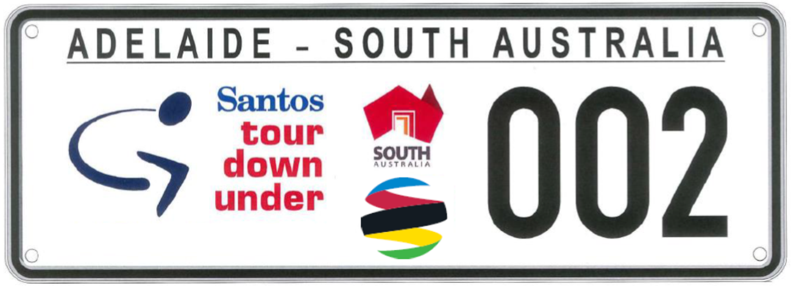
2019 TDU Number Plate Design

PASTORAL LAND MANAGEMENT AND CONSERVATION ACT 1989
Public Access Route Closures
Notice of Intent to Temporarily Close Public Access Route Number 13, named Halligan Point
Notice is hereby given of the intent to temporarily close the Halligan Point Public Access Route from the Oodnadatta Track to Lake Eyre National Park, for the period 1 December 2018 to and including 15 March 2019, pursuant to section 45 (7) of the Pastoral Land Management and Conservation Act 1989.
Notice of Intent to Temporarily Close Public Access Route Number 15, named K1 Warburton Crossing
Notice is hereby given of the intent to temporarily close the K1 Warburton Crossing Public Access Route from the Birdsville Track to the Simpson Desert Regional Reserve, for the period 1 December 2018 to and including 15 March 2019, pursuant to section 45 (7) of the Pastoral Land Management and Conservation Act 1989.
Notice of Intent to Temporarily Close Public Access Route Number 16, named Walkers Crossing
Notice is hereby given of the intent to temporarily close the Walkers Crossing Public Access Route from the Birdsville Track to the Innamincka Regional Reserve, for the period 1 December 2018 to and including 15 March 2019, pursuant to section 45 (7) of the Pastoral Land Management and Conservation Act 1989.
Dated: 30 November 2018
Jodie Gregg-Smith
Pastoral Board delegate of section 45 (7) of the Pastoral Land Management and Conservation Act 1989
Acting Regional Director
SA Arid Lands Region
Department of Environment, Water and Natural Resources

Petroleum and Geothermal Energy Act 2000
Grant of Associated Activities Licence AAL 265
(Adjunct to Petroleum Exploration Licence PRLs 231, 232 and 233)
Notice is hereby given that the undermentioned Associated Activities Licence has been granted with effect from 30 November 2018, under the provisions of the Petroleum and Geothermal Energy Act 2000, pursuant to delegated powers dated 29 June 2018.
No of Licence | Licensees | Area Km² | Locality | Reference
AAL 265 | Stuart Petroleum Pty Ltd  Cooper Energy Limited | 29.31 | Cooper Basin | MER-2018/1460
Description of Area
All that part of the State of South Australia, bounded as follows:
Area 1
Commencing at a point being the intersection of latitude 28°14'25" S GDA94
and longitude 139°39'10" E GDA94, thence east to longitude 139°44'35" E GDA94,
north to latitude 28°14'00" S GDA94, east to longitude 139°50'15" E GDA94,
south to latitude 28°15'45" S GDA94, west to longitude 139°50'00" E AGD66,
north to latitude 28°15'00" S AGD66, west to longitude 139°39'10" E GDA94, and north to the point of commencement.
Area 2
Commencing at a point being the intersection of latitude 28°17'40" S GDA94
and longitude 139°50'00" E AGD66, thence east to longitude 139°50'15" E GDA94,
south to latitude 28°22'35" S GDA94, west to longitude 139°50'00" E AGD66, and north to the point of commencement.
Area 3
Commencing at a point being the intersection of latitude 28°26'05" S GDA94
and longitude 139°46'00" E GDA94, thence east to longitude 139°50'00" E AGD66,
south to latitude 28°26'15" S GDA94, west to longitude 139°46'00" E GDA94, and north to the point of commencement.
Area 4
Commencing at a point being the intersection of latitude 28°26'05" S GDA94
and longitude 139°39'15" E GDA94, thence east to longitude 139°40'25" E GDA94,
south to latitude 28°26'15" S GDA94, west to longitude 139°39'15" E GDA94, and north to the point of commencement.
AREA: 29.31 square kilometres approximately
Dated: 30 November 2018
Barry A. Goldstein
Executive Director
Energy Resources Division
Department for Mining and Energy
Delegate of the Minister for Energy and Mining

South Australia
Public Sector (Reorganisation of Public Sector
Operations—South Australian Housing Trust No. 2) Notice 2018
under section 9(1) of the Public Sector Act 2009
1—Short title
This notice may be cited as the Public Sector (Reorganisation of Public Sector Operations—South Australian Housing Trust No. 2) Notice 2018.
2—Commencement
This notice will come into operation on 1 December 2018.
3—Transfer of employees
- The employees of the Department of Human Services listed in Schedule 1 are transferred to the employment of the Chief Executive, South Australian Housing Trust on the same basis of engagement as applied before the transfer.
- The employee of the Urban Renewal Authority listed in Schedule 1 is transferred to the employment of the Chief Executive, South Australian Housing Trust on the same basis of engagement as applied before the transfer.
Schedule 1—Employees being transferred
1 – Employees of the Department of Human Services
Lisa ALLISON
Thomas ASHBY
Kevin BIGNELL
Marie BLIGHT
Monica BOULTON
Matthew BOWMAN
Anne-Marie BROWN
Derek BUTLER
Janette CHEESMAN
Despina DAMIS
Kimberley DOMAN
Rachel DOW
Chin FOO
Stephen HILL
Kate HOLLOWAY
Mark HUNTER
Michelle JONES (KAZANIECKI)
Ania KARZEK
John KOLACZKOS
Hermiene LANGES
John LUKE
Rita LOWIS
Rosalina MANCINI
Kerry MILBURN
Maria NELSON
David OAKLEY
Raamkummar PATHANGI RANGASWAMY
Gillian QUIGLEY
Stephen RETALLACK
Peter SIELS
Sarah STANBOROUGH
Nick TUFFNELL
Yvonne TUONG
Matt TURNER
Susana VALDIVIA
Natalie WADE
Jenny WARNER
Andrew WOOD
Xiaohui (Simo) XU
Adam ZAKNIC
NingYi (Jennifer) ZHANG
2 – Employee of Urban Renewal Authority
David SUTTON
Made by the Premier
on 28 November 2018
Cabinet Submission reference number: MHSCS18002

REMUNERATION TRIBUNAL
Report No. 10 of 2018
2018 Review of Electorate Allowances for Members of the Parliament of South Australia
INTRODUCTION
- Section 14 of the Remuneration Act 1990 (“the Act”) provides that additional jurisdiction may be conferred on the Remuneration Tribunal (“the Tribunal”) by any other Act, or by proclamation of the Governor. Section 3A of the Parliamentary Remuneration Act 1990 (“the PR Act”) confers jurisdiction on the Remuneration Tribunal to make a determination or perform any other function required by the PR Act.
- Section 4(1)(c) of the PR Act provides that electorate allowances form part of the remuneration of members of Parliament. Section 8(2) of the Act requires the Tribunal to review previous Determinations of remuneration under the Act at least once in each year.
BACKGROUND
- Electorate allowances are provided to members of Parliament to meet the costs of discharging their duties in the electoral district the member represents.
- In 2017, the Tribunal conducted its annual review of electorate allowances for members of the Parliament, with no adjustment made to the levels of those allowances.
PROCEDURAL HISTORY
- Section 10(2) of the Act, requires that before the making of a Determination affecting the remuneration of a particular person, or persons of a particular class, the Tribunal must allow that person, or persons of that class, a reasonable opportunity to make submissions.
- The Tribunal wrote to the Premier, as the Minister responsible for the Act, and the members of Parliament on 5 July 2018, notifying of the Tribunal’s intention to review electorate allowances, and invited submissions with a closing date of 8 August 2018. A notice of the review was also placed on the Tribunal’s public website.
SUBMISSIONS
- The Tribunal received three submissions. A summary of those submissions and the Tribunal’s consideration thereof is provided below.
- Member for Mawson
The member for Mawson submitted that, as a consequence of the redistribution of State’s electoral boundaries in 2018, the size (area) of the electoral district of Mawson has been altered from a 249 km² electorate to a 5371 km² electorate, which now includes Kangaroo Island and part of regional South Australia.
The Tribunal considers that the changes to the electorate of Mawson, as submitted by the member for Mawson, are a relevant consideration for the Tribunal’s decision in determining an appropriate level of electorate allowance for that electorate. Accordingly, within the accompanying Determination, the Tribunal will provide for the electoral district of Mawson to attract a level of electorate allowance that is equivalent to the amount payable for regional electoral districts with similar characteristics to that of Mawson.
- Member for Wright
The Tribunal received a submission from the member for Wright in relation to costs incurred as a result of temporary disruption to the location of the member’s electorate office. For apparently administrative reasons, the electorate office of the member was temporarily relocated some 25 kilometres outside the boundaries of the electorate from the original location, subsequent to the 2018 election.
The member took steps to facilitate notification to the constituents of this change and to make arrangements for more convenient opportunities for meetings and consultations with the electors and the community which would not require extensive travel to and from the temporary location by them.
The member for Wright seeks reimbursement of the costs of the notification. A breakdown of printing and postage costs to effect the notification is included with the member’s submission. The Tribunal considers that the provision of this service to the constituents in the electorate for these unusual and limited circumstances is not unreasonable and that the expenses incurred are properly characterised as expenditure for the purpose of efficiently discerning and representing the interests of the persons and the communities within the electorate.
Accordingly, a discrete amount effectively reimbursing this expenditure will be separately provided for in the Determination of the electorate allowance applicable to the electorate of Wright. The entitlement in this respect will be limited to the circumstances referred to above and will be non-recurring.
- The Hon Connie Bonaros MLC
The Tribunal received a submission from the Hon Connie Bonaros expressed to be on behalf of herself and the Hon Frank Pangallo MLC. The submission proposed that the Tribunal should determine an allowance for a member of the Legislative Council for the purpose of staff accompanied travel. It was submitted that members of the Legislative Council represent all of the electors of South Australia, accordingly, it is submitted, it is necessary and appropriate for members of the Legislative Council to travel throughout the State to consult with citizens and their community representatives and organisations, in order to properly represent their interests in the Parliament. It was submitted that it is appropriate that a Legislative Councillor be accompanied by a staff member for this purpose.
There is no submission in relation to the relevant travel of the member of the Legislative Council. The issue before the Tribunal is therefore limited to the merit of providing an allowance for a staff member to travel with a Legislative Councillor, on parliamentary business, outside the metropolitan area. There is currently no such provision within any Determination of the Tribunal applicable to the entitlements of members of the Parliament. The Tribunal considers that the jurisdiction and power to provide such an allowance for this purpose would arise under the Parliamentary Remuneration Act 1990, if it were persuaded of the merit of doing so. The mechanism would be to include an amount within the electorate allowance determined for members of the Legislative Council.
While the submission expresses an affirmative and favourable view of the merit of such staff accompanied travel, on behalf of the authors, the grounds upon which this view has been arrived at were not set out or explained in detail, beyond the desirability of such accompanied travel as an “incentive” for members of the Legislative Council “to engage more effectively” with their electorate. While the merit of travel by Legislative Councillors for the stated purposes is unexceptional, the role and function that the presence of a staff member would play in the circumstances referred to is not explained such that it can be understood how the incentive referred to would arise.
While the submission refers to specific considerations relevant to the political party SA Best and the party's policy platform regarding consultations in regional and rural areas, we do not consider that advantages to the various political parties and their priorities, which no doubt will be perceived variously by them from time to time, is relevant to our considerations.
The Tribunal’s focus is upon the entitlements of members of the Parliament and the performance of their parliamentary duties as representatives of the electors. A consequence of this view is that, in the relevant circumstances, any allowance of the kind sought would, in our view, have to be considered in respect of all of the members of the Legislative Council. Notably, no like submission is before us on behalf of any other members of the Council. Nor are we aware of any previous submission for such an allowance. While the submission does not identify an amount of allowance, the cost of a general allowance of this kind would have to be considered by the Tribunal. No costing or cost analysis is contained within the submission.
As we are unable to discern the objective merit in a general principle that members of the Legislative Council require the assistance of staff when travelling outside the metropolitan area for the purpose of political consultations, or the cost of any such provision, the Tribunal has decided not to include this consideration in respect of our Determination providing the electorate allowance for members of the Legislative Council.
CONCLUSION
- Electorate allowances are provided to members of Parliament for the purpose of discharging duties in the electoral district the member represents.
- The Tribunal considers it appropriate for an economic adjustment to be applied to the electorate allowances for members of Parliament at this time. Accordingly, the Tribunal has had regard to the Consumer Price Index¹, as published by the Australian Bureau of Statistics, in the making of the accompanying Determination.
¹ Australian Bureau of Statistics, Consumer Price Index (Series 6401.0), All Groups, Adelaide, for the year ending September 2018
Dated: 28 November 2018
John Lewin
President
Peter Alexander
Member
Pamela Martin
Member

REMUNERATION TRIBUNAL
Determination No. 10 of 2018
Electorate Allowances for Members of the Parliament of South Australia
SCOPE OF DETERMINATION
  - This Determination applies to the members of the Parliament of South Australia.
ELECTORATE ALLOWANCES FOR MEMBERS OF PARLIAMENT
  - There shall be payable to a Member of Parliament, in respect of the expenses associated with discharging duties in the electoral district the member represents, an electorate allowance at the following annual rate.
ELECTORAL DISTRICT RATE PER ANNUM
2.1 HOUSE OF ASSEMBLY
(a) Adelaide, Badcoe, Bragg, Gibson, Cheltenham, Colton, Croydon,
Davenport, Dunstan, Elder, Enfield, Hurtle Vale, Florey, Hartley,
Kaurna, Lee, Elizabeth, Black, Morialta, Morphett, King, Newland,
Playford, Port Adelaide, Ramsay, Reynell, Torrens, Unley, Waite,
West Torrens and Wright. $16,619
(b) Heysen, Kavel, Light and Taylor $23,312
(c) Frome, Mount Gambier and Schubert $27,242
(d) Chaffey, Narungga, Finniss, Hammond and Mawson $35,202
(e) MacKillop $39,809
(f) Flinders $45,723
(g) Giles and Stuart $50,763
2.2 LEGISLATIVE COUNCIL
Members of the Legislative Council $22,483
  - The electorate allowances payable to a Member under this Determination shall be calculated from the day on which he or she commences to be a Member, and except as provided by clause 4 of this Determination, shall cease to be payable on the day on which such person ceases to be a Member.
  - A former member of the Parliament shall be deemed to continue as a member of the Parliament until a successor is elected in his or her place.
EXPENSE REIMBURSEMENT FOR THE MEMBER FOR WRIGHT
  - The member for Wright shall be entitled to be paid an expense reimbursement for the amount of $10,825.51. The purpose of the reimbursement is to meet the costs associated with providing a notification to the persons of the electoral district of Wright, in relation to the temporary relocation of the member’s electorate office in 2018.
  - The payment at clause 5 of this Determination shall be non-recurring and shall be paid as soon as practicable after the date of signature of this Determination.
OPERATIVE DATE
  - The operative date of this Determination shall be 28 November 2018.
  - This Determination replaces Determination 17 of 2016 in its entirety.
Dated: 28 November 2018
John Lewin
President
Peter Alexander
Member
Pamela Martin
Member

REMUNERATION TRIBUNAL
Report No. 11 of 2018
2018 Review of the Common Allowance for Members of the Parliament of South Australia
INTRODUCTION
- Section 14 of the Remuneration Act 1990 (“the Act”) provides that additional jurisdiction may be conferred on the Remuneration Tribunal (“the Tribunal”) by any other Act, or by proclamation by the Governor. Section 3A of the Parliamentary Remuneration Act 1990 (“the PR Act”) confers jurisdiction on the Tribunal to make a Determination or perform any other function required by the PR Act.
- Section 4AA(3) of the PR Act, provides that the Tribunal must review the common allowance once per year, and if the Tribunal considers it appropriate to do so, the Tribunal may determine an increase to the level of the common allowance.
BACKGROUND
- In 2015, the PR Act was amended by the Parliamentary Remuneration (Determination of Remuneration) Amendment Act 2015 (“the Amending Act”) and a number of allowances for members of the Parliament and Ministers of the Crown were abolished. To compensate for the abolition of those allowances, a common allowance was established by the Amending Act.
- The Remuneration Tribunal is subject to a statutory direction under the Amending Act to determine the amount of the common allowance. Accordingly, in 2015, the Tribunal issued Report and Determination 7 of 2015, which determined the amount of the common allowance for members of Parliament.
- In determining the common allowance in 2015, the Tribunal was required by section 4AA of the PR Act to ascertain the full value of the following components of remuneration:
- annual travel allowance;
- metrocard special pass;
- remuneration consisting of subsidised or free interstate rail travel; and
- remuneration payable to all members of Parliament for service as ordinary members of parliamentary committees.
- In 2015, the Tribunal determined that the amount of remuneration as reasonable compensation for the abolition of: annual travel allowance, metrocard special pass and subsidised or free interstate rail travel was fixed at $17,124 per annum.
- In 2015, the amount of remuneration payable to all members of Parliament for service as ordinary members on parliamentary committees was fixed at $13,170 per annum.
- The Tribunal reviewed the common allowance in 2016 and 2017, resulting in no adjustment being made to the level of the allowance.
PROCEDURAL HISTORY
- Section 10(2) of the Act, requires that before the making of a Determination affecting the remuneration of a particular person, or persons of a particular class, the Tribunal must allow that person, or persons of that class, a reasonable opportunity to make submissions.
- The Tribunal wrote to the Premier, as the Minister responsible for the Act, and the members of Parliament on 5 July 2018, notifying of the Tribunal’s intention to review the common allowance, and invited submissions with a closing date of 8 August 2018. A notice of the review was also placed on the Tribunal’s public website.
- No submissions were received by the Tribunal.
CONSIDERATION
- The Tribunal would be assisted by submissions made by the relevant persons who are entitled to the opportunity to make submissions. It may be that vociferous public commentary concerning the entitlements of persons who become members of the Parliament inhibits the making of such submissions.
- Notwithstanding the absence of any submission, the Tribunal has a duty to make an independent judgement on an annual basis in relation to the level of the common allowance.
- It is a notorious feature of regulatory systems determining personal remuneration that levels of remuneration are determined and adjusted to prevent the indefinite diminution of the value of the remuneration so determined. This is a near universal characteristic of personal remuneration, whether fixed privately by agreement, as a matter of policy by organisations and corporations, or by public institutions and agencies. Having regard to the nature of the common allowance and the factors considered when the allowance was originally determined, the adjustment of the amount of the allowance could proceed on the basis of various considerations. However, the determination of a considered framework of considerations should proceed in a manner whereby those whose remuneration would be affected are on notice and are able to make relevant submissions. The Tribunal intends to address these considerations and provide such notice in due course.
- The level of the common allowance has not been adjusted by the Tribunal since the allowance came into operation on 1 January 2016. The Tribunal considers it necessary to apply an economic adjustment to the level of the common allowance on this occasion.
- Accordingly, the Tribunal has had regard to the Consumer Price Index¹, as published by the Australian Bureau of Statistics. The adjustment will reflect the movement in the Consumer Price Index over the 12 months between September 2017 and 2018.
- The Tribunal will issue the accompanying Determination which is operative from 1 October 2018.
¹ Australian Bureau of Statistics, Consumer Price Index (Series 6401.0), All Groups, Adelaide for the year ending September 2018.
Dated: 28 November 2018
John Lewin
President
Peter Alexander
Member
Pamela Martin
Member

REMUNERATION TRIBUNAL
Determination No. 11 of 2018
Common Allowance for Members of the Parliament of South Australia
DETERMINATION
- Pursuant to section 4AA of the Parliamentary Remuneration Act 1990, the Remuneration Tribunal makes the following Determination:
  - The amount of remuneration as reasonable compensation for the abolition of: annual travel allowance, metrocard special pass and subsidised or free interstate rail travel is $17,432 per annum.
  - The amount of remuneration payable to all members of Parliament for service as ordinary members on parliamentary committees is $13,407 per annum.
DATE OF OPERATION
- This Determination comes into operation on 1 October 2018.
Dated: 28 November 2018
John Lewin
President
Peter Alexander
Member
Pamela Martin
Member

REMUNERATION TRIBUNAL
Report No. 12 of 2018
2018 Review of Accommodation and Meal Allowances for Ministers of the Crown and Officers and Members of Parliament
INTRODUCTION AND BACKGROUND
- Section 4(1)(c) of the Parliamentary Remuneration Act 1990, confers jurisdiction on the Remuneration Tribunal (“the Tribunal”) to determine electorate allowances and other allowances and expenses for members of Parliament.
- Section 3 of the Remuneration Act 1990, defines such allowances and expenses as remuneration, and section 8(2) of the Act requires the Tribunal to review previous determinations of remuneration under the Act at least once in each year.
- The last Determination in relation to accommodation and meal allowances was Determination 13 of 2017.
PROCEDURAL HISTORY
- Section 10(2) of the Act, requires that before the making of a Determination affecting the remuneration of a particular person, or persons of a particular class, the Tribunal must allow that person, or persons of that class, a reasonable opportunity to make submissions.
- The Tribunal wrote to the Premier, as the Minister responsible for the Act, and the Members of the Parliament on 5 July 2018, notifying of the Tribunal’s intention to review accommodation and meal allowances, and invited submissions with a closing date of 8 August 2018. A notice of the review was also placed on the Tribunal’s public website.
- No submissions were received by the Tribunal.
ACCOMMODATION AND MEAL ALLOWANCES FOR MINISTERS OF THE CROWN AND THE LEADER AND DEPUTY LEADER OF THE OPPOSITION
- The allowances under consideration for Ministers of the Crown and the Leader and Deputy Leader of the Opposition, are provided for the purpose of accommodation and meal expenses associated with travelling in an official capacity within South Australia and interstate.
- The Tribunal has had regard to increases in accommodation and meal allowances applicable within the South Australian public sector, which have been adjusted on the basis of movements in the relevant ABS data series.
- The Tribunal is of the view that justification exists to increase the accommodation and meal allowances under consideration. Accordingly, the Tribunal will issue the accompanying Determination.
COUNTRY MEMBERS ACCOMMODATION ALLOWANCE
- The Country Members Accommodation Allowance is provided to a member of either house of Parliament whose usual place of residence is more than 75 kilometres by road (by the most direct route) from the Adelaide General Post Office (“GPO”), and who is required to stay in Adelaide overnight in order to attend to either parliamentary duties or the Member’s duty to be actively involved in community affairs. A modest level of allowance is also provided to a member whose permanent residence is outside metropolitan Adelaide but who does not qualify for the existing accommodation allowance because they do not live more than 75 kilometres from the GPO.
- The terms of the previous Determination have been amended such that the conditions under which the relevant entitlements now arise are dependent upon the actual occurrence of expenditure to carry on relevant parliamentary business.
- Having regard to the increased accommodation allowances granted to the South Australian public sector, which have been adjusted on the basis of the relevant ABS data series, the Tribunal is of the view that justification exists to increase the allowances for Country Members of Parliament.
Dated: 28 November 2018
John Lewin
President
Peter Alexander
Member
Pamela Martin
Member

REMUNERATION TRIBUNAL
Determination No. 12 of 2018
Accommodation and Meal Allowances for Ministers of the Crown and Officers and Members of Parliament
SCOPE OF DETERMINATION
- This Determination applies to Ministers of the Crown, the Leader and Deputy Leader of the Opposition, and to Country Members of Parliament.
ACCOMMODATION AND MEAL ALLOWANCES
- A Minister who actually incurs expenditure for both accommodation and meals when travelling on official business and which necessitates absence from home overnight shall be paid an allowance as follows:
    - Outside Metropolitan Adelaide, as defined by the Development Act 1993, but within the State - at the rate of $285 per day for accommodation and meals;
    - Interstate - at the rate of $504 per day for Sydney, and at the rate of $446 per day for places other than Sydney, for accommodation and meals;
    - Provided that, where it is necessary and appropriate, reasonable additional expenditure to that prescribed by the allowances in 2(a) and 2(b) for the purposes of accommodation and meals may be incurred.
- The allowances provided by this clause shall also be payable to the Leader of the Opposition for expenditure actually incurred when travelling on official business, and to the Deputy Leader of the Opposition when he or she deputises, at the Leader's request, for the Leader of the Opposition in his or her official capacity.
COUNTRY MEMBERS ACCOMMODATION ALLOWANCE
Part A
- A Member of either House of Parliament:
- whose usual place of residence is more than 75 kilometers by road from the General Post Office at Adelaide (by the most direct route); and
- who is required to stay in Adelaide overnight, and incurs actual expenditure, in order to attend not only to parliamentary duties but also to the Member's duty to be actively involved in community affairs and to represent and assist constituents in dealings with governmental and other public agencies and authorities,
shall be paid an accommodation allowance of $230 for each such night up to a maximum of 135 nights per annum, with the total allowance payable not to exceed $31,050 for the twelve month period commencing on and from 1 July 2018.
Part B
- A member of either house of Parliament:
- whose usual place of residence is less than 75 kilometers by road from the General Post Office at Adelaide (by the most direct route), but is outside Metropolitan Adelaide (as defined by the Development Act 1993); and
- who is required to stay in Adelaide overnight, and incurs actual expenditure, in order to attend not only to parliamentary duties but also to the member’s duty to be actively involved in the community,
shall be paid an accommodation allowance of $230 for each such night up to a maximum of 15 nights during each twelve month period commencing on and from 1 July 2018.
DATE OF OPERATION
- The allowances prescribed within this Determination shall operate on and from 28 November 2018, accept where otherwise stated, and supersede those previously prescribed in Determination 13 of 2017.
Dated: 28 November 2018
John Lewin
President
Peter Alexander
Member
Pamela Martin
Member

Return to Work Act 2014
Notice of Travel Allowance
Preamble
Section 33(8) of the Return to Work Act 2014 (the Act) states that:
If a worker travels in a private vehicle to or from any place for the purpose of receiving medical services, hospitalisation or approved recovery/return to work services, and the travel is reasonably necessary in the circumstances of the case, the worker is entitled to a travel allowance at rates fixed by a scale published by the Minister under this section.
NOTICE
I DECLARE that the rate for travel allowance in 2019 is hereby fixed for the purposes of section 33(8) of the Act at 45.1 cents per kilometre, and this notice supersedes all previous notices of the travel allowance rate published under section 33(8) of the Act.
This Notice is effective for travel on or after 1 January 2019.
Dated: 25 November 2018
Hon Rob Lucas MLC
Treasurer

TRAINING AND SKILLS DEVELOPMENT ACT 2008
Part 4 – Apprenticeships/Traineeships
PURSUANT to the provision of the Training and Skills Development Act 2008, the Training and Skills Commission (TaSC) gives notice that determines the following Trades or Declared Vocations in addition to the gazette notices of:
- 25 September 2008 | - 23 October 2008 | - 13 November 2008 | - 4 December 2008
- 18 December 2008 | - 29 January 2009 | - 12 February 2009 | - 5 March 2009
- 12 March 2009 | - 26 March 2009 | - 30 April 2009 | - 18 June 2009
- 25 June 2009 | - 27 August 2009 | - 17 September 2009 | - 24 September 2009
- 9 October 2009 | - 22 October 2009 | - 3 December 2009 | - 17 December 2009
- 4 February 2010 | - 11 February 2010 | - 18 February 2010 | - 18 March 2010
- 8 April 2010 | - 6 May 2010 | - 20 May 2010 | - 3 June 2010
- 17 June 2010 | - 24 June 2010 | - 8 July 2010 | - 9 September 2010
- 23 September 2010 | - 4 November 2010 | - 25 November 2010 | - 16 December 2010
- 23 December 2010 | - 17 March 2011 | - 7 April 2011 | - 21 April 2011
- 19 May 2011 | - 30 June 2011 | - 21 July 2011 | - 8 September 2011
- 10 November 2011 | - 24 November 2011 | - 1 December 2011 | - 8 December 2011
- 16 December 2011 | - 22 December 2011 | - 5 January 2012 | - 19 January 2012
- 1 March 2012 | - 29 March 2012 | - 24 May 2012 | - 31 May 2012
- 7 June 2012 | - 14 June 2012 | - 21 June 2012 | - 28 June 2012
- 5 July 2012 | - 12 July 2012 | - 19 July 2012 | - 2 August 2012
- 9 August 2012 | - 30 August 2012 | - 13 September 2012 | - 4 October 2012
- 18 October 2012 | - 25 October 2012 | - 8 November 2012 | - 29 November 2012
- 13 December 2012 | - 25 January 2013 | - 14 February 2013 | - 21 February 2013
- 28 February 2013 | - 7 March 2013 | - 14 March 2013 | - 21 March 2013
- 28 March 2013 | - 26 April 2013 | - 23 May 2013 | - 30 May 2013
- 13 June 2013 | - 20 June 2013 | - 11 July 2013 | - 1 August 2013
- 8 August 2013 | - 15 August 2013 | - 29 August 2013 | - 6 February 2014
- 12 June 2014 | - 28 August 2014 | - 4 September 2014 | - 16 October 2014
- 23 October 2014 | - 5 February 2015 | - 26 March 2015 | - 16 April 2015
101. 27 May 2015 | 102. 18 June 2015 | 103. 3 December 2015 | 104. 7 April 2016
105. 30 June 2016 | 106. 28 July 2016 | 107. 8 September 2016 | 108. 22 September 2016
109. 27 October 2016 | 110. 1 December 2016 | 111. 15 December 2016 | 112. 7 March 2017
113. 21 March 2017 | 114. 23 May 2017 | 115. 13 June 2017 | 116. 18 July 2017
117. 19 September 2017 | 118. 26 September 2017 | 119. 17 October 2017 | 120. 3 January 2018
121. 23 January 2018 | 122. 14 March 2018 | 123. 14 June 2018 | 124. 5 July 2018
125. 2 August 2018 | 126. 9 August 2018 | 127. 16 August 2018 | 128. 30 August 2018
129. 27 September 2018 | 130. 4 October 2018 | 131. 18 October 2018 | 132. 1 November 2018
133. 15 November 2018 | 134. 22 November 2018 | 135. 29 November 2018 | 136. 6 December 2018
Trades or Declared Vocations and Required Qualifications and Training Contract Conditions for the
Racing and Breeding Training Package RGR
*Trade/ #Declared Vocation/ Other Occupation | Qualification Code | Qualification Title | Nominal Term of Training Contract | Probationary Period
Racing Operations # | RGR20218 | Certificate II in Racing Industry | 12 Months | 60 Days
New Declared Vocation and Training Contract Conditions for the Certificate II in Construction
*Trade/ #Declared Vocation/ Other Occupation | Qualification Code | Qualification Title | Nominal Term of Training Contract | Probationary Period
Steel Frame Installer # | CPC20112 | Certificate II in Construction | 24 Months | 60 Days

South Australia
Oaths (Appointments) Proclamation 2018
under section 33 of the Oaths Act 1936
1—Short title
This proclamation may be cited as the Oaths (Appointments) Proclamation 2018.
2—Commencement
This proclamation comes into operation on the day on which it is made.
3—Appointment of persons to take declarations and attest instruments
The following police officers are appointed to take declarations and attest the execution of instruments:
Juma Abuyi
Swayne Kade Ackland
Ryan Peter Adderley
Jamie Shane Anderson
Kahla Nicole Anderson
Stuart McCallum Anderson
Elinor Kristin Arblaster
William Xavier Arbon
Marcus James Arnfield
Augustina Amoah Asabere
Bianca Leeanne Avery
Stuart John Bainbridge
Peter Scott Baker
Julie Ann Baldock
Gabrielle Amelia Banks
Lachlan Keith Bannon
Nicholas Andrew Bauer
Tristan Trent Beasley
Anthea Mary Beck
Liam Sean Bennett
Mason Peter Martin Beyer
Christopher Jamie Biddle
Rachel Elise Bisset
Emile Christopher Bitar
Samuel Michael Blake
Michel Bloom
Jarrad Luke Bollenhagen
James Paul Boonstoppel
Christopher Andrew Brannan
Bradley Craig Breeding
Tanya Renae Brine
Ashleigh Genevieve Broadbent
Nathan Lee Brophy
James Victor Bulian
Crystal Lee Burgon
Owen Mitchell Busuttil
Andrew William Butler
Tor Edvin Bjornsson Butler
Shane Patrick Byrne
Christopher Kevin Bytheway
Dale Stephen Carson
Amanda Sue Casey
Rebekah Lisa Cass
Lane Jacob Chapman
Caitlin Anne Charnstrom
Michael Ciaramella
Libby Victoria Clark
Trent James Clark
Hannah Louise Clarke
Rebecca Kate Claughton
James John Clements
David Shean Coad
Kate Louise Coden
Louise Coghlan
Amanda Jessica Coles
Dillon Peter Condon
Hayden Lee Conlay
Nikolaos John Contibas
Sarah Leanne Coombes
Brett Geoffrey Copeland
Mark Geoffrey Cranwell
Paul Cameron Crosby
Jordan Tyler Curry
Jane Alison Davies
Tessa Jayne Davis
Sarah Valerie Day
Helen Louise Dennis
Lisa Nicole Denny
Kent William Derwent
Blake Jared Deussen
Cameron James Devey
Jai Dinunzio
Rhys Levi Dowdell
Sarah Louise Drill
Stephen Joel Duval
Daniel Robert Ebert
Tierney Ellens
Joseph Michael Elliott
Thomas Michael Elliott
Tracy Emerson
Phillip James Eriksen
Keely Shae Etherington
Natasha Jane Evans
Ashley Kay Eyles
James Paul Fagg
Bethany Anne Fawcett
Eveleen Ciara Fazzalari
Anthony Feo
Nicole Peta Finlay
Chelsea Anne Fisher
Nathan Daniel Fisher
Zachary James Fisher
Stephen James Fleming
Matthew John Fletcher
Benjamin Kieran Flynn
George Fomba
Mitchell Frazier William Foster
Abigail Rebecca Foulkes
Jay Adrian Frahm
Joshua Ian Andrew Frances
Hayley Janey Evelyn Franklin
Carla Jayne Franson
Madeline Jade Freeman
Samuel John Fuller
Samuel Joel Gava
Joseph Russell Gilmore
Laura Jo-Ann Girardi
Zoe Jade Gomez
Natasha Ann Goode
Siobhan Gemma Goode
Courtney Sandra Gray
Maddison Kiesha Greaves
Shannon May Green
Cherelle Jade Griffin
Jake Gruden
Jason Gunn
Christopher Alan Hale
Christopher John Hall
Ricardo Estrela Hall
Sharna Harrison
Lee James Hartley
Daniel Paul Havelberg
Matthew John Hawgood
Rosemary Belle Hawkey
Benjamin Thomas Healy
Jack Alexander Heath
Luke Andrew Heinrich
Sophie Elisabeth Heinrich
Shannan Kate Herbert
Ashlee Carla Hermsen
Matthew Michael Heuer
Susan Anne Hodge
Matthew James Hodgson
Catherine Anna Hoffmann
Braydon Jay Hoggett
Roslyn Kerry Holden
David Keith Holl
Claire Sarah Rose Holland
Rick Hornberger
Dominic William Hoskin
Yi Huang
Thomas Daniel Hughes
Mitchell Shane Blight Humphreys
Emily Meg Hunter
Sophie Lisette Huntley
James Michael Irwin
Matthew Anthony Jackson
Sonny Jacobs
Erin Lee Jaensch
Ryan Adrian James
Scott Daniel James
Cindy Michelle Jenner
Briony Clare Johnson
Claire Louise Johnson
Erin Marie Johnson
Kara Johnson
Kayla Louise Johnson
Aaron Philip Johnston
Claire Lauren Judd
Gemma Jurjevic
Peter Demetrios Kastanos
Jasmine Erica Kelly
Kimberley Frances Kelly
Jayme Lee Kempster
Joseph James Kenworthy
Catherine Elizabeth King
James Edward Kitson
Brenton Robert Kitto
Brock Andrew Knott
Laura Annabel Koerner
Ayrton Brady Koning
Patrick Daniel Kossowski
Joanna Agnieszka Kruk
Adrian Wing Loc Kwong
Clohe Wendy Joan Lamont
Claudia Grace Lawrence
Heather Anne Lee
Amanda Jane Leray
Chelsea Rene Lieberwirth
Mardi Tammi Lim
Aaron Kenneth Lloyd
Daniel Scott Lockwood
Luke Rian Loftes
Hannah Louise Loy
Baden Coel Ludlow
Scott Cameron MacIntyre
Jordan Taylor Mackay
Kailey Anne Maczkowiack
Maddison Nicole Maitland
Joshua Iain Marsh
Alicia Kate Martschink
Bridget Ellie Mason
Dakota DJ Masterson
Michael Ryan Mawhinney
Wendy Kay Mazik
Melissa Kate McCaig
Lee Christopher McCann
Daniel Alan McCormick
Lauren Kate McDonald
Brandan Mark McElroy
Robert Ian McFarlane
Christian McIntyre
Chelsea Kate McKinnon
Jock Andrew McLeay
Lisa Joy McMurtrie
Michael Thomas Meaney
Lisa Kaye Milich
Tania Louise Milsom
Eliesa Faye Morello
Jasper Hamish Guy Morris
Jeffrey Robert Morris
Bradley Donald Moyle
Jemal Abdullah Mussa
Troy Laurence Nicholson
Emma Kate Nisbet
Rachel May Northeast
Jayden Bryce Oakley
Susan Lee O’Connor
Rylee Shae O’Grady
Brydie Jayne O’Leary
Mark Christopher Padovan
Kelsey Marie Page
Charlotte Elizabeth Pagh
Bradley Paterson
Caitlin Maree Patrikis
Samuel James Patterson
Georgia Mae Payne
Taylah Sue Payne
Jasmin Foote Peach
Jessica Ann Pearce
Johnathan Andrew Ridley Peecock
Benjamin Richard Philps
Rhiannon Sian Phillips
Daniel John Pichl
Benjamin David Pierens
Max Plaude
Jonathon Jade Poethke
Nicole Tamara Pollard
Lauren Kate Drury Prosser
Allison Jane Pullen
Paige Krystal Purdie
Claire Louise Pusser
Emma Si Ming Ramsay
Sarah Claire Randall
Samarth Raonta
Dylan Troy Reinbrecht
Daniel David Richards
Benjamin Wesley Neil Riddle
Angela Marie Robins
Scott Robinson
Christopher Lloyd Ryan
Chantelle Marie Ryder
Alison Leigh Sampson
Nadia Santucci
Reeden Lee Schache
Daniel James Scherer
Tyson James Schmidt
Sheryl Lynda Scorgie
Kirsty Jane Scott
Maddison Beatrice Sellick
Hannah Kate Shaw
Karen Elizabeth Shearer
Benjamin Heath Skewes
Lucy Annie Slaven
Karl Gary Slink
James Rennie Marshall Sloan
Jamie Leonard Smith
Kelly Jane Smyth
Veronica Sarah Stewart Smyth
Michaela Jane Snodgrass
Heidi Lee Somerville
Madeleine Rose Spano
Aaron James Spiniello
Justin J Spratt
Sheridan Amy Sribar
Adam Joseph Sroka
Bridgette Michelle Stacey
Maria Ann Staffin-Gardiner
Anthony Craig Stam
Lesa Marie Stamper
Emma May Steele
Simon John Steer
Petar James Stevanovic
Shaquille Nisiotis Stuart-Likouresis
Matthew Brian Suridge
Blair Jonathon Sykes
Nicole Jasmine Tajnikar
Bianca Tangredi
Aimee Ruth Tanimu
Amber-Rose Tanner
Coen Rhys Taylor
Jonathon Richard Taylor
Natasha Ann Taylor
Dianne Samantha Thomas
Jennifer Mary Thompson
Leah Nadine Tinney
Jonathon James Tinsley
Laura Marie Towey
Lara Jane Townsend
Kirsty Marie Trento
Beth Maree Trollope
Donna Louise Tuohy
Melanie Lou-Anne Turner
Neil Turner
Iesha Jade Vallance
Samantha Jade Van Kruyssen
Jason Paul Vesey
Andrew Peter Vincent
Sarah Votino
Sean Curt Vuorela
Leeah Alice Walker
Matthew David Walker
Scott Robert Walker
Simon James Walters
Drew Alan Waterman
Courtney Jane Webb
Ryan John Weissel
Nathan Kent Wellstead
Aleisha Marie Westby
Mandy Paige Whale
Emma Louise Whenan
Brendan Lee White
Garion Fredrick White
Steven Noel White
Corinne Alexandra Whybro
Christopher James Marinos Williams
Jesse Aaron Williams
Matthew John Williams
Adam Michael Williamson
Ellouise Georgia-Rose Wilson
Kate Julie Rose Wilson
Matthew Cameron Wilson
Matthew David Winkler
Bradley Raymond Winn
Madeline Grace Wishart
Thewodros Wondimu
Louise Anne Worsley
Douglas Michael Wright
Sarah Jane Wyatt
Kimberley Beth Yates
Sophie Rose Yialas
Justin Mark Young
Adrianna Angelina Zotti
Samuel Mark Zuliani.
Made by the Governor
with the advice and consent of the Executive Council
on 6 December 2018
AGO0118-18CS
South Australia
Radiation Protection and Control (Ionising Radiation) (Fees No 2) Variation Regulations 2018
under the Radiation Protection and Control Act 1982

Contents
Part 1—Preliminary
1 Short title
2 Commencement
3 Variation provisions
Part 2—Variation of Radiation Protection and Control (Ionising Radiation) Regulations 2015
4 Variation of regulation 60—Application for registration of apparatus
5 Variation of regulation 143—Application for registration of sealed radioactive source
6 Variation of regulation 171—Application for registration of premises under section 29 of Act
7 Revocation of regulation 204
8 Revocation of Schedule 4

Part 1—Preliminary
1—Short title
These regulations may be cited as the Radiation Protection and Control (Ionising Radiation) (Fees No 2) Variation Regulations 2018.
2—Commencement
These regulations will come into operation on the day on which the Radiation Protection and Control (Fees) Regulations 2018 come into operation.
3—Variation provisions
In these regulations, a provision under a heading referring to the variation of specified regulations varies the regulations so specified.
Part 2—Variation of Radiation Protection and Control (Ionising Radiation) Regulations 2015
4—Variation of regulation 60—Application for registration of apparatus
Regulation 60(b)—delete "the application and registration fees specified in Schedule 4" and substitute:
the prescribed application and registration fees
5—Variation of regulation 143—Application for registration of sealed radioactive source
Regulation 143(b)—delete "the application and registration fees specified in Schedule 4" and substitute:
the prescribed application and registration fees
6—Variation of regulation 171—Application for registration of premises under section 29 of Act
Regulation 171(1)(b)—delete "the application and registration fees specified in Schedule 4" and substitute:
the prescribed application and registration fees
7—Revocation of regulation 204
Regulation 204—delete the regulation
8—Revocation of Schedule 4
Schedule 4—delete Schedule 4
Note—
As required by section 10AA(2) of the Subordinate Legislation Act 1978, the Minister has certified that, in the Minister's opinion, it is necessary or appropriate that these regulations come into operation as set out in these regulations.
Made by the Governor
with the advice and consent of the Executive Council
on 6 December 2018
No 242 of 2018
18EW0002188
South Australia
Radiation Protection and Control (Fees) Regulations 2018
under the Radiation Protection and Control Act 1982

Contents
1 Short title
2 Commencement
3 Interpretation
4 Fees
Schedule 1—Fees

1—Short title
These regulations may be cited as the Radiation Protection and Control (Fees) Regulations 2018.
2—Commencement
These regulations come into operation on the day on which they are made.
3—Interpretation
In these regulations, unless the contrary intention appears—
Act means the Radiation Protection and Control Act 1982.
4—Fees
(1) The fees set out in Schedule 1 are prescribed for the purposes of the Act and the Radiation Protection and Control (Ionising Radiation) Regulations 2015.
(2) If for any reason an application for a licence or registration is not granted, any fee (other than an application fee) paid by the applicant for the licence or registration must be returned to the applicant.
Schedule 1—Fees

1—Interpretation
 | In this Schedule—
level 1 radiation apparatus means—
(a) apparatus for dental plain radiography; or
(b) cabinet X-ray units; or
(c) bone densitometry apparatus; or
(d) X-ray analysis apparatus; or
(e) apparatus for bomb disposal radiography,
other than level 2 or 3 radiation apparatus;
level 2 radiation apparatus means—
(a) fixed, mobile or portable apparatus for chiropractic, medical or veterinary plain radiography; or
(b) industrial radiography apparatus (including site radiography apparatus); or
(c) orthopantomographic or cephalometric apparatus for dental radiography; or
(d) mini C-arm fluoroscopy apparatus; or
(e) bore hole logging apparatus,
other than level 3 radiation apparatus;
level 3 radiation apparatus means—
(a) apparatus for computed or cone beam tomography; or
(b) fixed or mobile apparatus for medical or veterinary fluoroscopy (other than mini C-arm fluoroscopy apparatus); or
(c) apparatus capable of producing accelerating voltages of up to 0.5 megavolts for medical radiation therapy; or
(d) apparatus capable of producing X-rays or electron beams with an energy range of 0.5 to 20 megaelectronvolts for medical radiation therapy; or
(e) apparatus for mammography or soft tissue radiography.
 | In this Schedule, unless the contrary intention appears, a term or expression defined in the Radiation Protection and Control (Ionising Radiation) Regulations 2015 has the same meaning as in those regulations.
2—Licence to test for developmental purposes (section 23A of Act)
 | For a licence under section 23A of the Act to carry out developmental testing operations—
 | (a) application fee | $3 615.00
 | (b) annual fee—
 | (i) for a licence authorising, at a site, operations for the mining or processing of radioactive ores not involving in situ leaching | $33 736.00
 | (ii) for a licence authorising, at a site, operations for the mining or processing of radioactive ores involving in situ leaching | $33 736.00
 | (iii) for a licence authorising, at a site, mineral sands operations | $3 615.00
 | (iv) for a licence authorising, at a site, mineral processing operations where a radioactive substance is generated as a by-product | $3 615.00
3—Licence to carry out mining or mineral processing (section 24 of Act)
 | For a licence under section 24 of the Act to carry out operations for mining or mineral processing—
 | (a) application fee | $10 844.00
 | (b) annual fee—
 | (i) for a licence authorising, at a site, operations for the mining or processing of radioactive ores involving in situ leaching | $292 679.00
 | (ii) for a licence authorising, at a site, operations for the mining or processing of radioactive ores (other than activities involving in situ leaching)—
 | (A) with a capacity to extract or process up to 5 megatonnes of radioactive ore per year | $357 172.00
 | (B) with a capacity to extract or process more than 5 megatonnes but not more than 15 megatonnes of radioactive ore per year | $714 337.00
 | (C) with a capacity to extract or process more than 15 megatonnes of radioactive ore per year | $950 869.00
 | (iii) for a licence authorising, at a site, mineral sands operations | $27 709.00
 | (iv) for a licence authorising, at a site, mineral processing operations where a radioactive substance is generated as a by-product | $10 844.00
4—Licence to use or handle radioactive substances (section 28 of Act)
(1) | For a licence under section 28 of the Act to use or handle radioactive substances—
 | (a) application fee | $264.00
 | (b) licence fee or fee for renewal of licence | $118.00
(2) | No additional licence fee or application fee is payable by a person who applies for a temporary licence and a permanent licence at the same time where the subject matter of both applications is the same.
5—Registration of premises in which unsealed radioactive substances are handled or kept (section 29 of Act)
 | For registration under section 29 of the Act of premises in which unsealed radioactive substances are handled or kept—
 | (a) application fee | $1 299.00
 | (b) registration fee or fee for renewal of registration | $299.00
6—Facilities licence (section 29A of Act)
(1) | For a licence in respect of a facility containing unsealed radioactive substances resulting from past activities—
 | (a) application fee | $2 086.00
 | (b) licence fee or fee for renewal of licence | $8 348.00
(2) | For a licence in respect of a facility used for the storage or handling of radioactive substances—
 | (a) application fee | $1 393.00
 | (b) licence fee or fee for renewal of licence | $4 174.00
(3) | For a licence in respect of a pilot plant for developmental testing operations involving or in relation to mining or mineral processing where—  (a) the radioactive substances are not subjected to a process of chemical treatment and the amount of radioactive substance processed is less than 10 tonnes of ore per calendar month; or  (b) the radioactive substances are subjected to a process of chemical treatment including leaching, dissolution, solvent extraction or ion exchange and the amount of radioactive substance involved in the operation is less than 10 tonnes of ore per year—
 | (i) application fee | $1 393.00
 | (ii) licence fee or fee for renewal of licence | $4 174.00
(4) | For a licence in respect of a facility containing a particle accelerator that has, or is capable of having, a beam energy greater than 1 megaelectron volts or is capable of producing neutrons—
 | (a) application fee | $27 000
 | (b) licence fee or fee for renewal of licence | $9 000
(5) | For a licence in respect of a facility used for the production, processing, use, storage, management and disposal of unsealed sources of radioactive substances of activity greater than 106 times the exempt activity—
 | (a) application fee | $22 500
 | (b) licence fee or fee for renewal of licence | $9 000
7—Registration of a sealed radioactive source (section 30 of Act)
 | For registration under section 30 of the Act of a sealed radioactive source—
 | (a) application fee for each sealed radioactive source | $1 299.00
 | (b) registration fee or fee for renewal of registration—
 | (i) for the first source | $299.00
 | (ii) for each additional source to be registered in the name of the same owner | $99.50
8—Licence to operate radiation apparatus (section 31 of Act)
(1) | For a licence under section 31 of the Act to operate radiation apparatus—
 | (a) application fee | $268.00
 | (b) licence fee or fee for renewal of licence | $118.00
(2) | No additional licence fee or application fee is payable by a person who applies for a temporary licence and a permanent licence at the same time where the subject matter of both applications is the same.
9—Registration of radiation apparatus (section 32 of Act)
(1) | For registration under section 32 of the Act of each level 1 radiation apparatus—
 | (a) application fee | $501.00
 | (b) registration fee or fee for renewal of registration | $238.00
(2) | For registration under section 32 of the Act of each level 2 radiation apparatus—
 | (a) application fee | $538.00
 | (b) registration fee or fee for renewal of registration | $253.00
(3) | For registration under section 32 of the Act of each level 3 radiation apparatus—
 | (a) application fee | $651.00
 | (b) registration fee or fee for renewal of registration | $416.00
(4) | For registration under section 32 of the Act of each radiation apparatus other than level 1, 2 or 3 radiation apparatus—
 | (a) application fee | $501.00
 | (b) registration fee or fee for renewal of registration | $238.00
10—Licence to possess a radiation source (section 33A of Act)
(1) | For up to 5 apparatus or sealed radioactive sources or up to 2 premises—
 | (a) application fee | $377.00
 | (b) licence fee or fee for renewal of licence | $124.00
(2) | For 6 to 10 apparatus or sealed radioactive sources or 3 to 5 premises—
 | (a) application fee | $1 071.00
 | (b) licence fee or fee for renewal of licence | $293.00

(3) | For more than 10 apparatus or sealed radioactive sources or more than 5 premises—
 | (a) application fee | $1 991.00
 | (b) licence fee or fee for renewal of licence | $462.00
 | If more than 1 fee becomes payable under this clause, only the higher fee must be paid.
11—Accreditation of third party service providers (section 33B of Act)
(1) | Accreditation for shielding verifier—
 | (a) application fee | $191.00
 | (b) annual fee | $60.00
(2) | Accreditation for tester—
 | (a) application fee | $259.00
 | (b) annual fee | $60.00
(3) | Accreditation for both shielding verifier and tester—
 | (a) application fee | $325.00
 | (b) annual fee | $60.00
(4) | Accreditation for provider of courses of training leading to qualifications to hold a licence or registration under the Act—
 | (a) application fee | $259
 | (b) annual fee | $60
12—Miscellaneous fees
 | For a reprint of a licence or certificate of accreditation or registration | $19.00
Note—
As required by section 10AA(2) of the Subordinate Legislation Act 1978, the Minister has certified that, in the Minister's opinion, it is necessary or appropriate that these regulations come into operation as set out in these regulations.
Made by the Governor
with the advice and consent of the Executive Council
on 6 December 2018
No 243 of 2018
18EW0002188
South Australia
SACE Board of South Australia Variation Regulations 2018
under the SACE Board of South Australia Act 1983

Contents
Part 1—Preliminary
1 Short title
2 Commencement
3 Variation provisions
Part 2—Variation of SACE Board of South Australia Regulations 2008
4 Variation of regulation 3—Interpretation
5 Revocation of regulation 5

Part 1—Preliminary
1—Short title
These regulations may be cited as the SACE Board of South Australia Variation Regulations 2018.
2—Commencement
These regulations will come into operation on 29 January 2019.
3—Variation provisions
In these regulations, a provision under a heading referring to the variation of specified regulations varies the regulations so specified.
Part 2—Variation of SACE Board of South Australia Regulations 2008
4—Variation of regulation 3—Interpretation
Regulation 3, definition of qualified person—delete the definition
5—Revocation of regulation 5
Regulation 5—delete the regulation
Note—
As required by section 10AA(2) of the Subordinate Legislation Act 1978, the Minister has certified that, in the Minister's opinion, it is necessary or appropriate that these regulations come into operation as set out in these regulations.
Made by the Governor
on the recommendation of the Board and with the advice and consent of the Executive Council
on 6 December 2018
No 244 of 2018
ME18/059
South Australia
Gaming Machines (Prescribed Day) Variation Regulations 2018
under the Gaming Machines Act 1992

Contents
Part 1—Preliminary
1 Short title
2 Commencement
3 Variation provisions
Part 2—Variation of Gaming Machines Regulations 2005
4 Insertion of regulation 15C
15C Prescribed day (section 53A of Act)
5 Amendment of Schedule 3—Transitional regulations (section 87(5) of Act)

Part 1—Preliminary
1—Short title
These regulations may be cited as the Gaming Machines (Prescribed Day) Variation Regulations 2018.
2—Commencement
These regulations come into operation on the day on which they are made.
3—Variation provisions
In these regulations, a provision under a heading referring to the variation of specified regulations varies the regulations so specified.
Part 2—Variation of Gaming Machines Regulations 2005
4—Insertion of regulation 15C
After regulation 15B insert:
15C—Prescribed day (section 53A of Act)
In accordance with paragraph (b) of the definition of prescribed day in section 53A(9) of the Act, 31 December 2020 is prescribed.
5—Amendment of Schedule 3—Transitional regulations (section 87(5) of Act)
(1) Schedule 3, clause 2—delete "31 December 2018" and substitute:
the prescribed day
(2) Schedule 3, clause 2—after its present contents as varied by this regulation (now to be designated as subclause (1)) insert:
(2) In this clause—
prescribed day has the same meaning as in section 53A(9) of the Act.
Note—
As required by section 10AA(2) of the Subordinate Legislation Act 1978, the Minister has certified that, in the Minister's opinion, it is necessary or appropriate that these regulations come into operation as set out in these regulations.
Made by the Governor
with the advice and consent of the Executive Council
on 6 December 2018
No 245 of 2018
AGO0147-18CS
South Australia
Casino (Prescribed Day) Variation Regulations 2018
under the Casino Act 1997

Contents
Part 1—Preliminary
1 Short title
2 Commencement
3 Variation provisions
Part 2—Variation of Casino Regulations 2013
4 Insertion of regulation 7
7 Prescribed day (section 42B of Act)
5 Amendment of Schedule 1—Transitional regulations (section 72(1b) of Act)

Part 1—Preliminary
1—Short title
These regulations may be cited as the Casino (Prescribed Day) Variation Regulations 2018.
2—Commencement
These regulations come into operation on the day on which they are made.
3—Variation provisions
In these regulations, a provision under a heading referring to the variation of specified regulations varies the regulations so specified.
Part 2—Variation of Casino Regulations 2013
4—Insertion of regulation 7
After regulation 6 insert:
7—Prescribed day (section 42B of Act)
In accordance with paragraph (b) of the definition of prescribed day in section 42B(8) of the Act, 31 December 2020 is prescribed.
5—Amendment of Schedule 1—Transitional regulations (section 72(1b) of Act)
(1) Schedule 1, clause 1—delete "31 December 2018" and substitute:
the prescribed day
(2) Schedule 1, clause 1—after its present contents as varied by this regulation (now to be designated as subclause (1)) insert:
(2) In this clause—
prescribed day has the same meaning as in section 42B(8) of the Act.
Note—
As required by section 10AA(2) of the Subordinate Legislation Act 1978, the Minister has certified that, in the Minister's opinion, it is necessary or appropriate that these regulations come into operation as set out in these regulations.
Made by the Governor
with the advice and consent of the Executive Council
on 6 December 2018
No 246 of 2018
AGO0147-18CS
RULES OF COURT
Youth Court of South Australia
Youth Court (Adoption) Rules 2018 made under the Youth Court Act 1993
Part 1- Preliminary
1—Short title
These rules may be cited as the Youth Court (Adoption) Rules 2018.
2—Commencement
These rules will come into operation on the day on which section 7 of the Adoption (Review) Amendment Act 2016 comes into operation.
3—Interpretation
(1) In these rules, unless the contrary intention appears—
adoption jurisdiction of the Court means the jurisdiction of the Court under the Adoption Act 1988;
adoption order means an order of the Court under section 8 of the Adoption Act 1988 and includes, if the case requires, an adoption order within the meaning of section 14 of that Act;
Court means the Youth Court.
(2) A term used in these rules that is defined in the Adoption Act 1988 has the same meaning in these rules as it has in that Act (unless the contrary intention appears).
4—Application of rules
These rules apply to the adoption jurisdiction of the Court.
5—Object of rules
The object of these rules is the fair, effective, expeditious and efficient conduct of the proceedings of the Court.
6—Power to give directions
The Court may, in any proceedings, if it considers it appropriate to do so in particular circumstances, do either or both of the following:
(a) give directions as to the practice and procedure to be followed in the circumstances;
(b) dispense with compliance with a provision of these rules (including a provision governing the exercise of a power of the Court).
7—Forms
(1) It is sufficient compliance with these rules, as to the form of any document, if the document is substantially in accordance with the form specified by these rules.
(2) Forms not provided by these rules may be prepared at the direction of the Court or by the Registrar on behalf of the Court.
(3) All forms for use specifically in the adoption jurisdiction must use numbering with the prefix A.
(4) The forms set out in Schedule 1 must be used for the purposes specified in that Schedule or these rules.
Part 2—Adoption applications
8—Adoption application
An application to the Court under section 8 of the Adoption Act 1988 must be made using Forms A1 and A2 of Schedule 1.
9—Service
(1) A copy of an application for an adoption order must be served personally on—
(a) if the child who is the subject of the application is of or above the age of 10 years – the child; and
(b) each other party to the application.
(2) The copy of an application must include notification of the place, date and time for the hearing of the application.
(3) If it is not reasonably practicable to serve a copy of an application personally on a party, or the whereabouts of such a party cannot, after reasonable enquiries, be ascertained, the copy of the application may be served on that person by—
(a) posting it to the person at the person’s last known place of residence or employment; or
(b) sending it by fax or email to a fax number or an email address provided by the person (in which case the application will be taken to have been served at the time of sending); or
(c) in any other manner authorised by the Court.
(4) The Court will not proceed to hear an application for an adoption order unless each party served with the application has had at least 5 days notice of the hearing.
(5) The Court may dispense with service of an application on a child or other party under this rule if the Court considers that there is a proper reason to do so, including, for example—
(a) if the party is a birth parent who resides outside Australia; or
(b) if the child or other party is too young to understand the purpose or implications of the application or accompanying documents, or it is otherwise inappropriate in the circumstances to serve the documents on them.
10—Application to dispense with consent
An application to the Court under section 18 of the Adoption Act 1988 must be made using Form A3 of Schedule 1.
Part 3—Discharge applications
11—Discharge application
(1) An application to the Court for the discharge of an adoption order under section 14 of the Adoption Act 1988 must be made using Forms A4 and A2 of Schedule 1.
(2) An application must—
(a) state the orders that are sought; and
(b) state the grounds of the application; and
(c) include particulars of the factual allegations or circumstances relied on to make out the grounds of the application; and
(d) be signed by the applicant, or on the applicant's behalf by the applicant's legal representative.
(3) All statements and particulars in an application must be in plain language, and be set out and expressed clearly, specifically and succinctly.
12—Material supporting applications—other requirements
(1) An application to the Court as referred to in rule 11 must also be supported by an affidavit that sufficiently sets out the evidence on which the application is based.
(2) Leave to file further material may be sought orally and at any stage of the proceedings and, unless the Court allows or directs otherwise, served on the other parties at least 5 business days before the next date for the hearing of the proceedings.
13—Service
(1) A copy of an application for the discharge of an adoption order must be served personally on—
(a) if the child who is the subject of the application is of or above the age of 10 years – the child; and
(b) each other party to the application.
(2) The copy of an application must include notification of the place, date and time for the hearing of the application.
(3) If it is not reasonably practicable to serve a copy of an application personally on a party, or the whereabouts of such a party cannot, after reasonable enquiries, be ascertained, the copy of the application may be served on that person by—
(a) posting it to the person at the person’s last known place of residence or employment; or
(b) sending it by fax or email to a fax number or an email address provided by the person (in which case the application will be taken to have been served at the time of sending); or
(c) in any other manner authorised by the Court.
(4) The Court will not proceed to hear an application for the discharge of an adoption order unless each party served with the application has had at least 5 days notice of the hearing.
(5) The Court may dispense with service of an application on a child or other party under this rule if the Court considers that there is a proper reason to do so, including, for example—
(a) if the party is a birth parent who resides outside Australia; or
(b) if the child or other party is too young to understand the purpose or implications of the application or accompanying documents, or it is otherwise inappropriate in the circumstances to serve the documents on them.
14—Investigations
(1) If the Court directs that an investigation be conducted under section 14(2) of the Adoption Act 1988, the Court must specify the particular circumstances to be investigated.
(2) An investigation referred to in subrule (1) may only investigate the circumstances relating to the grounds on which a discharge order may be made as stated in the application for the discharge order.
Part 4—Miscellaneous
15—Application for recognition of international adoption order
An application to the Court under section 21(2) of the Adoption Act 1988 for the recognition of an international adoption order must be made using Forms A7 and Form A2 of Schedule 1.
16—Notification of applications
(1) The Court will give the Chief Executive notice of any application—
(a) for an adoption order; or
(b) for the discharge of an adoption order; or
(c) for the recognition of an international adoption order.
(2) The form of the notice will be decided by the Registrar and will be given to the Chief Executive by email sent to an email address agreed between the Registrar and the Chief Executive.
17—Representation of party under 18 years
(1) If the Court considers that it is in the best interests of a party in any proceedings under the Adoption Act 1988 who is less than 18 years of age to make an order under this rule, the Court may order that the party be represented by a legal practitioner.
(2) If the Court makes an order under subrule (1) so as to provide for representation by a legal practitioner employed or engaged by the Legal Services Commission, the Court will notify the Commission by email sent to an email address agreed between the Registrar and the Commission.
18—Directions hearings
(1) This rule applies to any application to the Court for an adoption order or for the discharge of an adoption order.
(2) An application will be listed for a directions hearing at a time determined by the Court.
(3) At a directions hearing, the Court may give 1 or more of the following directions:
(a) limiting the issues to be determined on the hearing of the application;
(b) requiring or relating to the discovery, inspection and copying of evidentiary material;
(c) arranging for the calling of any witnesses;
(d) arranging for the preparation, provision or production of any report;
(e) any other direction that may facilitate the hearing of the application before the Court.
(4) Nothing in this rule limits any direction that may, in any event, be given before or at the hearing of an application.
19—Proof of service
(1) If an application or other document is required to be served on another party, the Court may decline to consider the application or document until proof of service of the application has been filed in, or produced to, the Court.
(2) Proof of service of an application or document may consist of an affidavit made by the person who served the application or document setting out—
(a) the date, time and place of service; and
(b) how the person to be served was identified; and
(c) how service was effected.
(3) The Court may, however, require or permit oral evidence of service.
Part 5—Consequential amendments
20—Amendment of Youth Court (General) Rules 2016
The Youth Court (General) Rules 2016 are amended—
(a) by striking out from rule 3(1) the definition of adoption jurisdiction; and
(b) by striking out from rule 8(5) “for use specifically in the adoption jurisdiction must use numbering with the prefix A and forms”; and
(c) by striking out Part 3 (and by deleting copies of any applications included in the rules for information purposes only).
Schedule 1—Forms
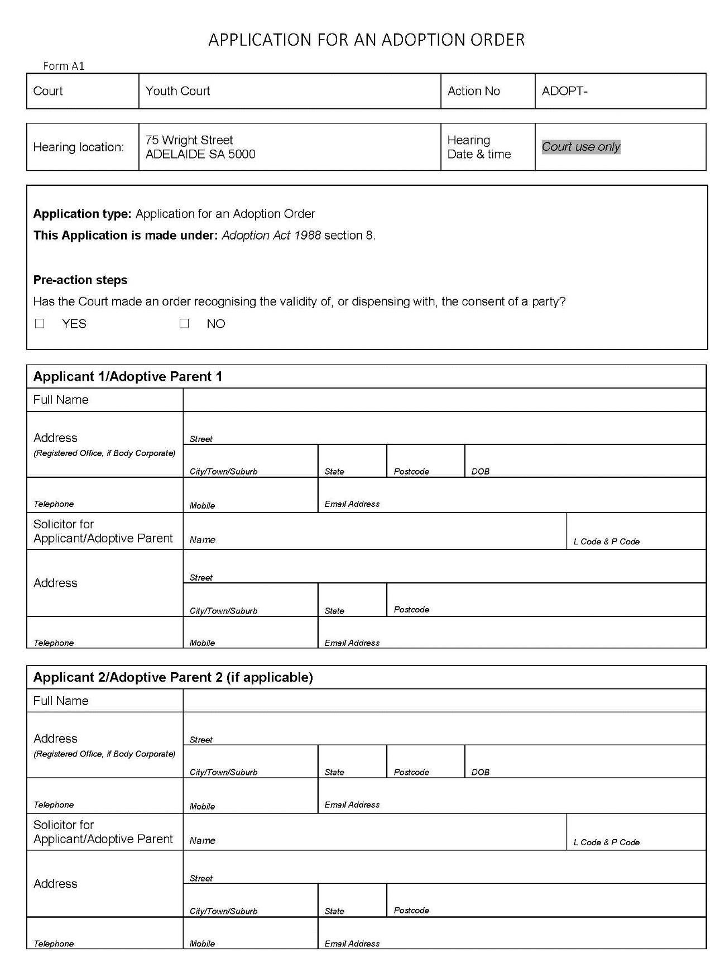
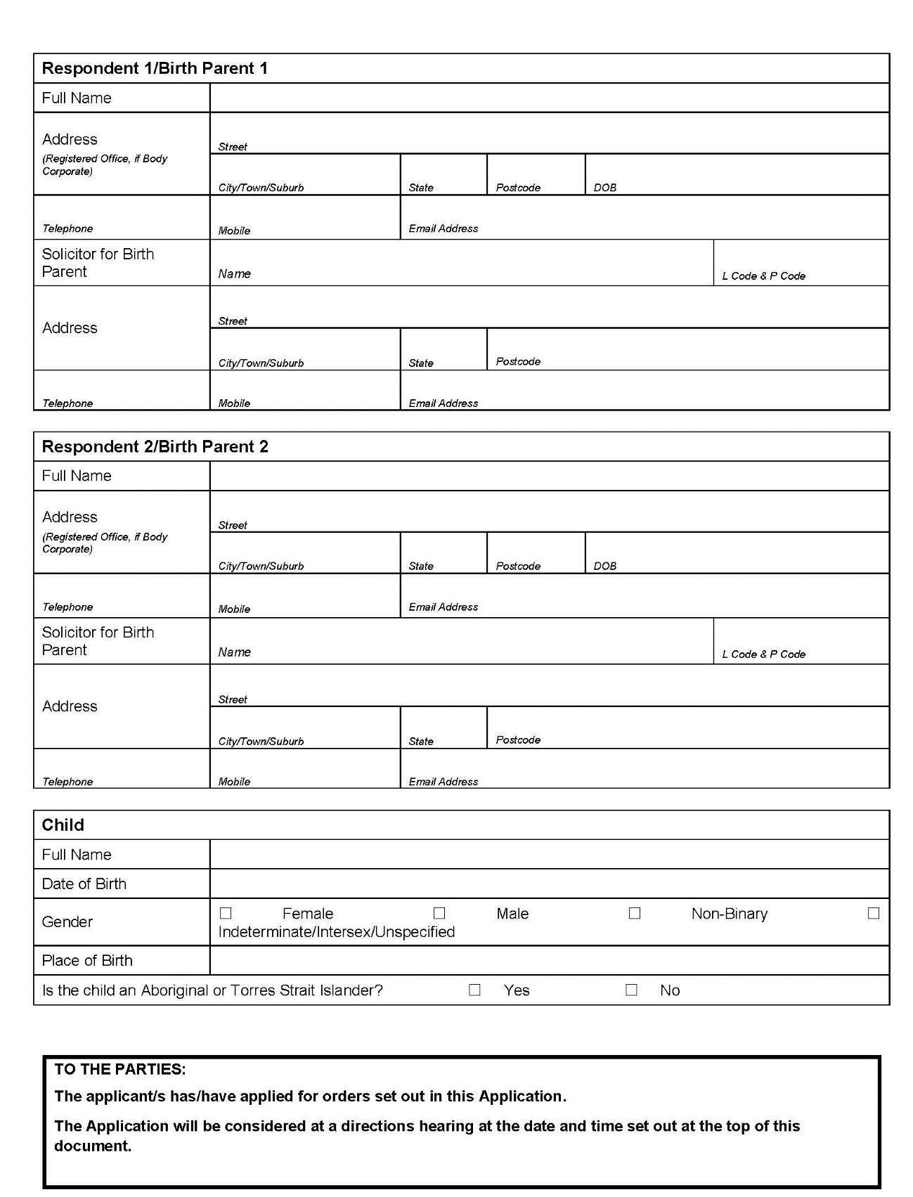
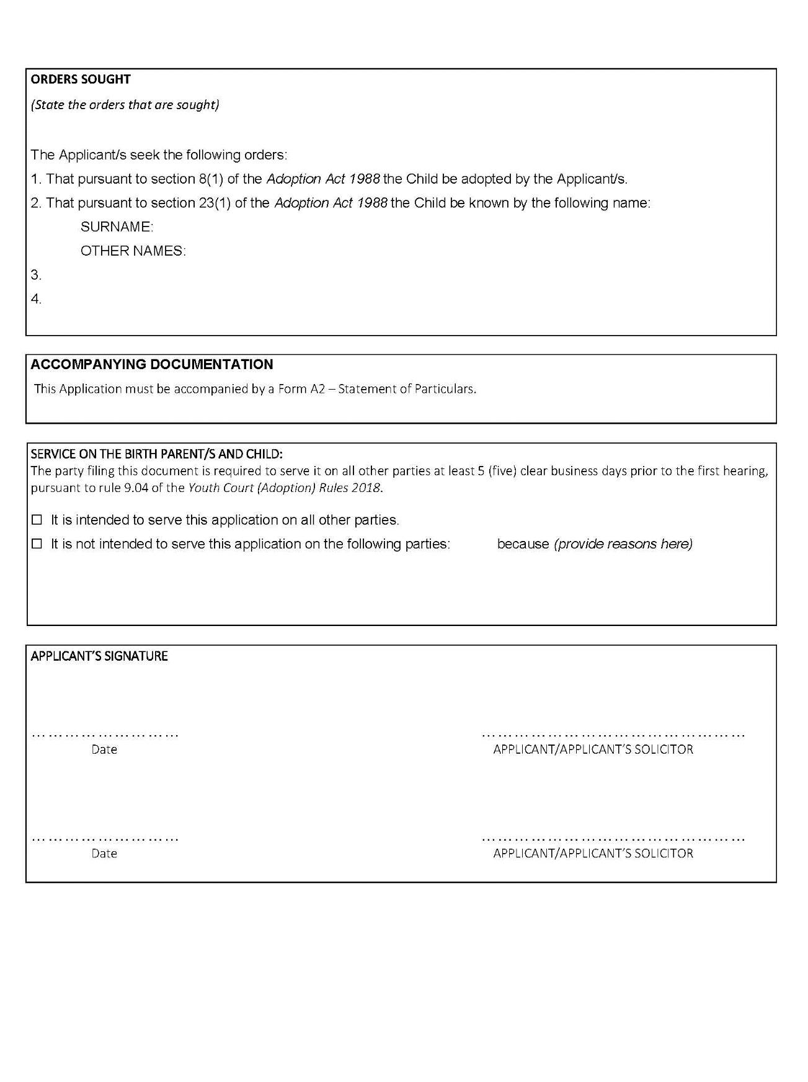
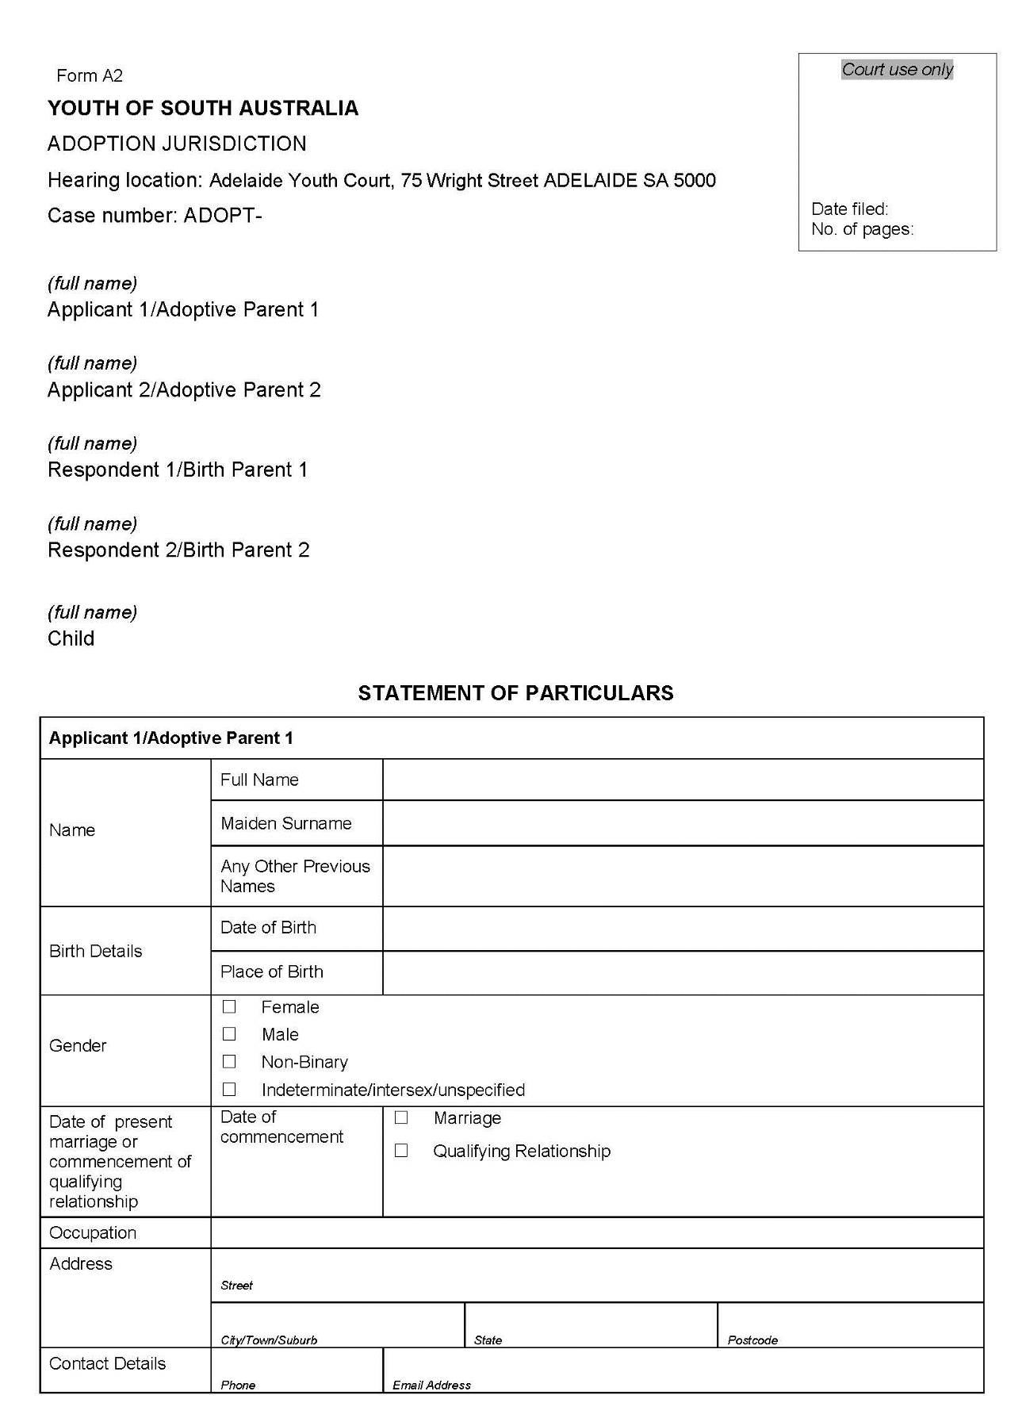
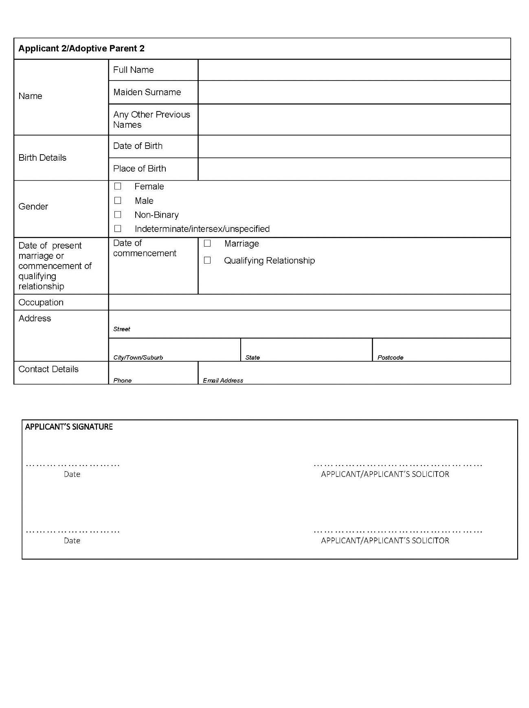
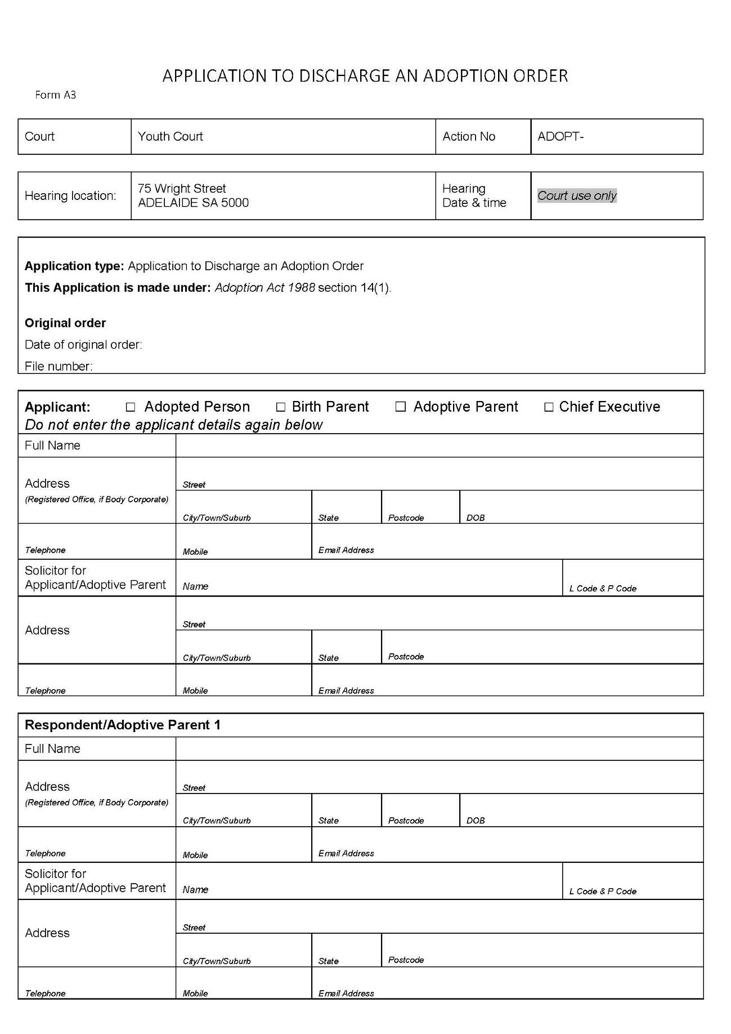

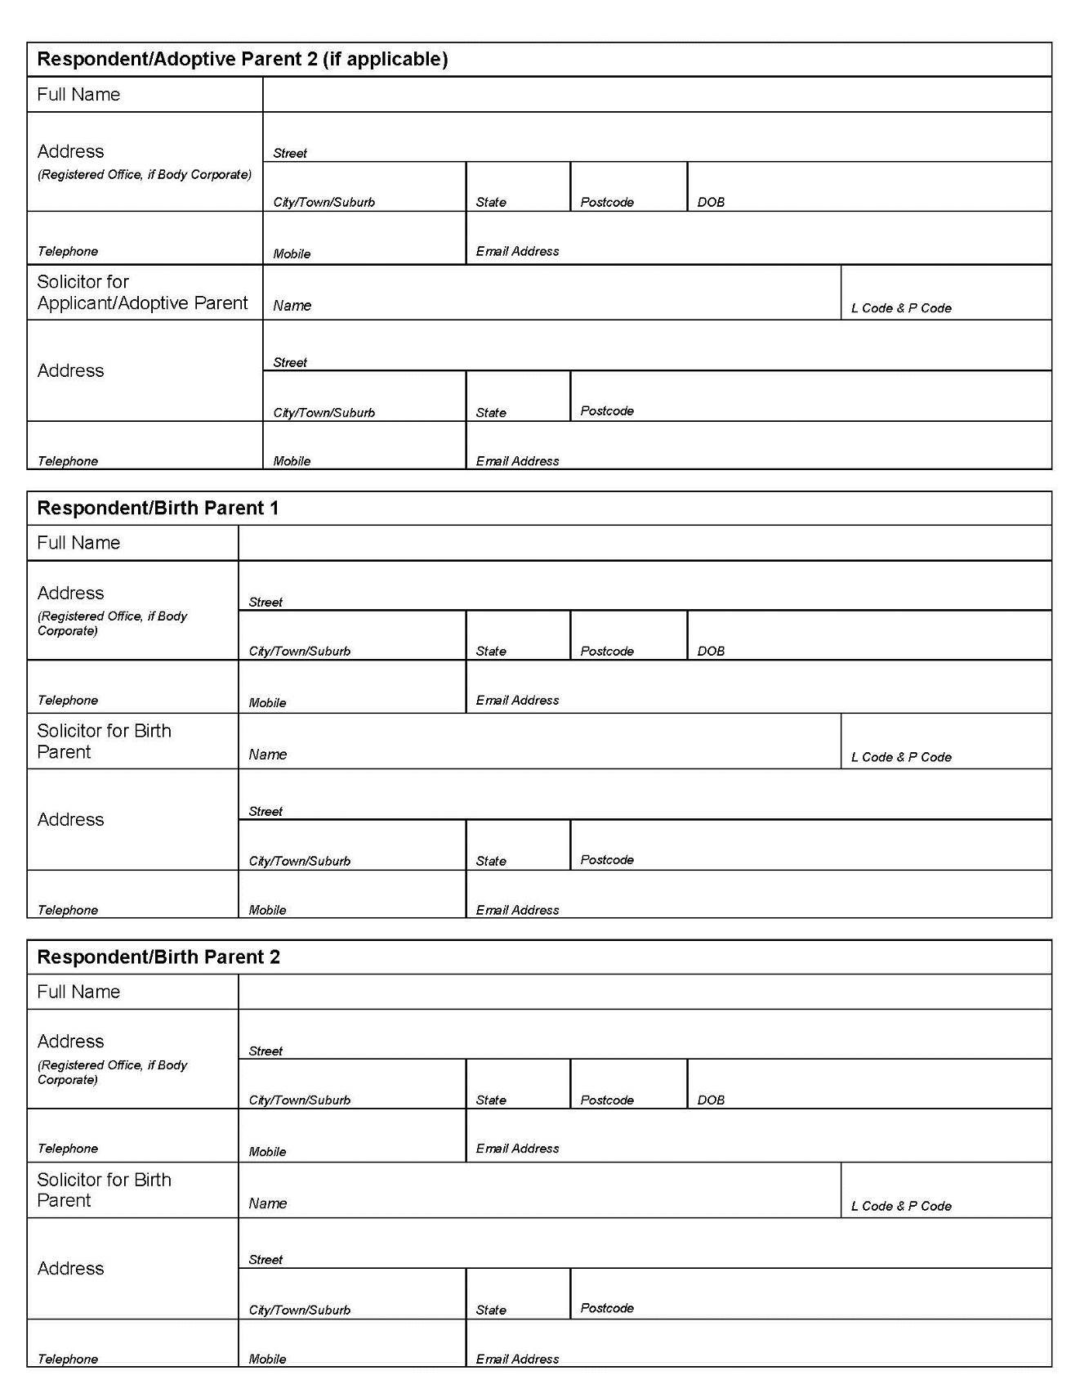
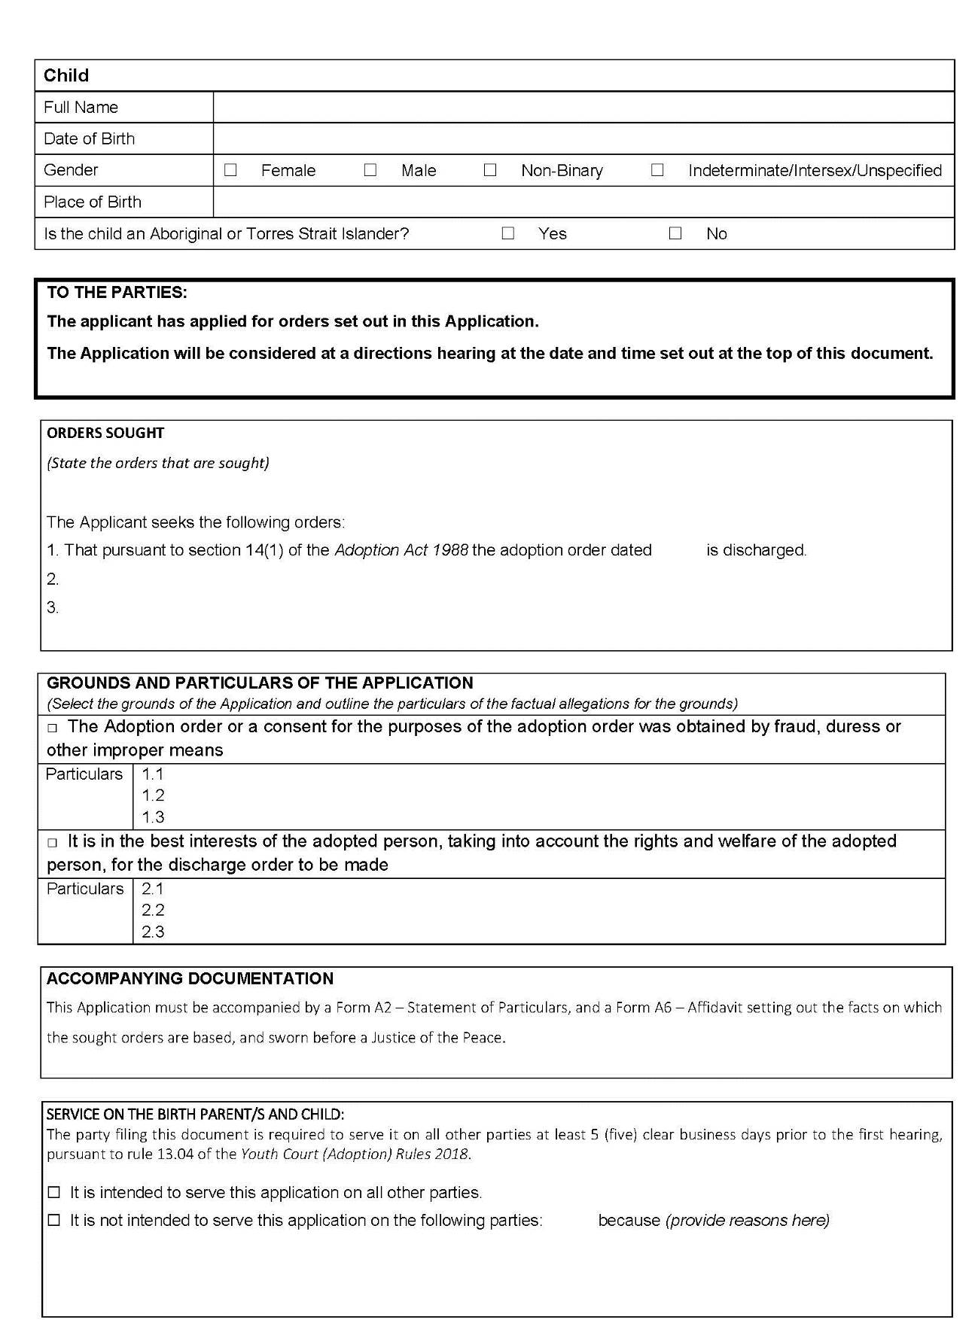
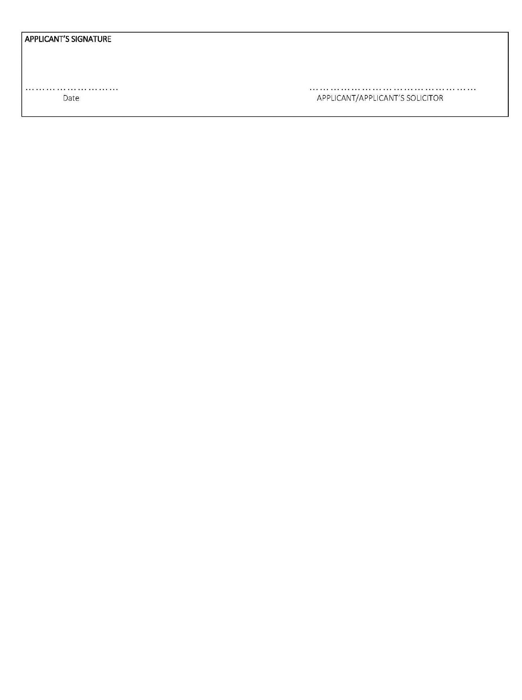
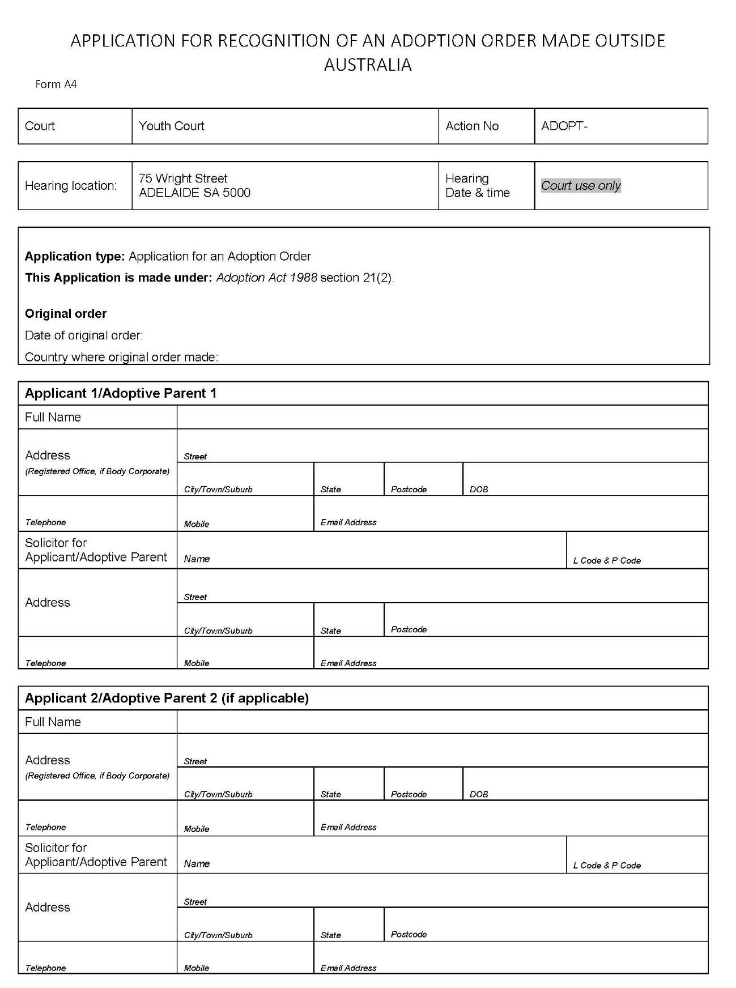
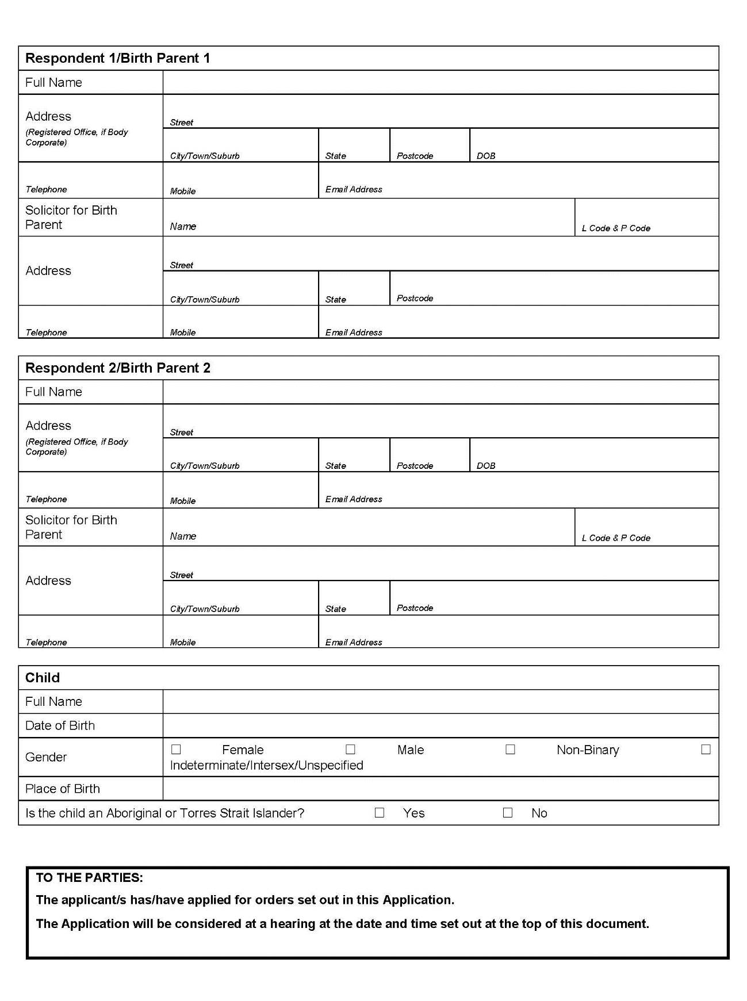
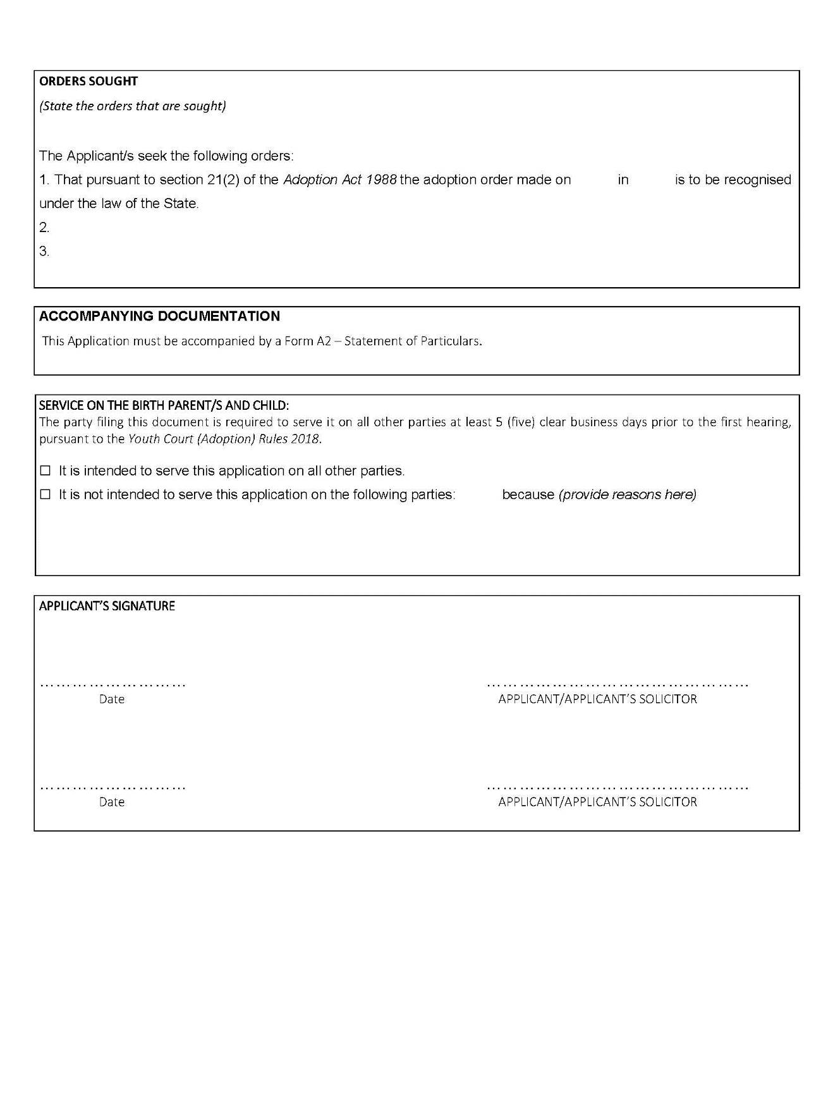
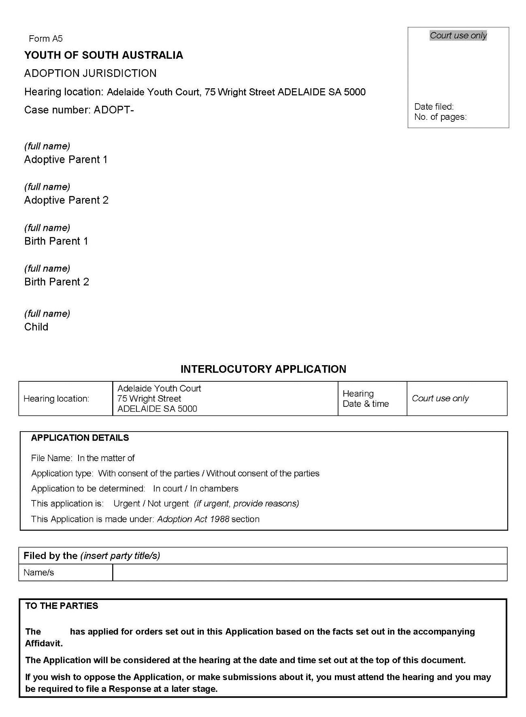
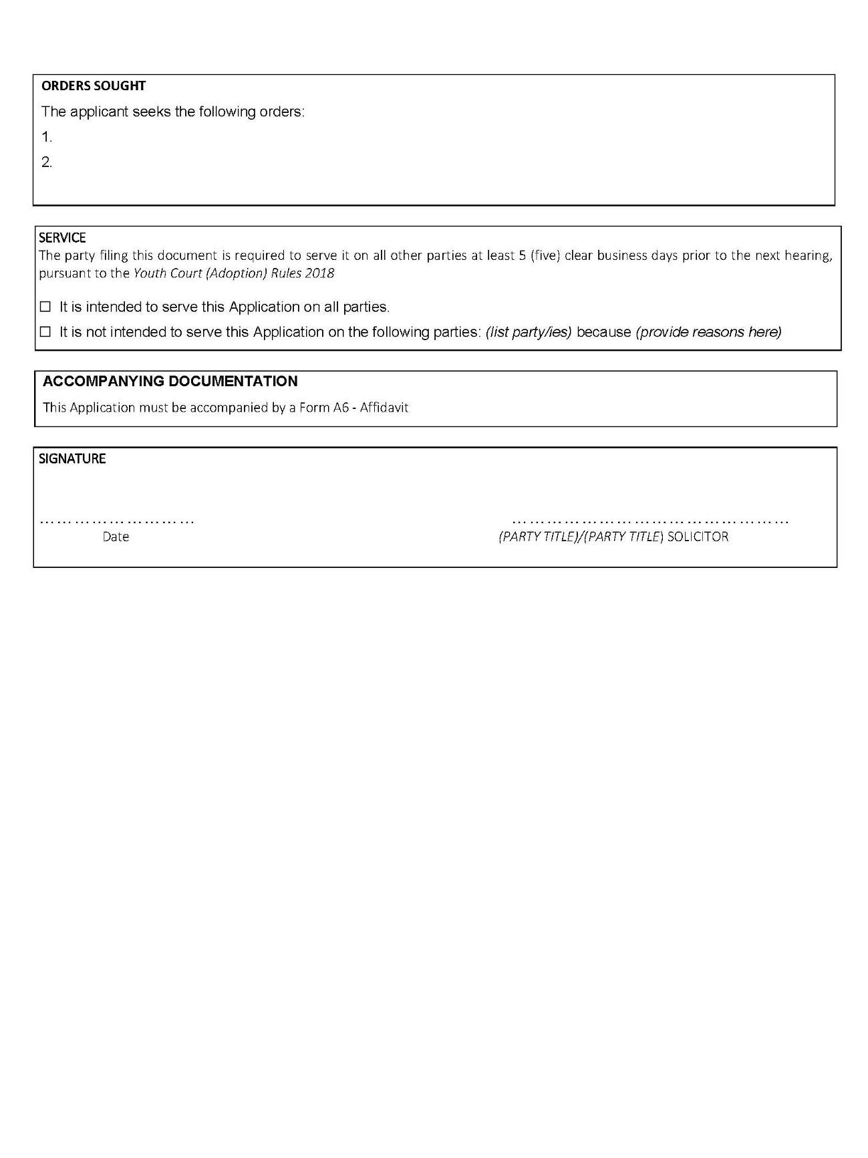
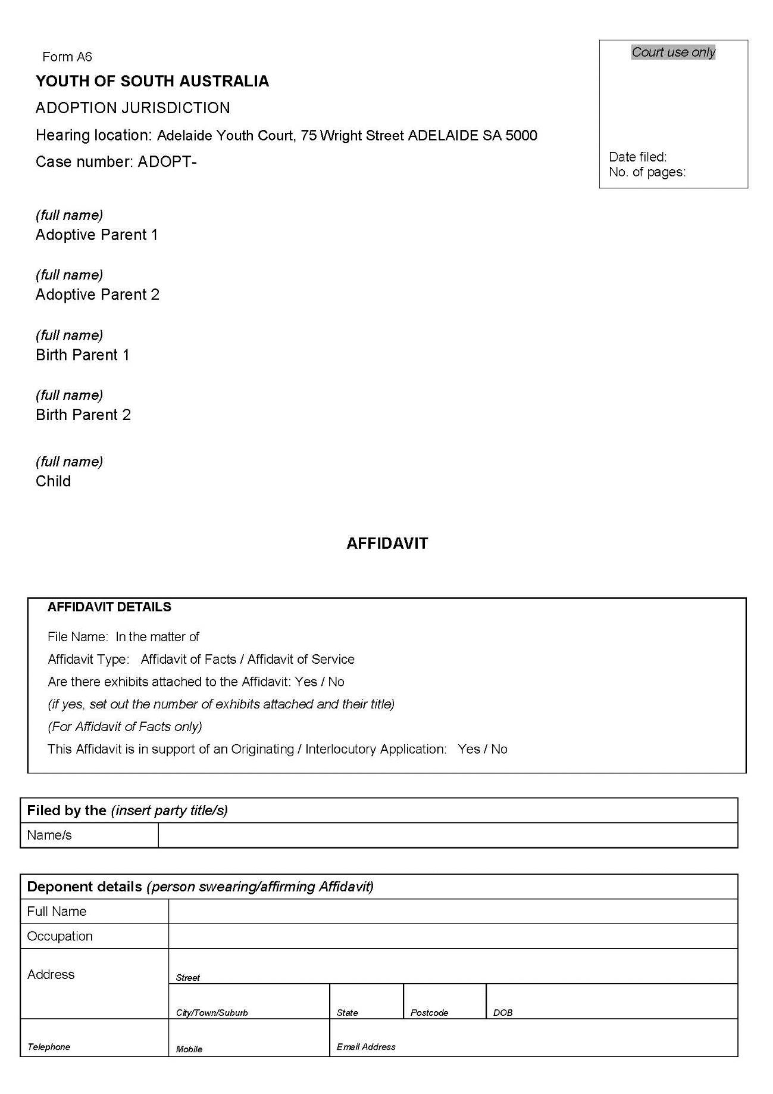
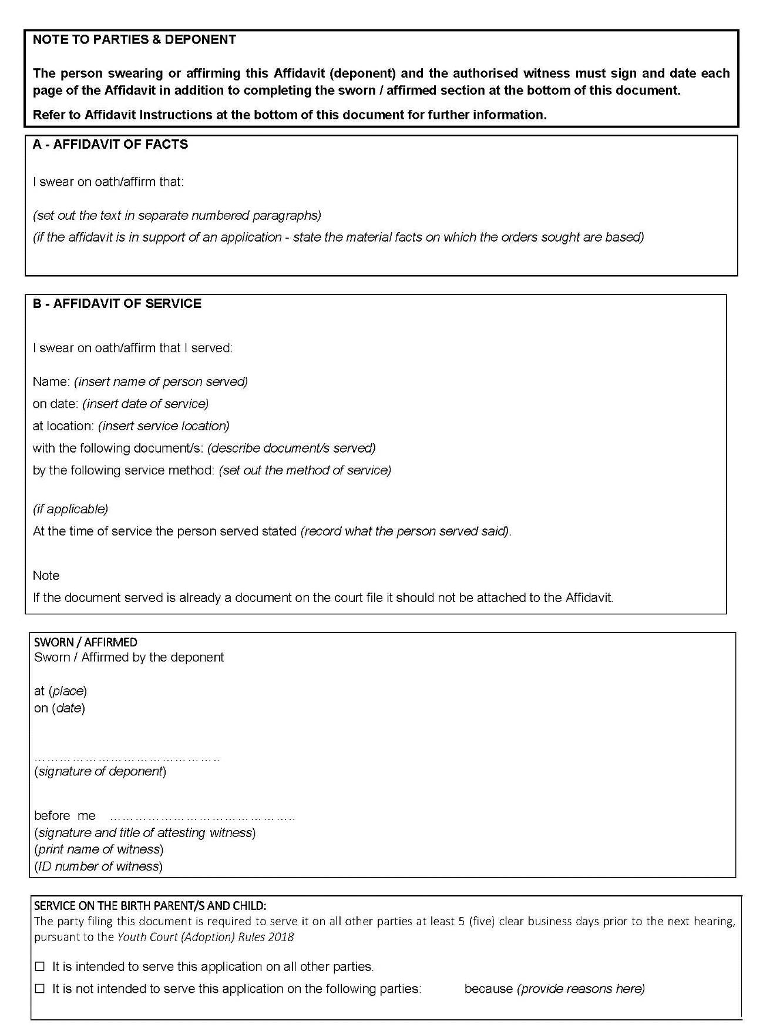
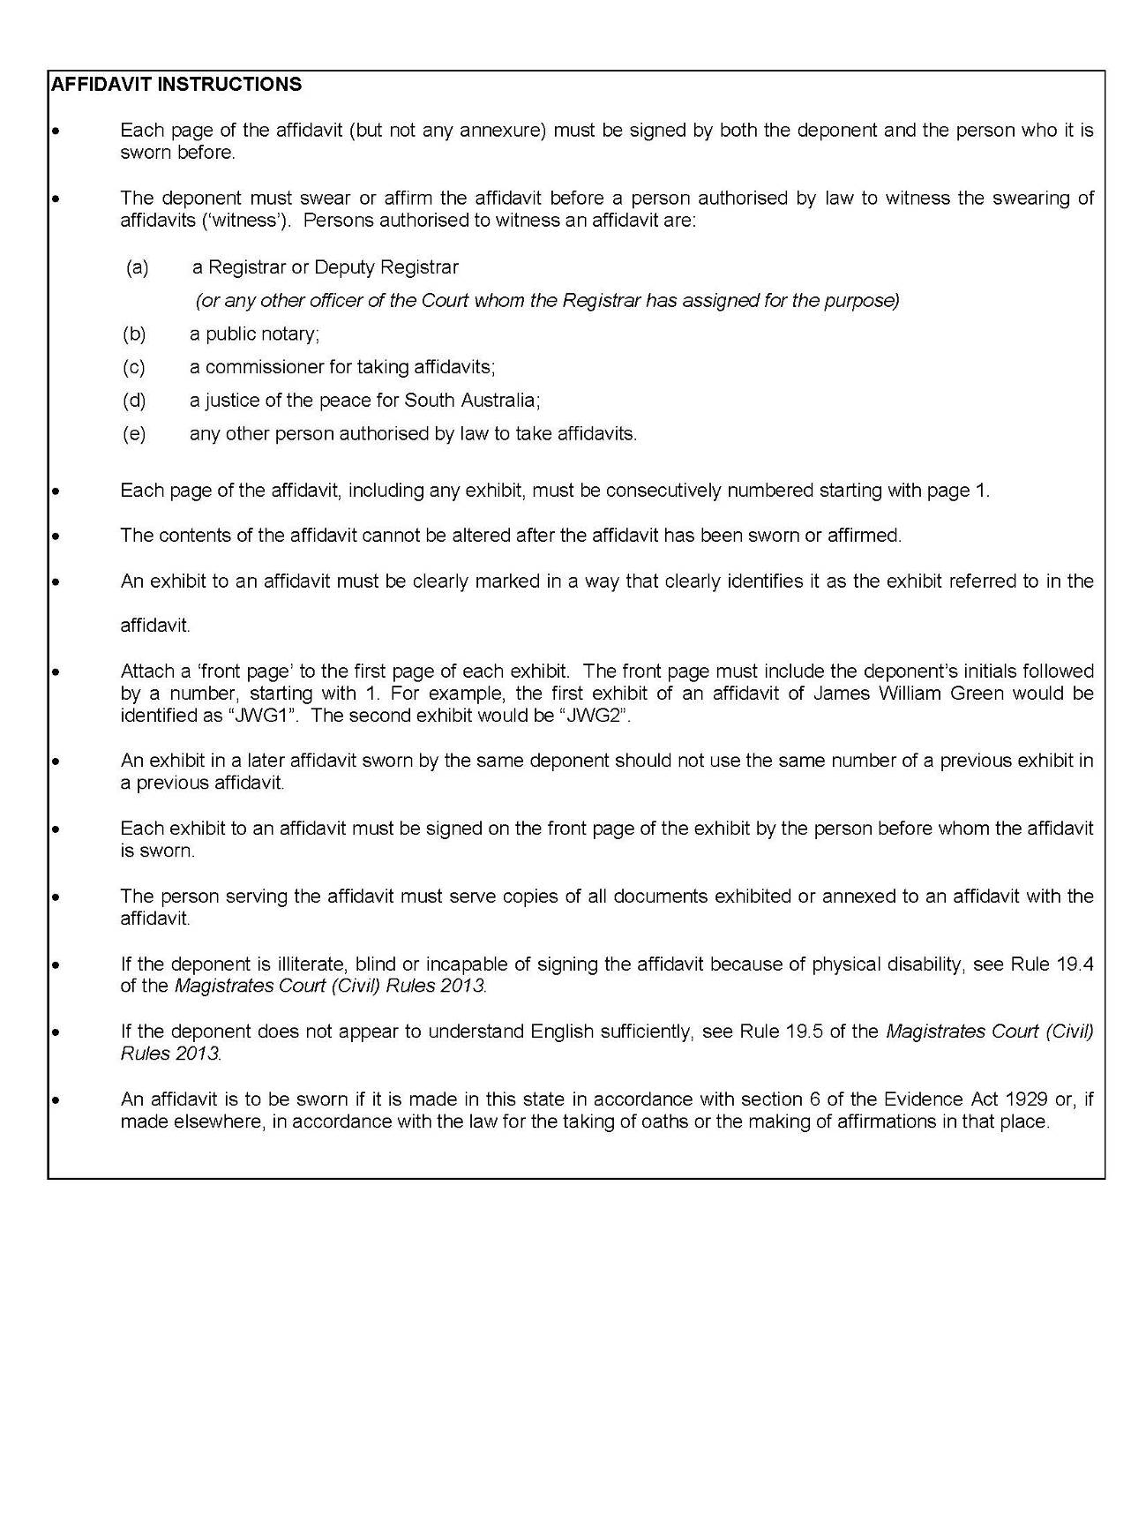
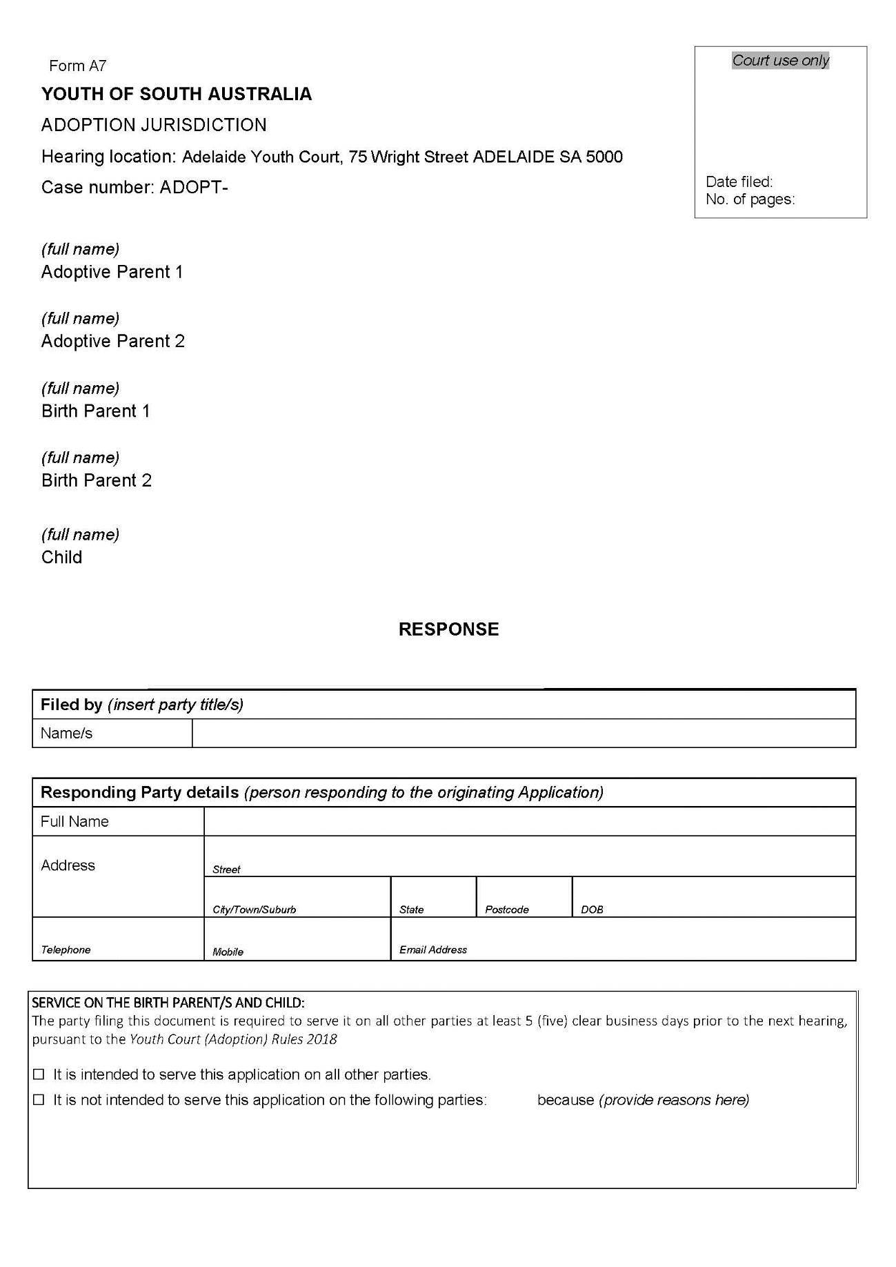
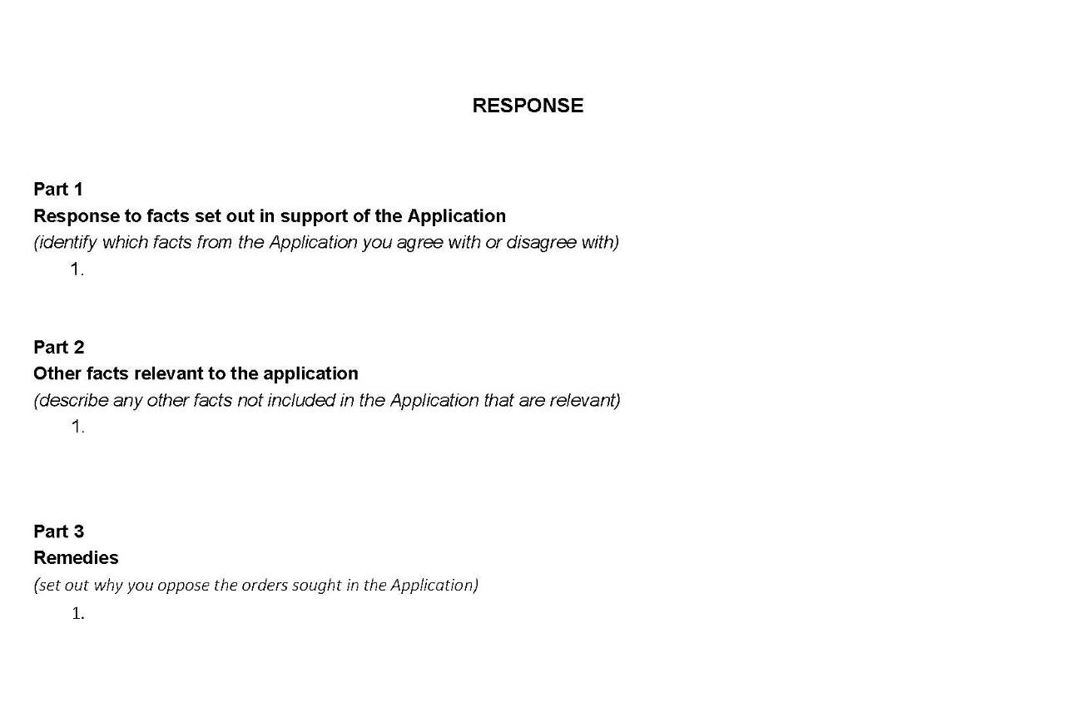

Made by the Judge and the magistrates who are members of the principal judiciary of the Court.
Dated: 3 December 2018
Judge P. Eldridge
Dated: 3 December 2018
Magistrate L. Davis
Dated: 4 December 2018
Magistrate O. Koehn
Dated: 3 December 2018
Magistrate D. White

District Council of Elliston
Liquor Licensing (Dry Areas) Notice 2018
Under section 131 (1a) of the Liquor Licensing Act 1997
1—Short title
This notice may be cited as the Liquor Licensing (Dry Areas) Notice 2018.
2—Commencement
This notice comes into operation on 31 December 2018.
3—Interpretation
(1) In this notice—
Principal notice means the Liquor Licensing (Dry Areas) Notice 2015 published in the Gazette on 5.1.15, as in force from time to time.
(2) Clause 3 of the principal notice applies to this notice as if it were the principal notice.
4—Consumption etc of liquor prohibited in dry areas
(1) Pursuant to Section 131 of the Act, the consumption and possession of liquor in the area described in the Schedule is prohibited in accordance with the provisions of the Schedule.
(2) The prohibition has effect during the periods specified in the Schedule.
(3) The prohibition does not extend to private land in the area described in the Schedule.
(4) Unless the contrary intention appears, the prohibition of the possession of liquor in the area does not extend to—
(a) a person who is genuinely passing through the area if—
(i) the liquor is in the original container in which it was purchased from licensed premises; and
(ii) the container has not been opened; or
(b) a person who has possession of the liquor in the course of carrying on a business or in the course of his or her employment by another person in the course of carrying on a business; or
(c) a person who is permanently or temporarily residing at premises within the area or on the boundary of the area and who enters the area solely for the purpose of passing through it to enter those premises or who enters the area from those premises for the purpose of leaving the area.
Schedule—Elliston Area 1
1—Extent of prohibition
The consumption of liquor is prohibited and the possession of liquor is prohibited.
2—Period of prohibition
From 9 pm on 31 December 2018 to 8 am on 1 January 2019.
3—Description of area
The area in and adjacent to Elliston bounded as follows: commencing at the point at which the prolongation in a straight line of the north-western boundary of Section 417 Hundred of Ward intersects the low water mark on Waterloo Bay, then generally south-easterly, southerly, westerly and south-easterly along the low water mark to the point at which it is intersected by the prolongation in a straight line of the western boundary of Section 405 Hundred of Ward, then northerly along that prolongation and boundary of Section 405, the western boundary of Section 7 Hundred of Ward and the western boundary of Section 68 Hundred of Ward, to the northern boundary of Section 68, then in a straight line by the shortest route to the point at which the western and southern boundaries of Section 384 Hundred of Ward meet, then northerly along the western boundary of Section 384 to the point at which it meets the north-eastern boundary of the Section, then in a straight line by the shortest route (across Flinders Highway) to the point at which the eastern boundary of Colton Back Road meets the northern boundary of Flinders Highway, then generally northerly and north-westerly along the eastern boundary of Colton Back Road to the point at which it is intersected by the prolongation in a straight line of the norther n boundary of Silo Road, then south-westerly along that prolongation and boundary of Silo Road to the western boundary of Lot 41 of DP 72507, then generally northerly and westerly along the western and southern boundaries of Lot 41 to the point at which the southern boundary of the Lot meets the eastern boundary of Flinders Highway, then generally southerly and south-easterly along that boundary to the point at which it is intersected by the prolongation in a straight line of the north-western boundary of Section 417 Hundred of Ward, then south-westerly along that prolongation and boundary of Section 417, and the prolongation in a straight line of that boundary, to the point of commencement. The area does not include any jetty, boat ramp or other structure projecting below the low water mark from within the area described above.
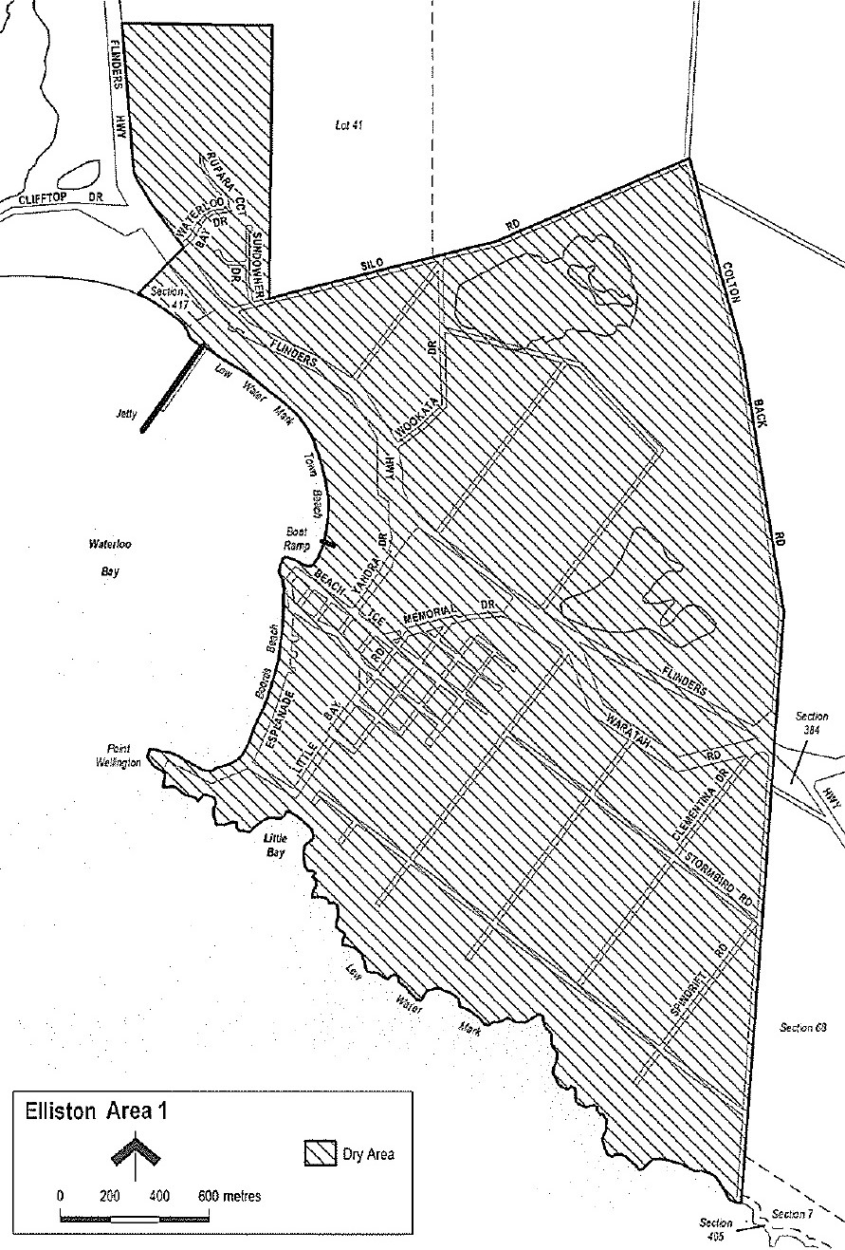
Schedule—Port Kenny Area 1
1—Extent of prohibition
The consumption of liquor is prohibited and the possession of liquor is prohibited.
2—Period of prohibition
From 9 pm on 31 December 2018 to 8 am on 1 January 2019.
3—Description of area
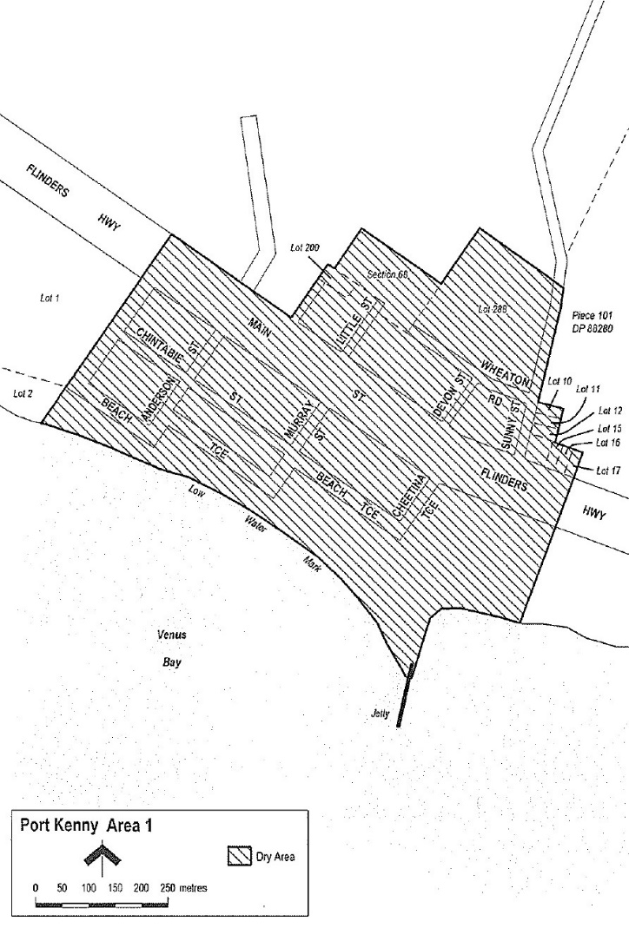
The area in and adjacent to Port Kenny bounded as follows: commencing at the point at which the prolongation in a straight line of the eastern boundary of Lot 1 of DP 29315 intersects the north-eastern boundary of Main Street (Flinders Highway), then south-westerly along that prolongation and boundary of Lot 1to the eastern boundary of Lot 2 of DP 29315, then south-westerly along that eastern boundary of Lot 2 and the prolongation in a straight line of that boundary to the low water mark on the northern side of Venus Bay, then generally south-easterly, northerly and easterly along the low water mark to the point at which it is intersected by the prolongation in a straight line of the eastern boundary of Lot 17 of DP 4405, then north-easterly along that prolongation and boundary of Lot 17 to the northern boundary of the Lot, then north-westerly along the northern boundaries of Lots 17, 16 and 15 of DP 4405 to the eastern boundary of Lot 12 of DP 4405, then northerly along the eastern boundary of that Lot, and the eastern boundaries of Lots 11 and 10 of DP 4405, to the northern boundary of Lot 10, then westerly along that boundary of Lot 10 to the eastern boundary of Sunny Street, then northerly along that boundary of Sunny Street and the western boundary of Piece 101 of DP 88280 to the point at which the western boundary of Piece 101 is intersected by the prolongation in a straight line of the north-eastern boundary of Lot 288 of FP 180320, then north-westerly along that prolongation and boundary of Lot 288 to the north-western boundary of the Lot, then south-westerly along the north-western boundary of Lot 288 to the north-eastern boundary of Section 68 Hundred of Wright, then north-westerly and south-westerly along the north-eastern and north-western boundaries of the Section to the point at which the north-western boundary meets the north-eastern boundary of Lot 200 of DP 84488, then north-westerly along that boundary of Lot 200 to the north-western boundary of the Lot, then south-westerly along the north-western boundary of Lot 200 and the prolongation in a straight line of that boundary to the point at which that prolongation intersects the north-eastern boundary of Main Street (Flinders Highway), then north-westerly along that boundary of Main Street to the point of commencement. The area does not include any jetty, boat ramp or other structure projecting below low water mark from within the area described above.
Schedule—Venus Bay Area 1
1—Extent of prohibition
The consumption of liquor is prohibited and the possession of liquor is prohibited.
2—Period of prohibition
From 9 pm on 31 December 2018 to 8 am on 1 January 2019.
3—Description of area
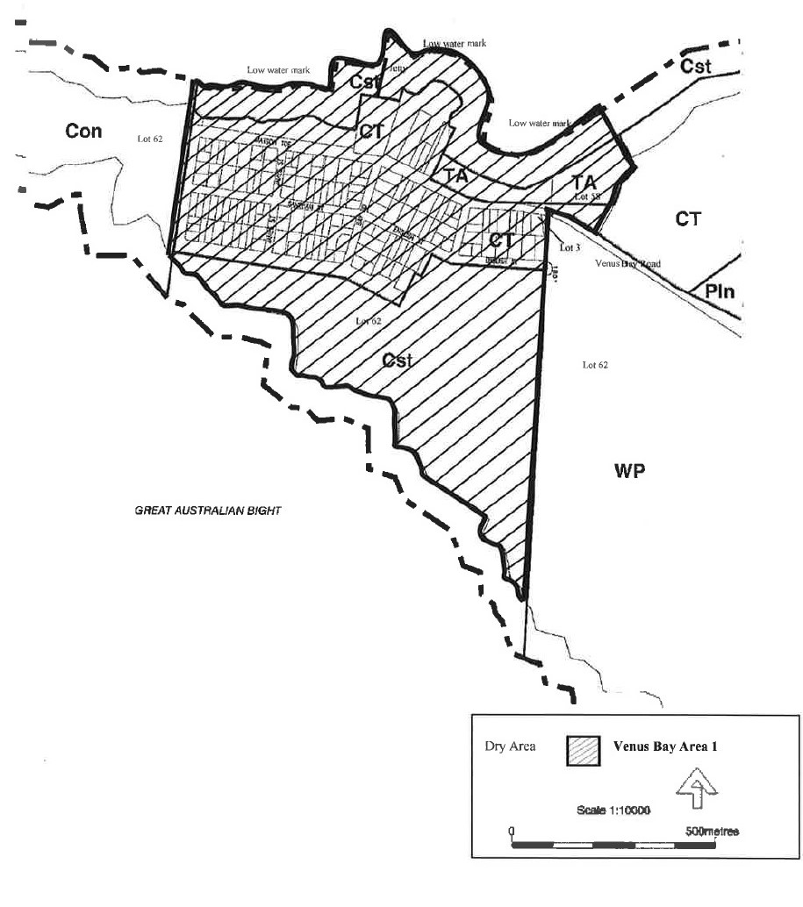
The area in and adjacent to the town of Venus Bay bounded as follows: commencing at the point at which the prolongation in a straight line of the northern boundary of Lot 62 DP 34608 intersects the low water mark of Venus Bay, then in a westerly, north-westerly direction along the northern boundary of Lot 62, then generally southerly, south-westerly along the western boundary of the Lot, then generally in a south, south-easterly, easterly, north-easterly and northerly direction along the boundary of Lot 62 to the point at which the common boundary of Lot 62 and Lot 3 FP6331 meets the southern boundary of Venus Bay Road, then in a straight line by the shortest route along (Venus Bay Road) to the south-western corner of Lot 58 DP34994, then in a straight line by the shortest route to the eastern boundary of the Lot, then generally north-easterly and north-westerly along that boundary of Lot 58 and the prolongation of this boundary to the point at which the boundary intersects the low water mark, then south-westerly and north-westerly along the northern low water mark to the point of commencement. This area includes any jetty, boat ramp or structure projecting below the low water mark from within the area described above.
Made by the District Council of Elliston
on 16 October 2018
Phil Cameron
Chief Executive Officer

MOUNT BARKER DISTRICT COUNCIL
Exclusion of Land from Classification of Community Land
NOTICE is hereby given that pursuant to Section 193(6)(a) and Section 193(4)(a) of the Local Government Act 1999, the Mount Barker District Council at its meeting held on 7 October 2008, resolved that the following land be excluded from Classification as Community Land:
Lot 412 in Deposited Plan 73444 being whole of land in Certificate of Title Volume 6037 Folio 785
Dated: 6 December 2018
A Stuart
Chief Executive Officer

Northern Areas Council
Close of Roll for Supplementary Election
Due to insufficient nominations being received for the 2018 Council elections, a supplementary election will be necessary to fill the vacancy of Councillor for Yackamoorundie Ward.
The voters roll for this supplementary election will close at 5.00pm on Monday 17 December 2018.
You are entitled to vote in the election if you are on the State electoral roll. If you have recently turned 18 or changed your residential or postal address you must complete an electoral enrolment form, available from post offices or online at www.ecsa.sa.gov.au
If you are not eligible to enrol on the State electoral roll you may still be entitled to enrol to vote if you own or occupy a property. Contact the Council to find out how.
Nominations to fill the vacancy will open on 17 January 2019 and will be received until 12 noon on Thursday 31 January 2019.
The election will be conducted entirely by post with the return of ballot material to reach the Returning Officer no later than 12 noon on Monday 4 March 2019.
Mick Sherry
Returning Officer

DISTRICT COUNCIL OF PETERBOROUGH
By-law made under the Local Government Act 1999
Permits and Penalties By-law 2018—By-law No. 1 of 2018
To provide for a permit system, set penalties for breaches of by-laws, provide for certain matters pertaining to liability and evidence, set regulatory requirements, clarify the construction of Council’s by-laws and for related purposes.
Part 1 – Preliminary
- Short Title
This by-law may be cited as the Permits and Penalties By-law 2018.
- Commencement
This by-law will come into operation four months after the day on which it is published in the Gazette in accordance with Section 249(5) of the Local Government Act 1999.
- Definitions
  - In any by-law of the Council, unless the contrary intention is clearly indicated:
    - authorised person means a person appointed as an authorised person pursuant to Section 260 of the Local Government Act 1999;
    - Council means the District Council of Peterborough;
    - drive a vehicle means to be in control of the steering, movement or propulsion of the vehicle;
    - driver of a vehicle means the person driving the vehicle;
    - motor vehicle has the same meaning as in the Road Traffic Act 1961;
    - person includes a natural person, a body corporate or incorporated association;
    - road has the same meaning as in the Local Government Act 1999;
    - vehicle has the same meaning as in the Road Traffic Act 1961 and the Australian Road Rules 1999 and includes a motor vehicle.
  - In this by-law:
    - owner has the same meaning as in the Road Traffic Act 1961;
    - prescribed offence means an offence against a by-law of the Council relating to the driving, parking or standing of vehicles.
- Construction
Every by-law of the Council shall be subject to any Act of Parliament and Regulations made thereunder.
Part 2 – Permits
- Council May Grant Permits
If any by-law of the Council states that a person needs a ‘permit’ or ‘permission’ to do a specified thing, then the following provisions apply:
  - the permit must be in writing;
  - the Council may:
    - attach conditions to the permit;
    - change or revoke a condition, by notice in writing; or
    - add new conditions, by notice in writing;
  - a person who holds a permit must comply with every condition attached to it. Failure to do so constitutes a breach of this by-law;
  - the Council may revoke a permit, by notice in writing, if:
    - the holder of the permit fails to comply with a condition attached to it; or
    - the permit is of a continuing nature, and the Council has reasonable grounds for revoking it;
  - the Council may, by resolution, fix, vary or revoke fees or charges for the granting of a permit to do a specified thing.
Part 3 – Enforcement
- Penalties
  - A person who contravenes, or fails to comply with any by-law of the Council is guilty of an offence and is liable to a maximum penalty, being the maximum penalty referred to in the Local Government Act 1999, which may be fixed for offences against a by-law.
  - A person who is convicted of an offence against any by-law of the Council in respect of a continuing act or omission is liable, in addition to the penalty otherwise applicable, to a further penalty, being the maximum penalty referred to in the Local Government Act 1999 which may be fixed for offences of a continuing nature against a by-law.
- Liability of Vehicles Owners and Expiation of Certain Offences
  - Without derogating from the liability of any other person, but subject to this paragraph, if a vehicle is involved in a prescribed offence, the owner of the vehicle is guilty of an offence and liable to the same penalty as is prescribed for the principal offence and the expiation fee that is fixed for the principal offence applies in relation to an offence against this paragraph.
  - The owner and driver of a vehicle are not both liable through the operation of this paragraph to be convicted of an offence arising out of the same circumstances, and consequently conviction of the owner exonerates the driver and conversely conviction of the driver exonerates the owner.
  - An expiation notice or expiation reminder notice given under the Expiation of Offences Act 1996 to the owner of a vehicle for an alleged prescribed offence involving the vehicle must be accompanied by a notice inviting the owner, if they were not the driver at the time of the alleged prescribed offence, to provide the Council or officer specified in the notice, within the period specified in the notice, with a statutory declaration:
    - setting out the name and address of the driver; or
    - if they had transferred ownership of the vehicle to another prior to the time of the alleged offence and has complied with the Motor Vehicles Act 1959 in respect of the transfer—setting out details of the transfer (including the name and address of the transferee).
  - Before proceedings are commenced against the owner of a vehicle for an offence against this section involving the vehicle, the complainant must send the owner a notice:
    - setting out particulars of the alleged prescribed offence; and
    - inviting the owner, if he or she was not the driver at the time of the alleged prescribed offence, to provide the complainant, within 21 days of the date of the notice, with a statutory declaration setting out the matters referred to in subparagraph 7.3.
  - Subparagraph 7.4 does not apply to:
    - proceedings commenced where an owner has elected under the Expiation of Offences Act 1996 to be prosecuted for the offence; or
    - proceedings commenced against an owner of a vehicle who has been named in a statutory declaration under this section as the driver of the vehicle.
  - Subject to subparagraph 7.7, in proceedings against the owner of a vehicle for an offence against this paragraph, it is a defence to prove:
    - that, in consequence of some unlawful act, the vehicle was not in the possession or control of the owner at the time of the alleged prescribed offence; or
    - that the owner provided the complainant with a statutory declaration in accordance with an invitation under this paragraph.
  - The defence in paragraph 7.6.2 does not apply if it is proved that the owner made the declaration knowing it to be false in a material particular.
  - If:
    - an expiation notice is given to a person named as the alleged driver in a statutory declaration under this paragraph; or
    - proceedings are commenced against a person named as the alleged driver in such a statutory declaration,
the notice or summons, as the case may be, must be accompanied by a notice setting out particulars of the statutory declaration that named the person as the alleged driver.
  - The particulars of the statutory declaration provided to the person named as the alleged driver must not include the address of the person who provided the statutory declaration.
- Evidence
In proceedings for a prescribed offence, an allegation in an information that:
  - a specified place was a road or local government land; or
  - a specified vehicle was driven, parked or left standing in a specified place; or
  - a specified vehicle was parked or left standing for the purposes of soliciting business from a person or offering or exposing goods for sale; or
  - a specified place was not formed or otherwise set aside by the Council for the purposes of the driving, parking or standing of vehicles; or
  - a specified person was an authorised person; or
  - a specified provision was a condition of a specified permit granted under paragraph 5 of this by-law; or
  - a specified person was the owner or driver of a specified vehicle; or
  - a person named in a statutory declaration under paragraph 7 of this by-law for the prescribed offence to which the declaration relates was the driver of the vehicle at the time at which the alleged offence was committed; or
  - an owner or driver of a vehicle for a prescribed offence was given notice under paragraph 7 of this by-law on a specified day,
is proof of the matters so alleged in the absence of proof to the contrary.
Part 4 – Miscellaneous
- Construction
Every by-law of the Council is subject to any Act of Parliament and Regulations made thereunder.
- Revocation
Council’s By-law No. 1 – Permits and Penalties, published in the Gazette on 13 January 2011, is revoked on the day on which this by-law comes into operation.
This by-law was duly made and passed at a meeting of the District Council of Peterborough held on 27 November 2018 by an absolute majority of the members for the time being constituting the Council, there being at least two thirds of the members present.
Mr Peter McGuinness
Chief Executive Officer

DISTRICT COUNCIL OF PETERBOROUGH
By-law made under the Local Government Act 1999
Moveable Signs By-law 2018—By-law No. 2 of 2018
To set standards for moveable signs on roads, to provide conditions for and the placement of such signs, to protect public safety and to protect or enhance the amenity of the area of the Council.
Part 1 – Preliminary

Short Title
This by-law may be cited as the Moveable Signs By-law 2018.
- Commencement
This by-law will come into operation four months after the day on which it is published in the Gazette in accordance with Section 249(5) of the Local Government Act 1999.
- Definitions
In this by-law:
  - banner means a moveable sign constituted of a strip of cloth, plastic or other material hung or attached to a pole, fence or other structure;
  - footpath means:
    - a footway, lane or other place made or constructed for the use of pedestrians; or
    - that part of road between the property boundary of the road and the edge of the carriageway on the same side as that boundary;
  - local government land means land owned by the Council or under the Council’s care, control and management;
  - moveable sign has the same meaning as the Local Government Act 1999;
  - road has the same meaning as in the Local Government Act 1999;
  - road related area has the same meaning as in the Road Traffic Act 1961;
  - vehicle has the same meaning as in the Road Traffic Act 1961 and the Australian Road Rules.
Part 2 – Provisions Applicable to Moveable Signs
- Design and Construction
A moveable sign displayed on a road must:
  - be constructed so as not to present a hazard to any member of the public;
  - be constructed so as to be stable when in position and to be able to keep its position in adverse weather conditions;
  - not be unsightly or offensive in appearance;
  - not contain flashing or moving parts;
  - be not more than 1.2 metres high, 80cm in width or 80cm in depth;
  - not have a display area exceeding 1m² in total or, if the sign is two-sided 1m² on each side;
  - in the case of an ‘A’ frame or sandwich board sign:
    - be hinged or joined at the top;
    - be of such construction that its sides can be and are securely fixed or locked in position when erected;
  - in the case of an inverted ‘T’ sign, contain no struts or members than run between the display area of the sign and the base of the sign.
- Placement
A moveable sign displayed on a road must:
  - not be placed anywhere except on the footpath;
  - not be placed on a sealed footpath, unless the sealed part is wide enough to contain the sign and still leave a clear thoroughfare at least 1.2 metres wide;
  - be placed at least 40cm from the kerb (or if there is no kerb, from the edge of the roadway);
  - not be placed on a landscaped area, other than on landscaping that comprises only lawn;
  - not be placed on a designated parking area or within 1 metre of an entrance to any premises;
  - not be fixed, tied or chained to, leaned against or placed closer than 2 metres to any other structure, object or plant (including another moveable sign);
  - not be placed in a position that puts the safety of any person at risk;
  - not be placed on a median strip, roundabout, traffic island or on a carriageway;
  - not be placed on a footpath with a minimum height clearance of a structure above it of less than 2 metres;
  - not be within 6 metres of an intersection of a road.
- Restrictions
A moveable sign displayed on a road must:
  - only contain material which advertises a business being conducted on commercial premises adjacent to the sign, or the goods and services available from that business;
  - be limited to one per 10 metres of business premises to which the sign relates;
  - notwithstanding subparagraph 5.6 of this by-law, be placed 6 metres from another moveable sign relating to the same business;
  - not be displayed unless the business to which it relates is open to the public;
  - be securely fixed in position such that it cannot be blown over or swept away;
  - not be displayed during the hours of darkness unless it is clearly visible.
- Appearance
A moveable sign displayed on a road must:
  - be painted or otherwise detailed in a competent and professional manner;
  - be legible and simply worded to convey a precise message;
  - be of such design and contain such colours that are compatible with the architectural design of the premises adjacent to the sign and are compatible with the townscape and overall amenity of the locality in which the sign is situated;
  - contain a combination of colours and typographical styles that blend in with and reinforce the heritage qualities of the locality and the buildings in which the sign is situated;
  - not have any balloons, flags, streamers or other things attached to it.
- Banners
A banner must:
  - only be displayed on a road, footpath or road related area;
  - be securely fixed to a pole, fence or other structure so that it does not hang loose or flap;
  - not be attached to any building, structure, fence, vegetation or other item owned by the Council on a road, or other improvement to a road owned by the Council;
  - not be displayed more than one month before and two days after the event it advertises;
  - not be displayed for a continuous period of more than one month and two days in any twelve month period;
  - not exceed 3m² in size.
- Signs on Local Government Land
A person must not, without permission, display or cause to be displayed a moveable sign on any local government land or rest on or attach to any vehicle on any local government land any moveable sign, except a moveable sign:
  - attached to a licensed taxi or bus;
  - on or attached to a vehicle belonging to any council and which has been placed on or attached to the vehicle with the consent of the council to which the vehicle belongs;
  - on or attached to a vehicle which only has a sign or signs painted on or glued to it, the main purpose of which is to identify it as belonging to a business; or
  - comprising a sunscreen on a vehicle, where any message or trade name or mark on the sunscreen does not advertise a business being carried on in the vicinity of the place the vehicle is parked, or the products available from that business.
Part 3 – Enforcement
- Removal of Unauthorised Moveable Signs
  - If:
    - a moveable sign has been placed on any road or footpath in contravention of this by-law or of Section 226 of the Local Government Act 1999, an authorised person may order the owner of the sign to remove the moveable sign from the road or footpath;
    - the authorised person cannot find the owner, or the owner fails to comply immediately with the order, the authorised person may remove and dispose of the sign;
    - a moveable sign is removed under subparagraph 10.1.2 of this by-law and is not claimed within 30 days of such removal the authorised person may sell, destroy or otherwise dispose of the moveable sign as the authorised person thinks fit.
  - Any person who displays an unauthorised moveable sign or who is the owner of an unauthorised moveable sign which has been removed under subparagraph 9.1 of this by-law must pay the Council any reasonable costs incurred in removing, storing or attempting to dispose of the moveable sign before being entitled to recover the moveable sign.
- Removal of Authorised Moveable Signs
A moveable sign must be removed or relocated by the person who placed the moveable sign on a road or footpath or the owner of the sign, at the request of an authorised person if:
  - in the opinion of the authorised person, and notwithstanding compliance with this by-law, there is any hazard or obstruction or there is likely to be a hazard or obstruction arising out of the location of the moveable sign; or
  - so required by the authorised person for the purpose of special events, parades, road or footpath works or any other circumstances which, in the opinion of the authorised person, requires relocation or removal of the moveable sign.
Part 4 – Miscellaneous
- Specified Exemptions
  - This by-law does not apply to a moveable sign which:
    - is a moveable sign that is placed on a public road pursuant to an authorisation under the Local Government Act 1999 or another Act;
    - directs people to the open inspection of any land or building that is available for purchase or lease;
    - directs people to a garage sale that is being held on residential premises;
    - directs people to a charitable function;
    - is related to a State or Commonwealth election and is displayed during the period commencing at 5:00pm on day before the issue of writ or writs for the election and ending at the close of polls on polling day;
    - is related to an election held under the Local Government Act 1999 or the Local Government (Elections) Act 1999 and is displayed during the period commencing four weeks immediately before the date that has been set for polling day and ending at the close of voting on polling day;
    - is related to a referendum and is displayed during the course and for the purpose of that referendum;
    - is displayed with permission of the Council and in accordance with any conditions attached to that permission; or
    - is a sign of a class prescribed in regulations.
  - Clauses 6.2, 6.3 and 6.4 of this by-law do not apply to a flat sign containing only the banner or headlines of a newspaper or magazine.
  - Clauses 4, 6.2, 6.3, 6.4 and 7 of this by-law do not apply to a directional sign to an event run by a charitable body.
- Prohibition
  - The Council may, by resolution, prohibit the display of moveable signs on a road or part of road subject to this clause.
  - A resolution made by the Council under sub-clause 13.1 may prohibit the display of moveable signs absolutely, or at particular times or on particular days.
  - The Council may only make a resolution under sub-clause 13.1 if, in the opinion of the Council, the display of movable signs on the road would endanger the safety of road users.
  - Notwithstanding any other clause of this by-law, a person must not display a moveable sign on a road or part of a road contrary to a prohibition made by the Council under this clause.
Part 4 – Miscellaneous
- Revocation
Council’s By-law No. 2 – Moveable Signs, published in the Gazette on 13 January 2011 is revoked on the day on which this by-law comes into operation.
This by-law was duly made and passed at a meeting of the District Council of Peterborough held on 27 November 2018 by an absolute majority of the members for the time being constituting the Council, there being at least two thirds of the members present.
Mr Peter McGuinness
Chief Executive Officer

DISTRICT COUNCIL OF PETERBOROUGH
By-law made under the Local Government Act 1999
Roads By-law 2018—By-law No. 3 - Roads
A by-law to regulate certain activities on roads in the Council’s area.
Part 1 – Preliminary

Short Title
This by-law may be cited as the Roads By-law 2018.
- Commencement
This by-law will come into operation four months after the day on which it is published in the Gazette in accordance with Section 249(5) of the Local Government Act 1999.
- Interpretation
In this by-law, unless the contrary intention appears:
  - camp includes setting up a camp, or causing a tent, caravan or motor home to remain on the land for the purpose of staying overnight, whether or not any person is in attendance or sleeps on the land;
  - effective control means a person exercising effective control of an animal either:
    - by means of a physical restraint;
    - by command, the animal being in close proximity to the person, and the person being able to see the animal at all times;
  - electoral matter has the same meaning as in the Electoral Act 1995 provided that such electoral matter is not capable of causing physical damage or injury to a person within its immediate vicinity;
  - emergency worker has the same meaning as in the Road Traffic (Road Rules – Ancillary and Miscellaneous Provisions) Regulations 2014;
  - township has the same meaning as in the Local Government Act 1999;
  - vehicle has the same meaning as in the Road Traffic Act 1961.
Part 2 – Management of Roads
- Activities Requiring Permission
A person must not on any road, without the permission of the Council:
  - Advertising
subject to paragraph 7.2, display any sign other than a moveable sign which is displayed on a road in accordance with the Council’s Moveable Signs By-law 2018;
  - Amplification
use an amplifier or other device whether mechanical or electrical for the purpose of broadcasting announcements or advertisements;
  - Animals
    - within the township of Peterborough:
4.3.1.1 lead or drive any horse, cattle, sheep or other like animal except on a road where the Council has set aside a track or other area for the use by or in connection with an animal of that kind;
4.3.1.2 cause or allow any animal to stray onto, move over, graze or be left unattended on any road;
4.3.1.3 stand, draw up or allow to remain stationary any horse, cattle, sheep or other like animal, whether attached to a vehicle or not;
4.3.1.4 lead, herd, drive or exercise any animal in such a manner as to cause a nuisance or endanger the safety of any person;
    - lead, herd, drive or exercise any animal in such a manner as to cause a nuisance or endanger the safety of any person;
  - Camping and Tents
    - erect a tent or other structure of calico, canvas, plastic or other similar material as a place of habitation on a road to which this subparagraph applies;.
    - camp or sleep overnight on a road to which this subparagraph applies;
  - Donations
ask for or receive or indicate a desire for a donation of money or any other thing, or otherwise solicit for charitable purposes;
  - Driving on Formed Surface
drive a motor vehicle other than on a portion of the road that has been formed or otherwise set aside by the Council for the driving of motor vehicles, unless it is not reasonably practical to do so;
  - Obstructions
erect, install or place or cause to be erected, installed or placed any structure, item, object or material of any kind so as to obstruct a road or footway, water-channel, or watercourse in a road;
  - Preaching
subject to paragraph 7.2, preach, harangue or otherwise solicit for religious purposes;
  - Public Exhibitions and Displays
    - sing, busk, play a recording or use a music instrument, or perform similar activities;
    - conduct or hold a concert, festival, show, circus, performance or a similar activity;
    - subject to paragraph 7.2, cause any other public exhibitions or displays;
  - Vehicles
repair, wash, paint, panel beat or perform other work of a similar nature to a vehicle, except for running repairs in the case of a vehicle breakdown.
Part 3 – Miscellaneous
- Directions
A person must comply with any reasonable direction or request from an authorised person relating to:
  - that person's use of the road;
  - that person's conduct and behaviour on the road;
  - that person's safety on the road;
  - the safety and enjoyment of the road by other persons.
- Removal of Animals and Objects
If any animal or object is found on a road in breach of this by-law:
  - any person in charge of the animal or object shall forthwith remove it from that land on the request of an authorised person; and
  - any authorised person may remove any animal or object from the road if the person fails to comply with the request, or if no person is apparently in charge of the animal or object.
- Exemptions
  - The restrictions in this by-law do not apply to a police officer, emergency worker, Council officer or employee acting in the course and within the scope of that person’s normal duties, or to a contractor while performing work for the Council and while acting under the supervision of a Council officer.
  - The restrictions in clauses 4.1, 4.8 and 4.9.3 of this by-law do not apply to electoral matter authorised by a candidate and which is:
    - electoral matters authorised by a candidate and which relate to a Commonwealth or State election that occurs during the period commencing at 5:00pm on the day before the issue of the writ or writs for the election and ending at the close of polls on polling day; or
    - electoral matters authorised by a candidate and which relate to an election under the Act or the Local Government (Elections) Act 1999 that occurs during the period commencing four weeks immediately before the date that has been set (either by or under either Act) for polling day and ending at the close of voting on polling day; or
    - matters which relate to, and occur during the course of and for the purpose of a referendum.
- Application
Clause 4.4 of this by-law only applies in such part or parts of the Council area as the Council may by resolution direct in accordance with Section 246(3)(e) of the Act.
- Revocation
Council’s By-law No. 3 – Roads, published in the Gazette on 13 January 2011, is revoked on the day on which this by-law comes into operation.
This by-law was duly made and passed at a meeting of the District Council of Peterborough held on 27 November 2018 by an absolute majority of the members for the time being constituting the Council, there being at least two thirds of the members present.
Mr Peter McGuinness
Chief Executive Officer

DISTRICT COUNCIL OF PETERBOROUGH
By-law made under the Local Government Act 1999
Local Government Land By-law 2018—By-law No. 4 of 2018
A by-law to regulate access to and use of Local Government land (other than roads), and certain public places.
Part 1 - Preliminary

Short Title
This by-law may be cited as the Local Government Land By-law 2018.
- Commencement
This by-law will come into operation four months after the day on which it is published in the Gazette in accordance with Section 249(5) of the Act.
- Interpretation
In this by-law, unless the contrary intention appears:
  - animal includes birds, insects and fish;
  - boat includes a raft, pontoon or personal watercraft or other similar device;
  - camp includes setting up a camp, or causing a tent, caravan or motorhome to remain on the land for the purpose of staying overnight, whether or not any person is in attendance or sleeps on the land;
  - electoral matter has the same meaning as in the Electoral Act 1985 provided that such electoral matter is not capable of causing physical damage or injury to any person within its immediate vicinity;
  - effective control means a person exercising effective control of an animal either:
    - by means of a physical restraint; or
    - by command, the animal being in close proximity to the person and the person being able to see the animal at all times;
  - emergency worker has the same meaning as in the Road Traffic (Road Rules – Ancillary and Miscellaneous Provisions) Regulations 2014;
  - funeral ceremony means a ceremony only (ie a memorial service) and does not include a burial;
  - liquor has the same meaning as in the Liquor Licensing Act 1997;
  - local government land has the same meaning as in the Local Government Act 1999, but does not include any road;
  - offensive includes threatening, abusive, insulting or annoying behaviour and offend has a complimentary meaning;
  - park means land reserved or delineated as a park or designated by the Council as a park;
  - reserve means land reserved or dedicated as a reserve or designated by the Council as a reserve;
  - road has the same meaning as in the Local Government Act 1999;
  - tobacco product has the same meaning as in the Tobacco Products Regulation Act 1997;
  - township has the same meaning as in the Local Government Act 1999;
  - vehicle has the same meaning as in the Road Traffic Act 1961;
  - waters includes a body of water, including a pond, lake, river, creek or wetlands under the care, control and management of the Council.
Part 2 – Management of Local Government Land
- Activities Requiring Permission
A person must not on any local government land without the permission of the Council:
  - Advertising
subject to paragraph 8.2 of this by-law, display, paint or erect any sign or hoarding for the purpose of commercial advertising or any other purpose;
  - Alcohol
consume, carry or be in possession or in charge of any liquor on local government land comprising parks or reserves to which this subparagraph applies;
  - Amplification
subject to paragraph 8.2 of this by-law, use an amplifier or other mechanical or electrical device for the purpose of broadcasting or magnifying sound;
  - Animals
    - lead, herd or exercise an sheep, cow, goat or horse, except where the Council has set aside a track or other area for use by or in connection with an animal of that kind, and provided that the animal or animals are under effective control;
    - cause or allow an sheep, cow, goat or horse to stray onto, move over, graze or be left unattended on local government land;
  - Annoyance
do anything likely to offend or unreasonably interfere with any other person:
    - using that land; or
    - occupying nearby premises,
by making a noise or creating a disturbance;
  - Attachments
subject to paragraph 8.2 of this by-law, attach anything to a tree, plant, equipment, fence, post, structure or fixture on local government land;
  - Bees
place a hive of bees on such land, or allow it to remain thereon;
  - Boats
subject to the provisions of the Harbors and Navigation Act 1993 and the Marine Safety (Domestic Commercial Vessel) National Law on land to which this subparagraph applies:
    - launch or retrieve a boat to or from any waters;
    - launch or retrieve a boat other than from a boat ramp constructed for that purpose;
    - propel, float or otherwise use a boat on or in any waters;
    - hire out a boat or otherwise use a boat for commercial purposes; or
    - moor a boat on any waters or to a pontoon attached to local government land;
  - Bridge Jumping
jump or dive from a bridge;
  - Buildings
use a building, or structure for a purpose other than its intended purpose;
  - Burials and Memorials
    - bury, inter or spread the ashes of any human or animal remains;
    - erect any memorial;
  - Camping and Tents
camp:
    - within any township (unless a sign or signs erected by the Council indicates to the contrary);
    - outside any township, on any land to which this subparagraph applies;
  - Canvassing
subject to paragraph 8.2, convey any advertising, religious or other message to any bystander, passer-by or other person;
  - Closed Lands
    - enter or remain on any part of local government land at any time during which the Council (or a person authorised by the Council by resolution for that purpose) has declared that part to be closed to the public and which is indicated by a sign to that effect;
    - where entry fees or charges are payable, without paying those fees or charges; or
    - where the land has been enclosed by fences and/or walls and gates that have been closed and locked;
  - Defacing Property
deface, paint, spray, write, cut names, letters or make marks on any tree, rock, gate, fence, building, sign, bridge or property of the Council;
  - Distribution
subject to paragraph 8.2 of this by-law, give out or distribute any hand bill, book, notice, leaflet, or other printed matter to any bystander, passer-by or other person;
  - Donations
ask for or receive or indicate that he or she desires a donation of money or any other thing;
  - Entertainment and Busking
    - sing, busk or play a recording or use a musical instrument for the purpose of receiving money;
    - subject to paragraph 8.2 of this by-law, conduct or hold a concert, festival, show, public gathering, circus, meeting, performance or any other similar activity;
  - Equipment
use an item of equipment, facilities or property belonging to the Council if that person is of or over the age indicated by a sign or notice as the age limit for using such equipment, facility or property;
  - Fires
subject to the Fire and Emergency Services Act 2005 light a fire except:
    - in a place provided by the Council for that purpose; or
    - in a portable barbeque, as long as the barbeque is used in an area that is clear of flammable material for a distance of at least 4 metres;
    - in a place determined by Council;
  - Fireworks
ignite or discharge any fireworks;
  - Flora and Fauna
subject to the Native Vegetation Act 1991 and the National Parks and Wildlife Act 1972:
    - damage, pick, disturb, interfere with or remove any plant or flower thereon;
    - cause or allow an animal to stand or walk on any flower bed or garden plot;
    - deposit, dig, damage, disturb, interfere with or remove any soil, stone, wood, clay, gravel, pebbles, timber, bark or any part of the land;
    - take, interfere with, tease, harm or disturb any animal, bird or marine creature or the eggs or young of any animal, bird or marine creature;
    - pick, collect, take, interfere with or disturb any fruit, nuts, berries or native seeds;
    - disturb, interfere with or damage any burrow, nest or habitat of any animal or bird;
    - use, possess or have control of any device for the purpose of killing or capturing any animal, bird or marine creature;
  - Games
    - play or practice any game which involves kicking, hitting or throwing a ball or other object on local government land which may cause or be likely to cause injury or discomfort to a person being on or in the vicinity of that lands or detract from or be likely to detract from another person’s lawful use and enjoyment of that land;
    - participate in, promote or organise any organised competition or sport, as distinct from organised social play;
    - promote, organise or take part in any organised athletic sport on local government land to which this subparagraph applies;
    - play or practice the game of golf on local government land to which this subparagraph applies;
  - Interference with Land
interfere with, alter or damage the land (including a building, structure or fixture located on the land) including:
    - altering the construction or arrangement of the land to permit or facilitate access from an adjacent property;
    - erecting or installing a structure in, on, across, under or over the land;
    - changing or interfering with the construction, arrangement or materials of the land;
    - planting a tree of other vegetation on the land, interfering with the vegetation on the land or removing vegetation from the land; or
    - otherwise use the land in a manner contrary to the purpose for which the land was designed to be used.
  - Model and Drone Aircraft, Boats and Cars
Subject to the Civil Aviation Act 1988 (Cth):
    - fly or operate a model or drone aircraft, boat or model or remote control car in a manner which may cause or be likely to cause injury or discomfort to a person being on or in the vicinity of the land or detract from or be likely to detract from another person's lawful use of and enjoyment of the land; or
    - fly or operate a model or drone aircraft, boat or model or remote control car on any local government land to which the Council has resolved this subclause applies;
  - Overhanging Articles or Displaying Personal Items
suspend or hang an article or object from a building, verandah, pergola, post or other structure on local government land where it might present a nuisance or danger to a person using the land or be of an unsightly nature;
  - Playing Area
use or occupy a playing area:
    - in such a manner as to damage or be likely to damage the surface of the playing area or infrastructure (above and under ground level);
    - in a manner contrary to the purpose for which the playing area was intended to be used or occupied; or
    - contrary to directions of the Council made by resolution and indicated on a sign displayed adjacent to the playing area;
  - Preaching
subject to paragraph 8.2, preach, harangue or solicit for religious purposes;
  - Rubbish and Rubbish Dumps
interfere with, remove or take away any rubbish that has been discarded at any rubbish dump or rubbish bin;
  - Swimming
subject to the provisions of the Harbors and Navigation Act 1993 swim in, bathe or enter any waters:
    - to which this subparagraph applies;
    - other than in accordance with any conditions that the Council may have determined by resolution to apply to such use.
  - Trading
sell, buy, offer or display anything for sale;
  - Vehicles
repair, wash, paint, panel beat or carry out other work to a vehicle, except for running repairs in the case of a breakdown;
  - Weddings, Functions and Special events
    - hold, conduct or participate in a marriage ceremony, funeral or special event;
    - erect a marquee, stage or structure for the purpose of holding or conducting a wedding, funeral or special event.
- Prohibited Activities
A person must not on any local government land:
  - Animals
    - cause or allow any animal to enter, swim, bathe or remain in any waters to the inconvenience, annoyance or danger of any other person bathing or swimming;
    - cause or allow an animal to damage a flowerbed, garden plot, tree, lawn or like thing or place;
    - lead, herd, drive or exercise a horse in such manner as to cause a nuisance or endanger the safety of a person;
  - Equipment
use any item of equipment, facilities or property belonging to the Council other than in the manner and for the purpose for which it was designed, constructed or intended to be used or in such manner as is likely to damage or destroy it;
  - Glass
wilfully break any glass, china or other brittle material;
  - Interference with Permitted Use
interrupt, disrupt or interfere with any other person’s use of local government land which is permitted or for which permission has been granted;
  - Obstruction
obstruct:
    - any path or gate;
    - door, entrance stairway or aisle in any building;
  - Playing games
play or practice a game:
    - which is likely to cause damage to the lands or anything in it;
    - in any area where a sign indicates that the game is prohibited;
  - Smoking
smoke, hold or otherwise have control over an ignited tobacco product:
    - in any building; or
    - on any land to which this subparagraph applies;
  - Throwing objects
throw, roll, project or discharge a stone, substance or other missile, excluding sport and recreational equipment designed to be used in that way;
  - Toilets
in any public convenience on local government land:
    - urinate other than in a urinal or pan or defecate other than in a pan set apart for that purpose;
    - deposit anything in a pan, urinal or drain which is likely to cause a blockage;
    - use it for a purpose for which it was not designed or constructed;
    - enter a toilet that is set aside for use of the opposite sex except:
5.9.4.1 where a child under the age of eight years is accompanied by an adult parent or guardian of that sex; or
5.9.4.2 to provide assistance to a disabled person; or
5.9.4.3 in the case of a genuine emergency;
  - Solicitation
tout or solicit customers for the parking of vehicles or for any commercial purpose whatsoever;
  - Waste
deposit in a receptacle any rubbish emanating from domestic or trade purposes, unless designated by a sign or signs.
Part 3 – Miscellaneous
- Directions
  - A person on local government land must comply with a reasonable direction from an authorised person relating to:
    - that person’s use of the land;
    - that person’s conduct and behaviour on the land;
    - that person’s safety on the land; or
    - the safety and enjoyment of other persons on the land.
  - A person who, in the opinion of an authorised person, is likely to commit or has committed, a breach of this by-law must immediately comply with a direction of an authorised person to leave that part of local government land.
- Removal of Animals and Objects
An authorised person may remove an animal or object that is on local government land in breach of a by-law if no person is in charge of, or apparently in charge of, the animal or object.
- Exemptions
  - The restrictions in this by-law do not apply to a police officer, emergency worker, Council officer or employee acting in the course and within the scope of that person’s normal duties, or to a contractor while performing work for the Council and while acting under the supervision of a Council officer.
  - The restrictions in paragraphs 4.1, 4.3, 4.6, 4.13, 4.16, 4.18.2 and 4.28 of this by-law do not apply to electoral matter authorised by a candidate and which is:
    - related to a Commonwealth or State election and occurs during the period commencing at 5:00pm on the day before the issue of the writ or writs for the election and ending at the close of polls on polling day; or
    - related to an election under the Act or the Local Government (Elections) Act 1999 and occurs during the period commencing four weeks immediately before the date that has been set (either by or under either Act) for polling day and ending at the close of voting on polling day; or
    - related to, and occurs during the course of and for the purpose of a referendum.
- Application
The restrictions in paragraphs 4.2, 4.8, 4.12.2, 4.23.3, 4.23.4, 4.25.2, 4.30.1 and 5.7.2 of this by-law only apply in such part or parts of the Council area as the Council may by resolution direct in accordance with Section 246(3)(e) of the Act.
- Revocation
Council’s By-law No. 4 – Local Government Land, published in the Gazette on 13 January 2011, is revoked on the day on which this by-law comes into operation.
This by-law was duly made and passed at a meeting of the District Council of Peterborough held on 27 November 2018 by an absolute majority of the members for the time being constituting the Council, there being at least two thirds of the members present.
Mr Peter McGuinness
Chief Executive Officer

DISTRICT COUNCIL OF PETERBOROUGH
By-law made under the Local Government Act 1999 and Dog and Cat Management Act 1995
Dogs By-law 2018—By-law No. 5 of 2018
A by-law to limit the number of dogs kept on premises and for the management and control of dogs in the Council’s area.
Part 1 - Preliminary

Short Title
This by-law may be cited as the Dogs By-law 2018.
- Commencement
This by-law will come into operation four months after the day on which it is published in the Gazette in accordance with Section 249(5) of the Local Government Act 1999.
- Interpretation
In this by-law, unless the contrary intention appears:
  - approved kennel establishment means a building, structure, premises or area approved by the relevant authority, pursuant to the Development Act 1993 for the keeping of dogs on a temporary or permanent basis;
  - assistance dog means a dog trained and used for the purpose of assisting a person who is wholly or partially disabled and includes a dog undergoing training of a kind approved by the Dog and Cat Management Board for assistance dogs;
  - authorised person means a person appointed as an authorised person under the Dog and Cat Management Act 1995;
  - children’s playground means any enclosed area in which there is equipment, apparatus or other installed devices for the purpose of children’s play (or within three metres of such devices if there is no enclosed area);
  - control, in relation to a dog, includes the person having ownership, possession or charge of, or authority over, the dog;
  - dog has the same meaning as in the Dog and Cat Management Act 1995;
  - effective control means a person exercising effective control of a dog either:
    - by means of a physical restraint;
    - by command, the dog being in close proximity to the person, and the person being able to see the dog at all times;
  - keep includes the provision of food or shelter;
  - leash includes any chain, cord or leash;
  - local government land has the same meaning as in the Local Government Act 1999;
  - park has the same meaning as in the Dog and Cat Management Act 1995;
  - premises includes:
    - land;
    - a part of any premises or land;
  - public place has the same meaning as in the as in the Dog and Cat Management Act 1995;
  - reserve means land reserved or dedicated as a reserve or designated by the Council as a reserve;
  - small dwelling means a self-contained residence that is:
    - a residential flat building; or
    - contained in a separate strata unit; or
    - on an allotment less than 500 square metres in area; or
    - without a secure yard of at least 100 square metres in area;
  - township has the same meaning as in the Local Government Act 1999;
  - working livestock dog means a dog:
    - usually kept, proposed to be kept or worked on rural land by a person who is:

3.17.1.1 a primary producer; or

3.17.1.2 engaged or employed by a primary producer; and
    - kept primarily for the purpose of herding, droving, protecting, tending or working stock, or training for herding, droving, protecting, tending or working stock.
Part 2 – Limits on Dog Numbers
- Limits on Dog Numbers in Private Premises
  - A person must not, without permission, keep any dog on any premises where the number of dogs on the premises exceeds the prescribed limit.
  - Subject to subparagraph 7.3, the prescribed limit on the number of dogs to be kept on premises:
    - within a township on small dwelling is two dogs;
    - outside a township is three dogs.
  - For the purposes of calculating the prescribed limit, the following dogs are to be disregarded:
    - any dog that is under three months of age; and
    - up to five working livestock dogs kept on premises outside a township.
  - The prescribed limit does not apply to:
    - an approved kennel establishment;
    - a veterinary practice;
    - a pet shop;
    - any premises that the Council has exempted from the requirements of this paragraph; or
    - any business involving dogs provided that the business is registered in accordance with the Dog and Cat Management Act 1995.
  - The Council may require that premises which are the subject of an application for permission to keep additional dogs, must be inspected by a authorised person for the purpose of assessing the suitability of the premises for housing dogs.
  - If an Authorised Person forms the opinion that there is no secure area where a dog may be effectively confined on any premises, the authorised person may direct that no dog is to be kept on the premises.
  - A person must comply with any direction under paragraph 4.6.
Part 3 – Dog Controls
- Dog Exercise Areas
  - Subject to paragraphs 6 and 7, a person may enter any dog exercise area for the purpose of exercising a dog under his or her control.
  - For the purposes of this paragraph, a dog exercise area is any:
    - park; or
    - local government land that the Council has resolved is a dog exercise area.
  - A person must ensure that any dog under their control remains under effective control while the dog is in a dog exercise area.
- Dog on Leash Areas
  - A person must not allow a dog under that person’s control to be in, or remain in, a dog on leash area unless the dog is secured by a strong leash not exceeding two metres in length which is either:
    - tethered securely to a fixed object capable of securing the dog; or
    - held by a person capable of controlling the dog and preventing it from being a nuisance or a danger to other persons.
  - For the purposes of this paragraph, a dog on leash area is any:
    - local government land or public place to which the Council has resolved that this paragraph applies; or
    - park when organised sport is being played.
- Dog Free Areas
  - A person must not allow a dog under that persons control to be in, enter or remain in any dog free area.
  - For the purposes of this paragraph, a dog free area is any:
    - children’s playground on local government land; or
    - local government land or public place to which the Council has resolved this paragraph applies.
  - The restrictions in subparagraph 7.1 do not apply to any assistance dog.
- Application of Paragraphs
  - The Council may from time to time, by resolution, identify local government land as a dog exercise area in accordance with subparagraph 5.2.2 of this by-law.
  - Any of subparagraphs 6.2.1 and 7 of this by-law shall apply only in such portion or portions of the area as the Council may from time to time, by resolution, direct in accordance with Section 246 of the Local Government Act 1999.
  - Where the Council makes a resolution under either of subparagraphs 8.1 or 8.2, the Council’s Chief Executive Officer must ensure that:
    - the area is denoted by signs erected by the Council; and
    - information is provided to the public on the Council’s website and in any other manner determined by the Council’s Chief Executive Officer.
Part 4 – Miscellaneous
- Revocation
Council’s By-law No. 5 – Dogs, published in the Gazette on 13 January 2011, is revoked on the day on which this by-law comes into operation.
This by-law was duly made and passed at a meeting of the District Council of Peterborough held on 27 November 2018 by an absolute majority of the members for the time being constituting the Council, there being at least two thirds of the members present.
Mr Peter McGuiness
Chief Executive Officer

DISTRICT COUNCIL OF PETERBOROUGH
By-law made under the Local Government Act 1999 and the Dog and Cat Management Act 1995
Cats By-law 2018—By-law No. 6 of 2018
For the management and control of cats within the Council’s area.
Part 1 – Preliminary

Short Title
This by-law may be cited as the Cats By-law 2018.
- Commencement
This by-law will come into operation four months after the day on which it is published in the Gazette in accordance with Section 249(5) of the Local Government Act 1999.
- Definitions
  - In this by-law:
    - cattery means a building, structure, premises or area approved by the relevant authority pursuant to the Development Act 1993 for the keeping of cats on a temporary or permanent basis that is operating in accordance with all relevant approvals;
    - cat means an animal of the species Felis catus;
    - effective control by means of physical restraint means:
3.1.3.1 the person is exercising effective control of the cat by means of a chain, cord or leash that does not exceed 2 metres in length restraining the cat;
3.1.3.2 the person has effectively secured the cat:
        - by placing it in a cage, vehicle or other object or structure; or
        - by tethering it to a fixed object by means of a chain, cord or leash that does not exceed 2 metres in length.
    - keep and kept include the provision of food or shelter;
    - premises includes:
3.1.5.1 land;
3.1.5.2 a part of any premises or land;
    - prescribed premises means:
3.1.6.1 a cattery;
3.1.6.2 a veterinary practice;
3.1.6.3 a pet shop; or
3.1.6.4 any premises for which the Council has granted an exemption;
    - public notice has the same meaning as in Section 4(1aa) of the Local Government Act 1999;
    - responsible for the control means a person who has possession or control of the cat;
    - wander at large means the cat is in a public place or a private place without the consent of the occupier, and no person is exercising effective control of the cat by means of physical restraint.
  - For the purposes of this by-law the prescribed limit, in respect of the number of cats to be kept on premises, is two cats.

Part 2 – Registration and Identification of Cats
- Cats Must be Registered
  - Every cat kept in the Council’s area must be registered under this by-law.
  - If a cat is unregistered, any person who owns or is responsible for the control of the cat is guilty of an offence.
  - If a person is guilty of an offence by reason of a cat being unregistered, the person is guilty of a continuing offence for each day that the cat remains unregistered.
  - A person is not guilty of an offence by reason of the fact that the cat is unregistered if:
    - the cat is less than 12 weeks of age; or
    - less than 14 days has elapsed since the person:
4.4.2.1 first owned or became responsible for the control of the cat; or
4.4.2.2 caused or permitted the cat to be usually kept within the area of the Council; or
    - the cat:
4.4.3.1 is travelling with the person; and
4.4.3.2 is not usually kept within the area of the Council; or
    - the person is responsible for the control of the cat only by reason of the cat being kept, for business purposes, at prescribed premises.
- Registration Procedure for Cats
  - An application for registration of a cat must:
    - be made to the Council in the manner and form approved by the Council; and
    - nominate a person of or over 16 years of age who consents to the cat being registered in his or her name; and
    - nominate, with reference to an address of premises, the place at which the cat will usually be kept; and
    - include the unique identification number assigned to the microchip implanted in the cat in accordance with paragraph 8; and
    - be accompanied by the registration fee and, if applicable, any late payment fee set by the Council by resolution for the cat.
  - Subject to subparagraph 5.3, on application and payment of the registration fee and any fee for late payment of the registration fee, the Council must register the cat in the name of the person nominated and issue to that person a certificate of registration in the form approved by Council.
  - The Council may refuse to register a cat under this by-law if:
    - the number of cats kept or proposed to be kept at premises exceeds the prescribed limit; or
    - keeping a cat at the proposed premises would be contrary to any Act, Regulation or by-law.
  - A cat registered in the name of a particular person must, on application to the Council, be registered in the name of some other person who is of or over 16 years of age and consents to the cat being registered in his or her name.
- Duration and Renewal of Registration
  - Registration under this by-law remains in force until 30 June next ensuing after registration was granted and may be renewed from time to time for further periods of 12 months.
  - If an application for renewal of registration is made before 31 August of the year in which the registration expired, the renewal operates retrospectively from the date of expiry.
- Accuracy of Records
  - The person in whose name a cat is individually registered must inform the Council as soon as practicable after any of the following occurs:
    - the cat is removed from the place recorded in the register as the place at which the cat is usually kept with the intention that it will be usually kept at some other place (whether in the area of the Council, in a different Council area or outside the State);
    - the cat dies;
    - the cat has been missing for more than 72 hours;
    - the residential address or telephone number of the owner of the cat change;
    - the ownership of the cat is transferred to another person.
  - Information given to the Council under this section must include such details as may be reasonably required for the purposes of ensuring the accuracy of records kept under the Dog and Cat Management Act 1995 and this by-law.
  - If ownership of a cat is transferred from the person in whose name the cat is individually registered, the person must give to the new owner the certificate of registration last issued in respect of the cat.

Part 3 – Cat Management and Control
- Cats not to Wander at Large
  - A person who owns or is responsible for the control of a cat must not allow the cat to wander at large.
  - A person is not guilty of an offence by reason of the fact that a cat is wandering at large if the cat is wandering at large:
    - within a designated span of hours;
    - within a designated area.
  - In this paragraph:
    - designated span of hours means the span or spans of hours determined by the Council, by resolution, when the requirements of this paragraph will not apply;
    - designated area means a part or parts of the Council that the Council may, by resolution, determine that the requirements of this paragraph will not apply.
- Cats not to be a Nuisance
  - A person who owns or is responsible for the control of a cat must not allow the cat to cause a nuisance.
  - In this paragraph, a cat causes a nuisance if the cat, alone or together with other cats:
    - creates or is responsible for noise;
    - creates or is responsible for odour,
    - wanders at large; or
    - defecates or urinates on premises without consent of the owner or occupier of the premises,
which persistently occurs or continues to such a degree that it unreasonably interferes with the peace, comfort and convenience of a person.
- Limit on Cat Numbers
  - A person must not, without permission, keep any cat on any premises where the number of cats on the premises exceeds the prescribed limit.
  - Permission under this paragraph may be given if the Council is satisfied that:
    - no insanitary condition exists or is likely to arise on the premises as a result of the keeping of cats;
    - a nuisance is not caused to any neighbour as a result of the keeping of cats on the premises; and
    - all cats kept on the premises are desexed in accordance with any requirements of the Dog and Cat Management Act 1995.
  - The prescribed limit does not apply to:
    - prescribed premises; or
    - any cat under 12 weeks of age.

Part 3 – Miscellaneous
- Requirement to Publish Determinations
If the Council makes a determination under paragraph 8 of this by-law, the Council must give public notice of the making of that determination.
- Revocation
Council’s By-law No.7 – Cats, published in the Gazette on 16 October 2014, is revoked on the day on which this by-law comes into operation.
The foregoing by-law was duly made and passed at a meeting of the District Council of Peterborough held on 27 November 2018 by an absolute majority of the members for the time being constituting the Council, there being at least two thirds of the members present.
Mr Peter McGuinness
Chief Executive Officer

Local Government (Elections) Act 1999
Local Government Elections – Results of Council Elections
Corporation of the City of Adelaide
Lord Mayor, 1 vacancy
Formal Ballot Papers: 7253
Informal Ballot Papers: 40
Quota: 3627
Candidates | 1st Preference Votes | Elected
KELLY, Steven | 522
TRELOAR, Kate | 805
VERSCHOOR, Sandy | 3596 | Elected
HAMILTON, Mark Eric | 2330
Area Councillor, 4 vacancies
Formal Ballot Papers: 6966
Informal Ballot Papers: 282
Quota: 1394

Candidates | 1st Preference Votes | Elected
KENIHAN, Quentin
HUNT, Briony Elizabeth | 331
MORAN, Anne | 1821 | Elected 1
KNOLL, Franz Peter | 1014 | Elected 4
WILKINSON, Sandy | 694
JOHNSTON, Stephanie | 623
ABRAHIMZADEH, Arman | 1217 | Elected 2
BARONE, Claudio | 154
SIMMS, Robert | 1112 | Elected 3
Councillor North Ward, 2 vacancies
Formal Ballot Papers: 2291
Informal Ballot Papers: 37
Quota: 764
Candidates | 1st Preference Votes | Elected
BAIN, Glenn | 218
COUROS, Mary | 414 | Elected 2
CARTER, Rick | 63
TURNER, Dan | 115
MARTIN, Phil | 731 | Elected 1
DUNIS, Valdis | 211
BROOKS, Elbert | 318
KOLBIG, Sally | 221
Councillor Central Ward, 3 vacancies
Formal Ballot Papers: 2304
Informal Ballot Papers: 71
Quota: 577
Candidates | 1st Preference Votes | Elected
CARROLL, Diana | 193
ARMSTRONG, Driller Jet | 148
KHERA, Jessy | 298 | Elected 3
HOU, Zhuopeng (Simon) | 475 | Elected 2
NESBITT, Chris | 48
MORALEE, Julie | 166
RUSSO, Remo | 105
TAYLOR, Sam | 176
ABIAD, Houssam | 454 | Elected 1
JOVANOVIC, Sanja | 83
GITSHAM, Darren | 158
Councillor South Ward, 2 vacancies
Formal Ballot Papers: 2590
Informal Ballot Papers: 52
Quota: 864
Candidates | 1st Preference Votes | Elected
SNAPE, Keiran | 323
HYDE, Alexander | 590 | Elected 2
DONOVAN, Helen | 585 | Elected 1
De BONDI, Phil | 356
PRICE, Betty-Jean (B-J) | 157
HENDERSON, Kelly | 106
CORBELL MOORE, Priscilla | 473
Adelaide Hills Council
Mayor, 1 vacancy
Formal Ballot Papers: 9037
Informal Ballot Papers: 50
Quota: 4519
Candidates | 1st Preference Votes | Elected
WISDOM, Jan-Claire | 6012 | Elected
HEALEY, George | 3025
Councillor Ranges Ward, 7 vacancies
Formal Ballot Papers: 5500
Informal Ballot Papers: 130
Quota: 688
Candidates | 1st Preference Votes | Elected
HAMILTON, Dan | 328
COOMBE, Howard Frayne | 44
PARKIN, Kirsty Lee | 693 | Elected 3
EVANS, Stan | 300
BAILEY, Ian | 592 | Elected 4
KEMP, John | 400 | Elected 5
SADLER, James Grant | 175
NG, Lawrence | 297
DANIELL, Nathan | 849 | Elected 1
OSTERSTOCK, Mark | 328 | Elected 7
MUDGE, Leith | 289 | Elected 6
CRANWELL, Don | 370
BOYD, Kirrilee | 835 | Elected 2
Councillor Valleys Ward, 5 vacancies
Formal Ballot Papers: 3426
Informal Ballot Papers: 76
Quota: 572
Candidates | 1st Preference Votes | Elected
STRATFORD, Andrew | 846 | Elected 2
GREEN, Linda | 450 | Elected 3
PEDLER, Janet | 206
GILL, Pauline Elizabeth | 213 | Elected 4
CARTER, Henry | 204
GRANT, Chris | 249 | Elected 5
HENDERSON, Murray | 183
HERRMANN, Malcolm | 914 | Elected 1
STEEPLES, Tom | 161
Adelaide Plains Council
Mayor, 1 vacancy
Formal Ballot Papers: 1981
Informal Ballot Papers: 12
Quota: 991
Candidates | 1st Preference Votes | Elected
STARRS, Chris | 195
LAWRENCE, Mel | 541
WASLEY, Mark | 794 | Elected
FLAHERTY, Tony | 451
Councillor Mallala/Dublin Ward, 3 vacancies
Formal Ballot Papers: 750
Informal Ballot Papers: 20
Quota: 188
Candidates | 1st Preference Votes | Elected
CROSS, Andrew Martin | 62
KEEN, Terry-Anne | 85 | Elected 3
JONES, Steve | 86
STRUDWICKE, Marcus | 143 | Elected 2
LUSH, John | 374 | Elected 1
Councillor Two Wells Ward, 3 vacancies
Formal Ballot Papers: 647
Informal Ballot Papers: 18
Quota: 162
Candidates | 1st Preference Votes | Elected
KENNEDY, Steve | 43
BOON, Kay | 174 | Elected 1
DANIELE, Peppino (Joe) | 131 | Elected 2
STUBING, Edward | 99
WOLFENDALE, Jessica | 41
BRADLEY, Danny Keith | 29
MAIOLO, Frank | 130 | Elected 3
Councillor Lewiston Ward, 3 vacancies
Formal Ballot Papers: 538
Informal Ballot Papers: 18
Quota: 135
Candidates | 1st Preference Votes | Elected
Di TROIA, Carmine | 127 | Elected 3
HAYES, Mark | 88
PARKER, Brian | 146 | Elected 2
PANELLA, Margherita | 177 | Elected 1
Alexandrina Council
Mayor, 1 vacancy
Formal Ballot Papers: 8415
Informal Ballot Papers: 75
Quota: 4208
Candidates | 1st Preference Votes | Elected
PARKES, Keith | 7472 | Elected
HURST, Mark Christopher | 943
Councillor Nangkita Kuitpo Ward, 1 vacancy
Formal Ballot Papers: 747
Informal Ballot Papers: 3
Quota: 374
Candidates | 1st Preference Votes | Elected
GLASS, Stewart | 186
GARTRELL, Grant | 223
COOMANS, Bill | 338 | Elected
Councillor Strathalbyn Ward, 2 vacancies
Formal Ballot Papers: 1854
Informal Ballot Papers: 25
Quota: 619
Candidates | 1st Preference Votes | Elected
MAIDMENT, Craig Geoffrey | 891 | Elected 1
BULLOCK, Bill | 241
GALEA, Michael | 139
KEILY, Rex John | 302 | Elected 2
STEVENSON, Lynette | 281
Councillor Angas Bremer Ward, 2 vacancies
Formal Ballot Papers: 1474
Informal Ballot Papers: 29
Quota: 492
Candidates | 1st Preference Votes | Elected
TURNER, Wayne | 79
MADDERN, Grant | 110
NEUMANN, Eric | 100
BRADFORD, Karyn | 698 | Elected 1
FARRIER, Michael | 280 | Elected 2
FEATHERSTON, Barry | 207
Councillor Port Elliot Middleton Ward, 2 vacancies
Formal Ballot Papers: 1324
Informal Ballot Papers: 32
Quota: 442
Candidates | 1st Preference Votes | Elected
WALKER, Madeleine | 211
SCOTT, Michael | 644 | Elected 1
WEISE, Ruediger | 163
LEWIS, Bronwyn | 306 | Elected 2
Councillor Goolwa Hindmarsh Island Ward, 4 vacancies
Formal Ballot Papers: 3001
Informal Ballot Papers: 51
Quota: 601
Candidates | 1st Preference Votes | Elected
GARDNER, Margaret Anne | 691 | Elected 1
LUME, Karen | 359
REBBECK, Melissa | 358 | Elected 4
CANE, Tracey-Lee | 271
CARTER, John | 569 | Elected 3
STEWART, James Laird | 610 | Elected 2
TYE, Mike | 143
The Barossa Council
Mayor, 1 vacancy
Formal Ballot Papers: 6180
Informal Ballot Papers: 34
Quota: 3091
Candidates | 1st Preference Votes | Elected
LANGE, Michael James (Bim) | 3201 | Elected
SLOANE, Bob | 2979
Area Councillor, 11 vacancies
Formal Ballot Papers: 5866
Informal Ballot Papers: 382
Quota: 489
Candidates | 1st Preference Votes | Elected
TROUP, Cathy | 630 | Elected 2
JOHNSTONE, Russell | 343 | Elected 7
HAEBICH, David | 391 | Elected 4
ANDREWS, Michael | 83
ATKINSON, Annie | 135
HURN, Tony | 571 | Elected 3
BARRETT, Don | 344 | Elected 9
MORRIS, Beverley | 91
MILLER, Richard | 299 | Elected 8
BOOTHBY, Leonie | 312 | Elected 5
SHEPPARD, Colin | 91
SCHILLING, Kathryn Louise | 303 | Elected 6
ANGAS, John | 788 | Elected 1
de VRIES, Dave | 248 | Elected 10
HARMS, Christopher | 109
LINDEN, Chris | 246
WILLIAMS, Mike | 90
GROSSMAN, Mark | 139
McGANN, Maz | 178
JACKSON, Di | 53
WIESE-SMITH, Carla | 194 | Elected 11
BALCH, Steve | 228

Barunga West Council
Area Councillor, 9 vacancies
Formal Ballot Papers: 1066
Informal Ballot Papers: 36
Quota: 107
Candidates | 1st Preference Votes | Elected
SCHKABARYN, Tony | 52
McDONALD, Margaret Anne | 81 | Elected 4
LOCKE, Rob | 50 | Elected 8
KERLEY, Leonie | 81 | Elected 5
EASON, Dave | 148 | Elected 3
BUTTON, Peter | 220 | Elected 1
ROWLANDS, Grant | 77 | Elected 6
MORRIS, Graham | 12
FURBER, Ann | 26
LOCKYER, Brian | 57 | Elected 7
HEWETT, Rebecca | 211 | Elected 2
SIMMONS, Georgie | 51 | Elected 9
Berri Barmera Council
Mayor, 1 vacancy
Formal Ballot Papers: 3077
Informal Ballot Papers: 17
Quota: 1539
Candidates | 1st Preference Votes | Elected
NOBILE, Raffaele (Ralf) | 958
HUNT, Peter R | 2119 | Elected
Area Councillor, 8 vacancies
Formal Ballot Papers: 3006
Informal Ballot Papers: 108
Quota: 335
Candidates | 1st Preference Votes | Elected
SINDOS, Meta | 265 | Elected 5
FULLER, Mike | 194 | Elected 7
SELVARAJ, Kingson | 43
BOCCHINO, Danny | 50
TOWLE, Tom | 31
LYNCH, Stephen Mark | 138
KASSEBAUM, Andrew | 260 | Elected 3
LITTLE, Adrian | 124 | Elected 8
WATERMAN, David | 118
MARRETT, Collis | 163
SCOTT, Trevor | 173 | Elected 6
WINNALL, Ella | 589 | Elected 2
EVANS, Margaret McLean | 179 | Elected 4
CENTOFANTI, Rhonda Louise | 679 | Elected 1
City of Burnside
Mayor, 1 vacancy
Formal Ballot Papers: 9380
Informal Ballot Papers: 62
Quota: 4691
Candidates | 1st Preference Votes | Elected
MONCEAUX, Anne | 5556 | Elected
PARKIN, David | 3824
Councillor Beaumont Ward, 2 vacancies
Formal Ballot Papers: 1521
Informal Ballot Papers: 47
Quota: 508
Candidates | 1st Preference Votes | Elected
HUEBL, Paul | 511 | Elected 2
JONES, Harvey | 667 | Elected 1
BROWN, Graeme | 215
DIXON, Andrew | 128
Councillor Burnside Ward, 2 vacancies
Formal Ballot Papers: 1463
Informal Ballot Papers: 34
Quota: 488
Candidates | 1st Preference Votes | Elected
DAWS, Mike | 421 | Elected 1
BILLS, Graham Maynard | 406
ANDREWS, Andrew | 188
TURNBULL, Jenny | 448 | Elected 2
Councillor Eastwood and Glenunga Ward, 2 vacancies
Formal Ballot Papers: 1588
Informal Ballot Papers: 73
Quota: 530
Candidates | 1st Preference Votes | Elected
LEMON, Helga | 613 | Elected 2
WILKINS, Di | 328
CARBONE, Julian | 647 | Elected 1
Councillor Kensington Gardens and Magill Ward, 2 vacancies
Formal Ballot Papers: 1508
Informal Ballot Papers: 44
Quota: 503
Candidates | 1st Preference Votes | Elected
DAVIS, Henry | 894 | Elected 1
BAGSTER, Lance James | 185
BILLS, Tesslyn | 196
PIGGOTT, Grant Edward | 233 | Elected 2
Councillor Kensington Park Ward, 2 vacancies
Formal Ballot Papers: 1613
Informal Ballot Papers: 50
Quota: 538
Candidates | 1st Preference Votes | Elected
SHAKES, Christopher | 263
HUGHES, Sarah | 465 | Elected 2
DAVEY, Jane | 463 | Elected 1
PAUL, George Marvin | 43
JONES, Bill | 379
Councillor Rose Park and Toorak Gardens Ward, 2 vacancies
Formal Ballot Papers: 1436
Informal Ballot Papers: 44
Quota: 479
Candidates | 1st Preference Votes | Elected
CORNISH, Peter | 516 | Elected 2
HENSCHKE, Lilian | 659 | Elected 1
ROONEY, Pauline | 261
City of Campbelltown
Mayor, 1 vacancy
Formal Ballot Papers: 10454
Informal Ballot Papers: 65
Quota: 5228
Candidates | 1st Preference Votes | Elected
WHITTAKER, Jill | 7365 | Elected
RYAN, Marijka | 3089
Councillor Hectorville Ward, 2 vacancies
Formal Ballot Papers: 1980
Informal Ballot Papers: 73
Quota: 661
Candidates | 1st Preference Votes | Elected
MURAS, Jane | 184
ANGELINO, Raffaele | 388
FERGUSON, Mark | 175
BLACK, Judy | 269
BLACKBOROUGH, Luci | 477 | Elected 1
KENNEDY, John | 487 | Elected 2
Councillor Gorge Ward, 2 vacancies
Formal Ballot Papers: 2375
Informal Ballot Papers: 75
Quota: 792
Candidates | 1st Preference Votes | Elected
BARBARO, Dom | 679 | Elected 2
VARGA, Veronica | 106
ALOI, Bruno | 128
McLUSKEY, Johanna | 766 | Elected 1
AMBER, Max | 696
Councillor Newton Ward, 2 vacancies
Formal Ballot Papers: 1641
Informal Ballot Papers: 113
Quota: 548
Candidates | 1st Preference Votes | Elected
PLACENTINO, John | 425
LEOMBRUNO, Anna | 689 | Elected 1
CASCIANO, Elena | 527 | Elected 2
Councillor River Ward, 2 vacancies
Formal Ballot Papers: 2235
Informal Ballot Papers: 51
Quota: 746

Candidates | 1st Preference Votes | Elected
ROSITANO, Giles | 126
JAROWYJ, Peter | 249
SCHIRMER, Kristy | 474
IRVINE, Sue | 636 | Elected 2
NOBLE, Matthew | 750 | Elected 1
Councillor Woodforde Ward, 2 vacancies
Formal Ballot Papers: 1927
Informal Ballot Papers: 50
Quota: 643
Candidates | 1st Preference Votes | Elected
BONOMI, Therese | 693 | Elected 1
DESTENO, David | 325
FLYNN, John | 413 | Elected 2
GRIGG, Neville | 266
GUARE, Brad | 41
SILIS, Andrew | 189
District Council of Ceduna
Mayor, 1 vacancy
Formal Ballot Papers: 1045
Informal Ballot Papers: 2
Quota: 523
Candidates | 1st Preference Votes | Elected
WILL, Perry Alan | 525 | Elected
MAYNARD, Ken | 520
Area Councillor, 8 vacancies
Candidates | Elected
MACGOWAN, Ian | Elected Unopposed
SLEEP, Robert George | Elected Unopposed
BERGMANN, Ian | Elected Unopposed
BROWN, Paul Gibson | Elected Unopposed
BREWSTER, Joyce Lorraine | Elected Unopposed
RYAN, Geoff | Elected Unopposed
CODRINGTON, Peter Colin | Elected Unopposed
NIEMZ, Brenton | Elected Unopposed
City of Charles Sturt
Mayor, 1 vacancy
Formal Ballot Papers: 23725
Informal Ballot Papers: 197
Quota: 11863
Candidates | 1st Preference Votes | Elected
RUSSO, Maria | 2978
KITSIS, Paul | 3789
EVANS, Angela Jane | 16958 | Elected
Councillor Semaphore Park Ward, 2 vacancies
Formal Ballot Papers: 2984
Informal Ballot Papers: 98
Quota: 995
Candidates | 1st Preference Votes | Elected
WILLIAMS, Ant | 488
WASYLENKO, Barbara | 416
GHENT, Stuart | 1077 | Elected 1
BAIN, Graham Walter | 97
FERRAO, Gerard | 906 | Elected 2
Councillor Grange Ward, 2 vacancies
Formal Ballot Papers: 3032
Informal Ballot Papers: 143
Quota: 1011
Candidates | 1st Preference Votes | Elected
McGRATH, Sarah | 741 | Elected 2
SCHEFFLER, Tom | 1379 | Elected 1
HANLEY, Raelene Ann | 309
TULLIO, Rachele | 603
Councillor Henley Ward, 2 vacancies
Formal Ballot Papers: 2893
Informal Ballot Papers: 73
Quota: 965
Candidates | 1st Preference Votes | Elected
VAN DEN NIEUWELAAR, Kenzie | 943 | Elected 1
ANDERSON, Scott | 260
SYKES, Paul Andrew | 838 | Elected 2
PITTMAN, Chris | 311
TURNBULL, Alexandra | 310
KNOTT, Christopher James | 231
Councillor Woodville Ward, 2 vacancies
Formal Ballot Papers: 3366
Informal Ballot Papers: 100
Quota: 1123
Candidates | 1st Preference Votes | Elected
PETROVSKI, Reuben | 80
CUTOVIC, Drew | 129
REEVE, Gary | 430
CUTLER, Jan (Foxy) | 56
NGUYEN, Oanh | 857 | Elected 1
WATSON, Charlotte | 542 | Elected 2
BULYGA, Walter | 104
GRANT, Robert Hugh | 620
CHRISAKIS, Van Tran | 548
Councillor West Woodville Ward, 2 vacancies
Formal Ballot Papers: 2473
Informal Ballot Papers: 229
Quota: 825
Candidates | 1st Preference Votes | Elected
THOMAS, Kelly | 1138 | Elected 1
WASYLENKO, Tolley | 646 | Elected 2
MESCHINO, Carlo | 686
Councillor Findon Ward, 2 vacancies
Formal Ballot Papers: 3326
Informal Ballot Papers: 130
Quota: 1109
Candidates | 1st Preference Votes | Elected
TEDESCO, Frank | 391
PPIROS, Peter | 755
HIBELJIC, Helen | 717 | Elected 2
SIMPSON, David | 583
TURELLI, George | 880 | Elected 1
Councillor Hindmarsh Ward, 2 vacancies
Formal Ballot Papers: 2483
Informal Ballot Papers: 120
Quota: 828
Candidates | 1st Preference Votes | Elected
ALEXANDRIDES, Paul | 1043 | Elected 1
KINSELLA, Katriona | 665
BARABAS, Alex | 87
CAMPBELL, Alice | 688 | Elected 2
Councillor Beverley Ward, 2 vacancies
Formal Ballot Papers: 2617
Informal Ballot Papers: 105
Quota: 873
Candidates | 1st Preference Votes | Elected
VELLOTTI, Gennaro | 291
AGIUS, Edgar | 650 | Elected 2
BLACK, Deb | 432
MITCHELL, Matt | 800 | Elected 1
HARLEY, Mick | 444
Clare & Gilbert Valleys Council
Mayor, 1 vacancy
Candidates | Elected
THOMAS, Wayne | Elected Unopposed
Area Councillor, 9 vacancies
Formal Ballot Papers: 2802
Informal Ballot Papers: 103
Quota: 281
Candidates | 1st Preference Votes | Elected
RYE, Alan | 122
HUNTER, Cate | 259 | Elected 7
ALDER, Ann | 336 | Elected 1
BARTHOLOMAEUS, Malcolm | 272 | Elected 6
BOXALL, Christopher John | 176
BURFITT, Ian | 284 | Elected 3
CALVERT, Elizabeth | 221 | Elected 8
BRUHN, Leon | 283 | Elected 4
KOCH, Brian | 197 | Elected 9
STANTON-NOBLE, Portia | 62
GOLDING, Nedd | 277 | Elected 5
DRUMMOND, Lucy Patricia | 313 | Elected 2

District Council Of Cleve
Area Councillor, 7 vacancies
Formal Ballot Papers: 795
Informal Ballot Papers: 9
Quota: 100
Candidates | 1st Preference Votes | Elected
RAYSON, Colin Arthur | 72 | Elected 5
TRIGG, Bryan | 158 | Elected 2
FENNELL, Grant Andrew | 45 | Elected 6
QUINN, Robert Michael | 58 | Elected 4
COOK, Gregory James | 72 | Elected 3
BRITZA, Yvonne | 29
BURTON, Douglas Gordon | 20
TARRAN, Chris | 33 | Elected 7
SIVIOUR, Dean Terrence | 35
CAMERON, Phil | 272 | Elected 1
District Council of Coober Pedy
Mayor, 1 vacancy
Formal Ballot Papers: 525
Informal Ballot Papers: 4
Quota: 263
Candidates | 1st Preference Votes | Elected
FREYTAG, Justin | 173
SOTIRIANAKOS, Antonios | 8
PAVLIDIS, George | 92
HOAD, Les | 182 | Elected
WAYNE, Nigel | 70
Area Councillor, 8 vacancies
Formal Ballot Papers: 493
Informal Ballot Papers: 34
Quota: 55
Candidates | 1st Preference Votes | Elected
ROFFEY, Des | 43 | Elected 5
RAPAIC, Boro | 43 | Elected 8
AYLETT, Mel | 10
TRUEMAN, Brett Christopher | 12
BRELLAS, Nick | 52 | Elected 3
CROMBIE, Ian Christopher | 26 | Elected 7
HAY, Kyle Marie | 78 | Elected 2
ADAMO, Carrie | 46 | Elected 4
MALUGANI, Vincenzo | 24
MICHIE, Angela | 6
SCULLY, Greg | 16
MITCHELL, Neville | 38 | Elected 6
NAUMOVIC, George | 99 | Elected 1
Coorong District Council
Councillor Parks Ward, 2 vacancies
Formal Ballot Papers: 530
Informal Ballot Papers: 3
Quota: 177
Candidates | 1st Preference Votes | Elected
ROWNTREE, Lisa | 168 | Elected 2
ARTHUR, Jeff (Tank) | 277 | Elected 1
BARRIE, Julie | 85
Councillor Mallee Ward, 4 vacancies
Formal Ballot Papers: 1036
Informal Ballot Papers: 7
Quota: 208
Candidates | 1st Preference Votes | Elected
QUALMANN, Brenton David | 183 | Elected 3
JAENSCH, Neville Ross | 165 | Elected 4
WRIGHT, Peter | 28
SIMMONS, Paul | 343 | Elected 1
MIDDLETON, Donna | 48
PAECH, Fiona | 43
TAYLOR, Glynis | 226 | Elected 2
Councillor Lakes Ward, 3 vacancies
Candidates | Elected
BLAND, Sharon | Elected Unopposed
LENG, Vern | Elected Unopposed
HILL, Tracy | Elected Unopposed

Copper Coast Council
Mayor, 1 vacancy
Formal Ballot Papers: 5216
Informal Ballot Papers: 37
Quota: 2609
Candidates | 1st Preference Votes | Elected
WELSH, Warwick | 2374
TALBOT, Roslyn | 2842 | Elected
Area Councillor, 9 vacancies
Formal Ballot Papers: 5071
Informal Ballot Papers: 209
Quota: 508
Candidates | 1st Preference Votes | Elected
VLUGGEN, Cathy | 412 | Elected 4
HELFAND, Shagina | 166
SCHMIDT, Bruce | 348 | Elected 5
WALKER, Brent | 520 | Elected 3
RODDA, Dean Wayne | 724 | Elected 2
HURRELL, Dave | 78
SAWLEY, Neil | 222 | Elected 6
TREMAYNE, Lee | 76
ROBERTS, Kym | 121
SIMS, Peter | 188
POPE, Margaret | 217 | Elected 8
CHAPPELL, Brenton | 27
CARBONE, John | 92
BELL, Su | 181
LOVE, Tim | 220 | Elected 9
WOODFORDE, David | 273 | Elected 7
GRIFFITS, Matthew | 55
WITTWER, Samuel | 73
OSWALD, Peter | 774 | Elected 1
TORIBIO, Oscar | 47
SHORT, Bob | 80
KOCH, Rebecca | 132
McCULLOCH, Rob | 45
District Council of Elliston
Area Councillor, 8 vacancies
Formal Ballot Papers: 498
Informal Ballot Papers: 12
Quota: 56
Candidates | 1st Preference Votes | Elected
McLEOD, Andrew | 64 | Elected 3
CALLAGHAN, Kym Leslie | 87 | Elected 2
WILLIAMS, Kerry Anne | 94 | Elected 1
HITCHCOCK, Peter William | 58 | Elected 5
DOWDEN, Peter (Pedro) | 9
SMITH, Jimmy | 10
HANCOCK, Malcolm Bruce | 44 | Elected 6
MAY, Debbie | 62 | Elected 4
HENDERSON, Tom | 23 | Elected 7
DUDLEY, Jay | 8
McGLASSON, Creagh | 36 | Elected 8
SMITH, Isabelle | 3
The Flinders Ranges Council
Mayor, 1 vacancy
Candidates | Elected
SLATTERY, Peter Joseph | Elected Unopposed
Area Councillor, 8 vacancies
Formal Ballot Papers: 683
Informal Ballot Papers: 21
Quota: 76
Candidates | 1st Preference Votes | Elected
FLINT, Greg | 50 | Elected 7
ANDERSON, Ken | 99 | Elected 3
REUBENICHT, Annie | 64 | Elected 5
TAYLOR, Steve | 77 | Elected 4
HIPWELL, Julian | 32 | Elected 8
WOOLFORD, Kevin John | 50 | Elected 6
SMITH, Andrew John | 121 | Elected 2
DAY, Ellenor Patricia | 35
DOWNING, Nikki (Nicole) | 12
REYNOLDS, Patsy | 143 | Elected 1

District Council of Franklin Harbour
Area Councillor, 6 vacancies
Candidates | Elected
REHN, Terry | Elected Unopposed
WILLIAMS, Mick | Elected Unopposed
WAGNER, Daven Michael | Elected Unopposed
GILES, Geoff | Elected Unopposed
WALSH, Robert | Elected Unopposed
FRANKLIN, Sharran Lee | Elected Unopposed
Town of Gawler
Mayor, 1 vacancy
Candidates | Elected
REDMAN, Karen | Elected Unopposed
Area Councillor, 10 vacancies
Formal Ballot Papers: 4716
Informal Ballot Papers: 247
Quota: 429
Candidates | 1st Preference Votes | Elected
HUGHES, David | 445 | Elected 2
SAMBELL, Brian | 890 | Elected 1
TOOLEY, Ian Malcolm | 433 | Elected 3
GOLDSTONE, Kelvin | 250 | Elected 9
DAVIES, Cody | 319 | Elected 5
BRADLEY, Alex | 115
SHACKLEY, Adrian David | 242
LITTLE, Paul Robert | 297 | Elected 8
GIDMAN, Beverley | 212
KOCH, Paul | 224 | Elected 10
GEJAS, Shauna | 143
FISCHER, Kevin | 210
FRASER, Diane | 190 | Elected 7
SYMES, Robin (Nobby) | 152
VALLELONGA, Jim | 249 | Elected 4
SHANKS, Nathan | 345 | Elected 6
Regional Council of Goyder
Councillor Hallett Ward, 1 vacancy
Formal Ballot Papers: 183
Informal Ballot Papers: 0
Quota: 92
Candidates | 1st Preference Votes | Elected
MATTEY, S Peter | 125 | Elected
PERREN, Dave | 58
Councillor Burra Ward, 3 vacancies
Formal Ballot Papers: 777
Informal Ballot Papers: 1
Quota: 195
Candidates | 1st Preference Votes | Elected
KELLOCK, Jane | 133 | Elected 3
THOMPSON, Heidi | 274 | Elected 1
TURNER, Jenny | 53
VENNING, Darryl John | 74
GEBHARDT, Bill | 243 | Elected 2
Councillor Eudunda Ward, 2 vacancies
Formal Ballot Papers: 482
Informal Ballot Papers: 13
Quota: 161
Candidates | 1st Preference Votes | Elected
HIBBERT, Debbie | 289 | Elected 1
SCHILLER, Peter | 117 | Elected 2
RIEMEKASTEN, Detlef Andreas | 76
Councillor Robertstown Ward, 1 vacancy
Candidates | Elected
NEAL, John | Elected Unopposed
District Council of Grant
Mayor, 1 vacancy
Formal Ballot Papers: 2337
Informal Ballot Papers: 8
Quota: 1169
Candidates | 1st Preference Votes | Elected
HILL, Alan | 1111
SAGE, Richard | 1226 | Elected

Councillor Central Ward, 7 vacancies
Formal Ballot Papers: 1754
Informal Ballot Papers: 44
Quota: 220
Candidates | 1st Preference Votes | Elected
MANN, Brad | 331 | Elected 1
ELLIOTT, Jody | 98 | Elected 7
SCHEIDL, Des | 99
REIS, Julie | 148 | Elected 6
DUKALSKIS, Megan | 190 | Elected 4
KUHL, Barry | 242 | Elected 3
ELLIOTT, Robert | 47
BOSTON, Kylie | 156 | Elected 5
GILMORE, Byron | 99
BURCH, Tony | 65
BAIN, Bruce James | 279 | Elected 2
Councillor Tarpeena Ward, 1 vacancy
Candidates | Elected
LITTLE, Shirley | Elected Unopposed
Councillor Port MacDonnell Ward, 1 vacancy
Candidates | Elected
CLAYFIELD, Gill | Elected Unopposed
City of Holdfast Bay
Mayor, 1 vacancy
Formal Ballot Papers: 9212
Informal Ballot Papers: 32
Quota: 4607
Candidates | 1st Preference Votes | Elected
WILSON, Amanda | 5795 | Elected
STEER, Kym | 2656
DAVISON, Nathan | 761
Councillor Glenelg Ward, 3 vacancies
Formal Ballot Papers: 1980
Informal Ballot Papers: 32
Quota: 496
Candidates | 1st Preference Votes | Elected
CHABREL, Philip | 334 | Elected 2
GREWAL, Jung | 41
FISK, Bob | 211
SERIC, Josip (Joe) | 80
AUST, Rosie | 240
NOONAN, John | 150
DUNSTALL, Maurice John | 242
ABLEY, Rebecca | 289 | Elected 1
PATTON, Robert (Bob) | 305 | Elected 3
BOYLAN, Frank | 88
Councillor Somerton Ward, 3 vacancies
Formal Ballot Papers: 2360
Informal Ballot Papers: 60
Quota: 591
Candidates | 1st Preference Votes | Elected
HOPPRICH, Ryan | 174
LOOKER, Tim | 436
SMEDLEY, John | 441 | Elected 3
CRABBE, Chris | 276
BOUCHÉE, Mikki | 509 | Elected 2
COLLINS, Aaron | 121
MILLER, William | 403 | Elected 1
Councillor Brighton Ward, 3 vacancies
Formal Ballot Papers: 2364
Informal Ballot Papers: 85
Quota: 592
Candidates | 1st Preference Votes | Elected
DALY, Ken | 288
CLANCY, Rosemary | 937 | Elected 1
FLEMING, Jane Mary | 601 | Elected 2
KEYS, Alan John | 148
SNEWIN, Robert | 390 | Elected 3
Councillor Seacliff Ward, 3 vacancies
Formal Ballot Papers: 2224
Informal Ballot Papers: 63
Quota: 557

Candidates | 1st Preference Votes | Elected
BRADSHAW, Annette | 708 | Elected 1
LINDOP, Clare | 552 | Elected 2
YATES, Lynda | 393
LONIE, Susan | 421 | Elected 3
NG, Toh Sang | 150
Kangaroo Island Council
Mayor, 1 vacancy
Formal Ballot Papers: 2245
Informal Ballot Papers: 15
Quota: 1123
Candidates | 1st Preference Votes | Elected
CLEMENTS, Peter Ian | 765
PENGILLY, Michael | 1480 | Elected
Area Councillor, 9 vacancies
Formal Ballot Papers: 2199
Informal Ballot Papers: 64
Quota: 220
Candidates | 1st Preference Votes | Elected
WALKOM, Graham | 99 | Elected 9
DENHOLM, Peter Allan | 285 | Elected 1
IRWIN, Leeza Anne | 84 | Elected 8
HAYWARD, Monique | 82
HARRIS, Ants | 62
TAYLOR, Jasper | 116
LIU, Ken | 262 | Elected 2
TEASDALE, Bob | 114 | Elected 7
RICKETTS, Graeme | 45
BUDARICK, Kym Scott | 59
KAUPPILA, Sharon | 247 | Elected 3
ANDERSON, Tia | 13
TURNER, Larry | 135 | Elected 6
CHIRGWIN, Rosalie | 21
PLEDGE, Shirley | 236 | Elected 4
MUMFORD, Sam | 216 | Elected 5
IRWIN-OAK, Linda Nicole | 50
RIGGS, Kevin | 53
VEITCH, Wayne | 20
District Council of Karoonda East Murray
Mayor, 1 vacancy
Candidates | Elected
PHILLIPS, Caroline Anne | Elected Unopposed
Area Councillor, 6 vacancies
Formal Ballot Papers: 471
Informal Ballot Papers: 2
Quota: 68
Candidates | 1st Preference Votes | Elected
OWENS, Gordon | 19
NORMAN, Russell Paul | 40 | Elected 6
ZADOW, Darren (Fred) | 138 | Elected 1
BURDETT, Kevin John | 108 | Elected 2
SMITH, Yvonne June | 43 | Elected 4
MARTIN, Simon | 79 | Elected 3
SPARKS, Daryl Keith | 30 | Elected 5
WOOLDRIDGE, John | 14
District Council of Kimba
Area Councillor, 7 vacancies
Formal Ballot Papers: 635
Informal Ballot Papers: 6
Quota: 80
Candidates | 1st Preference Votes | Elected
CANT, Brian Stuart | 75 | Elected 3
BALDOCK, Graeme John | 24 | Elected 4
HARRIS, Thomas | 115 | Elected 2
WOOLFORD, Stephanie | 17
RAYSON, Peter | 29 | Elected 5
JOHNSON, Dean | 306 | Elected 1
WILLMOTT, Peta | 20 | Elected 7
McDONALD, Dianne | 4
LIENERT, (Alison) Megan | 28 | Elected 6
ARCUS, Philip | 17
Kingston District Council
Mayor, 1 vacancy
Formal Ballot Papers: 1140
Informal Ballot Papers: 7
Quota: 571
Candidates | 1st Preference Votes | Elected
LYON, Reg | 342
RASHEED, Kay | 798 | Elected
Area Councillor, 7 vacancies
Formal Ballot Papers: 1133
Informal Ballot Papers: 17
Quota: 142
Candidates | 1st Preference Votes | Elected
ENGLAND, Chris | 262 | Elected 1
RINGSHAW, Michael | 130 | Elected 4
POPE, Jeff | 96 | Elected 5
HARDING, Tim | 87 | Elected 7
ARMFIELD, William | 90 | Elected 6
GLUYAS, Jodie | 228 | Elected 2
CHARLTON, Christopher | 25
WINGARD, Rick | 129 | Elected 3
WILLIS, James | 26
TRENAMAN, Julie | 60
Light Regional Council
Mayor, 1 vacancy
Candidates | Elected
O'BRIEN, Bill | Elected Unopposed
Councillor Dutton Ward, 3 vacancies
Formal Ballot Papers: 1207
Informal Ballot Papers: 9
Quota: 302
Candidates | 1st Preference Votes | Elected
MOSLEY, David Paul | 224 | Elected 2
ELLIS, Keith | 131
ROHRLACH, Deane | 524 | Elected 1
GRAIN, Jason | 158 | Elected 3
LLEWELYN, Dafydd (David) | 151
BLAIKIE, Chris | 19
Councillor Light Ward, 2 vacancies
Formal Ballot Papers: 721
Informal Ballot Papers: 11
Quota: 241
Candidates | 1st Preference Votes | Elected
McKENNA, Jordan | 135
FRANKCOM, Mark | 142 | Elected 2
SHEARING, Garry | 122
REICHSTEIN, Lynette Elizabeth | 322 | Elected 1
Councillor Laucke Ward, 2 vacancies
Formal Ballot Papers: 493
Informal Ballot Papers: 19
Quota: 165
Candidates | 1st Preference Votes | Elected
NOTTLE, Peter | 121
LEWIS, Sharron | 136 | Elected 2
KENNELLY, Peter | 236 | Elected 1
Councillor Mudla Wirra Ward, 3 vacancies
Formal Ballot Papers: 575
Informal Ballot Papers: 12
Quota: 144
Candidates | 1st Preference Votes | Elected
CLOSE, Bill | 247 | Elected 1
ZELLER, Simon | 91 | Elected 3
CLARKE, Janice | 46
MITCHELL, Sam | 191 | Elected 2
District Council of Lower Eyre Peninsula
Area Councillor, 7 vacancies
Formal Ballot Papers: 1496
Informal Ballot Papers: 36
Quota: 188
Candidates | 1st Preference Votes | Elected
TINGAY, Alan | 168 | Elected 4
WOOLLEY, Steve | 159 | Elected 6
MITCHELL, Peter | 149 | Elected 7
QUIGLEY, Jo-Anne | 213 | Elected 1
LAMONT, Helen Kay | 90
COATES, Jill | 76
BAYLY, Geoff | 159 | Elected 5
HOLMAN, Wendy | 205 | Elected 3
JANSSEN, Willy | 36
CLARKE, Doug | 29
HOWELL, Brett | 212 | Elected 2
District Council of Loxton Waikerie
Mayor, 1 vacancy
Formal Ballot Papers: 4735
Informal Ballot Papers: 11
Quota: 2368
Candidates | 1st Preference Votes | Elected
STASINOWSKY, Leon | 2840 | Elected
ASHER, Frances J | 1895
Area Councillor, 10 vacancies
Formal Ballot Papers: 4570
Informal Ballot Papers: 202
Quota: 416
Candidates | 1st Preference Votes | Elected
WALKER, Peter | 876 | Elected 1
WHEELDON, Terry | 269 | Elected 10
NEIDECK, Tracey L | 109
WEBBER, Kym | 153 | Elected 8
LLOYD, Susan Mavis | 73
VOWLES, Michael John | 758 | Elected 2
NORTON, Trevor (Nobby) | 340 | Elected 4
KLEEMANN, Jordann | 203 | Elected 6
WARD, Mark Leslie | 202
NICHOLLS, Bob | 103
HUGHES, Adrian | 39
ALTSCHWAGER, Sonya | 423 | Elected 3
THIELE, Deb | 194 | Elected 9
MATTHEWS, Clive Andrew | 270 | Elected 5
ZEPPEL, Michael | 97
MURDOCH, Kimberlee | 68
HOFFMANN, Chris | 33
FLAVEL, Jody | 273 | Elected 7
PHILLIPS, Maureen | 87
City of Marion
Mayor, 1 vacancy
Formal Ballot Papers: 15907
Informal Ballot Papers: 96
Quota: 7954
Candidates | 1st Preference Votes | Elected
HANNA, Kris | 9094 | Elected
BYRAM, Janet | 3971
DE JONGE, Robert | 1502
WESTWOOD, Nick | 1340
Councillor Mullawirra Ward, 2 vacancies
Formal Ballot Papers: 2499
Informal Ballot Papers: 95
Quota: 834
Candidates | 1st Preference Votes | Elected
APPLEBY, Jerome David | 663
GOLDING, Les | 115
CLANCY, Kendra | 654 | Elected 2
TOTANI, Lisa | 195
ELLIOTT, Annie | 96
VELISKOU, Jason | 776 | Elected 1
Councillor Woodlands Ward, 2 vacancies
Formal Ballot Papers: 2408
Informal Ballot Papers: 147
Quota: 803
Candidates | 1st Preference Votes | Elected
MILLER, Ian | 598
PFEIFFER, Tim | 978 | Elected 1
PYSHKINA, Olesya | 264
MASIKA, Joseph | 569 | Elected 2
Councillor Warracowie Ward, 2 vacancies
Formal Ballot Papers: 2945
Informal Ballot Papers: 130
Quota: 982
Candidates | 1st Preference Votes | Elected
MIDZI, Jaison | 457
ADAMS, John | 416
HULL, Bruce | 638 | Elected 2
FORDE, Tony | 417
LITHGOW, Kirsty | 292
PRIOR, Nathan John | 725 | Elected 1
Councillor Warriparinga Ward, 2 vacancies
Formal Ballot Papers: 2414
Informal Ballot Papers: 141
Quota: 805
Candidates | 1st Preference Votes | Elected
HUTCHINSON, Luke | 1039 | Elected 1
MERCER, Kym | 404
TELFER, Raelene June | 971 | Elected 2
Councillor Coastal Ward, 2 vacancies
Formal Ballot Papers: 2651
Informal Ballot Papers: 172
Quota: 884
Candidates | 1st Preference Votes | Elected
CROSSLAND, Ian Derek | 1261 | Elected 1
GARD, Tim | 621 | Elected 2
LERWILL, Fleur | 615
ASAL, Moheb | 154
Councillor Southern Hills Ward, 2 vacancies
Formal Ballot Papers: 2253
Informal Ballot Papers: 82
Quota: 752
Candidates | 1st Preference Votes | Elected
DUNCAN, Maggie | 604 | Elected 1
SHILLING, Matthew | 343 | Elected 2
TURNER, Jason | 281
VERRALL, Frank | 346
KERRY, Nick | 292
RAJU, Chitra | 387
Mid Murray Council
Mayor, 1 vacancy
Formal Ballot Papers: 2768
Informal Ballot Papers: 21
Quota: 1385
Candidates | 1st Preference Votes | Elected
SCHIANSKY, Kitty | 467
BOTTROFF, Lisa | 259
BURGESS, Dave | 2042 | Elected
Councillor Eyre Ward, 3 vacancies
Formal Ballot Papers: 806
Informal Ballot Papers: 15
Quota: 202
Candidates | 1st Preference Votes | Elected
GAMERTSFELDER, Jakob | 59
FORRESTER, Leonard Thomas John | 117 | Elected 3
MYERS, Kevin Paul | 160 | Elected 2
TREDREA, Wayne | 104
MEDHURST, Callen | 40
HAUSLER, Leigh Andrew | 100
McCARTHY, Dennis | 226 | Elected 1
Councillor Shearer Ward, 4 vacancies
Formal Ballot Papers: 1288
Informal Ballot Papers: 30
Quota: 258
Candidates | 1st Preference Votes | Elected
McCORMACK, Brian T | 32
HUMPHREY, Jane | 65
UDY, Terry | 82
RAISON, Peter (Beachy) | 281 | Elected 2
HOSKING, Tony | 72
WILKINSON, Steven | 339 | Elected 1
BAILEY, Simone | 146 | Elected 3
THOMPSON, Mark | 45
CRITCHLEY, Vince | 48
SMITH, Peter R | 178 | Elected 4
Councillor Murray Ward, 2 vacancies
Formal Ballot Papers: 641
Informal Ballot Papers: 20
Quota: 214
Candidates | 1st Preference Votes | Elected
GLADIGAU, Kelly | 160
McGRATH, Shane | 96
HALL, Jeffrey | 178 | Elected 2
HENNESSY, Steven | 207 | Elected 1

City of Mitcham
Mayor, 1 vacancy
Formal Ballot Papers: 15628
Informal Ballot Papers: 47
Quota: 7815
Candidates | 1st Preference Votes | Elected
QUAST, Matthew | 667
HOLMES-ROSS, Heather | 7627 | Elected
SPEAR, Glenn William | 7334
Councillor Boorman Ward, 2 vacancies
Formal Ballot Papers: 2342
Informal Ballot Papers: 59
Quota: 781
Candidates | 1st Preference Votes | Elected
TILLEY, Andrew Playford | 897 | Elected 1
KENNEDY, Adam | 267
CHRISTOPOULOS, Adriana | 615 | Elected 2
SAIES, Michael | 300
JOLLEY, Gwyn | 263
Councillor Gault Ward, 2 vacancies
Formal Ballot Papers: 2329
Informal Ballot Papers: 41
Quota: 777
Candidates | 1st Preference Votes | Elected
SCOTT, Janet | 241
BUDGE, Ian James | 332
FISHER, Stephen Edward | 588 | Elected 2
BERRY, Jasmine | 762 | Elected 1
GRIFFIN, Mark Anthony | 406
Councillor Overton Ward, 2 vacancies
Formal Ballot Papers: 1711
Informal Ballot Papers: 97
Quota: 571
Candidates | 1st Preference Votes | Elected
SANDERSON, John Liddell | 776 | Elected 1
ECONOMOS, Nicholas | 433
STEELE, Katarina | 502 | Elected 2
Councillor Babbage Ward, 2 vacancies
Formal Ballot Papers: 2017
Informal Ballot Papers: 76
Quota: 673
Candidates | 1st Preference Votes | Elected
TALIANGIS, Michael | 333
MUNRO, Dave | 469 | Elected 2
ISMAIL, Mohsen | 88
WARREN, Richard | 186
VIDYAM, Sesh | 188
TODD, Yvonne | 512 | Elected 1
MOATE, Jody | 241
Councillor Craigburn Ward, 3 vacancies
Formal Ballot Papers: 3988
Informal Ballot Papers: 86
Quota: 998
Candidates | 1st Preference Votes | Elected
HOCKLEY, Karen | 1651 | Elected 1
KRUSE, Darren | 554 | Elected 3
SMITH, Davin | 151
TAEUBER, Lindy | 635 | Elected 2
SMITH-McCUE, Dianna | 157
SILBEREISEN, Jane | 373
WILKINS, Craig | 467
Councillor The Park Ward, 2 vacancies
Formal Ballot Papers: 2743
Informal Ballot Papers: 43
Quota: 915
Candidates | 1st Preference Votes | Elected
MORRISON, Tom | 458
McCARTHY, Corin | 532 | Elected 2
HODGMAN, Jacob | 265
BANGE, Jane | 627 | Elected 1
HUTCHESSON, Catherine | 228
WARD, Mark | 463
GAMTCHEFF, Mark | 170

Mount Barker District Council
Mayor, 1 vacancy
Candidates | Elected
FERGUSON, Ann Shirley | Elected Unopposed
Councillor North Ward, 4 vacancies
Formal Ballot Papers: 3067
Informal Ballot Papers: 45
Quota: 614
Candidates | 1st Preference Votes | Elected
SEAGER, Harry | 501 | Elected 2
WESTWOOD, Simon | 406 | Elected 4
HAMILTON, Susan | 207
HARDINGHAM, Narelle | 418 | Elected 3
FRANKLIN, Kimberley | 142
McKAY, Debbie | 257
LEACH, David | 1136 | Elected 1
Councillor Central Ward, 4 vacancies
Formal Ballot Papers: 3131
Informal Ballot Papers: 47
Quota: 627
Candidates | 1st Preference Votes | Elected
BLAKEMORE, Scott | 258
SIZE, Janette | 184
SAKKO, Adriaan | 84
RICHARDSON, Tim | 287
JONES, Samantha | 298 | Elected 4
ORR, Bradley | 640 | Elected 1
BAILEY, Carol | 499 | Elected 3
HYNES, Debra | 59
GROSSER, Ian David | 565 | Elected 2
BAILS, Michael | 116
KEEN, Trevor | 141
Councillor South Ward, 2 vacancies
Formal Ballot Papers: 1242
Informal Ballot Papers: 30
Quota: 415
Candidates | 1st Preference Votes | Elected
GARNER, Reagan | 278
MINETT, Tess | 285 | Elected 2
ILLINGWORTH, John | 228
MORRISON, Greg | 451 | Elected 1
City of Mount Gambier
Mayor, 1 vacancy
Formal Ballot Papers: 7996
Informal Ballot Papers: 40
Quota: 3999
Candidates | 1st Preference Votes | Elected
MARTIN, Lynette | 5286 | Elected
LEE, Andrew | 2040
JONES, Mark | 670
Area Councillor, 8 vacancies
Formal Ballot Papers: 7749
Informal Ballot Papers: 286
Quota: 862
Candidates | 1st Preference Votes | Elected
RASMUSSEN, Perri-anne | 286
JENNER, Paul | 466 | Elected 8
VIRGO, Jason | 213
AMOROSO, Kate | 470 | Elected 4
HOOD, Ben | 1642 | Elected 1
MEZINEC, Sonya | 580 | Elected 3
SMITH, Allen | 302
FOSTER, Craig | 174
DEE, Khun | 125
von STANKE, Ian | 435
PERSELLO, Hanna | 197
MORELLO, Frank | 388 | Elected 7
GRECO, Christian | 415 | Elected 6
LYNAGH, Josh | 366
PRATT, Don | 180
PERRYMAN, Steven | 945 | Elected 2
BURT, David | 143
RIGOPOULIS, Leon | 77
BRUINS, Max | 345 | Elected 5

District Council of Mount Remarkable
Councillor Telowie Ward, 3 vacancies
Candidates | Elected
RICHARDS, Barry James | Elected Unopposed
MORLEY, Vicki Sandra | Elected Unopposed
HEASLIP, Phillip Michael | Elected Unopposed
Councillor Willochra Ward, 4 vacancies
Formal Ballot Papers: 732
Informal Ballot Papers: 2
Quota: 147
Candidates | 1st Preference Votes | Elected
BLIESCHKE, Peter | 24
ARTHUR, Lyall Douglas | 30
NOTTLE, Colin Edward | 113 | Elected 4
NORTON, Don | 100 | Elected 2
JACOBS, Peter Ross | 13
WOOLFORD, Jan | 167 | Elected 1
PRESTRIDGE, Greg | 97
ARTHUR, Tim | 79
KELLER, Ian (Danny) | 109 | Elected 3
The Rural City of Murray Bridge
Mayor, 1 vacancy
Candidates | Elected
LEWIS, Brenton John | Elected Unopposed
Area Councillor, 9 vacancies
Formal Ballot Papers: 4713
Informal Ballot Papers: 214
Quota: 472
Candidates | 1st Preference Votes | Elected
WALKER, Robert J | 244
HEIGHES, Penny | 183
THORLEY, Wayne Brian | 326 | Elected 8
O'BRIEN, Mat | 373 | Elected 7
ECKERMANN, Karen Jane | 328 | Elected 6
SECKER, Sharon Linda | 89
FRESIELLO, Rocco | 173
MORITZ, Steve | 75
HEWITSON, John | 189
SINGH, Jagtar | 137
SCHUBERT, Clem | 501 | Elected 2
TOOGOOD, Fred | 463 | Elected 3
KEEN, Airlie | 407 | Elected 4
De MICHELE, John | 358 | Elected 5
CUSACK, Tod | 160
BALTENSPERGER, Andrew | 504 | Elected 1
MATTHEWS, Tyson | 203 | Elected 9
Naracoorte Lucindale Council
Mayor, 1 vacancy
Formal Ballot Papers: 3164
Informal Ballot Papers: 18
Quota: 1583
Candidates | 1st Preference Votes | Elected
VICKERY, Erika | 2337 | Elected
CASTINE, Lee Alister Hayward | 827
Area Councillor, 10 vacancies
Formal Ballot Papers: 3047
Informal Ballot Papers: 143
Quota: 278
Candidates | 1st Preference Votes | Elected
SCHULTZ, Ken | 402 | Elected 2
EARL, Julie | 150 | Elected 8
RAYNER, Trevor Gordon | 207 | Elected 5
CROSSLING, Monique | 297 | Elected 3
JAMES, Derek | 156 | Elected 7
GRUNDY, Cameron | 185 | Elected 9
TAYLOR, Alan Raymond | 102
RUMBALL, Brett James | 62
DENNIS, Tom | 212 | Elected 6
McGUIRE, Craig William | 645 | Elected 1
BANNING, Ken | 72
ROBINSON, Kenneth David (Toby) | 130
ALI, Didar | 81
SMITH, Rebecca | 21
DICKENSON, Bradley | 39
ROSS, Damien | 177 | Elected 4
McLACHLAN, Scott | 109 | Elected 10
Northern Areas Council
Councillor Belalie Ward, 4 vacancies
Formal Ballot Papers: 768
Informal Ballot Papers: 8
Quota: 154
Candidates | 1st Preference Votes | Elected
CLARK, Denis Vincent | 304 | Elected 1
ROBINSON, Merv | 95 | Elected 3
WHITE, Kerry | 34
MOORE, Glan | 88 | Elected 4
POLLARD, Leon James | 194 | Elected 2
LANGES, Hank | 53
Councillor Broughton Ward, 1 vacancy
Candidates | Elected
BROWNE, Ben | Elected Unopposed
Councillor Rocky River Ward, 3 vacancies
Formal Ballot Papers: 548
Informal Ballot Papers: 8
Quota: 138
Candidates | 1st Preference Votes | Elected
HAWKINS-CLARKE, Jonathan | 99
SCARMAN, Sue | 102 | Elected 2
WEBB, Kathy | 87 | Elected 3
HIGGINS, Denise | 260 | Elected 1
Councillor Yackamoorundie Ward, 1 vacancy
Candidates | Elected
No nominations received
City of Norwood Payneham & St Peters
Mayor, 1 vacancy
Formal Ballot Papers: 7437
Informal Ballot Papers: 44
Quota: 3719
Candidates | 1st Preference Votes | Elected
MIGNONE, Joe | 1916
BRIA, Robert | 5521 | Elected
Councillor St Peters Ward, 2 vacancies
Formal Ballot Papers: 1379
Informal Ballot Papers: 22
Quota: 460
Candidates | 1st Preference Votes | Elected
WESTBROOK, Carmel | 117
MOORHOUSE, Kester | 529 | Elected 1
MOORE, Evonne June | 273 | Elected 2
REDFORD, Angus | 228
PASALIDIS, Isaac | 232
Councillor Torrens Ward, 2 vacancies
Formal Ballot Papers: 1042
Informal Ballot Papers: 56
Quota: 348
Candidates | 1st Preference Votes | Elected
KNOBLAUCH, Garry John | 350 | Elected 2
MARRO, Khaliah | 268
MINNEY, John | 353 | Elected 1
EDWARDS, Luke Patrick | 71
Councillor Payneham Ward, 2 vacancies
Formal Ballot Papers: 1121
Informal Ballot Papers: 38
Quota: 374
Candidates | 1st Preference Votes | Elected
DUKE, Kevin | 445 | Elected 1
LIMNIOS, Nick | 179
DOTTORE, Carlo | 325 | Elected 2
ANCHOR, Benjamin | 89
BOX, Jordan | 83
Councillor Maylands/Trinity Ward, 3 vacancies
Formal Ballot Papers: 1571
Informal Ballot Papers: 43
Quota: 393
Candidates | 1st Preference Votes | Elected
NEWTON, Tess | 132
SIMS, Scott | 292 | Elected 2
SHEPHERDSON, Kevin | 149
STOCK, Mike | 326 | Elected 3
GRANOZIO, Connie | 577 | Elected 1
EARLE-RUSSO, Sandra | 95
Councillor West Norwood/Kent Town Ward, 2 vacancies
Formal Ballot Papers: 1096
Informal Ballot Papers: 31
Quota: 366
Candidates | 1st Preference Votes | Elected
FAHEY, Simon James | 119
PATTERSON, Fay | 280 | Elected 2
WHITINGTON, Sue | 479 | Elected 1
WOODLEY-BAKER, Rochelle | 218
Councillor Kensington/East Norwood Ward, 2 vacancies
Formal Ballot Papers: 1095
Informal Ballot Papers: 35
Quota: 366
Candidates | 1st Preference Votes | Elected
MEX, Christel Lorraine | 711 | Elected 1
CALLISTO, John | 105 | Elected 2
WATSON, Callum | 107
CICCARELLO, Vini | 172
City of Onkaparinga
Mayor, 1 vacancy
Formal Ballot Papers: 31599
Informal Ballot Papers: 235
Quota: 15800
Candidates | 1st Preference Votes | Elected
THOMPSON, Erin | 7757 | Elected
HOLTHAM, Robyn | 4611
NANKIVELL, Brian | 7428
HENNESSY, Gary | 7229
KILBY, Gail | 4574
Councillor South Coast Ward, 2 vacancies
Formal Ballot Papers: 5655
Informal Ballot Papers: 194
Quota: 1886
Candidates | 1st Preference Votes | Elected
KIRYK, Sarah | 466
McMAHON, Simon | 1250 | Elected 1
FRANCIS, Janette Gail | 156
WAINWRIGHT, Hazel Ann | 1020
CALYX, Cobi | 544
REITER, Joshua | 151
SCANLAN, Krystal | 373
PEAT, Richard Douglas | 1247 | Elected 2
LAFFAN, Peter | 448
Councillor Mid Coast Ward, 2 vacancies
Formal Ballot Papers: 5229
Informal Ballot Papers: 252
Quota: 1744
Candidates | 1st Preference Votes | Elected
DADZIS, Astra | 313
FONG, Leo | 224
SWANN, Nick | 545
RANN, Gary | 81
COWAN, Beau | 1238 | Elected 2
JAMIESON, Bill | 1515 | Elected 1
DEAKIN, Jon | 527
HEATON, Cassandra | 786
Councillor Knox Ward, 2 vacancies
Formal Ballot Papers: 4392
Informal Ballot Papers: 184
Quota: 1465
Candidates | 1st Preference Votes | Elected
MAGIN, Linda Liu | 422
GREAVES, Heidi | 725 | Elected 2
YOUNG, David Roy | 176
MERRITT, Heather | 378
DE GRAAF, Alayna | 740 | Elected 1
WELLINGTON, Kingsley Rex | 553
MCOWAT, Kellie | 250
GODDEN, Robert Charles James | 116
NEVILLE, Jake Stephen | 452
DUFF, Aaron | 580
Councillor Pimpala Ward, 2 vacancies
Formal Ballot Papers: 4687
Informal Ballot Papers: 147
Quota: 1563
Candidates | 1st Preference Votes | Elected
MERRITT, Cheryl | 390
PERRY, Wendy Anne | 660
CHADWICK, Helen | 245
BROWN, Sandra | 846 | Elected 1
PIVNIK, Edward | 195
RICHARDSON, Kym | 817
O'BRIEN, Michael | 736 | Elected 2
RUSHTON, Robyn Joanne | 342
RUSSELL, Nicole | 132
KRETSCHMER, Arnold | 152
NASH, Sharon | 172
Councillor Thalassa Ward, 2 vacancies
Formal Ballot Papers: 5056
Informal Ballot Papers: 229
Quota: 1686
Candidates | 1st Preference Votes | Elected
THEMELIOTIS, Marion | 1702 | Elected 2
GOLDING, Dan | 806
EATON, Geoff | 1873 | Elected 1
PARSLOW, Darryl John | 675
Councillor Southern Vales Ward, 2 vacancies
Formal Ballot Papers: 5612
Informal Ballot Papers: 185
Quota: 1871
Candidates | 1st Preference Votes | Elected
WAGNER, Luke | 374
DRAGGETT, Karon Lee | 220
GERHARDY, Saskia | 582
KOLAR, Ivan | 131
OLSEN, Wayne | 946 | Elected 2
GRIFFIN, Richard | 304
UNG, Fong | 245
TOOP, Katie | 507
BRAY, Martin | 1405 | Elected 1
ROSENBERG, Lorraine Florence | 591
ROBERTSON, Gem | 307
District Council of Orroroo Carrieton
Area Councillor, 6 vacancies
Formal Ballot Papers: 467
Informal Ballot Papers: 2
Quota: 67
Candidates | 1st Preference Votes | Elected
CHAPMAN, Grant Allan | 127 | Elected 1
GOEHRING, Ralph | 49 | Elected 4
BOWMAN, Kathie | 73 | Elected 2
PARKYN, Col | 58 | Elected 5
SHACKLEFORD, Colleen | 20
SCHMIDT, Lorna Ann | 47 | Elected 6
BYERLEE, Emily Josephine | 21
FORD, Joylene Joan | 72 | Elected 3
District Council of Peterborough
Mayor, 1 vacancy
Candidates | Elected
WHITTLE, Ruth | Elected Unopposed
Area Councillor, 8 vacancies
Formal Ballot Papers: 716
Informal Ballot Papers: 20
Quota: 80
Candidates | 1st Preference Votes | Elected
SLEEP, Russell David | 81 | Elected 4
PICKERING, Mike | 59 | Elected 5
MILLER, Kim William | 52 | Elected 7
HOTCHIN, Ray | 90 | Elected 3
MERCER, Graham John | 142 | Elected 1
MARTIN, Teena | 20
GILES, Wendy | 6
BURFORD, Michael | 37 | Elected 6
DEAN, Christopher | 17
MILLS, Shane | 14
SPOONER, Belinda | 45 | Elected 8
CHAMBERS, Cassandra | 126 | Elected 2
HUCKS, Neil | 27
City of Playford
Mayor, 1 vacancy
Formal Ballot Papers: 14752
Informal Ballot Papers: 128
Quota: 7377
Candidates | 1st Preference Votes | Elected
MUSOLINO, Dino | 2493
DOCHERTY, Glenn | 8708 | Elected
PERRY, Allan | 1731
ALDRIDGE, Mark Marshall | 1820
Councillor Ward 1, 3 vacancies
Formal Ballot Papers: 3101
Informal Ballot Papers: 112
Quota: 776
Candidates | 1st Preference Votes | Elected
TAME, Cathy-Jo | 431 | Elected 3
REARDON, Shaun | 392
RENTOULIS, Peter | 742 | Elected 1
LEEK, Goy | 206
IENCO, Giuliana | 109
WISSELL, Gabby | 270
MARSH, Clint | 482 | Elected 2
O'RIELLY, Max | 149
GOODRICH, Liam | 320
Councillor Ward 2, 3 vacancies
Formal Ballot Papers: 2735
Informal Ballot Papers: 111
Quota: 684
Candidates | 1st Preference Votes | Elected
COPPINS, Stephen | 354 | Elected 3
DAWSON, Peter | 237
ONUZANS, Jane | 579 | Elected 2
SMALLWOOD-SMITH, Gay | 787 | Elected 1
BALFORT, Gary | 309
BUGINGO, Simion | 469
Councillor Ward 3, 3 vacancies
Formal Ballot Papers: 2947
Informal Ballot Papers: 96
Quota: 737
Candidates | 1st Preference Votes | Elected
GOSSINK, Veronica | 505 | Elected 2
CRAIG, Andrew | 730 | Elected 1
HUCKSTEPP, Steve | 400
KERRISON, David | 668 | Elected 3
FEDERICO, Joe | 331
DUIN, Anna | 270
HETZEL, John | 43
Councillor Ward 4, 3 vacancies
Formal Ballot Papers: 2630
Informal Ballot Papers: 103
Quota: 658
Candidates | 1st Preference Votes | Elected
RYAN, Dennis | 486 | Elected 2
BAKER, Marilyn | 794 | Elected 1
BYRNE, Sharka Charlotte | 165
NDI, Sumbo | 184
HAIDARI, Mohammad | 140
STROET, Katrina | 324 | Elected 3
POUDYAL, Puskar | 118
DAVEY, Denis Ronald | 256
O'RIELLY, Tony | 163
Councillor Ward 5, 3 vacancies
Formal Ballot Papers: 2812
Informal Ballot Papers: 107
Quota: 704
Candidates | 1st Preference Votes | Elected
RETALLICK, Matthew | 169
HALLS, Shirley | 490 | Elected 2
SMITH, Jerome | 165
NORRIS, Misty | 483 | Elected 1
ARIFI, Akram | 492 | Elected 3
MACMILLAN, Duncan | 388
HATUNGIMANA, Modeste | 146
JOBSON, Phillip | 151
MAYNE, Lawrence | 29
MORGAN, Wendy | 107
EDWARDS, Michael Anthony | 84
HOCHWALD, Hans | 28
STUART, Terry | 80

City of Port Adelaide Enfield
Mayor, 1 vacancy
Formal Ballot Papers: 23528
Informal Ballot Papers: 253
Quota: 11765
Candidates | 1st Preference Votes | Elected
JOHNS, Colin | 5879
LE RAYE, John | 1438
BOAN, Claire | 12515 | Elected
MOFFATT, Steven | 3696
Councillor Outer Harbor Ward, 2 vacancies
Formal Ballot Papers: 3986
Informal Ballot Papers: 146
Quota: 1329
Candidates | 1st Preference Votes | Elected
McCLUSKEY, Vanessa | 1562 | Elected 1
WOTTON, Adrian | 1147 | Elected 2
JAMIESON, Peter Andrew | 702
JOHANSEN, Bruce | 423
WARIA-READ, Patricia | 152
Councillor Semaphore Ward, 2 vacancies
Formal Ballot Papers: 3015
Informal Ballot Papers: 94
Quota: 1006
Candidates | 1st Preference Votes | Elected
MURPHY, Rachel | 281
SMITH, Kyall | 187
WRIGHT, Helen | 788 | Elected 1
WILKINS, David | 655 | Elected 2
HOGAN, Michelle | 409
TIPPINS, Ashley | 183
HEHIR, Rachel | 512
Councillor Port Adelaide Ward, 2 vacancies
Formal Ballot Papers: 2562
Informal Ballot Papers: 98
Quota: 855
Candidates | 1st Preference Votes | Elected
THOMPSON, Martina | 408
MURRAY, Peter | 216
VINES, Steve | 503 | Elected 2
DIXON, Kyran | 412
RICHARDSON, Stephen | 78
UEBERGANG, Jen | 324
den HARTOG, Joost | 621 | Elected 1
Councillor Parks Ward, 3 vacancies
Formal Ballot Papers: 4005
Informal Ballot Papers: 180
Quota: 1002
Candidates | 1st Preference Votes | Elected
CROCI, John Alexander | 758 | Elected 2
AK, Bhushan | 117
MITCHELL, Kat | 482 | Elected 3
KAPITOULOV, Allyssa | 202
PERERA, Nayan | 80
HUYNH, Vandi | 386
NKAMBA, Nkweto (NK) | 522
LJEVAKOVIC, Jess | 223
DINH, Kim | 1235 | Elected 1
Councillor Enfield Ward, 3 vacancies
Formal Ballot Papers: 3841
Informal Ballot Papers: 162
Quota: 961
Candidates | 1st Preference Votes | Elected
MARTIN, Carol | 1236 | Elected 1
PETRACCARO, Angelina | 157
GHASIMY, Shukria | 210
IAMMARRONE, Michael | 1037 | Elected 2
CLAYTON, Barbara | 723 | Elected 3
AUGUSTINE, Jinesh | 217
WEGROWSKI, Adrian | 261
Councillor Klemzig Ward, 2 vacancies
Formal Ballot Papers: 1977
Informal Ballot Papers: 148
Quota: 660

Candidates | 1st Preference Votes | Elected
BARCA, Tony | 826 | Elected 1
ABBOTT, James | 167
KARBASI, Moji | 238
RUSSELL, Paul | 567 | Elected 2
FAURIE, Florent | 179
Councillor Northfield Ward, 3 vacancies
Formal Ballot Papers: 4120
Informal Ballot Papers: 189
Quota: 1031
Candidates | 1st Preference Votes | Elected
OSBORN, Matt | 1142 | Elected 2
YOON, Jin Wook | 360
JANCZAK, Martyna | 486
EVANS, Hannah | 837 | Elected 3
BASHAM, Mark | 1295 | Elected 1
City of Port Augusta
Mayor, 1 vacancy
Formal Ballot Papers: 4517
Informal Ballot Papers: 7
Quota: 2259
Candidates | 1st Preference Votes | Elected
JOHNSON, Sam | 1747
BENBOW, Brett Andrew | 1774 | Elected
SOLOMON, Peter | 579
AMATO, Daniele | 417
Area Councillor, 9 vacancies
Formal Ballot Papers: 4297
Informal Ballot Papers: 226
Quota: 430
Candidates | 1st Preference Votes | Elected
SHINE, Linley | 494 | Elected 3
FOOTE, Louise | 310 | Elected 4
HARRIS, Jodie Marie | 113
LEONARD, Matt | 651 | Elected 2
CARGILL, James | 30
MYERS, Mark Anthony | 92
NAISBITT, John | 270 | Elected 6
MARSH, Maralyn | 222 | Elected 7
COLE, Bill | 74
PAYNTER, Fran | 197 | Elected 9
BROWN, Phillip | 286 | Elected 5
PARRY, Maurice (Mo) Stephen | 44
WILLIAMS, Rob | 30
SINGH, Sunny | 740 | Elected 1
DALLA SANTA, Beaudine | 90
MORRIS, Alan Franklin | 65
PIDGEON, Phillip Stewart | 97
JOHNSTON, Ann | 160 | Elected 8
THOMAS, Kym | 78
MITCHELL, Tony | 155
BROUGHTON, Graham | 99
City of Port Lincoln
Mayor, 1 vacancy
Formal Ballot Papers: 4377
Informal Ballot Papers: 11
Quota: 2189
Candidates | 1st Preference Votes | Elected
PAPAZOGLOV, Jim | 1167
FLAHERTY, Brad | 1786 | Elected
MISLOV, Diana | 1424
Area Councillor, 9 vacancies
Formal Ballot Papers: 4153
Informal Ballot Papers: 185
Quota: 416
Candidates | 1st Preference Votes | Elected
RITCHIE, Jack | 344 | Elected 9
BROADFOOT, Andrea | 462 | Elected 3
ROWSELL, Robyn | 334 | Elected 7
COOTE, Timothy Steven | 241
STAUNTON, Valerie | 302 | Elected 6
JOLLEY, Peter | 364 | Elected 5
DAVIES, Linda | 522 | Elected 2
DODD, Geoff | 400 | Elected 4
LINN, Peter Malcolm | 327 | Elected 8
DAVIS, Faye | 614 | Elected 1
REID, Lee Alan | 97
WATSON, Julie | 146
Port Pirie Regional Council
Mayor, 1 vacancy
Formal Ballot Papers: 5979
Informal Ballot Papers: 16
Quota: 2990
Candidates | 1st Preference Votes | Elected
BASLEY, Mike | 1495
ROHDE, John | 1640
STEPHENS, Leon William | 2844 | Elected
Area Councillor, 9 vacancies
Formal Ballot Papers: 5753
Informal Ballot Papers: 244
Quota: 576
Candidates | 1st Preference Votes | Elected
CONNOR, Joby | 624 | Elected 3
WILSON, Neville | 548 | Elected 4
GULIN, Ali | 226 | Elected 9
JACKSON, Kendall | 625 | Elected 2
RAFANELLI, Nicole Faye | 280
KEAIN, Jack | 426 | Elected 6
PERKS, Matt | 489 | Elected 5
WERFEL, Trevor | 87
JOHNSON, Bluey | 252
GADALETA, Dino | 412 | Elected 7
HAYLOCK, Garry | 228
HOPGOOD, Mick | 277 | Elected 8
ZUBRINICH, Alan | 1180 | Elected 1
MUNRO, Brenda Annette | 99
City of Prospect
Mayor, 1 vacancy
Formal Ballot Papers: 4618
Informal Ballot Papers: 37
Quota: 2310
Candidates | 1st Preference Votes | Elected
CHIRMULEY, Dilip | 954
O'LOUGHLIN, David Andrew | 3664 | Elected
Councillor North Ward, 2 vacancies
Formal Ballot Papers: 1117
Informal Ballot Papers: 30
Quota: 373
Candidates | 1st Preference Votes | Elected
NGUYEN, Thuy | 428 | Elected 1
PEARCE, Robin | 357 | Elected 2
LEE, Monica | 279
van DIERMEN, Susan | 53
Councillor West Ward, 2 vacancies
Formal Ballot Papers: 1207
Informal Ballot Papers: 47
Quota: 403
Candidates | 1st Preference Votes | Elected
LARWOOD, Matthew | 456 | Elected 1
HALMAN, Ben | 118
PHILPOTT, David | 213
BARNETT, Kristina | 420 | Elected 2
Councillor Central Ward, 2 vacancies
Formal Ballot Papers: 994
Informal Ballot Papers: 49
Quota: 332
Candidates | 1st Preference Votes | Elected
BRAVINGTON, Elijah | 120
De BACKER, Alison | 320 | Elected 2
GROOTE, Mark | 554 | Elected 1
Councillor East Ward, 2 vacancies
Formal Ballot Papers: 1173
Informal Ballot Papers: 29
Quota: 392
Candidates | 1st Preference Votes | Elected
HARRIS, Allen | 343 | Elected 2
RYPP, Steven | 431 | Elected 1
SEARSON, Darren | 217
STANDEN, Mark | 182

Renmark Paringa Council
Mayor, 1 vacancy
Formal Ballot Papers: 3243
Informal Ballot Papers: 17
Quota: 1622
Candidates | 1st Preference Votes | Elected
MARTINSON, Neil | 1813 | Elected
DUGGIN, Peter James | 1430
Area Councillor, 8 vacancies
Formal Ballot Papers: 3148
Informal Ballot Papers: 117
Quota: 350
Candidates | 1st Preference Votes | Elected
HUNTER, Peter | 976 | Elected 1
BROUGHTON, Gary Lee | 78
SIMS, David | 117 | Elected 7
TOWNSEND, Ben | 208 | Elected 3
HOWIE, Margaret | 138 | Elected 6
LYMBERY, Stacey | 136
PEDLER, Scott | 86
SINGH-MALHI, Sim | 602 | Elected 2
SLADE, Helen Marjorie | 109
PATTY, Violet | 91
Du RIEU, Henry Robertson | 153 | Elected 5
SPANO, Maria | 202 | Elected 4
CHOWN, Mark | 46
LOCKYER, Glacy | 19
ROBERTS, Ruth | 55
MADDOCKS, Allan Peter | 132 | Elected 8
District Council of Robe
Mayor, 1 vacancy
Formal Ballot Papers: 784
Informal Ballot Papers: 1
Quota: 393
Candidates | 1st Preference Votes | Elected
YATES, James | 142
NUNAN, Alison | 642 | Elected
Area Councillor, 6 vacancies
Formal Ballot Papers: 774
Informal Ballot Papers: 12
Quota: 111
Candidates | 1st Preference Votes | Elected
DELL'ANTONIO, Rino | 103 | Elected 3
RISELEY, Peter | 245 | Elected 1
LYNCH-RHODES, Brenton | 31
BATES, Bob | 180 | Elected 2
WRIGHT, Ned | 58 | Elected 4
LAURIE, David Park | 51 | Elected 6
BOYD, Michael Alan | 75 | Elected 5
ROGERS, Timothy | 31
City of Salisbury
Mayor, 1 vacancy
Formal Ballot Papers: 25032
Informal Ballot Papers: 255
Quota: 12517
Candidates | 1st Preference Votes | Elected
PILKINGTON, Damien | 7704
NORRIS, Matthew | 3441
WATSON, Teddy | 2480
ALDRIDGE, Gillian | 11407 | Elected
Councillor Central Ward, 2 vacancies
Formal Ballot Papers: 3414
Informal Ballot Papers: 220
Quota: 1139
Candidates | 1st Preference Votes | Elected
FURTADO, Moira | 467
BUCHANAN, Chad | 1716 | Elected 1
KHIEV, Dara | 613
PROLETA, Donna Margaret | 485 | Elected 2
GHIMIRE, Lok Nath | 133
Councillor East Ward, 2 vacancies
Formal Ballot Papers: 3138
Informal Ballot Papers: 184
Quota: 1047

Candidates | 1st Preference Votes | Elected
DAWSON, Sherri | 436
BLACKMORE, Maria | 661 | Elected 2
JACKSON, Emma | 144
EL-YOUSSEF, Ahmad | 97
GILL, Betty | 444
BALAZA, David Matthew | 529
DUNCAN, Adam | 827 | Elected 1
Councillor South Ward, 2 vacancies
Formal Ballot Papers: 2859
Informal Ballot Papers: 190
Quota: 954
Candidates | 1st Preference Votes | Elected
HUMBLE, Stephen | 244
BEDFORD, Sean | 667
HODGKIN, Daniel | 350
HENNINGSEN, Natasha | 637 | Elected 2
WOODMAN, Julie | 961 | Elected 1
Councillor Hills Ward, 2 vacancies
Formal Ballot Papers: 2991
Informal Ballot Papers: 227
Quota: 998
Candidates | 1st Preference Votes | Elected
BATES, Antony (Tony) | 448
JENSEN, Peter | 946 | Elected 1
ADAM, Rob | 150
REARDON, Shiralee | 801 | Elected 2
BRYANT, David John | 392
PRAJAPATI, Gaurang | 254
Councillor Para Ward, 2 vacancies
Formal Ballot Papers: 4094
Informal Ballot Papers: 340
Quota: 1365
Candidates | 1st Preference Votes | Elected
GOHIL, Raj | 479
VAN DER MERWE, Jan | 297
OUK, Sarah | 1358 | Elected 1
ZAHRA, Riccardo | 913
GRENFELL, Kylie | 1047 | Elected 2
Councillor North Ward, 2 vacancies
Formal Ballot Papers: 3529
Informal Ballot Papers: 300
Quota: 1177
Candidates | 1st Preference Votes | Elected
HOOD, David | 995 | Elected 1
DAHAL, Kamal | 580
CARUSO, Linda | 938
REYNOLDS, Graham | 1016 | Elected 2
Councillor West Ward, 2 vacancies
Formal Ballot Papers: 3559
Informal Ballot Papers: 245
Quota: 1187
Candidates | 1st Preference Votes | Elected
HEASMAN, Silvana | 294
BRUG, Beau | 2248 | Elected 1
BRAUN, Lisa | 462 | Elected 2
FURLONG, Brad | 102
WHITE, Steve | 453
Southern Mallee District Council
Area Councillor, 7 vacancies
Formal Ballot Papers: 897
Informal Ballot Papers: 19
Quota: 113
Candidates | 1st Preference Votes | Elected
IRELAND, Paul | 152 | Elected 2
PFEIFFER, Neville Kenneth | 50 | Elected 6
SPARNON, Mick | 47 | Elected 7
NICKOLLS, Jeffrey Gordon | 115 | Elected 3
BOSELEY, Rebecca | 52 | Elected 5
GRIEGER, Andrew John | 194 | Elected 1
DANIEL, Paul | 32
WILKIE, Clive | 10
WHITE, Mark | 52
DUNSFORD, Allan Thomas | 12
SIMON, Jessie | 27
HANCOCK, Trevor | 71 | Elected 4
WILLOUGHBY, Barry | 68
LLOYDE, David | 15
District Council of Streaky Bay
Councillor Flinders Ward, 4 vacancies
Formal Ballot Papers: 377
Informal Ballot Papers: 7
Quota: 76
Candidates | 1st Preference Votes | Elected
BARBER, Travis Maxwell | 258 | Elected 1
PUDNEY, Clifford John | 36 | Elected 3
HACKETT, Peter | 11 | Elected 4
HEIN, Bruce Ronald | 15
KARP, Lauren | 57 | Elected 2
Councillor Eyre Ward, 4 vacancies
Formal Ballot Papers: 414
Informal Ballot Papers: 5
Quota: 83
Candidates | 1st Preference Votes | Elected
WHEATON, Philip | 97 | Elected 2
McGOWAN, Trudy | 48 | Elected 4
MORGAN, Penny | 25
TREZONA, Neville Graham | 91 | Elected 3
GUNN, Graham McDonald | 153 | Elected 1
Tatiara District Council
Mayor, 1 vacancy
Candidates | Elected
EXCELL, Graham John | Elected Unopposed
Area Councillor, 9 vacancies
Formal Ballot Papers: 2037
Informal Ballot Papers: 52
Quota: 204
Candidates | 1st Preference Votes | Elected
MOCK, Robert James | 212 | Elected 4
OLIVER, Maureen | 193 | Elected 6
JACKSON, Jamie | 230 | Elected 2
McINERNEY, Ken | 102 | Elected 9
HANNEMANN, Miles Weston | 112 | Elected 8
EDWARDS, David (Eddy) | 161 | Elected 7
LANGLEY, Cathy | 214 | Elected 3
PENNIMENT, Diana Elizabeth | 187 | Elected 5
MURPHY, Mark | 112
GOOSSENS, Liz | 514 | Elected 1
City of Tea Tree Gully
Mayor, 1 vacancy
Formal Ballot Papers: 18676
Informal Ballot Papers: 196
Quota: 9339
Candidates | 1st Preference Votes | Elected
KNIGHT, Kevin | 12012 | Elected
BARBARO, Paul | 6664
Councillor Pedare Ward, 2 vacancies
Formal Ballot Papers: 3286
Informal Ballot Papers: 78
Quota: 1096
Candidates | 1st Preference Votes | Elected
GRIFFIN, Paul | 398
DENTON, Gavin | 499
KEANE, Bernie | 854 | Elected 2
RANKINE, Brett | 1212 | Elected 1
JACQUES, Leighton Arthur | 323
Councillor Drumminor Ward, 2 vacancies
Formal Ballot Papers: 2621
Informal Ballot Papers: 158
Quota: 874
Candidates | 1st Preference Votes | Elected
PETRIE, Lyn | 776 | Elected 2
WYLD, Damian | 1181 | Elected 1
HARBINSON, Matthew | 664
Councillor Hillcott Ward, 2 vacancies
Formal Ballot Papers: 2722
Informal Ballot Papers: 113
Quota: 908
Candidates | 1st Preference Votes | Elected
KEANE, Sandy | 1288 | Elected 1
MITCHELL, Krystle | 232
PANAGARIS, Peter | 638
SCHLUETER, Alicia | 564 | Elected 2
Councillor Balmoral Ward, 2 vacancies
Formal Ballot Papers: 2939
Informal Ballot Papers: 111
Quota: 980
Candidates | 1st Preference Votes | Elected
McGEE, Alexandra | 484
SHABBAR, Marwa | 82
UNGER, Rob | 644 | Elected 2
ELLERY, James | 449
SAVVAS, Olivia | 664 | Elected 1
DHILLON, Maninder | 389
FOORD, Andrew | 227
Councillor Steventon Ward, 2 vacancies
Formal Ballot Papers: 3490
Informal Ballot Papers: 93
Quota: 1164
Candidates | 1st Preference Votes | Elected
JONES, Lucas | 2169 | Elected 1
SALEHI, Bahar | 143
MATTISKE, Adla | 596
LINTVELT, Jessica | 582 | Elected 2
Councillor Water Gully Ward, 2 vacancies
Formal Ballot Papers: 3165
Informal Ballot Papers: 114
Quota: 1056
Candidates | 1st Preference Votes | Elected
HARRIS, Luke | 363
SANCHEZ, Robert | 304
FIELD, Peter | 1287 | Elected 1
COLEMAN, Robin | 1211 | Elected 2
District Council of Tumby Bay
Mayor, 1 vacancy
Formal Ballot Papers: 1304
Informal Ballot Papers: 1
Quota: 653
Candidates | 1st Preference Votes | Elected
TELFER, Sam | 976 | Elected
STEWART, Geoffrey | 328
Area Councillor, 6 vacancies
Formal Ballot Papers: 1274
Informal Ballot Papers: 27
Quota: 183
Candidates | 1st Preference Votes | Elected
TRENBERTH, Ricky | 243 | Elected 1
HIBBIT, Stephen | 195 | Elected 5
KROEMER, Helen Terese | 128 | Elected 6
RANDALL, Robert | 205 | Elected 4
ALLEN-JORDAN, Hannah | 220 | Elected 3
LAWRIE, Bob | 239 | Elected 2
BRYANT, Thelma Diane | 44
Corporation of the City of Unley
Mayor, 1 vacancy
Formal Ballot Papers: 8357
Informal Ballot Papers: 61
Quota: 4179
Candidates | 1st Preference Votes | Elected
HEWITSON, Michael | 4220 | Elected
CENTRELLA, Dario | 2465
SCHNELL, Bob | 1672
Councillor Unley Ward, 2 vacancies
Formal Ballot Papers: 1466
Informal Ballot Papers: 37
Quota: 489
Candidates | 1st Preference Votes | Elected
DEWING, Sue | 347 | Elected 1
GREEN, Daniel | 145
RUSSO, Jane | 268 | Elected 2
SALAMAN, Rufus | 219
CHATAWAY, Roslyn | 135
BONHAM, Jennifer | 208
BARNES, Dami | 144
Councillor Parkside Ward, 2 vacancies
Formal Ballot Papers: 1074
Informal Ballot Papers: 43
Quota: 359
Candidates | 1st Preference Votes | Elected
MARTIN, Stu | 95
DE ROSA, Max | 88
BRINKLEY , Michael | 92
DABROWSKI, Rob | 172
HUDSON, Mike | 227 | Elected 2
ANASTASSIADIS, Kay | 229 | Elected 1
KEYNES, Alex | 171
Councillor Fullarton Ward, 2 vacancies
Candidates | Elected
HUGHES, Peter | Elected Unopposed
DODD, Jordan | Elected Unopposed
Councillor Goodwood Ward, 2 vacancies
Formal Ballot Papers: 1468
Informal Ballot Papers: 25
Quota: 490
Candidates | 1st Preference Votes | Elected
TRAN, Adeline Wei Wei | 191
DOOLETTE, Ann | 156
MALCOLM, Anthony | 135
TIPPER, Denise | 191
WRIGHT, Emma | 327 | Elected 1
SHEEHAN, Nicole | 285 | Elected 2
SMOLUCHA, Luke | 183
Councillor Clarence Park Ward, 2 vacancies
Formal Ballot Papers: 1343
Informal Ballot Papers: 29
Quota: 448
Candidates | 1st Preference Votes | Elected
PALMER, Don | 410 | Elected 2
ANSPACH, Tamsin | 256
WALLACE, Angus | 203
BOISVERT, Jennie | 474 | Elected 1
Councillor Unley Park Ward, 2 vacancies
Candidates | Elected
BRONIECKI, Monica | Elected Unopposed
RABBITT, Michael | Elected Unopposed
City of Victor Harbor
Mayor, 1 vacancy
Formal Ballot Papers: 6315
Informal Ballot Papers: 20
Quota: 3158
Candidates | 1st Preference Votes | Elected
PHILP, Graham | 659
JEFFREY, Carolyn (CJ) | 1640
JENKINS, Moira | 2404 | Elected
SMOKER, Mike | 672
JACOBSEN, James Webster | 940
Area Councillor, 9 vacancies
Formal Ballot Papers: 6044
Informal Ballot Papers: 268
Quota: 605
Candidates | 1st Preference Votes | Elected
FOREMAN, Jan | 241
HENDERSON, Marilyn | 396 | Elected 5
GLAZBROOK, Tim | 652 | Elected 2
MANN, Brayden | 1200 | Elected 1
TREZISE, Kerry | 248
KEMP, David | 254 | Elected 8
CHARLES, Peter (Oopsy) | 469 | Elected 6
TELFER, Tim | 244
LOWE, Bill | 81
SCHOFIELD, Carol | 345 | Elected 7
MARSHALL, Bob | 287
ROBERTSON, Andrew Gordon | 290 | Elected 9
LANG, Anthony | 43
McRAE, Chris | 215
LOESER, Keith | 31
HAYLES, Nick | 499 | Elected 4
LITTLELY, Bryan | 549 | Elected 3
Wakefield Regional Council
Mayor, 1 vacancy
Candidates | Elected
REID, Rodney John | Elected Unopposed
Councillor North Ward, 3 vacancies
Formal Ballot Papers: 693
Informal Ballot Papers: 4
Quota: 174
Candidates | 1st Preference Votes | Elected
NICHOLLS, John Douglas | 205 | Elected 2
WOOD, John Stewart | 128 | Elected 3
RUSSELL, Denni | 218 | Elected 1
HARDY, Norma Irene | 142
Councillor Central Ward, 4 vacancies
Formal Ballot Papers: 1073
Informal Ballot Papers: 12
Quota: 215
Candidates | 1st Preference Votes | Elected
KOUIS, George | 42
WILLIAMS, Terry | 257 | Elected 2
BAIS, Laury | 42
RANKINE, Michael | 235 | Elected 3
GREENSHIELDS, Michael | 129 | Elected 4
MAY, Malcolm | 336 | Elected 1
KELLY, Liz | 32
Councillor South Ward, 2 vacancies
Formal Ballot Papers: 397
Informal Ballot Papers: 8
Quota: 133
Candidates | 1st Preference Votes | Elected
SMITH, Barry | 56
WILLIAMS, Wendy | 123 | Elected 2
BOWYER, Peter Norman | 218 | Elected 1
Corporation of the Town of Walkerville
Mayor, 1 vacancy
Candidates | Elected
FRICKER, Elizabeth | Elected Unopposed
Area Councillor, 8 vacancies
Formal Ballot Papers: 1820
Informal Ballot Papers: 70
Quota: 203
Candidates | 1st Preference Votes | Elected
BISHOP, MaryLou | 260 | Elected 2
COLEMAN, Norm | 179 | Elected 4
SHARMA, Mahesh | 132
NENKE, James Paul | 149 | Elected 8
FURLAN, Stephen | 135 | Elected 7
WILKINS, Conrad | 113 | Elected 5
WIGG, Carolyn Ann | 83
ASHBY, Robert | 200 | Elected 3
JOSHI, Jennifer | 123 | Elected 6
STOLL, Andrew | 98
WILLIAMS, James | 348 | Elected 1
Wattle Range Council
Mayor, 1 vacancy
Formal Ballot Papers: 4221
Informal Ballot Papers: 16
Quota: 2111
Candidates | 1st Preference Votes | Elected
NOLL, Des | 2324 | Elected
MUHOVICS, Dennis | 1897
Councillor Kintore Ward, 2 vacancies
Candidates | Elected
DUNNICLIFF, Peter | Elected Unopposed
McGRATH, Kevin Joseph | Elected Unopposed
Councillor Riddoch Ward, 2 vacancies
Formal Ballot Papers: 647
Informal Ballot Papers: 20
Quota: 216
Candidates | 1st Preference Votes | Elected
PALTRIDGE, Rick | 311 | Elected 1
BURROW, Dean Francis | 250 | Elected 2
SHAW, Tania Kidman | 86
Councillor Corcoran Ward, 5 vacancies
Formal Ballot Papers: 2158
Informal Ballot Papers: 41
Quota: 360

Candidates | 1st Preference Votes | Elected
COX, Sharon Wendy | 533 | Elected 2
DREW, John | 578 | Elected 1
EMMERICH, Klaus | 50
LOOBY-McROSTIE, Nicole Kathrine | 211
SLARKS, Graham | 127 | Elected 5
NEAGLE, Moira | 201 | Elected 4
BROWN, Glenn | 458 | Elected 3
Councillor Sorby Adams Ward, 2 vacancies
Formal Ballot Papers: 601
Informal Ballot Papers: 25
Quota: 201
Candidates | 1st Preference Votes | Elected
PRICE, Dale | 243 | Elected 1
LAWLOR, Gwenda | 90
STEWART, Robert John | 39
AGNEW, Deb | 229 | Elected 2
City of West Torrens
Mayor, 1 vacancy
Formal Ballot Papers: 11764
Informal Ballot Papers: 61
Quota: 5883
Candidates | 1st Preference Votes | Elected
RUNDLE, Robert | 1734
COXON, Michael Stuart | 2777 | Elected
DEMETRIOU, George | 1110
KARYDIS, Antonia | 2661
MANGOS, Arthur Con | 2773
OWEN, Trevor Neil | 709
Councillor Keswick Ward, 2 vacancies
Formal Ballot Papers: 1623
Informal Ballot Papers: 61
Quota: 542
Candidates | 1st Preference Votes | Elected
WOODWARD, John | 662 | Elected 1
PAPANIKOLAOU, Elisabeth | 525 | Elected 2
FARNDEN, Michael | 436
Councillor Hilton Ward, 2 vacancies
Formal Ballot Papers: 1476
Informal Ballot Papers: 82
Quota: 493
Candidates | 1st Preference Votes | Elected
O'RIELLEY, Cindy | 515 | Elected 2
VLAHOS, George | 658 | Elected 1
DEED, Samuel | 303
Councillor Plympton Ward, 2 vacancies
Formal Ballot Papers: 1655
Informal Ballot Papers: 89
Quota: 552
Candidates | 1st Preference Votes | Elected
TSIAPARIS, Simon | 968 | Elected 1
ALI, Abdurhman Haj | 252
PAL, Surender | 435 | Elected 2
Councillor Lockleys Ward, 2 vacancies
Formal Ballot Papers: 1525
Informal Ballot Papers: 86
Quota: 509
Candidates | 1st Preference Votes | Elected
McKAY, Kym | 790 | Elected 1
HUGGETT, Daniel | 505 | Elected 2
NUSKE, Grant | 115
GUPTA, Shital | 115
Councillor Airport Ward, 2 vacancies
Formal Ballot Papers: 1901
Informal Ballot Papers: 89
Quota: 634
Candidates | 1st Preference Votes | Elected
DOTTO, Vania Louise | 229
WOOD, Jassmine | 450 | Elected 2
PALMER, Garth | 507
REYNOLDS, Brandon | 554 | Elected 1
MOYA, Daniel | 161

Councillor Morphett Ward, 2 vacancies
Formal Ballot Papers: 1484
Informal Ballot Papers: 77
Quota: 495
Candidates | 1st Preference Votes | Elected
WILTON, David | 399 | Elected 2
COSTANZO, Sonia | 320
McKAY, Anne | 598 | Elected 1
BARTNIK, Robert | 167
Councillor Thebarton Ward, 2 vacancies
Formal Ballot Papers: 1563
Informal Ballot Papers: 98
Quota: 522
Candidates | 1st Preference Votes | Elected
MUGAVIN, Dominic | 408 | Elected 1
NITSCHKE, Graham | 408 | Elected 2
SARRIS, Spiros | 393
CRUZ, Helika | 238
McKAY, Matthew | 116
City of Whyalla
Mayor, 1 vacancy
Formal Ballot Papers: 7194
Informal Ballot Papers: 16
Quota: 3598
Candidates | 1st Preference Votes | Elected
BREUER, Lyn | 1832
ANTONIO, Thomas Anthony | 2873
McLAUGHLIN, Clare | 1986 | Elected
CASWELL-CAMPBELL, Kathryn Michelle | 503
Area Councillor, 9 vacancies
Formal Ballot Papers: 6809
Informal Ballot Papers: 354
Quota: 681
Candidates | 1st Preference Votes | Elected
POND, Tamy | 513 | Elected 6
GIUMELLI, Alex | 174
WESTERMAN, Zia | 295 | Elected 8
DUNN, David K | 261
LEDO, Bruce | 216
KLOBUCAR, Ethan | 98
CRESSHULL, Michael | 230
KNOX, David | 379 | Elected 7
MARSHALL, Joanne | 602 | Elected 1
STUPPOS, Soto | 517 | Elected 4
BREUER, Tim | 351
SANTUCCI, Rick | 442 | Elected 5
ADAIR, Irene | 292 | Elected 9
WATERS, Jo-Anne | 174
CUTTS, Anthony | 246
RAJAMANI, Raj | 207
CARTER, Colin | 225
MARTIN, Lee | 148
STONE, Phill | 592 | Elected 2
KLOBUCAR, Peter James | 300
SIMPSON, Bill | 547 | Elected 3
Wudinna District Council
Area Councillor, 7 vacancies
Candidates | Elected
LEA, Candice | Elected Unopposed
Du BOIS, Richard Andrew | Elected Unopposed
SCHOLZ, Eleanor | Elected Unopposed
LUSCOMBE, Ned | Elected Unopposed
WALLADGE, Craig | Elected Unopposed
HABERMANN, Liz | Elected Unopposed
SCHOLZ, Naomi | Elected Unopposed
District Council of Yankalilla
Councillor Field Ward, 4 vacancies
Formal Ballot Papers: 801
Informal Ballot Papers: 10
Quota: 161
Candidates | 1st Preference Votes | Elected
OLSSON, David | 217 | Elected 1
O'NEIL, Peter | 150 | Elected 3
ZARINS, Leon | 129 | Elected 4
ROTHWELL, Simon James | 213 | Elected 2
WETHERBY, Victoria Winifred | 92
Councillor Light Ward, 5 vacancies
Formal Ballot Papers: 1244
Informal Ballot Papers: 13
Quota: 208
Candidates | 1st Preference Votes | Elected
SPILSBURY, Bruce | 266 | Elected 2
LEVERINGTON, Eden | 49
VERWEY, Bill | 56
TRIGG, Ruth | 249 | Elected 3
QUIRKE, Davina | 97 | Elected 4
ROWLANDS, Glen | 383 | Elected 1
CHRISTIE, Alistair | 66 | Elected 5
GIBBS, Wayne Leslie | 43
MARKS, Stephen | 35
Yorke Peninsula Council
Mayor, 1 vacancy
Formal Ballot Papers: 4537
Informal Ballot Papers: 15
Quota: 2269
Candidates | 1st Preference Votes | Elected
AGNEW, Ray | 1301
BRAUND, Darren Terry | 1664 | Elected
HOYLE, Scott Wayne | 1572
Councillor Kalkabury Ward, 4 vacancies
Formal Ballot Papers: 1481
Informal Ballot Papers: 22
Quota: 297
Candidates | 1st Preference Votes | Elected
STOCK, Tania | 540 | Elected 1
HEADON, Alan John | 166
JOHNS, Roger Thomas | 147 | Elected 3
TOLLEY, Susan | 68
CARRUTHERS, Richard William | 254 | Elected 2
DAVEY, Trevor | 114
LANGFORD, David | 117 | Elected 4
MARSCHALL, Ian | 75
Councillor Gum Flat Ward, 3 vacancies
Formal Ballot Papers: 1408
Informal Ballot Papers: 13
Quota: 353
Candidates | 1st Preference Votes | Elected
COOK, Jeff | 324 | Elected 3
BITTNER, Naomi | 462 | Elected 1
O'BRIEN, Leanne | 335 | Elected 2
CLERKE, Trevor Noel | 287
Councillor Innes/Penton Vale Ward, 4 vacancies
Formal Ballot Papers: 1604
Informal Ballot Papers: 21
Quota: 321
Candidates | 1st Preference Votes | Elected
RICH, John David | 248 | Elected 4
BENNETT, Anthony | 210 | Elected 3
GRAY, Kylie Leanne | 127
SEARLE, Rex Eric | 105
VOIGT, Gina | 163
MEYER, Adam | 435 | Elected 1
MURDOCK, Kristin | 254 | Elected 2
SWALES, Jason | 62

National Electricity Law
The Australian Energy Market Commission (AEMC) gives notice under the National Electricity Law as follows:
Under ss 102 and 103, the making of the National Electricity Amendment (Metering installation timeframes) Rule 2018 No. 15 (Ref. ERC0236) and related final determination. All provisions commence on 1 February 2019.
Under ss 102 and 103, the making of the National Electricity Amendment (Global settlement and market reconciliation) Rule 2018 No. 14 (Ref. ERC0240) and related final determination. Schedule 5 commences operation on 13 December 2018. Schedules 1-4 commence operation on 6 February 2022.
Documents referred to above are available on the AEMC’s website and are available for inspection at the AEMC’s office.
Australian Energy Market Commission
Level 6, 201 Elizabeth Street
Sydney NSW 2000
Telephone: (02) 8296 7800
www.aemc.gov.au
Dated: 6 December 2018

National Energy Retail Law
The Australian Energy Market Commission (AEMC) gives notice under the National Energy Retail Law as follows:
Under ss 259 and 261, the making of the National Energy Retail Amendment (Metering installation timeframes) Rule 2018 No. 7 (Ref. RRC0016) and related final determination. All provisions commence on 1 February 2019.
Documents referred to above are available on the AEMC’s website and are available for inspection at the AEMC’s office.
Australian Energy Market Commission
Level 6, 201 Elizabeth Street
Sydney NSW 2000
Telephone: (02) 8296 7800
www.aemc.gov.au
Dated: 6 December 2018

National Gas Law
The Australian Energy Market Commission (AEMC) gives notice under the National Gas Law as follows:
Under s 308, the making of a draft determination on the Regulation of covered pipelines (Ref. GRC0048) proposal. Requests for a
pre-determination hearing must be received by 13 December 2018. Submissions must be received by 31 January 2019.
Submissions can be made via the AEMC’s website. Before making a submission, please review the AEMC’s privacy statement on its website. Submissions should be made in accordance with the AEMC’s Guidelines for making written submissions on Rule change proposals. The AEMC publishes all submissions on its website, subject to confidentiality.
Written requests should be sent to submissions@aemc.gov.au and cite the reference in the title. Before sending a request, please review the AEMC’s privacy statement on its website.
Documents referred to above are available on the AEMC’s website and are available for inspection at the AEMC’s office.
Australian Energy Market Commission
Level 6, 201 Elizabeth Street
Sydney NSW 2000
Telephone: (02) 8296 7800
www.aemc.gov.au
Dated: 6 December 2018

Notice Submission

Notices for publication must be submitted before 4 p.m. Tuesday, the week of intended gazettal.
Proofs of formatted content are supplied for all notice submissions. Alterations must be returned before 4 p.m. Wednesday.
The SA Government Gazette is compiled and published each Thursday. Requests to withdraw submitted notices must be received before 10 a.m. on the day of publication.

Gazette notices should be emailed as Word files—and signed PDF files if applicable—
in the following format:
- Title (name of the governing legislation/department/organisation)
- Subtitle (description of notice)
- A structured body of text
- Date of authorisation
- Name, position, and department/organisation of the authorising person

Please provide the following information in your email:
- Date of intended gazettal
- Details that may impact on publication of the notice
- Email address and phone number of the person authorising the submission
- Name of the person and organisation to be charged for the notice, if applicable
- Request for a quote, if required
- Purchase order, if required

Email: governmentgazettesa@sa.gov.au
Phone: (08) 8207 1025
Website: www.governmentgazette.sa.gov.au

Printed and published weekly by authority of S. Rodrigues, Government Printer, South Australia
$7.50 per issue (plus postage), $378.15 per annual subscription—GST inclusive
Online publications: www.governmentgazette.sa.gov.au

