
THE SOUTH AUSTRALIAN
GOVERNMENT GAZETTE
Published by Authority

Adelaide, Thursday, 13 December 2018

Contents

Acts Assented To 4260
Appointments, Resignations, Etc. 4260
Corporations and District Councils—Notices 4291
Development Act 1993—Notice 4260
Explosives Act 1936—Notices 4261
Fisheries Management Act 2007—Notices 4261
Fisheries Management (Prawn Fisheries)
Regulations 2017—Notice 4262
Housing Improvement Act 2016—Notice 4264
Mental Health Act 2009—Notice 4264
Mining Act 1971—Notice 4265
Petroleum and Geothermal Energy Act 2000—Notices 4265
Proof of Sunrise and Sunset Act 1923—Notice 4266
Proclamations 4272
Regulations
Motor Vehicles Act 1959—(No. 247 of 2018) 4282
Road Traffic Act 1961—
(No. 248 of 2018) 4284
(No. 249 of 2018) 4286
Criminal Procedure Act 1921—(No. 250 of 2018) 4289
Roads (Opening and Closing) Act 1991—Notices 4267
Road Traffic Act 1961—Notices 4267
Summary Offences Act 1953—Notice 4271
Trustee Act 1936—Administration of Estates 4296

Department of the Premier and Cabinet
Adelaide, 13 December 2018
His Excellency the Governor directs it to be notified for general information that he has in the name and on behalf of Her Majesty The Queen, this day assented to the undermentioned Acts passed by the Legislative Council and House of Assembly in Parliament assembled, viz.:
No. 40 of 2018—Summary Offences (Liquor Offences) Amendment Act 2018
An Act to amend the Summary Offences Act 1953 and to make related amendments to the Criminal Investigation (Covert Operations) Act 2009, the Criminal Law (Clamping, Impounding and Forfeiture of Vehicles) Act 2007 and the Liquor Licensing Act 1997.
No. 41 of 2018—Road Traffic (Evidentiary Provisions) Amendment Act 2018
An Act to amend the Road Traffic Act 1961.
No. 42 of 2018—South Australian Employment Tribunal (Miscellaneous) Amendment Act 2018
An Act to amend the South Australian Employment Tribunal Act 2014.
By command,
Steven Spence Marshall
Premier

Department of the Premier and Cabinet
Adelaide, 13 December 2018
His Excellency the Governor in Executive Council has been pleased to appoint the undermentioned to the Aboriginal Lands Trust, pursuant to the provisions of the Aboriginal Lands Trust Act 2013:
Member: from 17 December 2018 until 16 December 2021
Elijah James Bravington
By command,
Steven Spence Marshall
Premier
DPC18/079CS

Department of the Premier and Cabinet
Adelaide, 13 December 2018
His Excellency the Governor in Executive Council has been pleased to appoint the undermentioned to the Industrial Relations Consultative Council, pursuant to the provisions of the Fair Work Act 1994:
Member: from 13 December 2018 until 16 March 2019
Owen Webb
By command,
Steven Spence Marshall
Premier
T&F18/129CS

Department of the Premier and Cabinet
Adelaide, 13 December 2018
His Excellency the Governor in Executive Council has been pleased to appoint the undermentioned to the Urban Renewal Authority Board of Management, pursuant to the provisions of the Urban Renewal Act 1995:
Member: from 13 December 2018 until 12 December 2020
James White McDowell
Costa Tragakis
By command,
Steven Spence Marshall
Premier
MTIL18/049CS

DEVELOPMENT ACT 1993
Notice under Section 25(17)
City of Onkaparinga—Aldinga Urban Lands Development Plan Amendment
Preamble
- The Aldinga Urban Lands Development Plan Amendment (the Amendment) by the City of Onkaparinga has been finalised in accordance with the provisions of the Development Act 1993.
- The Minister for Planning has decided to approve the Amendment.
PURSUANT to section 25 of the Development Act 1993, I—
- approve the Amendment; and
- fix the day on which this notice is published in the Gazette as the day on which the Amendment will come into operation.
Dated: 25 November 2018
Stephan Knoll
Minister for Planning

EXPLOSIVES ACT 1936
Inspectors of Explosives—Appointments
I, Robert Ivan Lucas, Treasurer in and for the State of South Australia, hereby appoint the following persons as Inspectors of explosives for the purposes of the Explosives Act 1936 pursuant to section 9(1) of that Act:
- Imogen SELLEY
- Alexandre Maxime BURGUN
Dated: 5 December 2018
Hon Rob Lucas MLC
Treasurer

EXPLOSIVES ACT 1936
Inspectors of Explosives—Revocations
I, Robert Ivan Lucas, Treasurer in and for the State of South Australia, hereby revoke the following persons as Inspectors of explosives for the purposes of the Explosives Act 1936 pursuant to section 9(1) of that Act:
- David OSBORNE
- Phillip Edward MILES
Dated: 5 December 2018
Hon Rob Lucas MLC
Treasurer

FISHERIES MANAGEMENT ACT 2007
Section 115
Ministerial Exemption ME9903023
TAKE notice that pursuant to section 115 of the Fisheries Management Act 2007, Dr Lachlan McLeay, Research Scientist, SARDI Aquatic Sciences, 2 Hamra Ave, West Beach SA 5024 and licence holders of the Northern Zone Rock Lobster licences listed in Column 2 of Table 1 (the ‘exemption holders’) and their agents are exempt from regulation 5(a) and clause 18(1)(a) and (b) of Schedule 6 of the Fisheries Management (General) Regulations 2017, but only insofar as in the area described in Schedule 1, the exemption holder is permitted to operate rock lobster pots described in Schedule 2 (the “exempted activity’), subject to conditions specified in Schedule 3, from 30 November 2018 until 30 November 2019, unless varied or revoked earlier.
Schedule 1
Waters of the Northern Zone Rock Lobster Fishery, excluding Sanctuary Zones and Restricted Access Zones of any Marine Park, unless otherwise authorised under the Marine Parks Act 2007.
Schedule 2
Batten pot with the following dimensions:
- Rectangle with a maximum dimension > 122mm
- single cove – top entry fitted with a rigid metal frame rectangular or square in shape with two opposite sides measuring not more than 135 mm
- two escape gaps (escape gap dimensions - 280mm L x 57mm H)
- Total weight > 40kg
Schedule 3
- The exempted activity may only be undertaken as part of the research project entitled “Assessing the efficiency of alternative pot designs for the Southern Rock Lobster (Jasus edwardsii) fishery”.
- No more than a total of fifteen (15) batten pots as described in Schedule 2 may be used in the exempted activity on any one vessel at any one time.
- The exempted activity may only occur on the following vessels (column 1) endorsed to the relevant licences listed in column 2 of Table 1:
Table 1: Participating Licence Holders
Column 1 - Vessel | Column 2 – Licence Number | Licence Holder
Regardless | N056 | Theophilos Toumazos
New Horizon II | N035 | Roger Rowe
Shooting Star | N101 | Roger Rowe
Ben Ledi | N080 | Rosslyn Rowe
Jo Be II | N087 | Rosslyn Rowe
Mallys Pride | N096 | Rowesons Pty Ltd, Rosslyn Rowe
Jazzindi | N031 | Rowesons Pty Ltd, Rosslyn Rowe
Satori | N009 | Rowe Fishery Pty Ltd, Simon Rowe
Jaydon | N027 | Trent Gregory
Jodie KD II | N029 | Bo Run Pty Ltd, Kun Cao
Kelynsu | N079 | Southern Sea Eagles Pty Ltd, Theophilos Toumazos
Celtic Chief | N007 | Southern Sea Eagles Pty Ltd, Theophilos Toumazos
Eliza K | N040 | Debra Ferguson
Sea Cheetah | N054 | Andrew Ferguson
Arctic Gull | N032 | Andrew Ferguson
Shannon Rise | N070 | Beston Farms Pty Ltd, Andrew Ferguson
Lady Laurel | N004 | Ngai Tahu Seafood Australian Pty Ltd., Andrew Ferguson
Alibi | N064 | Andrew Ferguson
Carolina Anne | N038 | Andrew Ferguson
Rebecca | N036 | Rebecca Cray Pty Ltd., Fred Hendry
Quadrant | N023 | Bernard Evans
- The agents who may undertake the exempted activity on behalf of the exemption holders are the registered masters endorsed on the Northern Zone Rock Lobster Fishery licences listed in condition 3.
- Agents must complete the SARDI Catch Sampling data sheets recording information from all research pots lifted pursuant to this exemption and paired traditional pots, as instructed by the exemption holder. This data must be provided to SARDI as directed.
- Whilst engaged in the exempted activity, the exemption holders or their agents must have in their possession a copy of this notice, and produce that notice to a PIRSA Fisheries Officer upon request.
- The exemption holder or their agent must not contravene or fail to comply with the Fisheries Management Act 2007, or any other regulations made under that Act, except where specifically exempted by this notice.
This notice does not purport to override the provisions or operation of any other Act including, but not limited to, the Marine Parks Act 2007. The exemption holder and his or her agents must comply with any relevant regulations, permits, requirements and directions from the Department for Environment and Water when undertaking activities within a marine park.
Dated: 29 November 2018
Sean Sloan
Executive Director
Fisheries and Aquaculture
Delegate of the Minister for Primary Industries and Regional Development

FISHERIES MANAGEMENT ACT 2007
Section 115
Ministerial Exemption ME9903031
TAKE NOTICE that pursuant to section 115 of the Fisheries Management Act 2007, Brad Grant, Principal Environmental Scientist, BMT Eastern Australia Pty Ltd, Level 8, 200 Creek St, Brisbane, Qld 4000 (the ‘exemption holder’), or a person acting as his agent, is exempt from sections 70 and 73 of the Fisheries Management Act 2007 and Regulations 5 and 7, Clause 63 of Schedule 6 and Schedule 8 of the Fisheries Management (General) Regulations 2017 but only insofar as the exemption holder shall not be guilty of an offence when taking or being in possession of up to 200 Razorfish (Pinna bicolor) (the 'exempted activity') collected from the waters specified in Schedule 1 subject to the conditions specified in Schedule 2, from 5 December 2018 until 12 December 2018, unless varied or revoked earlier.
Schedule 1
South Australian marine coastal waters within 200 metres of Latitude -34.788822, Longitude 138.465461, situated near the mouth of the Port River.
Schedule 2
- No more than a total of 200 Razorfish may be collected pursuant to this notice.
- The nominated agents of the exemption holder;
- Employees or affiliated personnel of BMT Eastern Australia Pty Ltd
- The specimens collected pursuant to this notice are for research purposes only and must not be sold.
- The exemption holder may not collect specimens for aquaculture research purposes pursuant to this notice.
- Organisms collected pursuant to this notice must not be released into any waters of the State.
- Within 14 days of the collection of organisms pursuant to this notice, the exemption holder must provide a report in writing to PIRSA Fisheries and Aquaculture, (GPO Box 1625, ADELAIDE SA 5001), giving the following details:
- the date and time of collection
- any mortalities resulting from collection
- the results of testing undertaken including details of any infectious or notifiable disease detected.
- At least 1 hour before conducting activities under this exemption, the exemption holder must contact PIRSA Fishwatch on 1800 065 522 and answer a series of questions about the exempted activity. The exemption holder will need to have a copy of this notice in their possession at the time of making the call, and be able to provide information about the area and time of the exempted activity, the vehicles and/or boats involved, the number of agents undertaking the exempted activity and other related questions.
- A person acting as an agent of the exemption holder must possess a signed letter from the exemption holder stating that they are acting as an agent for the purposes of the exempted activity, and identification stating that they are an employee or otherwise affiliated with BMT Eastern Australia Pty Ltd.
Dated: 30 November 2018
Sean Sloan
Executive Director
Fisheries and Aquaculture
Delegate of the Minister for Primary Industries and Regional Development

FISHERIES MANAGEMENT (PRAWN FISHERIES) REGULATIONS 2017
Notice Variation
TAKE NOTE that pursuant to regulation 10 of the Fisheries Management (Prawn Fisheries) Regulations 2017, the notice dated 28 February 2018 on page 1092 of the South Australian Government Gazette on 06 March 2018 prohibiting fishing activities in the Spencer Gulf Prawn Fishery, is hereby varied such that it will not be unlawful for a person fishing pursuant to a Spencer Gulf Prawn Fishery licence to use prawn trawl nets in the areas specified in Schedule 1, during the period specified in Schedule 2, and under the conditions specified in Schedule 3.
Schedule 1
The waters of the Spencer Gulf Prawn Fishery:
- Except the Northern Closure area, which is defined as the area north of the following index points:
 | 33 | ° | 27.00 | S | 137 | ° | 14.00 | E
 | 33 | ° | 27.00 | S | 137 | ° | 29.50 | E
 | 33 | ° | 23.50 | S | 137 | ° | 31.00 | E
 | 33 | ° | 23.50 | S | 137 | ° | 32.50 | E
 | 33 | ° | 33.80 | S | 137 | ° | 36.20 | E
 | 33 | ° | 44.00 | S | 137 | ° | 30.00 | E
 | 33 | ° | 50.00 | S | 137 | ° | 39.00 | E
- Except the Southern Closure area, which is defined as the waters contained within the following index points:
 | 33 | ° | 41.00 | S | 137 | ° | 06.00 | E
 | 33 | ° | 56.00 | S | 137 | ° | 18.00 | E
 | 34 | ° | 08.00 | S | 136 | ° | 58.00 | E
 | 34 | ° | 14.00 | S | 136 | ° | 58.00 | E
 | 34 | ° | 14.00 | S | 136 | ° | 55.30 | E
 | 34 | ° | 29.00 | S | 136 | ° | 47.50 | E
 | 34 | ° | 29.00 | S | 136 | ° | 58.00 | E
 | 34 | ° | 36.00 | S | 136 | ° | 58.00 | E
 | 34 | ° | 36.00 | S | 136 | ° | 35.00 | E
 | 34 | ° | 19.00 | S | 136 | ° | 45.00 | E
 | 34 | ° | 10.00 | S | 136 | ° | 45.00 | E
 | 34 | ° | 02.00 | S | 136 | ° | 51.00 | E
 | 33 | ° | 57.30 | S | 137 | ° | 00.20 | E
 | 33 | ° | 56.40 | S | 136 | ° | 59.70 | E
 | 33 | ° | 59.70 | S | 136 | ° | 53.20 | E
 | 33 | ° | 50.00 | S | 136 | ° | 42.50 | E
- Except the Wardang Closure area, which is defined as the waters contained within the following index points:
 | 34 | ° | 10.00 | S | 137 | ° | 28.00 | E
 | 34 | ° | 21.00 | S | 137 | ° | 12.00 | E
 | 34 | ° | 45.00 | S | 137 | ° | 15.00 | E
 | 34 | ° | 48.53 | S | 137 | ° | 09.45 | E
 | 34 | ° | 48.53 | S | 137 | ° | 06.00 | E
 | 34 | ° | 50.75 | S | 137 | ° | 06.00 | E
 | 34 | ° | 54.00 | S | 137 | ° | 01.00 | E
- Except the Corny closure area, which is defined as the waters within and bounded by the following closure index points:
 | 34 | ° | 27.00 | S | 136 | ° | 53.00 | E
 | 34 | ° | 27.00 | S | 137 | ° | 02.00 | E
 | 34 | ° | 35.00 | S | 136 | ° | 56.00 | E
 | 34 | ° | 48.60 | S | 136 | ° | 52.00 | E
 | 34 | ° | 54.00 | S | 136 | ° | 52.00 | E
 | 34 | ° | 54.00 | S | 136 | ° | 48.50 | E
 | 34 | ° | 49.50 | S | 136 | ° | 48.50 | E
 | 34 | ° | 49.50 | S | 136 | ° | 40.50 | E
 | 34 | ° | 39.50 | S | 136 | ° | 40.50 | E
Schedule 2
Commencing at sunset on 5 December 2018 and ending at sunrise on 16 December 2018.
Schedule 3
- The coordinates in Schedule 1 are defined as degrees decimal minutes and are based on the World Geodetic System 1984 (WGS 84).
- No fishing activity may be undertaken between the prescribed times of sunrise and sunset for Adelaide (as published in the South Australian Government Gazette pursuant to the requirements of the Proof of Sunrise and Sunset Act 1923) during the period specified in Schedule 2.
- Fishing must cease:
  - in the area north of the fishing area known as the ‘Mid/North Gulf’ if the average catch per vessel, per night (based on the best information available to the committee at sea) drops below 400kg.
  - in the area known as the ‘Southern Gulf’ area if the average catch per vessel, per night (based on the best information available to the committee at sea) drops below 350kg.
- Based on the best information available from the fleet, fishing must cease in an area in the Mid/North Gulf if the average prawn bucket count exceeds 260 prawns per 7kg; or in an area in the Southern Gulf if the average prawn bucket count exceeds 260 prawns/7kg.
- No fishing activity may occur without the authorisation of Coordinator at Sea, Paul Watson, or other nominated Coordinator at Sea appointed by the Spencer Gulf and West Coast Prawn Fishermen’s Association.
- The authorisation of the Coordinator at Sea must be in writing, signed and record the day, date and permitted fishing area within the waters of Schedule 1 in the form of a notice sent to the fishing fleet or vary an earlier authorisation issued by the Coordinator at Sea.
- The Coordinator at Sea must cause a copy of any authorisation for fishing activity or variation of same, made under this notice to be emailed to the Prawn Fisheries Manager immediately after it is made.
- The Spencer Gulf and West Coast Prawn Fishermen’s Association must keep records of all authorisations issued pursuant to this notice.
Dated: 5 December 2018
Steve Shanks
Prawn Fisheries Manager
Delegate of the Minister for Primary Industries and Regional Development

HOUSING IMPROVEMENT ACT 2016
Section 25
Rent Control Revocations
I am satisfied that each of the houses described hereunder has ceased to be unsafe or unsuitable for human habitation for the purposes of the Housing Improvement Act 2016, notice is hereby given that, in exercise of the powers conferred by the said Act, the Minister for Human Services Delegate does hereby revoke the said Rent Control in respect of each property.
Address of Premises | Allotment  Section | Certificate of Title  Volume/Folio
54 Eton Street, Malvern SA 5061 | Allotment 174 Deposited Plan 1153 Hundred of Adelaide | CT1442/58, CT5205/754
19 Barnes Avenue, Magill SA 5072 | Allotment 71 Filed Plan 20595  Hundred of Adelaide | CT4334/546, CT5433/406
48A Albert Street, Goodwood SA 5034 | Allotment 351 Deposited Plan 67292 Hundred of Adelaide | CT2392/166, CT5778/778, CT5942/619
6 Chatham Road, Keswick SA 5035 | Allotment 347 Deposited Plan 1288 Hundred of Adelaide | CT1422/5, CT5428/975
17 Reddens Road, Verdun SA 5245 (AKA lot 157) (house at northern end) | Allotment 157 Deposited Plan 21852 Hundred of Onkaparinga | CT4307/273, CT5082/30
312B Lobethal Road, Ashton SA 5137 The Cottage (AKA Lot 56) - now signed as "312 | Allotment 56 Filed Plan 129810  Hundred of Onkaparinga | CT4400/207, CT5273/349
95 Albert ST, Goodwood SA 5034 | Allotment 49 Deposited Plan 572 Hundred of Adelaide | CT2446/114, CT5668/885
7 High Street, Glenelg SA 5045 | Allotment 213 Filed Plan 6538  Hundred of Noarlunga | CT1477/158, CT5423/411
9 Queens Ave, Burnside SA 5066 | Allotment 1 Filed Plan 16943  Hundred of Adelaide | CT5482/796
217 Young Street, Unley SA 5061 | Hundred of 152 Filed Plan 12870 Hundred of Adelaide | CT5075/639
33 John ST, Eastwood SA 5063 | Allotment 58 Filed Plan 15146  Hundred of Adelaide | CT5826/976
12A Orient Road, Kensington Gardens SA 5068 | Allotment 67 Deposited Plan 1170 Hundred of Adelaide | CT5311/201
30 Dew Street, Thebarton SA 5031 (AKA 30a) | Allotment 51, 52 & 53 Filed Plan 6527 Hundred of Adelaide | CT5694/368
Dated: 13 December 2018
John Herrmann
Housing Regulator and Registrar
Office of Housing Regulation, Housing SA
Delegate of Minister for Human Services

MENTAL HEALTH ACT 2009
Authorised Mental Health Professionals
NOTICE is hereby given in accordance with Section 94(1) of the Mental Health Act 2009, that the Chief Psychiatrist has determined the following persons as Authorised Mental Health Professionals commencing from date of Gazettal:
Natasha Jansen
Petrina Roennfeldt
Laura Mullins
Simon McKay
Kate Stepic
Natasha Jansen
Laura Miller
Rachael Linke
Tracey Dagnall
A person’s determination will expire three years after the date of Gazettal.
Dated: 13 December 2018
Dr J Brayley
Chief Psychiatrist

Mining Act 1971
Notice pursuant to Section 28(5) of the Mining Act 1971
Notice is hereby given in accordance with Section 28(5) of the Mining Act 1971 that the delegate of the Minister for Energy and Mining intends to grant Exploration Licences over the areas described below.
Applicant: Copar Resources Pty Ltd
Location: Narrina area approximately 200km northeast of Port Augusta
Pastoral Leases: Mulga View, Wertaloona, Pinda Springs, Agnorichina, Gum Creek, Alpana, Mount Falkland
Term: Two years
Area in km²: 965
Reference number: 2018/00151
Applicant: Variscan Mines Limited
Location: Lake Callabonna area approximately 200km east of Marree
Pastoral Leases: Frome Downs, Moolawatana, Quinyambie
Term: Two years
Area in km²: 178
Reference number: 2018/00165
Applicant: Havilah Resources Limited
Location: Lake Charles area approximately 120km north-northeast of Olary
Pastoral Leases: Mulyungarie, Quinyambie
Term: Two years
Area in km²: 322
Reference number: 2018/00169
Applicant: Red Tiger Resources Limited
Location: Intercept Hill area approximately 30km northeast of Woomera
Pastoral Leases: Arcoona
Term: Three years
Area in km²: 423
Reference number: 2018/00172
Applicant: PNX Metals Limited
Location: Burra area approximately 140km north-northeast of Adelaide
Term: Two years
Area in km²: 84
Reference number: 2018/00175
Applicant: PNX Metals Limited
Location: Mongolata area approximately 15km northeast of Burra
Term: Two years
Area in km²: 60
Reference number: 2018/00176
Plans and co-ordinates can be found on the Department for Energy and Mining website:
http://www.minerals.dpc.sa.gov.au/exploration/public_notices or by contacting Mineral Tenements on 08 8429 2572.
Community information on mineral exploration licence processes and requirements under the Mining Act 1971 is available from: http://energymining.sa.gov.au/minerals/exploration/public_notices/exploration_licence_applications or hard copy on request to Mineral Tenements.
J Martin
Mining Registrar
Department for Energy and Mining
Delegate of the Minister for Energy and Mining

Petroleum and Geothermal Energy Act 2000
Suspension of Petroleum Exploration Licence PEL 117
Pursuant to section 90 of the Petroleum and Geothermal Energy Act 2000, notice is hereby given that the abovementioned Petroleum Exploration Licence has been suspended for the period from 13 November 2018 to 12 May 2019 inclusive, pursuant to delegated powers dated 29 June 2018.
The expiry date of PEL 117 is now determined to be 31 December 2020.
Dated: 4 December 2018
Barry A. Goldstein
Executive Director
Energy Resources Division
Department for Energy and Mining
Delegate of the Minister for Energy and Mining

Petroleum and Geothermal Energy Act 2000
Suspension of Petroleum Exploration Licences PELs 118 and 119
Pursuant to section 90 of the Petroleum and Geothermal Energy Act 2000, notice is hereby given that the abovementioned Petroleum Exploration Licences have been suspended for the period from 1 November 2018 to 30 April 2019 inclusive, pursuant to delegated powers dated 29 June 2018.
The expiry date of PELs 118 and 119 is now determined to be 1 October 2022.
Dated: 4 December 2018
Barry A. Goldstein
Executive Director
Energy Resources Division
Department for Energy and Mining
Delegate of the Minister for Energy and Mining

Petroleum and Geothermal Energy Act 2000
Suspension of Petroleum Exploration Licences PELs 121 and 122
Pursuant to section 90 of the Petroleum and Geothermal Energy Act 2000, notice is hereby given that the abovementioned Petroleum Exploration Licences have been suspended for the period from 16 November 2018 to 15 May 2019 inclusive, pursuant to delegated powers dated 29 June 2018.
The expiry date of PELs 121 and 122 is now determined to be 31 December 2020.
Dated: 4 December 2018
Barry A. Goldstein
Executive Director
Energy Resources Division
Department for Energy and Mining
Delegate of the Minister for Energy and Mining

Proof of Sunrise and Sunset Act 1923
Almanac for January, February and March 2019
Pursuant to the requirements of the Proof of Sunrise and Sunset Act, 1923, I Anthony David Braxton-Smith, Chief Executive, Department of Planning, Transport and Infrastructure at the direction of the Honourable the Minister for Transport, publish in the Schedule hereto an almanac setting out the times of sunrise and sunset on every day for the three calendar months January, February and March 2019.
Dated: 6 December 2018
A D Braxton-Smith
Chief Executive
Department of Planning, Transport and Infrastructure

Schedule
Sunrise & Sunset times for Adelaide 2019
Latitude: South 34˚ 56' Longitude: East 138˚ 36'. GMT +9.50 hours (Daylight saving GMT +10.5 hours)
 | January |  |  |  |  |  | February |  |  |  |  |  | March
 | Rise |  |  | Set |  |  | Rise |  |  | Set |  |  | Rise |  |  | Set
Date | hr | min |  | hr | min |  | hr | min |  | hr | min |  | hr | min |  | hr | min
1 | 06 | 05 |  | 20 | 33 |  | 06 | 34 |  | 20 | 23 |  | 07 | 02 |  | 19 | 54
2 | 06 | 06 |  | 20 | 33 |  | 06 | 35 |  | 20 | 22 |  | 07 | 03 |  | 19 | 52
3 | 06 | 06 |  | 20 | 33 |  | 06 | 37 |  | 20 | 22 |  | 07 | 04 |  | 19 | 51
4 | 06 | 07 |  | 20 | 33 |  | 06 | 38 |  | 20 | 21 |  | 07 | 05 |  | 19 | 50
5 | 06 | 08 |  | 20 | 33 |  | 06 | 39 |  | 20 | 20 |  | 07 | 05 |  | 19 | 48
6 | 06 | 09 |  | 20 | 33 |  | 06 | 40 |  | 20 | 19 |  | 07 | 06 |  | 19 | 47
7 | 06 | 10 |  | 20 | 33 |  | 06 | 41 |  | 20 | 18 |  | 07 | 07 |  | 19 | 46
8 | 06 | 11 |  | 20 | 33 |  | 06 | 42 |  | 20 | 17 |  | 07 | 08 |  | 19 | 44
9 | 06 | 11 |  | 20 | 33 |  | 06 | 43 |  | 20 | 16 |  | 07 | 09 |  | 19 | 43
10 | 06 | 12 |  | 20 | 33 |  | 06 | 44 |  | 20 | 15 |  | 07 | 10 |  | 19 | 42
11 | 06 | 13 |  | 20 | 33 |  | 06 | 45 |  | 20 | 14 |  | 07 | 11 |  | 19 | 40
12 | 06 | 14 |  | 20 | 33 |  | 06 | 46 |  | 20 | 13 |  | 07 | 12 |  | 19 | 39
13 | 06 | 15 |  | 20 | 33 |  | 06 | 47 |  | 20 | 12 |  | 07 | 12 |  | 19 | 38
14 | 06 | 16 |  | 20 | 32 |  | 06 | 48 |  | 20 | 11 |  | 07 | 13 |  | 19 | 36
15 | 06 | 17 |  | 20 | 32 |  | 06 | 49 |  | 20 | 10 |  | 07 | 14 |  | 19 | 35
16 | 06 | 18 |  | 20 | 32 |  | 06 | 50 |  | 20 | 09 |  | 07 | 15 |  | 19 | 33
17 | 06 | 19 |  | 20 | 31 |  | 06 | 51 |  | 20 | 08 |  | 07 | 16 |  | 19 | 32
18 | 06 | 20 |  | 20 | 31 |  | 06 | 52 |  | 20 | 07 |  | 07 | 16 |  | 19 | 31
19 | 06 | 21 |  | 20 | 31 |  | 06 | 53 |  | 20 | 06 |  | 07 | 17 |  | 19 | 29
20 | 06 | 22 |  | 20 | 30 |  | 06 | 54 |  | 20 | 05 |  | 07 | 18 |  | 19 | 28
21 | 06 | 23 |  | 20 | 30 |  | 06 | 54 |  | 20 | 03 |  | 07 | 19 |  | 19 | 26
22 | 06 | 24 |  | 20 | 29 |  | 06 | 55 |  | 20 | 02 |  | 07 | 20 |  | 19 | 25
23 | 06 | 25 |  | 20 | 29 |  | 06 | 56 |  | 20 | 01 |  | 07 | 21 |  | 19 | 24
24 | 06 | 26 |  | 20 | 28 |  | 06 | 57 |  | 20 | 00 |  | 07 | 21 |  | 19 | 22
25 | 06 | 27 |  | 20 | 28 |  | 06 | 58 |  | 19 | 59 |  | 07 | 22 |  | 19 | 21
26 | 06 | 28 |  | 20 | 27 |  | 06 | 59 |  | 19 | 57 |  | 07 | 23 |  | 19 | 19
27 | 06 | 29 |  | 20 | 27 |  | 07 | 00 |  | 19 | 56 |  | 07 | 24 |  | 19 | 18
28 | 06 | 30 |  | 20 | 26 |  | 07 | 01 |  | 19 | 55 |  | 07 | 25 |  | 19 | 17
29 | 06 | 31 |  | 20 | 25 |  |  |  |  |  |  |  | 07 | 25 |  | 19 | 15
30 | 06 | 32 |  | 20 | 25 |  |  |  |  |  |  |  | 07 | 26 |  | 19 | 14
31 | 06 | 33 |  | 20 | 24 |  |  |  |  |  |  |  | 07 | 27 |  | 19 | 12
*NOTE: Daylight Saving Time is subject to change.
Sunrise and Sunset times calculated on 26 November 2018. Certified correct by A Dolman on 6 December 2018.

ROADS (OPENING AND CLOSING) ACT 1991
Section 24
Notice of Confirmation of Road Process Order
Road Closure—Railway Terrace (portion), Balaklava
BY Road Process Order made on 30 October 2018, the Wakefield Regional Council ordered that:
- Portion of Railway Terrace, situated adjoining Allotments 21 and 25 in Deposited Plan 115407, more particularly delineated and lettered ‘A’ and ‘B’ in Preliminary Plan 18/0018 be closed.
- Transfer the whole of the land subject to closure to McCracken Investments Pty Ltd in accordance with the Agreement for Transfer dated 11 April 2018 entered into between the Wakefield Regional Council and McCracken Investments Pty Ltd.
On 10 December 2018 that Order was confirmed by the Minister for Transport, Infrastructure and Local Government conditionally upon the deposit by the Registrar-General of Deposited Plan 120048 being the authority for the new boundaries.
Pursuant to section 24 of the Roads (Opening and Closing) Act 1991, NOTICE of the Order referred to above and its confirmation is hereby given.
Dated: 13 December 2018
M. P. Burdett
Surveyor-General
DPTI: 2018/11760/01

ROADS (OPENING AND CLOSING) ACT 1991
Section 24
Notice of Confirmation of Road Process Order
Road Opening and Closing—Saltfleet Street (Portion), Port Noarlunga
By Road Process Order made on 25 October 2018, the City of Onkaparinga ordered that:
- Portion of Allotment 61 in Deposited Plan 64183, Hundred of Noarlunga, more particularly delineated and numbered ‘1’ in Preliminary Plan 18/0011 be opened as road.
- Portion of Saltfleet Street, situated adjoining the eastern boundary of Allotment 61 in Deposited Plan 64183, Hundred of Noarlunga, more particularly delineated and lettered ‘A’ in Preliminary Plan 18/0011 be closed.
- The whole of the land subject to closure be transferred to Jane Alice Bargery in accordance with Agreement for Exchange dated 15 October 2018 entered into between the City of Onkaparinga and Jane Alice Bargery.
On 10 December 2018 that order was confirmed by the Minister for Transport and Infrastructure, conditionally upon the deposit by the Registrar-General of Deposited Plan 120070 being the authority for the new boundaries.
Pursuant to section 24 of the Roads (Opening and Closing) Act 1991 NOTICE of the order referred to above and its confirmation is hereby given.
Dated: 13 December 2018
M. P. Burdett
Surveyor-General
DPTI: 2018/07698/01

South Australia
Road Traffic (Electric Personal Transporters) Notice 2018 No 1
under section 161A of the Road Traffic Act 1961
1 Short Title
This Notice may be cited as the Road Traffic (Riverbank Segway Tours) Notice 2018.
2 Commencement and revocation
This Notice will come into operation on the day it is published in the Gazette. This Notice revokes the Road Traffic (Electric Personal Transporters) Notice 2016 dated 13 December 2016.
3 Interpretation
In this Notice—
Act means the Road Traffic Act 1961;
Council means the Corporation of the City of Adelaide;
electric personal transporter has the same meaning as in the Road Traffic (Miscellaneous) Regulations 2014;
Minister means the Minister to whom the administration of the Act is committed;
path means a bicycle path, footpath or shared path.
4 Approval
In accordance with the power under section 161A of the Act, I hereby approve an electric personal transporter to be driven on or over a road subject to the following conditions:
5 Conditions
An electric personal transporter may be driven:
1. within the Council area designated in the Schedule to this Notice;
2. on roads or paths authorised for use by Council;
3. in accordance with any other conditions and/or by-laws imposed by Council.
6 Revocation
This Notice may be revoked by the Minister or his delegate at any time.
7 Execution
Dated: 11 December 2018
Hon Stephan Knoll MP
Minister for Transport, Infrastructure and Local Government
Minister for Planning
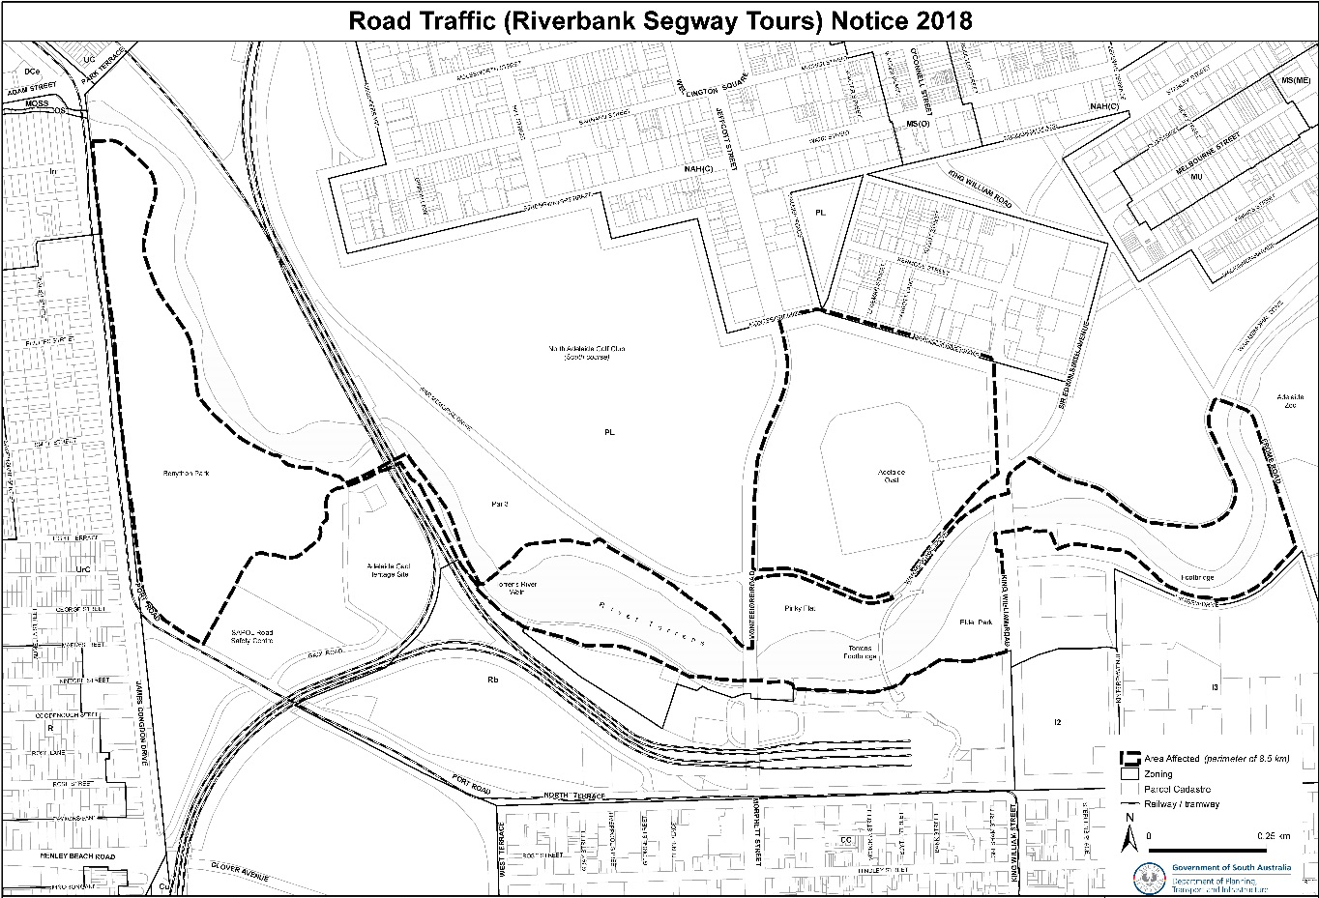

South Australia
Road Traffic (Electric Personal Transporters) Notice 2018 No 2
under section 161A of the Road Traffic Act 1961
1 Short Title
This Notice may be cited as the Road Traffic (Holdfast Bay Segway Tours) Notice 2018.
2 Commencement
This Notice will come into operation on the day it is published in the Gazette.
3 Interpretation
In this Notice—
Act means the Road Traffic Act 1961;
Council means the City of Holdfast Bay ABN 62 551 270 492;
electric personal transporter has the same meaning as in the Road Traffic (Miscellaneous) Regulations 2014;
Minister means the Minister to whom the administration of the Act is committed;
path means a bicycle path, footpath or shared path.
4 Approval
In accordance with the power under section 161A of the Act, I hereby approve an electric personal transporter to be driven on or over a road subject to the following conditions:
5 Conditions
An electric personal transporter may be driven:
1. within the Council area designated in the Schedule to this Notice;
2. on roads or paths authorised for use by Council;
3. in accordance with any other conditions and/or by-laws imposed by Council.
6 Revocation
This Notice may be revoked by the Minister or his delegate at any time.
7 Execution
Dated: 11 December 2018
Hon Stephan Knoll MP
Minister for Transport, Infrastructure and Local Government
Minister for Planning

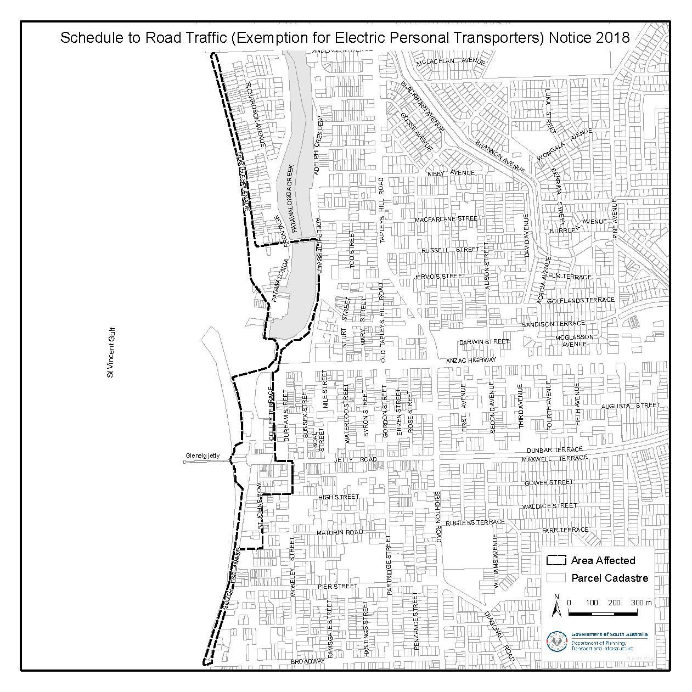

Road Traffic Act 1961
Breath Analysing Instruments
I, GRANT STEVENS, Commissioner of Police, do hereby notify that on and from 30 November, 2018, the following persons were authorised by the Commissioner of Police to operate breath analysing instruments as defined in and for the purposes of the:
- Road Traffic Act 1961;
- Harbors and Navigation Act 1993;
- Security and Investigation Industry Act 1995; and
- Rail Safety National Law (South Australia) Act 2012.
PD Number | Officer Name
94870 | COOPER, Stephanie Lee
79478 | HAYMAN, Ryan Edward
72964 | HOLYOAK - TARRANT, Marita Jane
55543 | LEIGH, Angela
69739 | TEODORO, Felix Alberto
76593 | ZULIANI, Samuel Mark
Dated: 30 November 2018
Grant Stevens
Commissioner of Police
Reference: 2018-0132

Road Traffic Act 1961
Breath Analysing Instruments
I, GRANT STEVENS, Commissioner of Police, do hereby notify that on and from 6 December, 2018, the following persons were authorised by the Commissioner of Police to operate breath analysing instruments as defined in and for the purposes of the:
- Road Traffic Act 1961;
- Harbors and Navigation Act 1993;
- Security and Investigation Industry Act 1995; and
- Rail Safety National Law (South Australia) Act 2012.
PD Number | Officer Name
76390 | ARCHER, Grant Malcolm
76394 | BLACK, Kathryn Margaret
75132 | FRAZER, Aaron Michael
76552 | KRAEMER, Alexandra Jurriana
76095 | NICHOLLS, Steven John
75929 | RADLOFF, Benjamin James
76355 | ROSE, Matthew Frederick
75812 | SHENTON, Trevor David
76555 | VIVIAN, Georgina Alice
76655 | YATES, Kimberley Beth
Dated: 6 December 2018
Grant Stevens
Commissioner of Police
Reference: 2018-0160

SUMMARY OFFENCES ACT 1953
Event Declaration
New Year’s Eve, Semaphore
NOTICE is hereby given in accordance with Section 72A (3) of the Summary Offences Act 1953, that the following event has been declared for the duration of the event between the listed dates.
EVENT: New Year’s Eve, Semaphore
PLACE: Public places known as Semaphore, Exeter and Glanville
DATE: 31/12/18 – 01/01/19
CONDITIONS: Shall be in force from 3.00 p.m. on 31 December 2018 until 7.00 a.m. on 1 January 2019
At this event a police officer may carry out a metal detector search in relation to the any person who is in, or attempting to enter or leave the event and any property in the person’s possession.
Dated: 6 December 2018
Superintendent Anthony Fioravanti
Delegate of the Commissioner

South Australia
National Electricity (South Australia) (Australian Energy Regulator—Wholesale Market Monitoring) Amendment Act (Commencement) Proclamation 2018
1—Short title
This proclamation may be cited as the National Electricity (South Australia) (Australian Energy Regulator—Wholesale Market Monitoring) Amendment Act (Commencement) Proclamation 2018.
2—Commencement of remaining provisions
The following provisions of the National Electricity Law set out in the Schedule to the National Electricity (South Australia) Act 1996, inserted into the National Electricity Law by section 6 of the National Electricity (South Australia) (Australian Energy Regulator—Wholesale Market Monitoring) Amendment Act 2016 (No 56 of 2016), will come into operation on 13 December 2018:
(a) section 18D(1)(b);
(b) section 18D(2) to (6) (inclusive).
Made by the Governor
with the advice and consent of the Executive Council
on 13 December 2018
MEM18-024CS

South Australia
Statutes Amendment (National Energy Laws) (Binding Rate of Return Instrument) Act (Commencement) Proclamation 2018
1—Short title
This proclamation may be cited as the Statutes Amendment (National Energy Laws) (Binding Rate of Return Instrument) Act (Commencement) Proclamation 2018.
2—Commencement of Act
The Statutes Amendment (National Energy Laws) (Binding Rate of Return Instrument) Act 2018 (No 33 of 2018) will come into operation on 13 December 2018.
Made by the Governor
with the advice and consent of the Executive Council
on 13 December 2018
MEM18-023CS
South Australia
Administrative Arrangements (Committal of Acts) Proclamation 2018
under section 5 of the Administrative Arrangements Act 1994
1—Short title
This proclamation may be cited as the Administrative Arrangements (Committal of Acts) Proclamation 2018.
2—Commencement
This proclamation will come into operation on 1 January 2019.
3—Committal of Acts
The administration of an Act referred to in Schedule 1 is committed to the Minister for Primary Industries and Regional Development.
Schedule 1—Acts committed to Minister for Primary Industries and Regional Development
Dog Fence Act 1946
Pastoral Land Management and Conservation Act 1989
Made by the Governor
with the advice and consent of the Executive Council
on 13 December 2018
DPC18/080CS

South Australia
Administrative Arrangements (Minister for Environment and Water) Proclamation 2018
under sections 7 and 8 of the Administrative Arrangements Act 1994
1—Short title
This proclamation may be cited as the Administrative Arrangements (Minister for Environment and Water) Proclamation 2018.
2—Commencement
This proclamation will come into operation on 1 January 2019.
3—Transfer of land etc and interpretative provision relating to Minister for Environment and Water
(1) The land described in Schedule 1 (and any improvements on the land), being land vested in the Minister for Transport, Infrastructure and Local Government, is transferred to the Minister for Environment and Water.
(2) The assets, rights and liabilities attributable to the land described in Schedule 1 are transferred to the Minister for Environment and Water.
(3) The assets of the Minister for Transport, Infrastructure and Local Government described in Schedule 2, and the rights and liabilities of that Minister attributable to those assets, are transferred to the Minister for Environment and Water.
(4) A reference to the Minister for Transport, Infrastructure and Local Government in an instrument or contract, agreement or other document made or entered into in connection with the administration of—
(a) the land described in Schedule 1 (and any improvements on the land); or
(b) the assets described in Schedule 2,
before 1 January 2019 will have effect as if it were a reference to the Minister for Environment and Water.
Schedule 1—Description of land transferred to Minister for Environment and Water
Certificate of Title Register Book Volume 5796 Folio 195
Certificate of Title Register Book Volume 5927 Folio 883
Certificate of Title Register Book Volume 6134 Folio 232
Certificate of Title Register Book Volume 5682 Folio 154
Certificate of Title Register Book Volume 6212 Folio 771
Certificate of Title Register Book Volume 6211 Folio 943
Certificate of Title Register Book Volume 5669 Folio 112
Certificate of Title Register Book Volume 5948 Folio 489
Certificate of Title Register Book Volume 6097 Folio 600
Certificate of Title Register Book Volume 6097 Folio 601
Certificate of Title Register Book Volume 6028 Folio 246
Schedule 2—Description of other assets transferred to Minister for Environment and Water
Cast Iron Lead Light at Government Road, Elliston (being item 14211 on the South Australian Heritage Register)
Troubridge Island Lighthouse at Troubridge Island (being item 10184 on the South Australian Heritage Register)
Office (formerly known as the dwelling "Struan House") at Penola Road, Struan (being item 10249 on the South Australian Heritage Register)
National War Memorial at Kintore Ave, Adelaide (being item 13660 on the South Australian Heritage Register)
Made by the Governor
with the advice and consent of the Executive Council
on 13 December 2018
DPC18/080CS

South Australia
Administrative Arrangements (Minister for Primary Industries and Regional Development) Proclamation 2018
under sections 7 and 8 of the Administrative Arrangements Act 1994
1—Short title
This proclamation may be cited as the Administrative Arrangements (Minister for Primary Industries and Regional Development) Proclamation 2018.
2—Commencement
This proclamation will come into operation on 1 January 2019.
3—Transfer of assets etc and interpretative provision relating to Minister for Primary Industries and Regional Development
(1) The assets, rights and liabilities of the Minister for Environment and Water related to the administration of the following Acts are transferred to the Minister for Primary Industries and Regional Development:
(a) the Dog Fence Act 1946;
(b) the Pastoral Land Management and Conservation Act 1989.
(2) A reference to the Minister for Environment and Water in an instrument or contract, agreement or other document made or entered into under or in connection with an Act referred to in subclause (1) before 1 January 2019 will have effect as if it were a reference to the Minister for Primary Industries and Regional Development.
Made by the Governor
with the advice and consent of the Executive Council
on 13 December 2018
DPC18/080CS

South Australia
National Parks and Wildlife (Ikara-Flinders Ranges National Park) Proclamation 2018
under section 27(3) of the National Parks and Wildlife Act 1972
1—Short title
This proclamation may be cited as the National Parks and Wildlife (Ikara-Flinders Ranges National Park) Proclamation 2018.
2—Commencement
This proclamation comes into operation on the day on which it is made.
3—Alteration of boundaries of Ikara-Flinders Ranges National Park
The boundaries of the Ikara-Flinders Ranges National Park are altered by adding to the Park the following Crown land:
Allotment 1 in Deposited Plan 115293, Out of Hundreds (Parachilna), County of Hanson.
Made by the Governor
with the advice and consent of the Executive Council
on 13 December 2018
18EWDEWCS0023

South Australia
National Parks and Wildlife (Lawari Conservation Park) Proclamation 2018
under section 30(2) of the National Parks and Wildlife Act 1972
1—Short title
This proclamation may be cited as the National Parks and Wildlife (Lawari Conservation Park) Proclamation 2018.
2—Commencement
This proclamation comes into operation on the day on which it is made.
3—Alteration of boundaries of Lawari Conservation Park
The boundaries of the Lawari Conservation Park are altered by adding to the Park the following Crown land:
The allotment comprising Pieces 61 and 62 in Deposited Plan 116374, Hundred of Nangkita, County of Hindmarsh;
The allotment comprising Pieces 253 and 254 in Deposited Plan 117224, Hundred of Nangkita, County of Hindmarsh;
The allotment comprising Pieces 255 and 256 in Deposited Plan 117224, Hundred of Nangkita, County of Hindmarsh;
The allotment comprising Pieces 257 and 258 in Deposited Plan 117224, Hundred of Nangkita, County of Hindmarsh;
The allotment comprising Pieces 259 and 260 in Deposited Plan 117224, Hundred of Nangkita, County of Hindmarsh;
Allotments 429 and 430 in Deposited Plan 117224, Hundred of Nangkita, County of Hindmarsh.
Made by the Governor
with the advice and consent of the Executive Council
on 13 December 2018
18EWDEWCS0023

South Australia
National Parks and Wildlife (Ngarkat Conservation Park) Proclamation 2018
under section 30(2) of the National Parks and Wildlife Act 1972
1—Short title
This proclamation may be cited as the National Parks and Wildlife (Ngarkat Conservation Park) Proclamation 2018.
2—Commencement
This proclamation comes into operation on the day on which it is made.
3—Alteration of boundaries of Ngarkat Conservation Park
The boundaries of the Ngarkat Conservation Park are altered by adding to the Park the following Crown land:
Allotment 58 in Deposited Plan 114960, Out of Hundreds (Pinnaroo), Out of Counties;
Allotment 59 in Deposited Plan 115418, Hundred of Makin, County of Buckingham;
Allotment 60 in Deposited Plan 115418, Out of Hundreds (Pinnaroo), Out of Counties;
Allotments 61 and 62 in Deposited Plan 115418, Hundred of Fisk, County of Chandos;
Allotment 100 in Deposited Plan 115637, Hundred of Shaugh, County of Buckingham.
Made by the Governor
with the advice and consent of the Executive Council
on 13 December 2018
18EWDEWCS0023
South Australia
National Parks and Wildlife (Telowie Gorge Conservation Park) Proclamation 2018
under section 29(3) of the National Parks and Wildlife Act 1972
1—Short title
This proclamation may be cited as the National Parks and Wildlife (Telowie Gorge Conservation Park) Proclamation 2018.
2—Commencement
This proclamation comes into operation on the day on which it is made.
3—Alteration of boundaries of Telowie Gorge Conservation Park
The boundaries of the Telowie Gorge Conservation Park are altered by adding to the Park the following Crown land:
Section 515, Hundred of Telowie, County of Frome;
Section 328, Hundred of Napperby, County of Victoria.
Made by the Governor
with the advice and consent of the Executive Council
on 13 December 2018
18EWDEWCS0023

South Australia
National Parks and Wildlife (Telowie Gorge Conservation Park—Mining Rights) Proclamation 2018
under section 43 of the National Parks and Wildlife Act 1972

Preamble
1 The Crown land described in Schedule 1 is, by another proclamation made on this day, added to the Telowie Gorge Conservation Park under section 29(3) of the National Parks and Wildlife Act 1972.
2 It is intended that, by this proclamation, certain existing and future rights of entry, prospecting, exploration or mining be preserved in relation to the land described in Schedule 1.

1—Short title
This proclamation may be cited as the National Parks and Wildlife (Telowie Gorge Conservation Park—Mining Rights) Proclamation 2018.
2—Commencement
This proclamation comes into operation on the day on which it is made.
3—Interpretation
In this proclamation—
Environment Minister means the Minister for the time being administering the National Parks and Wildlife Act 1972;
Mining Minister means the Minister for the time being administering the Mining Act 1971 or the Minister for the time being administering the Petroleum and Geothermal Energy Act 2000, as the case requires.
4—Existing rights to continue
Subject to clause 6, existing rights of entry, prospecting, exploration or mining under the Mining Act 1971 or the Petroleum and Geothermal Energy Act 2000 may continue to be exercised in respect of the land described in Schedule 1.
5—New rights may be acquired
Rights of entry, prospecting, exploration or mining may, with the approval of the Mining Minister and the Environment Minister, be acquired pursuant to the Mining Act 1971 or the Petroleum and Geothermal Energy Act 2000 in respect of the land described in Schedule 1 and may, subject to clause 6, be exercised in respect of that land.
6—Conditions for exercise of rights
A person in whom rights of entry, prospecting, exploration or mining are vested pursuant to the Mining Act 1971 or the Petroleum and Geothermal Energy Act 2000 (whether those rights were acquired before or after the making of this proclamation) must not exercise those rights in respect of the land described in Schedule 1 unless the person complies with the following conditions:
(a) if work to be carried out in relation to the land in the exercise of those rights is a regulated activity within the meaning of the Petroleum and Geothermal Energy Act 2000, the person must ensure that—
(i) the work is not carried out until a statement of environmental objectives in relation to the activity that has been approved under that Act has also been approved by the Environment Minister; and
(ii) the work is carried out in accordance with the statement as so approved;
(b) if work to be carried out in relation to the land in the exercise of rights under the Mining Act 1971 or the Petroleum and Geothermal Energy Act 2000 has not previously been authorised (whether by inclusion in an approved statement of environmental objectives referred to in paragraph (a) or otherwise), the person must give at least 3 months notice of the proposed work to the Mining Minister and the Environment Minister and supply each Minister with such information relating to the proposed work as the Minister may require;
(c) if directions are agreed between the Mining Minister and the Environment Minister and given to the person in writing in relation to—
(i) carrying out work in relation to the land in a manner that minimises damage to the land (including the land's vegetation and wildlife) and the environment generally; or
(ii) preserving objects, structures or sites of historical, scientific or cultural interest; or
(iii) rehabilitating the land (including the land's vegetation and wildlife) on completion of the work; or
(iv) (where the work is being carried out in the exercise of rights acquired after the making of this proclamation) prohibiting or restricting access to any specified area of the land that the Ministers believe would suffer significant detriment as a result of carrying out the work,
(being directions that do not reduce or otherwise detract from any requirement in respect of any of those matters contained in an approved statement of environmental objectives referred to in paragraph (a)), the person must comply with those directions in carrying out the work;
(d) if a plan of management is in operation under section 38 of the National Parks and Wildlife Act 1972 in respect of the land, the person must have regard to the provisions of the plan of management;
(e) in addition to complying with the other requirements of this proclamation, the person—
(i) must take such steps as are reasonably necessary to ensure that objects, structures and sites of historical, scientific or cultural interest and the land's vegetation and wildlife are not unduly affected by any work; and
(ii) must maintain all work areas in a clean and tidy condition; and
(iii) must, on the completion of any work, obliterate or remove all installations and structures (other than installations and structures designated by the Mining Minister and the Environment Minister as suitable for retention) used exclusively for the purposes of that work;
(f) if no direction has been given by the Mining Minister and the Environment Minister under paragraph (c)(iii), the person must (in addition to complying with any approved statement of environmental objectives referred to in paragraph (a)) rehabilitate the land (including its vegetation and wildlife) on completion of any work to the satisfaction of the Environment Minister.
7—Governor may give approvals, directions
If—
(a) the Mining Minister and the Environment Minister cannot agree as to whether—
(i) approval should be granted or refused under clause 5; or
(ii) a direction should be given under clause 6(c); or
(b) the Environment Minister does not approve a statement of environmental objectives under clause 6(a),
the Governor may, with the advice and consent of the Executive Council—
(c) grant or refuse the necessary approval under clause 5; or
(d) give a direction in writing under clause 6(c); or
(e) grant or refuse the necessary approval under clause 6(a).
Schedule 1—Description of land
Section 515, Hundred of Telowie, County of Frome;
Section 328, Hundred of Napperby, County of Victoria.
Made by the Governor
with the advice and consent of the Executive Council
on 13 December 2018
18EWDEWCS0023
South Australia
Motor Vehicles (Miscellaneous) Variation Regulations 2018
under the Motor Vehicles Act 1959

Contents
Part 1—Preliminary
1 Short title
2 Commencement
3 Variation provisions
Part 2—Variation of Motor Vehicles Regulations 2010
4 Variation of regulation 14—Classes of vehicles Registrar may refuse to register
5 Variation of Schedule 2—Classification of driver's licences

Part 1—Preliminary
1—Short title
These regulations may be cited as the Motor Vehicles (Miscellaneous) Variation Regulations 2018.
2—Commencement
These regulations come into operation on the day on which they are made.
3—Variation provisions
In these regulations, a provision under a heading referring to the variation of specified regulations varies the regulations so specified.
Part 2—Variation of Motor Vehicles Regulations 2010
4—Variation of regulation 14—Classes of vehicles Registrar may refuse to register
Regulation 14—after paragraph (b) insert:
(c) vehicles that are the subject of a recall notice made under section 122 of the Australian Consumer Law.
5—Variation of Schedule 2—Classification of driver's licences
(1) Schedule 2, clause 1, table, entry relating to licence class MR, item 2—after "motor vehicle" insert:
(other than a special purpose vehicle)
(2) Schedule 2, clause 1, table, entry relating to licence class MR, item 4—delete "A special purpose vehicle with a GVM not greater than 15 t" and substitute:
A special purpose vehicle with—
(a) 2 axles and a GVM greater than 8 t; or
(b) 3 or more axles and a GVM not greater than 15 t.
(3) Schedule 2, clause 1, table, entry relating to licence class HR, item 2—delete "(including an articulated bus but not including any other articulated motor vehicle)" and substitute:
(other than an articulated motor vehicle or a special purpose vehicle)
(4) Schedule 2, clause 1, table, entry relating to licence class HR—after item 3 insert:

4 | An articulated bus with 3 or more axles and a GVM greater than 8 t.
5 | A special purpose vehicle with 3 or more axles and a GVM greater than 15 t.
Note—
As required by section 10AA(2) of the Subordinate Legislation Act 1978, the Minister has certified that, in the Minister's opinion, it is necessary or appropriate that these regulations come into operation as set out in these regulations.
Made by the Governor
with the advice and consent of the Executive Council
on 13 December 2018
No 247 of 2018
MTIL18/031CS
South Australia
Road Traffic (Road Rules—Ancillary and Miscellaneous Provisions) (Seatbelts) Variation Regulations 2018
under the Road Traffic Act 1961

Contents
Part 1—Preliminary
1 Short title
2 Commencement
3 Variation provisions
Part 2—Variation of Road Traffic (Road Rules—Ancillary and Miscellaneous Provisions) Regulations 2014
4 Variation of regulation 37—Exemptions from wearing seatbelts

Part 1—Preliminary
1—Short title
These regulations may be cited as the Road Traffic (Road Rules—Ancillary and Miscellaneous Provisions) (Seatbelts) Variation Regulations 2018.
2—Commencement
These regulations come into operation on the day on which they are made.
3—Variation provisions
In these regulations, a provision under a heading referring to the variation of specified regulations varies the regulations so specified.
Part 2—Variation of Road Traffic (Road Rules—Ancillary and Miscellaneous Provisions) Regulations 2014
4—Variation of regulation 37—Exemptions from wearing seatbelts
(1) Regulation 37(1)—delete subregulation (1)
(2) Regulation 37(2)—after "rule 267(3)" insert:
(Exemptions from wearing seatbelts)
Note—
As required by section 10AA(2) of the Subordinate Legislation Act 1978, the Minister has certified that, in the Minister's opinion, it is necessary or appropriate that these regulations come into operation as set out in these regulations.
Made by the Governor
with the advice and consent of the Executive Council
on 13 December 2018
No 248 of 2018
MTIL18/031CS
South Australia
Road Traffic (Miscellaneous) (Declared Hospitals) Variation Regulations 2018
under the Road Traffic Act 1961

Contents
Part 1—Preliminary
1 Short title
2 Commencement
3 Variation provisions
Part 2—Variation of Road Traffic (Miscellaneous) Regulations 2014
4 Variation of Schedule 2—Hospitals declared for compulsory blood tests

Part 1—Preliminary
1—Short title
These regulations may be cited as the Road Traffic (Miscellaneous) (Declared Hospitals) Variation Regulations 2018.
2—Commencement
These regulations come into operation on the day on which they are made.
3—Variation provisions
In these regulations, a provision under a heading referring to the variation of specified regulations varies the regulations so specified.
Part 2—Variation of Road Traffic (Miscellaneous) Regulations 2014
4—Variation of Schedule 2—Hospitals declared for compulsory blood tests
(1) Schedule 2, hospital facilities of Country Health SA Local Health Network Incorporated—delete the list of hospital facilities of Country Health SA Local Health Network Incorporated (from "Angaston District Hospital" to "Southern Yorke Peninsula Hospital (Yorketown)" (inclusive)) and substitute the following list:
Angaston District Hospital
Balaklava Soldiers' Memorial District Hospital
Barmera Hospital
Booleroo Centre District Hospital and Health Service
Bordertown Memorial Hospital
Burra Hospital
Ceduna District Health Service
Central Yorke Peninsula Hospital (Maitland)
Clare Hospital
Cleve District Hospital & Aged Care
Cowell District Hospital & Aged Care
Crystal Brook and District Hospital
Cummins and District Memorial Hospital
Coober Pedy Hospital and Health Service
Elliston District Hospital
Eudunda Hospital
Gawler Health Service
Gumeracha District Soldiers' Memorial Hospital
Hawker Memorial Hospital
Jamestown Hospital & Health Service
Kangaroo Island Health Service
Kapunda Hospital
Karoonda and Districts Soldiers' Memorial Hospital
Kimba District Hospital & Aged Care
Kingston Soldiers' Memorial Hospital
Lameroo District Health Service
Laura and District Hospital
Leigh Creek Health Service
Loxton Hospital Complex
Mannum District Hospital
Meningie & Districts Memorial Hospital and Health Service
Millicent and District Hospital and Health Service
Minlaton Medical Centre
Mt Barker District Soldiers' Memorial Hospital
Mt Gambier and Districts Health Service
Mount Pleasant District Hospital
Murray Bridge Soldiers' Memorial Hospital
Naracoorte Health Service
Northern Yorke Peninsula Health Service (Wallaroo)
Oodnadatta Health Service
Orroroo and District Health Service
Penola War Memorial Hospital
Peterborough Soldiers' Memorial Hospital and Health Service
Pinnaroo Soldiers' Memorial Hospital
Port Augusta Hospital and Regional Health Service
Port Broughton District Hospital & Health Service
Port Lincoln Health Service
Port Pirie Regional Health Service
Quorn Health Service
Renmark Paringa District Hospital
Riverland General Hospital
Riverton District Soldiers' Memorial Hospital
Roxby Downs Health Service
Snowtown Hospital
Southern Fleurieu Health Service
Southern Yorke Peninsula Hospital (Yorketown)
Strathalbyn & Districts Health Service
Streaky Bay District Hospital
Tailem Bend District Hospital
Tanunda War Memorial Hospital
Tumby Bay Hospital and Health Service
Waikerie Health Service
The Whyalla Hospital & Health Service
Wudinna Hospital.
(2) Schedule 2, list of hospitals—delete "Moonta Health and Aged Care Service Incorporated"
Note—
As required by section 10AA(2) of the Subordinate Legislation Act 1978, the Minister has certified that, in the Minister's opinion, it is necessary or appropriate that these regulations come into operation as set out in these regulations.
Made by the Governor
with the advice and consent of the Executive Council
on 13 December 2018
No 249 of 2018
MTIL18/031CS
South Australia
Criminal Procedure (General) (Costs) Variation Regulations 2018
under the Criminal Procedure Act 1921

Contents
Part 1—Preliminary
1 Short title
2 Commencement
3 Variation provisions
Part 2—Variation of Criminal Procedure (General) Regulations 2017
4 Insertion of regulation 10
10 Costs payable by defendant in certain criminal proceedings

Part 1—Preliminary
1—Short title
These regulations may be cited as the Criminal Procedure (General) (Costs) Variation Regulations 2018.
2—Commencement
These regulations will come into operation on 1 January 2019.
3—Variation provisions
In these regulations, a provision under a heading referring to the variation of specified regulations varies the regulations so specified.
Part 2—Variation of Criminal Procedure (General) Regulations 2017
4—Insertion of regulation 10
After regulation 9 insert:
10—Costs payable by defendant in certain criminal proceedings
Pursuant to section 189A(2)(a) of the Act, the amount of $150 is prescribed for the purposes of subsection (2) of that section.
Note—
As required by section 10AA(2) of the Subordinate Legislation Act 1978, the Minister has certified that, in the Minister's opinion, it is necessary or appropriate that these regulations come into operation as set out in these regulations.
Made by the Governor
with the advice and consent of the Executive Council
on 13 December 2018
No 250 of 2018
AGO0148-18CS
The Corporation of the City of Adelaide
Local Government Act 1999 – Section 246
Notification of Application of By-law—Rundle Mall By-law 2018
The Corporation of the City of Adelaide gives notice pursuant to Section 246(4a) of the Local Government Act 1999 that at its meeting of 11 December 2018 the Council resolved, in accordance with Section 246(3)(e) of the Local Government Act 1999 and Clause 9 of Council’s Rundle Mall By-law 2018, that Clause 5.9 of Council’s Rundle Mall By-law 2018 (prohibition on smoking) shall apply to the following parts of the area of the Council:
- Those parts of Rundle Mall depicted in purple on the plan included as Attachment J to the report titled ‘By-law Implementation Report’ on the agenda for the meeting of the Council held on 11 December 2018 (the Plan); and
- Those parts of the streets and laneways in the vicinity of Rundle Mall depicted in blue on the Plan (namely, the identified portions of James Place, Stephens Place, Gawler Place, Francis Street, Lindes Lane, Charles Street, and Twin Street).
A copy of the Plan is included below for reference purposes.
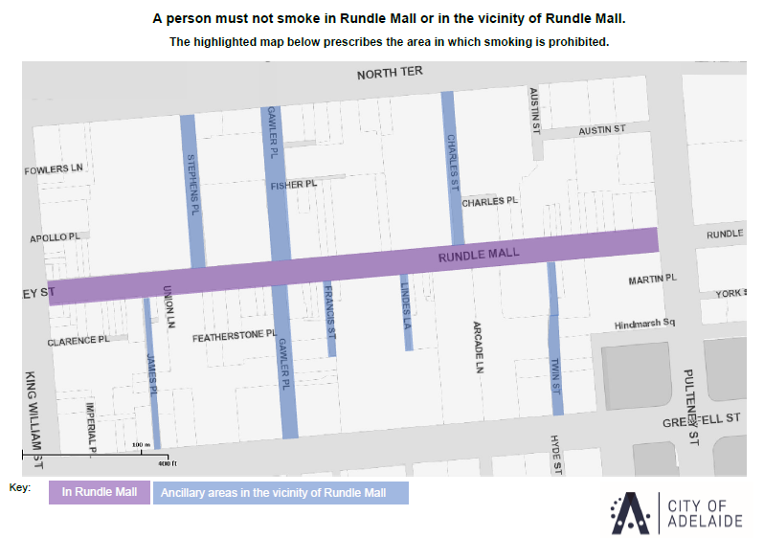
In accordance with Section 249(5) of the Local Government Act 1999, the Rundle Mall By-law 2018 and the Council’s resolution come into operation on 23 December 2018. Consequently, smoking will continue to be prohibited in the depicted areas from that date onwards. Prior to 23 December 2018, smoking is prohibited in these areas by virtue of Council’s By-law No. 10 – Smoking Control.
Copies of the Rundle Mall By-law 2018 and the Plan are available for inspection at the Colonel Light Centre, 25 Pirie Street, Adelaide SA 5000 during ordinary office hours (8:30am to 5:00pm). Alternatively, they can be accessed on Council’s website: https://www.cityofadelaide.com.au/your-council/policies-papers/#B
Dated: 11 December 2018
Mark Goldstone
Chief Executive Officer

CITY OF BURNSIDE
Section 79(2) Fire and Emergency Services Act 2005 and
Regulation 34(3)(a) Fire and Emergency Services Regulations 2005
Declaration to Permit a Person to Operate a Gas Fire or Electric Element for Cooking Purposes
in the Open Air Contrary to the Terms of a Total Fire Ban
Pursuant to regulations under the Fire and Emergency Services Act 2005, the City of Burnside hereby DECLARES that persons may, in connection with the use of an electric barbeque provided and owned by the Council that is located in any one of the parks or reserves listed below, operate electric elements for cooking purposes in the open air contrary to the terms of a total fire ban:
- Tusmore Park, 25C Stirling Street, Tusmore SA, 5065;
- Kensington Park Reserve, 350 The Parade, Kensington Park SA, 5068;
- Symons and Symons Reserve, 122895 Conyngham Street, Glenside SA, 5065;
- Plane tree reserve,121732 Plane Tree Reserve, Glenside SA 5065;
- Hazelwood Park, 103320 Hazelwood Park, Greenhill Road, Hazelwood Park SA, 5066;
- Kensington Gardens, 420 The Parade Kensington Gardens SA, 5068;
- Millers Reserve, 59 Hay Road, Linden Park SA, 5065;
- Langmans Reserve, 102664 Windarra Avenue, Burnside SA, 5066;
- Penfold Park, 589 The Parade, Magill SA, 5072;
- Main Street Reserve, 12 Main Street, Eastwood SA, 5063;
- J B Ware Reserve, 586 Portrush Road, Glen Osmond SA, 5064;
- Glenunga Reserve, 107476 Conyngham Street, Glenunga SA, 5064;
This notice operates at all times until revoked.
The operation of an electric element under this notice is subject to the following conditions:
  - The space immediately around and above the gas fire or electric element must be cleared of all flammable material to a distance of a least four metres.
  - A person who is able to control the gas fire or electric element must be present at all times while it is lighted or charged.
  - An appropriate agent adequate to extinguish any fire must be at hand.
  - For the avoidance of doubt, this notice does not authorise the use of any other cooking appliance other than the electric barbeques specified above.
Paul Deb
Chief Executive Officer

CITY OF TEA TREE GULLY
Roads (Opening and Closing) Act 1991
Notice of Proposed Road Closure -Portion of Hancock Road, Tea Tree Gully
NOTICE is hereby given, pursuant to section 10 of the Roads (Opening and Closing) Act 1991, that the City of Tea Tree Gully proposes to make a Road Process Order to close and merge with allotment 19 in Field Plan 10178 comprised in Certificate of Title Volume 5351 Folio 349 the portion of public road adjoining 175 Hancock Road Tea Tree Gully, more particularly delineated and lettered ‘A’ on Preliminary Plan No. 17/0061.
The Preliminary Plan and a Statement of Persons Affected is available for public inspection at the offices of the City of Tea Tree Gully Council Office, Civic Centre, 571 Montague Road Modbury and the Adelaide office of the Surveyor-General at 101 Grenfell Street, Adelaide during normal office hours. The Preliminary Plan can also be viewed at www.sa.gov.au/roadsactproposals.
Any application for easement or objection must set out the full name, address and details of the submission and must be fully supported by reasons. The application for easement or objection must be made in writing to the City of Tea Tree Gully Council Office, Civic Centre, 571 Montague Road Modbury WITHIN 28 DAYS OF THIS NOTICE and a copy must be forwarded to the Surveyor-General at GPO Box 1354, Adelaide 5001. Where a submission is made, the Council will give notification of a meeting at which the matter will be considered.
Dated: 13 December 2018
John Moyle
Chief Executive Officer
PP 17/0061

City of Whyalla
South Australia
Liquor Licensing (Dry Areas) Notice 2018
under section 131(1a) of the Liquor Licensing Act 1997
1—Short title
This notice may be cited as the Liquor Licensing (Dry Areas) Notice 2018.
2—Commencement
This notice comes into operation on 31 December 2018.
3—Interpretation
(1) In this notice—
principal notice means the Liquor Licensing (Dry Areas) Notice 2015 published in the Gazette on 5.1.15, as in force from time to time.
(2) Clause 3 of the principal notice applies to this notice as if it were the principal notice.
4—Consumption etc of liquor prohibited in dry areas
(1) Pursuant to section 131 of the Act, the consumption and possession of liquor in the area described in the Schedule is prohibited in accordance with the provisions of the Schedule.
(2) The prohibition has effect during the periods specified in the Schedule.
(3) The prohibition does not extend to private land in the area described in the Schedule.
(4) Unless the contrary intention appears, the prohibition of the possession of liquor in the area does not extend to—
(a) a person who is genuinely passing through the area if—
(i) the liquor is in the original container in which it was purchased from licensed premises; and
(ii) the container has not been opened; or
(b) a person who has possession of the liquor in the course of carrying on a business or in the course of his or her employment by another person in the course of carrying on a business; or
(c) a person who is permanently or temporarily residing at premises within the area or on the boundary of the area and who enters the area solely for the purpose of passing through it to enter those premises or who enters the area from those premises for the purpose of leaving the area.
Schedule 1—Whyalla Area 1

1—Extent of prohibition
The consumption of liquor is prohibited and the possession of liquor is prohibited.

2—Period of prohibition
From 9pm on 31 December 2018 to 9am on 1 January 2019.
From 12pm to 12am on 26 January 2019.
From 9am to 12am on 16 February 2019.

3—Description of area
Commencing at the point at which the prolongation in a straight line of the western boundary of Lot 100 D61444 intersects with the Corporation of the City of Whyalla, Local Government boundary then extending east north-east along the Local Government boundary, then south-east, then north-easterly, northerly and north-westerly along the Local Government boundary to encompass the Whyalla marina breakwater northern and southern extensions, to a point where the Local Government Boundary intersects the eastern boundary of Lot 3 D26088, north-west along the eastern boundary of Lot 3 D26088 and continuing along the eastern boundary of Lot 1 D21007, then north-west along the boundary of Lot 1 D26088 and southerly, north westerly, north easterly and northerly to following the Local Government Boundary around the railway reserve (Indenture Land), then north-west along the north-eastern boundary of Lot 1 D26088 to intersect with the north-eastern most point of Gay Street, then north-westerly until such point where a prolongation in a straight line of the north-western boundary of Section 394 intersects with the north-eastern boundary of Gay Street, south-west along the prolongation and north-western boundary of Section 394, then south-west along the north-western boundary of Buttlingara Way to intersect with the north eastern boundary of Cudmore Terrace, north-west along the north-eastern boundary of Cudmore Terrace to intersect with the with the south eastern boundary of Wallack Terrace, then south-west along the north-western boundary of Lot 100 to intersect with the eastern boundary of Watson Terrace, south along the eastern boundary of Watson Terrace to intersect with the western most point of Lot 340 in D33299, along the boundary of Lot 340 D33299 commencing north easterly and continuing in a clockwise direction to intersect at the southern boundary of Neagle Terrace, westerly along the southern boundary of Neagle Terrace to intersect with the southern boundary of Lot 3 F14874, west along the southern boundary of Lot 3 F14874 and Lot 105 D61444 to the point of intersection with Lot 1 D67562, south along the eastern boundary of Lot 1 D67562 and Lot 101 D61444 to the point of intersection with the southern boundary of Lot 101 D61444, then west along the southern boundary of Lot 101 D61444 to the point of intersection with the western boundary of Lot 101 D61444, then north along the western boundary of Lot 101 D61444 to the point of intersection with the northern boundary of Lot 100 D61444, west along the northern boundary of Lot 101 D61444, to the point of intersection with the western boundary of Lot 101 D61444, then south along the western boundary of Lot 101 D61444 and a prolongation of this line to the point of commencement. The area includes any area beneath marina structures that protude from land into the water, the area excludes the Whyalla Foreshore Motor Inn, The Foreshore Café, Whyalla Surf Life Saving Club, Whyalla Yacht Club, Air Sea Rescue, Whyalla Sports Fishing Club and the Boat Owners Association.
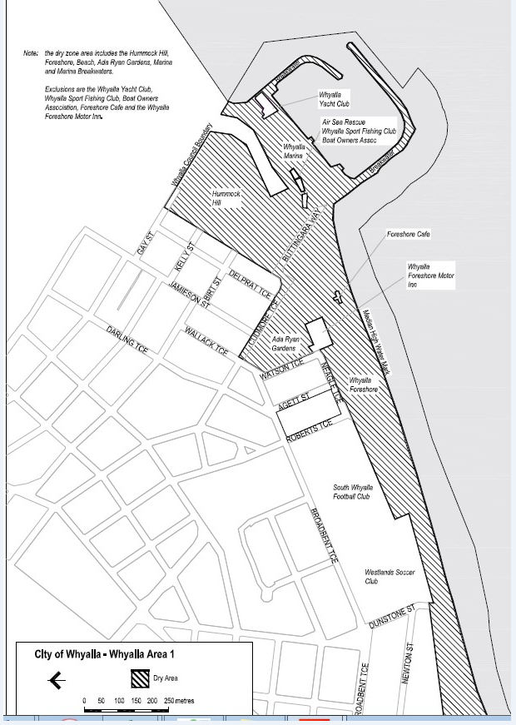

The Barossa Council
Development Act 1993
The Barossa Council Development Plan
Nuriootpa (Sturt Highway Service Centre) Development Plan Amendment Draft for Public Consultation
The Barossa Council has prepared a draft Development Plan Amendment (DPA) to amend The Barossa Council Development Plan.
The DPA amends the Development Plan to facilitate the development of a highway service centre and associated facilities at the corner of Sturt Highway and Belvidere Road (7 Belvidere Road), Nuriootpa. The DPA amends existing policies in the Primary Production (Barossa Valley Region) Zone and introduces a new policy area for the land to guide and control future development.
The DPA is available for inspection from 13 December 2018 until 21 February 2019 at the following locations:
- Council Office and Library, 43-51 Tanunda Road, Nuriootpa
- Lyndoch Library, 29 Barossa Valley Way
- Angaston Library, Washington Street (Town Hall)
- Tanunda Library, 79 Murray Street
- Mount Pleasant Library, 130-132 Melrose Street
- Council’s website at www.barossa.sa.gov.au
The DPA documents can be downloaded from Council’s website. A print copy or electronic version on CD will be provided on request at no cost.
Anyone may make a written submission on the DPA. Submissions must be sent to the Chief Executive Officer by no later than 5:00 pm Friday 21 February 2019:
- by post to PO Box 867, Nuriootpa, SA, 5355; or
- by email barossa@barossa.sa.gov.au; or
- by fax on (08) 8563 8461
Submissions must indicate if the author wishes to speak in support of their submission at a public meeting about the DPA.
Copies of all submissions received will be made available to the public for inspection by interested persons at the Council Office, 43-51 Tanunda Road, Nuriootpa and on Council’s website from 25 February 2019 until the date of the public meeting.
The public meeting will be held on Monday 4 March 2019 at 7:00 pm at the Council Chamber, 43-51 Tanunda Road, Nuriootpa. If
no-one requests to be heard, then there will be no public meeting.
Dated: 12 December 2018
Martin McCarthy
Chief Executive Officer

CLARE AND GILBERT VALLEYS COUNCIL
Declaration of Public Roads
Notice is hereby given, pursuant to Section 210 of the Local Government Act 1999, that the Clare and Gilbert Valleys Council resolved at the meeting held on 29th January 2018, that the private roads delineated on Enrolled Plan GRO Book 23 Page 2 and known as Young Street, Hill Street, Church Street, Stein Street, Short Street, Mill Street and Wakefield Street, Mintaro are hereby declared to be public roads.
Dr H Macdonald
Chief Executive Officer

DISTRICT COUNCIL OF PETERBOROUGH
Section 210(1) of the Local Government Act 1999 (SA)
Declaration of Public Road
The District Council of Peterborough hereby declares the private road comprising allotment 212 in Deposited Plan 1475 to be a public road pursuant to section 210(1) of the Local Government Act 1999 (SA).
Peter McGuiness
Chief Executive Officer

Trustee Act 1936
Public Trustee
Estates of Deceased Persons
In the matter of the estates of the undermentioned deceased persons:
BILALOVIC Abraham late of 77 Sydenham Road Norwood of no occupation who died 5 January 2018
COX Margaret Catherine late of 19 Cornhill Road Victor Harbor Home Duties who died 23 February 2018
GRAVES Raymond James late of 34 Norman Terrace Everard Park Retired Company Manager who died 10 July 2018
HEUER Patricia Mary late of 10 East Parkway Colonel Light Company Director who died 18 July 2018
LEWIS Valerie late of 88 Alfred Street Parkside Retired Teacher who died 27 May 2018
MANSON Anthony John late of 67 Porter Street Salisbury of no occupation who died 14 August 2018
RICE Peter Melvin late of 9 Third Street Hallett Cove Public Servant who died 28 May 2018
TOTH Louis late of 13 Fitzroy Terrace Fitzroy of no occupation who died 6 July 2018
WOODFORD David late of 168 Bridge Road Pooraka of no occupation who died 18 June 2018
Notice is hereby given pursuant to the Trustee Act 1936, the Inheritance (Family Provision) Act 1972 and the Family Relationships Act 1975 that all creditors, beneficiaries, and other persons having claims against the said estates are required to send, in writing, to the office of Public Trustee at GPO Box 1338, Adelaide, 5001, full particulars and proof of such claims, on or before the 11 January 2019 otherwise they will be excluded from the distribution of the said estate; and notice is also hereby given that all persons indebted to the said estates are required to pay the amount of their debts to the Public Trustee or proceedings will be taken for the recovery thereof; and all persons having any property belonging to the said estates are forthwith to deliver same to the Public Trustee.
Dated: 13 December 2018
N S Rantanen
Acting Public Trustee

Notice Submission

Notices for publication must be submitted before 4 p.m. Tuesday, the week of intended gazettal.
Proofs of formatted content are supplied for all notice submissions. Alterations must be returned before 4 p.m. Wednesday.
The SA Government Gazette is compiled and published each Thursday. Requests to withdraw submitted notices must be received before 10 a.m. on the day of publication.

Gazette notices should be emailed as Word files—and signed PDF files if applicable—
in the following format:
- Title (name of the governing legislation/department/organisation)
- Subtitle (description of notice)
- A structured body of text
- Date of authorisation
- Name, position, and department/organisation of the authorising person

Please provide the following information in your email:
- Date of intended gazettal
- Details that may impact on publication of the notice
- Email address and phone number of the person authorising the submission
- Name of the person and organisation to be charged for the notice, if applicable
- Request for a quote, if required
- Purchase order, if required

Email: governmentgazettesa@sa.gov.au
Phone: (08) 8207 1025
Website: www.governmentgazette.sa.gov.au

Printed and published weekly by authority of S. Rodrigues, Government Printer, South Australia
$7.50 per issue (plus postage), $378.15 per annual subscription—GST inclusive
Online publications: www.governmentgazette.sa.gov.au

