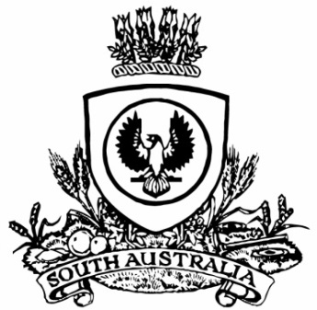
No. 10 971
SUPPLEMENTARY GAZETTE
THE SOUTH AUSTRALIAN
GOVERNMENT GAZETTE
Published by Authority

Adelaide, Saturday, 17 February 2018

South Australia
Constitution (Prorogation of Parliament and Dissolution of House of Assembly) Proclamation 2018
under sections 6 and 28 of the Constitution Act 1934
1—Short title
This proclamation may be cited as the Constitution (Prorogation of Parliament and Dissolution of House of Assembly) Proclamation 2018.
2—Commencement
This proclamation comes into operation on the day on which it is made.
3—Prorogation of Parliament
The Parliament of South Australia is prorogued until 10 April 2018.
4—Dissolution of House of Assembly
The House of Assembly is dissolved.
Made by the Governor
with the advice and consent of the Executive Council
on 17 February 2018
DPC18/013CS

