
THE SOUTH AUSTRALIAN
GOVERNMENT GAZETTE
Published by Authority

Adelaide, Tuesday, 23 January 2018

Contents

Appointments, Resignations, Etc. 204
Aquaculture Act 2001—Notices 206
Corporations and District Councils—Notices 398
Development Act 1993—Notices 206
Electoral Act 1985—Notices 207
Fisheries Management Act 2007—Notices 261
Health Care Act 2008—Notice 265
Housing Improvement Act 2016—Notices 267
Land Acquisition Act 1969—Notices 267
Liquor Licensing Act 1997—Notice 269
Mining Act 1971—Notices 272
National Parks and Wildlife (National Parks)
Regulations 2016—Notice 275
Notice to Mariners—Notices 276
Passenger Transport Act 1994—Notice 276
Petroleum and Geothermal Energy Act 2000
—Notices 277
Proclamations 282
Professional Standards Act 2004—Notice 278
Public Sector Act 2009—Notice 278
Regulations
Summary Offences Act 1953—(No. 1 of 2018) 284
Livestock Act 1997—(No. 2 of 2018) 286
Magistrates Court Act 1991—(No. 3 of 2018) 297
Magistrates Court Act 1991—(No. 4 of 2018) 299
Road Traffic Act 1961—(No. 5 of 2018) 302
Road Traffic Act 1961—(No. 6 of 2018) 375
Road Traffic Act 1961—(No. 7 of 2018) 377
Road Traffic Act 1961—(No. 8 of 2018) 379
Dangerous Substances Act 1979—(No. 9 of 2018) 381
Development Act 1993—(No. 10 of 2018) 383
Rules of Court
Corporations Rules 2003—(Amendment No. 9) 387
Corporations Supplementary Rules 2015—
(Amendment No. 1) 392
Shop Trading Hours Act 1977—Notice 279
Summary Offences Act 1953—Notice 279
Training and Skills Development Act 2008—Notice 281
Trustee Act 1936—Administration of Estates. 400
Unclaimed Moneys Act 1891—Notice 400

Department of the Premier and Cabinet
Adelaide, 23 January 2018
His Excellency the Governor in Executive Council has been pleased to appoint the undermentioned to the Pastoral Land Appeal Tribunal Panel of Experts, pursuant to the provisions of the Pastoral Land Management and Conservation Act 1989 and Pastoral Land Management and Conservation Regulations 2006:
Panel Member: from 23 January 2018 until 22 January 2021
Jennifer Beverley Nolan
Catherine Hollingsworth
Alan Mark Rumsby
Richard Raymond Barratt
By command,
Ian Keith Hunter
for Premier
18MSECCS002

Department of the Premier and Cabinet
Adelaide, 23 January 2018
His Excellency the Governor in Executive Council has been pleased to appoint the undermentioned to the Minister's Advisory Committee, pursuant to the provisions of the Return to Work Act 2014:
Member: from 23 January 2018 until 30 November 2020
Michelle Maria Atchison
Peter Jezukaitis
Roger Paterson
Estha van der Linden
Stephen Myatt
Anna Louise Moeller
Donald Blairs
Elizabeth Dabars
Les Birch
By command,
Ian Keith Hunter
for Premier
MIR0038/17CS

Department of the Premier and Cabinet
Adelaide, 23 January 2018
His Excellency the Governor in Executive Council has been pleased to appoint the undermentioned to the Minister's Advisory Committee, pursuant to the provisions of the Return to Work Act 2014 and section 36 of the Acts Interpretation Act 1915:
Deputy Member: from 23 January 2018 until 30 June 2018
Robert Bonner (Deputy to Dabars)
By command,
Ian Keith Hunter
for Premier
MIR0038/17CS

Department of the Premier and Cabinet
Adelaide, 23 January 2018
His Excellency the Governor in Executive Council has been pleased to appoint Brian Stuart McKenny to the position of Chief Psychiatrist, for a term commencing on 23 January 2018 and expiring on 17 May 2018 - pursuant to Section 89 of the Mental Health Act 2009.
By command,
Ian Keith Hunter
for Premier
HEAC-2018-00002

Department of the Premier and Cabinet
Adelaide, 23 January 2018
His Excellency the Governor in Executive Council has suspended the appointment of Elizabeth Dabars as a Member of the Minister’s Advisory Committee, effective from 23 January 2018 and expiring on 30 June 2018, pursuant to the Return to Work Act 2014 and section 36 of the Acts Interpretation Act 1915.
By command,
Ian Keith Hunter
for Premier
MIR0038/17CS

Department of the Premier and Cabinet
Adelaide, 23 January 2018
His Excellency the Governor in Executive Council has been pleased to appoint Bret Walker SC, to be a Commissioner to enquire into and report upon the matters set out in the commission issued to the said Bret Walker SC on 23 January 2018 - pursuant to the Royal Commissions Act 1917.
By command,
Ian Keith Hunter
for Premier
AGO0008/18CS

Department of the Premier and Cabinet
Adelaide, 23 January 2018
HIS EXCELLENCY THE HONOURABLE HIEU VAN LE, Companion in the Order of Australia, Governor in and over the State of South Australia:
TO
BRET WALKER, SC
GREETING
Whereas
- South Australia is a “Basin State” within the meaning of the Water Act 2007 (Cth) (“the Act”), the Basin Plan made under s.44(3)(b)(i) of the Act, and is a party to the Murray-Darling Basin Agreement (“the Basin Agreement”), which forms Schedule 1 to the Act.
- There exist “Water Resource Plan Areas”, as defined in the Basin Plan, within the State of South Australia. The South Australian River Murray forms the downstream area of the Water Resource Plan Areas outlined in the Basin Plan.
- The objects and purposes of the Act and the Basin Plan include, but are not limited to, the following matters:
  - ensuring the return to environmentally sustainable levels of extraction for water resources that are over-allocated or over-used;
  - to protect, restore and provide for the ecological values and ecosystem services of the Murray-Darling Basin (taking into account, in particular, the impact that the taking of the water has on the water courses, lakes, wetlands, groundwater and water dependent ecosystems that are part of the Basin water resources and on associated biodiversity);
  - the establishment and enforcement of environmentally sustainable limits on the quantities of surface water and groundwater that may be taken from the Basin water resources (including by interception activities);
  - to give effect to relevant international agreements through the integrated management of Basin water resources;
  - to establish a sustainable and long term adaptive management framework for the Basin water resources, that takes into account the broader management of natural resources in the Murray-Darling Basin;
  - to optimise social, economic and environmental outcomes arising from the use of Basin water resources in the national interest;
  - to achieve certain “enhanced environmental outcomes”.
These objects and purposes are more fully outlined in ss.3, 20 and 28 of the Act, chapters 5 and 8 of the Basin Plan, and Schedule 5 of the Basin Plan in relation to enhanced environmental outcomes.
- The purpose of the Basin Agreement is to promote and co-ordinate effective planning and management for the equitable, efficient and sustainable use of water and other natural resources of the Murray-Darling Basin, including implementing arrangements between the Basin States in order to give effect to the Basin Plan and the Act.
- As a Basin State, as a contracting party to the Basin Agreement, and as the downstream State, which includes the South Australian River Murray Water Resource Plan Area, South Australia has a significant interest in:
  - compliance with and the effectiveness of the Basin Plan generally;
  - the delivery of Water Resource Plans defined by the Act and Basin Plan in forms compliant and consistent with the Basin Plan by 30 June 2019; and
  - the protection and improvement of the environment of the Murray-Darling Basin, which is itself dependent upon the implementation and effective operation of the Basin Plan.
- The South Australian Government is concerned at recent reports as to alleged non-compliance with the Basin Plan, the current state of implementation of the Basin Plan, and whether the Basin Plan will achieve its objects and purposes and those of the Act. It considers that an independent Commission of Inquiry with coercive powers is required to inquire into these and related matters
I, the Governor, with the advice and consent of the Executive Council, DO HEREBY APPOINT YOU to be a Commissioner to inquire into and report upon the following matters:
- Whether the Water Resource Plans defined by the Act and Basin Plan (which are to include the long-term average sustainable diversion limits for each Basin water resource) will be delivered in full and in a form compliant and consistent with the Basin Plan by 30 June 2019.
- If any Water Resource Plans are unlikely to be delivered in full and in a form compliant and consistent with the Basin Plan, the reasons for this.
- Whether the Basin Plan in its current form, its implementation, and any proposed amendments to the Plan, are likely to achieve the objects and purposes of the Act and Plan as variously outlined in ss.3, 20, 23 and 28 of the Act, and the ‘enhanced environmental outcomes’ and additional 450 GL provided for in s. 86AA(2) and (3) of the Act, respectively.
- Whether the underlying assumptions in the original modelling used to develop the objects and purposes of the Act and the Basin Plan have been sufficiently adjusted for the impact of improved technologies.
- If the Basin Plan is unlikely to achieve any of the objects and purposes of the Act and Basin Plan and/or the ‘enhanced environmental outcomes’ and the additional 450 GL referred to above, what amendments should be made to the Basin Plan or Act to achieve those objects and purposes, the ‘enhanced environmental outcomes’ and the additional 450 GL?
- Any legislative or other impediments to achieving any of the objects and purposes of the Act and Basin Plan and/or the ‘enhanced environmental outcomes’ and additional 450 GL referred to above, and any recommendations for legislative or other change if needed.
- The likely impact of alleged illegal take or other forms of non-compliance on achieving any of the objects and purposes of the Act and Basin Plan, and the ‘enhanced environmental outcomes’ and the additional 450 GL, referred to above.
- In relation to any found instances of illegal take or work, whether appropriate enforcement proceedings have been taken in respect of such matters and if not, why.
- Whether, in any event, the enforcement and compliance powers under the Act are adequate to prevent and address non-compliance with the Act and the Basin Plan, and any recommendations for legislative or other change if needed.
- Whether monitoring, metering and access to relevant information (such as usage data) is adequate to achieve the objects and purposes of the Act and Basin Plan and the ‘enhanced environmental outcomes’ and additional 450 GL referred to above.
- Whether water that is purchased by the Commonwealth for the purposes of achieving the objects and purposes of the Act and Basin Plan and/or the ‘enhanced environmental outcomes’ and the additional 450 GL referred to above will be adequately protected from take for irrigation under water resource plans, and any recommendations for legislative or other change if needed.
- Whether the Basin Plan in its current form, its implementation, and any proposed amendments to the Plan, are adequate to achieve the objects and purposes of the Act and Basin Plan, the ‘enhanced environmental outcomes’ and the additional 450 GL referred to above, taking into account likely, future climate change.
- Any other related matters.
AND I:
- Require you to begin your inquiry as soon as practicable.
- Require you to make your inquiry as expeditiously as possible.
- Require you to submit your final report by 1 February 2019. The provision of interim reports is at the discretion of the Commissioner.
GIVEN under my hand and the Public Seal of South Australia, at Adelaide, this 23rd day of January 2018.
By command,
Ian Keith Hunter
for Premier
Recorded in Register of Commissions, Letters Patent, Etc., Vol. XXVIII
M. Brougham
Clerk of Executive Council
GOD SAVE THE QUEEN!

AQUACULTURE ACT 2001
Grant of Aquaculture Lease
Pursuant to the provisions of section 22 of the Aquaculture Act 2001, notice is hereby given of the grant of the following lease for the purposes of aquaculture in the waters of the state:
LA00416
Further details are available for the above lease on the Aquaculture Public Register; which can be found at http://www.pir.sa.gov.au/aquaculture/aquaculture_public_register or by contacting Aquaculture Leasing & Licensing on 8226 0900.
Corina Girolamo
Leasing & Licensing Officer

AQUACULTURE ACT 2001
Grant of Aquaculture Lease
Pursuant to the provisions of section 22 of the Aquaculture Act 2001, notice is hereby given of the grant of the following leases for the purposes of aquaculture in the waters of the state:
LA00418
LA00419
Further details are available for the above leases on the Aquaculture Public Register; which can be found at http://www.pir.sa.gov.au/aquaculture/public_register or by contacting Aquaculture Leasing & Licensing on 8226 0900.
Corina Girolamo
Aquaculture Leasing & Licensing Officer

DEVELOPMENT ACT 1993
Notice under Section 26(9)
Repatriation General Hospital and Surrounding Areas Development Plan Amendment
Preamble
- The ‘Repatriation General Hospital and Surrounding Areas Development Plan Amendment’ (the Amendment) has been finalised in accordance with the provisions of the Development Act 1993.
- The Minister for Planning has decided to approve the Amendment.
PURSUANT to section 26 of the Development Act 1993, I –
  - approve the Amendment; and
  - fix the day on which this notice is published in the Gazette as the day on which the Amendment will come into operation.
Dated: 21 December 2017
John Rau
Deputy Premier
Minister for Planning

DEVELOPMENT ACT 1993
Section 28(1)
Declaration of Interim Operation of Rural City of Murray Bridge
Primary Production (Central Policy Area 3) Value Adding Development Plan Amendment
PURSUANT to Section 28 (1) of the Development Act 1993, I, John Rau, Minister for Planning, am of the opinion that it is necessary in the interest of the orderly and proper development of the area affected by the Rural City of Murray Bridge – Primary Production (Central Policy Area 3) Value Adding Development Plan Amendment (the Amendment), that the Amendment should come into operation without delay.
I declare that the Amendment will come into operation on an interim basis on the day in which this notice is published in the Gazette.
Dated: 14 December 2017
John Rau
Deputy Premier
Minister for Planning

ELECTORAL ACT 1985
Part 3, Division 2
TAKE notice that pursuant to Section 15 of the Electoral Act 1985, I, Mick Sherry, Electoral Commissioner, divide the House of Assembly electoral districts, named in the Schedule, that were defined in the Electoral Districts Boundaries Commission Order of 7 December 2016 and that become effective at the next general elections.
The division of the district boundaries into 84 subdivisions are named, delineated and described in the separate sketch plans contained in the Schedule.
The Schedule
Adelaide | Enfield | Kavel | Port Adelaide
Badcoe | Finniss | King | Ramsay
Black | Flinders | Lee | Reynell
Bragg | Florey | Light | Schubert
Chaffey | Frome | MacKillop | Stuart
Cheltenham | Gibson | Mawson | Taylor
Colton | Giles | Morialta | Torrens
Croydon | Hammond | Morphett | Unley
Davenport | Hartley | Mount Gambier | Waite
Dunstan | Heysen | Narungga | West Torrens
Elder | Hurtle Vale | Newland | Wright
Elizabeth | Kaurna | Playford

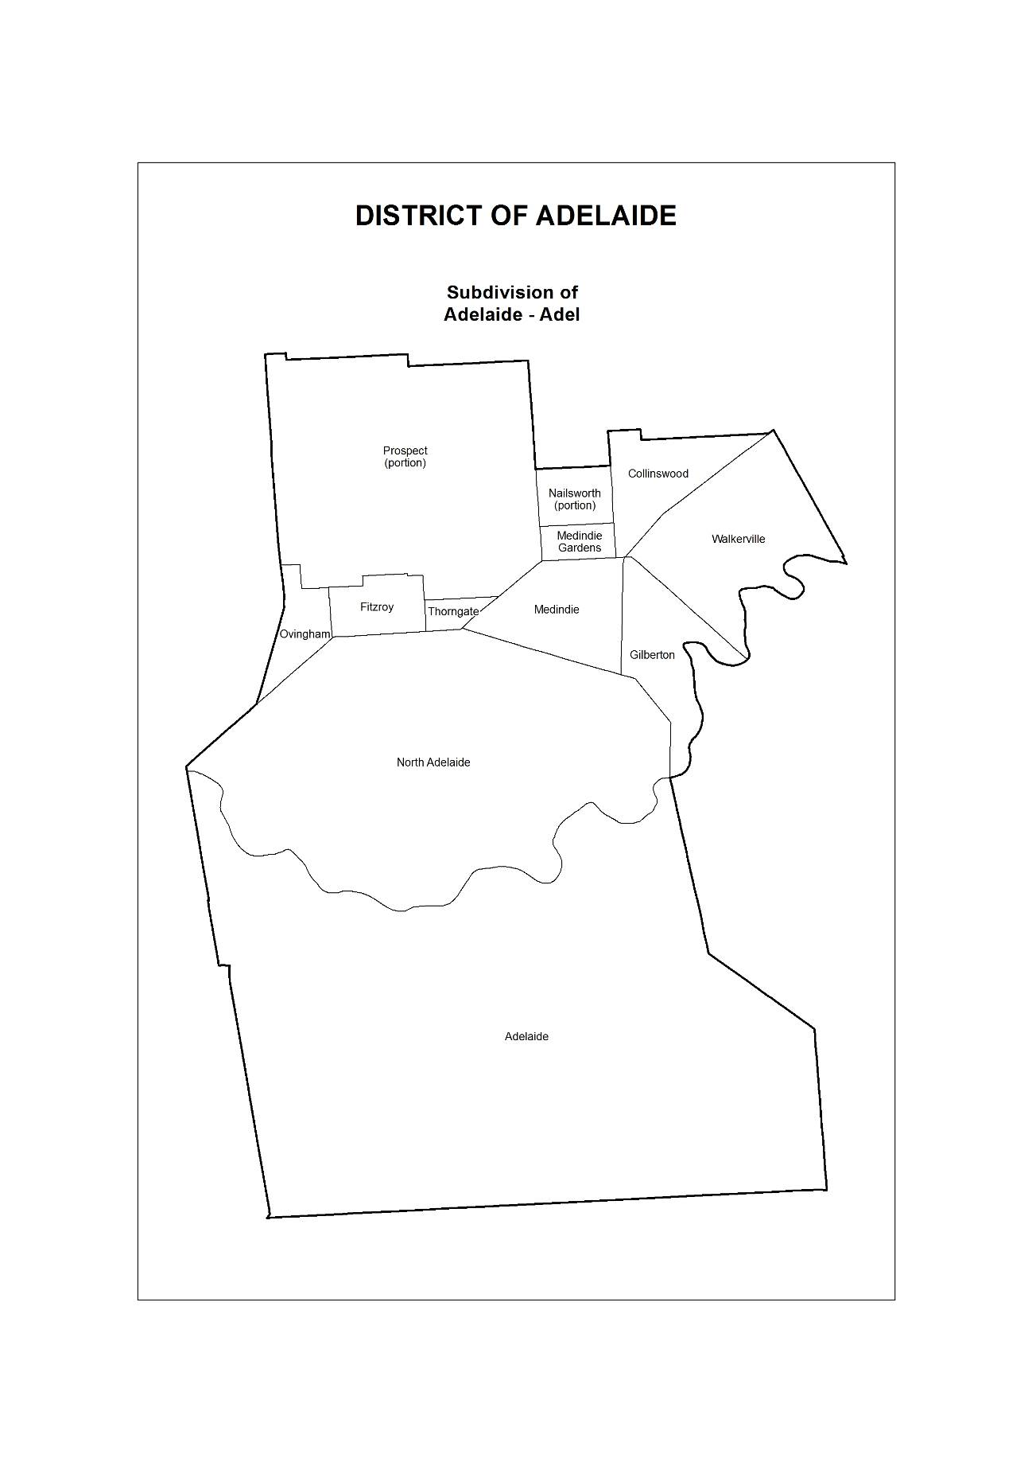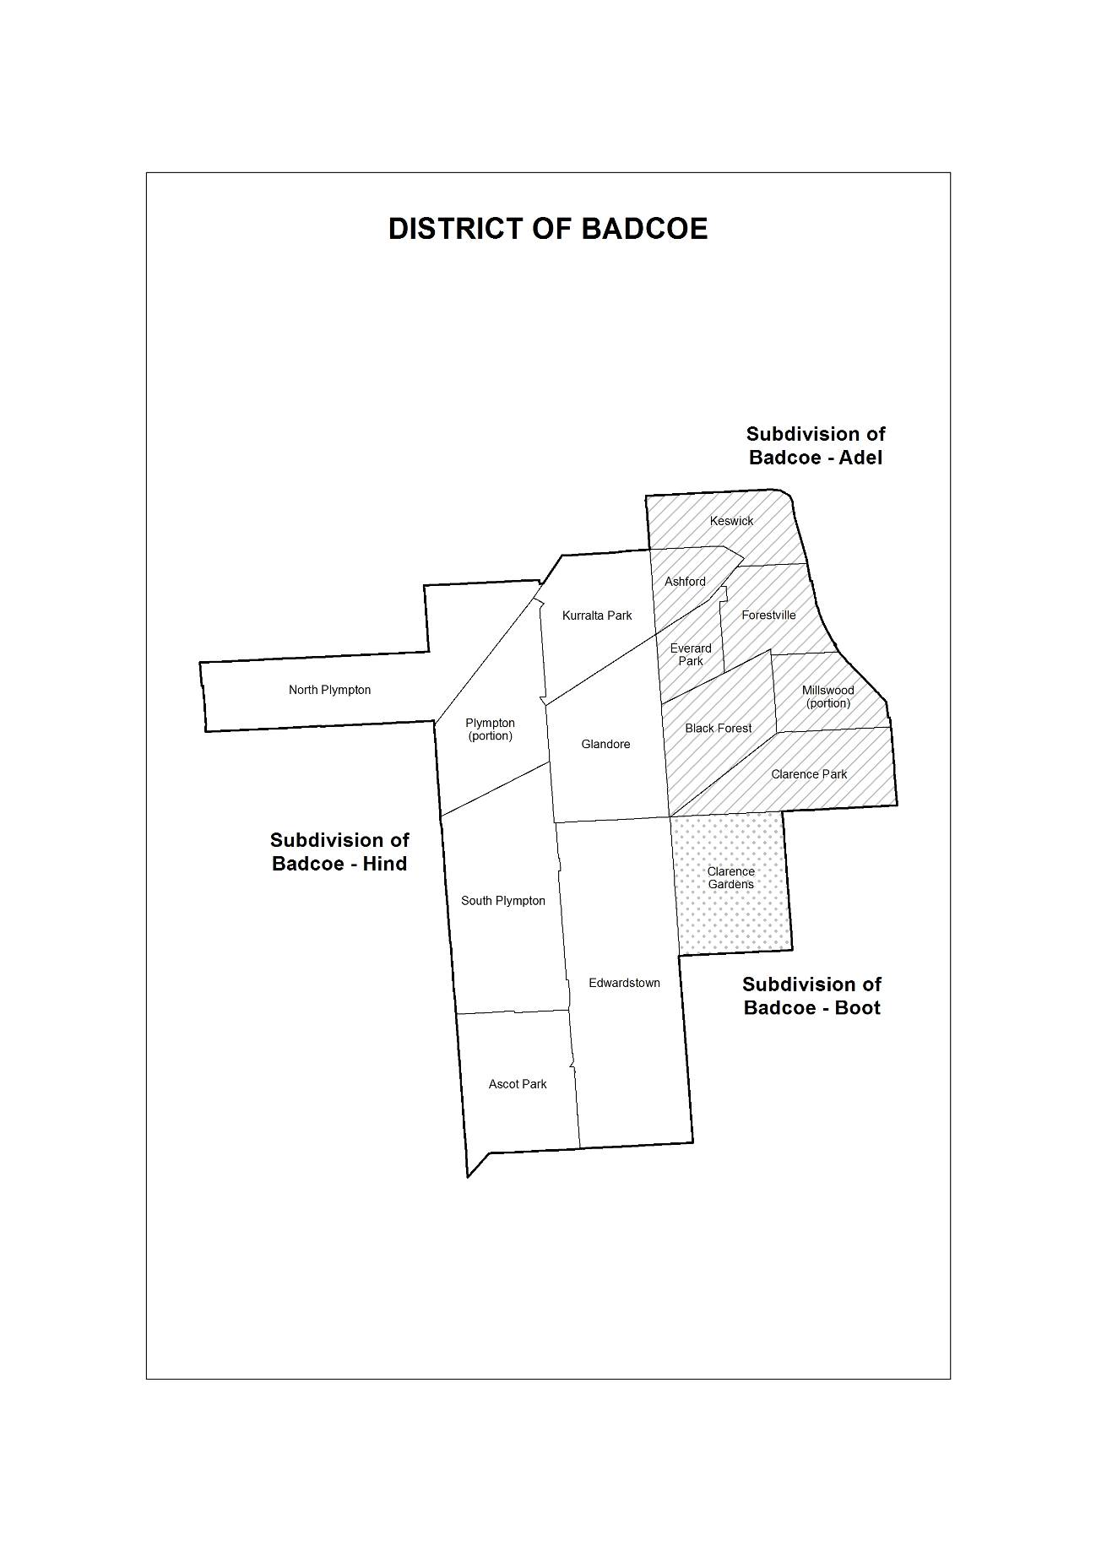
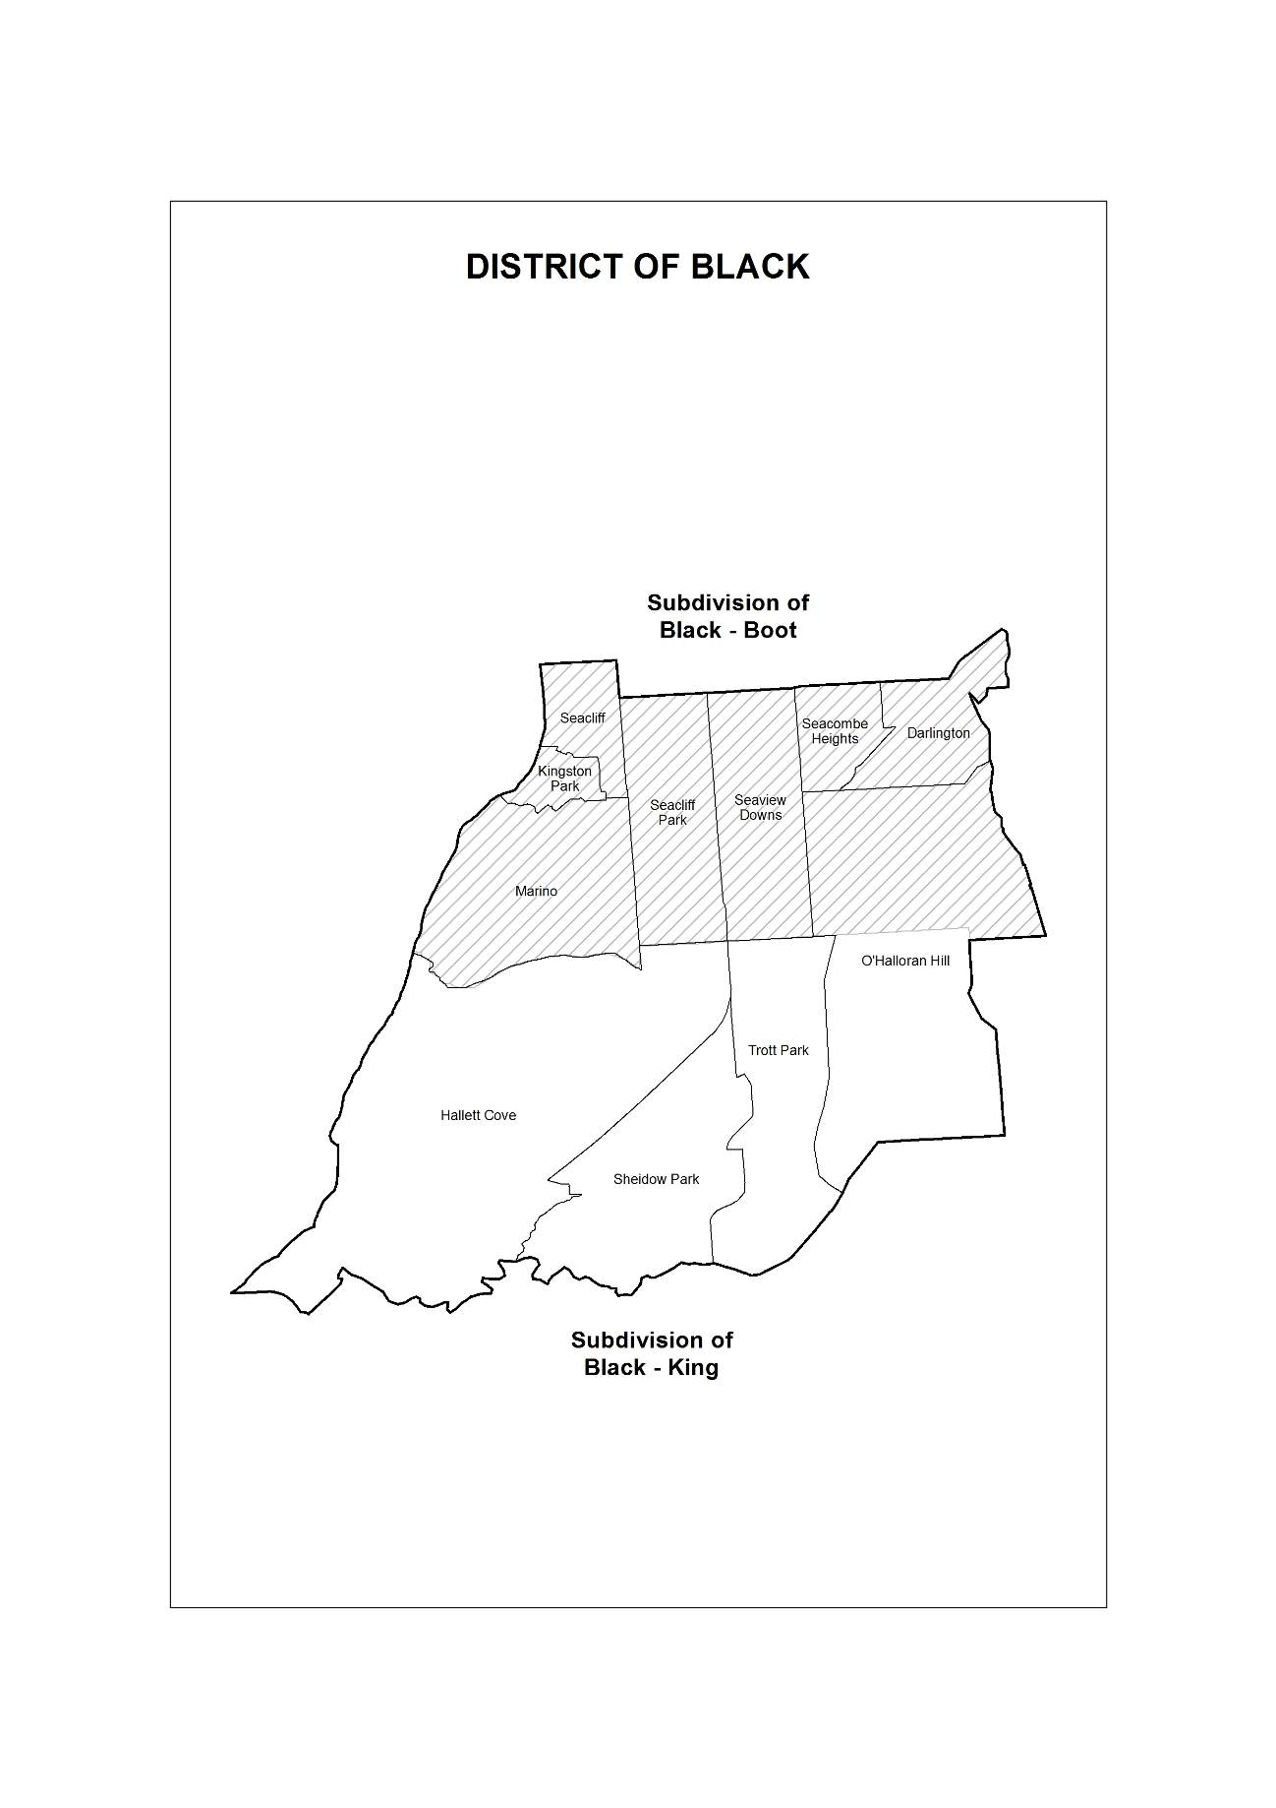
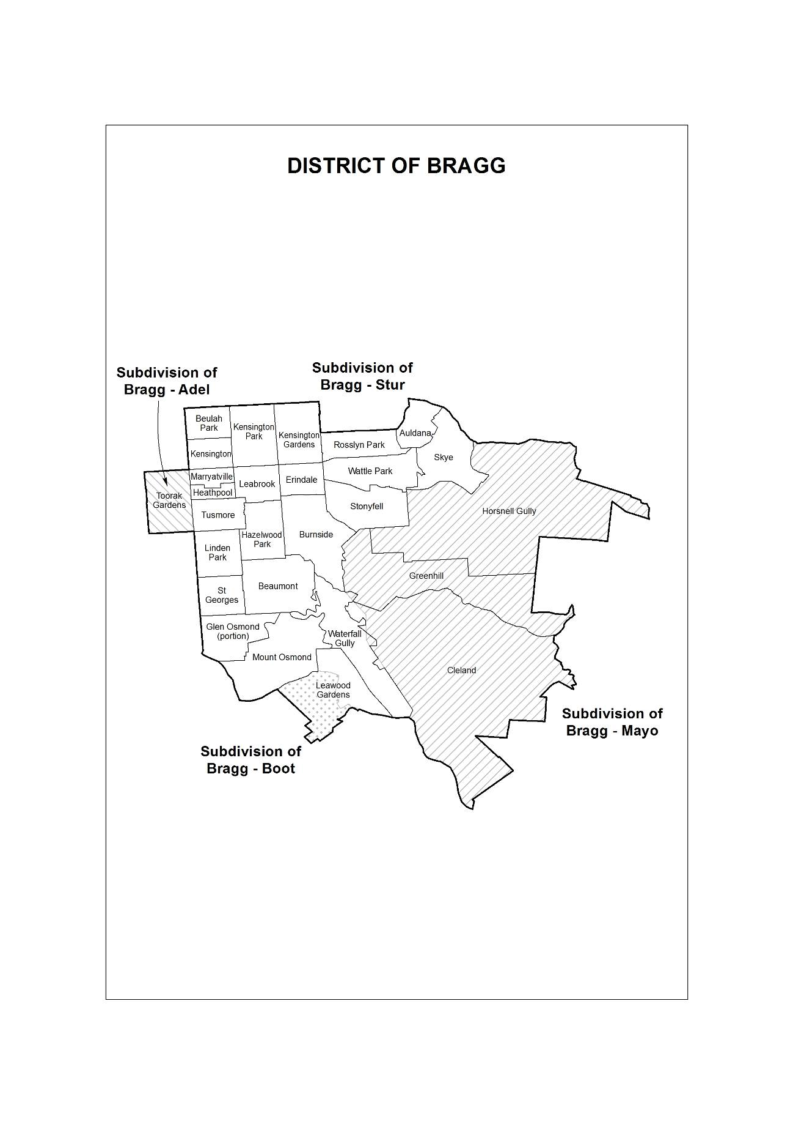
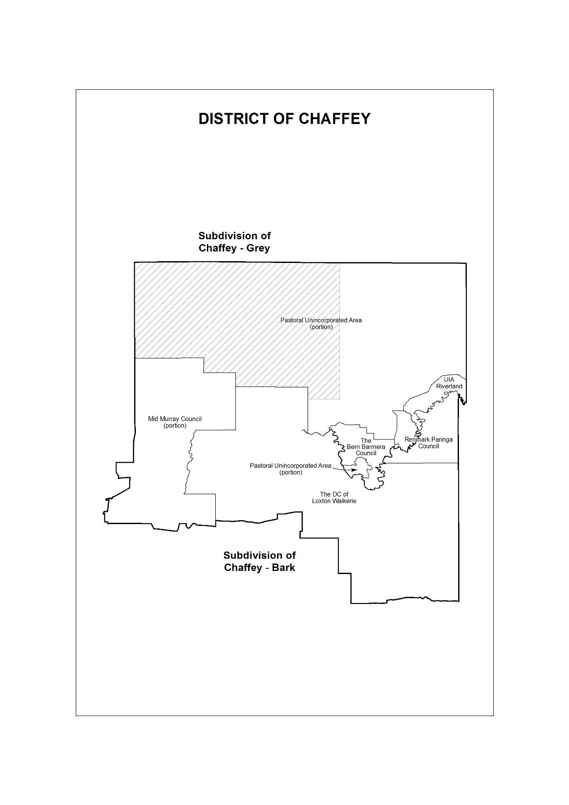
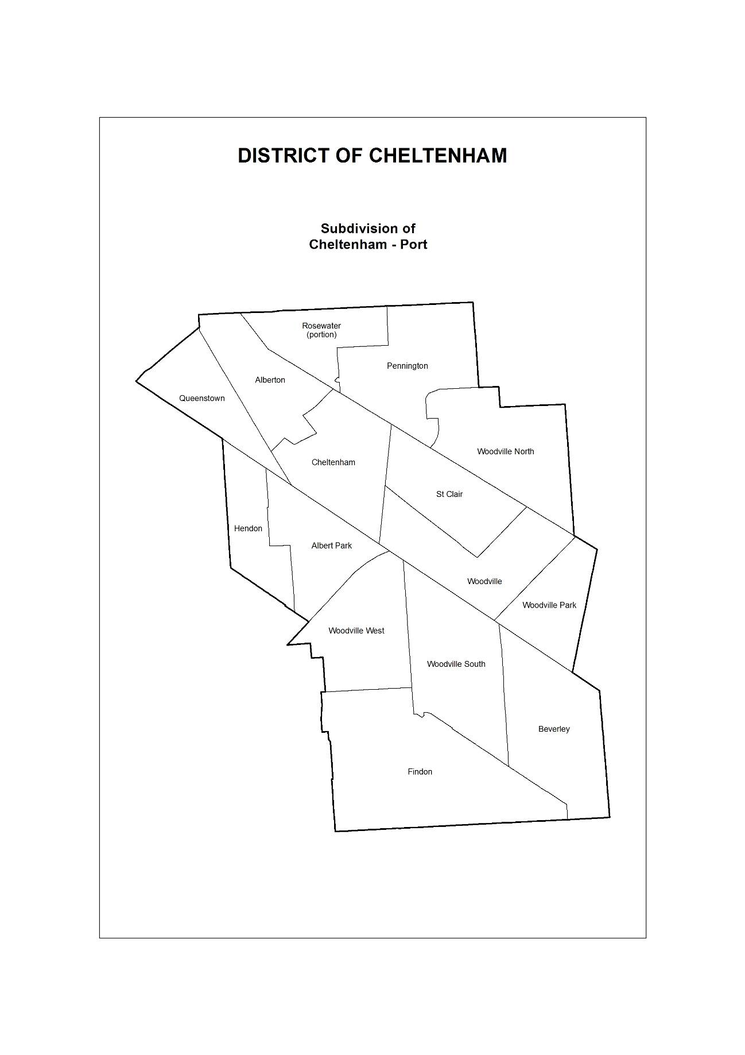
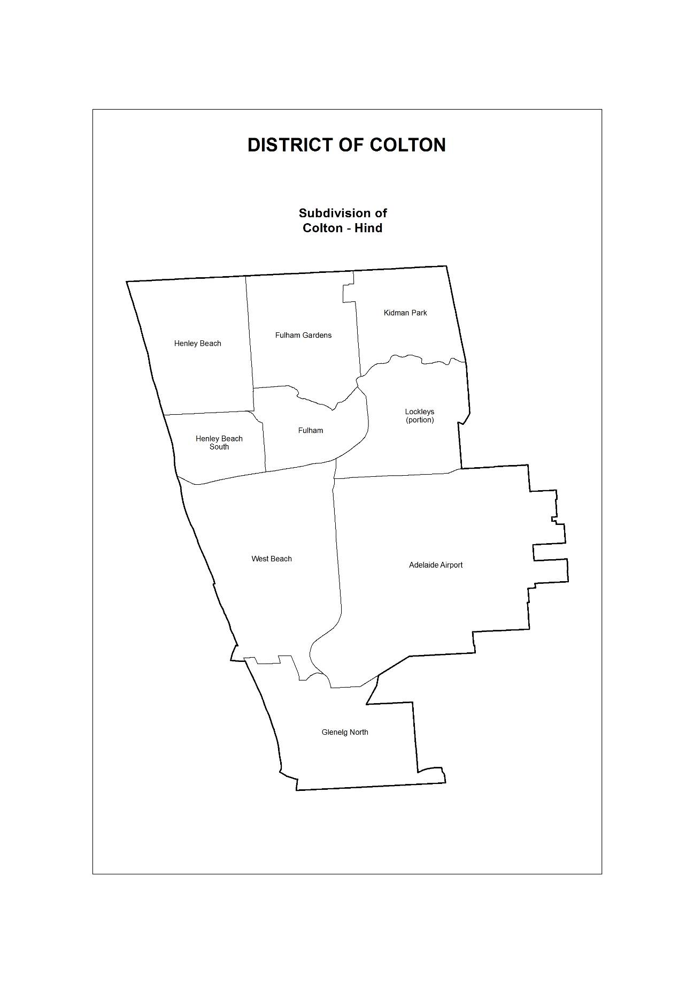
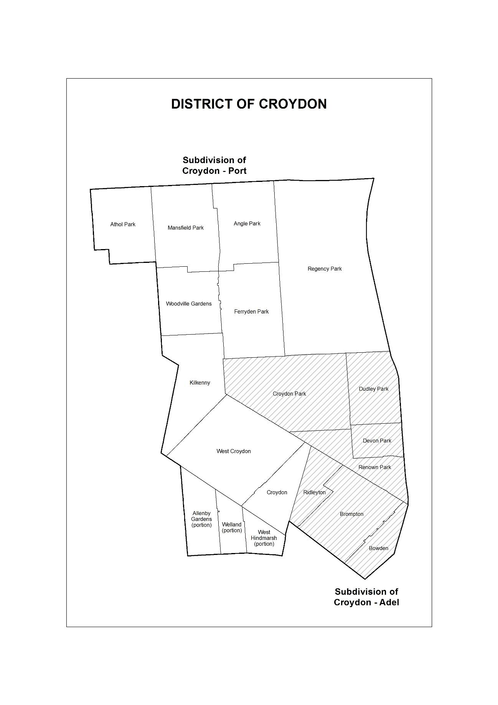
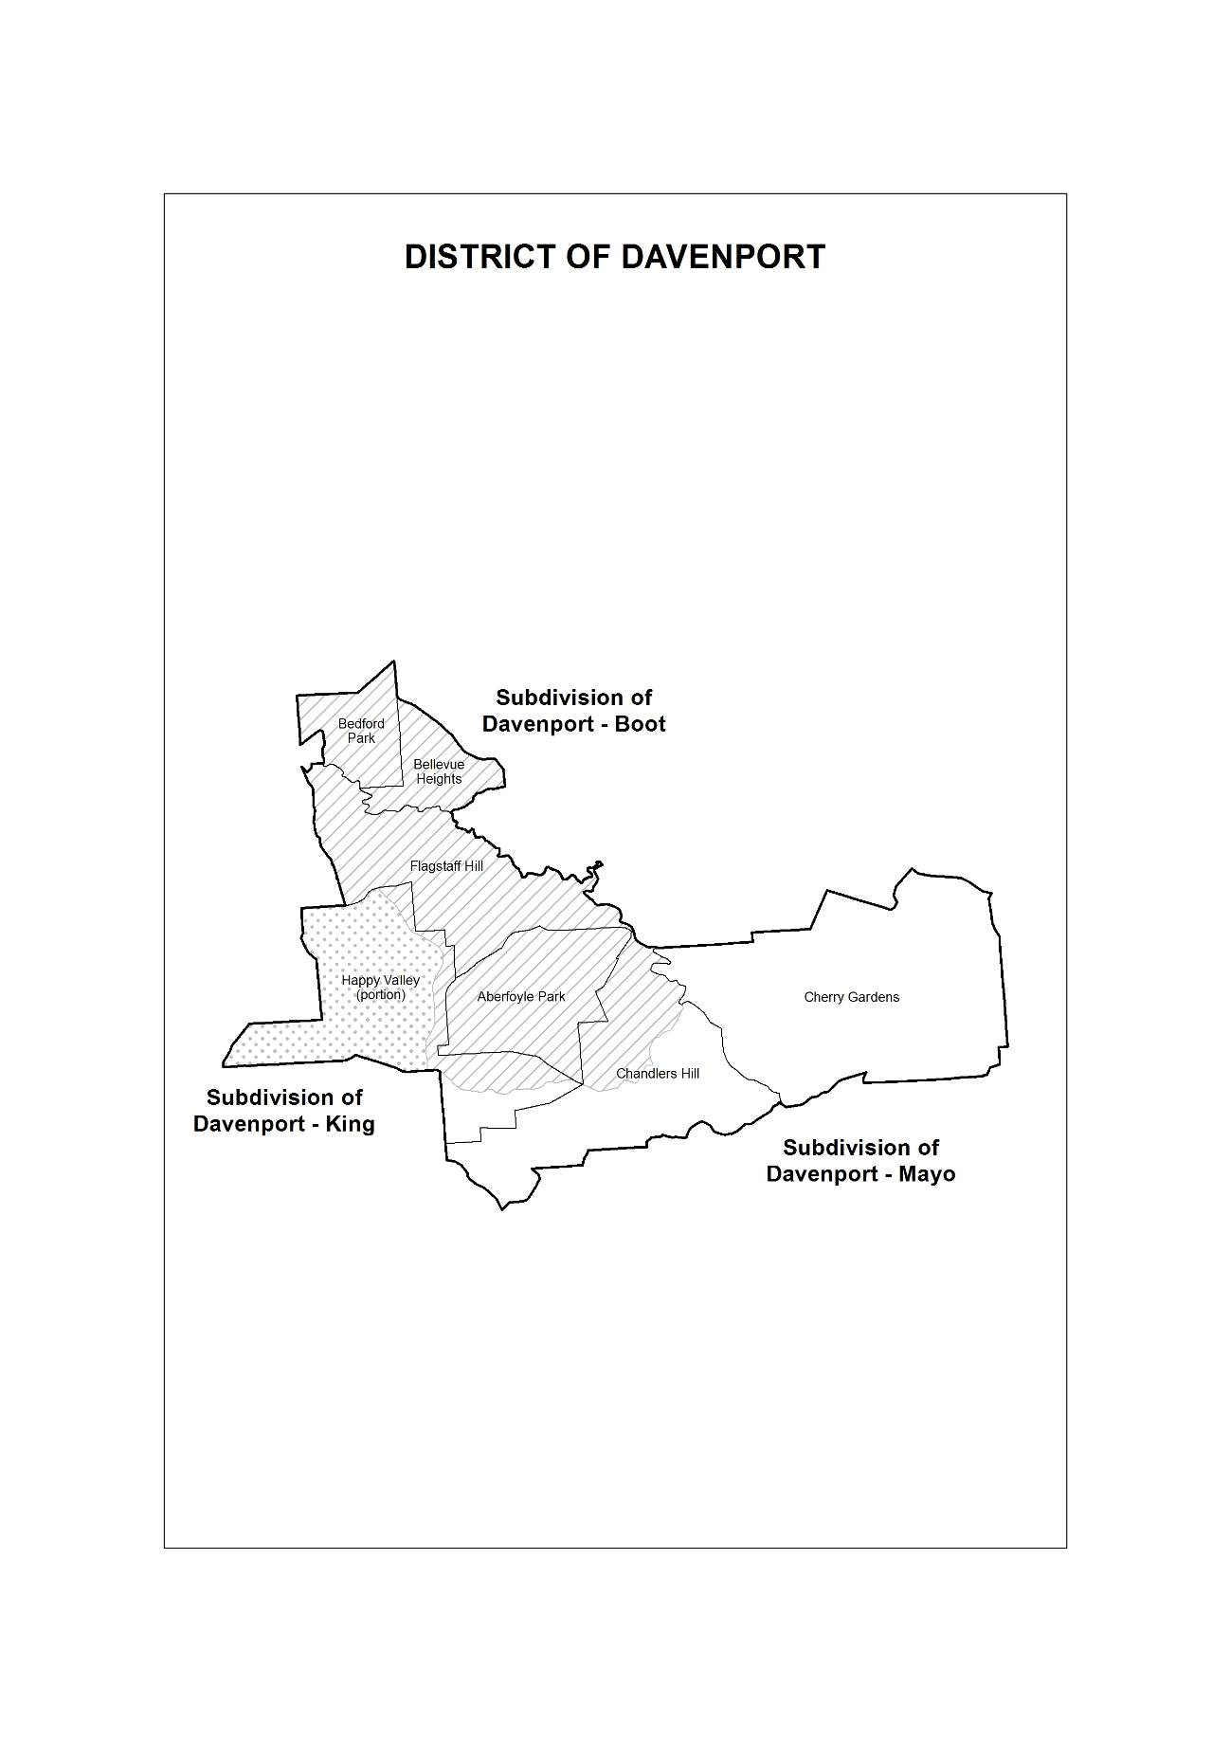
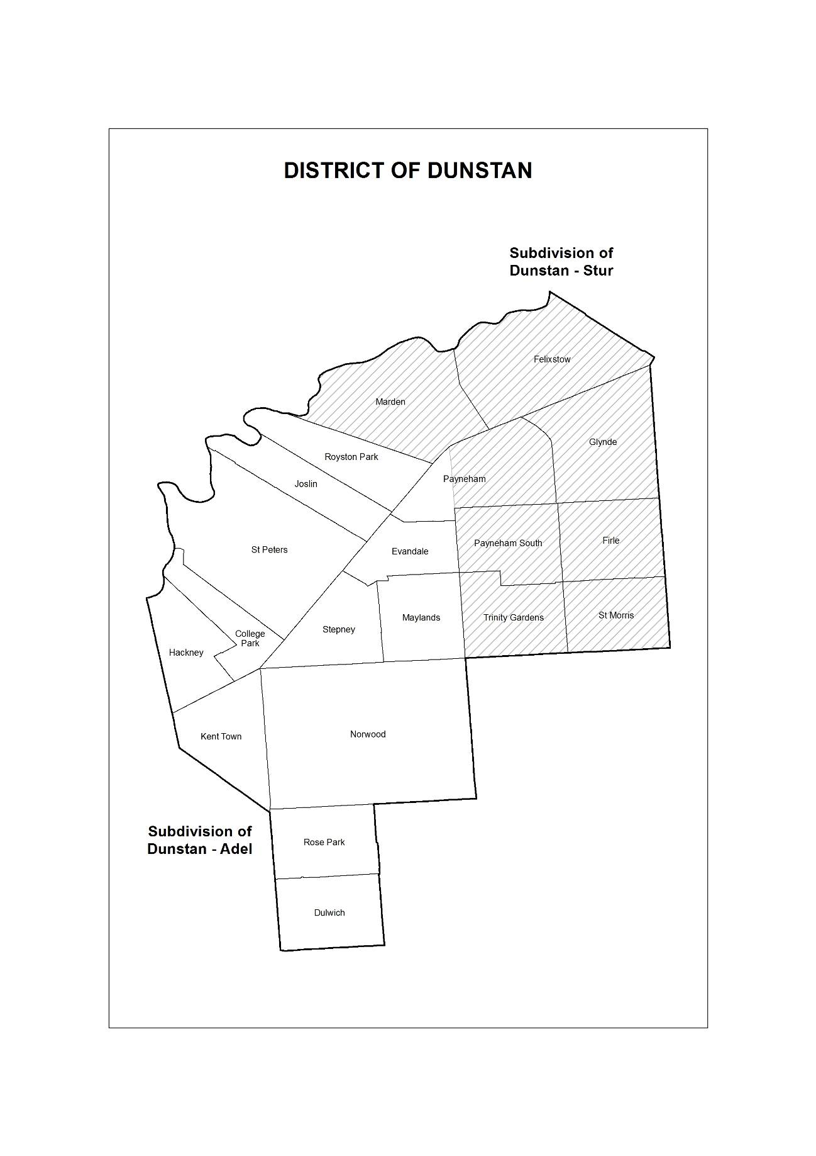
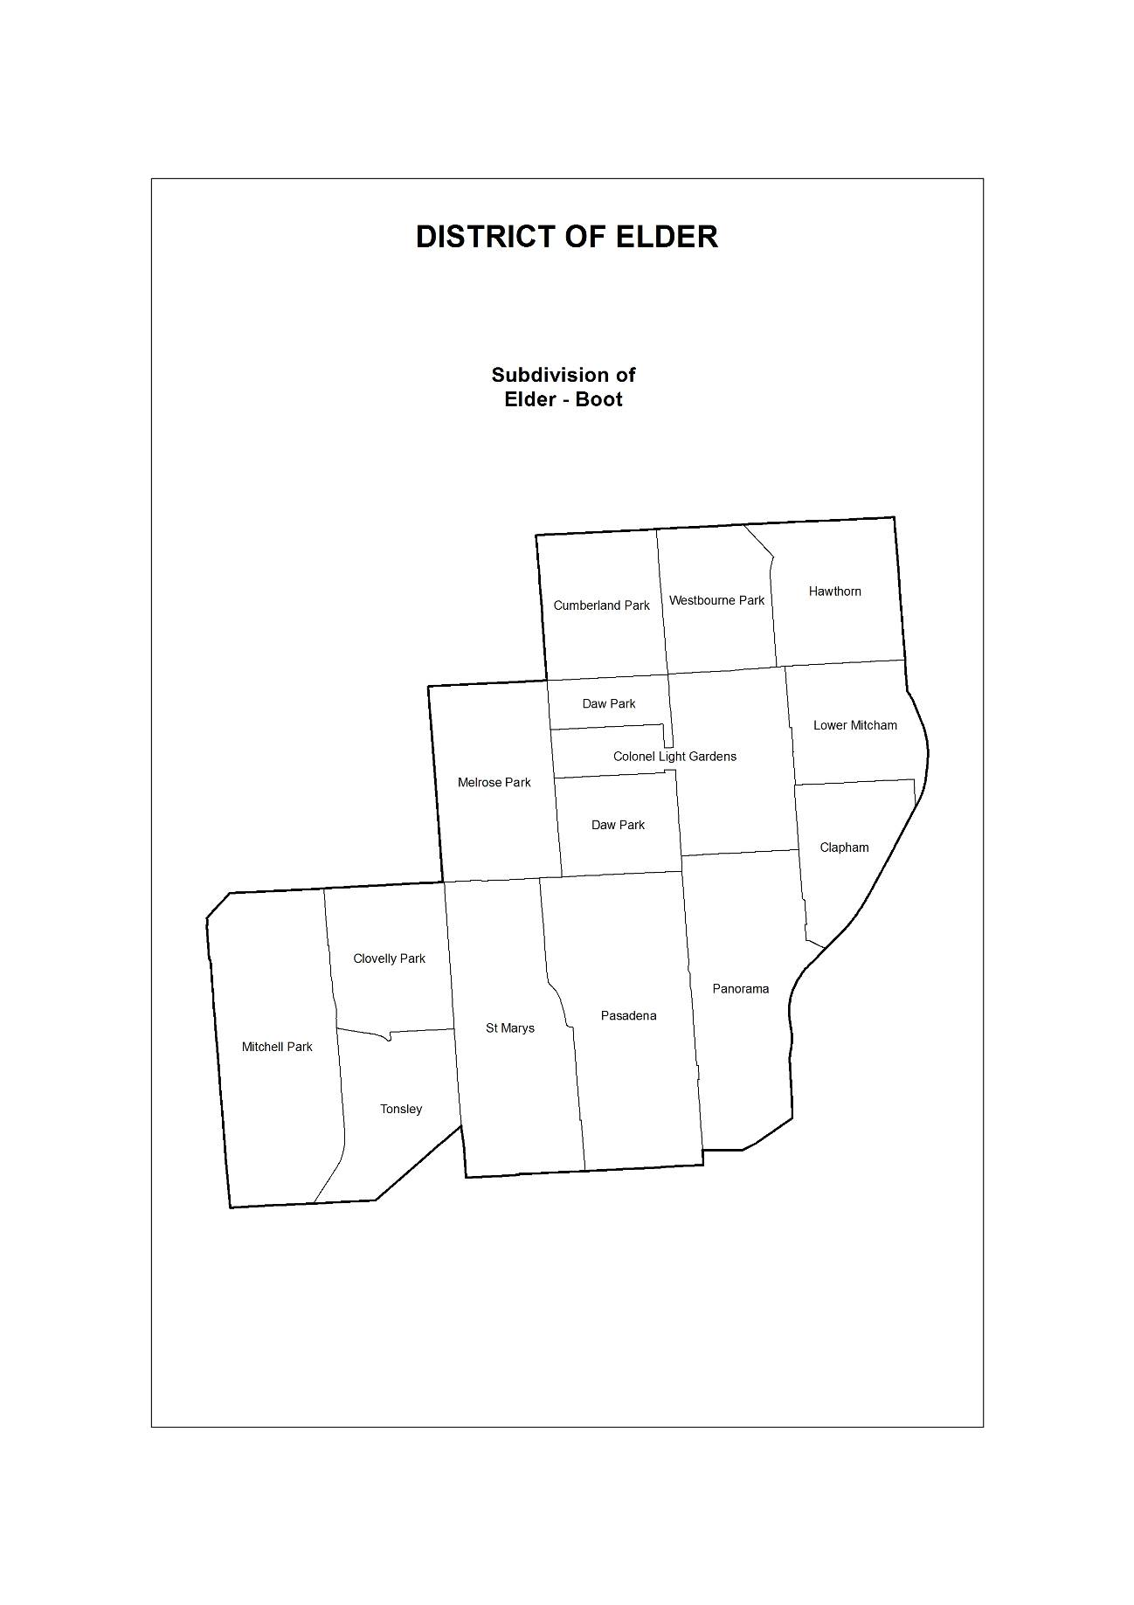
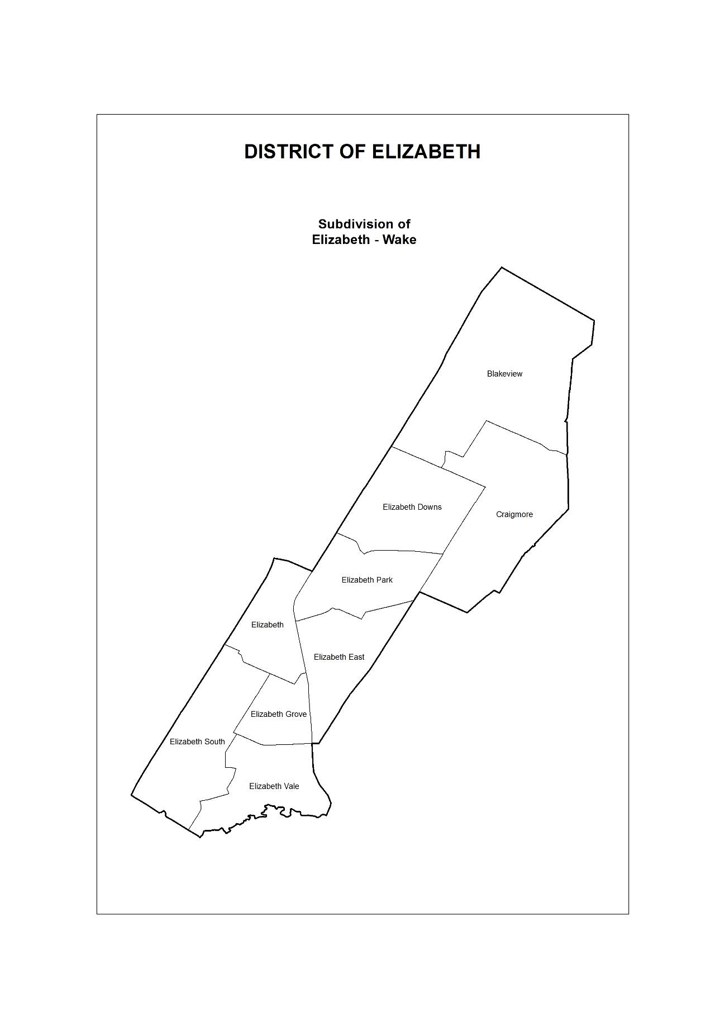
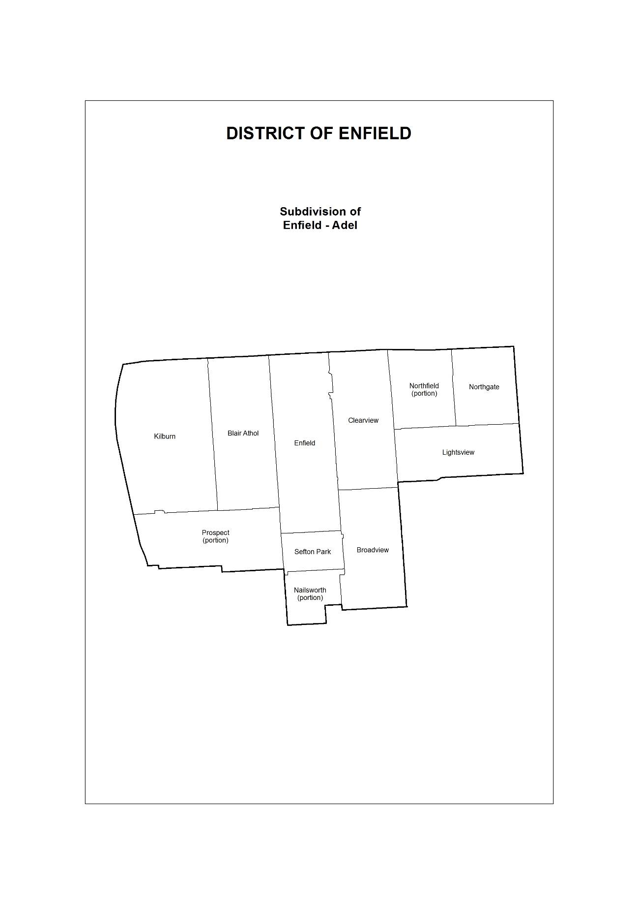
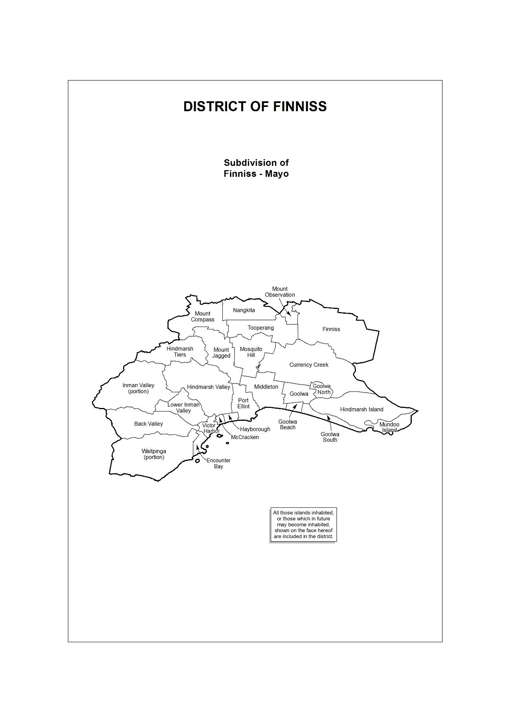
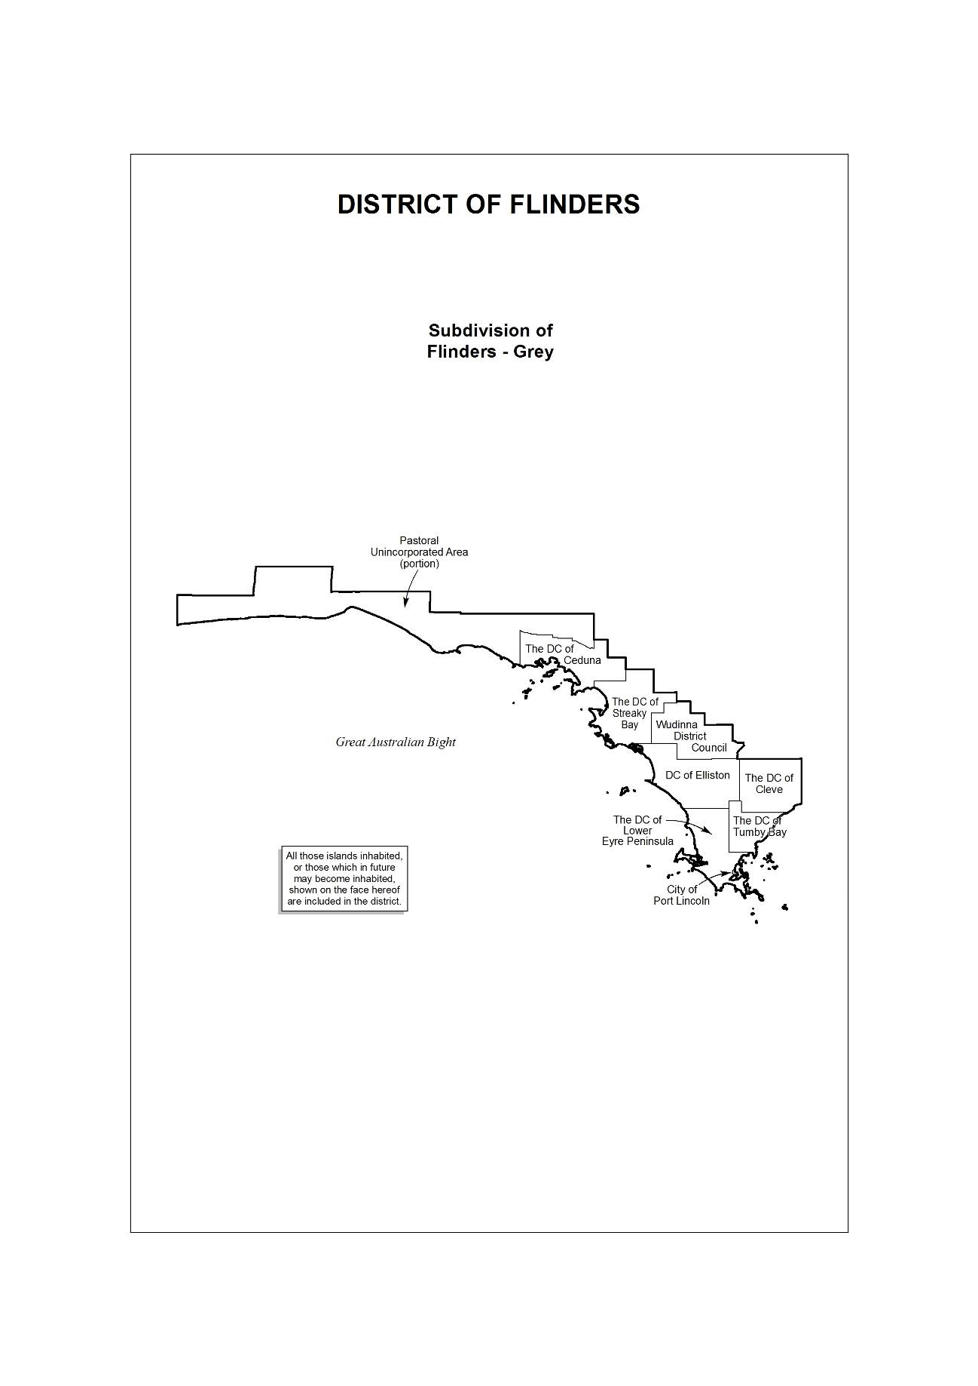
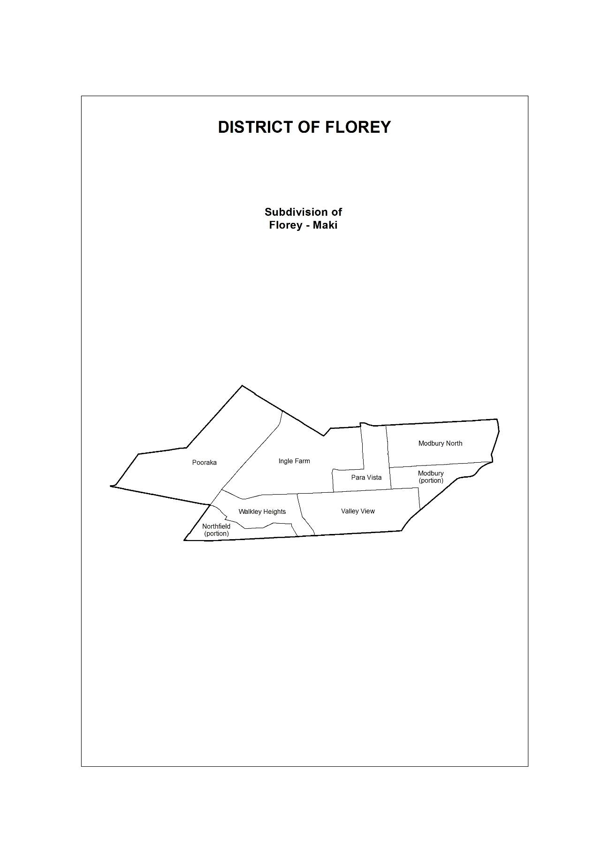
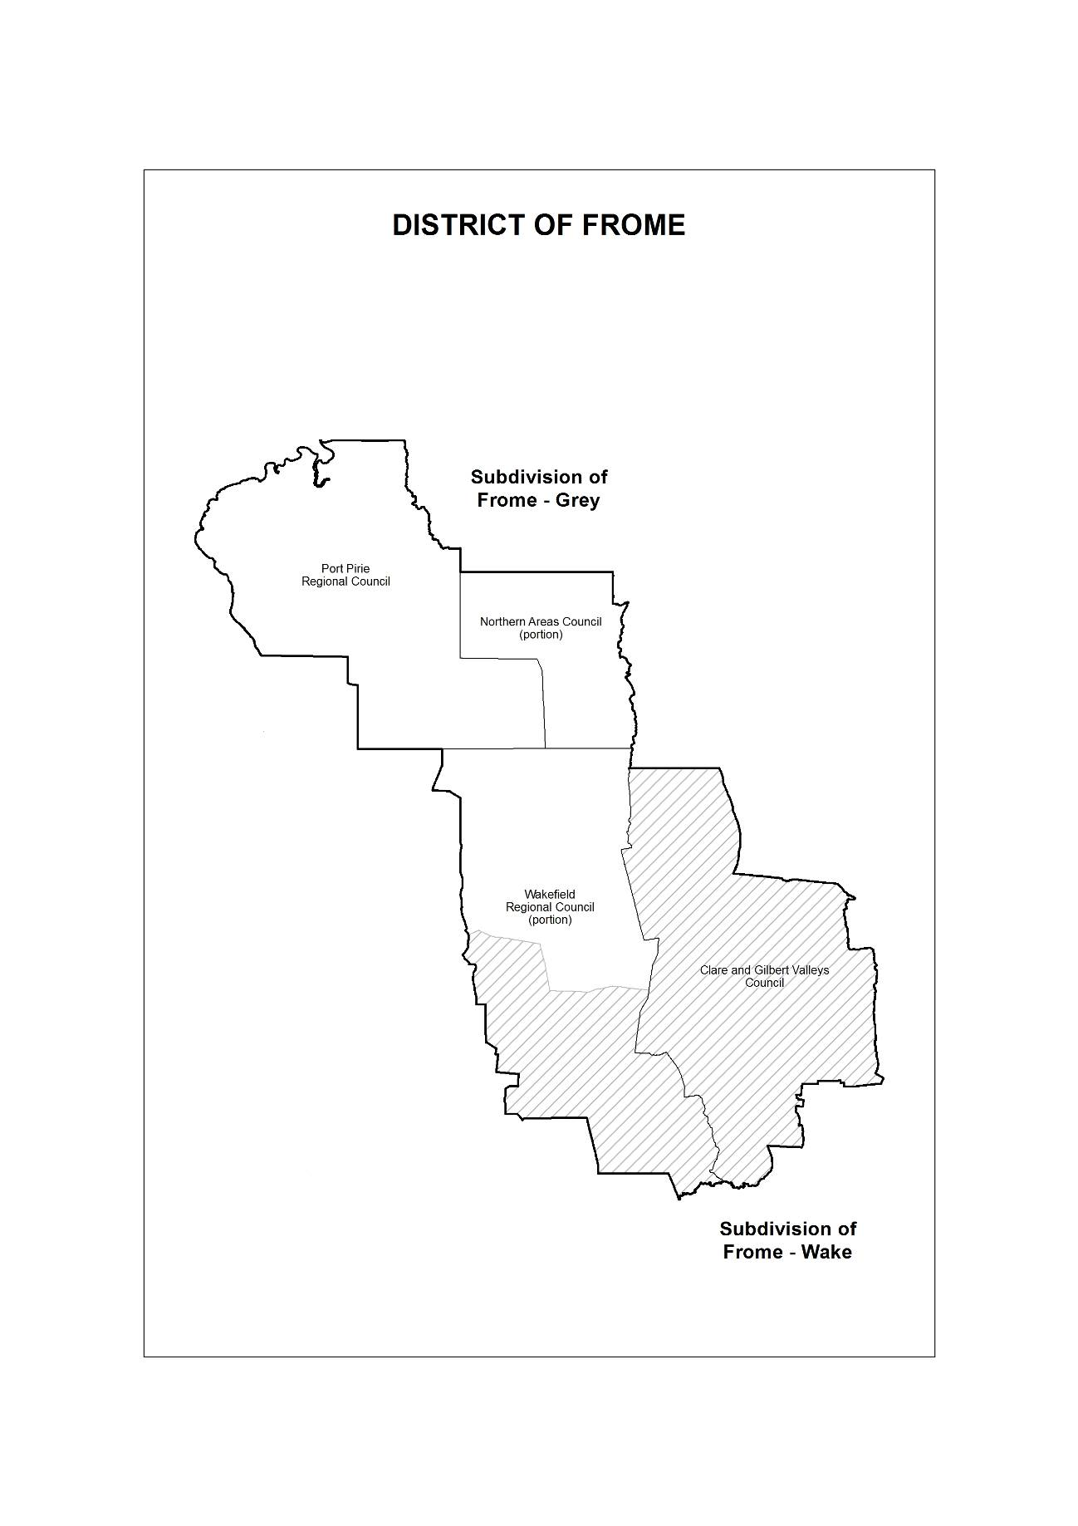
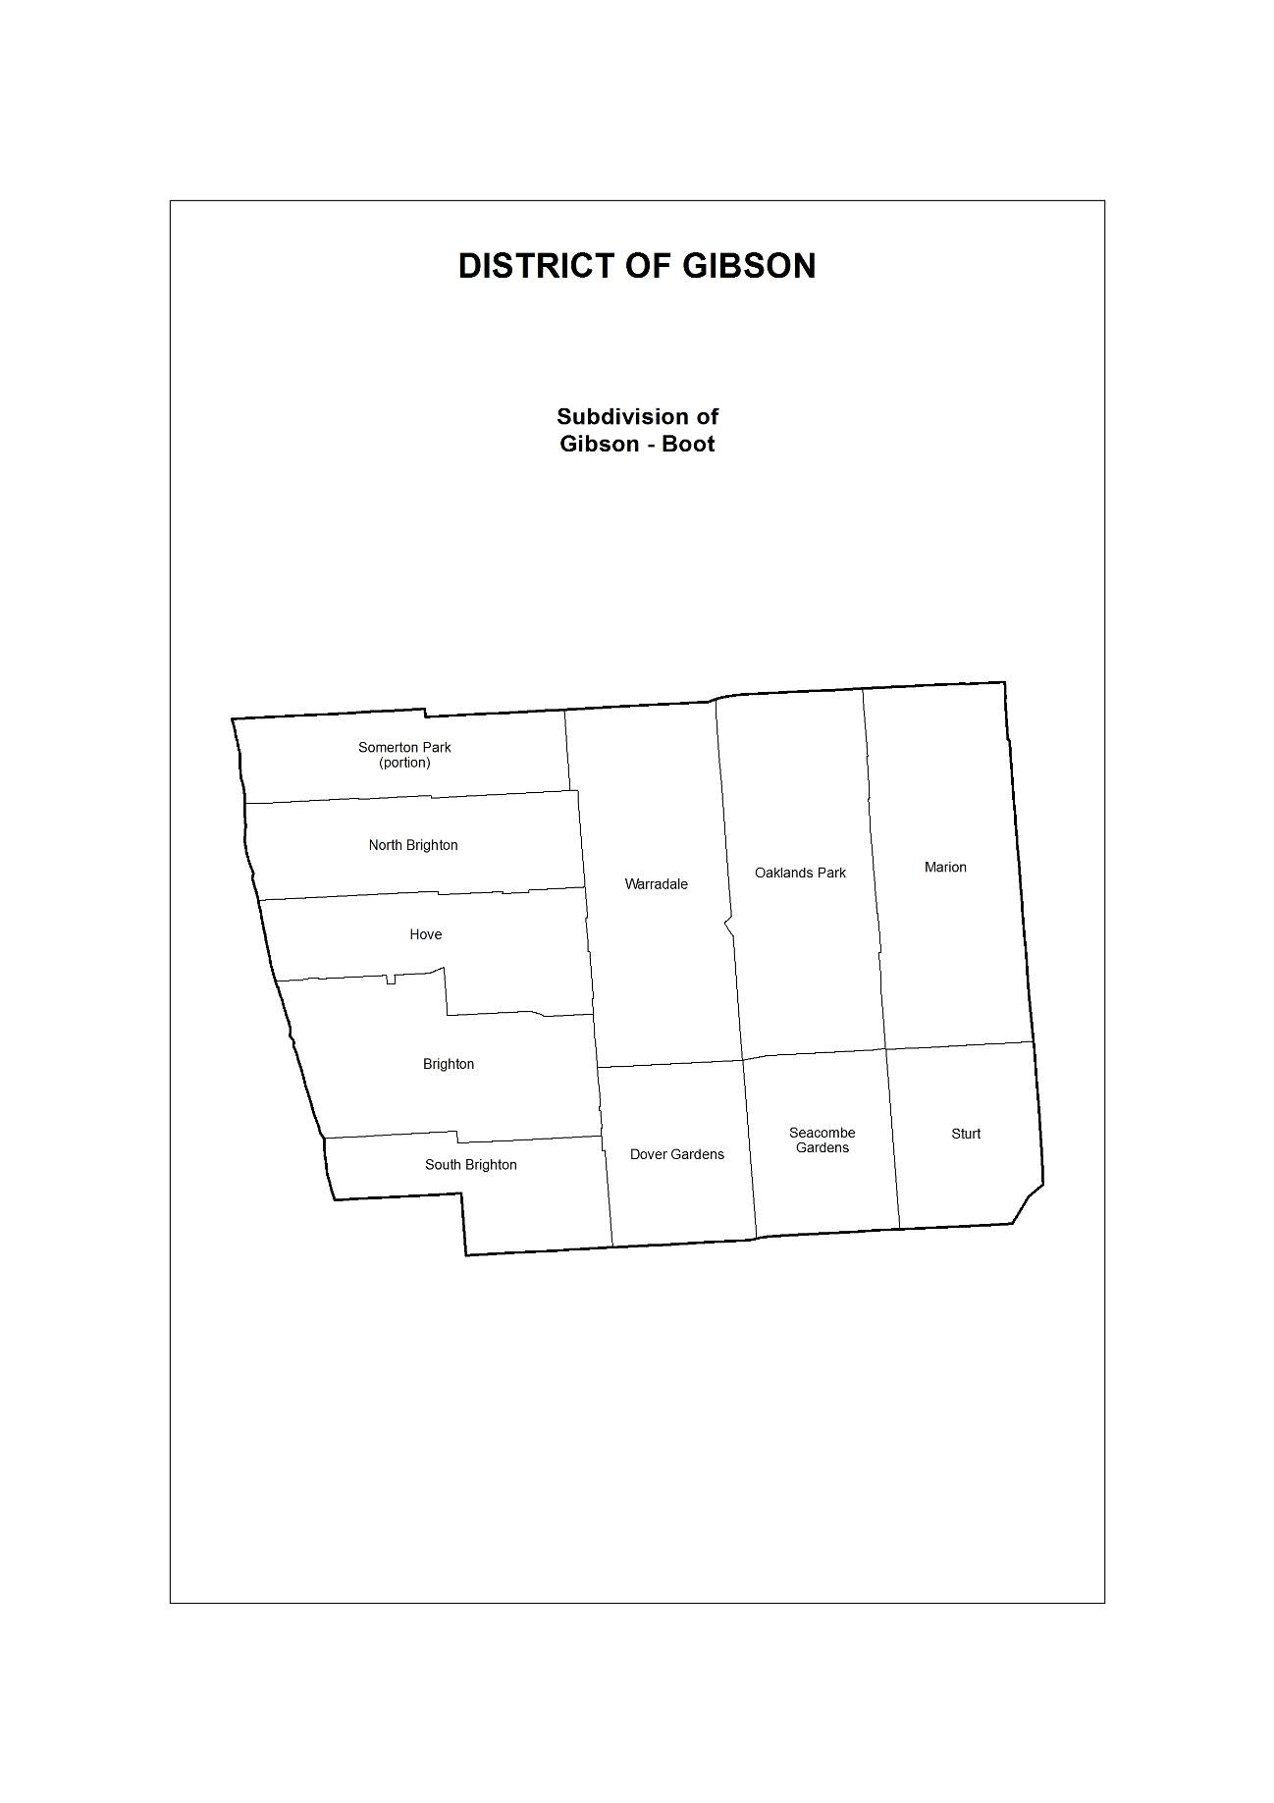
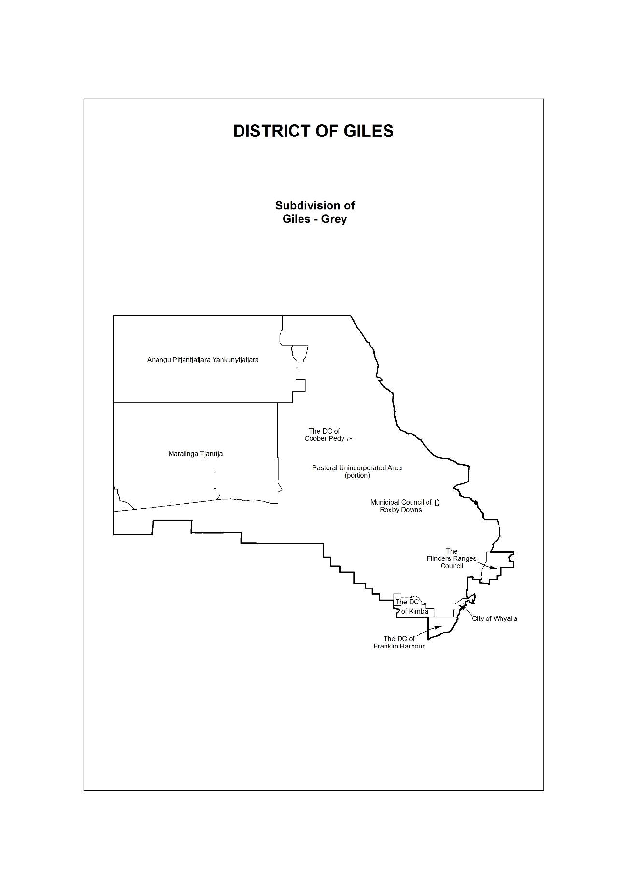
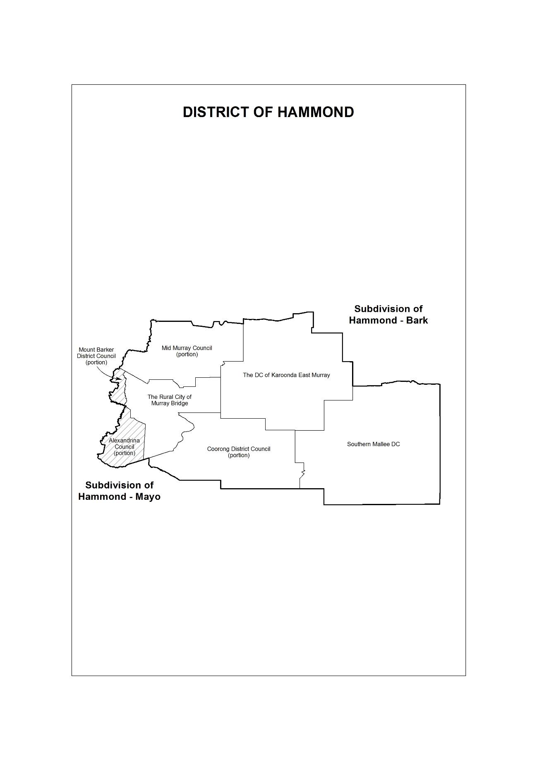
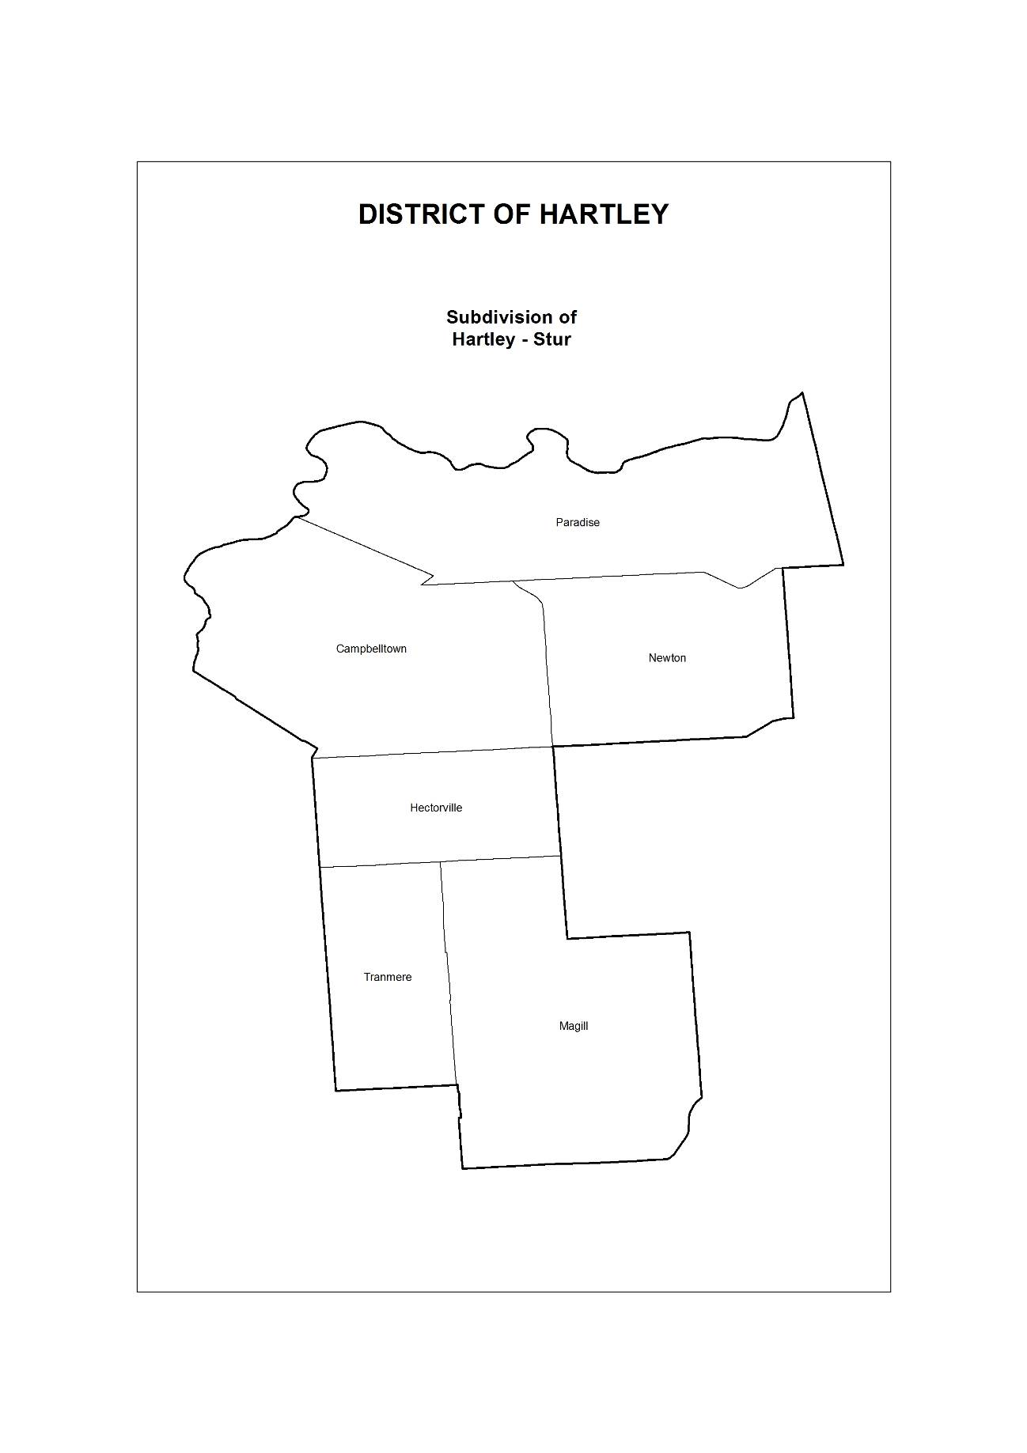
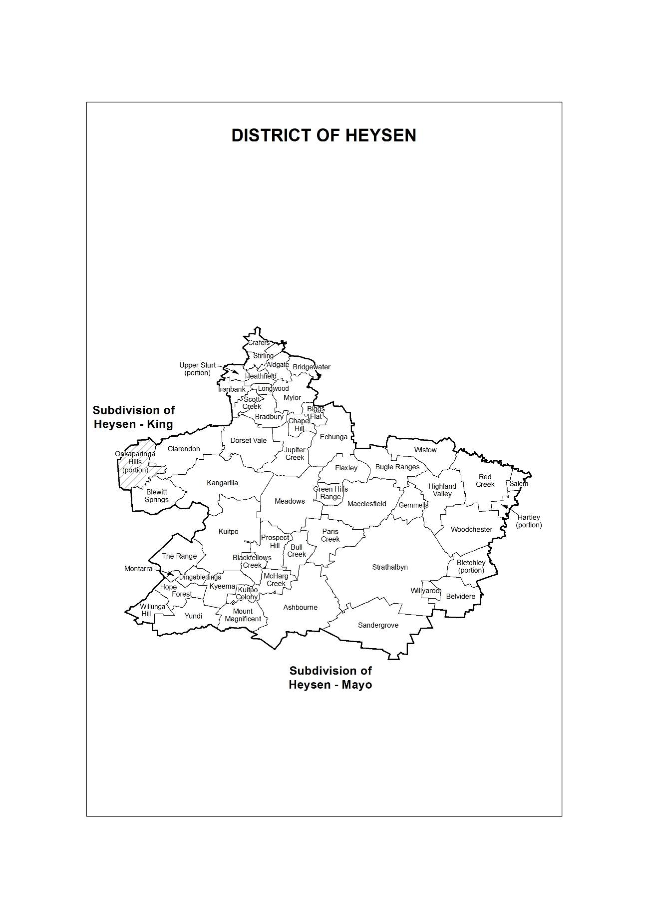
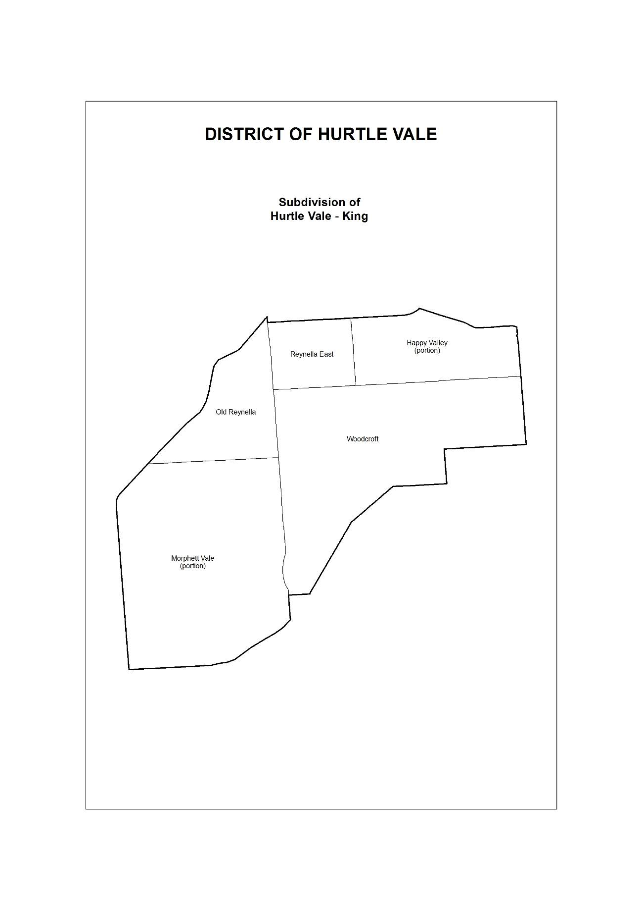
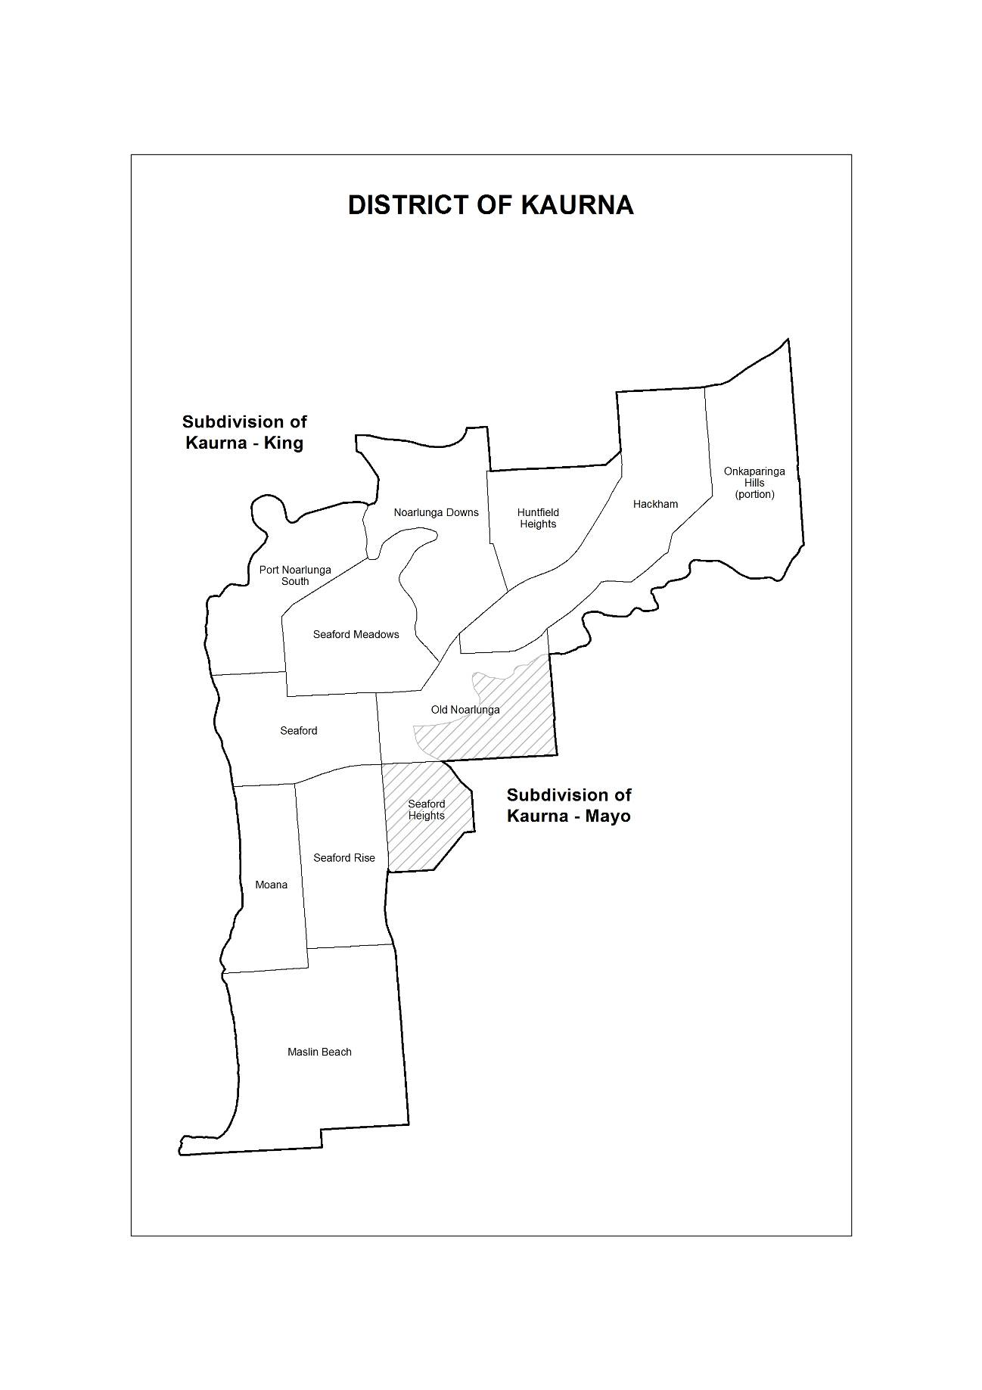
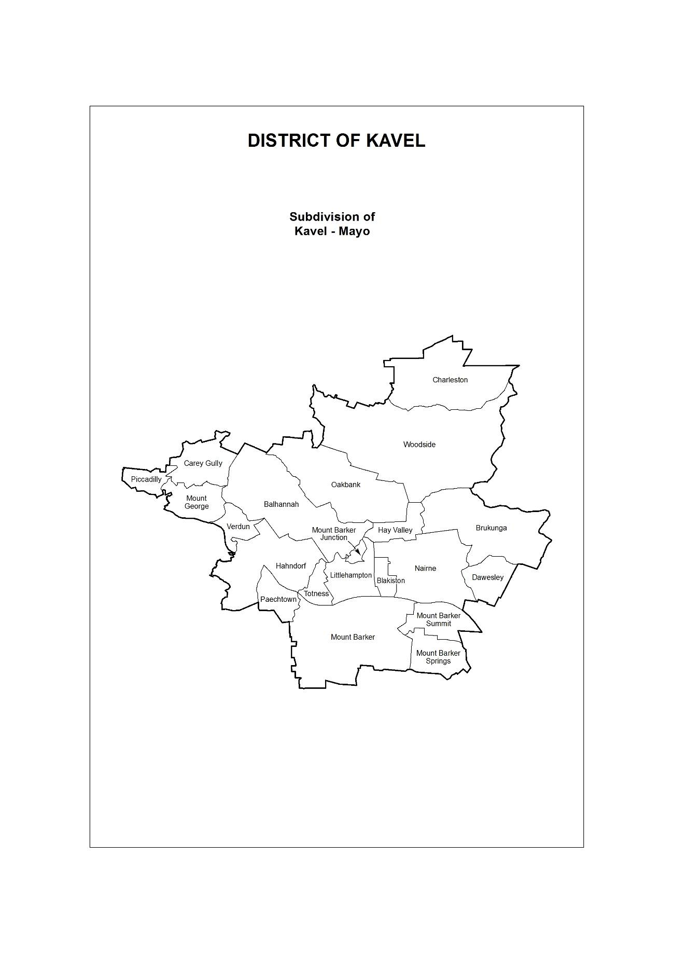
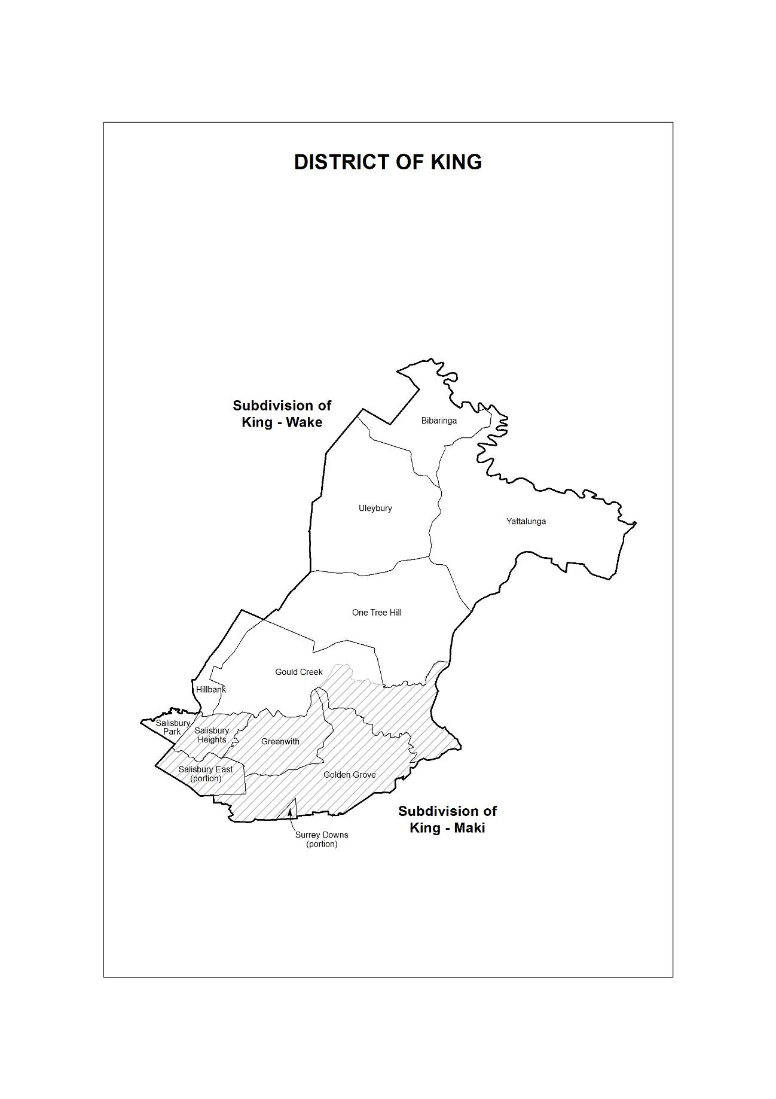
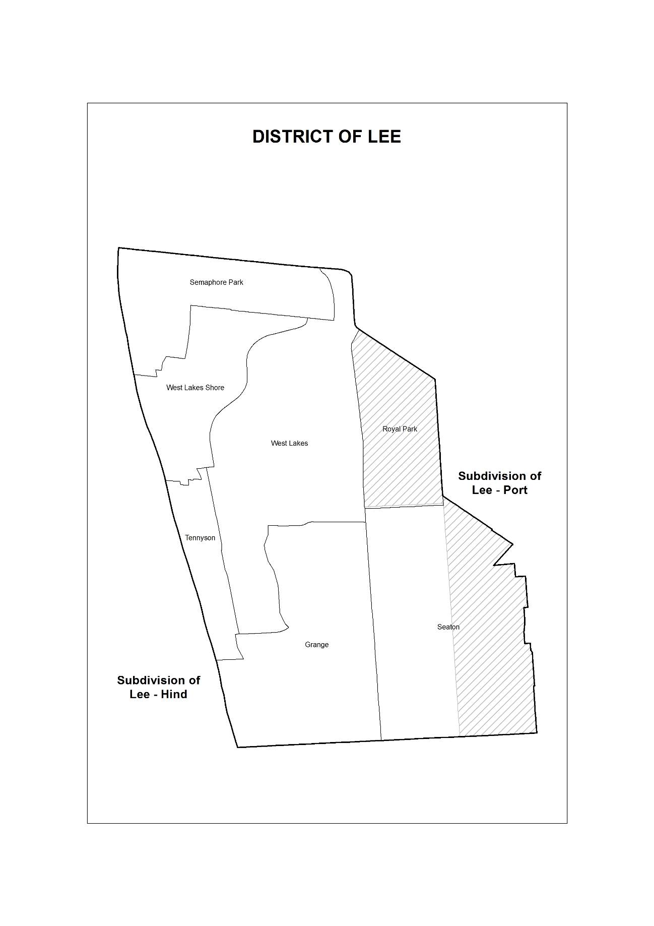
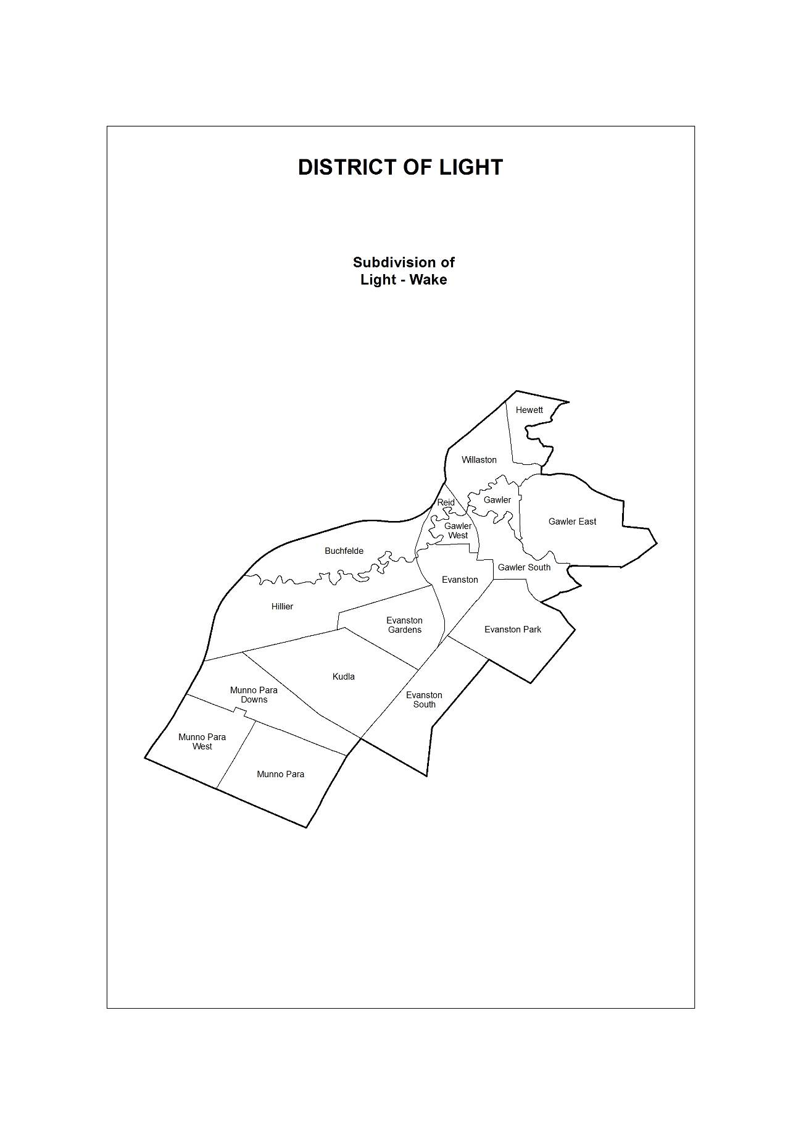
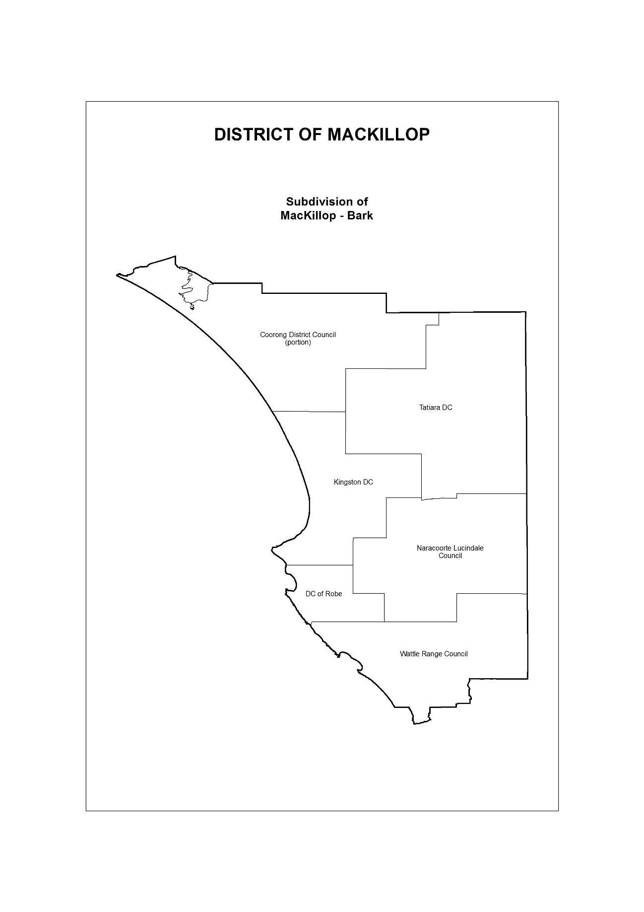
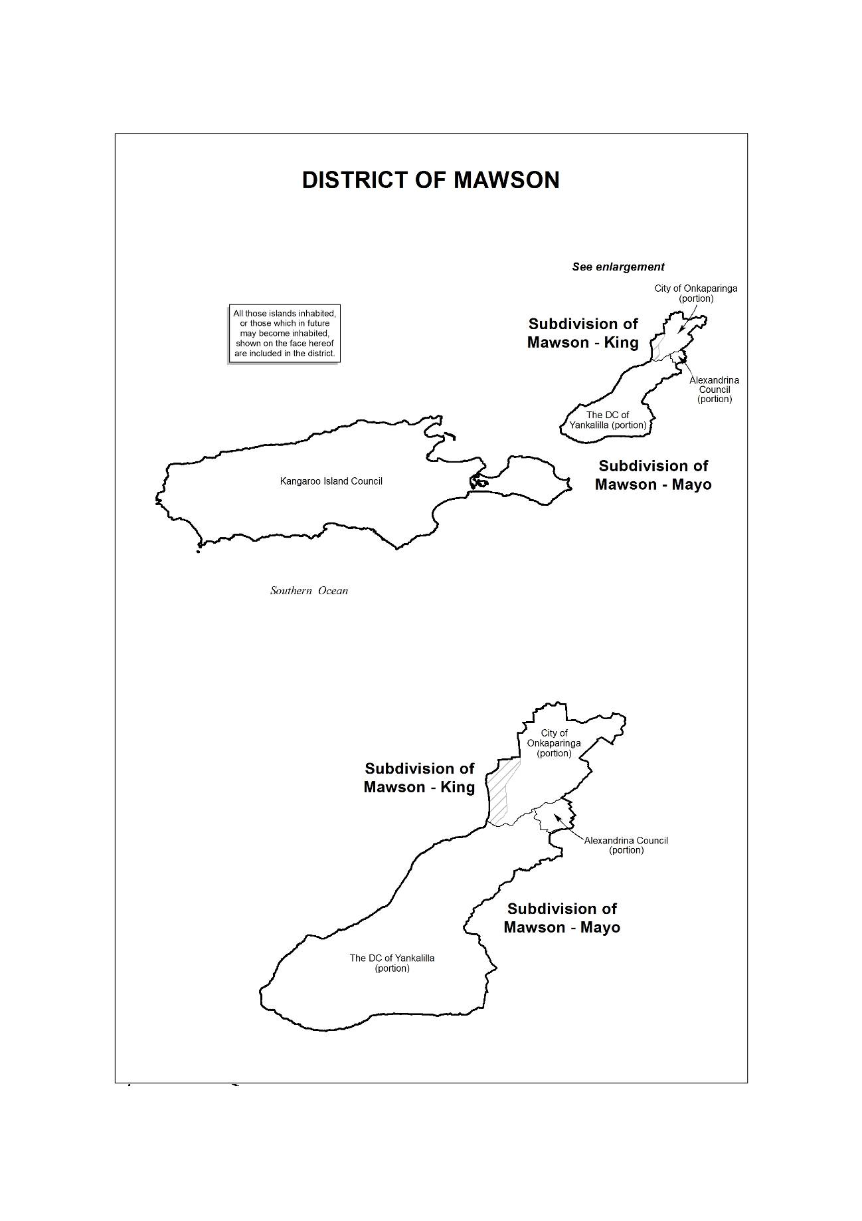
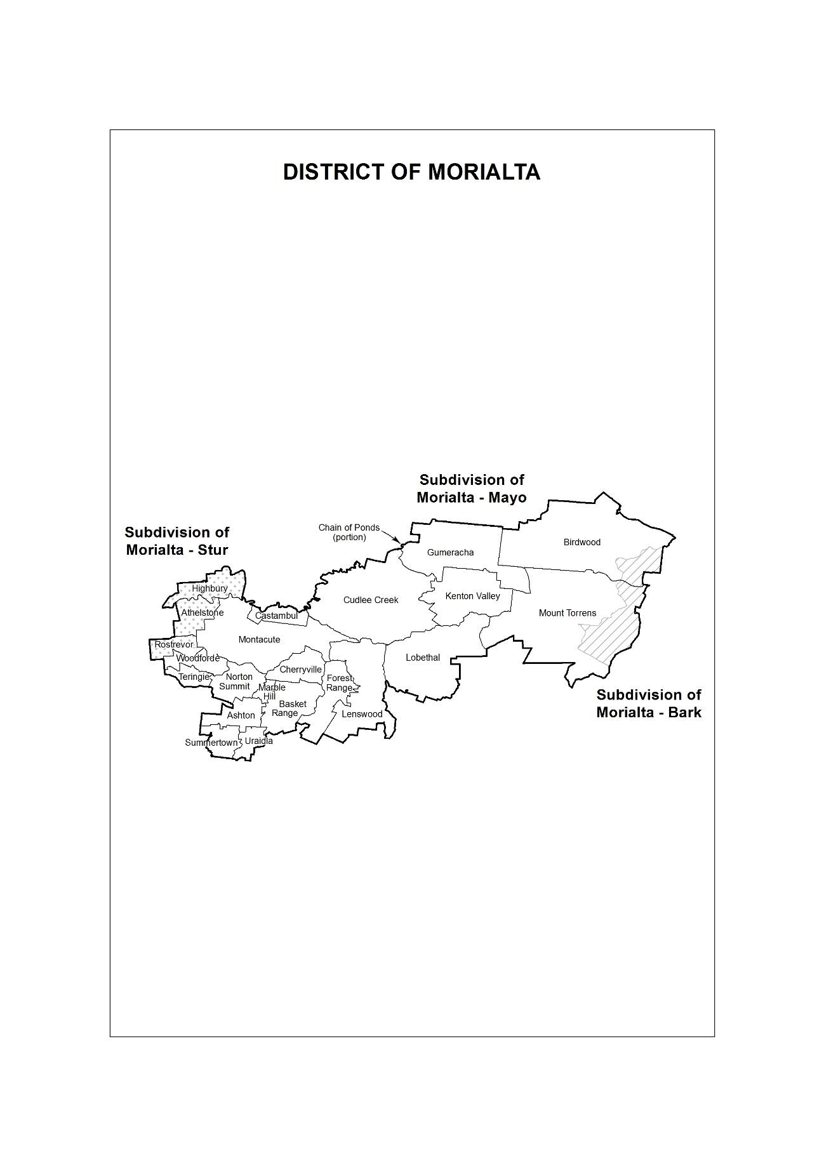
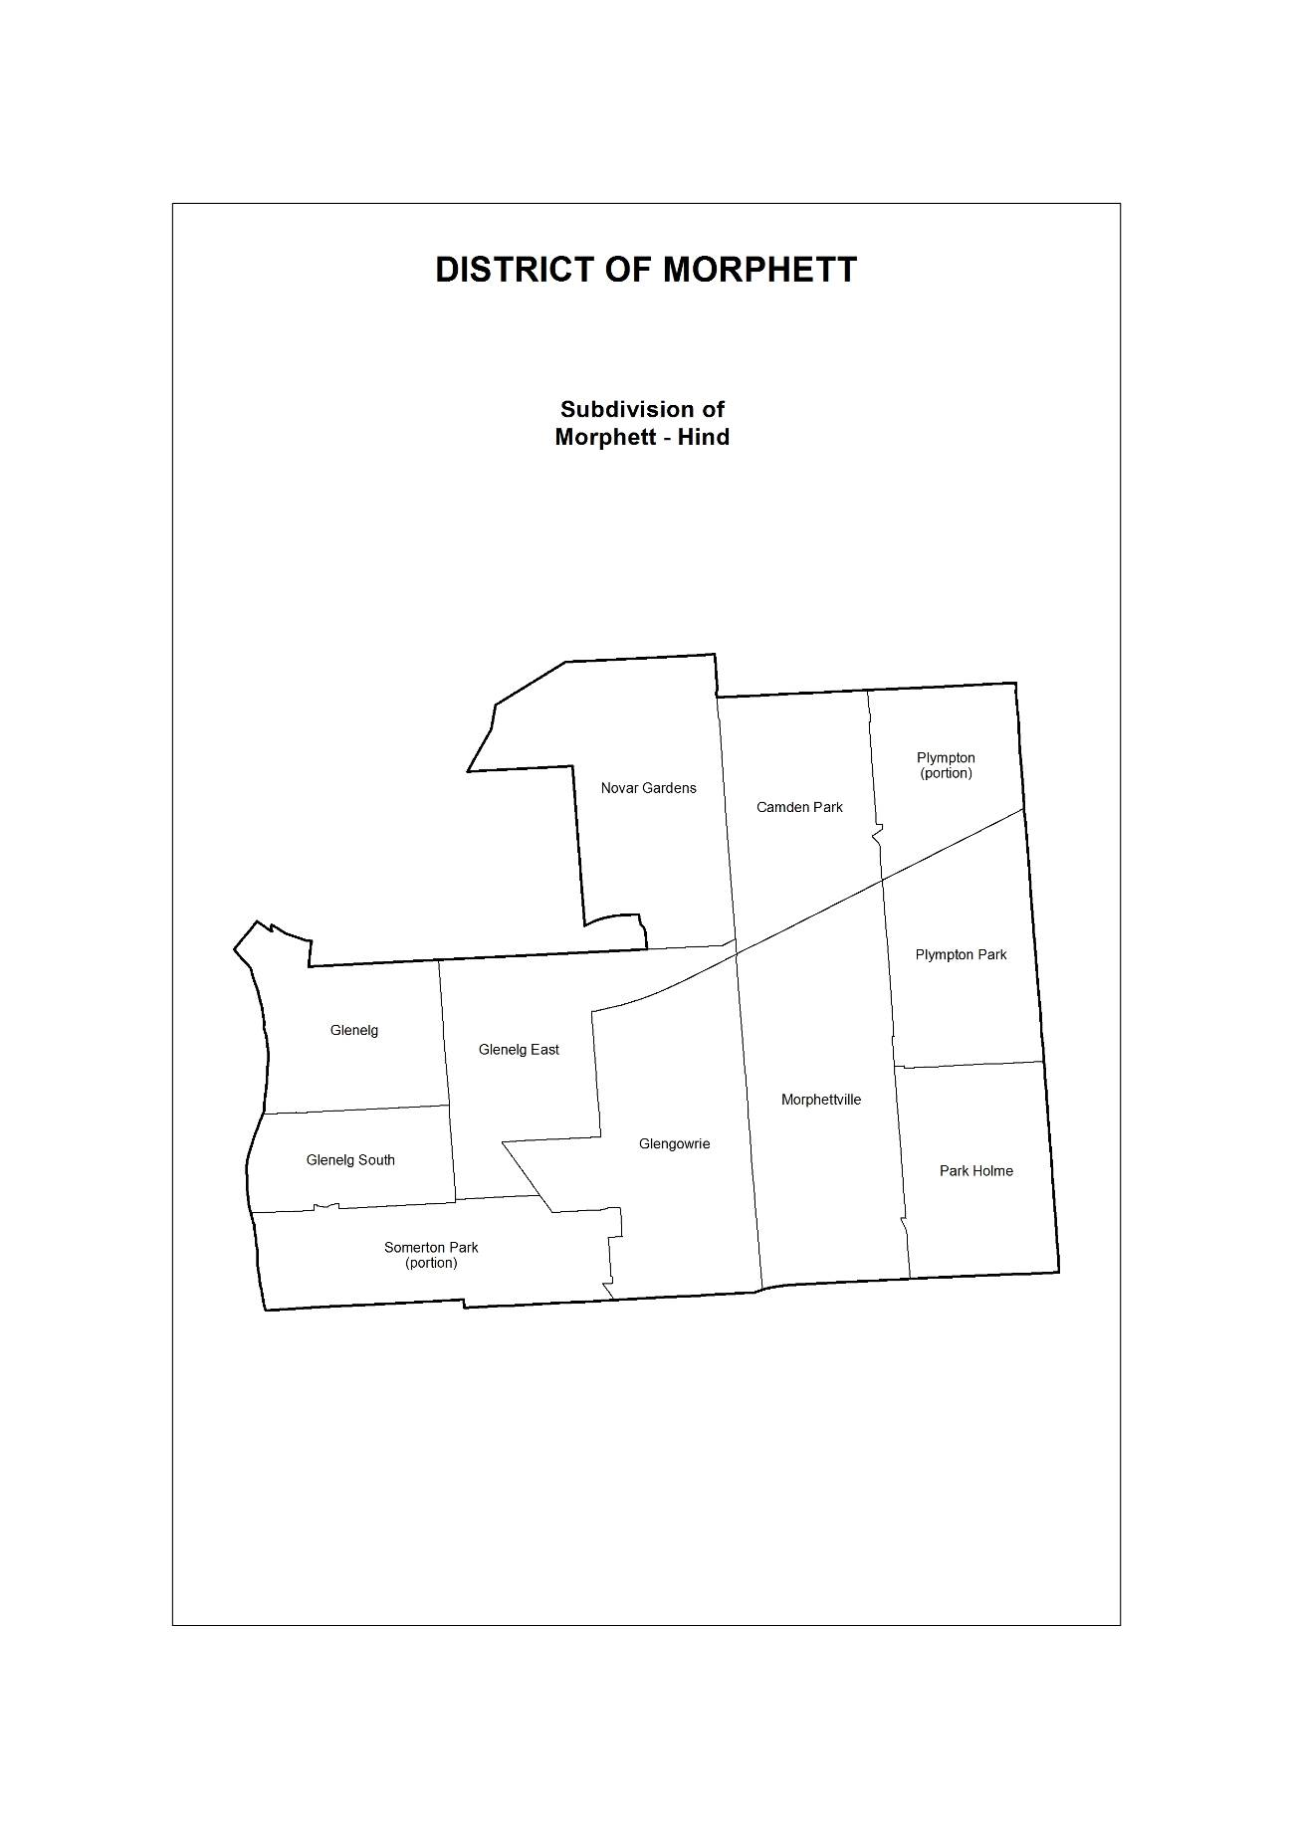
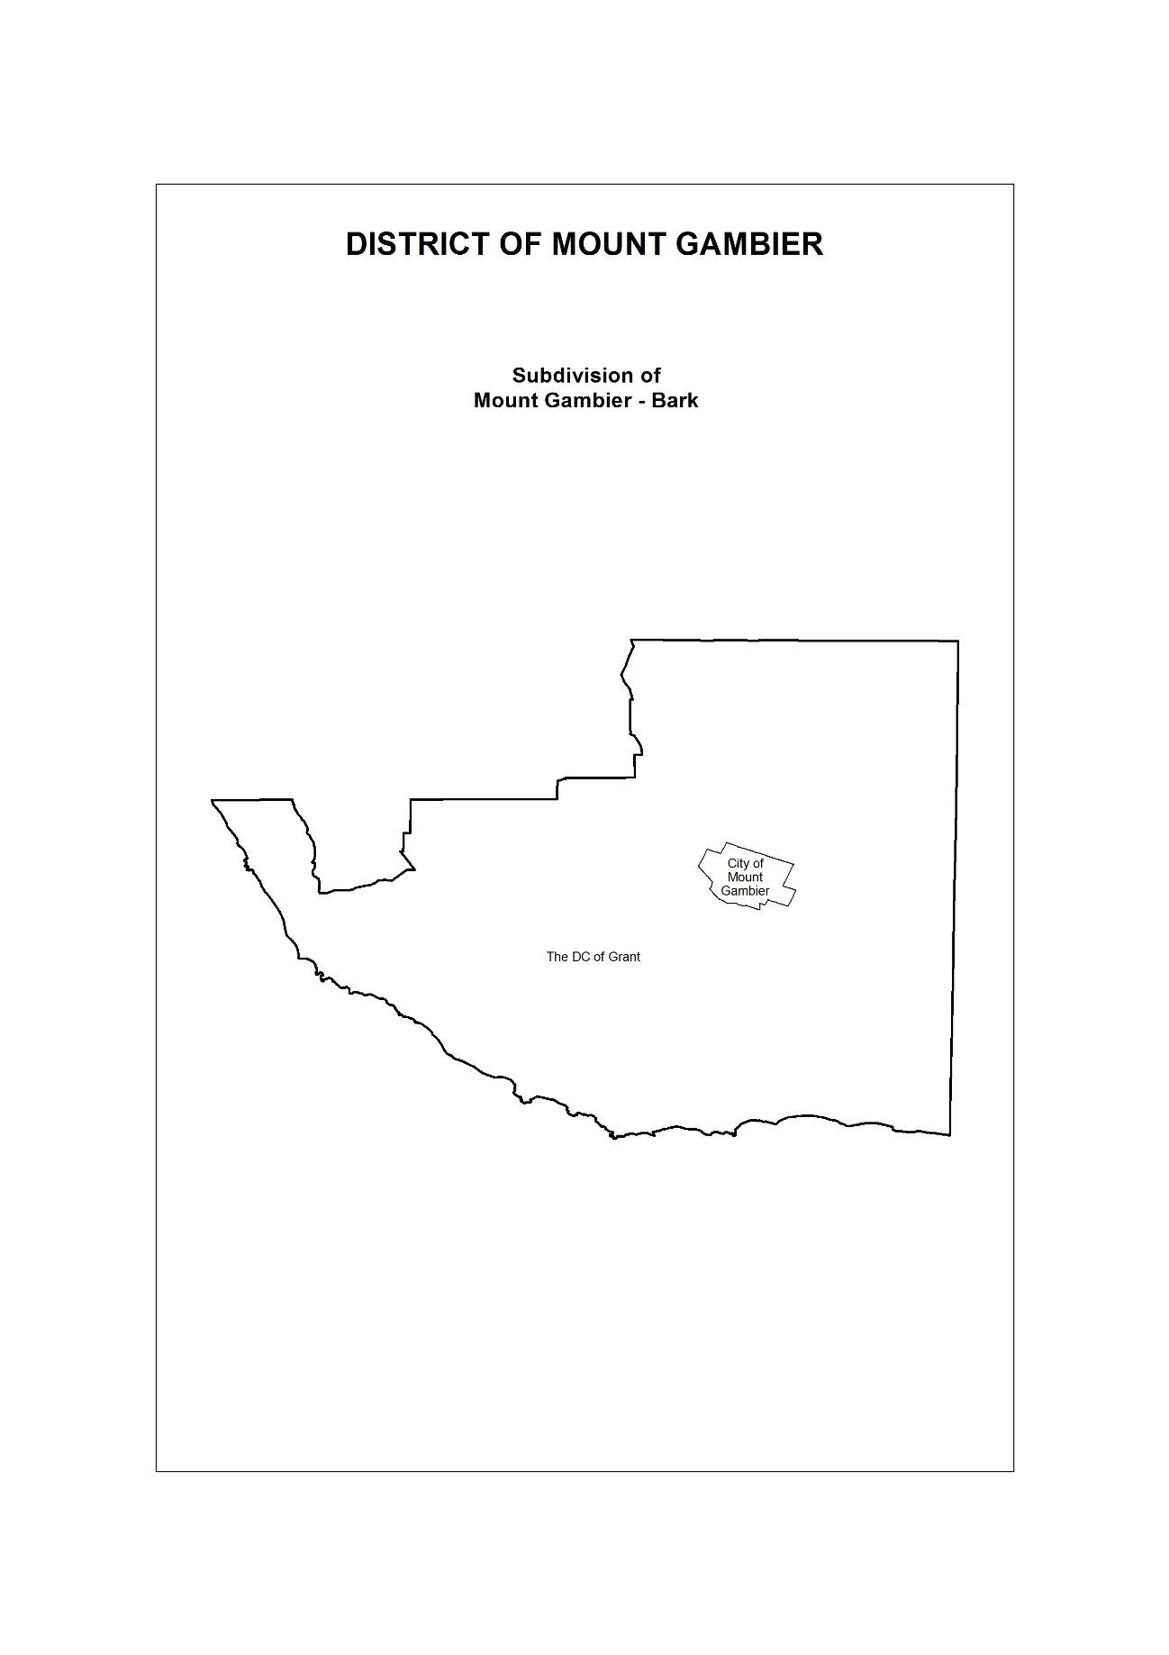
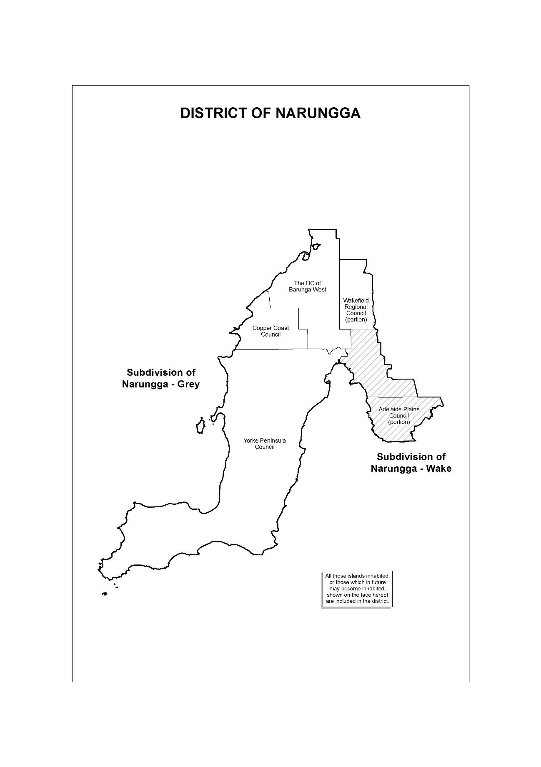
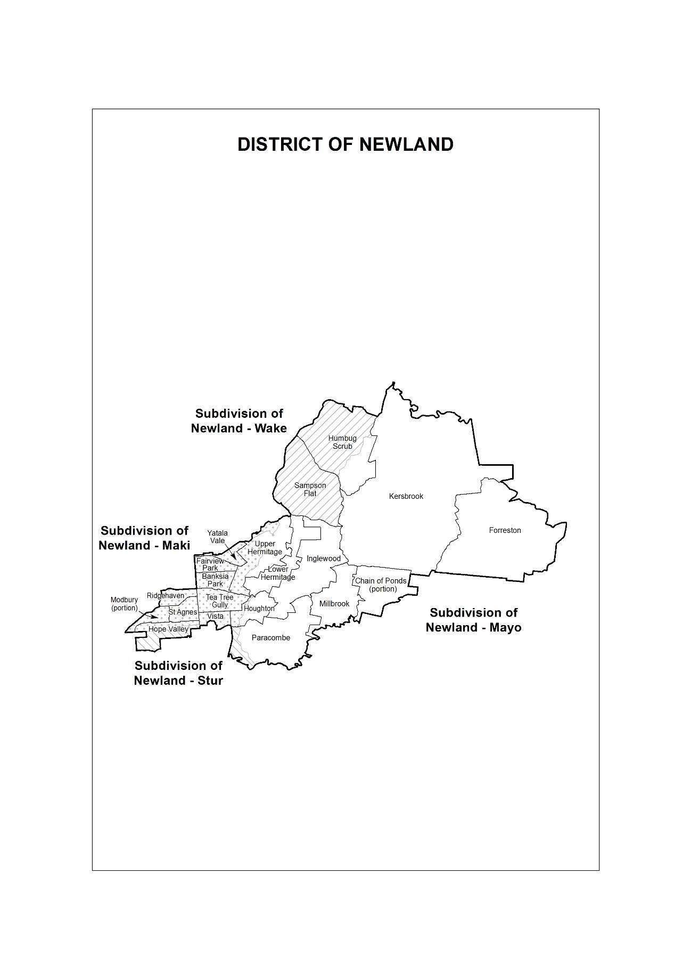
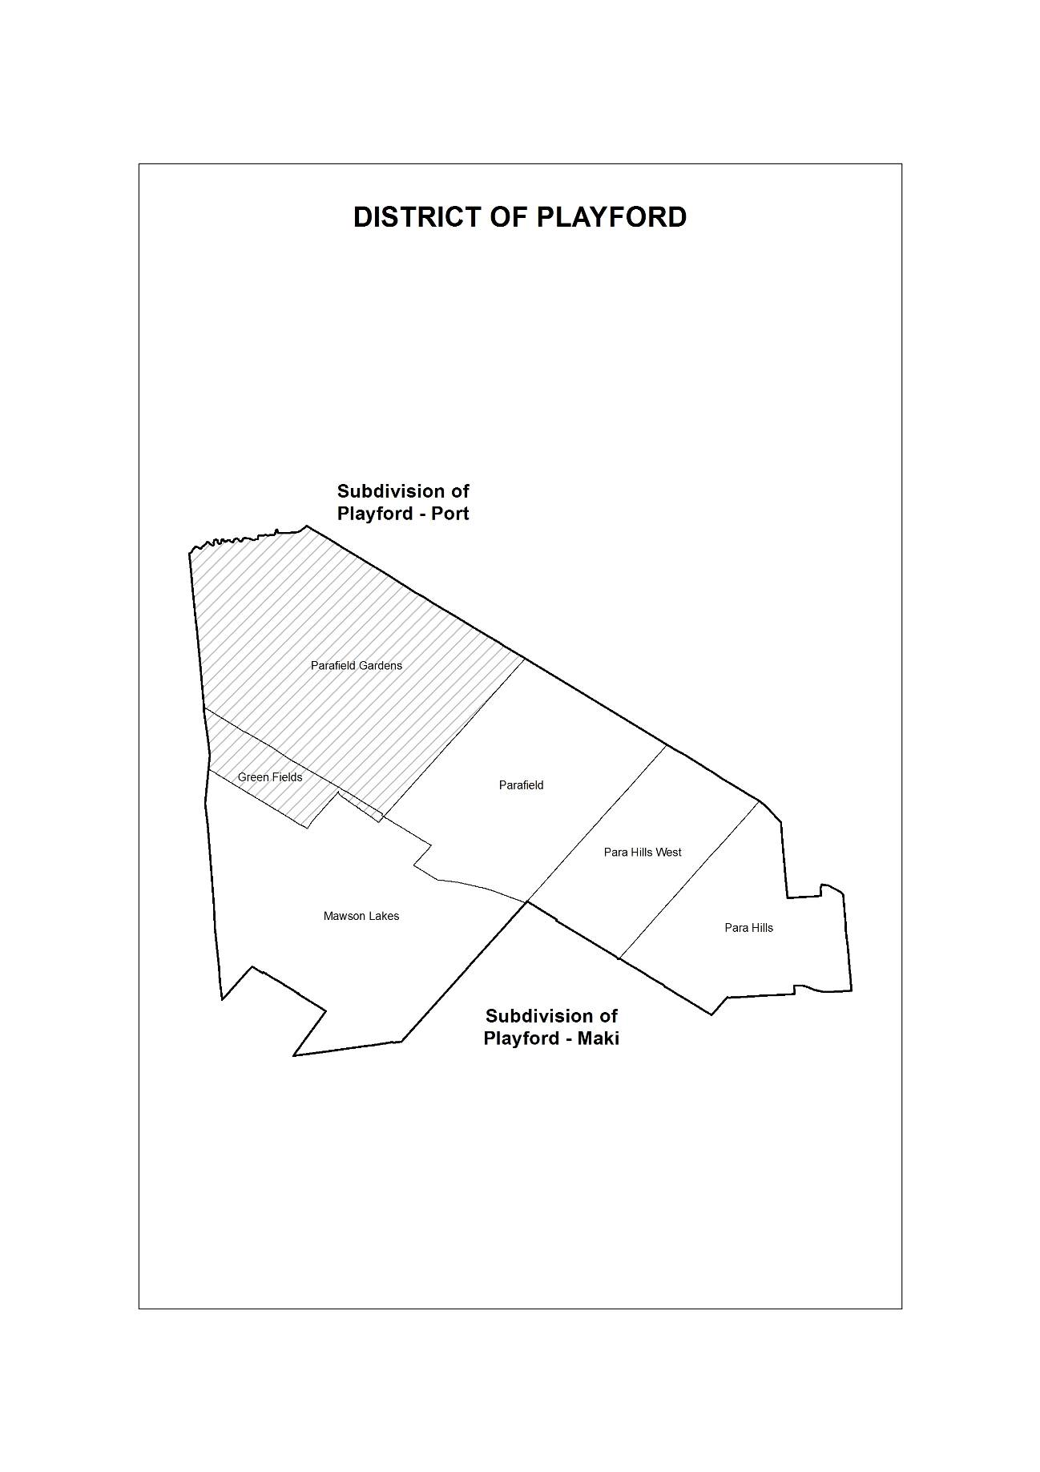
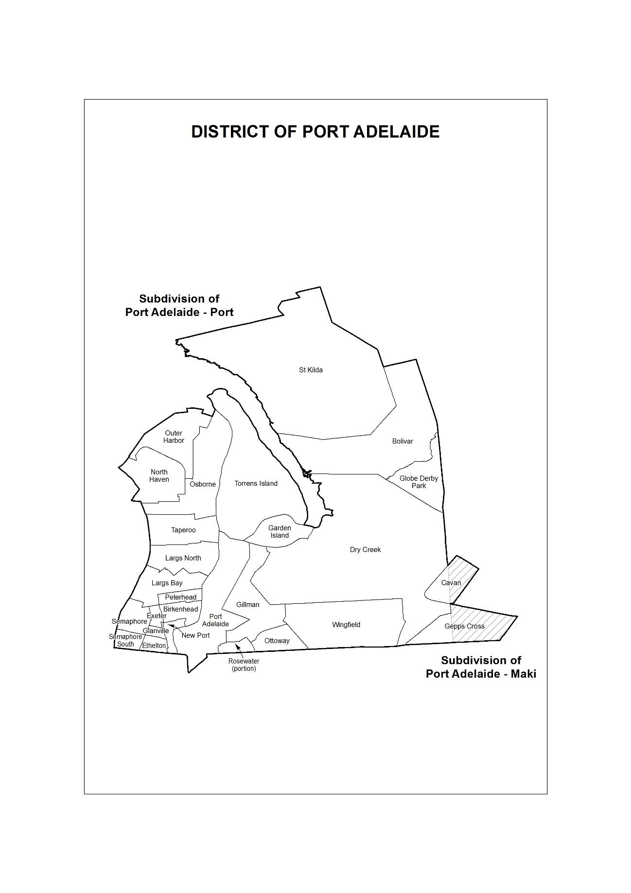
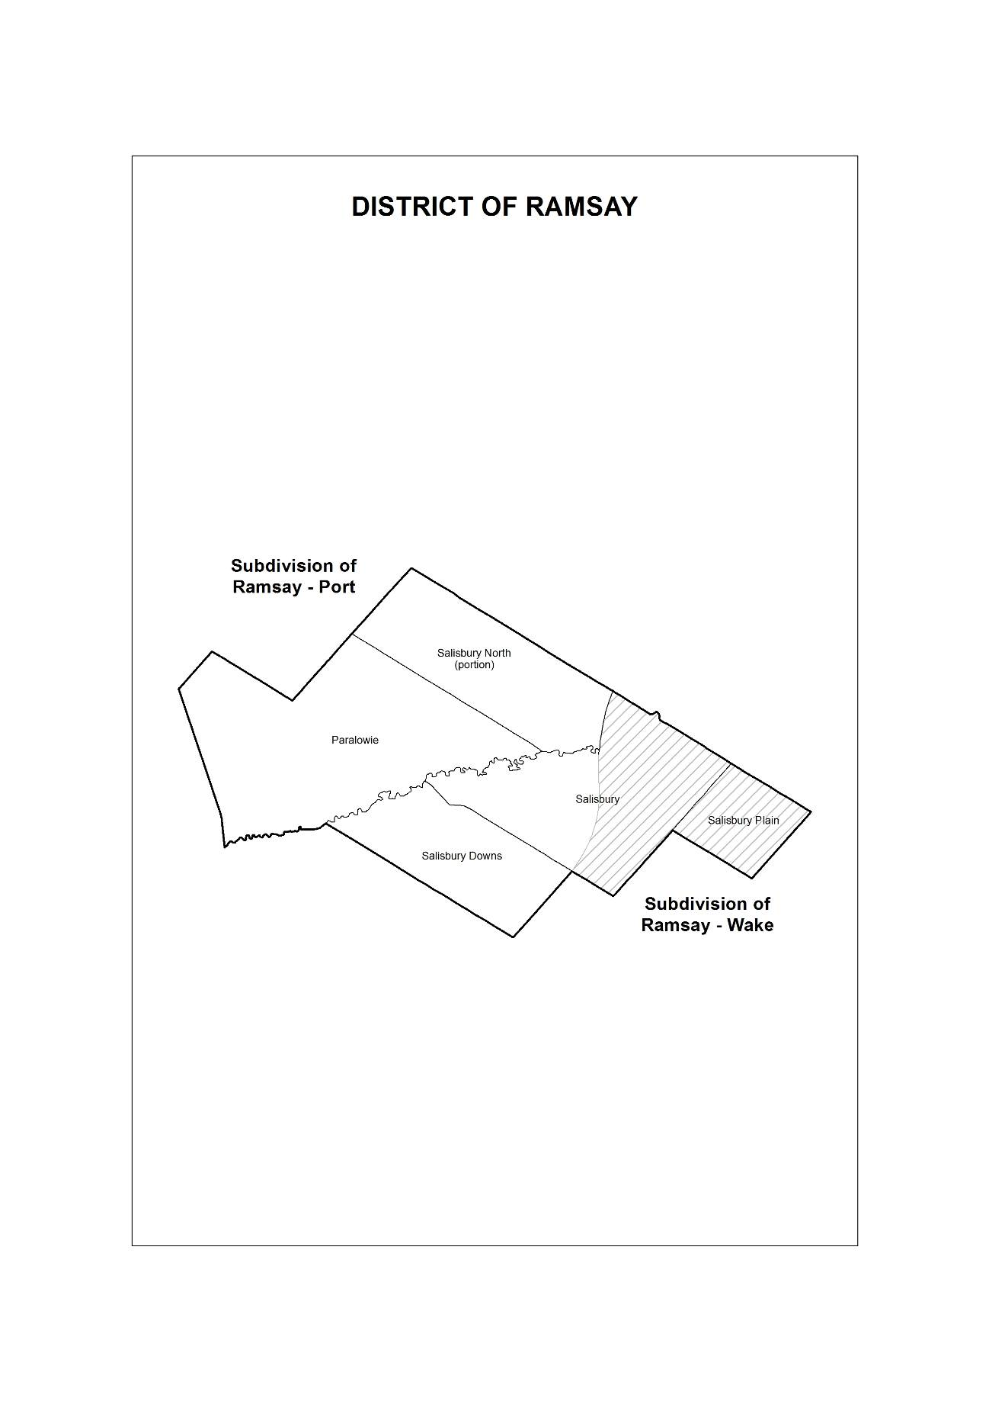
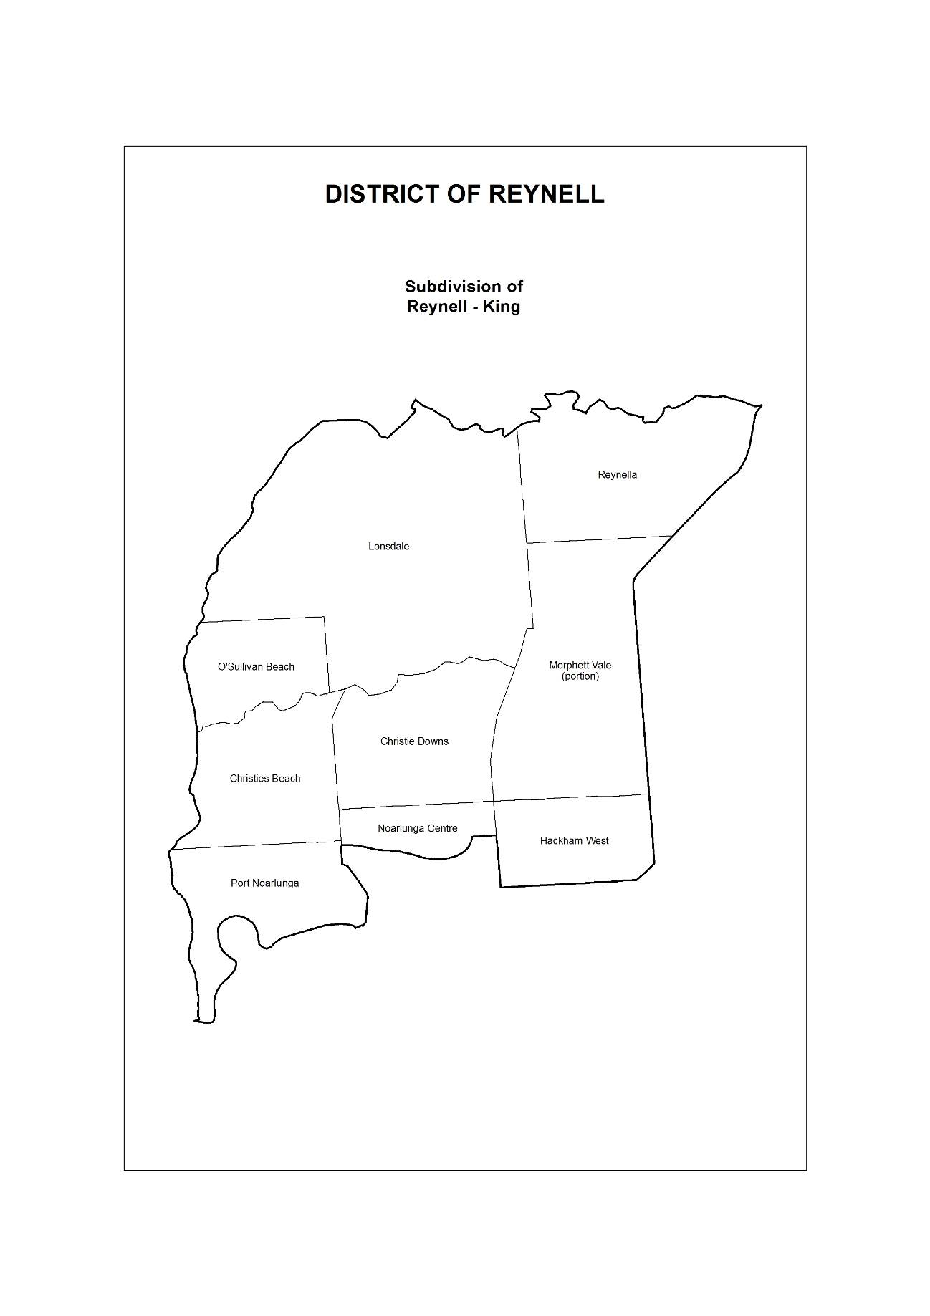
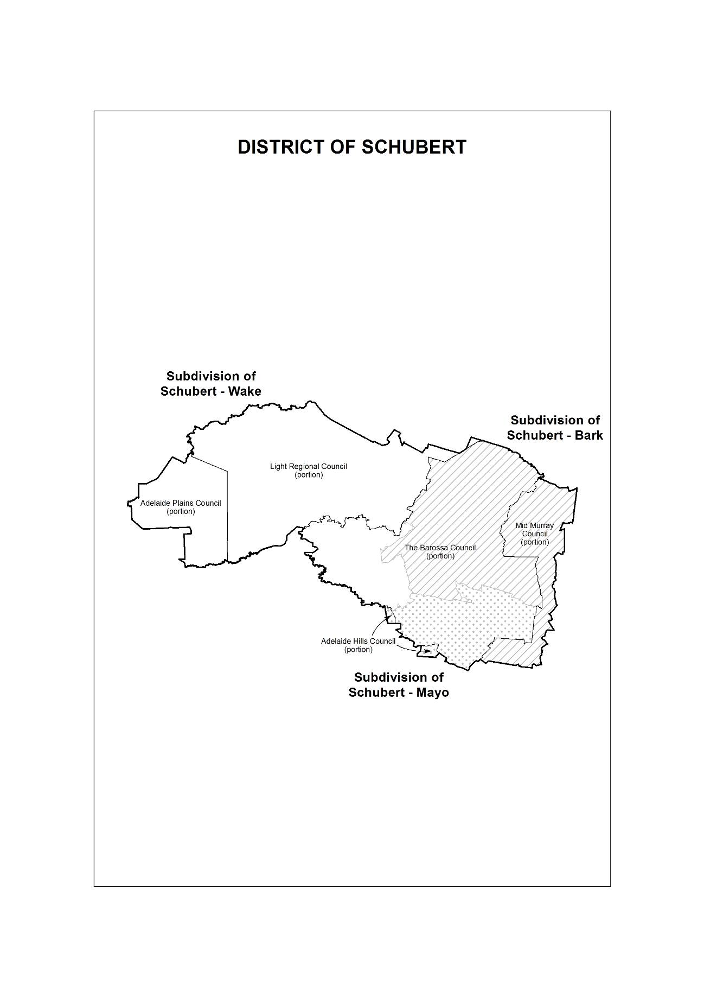
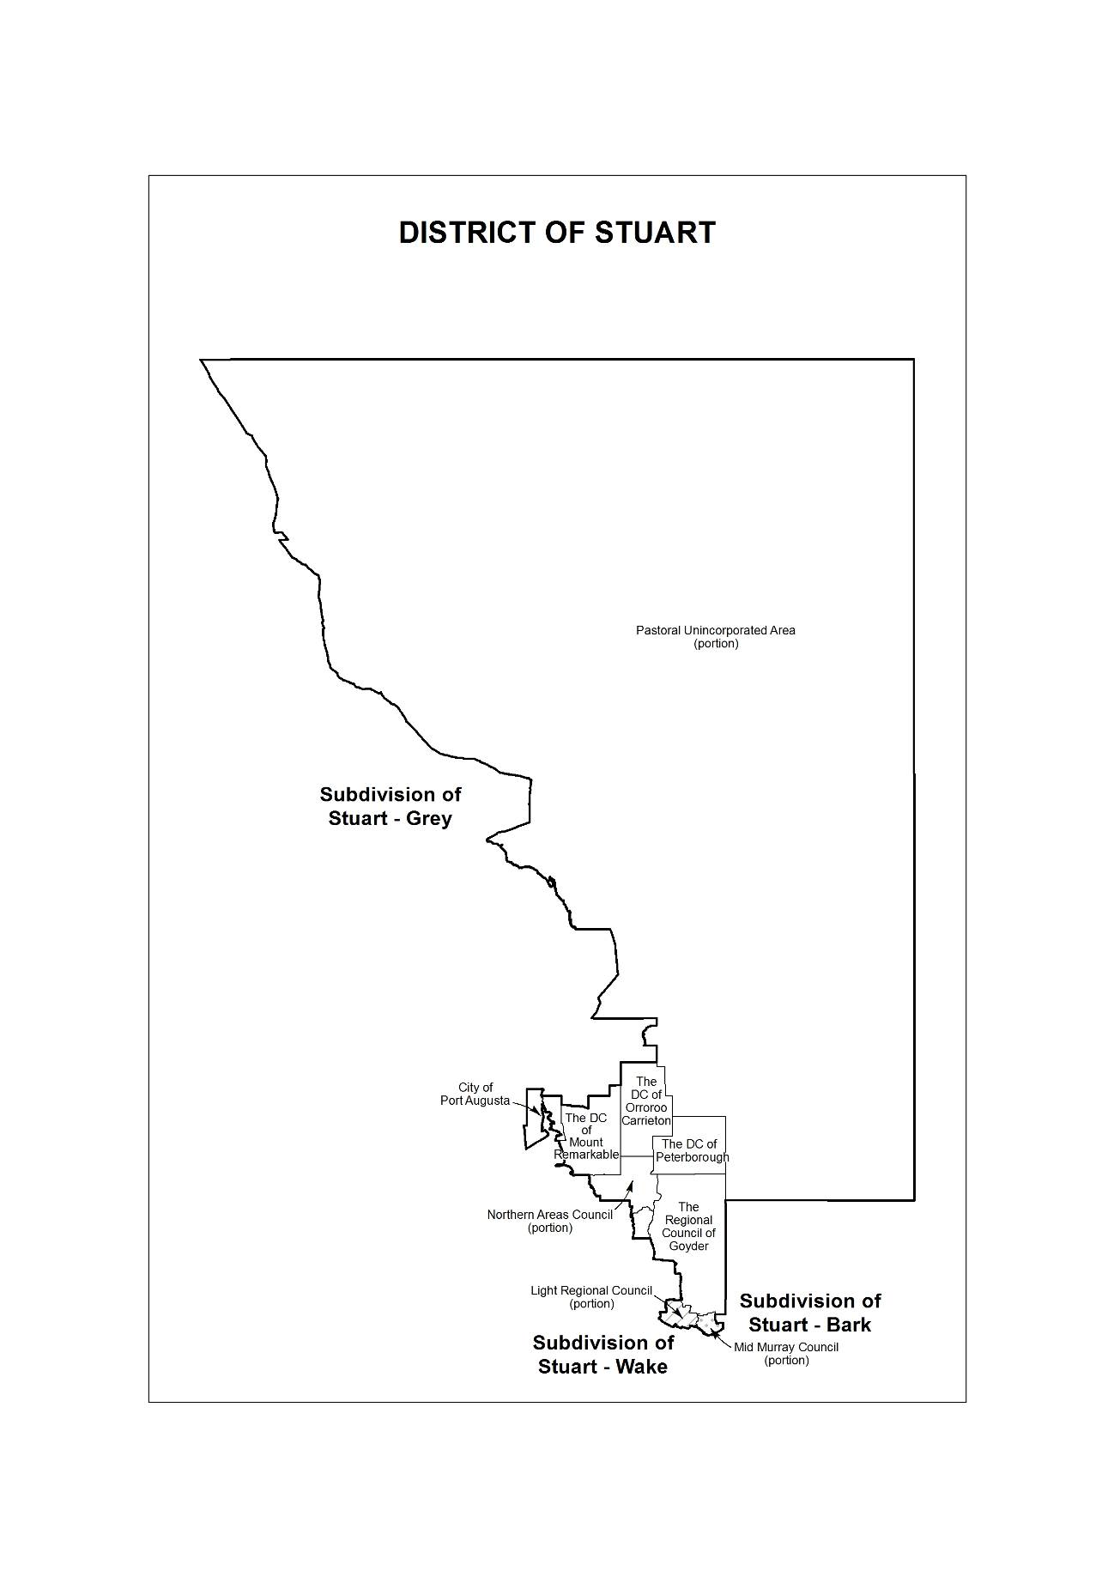
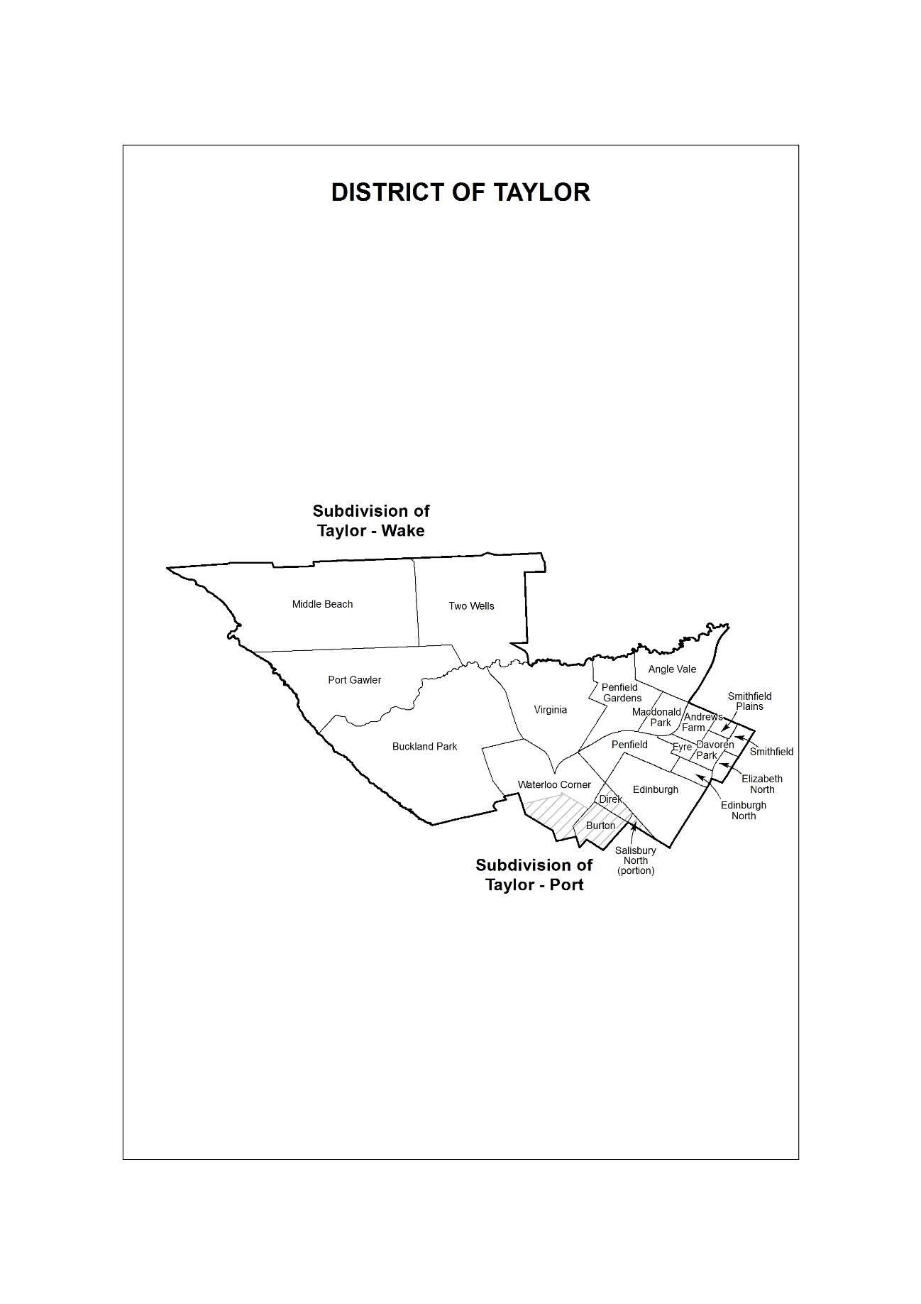
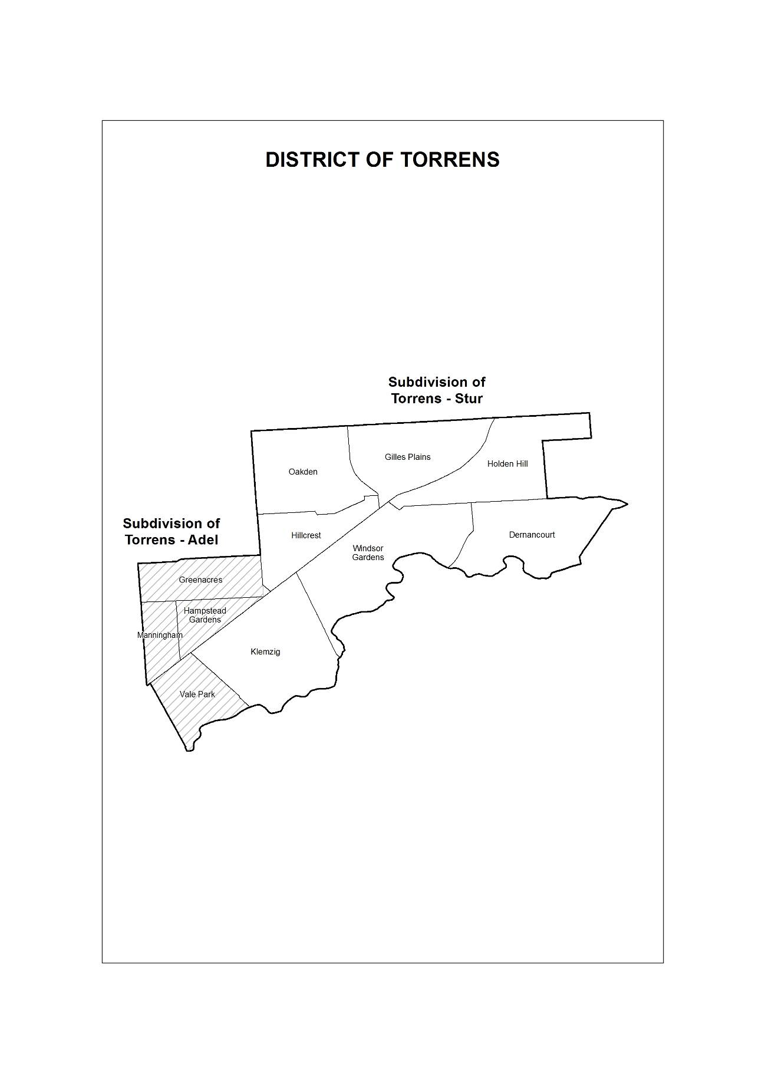
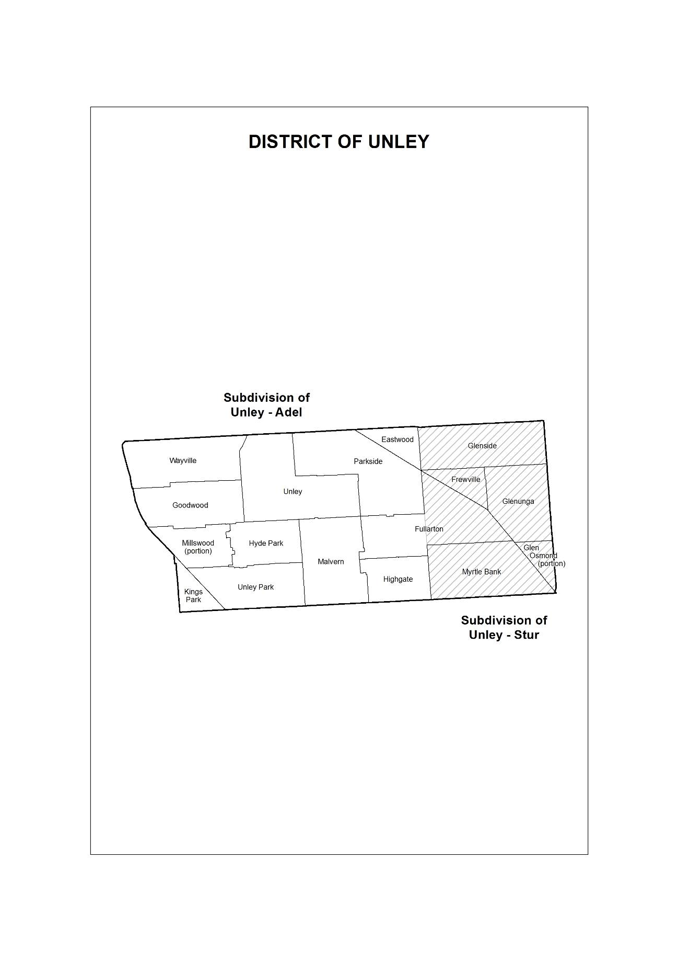
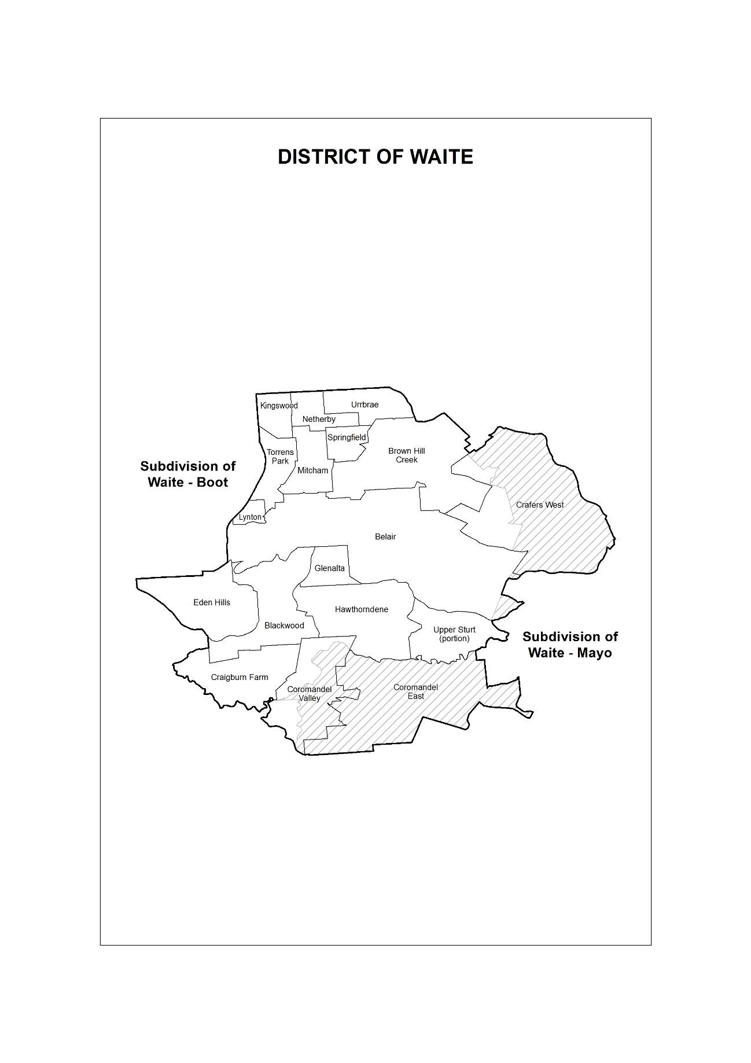
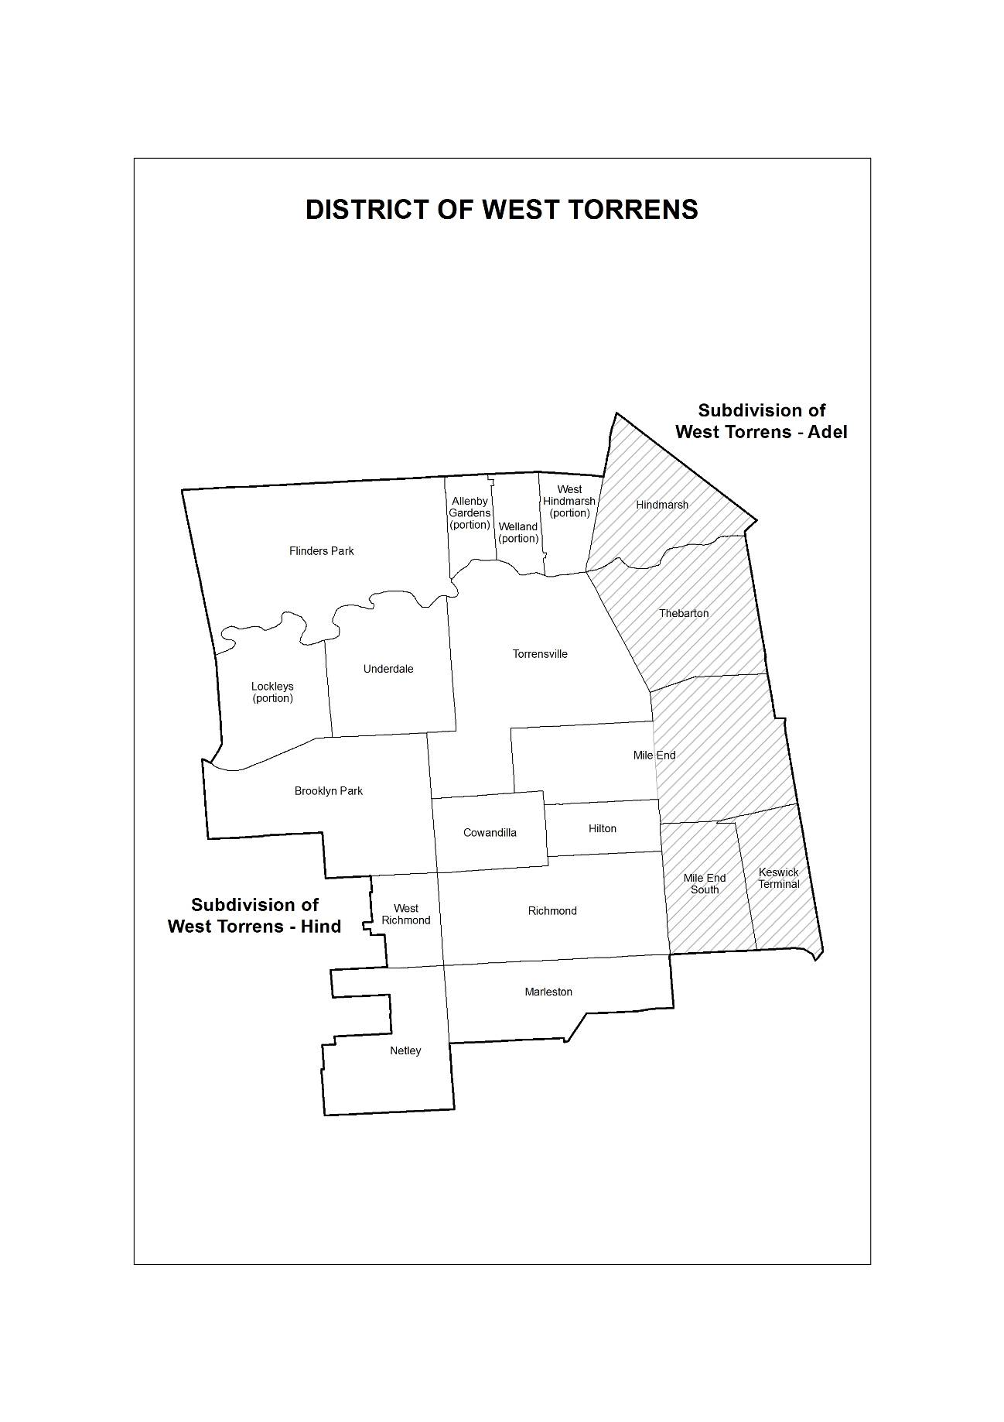
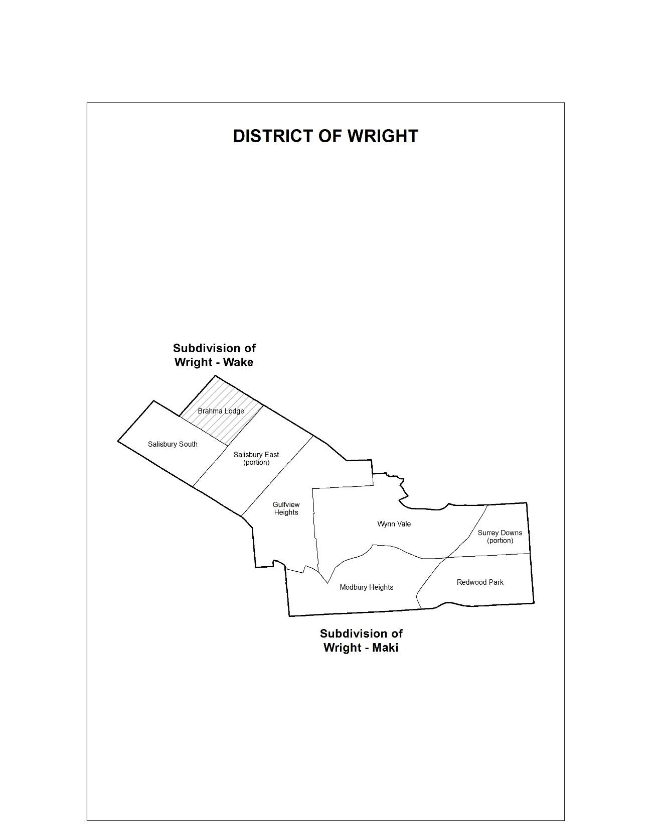
Dated: 23 January 2018
Mick Sherry
Electoral Commissioner
ECSA 330/2017

ELECTORAL ACT 1985
Part 3, Division 2
Remote Subdivisions
PURSUANT to section 15 of the Electoral Act 1985, I, Mick Sherry, Electoral Commissioner, hereby revoke the declaration contained on page 4567 of the South Australian Government Gazette dated 12 December 2013 and declare the following subdivisions to be remote subdivisions:
Chaffey-Bark
Flinders-Grey
Giles-Grey
MacKillop-Bark
Narungga-Grey
Stuart-Grey
Dated: 23 January 2018
Mick Sherry
Electoral Commissioner
ECSA 330/2017

ELECTORAL ACT 1985
Part 3, Division 4
District Polling Places
PURSUANT to Section 18 of the Electoral Act 1985, I, Mick Sherry, Electoral Commissioner, hereby abolish the polling places described in the notice contained on page 284 of the South Australian Government Gazette, dated 23 January 2014, and appoint the following places to be polling places for both the Legislative Council district of South Australia and for the House of Assembly districts as specified:
District of Adelaide
Adelaide, Adelaide Hospital, Adelaide South, Adelaide West, Nailsworth (S2), North Adelaide, North Adelaide East, Prospect (S1), Prospect North (S2), Prospect South, Walkerville, Walkerville North.
District of Badcoe
Ascot Park, Black Forest, Black Forest East, Clarence Gardens, Clarence Park (S1), Edwardstown, Goodwood (S2), Keswick, Kurralta Park (S1), Melrose Park (S2), Netley (S2), Park Holme South (S2), Plympton (S1), Plympton West (S2), South Plympton (S1), South Plympton North.
District of Black
Brighton (S2), Hallett Cove, Hallett Cove East, Hallett Cove South, Happy Valley West (S2), Marino, Seacliff (S1), Seacombe Heights (S1), Seaview Downs, Sheidow Park, Sheidow Park South.
District of Bragg
Beaumont, Burnside, Glen Osmond, Kensington, Kensington Park, Linden Park, Magill (S2), Magill South (S2), Norwood (S2), Rose Park (S2), Tranmere South (S2), Tusmore, Wattle Park.
District of Chaffey
Barmera, Berri, Blanchetown, Cadell, Cobdogla, Glossop, Loxton, Loxton North, Lyrup, Monash, Moorook, Morgan, Paringa, Ramco, Renmark, Renmark North, Renmark West, Sedan, Swan Reach, Waikerie, Winkie.
District of Cheltenham
Albert Park, Beverley, Cheltenham, Findon, Findon West, Kilkenny (S2), Pennington, Queenstown, Rosewater (S1), Royal Park (S2), Seaton Park (S2), Woodville, Woodville Gardens (S2), Woodville South, Woodville West (S1).
District of Colton
Fulham, Glenelg (S2), Glenelg North, Henley Beach, Henley Beach North, Henley Beach South, Kidman Park, Lockleys, Lockleys North (S2), West Beach.
District of Croydon
Allenby Gardens (S1), Brompton, Croydon, Croydon Park, Kilkenny (S1), Kilkenny North, Mansfield Park, Regency Park, Renown Park, West Croydon, West Hindmarsh (S1), Woodville Gardens (S1).
District of Davenport
Aberfoyle Park, Aberfoyle Park Central, Aberfoyle Park North, Aberfoyle Park South, Bedford Park, Bellevue Heights (S1), Cherry Gardens, Flagstaff Hill, Flagstaff Hill East (S1), Happy Valley (S2), Happy Valley West (S1).
District of Dunstan
Felixstow, Glynde (S1), Joslin, Kent Town, Marden, Maylands, Norwood (S1), Norwood West, Rose Park (S1), St Morris, St Peters, St Peters East, Trinity Gardens.
District of Elder
Clapham (S1), Colonel Light Gardens South, Daw Park, Hawthorn, Marion (S2), Melrose Park (S1), Mitchell Park, Mitchell Park South, Pasadena, St Marys, Westbourne Park.
District of Elizabeth
Craigmore, Craigmore North, Craigmore South, Elizabeth, Elizabeth Downs, Elizabeth East (S1), Elizabeth Grove, Elizabeth Park, Elizabeth South, Elizabeth Vale (S1), Hillbank (S2).
District of Enfield
Blair Athol, Blair Athol North, Broadview, Clearview, Enfield, Enfield South, Hampstead Gardens (S2), Kilburn, Nailsworth (S1), Northfield, Northgate, Prospect (S2), Prospect North (S1).
District of Finniss
Currency Creek, Goolwa, Goolwa Central, Middleton, Mount Compass, Port Elliot, Victor Harbor, Victor Harbor East, Victor Harbor South.
District of Flinders
Arno Bay, Ceduna, Cleve, Coffin Bay, Cummins, Darke Peak, Elliston, Karkoo, Kirton Point, Lock, Minnipa, North Shields, Poochera, Port Kenny, Port Lincoln, Port Lincoln Central, Port Lincoln South, Port Neill, Smoky Bay, Streaky Bay, Tumby Bay, Ungarra, Wangary, Warramboo, Wirrulla, Wudinna.
District of Florey
Ingle Farm, Ingle Farm North (S1), Modbury (S1), Modbury Heights (S2), Modbury North, Modbury North East (S1), Para Hills East (S3), Para Vista, Pooraka, Pooraka North, Valley View, Walkley Heights.
District of Frome
Auburn, Balaklava, Blyth, Brinkworth, Clare, Crystal Brook, Georgetown, Hamley Bridge, Manoora, Marrabel, Napperby, Owen, Port Pirie, Port Pirie South, Redhill, Risdon Park, Risdon Park South, Riverton, Saddleworth, Solomontown, Tarlee, Watervale, Yacka.
District of Gibson
Brighton (S1), Marion (S1), Marion South, North Brighton, North Brighton West, Oaklands Park, Seacliff (S2), Seacombe Heights (S2), South Brighton, Sturt, Warradale.
District of Giles
Andamooka, Coober Pedy, Cowell, Hawker, Iron Knob, Kimba, Quorn, Roxby Downs, Whyalla Central East, Whyalla Central West, Whyalla Norrie East, Whyalla Norrie North, Whyalla Norrie North-West, Whyalla Norrie South, Whyalla Stuart West, Woomera.
District of Hammond
Callington, Cambrai, Coomandook, Harrogate, Jervois, Karoonda, Lameroo, Langhorne Creek, Mannum, Milang, Murray Bridge, Murray Bridge East, Murray Bridge South, Murray Bridge West, Mypolonga, Nildottie, Palmer, Pinnaroo, Ponde, Purnong, Tailem Bend, Walker Flat, Wellington, Woods Point.
District of Hartley
Athelstone South (S2), Campbelltown, Glynde (S2), Hectorville, Magill (S1), Magill South (S1), Newton, Paradise, Paradise East, Rostrevor South (S2), Tranmere, Tranmere South (S1).
District of Heysen
Aldgate, Ashbourne, Bradbury, Bridgewater, Clarendon, Crafers (S1), Echunga, Kangarilla, Macclesfield, Meadows, Mount Barker (S2), Mylor, Piccadilly (S2), Prospect Hill, Stirling, Stirling West (S1), Strathalbyn, Upper Sturt, Woodchester, Yundi.
District of Hurtle Vale
Hackham (S2), Happy Valley (S1), Happy Valley West (S3), Morphett Vale (S2), Morphett Vale Central (S1), Morphett Vale East, Morphett Vale South, Old Reynella (S1), Pimpala, Reynella (S2), Reynella East, Woodcroft.
District of Kaurna
Hackham (S1), Hackham West (S2), Huntfield Heights, Maslin Beach, Noarlunga Downs, Old Noarlunga, Port Noarlunga (S2), Port Noarlunga South, Seaford, Seaford East, Seaford Rise.
District of Kavel
Brukunga, Charleston, Hahndorf, Littlehampton, Mount Barker (S1), Mount Barker Central, Mount Barker South, Nairne, Oakbank, Piccadilly (S1), Woodside.
District of King
Elizabeth East (S2), Elizabeth Vale (S2), Golden Grove, Golden Grove Central (S1), Golden Grove East, Greenwith, Greenwith West, Hillbank (S1), One Tree Hill, Salisbury East North, Salisbury Heights, Salisbury Park (S1).
District of Lee
Grange, Royal Park (S1), Royal Park South, Seaton, Seaton Park (S1), Seaton West, Semaphore Park, Semaphore Park South, West Lakes Shore, Woodville West (S2).
District of Light
Andrews Farm (S2), Angle Vale (S2), Evanston, Evanston Gardens, Gawler, Gawler East, Gawler South, Gawler West, Hewett (S1), Munno Para (S1), Munno Para East, Smithfield Plains (S2), Willaston.
District of MacKillop
Beachport, Bordertown, Coonalpyn, Coonawarra, Frances, Furner, Glencoe, Kalangadoo, Keith, Kingston, Lucindale, Meningie, Millicent, Millicent South, Mount Burr, Mundulla, Nangwarry, Naracoorte, Naracoorte South, Padthaway, Penola, Rendelsham, Robe, Southend, Tantanoola, Tintinara, Western Flat, Willalooka, Wolseley.
District of Mawson
Aldinga Beach, Aldinga Beach West, American River, Cape Jervis, Kingscote, McLaren Flat, McLaren Vale, Myponga, Parawa, Parndana, Penneshaw, Second Valley, Sellicks Beach, Willunga, Yankalilla.
District of Morialta
Athelstone, Athelstone South (S1), Birdwood, Cudlee Creek, Gumeracha, Highbury (S1), Highbury West, Hope Valley East (S2), Lenswood, Lobethal, Montacute, Mount Torrens, Norton Summit, Rostrevor, Rostrevor South (S1), Summertown, Uraidla.
District of Morphett
Glenelg (S1), Glenelg East, Glenelg East Central, Glenelg South, Glengowrie, Morphettville, Novar Gardens, Park Holme, Park Holme South (S1), Plympton (S2), Plympton Park, Plympton West (S1), Somerton Park, South Plympton (S2).
District of Mount Gambier
Carpenter Rocks, Compton, Glenburnie, Kongorong, Moorak, Mount Gambier, Mount Gambier East, Mount Gambier North, Mount Gambier Park, Mount Gambier West, Port MacDonnell, Suttontown, Tarpeena, Yahl.
District of Narungga
Alford, Ardrossan, Arthurton, Bute, Coobowie, Corny Point, Curramulka, Dublin, Edithburgh, Hardwicke Bay, Kadina, Lochiel, Maitland, Mallala, Marion Bay, Minlaton, Moonta, Paskeville, Pine Point, Port Broughton, Port Clinton, Port Victoria, Port Vincent, Port Wakefield, Snowtown, Stansbury, Wallaroo, Wallaroo Mines, Warooka, Yorketown.
District of Newland
Banksia Park, Fairview Park, Forreston, Highbury (S2), Hope Valley, Hope Valley East (S1), Hope Valley West, Houghton, Kersbrook, Modbury (S2), Modbury North East (S2), Paracombe, Redwood Park (S2), Ridgehaven (S1), St Agnes, St Agnes West, Surrey Downs (S2), Tea Tree Gully.
District of Playford
Ingle Farm North (S2), Mawson Lakes, Mawson Lakes North, Para Hills East (S1), Para Hills West, Parafield Gardens, Parafield Gardens Central (S1), Parafield Gardens North-West (S1).
District of Port Adelaide
Birkenhead, Ethelton, Largs Bay, Largs Bay Central, North Haven, Ottoway, Port Adelaide, Rosewater (S2), Semaphore, Semaphore South, Taperoo, Taperoo East.
District of Ramsay
Burton (S2), Lake Windemere (S1), Parafield Gardens Central (S2), Parafield Gardens North-West (S2), Paralowie (S1), Paralowie South, Paralowie West (S1), Salisbury, Salisbury Central, Salisbury Downs, Salisbury North (S1), Salisbury Park (S2).
District of Reynell
Christie Downs, Christie Downs East, Christie Downs North, Christies Beach, Christies Beach North, Hackham West (S1), Morphett Vale (S1), Morphett Vale Central (S2), Morphett Vale North, Old Reynella (S2), O'Sullivan Beach, Port Noarlunga (S1), Reynella (S1).
District of Schubert
Angaston, Angle Vale (S3), Eden Valley, Freeling, Greenock, Hewett (S2), Keyneton, Lyndoch, Moculta, Mount Pleasant, Nuriootpa, Roseworthy, Sandy Creek, Springton, Stockwell, Tanunda, Two Wells (S2), Wasleys, Williamstown.
District of Stuart
Booborowie, Booleroo Centre, Burra, Eudunda, Farrell Flat, Gladstone, Hallett, Jamestown, Kapunda, Laura, Leigh Creek, Melrose, Orroroo, Peterborough, Point Pass, Port Augusta, Port Augusta Central, Port Augusta West, Port Germein, Robertstown, Spalding, Stirling North, Terowie, Truro, Willsden, Wilmington, Wirrabara.
District of Taylor
Andrews Farm (S1), Angle Vale (S1), Burton (S1), Davoren Park, Elizabeth North, Lake Windemere (S2), Munno Para (S2), Paralowie (S2), Paralowie West (S2), Salisbury North (S2), Smithfield, Smithfield Plains (S1), Two Wells (S1), Virginia.
District of Torrens
Dernancourt, Gilles Plains, Hampstead Gardens (S1), Hillcrest, Holden Hill, Klemzig, Oakden, Vale Park, Windsor Gardens East, Windsor Gardens West.
District of Unley
Clarence Park (S2), Fullarton, Glenunga, Goodwood (S1), Millswood, Myrtle Bank, Parkside, Unley, Unley Park, Unley South, Wayville.
District of Waite
Belair, Bellevue Heights (S2), Blackwood, Blackwood Central, Clapham (S2), Coromandel Valley, Crafers (S2), Eden Hills, Flagstaff Hill East (S2), Hawthorndene, Kingswood, Mitcham, Netherby, Stirling West (S2).
District of West Torrens
Allenby Gardens (S2), Brooklyn Park, Brooklyn Park North, Brooklyn Park West, Cowandilla, Flinders Park, Kurralta Park (S2), Lockleys North (S1), Mile End, Netley (S1), Richmond, Torrensville, West Hindmarsh (S2).
District of Wright
Brahma Lodge, Golden Grove Central (S2), Gulfview Heights, Modbury Heights (S1), Para Hills East (S2), Redwood Park (S1), Ridgehaven (S2), Salisbury East, Salisbury East South, Surrey Downs (S1), Wynn Vale, Wynn Vale West.
Polling places with ‘(S1)’, ‘(S2)’ or ‘(S3)’ denotes a shared polling location where more than one district polling booth will be established.
Dated: 23 January 2018
Mick Sherry
Electoral Commissioner
ECSA 90/2017

ELECTORAL ACT 1985
Part 9, Division 5
Declared Institutions
PURSUANT to section 83 of the Electoral Act 1985, I, Mick Sherry, Electoral Commissioner, hereby revoke the Schedule of Declared Institutions on page 286 of the Government Gazette dated 23 January 2014 and pronounce the following as Declared Institutions:
The Schedule
Abbeyfield Society (District of Barossa Inc) 5 Memorial Drive, WILLIAMSTOWN 5351
ACH Group - Milpara 147 St Bernards Road, ROSTREVOR 5073
ACH Group - Perry Park 26 River Road, PORT NOARLUNGA 5167
ACH Group Highercombe 5-11 Sirius Avenue, HOPE VALLEY 5090
ACHA - Flinders Private 1 Flinders Drive, BEDFORD PARK 5042
Adelaide Pre-release Centre Grand Junction Road, NORTHFIELD 5085
Adelaide Women's Prison Grand Junction Road, NORTHFIELD 5085
Aldridge Court 109-111 Young Street, PARKSIDE 5063
All Care Aged Care, The Vales 60-66 States Road, MORPHETT VALE 5162
Allity - Aged Care Centre 1 Warooka Drive, SMITHFIELD 5114
Allity - Walkerville Aged Care 160 Walkerville Terrace, WALKERVILLE 5081
Alwyndor Aged Care 52 Dunrobin Road, HOVE 5048
Amber Aged Care 58 Avenue Road, PARADISE 5075
Ananda Aged Care Findon 2 Malken Way, FINDON 5023
Ananda Aged Care Hope Valley 95-97 Awoonga Road, HOPE VALLEY 5090
Angaston District Hospital 29 North Street, ANGASTON 5353
Anglicare Brompton 2-10 First Street, BROMPTON 5007
Anglicare SA - Grange 56 High Street, GRANGE 5022
Anglicare SA Elizabeth Dutton Court 33 Catalina Road, ELIZABETH EAST 5112
Anglicare SA Elizabeth East 36 Halsey Road, ELIZABETH EAST 5112
Anglicare SA Westbourne Park 56 Monmouth Road, WESTBOURNE PARK 5041
Annie Lockwood Court 7 Newton Street, WHYALLA 5600
Ardrossan Community Hospital 37 Fifth Street, ARDROSSAN 5571
Ashford Hospital 55 Anzac Highway, ASHFORD 5035
Ashman Grove Residential Aged Care 58 Chief Street, BROMPTON 5007
Auscare Unley 262 Cross Road, KINGS PARK 5034
Balaklava Mill Court Homes 7 Railway Terrace, BALAKLAVA 5461
Barmera Health Services 24 Hawdon Street, BARMERA 5345
Barossa Village Incorporated Atze Parade, NURIOOTPA 5355
Barunga Village Inc 11 Edmund Street, PORT BROUGHTON 5522
Bellara Village 98 Newton Road, CAMPBELLTOWN 5074
Bene Aged Care 6 Mumford Avenue, ST AGNES 5097
Bethsalem Care 10 Education Road, HAPPY VALLEY 5159
Boandik Crouch Street 26 Crouch Street South, MOUNT GAMBIER 5290
Boandik Lodge Inc 101 Lake Terrace East, MOUNT GAMBIER 5290
Boandik Lodge St Marys 71 Boandik Terrace, MOUNT GAMBIER 5290
Boneham Aged Care Services Inc 82 Williams Road, MILLICENT 5280
Bonney Lodge 24 Hawdon Street, BARMERA 5345
Booleroo Health Service 5-9 Stephens Street, BOOLEROO CENTRE 5482
Bucklands Southern Cross Care 333 Marion Road, NORTH PLYMPTON 5037
Bupa Campbelltown 1 Steele Street, CAMPBELLTOWN 5074
Bupa Enfield 5 Bradford Court, ENFIELD 5085
Bupa Morphettville 29-31 Austral Terrace, MORPHETTVILLE 5043
Burnside Hospital 120 Kensington Road, TOORAK GARDENS 5065
Cadell Training Centre Bodan Road, CADELL 5321
Calvary Central Districts Hospital 25-37 Jarvis Road, ELIZABETH VALE 5112
Calvary North Adelaide Hospital 89 Strangways Terrace, NORTH ADELAIDE 5006
Calvary Rehabilitation Hospital 18 North East Road, WALKERVILLE 5081
Calvary St Catherine's Retirement Community 6-12 Coneybeer Street, BERRI 5343
Calvary Wakefield Hospital 300 Wakefield Street, ADELAIDE 5000
Carinya Aged Care 39 Fisher Street, MYRTLE BANK 5064
Ceduna District Health Services Aged Care incl. Ceduna Hospital 3 O'Loughlin Terrace, CEDUNA 5690
Charles Young Aged Care 53 Austral Terrace, MORPHETTVILLE 5043
Christies Beach Residential Care 50 Gulfview Road, CHRISTIES BEACH 5165
CHSALHN - Streaky Bay Hospital incl. Elmhaven 1 Flinders Drive, STREAKY BAY 5680
CHSALHN Loxton Hospital Complex Drabsch Street, LOXTON 5333
Clare Hospital & Health Service incl Nursing Home 47 Farrell Flat Road, CLARE 5453
Clayton Residential Aged Care Services 156 Main North Road, PROSPECT 5082
Copperhouse Court Hostel 43A Flinders Avenue, WHYALLA STUART 5608
Country Health SA - Gawler Health Service 21 Hutchinson Road, GAWLER EAST 5118
Disability Services - Highgate Park 103 Fisher Street, FULLARTON 5063
Dunbar Homes Inc 11 Mawson Road, SALISBURY 5108
Edenfield Family Care 20-36 Gardenia Drive, PARAFIELD GARDENS 5107
Edenfield Family Care - Ramsay 77 Seaview Road, PORT AUGUSTA 5700
Eldercare - Cottage Grove 150 Reynell Road, WOODCROFT 5162
Eldercare - Sash Ferguson 8 Fletcher Road, MOUNT BARKER 5251
Eldercare Acacia Court 81 Tapleys Hill Road, HENDON 5014
Eldercare Allambi 86 Oaklands Road, GLENGOWRIE 5044
Eldercare Elanora 1 Pioneer Street, STANSBURY 5582
Eldercare Evanston Park 17 Morrow Avenue, EVANSTON PARK 5116
Eldercare Seaford 100 Seaford Road, SEAFORD 5169
Eldercare The Lodge 14-20 King William Road, WAYVILLE 5034
Eldercare The Village 6 Centenary Avenue, MAITLAND 5573
Eldercare Trowbridge House 9 Luhrs Road, PAYNEHAM SOUTH 5070
Estia Health - Hope Valley 1099 Grand Junction Road, HOPE VALLEY 5090
Estia Health Aberfoyle Park 39 Campus Drive, ABERFOYLE PARK 5159
Estia Health Burton 367-379 Waterloo Corner Road, BURTON 5110
Estia Health Craigmore 150 Adams Road, CRAIGMORE 5114
Estia Health Encounter Bay 150 Bay Road, ENCOUNTER BAY 5211
Estia Health Flagstaff Hill 40 Skyline Drive, FLAGSTAFF HILL 5159
Estia Health Golden Grove 27-31 Captain Robertson Avenue, GOLDEN GROVE 5125
Estia Health Kadina 8 Mine Street, KADINA 5554
Estia Health Kensington Gardens 421 The Parade, KENSINGTON GARDENS 5068
Estia Health Lockleys 8 Mellor Avenue, LOCKLEYS 5032
Estia Health Parkside 17 Robsart Street, PARKSIDE 5063
Estia Health Salisbury 7 Salisbury Highway, SALISBURY 5108
Estia Health Salisbury East 8 Oakmont Court, SALISBURY EAST 5108
Estia Health Strathalbyn 7 Langhorne Creek Road, STRATHALBYN 5255
Eudunda Hospital incl Senior Citizens Hostel 40 Ward Street, EUDUNDA 5374
Flinders House/Quorn Aged 1 Hospital Road, QUORN 5433
Flinders Medical Centre Flinders Drive, BEDFORD PARK 5042
Fullarton Lutheran Homes 14 Frew Street, FULLARTON 5063
Fullarton Private Hospital 293-295 Fullarton Road, PARKSIDE 5063
Fullarton Residental Care - Southern Cross Care 345 Fullarton Road, FULLARTON 5063
Gawler Supportive Care 6 East Terrace, GAWLER EAST 5118
Gilbert Valley Senior Citizens Homes 20 Masters Street, RIVERTON 5412
Glenside Health Services 226 Fullarton Road, GLENSIDE 5065
Gloucester Residential Care 25 Roopena Street, INGLE FARM 5098
Griffith Rehabilitation Hospital 13 Dunrobin Road, HOVE 5048
Hahndorf Residential Care Services 1A Main Road, HAHNDORF 5245
Hamley Bridge Memorial Hospital Inc 19 Albert Street, HAMLEY BRIDGE 5401
Harwin Estate Retirement Village 133 Frost Road, SALISBURY SOUTH 5106
Hawdon House Scott Avenue, BARMERA 5345
Helping Hand Aged Care 2 The Strand, MAWSON LAKES 5095
Helping Hand Aged Care Lightsview 1 East Parkway, LIGHTSVIEW 5085
Helping Hand Belalie Lodge 1-7 Cumnock Street, JAMESTOWN 5491
Helping Hand Carinya 17-19 Victoria Road, CLARE 5453
Helping Hand Lealholme 15 Halliday Street, PORT PIRIE 5540
Helping Hand New Aged Care 49 Buxton Street, NORTH ADELAIDE 5006
Helping Hand New Aged Care - Ingle Farm 7-31 Shackleton Avenue, INGLE FARM 5098
Helping Hand Parafield Gardens 437 Salisbury Highway, PARAFIELD GARDENS 5107
Hillside Aged Care 177 Longwood Road, HEATHFIELD 5153
Holly Aged Care 16-24 Penneys Hill Road, HACKHAM 5163
Italian Benevolent Foundation - Bene St Clair Aged Care 2 Jelley Street, WOODVILLE 5011
Jallarah Homes Inc 10 South Terrace, MENINGIE 5264
Jamie Larcombe Centre - Glenside Health Service Campus Eucalyptus Lane, GLENSIDE 5065
John Paul II Village 6A Dianne Street, KLEMZIG 5087
Kalyra Belair Aged Care Facility 2 Kalyra Road, BELAIR 5052
Kalyra Communities 19 Aldersey Street, McLAREN VALE 5171
Kalyra Woodcroft 54 Woodcroft Drive, MORPHETT VALE 5162
Kangaroo Island Health Service 5-7 The Esplanade, KINGSCOTE 5223
Kapara Aged Care Facility 80 Moseley Street, GLENELG SOUTH 5045
Kapunda Homes inc. Kapunda Hospital 32 Nash Street, KAPUNDA 5373
Kara House Nursing Home 47 Webb Street, CLARE 5453
Karoonda Hospital - MPS 13 Stokes Road, KAROONDA 5307
Kensington Aged Care 276 Portrush Road, BEULAH PARK 5067
Lambert Village - Eureka Care Communities 85-87 Gray Street, MOUNT GAMBIER 5290
Laura Hospital 53-55 Mill Street, LAURA 5480
Leahurst Home for Aged Trained Nurses 502 Magill Road, MAGILL 5072
Lerwin Nursing Home 67 Joyce Street, MURRAY BRIDGE 5253
LHI Retirement Services 24 Avenue Road, GLYNDE 5070
LHI Retirement Services RCF 1217-1219 Grand Junction Road, HOPE VALLEY 5090
Life Care 6 Pridham Boulevard, ALDINGA BEACH 5173
Linsell Lodge: Salvation Army 2-16 Cardigan Street, ANGLE PARK 5010
Little Para Aged Care 24-28 Wayford Street, ELIZABETH VALE 5112
Lobethal & Districts Aged Homes Inc 8 Woodside Road, LOBETHAL 5241
Longridge Aged Care 900 Attiwill Street, NARACOORTE 5271
Lyell McEwin Hospital Haydown Road, ELIZABETH VALE 5112
Maitland Hospital & Health Services 65 Robert Street, MAITLAND 5573
Mary MacKillop Care SA 206 Sir Donald Bradman Drive, COWANDILLA 5033
Matthew Flinders Home Inc 61-63 Oxford Terrace, PORT LINCOLN 5606
McLaren Vale & Districts War Memorial Hospital 3 Aldersey Street, McLAREN VALE 5171
Melaleuca Court Nursing Home 44 First Street, MINLATON 5575
Meningie Hospital 2 South Terrace, MENINGIE 5264
Mid Murray Homes for The Aged Inc 14 Adelaide Road, MANNUM 5238
Miroma Place Hostel 21 Tumby Bay Road, CUMMINS 5631
Mitcham Residential Care Facility 22 Harrow Terrace, KINGSWOOD 5062
Mobilong Prison 434 Maurice Road, MURRAY BRIDGE 5253
Moonta Health & Aged Care 7-12 Majors Road, NORTH MOONTA 5558
Mount Barker District Soldiers Memorial Hospital 87 Wellington Road, MOUNT BARKER 5251
Mount Carmel Residential 740 Torrens Road, ROSEWATER 5013
Mount Gambier & Districts Health Service 276-300 Wehl Street North, MOUNT GAMBIER 5290
Mount Gambier Prison Benara Road, MOORAK 5291
Mount View Homes 31 Arthur Street, BOOLEROO CENTRE 5482
Murray Bridge Soldiers Memorial Hospital 96 Swanport Road, MURRAY BRIDGE 5253
Naracoorte Health Service 101 Jenkins Terrace, NARACOORTE 5271
Noarlunga Hospital Alexander Kelly Drive, NOARLUNGA CENTRE 5168
North Eastern Community Residential Aged Care 580 Lower North East Road, CAMPBELLTOWN 5074
Oakwood Aged Care 6 Ellis Street, ENFIELD 5085
Ocean Grove Supportive Care - Brighton 39 Beach Road, BRIGHTON 5048
Olive Grove Aged Care 67 Porter Street, SALISBURY 5108
Onkaparinga Valley Residential Care 38 Nairne Road, WOODSIDE 5244
Orroroo Community Home 32 Fifth Street, ORROROO 5431
Orroroo Community Home 68 Price Maurice Road, ORROROO 5431
Para Hills Residential Care 50 Kesters Road, PARA HILLS WEST 5096
Paradise Retirement Village 695 Lower North East Road, PARADISE 5075
Parkrose Village 34 Norman Terrace, EVERARD PARK 5035
Parkwynd Private Hospital 137 East Terrace, ADELAIDE 5000
Penwood Village Aged Care Facility 19 Windsor Avenue, PENNINGTON 5013
Pinchunga Aged Care Facility incl. Hospital 18 Church Street, PENOLA 5277
Pioneer Lodge Hostel 1 Lawrie Terrace, WAIKERIE 5330
Port Augusta Hospital 71 Hospital Road, PORT AUGUSTA 5700
Port Broughton District Hospital and Health Services Bay Street, PORT BROUGHTON 5522
Port Lincoln Hospital Oxford Terrace, PORT LINCOLN 5606
Port Lincoln Prison Pound Lane, PORT LINCOLN 5606
Port Pirie Regional Health Service The Terrace, PORT PIRIE 5540
Quorn Health Services Hospital Road, QUORN 5433
Ramsay Healthcare SA - The Adelaide Clinic 33 Park Terrace, GILBERTON 5081
Regis Aged Care 6 Booth Avenue, LINDEN PARK 5065
Regis Aged Care 1 Wilton Street, DAVOREN PARK 5113
Regis Kingswood 9 Brenchley Grove, KINGSWOOD 5062
Rembrandt Living 1 Madras Street, OAKLANDS PARK 5046
Renmark Hostel Country River Village Ral Ral Avenue, RENMARK 5341
Renmark Nursing Home Ral Ral Avenue, RENMARK 5341
Resthaven - Bellevue Heights 47 Eve Road, BELLEVUE HEIGHTS 5050
Resthaven - Craigmore 200-208 Adams Road, CRAIGMORE 5114
Resthaven - Leabrook 336 Kensington Road, LEABROOK 5068
Resthaven - Marion 10 Township Road, MARION 5043
Resthaven - Mitcham 48 Smith-Dorrien Street, MITCHAM 5062
Resthaven - Port Elliot 3 Frederik Street, PORT ELLIOT 5212
Resthaven Malvern 43 Marlborough Street, MALVERN 5061
Resthaven Mount Gambier 24 Elizabeth Street, MOUNT GAMBIER 5290
Resthaven Murray Bridge 53 Swanport Road, MURRAY BRIDGE 5253
Resthaven Paradise Residential Services 61 Silkes Road, PARADISE 5075
Resthaven Westbourne Park 30 Sussex Terrace, WESTBOURNE PARK 5041
Ridgehaven Aged Care Gate 3, Hazel Grove, RIDGEHAVEN 5097
Ridleyton Greek Home for the Aged 89 Hawker Street, RIDLEYTON 5008
Riverland General Hospital 10 Maddern Street, BERRI 5343
Riverview Lutheran Rest Home Inc 5 Luther Road, LOXTON 5333
Ross Robertson Memorial Aged Care 19 Cornhill Road, VICTOR HARBOR 5211
Royal Adelaide Hospital Port Road, ADELAIDE 5000
RSL Care SA - Villas 18 Trafford Street, ANGLE PARK 5010
Salisbury Private Nursing Home 147 Frost Road, SALISBURY SOUTH 5106
Seaview Village 103 Seaview Terrace, THEVENARD 5690
Semaphore Hostel 160 Military Road, SEMAPHORE 5019
Semaphore Residential Care Centre 122 Esplanade, SEMAPHORE 5019
Serene Nursing Home 1 Myzantha Street, LOCKLEYS 5032
Sheoak Lodge Towers Road, MILLICENT 5280
Snowtown Hospital & Health Services incl. Lumeah Aged Care Home South Terrace, SNOWTOWN 5520
Somerton Residential Care 6 Grainger Road, SOMERTON PARK 5044
South Coast District Hospital Bay Road, VICTOR HARBOR 5211
Southern Cross Care - Bellevue Court 9 Bellevue Court, GAWLER EAST 5118
Southern Cross Care - Labrina Village 63-71 Labrina Avenue, PROSPECT 5082
Southern Cross Care - Lourdes Valley 18 Cross Road, MYRTLE BANK 5064
Southern Cross Care - McCracken Views 31 Adelaide Road, McCRACKEN 5211
Southern Cross Care - Oakfield Lodge 15 Hawthorn Street, MOUNT BARKER 5251
Southern Cross Care - Oaklands Park Lodge 393 Morphett Road, OAKLANDS PARK 5046
Southern Cross Care - Onkaparinga Lodge 28 Liddel Drive, HUNTFIELD HEIGHTS 5163
Southern Cross Care - Sandpiper Lodge 35 Washington Street, GOOLWA 5214
Southern Cross Care - TCP/CAPS 6 Bellevue Court, GAWLER EAST 5118
Southern Cross Care - The Pines Lodge 342 Marion Road, NORTH PLYMPTON 5037
Southern Cross Care - West Beach 655-671 Burbridge Road, WEST BEACH 5024
Southern Flinders Health - Crystal Brook Edmund Terrace, CRYSTAL BROOK 5523
Southern Yorke Peninsula Health Service 19 Waterloo Bay Road, YORKETOWN 5576
St Andrew's Hospital 350 South Terrace, ADELAIDE 5000
St Anna's Residential Care Facility 41 Burley Griffin Boulevard, BROMPTON 5007
St Basil's Nursing Home (SA) Aegean Village 10 Morton Road, CHRISTIE DOWNS 5164
St Joseph's House 22 Norman Street, PORT PIRIE 5540
St Louis Nursing Home 21 Foster Street, PARKSIDE 5063
St Margarets Hospital 65 Military Road, SEMAPHORE SOUTH 5019
St Paul's Lutheran Homes Hahndorf 7 Braun Drive, HAHNDORF 5245
St Raphael's Home for the Aged 2 Franciscan Avenue, LOCKLEYS 5032
Star of the Sea Home for the Aged 15-21 Elizabeth Street, WALLAROO 5556
Stirling Hospital 20 Milan Terrace, STIRLING 5152
Strathalbyn & District Aged Care Facility 43 High Street, STRATHALBYN 5255
Sunnydale Supportive Care 247 Military Road, SEMAPHORE 5019
Sutherland Court Aged Care Facility 11-19 Woodville Road, WOODVILLE SOUTH 5011
Tailem Bend Hospital 74 Princes Highway, TAILEM BEND 5260
Tanunda Lutheran Home 27 Bridge Street, TANUNDA 5352
Tanunda Soldiers War Memorial Hospital 15 Mill Street, TANUNDA 5352
The Eyre Peninsula Old Folks Home Inc 26 Flinders Highway, PORT LINCOLN 5606
The Homestead Aged Care 29 Homestead Avenue, WALKLEY HEIGHTS 5098
The Memorial Hospital Sir Edwin Smith Avenue, NORTH ADELAIDE 5006
The Oaks Aged Care Facility 209 Ruwoldt Road, YAHL 5291
The Park - Warrina Homes 59 George Street, PARADISE 5075
The Philip Kennedy Centre 477-479 Military Road, LARGS BAY 5016
The Queen Elizabeth Hospital 28 Woodville Road, WOODVILLE SOUTH 5011
The Society of Saint Hilarion 7 Kelly Avenue, SEATON 5023
The Willochra Home 8 Allan Street, CRYSTAL BROOK 5523
Trevu House 1-13 Deland Avenue, GAWLER EAST 5118
Trott Park Residential Aged Care 4 Kangaroo Thorn Road, TROTT PARK 5158
Tumby Bay Hospital 8 Esplanade, TUMBY BAY 5605
Uniting SA - Hawksbury Gardens Aged Care Facility 8 Elmgrove Road, SALISBURY NORTH 5108
Uringa Hostel 13 Wibberley Street, TUMBY BAY 5605
Valley View Aged Care 66 Nelson Road, VALLEY VIEW 5093
Villa St Hilarion - Fulham 21-27 Farncomb Road, FULHAM 5024
ViTA (ACH Group) 17 Rockville Avenue, DAW PARK 5041
Waikerie Health Service 1 Lawrie Terrace, WAIKERIE 5330
Wami Kata Old Folks Home Inc. 3 Bartlett Parade, DAVENPORT COMMUNITY 5700
Warrina Court Hostel 46 McShane Street, CAMPBELLTOWN 5074
Wesley House 324 Military Road, SEMAPHORE PARK 5019
West Park Aged Care 7 Partridge Street, GOOLWA 5214
Westminster Aged Care Facility Cnr Fort Street & Sylvan Way, GRANGE 5022
Wheatfields Inc. 8 Cherry Street, FREELING 5372
Whyalla Hospital & Health Services 20 Wood Terrace, WHYALLA 5600
Women's and Children's Hospital 72 King William Road, NORTH ADELAIDE 5006
Wynwood Nursing Home 77 Sydenham Road, NORWOOD 5067
Yankalilla Centre 175 Main South Road, YANKALILLA 5203
Yeltana Nursing Home 25 Newton Street, WHYALLA 5600
Dated: 23 January 2018
Mick Sherry
Electoral Commissioner
ECSA 129/2017

FISHERIES MANAGEMENT ACT 2007
Section 79
TAKE NOTICE that, pursuant to section 79 of the Fisheries Management Act 2007, it is hereby declared that it shall be unlawful for the holder of any fishery authority to engage in the class of fishing activity specified in Schedule 1 during the period specified in Schedule 2.
Schedule 1
The use of crab pots or sand crab pots in the following waters:
All waters east of the line commencing at the seaward end of the southern Outer Harbor breakwater closest to latitude 34°47.316′S, longitude 138°28.002′E, then westerly along the geodesic to the point near Entrance beacon closest to latitude 34°47.202′S, longitude 138°24.9′E, then south south-easterly along the geodesic to a point closest to latitude 35°2.514′S, longitude 138°29.274′E, then east to Mean High Water Springs at latitude 35°2.514′S, longitude 138°30.624′E.
All waters east of the line commencing at the seaward end of the northern Outer Harbor breakwater closest to latitude 34°47.042′S, longitude 138°28.202′E, then north-westerly along the geodesic to the point near Spoil Ground Pole closest to latitude 34°44.851′S, longitude 138°26.680′E, then north-easterly along the geodesic to Mean High Water Springs between St Kilda and Gawler Point at latitude 34°41.614′S, longitude 138°28.406′E.
All waters in the area contained within 2 nautical Miles (NM) from the boat ramps at the following locations:
Ardrossan (latitude 34°26.092′S, longitude 137°55.045′E);
Black Point (latitude 34°36.379′S, longitude 137°52.923′E);
Port Vincent (latitude 34°46.666′S, longitude 137°51.774′E);
Stansbury (latitude 34°54.227′S, longitude 137°47.861′E).
The coordinates specified in this Schedule are based on the Geocentric Datum of Australia (GDA94).
Schedule 2
From 16 January 2018 to 28 February 2018 (inclusive) and 30 March 2018 to 2 April 2018 (inclusive).
Dated: 15 January 2018
Jon Presser
A/ Executive Director
Fisheries and Aquaculture
Delegate to the Minister for Agriculture, Food and Fisheries

FISHERIES MANAGEMENT ACT 2007
Section 115
Ministerial Exemption ME9902970
Take note that pursuant to section 115 of the Fisheries Management Act 2007, the holder of a Western Zone Abalone Fishery Licence issued pursuant to the Fisheries Management (Abalone Fisheries) Regulations 2017 (the ‘exemption holder’) or their registered master are exempt from the provisions of regulation 4 and Part 2, clause 5(1) of Schedule 2 and clause 113 of Schedule 6 of the Fisheries Management (General) Regulations 2017 in that the exemption holder shall not be guilty of an offence when taking Roe’s abalone (Haliotis roei), from waters of the Western Zone as defined in the Fisheries Management (Abalone Fisheries) Regulations 2006 (the exempted activity) subject to the conditions specified in Schedule 1 from 18 January 2018 until 31 December 2018, unless varied or revoked earlier.
Schedule 1
- The exemption holder or registered master must notify PIRSA FISHWATCH on 1800 065 522 at least 2 hours prior to conducting the exempted activity and answer a series of questions about the exempted activity.
- The exempted activity must not occur within any aquatic reserve or within any sanctuary zone or restricted area zone established under the Marine Parks Act 2007.
- A maximum of 500 kg whole weight or 165 kg meat weight of Haliotis roei is permitted to be harvested pursuant to this exemption per exemption holder.
- The exemption holder may not take Haliotis roei that is less than 7.5 cm in shell length.
- All Haliotis roei taken from waters of the Western Zone Abalone fishery east of Cape Carnot must be landed in shell.
- Haliotis roei with a minimum shell length of 7.5 cm may be shucked at sea.
- All Haliotis roei taken pursuant to this exemption must be stored separately from other species of abalone taken in a tagged, approved bag or bin.
- Subject to condition 7:
All Haliotis roei shells shucked at sea must be retained in a separate tagged, approved bag or bin and consigned with the Haliotis roei meat to a registered fish processor.
- The estimated meat weight or whole weight of Haliotis roei must be recorded on Part A of the CDR1 form separately to other species of abalone in a manner that clearly indicates the form of Haliotis roei recorded (meat or whole weight).
- All Haliotis roei meat and corresponding shells taken pursuant to this notice must be delivered to one of the registered fish processors listed in Schedule 2 of this notice for weighing, within 48 hours of landing, within the State of South Australia.
- The exemption holder must measure the first 50 shells from each fishing day (including when less than 50 Haliotis roei caught on any one day) with corresponding map code recorded on an Excel file as directed by the Science Leader, Fisheries, SARDI Aquatic Sciences.
- Subject to condition 11:
Upon completion of the day’s fishing activities the exemption holder must provide shell measurements as directed by the Science Leader, Fisheries, SARDI Aquatic Sciences.
- The exemption holders shall not contravene or fail to comply with the Fisheries Management Act 2007, or any other regulations made under that Act except where specifically exempted by this notice.
- Whilst engaged in the exempted activity the exemption holder must have in his possession a copy of this notice and produce a copy of the notice if required by a PIRSA Fisheries Officer.
Schedule 2
FP0005  Dover Fisheries Pty Ltd  23 Wilson Street  Royal Park SA 5014 | FP0118  Southern Ocean Rock Lobster Pty Ltd  PO Box 2389  Port Lincoln SA 5606
FP0008  Western Abalone Processors Pty Ltd  PO Box 914  Port Lincoln SA 5606 | FP0246  Sou’rn Waters Marine Prods Pty Ltd  26 North Quay Boulevard  Port Lincoln SA 5606
FP0030  SAFCOL Australia Pty Ltd  PO Box 1085  Elizabeth Vale SA 5112 | FP0379  Hot Dog Fisheries Pty Ltd  81-83 Flinders Drive  Cape Jervis SA 5204
FP0103  First Class Australasia Pty Ltd  1196-1200 Old Port Road  Royal Park SA 5014 | FP0565  Streaky Bay Marine Products Pty Ltd  24 Flinders Drive  Streaky Bay SA 5680
This notice does not purport to override the provisions or operation of any other Act including, but not limited to, the Marine Parks Act 2007. The exemption holder and his agents must comply with any relevant regulations, permits, requirements and directions from the Department of Environment, Water and Natural Resources when undertaking activities within a marine park.
Dated: 18 January 2018
Jon Presser
A/Executive Director
Fisheries and Aquaculture
Delegate of the Minister for Agriculture, Food and Fisheries

FISHERIES MANAGEMENT ACT 2007
Section 115
Ministerial Exemption ME9902979
TAKE NOTICE that pursuant to Section 115 of the Fisheries Management Act 2007, Dr Craig Styan of University College London Australia, X Building, Mawson Lakes (the ‘exemption holder’) or his nominated agents, are exempt from the provisions of Section 70 of the Fisheries Management Act 2007, and Regulation 5, clause 116 of schedule 6 of the Fisheries Management (General) Regulations 2017 but only insofar as the exemption holders are permitted to collect marine invertebrates in waters specified in schedule 1 (the 'exempted activity'), subject to the conditions set out in schedule 2, from 17 January 2018 until 16 January 2019, unless varied or revoked earlier.
Schedule 1
Coastal waters and intertidal rocky reefs in Spencer Gulf and Gulf St Vincent, excluding all aquatic reserves and specially protected areas, being marine parks, the Adelaide Dolphin Sanctuary and River Murray.
Schedule 2
- A maximum number of individuals of the species listed in Table 1 may be collected under this permit:
Table 1: species and maximum number of individuals that may be collected.
Species | Maximum number of individuals
Tube Worm (Galeolaria Caespitosa) | Aggregated sample
Sea Urchins (Heliocidaris sp.) | 20
Tasmanian cunjevoi (Pyura sp.) | 20
Peacock worm (Sabella sp.) | 20
Family Asteroidae | 20
- The specimens collected by the exemption holder are to be used for scientific purposes only and must not be sold. Any unwanted specimens must be returned to the water immediately after sorting and collection in the location where they were extracted.
- Organisms collected pursuant to this notice must not be released back into any waters of the State once they have been kept separate to their natural environment.
- Any protected species incidentally taken while undertaking the exempted activity must be immediately returned carefully to the water.
- Before conducting the exempted activity, the exemption holder or a person acting as an agent must contact PIRSA Fishwatch on 1800 065 522 and answer a series of questions about the exempted activity. The exemption holder or agent will need to have a copy of this exemption at the time of making the call, and be able to provide information about the area and time of the exempted activity, the vehicles and/or boats involved, the number of agents undertaking the exempted activity and other related issues.
- The exemption holder must provide a report to PIRSA Fisheries and Aquaculture detailing the activities undertaken and listing the names and number of any specimens taken. The report must be lodged within 15 days of the exemption completion date to which the exempted activity relates.
- The following persons may act as an agent and must be in possession of UCL identification during the exempted activity: –
- Mr Antony Lockyer; and
- Ms Hazel Vandeleur;
- While engaged in the exempted activity the exemption holder or agent must have in their possession the copy of this notice, and produce the notice to a Fisheries Officer upon request.
- The exemption holder must not contravene or fail to comply with the Fisheries Management Act 2007 or any regulations made under that Act, except where specifically exempted by this notice.
Dated: 17 January 2018
Jon Presser
A/Executive Director
Fisheries and Aquaculture
Delegate of the Minister for Agriculture, Food and Fisheries

FISHERIES MANAGEMENT ACT 2007
Section 115
Ministerial Exemption ME9902981
Take note that pursuant to section 115 of the Fisheries Management Act 2007, each of the registered fish processors specified in Schedule 1 (the ‘exemption holders’) are exempt for the provisions of Part 2, clause 5 of Schedule 2 of the Fisheries Management (General) Regulations 2017 and regulation 7 of the Fisheries Management (Fish Processors) Regulations 2017 but only in so far that the exemption holder may not be guilty of an offence when possessing and processing undersized Haliotis roei consigned by the holder of a Western Zone Abalone Fishery Licence (the exempted activity) subject to the conditions specified in Schedule 2 from 18 January 2018 until 31 December 2018, unless varied or revoked earlier.
Schedule 1
FP0005  Dover Fisheries Pty Ltd  23 Wilson Street  Royal Park SA 5014 | FP0118  Southern Ocean Rock Lobster Pty Ltd  PO Box 2389  Port Lincoln SA 5606
FP0008  Western Abalone Processors Pty Ltd  PO Box 914  Port Lincoln SA 5606 | FP0246  Sou’rn Waters Marine Prods Pty Ltd  26 North Quay Boulevard  Port Lincoln SA 5606
FP0030  SAFCOL Australia Pty Ltd  PO Box 1085  Elizabeth Vale SA 5112 | FP0379  Hot Dog Fisheries Pty Ltd  81-83 Flinders Drive  Cape Jervis SA 5204
FP0103  First Class Australasia Pty Ltd  1196-1200 Old Port Road  Royal Park SA 5014 | FP0565  Streaky Bay Marine Products Pty Ltd  24 Flinders Drive  Streaky Bay SA 5680
Schedule 2
- The exemption holder may not possess or process abalone Haliotis roei that is less than 7.5 cm shell length or, meat, having been removed from the shell, weighs less than 23 grams.
- The exemption holder must ensure that each bag or bin of Haliotis roei is processed separately to other species of abalone consigned.
- The exemption holder must record the weight of Haliotis roei separately to other species of abalone consigned on Part B of the CDR1 Form.
- The exemption holder must retain in their sealed bags, any Haliotis roei shells consigned under this notice for a period of not less than 48 hours.
- The exemption holder must not dispose of any Haliotis roei shells or waste product in any waters of the State.
Dated: 18 January 2018
Jon Presser
A/Executive Director
Fisheries and Aquaculture
Delegate of the Minister for Agriculture, Food and Fisheries

Fisheries Management Act 2007
Notice is hereby given pursuant to Section 90 (2) of the Fisheries Management Act, 2007, that the following items have been seized by Officers of the Department of Primary Industries and Regions SA, Fisheries and Aquaculture.
at PORT LINCOLN on 2/01/2018
1) 3x Blue Prawn Crates, with “Bill Caire’s Cases” and “Eriac Pty Ltd” stamped on both sides.
The above items were suspected to have been used, or intended to be used, in contravention of the Fisheries Management Act, 2007, and were taken into possession at:
PORT LINCOLN
After the expiration of one month from the date of this notice the items listed above shall, on the order of the Minister for Agriculture, Food and Fisheries, be forfeited to the Crown and shall be either disposed of by sale or destruction.
The above items may be viewed at the Port Lincoln office of the Department of Primary Industries and Regions SA, Fisheries and Aquaculture.
Dated: 17 January 2018
Bree Balmer
Prosecutions Coordinator

Fisheries Management Act 2007
Notice is hereby given pursuant to Section 90 (2) of the Fisheries Management Act, 2007, that the following items have been seized by Officers of the Department of Primary Industries and Regions SA, Fisheries and Aquaculture.
at PORT MACDONNELL on 27/12/2017
Six Black drop nets, yellow rope, single white 4 litre floats.
The above items were suspected to have been used, or intended to be used, in contravention of the Fisheries Management Act, 2007, and were taken into possession at:
PORT MACDONNELL
After the expiration of one month from the date of this notice the items listed above shall, on the order of the Minister for Agriculture, Food and Fisheries, be forfeited to the Crown and shall be either disposed of by sale or destruction.
The above items may be viewed at the Mount Gambier office of the Department of Primary Industries and Regions SA, Fisheries and Aquaculture.
Dated: 15 January 2018
Bree Balmer
Prosecutions Coordinator

Fisheries Management Act 2007
Notice is hereby given pursuant to Section 90 (2) of the Fisheries Management Act, 2007, that the following items have been seized by Officers of the Department of Primary Industries and Regions SA, Fisheries and Aquaculture.
at VENUS BAY on 7/02/2017
One Fish Trap with Orange Mesh Two hoops, Green Rope White 4 ltr buoy
The above items were suspected to have been used, or intended to be used, in contravention of the Fisheries Management Act, 2007, and were taken into possession at:
VENUS BAY
After the expiration of one month from the date of this notice the items listed above shall, on the order of the Minister for Agriculture, Food and Fisheries, be forfeited to the Crown and shall be either disposed of by sale or destruction.
The above items may be viewed at the Port Lincoln office of the Department of Primary Industries and Regions SA, Fisheries and Aquaculture.
Dated: 19 January 2018
Bree Balmer
Prosecutions Coordinator

Fisheries Management Act 2007
Notice is hereby given pursuant to Section 90 (2) of the Fisheries Management Act, 2007, that the following items have been seized by Officers of the Department of Primary Industries and Regions SA, Fisheries and Aquaculture.
at CAPE NORTHUMBERLAND on 29/12/2017
One Rock lobster pot with red neck, green rope, 1 x large white float and 1 x small oblong float. 1 x wire bait basket and 1 x black bait container.
The above items were suspected to have been used, or intended to be used, in contravention of the Fisheries Management Act, 2007, and were taken into possession at:
CAPE NORTHUMBERLAND
After the expiration of one month from the date of this notice the items listed above shall, on the order of the Minister for Agriculture, Food and Fisheries, be forfeited to the Crown and shall be either disposed of by sale or destruction.
The above items may be viewed at the Mount Gambier office of the Department of Primary Industries and Regions SA, Fisheries and Aquaculture.
Dated: 19 January 2018
Bree Balmer
Prosecutions Coordinator

Fisheries Management Act 2007
Notice is hereby given pursuant to Section 90 (2) of the Fisheries Management Act, 2007, that the following items have been seized by Officers of the Department of Primary Industries and Regions SA, Fisheries and Aquaculture.
at GLEESONS LANDING on 10/01/2018
One Rock Lobster Pot with green rope. No buoys.
The above items were suspected to have been used, or intended to be used, in contravention of the Fisheries Management Act, 2007, and were taken into possession at:
GLEESONS LANDING
After the expiration of one month from the date of this notice the items listed above shall, on the order of the Minister for Agriculture, Food and Fisheries, be forfeited to the Crown and shall be either disposed of by sale or destruction.
The above items may be viewed at the Yorketown office of the Department of Primary Industries and Regions SA, Fisheries and Aquaculture.
Dated: 19 December 2018
Bree Balmer
Prosecutions Coordinator

HEALTH CARE ACT 2008
Fees and Charges
I, PETER BRYDEN MALINAUSKAS, Minister for Health, hereby give notice pursuant to section 44 of the Health Care Act 2008, of the fees in the list attached to apply to a Medicare patient who is not a compensable patient:
These fees will operate from 1 February 2018 until I make a further Notice under section 44 of the Act.
Dated: 30 December 2017
Peter Malinauskas
Minister for Health

1 Interpretation
(1) unless the contrary intention appears –
admitted patient means a patient of a public hospital site who has undergone the formal admission process of the public hospital site;
Australian Government Department of Health Schedule of Fees and Charges for Residential and Home Care is a schedule issued by the Australian Government Department of Health which contains the maximum daily fees for residential care and for home care (in an accredited aged care facility), in addition to income thresholds and caps on income tested care fees;
Commonwealth benefit, in relation to a patient, means the aggregate of the following amounts:
(a) the maximum amount (expressed on a daily basis) payable as an age pension under the Social Security Act 1991 of the Commonwealth to a person who is not a member of a couple within the meaning of that Act, excluding the amount of any pharmaceutical allowance payable under that Act; and
(b) —
(i) if the patient receives rent assistance under that Act—the amount (expressed on a daily basis) received; or
(ii) if the patient is not entitled to an age pension or disability support pension under that Act—the maximum amount (expressed on a daily basis) payable as rent assistance under that Act;
hospital in the home service, in relation to a public hospital site, means treatment or care provided by the public hospital site to a patient at a location outside of the public hospital site’s premises (being treatment or care provided as a direct substitute for treatment or care that would normally be provided as an inpatient service on the public hospital site’s premises);
Hospital Nursing Home Service patient means a patient who is transitioning accommodation from accredited aged care residential facilities to a public hospital facility for reasons other than for specific clinically required hospital treatment or a patient who is admitted to an SA Health hospital site having been assessed and determined as in need of aged care residential services consistent with those typically provided by an accredited aged care facility. These patients are not long-stay patients and should be charged from their first day in the facility;
incorporated hospital means a hospital incorporated under the Health Care Act 2008;
long stay patient means a patient who has been an admitted patient in a public hospital site for a continuous period exceeding 35 days;
Medicare patient means a patient who is an eligible person for the purpose of receiving medical benefits under the Health Insurance Act 1973 of the Commonwealth;
overnight stay patient means an admitted patient of a public hospital site who remains an admitted patient of the public hospital site until a day subsequent to the day of his or her admission;
patient means a person to whom a public hospital site provides medical or diagnostic services or other treatment or care and includes a person to whom a public hospital site provides outreach services;
private, in relation to a patient, connotes that the patient receives medical or diagnostic services from a medical practitioner selected by the patient;
public, in relation to a patient, connotes that the patient receives medical or diagnostic services from a medical practitioner selected by the public hospital site;
public hospital site means a hospital facility which is operated by and is part of an incorporated hospital and which can have buildings and facilities at more than one location in the State;
same day patient means an admitted patient of a public hospital site who, on the same day, is both admitted to and leaves the care of the public hospital site (whether on formal discharge by the public hospital site or voluntary discharge by the patient);
single room, in relation to the accommodation of a patient, means the accommodation of the patient in a room in which he or she is the only patient.
(2) a patient will be regarded as being acutely ill during a particular period if a medical practitioner has certified that the patient will require extensive medical treatment and supervision during that period.
(3) A certificate referred to in subsection (2) remains in force for the period specified in the certificate (not exceeding 30 days) or, if no period is specified, for a period of 30 days.
1—Fees for services provided to Medicare patients
(1) The fee to be charged by a public hospital site for a service of a kind set out in the Schedule provided to a Medicare patient who is not a compensable patient is as set out in the Schedule.
(2) A person who is—
(a) a resident of a State or Territory of the Commonwealth other than South Australia; or
(b) a member of the armed forces of the Commonwealth; or
(c) entitled to a benefit under the Veterans' Entitlements Act 1986 of the Commonwealth,
may, with the approval of the Minister, be released from liability to pay the fees contained in the schedule.
(3) A public hospital site may remit the whole or part of a fee payable to it in order to alleviate financial hardship.
Schedule—Fees for services provided to Medicare patients by incorporated hospitals and public hospital sites
 |  | Fee (per day)
1 | For the accommodation, maintenance, care and treatment at a public hospital site of a public overnight stay patient | no fee
2 | For the accommodation, maintenance and care at a public hospital site of a private overnight stay patient—
 | (a) where the patient requests and subsequently receives single room accommodation | $605.00  (maximum fee/day)
 | (b) in any other case | $350.00
3 | For the accommodation, maintenance, care and treatment at a public hospital site of a public patient who is a same day patient | no fee
4 | For the accommodation, maintenance and care at a public hospital site of a private patient who is a same day patient—
 | (a) for gastro-intestinal endoscopy or other minor surgical and non-surgical procedures that do not normally require an anaesthetic (Band 1) | $254.00
 | (b) for procedures (other than Band 1 procedures) carried out under local anaesthetic with no sedation given where the actual time in the theatre is less than one hour (Band 2) | $291.00
 | (c) for procedures (other than Band 1 procedures) carried out under general or regional anaesthesia or intravenous sedation where the actual time in the theatre is less than one hour (Band 3) | $321.00
 | (d) for any procedures carried out under general or regional anaesthesia or intravenous sedation where the actual time in the theatre is one hour or more (Band 4) | $350.00
5 | For the accommodation, maintenance, care and treatment at a public hospital site of a public long stay patient who is acutely ill | No fee
6 | For the accommodation, maintenance, care and treatment at a public hospital site of a public long stay patient who is not acutely ill, excluding category 8 | 87.5 per cent of the Commonwealth benefit
7 | For the accommodation, maintenance, care and treatment at a public hospital site of a private long stay patient who is not acutely ill | $118.00 plus 87.5 per cent of the Commonwealth benefit
8 | For Hospital Nursing Home Service patients. These patients are not long-stay patients and should be charged from their first day at the public hospital site. | equivalent to the ‘Australian Government Department of Health Schedule of Fees and Charges for Residential and Home Care’
9 | For hospital in the home services provided by a public hospital site to a private patient | $191.00  (maximum fee/day)

HOUSING IMPROVEMENT ACT 2016
Rent Control
The Minister for Social Housing Delegate in the exercise of the powers conferred by the Housing Improvement Act 2016, does hereby fix the maximum rental per week which shall be payable subject to Section 55 of the Residential Tenancies Act 1995, in respect of each house described in the following table. The amount shown in the said table shall come into force on the date of this publication in the Gazette.
Address of Premises | Allotment  Section | Certificate of Title  Volume/Folio | Maximum Rental  per week payable
29 Lovey Road, Penfield SA 5121  Lot 302 Womma Road, Penfield | Allotment 302 Deposited Plan 19546 Hundred of Munno Para | CT 5158/703 | $160.00
Dated: 23 January 2018
Tim Baker
Director
Property and Contract Management
Housing SA
Delegate of Minister for Social Housing

HOUSING IMPROVEMENT ACT 2016
Rent Control Revocations
Whereas the Minister for Social Housing Delegate is satisfied that each of the houses described hereunder has ceased to be unsafe or unsuitable for human habitation for the purposes of the Housing Improvement Act 2016, notice is hereby given that, in exercise of the powers conferred by the said Act, the Minister for Social Housing does hereby revoke the said Rent Control in respect of each property.
Address of Premises | Allotment  Section | Certificate of Title  Volume/Folio
2/ 90 Grundy Terrace, CHRISTIES BEACH SA 5165 | Allotment 134 Deposited Plan 3299  Hundred of Noarlunga | CT5275/987
18 Cockshell Street, Davoren Park SA 5113  (AKA Lot 71 Curnow Street) | Allotment 71 Deposited Plan 111996  Hundred of Munno Para | CT5728/861, CT6169/132
16 Robertson Road, Moana SA 5169 | Allotment 132 Deposited Plan 3752  Hundred of Willunga | CT5358/596
Dated: 23 January 2018
Tim Baker
Director
Property and Contract Management
Housing SA
Delegate of Minister for Social Housing

LAND ACQUISITION ACT 1969
(Section 16)
Notice of Acquisition—Form 5
1. Notice of acquisition
The Commissioner of Highways (the Authority), of 50 Flinders Street, Adelaide 5000, acquires the following interests in the following land:
Comprising an unencumbered estate in fee simple in that piece of land being portion of Allotment 100 in Deposited Plan No 15419 comprised in Certificate of Title Volume 5748 Folio 367, and being the whole of the land identified as Allotment 200 in D117194 lodged in the Lands Titles Office.
This notice is given under section 16 of the Land Acquisition Act 1969.
2. Compensation
A person who has or had an interest in the land that is divested or diminished by the acquisition or the enjoyment of which is adversely affected by the acquisition who does not receive an offer of compensation from the Authority may apply to the Authority for compensation.
3. Inquiries
Inquiries should be directed to:
Carlene Russell
GPO Box 1533
Adelaide SA 5001
Telephone: (08) 8343 2512
Dated: 18 January 2018
The Common Seal of the COMMISSIONER OF HIGHWAYS was hereto affixed by authority of the Commissioner in the presence of:
Mohammed Elgazzar
Manager Portfolio and Acquisition Services (Authorised Officer)
Department of Planning, Transport and Infrastructure
DPTI 2017/14709/01

LAND ACQUISITION ACT 1969
(Section 16)
Notice of Acquisition—Form 5
1. Notice of acquisition
The Commissioner of Highways (the Authority), of 50 Flinders Street, Adelaide 5000, acquires the following interests in the following land:
Comprising an unencumbered estate in fee simple in that piece of land being portion of Allotment 6 in Deposited Plan No 60300 comprised in Certificate of Title Volume 5886 Folio 691 and being whole of the land identified as Allotment 50 in D117192 lodged in the Lands Titles Office
This notice is given under section 16 of the Land Acquisition Act 1969.
2. Compensation
A person who has or had an interest in the land that is divested or diminished by the acquisition or the enjoyment of which is adversely affected by the acquisition who does not receive an offer of compensation from the Authority may apply to the Authority for compensation.
3. Inquiries
Inquiries should be directed to:
Carlene Russell
GPO Box 1533
Adelaide SA 5001
Telephone: (08) 8343 2512
Dated: 18 January 2018
The Common Seal of the COMMISSIONER OF HIGHWAYS was hereto affixed by authority of the Commissioner in the presence of:
Mohammed Elgazzar
Manager Portfolio and Acquisition Services (Authorised Officer)
Department of Planning, Transport and Infrastructure
DPTI 2017/14708/01

LAND ACQUISITION ACT 1969
(Section 16)
Notice of Acquisition—Form 5
1. Notice of acquisition
The Commissioner of Highways (the Authority), of 50 Flinders Street, Adelaide 5000, acquires the following interests in the following land:
Comprising an unencumbered estate in fee simple in that piece of land being portion of Section 2281 in the Hundred of Goolwa comprised in portion of Certificate of Title 5833 Folio 434 and being whole of land identified as Allotment 1 in D117193 lodged in the Lands Titles Office
This notice is given under section 16 of the Land Acquisition Act 1969.
2. Compensation
A person who has or had an interest in the land that is divested or diminished by the acquisition or the enjoyment of which is adversely affected by the acquisition who does not receive an offer of compensation from the Authority may apply to the Authority for compensation.
3. Inquiries
Inquiries should be directed to:
Carlene Russell
GPO Box 1533
Adelaide SA 5001
Telephone: (08) 8343 2512
Dated: 18 January 2018
The Common Seal of the COMMISSIONER OF HIGHWAYS was hereto affixed by authority of the Commissioner in the presence of:
Mohammed Elgazzar
Manager Portfolio and Acquisition Services (Authorised Officer)
Department of Planning, Transport and Infrastructure
DPTI 2017/14707/01

South Australia
Liquor Licensing (Dry Areas) Notice 2018
under section 131(1a) of the Liquor Licensing Act 1997
1—Short title
This notice may be cited as the Liquor Licensing (Dry Areas) Notice 2018.
2—Commencement
This notice comes into operation on 15 February 2018.
3—Interpretation
(1) In this notice—
principal notice means the Liquor Licensing (Dry Areas) Notice 2015 published in the Gazette on 5.1.15, as in force from time to time.
(2) Clause 3 of the principal notice applies to this notice as if it were the principal notice.
4—Consumption etc of liquor prohibited in dry areas
(1) Pursuant to section 131 of the Act, the consumption and possession of liquor in the area described in the Schedule is prohibited in accordance with the provisions of the Schedule.
(2) The prohibition has effect during the periods specified in the Schedule.
(3) The prohibition does not extend to private land in the area described in the Schedule.
(4) Unless the contrary intention appears, the prohibition of the possession of liquor in the area does not extend to—
(a) a person who is genuinely passing through the area if—
(i) the liquor is in the original container in which it was purchased from licensed premises; and
(ii) the container has not been opened; or
(b) a person who has possession of the liquor in the course of carrying on a business or in the course of his or her employment by another person in the course of carrying on a business; or
(c) a person who is permanently or temporarily residing at premises within the area or on the boundary of the area and who enters the area solely for the purpose of passing through it to enter those premises or who enters the area from those premises for the purpose of leaving the area.
(5) The Schedule is in substitution for Schedule—Kingscote Area 1 in the principal notice.

Schedule—Kingscote Area 1

1—Extent of prohibition
The consumption of liquor is prohibited and the possession of liquor is prohibited.
2—Period of prohibition
From 4 pm on 15 February 2018 to 10 am on 18 February 2018.
3—Description of area
The area in and adjacent to Kingscote bounded as follows: commencing at the point at which the south-western boundary of Murray Street intersects the north-western boundary of Osmond Street, then north-easterly along the north-western boundary of Osmond Street and the prolongation in a straight line of that boundary to the point at which it intersects the northern boundary of Telegraph Road, then easterly along the northern boundary of Telegraph Road and the prolongation in a straight line of that boundary to the low water mark of Nepean Bay, then generally easterly and south-westerly along the low water mark to the point at which it is intersected by the prolongation in a straight line of the south-western boundary of Murray Street, then generally north-westerly along that prolongation and boundary of Murray Street to the point of commencement. The area includes any wharf, jetty, boat ramp, breakwater or other structure projecting below low water mark from within the area described above (and any area beneath such a structure).
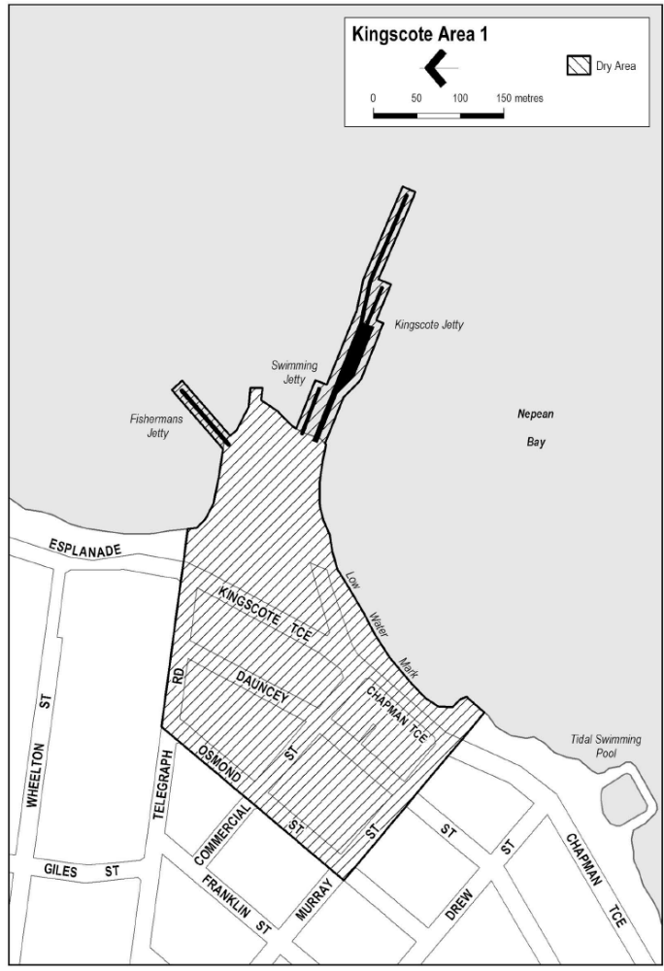
Made by the Liquor and Gambling Commissioner
on 18 January 2018

MINING ACT 1971
Notice pursuant to Section 29 (1a) and 29 (5) (b) (ii) of the Mining Act 1971
NOTICE is hereby given that the notice under the Mining Act 1971 (the Act) published on 10th November 2016 in the South Australian Government Gazette at page 4367, is varied in respect of land referred to in the Schedule.
Notice is further hereby given that:
- Pursuant to subsection 29 (1a) of the Act no applications may be made for corresponding licences over land identified in Columns 1, 2, 3 and 6 of the Schedule during the succeeding period listed in Column 4 of the Schedule.
- Applications for corresponding licences may be made during the period listed in Column 5 of the Schedule and during that period, pursuant to subsection 29 (5) (b) (ii) of the Act, subsection 29 (4) of the Act will not apply in relation to any such applications. (See Note 1).
- Plans and coordinates for the land identified in Columns 1, 2, 3 and 6 of the Schedule can be obtained at the Department of the Premier and Cabinet (DPC) Minerals website http://www.minerals.dpc.sa.gov.au/exploration/public_notices or by phoning Mineral Tenements on (08) 8463 3103.
- This Notice becomes effective on 23rd January 2018.
The Schedule
Column 1  ERA No | Column 2  Locality | Column 3  Area (km²) | Column 4  Moratorium Period | Column 5  Application Open Dates | Column 6  Specific criteria
961 | Echo Hill area - approx  100 km NW of Marla | 1908 | 18/10/2017 to 01/4/2018 | 02/04/2018 to 06/04/2018 | APY Lands
Dated: 23 January 2018
J Martin
General Manager Mineral Tenements
Mining Registrar, Mineral Resources
Department of State Development
Delegate of the Minister for Mineral Resources and Energy
NOTE 1: The effect of this notice is that:
- No applications for a corresponding licence may be made during the succeeding period.
- The succeeding period will always expire on a Sunday. From the immediately following Monday to the immediately following Friday, applications for a corresponding licence may be made (the application week).
- Applications made in the application week will not be dealt with under subsection 29(4) i.e., on a first come first served basis, but under subsection 29(6) i.e., on a merits basis.
- If no applications are made in the application week, the land in question will cease to be subject to the notice and any applications for an exploration licence made after that time will be dealt with under subsection 29(4).

Mining Act 1971
Notice is hereby given in accordance with Regulation 86(5) of the Mining Regulations 2011 (Mining Regulations) determining the reporting periods and minimum information required to be provided in a Compliance Report for a holder of a mineral lease and any associated miscellaneous purposes licence or associated extractive mineral lease, under Regulation 86(1), (3), (4) and 7 of the Mining Regulations.
- REQUIREMENT FOR DECLARATION OF ACCURACY
The compliance report must include a signed statement by the tenement holder (or their agent) that the content of the report has been reviewed and is accurate.
Provide a summary of the steps undertaken to review the compliance report to ensure its accuracy.
- COMPLIANCE REPORTS
The compliance report must summarise the tenement holders own compliance monitoring activities, and provide evidence that mining operations are compliant with the approved program for environment protection and rehabilitation (PEPR), conditions of the relevant mineral lease and any associated miscellaneous purposes licence, or associated extractive mineral lease, and the requirements of the Mining Act 1971 (the Mining Act).
The compliance report will replace the mining and rehabilitation compliance report where this is required in any mineral lease and/or miscellaneous purposes licence conditions.
- REQUIREMENT FOR SUBMISSION AND REPORTING PERIOD
Unless otherwise agreed or determined by an Authorised Officer in writing:
- A compliance report is required for all mineral leases and any associated miscellaneous purposes licences or associated extractive mineral leases.
- The reporting period is one year, based on the anniversary of the PEPR approval by the Minister under Section 70B (5) of the Mining Act.
- The period after the reporting period to submit the compliance report is two months.
- A final compliance report is to be submitted to support an application for the surrender of a mining lease and any associated miscellaneous purposes licence or associated extractive mineral lease.
- CONTENT OF COMPLIANCE REPORT
The compliance report must provide information required by all elements of Regulation 86(4) (a–i) of the Mining Regulations. The following sections specify the content required to satisfy these elements and other additional information required, where it is relevant to the operation.

4.1 Public liability insurance
In accordance with Regulation 90(2) of the Mining Regulations, the tenement holder must provide copy of the cover note for the insurance required under Regulation 90(1) or a copy of the policy of insurance or both. Documents provided should certify that the insurance is current.
4.2 Identification
The compliance report must clearly identify:
- tenement number(s)
- name of the mine operation
- general location details
- name(s) of the tenement holder and mine operator(s)
- site contact
- reference and approved date of relevant PEPR(s) being reported against
- dates of the reporting period
- report submission date
4.3 Tenements
Provide:
- a summary list and the status of currency of all tenements covered by the approved PEPR.
- a plan(s) of the mining operation showing all tenement boundaries covered by the approved PEPR.
4.4 Other approvals
Provide a summary list and the status of currency of any other approvals obtained to authorise the mining operation, that are relevant to the achievement of environmental outcomes within the approved PEPR and or compliance with the tenement conditions.
4.5 Ore reserves and mineral resources
Provide:
- a statement of the current ore reserves and mineral resource estimates in the tenement area and a brief description of the basis of this estimate; include Australasian Joint Ore Reserves Committee (JORC) compliant ore reserve and mineral resource estimates and categories, if available.
- a statement of any change in the mineral resource and ore reserves from those that form the basis for the mining operation in the approved PEPR.
or
- an estimate of the resource to be mined, the basis of this estimate, and demonstrate that the resource continues to be economically mined at current commodity prices.
and
- a summary of any new delineation or exploration drilling activities on the tenement, or any other potential sources of ore (e.g. from nearby mines) that may have a significant effect on the future production levels and mine life.
- a statement of the estimated mine life.
4.6 Mining, processing and waste storage activities
Provide:
- a summary of the quantity of ore mined and processed in the reporting period, and the expected quantity to be mined and processed in the next reporting period.
- a summary of the quantity of ore currently stockpiled on the tenement, the amount of concentrate or other products exported from the tenement in the reporting period, and the amount expected to be exported in the next reporting period.
- a summary of the amount of overburden / waste mined during the reporting period, the amount of overburden / waste to be mined during the next period and the amount of overburden / waste mined since commencement of mining operations.
4.7 Compliance with environmental outcomes and leading indicator criteria
Provide:
- a statement that operations were, or were not, compliant with each environmental outcome (including mine completion outcomes) specified in the tenement conditions or approved PEPR. The statement must be supported by a summary of measurement criteria data that clearly demonstrates the conclusion that the environmental outcome was (or was not) fully achieved.
- summarise data relating to any leading indicator criteria in the approved PEPR. If any leading indicator criteria have been or will become relevant to the operation of any control strategy, the report must state the actions that were taken and if the relevant controls strategies continue to be effective.
4.8 Compliance with non-outcome based tenement conditions
Provide:
- a statement on the compliance status of any tenement conditions of the lease or licence that do not relate to an environmental outcome in the approved PEPR.
- evidence to support the statement of compliance.
4.9 Rectification of non-compliances
Where instances of non-compliance with either the relevant environmental outcomes in the approved PEPR or tenement conditions have occurred during the current reporting period, provide the following information for each non-compliance:
- the date of the incident
- what environmental outcome or tenement condition was breached
- the date the incident was reported under Regulation 87 of the Mining Regulations , or other reporting protocol endorsed by the Government of SA (including the South Australian Uranium Incident Reporting Protocol)
- the cause of the non-compliance
- any actions taken or yet to be taken to rectify the non-compliance and to prevent the reoccurrence of any such non-compliance
Where non-compliances under Regulation 86 or initial incident reports under Regulation 87 of the Mining Regulations have previously been reported in compliance reports and not fully rectified at the time of reporting, a progress report must be included to assess the effectiveness of rectification.
4.10 Disturbance and rehabilitation activities
Provide a summary of the disturbance and rehabilitation activities, including:
- the amount of land disturbed and activity that created the disturbance in the reporting period
- strategies implemented to avoid or minimise disturbance
- rehabilitation works carried out in the reporting period
- the amount of land where rehabilitation works are completed
- an estimated amount of land to be rehabilitated in the next reporting period
- any potential improvements learned from previous rehabilitation activities.
4.11 Reconciliation of native vegetation clearance
Where native vegetation has been approved for clearance, include:
- the approved maximum clearance (as described in the PEPR) in hectares
- the amount cleared in the reporting period (in hectares and shown on a plan)
- the total amount cleared to date, and
- an estimated amount to be cleared in the next reporting period.
4.12 Environment Protection and Biodiversity Conservation Act 1999 reporting
If the tenement was the subject of an approval under the Commonwealth Environment Protection and Biodiversity Conservation Act 1999 (EPBC Act), include a summary report demonstrating compliance with all EPBC Act approval conditions.
4.13 Exempt land
Provide:
- a statement that all waivers for land relevant to the mining operation are in place and compliant with exempt land provisions in accordance with Section 9 of the Mining Act.
- the status of exempt land, including;
  - name of person entitled to exemption
  - certificate of title or crown land details
  - reason for exemption
  - area of exemption (hectares)
  - date waiver registered
  - any relevant conditions
- a plan showing all exempt land relevant to the mining operations. The plan must detail the extent of mining operations at the end of the reporting period.
4.14 Complaints
Provide a summary of any complaints raised by third parties for the reporting period. For each complaint specify:
- The date of complaint
- the nature of the compliant
- whether or not it related to a non-compliance
- what action was taken to address the complaint (or yet to be taken), and
- the date the compliant was resolved.
4.15 Management system reviews
Provide a summary of any management system reviews undertaken during the reporting period in order to ensure compliance with relevant tenement conditions and environmental outcomes (including mine completion outcomes), including:
- when an audit or review was undertaken
- who undertook the audit or review
- what aspect(s) of the management system was audited or reviewed
- what issues, or recommendations for improvement were noted
- an assessment of any issues identified in the audit or review with the potential to lead to a non-compliance with approved environmental outcomes, and
- what corrective action has been, or will be, taken to address any issues identified.
4.16 Verification of uncertainty
Provide:
- a description and status of works undertaken during the reporting period or proposed to be undertaken to address any identified uncertainties or assumptions made in the approved PEPR
and
- a description and status of works undertaken during the reporting period or proposed to be undertaken to address any additional uncertainties or assumptions identified since the PEPR was approved.
4.17 Change to mining operations and emerging environmental hazards
Provide:
- a summary list of any change(s) to mining operations endorsed under the approved PEPR for the reporting period.
- a description of any new or emerging environmental hazards that apply, or appear to be arising, in relation to mining operations.
4.18 Technical reports
Provide a summary list of all technical data, studies and reports generated during the reporting period that support the achievement of tenement conditions and environmental outcomes in the approved PEPR.
- MAPS, PLANS AND CROSS-SECTIONS
All maps, plans and cross-sections must conform to the following standards:
- Australian Height Datum (AHD)
- state and show the relevant datum
- metric units
- have a title, north arrow, scale bar and legend
- date prepared and author
- be of appropriate resolution and scale for represented information, and
- be legible in both the hardcopy and electronic versions of the submission.
- APPENDICES
Appendices are required in the compliance report where detailed information regarding monitoring, investigations and technical reports are required to demonstrate compliance with environmental outcomes (including mine completion outcomes). Key principles to be followed in the preparation of Appendices are as follows:
- when appending a technical report, a summary of the main findings and conclusions must be included in the technical report. Conclusions must be linked back to the approved PEPR and the relevant environmental outcome or tenement conditions.
- where large sets of data have been collected, charts and tables are to be used to summarise findings.
- graphic representations of the data must clearly display labels, units and values.
- SUBMISSION OF THE COMPLIANCE REPORT
Unless otherwise specified by an Authorised Officer:
- one hard copy and an electronic version of the compliance report must be submitted.
- each page, plan or other separate sheet must include the tenement number(s), date of the compliance report preparation and sequential page numbering
- the electronic version must be submitted in one single Acrobat PDF file
Mark submissions ‘Attention: Mining Regulation Branch’ and forward by email, post or courier:
Email
DPC.MiningRegRehab@sa.gov.au
Mail
Mining Regulation
Mineral Resource Division
Department of the Premier and Cabinet (DPC)
GPO Box 320
Adelaide SA 5001
Hand deliver/courier
Mining Regulation
Mineral Resource Division
Department of the Premier and Cabinet (DPC)
c/- Level 7, 101 Grenfell Street
Adelaide SA 5001
In accordance with Regulation 86 of the Mining Regulations 2011 this notice will have effect from 23 January 2018.
Greg Marshall
Director Mining Regulation

NATIONAL PARKS AND WILDLIFE (NATIONAL PARKS) REGULATIONS 2016
Closure of the Telowie Gorge Conservation Park and the Napperby Block of Mt Remarkable National Park
PURSUANT to Regulations 7(3) (a) and 7(3) (d) of the National Parks and Wildlife (National Parks) Regulations 2016, I, Marguerite Chantal Swart, Director, Regional Programs, Parks and Regions Group, authorised delegate of the Director of National Parks and Wildlife, close to the public, the whole of Telowie Gorge Conservation Park and the Napperby Block of Mt Remarkable National Park from:
6am on Saturday, 17 February 2018 until 6pm on Friday, 23 February 2018
The purpose of the closure is to ensure the safety of the public during a pest control program within the reserves during the period indicated.
Dated: 18 January 2018
M. C. Swart
A/Director, Regional Programs
Parks and Regions Group
Department of Environment, Water and Natural Resources

NOTICE TO MARINERS
No 1 of 2018
Water Traffic Restrictions – Gulf St Vincent – Rogues Point
Mariners are advised that a two metre square floating research structure will be located at Windara Reef near Rogues Point, Yorke Peninsula, within the following GPS coordinates:
- 34° 30.496’ S, 137° 53.953’ E
- 34° 30.604’ S, 137° 53.949’ E
- 34° 30.499’ S, 137° 54.083’ E
- 34° 30.607’ S, 137° 54.079’ E
The structure will be marked with an isolated danger marker. Mooring to this structure is prohibited. Further information regarding Windara Reef can be found at http://pir.sa.gov.au/fishing/recreational_fishing/windara_reef
Mariners are advised to navigate with extreme caution in the area.
Gordon Panton
Manager Marine Operations
Department of Planning, Transport & Infrastructure
DPTI 2017/02277/01
www.dpti.sa.gov.au

NOTICE TO MARINERS
No 2 of 2018
South Australia – Port Victoria – New Beacon
Mariners are advised that the existing unlit starboard beacon marking Eclipse Rock in Port Victoria has been replaced with a lit isolated danger beacon in position 34° 29’ 44.52” S, 137° 28’ 28.50” E, Fl W (2) 6s, range 3 NM.
The lit beacon at the end of the Port Victoria jetty, Fl WR 2s, has been removed.
Mariners are advised to proceed with caution in the area.
Charts affected: Aus 776, Aus 777
Dated: 12 January 2018
Gordon Panton
Manager Marine Operations
Department of Planning, Transport & Infrastructure.
DPTI 2017/02277/01
www.dpti.sa.gov.au

South Australia
Passenger Transport (Exemption for Small Passenger Vehicles and Taxis) Notice 2017
under section 54 of the Passenger Transport Act 1994
- SHORT TITLE
This Notice may be cited as the Passenger Transport (Exemption for Small Passenger Vehicles and Taxis) Notice 2017.
- COMMENCEMENT
This Notice will come into operation on the day on which it is published in the Government Gazette.
- INTERPRETATION
In this Notice:
Act means the Passenger Transport Act 1994;
date of manufacture means:
(a) if the vehicle is fitted with a compliance plate—the last calendar day of the month of manufacture shown on the compliance plate;
(b) if the vehicle is fitted with 2 or more compliance plates—the last calendar day of the earliest month of manufacture shown on any of the compliance plates;
(c) in any other case—the last calendar day of the month of manufacture or, if that is not reasonably practicable to ascertain, the last calendar day of the year of manufacture.
equipment is taken to include (without limitation) a despatch or electronic booking system, security camera system (including fixed brackets for holding such equipment) but does not include a mobile phone or hands-free adaptor;
new motor vehicle means a motor vehicle not previously registered in South Australia or elsewhere;
passenger transport service has the same meaning attributed to it under Section 4 of the Passenger Transport Act 1994;
small passenger vehicle has the same meaning attributed to it under Regulation 3 of the Passenger Transport Regulations 2009;
- EXEMPTION
I STEPHEN MULLIGHAN, MINISTER FOR TRANSPORT AND INFRASTRUCTURE,
Hereby revoke the exemption for new small passenger vehicles from section 54 of the Act published by Gazette notice dated 4 September 2017, effective 11.59pm 31 January 2018.
- small passenger vehicle (including country taxis)
In accordance with subsection 54(3) and subsection 54(4) of the Act, I hereby exempt, effective 12.01am 1 February 2018, the following specified class of vehicles, being small passenger vehicle and country taxis, each for a period of 12 calendar months from its date of manufacture, from section 54 of the Act on condition that the small passenger vehicle must:
- be a new motor vehicle;
- be attached to a valid Small Passenger Vehicle Accreditation or Country Taxi Accreditation;
- have certified, by a person authorised by the Minister to certify compliance for the purpose of this exemption, that any equipment fitted for the purpose of the provision of a passenger transport service meets Australian standards, has been fitted in accordance with the manufacturers criteria and in a manner so as not to present an injury hazard to occupants of the vehicle, and complies with the Act and Regulations;
- display a vehicle inspection exemption label; and
- otherwise, remain unmodified.
- Taxi
In accordance with subsection 54(3) and subsection 54(4) of the Act, I hereby exempt, effective 12.01am 1 February 2018, the following specified class of vehicles, being taxis, each for a period of 6 calendar months from its date of it being added to an accreditation, provided this period does not exceed 12 calendar months from its date of manufacture, from section 54 of the Act on condition that the small passenger vehicle must:
- be a new motor vehicle;
- have certified, by a person authorised by the Minister to certify compliance for the purpose of this exemption, that any equipment fitted for the purpose of the provision of a passenger transport service meets Australian standards, has been fitted in accordance with the manufacturers criteria and in a manner so as not to present an injury hazard to occupants of the vehicle, and complies with the Act and Regulations;
- display a vehicle inspection exemption label; and
- otherwise, remain unmodified.
- AUTHORISATION
Dated: 10 January 2018
Hon Stephen Mullighan MP
Minister for Transport and Infrastructure

Petroleum and Geothermal Energy Act 2000
Application for Grant of Associated Activities Licence
AAL 256
Pursuant to section 65(6) of the Petroleum and Geothermal Energy Act 2000 and Delegation dated 31 March 2017, notice is hereby given that an application for the grant of an Associated Activities Licence within the area described below has been received from:
Victoria Oil Exploration (1977) Pty Ltd
Impress (Cooper Basin) Pty Ltd
Permian Oil Pty Ltd
Springfield Oil and Gas Pty Ltd
The application will be determined on or after 20 February 2018.
Description of Application Area
All that part of the State of South Australia, bounded as follows:
Commencing at a point being the intersection of latitude 27°26'20" S GDA94 and longitude 139°42'44" E GDA94, thence east to longitude 139°42'57" E GDA94, south to latitude 27°26'51" S GDA94, west to longitude 139°42'40" E AGD66, north to latitude 27°26'30" S GDA94, west to longitude 139°42'44" E GDA94, and north to the point of commencement.
AREA: 0.33 square kilometres approximately
Dated: 19 January 2018
Barry A. Goldstein
Executive Director
Energy Resources Division
Department of the Premier and Cabinet
Delegate of the Minister for Mineral Resources and Energy

Petroleum and Geothermal Energy Act 2000
Suspension of Petroleum Exploration Licences
PELs 138, 147 and 148
Gas Storage Exploration Licences
GSELs 576, 577, 578, 579, 580, 581, 582 and 583
Pursuant to section 90 of the Petroleum and Geothermal Energy Act 2000, notice is hereby given that the abovementioned Exploration Licences have been suspended under the provisions of the Petroleum and Geothermal Energy Act 2000, pursuant to delegated powers dated 31 March 2017.
Petroleum Exploration Licence (PEL) 138 has been suspended for the period from 24 August 2017 to 23 August 2018 inclusive.
The expiry date of PEL 138 is now determined to be 15 April 2022.
Petroleum Exploration Licences (PELs) 147 and 148, and Gas Storage Exploration Licences (GSELs) 576, 577, 578, 579, 580, 581, 582 and 583 have been suspended for the period from 22 August 2017 to 21 August 2018 inclusive.
The expiry date of PELs 147 and 148 and GSELs 576, 577, 578, 579, 580, 581, 582 and 583 is now determined to be 28 July 2023.
Dated: 16 January 2018
Barry A. Goldstein
Executive Director
Energy Resources Division
Department of the Premier and Cabinet
Delegate of the Minister for Mineral Resources and Energy

PROFESSIONAL STANDARDS ACT 2004
CPA Australia Professional Standards Scheme
PURSUANT to section 14 of Professional Standards Act 2004, I authorise the publication in the Gazette of the CPA Australia Professional Standards Scheme.
Pursuant to section 15 (1) (a) of the Professional Standards Act 2004, I specify 24 January 2018 as the date of commencement of the Professional Standards Scheme.
Dated: 15 January 2018
John Rau
Attorney-General

South Australia
Public Sector (Reorganisation of Public Sector Operations) Notice 2017
under Section 9 (1) of the Public Sector Act 2009

1—Short title
This notice may be cited as the Public Sector (Reorganisation of Public Sector Operations) Notice 2017.

2—Commencement
This notice will come into operation on the day that it is made.

3—Transfer of employees
The employees of the Department of Planning, Transport and Infrastructure specified in Schedule 1 are transferred to the Department of Treasury and Finance on the same basis of engagement as applied before the transfer.

Schedule 1—Employees being transferred
All employees employed in the business unit known as the Office of the Registrar-General (retained function), including those employees who:
  - are currently working on a term basis in another public sector agency and who have a right of return to duties pursuant to Regulation 6 of the Public Sector Regulations 2010; and/or
  - are absent from their substantive duties on any form of paid or unpaid leave and who have a right at the conclusion of such leave to return to duties .

Made by the Premier
8 January 2018
11900813

Shop Trading Hours Act 1977
Temporary Exemption
NOTICE is hereby given that pursuant to section 5 (9) (b) of the Shop Trading Hours Act 1977 (the Act), I, John Rau, Minister for Industrial Relations, do hereby declare that shops within the ambit of sections 13 (5a) and 13 (5b), situated within the Greater Adelaide Shopping District, are exempt from the provisions of the Act, subject to the following conditions:
- Exemption will apply on Saturday, 31 March 2018 until 5:00 pm.
- Normal trading hours prescribed by section 13 of the Act shall apply at all other times.
- All employees working during these extended hours will do so on a strictly voluntary basis.
- Any and all relevant industrial instruments are to be complied with.
- All work health and safety issues (in particular those relating to extended trading hours) must be appropriately addressed.
Dated: 2 January 2018
John Rau
Deputy Premier
Minister for Industrial Relations

SUMMARY OFFENCES ACT 1953
Declared Public Precincts
Notice of Ministerial Declaration
I, JOHN ROBERT RAU, Attorney-General in the State of South Australia, being the Minister responsible for the administration of Part 14B – Declared Public Precincts of the Summary Offences Act 1953, DO HEREBY DECLARE pursuant to the provisions of section 66N of the said Act that the area, comprised of more than one public place, within the following boundaries:
- Esplanade from Aldinga Beach Road (Aldinga Beach), south along Lower Esplanade; and
- Esplanade (Aldinga-Silver Sands) to Ningana Road; and
- South from Ningana Road to Button Road; and
- South from Button Road to the southern point of the Esplanade (Sellicks Beach) and encompassing all land back to the water line at the beach
will be a declared public precinct for a period of 12 hours from 10.00am on 26 January 2018 local time until 10.00pm on 26 January 2018.
I am satisfied that there is, during the period specified in this declaration, a reasonable likelihood of conduct posing a risk to public order and safety in the area specified.
I am satisfied that the inclusion of each public place in the area is reasonable having regard to that identified risk.
Dated: 18 December 2018
Attorney-General

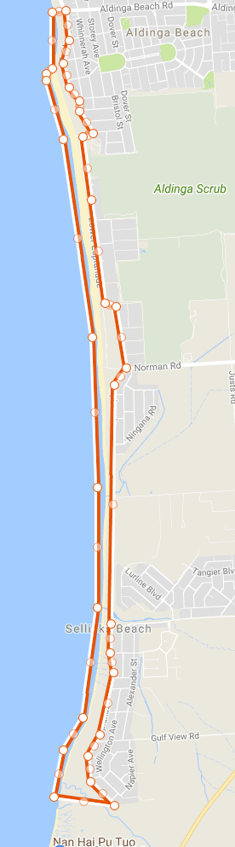

TRAINING AND SKILLS DEVELOPMENT ACT 2008
Part 4 – Apprenticeships/Traineeships
Pursuant to the provision of the Training and Skills Development Act 2008, the Training and Skills Commission (TaSC) gives notice that determines the following Trades or Declared Vocations in addition to the gazette notices of:
- 25 September 2008 | - 23 October 2008 | - 13 November 2008 | - 4 December 2008
- 18 December 2008 | - 29 January 2009 | - 12 February 2009 | - 5 March 2009
- 12 March 2009 | - 26 March 2009 | - 30 April 2009 | - 18 June 2009
- 25 June 2009 | - 27 August 2009 | - 17 September 2009 | - 24 September 2009
- 9 October 2009 | - 22 October 2009 | - 3 December 2009 | - 17 December 2009
- 4 February 2010 | - 11 February 2010 | - 18 February 2010 | - 18 March 2010
- 8 April 2010 | - 6 May 2010 | - 20 May 2010 | - 3 June 2010
- 17 June 2010 | - 24 June 2010 | - 8 July 2010 | - 9 September 2010
- 23 September 2010 | - 4 November 2010 | - 25 November 2010 | - 16 December 2010
- 23 December 2010 | - 17 March 2011 | - 7 April 2011 | - 21 April 2011
- 19 May 2011 | - 30 June 2011 | - 21 July 2011 | - 8 September 2011
- 10 November 2011 | - 24 November 2011 | - 1 December 2011 | - 8 December 2011
- 16 December 2011 | - 22 December 2011 | - 5 January 2012 | - 19 January 2012
- 1 March 2012 | - 29 March 2012 | - 24 May 2012 | - 31 May 2012
- 7 June 2012 | - 14 June 2012 | - 21 June 2012 | - 28 June 2012
- 5 July 2012 | - 12 July 2012 | - 19 July 2012 | - 2 August 2012
- 9 August 2012 | - 30 August 2012 | - 13 September 2012 | - 4 October 2012
- 18 October 2012 | - 25 October 2012 | - 8 November 2012 | - 29 November 2012
- 13 December 2012 | - 25 January 2013 | - 14 February 2013 | - 21 February 2013
- 28 February 2013 | - 7 March 2013 | - 14 March 2013 | - 21 March 2013
- 28 March 2013 | - 26 April 2013 | - 23 May 2013 | - 30 May 2013
- 13 June 2013 | - 20 June 2013 | - 11 July 2013 | - 1 August 2013
- 8 August 2013 | - 15 August 2013 | - 29 August 2013 | - 6 February 2014
- 12 June 2014 | - 28 August 2014 | - 4 September 2014 | - 16 October 2014
- 23 October 2014 | - 5 February 2015 | - 26 March 2015 | - 16 April 2015
101. 27 May 2015 | 102. 18 June 2015 | 103. 3 December 2015 | 104. 7 April 2016
105. 30 June 2016 | 106. 28 July 2016 | 107. 8 September 2016 | 108. 22 September 2016
109. 27 October 2016 | 110. 1 December 2016 | 111. 15 December 2016 | 112. 7 March 2017
113. 21 March 2017 | 114. 23 May 2017 | 115. 13 June 2017 | 116. 18 July 2017
117. 19 September 2017 | 118. 26 September 2017 | 119. 17 October 2017 | 120. 3 January 2018
121. 23 January 2018
Trades or Declared Vocations and Required Qualifications and Training Contract Conditions
for the Construction, Plumbing and Services Training Package CPC
Previous Trade Occupation Name | New Trade Occupation Name | Qualification Code | Title | Nominal Term of Training Contract | Probationary Period
Signwriter/Sign Manufacturer | Sign Maker | CPC30216 | Certificate III in  Signs and Graphics | 48 Months | 90 Days

South Australia
Statutes Amendment (Court Fees) Act (Commencement) Proclamation 2018
1—Short title
This proclamation may be cited as the Statutes Amendment (Court Fees) Act (Commencement) Proclamation 2018.
2—Commencement
The Statutes Amendment (Court Fees) Act 2017 (No 50 of 2017) will come into operation on 5 March 2018.
Made by the Governor
with the advice and consent of the Executive Council
on 23 January 2018
AGO0002/18CS

South Australia
Statutes Amendment (Extremist Material) Act (Commencement) Proclamation 2018
1—Short title
This proclamation may be cited as the Statutes Amendment (Extremist Material) Act (Commencement) Proclamation 2018.
2—Commencement
The Statutes Amendment (Extremist Material) Act 2017 (No 61 of 2017) will come into operation on 23 January 2018.
Made by the Governor
with the advice and consent of the Executive Council
on 23 January 2018
AGO0005/18CS

South Australia
Summary Procedure (Service) Amendment Act (Commencement) Proclamation 2018
1—Short title
This proclamation may be cited as the Summary Procedure (Service) Amendment Act (Commencement) Proclamation 2018.
2—Commencement
The Summary Procedure (Service) Amendment Act 2017 (No 36 of 2017) will come into operation on 4 March 2018.
Made by the Governor
with the advice and consent of the Executive Council
on 23 January 2018
AGO0007/18CS
South Australia
Summary Offences (Prescribed Interviewers) Variation Regulations 2018
under the Summary Offences Act 1953

Contents
Part 1—Preliminary
1 Short title
2 Commencement
3 Variation provisions
Part 2—Variation of Summary Offences Regulations 2016
4 Variation of regulation 20—Prescribed interviewers

Part 1—Preliminary
1—Short title
These regulations may be cited as the Summary Offences (Prescribed Interviewers) Variation Regulations 2018.
2—Commencement
These regulations come into operation on the day on which they are made.
3—Variation provisions
In these regulations, a provision under a heading referring to the variation of specified regulations varies the regulations so specified.
Part 2—Variation of Summary Offences Regulations 2016
4—Variation of regulation 20—Prescribed interviewers
(1) Regulation 20(1)(a)—delete "Public Service" wherever occurring and substitute in each case:
public sector
(2) Regulation 20(1)—delete "(and a prescribed interviewer is, for the purposes of section 74EC of the Act, a prescribed person)."
(3) Regulation 20(2), after the definition of Minister insert:
public sector employee has the same meaning as in the Public Sector Act 2009.
Note—
As required by section 10AA(2) of the Subordinate Legislation Act 1978, the Minister has certified that, in the Minister's opinion, it is necessary or appropriate that these regulations come into operation as set out in these regulations.
Made by the Governor
with the advice and consent of the Executive Council
on 23 January 2018
No 1 of 2018
AGO0179/17CS
South Australia
Livestock (Identification and Tracking of Pigs) Variation Regulations 2018
under the Livestock Act 1997

Contents
Part 1—Preliminary
1 Short title
2 Commencement
3 Variation provisions
Part 2—Variation of Livestock Regulations 2013
4 Variation of regulation 3—Interpretation
5 Substitution of Part 11 Division 2
Division 2—Identification and tracking of pigs
Subdivision 1—Preliminary
72 Application of Division
72A Interpretation
72B Movement documentation
72C Prescribed movement details
72D Uploading information to pig database
72E False or misleading statements under this Division
Subdivision 2—Identification and tracking of pigs
72F Identification of pigs
72G Tracking requirements

Part 1—Preliminary
1—Short title
These regulations may be cited as the Livestock (Identification and Tracking of Pigs) Variation Regulations 2018.
2—Commencement
These regulations come into operation on the day on which they are made.
3—Variation provisions
In these regulations, a provision under a heading referring to the variation of specified regulations varies the regulations so specified.
Part 2—Variation of Livestock Regulations 2013
4—Variation of regulation 3—Interpretation
(1) Regulation 3(1)—after "In these regulations" insert:
, unless the contrary intention appears
(2) Regulation 3(1), definition of prescribed movement details—delete the definition and substitute:
prescribed movement details, in relation to cattle, sheep or goats—see subregulation (2);
(3) Regulation 3(1), definition of prescribed premises—after paragraph (e) insert:
(f) an artificial breeding centre;
(4) Regulation 3(3)(a)—after "being" insert:
moved or
5—Substitution of Part 11 Division 2
Part 11 Division 2—delete Division 2 and substitute:
Division 2—Identification and tracking of pigs
Subdivision 1—Preliminary
72—Application of Division
This Division applies only in relation to pigs.
72A—Interpretation
(1) In this Division, unless the contrary intention appears—
business day means a day that is not a Saturday, Sunday or public holiday;
default deceased PIC, in relation to a saleyard, means the PIC allocated to the saleyard for the purpose of registering dead pigs at the saleyard;
default export PIC, in relation to a port for live export, means the PIC allocated to the port for the purpose of registering the export of pigs from the port;
land of pasture, in relation to a pig, means the land on which the pig is being pastured, or if it is not being pastured on land, the land on which it was most recently pastured;
movement documentation, in relation to the movement of pigs—see regulation 72B;
pig database means the database approved by the Chief Inspector that contains information relating to the identification and tracking of pigs;
pig database manager means the person designated for the time being by the Chief Inspector by notice in the Gazette as the pig database manager for the purposes of this Division;
prescribed movement details, in relation to the movement of pigs—see regulation 72C;
responsible stock agent—see regulation 72G(1)(a)(iii)(C).
(2) In this Division, a reference to the movement of a pig from its land of pasture includes a reference to the movement of the pig from interstate.
72B—Movement documentation
(1) For the purposes of this Division, movement documentation in relation to the movement of pigs must comprise—
(a) in the case of the movement of pigs for the purposes of their sale—
(i) a copy of the completed national vendor declaration in relation to the pigs; or
(ii) a document containing the following details:
(A) the prescribed movement details in relation to the movement of the pigs;
(B) the breed or other description (eg gender or age) of the pigs;
(C) the time of the movement (dispatch and arrival);
(D) the address of the land of dispatch;
(E) the name (including any trading name) of the owner of the pigs;
(F) the name, address, telephone number and signature of the person completing the document; or
(b) in any other case—a document containing the details required under paragraph (a)(ii).
(2) If, under this Division, a person is required to provide movement documentation—
(a) that person; and
(b) the person to whom the movement documentation is required to be provided,
must keep a copy of the documentation for at least 3 years.
Maximum penalty: $5 000.
Expiation fee: $315.
72C—Prescribed movement details
For the purposes of this Division, the prescribed movement details, in relation to the movement of pigs, are—
(a) the number of pigs in the consignment being moved; and
(b) the date of the movement (dispatch and arrival); and
(c) the PIC of the land of dispatch, and, if the pigs are identified by a tattoo, the pig tattoo code associated with the PIC of that land; and
(d) the PIC of the destination land (if known); and
(e) if the pigs were bred on the land of dispatch—that fact; and
(f) if the pigs were not bred on the land of dispatch—
(i) the length of time the pigs were pastured on the land of dispatch; and
(ii) the PIC of the land on which they were bred, or, if the pigs are identified by a tattoo, the pig tattoo associated with the PIC of the land on which they were bred.
72D—Uploading information to pig database
(1) For the purposes of this Division, a requirement to upload information to the pig database will be taken to include—
(a) a requirement to upload the information in a manner and form approved by the Chief Inspector; and
(b) a requirement to keep a record, in a manner and form approved by the Chief Inspector, of a confirmation of the receipt of that information into the pig database; and
(c) a requirement to keep a record of the details so uploaded for at least 3 years.
(2) A person who uploads information to the pig database under this Division must, as soon as practicable after discovering an error or omission in information in the database—
(a) if the error or omission was caused by the person—upload the correct or complete information to the database; or
(b) in any other case—notify the pig database manager of the error or omission.
Maximum penalty: $5 000.
Expiation fee: $315.
72E—False or misleading statements under this Division
A person must not make a statement that is false or misleading in a material particular (whether by reason of the inclusion or omission of any particular) in any details required to be provided under this Division.
Maximum penalty/expiation fee:
(a) if the person made the statement knowing that it was false or misleading:
Maximum penalty—$10 000.
(b) in any other case:
Maximum penalty—$5 000.
Expiation fee—$315.
Subdivision 2—Identification and tracking of pigs
72F—Identification of pigs
(1) For the purposes of this Division (but subject to this regulation), a pig will not be taken to be identified in accordance with this regulation unless it can be associated with its land of pasture as follows:
(a) if the pig was bred on that land—
(i) it has a tattoo on its left shoulder, displaying, in clearly legible characters (in paste or ink approved by the Chief Inspector), the pig tattoo code associated with a current PIC of the land; or
(ii) it has, in its left ear, an NLIS breeder identification tag of a kind approved by the Chief Inspector;
(b) in any other case—
(i) it has a tattoo on its right shoulder (or, if there is no available space on its right shoulder due to previous tattoos, on such space as is available first on the right rump of the pig followed by the left rump) displaying, in clearly legible characters (in paste or ink approved by the Chief Inspector), the pig tattoo code associated with a current PIC of the land; or
(ii) it has, in its right ear, an NLIS post-breeder identification tag of a kind approved by the Chief Inspector.
(2) A person must not—
(a) mark the shoulder of a pig with a tattoo except for the purposes of its identification in accordance with this regulation; or
(b) apply a tattoo to a piglet that is not weaned; or
(c) apply a tattoo to a weaned piglet weighing under 25kg except by means of a tattoo applicator approved by the Chief Inspector; or
(d) remove a tattoo from the shoulder of a pig except in accordance with an authorisation by the Chief Inspector under regulation 5.
Maximum penalty: $5 000.
Expiation fee: $315.
(3) The owner or person responsible for the management of a pig must not move the animal from land on which it is being pastured unless the animal is identified in accordance with this regulation.
Maximum penalty: $5 000.
Expiation fee: $315.
(4) Subregulation (3) does not apply—
(a) in relation to a piglet that has not been weaned and is removed from its land of pasture with its mother; or
(b) in circumstances of an emergency (for example, a bushfire or other emergency) where there is insufficient time to tag or tattoo the pig, provided that—
(i) the owner or person responsible for the management of the pig, within 7 days of its movement, provides the Chief Inspector with a document containing the prescribed movement details in relation to the pig and the name, address, telephone number and signature of the person who completed the document; and
(ii) if the pig is not returned to its land of pasture (or land with the same PIC as the land of pasture) within 7 days after the emergency, the pig is identified in accordance with this regulation.
(5) The following requirements apply in relation to a pig that is normally identified with a tag in accordance with this regulation but whose tag is subsequently lost, damaged or found to be incorrectly marked:
(a) in the case of a pig at a livestock saleyard—the person responsible for the management of the pig at the saleyard must—
(i) ensure that, before the pig is sold at the saleyard—
(A) a tattoo allocated to the saleyard is applied to the pig in a manner approved by the Chief Inspector; or
(B) an emergency NLIS post-breeder identification tag of a kind approved by the Chief Inspector is attached to its right ear; and
(ii) upload the details of the action taken under subparagraph (i) to the pig database within 2 business days;
(b) in the case of a pig at an abattoir—the operator of the abattoir and the person responsible for the management, slaughter or processing of the pig must ensure that the pig is not slaughtered or processed unless satisfied that the pig has been identified (by movement documentation or in some other manner approved by the Chief Inspector).
Maximum penalty: $5 000.
Expiation fee: $315.
72G—Tracking requirements
(1) The following requirements (tracking requirements) apply in relation to the movement of pigs in the following circumstances:
(a) movement of pigs from land of pasture to a saleyard for sale by a stock agent—
(i) the owner or person responsible for the management of the pigs must ensure that movement documentation in relation to the movement accompanies the pigs during the movement and is given to the stock agent for the vendor; and
(ii) the stock agent for the vendor must give a copy of the movement documentation to the operator of the saleyard on arrival of the pigs at the saleyard; and
(iii) the operator of the saleyard must, for each consignment of pigs sold at the saleyard, update the pig database as follows:
(A) for consignments going direct to an abattoir—the PIC of the abattoir and the number of pigs in the consignment must be uploaded before the end of the day of sale;
(B) for consignments going direct to any other destination land (other than their return to the previous land of pasture)—
• the prescribed movement details in relation to the movement to the saleyard; and
• the PIC of the destination land (if known),
must be uploaded within 2 business days of the sale;
(C) for consignments where the PIC of the destination land is not known—
• the prescribed movement details in relation to the movement to the saleyard; and
• the PIC of the responsible stock agent (being the stock agent acting for the purchaser or, if no such person is acting for the purchaser, the stock agent acting for the vendor),
must be uploaded within 2 business days of the sale of the pigs or their movement from the saleyard (whichever occurs sooner);
(D) for pigs not sold at the saleyard and returning to their previous land of pasture—the number of pigs being returned and the PIC of the land of pasture must be uploaded within 2 business days of the movement of the pigs from the saleyard; and
(iv) if a stock agent's PIC is uploaded under subparagraph (iii)(C), the operator of the saleyard must notify the stock agent of that fact as soon as reasonably practicable; and
(v) if the PIC of a stock agent for a purchaser was uploaded under subparagraph (iii)(C), the stock agent for the purchaser must—
(A) upload the prescribed movement details for the pigs to the pig database within 7 business days of their movement to the destination land, or, in the case of their movement to an abattoir, before their slaughter; and
(B) at the same time, notify the purchaser of the pigs in writing of the PIC of the destination land; and
(vi) if the PIC of a stock agent for a vendor was uploaded under subparagraph (iii)(C) (because no stock agent was acting for the purchaser), the stock agent for the vendor must upload the prescribed movement details for the pigs to the pig database within 2 business days of the movement of the pigs to the destination land, or, in the case of their movement to an abattoir, before their slaughter; and
(vii) if a pig is dead on arrival at a saleyard or dies at a saleyard, the operator of the saleyard must upload the saleyard's default deceased PIC in relation to the pig to the pig database within 2 business days of the pig's disposal at, or removal from, the saleyard;
(b) movement of pigs from a saleyard direct to an abattoir—the responsible stock agent must ensure that—
(i) movement documentation in relation to the movement accompanies the pigs during their movement and is given to the person responsible for the management of the pigs at the abattoir, and the operator of the abattoir, by the end of the day of sale; or
(ii) movement documentation in relation to the movement is received by the persons referred to in paragraph (i) before the arrival of the pigs at the abattoir;
(c) movement of pigs from a saleyard direct to land of pasture or other destination land—the responsible stock agent must ensure that—
(i) movement documentation in relation to the movement accompanies the pigs during their movement and is given to the purchaser or the person responsible for the management of the pigs following their movement, within 2 business days of the sale; or
(ii) movement documentation in relation to the movement is sent separately to the persons referred to in paragraph (i), provided that the documentation arrives before the pigs; or
(iii) within 2 business days of the movement—
(A) movement documentation in relation to the movement is uploaded to the pig database; and
(B) the purchaser or the person responsible for the management of the pigs following their movement is notified of that upload;
(d) movement of pigs from land of pasture direct to an abattoir—the owner or person responsible for the management of the pigs must ensure that movement documentation in relation to the movement accompanies the pigs during their movement and is given to—
(i) the purchaser or person responsible for the management of the pigs following their movement; and
(ii) the operator of the abattoir;
(e) movement of pigs from land of pasture direct to land of pasture with different PIC but no change of ownership of pigs—the owner or person responsible for the management of the pigs must, within 2 business days of their movement, upload to the pig database the prescribed movement details in relation to the movement;
(f) movement of pigs from land of pasture direct to land of pasture with different PIC following their sale—
(i) the owner or person responsible for the management of the pigs must ensure that movement documentation in relation to the movement accompanies the pigs during their movement and is given to the purchaser or person responsible for the management of the pigs following their movement; and
(ii) the purchaser or person responsible for the management of pigs following their arrival at the land of pasture must, within 2 business days after their arrival, upload to the pig database the prescribed movement details in relation to the movement;
(g) movement of pigs from land of pasture direct to prescribed premises—
(i) the owner or person responsible for the management of the pigs must ensure that movement documentation in relation to the movement accompanies the pigs during their movement and is given to the operator of the prescribed premises; and
(ii) the operator of the prescribed premises must upload the prescribed movement details in relation to the pigs to the pig database within 2 business days after their arrival at the premises;
(h) movement (including return) of pigs from prescribed premises or any other land of dispatch (other than saleyard or land of pasture) direct to land of pasture—
(i) the person responsible for the management of the pigs at the prescribed premises must ensure that movement documentation in relation to the movement accompanies the pigs during their movement and is given to the person responsible for the management of the pigs following their movement; and
(ii) the person responsible for the management of pigs following their arrival at the land of pasture must, within 2 business days, upload to the pig database the prescribed movement details in relation to the movement;
(i) movement of pigs from prescribed premises direct to prescribed premises with different PIC—
(i) the person responsible for the management of the pigs at the prescribed premises (first-mentioned) must ensure that movement documentation in relation to the movement accompanies the pigs during their movement and is given to—
(A) the person responsible for the management of the pigs following their movement; and
(B) the operator of the prescribed premises (second-mentioned); and
(ii) the person responsible for the management of pigs following their arrival at the prescribed premises (second-mentioned) must, within 2 business days after their arrival, upload the prescribed movement details in relation to the movement;
(j) movement of pigs from live export depot to port for live export—the operator of the live export depot must, within 2 business days of the movement, upload to the pig database—
(i) the prescribed movement details in relation to the movement; and
(ii) the port's default export PIC in relation to the pigs;
(k) after pigs are moved to an abattoir—
(i) the operator of the abattoir or the person responsible for the management of the pigs at the abattoir must ensure that, while at the abattoir, the pigs are kept in the same group as that in which they were consigned to the abattoir; and
(ii) the operator of the abattoir must—
(A) within 2 business days after the slaughter of the pigs—upload to the pig database the prescribed movement details in relation to the movement and the date of slaughter of the pigs; and
(B) ensure that all the prescribed movement details in relation to the movement of the pigs from their land of pasture to the abattoir (including any movement via a saleyard or other intermediary destination land) are kept available for inspection until an assessment is made of the fitness for human consumption of the carcass of the pigs.
Maximum penalty: $5 000.
Expiation fee: $315.
(2) The following provisions apply for the purposes of enabling compliance by a person with a tracking requirement under subregulation (1):
(a) a person selling or purchasing an animal through a stock agent must provide the stock agent with sufficient information for the stock agent to be able to comply with the tracking requirement;
(b) any other person who is involved in the management of a pig before, during or after its movement must provide a person who is subject to a tracking requirement in respect of that movement with sufficient information for that person to be able to comply with the tracking requirement;
(c) a person to whom paragraph (a) or (b) applies must not, without good reason, refuse a reasonable request for information by a person who is subject to a tracking requirement.
Maximum penalty: $5 000.
Expiation fee: $315.
(3) It is not a defence to a charge of an offence against this regulation of failing to provide a PIC to establish that a PIC had not previously been allocated in respect of the land or person concerned.
Note—
As required by section 10AA(2) of the Subordinate Legislation Act 1978, the Minister has certified that, in the Minister's opinion, it is necessary or appropriate that these regulations come into operation as set out in these regulations.
Made by the Governor
with the advice and consent of the Executive Council
on 23 January 2018
No 2 of 2018
17MAFF0064
South Australia
Magistrates Court (Fees) (Listing Fees) Variation Regulations 2018
under the Magistrates Court Act 1991

Contents
Part 1—Preliminary
1 Short title
2 Commencement
3 Variation provisions
Part 2—Variation of Magistrates Court (Fees) Regulations 2004
4 Variation of regulation 4—Fees
5 Variation of Schedule 1—Fees in Civil (General Claims) Division and Civil (Minor Claims) Division

Part 1—Preliminary
1—Short title
These regulations may be cited as the Magistrates Court (Fees) (Listing Fees) Variation Regulations 2018.
2—Commencement
These regulations will come into operation on the day on which Part 3 of the Statutes Amendment (Court Fees) Act 2017 comes into operation.
3—Variation provisions
In these regulations, a provision under a heading referring to the variation of specified regulations varies the regulations so specified.
Part 2—Variation of Magistrates Court (Fees) Regulations 2004
4—Variation of regulation 4—Fees
Regulation 4—after subregulation (1) insert:
(1a) The following provisions apply to the listing fees set out in clause 8A of Schedule 1:
(a) except where the Court or a registrar otherwise directs, the fee—
(i) is payable by the plaintiff; and
(ii) must be paid within the period of 14 days after the day on which the trial date is set;
(b) if there is more than 1 plaintiff, the Court or a registrar may direct that the fee is to be paid in equal portions by each of the plaintiffs;
(c) the trial will not proceed on the day set for that purpose unless the fee has been paid in accordance with this subregulation.
(1b) If an attempt to settle an action by mediation under section 27 of the Act has been made, the fee payable under clause 8A of Schedule 1 may, if the mediator so certifies, be discounted by 50%.
5—Variation of Schedule 1—Fees in Civil (General Claims) Division and Civil (Minor Claims) Division
Schedule 1—after clause 8 insert:

8A | On setting a date for trial
 | (a) for a minor civil action—
 | (i) where the amount claimed does not exceed $4 000.00 | $200.00
 | (ii) in any other case | $600.00
 | (b) for any other action under the Magistrates Court Act 1991—
 | (i) in the case of a prescribed corporation | $1 000.00
 | (ii) in any other case | $750.00
Note—
As required by section 10AA(2) of the Subordinate Legislation Act 1978, the Minister has certified that, in the Minister's opinion, it is necessary or appropriate that these regulations come into operation as set out in these regulations.
Made by the Governor
with the advice and consent of the Executive Council
on 23 January 2018
No 3 of 2018
AGO0002/18CS

South Australia
Magistrates Court (Fees) (Tiered Fees in Civil Jurisdiction) Variation Regulations 2018
under the Magistrates Court Act 1991

Contents
Part 1—Preliminary
1 Short title
2 Commencement
3 Variation provisions
Part 2—Variation of Magistrates Court (Fees) Regulations 2004
4 Variation of Schedule 1—Fees in Civil (General Claims) Division and Civil (Minor Claims) Division

Part 1—Preliminary
1—Short title
These regulations may be cited as the Magistrates Court (Fees) (Tiered Fees in Civil Jurisdiction) Variation Regulations 2018.
2—Commencement
These regulations will come into operation on 1 May 2018.
3—Variation provisions
In these regulations, a provision under a heading referring to the variation of specified regulations varies the regulations so specified.
Part 2—Variation of Magistrates Court (Fees) Regulations 2004
4—Variation of Schedule 1—Fees in Civil (General Claims) Division and Civil (Minor Claims) Division
(1) Schedule 1, clause 4—delete clause 4 and substitute:

4 | On filing a document to commence any other action under the Magistrates Court Act 1991—
 | (a) where the claim is not for money—
 | (i) in the case of a prescribed corporation | $526.00
 | (ii) in any other case | $311.00
 | (b) where the amount claimed, or the value of the property the subject of the claim, exceeds $12 000.00 but does not exceed $25 000.00—
 | (i) in the case of a prescribed corporation | $526.00
 | (ii) in any other case | $311.00
 | (c) where the amount claimed, or the value of the property the subject of the claim, exceeds $25 000.00 but does not exceed $50 000.00—
 | (i) in the case of a prescribed corporation | $750.00
 | (ii) in any other case | $400.00
 | (d) where the amount claimed, or the value of the property the subject of the claim, exceeds $50 000.00—
 | (i) in the case of a prescribed corporation | $1 100.00
 | (ii) in any other case | $750.00
(2) Schedule 1, clause 5—delete clause 5 and substitute:

5 | On lodging a counterclaim or third party notice in any other action under the Magistrates Court Act 1991—
 | (a) where the claim is not for money—
 | (i) in the case of a prescribed corporation | $526.00
 | (ii) in any other case | $311.00
 | (b) where the amount claimed, or the value of the property the subject of the claim, exceeds $12 000.00 but does not exceed $25 000.00—
 | (i) in the case of a prescribed corporation | $526.00
 | (ii) in any other case | $311.00
 | (c) where the amount claimed, or the value of the property the subject of the claim, exceeds $25 000.00 but does not exceed $50 000.00—
 | (i) in the case of a prescribed corporation | $750.00
 | (ii) in any other case | $400.00
 | (d) where the amount claimed, or the value of the property the subject of the claim, exceeds $50 000.00—
 | (i) in the case of a prescribed corporation | $1 100.00
 | (ii) in any other case | $750.00

Note—
As required by section 10AA(2) of the Subordinate Legislation Act 1978, the Minister has certified that, in the Minister's opinion, it is necessary or appropriate that these regulations come into operation as set out in these regulations.
Made by the Governor
with the advice and consent of the Executive Council
on 23 January 2018
No 4 of 2018
AGO0002/18CS

South Australia
Road Traffic (Light Vehicle Standards) Rules 2018
under the Road Traffic Act 1961

Contents
Part 1—Preliminary
1 Citation etc
1A Commencement
2 Object of Light Vehicle Standards
Part 2—Interpretation and application of the Light Vehicle Standards
3 Definitions
4 Meaning of vehicle
5 When restored vehicle is built
6 Measurement of width of vehicles
7 What is a road
8 What is a road-related area
9 Diagrams
10 Notes
11 Examples
12 Application to vehicles and combinations on roads and road-related areas
13 Vehicles to which the Light Vehicle Standards do not apply
14 Non-application of Light Vehicle Standards—exemption under other laws
15 Application of Light Vehicle Standards to vehicle complying with inconsistent ADR requirement
16 Application to vehicle subject of Motor Vehicle Standards Act approval
17 Interpretation of certain second edition ADRs
18 References to adopted standards
19 Compliance with particular adopted standards
20 Compliance with requirement to have particular equipment
Part 3—Australian Design Rules
Division 1—Compliance with ADRs
21 Second edition ADRs
22 Third edition ADRs
Division 2—Exemptions from compliance with ADRs
23 Vehicles that are not road vehicles
24 Vehicles subject to particular approvals etc under Motor Vehicle Standards Act
25 Partial exemption for personally imported vehicles
Part 4—General safety requirements
Division 1—All vehicles
26 Steering
27 Turning ability
28 Ability to travel backwards and forwards
29 Protrusions
29A Frontal protection systems
30 Driver’s view and vehicle controls
31 Seating
32 Mudguards
33 Horns, alarms etc
34 Rear vision mirrors
35 Rear vision mirrors—surfaces
36 Additional rear vision mirrors and surfaces
37 Automatic transmission
38 Diesel engines
39 Bonnet securing devices
40 Electrical wiring, components, connections and installations
41 Television receivers and visual display units
42 Requirement for windscreen to be fitted
43 Windscreens and windows
44 Window tinting
45 Windscreen wipers and washers
46 Wheels and tyres—size and capacity
47 Pneumatic tyres for particular vehicles
48 Pneumatic tyres—carcass construction
49 Tyres—defects
50 Tyres—manufacturer’s rating
51 Retreads
52 Tyre tread
Division 2—Additional requirements for motor bikes
53 Steering gear and handlebars
54 Foot rests
55 Chain guards
55A Sidecars
Part 5—Vehicle marking
56 Engine and vehicle identification numbers
57 White or silver band on certain vehicles
Part 6—Vehicle configuration and dimensions
Division 1—Axles
58 Axle configuration
59 Retractable axles
Division 2—Dimension requirements
60 Meaning of rear overhang and rear overhang line
61 Length of single motor vehicles
62 Length of single trailers
63 Length of combinations
64 Rear overhang
65 Length—trailer drawbars
66 Width
67 Height
68 Ground clearance
Part 7—Lights and reflectors
Division 1—Application of particular requirements
69 Part does not apply to particular vehicles
70 Particular requirements apply only at night
Division 2—General requirements for lights
71 Prevention of glare
72 Pairs of lights
Division 3—Headlights
73 Headlights to be fitted to vehicles
74 How headlights are to be fitted
75 How single headlights are to be fitted
77 Performance of headlights
78 Effective range of headlights
79 Changing headlights from high-beam to low-beam position
Division 4—Parking lights
80 Parking lights
Division 5—Daytime running lights
81 Daytime running lights
Division 6—Tail lights
82 Tail lights generally
83 Pattern of fitting tail lights
84 Performance of tail lights
85 Wiring of tail lights
Division 7—Number plate lights
86 Number plate lights
Division 8—Clearance lights
87 Front clearance lights
88 External cabin lights
89 Rear clearance lights
Division 9—Side marker lights
90 Vehicles needing side marker lights
91 Location of side marker lights
92 Performance of side marker lights
93 Side marker lights and rear clearance lights
Division 10—Brake lights
94 Fitting brake lights
95 Performance and operation of brake lights
Division 11—Reversing lights
96 Reversing lights
Division 12—Direction indicator lights
97 Direction indicator lights on motor vehicles
98 Direction indicator lights on trailers
99 Location of direction indicator lights
100 Operation and visibility of direction indicator lights
Division 13—Fog lights
101 Front fog lights
102 Rear fog lights
Division 14—Interior lights
103 Interior lights
Division 15—Reflectors generally
104 General requirements for reflectors
Division 16—Rear reflectors
105 Rear reflectors
Division 17—Side reflectors
106 Compulsory side reflectors on pole-type trailers
107 Optional side reflectors
Division 18—Front reflectors
108 Compulsory front reflectors on particular trailers
109 Optional front reflectors
Division 19—Warning lights and signs on buses carrying children
110 Application of Division 19
111 Fitting of warning lights and signs
112 Operation and performance of warning lights
113 Specifications for warning signs
Division 20—Other lights, reflectors, rear marking plates or signals
114 Other lights and reflectors
115 Rear marking plates and conspicuity markings
116 Signalling devices
117 Mechanical signalling devices
118 Turn signals
Part 8—Braking systems
Division 1—Brake requirements for all vehicles
119 Components of a braking system
120 Provision for wear
121 Supply of air or vacuum to brakes
122 Performance of braking systems
Division 2—Motor vehicle braking systems
123 What braking system a motor vehicle must have
124 Operation of brakes on motor vehicles
125 Air or vacuum brakes on motor vehicles
Division 3—Trailer braking systems
126 What brakes a trailer must have
127 Operation of brakes on trailers
128 Air or vacuum brakes on trailers
Part 9—Control of emissions
Division 1—Crank case gases and exhaust emissions
129 Crank case gases
130 Visible emissions—vehicles with internal combustion engines
131 Exhaust emissions—diesel-powered vehicles
132 Requirements of DT80 test cycle
133 Test procedure
Division 2—Exhaust systems
134 Exhaust systems
Division 3—Noise emissions
Subdivision 1—General
135 Measurement of stationary noise levels
136 Meaning of certified to ADR 83/00
137 Silencing device for exhaust systems
Subdivision 2—Noise levels applying to vehicles certified prior to the application of ADR 83/00
138 Application of rules in Subdivision 2
139 Stationary noise levels—car-type vehicles and motor bikes and motor trikes
140 Stationary noise levels—other vehicles with spark ignition engines
141 Stationary noise levels—other vehicles with diesel engines
Subdivision 3—Noise levels applying to vehicles certified to ADR 83/00
142 Stationary noise levels
Part 10—Alternative fuel systems
143 LPG-powered vehicles
144 Vehicles powered by natural gas
144A Hydrogen-powered vehicles
144B Electric-powered vehicles
Part 11—Mechanical connections between vehicles
145 General coupling requirements
146 Drawbar couplings
Schedule 1—Revocation of Road Traffic (Light Vehicle Standards) Rules 2013

Part 1—Preliminary
Note—
The Road Traffic (Light Vehicle Standards) Rules 2018 set standards that vehicles must comply with to be driven on roads and road-related areas.
The ADRs (Australian Design Rules) are rules for designing and building vehicles. Imported vehicles must also comply with the ADRs.
The Light Vehicle Standards require a vehicle that is subject to an ADR when built or imported to continue to comply with the ADR.
The Light Vehicle Standards also apply certain other standards (adopted standards) that are intended to complement the ADRs.
The ADRs do not cover—
• vehicles built before 1969;
• combinations of vehicles of any age;
• every safety feature for vehicles built between 1969 and 1988.
These matters are covered by the Light Vehicle Standards.
In most cases, if a vehicle complies with the Light Vehicle Standards, it is suitable for road use.
1—Citation etc
(1) These rules may be cited as the Road Traffic (Light Vehicle Standards) Rules 2018.
(2) These rules are made under section 111 of the Road Traffic Act 1961.
(3) In these rules, these rules are referred to as the Light Vehicle Standards.
Note—
1 Under the Road Traffic Act 1961, a person commits an offence if there is a breach of a light vehicle standards requirement and the person is the driver or operator of the light vehicle concerned (see sections 117 and 118).
2 Under section 161A of the Act, certain classes of light vehicles can only be driven on roads with the approval of the Minister.
1A—Commencement
These rules come into operation on the day on which they are made.
2—Object of Light Vehicle Standards
(1) The object of the Light Vehicle Standards is to set uniform Australian standards about the construction and performance of motor vehicles, trailers and combinations that are light vehicles.
(2) The standards are intended—
(a) to promote, throughout the life of those motor vehicles, trailers and combinations, their safe use and efficiency and the protection of the environment; and
(b) to reduce the cost of transport administration.
Part 2—Interpretation and application of the Light Vehicle Standards
3—Definitions
(1) In these rules, unless the contrary intention appears—
adopted standard means a standard, except a national standard, that is adopted, applied or incorporated by the Light Vehicle Standards;
Example—
Rule 51(2)(c) applies Australian Standard AS 1973-1976 Retreaded Pneumatic Passenger Car and Light Truck Tyre.
ADR means a national standard known as an Australian Design Rule;
air brake means an air-operated or air-assisted brake;
Air Services Act means the Air Services Act 1995 of the Commonwealth;
Airservices Australia means the body established under section 7 of the Air Services Act;
Airservices Australia vehicle means a vehicle driven by any of the following persons in the course of the person’s duty to Airservices Australia:
(a) the Chief Executive Officer of Airservices Australia appointed under section 34 of the Air Services Act;
(b) a person appointed to act as Chief Executive Officer of Airservices Australia under section 41 of the Air Services Act;
(c) a person employed under section 42 of the Air Services Act;
(d) a person engaged as a consultant under section 43 of the Air Services Act;
air storage tank, of a vehicle, means a tank fitted to the vehicle for storing compressed air;
ATM (aggregate trailer mass), of a trailer, means the total maximum mass of the trailer, as stated by the manufacturer, together with the trailer’s load and the mass imposed on the towing vehicle by the trailer when the towing vehicle and trailer are on a horizontal surface;
Australian Border Force vehicle means a vehicle driven by a member of the Australian Border Force, being—
(a) a person—
(i) who is covered by paragraph (a) of the definition of Immigration and Border Protection worker in section 4 of the Australian Border Force Act 2015 of the Commonwealth; and
(ii) who is in the Australian Border Force (as defined in that Act); or
(b) a person—
(i) who is covered by paragraph (b), (c) or (d) of the definition of Immigration and Border Protection worker in section 4 of the Australian Border Force Act 2015 of the Commonwealth; and
(ii) —
(A) whose services have been made available to the Australian Border Force; or
(B) who is performing services for the Australian Border Force;
Australian Standard (AS) or Australian/New Zealand Standard (AS/NZS) means a standard approved for publication by Standards Australia;
Note—
Copies of Australian Standards or Australian/New Zealand Standards are available for purchase from Standards Australia at www.standards.org.au
axle means 1 or more shafts, positioned in a line across a vehicle, on which 1 or more wheels intended to support the vehicle turn;
axle group means a single, tandem or tri-axle group;
braking system, of a vehicle, means all the brakes of the vehicle and all the components of the mechanisms by which they are operated;
British Standard means a standard approved for publication on behalf of the British Standards Institution;
Note—
Copies of British Standards are available for purchase from Standards Australia at www.standards.org.au
British Standards Institution means the institution of that name established under royal charter in the United Kingdom;
bus means a motor vehicle built mainly to carry people that seats over 9 adults (including the driver);
car means a motor vehicle built mainly to carry people that—
(a) seats not over 9 adults (including the driver); and
(b) has a body commonly known as a sedan, station wagon, coupe, convertible, or roadster; and
(c) has 4 or more wheels;
centre line, of an axle, means—
(a) for an axle consisting of 1 shaft—a line parallel to the length of the axle and passing through the centre of the axle; or
(b) for an axle consisting of 2 shafts—a line in the vertical plane passing through—
(i) the centre of both shafts; and
(ii) the centres of the wheels on the shafts;
centre line, of an axle group, means—
(a) if the group consists of 2 axles, 1 of which is fitted with twice the number of tyres as the other axle—a vertical line located one-third of the way from the centre line of the axle with more tyres towards the centre line of the axle with fewer tyres; and
(b) in any other case—a line located midway between the centre lines of the outermost axles of the group;
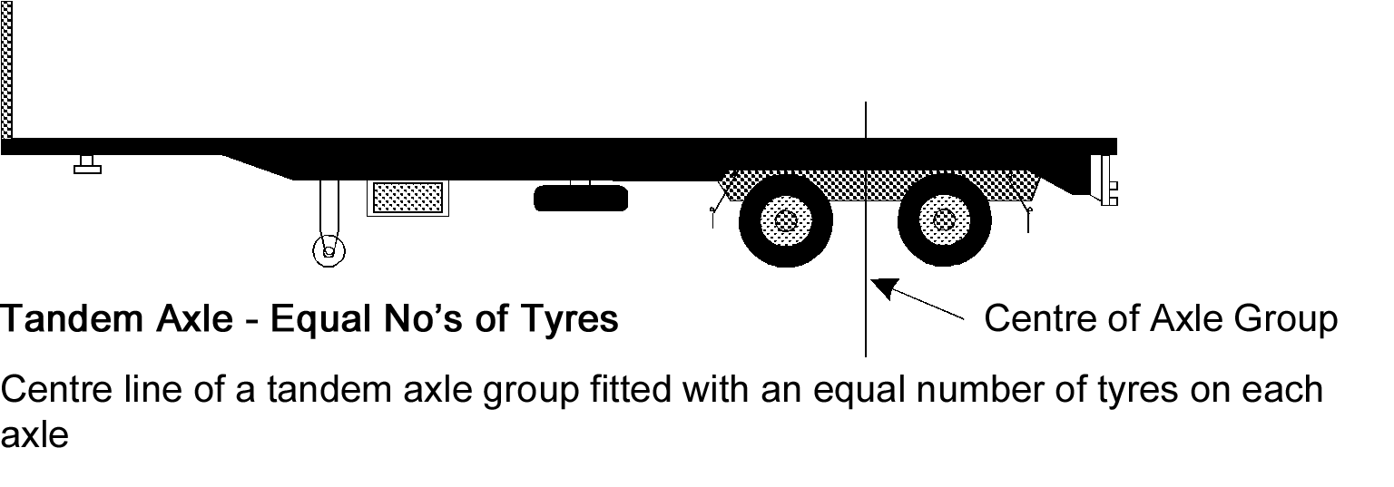
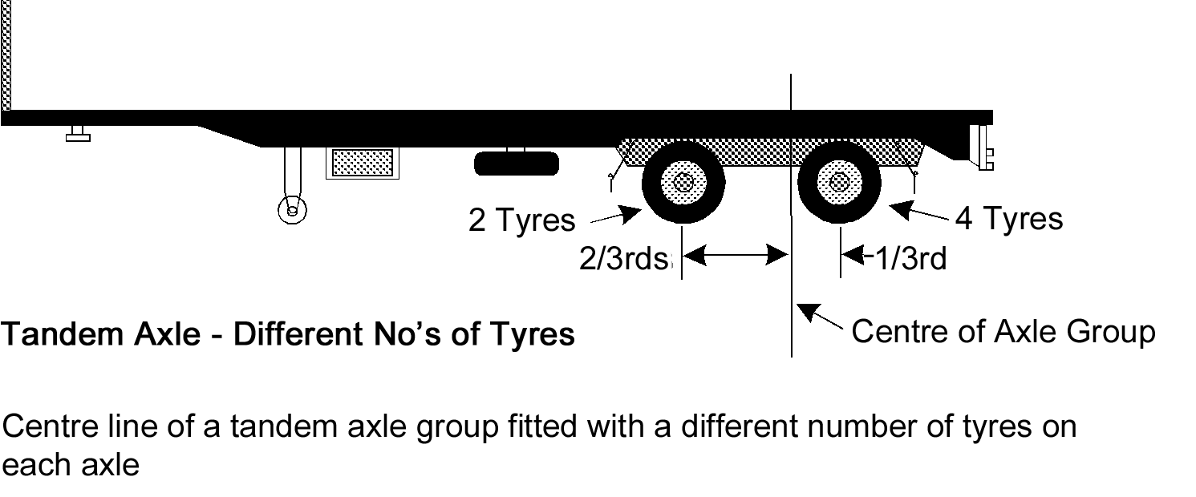
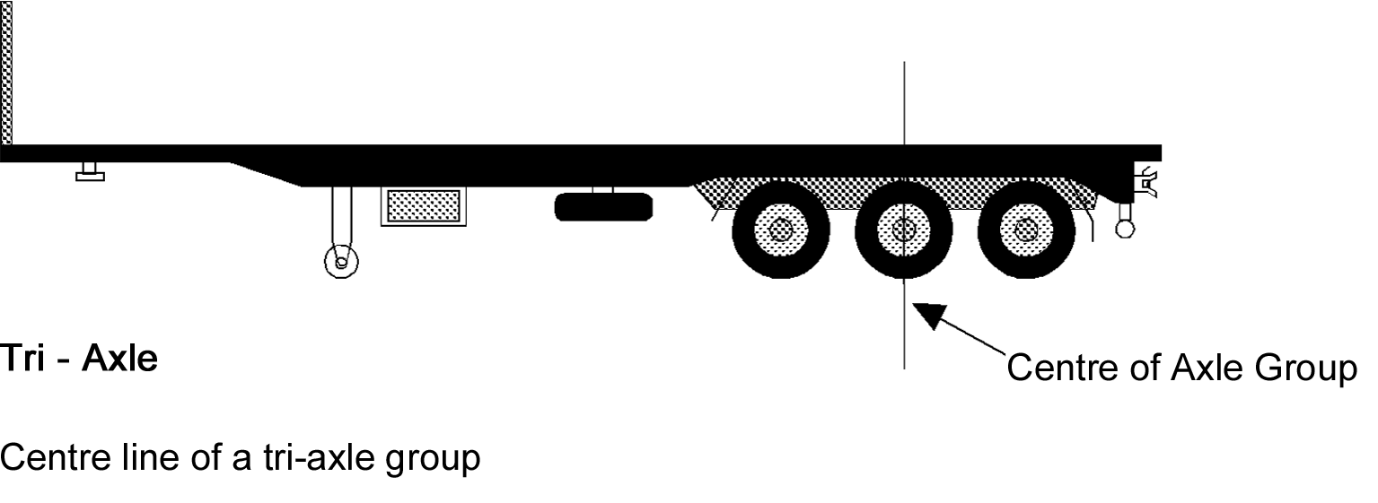
combination means a group of vehicles consisting of a motor vehicle connected to 1 or more vehicles;
converter dolly means a trailer with 1 axle group or single axle, and a fifth wheel coupling, designed to convert a semi-trailer into a dog trailer;
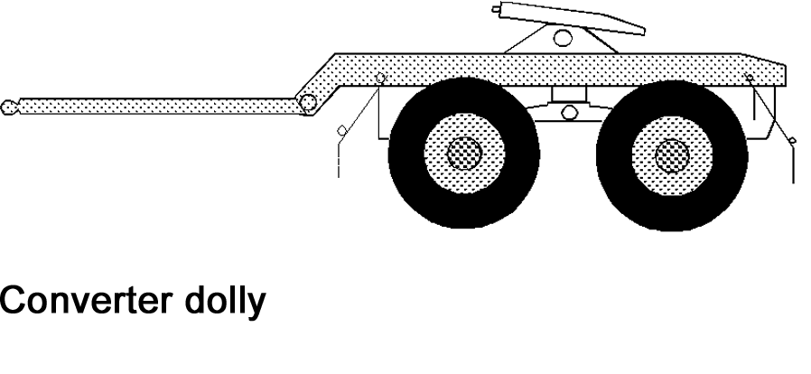
daylight means the period in a day from sunrise to sunset;
diesel engine means an engine that works on the compression-ignition principle, commonly known as a diesel engine;
dog trailer means a trailer (including a trailer consisting of a semi-trailer and converter dolly) with—
(a) 1 axle group or single axle at the front that is steered by connection to the towing vehicle by a drawbar; and
(b) 1 axle group or single axle at the rear;
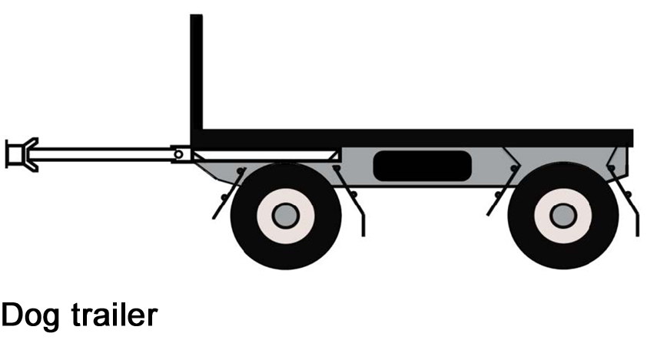
drawbar means a part of a trailer (except a semi-trailer) connecting the trailer body to a coupling for towing purposes;
drive includes be in control of;
driver, of a vehicle, means the person driving the vehicle;
emergency brake means a brake designed to be used if a service brake fails;
emergency vehicle means a vehicle driven by any of the following in the course of the person's duty:
(a) a member of an emergency services organisation within the meaning of the Fire and Emergency Services Act 2005;
(b) an authorised officer under the Emergency Management Act 2004;
(c) a person engaged in the provision of emergency ambulance services under section 57(1) of the Health Care Act 2008 on behalf of—
(i) SA Ambulance Service Inc; or
(ii) St Johns Ambulance Australia South Australia Incorporated;
(d) any other person engaged in the provision of emergency ambulance services under section 57(1) of the Health Care Act 2008;
(e) a member of the armed forces of the Commonwealth engaged in police, fire fighting or ambulance duties or duties in connection with the urgent disposal of explosives or any emergency;
exempt vehicle means—
(a) an Airservices Australia vehicle; or
(b) an Australian Border Force vehicle; or
(c) an emergency vehicle; or
(d) a police vehicle;
fifth wheel coupling means a device, except the upper rotating element and the kingpin (which are parts of a semi-trailer), used with a prime mover, semi-trailer, or converter dolly, to allow quick coupling and uncoupling and to provide for articulation;
front fog light means a light used to improve the illumination of the road in case of fog, snowfall, heavy rain or a dust storm;
GTM (gross trailer mass) means the mass transmitted to the ground by the axles of a trailer when the trailer is loaded to its GVM and connected to a towing vehicle;
GVM (gross vehicle mass), of a vehicle, means the maximum loaded mass of the vehicle—
(a) as specified by the vehicle's manufacturer; or
(b) as specified by an Australian Authority if—
(i) the manufacturer has not specified a maximum loaded mass; or
(ii) the manufacturer cannot be identified; or
(iii) the vehicle has been modified to the extent that the manufacturer's specification is no longer appropriate;
high-beam for a headlight or front fog light fitted to a vehicle, means that the light is built or adjusted so, when the vehicle is standing on level ground, the top of the main beam of light projected is above the low-beam position;
left, for a vehicle, means to the left of the centre of the vehicle when viewed by a person in the vehicle who is facing to the front of the vehicle;
light vehicle means a vehicle—
(a) if the vehicle is a trailer—with an ATM of 4.5 tonnes or less; or
(b) otherwise—with a GVM of 4.5 tonnes or less;
low-beam for a headlight or front fog light fitted to a vehicle, means that the light is built or adjusted so, when the vehicle is standing on level ground, the top of the main beam of light projected is—
(a) not higher than the centre of the headlight or fog light, when measured 8 metres in front of the vehicle; and
(b) not over 1 metre higher than the level where the motor vehicle is standing, when measured 25 metres in front of the vehicle;
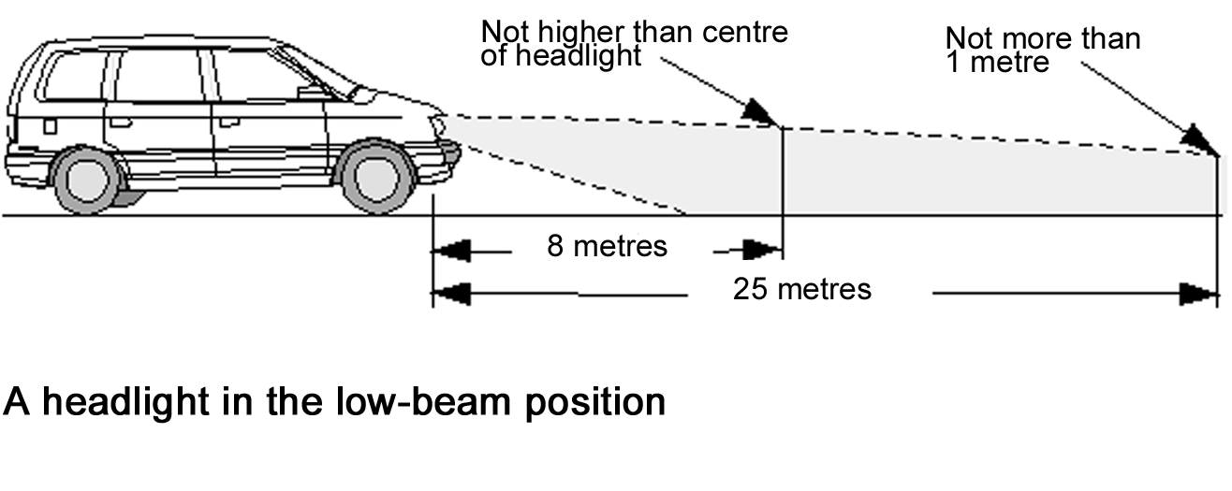
moped means a motor bike or motor trike with an engine cylinder capacity of not over 50 millilitres and a maximum speed of not over 50 kilometres an hour;
motor bike means a motor vehicle with 2 wheels, and includes a 2-wheeled motor vehicle with a sidecar attached to it that is supported by a third wheel;
motor trike means a motor vehicle with 3 wheels, but does not include a 2-wheeled motor vehicle with a sidecar attached to it that is supported by a third wheel;
motor vehicle means a vehicle built to be propelled by a motor that forms part of the vehicle;
Motor Vehicle Standards Act means the Motor Vehicle Standards Act 1989 of the Commonwealth;
mudguard means a fitting or device, with or without a mudflap, that is built and fitted to a vehicle in a way that will, as far as practicable, catch or deflect downwards any mud, stone, water, or other substance, thrown up by the rotation of the wheel of the vehicle for which the fitting or device is fitted;
national standard means a national standard under the Motor Vehicle Standards Act;
Note—
See also subrule (5).
nearer side of the vehicle, in relation to a light or reflector fitted to a vehicle, means the side of the vehicle that is closest to where the light or reflector is fitted;
parking brake of a vehicle, means the brake usually used to keep the vehicle stationary while the vehicle is parked;
point of articulation means—
(a) the axis of a kingpin for a fifth wheel; or
(b) the vertical axis of rotation of a fifth wheel coupling; or
(c) the vertical axis of rotation of a turntable assembly; or
(d) the vertical axis of rotation of the front axle group, or single axle, of a dog trailer; or
(e) the coupling pivot point of a semi-trailer;
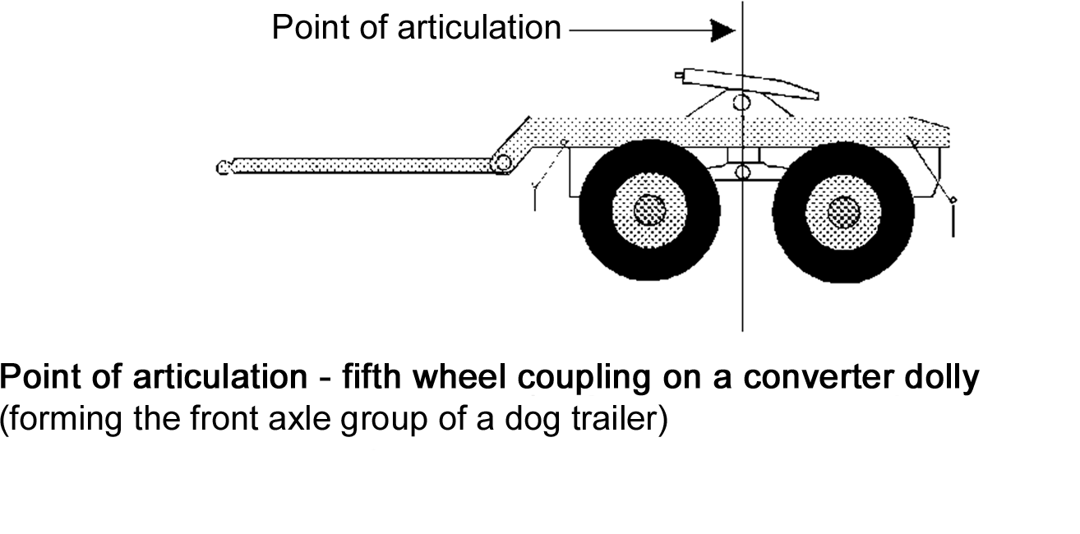
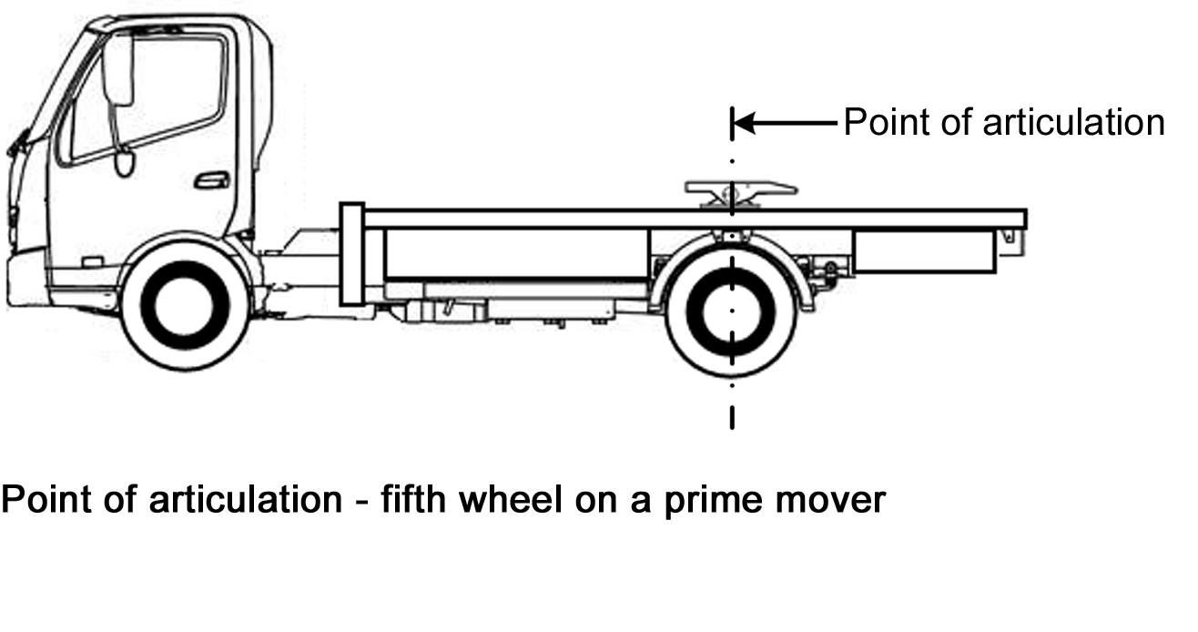
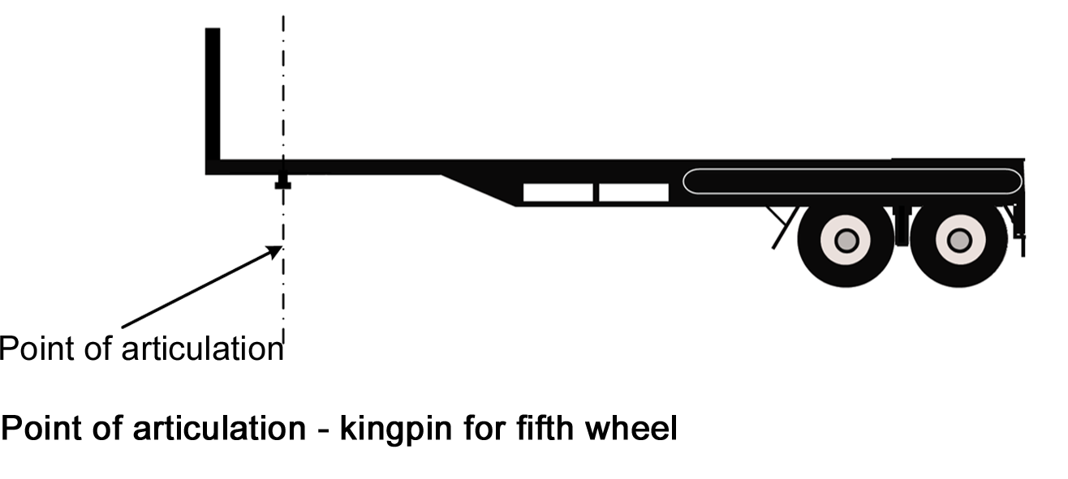
pole-type trailer means a trailer that—
(a) is attached to a towing vehicle by a pole, or an attachment fitted to the pole; and
(b) is ordinarily used for transporting loads, such as logs, pipes, structural members, or other long objects, that can generally support themselves like beams between supports;
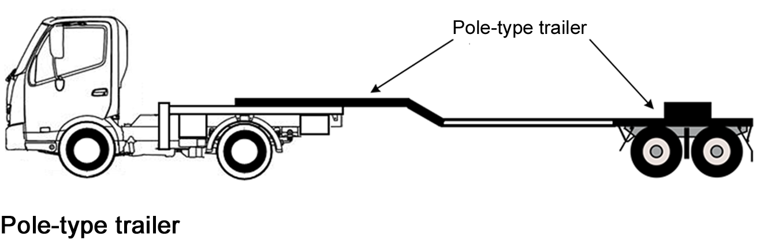
police officer means a member of South Australia Police, a member of the Australian Federal Police or a service police officer within the meaning of the Defence Force Discipline Act 1982 of the Commonwealth;
police vehicle means a vehicle driven by a police officer in the course of the police officer's duty;
prime mover means a motor vehicle built to tow a semi-trailer;
rear overhang, for the purposes of Part 6 Division 2—see rule 60;
rear overhang line, for the purposes of Part 6 Division 2—see rule 60;
right for a vehicle, means to the right of the centre of the vehicle when viewed by a person in the vehicle who is facing to the front of the vehicle;
road—see rule 7;
road-related area—see rule 8;
second edition ADR means a national standard incorporated in the document described as the Australian Design Rules for Motor Vehicle Safety, Second Edition published by the Commonwealth Government;
semi-trailer means a trailer (including a pole-type trailer) that has—
(a) 1 axle group or single axle to the rear; and
(b) a means of attachment to a prime mover that results in some of the load being imposed on the prime mover;
service brake for a vehicle, means the brake normally used to decelerate the vehicle;
side marker light means a light fitted to the side of a vehicle indicating the presence and length of the vehicle when viewed on that side;
single axle means an axle not forming part of an axle group;
single axle group means a group of at least 2 axles in which the horizontal distance between the centre lines of the outermost axles is less than 1 metre;
Standards Australia means Standards Australia Limited ACN 087 326 690, or any body to which Standards Australia Limited is a successor in law or that is a successor in law to Standards Australia Limited;
State Government enforcement vehicle means a vehicle driven by any of the following in the course of the person's duty:
(a) an authorised officer under the Agricultural and Veterinary Products (Control of Use) Act 2002;
(b) an authorised officer under the Dangerous Substances Act 1979;
(c) a fisheries officer under the Fisheries Management Act 2007;
(d) an inspector under the Livestock Act 1997;
(e) an inspector under the Plant Health Act 2009;
(f) an authorised person under the Primary Produce (Food Safety Schemes) Act 2004;
(g) an authorised officer under the Road Traffic Act 1961;
street rod vehicle means—
(a) a vehicle that has been modified for safe road use; and
(b) either—
(i) has a body and frame that were built before 1949; or
(ii) is a replica of a vehicle, the body and frame of which were built before 1949;
tandem axle group means a group of at least 2 axles in which the horizontal distance between the centre lines of the outermost axles is at least 1 metre, but not over 2 metres;
third edition ADR means a national standard incorporated in the document described as the Australian Design Rules for Motor Vehicles and Trailers, Third Edition published by the Commonwealth Government;
towing vehicle for a trailer, means the vehicle towing the trailer;
trailer means a vehicle that is built to be towed, or is towed, by a motor vehicle, but does not include a motor vehicle that is being towed;
tri-axle group means a group of at least 3 axles in which the horizontal distance between the centre lines of the outermost axles is over 2 metres, but not over 3.2 metres;
turntable means a bearing built to carry vertical and horizontal loads, but that does not allow quick separation of its upper and lower rotating elements, and that is used to connect and allow articulation between—
(a) a prime mover and semi-trailer; or
(b) the steering axle or axle group of a dog trailer and the body of the trailer; or
(c) a fifth wheel coupling and the vehicle to which it is mounted;
vacuum brakes means vacuum-operated or vacuum-assisted brakes;
vacuum storage tank of a vehicle, means a tank fitted to the vehicle for storing air at low pressure;
vehicle—see rule 4;
warning light means a light fitted to a vehicle designed specifically to warn road users of the vehicle’s presence on a road;
yellow includes amber.
(2) The definitions in subrule (1) define certain words and expressions, and include signpost definitions to words and expressions defined elsewhere in the Light Vehicle Standards.
Note—
A signpost definition (e.g. road-related area—see rule 8) is included in subrule (1) if the definition applies outside the rule defining the word or expression.
(3) The definitions in subrule (1) are part of the Light Vehicle Standards.
(4) A definition in the Light Vehicle Standards applies to each use of the word or expression in the Light Vehicle Standards, unless the contrary intention appears.
(5) For the purposes of the definition of national standard in subrule (1), a reference in the Light Vehicle Standards to a national standard is a reference to the national standard as in force from time to time.
4—Meaning of vehicle
(1) For the purposes of the Light Vehicle Standards, a reference to a vehicle is taken to be a reference to a light vehicle.
(2) To remove any doubt—
(a) a trailer is a vehicle; and
(b) a reference in the Light Vehicle Standards to a vehicle includes a reference to the equipment fitted to, or forming part of, the vehicle; and
(c) a reference in the Light Vehicle Standards to a vehicle is taken to be a reference to a single vehicle.
5—When restored vehicle is built
(1) In this rule—
restored vehicle means a vehicle that is being, or has been, restored to the vehicle’s manufacturer’s specifications, so far as it is practicable to meet the specifications.
(2) For the Light Vehicle Standards, a restored vehicle is taken to have been built when the vehicle was originally built and not when the vehicle was restored.
6—Measurement of width of vehicles
For the purposes of the Light Vehicle Standards, the width of a vehicle is measured disregarding any of the following devices:
(a) an anti-skid device mounted on the wheels of the vehicle;
(b) a central tyre inflation system fitted to the vehicle;
(c) any side marker light fitted to the vehicle;
(d) any mirror fitted to the vehicle;
(e) any reflector fitted to the vehicle;
(f) any signalling device fitted to the vehicle;
(g) any tyre pressure gauge fitted to the vehicle;
(h) any permanently fixed webbing assembly-type device, if the maximum distance across the body of the vehicle, including any part of the device, is not more than 2.55 metres.
Example of permanently fixed webbing assembly-type device—
A curtain-side device.
7—What is a road
A road is an area that is open to or used by the public and is developed for, or has as 1 of its main uses, the driving or riding of motor vehicles.
8—What is a road-related area
A road-related area is any of the following:
(a) an area that divides a road;
(b) a footpath or nature strip adjacent to a road;
(c) an area that is open to the public and is designated for use by cyclists or animals;
(d) any public place that is not a road and on which a motor vehicle may be driven, whether or not it is lawful to drive a motor vehicle there.
9—Diagrams
(1) A diagram in the Light Vehicle Standards is part of the Light Vehicle Standards.
(2) A diagram of something is an illustrative example of the thing, but does not represent the thing’s dimensions or the dimensions of any part of the thing.
10—Notes
A note in the Light Vehicle Standards is explanatory and is not part of the Light Vehicle Standards.
11—Examples
(1) An example (whether or not in the form of a diagram) in the Light Vehicle Standards is part of the Light Vehicle Standards.
(2) If the Light Vehicle Standards includes an example of the operation of a provision of the Light Vehicle Standards—
(a) the example is not exhaustive; and
(b) the example does not limit, and may extend, the meaning of the provision; and
(c) the example and the provision are to be read in the context of each other and of the other provisions of the Light Vehicle Standards, but, if the example and the provision as so read are inconsistent, the provision prevails.
12—Application to vehicles and combinations on roads and road-related areas
The Light Vehicle Standards apply to motor vehicles, trailers and combinations on roads and road-related areas.
13—Vehicles to which the Light Vehicle Standards do not apply
(1) In this rule—
heavy vehicle means a vehicle—
(a) if the vehicle is a trailer—with an ATM of more than 4.5 tonnes; or
(b) otherwise—with a GVM of more than 4.5 tonnes.
(2) The Light Vehicle Standards do not apply to—
(a) a vehicle used only on a railway or tramway; or
(b) a vehicle designed to be controlled by a person walking next to it; or
(c) a vehicle propelled by a motor with a maximum power output of not over 200 watts; or
(d) a power-assisted pedal cycle within the meaning of vehicle standards determined under the Motor Vehicle Standards Act, as amended from time to time (other than a power-assisted pedal cycle that has an auxiliary propulsion motor comprised (in whole or in part) of an internal combustion engine); or
(e) any cycle that was previously a power-assisted pedal cycle within the meaning of vehicle standards determined under the Motor Vehicle Standards Act, but that is no longer a power-assisted pedal cycle because of a change to the way that concept is defined (other than such a cycle that has an auxiliary propulsion motor comprised (in whole or in part) of an internal combustion engine); or
(f) a motorised wheelchair that cannot travel at over 10 kilometres an hour; or
(g) a vehicle or combination that is being repaired, or is being tested in the course of being repaired, so it will comply with the Light Vehicle Standards; or
(h) a vehicle or combination being driven or towed directly to a place where it is to be repaired so it will comply with the Light Vehicle Standards; or
(i) a heavy vehicle.
Note—
With respect to paragraphs (d) and (e), power-assisted pedal cycle is defined in the Australian Design Rule – Definitions and Vehicle Categories which are standards determined under section 7 of the Motor Vehicle Standards Act. The definition includes vehicles referred to as pedalecs.
14—Non-application of Light Vehicle Standards—exemption under other laws
(1) A provision of the Light Vehicle Standards does not apply to a vehicle or combination if the vehicle or combination is exempt from—
(a) the provision under another law of this jurisdiction; or
(b) the corresponding provision of the law of another jurisdiction.
(2) However, the vehicle or combination is exempt only if all conditions of the exemption (if any) are being complied with.
Example—
An exemption allowing a greater dimension limit for a vehicle is subject to conditions about the route where, and times when, the vehicle is allowed to travel. A relevant provision of the Light Vehicle Standards does not apply to the vehicle only if the conditions are complied with.
15—Application of Light Vehicle Standards to vehicle complying with inconsistent ADR requirement
(1) A requirement of Parts 4 to 10 of the Light Vehicle Standards does not apply to a vehicle if the requirement is inconsistent with a requirement of a second or third edition ADR that the vehicle complies with (regardless of whether or not the vehicle is required to comply with the ADR requirement).
(2) Subrule (1) does not apply if the vehicle is not of the same class or type as the vehicles to which the ADR requirement applies.
Example—
As the second and third edition ADR do not apply to a vehicle built in 1968, the vehicle must comply with rule 123 (What braking system a motor vehicle must have). If the owner of that type of vehicle modified the brakes so that they did comply with the second edition ADR, any requirement in rule 123 in relation to the vehicle’s brakes that was inconsistent with the second edition ADR would no longer apply to the vehicle.
However, if the modified brakes only comply with a rule of the second edition ADR that only applies to passenger cars, then rule 123 does apply, as rule 15(1) would not apply as a result of rule 15(2), because a vehicle is not a passenger car.
16—Application to vehicle subject of Motor Vehicle Standards Act approval
A provision of Parts 4 to 10 of the Light Vehicle Standards does not apply to a vehicle if—
(a) the vehicle does not comply with a requirement of an ADR applying to the vehicle; and
(b) the provision of the Light Vehicle Standards corresponds to the requirement of the ADR; and
(c) despite the non-compliance, approval has been given, under section 10A(2) or (3) of the Motor Vehicle Standards Act, to place identification plates on vehicles of that type; and
(d) the vehicle complies with the approval conditions (if any).
Note 1—
Section 10A(2) of the Motor Vehicle Standards Act deals with vehicles that do not comply with an ADR, but the non-compliance is only minor and inconsequential.
Note 2—
Section 10A(3) of the Motor Vehicle Standards Act deals with vehicles that do not comply with an ADR, and the non-compliance is not minor and inconsequential, but the vehicle will be safe to use if conditions are complied with.
17—Interpretation of certain second edition ADRs
The words ‘left’ and ‘right’ in the following second edition ADRs have the opposite meaning in the application of the ADRs, in accordance with the Light Vehicle Standards, to a motor vehicle with a left-hand drive:
(a) ADR 8 Safety Glass;
(b) ADR 12 Glare Reduction in Field of View;
(c) ADR 14 Rear Vision Mirrors;
(d) ADR 16 Windscreen Wipers and Washers;
(e) ADRs 18 and 18A Location and Visibility of Instruments;
(f) ADRs 35 and 35A Commercial Vehicle Braking Systems.
18—References to adopted standards
Unless the contrary intention appears, a reference in a rule or subrule to an adopted standard is a reference to the adopted standard as in force when the rule or subrule commenced.
19—Compliance with particular adopted standards
(1) This rule applies if—
(a) a provision of these rules requires a vehicle, or a component of a vehicle, to comply with an adopted standard (the replaced standard); and
(b) the adopted standard has been replaced by a later adopted standard (the later standard).
(2) The vehicle or component is taken to comply with the replaced standard if the vehicle or component complies with the later standard.
Example—
A vehicle is taken to comply with the replaced standard AS 1973-1976 Retreaded Pneumatic Passenger Car Tyres if the vehicle complies with the later standard AS 1973-1993 Pneumatic Tyres—Passenger Car, Light Truck, and Truck/Bus— Retreading and Repair Processes.
20—Compliance with requirement to have particular equipment
A vehicle is taken to have equipment mentioned in the Light Vehicle Standards only if the equipment is in working order.
Part 3—Australian Design Rules
Note—
This Part applies the second and third edition ADRs to various vehicles.
Under this Part, a vehicle that is subject to ADRs when it is built generally remains subject to the ADRs throughout its life. However, a vehicle need not comply with a standard if the standard is replaced by, or inconsistent with, a later standard and the vehicle complies with the later standard. As a result, older vehicles may be fitted with any equipment allowed on newer vehicles.
Vehicles that are modified must continue to comply with the Light Vehicle Standards. For guidance on vehicle modifications see Vehicle Standards Bulletin No. 14 - Light Vehicle Modifications.
See https://infrastructure.gov.au/roads/vehicle_regulation/bulletin/vsb_ncop.aspx
Rule 33(7) (Horns, alarms etc) of the Light Vehicle Standards modifies the effect of the corresponding ADR requirement.
Rule 115 (Rear marking plates and conspicuity markings) of the Light Vehicle Standards extends the application of particular second or third edition ADRs to vehicles to which the ADRs are not expressed to apply.
The following provisions of the Light Vehicle Standards apply to a vehicle instead of the corresponding ADR requirement:
• rule 44(6) to (7) (Window tinting)
• rule 50 (Tyres—manufacturer’s rating)
• rule 111 (Fitting of warning lights and signs)
• rule 114(5) (Other lights and reflectors)
Division 1—Compliance with ADRs
21—Second edition ADRs
(1) If a second edition ADR recommends that the ADR should apply to the design and construction of a vehicle, the vehicle must comply with the ADR.
(2) If a second edition ADR contains a requirement for a type of equipment fitted to a vehicle built on or after a stated time, any equipment of the same type fitted to the vehicle after it is built must comply with—
(a) the requirement as in force when the vehicle was built; or
(b) if the requirement is amended after the vehicle is built and before the equipment is fitted—the requirement as in force—
(i) when the vehicle was built; or
(ii) when the equipment was fitted; or
(iii) at any time between when the vehicle was built and the equipment was fitted.
(3) However, a vehicle, or equipment fitted to a vehicle, need not comply with a recommendation or requirement of a second edition ADR if—
(a) the recommendation or requirement is replaced by, or is inconsistent with, a requirement of either of the following (each a newer ADR):
(i) a later version of the second edition ADR applying to the vehicle or equipment;
(ii) a third edition ADR applying to the vehicle or equipment; and
(b) the vehicle or equipment complies with the requirement of the newer ADR.
(4) If a second edition ADR allows a vehicle built on or after a stated time to be fitted with equipment, a vehicle built before the time may also be fitted with the equipment.
22—Third edition ADRs
(1) If a third edition ADR applies to the design and construction of a vehicle, the vehicle must comply with the ADR.
(2) If a third edition ADR contains a requirement for a type of equipment fitted to a vehicle built on or after a stated time, any equipment of the same type fitted to the vehicle after it is built must comply with—
(a) the requirement as in force when the vehicle was built; or
(b) if the requirement is amended after the vehicle is built and before the equipment is fitted—the requirement as in force—
(i) when the vehicle was built; or
(ii) when the equipment was fitted; or
(iii) at any time between when the vehicle was built and the equipment was fitted.
(3) However, a vehicle, or equipment fitted to a vehicle, need not comply with a requirement of a third edition ADR if—
(a) the requirement is replaced by, or is inconsistent with, a requirement of a later version of the ADR applying to the vehicle or equipment; and
(b) the vehicle or equipment complies with the requirement of the later version.
(4) If a third edition ADR allows a vehicle built on or after a stated time to be fitted with equipment, a vehicle built before the time may also be fitted with the equipment.
Note—
The following table contains a list of some terms used in the third edition ADRs and the corresponding term used in the Light Vehicle Standards.

Third edition ADRs | Light Vehicle Standards
dipped-beam headlamp | low-beam (for a headlight)
front fog lamp | front fog light
rear fog lamp | rear fog light
wheelguard | mudguard
main-beam headlamp | high-beam (for a headlight)
reversing lamp | reversing light
direction indicator lamp | direction indicator light
stop lamp | brake light
rear registration plate lamp | number plate light
front position (side) lamp | parking light
rear position (side) lamp | tail light
end-outline marker lamp | front or rear clearance light
external cabin lamp | external cabin light
internal lamp | interior light
side marker lamp | side marker light
daytime running lamp | daytime running light
rear reflex reflector, non-triangular | rear reflector
front reflex reflector, non-triangular | front reflector
side reflex reflector, non-triangular | side reflector
Division 2—Exemptions from compliance with ADRs
23—Vehicles that are not road vehicles
A vehicle need not comply with an ADR applied by rule 21(1) or 22(1) if a determination or declaration under section 5B of the Motor Vehicle Standards Act states that the vehicle is not a road vehicle for that Act.
24—Vehicles subject to particular approvals etc under Motor Vehicle Standards Act
(1) A vehicle need not comply with an ADR applied by rule 21(1) or 22(1) if—
(a) despite non-compliance with the ADR, approval has been given, under section 10A(2) or (3) of the Motor Vehicle Standards Act, to place identification plates on vehicles of that type; and
(b) the vehicle complies with the approval conditions (if any).
Note—
See notes to rule 16.
(2) A vehicle need not comply with an ADR applied by rule 21(1) or 22(1) if—
(a) the vehicle may be supplied to the market under subsection 14A(1) of the Motor Vehicle Standards Act; and
(b) for a vehicle for which an approval has been given under that subsection—the vehicle complies with the approval conditions (if any).
(3) A vehicle need not comply with an ADR applied by rule 21(1) or 22(1) if—
(a) the vehicle may be used in transport in Australia under subsection 15(2) of the Motor Vehicle Standards Act; and
(b) for a vehicle for which an approval has been given under that subsection—the vehicle complies with the approval conditions (if any).
25—Partial exemption for personally imported vehicles
(1) In this rule—
personally imported vehicle means a vehicle built after 1968 that is imported into Australia under regulation 13 of the Motor Vehicle Standards Regulations 1989 of the Commonwealth by a person who—
(a) before the vehicle was imported into Australia, owned and used it for a continuous period of at least—
(i) for a vehicle owned by the applicant before 9 May 2000—3 months; or
(ii) in any other case—12 months; and
(b) has not, with the previous year, imported into Australia another vehicle owned by the person.
(2) A personally imported vehicle must be fitted with—
(a) seat belts that are as effective as seat belts that meet an Australian Standard or British Standard for seat belts as in force as at 10 February 2014; and
(b) seat belt anchorages that meet the number and location requirements of second or third edition ADR 5; and
(c) child restraint anchorages that meet the number, location, accessibility, thread size and form requirements of second edition ADR 34 or third edition ADR 5 or 34; and
(d) head restraints that meet the number, location and size requirements of second or third edition ADR 22.
(3) However, a personally imported vehicle need only meet the requirements of an ADR mentioned in subrule (2) if the ADR recommends that it should apply, or applies, to a vehicle of the same type.
(4) A personally imported vehicle need not otherwise comply with an ADR applied to its design and construction by rule 21(1) or 22(1).
Part 4—General safety requirements
Note—
For a vehicle to be operated safely, the vehicle needs to be properly designed to minimise the potential for accidents and harm to other road users.
This Part sets out various requirements covering the driver’s view from a vehicle, the driver’s control of a vehicle, protection of vehicle occupants and other road users, and other general safety features.
Division 1—All vehicles
26—Steering
(1) A motor vehicle must have a right-hand drive.
(2) A motor vehicle has a right-hand drive if the centre of at least 1 steering control of the vehicle is to the right of, or in line with, the centre of the vehicle.
(3) A component of the steering system of a motor vehicle that is essential for effective steering of the vehicle must be built to transmit energy by mechanical means only.
(4) Failure of a non-mechanical component of the steering system must not prevent effective steering of the vehicle.
27—Turning ability
(1) A motor vehicle must be able to turn in a circle not over 25 metres in diameter, measured by the outer edge of the tyre track at ground level.
(2) The vehicle must be able to comply with subrule (1) whether it turns to the left or to the right.
28—Ability to travel backwards and forwards
A motor vehicle with an unloaded mass over 450 kilograms must be able to be driven both backwards and forwards when the driver is in the normal driving position.
29—Protrusions
(1) An object fitted to a vehicle must be designed, built and fitted to the vehicle in a way that minimises the likelihood of injury to a person making contact with the vehicle.
(2) However, subrule (1) does not apply to an object fitted to a vehicle if—
(a) the vehicle was designed before 1965 and the object was part of the design of the vehicle; or
(b) the object was fitted to the vehicle before 1965 in accordance with the law of the place where the object was fitted.
29A—Frontal protection systems
(1) This rule applies to a motor vehicle built on or after 1 July 2013 that has a GVM not over 3.5 tonnes.
(2) In addition to complying with rule 29, a frontal protection system fitted to a motor vehicle to which this rule applies must comply with Australian Standard AS 4876.1-2002 Motor Vehicle Frontal Protection Systems—Part 1: Road User Protection (other than clause 3.2).
(3) In this rule—
frontal protection system means a structure (other than a bumper bar) fitted to the front of a motor vehicle to reduce damage to the vehicle structure and systems if the front of the vehicle comes into contact with an animal, vehicle or other object, and includes such a structure that replaces or supplements a bumper bar.
Examples of frontal protection systems—
Bull bars, nudge bars and roo bars.
30—Driver’s view and vehicle controls
A motor vehicle must be built—
(a) to allow the driver a view of the road and of traffic to the front and sides of the vehicle so the driver can drive the vehicle safely; and
(b) with its controls located so the driver can drive the vehicle safely.
31—Seating
A seat for a driver or passenger in a vehicle must be securely attached to the vehicle.
32—Mudguards
(1) A vehicle must have a mudguard firmly fitted for each wheel or adjacent wheels.
(2) However, subrule (1) does not apply to a vehicle if—
(a) the construction or use of the vehicle makes the fitting of mudguards unnecessary or impracticable; or
(b) the body or part of the body of the vehicle acts as a mudguard.
Examples of vehicles to which subrule (2)(a) applies—
(a) most road-making plant;
(b) some agricultural equipment.
(3) A mudguard may be up to—
(a) 230 millimetres above ground level; or
(b) on a vehicle built to be used off-road—300 millimetres above ground level.
(4) The outside of a rear mudguard, except a mudflap, of a vehicle that can be seen from the rear of the vehicle must be coloured white or silver if the vehicle—
(a) is at least 2.2 metres wide; and
(b) has a body the vertical measurement of which is under 300 millimetres at the rear, measured from the lowest point of the body above ground level to the highest point; and
(c) is not fitted with rear marking plates or conspicuity markings in accordance with rule 115.
33—Horns, alarms etc
(1) In this rule—
repeater horn means a device that makes a sound alternating between different tones or frequencies on a regular time cycle.
(2) A motor vehicle must be fitted with at least 1 horn or other device that can give sufficient audible warning to other road users of the approach or position of the vehicle.
(3) A motor vehicle must not be fitted with a device that can make a sound like the sound of a siren, exhaust whistle, compression whistle or repeater horn.
(4) However, subrule (3) does not apply to—
(a) an exempt vehicle; or
(aa) a vehicle at least 25 years old and fitted as an emergency vehicle or police vehicle if the vehicle—
(i) is used only for exhibition purposes; or
(ii) is part of a collection of former emergency vehicles or police vehicles; or
(b) an anti-theft alarm if the alarm cannot be operated while the vehicle’s ignition is on.
(5) Also, a motor vehicle may be fitted with a device that emits a regular, intermittent sound while the vehicle is reversing or in reverse gear.
(6) The device must not be louder than is necessary so the driver, and a person near the vehicle, can hear the device when it is operating.
(7) The provision of the relevant ADR that corresponds to subrule (3) applies to a vehicle as if that provision did not contain a reference to a bell.
34—Rear vision mirrors
(1) At least 1 rear vision mirror must be fitted to—
(a) a car; and
(b) a motor trike with 2 front wheels; and
(c) a motor bike, or motor trike with 1 front wheel, built before July 1975.
(2) At least 1 rear vision mirror must be fitted to each side of—
(a) a motor vehicle with a GVM over 3.5 tonnes; and
(b) a motor bike, or motor trike with 1 front wheel, built after June 1975.
(3) A motor vehicle with a GVM not over 3.5 tonnes (except a motor vehicle mentioned in subrule (1) or (2)) must be fitted with—
(a) at least 1 rear vision mirror on the right side of the vehicle; and
(b) at least 1 rear vision mirror on the left side of the vehicle or inside the vehicle.
(4) A rear vision mirror fitted to a motor vehicle as required by this rule must be fitted so that the vehicle’s driver in a normal driving position can clearly see by reflection the road behind the vehicle and any following or overtaking vehicle.
(5) A rear vision mirror fitted to a motor vehicle with a GVM over 3.5 tonnes must not project over 150 millimetres beyond the overall width of the vehicle, measured in accordance with the prescribed dimension requirements applying to the vehicle.
(6) However, the rear vision mirror may project not over 230 millimetres beyond the widest part of the vehicle or combination if it can fold to project not over 150 millimetres beyond the overall width of the vehicle, measured in accordance with the prescribed dimension requirements applying to the vehicle.
35—Rear vision mirrors—surfaces
(1) A rear vision mirror required to be fitted to the side of a motor vehicle with a GVM over 3.5 tonnes must have a reflecting surface of at least 150 square centimetres.
(2) The reflecting surface of the rear vision mirrors that are required to be fitted to a motor bike or moped must—
(a) each be of the same curvature; and
(b) if convex, be part of a notional sphere with a radius of at least 1.2 metres.
36—Additional rear vision mirrors and surfaces
A motor vehicle may be fitted with additional rear vision mirrors or mirror surfaces that are flat or convex or a combination of flat and convex surfaces.
37—Automatic transmission
(1) A motor vehicle fitted with an automatic transmission must have an engine starter mechanism that cannot operate when the transmission control is in a position to drive the vehicle.
(2) A vehicle built after 1975 that is fitted with an automatic transmission must have an indicator in the driver’s compartment showing the transmission control position.
(3) Subrules (1) and (2) do not apply to a motor vehicle with less than 4 wheels.
38—Diesel engines
A motor vehicle propelled by a diesel engine must be fitted with a device preventing the engine from being started accidentally or inadvertently.
39—Bonnet securing devices
(1) A motor vehicle with a moveable body panel forward of the windscreen that covers an engine or luggage storage or battery compartment, must have a device to secure the panel.
(2) However, if the panel opens from the front in a way that partly or completely obstructs the driver’s forward view through the windscreen, the panel must have primary and secondary devices to secure the panel.
40—Electrical wiring, components, connections and installations
(1) The wiring of electrical equipment of a vehicle, except the high tension ignition wiring, must—
(a) be supported at intervals of not over 600 millimetres, unless the vehicle is a pole-type trailer with a pole with an adjustable length, or an extendible trailer; and
(b) be insulated at each of its joints; and
(c) be located where it cannot—
(i) become overheated; or
(ii) contact moving parts; or
(iii) come near enough to the fuel system to be a fire hazard; and
(d) be protected from chafing.
(2) The electrical components of a vehicle must be securely mounted.
(3) The electrical connectors between motor vehicles and trailers, for operation of the vehicle lights required by the Light Vehicle Standards, must comply with at least 1 of the following standards:
(a) Australian Standard AS 4177.5-2004 Caravan and Light Trailer Towing Components—Part 5: Electrical Connectors;
(b) International Standards Organisation ISO 1185-1997;
(c) Society of Automotive Engineers SAE J 560-1998.
(4) A trailer must be equipped with an electrical conductor, independent of the trailer coupling, that provides a return path between the electrical circuits of the trailer and towing vehicle.
41—Television receivers and visual display units
(1) A television receiver or visual display unit must not be installed in a vehicle so any part of the image on the screen is visible to the driver from the normal driving position.
(2) However, subrule (1) does not apply to—
(a) a television receiver or visual display unit that cannot be operated when the vehicle is moving; or
(b) a driver’s aid in any vehicle or a destination sign in a bus.
Examples of driver's aids—
(a) closed-circuit television security cameras;
(b) dispatch systems;
(c) navigational or intelligent highway and vehicle system equipment;
(d) rearview screens;
(e) ticket-issuing machines;
(f) vehicle monitoring devices.
(3) A television receiver, or visual display unit, and its associated equipment in a vehicle must be securely mounted in a position that—
(a) does not obscure the driver’s view of the road; and
(b) does not impede the movement of a person in the vehicle.
42—Requirement for windscreen to be fitted
A motor vehicle (but not including a motor bike, a motor trike or a moped) must be fitted with a windscreen if it is manufactured or designed to have a windscreen.
43—Windscreens and windows
(1) In this rule—
approved material means material with the same characteristics as material mentioned in any of the following standards:
(a) Australian Standard AS R1-1965 Safety Glass for Land Transport;
(b) Australian Standard AS R1-1968 Safety Glass for Land Transport;
(c) Australian Standard AS 2080-1977 Safety Glass for Vehicles;
(d) British Standard BS 857:1967 Specification for Safety Glass for Land Transport;
(e) British Standard BS 5282:1975 Specification for Road Vehicle Safety Glass;
(f) British Standard BS AU178:1980 Specification for Road Vehicle Safety Glass;
(g) Japanese Industrial Standard JIS R 3211-1979 Safety Glasses for Road Vehicles;
(h) American National Standard ANSI Z26.1-1980 Safety Code for Safety Glazing Materials for Glazing Motor Vehicles Operating on Land Highway;
transparent material does not include any coating added to the windscreen, window or partition after its manufacture.
(2) Transparent material used in a windscreen, window, or an interior partition, of a motor vehicle must be of approved material if—
(a) the vehicle was built after June 1953; or
(b) the material was first fitted to the vehicle after June 1953.
44—Window tinting
(1) In this rule—
glazing—
(a) means material that may be used in a windscreen, window or interior partition of a motor vehicle, through which the vehicle’s driver can see the road; but
(b) does not include a coating added after manufacture of the material;
luminous transmittance, for glazing or a coating on glazing, means the amount of light that can pass through the glazing as a percentage of the amount of light that would be transmitted if the glazing or coating were absent;
rear glazing, for a motor vehicle, means glazing used in a window or interior partition of the motor vehicle located behind the driver in the normal driving position.
(2) Glazing used in a windscreen of a motor vehicle must have a luminous transmittance of at least 70%.
(3) Glazing used in a windscreen of a motor vehicle must not be coated in a way that reduces its luminous transmittance.
(4) However, subrules (2) and (3) do not apply to the greater of the following areas of a windscreen:
(a) the area above the highest point of the windscreen that is swept by a windscreen wiper;
(b) the upper 10% of the windscreen.
(5) Glazing used in a window or interior partition of a motor vehicle must have a luminous transmittance of at least 70%.
(6) Glazing used in a window or interior partition of a motor vehicle, other than rear glazing, may be coated to achieve a luminous transmittance of not less than 35%.
(6A) If a motor vehicle is fitted with at least 1 rear vision mirror to each side of the vehicle, the motor vehicle's rear glazing may be coated to achieve a luminous transmittance of at least 20%.
(6B) If all of the following apply to a motor vehicle, the motor vehicle's rear glazing may be coated to achieve a luminous transmittance of 0% or more:
(a) the vehicle is fitted with at least 1 rear vision mirror to each side of the vehicle;
(b) the vehicle is designed primarily for the carriage of goods;
(c) the vehicle has—
(i) at least 4 wheels; or
(ii) at least 3 wheels and a GVM of more than 1 tonne.
(7) The requirements about luminous transmittance applying to glazing used in a window of a motor vehicle stated in a second edition ADR or third edition ADR do not apply to a window that has been coated as provided in subrules (6), (6A) or (6B).
(8) Glazing used in a windscreen, window or interior partition of a motor vehicle that has been coated to reduce its luminous transmittance must not have a reflectance of more than 10%.
45—Windscreen wipers and washers
(1) A motor vehicle with 3 or more wheels that is fitted with a windscreen must be fitted with at least 1 windscreen wiper unless a driver in a normal driving position can obtain an adequate view of the road ahead of the motor vehicle without looking through the windscreen.
(2) At least 1 windscreen wiper fitted to the motor vehicle must—
(a) be able to remove moisture from the part of the windscreen in front of the driver to allow the driver an adequate view of the road ahead of the motor vehicle when the windscreen is wet; and
(b) be able to be operated from a normal driving position; and
(c) for a motor vehicle built after 1934—continue to operate until the wiper is switched off; and
(d) for a motor vehicle built after 1959 the driving position of which is nearer one side of the vehicle than the other—
(i) be able to remove moisture from the part of the windscreen in front of the driver, and a corresponding part of the windscreen on the other side of the centre of the motor vehicle, to allow the driver an adequate view of the road ahead of the motor vehicle when the windscreen is wet; and
(ii) if the windscreen wipers are operated by engine manifold vacuum—be provided with a vacuum reservoir or pump to maintain the efficient operation of the wiper or wipers while the vehicle is in motion.
(3) The windscreen washer must be able to be operated from a normal driving position.
46—Wheels and tyres—size and capacity
(1) In this rule—
ADR (Definitions and Vehicle Categories) means the ADR titled Vehicle Standard (Australian Design Rule - Definitions and Vehicle Categories) 2005;
radial ply tyre means a radial ply tyre within the meaning of ADR (Definitions and Vehicle Categories).
(2) The wheels and tyres fitted to an axle of a vehicle must be of sufficient size and capacity to carry the part of the vehicle’s gross mass transmitted to the ground through the axle.
(3) For the purposes of subrule (2), the size and capacity of a pneumatic tyre to be fitted to a vehicle must be decided using a cold inflation pressure that is not more than the lesser of—
(a) the pressure recommended by the tyre manufacturer; and
(b) a pressure of—
(i) for a radial ply tyre—825 kilopascals; or
(ii) for another tyre—700 kilopascals.
47—Pneumatic tyres for particular vehicles
A vehicle built after 1932 must be fitted with pneumatic tyres.
48—Pneumatic tyres—carcass construction
(1) A vehicle must not have pneumatic tyres of different carcass construction fitted to the same axle, but the tyres may have different cord materials and a different number of plies.
(2) However, subrule (1) does not apply to a tyre being used in an emergency as a temporary replacement for a tyre complying with the subrule.
49—Tyres—defects
A tyre fitted to a vehicle must be free of any apparent defect that could make the vehicle unsafe.
50—Tyres—manufacturer’s rating
(1) This rule applies to a motor vehicle if the vehicle—
(a) has 4 or more wheels; and
(b) was built after 1972.
(2) However, this rule does not apply to a tyre if the tyre—
(a) is recommended by the vehicle builder as suitable for limited use on the vehicle in special circumstances at a speed less than the speed applying to the vehicle under subrule (3); or
(b) is being used in an emergency as a temporary replacement for a tyre complying with this rule.
(3) A tyre fitted to a motor vehicle must, when first manufactured, have been rated by the tyre manufacturer as suitable for road use at the lesser of—
(a) a speed of at least—
(i) for a car with special features for off-road use—140 kilometres an hour; or
(ii) for another car—180 kilometres an hour; or
(iii) for another motor vehicle—120 kilometres an hour; and
(b) the vehicle’s top speed.
Example for paragraph (a)(i)—
A four-wheel drive vehicle.
(4) This rule applies to a vehicle instead of the tyre speed category requirements in the relevant ADR.
51—Retreads
(1) In this rule—
retread compliance date means 10 February 2014.
(2) A tyre retreaded before the retread compliance date must not be used on a vehicle if—
(a) Australian Standard AS 1973-1976 Retreaded Pneumatic Passenger Car Tyres or Australian Standard AS 1973-1985 Retreaded Pneumatic Passenger Car and Light Truck Tyres applies to the tyre; and
(b) the tyre was retreaded after publication of the Australian Standard; and
(c) the tyre was not retreaded in accordance with Australian Standard AS 1973-1976 Retreaded Pneumatic Passenger Car Tyres, Australian Standard AS 1973-1985 Retreaded Pneumatic Passenger Car and Light Truck Tyres or Australian Standard AS 1973-1993 Pneumatic Tyres—Passenger Car, Light Truck and Truck/Bus—Retreading and Repair Processes.
(3) A tyre that is retreaded after the retread compliance date must not be used on a vehicle if—
(a) Australian Standard AS 1973-1993 Pneumatic Tyres—Passenger Car, Light Truck and Truck/Bus—Retreading and Repair Processes applies to the tyre; and
(b) the tyre was not retreaded in accordance with that Australian Standard.
Note—
The Australian Standards mentioned in this rule require various markings on retreaded tyres. These may include a speed rating less than the rating originally marked on the tyre.
52—Tyre tread
(1) A tyre on a motor vehicle must not have cleats or other gripping devices that could damage road surfaces.
(2) Except at tread wear indicators, a tyre fitted to the vehicle must have a tread pattern at least 1.5 millimetres deep in a band that runs continuously—
(a) across the tyre width that normally comes into contact with the road; and
(b) around the whole circumference of the tyre.
(3) A vehicle must not be fitted with a tyre that has been treated by recutting or regrooving the tread rubber, unless the tyre was—
(a) constructed with an extra thickness of rubber designed for recutting or regrooving; and
(b) labelled to indicate the construction.
Division 2—Additional requirements for motor bikes
53—Steering gear and handlebars
(1) The handlebars on a motor bike must extend at least 250 millimetres, but not over 450 millimetres, on each side of the centre line of the vehicle.
(2) In taking a measurement for subrule (1), mirrors and lights mounted on the handlebars of the motor bike are disregarded.
(3) The lowest part of the hand grip on the handlebars must not be higher than 380 millimetres above the attachment point of the handlebars to the motor bike.
(4) Hand grips on the handlebars must be fitted symmetrically.
(5) If a motor bike has the head stem as the steering pivot point, the horizontal distance from the midpoint between the head stem bearings to the centre of the front wheel must not be over 550 millimetres.
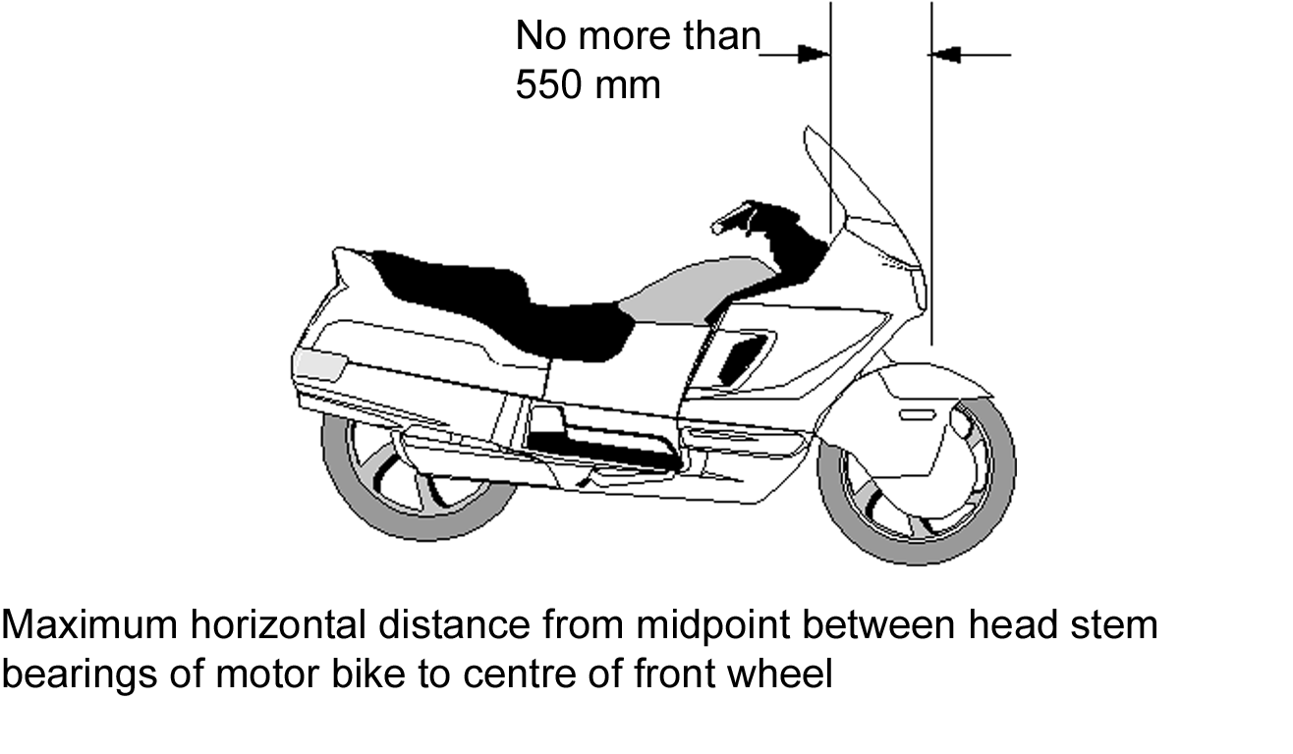
54—Foot rests
A motor bike must be fitted with foot rests for the driver, and for any passenger for whom a seating position is provided.
55—Chain guards
(1) If the engine power of a motor bike is transmitted to the rear wheel by a chain, the driver and any passenger must be protected from the front sprocket and at least the upper part of the chain by—
(a) the frame or equipment of the motor bike; or
(b) a chain guard.
(2) A chain guard must cover the chain to a point—
(a) at least 300 millimetres to the rear of the rearmost foot rest; or
(b) above the centre of the rear drive sprocket.
55A—Sidecars
A sidecar on a motor bike must be positioned on the left hand side of the motor bike.
Part 5—Vehicle marking
Note—
This Part contains requirements for a vehicle that help to identify the vehicle and, if the vehicle is unusually long, to warn other motorists.
56—Engine and vehicle identification numbers
(1) In this rule—
number includes letter.
(2) A motor vehicle must have an individual engine identification number clearly stamped, embossed or otherwise permanently marked on it.
(3) A motor vehicle built after 1930 must have the engine identification number on its engine block or the main component of its engine.
(4) A vehicle must have an individual vehicle identification number clearly stamped, embossed or otherwise permanently marked on a substantial part of its frame or chassis.
(5) An engine or vehicle identification number must be located where a person can read it easily without having to use tools to remove a part of the vehicle that would otherwise obstruct the person’s view.
57—White or silver band on certain vehicles
(1) This rule applies to a vehicle that—
(a) is at least 2.2 metres wide; and
(b) has a body with a vertical measurement under 300 millimetres at the rear, measured from the lowest point of the body above ground level to the highest point; and
(c) is not fitted with rear marking plates or conspicuity markings in accordance with rule 115.
(2) The vehicle must have a white or silver band at least 75 millimetres high across the full width of the rearmost part of the body of the vehicle.
Part 6—Vehicle configuration and dimensions
Note—
This Part sets out various requirements covering the suspension on vehicles and size limits for single vehicles and combinations of vehicles, so that they can be operated safely with other traffic, without taking up too much road space or damaging the road and structures on the road.
Generally, the limits in this Part apply to a vehicle and any load it may be carrying.
Specific requirements for loaded vehicles are covered by other laws.
Division 1—Axles
58—Axle configuration
(1) A motor vehicle must have only—
(a) 1 axle group, or single axle, towards the front of the vehicle; and
(b) 1 axle group, or single axle, towards the rear of the vehicle.
(2) A trailer must have only—
(a) 1 axle group or single axle; or
(b) 2 axle groups, 2 single axles, or 1 axle group and single axle, in the following configuration:
(i) 1 axle group, or single axle, towards the front of the vehicle, with all the wheels on the axle group or single axle connected to the steering mechanism for that part of the trailer;
(ii) 1 axle group, or single axle, towards the rear of the vehicle.
(3) A semi-trailer that is extendible, or is fitted with sliding axles, must—
(a) have a securing device that—
(i) can securely fix the extendible part or sliding axles to the rest of the vehicle in any position of adjustment provided; and
(ii) is located in a position that can prevent accidental or inadvertent release, if the device is mounted on the chassis of the vehicle; and
(iii) is fitted with a visible or audible warning system to indicate to a person standing beside the vehicle that the device is not engaged; and
(iv) is fitted with a way of preventing loss of air from the air brake supply, if the device uses air from the brake system and fails in a way allowing air to escape; and
(v) is held in the applied position by direct mechanical action without the intervention of an electric, hydraulic or pneumatic device; and
(b) be built so the adjustable parts of the vehicle remain connected if the securing device fails.
59—Retractable axles
(1) In this rule—
retractable axle means an axle with a means of adjustment enabling the axle to be raised or lowered relative to the other axles in the axle group.
(2) For the Light Vehicle Standards, a retractable axle is taken to be an axle only when the retractable axle is in the lowered position.
Division 2—Dimension requirements
60—Meaning of rear overhang and rear overhang line
(1) The rear overhang of a vehicle is the distance between the rear of the vehicle and the rear overhang line of the vehicle.
(2) For a vehicle with an axle group at the rear consisting of only 1 axle, the rear overhang line is a line running along the centre line of the axle.
(3) For a vehicle with an axle group at the rear consisting of 2 axles, 1 of which is fitted with twice the number of tyres as the other, the rear overhang line is a line running parallel to the axles that is—
(a) closer to the axle carrying the greater number of tyres than the line is to the other axle; and
(b) located at one-third of the distance between the 2 axles.
(4) For a vehicle with an axle group at the rear that is not an axle group mentioned in subrule (2) or (3), the rear overhang line is a line running parallel to the axles down the centre of the axle group.
(5) For the purposes of applying subrule (2), (3) or (4) to a vehicle, if an axle group includes at least 1 steerable axle, that axle is to be disregarded unless—
(a) the group consists of only 1 axle and that axle is a steerable axle; or
(b) all the axles in the group are steerable axles.
Examples of rear overhang line—

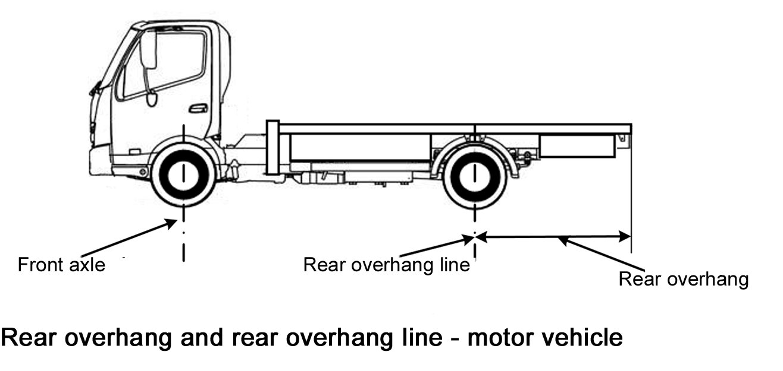
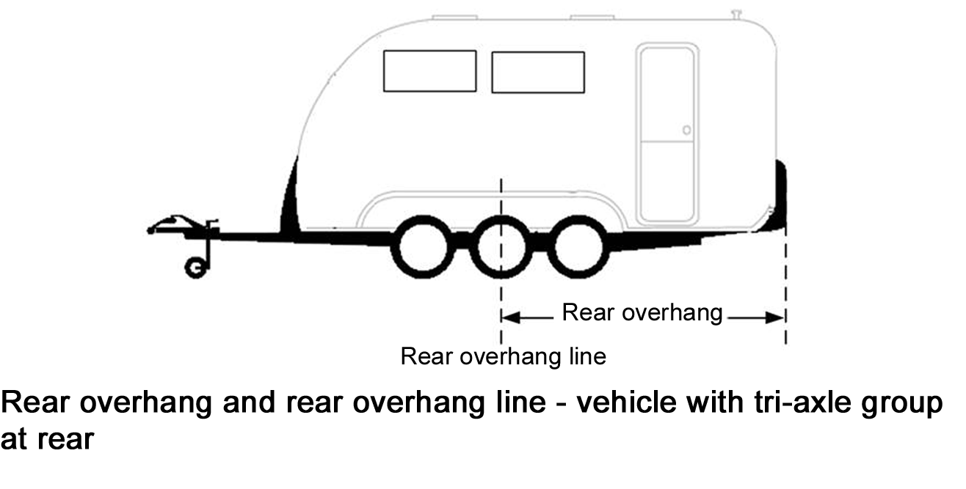
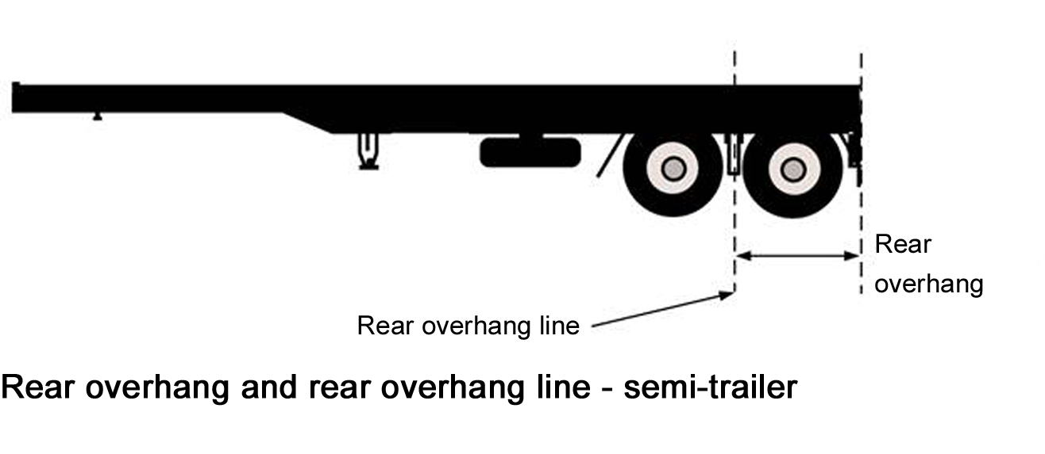
61—Length of single motor vehicles
A motor vehicle must not be over 12.5 metres long.
62—Length of single trailers
(1) On a semi-trailer or a dog trailer—
(a) the distance between the point of articulation at the front of the trailer and the rear overhang line must not be over 9.5 metres; and
(b) the distance between the point of articulation at the front of the trailer and the rear of the trailer must not be over 12.3 metres.
(2) A projection forward of the point of articulation at the front of a semi-trailer must be contained within a radius of 1.9 metres from the point of articulation.
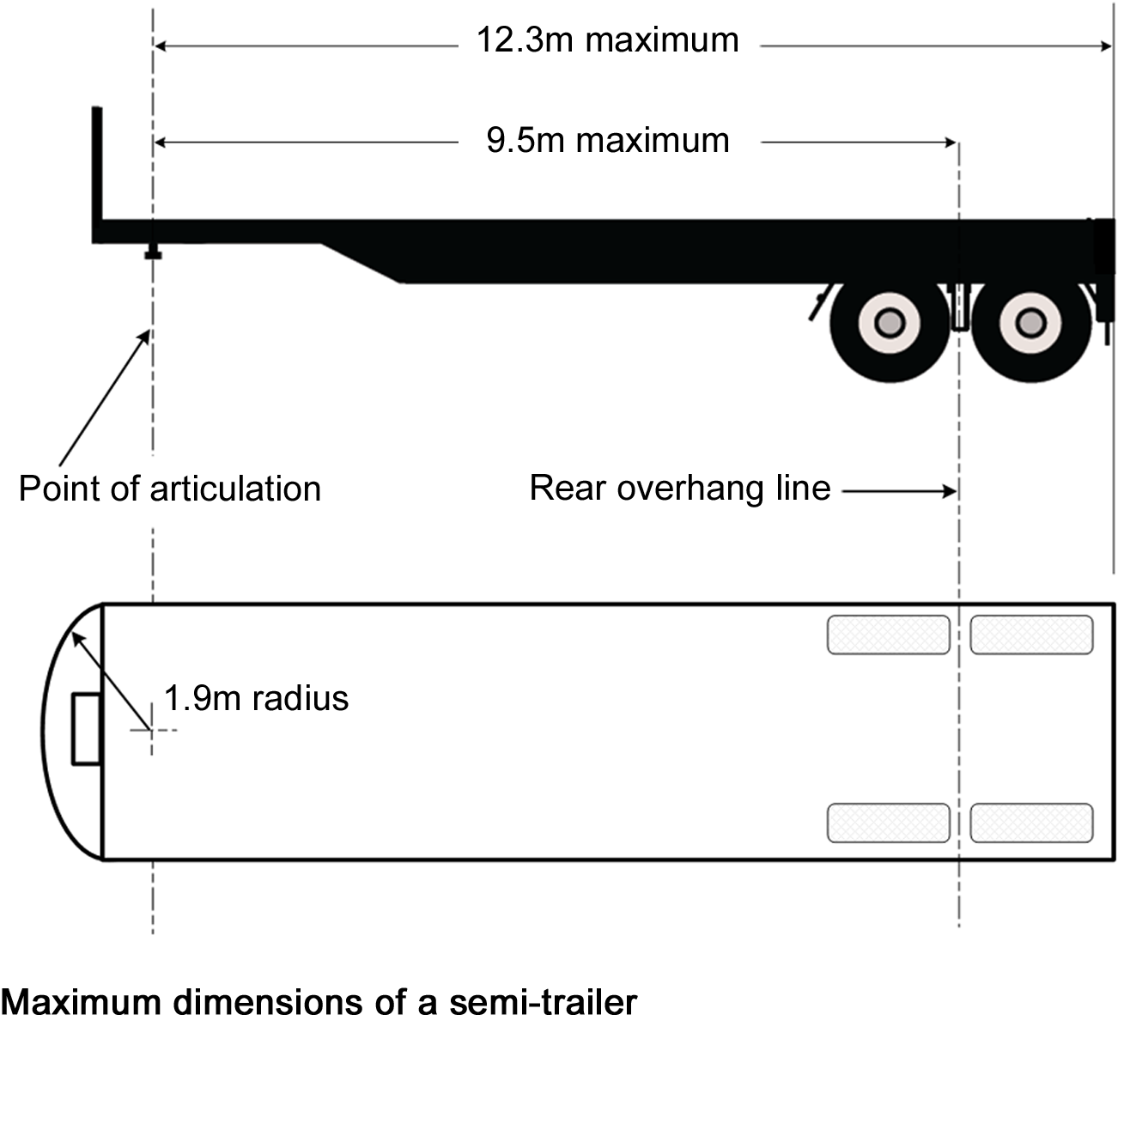
63—Length of combinations
A combination must not be over 19 metres long.
64—Rear overhang
(1) The rear overhang of a semi-trailer, or dog trailer consisting of a semi-trailer and converter dolly, must not exceed the lesser of—
(a) 60% of the distance between the point of articulation at the front and the rear overhang line; and
(b) 3.7 metres.
(2) The rear overhang of a trailer with only 1 axle group or single axle (except a semi-trailer) must not exceed the lesser of—
(a) the length of the load-carrying area, or body, ahead of the rear overhang line; and
(b) 3.7 metres.
(3) The rear overhang of a vehicle not mentioned in subrule (1) or (2) must not exceed the lesser of—
(a) 60% of the distance between the centre line of the front axle and the rear overhang line; and
(b) 3.7 metres.
65—Length—trailer drawbars
(1) The distance between the coupling pivot point on the drawbar of a dog trailer, and the centre line of the front axle group or of the front single axle of the trailer, must not be over 5 metres.
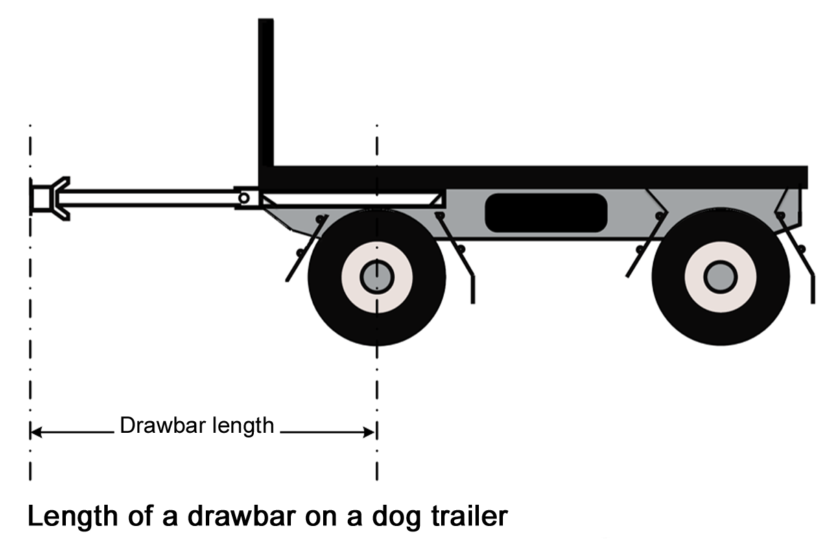
(2) The distance between the coupling pivot point on a drawbar, and the centre line of the axle group or single axle on a trailer with only 1 axle group or single axle (except a semi-trailer) must not be over 8.5 metres.
66—Width
A vehicle must not be over 2.5 metres wide.
67—Height
A vehicle must not be over 4.3 metres high.
68—Ground clearance
(1) In this rule—
ground clearance, of a vehicle, means the minimum distance to the ground from a point on the underside of the vehicle, except a point on a tyre, wheel, wheel hub, brake backing plate or flexible mudguard or mudflap of the vehicle.
(2) A motor vehicle or combination must have a ground clearance of—
(a) at least 100 millimetres at any point within 1 metre of an axle; and
(b) at the midpoint between adjacent axles—at least one-thirtieth of the distance between the centre lines of the axles; and
(c) at any other point—at least the distance that allows the vehicle or combination to pass over a peak in the road with a gradient on either side of 1:15, if the wheels of 1 axle of the vehicle or combination are on the slope on one side of the peak and the wheels of the next axle are on the slope on the other side.
(3) However, subrule (2) does not apply to—
(a) a motor vehicle with less than 4 wheels; or
(b) a combination that includes a motor vehicle with less than 4 wheels.
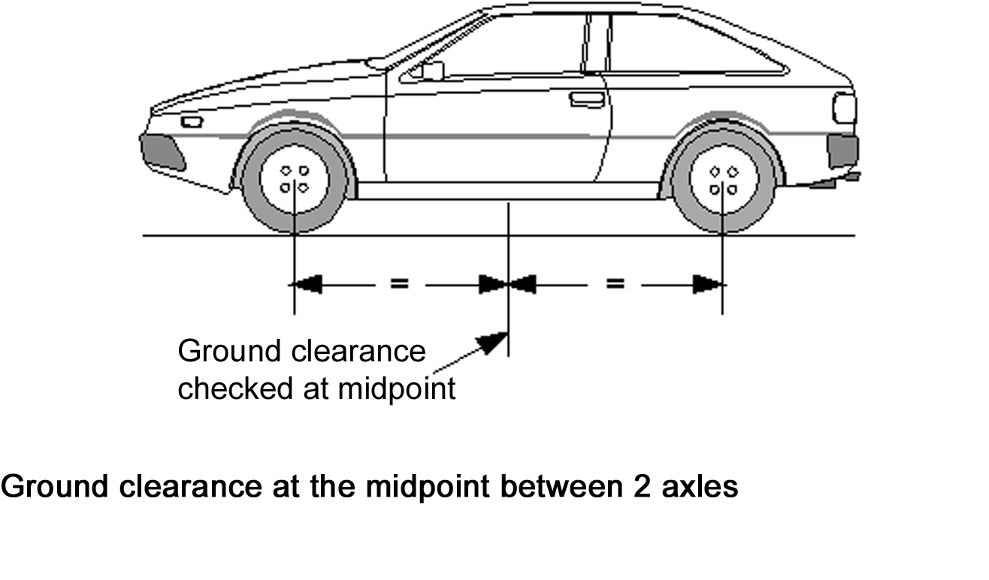
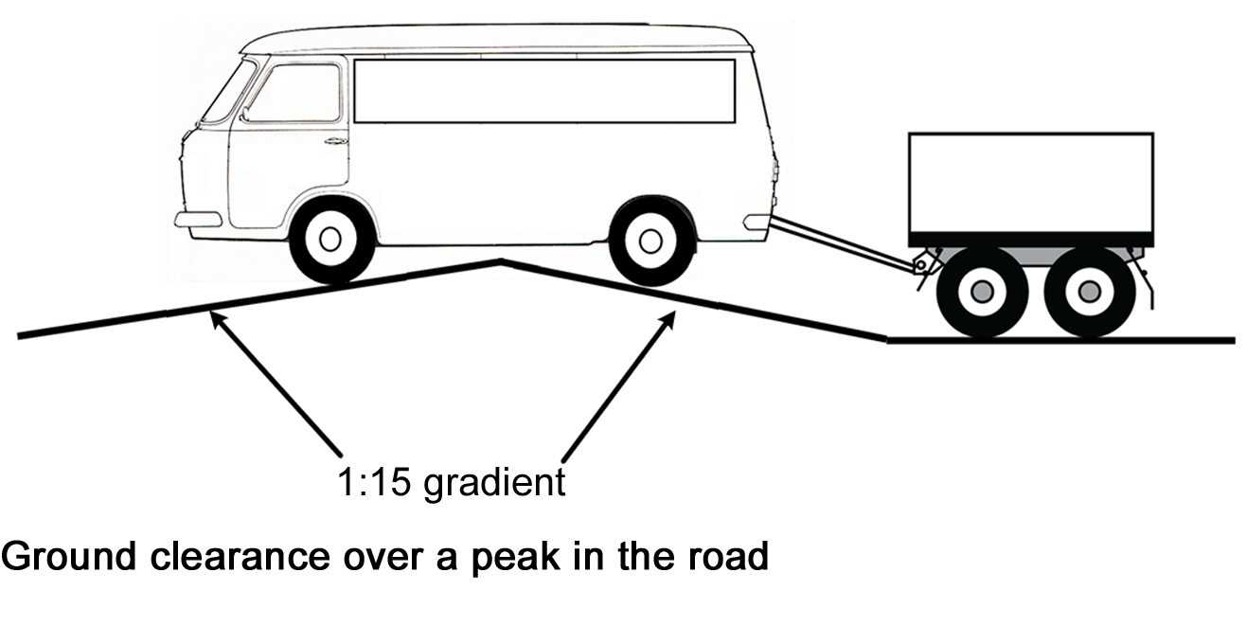
Part 7—Lights and reflectors
Note—
This Part deals with how the lights on a vehicle must be fitted and work so that the driver can see the road, pedestrians and other vehicles at night, and can signal to others.
Other laws provide for when certain lights must be switched on.
In this Part, the description ‘yellow’ is used as a more modern term, instead of the description ‘amber’ which is used in earlier legislation and some ADRs.
Division 1—Application of particular requirements
69—Part does not apply to particular vehicles
(1) This Part does not apply to a vehicle built before 1931 that is used only in the daylight.
(2) This Part does not apply to a vehicle built before 1946 that is used mainly for exhibition purposes.
70—Particular requirements apply only at night
The requirements of this Part for a light, except a brake or direction indicator light, to be visible over a stated distance apply only at night.
Division 2—General requirements for lights
71—Prevention of glare
A light, except a high-beam headlight, fitted to a vehicle must be built and adjusted to provide the necessary amount of light, without dazzling the driver of another vehicle approaching, or being approached by, the vehicle.
72—Pairs of lights
(1) If lights are required under the Light Vehicle Standards to be fitted to a vehicle in pairs—
(a) a light must be fitted on each side of the longitudinal axis of the vehicle; and
(b) the centre of each light in a pair must be the same distance from the longitudinal axis of the vehicle; and
(c) the centre of each light in a pair must be at the same height above ground level; and
(d) each light in a pair must project approximately the same amount of light of the same colour.
(2) Subrule (1) applies to a motor bike with an attached sidecar as if the sidecar were not attached.
Division 3—Headlights
73—Headlights to be fitted to vehicles
(1) A motor vehicle must be fitted with—
(a) 1 low-beam headlight if it is a moped, motor bike, or motor trike with 1 front wheel; or
(b) a pair of low-beam headlights if it has 4 or more wheels or is a motor trike, except a moped, with 2 front wheels.
(2) If a motor vehicle built after 1934 can travel at over 60 kilometres an hour—
(a) each low-beam headlight mentioned in subrule (1) must be able to work in the high-beam position; or
(b) the vehicle must be fitted with—
(i) 1 headlight that can work in the high-beam position if the vehicle is required to have 1 low-beam headlight; or
(ii) a pair of headlights that can work in the high-beam position.
(3) A motor bike may be equipped with a headlight modulation system that—
(a) varies the brightness of its high-beam headlight or low-beam headlight, but not both, at a rate of at least 200 and at most 280 flashes a minute; and
(b) is designed to operate only in the daylight.
(4) Up to 4 additional headlights may be fitted to a motor vehicle with 4 or more wheels, a motor bike or a motor trike.
(5) An additional headlight fitted to a vehicle must be fitted so that it faces forward and is symmetrical in relation to the centre-line of the vehicle.
Example—

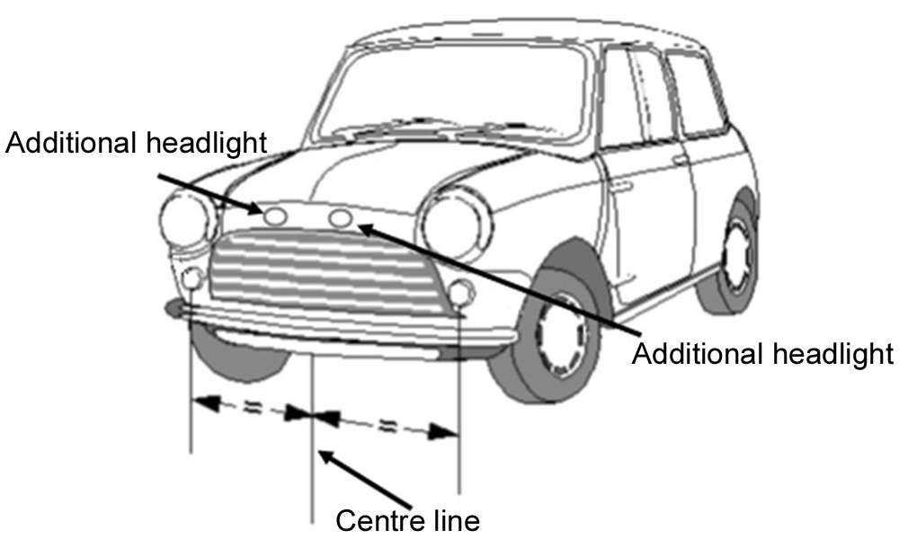
74—How headlights are to be fitted
(1) The centres of low-beam headlights fitted as a pair on a motor vehicle with 4 or more wheels must be at least 600 millimetres apart.
(2) However, subrule (1) does not apply to a motor vehicle built before 1970 if the centres of its low-beam headlights—
(a) were under 600 millimetres apart when the vehicle was built; and
(b) are not nearer than they were when the vehicle was built.
(3) Each low-beam headlight of a pair on a motor trike (except a moped) with 2 front wheels must not be over 400 millimetres from the nearer side of the vehicle.
(4) The centre of a low-beam headlight fitted to a motor vehicle built after June 1953 must be—
(a) at least 500 millimetres above ground level; and
(b) not over 1.4 metres above ground level.
75—How single headlights are to be fitted
(1) A motor bike or motor trike with a single headlight fitted must have the light fitted in the centre.
(2) Subrule (1) applies to a motor bike with an attached sidecar as if the sidecar were not attached.
77—Performance of headlights
(1) When on, a headlight, or additional headlight, fitted to a vehicle must—
(a) show only white light; and
(b) project its main beam of light ahead of the vehicle.
(2) Headlights must be fitted to a vehicle so their light does not reflect off the vehicle into the driver’s eyes.
78—Effective range of headlights
(1) This rule applies to a headlight that is on at night.
(2) A low-beam headlight must illuminate the road ahead of the vehicle for at least 25 metres.
(3) A high-beam headlight must illuminate the road ahead of the vehicle for at least 50 metres.
(4) However, a low-beam headlight fitted to a motor vehicle built before 1931, or a moped, need only illuminate the road ahead of the vehicle for 12 metres.
79—Changing headlights from high-beam to low-beam position
(1) A motor vehicle built after 1934 that can travel at over 60 kilometres an hour must be fitted with—
(a) a dipping device enabling the driver in the normal driving position—
(i) to change the headlights from the high-beam position to the low-beam position; or
(ii) simultaneously to switch off a high-beam headlight and switch on a low-beam headlight; and
(b) for a vehicle built after June 1953—a device to indicate to the driver that the headlights are in the high-beam position.
(2) A headlight fitted to a vehicle not fitted with a dipping device mentioned in subrule (1)(a) must operate in the low-beam position.
(3) When a headlight fitted to a vehicle is switched to the low-beam position, any other headlight on the vehicle must operate only in the low-beam position or be off.
Division 4—Parking lights
80—Parking lights
(1) A motor vehicle built after June 1953 must be fitted with—
(a) a pair of parking lights if it is a motor trike with 2 front wheels (except a moped) or a motor vehicle with 4 or more wheels; or
(b) at least 1 parking light if it is a motor bike with an attached sidecar, or a motor trike with 1 front wheel, (except a moped).
(2) A pair of parking lights fitted to a motor vehicle with 4 or more wheels must be fitted with the centre of each light—
(a) at least 600 millimetres from the centre of the other light; and
(b) not over 510 millimetres from the nearer side of the vehicle.
(3) However, a pair of parking lights fitted to a motor vehicle under 1300 millimetres wide may be fitted with the centre of each light not under 400 millimetres from the centre of the other light.
(4) A parking light fitted to a motor trike with 2 front wheels must not be over 400 millimetres from the nearer side of the vehicle.
(5) A parking light fitted to a motor bike with a sidecar must be fitted not over 150 millimetres from the side of the sidecar furthest from the motor bike.
(6) When on, a parking light must—
(a) show a white or yellow light visible 200 metres from the front of the vehicle; and
(b) not use over 7 watts of power.
(7) A parking light fitted to a motor vehicle built after 1969 must be wired so the parking light is on when a headlight on the vehicle is on.
(8) A parking light fitted to a sidecar attached to a motor bike must be wired to operate when a headlight, tail light or parking light on the motor bike is on.
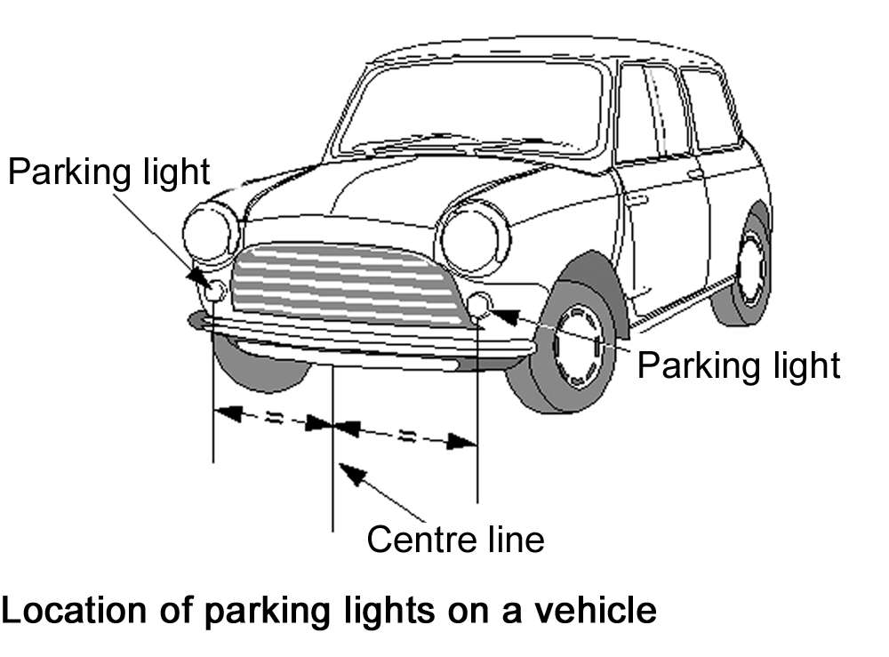
Division 5—Daytime running lights
81—Daytime running lights
(1) A pair of daytime running lights may be fitted to a motor vehicle.
(2) A pair of daytime running lights fitted to a vehicle with 4 or more wheels must be fitted with the centre of each light—
(a) at least 600 millimetres from the centre of the other light; and
(b) not over 510 millimetres from the nearer side of the vehicle.
(3) However, a pair of daytime running lights fitted to a motor vehicle under 1300 millimetres wide may be fitted with the centre of each light not under 400 millimetres from the centre of the other light.
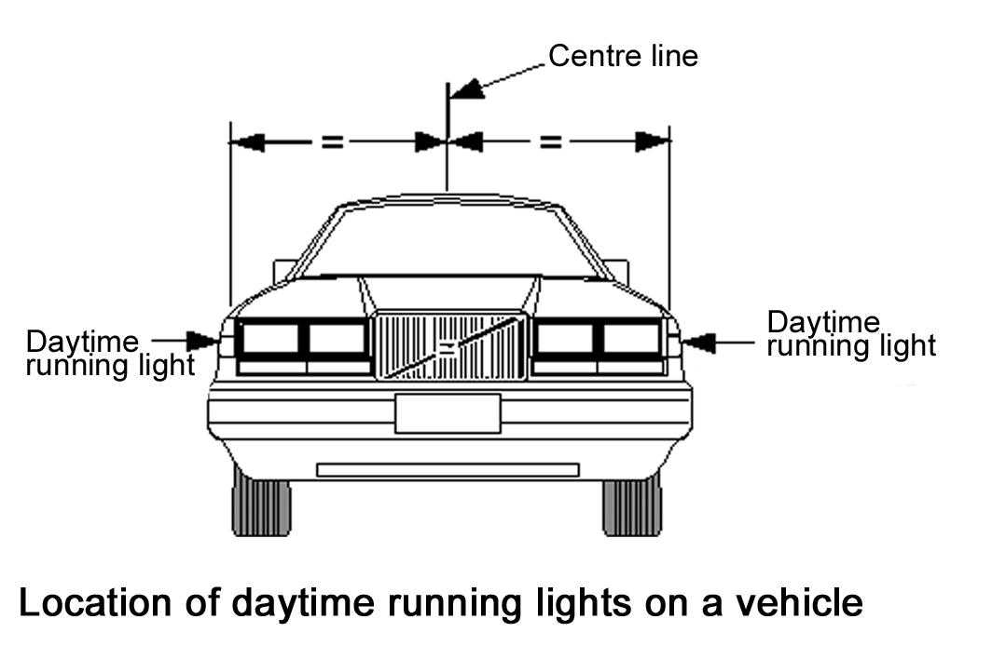
(4) When on, a daytime running light must—
(a) show a white or yellow light visible from the front of the vehicle; and
(b) not use over 25 watts of power.
Note—
The third edition ADRs only allow white daytime running lights.
(5) Daytime running lights must be wired so they are off when a headlight, except a headlight being used as a flashing signal, is on.
Division 6—Tail lights
82—Tail lights generally
(1) A vehicle must have at least 1 tail light fitted on or towards the rear of the vehicle.
(2) A motor trike with 2 rear wheels, or a motor vehicle with 4 or more wheels, built after 1959 must have at least 1 tail light fitted on or towards each side of the rear of the vehicle.
(3) A trailer built after June 1973 must have at least 1 tail light fitted on or towards each side of the rear of the vehicle.
(4) The centre of a tail light mentioned in subrule (1), (2) or (3) must not be over—
(a) 1.5 metres above ground level; or
(b) if it is not practicable to fit the light lower—2.1 metres above ground level.
(5) A vehicle may have 1 or more additional tail lights at any height above ground level.
83—Pattern of fitting tail lights
(1) If only 1 tail light is fitted to a vehicle, it must be fitted in the centre or to the right of the centre of the vehicle’s rear.
(2) Subrule (1) applies to a motor bike with an attached sidecar as if the sidecar were not attached.
(3) If 2 or more tail lights are fitted to a vehicle, at least 2 tail lights must be fitted as a pair.
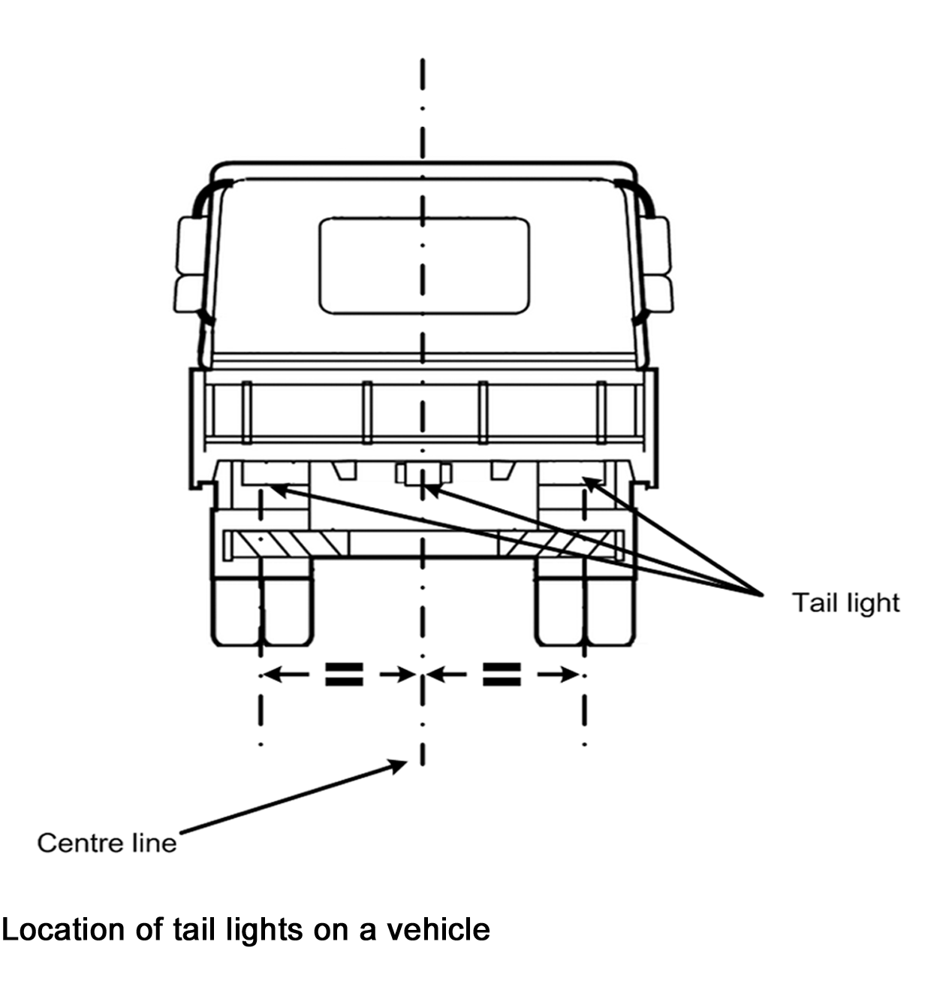
(4) Tail lights fitted in accordance with this Division may also serve as rear clearance lights if they are fitted to a vehicle in accordance with rule 89(3).
84—Performance of tail lights
(1) When on, a tail light of a vehicle must—
(a) show a red light visible 200 metres from the rear of the vehicle; and
(b) not use over 7 watts of power.
(2) A tail light fitted to a street rod vehicle may incorporate a blue lens not over 20 millimetres in diameter.
85—Wiring of tail lights
A tail light of a motor vehicle must be wired to come on, and stay on, when a parking light or headlight on the vehicle is on, unless an external switch is fitted to operate the tail light.
Division 7—Number plate lights
86—Number plate lights
(1) At least 1 number plate light must be fitted to the rear of a vehicle.
(2) When on, the number plate light or lights must illuminate a number plate on the rear of the vehicle with white light, so the characters on the number plate can be read at night 20 metres from the rear of the vehicle.
(3) A number plate light—
(a) may be combined with another light; and
(b) must not project white light to the rear of the vehicle except by reflection; and
(c) must not obscure the characters on the number plate; and
(d) must be wired to come on, and stay on, when a parking light, headlight or tail light on the vehicle is on.
Division 8—Clearance lights
87—Front clearance lights
(1) Front clearance lights may only be fitted to a vehicle that is at least 1.8 metres wide.
(2) A pair of front clearance lights must be fitted to a motor vehicle that is at least 2.2 metres wide, or a prime mover.
(3) The centre of a front clearance light must be—
(a) not over 400 millimetres from the nearer side of the vehicle; and
(b) if the vehicle was built after June 1953—
(i) at least 750 millimetres higher than the centre of any low-beam headlight fitted to the vehicle; or
(ii) not lower than the top of the windscreen.
(4) However, a front clearance light may be mounted on an external rear vision mirror or a mirror support if, when the mirror is correctly adjusted, no part of the lens of the clearance light is visible to a person in the normal driving position.
(5) When on, a front clearance light must—
(a) show a white or yellow light visible 200 metres from the front of the vehicle; and
(b) not use over 7 watts of power.
88—External cabin lights
(1) A motor vehicle fitted with front clearance lights may also have additional forward-facing lights on or above the roof of its cabin.
(2) The additional forward-facing lights must be spaced evenly between the front clearance lights, with their centres at least 120 millimetres apart.
(3) When on, an additional forward-facing light must—
(a) show a white or yellow light; and
(b) not use over 7 watts of power.
89—Rear clearance lights
(1) Rear clearance lights may only be fitted to a vehicle that is at least 1.8 metres wide.
(2) A pair of rear clearance lights must be fitted to the rear of a vehicle that is at least 2.2 metres wide.
(3) The centre of a rear clearance light must be—
(a) not over 400 millimetres from the nearer side of the vehicle; and
(b) if practicable, at least 600 millimetres above ground level.
(4) When on, a rear clearance light must—
(a) show a red light visible 200 metres from the rear of the vehicle; and
(b) not use over 7 watts of power.
Division 9—Side marker lights
90—Vehicles needing side marker lights
(1) A pair of side marker lights must be fitted towards the rear of the sides of a motor vehicle that is over 7.5 metres long and at least 2.2 metres wide.
(2) A pole-type trailer, and a motor vehicle built to tow a pole-type trailer, with at least 1 cross-bar or bolster must have a side marker light fitted to each side of the back or only cross-bar or bolster.
(3) A pole-type trailer with 2 or more cross-bars or bolsters may also have a side marker light fitted to each side of the front cross-bar or bolster.
(4) At least 2 side marker lights must be fitted to each side of—
(a) a trailer, except a pole-type trailer, that is at least 2.2 metres wide and not over 7.5 metres long; or
(b) a semi-trailer that is not over 7.5 metres long.
(5) At least 3 side marker lights must be fitted to each side of—
(a) a trailer, except a pole-type trailer, that is at least 2.2 metres wide and over 7.5 metres long; or
(b) a semi-trailer that is over 7.5 metres long.
91—Location of side marker lights
(1) The centre of a side marker light must not be over 150 millimetres from the nearer side of the vehicle.
(2) A front side marker light fitted to a motor vehicle must be towards the front of the side of the vehicle with no part of the lens visible to the driver.
(3) The centre of a front side marker light fitted to a trailer must be—
(a) within 300 millimetres of the front of the side of the trailer; or
(b) if the construction of the trailer makes it impracticable to comply with paragraph (a)—as near as practicable to the front of the trailer.
(4) The centre of a rear side marker light fitted to a vehicle must be—
(a) within 300 millimetres of the rear of the side of the vehicle; or
(b) if the construction of the vehicle makes it impracticable to comply with paragraph (a)—as near as practicable to the rear of the vehicle.
(5) Side marker lights fitted to a vehicle must, as far as practicable, be evenly spaced along the side of the vehicle.
(6) Subrules (2) to (5) do not apply to side marker lights fitted to a cross-bar or bolster of a pole-type trailer.
(7) Only the side marker lights nearest to the rear need be fitted if complying with subrules (3) and (4) would result in the front and rear side marker lights being under 2.5 metres apart.
(8) A side marker light fitted to a vehicle must be fitted so—
(a) its centre is not over—
(i) 1.5 metres above ground level; or
(ii) if it is not practicable to fit it lower—2.1 metres above ground level; and
(b) its centre is at least 600 millimetres above ground level; and
(c) it is, as far as practicable, in a row of side marker lights along the side of the vehicle.
(9) Subrule (8)(a) does not apply to a side marker light that is not required to be fitted to the vehicle by rule 90.
92—Performance of side marker lights
(1) When on, a side marker light fitted to a vehicle must—
(a) show a light visible 200 metres from the vehicle; and
(b) not use over 7 watts of power.
(2) When on, a side marker light fitted to a vehicle must show—
(a) to the front of the vehicle—a yellow light; and
(b) to the rear of the vehicle—
(i) if the light also operates as a rear light or reflector—a red light; and
(ii) in any other case—a red or yellow light.
(3) However, if a pole-type trailer with 2 or more cross-bars or bolsters has the side marker lights permitted by rule 90(3)—
(a) the side marker lights fitted to the front cross-bar or bolster may comply with subrule (2)(a) only; and
(b) the side marker lights fitted to the back cross-bar or bolster may comply with subrule (2)(b) only.
93—Side marker lights and rear clearance lights
The side marker light nearest to the rear of a vehicle may also be a rear clearance light for rule 89.
Division 10—Brake lights
94—Fitting brake lights
(1) A brake light must be fitted to the rear of a vehicle built after 1934.
(2) A pair of brake lights must be fitted to the rear of—
(a) a motor vehicle built after 1959 that has 4 or more wheels; and
(b) a motor trike built after 1959 that has 2 rear wheels; and
(c) a trailer built after June 1973.
(3) The centre of a brake light must be—
(a) at least 350 millimetres above ground level; and
(b) not over—
(i) 1.5 metres above ground level; or
(ii) if it is not practicable to fit the light lower—2.1 metres above ground level.
(4) A vehicle may be fitted with 1 or more additional brake lights.
(5) The centre of an additional brake light must be at least 350 millimetres above ground level.
(6) If only 1 brake light is fitted to a vehicle, it must be fitted in the centre or to the right of the centre of the vehicle’s rear.
(7) Subrule (6) applies to a motor bike with an attached sidecar as if the sidecar were not attached.
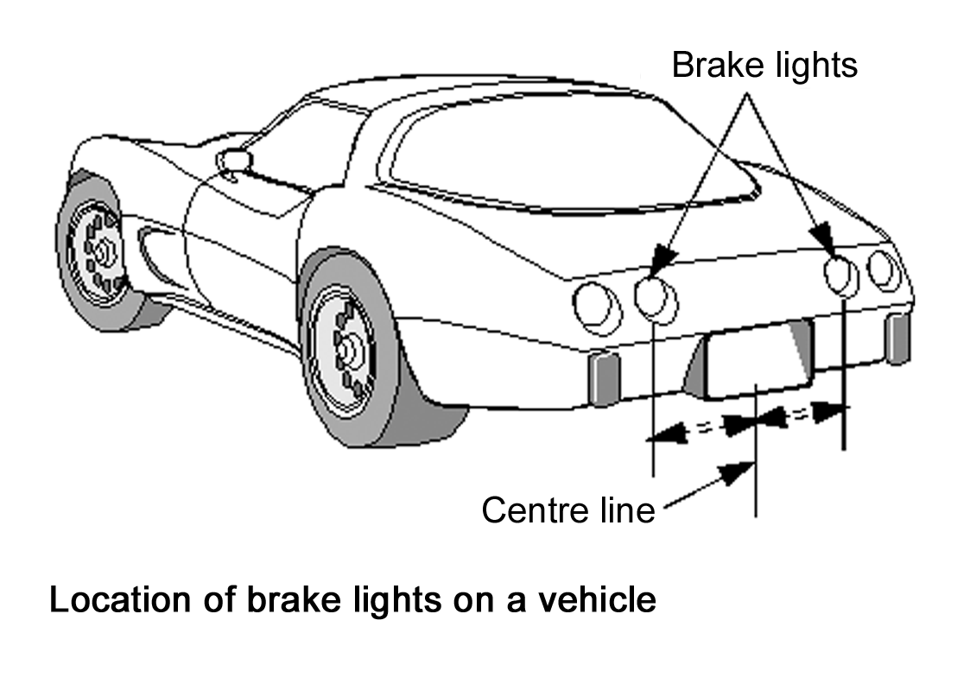
(8) For the purposes of this rule, a light fitted to a vehicle that functions as a brake light and a direction indicator light is taken to be a brake light if the vehicle was built before 1 January 1973.
95—Performance and operation of brake lights
(1) When on, a brake light must show a red light visible 30 metres from the rear of the vehicle.
(2) A brake light fitted to a street rod vehicle may incorporate a blue lens not over 20 millimetres in diameter.
(3) A brake light fitted to a motor vehicle must come on, if it is not already on, when—
(a) for a vehicle with 4 or more wheels or built after 1974—a service brake is applied; or
(b) for another vehicle—the rear wheel brake is applied.
(4) Subrule (3) does not apply if the controls in the vehicle that start the engine are in a position that makes it impossible for the engine to operate.
(5) A brake light on a trailer must come on when—
(a) the brake light of the towing vehicle comes on; or
(b) a brake control on the towing vehicle, which independently activates the service brake on the trailer, is operated.
(6) A brake light may be operated by an engine brake, retarder, or similar device if the device does not interfere with the proper operation of the brake light.
Division 11—Reversing lights
96—Reversing lights
(1) One or more reversing lights may be fitted to the rear of a vehicle and on each side towards the rear of the vehicle.
(2) A reversing light must have its centre not over 1.2 metres above ground level.
(3) When on, a reversing light must show a white or yellow light to the rear or to the side and rear of the vehicle.
Note—
Third edition ADRs only allow white reversing lights.
(4) A reversing light fitted to a motor vehicle must be wired so it operates only when the vehicle is reversing or in reverse gear.
(5) A reversing light fitted to a trailer must be wired so it operates only when a motor vehicle towing the trailer is reversing or in reverse gear.
(6) A yellow reversing light may also operate as a direction indicator light.
Division 12—Direction indicator lights
97—Direction indicator lights on motor vehicles
(1) A motor vehicle with 4 or more wheels that was built after August 1966 must have—
(a) a pair of direction indicator lights fitted on, or towards, its front that face forwards; and
(b) a pair of direction indicator lights fitted on, or towards, its rear that face backwards.
(2) A motor vehicle with less than 4 wheels that was built after June 1975 must have—
(a) a pair of direction indicator lights fitted on, or towards, its front that face forwards; and
(b) a pair of direction indicator lights fitted on, or towards, its rear that face backwards.
(3) A motor vehicle that is not required to have direction indicator lights may have—
(a) 1 or more pairs of direction indicator lights that are visible from both the front and rear of the vehicle; or
(b) both—
(i) a pair of direction indicator lights fitted on, or towards, its front that face forwards; and
(ii) a pair of direction indicator lights fitted on, or towards, its rear that face backwards.
98—Direction indicator lights on trailers
(1) A trailer built after June 1973 must have a pair of direction indicator lights fitted on, or towards, its rear that face backwards.
(2) A trailer that is not required to have direction indicator lights may have 1 or more pairs of direction indicator lights fitted on, or towards, its rear that face backwards.
99—Location of direction indicator lights
(1) A pair of direction indicator lights fitted to a vehicle must have the centre of each light at least—
(a) for a motor bike or the single wheel end of a motor trike—300 millimetres from the centre of the other light; and
(b) for lights fitted at the 2 wheel end of a motor trike—600 millimetres from the centre of the other light, unless the centre of each direction indicator light is not over 400 millimetres from the nearer side of the vehicle; and
(c) for another vehicle with a width of not over 1300 millimetres—400 millimetres from the centre of the other light; and
(d) for another vehicle with a width of over 1300 millimetres—600 millimetres from the centre of the other light.
(2) The centre of each direction indicator light must be at least 350 millimetres above ground level.
(3) The centre of each light in a pair of direction indicator lights required to be fitted to a vehicle must not be over—
(a) 1.5 metres above ground level; or
(b) if it is not practicable for the light to be fitted lower—2.1 metres above ground level.
100—Operation and visibility of direction indicator lights
(1) A direction indicator light fitted to a motor vehicle must—
(a) when operating, display regular flashes of light at a rate of not over 120 flashes a minute and—
(i) for a motor vehicle with 4 or more wheels—at least 60 flashes a minute; and
(ii) for another motor vehicle—at least 45 flashes a minute; and
(b) be able to be operated by a person in the normal driving position; and
(c) be wired to an audible or visible device in the vehicle that tells the driver that the direction indicator light is operating; and
(d) flash at the same time and rate as any other direction indicator lights fitted on the same side of the vehicle.
(2) A direction indicator light fitted to a side of a trailer must, when operating, flash at the same time and rate as the direction indicator light or lights fitted to the same side of the motor vehicle towing the trailer.
(3) The flashes of light displayed by a direction indicator light must be—
(a) if the light faces forwards—white or yellow; and
(b) if the light faces backwards—
(i) yellow; or
(ii) for a vehicle built before July 1973—yellow or red; and
(c) if the light faces out from the side of the vehicle—
(i) white or yellow towards the front and side; and
(ii) for a vehicle built before July 1973—yellow or red towards the rear and side; and
(iii) for a vehicle built after June 1973—yellow towards the rear and side.
Note—
The ADRs only allow yellow direction indicator lights.
(4) If a motor vehicle’s direction indicator lights display only yellow light, the vehicle may be equipped to allow the lights to operate simultaneously on both sides of the vehicle, if a visible or audible signal tells the driver when the lights are operating simultaneously.
(5) When on, a direction indicator light must be visible 30 metres from—
(a) if the light faces forwards—the front of the vehicle; or
(b) if the light faces backwards—the rear of the vehicle; or
(c) if the light faces out from the side of the vehicle—that side of the vehicle.
(6) When on, each direction indicator light in at least 1 pair of lights fitted on or towards the front of a prime mover, or a motor vehicle over 7.5 metres long, must be visible at a point—
(a) 1.5 metres at right angles from the side of the vehicle where the light is fitted; and
(b) in line with the rear of the vehicle.
Division 13—Fog lights
101—Front fog lights
(1) A pair of front fog lights may be fitted to a motor vehicle with 4 or more wheels.
(2) A pair of front fog lights, or a single front fog light, may be fitted to a motor bike or motor trike.
(3) A pair of front fog lights fitted to a motor vehicle with 4 or more wheels must have the centre of each light not over 400 millimetres from the nearer side of the vehicle unless the centres of the lights are at least 600 millimetres apart.
(4) If the top of the front fog light is higher than the top of any low-beam headlight on the vehicle, the centre of the fog light must not be higher than the centre of the low-beam headlight.
(5) A front fog light must—
(a) when on—
(i) project white or yellow light in front of the vehicle; and
(ii) be a low-beam light; and
(b) be able to be operated independently of any headlight; and
(c) be fitted so the light from it does not reflect off the vehicle into the driver’s eyes.
102—Rear fog lights
(1) In this rule—
rear fog light means a light used on a vehicle to make the vehicle more easily visible, from the rear, in dense fog.
(2) A vehicle may have fitted to its rear—
(a) a pair of rear fog lights; or
(b) 1 rear fog light fitted on, or to the right, of the centre of the vehicle.
(3) Subrule (2)(b) applies to a motor bike with an attached sidecar as if the sidecar were not attached.
(4) A rear fog light must—
(a) have its centre—
(i) not over 1.5 metres above ground level; and
(ii) at least 100 millimetres from the centre of a brake light; and
(b) when on, project red light behind the vehicle; and
(c) not use over 27 watts of power; and
(d) be wired to a visible device in the vehicle that tells the driver that the rear fog light is operating.
Division 14—Interior lights
103—Interior lights
A vehicle may be fitted with interior lights that illuminate any interior part of the vehicle.
Division 15—Reflectors generally
104—General requirements for reflectors
(1) A reflector fitted to a vehicle must show a red, white or yellow reflection of light when light is projected directly onto the reflector at night by a low-beam headlight that—
(a) is 45 metres from the reflector; and
(b) complies with the Light Vehicle Standards.
(2) The reflection must be clearly visible from the position of the headlight.
Division 16—Rear reflectors
105—Rear reflectors
(1) A motor vehicle with 4 or more wheels, and a trailer, must have a rear-facing red reflector towards each side of its rear.
(2) A motor bike, a sidecar attached to a motor bike, and a motor trike, must have a rear-facing red reflector.
(3) The centre of each reflector must be—
(a) at the same height above ground level; and
(b) not over 1.5 metres above ground level.
(4) However, subrule (3) does not apply to a reflector fitted to a sidecar attached to a motor bike.
(5) A reflector fitted to a motor vehicle with 4 or more wheels, or a trailer, must not be over 400 millimetres from the nearer side of the vehicle.
(6) A vehicle fitted with rear-facing red reflectors in accordance with subrule (1) or (2) may be fitted with additional red reflectors at any height above ground level or at any distance from the side of the vehicle.
Division 17—Side reflectors
106—Compulsory side reflectors on pole-type trailers
(1) Yellow or red side-facing reflectors must be fitted to the pole of a pole-type trailer so—
(a) 1 reflector is fitted to the middle third of the left and right faces of the pole; and
(b) the front reflector is not over 3 metres from the front of the trailer; and
(c) the other reflectors are not over 3 metres apart.
(2) Additional side-facing reflectors may be fitted to a pole-type trailer in accordance with rule 107.
107—Optional side reflectors
(1) A vehicle may be fitted with side-facing reflectors.
(2) A side-facing reflector—
(a) towards the front of the vehicle must be white or yellow; and
(b) towards the rear of the vehicle must be yellow or red; and
(c) on the central part of the vehicle must be yellow.
Division 18—Front reflectors
108—Compulsory front reflectors on particular trailers
(1) A front-facing white or yellow reflector must be fitted towards each side of the front of—
(a) a semi-trailer, except a pole-type trailer; or
(b) the front cross-bar or bolster of a pole-type trailer; or
(c) a trailer that is at least 2.2 metres wide.
(2) Each reflector must have its centre—
(a) at the same height above ground level; and
(b) not over 1.5 metres above ground level; and
(c) not over 400 millimetres from the nearer side of the vehicle.
(3) Additional front-facing reflectors may be fitted to a trailer mentioned in subrule (1) in accordance with rule 109.
109—Optional front reflectors
(1) A motor vehicle with 4 or more wheels, or a trailer, may have 1 or more front-facing white or yellow reflectors fitted towards each side of its front.
(2) A motor vehicle with less than 4 wheels may have 1 or more front-facing white or yellow reflectors.
(3) The centre of at least 1 reflector on each side of the front of the vehicle must be—
(a) at the same height above ground level as the centre of the other reflector; and
(b) the same distance from the longitudinal axis of the vehicle as the centre of the other reflector; and
(c) at least—
(i) for a vehicle with a width under 1300 millimetres—400 millimetres from the centre of the other reflector; and
(ii) for another vehicle—600 millimetres from the centre of the other reflector.
Division 19—Warning lights and signs on buses carrying children
110—Application of Division 19
This Division applies to a bus that is used mainly for carrying children if the bus is fitted with warning lights after June 1999.
Note—
For warning signs and lights fitted before July 1999, see rule 114.
111—Fitting of warning lights and signs
(1) Two warning lights and a warning sign must be fitted to the front and rear of the bus.
(2) The warning lights must be fitted—
(a) on each side of, and the same distance from, the centre of the warning sign; and
(b) with the edge of the warning sign not over 100 millimetres from the nearest point on the lens of the warning lights; and
(c) with the distance between the warning lights at least 300 millimetres at the nearest point; and
(d) so no part of the bus obstructs the light displayed—
(i) 30° to the left and right of the centre of each light; and
(ii) 10° above and below the centre of each light.
(3) The warning lights may be on the warning sign if the words or image on the sign are not obscured.
(4) The warning lights at the same end of the bus must be fitted—
(a) at the same height; and
(b) as high as practicable; and
(c) with the lowest point on the lens of each light not lower than midway between the highest and lowest points on the bus body.
(5) If the centres of the warning lights are under 1.8 metres above ground level, no part of the warning lights or warning sign may be on the left of the bus.
(6) This rule applies to a bus despite any requirement of a third edition ADR.
112—Operation and performance of warning lights
(1) When operating, a warning light must display regular flashes of yellow light at a rate of at least 90, and not over 180, flashes a minute.
(2) The warning lights at the same end of the bus must flash alternately.
(3) Unless the driver has turned the warning lights off, they must operate automatically when a door on the bus opens and for at least 10, and not over 20, seconds after all the doors on the bus have closed.
(4) The bus must have a visible or audible signal that tells the driver when the warning lights are operating.
(5) The bus must be fitted with a switch that allows the driver to turn the warning lights off.
(6) A warning light must have—
(a) an effective lit lens area of at least 60 square centimetres; and
(b) a luminous intensity (in candela) of at least the values mentioned in the following table when measured at the angles mentioned in the table.

Vertical angle from centre of light | Horizontal angle from centre of light
Vertical angle from centre of light | -30° | -20° | -10° | -5° | 0° | 5° | 10° | 20° | 30°
10° |  |  |  | 50 | 80 | 50
5° |  | 180 | 320 | 350 | 450 | 350 | 320 | 180
0° | 75 | 450 | 1000 | 1250 | 1500 | 1250 | 1000 | 450 | 75
-5° | 40 | 270 | 450 | 570 | 600 | 570 | 450 | 270 | 40
-10° |  |  |  | 75 | 75 | 75
(7) For subrule (6)(b), the luminous intensity of a light is to be measured in accordance with the test method mentioned in third edition ADR 6.
113—Specifications for warning signs
(1) A warning sign at the front of the bus must—
(a) display the words "school bus" in capital letters at least 100 millimetres high; or
(b) display an image of 2 children in the same proportions as the children in AS 1743-2001 Road Signs—Specifications (image W6-3), with the image of the taller child at least 230 millimetres high.
(2) A warning sign at the rear of the bus must display an image of 2 children in the same proportions as the children in AS 1743-2001Road Signs—Specifications (image W6-3), with the image of the taller child at least 230 millimetres high.
(3) The warning sign mentioned in subrules (1)(b) and (2) must—
(a) be a rectangular shape at least—
(i) if warning lights are on the warning sign—550 millimetres wide and 400 millimetres high; and
(ii) in any other case—400 millimetres wide and 250 millimetres high; and
(b) have a black border; and
(c) have black graphics and be coated with yellow retro-reflective material of class 1 or 2 that meets Australian/New Zealand Standard AS/NZS 1906.1-1993 Retroreflective Materials and Devices for Road Traffic Control Purposes—Part 1: Retroreflective Materials.
Division 20—Other lights, reflectors, rear marking plates or signals
114—Other lights and reflectors
(1) In this rule—
dimension exemption means an exemption from a dimension requirement for a vehicle as required by the Light Vehicle Standards or another law of this jurisdiction;
special use vehicle means any of the following vehicles:
(a) a vehicle built or fitted for use in hazardous situations on a road;
(b) a vehicle used on a road under a dimension exemption;
(c) a vehicle built or fitted to accompany a vehicle mentioned in paragraph (b);
(d) a vehicle that is a bus fitted, before July 1999, with a sign telling road users that the bus carries children.
(2) An exempt vehicle may be fitted with any light or reflector.
(3) A special use vehicle may be fitted with 1 or more flashing yellow lights.
Examples of special use vehicles to which subrule (3) applies—
(a) tow trucks;
(b) vehicle breakdown service vehicles.
(3a) A State Government enforcement vehicle may be fitted with 1 or more flashing magenta lights.
(4) A vehicle may not be fitted with any light or reflector not permitted under the Light Vehicle Standards other than a light or reflector required or permitted by another law of this jurisdiction.
(5) A vehicle, other than an exempt vehicle, a special use vehicle, or a State Government enforcement vehicle must not be fitted with a light that flashes other than as required or permitted by another law of this jurisdiction.
(6) A vehicle, other than an exempt vehicle, must not be fitted with a light or reflector that—
(a) shows a red light to the front; or
(b) shows a white light to the rear; or
(c) is shaped or located in a way that reduces the effectiveness of another light or reflector required to be fitted to the vehicle under the Light Vehicle Standards.
(7) Any requirements in a third edition ADR that are inconsistent with subrule (2) do not apply to an exempt vehicle.
(8) Any requirements in a third edition ADR that are inconsistent with subrule (3) do not apply to a special use vehicle.
(9) Any requirements in a third edition ADR that are inconsistent with subrule (3a) do not apply to a State Government enforcement vehicle.
115—Rear marking plates and conspicuity markings
(1) In this rule—
conspicuity marking means a conspicuity marking within the meaning of ADR 13/00;
rear marking plate means a rear marking plate that complies with the Vehicle Standards Bulletin titled "VSB 12—National Code of Practice—Rear Marking Plates".
Note—
The Vehicle Standards Bulletin titled "VSB 12—National Code of Practice—Rear Marking Plates" is available from the National Heavy Vehicle Regulator’s website at www.nhvr.gov.au.
(2) Rear marking plates or conspicuity markings may be fitted to—
(a) a motor vehicle; or
(b) a trailer.
Note—
See also the Vehicle Standards Bulletin titled "VSB 12—National Code of Practice—Rear Marking Plates" for requirements about "Do not overtake turning vehicle" signs that may apply to a vehicle fitted with conspicuity markings.
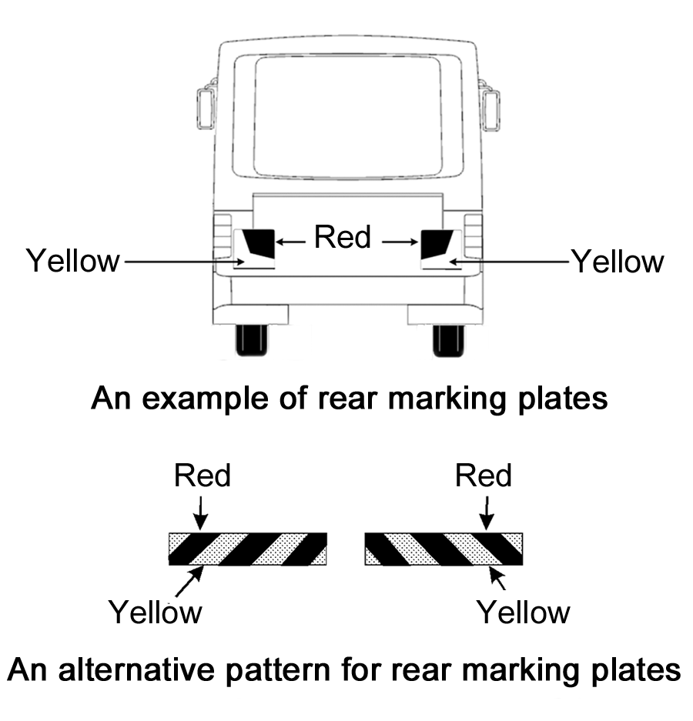
116—Signalling devices
(1) This rule applies to a motor vehicle if—
(a) the vehicle is not fitted with a brake light or direction indicator light mentioned in Division 10 or Division 12; and
(b) the construction of the vehicle would otherwise prevent the driver from hand signalling an intention—
(i) to turn or move the vehicle to the right; or
(ii) to stop or suddenly reduce the speed of the vehicle.
(2) The vehicle must be fitted with a mechanical signalling device or a pair of turn signals.
117—Mechanical signalling devices
(1) A mechanical signalling device must—
(a) be fitted to the right side of the vehicle; and
(b) be able to be operated by the driver from a normal driving position; and
(c) consist of a white or yellow representation of an open human hand at least 15 centimetres long; and
(d) be constructed so that the driver of the vehicle can keep the device—
(i) in a neutral position so it is unlikely that the driver of another vehicle or anyone else would regard it as a signal; and
(ii) in a horizontal position with the palm of the hand facing forwards and the fingers pointing out at a right angle to the vehicle to signal an intention to turn or move right; and
(iii) with the palm of the hand facing forwards and the fingers pointing upwards to signal an intention to stop or reduce speed suddenly.
(2) When the mechanical signalling device is in a position mentioned in subrule (1)(d)(ii) or (iii), the complete hand must be clearly visible from both the front and the rear of the vehicle, at a distance of 30 metres.
118—Turn signals
A turn signal must—
(a) consist of a steady or flashing illuminated yellow sign at least 15 centimetres long and 25 millimetres wide that—
(i) when in operation—is kept horizontal; and
(ii) when not in operation—is kept in a position so it is unlikely that the driver of another vehicle or anyone else would regard it as a signal; and
(b) be fitted to the side of the motor vehicle at least 50 centimetres, and not over 2.1 metres, above ground level, in a position so the driver of the vehicle, from the normal driving position, can see whether the signal is in operation; and
(c) be able to be operated by the driver from the normal driving position; and
(d) when in operation, be visible from both the front and rear of the vehicle at a distance of 30 metres.
Part 8—Braking systems
Note—
This Part sets out the braking system requirements for vehicles to ensure that they can be reliably slowed or stopped even if a part of a braking system fails, and to ensure that a vehicle can be prevented from rolling away when parked.
Division 1—Brake requirements for all vehicles
119—Components of a braking system
A brake tube or hose fitted to a vehicle must—
(a) be manufactured from a material appropriate to the tube’s or hose’s intended use in the vehicle; and
(b) be long enough to allow for the full range of steering and suspension movements of the vehicle; and
(c) be fitted to prevent the tube or hose being damaged during the operation of the vehicle by—
(i) a source of heat; or
(ii) any movement of the parts to which the tube or hose is attached or near.
120—Provision for wear
The braking system of a vehicle must allow for adjustment to take account of normal wear.
121—Supply of air or vacuum to brakes
(1) In this rule—
air brake compressor, of a vehicle, means a compressor for supplying air to the vehicle’s air brakes;
compressed air reserve, for a vehicle, means compressed air stored on the vehicle for supplying the vehicle’s braking system;
condensate drain valve means a device used to remove water from the compressed air reserve for a vehicle fitted with air brakes;
governor cut-out pressure, of a vehicle, means the air pressure at which the vehicle’s air brake compressor stops supplying air to the vehicle’s air brake reservoir;
spring brake means a brake using 1 or more springs to store the energy needed to operate the brake;
vacuum reserve, in relation to a vehicle, means air at a low pressure stored on the vehicle for supplying the vehicle’s braking system.
(2) If air brakes are fitted to a vehicle—
(a) the vehicle’s air brake compressor must be able to build up air pressure to at least 80% of the vehicle’s governor cut-out pressure, in not more than 5 minutes after the compressed air reserve is fully used up; and
(b) there must be an automatic or manual condensate drain valve at the lowest point of each air brake reservoir in the vehicle’s braking system; and
(c) any spring brake fitted to the vehicle must not operate before the warning mentioned in rule 128(3)(a) has been given.
(3) If vacuum brakes are fitted to a vehicle, the vacuum supply must be able to build up vacuum—
(a) to the level when the warning signal mentioned in rule 128(3)(a) no longer operates within 30 seconds after the vacuum reserve is fully used up; and
(b) to the normal working level within 60 seconds after the vacuum reserve is fully used up.
122—Performance of braking systems
(1) One sustained application of the brake of a motor vehicle built after 1930, or a combination that includes a motor vehicle built after 1930, must be able to produce the performance mentioned in subrules (2) to (7)—
(a) when the vehicle or combination is on a dry, smooth, level road surface, free from loose material; and
(b) whether or not the vehicle or combination is loaded; and
(c) without part of the vehicle or combination moving outside a straight path—
(i) centred on the longitudinal axis of the vehicle or combination before the brake was applied; and
(ii) 3.7 metres wide.
(2) The braking system of a motor vehicle or combination with a gross mass under 2.5 tonnes must bring the vehicle or combination from a speed of 35 kilometres an hour to a stop within—
(a) 12.5 metres when the service brake is applied; and
(b) 30 metres when the emergency brake is applied.
(3) The braking system of a motor vehicle or combination with a gross mass of at least 2.5 tonnes must bring the vehicle or combination from a speed of 35 kilometres an hour to a stop within—
(a) 16.5 metres when the service brake is applied; and
(b) 40.5 metres when the emergency brake is applied.
(4) The braking system of a motor vehicle or combination with a gross mass under 2.5 tonnes must decelerate the vehicle or combination, from any speed at which the vehicle or combination can travel, by an average of at least—
(a) 3.8 metres a second when the service brake is applied; and
(b) 1.6 metres a second when the emergency brake is applied.
(5) The braking system of a motor vehicle or combination with a gross mass of at least 2.5 tonnes must decelerate the vehicle or combination, from any speed at which the vehicle or combination can travel, by an average of at least—
(a) 2.8 metres a second when the service brake is applied; and
(b) 1.1 metres a second when the emergency brake is applied.
(6) The braking system of a motor vehicle or combination with a gross mass under 2.5 tonnes must achieve a peak deceleration of the vehicle or combination, from any speed at which the vehicle or combination can travel, of at least—
(a) 5.8 metres a second when the service brake is applied; and
(b) 1.9 metres a second when the emergency brake is applied.
(7) The braking system of a motor vehicle or combination with a gross mass of at least 2.5 tonnes must achieve a peak deceleration of the vehicle or combination, from any speed at which the vehicle or combination can travel, of at least—
(a) 4.4 metres a second when the service brake is applied; and
(b) 1.5 metres a second when the emergency brake is applied.
(8) The parking brake of a vehicle or combination must be able to hold the vehicle or combination stationary on a 12% gradient—
(a) when the vehicle or combination is on a dry, smooth road surface, free from loose material; and
(b) whether or not the vehicle or combination is loaded.
Division 2—Motor vehicle braking systems
123—What braking system a motor vehicle must have
(1) In this rule—
independent brake, for a vehicle, means a brake that is operated entirely separately from any other brake on the vehicle, except for any drum, disc or part, on which a shoe, band or friction pad makes contact, that is common to 2 or more brakes.
(2) A motor vehicle with 4 or more wheels built, or used, mainly for transporting goods or people by road must be fitted with—
(a) a braking system that—
(i) consists of brakes fitted to all wheels of the vehicle; and
(ii) has at least 2 separate methods of activation, arranged so effective braking remains on at least 2 wheels if a method fails; or
(b) 2 independent brakes, each of which, when in operation, acts directly on at least half the number of wheels of the vehicle.
(3) The braking system of a motor vehicle mentioned in subrule (2) that was built after 1945 must have a service brake operating on all wheels that, when applied—
(a) acts directly on the wheels and not through the vehicle’s transmission; or
(b) acts on a shaft between a differential of the vehicle and a wheel.
(4) The braking system of a motor vehicle with 4 or more wheels must have a parking brake that—
(a) is held in the applied position by direct mechanical action without the intervention of an electrical, hydraulic or pneumatic device; and
(b) is fitted with a locking device that can hold the brake in the applied position; and
(c) has its own separate control.
(5) The parking brake may also be the emergency brake.
(6) If 2 or more independent brakes are fitted to a motor vehicle with 4 or more wheels, the brakes must be arranged so brakes are applied to all the wheels on at least 1 axle of the vehicle when any brake is operated.
(7) A motor bike or motor trike must be fitted with—
(a) 2 independent brakes; or
(b) a single brake that acts directly on all wheels of the vehicle and is arranged so effective braking remains on at least 1 wheel if a part of the system fails.
(8) Subrule (7) applies to a motor bike with a sidecar attached as if the sidecar were not attached.
(9) A motor trike must have a parking brake that is held in the applied position by mechanical means.
124—Operation of brakes on motor vehicles
The braking system on a motor vehicle must be arranged to allow the driver of the motor vehicle to apply the brakes from a normal driving position.
125—Air or vacuum brakes on motor vehicles
(1) If a motor vehicle has air brakes, the braking system of the vehicle must include at least 1 air storage tank.
(2) If a motor vehicle has vacuum brakes, the braking system of the vehicle must include at least 1 vacuum storage tank.
(3) An air or vacuum storage tank must be built so the service brake can be applied to meet the performance standards of rule 122 at least twice if the engine of the vehicle stops or the source of air or vacuum fails.
(4) An air or vacuum storage system must be safeguarded by a check valve or other device against loss of air or vacuum if the supply fails or leaks.
Division 3—Trailer braking systems
126—What brakes a trailer must have
(1) A trailer with a GTM over 750 kilograms must have brakes that operate on at least 1 wheel at each end of 1 or more axles of the trailer.
(2) A semi-trailer or converter dolly with a GTM over 2 tonnes must have brakes that operate on all its wheels.
127—Operation of brakes on trailers
(1) The braking system of a trailer with a GTM over 2 tonnes must allow the driver of a motor vehicle towing the trailer to operate the brakes from a normal driving position.
(2) The brakes on a trailer with a GTM over 2 tonnes must—
(a) operate automatically and quickly if the trailer breaks away from the towing vehicle; and
(b) remain in operation for at least 15 minutes after a break-away; and
(c) be able to hold the trailer on a 12% grade while in operation after a break-away.
128—Air or vacuum brakes on trailers
(1) If a trailer has air brakes, its braking system must include at least 1 air storage tank.
(2) If a trailer has vacuum brakes, its braking system must include at least 1 vacuum storage tank.
(3) An air or vacuum storage system must—
(a) be built to give a visible or audible warning to the driver of the towing vehicle, while in a normal driving position, of a lack of air or vacuum that would prevent the brakes from meeting the performance standards of rule 122; and
(b) be safeguarded by a check valve or other device against loss of air or vacuum if the supply fails or leaks.
(4) Subrules (1), (2) and (3) do not apply to a trailer with a GTM of 2 tonnes or less.
Part 9—Control of emissions
Note—
This Part sets out requirements to ensure that motor vehicles do not emit too much smoke or noise and that exhaust gases cannot enter the passenger compartment of a vehicle.
Division 1—Crank case gases and exhaust emissions
129—Crank case gases
(1) This rule applies to a motor vehicle with 4 or more wheels that is powered by a petrol engine and was built after 1971.
(2) The vehicle must be built to prevent, or fitted with equipment that prevents, crank case gases from escaping to the atmosphere.
130—Visible emissions—vehicles with internal combustion engines
(1) This rule applies to a motor vehicle that is propelled by an internal combustion engine and was built after 1930.
(2) The vehicle must not emit visible emissions for a continuous period of at least 10 seconds.
(3) However, this rule does not apply to emissions that are visible only because of heat or the condensation of water vapour.
131—Exhaust emissions—diesel-powered vehicles
(1) In this rule—
GCM (gross combination mass), of a vehicle, means the greatest possible sum of the maximum loaded mass of the vehicle and of any vehicles that may lawfully be towed by it at any 1 time—
(a) as specified by the motor vehicle’s manufacturer; or
(b) as specified by an Australian Authority if—
(i) the manufacturer has not specified the sum of the maximum loaded mass; or
(ii) the manufacturer cannot be identified; or
(iii) the vehicle has been modified to the extent that the manufacturer's specification is no longer appropriate;
oxides emission rate means the rate measured in grams of NOx emitted per kilometre travelled per tonne of the vehicle’s test mass;
particle emissions rate means the rate measured in grams of particles emitted per kilometre travelled per tonne of the vehicle’s test mass;
tare mass of a vehicle means the vehicle’s unladen mass (however described);
vehicle’s test mass means—
(a) if the vehicle is a prime mover—half the sum of its tare mass and its GCM; or
(b) in any other case—half the sum of its tare mass and its GVM.
Note—
The vehicle’s test mass is the load applied to the dynamometer, while the vehicle is under test, to simulate half payload operation.
(2) This rule applies to a motor vehicle—
(a) powered by a diesel engine; and
(b) meeting the criteria for a passenger vehicle including omnibuses and goods vehicles as defined under the ADRs.
(3) For subrule (4), a vehicle is taken to have been manufactured in the month shown on its compliance plate (that is, the plate of the kind referred to in section 10A of the Motor Vehicle Standards Act, affixed or taken to be affixed to the vehicle) as its month of manufacture.
(4) When a vehicle is tested in accordance with the procedure described in rule 133—
(a) the vehicle must not emit oxides of nitrogen (NOx) at an oxides emission rate greater than that stated for the vehicle according to its GVM rating and age in the following table; and

Vehicle’s GVM rating (t) | Oxides emission rate (g/km/t)
 | Vehicle manufactured in December 1995 or earlier | Vehicle manufactured in January 1996 or later
3.5 or less | 1.5 | 1.5
more than 3.5 | 2.0 | 2.0
(b) the vehicle must not emit particles at a particle emissions rate greater than that stated for the vehicle according to its GVM rating and age in the following table; and

Vehicle’s GVM rating (t) | Particle emissions rate (g/km/t)
 | Vehicle manufactured in December 1995 or earlier | Vehicle manufactured in January 1996 or later
3.5 or less | 0.23 | 0.23
more than 3.5 | 0.23 | 0.15
(c) the opacity of the exhaust gas emitted by the vehicle must not be greater than 25%, averaged over a DT80 test cycle in the way described or mentioned in the test procedure stated in rule 133, that complies with rule 132.
132—Requirements of DT80 test cycle
(1) The requirements stated in the following subrules are the minimum standards for the dynamometer, emissions measurement and data management systems necessary to enable the proper conduct of the DT80 test cycle mentioned in rule 131(4)(c).
(2) The DT80 test cycle must be conducted on a chassis dynamometer system that—
(a) can carry out a full throttle transient DT80 test cycle, as described in rule 133, for the vehicle being tested; and
(b) provides for vehicle speed measurement and display, to an accuracy of ± 1% of actual speed; and
(c) provides internal steady state accuracy of ± 1% of calculated required tractive load over ambient temperatures of 2° - 40°C; and
(d) provides a T95 response time of 3 seconds or less; and
(e) provides inertial loading as required by the DT80 protocol at speeds > 15 km/h; and
(f) compensates for aerodynamic drag, rolling resistance and other parasitic losses; and
(g) corrects for ambient temperature, humidity and air density; and
(h) provides torque measurement accuracy of better than 1% full scale; and
(i) keeps roller speed within ± 10 km/h through gear changes; and
(j) restricts overshoot upon initial acceleration of rollers from rest; and
(k) incorporates a driver control panel for remote operation of critical functions from the driver’s seat, including controls for start test and stop test; and
(l) incorporates an emergency system override function; and
(m) is able to communicate speed, load and status signals to enable the driver to undertake the test in accordance with the DT80 procedure; and
(n) is integrated with the gas and particulate analysis system to initiate the start and finish of sampling and measurement, and generates emission results without the need for post-test processing.
(3) The emissions measurement system used for the DT80 test cycle must—
(a) be integrated with the dynamometer system stated in subrule (2); and
(b) have a data averaging interval of 1 second for all equipment; and
(c) provide emissions data sampling output ≥ 5Hz; and
(d) measure oxides of nitrogen (from a diluted and conditioned sample) with an accuracy of ± 30ppm over the range 0 - 1000ppm and ± 5% over the range 1001 - 5000ppm; and
(e) measure particulate matter (from diluted sample) as TSP or PM 10 with an accuracy of ± 10% on a real time continuous basis over a range of 0 - 1000 mg/m³ actual exhaust concentration at a sample temperature of < 51.7°C; and
(f) measure opacity (from a raw exhaust gas sample) with an accuracy of ± 1% over a range of 0 - 100% opacity; and
(g) measure flow rate with an accuracy of ± 5%; and
(h) measure ambient temperature with an accuracy of ± 1°C over a range of 0 - 50°C; and
(i) measure ambient humidity with an accuracy of ± 5% over a range of 0 - 100%; and
(j) compensate or correct for ambient humidity and temperature; and
(k) compensate for exhaust gas transport times and delays; and
(l) provide on-line calibration of the analytical system; and
(m) provide an exhaust sample collection and conditioning system—
(i) that is optimised to accommodate the exhaust temperature and flow rate, and emission concentration, for the vehicle being tested; and
(ii) that provides adequate conditioning of the exhaust gas to eliminate water in the sample stream and reduce temperatures to enable PM to be sampled at < 51.7°C; and
(n) use materials and equipment compatible with the exhaust from diesel-fuelled vehicles.
(4) The data management system used for the DT80 test cycle must—
(a) be integrated with the dynamometer and emissions measurement systems stated in subrules (2) and (3); and
(b) record the following items for each test:
(i) date, time, location and operator;
(ii) emissions analyser calibration data;
(iii) vehicle input data, including test mass tractive load corrections and identifying information;
(iv) dynamometer data (load, speed, distance) on a second by second basis;
(v) test data on a second by second basis from which a mass emission test result in g/km/t can be generated; and
(c) display, store and report all data in the International System of units (SI units); and
(d) provide a system for electronic backup of test data to local and remote media; and
(e) incorporate a quality control system that—
(i) ensures calibrations are carried out in accordance with manufacturers’ specifications; and
(ii) provides records consistent with normal audit requirements; and
(f) print a test report containing at least the following items:
(i) registered business name, ABN and address of the test facility;
(ii) registration number, make, model, GVM rating and date of manufacture of the tested vehicle;
(iii) date and location of test;
(iv) the final calculated NOx and PM results in g/km/t;
(v) the final calculated opacity results in per cent;
(vi) a statement of pass or fail for each emission compared to the emission limits stated in rule 131;
(vii) the signature of the test facility operator confirming that the test was conducted in accordance with the test procedure described in rule 133 and the requirements of this rule.
133—Test procedure
For the purposes of rule 131(4), the procedure for testing is as follows:

Step 1 | Secure the vehicle on the dynamometer.
Step 2 | Set the dynamometer to simulate the correct load and inertia for the vehicle.
Step 3 | Start sampling.
Step 4 | Idle for 60 seconds.
Step 5 | Accelerate rapidly to 80 km/h under simulated inertia, using wide open throttle, making gear changes as needed for smooth acceleration.
Step 6 | Decelerate by removing all pressure from the accelerator pedal, disengaging the gears and gently applying brakes to bring the vehicle to a standstill.
Step 7 | Idle for 10 seconds.
Step 8 | Accelerate rapidly to 80 km/h under simulated inertia, using wide open throttle, making gear changes as needed for smooth acceleration.
Step 9 | Decelerate by removing all pressure from the accelerator pedal, disengaging the gears and gently applying brakes to bring the vehicle to a standstill.
Step 10 | Idle for 10 seconds.
Step 11 | Accelerate rapidly to 80 km/h under simulated inertia, using wide open throttle, making gear changes as needed for smooth acceleration.
Step 12 | Keep speed at 80 km/h for 60 seconds, then stop sampling and bring the vehicle to rest.
Note—
Explanation of the test procedure
This test has been designed to evaluate vehicle emissions during typical ‘real-world’ operating modes and conditions. There are 3 simple modes—
(a) 3 idle periods;
(b) acceleration to 80 km/h 3 times;
(c) keep speed at 80 km/h.
The graph below shows the modes of operation. The actual test will result in a graph that has more variation than the graph below, because of the need to change gears when accelerating. Modes B – D and E – G and H – I have no specific time interval. All the specified time periods have an error margin of ± 1 second.
The vehicle is accelerated rapidly to 80 km/h 3 times by applying wide open throttle.
The driver selects the most appropriate gear change points for the vehicle being tested to achieve the correct speed.
The vehicle’s rolling resistance (based on tyre and bearing losses, frontal area and drag coefficient) must also be calculated and continuously factored into the dynamometer tractive effort calculations to ensure correct loading.
Empirical algorithms, based on vehicle test mass, GVM or other known parameters, may be used to automatically calculate realistic coefficients for the variables.
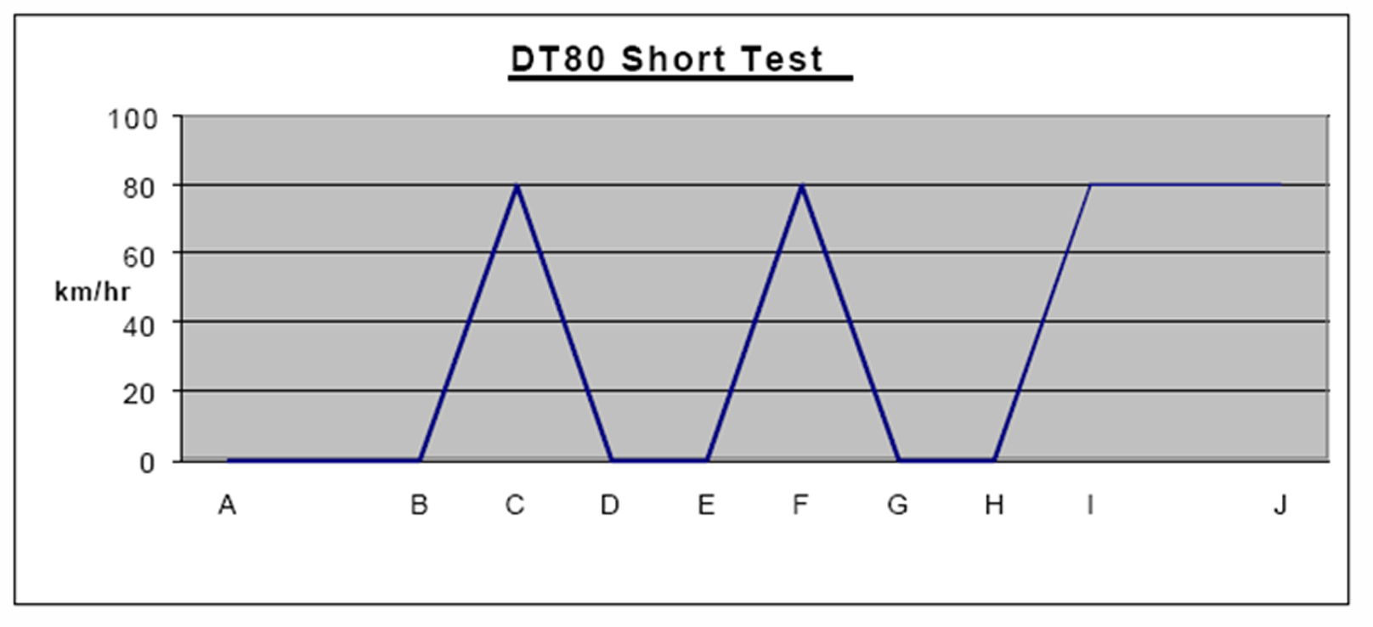
Division 2—Exhaust systems
134—Exhaust systems
(1) In this rule—
vertical exhaust system means an exhaust system that emits exhaust gases in an upward direction above or near the top of a vehicle to which the exhaust system is fitted.
(2) An outlet (a motor trike exhaust outlet) of an exhaust system fitted to a motor trike with a permanently enclosed body must extend—
(a) at least 40 millimetres beyond the outermost joint of the floorpan that is not continuously welded or permanently sealed; and
(b) not beyond the perimeter of the vehicle.
(3) The motor trike exhaust outlet must discharge the main exhaust flow to the air—
(a) if the outlet is fitted to the side of the motor trike—to the right hand side of the motor trike and below the horizontal axis of the motor trike at an angle between 15° and 45°; or
(b) if the outlet is fitted to the rear of the motor trike—at an angle between 10° above the horizontal axis of the motor trike and 45° below that axis.
(4) An outlet (a bus exhaust outlet) of an exhaust system fitted to a bus must be as near as practicable to the rear of the bus.
(5) If the bus is not fitted with a vertical exhaust system, the bus exhaust outlet must not extend beyond the perimeter of the bus.
(6) If the bus is fitted with a vertical exhaust system, the bus exhaust outlet must be located behind the rearmost part of the passenger compartment.
(7) A bus exhaust outlet must discharge the main exhaust flow to the air—
(a) if the outlet is not part of a vertical exhaust system—
(i) towards the rear, or to the right, of the bus; and
(ii) horizontally or downwards at an angle not more than 45° below the horizontal axis; or
(b) if the outlet is part of a vertical exhaust system—vertically upwards or towards the rear of the bus at any angle above the horizontal axis.
Division 3—Noise emissions
Subdivision 1—General
135—Measurement of stationary noise levels
(1) For this Division, the stationary noise level of a motor vehicle is to be measured in accordance with the procedure set out for the kind of vehicle in the National Stationary Exhaust Noise Test Procedures for In-Service Motor Vehicles – September 2006 (ISBN: 1 921168 50 1) published by the Commission.
(2) In this rule—
Commission means the National Transport Commission established by the National Transport Commission Act 2003 of the Commonwealth.
Note—
The National Stationary Exhaust Noise Test Procedures for In-Service Motor Vehicles – September 2006 is available on the Commission’s web site at www.ntc.gov.au
136—Meaning of certified to ADR 83/00
For this Division, a vehicle is certified to ADR 83/00 if approval has been given, under section 10A of the Motor Vehicle Standards Act, to place identification plates showing compliance with ADR 83/00 on vehicles of that type.
137—Silencing device for exhaust systems
(1) A motor vehicle propelled by an internal combustion engine must be fitted with a silencing device through which all the exhaust from the engine passes.
(2) For subrule (1), any silencing device designed to be manipulated by the vehicle’s operator, such as by means of in-vehicle controls, must be designed so that it can be tested with the device fully opened.
Subdivision 2—Noise levels applying to vehicles certified prior to the application of ADR 83/00
138—Application of rules in Subdivision 2
This Subdivision applies to a motor vehicle other than a vehicle certified to ADR 83/00.
139—Stationary noise levels—car-type vehicles and motor bikes and motor trikes
(1) In this rule—
car-type vehicle means—
(a) a car; or
(b) a utility truck, panel van, or another motor vehicle derived from a car design; or
(c) another motor vehicle with 4 or more wheels that is built mainly to carry not over 9 people including the driver.
(2) The stationary noise level of a car-type vehicle, or motor bike or motor trike, must not exceed—
(a) for a car-type vehicle built after 1982—90 dB(A); or
(b) for another car-type vehicle—96 dB(A); or
(c) for a motor bike or motor trike built after February 1985—94 dB(A); or
(d) for another motor bike or motor trike—100 dB(A).
140—Stationary noise levels—other vehicles with spark ignition engines
(1) This rule applies to a motor vehicle (except a motor vehicle to which rule 139 applies) with a spark ignition engine.
(2) The stationary noise level of the motor vehicle must not exceed the noise level applying to the vehicle under the table.

Column 1 | Column 2 | Column 3 | Column 4 | Column 5
Item | GVM | Exhaust height | When vehicle built | Noise level
 | (t) | (mm) |  | (dB(A))
1 | ≤3.5 | <1500 | before July 1983 | 92
1 | ≤3.5 | <1500 | after June 1983 | 89
2 | >3.5 | <1500 | before July 1983 | 98
2 | >3.5 | <1500 | after June 1983 | 95
3 | ≤3.5 | ≥1500 | before July 1983 | 88
3 | ≤3.5 | ≥1500 | after June 1983 | 85
4 | >3.5 | ≥1500 | before July 1983 | 94
4 | >3.5 | ≥1500 | after June 1983 | 91
141—Stationary noise levels—other vehicles with diesel engines
(1) This rule applies to a motor vehicle (except a motor vehicle to which rule 139 applies) with a diesel engine.
(2) The stationary noise level of the motor vehicle must not exceed the noise level applying to the vehicle under the table.

Column 1 | Column 2 | Column 3 | Column 4 | Column 5
Item | GVM | Exhaust height | When vehicle built | Noise level
 | (t) | (mm) |  | (dB(A))
1 | ≤3.5 | <1500 | before July 1980 | 105
 |  |  | after June 1980 but before July 1983 | 102
 |  |  | after June 1983 | 99
2 | >3.5 | <1500 | before July 1980 | 107
 |  |  | after June 1980 but before July 1983 | 104
 |  |  | after June 1983 | 101
3 | ≤3.5 | ≥1500 | before July 1980 | 101
 |  |  | after June 1980 but before July 1983 | 98
 |  |  | after June 1983 | 95
4 | >3.5 | ≥1500 | before July 1980 | 103
 |  |  | after June 1980 but before July 1983 | 100
 |  |  | after June 1983 | 97
Subdivision 3—Noise levels applying to vehicles certified to ADR 83/00
142—Stationary noise levels
The stationary noise level of a motor vehicle that is certified to ADR 83/00 must not exceed, by more than 5 dB(A), the noise level that is established for the motor vehicle when it is certified.
Part 10—Alternative fuel systems
Note—
This Part sets out requirements to ensure that LPG (Liquid Petroleum Gas) and CNG (Compressed Natural Gas) fuel systems are safely installed in motor vehicles. In the case of vehicles with an LPG system installed, there is an additional requirement to ensure that they can be identified as LPG-powered vehicles.
143—LPG-powered vehicles
(1) An LPG system installed in a motor vehicle, and the vehicle, must comply with all relevant requirements set out in the version of Australian Standard AS 1425 or Australian/New Zealand Standard AS/NZS 1425 that was current at the time the system was installed in the vehicle.
(2) A motor vehicle that has an LPG system installed must have fixed conspicuously to its front and rear number plates the labels required by the version of Australian Standard AS 1425 or Australian/New Zealand Standard AS/NZS 1425 that was current at the time the system was installed in the vehicle.
(3) If a motor vehicle had an LPG system installed before Australian Standard AS 1425-1973 was first published, the vehicle must have fixed conspicuously to its front and rear number plates a label—
(a) that is made of durable material; and
(b) that is at least 25 millimetres wide and 25 millimetres high; and
(c) that is of a reflective red that conforms with either Australian Standard AS 1743-1975 or Australian Standard AS 1906.1-1976 Retroreflective Materials and Devices for Road Traffic Control Purposes—Part 1: Retroreflective Materials; and
(d) that states ‘LPGAS’ or ‘LPG’, or similar words or acronyms that have the same meaning, in capital letters at least 6 millimetres high.
144—Vehicles powered by natural gas
A natural gas system installed in a motor vehicle, and the vehicle, must comply with all relevant requirements set out in the version of Australian Standard AS 2739 or Australian/New Zealand Standard AS/NZS 2739 that was current at the time the system was installed in the vehicle.
Examples—
Forms of natural gas include CNG (Compressed Natural Gas) and LNG (Liquid Natural Gas).
144A—Hydrogen-powered vehicles
(1) A hydrogen-powered vehicle built after 1 January 2019 must have fixed conspicuously to its front and rear number plates—
(a) for a vehicle fitted with 1 hydrogen fuel container—a label that complies with subrule (2); or
(b) for a vehicle fitted with 2 or more hydrogen fuel containers—2 labels that comply with subrule (2).
(2) For the purposes of subrule (1), a label complies with this subrule if—
(a) it is affixed to a plate made of metal that is at least 1 millimetre thick; and
(b) the label, and the plate to which it is affixed, is a regular pentagonal shape—
(i) each side of which is 25 millimetres long; and
(ii) each interior angle of which is 108°; and
(c) it has a yellow surface that complies with class 2 of Australian/New Zealand Standard AS/NZS 1906.1-2017 Retroreflective Materials and Devices for Road Traffic Control Purposes—Part 1: Retroreflective Sheeting; and
(d) it is marked "H" in a black capital letter that is at least 10 millimetres high and has the orientation shown in the example; and
(e) it is fixed to the number plates so that the letter on the label is in an upright position; and
(f) it does not wholly or partly obscure any characters on the number plates.
Example of label for hydrogen-powered vehicle—

Note—
The example of the label is for illustrative purposes only and does not represent the label’s actual size, dimensions or colour.
(3) In this rule—
hydrogen-powered vehicle means a vehicle that—
(a) is powered by a hydrogen fuel system; and
(b) has 1 or more hydrogen fuel containers fitted to the vehicle for the system.
144B—Electric-powered vehicles
(1) An electric-powered vehicle that is built after 1 January 2019 must have fixed conspicuously to its front and rear number plates a label that complies with subrule (2).
(2) For the purposes of subrule (1), a label complies with this subrule if—
(a) it is affixed to a plate made of metal that is at least 1 millimetre thick; and
(b) the label, and the plate to which it is affixed, is an equilateral triangular shape—
(i) each side of which is 35 millimetres in length; and
(ii) each interior angle of which is 60°; and
(c) it has a blue surface that complies with class 2 of Australian/New Zealand Standard AS/NZS 1906.1-2017 Retroreflective Materials and Devices for Road Traffic Control Purposes—Part 1: Retroreflective Sheeting; and
(d) it is marked "EV" in white capital letters that are at least 8 millimetres high and have the orientation shown in the example; and
(e) it is fixed to the number plates so that the letters on the label are in an upright position; and
(f) it does not wholly or partly obscure any characters on the number plates.
Example of label for electric-powered vehicle—

Note—
The example of the label is for illustrative purposes only and does not represent the label's actual size, dimensions or colour.
(3) However, this rule does not apply to a vehicle to which rule 144A applies even if the vehicle is fitted with an electric motor or traction motor that is used in conjunction with a hydrogen fuel system for the propulsion of the vehicle.
(4) In this rule—
electric-powered vehicle means a vehicle that is powered by 1 or more electric motors or traction motors that—
(a) are the only propulsion system for the vehicle; or
(b) are used in conjunction with another propulsion system for the vehicle.
Part 11—Mechanical connections between vehicles
Note—
This Part sets out various requirements to ensure that the couplings used when operating motor vehicles and trailers in combinations are strong enough to hold them together.
145—General coupling requirements
(1) A fifth wheel coupling, the mating parts of a coupling, a kingpin or a towbar must not be used for a load more than the manufacturer’s load rating.
(2) A kingpin must be used only with a fifth wheel coupling that has a corresponding jaw size.
Example—
An adaptor must not to be used to fit a kingpin to a fifth wheel coupling.
(3) The mating parts of a coupling used to connect a semi-trailer to a towing vehicle must not allow the semi-trailer to roll to an extent that makes the towing vehicle unstable.
146—Drawbar couplings
(1) A coupling for attaching a trailer, except a semi-trailer or pole-type trailer, to a towing vehicle must be built and fitted so—
(a) the coupling is equipped with a positive locking mechanism; and
(b) the positive locking mechanism can be released regardless of the angle of the trailer to the towing vehicle.
(2) If the trailer is in a combination and is not fitted with breakaway brakes in accordance with rule 127(2), it must be connected to the towing vehicle by at least 1 chain, cable or other flexible device, as well as the coupling required by subrule (1).
(3) The connection must be built and fitted so—
(a) the trailer is kept in tow if the coupling breaks or accidentally detaches; and
(b) normal angular movement of the coupling is permitted without unnecessary slack.
(4) If practicable, the connection must be built and fitted so the drawbar of the trailer is prevented from hitting the ground if the coupling accidentally detaches.
(5) For the purposes of subrules (3) and (4), a connection between a trailer and a towing vehicle includes anything which connects the trailer and the towing vehicle.
Examples of what is included in a connection—
(a) chains
(b) cables
(c) a thing fixed to a trailer or a towing vehicle to which a chain is attached
(d) shackles.
Schedule 1—Revocation of Road Traffic (Light Vehicle Standards) Rules 2013
The Road Traffic (Light Vehicle Standards) Rules 2013 are revoked.
Note—
As required by section 10AA(2) of the Subordinate Legislation Act 1978, the Minister has certified that, in the Minister's opinion, it is necessary or appropriate that these regulations come into operation as set out in these regulations.
Made by the Governor
with the advice and consent of the Executive Council
on 23 January 2018
No 5 of 2018
MTR/17/047
South Australia
Road Traffic (Miscellaneous) (Light Vehicle Standards Rules) Variation Regulations 2018
under the Road Traffic Act 1961

Contents
Part 1—Preliminary
1 Short title
2 Commencement
3 Variation provisions
Part 2—Variation of Road Traffic (Miscellaneous) Regulations 2014
4 Variation of Schedule 3—Fees

Part 1—Preliminary
1—Short title
These regulations may be cited as the Road Traffic (Miscellaneous) (Light Vehicle Standards Rules) Variation Regulations 2018.
2—Commencement
These regulations will come into operation on the day on which the Road Traffic (Light Vehicle Standards) Rules 2018 come into operation.
3—Variation provisions
In these regulations, a provision under a heading referring to the variation of specified regulations varies the regulations so specified.
Part 2—Variation of Road Traffic (Miscellaneous) Regulations 2014
4—Variation of Schedule 3—Fees
Schedule 3, clause 2(1), definition of light vehicle permit—delete "Road Traffic (Light Vehicle Standards) Rules 2013" and substitute:
Road Traffic (Light Vehicle Standards) Rules 2018
Note—
As required by section 10AA(2) of the Subordinate Legislation Act 1978, the Minister has certified that, in the Minister's opinion, it is necessary or appropriate that these regulations come into operation as set out in these regulations.
Made by the Governor
with the advice and consent of the Executive Council
on 23 January 2018
No 6 of 2018
MTR/17/047
South Australia
Road Traffic (Light Vehicle Mass and Loading Requirements) (Light Vehicle Standards Rules) Variation Regulations 2018
under the Road Traffic Act 1961

Contents
Part 1—Preliminary
1 Short title
2 Commencement
3 Variation provisions
Part 2—Variation of Road Traffic (Light Vehicle Mass and Loading Requirements) Regulations 2013
4 Variation of Dictionary

Part 1—Preliminary
1—Short title
These regulations may be cited as the Road Traffic (Light Vehicle Mass and Loading Requirements) (Light Vehicle Standards Rules) Variation Regulations 2018.
2—Commencement
These regulations will come into operation on the day on which the Road Traffic (Light Vehicle Standards) Rules 2018 come into operation.
3—Variation provisions
In these regulations, a provision under a heading referring to the variation of specified regulations varies the regulations so specified.
Part 2—Variation of Road Traffic (Light Vehicle Mass and Loading Requirements) Regulations 2013
4—Variation of Dictionary
Dictionary, definition of Light Vehicle Standards—delete "Road Traffic (Light Vehicle Standards) Rules 2013" and substitute:
Road Traffic (Light Vehicle Standards) Rules 2018
Note—
As required by section 10AA(2) of the Subordinate Legislation Act 1978, the Minister has certified that, in the Minister's opinion, it is necessary or appropriate that these regulations come into operation as set out in these regulations.
Made by the Governor
with the advice and consent of the Executive Council
on 23 January 2018
No 7 of 2018
MTR/17/047
South Australia
Road Traffic (Road Rules—Ancillary and Miscellaneous Provisions) (Light Vehicle Standards Rules) Variation Regulations 2018
under the Road Traffic Act 1961

Contents
Part 1—Preliminary
1 Short title
2 Commencement
3 Variation provisions
Part 2—Variation of Road Traffic (Road Rules—Ancillary and Miscellaneous Provisions) Regulations 2014
4 Variation of regulation 24—Lights to be fitted to vehicles
5 Variation of regulation 50—Approved seatbelts
6 Variation of regulation 55—Hazard warning lights
7 Variation of regulation 57—Mechanical signalling devices

Part 1—Preliminary
1—Short title
These regulations may be cited as the Road Traffic (Road Rules—Ancillary and Miscellaneous Provisions) (Light Vehicle Standards Rules) Variation Regulations 2018.
2—Commencement
These regulations will come into operation on the day on which the Road Traffic (Light Vehicle Standards) Rules 2018 come into operation.
3—Variation provisions
In these regulations, a provision under a heading referring to the variation of specified regulations varies the regulations so specified.
Part 2—Variation of Road Traffic (Road Rules—Ancillary and Miscellaneous Provisions) Regulations 2014
4—Variation of regulation 24—Lights to be fitted to vehicles
Regulation 24(b)—delete "Road Traffic (Light Vehicle Standards) Rules 2013" and substitute:
Road Traffic (Light Vehicle Standards) Rules 2018
5—Variation of regulation 50—Approved seatbelts
Regulation 50(2)(b)—delete paragraph (b) and substitute:
(b) the Road Traffic (Light Vehicle Standards) Rules 2018; or
6—Variation of regulation 55—Hazard warning lights
Regulation 55(b)—delete "Road Traffic (Light Vehicle Standards) Rules 2013" and substitute:
Road Traffic (Light Vehicle Standards) Rules 2018
7—Variation of regulation 57—Mechanical signalling devices
Regulation 57(b)—delete "Road Traffic (Light Vehicle Standards) Rules 2013" and substitute:
Road Traffic (Light Vehicle Standards) Rules 2018
Note—
As required by section 10AA(2) of the Subordinate Legislation Act 1978, the Minister has certified that, in the Minister's opinion, it is necessary or appropriate that these regulations come into operation as set out in these regulations.
Made by the Governor
with the advice and consent of the Executive Council
on 23 January 2018
No 8 of 2018
MTR/17/047
South Australia
Dangerous Substances (Dangerous Goods Transport) (Light Vehicle Standards Rules) Variation Regulations 2018
under the Dangerous Substances Act 1979

Contents
Part 1—Preliminary
1 Short title
2 Commencement
3 Variation provisions
Part 2—Variation of Dangerous Substances (Dangerous Goods Transport) Regulations 2008
4 Variation of regulation 4—Interpretation

Part 1—Preliminary
1—Short title
These regulations may be cited as the Dangerous Substances (Dangerous Goods Transport) (Light Vehicle Standards Rules) Variation Regulations 2018.
2—Commencement
These regulations will come into operation on the day on which the Road Traffic (Light Vehicle Standards) Rules 2018 come into operation.
3—Variation provisions
In these regulations, a provision under a heading referring to the variation of specified regulations varies the regulations so specified.
Part 2—Variation of Dangerous Substances (Dangerous Goods Transport) Regulations 2008
4—Variation of regulation 4—Interpretation
Regulation 4(1), definition of converter dolly, (a)—delete "Road Traffic (Light Vehicle Standards) Rules 2013" and substitute:
Road Traffic (Light Vehicle Standards) Rules 2018
Note—
As required by section 10AA(2) of the Subordinate Legislation Act 1978, the Minister has certified that, in the Minister's opinion, it is necessary or appropriate that these regulations come into operation as set out in these regulations.
Made by the Governor
with the advice and consent of the Executive Council
on 23 January 2018
No 9 of 2018
MTR/17/047
South Australia
Development (Schedule 3) Variation Regulations 2018
under the Development Act 1993

Contents
Part 1—Preliminary
1 Short title
2 Commencement
3 Variation provisions
Part 2—Variation of Development Regulations 2008
4 Variation of Schedule 3—Acts and activities that are not development
20 Car park etc in Osborne area of City of Port Adelaide Enfield
5 Insertion of Schedule 32
Schedule 32—Map of designated Osborne area

Part 1—Preliminary
1—Short title
These regulations may be cited as the Development (Schedule 3) Variation Regulations 2018.
2—Commencement
These regulations come into operation on the day on which they are made.
3—Variation provisions
In these regulations, a provision under a heading referring to the variation of specified regulations varies the regulations so specified.
Part 2—Variation of Development Regulations 2008
4—Variation of Schedule 3—Acts and activities that are not development
Schedule 3—after clause 19 insert:
20—Car park etc in Osborne area of City of Port Adelaide Enfield
(1) The following development undertaken within the designated Osborne area:
(a) development for the purposes of a car park and a pedestrian bridge over a railway;
(b) development that is ancillary to development within the ambit of paragraph (a), including—
(i) excavation, importation of fill and other earthworks; and
(ii) footings and other support structures; and
(iii) landscaping; and
(iv) safety features; and
(v) directional signs, information boards, lighting, seating, weather shelters, rubbish bins and other street furniture.
(2) In this clause—
designated Osborne area means the area designated as "car park" in the map set out in Schedule 32.
5—Insertion of Schedule 32
After Schedule 31 insert:
Schedule 32—Map of designated Osborne area
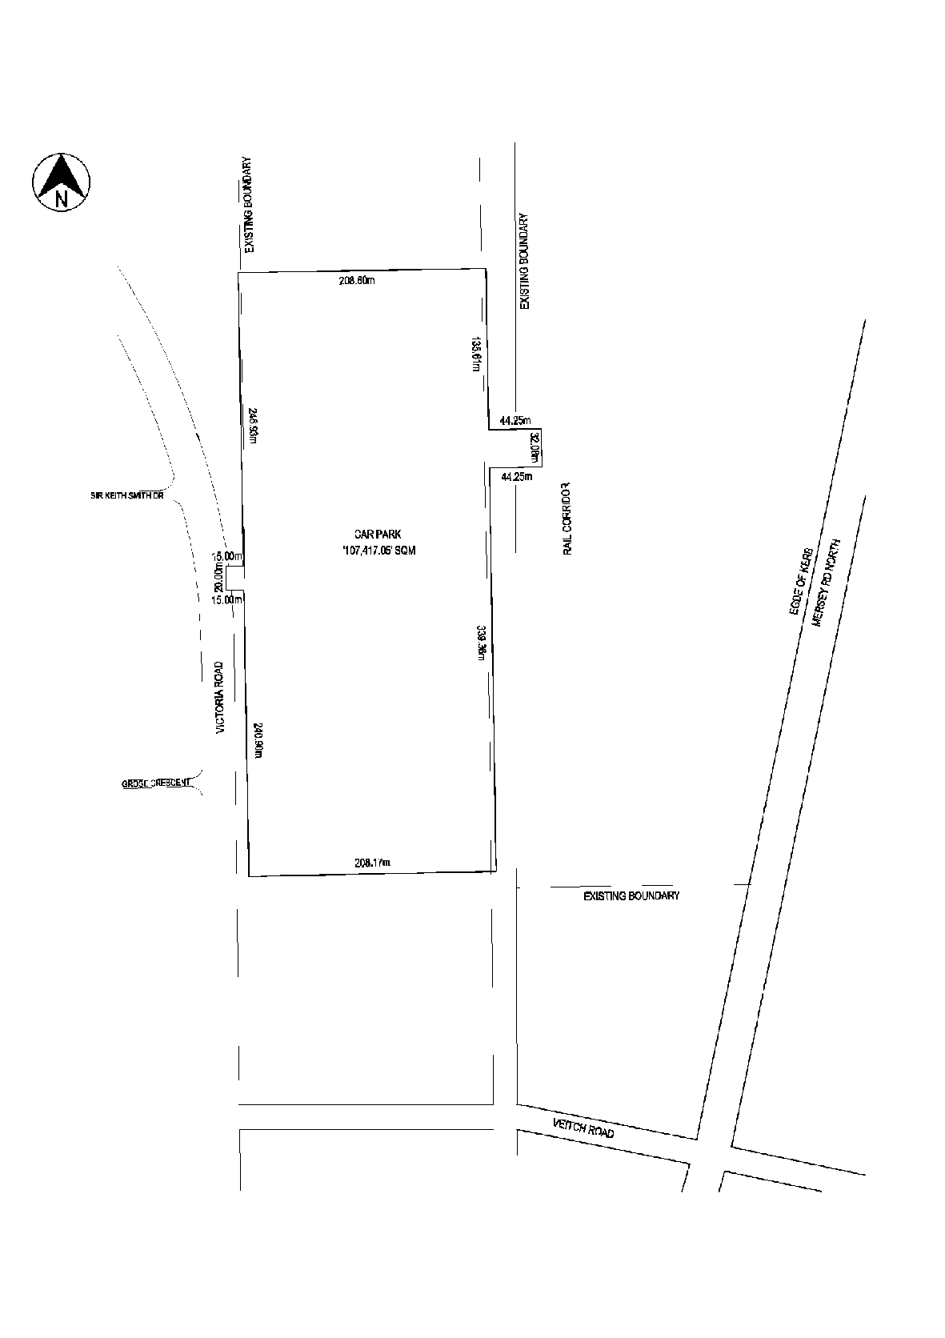
Note—
As required by section 10AA(2) of the Subordinate Legislation Act 1978, the Minister has certified that, in the Minister's opinion, it is necessary or appropriate that these regulations come into operation as set out in these regulations.
Made by the Governor
with the advice and consent of the Executive Council
on 23 January 2018
No 10 of 2018
17MDI/308CS

Rules of court
South Australia
Corporations Rules 2003 (Amendment No 9)
By virtue and in pursuance of section 72 of the Supreme Court Act 1935 and all other enabling powers. We, Judges of the Supreme Court of South Australia, make the following Corporations Rules 2003 (Amendment No 9).
- These Rules may be cited as the Corporations Rules 2003 (Amendment No 9).
- The amendments made by these Rules come into effect on 1 January 2018 or the date of their gazettal, whichever is later.
- The Corporations Rules 2003 are amended as set out below.
- Rule 1.4 is amended as follows:
  - inserting “(1)” before “Unless the contrary intention appears”;
  - deleting “official liquidator—see section 9”;
  - inserting the following new sub-rule (2) immediately below “statutory demand — see section 9” as follows:
“(2) Unless the contrary intention appears, an expression used in these Rules and in the Insolvency Practice Schedule (Corporations) has the same meaning in these Rules as it has in the Insolvency Practice Schedule (Corporations).”
- Rule 1.5 is amended by inserting “Insolvency Practice Schedule (Corporations) means Schedule 2 to the Corporations Act.” immediately below the definition of “defendant”.
- Subrule 2.8 (3) is amended as follows:
  - substituting “subsection 509(2)” for “subsection 509(6)” in column 1 headed “Provision” with respect to table item 3 ;
  - repealing table item 4 “Subsection 536(1) For an enquiry into the conduct of a liquidator”;
  - inserting new table items 9, 10 and 11 at the end as follows:
Subsection 45-1(3) of the Insolvency Practice Schedule (Corporations) | For an order under subsection 45-1(1) of the Insolvency Practice Schedule (Corporations) in relation to a registered liquidator
subsection 90-10(1) of the Insolvency Practice Schedule (Corporations) | For an inquiry into the external administration of a company
section 90-20 of the Insolvency Practice Schedule (Corporations) | For an order under section 90-15 of the Insolvency Practice Schedule (Corporations) in relation to the external administration of a company
- The heading to Division 4 is deleted and replaced with “Division 4—Process for seeking an inquiry or order in relation to controller, registered liquidator or external administration”.
- Rule 4.1 is amended by inserting “The complaint may be made by a person mentioned in any of paragraphs 11.2(1)(a) to (d).” after “must be made by an originating process seeking an inquiry in relation to the complaint”.
- A new rule 4.2 is inserted after rule 4.1 in Division 4 as follows:

“4.2 Order or inquiry in relation to registered liquidator or external administration of a company
An application to the Court:
- under section 45-1 of the Insolvency Practice Schedule (Corporations) for an order in relation to a registered liquidator; or
- under section 90-10 of that Schedule for an inquiry into the external administration of a company; or
- under section 90-20 of that Schedule for an order in relation to the external administration of a company;
must be made:
- in the case of a winding up by the Court—by an interlocutory process seeking the inquiry or order; or
- in any other case—by an originating process seeking the inquiry or order.
Note: An application for an order or inquiry in relation to the external administration of a company ordered to be wound up by a Court is normally made to the Court that made the winding up order.”
- Rule 5.6 is deleted and replaced as follows:

“5.6 Notice of application for winding up
(1) If a person applies for a company to be wound up and the application is not made under section 459P, 462 or 464 of the Corporations Act, the person must, unless the Court otherwise orders, cause a notice of the application to be published in a daily newspaper circulating generally in the State or Territory where the company has its principal, or last known, place of business. The notice must be in accordance with Form 9.
Note: If a person applies under section 459P, 462 or 464 of the Corporations Act for a company to be wound up, the person must cause a notice, setting out the information prescribed by regulation 5.4.01A of the Corporations Regulations, to be published in the manner provided by section 1367A of the Corporations Act and regulation 5.6.75 of the Corporations Regulations: see subsection 465A(1) of the Corporations Act.
(2) A notice under subrule (1), or under paragraph 465A(1)(c) of the Corporations Act, of an application for a company to be wound up must be published:
(a) at least 3 days after the originating process is served on the company; and
(b) at least 7 days before the date fixed for the hearing of the application.”
- Rule 5.11 is amended as follows:
  - The heading of Rule 5.11 is deleted and replaced with “5.11 Notice of winding up order and appointment of liquidator”;
  - Subrules 5.11(3) and (4) are deleted and replaced as follows:
“(3) If the winding up order results from an application other than an application under section 459P, 462 or 464 of the Corporations Act, the liquidator must cause a notice of the winding up order and the liquidator’s appointment to be published in a daily newspaper circulating generally in the State or Territory where the company has its principal, or last known, place of business. The notice must be in accordance with Form 11.
Note: If the winding up order results from an application under section 459P, 462 or 464 of the Corporations Act, the liquidator must cause a notice, setting out the information prescribed by regulation 5.4.01B of the Corporations Regulations, to be published in the manner provided by section 1367A of the Corporations Act and regulation 5.6.75 of the Corporations Regulations: see subsection 465A(2) of the Corporations Act.
(4) A notice under subrule (3), or under subsection 465A(2) of the Corporations Act, of a winding up order must be published as soon as practicable after the liquidator is informed of the appointment.”
- A note is inserted after the heading to Division 6 as follows:
“Note: See also rule 7.3 (report to provisional liquidator as to company’s affairs under section 475 of the Corporations Act).”
- Rule 6.2 is amended by:
  - deleting the heading and replacing it with “6.2 Notice of appointment of provisional liquidator”; and
  - deleting subrules (3) and (4) and replacing them as follows:
“(3) If the order results from an application other than an application under section 459P, 462 or 464 of the Corporations Act, the provisional liquidator must cause a notice of the provisional liquidator’s appointment to be published in a daily newspaper circulating generally in the State or Territory where the company has its principal, or last known, place of business. The notice must be in accordance with Form 12.
Note: If the order results from an application under section 459P, 462 or 464 of the Corporations Act, the provisional liquidator must cause a notice, setting out the information prescribed by regulation 5.4.01B of the Corporations Regulations, to be published in the manner provided by section 1367A of the Corporations Act and regulation 5.6.75 of the Corporations Regulations: see subsection 465A(2) of the Corporations Act.
(4) A notice under subrule (3), or under subsection 465A(2) of the Corporations Act, of a provisional liquidator’s appointment must be published as soon as practicable after the relevant order is made.”
- Rules 7.1 and 7.2 are deleted. A new rule 7.2 is inserted as follows:
“7.2 Vacancy in office of liquidator (Corporations Act s 473A and s 499(3) and Insolvency Practice Schedule (Corporations) s 90-15)
If, for any reason, there is no liquidator of a company under external administration, the Court may appoint a registered liquidator whose written consent in accordance with Form 8 has been filed.
Note: The Court may make the appointment:
- on its own initiative, during proceedings before the Court; or
- on application under section 90-20 of the Insolvency Practice Schedule (Corporations).
See subsection 90-15(2) of that Schedule.”
- Rule 7.3 is amended by:
  - inserting a new subrule 7.3(1A) before subrule 7.3(1) as follows:
“(1A) In this rule:
liquidator includes a provisional liquidator”;
  - deleting subrule 7.3(4) and replacing it as follows:
“(4) Unless the Court otherwise orders, a report filed by a liquidator under subsection 475(7) of the Corporations Act is not available for inspection by any person.
Note: A report filed by a liquidator under subsection 475(7) of the Corporations Act may include commercial-in-confidence information that may not be inspected: see subsection 1274(4G) of the Corporations Act.”
- Rule 7.5(3)(e) is deleted and replaced with “(e) whether ASIC has caused books in relation to the company to be audited under section 70-15 of the Insolvency Practice Schedule (Corporations);”
- Rule 7.11 is deleted and replaced as follows:

“7.11 Appointment of reviewing liquidator (Insolvency Practice Schedule (Corporations) s 90-23(8))
- An application to the Court under subsection 90-23(8) of the Insolvency Practice Schedule (Corporations) to appoint a registered liquidator to carry out a review into a matter relating to the external administration of a company must be made:
(a) in the case of a winding up by the Court—by filing an interlocutory process seeking the relevant orders; or
(b) in the case of a voluntary winding up—by filing an originating process seeking the relevant orders.
- The application must be accompanied by the written declaration made by the proposed reviewing liquidator under section 90-18 of the Insolvency Practice Rules (Corporations) 2016.”
- Rule 9.2 is deleted and replaced as follows:

“9.2 Determination of remuneration of external administrator (Insolvency Practice Schedule (Corporations) s 60-10(1)(c) and (2)(b))—Form 16
(1) This rule applies in relation to an application for a determination under paragraph 60-10(1)(c) or (2)(b) of the Insolvency Practice Schedule (Corporations) specifying remuneration that an external administrator of a company is entitled to receive for necessary work properly performed by the external administrator in relation to the external administration.
Note: Section 60-10 of the Insolvency Practice Schedule (Corporations) does not apply in relation to the remuneration of a provisional liquidator or a liquidator appointed by ASIC under section 489EC of the Corporations Act: see section 60-2 of the Insolvency Practice Schedule (Corporations).
(2) At least 21 days before filing an originating process, or interlocutory process, seeking the determination, the external administrator must serve a notice in accordance with Form 16 of the external administrator’s intention to apply for the determination, and a copy of any affidavit on which the external administrator intends to rely, on the following persons:
- each creditor who was present, in person or by proxy, at any meeting of creditors;
- each member of any committee of inspection;
- if there is no committee of inspection, and no meeting of creditors has been convened and held—each of the 5 largest (measured by amount of debt) creditors of the company;
- each member of the company whose shareholding represents at least 10% of the issued capital of the company.
(3) Within 21 days after the last service of the documents mentioned in subrule (2), any creditor or contributory may give to the external administrator a notice of objection to the remuneration claimed, stating the grounds of objection.
(4) If the external administrator does not receive a notice of objection within the period mentioned in subrule (3):
- the external administrator may file an affidavit, made after the end of that period, in support of the originating process, or interlocutory process, seeking the determination stating:
- the date, or dates, when the notice and affidavit required to be served under subrule (2) were served; and
(ii) that the external administrator has not received any notice of objection to the remuneration claimed within the period mentioned in subrule (3); and
- the external administrator may endorse the originating process, or interlocutory process, with a request that the application be dealt with in the absence of the public and without any attendance by, or on behalf of, the external administrator; and
- the application may be so dealt with.
(5) If the external administrator receives a notice of objection within the period mentioned in subrule (3), the external administrator must serve a copy of the originating process, or interlocutory process, seeking the determination on each creditor or contributory who has given a notice of objection.
(6) An affidavit in support of the originating process, or interlocutory process, seeking the determination must:
- include evidence of the matters mentioned in section 60-12 of the Insolvency Practice Schedule (Corporations); and
- state the nature of the work performed or likely to be performed by the external administrator; and
- state the amount of remuneration claimed; and
- include a summary of the receipts taken and payments made by the external administrator; and
- state particulars of any objection of which the external administrator has received notice; and
(f) if the external administration is continuing—give details of any matters delaying the completion of the external administration.”
- Rule 9.2A is amended by:
  - deleting the heading and replacing it with “9.2A Review of remuneration determination for external administrator (Insolvency Practice Schedule (Corporations) s 60-11(1))”;
  - deleting subrule 9.2A(1) and replacing it as follows:
“(1) This rule applies in relation to an application under subsection 60-11(1) of the Insolvency Practice Schedule (Corporations) for a review of a remuneration determination for an external administrator of a company.
Note 1: Section 60-11 of the Insolvency Practice Schedule (Corporations) does not apply in relation to the remuneration of a provisional liquidator or a liquidator appointed by ASIC under section 489EC of the Corporations Act: see section 60-2 of the Insolvency Practice Schedule (Corporations).
Note 2: An application may not be made under subsection 60-11(1) of the Insolvency Practice Schedule (Corporations) for a review of a remuneration determination made by the Court under paragraph 60-10(1)(c) or (2)(b) of that Schedule: see subsection 60-11(5) of that Schedule.”;
  - deleting subrule 9.2A(2);
  - deleting “a committee of creditors or” after “if there is” and before “a committee of inspection” in rule 9.2A(3)(a);
  - inserting “external” after “if the remuneration of the” in rule 9.2A(3)(b);
  - inserting “external” after “the” and before “administrator” in subrule 9.2A(7);
  - replacing “subsection 449E(4) of the Corporations Act” with “section 60-12 of the Insolvency Practice Schedule (Corporations)” in rule 9.2A(7)(a);
  - inserting “external” before “administrator” in rules 9.2A(7)(b), (c), (d) and (e);
  - inserting “external” before “administration” wherever occurring in rule 9.2A(7)(f); and
  - deleting subrule 9.2A(8).
- Rule 9.3 is amended as follows:
  - deleting the heading and replacing it with “9.3 Remuneration of provisional liquidator (Insolvency Practice Schedule (Corporations) s 60-16)—Form 16”;
  - deleting Subrule 9.3(1) and replacing it as follows:
“(1) This rule applies in relation to an application by a provisional liquidator of a company for a determination under subsection 60-16(1) of the Insolvency Practice Schedule (Corporations) of the remuneration the provisional liquidator is entitled to receive.”;
  - substituting “the order” with “the determination” wherever occurring in subrules 9.3(3), (5), (6) and (7);
  - substituting “section 60-12 of the Insolvency Practice Schedule (Corporations)” for “subsection 473(10) of the Corporations Act” in Subrule 9.3(8); and
  - substituting “external administrator” for “liquidator” in Rule 9.3(8)(b).
- Rules 9.4 and 9.4A are deleted.
- The heading to Division 11 is deleted and replaced with “Division 11—Inquiries, examinations, investigations, and orders against person concerned with corporation”
- Rule 11.2 is deleted and replaced as follows:

“11.2 Inquiries, examinations and investigations under paragraph 411(9)(b) or subsection 423(3) of the Corporations Act or Subdivision B of Division 90 of the Insolvency Practice Schedule (Corporations)
    - An application for an order for an examination or investigation under subsection 423(3) of the Corporations Act in relation to a controller of property of a corporation may be made by any of the following:
      - a person with a financial interest in the administration of the corporation;
      - an officer of the corporation;
      - if the committee of inspection (if any) so resolves—a creditor, on behalf of the committee;
(d) ASIC.
Note: An application:
- under paragraph 411(9)(b) of the Corporations Act for an inquiry into the administration of a compromise or arrangement or an examination or investigation in connection with such an inquiry; or
- under Subdivision B of Division 90 of the Insolvency Practice Schedule (Corporations) for an inquiry into the external administration of a company or an examination or investigation in connection with such an inquiry;
may be made by a person mentioned in subsection 90-10(2) of the Insolvency Practice Schedule (Corporations): see paragraph 411(9)(b) of the Corporations Act and subsection 90-10(1) of the Insolvency Practice Schedule (Corporations).
    - The following applications may be made without notice to any person:
(a) an application under paragraph 411(9)(b) of the Corporations Act for an inquiry into the administration of a compromise or arrangement or an examination or investigation in connection with such an inquiry;
(b) an application for an order for an examination or investigation under subsection 423(3) of the Corporations Act;
(c) an application under Subdivision B of Division 90 of the Insolvency Practice Schedule (Corporations) for an inquiry into the external administration of a company or an examination or investigation in connection with such an inquiry.
    - The provisions of this Division that apply to an examination under Division 1 of Part 5.9 of the Corporations Act apply, with any necessary adaptations, to an inquiry, examination or investigation under paragraph 411(9)(b) or subsection 423(3) of the Corporations Act or Subdivision B of Division 90 of the Insolvency Practice Schedule (Corporations).”
- Rule 11.8 is amended by:
  - deleting the heading and replacing it with “11.8 Inspection of record or transcript of examination or investigation under s 411 or s 423 of the Corporations Act or Subdivision B of Division 90 of the Insolvency Practice Schedule (Corporations)”;
  - substituting “under section 411 or 423 of the Corporations Act or Subdivision B of Division 90 of the Insolvency Practice Schedule (Corporations)” for “under section 411, 423 or 536” in subrule 11.8(1).
- The heading to Division 14 is deleted and replaced with “Division 14—Appeals authorised by the Corporations Act”.
- The heading to Rule 14.1 is deleted and replaced with “14.1 Appeals against acts, omissions or decisions”.
- The heading to Rule 15A.5 is deleted and replaced with “15A.5 Registered liquidator’s consent to act”.
  - Despite the repeal and substitution of Rule 9.2 made by these Rules, that Rule, as in force immediately before 1 September 2017, continues to apply in relation to the remuneration of an external administrator of a company who was appointed before 1 September 2017.
  - Despite the amendments of Rule 9.2A made by these Rules, that Rule, as in force immediately before 1 September 2017, continues to apply in relation to a review of the remuneration of an external administrator who was appointed before 1 September 2017.
  - Despite the amendments of Rule 9.3 made by these Rules, that Rule, as in force immediately before 1 September 2017, continues to apply in relation to the remuneration of a provisional liquidator who was appointed before 1 September 2017.
  - Despite the repeal of Rule 9.4 made by these Rules, that Rule, as in force immediately before 1 September 2017, continues to apply in relation to the remuneration of a liquidator of a company who was appointed before 1 September 2017.
  - Despite the repeal of Rule 9.4A made by these Rules, that Rule, as in force immediately before 1 September 2017, continues to apply in relation to a review of the remuneration of a liquidator of a company who was appointed before 1 September 2017.
  - Despite the repeal and substitution of Rule 11.2 made by these Rules, that Rule, as in force immediately before 1 September 2017, continues to apply in relation to an inquiry commenced by ASIC before that date under section 536 of the old Corporations Act (including an inquiry commenced because of the extension of section 536 of the old Corporations Act by subsection 411(9) of the Corporations Act to persons appointed under the terms of a compromise or arrangement).
  - In subrule (f) above:
old Corporations Act means the Corporations Act as in force immediately before 1 September 2017.
Note: The Court may give directions if a difficulty arises, or doubt exists, in relation to the practice and procedure to be followed in a proceeding: see rule 1.8 and subsection 467(3) of the Corporations Act.”
GIVEN under our hands and the Seal of the Supreme Court of South Australia
this 27th day of November 2017.
C Kourakis, CJ
D. H. Peek, J
M. F. Blue, J
T. L. Stanley, J
A. E. Bampton, J
G. J. Parker, J
D. C. Lovell, J
S. Doyle, J
J. Hughes, J

Rules of court
South Australia
Corporations Supplementary Rules 2015 (Amendment No 1)
By virtue and in pursuance of section 72 of the Supreme Court Act 1935 and all other enabling powers. We, Judges of the Supreme Court of South Australia, make the following Corporations Supplementary Rules 2015 (Amendment No 1).
- These Rules may be cited as the Corporations Supplementary Rules 2015 (Amendment No 1).
- The amendments made by these Rules come into effect on 1 January 2018 or the date of their gazettal, whichever is later.
- The Corporations Supplementary Rules 2015 are amended as set out below.
- Form 8 in the Schedule is deleted and replaced by the new Form 8 attached to this amendment.
- Form 16 in the Schedule is deleted and replaced by the new Form 16 attached to this amendment.
- Form 16A in the Schedule is deleted and replaced by the new Form 16A attached to this amendment.
- Form 17A in the Schedule is deleted and replaced by the new Form 17A attached to this amendment.
- Form 19 in the Schedule is deleted and replaced by the new Form 19 attached to this amendment.
GIVEN under our hands and the Seal of the Supreme Court of South Australia
this 27th day of November 2017
C Kourakis, CJ
D. H. Peek, J
M. F. Blue, J
T. L. Stanley, J
A. E. Bampton, J
G. J. Parker, J
D. C. Lovell, J
S. Doyle, J
J. Hughes, J

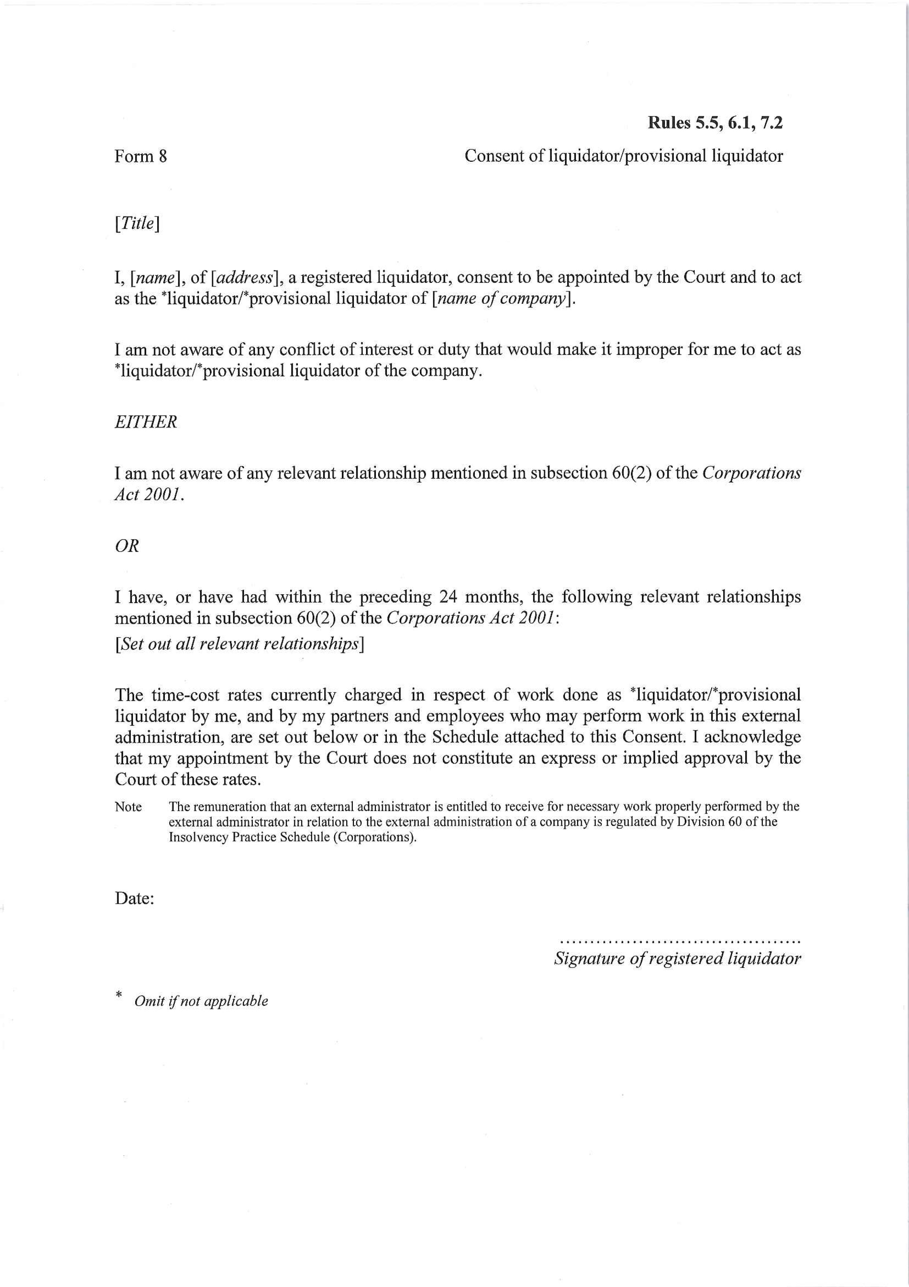
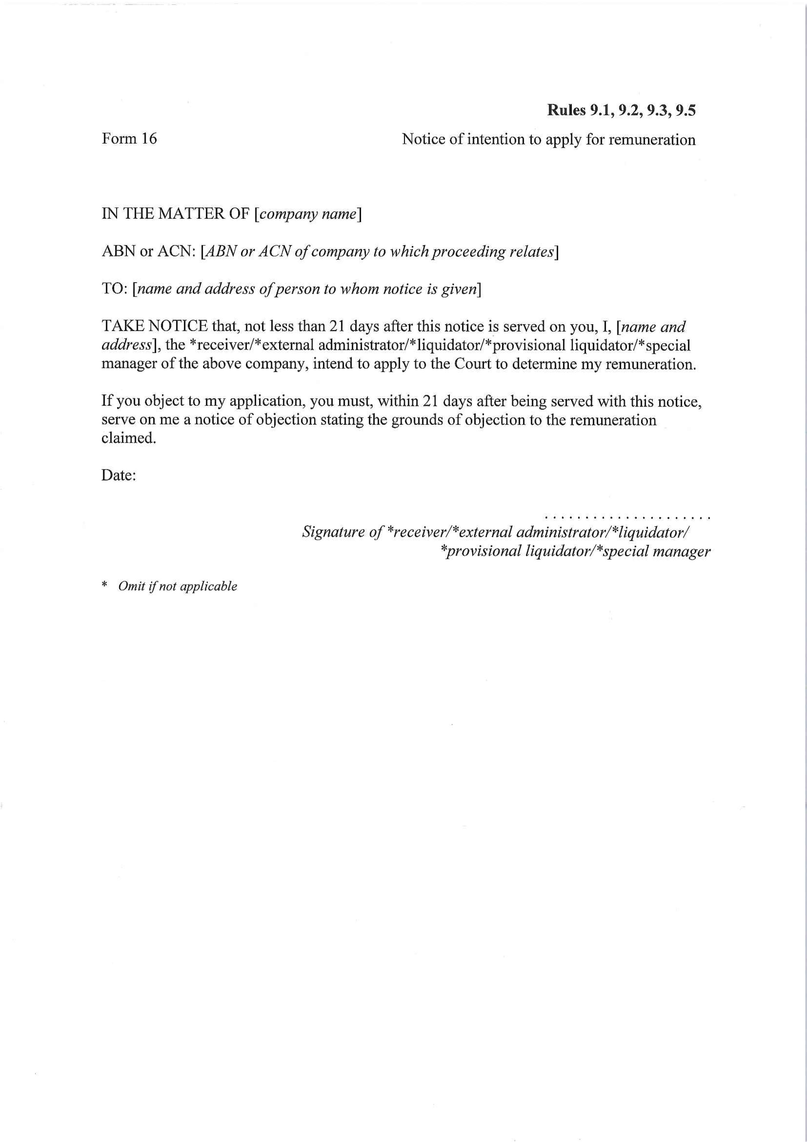
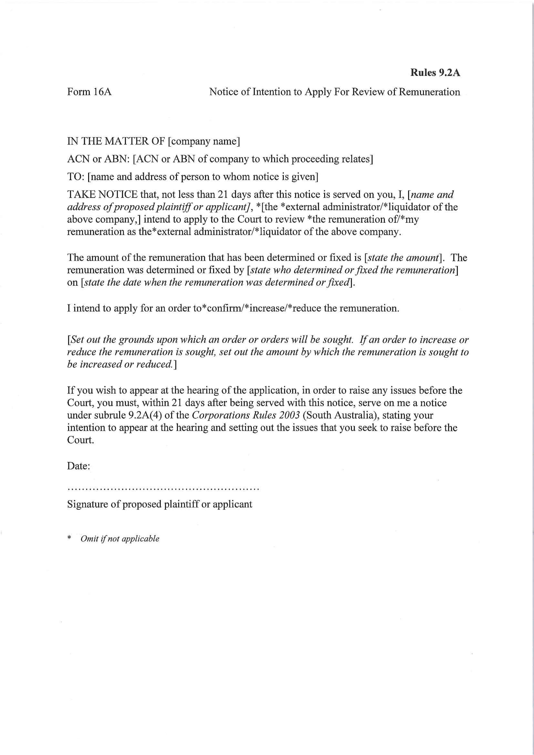
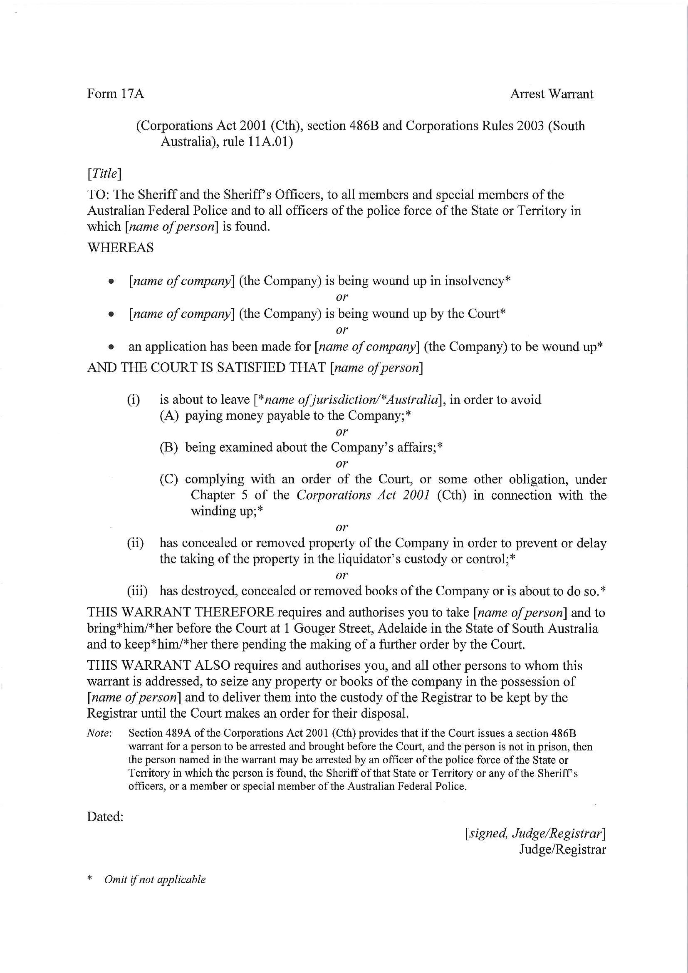
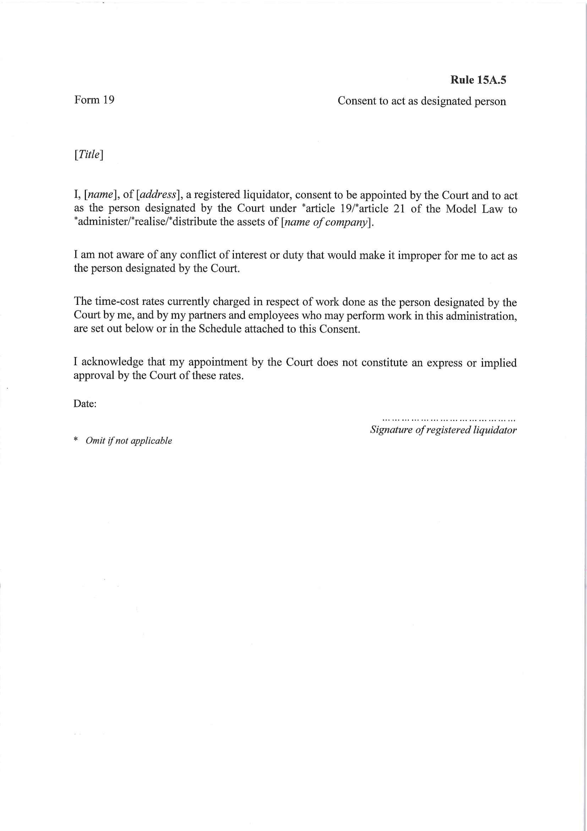

CITY OF MITCHAM
Amendment to Exclusion of Vehicles
NOTICE is hereby given that the City of Mitcham at its meeting held on 14 November 2017 resolved to amend its previous declaration made at its meeting held on 28 February 2011 and published in the Gazette on 3 March 2011 under Section 359 of the Local Government Act 1934 relating to the closure of a portion of Craigburn Road, Blackwood. This resolution revokes the prohibition of access to all vehicles including cyclists into and out of Hayman Retreat from Craigburn Road.
Council has resolved to revoke the previous exclusion of all vehicles as follows:
‘That:
- In accordance with Section 359(2) of the Local Government Act 1934 and Clause 3 of Part 3 of Schedule 1 of the Local Government (Accountability and Governance) Amendment Act 2015, Council hereby resolves to revoke paragraph 4 of its resolution passed at on 28 February 2011 as outlined below:
‘(4) That pursuant to Section 359 of the Local Government Act 1934 Council resolves to exclude all vehicles from a part of Craigburn Road Blackwood being an area 1 metre in width and 30.5 metres in length the southern boundary of which being between Point 2 (281471.62E 6120546.04N) and Point 3 (281501.64E 6120549.55N) shown on the attached survey plan with the exception of:
- Government owned vehicles driven by employees or agents of the government in the course of their employment;
- City of Mitcham owned vehicles driven by employees or agents of the City of Mitcham in the course of their employment;
- SA Water vehicles;
- ETSA Utilities vehicles;
- Country Fire Services vehicles;
- Telstra vehicles; and
- Police vehicles.’,
with such revocation to take effect at 12.00 noon on 23 January 2018.
M Pears
Chief Executive Officer

The Rural City of Murray Bridge
Development Act 1993
Primary Production (Central Policy Area 3) Value-Adding Development Plan Amendment
Public Consultation
Notice is hereby given that The Rural City of Murray Bridge, pursuant to sections 24 and 25 of the Development Act 1993, has prepared a Development Plan Amendment Report (DPA) to amend its Development Plan.
Council is keen to ensure its Development Plan policies for its primary production areas are suitable to facilitate appropriate primary production related development, resulting in increased economic activity and employment opportunities within the district.
In summary, the Amendment will change the Development Plan by proposing changes aimed at providing a clearer, but more flexible policy framework that will:
- better support the consideration of value adding activities in the Primary Production Zone, in particular in Central Policy Area 3 of the zone
- encourage and enable the development and expansion of existing and future primary production activities while discouraging residential development other than that necessary for, or in association with, primary production or value adding activities
- encourage and enable the development of infrastructure to support primary production and value adding activities.
It should also be noted that the Minister for Planning has declared that the DPA should come into operation on an interim basis pursuant to section 28 of the Act.
The DPA report will be on public consultation from Tuesday 23 January 2018 until Friday 23 March 2018
Copies of the DPA report are available during normal office hours at the Local Government Centre, 2 Seventh Street, Murray Bridge. Alternatively the DPA report can be viewed at http://letstalk.murraybridge.sa.gov.au/primary-production- value-adding-dpa or during normal office hours at the following locations:
- The Murray Bridge Library, Level 2/51 South Terrace, Murray Bridge, SA 5253.
A ‘Drop-in” session to answer queries and to provide further information on the DPA will be held on the following date:
- Wednesday – 21 February 2018 – Local Government Centre (2 Seventh Street, Murray Bridge) 5.30-7.30pm
Written submissions regarding the DPA should be submitted no later than 5.00 pm on Friday 23 March 2018. All submissions should be addressed to Chief Executive Officer, and should clearly indicate whether you wish to be heard in support of your submission at the public meeting for the DPA. If you wish to lodge your submission electronically, please email it to dpasubmissions@murraybridge.sa.gov.au
Copies of all submissions will be available for inspection at the Council offices at 2 Seventh Street, Murray Bridge from 30 March 2018 until the conclusion of the public meeting.
A public meeting will be held on Wednesday 11 April 2018 at 5:30pm at the Local Government Centre, 2 Seventh Street Murray Bridge at which time interested persons may be heard in relation to the DPA and the submissions. The public hearing will not be held if no submissions are received or if no submission makes a request to be heard.
If you would like further information about the DPA, contact Cherry Getsom or Glenn Searle on 08 8539 1414
Dated: 23 January 2018
Michael Sedgman
Chief Executive Officer
The Rural City of Murray Bridge

City of Onkaparinga
Roads (Opening and Closing) Act 1991
Road Closure - Public Road, McLaren Vale
NOTICE is hereby given, pursuant to section 10 of the Roads (Opening and Closing) Act 1991, that the City of Onkaparinga proposes to make a Road Process Order to close portion of the Public Road adjoining Allotments 21 & 22 in DP 60844, Allotment 102 in DP 43457, and Sections 65 & 75 in the Hundred of Willunga, shown more particularly delineated and lettered ‘A’ on the Preliminary Plan No. 18/0001.
Closed Road ‘A’ is to be merged with adjoining Section 75.
A copy of the plan and a statement of persons affected are available for public inspection at the offices of the Council at City of Onkaparinga, Ramsay Place, Noarlunga Centre and the Adelaide office of the Surveyor-General during normal office hours.
Any application for easement or objection must set out the full name, address and details of the submission and must be fully supported by reasons.
The application for easement or objection must be made in writing to the Council at City of Onkaparinga, PO Box 1, Noarlunga Centre 5168 WITHIN 28 DAYS OF THIS NOTICE and a copy must be forwarded to the Surveyor-General at GPO Box 1354, Adelaide 5001. Where a submission is made, the Council will give notification of a meeting at which the matter will be considered.
Dated: 23 January 2018
Mark Dowd
Chief Executive Officer

City of Onkaparinga
Roads (Opening and Closing) Act 1991
Road Closure - Public Road (Walkway) & Portion of Highview Ct, Hackham
NOTICE is hereby given, pursuant to section 10 of the Roads (Opening and Closing) Act 1991, that the City of Onkaparinga proposes to make a Road Process Order to close the Walkway adjoining Allotments 1 & 2 in DP 20434 and portion of Highview Court adjoining Allotment 3 in DP 20434, in the Hundred of Noarlunga, shown more particularly delineated and lettered ‘A’, ‘B’ & ‘C’ on the Preliminary Plan No. 18/0002.
Closed Road ‘A’ is to be merged with adjoining Allotment 1 in DP 20434.
Closed Road ‘B’ is to be merged with adjoining Allotment 2 in DP 20434.
Closed Road ‘C’ is to be merged with adjoining Allotment 3 in DP 20434.
A copy of the plan and a statement of persons affected are available for public inspection at the offices of the Council at City of Onkaparinga, Ramsay Place, Noarlunga Centre and the Adelaide office of the Surveyor-General during normal office hours.
Any application for easement or objection must set out the full name, address and details of the submission and must be fully supported by reasons.
The application for easement or objection must be made in writing to the Council at City of Onkaparinga, PO Box 1, Noarlunga Centre 5168 WITHIN 28 DAYS OF THIS NOTICE and a copy must be forwarded to the Surveyor-General at GPO Box 1354, Adelaide 5001. Where a submission is made, the Council will give notification of a meeting at which the matter will be considered.
Dated: 23 January 2018
Mark Dowd
Chief Executive Officer

DISTRICT COUNCIL OF BARUNGA WEST
Naming of Public Road
NOTICE is hereby given in accordance with Section 219 of the Local Government Act 1999, that at the Council meeting of 16 January 2018, Council resolved to name the following un-named roads;
The road located along Upper Yorke Road, 1150 metres in a north westerly direction from Bute Township which commences at Upper Yorke Road running in a northerly direction for 600 metres and intersects with Moyses Road be named “Trengove Road”.
The road commencing at Park Terrace in Bute and runs in a westerly direction to meet up with Lanner Park Road be named “Gun Club Road.”
The road to the Bute Waste Transfer Station commencing at Barunga Gap Road heading in an easterly direction be named “Watson Road”
A Cole
Chief Executive Officer

KINGSTON DISTRICT COUNCIL
Application of Dog By-laws
Notice is hereby given that at the meeting of Council held on 15 December 2017, pursuant to the powers contained in Section 246(3)(e) of the Local Government Act 1999, Kingston District Council resolved for the purposes of Clause 9 of the Council’s Dog By-law:
Dogs must be on a leash on all Local Government Land and in all public places in the Council’s area except for the following areas:
  - on the beach and foreshore reserve between Thredgolds Beach access point and Pinks Beach access point:
      - at all times when Daylight Savings is not in force; and
      - otherwise before 9am and after 8pm during Daylight Savings.
  - on the beach and foreshore reserve
      - North of the Kingston Jetty
      - South of Pinks Beach access point
  - Maria Creek Reserve (north of Maria Creek)
  - Old School Oval and Gall Park Oval (outside of school hours only) during such times as there are no organised sporting or community events taking place.
A MacDonald
Chief Executive Officer

DISTRICT COUNCIL OF ROBE
Naming of Public Roads
NOTICE is hereby given that at its meeting held on 9 January 2018, the District Council of Robe resolved pursuant to section 219(1) of the Local Government Act 1999, to approve the assigning of the name Roys Lane to the public unmade road previously known as Gibson Road.
Roger Sweetman
Chief Executive Officer

Trustee Act 1936
Public Trustee
Estates of Deceased Persons
In the matter of the estates of the undermentioned deceased persons:
ANDERSON William James late of 77 Sydenham Road Norwood of no occupation who died 21 October 2016
BROWN, Helen Sadgrove late of 1 - 13 Deland Avenue Gawler East of no occupation who died 11 October 2017
BRYSON, John Theodore late of 67 Slaughterhouse Road Orroroo Retired Station Manager who died 17 January 2017
CARDWELL Phillip David late of 56 Avenue Road Cumberland Park of no occupation who died 21 May 2017
COOPER Kenneth David late of 81 Tapleys Hill Road Hendon Retired Commonwealth Public Servant who died 26 July 2017
DAWES Janice Kay late of 25 Frost Street Newton Retired Sales Representative who died 21 March 2017
EWEN Clara Doris late of 10 Morton Road Christie Downs of no occupation who died 4 November 2017
GLASCOCK Marie Patricia late of 32 Alma Street Panorama of no occupation who died 23 November 2017
HANSEN Daisy Joan late of 39 - 43 Finniss Street Marion of no occupation who died 15 November 2017
MADDIGAN Mavis Brenda late of 25 Newton Street Whyalla of no occupation who died 2 November 2017
MAYNARD Ruth Gwendoline late of 133 Frost Road Salisbury of no occupation who died 17 August 2017
MORRIS Stanley James late of 122 Ward Street Whyalla of no occupation who died 8 February 2017
PEARSON Trevor David late of 181 - 193 Days Road Regency Park Numerologist who died 30 July 2017
PHILP Mary Alice late of 24 Avenue Road Glynde of no occupation who died 22 October 2017
POBKE Byron John late of 20 Alpha Road Prospect of no occupation who died 29 September 2017
RADTKE Johanna Elfriede late of 18 Cross Road Myrtle Bank Retired Accounts Payable Clerk who died 14 September 2017
ROVAS Maria Marie late of 24 Bartley Terrace Semaphore of no occupation who died 10 May 2017
SPENCER Peggy Carol late of 7 Fourth Ave Semaphore Park Home duties who died 4 September 2017
THOMPSON Frederick Oscar late of 1 Schottelius Avenue Murray Bridge Groundsman who died 21 September 2017
WALKER James Michael late of 1 Greenleaf Court Mawson Lakes Retired Court Reporter who died 20 October 2017
WOODWARD John Douglas late of 6 Bray Avenue Klemzig Carpark Attendant who died 6 November 2017
Notice is hereby given pursuant to the Trustee Act 1936, the Inheritance (Family Provision) Act 1972 and the Family Relationships Act 1975 that all creditors, beneficiaries, and other persons having claims against the said estates are required to send, in writing, to the office of Public Trustee at GPO Box 1338, Adelaide, 5001, full particulars and proof of such claims, on or before the 23 February 2018 otherwise they will be excluded from the distribution of the said estate; and notice is also hereby given that all persons indebted to the said estates are required to pay the amount of their debts to the Public Trustee or proceedings will be taken for the recovery thereof; and all persons having any property belonging to the said estates are forthwith to deliver same to the Public Trustee.
Dated: 23 January 2018
D A Contala
Public Trustee

UNCLAIMED MONEYS ACT 1891
Register of Unclaimed Moneys held by Zurich Financial Services Australia for the year ended 2010

Name and Address of Owner |  | Amount $ | Description of Unclaimed Money | Date
Andrew Fantasia | Unknown | 454.00 | Unpresented cheque | NA
Adelaide Brighton Limited | Elder Road, Birkenhead, 5015 SA | 909.10 | Unpresented cheque | 30.6.2010
ARA Group/Air Con Engineering | Taminga Street, Regency Park, 5010 SA | 909.10 | Unpresented cheque | 31.5.2010

Notice Submission

The weekly South Australian Government Gazette is issued on Tuesday afternoon, except where Executive Council meets on Wednesday, wherein publishing will occur on that day.
The next scheduled publication date is displayed on the website: www.governmentgazette.sa.gov.au.

Notices for gazettal, along with enquiries, can be directed to:

Email governmentgazettesa@sa.gov.au
Phone (08) 8207 1025

Gazette notices should be emailed in the following formats:

• Notices as individual Word files
• Maps, images, and diagrams as single, complete objects within the Word files
• Content containing official signatures for authorisation—notices as Word files and the signed documentation as PDF files

Please provide the following information in your email:

• Date the notice is to be gazetted
• Email address and phone number of the person authorising the submission
• Notification of whether a quote is required for chargeable notices
• Name of the person and organisation to be charged for the notice, if applicable
• A purchase order if required
• Details that may impact on publication of the notice

Notices must be submitted before 4 p.m. Friday, the week preceding intended gazettal.
Proofs of formatted content are supplied for all notices, with necessary alterations to be returned before 4 p.m. on the day preceding publication.
Submitted notices will be gazetted unless notification is received before 10 a.m. on the day of publication.

Printed and published weekly by authority of the Government Printer, South Australia
$7.35 per issue (plus postage), $370.00 per annual subscription—GST inclusive
Online publications: www.governmentgazette.sa.gov.au

